 |  | CBD
 |  |  |  | Distr.  GENERAL  UNEP/CBD/WGRI/5/INF/23  13 June 2014  ENGLISH ONLY
AD HOC OPEN-ENDED WORKING GROUP ON REVIEW OF IMPLEMENTATION OF THE CONVENTION
Fifth meeting
Montreal, 16-20 June 2014
Item 5 of the provisional agenda*

PROGRESS in the submission of the fifth national reports and their use in the preparation of the fourth edition of the global biodiversity outlook (GBO-4)
Note by the Executive Secretary

Introduction
- In decision X/10, the Conference of the Parties requested Parties to submit their fifth national report by 31 March 2014. The fifth national reports are an important source of information for the mid-term review of progress towards the implementation of the Strategic Plan for Biodiversity 2011-2020 which will be undertaken by the Conference of the Parties at its twelfth meeting, in October 2014. In particular the fifth national reports also provide a key source of information for the preparation of the fourth edition of the Global Biodiversity Outlook.
- The present document provides an update of progress in the submission of the fifth national reports. It compliments document UNEP/CBD/WGRI/5/2. It also provides information on how the information contained in the fifth national reports is being used in the preparation of the fourth edition of the Global Biodiversity Outlook (GBO-4).

Submission of the fifth national reports
- As of 13 June 2014 the Secretariat had received fifth national reports from 78 Parties (see annex I for a list of those countries that have submitted their fifth national report). This represents a submission rate of about 40%. On a regional basis 50% of Parties from Africa, 36% of Parties from Asia and the Pacific, 52% of Parties from Central and Eastern Europe, 18% of Parties from Latin America and the Caribbean, and 46% of Parties from Western Europe and Others, have submitted their fifth national reports. The rate of submission has surpassed the four previous rounds of national reporting though only 31 countries submitted their reports by the 31 march 2014 deadline (see figure below).
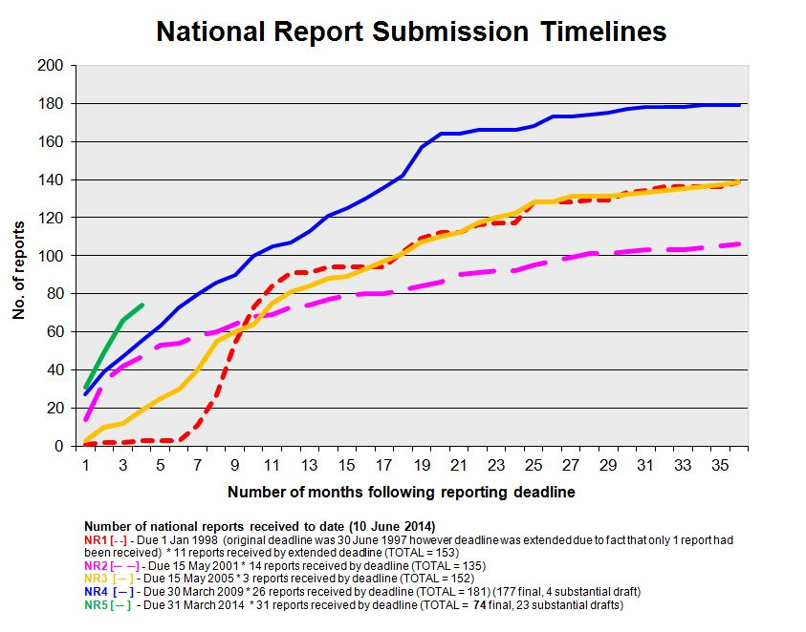

Use of the fifth national reports in the fourth edition of the global biodiversity outlook
- A draft of the executive summary of the fourth edition of the Global Biodiversity Outlook (GBO-4) has been made available as document UNEP/CBD/SBSTTA/18/2 and a complete draft of the report has been made available as UNEP/CBD/SBSTTA/18/INF/2. To date information from 50 fifth national reports have been considered in the preparation of the GBO-4. As additional reports are received and assessed this number will increase and the assessment in GBO-4 will be adjusted accordingly.
- Information in the fifth national reports on the status and trends of biodiversity and the actions being taken to conserve and sustainably use it is being used to assess global progress towards the attainment of the Aichi Biodiversity Targets. Some fifth national reports contain national assessments of progress towards the attainment of the Aichi Targets. This has also been taken into account where applicable. The information in the fifth national reports is complimented by other sources of information (such as the targets and actions identified in updated national biodiversity strategies and action plans, extrapolations of current trends towards the five goals of the Strategic Plan and Aichi Biodiversity Targets, other indicators information provided by the Biodiversity Indicators Partnership, and analysis in the technical report based on longer-term scenarios).
- An assessment of 50 of these reports illustrates that while progress is being made towards the achievement of all targets, it is insufficient on current trajectories to meet the targets by the 2015 and 2020 deadlines (see the figure below). Further, consistent with the indicators and extrapolations used in GBO-4, the information in the fifth national reports suggests that most progress has been made in relation to Aichi Biodiversity Targets 11, 16 and 17, while progress is limited for targets 3 and 10, in particular.
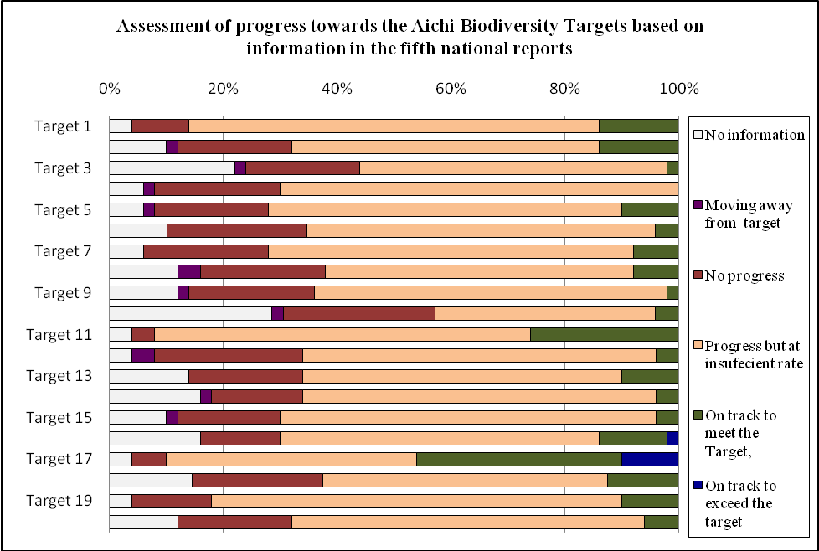
Figure – Assessment of progress towards the attainment of the Aichi Biodiversity Targets based on the information contained in 50 fifth national reports. Note that approximately 60% of these reporting countries have explicitly assessed their national progress towards the Aichi Biodiversity Targets in their reports. Where this is the case the country’s assessment has been applied to the same five point scale used in the dashboard summary contained in the executive summary of the GBO-4 (UNEP/CBD/SBSTTA/18/2). In the other cases the assessment has been inferred from the information contained in the report. A number of these reports did not contain information that allowed for an assessment of progress. This is noted in the figure as “No Information”
Annex I
LIST OF Parties THAT HAVE SUBMITTED FIFTH NATIONAL REPORTS
(as of 13 June 2014) (in order of receipt)

Final reports:
- South Africa
- Niger
- Belgium
- Japan
- Dominica
- Sudan
- Myanmar
- Côte d’Ivoire
- Somalia
- Niue
- Nepal
- Mongolia
- Poland
- Colombia
- Uganda
- Nauru
- China
- Palau
- Malaysia
- Solomon Islands
- Pakistan
- Senegal
- Nigeria
- Cameroon
- Denmark
- Canada
- Burundi
- Rwanda
- Spain
- Ecuador
- Cuba
- Namibia
- Germany
- Republic of Moldova
- Montenegro
- India
- Republic of Congo
- Belarus
- Iraq
- Kuwait
- Sweden
- Netherlands
- Qatar
- New Zealand
- Italy
- Madagascar
- Tajikistan
- Azerbaijan
- Switzerland
- Costa Rica
- Liberia
- United Kingdom
- Finland
- Hungary
- United Republic of Tanzania
- Tonga
- Australia
- Republic of Korea
- Kazakhstan
- Estonia
- Sao Tome and Principe
- Chad
- Benin
- United Arab Emirates
- Morocco
- Bosnia and Herzegovina
- Albania
- Equatorial Guinea
- Ethiopia
- Democratic Republic of the Congo
- Mali
- Gambia
- Mauritania
- Honduras
- Czech Republic
- Croatia
- Bulgaria
- Comoros
Advanced drafts:
- Saint Lucia
- Cambodia
- Maldives
- Malawi
- Panama
- Saint Kitts and Nevis
- Vietnam
- Burkina Faso
- Fiji
- Samoa
- Peru
- The Philippines
- Yemen
- Norway
- Brazil
- Dominican Republic
- Seychelles
- Djibouti
- France
- Mexico
- Russian Federation
- Sri Lanka
- Uruguay
- Botswana
- Tunisia
- Nicaragua
- Vanuatu
- Kyrgyzstan
- Guatemala
- Serbia

-----

* UNEP/CBD/WGRI/5/1.
A further 30 Parties have submitted advance drafts of their fifth national reports.
This assessment is preliminary and will be updated as additional fifth national reports are reviewed. The current assessment draws on information in the reports of the following countries: Azerbaijan, Belgium, Bosnia and Herzegovina, Burundi, Cameroon, Canada, China, Colombia, Congo, Costa Rica, Cote D'Ivoire, Cuba, Denmark, Dominica, Ecuador, Estonia, Ethiopia, Finland, Germany, Hungary, India, Iraq, Italy, Japan, Madagascar, Malaysia, Mongolia, Myanmar, Namibia, Nauru, Nepal, Netherlands, New Zealand, Niger, Nigeria, Niue, Pakistan, Palau, Poland, Rwanda, Senegal, Solomon Islands, Somalia, South Africa, Spain, Sudan, Tonga, Uganda, United Kingdom of Great Britain and Northern Ireland, and United Republic of Tanzania.

