Ref.: SCBD/IMS/JMF/NP/OH/SM/88701 14 February 2020

N O T I F I C A T I O N

Workshop for Subnational, Regional and Local Governments on the
Post-2020 Global Biodiversity Framework
1-3 April 2020, Edinburgh, Scotland

Dear Madam/Sir,
I have the honour to inform you that the Scottish Government, in consultation with the Department for Environment, Food and Rural Affairs of the United Kingdom of Great Britain and Northern Ireland, will convene a global Workshop for Subnational, Regional and Local Governments on the Post-2020 Global Biodiversity Framework at the Royal Botanic Garden, Edinburgh, Scotland, from 1 to 3 April 2020. The workshop will support the development of the post-2020 global biodiversity framework and will provide its outcomes to the third meeting of the Open-ended Working Group on the Post-2020 Global Biodiversity Framework.

The workshop aims to bring together officials of subnational, regional and local governments from around the world, experts from relevant non-governmental organizations and membership organizations that represent subnational and local authorities, as well as national government officials with responsibilities to the implementation of policy at the subnational and local levels. The workshop will also include a high-level session on the morning of Friday, 3 April, where the attendance of subnational political representatives is welcomed.

Representatives of subnational, regional and local authorities, as well as national governments working on subnational or local issues, wishing to attend the workshop are invited to complete the form provided in annex to this notification and return them to the Scottish Government via e-mail to eoi-subnationalworkshop@gov.scot by 24 February 2020.

Financial support may be available to a limited number of participants from developing countries, in particular the least developed countries and small island developing States, as well as countries with economies in transition, nominated by their respective authorities. Nominees who wish to solicit such assistance are kindly requested to advise the Scottish Government, as part of their expression of interest as attached. Participants will be selected on the basis of their responsibilities for the implementation of biodiversity objectives at the subnational, regional and local levels, with due regard to ensuring an equitable regional and gender balance.

I would be grateful if you could bring this invitation to the attention of appropriate subnational, regional and local government representatives within your country.

Further information, including the programme of the workshop and other relevant documents will be made available at http://www.biodiversityworkshop2020.scot
Please accept, Madam/Sir, the assurances of my highest consideration.

Elizabeth Maruma Mrema
Acting Executive Secretary

Enclosure: Expression of Interest Form

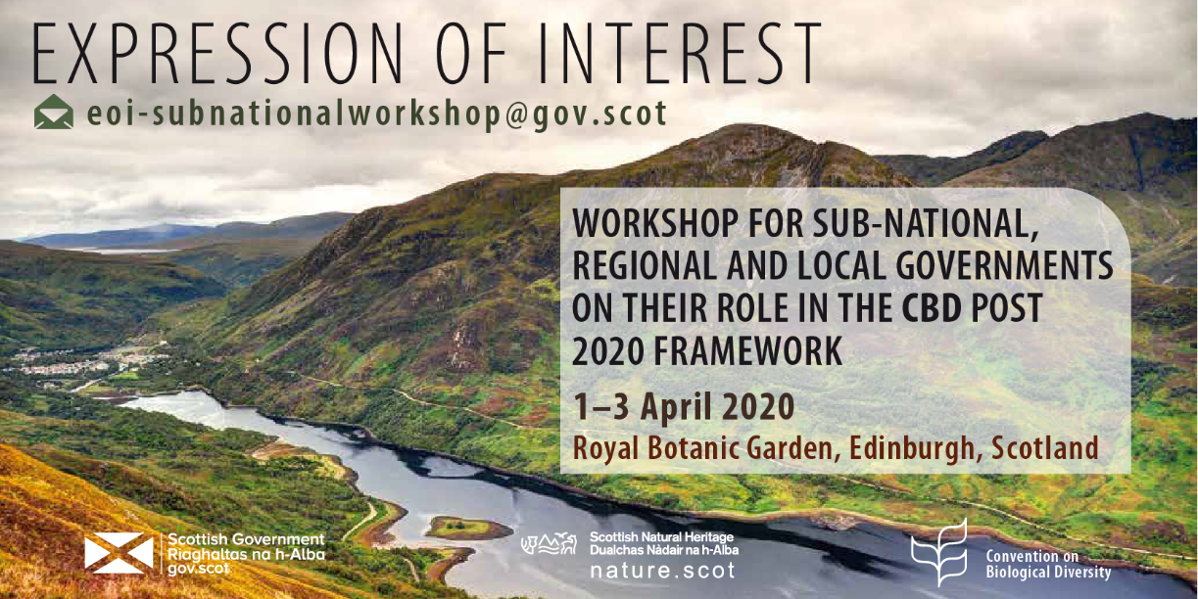
EXPRESSION OF INTEREST FORM

Please note the following details:

  - The workshop will be conducted in English.

  - Due to limitations of the venue delegate numbers will be limited to approximately 200.

  - We are inviting a mix of official and political representatives from subnational, regional and local governments.

  - Financial support will be available for a small number of participants, particularly those from the Global South. Any case for support should be set out via this form.

Interested officials and political representatives from Sub-National, Regional and Local Governments should use this form to express their interest in attending the Workshop.

Please submit this form by 24 February 2020 to eoi-subnationalworkshop@gov.scot stating EoI submission in the email subject line.

first name | last name | position/ job title | organisation | country/ region / city of representation | gender | accessibility needs (e.g. hearing, mobility) | dietary requirements | request for financial support (yes/no) | attendance evening reception 31/03/2020

