Implementation of the Convention on Biological Diversity’s
Programme of Work on Protected Areas

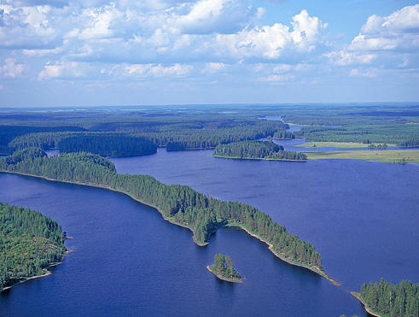
Petkeljärvi National Park (photo: Vallas)

Finland

Submitted to the Secretariat of the Convention on Biological Diversity March 30, 2012
Protected area information:

PoWPA Focal Point:
Ms. Sanna-Kaisa Juvonen (substituting for Mr. Kari Lahti until 31 January 2013)
Metsähallitus, Natural Heritage Services
P.O.Box 94 (Vernissakatu 4), 01301 Vantaa, Finland
Telephone: +358 40 755 9674
Fax: +358 205 64 4350
E-mail: sanna-kaisa.juvonen@metsa.fi

Lead implementing agency:
Ministry of the Environment of Finland and Natural Heritage Services of Metsähallitus

Multi-stakeholder committee:
There is a multi-stakeholder working group that works on the issues involving the Convention on Biological Diversity. The working group is comprised of representatives of ministries, other governmental agencies and non-governmental organisations. The working group’s work covers also protected areas. The working group is presided by the Ministry of the Environment. The working group has developed into an important cross-sectoral forum on the national level that deals with issues of conservation and sustainable use of biological diversity. The working group strengthens cooperation, interaction and sectoral responsibility of the participating organisations.

Description of protected area system

National Targets and Vision for Protected Areas
Finland is in the process of updating the National Biodiversity Strategy and Action Plan (NBSAP 2012-2020) to comply with the Strategic Plan for Biodiversity 2011-2020 and the Aichi Biodiversity Targets agreed at the 10th Conference of the Parties (CBD COP 10) of the Convention on Biological Diversity (CBD) in Nagoya, Japan in October 2010. It is expected that the Finnish Government will make a Decision-in-principle on the National Strategy for the Conservation and Sustainable Use of Biodiversity in Finland 2012–2020 during the spring of 2012. The National Strategy will be accompanied by an Action Plan. Together they form the new National Biodiversity Strategy and Action Plan 2012-2020 which has also been termed “Saving Nature for People”.
As actions for protected areas are included in the NBSAP 2012-2020, a separate action plan for implementation of CBD’s Programme of Work on Protected Areas (PoWPA) has not been prepared. This document compiles information from several different sources, including the draft version of the upcoming NBSAP 2012-2020 and the Fourth National Report on the Implementation of the Convention on Biological Diversity in Finland (NR4 Finland). The actions are collected from the draft version of NBSAP 2012-2020 and completed with actions of the CBD COP 10 Decision X/31 on Protected Areas and PoWPA.
In the National Biodiversity Strategy 2012-2020 (NS2012-2020), Target 11 is the target for protected areas by the year 2020: Network of protected areas and other means that support protected area system, guide use of areas and safeguard biodiversity cover at least 17 % of Finland’s terrestrial and inland water area and 10 % of coastal and marine area. Protected areas are appropriately managed and representative in an ecological and regional manner. Protected areas are well connected and green infrastructure connects them to broader landscapes and seascapes taking into account the special characteristics of traditional landscapes.
In the National Action Plan 2012-2020 (NAP 2012-2020) it is stated that Finland aims to form a comprehensive, effectively managed, ecologically functional and representative protected area network that is part of the global protected area system and that can buffer effects of climate change and can adapt to it. Finland’s protected area network is comprised of national and regional protected area systems.
The European Union has also set its targets for biodiversity in “Our life insurance, our natural capital: an EU biodiversity strategy to 2020”. Target 1 “Fully implement the Birds and Habitats Directives” and Target 2 “Maintain and restore ecosystems and their services” have especially to do with protected areas as they focus on Natura 2000 network, ecosystem services, green infrastructure and restoration of ecosystems.
At the moment, there is no separate national vision, nor comprehensive targets for protected areas.
Coverage
According to NR4 Finland, some 12 % of Finland’s total surface area is now under protection, counting legally established protected areas. When other areas reserved for nature conservation programmes are also counted, including European Union Natura 2000 network sites, the total area under protection increases to 15 %. There are about 12 % of Finland’s terrestrial areas in the Natura 2000 network and 19 % of the inland waters. In NS2012-2020 it is stated that of Finland’s marine areas about 13 % is protected when the new marine Natura 2000 areas are taken into account (see tables 1-3 below).
Establishment of Natura 2000 protected areas complimented the existing national network and notably increased the protection of still inadequately protected marine habitats and inland waters.

Description
In this description mainly those issues are dealt with in which there have been progress or changes after the Fourth National Report (2009) on the Implementation of the Convention on Biological Diversity in Finland. Many facts in the NR4 Finland are still relevant and are not repeated here.
Protected area system: Finland has an existing comprehensive nationwide protected area system that complements the global protected area network, and supports the worldwide effort to achieve the common global conservation goals. Finland’s protected area system is based on protected areas established under the Nature Conservation Act, wilderness areas established under the Wilderness Act and the Natura 2000 network, based on EU's Birds and Habitats Directives. Properties, land and waters under protection, are mostly owned by the state and there are no inhabitants inside the protected area boundaries. (NR4 Finland). It is also important to point out that most of the protected areas in Finland are strictly protected. This is true especially for forest protected areas. Logging is not permitted but for restoration and management purposes, and even as such, only in small surface areas.
There are 37 national parks (two new ones were established in 2011), 19 strict nature reserves and about 500 other protected areas established under the Nature Conservation Act. 12 wilderness areas aim to conserve wild nature, to preserve Sámi culture and livelihoods, and to develop diverse, sustainable use of nature within the area. Seven national hiking areas have been established under the Outdoor Recreation Act especially for recreational use of nature. (NS 2012-2020).
Finland has several national nature conservation programmes in addition to established PAs and Natura 2000 obligations. The current status of the conservation programmes is depicted in Table 2. It demonstrates the relevant proportions of the establishment of the areas in relation to the areas reserved in total. Even though some of the programmes are falling behind the planned schedule it needs to be emphasized that the total area of pending areas in programmes represent only about 15 % of the total areas to be protected, and that they all are already actually protected in principle due to the Government decision. Mostly they are also situated on state-owned land and thus also protected in practice. (NR4 Finland).
The protected areas cover both terrestrial and aquatic ecosystems. In addition, some special habitat types are protected by the Nature Conservation Act and the Forest Act. In addition to these, it is possible to reserve areas for protection under other acts and in land use plans. The most important ones in relation to the National Strategy’s Target 11 can be done under the Land Use and Building Act. However, these in relation to total area of Finland are small.
Table 1. Finland's Protected Areas 2010. The data on National parks is from year 2011. Source: Ministry of the Environment.

Proclaimed for Conservation | Established |  |  |  | Reserved in Conservation Programmes |  | TOTAL AREA | %
 | State land |  | Private land |  | State land | Private land
 | land | water | land | water | land + water | land + water
National Parks | 802 800 | 175 600 | - | - | 1 100 | 400 | 979 900 | 22.4
Strict Nature Reserves | 151 000 | 2 600 | - | - | - | - | 153 600 | 3.9
Mire Protection Areas | 448 600 | 11 800 | 17 500 | 200 | 125 100 | 2 500 | 605 700 | 15.3
Bird breeding Protection Areas | - | - | 16 400 | 39 900 | 10 800 | 4 900 | 72 000 | 1.8
Shoreline Protection Areas | - | - | 26 800 | 30 700 | 68 900 | 7 500 | 133 900 | 3.4
Herb-rich Forest Protection Areas | 1 200 | - | 1 700 | - | 2 000 | 500 | 5 400 | 0.1
Old-growth Forest Protection Areas | 9 200 | 200 | 3 100 | - | 268 900 | 1 500 | 282 900 | 7.2
New Natura 2000 sites (not included in existing PA network) | - | - | 9 300 | 1 800 | 111 100 | 15 900 | 138 100 | 3.5
Other protected areas on State lands (including e.g. Grey Seal PAs) | 41 800 | 26 100 | - | - | - | - | 67 900 | 1.7
Other protected areas on private lands | - | - | 28 800 | 47 500 | - | - | 76 300 | 3.0
Wilderness Areas | 1 379 000 | 110 000 | - | - | - | - | 1 489 000 | 37.7
TOTAL area land and water / ha | 2 833 600 | 326 300 | 103 600 | 120 100 | 587 900 | 33 200 | 4 004 700 | 100.0

Table 2. Implementation of national nature conservation programmes 2010. Source: Ministry of the Environment.
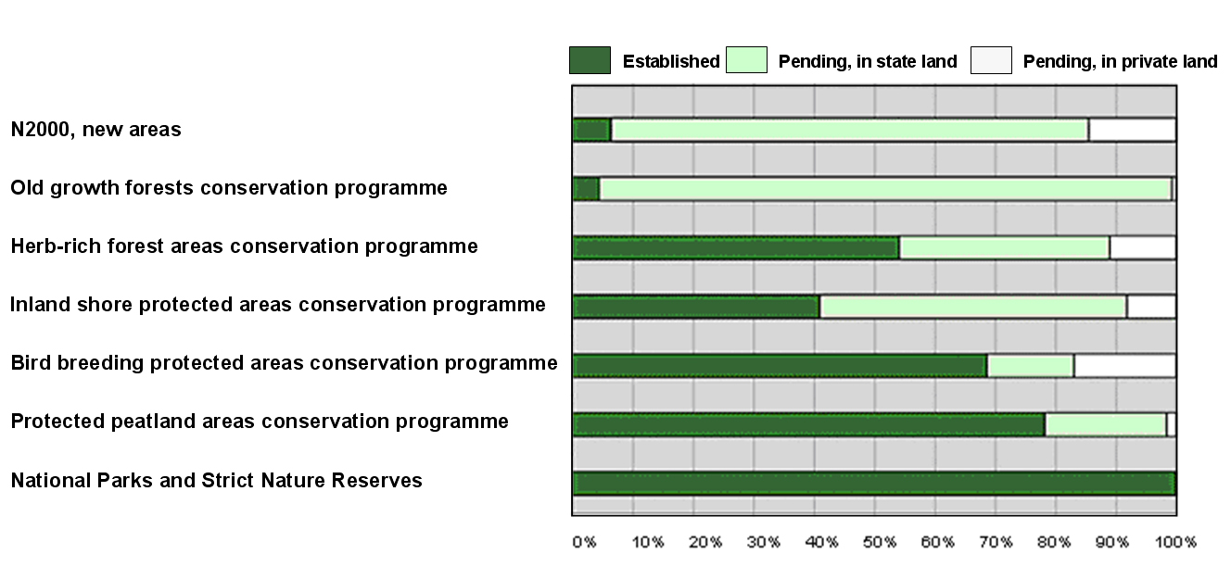
The majority of protected areas are situated in northern Finland. The network of protected areas still needs further development when it comes to geographical distribution, connectivity and representativity. Greatest challenges are in southern Finland, where habitats are fragmented and land use pressures much greater than in the north. This is also clearly indicated by the First Assessment of Threatened Habitat types in Finland (Raunio et al. 2008).
The Forest Biodiversity Programme METSO 2008-2016 aims to halt the ongoing decline in the biodiversity of forest habitats and species, and establish stable favourable trends in Southern Finland’s forest ecosystems. The objective of the programme is to ensure that Finnish forests will continue to provide suitable habitats for endangered and declining species. The programme aims to establish about 96 000 ha of new protected areas by 2020; this would be about 0.3 % of Finland’s surface area. As part of the National Strategy for Mires and Peatlands, there are plans to protect the most valuable mires and peatlands still in their natural states. The preliminary plans discussed have been about 0.5 % of Finland’s surface area. (NS 2012-2020).

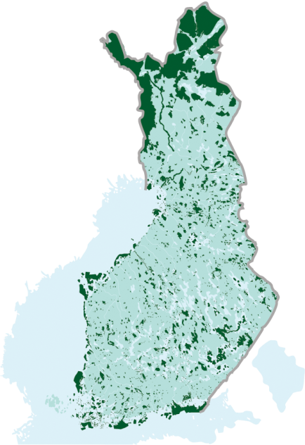
Natura 2000 network. Most of Finland’s Natura 2000 sites (see Figure 1) are already statutory protected areas established by Nature Conservation Act, Wilderness Act or by Government decisions on various nature conservation programmes (see Table 1. and 2), which restrict site use until they have been established as protected areas by the proper enactments. About 20 % of Natura area is protected by other legislation, which control use of land and water by permit. (NR4 Finland).
Figure 1. The Natura 2000 network in Finland. Source: Finnish Environment Institute.
Marine Protected Areas: In Finland there are numerous coastal and marine protected areas, including five national parks that have coastal and marine areas. The newest, Bothnian Sea National Park, was established in 2011 as the first true marine protected area with a 98 % marine component. Many other coastal protected areas have been established on state-owned and private lands. The marine component of many sites was much enhanced by inclusion within the Natura 2000 network of the European Union.
The work on Finnish marine protected areas follows very closely the development of the Natura 2000 network in marine areas and the congruent HELCOM (Helsinki Commission, Convention on Baltic Marine Environment Protection) work on Baltic Sea Protected areas (BSPAs). HELCOM has recently accessed the adequacy, representativity, replication and connectivity of the BSPAs and marine Natura 2000 networks (HELCOM 2010). Based on the assessment Finland currently protects 6.8% of its marine area with a total of 22 BSPAs (see table and figure from the HELCOM report). The area of designated BSPAs ranges from 148 to 116 296 ha. Many BSPAs are scattered as a series of small patches especially in the south of Finland. 81 % of the area of Finnish marine Natura 2000 sites overlaps with BSPAs and all designated BSPA sites are also Natura sites. There are over a hundred Natura sites with a marine component ranging from 5-100 % of the total area. The total marine area protected including the Natura sites is now over 13 % (see table).
Table 3. Natura 2000 sites and overlap with BSPAs. Source: HELCOM.
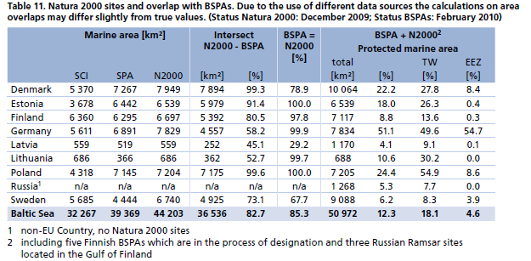
Five new Natura 2000 sites in the Finnish off-shore regions, with total area of 30 000 ha, have been approved by a Government decision in March 2012 and are also new BSPA sites. Some new sites in the Aland Islands may also be nominated in the future. This is important, as a strong bias of the BSPA network towards near-shore and inshore areas was found in the HELCOM assessment. This fact influenced each of the applied coherence criteria. It should be kept in mind, however, that more than 80 % of all Baltic Sea wide Natura 2000 sites are smaller than HELCOM minimum recommended size of 3000 ha for BSPAs, because no size limitations are prescribed for Natura 2000 sites. This is also one of the main reasons why all Natura 2000 sites have not been designated as BSPAs.
Apart from establishing an ecologically coherent network of BSPAs, an additional goal of HELCOM is to create a well-managed network. Proper management is a prerequisite for safeguarding the long-term conservation goals set for the individual sites, and also for the network as a whole. In recent years Finland has put much effort on inventorying underwater ecosystems in order to provide ecological information for conservation uses and for marine area planning. This has been done within national VELMU programme for underwater survey of biological diversity. Finland is currently working on the creation of additional management plans for the remaining BSPAs without a plan.

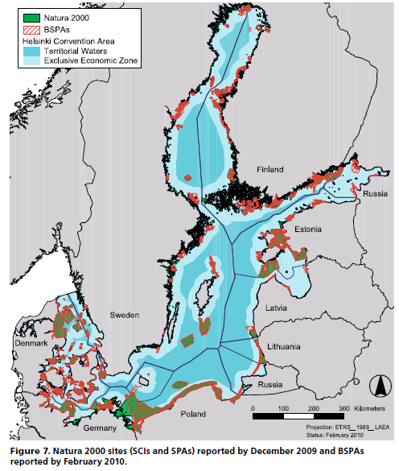
Figure 2. Natura 2000 sites and BSPAs in the Baltic Sea Area. Source: HELCOM.

Value of protected areas: The multiple values of protected areas are recognised in Finland. Assessment of protected area values and threats is always a part of management planning. Protected areas help to conserve the unique features and diversity of Finnish nature. However, nature is not conserved for the sole purpose of preserving natural features, but also to ensure the well-being of people and to preserve good living conditions. Many protected areas also have national landscapes and cultural heritage sites, which must be conserved.
Protected areas offer possiblilites for recreational use of nature and for nature-based tourism. In 2011, there were almost five million visits to state-owned protected areas. Of these more than two million were to national parks. There were more than 900 000 visits to customer service points in or in the vicinity of protected areas in 2011. Of these, half of the visits were to Visitor Centres run by Metsähallitus, which are typically situated inside national parks.
It has been estimated that in 2011 the impact of national parks in the local economies amounted to 108.3 million Euros and 1394 man-years through visitor spending. For national hiking areas these numbers were 14.6 million Euros and 189 man-years. There are also other protected areas that generate considerable impact on local economy. For example Kvarken Archipelago World Heritage Site’s impact on local economy in 2011 was 20.2 million Euros and 242 man-years in employment impact. There were 327 000 visits to Kvarken Archipelago. These values include the direct and indirect impacts of spending by visitors in the vicinity of national parks and the WH site.
To make the most of such benefits, suitable services must be available in the vicinity of protected areas for visitors to use. Metsähallitus maintains 6 738 km of trails, including long hiking trails and informative nature trails, as well as 3 155 campfire and picnic sites, lean-to shelters, and 2 276 waste collection points and dry compost toilets. Services are provided free of charge to all visitors. In the Finnish Sport Gala of 2012, Metsähallitus received a Sports Design Award for rendering possibilities for everybody to enjoy nature. In addition to facilities in nature, Metsähallitus offers internet sites for exploration of nature and planning of visits, such as outdoors.fi and excursionmap.fi.
Protected areas have also other positive impacts e.g. on public health through providing possibilities for outdoors activities and for safeguarding important ecosystems services. Attempts to value these have not yet been made.
Protected area use values extend also to research and education. Strict Nature Reserves are especially reserved for scientific purposes and environmental education is one of the key objectives of all national parks.
In northern Finland protected areas, wilderness reserves especially, play an important part in maintaining the traditional livelihoods of local and indigenous people. These include reindeer herding, local subsistance fishing, hunting and gathering.
Restoration of ecosystems: In the NS 2012-2020, Target 15 urges to restore degraded ecosystems, especially in order to prevent and adapt to climate change. Finland‘s target is to participate in restoration work so that the global target of restoration of at least 15 % of the degraded ecosystems can be achieved. Already a lot of work has been in forest and peatland restoration in Finland, especially in protected areas by Metsähallitus Natural Heritage Services (NHS).
Restoration work needs to be well planned and monitored so that the best benefits can be obtained and risks related to restoration minimised. By the end of 2011, NHS has restored and managed more than 35 000 ha in protected areas in state-owned lands within the METSO programme. Outside of METSO programme NHS has also worked in traditional landscapes and restored and managed about 1500 ha and additionally 400 ha of open peatlands. In private protected areas, NHS has restored about 150 ha of forests and peatlands and managed other valuable sites in 330 ha of land. At the moment there are two large EU LIFE+ projects implemented by NHS that work on restoration of peatlands and herb-rich forests, broad leaf forests and traditional open landscapes. Target 14 of NS 2012-2020 also urges for restoration and safeguarding of ecosystems that provide necessary ecosystem services. (NS 2012-2020).
Regional cooperation: Finland is situated in the boreal taiga region and is responsible for maintenance of biological diversity in the boreal region. It is also important for Finnish nature what happens in the neighbouring countries when it comes to biodiversity. Finland is very active in transboundary cooperation with neighbouring countries, particularly with Russia along the Fennoscandian Green Belt (GBF), and also with the countries around the Baltic Sea, such as Sweden, Estonia and Latvia. There are a large number of agreements, initiatives and hands-on conservation activities concerning nature conservation over the national borders. The GBF initiative aims at creating a chain of transboundary parks along the Finnish-Russian border from the Gulf of Finland to the River Paatsjoki in Inari. The cooperation with neighbouring countries has been funded by Metsähallitus, EU initiatives and also by the Ministry of the Environment of Finland. In 2012, there are several projects that will strengthen transboundary cooperation between Finnish and Russian protected areas, especially concentrating on nature-based tourism in the protected areas. (NAP 2012-2020, NR4 Finland).
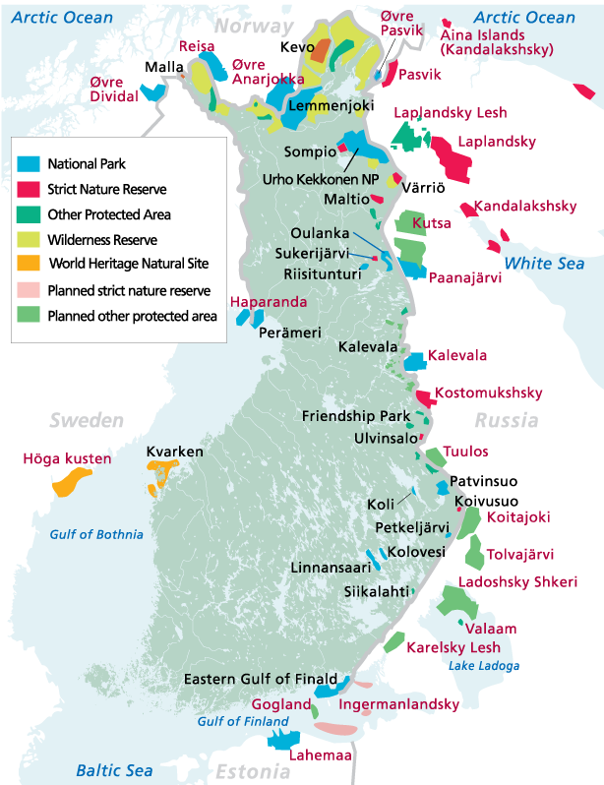
There is also active cooperation within the Barents Region in the form of Barents Protected Area Network (BPAN) project, which is defined in the decision COP 10 X/2 as regional initiative to implement the PoWPA. The overarching aim of the BPAN project is to promote and support a representative protected area network for conservation of biodiversity and boreal-arctic nature, especially forests and wetlands. The aim is to evaluate the state of protected area network in the Barents region and give recommend actions for its improvement.

Figure 3. Transboundary cooperation between Finnish protected areas and areas in neighbouring countries. Source: Metsähallitus.
Project will provide comparable information of the protected area systems between countries. The national PoWPA reporting framework, as modified for regional use, is used as one of the tools for compiling information. The project territory covers the whole Barents Region, which includes 13 administrative regions in the Northern parts of Finland, North West Russia, Norway and Sweden. The project is managed by the Finnish Environment Institute (SYKE) and participated by the national and regional nature conservation authorities, scientific institutes and NGOs.
The BPAN project, lead by Finland 2011-2013, is a key project of the Barents Euro-Arctic Council and its Working Group on Environment, of which Finland is also the chair country. Also other nature conservation projects of the Working Group promote the cross border protected area co-operation between the four countries. The final results will be presented in the next meeting of the Barents Environment Ministers in autumn 2013 in Northern Finland.
In addition to cooperation with neighbouring countries, Finland is active in European protected area fora, e.g. in EUROPARC Federation, Eurosite, PAN Parks, World Heritage Sites and in cooperation within Ramsar convention. Often the work in these fora is with Nordic and Baltic countries. NHS is the national focal point for Ramsar convention in Finland as well as for PoWPA which gives a good synergy with protected area planning and management for wetlands and other areas.
Global cooperation: At CBD COP9 in Bonn, Finland pledged half a million Euros for the LifeWeb Initiative to support Expressions of Interest in Peru and Tanzania. The LifeWeb Initiative is a partnership platform to strengthen financing for protected areas to conserve biodiversity, secure livelihoods and address climate change, through implementation of the CBD Programme of Work on Protected Areas. LifeWeb facilitates voluntary support for biodiversity priorities.
The scope of the project in Peru "Conservation and Ecological Restoration of Lomas and Community-based Management of Natural Resources in Atiquipa" involves conservation by establishment of the Lomas de Atiquipa protected area, restoration and reforestation as well as strengthening management of existing protected areas. The project also promotes sustainable use of the Atiquipa lomas, by formulation and implementation of an ecotourism plan and an environmental education and awareness plan with active participation of the Atiquipa local community. The lomas are unique and endangered ecosystems, which only occur between the Pacific coast and the lower heights of the Andes along the coasts of Peru and Northern Chile, within the Sechura Desert and Atacama Desert Ecoregions. At present only 100,000 hectares of lomas remain.
The scope of the project "Western Tanzania Livelihoods and Forest Conservation" involves strengthening protection and management of existing protected areas of Gombe National Park and Mahale Mountains National Park in the mountain and riverine forests near Lake Tanganyika. Part of the Eastern Afromontane Biodiversity Hotspot, the area boasts a great diversity of wildlife, including a number of rare and endemic species and a growing human population that is dependent on forest resource utilization. Both Gombe and Mahale ecosystems are a high conservation priority for the Government because these are the only National Parks with Chimpanzees in Tanzania. The project in Tanzania is based on the principle that, to achieve economic development and biodiversity conservation in rural landscapes, it is important to address the two simultaneously, and that local community empowerment is crucial to responsible natural resource management decision making. With this in mind, project components include village land management planning, capacity development for sustainable forestry and other land use, conservation friendly business development training, as well as monitoring of results on local livelihoods and biodiversity health.
In 2011, the Natural Heritage Services initiated a cooperation project with the National Parks of Colombia that aims to a strengthened management and administration of protected areas of Colombia through capacity building. The project is funded by the Ministry for Foreign Affairs of Finland. In addition, there has been a lot of consultancy conducted by NHS staff members in different countries of the world like Russia, China, Korea, Lithuania and Estonia. Finland has a framework agreement with IUCN and protected areas are always on the agenda.

Governance
Finland's strength is that one government agency, Natural Heritage Services of Metsähallitus (NHS), is almost entirely responsible of the management of the whole national system of protected areas. In this way, the quality, efficiency and effectiveness of the management of Finland's protected areas are consistent and coherent throughout the system and can be conducted in an adaptive manner. The system level international evaluations of the effectiveness of NHS work have given valuable guidance to improve the national and international level protected area management performance.
Metsähallitus is a state-owned enterprise which administers most state-owned lands and waters, altogether about 12.5 million ha. The NHS administers about 7 million ha of which there are 3.9 million ha of land area and 3.1 million ha of waters. The nature conservation activities of the Natural Heritage Services are under the guidance of the Ministry of the Environment.
Protected areas managed by NHS are in mostly on state-owned land and without inhabitants. Only -6-7% of total area protected, is privately owned. This, in European context unusual situation, has been preventing potential day-to-day conflicts between the local people and the NHS. There are, however, some noteworthy measures in place in order to guarantee the local participation in protected area management. In NR4 Finland these are listed as follows:
- Legal obligation to negotiate with Sámi Parliament and reindeer herding co-operative: Based on the Act on the Sámi Parliament, the authorities shall negotiate with the Sámi Parliament in all far-reaching and important measures, which may directly and in a specific way affect the status of the Sámi as an indigenous people; also all planning measures concerning State land that will have a substantial effect on the practice of reindeer herding, the State authorities must consult the representatives of the reindeer herding co-operative in question.
- Governance strategy for the Kvarken Archipelago World Heritage Site: This is a unique strategy including co-management elements between all relevant local stakeholders.
- Translations to Swedish and Sámi languages: There is a legal obligation for NHS to have all the informative material, including environmental education material, and guidance translated to Swedish language in the whole country and also to translate them to Sámi languages in northern areas where Sámi people are living.
- Protected area cooperation groups: Cooperation group meetings are fora for discussing the important management related issues with local stakeholders.
- Co-managed protected areas: Private protected areas in Finland are co-managed in practice and involve NHS, Centre for Economic Development, Transport and the Environment and the landowner. Also the transboundary parks are co-managed. Oulanka and Paanajärvi National Parks in Finland and in Russia, respectively, will have a joint PAN Parks certification. This means harmonizing their management a great deal.
- Official cooperation agreements: NHS has official framework agreements between the Reindeer Herders' Association, Island Committee and other important stakeholders, partners and sectors to guarantee that the management of protected areas is participatory.
- Management planning process: As a whole, the NHS management planning process is based on participatory approach.
In addition to this, NHS uses Akwé: Kon guidelines in management planning processes in the wilderness areas that are important for the Sámi people.

Key development challenges and threats
In general, the major threats to Finland’s protected areas are similar to the overall global threats to biodiversity: the economic exploitation of natural environments e.g. forestry and habitat conversion, climate change, invasive alien species, eutrophication and pollution. By definition protected areas, such as national parks and wilderness areas, have no inhabitants and no logging in Finland. In northern Finland controlled reindeer husbandry and subsistence hunting is allowed. In principle, no land use that can threaten the conservation status of any of the listed nature values of Natura 2000 or national nature conservation sites, for which the sites have been designated, is allowed. Projects are subject to statutory environment impact assessment and measures to prevent and mitigate potential threats are taken by all authorities responsible of biodiversity related matters. (NR4 Finland).
Habitat change is a serious threat to nature in Finland. In addition, the fragmentation of habitats is a considerable threat to Finland’s biodiversity. This applies especially in densely populated southern Finland where landowners are numerous and the protected areas are small. This development is not only threatening individual valuable habitats but also weakening the potential connectivity between the areas thus making the adaptation to climate change impacts more difficult. More resources will be needed as the numbers of new protected areas are increased, and as related conservation measures are implemented, either in the shape of new funding or redirected resources. (NR4 Finland).
Protected area system: Key elements of the future development of Finland’s system of protected areas must include the completion and strengthening of the network of protected areas. This means especially legal establishment of those areas already reserved for protection, and the protection of biotopes that have not yet been adequately safeguarded. Protective measures planned for areas already acquired for the State for the purposes of conservation are still incomplete in many of these areas.
It is also important to implement actions that guarantee the fulfilment of Natura 2000 conservation goals. In addition, it is necessary to further develop protected area monitoring and planning systems and to draft, implement and maintain management plans. (NAP 2012-2020).
One of the most important development challenges is that representativeness of protected areas needs to be improved. All the largest protected areas are in Lapland as well as all wilderness areas whereas protected areas in the south are small and fragmented. Ways to improve the situation need to be considered. (NAP 2012-2020).
As the Strategic Plan for Biodiversity 2011-2020 and the Aichi Biodiversity Target 11 and NS2012-2020 Target 11 require a calculation of percentage of protected areas, it is necessary to define the criteria on which these calculations are based as regards to protected areas and green and blue infrastructure. This would help to monitor the fulfilment of these obligations.
Protected area system also needs a national, goal-oriented vision with clear objectives for future development.
Marine protected areas: The coasts of Finland freeze on average for 90-180 days in winter and the entire biota will be affected if the ice disappears or looses its current role due to global warming. However, the most immediate challenges rise from the pressures listed by the CBD and in the EU’s Marine Strategy Framework Directive concerning the marine environment, eutrophication in particular. Many of the pressures are still poorly understood (globally, as well as in Finland) and more research on these effects is needed. In addition, the EU’s new Maritime Policy has lifted Marine Spatial Planning as a key tool in meeting the challenges with increased sea use and increased pressures on the marine biota. (NR4 Finland).
The most critical challenge for sustainable use of the Baltic Sea and the coastal areas is the lack of information on underwater biodiversity and detailed information on ecologically significant areas whether it is regionally, locally or per species. According to EU’s Integrated Coastal Zone Management, reliable and comprehensive information is needed for planning practices in coastal and marine areas. This includes assessments of need of conservation efforts and protected areas. (NAP 2012-2020).
Climate change: One of the most important ways to adapt to climate change is an ecologically functional and comprehensive network of protected areas. In this context, connectiveness of protected areas becomes of crucial importance. Areas in between protected areas – the so called green and blue infrastructure – should enable species to move from one place to another on landscape level in order to mitigate the adverse effects. Restoration activities that enhance connectivity and resilience against climate change become very important. New research information is needed on climate change and its progress as well as on its impact on the functionality of protected area network, especially regarding northern ecosystems. This is important also for a continued existence of Sámi culture and related reindeer husbandry. (NAP 2012-2020).
There is an example of green infrastructure in which managed forests complement the protected area network. Metsähallitus as a state enterprise also governs the commercial forestry in state-owned land. One key objective of Metsähallitus land use planning is to conserve biodiversity by supporting the protected area network. Natural and other ecologically important sites in commercially managed forests have been protected in practice in various ways. Some are strictly and permanently protected, while in others temporary or permanent restrictions may be applied to limit forestry practices. The work is done through Ecosystem-based Natural Resource Planning creating Landscape Ecological Plans. This applies only in state owned land and thus the importance of this measure is higher in northern parts of the country where the state is the biggest landowner. This planning system takes in to account all small and moderate scale habitats important from biodiversity perspective by creating ecological corridors, protecting valuable habitats and habitats important for threatened species. (NR4 Finland). A similar approach for private lands would greatly enhance building of the ecological network.
Invasive alien species: Finland has approved a National Streategy on Harmful Alien Species for managing invasive alien species. Implementation of the strategy will help to prevent the threat that invasive alien species pose to Finland’s biodiversity. (NS 2012-2020). The aim is to create a system in Finland that would prevent invasive alien species to enter the country and prevent the problems they cause to native species and ecosystems. This is also important in relation to protected areas. (NAP 2012-2020).
Tourism and recreational use of nature: It is important to strive for sustainable nature-based tourism and recreational use of nature in protected areas. NHS has prepared principles for sustainable nature tourism that guide the operations of Metsähallitus in protected areas as well as nature tourism based businesses acting within protected area premises. NHS drafts sustainable nature tourism plans in close cooperation with nature tourism oriented local enterprises and regional tourism associations and other relevant stakeholders. In the process of making the plans Limits of Acceptable Changes (LAC) are determined. Human impact in terms of nature tourism and recreational use of nature can be monitored using the Limits of Acceptable Changes methodology which has proven to be useful especially when linked with indicators that relate to the plans. The LAC represents a practical tool to help monitor changes in the state of protected areas and identify suitable actions to mitigate unfavourable changes. There is a principle decision within NHS that all protected areas with a tourism plan needs to use the LAC method in order to carry out adaptive planning approach. The plans can be used to prevent and mitigate area use conflicts within protected areas. These conflicts can sometimes arise between traditional and tourism uses. It is also probable that nature-based tourism is a growing business in Finland so sustainable nature tourism practices become even more important. (NR4 Finland).

Barriers for effective implementation
As stated before, Finland does not have an up to date national vision, nor comprehensive targets and actions with measurable indicators for development of the protected area network and its management. As no criteria have been agreed for judgement of how implementation of the Programme of Work on Protected Areas has proceeded, also reporting has been rather arbitrary. The following Actions for implementation of the Programme of Work on Protected Areas in this document will hopefully be executed and improve the situation.
The most practical barrier for effective implementation of the programme is lack of appropriate resources – monetary and human. For example the legal establishment of nature reserves in the Finnish Conservation Programmes requires expertise and funding which has been in short supply for years. According to an assessment in 2009, more than 1000 protected sites with a total area of 670 000 hectares still need a proper enactment. After being established, these sites must be formed into nature reserve real estate properties (cadastral units) and thousands of kilometers of boundaries need to be demarcated. These processes are also very time and resource consuming. At least sustainable budget funding, preferably accompanied by increasing project funding, will be needed in the future to tackle these huge tasks in addition to everyday management and habitat restoration measures. Engagement of private land owners and voluntary actors in these activities will also be more important than before.
A general barrier to effective PA programme implementation is that degradation of biological diversity is still not fully mainstreamed as a major environmental problem. There is lack of knowledge and understanding in all spheres of society of the consequences. Biodiversity issues need to be linked to other major environmental issues, such as climate change, ecosystem services, food security, human health and protection of water and this need to be done through effective communication, education and public awareness practices. (NAP 2012-2020).
Priority and timeline for key actions of the Programme of Work on Protected Areas
Actions and timeline presented here are in line with the draft version of the upcoming National Strategy and Action Plan for the Conservation and Sustainable Use of Biodiversity in Finland 2012-2020: Saving Nature for People. The NBSAP 2012-2020 will steer conservation and sustainable use of biodiversity in Finland until 2020. There will be an evaluatin of the NBSAP in 2015.

Priority actions and timeline for fully implementing the Programme of Work on Protected Areas
In NBSAP 2012-2020, most major challenges in relation to the system of protected areas in Finland have been covered and actions to combat these challenges have been developed. Priority actions and timelines are presented in the order of PoWPA programme elements and actions. Formulation of individual actions may still change somewhat in the next few months as the NBSAP is not yet fully completed and approved by all ministries and stakeholders and consequently requires a formal Government decision before implementation.
The responsibility for implementation actions of the NBSAP, and thus for implementation of the PoWPA, are delegated to the relevant ministries and other stakeholders. The first mentioned ministry bares the main responsibility. The following abbreviations are used in the list of actions:
MAF Ministry of Agriculture and Forestry
MD Ministry of Defence
MEC Ministry of Education and Culture
MEE Ministry of Employment and the Economy
MEnv Ministry of the Environment
MF Ministry of Finance
MFA Ministry for Foreign Affairs
MI Ministry of the Interior
MJ Ministry of Justice
ML Ministry of Labour
MSAH Ministry of Social Affairs and Health
MTC Ministry of Transport and Communications
Metla Finnish Forest Research Institute
MH Metsähallitus
MTT Agrifood Research Finland
FEI Finnish Environment Institute
GFR Game and Fisheries Research
LYNET Finnish Partnership for Research on Natural Resources and the Environment

Actions for implementation of the Programme of Work on Protected Areas in Finland

Programme Element 1: Direct actions for planning, selecting, establishing, strengthening and managing protected area systems and sites
Action 1: Strengthening of national and regional protected area network
Key steps | Timeline | Responsible parties
NATIONAL LEVEL
Development of a goal-oriented, national vision and an action plan for strengthening of protected area system and fulfilment of international obligations under CBD | 2012 | MEnv, MAF, MEE, MF, MH, other stakeholders
Assessment of representativeness, comprehensiveness and ecological gaps of protected area system as well as connectiveness of the protected area system | 2012-2015 | MEnv
Development of a plan for realisation of Target 11 of the Strategic Plan for Biodiversity 2011-2020 and of NBSAP 2012-2020: conservation of 17 % of terrestrial and inland waters and 10 % of coastal and marine protected areas, including criteria for calculating the percentages and monitoring the fulfilment of the Target 11 | 2012-2020 | MEnv, MAF, MEE
Completion of National Conservation Programmes and of Natura 2000 site conservation and regular assessment of the state of the network  (Site Condition Assessment NATA) | 2012-2020 | MEnv, MAF, MH
Improvement of management effectiveness of protected area network to enhance conservation statuses of habitats and species and adaptivity to climate change | 2012-2020 | MEnv, MAF
Evaluation of need for statutes and their priorities, and of management plans for areas that are reserved for State protection in land use plans and are outside of conservation programmes and Natura 2000 network | 2012-2020 | MEnv
Strengthening of representativeness and connectivity of forest protected areas in the Southern Finland, by implementation of METSO Programme on state-owned and private lands, and development of a mosaic of comprehensive protected area network | 2012-2015-2020 | MEnv, MAF
Implementation of the conservation programme of the National Strategy for Mires and Peatlands | 2012-2020 | MAF, MEnv, MEE
Improvement of management of sites in the Bird Wetlands Conservation Programme, restoration of wetlands, improvement of wetland protected area representativeness and implementation of the Ramsar Convention | 2012–2020 | MEnv, MAF, MEE
Strengthening of marine protected areas by implementing HELCOM Baltic Sea Action Plan and the HELCOM Recommendations | 2012-2020 | MEnv, MFA, MEE, MTC
Completion of VELMU Inventories of underwater marine environment and evaluation of need for establishment of new marine protected areas and broadening of existing ones | 2012-2015 | MEnv, MI, MD, MEC, MAF, MTC, MEE, MF
Inventorying of Important Plant Areas (IPAs) | 2012-2020 | MEnv
Enhancement of network of National Urban Parks | 2012-2020 | MEnv
Evaluation of possibilities for new kinds of protected area categories and governance types (for example provincial level parks) | 2012-2020 | MEnv
Application of IUCN categories to Finnish protected area system (using 2008 guidelines) to make Finnish protected area data more comparable on a global scale | 2012-2015 | MEnv, MH, other stakeholders
Keeping the information on Finnish protected areas up-to-date in the World Database on Protected Areas | 2012-2020 | MEnv
REGIONAL LEVEL
Continuation and strengthening of transboundary park cooperation | 2012-2020 | MEnv
Establishment of a national working group to promote Fennoscandian Green Belt Initiative, to coordinate work with neighbouring countries within the Initiative and to maintain contacts with European Green Belt Initiative | 2012-2014 | MEnv
Development and implementation of a plan for Green Belt protected areas in Finland | 2012 | MEnv
Implementation of Barents Protected Area Network project (BPAN 2011-2013) that aims for a comprehensive protected area network in the Barents region of Finland, North-West Russia, Norway and Sweden | 2012-2013 | MEnv

Action 2: Integration of protected areas into broader land- and seascapes through development of broad scale land use planning
Key steps | Timeline | Responsible parties
Improvement of spatial landscape level planning, including marine spatial planning, using the ecosystem approach to maintain coherent ecological entities and networks and to conserve habitats and species and maintain ecosystem services | 2012-2020 | MEnv, MAF
Application of green and blue infrastructure concept (ecological network) and development of a national approach to implement the concept in practice | 2012–2020 | MEnv, MAF
Improvement of ecological functionality and connectivity of Natura 2000 network as part of broad scale green and blue infrastructure | 2012-2020 | MEnv, MAF
Reservation of areas in land use plans to safeguard biodiversity and to improve connectiveness of the Natura 2000 network | 2012-2020 | MEnv, MAF, MTC, MEE
Implementation of the Action Plan based on the First Assessment of Threatened Habitat types in Finland to improve status of habitat types (ie. statutory protection of new habitat types) | 2012–2020 | MEnv, MAF, MEE, MTC

Action 3: Development of site-specific protected area planning and management
Key steps | Timeline | Responsible parties
Drafting and implementation of management plans of protected areas and Natura 2000 sites as needed | 2012-2020 | MEnv, MAF, MH
Development of restoration and management methods, development of monitoring of restoration and management effectiveness and of cost-effective targeting of restoration and management actions to improve quality, functionality and connectiveness of protected area network and its capacity to buffer climate change | 2012–2020 | MEnv, MAF
Needs assessment of management and restoration actions in protected areas in order to evaluate adaptation of habitat types and species to climate change | 2013–2015 | MEnv, FEI, MH, MAF, LYNET institutions, universities
Implementation of a research programme that addresses adaptation to climate change, including summary of research results to support monitoring and decision-making in protected areas in relation to climate change, and continuation of research cooperation in boreal taiga region and the Baltic Sea area and participation in regional strategies of adaptation to climate change | 2012–2015 | MEnv, MAF, MEC, MFA
Development of methods of adaptive management in land use planning that takes into account adaptation to climate change (specifically also in protected areas) | 2012–2015 | MEnv
Restoration of Bird Wetlands Conservation Programme sites | 2012-2016 | MEnv, MAF
Implementation of objectives of the METSO Programme, especially regarding restoration activities in wooded environments | 2012-2020 | MEnv, MAF
Implementation of the restoration actions of the National Strategy for Mires and Peatlands | 2012-2020 | MAF, MEnv, MEE
Improvement of management of traditional agricultural habitat types in protected areas | 2012-2020 | MEnv
Assessment of Red List of Finnish Species at ten-year intervals (due 2020), improvement of information on endangered species through inventories, utility of the information through information systems development and exchange of information, development and implementation of action plan for species conservation | 2012-2020 | MEnv, FEI, MAF, GFR, MEC, Museum of Natural History, universities

Programme Element 2: Governance, participation, equity and benefit sharing
Action 4: Promotion of equity and benefit-sharing and assessment of costs and benefits
Key steps | Timeline | Responsible parties
Evaluation of the state of ecosystems and ecosystem services (especially in protected areas) | 2013–2014 | MEnv, FEI, MAF, GFR, Metla, MTT
Implementation of a research programme for Economics of Ecosystems and Biodiversity (TEEB) and ecosystem services, including protected areas | 2012-2015 | MEnv, MAF, MEE
Promotion of sustainable nature-based tourism and recreational use of nature in protected areas in such a way that it does not threaten conservation values or management objectives of the area | 2012–2020 | MEnv, MEE, MAF, MH
Applying Akwé:Kon guidelines in the Sámi homeland area to mitigate conflicts between reindeer husbandry and other land use and negative impacts on nature in the region, safeguarding Sámi culture and traditional knowledge | 2012-2020 | MEnv, MAF, MEE, MTC, Sámi Parliament, MH
Reconciliation of hunting and nature conservation in protected areas through participatory management planning | 2012-2020 | MH

Programme Element 3: Enabling Activities
Action 5: Evaluation of legislation and putting policy into action
Key steps | Timeline | Responsible parties
Evaluation of the Nature Conservation Act in relation to protected areas and implementation of necessary changes | 2012-2014 | MEnv
Improvement of taking into account conservation and nature values in the renewing of the Environmental Protection Act | 2012–2014 | MEnv
Taking into account biological diversity in the assessment of the Land and Building Act and its conclusions | 2012–2013 | MEnv
Taking into account biological diversity in evaluation of renewal of Fishing Act | 2012-2020 | MAF
Monitoring of implementation of NBSAP 2012-2020 and completion of necessary changes, including monitoring of fulfilment of obligations under PoWPA | 2012–2015 | MEnv, other ministries and stakeholders
Implementation of Water Basin Management Plans (7 planning areas), including monitoring of Natura 2000 sites with water-based biodiversity values | 2012-2015 | MEnv, MAF
Implementation of the EU Marine Strategy Directive in accordance with statutory actions and targets | 2012–2020 | MEnv, MAF, MTC
Updating of national strategy of adaptation to climate change, including assessment of protected area network’s capability to adapt to climate change | 2012-2020 | MEnv, MAF, MTC, MEE, MSAH, MFA
Implementing actions of the National Streategy on Harmful Alien Species and other obligations in international agreements on alien species | 2012-2020 | MAF, GFR, MEnv, FEI, MTC
Taking into account nature conservation and biodiversity at a national and EU level in the preparation for the next EU financing period | 2012-2013 | MF, MAF, MEE, MEnv
Ensuring of financial sustainability of protected area administration and management | 2012-2020 | MEnv, MF

Action 6: Strengthening of communication, education and public awareness
Key steps | Timeline | Responsible parties
Strengthening of communication at all levels of society of importance of biodiversity and ecosystem services and the importance of protected areas in this context | 2012–2020 | MEnv, MEC, MAF, MEE, MH and other stakeholders
Development of cooperation between researchers, information providers, environmental authorities and educational sector | 2012–2020 | MEC, MEnv, MAF, MEE and stakeholders (i.e Metsähallitus, Natural History Museums and Botanical Gardens, NGOs)
Development of environmental education emphasizing biological diversity, in cooperation with stakeholders | 2012–2020 | MEC, MEnv, MAF, MEE and stakeholders (i.e Metsähallitus, Natural History Museums and Botanical Gardens, NGOs)
Improvement of the Biodiversity.fi portal for national biodiversity indicators (including protected areas and ecosystem services) | 2012-2020 | MEnv, MAF, MEC

Programme Element 4: Standards, assessment and monitoring
Action 7: Development of assessment and monitoring of protected areas
Key steps | Timeline | Responsible parties
Improvement of research cooperation in management of protected areas | 2012-2020 | MEnv, MEC, MAF, MEE
Implementation of monitoring and assessment systems for biodiversity information, status and trends, including protected areas | 2012–2016–2020 | MEnv, MAF, MEC, MEE
Development of information systems for biodiversity (species, habitats) and protected areas | 2012-2015 | MH, FEI
Implementation of Management Effectiveness Evaluation of protected areas | 2012-2015-2020 | MH

Action 8: Enhancement of work on a global level
Key steps | Timeline | Responsible parties
Implementation of the Strategic Action Plan 2011-2020 in international cooperation to halt loss of biodiversity | 2012–2016 | MFA, MEnv, MAF
Supporting actively bioversity actions within United Nations Environment Programme (UNEP) and Global Environment Facility (GEF) | 2012–2016 | MFA, MEnv
Prioritising of cooperation projects that reduce poverty in developing countries through conservation and sustainable use of biodiversity and maintenance of ecosystem services | 2012–2016 | MFA
Strengthening of cooperation and synergy between different environmental conventions at a national level, including the United Nations Framework Convention on Climate Change (UNFCCC) in order to enhance the benefits for both biodiversity conservation and prevention and mitigation of and adaptation to climate change | 2012–2016 | MFA, MEnv, MAF
Active participation in negotiations on environmental conventions and in implementation of conventions, such as CBD and especially its PoWPA and the Ramsar Convention | 2012–2016 | MFA, MEnv, MAF

Key assessment results
Ecological gap assessment
Assessment of Baltic Marine Protected Areas. The Commission (HELCOM) of the Baltic Marine Environment Protection Convention assessed in 2009-2010 the ecological coherence of the Baltic Sea Protected Areas (BSPA) and marine Natura 2000 networks (HELCOM 2010). Findings concerning Finland's marine protected areas are described earlier (p. 7-8). The full publication is available at: http://www.helcom.fi/publications/bsep/en_GB/bseplist/
The outcome of the marine protected area assessment lead to the following proposals for further HELCOM work. To secure the establishment of a network of BSPAs that fulfils all the criteria for ecological coherence (representativity, replication, adequacy and connectivity) and thereby provides sufficient protection to the entire ecosystem of the Baltic Sea it is necessary:
- for HELCOM to identify additional potential BSPAs and for Contracting States to designate appropriate new BSPAs by 2012, and
- in doing so, to focus on providing protection to species and habitats identified in HELCOM as being threatened and/or declining. EU Member States should consider the obligations of the Birds and Habitats Directives and their Annexes as well as the EU Marine Strategy Framework Directive, and in particular to designate new off-shore areas including the Exclusive Economic Zone (EEZ) to ensure that BSPAs not only cover a total of at least 10% of the Baltic Sea area as a whole, but if scientifi cally justified, at least 10% of all its sub-basins as well;
- to develop and apply by 2015, management plans and/or measures for existing BSPAs, and that every new BSPA designation should be followed by establishment and implementation of a management plan and/or measures within five years.
In the targets of the NBSAP 2012-2020, Finland is committed to enhancing the HELCOM recommendations as a member to the convention.
Assessment of threatened habitat types in Finland. The first assessment (2008) of threatened habitat types in Finland functions as a major tool to estimate the representativeness and to identify gaps of Finland’s protected area network. The assessment considered all natural habitat types, which were divided into seven main groups: the Baltic Sea and its coast, inland waters and shores, mires, forests, rocky habitats, traditional rural biotopes, and the fell area. Gaps in the conservation of the most threatened habitat types will be addressed in the consequent action programme which was approved in 2011.
Direct web page address: www.environment.fi/threatenedhabitattypes
Assessment of threatened species in Finland. The fourth assessment of threatened species in Finland has been published in December 2010. This Red List evaluation is the most comprehensive national assessment in the world. According to the assessment the majority of threatened species lives in forests (36 %) and traditional rural biotopes or other cultural habitats (23 %). This underlines the importance of conservation, management and restoration measures in the METSO programme to enhance protection of forest biodiversity in southern Finland.
Direct web page address: www.environment.fi/redlist
Management effectiveness assessment
Managament effectiveness of the Finnish protected area system has been evaluated in 1994 and 2004. A "State of the Parks" report was published in 2007. Site specific assessments have been conducted in strict nature reserves, national parks, wilderness areas and national hiking areas by rapid methods, such as RAPPAM and METT. Together these sites covered more than 80 % of the total protected area already by 2005.
A reassessment of the management effectiveness (PAME) of the 35 Finnish National Parks was conducted by the NHS in 2010/2011, using a customised questionnaire adapted from the model developed by the State Parks Agency in New South Wales, Australia. All Natura 2000 sites corresponding to the National Parks (in all over 40 sites) were also evaluated by a newly developed proforma for site condition assessment (NATA), which is used to monitor the state of the habitat and species values that the sites were designated for. One of the main objectives of the assessments was to engage parks managers and staff involved in management planning and monitoring in (self)evaluating the work processes and outcomes of management in each National Park, to find points of adaptive management. The assessments were conducted in teams and approved by regional directors of the NHS.
The comprehensive results of these assessments will be incorporated into the State of the Parks Report of the Finnish protected area system, which is currently being drafted and will be published later in 2012 (in Finnish with a summary in English). This report will cover developments in protected area coverage and management in 2006-2010.
Previous reports can be found on the Internet:
Management Effectiveness Evaluationof the Finnish Protected Areas (2004): www.metsa.fi/mee
State of the Parks (SOP) in Finland 2000-2005 (2007): www.metsa.fi/sop
Sustainable finance assessment
Because the the Finnish protected area system is primarily managed by Metsähallitus Natural Heritage Services (NHS), and the agency is mainly financed from the Government budget, the financial sustainability is a political issue. After organisational changes in 2005, the total funding has been fairly stable, although the proportional funding fom different ministries and project funding (such as EU LIFE+) has varied somewhat (see Figure 4). Although the general economic situation in Europe has weakened and national productivity pressures have affected all sectors of govenment financing in the past few years, future outlooks remain sustainable. However, growing funds are needed to complete the Natura 2000 conservation obligations and to legally establish protected areas as proper nature reserves.
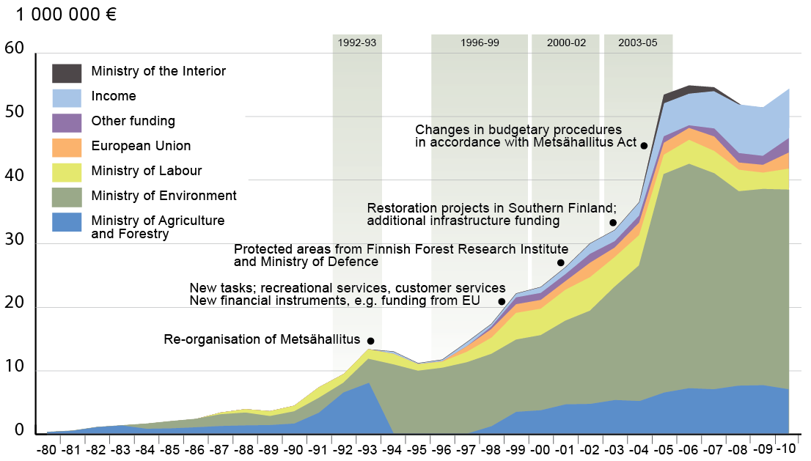
Figure 4. Trends in the funding of Metsähallitus Natural Heritage Services 1980-2010 (million Euros). Source: Metsähallitus.
Capacity needs assessment
Capacity needs are assessed regularly as part of NHS agency human resources development. Training needs are assessed also per person in annual work planning. There have been a lot of different kinds of training for the NHS staff and these are conducted on need basis.
Policy environment assessment
No policy environment assessment as such has been executed in the context of protected areas. However, this is done regularly in connection with normal NHS agency action planning and annual reporting for example, both on national and regional level. A wider scope to policy development is part of formulating the National Strategy and Action Plan for the Conservation and Sustainable Use of Biodiversity.
Protected area integration and mainstreaming assessment
No proper nation-wide assessment has been done. However protected area integration and mainstreaming is routinely already done at smaller scale as part of land use planning. For example within state-owned lands this is a multi-objective process within Natural Resource Planning and involves all relevant stakeholders. Also nature tourism plans are drafted and executed by NHS through wide involvement of regional actors.

Protected area valuation assessment
Natural and cultural values of individual protected areas are assessed in wide-ranging inventories and results are available for common use for the entire nature conservation administration. Other values are assessed as part of management planning processes. Statutory management plans have been finished for 85% of protected sites, including most national parks and wilderness areas.
Ecosystem services have not been valued in a systematic way, and there is not yet a common methodology for such assessments.
Climate change resilience and adaptation assessment
No assessment on climate change resilience and adaptation specifically focusing on protected areas is available yet in Finland, although considerable work has gone into the subject at general level. A national adaptation strategy was first adopted already in 2005 and implementation has been primarily through sector-specific strategies and programmes. The actions referring to biodiversity and protected area issues were based on conclusions made in a separate working paper published by the Finnish Environment Institute (Pöyry & Toivonen 2005). Metsähallitus has also drafted an in-house action plan in 2008, which includes some measures concerning planning and management of protected areas.
The impacts of climate change on habitat types were expertly evaluated in the first assessment of threatened habitat types in Finland (Raunio et al. 2008). Likewise general judgements were made in the assessment of Red list of Finnish species (2010) about climate change impacts. However, not enough information is yet available to draft very specific actions to adapt to these impacts. General measures towards enhancing protected area resilience through improving network connectivity are already on the PoWPA agenda.

Literature
Auvinen, A.-P., Kemppainen, E. & von Weissenberg, M. 2010: Fourth National Report on the Implementation of the Convention on Biological Diversity in Finland. The Finnish Environment 3/2010. Ministry of the Environment, Helsinki. 191 p. (NR4)
HELCOM 2010. Towards an ecologically coherent network of well-managed Marine Protected Areas – Implementation report on the status and ecological coherence of the HELCOM BSPA network. Balt. Sea Environ. Proc. No. 124B.
NBSAP 2012-2020. National Strategy and Action Plan for the Conservation and Sustainable Use of Biodiversity in Finland 2012–2020. Saving Nature for People. Draft version.
Separately referred to as:
- NS 2012-2020. National Strategy for the Conservation and Sustainable Use of Biodiversity in Finland 2012–2020. Draft version.
- NAP 2012-2020. National Biodiversity Action Plan for the Conservation and Sustainable Use of Biodiversity in Finland 2012–2020. Draft version.
Pöyry, J. & Toivonen, H. 2005. Climate change adaptation and biological diversity. FINADAPT Working Paper 3, Finnish Environment Institute Mimeographs 333, Helsinki, 46 pp.
Pertti Rassi, Esko Hyvärinen, Aino Juslén & Ilpo Mannerkoski (eds.) 2010: The 2010 Red list of Finnish species. Ministry of the Environment and Finnish Environment Institute. 685 p.
Raunio, A., Schulman, A., & Kontula, T. 2008: Suomen luontotyyppien uhanalaisuus – Osa 1. Tulokset ja arvioinnin perusteet. – Suomen ympäristö 8/2008. 264 s. [Threatened Habitat types in Finland. Part 1. Results and assessment criteria]

