Action Plan for Implementing the Programme of Work on Protected Areas of the Convention on Biological Diversity

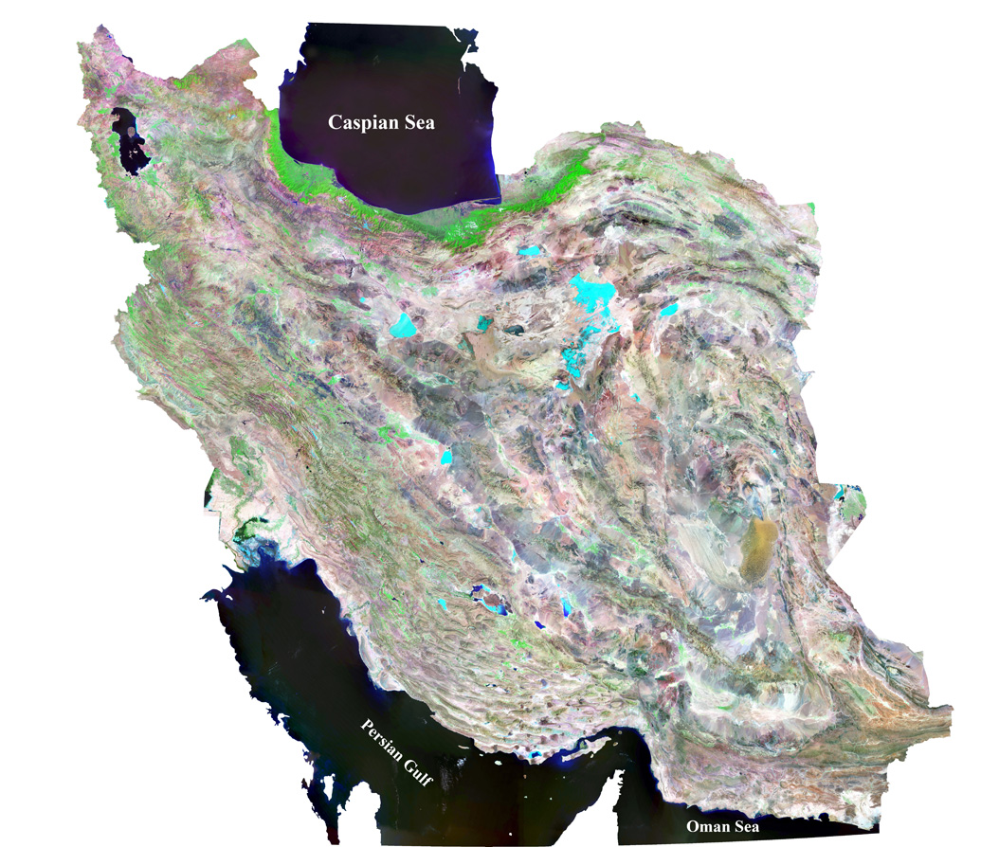

(Insert country name)
Islamic Republic of IRAN
Submitted to the Secretariat of the Convention on Biological Diversity [DATE]

Protected area information:
PoWPA Focal Point: (Name, contact details)
Mr. Naser Moghaddasi
Director General, Habitats and Protected Areas Bureau
Department of Environment
Tehran- Islamic Republic of IRAN
Mobil: 0098-9122203250
nasermoghaddasi@yahoo.com

Lead implementing agency: (Add name of primary government agency)
Department of Environment of Iran,
Multi-stakeholder committee: High Council for Conservation of Nature consists of ministers of: Department of Environment, Ministry of Industry- Mining and Tread, Ministry of Health, Ministry of Planning and Budget, Institute of Research and Standard, ,Ministry of Agricultural- Jihad, Ministry of Interior, Ministry of Road and Housing , Ministry of Energy,
In addition, the High council has some working Groups which deal with social economic and ecological aspect of PAs;

Description of protected area system
Coverage
(Amount and % protected for terrestrial and marine; maps of protected area system)
Treseterial PAS covering approximately 1O% of the country (1456475 ha), and marine PAS is equal to 214678 ha about 0.13% of the country land.
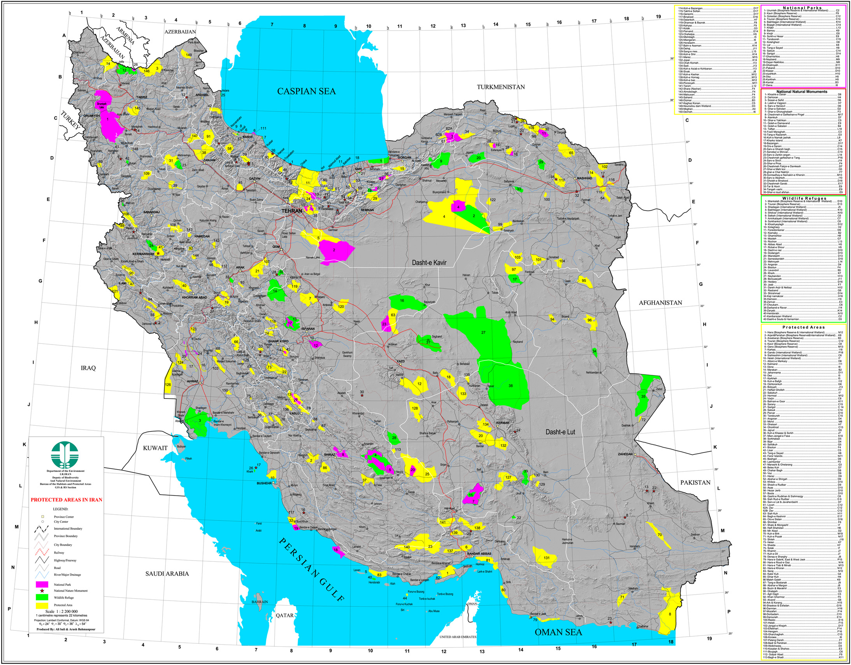

Description and background
In Iran, the first protected areas were established in 1967, with an emphasis on conserving stocks for hunting and fishing. The objectives evolved to conserving globally significant biodiversity. The number of protected areas has grown constantly and reached 254 by 2012, covering approximately 10.13% of the country (167,117 km2). The protected areas cover all important ecosystems and habitats in Iran.
The protected area system is governed by several laws under the Environmental Protection and Rehabilitation Bill (1974). Under these, the Department of Environment (DoE) is the agency responsible for establishing and managing protected areas, in consultation with other government agencies and stakeholders. The legislation establishes four categories of protected areas: National Parks; National Natural Monuments; Wildlife Refuges and; Protected Areas.
In addition, until now there are 154 non-hunting areas, with a total area of more than 7 million hectares. 24 Ramsar Sites with 1.4 million hectares, 84 national important wetlands with 2.8 million hectares are under management of Department of Environment. Iran also participates in the UNESCO MAB Programme, and since 1976 designated 10 Biosphere Reserves covering a total area of 3.1 million hectares, covering 1.9% of the country.

Governance types
Currently most of PAS are governed by the state, in Collaboration with local communities for conservation and sustainable use of natural resources. Meanwhile, establishment of the private PAs are encouraged.

Key threats
1- Climate change, drought, sand storm;
2- Land use changes due to unsustainable development projects;
3- Overgrazing, poaching and logging for fuel consumption and food, in some cases;
4- Insufficient financial allocation for PAS;
5- Local communities’ livelihood system, which mainly depends on natural resources;
6- Regional and trans boundary Environmental threats’, such as dust storm.

Barriers for effective implementation
(Description of key barrier s for effective implementation)
1-Insufficient business plan and detail studies of PA;
2- Public awareness related to PA values;
3- Insufficient cooperation and coordination between related stakeholders;
4- Weakness of law enforcement
5- Inconsistency of land use planning programme at national level with PA system;
6- Weaknesses in using new and modern technology;
7-Inadequate mechanism for monitoring and assessment of PA;
8- Insufficient Sectoral and inter-sectoral capacity building;
9- Insufficient mechanism for revenue generation in PA.
10- Inadequate involvement of local communities in decision making in management of PAs

National Targets and Vision for Protected Areas
(Insert national targets for protected areas/Target 11 of the Aichi Targets. Include rationale from protected area gap assessment, if completed, along with any additional information about the vision for the protected area system, including statements about the value of the protected area system to the country)
Target: During the 5th and the 6th National Socio-Economic Development Plan, which is correspondence with the Achi target plan timeline, DoE has planning to achieve 17% of its terrestrial and inland water and the 10% of costal and marine areas for conserving of biodiversity and ecosystem services within Protected Areas network.
Vision: Fully involvement of people and local communities in decision making and benefit sharing, knowledge sharing, applying appropriate technology, sustainable financial mechanism, climate change adaptation and resilience strategy; to demonstrate effective and sustainable management of PA network,

Progress in and plans for achieving the goals of the Programme of Work on Protected Areas
Progress: 0 = no work, 1 = just started, 2 = partially complete, 3 = nearly complete, 4 = complete
Goals of the Programme of Work on Protected Areas | Progress 0-4
- Progress in establishing and strengthening national and regional systems of protected areas (1.1) | 3
- Progress in integrating protected areas into broader land- and seascapes and sectors so as to maintain ecological structure and function (1.2) | 2
- Progress in establishing and strengthening regional networks, transboundary protected areas (TBPAs) and collaboration between neighbouring protected areas across national boundaries (1.3) | 2
- Progress in substantially improving site-based protected area planning and management (1.4) | 2
- Progress in preventing and mitigating the negative impacts of key threats to protected areas (1.5) | 2
- Progress in promoting equity and benefit-sharing (2.1)  - Progress in assessing and implementing diverse protected area governance types (2.1) | 2  1
- Progress in enhancing and securing involvement of indigenous and local communities and relevant stakeholders (2.2) | 2
- Progress in providing an enabling policy, institutional and socio-economic environment for protected areas (3.1)  - Progress in assessing the contribution of protected areas to local and national economies (3.1) | 2  1
- Progress in building capacity for the planning, establishment and management of protected areas (3.2) | 3
- Progress in developing, applying and transferring appropriate technologies for protected areas (3.3) | 2
- Progress in ensuring financial sustainability of protected areas and national and regional systems of protected areas (3.4) | 2
- Progress in strengthening communication, education and public awareness (3.5) | 3
- Progress in developing and adopting minimum standards and best practices for national and regional protected area systems (4.1) | 3
- Progress in evaluating and improving the effectiveness of protected areas management (4.2) | 1
- Progress in assessing and monitoring protected area status and trends (4.3) | 2
- Progress in ensuring that scientific knowledge contributes to the establishment and effectiveness of protected areas and protected area systems (4.4) | 3
- Progress in marine protected areas | 1

Priority activities for fully implementing the Programme of Work on Protected Areas:
Activities | Timeline
1- Effective PA management system | 2008-2020
2- development and implementation of sustainable financial strategy | 2008-2020
3- Capacity-building | 2008-2020

Action Plans (detailed steps) for completing priority activities for fully implementing the Programme of Work on Protected Areas:

Activity 1: (Effective PA management system)
Key steps | Timeline | Responsible agencies | Indicative budget
1-development of all PA business plan with new TOR, emphesising the governance type, benefit sharing with local communities and climate change | 2008-2016 | DoE,  Consultants | 20 million $
2-implementation of PA business plan (zoning, restoration,…) | 2008-2020 | DoE,  Local authority ,  Local community | 40 million $/annually
3- development and implementation of trans-boundary PAs | 2011- 2020 | DoE,  MFA,  Local authority , | Will agreed according to the bilateral MOU
4- strengthening the monitoring and assessment of PAs | 2010-2020 | DoE,  Local community,  Scientific center | 300,000 $/annually
5- Updating of national legislation | 2013-2015 | High Council,  DOE,  Parliament, | 50,000$
Activity 2: (development and implementation of sustainable financial strategy)
Key steps | Timeline | Responsible agencies | Indicative budget
1-Benefit sharing, involving local communities | 2010-2020 | DoE,  Local authority ,  Local community
2- development of SFS | 2012-2013 | DoE,  Budget and Planning Organisation,  Consultant,  NGOs, | 35,000 $
3- establishing the new mechanism for revenue generation such as trust funds, private investment, tax and tariffs | 2010- 2016 | DoE,  Parliament,  High Council,  Private Sectors | Depend on SFS
4- Streamlining the PA economical valuation in sub-national and national budget planning | 2010-2016 | DoE,  High Council,  Budget and Planning Organisation, | 50,000 $

Activity 3: (Capacity-building)

Key steps | Timeline | Responsible agencies | Indicative budget
1-Capacity gap assessment | 2012-2014 | DoE,  Consultant, | 50,000$
2- DoE staff training | 2008- 2016 | DoE,  Academia,  International and national consultant, | 50,000$/annually
3- main stakeholders | 2010-2016 | High council | 50,000$/annually
4- education, communication and awareness raising | 2008-2016 | DoE,  Media,  NGO,  Academia,  International and national consultant, | 50,000$/annually
Key assessment results
Ecological gap assessment (insert summary findings if available)
The current PAs system does not cover the entire biodiversity hotspots and habitats in the country;
Integrity of PAs with the broader land and seascape needs to be taken into account in the future business plans.
Management effectiveness assessment (Insert summary findings if available)
To protect the current PA system;
Improving the PAs national network and dissemination of the information and experience through network;
Strengthening the PA monitoring and assessment system.
Sustainable finance assessment (Insert summary findings if available)
Alongside with the governmental resources, looking for revenue generation mechanism is necessary, Such as tax, tariff, trust fund, environmental compensation, payment for ecosystem services and privet sectors.
Capacity needs assessment (Insert summary findings if available)
Education of local communities, stakeholders and decision makers capacity building, capacity gap analysis at individual, organizational and systemic level, increasing the number of the well-trained staff, are essential.
Policy environment assessment (Insert summary findings if available)
Enhancing environmental policy mechanism through related sectors.
Protected area integration and mainstreaming assessment (Insert summary findings if available)
Protected areas should be managed in broader land and seascape by integrating PAs in national and sub-national budget and planning system.
Protected area valuation assessment (Insert summary findings if available)
Recognition of PAs economic values and streamlining to the sub-national and national economic policy is needed.
Climate change resilience and adaptation assessment (Insert summary findings if available)
Revising the PAs management plan in accordance with the climate change impacts and situation;
climate change monitoring system in PAs, is needed.

