FOURTH NATIONAL REPORT TO THE UNITED NATIONS CONVENTION ON BIOLOGICAL DIVERSITY

2010
THE REPUBLIC OF SERBIA
MINISTRY OF ENVIRONMENT AND SPATIAL PLANNING

TABLE OF CONTENTS

 | EXECUTIVE SUMMARY | 4
1 | OVERVIEW OF BIODIVERSITY, STATUS, TRENDS AND THREATS | 7
 | 1.1 Types of diversity | 8
 | 1.2 Species diversity | 9
 | 1.2.1 Endangered species | 12
 | 1.3 Ecosystem diversity | 12
 | 1.3.1 Forest area | 15
 | 1.4 Genetic Diversity | 17
 | 1.4.1 Agrobiodiversity | 17
 | 1.4.2 Other genetic resources | 20
 | 1.5 Threats to biodiversity | 21
 | 1.5.1 Climate Change Impact | 23
 | 1.5.2 Land change | 25
 | 1.5.3 Main threats to terrestrial and freshwater habitats | 27
 | 1.6 Main sectors pressures on biodiversity | 30
 | 1.6.1 Agriculture | 30
 | 1.6.2 Forestry | 31
 | 1.6.3 Fishery | 32
 | 1.6.4 Hunting | 33
2 | CURRENT STATUS OF NATIONAL BIODIVERSITY STRATEGY AND ACTION PLAN | 34
 | 2.1 Overview of programs, national biodiversity related strategies and action plans | 35
 | 2.2 National Biodiversity Strategy and Action Plans | 37
 | 2.2.1 Action Plans | 38
 | 2.3 Progress in Legislation and Policy | 39
 | 2.3.1 International Treaties and Activities | 39
 | 2.3.2 National Legislation in the Field of Nature Conservation | 40
 | 2.3.3 Biodiversity Related Legislation and Programmes | 40
 | 2.4 Conservation of habitat and ecosystem diversity | 41
 | 2.4.1 Protected areas | 41
 | 2.4.2 Ecological Networks and Internationally Important Areas | 42
 | 2.5 Protection of species | 46
 | 2.5.1. Red Books of Plants and Animals | 47
 | 2.6 Monitoring, Reintroduction Programmes, In situ and Ex situ conservation | 47
 | 2.7 Genetic resources management | 50
 | 2.8 Landscape conservation | 50
 | 2.9 Obstacles in Environment and Nature Conservation | 52
3 | SECTORAL AND INTER-SECTORAL INTEGRATION OF BIODIVERSITY CONSERVATION | 54
 | 3.1 Environmental protection and EU integration | 54
 | 3.2 Legal and institutional framework for environmental management | 54
 | 3.2.1 Funding Systems in Environment Protection | 54
 | 3.3 Integrating biodiversity conservation into relevant sectors | 55
 | 3.3.1 National legislation | 55
 | 3.4 Environmental protection in national strategic documents | 56
 | 3.5 Sectors in protection of environment and biodiversity | 57
 | 3.5.1 Agriculture | 58
 | 3.5.2 Forestry | 62
 | 3.5.3 Fishery | 68
 | 3.5.4 Hunting | 69
 | 3.5.5 Water resources Management | 70
 | 3.5.6 Energy | 71
 | 3.5.7 Mining and Industry | 73
 | 3.5.8 Tourism | 75
 | 3.5.9 Traffic | 76
4 | PROGRESS TOWARDS THE 2010 TARGETS AND IMPLEMENTATION OF THE STRATEGIC PLAN | 78
 | 4.1. Two successful stories as the best examples of the implementation of the CBD Targets | 78
 | 4.2 Progress towards the 2010 target of the CBD | 81
APPENDIX I. INFORMATION CONCERNING THE REPORTING PARTY AND PREPARATION OF
NATIONAL REPORT
APP.I.1. Information Concerning the Reporting Party
APPENDIX II. A Draft of National Biodiversity Indicators
APP.II.1.Indicators List used for the Report

APPENDIX III. References

Executive Summary

Serbia has been a Party to the United Nations (UN) Convention on Biological Diversity (CBD) since 2001. It is also a Party to other UN Conventions, and a member of the Council of Europe. As a Party to the CBD, Serbia is required to contribute to the achievement of the Convention’s three objectives at a national level. These three objectives which underpin the principles of sustainable development are: the conservation of biological diversity, the sustainable use of its components and the fair and equitable sharing of the benefits arising out of the utilization of genetic resources (Article 1 of CBD Convention text). Serbia has made several efforts, especially in the last decade, in order to protect the natural heritage that it is bestowed with. Such efforts also positively contribute to achieving the CBD’s objectives at a national level as further expounded of this report.

Production and gross domestic product drop during 1990ies (market break down, economic sanctions, impoverishment of population, high unemployment rate etc.) has significantly reduced capabilities for investment in environmental protection. Due to political and economical circumstances, these issues were neglected, but lately, Serbia is dedicated to reach the standards of the EU in terms of Biodiversity conservation and nature protection. Serbia has made a significant progress in protecting biodiversity through legislative and institutional framework, as well as by making some concrete steps in this respect.

System of financing environmental protection in the Republic of Serbia is decentralised and counts on dedicated funds, own resources, and budget resources. Other sources of financing include municipal budgets, industrial financial resources, public enterprises financial resources, and foreign financial aid. General characteristics of the system of financing environmental protection are the insufficiency of dedicated funds and decentralisation of financing sources, particularly from the private sector, as well as the lack of application of financial instruments such as long-term loans, securities, partnership between public and private sector, or investment in stocks.

Proportional investment of dedicated funds for environmental protection related to the realised gross domestic product (%) in 2001 and 2008 was 0.3%. Other countries in transition assign around 2% of GDP for environmental protection. The Fund for Environmental Protection was established in 2005, in keeping with the Law on Environmental Protection, for the purpose of securing financial resources for stimulation of environmental protection and improvement in the Republic of Serbia. The budget funds of the autonomous province and local governments are imposed. The most active donors and international financial institutions that provide financing of environmental protection include: the EU, the World Bank, the European Bank for Reconstruction and Development, and bilateral donors.

Although Serbia ratified Convention on Biological Diversity in 2001, from 2001 to 2010, significant changes have taken place in the field of nature protection in the Republic of Serbia. It can be argued that almost all the most important global and regional conventions ratified by Serbia in the last 10 years.

After ratification of the Convention on Biological Diversity, within a rather short period Serbia ratified most of the significant global and regional environmental conventions, adopting a new set of laws in the field of environmental and nature protection. Moreover, sub-regional and bilateral cooperation exists with several countries with the aim to promote the conservation and sustainable use of biodiversity. Significant positive changes have happened over the past several years in the area of harmonization of development policy and biodiversity protection. The Republic of Serbia has been implementing several international and regional conventions and agreements relevant to environmental protection field and biodiversity conservation.

Since the National Biodiversity Strategy and Action Plan is a new document there is no overview available of the progress made in the implementation of priority activities so far. The specific actions have already been taken and several operational objectives of the National Biodiversity Strategy and Action Plan are therefore already being implemented.

The following information provides a summary of the progress.

- Convention on Biological Diversity has entered into force.
- A number of environmental conventions on global, European and regional levels have been signed.
- Several key laws in the area of environmental protection and sustainable development have been promulgated, which have all been harmonized with the appropriate EU directives
- The National Biodiversity Strategy and Action Plan have been drafted and are currently pending adoption.
- Preparation for the mapping out of the National Strategy of Sustainable Utilization of Natural Resources and Goods has started.
- The Law on Environmental Protection for the first time in our country predicted wider use of economic instruments in the area of environmental policy and sustainable development. One of the instruments is the establishment of the Fund for Environmental Protection.
- Preparation of new Law on GMO is in progress and introduction of the procedure of Biosafety Clearing-House mechanism has started.
- Institutional and organizational adjustments have been done, such as foundation of the Environmental Protection Agency
- CORINE Land Cover 2000 has been developed in Serbia
- Creating the terms for accessing to Natura 2000/Emerald Network,
- Important areas of bird species diversity (IBA) have been identified for the purpose of implementing the Council Directive 79/409/ЕЕC, the Convention on Wetlands, the Bern and Bonn Conventions.

The main characteristic of the institutional framework today is a much better situation compared to 2004 when the first set of four EU Environmental Laws was adopted. Diversification and overlapping of duties and responsibilities within government institutions is still evident, although to a lesser degree. Significant positive changes have happened over the past several years in the area of harmonization of development policy and biodiversity protection. The new legal framework on environmental protection was introduced into the Republic of Serbia by a set of laws from 2004 (Law in Environmental Protection, Law on Strategic Environmental Impact Assessment, Law on Environmental Impact Assessment, and Law on Integrated Prevention and Control of Pollution), and it was significantly improved in 2009 by adopting the second set of laws (16) related to environmental protection which represent a major progression in coordination of regulations related to environmental protection with EU directives. Besides laws within the competence of the Ministry of Environment and Spatial Planning, laws and regulations issued by the Ministry of Agriculture, Forestry, and Water Management also regulate activities in scope of biodiversity protection, particularly of use of forest, hunting, fishing and genetic resources for food and agriculture (Law on Food Safety, Law on Agriculture and Rural Development, Law on Animal Husbandry, Law on Protection of Rights of Plant Sort Cultivators, Law on Genetically Modified Organisms – all issued in 2009, as well as Law on Forest (2010) and Law on Hunting (2010).

Nature conservation is not a priority for the government as yet, although there are several great achievements in the implementation of nature legislation and policy documents. Also, the traditional obstacle is the economic pressure and the fact that nature conservation is mostly seen as a restrictive issue. Insufficient incorporation of biodiversity issues into sectoral strategies and programmes can be considered as another important obstacle and even if sometimes it has been incorporated, in reality it has been given low priority or has remained just as a declarative issue. According to the Spatial Plan of Serbia from 1996, it was envisaged that the special nature values should reach 10% of the total land area of the Republic by 2010. However, until present some 5.86% of the territory enjoys the status of protected area.

Main obstacles in Nature Conservation are:

- Insufficient implementation of the environmental and nature protection legislation
- Serbia has not as yet accessed to the International Agreement on Pan European Strategy for Biological and Landscape Diversity Conservation.
- There are no scientifically proven data as yet (national flora, national vegetation, and national fauna) on the life existing in the territory of Serbia.
- Lack of an integral Information system and the system of indicators for biodiversity monitoring
- An inadequate spatial planning system and inefficient implementation of the spatial planning and urbanization system
- Lack of efficient inter-sectoral cooperation in the field of protection of biodiversity and lack of integration of biodiversity protection in sectoral development policies
- Insufficient staff in protected areas and municipalities, which would perform the activities related to the CBD requirements. Those problems are less represented at scientific institutions’ level.
- Inefficient system and mechanisms for management of national parks, Ramsar areas, biosphere reserves, and other protected areas
- Inadequate management of forest ecosystems and protected areas
- Lack of adequate economic and financial instruments for nature protection and management of protected areas

One of the key challenges for Serbia is how to reconcile conservation and environmental considerations with economic development and economic interests and to achieve the real implementation of biodiversity principles in sectoral policies.

1. Overview of biodiversity, status, trends and threats

Serbia’s status as one of centers of biodiversity in Europe is to a high degree determined by its geological age, geomorphology, climate conditions and, in particular, by its role as refuge for a number of species during the glacial periods. Thus the Balkans and Pannonian regions of the country harbor numerous endemic-relic floral elements from previous geological ages. The data presented in “Biodiversity of Yugoslavia” (Stevanović and Vasić, 1995) have not been updated, although some information is available about certain taxa and ecosystems in the published literature, manuscripts or government databases.

Richness, diversity and endemic traits of Serbian flora are conditioned by great number of factors which acted globally in the area of Balkan Peninsula. Serbia hosts 39% of Europe's vascular plant species, 40% of Europe’s bryophyte flora, 51% of its fish fauna, 49% of reptiles and amphibians fauna, 74% of its bird fauna and 67% of all mammal species. Furthermore the country offers a resting place for many migratory species, including endangered ones. The total number of all species that live in Serbia represents 43.3% of all existing species in Europe

According to recent research, in the area of Balkans, the presence of 2600 endemic plant species is evident. Serbian territory represents the important center of endemic flora diversity of Balkan Peninsula. 287 species and subspecies of Balkans endemic taxa, which represent 8.06% of Serbian flora, are registered on Serbian territory and local endemics - 1.5% or 59 species. The number of Balkans endemic taxa is increasing in the direction from lowland regions of Vojvodina towards mountain to high-mountain areas. The basic type of endemism in Serbia is high-mountain endemism, which is also the case in the whole territory of Balkan Peninsula. The centers of endemic flora diversity are primarily, the high mountains Sar-planina, Prokletije, Koritnik ,Pastrik, Kopaonik, Stara planina and Suva planina. Whereas the lowland region of Serbia (Vojvodina) is dominated by agricultural landscape, the ramains of natural grasslands provide habitats for endemic species of Pannonian biogeographical region.
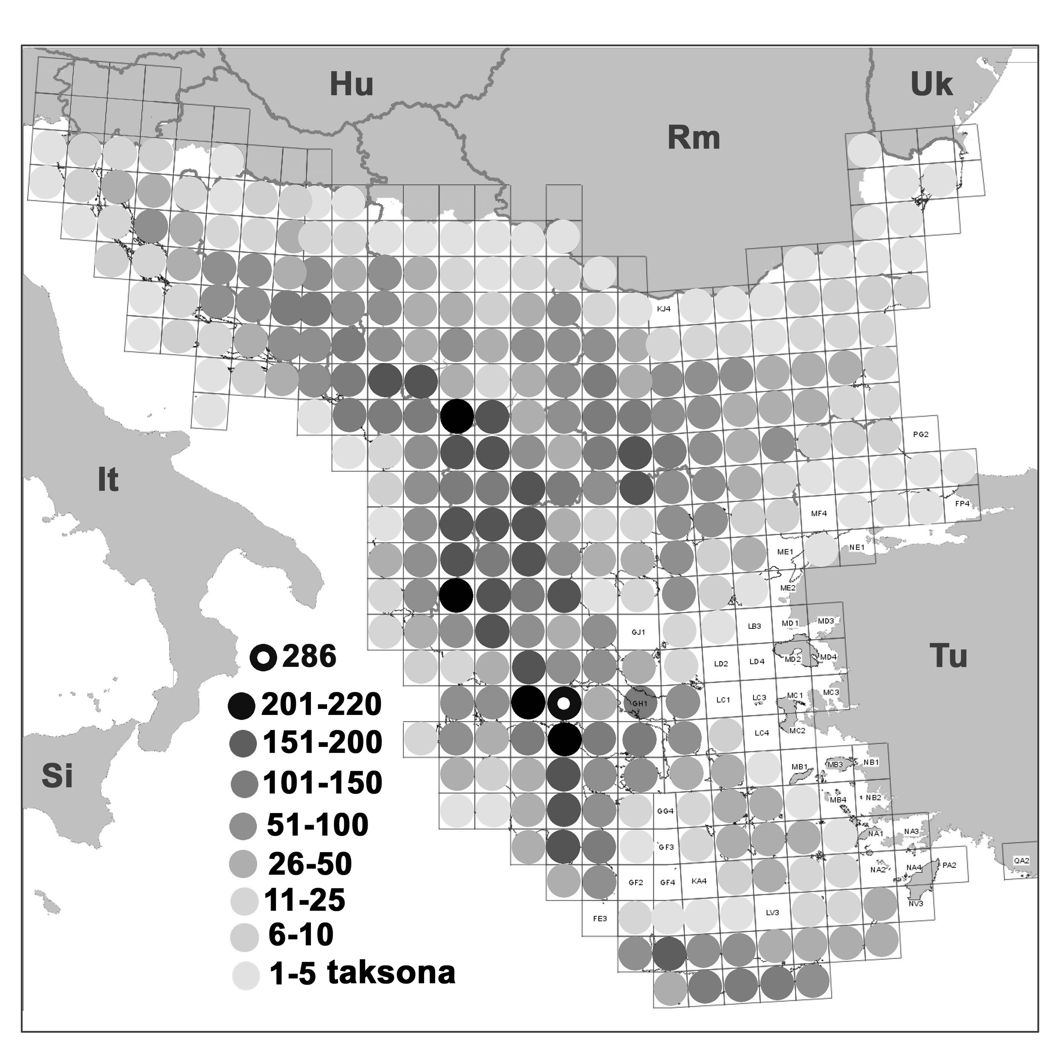

Figure 1.1: Number of endemic taxa (species and subspecies) in UTM network (50x50 km) on Balkan Peninsula

Having in mind that a lot of wildlife and plants found their habitat in this area during glaciations period in northern Europe, it is not surprising that Serbia has numerous relic species diversity as well.

  - Types of diversity

Serbia is characterized by high genetic, species and ecosystem diversity.

Highland and mountain regions of Serbia, as a part of Balkan Peninsula, are one of the sub-centers of six European biodiversity centers. In addition, considering the wealth of its flora, Serbia is potentially one of the global centers of plant diversity.

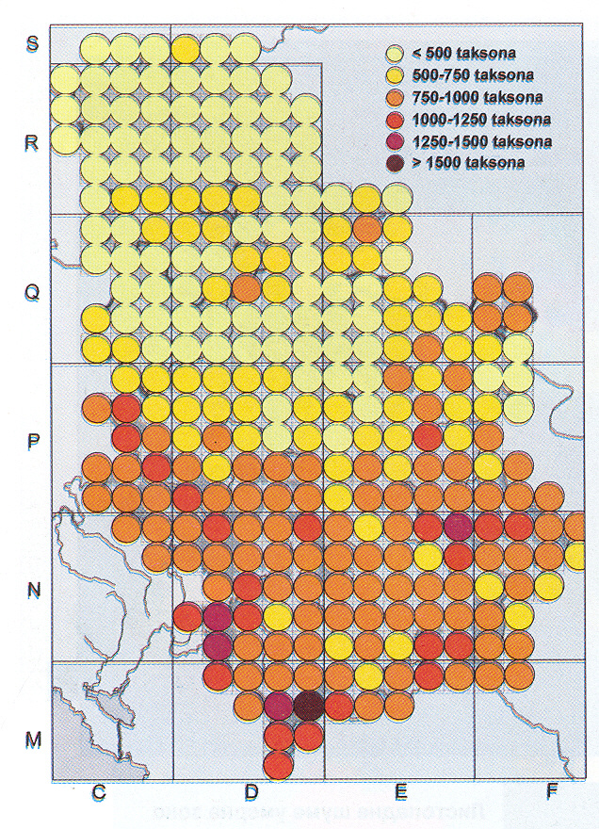
Figure 1.2: Floristic richness in Serbia

Serbian flora comprises 3662 taxa at the level of species and subspecies, which lists Serbia among European countries with greatest floral diversity and the density of flora per unit area. These taxa are classified under 141 families and 766 genera. The richness and diversity of flora is especially distinguished in high-mountain regions of Serbia (above all on Kopaonik and Sar planina) and in canyon valleys and gorges (the canyon of Lazareva reka, Rugovo and the gorge of Sicevo or Sicevacka gorge). More than 1,300 plant communities have been described in Serbia.

The following biomes are found in Serbia: steppe (in the north of Vojvodina), deciduous forests (in the majority of lowland and central mountain regions), and taigas and tundra characteristic for northern Holarctica regions (found in high mountains). Serbia has a heterogeneous flora and fauna, which includes species that are widespread in distribution, as well as regional and local endemic species.
(See the picture above.)

The high biodiversity of Serbia is additionally influenced by the diverse climate vegetation zones, including a large number of extrazonal, intrazonal and azonal ecosystems, such as wetlands, peatlands, salty lands, and sands. During the ice age, the territory of nowadays Serbia provided numerous refugia (parts of a species’ range less influenced by climate change) for a number of species. As a result, the region is inhabited by many relic and endemic-relic species.

Genetic resources in Serbia are very rich and include a large number of autochthonous sorts and races of cultivated plant and animal species as well as microorganisms. Serbia is also rich in plant and animal genetic resources in agriculture as well, which are either maintained by traditional agricultural systems or in ex situ conditions.

1.2. Species diversity

Species diversity in Serbia is not well researched or documented, as evidenced by the review of data concerning the number of species within the five kingdoms of living species (Monera – prokaryotic organisms, Protista – includes all algae, protozoa, as well as water and slime moulds, Fungi – fungi, Plantae – plants and Animalia – animals):

- There are no precise data on the number of prokaryotic species, i.e. species that belong to the Monera kingdom; 220 species of cyanobacteria, which belong to this kingdom, are listed for the territory of Serbia and Montenegro.
- Diversity in Serbia of the most heterogeneous kingdom, Protista, is largely unknown. Limited information is available concerning the diversity of freshwater algae (1,400 species) and Rhizopoda – amoebas with shells (236 species). However, data on other protozoa groups is not available, nor are there data on water or slime moulds.
- Also, there are no precise data on the number of Fungi kingdom. Although reports indicate that between 3,000 and 6,000 species of macromycetes exist in Serbia, only 625 have been described. According to the most recent data, 586 species of lichens are distributed in Serbia.
- There are 3662 vascular species and subspecies in Serbia. These taxa are grouped in 141 families and 766 genera, which puts Serbia into a group of European countries with highest floristic diversity per area unit. According to the recent data, 400 species of moss are distributed in Serbia.
- Data on species diversity within the Animalia kingdom in Serbia is known for roundworms (Nematodes) – 139 species, Anostraca, Notostraca and Conchostraca – 18 species, Amphipoda – 33 species, fish (Osteichthyes) – 110 species, amphibians (Amphibia) – 23 species, reptiles (Reptilia) – 25 species, birds (Aves) – 360 species and mammals (Mammalia) –100 species.

Table 1.1: Number of registered species in Europe and Serbia.(source “Biodiversity of Yugoslavia” Stevanović and Vasić, 1995 and SEPA)

 | Number of species in Europe | Number of Species in Serbia (inc. subs.)
Mamalia | 250 | 100
Aves | 700 | 360
Reptilia | 150 | 25
Amphibia | 70 | 23
Pisces | 500 | 110
Invertebrates | 90000 | 12000
Fungi | 8000 | 625
Algae | ~16000 | 1000
Lichens | 1500 | 586
Bryophyta | 1687 | 400
Spermatophyta and Pteridophyta |  | 3662

According to available data, approximately 44,200 taxa (species and sub-species) have been officially registered in Serbia. Taking into account that many groups of organisms have not been adequately researched, experts assume that approximately 60,000 taxa may occur in Serbia.
Data indicate the presence of relatively high level of mammal diversity in Serbia. The mammal fauna preference for deciduous forests has been established as well as their preference for open and semi- open habitat, but in lower range.

BOX 1.1.
Case study- The population dynamics of the specified bird and butterfly species of woodland and farmland habitats
The indicator results are based on monitoring the population dynamics of the specified bird and butterfly species of woodland and farmland habitats in the period 1990-2003. The population dynamics of 43 bird species which are on the list of this indicator was monitored. All butterfly species (51 species) belong to the category of rare and threatened species in Serbia. Within this indicator, the monitoring also included the trend of the change of woodland and farmland habitat areas.

The greatest number of bird and butterfly species had stable populations in the study period. A significant phenomenon is the trend of increasing population density of a number of species (10 % butterfly and 19 % bird). About a third of the monitored bird and butterfly species had a decreasing population density.

The area of woodland habitats increased approximately by 3 %, while the area of farmland habitats was reduced approximately by 2 %.

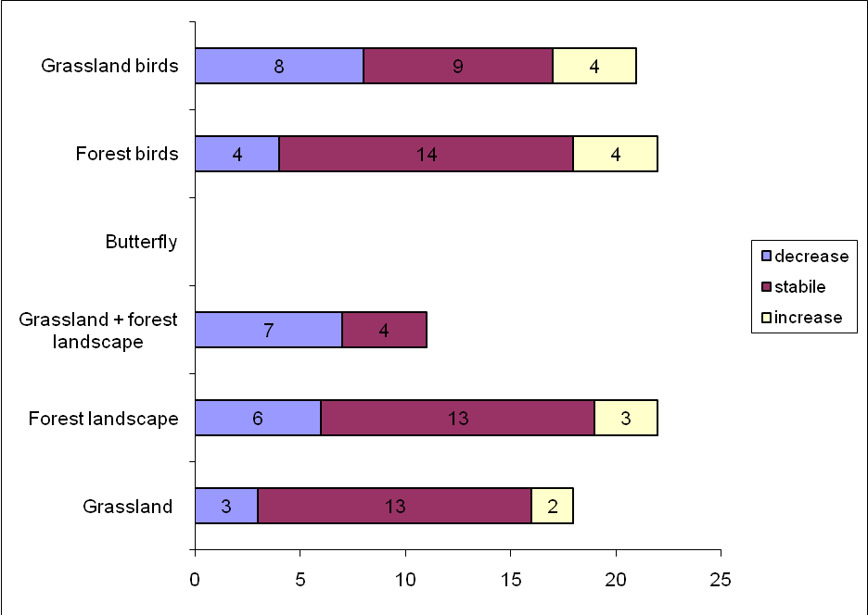
Trends in birds and butterfly population in Serbia (1990-2003).

The analysis of the trend of bird populations on woodland and farmland habitats shows that the greatest number of species had stable populations (23). The trend of population increase occurred in both habitat types, but the population increase of farmland birds was greater. The trend of bird population decrease was present in both groups, but this trend was more emphasised for farmland birds (8 species) compared to the population of woodland, park and garden birds (4 species). For two species, the trend could not be determined, because the density of their populations fluctuated during the study period.

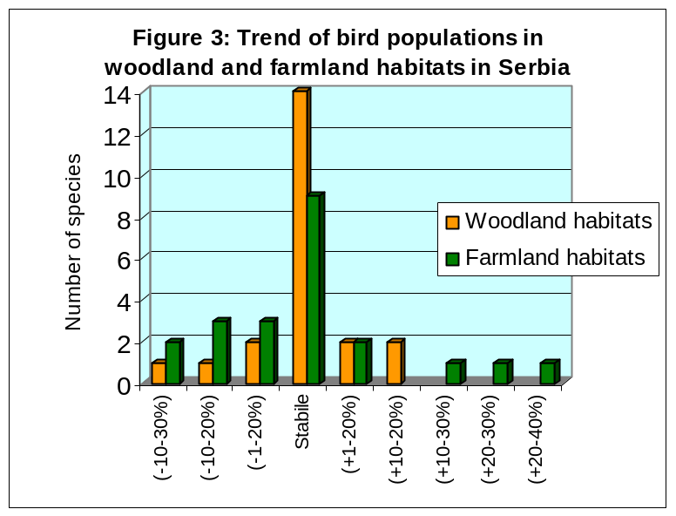

During the period 1980-2003 the woodland area increased. This trend, by all means, affected the population density of woodland, park and garden birds, so the greatest number of species had stable populations. The trend of farmland area change shows that this area decreased during the above mentioned period. Compared to woodland, park and garden birds, a lower number of farmland bird species had a stable population, but the intensity of population change was higher. In addition to a greater number of farmland bird species with a tendency of population decrease, several species significantly increased their density.

Based on the presented results, it can be concluded that woodland, park and garden birds had more stable populations compared to farmland birds, which can be related to the trend of habitat changes.
In the group of rare and threatened butterfly species, the monitoring results show that the greatest number of species (59 %) had a stable population in the analysed period. There was a decrease in population density in about a third of the monitored butterfly species. This phenomenon is especially characteristic of the species which inhabit both habitat types (woodland + farmland). This heterogeneous group also had the lowest number of species with stable populations.

The population density increased in only 5 butterfly species (10 %). Based on the change in habitat area, it is not possible to establish a clear correlation between the change of area and the population trend. It should be taken into account that and numerous factors disturb the habitats and have an adverse effect on the density of these populations. In addition, the population dynamics of the species is largely determined by the natural biological cycles. Butterflies have characteristic multiple annual cycles, with significant natural oscillations of the populations, specific for each species.

    - Endangered species

The Red List of endangered species is the most comprehensive world inventory of plants and animals protection status. Using a range of established criteria, the Red List assesses risk of extinction for species and sub-species.

Serbia developed its first Red List in 1999 and it pertained to extinct and critically endangered plant species – The Red List of Serbian Flora 1 – Extinct and Critically Endangered Taxa. It contains 171 plant taxa (species and sub-species), which makes up about 5% of the total flora in Serbia. Out of that number, 4 taxa have been irreversibly lost from the world gene stock because they were endemic in Serbia and could only be found here; 46 taxa have been exterminated in Serbia, but they still can be found in neighbouring areas or in ex situ conditions (botanic gardens); 121 species are highly endangered, with high probability to disappear from our region in the near future or the world if they are not given appropriate attention.

Table 1.2: Threatened species according IUCN and SRBIUCN status

 | Number of species | IUCN | SRB IUCN
Mammals | 100 | 11 | 8
Aves | 360 | 11 | 117
Reptilians | 25 | 3 | 13
Amphibians | 23 | 0 | 14
Pisces | 110 | 12 | 12
Insects* |  | 8 | 79

The second Red Book was published in 2003 and it pertains to Serbian butterflies Lepidoptera: Hesperioidea and Papilionoidea. This book contains the analysis of 57 species of butterflies that make up 34% of the butterfly fauna in Serbia. Besides the extinct Fenton’s Wood White (Leptidea morsei), the most endangered ones include Alpine Grizzled Skipper (Pyrgus andromedae), Swallowtail (Papilio machaon), Eastern Dappled White (Euchloe ausonia), Almond-eyed Ringlet and Yellow-spotted Ringlet (Erebia alberganus and Erebia manto), Apollo (Parnassius Apollo), Danube Clouded Yellow (Colias myrmidone), Lesser Purple Emperor (Apatura ilia) and Purple Emperor (Apatura iris), False Heath Fritillary (Melitaea diamina) and Lesser Marbled Fritillary (Brenthis ino).

  - Ecosystem diversity

We can find almost all characteristic terrestrial biomes of Europe within the territory of Serbia, which include four of twelve terrestrial biomes of the world:
- Zonobiome of deciduous (broadleaf) forests. In Serbia, this zonobiome is mostly found in the form of oak and beech forests;
- Steppe zonobiome – with muckland as zonal soil and steppe (in Serbia mostly with forest-steppe) vegetation;
- Zonobiome (orobiome) of conifer boreal forests – in mountain climate of western, south-west and south-east parts of Serbia;
- Zonobiome (orobiome) of highland “tundra” – in Alpine climate of Serbian highlands.

There is a range of cross and mutual impacts between these zonobiomes that occur due to geographic, petrographic and orographic characteristics of Serbian territory. A large majority of Serbia is of a highland nature, characterized by a low level of economic development, low population density and explicit depopulation processes. The specific bio-geographic position and natural features of the area, historical florogenesis and faunogenesis processes, as well as socio-economic phenomena and processes, have played important roles in the evolution of a rich biological diversity and the current relative ecological intactness of the region.

Serbian ecosystem diversity may primarily be observed through vegetation diversity and specificities, i.e. plant communities, which is the basic structural and productional component of all land ecosystems. Natural potential vegetation map of Serbia presents an “ecosystem mosaic” composed of forests, shrubs, meadows, swamps, marshes and lakes. The territory of Serbia is characterized by a diversity of habitats, hence diversity of biocenose, which makes this area a significant European centre of ecosystem diversity.

Basic types of zonal ecosystems in Serbia are:

- Ecosystems of thermopile sub-Mediterranean deciduous forests of Oriental Hornbeam and Hop hornbeam forests (Ostyo-Carpinion orientalis);
- Ecosystems of mesophile deciduous forests of Sessile Oak, Hornbeam and Beech (clusters of Carpinion betuli and Fagion moesiacum);
- Ecosystems of thermopile deciduous oak forests of central and eastern parts of Balkan Peninsula (Quercion frainetto);
- Ecosystems of thermopile deciduous forests in forest-steppe area of north-east parts of Serbia (Aceri tatarici-Quercion);
- Ecosystems of xerophile steppes (Festucion rupicolae)
- Ecosystems of hygrophile lowland Pedunculate Oak forests (Alno-Quercion roboris)
- Ecosystems of frigophile conifer forests of boreal type (Vaccinio-Piceion);
- Ecosystems of frigophile conifer forests of Balkan endemorelict pines (clusters of Pinion peucis and Pinion heldreichii);
- Ecosystem sub-Alpine shrubs vegetation (Pinion mugo and Vaccinion uliginosi);
- Ecosystems of Alpine mountain glades, pastures and rocky habitats (classes of Festuco-Seslerietea and Juncetea trifidii)
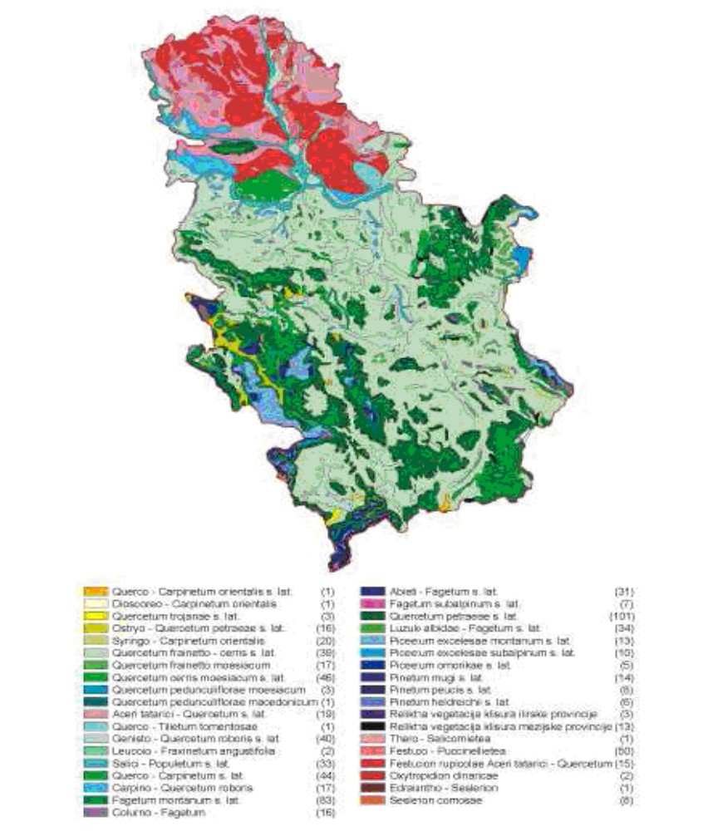
Distribution of Vegetation Classes in Serbia

Diversity and specificity of Serbian ecosystems may be observed through an overview of basic vegetation types:

- Forests and shrubs (i.e. woody) vegetation
- Forests: broadleaf deciduous forests; mixed deciduous – conifer forests; conifer forests;
- Shrubs: broadleaf deciduous shrubs vegetation;
- Conifer shrubs vegetation; mixed shrubs-herbaceous type of vegetation.
- Herbaceous vegetation
- Land herbaceous vegetation: meadows, pastures and continental rocky habitats; continental rocks, sands and halophytic habitats; highland glades, rock creeps, screes and seams; rocks and cliffs; highland snow deposits and other similar places;
- Aquatics herbaceous vegetation;
- Anthropo-dependant and anthropo-conditioned forms of herbaceous vegetation.

It has been registered 1200 vegetation communities and 500 sub-associations classified in 59 vegetation classes in Serbia. Great number of these communities is of endemic-relic character, especially those that can be found in gorges, canyons, peat bogs and high-mountain areas.

Serbian ecosystems are characterized by the presence of endemic and relic plant associations. The majority of associations with endemic characteristics are found within rocky areas, mountain glades and rock creeps. The following ecosystems are also significant for biological diversity protection: thermopile serpentine stone grounds, Pannonian salty grounds, mountain peatland, high greenery, mountain mezophile meadows, which include a large number of endemic species. Particular values of Serbian ecosystems are forests and shrub communities with endemic woody plants. The following forests are particularly important: spruce forests (Piceion omorikae), Fritillaria gracilis (Pinion heldreichii), Pinus peuce (Pinion peucis), Greek maple (Aceretum heldreichii, Aceri-Fagetum type), polidominating forests with Pancicev acer (Acer intermedium) and hazelnut seedlings (Fago-Corylenion colurnae), lilac shrubland (Syringion) and others.

Most important local and regional centers of ecosystem diversity in Serbia are primarily the following mountains: Kopaonik, Tara, Sar planina, Prokletije, Stara planina, Suva planina and others. It is also necessary to mention important refuge areas, such as canyons and gorges: Djerdapska gorge, Sicevacka gorge, Drina canyon, as well as river valley of Pcinja in southern Serbia and other areas with large numbers of endemic, relic and endemic-relic plant communities. Specific centers of ecosystem diversity, located in Vojvodina must be stressed here, with their continental sand, steppe and halophytic communities, which are found only in a few areas: Deliblato and Suboticko-Horgoska sands (Deliblatska and Subotičko-Horgoška peščara), “mosaic” salty grounds in Banat and Backa.

1.3.1. Forest area

The lowest parts of Serbia, primarily the Pannonian Basin and valeys along major rivers of Danube basin are characterised by fragments of more or less well preserved forests which belong to alliance of Salicion albae and Populion albae (forests of poplar and willow). Here are included flood Pannonian forests with the domination of poplars, willows, common oak and ash. Oak forests in other regions of Serbia are formed of various oak species present on the Serbian territory. Those various oak species are classified as two complex-the complex of xerothermophile cerris and other type of forests and the complex of xeromesophile petraea, cerris and hornbeam type of forests. Beech forests are spread on almost the half of entire forest grown areas in Serbia and they spread above oak forest storey in hill and mountain parts of country. Those are mesophile forest communities in mountain belt, at the height of 500 to 1000 metres. Mountain beech forests at higher altitudes change into mixed-type communities of beech and fir. Spruce forests are spread in mountain, that is in high-mountain areas, along with sub-alpine beech. The highest sub-alpine forest vegetation storey is the habitat of special sorts of conifer, Mountain Pine, Bosnian Pine and Macedonian Pine.
Broadleaf forest are in majority of 2 068 418 ha or 91,27% of forests (29,66% country territory), mixed-type forests follow with its 116 118 ha or 5,12% of forests (1,5% territory) and finally coniferous forests with 81 797 ha or 3,61% of forests (1,05% territory).

Mountain meadows and pastures spread on inter-forest surfaces (hill and hill-mountain areas) or above forest zone in high mountains.

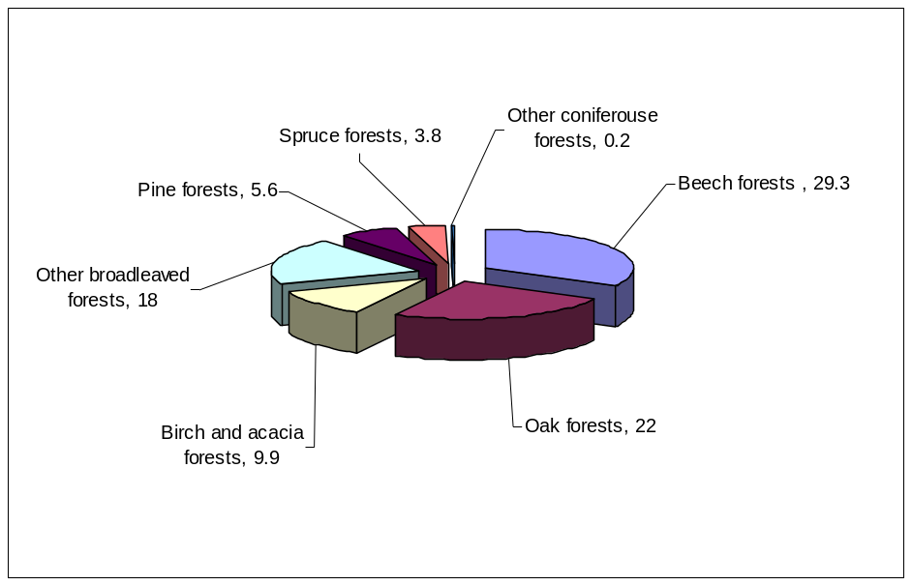

Figure 1.3: Forest types in Serbia.

According to CORINE Land Cover for 2006, forest area in Serbia is about 2 880 000 ha or 32% of territory.

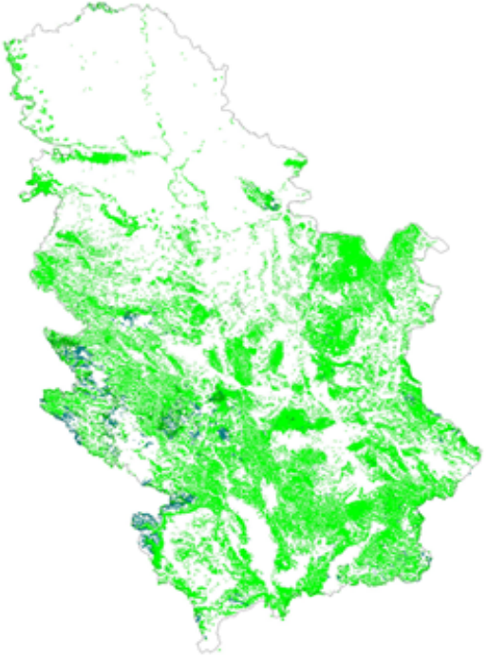
Figure 1.4: Broadleaf, coniferous and mixed forests in Serbia. *CLC 2006.

In comparison with year 1953, forest area in Central Serbia and Vojvodina Province increased by about 1 000 000 ha or by 75%. Numbers of factors like increase in habitants, industrialization, intensive agriculture, wars, crises, etc influenced the decrease of forest area in past 200 years. The lowest level of forest area was in the period 1885-1953, which was the period of major wars waged in Serbia but also the period of most intensive industrialization. Forest area per capita in Central Serbia in 2006 is 0.42 m3, which is more than in 1938 (0.32 m3) but still the less than in 1905 (0.56 m3).

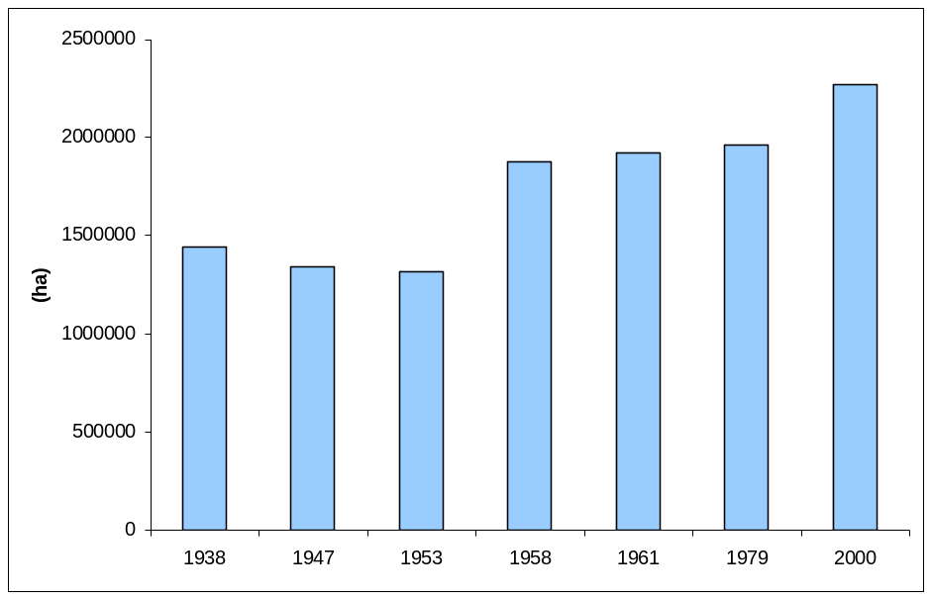

Figure 1.5: Forest area changes in Serbia (without Kosovo and Metohija).

Forested landscape is to a certain degree different category from forest land. Forest landscape include all types of forest land according to CORINE Land Cover (broadleaf, coniferous and mixed forests), but also the part of mixed forest-shrubs vegetation (about 50 %) and mixed forest agricultural land (about 33 %).Those partially fragmented forests are not consistent in an ecosystem sense, but they have an important imission capacity and at the same time can give landscape the richness of habitat.

  - Genetic Diversity

Genetic stock in the Republic of Serbia is very rich and it contains the great number of sorts and species of autochthonous populations of native plants and animals. The program of agrobiodiversity conservation which assumes ex-situ program of conservation of living and frozen plant and animal samples, germs, plant parts in the culture of tissues etc., has actively been conducted in Serbia over the last decade. (This is also the program of establishing the national bank of genes, in cooperation with scientific and expert institutions in the area of agriculture, as well as the in-situ program of conservation of rare or under threat of extinction living samples of plants and animals).

In Serbia, there are over 1200 sorts of agricultural plants: ca. 80 annual and perennial, over 740 cereals, over 170 industrial plants, over 70 sorts of forage crops, over 120 vegetable sorts, over 40 fruit sorts, over 50 grape vine sorts and 6 sorts of horticultural and medicinal plants.

In Serbia over 700 species of medicinal plants are known, out of which some 400 are officially registered and 280 are the subject of trade. One hundred and fifty two plant species are legally protected from use and trade and these species are the subject of collecting control. In the forest sector, 282 species of trees and shrubs are of economical importance. In addition, it should be noted that there is a large potential of plants (ca. 180 melliferous species) and ecosystems for honey production and as habitats for pollinators that are used in agriculture.

1.4.1 Agrobiodiversity

Based on the data contained in the Draft Programme of Rural Development (2008-2013), significant presence of more than 44 autochthonous and exotic breeds of domestic animals has been noted in Serbia (7 breeds of horse, 1 breed of donkey, 8 breeds of cows, 3 breeds of goats, 5 breeds of sheep, 18 breeds of pigs and several breeds of poultry). Between 400 and 500 of agricultural husbandries and associations own endangered species. The FAO information system for domestic animals diversity (DAD-IS) contains information about the presence of more than 100 breeds and sorts of domestic animals on the territory of the Republic of Serbia.

The following autochthonous breeds of domestic animals have survived in Serbia: podolac cow; busha; domestic ox; domestic mountain horse; nonius, domestic Balkan donkey, mangulica, moravka, resavka, pramenka (svrljiska, sjenicka, pirotska, karakacanski, krivovirski, bardoka, baljusa, vlaska vitoroga, lipska sheep), cigaya (cokanski type), domestic Balkan goat, domestic chicken (Sombor kaporka, naked-neck chicken, Svrljig chicken, Eastern-Serbian chicken), domestic turkey, domestic guineafowl, domestic goose (status of Sombor goose, Novi Pazar goose and Podunvska goose is unknown), domestic duck. Autochthonous sort of bee, Apis melifera carnica, is also important with its varieties, which is one of most valuable sorts of honeybees in the world, according to its characteristics.
Species | Race | Sort | Population size 2003 | Population size 2009 | Number of locations | Trend
Horse | Domestic mountain horse |  | 25 | 61 | 5 | ↑
Horse | Nonius |  | 50 | 71 | 6 | →
Donkey | Balkan donkey |  | no data | 53 | 5 | →
Cow | Busha |  | 100 | 290 | 9 | ↑
Cow | Podolac |  | 150 | 228 | 3 | ↑
Ox | Domestic ox |  | 150 | 48 | 5 | ↓
Pig | Mangulica |  | 350 | 402 | 9 | →
Pig | Moravka |  | 100 | 56 | 4 | ↓
Pig | Resavka |  | 30 | 19 | 2 | →
Sheep | Pramenka | Krivovirski | 350 | 261 | 2 | ↓
Sheep | Pramenka | Pirotski | 500 | - | - | →
Sheep | Pramenka | Lipski | 100 | 204 | 2 | ↑
Sheep | Pramenka | Metohijski (bardoka) | no data | 55 | 2 | →
Sheep | Pramenka | Karakacanski (kucovlaški) | 35 | 43 | 3 | →
Sheep | Pramenka | Vlasko vitorogi |  | 250 | 3 | →
Sheep | Cigaya | Cokanski | 550 | 400 | 3 | →
Goat | Balkan |  | no data | 210 | 3 | →
Chicken | (black) Svrljig |  | 300 |  |  | →
Chicken | Sombor kaporka |  | 300 | 227 | 2 | ↓
Chicken | Naked-necked |  | 500 | 704 | 3 | ↑
Table 1.3: Autochthonous breeds and sorts of domestic animals included in the Program of allocation and use of incentives
for conservation and sustainable use of genetic resources in 2008

* These are official data from the Ministry of Agriculture, Forestry and Water Management, but the number of some breeds and sorts is higher in reality; however, these heads have not been reported to the Ministry
Great number of cultures grown in Serbia has its wild types which grow wild in natural eco-systems.

The presence of 122 wild fruit species classified in 23 families and 38 genera within natural and primarilly forest eco-systems, has been stated in Serbia. In autochthonous Serbian flora there are progenitor species of apples (Malus silvestris, Malus florentina and Malus dasyphyla), pears (Pirus communis, Pirus amygdaliformis), plums (Prunus cerasifera, Prunus spinosa), sweet cherries (Prunus avium), cherries (Prunus fruticosa), wallnuts (Juglans regia), some sorts of almond (Prunus amygdalis), nuts (Corylus avellana), chestnut (Castanea sativa), raspberries (Rubus ideus), gooseberries (Rubes glossularia), red currant (Ribes petraeum, Ribes multiflorum), strawberries (Fragaria vesca, Fragaria viridis, Fragaria moschata) and others. It is a realistic assumption that the territory of Serbia is the primary genetic center of the greatest number of fruit sorts cultivated nowadays, the indicator of which being their major presence in natural and primarilly forest ecosystems.

Among domesticated members of Canidae family, Sharplaninac or Illyrian Shepherd Dog represents the autochthonous breed with exceptional qualities concerning courage and shepherd instinct. Serbian Tricolour Hound and Posavaz Hound are also important autochthonous breeds, their characteristic being very well developed hunting instinct.

The genetic stock of autochthonous microorganism types is of special importace and of unmeasurable potential for application in medicine, pharmacy, agriculture, food industry and other industry sectors.

    - Other genetic resources

In addition to cultivated plant types, overall agrobiodiversity of Serbia also includes wild plant species that represent important components of food production and agriculture (forage crops, medical and aromatic herbs, decorative plants, honey plants, wild fruit). Various agro-ecosystems (arable farms, orchards, vineyards, meadows, pastures, brink and ruderal habitats) and components thereof, including weed flora and vegetation also contribute to overall agrobiodiversity of Serbia.

The diversity of species that dwell in natural fields (meadows and pastures) has not been well studied or estimated, but number of species within the described 273 plant associations has been estimated at more than 1,000. Total number of medical and aromatic plant species of our flora is about 700, out of which 420 have officially been registered. 280 of these are traded as commodities. Honey plants are primarily found in meadow, forest and agro-ecosystems, and their number in our country has been estimated at approximately 1,800. In most general sense, flora of agrobiodiversity includes weed and ruderal plants as agro-ecosystem components. The studies conducted to date on weed flora diversity in Serbia reveal that the number of weed species represents 28% of the total flora (more than 1,000 species).

Within forest genetic resources, in addition to the natural rarities, great importance is given to wild fruit species. Eighty-eight species of wild fruit have been identified within the natural forest associations of Serbia, 12 of which are endangered species.

Among genetic resources of medical and aromatic herbs, greatest importance is given to genetic diversity of commercially important species (chamomile, mint, sage, hypericum, yarrow, oregano, bearberry, valerian, plantain, primula, etc.), as well as to sorts of limited areals and to those that are for some reason endangered. Looking at the genetic resources of medical and aromatic herbs and the need for their conservation, coordinated monitoring activity, which would look into the status of their populations, has not been implemented for a long time, while general conservation strategy at national and international levels have not been developed yet. This is one of the main reasons for the recommendation related to establishment of ECPGR Working Group for Medical and Aromatic Herbs (1999).

Threats to biodiversity in Serbia

Although Serbia is rich in biodiversity, the country has suffered a progressive loss of biodiversity as a result of human activity. In particular, agriculture, industrial development, urbanization, forest extraction, hunting, fishing, energy and mining, transport and tourism, are the sectors that have impacts on the biological diversity. Also, uncontrolled pollution, alteration of river courses and hydrotechnical works, mineral resource extraction and overexploitation of biological resources are significant endangering factors.

The permanent growth in human population is associated with a range of undesirable consequences, some of them being:

- Drastic increase in areas modified as forest- and agricultures;
- Intensive fragmentation of habitat due to the development of industrial and communicational systems and suburban areas;
- Inadequate and overwhelming exploit of biological resources, beyond ecosystem sustainable development (uncontrolled exploit of economically valuable resources such as trees, fish, wild animals, medicinal herbs, mushrooms etc.)
- Introduction of allochthonous species ( import of species from geographically distant parts to a certain habitat);
- Permanent air, water and soil pollution by a whole range of pollutants (sulphur and nitrate oxides, heavy metals and pesticides);
- Increased levels of ionizing and unionizing radiation;
- Climate change due to enormous emission of substances that destroy ozone layer and of gasses creating the greenhouse effect

Synergetic action of these factors has resulted in drastic decrease of biodiversity both on local and global level.
Biodiversity supports Serbian economy. It forms the basis of our primary production industries, such as agriculture, forestry, fisheries and other sectors. It provides services to those industries (e.g. by pollinating plants, contributing to soil health and recycling nutrients). Biodiversity is also the basis for the production of many other important human services, such as medicines.
Таxon | Macromycetae | Lichenes | Algae | Bryophyta | Vascular plants | Protosoa | Rotatoria | Nematodes | Oligochaeta | Gastropoda | Crustacea | Insecta | Pisces | Amphibia | Reptilia | Aves | Mammalia
Pressure factor
Forest overfelling | ++ | + |  | ++ | +++ |  |  |  | ++ | ++ |  | ++ |  | ++ | ++ | ++ | +++
„Sanitary“ forest cutting | + |  |  | ++ | ++ |  |  |  |  | ++ |  | ++ |  |  |  | + | ++
Growing of monocultures and allochthonous species | ++ | ++ |  | ++ | ++ |  |  |  |  |  |  |  |  |  |  | ++ | ++
Overcollecting, overhunting | +++ |  |  |  | ++ |  |  |  |  | +++ |  | ++ | +++ | +++ | ++ | +++ | +++
Habitat destruction | +++ | ++ | ++ | +++ | +++ | +++ | +++ | ++ | ++ | ++ | ++ | + | +++ | +++ | +++ | +++ | +++
Air pollution | + | +++ |  | +++ | ++ |  |  |  |  |  |  | + |  | + | + |  | +
Water pollution |  |  | +++ | ++ | ++ | ++ | ++ | + | +++ | + | +++ |  | +++ | +++ | ++ | ++ | +
Urbanisation | + |  |  |  | ++ |  |  |  |  | ++ |  | + |  | + | + | ++ | ++
Habitat fragmentation | ++ |  |  | + | +++ |  |  |  |  |  | + | + | +++ | ++ | ++ | +++ | +++
Intensive agriculture and/or livestock breeding | ++ | + |  | ++ | +++ |  |  |  |  | ++ |  | ++ |  | ++ | ++ | +++ | +++
Use of biocides | ++ |  | + |  | ++ |  |  |  |  | + | ++ | +++ | + | + | + | ++ | ++
Introduction of allochthonous species | ++ |  | ++ |  | ++ |  |  |  |  |  | ++ |  | +++ | +++ | +++ |  | +
Table 1.4: Main threats to biodiversity taxa
1.5.1 Climate change impact
In the light of various impacts on biodiversity, the topic of climate change impact has increasingly become the focus of public attention. According to a number of predictions, the global warming effect will probably have a significant impact on biodiversity condition in the area of South-Eastern Europe and accordingly the territory of the Republic of Serbia. The climate change impact modifies important external factors needed for the survival of autochthonous plant and animal species, primarily the rise of temperature and frequency of extreme weather conditions, more frequent and intensive floods, the increase in allochthonous species and consequently a significant threat of natural habitat endanger.
Number of objectives of Kyoto protocoll overlap with the aims of biodiversity conservation. Enlargenment of GHG sinks and reservoars, concurrently with ongoing biological diversity conservation efforts, would bring out multiple positive effects. Expansion of protected areas not only preserve biodiversity, but also include ecosystems considered as CO₂ reservoars (ancient forest stands, habitats on peat soils etc.). Habitat revitalization increase ecosystem’s resistance. Ongoing creation of ecological network enhances landscape dynamic and evolutionary processes which are necessery to biocenoses’ adaptation.

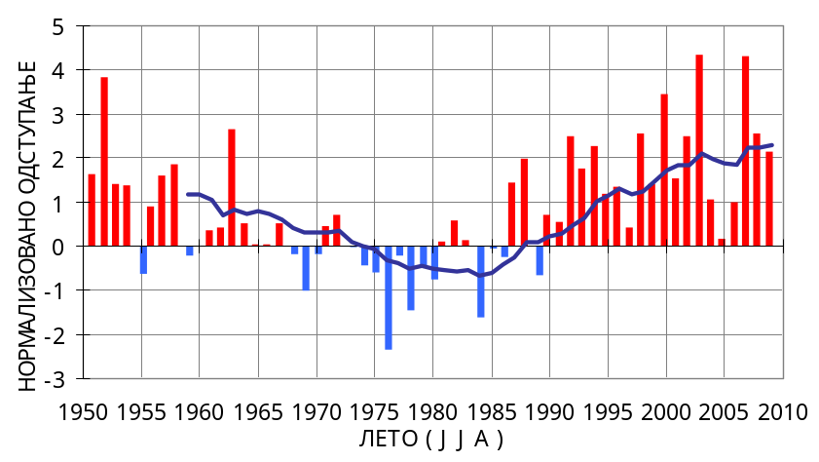
Figure 1.6: Normalised fluctuation of summer air temperatures in Serbia (Source: Republic Hydrometeorological Service of Serbia and Serbian Environment Protection Agency)

Normalized fluctuation of average annual air temperature in year 2009 is positive and more than 3, which indicates that air temperature values in Serbia in 2009 too were extremely higher than normal.

Normalized fluctuation of average summer air temperature in Serbia in 2009 is positive and higher than 2, which indicates that summer 2009 too was very warm in comparison to normal values in the period 1961-1990. It was twentieth summer warmer than average that continued since 1990.

Aforementioned statements show the continuation of tendency of average air temperature raise on the territory of the Republic of Serbia. According to data from the period 1951-2009, the raise of annual air temperature is dominant in Serbia. After 1990 the annual air temperature raise is more intensive. The intensity of temperature raise in the period 1991-2009 is multiple higher than in the period 1951-2009.

The basic impediments in solving climate change problems in the Republic of Serbia are as follow:

- The use of data on climate and information used for planning and projecting, because standard methods and instructions based on stationary climate traits are still applied.
- The need for including climate change as factor of sustainable development into sector strategies, especially into sector susceptible to climate change, such as agriculture, water management, forest management, energy management, tourism, health sector, engineering, traffic sector and others, has not yet become part of common knowledge.
- An adequate support for implementation of multidisciplinary research programs on climate change impact, susceptibility and adapting options, has not yet been provided.
- There is no particular state program for solving climate change problems.
- Limited financial means for the purpose of strengthening capacities, both systematic, institutionalized and individual, education, training and informing.
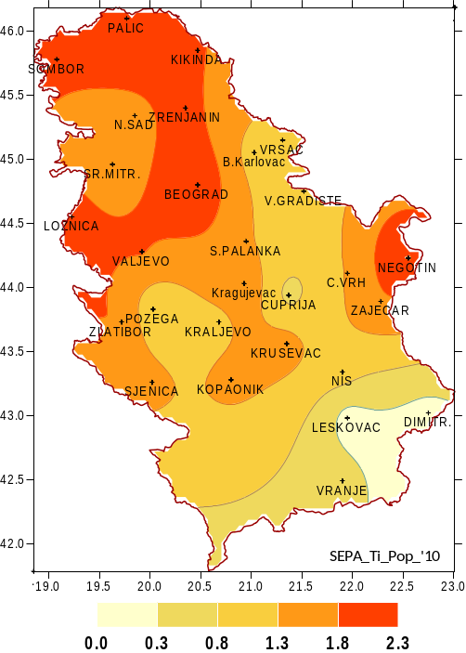
Figure 1.7: Territorial trends of annual air temperature in Serbia (Source: Republic Hydrometeorological
Service of Serbia and Serbian Environment Protection Agency)

Climate change has its impact on all biodiversity aspects. Its effect being thus that it changes population and species distribution, as well as the functioning and composition of ecosystem (destruction, change or modification of habitat).

ICP Monitoring

Subindicators, decolorisation, defoliation and combined damage are very important for monitoring of forest trees health. This is the network of ICP Forest monitoring. In the period 2006-2009, Pinus nigra, Picea abies and Abies alba have a slight (Abies alba) to average increase in defoliation. The only broadleaf tree specie with increase in defoliation is Caprinus betulus.

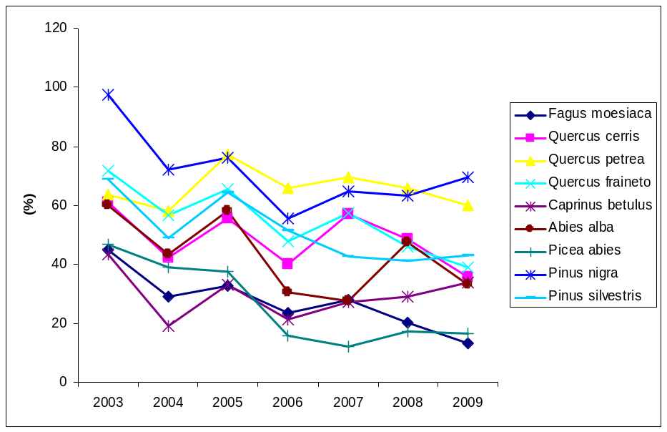
Figure 1.8: Slightly, moderately and severely defoliation

According to meteorological data, summer 2009 was extremely warm, but all year was warm and humid. Except 2003 which was extremely warm, second worst year for coniferous trees was 2005, but 2005 and 2007, for broadleaf trees. Decolorisation is parameter with better results than in previous year. Combined damage is the lowest in the period 2003-2009 for coniferous and broadleaf trees.

1.5.2 Land change

The diversity of habitat on the territory of the Republic of Serbia is also confirmed by data connected to CORINE „CO(o)R(dination of)IN(formation on the)E(nvironment) Habitats Codes” – the program of type setting and analysis of habitat diversity, the work of Environment Agency of the European Commission in Copenhagen. Land Cover CLC data show that on the territory of the Republic of Serbia, 29 of total 44 class of third level CORINE Land Cover Nomenclature-e registered on the entire European territory can be distinguished.

The analysis of change in ways of land use on the territory of the Republic of Serbia in the period 1990-2000 shows the presence of major change within the category of artificial surfaces, with visible increase of 3947 ha. Agricultural land in the study period is decreased by 8473 ha. Forest land and semi-natural areas are, in general, increased by 1 975 ha.

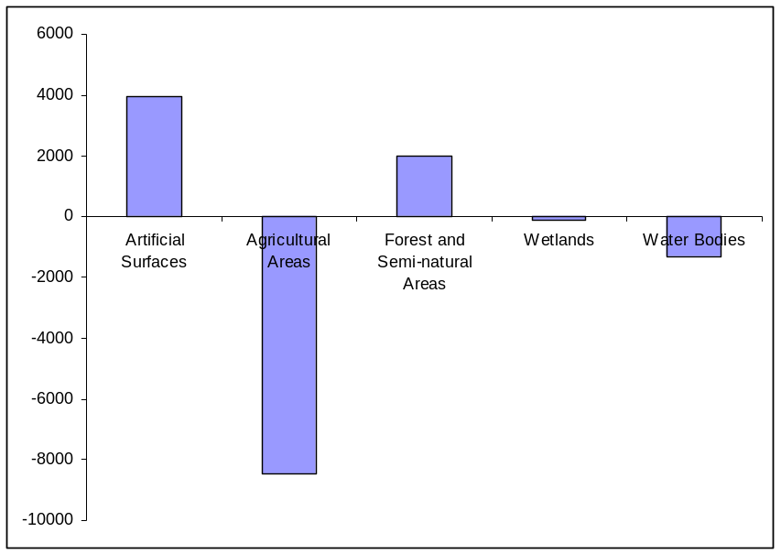
Figure 1.9: CORINE Land Cover changes in Serbia 1990-2000

The analysis of Corine Land Cover data base for year 2006 shows the presence of 28 of 44 CLC nomenclature class with the domination of agricultural land. Approximately 26% of this territory belongs to the non-irrigated arable land category, 16% belongs to the system of plough land units, whereas 13% is, in its greater part, agricultural land with important natural vegetation grown surfaces.

Forests and semi-natural areas cover almost 40% of land (broadleaf forests-27%). Land classified as artificial surface covers almost 3% of the territory and the rest of approximately 1,6% is classified as wet land and water basins.

The analysis of certain categories occupied by urban development in Serbia in the period 1990-2006 and their contribution to the ways of land use shows mostly pasture land and mixed agricultural areas, have been occupied.

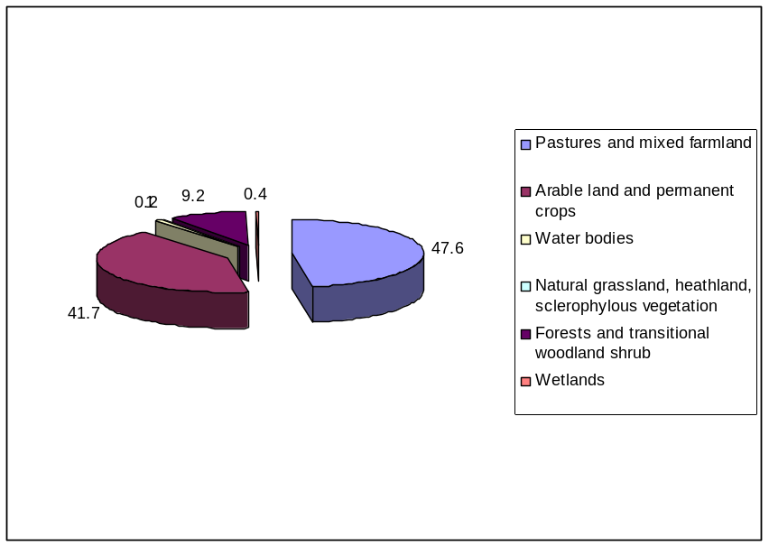
Figure 1.10: Land-cover categories uptacen by urban and other artificial land development 1990-2006.

The land occupation for the purpose of developing urban area and sporting-recreational objects in the Republic of Serbia amounted to annual 351 ha in the period 1990-2006, for the purpose of industrial and commercial site s- annual 127 ha, for road network and its infrastructure – annual 2 ha, whereas for the purpose of mines, waste yards and construction sites it amounted to annual 239 ha in the same period.

1.5.3 Main threats to terrestrial and freshwater habitats

Ecological and human factors interact with one another in dynamic and unpredictable ways. Nevertheless, at this stage of planning it is important to clearly distinguish between the direct and indirect role that different factors and conditions have in impacting biological diversity, as well as the interactions among those factors and how they related to or depend on variations in local conditions.
Main threats to terrestrial and freshwater biodiversity are caused by:

Habitat Loss, Fragmentation, and Degradation
- Conversion of native habitats to agricultural, forestry, residential, and commercial uses
- Alteration to flow regimes of natural waterways
- Construction, use, and maintenance of transportation infrastructures
- Logging
- Livestock grazing
- Population Declines in Wild Species
- Overexploitation and illegal harvesting of plant and wildlife species
- Hunting and fishing
- Gathering
- Pollution / Contamination
- Invasive, Non-native Species and GMOs
- Climate Change

 | ← Threat / Menaces →
← Ecosystem / Biodiversity components → |  | Habitat changes | Climate changes | Invasive species | Overexploitation | Nutrient & Pollution | Fragmentation
← Ecosystem / Biodiversity components → | Boreal forests | → | ↑↑ | ↑↑ | → | ↑↑↑ | ↑
← Ecosystem / Biodiversity components → | High mountain forests | → | ↑↑ | → | ↑ | ↑ | →
← Ecosystem / Biodiversity components → | Arable agriculture land | ↑ | ↑↑ | ↑↑↑ | ↑↑ | ↑↑↑ | ↑
← Ecosystem / Biodiversity components → | High mountain agriculture land (pasture) | → | ↑ | → | → | ↑↑ | ↑
← Ecosystem / Biodiversity components → | Mixed agriculture-forest land | → | → | ↑↑ | ↑↑ | ↑↑ | ↑↑
← Ecosystem / Biodiversity components → | Rivers | ↑↑ | ↑ | ↑↑ | ↑↑ | ↑↑↑ | ↑↑↑
← Ecosystem / Biodiversity components → | Wetland | ↑↑↑ | ↑↑ | ↑↑ | ↑↑↑ | ↑↑↑ | ↑↑↑
Table 1.5: Main threats to natural habitats
Legend: ↑↑↑- very strong impact, ↑↑- strong impact, ↑- low impact, →- stable.
Land conversion resulting in the habitat loss, fragmentation, and degradation is arguably the single most significant factor responsible for the endangerment of species in Serbia. Lands have been, and continue to be, converted for agricultural, commercial, and residential purposes. Land use conversions include draining of wetlands; encroachment of residential or commercial areas into native habitats; creation of recreation areas such as ski resorts; etc. Such conversion of native habitats to human-dominated environments reduces the area of habitat available to biodiversity, while also fragmenting and degrading remaining areas.

Even well planned road construction can destroy or seriously damage natural ecosystems, thus causing direct damage through loss of habitats for sensitive plant and animals, which is the main cause of biodiversity loss. Transportation infrastructures also fragment habitats, restricting or preventing natural movement of animals and exchange of genetic material. Habitat fragmentation damages ecosystems’ stability and health, particularly when the movement of keystone species important to ecosystem integrity (e.g., large predators,) is restricted. Many wildlife species that need to move to find food or for breeding purposes are either reluctant to cross the roads or get killed while crossing it. It is also a case that some animals are attracted to roads for various reasons - more abundant food, shelter from predators, or easier movement - which often leads to increased mortality due to accidental deaths.

Alteration to the natural flow regimes of rivers and streams and their floodplains and wetlands is recognized as a major factor contributing to loss of biological diversity and ecological function in aquatic ecosystems, including floodplains. Alteration to natural flow regimes can occur through reducing or increasing flows, altering seasonality of flows, changing the frequency, duration, magnitude, timing, predictability and variability of flow events, altering surface and subsurface water levels and changing the rate of rise or fall of water levels. Four primary ways in which humans alter flow regimes in natural waterways are: building of dams, diversion of flows by structures or extraction, alteration of flows on floodplains with levees and structures (including those on wetlands to allow water storage), and extraction of gravel and alluvial sands and dredging.

Worldwide, timber harvest practices have caused significant impacts to biodiversity and forest ecosystems, including reduction of forest area, fragmentation, degradation, and changes in patterns of forest age structure and species composition across the landscape. In general, timber practices have created forests that are younger, more even in age structure, biologically less diverse, and economically less productive. The mix of wildlife and plant species within the forests has changed along with the changes in over-story tree composition. In many areas this has involved replacing mixed broadleaved and conifer forests with conifer dominant forests or plantations. Fire suppression and the inability to prevent and control human and natural caused fires has also resulted in changes in the species composition of many forests. In some instances, forests are now more susceptible to damage from insects, disease, and fire.

Livestock grazing in natural ecosystems changes the relative mix of native species in grasslands and shrub-steppe ecosystems. In addition, grazing in forests has reduced the shrub and forb understory, which has resulted in the development of dense, fire-prone, forests. Grazing also has negative impacts on stream, riparian, and wetland systems, including increased sedimentation, altered stream flow patterns, and increased nutrient loads. Those ecosystems hardest hit by past grazing practices, where there has been nearly total replacement of native by non-native species, may never fully recover. However, today grazing does not have large negative environmental impacts in Serbia as most livestock are kept in stable systems.

Pollution and environmental contamination will likely accompany the projected population growth in Serbia and surrounding regions. Increased contamination of the environment, particularly via discharges of wastewater and storm water runoff and atmospheric deposition of pollutants, such as those in automobile emissions, can be anticipated. As additional land in the region is converted to intensive agriculture, there is greater potential for contamination from the application of fertilizers and pesticides. In addition there is lack of adequate manure management, especially on big farms leading to soil and water nitrification. New chemicals and the inadequacy of assessing the impacts of chemicals’ impacts on the environment are also risks.

Major sources of pollution/contamination include mining, logging, waste disposal and treatment, agriculture, and atmospheric deposition. In many regions of the world, species and ecosystems also continue to be impacted by the legacy of past contamination (e.g., metals, such as lead or chemicals, such as DDT, which persist and can build up in the food chain).

Main sectors pressures on biodiversity

Although Serbia is rich in biodiversity, the country has suffered a progressive loss of biodiversity as a result of human activity. In particular, agriculture, industrial development, urbanization, forest extraction, hunting, fishing, energy and mining, transport and tourism are the sectors that have impacts on the biological diversity. Also, uncontrolled pollution, alteration of river courses and hydro technical works, mineral resource extraction and overexploitation of biological resources, are significant endangering factors.

Table 1.6: Main sectors pressures on biodiversity

Sector | Impacts | Consequences
Agriculture | Intensifying of agricultural production, conversion of large areas to monocultures, and the use of chemical agents | Conversion of native habitats to agricultural ones  Conversion of native habitats to commercial uses
Forestry | Logging activities, forest-clearing activity, establishment of monoculture | Conversion of native habitats
Water Resources Management | Industrial and agricultural pollution, water flow channeling, swamp draining for agricultural use, construction of dams | Alteration to flow regimes of natural waterways, draining of wetlands  eutrophication
Transportation | Construction, use, and maintenance of transportation infrastructures | Fragmentation of natural habitats, pollution
Energy | Surface mines (coal mines), construction of damps and of wind turbines | Fragmentation of rivers, natural habitats, interception of migratory routes, pollution
Mining | Surface mines, mines and their infrastructure | Destruction of natural habitats, overexploitation
Natural Resources Management Sector (fishing, gathering, hunting…) | Overexploitation, introduction of alien species | Population declines in wild species

1.6.1 Agriculture

The most important regulations concerning the issue of fertilizers usage are Nitrate Directive EU Council Directive 1991/676/EEC, that protects water from nitrate pollution deriving from agriculture and Water Framework Directive 2000/60EC. The study of impact of agriculture on environment is performed by indicators showing the use of mineral fertilisers, plant protection substances, irrigation, the total livestock and organic agriculture surfaces.

There is no reliable data on the use of fertilizers in the Republic of Serbia, which is the reason for presenting fertilizer production in the period 2004-2009. In comparison with year 2007, the decrease of nitrate and phosphorous fertilisers production is evident, as well as the increase in mixed fertilizers production. Compared to year 2008, less amounts of complex fertilizers have been produced.

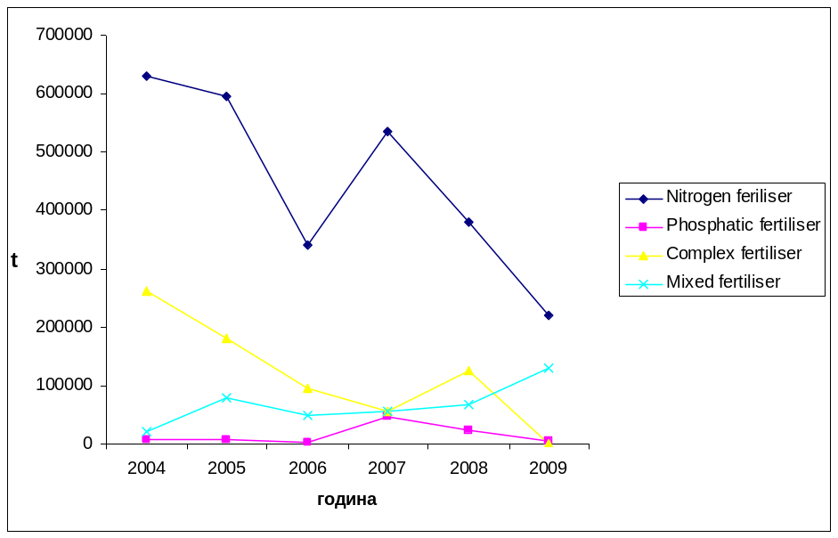
Figure 1.11: Production of fertilisers in Serbia

Although there is no absolute relation between the use of plant protection substances and potential risk to environment and human health, the indicator which shows the use of plant protection substances can be the first step towards the risk assessment. There is no reliable data on plant protection substances consumption in the Republic of Serbia. However, data on pesticide and other agricultural chemicals production in the period 2004-2009, show the amounts of 5000-8000 t annually.

1.6.2. Forestry

Forestry sector have a strong impact on forest ecosystem and also on biodiversity components.

Total energy potential of heating wood used in Serbia is about 20 000 TJ per year. Unfortunately energy potential of biomass is not included in total energy count of country. Heating wood is included in energy consumption only with 4%. In forested European countries wood energy consumption is about 10-20%. Firewood in Serbia is usually used by families. Because of that it is not included in state energy balance. Total energy consumption in houses (electricity, heating and coal) is about 85000 TJ per year. With energy potential of firewood use for energy in the houses it could be about 20%. And with modern technology of bio-fuel production, energy efficiency will be much better.

According to data, the main damage in forests is of human factor (illegal cutting and other damage by man) and it has been increasing in the past 3 or 4 years. Also the damage from weather increased during the same period.

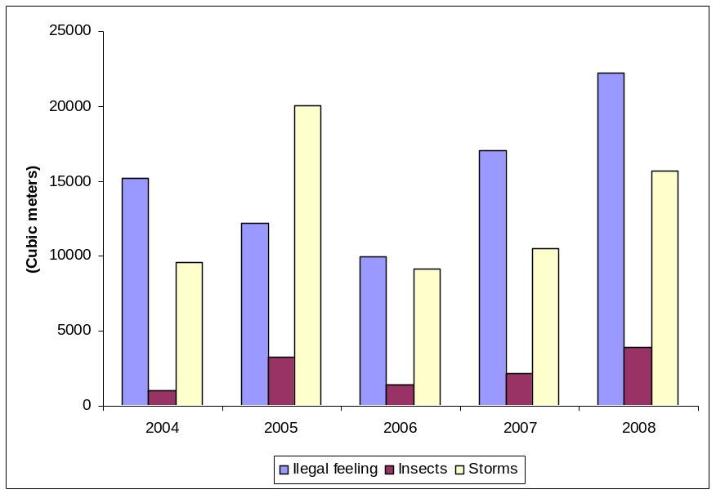
Figure 1.12: Damages in forest. (Blue- illegal cutting, Red- damage from insects, Yellow- weather damages)

But the most important damage in forest ecosystem is fire. 23 000 ha of forest were fire stricken in Serbia in 2007. Fortunately the damage in cubic meters wasn’t so high. In 2008 fire stricken forest area was about 600 ha, but the damage was higher than in 2007. About 7 000 cubic meters of wood were destroyed.

Alien or allochtonous tree species are for various reasons introduced in forests due to intensive forestry or horticulture. By its ecological parameters (the production of timber, competitiveness etc.), these species have the ability to change even the dynamics of natural forest ecosystems and the functional traits of biodiversity. Out of 68 tree species in Serbian forests, 15 allochthonous species have been registered so far, together with 27 cloned species. The number of introduced species is certainly far more greater, taking into consideration park and other non-forest surfaces used for cultivating these species for the purpose of decoration or else. Allochtone species are the most represented in forests and at the same time invasive too, such as acacia, Amorpha fruticosa (desert false indigo), Ailanthus and others.

1.6.3. Fishery

In Serbian freshwaters the total amount of 110 lamprey and Actinopterygii species is registered, 23 species (23.5%) of which being allochthonous and 12 species that can be characterised as invasive. Out of total number of species, 53 fish species (54.1%) including ten more allochthonous species, are the subject of industrial and recreational fishing. Taking into consideration the industrial fishing aspect,

29 fish species are more or less economically important, 12 species out of them represent target group at which catching, fishing activities are mostly aimed.

Recreational fishing affects approximately 45 species, however, in this case, about 50% of these species represents the target group.

Monitoring of freshwater fishing includes 22 most important fish species. Trend of freshwater fishing is in permanent increase and it is 4 times higher than in 2000. Precise monitoring has been established since 2006 and this increase is partially due to stronger control.

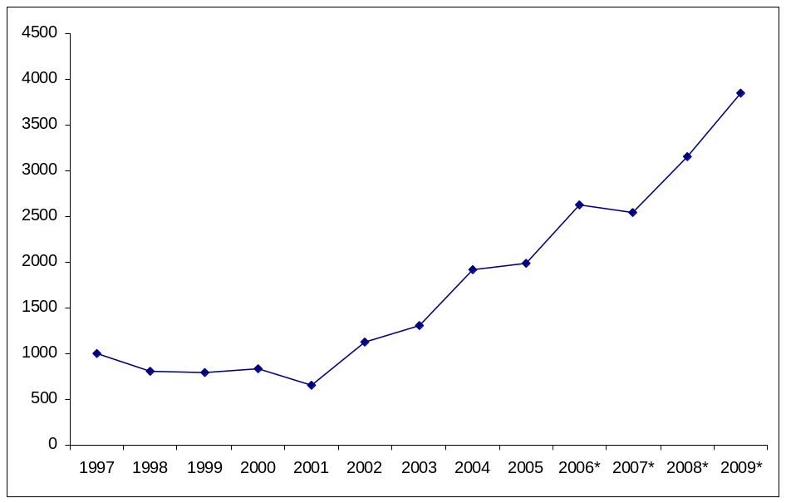

Figure 1.13: Freshwater fishing (*New methodology by SEPA and Statistic Institute)

It is not realistic that the increase of fishery is so high. Freshwater fishing was about 10 000 t per year in eighties and nineties. With stronger control and efficacy monitoring it is registered smaller illegal fishery. But there is evident increase in the period 2006-2009 and this is the increase registered by same methodology. Economic crisis could be one of the reasons for that.

Trend of most important fish species catch, shows increase in Ciprinus carpio, Silurus glanis and Scizostedon lucioperca species. In 1997 it was the most important catch in category of rest fish. But for 2009, we have precise data for species, due to precise questionnaire made by Serbian Environmental Protection Agency and Statistical institute of Serbia.
In 2009 it was evident increase in fish catch of Acipenser ruthenus for 63%, Ciprinus carpio for 72 %, Scizostedon lucioperca for 77 % and Silurus glanis for 79 %.Total catch for selected species increased by about 80 % in 2009. There is no precise explanation of this increase. Economic crisis and much higher level of water in rivers could be some of the reasons for explanation.

1.6.4. Hunting

There are 296 hunting grounds in Serbia, which is a considerable decrease compared to 457, in year 1999. The total hunting area in Serbia is approximately 7 million hectares, out of which 87% is hunting ground with over 26% of it being forest land.

90000 registered hunters in Serbia in 2008 are about 9% more than in 1999.

The hunting of most important game animal species is decreased compared to the previous period. According to Serbian Hunters Association data, the hunting of small game animals has decreased during year 2006 by approximately 10% in comparison to year 2005, whereas the hunting of large game animals has increased by 2% concerning wild boars and approximately 10% concerning roe deer.

These data indicate the incorrect balance sum of species numbers, not only for the faulty gauge of species numbers, but also for the unrecorded poaching or deliberate diminishing of revenues issued from the use of natural resource. Due exactly to such system, according to which, the hunting ground users gauge the species numbers and control hunting by themselves, an expert monitoring needs to be applied and thus make the hunting biologically and economically sustainable.

2. Current Status of National Biodiversity Strategy and
Action Plan

Since ratification of the Convention on Biological Diversity in 2001, Serbia has made a significant progress in protecting biodiversity through legislative and institutional framework, as well as by making some concrete steps in this respect.

Since the National Biodiversity Strategy and Action Plan is a new document there is no overview available of the progress made in the implementation of priority activities so far. The specific actions have already been taken and several operational objectives of the National Biodiversity Strategy and Action Plan are therefore already being implemented.

It is important to underline that most of the policy results included in the previous policy planning document also covered the biodiversity issues.

Challenges to the protection of biodiversity

One of the key challenges for Serbia is how to reconcile conservation and environmental considerations with economic development and economic interests and to achieve the real implementation of biodiversity principles in sectoral policies.

Serbia has a relatively low degree of preserved biological and landscape diversity on the European level. The trend of loss of biological and landscape diversity in Serbia is caused by general and recognizable factors and, as such, it represents a challenge for the future.

Principles for biodiversity protection

The basic principles for biodiversity protection are:

- Awareness raising campaigns to promote the legislation related to protection of nature/biodiversity, organized as activities on ongoing basis by both government and non-government sectors;
- Identification of wild flora and fauna species for which urgent action plans/protection programs are needed;
- Integration of necessary measures and requirements for protection of nature and biodiversity into the relevant legislation in all fields of economy relaying on use of biological/nature resources;
- Integration of necessary protection measures into the sectors of tourism, spatial planning and construction of major infrastructure facilities;
- Identification of potential eco-tourism sites. Drafting of relevant standards and criteria for development of eco-tourism in protected nature areas.

Summary of the Progress

The following information provides a summary of the progress.

- Convention on Biological Diversity has entered into force;
- A number of environmental conventions on global, European and regional levels have been signed;
- Several key laws in the area of environmental protection and sustainable development have been promulgated, which have all been harmonized with the appropriate EU directives;
- A number of bylaws have been drafted;
- The National Strategy and Action Plans have been drafted and are currently pending adoption;
- Preparation for the mapping out of the National Strategy of Sustainable Utilization of Natural Resources and Goods has started;
- The Law on Environmental Protection for the first time in our country predicted wider use of economic instruments in the area of environmental policy and sustainable development. One of the instruments is the establishment of the Fund for Environmental Protection;
- Preparation of new Law on GMO is in progress and introduction of the procedure of Biosafety Clearing-House mechanism has started;
- Institutional and organizational adjustments have been done, such as foundation of the Environmental Protection Agency;
- Setting-up of an environmental protection Information System (within the Environmental Protection Agency) for the purpose of establishing a data base for classification, presentation and distribution of numeric, descriptive, and spatial databases;
- CORINE Land Cover 2000 has been developed in Serbia;
- Important Plant Areas (IPA) in Serbia;
- Important Bird Areas (IBA) in Serbia;
- Protection of biodiversity of the Sava River Floodplains;
- Creating the terms for accessing to Natura 2000/Emerald Network, etc.;
- “Development of Strategy for Biodiversity Protection”, “Development of EMERALD Network in Serbia and Montenegro” financed by the Council of Europe;
- “Inventory of wetlands and other wet habitats in Serbia”, financed by MSEP-DEP;
- “Ex situ protection of biodiversity of aquatic ecosystems in Serbia”, financed by MSEP-DEP;
- “Harmonization of national nomenclature of classification of habitats with international standards (EUNIS system of classification)”, financed by MSEP-DEP;
- “Centres of flora biodiversity in Serbia, guidelines for evaluation and implementation of protection strategy” (IPA), financed by MSEP-DEP;
- Important areas of bird species diversity have been identified for the purpose of implementing the Council Directive 79/409/ЕЕC, the Convention on Wetlands, the Bern and Bonn Conventions;
- “Establishment of Green Belt in Serbia” as a part of the European Green Belt Project, financed by MSEPDEP.

2.1. Overview of Programmes, National Biodiversity-related Strategies and Action
Plans

Biodiversity considerations have been integrated into several sectoral development plans. Also, several strategic documents aiming at biodiversity conservation have been developed, with regard to forestry, hunting, eco-tourism, etc. The National Strategy of Sustainable Development in Serbia, the National Strategy of Agriculture, the National Forestry Policy with ecosystem approach. Serbia has outlined its nature conservation policy objectives in a range of documents.

Some of these plans are explained in further detail below.

National Program for Environmental Protection (NES)

According to the Law on Environmental Protection, the National Program for Environmental Protection (National Environmental Strategy -NES) shall be adopted for a minimum period of ten years. The National Program for Environmental Protection (NES) represents a strategic framework for tackling ecological and environmental concerns. The NES is implemented through a National Environmental Action Plan which represents an institutional framework for access to projects and budget funds, as well as EU pre-accession funds. This is the most important and the most comprehensive, cross-sectoral strategic planning and management tool in the field of environmental protection.
The National Program for Environmental Protection (Official Gazette of the Republic of Serbia No. 12/2010) was promulgated by the Government of the Republic of Serbia on the basis of the Law on Environmental Protection. The Programme will be implemented through the Action Plan, which will be developed by the Ministry of Environment in cooperation with other ministries.

National Strategy for Protection of Nature and Natural Values

According to the Law on Environmental Protection, the National Strategy for Protection of Nature and Natural Values as well as nature protection programs shall be adopted for a period of ten years. The Strategy shall stipulate the long-term objectives and guidelines for conservation of nature and natural values, implementation of such objectives in compliance with overall economic, social and cultural development of the Republic of Serbia. It is developed in line with the reports on the status of nature and implementation of protection of nature and natural values. The Guidelines set out by the National Strategy shall be incorporated in development of the design documents for spatial planning and management plans for natural recourses.

According to the National Strategy, the Autonomous Province and local self-government units shall adopt their own environmental protection programs.

National Strategy for Sustainable Development and Action Plan for Its Implementation

The Republic of Serbia Sustainable Development Strategy for the period of 2009-2017 was adopted in May 2008 (Official Gazette of the Republic of Serbia, No. 57/08). The Strategy is based on globally accepted principles defined in the Johannesburg Declaration on Sustainable Development, the UN Millennium Development Goals, and the EU Sustainable Development Strategy. Protecting and improving the environment and a rational utilization of natural resources are some of the basic national priorities of the Republic of Serbia. A group of outcome indicators in accordance with the internationally recognizable sustainable development indicators has been selected to monitor the Strategy implementation. These monitors have been set by the Strategy (outcome indicators) and ensure monitoring of Strategy implementation progress by following their values. The selected the indicators have been harmonized with the new, revised list of the UN sustainable indicators, also comprising indicators of the Millennium Development Goals’ implementation.

The Strategy provides for annual reporting on the progress of its realization.

Spatial Plan of the Republic of Serbia

One of the main goals of the Spatial Plan is to accomplish a protected and improved environment. In addition to other factors, improved environment should be based on a rational utilization of natural resources, use of renewable energy resources, afforestation and landscaping and other measures granting a healthier and more comfortable life in Serbia.

The Spatial Plan is adopted for the period of not less than 10, and not more than 25 years and its provisions are binding for all parties.

The Draft Law on Spatial Planning of the Republic of Serbia for the period from 2010-2020 stipulates the basis for long-term organization, spatial planning and utilization of area and regional plans of the Republic of Serbia for the purpose of bringing into line its economic and social development with natural, environmental and cultural potentials and limitations in its own territory. Monitoring of implementation of the Spatial Plan, respectively promotion of spatial development of the Republic of Serbia is provided through a set of spatial development indicators for the Republic of Serbia.

Millennium Development Goals

These goals and targets are based on the UN Millennium Declaration adopted by the General Assembly as a part of the guidelines for the UN Secretary-General to implement the Declaration.
The Report entitled “National Millennium Development Goals in Serbia” was adopted in 2007, and the defined National Millennium Goals should be taken into consideration during development of strategy papers and action plans.
The main targets of Goal 7 (Millennium Goals for Serbia until 2015) i.e. the Goal referring to the environment are to ensure environmental sustainability. This Goal comprises the following Specific Targets, namely:

Target 1: Integrate sustainable development principles in national documents, halt the loss of natural resources and encourage their revitalization.

Specific Target 1: Adopt and implement national programs, strategies and laws governing the area of sustainable development and environmental protection in the Republic of Serbia by 2015.

Specific Target 2: Increase land area covered by forest to 32% of the total territory of the Republic of Serbia by 2015.

Specific Target 3: Increase the land area protected to maintain biodiversity to 10% of the total territory of the Republic of Serbia by 2015.

2.2. National Biodiversity Strategy and Action Plans

The National Biodiversity Strategy of the Republic of Serbia is pending adoption.

The National Biodiversity Strategy and Action Plan (NBSAP) was developed with the involvement of relevant sectors, governmental and non-governmental organizations. After a long preparation phase the NBSAP was approved by the Ministry of Environment and Spatial Planning.

The basic principles of biodiversity protection in NBSAP are:

1) Principle of preservation in situ – Biological diversity is most effectively conserved in situ;

2) Integration principle - State authorities, those of the Autonomous Province, and local self-governance units shall promote and facilitate the integration of biodiversity protection and enhancement into all sector policies by implementing mutually harmonized plans and programs and by implementing regulations through permit system, technical, and other standards and norms, and by financing biodiversity protection through incentives and other measures;

3) Principle of prevention and precaution – Every activity must be planned and implemented in the way that: causes minimal possible change in the environment; represents the smallest risk towards biodiversity and native ecosystems; reduces spatial burden and consumption of raw materials and energy in construction, production, distribution, and utilization; includes the possibility for recycling; and prevents or limits impact to the environment at the source of pollution;.

4) Principle of natural value preservation - Natural values shall be used under the conditions and in the manner to ensure the preservation of the values of geodiversity, biodiversity, protected natural goods, and native ecosystems.
Renewable natural resources shall be used under the conditions that ensure their permanent and efficient renewal and permanent quality enhancement.
Non-renewable natural resources shall be used under the conditions that ensure their long-term, economical, and reasonable utilization, including limited utilization of strategic or rare natural resources and substitution by other available resources, composite or artificial materials.

5) International cooperation principle – The conservation of Serbia’s biological diversity is affected by international activities and requires cooperation and actions extending beyond Serbia’s national borders;

6) Protected areas system principle – The designation of protected areas is one of the most important tools to protect biological diversity. Central to the conservation of Serbia’s biological diversity is the establishment of a comprehensive, representative, and adequate system of ecological viable protected areas integrated with environmentally sound management of all other areas, including agricultural and other resource production systems;

7) Principle of sustainable development - Sustainable development is a harmonized system of technical/technological, economic and social activities in the overall development, where the natural and acquired values of the Republic are used in a cost efficient and reasonable manner, in order to preserve and enhance the quality of the environment, including native habitats and biodiversity, for the present and future generations.

8) Principle of polluters' and legal successors' liability - Any legal or natural entity who shall be involved in environmental degradation by its illegal or improper activities shall be liable in compliance with the law.

9) Principle of "polluter pays" - the polluter (or “operator”) shall pay charges for damage or threat of damage to protected species, protected and natural habitats, and sites of special scientific interest (biodiversity), as well as water and land it causes or may cause, by its operations or activities.

10) Principle of "user pays" – any person who utilizes natural values shall pay real cost for their utilization and recultivation of the area.

11) Principle of subsidiary liability - State authorities, within their financial abilities, shall eliminate the consequences of habitat degradation and biodiversity loss and reduce damages when the operator is unknown, and when damage originates from the sources outside the territory of the Republic.

12) Principle of incentives - State authorities, i.e. those of the autonomous province, units of local self- governance shall take the measures for the preservation and sustainable management of environmental capacities, particularly by reduced utilization of raw materials and energy and prevention or reduction of habitat degradation and biodiversity loss via economic instruments and other measures, by the best available techniques, facilities, and equipment which shall not require excessive cost and through selection of products and services.

13) Principle of public information and participation - in the exercise of the right to healthy and biologically diverse environment everyone shall be entitled to be informed of the environmental status and to participate in the process of decision making whose implementation may have an effect towards the environment.

14) Principle of protection of right to healthy environment and access to justice - a citizen or groups of citizens, their associations, professional and other organizations shall be entitled to exercise their right to healthy environment before the competent authority or the court in accordance with the law.

2.2.1. Action Plans

The following strategic documents as Action Plans have been prepared on behalf of the Republic of Serbia:

- Action Plan for Import Control, Monitoring and Combating Invasive Allochtone Species for implementing European Strategy on combating and controlling invasive allochtone species;
- Action Plan for Wetlands Preservation of International Importance;
- Action Plan for Conservation of the Brown Bear (Ursus arctos);
- Action Plan for Conservation of the Gray Wolf (Canis lupus);
- Action Plan for Conservation of the Lynx (Lynx lynx) species in the Republic of Serbia aimed at implementing the Bern Convention;
- Action Plan for management of Acipenseridae Species in Fishing Waters of the Republic of Serbia for the period from 2005-2010;
- Action Plan for management of huchen in Fishing Waters of the Republic of Serbia ;
2.3. Progress in Legislation and Policy

A foothold for legislative and institutional framework of environmental protection is established in the Constitution of the Republic of Serbia which states that the citizens are entitled to healthy environment and obliged to protect and promote the environment in compliance with the Law. The Republic of Serbia defines and provides the system of protection and promotion of the environment, protection and promotion of flora and fauna by promulgating the Law granting sustainable management of natural resources and healthy environment.

Prior to adoption of the Law on Nature Protection (Official Gazette of the Republic of Serbia No.36/09), the legal ground for defining the public interest to designate protected areas was based on the Law on Environmental Protection (Official Gazette of the Republic of Serbia No. 66/91 and 135/04), and other laws dealing with the protection of nature prior to adoption of the Law on National Parks (Official Gazette of the Republic of Serbia No.39/93).

The main characteristic of the institutional framework today is a much better situation compared to 2004 when the first set of four EU Environmental Laws was adopted. Diversification and overlapping of duties and responsibilities within government institutions is still evident, although to a lesser degree. Notwithstanding visible results in certain sectors, such an approach upholds a piece-meal control of environmental protection issues at the level of the Republic causing coordination problems both horizontally (cross-sectoral issues) and top-down (from the level of the Republic to the local self-government level). Decentralization of duties and responsibilities continued in May 2009 when the second set of environmental protection laws was adopted.

After ratification of the Convention on Biological Diversity, within a rather short period Serbia ratified most of the significant global and regional environmental conventions, adopting a new set of laws in the field of environmental and nature protection. Significant positive changes have happened over the past several years in the area of harmonization of development policy and biodiversity protection.

Biodiversity-related Programmes

- National Strategy of Sustainable Development in Serbia (Official Gazette of the Republic of Serbia, No. 57/2008);
- Action Plan for implementation of the National Strategy for Sustainable Development;
- National Program for Environmental Protection (Official Gazette of the Republic of Serbia, No. 12/2010);
- National Strategy for Development of Forestry in the Republic of Serbia (Official Gazette of the Republic of Serbia No. 59/2006);
- National Strategy for Integration of Serbia into the Clean Development Mechanism – Waste Management, Agriculture and Forestry;
- National Strategy for Development of Agriculture in Serbia (Official Gazette of the Republic of Serbia, No. 78/2005).

2.3.1 International Treaties and Activities

The Republic of Serbia has been implementing several international and regional conventions and agreements relevant to environmental protection field and biodiversity conservation. Moreover, sub-regional and bilateral cooperation exists with several countries with the aim to promote the conservation and sustainable use of biodiversity.
- The Convention on Wetlands of International Importance, especially as Waterfowl Habitat (Official Gazette of the SRY, No. 9/1977);
- Convention on Biological Diversity - CBD Convention (Official Gazette of the SRY - International Treaties, No. 11/2001);
- Convention on International Trade in Endangered Species of Wild Fauna and Flora - CITES Convention (Official Gazette of the SRY - International Treaties, No. 11/2001);
- Convention on Cooperation for the Sustainable Use of the Danube River - Danube River Protection Convention (Official Gazette of Serbia and Montenegro - International Treaties, No. . 4/2003);
- Kyoto Protocol to the United Nations Framework Convention of Climate Change (Official Gazette of the Republic of Serbia - International Treaties No. 88/2007 and 38/2009);
- United Nations Convention to Combat Desertification, particularly in Africa - UNCCD (Official Gazette of the Republic of Serbia - International Treaties, No. 102/2007);
- Convention on Conservation of Migratory Species of Wild Animals - Bonn Convention (Official Gazette of the Republic of Serbia - International Treaties, No. 102/2007);
- The Convention on the Conservation of European Wildlife and Natural Habitats - Bern Convention (Official Gazette of the Republic of Serbia - International Treaties, No. 102/2007);
- The Convention on the protection and sustainable development of the Carpathians - Carpathian Convention (Official Gazette of the Republic of Serbia - International Treaties, No. 102/2007)

2.3.2. National Legislation in the Field of Nature Conservation

The nature protection system in the Republic of Serbia is regulated according to the following laws:

- The Law on National Parks (Official Gazette of the Republic of Serbia, Nos. 39/93, 44/93, 53/93, 67/93, 48/94, 48/94 and 101/05);
- The Law on Environmental Protection (Official Gazette of the Republic of Serbia, Nos. 135/04 and 36/2009);
- The Law on Strategic Environmental Assessment (Official Gazette of the Republic of Serbia, No. 135/04);
- The Law on Environmental Impact Assessment (Official Gazette of the Republic of Serbia, No. 135/04);
- The Law on Nature Protection (Official Gazette of the Republic of Serbia, No. 36/2009).

The following by-laws define in more detail the relevant nature protection laws:

- The Decree on Control of Utilization and Trade of Wild Flora and Fauna (Official Gazette of the Republic of Serbia, Nos. 31/2005, 45/2005, 22/2007, 38/2008 and 9/2010);
- The Rulebook on Designation and Protection of Strictly Protected and Protected Wild Flora, Fauna and Fungi (Official Gazette of the Republic of Serbia, No. 5/2010);
- The Rulebook on Criteria for Mapping of Priority Habitats and Habitat Types, Sensitive, Endangered, Rare and High-Priority Protection Habitats and Measures for Their Conservation (Official Gazette of the Republic of Serbia, No. 35/2010);
- Rulebook on Cross-Border Transport and Trade of Protected Species (Official Gazette of the Republic of Serbia, No. 99/2009);
- Ordinance on Measures for Conservation and Protection of Fisheries Resources (Official Gazette of the Republic of Serbia, No. 1046/2009);
- Ordinance on Closed Season for Game Species (Official Gazette of the Republic of Serbia, No. 19/2002).

2.3.3. Biodiversity-related Legislation and Programmes

Among numerous important laws and strategic papers with significant impact on conservation of biodiversity, the most prominent ones are the following:

- National Strategy of Sustainable Development in Serbia (Official Gazette of the Republic of Serbia, No. 57/2008);
- The National Program for Environmental Protection (Official Gazette of the Republic of Serbia, No. 12/2010);
- The National Strategy for Integration of Serbia into the Clean Development Mechanism – Waste Management, Agriculture and Forestry;
- The National Strategy for Development of Forestry in the Republic of Serbia (Official Gazette of the Republic of Serbia, No. 78/2005);
- The Game and Hunting Law (Official Gazette of the Republic of Serbia, No. 18/2010);
- The Law on Forests (Official Gazette of the Republic of Serbia, No. 30/2010) ;
- The Law on Protection and Sustainable Use of Fisheries Resources (Official Gazette of the Republic of Serbia, No. 36/2009);
- The Rulebook on Cross-Border Transport and Trade of Protected Species (Official Gazette of the Republic of Serbia, No. 99/2009);
- The Ordinance on Measures for Conservation and Protection of Fisheries Resources (Official Gazette of the Republic of Serbia No. 1046/2009);
- The Ordinance on Closed Season for Game Species (Official Gazette of the Republic of Serbia No. 19/2002);
- The Law on Animal Welfare (Official Gazette of the Republic of Serbia No. 41/2009);
- The Law on Genetically Modified Organisms (Official Gazette of the SRY No. 41/2009);
- The Law on Livestock Breeding (Official Gazette of the Republic of Serbia No. 41/2009)

2.4. Conservation of Habitat and Ecosystem Diversity

Protection of nature within Serbia, as well as basic categorization of protected resources, has been defined in the Law on Nature Protection (Official Gazette of the Republic of Serbia, No. 36/2009).

In addition to protected areas as stipulated under this Law, there are also designated bird, flora and butterfly areas of international significance and Ramsar sites. Based on the Convention on Conservation of European Natural Habitats and of Wild Flora and Fauna, potential Emerald Sites have also been identified.

2.4.1. Protected areas

The total number of protected areas is 463, with square area of 518204 hectares. This is 5.86 % of the area of Serbia. In 2008, 6.6% of the areas were protected but revisions and loss of protection status for some areas resulted in the decrease of the total protected area.

Cumulative area of protected areas in Serbia
0
100000
200000
300000
400000
500000
600000
1985
1990
1995
2000
2005
2006
2007
2008
2009
(ha)
Nature monument
Cultural-historical monument
Nature reserve
Protected area
Nature Park
National park

Figure 2.1: Cumulative area of protected areas in Serbia.

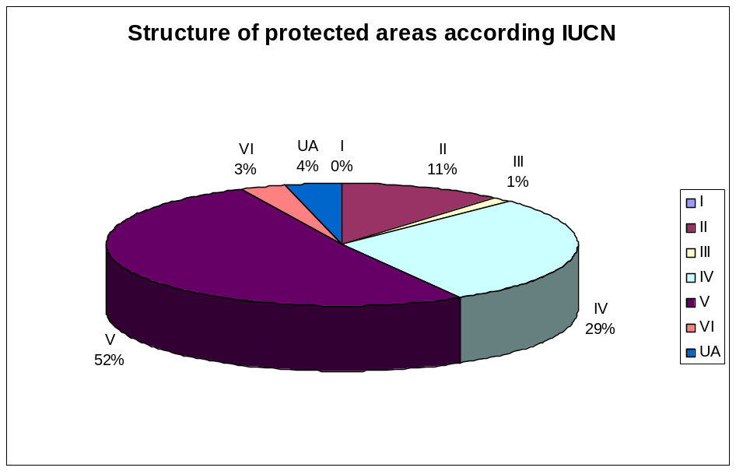
Figure 2.2: Structure of protected areas in Serbia according IUCN.

Within the UNESCO “Man and Biosphere-MAB” Programme, Nature Park “Golija” became a part of the biosphere reserves network in 2001, when it was named “Golija-Studenica”. Another nine natural areas have also been nominated for biosphere reserves.

2.4.2. Ecological Networks and Areas of International Significance

According to the Spatial Plan of Serbia from 1996, it was envisaged that the special nature values should reach 10% of the total land area of the Republic by 2010. However, until present some 5.86% of the territory enjoys the status of protected area.

The National Ecological Network is currently being developed in Serbia. The purpose of the Network is to conserve biological and landscape diversity, priority-type habitats, revitalization and/or promotion of deteriorated habitats of special interest for protection and conservation of endangered species.

A Reference Map with identified boundaries is due to be completed shortly, based on defined regional entities and according to the following protected areas of ecological significance:

1) Protected areas designated by law as such or under the procedure for being designated as protected areas, as well as protected areas identified as protected areas in the relevant strategic documents;
2) Areas of special significance for conservation, identified as such in line with the Convention on the Conservation of European Wildlife and Natural Habitats – the Bern Convention (Emerald Network);
3) Important Bird Areas (IBA) in line with the European Union priorities;
4) Important Plant Areas (IPA);
5) Selected Prime Butterfly Areas (PBA), in line with international regulations;
6) Areas listed in the Convention on Wetlands of International Importance (Ramsar Sites);
7) Speleological objects;
8) Transboundary areas in line with international regulations;
9) Types of priority habitats in the territory of Serbia as listed in the Rulebook on Criteria for Mapping of Priority Habitats and Habitat Types, Sensitive, Endangered, Rare and High-Priority Protection Habitats and Measures for Their Conservation (Official Gazette of the Republic of Serbia, No. 35/2010);
10) Rare and endangered wild species habitats at national, European or global level as well as habitats with endemic species in the Republic of Serbia as stipulated in the Rulebook on Designated Strictly Protected and Protected Wild Flora, Fauna and Fungi (Official Gazette of the Republic of Serbia, No. 5/010);
11) Any other areas of ecological significance not listed hereinabove, but designated as such in the Spatial Planning documents.

EMERALD SITES

Based on the criteria from the Bern Convention Recommendations (Recommendation No. 16, 1989), a List of Potential Emerald Sites in Serbia including 61 sites has been prepared. The total land area of these sites covers 1.019.269 ha which is equivalent to 11.54% of the territory of Serbia.

NATURA 2000

The Twinning Project ‘Strengthening Administrative Capacities for Protected Areas in Serbia (NATURA 2000)” was developed in a partnership between the Ministry of Environment and Spatial Planning of Serbia, on the one hand, and the Environment Agency form Austria together with the European Public Law Organization from Greece, on the other hand. The Project started on January 1st 2010 and will be finalized on December 31st 2011. The Project will contribute to (a) the harmonization of the Serbian legislation with the EU nature directives (Birds and Habitats Directive); (b) the establishment of the Natura 2000 Network in accordance with the EU criteria; (c) the development of two pilot management plans for NATURA 2000 areas, and (d) the elaboration and implementation of a training programme, which will systematically deal with capacity building in development of the NATURA 2000 Network in Serbia.

Pan-European Ecological Network (PEEN)

The Pan-European Ecological Network (PEEN) originated from the Pan-European Biological and Landscape Diversity Strategy (PEBLDS). The PEEN aims to link different European and national protected areas and ecological networks with the goal of ensuring a favourable conservation status of Europe’s key ecosystems, habitats, species and landscapes.

In the period from 2003-2006, the European Centre for Nature Conservation (ECNC) acted as a project coordinator with the aim of creating a map of the Pan-European Ecological Network (PEEN) in South-East Europe (SEE).

One of the results of the project was creation of the PEEN Indicative Map which identifies the core nature areas of European importance, existing corridors between these areas, and where new corridors could and should be established.
Green Belt

The goal of the European Green Belt Project is protection of the area with significant habitats which would create a part of an ecological network and spanning across the former “Iron Curtain Zone”. The European Green Belt, as a symbol of the unity between the East and the West would be a key component of the European goal to reduce the loss of biodiversity at global level by 2010 (Countdown 2010). The main objectives of this project are to strengthen transboundary cooperation, to raise awareness of local communities about the significance of biodiversity conservation, as well as to build capacities of the all stakeholders associated with the protected areas in this region. In that way the project contributes to the harmonization of management plans in the three adjoining nature protected areas, and likewise to the involvement of the local economies in the programs of protected areas management. Considering the transboundary character of this area, it is clear that cooperation and coordinated management measures are the key solutions for its sustainable future. The Green Belt established in Serbia covers 12 protected areas.

Ramsar Sites

According to the criteria from the Convention on Wetlands of International Importance and Waterfowl Habitats in particular, there are 6 Special Nature Reserves, 1 Special Landscape Area, in addition to other two protected areas in the territory of Serbia. The total area of the Ramsar Sites covers 55,627 hectares, which is equivalent to 0.63% of Serbian territory.

Important Bird Areas IBA

Forty-two internationally Important Bird Areas (IBA) have been registered in Serbia on 1,259,624 hectares, which is equivalent to 14.25% of the Serbian territory.

Important Plant Areas IPA

In addition, 62 internationally Important Plant Areas (IPA) on 7,473 km² or 8.5 % of the Serbian territory have been identified. The mapping of IPAs in Serbia is still in preparation. 56% of IPAs are protected in full or in part. The rest of IPAs are not under protection and frequently exposed to anthropogenic threats but may be proposed for protection in the near future.

Prime Butterfly Areas PBA

There are 40 Prime Butterfly Areas populated with day-flying butterflies. The PBAs cover the area of 903.643 ha which is equivalent to 10.23% of Serbian territory.

BOX 2.1: Successful Stories

- EMERALD NETWORK IN SERBIA

The Project for establishment of the Emerald Network in Serbia which started in 2005 was superseded by the Project entitled “Development of the Emerald Network in the Republic of Serbia”.

The Resolution No. 4 and Resolution No. 6 adopted by the Standing Committee of the Berne Convention serve as the basis for designating areas of special conservation interest within the Emerald Ecological Network. The Resolution No. 4 (1996) includes a list of endangered natural habitats requiring specific habitat conservation measures, while the Resolution No. 6 (1998) includes a list of flora and fauna requiring specific habitat conservation measures.

The List of Potential Emerald Sites of Serbia prepared in compliance with the criteria set out in the Recommendation No. 16 (1989) of the Bern Convention includes 61 sites.

Each of the selected 61 sites meets the basic criteria for nomination to the Emerald List i.e. each of these sites includes significant habitats of species defined by the Berne Convention as priority species and habitats for conservation at European level. Majority of these sites have already acquired a certain level of national protection (51 sites are either designated as protected natural goods or subject to protection review). In addition, certain sites are of international significance: one site is a Biosphere Reserve (Man and Biosphere / MAB UNESCO); 9 sites have been designated as Ramsar Sites; there are 35 Important Plant Areas (IPA); 35 nominated Important Bird Areas (IBA) and 30 Prime Butterfly Areas (PBA).

There is an ongoing procedure for protection of several areas (5 Areas), while preliminary examinations are in progress for new areas (5 Areas), the characteristics of which give grounds for their protection at national level.
Within this Project, the existing species and habitats in Serbia were identified and allocated according to respective Biogeographical Regions in line with the Resolution No. 4 and Resolution No. 6 adopted by the Convention on Conservation of European Wild Flora and Fauna and Natural Habitats, the EU Habitats Directive and the EU Birds Directive (Annex I and Annex II). In addition, the areas were allocated according to Biogeographical Regions; a Data Base of Areas of Special Conservation Interest (ASCI) in the territory of Serbia and Montenegro has been completed, including data on their respective ecological features; each identified area has its boundaries clearly marked within the GIS; the GIS incorporates data on availability of selected flora and fauna species and types of habitats. The Report on the Project activities has been submitted to the Ministry and to the Council of Europe and a publication entitled Emerald Ecological Networks in Serbia has also been published.

Further to the Convention on Conservation of European Wild Flora and Fauna and Natural Habitats, 61 potential Emerald Sites have been identified for the purpose of the Ecological Network, covering the total area of 1,019,269.31 ha, which is equivalent to 11.54% of the territory of Serbia. In addition, 73 priority habitats have been established in Serbia, out of which 65 habitats are located within the 61 potential Emerald Sites, including 189 Emerald Species, out of which 143 species are located within the selected areas.

- INVENTORY OF THE WEST STARA PLANINA Mt. BIODIVERSITY
The Project „Trans-Boundary Cooperation Through the Management of Shared Natural Resources – REReP, Promotion of Networks and Exchanges in the Countries of South-Eastern Europe“ was realised within the scope of the REReP Programme (Regional Environment Reconstruction Programme for South Eastern Europe). The basic task of the Project was to strengthen and develop the contact and cooperation between countries and people in score of environmental protection and biodiversity conservation. One of the main components of this project was strengthening of cooperation on protection and management of the key transboundary areas chosen by the countries of the south-eastern Europe and which has great significance in biodiversity protection, enabling in this way a successful transboundary social cooperation. The realisation of the Project started in the middle of 2000. At the end of 2001, local REC (Regional Environment Centre) offices in Serbia and Bulgaria, in cooperation with their countries and local organisations, designated the area of West Stara Planina-Mountain as the third transboundary area where the Project was realised. Two themes were defined that were related to the biodiversity of the Stara Planina Mt: „Inventory of the West Stara Planina Mt. Biodiversity“.

2.5. Protection of Species

The Decree on the Protection of Natural Rarities, comprising 215 flora species and 429 fauna species was in force until 2010 when the Rulebook on Designation and Protection of Strictly Protected and Protected Wild Flora, Fauna and Fungi (Official Gazette of the Republic of Serbia No. 5/2010) came into force.

According to the new Rulebook there are 1760 strictly protected and 868 protected wild species of flora, fauna and fungi. All endangered taxa are protected by the Ordinance on Proclamation of Wild Taxa as Protected and Strictly Protected.

In addition, utilization of certain types of mammals, flora, birds and fish is regulated by the Game and Hunting Law (Official Gazette of the Republic of Serbia No. 18/2010); the Law on Forests (Official Gazette of the Republic of Serbia No. 30/2010); the Law on Protection and Sustainable Use of Fishing Resources (Official Gazette of the Republic of Serbia No. 36/2009) and the Ordinance on Measures for Conservation of Fishing Resources (Official Gazette of the Republic of Serbia No. 104/2009).

TABLE 2.1: Changes in the number of protected species in Serbia between 1993 and 2010

Taxa | 1 | 2 |  | 3
Taxa | 1 | a | b | 3
Аlgae | - | 25 | - | -
Ferns (Pteridophyta) | 12 | 22 | 9 | 2
Seed Plants (Spermatophyta) | 203 | 559 | 554 | 76
Mosses (Bryophyta) | - | 47 | 10 | -
Fungi & Lichens | - | 75 | 37 | 25
Arthropoda (includes insects, spiders, crustaceans, and others) | 37 | 543 | 149 | -
Mollucs (Mollusca) | 4 | 61 | 3 | 3
Ringed worms (Annelidae) | - | 5 | 2 | 1
Fishes & Agnathas | 16 | 30 | 34 | -
Amphibians (Amphibia) | 19 | 18 | 3 | 3
Reptiles (Reptilia) | 14 | 18 | 2 | 2
Birds (Aves) | 273 | 307 | 35 | -
Mammals (Mammalia) | 66 | 50 | 30 | -

Legend:
1 - Decree on the Protection of Natural Rarities (Official Gazette of the Republic of Serbia No. 50/1993)
2 - Rulebook on Designation and Protection of Strictly Protected and Protected Wild Flora, Fauna and Fungi (Official Gazette of the Republic of Serbia No. 5/2010)
2a – Strictly protected wild species
2b – Protected wild species
3 - Decree on Control of Utilization and Trade of Wild Flora and Fauna (Official Gazette of the Republic of Serbia Nos. 31/2005, 45/2005, 22/2007, 38/2008 and 9/2010)

It is an evident increase of protected species for about 300%. This is the result of biodiversity monitoring development, more scientific biodiversity projects, and stronger “response” of the State. The Government also has prepared many Action Plans for endangered and protected species, especially for large carnivores.

The Decree stipulates the measures for control of utilization and trade of 112 species of wild flora and fauna, out of which 78 species of flora (2 fern species and 76 seed plant species), 15 fungi species, 10 lichen species (8 species from the Usnea genus, except for the ones which are strictly protected), as well as 9 fauna species (2 reptile species, 2 amphibian species and 4 invertebrate species).
2.5.1. Red Books of Plants and Animals

The lists and expert scientific studies of endangered wild species classified in the endangered categories and endangering factors, i.e. red lists and red books represent the basis both for undertaking of measures and activities that contribute to the preservation of endangered species and their habitats and for monitoring and making prognoses of the states of the populations of those species in the future. Addotionally, they are the basis for adoption of certain strategies, action plans, and decrees on protection of nature and natural values on the national level.

Red Book of Flora of Serbia 1 – Extinct and Extremely Endangered Taxa

Serbia got its first Red Book in 1999 and it is related to the extinct and extremely endangered plant species. It contains 171 plant taxa (species and subspecies) and presents around 5% of the total flora of Serbia. Out of that number, 4 taxa have been irretrievably lost from the world genofund, and before that they had lived only in Serbia; 46 taxa have dissappeared from the territory of Serbia, but they can be found in the neighboring territories or in ex situ conditions (botanical gardens); while 121 species are extremely endengered with a high probability of dissappearing from our territory in the near future or of disappearing from the entire world if due attention is not devoted to them.

Red Data Book of Serbian Butterflies, Lepidoptera: Hesperioidea and Papilionoidea

The Red Book of day-flying butterflies was published in 2003. It includes the presentation of 57 endangered species of day-flying butterflies, which in percentages represent 34% of the fauna of day-flying butterflies of Serbia. Apart from the extinct Fruška Gora Mt. Fenton’s wood white, among the extremely endangered ones are also the Alpine hesperida (Grizzled Skipper), Swallowtail, Eastern Dappled White, Stara Planina-Mount and Prokletija Mt. Yellow Spotted Ringlet, Apollo Butterfly, the Danube Clouded Yellow, Lesser Purple Emperor and Purple Emperor, Compton Tortoiseshell, Lesser Marbled Fritillary.

Preliminary list of species for the Red List of Vertebrates

The preliminary list of species for the Red List of Vertebrates was made by the end of 1990 and the beginning of 1991. This list is the basis and the startig point for the work on the Red List and/or Red Book of Vertebrata of Serbia.
This list includes 1 species of agnatha and 29 fish species, 22 amphibian species, 21 reptile species, 72 mammal species, and 353 bird species. The work on the Red List of Vertebrates has not been completed.

Atlas of Breeding Birds of Prey of Serbia

The publication was issued in 2000 and it contains the data on the distribution, number, the trend of nesting populations, sizes of areas, and specific problems of protection of all the 25 species of vulcher birds of Serbia, in the course of 1977-1996.

2.6. Monitoring, Reintroduction Programmes, In situ and Ex situ Conservation

The current status of biodiversity monitoring in Serbia can be characterized as rather incomplete and fragmented monitoring. The level and quality of the obtained data from monitoring is also very inhomogeneous. Another important issue is the scale of monitored parameters and the quality of data obtained in monitoring.

The Serbian Environmental Protection Agency (SEPA) was established 2004. One of its most important missions is to gather data from the environment monitoring, including biodiversity monitoring, their processing, and assessment and reporting on the national and international level.

A number of projects have been implemented focused on in situ protection of rare and endangered species and their habitats (Protection of Hermann’s Tortoises (Testudo hermanni) in the Republic of Serbia; Monitoring of metapopulation system of water grogs (Rana synklepton esculenta) in the south-eastern part of the Pannonian Plain; Diversity of the fauna of bats (Mammalia, Chiroptera) in Serbia; Sustainable development and protection of forest ecosystems in Serbia – harmonization with the international standards; Implementation of GIS technologies in the valuation and protection of natural potentials of the National Park Tara; Providing of conditions for sheltering the animals that are on the lists for control of trade in endangered and rare species, etc. In addition, preliminary monitoring of threatened animal and plant species in the territory of the Autonomous Province of Vojvodina was organized in 2002/03 by the Provincial Secretariat for Environmental Protection and Sustainable Development. It included biodiversity monitoring on the ecosystem and species level, monitoring of protected welfares of national and international interest, fragile ecosystems, rare and threatened species, endemic and relict species and their habitats.

Reintroduction is rather an efficient way of protection of species in their natural habitats. The Ministry of Environment and Spatial Planning initiated several reintroduction projects.

The project of the European beaver reintroduction in Serbia has been realized in association with the Ministry of Science and Environmental Protection – the Directorate for Environmental Protection, the Faculty of Biology in Belgrade, the Association from Bavaria, and SNR Zasavica. Several beaver families were reintroduced in Obedska Bara-Swamp and Zasavica special nature reserve.

Micropropagation and reintroduction of Nepeta rtanjensis, a stenoendemic and critically endangered perennial of Serbia is a successful ongoing project that is financed by the Ministry of Environment and Spatial Planning. The total number of the natural population of this species is estimated to only around 700.

Ex situ protection involves the activities that are focused on protection of rare and endangered species outside their respective natural habitats. Gene banks can be efficiently used for reintroduction (re-settlement) of the species that have disappeared from a certain area. Ex situ conservation programs include Zoos, botanical gardens, and rehabilitation centres for animals. Ex situ plant gene banks are located within quite a number of scientific institutions, first of all institutes and faculties.
The legal framework for those centres includes CITES Convention and bylaws. Serbia ratified the Convention on International Trade in Endangered Species of Wild Fauna and Flora - CITES Convention (Official Gazette of the SRY - International Treaties, No. 11/2001)

BOX 2.2.

Case studies: Conservation and monitoring of endangered bird species

Case 1:
-The Action Plan for Recovery and Conservation of the Vultures on the Balkan Peninsula was conceived as a long-term strategy of protection and replacement of vultures in the Balkan countries with the aim to create the best possible conditions for their survival, and it has been planned to also reintroduce certain species as required. This Action Plan involves a large number of prominent international organizations (the Black Vulture Conservation Foundation, the Frankfurt Zoological Society, the Foundation for the Preservation of the Bearded Vulture, the Legue for Protection of birds of France, BirdLife International, Royal Society for Protection of Birds, IUCN of Europe, the Working Group for Griffon Vulture for the Eastern Mediterannean), as well as a number of domestic governmental and non-governmental organizations. Within the project it has been planned to reintroduce griffon vulture in Stara Planina-Mount (Eastern Serbia), as well as of the black vulture in the southwestern Serbia. Preparations for reintroduction of griffon vulture have been initiated and their intensification is expected in the course of the years to follow.

Serbia was was included in the project in 2004 with its separate project „Action Plan for Protection of Vultures of Serbia“. The main activities in Serbia are realized through the monitoring of all the nesting colonies, individual pairs, and individual vultures and problems of their protection, regular operation of feeding sites for vultures, prevention of negative events, such as poisoning and killing, and numerous other activities.

Case 2:
- Black stork (Ciconia nigra) is a rare species in Europe (R), within the category SPEC 2, species of interest to protection in Europe. It has the status of strictly protected species in Serbia. The number of pairs in Serbia in the period 1990-2000 was 110-120, with contemporary indications of slight increase in number. The majority of pairs nests in old, conserved alluvial forests along the rivers Danube, Sava, Tamis and Tisa in Vojvodina, whereas the minor number of pairs also nests on rocks in highland areas. The centre of national population is in Special Nature Reserve „Gornje Podunavlje“, where 20-30 pairs nest, as well as in Special Nature Reserve „Obedska bara“, with its population of 18-20 pairs. The bird population is primarily endangered by inappropriate and unadjusted forestry and the lack of shallow water habitat appropriate for feeding.

Case 3:
- White-tailed eagle (Haliaeetus albicilla) within the category SPEC1, a globally endangered species which has contemporary experienced the complete population recovery in Serbia. During 2009, its number in Serbia was 86-114 pairs, out of which 97 were in Vojvodina. The changes in number of white-tailed eagle in the period 1950-2009 show rapid depopulation in 1950`s, stagnation in the period 1960-1980, slight increase in population till mid 1990`s, since when, the exponential increase has followed. That resulted in increased number of known nesting pairs, from 20 in 1998 to 86 in 2009, that is, it increased 4,3 times in 22 years (Ham I, Skorić S. & Vučanović М. (2009): The distribution, successful nesting and population number of white-tailed eagle Haliaeetus albicillain in Serbia in 2009. Ciconia 18: 16-28). The essential reasons of increase in population number are partial improvement of habitat condition, conservation of nesting sites and feeding in winter, and also positive trends in surrounding populations in Europe. The greatest number of pairs in Serbia (18-20) nests in Special Nature Reserve „Gornje Podunavlje“.

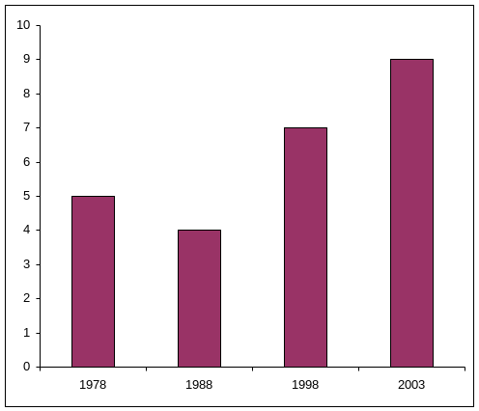

Number of nesting pairs of white-tailed eagle (Haliaeetus albicilla) in the protected area “Gornje Podunavlje-Upper Danube River Basin” in the period of 1978-2003

2.7. Genetic Resources Management

In ex situ protection, the biggest importance have the plant gene banks and the national collections in different scientific institutions (institutes and faculties: the Institute of Field and Vegetable Crops, Novi Sad; the Institute of Fodder Crops, Kruševac; the Institute of Small Grain Crops, Kragujevac; the Institute of Vegetables, Smederevska Palanka; the Potato Centre, Guča; the faculties of agriculture of the Universities in Novi Sad and Belgrade). The national collection of the plant gene bank, the formation of which was initiated in the nineties of the twentieth century, is temporarily accommodated in the Maize Research Institute in Zemun Polje, up to the setting up in operation of the Plant Gene Bank in Batajnica within the Directorate of National Reference Laboratories. This collection contains 4,238 samples of plant genetic resources: cereals – 2,983 in total, industrial crops – 367 in total, vegetables – 214 in total, fodder crops – 285 in total, as well as 389 samples of medicinal and aromatic plants.

Based on the data contained in the Draft Programme of Rural Development (2008-2013), presence has been recorded in Serbia of over 44 autochthonous and exotic breeds of domestic animals (7 breeds of horses, 1 breed of donkeys, 8 breeds of cattle, 3 breeds of goats, 5 breeds of sheep, 18 breeds of hogs, and several breeds of poultry). Between 400 and 500 agricultural farms and cooperatives possess endangered species. FAO information system for diversity of domestic animals (DAD-IS) contains information on the presence of over 100 breeds and strains of domestic animals in the territory of the Republic of Serbia.

Introduction of the documentation system and the first programme of professional training was initiated in 1989, in cooperation with ECPGR (European Cooperative Programme for Plant Genetic Resources, coordinated by IPGRI – International Institute of Plant Genetic Resources) and the Nordic Gene Bank, whereby the Maize Research Institute in Zemun Polje was designated as the national coordinator. NOBIS computer system was introduced in order to enable the use of descriptors and databases. Sixty four databases of the national collections were compiled for 4,958 genotypes with passport data, characterization, and previous evaluation. The data are centralized in the central database of the national plant gene bank. Characterization, evaluation, and regeneration are parts of the tasks of the Institute. International collections do not contain the complete overview of the bank of genetic resources of our country. It is known that samples of small grain wheat, potato, water melon, and some other old varieties exist in Beltswille (USA) and in the Institute of Plant Industry VIR (Russia). It is also known that a sample of spring barley is in the collections of Gatersleben (Germany) and ICARDE (Syria). It is also believed that numerous samples and collections of alfalfa, medicinal plants, spring common oats, large-seed legumes, and cabbages are in foreign plant gene banks, but there are no data that would corroborate such assumptions. It is believed that the autochthonous materials of maize and wheat from the former SFRY exist in the gene banks in the USA, Russia, and Italy, but the communication that would enable insight in the state of those collections is currently insufficiently developed.

In view of the fact that, on the national level, the law (or bylaws) on genetic resources has not as yet been adopted, the issues of preservation, access to, and use of genetic resources are not regulated in an adequate way.

2.8. Landscape Conservation

In Serbia there is no strategy that would concretely cover protection and sustainable utilization of landscape diversity, nor are the landscape issues integrated in sectoral policies. Yet another weak aspect, particularly of the present period, is slow adoption of a modern legislation that would ensure due implementation of relevant international agreements and initiatives that include conservation and sustainable utilization of landscapes, and particularly for establishing of a sufficient legal framework for sustainable use of landscapes in Serbia. As opposed to biodiversity and nature protection, landscape protection is not even concretely considered within the National Environmental Strategy (NES). The only exception is the 2004 Law on Environmental Protection, in which landscapes are mentioned within the protected and public natural goods. The procedures for (environmental) impact assessment insufficiently include landscapes and preservation of their diversity.

The overall institutional framework in this area is still weak and with insufficient capacities to consider all the aspects of sustainable utilization of landscapes and adequate protection of the diversity of types of landscapes.
The methods for classification and categorization of types of landscapes and indicators for assessment of their preservation, cultural, scientific, and production values have not been elaborated. Public awareness of the importance of protection of landscape diversity and of its environmental capacity in the context of sustainable development is on a very low level.

The main problems of protection and development of landscapes in the Republic of Serbia, i.e. the problems of degradation of quality are as follows:

- Fragmentation and degradation of landscapes due to urban development, construction of infrastructure systems, water storages, tourist and recreational centres, overexploitation;
- Homogenization of landscapes, which takes place due to the intensification and increase of the level of agricultural production, which results in the disappearance of biodiversity (landscape, ecosystem, and species);
- Disappearance of the characteristic mosaic pattern in rural landscapes, which takes place due to depopulation and abandoning of the traditional method of land use;
- Disappearance of the specific character of urban and rural landscapes by expansion of periurban areas, conversion of agricultural land, construction and utilization of space, which do not take into account the regional and local specific features;
- Reduction of green and open spaces in urban environments and loss of the link with the regional system of open spaces.

The following objectives of the Policy include preservation and sustainable utilization of landscape diversity in Serbia:

- Development of the national strategic framework for preservation and sustainable use of landscapes in Serbia
  - Making of the national classification of landscapes and inventory taking of landscape types, assessment of their statuses, as well as assessment of the overall landscape diversity in Serbia.
  - Making of the Atlas of Landscape Types in Serbia.
  - Mapping out of the National Strategy for Preservation of Landscapes on the basis of an integral approach to individual landscape types.
- Strengthening of the legislative and regulatory framework for preservation of landscape diversity in Serbia
  - Accession to the European Convention on Landscapes;
  - Adoption of a new Law on Preservation of Nature and Landscapes including harmonization with the EU legislation (EU’s Acquis) and international initiatives, including in the field of preservation of geodiversity;
  - Making of the analyses of omissions in covering of the types of landscapes of importance for preservation within the network of protected areas;
  - Extension of the network of protected areas in order to achieve legal protection of representative examples of diversified types of landscapes, which are of importance for conservation due to their scientific, landscape, cultural, and other values;
  - Introduction and imposing of adequate penalties/fines for non-compliance with statutory regulations;
  - Adoption of a system of incentives for landscape preservation.
- Integration of the landscape issues in the strategies of development and spatial planning, and in the sectoral policies
  - Revision of the existing methods of spatial planning with the aim to incorporate landscape issues in the official methodology for drawing up of spatial plans.
  - Definition of borders for the use and/or prohibited anthropogenous activities with respect to different landscape types.
  - Improvement in resolving the issues of protection of landscape diversity in the management plans for protected areas.
- Implementation of management systems that improve the practices of land management in order to protect the diversity of landscape types
  - Promotion of adaptive land use management systems.
  - Development of the best practices: Landscape Management Codex.
  - Strengthening of aspects of landscape diversity in the procedures for Environmental Impact Assessment.
  - Establishing of the landscape monitoring and information system (as an integral part of the environmental information system)
- Restoration of the degraded parts of landscapes
- Drawing up of the integral programme of landscape research
- Strengthening of institutional capacities for preservation of landscape diversity in Serbia
  - Setting up of an institutional mechanism for horizontal and vertical coordination of landscape aspects in the context of sustainable development between different interested parties.
  - Expanding of the capacities of the Institute for Nature Conservation of Serbia for the purpose of covering landscape preservation, as well as for the purpose of strengthening its role in the coordination/supervision of preservation of landscape diversity.
  - Drawing up of the programme for development of capacities in the area of preservation of landscape diversity targeted to municipalities/local self-governments.
- Promotion of the support to education and raising of public awareness with respect to the importance of landscape preservation in the context of sustainable development
  - Adaptation of the educational system so as to integrate strategies for preservation of landscape diversity.
  - Drawing up and implementation of the programme of education of public and its awareness raising, as well as for land users, promotion of landscape preservation and their importance in the context of sustainable development.

2.9. Obstacles in Environmental Protection and Nature Conservation

General causes of problems in the environment

1. Lack of strategic and planning documents in the areas of environmental protection and sustainable use of natural resources defined in the Law on Environmental Protection and special laws

2. Poor integration of the environmental protection policy in the policies of other sectors. In formulation of policies in the Republic of Serbia, sectoral planning is still dominant with very little horizontal integration. The existing sectoral strategies are not sufficiently harmonized with respect to the environmental protection.

3. Insufficient institutional capacities. The capacities of the institutions are not sufficient to respond to a wider reform of the policy, or legislation in the area of environmental protection. Due to insufficient institutional coordination, both on horizontal and on vertical planes, adoption and implementation of strategic documents, laws, and of other regulations is aggravated. Particularly, the capacities on the local level are insufficiently developed for implementation the set of laws from 2004, and particularly the set of new laws in the area of environmental protection adopted in 2009. Transfer of competence to the local level also requires capacity building on the local level.

4. An ineffective monitoring and reporting system. Not all the relevant criteria and indicators for monitoring have been established.

5. Insufficiently efficient enforcement of regulations in the area of environmental protection results from the incomplete legal system, insufficient institutional capacities, insufficiently efficient inspection supervision, and slowness of courts.

6. Insufficient capacity in surveying the legislation implementation and inadequate sanction system regarding violation of nature conservation regulation.

7. Ineffective system of financing of environmental protection and lack of economic incentives. The level of budgetary investments in the environment is low, on average (2001-2008 periods) it amounts to 0.3% of GDP annually. The system of economic instruments is undeveloped and does not enable sufficient economic incentives for reduction of pollution.

8. Low level of awareness related to the environment, insufficient education on the environment, and inadequate participation of general public in decision making. Formal education in the area of environmental protection within the educational process is not as yet satisfactory.

Obstacles in Nature Conservation

Nature conservation is not a priority for the government as yet, although there are several great achievements in the implementation of nature legislation and policy documents. Also, the traditional obstacle is the economic pressure and the fact that nature conservation is mostly seen as a restrictive issue. Insufficient incorporation of biodiversity issues into sectoral strategies and programmes can be considered as another important obstacle and even if sometimes it has been incorporated, in reality it has been given low priority or has remained just as a declarative issue.

Main obstacles in Nature Conservation are:

- Insufficient implementation of the environmental and nature protection legislation;
- Serbia has not as yet accessed to the International Agreement on Pan European Strategy for Biological and Landscape Diversity Conservation;
- There are no national programmes for plant genetic resources, which results in losses of agro-biodiversity. There is a need for the establishment of a professional body, which should determine priorities;
- There are no scientifically proven data as yet (national flora, national vegetation, and national fauna) on the life existing in the territory of Serbia;
- Lack of an integral information system and the system of indicators for biodiversity monitoring;
- An inadequate spatial planning system and inefficient implementation of the spatial planning and urbanization system;
- Lack of efficient inter-sectoral cooperation in the field of protection of biodiversity and lack of integration of biodiversity protection in sectoral development policies;
- Insufficient staff in protected areas and municipalities, which would perform the activities related to the CBD requirements. Those problems are less represented at scientific institutions’ level;
- Inefficient system and mechanisms for management of national parks, Ramsar areas, biosphere reserves, and other protected areas;
- Inadequate management of forest ecosystems and protected areas;
- An ineffective management system for collection of and trading in wild flora, fauna, and fungi;
- Lack of adequate economic and financial instruments for nature protection and management of protected areas

3. Sectoral and Intersectoral Integration of Biodiversity
Conservation

Biological resources represent an important economic potential. Their exploitation significantly contributes to the socio-economic development. Biological resources are renewable, but only to a certain extent. If their exploitation in agriculture, forestry, or industry is excessive, the survival of certain species and/or ecosystems could be put into danger. The principles of sustainable use of biological resources must be implemented first of all within sectors that significantly contribute to socio-economic development, such as agriculture, forestry, hunting, fishing, energetic, industry, etc.

3.1. Environmental protection and EU integration
- Resolution of the National Assembly for the Accession to the EU
- National Strategy of Serbia for the Accession to the EU
- Action Plan for harmonisation of the legislation of the Republic of Serbia with EU legislation
- Resolution of the Council of 6 November 2007 on principles, priorities, and conditions of EU partnership with the Republic of Serbia, including Kosovo, according to the UN Security Council Resolution 1244 of 10 June 1999, and repealing Decision 2006/56/EC
- Commission of the European Communities, Serbia 2006 Progress Report, SEC(2006) 1389, of 8 November 2006
- Convention on access to information, public participation in decision-making and access to justice in environmental matters (Aarhus Convention) ("Official Gazette of the Republic of Serbia – International Conventions" No. 38/09 of 25 May 2009)

3.2. Legal and institutional framework for environmental management

The system of legal norms in environmental protection and improvement in the Republic of Serbia consists of a number of laws and other regulations. Legal and executive authorities are appointed to competent republic organs. Certain authorities are legally devolved to the autonomous province or local governments.

3.2.1. Funding systems in Environment Protection

System of financing environmental protection in the Republic of Serbia is decentralised and counts on dedicated funds, own resources, and budget resources.

Other sources of financing include municipal budgets, industrial financial resources, public enterprises financial resources, and foreign financial aid. General characteristics of the system of financing environmental protection are the insufficiency of dedicated funds and decentralisation of financing sources, particularly from the private sector, as well as the lack of application of financial instruments such as long-term loans, securities, partnership between public and private sector, or investment in stocks.

Proportional investment of dedicated funds for environmental protection related to the realised gross domestic product in 2001 and 2008 was 0.3%. Other countries in transition assign around 2% of GDP for environmental protection.

Funds for environmental protection at the republic level come form taxes for commercial collecting and trading of wild flora and fauna, taxes for environmental pollution equalling 60%, taxes for environmental pollution in areas of particular national interest equalling 80%, taxes for water protection, and funds approved by the Law on Budget of the Republic of Serbia.

The Fund for Environmental Protection was established in 2005, in keeping with the Law on Environmental Protection, for the purpose of securing financial resources for stimulation of environmental protection and improvement in the Republic of Serbia.
The budget funds of the autonomous province and local governments are imposed.
The most active donors and international financial institutions that provide financing of environmental protection include: the EU, the World Bank, the European Bank for Reconstruction and Development, and bilateral donors.

3.3. Integrating biodiversity conservation into relevant sectors

3.3.1. National legislation

The new legal framework on environmental protection was introduced into the Republic of Serbia by a set of laws from 2004 (Law in Environmental Protection, Law on Strategic Environmental Impact Assessment, Law on Environmental Impact Assessment, and Law on Integrated Prevention and Control of Pollution), and it was significantly improved in 2009 by adopting the second set of laws (16) related to environmental protection ("Official Gazette of the Republic of Serbia" No. 36/09, Appendix 1), which represent a major progression in coordination of regulations related to environmental protection with EU directives.

A significant number of laws that regulate specific sectors, including issues on environmental and biodiversity protection, were implemented in Serbia. The most important are:

- Law on Mining ("Official Gazette of the Republic of Serbia" No. 44/19995, 34/2006 and 104/2009)
- Law on Geological Research ("Official Gazette of the Republic of Serbia" No. 44/1995 and 101/2005)
- Law on Spatial Planning of the Republic of Serbia ("Official Gazette of the Republic of Serbia" No. 13/1996)
- Law on Plant Protection ("Official Gazette of the Republic of Serbia" No. 24/1998, 26/1998, 101/2005, and 41/2009)
- Law on Water Regime ("Official Gazette of SRY" No. 59/1998, "Official Gazette of the Republic of Serbia" No. 101/2005)
- Law on Energetics ("Official Gazette of the Republic of Serbia" No. 84/2004)
- Law on Agricultural Land ("Official Gazette of the Republic of Serbia" No. 62/2006, 65/2008, and 41/2009)
- Law on Organic Production ("Official Gazette of the Republic of Serbia" No. 30/2010)
- Law on Forest Reproductive Material ("Official Gazette of the Republic of Serbia" No. 135/2004, 08/2005, and 41/2009)
- Regional Development Strategy of the Republic of Serbia for 2007-2012 ("Official Gazette of the Republic of Serbia" No. 21/2007)
- Law on Air Protection ("Official Gazette of the Republic of Serbia" No. 36/2009)
- Law on Tourism ("Official Gazette of the Republic of Serbia" No. 36/2009)
- Law on Protection from Environmental Noise ("Official Gazette of the Republic of Serbia" No. 36/2009)
- Law on Waste Management ("Official Gazette of the Republic of Serbia" No. 36/2009)
- Law on Chemicals ("Official Gazette of the Republic of Serbia" No. 36/2009)
- Law on Agriculture and Rural Development ("Official Gazette of the Republic of Serbia" No. 41/2009)
- Law on Animal Husbandry ("Official Gazette of the Republic of Serbia" No. 41/2009)
- Law on Plant Health ("Official Gazette of the Republic of Serbia" No. 41/2009)
- Law on Plant Protection Products ("Official Gazette of the Republic of Serbia" No. 41/2009)
- Law on Genetically Modified Organisms ("Official Gazette of SRY" No. 41/2009)
- Law on Planning and Construction ("Official Gazette of the Republic of Serbia" No. 72/2009)
- Law on Environmental Protection Fund ("Official Gazette of the Republic of Serbia" No. 72/2009)
- Law on Waters ("Official Gazette of the Republic of Serbia" No. 30/2010)
- Law on Forests ("Official Gazette of the Republic of Serbia" No. 30/2010)
- Low on Game Annimals and Hunting ("Official Gazette of the Republic of Serbia" No. 18/2010)

3.4. Environmental protection in national strategic documents

Implementing the strategies is a cross-government responsibility, with leadership from all departments to their stakeholders. To halt biodiversity loss, the strategies seek to make biodiversity a part of the mainstream policies and to incorporate the relevant targets at the country level. The basis for most of this is a statutory requirement for public bodies to take account of biodiversity conservation when realising their functions. The strategies emphasise that healthy, thriving and diverse ecosystems are essential to everybody’s quality of life and well-being.
The strategic framework for biodiversity protection is defined through strategic documents and purposes of the Serbian Government for the accession to the EU, through the National Environmental Protection Programme, and through strategic sectors (agriculture, forestry, etc.). The most important strategic documents include:

- National Strategy for Economic Development of the Republic of Serbia for 2006-2012
- Regional Development Strategy of the Republic of Serbia for 2007-2012
- Energy Sector Development Strategy of the Republic of Serbia by 2015
- Agricultural Development Strategy of the Republic of Serbia
- Integrated Border Management Strategy
- Foreign Investment Stimulation and Development Strategy
- Forestry Development Strategy
- Waste Management National Strategy with the EU Approximation Programme
- Poverty Reduction Strategy
- Spatial Plan of the Republic of Serbia
- Water Management Basics of the Republic of Serbia
- Strategy for Development of Railway, Road, Water, Air, and Intermodal Transport in the Republic of Serbia for 2008-2015

*National Strategy for the Accession of Serbia and Montenegro to the EU from 2005 sets the main goal to increase the gross domestic product rate through investments based on principles of sustainable development.

*National Strategy for Sustainable Development of Serbia was adopted in 2008. In Chapter 5, Environment and Natural Resources, the following are listed as sector goals in biodiversity protection: issuing the law on nature protection and ratification of international conventions, development of the National Strategy for Biodiversity Conservation and Action Plan, enlargement of natural protected areas up to 10% of the country's territory, establishment of biomonitoring, information system, inventory, biodiversity monitoring, GMO control, Gene Bank. According to goals determined in the Strategy, the Action Plan defines the following: specific measures and/or activities for Strategy implementation; competent institutions and partners in implementation of measures and/or activities; deadlines for implementation of measures and/or activities; total cost of implementation of measures and/or activities, and financing sources.
Goals of protection and improvement of biodiversity in this strategy include:

- issuing the law on nature protection and ratification of international conventions;
- development of the national strategy for sustainable use of natural resources and assets;
- development of the national strategy and action plan for biodiversity conservation;
- enlargement of natural protected areas up to 10% of the territory of Serbia, namely, enlargement of protected areas network, establishment of ecological corridors, and of ecologically important areas network;
- establishment of efficient biomonitoring system;
- establishment of information system on biota and other natural assets of the Republic of Serbia;
- inventory of biological diversity in the Republic of Serbia;
- establishment of monitoring of biodiversity components;
- implementation of efficient GMO control mechanisms in keeping with the EU practice;
- improvement of methods for sustainable use of the gene pool and establishment of a genetic material bank, with increased support to genetic resources conservation, and increase of the number of subjects and areas included in conservation activities.

*Development of the National Environmental Protection Programme was initiated in scope of the Environmental Capacity Building Programme in Serbia, financed by the European Commission. The programme was adopted by the Government in January 2010. The programme will be implemented through the Action Plan, which will be developed by the Ministry of Environment and Spatial Planning in cooperation with other relevant institutions. The Action Plan relates to the period of 5 years. The National Environmental Protection Programme relates to the period of at least 10 years. It provides the basic strategic framework for solving ecological and environmental issues, and it is realised through the Action Plan. It is prepared with the aim to develop the modern environmental protection policy in the Republic of Serbia.

The following principles are, among others, applied in development and implementation of the Programme:
- The principle of sustainable development
- The principle of natural asset conservation
- The principle of compensation
- The principle of raising awareness on environmental protection
- The principle of public information and involvement
- The principle of harmonisation of national legislative with EU legislation (Acquis Communautaire) in scope of environmental protection

Timeline for implementation of environmental protection policy goals:
- Short-term goals for 2010-2014 (development of the efficient environmental protection policy framework (in keeping with the EU acquis on environmental protection) – improvement of the legal framework, development of sector strategies, improvement of monitoring system, etc.
- Continual goals for 2010-2019, include, among others, goals related to nature and biodiversity conservation.
- Medium-term goals for 2015-2019 include investment projects of lower priority and implementation of EU acquis of lower priority.

3.5 Sectors in protection of environment and biodiversity

Besides the Ministry of Environment and Spatial Planning, other competent ministries related to the environment include:

- Ministry of Agriculture, Forestry, and Water Management – Directorate for Forests, Directorate for Plant Protection (control of production, traffic, import, export, storage, and application of plant protection and nutrition agents), Veterinary Directorate;
- Ministry of Economy and Regional Development (industry, integral planning of tourism development and complementary activities);
- Ministry of Health (implementation of sanitary regulations related to environmental protection);
- Ministry of Infrastructure (road, air, railway, and water traffic)
- Ministry of Mining and Energy (energy efficiency, licenses for exploitation of mineral resources except ground waters, renewable energy sources);
- Ministry of Trade and Services

3.5.1 Agriculture

Besides laws within the competence of the Ministry of Environment and Spatial Planning, laws and regulations issued by the Ministry of Agriculture, Forestry, and Water Management also regulate activities in scope of biodiversity protection, particularly of use of forest, hunting, fishing and genetic resources for food and agriculture (Law on Food Safety, Law on Agriculture and Rural Development, Law on Animal Husbandry, Law on Protection of Rights of Plant Sort Cultivators, Law on Genetically Modified Organisms – all issued in 2009, as well as Law on Forests (2010) and Law on Hunting (2010).

The Law on Animal Husbandry form 2009 also regulates conservation of genetic resources of livestock and biological diversity in animal husbandry. The following aims in animal husbandry are determined, among other things: conservation of genetic variability and biological diversity in animal husbandry; conservation of agricultural areas used according to their purpose; implementation of organic production in animal husbandry; conservation of autochthonous races of domestic animals and cattle breeding with respect to ecological norms. The Law foresees the administration of the List of Genetic Reserves of Domestic Animals, as well as the way of their preservation, with the corresponding Registry of Autochthonous Races. Furthermore, the Law foresees the development of the Programme of Biological Diversity Conservation in Animal Husbandry for the period of five years, which will include the assessment of the state of biological diversity in animal husbandry. The Law pays particular attention to the autochthonous race of the honeybee Apis mellifera carnica and forbids breeding and traffic with reproductive material of other honeybee races on the territory of the Republic of Serbia.

The Law on GMO of the Republic of Serbia came into force in June 2009. However, during the summer it was withdrawn for further amendments. It was preceded by the Federal Law on GMO ("Official Gazette of SRY" No. 21/2001 from 11. May 2001, and "Official Gazette of RS" No. 101/2005) that was mainly based upon EU 90/220/EEC directive, with following rulebooks: Rulebook on Limited Use of GMO, Rulebook on Trade of GMO and GMO Products, Rulebook on Production of GMO and GMO Products (these rulebooks are based on EU 2001/18/EC directive), Rulebook on Identity Card of Federal Inspector for GMO, Rulebook on Contents and Data of GMO and GMO Product Registry.

The Ministry of Agriculture, Forestry, and Water Management is responsible for the following:
- All questions related to GMO,
- Implementation of the Cartagena Protocol on Biosafety,
- Biosafety Clearing House,
- Organisation of the National Committee for Biosafety,
- Registration and protection of plant sorts,
- Conservation of genetic resources and agrobiodiversity,
- Accreditation of laboratories,
- Phytosanitary inspectorate,
- Food and livestock food production quality control

The following strategic documents regulate the scope of agriculture:
- Agriculture Development Strategy (2005)
- Draft Programme of Rural Development in the Republic of Serbia (developed in 2008, waits adoption)
- Development and Improvement of Animal Husbandry in the Republic of Serbia for 2008-2012

* Strategy for Agricultural Development in Serbia, adopted in 2005, foresees instruments for assuring adequate protection and control measures when working with GMO, and obligates relevant institutions to harmonise the legislative in scope of GMO with the EU legislative. In this Strategy, the significance of biodiversity conservation is emphasized several times, particularly in relation to conservation and management of forests, as well as to the necessity to preserve agrobiodiversity and plant and animal genetic resources. The Action Plan of the Strategy foresees the development of the National Programme for Conservation and Sustainable Use of Genetic Resources in Agriculture; adjustment of the existing national database on plant and animal genetic resources to international standards (FAO and IPGRI); support to production based on autochthonous races of domestic animals and plant sorts; study of agrobiodiversity and putting into function the national plant gene bank.

*Rural Development Draft Programme proposes measures for rural development for 2008-2013, and includes measures related to agrobiodiversity conservation. The second axis of the programme contains measures for environmental improvement, and one of its sub-measures is the "support of traditional races of domestic animals".

Aims of implementation of this sub-measure are: maintenance of animal genetic resources and cultural heritage through the increase of the number of breeding animals of local traditional races that are well-adapted to unfavourable conditions in mountain agroecosystems and that have an important role in preservation of traditional pasture systems in mountain and hilly regions; building of institutional capacities and acquisition of practical experience in implementation of measures of support to traditional races, in keeping with the similar measures in the EU.

This Programme, among other things, provides the list of races for which the right to financial support can be obtained. This list was completed according to the threat status of these races, and in keeping with the FAO World Watch List for Domestic Animal Diversity and the Article 27 (4) and Annex IV of the EU Regulation (1974/2006). The list includes the following races: domestic mountain pony, nonius, Balkan donkey, Busha cattle, Podolian cattle, domestic buffalo, Mangalitsa pig, Morava pig, Resava pig, various types of Pramenka sheep, Čokan Tsigai sheep, Balkan goat, Svrljig hen, Sombor hen, and Novi Pazar goose. The Programme foresees the conditions that keepers of these races have to fulfil in order to gain the right to use funds from the Programme. Draft particularly stresses the need to keep a status inventory and to give support to conservation of plant genetic resources, particularly through the development of the National Programme and the insurance of the measures for its implementation.

*Animal Husbandry Development and Improvement Programme in the Republic of Serbia for 2008-2012 suggests the intensification of cattle breeding for the purpose of rational use of agricultural resources, and conservation of genetic potential of autochthonous races.
*The project "Support to Development of the National Programme for Plant and Genetic Resources for Food and Agriculture" is in the preparatory phase. This project will last until the first half of 2011, and it will be realised for the purpose of conservation of rare and threatened plant resources of the Republic of Serbia. The Programme was adopted by FAO in 2009. FAO expertise during this period will significantly contribute to the development of the National Program for plant genetic resources, and to its adequate implementation after its finalisation. This national programme will provide necessary means for the development of national action plans and long-term strategies.
According to the data of the Statistical Office of the Republic of Serbia, the state owns 5,096,646 ha of agricultural land, which makes 65.8% of its total surface area. Monitoring of areas of agricultural land in the period 2000-2009 shows the decreasing trend for areas under arable land, gardens, and vineyards, and the increasing trend for areas covered by meadows.

Table 3.1: Agricultural land areas

Year | Agricultural land – total | Agricultural area |  |  |  |  | Pastures | Fishponds, reeds, and ponds
Year | Agricultural land – total | Total | Arable land and gardens | Orchards | Vineyards | Meadows | Pastures | Fishponds, reeds, and ponds
2000 | 5109 | 4259 | 3356 | 245 | 71 | 587 | 815 | 35
2001 | 5111 | 4255 | 3355 | 243 | 69 | 588 | 821 | 35
2002 | 5107 | 4255 | 3351 | 245 | 69 | 590 | 817 | 36
2003 | 5115 | 4253 | 3345 | 246 | 67 | 594 | 826 | 36
2004 | 5113 | 4252 | 3344 | 244 | 66 | 598 | 823 | 38
2005 | 5112 | 4242 | 3330 | 239 | 64 | 609 | 832 | 38
2006 | 5105 | 4228 | 3318 | 238 | 62 | 610 | 838 | 39
2007 | 5092 | 4218 | 3299 | 240 | 59 | 620 | 835 | 39
2008 | 5093 | 4222 | 3302 | 241 | 58 | 621 | 833 | 38
2009 | 5097 | 4224 | 3301 | 240 | 58 | 625 | 834 | 39

Livestock density per unit of agricultural land represents an indicator of environmental pressure. Large density can trigger a specific environmental pressure, particularly if intensive agricultural production is combined with the import of livestock food and intensive input of fertilizers and pesticides. Distribution of most significant cattle species shows that the environmental pressure is the highest in central and western parts of Serbia, which are mainly hilly/mountain areas.
BOX 3.1.
Case study: Area under organic farming
Organic production is based on biological balance of the system soil-plant-animal-human. It represents a holistic system of production that promotes and strengthens the agroecosystem, health, biodiversity, biological cycles, and soil. The accent is on using the input from farms, taking into account that regional conditions require locally applicable systems. This can be realised by using, where possible, cultural, biological, and mechanical methods, which is contrary to usage of synthetic material in order to fulfil specific functions in scope of the system.
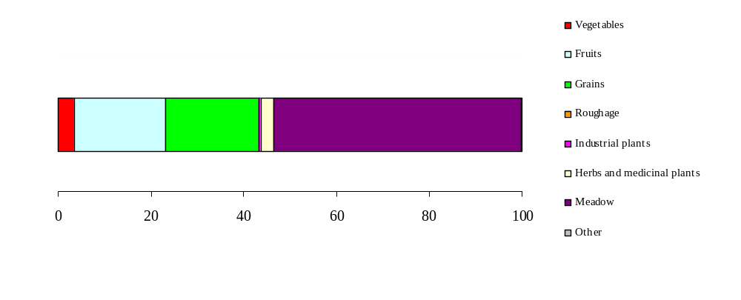
Total area under organic production in Serbia

According to the data provided by the Ministry of Agriculture, Forestry, and Water Management, the total area of agricultural land where methods of organic production were applied in 2009 is 2,876.49 hа. Of this, 2,388.27 hа or 0.057% of arable land is in the period of conversion, which is a time period necessary for the transition from conventional production to organic production, while 488.22 hа or 0.011 % of arable land is under certified organic production. The total share of area where methods of organic agriculture are applied represents 0.068% of the total arable land.

Case study: Development of agriculture and tourism within the framework for sustainable protection and management of the Special Nature Reserve

The main objective of the project "Protection and Management of the Special Nature Reserve Zasavica as a Tool for Sustainable Rural Development" was to integrate the protection and management of Zasavica with sustainable rural development and particularly with the development of sustainable agriculture and tourism. With the growing interest for protection and maintenance of semi-natural areas, there is an increasing need to develop capacities for managing protected areas. This counts in particular for landscapes and biodiversity related to various forms of grazing, which existed and still exists in floodplain meadows, fen meadows, and alpine meadows. The aims of this project proposal were to help the Nature Conservation Movement (non-governmental and non-profit organisation that has taken up the responsibility for the management of the Special Nature Reserve Zasavica) to elaborate the management and development plan, which will give directions for the development of agriculture and tourism within the framework for sustainable protection and management of the Special Nature Reserve. An additional objective of the project was to support the survival of two endangered native cattle breeds that were originally grazing in the floodplains of the Sava River from where only a small number of animals have survived. These are the "swallow-bellied Mangalitsa pig" and the "Podolian cattle", which are both on the FAO list of native breeds threatened with extinction. The project aims to promote the reintroduction of these species in farm households in the surroundings of the reserve and the use of these animals to maintain the floodplain meadows by grazing, as a contribution to the management of the biodiversity of floodplain meadows.

The proposed project was carried out in close cooperation with the Institute for Nature Conservation of Serbia and the Ministry of Environment and Spatial Planning of Serbia.

The immediate objectives of the project were:

1. To elaborate an integrated management and development plan for the Special Nature Reserve Zasavica based on methodologies of the Birds and Habitats Directives and with active involvement of local stakeholders.
2. To develop sustainable agriculture and tourism as a tool to support management of the Special Nature Reserve and to develop local and regional rural economies and livelihoods.
3. To improve organisational and institutional capacities of organisations involved in sustainable management and development of protected areas in Serbia.

Specific project products were:

1. Management and Development Plan for the Special Nature Reserve Zasavica as a replicable model for management plans of protected areas in Serbia based on methodologies of the EU Habitats Directive and other relevant international conventions, including development strategies for sustainable agriculture and tourism and a plan for restoration of the area hydrology.
2. Strategy for survival, reintroduction, and use of the swallow-bellied Mangalitsa pig and the Podolian cattle in farm households as a contribution to the management of the Special Nature Reserve and to the viability of the small farm households.
3. Improved facilities and opportunities for eco-tourism through targeted investments.
4. Recommendations for organisational and institutional set-up of management of protected areas in Serbia.
5. Increased capacities of organisations and individuals involved in management of protected areas, including stakeholders involved in management planning, biodiversity management, monitoring, awareness raising, information dissemination, and communication.
3.5.2. Forestry

The Forestry Development Strategy from 2005 sets conservation and improvement of biodiversity in forest areas as one of its goals, as a part of the concept of sustainable forest management. The strategy foresees the elaboration of the National Forestry Programme, as an action plan. Before the development of this Strategy, the Republic of Serbia did not have a comprehensive, founded, and defined development strategy, but it was defined through legal regulations and specific strategic documents, as a basis for the sector development. The basic goal of the Strategy is to preserve and improve the state of forests and to develop forestry as an economy branch. The Strategy recognises the importance of the forestry sector and forests in conservation and improvement of the environment and in nature protection; thus, conservation, real improvement, sustainable use, and valorisation of forest biodiversity are among major objectives, as well as improvement of sustainable forest management in protected natural assets, in keeping with coordinated and accepted international standards and the National Strategy for Sustainable Development.

The Law on Forestry ("Official Gazette of RS" No. 30/2010) defines the ban of woodcutting, destroying young trees, and seed collecting of strictly protected and protected species of forest trees, determined by a special regulation on nature protection, except in the case when they represent a source of illnesses or pests, or if they impose a threat to humans and objects.

Forests in Serbia are managed by public enterprises. The largest areas are covered by: "Srbijašume", "Vojvodinašume", and National Parks. PE "Srbijašume" incorporates 17 Forest Economies, and PE "Vojvodinašume” 4.

The total area of commercial forests in Serbia covers around 1,700,000 ha, or around 90% of the total forest area.

The management of legally defined forest areas is devolved to public enterprises. The forestry development concept is based on integral management of forest ecosystems according to the principles of sustainable development and profitability, which along with the maximal use of forest resources implies conservation of forest ecosystems and richness of biological diversity. Public enterprises that are authorised for forest management realise expert and technical activities in private forests as well, over the area of more than 800,000 ha.

For forests and forest land owned by state (more than 1,100,000 ha) that are assigned to public enterprises, the Specific Management Basis is elaborated every 10 years, which is approved by the Directorate for Forests of the Ministry of Agriculture, Forestry, and Water Management. The forest area in Serbia covered by planed management documents includes around 900,000 ha, or 48% of the total forest area, and 53% of the total area of commercial forests.

Forest monitoring

The operational and management responsibilities for forestry have been devolved to "Srbijašume" and, since the end of 2002, also to "Vojvodinašume”, forming two public enterprises for forest management in the country. The stewardship over 242,439.85 ha of protected areas (almost 40% of the total protected area in the Republic of Serbia) is assigned to PE "Srbijašume". It realises the following activities in protected areas: labels protected natural welfare, provides guardian service and protection, puts into effect determined regimes of protection, organizes scientific and other activities.

Faculty of Forestry issued the publication "Heavy metals in forest ecosystems of Serbia" in 2002. At the end of 2004, the Directorate for Environmental Protection and Directorate for Forests of the Ministry of Agriculture, Forestry, and Water Management published "Forest condition monitoring in the Republic of Serbia, Level I (Biomonitoring)". This publication is the annual report of the study results obtained in 2002/2004 during the monitoring program "ICP Forests in Serbia (Level I)". Forest tree crown condition and soil chemistry (and some foliar analysis) were studied at 103 sampling spots in 16x16km grid determined in keeping with the ICP methodology. The Institute of Forestry performed forest condition observations in central Serbia, while in Vojvodina, the Poplar Research Institute in Novi Sad was in charge of monitoring and assessment. The Faculty of Forestry in Belgrade was responsible for the soil study. Obtained data were submitted to the relevant European institution Programme Coordinating Centre (PCC) in Netherlands and to Forest Soil Coordinating Centre (FSCC) in Belgium.

Forest protection

In state owned forests in Serbia, 1,017 ha of seed stands were sorted out for the purpose of reproduction, which makes the best regionally representative seed stands among them well protected, and their reproduction is regulated in keeping with the principles of nature conservation.

The surface area of forests under any type of protection, managed by public enterprises, is more than 410,000 ha, which is around 22% of the total forest area. The largest part of this surface area (around 75%) is used for commercial purposes in keeping with the planning documents (Special Management Bases).
It should be mentioned that the surface area of more than 500,000 ha in Serbia is under some type of protection, which means that more than 80% of protected areas is covered by forests.

The surface area of forests under 1st and 2nd degree of protection in protected natural assets managed by public enterprises is 83,000 ha, which represents around 4.5 % of total surface area covered by forests. Around 15,000 ha of forests or around 1% of the total forest area is under the 1st degree protection regime, which signifies that no commercial activities are performed. Under the 2nd degree protection regime, there are also no commercial activities apart from reproductive-sanitary measures projected by planning documents.

As a result of the state of concern in forestry management, the project "Institutional Development and Capacity Building for the National Forest Programme of Serbia" started in April 2003. It was initiated by the Ministry of Agriculture, Forestry, and Water Management – Directorate for Forests, and supported by UN FAO. One of the main goals of the Project was to formulate the Forest Policy document.

Other projects also started in the last two years, among which the projects related to the inventory of forests and introduction of the GIS technology in forestry, financed by the Norwegian Government. There are also several regional projects – the project supported by the European Forest Institute focused on advanced education in forest policy and economy, the project for development of the forest sector in Serbia financed by the Finnish Government, and others.

Forest exploitation

The wood volume in forests of Serbia comprises around 363 million m³, which is around 161 m³/ha. In deciduous forests it is 159 m³/ha, and in coniferous forests 189 m³/ha.

The volume increment is around 9 million m³, which is around 4 m³/ha. In deciduous forests it is 3.7 m³/ha, and in coniferous forests 7.5 m³/ha.
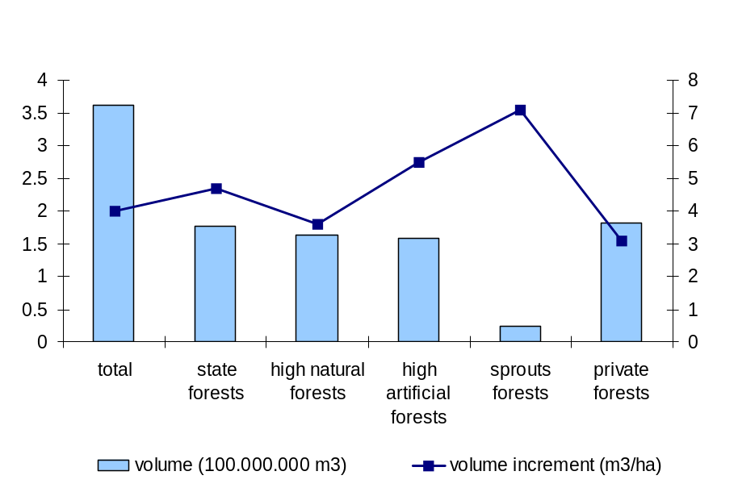
Figure 3.1: Volume and volume increment in Serbian forests.

Woodcutting equals to approximately 2.6 million m³. Along with the non-registered woodcutting, sustainable woodcutting ranges from 1/3 to ½ of the volume increment, which can be considered as sustainable. The ratio of firewood and industrial wood at the global level equalled 51.2 : 48.8 for 2005, while in Europe this ratio was 17.8 : 82.2. In Serbia, this ratio in 2005 was 52 : 48, with an increasing trend of industrial wood ratio, which commenced in 2003.
BOX 3.2.

Case study: Cross-analysis for forest and biodiversity protection

Key messages:
• Forest area in Serbia is almost doubled in the past 50 years.
• Forest ecosystem state is stable and getting better.
• Pressure on forests is less and it will continue to decrease.

Status indicators
The state of selected woodland bird species between 1990 and 2003 shows that most of the populations (14 species) have a stable trend. With four growing population species, the result is that 80% of woodland bird species are in good condition. Only four species have reduced populations. It is very important to notify that populations of three Parus sp. have stable and growing trends, which is a significant indicator of the ecosystem state.

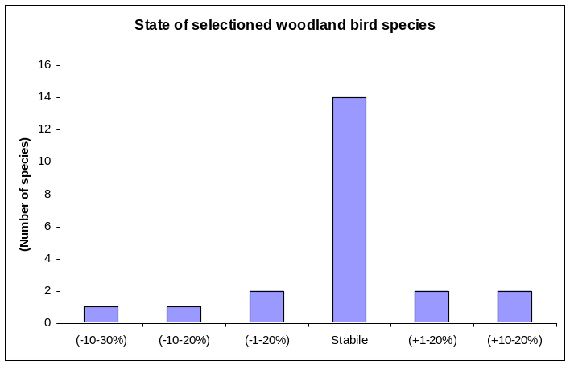
State of selected woodland bird species. Source: Institute for Nature Conservation of Serbia

Trend indicators

In the past 50 years, the forest area in Serbia has almost doubled. The quality of trees has improved much more in the past 20 years. The forest health state by ICP Forest Monitoring shows that, with the exception of the Norway spruce (Picea abies), all important wood species have a stable state and less defoliation in the past five years.
These indicators show that the forest ecosystems are in the better state than in most European countries. Certainly, the forests were much better at the beginning of the 19th century, and the old name of the central Serbia – Šumadija (Forestland) was once true.

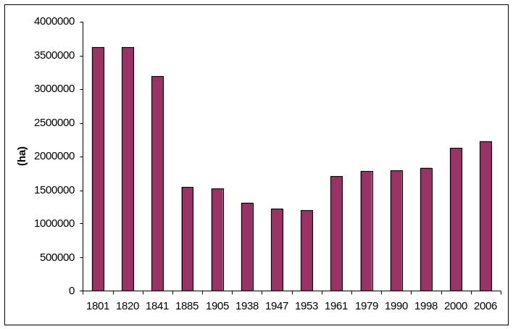
Figure: Forest area in central Serbia. Sources: Srbijašume, SEPA

Pressure indicators

In the same time, the pressure on forest ecosystems is reduced. Forest cutting is 10-15% less in the past 30 years. The use of firewood per capita shows slight reduction. The development of gasification and central heating networks reduced the use of fossil fuel and firewood. However, the future development of bio-fuel production in Serbia will allow better exploiting of forest renewable energy sources.

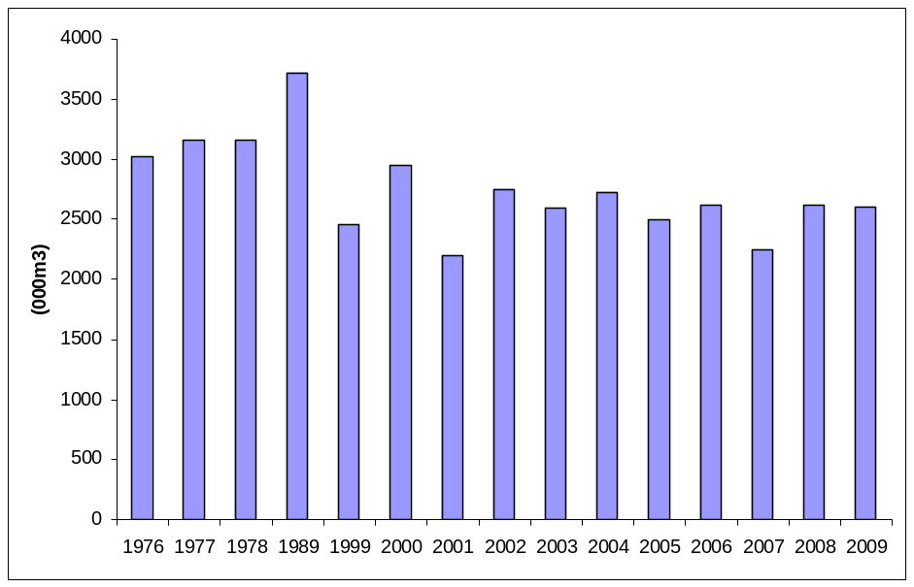
Forest cutting in Serbia. Source: Statistical Office of the Republic of Serbia

The policy of sustainable use of nature and the respect of expert opinion led to deadwood quantity of about 12 m³/ha in Serbian forests. This level of deadwood allows enough habitats for many forest species that are important for ecosystem stability. On the other hand, excessive hunting alters populations of game animals not only in number and structure of autochthonous game species, but also in number and structure of allochthonous game species.

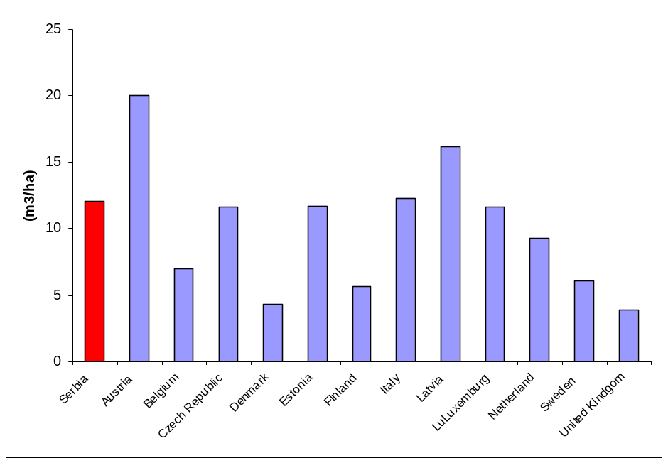

Deadwood in forests. Sources: EEA, SEPA

Solution and action indicators

According to EEA data, the exceedance of critical loads for acidification by deposition of nitrogen and sulphur compounds will be reduced by more than 50% in 2020, compared to 2000, with the current legislation. In the best-case scenario, with a maximum feasible reduction there will be no exceedance at all.

With the development of legislation for air pollution and with a strong monitoring and control, the pressure on forests will be reduced and the state of forest ecosystems will be more stable. This is very important for many forest and non-forest endangered species. Populations of plants and animals will be more stable and ecosystem chains will not be so sensitive to external influence.

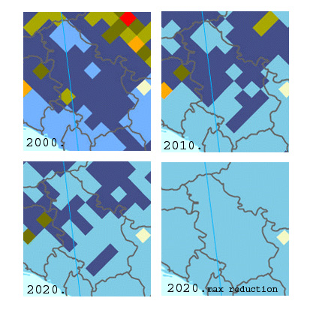
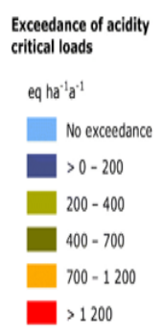
Exceedance of critical loads for acidification by deposition of nitrogen and sulphur compounds in Serbia. Source: EEA – http://themes.eea.europa.eu/IMS/ISpecs/ISpecification20091007131526/IAssessment1245763350536/view_content

Through the future legislation for game animals and sustainable use of nature resources, harmonised with the EU, and especially through the development of social consciousness about the value of biodiversity, the beauty and the health of forests will be conveyed to people. Only in that way people will live in harmony with the Nature.
3.5.3 Fishery

The Law on Protection and Sustainable Use of the Fish Stock ("Official Gazette of RS" No. 36/2009) and the Decree on Measures for Conservation and Protection of the Fish Stock ("Official Gazette of RS" No. 104/2009) protect specific species of fish.

The Law on Protection and Sustainable Use of the Fish Stock has the following objectives: (i) management of the fish stock in fishing waters, including protection and sustainable use, fishing, and trade of fishes; (ii) sustainable use of fishery resources that contributes to biodiversity conservation; (iii) definition of conditions for commercial, recreational, and sport fishing, as well as fishing for scientific purposes and electro-fishing; (iv) definition of conditions for trade of fishes; (v) development of efficient control that includes rights, duties, and authorisation of inspectors; (vi) more strict penal policy ("Official Gazette of RS" No. 36/2009).

The Decree on Closed Season was issued in 2009, and it defines species for which permanent closed season is enforced, species for which limited closed season is enforced, ban of fishing below defined size, as well as maximum allowed quantity of daily catch.

All fishing waters in Serbia are organised into six fishing areas, devolved to users, selected by a tender containing defined legal conditions and obligations, for a period of ten years. For each fishing area, the type of fishing is designated, recreational and commercial, or only recreational. Management of fishing areas is realised by enterprises with any form of ownership that satisfy legally prescribed conditions.

The National Strategy of Sustainable Use of Nature Resources includes fishery resources as well. Its aim is the sustainable use of fishery resources in fishing waters of Serbia, with full respect of ecological and socio-economic principles. The use of fishing resources should be done with such rate and regime that will enable maintenance of economic stability of fishing waters and high densities of exploited populations, in order to keep such production and harvest that will secure ecosystem stability during a long time period. In this way, the role and function of fish stock of important fish species will be preserved, as well as its overall potential to fulfil the needs of present and future generations. It is expected that the trend of exploitation of fishery resources in Serbia will result in further increase of recreational fishing and maintenance of commercial fishing at the level that is ecologically and socio-economically acceptable.

The number of sport fishermen in Serbia is about 100,000, and this represents the increase of about 10% since 2006. There are more men than women in sport fishery.

The percentage of sport fishermen is around 1.2% and it is almost the least in Europe; however, sport fishing in freshwaters is increasing in Serbia.

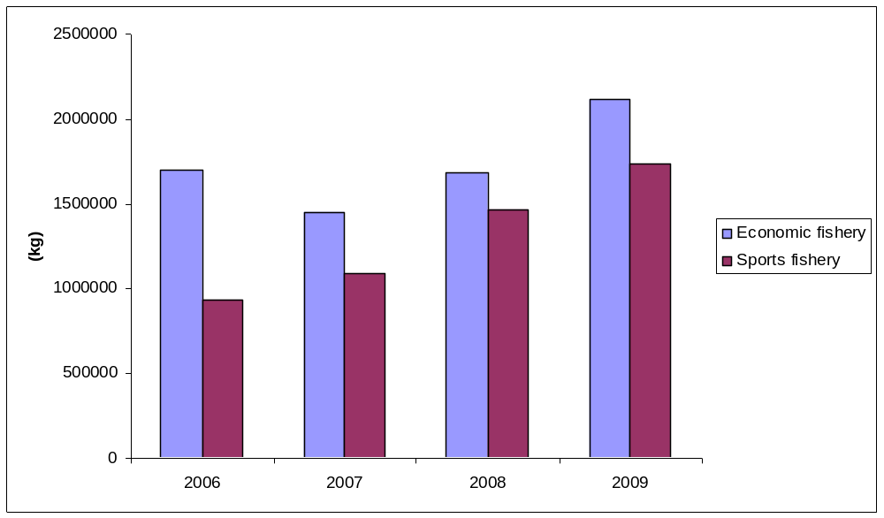

Figure 3.2: Structure of fishing (blue – commercial fishing, red – sport fishing)

The analysis of fishery by the type of fishing indicates that the commercial fishery increased for about 25% in the past 4 years, and the sport fishery for about 85%!

3.5.4 Hunting

So far, the strategy for hunting development was non-existent in Serbia, and this activity was defined through legal regulations and several strategic documents that served as a basis for the sector development. The legal framework of the sector development is the Spatial Plan of the Republic of Serbia, along with the Law on Game and Hunting (2010). Since the global hunting policy underwent significant conceptual changes, from exclusively commercial orientation to biodiversity protection, a clear necessity to develop the National Hunting Policy of the Republic of Serbia, as a long-term strategic document, has arisen. The Law on Game and Hunting defines conditions of use, management, protection, and improvement of game populations and their habitats. The draft version foresees issuing of the Game and Hunting Management Strategy of the Republic of Serbia, issuing of planning documents, as well as development of the monitoring and information system on game populations and their habitats. It is very important to emphasize that there is no legal decree on state taxes for exploitation of game animals as a natural asset.

Hunting is a frequent activity in Serbia. It is monitored through a number of status indicators (number of game animals, etc.), pressures (number of hunters, hunting grounds, catch, etc.), responses (secured benefit, breeding, introduction, feeding grounds, etc.), of which some are available, and some should be developed in the next period.

The number of most important game animals shows a decreasing trend in the last twenty years.

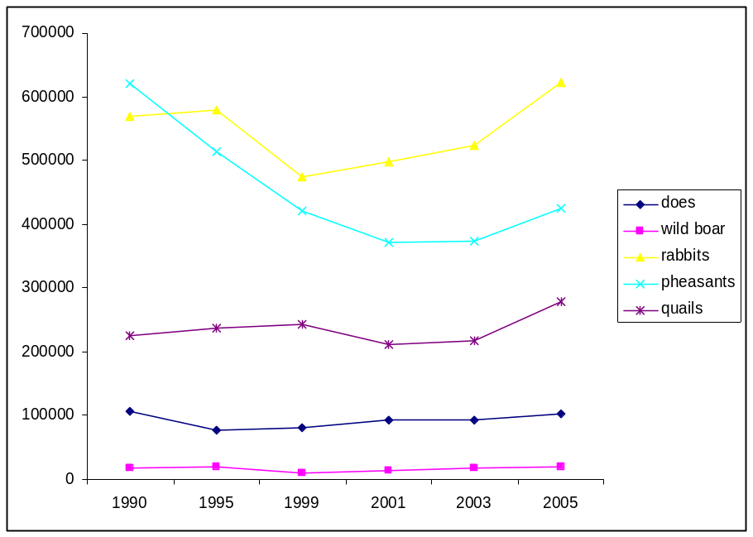
Figure 3.3: Number of game animals

The number of all most important game animals in hunting grounds of the Hunting Society of Serbia is decreasing. The number of small game animals is particularly decreasing, ranging from 2 to 10%, while the decrease of large game animals ranges from 3 to 6%.

The estimated population size of mouflon is relatively stable in the period 1999-2003 (around 650), while the number of chamois (100-400) and brown bear (24-81) varies from year to year, due to both migratory behaviour of these species and to relatively small population size, which increases the estimation bias.

Although grey wolf is a species that is a very good indicator of environmental state, there are no data on population size in Serbia, yet numerous indicators of caused damage point to a presence of a large population. Rough data on annual catch range from 170 to 180 individuals. In Vojvodina, grey wolf is under the regime of permanent protection, while in central Serbia there is no closed season for this species.

3.5.5. Water resource management

The Republic Directorate for Waters, as an authority in scope of the Ministry of Agriculture, Forestry, and Water Management, performs the duties of state management and expert jobs, which are, among other things, related to implementation of measures of water protection and management of water regimes. Through the Law on Waters, the Public Water Economy Enterprise "Srbijavode" was established. Certain authorities in scope of water economy were passed in 2002 to AP Vojvodina after the formation of the "Public Water Economy Enterprise Vode Vojvodine". These two enterprises manage water resources in Serbia.

After the Convention on Cooperation for the Protection and Sustainable Use of the Danube River ("Official Gazette of SCG – International Conventions" No. 4/03) and the Framework Agreement on the Sava River Basin were ratified, the questions on joint management plan development for river basins were covered, particularly those with international character.

One of the activities that lead to harmonisation with the EU Standards is the application of the EU directives related to water management, particularly through cooperation in scope of the ICPDR, the Danube River Commission, and the International Sava River Basin Commission. The Republic of Serbia became a member of the International Commission for the Protection of the Danube River (ICPDR) in 2003, and ratified the Convention on Cooperation for the Protection and Sustainable Use of the Danube River. In December 2009, the Danube River Management Plan with the measure programme was adopted, through which member states were obliged to realise these measures by 2015. In scope of the trans-boundary cooperation in water management sector in the Sava River basin, the Republic of Serbia takes part in the International Sava River Basin Commission (Sava Commission) since its establishment in 2005, as a body authorised for implementation of the Framework Agreement on the Sava River Basin. The strategic goal of the Framework Agreement is to create conditions for sustainable development of the region in the Sava River basin, through the establishment of the integral and sustainable management of waters in the basin.

In June 2009, the European Commission received the mandate from the EU Council to develop the Joint Comprehensive Strategy for the countries of the Danube River Basin, which is expected to be prepared by August 2010, in order to finalise the internal procedure of its adoption in the EC by the end of 2010. Formal adoption of the Joint Comprehensive Strategy for the countries of the Danube River basin could follow in the first half of 2011.

Through the coordination of the Sava Commission, the proposition of the project "Biodiversity and Ecological Status of the Alluvium, Water, and Biota in the Sava River Basin" is under preparation, the implementation of which is planned in scope of the second cycle of the Sava River Basin Management Plan.

The new Law on Waters, adopted on 5. May 2010 ("Official Gazette of the RS" No. 30/2010) defines the Strategy of Water Management and Protection of Waters from Pollution.

3.5.6 Energy

The Law on Energetics ("Official Gazette of RS" No. 84/04) was issued in 2004, and it was the beginning of the reformation process of the energetics sector, with the aim to enable preconditions for development and efficient activities of all subjects in the field of energetics, and to harmonise this law with the EU regulations.

The elaboration of the Law on Rational Use of Energy is under way, the finalisation of which is expected in 2010. According to the set of laws related to environmental protection, which came into force in 2004, it is the responsibility of the PE ЕPS to coordinate the activities of its subjects with their clauses by 2015. This means that the national regulations, which will be harmonised with the EU, will also demand the application of protection measures in keeping with the best available techniques (BAT) for new objects and revitalised objects.

The Law on Air Protection ("Official Gazette of RS" No. 36/09), adopted in 2009, comprehensively defines the management of air quality, as well as measures that will prevent the emission of pollutants into air. The law also provides a basis for elaboration of sub-acts that will regulate the emission control for greenhouse gases and gradual elimination of substances that deplete the ozone layer.

Two conventions were ratified, which oblige us to report air emissions: the Convention on Long-Range Transboundary Air Pollution – CLRTAP with the EMEP Protocol (1987) and the UN Framework Convention on Climate Change UNFCCC (1997) with the Kyoto Protocol (2007).

The Republic of Serbia is a member of the UN Framework Convention on Climate Change (UNFCCC) since 2001. The Kyoto Protocol came into force for the Republic of Serbia on January 2008.

Through the ratification of the Treaty on Establishing the Energy Community (2006), Serbia has, among other things, accepted the duty to issue and realise the plan to apply the directive 2001/77/ЕC on promotion of electricity produced from renewable energy sources, and directive 2003/30/ЕC on promotion of use of biofuels or other renewable fuels for transport. On the other hand, it fulfilled the conditions to use the technology transfer and financial consulting related to RES.

From the aspect of environmental protection, the adoption of the following documents was significant:
- Strategy for Introducing Cleaner Production in the Republic of Serbia (2009)
- National Environmental Protection Programme (2009)
- Adoption of the Kyoto Protocol (2009)

State and trends

In the period 2002-2009, production of the primary energy is in constant slight increase. According to the estimates of the Ministry of Mining and Energy, the production in 2009 equalled to 9.70 million TOE (tonnes of oil equivalent), which is for 3% higher than in 2008.

The period from 2002 to 2007 is characterised by an increased consumption of the total primary energy (total primary energy is the sum of produced and imported energy), as ell as by the domination of fossil fuels (coal, oil, and gas) in consumption.

Although the portion of the renewable energy sources in the energy consumption is only 7%, from the aspect of environmental protection and energy safety, the constant increase is encouraged. During the last few years, the renewable energy sources have an increasing role in energy production.

The Republic of Serbia has the potential to produce 4.3 million TOE from renewable sources, but in 2009 only 1.28 million TOE was produced, which makes around 30% of the potential.

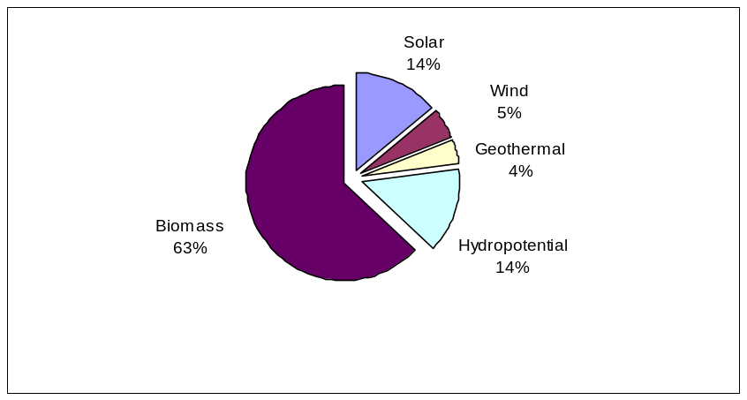
Figure 3.4: Renewable potentials in Serbia.

The ratio of renewable energy sources in consumption of the total primary energy in 2009, in comparison to previous years, was slightly increasing, but it is still at the very low level of 8.6%.

BOX 3.3.

Case study: Introduction of the Environmental Management System (EMS) in Serbia

Procedures for introduction of the environmental management system (EMS) were elaborated in the PE Transnafta, and in 2009 the main HDPE cable was laid and the fibre-optic cable was installed in order to enable early detection of oil leaking from the oil pipeline, namely the application of best available techniques.

The elaboration of the Investment-Technical Documentation for the flue gases desulphurisation system in the Thermal Power Plant "Kostolac B" was finished in 2008. After mounting the installation for flue gases desulphurisation from blocks of the TPP "Kostolac B", the best effect of decreased emission of these oxides is expected, considering that their contribution in the total emission of SO₂ from thermal power plants of the PE "Electric Power Industry of Serbia" is the greatest (contribution in the total emission is around 38.8%, and contribution in the total power is around 16%). Technological-technical solution is based on state of the art achievements in the field of wet desulphurisation systems (WFGD) and it is harmonised with the Directive 2001/80/ЕC.

The oil industry of Serbia has planned the reconstruction of existent and construction of new plants that will satisfy the EU demands in environmental protection, through investments plans and the strategic plan for development of refinery treatment processes. The largest share of investments is directed toward the emission and imission monitoring programmes, land sanitation, object reconstruction, etc.

In the PE "Electric Power Industry of Serbia", the electro filters of the TPP "Nikola Tesla" and TPP "Kostolac A" are coordinated with the demands of the EU regulation for decrease of the powder emission. In the TPP "Kolubara A" and TPP "Morava", the equipment for smoke channels was installed. At the end of 2008, the Integral System for Continual Monitoring of the influence of the TPP "Nikola Tesla A and B" on air quality was set in probe operation.

3.5.7. Mining and Industry

In order to overcome existing problems in environmental protection, the aims of industrial policy were defined, among which is the improvement of ecological standards in production processes. The Law on Regional Development (2009) foresees the measures for stimulation of the regional development, related to improvement of environmental protection.

The Strategy for Introducing Cleaner Production in the Republic of Serbia (2009) elaborates the national concept of sustainable development, though encouragement of cleaner production. During 2009, the Eco-Management and Audit Scheme (EMAS) was promoted as a voluntary measure to interested organisations and chambers of commerce.

The Project of Cleaner Production realised by the Centre for Cleaner Production under the auspice of UNIDO and with the support from the Ministry of Environment and Spatial Planning and the Chamber of Commerce of Serbia, started its activities in 2007. One of the results is the development of the "Strategy for Introducing Cleaner Production in the Republic of Serbia" (adopted in March 2009), which elaborates the national concept of sustainable development, through encouragement of cleaner production. The cleaner production according to the UNIDO methodology was introduced in 26 companies.

From the aspect of environmental impact, the problem is that the largest share in industrial production belongs to "dirty industries": production of food and beverages, production of chemicals and chemical products, production of basic metals. The total share of "dirty industries" in the total industry in 2009 is estimated to over 50%.

The Eco-Management and Audit Scheme (EMAS) was promoted as a voluntary measure. In 2008, directives relate to EMAS were translated into Serbian. During 2009, the Eco-Management and Audit Scheme (EMAS) for industrial objects is promoted as a voluntary measure to interested organisations and chambers of commerce.
In 2009, the "Rulebook on closer conditions and procedure of obtaining the right to use the ecological sign, and on elements, image, and use of the ecological sign for products, processes, and services" was issued. Groups of products and criteria for groups of products for the national eco-sign will be the same as for the eco-sign of the EU (Flower); thus, in the moment of the accession to the EU we will have the complete infrastructure for the "Flower", and the national eco-sign may then further develop independently. During 2009, two enterprises submitted the request for obtaining the eco-sign.

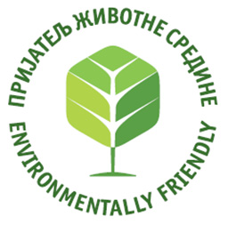
Figure 3.5.: The National Eco-sign
BOX 3.4.

CASE STUDY: "Development of the National Strategy for Including the Republic of Serbia into the Clean Development Mechanism of the Kyoto Protocol"

The Project "Development of the National Strategy for Including the Republic of Serbia into the Clean Development Mechanism of the Kyoto Protocol", the realisation of which was done with the financial support of the Government of the Kingdom of Norway, represents an effort of the Government of the Republic of Serbia to build and strengthen the state capacity for efficient implementation of the Kyoto Protocol.

The project includes the sectors of waste management, agriculture, and forestry, and it identifies the possibilities to realise projects for the clean development mechanism in these sectors, in both short-term and long-term periods.

The elaboration of the "National Strategy for Including the Republic of Serbia into the Clean Development Mechanism of the Kyoto Protocol for the Sectors of Waste Management, Agriculture, and Forestry", as a part of the cited Project, was entrusted to the ministry competent for environmental issues. Considering the sectors included within the Strategy, and the authority of specific ministries of the Government of the Republic of Serbia, the Project is realised in cooperation with the Ministry of Agriculture, Forestry, and Water Management of the Republic of Serbia.

The "Designated National Authority for Implementation of the Clean Development Mechanism of the Kyoto Protocol" (DNA) in the Republic of Serbia became operational on 21. November 2008. The DNA was established by the Decree of the Government (05 No. 02-2099/2008-1 of 5. June 2008), while the "Agreement on Establishment of the Designated National Authority for Implementation of the Clean Development Mechanism of the Kyoto Protocol" was signed on 30. July 2008. The DNA, as a separate authority, was introduced into the national legal framework through the Law on Air Protection.

The DNA in the Republic of Serbia is a multi-sectoral authority that includes representatives from the relevant ministries.

SUCCESIFULL STORY: Open-pit mines in the area of the NP "Fruška Gora"

The exploitation of minerals and rocks represents one of the most important threatening factors in the area of the NP "Fruška Gora". The long-term exploitation of rock and other raw materials caused the wide range degradation and destruction, which reflects in impoverishment of ecosystems, destruction of soil, forests, and other habitats, loss of specific phytocoenoses and important species of birds and other animals. This area suffered great alterations of the microclimate, of the regime of surface and ground waters, and of the environmental quality, which reflects in negative impacts of the noise, seismic activities (rock mining), decrease of air quality, etc. There are 20 abandoned open-pit mines in the National Park. The trachyte rock, followed by limestone, volcanic tuff, and several other rocks and minerals were mainly exploited in this mines. The process of spontaneous renewal of vegetation started after the cessation of mining. Some open-pit mines were exploited again, which caused direct damage to soil, water, air, and biota. These open-pit mines are planned for recultivation by 2022 through the Special Purpose Area Spatial Plan of the NP "Fruška Gora". Projects were developed for the two largest recently active open-pit mines, "Srebro" and "Kišnjeva Glava", where rock was intensively exploited, and activities on recultivation were commenced. With the aim to set up the tourist-recreational purpose, and to protect habitats of species that are natural rarities, according to the prescribed protection regime, the measures and limitations were defined during the process of recultivation. The recultivation of one of the open-pit mines was directed toward conservation of the feeding ground for globally threatened birds of prey that nest in Fruška Gora.

Areas for future exploitation in the protection zone of the National Park were selected in the valley of Komesarovac, which represents habitats for a number of protected orchid species. These habitats are now designated for expansion of the National Park borders, through the elaboration of the spatial planning documentation, in the process of interest coordination.

3.5.8 Tourism

The new Law on Tourism was issued in May 2009 ("Official Gazette of RS" No. 36/09), and it prescribes and coordinates conditions and ways of planning and development of tourism. The Law also foresees the proclamation and sustainable use of tourist areas. If the tourist area is within the area of a protected natural asset, then regimes of protection and internal order are applied in keeping with the regulations that define conservation and use of the asset.

The Strategy of Tourism Development in the Republic of Serbia ("Official Gazette of RS" No. 91/06) emphasizes the concept of sustainable development, where natural resources hold possibilities for reaching commercial and other objectives in tourism. In order to realise this Strategy, 15 master (business) plans were elaborated for selected tourist destinations, which register the potentials for the development of tourism. Two types of tourist offers, among a number of others, are interesting for their significant potential for biodiversity and rural economy:

- Mountain and lake resources
- Rural tourism

The Strategy outlines that mountains and lakes are the strongest potential tourist product, from the aspect of resources, but are almost non-existent from the aspect of infrastructure and marketing.

Significant investments in physical infrastructure, training, and visibility are necessary in order to attract tourists to mountain areas in both summer and winter periods.

The rural tourism is another important product of the future tourism in Serbia, as it emphasizes the commitment and orientation towards nature and development of sustainable tourism. Though not sufficiently competitive, its potentials are evident: rich nature, its resources, arable land, significant share of rural population, non-polluted environment, potentials for production of organic and "healthy food", possibility for complementary activities like horse riding, traditional gastronomy, etc. Its development potentials are emphasized through better protection of cultural heritage, nature resources, traditional architecture, and way of life, which are all preconditions for balanced socio-economic development of rural areas.

"Sustainable Tourism in Function of Rural Development" – joint programme of UN agencies – is the largest UN project dedicated to development of tourism worth four million dollars, and financed by the Millennium Development Goals Achievement Fund. The Project will be realised in the next 2.5 years, in three phases.

Like other economy branches, tourism influences the quality of environment as a consumer of natural and other resources: land, water, fuels, electric energy, and food, as well as a producer of a significant amount of waste and emissions. The negative influence of tourism to environment is expressed through the pressure on natural resources, biota, and habitats, and through production of waste and pollution.

On the other hand, tourism has a great interest to maintain the quality of the environment at a high level, since the clean and healthy environment is one of the important prerequisites of its successful development. Positive effects of tourism on the environment reflect in the fact that this is the activity that strives toward adequate use of natural resources, improvement of landscapes, and maintenance of ecological, economic, and socio-cultural values of the local community.

The features of the territory of Serbia, its natural and artificial values, make a good predisposition for the modern concept of tourism. The main tourist activities include tourism in large cities, spa tourism, mountain tourism, tourism related to special interests (cultural assets, natural assets, hunting, fishing), rural tourism, river tourism (particularly on the Danube).

Compared to 2007, in 2008 a slight decrease of tourist visits and overnight stays was recorded at the annual level, which is probably the consequence of reduced financial possibilities of the population. Domestic tourists constantly prevail in the tourist structure.

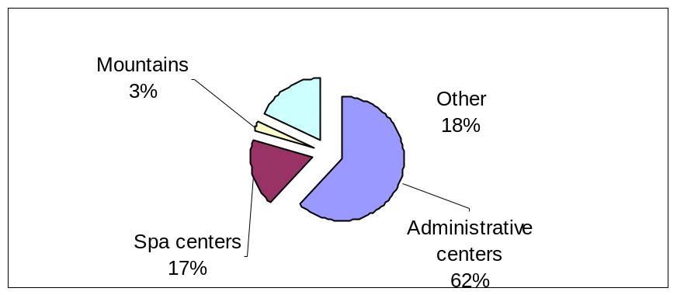
Figure 3.6: Turists visits in Serbia in 2009.

In 2009, the majority of tourists visited the main administrative centres, while, according to the data for 2008, tourists mostly stayed in spas and mountain centres (32% and 26% of the total tourist overnight stays, respectively).

3.5.9 Traffic

Considering the future inevitable increase of all types of vehicles, planned by the Strategy for Traffic Development, it is necessary to seek solutions for coordination of their use with ever more strict requirements for environmental conservation.

According to the analyses done for the Strategy for Development of Railway, Road, Water, Air, and Intermodal Transport in the Republic of Serbia from 2008 to 2015, Serbia significantly lags behind the infrastructure reforms in comparison to the neighbouring regions and the EU. The aspect of environment was introduced into the Strategy and it is presented in the first principle of the traffic development – Transport strategy must be focused on life quality, environmental conservation, welfare, and mobility.

It is necessary to incorporate requirements for protection of biodiversity/nature into the plans for the development of traffic infrastructure, both through ecological optimisation of traffic corridors and through practical protection measures (securing the passages for wild animals on routes of their usual daily or seasonal migrations, construction of fish paths, securing the afforestation/planting in the zone of traffic impact, securing the functioning of drainage and sewage channels, and positioning of noise barriers in places of direct traffic impact).

The level of traffic development represents an indicator of commercial activities and competitiveness of industry and services, and it is a relevant factor of the European integration. Its role is multifunctional: it influences the development of territorial division of labour, encourages fast development of various economy branches, promotes regional development, and initiates development of underdeveloped countries.

In the previous period, from 2002 to 2009, the scale of transport was increased in all traffic sectors, and the basic promoter has been the cargo transportation. Considering the passenger transport structure, the road passenger transport dominates, and considering the cargo transport structure, the railway cargo transport dominates.

4. Progress towards the 2010 Targets and Implementation
of the Strategic Plan

4.1. Two successful stories as the best examples of the implementation
of the CBD Targets

Griffon Vulture

The colloquial Serbian name of the Euroasian Griffon Vulture (Gyps fulvus Hablizl 1883) is “beloglavi sup”, the “White-headed Griffon”. The species is unable to cut the skin of dead herbivorous animals with its bill. It therefore normally starts feeding after a Black Vulture has finished its meal. If a Black Vulture is not around, Griffon Vulture will start feeding through the mouth or anal hole of an animal carcass. The head and long neck are covered with white fluffs. Griffon Vulture weighs up to 8.5 kg. The range of its rectangle-shaped wings is 2.8 metres. Griffon Vultures nest on rocks, where they build smaller or larger groups of nests (colonies). Griffon Vulture was a frequent species in Serbia until the 1950s. It nested in gorges, on the fringes of the Pannonian depression and in mountainous region. In recent times, the species has been observed only in three Western Serbian gorges. However, population of Griffon Vulture has suddenly declined in Balkan Peninsula. A stable population counting a few hundred pairs persisted only on the island of Crete (Greece).

The Institute for Biological research “Sinisa Stankovic” in Belgrade initiated in 1985 a monitoring programme and demographic research of Griffon Vulture in Serbia and in Hercegovina. However, despite a well-elaborated legal basis for protecting birds and their habitats, the abundance of Griffon Vulture suddenly declined in the period of 1990s.

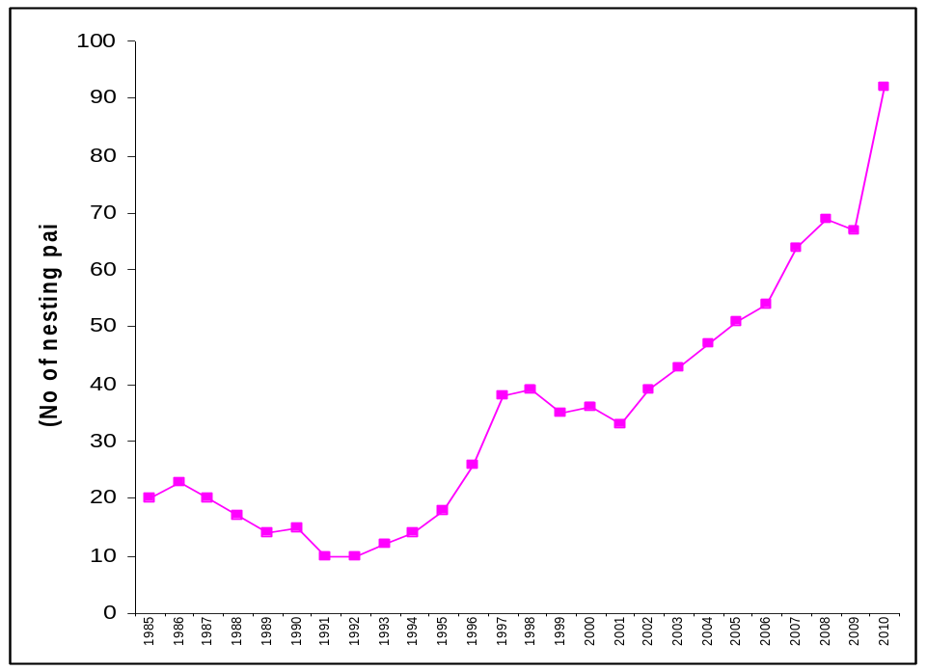

Figure 4.1: Trend of nesting paires at Uvac. (Institute for Biological Researches “Sinisa Stankovic“, Belgrade)

Nine years of permanent education inspired some locals with a wish to help protect this species and get widespread support in there local communities. In order to stop further and sudden decline of this species and to launch a local initiative, a group of nature lovers and local citizens, together with ornithologists, founded the Birds of Prey Protection Fund in 1994. Widespread support to the idea promoted by the Fund has enabled undisturbed running of the programme of protection of Griffon Vulture in the Uvac River gorge. Today, over 500 birds fly above the “restaurant for Griffons”.

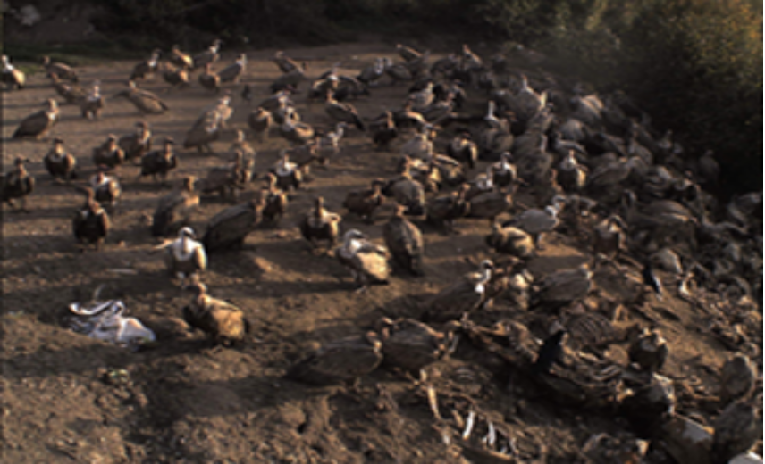

Figure 4.2: Colony of Griffon Vulture at Uvac. (Photo S. Marinkovic)

Uvac is the last resort and a hope for successful return of this species to the Balkan. Simultaneouse programmes of Griffon Vulture reintroduction are currently running in Hercegovina and at two spots on Mt. Stara planina: one is near Pirot (Serbia), and the other at Kotel (Bulgaria).

Protection of Wild Species

Protection of wild species is regulated by a group of by-laws. All endangered taxa are protected by the Ordinance on Proclamation of Wild Taxa as Protected and Strictly Protected.
Until 2010, i.e. until the Rules of proclamation and protection of the strictly protected and protected wild species of plants, animals and fungi have been adopted, the Decree on protection of rarities of nature (1993) had been effective, according to which 215 plant and 429 animal species were protected. New Rules (2010) provides protection of 1760 strictly protected and 868 protected wild species of plants, animals and fungi. Strictly protected wild species are totally protected, except for science and education. Protected species are under controlled exploitation.

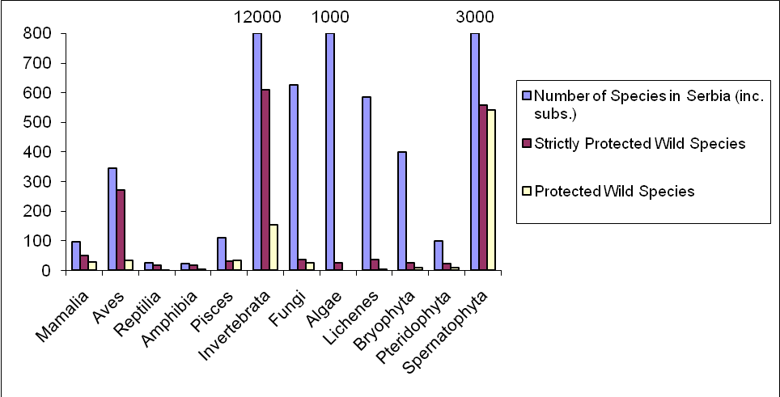

Figure 4.3: Total number of species by classis, strictly protected and protected species in Serbia. (Invertebrate c.10000, algae c. 1000, spermatophyte c. 3000).
It is evident increase of protected species for about 300 %. This is result of biodiversity monitoring development, more scientific biodiversity projects and stronger “response” of State. Government also has prepared many Action plans for endangered and protected species, especially for large carnivores.

Almost all mammals, birds, amphibians and reptilians are protected. Large number of insects (especially daily butterflies) and plants are also protected.

4.2. Progress towards the 2010 target of the CBD

Protect the components of biodiversity

Goal 1. Promote the conservation of the biological diversity of ecosystems,
habitats and biomes

Target 1.1: At least 10% of each of the world’s ecological regions effectively conserved
Target 1.2: Areas of particular importance to biodiversity protected


ASSESMENT

Still, Serbia does not have 10% of the protected territories although it has increased the surface area and the number of the protected areas. A noticeable improvement has been made in specifying the areas of international importance; a significant increasing trend is also observed regarding wood land. Biodiversity indicators do not indicate existence negative trends.

Relevant CBD Indicators | State of implementation and measures taken in Serbia
Coverage of protected areas  Trends in extent of selected biomes, ecosystems and habitats  Trends in abundance and distribution of selected species | 5.85% of the territory covered by the nationally designated protected areas, 518204.6263ha  1760 strictly protected species and 868 protected species, in accordance with the Rules of proclamation and protection of the strictly protected and protected wild species of plants, animals and mashrooms (Official Gazette of Republic of Serba, 5/2010)  112 wild species under the use control, in accordance with the Ordinance on control of use and trade in wild flora and fauna (Official Gazette of Republic of Serba, 31/2005, 45/2005, 22/2007, 38/2008 and 9/2010.  61 Potential Emerald area, total surface area 1019269.31 ha, or 11.54% of the Srbian territory  42 Important Bird Areas (IBA), with total area of 1.259.624 ha or 14.25% of the Srbian territory  40 Prime Buttererfly areas (PBA), total area of 903.643 ha, or 10.23% of the Srbian territory.  9 Ramsar areas, with total area of 55.627 ha, or 0.63% of the Srbian territory  62 Important Plant Areas (IPA) , the mapping is still in preparation  Forest area increase for 75 % from 1953-2006  Worked out Indicative map of the Pan-European Ecological Network for Southeastern Europe (PEN), which specifies the main natural areas of European importance, existing corridors between these areas, as well as new corridors that have to be established.  Selected 8 areas of importance within the ecological network along the Sava river, for the purpose of regional and national implementation of the Bern Convention, Bonn Convention and the Convention on biological diversity.  Green Belt has been established in Serbia, with 12 protected areas  Developed Potential Ecological Network of AP Vojvodina, with the status survey, analysis and determination of guidelines and actions for biodiversity conservation  Defined Ecological Network of the Republic of Serbia with the reference and layout map.  Creation of the data base of priority habitat types in Serbia (vulnerable, endangered, rare and priorities for protection)  Creation of data base of rare, endangered and endemic species in the Republic of Serbia

Goal 2. Promote the conservation of species diversity

Target 2.1: Restore, maintain, or reduce the decline of populations of species of selected taxonomic groups
Target 2.2: Status of threatened species improved


ASSESMENT

Between 2000 and 2010 Serbia has made large improvement in protection of species diversity. This improvement is embodied in adoption of legislation by witch the number of protected species is increased and better records keeping of the endangered species status. The main status of species diversity shows on the basis of selected bird and butterfly species that there has been increase of many selected species, while many others had more stable population.

Relevant CBD Indicators | State of implementation and measures taken in Serbia
Trends in abundance and distribution of selected species  Change in status of endangered species  Percentage area of protected areas | 1760 strictly protected species and 868 protected species, in accordance with the Rules of proclamation and protection of the strictly protected and protected wild species of plants, animals and mashrooms (Official Gazette of Republic of Serba, 5/2010)  112 wild species under the control of use in accordance with the Decree on Control of Utilization and Trade of Wild Flora and Fauna (Official Gazette of Republic of Serba 31/2005, 45/2005, 22/2007, 38/2008 and 9/2010).  Ex situ conservation in botanical gardens, gardens, arboretums, zoo, and in rehabilitation center for animals  Large number of rare, endemic and relict species is introduced in in vitro culture  Creation of data base of rare, endemic and relict species in the Republic of Serbia.  Trends in abundance and distribution of indicator species of birds and butterflies in accordance with EEE Core Set Indicators (CSI)  Reintroduction Programmes are realized for some species.  Action Plans for Conservation of Lynx (Lynx lynx), Brown Bear (Ursus arctos), Gray Wolf (Canis lupus), Action Plan for Recovery and Conservation of the Vultures on the Balkan Peninsula, Action plan for management of the sturgeon varieties in fishing waters of the Republic of Serbia from 2005 till 2010; Action plan of fry management in the fishing waters of the Republic of Serbia .  Forest area increase for 75% from 1953.-2006.  5.85% of the territory covered by the nationally designated protected areas (518204.6263ha), 61 Potentially, the Emerald area, 1019269.31 ha, or 11.54% Serbain territory , 42 Important Bird Areas (IBA) total area 1.259.624 ha or 14.25% Serbian territory; 40 Prime Buttterfly Areas (PBA), total area 903.643 ha, i.e. 10.23%.  Developed Indicative map of the Pan-European Ecological Network for Southeastern Europe (PEN), which shows main natural areas of the European importance, existing corridors between these areas and new corridors to be established.  Selected 8 areas of importance within the ecological network along the Sava river for the purpose of regional and national implementation of the Bern Convention, Bonn Convention and the Convention on biodiversity.  Green Belt established in Serbia, with 12 protected areas.  Developed Potential Ecological Network of AP Vojvodina, with the status survey, analysis and determination of guidelines and actions for biodiversity conservation.  Ecological Network of the Republic of Serbia with reference and layout map.

Goal 3. Promote the conservation of genetic diversity

Target 3.1: Genetic diversity of crops, livestock, and of harvested species of trees, fish and wildlife and other valuable species conserved, and associate indigenous and local knowledge maintained

ASSESMENT

It is not possible to detect a significant trend. As regards the autochthonic species and domestic animal breed, the public sector has lately made efforts to conserve them. In the last few years efforts have been made to reduce pressure on the natural population of the medicinal and aromatic herbs, as well as of wild fauna, by specifying the quotas for picking in the landscape. Organized farm growing of medicinal and aromatic herbs in some Serbian areas is a source of income for local population; however, this activity has not yet been adequately promoted, disregarding the potentials or quality of the medicinal and aromatic herbs in Serbia.

Relevant CBD Indicators | State of implementation and measures taken in Serbia
Trends in genetic diversity of domesticated animals, cultivated plants, and fish species of major socioeconomic importance  Biodiversity used in food and medicine (indicator under development)  Trends in abundance and distribution of selected species | Growing of the population of the autochthonic domestic animal breeds included in the Program of allocation and use of incentives for conservation and sustainable use of genetic resources  Rural Development Draft Program proposes measures for rural development in 2008 - 2013. It also includes the measures for agro biodiversity conservation. The program includes a list of races for which a right to the financial support under the Rural Development Program can be acquired on the grounds of vulnerability, i.e. in accordance with FAO World List of domestic animals diversity monitoring. The Program specifies the conditions to be satisfied by the holders of these races to qualify for use of the funds from the Program.  The Serbian Agricultural Development Strategy, adopted in 2005, is important for conservation of biodiversity, especially in connection with woods conservation and management, as well as for conservation of agro biodiversity and plant and animal genetic resources; support for production based on autochthonous animal races and plant species  Law on Genetically Modified Organisms (Official Gazette of Republic of Serbia, 41/2009)  Some protected areas implement their own programmes for conservation of certain native animal breeds  Large number of rare, endemic and relict species is introduced in in vitro culture  Ex situ conservation in botanical gardens, gardens, arboretums, Zoo’s, and in rehabilitation center for animals  As regards conservation of genetic plant resources Serbia has established regional, European and global cooperation. Regional Project SEDNet “South East Development Net” for genetic resources of plants (2004-2010), aimed at intensifying and improving regional cooperation in the Balkans in the field of conservation and sustainable use of the genetic resources through a coordinated network of the National Programs.

Promote sustainable use

Goal 4. Promote sustainable use and consumption

Target 4.1: Biodiversity-based products derived from sources that are sustainably managed, and production areas managed consistent with the conservation of biodiversity
Target 4.2: Unsustainable consumption, of biological resources, or that impacts upon biodiversity, reduced
Target 4.3: No species of wild flora or fauna endangered by international trade

ASSESMENT

Serbia adopted the Sustainable Development Strategy in 2008 and integrated the sustainable development concept in the sectoral and cross-sectoral strategies and policies. A significant contribution to better sustainable use and consumption will be made by the National strategy of sustainable use of natural resources. Almost a half of forestry entities holds a certificate for sustainable managing of forests (FSC), and the other half is in the certification process. The way and control of use and trade in wild flora and fauna are regulated by special Ordinance. CITES provisions are implemented in the area of international trade. The organic agriculture land is still insignificant in relation to the total arable land.

Relevant CBD Indicators | State of implementation and measures taken in Serbia
Area of forest, agricultural and aquaculture ecosystems under sustainable management  Proportion of products derived from sustainable sources (indicator under development)  Trends in abundance and distribution of selected species  Marine trophic index  Nitrogen deposition  Water quality in aquatic ecosystems  Ecological footprint and related concepts  Change in status of threatened species | Sustainable agricultural and fisheries practices are being promoted  The Republic of Serbia Sustainable Development Strategy for the period 2009-2017. A group of outcome indicators in accordance with the internationally recognizable sustainable development indicators have been harmonized with the new, revised list of UN sustainable indicators, also comprising indicators of Millennium Development Goals’ implementation. Concept of Sustainable Development to some extent is integrated in sectoral and cross-sectoral policies such as fisheries, agriculture, land development and tourism.  The Serbian Agricultural Development Strategy focuses on the biodiversity conservation, especially forest conservation and management, as well as on the conservation of agro biodiversity and plant and animal genetic resources, and on the support to production based on the autochthonous domestic animal breeds and plant species. The Action Plan of the Strategy provides adoption of the National program for conservation and sustainable use of the genetic resources in agriculture.  Certificate for Sustainable Forest Management (Forest Stewardship Council) is held by 10 Forestry Enterprises, and 11 are in the certification process. After certification, all state owned forests will have FSC certificates on sustainable management.  Total share in organic agricultural land in relation to the arable land is still very small, despite large potentials of Serbia for this production, 0.07 % of the total agricultural land, while only 0.011 % of the arable land is used for certified organic production. The Law on organic production was adopted in 2010 (Official Gazette of RS, 30/10).  Measures and conditions for biodiversity and nature protection are embodied in the legislation and documents in all economy branches oriented to using the biological/natural resources.  The Law on Strategic Environmental Impact Assessment from 2004 (Official Gazette of RS, 135/04) is adjusted to the Directive 2001/42/EC on Environmental Impact Assessment of certain plans and programs. The Law on Strategic Environmental Impact Assessment from 2004 (Official Gazette of RS, 135/04)  Some protected areas implement their own programmes for conservation of certain native animal breeds  In accordance with the Decree on Control of Utilization and Trade of Wild Flora and Fauna (Official Gazette of Republic of Serba, 31/2005, 45/2005, 22/2007, 38/2008 and 9/2010, 112 wild species under the controlled use  Convention on International Trade in Endangered Species of Wild Fauna and Flora - CITES Convention (Official Gazette of the SRY - International Treaties No. 11/2001), Rules of on Cross-Border Traffic and Trade in Protected Species (Official Gazette of the Republic of Serbia , 99/2009)  Conservation and sustainable use of genetic resources and sustainable use of genetic resources through the coordinated network of the Serbia has established regional, European and global cooperation. Regional Project SEDNet “South East Development Net” for genetic resources of plants (2004-2010), aimed at intensifying and improving regional cooperation in the Balkans in the field of conservation and sustainable use of the genetic resources through a coordinated network of the National Programs

Address threats to biodiversity

Goal 5. Pressures from habitat loss, land use change and degradation, and unsustainable water use, reduced

Target 5.1: Rate of loss and degradation of natural habitats decreased
ASSESMENT

The largest progress is significant increase in wood areas, and their putting under protection. The work on creation of the National Ecological Network, creation of rules, data bases and red books, represent significant steps forward in the last 10 years.

Relevant CBD Indicators | State of implementation and measures taken in Serbia
Trends in extent of selected biomes, ecosystems and habitats  Trends in abundance and distribution of selected species  Marine trophic index | In the last 50 years, a significant trend in increasing the wood land surface - 75 % from 1953 -2006. A large number of important wood ecosystems in Serbia was put under protection.  9 Ramsar areas in Serbia (Wetlands habitats of international importance, especially as the habitat of wetland birds –Ramsar Convention). Large number of wetlands and wet habitats is put under protection.  The Rulebook on Criteria for Mapping of Priority Habitats and Habitat Types, Sensitive, Endangered, Rare and High-Priority Protection Habitats and Measures for Their Conservation (Official Gazette of the Republic of Serbia 35/2010) define the priority habitat types for protection and their current status in Serbia  Created Ecological Network of the Republic of Serbia with reference and layout map  Creation of the data base of the priority habitat types 9 in Serbia (vulnerable, endangered, rare and priority habitats for protection)  Creation of the data base of rare, threatened and endemic species in the Republic of Serbia  Editions of the Red Book

Goal 6. Control threats from invasive alien species

Target 6.1: Pathways for major potential alien invasive species controlled
Target 6.2: Management plans in place for major alien species that threaten ecosystems, habitats or species

ASSESMENT

The issue of suppressing and control of the invasive species is not resolved systematically in Serbia. Apart from legal regulations which regulate the control and suppression of invasive species spreading, actions aimed at removal of the invasive species are still rare.

Relevant CBD Indicators | State of implementation and measures taken in Serbia
Trends in invasive alien species | The Law on Nature Protection Law from 2009 and Law on Environmental Protection from 2004 regulate the control and prevention of invasive species protrusion  In the forestry, agriculture and fishery sectors, the invasive species are determined, and so are the measures to control their entry  Rules are made of the Lists of harmful organisms and Llists of Plants, Plant Products and Prescribed Fauna Facilities (Official Gazette RS, 07/10)  The work on Strategy for Prevention of Invasive Species Spreading is being carried out  Legal or systems solution for extermination of the invasive species does not exist, but only some single cases of fight against the invasive species at some protected land entities, and/or extermination of ambrosia in some smaller areas in Serbia.

Goal 7. Address challenges to biodiversity from climate change, and pollution

Target 7.1: Maintain and enhance resilience of the components of biodiversity to adapt to climate change
Target 7.2: Reduce pollution and its impacts on biodiversity

ASSESMENT

As regards the efforts to prevent climate changes, large increase in wood land and the work on establishment of the ecological networks make a significant move forward. Water quality in Serbia has insignificantly improved in the in the last decade.

Relevant CBD Indicators | State of implementation and measures taken in Serbia
Connectivity/fragmentation of ecosystems  Nitrogen deposition  Water quality in aquatic ecosystems | In the last five decades, the wood land increased by 75%  When finalized, The Ecological Network of Serbia and the Natura 2000, which are now in the preliminary implementation stage, will greatly reduce further ecosystem fragmenting  Environmental Protection Law and other laws and legislation regulating the environmental protection, as well as other laws and legislation in other sectors, define the standards for the sake of pollution prevention  Measures and conditions for biodiversity conservation and nature protection are integrated in the legislation and documents in all economic fields oriented towards the use of the biological/natural resources  National Environmental Protection Program proposes incentive instruments intended for reducing of the agricultural activities in the fields vulnerable to pollution by nitrates, in accordance with the 91/676/ЕЕС Directive, as well as in the protected areas  Median concentration of BOD (Biological Oxygen Demand) for total water regions reported a negligible trend in the ten-year period from 1998-2008.

Maintain goods and services from biodiversity to
support human well-being

Goal 8. Maintain capacity of ecosystems to deliver goods and services and support livelihoods

Target 8.1: Capacity of ecosystems to deliver goods and services maintained
Target 8.2: Biological resources that support sustainable livelihoods, local food security and health care, especially of poor people maintained

ASSESMENT

In the last few years a noticeable progress has been made in state owned forests management in accordance with the principles of sustainable managing. Laws and strategies adopted per sectors recognize the importance of biodiversity conservation and production based on the autochthonous races and taxa. The ways of collecting of the nature products, issuing of licenses and quotas for such collecting are regulated by a special Ordinance. Quality of waters and lakes in Serbia has not significantly changed in the last 10 years.

Relevant CBD Indicators | State of implementation and measures taken in Serbia
Biodiversity used in food and medicine (indicator under development)  Water quality in aquatic ecosystems  Marine trophic index  Incidence of Human induced ecosystem failure  Health and well being of communities who depend directly on local ecosystem goods and services | Almost a half of state owned forestry operators holds a certificate for sustainable managing of forests (FSC), and the other are in the certification process.  Collecting of eating and medicinal herbs, spices, fungi, snails, and other species, issuing of permits and quotas, are regulated by the Ordinance on control of use and trade in wild flora and fauna (Official Gazette of Republic of Serba, 31/2005, 45/2005, 22/2007, 38/2008 and 9/2010)  Law on Forests (2010), Law on Cattle Raising (2009), Agriculture Development Strategy (2005) and the Rural Development Strategy Plan 2009-2013 are important documents which, with their measures and goals, show the importance of biodiversity conservation, especially in connection with forest conservation and managing, as well as the need to conserve agro biodiversity and production based on the autochthonous domestic animal breeds and varieties of plants.  The Law on Organic Production was adopted in 2010 (Official Gazette of RS, 30/10).  Despite promotion of the organic production in the recent period, the organic agriculture land is still insignificant in relation to the total arable land.  Some protected areas implement their own programmes for conservation of certain native animal breeds  Median concentration of BOD (Biological Oxygen Demand) for total water regions reported a negligible trend in the ten-year period from 1998-2008.  Serbia does not have local communities who depend directly on ecosystem goods and services

Protect traditional knowledge, innovations and practices

Goal 9: Maintain socio-cultural diversity of indigenous and local communities

Target 9.1: Protect traditional knowledge, innovations and practices
Target 9.2: Protect the rights of indigenous and local communities over their traditional knowledge, innovations and practices, including their rights to benefit-sharing.

ASSESMENT

The issue of protection traditional knowledge, innovations and practices has not been resolved in the whole and systematically.

Relevant CBD Indicators | State of implementation and measures taken in Serbia
Status and trends of linguistic diversity and numbers of speakers of indigenous languages  Additional indicators to be developed | Depopulation of rural areas is the process running for decades in Serbia. The number of households has been decreasing causing the loss of traditional knowledge and practice in agriculture, cattle breeding, and food production.  The Rural Development Draft Program provides measures for rural development in the period 2008 – 2013, as well as the measures concerning biodiversity conservation. One of the objectives of the Program is maintaining of the genetic animal resources through the increase in number of the local traditional breeds which are well adapted to the unfavorable conditions in the mountainous agro ecosystems and play important role in keeping the traditional pasture systems in the mountain and hill- country. The Program contains a list of the threatened autochthonous breeds for which the financial support may be obtained from the Rural Development Program.

Ensure the fair and equitable sharing of benefits
arising out of the use of genetic resources

Goal 10. Ensure the fair and equitable sharing of benefits arising out of the use of genetic resources

Target 10.1: All access to genetic resources is in line with the Convention on Biological Diversity and its relevant provisions
Target 10.2: Benefits arising from the commercial and other utilization of genetic resources shared in a fair and equitable way with the countries providing such resources in line with the Convention on Biological Diversity and its relevant provisions

ASSESMENT

All access to genetic resources and benefits arising from the commercial and other utilization of genetic resources are regulated by the Serbian legislation in accordance with the Convention on Biological Diversity and its relevant provisions.

Relevant CBD Indicators | State of implementation and measures taken in Serbia
Indicator to be developed | Laws within the competence of the Ministry of Environment and Spatial Planning (Environmental Protection Law and Nature Protection Law, before all others), as well as the laws and legislation proposed by the Ministry of Agriculture, Forestry and Water Management, regulate also the biodiversity protection, especially in the field of use and protection of the forestry, hunting, fishery and genetic resources for food and agriculture. The set of these laws provides for fair and equitable use of research and development findings resulting from the use of genetic resources.

Ensure provision of adequate resources

Goal 11: Parties have improved financial, human, scientific, technical and technological capacity to implement the Convention

Target 11.1: New and additional financial resources are transferred to developing country Parties, to allow for the effective implementation of their commitments under the Convention, in accordance with Article 20
Target 11.2: Technology is transferred to developing country Parties, to allow for the effective implementation of their commitments under the Convention, in accordance with its Article 20, paragraph 4

ASSESMENT

Relevant CBD Indicators | State of implementation and measures taken in Serbia
Official development assistance provided in support of the Convention  Indicator to be developed | The Republic of Serbia is still an undeveloped country in transition, without financial capacity to give any financial or technological support to other developing countries.

APPENDIX II. A Draft of National Biodiversity Indicators

APP. II.1. Indicators List used for the Report

- Protected species
Type: National, International

Taxa | 1 | 2 |  | 3
Taxa | 1 | a | b | 3
Аlgae (alge) | - | 25 | - | -
Pteridophyta | 12 | 22 | 9 | 2
Spermatophyta | 203 | 559 | 554 | 76
Bryophyta | - | 47 | 10 | -
Fungi & Lichenes | - | 75 | 37 | 25
Arthropoda | 37 | 543 | 149 | -
Mollusca | 4 | 61 | 3 | 3
Annelidae | - | 5 | 2 | 1
Pisces & Agnatha | 16 | 30 | 34 | -
Amphibia | 19 | 18 | 3 | 3
Reptilia | 14 | 18 | 2 | 2
Aves | 273 | 307 | 35 | -
Mammalia | 66 | 50 | 30 | -
Changes in the number of protected species in Serbia 1993-2010
Legend:
1 – Decree on Protection of Rarities of Nature (1993); 2 – Rules of proclamation and protection of the strictly protected and protected wild species of plants, animals and mashrooms (2010);2a – Strictly protected wild species; 2b – Protected wild species; 3 – Decree on Control of Utilization and Trade of Wild Flora and Fauna (2005, 2007, 2008 i 2010)

2. Protected areas
Type: National, EEA, International

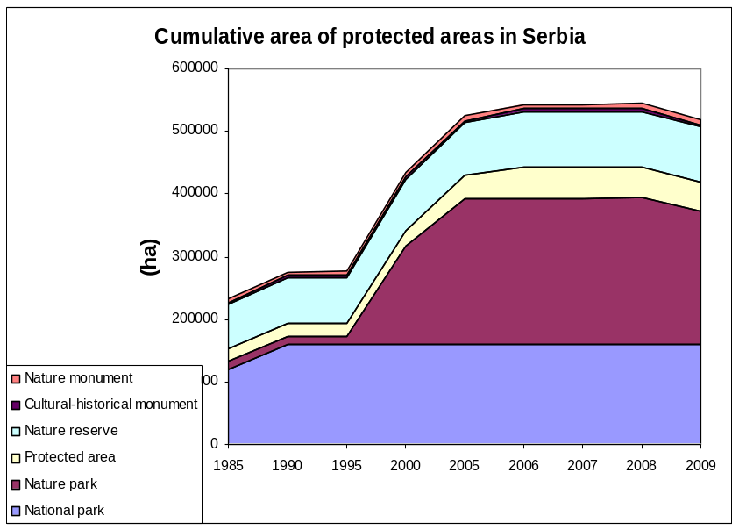

- Structure of protected areas
Type: National, International

4. Number of endangered species by IUCN
Type: National, International

 | - Number of species | - IUCN | - SRBIUCN
Mammals | 100 | 11 | 8
Aves | 345 | 11 | 117
Reptilians | 24 | 3 | 13
Amphibians | 23 | 0 | 14
Pisces | 100 | 12 | 12
Insects* | 230 | 8 | 79

Threatened species according IUCN and SRBIUCN.

- Number of species
Type: National, International

 | Number of Species in Serbia (inc. subs.)
Mamalia | 98
Aves | 344
Reptilia | 25
Amphibia | 23
Pisces | 110
Invertebrata | 12000
Fungi | 625
Algae | 1000
Lichenes | 586
Bryophyta | 400
Spermatiphyta and Pteridophyta | 3662

6. Trends in birds and butterfly populations
Type: National, International, EEA

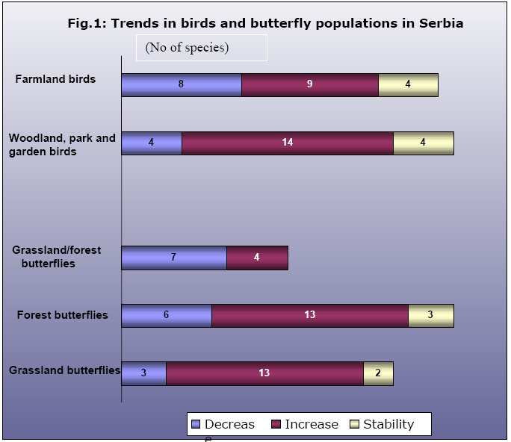

- Forest area changes
Type: National, International

- Type of forests
Type: National, International, MCPFC

- ICP Forest monitoring
Type: National, International, MCPFC

- Growing stock
Type: National, International, MCPFC

- Damages in forests
Type: National, International, MCPFC

- Firewood per capita
Type: National, International, MCPFC

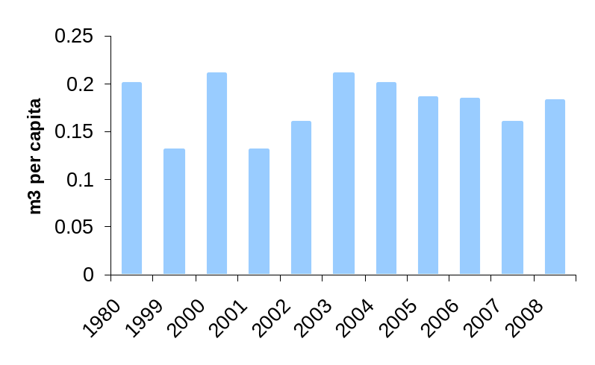

- Forest cutting
Type: National, International, MCPFC

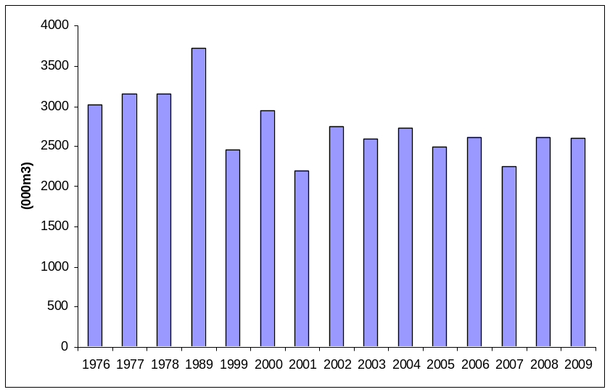

- Contribution of forest sector to GDP
Type: National, International, MCPFC

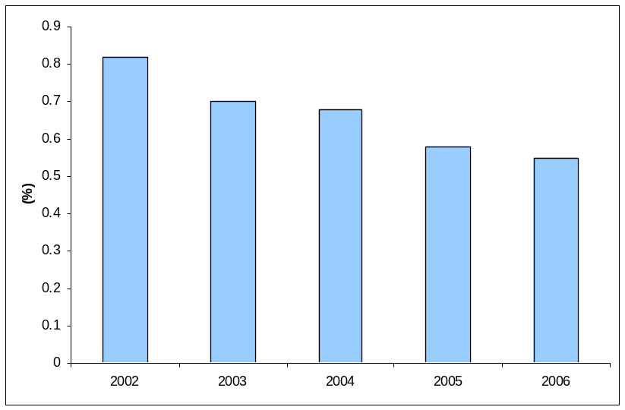

- Deadwood
Type: National, International, MCPFC

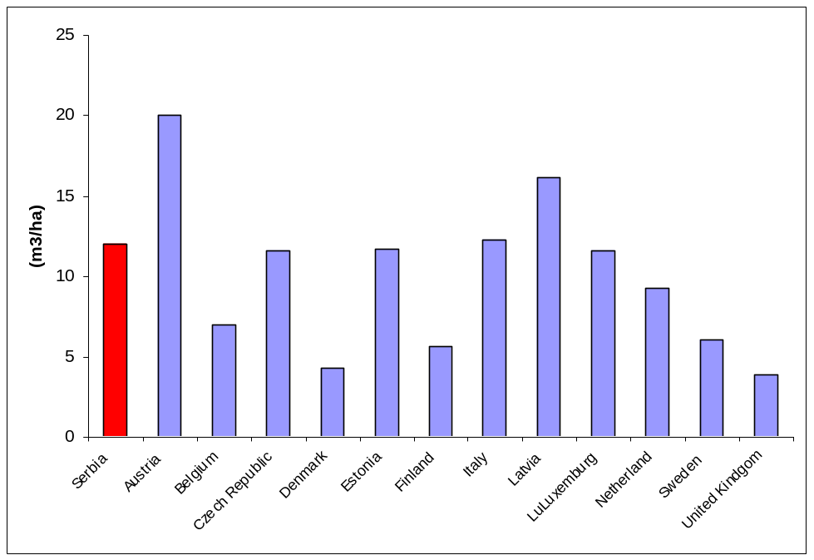

- Forest holdings
Type: National, International, MCPFC
Private, 52.2
Other, 8
State, 39.8

- Naturalness
Type: National, International, MCPFC

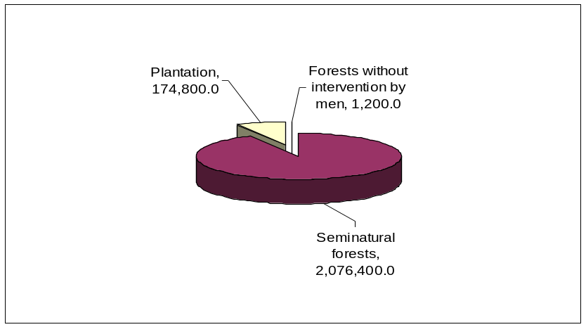

- Protected forests
Type: National, International, MCPFC

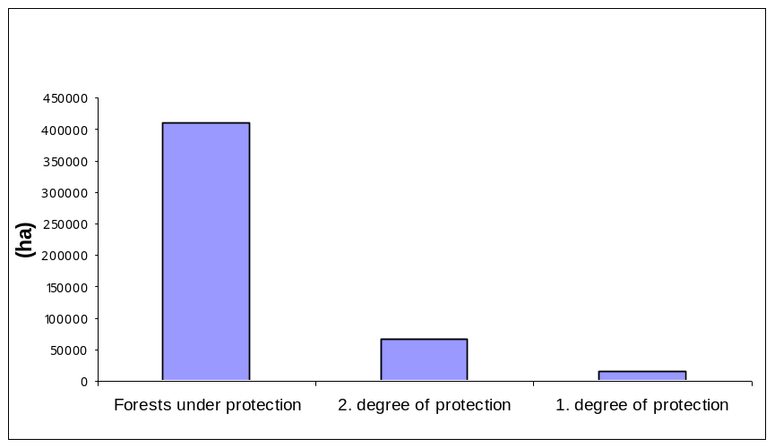

25. Forest area under Management Plan
Type: National, International, MCPFC

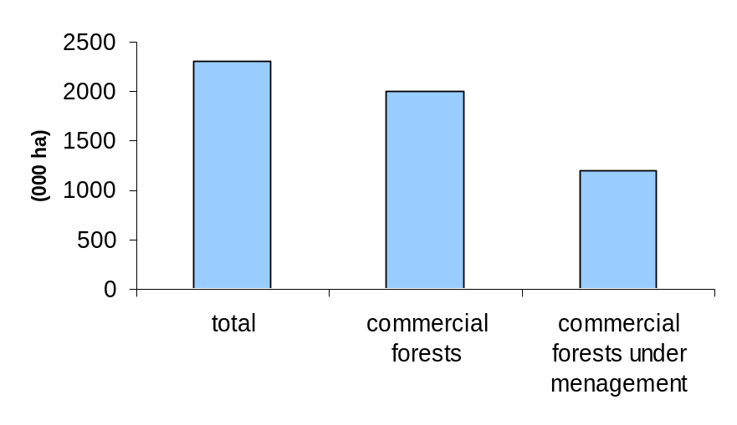

27. Number of game animals
Type: National

28. Catching
Type: National

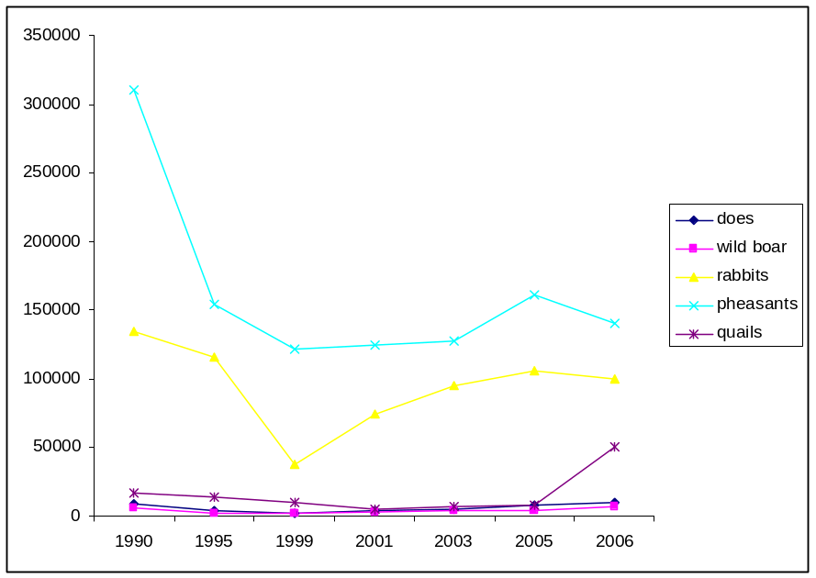

29. Freshwater fishing
Type: National, International

31. Structure of Fishery
Type: National, International

32. Structure of fishing
Type: National, International

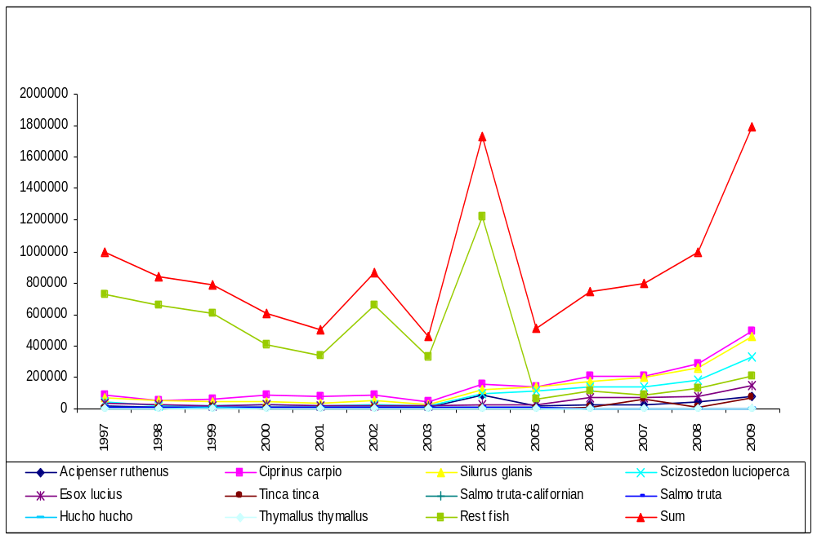

33. Water quality in aquatic ecosystems
Type: National, International

Year | 1999 | 2000 | 2001 | 2002 | 2003 | 2004 | 2005 | 2006 | 2007 | 2008
Water region Danube | 3.01 | 2.96 | 2.68 | 2.83 | 3.13 | 2.79 | 2.72 | 2.81 | 2.84 | 2.61
Water region Morava | 2.28 | 2.78 | 3.33 | 2.57 | 3.18 | 2.35 | 2.42 | 2.36 | 2.92 | 2.82
Water region Sava | 2.07 | 1.85 | 1.96 | 2.43 | 2.06 | 1.71 | 1.67 | 1.69 | 1.93 | 1.70
Total water regions | 2.50 | 2.75 | 2.64 | 2.67 | 2.84 | 2.55 | 2.51 | 2.59 | 2.53 | 2.51
Median concentration of BOD-5 (Biological Oxygen Demand) in mg/l

APPENDIX III.

REFERENCES

Biro, E., Bouwma, I. and Grobelnik, V. 2006. Indicative map of the Pan-European Ecological Network in South-Eastern Europe - Technical Background document. (ECNC Technical Report Series).ECNC, Tilburg, the Netherlands.
Economic Commission for Europe, Committee on Environmental Policy (2007) Environmental Performance Reviews: Republic of Serbia, Second Review. United Nations, New York and Geneva.
Ham, I., Škorić, Vucanovic, S. 2009.: Distribution, breeding success and population size of White-tailed Eagle Haliaeetus albicilla in Serbia in 2009. Ciconia 18: 16-28.
Jakšić, P. 2003. Red Data Book of Serbian Butterflies, Lepidoptera: Hesperioidea and Papillionoidea. Institute for Nature Conservation of Serbia, Belgrade.
Jakšić, P. (ed.) 2008. Prime Butterfly Areas in Serbia. HabiProt, Belgrade.
Karadžić, B. and.Mijović, A. (eds) 2007. Environment in Serbia, an indicator based review. Ministry of Science and Environmental Protection, Environment Protection Agency.
Кицошев, В., Сабадош, К., Киш, А. 2007.: Значај заштићених природних добара у ублажавању последица промене климе, XXXV Саветовање са међународним учешћем – Заштита ваздуха 2007, Circulation 25-30, Привредна комора Србије – Одбор за заштиту животне средине и одрживи развој, Београд.
Ministry of Agrriculture, Forestry and Water Management, Directorate for Forests. Forest condition monitoring in the Republic of Serbia, Annual Reports ICP Forests 2004. Belgrade.
Ministry for the Protection of Natural Resources and the Environment, Republic of Serbia, 2003. Report of the State of the Environment and Natural Resource in 2002.
Ministry of Science and Environmental Protection, Environmental Protection Agency. Reports of the State of the Environment and Natural Resource in 2003, 2004 and 2005.
Ministry of Environment and Spatial Planning, Environmental Protection Agency. Reports of the State of the Environment and Natural Resource in 2006, 2007 and 2008.
Puzović, S. (ed.) 2000. Atlas of Breeding Birds of Prey of Serbia. Institute for Nature Conservation of Serbia, Belgrade.
Puzović, S. Simić, D. 2002. Birds in Europe. Population estimates, trend and conservation status. Conservation Series No. 12. Ian Burfield and Frans van Bommel. BirdLife International.
Puzović, S. 2009. Important Bird Area in Serbia. Ministry of Environment and Spatial Planning, Institute for Nature Conservation of Serbia, Provincial Secretariat of Environmental Protection and Sustainable Development.
Republic Office of Statistics. Statistical Yearbooks.
Sekulić, N. and Šinžar, J. (eds.) 2010. Emerald Ecological Network in Serbia. Ministry of Environment and Spatial Planning, Institute for Nature Conservation of Serbia. Belgrade.
Stevanović V., Vasić V. (eds.) 1995. Biodiversity in Yugoslavia - with view of international significance species. Faculty of Biology, Ecolibri. Belgrade.
Stevanović V. (ed.) 1999. Red Data Book of Flora of Serbia 1. Ministry of Environment, Faculty of Biology, Institute for Nature Conservation of Serbia. Belgrade.
Stevanović, V. 2005. IPAs in Serbia. In: Important plant areas in Central and Eastern Europe. Plant life International.
Szabados, K., Panjković, B. (eds) 2009. Development of Ecological Network in Vojvodina, Project Report, Institute for Nature Conservation of Serbia, Department in Novi Sad, Novi Sad..

