Ref.: SCBD/SSSF/AS/SBG/CC/VA/
Notification February 25, 2020

August 15, 2020
Dear Executive Secretary,
The undersigned organizations, Wild Heritage, Griffith University (Australia) and the Australian Rainforest Conservation Society are writing in response to notification No. 2020-053
of June 25, 2020, Peer review of draft documents for the twenty-fourth meeting of the Subsidiary Body on Scientific, Technical and Technological Advice (SBSTTA 24). This submission is regarding the document on indicators for the draft goals and targets of the post-2020 global biodiversity framework.

With many thanks and best regards,

Cyril Kormos
Executive Director, Wild Heritage
Cyril@wild-heritage.org / +1 510 862 5359
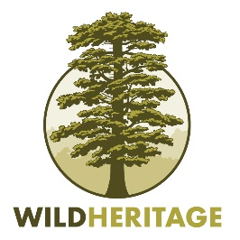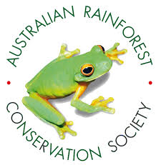

General Comments
Page | Comment
18 | Wherever forest area is being reported by the FAO, separate figures should be included for the three major forest categories recognized by the FAO: i.e. primary forest, other naturally regenerated forests and planted forest, to provide a more complete assessment of current forest status. (e.g. see: GA2. Ecosystem integrity and connectivity, terrestrial, freshwater and Trends in fragmentation and quality of forest ecosystems Forest area as a percentage of total land area).
28,31,52,53 | Table 2 assumes in numerous places (see: GA6. Protection of critical ecosystems; GB1. Nature’s regulating contributions including climate regulation, disaster prevention and other T2.1. Area of terrestrial, freshwater and marine ecosystem under protection and conservation, T2.2. Areas of particular importance for biodiversity are protected and conserved as priority, T2.6. Increased protection and conservation effectiveness) that certification systems such as FSC and PEFC can be used as indicators to measure biodiversity and climate benefits. This is inappropriate because certified logging results in substantial losses of biodiversity and also causes significant CO2 emissions and depletion of carbon stocks. Forests managed for commodity production are also at greater risk from drought, fire and invasive species. It is therefore not an appropriate indicator of biodiversity protection, climate mitigation/adaptation or of an OECM (Other Effective Area Based Conservation Measure).
35 | It is unclear how certification of forestry practices contributes to: GB3. Nature’s non-material contributions including cultural.
91 | Regarding T14.3, the proposed indicator is “total FSC and PEFC forest management certification”. However, this is not appropriate because a forestry operation that has been certified only indicates that best practices have been used. It does not guarantee sustainability for timber yield, or for biodiversity/climate benefits or other ecosystem service values.

