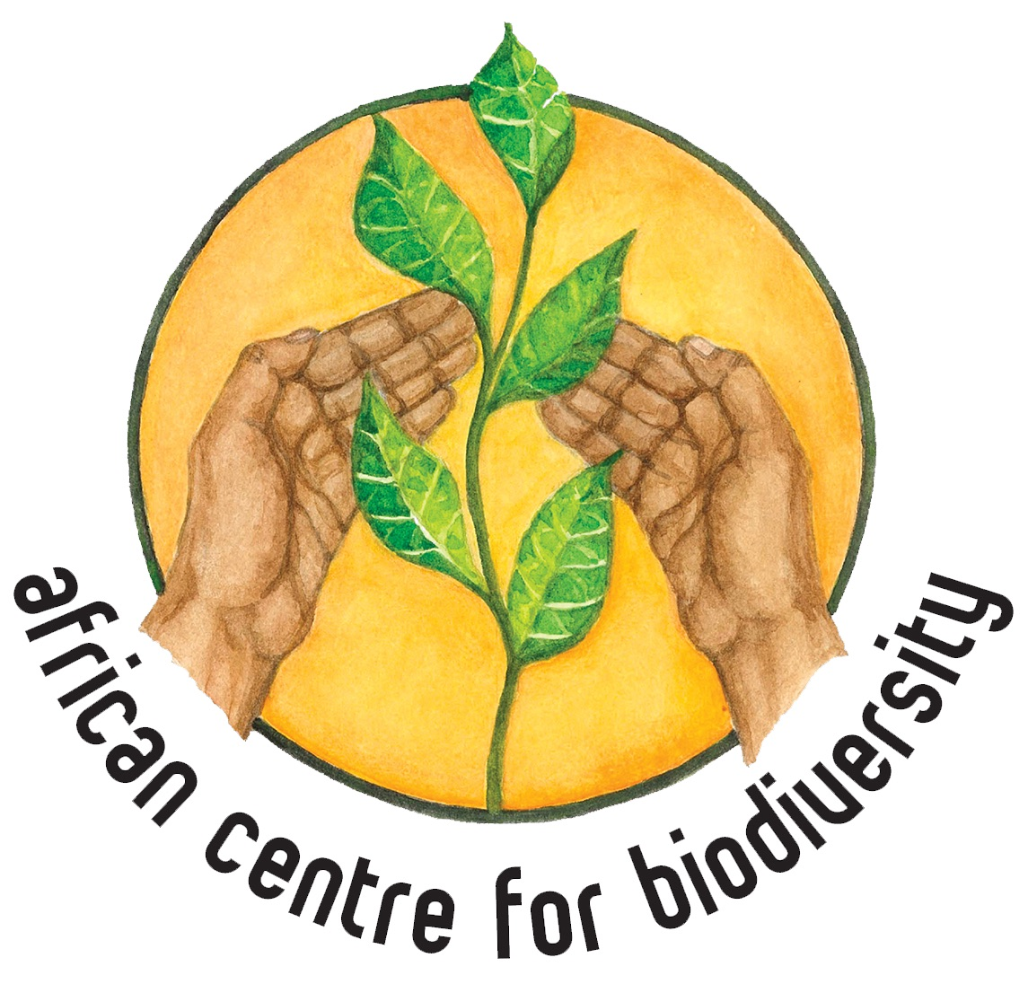

Submission by the African Centre for Biodiversity

To the Convention on Biological Diversity

In regard to the views on possible targets, indicators and baselines for the post-2020 global biodiversity framework

January 2020

The African Centre for Biodiversity (previously ‘Biosafety’) was established in 2003 and registered in 2004. ACB carries out research, analysis, capacity and movement building, and advocacy. It also shares information to widen awareness and catalyse collective action and influence decision-making on issues of biosafety, agricultural biodiversity and farmer-managed seed systems (FMSS), and on the expansion of corporate power in African agro-food systems. The ACB’s work both informs and amplifies the voices of social movements fighting for food sovereignty in Africa.

The overall objective of ACB’s work is to strengthen food security in Southern and East Africa by promoting seed diversity and agro-ecological practices. Specific objectives linked to programmes are to secure biosafety in Africa; secure agricultural biodiversity in Africa; and to limit corporate expansion while ensuring farmers have alternative systems of support based on agro-ecology in place.

The ACB, under the leadership of Ms. Mariam Mayet, has engaged with the CBD, in particular the Cartagena Protocol, since its inception, and has also played an instrumental role in shaping the discourse on farmers’ rights, farmer-managed seed systems and farmers’ seed.

This submission is based primarily in light of the fact that industrial agriculture, monocropping and modern breeding have had significant effects on biodiversity. Industrial agriculture’s impact on terrestrial, freshwater and marine ecosystems is severe due to destruction of habitats, pollution, soil depletion and genetic erosion, amongst a range of other direct and indirect negative impacts. Industrial agriculture has also significantly eroded both agricultural and genetic diversity, affecting the resilience of socio-ecological systems and food and nutritional security. From an African context, biodiversity loss interacts with the fact that the continent is and will be hardest hit by the impacts of the climate crisis and the potential advance of industrial agriculture on the continent will only worsen its ability to adapt to climate change and ensure the right to food for all of its people.

While the ACB is in agreement with the Zero Draft Post-2020 Global Biodiversity Framework, urgent action is required to address the significant threats to global biodiversity, which includes industrial agro-food systems. This needs to be clearly specified and addressed. There are other important agreements, such as the International Treaty on Plant Genetic Resources for Food and Agriculture (ITPGRFA) and the International Declaration on the Rights of Peasants and Other People Working in Rural Areas, that should be taken into account and specifically mentioned in order to achieve the targets set out in this post-2020 Framework. The remainder of this submission focuses on suggestions for addressing the impacts of industrial agriculture more specifically and ideas of goals and indicators that can accompany them.

2030 and 2050 Goals

There should be specific mentions of the sectors that have significant effects on terrestrial, freshwater and marine ecosystems in 10(a). This will include industrial agriculture. This should then include targets and indicators relating to drastically reduced synthetic fertiliser and pesticide application, reductions in concentrated feeding facilities and structural shifts from industrial agriculture to agroecological forms of agriculture.

To ensure that genetic diversity is maintained and enhanced under 10 (c) specific mention should be given to the role smallholder farmers play in preventing genetic erosion, the developing and maintaining genetic diversity (specifically for food and agriculture) and crop biodiversity, and therefore the need to ensure not only the equitable sharing of benefits, but the ability of farmer seed systems to function through the realisation and implementation of farmers’ rights as stated under the ITPGRFA.

In terms of improving nutrition under 10 (d)(i), the post-2020 Framework should acknowledge the impact that industrial agriculture has on nutrition, and the significant role smallholder farmer systems play in terms of providing access to significant, reliable, affordable, and culturally appropriate foods, and adaptable and resilient seed and food systems, especially in Africa. Industrial agriculture has limited on-farm diversity and low genetic diversity, compared to smallholder farming systems which are biodiverse, integrated systems. The shift towards industrial agriculture and food has showed lower nutritional content in the foods (due to high synthetic inputs and poor soil health) and reduced dietary diversity, having significant impacts on nutrition, especially for the rural and urban poor. Therefore the goals should acknowledge this and support a shift towards biodiverse agroecological systems to improve nutrition and nutritional security. These systems are also shown to be less resource demanding, and more resilient to natural disasters due to their high bio- and genetic diversity. Resilience and adaptability will become increasingly important with increased climate stress and natural disasters putting strain on food supplies.

2030 Mission and 2030 action targets

We need urgent and effective actions to achieve these targets, and to reduce the extreme implications that human civilisation will face with biodiversity loss and the collapse of our ecological systems. In order to achieve these targets, we emphasise the need for democratised agricultural and food systems, based on farmer’s rights, and recognising the significant role played in the development and conservation of genetic diversity, agricultural biodiversity and ecological health.

To reinforce what has been said above, 12(a)(1) needs to specify the sectors and activities that threaten biodiversity, and address them each specifically. This includes, but is not limited to, the industrial agro-food system, which impacts terrestrial, freshwater and marine ecosystems. Agroecological systems are integrated systems, and provide effective methods for integrating biodiversity, conserving wild landscapes, and ensuring the integrity of upstream and downstream social and ecological systems. Specific goals in this regard should thus include policies that focus on restoring and building up natural soil fertility and support smallholder farmers in agroecology, public research and extension funding and services directed towards agroecology, policies and programmes that support market access for agroecologal produce of small farmers (including public procurement), and so on. Reports such as those from the International Panel of Experts on Sustainable Food Systems (IPES-Food), the Food and Agriculture Organisation and the EAT-Lancet Commission provide important practical goals, targets, indicators and practical actions for making the necessary shifts in food systems that connect the enhancement of nutritional diversity with protecting and rebuilding biodiversity. Following the IPES-Food report, indicators can include connected elements like nutrient content per hectare, total biomass produced, resource efficiency, ecosystem benefits created, and livelihood resilience and social equity.

Another important threat to biodiversity is extractivism, specifically mining, which affects biodiversity by extracting large amounts of water from catchment and river systems, water pollution and destruction of plant, animal and soil life. Goals need to include the scaling down of mining to levels commensurate with social and ecological needs rather than narrowly economic agendas.

12(a)(4) specifically refers to the pollution from agricultural inputs (amongst others) in terms of synthetic fertilisers and biocides. Actions to achieve this need to specify shifting to less external inputs, based on agroecological agriculture and local food economies.

Biodiverse agroecological systems, farmer seed and farmer seed systems will contribute directly and significantly to climate change mitigation and adaptation, and disaster risk reduction as an effective nature-based solution. This is particularly important in Africa, which is one of the continents to be hardest hit by the climate crisis. Smallholder farming systems, using mostly farmer seed acquired through farmer seed systems, is the base of food production and supply in most of Africa and should be recognised as such, and strengthened and supported as a result. Despite this fact increasing pressures and threats to these systems are being witnessed, through normative legislation, policies and programmes which need to be urgently redressed. This is also clear in farmer-input subsidy programmes (FISPs), and touches on 12(c)(12) on the negative impact of subsidies, as well as the incomparable subsidies given to resource depleting, extractive agricultural practices lacking diversity in much of the developed world, and having direct and indirect impacts on the food sovereignty of developing countries. As such, a goal needs to explicitly include reducing the subsidies that exist in varying forms to industrial agriculture, with indicators measured by an annual decrease in the value of such subsidies, as well as an indicator measuring the commensurate transfer of resources to supporting ecological forms of agriculture.

Paragraph 12(c)(14) speaks directly to supply chain issues, which includes agricultural and food systems, and its negative impacts on biodiversity, and ecological functioning. This must be expanded to include both input and output supply chains. At the same time, in the case of agriculture, we should not be limited to only greening existing global supply chains, but shifting agricultural systems away from global supply chains as much as possible towards regional and local systems. This is an imperative from the angle of reducing greenhouse gas emissions, but also of protecting biodiversity by having concrete goals of supporting food systems based on smallholder agroecological production, short supply chains and alternative retail infrastructures.

We support the specific mentioning of the potential adverse impacts of biotechnology on biodiversity, which the Cartagena Protocol aims to achieve. This said, national laws tend to overlook the environmental and ecological impacts of these technologies, and many do not include socio-economic considerations, making these simple rubber-stamping exercises. Transparent and democratic decision-making is required, ensuring, prior and informed consent (FPIC) is achieved, where all impacted groups have access to reliable and up-to-date information.

Enabling Conditions

In further regard to free, prior and informed consent (FPIC), it is welcomed that 14(a) mentions the rights of indigenous peoples and local communities in the implementation of the framework. However, more concrete and meaningful goals and indicators could be advanced if, in the text and consequent goals and indicators, their rights were expanded to include their right to free, prior and informed consent (FPIC) as it relates to land, oceans, rivers and biodiversity under their stewardship. This is particularly relevant for Africa given the resource boom on the continent and the expansion of mining activities. Giving indigenous peoples and local communities the formal power to decide whether ‘development’ projects and biotechnology interventions may take place in their territories is a critical measure for protecting biodiversity as it puts decision-making power in the hands of those who directly conserve and benefit from local biodiversity. Indicators would include the extent to which national policies and programmes enshrine this principle, and the extent of the actual enactment of this principle across specific locations to protect biodiversity.

Implementation support mechanisms

Where technological transfer is mentioned, such as in paragraph 13(d), it is imperative for a technology assessment to be required, to ensure technologies are relevant, responsive and appropriate to the context. This should be stated clearly. Indicators for technology assessment capacity and implementation may include the percentage of parties that undertake assessments, percentage of decisions with associated summary reports of assessments, and the percentage of parties that have access to and use relevant risk assessment guidance materials.

Kind regards,

Mariam Mayet

Executive Director
African Centre for Biodiversity (ACB)

IPES-Food. 2016. From Uniformity to Diversity: A Paradigm Shift from Industrial Agriculture to Diversified Agroecological Systems. International Panel of Experts on Sustainable Food Systems.
FAO. 2018. The Future of Food and Agriculture: Alternative Pathways to 2050. Rome: The Food and Agriculture Organisation of the United Nations.
EAT-Lancet Commission. 2018. Healthy Diets from Sustainable Food Systems: Food Planet Health. Summary Report of the EAT-Lancet Commission.

