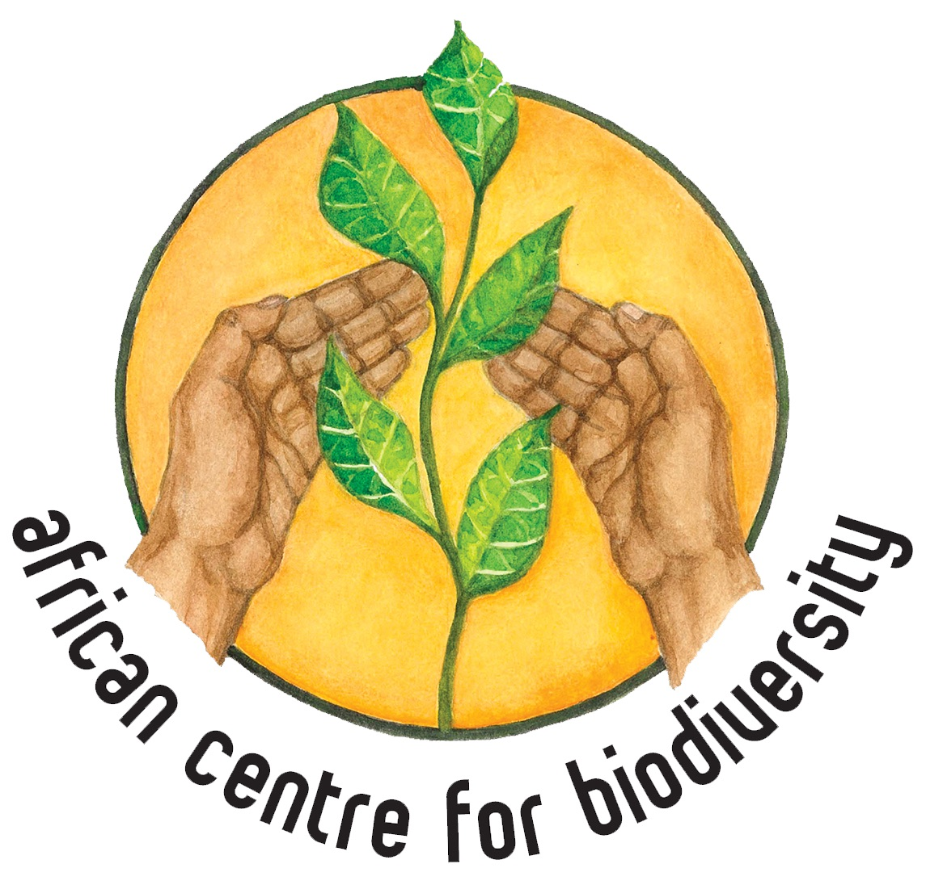

Comments by the African Centre for Biodiversity

To the Convention on Biological Diversity

In regard to the document ‘Indicators for global and national biodiversity targets – Experience and indicator resources for development of the post-2020 global biodiversity framework’ (CBD/SBSTTA/23/INF/4)

January 2020

The African Centre for Biodiversity (previously ‘Biosafety’) was established in 2003 and registered in 2004. ACB carries out research, analysis, capacity and movement building, and advocacy. It also shares information to widen awareness and catalyse collective action and influence decision-making on issues of biosafety, agricultural biodiversity and farmer-managed seed systems (FMSS), and on the expansion of corporate power in African agro-food systems. The ACB’s work both informs and amplifies the voices of social movements fighting for food sovereignty in Africa.

The overall objective of ACB’s work is to strengthen food security in Southern and East Africa by promoting seed diversity and agro-ecological practices. Specific objectives linked to programmes are to secure biosafety in Africa; secure agricultural biodiversity in Africa; and to limit corporate expansion while ensuring farmers have alternative systems of support based on agro-ecology in place.

The ACB, under the leadership of Ms. Mariam Mayet, has engaged with the CBD, in particular the Cartagena Protocol, since its inception, and has also played an instrumental role in shaping the discourse on farmers’ rights, farmer-managed seed systems and farmers’ seed.

This submission is based primarily in light of the fact that industrial agriculture, monocropping and modern breeding have had significant effects on biodiversity. Industrial agriculture’s impact on terrestrial, freshwater and marine ecosystems is severe due to destruction of habitats, pollution, soil depletion and genetic erosion, amongst a range of other direct and indirect negative impacts. Industrial agriculture has also significantly eroded both agricultural and genetic diversity, affecting the resilience of socio-ecological systems and food and nutritional security. From an African context, biodiversity loss interacts with the fact that the continent is and will be hardest hit by the impacts of the climate crisis and the potential advance of industrial agriculture on the continent will only worsen its ability to adapt to climate change and ensure the right to food for all of its people.

It is within this context that ACB highlights and emphasises the significant role African smallholder farmers, farmer-managed seed and agricultural systems, local communities and indigenous populations play in developing and maintaining genetic diversity, agricultural biodiversity, and biodiversity and ecological health more broadly, which in turn bolster the genetic resources and ecological processes on which we rely. As part of the post-2020 agenda, farmers’ rights and farmer seed systems need to be recognised, restored, and protected, and a drastic shift away from the industrial and dependency-creating agricultural system and towards biodiverse, agroecological systems is urgently needed. These provide the base for sustainable food production and will become increasingly important with the imminent climate and ecological crises.

While the ACB is largely in agreement with the indicators laid out in ‘Indicators for global and national biodiversity targets – Experience and indicator resources for development of the post-2020 global biodiversity framework’ (CBD/SBSTTA/23/INF/4), urgent action is required to address the significant threats to global biodiversity, which includes industrial agro-food systems. This needs to be clearly specified and addressed. There are other important agreements, such as the International Treaty on Plant Genetic Resources for Food and Agriculture (ITPGRFA) and the International Declaration on the Rights of Peasants and Other People Working in Rural Areas, that should be taken into account and specifically mentioned in order to achieve the targets set out in the post-2020 Framework. Below are suggestions of where indicators might more clearly link to overcoming the impacts of industrial agriculture on biodiversity and of achieving greater biodiversity in agriculture.

Aichi Target 3 (Incentives):

- At the moment there is an indicator for trends in potentially environmentally harmful elements of government support to agriculture, but an indicator needs to be included that specifically assesses government support to agroecological and other ecologically-centred forms of agriculture. This is especially important in light of the fact that despite the efforts and targets of the CBD, large initiatives like the Gates Foundation’s Alliance for a Green Revolution in Africa (AGRA) are forming partnerships with African governments to promote technologies and production methods that promote a small number of uniform crops and so will reduce the biodiversity in African agriculture, together with promotion of increased usage of synthetic fertilisers. Governments need to be urged to support agroecological alternatives grounded in production, crop and dietary diversity.
- There should be an indicator relating to the number of countries with policies and programmes that actively support the conservation of genetic resources and promotion of genetic diversity in agriculture. Such policies and programmes should conserve genetic resources at national level, but also promote and support in situ conservation that is grounded in existing ecological contexts and production systems.

Aichi Target 7 (Sustainable forestry and agriculture):

- There should be an indicator for assessing the genetic and crop diversity in agricultural systems.
- There is an indicator ‘Proportion of agricultural area under productive and sustainable agriculture’, but given the growing international recognition of agroecology as a critical solution to the ecological devastation caused by industrial agriculture, there should be an indicator that examines ‘Proportion of agricultural area under agroecological forms of agriculture’. This is further required in light of the fact that what constitutes ‘sustainable agriculture’ can be open to wide interpretation. For example, AGRA’s programmes may promote their model as sustainable under the current wording, while it in fact is promoting the greater uptake of synthetic fertiliser use and reduced crop diversity.

