CONVENTION ON BIOLOGICAL DIVERSITY (CBD) NOTIFICATION 2020-055

Consultation and Information Briefing on a Draft Outline of a new Gender Plan of Action for the Post-2020 Period

Submission by Australia

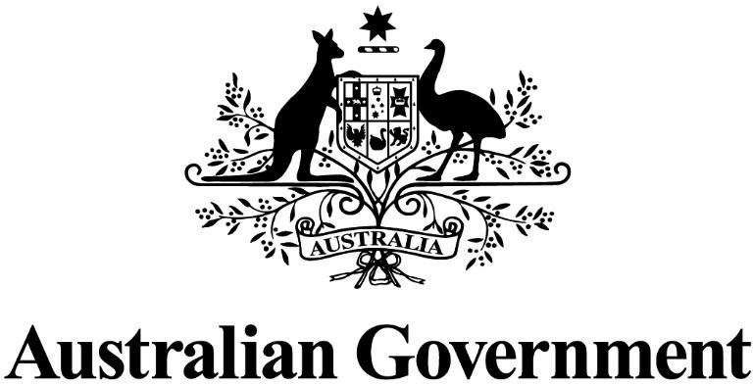

NOTE: Information provided in this response has predominately been drawn from Australian Government input

CBD Notification 2020-045

Australia thanks the Secretariat for the opportunity to submit views on the review of implementation of the 2015-2020 Gender Plan of Action and a proposed new draft gender plan of action for the post-2020 period, to be considered at the third meeting of the Subsidiary Body on Implementation, as communicated in Notification 2020-055 4 August 2020 Ref: SCBD/SSSF/AS/JS/TM/89017.
Australia’s response below pertains to the draft outline for a new Gender Plan of Action for the post-2020 period. As requested, Australia’s comments have been provided on the draft outline in the associated review template below. We have also provided general comments on the broader process and approach for consideration.

Review comments on the draft outline of a gender plan of action for the post-2020 period
Contact information
Surname: | Miller
Given Name: | Katherine
Government (if applicable): | Australia
Organization: | Department of Agriculture, Water and the Environment
Address: | John Gorton Building, King Edward Terrace, Parkes, ACT, 2600
City: | Canberra
Country: | Australia
E-mail: | CBDAustralia@awe.gov.au
General Comments
Australia appreciates the work undertaken to date on the review of the implementation of the 2015-2020 Gender Plan of Action, as this provides the opportunity for lessons learned to be utilised in the development of the new Plan.
Some broad comments on findings of the review, the process to date and the draft outline are below. We are looking forward to engaging in this process going forward.
- Australia wishes to reiterate the mandate set out by COP14/18 which was to ‘undertake a review of the implementation of the 2015-2020 Gender Plan of Action, in parallel to the development of the fifth edition of the Global Biodiversity Outlook and the second edition of the Local Biodiversity Outlooks, in order to identify gaps, best practices and lessons
learned’. We note that this decision does not include formal agreement by Parties to develop a new Gender Plan of Action. Our view is that this needs to be considered and addressed further at the third meeting of the Subsidiary Body on Implementation, including agreement to the most effective and efficient approach to the development of a
new plan.

- Australia strongly supports the Convention taking action on gender equality and we support the review’s finding that the current Gender Plan of Action has added value, particularly in bringing attention to and advancing action on gender equality and women’s empowerment.
- Should Parties agree to the development of a new plan, we agree that a strong focus should be on enhancing global and domestic efforts towards action and implementation. Providing practical examples of such actions would be beneficial in enhancing these efforts.
- We note the survey findings indicate that measurable targets and indicators will be needed to support the implementation of a gender-responsive Post-2020 Global Biodiversity Framework. Australia put forward several suggestions for indicators to this effect in our submission to Notification 2020-045.
- Regarding the draft outline provided for a new plan, we note the objectives put forward are intended to be measurable and support the achievement of relevant international gender and biodiversity-related commitments. We are supportive this approach, however we caution that care must be taken to not dismiss important qualitative elements in the pursuit of what is measurable. We also firmly believe that the plan should first and foremost support the achievement of the Convention’s three objectives and the goals and targets of the Global Biodiversity Framework (noting that this is currently under development).
- Finally, we strongly support the need for a participatory and inclusive process. However, we are concerned that the release of this draft outline prior to agreement by Parties that a new plan is required, and at the same time as Parties and Non-Parties are considering and responding to the Global Biodiversity Framework’s monitoring elements and indicators, may result in an lack of engagement in this process. This highlights the need for flexibility in timing and the approach to a new plan to ensure participation is maximised.
Specific Comments
4 | A | 1 | “Equal” is more appropriate language than “equitable” and better reflects the language used in the draft objectives. This comment applies across the whole draft outline.
4 | B | 1 | We suggest this draft objective could be further broken down into the following:  Ensure full and equal participation of all genders, particularly women and girls, in decision making regarding biodiversity.  Encourage gender-inclusive governance structures, with a focus on strengthening the representation and leadership of women at all levels of biodiversity-related governance.  The explicit reference to women and girls when referring to participation, representation and leadership is critical.

However, we do not want to see an unintentional exclusion of female-identifying or non-binary persons – hence the proposed split of this into two objectives and some clarification around language – for broader consideration and discussion.
We reiterate that female-identifying members of the LGBTIQA+ community should be counted towards the gender equality targets on boards and/ or representative bodies.
4 | B | 2 | We suggest consideration is given to expanding this objective along the lines of:  Enhancing the full and effective participation of women in CBD processes, including through the engagement of women’s groups and encouraging women delegates.
4 | B | 3 | We suggest that consideration should be given throughout this draft outline to ensuring the new gender plan of action is easily communicable to all readers. On that basis, we suggest this objective could be shortened to:  Mainstream gender considerations into national biodiversity strategies and action plans, including planning and reporting.  We need to ensure that we are able to move beyond only identifying or raising awareness of gender issues, to taking measures to actively address gender inequalities and to incentivising concrete policy responses.
5 | B | 4 | Suggest expanding this objective beyond legal and social barriers to all barriers being considered and addressed with a focus also on simplifying language:  Barriers that may prevent access, ownership or control over land and other biological resources for women and girls are identified and removed.  Another objective that could be considered for insertion here may be along the lines of that in the UNCCD action plan, which  incorporates taking clear action to increase women’s land rights.
6 | A | 6 | “Equal” is more appropriate language than “equitable” and better reflects the language used in the draft objectives. This comment applies across the whole draft outline.
6 | B | 7 | For consideration, it may be beneficial to expand this to specify the need to promote steady and formal paid employment for women and girls in biodiversity-related sectors.

7 | B | 9 | We note the importance that any financial and human resources are combined with and supported by strong, results-orientated frameworks.
7 | B | 10 | It is unclear in this context what is meant by the term ‘gender perspective’. ‘Gender’ relates to social and cultural norms, and identity. It can be fluid, and not all people conform to traditional or stereotypical gender norms. Women and girls should be explicitly mentioned in addition to any broader gender terminology.  Language that encourages action and change could be considered here, for example, utilising similar language to that in the UNFCCC gender action plan. Language like ‘strengthen capacity building efforts’ and ‘mainstreaming gender into all areas…’.
7 | B | 11 | The collection and appropriate use of sex-disaggregated data is critical in addressing gender equality and improving understanding of the role of women and girls in relation to conserving and protecting biodiversity, but also the different impacts associated with biodiversity loss. Capacity building for data collection and statistics, including sex-disaggregated data, is also important.  As the GBF develops, there is a need to ensure strong alignment between this plan and any proposed indicators regarding the collection of sex-disaggregated data in support of implementation.
8 | B | 12 | Noting this objective is broad and encompasses both differentiated impacts on biodiversity loss as well as the role of women as agents of change, there may be potential to split this objective into two.  For consideration, please see the following text:  Strengthened evidence base and understanding of the differentiated impacts of biodiversity loss on women and men.  Strengthened recognition and understanding of the role of women as agents of change in the conservation and sustainable use of biodiversity, and access and benefit sharing.
8 | B | 13 | There may be benefit in aligning this objective with the UNCCD text to appropriately reflect different national circumstances.  Consideration could also be given to replacing ‘vulnerable population groups’ with wording such as ‘people who may be vulnerable, including women and girls’ given events and circumstances can make them vulnerable.

9 | B | 15 | It is unclear in this context what is meant by the term ‘gender perspective’. ‘Gender’ relates to social and cultural norms, and identity. It can be fluid, and not all people conform to traditional or stereotypical gender norms. Women and girls should be explicitly mentioned in addition to any broader gender terminology.  It may also be useful to clarify what review processes are being referred to here and link it back to biodiversity-related processes, noting that is the CBD’s remit.
9 | B | 16 | This objective could be improved by providing more guidance as to what ‘gender-responsive national reports’ could look like.  This objective could also be made clearer through text along the lines of the following i.e. “national reports under the CBD consider gender impacts, particularly those on women and girls, where possible…” or “efforts to ensure national reports under the CBD can specifically address gender, specifically women and girls, are enhanced”.
9 | B | 17 | We note that this objective appears to place responsibility for awareness raising activities on women’s groups and gender constituencies. We suggest rephrasing this objective so the responsibility for such activities are shared.  We also suggest including women as the direct recipients (those being communicated to) of outreach, awareness and uptake as per UNFCCC Action Plan.

