Review of the document on linkages between the post-2020 global biodiversity framework and the 2030 agenda for sustainable development

Contact information
Surname: |  |  | Obura
Given Name: |  |  | David
Government (if applicable): |  |  | n/a
Organization: |  |  | CORDIO East Africa
Address: |  |  | Box 10135 - 80101
City: |  |  | Mombasa
Country: |  |  | Kenya
E-mail: |  |  | dobura@cordioea.net
Comments
Page | Paragraph | Comment
1 | 2 | Full linkages from the GBF to the SDGs will be essential to the success of the GBF, and its value to all other international conventions as the ‘case-holder’ for biodiversity or nature as the foundation for human economy and social life. This is well captured in the Theory of Change expressed in the Zero Draft of the GBF. In fact, the Zero Draft almost cites directly, in paragraph 8 (CBD/WG2020/2/2, p. 7) that its Theory of Change IS that expressed by the 2030 Agenda – which is correct and should be reinforced in the final GBF.  This is supported by the publication doi:10.1016/j.marpol.2020.103973 which provides the following perspectives:  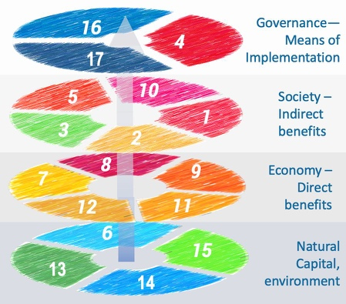  - What is important about this for the current document on linkages with the SDGs is that the SYSTEMIC linkages between the GBF and the SDGs are as important to highlight as the individual goal/target/indicator linkages, which take up vast space in the tables. The amount of detail in these tables is so high that all actors will be challenged to recall it, and organizing principles will be essential for operationalization. Also, the specifics of whether a particular target or goal in the GBF is linked most to one or another target or goal in the SDGs can be debated – but if all are clear IN PRINCIPLE of their complementarity, then in practice each country or actor can construct their own working example of the linkages that can motivate (and measure) changes.  - The mechanistic links between nature, economic use/activity and social benefits are important. The model in the reference above establishes the direct links from the nature goals to direct use/economic goals to indirect use/social goals. In fact this mirrors the focus of goals a, b and c in the CBD and GBF.  - This helps to explain why the CBD has focused on goal a historically, as it focuses closely on the state of nature. Under goals b and c there are increasing sources of variation brought in by greater human dimensions of use (goal b) and benefits (goal c) – making it extremely challenging for the biodiversity-focus of the CBD and the agencies responsible for country commitments to cope with. Aligning fully with the SDGs will enable the CBD to partner with conventions and agencies whose primary focus is in those economic and social pillars (e.g. FAO on food production and food security), to share that responsibility and to take ownership for different aspects of the dynamic.  Recommendation - alignment of the GBF and SDGs will be strengthened by a focus for the GBF on Sustainable Use as a dominant theme. This will help to redress the imbalance in attention between goals a, b and c; and address the needs and rights of the majority of the world’s people in relation to sustainable and equitable use of all of biodiversity. Further comments on how to do this are detailed below in comments to paragraphs 8-9 (page 27), and in general comments on the monitoring framework.
1 | 4 | How different SD goals (Column 2 in Table 1) line up with the GBF goals is challenging to argue through, as it depends on if the relationship is direct or indirect (multi-stepped). In this respect different actors can have very different opinions. It is not so important what the RIGHT assignment is, more that the assignment works in a particular context, and that flexible interpretations can be allowed to the extent they are mutually reinforcing (motivating action among actors), rather than competing (undermining collective action). The links between Goal A and the ‘nature’ SDGs 6, 13, 14, 15 is relatively straightforward, but the links are more complex for the other goals. The reference cited above (doi:10.1016/j.marpol.2020.103973) provides an organizing framework for relating the goals, as it:  - Splits the SD goals into the three domains of nature, economy and society that are the three pillars of sustainable development (plus a fourth group corresponding to the means of implementation, now under goal d in the GBF).  - Provides an organizing principle for the primary split among the three goals of the GBF in relation to the SDGs, where goal a focuses on nature, goal b on Nature’s Contributions to People (ie. the transactions of regulating, material and non-material NCPs that we value explicitly or implicitly through economic transactions) as the ‘nature’ element of sustainable use, and goal c on the sharing of the end-benefits (income/prosperity, food, health, etc), or the ‘people’ element of sustainable use.  These aspects are elaborated further in the following comments.
2 | 1 | Goal A. Extending the model cited above, Goal A should relate, as indicated in the table, to SDGs 6, 13, 14, and 15.
2 | 2 | Goal B relates to direct material and non-material interactions that can be measured (crops, fish, water filtration, carbon sequestration, enjoyment of nature) and often valued monetarily (as well as background ‘maintenance’ or regulatory functions in nature). These may variously fit under different ‘economy’ or direct benefit SDGs, but goal 12 on Sustainable Use focuses on the NATURE of human transactions with nature. Other institutions (e.g. FAO) may deal with very different human aspects of provisioning from nature, such as different farming or fishing systems and regulatory aspects, but the GBF in goal b should focus on the quantity or provision of benefits (crops, fish, etc), and if this is in balance with natural regeneration capabilities, i.e. sustainable from a biological sense (see also CBD/SBSTTA/24/INF/9 comments on goal d in the zero draft, to focus on NCP provision rather than benefits of using NCPs).  The rationale here is that to be implementable, goal b should focus on the BIODIVERSITY or NATURE aspect of the interactions between people and nature, thus on the NCPs that are actually transactioned through economic activities.  Thus goals 7 (energy) and 9 (innovation/products/infrastructure) are specific aspects of nature’s provisioning, goal 8 addresses the jobs and economic activity that are based on nature, and goal 11 focuses on urban systems and human settlements, where the housing and shelter functions of nature are maximized (see IPBES 2019 and definitions of the anthromes – particularly the urban unit of analysis). Primary responsibility for these as economic sectors lies with other agencies, but their relation to and dependence on nature fits within the mandate of the goal b of the GBF and SDG 12 on sustainable production and consumption, addressing HOW NCPs are accessed, and limits on production/consumption to ensure natural regeneration and productive capacities are not undermined.  Recommendation – reinforce alignment of goal b of the GBF with SDG 12
3 | 2 | Goal C relates to how direct benefits are shared among people and the wellbeing gained. Some of these benefits correspond to SDGs 1, 2 and 3, i.e. in the amount of income/wealth, food security and health outcomes, respectively. The core of goal c for the CBD has been on how benefits are shared or distributed among people, ie. SDGs 5 and 10. While goal c has been narrowly focused on genetic resources, the GBF now needs to squarely address indirect benefits and equitable sharing of these in relation to species and ecosystem-related benefits as well.  Recommendation – equitable sharing of benefits from species and ecosystems is not addressed structurally in a meaningful way in the GBF. There are two principle options for incorporating this:  - Under goal c, alongside sharing of benefits from genetic resources, or  - Under goal d as an explicit goal component. See comments on the monitoring framework for detailed comments on this.  Option a) requires amending the formal convention texts, while option b) requires further edits to the GBF goals and goal components as currently presented in these documents.
3 | 3 | Goal D – This new element of the GBF (ie. not present in the Zero draft), is consistent with the SDG model cited above recognizing the importance of elevating Means of Implementation to the same level as the main goals – thus knowledge (SDG 4) and governance (SDG 16), but also participation and generating resources for implementation (SDG 17).
4-26 |  | As explained above, the specific links from GBF to SDG targets can be impossibly complex, as 20 * 169 combinations are possible. Thus comments are not provided on these sections, but more on the overarching principles that will help any country or geography understand linkages among goals and targets relevant to their context, to motivate action to meet the GBF and SDGs.
27 | 8-9 | The 2050 vision is explicit about the position of people ‘living in harmony with nature’, using the verbs ‘valued, conserved, restored, widely used, maintaining, sustaining’. Focus to date on objective a of the Convention, preserving nature intact in wild places has not worked well enough, and with 21st century population and economic realities, already exceeding a one-planet footprint, a strong focus on the transactions between people and nature is necessary to bring humanity’s footprint down to one earth. The model below illustrates a focus on Nature’s Contributions to People and Sustainable Use, and how managing NCP flows to a) provide benefits equitably to people, and b) sustain the natural systems that provide them can provide a ‘whole of GBF’ perspective that has been historically absent.  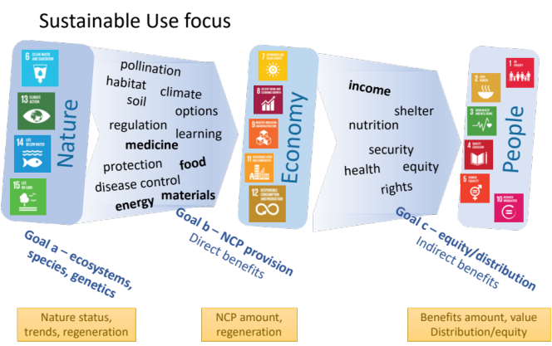  This focus on sustainable use is founded on the Sustainable Development Goals, and this approach enables a focused application of their theory of change in the context of the GBF. It also provides clear roles and responsibilities between the CBD and other international bodies, and indeed within countries between agencies responsible for the environment with other agencies (e.g. for food and agriculture). The GBF and nature agencies are clearly responsible for monitoring and securing natural assets, but also on knowledge and responsibilities for the supply and regeneration of NCPs as direct benefits to people, and on the distribution and equity of access of those and indirect benefits to people. In the flow from left to right in the figure above, the roles of other agencies increases, such as of food and agriculture agencies in regulating the offtake of NCPs and how they contribute to societal benefits such as nutrition, food security and income, and equity in their distribution.  From a monitoring and indicators perspective, the figure also indicates the the of indicators that are relevant, in the bottom row of orange boxes:  - Goal a – on the status, trends and regenerative ability of nature (ecosystems, species, genes). These indicators have been the focus of work under the CBD and natural scientists for decades and indicators are more developed for goal a than other parts of the GBF (90% of indicators in the GBO relate to biodiversity).  - Goal b - at the local level direct measures of NCP production and their regeneration are logical (e.g. tonnes of maize/corn, fish, etc) but aggregating these to national and international levels is traditionally done by other agencies, in this example FAO  - Goal c – measures of indirect benefits and their distribution may also be done tangibly at local levels and aggregated to national and international levels, and as with Goal b, have traditionally been done by other agencies. For the GBF, focusing on the trail specifically of NCPs into these domains should be the focus, and of how to effectively support monitoring at local levels of tangible benefits (e.g. disaggregated access to and use of food/medicines from nature), and how these aggregate to national and international reporting levels.  As indicated in earlier comments (page 3 para 2 on Goal c) however, a major structural element is missing in the GBF in addressing equitable benefit sharing of NCPs from species and ecosytems, thus the greatest part of ‘Positioning people in the GBF’ is in fact lacking.  Recommendations –  - reinforce the role of the SDGs in the GBF in locating people within the GBF, by focusing on Sustainable Use as a mechanism to assure a) benefits are distributed equitably among people, and b) the natural systems that provide them are sustained.  - Make space for physical/tangible measures of NCPs to be incorporated into the monitoring and indicators framework, with aggregation/abstraction being done based on these, to assure equity at local levels.  - equitable sharing of benefits from species and ecosystems is not addressed structurally in a meaningful way in the GBF, thus this most important linkage to people is lacking. There are two principle options for incorporating this:  - Under goal c, alongside sharing of benefits from genetic resources, or  - Under goal d as an explicit goal component. See other comments.
28 | 10-11 | The comments here relate to the call in the sentence “… further strengthen (the GBF) by following the Sustainable Development Goals’ model of integrating matters of equity throughout the goals and targets”. We offer a model focused on Sustainable Use to do this not only in the current structure of the GBF and its monitoring framework and indicators, but also in how they can consistently incorporate advances in knowledge and indicators in coming years.  This explicitly addresses inter-generational equity by ensuring the Frameworkhas made itself as responsive as possible to emerging knowledge, issues and needs of future generations, rather than locking them into an inflexible framework that becomes less relevant over time.  Building on the comments here on goals b and c, we provide major comments on the monitoring framework and indicators, focusing on these two goals.
29 | 12-13 | The SDG model presented here also makes explicit how to incorporate gender equality across all aspects of the GBF, with SDGs 5 and 10 providing the mechanisms to assure direct and indirect benefits from nature are distributed equitably. Disaggregation of NCP and benefit indicators under goals b and c is an essential tool for assessing progress.
29-30 | 14-15 | Incorporating economic sectors is explicit in the SDG model we present, in that these are addressed by the direct benefit SD goals 7, 8, 9, 11, 12. These address the passage of nature’s benefits to people through ecosystem services or Nature’s Contributions to People.  SDG 12 in particular addresses economic production and consumption practices that need to be transformed to become sustainable, providing the core elements for a Sustainable Use focus of the GBF.

Comments should be sent by e-mail to secretariat@cbd.int by 25 July 2020

