SUBMISSION OF THE REPUBLIC OF COSTA RICA
PROPOSAL FOR THE POST 2020 STRATEGIC FRAMEWORK

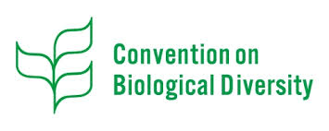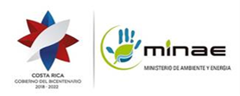

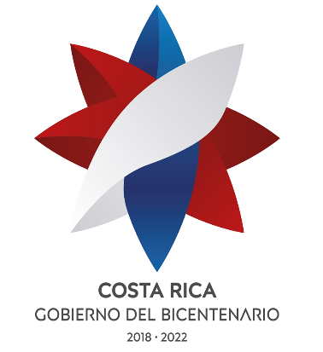

Costa Rica welcomes the opportunity to share its proposal regarding the structure of the Post 2020 strategic framework.

Costa Rica takes this opportunity to reiterate its willingness to support the necessary negotiation spaces to achieve an adequate consensus among all Contracting Parties to the Convention on Biological Diversity. Therefore, it underlines the importance of maintaining a constructive, participatory, transparent and ambitious spirit in the negotiations in such a way that all the Parties have the sole interest of achieving the effective application of the three objectives of the Convention and thereby reducing the loss of biodiversity and favor the well-being of the human being.

Proposed Structure of the Strategic Framework for POST 2020 of the Convention on Biological Diversity

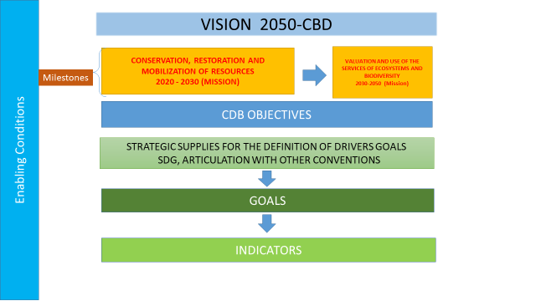

The country considers that the 2050 Vision that was approved by the Parties in Decision X / 2 The Strategic Plan for Biological Diversity 2011-2020 and the Aichi Biodiversity Targets, is in force and it is necessary to maintain the elements that the Vision 2050 includes. Therefore, it remains in the structure as the strategic apex for the design and establishment of goals and indicators.

The milestones included in the figure represent the most important issues to be developed in the missions to fulfill the vision. Costa Rica proposes two milestones distributed in two periods:

- 2020-2030. In this first decade, work must be concentrated on the conservation, restoration and mobilization of resources. To avoid the loss of biodiversity it is necessary to conserve. One of the most important conservation strategies is restoration and also to conserve, it is necessary to mobilize domestic and international resources to direct them towards actions to prevent the loss of biodiversity.
- 2030-2050. In this period the mission of the World must be directed towards the valuation and sustainable use of biodiversity and the ecosystem services that it offers us

After the missions, there are three objectives of the Convention. The objectives of CBD act as the platforms through which the goals to be negotiated are prioritized and gather.

At the next strategic level are the strategic inputs among which are the drivers that cause loss of biodiversity, the Sustainable Development Goals and synergistic actions with other conventions.

The milestones include the thematic priorities per period, the objectives of the Convention on Biological Diversity and strategic inputs are the elements so that the goals are prioritized and properly grouped for national application by the Party countries. Next, there are the goals and indicators.

The enabling conditions are found throughout all strategic levels.

