Case Study

City of Kanazawa, Japan
-A City that Pursues Harmony between Conservation and Development-
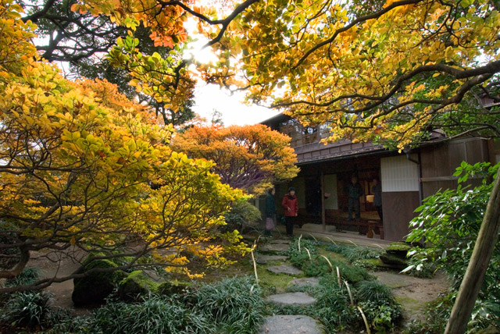
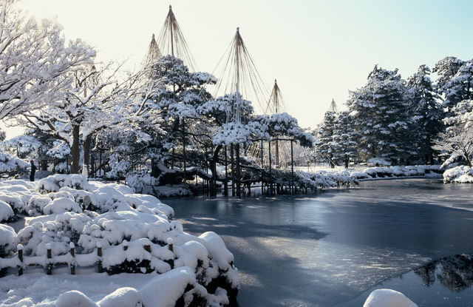
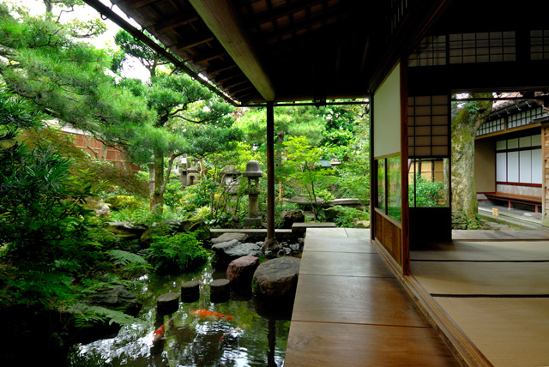
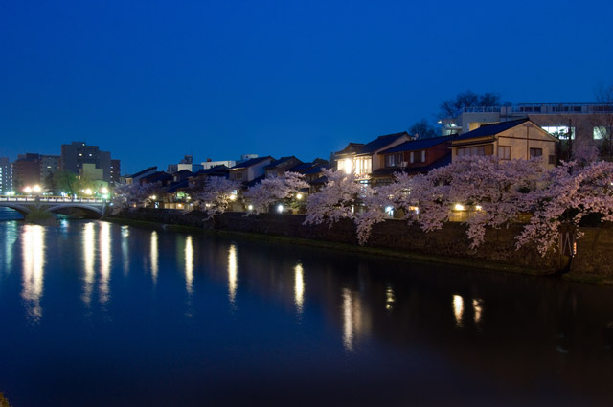

1. BRIEF DESCRIPTION OF THE CITY’S BIODIVERSITY RESOURCES

Geography
The city of Kanazawa is located near the center of Ishikawa Prefecture. It is bordered to the north by the Noto Peninsula and to the west by the Sea of Japan, with its coast covered by sand dunes which extend north into the famous Uchinada Dune. Mt. Okuiozen (939 m) and other mountainous areas to the east separate the city from neighboring Toyama Prefecture, while mountains in the southeast rise to altitudes of over 1,500 m above the sea level, with Mt. Naradake (1,644 m) being the highest peak within the metropolitan area. Kanazawa’s most important watercourses, the Sai and Asano Rivers, have their sources in these mountain systems, from where they flow towards the Sea of Japan, dividing the city into 3 plateaus.

Further downstream, the Sai River divides the plains to the west of the city into a northern and a southern area, with different characteristics. The northern area is an alluvial plain formed by deposits of gravel, sand, clay and silt, which have been transported by the Sai, Asano, Kanakusari and Morishita Rivers. It is characterized by low humidity and mild slopes and contains the largest body of stagnant water in Ishikawa Prefecture, the Kahoku Lagoon (4.13 km²). On the other hand, the southern plain represents the northeastern part of the alluvial fan formed by Tedori River, the longest river in the prefecture, having a more hilly structure than the northern plain.

Nestled among these landforms, the central urban area of Kanazawa spreads over a diverse landscape comprising three hill and plateau systems (Utatsuyama Hills, Kodatsuno Plateau and Teramachi Plateau) and the two rivers of Asano and Sai. The differences in altitude characteristic of the fluvial terraces that extend across this urban area make Kanazawa a city rich in slope roads, scenic views and other singular places. The plateaus have a southwest-northeast orientation and retain a significant amount of vegetation cover, forming important green corridors that traverse the city.

Climate
Kanazawa City lies at 36.35 degrees north latitude and 136.37 degrees east longitude, having a climate with four clearly defined seasons. Being situated within the Sea of Japan climate zone, it is characterized by high amounts of rain and snowfall. With an average rainfall of over 2,000 mm and about 1,700 hours of sunlight per year, Kanazawa is one of the wettest areas in Japan. However, the influence of the warm Tsushima current flowing off the Sea of Japan coast makes winters in the region less cold than in other areas at the same latitude. On the other hand, winter winds from the northwest transport moisture vapor generated by the ocean current to bring wet and heavy snowfall. Mostly overcast winter skies, with little sunshine, are typical of Kanazawa’s climate.

Nature in the city
Green areas within Kanazawa’s urban area remind of the city’s history as a castle town, as illustrated by the Kenrokuen Garden, which dates from the Edo Period and is considered one of the three most beautiful traditional gardens in Japan. Around Kenrokuen, the adjacent Kanazawa Castle Park and the Honda Forest Park, which is located on the former residential grounds of the Honda family, the chief ministers of the ruling Kaga Clan, along with the residences of other high-ranking samurai and tree-covered river terraces compose a green landscape that has caused the city to be referred to as the “capital of forests”. In particular, the Japanese gardens and ponds in Kenrokuen, Honda Forest Park and the Nagamachi Samurai Quarter, which draw water from Kanazawa’s numerous canals, serve as important habitats for the city’s fauna and flora. Together with the Sai and Asano Rivers, Kanazawa’s network of 55 water canals, with a total length of 150 km, also create a clean and diverse water environment for biodiversity in the city.

Kanazawa’s ecosystems
The natural environment of Kanazawa City spans a variety of landforms and altitudes, ranging from relatively undisturbed mountain areas (okuyama) to the human-managed forests (satoyama) characteristic of Japan’s rural landscapes, and then to urban areas and beaches. The main ecosystems encountered in the city include:
- Sand dunes: Stretching along the Sea of Japan coast, where forest formation is prevented by strong winds, blown sand and dryness, sand dunes are inhabited by specific vegetation and fauna living either in the low plant communities or in the sand.
- Coastal forests: Planted behind the sand dunes in order to provide protection from blown sand, coastal forests serve as stopovers for migratory birds, while also offering habitats and shelters for other fauna.
- Kahoku Lagoon: In combination with its surrounding, the body of standing water of the Kahoku Lagoon provides a diverse environment populated by water birds and other riparian species, aquatic plants such as ebimo (Potamogeton crispus) and kuromo (Hydrilla verticillata), as well as reed beds and other wetland vegetation.
- Rice paddies and other agricultural land: The cultivation of various crops contributes to maintaining insect diversity, which in its turn attracts geese, ducks and other birds. Cultivated land also serves as habitat for amphibians.
- Plateaus and terraces: The forest areas on the sloping terraces of the Sai and Asano Rivers and on the plateaus between them form an uninterrupted green corridor which connects the city center with the surrounding hills and low mountains, facilitating species movement across land and water environments.
- Rivers: While the rivers themselves are populated by fish and aquatic insects, the riparian forest areas and tsuruyoshi reed (Phragmites japonica) communities also function as habitats for a variety of organisms which feed on the food resources provided by the rivers.
- Hills and low mountain areas: Rising in the background of the urban area, Kanazawa’s hills and low mountains are covered by the human-managed forests of satoyama, which hold a special significance in terms of the biodiversity they shelter.
- Mid-mountain areas: At altitudes of over 400 m, mid-mountain areas are at present covered by extensive woodlands almost undisturbed by human intervention, which provide habitats for small mammals and large herbivores such as the Asian black bear (Ursus thibetanus).
- Subalpine mountain areas: Areas at altitudes of 1,500 m or higher, characterized by abundant snowfall, provide habitats for mammals such as ermine (Mustela ermine) and the Japanese dormouse (Glirulus japonicas). Connected with the Hakusan mountain range, these areas function as a migration pathway at high altitudes.
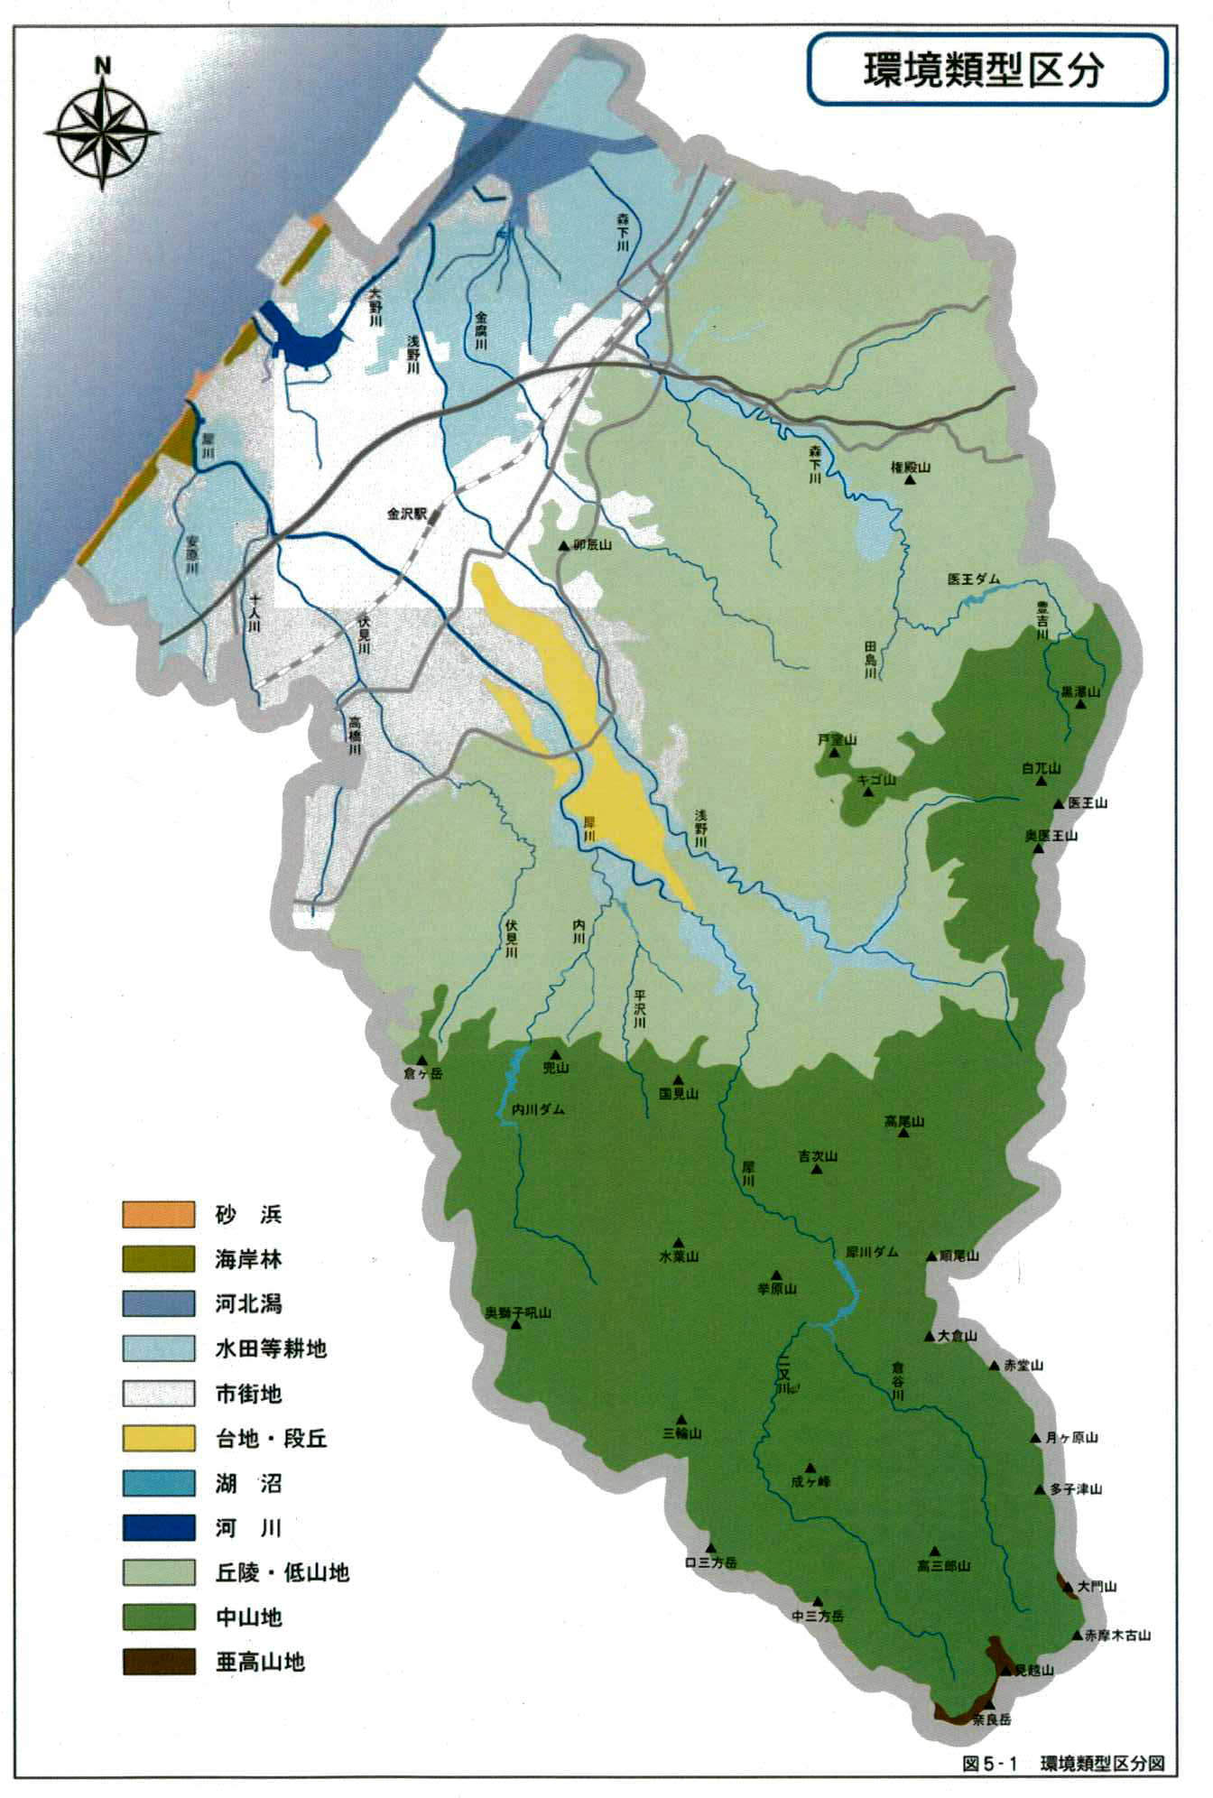
ECOSYSTEM DISTRIBUTION MAP
Morishita River
Ono River
Kanakusari River
Asano River
Sai River
Morishita River
Mt. Gonden
Io Dam
Kanazawa Station
Mt. Utatsu
Yasuhara River
Junin River
Fushimi River
Takahashi River
Tajima River
Toyoyoshi River
Mt. Kurotaki
Mt. Tomuro
Mt. Kigo
Mt. Shirahage
Mt. Iozen
Sai River
Asano River
Mt. Okuiozen
Fushimi River
Uchi River
Hirasawa River
Mt. Kabuto
Uchi River Dam
Mt. Kuragadake
Mt. Kunimi
Mt. Takao
Mt. Kichiji
Sai River
Mt. Mizuba
Mt. Okushishiku
Sai River Dam
Mt. Agehara
Mt. Zunno
Mt. Okura
Futamata River
Sand beaches
Coastal forests
Kahoku Lagoon
Cultivated land
Urban area
Plateaus and terraces
Lakes
Rivers
Hills and low
Mid-mountain areas
Subalpine mountain
KurataniRiver

Mt. Minowa

Mt. Narigamine

Mt. Tsukigahara
Mt. Takotsu

Mt. Takasaburo

Mt. Kuchisanpodake

Mt. Nakasanpodake

Mt. Daimon
Mt. Akamakko
Mt. Mikoshi

Mt. Naradake
Hills and low mountain areas

Subalpine mountain areas

2. THREATS, CHALLENGES AND REASONS FOR LOSS OF BIODIVERSITY

Accelerating urbanization
The population of Kanazawa doubled between 1920 and 1980, rising from 200,000 to 400,000. By 2005, the city had reached 450,000 inhabitants. Densely inhabited district (DID) ratios also increased from 3.5% in 1960 to 12.7% in 2005, while the DID population ratio rose from 71.9% to 80.3%. Population growth and urbanization rates were particularly high during the period of high economic growth between 1960 and 1980, when rapid urban development was occurring throughout Japan. Since the 1980s, however, rates of population growth and urbanization fell to moderate levels.

Deterioration of forest areas
For centuries, forest areas adjacent to human settlements in Japan have been managed for a variety of purposes. They provided timber products, as well as undergrowth and fallen leaves which were fed to cattle and horses or utilized as compost. Thus, functional links were maintained between forests and other components of the landscape, including rice paddies and crop fields. As forest density was regulated by human management activities, a certain amount of sunlight was allowed to reach the forest floor, contributing to vegetation growth and, consequently, to soil preservation. These human-managed forest environments are known in Japan as satoyama. During the last decades, urbanization, stagnating timber prices and the replacement of fuelwood and charcoal by new energy sources have led to the degradation of satoyama forests due to under-management and under-use. In these circumstances, the challenge is how to maintain the other ecosystem services of secondary forests, including biodiversity conservation, water source protection, landslide prevention and carbon storage.

An additional problem is posed by the increasing occurrence of bears and other wildlife in the proximity of the urban area, which is believed to be a consequence of the disappearance of the intermediary area separating human settlements from bear habitats which satoyama used to represent.

Loss of riparian areas
Until the 1970s, river improvement and water control projects were carried out with the aim to minimize flood damage and other water-related disasters. To facilitate management, river channels were straightened and lined with concrete revetments. Many of Kanazawa’s canals were covered in order to secure sufficient road width and parking space. As a result, fish and other water species vanished from Kanazawa’s rivers and canals, and there was a gradual loss of riparian areas, breaking the centuries-long connection between the city’s inhabitants and water.

3. MEASURES TAKEN TO IMPLEMENT THE CBD PROGRAMMES OF WORK

In 1968, as the environmental degradation and pollution problems brought about by high economic growth were attracting increasing attention, Kanazawa adopted its Ordinance on the Preservation of the Traditional Environment, being the first local government in Japan to formulate and enact a policy protecting its characteristic landscape. The ordinance defined the ‘traditional environment’ as the whole formed by the “natural landscapes of green trees, crystalline rivers and pure air together with the historical architecture and heritage sites they contain”. It stipulated that, while seeking to prevent to the utmost extent possible the destruction of the city’s characteristic traditional environment in the face of urban development, a “new traditional environment” will be developed in harmony with the requirements of a modern city. The ordinance served as the basis for the designation of several Traditional Environment Preservation Areas, making a critical contribution to the conservation of green and water environments in the city, and thus to the maintenance of habitats for biodiversity in the urban area.

In 1989, this ordinance was further developed into the Ordinance on the Preservation of the Traditional Environment and the Creation of Scenic Landscapes. Later, additional ordinances were adopted to facilitate the implementation of more concrete measures for the conservation of green areas and water environments: the Ordinance on the Conservation of Natural Environment in 1993, the Ordinance on the Conservation of Canals in 1996, the Ordinance on the Conservation of Green Slopes in 1997 and the Ordinance on the Promotion of Green City Building in 2001. All these policy measures undertaken by the local government had significant impacts in terms of the conservation of flora and fauna habitats in the city. In 2003, the City enacted the Ordinance on Forest Development, which aims to conserve Kanazawa’s rich forest areas, and in 2009 the Kanazawa City College of Forestry was established with the aim to develop human resources for forestry management. Also, the Vision of Kanazawa as a Global City, which was formulated in 1995 as the city’s long-term plan, “co-existence with nature” is highlighted as one of the major goals of future policy making and implementation, with conservation, restoration and creation of natural environment in the urban area being included as a major principle of urban planning and development.

Green area conservation
At the national level, a major legislative measure focusing on the preservation of trees and groves in urban areas was the enforcement in 1962 Act for Preservation of Trees for Conservation of Scenic Beauty of Cities. This was followed at the city level by various steps to preserve green areas in Kanazawa, including:

(1) The Ordinance on the Preservation of the Traditional Environment (April 1968)
The ordinance contributed to the conservation of trees and vegetation areas as part of the city’s ‘traditional environment’. 13 Traditional Environment Preservation Areas with a total surface of 422 ha were designated, including Kenrokuen and other scenic areas in the city center, the temple districts in Teramachi and at the foot of Mt. Utatsu and the banks of the Sai and Asano Rivers.

(2) Initiatives for the conservation of the natural environment (1992~)
Initiatives undertaken by Kanazawa City with the objective of conserving and restoring the natural environment have included the formulation of the Basic Plan for the Conservation of the Natural Environment (1992) , the adoption of the Ordinance on the Conservation of the Natural Environment (1993) and the creation of the Natural Environment Conservation Manual (1994). So far, two Natural Environment Conservation Areas have been designated: the Hiraguri area (1995), which retains the specific features of satoyama woodlands, being renowned for its katakuri (Erythronium japonicum) colonies, and Kunimiyama, an area rich in vegetation characteristic of the Sea of Japan zone such as tokiwaikariso (Epimedium sempervirens) and yukiguni mitsuba tsutsuji (Rhododendron lagopus).

(3) Ordinance on the Conservation of Green Slopes (April 1997)
The objective of this ordinance is to preserve the green slopes which give Kanazawa’s landscapes their distinctive undulating character, providing aesthetic and recreational services, and to reinforce their quality as fauna and flora habitats in partnership with the citizens. In its recognition of the critical role of green slopes as habitats for a variety of species and as green corridors connecting the urban area with peri-urban satoyama areas, this ordinance is the first to focus specifically on the conservation of biodiversity habitats.

(4) Ordinance on the Promotion of Green City Building (April 2001)
The aim of this ordinance is to encourage the active citizen participation in the conservation and creation of green areas in order to secure a quality living environment for the city’s residents that can at the same time sustain a diversity of life forms.

(5) Ordinance on Forest Development (April 2003)
Forests account for 60% of the total metropolitan area of Kanazawa City. In order to conserve and nurture forests and ensure that their benefits are enjoyed by the citizens, the ordinance lays out the fundamental principles that should guide forest policy and management and defines the responsibilities of the government, citizens, forest owners and forest-related businesses, while also outlining the basic measures to be taken to ensure that the city’s forests are adequately protected for future generations.

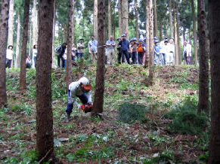
Revitalization of satoyama areas
The City has provided specific assistance targeted at the regeneration of aged broadleaf forest and management of degraded bamboo forests. To ensure efficient use of forest thinnings, wood thinned from Kanazawa’s managed forests
has been used to refurbish classroom walls and other public facilities.
Forest management activities by
Kanazawa City College of Forestry

Since its establishment in 2009, the Kanazawa City College of Forestry has been offering practical training programmes in forest and mid-mountain area management.

It is expected that such sustainable forestry practices will contribute to restoring vitality to satoyama areas, as well as to fostering biodiversity and creating a healthy and rich forest environment within Kanazawa’s metropolitan area.

Conservation of riparian areas
With easy access to nature becoming increasingly scarce in the urban area nowadays, the scenic, recreational and restorative values of Kanazawa’s rivers and canals and their adjoining areas are given new recognition, and efforts are being made to incorporate them in urban planning processes. However, initiatives so far have emphasized landscape preservation and improvement of water accessibility, with little attention being given to biodiversity and habitats.

The first riparian environment restoration project in Kanazawa was based on the Water and Green Restoration Plan of 1980 and focused on repairing canals and reestablishing year-round flows. Later, measures for the conservation and restoration of riparian environments were adopted as part of the Firefly Habitat Project and other projects implemented by related departments within the city government, as well as based on the Ordinance on the Preservation of the Natural Environment and the Ordinance on the Preservation of Canals.

(1) Water and Green Restoration Plan (November 1980)
The plan was formulated in response to a report titled Water Canals of Kanazawa, produced by the local economic association in October 1979, which lamented the gradual disappearance of the canals under concrete surfaces and stressed the need to restore and conserve them both for their cultural heritage value and as places where people can interact with the water environment.

The plan consists of several components, including a survey of the current status of the canals, a survey of the management status and a restoration plan for the candidate sites. It served as a basis for further proposals, including the overall improvement of canals in the city’s cultural zone, a better canal management system and the release of freshwater fish, and also led to a comprehensive landscaping project around the Kuratsuki Canal.

(2) Inter-sectoral projects by city government departments (1987-1990)
Mid-level officers from 10 departments involved in riparian area-related projects formed a Riparian Area Study Group, which debated issues concerning ways of reestablishing the connection between people and water, as well as biodiversity-friendly landscaping and construction techniques. As a result of these discussions, it was decided that river improvement projects in the city will use natural water courses and natural stone revetments wherever possible, in order to conserve and restore the riparian environment.

(3) Ordinance on the Conservation of Canals (April 1996)
The ordinance establishes conservation, restoration and enhancement standards for each designated canal, including standards for landscaping, removing the cover materials of the canals that had been closed, securing a supply of clean water, and using the canal for various purposes. In particular, measures taken to ensure a year-round flow of clean water in the canals have resulted in the creation of more stable environments for aquatic species.

4. RESULTS AND MAIN ACHIEVEMENTS

Biodiversity in the urban area
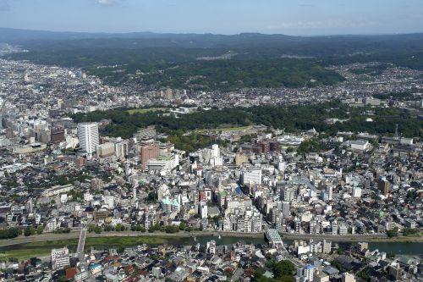
Kanazawa’s policies have played an important role in protecting Honda Forest Park, Kanazawa Castle, Kenrokuen and other green areas in the city center from development and in maintaining the continuity of the green corridors that link them with the river terraces bordering the Teramachi and Kodatsuno Plateaus, and further to satoyama areas and to the mountains of Iozen and Naradake,
Green areas in the city

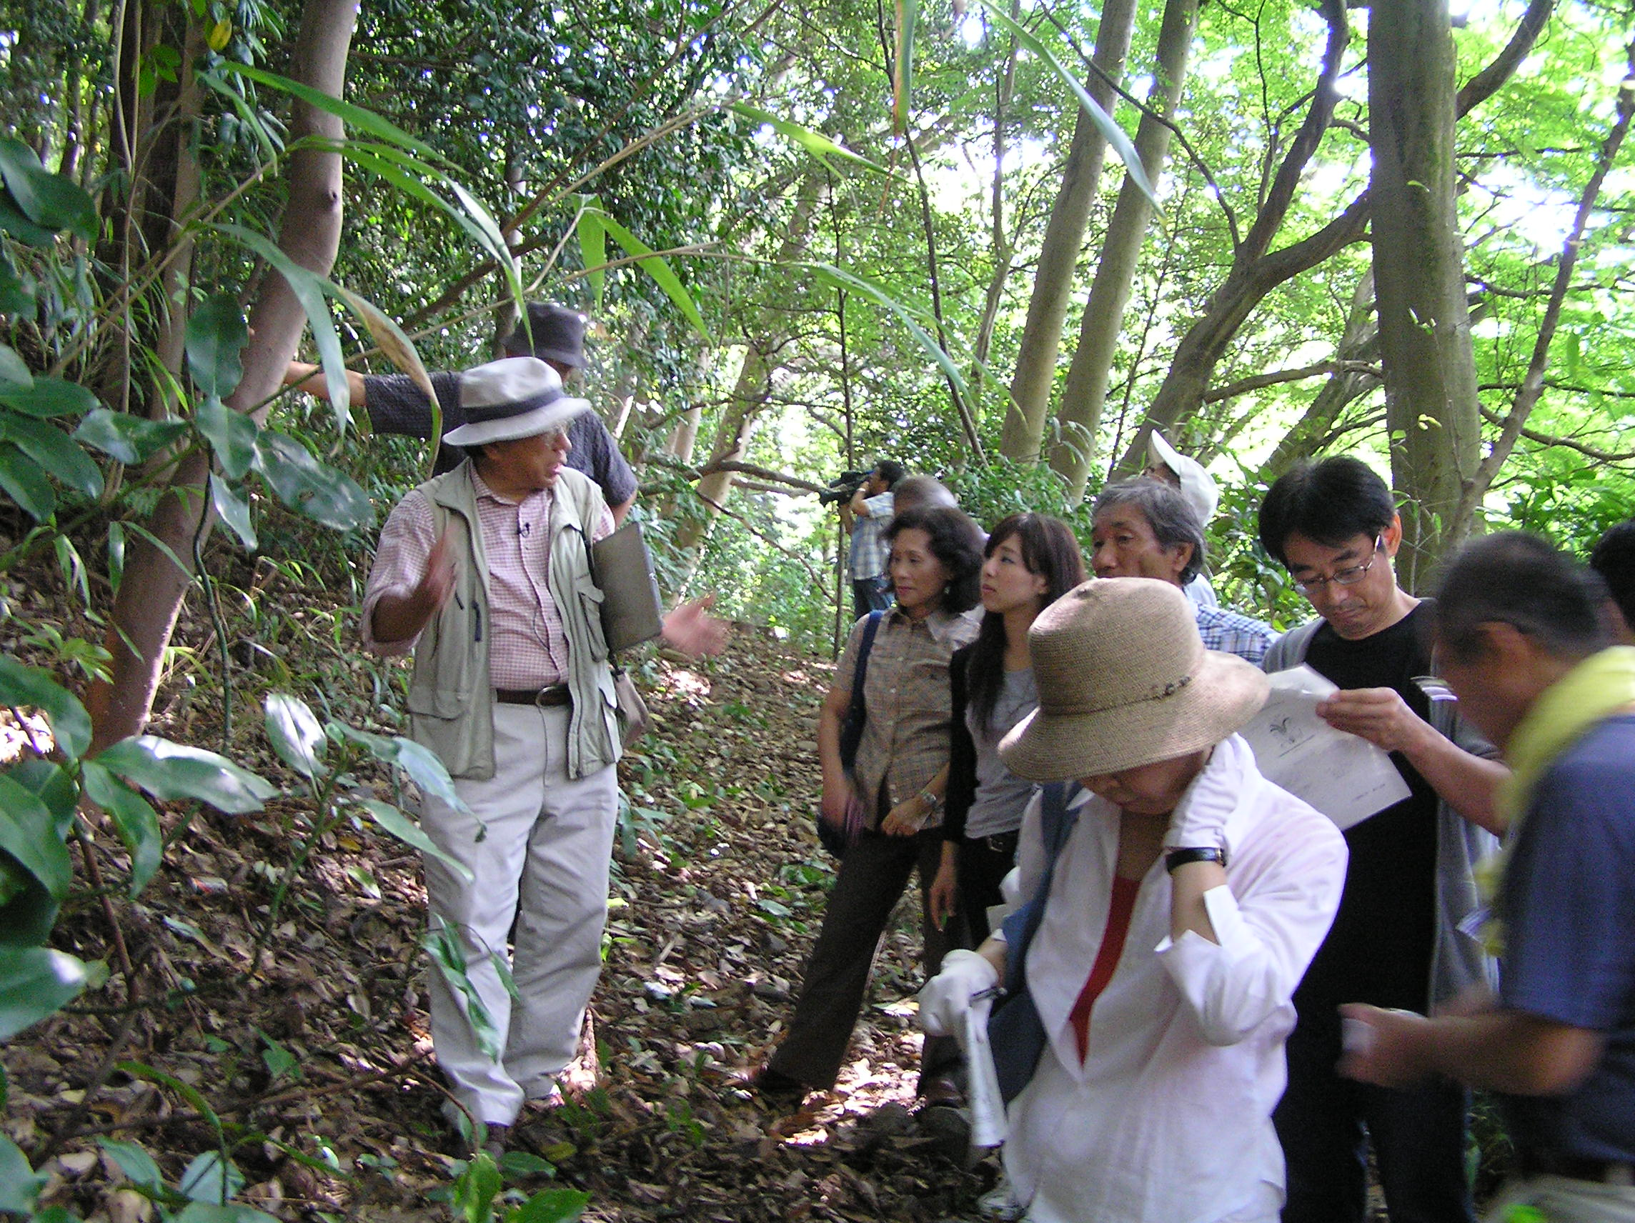
In particular, Honda Forest Park is characterized by a high degree of naturalness, containing multiple layers of vegetation, from tall trees such as tabu (Machilus thunbergii) and sudajii (Castanopsis sieboldii) and a sub-tree layer represented by yabutsubaki (Camellia japonica) to himeaoki (Aucuba japonica var. borealis) and other shrubs. Surveys have shown that the park provides habitats for numerous species of birds and
Nature observation in Honda Forest
Park
other fauna. On summer mornings and late afternoons from the beginning of July till August, the song of higurashi cicadas resonates in the city, creating characteristic soundscapes. In 1996 the song of the higurashi of Honda Forest Park was selected together with the sound of the bells in the Teramachi temple district as one of the Top 100 Japanese Soundscapes to Be Preserved.

As in the case of Honda Forest Park, the Honmaru Garden in Kanazawa Castle Park also contains
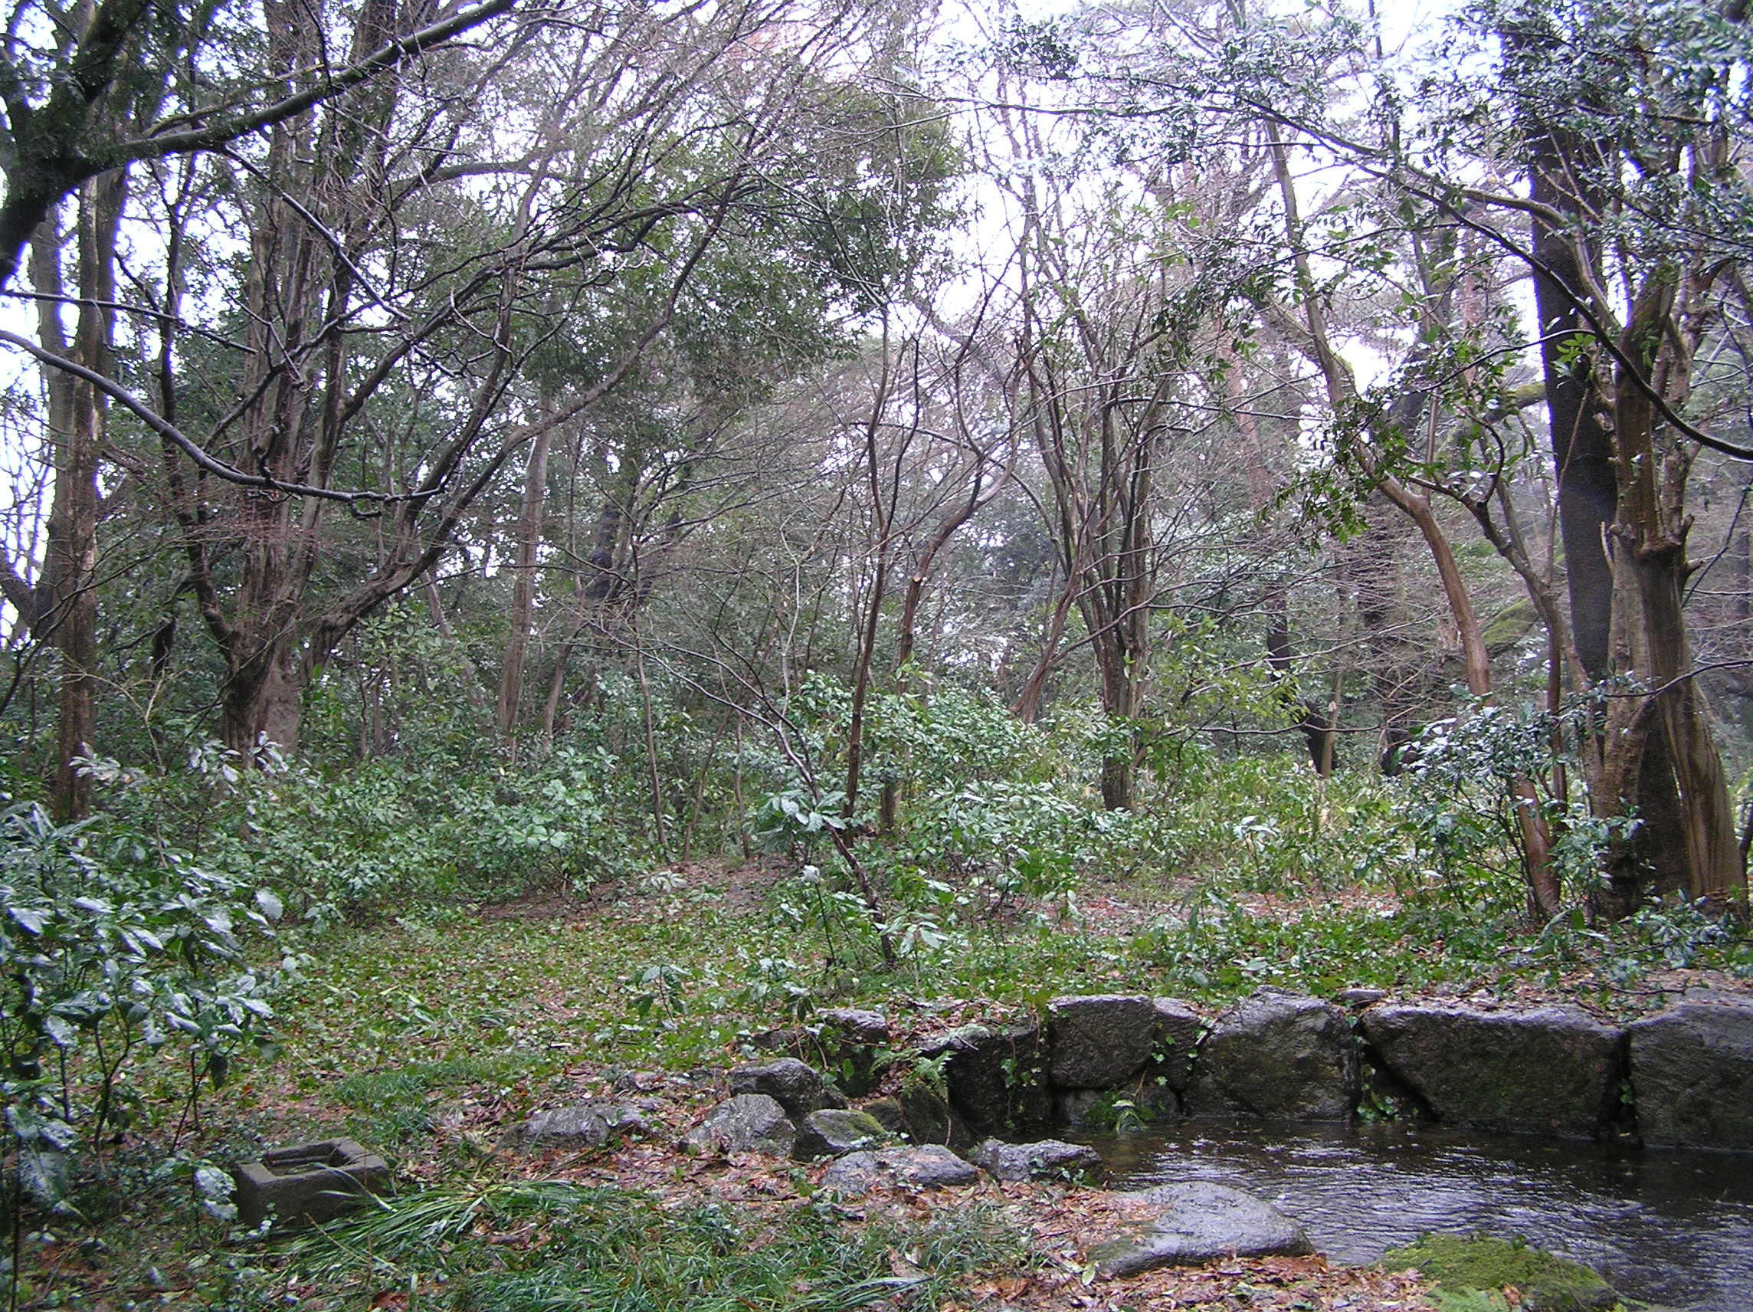
vegetation close to its natural state. There was a rapid
increase in vegetation cover after the war, when Kanazawa University was relocated to the former castle grounds. Even now, the number of plant species in this area of the park exceeds 500.
Honmaru Garden in Kanazawa Castle Park

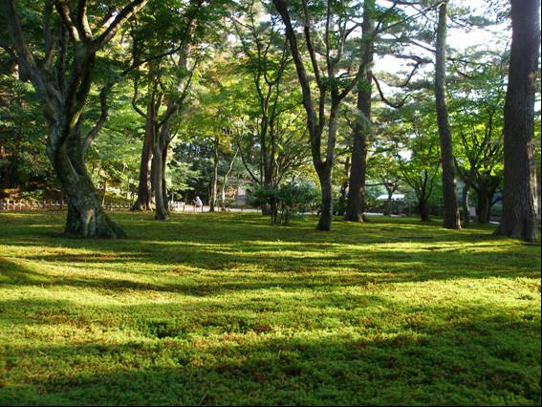
In contrast, Kenrokuen was created as the manmade garden of a feudal lord and relies on human management. Nevertheless, the fact that the garden design incorporates a large proportion of native vegetation has caused some of its areas to become close to that of natural forests over time. Research conducted in Kenrokuen has identified habitats for over 100 bryophyte (moss) species, an extremely high number even when compared with other Japanese gardens. It has been suggested that the factors enabling this high bryophyte diversity are the garden design, which consists of a wide variety of microenvironments, and the meticulous management practices including sweeping fallen leaves and weeding. Such research findings seem to indicate that a garden which has been preserved for its ‘traditional environment’ and historical heritage values has played an important role in conserving biodiversity in the city.
Moss in Kenrokuen

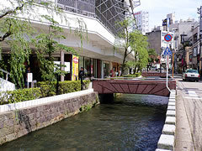
With regard to biodiversity management in water environments, the artificial stream built along the Hakuchoro promenade on the eastern side of Kanazawa Castle Park has been successful in attracting insects and other aquatic species. Since firefly nymphs were released for the first time in 1987, fireflies have been occurring naturally around the stream, reaching a current population of about 100. A diversity of firefly habitats have been restored around the city, and watching the glowing insects as they fly over the Onosho Canal in the Nagamachi samurai district has become a favorite scene of early summer evenings.
The uncovered channel of the Kuratsuki
Canal

On the other hand, consideration of ecological factors when carrying out watercourse improvement works has increased the suitability of rivers and canals as habitats for various species. Upstream migration of salmon has been observed in the city’s rivers. Once uncovered and rehabilitated, the canals do not just add to the attractiveness of the city and to the quality of life of its residents, but also contribute to enhancing capacity to sustain biodiversity at the landscape level, by linking the various constituents of the landscape with the two main rivers and, indirectly, with the sea.

Implementation of participatory projects
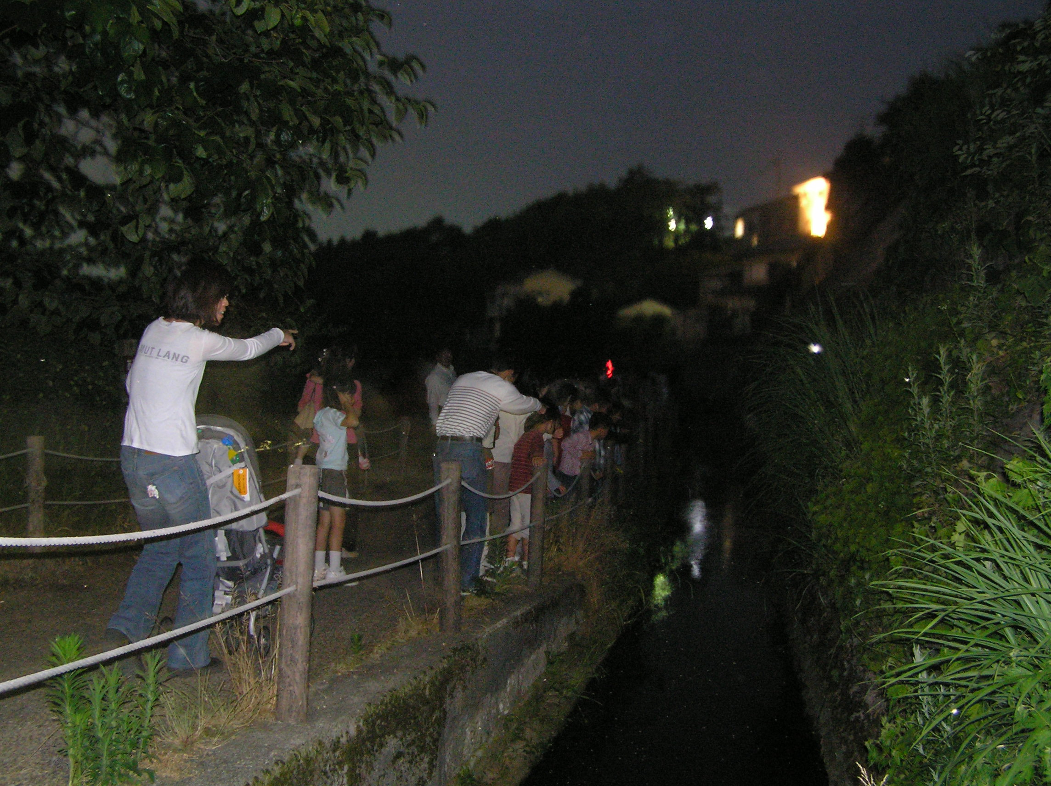
The diversity of Kanazawa’s environment, which ranges from okuyama and satoyama to intra-urban green areas and coastal areas, provides opportunities for a variety of interactions with nature. At the same time, local government initiatives intended to conserve and develop this rich environment have also been undertaken in the form of participatory projects, aiming to sensitize residents to environmental issues and to engage them in the preservation of biodiversity.
Firefly observation at Tatsumi Canal

Every year since 1987, students from elementary schools in Kanazawa have been invited to participate in firefly habitat surveys, with a total of 8,500 children and parents attending in 2009. While in 1987 only 51 sites with 10 or more fireflies were identified, in 2009 the number of such sites had risen to 103.

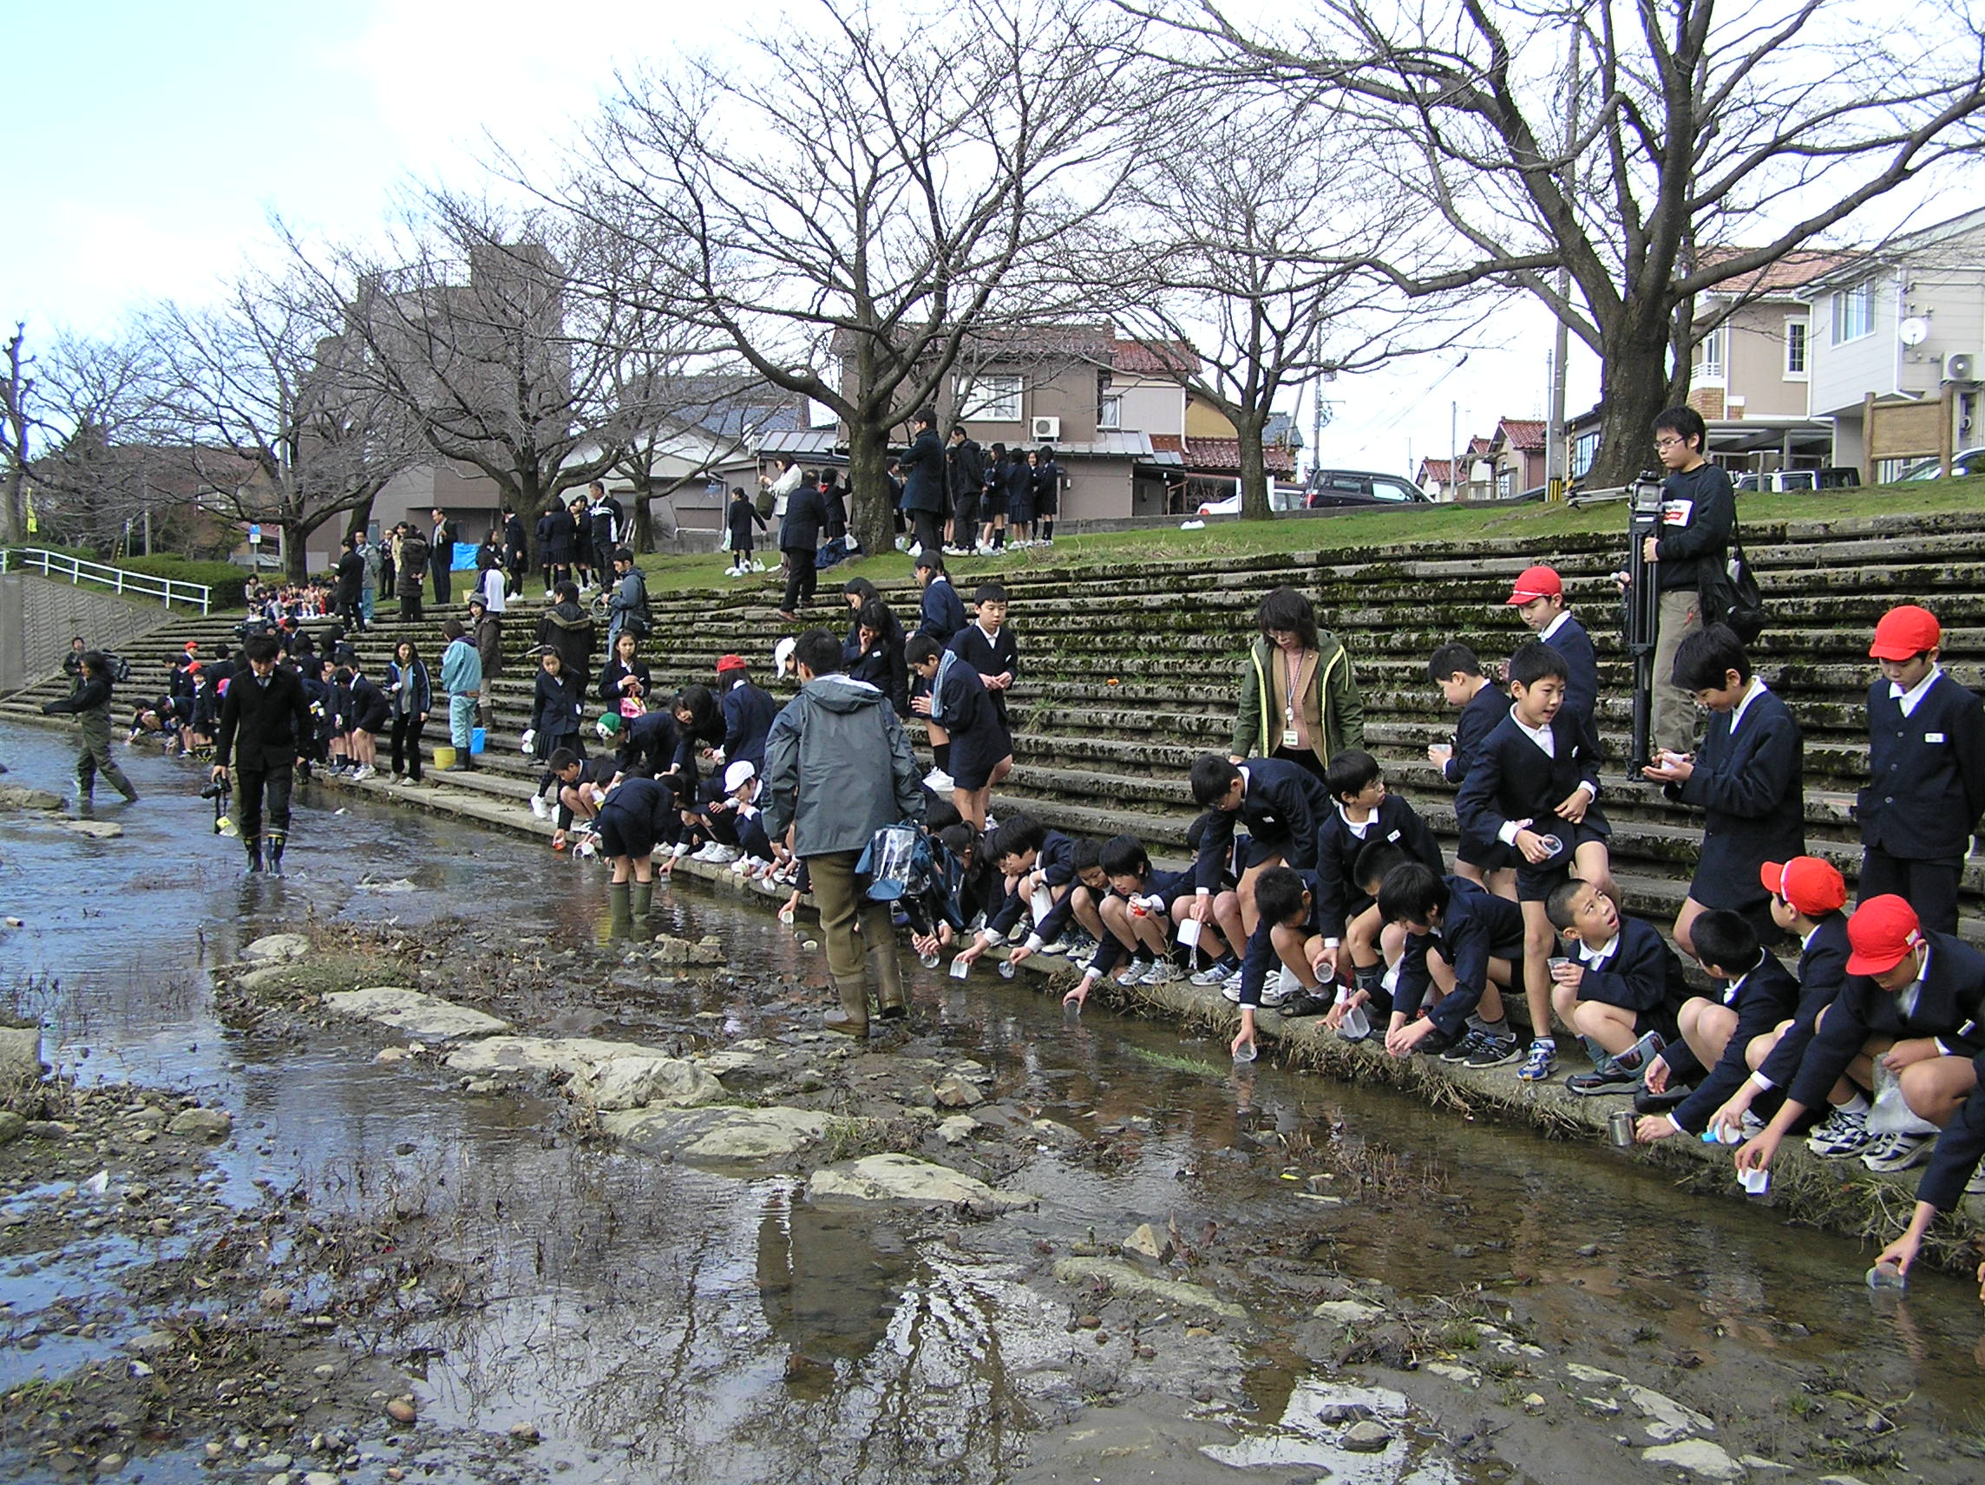
Since 2006, an event called Firefly Viewing Evenings on the Hakuchoro Promenade has been organized in collaboration with citizen volunteers, attracting a large number of residents and tourists. In 2010, a total of 3,000 visitors let themselves be enchanted by the magical dance of the fireflies over 5 days.

Another participatory project carried out since 1989 is the release of juvenile salmon reared by elementary school students into nearby rivers. To facilitate upstream migration of salmon during spawning season, the Fushimi River, which runs through several residential areas, has been equipped with fishways. In 2009, 16 elementary schools participated in the release of salmon juvenile as part of this project.
Release of young salmon in Kanazawa’s rivers

Coexistence of humans and nature
By drawing a clear line between conservation and development, Kanazawa has succeeded in retaining much of its natural environment, along with the characteristic atmosphere and cultural identity of a feudal castle town. The lush green of the river terraces, the remnants of primary forest still standing in the city and the traditional gardens of the samurai residences add to the city’s charm and distinctive character. The soft sounds of the rivers and canals that thread their way through the city fill the air. Every moment, these sights and sounds of the natural environment sooth the soul, nourishing life and traditional culture.

In 2008, the Operating Unit Ishikawa/Kanazawa of the United Nations University-Institute of Advanced Studies opened as the Institute’s first local research office in Japan in Kanazawa. Under its overall mandate of linking global and local sustainability efforts, the Operating Unit has been promoting research activities focusing on urban biodiversity. Since its designation in June 2009 as the first UNESCO Creative City in the field of crafts and folk arts in Asia, the city has also embarked on the exploration of new ways of preserving and developing its traditional industries, along with the sustainability elements they contain, as illustrated by low environmental impacts and minimum reliance on fossil fuel.

Finding creative ways to build itself as city where humans and nature can coexist is and will remain an important priority for Kanazawa.

