Item 6
Progress in the implementation of the long-term strategic framework for capacity-building and development:
Preliminary results of the survey on the use of the strategic framework

Background

In its decision 15/8 of 19 December 2022, the Conference of the Parties (COP) adopted the long-term strategic framework for capacity-building and development to support priorities determined by Parties in their national biodiversity strategies and action plans for the implementation of the Kunming-Montreal Global Biodiversity Framework (KMGBF). In the same decision, the COP requested the Executive Secretary to undertake, in collaboration with other biodiversity-related conventions and partners, a review of the strategic framework, in conjunction with the global review of the KMGBF, including the means of implementation, for consideration by the Conference of the Parties at its seventeenth meeting, to assess its use by Parties, indigenous peoples and local communities, women and youth organizations, and other relevant stakeholders and, if necessary, propose updates to ensure its effectiveness in assisting Parties.

Pursuant to the above requests, the Secretariat, through notification 2026-020, commissioned a survey on the use of the strategic framework by national focal points to the Convention and its Protocols, indigenous peoples and local communities, women and youth organizations and other relevant stakeholders, including its application, relevance and effectiveness, as well as the support available to facilitate its awareness, uptake and use. The survey was conducted from 18 February to 1 April 2026.

This document presents the preliminary results of the survey. A summarised synthesis of the results will be part of the note by the Secretariat providing a progress report on the use of the strategic framework, and the lessons learned in its application, for consideration of the Subsidiary Body on Implementation at seventh meeting and by the Conference of the Parties at its seventeenth meeting.

Participation in the survey

Participation in the survey was relatively high, reflecting a strong engagement with the strategic framework. A total of seventy-six (76) responses were received from wide range of actors, including national governments, UN agencies, intergovernmental organizations, non-governmental organizations representing indigenous peoples and local communities, women and youth, and the private sector. The responses were from all regions, and the geographical representation was relatively balanced, as illustrated Table 1 below. Africa had the highest number of responses from national governments, followed by GRULAC and with regards to participation of civil society organizations, GRULAC has had the highest number of responses.

Table 1: Participation of Various Actors by Region
Region | National governments | UN agencies, Intergovernmental organizations | Non-government actors (IPLCs, women, youth, private sector) | Total
Africa | 14 | 1 | 5 | 20
Asia–Pacific | 8 | 4 | 1 | 13
GRULAC | 12 | 4 | 10 | 26
Europe and Others | 7 | 2 | 0 | 9
Total | 41 | 11 | 16 | 68

- USE OF THE LONG-TERM STRATEGIC FRAMEWORK IN GUIDING CAPACITY-BUILDING UNDER THE KUNMING-MONTREAL GLOBAL BIODIVERSITY FRAMEWORK

The survey assessed the respondents’ awareness of the long‑term strategic framework for capacity‑building and development, the extent to which the respondents were familiar with its content and how it had been used/applied in support of the implementation of the KMGBF. Respondents who had not used it were requested to state the reasons for non‑use, providing insights into some of the barriers affecting its uptake and practical application.

Awareness of and familiarity with strategic framework

The strategic framework is broadly recognized by most respondents, who stated being moderately to very familiar with the framework (43 % and 19% respectively), see Figure 1 below. A number of respondents were unfamiliar with the strategic framework (22% being slightly unfamiliar and 16% being not familiar with it at all), indicating a need for its further promotion and socialisation.

Figure 1. Levels of familiarity of the LTSF
(n= 76)
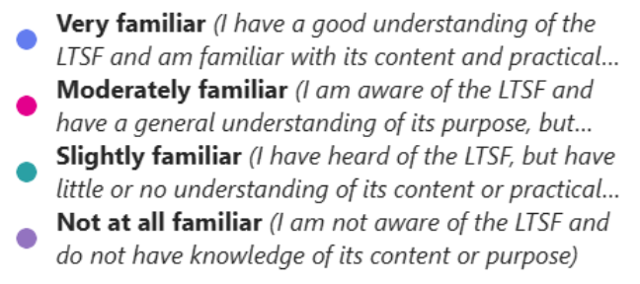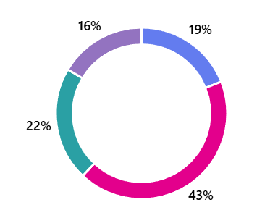

Use / application of strategic framework

Of the 76 survey respondents, 29 (approximately 38%) confirmed having used the guidance provided in the strategic framework in designing capacity development intervention(s) in support of the KMGBF. Among those 29 respondents, majority used it frequently in designing capacity development programmes and projects (15 applications) and many also used it to guide the integration of capacity development into institutional processes and systems supporting NBSAP implementation (14 applications). A number of respondents also commonly used it to support the creation or revision of NBSAPs and the design of capacity development action plans at various levels (13 applications each). Overall, these findings show that the framework is primarily being used as a planning tool to support capacity‑building at the systemic and institutional levels, consistent with the framework’s intended purpose and objectives (see Figure 2).

Figure 2. Use of the strategic framework
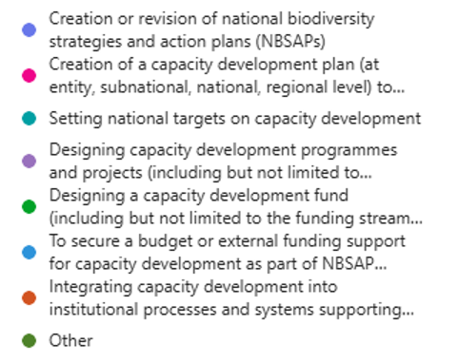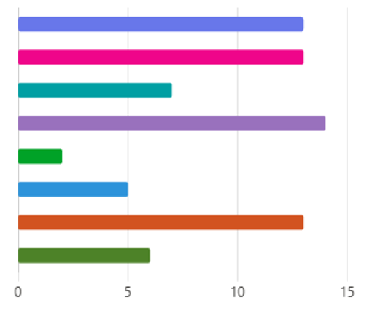
Colombia provided an example of how the application of the strategic framework in the update and implementation of the NBSAP supported a systemic and institutional approach to capacity development aligned with KMGBF implementation. Capacity‑building was embedded across national and subnational biodiversity governance structures, strengthening institutional capacities within government agencies, research institutions, and local authorities. The framework also supported the mainstreaming of biodiversity considerations into climate change, land‑use planning, and sustainable development policies, reinforcing policy coherence and cross‑sectoral action. In addition, it informed project design and resource mobilization efforts, helping ensure that external funding contributes not only to conservation outcomes but also to long‑term institutional strengthening and sustained implementation capacity.

Reasons for not using the strategic framework

The 62% of survey respondents who reported not having used the guidance provided in the strategic framework cited a lack of practical guidance on how to apply the framework (11 respondents, and insufficient financial resources to apply the guidance (10 respondents) as the main reasons. Relatively few respondents indicated that the reason was that use of the framework was not a priority (2) and that it was not relevant to national or organizational circumstances (1). This points to the potential for increased uptake of the framework if clear, user-friendly, and context-specific guidance with supporting practical case studies and examples of good practices were made available.

Overall, the findings suggest that the reasons for not using the framework are primarily related to practical capacity and resource constraints and not because it is not considered relevant or important.

- RELEVANCE OF THE LONG-TERM STRATEGIC FRAMEWORK
The survey assessed the perceived relevance of the strategic framework in relation to respondents’ needs and priorities for implementing the KMGBF and examined whether respondents considered the guidance provided in the framework to be relevant. Respondents were asked to identify which components they considered most useful in guiding capacity development efforts.

Only 50 of the 76 survey respondents answered the question on the relevance of the strategic framework. Among those who responded, a majority (42 respondents, or 84%) indicated that they found the guidance provided in the framework relevant to their needs and priorities for capacity development in support of the KMGBF. Only 8 respondents (16%), reported that the framework was not relevant to their needs. The findings suggest that among those sufficiently familiar with the framework, majority recognise its relevance and value in guiding capacity development efforts.

The respondents who indicated that the strategic framework was relevant to their needs, identified the following as the most relevant components of the strategic framework:
- Section IV: Key strategies to improve capacity building and development (25 selections)
- Section III: Guiding Principles (20 selections)
- Section V: Mechanisms for Implementation (15 selections), and
- Section II B: Capacity Results (9 selections).

In the qualitative comments, many respondents further reiterated the value of the strategic framework as a strategic planning tool and the relevance and importance of the key strategies to improve capacity building and development and the mechanisms for implementation in translating the framework into actionable guidance, including setting priorities, integrating capacity development into NBSAPs and sectoral planning, strengthening coordination, and mobilizing resources. They also emphasize the importance of guiding principles for promoting inclusive, rights‑based, and country‑driven approaches. The component on capacity results was less emphasised, which seems to indicate that respondents prioritise strategic and procedural guidance over predefined outcome statements in their capacity development planning.

Figure 3: LTSF components considered most relevant for guiding capacity development efforts

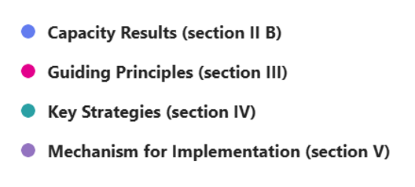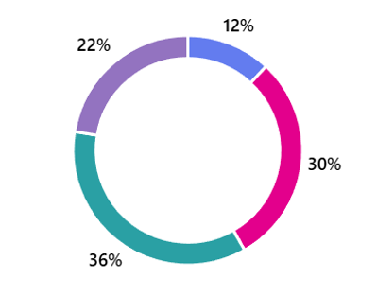

The qualitative responses from respondents who did not find the LTSF relevant to their capacity development efforts echo similar challenges as those identified by those who reported not using the framework. These include limited practical and operational applicability of the framework, uncertainty regarding alignment with existing national sectoral and KMGBF‑related processes, as well as resource and coordination constraints. Several respondents highlighted the need for more inclusive, context‑specific guidance that better reflects the realities of diverse stakeholder groups. These responses suggest that perceptions of limited relevance are driven less by disagreement with the framework’s objectives and more by gaps in operationalization and alignment.

- EFFECTIVENESS OF THE LONG-TERM STRATEGIC FRAMEWORK

Section C of the survey set out to assess the effectiveness of the long‑term strategic framework in guiding capacity development interventions in support of the KMGBF. It examined which key strategies under component 4 of the framework have been most effective in practice and how their application has contributed to tangible changes in capacity. It also explored the respondents’ perceptions of the framework’s influence on improving the coherence, efficiency, effectiveness, and sustainability of capacity development efforts.

The following were identified as most effective key strategies for guiding capacity development interventions:
- Promoting partnerships and networks for implementation (25 selections),
- Aligning capacity development efforts with broader cross-sectoral plans and programmes (20 selections),
- Institutionalizing capacity building and development (17 selections),
- Integrating long-term capacity development into NBSAPs (13 selections), and
- Enhancing synergies between capacity development efforts of relevant processes (10 selections) as the most effective strategies - see Figure 4.

Figure 4. Key strategies used to guide capacity development interventions
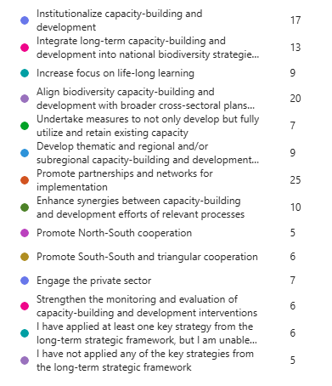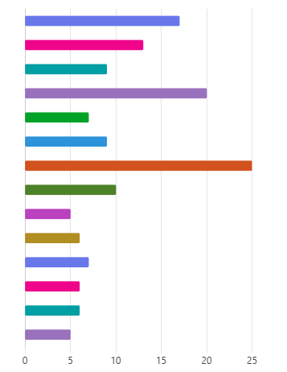

The qualitative responses highlighted the following regarding the application and effectiveness of the key strategies identified as most effective:

- Promoting partnerships and networks for implementation: this strategy was applied through inter-ministerial collaboration and multi-stakeholder, regional and international networks facilitating peer exchange and regulatory cooperation. It was considered effective because it enabled pooling of expertise and resources, strengthened coordination across actors and sectors, supported continuity where institutional capacity was limited, and grounded capacity development in practical implementation contexts.

- Aligning capacity development with broader cross‑sectoral plans and programmes, including climate change, gender equality, livelihoods, education and private sector engagement. This alignment was reported to have increased the relevance of capacity‑building interventions to implementing institutions and stakeholders, facilitated the mainstreaming of biodiversity considerations into sectoral policies and practices, and helped address competing national priorities by positioning capacity development as a cross‑cutting enabler rather than a stand‑alone activity.

- Institutionalising capacity development was applied by embedding capacity‑building functions within institutional mandates, planning processes, human resource systems, and governance arrangements. It was considered effective because it shifted capacity development away from ad hoc or project‑based activities toward more sustained, system‑wide approaches, supporting continuity, institutional ownership, and the retention and utilisation of knowledge and skills over time.

- Integrating long-term capacity development into NBSAPs: this strategy was applied by embedding capacity development priorities, actions, and timelines within NBSAPs. It was considered effective because it anchored capacity‑building within core national planning and implementation processes, supported systematic identification of capacity gaps and priorities, and strengthened links to resource mobilization, monitoring, and policy implementation.

Several qualitative responses also indicated that while the strategies applied align closely with the long‑term strategic framework, they were not always implemented explicitly because of it. Rather, the LTSF was recognised as reflecting established good practice and adding value primarily by systematising, legitimising, and connecting existing capacity‑building efforts. This points to the framework’s effectiveness primarily in its enabling and coherence‑building role across initiatives and processes.

The respondents identified the following as the medium‑term capacity development outcomes that were most positively catalysed by the strategic framework:
- the strengthening of strategic partnerships and learning networks (18 selections)
- the successful development and update of NBSAPs (16 selections).
- the establishment of sound enabling frameworks and institutional arrangements (13 selections).
- reinforced mechanisms, incentive structures, and investments that ensure the utilisation and retention of capacity (13 selections).

Notably, a significant proportion of respondents indicated that it was too early to assess medium‑term capacity development outcomes (15 selections), reflecting the relatively recent adoption and longer‑term orientation of the framework.

Figure 5. Medium‑term capacity development outcomes positively catalysed by the long‑term strategic framework

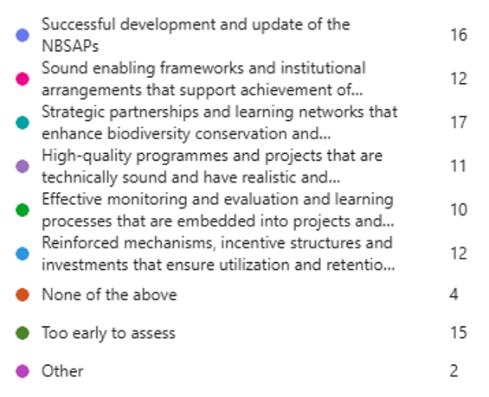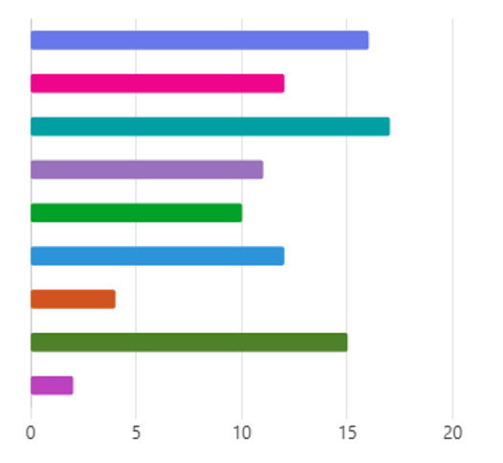

Regarding the extent to which the guidance provided in the strategic framework had enhanced the coherence, efficiency, effectiveness, and sustainability of their capacity development efforts, the responses were mixed. Among the 50 respondents who answered the question on the effectiveness of the strategic framework, 15 reported that the framework contributed to a moderate extent, 7 indicated a great extent of influence, a smaller number reported a limited extent (7) while few noted that it had no influence at all (4).

The largest number of respondents (16) indicated that it was too early to assess the framework’s contribution and impact in enhancing the coherence, efficiency, effectiveness, and sustainability of their capacity development efforts, reflecting the fact that longer timeframes are required for capacity development outcomes to materialize.
The qualitative responses of those who stated that in their view the strategic framework had had a moderate or great influence on the coherence, efficiency, effectiveness, and sustainability of their capacity development efforts suggest that the strategic framework primarily contributed by strengthening alignment and strategic coherence across existing capacity development efforts, rather than acting as the sole or primary driver of change. Its influence was commonly described as indirect and complementary, operating alongside national strategies, donor programmes, and pre‑existing institutional reforms.

In terms of lessons learned from applying the strategic framework, qualitative responses consistently highlighted that partnerships, networks, peer learning, and the integration of capacity development into institutional and planning frameworks worked well in strengthening coherence, coordination, and ownership. However, effectiveness and sustainability were constrained by limited operational guidance, insufficient and misaligned funding, uneven dissemination and awareness of the framework, and difficulties translating high‑level strategies into context‑specific action. These lessons suggest that while the strategic framework provides valuable strategic direction and legitimacy, its effectiveness is context-specific and closely linked to the availability of resources and the strength of existing national institutional structures and systems.

- SUPPORT FOR THE USE OF THE LONG-TERM STRATEGIC FRAMEWORK

Section D of the survey examined the support made available to facilitate the uptake and application/use of the strategic framework, including dedicated training activities, as well as additional technical support received by the respondents from partners. The survey also identified the unmet support needs to enhance uptake and use of the framework.

The respondents reported limited participation in dedicated training sessions on capacity‑building and development, including the long‑term strategic framework to date. Of the 76 survey respondents only 9 confirmed having participated in the NBSAP dialogues that were organized by the Secretariat. The majority reported (41 respondents) had not participated in such dedicated trainings or were uncertain whether they or colleagues had participated (29 respondents).

Among respondents who did participate, only two explicitly cited benefits in relation to the long‑term strategic framework in the context of the NBSAP dialogue training sessions. In these cases, respondents described how knowledge gained from the CBD Secretariat‑led dialogues was used to align capacity development efforts with the structure and priorities of the strategic framework including integration into NBSAP processes, strengthened institutional coordination, and the design of regional and national capacity‑building interventions.

Beyond the NBSAP dialogues, most respondents reported that they had received no additional training or technical support, and some indicated that any additional support received was not explicitly focused on applying the long‑term strategic framework. Where support was reported, it was primarily related to broader KMGBF implementation, NBSAP processes, or sector‑specific capacity development activities, delivered through partner‑led initiatives and engagement with Technical and Scientific Cooperation Support Centres (TSCCs).

Respondents identified critical areas of support that would act as key enabling conditions for enhancing the uptake and effective use of the long‑term strategic framework. These include the following:

- Practical and operational guidance: including user‑friendly tools, such as step‑by‑step guidance, templates, and case examples, to translate the strategic framework’s strategic orientation into concrete, context‑specific capacity development actions.
- Targeted training and capacity‑building: additional training was requested to support practical application of the strategic framework, including follow‑up workshops, training‑of‑trainers’ courses, peer-to-peer learning, and tailored sessions for non‑government actors, including IPLCs, women, and youth.
- Sustained financial and technical support: respondents highlighted the need for predictable, long‑term financial and technical support to enable implementation, noting that short‑term project funding and donor misalignment limit sustained uptake of LTSF‑aligned capacity development efforts.
- Stronger coordination, dissemination, and institutional support: improved awareness, clearer communication of support mechanisms, and stronger coordination, particularly through TSCCs and national institutions, were identified as necessary to embed the LTSF within existing systems and scale its use across stakeholders.

- CONCLUSIONS

The survey highlighted a number of critical issues and identified key strategic areas where additional action and support are needed to improve the uptake and use of the strategic framework. These include, inter alia, practical user-friendly guidance (e.g. toolkits, case studies, step-by-step methodologies, etc.), targeted training sessions on how to apply the framework with context-specific adaptation, sustainable and accessible financing for long-term capacity development, enhanced support for inclusive engagement of indigenous peoples and local communities, women and youth; and greater technical assistance, knowledge exchange through regional and sub-regional platforms.

Some respondents did not answer all the questions; therefore, the total number of actors is different from the total number of responses received.

