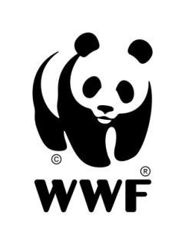WWF GUIANAS PRESS RELEASE

Protected Areas Bill Approved in Guyana’s National Assembly

On July 7, 2011 at a sitting of Guyana’s Parliament the Protected Areas (PA’s) Bill was debated upon and approved by all parties sitting in the national assembly, with only minor adjustments still to be finalized. With the passage of the legislation an announcement for new protected areas in Guyana is anticipated. These would bring the country closer to the requirement of the Convention of Biological Diversity (CBD) to which it is a signatory.
WWF Guianas and other environmental organizations in Guyana and globally have been lobbying for the passage of this bill for several years. In February this year WWF US CEO Carter Roberts, and Members of WWF US’s Board of Directors visited Guyana and the PA bill was one of the topics high on the agenda for discussion with Guyana’s President Bharrat Jagdeo.

The Bill provides “for the protection and conservation of Guyana’s natural heritage and natural capital; the creation, management and financing of a national system of protected areas …”.

Additionally this piece of legislation aims to advance the recovery and rehabilitation of degraded areas and gives recognition to conservation efforts of Amerindian communities. The newly approved Bill also stipulates the establishment of a PA Commission and PA Trust Fund, both of which are an integral part of developing an effective, efficient and sustainably managed PA system in Guyana. The establishment of a PA commission is intended to strengthen and build institutional capacity for the management of PAs in Guyana while the Trust Fund provides for financial support to existing and new protected areas with an approved management plan.

Under this legislation the PA Commissioner, within one year of his/her appointment, is tasked with presenting a "system plan" with a number of specifications including a vision, conservation goals and priorities and describing threats to the conservation of biodiversity.
A programme for obtaining international recognition for national protected areas, monitoring and evaluation, and the costs and investment needs and priorities for the NPAS should be set out.

