 |  | CBD/SBSTTA/27/INF/4/Rev.1

 | Distr.: General  10 October 2025  English only

Subsidiary Body on Scientific,
Technical and Technological Advice
Twenty-seventh meeting
Panama City, 20–24 October 2025
Item 3 of the provisional agenda*
Planning, monitoring, reporting and review: global review of collective progress in the implementation of the
Kunming-Montreal Global Biodiversity Framework
Analysis of national biodiversity strategies and action plans and national targets established by Parties aligned with the Kunming-Montreal Global Biodiversity Framework**
Note by the Secretariat

I. Introduction
- In its decision 15/6, the Conference of the Parties established mechanisms for planning, monitoring, reporting and review. In its decision 16/32, the Conference of the Parties further refined the mechanisms adopted in decision 15/6, including through finalizing the national reporting template for the seventh and eighth national report and agreeing on the concrete procedures for conducting the global review on collective progress in the implementation of the Framework. The Conference of the Parties also decided that the global review will be primarily based on national reports and a global report on collective progress in the implementation of the Framework. Among other sources, the global report should be based on:
  - The national reports, as the primary source of information. The seventh national reports are to be submitted by 28 February 2026;
  - The global analysis of information in national biodiversity strategies and action plans and national targets. Parties were requested to submit updated or revised national biodiversity strategies and action plans, including submitting national targets, by the sixteenth meeting of the Conference of the Parties or as soon as possible after that.
- The present note provides an analysis of the revised or updated national biodiversity strategies and action plans and the national targets submitted to the Secretariat by May 31, 2025. Annex I contains a list of all national biodiversity strategies and action plans submitted by Parties as of that date. Section A contains information on national biodiversity strategies and action plans and section B contains information on the national targets. The analysis will be updated for the sixth meeting of the Subsidiary Body on Implementation. This update will also include information on the methodology underpinning it as an annex.

Contents Page
I. Introduction 1
Section A. Analysis of national biodiversity strategies and action plans 5
II. Background 5
III. Analysis of contents of the national biodiversity strategies and action plans submitted after the adoption of the Kunming Montreal Global Biodiversity Framework 6
IV. Legal status and revision process of revised/updated national biodiversity strategies and action plans 7
Adoption as “whole of government” instrument 7
Adoption as Policy Instrument 7
Assessment of previous national biodiversity strategies and action plans 8
Coordination Mechanism 10
Stakeholder engagement 10
V. Contents of the national biodiversity strategies and action plans 14
Concrete actions, policies and programmes to meet national targets 15
Resource Mobilization Strategies 16
Monitoring Systems 17
Communication Strategies 17
Contributions by actors other than national governments 18
VI. Mainstreaming 19
National development plans and Sustainable development Plans 19
Poverty eradication 20
Subnational plans 21
Multilateral Environmental Agreements and Biodiversity Related Conventions 21
VII. Protocols 23
Cartagena Protocol 23
Nagoya Protocol and Digital Sequence Information 24
Section B. Analysis of national targets submitted through the online reporting tool 25
VIII. General observations 25
IX. Analysis of national targets 29
Target 1: plan and manage all areas to reduce biodiversity loss 29
Target 2: restore 30 per cent of all degraded ecosystems 31
Target 3: conserve 30 per cent of land, waters and seas 34
Target 4: halt species extinction, protect genetic diversity and manage human-wildlife conflicts 37
Target 5: ensure sustainable, safe and legal harvesting and trade of wild species 39
Target 6: reduce the introduction of invasive alien species by 50 per cent and minimize their impact 42
Target 7: reduce pollution to levels that are not harmful to biodiversity 44
Target 8: minimize the impacts of climate change on biodiversity and build resilience 46
Target 9: manage wild species sustainably to benefit people 48
Target 10: enhance biodiversity and sustainability in agriculture, aquaculture, fisheries and forestry 50
Target 11: restore, maintain and enhance nature’s contributions to people 52
Target 12: enhance green spaces and urban planning for human well-being and biodiversity 54
Target 13: increase the sharing of benefits from genetic resources, digital sequence information and traditional knowledge 56
Target 14: integrate biodiversity in decision-making at every level 59
Target 15: businesses assess, disclose and reduce biodiversity-related risks and negative impacts 61
Target 16: enable sustainable consumption choices to reduce waste and overconsumption 63
Target 17: strengthen biosafety and distribute the benefits of biotechnology 65
Target 18: reduce harmful incentives by at least $500 billion per year and scale up positive incentives for biodiversity 68
Target 19: mobilize $200 billion per year for biodiversity from all sources, including $30 billion through international finance 70
Target 20: strengthen capacity-building, technology transfer and scientific and technical cooperation for biodiversity 73
Target 21: ensure that knowledge to guide action on biodiversity is available and accessible 75
Target 22: ensure participation in decision-making and access to justice and information related to biodiversity for all 78
Target 23: ensure gender equality and a gender-responsive approach for biodiversity action 81
Annex I. Status of development of national biodiversity strategies and action plans 85
Annex II. List of conventions or multilateral environmental agreements mentioned in the revised and updated national biodiversity strategies and action plans 88
Annex III. Parties whose national targets were considered in the analysis of national targets 92

Section A. Analysis of national biodiversity strategies and action plans

II. Background
- An analysis of national biodiversity strategies and action plans submitted during the implementation of the Strategic Plan for Biodiversity 2011–2020 was included as part of the fifth edition of the Global Biodiversity Outlook, published in 2020. A further analysis was prepared by the Secretariat for consideration by the Conference of the Parties at its fifteenth meeting in December 2022. These analyses highlighted some of the salient features of the post-2020 national biodiversity strategies and action plans by assessing them against the guidance for their preparation contained in decision IX/8. While the national biodiversity strategies and action plans developed during the decade 2011–2020 included more successes in terms of achieving whole-of-government approaches, as compared with the decade 2001–2010, there remained gaps in several areas, notably: adoption of national biodiversity strategies and action plans as a national policy through legislation; costing the actions of the plan and developing a clear finance plan; stakeholder engagement; building capacity; and mainstreaming in other sectors of government. Moreover, national targets in many national biodiversity strategies and action plans were not aligned with the Aichi Biodiversity Targets of the Strategic Plan for Biodiversity 2011–2020.
- After the adoption of the KMGBF and decision 15/6, Parties initiated the process of revising or updating their NBSAPs and national targets in alignment with the Framework. In 2024, the Secretariat, in collaboration with partners, organized a series of regional NBSAP dialogues to provide an opportunity for country-to-country exchange and learning to support this process. These dialogues were organized in all regions, providing an opportunity for every Party to attend a dialogue. A summary of the experiences and findings from the dialogues was provided in document CBD/SBI/5/2/Add.3 and salient points were highlighted in document CBD/SBI/5/2/Rev.1.
- An analysis of the NBSAPs revised and updated after the adoption of the Kunming-Montreal Global Biodiversity Framework and decision 15/6 was prepared by the Secretariat for consideration of the fifth meeting of the Subsidiary Body on Implementation and COP-16. At the time of writing that analysis, only 19 Parties had submitted an NBSAP in an official language of the United Nations. Most had been developed with some level of stakeholder engagement and about half were informed by an assessment of the previous national biodiversity strategy and action plan. Most of the NBSAPs contained references to means of implementation, including finance and capacity development. However, less than half of them included a resource mobilization strategy or mentioned the intention to develop one. Most of the 19 NBSAPs reviewed contained linkages with subnational-level plans. Just under half of them mentioned a link with national development plans; most, however, are linked with sustainable development plans. A link with a poverty eradication strategy or similar instrument is mentioned only occasionally. More than half of the NBSAPs contained actions related to the implementation of national targets and most contained targets or actions to implement the Protocols, or multilateral environmental agreements. While most of them contained a monitoring and evaluation plan, less than half provided details on how specific indicators will be used for monitoring and, very few provided information on the link with the headline indicators adopted in decision 15/5 of the Conference of the Parties. This document presents an update of that analysis.

III. Analysis of contents of the national biodiversity strategies and action plans submitted after the adoption of the Kunming Montreal Global Biodiversity Framework
- As of 31 May 2025, 51 Parties have submitted a revised or updated national biodiversity strategy and action plan pursuant to the request in decision 15/6. Of the 51 NBSAPs, 8 (16%) were from African States, 15 (29%) were from Asia-Pacific States, 3 (6%) were from Eastern European States, 6 (11%) were from Latin American and Caribbean States and 19 (37%) were from Western European and other States (22 developed countries, 26 developing countries, 1 economy in transition, 2 Small Island Developing States). A total of 43 NBSAPs were submitted by the deadline set in decision 15/6. Figure 1 depicts the rate of submission of NBSAPs since COP 15.
- The timelines of the NBSAPs submitted to date also vary by Party. 45 (88%) of them cover periods up to 2030, and 6 (11%) NBSAPs cover periods beyond 2030. Among the Parties that have yet to submit a revised or updated NBSAP after the adoption of the Framework, 45 (31%) cover periods up to 2030, 2 NBSAPs cover periods beyond 2030, and 11 NBSAPs do not specify a timeline). The remaining 87 NBSAPs that have yet to be revised and updated in line with the Framework have a coverage end date prior to 2023. Figure 1 reflects these figures as percentages of the total number of Parties/NBSAPs

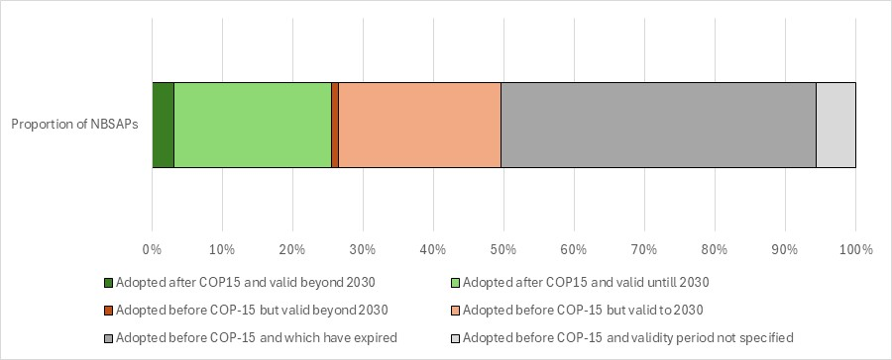Figure 1 - Proportion of national biodiversity strategies and action plans submitted before and after COP-15 and their period of validity. The 196 Parties to the Convention on Biological Diversity are represented in the graph.
- The present analysis considered the extent to which Parties reflected the guidance contained in decisions IX/8 and 15/6 in the development, revision or update of their national biodiversity strategy and action plan. The analysis focuses on four broad areas (a) process and legal status; (b) components of the national biodiversity strategies and action plans; and (c) mainstreaming.

IV. Legal status and revision process of revised/updated national biodiversity strategies and action plans
Adoption as “whole of government” instrument
- The Kunming-Montreal Global Biodiversity Framework was adopted by Parties “as a framework for all - the whole of government and the whole of society” (see below). The intention was that its implementation would entail political will and recognition at the highest levels of government, and engagement by all sectors and levels of government, and by all actors of society.
- The NBSAPs analysed in this document were adopted by a range of different bodies. A total of 22 NBSAPs have been adopted as “whole-of-government” instruments. For example:
  - The 10 (20%) NBSAPs of Canada, Cuba, Germany, Ireland, Japan, Malaysia, Republic of Korea, Spain, Thailand, and the United Arab Emirates are approved by a cabinet or council of ministers;
  - The 6 (11%) NBSAPs of Hungary, Liechtenstein, Luxembourg, Peru, Switzerland, and Viet Nam are approved by a head of state or government;
  - The 2 (4%) NBSAPs of the European Union and Slovenia are approved by a parliament;
  - The 3 (6%) NBSAPs of Togo, the United Republic of Tanzania, and Yemen are approved by a national or inter-ministerial committee;
  - The NBSAP of Italy is first approved by the State-Regions Conference representing the Regions and Autonomous Provinces of the country, and then by Ministerial Decree.
- Six (11%) other NBSAPs have been adopted by authorities specific to the environmental sector, either by individual ministries or national committees, and the remaining 26 NBSAPs do not provide sufficient information to know the type of approach that was used and whether it was a whole-of-government approach or not.
- Of the 22 (43%) Parties mentioned above as having employed a “whole-of-government” approach, 2 are from Africa, 7 are from the Asia-Pacific region, 2 are from Central or Eastern Europe, 2 are from Latin America or the Caribbean, and 9 are from Western Europe or other Governments. Of the GEF eligible countries, 35% employed a whole-of-government approach versus 50% for non-eligible countries.
- While the current analysis covers only a subset of all the expected revised and updated NBSAPs, compared to the findings in the analysis of post COP-10 NBSAPs (CBD/COP/15/9/Add.1), the proportion of NBSAPs which are adopted by an authority specific to the environmental sector has increased, but the proportion which have been adopted by bodies representing the whole-of-government has remained relatively consistent. While the proportion of non- GEF-eligible Parties which have adopted whole-of-government instruments has declined, the proportion of GEF-eligible Parties that have done so has stayed relatively consistent.
- The implications of the adoption of NBSAPs as “whole-of-government" instruments vary from country to country and by the levels and sectors of government involved, and it is still too early to assess if, and to what extent, adoption as a “whole-of-government" instrument has resulted in the mainstreaming of biodiversity into sectoral and cross-sectoral policy and practice.
Adoption as Policy Instrument
- Decision 15/6 paragraph 9 “encourages Parties to adopt the revised or updated national biodiversity strategies and action plans as policy and/or legal instruments.” Doing so gives the NBSAP a legal and political status, beyond that of a purely technical document, which it is hoped would increase its take-up and implementation by a range of actors. In many countries the development and adoption of NBSAPs have been associated with the establishment of legal frameworks which have facilitated biodiversity action. The actual implications of adoption as a “policy instrument” vary from country to country and by the type of instrument in question. Like with the adoption by whole-of-government, it is not known if, and to what extent, adoption as a policy instrument has indeed represented a stronger legal basis for biodiversity action and by extension into the creation of on-the-ground and tangible change.
- A total of 27 (53%) Parties have adopted NBSAPs as a policy instrument. The vast majority of these (24) were adopted as national policies. The NBSAP of Slovenia has been adopted as a law. The NBSAPs of India and the Republic of Korea were adopted as reports mandated by law or national policy. The remaining NBSAPs do not provide sufficient information to assess if they have been adopted as a policy instrument, or, if they have been, what type of instruments they are (Figure 2)
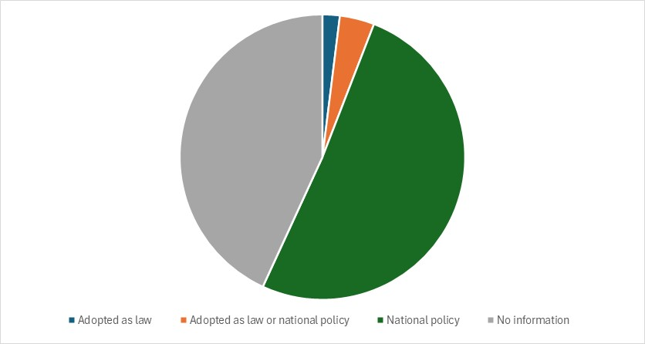
Figure 2. Proportion of Parties with NBSAPs adopted as a policy instrument, as a law, as a report mandated by law or national policy, or with no information on the type of instrument
Assessment of previous national biodiversity strategies and action plans
- Of the 51 NBSAPs reviewed, 28 (55%) mention that an assessment of the previous NBSAP(s) was done as a part of, or contributing to, the revision and updating process. These assessments have helped Parties to understand the strengths and shortcomings of their previous NBSAPs in order to build and improve on these. Generally, these assessments address the proportion of NBSAP activities that have been implemented, their achievements or lack thereof, and their implementation challenges.
- 15 (29%) NBSAPs mention targets from their previous NBSAP(s) that were achieved or other successes achieved in the implementation of their previous NBSAP(s). Some of the most common areas of achievement include increases in biodiversity awareness and increases in protected areas.
- 14 (27%) NBSAPs mention lessons learned, targets that were partially achieved, or targets that were not achieved from their previous NBSAP(s). Some of the most common areas in which targets were not met include the mainstreaming and cross-sectoral integration of biodiversity policies and the reduction in rates of habitat deterioration and destruction.
- 7 (14%) NBSAPs mention implementation challenges from their previous NBSAP(s). Some of the most common areas of difficulty include the mobilization of financial resources and the lack of institutional capacity (Figure 3)
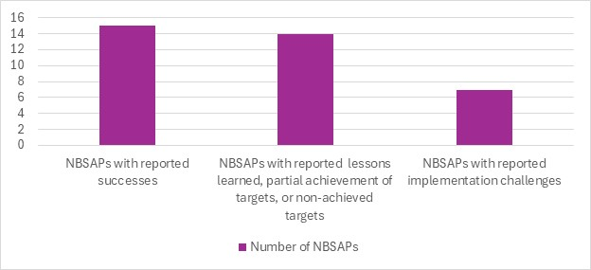

Figure 3. Number of NBSAPs which have reported successes, challenges, lessons learned or targets which were partially or not achieved. Note that some NBSAPs might be represented in several bars as the categories are not exclusive of one another
- Two examples of how assessments were reported in the NBSAPs include:
  - Tonga assessed both the degree of implementation of its targets, and the degree of effectiveness of the measures taken. The implementation of the targets in its previous NBSAP are 2% complete, 72% actively under implementation, 25% planned, and 1% not yet started. The measures taken in implementation were mostly deemed effective (45%) or partially effective (50%). None were deemed ineffective and the effectiveness of only 5% of the measures is not known. Tonga seeks to learn lessons from its successes including the implementation of local marine protected areas, the increase in appreciation of traditional knowledge in the tourism sector, and increases in participatory processes and community involvement in ago-biodiversity. Implementation challenges included a lack of reliable data and data management capacity, sufficient financing, and the exacerbation of the scale of problems from climate change;
  - The United Arab Emirates assessed their 2014–2021 NBSAP through the evaluation of each of its national targets and whether they were progressing at an insufficient rate, on track for achievement, or on track to exceed the target. Two targets were reported to be on track to exceed their initial ambition. The targets were related to the amount of area conserved and the raising of biodiversity awareness.
- 20. While the current analysis covers only a subset of all the expected revised and updated NBSAPs, compared to the findings in the analysis of post COP 10 NBSAPs (CBD/COP/15/9/Add.1), the proportion of Parties which have indicated that they have conducted an assessment of their previous NBSAP and provided insights on the results of those assessments has decreased (from 65% to 55%) while the proportion of Parties which have reported on specific achievements has stayed relatively consistent.
Coordination Mechanism
- The institutional arrangements in place for the development, implementation, monitoring and reporting of the NBSAP are key to the success of biodiversity action. Having implications for governance, accountability, sustainability and cross sectoral and whole of society engagement, they are also a reflection of the long-term commitment of countries to such action. Coordination mechanisms take on different forms in different countries. Building on their assessments of previous NBSAPs, several Parties have recognized the need for stronger institutional arrangements to support more effective implementation.
- Of the 51 NBSAPs reviewed, 22 (43%) record having a formal coordination mechanism, committee, or a working group for NBSAP-related tasks, composed of a variety of stakeholders. An additional 5 (10%) record plans to create such coordination mechanisms. The mandates of these coordination mechanisms vary. In some countries their mandate is limited to the revision of the NBSAP, while in other countries, coordination mechanisms are also mandated to monitor, evaluate, or report on implementation. In some countries, they are also mandated to oversee the implementation process itself. Some examples of these coordination mechanisms include:
  - Ireland has three different bodies, each with different roles in the NBSAP review and implementation processes. The NPWS NBAP Steering Committee leads the development of the NBSAP, the Biodiversity Working Group assists in the implementation of the NBSAP, and the Biodiversity Forum uses independent experts to increase stakeholder participation throughout the process.
  - India’s National Biodiversity Authority, develops and implements the NBSAP. However, there are also state-level biodiversity boards and Union Territory Biodiversity Councils, which are being strengthened to improve their implementation capacity, as well as biodiversity management committees at the local level which support grassroots mobilization.
- While the current analysis covers only a subset of all the expected revised and updated NBSAPs, compared to the findings in the analysis of post COP 10 NBSAPs (CBD/COP/15/9/Add.1), there is a slight decrease in the proportion of Parties who reported having a formal coordination mechanism.
- Of the 29 NBSAPs without a formal coordination mechanism, 9 Parties list responsible domestic organs or authorities responsible for the tasks that a coordination mechanism would otherwise conduct. For example:
  - The United Republic of Tanzania plans to establish focal points and support the National Designated Authority of the GEF to facilitate the implementation of their NBSAP.
Stakeholder engagement
- Closely linked to the effectiveness of coordination mechanisms is the extent to which diverse stakeholders are meaningfully engaged in NBSAP development and implementation. The Conference of the Parties in its decision 15/6 (para. 23) encourages Parties to enable the full and effective participation and engagement of women, indigenous peoples and local communities, youth, civil society organizations, academia, the private sector, all levels of government and stakeholders from all other relevant sectors, in all levels of development and implementation of the national biodiversity strategies and action plans.
- Of the NBSAPs analysed, 38 (75%) report having been developed with some level of stakeholder engagement.
  - 34 (67%) Parties report engaging actors other than national governments
  - 33 (65%) Parties report engaging other ministries.
  - 26 (51%) Parties report engaging NGOs/civil society
  - 21 (41%) Parties involved subnational governments, cities and other local authorities
  - 20 (39%) Parties involved environmental experts and technical partners from professional environmental institutions
  - 20 (39%) Parties involved the private sector
  - 18 (35%) Parties involved academia and research institutions
  - 14 (27%) Parties involved youth
  - 13 (25%) Parties engaged indigenous peoples and local communities.
  - 12 (24%) Parties report the involvement of citizens/the public.
- Figure 4 shows these numbers alongside the percentages of NBSAPs reporting the participation of the group on the NBSAP committee, and their expected involvement in the implementation of the NBSAP. Notably, of the 51 NBSAPs reviewed, over three-quarters (40, 78%) of Parties included contributions, specific and concrete actions, and activities from a range of actors other than national government towards the achievement of national targets within their NBSAPs. Over half (32, 63%) of NBSAPs identified ministries other than environment ministry as involved in the implementation of national targets (Figure 5).
- A number of Parties highlighted the important role of their NBSAP, and NBSAP development process, in enabling and supporting coordination between different actors towards common goals. For example:
  - Malta highlights a main objective of their NBSAP is to structure and facilitate collective action for biodiversity conservation and restoration through stakeholder cooperation.
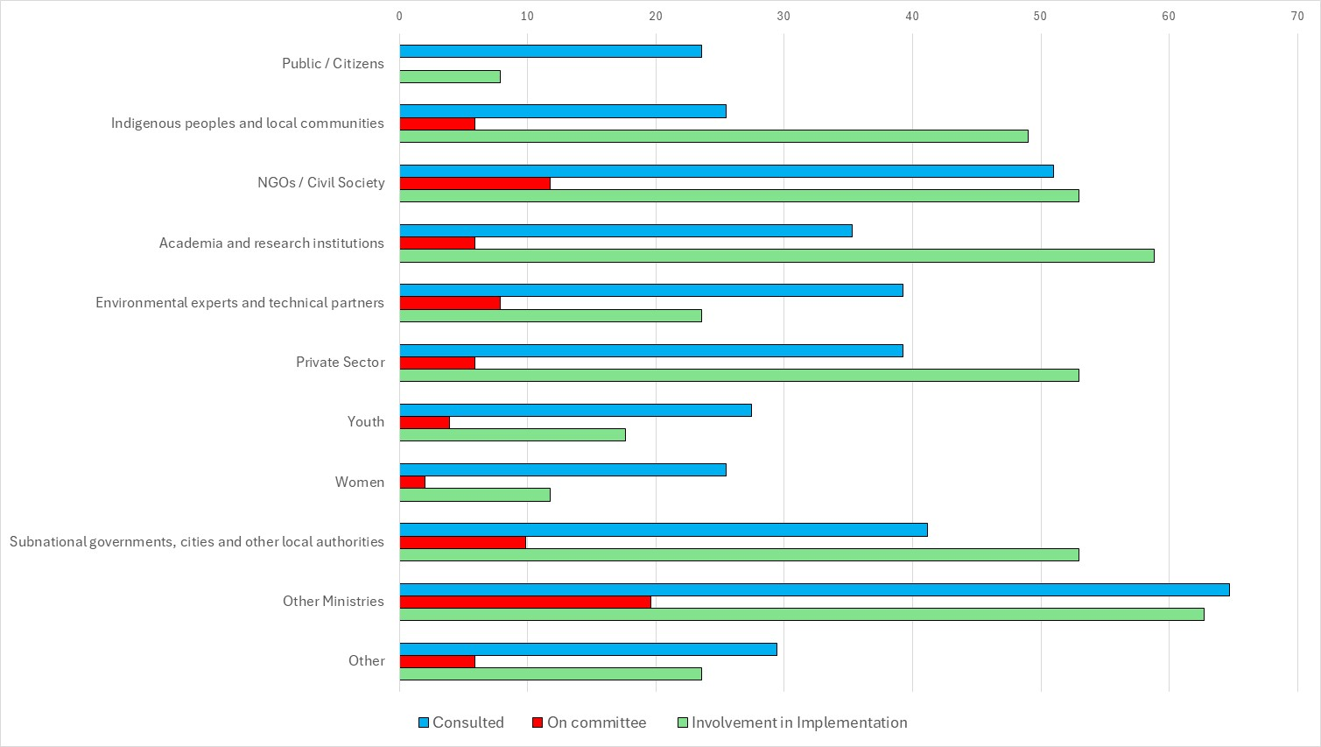Figure 4. Percentage of Parties reporting the different levels of engagement of Indigenous People and local communities and stakeholders in the NBSAP process

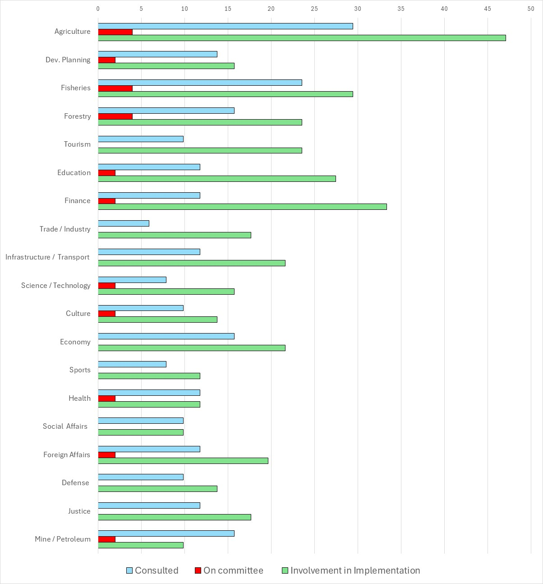Figure 5. Percentage of Parties reporting the engagement of different ministries in the NBSAP process
- Many NBSAPs (21, 41%) provide detailed information on their stakeholder engagement processes. Some examples include:
  - Ireland’s NBSAP contains a chapter describing its NBSAP process. Stakeholders were engaged in three distinct stages. The first stage focused on the high-level structure and direction of the NBSAP and included stakeholders with a role in biodiversity governance and assessment, the second focused on the actions proposed in the NBSAP and involved stakeholders that would be directly impacted or involved in implementation; the third stage comprised an open public consultation for all interested parties. The first two stages involved several coordinated groups including a NBAP Steering Committee, a Biodiversity Forum (involving an independent group of biodiversity experts), a Biodiversity Working Group (involving an interdepartmental group) and a Business for Biodiversity Platform Steering Group. Ireland also held a National Biodiversity Conference, a Citizens’ Assembly and a Children and Young People’s Assembly on Biodiversity Loss to create recommendations to inform their NBSAP;
  - Austria’s NBSAP explains that its development started with a series of workshops with a range of stakeholders which formed the basis for a public consultation on potential elements of a strategy. The strategy was then discussed and coordinated at National Biodiversity Commission among representatives from all relevant actors, sectors and additional stakeholders;
  - Organizations representing Indigenous People and Local Communities and afro-descendants, participated actively in the update and revision of Peru’s NSBAP. As a result, their needs, proposals, knowledges and visions are reflected in the NBSAP, its targets, and in its 2050 vision. Peru’s NBSAP also cites IPLC’s contributions to forest conservation and restoration, climate change mitigation, monitoring and oversight of forest resources and wild fauna, and their contributions as early warning systems in their territories;
  - India National Biodiversity Authority, under Ministry of Environment, Forest and Climate Change, established Working Group comprising independent experts and representatives from various Ministries, State Biodiversity Boards and public institutions. Additionally, a series of National, Regional, Inter and Intra Ministerial Consultations were held, collaborating with 24 Central Ministries, international conservation organizations, subject matter specialists, corporates, industry, state governments, local level institutions, NGOs, youth, and women groups and civil society members from all the 28 states and 8 union territories of India;
  - Thailand undertook detailed stakeholder mapping with "responsible agencies and sectors relevant to each goal", including several National Consultative Meetings and focus groups with the "target groups of each goal” including “government agencies, private sector representatives, business sector, educational institutions, civil society, independent organizations, ethnic groups, local communities, women and youth groups, and representatives from agencies"
- While the current analysis covers only a subset of all the expected revised and updated NBSAPs, the reported involvement of IPLCs in these processes in the NBSAPs analysed to date is consistent (25%) with the findings in the analysis of Post COP 10 NBSAPs (CBD/COP/15/9/Add.1). Reported involvement of NGOs / civil society is less when compared to findings in the analysis of Post COP 10 NBSAPs (CBD/COP/15/9/Add.1) and private sector is more (Table 1).
 | Indigenous peoples and local communities | NGOs / Civil Society | Academia and research institutions | Private sector
Current analysis (51 NBSAPs) | 25% | 51% | 35% | 39%
Post COP 10 NBSAPs (CBD/COP/15/9/Add.1, 2022) | 26% | 62% | 44% | 33%
Table 1. Percentages of NBSAPs reporting stakeholder engagement NBSAP revision and updating processes

V. Contents of the national biodiversity strategies and action plans
- The Conference of the Parties, in its decision 15/6 paragraph 5, adopted guidance for revising and updating NBSAPs to align with the Framework which is outlined in Annex I of the decision. This guidance detailed common elements for inclusion in updated NBSAPs. These elements included (a) national targets addressing or contributing towards each of the goals and targets of the Kunming-Montreal Global Biodiversity Framework and ensuring close alignment where possible, taking into account the availability of resources and means of implementation, (b) concrete actions, policies and programmes designed to meet the national targets and contribute to the global goals and targets, including spatial, temporal and financial aspects, as appropriate and (c) National monitoring, reviewing and assessment.
- National targets were submitted through the on-line reporting tool. The submission template includes national indicators which would be used to monitor each target, information on the non-state actors engaged in each target, information of the main policy measures to implement, and means of implementation needed for each target as well as information on the consideration of Section C for each Target. These aspects are addressed in section B of this document
- Not all Parties completed the full national target submission template and in some cases the level of detail in the NBSAP was higher than in the national target submission template. This section addresses Parties’ response to the NBSAP guidance in decision 15/6 in their NBSAPs. It addresses the inclusion of concrete actions, policies and programmes to meet their national targets, biodiversity financing, and monitoring systems in the revised and updated NBSAPs. This section also addresses the inclusion of communication strategies or elements thereof and the reflection of non-state actor contributions to the implementation of the GBF in the NBSAPs.
Concrete actions, policies and programmes to meet national targets
- A key component of the revised NBSAPs is the articulation of how national targets will be achieved in practice. This is primarily done through the inclusion of concrete actions, policies, and programmes. Of the 51 NBSAPs analysed, over three quarters (39, 76%) of Parties have totally or partially fulfilled section 6 (b) of the NBSAP guidance in Annex I of Decision 15/6. The majority include an action planning matrix within their NBSAP outlining specific concrete actions, and to varying degrees policies and programmes, designed to meet national targets. As part of their action planning matrices, some Parties also included responsible actors, supporting institutions/key partners, measurable outputs and indicators baselines, milestones, and required capacity.
- Parties’ concrete actions, policies and programmes include spatial, temporal and financial aspects to varying degrees. The most common were temporal aspects through the inclusion of timebound actions and targets. This information is further elaborated by Parties in the submission of their national targets. Several Parties included financial aspects into action planning matrices or a chapter on financial means. Financial considerations were also developed as part of national targets mapped to global target 19 (please see section on biodiversity finance). Most actions were not spatially specific, however spatial aspects were more often included in actions and national targets related to global targets 1-3 or within introductory sections on areas important to biodiversity. Some examples include:
  - Suriname's NBSAP contains a Strategic Action Framework containing 121 actions (including concrete actions policies and programmes) to meet national targets, each with timeframes for implementation, a review of required capacity, identification of lead responsible agencies and key partners, an estimated cost and synergies (including with GBF targets and SDGs). Suriname's NBSAP also presents additional details of estimated costs per target and potential funding sources in a section on ‘financial overview and funding opportunities’, Suriname's 4th Strategic Pathway is focused on increasing ‘mainstreaming’ and ‘enabling conditions’ which includes targets to improve financial resources, capacity building and national biodiversity integration aiming to harmonise environmental and economic policies;
  - Denmark outlines concrete actions designed to meet national targets as well as policies and programmes within their NBSAP, including the Marine Strategy Action programme, Maritime Spatial Plan and River Basin Management Plans;
  - Japan provides a comprehensive GANTT chart in their NBSAP to outline the sequence and timeline of actions towards their 30X30 targets, providing a clear temporal framework for monitoring and implementation progress.
Resource Mobilization Strategies
- To support the implementation of these actions, policies, and programmes, securing adequate financial resources is essential. In decision 16/34 paragraph 10, the Conference of the Parties encouraged Parties to “develop, update and implement national biodiversity finance plans or similar instruments, based on an assessment of biodiversity expenditures and finance needs [...]”. In line with this guidance, 27 (53%) NBSAPs include elements that address biodiversity finance. 67% of the countries whose NBSAPs included these elements are part of the BIOFIN Initiative and are at either the design or implementation stage. Table 1 shows the sources of finance identified in the 27 NBSAPs.
- Of the 27 NBSAPs mentioned above, 16 NBSAPs include costing estimates for their implementation,of which 10 provide cost estimates at the action level and 6 provide overall cost estimates. Of the NBSAPs that include costing at either level, 10 include financial gap analyses, comparing total available resources against estimated finance needs for implementation.

 | Domestic | International | Public | Private
Number of NBSAPs | 27 | 17 | 27 | 14
Table 1. Funding sources identified for NBSAP resource mobilization
- Examples of some of the approaches taken with regards to resource mobilization strategies are:
  - Yemen prepared a budget and resource mobilization plan which includes costing for (a) each of the six strategic pathways (ii) all nineteen associated outcomes and (iii) an approximate total budget envelope;
  - Burkina Faso’s financing plan presents a structured table outlining the financial contributions of various stakeholders over three- and five-year periods, the respective proportion of each contribution relative to the total budget, as well as the overall projected finance needs;
  - France’s NBSAP financing plan includes a financing trajectory by stakeholder, covering public, private and EU sources. Projected funding increases are justified through a detailed cost breakdown for targeted priority areas, including protected areas and ecological restoration;
  - Uganda’s financing plan includes action-level costing by strategy and outlines the total minimum implementation cost, alongside a resource mobilization plan which leverages domestic mechanisms such as payments for ecosystem services.
Monitoring Systems
- Monitoring systems provide a basis for tracking progress in implementation and informing decision-making. Although the specific indicators which will be used to monitoring national targets are included in the national target submission template, the description of how national monitoring systems should work would ideally be described in the NBSAP. Of the 51 NBSAPs analyzed, 32 (63%) indicate having a monitoring system in place or explain how the implementation of the NBSAP will be monitored. For example:
  - In France, each entity in charge of implementing the actions in the NBSAP will report on the relevant process and impact indicators for their action. The French Biodiversity Office will compile reports on each action and report to the General Secretary of Ecological Planning who will suggest corrective action if necessary;
  - The Malaysia Biodiversity Centre (MBC) and a set of thematic working groups comprised of representatives of different state and non-state actors will monitor the implementation of Malaysia’s NBSAP. An online monitoring system will be used to monitor the targets and indicators of the Policy and the progress of the NPBD 2022-2030. A National Biodiversity Conference will be organized annually to bring together all stakeholder groups to discuss implementation progress.
- A number of NBSAPs explain how existing monitoring functions or systems will be enhanced. For example:
  - The Republic of Korea aims to amend its Biodiversity Act to strengthen the function of the National Biodiversity Centre to include collecting, verifying and disclosing biodiversity statistics, overseeing the overall implementation of the NBSAP, preparing national reports and building a system for information integration and implementation monitoring. The country aims to disclose information on the country’s progress of implementation of the NBSAP through its CHM (www.kbr.go.kr), and to hold regular forums to review the implementation of each strategic goal;
  - Slovenia positions monitoring as a means to facilitate implementation. It foresees to establish a comprehensive information system in such a way as to create a national hub of data and information crucial for the implementation and monitoring of the situation and planning of the nature protection policy, which will be publicly available and maintained.
Communication Strategies
- In addition to establishing monitoring systems to track implementation, several COP decisions have emphasized the importance of integrating communication, education, and public awareness (CEPA) into NBSAPs. Specifically, decisions VIII/6 and IX/8 state that communication, education and public awareness (CEPA) strategies and activities should be integral parts of NBSAPs. This is important as CEPA can help increase public understanding of national biodiversity goals, promote behaviour change, and encourage participation from key sectors in implementing NBSAP actions. Public awareness and commitment, can in turn, increase political will to take biodiversity action.
- Nearly all the 51 NBSAP’s reviewed contained reference to CEPA activities with 22 (43%) NBSAPs containing a clear CEPA or communication strategy and action plan or equivalent and 26 (51%) NBSAPs containing initiatives relating to communication, education and public awareness. Examples include:
  - Aruba (Kingdom of the Netherlands) emphasize that nature-conscious action begins with awareness of the Rights of Nature and are building their communications and education approach upon new legislative changes for inclusion of Rights of Nature. Supported by their subgoal of “Nature Education for a new Aruban Narrative” across government and society.
  - Republic of Moldova emphasizes the support of NGOs in developing and maintaining their most active social public engagement initiatives. Highlighting the work of organisations such as EcoContact, the Biotica Society, EcoTiras, and the National Environment Center, who frequently implement national campaigns to urge their population to join collective actions for conservation and protection of biodiversity, including national forest plantation and waste-free forest campaigns.
  - Indonesia has developed a CEPA framework and guidance document aiming to increase community support and active participation, emphasising that communication, education and public awareness is a key to the success of their NBSAP programme.
  - Libya's NBSAP includes the implementation of public and community awareness campaigns as part of actions towards several national targets. These actions include raising awareness of climate change and nature-based solutions, sustainable consumption and production approaches, importance and benefits of waste reduction, pollution reduction and biodiversity conservation.
- Nearly half (25, 49%) of the NBSAPs reviewed had CEPA-related initiatives that were identified as actions towards national targets. These were not only related to global target 21 but also other global targets such as 6, 7, and 16, for which Parties had identified the public and other actors, engagement and behavioural change as a key component to achieving these targets.
- While the current analysis covers only a subset of all the expected revised and updated NBSAPs, the number of Parties including communication or CEPA strategies, action plans or equivalent connected to their NBSAPs has almost doubled compared to the findings in the analysis of Post COP 10 NBSAPs (CBD/COP/15/9/Add.1).
Contributions by actors other than national governments
- In line with the whole of society approach called for in the Kunming-Montreal Global Biodiversity Framework, the Conference of the Parties, in Decision 15/6, (paragraph 26), invited actors other than national governments to develop, on a voluntary basis, commitments contributing to NBSAPs. These actors included indigenous peoples and local communities, subnational governments, cities and other local authorities, non-governmental organizations, women, youth, research organizations, the business and finance community and representatives of sectors related to or dependent on biodiversity.
- The national target submission template includes an option for parties to integrate contributions by actors other than national governments alongside their national targets. While some parties did avail of that space as is described in section B, most Parties provided more details of contributions and commitments by these actors in their NBSAPs than they did in their national target submissions through the online reporting tool.
- Within the 51 NBSAPs reviewed, most contributions of actors other than national governments were either by those identified as partners working alongside leading government bodies, supporting actions or outlined within the text of actions and targets. Few actions, as yet, have been identified as being led by actors other than national governments with the exception of subnational authorities and indigenous peoples and local communities through local government-led, community-led or indigenous-led actions. Some examples include:
  - Canada emphasised the value of indigenous-led conservation actions and initiatives within their NBSAP, including Indigenous Led Area-Based Conservation efforts with significant results such as the establishment of over 100,000 km2 of Indigenous-led PAs and OECMs. As well as important projects such as the Indigenous Guardians programs and the Project Finance for Permanence that is providing $800M to support Indigenous-led conservation initiatives.
  - Suriname’s Indigenous and Tribal Peoples Authority representatives are lead responsible agents and key partners for a significant number of actions in their NBSAP, including assessments and management of biodiversity within tribal territories, enforcement of wildlife laws and development of laws and regulations to protect traditional knowledge and support rights.
  - Burkina Faso emphasises the “important role of Civil Society Organisations serving as interfaces between state structures, technical and financial partners (PTFs), and grassroots communities, executing projects and programs related to biodiversity themselves.”
  - Togo highlights that “the roles and contributions of local communities as guardians of biodiversity and partners in its conservation must be recognized, including their rights”, and supports local communities’ engagement and wellbeing in 20 of their 25 national targets and monitoring framework Suriname’s confirmation of Indigenous and Tribal Peoples Authority representatives as lead responsible agents for 8 actions within their NBSAP.
  - Libya identifies key business group, national oil corporation, and scientific and academic actors as those responsible for implementation of actions alongside government bodies within 12 of their 20 national targets.

VI. Mainstreaming
- Decision 15/6 paragraph 9 encourages Parties to mainstream their NBSAPs (or elements thereof) with broader strategies and plans, such as national sustainable development plans, national development plans, poverty reduction strategies and other relevant national sectoral and cross-sectoral plans, in line with national circumstances and priorities. The decision also recognizes (paragraphs 22 and 23) that other biodiversity-related multilateral environmental agreements will contribute to the implementation of relevant or corresponding elements of the Kunming-Montreal Global Biodiversity Framework consistent with their mandates and priorities and therefore also encourages Parties to include relevant actions to implement commitments and recommendations under each of the biodiversity-related multilateral environmental agreements to which they are a party in their NBSAPs.
National development plans and Sustainable development Plans
- One of the key motions for integrating biodiversity into the mainstream of countries’ socio-economic activities is including or linking their biodiversity action in(to) their national development plans and/or their sustainable development plans. While in many cases these two plans are one and the same, in other cases the national development plan details economic development efforts while the sustainable development plan outlines how the country intends to meet the sustainable development goals more broadly.
- Of the 51 NBSAPs reviewed, 6 (12%) Parties’ NBSAPs state that biodiversity has been integrated into their national development plan or equivalent instrument (Figure 6). For example:
  - Jordan’s NBSAP was fully integrated within their Economic Modernization Vision (EMV), which served as the primary national policy document to influence key factors affecting biodiversity gains or losses.
  - The Indonesian Biodiversity Strategy and Action Plan (IBSAP) was harmonised with both their National Long-Term Development Plan (RPJPN) and their Draft National Medium-Term Development Plan.
- The NBSAPs of 16 (31%) other Parties contain elements and/or targets and actions which aim at mainstreaming with the national development plan or equivalent instrument.
- Of the 51 NBSAPs reviewed, 32 (63%) Parties mention an integration of their NBSAP with their sustainable development plans or equivalent instruments (figure 6). These parties do not overlap with the 6 that have integrated biodiversity into their national development plans. For example:
  - Hungary’s National Biodiversity strategy presents a table which outlines linkages between strategic pathways and targets and SDGs.
  - Each National Target, action and intervention in Suriname’s NBSAP has been reviewed for synergies with SDGs, and these are presented in their strategic action framework.
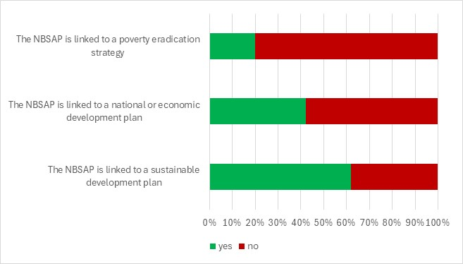
Figure 6. Proportion of NBSAPs which have been linked to poverty eradication strategies, national or economic development plans or sustainable development plans
Poverty eradication
- Building on the integration of biodiversity into national development plans, Parties are also encouraged to identify opportunities to link biodiversity conservation with poverty eradication. 10 (20%) Parties’ post-Nagoya NBSAPs mention links to poverty eradication and/or integrate this objective into their principles, targets and/or actions. For example:
  - Uganda’s NBSAP III recognizes the role of biodiversity in supporting human well-being, poverty reduction, gender equality, and national development as a core guiding principle. Accordingly, Section 5.1.8 discusses integrating the strategy with the National Poverty Reduction Strategy as part of its implementation approach.
  - Yemen’s NBSAP highlights poverty as a primary driver of biodiversity loss due to limited livelihood options. It commits, under their 14th Target, to fully integrate biodiversity into poverty eradication strategies.
Subnational plans
- Complementing national-level efforts, many Parties also emphasize the importance of subnational plans to address biodiversity conservation within local contexts and governance structures. Of the 51 NBSAPs reviewed, 31 (61%) NBSAPs address subnational or municipal issues including but not limited to urban greening initiatives, Subnational Biodiversity Strategy and Action Plans (SBSAPs), and Local Biodiversity Strategy and Action Plans (LBSAPs). Of these, 9 NBSAPs mention that they either already have SBSAPs, LBSAPs, or comparable plans, have started developing them, or they exclusively detail current or previous initiatives undertaken at the subnational level.
- 26 of the 31 revised and updated NBSAPs addressing subnational or municipal issues contain actions, goals, or targets regarding subnational/municipal issues or policies, and 5 NBSAPs mention their intent to prepare SBSAPs, LBSAPs, or another comparable plan. For example, Germany states that 15 of their 16 states have developed an SBSAP and the 16th SBSAP is currently in development. Germany also has targets aimed at urban areas dealing with landscape quality, green spaces, and climate adaptation.
- While the current analysis covers only a subset of all the expected revised and updated NBSAPs, compared to the findings in the analysis of post COP 10 NBSAPs (CBD/COP/15/9/Add.1), both the proportion of Parties which have mentioned that they already have an SBSAP, LBSAP, or another comparable plan and the proportion of Parties with actions, goals, or targets regarding subnational or municipal issues have increased.
Multilateral Environmental Agreements and Biodiversity Related Conventions
- As the Kunming-Montreal Global Biodiversity Framework contains many relevant and corresponding elements consistent with the mandates and priorities of the other multilateral environmental agreements and biodiversity related conventions, in many instances, Parties articulate their commitments and plans to implement these agreements and conventions through their NBSAPs. In an effort to spell out synergistic implementation they also frequently mention the other Rio Conventions.
- Of the 51 NBSAPs reviewed, 46 (90%) NBSAPs mentioned at least one Multilateral Environmental Agreement (MEA) or environmental convention (excluding the CBD, the Cartagena Protocol, the Nagoya-Kuala Lumpur Supplementary Protocol, and the Nagoya Protocol). Of these:
  - 39 (76%) NBSAPs mentioned at least one biodiversity-related convention, 6 (11%) NBSAPs mentioned at least one chemicals-related convention, 27 (53%) NBSAPs mentioned either UNFCCC or UNCCD, 16 (31%) NBSAPs mentioned marine-related conventions, and 12 (24%) NBSAPs mentioned at least one human rights-related convention;
  - 32 (63%) NBSAPs integrated at least one MEA into at least one domestic goal, target, or action, including the creation of synergies between the NBSAP and the MEA. Among the most commonly integrated MEAs were the Ramsar Convention, CITES, UNFCCC, CMS, and the WHC. Some notable examples, characteristic of these measures, include:
    - Viet Nam, as a part of their objective on the expansion and enhancement of the effectiveness of the management for the system of natural heritage sites and protected areas, includes a quantitative target for the increase in the number of Ramsar and other heritage sites as well as qualitative goals with regards to the review of criteria and classification of said sites;
    - Spain seeks to bolster its implementation of the CITES convention through the Spanish Action Plan against Illegal Trafficking and Poaching of International Wildlife Species (TIFIES Plan), which includes the establishment of a CITES Species Rescue Center Network before 2025 and the increase of regulations to enforce a zero-tolerance policy for the illegal trade of wildlife species and timber, among other measures. Spain also details its plans to fulfil its commitments to the Amsterdam Declaration and the Ramsar Convention as well as a desire to strengthen its role within OSPAR, the Barcelona Convention, ACCOBAMS, the International Whaling Commission, and ACAP, including a plan to ratify the BBNJ Agreement.
  - 33 (65%) NBSAPs acknowledged the legal importance of their ratification of, or their intention of ratification of at least one MEA, including explanations of measures having already been taken towards domestic implementation or international entry into force. In addition to the MEAs mentioned above, some of the most commonly acknowledged MEAs included the BBNJ Agreement, the Bern Convention, UNCCD, the IPPC, and the ITPGRFA (Please see annex I).

VII. Protocols
- National Biodiversity Strategies and Action Plans are the national implementation vehicle for the Protocols and the Supplementary Protocol as they are for the rest of the Convention and the Kunming-Montreal-Global Biodiversity Framework. The KM-GBF integrates biosafety and access and benefit sharing and thus, NBSAPs aligned with the new framework should also integrate these considerations. The COP 15 guidance on NBSAP calls on Parties to integrate and mainstream biosafety and access and benefit-sharing in NBSAPs pursuant to relevant decisions of the Conference of the Parties to the Convention and of the Conference of the Parties serving as the meetings of the Parties to the Cartagena Protocol on Biosafety and the Nagoya Protocol on Access and Benefit-sharing, as appropriate. Parties have integrated the protocols and supplementary protocols into their national biodiversity planning in different ways. This section looks at how the protocols and the supplementary protocol, as well as digital sequence information are reflected in the revised and updated NBSAPS.
Cartagena Protocol
- Following the guidance in decision 15/6 and other calls to mainstream the protocols into NBSAPs, a significant number of Parties address their commitments under the Cartagena Protocol on Biosafety, related supplementary agreements, or biosafety issues more broadly within their NBSAPs. Of the 51 NBSAPs reviewed, 46 (90%) NBSAPs were submitted by Parties to the Cartagena Protocol on Biosafety, 29 of which are also Parties to the Nagoya – Kuala Lumpur Supplementary Protocol on Liability and Redress.
- 38 (75%) of the NBSAPs reviewed mention the Cartagena Protocol, the Supplementary Protocol, or matters related to their implementation. Of these:
  - 2 Parties report having exclusively conducted assessments of the degree of domestic implementation of international biosafety obligations or of current domestic biosafety benefits and challenges.
  - 33 Parties included national goals, targets, or actions relating to biosafety, including, but not limited to, national targets set in alignment with GBF Target 17.
  - 4 Parties mention the Protocol but do not provide further information on biosafety.
- Some examples of how the Cartagena Protocol was included in the NBSAPs include:
  - Slovenia’s NBSAP emphasizes the need for an interdisciplinary and interdepartmental approach to biosafety and modern biotechnology products stating that sectors and ministries important for research and development, human health, agriculture and food production and industry should be intensively involved in ensuring biosafety. The country’s biosafety measures include periodic monitoring of developments in biotechnology, continuous updating of the existing biosafety system, and monitoring to ensure safe use of biotechnology and its products;
  - Burkina Faso emphasizes the need to strengthen capacities for risk evaluation and management, and to raise awareness on the advantages and risks related to the use of biotechnology techniques;
  - Malaysia seeks to incorporate biosafety principles into sectoral policies, particularly the agriculture and health sectors, to increase the number and capacity of laboratories that can detect and identify LMOs and their products, to strengthen the network of laboratories that can do this work, and to develop emergency response plans and establish trained emergency response teams to implement response measures.
Nagoya Protocol and Digital Sequence Information
- Many Parties also address obligations under the Nagoya Protocol on Access and Benefit-Sharing within their NBSAPs. Of the 51 NBSAPs reviewed, 37 (73%) NBSAPs were submitted by Parties to the Nagoya Protocol on Access to Genetic Resources and the Fair and Equitable Sharing of Benefits Arising from their Utilization.
- 40 (78%) of the NBSAPs reviewed mention the Nagoya Protocol. Of these:
  - 3 Parties report having conducted assessments on the degree of domestic implementation of the Nagoya Protocol obligations;
  - 34 Parties forwarded national goals, targets, or actions relating to the access and sharing of benefits arising from the use of genetic resources, as expressed in the Nagoya Protocol;
  - 3 Parties mention the Protocol and 4 Parties state their intention to ratify it but do not provide further information on domestic measures.
- Some examples of how the Nagoya Protocol was included in the NBSAPs include:
  - Colombia intends to join the Nagoya Protocol and implement its obligations through five distribution mechanisms administered by the Ministry of Environment and Sustainable Development. Each of the domestic regions must adopt specific strategies based on sustainability, knowledge, and technological innovation, according to their territorial contexts and communities which protect and preserve the knowledge to create frameworks that stimulate research and the development of biotechnological products;
  - In Uganda, access and benefit sharing (ABS) is recognised as a key instrument to ensure that local communities, women and men benefit from the commercialization and use of their natural resources. For that reason, the national ABS legislation is scheduled for revision through an inclusive and participatory process involving all stakeholders. Among other measures, Uganda plans to reinforce institutional structures, increase funding and mechanisms for research and development; and increase awareness so that the potential of ABS can be harnessed;
  - Austria plans to implement an access and benefit sharing information initiative aimed at enhancing awareness and understanding among of potential users. This initiative will also take into account the issue of Digital Sequence Information.
- 22 (43%) of the NBSAPs mention digital sequencing information (DSI), the Cali Fund, or the Multilateral mechanism for the fair and equitable sharing of benefits from the use of DSI. 9 (18%) Parties mention the Cali Fund or the multilateral mechanism. These mentions included national involvement in their establishment at COP15, monetary and non-monetary contributions, and their use as a source of funding for the implementation of NBSAPs. 21 (41%) Parties mentioned the access and benefit sharing from DSI across their NBSAPs. These mentions included awareness initiatives, mechanisms to involve businesses, and support for academia and research to increase capacity. The Islamic Republic of Iran presents an example of an NBSAP where the access and benefit sharing of DSI is mainstreamed including a status assessment of existing DSI activities, a national goal on fair and equitable sharing of benefits from the use of DSI, and the integration of DSI into several targets across various sectors from science and capacity building to data availability.

Section B. Analysis of national targets submitted through
the online reporting tool

VIII. General observations
- As of 31 May 2025, 130 Parties (annex III) have submitted 3035 national targets through the online reporting tool. 66 per cent of Parties, had submitted at least one national target, divided as follows: 46 African States, 37 Asia-Pacific States, 8 Eastern European States, 17 Latin American and Caribbean States and 22 Western European and other States. On average each Party has set 24 national targets but the number ranges from 1 to 148. 84 Parties have set national targets for each of the targets of the Framework. The majority of Parties have submitted detailed targets however, however a few Parties have submitted national targets which are draft or have limited detail. Also a few Parties have set national targets which are identical to the targets of the Kunming-Montreal Biodiversity Framework (see figure 7).

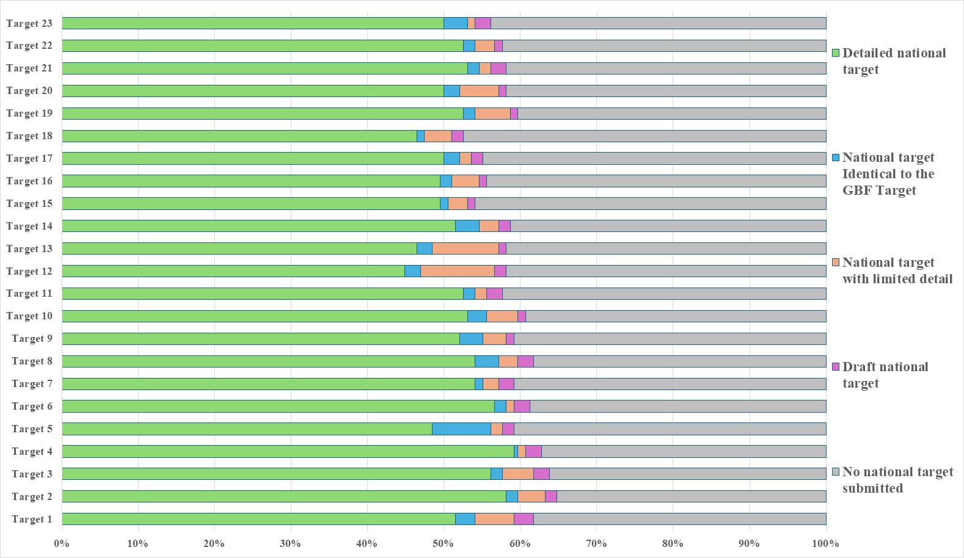Figure 7 – National target submissions as of 31 May 2025. The coloured bars indicate the proportion of Parties with national targets in each category. The 196 Parties to the Convention on Biological Diversity are represented in the graph.
- Based on the national target submissions the following observations can be drawn:
  - Links between national targets and the goals of the Kunming-Montreal Global Biodiversity Framework – In their national target submissions Parties are requested to identify which goal or goals of the Kunming-Montreal Global Biodiversity Framework their national targets contribute to. Around half of the national targets have been identified as contributing to Goals A and B. In particular national targets related to targets 1 to 12 of the Kunming-Montreal Global Biodiversity Framework were most commonly associated with Goals A and B. By comparison fewer national targets have been linked to Goals C and D. National targets related to targets 13 and 17 of the Framework were commonly linked to Goal C and national targets related to targets 15, 18, 19 and 23 were commonly linked to Goal D;
  - Links between national targets and the targets of the Kunming-Montreal Global Biodiversity Framework – In their national target submissions Parties must link their national targets to at least one target of the Framework. However, most Parties have linked individual national targets to multiple targets of the Framework. National targets linked to targets 1 to 12 of the Framework were often associated with several Framework targets in that range. For example, national targets related to Framework targets 1, 2 or 3 were often linked to others within that group. National targets related to target 3 of the Framework were also commonly linked to targets 5, 6, 8, 9, 10, 11, 12 and 21 of the Framework. National targets related to target 5 of the Framework were also commonly linked to targets 9 and 10 of the Framework, and national targets related to target 9 of the Framework were also commonly linked to targets 4, 5, and 10 of the Framework. By comparison national targets related to targets 15, 16, 17, 18, 19 and 21 have fewer connections to other targets in the Framework;
  - Degree of alignment - In their national target submissions Parties are invited to provide an assessment of how aligned their national target is with the associated target of the Kunming-Montreal Global Biodiversity Framework. Around half of the national targets submitted were reported as having a high degree of alignment with their associated target of the Kunming-Monreal Global Biodiversity Framework. Around a third were reported as having moderate alignment and around a tenth were reported as having low alignment. For some national targets no degree of alignment was provided;
  - Scope of the national targets in comparison to the targets of the Kunming-Montreal Global Biodiversity Framework – For each target of the Kunming-Montreal Global Biodiversity Framework, of the Parties that have submitted associated national targets, few Parties (on average 11%) have set national targets which fully address all of the target elements. Less than a quarter of Parties (on average 20%) have set national targets which fully address at least half but not all of the target elements. About a quarter (on average 26%) of Parties have set national targets which fully address at least one but less than half of the target elements. On average, for any given target in the Kunming-Montreal Global Biodiversity Framework, about 43% of Parties have set national targets which do not fully address any element. In general, the national targets set by Parties more closely address GBF Targets 3, 4, 6, 8, 10, and 21 of the Framework. By comparison national targets address GBF Targets14, 16, 19 and 19 to a lesser extent (see figure 8).

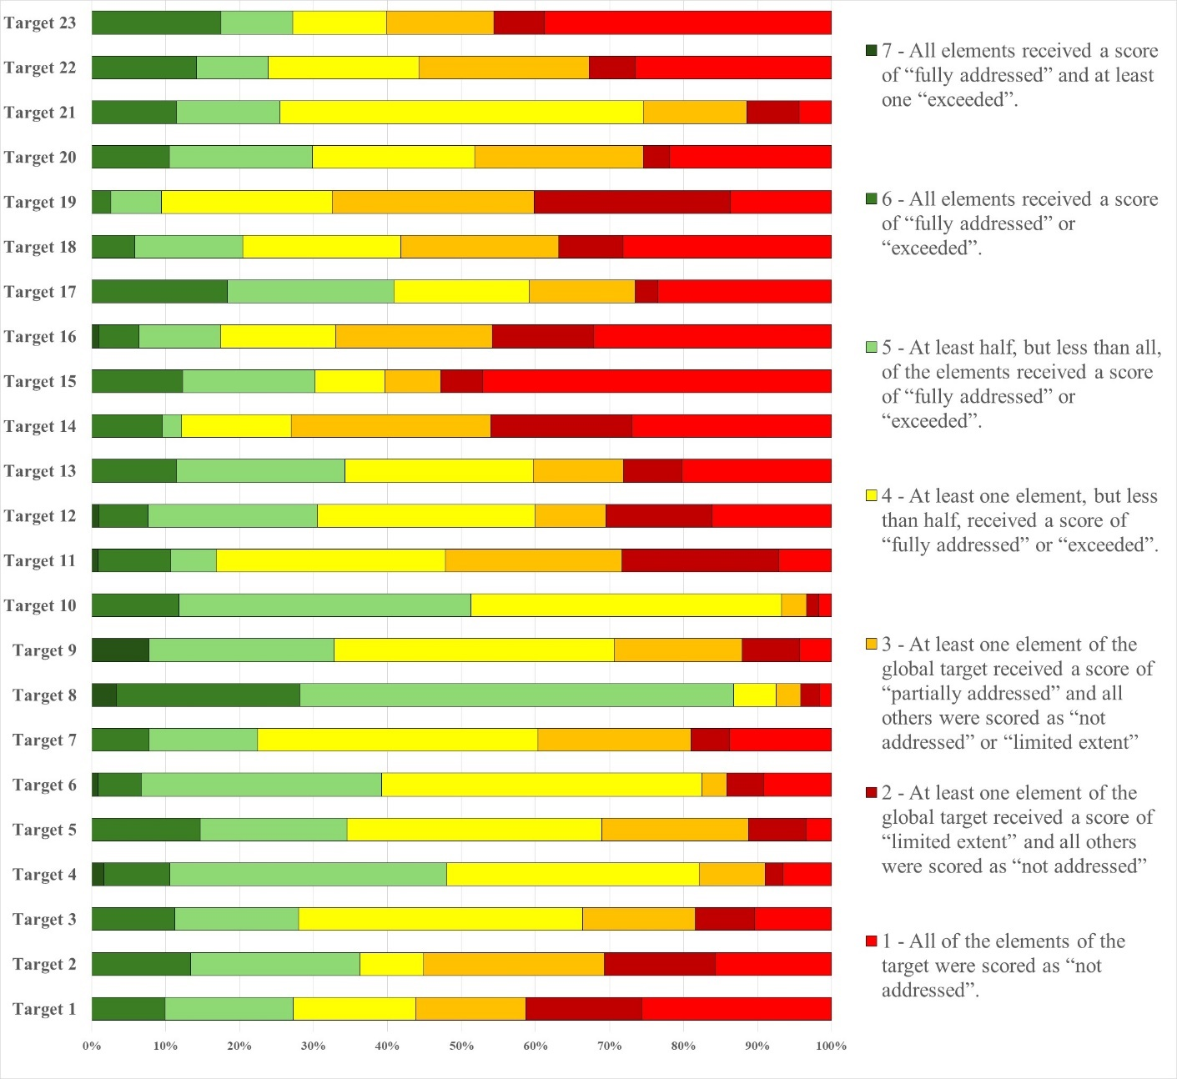Figure 8 – Assessment of the scope of the national targets set by Parties against the scope of the targets in the Kunming-Montreal Global Biodiversity Framework. The coloured bars indicate the proportion of Parties that have set national targets which correspond to each category. The number of Parties represented in each bar varies with the number of Parties that have submitted national targets related to a given target of the Kunming-Montreal Global Biodiversity Framework.
  - Links to section C of the Kunming-Montreal Global Biodiversity Framework – Section C of the Framework contains a set of considerations for its implementation. In their national target submissions, some Parties have identified which of these considerations have been considered. More than two thirds of national targets contain this information. The most commonly mentioned considerations were collective effort towards the targets, and whole-of-government and whole-of-society approach. By comparison few national targets mentioned different value systems, right to development or principles of the Rio Declaration;
  - Indicators – Headline and binary indicators are automatically linked to national targets based on which target of the Kunming-Montreal Global Biodiversity Framework the national target has been mapped to. The use of component, complementary and national indicators is optional. Less than a fifth of national target submissions identified component or complementary indicators. About half of Parties have identified national indicators for some of their national targets;
  - Means of implementation – More than a third of national target submissions provide information on the associated means of implementation for the target. Of the national targets with this information almost three quarters indicate that additional means of implementation are required to meet the target. For most national targets, Parties expressed the required means of implementation generally. Commonly mentioned required means of implementation were financial resources, human resources, capacity building, awareness raising, technology transfer and capacity building, and scientific research and collaboration. However, for some national targets more specific needs were identified. Examples include the development of baseline data, mapping, monitoring, regulatory frameworks, community engagement, improvements in infrastructure, public-private partnerships, infrastructure improvement;
  - Commitments from actors other than national governments - Less than one fifth of the target submissions provide information on commitments of actors other than national governments. However, many of the target submissions indicate that the involvement of actors other than national governments has not yet begun or that they need to be engaged. Most indicate the ways in which these actors can be involved generally in the implementation of the target but do not indicate specific ongoing actions or commitments. Some also refer to general ongoing activities but which are not necessarily linked to specific commitments or targets of the Kunming-Montreal Global Biodiversity Framework. Actors commonly noted in the target submissions include indigenous people and local communities, nongovernmental organisations, the private sector, youth groups, and academic institutions.

IX. Analysis of national targets
Target 1: plan and manage all areas to reduce biodiversity loss
- 121 Parties have submitted 393 national targets related to Target 1. On average a Party has submitted 3 national targets related to Target 1 but the number ranges from 1 to 27.
- Of the national targets mapped by Parties to GBF Target 1, most (68%) were also identified as contributing to Goal A, and almost half (49%) were identified as contributing to Goal B. Few were identified as contributing to Goals C (15%) and D (12%). Almost half of the national targets were also linked to GBF Target 3 (48%) while some were linked to GBF Targets 2 (40%) and 4 (35%)
- Almost a half of the national targets (47%) submitted by Parties were reported as having high alignment to GBF Target 1, almost a third (32%) were reported as having medium alignment to the target and more than a tenth (14%) as having low alignment. For 7% of the national targets Parties did not indicate a degree of alignment.
- Few (10%) Parties have set national targets which fully address all elements of Target 1 and approximately an additional fifth (17%) have set targets which fully address half of the target elements. About a fifth (17%) of Parties have set national targets which fully address one but less than half of the target elements. More than half of Parties (56%) have set national targets which do not fully address any element of Target 1. More than a tenth (15%) have set national targets which partially address all or some of the elements. Less than a half of Parties have set national targets which address the elements of Target 1 to a limited extent (16%) or not at all (26%).
- In the national targets submitted, there was a greater focus on the elements of Target 1 related to biodiversity inclusive spatial planning with about a third (34%) of national targets fully addressing this issue. Around a quarter of national targets fully address the elements related to making planning process participatory (28%), integrated (27%), bringing the loss of important areas close to zero (21%) and respecting the rights of indigenous peoples and local communities (26%). About a fifth (20%) of Parties have set targets which fully address having all areas under spatial planning or other management processes (see figure 9). Some Parties have set targets which refer to putting in place spatial planning or other management processes for specific areas, for example protected areas or areas of high biodiversity importance, areas under agriculture, forestry and fisheries, urban areas, and areas of environmental importance. Some Parties have also set targets indicating the percentage of areas that will be under spatial planning or management by 2030. These range from 30% to 100%. Further some have targets with different percentages for different ecosystem types. Many of the targets set refer to management approaches such as sustainable use plans, restoration plans, plans for the control of invasive alien species and development plans, but which do not address the use and planning of terrestrial, inland water and marine areas. Further some target submissions refer to existing land use and management processes and indicate that biodiversity will be reflected in these.
- Less than half (42%) of the national target submissions contain information on the associated means of implementation. For targets with this information, most (76%) indicate that additional means of implementation are needed. A fifth (20%) indicate that the means of implementation are available. The most mentioned type of means of implementation was funding from external and internal sources, including national biodiversity funds, multilevel financial partnerships and innovative mechanisms such as payments for ecosystem services. Additional types of means of implementation commonly mentioned were human resources, capacity building, scientific research and collaboration, technical and technological support and improvements, synergies with planning processes, awareness raising, technology transfer, access to information, the establishment of necessary web portals, geographic information systems and monitoring systems, clarifying the roles and responsibilities of different national organizations and departments, resolving questions concerning legislation and regulatory frameworks, and means of engaging with stakeholders.
- Few (16%) target submissions provide information on the involvement of non-state actors. Of the ones that do, some indicate that the involvement of non-state actors has not yet begun or that they need to be engaged. Most indicate the ways in which non-state actors can be involved generally in the implementation of the target but do not indicate specific ongoing actions or commitments which have been taken by non-state actors. Some also refer to general ongoing activities, such as awareness raising, but which are not necessarily linked to specific commitments.
- Less a quarter of national target submissions identified component indicators (22%) and complimentary indicators (21%). More than a third (35%) of national targets identified national indicators. Examples of elements measured by these national indicators include the effectiveness and equitability of management plans, the number of spatial plans, the number of areas of high importance for biodiversity identified or integrated into spatial plans. Many national indicators for Target 1 were also disaggregated by biome.
- Almost two thirds (61%) of national target submissions contain information on which elements of section C of the Kunming-Montreal Global Biodiversity Framework the national target helps to address. The most commonly addressed elements were collective effort towards the target (69%), the ecosystem approach (70%), national circumstances and priorities and capabilities (66%) and whole-of-government and whole-of-society approach (67%). Comparatively few targets addressed different value systems (25%), the right to development (28%) or intergenerational equity (30%)
- More than half (54%) of national target submissions contained information on associated policy measures. Commonly reported measures include:
  - Strengthening biodiversity inclusive spatial planning, for example by updating and developing supporting legislation, policies and frameworks, updating master planning and statutory planning processes at all scales, zoning maps, management plans, guidelines and assessment frameworks;
  - Developing or strengthening specific strategies, plans, tools and techniques for restoration, connectivity and resilience, including protected area management plans, blue-green infrastructure and local nature recovery strategies;
  - Strengthening of knowledge and data, including the development of central biodiversity spatial databases, registries and indexes;
  - Deepening engagement with and awareness of stakeholders and citizens through the development of guidelines and plans for environmental education;
  - Increasing partnerships and local community engagement in development and implementation of strategies and plans;
  - Institutional strengthening and capacity-building.
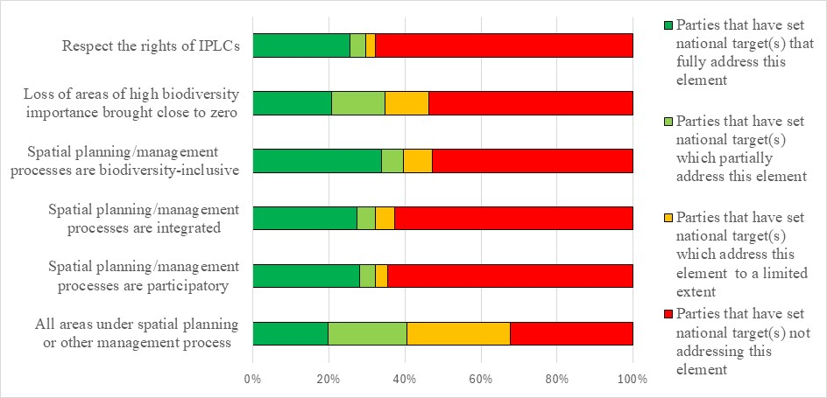Figure 9 – Assessment of the degree to which Parties have addressed the elements of GBF Target 1 in their national target(s). The coloured bars indicate the proportion of Parties that have set national targets which correspond to each assessment category. The number of Parties represented in each bar varies with the number of Parties that have submitted national targets related to a given target of the Kunming-Montreal Global Biodiversity Framework.
Target 2: restore 30 per cent of all degraded ecosystems
- 125 Parties have submitted 371 national targets related to Target 2. On average a Party has submitted 3 national targets related to Target 2 but the number ranges from 1 to 21. Of the national targets mapped by Parties to GBF Target 2, most (85%) were also identified as contributing to Goal A, and more than half (57%) were identified as contributing to Goal B. Few were identified as contributing to Goal C (16%) and D (11%). Almost half of the national targets were also linked to GBF Targets 1 (42%) and 3 (45%). More than a third (36%) were also linked to GBF Target 4.
- Half of the national target (50%) submitted by Parties were reported as having high alignment to GBF Target 2, about a quarter (27%) were reported as having medium alignment to the target and a few (10%) were reported as having low alignment. For 13% of the national targets Parties did not indicate a degree of alignment.
- . Few (13%) Parties have set national targets which fully address all elements of Target 2 and approximately an additional quarter (23%) have set targets which fully address half of the target elements. About a tenth (9%) of Parties have set national targets which fully address one but less than half of the target elements. More than half of Parties (55%) have set national targets which do not fully address any element of Target 2. About a quarter of Parties (24%) have set national targets which partially address all or some of the elements. More than a third of Parties have set national targets which address the elements of Target 2 to a limited extent (15%) or not at all (16%).
- In the national targets submitted, most Parties have addressed elements related to the restoration of terrestrial areas (83%) and inland waters (70%). For non-landlocked countries most (75%) refer to the restoration of degraded marine and coastal areas:
  - Restoration of terrestrial areas: Almost two-thirds (63%) of Parties have set targets which included quantitative elements for the restoration of terrestrial areas. Almost half of these (49%) aim to restore 30% of terrestrial areas and the remainder set restoration values of between 5% and 80% or set targets with specific amounts of hectares to be restored. In addition, some place emphasis on specific terrestrial ecosystem types such as grasslands and meadows, peatlands, areas under agriculture and forestry, areas used for grazing, rangelands, key biodiversity areas, water basins, and priority areas;
  - Restoration of inland waters: More than half of Parties (55%) have set targets with quantitative elements for the restoration of inland waters. Of these more than half (53%) have targets which call for the restoration of 30% of degraded inland waters. The remainder have restoration targets of between 5% and 25% or have specific quantitative targets expressed in kilometres or hectares. Some targets identified specific types of inland water areas that would be restored including wetlands, rivers, ecosystems underrepresented in protected areas, water towers and estuaries;
  - Restoration of marine and coastal areas: Of non-landlocked countries more than half (51%) have set targets with quantitative elements for the restoration of marine and coastal areas. More than half (59%) of these Parties have set targets which aim to restore 30% of degraded marine and coastal areas. The remainder have set restoration targets of between 5% and 80% or have set targets with specific quantitative values in square kilometres or hectares. Some targets identified specific types of marine and coastal areas that would be restored, including mangroves, areas underrepresented in protected areas and priority areas.
- Comparatively few national targets address the other elements of Target 2. About two thirds of Parties have set targets which do not address the enhancement of biodiversity (61%) or ecosystem services (58%) through restoration or using restoration to enhance the integrity of ecosystems (60%) (see figure 10).
- Less than half (41%) of the national target submissions contain information on the associated means of implementation. For targets with this information, most (79%) indicate that additional means of implementation are needed. Almost a fifth (16%) indicate that the means of implementation are available. Of the Parties indicating that additional means of implementation are required, most mentioned the need for financial resources. Parties also noted the need for the development of baseline data, mapping, ongoing monitoring, development and implementation of plans, and the establishment of research institute, data and information repositories. The need for capacity building, including increasing training to build expertise within country, human resources to mobilise stakeholders, institutional strengthening to overcome capacity gaps in, for example, rural and marine and coastal areas, developing and updating guidelines, protocols and best practice for effective restoration were noted. Some Parties also noted the need for technical and technological support and improvements including expertise, tools and technologies for surveying and monitoring, restoration and knowledge management including for geographic information systems, artificial intelligence, drones and equipment for nurseries. Other means of implementation mentioned included stakeholder and citizen participation collaboration and coordination and strengthening legal frameworks and harmonising planning instruments across sectors and levels of government.
- Few (13%) target submissions provide information on the involvement of non-state actors. Of the ones that do, some indicate that the involvement of non-state actors has not yet begun or that they need to be engaged. Most indicate the ways in which non-state actors can be involved generally in the implementation of the target but do not indicate specific ongoing actions or commitments which have been taken by non-state actors. Examples of the types of contributions noted include technology transfer, capacity building, providing data and information, undertaking studies, and providing funding. Few national targets identify specific actors with ongoing activities or commitments. Those that do often refer to specific projects or actions which are being taken on an ad hoc basis which, while relevant to the target, are not specifically linked to the attainment of the national target. Others refer to cross cutting actions which are being taken which are relevant to the implementation of the Convention and the Kunming-Montreal Global Biodiversity Framework at the national level generally.
- More than a quarter of national target submissions identified component indicators (26%) and complimentary indicators (23%). Approximately one third (34%) of national targets mapped to GBF Target 2 contained national indicators. Most of the national indicators for Target 2 measure the degraded area or the area under restoration in specific biomes or with relevance to specific species.
- About two thirds (63%) of national target submissions contain information on which elements of section C of the Kunming-Montreal Global Biodiversity Framework the national target helps to address. The most addressed elements were the ecosystem approach (76%), collective efforts toward the target (72%), and whole-of-government and whole-of-society approach (71%). Comparatively few targets addressed different value systems (28%), the right to development (32%) or intergenerational equity (33%)
- More than half (57%) of national targets have associated policy measures. Commonly reported measures were establishing and strengthening plans, programmes, policies and supporting legal frameworks for ecosystem recovery and rehabilitation. Measures to build capacity for development and implementation of these through, for example, technical assistance and institutional strengthening, strengthening data collection and knowledge generation including systems to identify, categorise, prioritise, inventory, map and regularly update information on degraded areas and components of ecosystem health such as soil health, were also noted. Strengthening guidance, standards, compliance checks, controls, accountability and transparency, including through environment impact assessment standards, bonds, independent auditors and public access to information, were also identified in some target submissions.
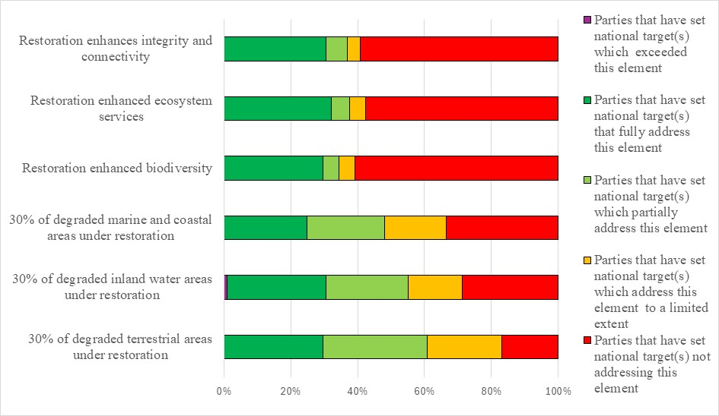Figure 10 – Assessment of the degree to which Parties have addressed the elements of GBF Target 2 in their national target(s). The coloured bars indicate the proportion of Parties that have set national targets which correspond to each assessment category. The number of Parties represented in each bar varies with the number of Parties that have submitted national targets related to a given target of the Kunming-Montreal Global Biodiversity Framework.
Target 3: conserve 30 per cent of land, waters and seas
- 125 Parties have submitted 393 national targets related to Targe 3. On average a Party has submitted 3 national targets related to Target 3 but the number ranges from 1 to 22. Almost all national targets (91%) were identified as contributing to Goal A, and more than half (58%) were identified as contributing to Goal B. Few were identified as contributing to Goal C (18%) and D (13%). Most of the national targets were also linked to GBF Target 2 (88%) and 4 (80%). About two-thirds (67%) were linked to Target 10.
- More than a half of the national target (53%) submitted by Parties were reported as having high alignment to GBF Target 3, a quarter (25%) were reported as having medium alignment to the target and a few (13%) as having low alignment. For 9% of the national targets Parties did not indicate a degree of alignment.
- Few (11%) Parties have set national targets which fully address all elements of Target 3 and approximately an additional fifth (17%) have set targets which fully address half of the target elements. More than a third (38%) of Parties have set national targets which fully address one but less than half of the target elements. More than a third of Parties (34%) have set national targets which do not fully address any element of Target 3. Less than a fifth of Parties (15%) have set national targets which partially address all or some of the elements. About a fifth of Parties have set national targets which address the elements of Target 3 to a limited extent (8%) or not at all (10%).
- Most Parties (83%) have set targets addressing the protection of terrestrial areas to some extent. Of these most (85%) have national targets with quantitative elements related to the protection of terrestrial areas of which more than two-thirds (67%) have set targets aiming to have 30% or more of terrestrial areas protected by 2030. The remainder have set targets aiming to conserve between 1.2% and 28% or have set targets aiming to protect a set number of hectares.
- Less than three-quarters (70%) of Parties have set targets addressing the protection of inland water ecosystems to some extent. Of these most (83%) have set targets with quantitative elements of which about two thirds (67%) have set targets which aim to protect 30% or more of their inland water ecosystems. The remainder aim to protect between 1.2% and 28% or aim to protect a set number of hectares.
- Of the non-landlocked Parties submitting targets related to Target 3, most (82%) have set targets addressing the protection of marine and coastal areas to some extent. Of these most (84%) have set targets with quantitative elements of which about two thirds (63%) aim to protect 30% or more of their marine and coastal areas. The remainder aim to protect between 4% and 20% of marine and coastal areas.
- The qualitative elements of GBF Target 3 are addressed to a lesser extent in the national targets set by Parties. Almost three quarters of Parties (71%) do not address sustainable use within protected areas. However, this could be because some Parties do not allow any form of use or limit the types of use within their protected areas estates. Around two-thirds of Parties do not have targets addressing the equitable governance of protected areas (60%), the integration of protected areas into the land and seascape (66%) or the rights of indigenous peoples and local communities in relation to protected areas (62%). More than half of Parties do not have targets addressing the connectedness of protected areas (51%), the protection of particularly important areas (52%) or the representativeness of protected areas (55%). However, about half of Parties have set national targets fully (42%) or partially (11%) addressing management effectiveness (see figure 11)
- Less than half (44%) of the national target submissions contain information on the associated means of implementation. For targets with this information, most (78%) indicate that additional means of implementation are needed. Almost a fifth (29%) indicate that the means of implementation are available. A bout half of parties identified the need for financial resources and nearly half identified capacity building needs, including human resources, institutional, regulatory and logistical. Several parties specifically identified a need for the coordination of actions across stakeholders and the need for technical and scientific cooperation, access and transfer of technologies, especially for mapping, planning, data collection, monitoring and reporting needs. The need for awareness raising was also identified in some submissions as was the need to reduce the impact of armed groups and means to protect the lives of environmental defenders.
- Few (15%) target submissions provide information on the involvement of non-state actors. Of those that do, some indicate that the involvement of non-state actors has not yet begun or that they need to be engaged. Most indicate the ways in which non-state actors can be involved generally in the implementation of the target but do not indicate specific ongoing actions or commitments which have been taken by non-state actors. Examples of the types of contributions noted include technology transfer, capacity building, providing data and information, undertaking studies, and providing funding. Few national targets identify specific actors with ongoing activities or commitments. Those that do often refer to specific projects or actions which are being taken on an ad hoc basis which, while relevant to the target, are not specifically linked to the attainment of the national target. Others refer to cross cutting actions which are being taken which are relevant to the implementation of the Convention and the Kunming-Montreal Global Biodiversity Framework at the national level generally.
- About than a quarter of national target submissions identified component indicators (26%) and complimentary indicators (22%). More than one third (37%) of national targets submissions identified national indicators. Examples of elements measured by these national indicators include the number of ecological corridors, the degree of ecological connectivity of protected areas, the degree of ecological integrity of protected areas, and the area or number of biodiversity heritage sites. While many national indicators for Target 3 were disaggregated by biome, others were also disaggregated by importance for biodiversity, indigenous and traditional territories, and management effectiveness.
- Almost two thirds (65%) of national target submissions contain information on which elements of section C of the Kunming-Montreal Global Biodiversity Framework the national target helps to address. The most commonly addressed elements were ecosystem approach (75%), whole-of-government and whole-of-society approach (68%), national circumstances and priorities and capabilities (63%) and collective effort towards the targets (64%). About half (52%) of targets submissions are identified as addressing the contribution and rights of indigenous peoples and local communities. Comparatively few target submissions addressed different value systems (31%), the right to development (30%) or intergenerational equity (34%).
- More than half (56%) of national targets have associated policy measures. Common policy measures identified in the submissions include spatial planning, the legal designation of new protected areas, OECMs and ecological networks, plans to enhance effectiveness, the development of new management plans, enhancing stakeholder engagement and indigenous rights, enhancing sustainable practices and increasing supportive institutional arrangements. Some Parties also identified more general measures that address threats to the environment including climate change, plastic pollution and invasive species.
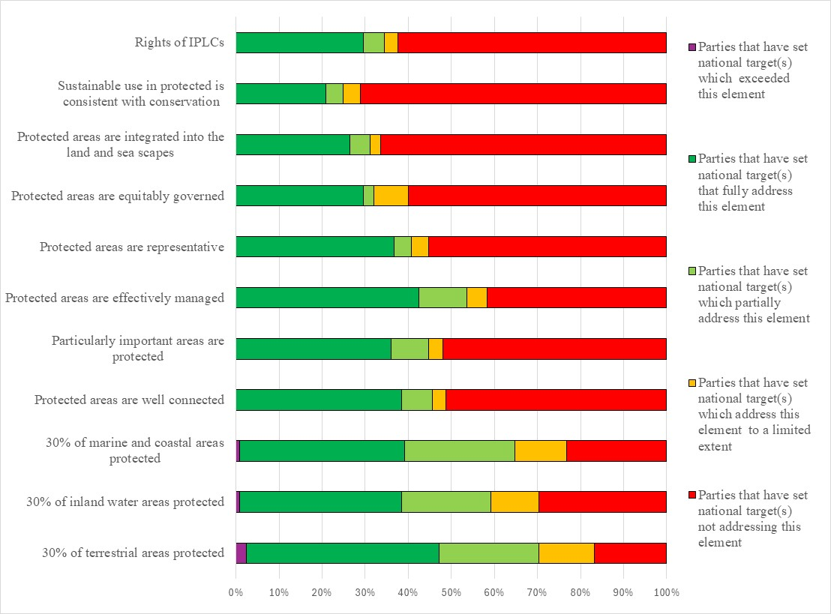Figure 11 – Assessment of the degree to which Parties have addressed the elements of GBF Target 3 in their national target(s). The coloured bars indicate the proportion of Parties that have set national targets which correspond to each assessment category. The number of Parties represented in each bar varies with the number of Parties that have submitted national targets related to a given target of the Kunming-Montreal Global Biodiversity Framework.
Target 4: halt species extinction, protect genetic diversity and manage human-wildlife conflicts
- 123 Parties have submitted 458 national targets related to Target 4. On average a Party has submitted 3 national targets related to Target 4 but the number ranges from 1 to 37. Most (89%) national targets mapped to GBF Target 4 were also identified as contributing to Goal A, and about half (52%) were identified as contributing to Goal B. Few were identified as contributing to Goal C (20%) and D (10%). National targets were also commonly linked to GBF Targets 1 (30%), 2 (29%), 3 (33%), 5 (31%), 9 (31%), 10 (33%), and 11 (30%).
- Less than a half of the national targets (45%) submitted by Parties were reported as having high alignment to GBF Target 4, a third (35%) were reported as having medium alignment to the target and a few (13%) as having low alignment. For 7% of the national targets Parties did not indicate a degree of alignment.
- Few (11%) Parties have set national targets which fully address all elements of Target 4 and approximately an additional third (37%) have set targets which fully address half of the target elements. More than a third (34%) of Parties have set national targets which fully address one but less than half of the target elements. Less than a fifth of Parties (18%) have set national targets which do not fully address any element of Target 4.Less than a tenth of Parties (9%) have set national targets which partially address all or some of the elements. Few Parties have set national targets which address the elements of Target 4 to a limited extent (2%) or not at all (7%).
- More than two-thirds of Parties have set targets which fully address (67%) or exceed (2%) ensuring urgent management actions are taken. Around half have set targets fully addressing the recovery and conservation of threatened species (51%) and managing human wildlife conflict (48%). The other elements of the target have been addressed to a lesser extent. Almost half of Parties have set targets which do not address halting human-induced extinction of known threatened species (42%) or address this element to a limited extent (8%). Similarly, almost half of Parties have set targets which do not address maintaining and restoring the genetic diversity of wild species (33%) or address this issue to a limited extent (14%). More than half of Parties have set targets which do not address maintaining and restoring genetic diversity of domestic species (46%) or address this issue to a limited extent (5%) (see figure 12).
- Less than half (41%) of the national target submissions contain information on the associated means of implementation. For targets with this information, most (76%) indicate that additional means of implementation are needed and about a fifth (19%) indicate that the means of implementation are available. Example of the types of required means of implementation identified in the target submissions were financial resources, including to establish funds to support landowners in biodiversity protection, to put in place institutional and legal frameworks to promote sustainable land management and genetic resource conservation, and to establish capacity-building programs to address institutional gaps and enhance biodiversity-related skills. The need for community engagement initiatives, including public-private partnerships and ensuring synergy among stakeholders, including through training, financial incentives, and sustainable development opportunities were also noted. Advancing biodiversity research and monitoring infrastructure, including laboratories for digital sequencing and genetic analysis, and the development of artificial intelligence tools for species identification and ecosystem monitoring were also noted.
- Few (14%) target submissions provide information on the involvement of non-state actors. Of the ones that do, some indicate that the involvement of non-state actors has not yet begun or that they need to be engaged. Most indicate the ways in which non-state actors can be involved generally in the implementation of the target but do not indicate specific ongoing actions or commitments which have been taken by non-state actors. Examples of the types of contributions noted include actions related to research, species recovery, rehabilitation and conservation, the monitoring of threatened species, awareness raising and capacity building. Few national targets identify specific actors with ongoing activities or commitments.
- About a quarter of national target submissions identified component indicators (28%) and complementary indicators (25%). More than one third (40%) of national targets mapped to GBF Target 4 contained supplementary national indicators. Examples of elements measured by these national indicators include the number of cases of human-wildlife conflict, the number of conservation or management initiatives, and the number of genetic resources in seed banks and gene banks. While many national indicators were disaggregated by biome, some were also disaggregated by whether initiatives were in-situ or ex-situ and if the targeted species were native or non-native.
- More than half (60%) of national target submissions contain information on which elements of section C of the Kunming-Montreal Global Biodiversity Framework the national target helps to address. The most commonly addressed elements were collective effort towards the targets (68%), national circumstances of priorities (63%), whole-of-government and whole-of-society approach (61%), and ecosystem approach (70%). Comparatively few target submissions addressed different value systems (25%), the right to development (23%), gender (32%) or intergenerational equity (31%).
- More than half (59%) of national targets have associated policy measures. The measures identified tended to focus on biodiversity conservation, sustainable resource use, and the strengthening of legal and administrative frameworks. Measures to manage threatened and invasive species were also noted as were actions for habitat and species protection, including initiatives to document genetic resources, gene conservation, and protecting migratory corridors. Community engagement and stakeholder partnerships were also noted as were education initiatives.
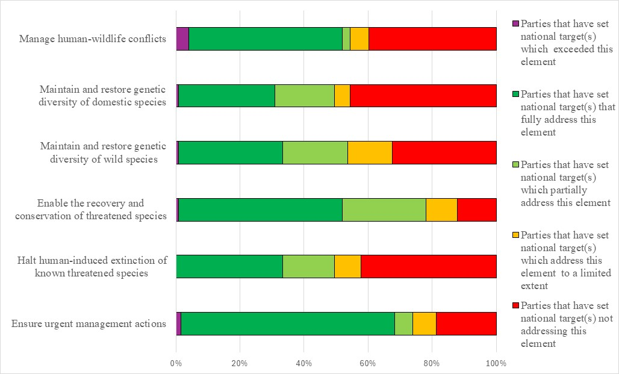
Figure 12 – Assessment of the degree to which Parties have addressed the elements of GBF Target 4 in their national target(s). The coloured bars indicate the proportion of Parties that have set national targets which correspond to each assessment category. The number of Parties represented in each bar varies with the number of Parties that have submitted national targets related to a given target of the Kunming-Montreal Global Biodiversity Framework.
Target 5: ensure sustainable, safe and legal harvesting and trade of wild species
- 116 Parties have submitted 322 national targets related to Target 5. On average, a Party has submitted 4 national targets related to Target 5, but the number ranges from 1 to 12. Of the national targets mapped by Parties to GBF Target 5, more than two thirds were also identified as contributing to Goal A (67%), and Goal B (68%). About a quarter (27%) were identified as contributing to Goal C and few (14%) were identified as contributing to Goal D. Nearly half of the national targets submitted by Parties linked to GBF Target 5 were also identified as being relevant to Target 9 (49%), 4 (43%) and 10 (42%).
- Half of the national targets (50%) submitted by Parties were reported as having high alignment to GBF Target 5, less than a third (29%) were reported as having medium alignment and less than a fifth (14%) as having low alignment to the target. For 7% of the national targets, Parties did not indicate a degree of alignment.
- Few (15%) Parties have set national targets which fully address all elements of Target 5 and approximately an additional fifth (20%) have set targets which fully address half of the target elements. More than a third (34%) of Parties have set national targets which fully address one but less than half of the target elements. Around a third of Parties (31%) have set national targets which do not fully address any element of Target 5. Just over a fifth of Parties (20%) have set national targets which partially address some GBF elements but do not address others or address them to a limited extent. Just under a tenth (8%) have set targets that address some or all of the GBF elements to a limited extent. Few Parties (3%) have set national targets do not address any elements of GBF Target 5.
- Over half (56%) of Parties have national targets which fully address the element of GBF Target 5 on ensuring that the use and harvesting of wild species is sustainable, preventing overexploitation, minimizing impacts on non-target species and ecosystems. Almost half of Parties (48%) have national targets which fully address ensuring that the use, harvesting and trade of wild species is legal. Under half of Parties (40%) have national targets which fully address ensuring that the trade in wild species is sustainable, preventing overexploitation, minimizing impacts on non-target species and ecosystems. Around a third of Parties have national targets which fully address ensuring that the use, harvesting and trade of wild species is safe, reducing the risk of pathogen spillover (35%) applying the ecosystem approach in addressing sustainable, safe and legal use, harvesting and trade of wild species (31%) and respecting and protecting customary sustainable use by indigenous peoples and local communities in addressing sustainable, safe and legal use, harvesting and trade of wild species (33%) (see figure 13).
- Nearly half (44%) of the national target submissions contain information on the associated means of implementation. Of these, the majority of submissions (76%) indicate that means of implementation will be required, while a fifth (18%) indicate that means of implementation are available. Over half of national targets that included information on means of implementation required mobilization of financial resources and funding. Less than half identified the need for capacity building, primarily related to training, human resources, and institutional capacity. Other means of implementation mentioned included technical and scientific knowledge and support, awareness raising, coordination and synergies of action between stakeholders, and transfer of technology and equipment. Specific examples include training and equipment for surveillance, checkpoints for monitoring trade, technical assistance in establishing traceability mechanisms, laboratories to diagnose zoonotic events, tools to document traditional knowledge, and the creation of platforms for citizen participation.
- Nearly a fifth (15%) of target submissions provide information on the involvement of actors other than national governments. Of those that submitted information, the most commonly mentioned groups were civil society organizations, mainly non-governmental organisations and indigenous peoples and local communities followed by private sector, academia, youth and citizen participation. Some submissions identified the types of support needed or provided to enable these actors’ contributions, for example, training, capacity building, development of funding opportunities, partnership programmes such as co-management of protected areas, and education and awareness raising programmes. Few outlined details of planned contributions in their target submissions. Of those that did, the types of contributions included contributions of indigenous peoples and local communities to monitoring and data collection, design and implementation of management plans, and development of public-private sector partnerships.
- A quarter (25%) of national target submissions identified component and complementary indicators. More than one third (39%) of national targets mapped to GBF Target 5 contained supplementary national indicators. Examples of elements measured by these national indicators include the proportion of traded wildlife which was illegally poached or trafficked and the number of species harvested and traded sustainably. While national indicators primarily focused on aquatic species, other indicators were also comprehensive of all species, both terrestrial and aquatic.
- Almost two thirds (61%) of national target submissions contain information on which elements of section C of the Kunming-Montreal Global Biodiversity Framework are addressed by the national target. Of these, almost three quarters identified collective efforts towards the targets (72%), and a whole-of-government and whole-of-society approach (71%) and ecosystem approach (70%).
- Around a half (52%) of national target submissions contained information on associated policy measures. Commonly reported measures include measures to increase sustainable forestry, wildlife, fisheries and game management practices such as promotion of continuous cover forestry and soil-conserving harvesting methods, strengthening hunting and fishing regulations, quotas and monitoring to ensure ecologically sustainable levels are achieved, minimizing impacts to non-target species through technological advancements such as development of whale safe gear for fisheries, provision of training on sustainable extraction practices, certification of forestry and fishing products and support to obtain these. Other commonly reported measures included support for participation of local communities and inclusion of traditional knowledge in nature resource management and decision-making, including development of and capacity building for co-management programmes and indigenous-led conservation and monitoring initiatives such as indigenous guardians programs. Other reported measures included strengthening national legislation, enforcement and international cooperation related to trade including strengthening law enforcement to combat organised crime related to wildlife trafficking, implementation of CITES and initiatives such as Forest Law Enforcement Governance and Trade (FLEGT) Action Plan as well as enhanced cooperation between indigenous people and local communities and enforcement agencies. Mechanisms to monitor, preserve and support genetic diversity, including breeding and (re)colonisation of native species in areas where populations have collapsed.
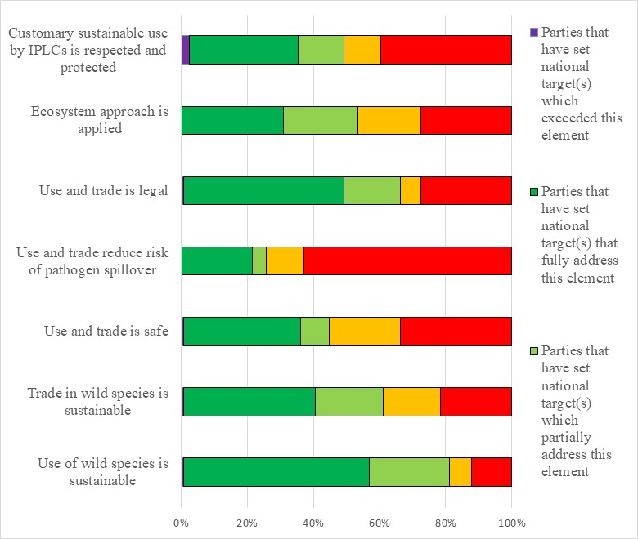Figure 13 – Assessment of the degree to which Parties have addressed the elements of GBF Target 5 in their national target(s). The coloured bars indicate the proportion of Parties that have set national targets which correspond to each assessment category. The number of Parties represented in each bar varies with the number of Parties that have submitted national targets related to a given target of the Kunming-Montreal Global Biodiversity Framework.
Target 6: reduce the introduction of invasive alien species by 50 per cent and minimize their impact
- 120 Parties have submitted 234 national targets related to Target 6. On average a Party has submitted 2 national targets related to Target 6 but the number ranges from 1 to 16. Most national targets (85%) were also identified as contributing to Goal A. Half (50%) were identified as contributing to Goal B. Few national targets were identified as contributing to Goal C (16%) and Goal D (12%). Less than half of the national targets were also linked to GBF Target 4 (44%) while just over one third of the national targets were linked to GBF targets 1 (35%), 3 (36%), and 5 (35%).
- Almost half of the national targets (47%) submitted by Parties were reported as having high alignment to GBF Target 6, almost a third (30%) were reported as having medium alignment to the Target and more than a tenth (12%) as having low alignment. For 11% of the national targets Parties did not indicate a degree of alignment.
- Few (7%) Parties have set national targets which fully address all elements of Target 6 and approximately an additional third (33%) have set targets which fully address half of the target elements. Less than half (43%) of Parties have set national targets which fully address one but less than half of the target elements. Around a fifth of Parties (18%) have set national targets which do not fully address any element of Target 6. Approximately 3% of Parties have set national targets which partially address all or some of the elements. Several Parties reported national targets which address the elements of Target 6 to a limited extent (5%) or not at all (9%).
- In the national targets submitted, there was a greater focus on the elements of Target 6 related to the eradication and control of already established invasive alien species as opposed to the identification and management of IAS pathways and prevention of IAS introductions. Over half of Parties (63%) had national targets which addressed the eradication or control of invasive alien species. Less than half of Parties (48%) had national targets which addressed eliminating, minimizing, reducing and/or mitigating the impact of invasive alien species on species and ecosystem services. Approximately one quarter of Parties fully addressed the prevention of the introduction of priority invasive alien species (24%) and a similar percentage addressed reducing the rate of introduction and establishment of non-priority species by at least 50% by 2030 (28%). Less than half of Parties (41%) included a quantitative element in their national targets to reduce the rate of introduction of invasive alien species. Of these about three quarters (76%)) aimed for a 50% reduction and approximately one fifth (16%) aim to reduce introduction by more than 50%. Just over one third of national targets (37%) fully addressed the identification and management of introduction pathways, but more than half (54%) of targets did not address introduction pathways. Overall, the targets had a greater focus on controlling or managing the spread of invasive alien species and the impacts compared to their eradication (see figure 14)
- Less than half (43%) of the national target submissions contain information on the associated means of implementation. For targets with this information, most (81%) indicate that additional means of implementation are needed. Few (15%) indicate that the means of implementation are available. The most commonly mentioned means of implementation included funding from internal and external sources, and capacity building followed by technical and technological support and improvements, and scientific research and collaboration.
- Few (18%) target submissions provide information on the involvement of non-state actors. Common actions included management initiatives, financing, environmental education, data collection and research, and monitoring from a range of actors including nongovernmental organisations, private entities, indigenous peoples and local community organisations, civil society organizations, and academic institutions.
- Almost a third of national targets identified component indicators (32%) and complimentary indicators (31%). More than one third (41%) of national targets mapped to GBF Target 6 contained supplementary national indicators. Examples of elements measured by these national indicators include the number of invasive alien species introduction events, the quantity of area affected by invasive alien species, and the proportion of area or number of invasive alien species covered by prevention, control, and/or management actions have been taken. National indicators were occasionally disaggregated by taxonomic groups.
- Almost two thirds (65%) of national target submissions contain information on which elements of section C of the Kunming-Montreal Global Biodiversity Framework the national target helps to address. The most commonly addressed elements were the ecosystem approach (76%), national circumstances and priorities and capabilities (72%), collective effort towards the target (72%), consistency with international agreements or instruments (68%); whole-of-government and whole-of-society approach (68%) and science and innovation (63%).
- More than half (58%) of national target submissions contained information on the associated policy measures. Some commonly mentioned measures include; the development or improvement of legal and enforcement measures, monitoring and knowledge management systems, the creation of early warning systems, public awareness and education campaigns, increased capacity building, and the development of invasive alien species action or management plans.
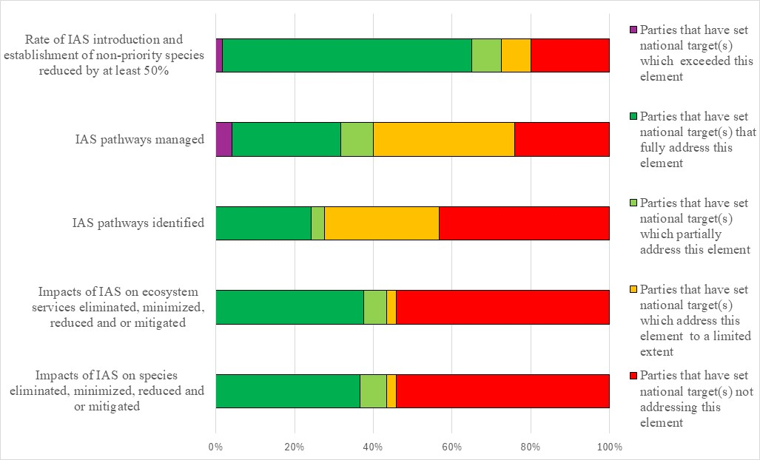Figure 14 – Assessment of the degree to which Parties have addressed the elements of GBF Target 6 in their national target(s). The coloured bars indicate the proportion of Parties that have set national targets which correspond to each assessment category. The number of Parties represented in each bar varies with the number of Parties that have submitted national targets related to a given target of the Kunming-Montreal Global Biodiversity Framework.
Target 7: reduce pollution to levels that are not harmful to biodiversity
- 116 Parties have submitted 261 national targets related to Target 7. On average a Party has submitted about 2 national targets related to Target 7 but the number ranges from 1 to 19. Of the national targets mapped by Parties to GBF Target 7, most (68%) were identified as contributing to Goal A, and around half (50%) were identified as contributing to Goal B. Few targets were identified as contributing to Goals C (14%) and D (11%). Around a third of the national targets were also linked to GBF Targets 10 (34%) while around a quarter were linked to Target 1 (25%), 2 (25%), 3(23%) 4 (27%) and 11 (25%).
- Less than a half of the national targets (44%) submitted by Parties were reported as having high alignment to GBF Target 7, about a third (30%) were reported as having medium alignment to the Target and almost a fifth (16%) as having low alignment. For 10% of the national targets Parties did not indicate a degree of alignment.
- Few (8%) Parties have set national targets which fully address all elements of Target 7 and approximately an additional fifth (15%) have set targets which fully address half of the target elements. More than a third (38%) of Parties have set national targets which fully address one but less than half of the target elements. Less than half of Parties (40%) have set national targets which do not fully address any element of Target 7.. A fifth of Parties (21%) have set targets which address all or some elements to a partial extent. A similar proportion of Parties have set national targets which address the elements of Target 7 to a limited extent (5%) or not at all (14%).
- In the national targets submitted, there was a greater focus on the elements of Target 7 related to reducing pollution risks to levels that are not harmful to biodiversity and ecosystem services. About two thirds of Parties have set targets which fully (33%) or partially (33%) address the pollutions risks to biodiversity and which fully (30%) or partially (29%) address pollution risks to ecosystem services. Fewer Parties have submitted targets addressing excess nutrients, pesticides or risks from highly hazardous chemicals. Around three quarters of Parties have set targets which address excess nutrients to a limited extent (45%) or not at all (33%) and which address pesticides to a limited extent (28%) or not at all (46%). Most Parties have set targets address highly hazardous chemicals to a limited extent (29%) or not at all (57%). With regards to working towards the elimination of plastics, less than half of Parties have set targets which fully (42%) address or partially address (4%) this (see figure 15).
- Less than a quarter (22%) of Parties have included quantitative measures in their national targets related to the reduction of excess nutrients lost to the environment and on the reduction of pesticide risk. The majority of these have set targets which aim for a 50% reduction, however the values range from 10% to 60%. Few Parties (15%) have set quantitative targets for the reduction of highly hazardous chemicals. The majority (88%) of these have set targets which aim for a 50% reduction.
- Less than half (40%) of the national target submissions contain information on the associated means of implementation. For targets with this information, two thirds (66%) indicate that additional means of implementation are needed. About a third (28%) indicate that the means of implementation are available. Examples of commonly identified required means of implementation include technical and financial partnerships at national, sub-regional, regional, and international levels; effective collaboration with stakeholders across sectors; and strengthened technical and scientific cooperation, training and capacity-building for specialists, upgrading and deploying necessary equipment, enforcement of relevant legislation, and the provision of adequate financial resources to support implementation efforts.
- Few (13%) target submissions provide information on the involvement of non-state actors. Commonly reported actions include awareness raising and advocacy, participating in pollution reduction initiatives, organizing community clean up initiatives, research and monitoring.
- Approximately a quarter of national targets identified component indicators (23%) and complimentary indicators (22%). Approximately one third (34%) of national targets mapped to GBF Target 7 contained supplementary national indicators. Examples of elements measured by these national indicators include the volume or the number of banned hazardous chemicals and pesticides used, the quantity of hazardous waste generated, the quantity of area or the number of instances in which environmentally friendly farming techniques are used, and water or air quality (via various indices).
- More than half (55%) of national target submissions contain information on which elements of section C of the Kunming-Montreal Global Biodiversity Framework the national target helps to address. The most addressed elements were collective effort towards the target (70%), national circumstances and priorities and capabilities (68%) and whole-of-government and whole-of-society approach (68%).
- More than half (52%) of national target submissions contained information on the associated policy measures. Commonly reported measures included:
  - Developing and strengthening legislation, policies, and institutional frameworks related to environmental monitoring, pollution control, and sustainable resource management, as well as establishing or reinforcing governing bodies to oversee these actions;
  - The creation of environmental management plans, stricter standards for pollutant emissions, and improved monitoring mechanisms for water, air, soil, and biodiversity;
  - Strengthening measures to promote sustainable agriculture, including the use of climate-smart practices, improved risk assessments, and the reduction of harmful inputs like pesticides and fertilizers;
  - The mainstreaming of biodiversity into national development planning, protecting natural habitats and species, including through the establishment of red lists and restoration initiatives, addressing invasive species, and enhancing the resilience of ecosystems;
  - Promoting circular economy principles, such as waste reduction, recycling, and the use of durable, ecological materials, advancements in green technologies and renewable energy;
  - Capacity-building efforts, such as training farmers, engaging local communities, fostering public awareness, and creating mechanisms for citizen participation in environmental governance.
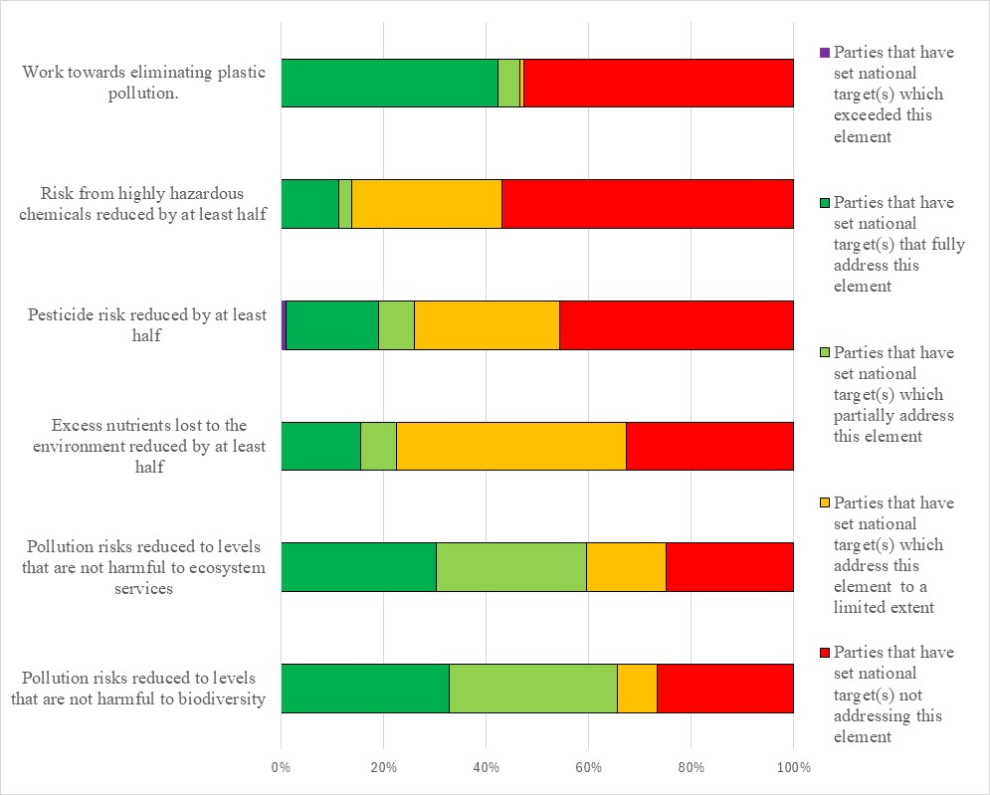
Figure 15 – Assessment of the degree to which Parties have addressed the elements of GBF Target 7 in their national target(s). The coloured bars indicate the proportion of Parties that have set national targets which correspond to each assessment category. The number of Parties represented in each bar varies with the number of Parties that have submitted national targets related to a given target of the Kunming-Montreal Global Biodiversity Framework.
Target 8: minimize the impacts of climate change on biodiversity and build resilience
- 121 Parties have submitted 287 national targets related to Target 8. On average a Party has submitted 3 national targets related to Target 8 but the number ranges from 1 to 15. Of the national targets mapped by Parties to GBF Target 8, most (70%) were identified as contributing to Goal A, and more than half (58%) were identified as contributing to Goal B. Few were identified as contributing to Goals C (15%) and D (11%). Less half of the national targets were also linked to GBF Target 11 (41%) while approximately one third of the national targets were linked to GBF Target 1 (30%), Target 2 (36%), Target 3 (34%), Target 4 (32%), and Target 10 (32%).
- Almost a half of the national targets (45%) submitted by Parties were reported as having high alignment to GBF Target 8, almost a third (30%) were reported as having medium alignment to the Target and more than a tenth (14%) as having low alignment. For 11% of the national targets Parties did not indicate a degree of alignment.
- More than a quarter (28%) Parties have set national targets which fully address all elements of Target 8 and approximately an additional half (59%) have set targets which fully address half of the target elements. Few (6%) Parties have set national targets which fully address one but less than half of the target elements. Few Parties (7%) have set national targets which do not fully address any element of Target 8 Approximately 3% have set national targets which partially address all or some of the elements. Very few Parties reported national targets which address the elements of Target 8 to a limited extent (2%) or not at all (2%).
- In the national targets submitted, there was a greater focus on the elements of Target 8 related to the effects of climate change as opposed to those of ocean acidification. Most Parties (88%) have national targets which fully addressed the minimization of the impact of climate change on biodiversity and the minimization of the negative impacts of climate action on biodiversity. Most Parties (88%) have national targets which fully addressed the fostering of positive impacts of climate change on biodiversity. Most Parties referred to the application of ecosystem-based approaches (68%) and nature-based solutions (71%). While about a third (36%) of Parties fully addressed the minimization of the impact of ocean acidification on biodiversity, more than half (56%) did not address it (figure 16).
- Less than half (43%) of the national target submissions contain information on the associated means of implementation. For targets with this information, about two thirds (69%) indicate that additional means of implementation are needed. About a quarter (27%) indicate that the means of implementation are available. Means for implementation commonly mentioned were financial, technical expertise and technological resources, capacity building, training and awareness raising, increased coordination and collaboration cross-sectoral and at multiple levels, institutional strengthening and logistics to roll out policy at ground level.
- Few national target submissions (14%) provide information on the involvement of non-state actors. Commonly included in the submissions were conservation and restoration initiatives, financing, environmental education and research, and the application of ecosystem-based approaches and nature-based solutions from a range of actors including nongovernmental organisations, the private entities, indigenous peoples and local communities, youth groups, and academic institutions.
- About a quarter of national targets identified component indicators (25%) and complimentary indicators (24%). Approximately one third (35%) of national targets mapped to GBF Target 8 contained national indicators. Examples of elements measured by these national indicators include the area of degraded and restored land, the number of nature-based solutions and the quantity of greenhouse gas emissions that they absorbed, and the degree of implementation of national disaster risk strategies. The national indicators for GBF Target 8 sometimes addressed specific ecosystems, usually forests or coral reefs.
- Almost two thirds (60%) of national target submissions contain information on which elements of section C of the Kunming-Montreal Global Biodiversity Framework the national target helps to address. The most addressed elements were the ecosystem approach (76%), consistency with international agreements or instruments (72%), collective effort towards the targets (70%) and whole-of-government and whole-of-society approach (72%). Comparatively few targets addressed different value systems (32%), the right to development (33%) or gender (38%)
- More than half (56%) of national target submissions contained information on associated policy measures. The most commonly mentioned policy measures fall into four broad categories; increasing knowledge of the current status and future scenarios of biodiversity and climate change, mainstreaming biodiversity and climate change concerns into decision-making, taking actions to restore biodiversity, and promoting wider stakeholder participation and building their capacity.
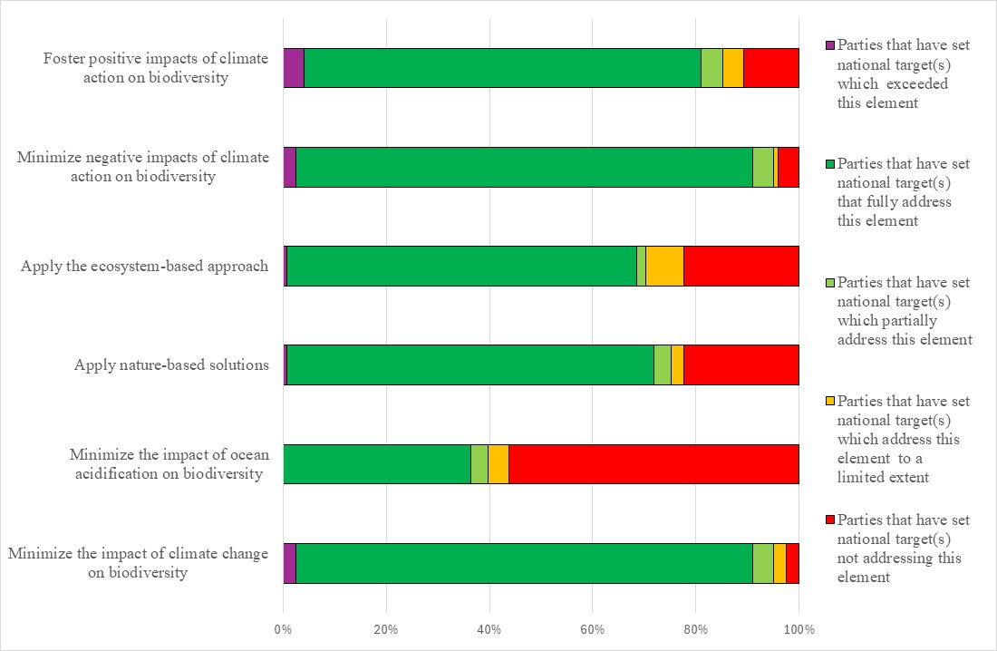
Figure 16 – Assessment of the degree to which Parties have addressed the elements of GBF Target 8 in their national target(s). The coloured bars indicate the proportion of Parties that have set national targets which correspond to each assessment category. The number of Parties represented in each bar varies with the number of Parties that have submitted national targets related to a given target of the Kunming-Montreal Global Biodiversity Framework.
Target 9: manage wild species sustainably to benefit people
- 116 Parties have submitted 306 national targets related to Target 9. On average a Party has submitted 3 national targets related to Target 9, but the number ranges from 1 to 13. Of the national targets mapped by Parties to GBF Target 9, more than three quarters were identified as contributing to Goal B (78%) while about two-thirds (63%) were linked to Goal A. About a third were identified as contributing to Goal C (32%), and over a tenth (13%) were identified as contributing to Goal D. Approximately half were also linked to GBF Targets 4 (45%), 5 (52%), and 10 (46%).
- Almost half of the national target (44%) submitted by Parties were reported as having high alignment to GBF Target 9 and nearly a third (31%) were reported as having medium alignment, while about a fifth were reported as having low alignment (18%). For 6% of the national targets, Parties did not indicate a degree of alignment.
- Few (8%) Parties have set national targets which fully address all elements of Target 9 and approximately an additional quarter (25%) have set targets which fully address half of the target elements. More than a third (38%) of Parties have set national targets which fully address one but less than half of the target elements. About a third of Parties (29%) have set national targets which do not fully address any element of Target 9. . Less than a quarter (17%) have set national targets which partially address all or some of the elements. Less than a tenth of Parties have set national targets which address the elements of Target 9 to a limited extent (6%) and few have set national targets which do not address the elements of Target 9 (4%).
- In the national targets submitted, there was a greater focus on the elements of Target 9 related to environmental benefits, with around half of national targets (52%) fully addressing this. Comparatively fewer national targets fully addressed the economic (38%) or social (40%) benefits of the sustainable management and use of wild species. Similarly fewer Parties fully addressed the benefits for people in vulnerable situations (24%), the protection and encouragement of customary sustainable use by indigenous people and local communities (21%) and benefits to people derived from biodiversity-based activities, products and services (17%) (figure 17).
- Less than half (45%) of the national target submissions contain information on the associated means of implementation. For targets with this information, most (76%) indicate that additional means of implementation are needed. Less than a quarter (20%) indicate that the means of implementation are available. The most commonly identified required means of implementation were financial resources, capacity building and institutional strengthening, followed by technology transfer and technical assistance, and scientific research and cooperation.
- Few national target submissions (15%) provide information on the involvement of non-state actors. National target submissions highlighted nongovernment organizations, community-based organizations, indigenous peoples and local communities, faith-based groups, private sector companies, academia and research institutions, youth networks, and development partners. These actors contribute through research, education, funding, advocacy, and direct conservation activities.
- Less than a third of national target submissions identified component indicators (30%) or complimentary indicators (27%). None of the submissions identified national indicators. More than one third (39%) of national targets mapped to GBF Target 9 contained supplementary national indicators. Examples of elements measured by these national indicators include the number of wild species identified as being of high social or economic value that have been identified or brought under protection, the number of regions engaged in sustainable management practices, and the percentage of the population using and benefiting from wild resources. Several national indicators for GBF Target 9 identify ecosystem services provided by wild species. While the medicinal applications of wild species were the most frequently mentioned, food, energy, and culture were also integrated into indicators.
- About two thirds (62%) of national target submissions contain information on which elements of section C of the Kunming-Montreal Global Biodiversity Framework the national target helps to address. The most commonly addressed elements were collective effort towards the targets (72%), ecosystem approach (70%), whole-of-government and whole-of-society approach (71%), national circumstances, priorities and capabilities (68%), consistency with international agreements or instruments (68%), and contribution and rights of indigenous peoples and local communities (69%). Comparatively few targets addressed the right to development (38%) and different value systems (38%).
- More than half (53%) of national target submissions contained information on the associated policy measures. Common measures include strengthening policies for sustainable fisheries, forestry, and wildlife management; ensuring equitable community participation; supporting sustainable local projects; promoting gender and youth inclusion; mainstreaming biodiversity across sectors; and advancing research and disease risk management.
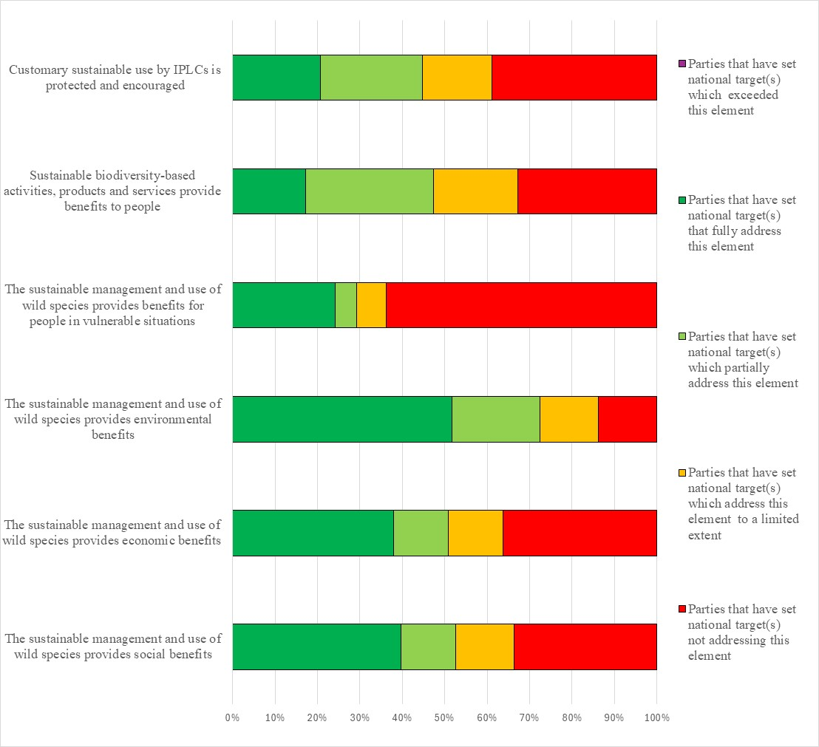Figure 17 – Assessment of the degree to which Parties have addressed the elements of GBF Target 9 in their national target(s). The coloured bars indicate the proportion of Parties that have set national targets which correspond to each assessment category. The number of Parties represented in each bar varies with the number of Parties that have submitted national targets related to a given target of the Kunming-Montreal Global Biodiversity Framework.
Target 10: enhance biodiversity and sustainability in agriculture, aquaculture, fisheries and forestry
- 119 Parties have submitted 447 national targets related to Targe 10. On average a Party has submitted 4 national targets related to Target 10, but the number ranges from 1 to 27. Of the national targets mapped by Parties to GBF Target 10, almost three quarters (74%) were identified as contributing to Goal B and more than half (57%) as contributing to Goal A. About a fifth were identified as contributing to Goals C (19%) and few were identified as contributing to Goal D (13%). Around a third of the national targets were also linked to GBF Targets 4 (34%), 5 (30%), 9 (32%), and 11 (35%).
- Almost a half of the national targets (46%) submitted by Parties were reported as having high alignment to GBF Target 10 and over a quarter (29%) were reported as having medium alignment, while under a fifth (15%) were reported as having low alignment. For 9% of the national targets, Parties did not indicate a degree of alignment.
- Few (12%) Parties have set national targets which fully address all elements of Target 10 and approximately an additional third (39%) have set targets which fully address half of the target elements. Less than half (42%) of Parties have set national targets which fully address one but less than half of the target elements. Few of Parties (7%) have set national targets which do not fully address any element of Target 10. Few (3%) have set national targets which partially address all or some of the elements. Few Parties have set national targets which address the elements of Target 10 to a limited extent (2%) or not at all (2%).
- In the national targets submitted, there was a greater focus on the elements of Target 10 related to the sustainable management of areas under agriculture, fisheries and forestry, with about three quarters of national targets (75%, 70% and 72% respectively), fully addressing these elements. Around half of the Parties (52%) fully addressed the element of GBF target 10 related to the sustainable management of areas under aquaculture in their national targets. Similarly, about half of Parties fully addressed the element related to the application of biodiversity friendly practices (52%) and the contribution of sustainable management to conservation and restoration (51%). By comparison fewer Parties fully addressed the elements related to resilience, efficiency and productivity (38%), food security (38%) and maintaining nature’s contribution to people (34%) (see figure 18).
- Less than half (42%) of the national target submissions contain information on the associated means of implementation. For targets with this information, most (75%) indicate that additional means of implementation are needed. About a fifth (21%) indicate that the means of implementation are available. The most commonly mentioned required means of implementation included funding from internal and external sources, capacity building, technical and technological support and improvements, and scientific research and collaboration.
- Few (15%) national target submissions provide information on the involvement of non-state actors. Submissions highlight that non-state actors play a vital role in biodiversity conservation through research, restoration, education, and sustainable practices, with many providing specific examples of ongoing commitments; however, some indicate that further engagement and better coordination are needed to maximize their impact on the national target.
- Less than a quarter of national target submissions identified component indicators (22%) or complimentary indicators (22%). Approximately one third (35%) of national targets mapped to GBF Target 10 contained supplementary national indicators. There were more national indicators reported related to agriculture and forestry compared to aquaculture and fisheries. Examples of elements measured by these national indicators include the quantity of forested land, the quantity of area or the number of instances in which environmentally friendly farming techniques are used, and the proportion of plans (across all four sectors) which address sustainability practices.
- Approximately two thirds (60%) of national target submissions contain information on which elements of section C of the Kunming-Montreal Global Biodiversity Framework the national target helps to address. The most commonly addressed elements were ecosystem approach (77%), collective effort towards the targets (72%), and whole-of-government and whole-of-society approach (72%).
- More than half (55%) of national target submissions contained information on the associated policy measures. Common measures include strengthening legal and enforcement frameworks; improving monitoring, data management, and early warning systems; raising public awareness and education; building capacity among stakeholders; promoting sustainable land and resource management; supporting financial incentives like Payments for Ecosystem Services; and implementing national action and restoration plans for biodiversity and ecosystem health.
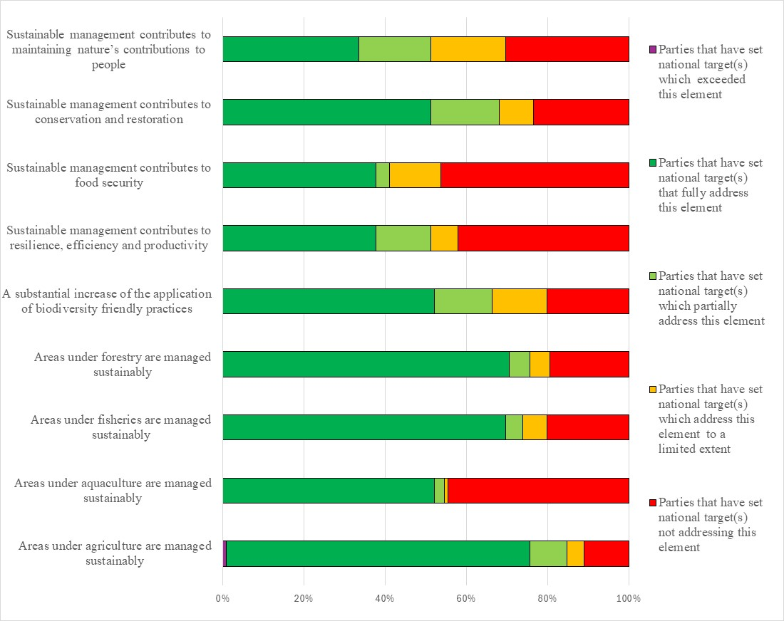
Figure 18 – Assessment of the degree to which Parties have addressed the elements of GBF Target 10 in their national target(s). The coloured bars indicate the proportion of Parties that have set national targets which correspond to assessment each category. The number of Parties represented in each bar varies with the number of Parties that have submitted national targets related to a given target of the Kunming-Montreal Global Biodiversity Framework.
Target 11: restore, maintain and enhance nature’s contributions to people
- 113 Parties have submitted 356 national targets related to Target 11. On average a Party has submitted 3 national targets related to Target 11 but the number ranges from 1 to 41. Of the 356 national targets mapped by Parties to GBF Target 11, almost three quarters many were identified as contributing to Goal B (74%) and around two-thirds to Goal A (66%). Comparatively few were identified as contributing to Goals C (20%) and D (13%). Less than half of the national targets were also linked to GBF Target 10 (41%) while around a third of the national targets were linked to GBF Target 1 (30%), 2 (34%), Target 3 (32%), Target 4 (35%), and Target 8 (33%).
- Almost a half of the national targets (45%) submitted by Parties were reported as having high alignment to GBF Target 11, a third (33%) were reported as having medium alignment to the Target and more than a tenth (14%) as having low alignment. For 7% of the national targets Parties did not indicate a degree of alignment.
- Few (11%) Parties have set national targets which fully address all elements of Target 11 and approximately an additional tenth (6%) have set targets which fully address half of the target elements. About a third (31%) of Parties have set national targets which fully address one but less than half of the target elements. More than half of Parties (52%) have set national targets which do not fully address any element of Target 11. About a quarter (24%) have set national targets which partially address all or some of the elements. A similar proportion of Parties reported national targets which address the elements of Target 11 to a limited extent (21%). Few Parties (7%) set national targets which address none of the elements of Target 11.
- With regards to the elements of Target 11, about a third of Parties have set national targets which fully address (30%) or exceed (3%) the element of the GBF target related to restoring, maintaining and enhancing nature’s contributions to people through ecosystems-based approaches while around a quarter (26%) have set targets fully addressing the element related to restoring, maintaining and enhancing nature’s contributions to people through nature based solutions.
- Few Partes have set national targets fully addressing (14%) or exceeding (3%) the restoration, maintenance and enhancement of air, water and climate regulation. A higher proportion of Parties have set national targets fully addressing (19%) the restoration, maintenance and enhancement of soil health, and pollination. Around a quarter of Parties have set national targets fully addressing the restoration, maintenance and reduction of disease (21%) and the restoration, maintenance and enhancement of protection from natural hazards and disasters (29%) (figure 19).
- Less than half (42%) of the national target submissions contain information on the associated means of implementation. For targets with this information, most (73%) indicate that additional means of implementation are needed while about a quarter (23%) indicate that the means of implementation are available. Means for implementation commonly mentioned as being needed were awareness raising, capacity building, financial resources, policy instruments and legislative changes, including inter-ministerial and sectoral cooperation, and technology transfer.
- Approximately one fifth (16%) of the target submissions provide information on the involvement of actors other than national governments. Common actions included community engagement, financing, technology and research, and the application of ecosystem-based approaches and nature-based solutions from a range of actors including non-governmental organisations, private entities, indigenous peoples and local communities, youth groups, and academic institutions.
- More than a quarter of national target submissions identified component indicators (26%) and complimentary indicators (25%). More than one third (39%) of national targets mapped to GBF Target 11 contained supplementary national indicators. There were more national indicators related to soil, water, and air quality compared to the status of pollinators, the reduction of disease risk, and the protection from natural hazards.
- About two thirds (65%) of national target submissions contain information on which elements of section C of the Kunming-Montreal Global Biodiversity Framework the national target helps to address. The most commonly addressed elements were the ecosystem approach (74%), collective effort towards the targets (66%) and whole-of-government and whole-of-society approach (62%) and national circumstances, priorities and capabilities (63%). Comparatively few targets addressed different value systems (29%), the right to development (27%) or intergenerational equity (33%).
- More than half (56%) of national target submissions contained information on associated policy measures. Some commonly mentioned policy measures include climate-smart agricultural practices, including ones that support pollinators, river basin and/or forest management plans, education and outreach programs, integration of ecosystem services into national accounting and decision-making processes, and the development or strengthening of pollution guidelines and regulations. Many of these policy measures were proposed in conjunction with or in the context of nature-based solutions and ecosystem-based approaches.
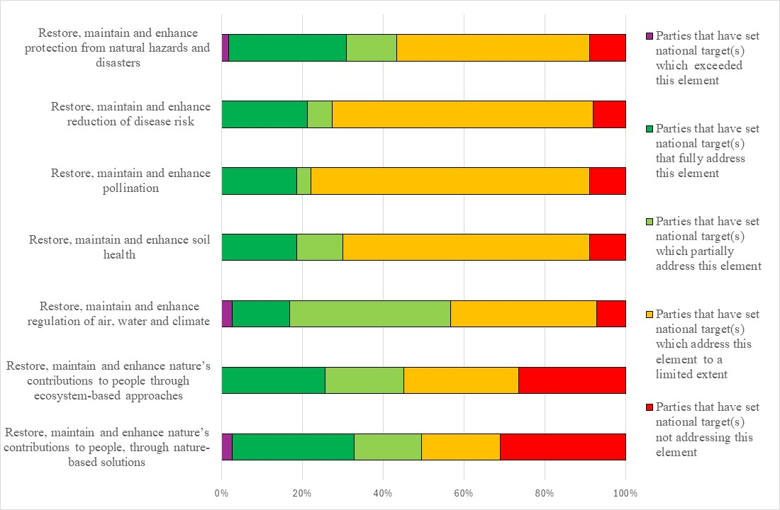
Figure 19 – Assessment of the degree to which Parties have addressed the elements of GBF Target 11 in their national target(s). The coloured bars indicate the proportion of Parties that have set national targets which correspond to each assessment category. The number of Parties represented in each bar varies with the number of Parties that have submitted national targets related to a given target of the Kunming-Montreal Global Biodiversity Framework.
Target 12: enhance green spaces and urban planning for human well-being and biodiversity
- 114 Parties have submitted 260 national targets related to Target 12. On average a Party has submitted 2 national targets related to Target 12 but the number ranges from 1 to 10. Of the national targets mapped by Parties to GBF Target 12, almost three quarters (69%) were identified as contributing to Goal B while more than half as contributing to Goal A (56%). Fewer were identified as contributing to Goals C (18%) and D (13%). Almost half of the national targets were also linked to GBF Target 11 (41%) while approximately one third of the national targets were linked to GBF Target 1 (36%), Target 2 (32%), Target 8 (31%), and Target 10 (31%).
- About half of the national targets (49%) submitted by Parties were reported as having high alignment to GBF Target 12, approximately a quarter (28%) were reported as having medium alignment to the target and more than a tenth (13%) as having low alignment. For 10% of the national targets Parties did not indicate a degree of alignment.
- Few (8%) Parties have set national targets which fully address all elements of Target 12 and approximately an additional quarter (23%) have set targets which fully address half of the target elements. About a third (30%) of Parties have set national targets which fully address one but less than half of the target elements. Less than half of Parties (40%) have set national targets which do not fully address any element of Target 12.Few Parties (10%) have set national targets which partially address all or some of the elements. Approximately one third have set national targets which address the elements of Target 12 to a limited extent (14%) or not at all (16%).
- In the national targets submitted there was a greater focus on the elements of Target 12 related to the area of green spaces then blue spaces. Around half (48%) of Parties have set national targets fully addressing an increase the area of green spaces while around a third (33%) have set national targets fully addressed an increase in blue spaces. Around a third of Parties have set national targets which fully address an increase of the quality of green and blue spaces (35%), an increase of the connectivity of green and blue spaces (34%) and ensuring biodiversity inclusive urban planning (39%). Comparatively fewer Parties have set national targets fully addressed increasing access and benefits from green and blue spaces (20%), mainstreaming the conservations and sustainable us of biodiversity in urban and densely populated areas (23%) and enhancing native biodiversity in urban and densely populated areas (18%) (Figure 20).
- About a third (39%) of the national target submissions contain information on the associated means of implementation. For targets with this information, most (76%) indicate that additional means of implementation are needed and most of the remaining targets (21%) indicate that the means of implementation are available. Means for implementation commonly mentioned included technology transfer, technical assistance, and capacity building but the most frequently identified was financial resources.
- Few of the target submissions (13%) provide information on the involvement of non-state actors. Common actions included financing and implementation support from a range of actors including NGOs, private entities, indigenous peoples and local communities, youth groups, and academic institutions.
- About a fifth of national targets identified associated component indicators (23%) and complimentary indicators (18%). More than one third (37%) of national targets contained supplementary national indicators. Examples of elements measured by these national indicators include the share of urban plans that have been updated according to urban greening guidelines, the proportion of the urban population with access to green or blue spaces, and the proportion of native species in urban green and blue spaces. While national indicators did distinguish between urban green spaces and blue spaces, further disaggregation was infrequent.
- Over half (57%) of national target submissions contain information on which elements of section C of the Kunming-Montreal Global Biodiversity Framework the national target helps to address. The most addressed elements were collective effort towards the target (71%), the ecosystem approach (70%), and whole-of-government and whole-of-society approach (74%). Comparatively few targets addressed different value systems (34%), and the right to development (38%).
- More than half (59%) of national target submissions contained information on the associated policy measures. Some commonly mentioned policy measures include climate adaptation initiatives such as tree planting, mainstreaming of green infrastructure into urban plans, mapping and/or development of urban green and/or blue spaces, water management directives, and knowledge management initiatives.
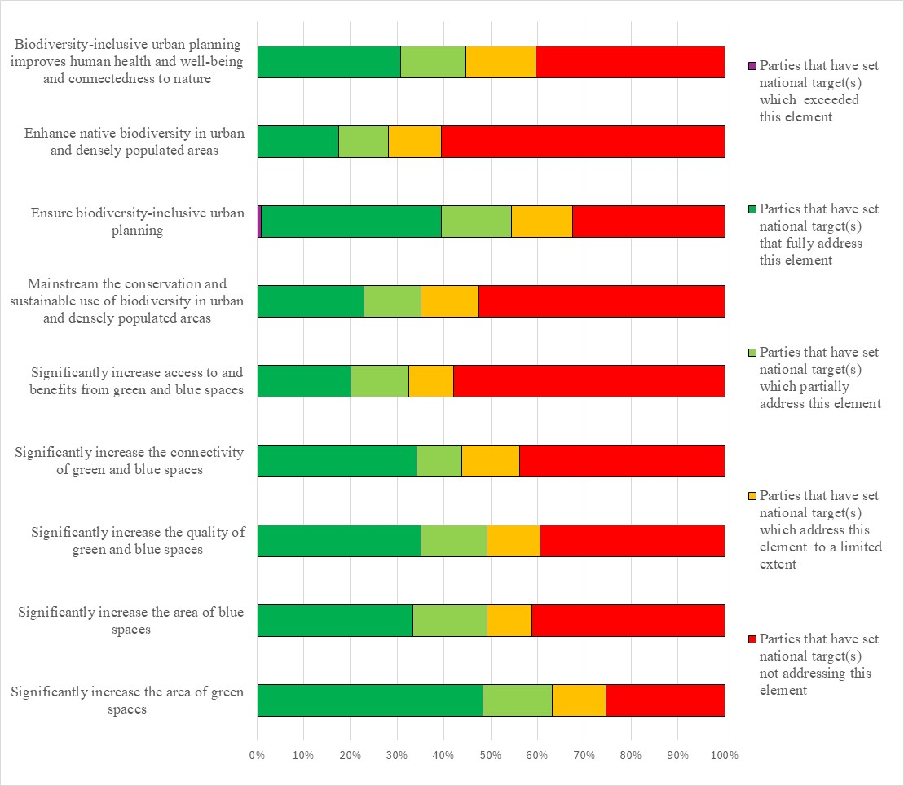
Figure 20 – Assessment of the degree to which Parties have addressed the elements of GBF Target 12 in their national target(s). The coloured bars indicate the proportion of Parties that have set national targets which correspond to each assessment category. The number of Parties represented in each bar varies with the number of Parties that have submitted national targets related to a given target of the Kunming-Montreal Global Biodiversity Framework.
Target 13: increase the sharing of benefits from genetic resources, digital sequence information and traditional knowledge
- 114 Parties have submitted 224 national targets related to Target 13. More than three quarters (79%) of the Parties that submitted national targets related to Target 13 were also Parties to the Nagoya Protocol on Access to Genetic Resources and the Fair and Equitable Sharing of Benefits Arising from their Utilization. On average a Party has submitted 2 national targets related to Target 13 but the number ranges from 1 to 10. Of the national targets mapped by Parties to GBF Target 13, most were identified as contributing to Goal C (71%). One third were mapped to Goal A (33%), and less than half were mapped to Goal B (41%). Comparatively few were linked to Goal D (19%). Some national targets were also linked to GBF Targets 5 (29%) and 9 (9%).
- Approximately half of the national targets (53%) submitted by Parties were reported as having high alignment to GBF Target 13, over a quarter (26%) were reported as having medium alignment to the Target, and more than a tenth (13%) as having low alignment. For 10% of the national targets Parties did not indicate a degree of alignment.
- Few (11%) Parties have set national targets which fully address all elements of Target 13 and approximately an additional quarter (23%) have set targets which fully address half of the target elements. About a quarter (25%) of Parties have set national targets which fully address one but less than half of the target elements. Less than half of Parties (40%) have set national targets which do not fully address any element of Target 13. Some Parties (12%) have set national targets which partially address all or some of the elements. More than a quarter of Parties reported national targets which address the elements of Target 13 to a limited extent (8%) or not at all (20%).
- In the national targets submitted, more Parties fully addressed the facilitation of appropriate access to genetic resources (46%) compared to the facilitation of a significant increase of the benefits shared (17%). There were also more targets which fully addressed the elements of Target 13 related to genetic resources than digital sequence information and the benefits that arise from traditional knowledge associated with genetic resources. Further, there was generally a greater focus on legal policy and administrative measures as opposed to capacity building measures (see figure 21):
  - About half of Parties (49%) set targets which fully addressed taking legal, policy and administrative measures to ensure the fair and equitable sharing of benefits that arise from their utilization. Fewer Parties (30%) had targets fully addressing taking capacity building measures to ensure fair and equitable benefit-sharing;
  - About a third (30%) set targets which fully addressed taking legal, policy and administrative measures to ensure the fair and equitable sharing of benefits that arise from the utilization of genetic resources. Fewer Parties (30%) had targets fully addressing taking capacity building measures to ensure the fair and equitable sharing of benefits that arise from the utilization of genetic resources;
  - More than a third (37%) set targets which fully addressed taking legal, policy and administrative measures to ensure the fair and equitable sharing of benefits that arise from traditional knowledge associated with genetic resources. Fewer Parties (26%) had targets fully addressing taking capacity building measures to ensure the fair and equitable sharing of benefits that arise from traditional knowledge associated with genetic resources.
- Less than half (47%) of the national target submissions contain information on the associated means of implementation. For targets with this information, most (83%) indicate that additional means of implementation are needed. Few (11%) indicate that the means of implementation are available. Means for implementation commonly mentioned were financial and human resources, identifying and filling capacity gaps, awareness raising, and the creation or enhancement of administrative, legal, and/or institutional frameworks, including explicit linkages with the Nagoya Protocol.
- Few (16%) national target submissions provide information on the involvement of non-state actors. Common actions included financing, data collection and research, general implementation support, and awareness raising from a range of actors including nongovernmental organisations, private entities, indigenous peoples and local communities, youth groups, and academic institutions.
- About a quarter of national targets identified component indicators (26%) and complimentary indicators (29%). Less than half (41%) of national targets mapped to GBF Target 13 contained supplementary national indicators. Examples of elements measured by these national indicators include the quantity of data from genetic resources of native species, the proportion of the population aware of the Nagoya Protocol and other sharing agreements, and the number of annual requests for access to national genetic resources. There was a greater number of indicators relating to the non-monetary benefits compared to those relating to the monetary benefits of the sharing of resources. Indicators were frequently disaggregated by type of non-monetary benefit and by type of beneficiary.
- Around two thirds (65%) of national target submissions contain information on which elements of section C of the Kunming-Montreal Global Biodiversity Framework the national target helps to address. The most commonly addressed elements were contribution and rights of indigenous peoples and local communities (75%), consistency with international agreements or instruments (71%), whole-of-government and whole-of-society approach (71%). Comparatively few targets addressed Principles of the Rio Declaration (37%) and different value systems (38%).
- More than half (51%) of national target submissions contained information on the associated policy measures. Some commonly mentioned policy measures include the increased participation in and mainstreaming of multilateral agreements such as the Nagoya Protocol and the Biodiversity Beyond National Jurisdiction (BBNJ) Agreement, the creation or strengthening of domestic legislation, increased research and knowledge generation, further capacity building, and the increase of plant and animal genetic resources in conservation facilities.
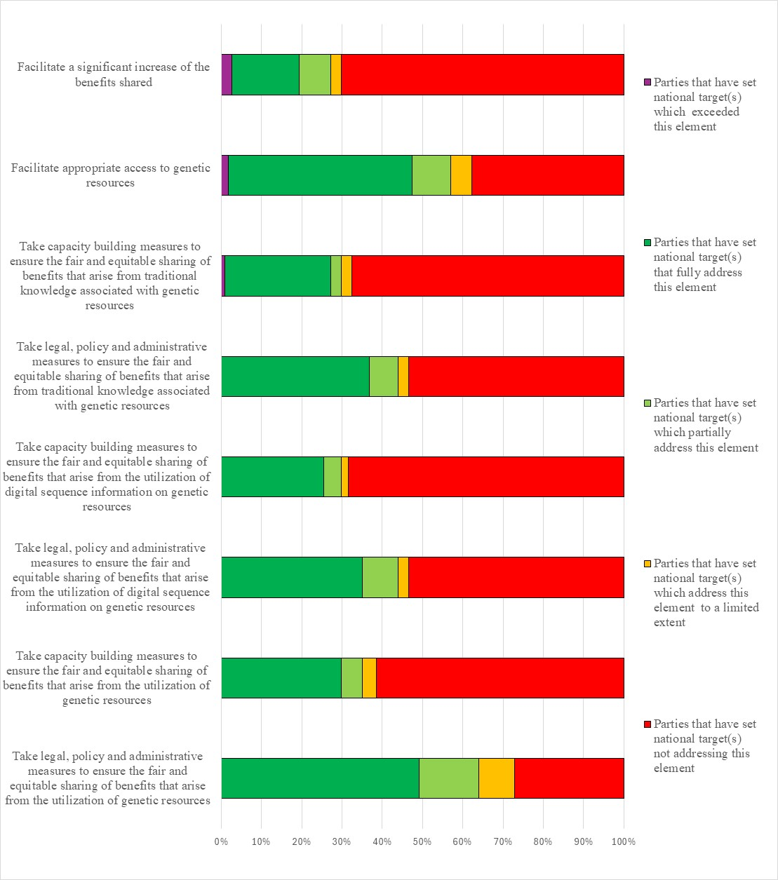
Figure 21 – Assessment of the degree to which Parties have addressed the elements of GBF Target 13 in their national target(s). The coloured bars indicate the proportion of Parties that have set national targets which correspond to each assessment category. The number of Parties represented in each bar varies with the number of Parties that have submitted national targets related to a given target of the Kunming-Montreal Global Biodiversity Framework.
Target 14: integrate biodiversity in decision-making at every level
- 115 Parties have submitted 416 national targets related to Target 14. On average a Party has submitted 4 national targets related to Target 15 but the number ranges from 1 to 29. Of the national targets mapped by Parties to GBF Target 14, around half were also identified as contributing to Goal A (44%) or Goal B (53%). Less than a quarter were identified as contributing to Goal C (23%) while almost a third contributed to Goal D (32%). Around than a quarter of national targets were also linked to GBF Targets 1 (26%), 11 (24%), and 21 (23%) while few were linked to GBF Targets 17 (8%) and 6 (10%).
- Almost a half of the national targets (46%) submitted by Parties were reported as having high alignment to GBF Target 14, while less than a quarter were reported as having medium alignment (24%) or low (18%) to the target. For 12% of the national targets, Parties did not indicate a degree of alignment.
- Few (10%) Parties have set national targets which fully address all elements of Target 14. Similarly, few (3%) have set targets which fully address half of the target elements. Less than a fifth (15%) of Parties have set national targets which fully address one but less than half of the target elements. Almost three-quarters of Parties (73%) have set national targets which do not fully address any element of Target 14.. About a quarter of Parties (27%) have set national targets which partially addresses some elements of Target 14. Almost half of Parties have set targets which address the elements of Target 14 to a limited extent (19%) or not at all (27%).
- The national targets set by Parties had a greater focus on the full integration of biodiversity and its multiple values into policies, regulations, planning and development processes. However less than quarter of Parties (23%) fully addressed this element in their national targets. Few Parties fully addressed the integration of biodiversity into poverty reduction strategies (15%), into strategic environmental assessments and environmental impact assessments (13%), national accounting (14%), across levels of government (10%), and across sectors (14%). Similar few Parties fully addressed the progressive alignment of all relevant public and private activities and fiscal and financial flows with goals and targets of the Framework (13%) (figure 22).
- Under half (44%) of the national target submissions contain information on the associated means of implementation. For targets with this information, most (69%) indicate that additional means of implementation are needed. Less than a third (29%) indicate that the means of implementation are available. Commonly mentioned required means of implementation were financial resources, information and technology sharing, national, regional and international cooperation and partnerships, human resources, and enhancing legal frameworks.
- Few (16%) target submissions provide information on the involvement of non-state actors. Common actions included community engagement, financing, technology and research from a range of actors including non-governmental organisations, private entities, indigenous peoples and local communities, youth groups, and academic institutions.
- Less than a quarter of the submitted national targets identified component (18%) or complimentary (16%) indicators. Approximately one third (32%) of national targets mapped to GBF Target 14 contained national indicators. Examples of elements measured by these national indicators include the number of biodiversity inclusive policies, regulations, strategies, and assessments, the proportion of environmental management instruments of investment projects which include biodiversity standards, and the number of subnational and local biodiversity strategies and action plans. There were more national indicators to track biodiversity’s mainstreaming into policies or action plans compared to the use of environmental accounting.
- About two thirds (60%) of national target submissions contain information on which elements of section C of the Kunming-Montreal Global Biodiversity Framework the national target helps to address. The most commonly addressed elements were whole-of-government and whole-of-society approach (76%), national circumstances, priorities and capabilities (71%), and collective effort towards the targets (68%). Comparatively few targets addressed the right to development (33%) and different value systems (32%).
- More than half (55%) of national target submissions contained information on the associated policy measures. Many of the measures identified had a focus on policy integration and governance, including actions to embed biodiversity protection within national policies, sectoral strategies, and development frameworks. These measures emphasized the incorporation of biodiversity values into regulations, planning, environmental assessments, and national accounting systems to ensure comprehensive governance. Many target submissions also addressed financial and resource mobilization, underscoring the need for dedicated biodiversity funding within national budgets. Many measures also advocate for integrating biodiversity revenue streams into financial structures and ensuring sufficient human, technical, and financial resources to support biodiversity governance. Capacity building measures and training, primarily through workshops and training programs designed for policymakers, institutional technicians, and biodiversity managers were also noted. Public awareness and community participation is a key component in many of the identified measures, with efforts directed toward raising awareness, promoting environmental education, and increasing citizen engagement. Many policies highlight local community involvement, integrating biodiversity considerations into economic and social development to support sustainable livelihoods. Monitoring, reporting, and impact assessment appear in some measures, including the establishment of biodiversity monitoring systems to track policy impacts. Measures addressing sustainable development and economic sectors, focusing on sustainable tourism management, biodiversity-friendly business strategies, and nature tourism initiatives that balance economic growth with conservation objectives were also noted.
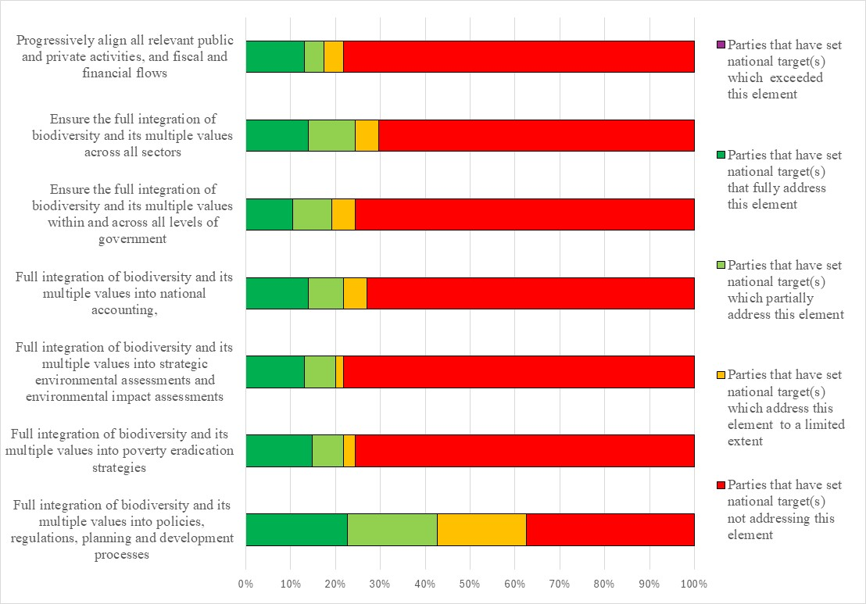
Figure 22 – Assessment of the degree to which Parties have addressed the elements of GBF Target 14 in their national target(s). The coloured bars indicate the proportion of Parties that have set national targets which correspond to each assessment category. The number of Parties represented in each bar varies with the number of Parties that have submitted national targets related to a given target of the Kunming-Montreal Global Biodiversity Framework.
Target 15: businesses assess, disclose and reduce biodiversity-related risks and negative impacts
- 106 Parties have submitted 225 national targets related to Target 15. On average a Party has submitted 2 national targets related to Target 15 but the number ranges from 1 to 9. Of the national targets mapped by Parties to GBF Target 15, half were also identified as contributing to Goal B (50%) and Goal D (50%). A third were identified as contributing to Goal A (33%) and Goal C (33%). About a third of the national targets were also linked to GBF Target 14 (37%).
- Almost a half of the national targets (48%) submitted by Parties were reported as having high alignment to GBF Target 15, almost a third (28%) were reported as having medium alignment to the Target and more than a tenth (14%) as having low alignment. For 11% of the national targets, Parties did not indicate a degree of alignment
- Few (12%) Parties have set national targets which fully address all elements of Target 15 and approximately an additional fifth (18%) have set targets which fully address half of the target elements. Less than a tenth (9%) of Parties have set national targets which fully address one but less than half of the target elements. More than half of Parties (60%) have set national targets which do not fully address any element of Target 15.Less than a tenth (8%) have set national targets which partially address all or some of the elements. More than half of Parties have set national targets which address the elements of Target 15 to a limited extent (6%) or not at all (47%).
- With regards to the elements of GBF Target 15, more than a third of Parties fully addressed the elements related to taking measures to encourage and enable business to monitor, assess and disclose their risks to (35%) and impacts on (35%) biodiversity in their national targets. About a quarter of Parties set national targets fully addressing taking measures to encourage and enable business to monitor, assess and transparently disclose their dependencies (27%) on biodiversity and taking measures to encourage and enable business to provide information needed to consumers to promote sustainable consumption patterns (29%). Comparatively fewer Parties fully addressed measures to encourage and enable business to report on compliance with access and benefit-sharing regulations and measures, in their national targets (figure 23).
- Just under half (45%) of the national target submissions contain information on the associated means of implementation. For targets with this information, most (66%) indicate that additional means of implementation are needed. A quarter (25%) indicate that the means of implementation are available. The most frequently mentioned type of means was financial resources. Capacity building was also commonly referenced. Human and technical resources, knowledge sharing, stakeholder collaboration and synergy and regulatory frameworks were also frequently mentioned.
- Few (7%) national target submissions provide information on the involvement of non-state actors. Common actions included environmental education, ecosystem restoration, research, monitoring, advocacy, and sustainable business practices, involving NGOs, private companies, academia, and local communities.
- Less than a quarter of national targets mapped to GBF Target 15 identified component (22%) or complimentary (24%) indicators. Less than half (41%) identified supplementary national indicators. In addition to the national indicators which addressed elements in the GBF Target, such as the number of businesses which publish sustainability reports, national indicators also focused on the role of businesses beyond their reporting obligations. Examples of elements measured by this type of indicators include the positive contributions of businesses to biodiversity conservation, the number of businesses generating biodiversity action plans, and the quantity of waste generated by businesses. National indicators for GBF Target 15 were occasionally sector-specific but were usually applicable to all businesses.
- About two thirds (62%) of national target submissions contain information on which elements of section C of the Kunming-Montreal Global Biodiversity Framework the national target helps to address. The most addressed elements were whole-of-government and whole-of-society approach (82%), national circumstances, priorities and capabilities (75%), and collective effort towards the targets (76%).
- More than half (57%) of national target submissions contained information on the associated policy measures. Most national targets emphasize legal and regulatory reforms to embed biodiversity into corporate governance, policy, and environmental, social and governance frameworks, with a strong focus on mandatory risk disclosure, especially for large and transnational companies. Measures commonly aim to institutionalize corporate accountability through regulatory authorities. Additional measures aim to promote sustainable business models via circular economy laws supported via financial incentives and benefit-sharing mechanisms. Beyond corporate focus, governments also prioritize public awareness, stakeholder engagement, and green finance tools like biodiversity-linked investments to drive cross-sectoral support for conservation. Less than half of the measures emphasize strengthening environmental impact assessments and reporting, including the establishment of biodiversity management plans to monitor and control environmental impacts. Measures also advocate for mandatory environmental labelling to enhance transparency and integrate biodiversity considerations into existing certification standards, while encouraging businesses to embed biodiversity into their core strategies.

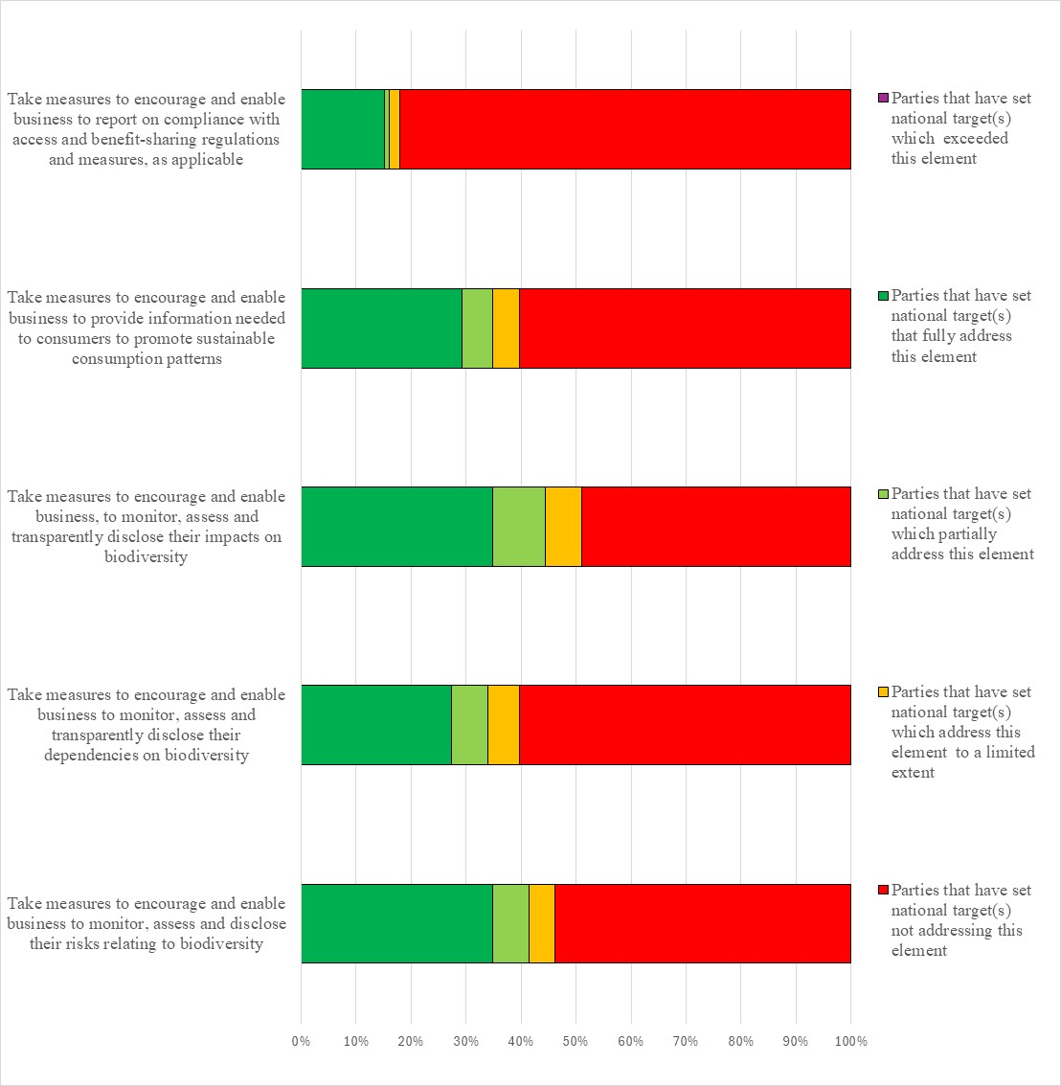
Figure 23 – Assessment of the degree to which Parties have addressed the elements of GBF Target 15 in their national target(s). The coloured bars indicate the proportion of Parties that have set national targets which correspond to each assessment category. The number of Parties represented in each bar varies with the number of Parties that have submitted national targets related to a given target of the Kunming-Montreal Global Biodiversity Framework.
Target 16: enable sustainable consumption choices to reduce waste and overconsumption
- 109 Parties have submitted 201 national targets related to Target 16. On average a Party has submitted 2 national targets related to Target 16 but the number ranges from 1 to 9. Of the national targets mapped by Parties to GBF Target 16, around two thirds (60%) were identified as contributing to Goal B and less than half were identified as contributing to Goal A (41%). Around a quarter of national targets were identified as contributing to Goal C (26%) and about a third were linked to Goal D (32%). About a third of national targets related to GBF target 16 were also linked to GBF Targets 10 (28%), 14 (27%) and 15 (30%).
- Less than half of the national targets (47%) submitted by Parties were reported as having high alignment to GBF Target 16, close to a third (30%) were reported as having medium alignment to the Target and fewer (13%) were reported as having low alignment. 9% of the national targets Parties did not indicate a degree of alignment.
- Few (6%) Parties have set national targets which fully address all elements of Target 16 and approximately an additional tenth (11%) have set targets which fully address half of the target elements. Less than a fifth (16%) of Parties have set national targets which fully address one but less than half of the target elements. More than half of Parties (67%) have set national targets which do not fully address any element of Target 16. Approximately one quarter (21%) of Parties have set national targets which partially address all or some of the elements. Less than half Parties reported national targets which address the elements of Target 16 to a limited extent (14%) or not at all (32%).
- About a quarter of Parties (26%) fully addressed the establishment of policy, legislative or regulatory frameworks to encourage and enable people to make sustainable consumption choices. Similarly, about a quarter of Parties (24%) fully addressed the improvement of education, access to relevant information and alternatives to encourage people to make sustainable consumption choices. Fewer Parties fully addressed the reduction of the global footprint of consumption (16%) and the reduction of waste generation (17%). Few Parties fully addressed the reduction in overconsumption (11%) and the halving of food waste (8%). Few Parties (12%) set targets with a quantitative value for the reduction of food waste. Of those that did, more than half (54%) set a target of reducing food waste by half. The remainder set targets for reducing food wasted by between 10% and 30% (figure 24).
- Less than half (43%) of the national target submissions contain information on the associated means of implementation. For targets with this information, most (74%) indicate that additional means of implementation are needed. Around a fifth (21%) indicate that the means of implementation are available. Some commonly mentioned means of implementation include funding, capacity building, data and information, and technology transfer.
- Few (13%) target submissions provide information on the involvement of non-state actors. Common actions identified included financing, data collection, and implementation support from a range of actors including non-governmental organisations, indigenous people and local communities, civil society, academic institutions, and the private sector.
- Around a quarter of Parties identified component indicators (27%) and complimentary indicators (23%) for their national targets. More than one third (38%) of national targets mapped to GBF Target 16 contained supplementary national indicators. The national indicators had a greater focus on monitoring consumer awareness of sustainable consumption options, the quantity of food waste, and the rate of recycling compared to monitoring consumption and overconsumption.
- Approximately two thirds (60%) of national target submissions contain information on which elements of section C of the Kunming-Montreal Global Biodiversity Framework the national target helps to address. The most addressed elements were whole-of-government and whole-of-society approach (81%), collective efforts toward the target (79%), and national circumstances and priorities and capabilities (71%). Comparatively few targets addressed different value systems (39%).
- More than half (53%) of national target submissions contained information on the associated policy measures. The policy measures mentioned can be largely categorized based on which elements of the target they address; awareness and education initiatives, targeted policies on food and waste reduction, water quality measures, and programs to reduce to the overall impacts of consumption, and sustainable ecotourism.

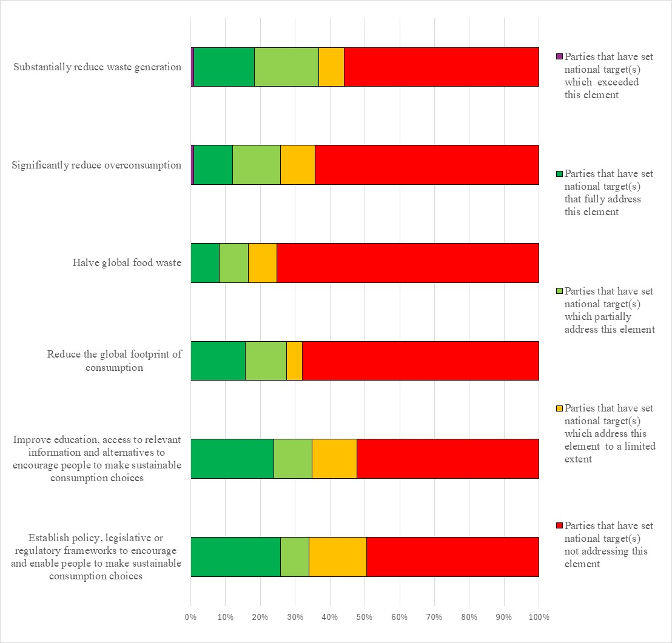Figure 24 – Assessment of the degree to which Parties have addressed the elements of GBF Target 16 in their national target(s). The coloured bars indicate the proportion of Parties that have set national targets which correspond to each assessment category. The number of Parties represented in each bar varies with the number of Parties that have submitted national targets related to a given target of the Kunming-Montreal Global Biodiversity Framework.
Target 17: strengthen biosafety and distribute the benefits of biotechnology
- 108 Parties have submitted 179 national targets related to Target 17. On average a Party has submitted 2 national targets related to Target 17 but the number ranges from 1 to 8. Of the Parties that have submitted national targets related to Target 17, most (91%) are also Parties to the Cartagena Protocol on Biosafety. Of the national targets mapped by Parties to GBF Target 17, more than half (56%) were also identified as contributing to Goal B. Less than half were identified as contributing to Goals A (44%) and C (45%). About a third were identified as contributing to goal D (32%). Less than a third (29%) of the national targets were also identified as being relevant to Target 13 while a quarter were also linked to GBF Targets 5 (25%), 9 (25%), and 10 (25%).
- More than a half of the national target (53%) submitted by Parties were reported as having high alignment to GBF Target 17, around a quarter (26%) were reported as having medium alignment to the target and more than a tenth (13%) as having low alignment. For 8% of the national targets Parties did not indicate a degree of alignment.
- About a fifth (18%) Parties have set national targets which fully address all elements of Target 17 and approximately an additional quarter (22%) have set targets which fully address half of the target elements. Less than a fifth (18%) of Parties have set national targets which fully address one but less than half of the target elements. Less than half of Parties (41%) have set national targets which do not fully address any element of Target 17. More than a tenth (14%) have set national targets which partially address all or some of the elements. More than a quarter of Parties have set national targets which address the elements of Target 17 to a limited extent (3%) or not at all (23%). In these cases, the national targets have tended to be more cross cutting than Target 17 and focus on the use of genetic resources and ecosystem services generally. In addition, some national targets position biosafety as a means of helping to reach other targets, for example Target 6 addressing invasive alien species and Target 13 addressing access and benefit sharing as well as those targets addressing issues related to agriculture and food security (Target 10), human wellbeing (Target 11) and business (Target 15). While relevant to Target 17, the focus in these targets is somewhat limited to the strategic actions or policies required to reach other Targets within the framework and therefore the elements of Target 17 are not always explicitly addressed.
- In the national targets submitted, there was a greater focus on the elements of Target 17 related to Article 8(g) of the text of the Convention. Less than half of Parties have set national targets which fully address the establishment of biosafety measures (42%), the strengthening of capacity (49%) and fully addressing implementation for Article 8(g) (46%). By comparison relatively few Parties have set targets addressing the elements of Target 17 related to Article 19 of the Convention. Less than a quarter of Parties (22%) had submitted that national targets which fully address the establishment of measures for the handling of biotechnology and distribution of its benefits. Similarly, less than a third (31%) of Parties have set national targets fully addressing the strengthening of capacity for measures for the handling of biotechnology and distribution of its benefits while less than a quarter (23%) have set national targets which fully address the implementation of such measures (figure 25).
- Less than half (48%) of the national target submissions contain information on the associated means of implementation. For targets with this information, most (83%) indicate that additional means of implementation are needed. Few (13%) indicate that the means of implementation are available. Examples of the types of means of implementation identified as being needed include, financial resources, institutional and individual capacity building, appropriate enabling environments, necessary legal systems, public awareness, technology transfer, monitoring and surveillance systems, methods of effectively engaging with the private sector, including with larger transnational corporations, and standard operating procedures for handling issues related to biosafety.
- Few (16%) national target submissions provide information on the involvement of non-state actors. Of those that do, some indicate that the involvement of non-state actors has not yet begun or that they need to be engaged. Most indicate the ways in which non-state actors can be involved generally in the implementation of the target but do not indicate specific ongoing actions or commitments which have been taken by non-state actors. Examples of the types of contributions noted include technology transfer, capacity building, providing data and information, undertaking studies, and providing funding. In addition, some national targets note the types of non-state actors which could be involved in implementation. These include biotechnology and pharmaceutical companies, companies developing and selling seeds, research institutes, academia, and development partners and agencies. Others note the need for the involvement of indigenous people and local communities, the private sector and non-governmental organisations. Few national targets identify specific actors with ongoing activities or commitments. Those that do often refer to specific projects or actions which are being taken on an ad hoc basis which, while relevant to the target, are not specifically linked to the attainment of the national target.
- Around a quarter of national target submissions identified component (25%) and complimentary (28%) indicators. Less than half (43%) of national targets mapped to GBF Target 17 contained supplementary national indicators. Examples of elements measured by these national indicators include the number of biosafety issues identified, the proportion of biotechnology products available on the market, the proportion of the population aware of biosafety or biotechnology, and the number of biosafety specialists trained.
- Two thirds (66%) of national target submissions contain information on which elements of section C of the Kunming-Montreal Global Biodiversity Framework the national target helps to address. The most addressed elements were science and innovation (78%), consistency with international agreements or instruments (72%); biodiversity and health (70%) and collective effort towards the targets (68%). Comparatively few targets addressed different value systems (32%) and human rights-based approach (37%).
- About half (54%) of national targets have associated policy measures. Commonly reported measures include developing and/or strengthening legislation, policies and frameworks related to biosafety and the protection of genetic resources and the establishment or strengthening of related bodies and facilities, strengthen measures related to access and benefit sharing, including those related to traditional knowledge, and the development of guidelines and/or standards for considering digital sequence information. The strengthening of monitoring and controlling of the use of modern biotechnology, increasing knowledge of biotechnology and promoting its use, improving consultation processes, improving communication and information tools, establishing partnerships with relevant organisations and the private sector, and capacity building and improving public awareness and access to information were also frequently mentioned.

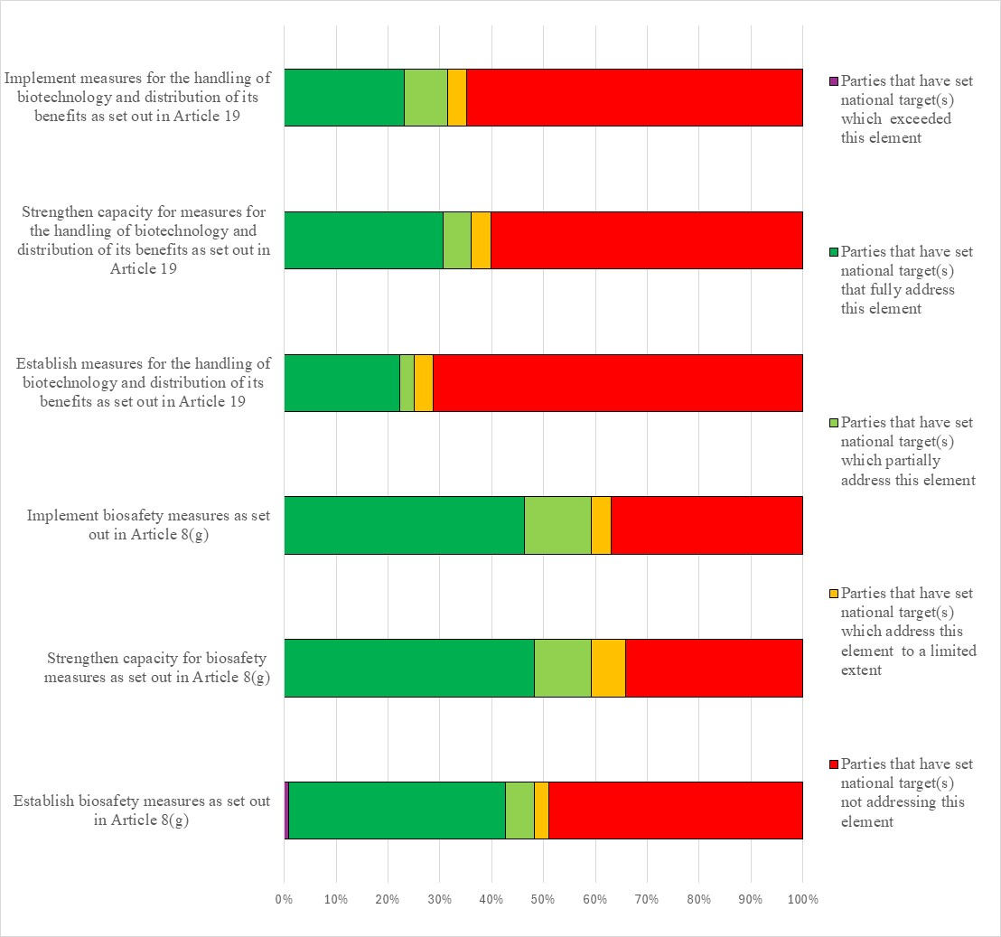
Figure 25 – Assessment of the degree to which Parties have addressed the elements of GBF Target 18 in their national target(s). The coloured bars indicate the proportion of Parties that have set national targets which correspond to assessment each category. The number of Parties represented in each bar varies with the number of Parties that have submitted national targets related to a given target of the Kunming-Montreal Global Biodiversity Framework.
Target 18: reduce harmful incentives by at least $500 billion per year and scale up positive incentives for biodiversity
- 103 Parties have submitted 193 national targets related to Target 18. On average a Party has submitted 2 national targets related to Target 18 but the number ranges from 1 to 11. Of the national targets mapped by Parties to GBF Target 18, more than half were identified as also contributing to Goal D (59%), and half were identified as contributing to Goal B (50%). More than a third were identified as contributing to Goal A (39%). Comparatively few national targets were identified as contributing to Goal C (24%). Approximately one third of the national targets were linked to GBF Target 14 (33%), and Target 15 (32%).
- Almost half of the national targets (49%) submitted by Parties were reported as having high alignment to GBF Target 18, almost a third (31%) were reported as having medium alignment to the Target and more than a tenth (13%) as having low alignment. 7% of the national targets Parties did not indicate a degree of alignment.
- Few (6%) Parties have set national targets which fully address all elements of Target 18 and approximately an additional fifth (15%) have set targets which fully address half of the target elements. Less than a quarter (21%) of Parties have set national targets which fully address one but less than half of the target elements. More than half of Parties (58%) have set national targets which do not fully address any element of Target 18. About a quarter of Parties (21%) have set national targets which partially address all or some of the elements of GBF Target 18. More than a third of Parties reported national targets which address the elements of Target 18 to a limited extent (9%) or not at all (28%).
- One element of GBF Target 18 has a 2025 deadline: by 2025 incentives, including subsidies, harmful for biodiversity are to be identified. Few Parties (15%) have fully addressed this element in their national targets. The majority of Parties have either addressed this element to a limited extent (4%) or not at all (59%) in their national targets.
- In the national targets submitted, there was a comparatively higher emphasis on scaling up positive incentives for conservation and sustainable use of biodiversity with about a third (32%) of Parties fully addressing this issue. About a fifth of Parties (21%) fully addressed the elimination, phase out, or reform of incentives harmful to biodiversity. Few Parties (10%) fully addressed the reduction of incentives harmful for biodiversity by at least $500 billion per year by 2030. Most Parties (67%) did not submit targets addressing the reduction in incentives harmful for biodiversity by $500 billion. Few Parties (12%) included a quantitative element for the reduction of harmful subsidies. Some of those that did refer to reductions of $500 billion while others refer to specific percentage reductions of between 10% and 50%. Some Parties also included quantitative values of between 5% and 25% for the increase of positive incentives (figure 26).
- Half (50%) of the national target submissions contain information on the associated means of implementation. For targets with this information, most (78%) indicate that additional means of implementation are needed. Some (16%) indicate that the means of implementation are available. The most mentioned required means of implementation was financial resources. However, planning, monitoring, technology transfer and capacity building were also frequently mentioned.
- A fifth (20%) of national target submissions provide information on the involvement of non-state actors. Common actions included resource mobilization, data collection and research, and monitoring from a range of actors including non-governmental organisations, private entities, indigenous people and local communities, and academic institutions.
- About a quarter of national targets identified component indicators (23%) and complimentary indicators (24%). More than one third (37%) of national targets mapped to GBF Target 18 contained supplementary national indicators. Most of the national indicators monitor the number or value of beneficial or harmful subsidies for biodiversity in various sectors, especially agriculture and energy.
- Two thirds (66%) of national target submissions contain information on which elements of section C of the Kunming-Montreal Global Biodiversity Framework the national target helps to address. The most commonly addressed elements were national circumstances, priorities and capabilities (79%), whole-of-government and whole-of-society approach (78%), access to financial resources (73%) and collective effort towards the targets (73%). Comparatively few targets addressed different value systems (41%).
- More than half (56%) of national target submissions contained information on the associated policy measures. Some commonly mentioned measures include the development or improvement of monitoring and reporting programs, research and knowledge collection to identify harmful incentives and to optimize the use of positive subsidies, including in the agricultural and energy sectors, increasing awareness, and developing or strengthening political and/or legal frameworks.
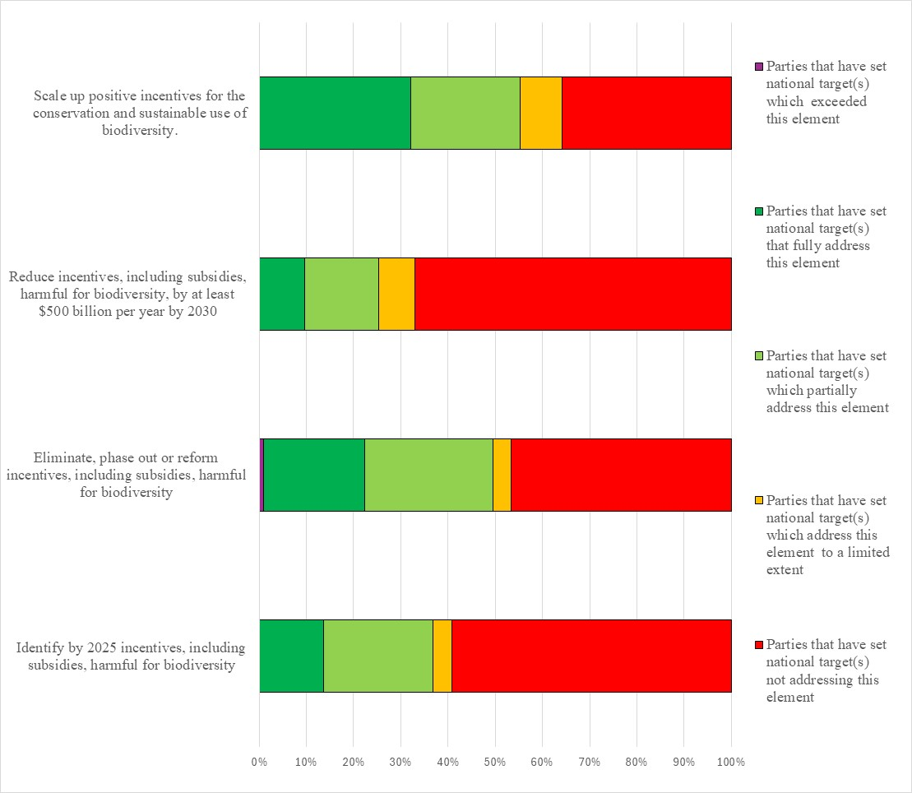
Figure 26 – Assessment of the degree to which Parties have addressed the elements of GBF Target 18 in their national target(s). The coloured bars indicate the proportion of Parties that have set national targets which correspond to each assessment category. The number of Parties represented in each bar varies with the number of Parties that have submitted national targets related to a given target of the Kunming-Montreal Global Biodiversity Framework.
Target 19: mobilize $200 billion per year for biodiversity from all sources, including $30 billion through international finance
- 117 Parties have submitted 193 national targets related to Target 19. On average a Party has submitted 2 national targets related to Target 19 but the number ranges from 1 to 14. Of the national targets mapped by Parties to GBF Target 19, more than two thirds of national targets were identified as contributing to Goal D (68%) while fewer were identified as contributing to Goal A (22%), Goal B (30%), or Goal C (20%). Between 8% and 23% of the national targets submitted by Parties were linked to one of the 23 GBF Targets. Around a quarter of national targets linked to GBF Target 18 were also linked to GBF Targets 20 (23%), 14 (22%) and 18 (21%).
- Less than half of the national targets (45%) submitted by Parties were reported as having high alignment to GBF Target 19, a quarter (25%) were reported as having medium alignment to the Target and a similar number (20%) were reported as having low alignment. 9% of the national targets Parties did not indicate a degree of alignment.
- Few (3%) Parties have set national targets which fully address all elements of Target 19 and approximately an additional tenth (7%) have set targets which fully address half of the target elements. Less than a quarter (23%) of Parties have set national targets which fully address one but less than half of the target elements. More than half of Parties (68%) have set national targets which do not fully address any element of Target 19. Approximately a quarter (27%) of Parties have set national targets which partially address all or some of the elements. Less than half of Parties reported national targets which addressed the elements of Target 19 to a limited extent (26%) or not at all (14%).
- One element of GBF Target 19 has a 2025 deadline: by 2025 total biodiversity related international financial resources from developed countries, including official development assistance, and from countries that voluntarily assume obligations of developed country Parties, to developing countries, in particular the least developed countries and small island developing States, as well as countries with economies in transition should increase at least $20 billion per year. Few Parties (8%) fully address increasing biodiversity related international financial resources in their national targets. About a quarter of Parties have included quantitative elements in their national targets related to increasing international financial resources. Some have set targets with specific monetary amounts while others have set targets with percentage increases. For those targets with monetary values, the values range from 1 million dollars to 200 billion dollars. For those targets with percentage increases these range from 0.8% to 400%. In addition, many of the national targets with percentage increases are expressed in relation to gross domestic product or official development assistance. Given the different ways Parties have expressed these quantitative elements it is not possible to aggregate these values.
- About a fifth of national targets (21%) fully address significantly increasing domestic resource mobilization. The leveraging of private finance, the promotion of blended finance, the implementation of strategies for raising new and additional resources, and the encouragement of the private sector to invest in biodiversity was fully addressed by few Parties (12%). Similarly, few Parties fully addressed the stimulation of innovative finance schemes (15%), the optimization of co-benefits and synergies between finance for biodiversity and climate change (9%), and the increase in total biodiversity related international financial resources to developing countries (9%), and the enhancement of the role of collective action (9%) (see figure 27).
- Less than half (47%) of the national target submissions contain information on the associated means of implementation. For targets with this information, most (65%) indicate that additional means of implementation are needed. Some (25%) indicate that the means of implementation are available. Some commonly mentioned means of implementation include funding, capacity building, planning and monitoring programs, and technology transfer.
- Few (13%) national target submissions provide information on the involvement of non-state actors. Common actions included resource mobilization and financing, data collection, innovation, and public-private partnerships from a range of actors including non-governmental organizations, Indigenous Peoples and local communities, academic institutions, the private sector and financial institutions.
- Less than a quarter national target submissions identified component indicators (15%) and complimentary indicators (23%). Less than half (43%) of national targets mapped to GBF Target 19 contained supplementary national indicators. Examples of elements measured by these national indicators include the number of agreements or fora for resource mobilization and the number of innovative finance schemes utilized. Several of the national indicators monitor the quantity of funds by provenance and intended purpose.
- Approximately three quarters (70%) of national target submissions contain information on which elements of section C of the Kunming-Montreal Global Biodiversity Framework the national target helps to address. The most commonly addressed elements were access to financial resources (75%), whole-of-government and whole-of-society approach (67%), collective effort towards the targets (64%), and cooperation and synergies (59%). Comparatively few targets addressed human rights-based approach (29%), different value systems (29%), Principles of the Rio Declaration (31%), intergenerational equity (32%), and formal and informal education (31%).
- More than half (53%) of national target submissions contained information on the associated policy measures. Some commonly mentioned measures beyond those explicitly mentioned in the wording of Target 19 include utilizing carbon markets, taxes, mainstreaming of ecosystem accounting, awareness raising initiatives including conferences or dialogues, training and capacity building, information schemes such as labelling and rating, increases in biodiversity aid, planning and monitoring.
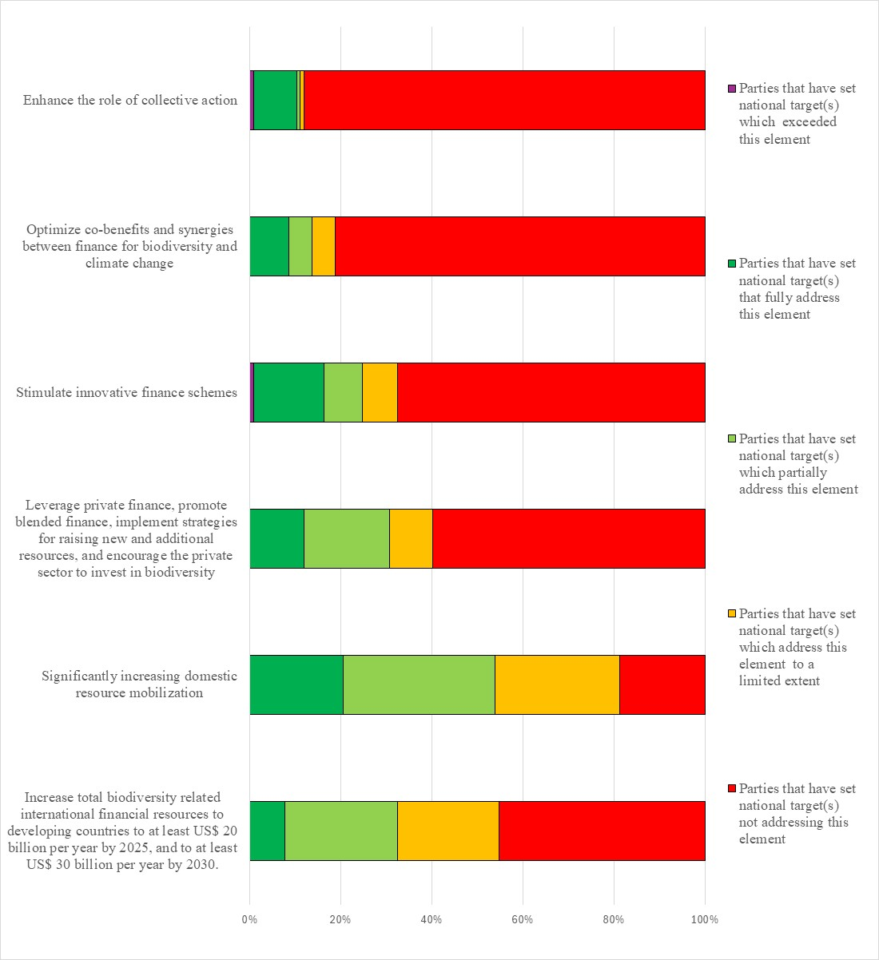
Figure 27 – Assessment of the degree to which Parties have addressed the elements of GBF Target 19 in their national target(s). The coloured bars indicate the proportion of Parties that have set national targets which correspond to each assessment category. The number of Parties represented in each bar varies with the number of Parties that have submitted national targets related to a given target of the Kunming-Montreal Global Biodiversity Framework.
Target 20: strengthen capacity-building, technology transfer and scientific and technical cooperation for biodiversity
- 114 Parties have submitted 284 national targets related to Target 20. On average a Party has submitted 3 national targets related to Target 20 but the number ranges from 1 to 16. Of the national targets mapped by Parties to GBF Target 20, almost half were identified as contributing to Goals B (48%) and D (47%) while around a third were identified as contributing to Goals A (38%) and C (31%). Almost half of the national targets were also linked to GBF Target 21 (47%).
- Almost a half of the national targets (46%) submitted by Parties were reported as having high alignment to GBF Target 20, approximately a quarter (28%) were reported as having medium alignment to the Target and more than a tenth (14%) as having low alignment. For 12% of the national targets, Parties did not indicate a degree of alignment.
- Few (11%) Parties have set national targets which fully address all elements of Target 20 and approximately an additional fifth (19%) have set targets which fully address half of the target elements. Less than a quarter (22%) of Parties have set national targets which fully address one but less than half of the target elements. About half of Parties (48%) have set national targets which do not fully address any element of Target 20.Approximately one quarter (23%) of Parties have set national targets which partially address all or some of the elements. About a quarter of national targets addressed elements of GBF Target 20 to a limited extent (4%) or not at all (22%).
- About one third of Parties fully addressed the strengthening of capacity-building and development (39%), the strengthening of access to and transfer of technology (37%), the development of and access to innovation (29%), and the promotion of technical and scientific cooperation, including through South-South, North-South and triangular cooperation (41%). About a fifth of Parties fully addressed the fostering of joint technology development (16%), the fostering of joint scientific research programmes (18%), and the strengthening of scientific research and monitoring capacities (21%) (see figure 28).
- Less than half (46%) of the national target submissions contain information on the associated means of implementation. For targets with this information, most (67%) indicate that additional means of implementation are needed while over a quarter (29%) indicate that the means of implementation are available. Means for implementation commonly mentioned were capacity building, including data and information capacity, financial resources, and technological and scientific cooperation, including technology transfer.
- Less than one fifth (15%) of national target submissions provide information on the involvement of non-state actors. Common actions included implementation support, financing, and research, from a range of actors including nongovernment organizations, private entities, indigenous peoples and local communities, youth groups, and academic institutions.
- About a quarter of national target submissions identified component indicators (23%) and complimentary indicators (24%). Less than half (41%) of national targets mapped to GBF Target 20 contained supplementary national indicators. Examples of elements measured by these national indicators include the quantity of funds mobilized for biodiversity related to capacity development, the number of capacity building initiatives, the number of international scientific research agreements signed, and many indicators relating to the number and scope of domestic biodiversity scientific research initiatives
- Approximately two thirds (64%) of national target submissions contain information on which elements of section C of the Kunming-Montreal Global Biodiversity Framework the national target helps to address. The most commonly addressed elements were science and innovation (70%), collective effort towards the targets (69%), and whole-of-government and whole-of-society approach (64%). Comparatively few targets addressed different value systems (32%), the right to development (32%) or the human rights-based approach (35%).
- More than half (56%) of national target submissions contained information on the associated policy measures. Some commonly mentioned policy measures beyond those explicitly mentioned in GBF Target 20 include education and/or awareness campaigns, information sharing, including with regards to wild species, financing, capacity building, the development or strengthening of frameworks for scientific collaboration, and planning and monitoring. In many of the policy measures the need to and importance of collaborating with non-state actors, including nongovernment organisations, indigenous people and local communities, research institutions, and the private sector was also noted.
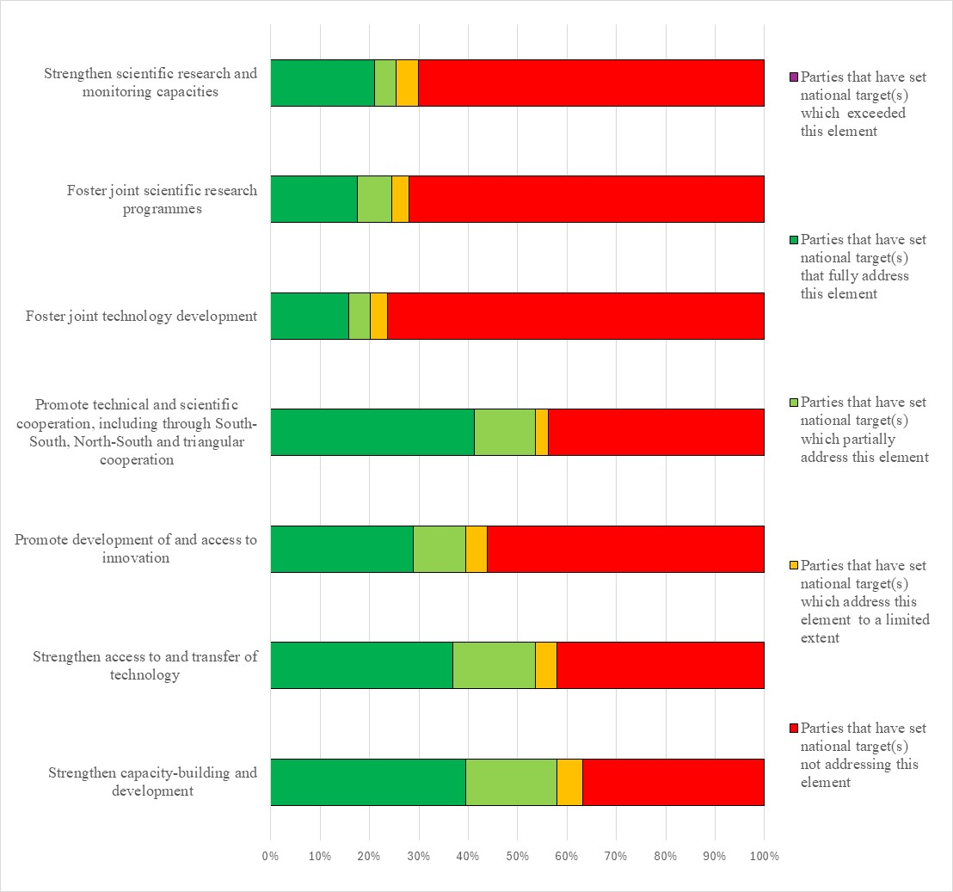Figure 28 – Assessment of the degree to which Parties have addressed the elements of GBF Target 20 in their national target(s). The coloured bars indicate the proportion of Parties that have set national targets which correspond to each assessment category. The number of Parties represented in each bar varies with the number of Parties that have submitted national targets related to a given target of the Kunming-Montreal Global Biodiversity Framework.
Target 21: ensure that knowledge to guide action on biodiversity is available and accessible
- 114 Parties have submitted 426 national targets related to Targe 21. On average a Party has submitted 4 national targets related to Target 21 but the number ranges from 1 to 32. Of the national targets mapped by Parties to GBF Target 21, less than half were also identified as contributing to Goals A (42%) and B (49%). About a quarter (24%) were identified as contributing to Goal C and more than a third (35%) were identified as contributing to Goal D. Around a third of the national targets submitted by Parties linked to GBF Target 21 were also identified as being relevant to Targets 20 (34%) and 22 (27%).
- More than a third of the national target (39%) submitted by Parties were reported as having high alignment to GBF Target 21, less than a third (30%) were reported as having medium alignment to the target and less than a fifth (14%) as having low alignment. For 14% of the national targets Parties did not indicate a degree of alignment.
- Few (11%) Parties have set national targets which fully address all elements of Target 21 and approximately an additional tenth (14%) have set targets which fully address half of the target elements. About half (49%) of Parties have set national targets which fully address one but less than half of the target elements. About a quarter of Parties (25%) have set national targets which do not fully address any element of Target 21. More than a tenth of Parties (14%) have set national targets which partially address all or some of the elements. More than a third of Parties have set national targets which address the elements of Target 21 to a limited extent (7%) or not at all (4%). Many of the national targets which have been set by Parties have also been aligned to other Targets of the Kunming-Montreal Global Biodiversity Framework. Many of these national targets have data collection, monitoring, knowledge management or research activities or policies associated with them. However, these activities or policies tend to focus on specific topics, such as threatened species, ecosystem types, or types of pollution, rather than representing overarching policies or frameworks for addressing the elements identified in Target 21. The focus in these national targets is therefore somewhat limited to the strategic actions or policies required to reach other targets within the framework.
- More than a third of Parties have set national targets which fully address making the best available data (39%) and knowledge (44%) accessible and strengthening communication, education and public awareness (40%). About a third of Parties have set national targets fully addressing the elements of GBF Target 21 on strengthening knowledge management (32%) and monitoring (32%). Around a quarter of Parties have set national targets fully addressing the elements of Target 21 on strengthening research (25%), and on accessing traditional knowledge innovations practices and technologies of indigenous peoples and local communities with their free, prior and informed consent (27%) (see figure 29).
- Less than half (43%) of the national target submissions contain information on the associated means of implementation. Over half (59%) of submissions indicate that means of implementation will be required. More than a third of submissions (37%) indicate that means of implementation are available. Means of implementation commonly mentioned were financial and human resources, technology transfer, capacity building, awareness raising, and improved institutional capacity.
- Few (11%) target submissions provide information on the involvement of non-state actors. Of the ones that do some indicate that the involvement of non-state actors has not yet begun or that they need to be engaged. Most indicate the ways in which non-state actors can be involved generally in the implementation of the national target but do not indicate specific ongoing actions or commitments which have been taken by non-state actors. Examples of the types of contributions noted include conducting surveys, studies and research, generating information and developing or maintaining information databases to make information more accessible, undertaking environmental education, organizing volunteer activities, supporting capacity building and providing funding for activities. In addition, some national targets note the types of non-state actors which could be involved in implementation. These include non-governmental organisations, community organisations, indigenous people and local community organisations, youth networks, research organisations and universities. Few national targets identify specific actors with ongoing activities or commitments. Those that do often refer to specific projects or actions which are being taken on an ad hoc basis which, while relevant to the target, are not specifically linked to the attainment of the national target.
- Around a fifth of national target submissions identified component (21%) and complimentary (20%) indicators. Less than half (44%) of national targets mapped to GBF Target 21 contained supplementary national indicators. Examples of elements measured by these national indicators include the number of innovations developed, the number of awareness platforms, and the proportion of decision-makers with access to biodiversity information. Several national indicators monitor the availability of data on traditional knowledge and practices. Infrequently, indicators were disaggregated by type of information.
- Most (58%) national target submissions contain information on which elements of section C of the Kunming-Montreal Global Biodiversity Framework the national target helps to address. The most commonly addressed elements were science and innovation (69%), collective effort towards the targets (67%), and whole-of-government and whole-of-society approach (66%). Comparatively few targets addressed right to development (32%), and different value systems (33%).
- Half (50%) of national targets have associated policy measures. Three broad and interrelated categories of measures were identified in the target submissions:
  - Data collection and knowledge generation, which includes measures related to encouraging biodiversity research, assessments and surveys, developing biodiversity inventories and updating maps, improving the accessibility of data and strengthening or developing associated platforms, including for example clearing house mechanisms, developing, strengthening or participating in relevant earth observation systems.
  - Procedures and standards, which includes establishing, strengthening or promoting cooperation with relevant councils and processes undertaking data collection and assessments, and developing or applying methods for research and data collection, including for example the UN statistical standard for the System of Environmental Economic Accounting – Ecosystem Accounting.
  - Engagement and awareness raising, examples which include promoting citizen science, undertaking communication and education activities, capacity building and training, supporting the protection, generation and use of indigenous knowledge.
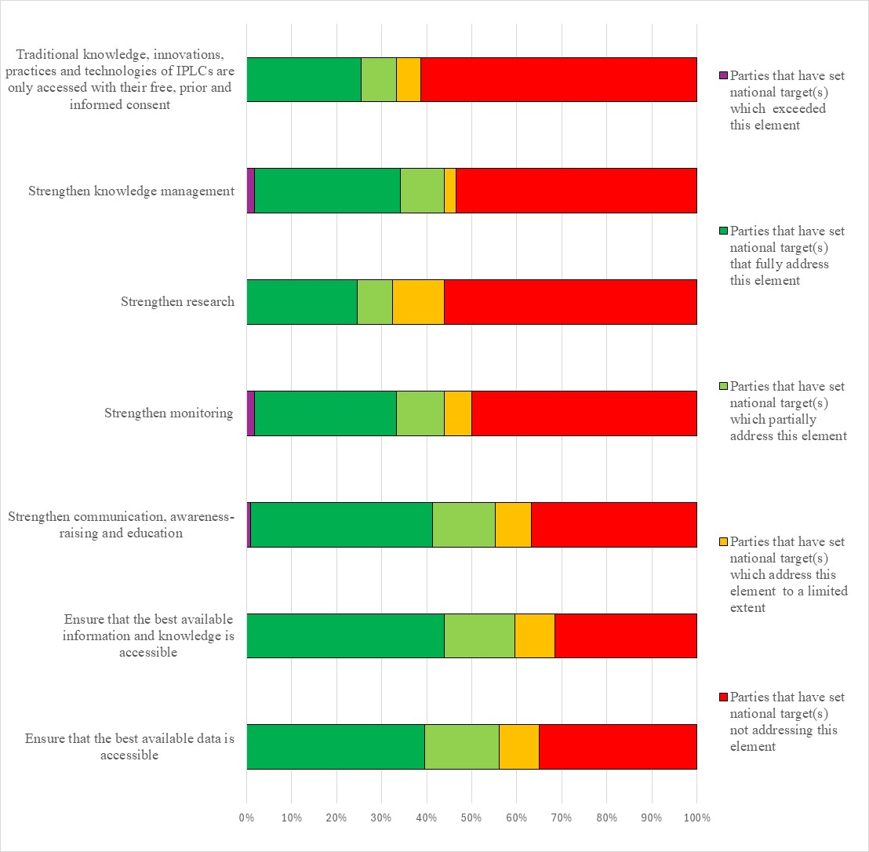Figure 29 – Assessment of the degree to which Parties have addressed the elements of GBF Target 21 in their national target(s). The coloured bars indicate the proportion of Parties that have set national targets which correspond to each assessment category. The number of Parties represented in each bar varies with the number of Parties that have submitted national targets related to a given target of the Kunming-Montreal Global Biodiversity Framework.
Target 22: ensure participation in decision-making and access to justice and information related to biodiversity for all
- 113 Parties have submitted 274 national targets related to Target 22. On average a Party has submitted 2 national targets related to Target 22 but the number ranges from 1 to 14. Of the national targets mapped by Parties to GBF Target 22, less than half were identified as contributing to Goal A (43%) and more than a half of national targets were identified as contributing to Goal B (55%), Around a third of national targets were identified as contributing to Goals C (31%) and D (38%). Less than half of the national targets were linked to GBF Target 21 (42%) and Target 23 (38%).
- About two fifths of the national targets (41%) submitted by Parties were reported as having high alignment to GBF Target 22. Around a quarter were reported as having medium (28%) alignment and low alignment (21%) to the Target. For 11% of the national targets, Parties did not indicate a degree of alignment.
- Few (14%) Parties have set national targets which fully address all elements of Target 22 and approximately an additional tenth (10%) have set targets which fully address half of the target elements. Less than a quarter (20%) of Parties have set national targets which fully address one but less than half of the target elements. More than half Parties (56%) have set national targets which do not fully address any element of Target 22. Approximately one quarter (23%) of Parties have set national targets which partially address all or some of the elements. A third of Parties have set national targets which address elements of GBF Target 22 to a limited extent (6%) or not at all (27%).
- Around a third of Parties had national targets fully addressing the full, equitable, inclusive, effective and gender-responsive representation and participation in decision-making related to biodiversity by Indigenous Peoples and local communities (37%), by women and girls (35%), children and youth (33%), and persons with disabilities (32%). With regards to the element of GBF Target 22 related to access to justice, around a quarter of Parties fully addressed this issue in relation to Indigenous Peoples and local communities (27%), women and girls (23%), children and youth (23%) and persons with disabilities (22%). Similarly, for the element of GBF Target 22 related to access to information, about a quarter of Parties addressed this issue in their national targets for Indigenous Peoples and local communities (29%), women and girls (24%), children and youth (24%) and persons with disabilities (24%). Less than a fifth (15%) of Parties fully addressed the full protection of environmental human rights defenders in their national targets. Almost a third (28%) fully addressed respecting the cultures and rights of Indigenous Peoples and local communities over lands, territories, resources, and traditional knowledge (see figure 30).
- Less than half (45%) of the national target submissions contain information on the associated means of implementation. For targets with this information, most (70%) indicate that additional means of implementation are needed and most of the remaining targets (26%) indicate that the means of implementation are available. Commonly mentioned required means of implementation were capacity building, inter-ministerial coordination, management schemes, monitoring, data collection, financial resources, and technical assistance.
- Few (6%) of the national target submissions provide information on the involvement of non-state actors. Common actions included collaboration with the government and/or implementation support, technical assistance, financing, and capacity building from a range of actors including civil society, nongovernmental organisations, private entities, indigenous people and local communities, and academic institutions.
- About a quarter of national targets identified component indicators (26%) and complimentary indicators (23%). Less than half (41%) of national targets mapped to GBF Target 22 contained supplementary national indicators. Examples of elements measured by these national indicators include the satisfaction score of marginalized groups in decision-making processes, the percentage of protected areas that incorporate ancestral or traditional uses, and the number of environmental human rights defenders that are arrested, charged, or convicted annually. National indicators were more frequently disaggregated by gender and Indigenous People and local community status than by age or by disability status.
- Approximately two thirds (62%) of national target submissions contain information on which elements of section C of the Kunming-Montreal Global Biodiversity Framework the national target helps to address. The most commonly addressed elements were whole-of-government and whole-of-society approach (75%), collective effort towards the targets (75%), contribution and rights of Indigenous Peoples and local communities (71%). Comparatively few targets addressed the right to development (32%) and principles of the Rio Declaration (34%).
- Half (50%) of national target submissions contained information on the associated policy measures. Some of the most common policy measures mentioned include Indigenous-led or community-based management, especially of conservation initiatives, awareness-raising programs, participation programs, including direct citizen engagement, such as the promotion of various forums, and the strengthening or development of administrative and/or legal measures.
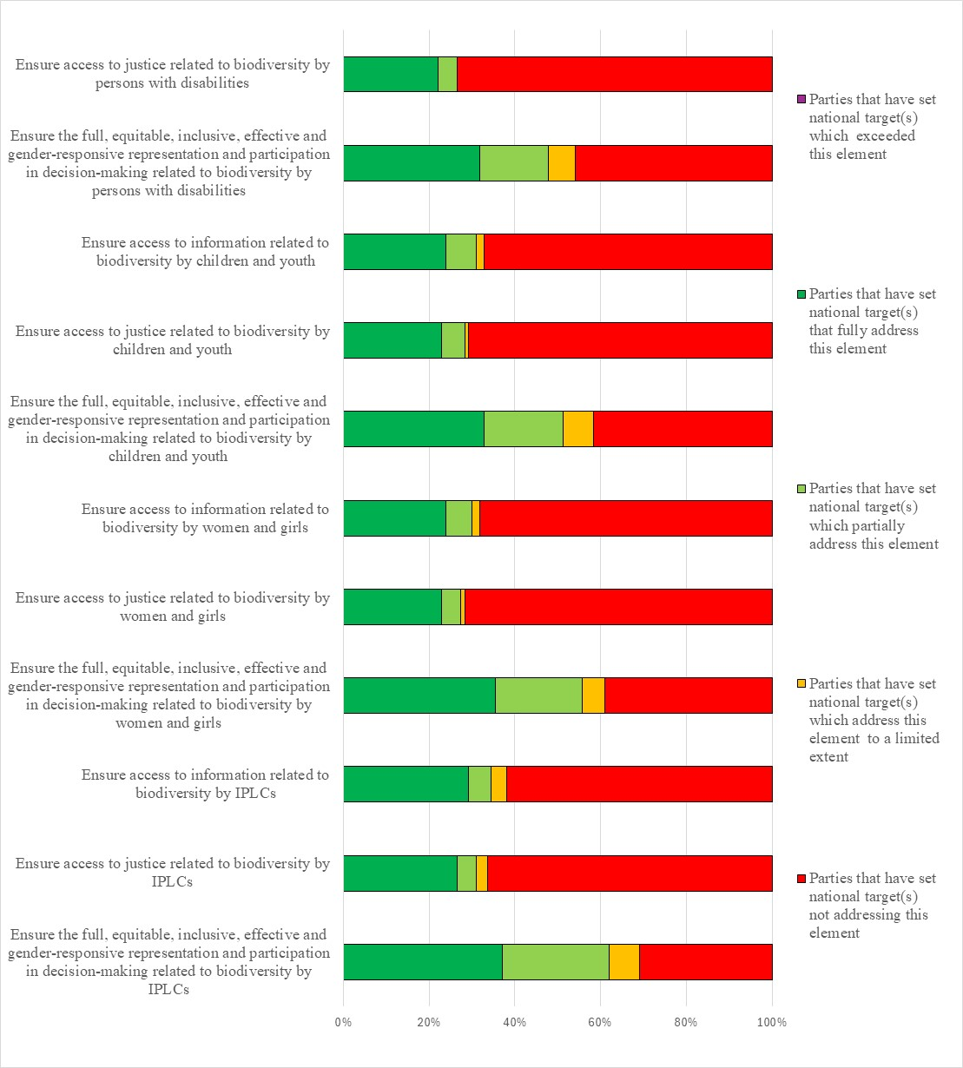Figure 30 – Assessment of the degree to which Parties have addressed the elements of GBF Target 22 in their national target(s). The coloured bars indicate the proportion of Parties that have set national targets which correspond to each assessment category. The number of Parties represented in each bar varies with the number of Parties that have submitted national targets related to a given target of the Kunming-Montreal Global Biodiversity Framework.
Target 23: ensure gender equality and a gender-responsive approach for biodiversity action
- 110 Parties have submitted 198 national targets related to Target 23. On average a Party has submitted 2 national targets related to Target 23 but the number ranges from 1 to 19. Of the national targets mapped by Parties to GBF Target 23, more than half (57%) were identified as contributing to Goal B, while around half were identified as contributing to Goal A (43%) and Goal D (44%). Over a third (36%) were identified as contributing to Goal C. A half (53%) of the national targets submitted by Parties linked to GBF Target 23 were also identified as being relevant to Target 22.
- Over half of the national targets (52%) submitted by Parties were reported as having high alignment to GBF Target 23, less than a third (27%) were reported as having medium alignment, and less than a fifth (13%) as having low alignment to the target. Few (8%) of the national targets Parties did not indicate a degree of alignment.
- About a fifth (17%) Parties have set national targets which fully address all elements of Target 23 and approximately an additional tenth (10%) have set targets which fully address half of the target elements. Around a tenth (13%) of Parties have set national targets which fully address one but less than half of the target elements. More than half Parties (60%) have set national targets which do not fully address any element of Target 23. Over a tenth (15%) of Parties have set national targets which partially addresses some GBF elements but do not address others or address them to a limited extent. Few (7%) have set targets that address some or all of the GBF elements to a limited extent. More than a third of Parties (39%) have set national targets do not address any elements of GBF Target 23.
- About a third of Parties (34%) have national targets which fully address ensuring gender equality in the implementation of the Framework through a gender-responsive approach. Over a third of Parties (35%) have national targets which fully address recognizing the full, equitable, meaningful, and informed participation and leadership of women and girls at all levels of action, engagement, policy and decision-making related to biodiversity. A fifth of Parties (20%) have national targets which fully address recognizing the equal rights of women and girls to land and natural resources. About a fifth of Parties (21%) have national targets which fully address recognizing the equal access of women and girls to land and natural resources (see figure 31)
- Over half (55%) of the national target submissions contain information on the associated means of implementation. Of these, the majority of submissions (79%) indicate that means of implementation will be required, while about a fifth (18%) indicate that means of implementation are available. The most commonly mentioned required means of implementation fall into three broad categories: funding, capacity building and political support. Examples include, a dedicated budget allocated to carry out actions and activities that strengthen and promote the incorporation of the gender perspective, a desk for gender and human rights in biodiversity management, training of government officials at all levels on gender and biodiversity issues, development of competencies to effectively incorporate the gender perspective into regulatory documents, a tool to track effective engagement of women, training national stakeholders to take gender into account in the formulation of biodiversity conservation projects, increasing political will of decision makers to remove barriers to access for women in decision making and conservation funding opportunities.
- Few (10%) national target submissions provide information on the involvement of actors other than national governments. Of the ones that do, over half detail the types of non-state actors involved or to be involved. Few mentioned women directly. The majority mentioned civil society organisations and groups, which mostly included non-governmental organizations and community-based organizations. Around a fifth mentioned indigenous peoples and local communities and the private sector. Few mentioned youth and academia. Information in submissions on non-state actors' commitments varied widely, ranging from those that highlighted the significance of current contributions, identified contributions that are needed by non-state actors, and outlined actions to support and improve engagement of non-state actors in actions. Some also indicated that commitments are in development, and others refer to non-state actors' contributions as being detailed as part of the implementing agencies in their NBSAPs. Few outlined details of planned contributions by non-state actors in their target submissions. Of those that did, the types of contributions by non-state actors include civil society organizations' role in advocating and promoting gender-responsive and women's empowerment approaches, provision of training and awareness raising to local communities, private sector's role in implementing the regulations that enhance gender rights as well as non-state actors' roles in reporting illegal wildlife activities, data collection, and engagement in the preparation and implementation of protected area co-management plans.
- Around a third of national target submissions identified component (34%) and complementary (31%) indicators. Less than half (46%) of national targets mapped to GBF Target 23 contained supplementary national indicators. Several of the national indicators for Target 23 monitor progress as disaggregated by gender, age, or disability status.
- About two thirds of national target submissions (67%) contain information on which elements of section C of the Kunming-Montreal Global Biodiversity Framework are addressed by the national target. Of these, the majority of submissions (84%) indicated they addressed a whole-of-government and whole-of-society approach, gender (81%), collective efforts towards the targets (79%), and contribution and rights of indigenous peoples and local communities (73%).
- Over half (54%) of national targets have associated policy measures. Commonly reported measures related to equitable, inclusive, and gender-responsive representation and participation in biodiversity and natural resource management decision-making at all levels. For example, through the development of national gender strategies and action plans, establishment of quotas and standards for female representation in decision making bodies, strengthening and development of laws and policies such as a national equality policy, tools to evaluate and monitor gender inclusion such as Gender Based Analysis Plus and gender-sensitive indicators, and standards for participation of women and girls in design and objectives of funded projects. Other policy measures focused on supporting and protecting the rights of women, including development of safeguards to protect women involved in biodiversity activities at all levels and provide safety from gender-based harassment, violence and discrimination, as well as integration of gender equality in access and benefit sharing regulations and policies, and the reforming of laws and policies that discriminate against women. Other policy measures focused on awareness raising and capacity building, education, and targeted training of women and girls to enhance leadership, advocacy skills, knowledge of legislation, opportunities in biodiversity management, and creation of partnership projects.

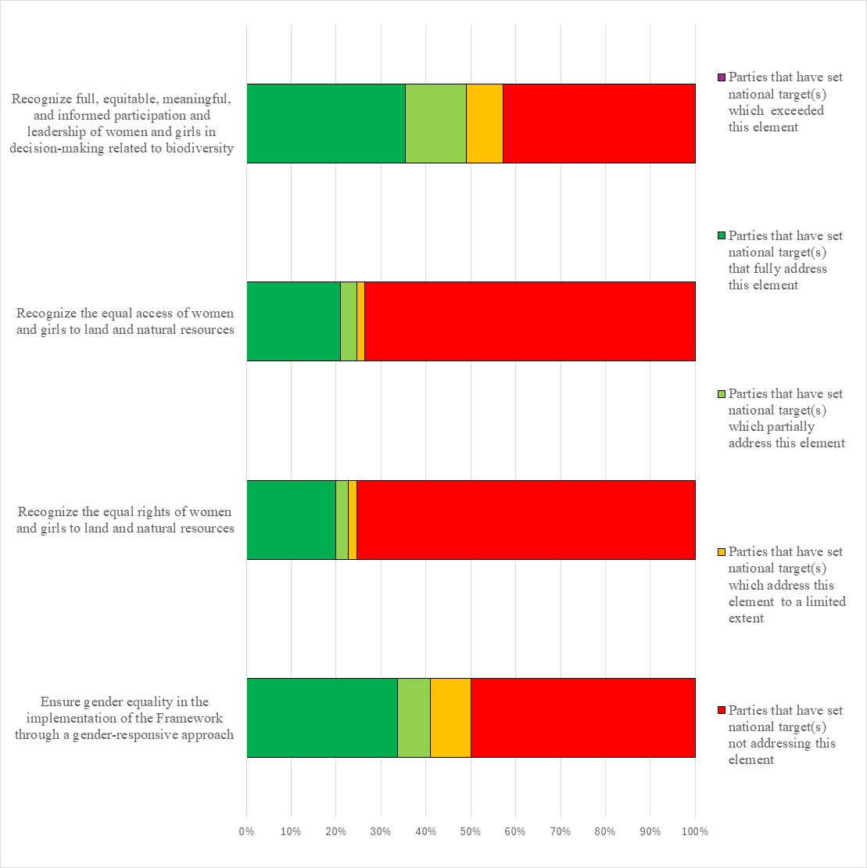
Figure 31 – Assessment of the degree to which Parties have addressed the elements of GBF Target 23 in their national target(s). The coloured bars indicate the proportion of Parties that have set national targets which correspond to each assessment category. The number of Parties represented in each bar varies with the number of Parties that have submitted national targets related to a given target of the Kunming-Montreal Global Biodiversity Framework.

Annex I
Status of development of national biodiversity strategies and action plans
- All Parties (196) have submitted at least one national biodiversity strategy and action plan as of 7 July 2025. Below is the year of adoption of the national biodiversity strategies and action plans (where the year of adoption is unknown, the year of completion is provided.)
- National biodiversity strategies and action plans revised or updated in line with the Kunming-Montreal Global Biodiversity Framework (submitted as per decision 15/6) are identified with a † symbol. The national biodiversity strategies and action plans considered in this analysis are identified with a ± symbol.

- Afghanistan (2014, 2023†)±
- Albania (1999, 2016)
- Algeria (2005, 2016)
- Andorra (2016†)±
- Angola (2006, 2019)
- Antigua and Barbuda (2014)
- Argentina (2003, 2017, 2024†)±
- Armenia (1999, 2015)
- Australia (1996, 2010, 2019, 2024†)±
- Austria (1998, 2005, 2014, 2024†)±
- Azerbaijan (2004, 2016)
- Bahamas (1999)
- Bahrain (2007, 2016)
- Bangladesh (2006, 2016)
- Barbados (2002, 2020)
- Belarus (1997, 2010, 2015)
- Belgium (2007, 2013, 2025†)±
- Belize (1998, 2016)
- Benin (2002, 2016)
- Bhutan (1997, 2002, 2009, 2014)
- Bolivia (Plurinational State of) (2001, 2018)
- Bosnia and Herzegovina (2011*, 2016) *adopted, prepared prior to COP-10
- Botswana (2005, 2007, 2016)
- Brazil (2002, 2006, 2016)
- Brunei Darussalam (2015)
- Bulgaria (2000, 2005)
- Burkina Faso (1999, 2011, 2024†)±
- Burundi (2000, 2013, 2025†)±
- Cabo Verde (1999, 2014)
- Cambodia (2002, 2016)
- Cameroon (1999, 2012)
- Canada (1996, 2016, 2024†)±
- Central African Republic (2003)
- Chad (1999, 2014)
- Chile (2003, 2018)
- China (1994, 2010, 2023, 2024†)±
- Colombia (2005, 2012, 2017, 2024†)±
- Comoros (2000, 2016)
- Congo (2001, 2015)
- Cook Islands (2002)
- Costa Rica (1999, 2016)
- Côte d’Ivoire (2002*, 2016) *Strategy
- Croatia (1999, 2008, 2017)
- Cuba (1997, 2006, 2016, 2024†)±
- Cyprus (2020)
- Czechia (2005, 2016)
- Democratic People’s Republic of Korea (1998, 2007)
- Democratic Republic of the Congo (2000, 2002, 2016)
- Denmark (1996*, 2004**, 2014, 2024†)± *Strategy, **Action Plan
- Djibouti (2001, 2017)
- Dominica (2002, 2013)
- Dominican Republic (2011)
- Ecuador (2001, 2016)
- Egypt (1998, 2016)
- El Salvador (1999, 2013)
- Equatorial Guinea (2005, 2015)
- Eritrea (2000, 2014)
- Estonia (1999, 2012)
- Ethiopia (2006, 2015)
- European Union (1998, 2006, 2011, 2020*†)± *Adopted by the European Commission in May 2020
- Fiji (2003, 2020)
- Finland (1997, 2006, 2012)
- France (2004, 2011, 2023†)± *Strategy adopted in 2004; Sectoral Action Plans adopted between 2006-2008 and revised in 2009; Strategy revised in 2011 and 2023
- Gabon (1999)
- Gambia (1999, 2015)
- Georgia (2005, 2014)
- Germany (2007*, 2015**, 2024†)± *Strategy, **Nature Conservation Action Programme 2020 for Strategy (2007)
- Ghana (2002*, 2016) *Strategy only
- Greece (2014)
- Grenada (2000, 2016)
- Guatemala (1999, 2014)
- Guinea (2001, 2016)
- Guinea-Bissau (2001, 2015)
- Guyana (1999*, 2007*, 2015) * Action Plan only
- Haiti (2020)
- Honduras (2001, 2017)
- Hungary (2008, 2015, 2023†)
- Iceland (2008*, 2010**)± *Strategy; **Action Plan (intend to develop Aichi-compliant targets only)
- India (1999, 2008, 2014*, 2024†)± *Addendum to NBAP 2008
- Indonesia (1993, 2003, 2016, 2024†)±
- Iran (Islamic Republic of) (2006, 2016, 2024†)±
- Iraq (2015)
- Ireland (2002, 2011, 2017, 2023†)±
- Israel (2010)
- Italy (2010, 2023†)±
- Jamaica (2003, 2016)
- Japan (1995, 2002, 2008, 2010, 2012, 2023†)±
- Jordan (2001, 2015, 2024†)±
- Kazakhstan (1999)
- Kenya (1999)
- Kiribati (2006, 2016)
- Kuwait (completed 1997 - not adopted; 2018)
- Kyrgyzstan (1998, 2002, 2014)
- Lao People’s Democratic Republic (2004, 2016)
- Latvia (2000, 2003*, 2014) *Action Plan revised
- Lebanon (1998, 2005, 2016)
- Lesotho (2000)
- Liberia (2003, 2017)
- Libya (2023†)±
- Liechtenstein (2014, 2024†)±
- Lithuania (1998, 2015)
- Luxembourg (2007, 2017, 2023†)±
- Madagascar (2002, 2007, 2016)
- Malawi (2006, 2015)
- Malaysia (1998, 2016, 2023†)±
- Maldives (2002, 2015)
- Mali (2001, 2014)
- Malta (2012, 2024†)±
- Marshall Islands (2000)
- Mauritania (1999, 2014, 2024†)±
- Mauritius (2006, 2017)
- Mexico (2000, 2016, 2023†)
- Micronesia (Federated States of) (2002, 2018)
- Monaco (2021)
- Mongolia (1996, 2015)
- Montenegro (2010, 2016)
- Morocco (2002, 2004, 2016)
- Mozambique (2001, 2003, 2015)
- Myanmar (2012, 2015)
- Namibia (2002, 2014)
- Nauru (2010)
- Nepal (2002, 2014)
- Netherlands (Kingdom of the) (1995, 2001, 2008, 2013, 2024*†)±*Curaçao and Aruba completed in 2024, Kingdom of the Netherlands completed in 2025.
- New Zealand (2000, 2016, 2020)
- Nicaragua (2001, 2016)
- Niger (2000, 2009, 2014)
- Nigeria (2006, 2015, 2025†)
- Niue (2001, 2015)
- North Macedonia (2005, 2018)
- Norway (2001, 2004, 2006, 2015, 2024†)±
- Oman (2001)
- Pakistan (1999, 2018)
- Palau (2005, 2018)
- Panama (2000, 2018)
- Papua New Guinea (2007, 2019)
- Paraguay (2003, 2016)
- Peru (2001, 2014, 2024†)±
- Philippines (1997, 2002, 2015)
- Poland (2003, 2007, 2015)
- Portugal (2001, 2018)
- Qatar (2004, 2014)
- Republic of Korea (1997, 2009, 2014, 2018, 2024†)±
- Republic of Moldova (2000, 2015, 2024†)±
- Romania (1996, 2001, 2014)
- Russian Federation (2001, 2014)
- Rwanda (2003, 2016)
- Saint Kitts and Nevis (2004, 2014)
- Saint Lucia (2000, 2018)
- Saint Vincent and the Grenadines (2004, 2017)
- Samoa (2001, 2015)
- San Marino (2018)
- Sao Tome and Principe (2005, 2016)
- Saudi Arabia (2005) (do not intend to revise their NBSAP as existing framework responds to SP/ABTs)
- Senegal (1998, 2015)
- Serbia (2011, 2021)
- Seychelles (2008, 2015)
- Sierra Leone (2003, 2017)
- Singapore (1992, 2002, 2009, 2019)
- Slovakia (1998, 2002*, 2014) *Action Plan updated only
- Slovenia (2001*, 2020†)± * Strategy only
- Solomon Islands (2009, 2016)
- Somalia (2015)
- South Africa (2005, 2015)
- South Sudan (2018)
- Spain (1999*, 2005*, 2011**, 2022***†)± *Strategy; **Action Plan, ***Strategic Plan received post-COP15
- Sri Lanka (1998, 2016)
- State of Palestine (2022†)±
- Sudan (2000, 2015)
- Suriname (2006*, 2013**, 2024†)±*Strategy; **Action Plan
- Swaziland (2001, 2016)
- Sweden (1995, 2006, 2014)
- Switzerland (2006, 2012*, 2017**, 2024†)± *Strategy; **Action Plan
- Syrian Arab Republic (2002)
- Tajikistan (2003, 2016)
- Thailand (1997, 2002, 2008, 2015, 2024†)±
- Timor-Leste (2011, 2015)
- Togo (2003, 2014, 2024†)±
- Tonga (2006, 2022†)±
- Trinidad and Tobago (2001, 2018)
- Tunisia (1998, 2009, 2017, 2024†)±
- Turkey (2001, 2007, 2018)
- Turkmenistan (2002, 2018)
- Tuvalu (2013)
- Uganda (2002, 2015, 2025†)±
- Ukraine (1998*, 2000**, 2010***, 2011****) *Strategy only; **Strategy and Action Plan, ***Revised Strategy; ****Revised Action Plan
- United Arab Emirates (2014, 2023†)±
- United Kingdom of Great Britain and Northern Ireland (1994, 2006, 2011, 2025†)±
- United Republic of Tanzania (2004, 2015, 2025†)±
- Uruguay (1999, 2016)
- Uzbekistan (1998)
- Vanuatu (2000, 2018)
- Venezuela (Bolivarian Republic of) (2001, 2010, 2024†)±
- Viet Nam (1994, 2007, 2015, 2022†)±
- Yemen (2005, 2017, 2024†)±
- Zambia (1999, 2015)
- Zimbabwe (2002, 2014)

Annex II
List of conventions or multilateral environmental agreements mentioned in the revised and updated national biodiversity strategies and action plans
Due to the differences in analysis procedure and search terms throughout the iterative process of analyzing the national biodiversity strategies and action plans, the list of multilateral environmental agreements may be incomplete.
Convention/MEA | NBSAPs which acknowledged, planned to ratify, or had synergies, actions, goals, or targets with the Convention/MEA
Aarhus Convention on Access to Information, Public Participation in Decision-making and Access to Justice in Environmental Matter | Republic of Moldova, Norway, State of Palestine
African Convention on the Conservation of Nature and Natural Resources (Algiers Convention) | Libya, Uganda
African-Eurasian Migratory Waterbird Agreement (AEWA) | Belgium, Italy, Luxembourg, Netherlands (Kingdom of the) (Mainland), Slovenia, State of Palestine, Togo
Agreement on the Conservation of Albatrosses and Petrels (ACAP) | Spain
Agreement on the Conservation of Cetaceans of the Black Sea, Mediterranean Sea and Contiguous Atlantic Area (ACCOBAMS) | Italy, Spain
Agreement on the Conservation of Populations of European Bats (Eurobats) | Belgium, Italy, Luxembourg, Republic of Moldova
Agreement on the Conservation of Small Cetaceans of the Baltic, Northeast Atlantic, Irish and North Seas (ASCOBANS) | Belgium, Germany
Alpine Convention | Liechtenstein
Amazon Cooperation Treaty Organization | Suriname
Amsterdam Declaration | Italy, Spain
Antarctic Treaty | Luxembourg
ASEAN Heritage Parks | Malaysia
Ballast Water Management Convention | Italy, Japan, Norway, Tonga
Baltic Marine Environment Protection Commission (HELCOM) | Germany
Barcelona Convention | Italy, State of Palestine
Basel Convention on the Control of Transboundary Movements of Hazardous Wastes and Their Disposal | Norway, Suriname
Bern Convention | Andorra, Belgium, Italy, Liechtenstein, Luxembourg, Republic of Moldova, Norway
Commission for Controlling the Desert Locust in North-West Africa | Libya
Convention for the Conservation of Antarctic Marine Living Resources (CCAMLR) | Belgium
Convention for the Protection and Development of the Marine Environment of the Wider Caribbean Region (Cartagena Convention) | Aruba (Kingdom of the Netherlands)
Convention for the Protection of the Marine Environment of the North-East Atlantic (OSPAR) | Belgium, Germany, Ireland, Norway, Spain
Convention for the Safeguarding of the Intangible Cultural Heritage | Italy
Convention on Fishing and Conservation of Living Resources of the High Seas | State of Palestine
Convention on International Trade in Endangered Species of Wild Fauna and Flora (CITES) | Afghanistan, Argentina, Australia, Austria, Belgium, Burkina Faso, Burundi, Canada, China, Colombia, Curaçao (Kingdom of the Netherlands), France, Germany, Indonesia, Ireland, Italy, Japan, Hungary, Libya, Luxembourg, Republic of Moldova, Netherlands (Kingdom of the), Norway, Peru, Republic of Korea, Slovenia, Spain, State of Palestine, Suriname, Switzerland, Thailand, Togo, Tonga, Tunisia, Uganda, Venezuela (Bolivarian Republic of)
Convention on Long-Range Transboundary Pollution (LRTAP) | Norway
Convention on the Conservation of Migratory Species of Wild Animals (CMS) | Argentina, Australia, Belgium, Burkina Faso, Curaçao (Kingdom of the Netherlands), Germany, Italy, Luxembourg, Netherlands Kingdom of the), Norway, Peru, Republic of Korea, Slovenia, State of Palestine, Thailand, Tunisia, Togo, Tonga, United Arab Emirates
Convention on the Elimination of All Forms of Discrimination Against Women (CEDAW) | Peru, Uganda
Convention on the Protection of the Black Sea Against Pollution (Bucharest Convention) | Italy
Convention on the Rights of Persons with Disabilities (CRPD) | Canada
Convention on the status of the Volta River and the Establishment of Volta Basin Authority | Burkina Faso
Convention Relating to the Preservation of Flora and Fauna in their Natural State | Uganda
Declaration on the Rights of Indigenous Peoples (UNDRIP) | Norway, Peru
East Asian-Australasian Flyway Partnership (EAAFP) | Japan, Malaysia, Republic of Korea
Espoo Convention on Environmental Impact Assessment in a Transboundary Context | State of Palestine
EU Water Framework Directive (Water Directive) | Norway
European Landscape Convention | Andorra, Italy, Republic of Moldova, Norway, Slovenia
High Seas Treaty (BBNJ) | Belgium, European Union, France, Germany, Indonesia, Norway, Republic of Korea, Slovenia, Spain
Indigenous and Tribal Peoples Convention (ILO Convention 169) | Peru
International Convention for the Prevention of Pollution from Ships (MARPOL) | Japan, Tonga
International Convention on Civil Liability for Oil Pollution Damage (CLC) | Aruba (Kingdom of the Netherlands)
International Convention on the Establishment of an International Fund for Compensation for Oil Pollution Damage (FUND) | Aruba (Kingdom of the Netherlands)
International Plant Protection Convention (IPPC) | Argentina, Burkina Faso, Libya, Norway, Peru, Suriname, Togo
International Seabed Authority (ISA) | Canada
International Treaty on Plant Genetic Resources for Food and Agriculture (ITPGRFA) | Argentina, Burkina Faso, Canada, Jordan, Netherlands (Kingdom of the), Norway, Peru, State of Palestine, Togo, Uganda
International Tropical Timber Agreement (ITTA) | Suriname, Togo
International Union for the Protection of New Varieties of Plants (UPOV) | Belgium, Burkina Faso
International Whaling Commission (ICRW) | Australia, Belgium, Spain, Switzerland
Kyoto Protocol | Libya, State of Palestine
London Dumping Convention/Protocol | Japan, State of Palestine, Suriname
Lusaka Agreement on Cooperative Enforcement Operations Directed at Illegal Trade in Wild Fauna and Flora | Uganda
Maputo Convention | Burkina Faso
Minamata Convention on Mercury | Norway, Suriname
Montreal Protocol on Substances That Deplete the Ozone Layer (Montreal Protocol) | State of Palestine
MoU on Prey Birds | Libya
MoU on Sharks | Italy
New Plastics Treaty' | Japan, Norway
Noumea Convention | Tonga
Oil Spills Protocol of the Convention for the protection and development of the marine environment of the wider Caribbean region | Aruba (Kingdom of the Netherlands)
Paris Agreement | Cuba, European Union, Germany, Italy, Libya, Republic of Moldova, Norway, Suriname, Thailand
Protocol Concerning Cooperation in Combating Pollution of the Mediterranean Sea by Oil and Other Harmful Substances in Cases of Emergency (Emergency Protocol) | State of Palestine
Protocol Concerning Specially Protected Areas and Wildlife to the Convention for the Protection and Development of the Marine Environment of the Wider Caribbean Region (SPAW Protocol) | Aruba (Kingdom of the Netherlands)
Ramsar Convention on Wetlands of International Importance Especially as Waterfowl Habitat (Ramsar) | Argentina, Aruba (Kingdom of the Netherlands), Australia, Belgium, Burkina Faso, Canada, China, Colombia, Curaçao (Kingdom of the Netherlands), Hungary, Indonesia, Ireland, Italy, Japan, Jordan, Libya, Luxembourg, Malaysia, Republic of Moldova, Netherlands (Kingdom of the), Norway, Peru, Republic of Korea, Slovenia, Spain, Suriname, Thailand, Tonga, Tunisia, Togo, Uganda, United Arab Emirates, Viet Nam
Rotterdam Convention on the Prior Informed Consent Procedure for Certain Hazardous Chemicals and Pesticides in International Trade (Rotterdam Convention) | Norway, Suriname, Tonga
Sendai Framework for Disaster Risk Reduction | Thailand
Stockholm Convention on Persistent Organic Pollutants (Stockholm Convention) | Canada, Norway, Suriname, Tonga, Tunisia
UN Covenant on Civil and Political Rights | Norway
UNESCO Man and the Biosphere Programme (MAB) | Italy, Malaysia, Spain
United Nations Convention on the Law of the Sea (UNCLOS) | Belgium, Canada, Indonesia, Norway
United Nations Convention to Combat Desertification (UNCCD) | Argentina, Australia, Belgium, Burkina Faso, France, Germany, Ireland, Italy, Libya, Malta, Netherlands (Kingdom of the), Norway, Peru, State of Palestine, Suriname, Thailand, Togo, Tonga, Tunisia, Uganda, United Kingdom, Yemen
United Nations Educational, Scientific and Cultural Organization (UNESCO) | Belgium, Germany, Netherlands (Kingdom of the), Norway, Suriname
United Nations Framework Convention on Climate Change (UNFCCC) | Andorra, Australia, Austria, Belgium, Burkina Faso, Canada, France, Germany, Ireland, Italy, Japan, Libya, Malta, Netherlands (Kingdom of the), Peru, Republic of Korea, Slovenia, State of Palestine, Suriname, Thailand, Tonga, Tunisia, Uganda, United Arab Emirates, United Kingdom, Yemen
Vienna Convention for the Protection of the Ozone Layer (Vienna Protocol) | State of Palestine
Waigani Convention | Tonga
World Heritage Convention (WHC) | Argentina, Australia, Belgium, Germany, Hungary, Italy, Norway, Peru, State of Palestine, Uganda

Annex III
Parties whose national targets were considered in the analysis of national targets

- Algeria
- Angola
- Armenia
- Australia
- Austria
- Azerbaijan
- Bangladesh
- Belarus
- Belgium
- Benin
- Bhutan
- Bolivia (Plurinational State of)
- Bosnia and Herzegovina
- Botswana
- Burkina Faso
- Burundi
- Cabo Verde
- Cambodia
- Cameroon
- Canada
- Central African Republic
- Chad
- Chile
- China
- Colombia
- Comoros
- Cook Islands
- Costa Rica
- Côte d'Ivoire
- Croatia
- Cuba
- Cyprus
- Czechia
- Democratic Republic of the Congo
- Djibouti
- Dominican Republic
- Ecuador
- Egypt
- El Salvador
- Equatorial Guinea
- Eritrea
- Eswatini
- Ethiopia
- European Union
- Fiji
- Finland
- France
- Gabon
- Ghana
- Guatemala
- Guinea
- Guyana
- Honduras
- Hungary
- India
- Indonesia
- Iran (Islamic Republic of)
- Iraq
- Ireland
- Israel
- Italy
- Japan
- Jordan
- Kazakhstan
- Kenya
- Lao People’s Democratic Republic
- Lebanon
- Liberia
- Libya
- Liechtenstein
- Luxembourg
- Madagascar
- Malawi
- Malaysia
- Mali
- Malta
- Marshall Islands
- Mexico
- Mongolia
- Morocco
- Mozambique
- Namibia
- Nauru
- Nepal
- Netherlands (Kingdom of the)
- New Zealand
- Niger
- Nigeria
- Norway
- Pakistan
- Palau
- Panama
- Papua New Guinea
- Paraguay
- Peru
- Philippines
- Portugal
- Qatar
- Republic of Korea
- Republic of Moldova
- Russian Federation
- Rwanda
- Samoa
- Saudi Arabia
- Senegal
- Sierra Leone
- Singapore
- Slovenia
- Somalia
- South Africa
- South Sudan
- Spain
- Sudan
- Suriname
- Sweden
- Thailand
- Togo
- Tonga
- Tunisia
- Türkiye
- Uganda
- United Arab Emirates
- United Kingdom of Great Britain and Northern Ireland
- Uruguay
- Uzbekistan
- Vanuatu
- Venezuela (Bolivarian Republic of)
- Yemen
- Zambia
- Zimbabwe

__________

* CBD/SBSTTA/27/1.
** The present document is being issued without formal editing.
All national biodiversity strategies and action plans aligned with the Kunming-Montreal Global Biodiversity Framework and national targets are available in the Convention’s online reporting tool: https://ort.cbd.int/. However, note that all Parties have developed at least one national biodiversity strategy and action plan since they became a Party. Currently, no Party has yet submitted a seventh national report.
CBD/COP/15/9/Add.1.
CBD/SBI/5/2/Add.1/Rev.1.
Of these, 5 NBSAPs (Indonesia, Italy, Netherlands (Kingdom of the), Norway, Thailand) were received in non-UN official languages and were analysed using an automated or a courtesy translation.
Afghanistan, Andorra, Argentina, Australia, Austria, Belgium, Burkina Faso, Burundi, Canada, China, Colombia, Cuba, Denmark, European Union, France, Germany, Hungary, India, Iran (Islamic Republic of), Ireland, Italy, Libya, Liechtenstein, Malaysia, Malta, Mauritania, Norway, Republic of Korea, Republic of Moldova, Slovenia, Spain, State of Palestine, Switzerland, Thailand, Togo, Tonga, Tunisia, Uganda, United Kingdom of Great Britain and Northern Ireland, United Republic of Tanzania, Venezuela (Bolivarian Republic of), Viet Nam, Yemen.
Indonesia, Japan, Jordan, Peru, Suriname, United Arab Emirates.
Algeria, Angola, Bolivia (Plurinational State of), Botswana, Cabo Verde, Chile, Congo, Costa Rica, Croatia, Czechia, Ecuador, Egypt, Fiji, Greece, Guinea, Haiti, Kyrgyzstan, Lao People’s Democratic Republic, Lebanon, Liberia, Madagascar, Malawi, Maldives, Mauritius, Micronesia (Federated States of), Mongolia, North Macedonia, Palau, Papua New Guinea, Philippines, Qatar, Saint Lucia, San Marino, Mexico, Monaco, Pakistan, Senegal, Sierra Leone, Somalia, South Africa, South Sudan, Türkiye, Turkmenistan, Vanuatu, Zambia.
Barbados, New Zealand.
Albania, Armenia, Bhutan, Brazil, Democratic People’s Republic of Korea, El Salvador, Equatorial Guinea, Myanmar, Nauru, Niue, Rwanda.
The NBSAPs that were submitted before May 31, 2025, could resubmit information until July 25, 2025, to add information to their submission on the Online Reporting Tool to clarify whether a Whole-of-Government Approach was used or not.
Australia, Burkina Faso, India, Suriname, United Kingdom, Venezuela (Bolivarian Republic of).
Australia, Canada, Burkina Faso, Cuba, European Union, France, Hungary, Ireland, Italy, Japan, Liechtenstein, Luxembourg, Malaysia, Peru, Spain, Suriname, Switzerland, Thailand, Togo, United Arab Emirates, United Kingdom, Viet Nam, Venezuela (Bolivarian Republic of) and Yemen.
Argentina, Belgium, Burkina Faso, Burundi, Canada, China, European Union, France, Germany, Ireland, Italy, Malaysia, Malta, Mauritania, Netherlands (Kingdom of the), Norway, Peru, Slovenia, State of Palestine, Suriname, Switzerland, Thailand, Togo, Tonga, Tunisia, Uganda, Venezuela (Bolivarian Republic of), Yemen.
Burundi, Canada, Germany, Ireland, Mauritania, Norway, Peru, Slovenia, State of Palestine, Switzerland, Thailand, Tonga, Tunisia, United Arab Emirates, Yemen. There is overlap between the NBSAPs which detail successes, lessons learned, and implementation challenges: these categories are not mutually exclusive.
Canada, France, Germany, Italy, Netherlands (Kingdom of the), Peru, Slovenia, State of Palestine, Switzerland, Thailand, Togo, Uganda, Venezuela (Bolivarian Republic of), Yemen.
Canada, Mauritania, Slovenia, Suriname, Tonga, Tunisia, Yemen.
Afghanistan, Andorra, Argentina, Austria, Belgium, Burkina Faso, Burundi, China, Colombia, France, Germany, India, Indonesia, Ireland, Japan, Luxembourg, Malaysia, Republic of Korea, Togo, Tonga, United Kingdom, Venezuela (Bolivarian Republic of).
Aruba (Kingdom of the Netherlands), Curaçao (Kingdom of the Netherlands), Libya, Mauritania, State of Palestine, Uganda.
Canada, Cuba, European Union, Liechtenstein, Republic of Moldova, Spain, Suriname, Thailand, United Republic of Tanzania.
Afghanistan, Andorra, Argentina, Aruba (Kingdom of the Netherlands), Australia, Austria, Belgium, Burundi, Canada, China, Colombia, Cuba, Curaçao (Kingdom of the Netherlands), France, Germany, India, Indonesia, Ireland, Italy, Jordan, Liechtenstein, Luxembourg, Malta, Mauritania, Netherlands (Kingdom of the), Norway, Peru, Republic of Korea, Slovenia, State of Palestine, Suriname, Switzerland, Thailand, Tonga, Tunisia, Uganda, United Arab Emirates, United Kingdom, Venezuela (Bolivarian Republic of), Yemen.
Afghanistan, Andorra, Argentina, Aruba (Kingdom of the Netherlands), Austria, Belgium, Burundi, Canada, Colombia, Curaçao (Kingdom of the Netherlands), France, Germany, India, Ireland, Italy, Jordan, Liechtenstein, Luxembourg, Malta, Mauritania, Netherlands (Kingdon of the), Norway, Peru, Republic of Korea, Slovenia, State of Palestine, Suriname, Switzerland, Thailand, Tonga, Tunisia, Uganda, United Arab Emirates, United Kingdom, Venezuela (Bolivarian Republic of), Yemen.
Afghanistan, Argentina, Aruba (Kingdom of the Netherlands), Austria, Belgium, Canada, China, Colombia, Cuba, Curaçao (Kingdom of the Netherlands), France, Germany, India, Indonesia, Iran (Islamic Republic of), Ireland, Italy, Jordan, Liechtenstein, Luxembourg, Malta, Mauritania, Norway, Republic of Korea, State of Palestine, Suriname, Switzerland, Thailand, Tonga, Uganda, United Arab Emirates, United Kingdom, Venezuela (Bolivarian Republic of), Yemen.
Afghanistan, Andorra, Argentina, Austria, Canada, France, Germany, India, Ireland, Jordan, Liechtenstein, Mauritania, Netherlands (Kingdom of the), Norway, Peru, Republic of Korea, Slovenia, State of Palestine, Suriname, Switzerland, Thailand, Tonga, Uganda, United Arab Emirates, United Kingdom, Venezuela (Bolivarian Republic of).
Afghanistan, Andorra, Argentina, Australia, Austria, Belgium, Canada, France, Germany, India, Ireland, Liechtenstein, Luxembourg, Netherlands (Kingdom of the), Norway, Switzerland, Tunisia, Uganda, United Arab Emirates, United Kingdom, Venezuela (Bolivarian Republic of).
Andorra, Canada, France, Germany, India, Ireland, Italy, Netherlands (Kingdom of the), Norway, Republic of Korea, Slovenia, State of Palestine, Suriname, Thailand, Tonga, Tunisia, Uganda, United Kingdom, Venezuela (Bolivarian Republic of), Yemen.
Argentina, Canada, Colombia, France, Germany, India, Ireland, Italy, Jordan, Liechtenstein, Mauritania, Netherlands (Kingdom of the), Norway, Suriname, Thailand, Tonga, Uganda, United Arab Emirates, United Kingdom, Venezuela (Bolivarian Republic of).
Afghanistan, Argentina, Belgium, Canada, Colombia, France, Germany, India, Jordan, Netherlands (Kingdom of the), Peru, State of Palestine, Switzerland, Thailand, Uganda, United Arab Emirates, United Kingdom, Venezuela (Bolivarian Republic of).
Afghanistan, Canada, Colombia, Germany, India, Ireland, Netherlands (Kingdom of the), Norway, Peru, Republic of Korea, Thailand, Tonga, Uganda, Venezuela (Bolivarian Republic of).
Argentina, Canada, Colombia, Indonesia, Jordan, Norway, Peru, State of Palestine, Suriname, Thailand, Tonga, Uganda, Venezuela (Bolivarian Republic of).
Austria, Belgium, Canada, France, Germany, Ireland, Italy, Luxembourg, Peru, Republic of Korea, Tonga, United Kingdom.
Afghanistan, Andorra, Argentina, Aruba (Kingdom of the Netherlands), Australia, Austria, Belgium, Burkina Faso, Burundi, Canada, China, Colombia, Cuba, Curaçao (Kingdom of the Netherlands), Denmark, European Union, France, India, Indonesia, Iran (Islamic Republic of), Ireland, Italy, Libya, Liechtenstein, Malaysia, Mauritania, Netherlands (Kingdom of the), Norway, Peru, Republic of Moldova, Slovenia, Suriname, Thailand, Togo, Tonga, Tunisia, Uganda, United Arab Emirates, United Kingdom, Venezuela (Bolivarian Republic of), Viet Nam, Yemen.
Afghanistan, Aruba (Kingdom of the Netherlands), Austria, Belgium, Burkina Faso, Burundi, Canada, Cuba, Curaçao (Kingdom of the Netherlands),Denmark, France, India, Indonesia, Ireland, Italy, Libya, Liechtenstein, Luxembourg, Malaysia, Netherlands (Kingdom of the), Norway, Republic of Korea, Slovenia, State of Palestine, Suriname, Switzerland, Thailand, Togo, Tonga, Tunisia, Uganda, United Arab Emirates, Viet Nam, Yemen.
Argentina, Aruba (Kingdom of the Netherlands), Austria, Burkina Faso, Burundi, Canada, China, Colombia, Cuba, Curaçao (Kingdom of the Netherlands), Denmark, European Union, France, Germany, Hungary, India, Indonesia, Ireland, Italy, Japan, Jordan, Libya, Luxembourg, Malaysia, Netherlands (Kingdom of the), Norway, Peru, Republic of Korea, Republic of Moldova, Slovenia, State of Palestine, Suriname, Switzerland, Thailand, Togo, Tunisia, Uganda, United Arab Emirates, Venezuela (Bolivarian Republic of), Viet Nam, Yemen.
Aruba (Kingdom of the Netherlands), Burundi, Colombia, Cuba, Denmark, Germany, Ireland, Italy, Libya, Peru, Slovenia, Thailand, Uganda, United Arab Emirates, Yemen.
Argentina, Aruba (Kingdom of the Netherlands), Burundi, Colombia, Germany, Hungary, Ireland, Italy, Jordan, Libya, Republic of Korea, Republic of Moldova, Slovenia, Thailand, Uganda, United Arab Emirates, Venezuela (Bolivarian Republic of), Yemen.
For example, by Aruba (Kingdom of the Netherlands),Austria, Denmark, India, Italy, Netherlands (Kingdom of the), Republic of Korea.
Austria, Burkina Faso, Burundi, China, Colombia, Curaçao (Kingdom of the Netherlands), Denmark, European Union, France, Hungary, India, Indonesia, Ireland, Italy, Norway, Malaysia, Republic of Moldova, Slovenia, Suriname, Thailand, Togo, Tonga, Tunisia, Uganda, United Arab Emirates, United Kingdom, Yemen.
Austria, Burkina Faso, Burundi, China, Colombia, India, Indonesia, Ireland, Malaysia, Netherlands (Kingdom of the), Republic of Moldova, Suriname, Thailand, Togo, Tonga, Tunisia, Uganda, Yemen.
Burkina Faso, Burundi, Colombia, European Union, France, India, Ireland, Libya, Norway, Republic of Moldova, Suriname, Slovenia, Togo, Tunisia, Uganda, Yemen.
Burkina Faso, European Union, India, Ireland, Norway, Togo.
Burkina Faso, European Union, India, Ireland, Norway, Togo.
Burkina Faso, Colombia, European Union, France, India, Ireland, Norway, Republic of Moldova, Togo, Yemen.
Afghanistan, Andorra, Argentina, Belgium, Burkina Faso, Burundi, Canada, China, Cuba, European Union, France, Germany, Hungary, Indonesia, Ireland, Italy, Japan, Liechtenstein, Luxembourg, Malaysia, Republic of Korea, Republic of Moldova, Slovenia, Suriname, Switzerland, Thailand, Togo, Tonga, Tunisia, Uganda, United Kingdom, Yemen.
Afghanistan, Andorra, Argentina, Aruba (Kingdom of the Netherlands), Austria, Burkina Faso, China, Curaçao (Kingdom of the Netherlands), Germany, Indonesia, Luxembourg, Malaysia, Republic of Korea, Republic of Moldova, State of Palestine, Switzerland, Thailand, Togo, Tonga, Tunisia, Uganda, United Arab Emirates, Venezuela (Bolivarian Republic of).
Aruba (Kingdom of the Netherlands), Australia, Belgium, Burundi, Canada, Cuba, Curaçao (Kingdom of the Netherlands), European Union, France, Hungary, Iran (Islamic Republic of), Ireland, Italy, Japan, Jordan, Libya, Liechtenstein, Malta, Netherlands (Kingdom of the), Norway, Peru, Slovenia, Spain, Suriname, United Kingdom, United Republic of Tanzania, Viet Nam, Yemen.
Afghanistan, Andorra, Argentina, Aruba (Kingdom of the Netherlands), Belgium, Canada, China, Cuba, Germany, Hungary, Ireland, Italy, Libya, Liechtenstein, Malaysia, Malta, Netherlands (Kingdom of the), Republic of Korea, Republic of Moldova, State of Palestine, Suriname, Thailand, Tonga, Uganda, United Arab Emirates, United Kingdom.
Colombia, Indonesia, Jordan, Mauritania, Republic of Moldova, Venezuela (Bolivarian Republic of).
Andorra, Burkina Faso, Canada, China, France, Japan, Malaysia, Netherlands (Kingdom of the), Peru, State of Palestine, Suriname, Tonga, Tunisia, Uganda, United Arab Emirates, United Republic of Tanzania.
Aruba (Kingdom of the Netherlands), Australia, Belgium, Burkina Faso, Canada, China, Colombia, Cuba, European Union, Hungary, India, Indonesia, Iran (Islamic Republic of), Ireland, Italy, Japan, Luxembourg, Malaysia, Malta, Mauritania, Curaçao(Kingdom of the Netherlands), Norway, Peru, Republic of Korea, Republic of Moldova, Slovenia, State of Palestine, Suriname, Thailand, Tonga, Tunisia, Uganda, Venezuela (Bolivarian Republic of).
Afghanistan, Burkina Faso, Burundi, China, Indonesia, Malaysia, State of Palestine, Tonga, Uganda, Yemen,
Andorra, Aruba (Kingdom of the Netherlands), Austria, Belgium, Burkina Faso, Canada, China, Colombia, Curaçao (Kingdom of the Netherlands), Denmark, European Union, France, Germany, Hungary, India, Indonesia, Ireland, Italy, Japan, Liechtenstein, Malaysia, Malta, Norway, Peru, Republic of Korea, Slovenia, State of Palestine, Thailand, United Arab Emirates , United Kingdom, United Republic of Tanzania, Venezuela (Bolivarian Republic of).
Burkina Faso, Canada, Denmark, Germany, Indonesia, Japan, Malaysia, Republic of Korea, United Kingdom.
Andorra, Aruba (Kingdom of the Netherlands), Austria, Belgium, China, Colombia, Curaçao (Kingdom of the Netherlands), European Union, France, Germany, Hungary, India, Indonesia, Ireland, Italy, Japan, Liechtenstein, Malaysia, Malta, Norway, Peru, Republic of Korea, Slovenia, State of Palestine, Thailand, United Arab Emirates.
China, Curaçao (Kingdom of the Netherlands), France, Ireland, United Republic of Tanzania.
Afghanistan, Andorra, Argentina, Aruba (Kingdom of the Netherlands), Australia, Austria, Belgium, Burkina Faso, Burundi, Canada, China, Colombia, Cuba, Curaçao (Kingdom of the Netherlands), European Union, France, Germany, Hungary, Indonesia, Ireland, Italy, Japan, Jordan, Libya, Liechtenstein, Luxembourg, Malaysia, Malta, Netherlands (Kingdom of the), Norway, Peru, Republic of Korea, Republic of Moldova, Slovenia, Spain, State of Palestine, Suriname, Switzerland, Thailand, Togo, Tonga, Tunisia, Uganda, United Arab Emirates , United Kingdom, Venezuela (Bolivarian Republic of), Viet Nam, Yemen.
Afghanistan, Argentina, Aruba (Kingdom of the Netherlands), Australia, Austria, Belgium, Burkina Faso, Burundi, Canada, China, Colombia, Curaçao (Kingdom of the Netherlands), France, Germany, Hungary, Indonesia, Ireland, Italy, Japan, Jordan, Libya, Luxembourg, Malaysia, Netherlands (Kingdom of the), Norway, Peru, Republic of Korea, Republic of Moldova, Slovenia, Spain, State of Palestine, Suriname, Switzerland, Thailand, Togo, Tonga, Tunisia, Uganda, United Arab Emirates , Venezuela (Bolivarian Republic of), Viet Nam. Biodiversity-related conventions strictly refers to the MEAs which are a part of the Liaison Group of Biodiversity-related Conventions.
Canada, Norway, State of Palestine, Suriname, Tonga, Tunisia. Chemicals-related conventions refers to MEAs and Conventions as described in the Global Framework on Chemicals Annex II.u, excluding CEDAW and including the Vienna Protocol.
Andorra, Argentina, Australia, Austria, Burkina Faso, Canada, France, Germany, Ireland, Italy, Japan, Libya, Malta, Netherlands (Kingdom of the), Peru, Republic of Korea, Slovenia, State of Palestine, Suriname, Thailand, Togo, Tonga, Tunisia, Uganda, United Arab Emirates, United Kingdom, Yemen. Apart from CBD, the Rio conventions include UNCCD and UNFCCC.
Aruba (Kingdom of the Netherlands), Canada, European Union, France, Germany, Indonesia, Ireland, Italy, Japan, Norway, Republic of Korea, Slovenia, Spain, State of Palestine, Suriname, Tonga. Marine-related conventions refers to the following agreements: ACCOBAMS, ASCOBANS, Ballast Water, HELCOM, Barcelona, Cartagena, OSPAR, Fishing & Conservation on the High Seas, Bucharest, BBNJ, MARPOL, CLC, FUND, ISA, LC/LP, Noumea, Oil Spills in Caribbean, Emergency Protocol, SPAW Protocol, and UNCLOS.
Burkina Faso, Canada, Germany, Italy, Luxembourg, Netherlands (Mainland), Norway, Peru, Suriname, Uganda. Human rights-related conventions refers to the following agreements: CEDAW, CRPD, UNDRIP, ILO 169, Maputo, UN Covenant on Civil and Political Rights, UNESCO.
Afghanistan, Andorra, Argentina, Austria, Belgium, Burundi, Canada, China, Colombia, Curaçao (Kingdom of the Netherlands), European Union, France, Germany, Hungary, Ireland, Italy, Japan, Liechtenstein, Malaysia, Malta, Netherlands (Kingdom of the), Norway, Peru, Republic of Korea, Republic of Moldova, Slovenia, Spain, Suriname, Switzerland, Thailand, Togo, Tonga, Tunisia, Uganda, United Kingdom, Venezuela (Bolivarian Republic of), Viet Nam, Yemen.
Argentina, Aruba (Kingdom of the Netherlands), Australia, Belgium, Burkina Faso, Canada, China, Cuba, European Union, France, Germany, Hungary, Indonesia, Italy, Japan, Jordan, Libya, Luxembourg, Malta, Netherlands (Kingdom of the), Norway, Peru, Republic of Korea, Republic of Moldova, Slovenia, Spain, State of Palestine, Suriname, Thailand, Togo, Tonga, Uganda, United Arab Emirates. Of these 33 NBSAPs, 21 also integrated at least one MEA into at least one goal, target, or action.
Afghanistan, Aruba (Kingdom of the Netherlands), Austria, Belgium, Burkina Faso, Burundi, China, Colombia, Cuba, Curaçao (Kingdom of the Netherlands), Denmark, European Union, France, Germany, Hungary, India, Indonesia, Iran (Islamic Republic of), Ireland, Italy, Japan, Jordan, Libya, Luxembourg, Malaysia, Malta, Mauritania, Netherlands (Kingdom of the), Norway, Peru, Republic of Korea, Republic of Moldova, Slovenia, Spain, State of Palestine, Suriname, Switzerland, Thailand, Togo, Tonga, Tunisia, Uganda, United Arab Emirates, United Kingdom, United Republic of Tanzania, Venezuela (Bolivarian Republic of), Viet Nam, Yemen.
Aruba (Kingdom of the Netherlands), Austria, Belgium, Burkina Faso, Colombia, Cuba, Curaçao (Kingdom of the Netherlands), Denmark, European Union, France, Germany, Hungary, India, Iran (Islamic Republic of), Ireland, Italy, Japan, Luxembourg, Netherlands (Kingdom of the), Peru, Republic of Moldova, Slovenia, Spain, Switzerland, Togo, Uganda, United Arab Emirates, United Kingdom, Venezuela (Bolivarian Republic of), Viet Nam.
Argentina, Austria, Belgium, Burkina Faso, Canada, China, Colombia, Cuba, Curaçao (Kingdom of the Netherlands), Denmark, France, Germany, Hungary, Indonesia, Iran (Islamic Republic of), Japan, Jordan, Libya, Malaysia, Malta, Netherlands (Kingdom of the), Norway, Peru, Republic of Korea, Republic of Moldova, Slovenia, State of Palestine, Suriname, Thailand, Togo, Tonga, Tunisia, Uganda, United Arab Emirates , United Kingdom, United Republic of Tanzania, Venezuela (Bolivarian Republic of), Viet Nam, Yemen.
Denmark, Jordan.
Argentina, Belgium, Burkina Faso, Canada, China, Colombia, Cuba, France, Germany, Hungary, Indonesia, Iran (Islamic Republic of), Japan, Libya, Malaysia, Malta, Netherlands (Kingdom of the), Norway, Peru, Republic of Korea, Republic of Moldova, Slovenia, State of Palestine, Suriname, Thailand, Uganda, United Arab Emirates, United Kingdom, United Republic of Tanzania, Venezuela (Bolivarian Republic of), Viet Nam, Yemen.
Austria, Curaçao (Kingdom of the Netherlands), Togo, Tonga.
Afghanistan, Argentina, Aruba (Kingdom of the Netherlands), Austria, Belgium, Burkina Faso, Burundi, China, Cuba, Curaçao (Kingdom of the Netherlands), Denmark, European Union, France, Germany, Hungary, India, Indonesia, Ireland, Japan, Jordan, Luxembourg, Malaysia, Malta, Mauritania, Netherlands (Kingdom of the), Norway, Peru, Republic of Korea, Republic of Moldova, Spain, Switzerland, Togo, Tonga, Tunisia, Uganda, United Kingdom, United Republic of Tanzania, Venezuela (Bolivarian Republic of), Viet Nam.
Afghanistan, Argentina, Austria, Belgium, Burkina Faso, Burundi, Canada, China, Colombia, Cuba, Denmark, France, Germany, Hungary, India, Indonesia, Ireland, Japan, Jordan, Libya, Malaysia, Malta, Netherlands (Kingdom of the), Norway, Peru, Republic of Korea, Republic of Moldova, Slovenia, Spain, State of Palestine, Suriname, Switzerland, Thailand, Togo, Tonga, Tunisia, Uganda, Venezuela (Bolivarian Republic of), Viet Nam, Yemen.
Denmark, Jordan, Netherlands (Kingdom of the).
Afghanistan, Argentina, Austria, Belgium, Burkina Faso, Burundi, China, Colombia, Cuba, Denmark, France, Germany, Hungary, Indonesia, Ireland, Japan, Jordan, Libya, Malaysia, Malta, Norway, Peru, Republic of Korea, Republic of Moldova, Spain, State of Palestine, Suriname, Thailand, Togo, Tunisia, Uganda, Venezuela (Bolivarian Republic of), Viet Nam, Yemen.
Canada, Indonesia, Switzerland.
Colombia, Slovenia, State of Palestine, Tonga.
Afghanistan, Argentina, Austria, Belgium, Burkina Faso, Burundi, Canada, China, Germany, India, Iran (Islamic Republic of), Japan, Jordan, Netherlands (Kingdom of the), Norway, Republic of Korea, State of Palestine, Thailand, Togo, Uganda, United Kingdom, Yemen.
Belgium, Canada, Germany, Netherlands (Kingdom of the), Norway, Republic of Korea, Togo, Uganda, United Kingdom.
Afghanistan, Argentina, Austria, Belgium, Burkina Faso, Burundi, Canada, China, Germany, India, Iran (Islamic Republic of), Japan, Jordan, Netherlands (Kingdom of the), Norway, Republic of Korea, State of Palestine, Thailand, Uganda, United Kingdom, Yemen.
Where Parties have set general restoration targets which do not refer to specific ecosystem types this analysis assumes that the target applies to all ecosystems equally. For example, if a Party has set a target which refers to the restoration of 30% of degraded ecosystems generally, it is assumed that it applies that the target applies to terrestrial, inland waters and marine and coastal areas and that 30% of degraded terrestrial, inland waters and marine and coastal areas will be restored.
Where Parties have set protected areas targets which do not refer to specific ecosystem types, this analysis assumes that the target, including any quantitative elements, applies to all ecosystems equally. For example if a Party has set a target which aims to increase protected area coverage to 30% generally, it is assumed that the target applies to terrestrial, inland waters and marine and coastal areas.
Many Parties’ national quantitative targets were in terms of percentage increases in positive subsidies or reductions in negative subsidies. There was insufficient information to compare their targets to the flat rate detailed in the GBF Target 18.

