 |  | CBD/COP/16/INF/4
 |  | Distr.: General  23 September 2024  English only
Conference of the Parties to the Convention on Biological Diversity
Sixteenth meeting
Cali, Colombia, 21 October–1 November 2024
Item 10 of the provisional agenda*
Mechanisms for planning, monitoring, reporting and review

Revised Guidance on needs related to implementing the monitoring framework of the Kunming-Montreal Global Biodiversity Framework**
Note by the Secretariat
1. The Executive Secretary circulates herewith, for the information of participants in the sixteenth meeting of the Conference of the Parties, the summary of advice on the existing capacity, gaps and needs related to the monitoring of the Kunming-Montreal Global Biodiversity Framework.
2. An earlier version of the document was prepared by the Ad Hoc Technical Expert Group on Indicators for the Kunming-Montreal Global Biodiversity Framework with support from the Secretariat, to support the consideration of document CBD/SBSTTA/26/2 on the monitoring framework for the Kunming-Montreal Global Biodiversity Framework. In recommendation 26/1, the Subsidiary Body on Scientific, Technical and Technological Advice requested that a peer-review process for the document be undertaken. This review process was undertaken from 31 May to 1 July 2024. By the deadline, comments had been received from seven Parties and 10 observers. The present document takes these review comments into account.
Acknowledgements: In order to operationalize the monitoring framework for the Kunming-Montreal Global Biodiversity Framework, the Conference of the Parties, in its decision 15/5, established an Ad Hoc Technical Expert Group (AHTEG) on Indicators for the Kunming-Montreal Global Biodiversity Framework. The guidance in this document was produced by the AHTEG with substantive contributions and dedication from all the members involved. The AHTEG co-chairs were Ms. Maria Cecilia Londoño Murcia (Colombia) and Mr. James Williams (United Kingdom of Great Britain and Northern Ireland). The members of the AHTEG were, presented by regional group and then the by observer organization: Burundi: Mr. Onesphore Masabo, Central African Republic: Mr. Cleoface Landry Mabessimo, Ghana: Mr. Alfred Apau Oteng-yeboah, Namibia: Ms. Britta Hackenberg, Nigeria: Ms. Egbuwalo Sikeade Oluwakemi, South Africa: Ms. Ntakadzeni Tshidada, China: Mr. Jing Xu, Indonesia: Ms. Ruliyana Susanti, Japan: Mr. Ryo Kohsaka, Malaysia: Ms. Lillian Chua Swee-lian, Pakistan: Mr. Rizwan Irshad, Türkiye: Mr. Muhammed Hakan Çakmak, Belarus: Mr. Vasili Shakun, Bosnia and Herzegovina: Ms. Belma Kalamujić Stroil, Czechia: Mr. Jan Dušek, Georgia: Ms. Salome Nozadze, Hungary: Mr. Zsolt Molnár, Montenegro: Ms. Milena Batakovic, Antigua and Barbuda: Ms. Shanna Challenger, Argentina: Ms Monica Gabay (replaced Mr. Alberto Santos Capra, Brazil: Mr. Geraldo Wilson Fernandes, Colombia: Ms. Maria Cecilia Londoño Murcia, Jamaica: Ms. Andrea Donaldson, Mexico: Mr. Arturo Flores Martínez, Australia: Mr. Piers Dunstan, Canada: Mr. Brett Painter, European Union: Ms. Sara Vallecillo, France: Ms. Odile Conchou, Norway: Ms. Lucrezia Gorini, United Kingdom of Great Britain and Northern Ireland: Mr James Williams, Forest Peoples Programme: Mr. Maurizio Farhan Ferrari, International Indigenous Forum on Biodiversity (IIFB): Ms. Joji Carino, Food and Agriculture Organization of the United Nations (FAO): Ms. Julie Bélanger, Intergovernmental Oceanographic Commission of UNESCO (IOC): Mr. Stephen Widdicombe, Office of the United Nations High Commissioner for Human Rights (OHCHR): Mr. Marc Titus Cebreros, United Nations Statistics Division (UNSD): Ms. Ilaria Di Matteo (replaced Alessandra Alfieri),World Bank: Ms. Macha Petronella Kemperman, Global Biodiversity Information Facility (GBIF): Mr. Tim Hirsch, GEO BON: Mr. Andrew Gonzalez, International Union for Conservation of Nature (IUCN): Ms. Emily Nicholson, Secretariat of the Pacific Regional Environment Programme (SPREP): Ms. Tiffany Straza, Birdlife International: Mr. Stuart Butchart, Coastal Oceans Research and Development – Indian Ocean (CORDIO): Mr. David Obura, Global Youth Biodiversity Network: Ms. Josefa Isabel Cariño Tauli, and Leibniz Institute: Ms. Amber Hartman Scholz. The SBSTTA Co-Chairs who were in place between 2023 and 2024 also provided inputs to the work as ex-official members, this included: Ms Senka Barudanovic of Bosnia and Herzegovina and Mr Hesiquio Benítez Díaz of Mexico. The work of the Technical Advisory Group on Financial Reported also provided inputs and its co-chairs participated directly in the work of the AHTEG to develop this guidance, the co-chairs were: Ms. Lucretia Landmann of Switzerland and Juan Camilo Pinto Ojeda of Colombia.

The AHTEG was supported by the Secretariat of the Convention on Biological Diversity and UNEP-WCMC. Many staff from these two organizations were involved in supporting the work. Additionally, many experts from around the world contributed to the development of the methodologies for the headline and binary indicators which are described in this document.
Further information of the mandate and working methods of the Ad Hoc Technical Expert Group (AHTEG) on Indicators for the Kunming-Montreal Global Biodiversity Framework is contained in document CBD/COP/16/INF/3. The information provided in this document is guidance for Parties to take into account, as appropriate and subject to their national circumstances, when reporting and monitoring implementation of the Kunming-Montreal Global Biodiversity Framework. Similarly, the data sources and disaggregation of the headline indicators identified in this guidance are provided for the information of Parties to take into account, as appropriate. This guidance does not replace or qualify decisions 15/4, 15/5 or any other decisions of the Conference of the Parties or recommendations of its Subsidiary Bodies.

Contents
Section 1: A global biodiversity observing system to support the monitoring framework of the Kunming-Montreal Global Biodiversity Framework 4
1. Summary 4
2. The need 4
3. Biodiversity observations fit for purpose 5
4. Six critical issues a global biodiversity observing system (GBiOS) can address 6
5. A federated network of national biodiversity observation networks 8
6. Next steps 9
7. Conclusion 11
Annex I. References 11
Section 2: Capacity needs of Parties with respect to headline indicators of the Kunming-Montreal Global Biodiversity Framework monitoring framework 14
1. Introduction 14
2. Results 15
3. Summary 26
Annex I. Capacity needs assessment survey structure 27
Annex II. Geographic coverage and official development assistance ODA status of survey respondents 29
Section 3: A Gap Analysis of the Kunming-Montreal Global Biodiversity Framework monitoring framework 30
1. Summary 30
2. Introduction 32
3. Methods 33
4. Results 36
5. Filling the gaps 55
6. Guidance for Parties 57
Annex I. List of distinct elements in the Kunming-Montreal Global Biodiversity Framework goals and targets 59

Section 1: A global biodiversity observing system to support the monitoring framework of the Kunming-Montreal Global Biodiversity Framework

1. Summary
- The rate and extent of global biodiversity change is surpassing Parties’ ability to measure, monitor and act to halt and reverse biodiversity trends and the impacts on nature and human well-being. A global biodiversity observing system is needed to help address some of the challenges related to biodiversity monitoring. It can be assembled by linking, coordinating, supporting, and scaling up national, and where relevant regional, local and community, monitoring activities, and synthesising and analysing data from them. Such a system would have multiple benefits including the generation of headline indicators for national reporting. This global biodiversity observing system can be viewed as a peer-to-peer network; sharing biodiversity observations, information systems, and transformed data products; to track and guide action to support progress towards the goals and targets of the Kunming-Montreal Global Biodiversity Framework. International coordination of biodiversity observations could help to guide monitoring to fill data gaps and lower the barriers to the access and use of biodiversity data and knowledge. Information systems are also needed for the analysis of observations to produce the datasets, the application of statistical models, and syntheses to assess trends and progress to the goals and targets of the Framework.
- A global biodiversity observing system can support countries with the acquisition of data for the indicators of the monitoring framework, including gathering information about the human drivers of biodiversity loss and their impacts on people. A coordinated international network of national biodiversity observation networks can be linked with the work of regional and subregional technical support centres to support the implementation of the indicators of the monitoring framework. Investment in cooperative monitoring and knowledge sharing will be of tremendous value to countries worldwide as they seek to make the transformative changes needed to meet the global goals set out in the Kunming-Montreal Global Biodiversity Framework.

2. The need
- The Kunming-Montreal Global Biodiversity Framework, adopted under the Convention on Biological Diversity provides a vision for living in harmony with nature that will have lasting benefits for humanity (Obura et al. 2023). Attaining this vision will require ambitious action to address the drivers of biodiversity loss and guide conservation action to avoid the great social and economic costs of ecosystem degradation (Leadley et al. 2022). This will require understanding where, why and how fast biodiversity is changing — something for which there is limited knowledge of today for much of the planet because of the existence of large geographic and taxonomic gaps in the data available, plus limited availability of historical records for large areas of the Earth’s surface.
- An essential element of the Kunming-Montreal Global Biodiversity Framework is its monitoring framework (as outlined by the Conference of the Parties in its decision 15/5), which includes a set of headline and binary indicators that will be used by Parties to monitor and report their progress toward the framework’s targets and goals. Some of the indicators track actions and policies that implement the Kunming-Montreal Global Biodiversity Framework (such as the establishment of protected areas) and those that reduce the drivers of biodiversity loss (for example, pollution abatement). Other indicators measure the outcomes for nature and people over time, for example, indices of risks of losing species and ecosystems, and measures of the provision of ecosystem services and nature’s contributions to people. National indicators can be aggregated to provide insight into progress at regional and global levels. Support to calculate and aggregate information across the indicators of the monitoring framework could be achieved through the regional technical and scientific support cooperation centres (annex II, decision 15/8) and the proposed Global Knowledge Support Service for Biodiversity.
- All indicators rely on underlying monitoring to generate the data from which they are calculated. Disparities among Parties in the production, distribution, access and use of biodiversity observations and associated knowledge (Gonzalez and Londoño 2022) means that the international community needs significantly more resources and capacity to meet the needs of the monitoring framework (figure 1): to monitor the drivers of biodiversity loss and track species and ecosystem recovery and restoration, as well as assess the risks of losing the many benefits that nature provides.
- Addressing the challenges identified above will require action on multiple levels and on numerous issues. However, to effectively address these challenges there there is a critical need for an international mechanism that supports coordination of biodiversity monitoring within and cooperation among countries to ensure knowledge gaps are filled and to help leverage the necessary resources, including funding. A useful comparison is the monitoring of weather by the Global Observing System (GOS) – the major mechanism for providing continuous and reliable weather data worldwide. Many nations monitor weather (the World Meteorological Organization has 193 members) and share these observations via an international information system. Today there are approximately 17,500 weather stations/platforms worldwide making weather observations at or near the Earth’s surface. Data from these stations are exchanged globally in real-time to support models for weather and climate prediction.

3. Biodiversity observations fit for purpose
- To achieve the goals of the Kunming-Montreal Global Biodiversity Framework, four key components to bridge science and policy were identified by the AHTEG:
  - Biodiversity observations guided by policy needs;
  - Observations compiled through coordinated monitoring programs designed to generate indicators and insights enabling rapid detection of changes in biodiversity and attribution of their causes for biodiversity change (Gonzalez et al. 2023);
  - Modelling of observations and indicators to project biodiversity change (Urban et al. 2016) and its consequences, including the loss of ecological and evolutionary resilience; and
  - Frequent assessments derived from monitoring to provide policy options to guide action.
- Currently the international biodiversity science-policy interface is lacking the necessary scale and comprehensiveness for all four of these components, and so the delivery of policy-relevant knowledge about biodiversity change is slow relative to the timeline set out by the Kunming-Montreal Global Biodiversity Framework.
- The weather forecasting and climate assessment communities have had all these components; provisioning scientific knowledge to policy action; for several decades. This includes daily weather observations needed for forecasting, the Intergovernmental Panel on Climate Change created by the World Meteorological Organization for scientific climate assessments, and the Global Observing System to organize the international and interagency long-term strategies for operational collection of climate-relevant observations at multiple scales.
- For biodiversity there is a missing link – a global biodiversity observing system (GBiOS) – to complement the work of Intergovernmental Science-Policy Platform on Biodiversity Ecosystem Services and support assessments of progress towards the Framework. A GBiOS would provide a similar service for biodiversity assessments, connecting existing data repositories and networks for observations of biodiversity change and its drivers.
- The establishment of a global biodiversity observing system (GBiOS; Pereira and Cooper 2006, Scholes et al. 2012) would interlink and expand existing biodiversity monitoring capacities and organizations to assess how, where and why biodiversity is changing and to grow Parties’ ability to share data and their collective capacity to monitor all dimensions of biodiversity; thereby sharing the insights that will guide the action needed to realize the targets and goals of the Kunming-Montreal Global Biodiversity Framework (Leadley et al. 2022).
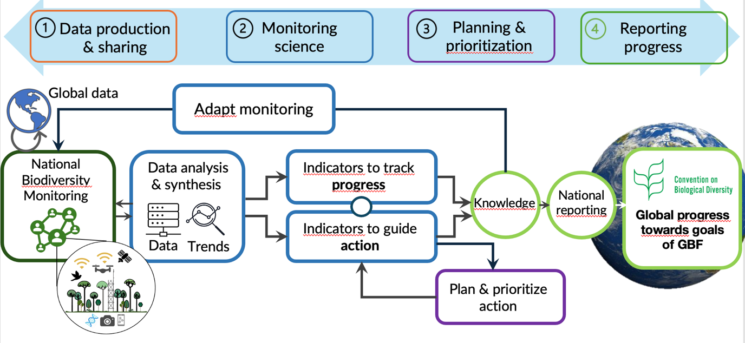
Figure 1: The links between biodiversity monitoring systems, data, and indicators used to track progress and guide action stemming from the priorities in National Biodiversity Strategy and Action Plans. Data from biodiversity observations and monitoring (far left) flows into data analysis and synthesis to update understanding of the status and trends of different dimensions of biodiversity (i.e., essential biodiversity variables). This information is used to update the indicators (middle) used to track change and/or guide action following the national biodiversity strategy and action plan. This knowledge then flows into national reports to the CBD. The goal is a streamlined flow of knowledge that is supported appropriately at the various steps. (see also Gonzalez et al. (2022) in document CBD/ID/OM/2022/1/INF/2)

- In the case of oceans specifically, the Global Ocean Observing System (GOOS) is coordinating observations around a set of Essential Ocean Variables (EOVs). These variables allow for changes in ocean biodiversity to be monitored and for the drivers of these changes to be better understood. The EOVs are implemented through the components of GOOS, the EOV expert panels (who identify and set requirements for EOVs), the Observations Coordination Group (which facilitate the collection of observations across multiple platforms) and the GOOS Regional Alliances (who facilitate the collection of observations at national and regional scales). Supporting GOOS, through UNESCO’s Intergovernmental Oceanographic Commission’s International Oceanographic Data and Information Exchange, is the Ocean Biodiversity Information System (OBIS) and the Ocean Data and Information System (ODIS). OBIS coordinates ocean biodiversity data and metadata activities through national and thematic nodes that ensure that observation streams and data are standardized, quality controlled, integrated and accessible, while ODIS is providing a system that federates ocean data systems, to ensure that data is discoverable, accessible and interoperable (see https://iode.org/programme-components/). The Global Ocean Observing System is co-sponsored and has direct implementation linkages with the World Meteorological Organisation, the UN Environment Program, and the International Science Council. However while key components of a Global Biodiversity Observing System for the ocean already exist, similar systems and processes do not currently exist for other ecosystem types.
- National biodiversity observation networks (see below) will be key units making up GBiOS, just as national weather centers and climate observing networks are key units in the WMO’s Integrated Global Observing System, which integrates observations made by national climate networks of the Global Observing System. Like the climate observing system, a GBiOS would ensure that biodiversity observations, along with data on drivers of biodiversity change are coordinated, updated frequently and available in standardized, interoperable, accurate and representative forms. The system would abide by FAIR (Findable, Accessible, Interoperable and Reusable) and CARE (Collective benefit, Authority to control, Responsibility and Ethics) data principles (Wilkinson et al. 2016, Carroll et al. 2020), in line with the 2021 United Nations Educational, Scientific and Cultural Organization (UNESCO) Recommendation on Open Science (see document SC-PCB-SPP/2021/OS/UROS) and ensure that indigenous peoples and local communities can exercise free, prior and informed consent for data access.

4. Six critical issues a global biodiversity observing system (GBiOS) can address
- A GBiOS can address multiple outstanding issues to support the implementation of the monitoring framework and actions needed to meet the goals and targets of the Kunming-Montreal Global Biodiversity Framework (see also document CBD/ID/OM/2022/1/INF/2). Here six issues are addressed:
- Engagement and coordination among all groups: The task of building and maintaining a GBiOS is by design broadly collaborative, engaging national and subnational governments, indigenous peoples and local communities, women and youth, academic researchers, biological survey stakeholders, citizen science groups, non-governmental organizations, businesses and the financial sector. Broad nation-wide engagement can foster the mainstreaming of biodiversity information into decisions across all sectors of society (Kühl et al. 2020). Each sector has specific needs for biodiversity observations and resulting information, so the design and implementation of GBiOS should reflect the broad range of uses and decisions it will support and provide consistent and standardised data with baselines and reference conditions.
- Gaps, biases, and standards in biodiversity data: a GBiOS could focus on addressing the gaps in the taxonomic and geographic coverage of biodiversity monitoring, both by mobilising existing data through improved interoperability and ensuring its persistence by knowledge management infrastructures that support multiple languages and meet local and national knowledge needs under the monitoring framework. National monitoring would grow national data resources across the full range of biodiversity dimensions required by the monitoring framework of the Global Biodiversity Framework. Global data repositories that compile locally and nationally derived data such as the Global Biodiversity Information Facility (GBIF) and the Ocean Biodiversity Information System (OBIS), World Database of Key Biodiversity Areas, databases like BioTIME (Dornelas et al. 2018) and Projecting Responses of Ecological Diversity In Changing Terrestrial Systems (PREDICTS) (Hudson et al. 2017) the Living Planet Database and information sources like the International Union for Conservation of Nature (IUCN) Red List of threatened species and IUCN Red List of Ecosystems contribute to national understanding and are a valuable resource for countries. Global datasets contain significant gaps and are not at this time representative in their taxonomic and geographic coverage of Earth's biodiversity (Gallagher et al. 2023, Nicholson et al. 2024). These data gaps were highlighted in the Summary for Policymakers of the Intergovernmental Science-Policy Platform on Biodiversity Ecosystem Services Global Assessment of Biodiversity and Ecosystem Services (Appendix 4 of the Summary) (Pereira et al. 2013). A GBiOS could contribute to these global databases and services by strengthening their links to observation sources stemming from monitoring worldwide.
- Information for indicators: A GBiOS has the potential to generate and collate data and information needed to assess progress towards the Global Biodiversity Framework’s Goal A and Goal B on maintaining and restoring ecosystems, maintaining genetic diversity, halting extinctions, recovering species abundance, sustainably managing biodiversity, and maintaining ecosystem nature’s contributions to people. It can similarly support the assessment of progress towards many of the targets, such as Target 2 on restoration, Target 3 on protected and conserved areas (e.g. in relation to their effectiveness and outcomes), and Target 4 on management actions for species (e.g. in relation to recovery of threatened species’ population). Biodiversity observations can be used to estimate Essential Biodiversity Variables (EBV; Pereira et al. 2013, Schmeller et al. 2018) and Essential Ecosystem Service Variables (EESV; Balvanera et al. 2022) which underpin many of the indicators for these goals and many targets. The common use of EBVs and EESVs, and other standards, classification schemes and typologies would allow interoperable and harmonized data sets to be collected by different governmental and non-governmental organizations. In the case of the ocean GOOS already uses the Essential Ocean Variables (EOVs) framework to monitor the ocean system, including biodiversity (see Muller-Karger et al., 2018). Interoperability is vital to ensure that data can be compared and combined for different purposes including the calculation of indicators, models of biodiversity change and assessment tools such as Ecosystem Accounts under the UN System for Economic and Environmental Accounting, and systems for evaluating extinction risk and ecosystem collapse.
- Understand biodiversity change across scales: The coordination of observations within and among Parties made possible by GBiOS could also support the monitoring of direct and indirect human drivers needed for trend attribution and the forecasting of change over different scales (Gonzalez et al. 2023, Leung and Gonzalez 2024). Some drivers may be observed directly with biodiversity observations, such as invasive species occurrence and impact, but information about other drivers, such as climate, pollution, and land use change, will require coordination with other observation networks to understand and project how drivers interact to cause biodiversity change. Cooperation with other global observing systems capturing trends in drivers would transform our ability to understand and predict biodiversity change.
- Capacity and technologies: A GBiOS could be used to assess where data gaps exist and guide the strategic implementation of monitoring, including technologies for observation (e.g., site-based observations and remote sensing) rapid classification, data assimilation for inferences about the causes of biodiversity loss and recovery, and prediction to support action (Gonzalez et al. 2023, Urban et al. 2016). New data and monitoring standards that allow rapid updates of data and indicators would be available to national and subnational governments. This gap-filling process could support Target 20 of the Global Biodiversity Framework prompting strategic investment in capacity-building, regional biodiversity observing technologies, data collection and curation services, and international cooperation (South-South, North-South and triangular cooperation) to share tools and knowledge for areas that need them most.
Community-based monitoring and information systems and other knowledge systems:
- A GBiOS should support the knowledge gathered and shared by community-based monitoring and information systems (CBMIS, Ferrari et al. 2015) and those conducted by citizen scientists. This would leverage the many contributions they are making of Parties’ understanding of biodiversity change and nature’s contributions to people. Indigenous and local knowledge has long been used and shared for the stewardship and active management of ecosystems at small and large scales. Community-based monitoring and information systems produce information that is increasingly valued and used for biodiversity research and conservation. Key to realizing the potential of community-based monitoring will be to link large-scale satellite derived knowledge with monitoring programs managed or coordinated at the community level (Eicken et al. 2021).
- A GBiOS can foster the creation of organizational support structures compatible with traditional and participatory observing methodologies and data management systems (using FAIR and CARE principles of data production and use; Wilkinson et al. 2016, Carroll et al. 2020), while respecting indigenous peoples’ intellectual property rights and the implementation of free, prior, and informed consent. Concern for intellectual property rights and other factors that influence knowledge sharing can be addressed by global agreements, such as the UNESCO Recommendation on Open Science, or the knowledge guidelines in operation under the Intergovernmental Science-Policy Platform on Biodiversity Ecosystem Services. Only by linking the full array of monitoring programs will it be possible to fully realize the value of community-based monitoring and its contribution to GBiOS.

5. A federated network of national biodiversity observation networks
- A GBiOS is conceived as an international network supporting coordination and cooperation among national biodiversity observation networks. These can be sub-national, national, or regional in level of operation. A national biodiversity observation network (Figure 2) should coordinate biodiversity observations and systematic monitoring schemes conducted by many groups to support a national monitoring framework (Kühl et al. 2020, Navarro et al. 2017). This coordination ensures biodiversity information is accessible to groups implementing actions stemming from National Biodiversity Strategies and Action Plans (NBSAPs) designed to guide national and subnational action under the Global Biodiversity Framework.
- Guidelines for network establishment are publicly available from the Group on Earth Observations Biodiversity Observation Network (GEO BON https://geobon.org/bons/bon-development/) and describe how to create an ‘enabling environment’ that assembles the partnerships, human capacity, scientific infrastructure and indigenous and traditional knowledge needed to build a biodiversity observation network.
- A GBiOS would support communication and coordination among biodiversity observation networks (BON) and other monitoring programs. Some regional networks already exist that demonstrate the value of collaborations among national biodiversity observation including those in the Arctic, Asia-Pacific region, and the emerging Europe-wide network. Other networks are thematic (e.g. marine BON, freshwater BON, soil BON, omics BON) and support monitoring activities and supply methods and insights from these ecosystems around the world.
- BON development may involve investment in additional monitoring capacity at new and existing sites to reduce data gaps. The addition of new sites to the BON network can reduce uncertainty in trend detection and geographic patterns and improve understanding of biodiversity change locally and nationally and contribute information for regional and global assessments. Other sites may be chosen to acquire the information to improve models for forecasts projecting future changes in biodiversity (Urban et al. 2016, Cavender-Bares et al. 2022). Regional or subregional technical support centres working with BONs could provide services for supporting the use and sharing of data, statistical models for trend assessments, and predictive modeling to guide decisions for conservation and spatial planning.

6. Next steps
- A number of next steps are needed to establish the governance model, funding, the deployment of technologies and other resource needs, and investment in careers to support GBiOS activities in the long-term.
Co-sponsorship and governance:
- A proposal for a governance model should be elaborated along with identification of the partner organizations – from both public and private sectors – that can co-sponsor GBiOS by providing international support for the governance, administration and resourcing of this globally coordinated network. Many organizations actively support the establishment of monitoring schemes and systems around the world. Over the last decade, GEO BON (https://geobon.org/), a network with over 3,000 experts in 147 countries, has particularly focused on the establishment of biodiversity observation networks that are designed to help national and subnational governments monitor biodiversity (Figure 2).
- An important next step will be to convene all organisations committed to biodiversity monitoring worldwide to establish the initial basis for collaboration and international co-sponsorship of GBiOS.

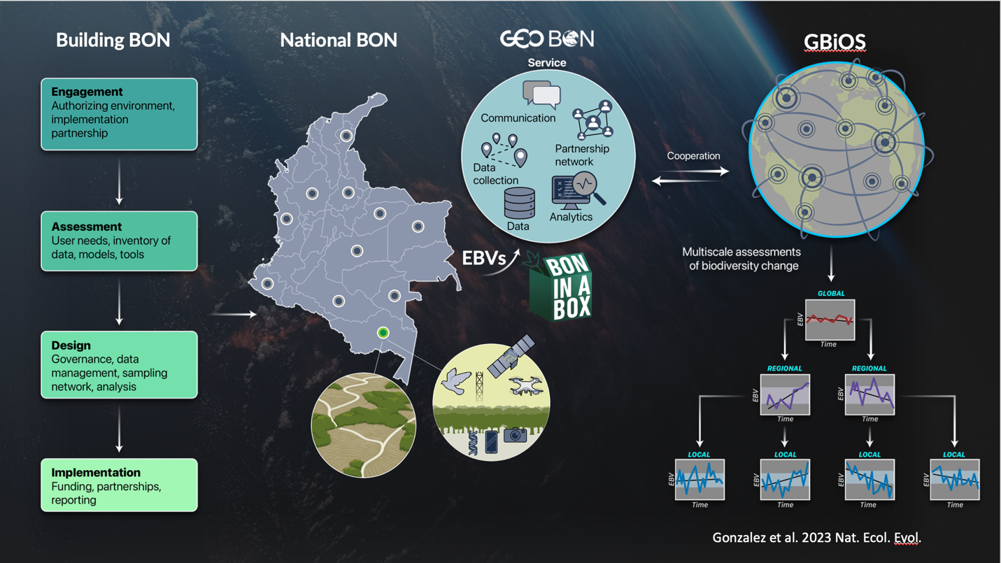

Figure 2: GBiOS as a global network of interconnected national and regional biodiversity observation networks (BON) to assess biodiversity trends worldwide (source Gonzalez et al. 2023): a) Countries without a national BON can establish and implement one following the multistep process identified by GEO BON (Bush et al. 2017, Navarro et al. 2017). b) Each national BON (Colombia is shown as an example) follows harmonized methods and coordinated activities for biodiversity observations, data curation and sharing, trend detection and attribution, modeling, and policy-decision support that forms a BON service. c) In the proposed GBiOS, national and regional BONs (white circles) form an international network, sharing technologies, data (e.g., via a Global Open Science Cloud) and information about biodiversity trends (EBVs and EESVs) and ecological events and in so doing allowing the global community to make rapid multiscale assessments of progress toward international biodiversity targets and goals.

Assessment of resource needs and added value:
- In a first phase, an assessment of the existing capacity within and among countries is needed. This collective assessment of current capacity to observe biodiversity and ecosystems, would support a second assessment of what is needed to improve capacity within and among countries, including human capacity and technologies for observations and data sharing and analysis.
- This would involve an assessment of the technical needs and financial investments required. This includes: the necessary technologies and data infrastructures (including existing global data repositories such as GBIF, OBIS, GenBank, IUCN Red Lists of threatened species and ecosystems, World Database of Key Biodiversity Areas, those supporting the land tenure and land use change indicator such as Landmark, Rights and Resources Initiative Tenure Database, Global Land Observatory, Prindex, LANDex and the territories and areas governed, managed, and conserved by custodian indigenous peoples and local communities (ICCAs—territories of life) Registry, and the Indigenous Navigator etc.) needed to support long-term monitoring and make the data available in a secure and just manner; mechanisms for governance and financing; and the existing national and regional BON components that can be integrated to form the first phase of the GBiOS implementation. This assessment would include the knowledge and capacity needs, and the economic costs and benefits (return on investment) arising from an initial investment in GBiOS, followed by alternative pathways for progressive development of its capacity by 2030 and beyond.
Funding GBiOS for the long-term:
- As noted below, the lack of sufficient resources has been identified as a challenge to monitoring. A long-term funding model would help support nations with the establishment of their national biodiversity observation networks and associated monitoring and data infrastructures. One outcome of this would be a growth in national and international data which would be published to national and international data repositories (e.g. country nodes of GBIF). This growth in capacity would support operationalization of the Monitoring Framework. An integrated system of observations for biodiversity could connect to observing systems for climate and other human drivers and pressures.
- One way to fund GBiOS would be a UN coalition fund like the Systematic Observations Financing Facility for the Global Climate Observing System (GCOS). Data from GBiOS would support ecosystem accounts under the System of Environmental-Economic Accounting and guide investments to create local social and economic benefits for the global public good. Global data production and exchange could be an important measure of success, along with use by private sector for financial disclosures and impact assessments. A financing facility could contribute to strengthening societal adaptation and resilience across the globe, benefitting the most vulnerable peoples and countries.

7. Conclusion
- A GBiOS is needed to support the full realization of the Kunming-Montreal Global Biodiversity Framework, the Sustainable Development Goals, and other multilateral environmental agreements and protocols. The global community is increasingly aware of the great cultural, economic and health benefits society receives from biologically diverse and resilient ecosystems. A GBiOS could contribute to filling significant data gaps around the world, offer a representative and inclusive understanding of biodiversity change, support technological innovation and employment in data sciences and related fields, and thereby support effective implementation of the Global Biodiversity Framework’s monitoring framework and the policies designed to reverse biodiversity loss and achieve the global goals for nature in the coming decades.

Annex I. References
- Balvanera, P., et al. (2022) Essential ecosystem service variables for monitoring progress towards sustainability. COSUST., 54, 101152.
- Bush, A., et al. (2017) Connecting Earth observation to high-throughput biodiversity data. Nat. Ecol. Evol., 1, 0176.
- Carroll et al. (2020) The CARE Principles for Indigenous Data Governance. Sci. Data. 3, 160018
- Carroll, S. R., et al. (2021) Operationalizing the CARE and FAIR Principles for Indigenous data futures. Sci. Data. 8, 108.
- Cavendar-Bares, J. et al. (2022) Intregating remote sensing with ecology and evolution to advance biodiversity conservation. Nat. Ecol. Evol, 6, 506–519 (2022)
- Dornelas, M. et al. (2018) BioTIME: A database of biodiversity time series for the Anthropocene. Global. Ecol Biog., 27, 760-786.
- Eicken, H., et al. (2021) Connecting top-down and bottom-up approaches in environmental observing. BioScience i71, 467–483
- Ferrari et al. (2015) Community-based monitoring and information systems (CBMIS) in the context of the Convention on Biological Diversity (CBD). Biodiversity, 16, 57-67.
- Gallagher, R. V. et al. (2023) Global shortalls in threat assessments for endemic flora by country. New Phyt., 5, 885-898.
- Gonzalez, A. & Londoño, MC. (2022) Monitoring biodiversity for action. Science, 378, 1147.
- Gonzalez, A., et al. (2023) A framework for the detection and attribution of biodiversity change. Phil. Trans. Roy. Soc. B, 378, 20220182.
- Hudson, L. N. et al. (2017) The database of the PREDICTS (projections responses of ecological diversity in changing terrestrial ecosystems) projects. Ecol & Evol., 7, 145-188.
- Hughes, A. C., et al. (2021) Sampling biases shape our view of the natural world. Ecography, 44, 1259-1269.
- IPBES, “IPBES (2019): Global assessment report on biodiversity and ecosystem services of the Intergovernmental Science-Policy Platform on Biodiversity and Ecosystem Services” (IPBES, Bonn, Germany, 2019), p. 1148.
- Kühl, H. S. et al., One Earth, 3, 462-474 (2020)
- Kull D. et al (2021) The Value of Surface-based Meteorological Observation Data (English). Washington, D.C. : World Bank Group. http://documents.worldbank.org/curated/en/192461614151036836/The-Value-of-Surface-based-Meteorological-Observation-Data
- Leadley, P., Gonzalez, A., Obura, D. et al. (2022) Achieving global biodiversity goals by 2050 requires urgent and integrated actions. One Earth, 5, 597-603.
- Leung, B., and Gonzalez, A. (2024) Global monitoring for biodiversity: Uncertainty, risk, and power analysis to support trend change detection. Science, 10, eadj144.
- Muller-Karger F.E. et al (2018). Advancing Marine Biological Observations and Data Requirements of the Complementary Essential Ocean Variables (EOVs) and Essential Biodiversity Variables (EBVs) Frameworks. Frontiers in Marine Science. https://doi.org/10.3389/fmars.2018.00211
- Navarro, L. et al. (2017) Monitoring biodiversity change through effective global coordination. COSUST, 29, 158-169
- Nicholson, E. et al. (2024) Roles of the Red List of Ecoystems in the Kunming-Montreal Global Biodiversity Framework. Nat. Ecol. & Evol., 8, 614-621.
- Obura, D. et al. (2023) Achieving a nature- and people positive future. One Earth, 6, 105-117.
- Pereira, H.M. & Cooper D. H. (2006) Towards the global monitoring of biodiversity change. TREE, 21, 123-129.
- Pereira, H.M., et al. (2013) Essential biodiversity variables. Science, 339, 277-278.
- Schmeller, D. S., (2018) A suite of essential biodiversity variables for detecting critical biodiversity change. Biol. Revs., 93, 55-71.
- Scholes, R. J., et al. (2012) Building a global observing system for biodiversity. COSUST 4, 139-146.
- Urban, M. C., et al. (2016) Improving the forecast for biodiversity under climate change. Science, 353, aad8466.
- Wilkinson et al. (2016) The FAIR Guiding Principles for scientific data management and stewardship. Sci Data 3, 160018.

Section 2: Capacity needs of Parties with respect to headline indicators of the Kunming-Montreal Global Biodiversity Framework monitoring framework

1. Introduction
- In its decision 15/5, the Conference of the Parties to the Convention on Biological Diversity adopted the monitoring framework for the Kunming-Montreal Global Biodiversity Framework. In the same decision, the Conference of the Parties established an Ad Hoc Technical Expert Group (AHTEG) on indicators, with a time-bound mandate until the sixteenth meeting of the COP (COP-16), to advise on the further operationalization of the monitoring framework. As part of its terms of reference, the AHTEG prepared advice on the capacity gaps Parties have with respect to the monitoring framework.
- At the request of the AHTEG, to support this work, the United Nations Environment Programme World Conservation Monitoring Centre (UNEP-WCMC) prepared an online capacity needs assessment survey on the needs of Parties to use the headline indicators of the monitoring framework. Parties were invited to participate in the online survey. The results of the survey may help to identify capacity needs in relation to the use of the monitoring framework and provide valuable information for the provisioning of capacity development activities linked to the monitoring of implementation of the Kunming-Montreal Global Biodiversity Framework at the national level.
- The survey was distributed to Parties through CBD Notification 2024 – 013 of 8 February 2024. The survey was made available online in English, Spanish and French. Preliminary results from the survey were presented for consideration by the AHTEG at its sixth meeting held 12 to 15 March 2024. The results presented here are based on all responses provided to the survey as at 18 April 2024.
- The capacity needs assessment focused on the capacity needs of Parties to produce and compile the headline indicators of the monitoring framework. Binary indicators were excluded from the assessment since the wording of the questions for the binary indicators was not finalised at the time of the survey.
- For each of the 26 headline indicators, the survey collected information on (i) the current capacity of Parties to monitor and report on progress towards national actions and targets, using the headline indicators, and (ii) the needs for both technical and financial assistance. Survey questions provided via the survey are can be found at Annex I.
- At the time of the survey, methodologies for the headline indicators were in varying degrees of development (Annex 1 of document CBD/IND/AHTEG/2023/3/2).
- Responses to the survey were also categorized according to whether the Party responding to the survey is eligible to receive official development assistance (ODA). Those countries considered eligible for ODA include: all low- and middle-income countries based on gross national income per capita as published by the World Bank, except members of the G8 and the European Union and countries with a firm date for entry into the European Union; and all the Least Developed Countries (LDCs) as defined by the United Nations.

2. Results
- A total of 44 Parties responded to the survey, of these 29 (66%) are eligible for ODA and 15 (34%) are not (see Table 1 of Annex II). The analysis of capacity development needs is representative of a geographically representative but relatively small sample of countries (see Table 2 of Annex II). In this regard the findings should be seen as an indication of the main needs, gaps and priorities identified by Parties.
National capacity of Parties to report on the headline indicators
- The proportion of Parties aware of a national institution responsible for reporting on each indicator varies by indicator (Figure 1A). For example, only 22% of Parties consider there is a national institution in-country responsible for reporting on headline indicator 18.2 (Value of subsidies and other incentives harmful to biodiversity). In contrast, 89% of Parties consider there is a national institution responsible for reporting on headline indicator 3.1 (Coverage of protected areas and other effective area based conservation measures). Across all headline indicators, an average of 53% of Parties consider there is a national institution in-country responsible for reporting on a given headline indicator.
- Parties are more aware of a national institution that can compile and report on headline indicators with an established methodology (mean of 63%) compared to those without an established methodology (mean of 43%).
- The headline indicators for which Parties most consider there is national institution are similar among ODA-eligible Parties and non-ODA-eligible Parties (Figure 1B & 1C). The proportion of Parties with a known national institution responsible for reporting on each indicator is slightly lower for Parties eligible for ODA compared to that of Parties not eligible to receive ODA (mean of 51% versus 58%).
National capacity of Parties to compile the headline indicators.
- Parties that identified a national institution responsible for reporting on a given headline indicator were subsequently asked whether specific headline indicators are compiled in a national database by those institutions:
  - The proportion of Parties compiling each headline indicator in a national database varies (Figure 2A). The indicator most commonly compiled in a national database by Parties is 3.1 (Coverage of protected areas and other effective area based conservation measures) (67%). The headline indicators compiled least frequently by Parties is C.2 (Non-monetary benefits arising from applicable international Access and Benefit-sharing instruments) (21%). Across all headline indicators, an average of 39% of Parties compile the indicators in a national database.
  - Parties are more able to compile headline indicators in a national database for indicators with an established methodology (mean of 45%) compared to indicators without an established methodology (mean of 34%).
  - Overall, the headline indicators which Parties are most commonly compiled in a national database are similar among ODA-eligible Parties and non-ODA-eligible Parties (Figure 2B & 2C). However, the proportion of Parties compiling the headline indicators in a national database is lower for ODA-eligible Parties compared to that of non-ODA-eligible Parties (mean of 35% versus 44%).

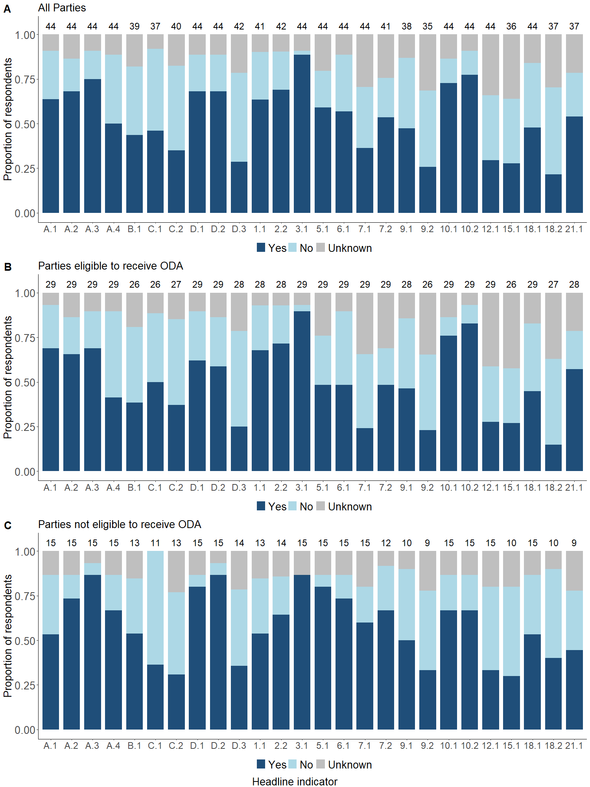
Figure 1: Proportion of Parties aware of a national institution(s) responsible for reporting on the headline indicators, at the national level. The number above each bar is the total number of Parties that responded to the survey.
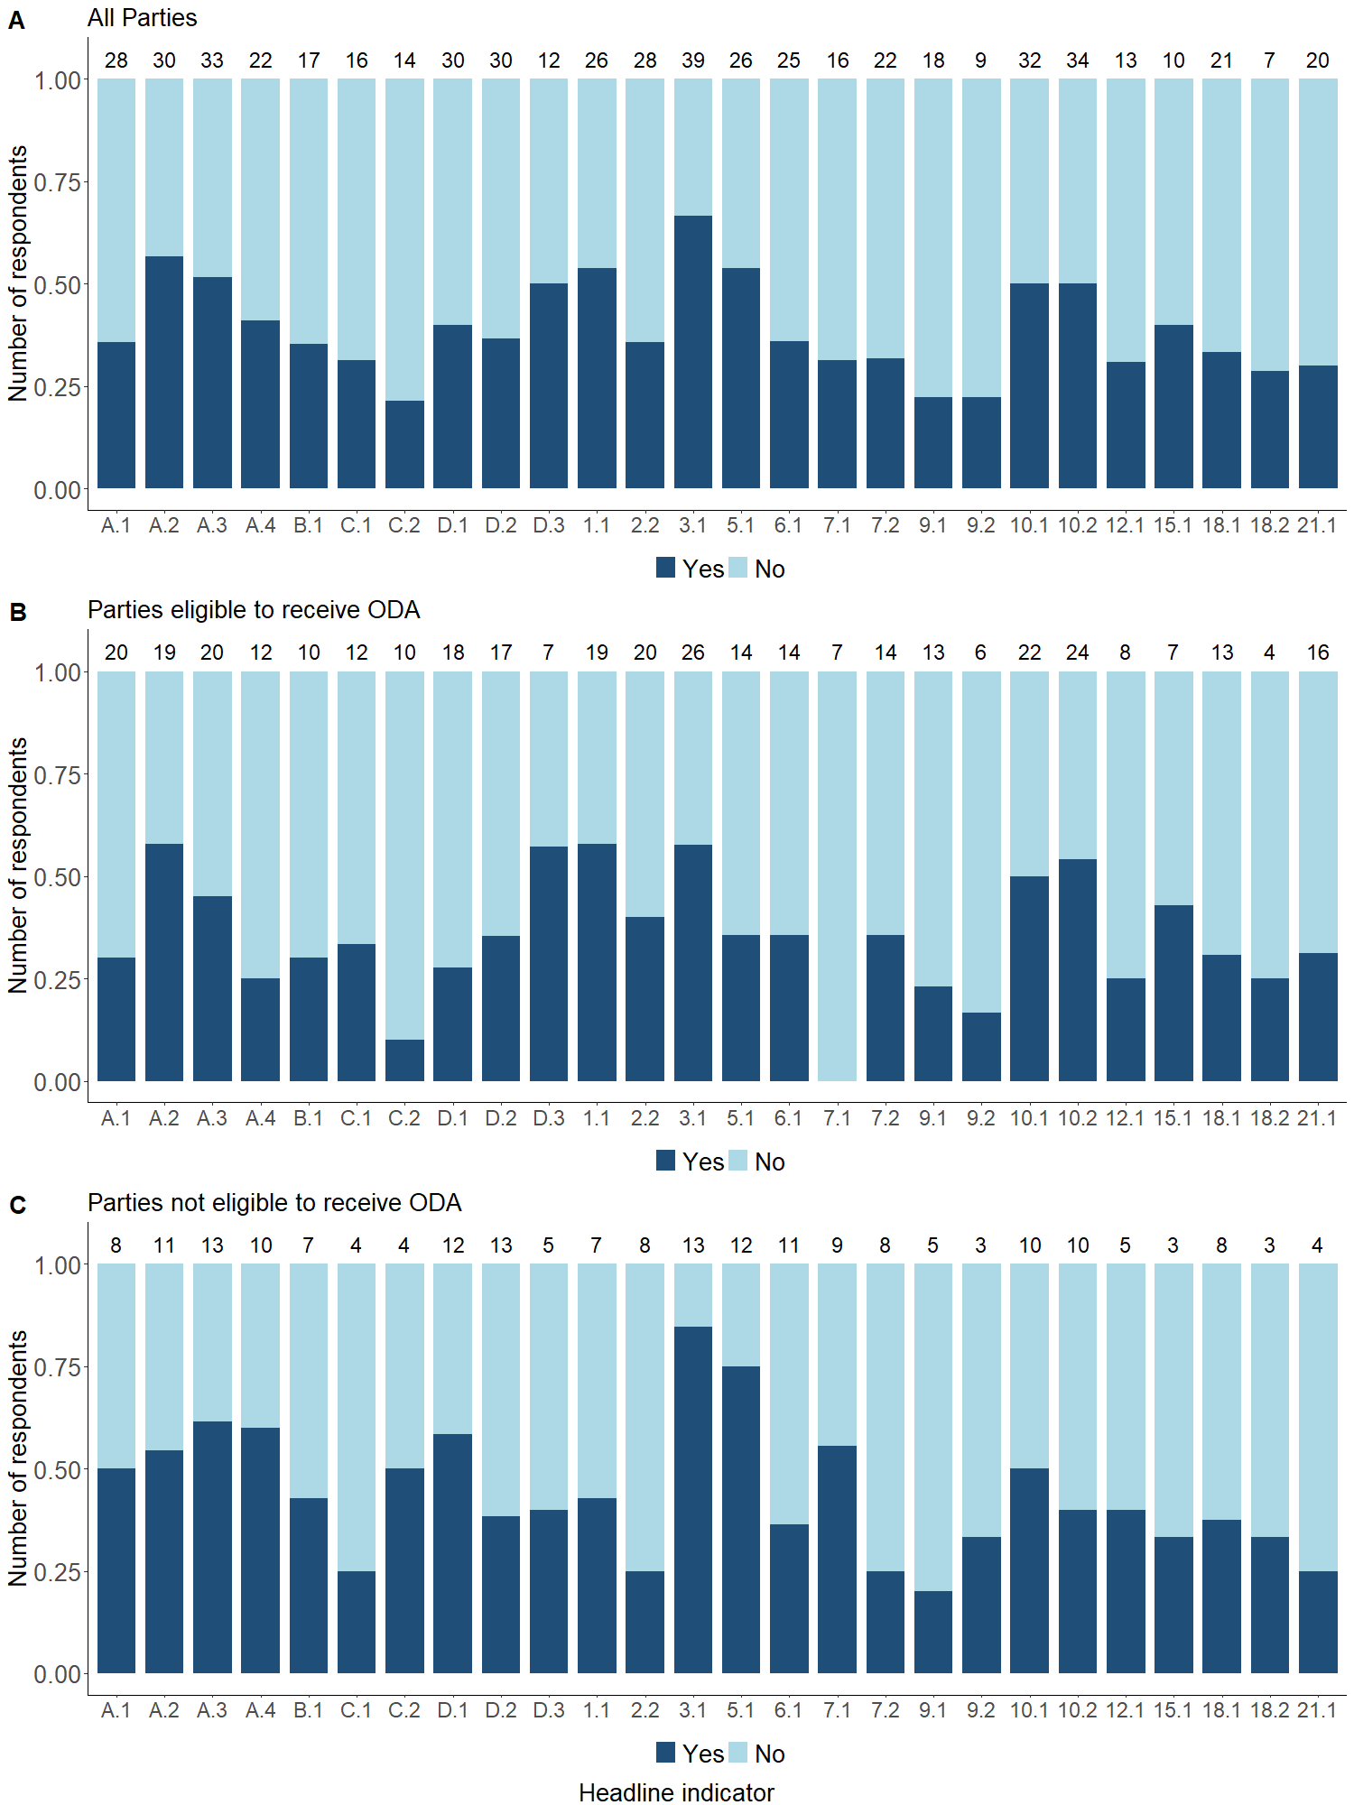
Figure 2: Proportion of Parties compiling the headline indicator in a national database. The number above each bar is the total number of Parties that responded “yes” to having a national institution(s) responsible for reporting on a given indicator (Figure 1).
Timeframe for production of the indicator at the national level
- a. Parties that could not identify a national institution responsible for reporting on a given headline indicator were subsequently asked to about their expected timeframe by which they may be able to produce the headline indicator. Parties were asked to indicate whether they may be able to produce the headline indicators in the short term (within 1-2 years, to align with the submission of the seventh National Reports to the CBD, due in 2026) or in the medium term (within 3-5 years, to align with the submission of the eighth national report due in 2029).
- The timeframe in which headline indicators can be produced by Parties differed across indicators (Figure 3A). Very few Parties indicated they will be able to produce the headline indicators in the short term (mean of 14%). The indicators which Parties are most likely to produce in the short term include A.2 (Extent of natural ecosystems), 2.1 (Area under restoration) & A.1 (Red List of Ecosystems). Most Parties will be able to produce the headline indicators in the medium term (mean of 54%). The headline indicators which Parties are most likely to produce in the medium term include 1.1 (Percentage of land and sea area covered by biodiversity-inclusive spatial plans), 12.1 (Average share of the built-up area of cities that is green/blue space for public use for all) & 7.2 Aggregated Total Applied Toxicity)
- Several Parties will be unable to produce the indicator either in the short term or the medium term (25%). Reasons given include: (i) lack of an agreed up-to-date methodology; (ii) lack of available data (iii) lack of human and technical capacity; (iv) lack of political will; and or (v) lack of financial support. Some headline indicators are considered not applicable by Parties (7%); in particular indicators 9.2 (Percentage of the population in traditional occupations) and 7.1 (Index of coastal eutrophication potential).
- A similar proportion of Parties are able to produce headline indicators with an established methodology in the short or medium term (mean of 15% and 52% respectively) compared to indicators without an established methodology (mean of 13% and 57% respectively). The proportion of Parties unable to produce the headline indicators is also similar (23% for indicators with an established methodology; 28% for indicators without an established methodology).
- The timeframe in which headline indicators can be produced by Parties differed among ODA-eligible Parties and non-ODA-eligible Parties (Figure 3B & 3C). The proportion of Parties able to produce the headline indicators in the short term was the same for both ODA-eligible Parties and non-ODA-eligible Parties (mean of 14%). The proportion of Parties able to produce the headline indicators in the medium term is greater for ODA-eligible Parties (mean of 57%) compared to non-ODA-eligible Parties (mean of 48%). The proportion of Parties unable to produce the headline indicators is lower for ODA-eligible Parties (mean of 21%) compared to non-ODA-eligible Parties (mean of 36%).

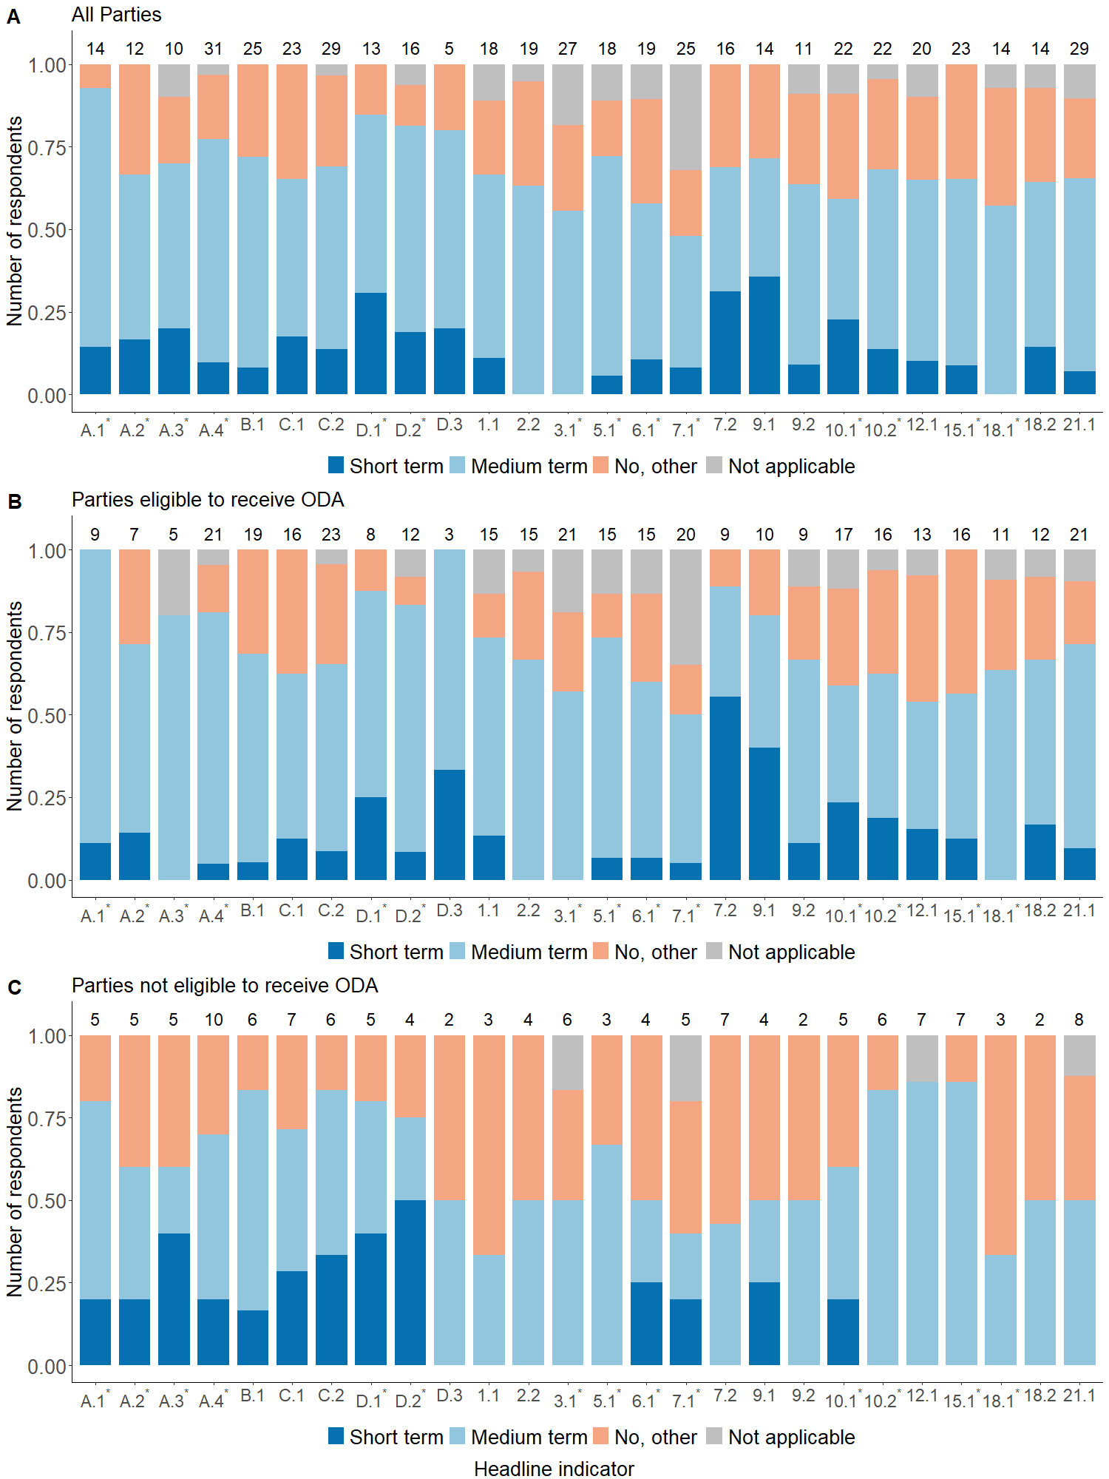
Figure 3: Proportion of Parties able to produce the headline indicator in the short term (1-2 years), medium term (3-5 years) or not able to produce the headline indicator for a given reason(s) or because it was not applicable. The number above each bar is the total number of Parties that responded either “no” or “unknown” to having a national institution(s) responsible for reporting on a given indicator (Figure 1).

National capacity required for the production and compilation of headline indicators
- The proportion of Parties requiring assistance for the production and compilation of headline indicator at the national level varies for each indicator (Figure 4A). For example, 83% of Parties require support for producing headline indicators C.2 (Non-monetary benefits arising from applicable international Access and Benefit-sharing instruments), 15.1 (Number of companies disclosing their biodiversity-related risks, dependencies and impacts) and 18.2 (Value of subsidies and other incentives harmful to biodiversity). In contrast, only 32% of Parties require support for producing and compiling headline indicator 3.1 (Coverage of protected areas and other effective area based conservation measures). Across all headline indicators, an average of 64% of Parties require assistance for producing and compiling a given headline indicator.
- Parties require more support on headline indicators without an established methodology (mean of 70%) compared to those with an established methodology (mean of 59%).
- The headline indicators for which Parties require assistance are similar among ODA-eligible Parties and non-ODA-eligible Parties (Figure 4B & 4C). However, the proportion of Parties that require assistance for the production and compilation of each headline indicator is considerably higher among ODA-eligible Parties (mean of 75%), compared to that of non-ODA-eligible Parties (mean of 40%).
- Parties that responded “yes” to requiring assistance for the production and compilation of headline indicators at the national level in the survey, were subsequently asked to specify the type of assistance required (see Figure 5). The most frequently reported support required is “training on the methodology for compiling the indicator at the national context” (Figure 5B). The second most frequently requested type of support is “data collection” (Figure 5A). The third most frequently requested type of support is “assistance analysing the indicator” (Figure 5C). Parties requested less support for “institutional coordination on data reporting” (Figure 5D).

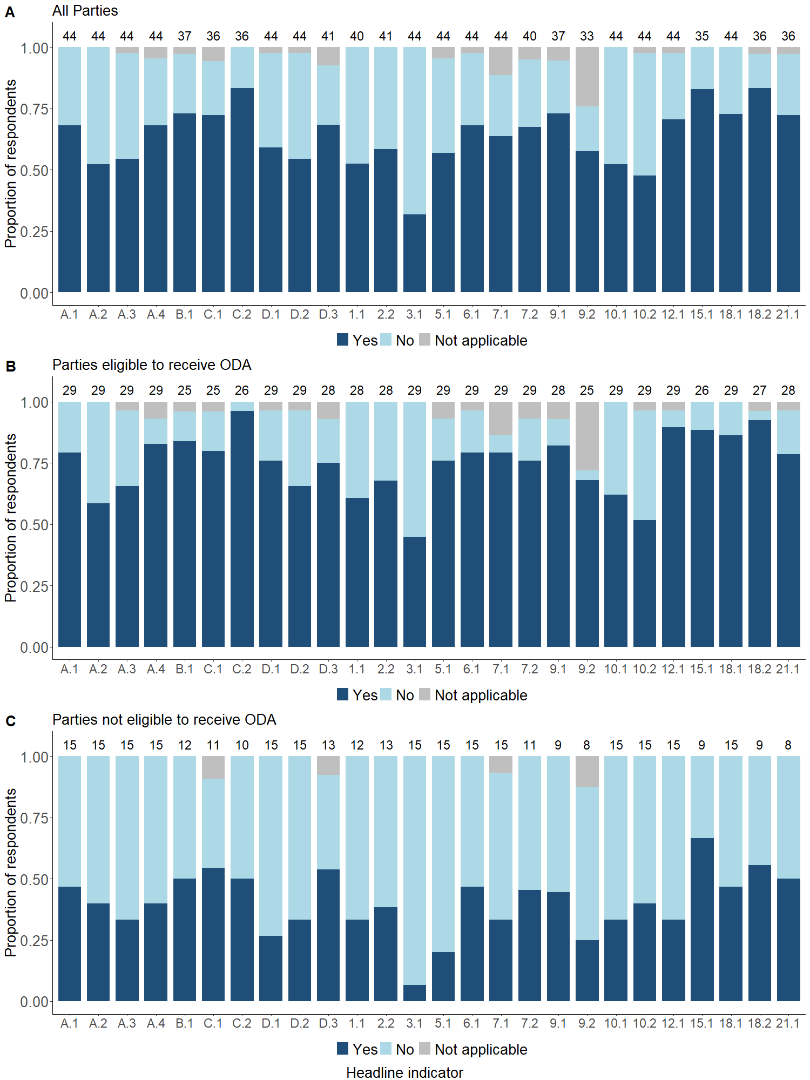
Figure 4: Capacity development required reported by Parties, with respect to the national production and compilation of headline indicators. The number above each bar is the total number of Parties that responded.
Financial resources available for the production and compilation of headline indicators
- The availability of financial resources for the production and compilation of headline indicators at the national level varies (Figure 6A). Most Parties have insufficient financial resources to produce and compile the headline indicators at the national level. On average, 34% of Parties expressed having no financial resources available at national level, 23% expressed that the financial resources are far from sufficient, and another 24% expressed that financial resources available are not quite sufficient. Only 19% of Parties expressed having sufficient financial resources available.
- The proportion of Parties with sufficient financial resources available to produce and compile the headline indicators at the national level, on average, is smaller for indicators without an established methodology (mean of 14%) compared to those with an established methodology (mean of 24%). For indicators without an established methodology, on average, 39% of Parties expressed having no financial resources available, 24% expressed financial resources are far from sufficient and the remaining 23% report financial resources are not quite sufficient. For indicators with an established methodology, on average, 30% of Parties expressed having no financial resources available, 21% report financial resources available are far from sufficient and 25% report financial resources are not quite sufficient.
- Overall, the financial resources available vary drastically when comparing ODA-eligible Parties and non-ODA-eligible Parties (Figure 6B & 6C). On average, the proportion of Parties with sufficient financial resources available to produce and compile the headline indicators is considerably smaller for ODA-eligible Parties (mean of 4%) compared to non-ODA-eligible Parties (mean of 53%). On average, 39% of ODA-eligible Parties expressed having no financial resources available, 25% express financial resources are far from sufficient, and 31% express financial resources are not quite sufficient. Despite many non-ODA-eligible Parties reporting that they have sufficient financial resources, on average, 24% expressed having no financial resources available, 17% expressed financial resources available are far from sufficient and 7% expressed financial resources are not quite sufficient

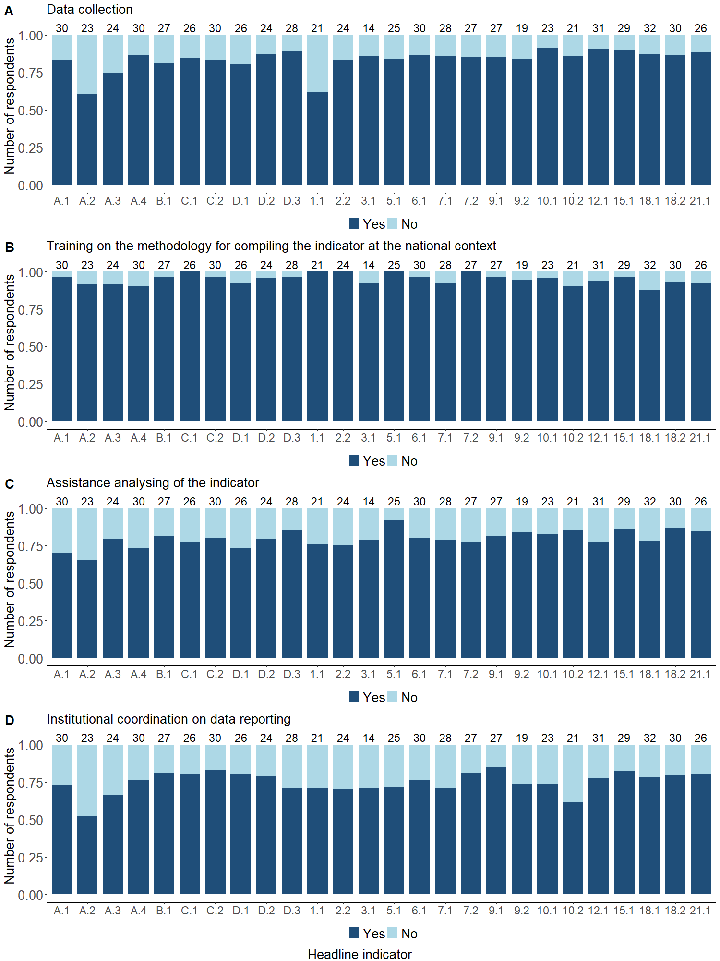
Figure 5: Capacity development required reported by Parties, by type, with respect to the production and compilation of headline indicators of the monitoring framework for the Kunming-Montreal Global Biodiversity Framework at the national level. The number above each bar is the total number of Parties that responded “yes” to requiring assistance (Figure 4).

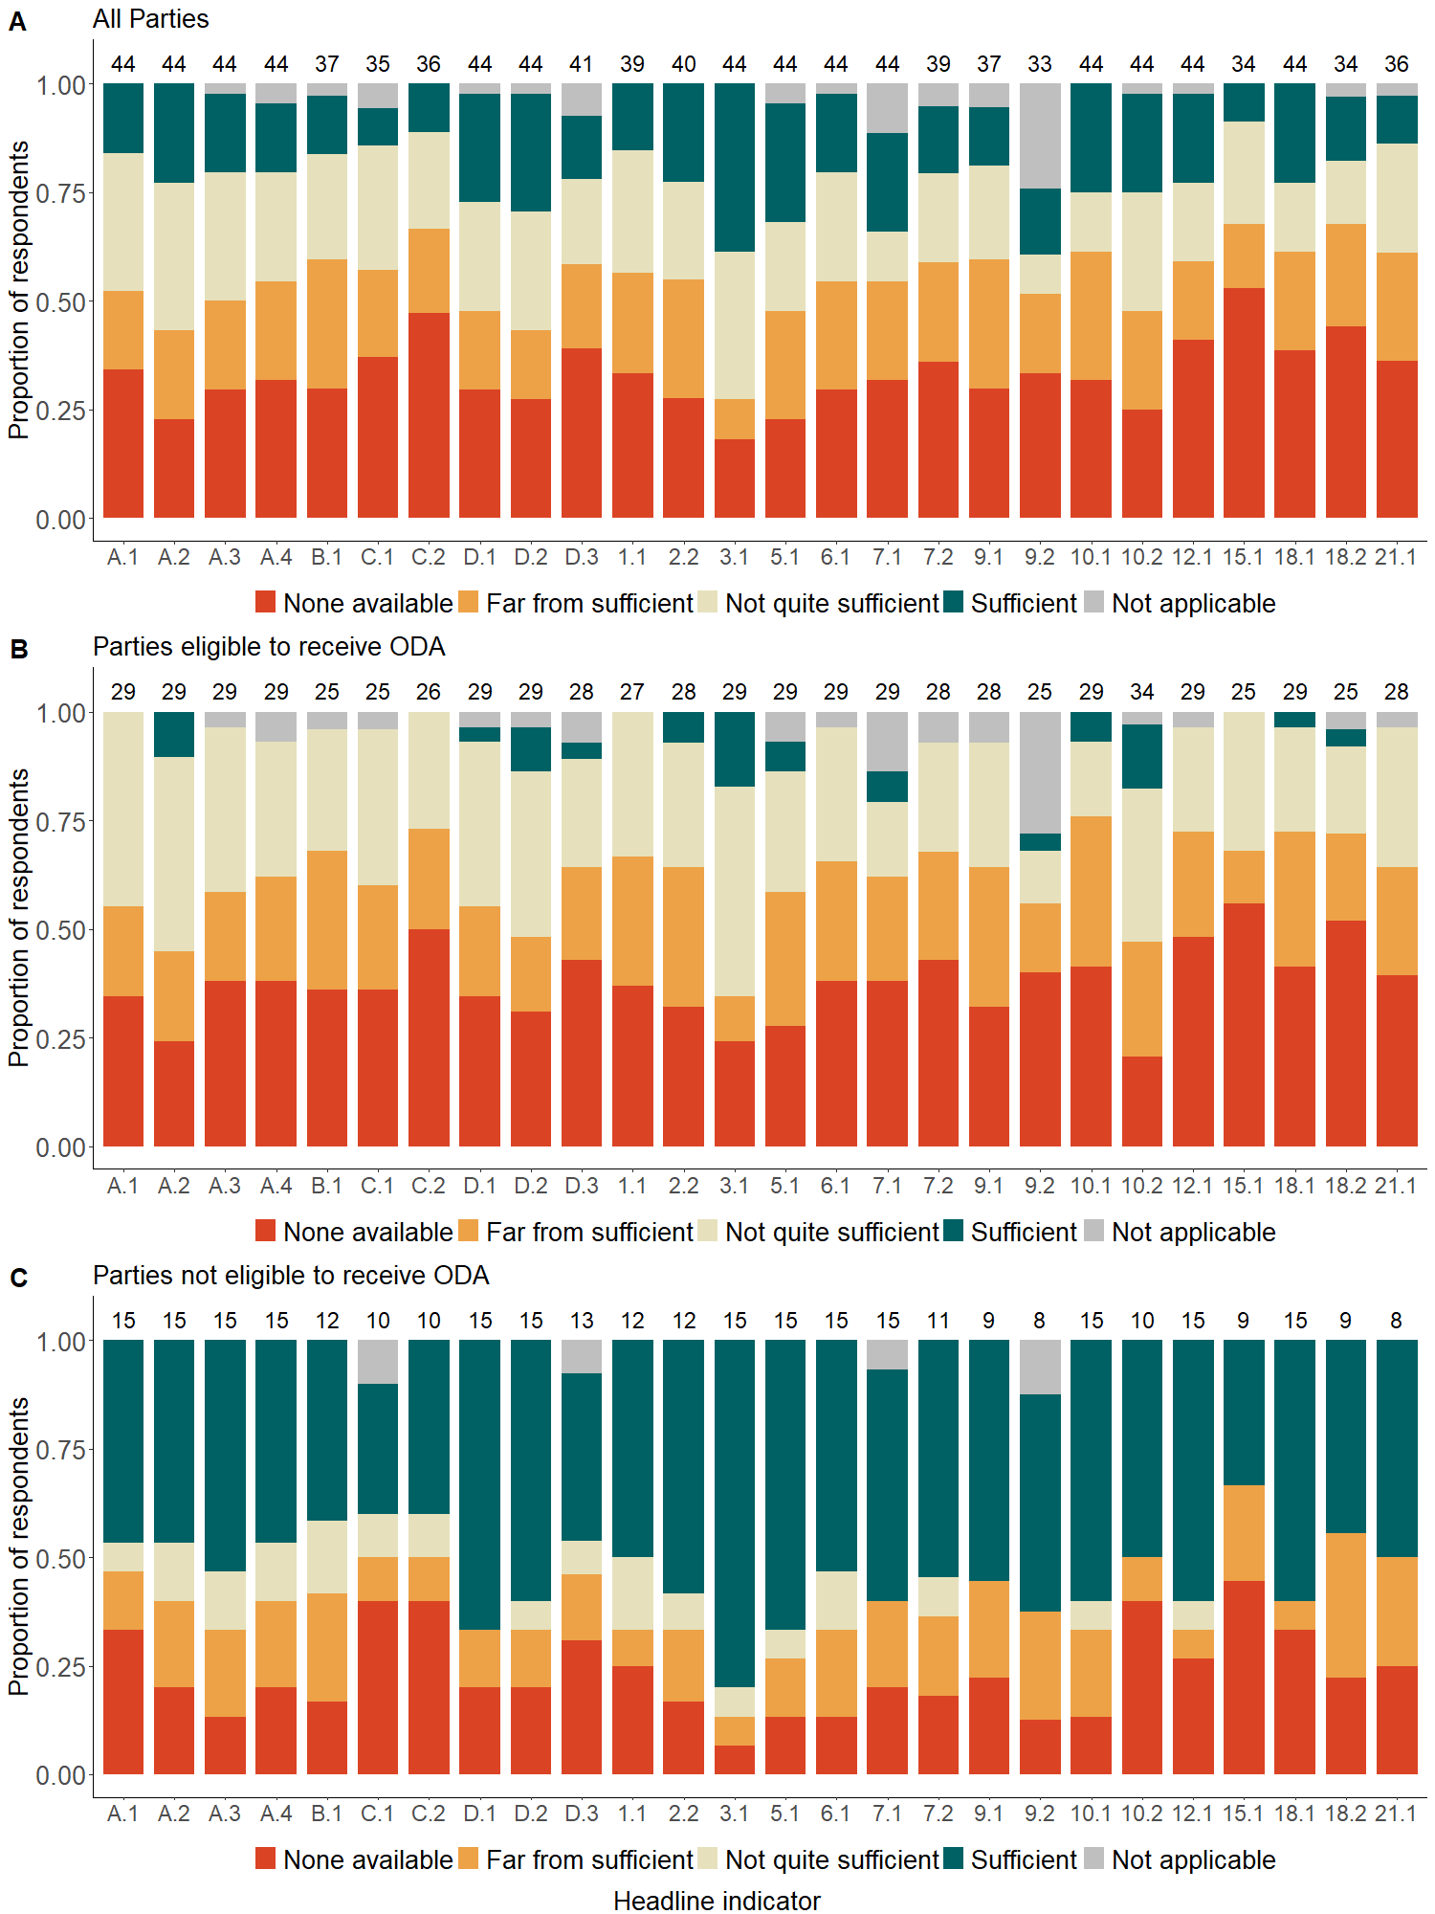
Figure 6: Availability of financial resources reported by Parties, with respect to the production and compilation of headline indicators of the monitoring framework for the Kunming-Montreal Global Biodiversity Framework, at the national level. The number above each bar is the total number of Parties that responded.

3. Summary
- There were several headline indicators for which Parties indicated sufficient national capacity for production and use, including headline indicators A.3 (Red List Index), D.1 (International public funding, including official development assistance for conservation and sustainable use of biodiversity and ecosystems), D.2 (Domestic public funding on conservation and sustainable use of biodiversity and ecosystems), 3.1 (Coverage of protected areas and other effective area-based conservation measures), 10.1 (Proportion of agricultural area under productive and sustainable agriculture), 10.2 (Progress towards sustainable forest management). Overall, these indicators have an established methodology and an institution with a mandate to develop, calculate the indicator based on collated data, and regularly update the indicator. Additionally, many are aligned with Sustainable Development Goals and are therefore likely to have received support from capacity development initiatives.
- Many Parties indicated capacity gaps in producing some headline indicators. This is particularly true for those indicators for which a methodology is in development, and for which there are no established data collection mechanisms, for example C.1 (Monetary benefits received in accordance with applicable internationally agreed Access and Benefit-sharing instruments), C.2 (Non-monetary benefits arising from applicable international Access and Benefit-sharing instruments), 15.1 (Number of companies disclosing their biodiversity- related risks, dependencies and impacts), 18.1 (Positive incentives in place to promote biodiversity conservation and sustainable use) and 18.2 (Value of subsidies and other incentives harmful to biodiversity). The majority of these indicators are associated with targets on “meeting people’s need through sustainable use and benefit-sharing” and “tools and solutions for implementation and mainstreaming.” Since the time of the survey the AHTEG has produced guidance on the headline indicators (CBD/SBSTTA/26/INF/14 and subsequently CBD/COP/16/INF/3). However, it should be noted that many of the headline indicators still require further work, as described in Annex II of CBD/SBSTTA/26/2.
- The production of an indicator may require a monitoring system to produce primary data, the compilation and analysis of the derived data, and the presentation of the information in an accessible and useable format for end-users. At present many Parties indicate that they have insufficient financial resources to produce the headline indicators.

Annex I. Capacity needs assessment survey structure
To help reduce the response burden of Parties, some of the questions are skipped depending on the response to a previous question. The skipping rules are indicated in red.
(*) denotes mandatory questions
Q.1 Is there a national institution with responsibility for reporting on this indicator?*
​​☐​ | Yes
​​☐​ | No (skip to Q8)
​​☐​ | Unknown (skip to Q8)

Q2. Please provide the full name of the entity responsible for reporting the indicator

Q3. Please provide the type of entity responsible for reporting the indicator
​​☐​ | Government Ministry
​​☐​ | Non-governmental organization
​​☐​ | Academic institution
​​☐​ | Other

Q3a. Please specify the type of entity

Q4. Is the indicator compiled in a national database? *
​​☐​ | Yes
​​☐​ | No (skip to Q9)

Q5. Please indicate the website for the national database

Q6. Please indicate the last year for which the indicator was reported in the national database

Q7. How can the indicator be disaggregated? (multiple responses allowed, skip to Q11)
​​☐​ | Indigenous Peoples and Local Communities
​​☐​ | Gender
​​☐​ | Age
​​☐​ | Ecosystem type
​​☐​ | Taxonomy
​​☐​ | Other (go to Q7a)

Q7a. Please specify the type of disaggregation(s)

Q8. Is your country able to produce the indicator at the national level in the short (1-2 years) or medium term (3-5 years)?*
​​☐​ | Yes, in the short term
​​☐​ | Yes, in the medium term
​​☐​ | No, for other reasons
​​☐​ | No, because it is not applicable for the country (go to next Headline Indicator)

Q8a. Please specify why your country is unable to produce the indicator at the national level

Q9. Does your country need assistance for producing and compiling the indicator at the national level? *

Q10. What type of assistance does your country need for producing and compiling the indicator at the national level? (multiple responses allowed) *
​​☐​ | Data collection
​​☐​ | Training on the methodology for compiling the indicator at the national context
​​☐​ | Assistance analysing of the indicator
​​☐​ | Institutional coordination on data reporting
​​☐​ | Other (go to Q10a)

Q10a. Please specify the type of assistance your country needs for producing and compiling the indicator at the national level

Q11. Which situation best describe the availability of financial resources for the production of the indicator at the national level? *
​​☐​ | No financial resources are available to produce and compile the indicator
​​☐​ | Financial resources available are far from sufficient to produce and compile the indicator
​​☐​ | Financial resources available are not quite sufficient to produce and compile the indicator
​​☐​ | Financial resources available are sufficient to produce and compile the indicator

Annex II. Geographic coverage and official development assistance ODA status of survey respondents
Table 1: Geographic coverage of Parties
Region | Number of respondents | Percentage
Africa | 11 | 25%
Americas | 12 | 27%
Asia | 8 | 18%
Europe | 11 | 25%
Oceania | 2 | 5%

Table 2: Parties eligible to receive official development assistance (ODA)
Eligible to receive ODA | Number of respondents | Percentage
Yes | 29 | 66%
No | 15 | 34%

Section 3: A Gap Analysis of the Kunming-Montreal Global Biodiversity Framework monitoring framework

1. Summary
- The Kunming-Montreal Global Biodiversity Framework is an ambitious and complex text. The associated monitoring framework was designed to include a minimum set of mandatory (‘headline’ and ‘binary’) indicators with additional optional (‘component’ and ‘complementary’) indicators to aid in reporting. As such, the headline and binary indicators are not intended to cover all the elements included in the Kunming-Montreal Global Biodiversity Framework. To clarify which elements are covered by the headline or binary indicators, which elements could be covered by component and/or complementary indicators, and which elements are not covered by any existing indicators, the Ad Hoc Technical Expert Group (AHTEG) on indicators conducted an analysis of the indicators in the monitoring framework to identify gaps and opportunities to fill them (Figure 1).
- The monitoring framework of the Kunming-Montral Global Biodiversity Framework covers the four goals and twenty-three targets of the Framework reasonably well. The four different kinds of indicators – headline, binary, component and complementary – combined offer a good picture of progress made. The gap analysis conducted by the AHTEG expands on the summary provided in Annex 3 of document CBD/SBSTTA/26/2.
- By the sixteenth meeting of the Conference of the Parties to the Convention (COP16), it is expected that the majority of the headline indicators, along with all of the binary indicators, will be operational or ready to be operationalized. The list of component and complementary indicators has also been revised to include only those that are currently available. The analysis of the coverage of these indicators together reveals the monitoring framework that is on track to be operational by COP-16 and can inform on much of the Global Biodiversity Framework. This coverage is particularly good if component and complementary indicators are included, along with disaggregations of some headline indicators. The use of the component and complimentary indicators by Parties in their national reports is optional and subject to the national circumstances and priorities of Parties. Implementation of a limited number of disaggregations of the headline indicators by Parties is recommended in order to enable better assessment of progress towards to goals and targets of the framework, recognising that this is also subject to national circumstances and priorities. Few goals or targets retain gaps in coverage, and for these, additional research and indicator development is welcomed. Additionally, this does not account for any additional national or subnational indicators that Parties may use to cover those gaps that are priorities to them.
- Overall, the monitoring framework should be considered as a whole to effectively address the goals and targets of the Framework. Even so, some gaps remain due to lack of coverage by indicators and data availability for some groups and regions. In some cases, these could be filled by additional development of existing headline indicators. For some headline indicators, development and testing is required, for others an extension of their coverage or the development of disaggregation methodology may help fill those gaps. In other cases, however, headline indicators alone will not be sufficient, and Parties should consider using additional indicators.
- There is significant variation as to what “partial coverage” means for some goals and targets. This can be a result of indicators focusing on structure and processes and not being appropriate for measuring outcomes (e.g. binary indicators), or only addressing a part of the goal or target’s ambition, or not having sufficient resolution or coverage to fully capture this ambition. As such, solutions to improving the monitoring framework are multiple, and goal- or target-specific.
- As it stands, the monitoring framework can already inform on progress towards meeting the goals and targets of the Kunming-Montreal Global Biodiversity Framework, but substantial investment is still required to collect the necessary data to compute indicators and effectively monitor its full ambition. It is recommended that Parties use these results to guide their National Biodiversity Strategy and Action Plans and data collection efforts. Beyond national priorities, collaborative efforts are needed to resource the development of indicators already in the monitoring framework. Particular focus must also be given to data collection needs, especially for cross-cutting considerations as outlined in section C of the Kunming-Montreal Global Biodiversity Framework which addresses considerations for its implementation, that will contribute to filling gaps and take advantage of synergies between indicators.

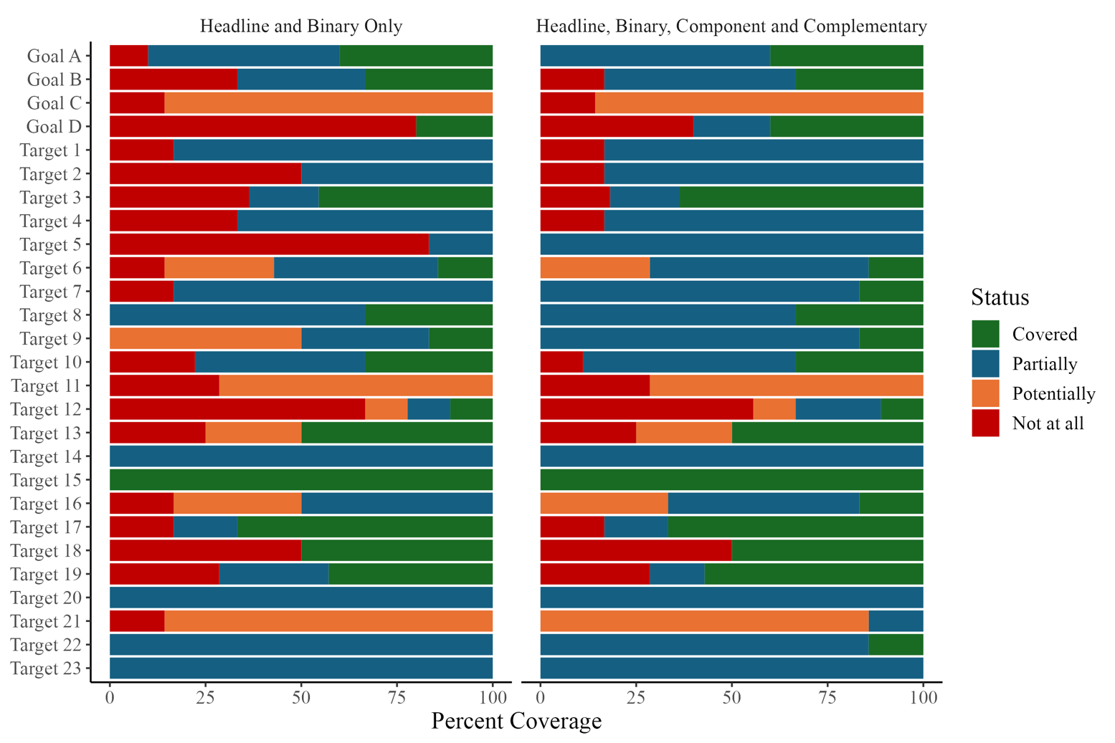Figure 1. Coverage of each goal and target of the Global Biodiversity Framework by its headline and binary indicators of the monitoring framework only (left hand side) and after inclusion of relevant component and complementary indicators (right hand side). Further detail on the meaning of the coverage statuses is available below in section 3, Methods.

2. Introduction
- The monitoring framework is an essential part of the of the Kunming-Montreal Global Biodiversity Framework. There was no formal monitoring process for the Aichi Biodiversity Targets, a set of 20 targets within five strategic goals established within the Strategic Plan for Biodiversity 2011-2020. Monitoring the achievement of these targets therefore relied on voluntary efforts and international organisations to report on the global state of nature, as well as targets relating to the underlying causes of biodiversity loss, direct pressures, benefits and means of implementation. The monitoring framework for the Kunming-Montreal Global Biodiversity Framework now makes it a requirement for Parties to the Convention to track their national efforts and progress towards the implementation in a more standardized way through their national reports. This new approach to reporting highlights the commitment of Parties to deliver on the goals and targets of the Kunming-Montreal Global Biodiversity Framework. The 7th and 8th National Reports are due in 2026 and 2029 respectively, and will enable national progress to be tracked, guiding management, resources and decision-making to deliver on the ambition of the Kunming-Montreal Global Biodiversity Framework. The Secretariat of the Convention on Biological Diversity is responsible for collecting national reports and using them to assess global progress towards the goals and targets.
- The monitoring framework relies on four types of indicators: headline, binary, component and complementary indicators. Of these, headline and binary indicators are mandatory in national reports, and the component and complementary indicators are optional. At a national level, Parties may choose how many of the component and complementary indicators to use and may also choose to use additional national level indicators in their National Reports.
- Headline indicators are a minimum set of high-level indicators that aim to capture the overall scope of the goals or targets in the Kunming-Montreal Global Biodiversity Framework. These indicators are quantitative measures of outcomes relevant to each goal or target. There are a total 24 headline indicators in the framework spread across the four goals and fifteen of the twenty-three targets. These indicators are at various levels of readiness, from in development to fully tested and implemented, and have varying levels of data completeness and coverage across countries. The guidance to help Parties produce these quantitative headline indicators have been produced by the AHTEG and are publicly available. Headline indicators require a significant amount of effort and investment to be developed and often focus on a particular aspect of the goal or target they are linked to. Headline indicators tend to focus on the measurable outcomes achieved to deliver on the aims of a goal or target.
- Binary indicators are qualitative measures of the efforts made by Parties to deliver on the goals and targets. These indicators are compiled from a set of questions answered by Party focal points and aimed at understanding the progress made towards implementing measures to deliver on the ambition of the Framework. The answers to the set of questions for each binary indicator are used to assign an overall score (from 0 to 5) for each Party, providing valuable information about the progress made by Parties in facilitating and promoting the outcomes of the goals and targets. Binary indicators can usefully inform on the existence of the measures, processes and legislation needed to provide a framework for delivery of the Kunming-Montreal Global Biodiversity Framework’s goals and targets. It is important to note, however, that they do not measure realized outcomes nor the effectiveness and quality of these measures, processes, and legislation. These indicators have lower methodological requirements than headline indicators and are more readily compiled. Guidance on answering questions is available in the metadata of the binary indicators. Goal B and thirteen targets have binary indicators; eight targets have a binary indicator but no accompanying headline indicator.
- Component and complementary indicators are optional for inclusion in national reports but some cover additional aspects of the goals and targets that the headline and binary indicators do not. These indicators do not have metadata provided by the Secretariat and are typically supported by various custodian organisations. Many of these indicators are quantitative outcome-oriented indicators. Of the original set of component and complementary indicators proposed by the Conference of the Parties in its decision 15/5 (60 and 160 respectively), not all are operational or actively still supported. In addition, some of the component and complimentary indicators are possible disaggregations of the headline indicators. The AHTEG has reviewed the original list of component and complementary indicators and proposed an revised list of 63 component and 149 complementary indicators across the goals and targets (Annex I of document CBD/SBSTTA/26/2) to take this into account.
- Following its review of all four types of indicators and the production of the metadata for headline and binary indicators, the AHTEG conducted a gap analysis of the Kunming-Montreal Global Biodiversity Framework’s goals and targets to assess the coverage of the monitoring framework indicators. The aim of this gap analysis was to identify how many of the different elements in the goals and targets are adequately addressed by the monitoring framework, and which elements may require additional effort to identify or develop indicators. The gap analysis focused on the text of the goals and targets, although the considerations set out in section C of the Kunming-Montreal Global Biodiversity Framework are to be considered as part of each goal and target.

3. Methods

Elements of the goals and targets
- The goals and targets of the Framework reflect its considerable ambition. The text of each goal and target is often long and complex, containing multiple clauses that are all important to deliver on the ambition of the Kunming-Montreal Global Biodiversity Framework. In order to enable a comprehensive and holistic analysis of the monitoring of the Kunming-Montreal Global Biodiversity Framework’s ambition, the text of each goal and target was divided into a set of distinct elements. The elements were defined exclusively by the text of the goal or target, without the relevant considerations from section C of the Framework. This exercise was done in two steps: a first division of the text was proposed to all AHTEG members who subsequently reviewed and edited the elements until each goal and target was separated into clear distinct elements (an example is provided in Table 1). This process was run for one month, after which other stakeholders were invited to comment on the elements of goals and targets relevant to them: specifically, Target 17 for the Liaison Group on the Cartagena Protocol on Biosafety, Target 20 for the Informal Advisory Group on Technical and Scientific Cooperation and Goal D and Targets 18 and 19 for the Technical Expert Group on Financial Reporting. In total 190 elements were identified with each goal and target having between 4 and 13 elements (Table 2).
Table 1. Example breakdown of Target 9 into its individual elements. The specific emphasis of each element to be monitored under the monitoring framework of the Kunming-Montreal Global Biodiversity Framework is highlighted in bold.
 | Target/Element Text
Target 9 | Ensure that the management and use of wild species are sustainable, thereby providing social, economic and environmental benefits for people, especially those in vulnerable situations and those most dependent on biodiversity, including through sustainable biodiversity-based activities, products and services that enhance biodiversity, and protecting and encouraging customary sustainable use by indigenous peoples and local communities (IPLCs).
Element 9a | 9a. Ensure that the management and use of wild species are sustainable, thereby providing social benefits for people
Element 9b | 9b. Ensure that the management and use of wild species are sustainable, thereby providing economic benefits for people
Element 9c | 9c. Ensure that the management and use of wild species are sustainable, thereby providing environmental benefits for people
Element 9d | 9d. Sustainable management and use of wild species provides benefits for people in vulnerable situations and those most dependent on biodiversity
Element 9e | 9e. Ensure benefits to people through sustainable biodiversity-based activities, products and services that enhance biodiversity
Element 9f | 9f. Protect and encourage customary sustainable use by IPLCs

Table 2. Number of distinct elements identified in the text of each goal and target of the Kunming-Montreal Global Biodiversity Framework.
 | Elements
Goal A | 10
Goal B | 6
Goal C | 7
Goal D | 5
Target 1 | 6
Target 2 | 6
Target 3 | 11
Target 4 | 6
Target 5 | 6
Target 6 | 7
Target 7 | 6
Target 8 | 6
Target 9 | 6
Target 10 | 9
Target 11 | 7
Target 12 | 9
Target 13 | 8
Target 14 | 7
Target 15 | 5
Target 16 | 6
Target 17 | 6
Target 18 | 6
Target 19 | 7
Target 20 | 7
Target 21 | 7
Target 22 | 14
Target 23 | 4

The gap analysis
- The gap analysis itself was conducted in two steps: first, a survey shared with all AHTEG members prior to the sixth meeting of the AHTEG held in Cambridge in March 2024, and second, a working session at that meeting.
- The focus of the survey was to broadly identify where the headline and binary indicators aligned with the elements of the goals and targets and where component and complementary indicators might support monitoring of the elements. Respondents were asked to select which elements could be monitored using each headline and binary indicator in turn, then given the option to repeat this for any complementary or component indicator of their choice. At this stage, respondents did not have access to the updated metadata and list of component and complementary indicators. As such, respondents were specifying whether the intent and concepts behind the indicators could map on to each element rather than realised indicators with methodology. Therefore, the results of the survey were not used to report on the gaps of the monitoring framework but rather to guide the in-person session at the sixth meeting of the AHTEG held in Cambridge.
- The in-person session was divided into two tasks. Task one was focused on the component and complementary indicators and AHTEG members were asked to review all such proposed indicators and whether they existed and were useful for monitoring their assigned goal or target. The results of this exercise are summarised in Annex 1 of document CBD/SBSTTA/26/2. Component or complementary indicators that correspond to recommended disaggregations of a headline indicator were removed from the lists of component or complementary indicators.
- In task two, AHTEG members were asked to split up in self-directed groups of expertise, focusing on specific goals and targets. Within each group, AHTEG members were then asked to review all the goal or target elements individually. For each element, groups were asked to specify if a headline or binary indicator is available to monitor the element. When a headline or binary indicator was assigned to an element, groups were asked to specify whether the indicator:
  - Covered the element, i.e. it can currently inform progress on the element.
  - Partially covered the element, i.e. it can currently inform progress on some of the element.
  - Potentially covered the element, i.e. it could inform progress on the element but the indicator is still in development and/or has not been tested.
- The current data coverage of the headline indicators was not evaluated, but rather their design based on the metadata. For each of these categorisations, participants were asked to provide an explanation (justification and caveats) about their choice and specify whether a specific disaggregation of the indicator is required to inform progress on the element. For elements where no headline nor binary indicator could inform progress, participants were asked to suggest component or complementary indicators from the list identified in task one that may be appropriate to inform on progress towards these elements.
- This process was repeated after the meeting in Cambridge for specific indicators that had not received sufficient attention during the meeting. These subsequent exercises were conducted with AHTEG members for Targets 14 and 16, with the Technical Expert Group on Financial Indicators for Goal D and Targets 18 and 19 and with relevant members of the Secretariat for Targets 17 and 20.

4. Results

Overall

- Of the 190 elements identified across the goals and targets, 39 (20%) are currently well covered by the headline and binary indicators of the monitoring framework, 79 (42%) are partially covered by the headline and binary indicators, 27 (14%) are potentially covered and 45 (24%) are not at all covered (Figure 2a). When including the optional component and complementary indicators, the coverage of elements improves: 47 (25%) are well covered by all four types of indicators, 94 (49%) are partially covered, 24 (13%) are potentially covered and 25 (13%) are not covered at all (Figure 2b).

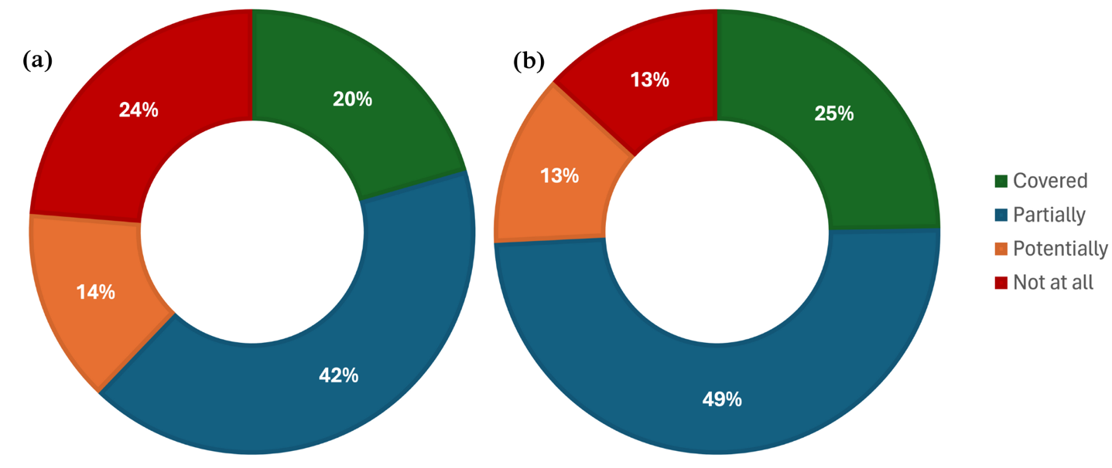Figure 2. Ability of the monitoring framework to track progress towards all 190 elements in the goals and targets of the Framework using (a) only headline and binary indicators, and (b) headline, binary, component, and complementary indicators.

Goal A
- Goal A elements are well covered (Figure 3) by its four headline indicators (A.1, A.2, A.3 and A.4). Headline indicator A.1, by focusing on risk of collapse, measures progress towards maintaining, enhancing and restoring resilience. However, it can only partially inform on integrity and connectivity as not all Red List of Ecosystems assessments include the relevant data. Headline indicator A.2 directly measures change in extent of natural (and semi-natural) ecosystems and therefore tracks progress towards substantially increasing the area of natural ecosystems by 2050. Headline indicator A.3 directly addresses extinction risk but only partially addresses extinction rate and the extinction of known threatened species. These are incorporated into headline indicator A.3 but could be separately quantified using the same Red List data as that of A.3. Headline indicator A.4 requires more widespread testing (particularly in relation to its representativeness) and implementation but allows monitoring of the genetic diversity within populations of wild species; it also only partially addresses the genetic diversity within populations of domestic species, requiring more development to fully address this element. The abundance of native wild species is not addressed by any headline indicator but can be partially addressed for vertebrates (Living Planet Index) and birds (Wild Bird Index) in some countries with the use of component indicators.
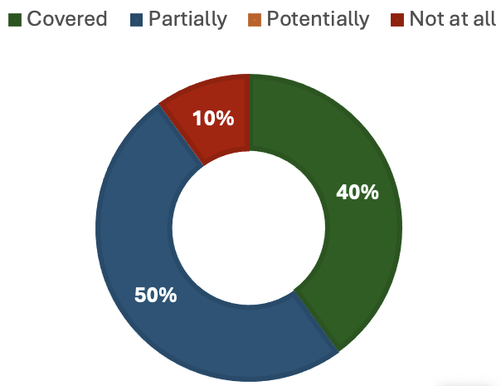
Figure 3. Coverage of goal A elements by headline indicators A.1, A.2, A.3 and A.4.

Goal B
- Goal B elements are partially covered (Figure 4) by its headline (B.1) and binary indicators (B.b). Headline indicator B.1 measures trends in ecosystem service use, which can inform on the maintenance and enhancement of nature’s contribution to people. It is based on the global standard for ecosystem service accounts, which does not take into account the diversity of values of nature nor the sustainable use of ecosystem services and biodiversity for the benefit of present and future generations. Binary indicator B.b partially addresses the restoration, enhancement and maintenance of nature’s contribution to people as well as the sustainable use and management of biodiversity by tracking the establishment of measures to support relevant national efforts. Neither indicator B.1 nor B.b monitor the valuation of nature’s contribution to people but the component indicator (total value of ecosystem services in monetary units) partially addresses this gap by focusing on monetary valuation alone of ecosystem services in exchange values alone. Disaggregation of headline indicator 2.1 for restoration areas targeting the enhancement of ecosystem services may help inform restoration of nature’s contribution to people and indicators relevant to Targets 5 and 9 may help to partially inform on the sustainable use and management of biodiversity.

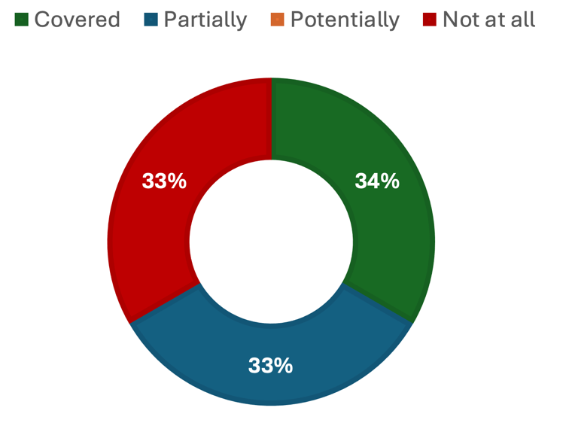
Figure 4. Coverage of Goal B elements by headline indicator B.1 and binary indicator B.b.

Goal C
- Goal C elements are potentially covered (Figure 5) by its headline indicators (C.1 and C.2). The methodology for both C.1 and C.2 is still in development and testing of these indicators is required, as such they can only potentially inform on progress towards the elements of Goal C. Headline indicator C.1 will focus on monetary benefits and C.2 on non-monetary benefits derived from both genetic resources and traditional knowledge associated with genetic resources. Additionally, no agreement yet exists on the benefits derived from digital sequence information but both C.1 and C.2, once an agreement is reached, may measure progress towards the sharing of these benefits. Neither headline indicator will enable progress tracking of the protection of traditional knowledge associated with traditional knowledge and no component nor complementary indicator is in place to fill this gap.
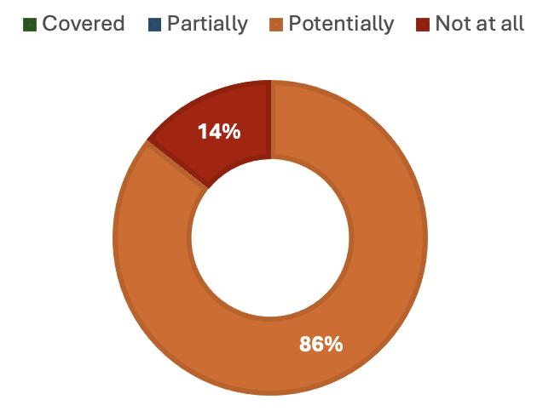
Figure 5. Coverage of Goal C elements by headline indicators C.1 and C.2.

Goal D
- Goal D elements are not all covered (Figure 6) by their headline indicators (D.1, D.2 and D.3). All three headline indicators only allow monitoring of financial resources, and no other elements of Goal D. Technical and scientific cooperation can be tracked by one complementary indicator (volume of official development assistance flows for scholarships by sector and type of study) and partially informed by two more (joint scientific papers published (in Ocean Biodiversity Information System) by sector, and Proportion of total research budget allocated to research in the field of marine technology). Access to and transfer of technology can be monitored with two complementary indicators (total amount of funding for developing countries to promote the development, transfer, dissemination and diffusion of environmentally sound technologies, and global imports of information and communications technology goods as presented by bilateral trade flows by information and communications technology goods categories). No indicators currently allow the monitoring of adequate capacity-building nor the equitable access of means of implementation for all Parties.
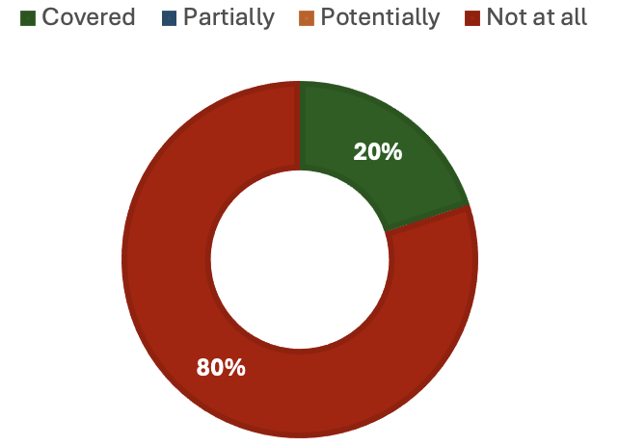
Figure 6. Coverage of goal D elements by headline indicators D.1, D.2 and D.3.

Target 1
- Target 1 elements are partially covered (Figure 7) by Goal A headline indicators (A.1 and A.2) and its binary indicator (1.b). Binary indicator 1.b provides information towards the coverage of spatial planning processes addressing land/sea use change and whether this spatial planning is participatory, integrated and biodiversity inclusive. However, this information only allows partial progress towards tracking these elements as it only provides information about the existence of measures and their implementation, not their spatial coverage nor outcome. Headline indicators A.1 and A.2 provide information on the loss of areas of high biodiversity importance and high ecological integrity but not whether this is a result of spatial planning or management processes. No indicators are in place to inform whether spatial planning or management processes respect the rights of indigenous peoples and local communities. Headline indicator 1.1 has not been developed so is not assessed here but could potentially enable monitoring of all the elements of Target 1.

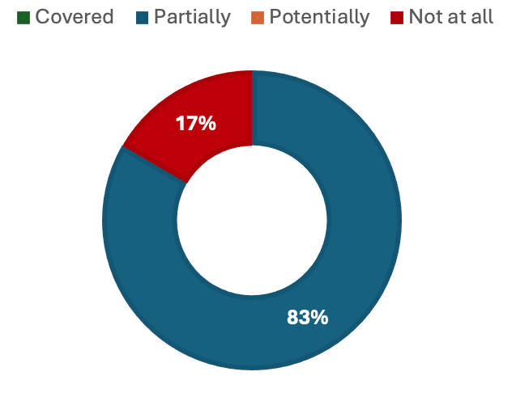
Figure 7. Coverage of Target 1 elements by headline indicators A.1 and A.2 and binary indicator 1.b.

Target 2
- Some Target 2 elements are partially covered (Figure 8) by its headline indicator (2.1). Headline indicator 2.1 measures specifically how much area is under restoration but does not provide information on the proportion of degraded ecosystems being restored (terrestrial, inland water or marine and coastal) as called for in the target’s elements. It also does not provide any information on whether the restoration taking place is effective, whether for enhancing biodiversity, ecosystem functions and services nor ecological integrity and connectivity. This headline indicator can only provide monitoring of the occurrence of restoration. Two complementary indicators (proportion of Key Biodiversity Areas in favourable condition, and Global Ecosystem Restoration Index) provide some information towards measuring progress on the effectiveness of restoration at enhancing biodiversity and ecological integrity and connectivity.

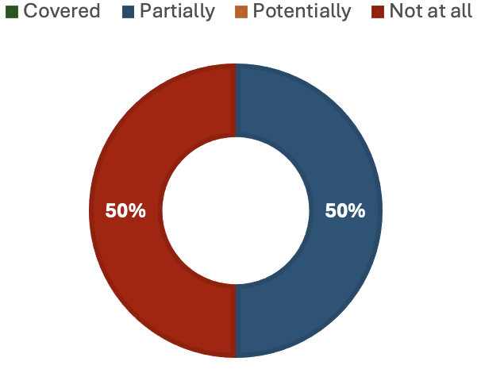
Figure 8. Coverage of Target 2 elements by headline indicator 2.1.

Target 3
- Most Target 3 elements are well covered (Figure 9) by its headline indicator (3.1) and its possible disaggregations. Disaggregation by realm allows monitoring of the 30% of terrestrial, inland water and marine and coastal areas included in protected areas and other effective area-based conservation measures (OECMs). Disaggregation by areas of particular importance for biodiversity allows the monitoring of their coverage by protected areas and OECMs. Disaggregation by realms, ecosystem functional groups, and areas of particular importance allows monitoring of the ecological representativeness of protected areas and OECMs. Disaggregation by effectiveness allows the monitoring of the effectiveness of management and conservation of terrestrial, inland water, marine and coastal areas. However, this disaggregation will be challenging to undertake comprehensively until data on protected area management effectiveness are more widely and consistently available. Further, this disaggregation partially informs on whether sustainable use is fully consistent with conservation outcomes by focusing on conservation outcomes (albeit not specifically related to sustainable use). Disaggregation by governance can be used as a proxy for monitoring whether protected areas and OECMs are equitably governed, therefore partially informing this element. No disaggregation of 3.1 is yet possible by indigenous peoples and local communities thus it cannot inform on the recognition and respect of the rights of indigenous peoples and local communities, including over their traditional territories. However, the traditional knowledge indicator on land tenure, disaggregated by protected areas and OECMs, could fill this gap. Headline indicator 3.1 further does not measure whether protected areas and OECMs are well connected nor if areas of particular importance for ecosystem functions and services are included in protected areas and OECMs. Physical connectivity can be measured using two component indicators (Protected Connected Index (Protconn), and Protected Area Connectedness Index (Parc-connectedness)). No component or complementary indicators exist to fill the gap in monitoring the inclusion of ecosystem functions and services in protected areas and OECMs, nor on the degree to which protected areas and OECMs are integrated into wider landscapes, seascapes and the ocean.

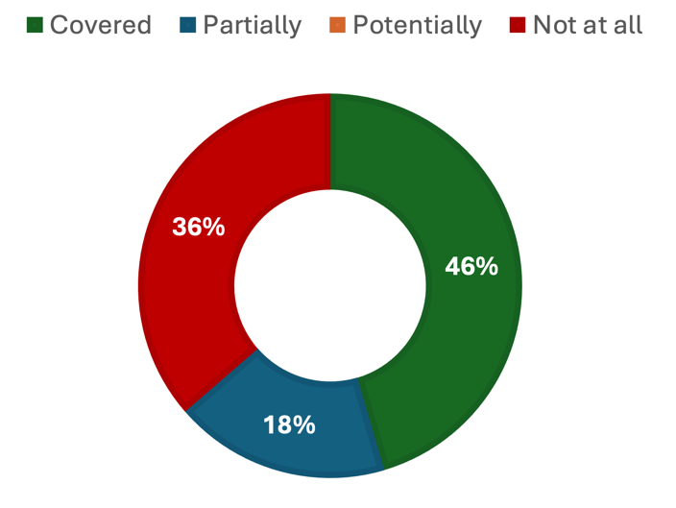
Figure 9. Coverage of Target 3 elements by headline indicator 3.1.

Target 4
- Target 4 elements are partially covered (Figure 10) by its headline indicators (A.3 and A.4). Headline indicator A.3 reflects trends in extinction risk, including extinctions themselves, but does not currently explicitly quantify their number (although this can be determined from the input data) and therefore only partially tracks progress towards halting human-induced extinction of known threatened species. Headline indicator A.3 further reflects the balance between species recovering and those deteriorating in status but does not reflect improvements in the status of species classified as Least Concern, so only partially informs on the recovery and conservation of species. One component indicator (the Green Status of Species) is specifically designed to quantify progress in the recovery and conservation of species. Headline indicator A.4 requires further testing (in relation to its representativeness) and inclusion of more species, especially recent breeds and indigenous domesticated species, before it can fully inform on the maintenance and restoration of genetic diversity within and between populations of native, wild and domestic species. Neither headline indicator enables progress tracking towards urgent management actions, including through in situ and ex situ conservation and sustainable management practices. However, one component (number of plant and animal genetic resources for food and agriculture secured in medium or long-term conservation facilities) and one complementary (number of island invasive alien species eradications) indicator monitor the implementation of some in situ actions and therefore partially inform on this element and a more comprehensive indicator is under development by IUCN. No indicators are currently available to monitor the management of human-wildlife interactions to minimize human-wildlife conflicts but a component indicator is being developed by the IUCN SSC Human-Wildlife Conflict and Coexistence Specialist Group

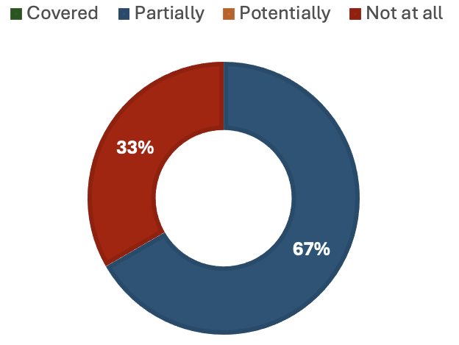
Figure 10. Coverage of Target 4 elements by headline indicators A.3 and A.4.

Target 5
- Target 5 elements are not well covered by its headline indicator (5.1, Figure 11). Headline indicator 5.1 only monitors marine fish stocks and therefore only partially tracks progress towards the sustainable use and harvesting of wild species. Multiple component and complementary indicators could partially address the gaps left by headline indicator 5.1. Two component indicators (Red List Index (impacts of utilisation), and the Living Planet Index for utilised species) and all the complementary indicators identified for this target can further inform progress towards the sustainable use and harvesting of wild species. Sustainable trade in wild species could be partially informed by two complementary indicators (number of Marine Stewardship Council Chain of Custody Certification holders by distribution country, and Biodiversity-based trade growth rates). The safe harvesting and trade of wild species, reducing the risk of pathogen spillover, could be partially informed by two complementary indicators (Inland fisheries threat indicator, and Marine Stewardship Council Certified Catch). The legality of harvesting and trade in wild species could be partially informed by one component (Degree of implementation of international instruments aiming to combat illegal, unreported and unregulated fishing) and three complementary indicators (Inland fisheries threat indicator, Marine Stewardship Council Certified Catch, and Biodiversity-based trade growth rates). The traditional knowledge indicator on traditional occupations (headline indicator 9.2) will potentially inform on the respect and protection of customary sustainable use once it is more widely tested and used. No indicators currently inform progress towards the application of the ecosystem approach in addressing sustainable harvesting and trade of wild species.

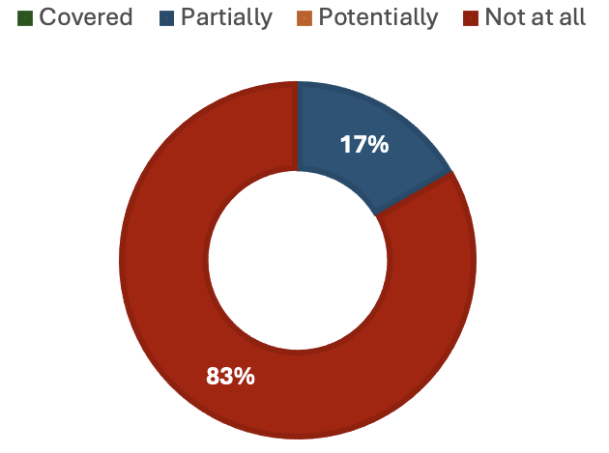
Figure 11. Coverage of Target 5 elements by headline indicator 5.1.

Target 6
- Target 6 elements are partially covered (Figure 12) by its headline (6.1) and binary (6.b) indicators. Headline indicator 6.1 monitors the reduction in rates of introduction and establishment of invasive alien species (IAS). However, it only partially addresses the impacts of IAS on biodiversity, as a reduction in introduction and establishment rates is an indirect measure of this impact (i.e. less introduction and establishment would be expected to lead to reduced impact on biodiversity). One complementary indicator (Red List Index (impacts of IAS)) can further inform on this element. The headline and binary indicators do not directly address the issue of pathway management. Headline indicator 6.1 may potentially inform on the identification of pathways of introduction and the prevention of introduction and establishment by priority IAS by disaggregation (by pathway and priority species respectively) but will require further development as it is not possible with current data sources. Indicator 6.b, which tracks the number of countries adopting relevant regulation, processes and measures to reduce the impact of invasive alien species could potentially inform on the impacts of IAS on biodiversity and ecosystem services but does not currently differentiate between the two nor does it measure realised reductions in impact. This binary indicator also partially informs on the eradication and control of IAS by providing information on the existence of relevant measures. Disaggregation of headline indicator 2.1 by restoration activity could further support monitoring of the eradication and control of IAS. Neither indicator 6.1 nor 6.b provide any information on the management of the pathways of introduction of IAS but one complementary indicator (Sustainable Development Goal 15.8.1) partially addresses this gap. Data collected from post-implementation monitoring of National Invasive Species Strategy and Action Plans may help address gaps left by these indicators across Target 6 elements.

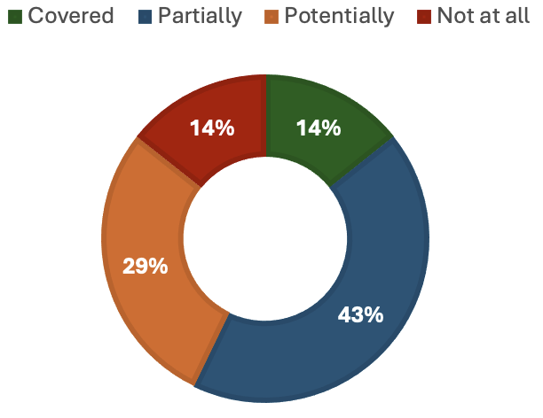
Figure 12. Coverage of Target 6 elements by headline indicator 6.1 and binary indicator 6.b.

Target 7
- Target 7 elements are partially covered (Figure 13) by its headline indicators (7.1 and 7.2). Both headline indicators partially inform on the reduction of risks and negative impacts from pollution to levels that are not harmful to biodiversity and ecosystem functions and services by monitoring a subset of them. Headline indicator 7.1 does not cover all pollution sources and is restricted to marine environments with river mouths, whilst 7.2 only measures the impacts from pesticides. Therefore, headline indicator 7.1 also partially informs on the reduction of nutrients lost to the environment but can be supported by two complementary indicators (trends in loss of reactive nitrogen to the environment, and trends in nitrogen deposition). Similarly, headline indicator 7.2 only partially informs on the reduction of overall risk from highly hazardous chemicals but can be supported by one complementary indicator (hazardous waste generation). Additionally, headline indicator 7.2 is currently a partial measure of risk as it does not include best management processes and therefore partially informs on the reduction of overall risk from pesticides. Neither headline indicator can inform on progress made towards eliminating plastic pollution but one component (floating plastic debris density (by micro and macro plastics)) and two complementary (trends in the amount of litter, including microplastics, in the water column and on the seafloor, and municipal solid waste collected and managed) indicators could provide some information to fill this gap, taking into account the discussion at the Intergovernmental Negotiating Committee on Plastic Pollution and its indicators. One component indicator informs on negative impacts of all pollution types (Red List Index (impact of pollution)).

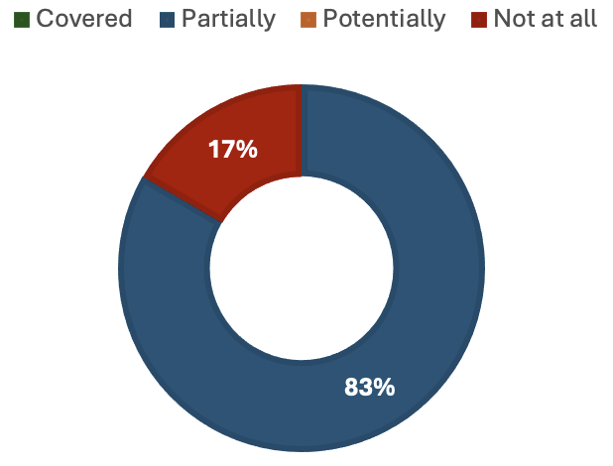
Figure 13. Coverage of Target 7 elements by headline indicators 7.1 and 7.2.

Target 8
- Target 8 elements are partially covered (Figure 14) by its binary indicator (8.b). Target 8 calls for the implementation of nature-based solutions and the ecosystem-based approach, both of which are addressed by 8.b. Indicator 8.b tracks the number of countries with agreed policies to minimize the impact of climate change and ocean acidification on biodiversity and that minimize negative and foster positive impacts of climate action on biodiversity. However, it provides no information on the impacts of nature based solutions on the resilience of biodiversity, nor about how these impacts are changing and therefore only partially allows progress tracking. One component indicator (Bioclimatic Ecosystem Resilience Index (BERI)) partially addresses biodiversity and resilience to climate change.

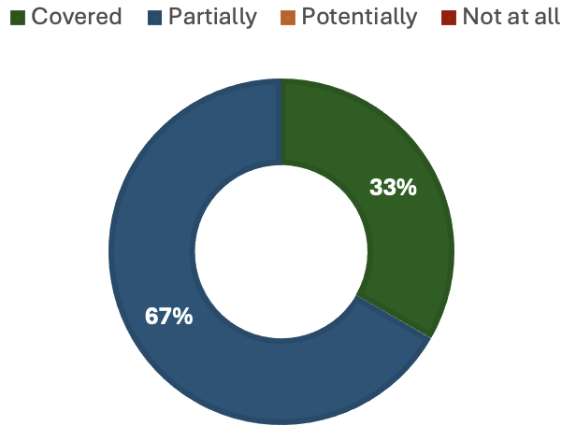
Figure 14. Coverage of Target 8 elements by binary indicator 8.b.

Target 9
- Target 9 elements are potentially covered (Figure 15) by its headline (9.2) and binary (9.b) indicators. Indicator 9.b provides information on the number of countries with policies to sustainably manage and use wild species but no information on whether these are providing social, economic or environmental benefits, thereby only partially informing on these elements. Another headline indicator, 9.1, a potential disaggregation of B.1, was intended to measure the benefits derived from the sustainable use of wild species but could not be developed at this stage because the methodology to assess sustainability within B.1 remains to be developed (more information available here). More information on sustainable management can be obtained from headline indicator 5.1 and two component indicators (Red List Index (impacts of utilization), and Living Planet Index for used species). Headline indicator 9.2 is focused on trends in traditional occupations, which provides partial information on the benefits derived from wild species by people in vulnerable situations and those most dependent on biodiversity and on sustainable biodiversity-based activities, products and services that enhance biodiversity. Progress towards the protection of customary and sustainable use by indigenous peoples and local communities is measured by indicator 9.b.

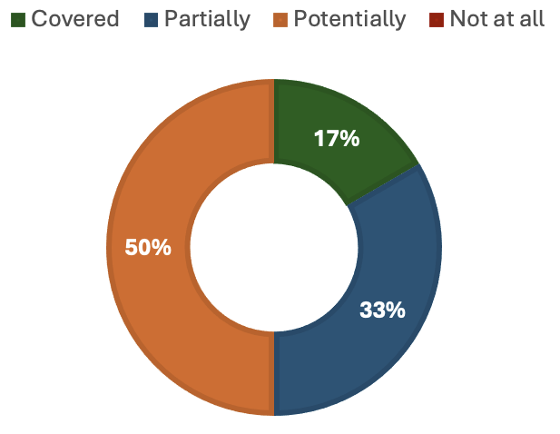
Figure 15. Coverage of Target 9 elements by headline indicator 9.2 and binary indicator 9.b.

Target 10
- Target 10 elements are partially covered (Figure 16) by its headline indicators (10.1 and 10.2). Progress towards the sustainable management of areas under agriculture and their contribution to food security is measured by 10.1. Progress towards the sustainable management of areas under forestry is covered by 10.2. Neither of these headline indicators can inform on the sustainable management of fisheries, although headline indicator 5.1 can inform on progress for marine fisheries only. No indicators exist to monitor progress towards the sustainable managements of areas under aquaculture. Both 10.1 and 10.2 partially inform on the maintenance of nature’s contributions to people, including ecosystem functions and services, the substantial increase in biodiversity-friendly practices and the resilience of long-term efficiency and productivity of the agriculture and forestry sectors, but not other productive systems. Some information on other productive systems can be acquired from three Sustainable Development Goal indicators (14.2.1, 2.3.2 and 2.3.1). Headline indicators 10.1 and 10.2 also currently inform on the contribution of productive sectors to conservation of biodiversity but not restoration.
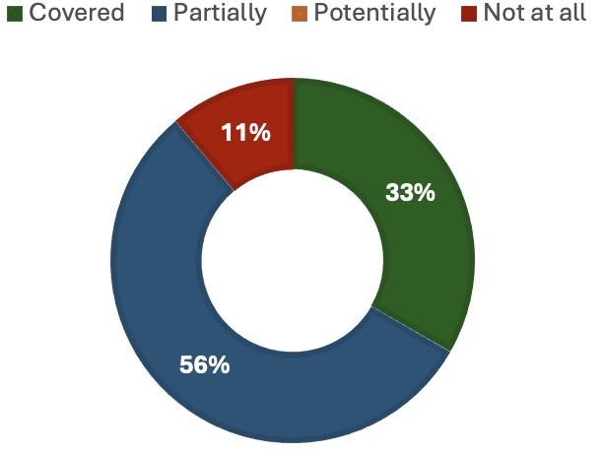
Figure 16. Coverage of Target 10 elements by headline indicators 10.1 and 10.2.

Target 11
- Target 11 elements are potentially covered (Figure 17) by its headline indicator (B.1). Multiple elements of Target 11 are a disaggregation of headline indicator B.1 by type of ecosystem service (e.g. regulation of air, water and climate, soil health, pollination, disaster risk, and protection from natural hazards and disasters). The methodology for B.1 to produce accounts for these ecosystem service types is not finalized, but once complete should provide information on progress made towards restoring, maintaining and enhancing these services. Component and complementary indicators from other goals (A and B) could further inform on each of these services. Restoration, maintenance and enhancement of nature’s contributions to people through nature-based solutions and ecosystem-based approaches cannot currently be informed by B.1. To date, only the use of ecosystem services is measured by B.1, not its associated management approaches.

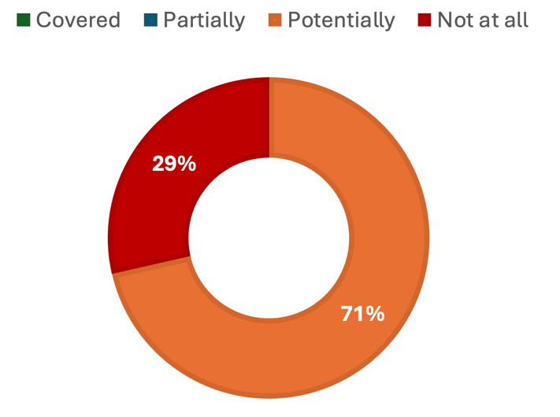
Figure 17. Coverage of Target 11 elements by headline indicator B.1.

Target 12
- Target 12 elements are not well covered (Figure 18) by its headline (12.1) and binary (12.b) indicators. Only one element is fully covered: ensuring biodiversity-inclusive urban planning. Indicator 12.b tracks progress towards biodiversity-inclusive spatial planning of green and blue spaces. However, neither indicator monitors the human health and wellbeing outcomes from this urban planning. Headline indicator 12.1 reports on open public spaces of all types, including sealed squares and key disaggregations for the green and blue components remains to be fully tested. There is currently a pilot study to develop a methodology to track progress on access by monitoring green spaces, potentially informing on the area of green spaces available in urban and densely populated areas. However, this methodology will not inform on blue spaces. Furthermore, this indicator will not address the quality nor connectivity of blue and green spaces nor the benefits derived from these. Headline indicator 12.1 further does not provide information on the mainstreaming of conservation and sustainable use of biodiversity nor the enhancement of native biodiversity in urban and densely populated areas. One component indicator (Singapore Index/City Biodiversity Index) can address some of these gaps. No other headline indicators can support monitoring of Target 12.

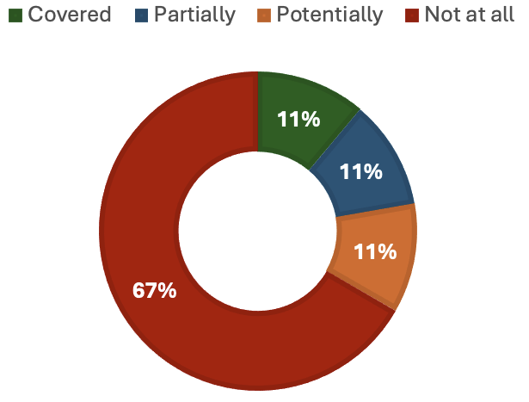
Figure 18. Coverage of Target 12 elements by headline indicator 12.1 and binary indicator 12.b.

Target 13
- Target 13 elements are quite well covered (Figure 19) by its headline indicators (C.1 and C.2). Its binary (13.b) indicator is still under development by the Conference of the Parties. The binary indicator reviewed by the AHTEG tracks the number of countries that have taken measures to ensure the fair and equitable sharing of benefits from the utilization of genetic resources and from digital sequence information on genetic resources, as well as traditional knowledge associated with genetic resources, covering the policy elements of Target 13. Headline indicators C.1 and C.2 monitor the benefits derived from genetic resources and traditional knowledge associated with genetic resources therefore allowing progress tracking of their increase. No indicator is available to track access to genetic resources and Parties are not required to regulate access. The taking of effective capacity-building measures to ensure benefit sharing is not the focus of headline indicators C.1 and C.2, but while these may potentially inform on such progress for genetic resources and traditional knowledge associated with genetic resources, this would not be the case for digital sequence information on genetic resources, for which a global agreement remains to be reached.

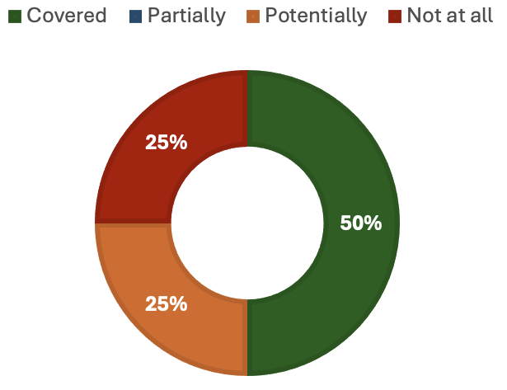
Figure 19. Coverage of Target 13 elements by headline indicators C1 and C2 and binary indicator 13.b.

Target 14
- Target 14 elements are partially covered (Figure 20) by its binary indicator (14.b). As a binary indicator, 14.b monitors the number of countries developing, adopting or implementing policy instruments aimed at encouraging and enabling people to make sustainable consumption choices. As it provides no information on the outcomes of these policy instruments, this indicator cannot provide sufficient information to fully monitor the integration of biodiversity and its multiple values into policies, regulations, planning and development processes, poverty eradication strategies, strategic environmental impact assessments and national accounting within and across all levels of government and across all sectors, in particular those with significant impacts on biodiversity. It also only partially addresses the alignment of all relevant public and private activities and fiscal and financial flows with the goals and targets of the Framework. The component indicator for Target 14 (Sustainable Development Goal indicator 15.9.1b) can further inform on the integration of biodiversity and its multiple values into national accounting.
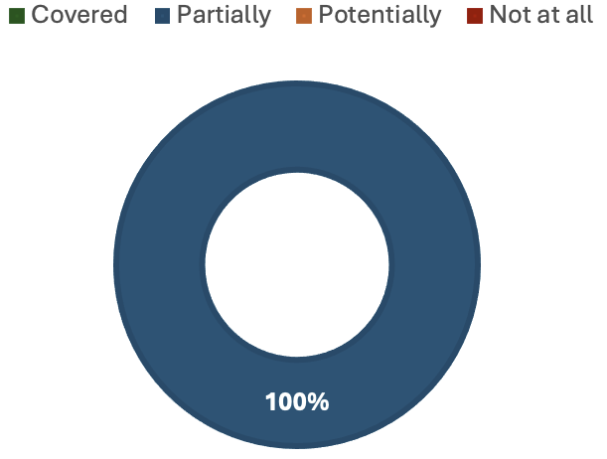
Figure 20. Coverage of Target 14 elements by binary indicator 14.b

Target 15
- Target 15 elements are covered (Figure 21) by its headline (15.1) and binary (15.b) indicators. The text of Target 15 specifically calls for Parties to “take legal, administrative or policy measures to…”. As such, indicator 15.b allows progress tracking of all elements of Target 15. Specifically, it provides information on measures to encourage and enable business to monitor, assess and transparently disclose their risks, dependencies and impacts relating to biodiversity. It further tracks whether Parties have taken measures to encourage and enable business to provide information to customers to promote sustainable consumption patterns and to report on compliance with access and benefit-sharing regulations where applicable. Headline indicator 15.1 further measures progress on disclosure of risks, dependencies and impacts by providing information on the number of companies and financial institutions publicly disclosing these in line with international standards.

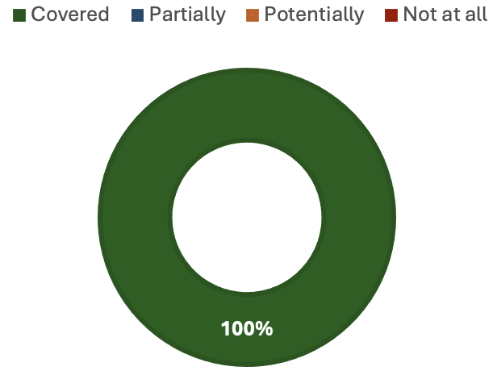
Figure 21. Coverage of Target 15 elements by headline indicator 15.1 and binary indicator 15.b.

Target 16

- Target 16 elements are partially covered (Figure 22) by its binary indicator (16.b). Indicator 16.b tracks the number of countries developing, adopting or implementing policy instruments aimed at encouraging and enabling people to make sustainable consumption choices, including through access to education and information on the impacts of consumption on biodiversity. This indicator provides no measure of effectiveness of these instruments. Therefore, 16.b only partially informs on progress made towards encouraging and enabling people to make sustainable consumption choices through policy and by improving access to education and information. One complementary indicator (Sustainable Development Goal indicator 4.7.1) can further help track progress towards access to education. Indicator 16.b also partially informs on progress made towards the reduction of the global footprint of consumption along with three component indicators (Material Footprint per Capita, Global Environmental Impacts of Consumption, and Ecological Footprint). Additionally, in combination with other data (e.g. component indicator Global Environmental Impacts of Consumption), 16.b may potentially inform on progress made towards reducing overconsumption and reducing waste generation. Indicator 16.b does not provide any information on food waste. One component indicator (Food waste index) may help fill this gap.

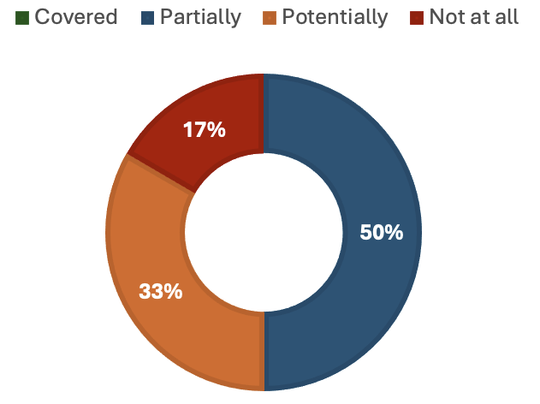
Figure 22. Coverage of Target 16 elements by binary indicator 16.b.

Target 17
- Target 17 elements are well covered (Figure 23) by its binary indicator (17.b). Indicator 17.b allows progress tracking of the establishment of measures by providing information on the number of countries with measures on biosafety, as set out under Article 8(g), and on the handling of biotechnology and distribution of its benefits, as set out under Article 19. Additionally, information on Parties signatory to Nagoya Protocol, which goes beyond the requirements of Article 8(g), can support progress tracking towards elements on biosafety. Indicator 17.b further addresses the implementation measures on biosafety and on biotechnology and distribution of its benefits by tracking the number of countries implementing such measures. However, it provides no information as to the effectiveness or breadth of these measures nor their implementation. The gap in measuring this element for biotechnology was also noted in the gaps in tools and guidance for the monitoring framework (Annex 3 of document CBD/SBSTTA/26/3). Finally, 17.b provides some information on participation and access to results from biotechnological research activities based on genetic resources of other Parties, which partially addresses the strengthening of capacity for measures on biotechnology, but it provides no such information on the strengthening of capacity for measures on biosafety.

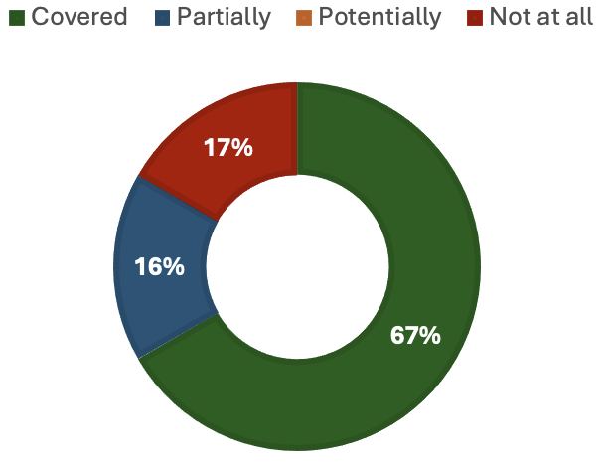
Figure 23. Coverage of Target 17 elements by binary indicator 17.b.

Target 18

- Target 18 elements are partially covered (Figure 24) by its headline indicators (18.1 and 18.2). Headline indicator 18.2 measures the value of subsidies and other incentives harmful to biodiversity and, as such, enables the progress to be tracked towards both the identification, by 2025, of incentives harmful to biodiversity and reduction of these incentives by 500 billion United States dollars per year by 2030. Headline indicator 18.1 measures the positive incentives in place to promote biodiversity conservation and sustainable use, which allows progress on the scaling up of such incentives to be tracked. These indicators do not allow for the monitoring of the elimination, phase-out and reform of incentives harmful to biodiversity. This is due to methodological issues with the data available to assess the value of subsidies. Such data are subject to many market forces, such as shifting commodity prices, that make it impossible to assess whether a decrease in value was caused by a reform, phase out, elimination or other. Therefore, there is no standardized, globally agreed methodology for assessing the value of subsidies and other incentives harmful to biodiversity that are eliminated, phased out or reformed, nor is there a global database providing this information. The issue of how to reform and/or phaseout harmful subsidies was further noted in the report on key gaps in tools and guidance for the monitoring framework (Annex 3 of document CBD/SBSTTA/26/3).

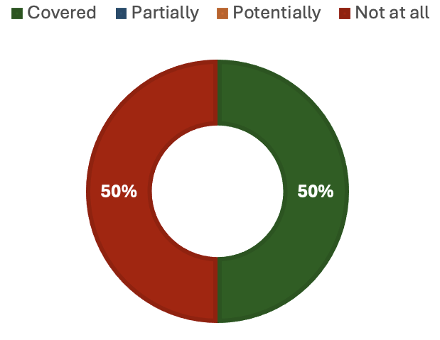
Figure 24. Coverage of Target 18 elements by headline indicators 18.1 and 18.2.

Target 19
- Target 19 elements are partially covered (Figure 25) by its headline indicators (D.1, D.2 and D.3). Progress on elements related to financial resources can be tracked with each of the headline indicators. Headline indicator D.1 quantifies the total international public finance flows with biodiversity objectives, which will inform on the increase of biodiversity related international financial resources. Headline indicator D.2 quantifies the domestic public funding on conservation and sustainable use of biodiversity and ecosystems, which will inform on the increase of domestic resource mobilisation. Headline indicator D.3 quantifies the amount of private funding (domestic and international) on conservation and sustainable use of biodiversity and ecosystems, which will inform on the private sector’s investment in biodiversity and the uptake of innovative schemes with environmental and social safeguards. As such, all three headline indicators partially inform on enhancing the effectiveness, efficiency and transparency of resource provision and use through their focus on transparent reporting of finance resource provision and use. However, no indicators are available to track progress on the optimization of co-benefits and synergies of finance targeting the biodiversity and climate crises, on the ease of access of financial resources, nor on the enhancement of the role of collective actions and non-market-based approaches.

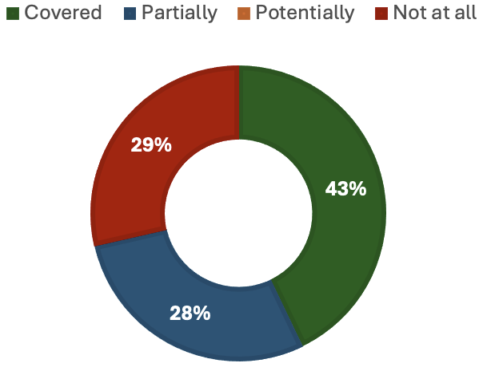
Figure 25. Coverage of Target 19 elements by headline indicators D.1, D.2 and D.3.

Target 20

- Target 20 elements are partially covered (Figure 26) by its binary indicator (20.b). Binary indicator 20.b measures the number of countries that have taken action to strengthen capacity-building and development, access to and transfer of technology, and to promote the development of and access to innovation and technical and scientific cooperation. As a binary indicator it cannot inform on the effectiveness of this action nor on their extent and therefore can only provide partial progress tracking towards the aims of Target 20. As such, there are no existing indicators that directly measure all the elements. However, some complementary indicators could partially measure some of the elements. Specifically, three complementary indicators (Volume of official development assistance flows for scholarships by sector and type of study; Sustainable Development Goal (SDG) indicator 12.8.1; SDG indicator 17.19.1) can inform on capacity building and development. There are three others (Total amount of funding for developing countries to promote the development, transfer, dissemination and diffusion of environmentally sound technologies; Global imports of information and communication technology goods as presented by bilateral trade flows by information and communication technology goods categories; SDG indicator 17.7.1) on access to and transfer of technology. Plus one (SDG indicator 17.9.1) on technical and scientific cooperation, and one (Total amount of funding for developing countries to promote the development, transfer, dissemination and diffusion of environmentally sound technologies) on technology development. Finally, there are four (Number of researchers per population; Joint scientific papers published (in Ocean Biodiversity Information System) by sector; Proportion of total research budget allocated to research in the field of marine technology; SDG indicator 9.5.2) strengthening monitoring capacity. Additionally, three component and complementary indicators for Goal D are relevant to Target 20 (Finance mobilized for capacity-building; Financial and technical assistance provided in dollars (including through South-South, North-South and triangular cooperation); Finance mobilized for promoting the development, transfer, dissemination and diffusion of technology).

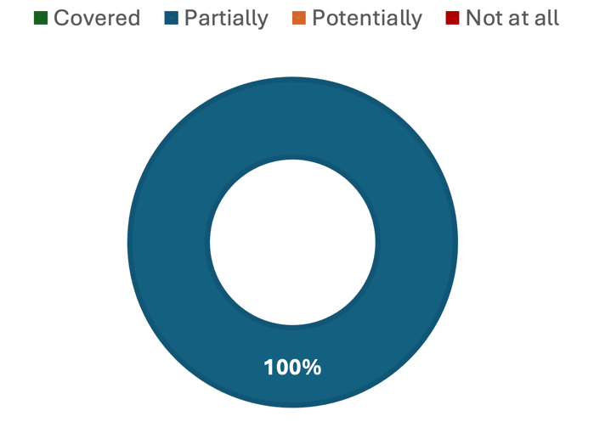
Figure 26. Coverage of Target 20 elements by binary indicator 20.b.

Target 21
- Target 21 elements are potentially covered (Figure 27) by its headline indicator (21.1). Headline indicator 21.1 is in development and therefore not fully operational and tested. It can potentially measure progress on strengthening monitoring, research, and knowledge management and on ensuring that the best available data, information and knowledge are available to decision-makers, practitioners and the public. It is proposed to do so by monitoring the different types of biodiversity information and sources to assess coverage and uncertainty, guiding the implementation of the Monitoring Framework. This indicator will also make use of traditional knowledge that can be accessed with free, prior and informed consent. All four traditional knowledge indicators will help with this element. One gap left by 21.1 will be in tracking progress towards strengthening communication, awareness-raising and education. This gap may be partially addressed by one complementary indicator (Biodiversity literacy in global zoo and aquarium visitors). This gap may also be partially addressed by reporting progress specifically toward section K (communication, education, awareness and uptake) of the Framework.

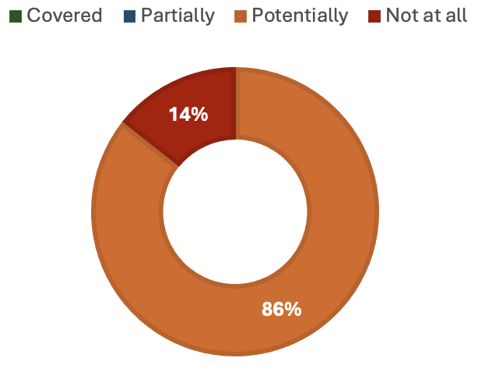
Figure 27. Coverage of Target 21 elements by headline indicator 21.1.

Target 22
- Target 22 elements are partially covered (Figure 28) by its binary indicator (22.b). As a binary indicator, 22.b measures progress towards the conditions necessary to deliver on the aims of Target 22. As such, no information on outcomes is available from 22.b and it partially informs on the full, equitable, inclusive, effective and gender-responsive representation and on participation in decision-making related to biodiversity by indigenous peoples and local communities, women and girls, children and youth and people with disabilities, the access to justice and information related to biodiversity for these same groups, and the full protection of environmental human rights defenders. Specifically, it tracks progress in the establishment, monitoring and resourcing of policies and measures to deliver on these aims. Additional indicators, such as the four traditional knowledge indicators and Sustainable Development Goal indicator 16.10.1 can help inform on the outcomes of the measures monitored by 22.b.

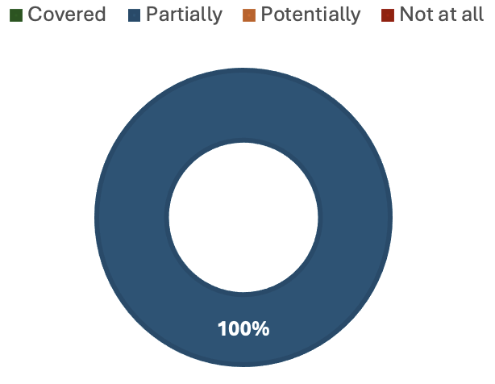
Figure 28. Coverage of Target 22 elements by binary indicator 22.b.

Target 23
- Target 23 elements are partially covered (Figure 29) by its binary indicator (23.b). Indicator 23.b monitors the number of countries with legal, administrative or policy frameworks, including the Gender Plan of Action, as well as the allocation of specific financial resources to ensure that all women and girls have equal opportunity and capacity to contribute to the three objectives of the Convention, including by ensuring women’s equal rights and access to land and natural resources. This indicator cannot assess the impact of these frameworks and therefore can only partially inform on the status of gender equality in the implementation of the framework, the recognition of equal rights and access of women and girls to land and natural resources and the full, equitable, meaningful and informed participation and leadership of women and girls at all levels of action, engagement, policy and decision-making related to biodiversity. Disaggregation by gender of many headline, component and complementary indicators of the Monitoring framework, once available, would help fill the gaps left by 23.b. Information collected through Parties’ national implementation of the Gender Plan of Action may further address these gaps. UNEP-WCMC and Women4Biodiversity are developing an indicator for the national implementation of the Gender Plan of Action which currently a component indicator for Target 23 in the Monitoring Framework.

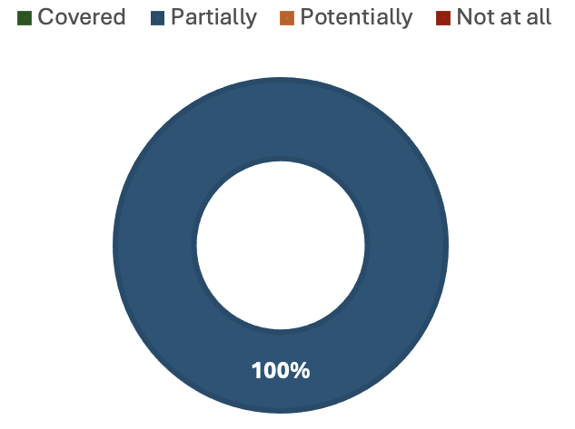
Figure 29. Coverage of Target 23 elements by binary indicator 23.b.

5. Filling the gaps
- The need for significant effort and investment in the implementation of the monitoring framework remains apparent. The monitoring framework of the Kunming-Montreal Global Biodiversity Framework covers the four goals and twenty-three targets reasonably well. The four different kinds of indicators – headline, binary, component and complementary – combined offer a good picture of progress made. However, there are gaps in the coverage of the monitoring framework for all three sections of the Framework: reducing threats to biodiversity; meeting people’s needs through sustainable use and benefit sharing; and tools and solutions for implementation and mainstreaming. As a result of these gaps, most of the goals and targets are not completely covered by the monitoring framework. International effort and resourcing are required to fill these gaps in the monitoring framework. A number of possible solutions to filling the gaps in the monitoring framework were identified by the AHTEG, noting that not all gaps in the framework require the same level of investment. In some cases, expanding existing methods may help move goals and targets from partially/potentially covered to fully covered. In others, where specific elements are not covered at all, additional investment will be necessary to address these gaps and a focus on identifying opportunities for synergies across goals and targets may yield the best results.

Gaps in existing headline indicators
- The most straightforward solution to addressing gaps in the monitoring framework is to focus more effort on the development of those headline indicators where special focus on possible disaggregation or coverage will enable a more complete coverage of the relevant goals and targets without the need for new indicator development. For example, headline indicators for goal A partially cover its ambition but expanding the scope of Red List of Ecosystems assessments (with appropriate resourcing and tools) to include connectivity and integrity measures would improve headline indicator A.1 to more fully cover multiple elements. Additionally, extending the use of Red List of Threatened Species data for A.3 and expanding the coverage of A.4 to include more regions and species would, all together move coverage of Goal A from 40% to 90%, while application of one or more component indicators relating to species’ population abundance would enable complete coverage. These efforts would not require the development of new indicators and would improve coverage significantly.
- Similarly, multiple headline indicators (B.1, 2.1, 3.1 and 6.1) have the potential to cover more elements of their specific goal or target if disaggregated to the relevant level. In some cases, the lack of disaggregation is a methodological challenge. In other cases, it is due to data availability. Improving and/or broadening data collection for these indicators would significantly improve the coverage of the monitoring framework at a relatively low cost and without the need to develop new indicators.
- Some headline indicators have been specifically designed for the monitoring framework (e.g. C.1, C.2 and 21.1) and have the potential to cover their goals and targets thoroughly but are not yet fully in place. Committing the resources needed to finalising their methodologies would enable the monitoring of targets that are currently underrepresented or currently unmonitored.

Gaps in the binary indicators
- Some targets, particularly those where headline indicators offer poor coverage or where only binary indicators are available, may require additional indicators to be developed to address their gaps. This is likely to need to be focussed investment of resources over a period of time. Binary indicators are a highly valuable source of information that can be used to rapidly and relatively cheaply assess progress towards implementing the necessary measures to deliver on goals and targets. However, by their very nature, they cannot inform on the implementation or effects of these measures. As such, they can only track those elements where goals or targets specifically call for the taking of measures but only partially those calling for results. Therefore, for all targets calling for results, and where only binary indicators are available, only partial coverage can be achieved within the current monitoring framework. Efforts need to be made to design fit for purpose quantitative indicators that can support the binary indicators and cover the outcome elements of those targets. Collaboration may help lower the burden of designing new indicators. For example, the UN Women’s Caucus and the Global Youth Biodiversity Network are working on indicators that may be suited to report on targets relevant to women and girls and to children and youth, respectively.
- It is important to note that the gaps in coverage of binary indicators identified in this report depend on the final wording for the binary indicators adopted at COP-16. If the language of the binary indicators is substantially changed by the Conference of the Parties at its sixteenth meeting, then the coverage of these indicators would be affected and the gap analysis should be revised. Such changes would also make the metadata for binary indicators outdated, implying a need for modification of that document.

Gaps in coverage
- Some targets are likely to require significant effort to fill the gaps identified. Specifically, Targets 1 and 9 did not have their headline indicators developed for methodological reasons (see document CBD/COP/16/INF/3 for more detail). Similarly, Targets 5 and 12 are only sparsely covered due to the narrow focus of headline indicators 5.1 and 12.1. These cannot be extended easily. As such, more indicators may be required to monitor these targets. Synergies between indicators are possible between Targets 5 and 9 as they share many common goals. Finally, the focus of Target 10 is broader than its headline indicators can currently cover, and developing new indicators, or an extension to 10.1, to cover other productive sectors, especially fisheries, is important for monitoring this target fully. Here again, there is an opportunity for a new indicator for Target 5 to be extended to inform on Target 10, therefore reducing the need for multiple new indicators to be developed if synergies are exploited.
- For some elements, no headline, binary, component nor complementary indicators are available and new indicators are required. There are eight targets and one goal containing elements that cannot currently be monitored at all under the monitoring framework (namely, Goal D and Targets 3, 4, 5, 10, 12, 13, 17 and 18). For some of these (Targets 5 and 12) the gaps are sufficiently large that Parties may wish to consider if new indicators are required. For others (Targets 3, 13, 18) it might be possible to extend the methods or identify disaggregation options on existing headline indicators to cover those gaps. Others may require specific indicators (Goal D and Target 4) to complement the existing headline indicators. These additional indicators could come in the form of component or complementary indicators specifically addressing the gaps identified (e.g. Target 4: manage human-wildlife interactions to minimize human-wildlife conflicts) or additional straightforward binary indicators may suffice (e.g. Goal D: adequate capacity-building is secured). Additional component and complementary indicators could be provided by custodian organisations currently focused on those specific aspects of the goals and targets whilst additional binary indicators could be proposed by the Subsidiary Body and follow the methodology designed by the AHTEG.

Gaps in capacity needs
- A study of gaps in tools and guidance to support the implementation of the targets of the Framework was also conducted in parallel (CBD/SBSTTA/26/INF/15). One of the key gaps identified in that report was the issue of defining terms, specifically for Targets 1, 2 and 9. This issue was addressed by the AHTEG in its work on the metadata for these targets and definitions can be found in the glossary for the monitoring framework available in document CBD/COP/16/INF/3. Other gaps in the report on supporting the implementation of the monitoring framework align with those identified by the AHTEG in this gap analysis. Specifically, there are gaps in data availability and tools for collecting data on human-wildlife conflict (Target 4), sustainable inland fisheries (Target 5) – two elements for which there is currently no indicator available in the monitoring framework – and plastic pollution (Target 7). The report further notes the need to expand the guidance for Targets 15 and 16 to other sectors, as mentioned above. Additionally, the report calls for tools to effectively monitor and systematically evaluate progress in terms of gender responsive policies (Target 23), which is a gap noted by the AHTEG for all targets with only a binary indicator. These similarities between reports strengthen the case for the gaps identified by the AHTEG and suggest that the solutions proposed herein will enable tackling of the gaps in coverage and in tools and guidance of each goal and target of the monitoring framework together.

6. Guidance for Parties
- The list of elements (Table A1) offers a starting point for Parties to focus on national priorities and align their National Biodiversity Strategy and Action Plan (NBSAP). Specific elements may be of high priority to some Parties (e.g. human-wildlife conflict) but not currently well addressed in the monitoring framework. Identifying for which elements this is the case will allow Parties to consider whether to rely on their own indicators or to collaborate with relevant organisations that may offer information on these priorities. These can be reported in NBSAPs alongside the required headline and binary indicators. Additionally, identifying these national priority elements could help direct national efforts and resources to developing and implementing those indicators (especially voluntary indicators such as component and complementary indicators) that can most directly inform the priorities set out in their NBSAPs.
- Beyond national priorities, global cooperation is required to resource the organisations acting as custodians for indicators. This is essential for the full development of indicators and possible disaggregations and for the improvement of coverage. Many such organisations currently exist (e.g. The Indigenous Navigator, IUCN, and GEO BON among others) and require support from Parties to deliver fit for purpose indicators that can improve the coverage of the monitoring framework. Many issues of partial or potential coverage are linked to the availability of data that could allow disaggregation of indicators. It should be noted however that there is a balance between asking Parties for more disaggregated data (which would increase the burden of reporting) and overlay of data provided by Parties with information from other sources (which implies more effort in analysis of collated data).
- The need to improve data collection efforts is particularly apparent when considering section C of the Framework. Developing and making use of synergies between monitoring the implementation of the Framework and a human rights-based approach to monitoring and data, as well as operationalising the traditional knowledge indicators, can support Parties to address some of the aspects of section C (for more information see section 2 of CBD/COP/16/INF/3). In many cases the disaggregation of headline indicators is not yet possible to show how the cross-cutting aspects of the Framework are being delivered.
- The work of the AHTEG, and input by many organisations and individuals, has significantly improved the readiness level of existing indicators and the ability of the monitoring framework to track progress towards the ambitions of the Global Biodiversity Framework. The upcoming methodological assessment on monitoring biodiversity and nature’s contributions to people (“monitoring assessment”) by the Intergovernmental Panel on Biodiversity and Ecosystem Services will also help to specifically inform the way that existing data and methods could contribute to filling gaps. It is for Parties to decide if the gaps identified need to be filled or not, and whether the monitoring framework should cover all elements of all targets; some suggestions for ways to improve coverage are made in the section on filling the gaps above.

Annex I. List of distinct elements in the Kunming-Montreal Global Biodiversity Framework goals and targets

Table A1. List of distinct elements identified in the text of the Framework that require monitoring for a holistic progress tracking. Here, the text was taken from the goals and targets alone, without the corresponding and relevant considerations set out in section C of the Framework, which are to be considered cross-cutting.
Goal/Target | Element
Goal A | A (i) The integrity of all ecosystems is maintained, enhanced, or restored
Goal A | A (ii) The connectivity of all ecosystems is maintained, enhanced, or restored
Goal A | A (iii) The resilience of all ecosystems is maintained, enhanced, or restored
Goal A | A (iv) The area of natural ecosystems is substantially increased by 2050
Goal A | A (v) Human induced extinction of known threatened species is halted
Goal A | A (vi) By 2050, the extinction rate of all species is reduced tenfold
Goal A | A (vii) By 2050, the extinction risk of all species is reduced tenfold
Goal A | A (viii) By 2050, the abundance of native wild species is increased to healthy and resilient levels
Goal A | A (ix) The genetic diversity within populations of wild species is maintained, safeguarding their adaptive potential
Goal A | A (x) The genetic diversity within populations of domestic species is maintained, safeguarding their adaptive potential
Goal B | B (i) Biodiversity is sustainably used and managed
Goal B | B (ii) Nature’s contributions to people, including ecosystem functions and services, are valued
Goal B | B (iii) Nature’s contributions to people, including ecosystem functions and services, are maintained
Goal B | B (iv) Nature’s contributions to people, including ecosystem functions and services, are enhanced
Goal B | B (v) Nature’s contributions to people currently in decline are restored
Goal B | B (vi) supporting the achievement of sustainable development for the benefit of present and future generations by 2050.
Goal C | C (i) The monetary benefits from the utilization of genetic resources are shared fairly and equitably, including, as appropriate with indigenous peoples and local communities, and substantially increased by 2050
Goal C | C (ii) The monetary benefits from the utilization of digital sequence information are shared fairly and equitably, including, as appropriate with indigenous peoples and local communities, and substantially increased by 2050
Goal C | C (iii) The monetary benefits from the utilization of traditional knowledge associated with genetic resources are shared fairly and equitably, including, as appropriate with indigenous peoples and local communities, and substantially increased by 2050
Goal C | C (iv) The non-monetary benefits from the utilization of genetic resources are shared fairly and equitably, including, as appropriate with indigenous peoples and local communities, and substantially increased by 2050
Goal C | C (v) The non-monetary benefits from the utilization of digital sequence information are shared fairly and equitably, including, as appropriate with indigenous peoples and local communities, and substantially increased by 2050
Goal C | C (vi) The non-monetary benefits from the utilization of traditional knowledge associated with genetic resources are shared fairly and equitably, including, as appropriate with indigenous peoples and local communities, and substantially increased by 2050
Goal C | C (vii) Traditional knowledge associated with genetic resources is appropriately protected
Goal D | D (i) Adequate financial resources secured
Goal D | D (ii) Adequate capacity-building secured
Goal D | D (iii) Adequate technical and scientific cooperation secured
Goal D | D (iv) Access to and transfer of technology secured
Goal D | D (v) Means of implementation are equitably accessible to all Parties
Target 1 | 1a. All areas are under spatial planning and/or effective management processes addressing land/sea use change
Target 1 | 1b. Spatial planning is participatory
Target 1 | 1c. Spatial planning is integrated
Target 1 | 1d. Spatial planning is biodiversity-inclusive
Target 1 | 1e. Spatial planning/management processes bring the loss of areas of high biodiversity importance, including ecosystems of high ecological integrity, close to zero by 2030
Target 1 | 1f. Spatial planning/management processes respect the rights of indigenous peoples and local communities
Target 2 | 2a. Ensure that by 2030, at least 30 per cent of areas of degraded terrestrial ecosystems are under restoration
Target 2 | 2b. Ensure that by 2030, at least 30 per cent of degraded inland water ecosystems are under restoration
Target 2 | 2c. Ensure that by 2030, at least 30 per cent of degraded marine and coastal ecosystems are under restoration
Target 2 | 2d. Restoration is effective, enhancing biodiversity
Target 2 | 2e. Restoration is effective, enhancing ecosystem functions and services
Target 2 | 2f. Restoration is effective, enhancing ecological integrity and connectivity
Target 3 | 3a. Ensure and enable that by 2030 at least 30 per cent of terrestrial and inland water areas are included in systems of protected areas and other effective area-based conservation measures, recognizing indigenous and traditional territories where applicable
Target 3 | 3b. Ensure and enable that by 2030 at least 30 per cent of marine and coastal areas are included in systems of protected areas and other effective area-based conservation measures, recognizing indigenous and traditional territories where applicable
Target 3 | 3c. Ensure and enable that by 2030, areas of particular importance for biodiversity are included in systems of protected areas and other effective area-based conservation measuress, recognizing indigenous and traditional territories where applicable
Target 3 | 3d. Ensure and enable that by 2030, areas of particular importance for ecosystem functions and services are included in systems of protected areas and OECMs, recognizing indigenous and traditional territories where applicable
Target 3 | 3e. Systems of protected areas and other effective area-based conservation measures, recognizing indigenous and traditional territories where applicable, effectively manage and conserve terrestrial, inland water, marine and coastal areas
Target 3 | 3f. Systems of protected areas and other effective area-based conservation measures, recognizing indigenous and traditional territories where applicable, are ecologically representative
Target 3 | 3g. Systems of protected areas and other effective area-based conservation measures, recognizing indigenous and traditional territories where applicable, are well connected
Target 3 | 3h. Systems of protected areas and other effective area-based conservation measures, recognizing indigenous and traditional territories where applicable, are equitably governed
Target 3 | 3i. Systems of protected areas and other effective area-based conservation measures, recognizing indigenous and traditional territories where applicable, are integrated into wider landscapes, seascapes and the ocean
Target 3 | 3j. Ensure that any sustainable use, where appropriate in such areas is fully consistent with conservation outcomes
Target 3 | 3k. Systems of protected areas and OECMs recognize and respect the rights of indigenous peoples and local communities, including over their traditional territories
Target 4 | 4a. Ensure urgent management actions including through in situ and ex situ conservation and sustainable management practices
Target 4 | 4b. Halt human-induced extinction of known threatened species
Target 4 | 4c. Enable the recovery and conservation of species, in particular threatened species
Target 4 | 4d. Maintain and restore the genetic diversity within and between populations of native, wild species to maintain their adaptive potential
Target 4 | 4e. Maintain and restore the genetic diversity within and between populations of domestic species to maintain their adaptive potential
Target 4 | 4f. Effectively manage human-wildlife interactions to minimize human-wildlife conflicts for coexistence
Target 5 | 5a. Ensure that the use and harvesting of wild species is sustainable preventing overexploitation, minimizing impacts on non-target species and ecosystems
Target 5 | 5b. Ensure that the trade in wild species is sustainable preventing overexploitation, minimizing impacts on non-target species and ecosystems
Target 5 | 5c. Ensure that the use, harvesting and trade of wild species is safe, reducing the risk of pathogen spillover
Target 5 | 5d. Ensure that the use, harvesting and trade of wild species is legal
Target 5 | 5e. Apply the ecosystem approach in addressing sustainable, safe and legal use, harvesting and trade of wild species
Target 5 | 5f. Respect and protect customary sustainable use by indigenous peoples and local communities in addressing sustainable, safe and legal use, harvesting and trade of wild species
Target 6 | 6a. Eliminate, minimize, reduce and or mitigate the impacts of invasive alien species on biodiversity
Target 6 | 6b. Eliminate, minimize, reduce and or mitigate the impacts of invasive alien species on ecosystem services
Target 6 | 6c. Identify pathways of the introduction of invasive alien species
Target 6 | 6d. Manage pathways of the introduction of invasive alien species
Target 6 | 6e. Prevent the introduction and establishment of priority invasive alien species
Target 6 | 6f. Reduce the rates of introduction and establishment of other known or potential invasive alien species by at least 50 per cent by 2030
Target 6 | 6g. Eradicate or control invasive alien species, especially on priority sites, such as islands
Target 7 | 7a. Reduce pollution risks and the negative impact of pollution from all sources, by 2030, to levels that are not harmful to biodiversity considering cumulative effects
Target 7 | 7b. Reduce pollution risks and the negative impact of pollution from all sources, by 2030, to levels that are not harmful to ecosystem functions and services, considering cumulative effects
Target 7 | 7c. Reduce excess nutrients lost to the environment by at least half including through more efficient nutrient cycling and use
Target 7 | 7d. Reduce the overall risk from pesticides by at least half including through integrated pest management, based on science, taking into account food security and livelihoods
Target 7 | 7e. Reduce the overall risk from highly hazardous chemicals by at least half
Target 7 | 7f. Work towards eliminating plastic pollution.
Target 8 | 8a. Minimize the impact of climate change on biodiversity, and increase its resilience, through mitigation, adaptation and disaster risk reduction actions
Target 8 | 8b. Minimize the impact of ocean acidification on biodiversity, and increase its resilience, through mitigation, adaptation and disaster risk reduction actions
Target 8 | 8c. Apply nature-based solutions (in minimizing climate change/ocean acidification impacts and increasing resilience)
Target 8 | 8d. Apply the ecosystem-based approach (in minimizing climate change/ocean acidification impacts and increasing resilience)
Target 8 | 8e. Minimize negative impacts of climate action on biodiversity
Target 8 | 8f. Foster positive impacts of climate action on biodiversity
Target 9 | 9a. Ensure that the management and use of wild species are sustainable, thereby providing social benefits for people
Target 9 | 9b. Ensure that the management and use of wild species are sustainable, thereby providing economic benefits for people
Target 9 | 9c. Ensure that the management and use of wild species are sustainable, thereby providing environmental benefits for people
Target 9 | 9d. Sustainable management and use of wild species provides benefits for people in vulnerable situations and those most dependent on biodiversity
Target 9 | 9e. Ensure benefits to people through sustainable biodiversity-based activities, products and services that enhance biodiversity
Target 9 | 9f. Protect and encourage customary sustainable use by indigenous peoples and local communities
Target 10 | 10a. Ensure that areas under agriculture are managed sustainably
Target 10 | 10b. Ensure that areas under aquaculture are managed sustainably
Target 10 | 10c. Ensure that areas under fisheries are managed sustainably
Target 10 | 10d. Ensure that areas under forestry are managed sustainably
Target 10 | 10e. Ensure sustainable management of productive sectors through a substantial increase of the application of biodiversity friendly practices, such as sustainable intensification, agroecological and other innovative approaches
Target 10 | 10f. Ensure that sustainable management of productive sectors contributes to the resilience and long-term efficiency and productivity of these production systems
Target 10 | 10g. Ensure that sustainable management of productive sectors contributes to food security
Target 10 | 10h. Ensure that sustainable management of productive sectors contributes to conserving and restoring biodiversity
Target 10 | 10i. Ensure that sustainable management of productive sectors contributes to maintaining nature’s contributions to people, including ecosystem functions and services
Target 11 | 11a. Restore, maintain and enhance nature’s contributions to people, including ecosystem functions and services through nature-based solutions for the benefit of all people and nature
Target 11 | 11b. Restore, maintain and enhance nature’s contributions to people, including ecosystem functions and services through ecosystem-based approaches for the benefit of all people and nature
Target 11 | 11c. Restore, maintain and enhance regulation of air, water and climate
Target 11 | 11d. Restore, maintain and enhance soil health
Target 11 | 11e. Restore, maintain and enhance pollination
Target 11 | 11f. Restore, maintain and enhance reduction of disease risk
Target 11 | 11g. Restore, maintain and enhance protection from natural hazards and disasters
Target 12 | 12a. Significantly increase the area of green spaces in urban and densely populated areas
Target 12 | 12b. Significantly increase the area of blue spaces in urban and densely populated areas
Target 12 | 12c. Significantly increase the quality of green and blue spaces in urban and densely populated areas
Target 12 | 12d. Significantly increase the connectivity of green and blue spaces in urban and densely populated areas
Target 12 | 12e. Significantly increase the access to and benefits from green and blue spaces in urban and densely populated areas
Target 12 | 12f. Mainstream the conservation and sustainable use of biodiversity in urban and densely populated areas
Target 12 | 12g. Ensure biodiversity-inclusive urban planning contributing to inclusive and sustainable urbanization and to the provision of ecosystem functions and services.
Target 12 | 12h. Enhance native biodiversity in urban and densely populated areas
Target 12 | 12i. Improve human health and well-being and connectedness to nature, through biodiversity-inclusive urban planning
Target 13 | 13a. Take effective legal, policy and administrative measures at all levels, as appropriate, to ensure the fair and equitable sharing of benefits that arise from the utilization of genetic resources
Target 13 | 13b. Take effective capacity building measures at all levels, as appropriate, to ensure the fair and equitable sharing of benefits that arise from the utilization of genetic resources
Target 13 | 13c. Take effective legal, policy and administrative measures at all levels, as appropriate, to ensure the fair and equitable sharing of benefits that arise from the utilization of digital sequence information on genetic resources
Target 13 | 13d. Take effective capacity building measures at all levels, as appropriate, to ensure the fair and equitable sharing of benefits that arise from the utilization of digital sequence information on genetic resources
Target 13 | 13e. Take effective legal, policy and administrative measures at all levels, as appropriate, to ensure the fair and equitable sharing of benefits that arise from traditional knowledge associated with genetic resources
Target 13 | 13f. Take effective capacity building measures at all levels, as appropriate, to ensure the fair and equitable sharing of benefits that arise from traditional knowledge associated with genetic resources
Target 13 | 13g. Facilitate appropriate access to genetic resources
Target 13 | 13h. By 2030, facilitate a significant increase of the benefits shared, in accordance with applicable international access and benefit-sharing instruments
Target 14 | 14a. Ensure the full integration of biodiversity and its multiple values into policies, regulations, planning and development processes
Target 14 | 14b. Ensure the full integration of biodiversity and its multiple values into poverty eradication strategies
Target 14 | 14c. Ensure the full integration of biodiversity and its multiple values into strategic environmental assessments and environmental impact assessments
Target 14 | 14d. Ensure the full integration of biodiversity and its multiple values into national accounting, as appropriate
Target 14 | 14e. Ensure the full integration of biodiversity and its multiple values within and across all levels of government
Target 14 | 14f. Ensure the full integration of biodiversity and its multiple values across all sectors, in particular those with significant impacts on biodiversity
Target 14 | 14g. Progressively align all relevant public and private activities, and fiscal and financial flows with the goals and targets of this framework
Target 15 | 15a. Take legal, administrative or policy measures to encourage and enable business, and in particular to ensure that large and transnational companies and financial institutions, along their operations, supply and value chains and portfolios, regularly monitor, assess and transparently disclose their risks relating to biodiversity
Target 15 | 15b. Take legal, administrative or policy measures to encourage and enable business, and in particular to ensure that large and transnational companies and financial institutions, along their operations, supply and value chains and portfolios, regularly monitor, assess and transparently disclose their dependencies on biodiversity
Target 15 | 15c. Take legal, administrative or policy measures to encourage and enable business, and in particular to ensure that large and transnational companies and financial institutions, along their operations, supply and value chains and portfolios, regularly monitor, assess and transparently disclose their impacts on biodiversity
Target 15 | 15d. Take legal, administrative or policy measures to encourage and enable business, and in particular to ensure that large and transnational companies and financial institutions, provide information needed to consumers to promote sustainable consumption patterns
Target 15 | 15e.Take legal, administrative or policy measures to encourage and enable business, and in particular to ensure that large and transnational companies and financial institutions, report on compliance with access and benefit-sharing regulations and measures, as applicable
Target 16 | 16a. Ensure that people are encouraged and enabled to make sustainable consumption choices by establishing supportive policy, legislative or regulatory frameworks
Target 16 | 16b. Ensure that people are encouraged and enabled to make sustainable consumption choices by improving education and access to relevant and accurate information and alternatives
Target 16 | 16c. By 2030, reduce the global footprint of consumption in an equitable manner in order for all people to live well in harmony with Mother Earth
Target 16 | 16d. By 2030, halve global food waste
Target 16 | 16e. By 2030, significantly reduce overconsumption
Target 16 | 16f. By 2030, substantially reduce waste generation
Target 17 | 17a. Establish, in all countries, biosafety measures as set out in Article 8(g) of the Convention on Biological Diversity
Target 17 | 17b. Strengthen capacity for, in all countries, biosafety measures as set out in Article 8(g) of the Convention on Biological Diversity
Target 17 | 17c. Implement, in all countries, biosafety measures as set out in Article 8(g) of the Convention on Biological Diversity
Target 17 | 17d. Establish, in all countries, measures for the handling of biotechnology and distribution of its benefits as set out in Article 19 of the Convention.
Target 17 | 17e. Strengthen capacity for, in all countries, measures for the handling of biotechnology and distribution of its benefits as set out in Article 19 of the Convention.
Target 17 | 17f. Implement, in all countries, measures for the handling of biotechnology and distribution of its benefits as set out in Article 19 of the Convention.
Target 18 | 18a. Identify by 2025 incentives, including subsidies, harmful for biodiversity
Target 18 | 18b. Eliminate incentives, including subsidies, harmful for biodiversity, in a proportionate, just, fair, effective and equitable way
Target 18 | 18c. Phase out incentives, including subsidies, harmful for biodiversity, in a proportionate, just, fair, effective and equitable way
Target 18 | 18d. Reform incentives, including subsidies, harmful for biodiversity, in a proportionate, just, fair, effective and equitable way
Target 18 | 18e. Substantially and progressively reduce incentives, including subsidies, harmful for biodiversity, by at least $500 billion per year by 2030, starting with the most harmful incentives
Target 18 | 18f. Scale up positive incentives for the conservation and sustainable use of biodiversity.
Target 19 | 19a. Increasing total biodiversity related international financial resources from developed countries and from countries that voluntarily assume obligations of developed country Parties, to developing countries to at least US$ 20 billion per year by 2025, and to at least US$ 30 billion per year by 2030.
Target 19 | 19b. Significantly increasing domestic resource mobilization, facilitated by the preparation and implementation of national biodiversity finance plans or similar instruments
Target 19 | 19c. Leveraging private finance, promoting blended finance, implementing strategies for raising new and additional resources, and encouraging the private sector to invest in biodiversity
Target 19 | 19d. Stimulating innovative schemes such as payment for ecosystem services, green bonds, biodiversity offsets and credits, benefit-sharing mechanisms, with environmental and social safeguards.
Target 19 | 19e. Optimizing co-benefits and synergies of finance targeting the biodiversity and climate crises
Target 19 | 19f. Enhancing the role of collective actions, including by indigenous peoples and local communities, Mother Earth centric actions and non-market-based approaches including community based natural resource management and civil society cooperation and solidarity aimed at the conservation of biodiversity
Target 19 | 19g. Enhancing the effectiveness, efficiency and transparency of resource provision and use
Target 20 | 20a. Strengthen capacity-building and development to meet the needs for effective implementation, particularly in developing countries
Target 20 | 20b. Strengthen access to and transfer of technology to meet the needs for effective implementation, particularly in developing countries
Target 20 | 20c. Promote development of and access to innovation to meet the needs for effective implementation, particularly in developing countries
Target 20 | 20d. Promote technical and scientific cooperation, including through South-South, North-South and triangular cooperation, to meet the needs for effective implementation, particularly in developing countries
Target 20 | 20e. Foster joint technology development for the conservation and sustainable use of biodiversity
Target 20 | 20f. Foster joint scientific research programmes for the conservation and sustainable use of biodiversity
Target 20 | 20g. Strengthen scientific research and monitoring capacities, commensurate with the ambition of the goals and targets of the Framework.
Target 21 | 21a. Ensure that the best available data is accessible to decision-makers, practitioners and the public to guide effective and equitable governance, integrated and participatory management of biodiversity
Target 21 | 21b. Ensure that the best available information and knowledge is accessible to decision-makers, practitioners and the public to guide effective and equitable governance, integrated and participatory management of biodiversity
Target 21 | 21c. Strengthen communication, awareness-raising and education
Target 21 | 21d. Strengthen monitoring
Target 21 | 21e. Strengthen research
Target 21 | 21f. Strengthen knowledge management
Target 21 | 21g. (Ensure that) traditional knowledge, innovations, practices and technologies of indigenous peoples and local communities (are) only be accessed with their free, prior and informed consent, in accordance with national legislation.
Target 22 | 22a. Ensure the full, equitable, inclusive, effective and gender-responsive representation and participation in decision-making related to biodiversity by indigenous peoples and local communities, respecting their cultures and their rights over lands, territories, resources, and traditional knowledge
Target 22 | 22b. Ensure access to justice related to biodiversity by indigenous peoples and local communities, respecting their cultures and their rights over lands, territories, resources, and traditional knowledge
Target 22 | 22c.Ensure access to information related to biodiversity by indigenous peoples and local communities, respecting their cultures and their rights over lands, territories, resources, and traditional knowledge
Target 22 | 22d. Ensure the full, equitable, inclusive, effective and gender-responsive representation and participation in decision-making related to biodiversity by women and girls
Target 22 | 22e. Ensure access to justice related to biodiversity by women and girls
Target 22 | 22f. Ensure access to information related to biodiversity by women and girls
Target 22 | 22g. Ensure the full, equitable, inclusive, effective and gender-responsive representation and participation in decision-making related to biodiversity by children and youth
Target 22 | 22h. Ensure access to justice related to biodiversity by children and youth
Target 22 | 22i. Ensure access to information related to biodiversity by children and youth
Target 22 | 22j. Ensure the full, equitable, inclusive, effective and gender-responsive representation and participation in decision-making related to biodiversity by persons with disabilities
Target 22 | 22k Ensure access to justice related to biodiversity by persons with disabilities
Target 22 | 22l. Ensure access to information related to biodiversity by persons with disabilities
Target 22 | 22m. Ensure the full protection of environmental human rights defenders.
Target 22 | 22n. respecting their cultures and their rights over lands, territories, resources, and traditional knowledge
Target 23 | 23a. Ensure gender equality in the implementation of the Framework through a gender-responsive approach, where all women and girls have equal opportunity and capacity to contribute to the three objectives of the Convention
Target 23 | 23b. Recognize the equal rights of women and girls to land and natural resources
Target 23 | 23c. Recognize the equal access of women and girls to land and natural resources
Target 23 | 23d. Recognize full, equitable, meaningful, and informed participation and leadership of women and girls at all levels of action, engagement, policy and decision-making related to biodiversity.
__________

* CBD/COP/16/1.
** The present document is being issued without formal editing.
CBD/SBSTTA/26/INF/19.
All review comments are accessible from www.cbd.int/notifications/2024-051.
For further information see https://goosocean.org/ and https://goosocean.org/eov
For illustration an assessment by Kull et al 2021 observed that costs of the global observing systems that support operational meteorology, including space-based and surface-based observing systems, have been estimated to be on the order of US$10 billion per year while the cost of numerical weather prediction has been estimated to be on the order of US$3 billion per year. By comparison it has been estimated that the societal benefits of timely and high-quality weather forecasting are on the order of $160 billion per year.
the Development Assistance Committee list of ODA recipients https://www.oecd.org/dac/financing-sustainable-development/development-finance-standards/daclist.htm
A.1 Red List of Ecosystems, A.2 Extent of natural ecosystems, A.3 Red List Index, A.4 The proportion of populations within species with an effective population size > 500
B.1 Services provided by ecosystems, B.b Number of countries with policies or actions for implementing and monitoring the sustainable use of biodiversity and the maintenance and enhancement of nature’s contributions to people, including ecosystem functions and services.
2.1 Area under restoration
C.1 Monetary benefits received in accordance with applicable internationally agreed Access and Benefit-sharing instruments, C.2 Non-monetary benefits arising from applicable international access and benefit-sharing instruments
D.1 International public funding, including official development assistance for conservation and sustainable use of biodiversity and ecosystems, D.2 Domestic public funding on conservation and sustainable use of biodiversity and ecosystems, D.3 Private funding (domestic and international) on conservation and sustainable use of biodiversity and ecosystems
A.1 Red List of Ecosystems, A.2 Extent of natural ecosystems, 1.b Number of countries using participatory, integrated and biodiversity-inclusive spatial planning and/or effective management processes addressing land- and sea-use change to bring the loss of areas of high biodiversity importance close to zero by 2030.
1.1 Percentage of land and sea area covered by biodiversity-inclusive spatial plans; this headline indicator was not developed as no data sources could be identified to support its development (more information available here).
2.1 Area under restoration
3.1 Coverage of protected areas and other effective area-based conservation measures
A.3 Red list Index, A.4 The proportion of populations within species with an effective population size > 500
5.1 Proportion of fish stocks within biologically sustainable levels
9.2 Percentage of the population in traditional occupations
6.1 Rate of invasive alien species establishment, 6.b Number of countries adopting relevant regulations, processes and measures to reduce the impact of invasive alien species.
2.1 Area under restoration
7.1 Index of coastal eutrophication potential, 7.2 Aggregated Total Applied Toxicity
8.b Number of countries with policies to minimize the impact of climate change and ocean acidification on biodiversity and to minimize negative and foster positive impacts of climate action on biodiversity.
9.1 Benefits from the sustainable use of wild species, 9.2 Percentage of the population in traditional occupations, 9.b Number or countries with policies to sustainably manage use of wild species, providing social, economic and environmental benefits for people, and to protect and encourage customary sustainable use by indigenous peoples and local communities.
B.1 Services provided by ecosystems
10.1 Proportion of agricultural area under productive and sustainable agriculture, 10.2 Progress towards sustainable forest management
5.1 Proportion of fish stocks within biologically sustainable levels
14.2.1 Number of countries using ecosystem-based approaches to managing marine areas, 2.3.2: Average income of small-scale food producers, by sex and indigenous status, 2.3.1: Volume of production per labour unit by classes of farming/pastoral/forestry enterprise size
B.1 Services provided by ecosystems
12.1 Average share of the built-up area of cities that is green/blue space for public use for all, 12.b Number of countries with biodiversity-inclusive urban planning referring to green or blue urban spaces.
C.1 Monetary benefits received in accordance with applicable internationally agreed Access and Benefit-sharing instruments, C.2 Non-monetary benefits arising from applicable international Access and Benefit-sharing instruments
The AHTEG reviewed the language for binary indicator 13.b contained in the annex to recommendation SBSTTA 25/1, noting that this annex is currently in brackets and has not yet been agreed.
14.b Number of countries integrating biodiversity and its multiple values into policies, regulations, planning, development processes, poverty eradication strategies and, as appropriate, national accounts, within and across all levels and across all sectors, and progressively aligning all relevant public and private activities and fiscal and financial flows with the goals and targets of the Framework
15.1 Number of companies disclosing their biodiversity- related risks, dependencies and impacts, 15.b Number of countries with legal, administrative or policy measures aimed at encouraging and enabling business and financial institutions, and in particular, ensuring that large and transnational companies and financial institutions progressively reduce their negative impacts on biodiversity, increase their positive impacts, reduce their biodiversity-related risks and promote actions to ensure sustainable patterns of production.
16.b Number of countries developing, adopting or implementing policy instruments aimed at encouraging and enabling people to make sustainable consumption choices.
SDG indicator 4.7.1: Extent to which (i) global citizenship education and (ii) education for sustainable development are mainstreamed in (a) national education policies; (b) curricula; (c) teacher education; and (d) student assessment
17.b Number of countries that have taken action to implement biosafety measures as set out in Article 8(g) of the Convention and measures for the handling of biotechnology and the distribution of its benefits as set out in Article 19.
18.1 Positive incentives in place to promote biodiversity conservation and sustainable use, 18.2 Value of subsidies and other incentives harmful to biodiversity
D.1 International public funding, including official development assistance for conservation and sustainable use of biodiversity and ecosystems, D.2 Domestic public funding on conservation and sustainable use of biodiversity and ecosystems, D.3 Private funding (domestic and international) on conservation and sustainable use of biodiversity and ecosystems
20.b Number of countries that have taken significant action to strengthen capacity-building, development and access to and transfer of technology and to promote the development of and access to innovation and technical and scientific cooperation.
SDG indicator 12.8.1 Extent to which (i) global citizenship education and (ii) education for sustainable development are mainstreamed in (a) national education policies; (b) curricula; (c) teacher education; and (d) student assessment, SDG 17.19.1. Dollar value of all resources made available to strengthen statistical capacity in developing countries
21.1 Indicator on biodiversity information for monitoring the Kunming-Montreal Global Biodiversity Framework.
22.b Number of countries taking action toward the full, equitable, inclusive, effective and gender-responsive representation and participation, in decision-making, and access to justice and information related to biodiversity by indigenous peoples and local communities respecting their cultures and their rights over lands, territories, resources, and traditional knowledge,, as well as by, women, and girls, children and youth and persons with disabilities, and the full protection of environmental human rights defenders.
SDG indicator 16.10.1 Number of verified cases of killing, kidnapping, enforced disappearance, arbitrary detention and torture of journalists, associated media personnel, trade unionists and human rights advocates in the previous 12 months
23.b Number of countries with legal, administrative or policy frameworks, inter alia, the Gender Plan of Action, to ensure that all women and girls have equal opportunity and capacity to contribute to the three objectives of the Convention, including by ensuring women’s equal rights and access to land and natural resources.
5.1 Proportion of fish stocks within biologically sustainable levels, 12.1 Average share of the built-up area of cities that is green/blue space for public use for all
10.1 Proportion of agricultural area under productive and sustainable agriculture

