 |  | CBD
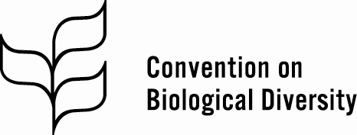 |  | Distr.  GENERAL  CBD/POST2020/WS/2021/1/1  7 July 2021  ORIGINAL: ENGLISH
THIRD GLOBAL THEMATIC DIALOGUE FOR INDIGENOUS PEOPLES AND LOCAL COMMUNITIES ON THE POST-2020 GLOBAL BIODIVERSITY FRAMEWORK
Online, 2-3 and 5-6 August 2021

Provisional agenda
- Opening of the meeting.
- Organizational matters.
- Update on the post-2020 global biodiversity framework.
- Traditional knowledge in the first draft of the post-2020 global biodiversity framework.
- Customary sustainable use in the first draft of the post-2020 global biodiversity framework.
- The contribution of indigenous peoples and local communities lands, territories and waters towards area-based conservation targets in the first draft of the post-2020 global biodiversity framework.
- Equitable participation in the first draft of the post-2020 global biodiversity framework.
- Remaining targets in the first draft of the post-2020 global biodiversity framework.
- Commemoration of the International Day of the World’s Indigenous Peoples.
- Closure of the meeting.

__________

