|  |  |  |  |
| --- | --- | --- | --- |
|  |  | **CBD** | |
|  | | |  | Distr.  GENERAL  CBD/CP/CC/15/4  9 April 2018  ENGLISH ONLY | |

COMPLIANCE COMMITTEE UNDER THE CARTAGENA PROTOCOL ON BIOSAFETY

Fifteenth meeting

Montreal, Canada, 8-10 May 2018

# Review of general issues of compliance

# *Note by the Executive Secretary*

# I. INTRODUCTION

1. The Compliance Committee at its fourteenth meeting reviewed the compliance of Parties with the obligations under the Cartagena Protocol on Biosafety (Protocol) on the basis of the third national reports, with a focus on the priority issues identified by the Conference of the Parties serving as the meeting of the Parties to the Protocol.[1] The Committee decided that, at that stage, it would focus its activities on supporting Parties in complying with their obligation to introduce the necessary and appropriate legal, administrative and other measures to implement the Protocol, in accordance with Article 2(1) of the Protocol. In this context, the Committee also agreed to review compliance with the obligation in Article 33 of the Protocol for Parties to monitor the implementation of their obligations under the Protocol at the national level. The Committee requested the Secretariat to contact Parties that had reported not to comply fully with these obligations in order to collect information on the challenges they were facing in this regard and to report back to the Committee at its fifteenth meeting.
2. Also at its fourteenth meeting, in the context of its review of general issues of compliance, the Committee considered the updated rate of submission of third national reports and explored the reasons for the lower rate of submission as compared with the previous reporting cycle. The Committee decided that the Chair of the Committee would send letters to Parties that had not submitted their third national report reminding them of their obligation to do so.
3. The present document gives an overview of the information provided by Parties on the challenges they are facing in introducing measures to implement the Protocol and in monitoring the implementation of their obligations in Section II. Section III contains an overview of the responses received to the letters sent by the Chair of the Committee to those Parties that had not submitted their third national report. Elements for a draft recommendation are presented in Section IV.

# II. Challenges faced by Parties in introducing measures to implement the Protocol and in monitoring the implementation of obligations

**A. Challenges reported by Parties in introducing measures to implement the Protocol**

1. The Committee at its fourteenth meeting requested the Secretariat to contact Parties that reported:
   1. Having only draft, temporary or partial national biosafety frameworks in place, or not to have introduced any legal, administrative and other measures for the implementation of the Protocol and collect information on the challenges they are facing in this regard;
   2. Not having in place a monitoring system and collect information on the challenges they are facing in this regard;

and to report back to the Committee at its fifteenth meeting.[2]

1. In their third national reports, 82 Parties reported having introduced only draft, temporary or partial national biosafety frameworks or not having introduced any legal, administrative or other measures for the implementation of the Protocol. A total of 87 Parties reported not having a monitoring system in place.
2. The Secretariat developed a survey containing questions related to challenges Parties might be facing in this regard and invited the Parties concerned to complete the survey. The questions and survey methodology are shown in annex I.
3. Out of the 89 total Parties that were sent the survey, 55 Parties had responded to the survey by 20 March 2018.[3] In relation to the obligation to take legal, administrative and other measures necessary to implement the obligations in the Protocol, Parties indicated that they faced the following challenges: lack of financial resources (76%); lack of awareness on biosafety (71%); lack of human resources with necessary qualifications or skills (55%); lack of human resources (41%); lack of political will to adopt measures (37%); other challenges (13%), including lack of institutional capacity and lack of clarity in institutional roles and mandates, lack of awareness, including within institutions involved, no priority for biosafety in the absence of introductions of living modified organisms (LMOs).

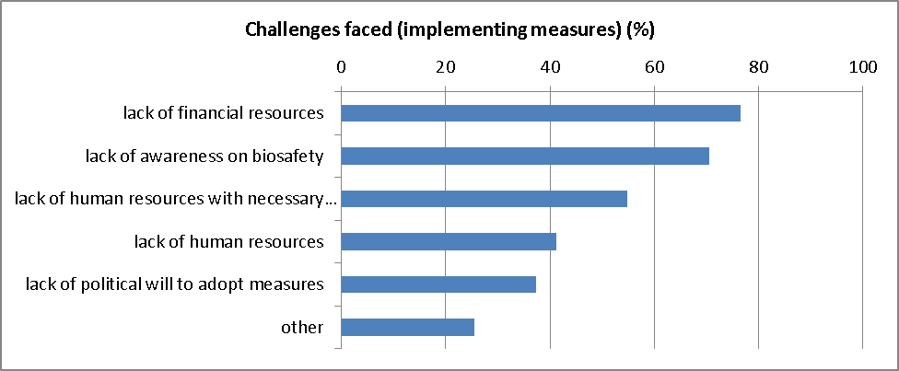

1. Parties reported that the following types of support were needed to address the challenges concerning the introduction of measures to implement the Protocol: capacity-building activities (92%); funding (86%); partnerships with countries in the region to learn from their experience (86%); capacity-building materials (73%); other types of support (10%), including: sensitization of policymakers and institutions, general awareness-raising activities and support to increase technical expertise and to exchange knowledge.

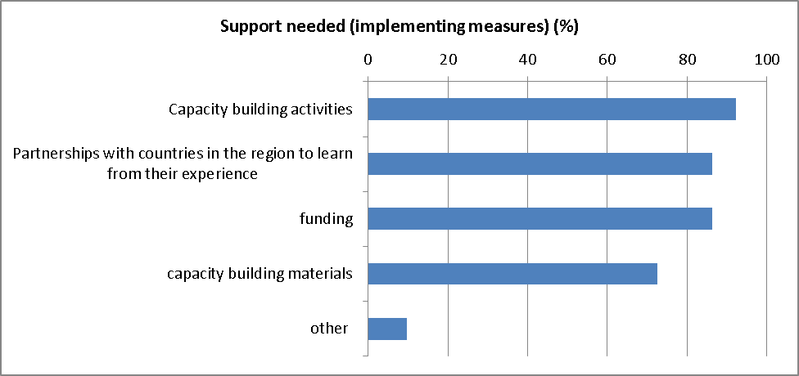

1. Those Parties that indicated that capacity-building is needed also indicated that following thematic areas would be of their interest: scientific understanding of LMOs (100%); awareness-raising (94%); policy formulation (64%); legislative, e.g. drafting (62%). In their written comments, Parties indicated, among other things, that staff did not have the required capacities to inform the public about biosafety.

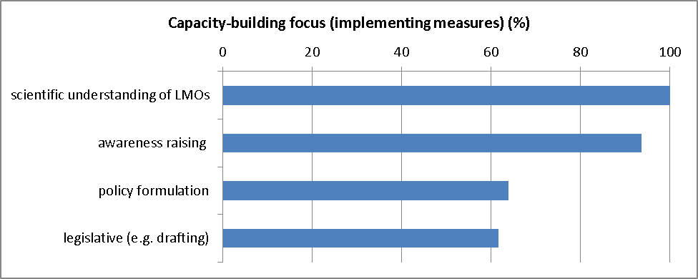

1. In relation to the obligation to monitor the implementation of the obligations under the Protocol, Parties reported the following challenges: lack of financial resources (88%); lack of mechanisms to gather relevant data (76%); lack of awareness on biosafety (73%); lack of human resources with necessary qualifications or skills (67%); lack of human resources (52%); lack of political will (27%).

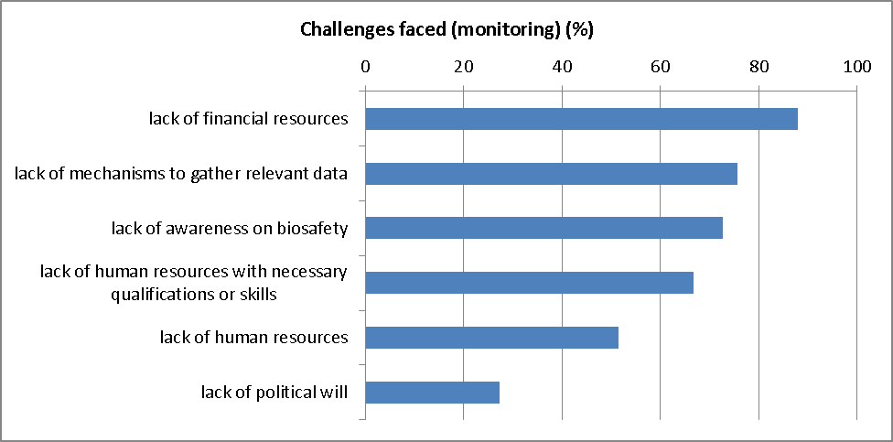

1. Parties indicated that the following types of support are needed to address the challenges in monitoring the implementation of the obligations under the Protocol: capacity building activities (88%); funding (85%); capacity building materials (82%); partnerships with countries in the region to learn from their experience (76%).

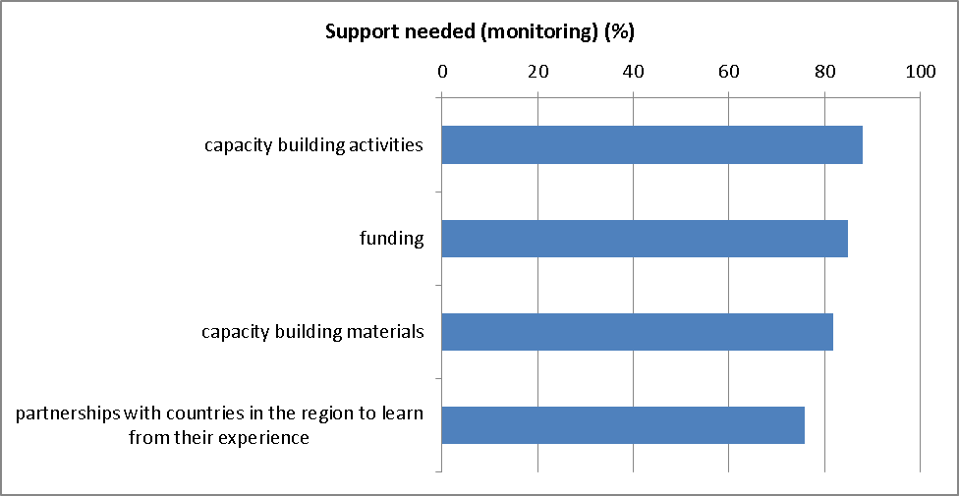

1. Those Parties that indicated that capacity building is required also indicated that the following thematic areas would be of interest: strengthening of institutions and mechanisms (97%); training of personnel (91%); awareness raising (67%). In their comments, Parties indicated that training was needed for the preparation of project proposals and for the development of scenario models and databases.[4]

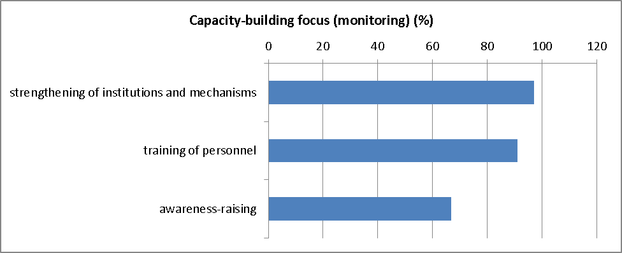

1. In addition, 36 Parties provided further information in the survey on the challenges they faced in taking measures to implement the Protocol or in monitoring the implementation of these obligations, indicating the following challenges: lack of progress in adopting the legal framework (12 Parties); lack of technical expertise (8 Parties); lack of public awareness (5 Parties); lack of political will and priority (4 Parties); lack of financial resources (4 Parties); lack of institutional frameworks or coordination among authorities (4 Parties); no national applications or introductions of LMOs (3 Parties); lack of trained personnel or high turn-over of staff (3 Parties); insufficient knowledge among decision takers (2 Parties); lack of facilities (1 Party).[5]
2. Two Parties responded to the invitation by the Secretariat to complete the survey by explaining that no separate monitoring system had been established concerning Protocol obligations in addition to the monitoring system that had been developed to monitor the implementation of national and regional regulations for the implementation of the Protocol. As these Parties clarified that they did not face compliance challenges in this regard, they did not fill out the survey.
3. In addition to the challenges identified in the survey, a number of Parties provided information on challenges they face in this regard as free text in their third national reports. The Committee considered this information at its thirteenth meeting, when providing an input to the third assessment and review of the effectiveness of the Protocol and mid-term evaluation of the [Strategic Plan](https://bch.cbd.int/protocol/issues/cpb_stplan.shtml) (see [UNEP/CBD/BS/CC/13/6](https://www.cbd.int/doc/meetings/bs/bscc-13/official/bscc-13-06-en.pdf)). The Committee considered the information in more detail at its fourteenth meeting, in the context of its review of compliance on the basis of third national reports, with a focus on priority areas identified by the Conference of the Parties serving as the meeting of the Parties to the Protocol, as indicated below (see [CBD/CP/CC/14/5](https://www.cbd.int/doc/meetings/bs/cpcc-14/official/cpcc-14-05-en.pdf)).
4. The updated information on the basis of third national reports shows that the introduction of measures necessary to implement the Protocol remains a challenge in most regions. In Africa, Latin America and the Caribbean, and Asia and the Pacific, between 21 and 32 per cent of Parties report that a domestic regulatory framework is fully in place. In these regions, about half of the Parties report that a domestic regulatory framework is partially in place, and 16 to 28 per cent of Parties report that only a draft framework exists.[6] In the Central and Eastern European region, 76 per cent of Parties report that a domestic regulatory framework is fully in place, while 24 per cent of Parties in this region report that the domestic regulatory framework is partially in place. All Parties in the Western Europe and Others region report that a domestic regulatory framework is fully in place. The third national reports show that a large number of Parties, especially developing country Parties, face challenges in fully taking the measures necessary to implement the Protocol domestically. Parties provided in their free text submissions that the challenges to fully adopt the measures necessary to implement the Protocol relate to the lack of political will, the lack of adequate financial resources, the lack of human resources and capacities, including the high turn-over of staff, the lack of institutional capacities and coordination, lack of public awareness and education on biosafety and lack of awareness among decision-makers.[7]
5. In relation to their capacities to monitor the implementation of the obligations under the Protocol, 60 per cent of Parties report in their third national reports that a monitoring system is in place, while 40 per cent report that this is not the case, with significant regional differences.[8] Only one Party explicitly referred to challenges in this regard in the written comments provided in the third national report, indicating that its monitoring challenges relate to difficulty in detecting and identifying LMOs, which seems to indicate that the question was interpreted differently from what was intended.

**B. Previous assessment by the Committee of challenges faced by Parties in introducing measures to implement the Protocol**

1. Following the cyclical organization of work, as agreed by the Committee at its eighth meeting, the Committee previously considered the challenges Parties face in introducing measures to implement the Protocol. This subsection provides a summary of the past endeavours of the Committee in this regard.

| **Date, decision or meeting** | **Consideration of challenges faced by Parties in introducing measures to implement the Protocol** |
| --- | --- |
| Decision [BS-VI/1](http://bch.cbd.int/protocol/decisions/?decisionID=13234)  Sixth meeting of the Conference of the Parties serving as the meeting of the Parties to the Protocol (2012) | The Conference of the Parties serving as the meeting of the Parties to the Protocol recognized that the fulfilment by each Party of the obligation to introduce legal, administrative and other measures necessary for the implementation of the Protocol was the topmost priority in the domestic implementation of the Protocol. It called upon Parties that had not yet done so to expedite their efforts in this regard and requested Parties that had not yet put in place operational biosafety frameworks to submit information on the difficulties they were faced with in this regard, and the plans and timelines they envisaged, as appropriate, for the purpose of taking the necessary measures. The Conference of the Parties serving as the meeting of the Parties to the Protocol also reminded these Parties that they could submit their difficulties to the Compliance Committee in order to seek assistance. |
| 2012 | On the basis of decision BS-VI/1, the Secretariat identified 38 Parties that had reported, in their second national reports, not having taken any measures, or to only have taken temporary measures to implement the Protocol, or to have in place only a draft biosafety framework.[9] The Secretariat sent a letter to these Parties, inviting them to submit the information requested by the Conference of the Parties serving as the meeting of the Parties to the Protocol in its decision BS-VI/1, and prepared a synthesis of the information submitted for consideration by the Committee at its tenth meeting. |
| 10th meeting of the Compliance Committee (2013) | The Committee considered compliance on the basis of the second national reports with a focus on priority issues identified by the Conference of the Parties serving as the meeting of the Parties to the Protocol and, in this context, reviewed the synthesis of the 13 responses received to the letters referred to above. The information provided by the Parties concerned seemed to indicate that “the continued lack of capacity to further develop specific regulations, conduct national consultations, and put in place the necessary infrastructure and administrative facilities, hinder further progress”. It was also noted that “the Parties concerned that have responded to the Secretariat’s enquiry seem to be committed, despite their limitations in capacity, to adopt the necessary legal and administrative measures, within the shortest possible time, and thereby fulfil their obligations under the Protocol.”[10]  The Committee recognized the various difficulties faced by Parties in finalizing and operationalizing their national biosafety frameworks.[11] |
| 2013 | At the Committee’s request, the Secretariat sent another letter to the 25 Parties that had not responded to the first letter. Responses were received from 5 Parties.  The Chair of the Committee then sent an additional letter to the national focal points of the 20 remaining Parties with a copy to their respective ministry of foreign affairs inquiring as to why they had been unable to fulfil their obligation and offering the assistance of the Compliance Committee.  Four more responses were received.[12] A total of 16 Parties have never responded to the communications sent. |
| 11th meeting of the Compliance Committee (2014) | The Committee reverted to this issue and decided that the Secretariat should follow up with those Parties that were still behind in putting in place their national biosafety framework, in consultation with the Chair of the Committee.[13] |
| 12th meeting of the Compliance Committee (2015) | The Committee considered the outcomes of the seventh meeting of the Conference of the Parties serving as the meeting of the Parties to the Protocol and noted the invitation in decision [BS-VII/1](http://bch.cbd.int/protocol/decisions/?decisionID=13348) to Parties facing difficulties complying with one or more of their obligations under the Protocol to seek assistance from the Compliance Committee or the Secretariat and discussed extensively what assistance the Committee may provide to Parties and how to raise awareness of the supportive role of the Committee. The Committee developed a brief information note and requested the Secretariat to make it available online.[14] The note explains the kind of assistance with which the Committee may be able to provide Parties. |
| 13th meeting of the Compliance Committee (2016) | When providing an input to the third assessment and review of the effectiveness of the Protocol and the mid-term evaluation of the Strategic Plan, the Committee considered among others the challenges in relation to the introduction of domestic measures necessary to implement the Protocol, and noted that Parties indicated in their third national reports that the slow rate of adoption of legal, administrative and other measures continues to be one of the main obstacles to implementing the obligations under the Protocol.[15] This was subsequently reflected in, among others, decision [CP-VIII/15](http://bch.cbd.int/protocol/decisions/?decisionID=13543), in which the Conference of the Parties serving as the meeting of the Parties to the Protocol urged Parties that had not yet done so to put in place their national biosafety frameworks, in particular biosafety legislation, as a matter of priority. |

**III. Responses received to the letters sent by the Chair of the Committee to Parties that had not yet submitted their third national report**

1. At its fourteenth meeting, the Committee considered an update of the number of third national reports submitted following its previous meeting. It noted that 30 Parties had not yet submitted their third national report, including 4 Parties that had also not submitted their second national report. The Committee decided that the Chair of the Committee should send a letter to the national focal point of the Parties concerned reminding these Parties of their obligation to submit their national reports, briefly explaining the benefits of reporting and offering assistance in this regard, and reminding eligible Parties of the extended possibility to access Global Environment Facility (GEF) funds for the completion of their third national reports. The Committee also decided that the Chair of the Committee should send a similar letter to the Ministry of Foreign Affairs of Greece, Montenegro and Turkmenistan for not having submitted their second and third national reports, as a follow-up to previous communications addressed to the national focal points of these three Parties.[16]
2. The Chair of the Committee sent letters to 28 Parties in July 2017, including 3 Parties that had not submitted more than one national report.[17] An overview of the Parties that received a letter is provided in annex II.
3. Following the issuance of the letter from the Chair of the Compliance Committee, six Parties submitted their complete third national report. Consequently, to date, 147 third national reports have been received. This results in a reporting rate of 86%. A total of 24 Parties have not yet submitted their third national report, including 4 Parties that have also not submitted previous national reports.[18] Furthermore, responses to the letter were received, as synthesized in the table below.

|  | **Party** | **Synthesis of communication** |
| --- | --- | --- |
| 1 | Afghanistan | Afghanistan submitted its third national report to the BCH on 15 January 2018. Afghanistan has not accessed GEF funds. |
| 2 | Azerbaijan | Azerbaijan enquired about the modalities for preparing its third national report. The Secretariat clarified the process. No third national report has been submitted to date. |
| 3 | Cabo Verde | Cabo Verde informed the Secretariat that it was in the process of developing its third national report and that it would seek UNEP-GEF support for the process. No third national report has been submitted to date. |
| 4 | Democratic People’s Republic of Korea | The Democratic People’s Republic of Korea informed the Secretariat that funding was required to enable it to carry out the consultations necessary for the finalization of its third national report, but that it did not have access to GEF funds for the completion of its third national report. It informed the Secretariat that it had accessed GEF funds in the past for the completion of its first and second national reports. It also informed the Secretariat that capacity-building was needed, including on: the biosafety clearing-house and the Nagoya-Kuala Lumpur Supplementary Protocol on Liability and Redress. No third national report has been submitted to date. |
| 5 | Solomon Islands | The complete third national report of Solomon Islands was submitted to the BCH on 22 January 2018. Solomon Islands is in the process of accessing GEF funds. |
| 6 | State of Palestine | The State of Palestine indicated that it had not been able to access GEF funds. No third national report has been submitted to date. |
| 7 | Syrian Arab Republic | The Syrian Arab Republic explained that it had not been able to access UNEP-GEF funds for the completion of its third national report. It indicated that the lack of access to funding constituted an impediment to the compliance with its obligations under the Protocol and requested assistance from the Secretariat in this regard. The Secretariat responded to this letter indicating that it would continue to engage the GEF Secretariat, seeking their cooperation for a timely and positive response to the Party’s funding request. |
| 8 | Tonga | The complete third national report of Tonga was submitted to the BCH on 21 July 2017. Tonga accessed GEF funds. |
| 9 | Turkmenistan | Turkmenistan informed the Secretariat that it had not been able to obtain access to the GEF funds necessary for the completion of its third national report. No third national report has been submitted to date. |

1. A total of 78 Parties accessed UNEP-GEF funds for the completion of their third national reports.[19] To date, 18 eligible Parties have not accessed GEF funds. This figure is in contrast to the 39 eligible Parties that had not accessed GEF funds at the time of the Committee’s fourteenth meeting.

# IV. Suggestions for the consideration of the Committee

**A. Facilitating the introduction of measures to implement the****obligations under the Protocol**

1. The Committee may wish to consider how it can respond to the issues raised in the present document. In relation to compliance with the obligation to introduce measures to implement the obligations under the Protocol, including the issue of monitoring, the Committee may wish to take into consideration the issues raised by Parties in the survey and in their third national reports, the review of this issue in the past and the work it has undertaken in elaborating the type of assistance the Committee can provide. A number of different options may be considered in this regard.
2. With regard to the number of Parties reporting not having fully taken the necessary measures to implement the Protocol, the Committee may wish to continue making recommendations to the Conference of the Parties serving as the meeting of the Parties to the Protocol that it urge Parties to put in place the necessary measures to implement obligations of the Protocol and that it provide GEF with guidance to support projects for this purpose. These recommendations have generally been adopted by the Conference of the Parties serving as the meeting of the Parties to the Protocol and the Conference of the Parties and have been transmitted as recommendation to GEF. However, the number of Parties that report not having fully taken the necessary measures to implement the Protocol remains high, and many Parties indicated that the lack of funding remains a challenge in this regard.
3. The Committee may wish to consider emphasizing that facilitating the establishment and further development of effective biosafety systems for the implementation of the Protocol is the top-most priority of the Strategic Plan for the Cartagena Protocol on Biosafety for the period 2011-2020. This is also reflected in the Framework and Action Plan for Capacity Building for the Effective Implementation of the Cartagena Protocol.[20] The Committee may wish to recommend to the Conference of the Parties serving as the meeting of the Parties to the Protocol that it urge donors to support projects for the development and implementation of national biosafety frameworks, in particular biosafety legislation, as a matter of priority.
4. The Committee may also wish to consider actions it may take through the Procedures and Mechanisms on Compliance as adopted in decision [BS-I/7](http://bch.cbd.int/protocol/decisions/?decisionID=8289) and further specified in decision [BS-V/1](http://bch.cbd.int/protocol/decisions/?decisionID=12314). The Committee may consider these actions also in view of the types of support it can provide to Parties having difficulties in complying with their obligations, as identified previously.[21]
5. Taking into account the lack of financial resources at its disposal, the Committee may wish to focus on challenges that may be addressed with non-monetary means, where the Committee could have a catalytic role. Further to some of the challenges and areas where support is needed as identified by Parties through the survey, this could include support by members of the Committee to Parties, for example in the establishment of regional partnerships, possibly as a means to organize capacity-building and awareness-raising activities. The Committee may also consider means to assist in raising awareness and developing political will for implementation of the Protocol, e.g. by highlighting the role of the Protocol in contributing to the conservation and sustainable use of biodiversity and the achievement of the Sustainable Development Goals.

**B. Facilitating the submission of national reports**

1. In relation to the obligation to submit national reports, the Committee may wish to outline the next steps for following up with those Parties that have not yet completed their third national report. The Committee may wish to consider whether those Parties that have not completed their third national report should be considered under individual cases of non-compliance at the Committee’s next meeting. Given the experience with the individual cases of non-compliance prior to the eighth meeting of the Conference of the Parties serving as the meeting of the Parties to the Protocol, this may encourage the Parties concerned to submit their third national report and/or fourth national report in a timely manner.
2. The Committee may also wish to consider making a recommendation to the Conference of the Parties serving as the meeting of the Parties to the Protocol at its ninth meeting to recommend that the Conference of the Parties, in adopting its guidance to the financial mechanism with respect to support for the implementation of the Cartagena Protocol, invite GEF to support Parties in developing national biosafety frameworks and to support eligible Parties in completing their fourth national report. The Committee may also wish to recommend that the Conference of the Parties serving as the meeting of the Parties to the Protocol remind Parties of the importance of timely submission of fourth national reports as a resource for the fourth assessment and review and final evaluation of the Strategic Plan for the Cartagena Protocol and for the development of the [post-2020 biodiversity framework](https://www.cbd.int/post2020/).

*Annex I*

**Survey of Parties that reported not having fully introduced legal, administrative or other measures for the implementation of the Protocol or not having in place monitoring systems for the implementation of the Protocol**

A survey was developed containing the following questions related to challenges in introducing measures to implement the Protocol and to challenges in monitoring the implementation of obligations under the Protocol:

1. What is the name of your country?
2. What challenges does your country face in taking legal, administrative and other measures necessary to implement the obligations in the Cartagena Protocol on Biosafety (choose all that apply)?
   * Lack of financial resources
   * Lack of human resources
   * Lack of  human resources with necessary qualifications or skills
   * Lack of political will to adopt measures
   * Lack of awareness on biosafety
   * Other (please specify)
3. What types of support does your country need to overcome the challenges identified above in taking measures to implement the Protocol (choose all that apply)?
   * Capacity building materials
   * Capacity building activities
   * Partnerships with countries in the region to learn from their experience
   * Funding
   * Other (please specify)
4. If you identified that capacity building is needed to support your country in taking measures necessary to implement the Protocol, please indicate the areas where your country would benefit from capacity-building (choose all that apply)
   * policy formulation
   * legislative (e.g. drafting)
   * awareness raising
   * scientific understanding of living modified organisms
5. Under Article 33 of the Cartagena Protocol, each Party is to monitor the implementation of its obligations under the Protocol. What challenges does your country face in monitoring the implementation of its obligations under the Protocol (choose all that apply)?

* Lack of financial resources
* Lack of human resources
* Lack of human resources with necessary qualifications or skills
* Lack of political will
* Lack of awareness on biosafety
* Lack of mechanism to gather relevant data

1. What types of support does your country need to overcome the monitoring challenges identified above (choose all that apply)?
   * Capacity building materials
   * Capacity building activities
   * Partnerships with countries in the region to learn from their experience
   * Funding
2. If you identified that capacity building is needed to monitor the implementation of the obligations under the Protocol, please indicate the areas where your country would benefit from capacity building (choose all that apply)
   * Training of personnel
   * Awareness-raising
   * strengthening of institutions and mechanisms
3. Please provide any other information on challenges faced in taking measures to implement the obligations of the Protocol or in monitoring the implementation of these obligations.

Depending on the answers provided in their third national reports, Parties were sent either all eight questions (49 Parties), only questions related only to challenges in introducing measures to implement the Protocol (questions 1 to 4 above; 30 Parties); or only questions to challenges in monitoring the implementation of obligations under the Protocol (questions 1 and 5 to 8 above; 30 Parties).

The survey was sent to the national focal points of the Parties concerned with a copy to the Biosafety Clearing-House focal point.

*Annex II*

**Overview of Parties that received a letter from the Chair of the Compliance Committee regarding outstanding national reports**

|  |  |
| --- | --- |
| *Parties that received a letter concerning their outstanding third national report* | *Parties that received a letter concerning their outstanding third national report and following up on communications concerning earlier outstanding national reports* |
|  |  |
| 1. Afghanistan | 1. Greece |
| 1. Angola | 1. Montenegro |
| 1. Armenia | 1. Turkmenistan |
| 1. Azerbaijan |  |
| 1. Belize |  |
| 1. Cabo Verde |  |
| 1. Comoros |  |
| 1. Côte d’Ivoire |  |
| 1. Democratic People’s Republic of Korea |  |
| 1. Djibouti |  |
| 1. Fiji |  |
| 1. Jordan |  |
| 1. Libya |  |
| 1. Myanmar |  |
| 1. Nauru |  |
| 1. Papua New Guinea |  |
| 1. Qatar |  |
| 1. Saudi Arabia |  |
| 1. Serbia |  |
| 1. Seychelles |  |
| 1. Solomon Islands |  |
| 1. State of Palestine |  |
| 1. Syrian Arab Republic |  |
| 1. The former Yugoslav Republic of Macedonia |  |
| 1. Tonga |  |

__________

1. See [CBD/CP/CC/14/3](https://www.cbd.int/doc/meetings/bs/cpcc-14/official/cpcc-14-03-en.pdf), Section I, for more information on the identification of the priority issues.
2. [CBD/CP/CC/14/5](https://www.cbd.int/doc/meetings/bs/cpcc-14/official/cpcc-14-05-en.pdf), para. 31(a).
3. For the purpose of the present document, the answers provided through the different surveys to the same questions have been merged.
4. All Parties responded to this question, including the four Parties that had not indicated that capacity-building materials were needed.
5. It is noted that some of these challenges overlap with the challenges mentioned already in response to other survey questions.
6. In addition, a total of three Parties in these regions report having taken temporary measures or not having taken any measures at all. See the responses to question 14 of the reporting format for the third national reports, available at: <http://bch.cbd.int/database/reports/analyzer>
7. In their written comments, a number of Parties also refer to issues such as poor Internet connection, lack of capacity-building on certain specific issues, such as risk assessment, identification of LMOs, the BCH, socio-economic considerations, liability and redress.
8. This issue was already presented to the Committee at its thirteenth meeting (see [UNEP/CBD/BS/CC/13/3](https://www.cbd.int/doc/meetings/bs/bscc-13/official/bscc-13-03-en.pdf), annex, para. 38). Currently, third national reports show that monitoring systems are in place as follows: Africa 61%; Asia and the Pacific 53%; Central and Eastern Europe 88%; Latin America and the Caribbean 31%; Western Europe and Others 85%.
9. Parties were identified on the basis of responses provided to question 15 of the second national reporting framework.
10. Synthesis provided by the Secretariat in [UNEP/CBD/BS/CC/10/3](https://www.cbd.int/doc/meetings/bs/bscc-10/official/bscc-10-03-en.pdf), paragraphs 10 and 11. The table of responses from these 13 Parties is available in paragraph 9 of that document.
11. Some members noted that some of the Parties that had not fulfilled this obligation might not be eligible for GEF funding. Others noted that Parties could be differentiated on the basis of lack of capacity, lack of funding or lack of prioritization as a possible reason for lagging behind in putting their national biosafety frameworks in place (see [UNEP/CBD/BS/CC/10/5](https://www.cbd.int/doc/meetings/bs/bscc-10/official/bscc-10-05-en.pdf), para. 27).The Committee recalled this discussion at its eleventh meeting (see [UNEP/CBD/BS/CC/11/4](https://www.cbd.int/doc/meetings/bs/bscc-11/official/bscc-11-04-en.pdf), para. 10).
12. The nine responses received are summarized in a table annexed to [UNEP/CBD/BS/CC/11/2](https://www.cbd.int/doc/meetings/bs/bscc-11/official/bscc-11-02-en.pdf).
13. No further action was taken in respect of these Parties, but the Committee considered in more general terms the types of assistance it could offer to Parties facing difficulties complying with their obligations at its twelfth meeting (see [UNEP/CBD/BS/CC/11/4](https://www.cbd.int/doc/meetings/bs/bscc-11/official/bscc-11-04-en.pdf), para. 18).
14. At its fourteenth meeting, the Committee requested the Secretariat to update the information note. The information note is available at: <http://bch.cbd.int/protocol/cpb_art34_cchelp.shtml>
15. [UNEP/CBD/BS/CC/13/6](https://www.cbd.int/doc/meetings/bs/bscc-13/official/bscc-13-06-en.pdf), annex, paras. 17-18.
16. The Committee decided that informal follow-up would be beneficial concerning the Party that had not submitted its third, second, first or interim report, the Marshall Islands. For more details, see CBD/CP/CC/14/INF/1.
17. At the time these letters were sent, 29 Parties had not submitted their third national reports, including the Marshall Islands. It was decided that communications with the Marshall Islands would continue in parallel. One Party (Oman) had submitted an incomplete national report. No letter was sent to this Party as parallel communications were already ongoing with a view to ensuring that Oman would provide the missing information. The complete third national report of Oman was submitted to the BCH on 3 August 2017.
18. These four Parties are: Greece, Marshall Islands, Montenegro and Turkmenistan.
19. Four of these Parties received a first instalment only and are to complete documentation to allow UNEP-GEF to disburse the remaining funds.
20. [Decision BS-VI/3](http://bch.cbd.int/protocol/decisions/?decisionID=13236), annex I.
21. The types of support that the Committee may offer were published on the BCH at the request of the Committee and are available at: <http://bch.cbd.int/protocol/cpb_art34_cchelp.shtml>