|  |  |  |  |  |
| --- | --- | --- | --- | --- |
| Macintosh HD:Users:bilodeau:Desktop:logos:template 2017:un.emf | Macintosh HD:Users:bilodeau:Desktop:logos:template 2017:unep-old.emf | | **CBD** | |
|  | | |  | | Distr.  GENERAL  CBD/SBI/2/INF/28  12 May 2018  ENGLISH ONLY |

SUBSIDIARY BODY ON IMPLEMENTATION

Second meeting

Montreal, Canada, 9-13 July 2018

Item 11 of the provisional agenda[1]*

**Cooperation with other conventions, international organizations and partnerships – joint and individual contributions from CPF member organizations to the achievement of the Aichi Biodiversity Targets**

*Note by the Executive Secretary*

1. In paragraph 7 of decision XIII/7 the Conference of the Parties requested the Executive Secretary to strengthen collaboration with the members of the Collaborative Partnership on Forests (CPF), including the Secretariat of the United Nations Forum on Forests (UNFF), as well as other relevant organizations and initiatives, to fully respond to the requests of the Conference of the Parties in paragraph 21 of decision XII/6, to support the implementation of the present decision, and to report on progress to the Subsidiary Body on Scientific, Technical and Technological Advice or the Subsidiary Body on Implementation, as appropriate, at a meeting prior to the fourteenth meeting of the Conference of the Parties.
2. In paragraph 21 of decision XII/6, the Conference of the Parties requested the Executive Secretary to prepare a study on the ways in which international organizations and secretariats with substantial programmes on forests are assisting in implementing the Strategic Plan for Biodiversity 2011-2020 and achieving the Aichi Biodiversity Targets of relevance to forests, and to report back to the Subsidiary Body on Scientific, Technical and Technological Advice, including on options for further action to achieve the forest-related Aichi Biodiversity Targets, in a mutually supportive manner. In this context, the Conference of the Parties acknowledged the review of the international arrangement on forests which was discussed at the eleventh session of UNFF, in May 2015, and invited other members of the CPF to contribute to the study. The Conference of the Parties also emphasized the actions outlined in decision X/36 which relate to cooperation with various forest-related bodies.
3. Furthermore, in paragraph 5 of decision XIII/7, the Conference of the Parties also invited the members of the CPF, in preparing the 2017-2030 work plan of the Partnership, to consider ways and means of further enhancing their individual and collective contributions to the Aichi Biodiversity Targets and support a coordinated approach to the achievement of the forest-related multilateral commitments and goals.

4. The present document has been prepared by the Secretariat as an information document, drawing on inputs from member organizations of the CPF through a survey, primarily addressing joint and individual contributions from CPF member organizations to achieve the forest-related Aichi Biodiversity Targets and other forest-related multilateral commitments. This document complements the note on options for further action to achieve the forest-related Aichi Biodiversity Targets, in a mutually supportive manner, contained in CBD/SBI/2/10/Add.1 (“collaboration with the members of the Collaborative Partnership on Forests”). Other sources of information, including online reviews, were also used to complement the document.

**Results of the survey of joint and individual contributions from CPF member organizations to the achievement of the Aichi Biodiversity Targets**

Table of Contents

INTRODUCTION 5

SECTION I – BACKGROUND INFORMATION 6

A. The Collaborative Partnership on Forests (CPF) 6

B. Internationally agreed forest related targets and objectives 8

UN Strategic Plan for Forests (UNSPF) - 2017-2030 8

Paris Agreement under the UN Framework Convention on Climate Change 10

Sustainable Development Goals (SDGs) 11

Voluntary commitments 11

C. Congruence among the international forest commitments 12

SECTION II - JOINT AND INDIVIDUAL CONTRIBUTIONS FROM CPF MEMBER ORGANIZATIONS TO ACHIEVING FOREST-RELATED AICHI BIODIVERSITY TARGETS 17

A. Consideration of national biodiversity targets in the work of CPF member organizations 17

B. Reduction of deforestation and forest degradation 18

Related Joint Initiatives by CPF member organizations 19

Relevant individual contribution from CPF member organizations 21

C. Sustainable Forest Management 22

D. Forest conservation 25

Related joint initiatives by CPF member organizations 26

Relevant individual contributions by CPF member organizations 26

E. Forest restoration 29

Support from CPF members to the implementation of the Short Term Action Plan on Ecosystem Restoration 29

Related Joint Initiatives by CPF member organizations 33

Relevant individual contributions by CPF member organizations 34

F. Traditional and indigenous knowledge 34

Related joint initiatives by CPF member organizations 35

Relevant contributions by individual member organizations of the CPF 35

Points for further consideration 36

Annex I. Text of the survey sent to CPF members 39

Survey of CPF members on the contribution of the CPF to the implementation of the UN Strategic Plan for Biodiversity 2011-2020 39

# INTRODUCTION

The findings of the survey presented in this document provide complementary information to that presented in document UNEP/CBD/SBSTTA/19/INF/3 on the contributions of CPF member organizations to the achievement of the forest-related Aichi Biodiversity Targets and the Expanded Programme of Work on Forest Biodiversity. In UNEP/CBD/SBSTTA/19/INF/3 a number of tables were provided to summarise on which Aichi Biodiversity Targets the other CPF member organizations have corresponding work. The analysis showed that all member organizations of the CPF conduct work that directly relates to reducing habitat loss and degradation (Target 5); and to safeguarding ecosystems and essential services (Target 14). Further, almost all organizations work towards increasing awareness (Target 1) and restoring and enhancing the resilience of ecosystems (Target 15).[2]

Rather than proposing a new review of how the Aichi Biodiversity Targets are taken into account by CPF members, the analysis of options for further action to achieve the Aichi Biodiversity Targets is framed around the same elements identified in UNEP/CBD/ SBSTTA/19/8 as areas of congruence between the forest-related Aichi Biodiversity Targets and other forest-related multilateral commitments.

These areas of congruence are: the reduction of the loss, degradation and fragmentation of natural forests, including through REDD+ (of relevance for forest elements of Target 5), sustainable forest management (of relevance for Target 7); forest conservation, including Target 11); benefits from forests (Target 14); forest restoration (of relevance for Target 15); elements of forest biodiversity and traditional and indigenous knowledge in the design of forest policy (of relevance for Target 18) and supporting enabling commitments (of relevance for Targets 1-4, 16, 17, 19, 20) (see Table 1).

Section I of this document provides background information on the CPF and reviews forest-related multilateral commitments before analysing their congruence with forest-related Aichi Biodiversity Targets. Section II lists contributions, both joint and individual, from CPF members to achieving the forest-related Aichi Biodiversity Targets under each of these areas of congruence.

The survey was answered by nine members of the CPF: United Nations Development Programme (UNDP), World Agroforestry Center (ICRAF), Global Environment Facility (GEF), International Tropical Timber Organization (ITTO), International Union for the Conservation of Nature (IUCN), Food and Agriculture Organization of the United Nations (FAO), Secretariat of the UN Forum of Forest (UNFF), International Union of Forest Research Organizations (IUFRO) and UN Environment. Comments were also received by the Secretariat of the UN Framework Convention on Climate Change (UNFCCC). The full text of the survey can be consulted in Annex I.

As reported in UNEP/ CBD/SBSTTA/19/8 paragraph 33 (a-d), the degree of support to the achievement of the forest-related Aichi Biodiversity Targets varies from one CPF member organization to another largely due to differences in their mandates and programmes of work. Roles range from convention secretariats, financing entities, research bodies to knowledge generation and dissemination organizations. Therefore, not all respondents answered all the questions in the survey.

# SECTION I – BACKGROUND INFORMATION

## A. The Collaborative Partnership on Forests (CPF)

The Collaborative Partnership on Forests (CPF) is a voluntary partnership on forests established in April 2001 in response to the Economic and Social Council of the United Nations (ECOSOC) Resolution 2000/35 that established the International Arrangement on Forests and the United Nations Forum on Forests (UNFF) therein. In 2015, ECOSOC gave further guidance to CPF through its Resolution 2015/33 by, inter alia, reaffirming the principles and defining the core functions of the CPF as a component of the International Arrangement on Forests. The core functions of the CPF as defined by Resolution 2015/33, paragraph 20, are: to support the work of UNFF and its member countries; to provide scientific and technical advice to UNFF, including on emerging issues; to enhance coherence as well as policy and programme cooperation and coordination at all levels among its member organizations, including through joint programming and the submission of coordinated proposals to their respective governing bodies, consistent with their mandates; and to promote the implementation of the United Nations Forest Instrument, including the achievement of its global objectives on forests, and the contribution of forests to the post-2015 development agenda.

Pursuant to ECOSOC Resolution 2015/33, paragraph 22, CPF and its member organizations were also encouraged to: (a) strengthen the Partnership by formalizing its working modalities, including through consideration of a multilateral memorandum of understanding, and by developing procedures for its effective functioning and operation; (b) identify ways to stimulate broader participation by existing member organizations in its various activities; (c) assess its membership and the potential added value of additional members with significant forest-related expertise; (d) identify ways to actively involve major groups and other stakeholders in activities of the CPF; (e) develop a workplan, aligned with the UN Strategic Plan for Forests 2017-2030, to identify priorities for collective actions by all of the Partnership’s members or subsets of members and the resource implications of such actions; (f) prepare periodic reports on the Partnership’s activities, achievements and resource allocations suitable for a wide range of audiences, including potential donors; and (g) further develop and expand its thematic joint initiatives, taking into account the strengths and focuses of the Partnership’s members.

In 2017, ECOSOC Resolution 2017/4 which adopted the UN Strategic Plan for Forests 2017-2030 and the quadrennial programme of work of the UNFF for 2017-2020, invited CPF to support the Forum and its members in advancing the global forest goals and targets, including through cooperation and partnership among its members. It also invited CPF to implement a joint workplan aligned to the Forum's quadrennial programmes of work and to identify collective actions by all subsets of the partnership's members, as well as associated resources needs.[3] The Partnership is currently comprised of fifteen international organizations, institutions and secretariats that have substantial programmes on forests.[4]

Since 2015, the CPF has met on several occasions and published periodic progress reports on its Website.[5] In March 2017, the CPF formalized its working modalities through the adoption of a Policy document.[6] In February 2018, it assessed the potential added value of two additional members with significant forest-related expertise that had requested participation, and decided to approve the request of the Secretariat of the Convention on the International Trade in Endangered Species, bringing its total membership to 15 member organizations.

With regards to the active involvement of major groups and other stakeholders the Partnership has held consultations with various major group representatives, involving many new stakeholders, in particular with regards to the International Conference “Working across Sectors to Halt Deforestation and Increase Forest Area – from Aspiration to Action”, in Rome, Italy, February 2018. CPF is also in the process of developing a potential CPF Forum to facilitate further interactions with major groups. A work plan for the Partnership for the period 2017-2020 was presented at the 13th session of the UNFF (UNFF 13) in May 2018. Several Joint Initiatives between CPF members are ongoing or planned, with a number of such initiatives supporting the achievement of the Aichi Biodiversity Targets. Joint Initiatives are described in the following sections of this note.

## B. Internationally agreed forest related targets and objectives

Since UNEP/CBD/SBSTTA/19/8, the landscape of forest-related international commitments has advanced, in particular at the global level with the adoption of the UN Strategic Plan for Forests (UNSPF) - 2017-2030; the Paris Agreement under the UN Framework Convention on Climate Change (UNFCC) and the Sustainable Development Goals (SDGs).

### UN Strategic Plan for Forests (UNSPF) - 2017-2030

In 2000, the United Nations Economic and Social Council, in resolution 2000/35, established the the United Nations Forum on Forests (UNFF), as part of the international arrangement on forest, to promote the management, conservation and sustainable development of all types of forests and to strengthen long-term political commitment. In 2007, at its seventh session, the Forum agreed to a non-legally binding instrument on all types of forests, which was subsequently adopted by the United Nations General Assembly in resolution A/RES/62/98. The Instrument contains four global objectives on forests. In 2015, the Council decided to strengthen the international arrangement on forests and extend it to 2030. Similarly, the 4 global objectives on forests were renamed and 6 global forest goals were adopted to 2030 and the non-legally binding instrument on all types of forests was renamed “the United Nations Forest Instrument”.

An agreement on the first-ever UN Strategic Plan for Forests 2017-2030 was forged at a special session of the UNFF held in January 2017. The UN Strategic Plan for Forests 2017-2030 was adopted by the UN Economic and Social Council on 20 April 2017, together with a quadrennial programme of work for the UNFF for the period 2017-2020.[7] These were subsequently adopted by the UN General Assembly on 27 April 2017.[8]

The UN Strategic Plan for Forests 2017-2030 provides a global framework for action at all levels to sustainably manage all types of forests and trees outside forests and halt deforestation and forest degradation. At the heart of the UN Strategic Plan for Forests 2017-2030 are six global forest goals and 26 associated targets to be achieved by 2030, which are voluntary and universal (Box 1).

|  |  |
| --- | --- |
| Box 1. Text of the Global Forest Goals  **Global Forest Goal 1**: Reverse the loss of forest cover worldwide through sustainable forest management, including protection, restoration, afforestation and reforestation, and increase efforts to prevent forest degradation and contribute to the global effort of addressing climate change.  **Global Forest Goal 2:** Enhance forest-based economic, social and environmental benefits, including by improving the livelihoods of forest  dependent people.  **Global Forest Goal** **3:** Increase significantly the area of protected forests worldwide and other areas of sustainably managed forests, as well as the proportion of forest products from sustainably managed forests. | **Global Forest Goal 4:** Mobilize significantly increased, new and additional financial resources from all sources for the implementation of sustainable forest management and strengthen scientific and technical cooperation and partnerships.  **Global Forest Goal 5:** Promote governance frameworks to implement sustainable forest management, including through the UN Forest Instrument, and enhance the contribution of forests to the 2030 Agenda.  **Global Forest Goal 6:** Enhance cooperation, coordination, coherence and synergies on forest-related issues at all levels, including within the UN System and across Collaborative Partnership on Forests member organizations, as well as across sectors and relevant stakeholders. |

In accordance with paragraphs 30 and 31 of ECOSOC Resolution 2017/4 concerning the the UN Strategic Plan for Forests 2017-2030 and quadrennial programme of work of the UNFF for the period 2017-2020, Member States may, on a voluntary basis, determine their contributions towards achieving the global forest goals and targets, taking into account their national circumstances, policies, priorities, capacities, levels of development and forest conditions. These voluntary national contributions or VNCs, may include the forest-related contributions which members of the Forum intend to make with regards to other international forest-related commitments and goals, such as the implementation of the 2030 Agenda for Sustainable Development and the Sustainable Development Goals, the Aichi Biodiversity Targets and the Paris Agreement under the United Nations Framework Convention on Climate Change (UNFCCC).

The 13th session of the UNFF (UNFF13), which took place in May 2018, in New York, received the first five communications on voluntary national contributions to the UNFF from the following countries: Ecuador, Ghana, Guatemala, Jamaica and Liberia.

The voluntary national contributions from Jamaica, in particular, lays out how the four actions

proposed to contribute to the global forest goals and targets of the UN Strategic Plan for Forests 2017-2030 link to the Aichi Biodiversity Targets. This voluntary national contribution provides an example of the type of contribution to global forest goal 2.5,[9] which could represent another way to further alignment between the achievement of the global forest goals and the Aichi Biodiversity Targets. One consideration is to explore how Parties to the Convention that are also members to the UNFF could consider actions under their National Biodiversity Strategies and Action Plans in the design of their voluntary national contributions towards achieving one or more global forest goals and targets of the UN Strategic Plan for Forests 2017-2030, and vice-versa to achieve the forest-related Aichi Biodiversity Targets.

### Paris Agreement under the UN Framework Convention on Climate Change

At UNFCCC COP 21 in Paris in 2015, Parties to the UNFCCC adopted in decision FCCC/CP/2015/10/Add.1 a landmark agreement to combat climate change and to accelerate and intensify the actions and investments needed for a sustainable low carbon future. The Paris Agreement builds upon the UNFCCC, bringing nations into a common cause to undertake ambitious efforts to combat climate change and adapt to its effects, with enhanced support to assist developing countries to do so. As such, it charts a new course in the global climate effort.

In its Article 5, the Paris Agreement under the UNFCCC encourages its Parties to take action using policy approaches and positive incentives for activities relating to reducing emissions from deforestation and forest degradation, and the role of conservation, sustainable management of forests and enhancement of forest carbon stocks in developing countries (REDD+), for which a framework had been defined in previous decisions of the UNFCCC COP[10], as well as alternative policy approaches, such as joint mitigation and adaptation approaches for the integral and sustainable management of forests.

Article 5 of the Paris Agreement also reaffirms the importance of incentivizing, as appropriate, associated non-carbon benefits, including the conservation of biodiversity and ecosystem services from forests. This is in line with previous decisions of the Conference of the Parties to the CBD which highlight the potential for synergies between REDD+ activities and the Aichi Biodiversity Targets (Decision XI/19, paragraph 6).[11]

### Sustainable Development Goals (SDGs)

The United Nations Sustainable Development Summit on 25 September 2015 adopted the 2030 Agenda for Sustainable Development, including the Sustainable Development Goals (SDGs). Paragraph 54 of United Nations General Assembly Resolution 70/1 of 25 September 2015 contains the 17 goals and 169 associated targets.

Some elements of forest-related Aichi Biodiversity Targets are reflected in the goals and targets. SDG Goal 15 in particular aims to protect, restore and promote sustainable use of terrestrial ecosystems, sustainably manage forests, combat desertification, and halt and reverse land degradation and halt biodiversity loss. Targets under this Goal that explicitly refer to forests are included in Table 1 of this note.

### Voluntary commitments

The New York Declaration on Forests, adopted by a number of countries, subnational authorities, companies, indigenous peoples’ organizations and NGOs at the United Nations Climate Summit in September 2014, includes a number of targets that are broadly consistent with the aforementioned forest-related multilateral commitments, including to at least halve the rate of loss of natural forests globally by 2020 and strive to end natural forest loss by 2030, as well as to restore 150 million hectares of degraded landscapes and forestlands by 2020 and at least an additional 200 million hectares by 2030.[12]

These commitments build upon those of the Bonn Challenge[13] a global effort to bring 150 million hectares of the world’s deforested and degraded land into restoration by 2020, and 350 million hectares by 2030. The Bonn Challenge is a voluntary initiative to strengthen political engagement to achieve many existing international commitments, including the Strategic Plan for Biodiversity 2011-2020 and Aichi Biodiversity Target 15.

Underlying the Bonn Challenge is the concept of forest landscape restoration (FLR), which aims to restore ecological integrity at the same time as improving human well-being through multifunctional landscapes. To date, the Bonn Challenge has generated 47 pledges from national and subnational jurisdictions as well as other actors totalling 160.2 million hectares of deforested and degraded land to be brought under restoration by 2020.

## C. Congruence among the international forest commitments

An updated version of Table 1 from UNEP/CBD/SBSTTA/19/8 is presented below to further explore the potential for congruence among the international forest commitments, particularly opportunities to build consistency among the forest-related Aichi Biodiversity Targets and other forest-related multilateral commitments. This congruence represents an opportunity to strengthen planning, guidance, other types of tools and financial mobilization among organizations that are leading, promoting and supporting the achievement of various interlinked forest-related goals, targets and objectives.

Table 1: Congruence among the forest-related Aichi Biodiversity Targets and other forest-related multilateral commitments

| **Element** | **CBD: Aichi Biodiversity Targets** | **UNSPF: Global Forest Goals** | **UNFCCC: REDD+** | **UN: Sustainable Development Goals** |
| --- | --- | --- | --- | --- |
| **Reducing deforestation and forest degradation** | Target 5: By 2020, the rate of loss of all natural habitats, including forests, is at least halved and where feasible brought close to zero, and degradation and fragmentation is significantly reduced | Global Forest Goal 1: Reverse the loss of forest cover worldwide through sustainable forest management, including protection, restoration, afforestation and reforestation, and increase efforts to prevent forest degradation and contribute to the global effort of addressing climate change.   * 1. Forest area is increased by 3% worldwide   1.3 By 2020, promote the implementation of sustainable management of all types of forests, halt deforestation, restore degraded forests and substantially increase afforestation and reforestation globally. | Element (a): Reducing emissions from deforestation  Element (b): Reducing emissions from forest degradation | Target 15.2: By 2020, promote the implementation of sustainable management of all types of forests, halt deforestation, restore degraded forests and substantially increase afforestation and reforestation globally.  Target 15.5: Take urgent and significant action to reduce the degradation of natural habitats, halt the loss of biodiversity and, by 2020, protect and prevent the extinction of threatened species. |
| **Sustainable forest management** | Target 7: by 2020, all areas under forestry are managed sustainably, ensuring conservation of biodiversity | Global Forest Goal 3: Increase significantly the area of protected forests worldwide and other areas of sustainably managed forests, as well as the proportion of forest products from sustainably managed forests  3.2. The area of forests under long-term forest management plans is significantly increased  3.3 The proportion of forest products from sustainably managed forests is significantly increased | Element (d): Sustainable management of forests | Target 15.2: By 2020, promote the implementation of sustainable management of all types of forests, halt deforestation, restore degraded forests and substantially increase afforestation and reforestation globally |
| **Forest conservation** | Target 11: by 2020, at least 17% of terrestrial areas, especially areas of particular importance for biodiversity and ecosystem services, are conserved through effectively and equitably managed, ecologically representative and well connected systems of protected areas …. and integrated into the wider landscapes  Targets 12 (species) and 13 (Genetic diversity) are also relevant | Global Forest Goal 3: Increase significantly the area of protected forests worldwide and other areas of sustainably managed forests, as well as the proportion of forest products from sustainably managed forests  3.1 The area of forests worldwide designated as protected areas or conserved through other effective area-based conservation measures is significantly increased | Safeguard (e) provides that actions are consistent with the conservation of natural forests and biological diversity… | Target 15.1: By 2020, ensure the conservation, restoration and sustainable use of terrestrial and inland freshwater ecosystems and their services, in particular forests…in line with obligations under international agreements  Target 6.6 By 2020, protect and restore water-related ecosystems, including mountains, forests, wetlands, rivers, aquifers and lakes. |
| **Forest restoration** | Target 15: by 2020, ecosystem resilience and the contribution of biodiversity to carbon stocks has been enhanced, through conservation and restoration, including restoration of at least 15 per cent of degraded ecosystems, thereby contributing to climate change mitigation and adaptation and to combating desertification | Global Forest Goal 1: Reverse the loss of forest cover worldwide through sustainable forest management, including protection, restoration, afforestation and reforestation, and increase efforts to prevent forest degradation and contribute to the global effort of addressing climate change.   * 1. Forest area is increased by 3 per cent worldwide   1.2 The world’s forest carbon stocks are maintained or enhanced  1.3 By 2020, promote the implementation of sustainable management of all types of forests, halt deforestation, restore degraded forests and substantially increase afforestation and reforestation globally  1.4 The resilience and adaptive capacity of all types of forests to natural disasters and the impact of climate change is significantly strengthened worldwide | Element (c): Conservation of forest carbon  Element (e): Enhancement of forest carbon stocks | Target 15.1: By 2020, ensure the conservation, restoration and sustainable use of terrestrial and inland freshwater ecosystems and their services, in particular forests…in line with obligations under international agreements  By 2020, promote the implementation of sustainable management of all types of forests, halt deforestation, restore degraded forests and substantially increase afforestation and reforestation globally.  Target 15.3: By 2030, combat desertification, restore degraded land and soil, including land affected by desertification, drought and floods, and strive to achieve a land degradation-neutral world. |
| **Benefits from forests** | Target 14: by 2020, ecosystems that provide essential services, including services related to water, and contribute to health, livelihoods and well-being, are restored and safeguarded, taking into account the needs of women, indigenous and local communities, and the poor and vulnerable. | GFG 2: Enhance forest-based economic, social and environmental benefits, including by improving the livelihoods of forest-dependent people | Guidance 1 (d) provides that REDD+ activities “take into account the multiple functions of forests and other ecosystems” | Target 15.6 Promote fair and equitable sharing of the benefits arising from the utilization of genetic resources and promote appropriate access to such resources, as internationally agreed.  Target 15.9 By 2020, integrate ecosystem and biodiversity values into national and local planning, development processes, poverty reduction strategies and accounts |
| **Traditional and indigenous knowledge** | By 2020, the traditional knowledge, innovations and practices of indigenous and local communities relevant for the conservation and sustainable use of biodiversity, and their customary use of biological resources, are respected, subject to national legislation and relevant international obligations, and fully integrated and reflected in the implementation of the Convention with the full and effective participation of indigenous and local communities, at all relevant levels. | N/A | Safeguard c): Respect for the knowledge and rights of indigenous peoples and members of local communities […]  Safeguards d) The full and effective participation of relevant stakeholders, in particular indigenous peoples and local communities, in [REDD+] actions; | Target 15.c. Enhance global support for efforts to combat poaching and trafficking of protected species, including by increasing the capacity of local communities to pursue sustainable livelihood opportunities.  Target 6.b. Support and strengthen the participation of local communities in improving water and sanitation management. |
| **Supporting and enabling commitments** | Targets 1 – 4, 16, 17, 19 and 20 | GFG 4: Mobilize significantly increased, new and additional financial resources from all sources for the implementation of sustainable forest management and strengthen scientific and technical cooperation and partnerships. | Warsaw Framework on REDD+ | Target 15.a. Mobilize and significantly increase financial resources from all sources to conserve and sustainably use biodiversity and ecosystems.  Target 15.b Mobilize significant resources from all sources and at all levels to finance sustainable forest management and provide adequate incentives to developing countries to advance such management, including for conservation and reforestation.  Many other targets relate to supporting and enabling measures in a more general way. |

# SECTION II - JOINT AND INDIVIDUAL CONTRIBUTIONS FROM CPF MEMBER ORGANIZATIONS TO ACHIEVING FOREST-RELATED AICHI BIODIVERSITY TARGETS

## A. Consideration of national biodiversity targets in the work of CPF member organizations

Since UNEP/CBD/SBSTTA/19/8, additional Parties to the CBD have adopted their National Biodiversity Strategy and Action Plans, which define national targets that are specific to their national context. CPF members were therefore consulted about how they take into account these targets, as defined in countries’ National Biodiversity Strategies and Action Plans, rather than the generic text of the targets in the Strategic Plan for Biodiversity 2011-2020. Prior to a detailed analysis of the contribution of CPF member organizations, under two of the elements in Table 1, Section A, provides information on how CPF member organizations take into account National Biodiversity Strategy and Action Plans in their work on forests.

All CPF member organizations that responded to the survey indicated actions that take into account National Biodiversity Strategies and Action Plans and the national targets that these contain as part of reviews of relevant national policies, laws and regulations. A few noted this as part of the actions undertaken prior to funding or implementing forest-related projects. Some, such as IUCN and UNDP, also indicated their direct involvement in supporting the development and/or implementation of National Biodiversity Strategies and Action Plans in certain countries.[14]

Among the biodiversity targets reported, several members indicated as critical the ability to easily consult restoration targets committed under different processes to establish better coherence among processes. This was also noted important in contributing to the identification of synergies in planning, implementation and progress reviews. A review of national targets under Aichi Biodiversity Targets 5 and 15 has been conducted by the CBD Secretariat as part of the Forest Ecosystem Restoration Initiative.[15] Work is under way to integrate the results of this analysis into the IUCN country profiles on forest landscape restoration (FLR) presented on its website InfoFLR.[16]

The United Nations Environment Programme (UNEP) indicated that it also encourages countries to assess synergies that may exist with the implementation of countries’ National Biodiversity Strategies and Action Plans, in view of activities supporting the development of national strategies for REDD+ implementation, through the UN-REDD Programme. UNEP/CBD/COP/12/INF/15 presents examples of this work and its relevance to the achievement of the Aichi Biodiversity Targets.

With regard to other barriers to the inclusion of national biodiversity targets in REDD+ planning, UNEP noted challenges with outdated or near final, yet not validated National Biodiversity Strategies and Action Plans, and lack of communication between teams working on REDD+ and National Biodiversity Strategies and Action Plans.

## B. Reduction of deforestation and forest degradation

As noted in Table 1 under the element of reducing deforestation and forest degradation, global forest goal (GFG) 1.1 of the UN Strategic Plan for Forests 2017-2030 calls for forest area to increase by 3% worldwide, while GFG 1.3 calls for halting deforestation by 2020. Both of these goals relate to Aichi Biodiversity Target 5. There are differences however in the wording of these goals and targets. For example, Aichi Biodiversity Target 5 calls for at least halving the rate of deforestation by 2020, rather than halting it. Also, Aichi Biodiversity Target 5 focuses on all natural habitats, including forests as a habitat for species, thereby connecting the benefits of achieving this Target to the achievement of other Aichi Biodiversity Targets, such as Targets 11 and 12. The UN Strategic Plan for Forests 2017-2030, by contrast, does not make a distinction between different types of forests.[17]

A further difference of importance between the UN Strategic Plan for Forests 2017-2030 and the Strategic Plan for Biodiversity 2011-2020 under this element of reducing deforestation and forest degradation stems from the fact that Aichi Biodiversity Target 5 is a target for the reduction of gross deforestation and degradation, while GFG 1.1 is a target for a net increase in forest cover. Thus, a positive net change of forest cover such as the 3% increase mandated by GFG 1.1 may not necessarily contribute to Aichi Biodiversity Target 5. Natural forest cover may be replaced by planted forests or recently restored forests that do not provide the same quality of habitat for species and the same range, quality or quantity of ecosystem benefits but instead focus on one or a few functions (e.g. wood provision, carbon sequestration, or even soil erosion control).

Moreover, even where natural forests are lost and replaced by regenerating natural forests over the same area, long lag times are necessary for ecosystems to recover their full composition and structure, creating a ‘recovery debt’ with significant impacts on biodiversity.[18] Therefore, success in meeting GFG 1.1 alone would not necessarily support the achievement of Aichi Biodiversity Target 5, if significant progress is not also achieved on GFG 1.3 which calls, among other objectives, for halting deforestation.

The survey conducted for this report therefore asked CPF member organizations to indicate how members account for natural forests and distinguish between net and gross forest targets in their decisions, knowledge products, technical assistance and/or financing, with regards to the reduction of deforestation and forest degradation, including their work on REDD+.

### Related Joint Initiatives by CPF member organizations

In February 2018, in Rome, Italy, CPF and its member organizations held an International Conference “Working across Sectors to Halt Deforestation and Increase Forest Area – from Aspiration to Action”. The conference brought together a wide range of stakeholders representing government institutions from forestry, agriculture, livestock and environment, as well as the private sector, small producer organizations, civil society, indigenous peoples’ groups, and research, to discuss the challenges of halting and reversing deforestation, and to jointly explore ways to accelerate progress towards achieving forest goals and targets, in particular SDG Target 15.2 and GFG Target 1.1. The opening keynote speech by Christina Figueres, former Executive Secretary of the UNFCCC, highlighted the singular value of primary forests at the nexus of the climate change mitigation and biodiversity conservation agendas.[19]

Throughout the three days of discussions participants highlighted the need to address the drivers of deforestation and degradation while providing sustainable alternatives to local communities for fuel, fibre, fresh water, and food. Land-use competition between forests and agriculture was stressed with attention on how it could be solved by introducing diversified agricultural production systems that integrate trees, crops and livestock with a landscape approach. Examples presented included agroforestry systems in which harvestable trees or shrubs are grown among or around crops or in silvo-pastoral systems, combining agriculture, forestry and grazing of domesticated animals in a mutually beneficial way. Others highlighted the need to underpin the stability of livelihoods and the role of forests as providers of ecosystem services by recognizing the many "hidden" values of forests, such as pollination, and by enhancing simple and direct systems of payments for ecosystem services.

The final document of the Conference stressed the vital role of corporate responsibility of agri-businesses in halting deforestation. Different measures of support were noted including international trade instruments favouring deforestation-free commodities and provisions of better access to services, finance and markets for small producers. The Conference noted that scaling-up finance and investment for sustainable land use and forests requires positive incentives, improved governance, public-private partnerships, and innovative financing instruments. The extent to which finance and investments will also focus on innovative measures for forest conservation will need to be further explored and included in follow up work on green finance by the CPF. Outcomes of the conference have been channelled to the UNFF and, through it, will be made available to the UN 2018 High Level Political Forum on Sustainable Development, which will review progress towards achieving SDG 15, in July 2018.

Another CPF Joint Initiative relevant to the element under discussion relates to the development of a Global Core Set of Forest-related Indicators. In May 2017, the 12th session of the UNFF (UNFF12) noted the ongoing work led by the CPF to develop a global set of forest indicators for use in assessing progress on, inter alia, the global forest goals and forest-related SDGs. CPF was invited to present its proposal for the Global Core Set of Forest-related Indicators at the thirteenth session of the Forum (UNFF13). The resulting proposal, which contains 21 indicators, incorporates many indicators based on data generated by FAO’s Forest Resource Assessment (FRA), with the intention of streamlining reporting on forests. Several of the proposed indicators, however, require further work to ensure that sufficient data and appropriate methodologies exist to report on them. Indicator 5 of the Global Core Set is “Change in area of primary forests”, and explicitly links to measurement of progress under Aichi Biodiversity Target 5. The data supplier for this indicator would be the FAO FRA. A footnote to the UN Strategic Plan for Forests 2017-2030 also indicates that the increase in 3% of GFG 1.1 will be measured based on the FAO FRA.

Discussions at the Expert Consultation on Global Forest Resources Assessment: Towards FRA 2020 held in June 2017 in Joensuu, Finland, concluded that national reporting on ‘primary forests’ under the FRA was inconsistent in terms of the methodologies used, leading to difficulties in aggregating figures. Given the importance of this data to measure the degree of congruence between efforts to achieve the global forest goals and efforts to achieve the Aichi Biodiversity Target 5, the Secretariat of the CBD is collaborating with the FRA team at FAO and other agencies and FRA national correspondents that were present at the FRA 2020 expert consultation, to support capacity development activities for countries, while also elaborating on more operational criteria for the definition of primary forests to improve global data on this key indicator.

*Relevant individual contribution from CPF member organizations*

UNEP-WCMC indicated that it is undertaking research with WWF-UK to combine biodiversity datasets with changing forest cover information (e.g. from Global Forest Watch) to investigate how processes of deforestation and reforestation affect the biodiversity of different taxonomic groups (particularly vertebrates). The results will be explored in relation to information about underlying drivers and pressures, and also on the implication of biodiversity change for forest natural regeneration processes and health. The work will feed into the development of a global forest biodiversity indicator, which will be key for monitoring forest conservation efforts as part of the post-2020 biodiversity agenda and could usefully complement data from the FAO FRA.

IUCN noted in its response Resolution 045 of the World Conservation Congress: “Protection of primary forests, including intact forest landscapes”. Under this resolution, IUCN also formed a task team of primary forest experts consisting of representatives of IUCN Members, Commissions, Secretariat and Council to work on analysing the current state of knowledge to discuss measures and solutions to the challenges faced by primary forests.

IUCN’s Environmental and Social Management System (ESMS) also provides a systematic procedure to check IUCN projects for potential adverse environmental and social impacts. Similarly, UNDP mentions that for its GEF-funded projects, a mandatory Social and Environmental Screening Protocol is applied, for which one of the safeguards is: "Standard 1.6 “Does the Project involve harvesting of natural forests, plantation development, or reforestation?"

With regards to relevant knowledge products, ICRAF mentioned in its response the Vegetation Cover for East Africa (VECEA) ‘Potential natural vegetation map’.[20] This mapping product could be used to assess the composition of forest species that could be used for natural forest restoration, based on those species that would have been present at a given site under natural conditions.

UNEP highlighted the support it provides to countries in their work on REDD+ strategy design and implementation, to ensure that actions are consistent with the conservation of natural forests and biological diversity. Similar to the work done by IUCN, this is done mainly through collaboration with governments on assessments of opportunities for forest-based activities that can provide multiple benefits, through mapping of biodiversity priorities, natural forest and potential areas for specific REDD+ actions.[21]

UNEP indicates that a fundamental element to this work is the existence of a national definition of natural forest, in order to correctly understand the implications of addressing Cancun safeguard (e). Countries will often need to clarify what definition of natural forest is being used for REDD+, for example, whether or not secondary forests are included. Using GIS to understand the spatial outcomes of different definitions could also be a useful aide to this decision.

## C. Sustainable Forest Management

This element was not covered by the survey; however, the ITTO/CBD Collaborative Initiative for Tropical Forest Biodiversity is particularly relevant under this area.

In the framework of the International Year of Biodiversity 2010 and the International Year of Forests 2011, the Secretariat of the [International Tropical Timber Organization (ITTO)](http://www.itto.int/) and the Secretariat of the Convention on Biological Diversity (CBD) signed a Memorandum of Understanding (MOU) on 2 March 2010 with the aim of strengthening collaboration in pursuit of their common objectives of conserving and sustainably managing tropical forest biodiversity. The governing bodies of CBD and ITTO adopted decisions in October and December 2010 respectively, welcoming the collaboration between the two organizations [[Decision X/36](http://www.cbd.int/decision/cop/?id=12302) and [ITTC Decision 6 (XLVI)](http://www.cbd.int/forest/doc/itto.decision.6.xlvi.en.pdf)]. After the successful implementation in the initial four-year period, the MOU was renewed on 13 October 2014 on the occasion of the Twelfth Session of the Conference of the Parties to CBD (CBD COP12) with the extended period of 2015-2020.

One of the most notable activities jointly taken by ITTO and the CBD Secretariat under this MOU is the development and implementation of the ITTO/CBD Collaborative Initiative for Tropical Forest Biodiversity. The Initiative provides a framework for the formulation and implementation of ITTO projects and other activities that support ITTO producer member countries in conserving and sustainably managing tropical forest biodiversity, thereby contributing, among others, to the implementation of the CBD Expanded Programme of Work on Forest Biodiversity.

The overall objective of the ITTO/CBD Collaborative Initiative for Tropical Forest Biodiversity is to enhance conservation and sustainable use of biodiversity in tropical forests with the direct participation of local stakeholders, addressing the main drivers of biodiversity loss in tropical forests. More specifically, the Initiative provides support to ITTO producer member countries in reducing loss of biodiversity through the implementation of ITTO projects focusing on the common objectives of the ITTO Strategic Action Plan 2013-2018 and the CBD Expanded Programme of Work on Forest Biodiversity.

The Initiative focuses both on protection and production forests. Scientists estimate that tropical forests host about two thirds of terrestrial biodiversity. The expansion of protected areas especially in forests of high conservation values, including transboundary conservation areas, is still required to meet the global [target of protecting 17% of terrestrial areas](http://www.cbd.int/sp/targets/#GoalC) under the [Strategic Plan for Biodiversity 2011-2020](http://www.cbd.int/sp/).

Considering that only 13% of the world’s forests are currently located within protected areas, it is also crucial to promote the conservation and sustainable use of forest biodiversity outside protected areas. The conservation and sustainable management of tropical timber producing forests in general, buffer zones and surrounding areas of protected forests in particular, are necessary to improve livelihoods of indigenous peoples and local communities and to avoid encroachment, poaching and other unsustainable activities in the core areas, thereby to advance conservation and sustainable use of tropical forest biodiversity.

Several projects have been developed and funded by ITTO since the start of the Initiative, some of which are described below.

**Development of a forest landscape restoration program for Guatemala based on ITTO guidelines**

The [ITTO/IUCN Guidelines for the Conservation and Sustainable Use of Biodiversity in Tropical Timber Production Forests (2009)](http://www.cbd.int/forest/doc/itto-iucn-biodiversity-guidelines-tropical-forests-2009-en.pdf) reflect the clear importance of conserving biodiversity outside protected areas by addressing the sustainable management and use of tropical forest resources particularly to secure livelihoods of forest-depending local and indigenous communities.

This project, co-funded by the Forest Ecosystem Restoration Initiative, aims at implementing forest landscape restoration actions through pilot restoration sites established in accordance with the "ITTO Guidelines for the Restoration, Management and Rehabilitation of Degraded and Secondary Tropical Forests”, focused on 4 strategic forest ecosystems that have been prioritized by the National Forest Institute (INAB) and the National Council for Protected Areas (CONAP) - cloud forests, dry forests, pine-oak forests and mangrove forests. The project will be implemented in two phases. The first phase will focus on strengthening technical capacities in the areas related to restoration, knowledge management for restoration, and establishment of pilot sites in two of the prioritized ecosystems (pine-oak forests and cloud forests). In the second phase, the experience gained from the implementation of the first phase will be used for the generation of information for dissemination at the national level as well as the implementation of trial plots in the other two ecosystems that were initially prioritized.

**Capacity Building for Sustainable Management of Tropical Rainforests and Biodiversity Conservation in the ITTO Congo Basin Countries (Cameroon, Central African Republic, Democratic Republic of the Congo, Gabon and Republic of the Congo)**

Overall, this five-year project (April 2012 to April 2017) aims to contribute to building human resource capacity required to achieve sustainable forest ecosystem management in the Congo basin by reconciling socio-economic imperatives and the maintenance of ecological balances. More specifically, the project intends to build the capacity for environmental and forestry training institutions in Central Africa to ensure that they are capable to train personnel to implement sustainable forest management, thereby to ensure biodiversity conservation in the Congo Basin.

**Building Capacities of ACTO Member Countries in Ecologically Responsible Forest Management and Biodiversity Conservation in Managed Forests of the Amazon (Bolivia, Brazil, Colombia, Ecuador, Guyana, Peru, Suriname and Venezuela)**

This project aims to enhance biodiversity conservation and strengthen environmental guidelines in managed forests across the Amazon Region. Specifically, the project aims at establishing an interdisciplinary process for building and delivering the technical capacity necessary for implementing ecologically responsible forest management in public and private production forests of the Amazon region, favouring the sustainable use and conservation of forest biodiversity.

The main project outcomes expected to be achieved upon project completion are: 1) Detailed national assessments taking into account the ITTO/IUCN Guidelines for Conservation of Biodiversity in Tropical Timber Production Forests as well as national and regional forest management standards, to report on (a) the extent to which public and private production forests of ACTO nations currently consider and implement biodiversity concerns and guidelines; and (b) the national-level capacity for training and knowledge exchange in ecologically responsible forest management; 2) At least three existing forest management centres are strengthened to become coordinating centres of excellence for training in ecologically responsible forest management for the Amazon region, supported by newly developed training materials and a strengthened network of professional trainers; and 3) A regional Knowledge Exchange Platform (KEP) on ecologically responsible forest management is established under the coordination of ACTO’s wider regional cooperation platform to facilitate sharing of information and experiences regarding the opportunities and challenges for incorporating biodiversity conservation concerns into the management of public and private forests.

**Community Based Restoration and Sustainable Management of Vulnerable Forests of the Rewa Delta, Viti Levu (Fiji)**

The development objective of the project is to contribute to the sustainable management of coastal and mangrove wetlands in the Rewa Delta, while improving the livelihoods of local communities. Specifically, the project proposes: restoration and management of at least 3,381 hectares as demonstration site; training of 17 communities involved in raising awareness on the importance of wetlands; and the development of alternative livelihood options to reduce overdependence on the coastal and mangrove wetland vegetation. The target community lies within the Tikina of Bau, Tailevu, a densely populated area in the Rewa Delta.

Expected outputs of the project include the collation of key issues on coastal and mangrove wetlands and the formulation of relevant policy framework. In addition, it is expected that communities will adopt alternative livelihoods that will reduce pressure from over-utilization of coastal and mangrove wetland resources; and by the end of the project, at least 500 ha of the degraded area in the selected demonstration site would be rehabilitated with appropriate coastal tree species to support ecosystem services and human wellbeing in the long term.

**Promoting Conservation of Selected High-value Indigenous Species of Sumatra (Indonesia)**

The overall objective of this project is to contribute to the sustainable management of selected high-value indigenous plant species of Sumatra. The specific objective of the project is to enhance the achievement of conservation goals through revitalization of the existing conservation program, harvest control systems, and regeneration. The expected outputs are: (1) accelerated conservation of selected high-value indigenous species; (2) promotion of harvest control of those species; and (3) improving the regeneration capacity of those species. This proposed project will also contribute to the socioeconomic improvement of the forest-dependent community.

**Capacity Building for the Sustainable Management of Tropical Dry Forests on the North Coast of Peru**

The project will deal with the limited capacities of key stakeholders to address the degradation of tropical dry forests on the north coast of Peru, covering the 3 departments that share this ecosystem: Tumbes, Piura and Lambayeque. The project envisages improving the living standards for rural communities through the conservation and sustainable use of tropical dry forests; to this end, it will strengthen the capacities of key stakeholders to establish policies for the sustainable management of degraded dry forests.

**Restoration and Sustainable Management of Sacred Forests on Ramsar Sites 1017 and 1018 in Benin**

The development objective of this project is to sustainably manage sacred forests within the Ramsar sites 1017 and 1018 in Benin through the sustainable management of 40 sacred forests within these sites, to be achieved by building the capacity of stakeholders to improve the living conditions of local communities.

## D. Forest conservation

GFG 3.1 calls for "The area of forests worldwide designated as protected areas or conserved through other effective area- based conservation measures are significantly increased." This goal aligns with Aichi Biodiversity Target 11; however, Aichi Biodiversity Target 11 also calls for networks of protected areas and other area-based conservation measures to meet a number of criteria such as effective and equitable management, ecological representativeness, connectivity and integration in wider landscape and seascapes. Under this element, the survey to CPF members therefore focused on these criteria.

### Relevant joint initiatives by CPF member organizations

UNEP mentioned the joint management with IUCN of the World Database on Protected Areas, which plays a key role in tracking global progress towards protected areas targets and supporting global and national level work on the monitoring and evaluation of protected areas coverage (including of ecosystem types), as well as protected areas effectiveness and information on other area-based conservation measures.

### Relevant individual contributions by CPF member organizations

IUCN further mentioned that its Protected Areas programme and World Commission on Protected Areas pioneered the concept of representativeness, and considerations of connectivity and integration into landscapes has also long been established in this work. Moreover, a decision was recently taken by the IUCN Congress to use Key Biodiversity Areas for the set-up of new protected areas and peatlands conservation projects. Aligning the creation of new protected areas and other area-based conservation measures with scientifically designated Key Biodiversity Areas is likely to increase the ecological representativeness of resulting protected area networks. Of relevant to this and the prior section is also IUCN’s World Commission on Protected Areas’ publication “Ecological restoration for protected areas: principles, guidelines and best practices”.[22]

ICRAF pointed at the relevance of the map produced by Dinnerstein et al.[23] It has been used to investigate the potential of allocating at least half of the Earth to conservation. Drawing on the updated map of ecoregion derived from the ‘VECEA’ dataset developed by ICRAF (see section 2.1.) this assessment distinguishes between ecoregions that are: (i) already half protected or more, (ii) those where ‘Nature could reach half’ if new conservation areas are added to the system, (iii) those where ‘Nature could recover’ and ecoregions would require restoration in addition to the designation of new protected areas to reach 50% of protection, and (iv) ‘Nature imperilled’ ecoregions, where the amount of protection is less than 20%, and where efforts should focus on conserving remaining, native habitat fragments. The results of this assessment, which builds on data products from various CPF members, could be useful in establishing priorities for the conservation of forest ecosystems as part of efforts to attain GFG 3.1 in a way that also contributes to Aichi Biodiversity Target 11.

ITTO also funds a number of project under ITTO/CBD Collaborative Initiative for Tropical Forest Biodiversity that are directed towards forest conservation, which are presented below.

**Management of the Emerald Triangle Protected Forests Complex to Promote Cooperation for transboundary Biodiversity Conservation between Thailand, Cambodia and the Lao People's Democratic Republic**

This project aimed at conserving forest biodiversity in the Emerald Triangle Protected Forests Complex situated between Thailand, Cambodia and the Lao People’s Democratic Republic, under the framework of a transboundary biodiversity conservation area (TBCA). The Emerald Triangle has some of the most extensive continuous natural forests in Southeast Asia containing large numbers of globally threatened species and is a last refuge for sixteen “Critically Endangered” and “Endangered” species from the IUCN Red List.

The project has contributed to strengthening ecosystem management by increasing the understanding of wildlife distribution patterns as a means of integrating transboundary biodiversity conservation efforts across the three participating countries (Cambodia, Thailand and Lao People’s Democratic Republic). Numerous trainings and workshops have contributed to the improvement of local community livelihoods under the integrated conservation and development programs. Sharing research results was also institutionalized as the basis of the formulation of sustainable management strategies of the Emerald Triangle Protected Forests Complex. The project has completed and final reports can be accessed on the ITTO website.[24]

**Promoting Biodiversity Conservation in Betung Kerihun National Park (BKNP) as the Trans-boundary Ecosystem between Indonesia and State of Sarawak Malaysia - Phase III (Indonesia)**

This project aims to promote sustainable conservation management of the Betung Kerihun National Park (BKNP) established in 1992 covering around 800,000 ha, as a transboundary ecosystem between Indonesia and Malaysia (Sarawak). The project will focus on strengthening transboundary cooperation with Sarawak so as to enhance commonly shared ecosystems and other conservation concerns. The expected outputs of the project are: (1) cooperation between Indonesia and Malaysia for the conservation of transboundary ecosystem between BKNP and BANP/LEWS; (2) formulation of an operational work plan on biodiversity conservation for the transboundary ecosystems; and (3) Improving the sustainable livelihoods of the local communities within and surrounding BKNP.

**Buffer Zone Management for Pulong Tau National Park with Involvement of Local Communities in Management, Sarawak, Malaysia**

This project aims to contribute to the integrated development of buffer zones for the environmental conservation and the uplifting livelihoods of indigenous communities in Sarawak. Its specific objective is to secure the buffer zone forests for the indigenous communities’ use and to strengthen conservation management for Pulong Tau National Park. These objectives are achieved through: establishing a 6,000 hectare buffer zone and its integrated management; securing its forest resource base to meet the needs of Penan communities; and providing the Penan communities with trainings to improve their livelihoods, with the active involvement of stakeholders. The project is being carried out by the Forest Department Sarawak (FDS) through its Community Service Initiative Unit (CSIU).

**Integrated Management of Natural Resources and Biodiversity in the Tacaná Volcano and its Range of Influence in Mexico and Guatemala**

The objective of this project is to contribute to the improvement of the livelihoods of 28,000 people living in both countries, through the conservation and sustainable use of local natural resources. More specifically a participatory process is launched for the conservation, sustainable management and use of natural resources and biodiversity in the Tacaná Volcano and its surrounding areas stretching between Guatemala and Mexico.

Expected outputs are: i) pilot areas established for the restoration and conservation of Tacaná Volcano border area in a participatory manner; ii) local production and economic initiatives identified and established for the enhancement of livelihoods of local communities; iii) technical and legal framework updated for the integrated management in Tacaná Volcano and iv) local communities, municipal councils and public agencies actively involved in the Guatemala- Mexico Bilateral Cooperation.

**Strengthening Mangrove Ecosystem Conservation in the Biosphere Reserve of Northwestern Peru**

This project envisages improving the standard of living of the population in mangrove ecosystem areas in the regions of Tumbes and Piura. More specifically, it will increase the number of participatory mechanisms for mangrove forest protection, conservation and rehabilitation in the regions of Tumbes and Piura through: (1) Adequate use of legal powers by regional and local governments for the conservation of mangrove forests; (2) Improving the level of forest administration and management so as to preserve mangrove ecosystems; and (3) Developing and implementing financial sustainability strategies for mangrove forests.

## E. Forest restoration

Forest restoration is mentioned in GFG 1 “Reverse the loss of forest cover worldwide through sustainable forest management, including protection, restoration, afforestation and reforestation […]” and 1.3 “By 2020, promote the implementation of sustainable management of all types of forests, halt deforestation, restore degraded forests and substantially increase afforestation and reforestation globally.” GFG 1.2 “The world’s forest carbon stocks are maintained or enhanced” is also relevant as forest restoration may be one way of enhancing forest carbon stocks.

Ecosystem restoration, including forests, is a central objective of the Strategic Plan on Biodiversity 2011-2020. Aichi Biodiversity Target 15 calls: By 2020 [...] the contribution of biodiversity to carbon stocks has been enhanced, through conservation and restoration, including restoration of at least 15 per cent of degraded ecosystems [...]. In 2016, a significant milestone was reached at the 13th Conference of the Parties to the CBD, with the adoption, in decision XIII/5, of the Short-Term Action Plan for Ecosystem Restoration, as a flexible framework and adaptable to national circumstances and legislation for immediate action towards achieving Aichi Biodiversity Targets 5, 12, 14 and 15.

The section below presents options for further action to achieve forest-related Aichi Biodiversity Targets in a mutually supportive manner with other forest restoration commitments and actions supported by CPF member organizations. It also examines support from CPF member organizations to the Short-Term Action Plan for Ecosystem Restoration, and presents information relative to other Joint Initiatives between CPF member organizations on restoration.

### Support from CPF members to the implementation of the Short Term Action Plan on Ecosystem Restoration

This section presents the results of part of the survey that mapped the contribution that CPF member organizations could make to the implementation of various steps of the Short Term Action Plan on Ecosystem Restoration, in terms of knowledge products, technical assistance in situ, and/or financing. This is intended to help to identify from which CPF members support is available, and the type of support, based on each step of the Short Term Action Plan on Ecosystem Restoration.[25] For example, of relevance to the first section of the Short-Term Action Plan for Ecosystem Restoration, the World Agroforestry Centre in collaboration with the University of Copenhagen and national partners, developed interactive decision-support tools for agroforestry, restoration, afforestation and biodiversity conservation planning.[26]

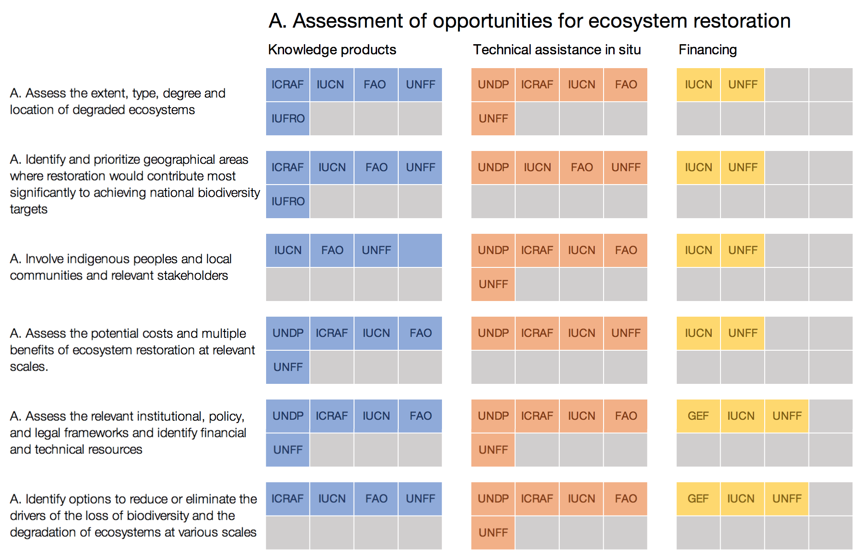

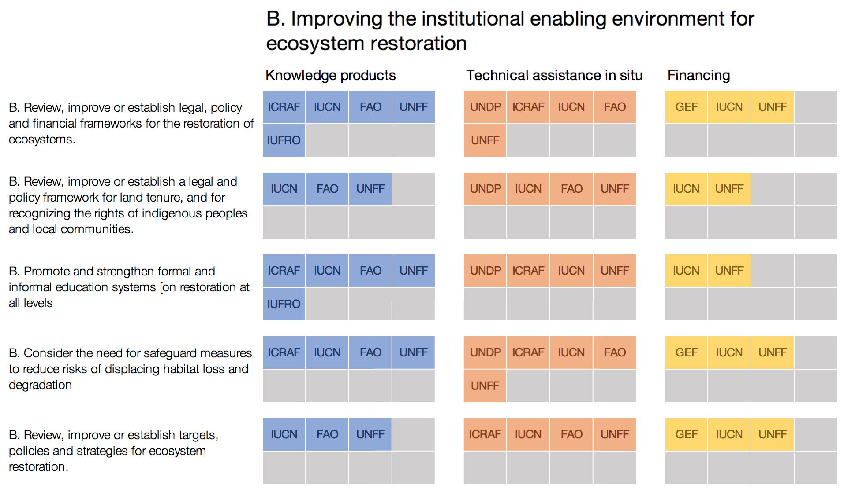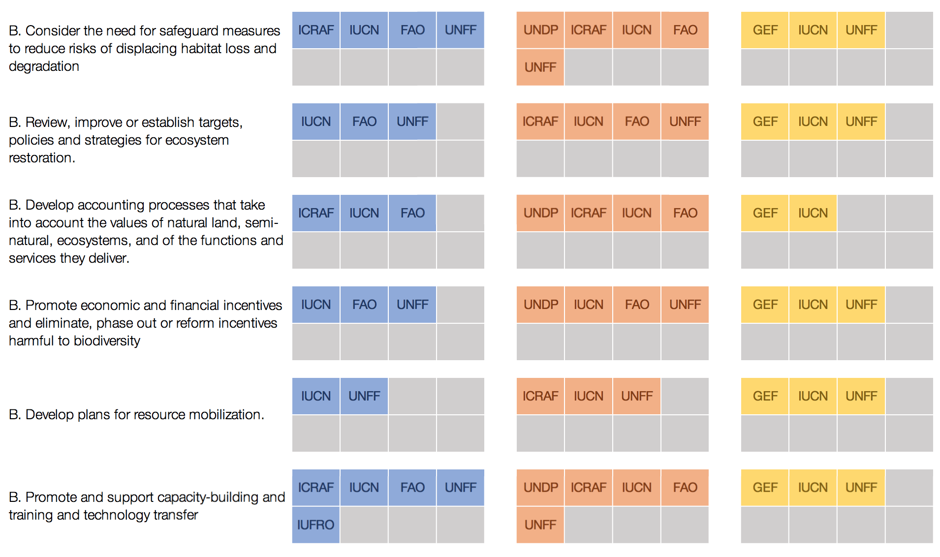



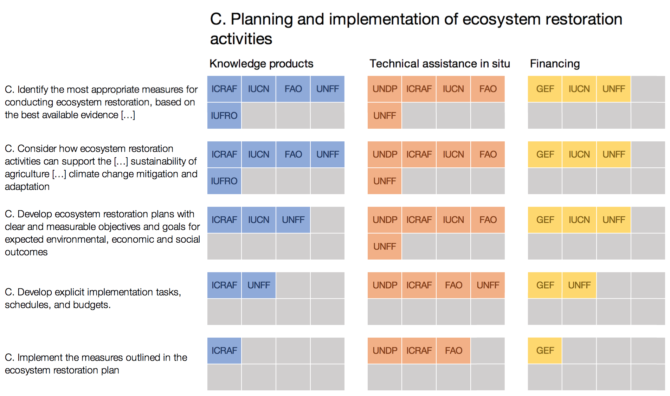

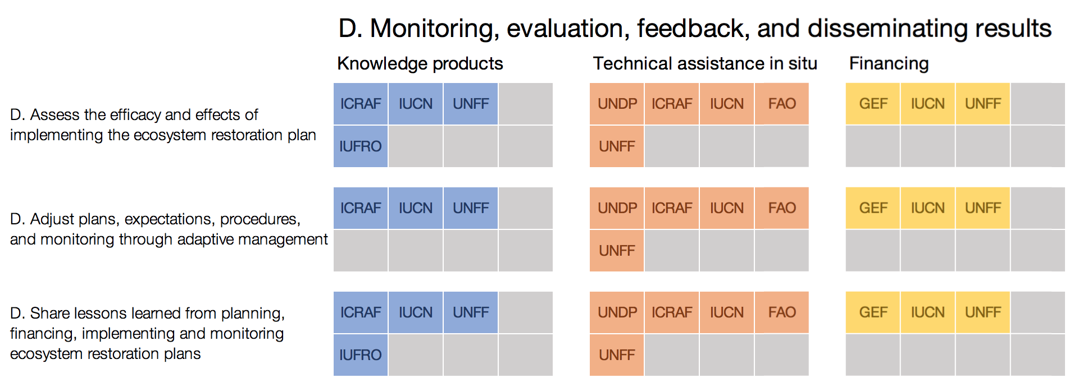

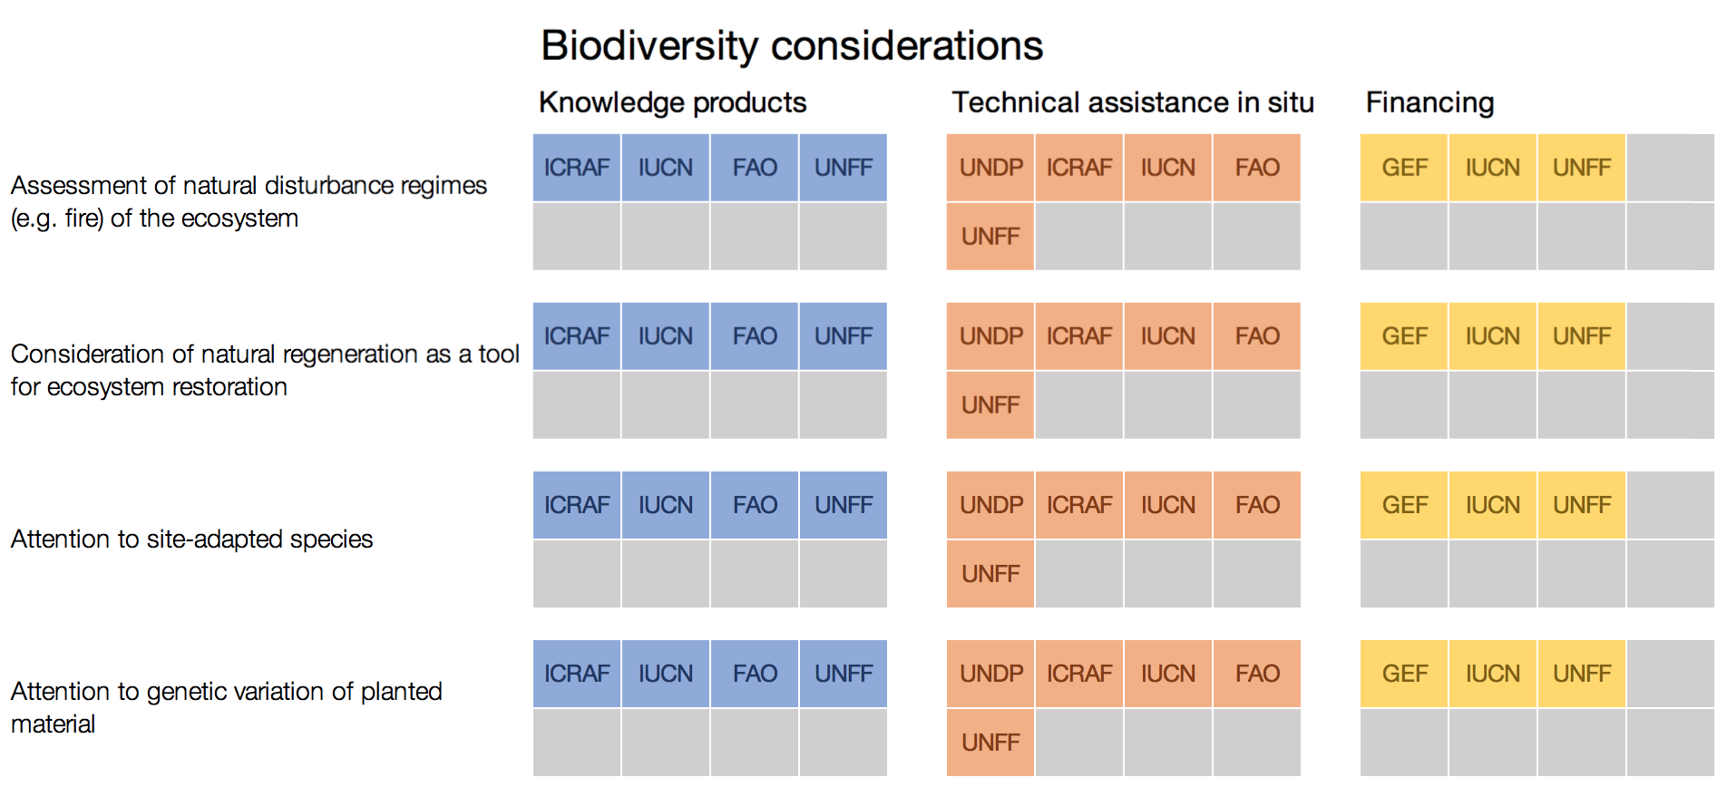

A main conclusion derived from the results of the survey is that, commensurate with the early stages in which many national policies and programmes on restoration find themselves, support from CPF members is stronger on the earlier steps of the Short-Term Action Plan for Ecosystem Restoration such as those connected to the ‘Assessment of opportunities for ecosystem restoration’ and ‘Improving the institutional enabling environment for ecosystem restoration’.

As restoration actors proceed from planning, governance reviews, resource mobilization to implementation, and monitoring, CPF members could examine ways to accompany such actions by focusing technical assistance, knowledge products and financing for implementation and monitoring efforts, guided by the Short-Term Action Plan for Ecosystem Restoration. This could be beneficial since less than half of the 9 respondents indicated making use and/or referencing the Short-Term Action Plan for Ecosystem Restoration in their work/products on restoration. This may simply reflect how recent the Short-Term Action Plan for Ecosystem Restoration has been adopted in comparison to other frameworks for the planning of restoration actions.

Further efforts will be required to inform, assist, and finance the steps under the Short-Term Action Plan for Ecosystem Restoration to Parties and with support of relevant organizations. Until 2020, with support from the Forest Ecosystem Restoration Initiative, funded by the Korea Forest Service, the CBD Secretariat is developing further outreach communication materials and direct support to implement the steps of the Short-Term Action Plan for Ecosystem Restoration, as well as to publish companion guidance documents that draw on the resources available from CPF partners identified as part of this exercise.

### Related Joint Initiatives by CPF member organizations

In May 2017, the CPF agreed to work on FLR as a Joint Initiative of its 2017 work plan. The objective of this initiative is to enhance the collective response of the CPF to current and evolving global forest-related issues through FLR. Coordinated efforts are envisaged to address REDD+ policies, climate change, desertification, biodiversity and SDGs, as well as to facilitate the mobilization of additional and needed finance for FLR. This initiative also responds to the invitation to CPF member organizations under CBD Decision XIII/7 on forest biodiversity.

This Joint Initiative could also bring opportunities to engage more closely with the GPFLR in a coordinated manner to strengthen national and international support and engagement on elements of the Short-Term Action Plan for Ecosystem Restoration.

Since 2015, the Secretariat of the CBD, has been working together with FAO in numerous capacity-building workshops on ecosystem restoration, in a number of regions, with support from the Forest Ecosystem Restoration Initiative. This collaboration extends to direct support projects for forest ecosystem restoration actions in several countries and is expected to continue in 2018, as described in UNEP/CBD/SBI/2/INF/18 entitled Forest Ecosystem Restoration Initiative - Review of implementation 2015-2017 and Outlook 2018-2020.

### Relevant individual contributions by CPF member organizations

UNEP, through its specialized biodiversity assessment centre UNEP-WCMC indicated that it has partnered with the International Institute of Applied Systems Analysis (IIASA) in two projects (REDD-PAC and Restore+) to model the implications of policy options on landscape scale conservation and restoration in Brazil, Indonesia (in relation to large-scale restoration opportunities on degraded land), and the Congo Basin. Through spatially explicit land-use modelling, the project can assess the outcomes of different policy options for primary/secondary natural forest and their biodiversity. For example, in Brazil the project is looking at how different options for implementing the law for the protection of native vegetation and how this may affect rates of loss and conversion of natural forest in different biogeographic regions of the country.

IUCN published a set of biodiversity guidelines for FLR opportunities assessments, presented in UNEP/CBD/SBI/2/INF/19. The intention is to help practitioners translate and communicate the importance of FLR work within a biodiversity perspective, and to help connect the design of FLR strategies with the attainment of NBSAPs.

The VECEA data produced by ICRAF could also be used to determine which types of natural habitats are most threatened and require most protection. The high-resolution baseline potential natural vegetation map that was developed by the project for eastern Africa has now been integrated in the Ecoregions 2017 map that updated the WWF Terrestrial Ecoregions map from 2001.[27] This product includes information on the level of protection currently enjoyed by various ecoregions, highlighting areas of priority for designation of new protected areas, restoration and conservation of remaining natural fragments, respectively.

The [ITTO Guidelines for the Restoration, Management and Rehabilitation of Degraded and Secondary Tropical Forests (2002)](http://www.cbd.int/forest/doc/itto-guidelines-restoration-management-rehabilitation-degraded-forests-2002-en.pdf) provide reference for the recovery of biodiversity in degraded forests in the tropics. These ITTO guidelines contribute to the conservation and sustainable use of tropical forest biodiversity by providing guidance for the field implementation of the projects and other activities under the ITTO/CBD Collaborative Initiative for Tropical Forest Biodiversity.

## F. Traditional and indigenous knowledge

GFG 5.3 reads "National and subnational forest-related policies and programs [...] engage relevant stakeholders, local communities and indigenous peoples, fully recognizing the UN Declaration on the Rights of Indigenous Peoples." This Goal does not fully align with Aichi Biodiversity Target 18 which calls for the "traditional knowledge, innovations and practices of indigenous and local communities" to be "fully integrated and reflected in the implementation of the Convention". In order to support this target, the CPF would therefore engage with indigenous peoples and local communities by drawing, where relevant, on traditional and indigenous knowledge, in addition to ‘engaging them’ and ‘recognizing their rights’.

### Relevant joint initiatives by CPF member organizations

The CPF policy document indicates that “it seeks collaboration with a wide range of partner” and that “a CPF Dialogue may be established to facilitate collaboration and communication between the Partnership and interested parties including major groups and other stakeholders”. This mirrors the approach of the UNFF, whose decisions have recognized the vital role forest-related stakeholders play in the implementation of Sustainable Forest Management of all types of forests, and encouraged the active participation of forest-related stakeholders, who within the context of the Forum are referred to as Major Groups (MG). One of these major groups, as identified in Chapter 23 of Agenda 21, is Indigenous Peoples.

Of particular relevant to Aichi Biodiversity Target 18 is on the type of intervention 1 ‘Information in support of capacity for advocacy”, under which are listed the following actions : “1.1 Develop an information and knowledge-sharing platform, including traditional knowledge, to support advocacy and effectiveness of interventions” and “1.2 Advocate for research and documentation of Traditional Forest-Related Knowledge”.

There are currently no Joint Initiatives under its work plan directly addressing the issue of Traditional Forest-Related Knowledge or engagement with Indigenous Peoples fora. However, the UNFF Secretariat suggested that indigenous peoples’ participation could be enhanced in two of the Joint Initiatives of the partnership: one avenue for such engagement, is that the Global Forest Expert Panels foster dialogues between scientific and traditional knowledge on the thematic issues they address, where relevant. Another Joint Initiative, the Policy Learning Initiative, which seeks to “identify more effective governance frameworks and policy instruments to implement specific sustainable forest management challenges”, could explore good practice in government policy related to forest tenure and indigenous people’s right, and apply it in the current country-level policy learning project.

### Relevant contributions by individual member organizations of the CPF

CPF members reported how they individually take into account indigenous peoples in their forest-related work that supports the implementation of the UNSPF: UNDP’s Social and Environmental Screening Protocol requires careful consideration of participation of indigenous communities during UNDP’s Sustainable Forest Management projects, funded by the GEF. Project approval cannot be granted by UNDP if these aspects have not been positively addressed during project preparations. The GEF itself has its own policies on the topic, providing another layer of verification. Meanwhile, IUCN reported working in partnership with local organizations across regions to enhance local participation and the rights of indigenous peoples, both in its work on REDD+ and FLR. IUFRO has for many years promoted work on traditional forest-related knowledge, specifically the ongoing work being done within Division 9 (Forest Policy and Economics), which includes two working parties on Traditional Knowledge in Research Group 9.03, created after IUFRO’s major efforts in 2005-2011 by the Task Force on Traditional Forest Knowledge.[28]

UNEP indicated that it is responsible for implementing the Interfaith Rainforest Initiative, funded by Norway’s International Forest and Climate Initiative and launched in June 2017. In a first-of-its-kind summit, Christian, Muslim, Jewish, Buddhist, Hindu and Taoist religious leaders joined forces with indigenous peoples from Brazil, Colombia, the Democratic Republic of the Congo, Indonesia, Meso-America and Peru to make the protection of rainforests an ethical priority for the world’s faith communities. The aim of the initiative is to mobilize leaders from all religions, faiths and spiritual traditions – including indigenous peoples and forest communities – to forge a united action plan to protect, restore and sustainably manage tropical rainforests across the planet. It will work both within and between countries, with global and national action plans.

In addition, in response to paragraph 1 of decision XI/24 in which the Conference of the Parties expressed support for an Indigenous and Community Conserved Areas Registry, UNEP-WCMC is working closely with governments to assist with national recognition of indigenous community conserved areas (ICCAs) and, in partnership with the indigenous and community conserved areas consortium, has continued to develop the registry to increase information about these areas, document their values and to promote and better understand better understand ICCAs worldwide.

UNEP also suggested that there might be scope for CPF partners to better support efforts to map indigenous and community conserved areas, through participatory mapping of customary tenure, land uses, and forest values. It also noted that the CPF and its members could integrate traditional knowledge to their communication strategies through video stories.

# Points for further consideration

As defined in ECOSOC Resolution 2015/33, a core function of the CPF is to enhance coherence as well as policy and programme cooperation and coordination at all levels among its member organizations, including through joint programming and the submission of coordinated proposals to their respective governing bodies, consistent with their mandates. Member organizations of CPF continue to provide a key role, including through the integration of relevant global forest goals and targets into their forest-related plans and programmes, where appropriate, and consistent with their respective mandates. The importance of such type of action was also underlined in the outcome document from the International Conference “Working across Sectors to Halt Deforestation and Increase Forest Area – from Aspiration to Action”, held in Rome in February 2018.

With the adoption of the CPF 2017- 2020 workplan and the start of several Joint Initiatives, as well as individual initiatives undertaken by CPF member organizations, there is an opportunity for targeted input from the Secretariat of the CBD to better account for the value of forest biodiversity and ecosystems in supporting the implementation of the global forests goals, the SDGs, the Paris Agreement and other forest-related multilateral commitments and goals, and to garner greater support from CPF members in the lead up to the review of progress made on the Strategic Plan on Biodiversity by 2020 and the preparations for the post 2020 global biodiversity framework. Preparations on the post 2020 global biodiversity framework could also examine ways through which the Partnership and the other 14 members, could support continued implementation of forest and land use related actions with a stronger connection to forest conservation and sustainable use objectives. Commitment from CPF member organizations to continue addressing forest biodiversity priorities after 2020 will remain important to maintain and expand such priorities within its work plan.

The adoption of the UN Strategic Plan for Forests 2017-2030 by the UNFF in 2017 provides a renewed framework for the work of the CPF. Aside from the forest related Aichi Biodiversity Targets, the global policy landscape for forests includes the Paris Agreement under the UNFCCC, under which forest accounting rules are still being refined, and the 2030 Agenda on Sustainable Development and SDGs, which include targets specific to forests and biodiversity. In addition, the Bonn Challenge has generated significant pledges for FLR, with several regional Ministerial Processes building political weight around the issue.

While this context creates a strong momentum for forests, the achievement of forest-related biodiversity targets under the CBD will require that, in the design and implementation of forest-related national actions to implement these goals, careful attention be given to options for further action to achieve the forest-related Aichi Biodiversity Targets, in a mutually supportive manner.

One of these options pertains to the importance of indicators of gross loss of natural and primary forests, and a more nuanced understanding of the status of forest biodiversity. Such indicators are key to measure, and enhance the contribution that progress under other forest-related goals, including through CPF member organization, can make to the achievement of the Strategic Plan for Biodiversity 2011-2020 and the Aichi Biodiversity Targets and to the preparations on the post 2020 global biodiversity framework.

Collectively, CPF members already provide a wide range of support on forest issues to Parties to the Convention, in terms of knowledge products, technical assistance and/or funding. However, further guidance could be developed by the Secretariat of the Convention, in cooperation with the CPF, to better inform Parties on the type of support that may be available from CPF member organizations with regards to specific areas of implementation of the Convention, including on the Short-Term Action Plan on Ecosystem Restoration.

The efforts deployed, respectively, by UNEP and IUCN to develop spatial assessments for the implementation of REDD+ and FLR that accounts for the multiple benefits of biodiversity, described in, may gain from further coordination on the data used, national partners involved and cross-referencing. The relevance of ICRAF’s Vegetation and Climate Change in East Africa (VECEA) mapping product to these spatial assessments should also be underlined, in particular its inclusion in future spatial planning work undertaken.

Subject to the availability of resources, the Secretariat of the Convention could facilitate further exchanges on the type of technical support provided by CPF members to countries with regards to indicators of loss and degradation of primary forest and forest biodiversity metrics as well as to identification of FLR opportunities, harnessing outputs generated to complement the quality of national reporting of progress on the forest-related Aichi Biodiversity Targets.

**Annex I. Text of the survey sent to CPF members**

# **Survey of CPF members on the contribution of the CPF to the implementation of the UN Strategic Plan for Biodiversity**

In paragraph 7 of its decision XIII/7, the CBD COP requested the Executive Secretary " to strengthen collaboration with the members of the Collaborative Partnership on Forests to fully respond to the requests of the Conference of the Parties in paragraph 21 of decision XII/6", which was to "prepare a study on the ways in which international organizations and secretariats with substantial programmes on forests are assisting in implementing the Strategic Plan for Biodiversity 2011-2020 and achieving the Aichi Biodiversity Targets" whilst "inviting other members of the Collaborative Partnership on Forests to contribute to the study".

The study previously produced in response to decision XII/6 (UNEP/CBD/SBSTTA/19/INF/3) consisted mainly in a stock-taking of actions from CPF members and their mapping against the framework of the Aichi Biodiversity Targets. In order to further respond to the request of CBD COP13, and updated study has to be produced by July 2018 for the 2nd meeting of the Subsidiary Body on Implementation of the CBD. It will focus on specific points of intersection between the UN Strategic Plan for Forests 2017-2030 (UNSPF) and the Aichi Biodiversity Targets that have been identified as strategic priorities in the current work of the CBD Secretariat on forests.

The study would be forward-looking, seeking to identify where the implementation of the Strategic Plan for Forests could further support the implementation of the Aichi Biodiversity Targets by 2020, and further integration of biodiversity in the global forest agenda.

This work also takes place in the context of paragraph 5 of Decision XIII/7 of the CBD COP, "inviting the members of the Collaborative Partnership on Forests, in preparing the 2017-2030 work plan of the Partnership, to consider ways and means of further enhancing their individual and collective contributions to the Aichi Biodiversity Targets and to support a coordinated approach to the achievement of the forest-related multilateral commitments and goals."

The survey was designed to receive the contributions of other members of the CPF to the study. It was made up of the following sections:

I. Natural forests and the reduction of deforestation, degradation and fragmentation - GFG 1.1 & 1.3 /Aichi Target 5

II. Restoration of forest and other ecosystems - GFG 1.2 / Aichi Target 15

III. Forests under protected areas and other area-based conservation measures - GFG 3.1 / Aichi Target 11

IV. Inclusion of indigenous peoples and traditional knowledge (GFG 5.3 / Aichi Target 18)

V. Joint initiatives between CPF members and strategic priorities for future work

The survey itself, and the report derived from its results, could be interpreted as a contribution to Global Forest Goal (GFG) 6 to "Enhance cooperation, coordination, coherence and synergies on forest-related issues at all levels, including within the UN System and across CPF member organizations".

A lesson encountered in gathering input from CPF members in the preparation of previous reports, regards the variety of their mandates, services and outputs, ranging from convention secretariats to financing organizations to research and other knowledge generation and dissemination functions. Therefore, not all questions in the survey may be relevant organizations. Therefore, at the beginning of each section, organizations were asked to review all questions and focus on those that were most relevant to their organization' s work (you may write 'N/A' under others, as necessary).

***Contact information***

***Which member organization of the CPF do you represent?***

***Name and responsibility within the organization***

*Email*

1. Natural forests and the reduction of deforestation, degradation and fragmentation - GFG 1.1 & 1.3 /Aichi Target 5

GFG 1.1. calls for forest area to be increased by 3% worldwide. However, GFG 1.3 calls for "halt[ing] deforestation by 2020", which echoes the text of Aichi Target 5. Aichi Target 5 also calls for a reduction of the loss of "natural habitats, including forests", highlighting the value of natural forests as a habitat for species.

Thus, from a biodiversity standpoint, any decrease in forest cover due to ongoing loss of natural forest cover is not compensated by an increase as a result of reforestation/ afforestation efforts, and success in meeting GFG 1.1 may not be meaningful if significant progress is not also achieved on GFG 1.3. This importance of considering natural forests and gross loss is clearly articulated in two major forest mechanisms: it is reflected in the 'principles' for the implementation of Forest Landscape Restoration, and in the Cancun safeguards for the implementation of REDD+.

This point highlights the importance of indicators of gross forest loss and continued action and collaboration amongst CPF members to reduce deforestation, fragmentation and the degradation of natural forests.

* 1. In the technical support to implementation that your organization delivers, do you refer to national targets for the reduction of the loss/degradation/fragmentation of ecosystems from countries' National Biodiversity Strategies and Action Plans? If not, why? Are there barriers to consulting these targets?
  2. In your FLR-related work, how do you take into account the FLR principle? "Avoid further reduction of natural forest cover - Address ongoing loss and conversion of primary and secondary natural forest."
  3. In your REDD+-related work, how do you take into account Cancun safeguard (e) "[REDD+] actions are consistent with the conservation of natural forests and biological diversity"?
  4. Do recent decisions from your organization or intergovernmental process refer to the concepts of primary/natural forest, their measurement or value for biodiversity, or to the concept gross/net forest cover loss? (where possible please cite the decision and para)
  5. Does the project cycle and/or environmental standards applied in the allocation of funding from your organization refer to the concepts of primary/natural forests, or net vs. gross deforestation targets?
  6. If possible, please provide an estimate of the proportion of your portfolio of investment into forest-related project that goes into conservation/protection of standing natural forests vs restoration/increase of forest cover.
  7. Do any of the knowledge products from your organization address the question of primary/natural forests and their measurement, and the importance of gross vs. net forest targets? If yes, please provide a reference

1. Restoration of forest and other ecosystems - GFG 1.2 / Aichi Target 15

GFG 1.2 reads "The world's forest carbon stocks are maintained or enhanced". This goal aligns with Aichi Target 15, which reads "By 2020 [...] the contribution of biodiversity to carbon stocks has been enhanced, through conservation and restoration, including restoration of at least 15 per cent of degraded ecosystems [...]."

At CBD COP 13, Parties adopted the Short-Term Action Plan for Ecosystem Restoration (STAPER), which provides step-by-step guidance for how to plan implementation of Aichi Target 15 in an ecologically sensible way (see https://www.cbd.int/doc/decisions/cop-13/cop-13-dec-05-en.pdf)

In order to support parties in using the STAPER for the design of their national restoration strategies, the Secretariat of the CBD is compiling information on existing resources under each of the recommended 'steps' of the plan. The following section aims at scoping out the potential role that the support provided by CPF member organisations may play in the implementation of the plan.

This collation of resources on restoration may also be useful in the technical assistance on Forest Landscape Restoration provided by a range of CPF partners.

* 1. Has your organization made use of/reference to the STAPER in you work/products on restoration?
  2. For each of the following steps of the STAPER, indicate if your organization is providing support and the kind of support provided

The aim of this assessment will be, for each step of the plan, to map the potential support available from CPF members and, where relevant, chart areas where collaboration could be enhanced.

1. Forests under protected areas and other area-based conservation measures - GFG 3.1 / Aichi Target 11

GFG 3.1 reads "The area of forests worldwide designated as protected areas or conserved through other effective area- based conservation measures is significantly increased. "This goal aligns with Aichi Target 11, however Aichi Target 11 also calls for networks of protected areas and other area-based conservation measures to meet a number of criteria such as effective and equitable management, ecological representativeness, connectivity and integration in wider landscape and seascapes.

* 1. In the allocation of funding to protected areas and other area-based conservation measures do you take into account the representativeness of the ecosystem types to be covered / considerations of connectivity and integration in the landscape?

1. Inclusion of indigenous peoples and traditional knowledge (GFG 5.3 / Aichi Target 18)

GFG 5.3 reads "National and subnational forest-related policies and programs [...] engage relevant stakeholders, local communities and indigenous peoples, fully recognizing the UN Declaration on the Rights of Indigenous Peoples." This goal aligns with Aichi Target 18 which calls for the "traditional knowledge, innovations and practices of indigenous and local communities" to be "fully integrated and reflected in the implementation of the Convention".

* 1. How CPF could enhance participation of indigenous peoples and input to specific initiatives under the CPF work plan? What initiatives would that be?

1. Joint initiatives: achievements to date and next steps

The previous report presented examples of individual support from CPF members to the Strategic Plan on Biodiversity and listed a number of Joint Initiatives. In this report, we would like to evaluate the success of those existing Joint Initiatives and how they integrate biodiversity considerations in reaching the Initiative's objectives and towards implementation of the Strategic Plan on Biodiversity.

Therefore, we are requesting information on the extent to which future plans under these initiatives integrate biodiversity considerations, and how alignment with the Aichi Targets could be strengthened.

Provide information on the extent to which future plans under these initiatives integrate biodiversity considerations, and how alignment with the Aichi Targets could be strengthened:

* 1. The Global Partnership for Forest and Landscape Restoration (IUCN as the secretariat, FAO, UNFF, UNEP-WCMC, CBD, ITTO, CIFOR, ICRAF, IUFRO, WRI, among others)
  2. International Model Forest Network (CIFOR, FAO, UNDP, CATIE, Government of Canada)
  3. Collaborative Partnership on Sustainable Wildlife Management (FAO as secretariat, CBD as Chair, UNEP, CIFOR, IUCN, IUFRO, CITES, CMS, CIC, IIFB, Traffic, International Trade Centre, OiE)
  4. The UN-REDD Programme (FAO, UNDP, UNEP)
  5. The ITTO/CBD Collaborative Initiative for Tropical Forest Biodiversity
  6. The ITTO-CITES Programme for Implementing CITES Listings of Tropical Timber Species
  7. The Critical Ecosystem Partnership Fund (GEF, the World Bank, EU, the Governments of France, Japan, Conservation International and the MacArthur Foundation)
  8. World Bank's Forest Carbon Partnership Facility (FCPF) (World Bank, UNDP, FAO, IDB)
  9. The UNCCD Global Mechanism (UNCCD, IFAD and FAO)
  10. Are there any other joint initiatives between members of the CPF or other organizations whose work is relevant for the implementation of the Aichi Targets?

Outlook to 2020 and beyond

* 1. What do you consider are the 2 most critical pathways to safeguard forest biodiversity, which could be optimized beyond 2020 as a result of the implementation of the Strategic Plan on Forests and other global frameworks (SDGs, Paris Agreement)? how can CPF advance such pathways?

__________

1. * CBD/SBI/2/1.
2. From UNEP/CBD/SBSTTA/19/8, Table 2, page 10.
3. E/Resolution/2017/4, Paragraph 39.
4. The latest member to join the CPF, as of April 2018, is CITES.
5. The full list of CPF meetings and, meeting reports and periodic progress reports can be consulted at http://www.cpfweb.org/74837/en/
6. http://www.cpfweb.org/47318-05366ac58ffc533300f705a3ef2533810.pdf
7. ECOSOC Resolution 2017/4: United Nations Strategic Plan for Forests 2017-2030 and quadriennal programme of work of the United Nations Forum on Forests for the period 2017-2020.
8. GA Resolutions 71/285
9. Global Forest Goal (GFG) 2.5 of the UN Strategic Plan for Forests mandates that “The contribution of all types of forests to biodiversity conservation and climate change mitigation and adaptation is enhanced, taking into account the mandates and ongoing work of relevant conventions and instruments”. This indicates that countries should bear in mind other forest-related goals and frameworks in seeking to achieve the global forest goals, including the Strategic Plan on Biodiversity 2011-2020 and its Aichi Biodiversity Targets.
10. See UNFCCC Decision 9/CP.19, Work Programme on Results-based Finance to Progress the Full Implementation of the Activities Referred to in Decision 1/CP.16, Paragraph 70, UN Doc. FCCC/CP/2013/10/Add.1, 3 1 January 2014 ; Decision 12/CP.17, Guidance on Systems for Providing Information on how Safeguards Are Addressed and Respected and Modalities Relating to Forest Reference Emission Levels and Forest Reference Levels as Referred to in Decision 1/CP.16, UN Doc. FCCC/CP/2011/9/Add.2, 15 March 2012.
11. Other reports relating to forests and climate include: UNEP/CBD/COP/12/INF/15 which highlighted the importance of joint planning under CBD and UNFCCC policy processes and provided a review of current guidance and national efforts, and UNEP/CBD/SBSTTA/20/INF/30 which presented further information on the potential contribution of REDD+ to the Strategic Plan for Biodiversity 2011-2020.
12. The declaration is available at http://www.un.org/climatechange/summit/wp-content/uploads/sites/2/2014/07/New-York-Declaration-on-Forest-%E2%80%93-Action-Statement-and-Action-Plan.pdf
13. http://www.bonnchallenge.org/
14. IUCN provided the following references: <https://www.cbd.int/doc/world/la/la-nbsap-v2-en.pdf>; <https://www.iucn.org/theme/forests/projects/stabilizing-land-use>; <https://www.iucn.org/content/financing-nbsaps-national-biodiversity-strategies-and-action-plans-options-and-opportunities>; <https://www.iucn.org/content/biodiversity-planning-asia-review-national-biodiversity-strategies-and-action-plans-nbsaps>; <https://www.iucn.org/content/use-economic-measures-national-biodiversity-strategies-and-action-plans-review-experiences-lessons-learned-and-ways-forward>; <https://www.cbd.int/doc/world/mm/mm-nbsap-v2-en.pdf>; <https://www.cbd.int/doc/world/la/la-nbsap-v2-en.pdf>;
15. UNEP/CBD/COP/13/INF/12 <https://www.cbd.int/doc/meetings/cop/cop-13/information/cop-13-inf-12-en.pdf>
16. <https://infoflr.org/countries>
17. A subset of natural forests of particular importance for Aichi Biodiversity Target 5 is primary forests, which in addition to being naturally regenerated are also characterized by the absence of significant human disturbance and by the presence of old-grown stands. Primary forests are of particular importance for the conservation of biodiversity as they provide irreplaceable habitat for certain species.
18. [Moreno-Mateos D, Barbier EB, Jones PC, Jones HP, Aronson J, Lopez-Lopez JA, McKrackin ML, Meli P, Montoya D, and Rey Benayas JM. 2017. Anthropogenic ecosystem degradation and the recovery debt. Nature Communications 8: 14163.](http://www.nature.com/articles/ncomms14163)
19. Co-chairs summary report (2008) Working across Sectors to Halt Deforestation and Increase Forest Area – from Aspiration to Action, A joint initiative of the Collaborative Partnership on Forests (CPF), available at <http://www.cpfweb.org/47129-080cab460fd2563e8b388f642b811133.pdf>
20. <http://vegetationmap4africa.org/Home.html>
21. All support to REDD+ decision-making products offered by UNEP, through the UN-REDD Programme, on REDD+ safeguards and non-carbon benefits, including those concerning natural forest, is available at <http://bit.ly/mbs-redd>.
22. Available at <https://www.iucn.org/content/ecological-restoration-protected-areas-principles-guidelines-and-best-practices>
23. Dinerstein E et al. 2017. An ecoregion-based approach to protecting half the terrestrial realm. BioScience 67 : 534 – 545. See also the commentary provided by Watson & Venter, 2017, A global plan for nature conservation, https://doi.org/10.1038/nature24144
24. <http://www.itto.int/project_search/detail/?proid=PD577%2F10+Rev.1+%28F%29>
25. https://www.cbd.int/conferences/2016/cop-13/documents Decision XIII/5

    Key steps: a) Assessment of opportunities for ecosystem restoration; b) Improving the institutional enabling environment for ecosystem restoration; c) Planning and implementation of ecosystem restoration activities; d) Monitoring, evaluation, feedback and disseminating results.
26. In addition to web-based maps, smart phone Apps are available from the Google Play Store. Kindt et al. 2017, Africa Tree Finder, https://play.google.com/store/apps/details?id=com.icraf.gsl.africatreefinder
27. <http://ecoregions2017.appspot.com/>
28. See <https://www.iufro.org/science/task-forces/former-task-forces/traditional-forest-knowledge/>