 |  | CBD/COP/16/INF/11
 |  | Distr.: General  16 September 2024  English only
Conference of the Parties to the
Convention on Biological Diversity
Sixteenth meeting
Cali, Colombia, 21 October–1 November 2024
Item 20 of the provisional agenda*
Marine and coastal biodiversity, and island biodiversity

Further information on the draft modalities for modifying the descriptions of ecologically or biologically significant marine areas and describing new areas**
  - Note by the Secretariat

Introduction
- The present document is intended to provide information to inform the deliberations of the Conference of the Parties under its agenda item on marine and coastal biodiversity and island biodiversity with regards to further work on ecologically or biologically significant marine areas. In particular, it provides some explanations and clarifications of certain elements of the draft modalities for the modification of descriptions of ecologically or biologically significant marine areas and the description of new areas.
- Earlier versions of this document were made available to inform the deliberations of the technical expert workshop and legal expert workshop to review modalities for modifying the descriptions of ecologically or biologically significant marine areas (EBSAs) and describing new areas, held in Oslo, from 20 to 24 November 2023 and from 23 to 27 November 2023, respectively, and to inform the deliberations of the Subsidiary Body on Scientific, Technical and Technological Advice at its twenty-sixth meeting, held in Nairobi, from 13 to 18 May 2024.
- Portions of this document were produced with financial support from the government of Norway.

Background on the process under the Convention to facilitate the description of ecologically or biologically significant marine areas
- In 2008, the Conference of the Parties to the Convention on Biological Diversity, at its ninth meeting, adopted the scientific criteria for identifying ecologically or biologically significant marine areas in need of protection in open-ocean waters and deep-sea habitats (decision IX/20, annex I).
- At its tenth meeting in 2010, the Conference of the Parties noted that the application of the EBSA criteria presents a tool which Parties and competent intergovernmental organizations can use to implement the ecosystem approach in relation to areas both within and beyond national jurisdiction, through the identification of areas and features of the marine environment that are important for conservation and sustainable use of marine and coastal biodiversity. The Conference of the Parties also recognized that the Convention on Biological Diversity has a key role in supporting the work of the United Nations General Assembly with regard to marine protected areas beyond national jurisdiction, by focusing on the provision of scientific and, as appropriate, technical information and advice relating to marine biological diversity, the application of the ecosystem approach and the precautionary approach. In addition, the Conference of the Parties recognized that capacity-building would be needed to support developing countries, in particular the least developed countries and small island developing States, in their efforts to identify EBSAs (decision X/29).
- In the same decision, the Conference of the Parties established a global process to facilitate the description of EBSAs through regional workshops, focused on describing areas that meet the scientific criteria for EBSAs.
- Since 2011, the Secretariat has convened 15 regional workshops to facilitate the description of EBSAs. These workshops, organized in collaboration with Parties, other Governments, and international organizations, and with significant scientific input from various scientific experts around the world, have facilitated the description of more than 300 areas meeting the EBSA criteria.
- The outputs of regional EBSA workshops are submitted for consideration by the Subsidiary Body on Scientific, Technical and Technological Advice and the Conference of the Parties, after which they are included in the EBSA repository (www.cbd.int/ebsa/ebsas) and transmitted to the UN General Assembly and its relevant processes, at the request of the Conference of the Parties.
- The EBSA process has been extremely valuable in improving our understanding of the ecological and biological significance of various components of the ocean and for providing a solid scientific basis for governments and competent intergovernmental authorities to select, as appropriate, adequate measures for the conservation and sustainable use of marine biodiversity. EBSAs provide information that is not only useful for management, but also provide a focus for research and monitoring of various features in the ocean. Furthermore, the EBSA regional workshop process has facilitated scientific collaboration, networking and capacity-building at various scales around the world. Information on progress and achievements of the EBSA process was synthesized and published in a report in 2022, which is available here.
- Notwithstanding the success of the EBSA process, discussions have been ongoing on means to improve this work, including means to incorporate best available scientific information and knowledge from various sources.

Background information to support the deliberations under agenda item 20
- Under the Convention, consideration of issues related to further developing the methodologies of the EBSA process began in earnest at the twelfth meeting of the Conference of the Parties in 2014, at which the Conference of the Parties (in decision XII/23, para. 10), requested the Executive Secretary to develop practical options to further enhance scientific methodologies and approaches on the description of areas meeting the EBSA criteria, ensuring that the best available scientific and technical information and traditional knowledge of various users of marine resources, including fishers, are used and that the products are scientifically sound and up-to-date.
- Pursuant to this request, and based on input received through notification No. 2015-113, as well as a compilation of experiences from scientific methodologies and approaches for the description of EBSAs (UNEP/CBD/SBSTTA/20/INF/20), the Executive Secretary provided practical options for further enhancing scientific methodologies and approaches on the description of areas meeting the EBSA criteria (UNEP/CBD/SBSTTA/20/3, annex IV) to the Subsidiary Body on Scientific, Technical and Technological Advice for consideration at its twentieth meeting.
- At its twentieth meeting in 2016, the Subsidiary Body on Scientific, Technical and Technological Advice determined that further work was needed on certain aspects of this issue prior to consideration by the Conference of the Parties and requested the Executive Secretary:
(a) To develop options regarding procedures within the Convention to modify the description of areas, both within and beyond national jurisdiction, decided by the Conference of the Parties for inclusion in the repository, based on new information that has become available since the previous regional workshops on ecologically or biologically significant areas;
(b) To develop options to facilitate the process of description of new areas against the criteria for ecologically or biologically significant marine areas;
(c) To make a draft report on options available for peer-review by Parties for further refinement; and
(d) To submit the final report to the Conference of the Parties for consideration at its thirteenth meeting, building on the work of the Subsidiary Body on Scientific, Technical and Technological Advice at its twentieth meeting.
- In response to this request, the Executive Secretary prepared a document providing options regarding procedures for modifying the description of EBSAs or facilitating the description of new areas (UNEP/CBD/COP/13/18), the draft of which was also subjected to peer-review through notification No. 2016-104 prior to being made available for the Conference of the Parties.
- At its thirteenth meeting in 2016, the Conference of the Parties welcomed the voluntary practical options for further enhancing scientific methodologies and approaches of the scientific and technical exercises, including collaborative arrangements, for the description of areas meeting the criteria for ecologically or biologically significant marine areas, as contained in annex II of decision XIII/12. This annex included provisions addressing (a) means to improve data compilation and synthesis for the description of EBSAs, (b) approaches for incorporating new information and new consideration of existing information in future descriptions of EBSA, including both scientific and traditional knowledge, and (c) means to enhance the EBSA repository and information-sharing mechanism. In the same decision, the Conference of the Parties also requested the Executive Secretary to facilitate an informal advisory group for EBSAs, in line with terms of reference provided in annex III of decision XIII/12.
- However, further consideration was needed regarding issues related to the modification of areas already described as EBSAs and possible additional modalities for the description of new EBSAs. So, in decision XIII/12, the Conference of the Parties requested the Executive Secretary to continue the work set out in paragraph 10 of decision XII/22 and recommendation XX/3 of the Subsidiary Body on Scientific, Technical and Technological Advice, building on discussions of the Conference of the Parties at its thirteenth meeting, by organizing an expert workshop, to make the report of this workshop available for subsequent peer-review by Parties, other Governments and relevant organizations, and to report on its progress to a future meeting of the Subsidiary Body on Scientific, Technical and Technological Advice for its consideration, prior to the fourteenth meeting of the Conference of the Parties.
- Pursuant to this request, and with financial support from the Governments of Germany and Sweden, the Secretariat of the Convention on Biological Diversity organized the Expert Workshop to Develop Options for Modifying the Description of Ecologically or Biologically Significant Marine Areas, for Describing New Areas, and for Strengthening the Scientific Credibility and Transparency of this Process. The workshop was hosted by the Government of Germany and was held in Berlin, from 5 to 8 December 2017. This expert workshop had the following objectives:
(a) To develop options, for cases both within and beyond national jurisdiction, regarding procedures within the Convention to modify the description of areas meeting the EBSA criteria and to describe new areas, while fully respecting the sovereignty, sovereign rights and jurisdiction of coastal States reaffirmed in decision XIII/12, paragraph 3;
(b) To develop options for strengthening the scientific credibility and transparency of the EBSA process, including by enhancing the scientific peer review by Parties, other Governments and relevant organizations.
- The report of this workshop was then made available for peer-review by Parties, other Governments and relevant organizations through notification No. 2018-004.
- On the basis of the workshop report and input received in response to the above-noted notification, the Secretariat provided draft options for modifying the description of ecologically or biologically significant marine areas, for describing new areas, and for strengthening the scientific credibility and transparency of this process (CBD/SBSTTA/22/7, annex), which was considered by the Subsidiary Body on Scientific, Technical and Technological Advice at its twenty-second meeting.
- This issue was subsequently considered by the Conference of the Parties at its fourteenth meeting. Unfortunately, the Conference of the Parties was unable to find consensus on all elements of this issue. In decision 14/9, the Conference of the Parties welcomed the report of the workshop and requested the Executive Secretary, subject to the availability of financial resources, to identify options for modifying the description of ecologically or biologically significant marine areas, for describing new areas, and for strengthening the scientific credibility and transparency of this process, noting the above-mentioned report and annex II to the decision 14/9, and to submit them to the Subsidiary Body on Scientific, Technical and Technological Advice and to the Conference of the Parties for consideration, and noting annex III.
- Pursuant to the above request, and with financial support from the Governments of Belgium and Germany, the Secretariat of the Convention on Biological Diversity organized the Expert Workshop to Identify Options for Modifying the Description of Ecologically or Biologically Significant Marine Areas (EBSAs) and Describing New Areas. The workshop was hosted by the Government of Belgium and was held in Brussels from 3 to 5 February 2020. The workshop report was provided as an information document for the twenty-fourth meeting of the Subsidiary Body.
- In view of the extraordinary circumstances faced at the twenty-fourth meeting of the Subsidiary Body on Scientific, Technical and Technological Advice and the fifteenth meeting of the Conference of the Parties, in particular the need to adopt the Kunming-Montreal Global Biodiversity Framework, there was insufficient time available at these meetings to fully discuss this issue.
- With a view to advancing discussions on these issues, the Conference of the Parties requested, in decision 15/26 the Executive Secretary to convene two expert workshops, with the following respective goals:
- To review the technical aspects of the modalities for modifying the descriptions of EBSAs and describing new areas;
- To review the legal issues pertaining to these modalities, on the basis of the outcomes of the technical workshop.
- Pursuant to the above requests, with financial support from the Governments of Belgium, Canada, Germany, Norway and Sweden, the Executive Secretary convened the technical expert workshop and legal expert workshop to review modalities for modifying the descriptions of ecologically or biologically significant marine areas and describing new areas, from 20 to 24 November 2023 and from 23 to 27 November 2023, respectively, in Oslo. The workshops were held back-to-back, with two overlapping days of joint sessions on 23 and 24 November 2023.
- The reports of the technical workshop and legal workshop, which contain a synthesis of the discussions held during the workshops and their outcomes, are available as documents CBD/EBSA/EM/2023/1/3 and CBD/EBSA/EM/2023/2/3, respectively.
- The results of the workshops informed the development of the draft recommendations and the annex in document CBD/SBSTTA/26/7/Add.1 containing the modalities for the modification of descriptions of ecologically or biologically significant marine areas and the description of new areas, which was provided for consideration by the Subsidiary Body at its twenty-sixth meeting.
- At its twenty-sixth meeting, the Subsidiary Body considered the above document and adopted recommendation 26/8. The Conference of the Parties will be invited to consider those matters on the basis of the draft decision included in recommendation 26/8, as reproduced in the compilation of draft decisions.

Explanation of the modalities for the modification of descriptions of ecologically or biologically significant marine areas and the description of new areas contained in document CBD/SBSTTA/REC/26/8
- With a view to facilitating an improved understanding of the modalities and to support deliberations on this issue by the Conference of the Parties, the remainder of the present document contains explanations and clarifications of portions of the recommendations contained in document CBD/SBSTTA/REC/26/8, including visual representations. Please note that this document does not address all elements of the recommendations contained in document CBD/SBSTTA/REC/26/8, but rather only those for which further explanation and clarification may be needed.
- It is important to note that the explanations/clarifications contained in this document do not have any formal status and are not intended to be a substitute for text contained in document CBD/SBSTTA/REC/26/8.

Explanations and clarifications with respect to selected operative paragraphs
“[4. Requests the Executive Secretary, subject to the availability of financial resources, in line with paragraph 36 of decision X/29, paragraph 12 of decision XI/17 and paragraph 6 of decision XII/22, to continue to facilitate the description of areas meeting the criteria for ecologically or biologically significant marine areas and to facilitate the modification of the descriptions of ecologically or biologically significant marine areas [when new information becomes available, as appropriate,] through the holding of additional workshops, where Parties and [other Governments] wish workshops to be held;]
[5. Also requests the Executive Secretary, subject to the availability of financial resources, in line with paragraph 36 of decision X/29, paragraph 12 of decision XI/17 and paragraph 6 of decision XII/22, to continue to facilitate the description of areas meeting the criteria for ecologically or biologically significant marine areas, and to facilitate the modification of the descriptions of ecologically or biologically significant marine areas, in areas beyond national jurisdiction;]”
- Paragraphs 4 and 5 refer to paragraphs from decisions X/29, XI/17 and XII/22 that outline the existing process to facilitate the description of areas meeting the EBSA criteria through workshops. Paragraph 5 relates to this work specifically in the context of areas beyond national jurisdiction.
- The process that presently exists, as per decisions X/29, XI/17 and XII/22, is illustrated and described below. However, it’s important to note that, if the modalities outlined in the draft decision are adopted by the Conference of the Parties, then the convening of workshops would need to be interpreted and implemented in the context of the modalities.

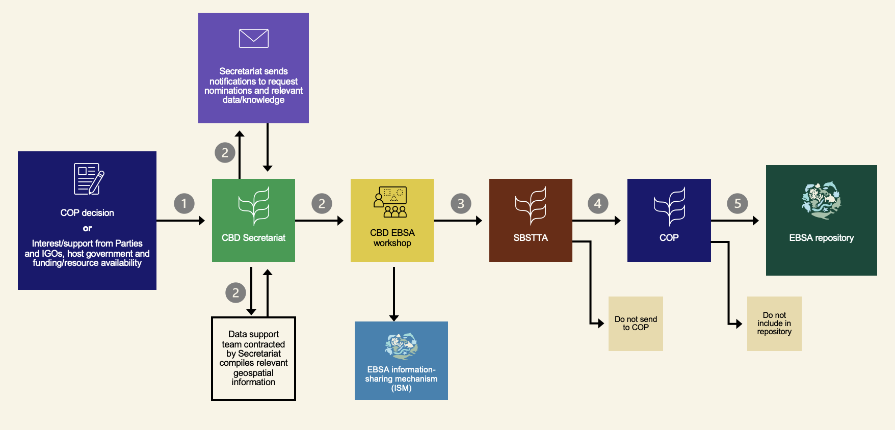

- Step 1: The convening of a CBD workshop to facilitate the description of EBSAs is initiated by a decision of the Conference of the Parties (COP), or an informal expression of interest and/or support from Parties and intergovernmental organizations and is dependent on the host government and availability of resources.
- Step 2: The Secretariat convenes a CBD workshop to facilitate the description of EBSAs, which includes (i) a notification to request the nomination of expert participants by Parties, other Governments, and relevant organizations, (ii) a notification to request submission of relevant data/knowledge, and (iii) contracting of data support team to support workshop preparations and provide data compilation and mapping support during the workshop. Please also note the following with respect to these workshops:
  - Information provided in response to the notification is made available for the workshop and posted in the information-sharing mechanism.
  - Workshop may develop new submissions and also review/discuss submissions developed prior to the workshop.
  - Workshop discusses areas beyond national jurisdiction, and, when requested by the State, also areas within national jurisdiction.
  - Workshop report, including areas described as meeting the EBSA criteria by the workshop, must be adopted by the workshop as a whole.
- Step 3: Outcomes of the workshop are provided to the Subsidiary Body for Scientific, Technical and Technological Advice (SBSTTA) for consideration, which decides whether to recommend to the COP to include the areas described as meeting the EBSA criteria into the EBSA repository.
- Step 4: Draft descriptions of areas meeting the EBSA criteria considered by SBSTTA are then provided to COP for consideration.
- Step 5: COP decides whether to request the Executive Secretary to include the areas in the repository, at which point they become CBD EBSAs.

Explanations and clarifications with respect to selected paragraphs of section I of the Annex (“Guidance in the implementation of the modalities”)
2. The modification of a description of an ecologically or biologically significant marine area, which can entail a modification to the textual description of the area, a modification to the ranking of the area against the criteria for such areas or a change in the location, shape, depth or size of the area[, or a withdrawal of the description of the area,] may be proposed for any of the following reasons:
(a) For areas beyond national jurisdiction:
(i) Newly available or accessible knowledge, including traditional knowledge, innovations and practices of indigenous peoples and local communities, on features associated with the area;
(ii) Change in the ecological or biological features of the area;
(iii) Scientific errors identified in the description;
(b) For areas within national jurisdiction, any of the reasons noted in paragraph 2 (a) [or any other reason] deemed valid by the State within whose jurisdiction the modification is proposed.
- Paragraph 2 addresses the modification of EBSA descriptions and focuses on what is meant by “modification” in this context and the reasons that a relevant proponent may propose a modification to an EBSA description.
- During SBSTTA 26, there were divergent views about the inclusion of the text “or a withdrawal of the description of the area” in this paragraph, and this text is in brackets.
- Regarding the reasons for modification, there were also divergent views expressed at SBSTTA 26 about the inclusion of the text “or any other reason” with respect to the modification of EBSA descriptions within national jurisdiction, and this text is in brackets.

“3. The modification of an existing description or the description of a new area may only be submitted by the following proponents:
(a) For areas beyond national jurisdiction, any States, individually or collectively, including through competent intergovernmental organizations;
(b) For areas within national jurisdiction, the State within whose jurisdiction the modification or description is proposed.
4. Proponents that develop submissions for the modification of an existing description or the description of a new area should consider the following at an early stage:
(a) Collaboration with competent intergovernmental organizations, other relevant organizations, experts, indigenous peoples and local communities, with their free, prior and informed consent, and women and youth organizations, in accordance with relevant national legislation, international instruments, including the United Nations Declaration on the Rights of Indigenous Peoples, and human rights law;
(b) The need to avoid developing submissions that may raise concerns regarding sovereignty, sovereign rights or jurisdiction;
(c) The need for a strong scientific basis with sufficient information, as well as the importance of transparency;
(d) The need to take into account the regional dimensions of marine and coastal ecosystems and their ecological and biological features and processes, including regional differences in data availability, as well as collaboration across regions.”
- Paragraph 3 explains that, if any modification of an existing EBSA or a description of a new EBSA is to be proposed that includes areas within national jurisdiction, the State that has jurisdiction over this area must consent to and be a part of the submission. This includes submissions that only partially include areas within national jurisdiction. Any submission regarding a modification or description that is wholly or partially within national jurisdiction that does not include, as a proponent, the State that has jurisdiction over the area, will not be accepted by the Secretariat. This is why all submissions must contain a map of the area and geographic coordinates.
- Paragraph 3 further explains that any State can provide a submission for a modification or description in areas beyond national jurisdiction. It also explains that competent intergovernmental organizations, which are composed of States, can propose a modification or description in areas beyond national jurisdiction on behalf of, and with the approval of, their Parties.
- It is important to note that, in the development of a submission, a State may choose to collaborate with any other stakeholders that they may deem relevant.
- Paragraph 4 complements paragraph 3 by touching on the importance of collaborating with a wide range of knowledge-holders in the process of developing submissions, as this will not only strengthen the quality of the proposal, but will help to avoid potential political concerns or other obstacles from arising later in the process. It also addresses other key considerations that should be taken into account in developing submissions.
“5. With respect to any submission for the modification of an existing description or the description of a new area, any State may formally communicate to the Executive Secretary, at any time, an objection to the inclusion of a description or a modification in the repository or the information-sharing mechanism for ecologically or biologically significant marine areas, owing to the existence of a claim or dispute relating to sovereignty, sovereign rights or jurisdiction involving an area included in the submission. In such a case, the submission will not be advanced any further and will not be included in the repository or information-sharing mechanism until the withdrawal of the objection is communicated to the Executive Secretary by the objecting State.”
- This process described in this paragraph was discussed heavily at the EBSA legal expert workshop, and is inspired by the rules of procedure and practice of the Commission on the Limits of the Continental Shelf (CLCS) on submissions relating to disputes. It provides a mechanism to ensure that proposals causing concern related to the existence of a claim or dispute relating to sovereignty, sovereign rights or jurisdiction are not taken forward in the context of the modalities described in the draft recommendations.
- Ideally, such a provision would not need to be used, as there are other elements of the modalities that aim to avoid such cases, namely:
  - The need for any submission to be accompanied by a map and geographic coordinates;
  - The need for proponents to avoid developing submissions that may raise concerns regarding sovereignty, sovereign rights or jurisdiction, as noted in paragraph 3;
  - Using bilateral diplomatic resolutions to such cases where a submission has raised such a concern (which could entail a proponent amending or withdrawing their submission).
- Note that this provision can apply not only to cases in which there is a pre-existing formal dispute among States, but also to cases in which a bilateral diplomatic resolution is unable to be achieved.

Explanations and clarifications with respect to selected paragraphs of section II of the Annex (“Repository and information-sharing mechanism for ecologically or biologically significant marine areas”)
“6. The repository for ecologically or biologically significant marine areas is to contain:
(a) The descriptions of areas meeting the criteria for ecologically or biologically significant marine areas that the Conference of the Parties has considered and requested the Executive Secretary to include in the repository and transmit to the General Assembly of the United Nations for its information and relevant processes, as well as to relevant international organizations;
[(b) For archival purposes, previous versions of descriptions of ecologically or biologically significant marine areas held in the repository, in cases where the descriptions have been modified, including information on the modalities by which the descriptions were initially included in the repository.]
7. The information-sharing mechanism for ecologically or biologically significant marine areas is to contain:
(a) The records of submissions of a modification or description of an area within national jurisdiction for inclusion in the repository for ecologically or biologically significant marine areas and the comments received on such submissions;
(b) Submissions of a modification or description of an area within national jurisdiction for inclusion in the information-sharing mechanism for ecologically or biologically significant marine areas, as well as any comments received on such submissions and any responses to those comments;
(c) The records of submissions of a modification or description of an area beyond national jurisdiction;
(d) Links to national processes and their related scientific information pertaining to areas meeting the criteria for ecologically or biologically significant marine areas, and other relevant compatible and complementary nationally agreed scientific criteria in national jurisdiction that were provided by the State concerned as information for the Subsidiary Body on Scientific, Technical and Technological Advice and the Conference of the Parties;
(e) Reports of the regional workshops convened by the Secretariat of the Convention on Biological Diversity to facilitate the description of ecologically or biologically significant marine areas;
[(f) For archival purposes, previous versions of descriptions of ecologically or biologically significant marine areas held in the [information-sharing mechanism]/[repository], in cases where the descriptions have been modified, including information on the modalities by which the descriptions were initially included in the [information-sharing mechanism]/[repository];]
(g) Guidance related to the application of the criteria for ecologically or biologically significant marine areas and the use of information contained in the descriptions of such areas;
(h) Other relevant scientific and technical information and other forms of knowledge, including, where [appropriate]/[available], the traditional knowledge of indigenous peoples and local communities, with their free, prior and informed consent, related to areas described as meeting the criteria for ecologically or biologically significant marine areas;
(i) Information and experience relating to the application of other relevant and complementary intergovernmentally agreed scientific criteria.”
- Paragraphs 6 and 7 explain what information would be contained in the EBSA repository and information-sharing mechanism in the context of the modalities contained in the recommendations, much of which is already contained in the repository and information-sharing mechanism, respectively. Presently, the EBSA repository is housed in the CBD clearing-house mechanism (CHM) and is accessible through the EBSA website (https://www.cbd.int/ebsa/) by either clicking on an individual EBSA shape on the map on the homepage or through the webpage that lists individual EBSAs (https://www.cbd.int/ebsa/ebsas). The EBSA website itself serves as the EBSA information-sharing mechanism.
- Presently, the only information contained in the EBSA repository are descriptions of EBSAs that have been considered by the COP and that the COP has requested the Secretariat to include in the EBSA repository.
- Paragraphs 6(b) and 7(f) address the placement of previous versions of EBSAs that have been modified through the modalities in this recommendation. These two paragraphs originally presented alternative options for where these versions would be stored—either in the repository or in the information-sharing mechanism. This reflects divergent views expressed at the EBSA expert workshops regarding where the previous versions of modified EBSAs should be placed. As a result of deliberations at SBSTTA 26, the text now includes additional alternatives in brackets. Paragraph 6(b), which is in brackets, described an archive in the repository for descriptions that were previously contained in the repository. Paragraph 7(f) also addresses an archive but there are alternative bracketed text for options on whether or not this archive in the information-sharing mechanism would include areas previously contained in the repository.
- In cases where EBSAs are modified, both the updated version of the EBSA and the previous version of the EBSA would indicate that the EBSA has been modified.
- There is also a provision for links to information on national processes to describe areas meeting the criteria for ecologically or biologically significant marine areas, and other relevant compatible and complementary nationally agreed scientific criteria in national jurisdiction.
- Note also that the Secretariat, with input from the EBSA Informal Advisory Group, has developed potential means by which the functionality of the EBSA website may be improved. These have not been implemented due to resource constraints and in light of the ongoing discussions under SBSTTA and COP regarding the EBSA process.

Explanations and clarifications with respect to section III of the Annex (“Modalities for the modification of descriptions of ecologically or biologically significant marine areas and description of new areas meeting the criteria for ecologically or biologically significant marine areas”)

Modification of the description of ecologically or biologically significant marine areas or description of new areas meeting the criteria for ecologically or biologically significant marine areas within national jurisdiction
- For submissions in areas within national jurisdiction, there are two potential end-points:
  - EBSA repository—Descriptions can only be included in the EBSA repository based on a request from the COP. This means that submissions must be considered by SBSTTA and COP (which means that SBSTTA and COP must take a decision on the submission). Descriptions included in the EBSA repository gain the status of a CBD EBSA.
  - EBSA information-sharing mechanism—Inclusion does not entail consideration by SBSTTA and COP. Rather, submissions to be included in the information-sharing mechanism are provided simply for information of SBSTTA and COP, but SBSTTA and COP will not take any decision regarding these submissions.

“Inclusion in the repository for ecologically or biologically significant marine areas
8. The submission of a modification or description of an area within national jurisdiction for inclusion in the repository for ecologically or biologically significant marine areas must be provided to the Secretariat together with information on the process by which the submission was developed, including any scientific peer-review process, and, in cases where information based on traditional knowledge is included, any information on consultations with indigenous peoples and local communities conducted with their free, prior and informed consent, in accordance with relevant national legislation, international instruments, including the United Nations Declaration on the Rights of Indigenous Peoples, human rights law and, where appropriate, the Mo’ otz Kuxtal Voluntary Guidelines. The proponent may also use the following options with respect to the development of the submission:
(a) The proponent may request the Secretariat to issue a notification, for information purposes, regarding its intent to submit a description or modification before the submission is developed;
[(b) The proponent may also choose to develop or refine a draft submission at a workshop on ecologically or biologically significant marine areas held pursuant to a decision of the Conference of the Parties before submitting it to the Secretariat.]
9. Upon receipt, the Secretariat shall make the submission available through the information-sharing mechanism for ecologically or biologically significant marine areas and issue a notification to provide information on the submission and communicate its inclusion in the mechanism. The submission shall be open for comments by Parties, other Governments and relevant organizations for a period of six months, and the Secretariat shall transmit any comments received to the proponent.
10. Upon receipt of such comments, which will be posted in the information-sharing mechanism, the proponent may do one of the following:
(a) Address the comments, if any, and, if necessary, provide a revised version of the submission to the Secretariat;
(b) Not address the comments and not proceed further, in which case the information-sharing mechanism will show a record of the submission and the comments, and the actual submission and comments will be available from the Secretariat upon request;
(c) Request the Secretariat to remove its original submission from the information-sharing mechanism, in which case the submission and the comments will be removed.
11. If comments are received and the proponent decides to address them and, if necessary, provide a revised version of the submission to the Secretariat, the Secretariat shall transmit the submission to the Subsidiary Body on Scientific, Technical and Technological Advice and the Conference of the Parties for their consideration. [The proponent may also request that the submission be discussed at a workshop on ecologically or biologically significant marine areas held pursuant to a decision of the Conference of the Parties before it is submitted to the Subsidiary Body.]
12. The submission shall be provided to the Conference of the Parties for consideration on the basis of a recommendation of the Subsidiary Body. The Conference of the Parties shall decide whether the submission is to be included in the repository for ecologically or biologically significant marine areas. A record of the submission shall remain in the information-sharing mechanism, regardless of whether it is included in the repository or not.”

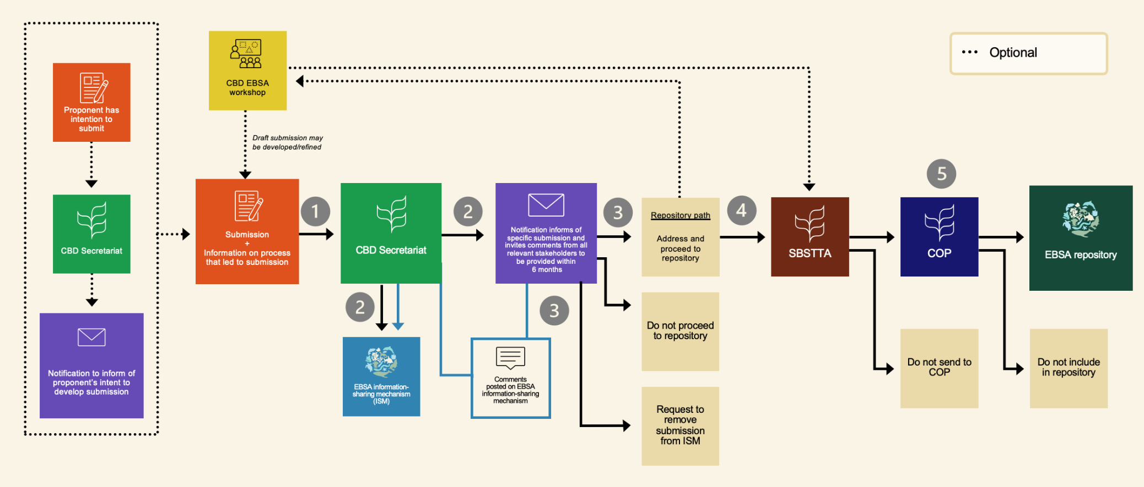

- Optional step: Before sending the submission to the Secretariat, the proponent may wish to request the Secretariat to issue a notification informing of their intent to develop a submission. This notification would be sent to Parties (CBD National Focal Points), Other Governments, indigenous peoples and local communities, and relevant organizations. This optional step could help to elicit information and expertise that can support the development of a strong submission and could also provide an opportunity for other States to flag potential concerns regarding the submission before it is submitted.
- Optional step: Submissions can also be developed/refined at a CBD EBSA workshop, before sending the submission to the Secretariat. This would be an opportunity to get input on a draft submission, even if the proponent may wish to further develop the submission before providing it to the Secretariat. While not mentioned in the modalities, the proponent can also develop their submission via any other means that they wish to pursue on their own (e.g., a proponent-led workshop).
- Step 1: The proponent sends the submission to the Secretariat. All submissions must include a map and geographic coordinates for the area in question. For inclusion in the EBSA repository, the submission must use the EBSA template.
- Step 2: The Secretariat adds a record of the submission as it was received to the information-sharing mechanism and issues a notification that will inform of the submission and invite comments for a period of six months. Comments received in response to the notification will be sent to the proponent and posted in the information-sharing mechanism by the Secretariat. The comments will be screened by the Secretariat to ensure that they are relevant to the submission. The intention here is for comments to focus on scientific input to strengthen the submission, as a form of peer-review. This may also serve as an opportunity to identify any political concerns that the submission may cause.
- Step 3: Upon receiving comments, if any, the proponent may choose to address comments (which may include responding to comments without revising the submission) and, if necessary, send a revised submission to the Secretariat, or not address comments and not proceed further in the process. If the proponent does not proceed further, a record of the submission and the comments received in response to the notification remain in the information-sharing mechanism (unless the proponent wishes to request the Secretariat remove the record), and the actual submission and comments will be available from the Secretariat upon request.
- Optional step: The proponent may choose to discuss the submission at a CBD EBSA workshop, the outputs of the workshop would then be provided to SBSTTA.
- Step 4: After addressing the comments, the submission is provided to SBSTTA for consideration. SBSTTA may recommend to the COP that it include the draft description in the repository, or do not recommend that the submission be considered by COP. SBSTTA may also recommend other action that it deems relevant with respect to the submission.
- Step 5: If SBSTTA recommends to the COP that it include the draft description in the repository, then the submission will be provided to COP for consideration, which then decides whether to request the Secretariat to include the submission in the repository. If it is included in the repository, the area is given the status of a CBD EBSA.
- A record of the submission as well as the comments received remain in the EBSA information-sharing mechanism regardless of whether or not it is included in the repository, unless the proponent requests it to be removed.

“Inclusion in the information-sharing mechanism for ecologically or biologically significant marine areas

13. The submission of a modification or description of an area within national jurisdiction for inclusion in the information-sharing mechanism for ecologically or biologically significant marine areas must be provided to the Secretariat together with information on the process by which the submission was developed, including any scientific peer-review process, and, in cases where information based on traditional knowledge is included, any information on consultations with indigenous peoples and local communities conducted with their free, prior and informed consent, in accordance with relevant national legislation, international instruments, including the United Nations Declaration on the Rights of Indigenous Peoples, human rights law and, where appropriate, the Mo’ otz Kuxtal Voluntary Guidelines. The proponent may also use the following options with respect to the development of the submission:

(a) The proponent may request the Secretariat to issue a notification, for information purposes, regarding its intent to submit a description or modification before the submission is provided to the Secretariat;

[(b) The proponent may also choose to develop or refine a draft submission at a workshop on ecologically or biologically significant marine areas held pursuant to a decision of the Conference of the Parties before submitting it to the Secretariat.]

[14. Upon receipt, the Secretariat shall make the submission available through the information-sharing mechanism and issue a notification to provide information on its availability in the information-sharing mechanism. [The proponent may request that the submission]/[The submission shall] be open for comments by Parties, other Governments and relevant organizations for a period of six months, and the Secretariat shall transmit any comments received to the proponent.]

[15. Upon receipt of such comments, which will be posted in the information-sharing mechanism, the proponent may do one of the following:

(a) Maintain the submission as provided to the Secretariat;

(b) Address the comments and provide a revised submission to the Secretariat for inclusion in the information-sharing mechanism;

(c) Request the Secretariat to remove its original submission from the information-sharing mechanism.]”

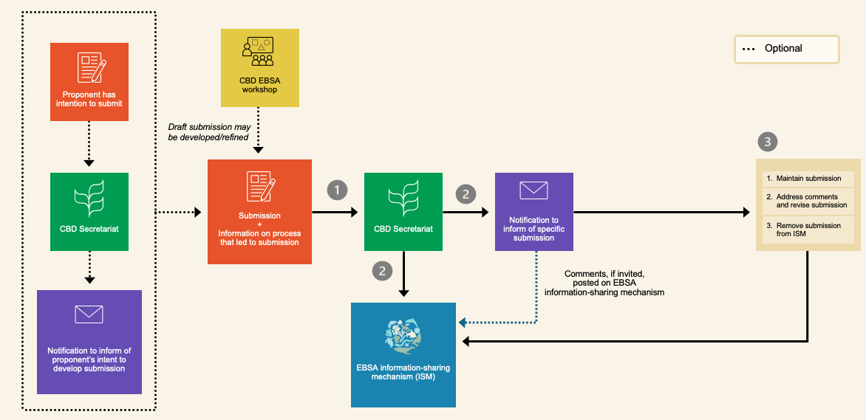

- Optional step: Before sending the submission to the Secretariat, the proponent may wish to request the Secretariat to issue a notification informing of their intent to develop a submission. This notification would be sent to Parties (CBD National Focal Points), Other Governments, indigenous peoples and local communities, and relevant organizations. This optional step could help to elicit information and expertise that can support the development of a strong submission and could also provide an opportunity for other States to flag potential concerns regarding the submission before it is submitted.
- Optional step: Submissions can also be developed/refined at a CBD EBSA workshop, before sending the submission to the Secretariat. This would be an opportunity to get input on a draft submission, even if the proponent may wish to further develop the submission before providing it to the Secretariat. While not mentioned in the modalities, the proponent can also develop their submission via any other means that they wish to pursue on their own (e.g., a proponent-led workshop).
- Step 1: The proponent (CBD National Focal Point) sends the submission to the Secretariat. All submissions must include a map and geographic coordinates for the area in question. For inclusion in the EBSA information-sharing mechanism, it is not required to use the EBSA template.
- Step 2: The Secretariat adds the submission to the information-sharing mechanism and issues a notification that will inform of the submission and indicate that it has been included in the information-sharing mechanism.
- Optional step: Currently, paragraph 14 reflects two alternative options (in brackets) regarding the notification inviting comments: 1) If requested by the proponent, the notification will invite comments during a period of six months, or 2) the notification will be required, without the need for a request from the proponent. In either case, comments will be sent to the proponent as they are received and posted in the information-sharing mechanism by the Secretariat.
- Step 3: Upon receiving any comments, the proponent may choose not to revise the submission and keep its original version in the information-sharing mechanism, address the comments and revise the submission to be updated in the information-sharing mechanism by the Secretariat, or request the Secretariat to remove the submission from the information-sharing mechanism.
- It is also important to note that, during SBSTTA 26, a textual change was made to the footnote of the title of this section that has implications for these modalities.

Modification of descriptions of ecologically or biologically significant marine areas or description of new areas meeting the criteria for ecologically or biologically significant marine areas beyond national jurisdiction
- All submissions in areas beyond national jurisdiction must go to the repository, which entails consideration by SBSTTA and COP (which means that COP must take a decision on the submission). Descriptions included in the EBSA repository also gain the status of a CBD EBSA.
“16. The submission of a modification or a description of an area beyond national jurisdiction must be provided to the Secretariat together with information on the process by which the submission was developed, including any scientific peer-review process, and, in cases where information based on traditional knowledge is included, any information on consultations with indigenous peoples and local communities conducted with their free, prior and informed consent, in accordance with relevant national legislation, international instruments, including the United Nations Declaration on the Rights of Indigenous Peoples, human rights law and, where appropriate, the Mo’ otz Kuxtal Voluntary Guidelines.
17. Before providing a submission, the proponent may request the Secretariat to issue, for information purposes, a notification regarding its intent to submit a description or modification.
18. The Secretariat shall include a record of the submission, as received, in the information-sharing mechanism of ecologically or biologically significant marine areas and disseminate information about the submission through a notification. The submission shall be open for comments by Parties, other Governments, competent intergovernmental bodies and relevant organizations for a period of six months.
19. The submission, as well as any comments received in response to the notification, shall be provided for discussion at a workshop on ecologically or biologically significant marine areas held pursuant to a decision of the Conference of the Parties, the outputs of which shall be submitted to the Subsidiary Body and the Conference of the Parties for their consideration.
20. The Conference of the Parties shall decide whether to request the Executive Secretary to include the submission in the repository of ecologically or biologically significant marine areas. A record of the submission shall remain in the information-sharing mechanism, regardless of whether it is included in the repository or not.”

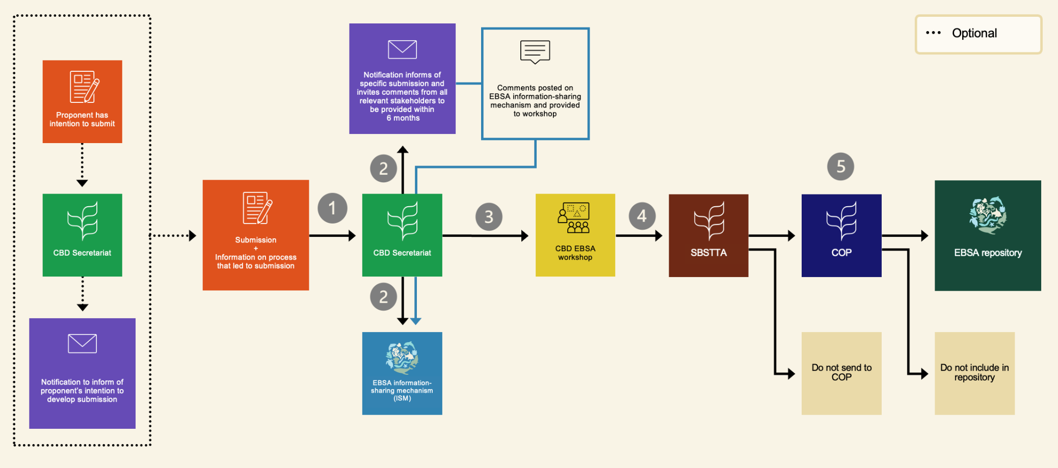

- Optional step: Before sending the submission to the Secretariat, the proponent may wish to request the Secretariat to issue a notification informing of their intent to develop a submission. This notification would be sent to Parties (CBD National Focal Points), Other Governments, indigenous peoples and local communities, and relevant organizations. This optional step could help to elicit information and expertise that can support the development of a strong submission and could also provide an opportunity for other States to flag potential concerns regarding the submission before it is submitted.
- Step 1: The proponent (CBD National Focal Point) sends the submission to the Secretariat. The submission must use the EBSA template and must include geographical coordinates and a map indicating the area that is being modified or described.
- Step 2: The Secretariat adds a record of the submission to the information-sharing mechanism and issues a notification that will inform of the submission and invite comments for a period of six months. Comments will be sent to the proponent as they are received, and posted in the information-sharing mechanism, by the Secretariat. The comments will be screened by the Secretariat to ensure that they are relevant to the submission. The intention here is for comments to focus on scientific input to strengthen the submission, as a form of peer-review. This may also serve as an opportunity to identify any political concerns that the submission may cause.
- Step 3: The submission and comments received are provided for discussion at a CBD EBSA workshop. Note that draft EBSA descriptions may also be developed at the workshop.
- Step 4: The workshop outcomes are then provided to SBSTTA for consideration. SBSTTA may choose to recommend to the COP that it include the submission in the repository, or not recommend that the submission be considered by COP.
- Step 5: If SBSTTA recommends to the COP that it include the draft description in the repository, then the submission will be provided to COP for consideration, which then decides whether to request the Secretariat to include the submission in the repository. If it is included in the repository, the area is given the status of a CBD EBSA.
- A record of the submission as well as the comments received remain in the EBSA information-sharing mechanism regardless of whether or not it is included in the repository.
__________

* CBD/COP/16/1.
** The present document is being issued without formal editing.
Explanations/clarifications are not provided for all paragraphs, but rather only those for which further explanation may be required to facilitate a full understanding of the issues contained in the document.
The reason or reasons for a modification must be provided in the submission.
“Free, prior and informed consent” refers to the tripartite terminology of “prior and informed consent”, “free, prior and informed consent” and “approval and involvement”.
General Assembly resolution 61/295, annex.
A record of the fact that a submission was received and objected to will be included in the information-sharing mechanism, regardless of whether the objection is withdrawn or not.
An inclusion under the present section entails consideration of the submission by the Conference of the Parties and the Subsidiary Body on Scientific, Technical and Technological Advice.
To be included in the repository, the submission must be prepared in the template for ecologically or biologically significant marine areas and include a map clearly indicating the area that is being modified or described.
Decision XIII/18, annex.
http://www.cbd.int/doc/meetings/mar/ebsaws-2015-01/other/ebsaws-2015-01-template-en.dot
An inclusion under the present section does not entail consideration by the Conference of the Parties or the Subsidiary Body on Scientific, Technical and Technological Advice and cannot apply to the descriptions of ecologically or biologically significant marine areas considered and endorsed by the Conference of the Parties held in the repository.
To be included in the information-sharing mechanism, the submission must contain geographical coordinates and a map clearly indicating the area that is being modified or described.
http://www.cbd.int/doc/meetings/mar/ebsaws-2015-01/other/ebsaws-2015-01-template-en.dot
To be included in the repository, the submission must be prepared in the template for ecologically or biologically significant marine areas and include geographical coordinates and a map clearly indicating the area that is being modified or described.
www.cbd.int/doc/meetings/mar/ebsaws-2015-01/other/ebsaws-2015-01-template-en.dot

