2026
Venue:
RCMRD, Nairobi-Kenya
Subregional Workshop Summary Report
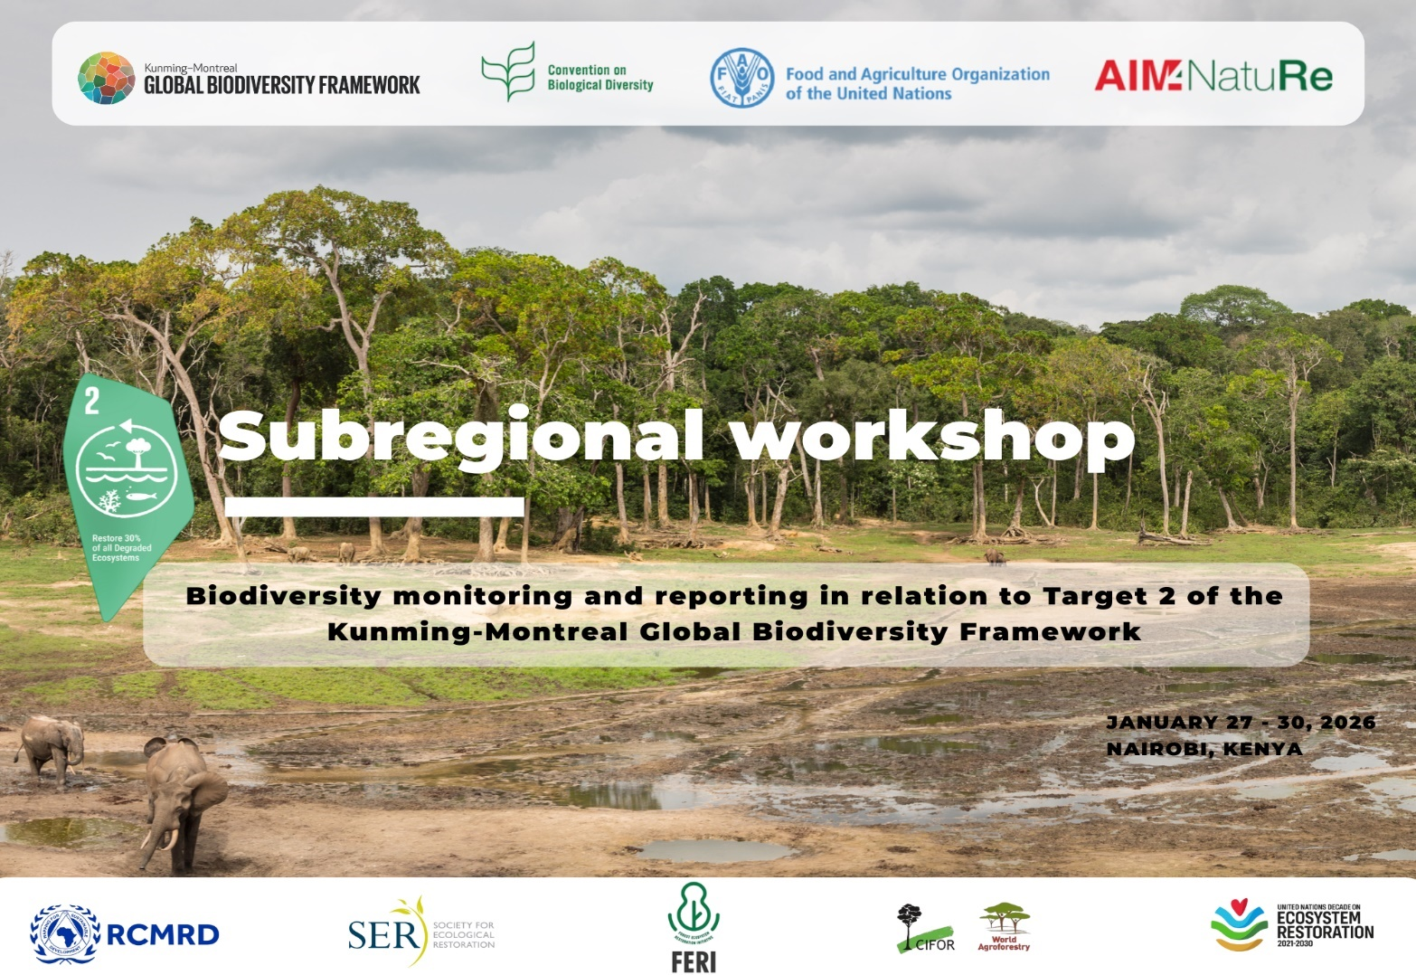
Contents
Executive Summary 3
Introduction 4
The launch 6
Day-by-Day Technical Synthesis 7
Setting the Stage 7
Day 1 – Institutional Anchoring, TSC Launch & KM-GBF Monitoring Framework 8
Regional Technical & Scientific Cooperation Support Centre (RCMRD – CBD TSC) 8
Target 2 Roadmap & FAO Support (FAO) 9
Donor Priorities & Enabling Implementation 9
UN Decade on Ecosystem Restoration – Global Framework & Platforms 9
(CIFOR–ICRAF) – Target 2 Self-Assessment Tool 10
National Restoration Monitoring System (CPF)-Madagascar 10
Breakout sessions 11
Key Discussions & Findings 11
Key Challenges 11
Recommendations 12
Day 2 – Restoration Data Reporting, FERM & Regional/National Experiences 13
Regional and National Implementation Pathways 13
UNCCD Component Indicator (SDG 15.3.1) and Land Degradation Neutrality 13
IPLC-Led Restoration Perspective: A Rights-Based and Bio-cultural Approach 14
Target 2 Monitoring Architecture and Reporting Workflow 15
Breakout session 16
Key Discussions & Findings 16
Recommendations 17
Conclusion 17
Day 3 – Science-to-Practice Linkages: CIFOR-ICRAF & Karura Forest 18
Applied Learning from the Tour: From Knowledge to Implementation 18
Comoros – Integrated Landscape and Seascape Restoration 18
Somalia – Operationalizing GBF Target 2 under Fragile Contexts 19
South Sudan – Landscape Restoration around Imatong Central Forest Reserve 20
Innovation and Bio-Economy Integration: Laboratory Demonstrations 20
Field Learning at Karura Forest: Restoration in Practice 21
Day 4 – National Reporting Readiness, ToT & Governance Structures 22
Country Experiences: Target 2 Reporting in Practice 22
Inclusivity and Gender Mainstreaming 23
SAT Insights: Closing the Implementation and Outcome Gaps 23
Country Needs Assessment: Priority Support Areas 23
RCMRD TSC Steering Committee: Governance for Delivery 23
Training of Trainers (TOT): Strengthening Regional Support Architecture 24
Way Forward: Milestones and Immediate Actions 24
Key Takeaway 24
Key Outcomes and Insights 24
Challenges and Mitigation Strategies 25
Key challenges 25
Mitigation strategies 25
Recommendations 25
Conclusion and Roadmap 25
Branding & Visibility (Target 2 Workshop) 27
Leadership & High-Level Visibility 27
Branding & Partner Recognition 27
RCMRD StoryMap 27
Visual Storytelling (Photography) 28
Plenary discussions and Breakout group sessions 29
Digital Reach & Engagement 29
Outcome 29
Summary and Conclusion 30
Summary 30
Conclusion 30
Annexes 31

Executive Summary
The Kunming–Montreal Global Biodiversity Framework (GBF) calls for urgent, coordinated action to halt and reverse biodiversity loss, with Target 2 committing countries to restore 30% of degraded ecosystems by 2030. Achieving this ambition depends on robust, harmonized monitoring and reporting systems, strengthened national capacities, and effective subregional collaboration.
In response, a Subregional Workshop on Biodiversity Monitoring and Reporting in relation to Target 2 of the GBF was successfully convened from 27–30 January 2026 at the Regional Centre for Mapping of Resources for Development (RCMRD) in Nairobi, Kenya. The workshop was co-organized by the Food and Agriculture Organization of the United Nations (FAO), RCMRD, and the Secretariat of the Convention on Biological Diversity (CBD), with technical support from the Society for Ecosystem Restoration (SER) and the Center for International Forestry Research and World Agroforestry (CIFOR-ICRAF).
The workshop brought together representatives from countries served by RCMRD in its role as a Subregional Technical and Scientific Cooperation (TSC) Support Centre—Comoros, Eswatini, Ethiopia, Kenya, Madagascar, Rwanda, Somalia, South Sudan, Uganda, the United Republic of Tanzania, and Zambia—as well as participants from four other African Subregional TSC Support Centres including Central African Forest Commission (COMIFAC), Ecological Monitoring Centre (CSE), Sahara and Sahel Observatory (OSS) and South African National Biodiversity Institute (SANBI) and representatives from Indigenous Peoples and Local Communities, women and youth.
The convening strengthened the countries’ capacity to accelerate monitoring, reporting, and data integration on ecosystem restoration in line with Target 2, while providing a platform to exchange subregional, national, and local experiences, challenges, and good practices. A Training of Trainers (ToT) component further equipped technical support centres to scale capacity-building efforts across the region.
The workshop also marked a key institutional milestone with the official launch of RCMRD’s mandate as a Subregional TSC Support Centre and the establishment of its Steering Committee, reinforcing regional coordination mechanisms to support countries in delivering measurable, comparable, and timely progress towards ecosystem restoration under the GBF.
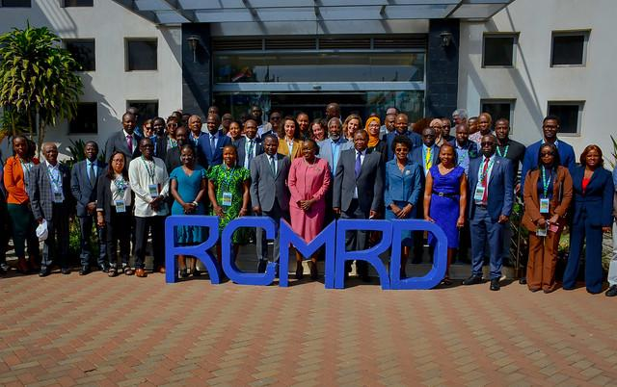
Delegates at the Subregional Workshop on Biodiversity Monitoring and Reporting in relation to GBF Target 2, hosted at RCMRD, Nairobi, 27–30 January 2026.

Introduction
The workshop was anchored by leadership at national, regional, global, and institutional levels, underscoring that effective ecosystem restoration depends on cooperation, transparency, and sustained collective action. Leaders delivered inspiring messages that reinforced the importance of coordinated efforts to achieve meaningful and measurable progress under Global Biodiversity Framework Target 2.
The Guest Speaker, Hon. Dr. Deborah Mlongo Barasa, Cabinet Secretary for Environment, Climate Change and Forestry, Kenya, emphasized that “restoring our ecosystems is not optional—it is essential for biodiversity, livelihoods, and our shared future.”
The RCMRD Governing Council Chairperson and Permanent Secretary, Ministry of Lands and Natural Resources, Zambia, Mr. Patrick Mucheleka, echoed the importance of regional cooperation, noting that it enables countries to learn faster, act smarter, and deliver on global biodiversity commitments.
In her video message, Ms. Astrid Schomaker, Executive Secretary of the Convention on Biological Diversity (CBD), reiterated that clear and consistent monitoring is essential to demonstrate progress and build confidence in the delivery of Target 2.
The RCMRD Director General, Dr. Emmanuel Nkurunziza, reaffirmed that RCMRD exists to support countries through practical tools, shared learning, and sustained technical cooperation.
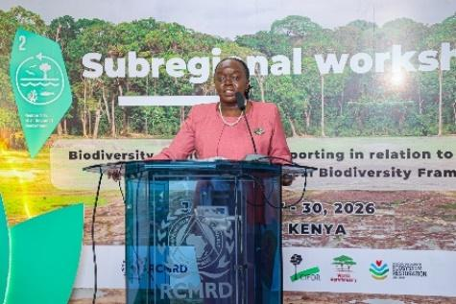
Hon. Dr. Deborah Mlongo Barasa
Cabinet Secretary for Environment, Climate Change and Forestry, Kenya
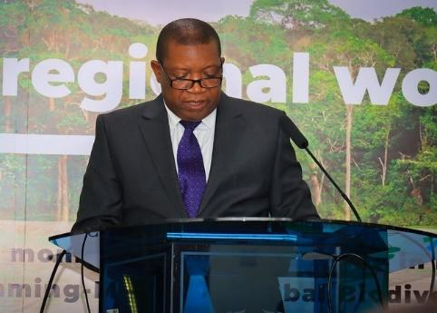
Mr. Patrick Mucheleka
RCMRD Governing Council Chairperson and Permanent Secretary, Ministry of Lands and Natural Resources, Zambia,
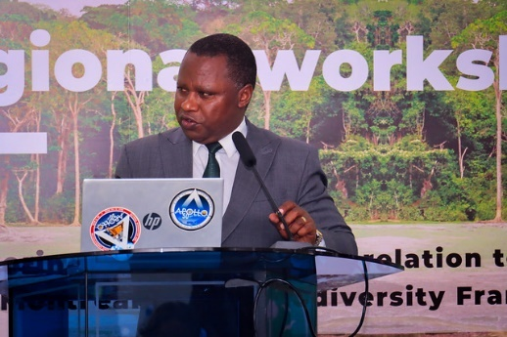
Dr. Emmanuel Nkurunziza
Director General, RCMRD
Robina Abuya, British Embassy, underscored the importance of robust monitoring systems to bridge the gap between ambition and implementation, unlock finance, and inform evidence-based policy.
Yelena Finegold, FAO Technical Lead of Restoration Monitoring, explained that the Target 2 Roadmap offers the shared route we can all follow, by bringing together a wide community of partners working on restoration.

The launch
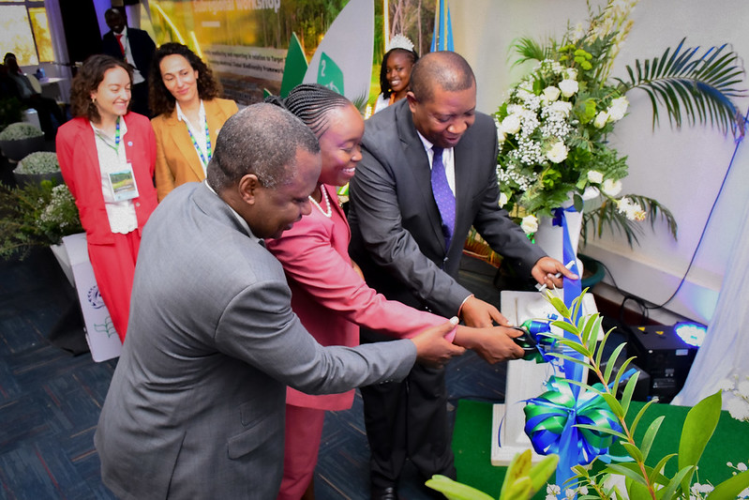
In a milestone for the region, RCMRD formally inaugurated its mandate as a Subregional Technical and Scientific Cooperation Support Centre. The Centre is now fully operational, strengthening Member States’ capacity to accelerate implementation of the Kunming–Montreal Global Biodiversity Framework and advance national commitments under the CBD.
The launch culminated into a symbolic tree-planting ceremony led by the chief guest flanked by the RCMRD Governing Council Chairperson, RCMRD Director General and regional dignitaries; affirming a shared commitment to restoring nature in line with Target 2 of the Kunming-Montreal Global Biodiversity Framework: restoring 30% of degraded ecosystems by 2030.

Day-by-Day Technical Synthesis

Setting the Stage
CBD Secretariat Presentation: National Reporting under the KMGBF
Overview of the Presentation
The Secretariat of the Convention on Biological Diversity (CBD) delivered a speech on national reporting under the Kunming–Montreal Global Biodiversity Framework (KMGBF), outlining the global review architecture, reporting mandates, progress to date, and key milestones toward COP 17. The session clarified how national reporting, NBSAPs, and global stocktakes are structured to assess collective progress toward halting and reversing biodiversity loss by 2050.
Key Highlights
- KMGBF and Monitoring Framework: Adopted in 2022, the KMGBF is supported by a monitoring framework, indicators, and enhanced review mechanisms to track implementation. COP 15 also endorsed subregional Technical and Scientific Cooperation Support Centres (TSCs) to strengthen national capacities.
- Mandated Reporting Timelines (Decision 15/6): Parties are required to submit updated NBSAPs and national targets by COP 16, the 7th National Reports (7NR) by 28 February 2026, and the 8th National Reports (8NR) by 30 June 2029. Collective progress will be reviewed at COP 17 through a global stocktake.
- Conceptual Framework for Review: The presentation illustrated the relationship between declining biodiversity trends, national-level implementation of targets, and the collective ambition of the KMGBF (2022–2050).
- Status of Submissions (as of 31 October 2025):
  - 58 Parties have aligned NBSAPs with the KMGBF.
  - 142 Parties submitted 3,382 national targets, with Africa accounting for 85% of submissions.
  - No 7th National Reports had been submitted at the time, despite being the primary reporting instrument.
- Additional Data Sources: Global reporting will also draw on commitments from non-state actors, inputs from biodiversity-related conventions and MEAs, SDG processes, and traditional knowledge of IPLCs.
- Road to COP 17: Key milestones include SBI 6 (Rome, Feb 2026), SBSTTA 28 (Nairobi, July–Aug 2026), and SBI 7 (Nairobi, Aug 2026), culminating in COP 17 in Yerevan, Armenia (19–30 October 2026), which will review KMGBF implementation, biodiversity finance, capacity building, and the Cartagena and Nagoya Protocols.

Day 1 – Institutional Anchoring, TSC Launch & KM-GBF Monitoring Framework
The workshop opened with the official launch of RCMRD as a Subregional Technical and Scientific Cooperation Support Centre, positioning the institution as a long-term regional hub for technical assistance, data harmonization, capacity development, and knowledge exchange; graced by Hon. Dr. Deborah Mlongo Barasa, Cabinet Secretary for Environment, Climate Change and Forestry, Kenya in the company of RCMRD Governing Council Chairperson and Permanent Secretary, Ministry of Lands and Natural Resources, Zambia, Mr. Patrick Mucheleka. Technical sessions clarified Target 2 requirements, ecosystem typologies, baselines, and restoration standards, highlighting gaps in national monitoring systems, weak integration across sectors, and the need to move from activity-based to outcome-based restoration tracking.
The day set the institutional, policy, and technical foundation for advancing monitoring and reporting under Target 2 of the Kunming–Montreal Global Biodiversity Framework. RCMRD outlined its mandate as a regional technical and scientific cooperation hub, highlighting its 50-year legacy, multi-sectoral thematic focus, and role as a one-stop centre for geospatial data, tools, and capacity support for 11 CBD-supported countries. This positioned RCMRD as a key regional backbone for harmonized restoration monitoring and reporting.

Regional Technical & Scientific Cooperation Support Centre (RCMRD – CBD TSC)
RCMRD introduced itself as an intergovernmental centre of excellence providing geo-information, data, tools, and capacity support to Member States, and outlined its role as the CBD Technical and Scientific Cooperation Support Centre (TSC) for 11 countries.
Key Highlights
- RCMRD supports biodiversity monitoring, ecosystem management, and land-use planning across 20 Member States.
- As TSC, RCMRD serves as a one-stop hub for technical knowledge, data repositories, tools, joint research, and resource mobilization.
- Strong partnerships (FAO, UNEP, EU, IUCN, AWF, among others) enhance delivery.
- Sustained resourcing and coordination are needed to meet growing demand for Target 2 technical support.

Target 2 Roadmap & FAO Support (FAO)
FAO welcomed participants and positioned the workshop within the Target 2 Roadmap to harmonize restoration monitoring and reporting for the 7th National Reports under the KMGBF.
Key Highlights
- The 7NR is the first formal progress report on the 23 KMGBF, with tight timelines.
- The workshop supports shared methodologies to reduce reporting burdens and improve coherence across frameworks.
- Inclusive participation (countries/ government agencies, IPLCs, youth, regional bodies) is essential for effective restoration.
- Closing the gap between high ambition and practical reporting capacity remains a key challenge.

Donor Priorities & Enabling Implementation
The UK Government reaffirmed its commitment to biodiversity restoration and monitoring through UK PACT and AIM4Nature, emphasizing evidence-based implementation of Target 2.
Key Highlights
- Restoration underpins climate-resilient growth and natural capital protection.
- Data systems and partnerships are critical to move from commitments to implementation.
- Strong monitoring enables policy impact and unlocks finance.
- Weak monitoring perpetuates the ambition–implementation gap.

UN Decade on Ecosystem Restoration – Global Framework & Platforms
Technical sessions under the UN Decade on Ecosystem Restoration highlighted global principles, standards of practice, flagship initiatives, and the FERM platform as key enablers for scaling restoration while addressing challenges of ecosystem representation, partner coordination, sustainability of monitoring systems, and community engagement.
Key Highlights
- UN Decade aligns CBD, UNCCD, and UNFCCC efforts and mobilizes 300+ partners.
- Flagships, Standards of Practice, and the Digital Hub support scaling and learning.
- Progress includes growing political momentum and private finance.
- Underrepresentation of some ecosystems (like the urban), risks of double-counting, short project cycles, and limited community engagement.

(CIFOR–ICRAF) – Target 2 Self-Assessment Tool
CIFOR-ICRAF presented a regional self-assessment of restoration readiness, revealing strong policy frameworks but persistent gaps in implementation, financing, cross-sectoral integration, and adaptive monitoring—particularly for non-forest and productive landscapes. The Society for Ecological Restoration (SER) clarified Target 2 requirements, restoration definitions, baselines, ecosystem typologies, and integrity-based approaches, emphasizing the need for outcome-focused monitoring across terrestrial, freshwater, and marine/coastal systems.
Key Highlights
- The tool supports structured diagnosis of policy, planning, finance, and monitoring gaps.
- Findings show strong policies but weak implementation and underdeveloped monitoring systems.
- Terrestrial bias and weak baselines limit prioritization across ecosystems.
- Restoration remains project-driven, with limited long-term systems and financing.

National Restoration Monitoring System (CPF)-Madagascar
Country experience from Madagascar demonstrated progress toward a national, traceable restoration monitoring system, while discussions highlighted the need to extend monitoring to marine and freshwater ecosystems, improve system interoperability, strengthen multi-sector coordination, and ensure community-driven data flows.
Key Highlights
- Country Partnership Framework (CPF) provides a single, traceable national platform integrating projects, sectors, and geographies.
- The system enables mapping, dashboards, impact tracking (biodiversity, livelihoods, carbon), and financial flows.
- Ongoing work addresses definitions of “restored,” verification standards, and double-counting.
- Capacity building and full operationalization are critical for effective national reporting by 2026.
Presentations Link Day 1

Breakout sessions
- Break-out session One: Group Discussion to share examples derived from country and local-level experiences, including how to assess degradation and determine baselines
- Break-out session Two: Group discussion on how to implement national targets and contribute to the Target 2 key outcomes

Key Discussions & Findings
The sessions revealed a persistent implementation–reporting gap in ecosystem restoration. While national commitments to Target 2 are ambitious, monitoring remains fragmented and largely terrestrial-focused, with marine, productive, and transboundary landscapes under-represented. Most countries rely on outdated 1990s baselines, which do not capture current drivers of degradation such as rapid urbanization, climate change, mining, and industrial agriculture.
Country experiences highlighted common priorities: Ethiopia’s integrated ecosystem typologies under the Green Legacy Initiative; Kenya’s focus on community conservancies, Other Effective Area-Based Conservation Measures (OECMs), and migratory corridors; Uganda’s wetland prioritization and functional landscape assessments; and Zambia’s application of the Land Degradation Neutrality (LDN) Framework for catchment restoration. Across contexts, restoration is planned with biodiversity in mind but rarely monitored for biodiversity outcomes. Activity-based indicators dominate, and large-scale tree planting risks creating low-diversity monocultures. Community-led OECMs were recognized as effective models for integrating customary governance and conservation outcomes.

Key Challenges
- Fragmented and outdated baselines and biodiversity data systems
- Weak outcome-based monitoring of ecosystem function, integrity, and connectivity
- Neglect of connectivity outside protected areas, increasing human–wildlife conflict
- Underinvestment in productive landscapes (agriculture and rangelands)
- Tensions between private land tenure, development priorities, and restoration mandates
- Limited institutional data-sharing and sustainable financing

Recommendations
- Harmonize national biodiversity information systems and data-sharing protocols
- Shift to absolute area-based reporting (hectares) for restoration tracking
- Scale community monitoring and citizen science for real-time data
- Align fiscal policy and incentives to de-risk restoration finance
- Integrate Targets 1, 2, and 10 into a single landscape planning and management framework
Click Breakout session day 1 Link

Day 2 – Restoration Data Reporting, FERM & Regional/National Experiences
Day 2 translated the policy commitments discussed on Day 1 into practical reporting workflows, focusing on how national restoration data are compiled, validated, and submitted under Target 2 of the Kunming–Montreal Global Biodiversity Framework. FAO-led sessions demystified the technical “end-to-end” process, linking national monitoring systems and regional initiatives (notably AFR100) to the Framework for Ecosystem Restoration Monitoring (FERM) and the CBD Online Reporting Tool (ORT). The discussions emphasized the importance of interoperability between national databases, regional registries, and global reporting platforms to ensure consistency, comparability, and credibility of restoration reporting.

Regional and National Implementation Pathways
Presentations from AUDA-NEPAD (AFR100) and country case studies demonstrated how large-scale commitments are being operationalized through integrated monitoring systems that track biophysical change, governance outcomes, and socio-economic benefits. AFR100 reported that African countries have surpassed the original 100-million-hectare restoration pledge, with standardized registries and GIS dashboards enabling spatial tracking of restoration polygons and associated impacts.
National experiences illustrated diverse but complementary pathways to delivery:
- Tanzania reported strong progress toward its national restoration targets under centralized political leadership, while highlighting persistent challenges related to geospatial data costs and fragmented institutional data systems.
- Ethiopia showcased the scale of the Green Legacy Initiative, shifting emphasis from tree-planting numbers to survival rates, indigenous species, and long-term financing through dedicated national budget allocations.
- Rwanda demonstrated how high-level political commitment and Nature-based Solutions have driven measurable gains in forest cover, urban wetland restoration, species recovery, and community benefit-sharing through eco-tourism.
- Uganda presented a data-driven, decentralized wetland restoration model aligned with GBF Target 2, combining mapping, legal instruments, and livelihood alternatives to address degradation drivers and sustain restoration outcomes.

UNCCD Component Indicator (SDG 15.3.1) and Land Degradation Neutrality
The UNCCD presentation highlighted strong synergies between the UNCCD and CBD processes, positioning SDG Indicator 15.3.1 (land degradation) as a critical metric for tracking progress under GBF Target 2 and related targets (3 and 10). The Land Degradation Neutrality (LDN) framework applies a cost-effective response hierarchy; Avoid, Reduce, and Reverse prioritizing prevention over restoration. Progress is assessed using an integrated, indicator-based approach combining land cover, land productivity, and soil organic carbon, under the “one-out, all-out” rule, whereby any decline classifies land as degraded. Countries are supported through standardized tools and platforms, including Trends.Earth and the UNCCD PRAIS portal, which provide pre-processed datasets that can be refined with national data. While UNCCD reporting timelines extend beyond the CBD’s 2026 deadline, the data generated remains highly relevant for NBSAP implementation and long-term monitoring of restoration and land degradation outcomes.
Key Points
- SDG 15.3.1 is a core indicator supporting GBF Target 2 and Targets 3 and 10.
- LDN follows a cost-effective hierarchy: Avoid > Reduce > Reverse.
- Degradation is assessed using three sub-indicators: Land Cover, Land Productivity, Soil Organic Carbon.
- “One-out, all-out” rule: decline in any sub-indicator classifies land as degraded.
- Countries can leverage Trends.Earth and the UNCCD PRAIS4 platform with pre-processed 250m datasets, refined by national data.
- UNCCD reporting (2026) provides critical inputs for long-term GBF and NBSAP implementation despite timeline differences.

IPLC-Led Restoration Perspective: A Rights-Based and Bio-cultural Approach
The presentation emphasized on the importance of Indigenous Peoples and Local Communities (IPLCs) inclusion in restoration activities for the success of Target 2. Using Kenya as a primary case study, the session highlighted how securing land tenure through the Community Land Act (2016) is a prerequisite for sustainable restoration. The speaker argued that for IPLCs, restoration is not just an environmental goal but a matter of livelihood, rights, and cultural survival.
Key Points
- Secure Land Tenure as a Precondition: Effective restoration depends on legally recognized community land rights, with Kenya’s Community Land Act (2016) providing a foundation for collective ownership and stewardship.
- Rights-Based Implementation (FPIC): Restoration interventions must uphold Free, Prior and Informed Consent (FPIC) as the standard for engagement on community lands.
- Bio-cultural Governance: Restoration success is measured through livelihood-linked, indigenous indicators (like; rangeland health, honey production), not only area-based targets.
- Indigenous Knowledge & ICCAs: Indigenous and Community Conserved Areas (ICCAs) strengthen connected, resilient landscapes managed through customary governance systems.
Critical Requirements for Implementation
- Formal Recognition: Embed community-led restoration and ICCAs within NBSAPs and national reporting frameworks.
- Equitable Decision-Making: Ensure IPLCs are partners in planning and governance, not only consultees.
- Landscape Connectivity: Support large, connected territories to sustain pastoralist mobility and ecosystem function.

Target 2 Monitoring Architecture and Reporting Workflow
FAO, as custodian agency for the headline indicator “Area Under Restoration,” outlined the harmonized reporting pipeline:
- Compilation of project and program data through national systems and regional platforms (e.g. AFR100).
- Validation and gap-filling through FERM, including use of default datasets and polygon verification.
- Final submission through the CBD Online Reporting Tool for inclusion in national reporting under the GBF.
This workflow reinforced the need for standardized definitions of “under restoration,” quality assurance mechanisms to avoid double-counting, and strengthened national capacities to manage spatial data across terrestrial, freshwater, and coastal/marine ecosystems.
Key Takeaways
Day 2 underscored that credible delivery of Target 2 depends on moving beyond fragmented, project-based reporting toward integrated national systems that link restoration action to measurable ecological, governance, and socio-economic outcomes. The sessions highlighted the value of regional platforms, political leadership, sustainable financing, and interoperable digital infrastructure in closing the gap between ambition and implementation, while calling for sustained investment in post-restoration monitoring and community-centred approaches to ensure long-term impact.
Presentations Link Day 2

Breakout session
Break-out session: discussion to identify challenges and opportunities for monitoring and reporting ecosystem restoration related to data collection, compilation, and validation (harmonization, disaggregation, sharing databases)

Key Discussions & Findings
Data Systems & Institutional Coordination for Target 2
The Data-to-Decision Gap
Restoration monitoring across the sub-region remains project-centric rather than system-centric, creating a “boom-and-bust” data cycle where valuable information is lost when projects end. Large volumes of field data collected through mobile tools are retained in donor silos and rarely integrated into national repositories, eroding institutional memory. A persistent vertical disconnect exists between national reporting platforms (e.g., Jazamiti) and sub-national data collection. In parallel, non-state actors often report independently for visibility, resulting in fragmented reporting pathways across national data systems.
Monitoring is driven by political and quantitative targets (e.g. trees planted) rather than ecological outcomes (e.g. ecosystem function and connectivity). Inconsistent definitions of “degradation” and “restoration” distort progress tracking; cost-effective approaches such as Assisted Natural Regeneration are frequently underreported. Limited GIS and remote sensing capacity at local levels further constrains the shift from tabular reporting to spatially robust monitoring.
Institutional Complexity & Data Governance
Implementing Target 2 requires whole-of-government coordination, yet institutional fragmentation remains a major bottleneck. Multi-agency validation processes are slow and resource-intensive. Tensions persist between open data objectives and community data rights under Free, Prior and Informed Consent (FPIC) principles. Weak or unenforced data-sharing agreements and institutional reluctance to share data limit real-time trend analysis and evidence-based decision-making.
Strategic Prioritization & Validation
Restoration priorities are expanding beyond protected areas to include productive landscapes and Arid and Semi-Arid Lands (ASALs), guided increasingly by degradation severity. Countries are strengthening data credibility through layered validation, including GIS cross-checks, drones, and multi-stakeholder verification for NR7 reporting.

Recommendations
- From Projects to Platforms: Establish permanent national data hubs and require all donor-funded projects to deposit spatial data.
- Harmonize Definitions: Adopt a regional standard for restoration that includes Nature-based Solutions (NbS) and natural regeneration.
- Operationalize Local Data Flows: Decentralize GIS capacity and deploy standardized, low-bandwidth tools for bottom-up reporting.
- Build Data Trust: Develop regional data sovereignty guidelines and incentivize non-state reporting through certification or fiscal benefits.

Conclusion
With NR7 due by 28 February 2026, consolidating existing data is urgent. The tools exist; delivery depends on institutional will to break silos and validate community-led restoration outcomes.
Click Breakout Session Day 2 Link

Day 3 – Science-to-Practice Linkages: CIFOR-ICRAF & Karura Forest
Participants engaged with applied restoration science, bio-economy integration, seed systems, soil health analysis, spatial monitoring, and community-based restoration models. The field visit reinforced the importance of grounding reporting systems in real landscapes and demonstrated how monitoring informs adaptive management, community engagement, invasive species control, and restoration economics.
The session provided a practical learning platform, connecting cutting-edge restoration science with real-world implementation. The study tour to CIFOR–ICRAF and the field excursion to Karura Forest enabled participants to translate policy and reporting frameworks into tangible restoration action, monitoring approaches, and bio-economy opportunities. Through expert-led engagements, country case presentations, laboratory demonstrations, and field observations, participants deepened their understanding of how science, community engagement, and innovative technologies can jointly accelerate delivery of Global Biodiversity Framework Target 2.

Applied Learning from the Tour: From Knowledge to Implementation
CIFOR–ICRAF scientists facilitated a Restoration World Café, with targeted visits to the laboratories to get an experience of soil analysis, different tree plantations and their ecological benefits as well as spatial observation laboratory. Friends from Karura in conjunction with Kenya Forest Service facilitated participants' tour to the forest providing a preview of the Karura Forest restoration planning framework and offering practical insights into landscape restoration design, stakeholder engagement, and long-term monitoring. This interactive format enabled peer learning across countries, allowing participants to interrogate real planning tools and implementation pathways that can be adapted to national contexts.
Country presentations from Comoros, Somalia, and South Sudan highlighted field-level restoration experiences and monitoring approaches in diverse ecological and institutional contexts. These cases underscored common challenges, including fragile institutional capacity, data gaps, financing constraints, and post-restoration monitoring limitations, while also demonstrating locally driven solutions rooted in community participation, landscape-specific interventions, and incremental system building. The exchanges reinforced the importance of peer learning among countries at different stages of restoration system maturity. For instance:

Comoros – Integrated Landscape and Seascape Restoration
Comoros presented a national, integrated approach to ecosystem restoration responding to severe deforestation, land degradation, coastal and mangrove loss, and climate change impacts. As a Small Island Developing State with high biodiversity and strong community dependence on natural resources, restoration is framed as both an ecological and livelihood priority. Interventions are guided by a National Restoration Framework aligned with the National Biodiversity Strategy and Action Plan (NBSAP) and national land restoration and climate adaptation priorities, with strong linkages to protected areas and OECMs.
Key Highlights
- Integrated restoration across ecosystems: Forests, watersheds, agroforestry systems, mangroves, and marine ecosystems addressed in a coordinated landscape–seascape approach.
- Community-led governance: Emphasis on community-based natural resource management and decentralized implementation.
- Practical monitoring systems: Use of simple, cost-effective tools combining field surveys, participatory monitoring, and basic indicators (e.g., vegetation recovery, tree survival, erosion reduction, mangrove extent, coral cover, fish abundance).
- Key lessons learned: Community ownership, use of native species, livelihood linkages, and participatory monitoring are critical success factors.
- Outstanding gaps: Need to strengthen national monitoring systems, improve institutional coordination, and secure sustainable, long-term financing to scale successful models.

Somalia – Operationalizing GBF Target 2 under Fragile Contexts
Somalia’s presentation highlighted restoration efforts addressing widespread ecosystem degradation, including loss of woody cover, rangeland degradation, riverbank erosion, mangrove loss, and marine ecosystem decline. Interventions are embedded within national policy frameworks (NBSAP, National Transformation Plan—NTP, Nationally Determined Contributions—NDC) and linked to climate adaptation, livelihoods, and energy transition measures.
Key Highlights
- Priority restoration actions: Large-scale tree planting, rangeland and watershed rehabilitation, mangrove and coastal restoration, and expansion of protected areas.
- Policy and development alignment: Strong integration of restoration with national development and climate agendas, including reducing charcoal dependence through biogas alternatives and public awareness on conservation.
- Key constraints: Limited technical capacity, weak geospatial and biodiversity data systems, underdeveloped monitoring and reporting mechanisms, and insufficient long-term financing.
- Key lessons learned: Policy coherence and institutional coordination are essential but must be matched with operational capacity and data systems.
- Way forward: Strengthen NBSAP implementation for GBF Target 2, scale community-led restoration, improve national monitoring and reporting systems, and mobilize blended biodiversity and climate finance to move from commitments to measurable impact.

South Sudan – Landscape Restoration around Imatong Central Forest Reserve
South Sudan presented a targeted landscape restoration initiative in the Imatong Central Forest Reserve (ICFR) landscape in Eastern Equatoria State, a critical biodiversity hotspot and water catchment under pressure from deforestation, climate change, and unsustainable land use. The intervention focuses on restoring degraded agricultural land to enhance food security, biodiversity, and climate resilience while reducing pressure on the ICFR.
Key Highlights
- Clear restoration target and scale: Restoration of 47,806 ha of degraded agricultural land across Ikotos (20,671 ha) and Torit (27,135 ha) Counties.
- Integrated, nature-based approaches: Agroforestry with indigenous tree species, crop diversification and rotation, soil and water conservation, and establishment of community woodlots for fuelwood and construction needs.
- Strong participatory implementation model: County- and payam-level land-use planning, participatory site assessments, cost Restoration Action Plans, continuous monitoring, and adaptive management.
- Multi-target contribution: Direct alignment with GBF Targets 2 (restoration), 7 (sustainable agriculture), and 8 (climate action), as well as South Sudan’s NBSAP priorities.
- Key implementation risks: Sustained financing, institutional capacity, and long-term monitoring systems are required to maintain scale and impact over time.

Innovation and Bio-Economy Integration: Laboratory Demonstrations
Participants undertook guided laboratory visits at CIFOR–ICRAF, gaining exposure to advanced scientific tools and restoration-enabling technologies, including:
- Soil Laboratory: Demonstrations on dry spectroscopy/spectrophotometry for rapid, cost-effective soil analysis—highlighted as a game-changing innovation for scalable soil health assessment.
- Tree and Seed Laboratory: Insights into indigenous seed systems, seed quality assurance, and restoration supply chains critical for scaling native ecosystem recovery.
- Spatial Observation Laboratory: Applications of remote sensing, spectral libraries, and spatial analytics to support restoration planning, monitoring, and reporting.
The sessions further showcased bio-economy integration approaches, including the biofarmer model, restoration economy pathways, participatory forest management planning, and the role of biodiversity knowledge systems (e.g. spectral libraries and extensive soil biodiversity datasets, including earthworm diversity) in strengthening evidence-based restoration. These innovations illustrated how restoration can be linked to livelihoods, enterprise development, and green value chains—supporting both ecological and socio-economic outcomes under Target 2.

Field Learning at Karura Forest: Restoration in Practice
The Karura Forest field visit offered participants a practical demonstration of urban forest restoration in a complex socio-ecological setting. Delegates observed:
- Indigenous tree nurseries and seedling production systems supporting restoration supply chains;
- Active restoration plots and invasive species removal sites;
- Monitoring approaches used to track restoration progress and ecosystem recovery; and
- Management responses to Lantana camara, a highly invasive species, and the ecological challenges it poses to forest recovery.
Discussions with practitioners highlighted the interplay between community engagement, enforcement of conservation policies, and the realities of urban pressures on protected ecosystems. Participants also reflected on community-related challenges and governance frameworks shaping conservation outcomes, reinforcing the importance of inclusive approaches, policy coherence, and sustained public awareness in securing long-term restoration gains.
Key Takeaways
Day 3 reaffirmed that achieving Target 2 requires a strong science–policy–practice interface. The combination of applied research, innovative monitoring technologies, country peer learning, and field-based restoration experience demonstrated how national systems can be strengthened through partnerships with regional research institutions, community actors, and technical support centres. The day emphasized that scalable, measurable restoration is most effective when anchored in sound science, enabled by digital and laboratory innovations, and sustained through community participation and restoration-aligned bio-economy pathways.
Presentation Link Day 3

Day 4 – National Reporting Readiness, ToT & Governance Structures
Day 4 focused on the practical realities of preparing and submitting the 7th National Reports (NR7) by the 28 February 2026 deadline, with specific attention to Target 2 (ecosystem restoration) readiness under the Kunming–Montreal Global Biodiversity Framework. Building on insights from the CIFOR–ICRAF and Karura Forest field visits, the sessions assessed country preparedness, highlighted operational bottlenecks, and identified priority support needs to accelerate timely, credible reporting.
NR7 Preparation: Practical Pathways to Timely Submission
The day opened with an interactive Mentimeter survey to gauge progress across participating countries. Results showed that most countries had initiated their NR7 processes with a number of them reporting between 25 to 75% completion of the online reporting template. Notably, nearly all countries had already compiled data relevant to Target 2. However, the reporting was not without challenges, as the most frequently cited constraints included data fragmentation, coordination of data collection processes and timing. Additional concerns related to limited financial resources, inconsistencies in data quality and technical capacity gaps. Despite these hurdles, the majority of countries expressed confidence that they are either on track or likely to meet the February 28th, 2026 reporting deadline.
Countries reviewed mandatory reporting requirements, with emphasis on completing critical elements—particularly the Target 2.1 headline indicator (Area Under Restoration)—even where other sections remain under development. Participants were encouraged to integrate national datasets with the Framework for Ecosystem Restoration Monitoring (FERM) and submit through the CBD Online Reporting Tool (ORT) to streamline workflows, reduce manual data entry, and improve consistency and comparability of reporting.

Country Experiences: Target 2 Reporting in Practice
Country presentations demonstrated diverse institutional approaches and common constraints:
- Zambia highlighted strategic alignment of biodiversity reporting with its National Development Plan (2022–2030) and efforts to strengthen inter-ministerial coordination through clearer reporting structures. Persistent challenges include data-sharing protocols, updating the Clearing-House Mechanism (CHM), and resource constraints.
- Eswatini emphasized a whole-of-society approach, grounding restoration reporting in community participation and Target 2 guidance. Key constraints include fragmented datasets and limited GIS capacity, with targeted requests for technical support to establish a national biodiversity monitoring system. Lessons underscored that inclusion enhances credibility, community engagement improves outcomes, and evidence-based reporting is essential.

Inclusivity and Gender Mainstreaming
The CBD Women’s Caucus reinforced the “leave no one behind” principle, calling for full implementation of the Gender Plan of Action across GBF delivery. Participants were encouraged to act as gender champions, ensuring inclusive decision-making and community engagement—recognized as foundational to the credibility and sustainability of restoration outcomes and reporting.

SAT Insights: Closing the Implementation and Outcome Gaps
Findings from the Self-Assessment Tool (SAT) revealed systemic gaps:
- Blind spots in productive landscapes and non-protected areas;
- Ambition–implementation gaps between national targets and local delivery;
- Outcome gaps, where monitoring prioritizes activities (e.g., planting) over ecological function and recovery;
- Data fragmentation risks, leading to inconsistent reporting; and
- Geographic skew, with project-centric efforts concentrated in KBAs/Protected Areas, leaving wider landscapes vulnerable.

Country Needs Assessment: Priority Support Areas
A regional survey highlighted shared constraints and targeted support needs, including:
- Interoperability and automation (Madagascar);
- NBIS development and mapping skills (Somalia, Ethiopia);
- Restoration supervision and capacity (Comoros, South Sudan, Zambia);
- Data fragmentation and practitioner capacity (Kenya, Tanzania);
- Joint planning and GBF tracking (Rwanda);
- GIS and remote sensing capacity (Uganda, Eswatini).
These needs underscore the urgency of coordinated regional technical assistance and sustained capacity development.

RCMRD TSC Steering Committee: Governance for Delivery
To strengthen oversight and country support, the TSC Steering Committee will be constituted through national nominations. A dedicated process will define IPLC representation, with a follow-up meeting scheduled to harmonize state and community participation. This governance mechanism will guide prioritization, coordination, and accountability for Target 2 support.

Training of Trainers (TOT): Strengthening Regional Support Architecture
The TOT session clarified the operational role of Technical and Scientific Cooperation Support Centres (TSCCs) as regional help desks providing:
- Direct country support and coordination;
- Knowledge management and resource dissemination;
- Collaborative workshops to unpack Target 2; and
- Partner-enabled technical resources (e.g., SER, CIFOR).
Discussions highlighted the need to harmonize the science–policy interface, address data silos through centralized systems, expand interoperability, and promote FERM’s national value beyond global reporting. Clear articulation of TSC capabilities, dashboards of expertise, translation/captioning for inclusivity, and lighter, more practical workshop agendas were recommended to improve uptake and sustainability.

Way Forward: Milestones and Immediate Actions
Participants agreed on a post-workshop roadmap toward COP17, with priority actions including:
- Immediate feedback submission;
- Steering Committee nominations and focal point identification;
- Resource mobilization for implementation; and
- NR7 submission by 28 February 2026.
Key milestones include: SBI-6 (Rome, Italy Feb 2026), SBSTTA-28 (Nairobi, Kenya Jul–Aug 2026), SBI-7 (Nairobi, Kenya Aug 2026), and COP17 (Yerevan, Armenia Oct 2026). The exact meeting dates can be found via this Link

Key Takeaway
Day 4 consolidated a shared commitment to move from readiness to delivery. Timely NR7 submission, credible Target 2 reporting, inclusive participation, and coordinated regional technical support are pivotal to translating ambition into measurable restoration outcomes across Eastern and Southern Africa.

Key Outcomes and Insights
- Regional institutional strengthening through the formal operationalization of RCMRD as a TSC Support Centre.
- Improved country readiness to report on Target 2 through FERM and ORT integration.
- Increased convergence between biodiversity, climate, and land restoration agendas.
- Recognition of productive landscapes and non-protected areas as critical restoration frontiers.
- Strong demand for regional technical backstopping on GIS, data systems, and monitoring standards.

Challenges and Mitigation Strategies
Key challenges
- Fragmented national data systems
- Limited GIS and monitoring capacity
- Weak interoperability across platforms
- Financing and sustainability of monitoring systems
- Overreliance on project-based reporting
Mitigation strategies
- Establish regional help desks through TSCs
- Standardize indicators and data templates
- Scale Training of Trainers and peer learning
- Strengthen national biodiversity information systems
- Align restoration monitoring with national planning and finance frameworks

Recommendations
- Institutionalize restoration monitoring within national systems and planning frameworks.
- Prioritize outcome-based restoration indicators linked to ecosystem integrity and livelihoods.
- Expand restoration monitoring beyond protected areas to productive landscapes and urban ecosystems.
- Strengthen regional cooperation through the TSC network for sustained technical backstopping.
- Mobilize blended finance for restoration monitoring, linking biodiversity outcomes to development and climate finance.
- Prioritize submission of the 7th National Reports (NR7).

Conclusion and Roadmap
The workshop affirmed that achieving KM-GBF Target 2 is not solely a technical exercise but a governance, financing, and coordination challenge requiring sustained regional cooperation. The agreed roadmap prioritizes timely submission of the 7th National Reports which are due on 28th February 2026, operationalization of TSC support mechanisms, and continued peer learning toward COP17. The subregion committed to positioning ecosystem restoration as a core development priority, demonstrating that nature recovery, climate resilience, and livelihoods are mutually reinforcing objectives.
Presentation Link Day 4

Branding & Visibility (Target 2 Workshop)
Strategic Visibility & Media Outreach
RCMRD amplified the Target 2 Workshop through coordinated media engagement and digital storytelling, securing multi-country, regional as well as global coverage. Pre- and post-event press releases, real-time social media updates, and post-event web features extended reach beyond participants, reinforcing RCMRD’s role as a regional TSC hub under the Convention on Biological Diversity.

Leadership & High-Level Visibility
- Cabinet Secretary (CS): Opening remarks by the Cabinet Secretary, Ministry of Environment, Climate Change and Forestry of Kenya amplified national-level visibility and media uptake, positioning the workshop within Kenya’s biodiversity and restoration agenda.
- RCMRD Governing Council (GC) Chair: High-profile participation elevated institutional visibility in the region; keynote moments and official remarks were featured in press and social content, strengthening policy-level positioning.
- CBD Secretariat: Visibility and acknowledgment of the Secretariat reinforced alignment with the Global Biodiversity Framework and strengthened credibility with Parties and partners across the globe.
Branding & Partner Recognition
Consistent co-branding across stage backdrops, banners, logos, templates, and badges ensured strong visual identity and partner acknowledgment, enhancing recall across on-site, media, and digital channels.

RCMRD StoryMap
The workshop StoryMap substantially strengthened the digital visibility and outreach of the Target 2 engagement, generating over 4,800 global online views and expanding the reach of its knowledge dissemination efforts to a broad international audience. This significant interaction reflects the growing demand for accessible, data-driven storytelling that translates technical workshop outcomes into compelling, user-friendly narratives for diverse audiences. The StoryMap served not only as a documentation tool but as a strategic communication platform—extending the workshop’s impact beyond physical participants to policymakers, practitioners, researchers, development partners, and the wider conservation community across regions.
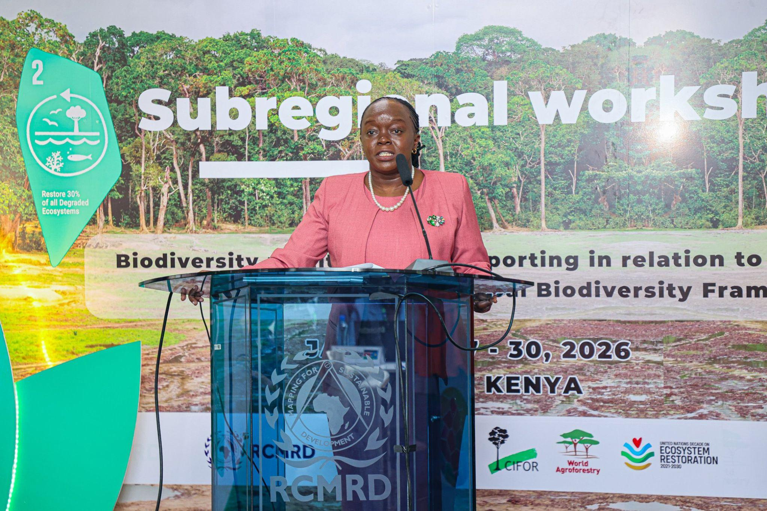
Visual Storytelling (Photography)
High Level moments (CS, GC Chair, CBD Secretariat)
Cabinet Secretary, Ministry of Environment, Climate Change and Forestry of Kenya, Dr. Deborah Mulongo Barasa.

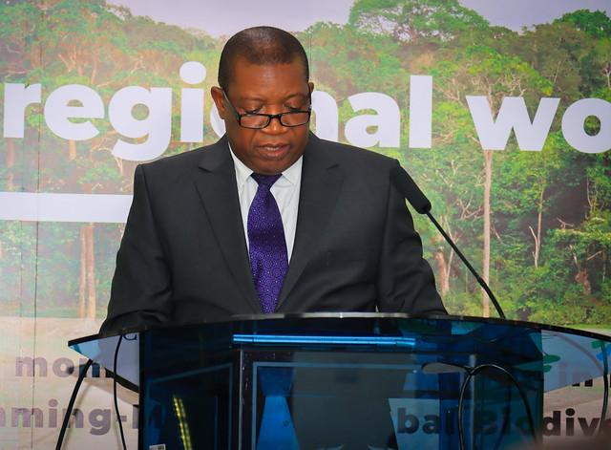
RCMRD Governing Council Chairperson and Permanent Secretary Ministry of Lands and Natural Resources, Zambia, Patrick Mucheleka.


Executive Secretary of the Convention on Biological Diversity (CBD), Ms. Astrid Schomaker.

Plenary discussions and Breakout group sessions
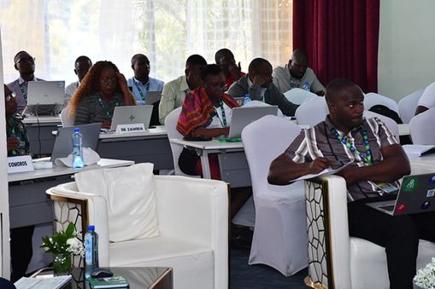
Plenary discussions and technical sessions

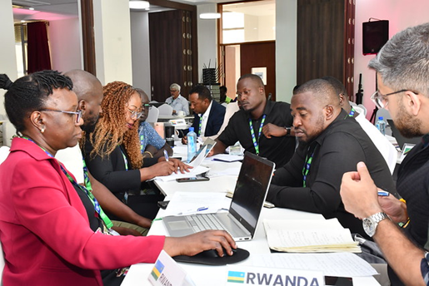
Breakout Group work Highlight

These assets were used for social media, websites, newsletters, and post-event knowledge products.
Digital Reach & Engagement
Continuous social media coverage, speaker quotes, and curated photo highlights increased engagement during the workshop, while post-event web stories (story map and others) and newsletters sustained visibility and awareness of Target 2 outcomes.
Outcome
The integrated branding, media, and digital strategy strengthened RCMRD’s institutional positioning, expanded regional visibility of Target 2, and delivered enduring communication assets for continued advocacy and reporting.
Communications Link Report

Summary and Conclusion

Summary
The workshop highlighted systemic challenges undermining effective implementation of KM-GBF Target 2 (ecosystem restoration) across the region. Key constraints include fragmented and outdated biodiversity data systems, weak outcome-based monitoring frameworks, limited interoperability across platforms, and insufficient investment in productive landscapes beyond protected areas. Tensions around land tenure, financing gaps, and overreliance on short-term project reporting further widen the ambition–implementation gap. Findings from the Self-Assessment Tool (SAT) confirmed persistent blind spots in non-protected and productive landscapes, geographic concentration of interventions in protected areas, and a focus on activity-based rather than outcome-based indicators.
Country needs assessments revealed priority support areas like strengthening National Biodiversity Information Systems (NBIS), improving GIS and remote sensing capacity, enhancing restoration supervision, enabling data automation and interoperability, and embedding joint planning mechanisms for GBF tracking. In response, recommended actions emphasize harmonizing data standards and definitions, institutionalizing restoration monitoring within national systems, operationalizing decentralized data flows, scaling community-based monitoring, aligning fiscal incentives to restoration finance, and strengthening regional technical backstopping through Technical Support Centres (TSCs).

Conclusion
The workshop reaffirmed that achieving KM-GBF Target 2 is not merely a technical undertaking but a governance, financing, and coordination imperative. Closing implementation and outcome gaps requires institutionalized monitoring systems, strengthened regional cooperation, sustainable financing mechanisms, and integrated landscape-level planning that links Targets 1, 2, and 10. The agreed roadmap prioritizes timely submission of the 7th National Reports (NR7) by 28 February 2026, operationalization of TSC support mechanisms, expanded peer learning, and sustained collaboration toward COP17. The subregion collectively committed to elevating ecosystem restoration as a core development priority—recognizing that biodiversity recovery, climate resilience, and sustainable livelihoods are mutually reinforcing and essential to long-term prosperity.

Annexes
Communications Report
List of Participants
Media Banner(s)
Photo gallery RCMRD FLICKR
Target 2 StoryMap
ToT Summary Report

