 |  | CBD/SBI/7/6/Add.1

 | Distr.: General  8 May 2026  Original: English

Subsidiary Body on Implementation
Seventh meeting
Nairobi, 4–12 August 2026
Item 6 of the provisional agenda*
Fifth assessment and review of the effectiveness
of the Cartagena Protocol on Biosafety and
midterm evaluation of the implementation plan
and the capacity-building action plan for the
Protocol
Analysis of information for the fifth assessment and review of the effectiveness of the Cartagena Protocol on Biosafety and midterm evaluation of the implementation plan and the capacity-building action plan for the Protocol
Note by the Secretariat

I. Introduction
- In accordance with Article 35 of the Cartagena Protocol on Biosafety, the Conference of the Parties serving as the meeting of the Parties to the Protocol is required to undertake an evaluation of the effectiveness of the Protocol at least every five years. Most recently, the Conference of the Parties serving as the meeting of the Parties to the Protocol conducted the fourth assessment and review at its tenth meeting (see decision CP-10/7).
- In decisions CP-10/3 and CP-10/4, the Conference of the Parties serving as the meeting of the Parties to the Cartagena Protocol adopted the implementation plan for the Cartagena Protocol on Biosafety, and the capacity-building action plan for the Cartagena Protocol on Biosafety, respectively. In decisions CP-10/3 and CP-10/4, the Conference of the Parties serving as the meeting of the Parties to the Protocol decided to conduct, respectively, a midterm evaluation of the implementation plan in conjunction with the fifth assessment and review of the effectiveness of the Protocol and a midterm evaluation of the capacity-building action plan in conjunction with the midterm evaluation of the implementation plan.
- In decision CP-10/3, the Conference of the Parties serving as the meeting of the Parties to the Cartagena Protocol requested the Executive Secretary of the Convention on Biological Diversity to include in the reporting format for the fifth national report on the implementation of the Protocol questions designed to elicit information on the indicators of the implementation plan and analyse and synthesize that information to facilitate the midterm evaluation and to make that information available to the Liaison Group on the Cartagena Protocol on Biosafety and, as appropriate, the Compliance Committee.
- In the same decision, the Conference of the Parties serving as the meeting of the Parties to the Protocol requested the Subsidiary Body on Implementation, at a meeting to be held before the twelfth meeting of the Conference of the Parties serving as the meeting of the Parties to the Protocol, to consider the information provided and the conclusions reached by the Liaison Group and the Compliance Committee and submit its findings and recommendations to the Conference of the Parties serving as the meeting of the Parties to the Protocol at its twelfth meeting with a view to facilitating the midterm evaluation of the implementation plan.
- The present note presents the analysis and synthesis of information for the fifth assessment and review of the effectiveness of the Protocol and the midterm evaluation of the implementation plan and the capacity-building action plan.
- Described in section II below is the methodology used in the analysis of that information. Section III contains an analysis and synthesis of information relevant for measuring progress towards the achievement of the objectives and goals of the implementation plan and the capacity-building action plan and towards the implementation of the Cartagena Protocol.

II. Methodology
- In decisions CP-10/3 and CP-10/4, the Conference of the Parties serving as the meeting of the Parties to the Cartagena Protocol decided that the baseline for the implementation plan and the capacity-building action plan would comprise information gathered in the fourth reporting cycle.
- This document provides an analysis of information relevant to the indicators of the implementation plan and the capacity-building action plan as compared with information from the baseline.
- The primary sources of information were the fifth national reports on the implementation of the Protocol, the Biosafety Clearing-House, experience from capacity-building projects and the Compliance Committee. Where additional sources of information were used to support the analysis, they have been identified through references in this document.
- Information in the fifth national reports submitted by 2 March 2026 was compared with information provided at the baseline by Parties in their fourth national reports. The comparison of those data was obtained by making use of the online national report analyser tool. Relevant information published on the Biosafety Clearing-House as at 2 March 2026 was compared with similar information available at the baseline. For each indicator, the source of information used was provided in a matrix on sources of information.
- Information from national reports used in the present document was derived from national reports of those Parties that had submitted their fifth national report by 2 March 2026 and previously submitted a fourth national report. That approach was intended to enable a consistent and comparable review of progress over time and followed the approach taken for the third and the fourth assessment and review of the effectiveness of the Protocol and the evaluation of the Strategic Plan for the Cartagena Protocol on Biosafety for the period 2011–2020.
- Of the 128 Parties that submitted their fifth national report on the Biosafety Clearing- House by 2 March 2026, a total of 123 had submitted a fourth national report.
- This note provides an analysis of information obtained in the fifth reporting cycle (current status) and of reported changes since the baseline. Changes are presented as “increase” (“+x per cent”) or “decrease” (“-x per cent”) and reflect absolute changes. Changes reported reflect changes at the global or the regional level and do not necessarily show changes reported by individual Parties.
- As percentages are rounded up to the nearest whole number to avoid the use of decimals, the rounded up percentages do not always sum to the expected result.
- In addition to providing information on current status and changes from the baseline globally, regional breakdowns are provided for certain indicators to help clarify the status reported or changes from the baseline at the global level. Regional breakdowns are presented in ascending order of magnitude (lowest to highest percentage). As the number of Parties in some regional groups is limited, small changes when expressed in percentages may result in large differences.
- The analysis covers each goal of the implementation plan and capacity-building action plan and uses the respective indicators to assess the progress made.

III. Analysis of the status of and trends in the implementation of the Cartagena Protocol on Biosafety
- The present section presents a comparative analysis of the status of and trends in the implementation of the Cartagena Protocol on Biosafety, following the goals of the implementation plan and the capacity-building action plan.
- Key figures and highlights are provided in subsection (a) for each respective goal while the full analysis is provided in subsection (b).

A. Goal A.1. Parties have in place functional national biosafety frameworks
(a) Key figures and highlights
- Forty-eight per cent of Parties to the Cartagena Protocol reported having introduced the necessary national measures for the implementation of the Protocol fully (+2 per cent) and 43 per cent partially (+4 per cent)
- There were substantial regional differences in the proportion of Parties that reported that measures were fully in place (100 per cent in one region compared with 10 per cent in another region). Those differences among regions were much less pronounced when the Parties that reported that measures were fully in place were considered together with Parties reporting that measures were partially in place (from 84 per cent to 100 per cent)
- In their free text answers, several Parties indicated that legal instruments for biosafety were under development and several Parties observed that delay in the adoption of those instruments hampered the implementation of the Protocol
- Designation of national focal points and competent national authorities:
  - Ninety-eight per cent of all Parties to the Protocol (170 Parties of 173) had designated their national focal point for the Protocol (no change from the baseline)
  - Ninety-eight per cent of all Parties to the Protocol (170 Parties of 173) had designated their focal point for the Biosafety Clearing-House (-1 per cent)
  - Ninety-two per cent of all Parties to the Protocol (160 Parties of 173) had designated one or more competent national authorities (+3 per cent)
  - Eighty-four per cent of all Parties to the Protocol (146 of 173 Parties) had made available to the Biosafety Clearing-House information concerning their point of contact for receiving notifications under Article 17 (+6 per cent)
- Ninety-one per cent of Parties reported having qualified staff to administer functions directly related to biosafety (+3 per cent). Only 42 per cent reported that that number was adequate. In their free text responses, Parties described how, owing to staff rotation and lack of training, technical capacities were precarious and staffing levels were often insufficient, with biosafety staff often working on a variety of topics
- Parties that reported still having capacity-building needs (100 Parties) identified the following areas of need: institutional and human resources (88 per cent); and integration of biosafety in cross-sectoral and sectoral legislation, policies and institutions (78 per cent)
(b) Analysis of information
- Goal A.1. includes three objectives to be accomplished in order to achieve the goal and three indicators to measure progress towards the objectives. With regard to indicator A.1 (a) (percentage of Parties that have measures in place to implement the provisions of the Protocol), information provided in response to questions 7 and 8 of the fifth national report was used to measure progress with respect to that indicator.
- Forty-eight per cent of Parties reported that they had introduced the necessary national measures for the implementation of the Protocol fully, representing an increase of 2 per cent from the baseline. There were substantial regional differences. Measures were reported to be fully in place by 10 per cent of Parties in the Latin American and Caribbean region (+5 per cent); 36 per cent of Parties in the African region (+3 per cent); 42 per cent of Parties in the Asia-Pacific region (+4 per cent); 68 per cent of Parties in the Eastern European region (no change from the baseline); and all Parties within the Western European and others States region (no change from the baseline).
- A total of 43 per cent of Parties reported that national measures were partially in place, representing an increase of 4 per cent from the baseline. At the regional level, measures were reported to be partially in place by none of the Parties in the Western European and others States region (no change from the baseline); 32 per cent of Parties in the Eastern European region (+6 per cent); 42 per cent of Parties in the Asia-Pacific region (no change from the baseline); 54 per cent of Parties in the African region (+10 per cent); and 75 per cent of Parties in the Latin American and Caribbean region (no change from the baseline). Further information is provided under goal A.4 (compliance) below.
- When considered together, 91 per cent of Parties reported that measures were either fully or partially in place, representing an increase of 6 per cent. Differences among regions were much less pronounced when Parties that reported that measures were fully in place and Parties that reported that measures were partially in place were considered together. The resulting proportions of Parties were 84 per cent in the Asia-Pacific region (+4 per cent); 85 per cent in the Latin American and Caribbean region (+5 per cent); 90 per cent in the African region (+13 per cent); 100 per cent in the Eastern European region (+6 per cent); and 100 per cent in the Western European and others States region (no change from the baseline).
- Three per cent of Parties reported that only temporary measures had been introduced (-1 per cent); 5 per cent of Parties reported that only draft measures existed (-5 per cent); and 1 per cent of Parties reported that no measures had yet been taken (-1 per cent). Further information is provided below in the context of goal A.4 (compliance) and in figure I.
Figure I
Introduction of the necessary measures for the implementation of the Protocol
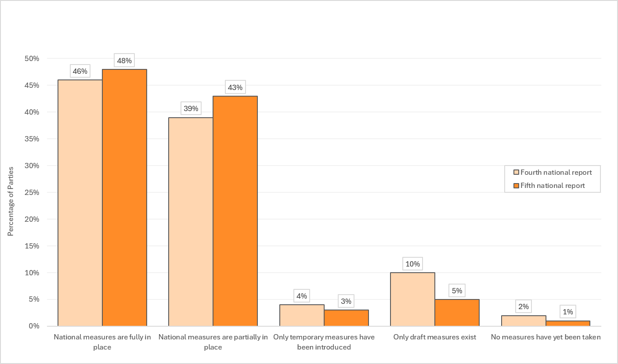
- With respect to the specific kinds of instruments that Parties reported having in place for the implementation of the Protocol, of the 123 Parties considered, 83 Parties reported having in place one or more biosafety laws (+7 from the baseline); 80 Parties reported having in place one or more national biosafety regulations (+7 from the baseline); 64 Parties reported having in place one or more sets of biosafety guidelines (+5 from the baseline); and 86 Parties reported having in place other laws, regulations or guidelines that indirectly applied to biosafety (+14 from the baseline). Two Parties reported that no instruments were in place.
- With regard to indicator A.1 (b) (percentage of Parties that have designated a national focal point, competent national authorities for the Protocol and an emergency measures (Article 17) contact point and have notified the Secretariat accordingly), information submitted to the Biosafety Clearing-House was used to measure progress in that regard.
- Ninety-eight per cent of Parties to the Protocol (170 Parties) had designated their national focal point for the Cartagena Protocol, representing no change from the baseline. Ninety-eight per cent of Parties to the Protocol (170 Parties) had designated their focal point for the Biosafety Clearing-House, representing a decrease of 1 per cent from the baseline. A total of 92 per cent of all Parties to the Protocol (160 Parties) had designated one or more competent national authorities, representing an increase of 3 per cent from the baseline. Furthermore, a total of 84 per cent of Parties to the Protocol (146 Parties) had made available to the Biosafety Clearing-House information concerning their point of contact for receiving notifications under Article 17, representing an increase of 6 per cent from the baseline.
- With regard to indicator A.1 (c) (percentage of Parties that have qualified staff to operationalize their national biosafety frameworks), information provided in response to question 11 of the fifth national report was used to measure progress in that regard. Additional information provided in the responses to questions 12 and 99 of the fifth national report was used as well.
- A total of 91 per cent of Parties reported having qualified staff to administer functions directly related to biosafety, an increase of 3 per cent from the baseline. At the regional level, little variation was observed: in the Latin American and Caribbean region, 85 per cent of Parties reported having qualified staff (+5 per cent); in the Asia-Pacific region, 85 per cent (no change from the baseline); in the African region, 92 per cent (+7 per cent); in the Eastern European region, 95 per cent (no change from the baseline); and in the Western European and other States region, 100 per cent (no change from the baseline).
- Of the Parties reporting that they had qualified staff to administer functions directly related to biosafety, 42 per cent reported that the number of staff was adequate.
- Further information was provided by Parties in response to question 99 of the fifth national report, regarding whether they had established adequate institutional capacity to enable the competent national authority to perform the functions required by the Cartagena Protocol on Biosafety. Fifty-six per cent of Parties had done so (-1 per cent), while 31 per cent reported having done so to some extent (+5 per cent). Thirteen per cent of Parties reported not having done so (-3 per cent).
- In their written contributions, many Parties described with varying levels of detail the national legal and institutional framework for biosafety. Several Parties mentioned that further instruments were under development. The descriptions showed that most Parties had in place a variety of instruments applying to biosafety, including primary or secondary legislation, policy or technical guidance instruments and, often, a combination of several instruments. Several Parties indicated, however, that the fact that adoption of important legal instruments for biosafety was pending hampered the implementation of the Protocol and some of those Parties explained that pending the adoption of specific biosafety legislation, other legal instruments were used to implement certain obligations under the Protocol. Several Parties mentioned that biosafety had been integrated into a variety of legal and policy instruments, including the national biodiversity strategy and action plan, in the context of efforts to mainstream biosafety. Several Parties mentioned that the development of national biodiversity targets in the context of the Kunming- Montreal Global Biodiversity Framework included work on national targets dedicated to biosafety. While many Parties mentioned having dedicated staff, Parties described how, owing to staff rotation and lack of training, technical capacities were precarious and staffing levels were often insufficient. Several Parties indicated that their biosafety staff engaged in work related to a variety of topics. While many Parties mentioned a national budget allocation for biosafety, several Parties indicated that financial resources were insufficient and unpredictable. A few Parties mentioned that, considering the rapid development of biotechnologies and an increasing volume in trade, capacities needed to be strengthened beyond current levels and additional resources were required.
- For goal A.1, under the capacity-building action plan for the Cartagena Protocol on Biosafety, the following two key areas for capacity-building were identified: development and implementation of legal, administrative and other measures to implement the Protocol; and strengthening capacities of competent national authorities.
- Of the Parties that reported that they still had capacity-building needs, 88 per cent reported that capacity-building was needed in the area of institutional and human resources (+5 per cent) and 78 per cent reported that capacity-building was needed for the integration of biosafety into cross-sectoral and sectoral legislation, policies and institutions (+1 per cent). Of the 98 Parties that reported having undertaken activities for the development and/or strengthening of human resources and institutional capacities in biosafety, 73 per cent reported that those activities had been undertaken in the area of institutional capacity and human resources (+7 per cent) and 40 per cent reported that those activities had been undertaken in the area of integration of biosafety in cross-sectoral and sectoral legislation, policies and institutions (-6 per cent). In the reporting period, a number of initiatives had been undertaken through which seven Parties benefited from technical legal assistance to strengthen their biosafety frameworks in collaboration with the United Nations Environment Programme (UNEP) and the Food and Agriculture Organization of the United Nations (FAO). Furthermore, the Secretariat of the Convention published a volume designed to support Parties in their efforts to mainstream biosafety across a variety of sectoral and cross-sectoral legal and policy instruments. Further information is provided in the context of goal A.4 (compliance) below.

B. Goal A.2. Parties have improved the availability and exchange of relevant information through the Biosafety Clearing-House
(a) Key figures and highlights
- A majority of Parties indicated that, when available, all mandatory information was published on the Biosafety Clearing-House with respect to: legislation, regulations and guidelines for implementation including advance informed agreement procedures (70 per cent of Parties indicated that they had published that information on the Biosafety Clearing-House); legislation, regulations and guidelines applicable to the import of living modified organisms intended for direct use as food or feed, or for processing (67 per cent of Parties); decisions regarding the importation of living modified organisms for intentional introduction into the environment (63 per cent of Parties); decisions regarding the domestic use of living modified organisms that may be subject to transboundary movement for direct use as food or feed, or for processing (63 per cent of Parties); decisions regarding the import of living modified organisms intended for direct use as food or feed, or for processing, that were taken under domestic regulatory frameworks (Article 11, para. 4, of the Cartagena Protocol) or in accordance with annex III to the Protocol (pursuant to Article 11, para. 6) (69 per cent of Parties); and summaries of risk assessments or environmental reviews of living modified organisms generated by regulatory processes and relevant information regarding the products thereof (65 per cent of Parties).
- Availability of information on illegal transboundary movements and unintentional transboundary movements of living modified organisms was low, with limited reporting through the Biosafety Clearing-House. Only 10 Parties indicated that information was available on unintentional transboundary movements, of which 50 per cent reporting having published all relevant information through the Clearing-House. Twenty-one Parties reported that information was available with respect to illegal transboundary movements, with 38 per cent of Parties indicating that they had published all relevant information through the Clearing-House.
- The use of the Biosafety Clearing-House has grown substantially: in the period from 1 March 2025 to 28 February 2026, active users had increased by 88 per cent and page views had increased by 33 per cent compared with the period from 7 June 2023 to 6 June 2024), the first period for which the new Google Analytics 4 traffic measurement statistics were available.
(b) Analysis of information
- Goal A.2. includes two objectives to be accomplished in order to achieve the goal and four indicators to measure progress towards those objectives. With regard to indicator A.2 (a) (percentage of Parties making mandatory information available to the Biosafety Clearing-House), information provided in response to questions 112 of the fourth national report and 102 of the fifth national report was used to measure progress.
- Of the 115 Parties reporting that the information was available, 70 per cent of Parties reported that they had published all information on the Biosafety-Clearing House related to legislation, regulations and guidelines for implementing the Protocol, as well as information required by Parties for advance informed agreement procedures. That represented a decrease of 2 per cent from the baseline. Another 24 per cent of Parties reported that that information had partially been only made available on the Clearing-House, which represented an increase of 6 per cent from the baseline.
- With respect to legislation, regulations and guidelines applicable to the import of living modified organisms intended for direct use as food or feed, or for processing, of the 100 Parties that reported that the information was available, 67 per cent reported that all information had been published on the Biosafety Clearing-House, a decrease of 6 per cent from the baseline. Another 24 per cent of Parties reported that this information had been made partially available on the Clearing-House, an increase of 12 per cent from the baseline.
- With respect to the status of mandatory information submitted to the Biosafety Clearing-House regarding bilateral, multilateral and regional agreements and arrangements, of those Parties that reported that the information was available (43 Parties), 35 per cent reported that all information had been published on the Clearing-House, which represented no change from the baseline. An additional 16 per cent of Parties reported that that information had been made partially available on the Clearing-House, which represented a 2 per cent increase from the baseline.
- With respect to notifications regarding releases that may lead to an unintentional transboundary movement of a living modified organism that is likely to have significant adverse effects on biological diversity (Article 17, para. 1), of the 10 Parties that reported that the information was available, 50 per cent reported that all information had been published on the Clearing-House, a decrease of 4 per cent from the baseline. Ten per cent of Parties (1 Party) reported that that information had been made partially available on the Clearing-House, which was an increase of 10 per cent from the baseline.
- Of those Parties that reported that information concerning cases of illegal transboundary movements of living modified organisms was available (21 Parties), 38 per cent reported that all information had been published on the Clearing-House, representing an increase of 8 per cent from the baseline. An additional 14 per cent reported that that information was partially available on the Clearing-House, representing a 3 per cent decrease from the baseline. Further information in that regard is provided under goal A.6 below.
- Of those Parties that reported that decisions regarding the importation of living modified organisms for intentional introduction into the environment were available (46), 63 per cent reported that all information had been published on the Clearing-House, representing no change from baseline, and another 20 per cent of Parties reported that that information was made partially available on the Clearing-House, representing an 11 per cent increase from the baseline.
- Of those Parties that reported that decisions regarding the domestic use of living modified organisms that may be subject to transboundary movement for direct use as food or feed, or for processing, were available (51 Parties), 63 per cent reported that all information had been published on the Clearing-House, a decrease of 7 per cent from the baseline. An additional 16 per cent of Parties reported that this information was made partially available on the Clearing-House, an increase of 14 per cent.
- Of those Parties that reported that the decisions regarding the import of living modified organisms intended for direct use as food or feed, or for processing, that were taken under domestic regulatory frameworks (Article 11 (4)) or in accordance with annex III to the Protocol (pursuant to Article 11 (6)) were available (55 Parties), 69 per cent reported that all information had been published on the Clearing-House, representing no change from the baseline, while 11 per cent of Parties reported that that information was made partially available on the Clearing-House, representing a 2 per cent increase from the baseline.
- With respect to cases where intentional transboundary movement may take place at the same time as the movement is notified to the Party of import (Article 13 (1) (a)), of the 13 Parties that reported that information was available, 54 per cent reported that all information had been published on the Clearing-House, representing an increase of 25 per cent from the baseline. Eight per cent of Parties (1 Party) indicated that that information had been made partially available on the Clearing-House, representing a decrease of 8 per cent from the baseline.
- With respect to living modified organisms exempt from the advance informed agreement procedure (Article 13 (1) (b)), of the nine Parties that reported that information was available, 44 per cent reported that all information had been published on the Clearing-House, representing an increase of 7 per cent from the baseline. No Parties indicated that that information had been made partially available on the Clearing-House, representing no change from the baseline.
- Of those Parties that reported that summaries of risk assessments or environmental reviews of living modified organisms generated by regulatory processes and relevant information regarding the products thereof were available (60 Parties), 65 per cent reported that all information had been published on the Clearing-House, representing a 3 per cent decrease from the baseline, while 20 per cent reported that that information was partially available on the Clearing-House, representing a 4 per cent increase from the baseline.
- Seventy-eight Parties provided a free text answer to question 103, in which Parties were asked to provide an explanation of why information may be available but not on the Clearing-House or only partially on the Clearing-House. Many Parties indicated that relevant information existed at the national level but had not yet been fully uploaded to the Clearing-House. The most common reasons provided by Parties included administrative delays, the need to compile and validate information from multiple institutions and limited technical and/or human capacity to maintain and update their Clearing-House records. A few Parties noted confidentiality considerations as a reason for why information had not been published on the Clearing-House.
- The Compliance Committee noted inconsistencies between information provided by Parties in national reports and information published by Parties through the Biosafety Clearing-House. Moreover, the Committee routinely reviews the completeness of information on the Biosafety Clearing-House. Further information is provided under goal A.4 (compliance) below.
- With regard to indicator A.2 (b) (percentage of Parties that publish any non-mandatory biosafety-related information through the Biosafety Clearing-House), non-mandatory information provided in response to questions 112 of the fourth national report and 102 of the fifth national report was used to measure progress. On the basis of answers provided to the sub-questions under question 102 of the fifth national report, related to non-mandatory information, 35 per cent of Parties (61 Parties) indicated that they had published non-mandatory information through the Clearing-House, representing an 8 per cent decrease from the baseline.
- With regard to indicator A.2 (c) (number of active users of and visits to the Biosafety Clearing-House), information derived through Google Analytics has been provided to measure progress.
- Statistics regarding the number of active users and visits to the Biosafety Clearing-House were acquired through Google Analytics, which had transitioned to a new traffic measurement system (Google Analytics 4). That made historical data before June 2023 inaccessible. Consequently, the indicator compared the most recent period of traffic and activity on the platform (1 March 2025–28 February 2026) with the first full period for which statistics were made available as a baseline (7 June 2023–6 June 2024). The number of active users on the Clearing-House increased from 86,147 in the former period to 162,371 in the latter period, representing an 88 per cent increase, and the number of page views increased from 578,140 in the former period to 771,499 in the latter period, representing a 33 per cent increase (see figure II).
Figure II
Traffic on the Biosafety Clearing-House
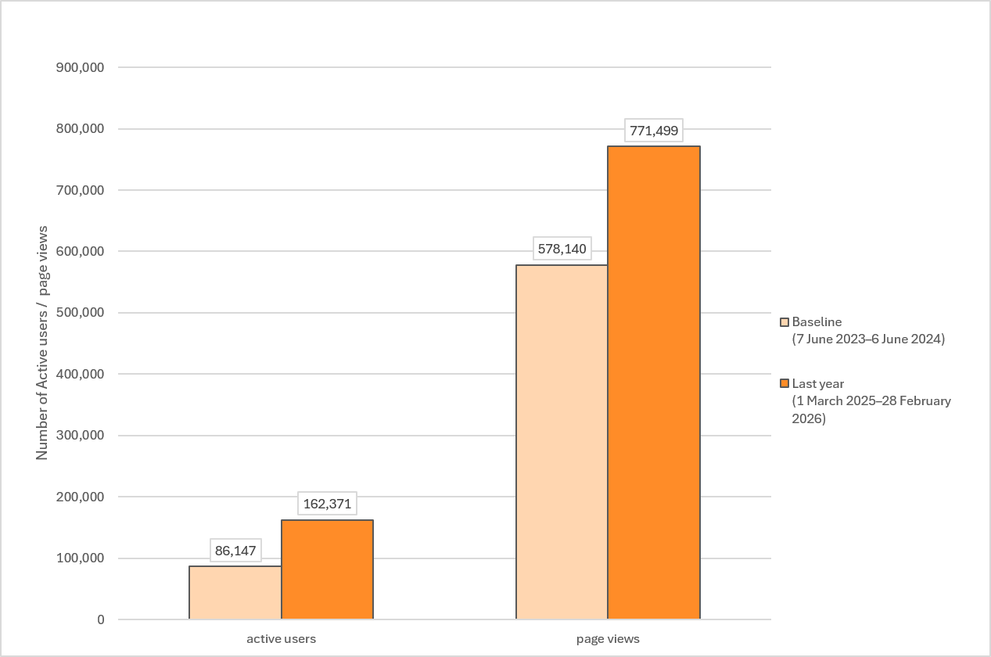
- With regard to indicator A.2 (d) (percentage of decisions on the Biosafety Clearing-House with associated reports on risk assessment), information derived from the Clearing-House was used to measure progress. The ratio between the number of risk assessment reports and the number of decisions on living modified organisms on the Clearing-House increased from 92 per cent (1,198 risk assessments to 1,299 decisions) in January 2020 to 99 per cent (1,402 risk assessments to 1,414 decisions) as at 28 February 2026, representing a 7 per cent increase.
- For goal A.2, under the capacity-building action plan, two key areas for capacity-building were identified: publishing information on the Clearing-House and accessing and using information on the Clearing-House.
- Of the 98 Parties that reported that they had undertaken activities for the development and/or strengthening of human resources and institutional capacities in biosafety, 55 per cent reported that those activities were undertaken in the area of information exchange and data management including participation on the Clearing-House, representing a decrease of 1 per cent. Of the 100 Parties that reported that they still had capacity-building needs, 72 per cent reported that they had such needs in the field of information exchange and data management including participation on the Clearing-House, representing no change from the baseline.
- The new platform of the Biosafety Clearing-House was launched in November 2021. As part of the launch, extensive help materials were developed to assist users in navigating the new site. Those help materials included articles available in the six official languages of the United Nations as well as 44 video tutorials (see the Biosafety Clearing-House knowledge base at: https://bch.cbd.int/en/kb). Multiple in-person workshops with dedicated training sessions on the Clearing-House have been conducted since the launch of the new platform to provide instruction on and support for using the Clearing-House. Under the UNEP-Global Environment Facility (GEF) project on sustainable capacity-building for effective participation on the Biosafety Clearing-House, implemented between 2016 and 2025, a series of national, regional and global training workshops were conducted to support eligible Parties in using the Clearing-House effectively. Moreover, dedicated Clearing-House training sessions were integrated into workshops on related topics, including risk assessment and customs, and regional workshops on national reporting in advance of the reporting deadline of the fifth national report. Dedicated training workshops on the Clearing-House were conducted on the margins of the tenth meeting of the Conference of the Parties serving as the meeting of the Parties to the Protocol in December 2022 and the margins of the eleventh meeting of the Conference of the Parties serving as the meeting of the Parties to the Protocol in October 2024. The Secretariat hosted a series of webinars on various features and functions of the Clearing-House in 2023 and 2024, covering topics such as how to search the Clearing-House and how to publish information, including scientific information, on the Clearing-House, as well as a webinar specific to finding help material on the platform.
- The help materials on the Clearing-House are used regularly. As at 2 March 2026, the 44 instructional video tutorials had a total of 2,055 engaged views. In the period from 1 March 2025 to 28 February 2026, the knowledge base received 47,719 views by 20,508 active users (representing 13 per cent of active users of the Biosafety Clearing-House).
- Eighty-nine Parties provided a free text response to question 108, in which Parties were asked to provide further details on the implementation of Article 20 in their country. Implementation of the Clearing-House varied widely, with some Parties indicating that they maintained robust and well-coordinated systems and others mentioning that they faced challenges that hindered effective implementation in that regard. Parties with stronger systems often referenced regular publication of mandatory and non-mandatory information through the Clearing-House, supported by established national frameworks and effective inter-agency coordination. Parties experiencing constraints commonly cited capacity-related challenges, including limited human and technical resources, as well as challenges related to inter-agency coordination. Several Parties experiencing constraints highlighted the need for continued training sessions and capacity-building activities to strengthen their implementation of Article 20.

C. Goal A.3. Full information on the implementation of the Protocol is made available by Parties in a timely manner
(a) Key figures and highlights
- Sixty-nine per cent of Parties (119 Parties) submitted their fifth national report by the reporting deadline compared with 23 per cent of Parties (39 Parties) that had submitted their fourth national report by the due date, representing an increase of 46 per cent in the submission rate
- Seventy-one eligible Parties had received the first disbursement of funds for the preparation of their fifth national report by mid-February 2026. In comparison, none of the eligible Parties had received funds for the preparation of their fourth national report at the time of the October 2019 submission deadline
(b) Analysis of information
- Goal A.3. includes one objective to be accomplished in order to achieve the goal and two indicators to measure progress towards the objective. With regard to indicator A.3 (a) (percentage of Parties that have submitted a complete national report within the established deadline), information used to measure progress was the percentage of Parties that had submitted a complete national report within the established deadline.
- The submission deadline for the fifth national report was 28 February 2026. By that date, 119 Parties out of the 173 that had the obligation to do so had submitted their fifth national report, representing a submission rate of 69 per cent. One non-Party had submitted a fifth national report. The deadline for submission of the fourth national report was 1 October 2019 and by that date, 39 fourth national reports had been submitted, which constituted a submission rate of 23 per cent. As compared with the submission rate at the baseline, the reporting rate for the fifth national report represented an increase of 46 per cent.
- With regard to indicator A.3 (b) (percentage of eligible Parties that have accessed Global Environment Facility funding for the preparation of their national report in a timely manner), information was provided by UNEP-GEF on the access by eligible Parties to financial support from GEF for the preparation of their national report.
- GEF made available funding to support Parties in developing their fifth national report, benefiting a total of 105 eligible Parties. Each Party participating in the project needed to conclude a small-scale funding agreement with UNEP, after which the funds could be disbursed. The initial disbursement of funds to the first group of Parties started at the end of the third quarter of 2025. In particular:
- As at 10 December 2025, 33 Parties had received their first disbursement, while disbursements for a further 19 Parties were being processed. Of the remaining 53 Parties, 37 were at various stages of preparation of the small-scale funding agreement, while UNEP had not received any response from 16 Parties regarding the preparation of the small-scale funding agreement
- As at 11 February 2026, 71 Parties had received the first disbursement from GEF funding for the development of their fifth national report
- In comparison, by the submission deadline for the fourth national reports, no Parties had yet accessed GEF funding and by the end of February 2020, Parties had still not accessed GEF funding. At the time, the delay had been attributed in part to delays in obtaining letters of commitment from eligible Parties, which resulted in delays in submitting the projects for approval to GEF.
- For goal A.3, two key areas for capacity-building were identified in the capacity-building action plan: establishing and strengthening national coordination systems to gather biosafety information; and preparing a national report.
- A number of tools, videos and guidance materials were developed to support Parties with the national reporting process. Those materials were available through the Biosafety Clearing-House in the official languages of the United Nations. The GEF-funded project to assist eligible Parties with their fifth national report included a help desk function to respond to questions from Parties.
- In addition, the GEF-funded project to support the preparation and submission of fifth national reports included funding for four regional workshops for Parties participating in the project. The workshops were held in Nairobi, in October 2025; Lima, in November 2025; Chisinau, in January 2026; and Bangkok, in January 2026. The regional workshops were organized by UNEP, as the implementing agency, with technical support from the Secretariat and GEF. The workshops provided an opportunity to discuss questions related to accessing funding, preparing the national report and uploading the report on the Biosafety Clearing-House. The workshops, in which representatives of 76 Parties participated, were evaluated positively with regard to relevance and effectiveness, organization, furtherance of the acquisition of knowledge and skills, participant engagement and interaction, and outcomes and follow-up.

D. Goal A.4. Parties are in compliance with the requirements of the Protocol
(a) Key figures and highlights
- With the support of the Compliance Committee, the number of fourth national reports submitted continued to increase, with 59 additional fourth national reports submitted, bringing the total to 162 (out of 171)
- Seven individual cases of non-compliance concerning the submission of national reports were identified by the Committee and six were resolved
- Two individual cases of non-compliance concerning the obligation to designate a national focal point for the Cartagena Protocol were identified by the Committee and both were resolved
- Thirty-four individual cases of non-compliance concerning the obligation to take measures to implement the obligations under the Protocol were identified by the Committee and eight were resolved or were no longer considered to be non-resolved
(b) Analysis of information
- Goal A.4. includes two objectives to be accomplished in order to achieve the goal and two indicators to measure progress towards the objectives. With regard to indicator A.4 (a) (percentage of Parties that comply with their obligations under the Protocol), information provided related to key obligations on which the Compliance Committee had focused its efforts, namely: (a) the obligation to take the legal, administrative and other necessary measures to implement the obligations under the Protocol; (b) the obligation to make certain information available to the Biosafety Clearing-House; (c) the obligation to designate national focal points and competent national authorities; and (d) the obligation to report on the implementation of the Protocol. Information related to those obligations is provided above for indicators A.1 (a), A.2 (a), A.2 (d) and A.3 (a). Information on the role of the Compliance Committee in that regard is provided below.
- The Committee’s review of compliance with the obligation to take the necessary measures to implement the Protocol was carried out mainly in the context of its consideration of individual cases of non-compliance. Further information is provided in the discussion of indicator A.4 (b) below.
- The Compliance Committee reviewed compliance issues in relation to completeness of information on the Clearing-House and consistency of mandatory information provided in fourth national reports and information published by Parties through the Biosafety Clearing-House. Furthermore, in that regard, follow-up on matters identified by the Committee was undertaken in relation to a variety of types of information, including contact details of focal points and competent national authorities; legal measures to implement the Protocol; decisions on living modified organisms for intentional introduction into the environment under the advance informed agreement procedure; decisions regarding the domestic use, including placing on the market, of living modified organisms intended for direct use as food or feed, or for processing, that may be subject to transboundary movement; decisions on the import of such organisms; summaries of risk assessments in respect of certain decisions; and cases of unintentional and illegal transboundary movements of living modified organisms.
- The Compliance Committee has reviewed compliance by Parties with the obligation to submit their third and fourth national reports and taken a range of incremental follow-up measures in that regard. In the context of the review of general issues of compliance, the follow-up on the submission of the fourth national reports started in June 2020, following the seventeenth meeting of the Committee, held in April 2020. Follow-up continued after the eighteenth meeting of the Committee, held in October 2023. Between June 2020 and 2 March 2026, a total of 59 fourth national reports were submitted. Of those reports, about half were submitted between June 2020 and 31 December 2022 and about half between 1 January 2023 and 2 March 2026. It may be noted that the initial part of the reporting period coincided with the coronavirus disease (COVID-19) pandemic and that that, together with the delays in accessing GEF funding for the preparation of the fourth national reports, might have contributed to the delays in the submission of those reports. While the submission of so many fourth national reports cannot be attributed solely to the follow-up by the Committee, the efforts of the Committee were important especially as related to Parties with reports that had been long overdue. Further information on the review of compliance with the reporting obligation is provided in the discussion of indicator A.4 (b) below.
- The supportive role of the Committee has been welcomed by the Conference of the Parties serving as the meeting of the Parties to the Protocol as a contribution to the progress reported by Parties in implementing their obligations under the Protocol.
- With regard to indicator A.4 (b) (percentage of Parties that have resolved non-compliance issues identified by the Compliance Committee), information to measure progress was based on the number of individual cases of non-compliance identified by the Compliance Committee that were resolved. Individual cases of non-compliance were cases that could not be resolved through the Committee’s general follow-up measures and usually related to situations of non-compliance by specific Parties that had persisted for multiple years.
- Individual cases of non-compliance have been related to the following obligations: the obligation to submit a national report in accordance with Article 33 of the Cartagena Protocol on Biosafety; the obligation to designate a national focal point for the Cartagena Protocol and share the contact information through the Biosafety Clearing-House, in accordance with Article 19 of the Protocol; and the obligation to take the necessary and appropriate legal, administrative and other measures for the implementation of the obligations of the Protocol, in accordance with Article 2, paragraph 1, of the Protocol.
- With regard to individual cases of non-compliance with Article 33 of the Protocol, the Committee, at its nineteenth meeting noted that there were seven Parties that still had not submitted either their third or their fourth national report despite the efforts of the Committee to remind them, on multiple occasions over many years, of their reporting obligation under Article 33. Acknowledging that follow-up with seven Parties had proceeded in an incremental manner, the Committee agreed to recommend that the Conference of the Parties serving as the meeting of the Parties to the Protocol, at its eleventh meeting, caution the seven Parties, unless a report was submitted before the eleventh meeting. The Committee requested that its Chair inform the Parties concerned of its recommendation, while urging them to submit their fourth national report as soon as possible. By the time that the eleventh meeting of the Conference of the Parties serving as the meeting of the Parties to the Cartagena Protocol was held, four of those Parties had submitted their fourth national report. Pursuant to decision CP-11/1 B, the remaining three Parties were cautioned for not having submitted their third and fourth national reports and urged to submit their fourth national report as a matter of urgency. Following the eleventh meeting, GEF extended financial assistance to those Parties to enable them to prepare their fourth national report and two of the three cautioned Parties subsequently submitted their fourth national report. As a result, six of those seven individual cases of non-compliance identified by the Committee were resolved.
- With regard to individual cases of non-compliance with Article 19, the Committee, at its nineteenth meeting, recognizing that two Parties had not designated a national focal point for the Cartagena Protocol over a period of several years despite numerous follow-up communications from the Secretariat and the Chair of the Committee, requested that its Chair write to the minister overseeing national focal points for the Convention urging them to designate their national focal points. Following those communications, both Parties designated a focal point and shared their contact information through the Biosafety Clearing-House. The two cases of non-compliance identified by the Committee were thereby resolved.
- With regard to individual cases of non-compliance concerning the obligation under Article 2, paragraph 1, the Committee focused its efforts on Parties that reported not having taken any measures to implement their obligations under the Protocol or having taken only draft or temporary measures in that regard.
- Through its review of compliance with the obligation to put measures in place to implement the Protocol and its consideration of information provided by Parties in their national reports in that regard, the Committee requested 34 Parties to prepare a compliance action plan. Such plans set out the actions and timeline with respect to adopting the necessary measures to implement the Protocol, in accordance with the obligation under Article 2, paragraph 1.
- Of the 34 Parties that had been requested to prepare a compliance action plan, 19 submitted a plan. One of the 19 Parties successfully completed the activities set out in its plan, while the other 18 plans are under active consideration by the Committee. Seven of the 34 Parties were no longer expected to prepare a compliance action plan, as subsequent information indicated that they had made progress with regard to the adoption of measures. The remaining eight Parties have not yet submitted a compliance action plan. The Committee continues to follow up with the remaining Parties on that matter.
- The Compliance Committee undertook informal online exchanges with six Parties that had submitted a compliance action plan. The exchanges served to enable a discussion with the Parties concerned about progress made and any challenges associated with the implementation of their plans. Informal online exchanges with a further six Parties whose compliance action plans were under active consideration have been scheduled for the twenty-first meeting of the Committee. In collaboration with the UNEP Montevideo Programme for the Development and Periodic Review of Environmental Law, the Committee has encouraged Parties with compliance action plans under active consideration to consider applying for financial assistance from UNEP with a view to strengthening their biosafety legal frameworks. Three Parties received support in that regard, as set out in more detail below.
- Of the 34 individual cases of non-compliance with the obligation under Article 2, paragraph 1, that were requested to prepare a compliance action plan in that regard, a total of 8 cases (24 per cent) were resolved successfully or were no longer considered individual cases of non-compliance.
- Regarding Goal A.4, one key area for capacity-building was identified under the capacity-building action plan, namely, “address non-compliance issues identified by the Compliance Committee”.
- Three Parties with compliance action plans under active consideration had received support from UNEP through its Montevideo Programme for the Development and Periodic Review of Environmental Law. The support enabled those Parties to undertake the necessary national legislative processes, including consultations, for developing biosafety legislation with the support of a consultant. One of the projects was concluded and draft biosafety legislation was submitted to the Government for processing through the legislature. Moreover, FAO extended technical support to four Parties to help them strengthen their biosafety legislation. The activities were co-funded by the Japan Biodiversity Fund and UNEP through its Montevideo Environmental Law Programme. One of those Parties was a Party whose case was considered under individual cases of non-compliance in relation to compliance with Article 2, paragraph 1, of the Protocol.

E. Goal A.5. Parties carry out scientifically sound risk assessments of living modified organisms (LMOs), and manage and control identified risks to prevent adverse effects of LMOs on the conservation and sustainable use of biological diversity,
taking also into account risks to human health
(a) Key figures and highlights
- Of the Parties conducting risk assessments of living modified organisms, 91 per cent reported that they conducted those risk assessments in line with the Protocol
- Sixty-seven per cent of Parties reported having measures to identify living modified organisms or specific traits that may have adverse effects on the conservation and sustainable use of biological diversity. The proportion of Parties that reported having such measures varied considerably at the regional level and ranged from 50 to 95 per cent
- Sixty-seven and sixty-four per cent of Parties reported having had access to and having used technical resource materials for risk assessment and risk management, respectively. At the regional level, the proportion of Parties that reported having had access to and having used resource materials for both risk assessment and risk management ranged from 46 to 100 per cent.
- Parties continued to underline the need for capacity-building on risk assessment and risk management of living modified organisms. Of those Parties with capacity-building needs, 96 per cent identified risk assessment and 94 per cent identified risk management as areas in which capacities needed to be strengthened. While 76 per cent of Parties reported that training had been provided on risk assessment, only 40 per cent of those Parties reported that the number of people trained was adequate. While 70 per cent of Parties reported that training had been provided on risk management, only 44 per cent of those Parties reported that the number of people trained was adequate.
(b) Analysis of information
- Goal A.5 includes two objectives to be accomplished in order to achieve the goal and four indicators to measure progress towards those objectives.
- With regard to indicator A.5 (a) (percentage of Parties that undertake risk assessment for decision-making on living modified organisms, where required under the Protocol), information provided in response to questions 55 and 58 of the fifth national report was used to measure progress in that regard.
- Fifty-three per cent of Parties reported having conducted some type of risk assessment of living modified organisms in the reporting period, representing a 5 per cent increase from the baseline. At the regional level, the breakdown for the proportion of Parties that reported having conducted some type of risk assessment of living modified organisms was as follows: 26 per cent of Parties in the Asia-Pacific region (+11 per cent); 35 per cent of Parties in the Latin American and Caribbean region (+5 per cent); 44 per cent of Parties in the African region (+3 per cent); 53 per cent of Parties in the Eastern European region (no change from the baseline); and 100 per cent of Parties in the Western European and other States region (+5 per cent increase).
- Of the Parties that reported having conducted some type of risk assessment referred to in paragraph 83 directly above, 91 per cent reported having always conducted a risk assessment for all decisions taken on living modified organisms for intentional introduction into the environment; or domestic use of living modified organisms that might be subject to transboundary movement for direct use as food or feed, or for processing representing a 2 per cent decrease from the baseline. At the regional level, the breakdown for the proportion of Parties having always conducted risk assessment for all such decisions was as follows: 67 per cent of Parties in the Latin American and Caribbean region (-16 per cent); 89 per cent of Parties in the Asia-Pacific region (no change from the baseline); 90 per cent of Parties in the Eastern European region (-10 per cent); 92 per cent of Parties in the African region (+9 per cent); and 100 per cent of Parties in the Western European and other States region (no change from the baseline).
- For indicator A.5 (b) (percentage of Parties that have access to and use relevant risk assessment and risk management resource materials), information provided in response to question 66 of the fifth national report was used to measure progress in that regard.
- With regard to risk assessment, a total of 67 per cent of Parties reported that they had had access to or had used resource materials, including guidance documents, for the purpose of conducting risk assessment or for evaluating risk assessment reports submitted by notifiers (see figure III below). That represented a 5 per cent increase from the baseline. At the regional level, the considerable variation observed in the proportion of Parties that reported having had access to such resource materials can be broken down as follows: 46 per cent of Parties in the Asia-Pacific region (-8 per cent); 56 per cent of Parties in the African region (+5 per cent); 60 per cent of Parties in the Latin American and Caribbean region (+25 per cent); 95 per cent of Parties in the Eastern European region (+11 per cent); and 100 per cent of Parties in the Western European and other States region (no change from the baseline).
- As regards risk management, a total of 64 per cent of Parties reported that they had had access to or had used resource materials, including guidance documents, for the purpose of conducting risk management (see figure III below), which represented a 5 per cent increase from the baseline. At the regional level, the considerable variation observed in the proportion of Parties reporting having had access to such resource materials can be broken down as follows: 46 per cent of Parties in the Asia-Pacific region (no change from the baseline); 50 per cent of Parties in the Latin American and Caribbean region (+20 per cent); 56 per cent of Parties in the African region (+5 per cent); 84 per cent of Parties in the Eastern European region (+5 per cent); and 100 per cent of Parties in the Western European and other States region (no change from the baseline).
Figure III
Percentage of Parties reporting access to resource materials for the purpose of conducting risk assessment and risk management
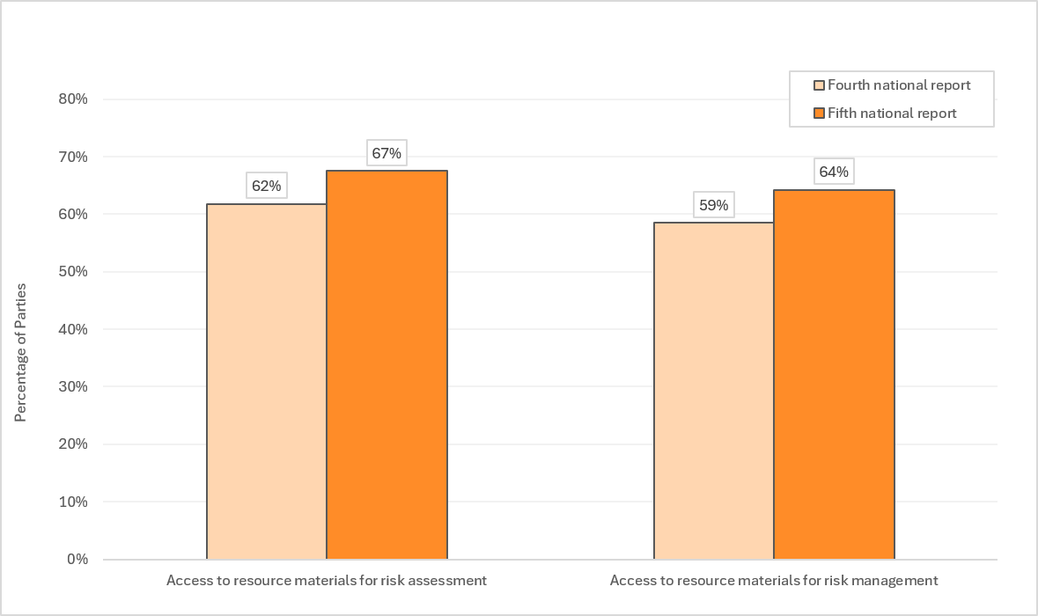
- With regard to indicator A.5 (c) (Percentage of Parties carrying out risk assessments, considering other available scientific evidence, referred to in Article 15), information provided in response to question 59 (a) of the fifth national report was used to measure progress. Of the 68 Parties that reported having carried out some type of risk assessment in the reporting period, 54 per cent reported having considered other available scientific evidence as referenced in Article 15 of the Protocol in all cases and 32 per cent reported having done so in some cases. No information in that regard was available for the baseline.
- With regard to indicator A.5 (d) (percentage of Parties that have measures in place to identify living modified organisms or specific traits that may have adverse effects on the conservation and sustainable use of biological diversity and adopt risk mitigation measures), information provided in response to question 65 of the fifth national report was used to measure progress. Sixty-seven per cent of Parties reported having measures to identify living modified organisms or specific traits that might have adverse effects on the conservation and sustainable use of biological diversity. Among regions, 50 per cent of Parties in the Asia-Pacific region; 61 per cent of Parties in the Latin American and Caribbean region; 66 per cent of Parties in the African region; 74 per cent of Parties in the Eastern European region; and 95 per cent of Parties of the Western European and other States region reported having those measures. No baseline information in that regard was available.
- In their free text answers, Parties emphasized the importance of risk assessment for the implementation of the Protocol and decision-making on living modified organisms. Many indicated that their legal frameworks provided for risk assessment and some highlighted instruments that had been amended. Parties described national biosafety institutions, regional systems, cooperation initiatives and resource materials that supported the implementation of Articles 15 and 16 of the Cartagena Protocol, as well as annex III thereto. While other Parties noted progress in establishing or reinforcing such institutions and frameworks, at the same time, many Parties underscored capacity gaps that hindered the operationalization of risk assessment and risk management provisions, including shortages of trained scientific personnel, inadequate or non-operational laboratory facilities, limited financial resources and incomplete regulatory frameworks. Many Parties therefore emphasized the need for continued capacity-building on risk assessment, risk management and monitoring; improved access to adequate technical infrastructure for research and analysis (for example, laboratories and reagents); financial assistance; access to technical resources; and the strengthening of national biosafety frameworks.
- For goal A.5, under the capacity-building action plan, five key areas for capacity-building were identified: (a) conducting and reviewing scientifically sound risk assessments; (b) regulating, managing and controlling identified risks; (c) access to infrastructure and technical expertise for risk assessment and risk management; (d) access to scientific data relevant for risk assessment and risk management; and (e) Parties have qualified staff to undertake case by-case risk assessment and risk management.
- Of the 98 Parties that reported that they had undertaken activities for the development and/or strengthening of human resources and institutional capacities in biosafety, 62 per cent (63 Parties) reported that those activities were undertaken in the area of risk assessment and other scientific and technical expertise (representing a 3 per cent decrease from the baseline) and 43 per cent (42 Parties) in the area of risk management (representing a 6 per cent decrease from the baseline). Of the 100 Parties that reported that they still had capacity-building needs, 96 per cent reported that they had such needs in the field of risk assessment and other scientific and technical expertise (representing a 9 per cent increase from the baseline) and 94 per cent in the area of risk management (representing an 11 per cent increase from the baseline).
- In their fifth national report, Parties provided further information with relevance to the indicators of the capacity-building action plan in response to questions 66 (a), 66 (b), 69 (c), 70 (a) and 70 (b).
- Sixty-eight per cent of Parties reported that their country had the capacity to assess the risks associated with living modified organisms or specific traits that may have adverse effects on the conservation and sustainable use of biological diversity, taking into account risks to human health. That represented a 1 per cent increase from the baseline. At the regional level, the proportion of Parties that reported having that capacity can be broken down as follows: 50 per cent of Parties in the Asia-Pacific region (-4 per cent); 60 per cent of Parties in the Latin American and Caribbean region (-5 per cent); 63 per cent of Parties in the African region (+8 per cent); 78 per cent of Parties in the Eastern European region (no change from the baseline); and 100 per cent of Parties in the Western Europe and other States region (no change from the baseline).
- In the current reporting period, 76 per cent of Parties reported having trained at least one person on risk assessment, representing a decrease of 6 per cent from the baseline. Forty per cent of those Parties reported that the number of people trained was adequate, representing a decrease of 6 per cent from the baseline.
- In the current reporting period, 70 per cent of Parties reported having trained at least one person on risk management of living modified organisms, representing a decrease of 5 per cent from the baseline. Forty-five per cent of Parties reported that the number of people trained in risk management was adequate, representing a decrease of 4 per cent from the baseline.
- During the reporting period, the Secretariat organized the following five training workshops on risk assessment of living modified organisms:
  - Francophone Africa training course on risk assessment of living modified organisms (September 2022), with 21 participants from 13 Parties;
  - Western, Central and Eastern Asian training course on risk assessment of living modified organisms (October 2022), with 17 participants from 12 Parties;
  - South, Southeast and Pacific Asia training course on risk assessment of living modified organisms (November 2022), with 20 participants from 12 Parties;
  - Training course for Caribbean States on risk assessments of living modified organisms (December 2024), with 22 participants from nine Parties;
(e) International training course on risk assessments of living modified organisms (June 2025), with 44 participants from 24 Parties).

F. Goal A.6. Parties prevent and address illegal and unintentional transboundary movements of living modified organisms
(a) Key figures and highlights
- Fifty-eight per cent of Parties reported having taken appropriate measures to prevent unintentional transboundary movements of living modified organisms and 16 per cent of Parties reported having taken such measures to some extent. Consideration of those figures together yields a global percentage of 74 per cent (+10 per cent). At the regional level, between 58 and 100 per cent of Parties reported that appropriate measures were in place or that they were in place to some extent
- Sixty-one per cent of Parties reported having adopted measures to prevent illegal transboundary movements of living modified organisms (+2 per cent) and 13 per cent of Parties (16 Parties) reported having done so to some extent (-1 per cent). At the regional level, between 40 and 100 per cent of Parties reported having adopted such measures or having done so to some extent
- Six Parties reported cases of unintentional transboundary movements of living modified organisms and 26 Parties reported cases of illegal transboundary movements of living modified organisms during the reporting period in their fifth national reports. Only two records concerning cases of illegal transboundary movements were submitted to the Biosafety Clearing-House in the reporting period and zero communications of unintentional transboundary movements were submitted to the Clearing-House
- While several Parties mentioned that measures were in place or under development concerning illegal and unintentional transboundary movements, many Parties described challenges in implementing those measures owing to different resource and capacity constraints, including lack of laboratory detection capacity; lack of human resource capacity; porous borders; lack of technical equipment at entry points; inadequate financial and institutional resources; and limited inter-institutional collaboration.
(b) Analysis of information
- Goal A.6 includes one objective to be accomplished in order to achieve the goal and one indicator to measure progress towards the objective. With regard to indicator A.6 (a) (percentage of Parties that have measures in place to prevent and address illegal and unintentional transboundary movements of living modified organisms), information provided in response to questions 62 and 145 of the fifth national report was used to measure progress.
- Fifty-eight per cent of Parties reported having taken appropriate measures to prevent unintentional transboundary movements of living modified organisms, including such measures as requiring a risk assessment to being carried out prior to the first release of a living modified organism. Sixteen per cent of Parties reported having taken such measures to some extent.
- When the Parties that reported having taken measures and those that reported having taken measures to some extent were considered together, the global figure was 74 per cent (an increase of 10 per cent), as indicated in figure IV below. The regional breakdown for Parties that reported having taken measures and those that reported having taken measures to some extent, considered together, was as follows: 58 per cent of Parties in the African region (+5 per cent); 68 per cent of Parties in the Asia-Pacific region (+8 per cent); 70 per cent of Parties in the Latin American and Caribbean region (+35 per cent); 89 per cent of Parties in the Eastern European region (+5 per cent); and 100 per cent of Parties in the Western European and other States region (no change from the baseline).
- In their free text answers regarding the implementation of Article 17, Parties reported mixed levels of implementation. Many Parties, particular in the Western European and other States group, mentioned relying on existing regional regulatory frameworks that provided for prevention, notification and emergency response measures. Several developing country Parties indicated that they had enacted or were drafting national biosafety laws that included emergency response provisions, notification obligations and designated contact points, although many reported that implementation was partial. A few Parties mentioned detecting unauthorized living modified crops (for example, cotton, maize and soy) or seeds near border areas during the reporting period. Some Parties mentioned gaps regarding implementation, including limited laboratory detection capacity, insufficient trained personnel, porous borders, lack of technical equipment at entry points, insufficient financial resources, lack of institutional support and limited inter-institutional collaboration. Some countries noted that, while institutional structures existed on paper, formalized response methods had not yet been tested or fully operationalized.
- Sixty-one per cent of Parties reported having adopted domestic measures aimed at preventing and/or penalizing transboundary movements of living modified organisms carried out in contravention of their domestic measures to implement the Cartagena Protocol (an increase of 2 per cent from the baseline). Thirteen per cent of Parties (16 Parties) reported having done so to some extent (a decrease of 1 per cent from the baseline). When the Parties that reported having adopted such measures and those that reported having adopted those measures to some extent were considered together, the global figure was 74 per cent (an increase of 1 per cent), as indicated in figure IV below. The regional breakdown for Parties that reported having adopted measures and those that reported having adopted measures to some extent, considered together, was as follows: 40 per cent of Parties in the Latin American and Caribbean region (-20 per cent); 69 per cent in the Asia-Pacific region (+4 per cent); 72 per cent in the African region (+8 per cent); 95 per cent in the Eastern European region (+6 per cent); and 100 per cent in the Western European and other States region (no change from the baseline).
Figure IV
Parties with measures in place for unintentional and illegal transboundary movements
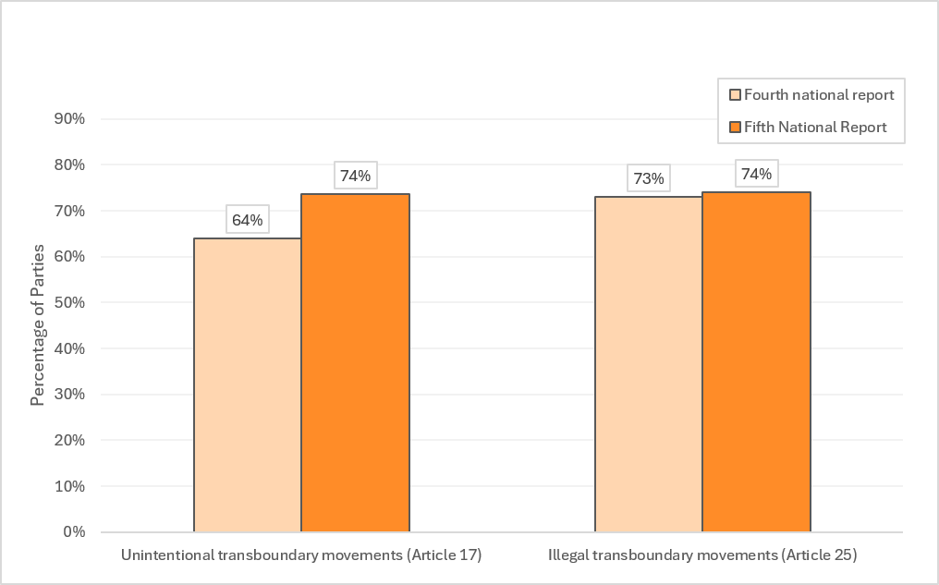
- Most Parties providing free text answers regarding the implementation of Article 25 reported that they had adopted or were developing domestic legal and institutional frameworks to prevent and penalize illegal transboundary movements of living modified organisms. While many Parties indicated that they had not detected cases of illegal transboundary movement during the reporting period, some Parties identified specific incidents concerning various species, including ornamental fish, soybeans, tomato, linseed, cotton, lentiviral vectors, rapeseed and papaya. It was noted that some of those incidents had occurred through unintentional imports, smuggling of seeds across porous borders or in times of conflict. Several Parties acknowledged gaps in capacity, including insufficient border detection and laboratory testing capabilities, lack of traceability systems, absence of implementing regulations for existing legislation, porous borders and limitations with respect to trained personnel. Parties mentioned that such challenges constrained the effective implementation of Article 25 and led to the potential underreporting of illegal movements.
- For goal A.6, under the capacity-building action plan, the following two key areas for capacity-building were identified: establishment of functional national systems for detection, notification and appropriate responses to unintentional transboundary movements, in accordance with Article 17 of the Protocol; and establishment of functional domestic measures to prevent and address illegal transboundary movement in accordance with Article 25 of the Protocol.
- Twenty-six per cent of Parties reported having carried out capacity-building activities in the field of measures to address unintentional and/or illegal transboundary movements of living modified organisms, representing a 2 per cent increase from the baseline. Of those Parties, 81 per cent reported having adopted domestic measures aimed at preventing and/or penalizing transboundary movements of living modified organisms carried out in contravention of its domestic measures to implement the Cartagena Protocol, while 4 per cent reported having adopted such measures to some extent.
- Of the Parties reporting that they still had capacity-building needs, 82 per cent stated that they had such needs in the field of measures to address unintentional and/or illegal transboundary movements of living modified organisms, representing an increase of 2 per cent from the baseline.
- In their fifth national reports, a total of 6 Parties reported cases of unintentional transboundary movements of living modified organisms and 26 Parties reported cases of illegal transboundary movements of living modified organisms. However, only two records concerning communications of information about an illegal transboundary movement of living modified ornamental fish and zero communications of unintentional transboundary movements were submitted to the Biosafety Clearing-House.
- In the context of illegal and unintentional transboundary movements, information on training in the field of monitoring capacities may be relevant. Sixty-eight per cent of Parties reported that individuals had been trained on the monitoring of living modified organisms, representing a 4 per cent decrease from the baseline.

G. Goal A.7. Parties have measures in place to fulfil the handling, transport, packaging and identification requirements of living modified organisms under Article 18 of the Protocol
(a) Key figures and highlights
- Sixty per cent of Parties had taken measures to require that living modified organisms subject to transboundary movements were handled, packaged and transported under conditions of safety. Considerable variation was observed among the regions, with 15 per cent of Parties in one region having reported taking such measures compared with 100 per cent of Parties in another region
- Fifty-one per cent of Parties reported having the capacity to enforce the requirements of identification and documentation of living modified organisms and 28 per cent of Parties reported having such capacity to some extent
- Very little capacity-building had been undertaken during the reporting period on the implementation of the documentation requirements under Article 18, paragraph 2, of the Protocol, with only 16 per cent of Parties reporting having carried out activities in that regard
(b) Analysis of information
- Goal A.7 includes two objectives to be accomplished in order to achieve the goal and four indicators to measure progress towards those objectives. With regard to indicator A.7 (a) (percentage of Parties that have taken necessary measures to require that living modified organisms subject to transboundary movement are handled, packaged and transported under conditions of safety, taking into consideration relevant international rules and standards, as appropriate), information provided in the response to question 79 of the fifth national report was used to measure progress in that regard.
- Sixty per cent of Parties reported having taken measures to require that living modified organisms subject to transboundary movement were handled, packaged and transported under conditions of safety, taking into account relevant international rules and standards, representing an increase of 5 per cent from the baseline. Considerable regional variability could be observed and the regional breakdown for Parties that reported having taken those measures was as follows: 15 per cent of Parties in the Latin American and Caribbean region (no change from the baseline); 54 per cent of Parties in the Asia-Pacific region (+8 per cent); 59 per cent of Parties in the African region (+5 per cent); 79 per cent of Parties in the Eastern European region (+11 per cent); and 100 per cent of Parties in the Western European and other States region (no change from the baseline) reporting to have taken these measures. A further 15 per cent of Parties reported having taken such measures to some extent, which represented a decrease of 2 per cent from the baseline. When Parties that reported having taken such measures and Parties that reported having taken such measures to some extent were considered together, the proportion of Parties that reported having taken such measures, at least to some extent, was 75 per cent (an increase of 3 per cent from the baseline), as indicated in figure V below, with regional differences becoming less pronounced.
- Indicators A.7 (b), (c) and (d) were, respectively: (b) percentage of Parties that have put in place documentation requirements for living modified organisms intended for direct use as food or feed, or for processing; (c) percentage of Parties that have put in place documentation requirements for living modified organisms destined for contained use; and (d) percentage of Parties that have put in place documentation requirements for living modified organisms for intentional introduction into the environment and other living modified organisms. Information provided in response to questions 80, 81, 83 and 85 of the fifth national report was used to measure progress in this regard.
- Fifty per cent of Parties reported having taken measures to require that documentation accompanying living modified organisms intended for direct use as food or feed, or for processing, in cases where the identity of the living modified organisms was not known, clearly identified that the shipment may contain living modified organisms and that they were not intended for intentional introduction into the environment. That figure represented an increase of 4 per cent from the baseline. At the regional level, considerable variation was observed and the regional breakdown for the Parties that had reported having taken measures was as follows: 15 per cent of Parties in the Latin American and Caribbean region (+5 per cent); 46 per cent of Parties in the African region (+5 per cent); 46 per cent of Parties in the Asia-Pacific region (+11 per cent); 74 per cent of Parties in the Eastern European region (+11 per cent); and 79 per cent of Parties of the Western European and other States region (-16 per cent). Twelve per cent of Parties reported having taken these measures to some extent (representing a 4 per cent decrease from the baseline). When Parties that reported having taken such measures and Parties that reported having taken such measures to some extent were considered together, the global total was 62 per cent (no change from the baseline), as indicated in figure V below.
- Fifty-five per cent of Parties reported having taken measures requiring that documentation accompanying living modified organism intended for direct use as food or feed, or for processing, in cases where the identity of the living modified organism is known, clearly identifies that the shipment contains living modified organisms and that they are not intended for intentional introduction into the environment, as well as provides a contact point for further information. That represented an increase of 2 per cent from the baseline. More specifically, 15 per cent of Parties in the Latin American and Caribbean region (-10 per cent), 38 per cent of Parties in the Asia-Pacific region (+3 per cent), 54 per cent of Parties in the African region (+5 per cent), 79 per cent of Parties in the Eastern European region (+11 per cent), and 100 per cent of Parties in the Western European and other States region (no change from the baseline) reported having taken such measures. Thirteen per cent of Parties reported having taken such measures to some extent, representing a 4 per cent decrease from the baseline. When Parties that reported having taken such measures and Parties that reported having taken such measures to some extent were considered together, the global total was 68 per cent (a decrease of 2 per cent from the baseline), as indicated in figure V below.
- Sixty-two per cent of Parties reported having taken measures to require that documentation accompanying living modified organisms that are destined for contained use clearly identifies them as living modified organisms and specifies any requirements for safe handling, storage, transport and use, and the contact point for further information, including the name and address of the individual and institution to which the living modified organisms are consigned. That figure represented an increase of 8 per cent from the baseline. Considerable regional variation was observed: 25 per cent of Parties in the Latin American and Caribbean region (+10 per cent), 46 per cent of Parties in the Asia-Pacific region (+11 per cent), 62 per cent of Parties in the African region (+8 per cent), 84 per cent of Parties in the Eastern European region (+10 per cent) and 100 per cent of Parties in the Western European and other States region (no change from the baseline) reported having taken such measures. Ten per cent of Parties reported having taken measures in that regard to some extent, representing a decrease of 4 per cent from the baseline. When Parties that reported having taken such measures and Parties that reported having taken such measures to some extent were considered together, the global total was 72 per cent (representing an increase of 4 per cent from the baseline), as indicated in figure V below.
- Fifty-seven per cent of Parties had taken measures to require that documentation accompanying living modified organisms that are intended for intentional introduction into the environment of the Party of import clearly identifies them as living modified organisms. That figure represented a 3 per cent increase from the baseline. Considerable regional variation was observed: 25 per cent of Parties in the Latin American and Caribbean region (+5 per cent), 35 per cent of Parties in the Asia-Pacific region (-7 per cent), 59 per cent of Parties in the African region (+8 per cent), 74 per cent of Parties in the Eastern European region (+6 per cent) and 100 per cent of Parties in the Western European and other States region (no change from the baseline), reported having taken such measures. Fifteen per cent of Parties reported having taken measures in that regard to some extent, representing a 1 per cent decrease from the baseline. When Parties that reported having taken such measures and Parties that reported having taken such measures to some extent were considered together, the global total was 72 per cent (representing an increase of 2 per cent from the baseline), as indicated in figure V below.
Figure V
Measures taken by Parties related to handling, transport, packaging and identification of living modified organisms (Article 18)
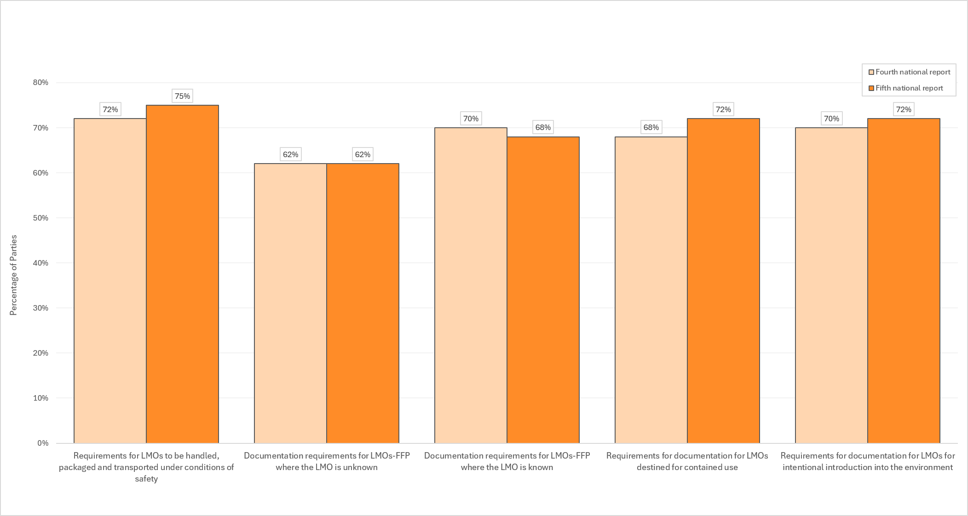
Abbreviations: LMOs, living modified organisms; LMOs-FFP, living modified organisms intended for direct use as food or feed, or for processing.
- In their free text answers regarding implementation of Article 18, Parties described a wide spectrum of implementation challenges that they were facing. Many Parties stated that they had established legal and regulatory frameworks governing the handling, transport, packaging, labelling and identification of living modified organisms, with some operating under comprehensive regional frameworks that mandated traceability, unique identifiers and detailed accompanying documentation for all categories of living modified organisms. Some Parties noted, however, that such frameworks were not yet fully operationalized or effectively enforced, particularly at points of entry. In that regard, Parties observed that, often, customs officers had not received training specifically related to living modified organisms and that infrastructure for detection of living modified organisms was absent, limited or non-functional. Some Parties reported having relied on foreign testing facilities for detection and identification of living modified organisms which could result in delays in analysis and decision-making. Capacity-building, sustained financial support, access to certified reference materials, laboratory accreditation, training of border and laboratory personnel and strengthening of inter-agency coordination were consistently identified as urgent priorities across all regions. Several Parties mentioned that the high costs of specialized reagents and new advances in biotechnology were further challenges to effective implementation of Article 18.
- For goal A.7, one key area for capacity-building was identified under the capacity-building action plan: establishment of functional national systems for handling, transport, packaging and identification, including in relation to documentation.
- Of the 98 Parties that reported having undertaken activities for the development and/or strengthening of human resources and institutional capacities in biosafety in the reporting period, 16 per cent reported that those activities had been undertaken in the field of the implementation of the documentation requirements under Article 18, paragraph 2, of the Protocol (an increase of 3 per cent from the baseline). Of the 100 Parties that reported that they still had capacity-building needs, 72 per cent reported that capacity-building on documentation requirements for handling, transport, packaging and identification was needed (an increase of 6 per cent from the baseline).
- In that context, further information on enforcement capacities was provided in response to question 87 of the fifth national report. Fifty-one per cent of Parties reported having the capacity to enforce the requirements for the identification and documentation of living modified organisms (an increase of 3 per cent from the baseline), while 28 per cent of Parties reported having such capacity to some extent (an increase of 3 per cent from the baseline).

H. Goal A.8. Parties are able to detect and identify living modified organisms
(a) Key figures and highlights
- The Biosafety Clearing-House provides access to detection methods for 56 per cent of the living modified organism records that it contains and in the fifth national report, 80 per cent of Parties reported having had access to resource materials and detection methods for detecting and identifying living modified organisms and 75 per cent reported having used those materials and methods
- Eighty-six per cent of Parties reported having had reliable access to technical infrastructure for the detection of living modified organisms (+7 per cent) and 75 per cent had access to such infrastructure for the identification of living modified organisms (no baseline information was available)
- Seventy-four per cent of Parties had access to tools for detecting and identifying living modified organisms and 67 per cent of Parties had access to certified reference materials. Considerable regional variation could be observed among Parties in different regions with respect to their reporting on having had access to and having used certified reference materials (between 39 and 95 per cent; and 48 and 100 per cent, respectively)
- Capacity-building on sampling, detection and identification of living modified organisms was a growing need for Parties (88 per cent, representing an 8 per cent increase from the baseline)
(b) Analysis of information
- Goal A.8 included three objectives to be accomplished in order to achieve the goal and four indicators to measure progress towards those objectives. With regard to indicator A.8 (a) (percentage of living modified organisms on the Biosafety Clearing-House for which detection methods are available), 569 living modified organism records have associated information in the detection method(s) field of the common format out of a total of 1,018 living modified organism records published on the Biosafety Clearing-House (representing 56 per cent of living modified organism records). No baseline information could be established, as the detection method(s) field utilized dynamic information retrieval to populate the field with automated links to the GMOMETHODS database of the European Union Reference Laboratory for Genetically Modified Food and Feed and the detection methods database of CropLife International.
- With regard to indicator A.8 (b), (percentage of Parties that have access to and use resource materials and detection methods to detect and identify living modified organisms), information provided in response to questions 90 (a) and 90 (b) of the fifth national reports was used to measure progress. No baseline information was available, as those questions were not included in the fourth national report. Eighty per cent of Parties reported having had access to resource materials and detection methods for detecting and identifying living modified organisms and 75 per cent of Parties reported having used resource materials and detection methods to detect and identify living modified organisms.
- With regard to indicator A.8 (c), (percentage of Parties that have access to and use certified reference materials necessary to detect and identify living modified organisms), information provided in response to questions 92 (a) and 92 (b) of the fifth national report was used to measure progress. No baseline information was available, as those questions were not included in the fourth national report. Sixty-seven per cent of Parties reported having had access to certified reference materials necessary to detect and identify living modified organisms, while 65 per cent reported having used such certified reference materials. Considerable variation was observed in the proportion of Parties in the different regions that reported having had access to certified reference materials: 48 per cent of Parties in the Latin American and Caribbean region; 59 per cent of Parties in the African region; 62 per cent of Parties in the Asia-Pacific region; 84 per cent of Parties in the Eastern European region; and 100 per cent of Parties in the Western European and other States region. Similar levels of variation were observed in the proportion of Parties that reported having used certified reference materials: 39 per cent of Parties in the Latin American and Caribbean region; 51 per cent of Parties in the African region; 73 per cent of Parties in the Asia-Pacific region; 84 per cent in the Eastern European region; and 95 per cent of Parties in the Western European and other States region.
- With regard to indicator A.8 (d) (percentage of Parties that have access to the technical infrastructure needed to detect and identify living modified organisms), information provided in response to questions 94 (a) and 94 (b) of the fifth national report was used to measure progress. Eighty-six per cent of Parties reported that they had reliable access to technical infrastructures, such as laboratories, for the detection of living modified organisms (an increase of 7 per cent from the baseline), while 75 per cent of Parties reported that they had reliable access to technical infrastructures, such as laboratories, for the identification of living modified organisms. Regarding the technical infrastructure for identification of living modified organisms, no information was available for the baseline.
- That indicator could be further complemented by the information provided in response to question 91 (a) of the fifth national report regarding access to tools for detecting and identify living modified organisms. Seventy-four per cent of Parties reported having access to tools for detection and identification of living modified organisms and the breakdown for the proportion of Parties having access to such tools by region was as follows: 57 per cent of Parties in the Latin American and Caribbean region; 66 per cent of Parties in the African region; 69 per cent of Parties in the Asia-Pacific region; 95 per cent of Parties in the Eastern European region; and 100 per cent of Parties in the Western Europe and other States region. No information was available for the baseline, as that question was not included in the fourth national report.
- Parties provided additional information related to the detection and identification of living modified organisms in their free text answers regarding the implementation of Articles 15, 16, 17, 18 and 25. Several Parties reported well-established networks of accredited laboratories capable of detection, identification and quantification of living modified organisms, using real time polymerase chain reactions and other molecular techniques, while numerous other Parties reported that laboratories existed but lacked accreditation, certified reference materials, adequate equipment or personnel with sufficient training. Many Parties highlighted the need for further strengthening of capacities to detect and identify living modified organisms in order to support the implementation of the Cartagena Protocol. In particular, developing country Parties mentioned the need to improve laboratory infrastructure and develop appropriate technical infrastructure at ports of entry.
- For goal A.8, four key areas for capacity-building were identified under the capacity-building action plan: (a) development, as necessary, and access to resource materials, procedures and information for sampling, detection and identification of living modified organisms; (b) strengthening sampling, detection and identification capacities of officials and laboratory staff; (c) access to technical infrastructure for detection and identification, including certified reference materials; and (d) strengthening collaboration, including through networks of laboratories.
- Of the Parties reporting that they had undertaken activities for the development and/or strengthening of human resources and institutional capacities in biosafety, 56 per cent reported that those activities were undertaken in the area of identification of living modified organisms, including detection (an increase of 6 per cent from the baseline). Of the Parties that reported that they still had capacity-building needs, 88 per cent indicated that those needs related to the field of sampling, detection and identification of living modified organisms (an increase of 8 per cent from the baseline).
- Further information on the technical infrastructure was provided in response to question 95 of the fifth national report on how many laboratories in a country were certified for the detection of living modified organisms. In response to that question, 63 per cent of Parties reported that one or more laboratories in their country was certified for the detection of living modified organisms, an increase of 7 per cent from the baseline, and in that group of Parties, three quarters reported that there were between one and four certified labs in their country, which represented an increase of 5 per cent.
- The Secretariat has undertaken activities to support Parties in strengthening their capacities in regard to the detection and identification of living modified organisms. The Secretariat published the Training Manual on the Detection and Identification of Living Modified Organisms in the Context of the Cartagena Protocol on Biosafety. In March 2023, the Secretariat co-organized the International Conference on GMO Analysis and New Genomic Techniques, which was attended by 21 participants from 21 Parties. A global workshop on the detection and identification of living modified organisms and the role of customs officials in implementing the Cartagena Protocol on Biosafety, which was held by the Secretariat of the Convention on Biological Diversity in Ljubljana in September 2025, brought together 32 participants from 12 Parties with a view to fostering learning and sharing of experiences related to the detection and identification of living modified organisms.
- The Secretariat facilitated, through the Biosafety Clearing-House, a network of laboratories for the detection and identification of living modified organisms. The network currently includes more than 80 participants from 33 Parties, as well as participants from non-Parties and organizations. The Secretariat periodically convenes online discussions of the network to enable the sharing of experiences on the detection and identification of living modified organisms.

I. Goal A.9. Parties that choose to do so take into account socioeconomic considerations when making decisions on the import of living modified organisms and cooperate on research and information exchange in accordance with Article 26 of the Protocol
(a) Key figures and highlights
- Thirty-two per cent of Parties that had taken decisions on the import of living modified organisms in the reporting period reported having always taken into account socioeconomic considerations (+4 per cent) and 35 per cent reported having done so only in some cases (+3 per cent)
- Thirty per cent of Parties reported that they had used resource materials for taking socioeconomic considerations into account (no baseline data)
- Twenty-nine per cent of Parties reported that they had cooperated with other Parties on research and information exchange on any socioeconomic impacts of living modified organisms (+1 per cent)
- Twenty-six per cent of Parties that reported having carried out capacity-building activities reported that those activities had been undertaken in the area of socioeconomic considerations (-3 per cent), while 73 per cent of Parties with capacity-building needs reported having those needs in the area of socioeconomic considerations (+3 per cent)
(b) Analysis of information
- Goal A.9 includes three objectives to be accomplished in order to achieve the goal and three indicators to measure progress towards the objectives.
- For indicator A.9 (a) (percentage of Parties that take into account socioeconomic considerations in decision-making in accordance with Article 26 of the Protocol), information provided in response to question 151 of the fifth national report was used to measure progress. Of the 123 Parties considered, 56 per cent (69 Parties) reported having taken decisions during the reporting period on the import of living modified organisms. Of those 69 Parties, 32 per cent reported having always taken socioeconomic considerations arising from the impact of living modified organisms into account in those decisions (a 4 per cent increase from the baseline); 35 per cent reported having done so only in some cases (a 3 per cent increase from the baseline); and 33 per cent reported that they had not done so (a decrease of 8 per cent) (see figure VI below).
Figure VI
Socioeconomic considerations in import decisions
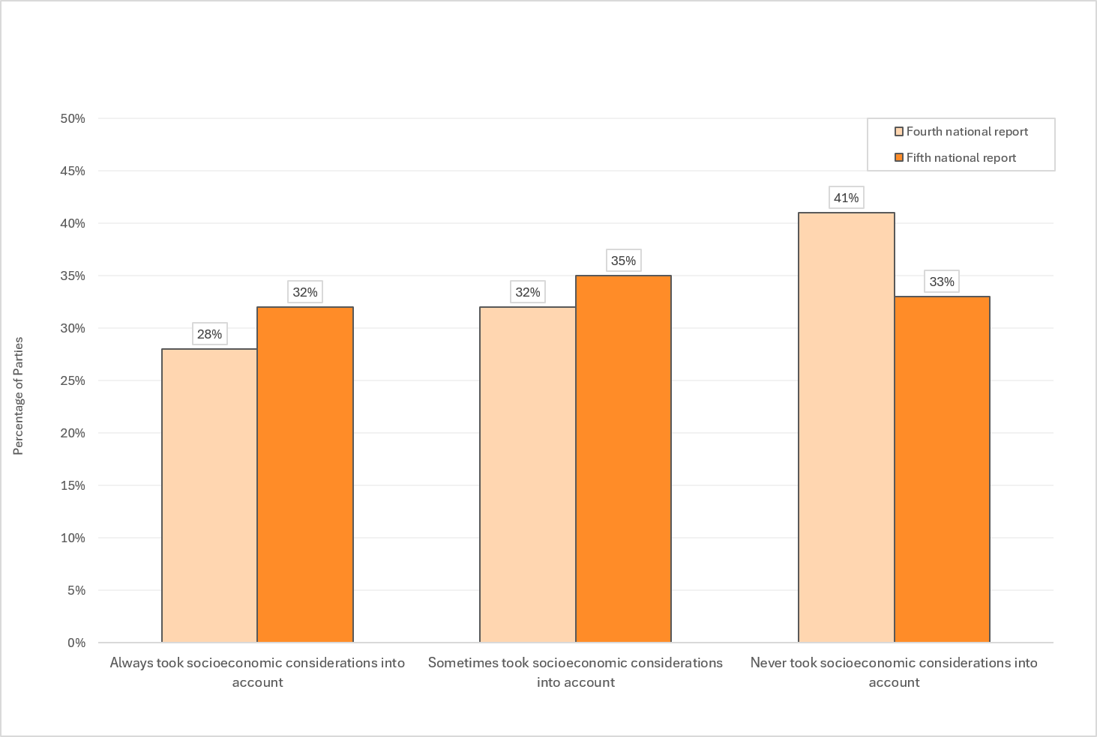
- With regard to indicator A.9 (b) (percentage of Parties that access and use resource materials for taking socioeconomic considerations into account), information provided in response to question 150 of the fifth national report was used to measure progress. As no similar question was included in the fourth national report, there was no information available for the baseline. Thirty per cent of Parties reported that they had used resource materials for taking socioeconomic considerations into account. At the regional level, there were considerable differences in the proportion of Parties reporting that they had accessed and used such resource materials. The breakdown was as follows: 11 per cent in the Eastern European region; 13 per cent in the Latin American and Caribbean region; 16 per cent in the Western European and other States region; 23 per cent in the Asia-Pacific region; and 59 per cent in the African region.
- For indicator A.9 (c) (percentage of Parties that cooperate on research and information exchange on any socioeconomic impacts of living modified organisms on the conservation and sustainable use of biological diversity, especially on indigenous peoples and local communities, in accordance with Article 26 of the Protocol), information provided in response to question 155 (c) of the fifth national report was used to measure progress. Twenty-nine per cent of Parties reported that they had cooperated with other Parties on research and information exchange related to any socioeconomic impacts of living modified organisms, representing an increase of 1 per cent. There were considerable differences among the regions with respect to the proportion of Parties that reported that they had cooperated in that regard. The breakdown was as follows: 10 per cent in the Latin American and Caribbean region; 26 per cent in the African region; 26 per cent in the Eastern European region; 35 per cent in the Asia-Pacific region; and 53 per cent in the Western European and other States region.
- In their free text answers to question 152 of the fifth national report, several Parties provided additional information related to socioeconomic considerations. Most of those Parties indicated that their regulatory framework enabled or required the consideration of socioeconomic aspects in the decision-making process related to living modified organisms. Some Parties mentioned that guidance documents for assessing socioeconomic aspects were in place or under development. Several Parties described that, in the current reporting period, socioeconomic aspects had been taken into consideration in decision-making on living modified organisms. Some of those Parties described their experience in that regard in greater detail and listed elements that were considered part of their socioeconomic assessment processes, including: income of farmers; income of households; production costs and profitability; reduction of pesticide use and cases of pesticide poisoning; and issues related to community acceptance of living modified organisms. One Party mentioned that guidance developed by the Ad Hoc Technical Expert Group on Socioeconomic Considerations had been taken into account in the assessments of socioeconomic aspects in a decision-making process concerning living modified microorganisms. A few Parties mentioned that capacity development was needed in the field of socioeconomic considerations.
- In their free text answers, several of those Parties that had indicated that their regulatory framework allowed for taking into account socioeconomic considerations mentioned that no decisions had been taken in the reporting period and that as a result socioeconomic considerations had not been taken into account. Some Parties indicated that, although their regulatory framework allowed for taking into consideration socioeconomic considerations, in practice the issue was not always considered or presented practical challenges.
- Several Parties stated that their regulatory framework did not provide for taking into account socioeconomic considerations. Some of those Parties indicated that efforts were under way or planned that would enable them to take socioeconomic considerations into account in the future.
- For goal A.9, two key areas for capacity-building were identified under the capacity-building action plan: (a) strengthening capacities for taking into account socioeconomic considerations in accordance with Article 26; and (b) development and access to resource materials on socioeconomic considerations.
- Of the 100 Parties that reported that they still had capacity-building needs, 73 per cent reported that those needs existed for the development of capacities in the field of socioeconomic considerations (a 3 per cent increase from the baseline). Of the 98 Parties that reported having undertaken activities for the development and/or strengthening of human resources and institutional capacities in biosafety, 26 per cent reported that those activities had been undertaken in the area of socioeconomic considerations (a 3 per cent decrease from the baseline).

J. Goal A.10. Parties to the Cartagena Protocol become Parties to the Nagoya- Kuala Lumpur Supplementary Protocol on Liability and Redress and have in place measures to fulfil their obligations under the Supplementary Protocol
(a) Key figures and highlights
- Between 2020 and 2025, eight countries became Party to the Nagoya-Kuala Lumpur Supplementary Protocol on Liability and Redress, bringing the total number of Parties to the Supplementary Protocol to 55
- Twenty-five countries reported that a national process towards becoming a Party to the Supplementary Protocol was in place
- Of the Parties to the Supplementary Protocol, 60 per cent reported having measures fully in place for the implementation of the Supplementary Protocol (+2 per cent); 7 per cent reported that national measures were partially in place (no change from the baseline); 2 per cent reported that only draft measures existed and 2 per cent reported that only temporary measures had been taken (no change from the baseline in both cases); and 29 per cent reported that no measures had yet been taken (-2 per cent)
- Eighty-two per cent of Parties to the Nagoya-Kuala Lumpur Supplementary Protocol on Liability and Redress reported on the implementation of the Supplementary Protocol in the fifth national report.
(b) Analysis of information
- Goal A.10 includes three objectives to be accomplished in order to achieve the goal and three indicators to measure progress towards those objectives.
- With regard to indicator A.10 (a) (percentage of Parties to the Cartagena Protocol that have become Parties to the Supplementary Protocol), information on the status of ratifications was used to measure progress. In the reporting period, eight Parties to the Cartagena Protocol deposited their instrument of ratification, acceptance, approval or accession to the Supplementary Protocol, bringing the total number of Parties to 55, which represented 32 per cent of the Parties to the Cartagena Protocol.
- Twenty-five Parties reported that a national process towards becoming a Party to the Supplementary Protocol was in place. Sixteen of those Parties were in the African region; 4 in the Asia-Pacific region; 3 in the Latin American and Caribbean region; and 1 each in the Eastern European region and the Western European and other States region.
- With regard to indicator A.10 (b) (percentage of Parties to the Supplementary Protocol that have the necessary measures in place to implement the provisions of the Supplementary Protocol), information provided in response to question 160 of the fifth national report was used to measure progress. Of the Parties to the Supplementary Protocol, 60 per cent (27 Parties) reported having measures fully in place for the implementation of the Supplementary Protocol (an increase of 2 per cent) and 7 per cent (3 Parties) reported that national measures were partially in place (no change from the baseline). Two per cent of Parties (1 Party) reported that only draft measures existed and 2 per cent of Parties (1 Party) reported that only temporary measures had been taken (no change from the baseline in both cases), while 29 per cent (13 Parties) reported that no measures had yet been taken (a 2 per cent decrease) (see figure VII).
- No change from the baseline was seen at the regional level, with the exception of the African region, with steep regional differences with respect to the extent to which measures had been adopted. Specifically:
- In the Latin American and Caribbean region, 100 per cent of Parties to the Supplementary Protocol reported that no measures had been taken
- In the Asia-Pacific region, 50 per cent of Parties reported that only temporary measures had been taken and 50 per cent reported that no measures had been taken
- In the African region, 20 per cent of Parties reported that measures were fully in place (+10 per cent); 20 per cent reported that measures were partially in place (no change from the baseline); 10 per cent reported that only draft measures had been taken (no change from the baseline); and 50 per cent reported that no measures had been taken (-10 per cent)
- In the Eastern European region, 75 per cent of Parties reported that national measure were fully in place; 8 per cent reported that measures were partially in place; and 17 per cent reported that no measures had been taken
- In the Western European and other States region, 100 per cent of Parties reported that national measures were fully in place
Figure VII
Measures in place for the implementation of the Nagoya-Kuala Lumpur Supplementary Protocol

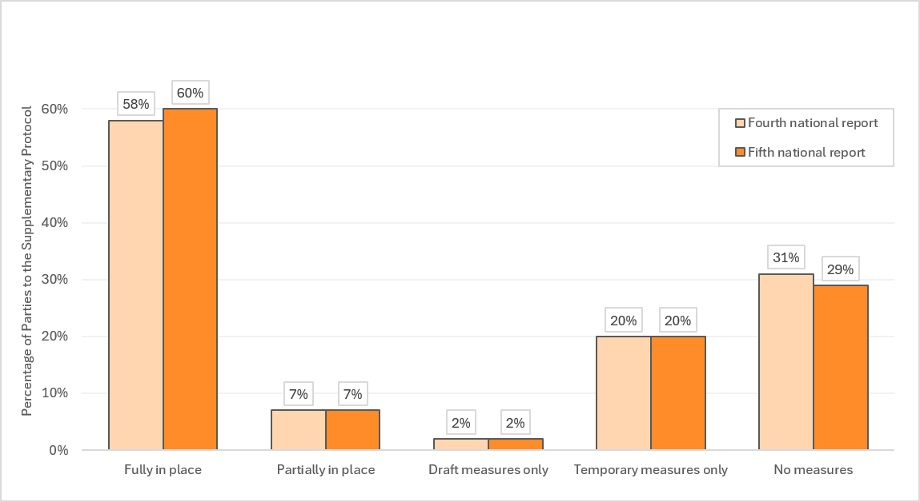
- With regard to indicator A.10 (c) (percentage of Parties to the Supplementary Protocol reporting on the implementation of the Supplementary Protocol), information provided by Parties answering questions relating to the Supplementary Protocol in the fifth national report was used to measure progress. By 2 March 2026, 82 per cent of Parties to the Supplementary Protocol (45 Parties) had submitted their fifth national report and all of them had responded to multiple choice questions related to the Supplementary Protocol in the fifth national report. Ten Parties to the Supplementary Protocol (18 per cent) had not yet submitted their fifth report.
- Eighty-two Parties provided a free text answer to question 174. Of those Parties, 38 were Party to the Supplementary Protocol, while 44 were not.
- For goal A.10, five key areas for capacity-building were identified under the capacity-building action plan: (a) supporting Parties to the Cartagena Protocol in ratifying the Supplementary Protocol; (b) development of national legal, administrative and other measures to implement the Supplementary Protocol; (c) development and access to resource materials, experiences and lessons learned regarding implementation of the Supplementary Protocol; (d) strengthening capacities of competent authorities of Parties to the Supplementary Protocol to discharge their functions; and (e) development or identification of baselines of the status of biodiversity.
- Of the 100 Parties that reported that they still had capacity-building needs, 71 per cent reported that those needs existed for the development of capacities in the field of liability and redress (a 5 per cent increase from the baseline). Of the 98 Parties that reported having undertaken activities for the development and/or strengthening of human resources and institutional capacities in biosafety, 10 per cent (10 Parties) reported that those activities had been undertaken in the area of liability and redress (a 7 per cent decrease).
- Of the resources on the Supplementary Protocol developed by the Secretariat, the web pages relating to the Supplementary Protocol received 14,777 page views and 9,745 active users between June 2023 and 28 February 2026.
- In the free text answers provided by Parties to the Supplementary Protocol, several Parties described how the Supplementary Protocol had been implemented in domestic legislation. Others explained that the Supplementary Protocol had not yet been implemented or had not yet been fully implemented. Some Parties indicated that draft legislation had been developed and a few of those Parties indicated that they had faced challenges in the course of the adoption process, including challenges of a technical, legal and institutional nature. Several Parties reported that further implementation measures were required.
- In the free text answers provided by non-Parties to the Supplementary Protocol, many described the domestic legal framework for environmental liability and several of those non-Parties indicated that the framework would also apply to damage resulting from living modified organisms. Some of those non-Parties indicated that their current national legal framework for liability and redress for damage from living modified organisms was insufficient and some of those non-Parties described ongoing efforts to strengthen their domestic legislation, with several in the latter group mentioning that they had faced challenges in that regard.
- In their free text answers, several non-Parties to the Supplementary Protocol indicated that no national process for becoming a Party to the instrument was in place. Some of them indicated that their current domestic framework for liability was sufficient. Several other non-Parties stated that there was a national process for becoming a Party to the instrument, or described that there was a need or a willingness to do so.

K. Goal B.1. Parties engage in capacity-building activities
(a) Key figures and highlights
- Eighty-one per cent of Parties reported that they still had capacity-building needs (-2 per cent)
- Eighty per cent of Parties had carried out, at least to some extent, activities for the development or strengthening of human resources and institutional capacities in biosafety (-2 per cent)
- Fifty-two per cent of Parties reported having cooperated with other Parties in strengthening capacities for the implementation of the Protocol
- Many Parties continued to rely on external funding to strengthen their domestic biosafety capacities.
(b) Analysis of information
- Goal B.1 includes four objectives to be accomplished in order to achieve the goal and four indicators to measure progress towards those objectives. For indicator B.1 (a) (percentage of Parties that have identified and prioritized their capacity-building needs), information provided in response to questions 121, 122 and 124 of the fifth national reports was used to measure progress.
- Forty-two per cent of Parties reported that they had carried out a capacity-building needs assessment (an increase of 2 per cent from the baseline). The regional breakdown for the proportion of Parties that had carried out a needs assessment showed pronounced changes in the Eastern European region and the Latin American and Caribbean region and was as follows: 11 per cent in the Western European and other States region (no change from the baseline); 25 per cent in the Latin American and Caribbean region (-25 per cent); 47 per cent in the Eastern European region (+26 per cent); 54 per cent in the Asia-Pacific region (+4 per cent); and 56 per cent in the African region (+5 per cent).
- Eighty-one per cent of Parties reported that they still had capacity-building needs, representing a decrease of 2 per cent from the baseline. The decrease was the result of decreases in the number of Parties reporting that they still had capacity-building needs in two regions only, namely, the Eastern European region where 84 per cent of Parties reported that they still had capacity-building needs (-5 per cent); and the Western European and other States region where 11 per cent of Parties reported that they still had needs (-5 per cent). No changes were reported in other regions, where the proportion of Parties that reported that they still had capacity-building needs remained as follows: African region: 100 per cent; Latin American and Caribbean region: 100 per cent; and Asia-Pacific region: 88 per cent.
- Sixty-four per cent of Parties reported that they had prioritized their capacity-building needs. Although the same question was not included in the format for the fourth national reports, in a similar question in the fourth national report Parties were asked whether they had developed a capacity-building action plan, which implied some level of prioritization of capacity-building needs. At the time, 30 per cent of Parties reported that they had developed a capacity-building action plan or strategy. A comparison of the answers provided in response to the two similar questions in the fourth and fifth national reports for the same group of Parties made it apparent that there had been an increase of 34 per cent. To a large extent, that large increase might have been the result of the differences in the formulation of the questions.
- For indicator B.1 (b) (percentage of Parties undertaking capacity-building activities), information provided in response to question 118 of the reporting format for the fifth national report was used to measure progress. Fifty-one per cent of Parties reported that they had undertaken activities for the development and/or strengthening of human resources and institutional capacities in biosafety in the current reporting period (a decrease of 11 per cent), while 28 per cent of Parties reported having done so to some extent (an 8 per cent increase). Considered together, the proportion of Parties that reported that they had undertaken such activities, at least to some extent, was 80 per cent (a decrease of 2 per cent). When both groups were considered together at the regional level, the proportion of Parties that reported having undertaken capacity-building activities at least to some extent showed an increase in only two regions and a decrease in the other three regions as follows: African region: 74 per cent (-11 per cent); Latin American and Caribbean region: 75 per cent (-5 per cent); Western European and other States region: 79 per cent (+16 per cent); Asia-Pacific region: 81 per cent (-7 per cent); and Eastern European region: 95 per cent (+6 per cent).
- With regard to indicator B.1 (c) (percentage of Parties with capacity-building needs that use capacity-building materials, including online resources), information provided in response to question 120 of the fifth reporting format was used to measure progress. No information was available for the baseline, as the question had not been included in the fourth national report. Of the Parties that reported having undertaken capacity-building activities in the current reporting period or having done so to some extent, 81 per cent reported having used capacity-building materials, including online resources, for the development and/or strengthening of capacity-building.
- With regard to indicator B.1 (d) (percentage of Parties that cooperate to strengthen capacities for the implementation of the Protocol), information provided in response to question 155 (e) of the fifth national report was used to measure progress. No information was available for the baseline, as the question was not included in the fourth national report. Fifty-two per cent of Parties reported that they had cooperated with other Parties in strengthening capacities for the implementation of the Protocol.
- For goal B.1, four key areas for capacity-building were identified under the capacity-building action plan: (a) self-assessment of capacity-building needs and priorities; (b) provision of support for capacity-building activities; (c) access to capacity-building materials; and (d) cooperation in capacity-building activities. The indicators of the capacity-building action plan covered the same issues as those covered under the implementation plan.
- In their free text answers to question 126, Parties provided further details on capacity-building efforts. Many developing country Parties explained that they lacked national budget allocations for strengthening biosafety capacities or that their national budget in that regard was insufficient. Several of those Parties indicated that, as a result, they had depended on external funding for their capacity-building activities conducted through projects and some Parties mentioned that as a result capacity-building efforts were fragmented. In that context, many Parties described how they had benefited from the support of donors, including GEF. Some of those Parties indicated that accessing GEF funding for biosafety activities was challenging and national priorities diverted allocations under the System for Transparent Allocation of Resources away from biosafety. Some Parties described how they had benefited from regional biosafety initiatives and programmes.
- Common challenges described by Parties in their free text answers included lack of trained staff, high turnover of staff, lack of institutional coordination and lack of financial resources. A few Parties noted that in the light of the rapid development of biotechnologies, further efforts were needed.
- About half of the Parties provided details on capacity-building initiatives that they had been involved in during the reporting period. Common areas of focus that were mentioned in that regard were: development of legal frameworks, institutional coordination, risk assessment and management, detection and identification and development of laboratory facilities, customs capacities, public awareness and outreach. Some of those Parties explained that efforts in those areas had been undertaken based on biosafety capacity-building needs assessments. One Party mentioned how it had identified its biosafety capacity needs in the context of Target 17 of the Kunming-Montreal Global Biodiversity Framework with the assistance of a regional centre of excellence.
- Some Parties described how they had supported other Parties in strengthening their capacities for biosafety or how activities that they had undertaken benefited the strengthening of capacities for biosafety in other countries.
- Through Convention on Biological Diversity notification 2025-1 issued on 3 January 2025, Parties, other Governments and organizations were invited to share information on capacity-building initiatives. Submissions were received from 19 Parties, one from a non-Party to the Cartagena Protocol and six from organizations. A summary of the submissions was made available in support of an online forum discussion which was held from 14 to 18 July 2025. The forum discussions addressed capacity-building needs and challenges, ongoing and planned capacity-building initiatives and lessons learned and opportunities centred on the goals of the capacity-building action plan for the Cartagena Protocol.
- Between January 2020 and March 2026, 22 capacity development initiatives were uploaded on the Biosafety Clearing-House. Moreover, several news articles on biosafety capacity-building initiatives were shared through the Biosafety Clearing-House in that period.

L. Goal B.2. Parties mobilize adequate resources from all sources to support implementation of the Protocol in accordance with Article 28 of the Protocol
(a) Key figures and highlights
- Seventy-one per cent of Parties reported having resources for biosafety from national budgets. Forty per cent of those Parties reported that those resources were adequate. At the regional level, the proportion of Parties reporting that resources for biosafety from national budgets were adequate varied significantly as follows: 0 per cent in the African region; 8 per cent in the Latin American and Caribbean region; 33 per cent in the Asia-Pacific region; 73 per cent in the Eastern European region; and 94 per cent in the Western Europe and other States region. That showed that, even when resources were available, they were largely inadequate in most regions
- Fifty-eight per cent of Parties reported having mobilized additional funding to support implementation of the Cartagena Protocol beyond the regular national budgetary allocation
- While 16 per cent of eligible Parties reported that their country’s allocation under the System for Transparent Allocation of Resources had been used for biosafety activities, based on explanations provided in free text answers provided by some Parties, that figure might in reality have been lower
- Many Parties indicated in their free text answers that, owing to insufficient national budget allocations, they depended on external funding for their biosafety capacity-building activities through projects. Some Parties mentioned that approved funding was frequently insufficient to meet their needs and some Parties mentioned that project-based funding led to fragmentation
(b) Analysis of information
- Goal B.2 includes three objectives to be accomplished in order to achieve the goal and three indicators to measure progress towards those objectives. With regard to indicator B.2 (a) (percentage of Parties that have adequate resources for biosafety from national budgets), information provided in response to question 10 of the fifth national reports was used to measure progress. While that question was not included in the reporting format for the fourth national report, some information on the availability of resources was reported in the fourth national report which could be used to contextualize the situation at the baseline.
- In their fifth national report, 71 per cent of Parties reported that they had resources for biosafety from national budgets. Forty per cent of those Parties reported that those resources were adequate. In their fourth national reports, 39 per cent of Parties reported that a mechanism had been established for budget allocations for the operation of their national biosafety measures while 30 per cent of Parties reported having established such a mechanism to some extent. A comparative analysis would therefore suggest that more Parties had been able to make resources available for implementation of the Cartagena Protocol from national budgets, although more than half of the Parties that reported having resources for biosafety from national budgets indicated that the resources were inadequate.
- Regional differences in resource availability were evident from the variation in the proportion of Parties reporting having resources for biosafety from national budgets: 59 per cent in the African region; 65 per cent in the Latin American and Caribbean region; 69 per cent in the Asia-Pacific region; 84 per cent in the Eastern European region; and 95 per cent in the Western European and other States region. The following percentages reflect the regional differences among Parties with respect to reporting that resources from national budgets for biosafety were adequate: 0 per cent of Parties in the African region; 8 per cent in the Latin American and Caribbean region; 33 per cent in the Asia-Pacific region; 73 per cent in the Eastern European region; and 94 per cent in the Western European and other States region.
- Furthermore, only those Parties that had responded that they had resources from national budgets for biosafety were asked whether those resources were adequate. It may be assumed that for those Parties that reported that they did not have resources from national budgets, resources from national budgets were inadequate. As a result, when those Parties were also considered, percentages of Parties reporting that resources were adequate would be further reduced.
- For indicator B.2 (b) (percentage of eligible Parties that use national STAR allocations for biosafety activities), information provided in response to question 117 of the fifth national report was used to measure progress. In their fifth national report, of the Parties that reported that the question was applicable to them, 16 per cent reported that their country’s STAR allocation had been used for biosafety activities. No baseline information was available, as the same question had not been included in the fourth national report.
- It may be noted that the percentage of eligible Parties whose national STAR allocations were used for biosafety activities may have been lower than the 16 per cent indicated above. In providing additional information, a few Parties indicated that the funds accessed through their country’s STAR allocation were enabling activity funds for national reporting projects or had been related to the UNEP-GEF project for sustainable capacity-building for effective participation in the Biosafety Clearing-House III. The funds provided through those projects were separate from countries’ STAR allocation.
- With regard to indicator B.2 (c) (percentage of Parties having accessed additional resources), information provided in response to question 153 of the fifth national reports was used to measure progress. A total of 58 per cent of Parties reported having mobilized funding in addition to the regular budget allocation to support the implementation of the Cartagena Protocol (a 2 per cent decrease from the baseline). At the regional level, 69 per cent of Parties in the African region reported having received funding beyond their national budget (a decrease of 10 per cent); 65 per cent of Parties in the Latin American and Caribbean region reported having received additional funding (+20 per cent); 58 per cent of Parties in the Asia-Pacific region reported having received additional funding (+8 per cent); 42 per cent of Parties in the Eastern European region (-11 per cent); and 42 per cent of Parties in the Western European and other States region (-16 per cent) reported having received additional funding.
- Parties also provided information on the amounts of funding that they had received beyond the regular budget allocation to support the implementation of the Cartagena Protocol. A higher percentage of Parties than at the baseline reported having received amounts of funding beyond the regular budget amounting to between zero United States dollars and 4,999 United States dollars (+5 per cent). In contrast, a decrease was observed in the percentage of Parties reporting amounts received ranging between US$ 5,000 and US$ 49,999 (-9 per cent) and ranging between US$ 50,000 and US$ 99,999 (-2 per cent). No change was observed in the percentage of Parties that reported having received amounts ranging between US$ 100,000 and US$ 499,999. A 3 per cent increase was reported among Parties having received more than US$ 500,000.
- The increases in the proportion of Parties that reported having received more than US$ 500,000 can be attributed mainly to increases in the Asia-Pacific region, where 19 per cent of Parties reported having received over US$ 500,000 (+11 per cent), and the Latin American and Caribbean region, where 20 per cent of Parties reported having received amounts over US$ 500,000 (+ 10 per cent), and to a lesser extent to increases in the Western European and other States region, where 11 per cent reported having received over US$ 500,000 (+6 per cent). In the African region, 13 per cent of Parties reported having received more than US$ 500,000 (a decrease of 5 per cent) and in the Eastern European region, 5 per cent of Parties reported having received over US$ 500,000 (no change from the baseline). In the latter two regions, however, there was an increase reported in the proportion of Parties having received between US$ 100,000 and US$ 499,999: in the African region, 15 per cent of Parties reported having received between US$ 100,000 and 499,999 (+5 per cent); and in the Eastern European region, 5 per cent of Parties reported having received such amounts (+5 per cent).
- In their free text answers related to the implementation of Article 22, Parties provided further details on resource mobilization. Many developing Parties indicated that they lacked national budget allocations for strengthening biosafety capacities or that their national budget in that regard was insufficient. Several of those Parties indicated that, as a result, they depended on external funding for their capacity-building activities through projects and some Parties mentioned that capacity-building efforts were fragmented as a result. Some Parties described that approved funding as frequently insufficient with respect to fully implementing the proposed activities, thereby limiting the scope and effectiveness of biosafety initiatives. In that context, many Parties described how they had benefited from support from donors, including GEF. Some Parties specifically mentioned having received funding from the Global Biodiversity Framework Fund. Some of those Parties indicated that accessing GEF funding for biosafety activities was challenging and that national priorities diverted STAR allocations away from biosafety. Some Parties described how they had benefited from regional biosafety initiatives and programmes. Further information is provided under goals B.1 and B.3.
- For goal B.2, three key areas for capacity-building were identified under the capacity-building action plan: (a) establishment of a national budget allocation mechanism for biosafety; (b) coordination with authorities, funding agencies and donors at the national level; and (c) access to additional resources through cooperation with other Parties and donors, including the private sector, and through international cooperation programmes. The indicators of the capacity-building action plan covered the same issues as those covered under the implementation plan and were addressed through the summary above.

M. Goal B.3. Parties promote and facilitate public awareness, education and participation on the safe transfer, handling and use of living modified organisms,
in accordance with Article 23 of the Protocol
(a) Key figures and highlights
- Fifty-two per cent of Parties reported that they had established a mechanism to facilitate and promote public participation, including consultation, in the decision-making process regarding living modified organisms (-2 per cent); and 21 per cent of Parties reported having done so to some extent (+5 per cent)
- Fifty per cent of Parties reported that they had informed the public about existing modalities for public participation in the decision-making process regarding living modified organisms (-3 per cent); and 20 per cent of Parties reported having done so to some extent (+5 per cent)
- Of the Parties that reported that decisions had been taken; 21 per cent reported that they had not consulted the public in the decision-making process; 36 per cent reported that the public had been consulted in the decision-making process one to four times; and 43 per cent reported that the public had been consulted five times or more
- Seventy-three per cent of Parties reported that in the current reporting period, their country had mainstreamed biosafety in relevant educational and training programmes
(b) Analysis of information
- Goal B.3 includes four objectives to be accomplished in order to achieve the goal and seven indicators to measure progress towards those objectives. With regard to indicator B.3 (a) (percentage of Parties accessing resource materials for facilitating and promoting public awareness, education and participation in biosafety), information provided in response to question 138 of the fifth national report was used to measure progress. No information was available for the baseline, as the question had not been included in the fourth national report. Fifty-one per cent of Parties reported that in the current reporting period, their country had accessed resource materials for facilitating and promoting public awareness, education and participation in biosafety. The regional breakdown for proportion of Parties reporting having accessed such resource materials was as follows: 32 per cent in the Western European and other States region; 42 per cent in the Eastern European region; 50 per cent in the Asia-Pacific region; 52 per cent in the Latin American and Caribbean region; and 63 per cent in the African region. No information was available for the baseline.
- In their free text answers to question 139 related to implementation of Article 23, about a third of Parties reported having resource materials in the form of reports, brochures, policy briefs, research papers, online modules, technical guides and educational materials. The materials were made available to experts and the general public, including local communities. A few Parties noted that the materials had been translated into local languages. Parties clarified that their materials were disseminated, including during conferences, workshops, seminars and trade fairs. Several resource materials (138) had been published by Parties and stakeholders as virtual library resources on the Biosafety Clearing-House.
- For indicator B.3 (b) (percentage of Parties mainstreaming biosafety in relevant educational and training programmes), information provided in response to question 134 was used to measure progress. Seventy-three per cent of Parties reported that in the current reporting period, their country mainstreamed biosafety in relevant educational and training programmes. As no question on biosafety mainstreaming was included in the format for the fourth national reports, no baseline was available. However, in response to question 145 of the fourth national reports, 86 per cent of Parties reported that academic institutions in their country offered biosafety education and training courses and programmes.
- In the free text answers to question 139, several Parties explained that biosafety had been mainstreamed in university and government programmes targeting different audiences, including students, teachers, technical personnel, scientists, regulators, judges and prosecutors, youth and media, as well as farmers. The format of those programmes varied and included workshops, round table meetings, conferences, seminars and symposiums.
- For indicator B.3 (c) (percentage of Parties having in place a mechanism facilitating and promoting public participation in decision-making regarding living modified organisms), information provided in response to question 129 was used to measure progress. Fifty-two per cent of Parties reported that they had established a mechanism to facilitate and promote public participation, including consultation, in the decision-making process regarding living modified organisms (a decrease of 2 per cent from the baseline); and 21 per cent of Parties reported having done so to some extent (an increase of 5 per cent from the baseline). When both groups were considered together, 73 per cent of Parties had in place public participation mechanisms or had them in place to some extent (an increase of 3 per cent as compared with the baseline).
- In their written contribution, a majority of Parties explained that their public participation mechanisms included public debates and hearings, workshops and sharing of information on national websites. Some Parties mentioned that advisory bodies played a role in facilitating public participation. Parties mentioned that there were several opportunities to engage in the decision-making process, including through workshops, forums, briefings, webinars and seminars. Several Parties described how their biosafety laws, policies or guidelines provided for a public participation mechanism or explained that public participation was provided for under other legislation. Several Parties described how regional and multilateral instruments included specific obligations to engage the public in decision-making on living modified organisms. A few Parties mentioned that the public was involved in capacity-building activities and that through those initiatives, a range of stakeholders was involved in such activities.
- For indicator B.3 (d) (percentage of Parties informing the public about means for participation in decision-making), information provided in response to question 130 of the fifth national report was used to measure progress. Fifty per cent of Parties reported that they had informed the public about existing modalities for public participation in the decision-making process regarding living modified organisms (a decrease of 3 per cent from the baseline) and 20 per cent of Parties reported having done so to some extent (an increase of 5 per cent from the baseline). When both groups were considered together, 69 per cent of Parties had informed the public about means for participation in decision-making or had done so to some extent (an increase of 2 per cent as compared with the baseline).
- In their free-text contributions, several Parties explained that they had issued notices through traditional media and social media platforms and websites, including national Biosafety Clearing-House websites, to engage the public in decision-making processes.
- For indicator B.3 (e) (percentage of Parties having consulted the public in the decision-making process in accordance with their respective laws and regulations), information provided in response to question 131 of the fifth national report was used to measure progress. Of the 75 Parties that reported that decisions had been taken, 21 per cent reported that they had not consulted the public in the decision-making process (a decrease of 8 per cent from the baseline); 36 per cent reported that the public had been consulted in the decision-making process one to four times (an increase of 7 per cent); and 43 per cent reported that the public had been consulted five times or more (an increase of 1 per cent from the baseline).
- In their free text responses, many Parties indicated that they had consulted the public when developing legal and policy instruments on biosafety and when taking a decision on the import of a living modified organism.
- For indicator B.3 (f) (percentage of Parties making the results of decisions available to the public), information provided in response to question 132 of the fifth national report was used to measure progress. No information was available for the baseline, as the question had not been included in the fourth national report. Fifty per cent of Parties reported having made the results of decisions regarding living modified organisms available to the public in the current reporting period. At the regional level, the breakdown for the proportion of Parties that reported having made the results of decisions available to the public was as follows: in the African region: 39 per cent; in the Asia-Pacific region: 38 per cent; in the Eastern European region: 68 per cent; in the Latin American and Caribbean region: 35 per cent; and in the Western European and other States region: 89 per cent.
- For indicator B.3 (g) (percentage of Parties that have informed the public about the means of public access to the Biosafety Clearing-House), information provided in response to question 133 of the fifth national report was used to measure progress. Sixty-seven per cent of Parties (84) reported having informed the public about the means to access the Biosafety Clearing-House (an increase of 4 per cent from the baseline).
- In their free text answers, some Parties underlined how the UNEP GEF project for sustainable capacity development for effective participation in the Biosafety Clearing-House III had been instrumental in that regard. Some Parties mentioned that the public had been informed about public access to the Biosafety Clearing-House through training sessions and information campaigns. Furthermore, Parties indicated that they had developed communication and outreach strategies, plans or programmes on the Biosafety Clearing-House.
- For goal B.3, five key areas for capacity-building were identified under the capacity-building action plan: (a) establishment of national systems for promoting public awareness, education and participation; (b) development and dissemination of resource and training materials on public awareness, education and participation; (c) provision of education on biosafety; (d) strengthening mechanisms for participation in decision-making; and (e) development of public awareness programmes.
- Of the Parties reporting that they had undertaken activities for the development and/or strengthening of human resources and institutional capacities in biosafety, 59 per cent reported that those activities had been undertaken in the area of public awareness, education and participation (a decrease of 7 per cent from the baseline). Of the Parties that had reported still having capacity-building needs, 85 per cent reported that they had such needs in the field of public awareness, education and participation (representing an increase of 8 per cent).
- The Secretariat has been involved in a number of activities aimed at supporting Parties in their efforts to implement the provisions of the Protocol with relevance to public participation, awareness and education, including through collaboration with the Economic Commission for Europe and the Secretariat of the Convention on Access to Information, Public Participation in Decision-Making and Access to Justice in Environmental Matters (Aarhus Convention) in the development of a pocket guide on promoting effective access to information and public participation regarding living modified organisms/genetically modified organisms and the organization of a joint Aarhus Convention and Convention on Biological Diversity round table on public awareness, education, access to information, public participation and access to justice in 2023 as well as online activities.

N. Goal B.4. Parties enhance cooperation and coordination on biosafety issues at the national, regional and international levels
(a) Key figures and highlights
- Sixty-five per cent of Parties reported that they had cooperated with other Parties in
the exchange of scientific, technical and institutional knowledge in the reporting period
- Sixty-three per cent of Parties reported having engaged in bilateral, regional or multilateral activities for the implementation of the Protocol in the current reporting period
- Seventy-three per cent of Parties reported having mechanisms for involving relevant stakeholders from different sectors in the implementation of the Protocol; and 33 per cent of Parties reported having mechanisms for involving indigenous peoples and local communities in the implementation of the Protocol
- Fifty-six per cent of Parties reported having integrated biosafety in national sectoral and cross-sectoral strategies, action plans, programmes, policies or legislation and 38 per cent of Parties reported having done so to some extent
(b) Analysis of information
- Goal B.4 includes three objectives to be accomplished in order to achieve the goal and four indicators to measure progress towards the objectives. There is no baseline for those indicators, as no corresponding questions were included in the format for the fourth national report. For indicator B.4 (a) (percentage of Parties cooperating in exchanging scientific, technical and institutional knowledge), information provided in response to question 155 (a) of the fifth national reporting format was used to measure progress. Sixty-five per cent of Parties reported that they had cooperated with other Parties in the exchange of scientific, technical and institutional knowledge in the reporting period. At the regional level, the proportion hovered between 48 and 68 per cent, with the exception of the Western European and other States region, where the proportion was 100 per cent.
- For indicator B.4 (b) (percentage of Parties engaging in bilateral, regional or multilateral activities for the implementation of the Protocol), information provided in response to question 156 of the fifth national reporting format was used to measure progress. Sixty-three per cent of Parties reported having engaged in bilateral, regional or multilateral activities for the implementation of the Protocol in the current reporting period. At the regional level, the proportion hovered between 47 and 68 per cent, with the exception of the Latin American and Caribbean region, where the proportion was 83 per cent.
- For indicator B.4 (c) (percentage of Parties that have mechanisms for involving indigenous peoples and local communities and relevant stakeholders from different sectors in the implementation of the Protocol), information provided in response to question 157 of the fifth national reporting format was used to measure progress. Thirty-three per cent of Parties reported having mechanisms for involving indigenous peoples and local communities in the implementation of the Protocol. At the regional level, the proportion of Parties that reported having such mechanisms varied considerably, as follows: 11 per cent in the Eastern European region; 16 per cent in the Western European and other States region; 22 per cent in the Latin American and Caribbean region; 27 per cent in the Asia-Pacific region; and 61 per cent in the African region. Moreover, 73 per cent of Parties reported having mechanisms for involving relevant stakeholders from different sectors in the implementation of the Protocol. At the regional level, the proportion of Parties that reported having such mechanisms hovered between 58 and 79 per cent for all regions with the exception of the Western European and other States region, where 95 per cent of Parties reported having such mechanisms.
- For indicator B.4 (d) (percentage of Parties that have integrated biosafety in national sectoral and cross-sectoral strategies, action plans, programmes, policies or legislation), information provided in response to question 9 of the fifth national reporting format was used to measure progress. Fifty-six per cent of Parties reported having integrated biosafety in national sectoral and cross-sectoral strategies, action plans, programmes, policies or legislation and 38 per cent of Parties reported having done so to some extent. With the two groups considered together, the percentage of Parties that reported having integrated biosafety, at least to some extent, was 95 per cent.
- In their free text answers to question 158, several Parties described how they cooperated at the institutional level with different government institutions. Many of those Parties described how stakeholders from different sectors were engaged in those coordination mechanisms as well. Some Parties explained that the institutional cooperation in their country was anchored in provisions in national legislation, while others mentioned that the legal framework underpinning institutional cooperation should be strengthened.
- Several Parties described cooperation activities with countries in the region or at the international level. Several of those activities were pursued in the context of projects supported by regional or global entities, including GEF, the African Union Development Agency, various international research centres of the Consultative Group on International Agricultural Research, the West African Economic and Monetary Union, the Economic Community of West African States and the European Union, as well as United Nations organizations, including FAO. Many of those initiatives aimed at strengthening biosafety capacities and several Parties mentioned that the activities were focused on specific areas, including detection and identification, risk assessment and public participation. Some Parties mentioned that in the context of regional cooperation efforts, guiding documents, strategies and plans that addressed biosafety had been developed.
- A few Parties observed that in certain cooperation initiatives, indigenous peoples and local communities were involved, while some other Parties mentioned that indigenous peoples and local communities were not involved in such activities.
- A few Parties stated that activities and meetings organized by the Secretariat of the Convention on Biological Diversity had contributed to strengthened cooperation among Parties.
- While most Parties providing a free text response to question 158 described cooperation efforts, a few Parties stated that no progress had been made in the field of cooperation.
- For goal B.4, three key areas for capacity-building were identified under the capacity-building action plan: (a) cooperation among and within Parties; (b) involvement of indigenous peoples and local communities and stakeholders from relevant sectors; and (c) mainstreaming of biosafety in sectoral and cross-sectoral legislation, policies and plans.
- While no information was available from the national reports on capacity-building in the field of cooperation, some information was available on institutional capacity and human resources. Of the 98 Parties reporting that they had undertaken activities for the development and/or strengthening of human resources and institutional capacities in biosafety, 40 per cent reported that those activities were undertaken in the area of integration of biosafety in cross-sectoral and sectoral legislation, policies and institutions (a decrease of 6 per cent). Of the 100 Parties reporting that they still had capacity-building needs, 78 per cent reported that they had such needs in the field of integration of biosafety in cross-sectoral and sectoral legislation, policies and institutions, representing no change from the baseline.
- In the reporting period, the Secretariat issued the Legislative Study on Biosafety Mainstreaming: Integrating the Cartagena Protocol on Biosafety into National Sectoral and Cross-Sectoral Policies, Laws and Institutional Frameworks, which incorporated updated examples of successful mainstreaming experiences of several Parties. Through those examples, guidance was provided that could help Parties integrate biosafety into sectoral and cross-sectoral legislation, policies and institutional frameworks. Further, the Secretariat organized a series of subregional dialogues for the integration of the Kunming-Montreal Global Biodiversity Framework, in which sessions were dedicated to the integration of Target 17 of the Framework into national biodiversity strategies and action plans.
__________

* CBD/SBI/7/1.
The information gathered in the fourth reporting cycle can be found in document CBD/SBI/3/3/Add.1.
The report analyser tool is available at Reports | Biosafety Clearing-House.
Where different reference points were used, they are provided in this document.
The matrix detailing the source of information based on which each indicator was analysed can be found at https://bch.cbd.int/protocol/issues/5ar.shtml. Where additional information was provided to contextualize the information directly related to the indicators, the source is referenced in the present document.
For example, if some Parties in a given region reported progress on a certain issue, it would not show in the analysis if the same number of Parties in that region reported the opposite.
For example, a change of +4.4 per cent of Parties reporting “yes” in combination with a change of +4.2 per cent of Parties reporting “yes, to some extent” would be presented as 4 per cent of Parties reporting “yes” and 4 per cent of Parties reporting “yes, to some extent”. The total could be presented as a change of +9 per cent of Parties (4.4 + 4.2 = 8.6, as rounded up to 9 per cent) reporting either “yes” or “yes, to some extent”.
Information in response to question 12 in the reporting format for the fifth national report.
In response to questions 122 and 123 of the reporting format for the fifth national report.
Of those 98 Parties, 35 reported having undertaken such activities to some extent.
The area of institutional capacity and human resources was one of many areas that Parties could select under the broader question related to capacity development.
The information provided by the 98 Parties was in response to questions 118 and 119 of the reporting format for the fifth national report.
Legislative Study on Biosafety Mainstreaming: Integrating the Cartagena Protocol on Biosafety into National Sectoral and Cross-Sectoral Policies, Laws and Institutional Frameworks, Biosafety Technical Series 06, Miranda Geelhoed, author (Montreal, Canada, Secretariat of the Convention on Biological Diversity, 2024).
Owing to the limited number of responding Parties, results were highly sensitive to individual responses, which may disproportionately influence the reported percentages.
Owing to the limited number of responding Parties, results were highly sensitive to individual responses, which may have disproportionately influenced the reported percentages.
Owing to the limited number of responding Parties, results were highly sensitive to individual responses, which may have disproportionately influenced the reported percentages.
For that purpose, the following categories of decisions were considered: decisions on living modified organisms for intentional introduction into the environment (according to Article 10 of the Cartagena Protocol or the domestic regulatory framework); and decisions on the domestic use of a living modified organism intended for direct use as food or feed, or for processing, including its placing on the market (Article 11, para. 1). For each of the decisions in those categories, there was verification of whether a corresponding risk assessment report had been submitted to the Clearing-House.
Further information on the UNEP-GEF project for sustainable capacity-building for effective participation on the Biosafety Clearing-House can be found at: www.thegef.org/projects-operations/projects/5688.
Based on the total of 162,371 active users on the Biosafety Clearing-House during that time period, as indicated in para. 50.
As provided in notification 2019-019.
By 2 March 2026, 129 reports had been received from Parties, with one of those reports having been submitted offline. That represented a submission rate of 75 per cent at the time of the start of the preparation of the present analysis document. In comparison, the analysis for the fourth assessment and review had been prepared on the basis of fourth national reports that had been submitted by 15 January 2020. At the time, 99 fourth national reports had been received, which represented a submission rate of 58 per cent (see document CBD/SBI/3/3/Add.1, para. 148).
See https://bch.cbd.int/en/kb/tags/nr5/Frequently-Asked-Questions-Fifth-National-Report/6529434b05aa4d43a9bf0936.
Decision CP-10/7, para. 42.
In accordance with sect. VI, subpara. 2 (b), of the procedures and mechanisms on compliance under the Cartagena Protocol on Biosafety, as contained in the annex to decision BS-I/7 of the Conference of the Parties serving as the meeting of the Parties to the Protocol.
See document CBD/CP/CC/19/5, para. 25.
Ibid., paras. 45-46.
In response to question 69 (c) of the fifth national report.
In response to question 70 (a) of the fifth national report.
In response to question 70 (b) of the fifth national report.
CBD/CP/RARM/OM/2022/1/2.
CBD/CP/RARM/OM/2022/2/2.
CBD/CP/RARM/OM/2022/3/2.
CBD/CP/RA/OM/2024/1/2.
CBD/CP/RA/OM/2025/1/2.
In the fourth national report, Parties could respond to the associated question only by answering “yes” or ”no”.
In their fourth national report, Parties did not have the option to answer the related question with “yes, to some extent”. That was likely the reason that a decreasing number of Parties answered the same question in the fifth national report with “yes”.
In response to question 76 of the fifth national report.
In response to question 146 of the fifth national report.
That information refers to communications reported on the Biosafety Clearing-House from 1 January 2020 to 2 March 2026.
In response to question 70 (c) of the fifth national report.
The term “dynamic information” refers to data that change in response to user input or server-side processing. This distinguishes dynamic information from static information, which remains unchanged unless explicitly updated by a user.
CBD Biosafety Technical Series 05 (Montreal, Canada, Secretariat of the Convention on Biological Diversity, 2022. Available at https://bch.cbd.int/en/database/VLR/BCH-VLR-SCBD-260177.
See document CBD/CP-DIOM/2023/1/1 for the report of the conference.
See document CBD/CP/DI/WS/2023/1/2 for the report of the workshop.
Owing to rounding up of decimals, percentage differences did not equal out to zero.
This includes 35 Parties that reported having done so to some extent.
In response to question 159 of the fifth national report.
Key areas 2–5 apply to Parties to the Nagoya-Kuala Lumpur Supplementary Protocol on Liability and Redress.
Including 35 Parties that reported having undertaken such activities to some extent.
For that calculation, owing to the rounding up of decimals, the sum of 51 per cent and 28 per cent was 80 per cent.
Owing to rounding up of decimals, the difference for the combined figures was 2 per cent rather than 3 per cent.
The submissions can be accessed at www.cbd.int/notifications/2025-001.
The report of the online forum can be accessed at https://bch.cbd.int/en/portals/capacity-building/forum.
In response to question 17 of the format for the fourth national report.
System for Transparent Allocation of Resources.
Response to question 126 of the fifth national report.
Based on answers provided to question 138 of the format for the fifth national report.
Owing to rounding up of decimals, the sum of the two percentages was 69 per cent.
Owing to rounding up of decimals, the figure was 95 per cent rather than 94 per cent.
Biosafety Technical Series 06, Miranda Geelhoed, author (Montreal, Canada, Secretariat of the Convention on Biological Diversity, 2024).

