Dear Delegates,

This user guide is divided into five sections:
- Technical and hardware requirements
- training sessions schedule
- official virtual meeting links for viewer and speaker
- platform user guide
- statement submission

- TECHNICAL AND HARDWARE REQUIREMENTS

- A computer or laptop is preferred.
- Reliable internet connection, preferably using wired connection and that you close all other programs running on your computer to dedicate more resources to the virtual meeting session and sit as close as possible to your WIFI router to maximize your signal strength.
- For optimal sound quality and to avoid noise and feedbacks, a hard-wired headset, with noise cancellation and microphone a is highly recommended.
- There two types of connections for each of the meetings, both links will be posted on the meeting home page: https://www.cbd.int/conferences/sbstta24-sbi3-prep
- First connection as Speaker, for which each accredited speaker will receive a login and password.
- Second connection as a Viewer will connect to live webcast.
- You can test your connectivity in advance of training and meeting sessions through this link: https://troubleshooter.interactio.io/
- Please note that the Interactio system will be available 1 hour prior to the start of each Special Virtual Session to familiarize yourself with the system.

- TRAINING SESSIONS SCHEDULE

Training schedule on the use of the Interactio platform is as follow:

- 8 September: 15:00 – 16:00 (Montreal Time) recommended for the Americas
- 9 September: 11:30-12:30 (London Time) recommended for Africa and Europe
- 10 September: 9:00-10:00 (China Time) recommended for Asia, South Pacific, Australia and New Zealand

Sessions links can be found on the meeting home page shown above, We Strongly recommend that you connect 10 minutes before the sessions.

- Official Meeting Sessions:

The meetings sessions are schedule between 15-18 September, daily from 7:00-9:00 AM (Montreal time) – however, the platform will be activated one hour earlier as of 6:00 AM Montreal Time, We encourage you to join and test your connection early to ensure your participation sound and voice is of the highest quality.

Links to the meetings will be posted on the meeting home page and provide you two ways to connect;

As Viewer through live webcasting, with options of the 6 Un languages.
Or as Speaker with active participation for accredited official speaker, and this link will require the Login and Password that you have received by email from the CBD.

- PLATFORM USER GUIDE - PARTICIPANT GUIDE FOR SPEAKERS

Joining the meeting

- Open the meeting link in a web browser (Google Chrome recommended, Microsoft Edge and Safari). Please test with your preferred browser to make sure it works in advance

- When prompted by the browser, you must turn on your microphone and camera to activate it on the Interactio system (1). And press Join to join the meeting (2).

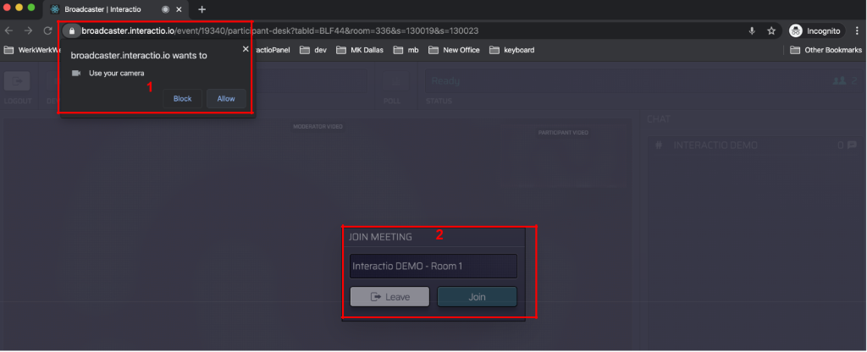

- Select the devices you want to use for the meeting:

(1) camera – select your camera
(2) microphone - select your audio input device
(3) speaker/headset – select your audio output device
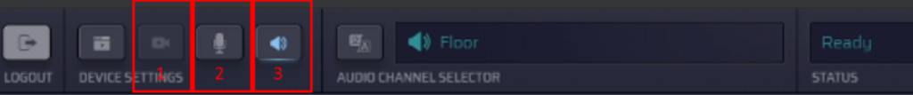
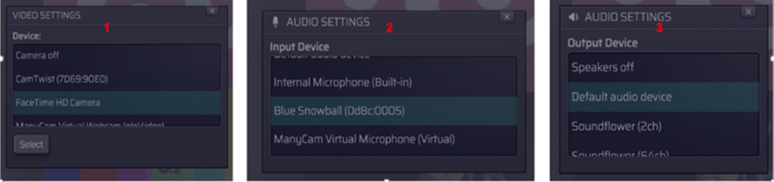

During the session

- Select the preferred audio language

Click the AUDIO CHANNEL SELECTOR (1) and choose the preferred language

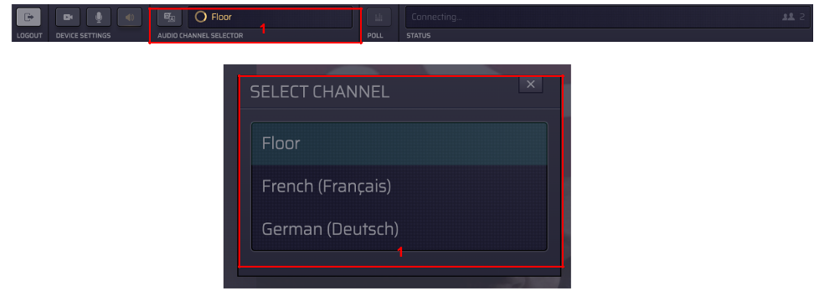
- Display video

Note:
- If your webcam is on, you will always see your own webcam, but it will only be shown to everyone once you have the floor and start to speak live.
- Pause the incoming video if internet is not stable which will maintain your audio connection

- Pause or play the presenter video by clicking on the button on the bottom left.

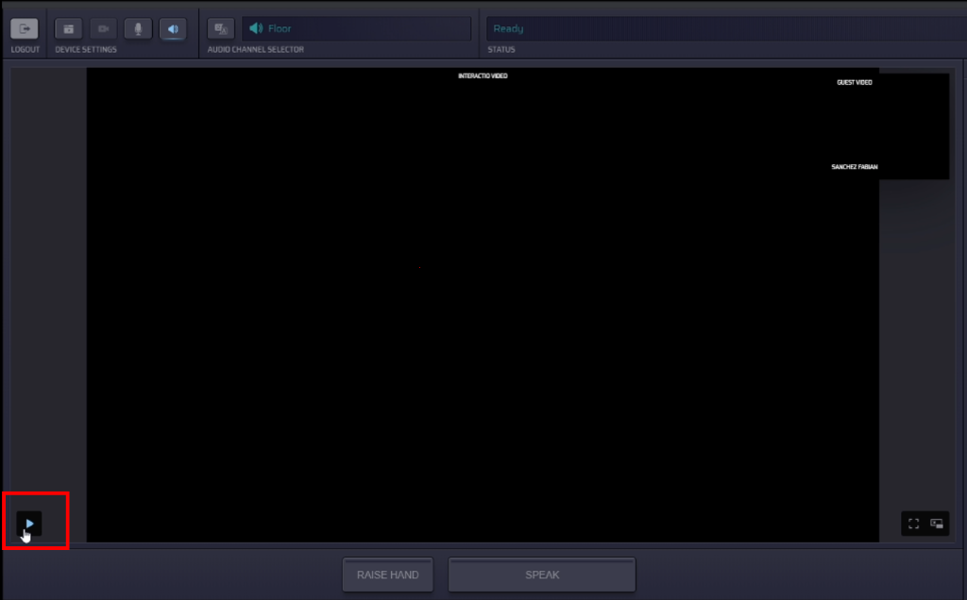

- If preferred, click on the full screen icon to make the video/shared screen full screen,

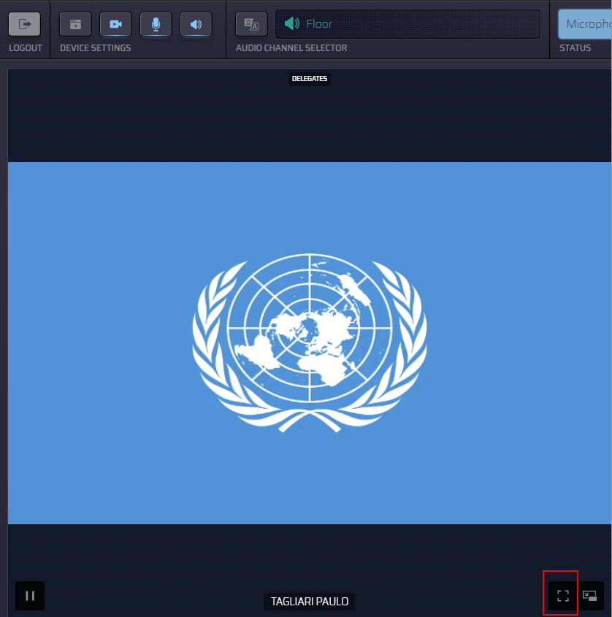

- Request for the Floor

- Press the button RAISE HAND at the bottom to indicate the wish to speak. Your name will be added to the queue. Please note that the queue you see on your screen is in alphabetical order and is not the queue that the Chair and moderators have on their monitors which is in the chronological order of the requests for interventions from the floor as per usual procedure of CBD meetings.
- The STATUS at the top will change to “Hand raised” (yellow).
- When you are given the floor, the STATUS will change to “Microphone open” and the SPEAK button will turn blue and flash.

- Press “SPEAK” to start speaking. The button will turn red and the STATUS will change to “Live”. Wait 2 seconds, then start speaking, everyone can now hear and see you.

- To share your screen, press the button in the red selection

- End speaking on the floor

Press the red SPEAK button to turn off the microphone when finished, it will turn blue, then back to grey status, ready for step 1 above.

- Other useful options

- USERS: see the list of attendees
- POLLS: participate in the live poll or simply view all previous polls’ results
- CHAT: view chat history and chat with others, if you have any technical problems, please use technical support information below and not on the interaction system.
- FILES: download files available to you

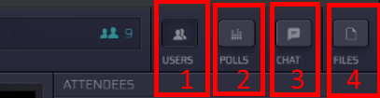

For Technical Support:

The Secretariat is providing help before and during the meetings and support can be reached from the meeting home page by clicking on the “green question mark” at the bottom right: https://www.cbd.int/conferences/sbstta24-sbi3-prep between 15-18 September 6:00AM – 9:00AM Montreal time.

- Statement Submission

Parties and organizations are requested to email their statements in advance of the sessions to statements@cbd.int so they can be shared with interpreters. Kindly include your country/organization in the subject line and the related session/topic.

