|  |  |  |  |
| --- | --- | --- | --- |
| Macintosh HD:Users:bilodeau:Desktop:logos:template 2017:un.emf | Macintosh HD:Users:bilodeau:Desktop:logos:template 2017:unep-old.emf | **CBD** | |
| CBD_logo_CMYK_black [Converted] | |  | Distr.  GENERAL  10 July 2019  ENGLISH ONLY |

GLOBAL CAPACITY-BUILDING WORKSHOP ON

MONITORING THE UTILIZATION OF GENETIC

RESOURCES UNDER THE NAGOYA PROTOCOL

Bonn, Germany, 30 September - 2 October 2019

# **information note for participants**

QUICK LINKS: (Control + click on icons for web page)

|  |
| --- |
| [passport-MP900442382](http://www.auswaertiges-amt.de/EN/Startseite_node.html)  Visa Information (pages 3, 7) |
| [CBD_spinelogo_CMYK_green [Converted]](https://www.cbd.int/meetings/NP-CB-WS-2019-01)  Meeting Documents (page 2) |
| [Piktogramm-bett-blau[1]](https://www.bonn.de/tourismus_kultur_sport_freizeit/tourist_information_aktuell/tourismus_und_hotels/?lang=en)  Hotel Information (pages 4, 8) |
| [MCj04325870000[1]](http://worldweather.wmo.int/en/city.html?cityId=56)  Weather Information (page 4) |
| [MCj04338080000[1]](http://www.xe.com/)  Currency Information (page 5) |

**INFORMATION HIGHLIGHTS**

1. Opening of the Meeting 2

2. Venue 2

Annex A – Directions to venue 6

4. Documents 2

5. General information on

access to Bonn 2

6. Visa information 3

Annex B – Country list for Visa 7

7. Hotel information 4

Annex C – Hotel Listing 8

10. Weather and time zone

information 4

1. Opening of the Meeting

The Global Capacity-building Workshop on Monitoring the Utilization of Genetic Resources under the Nagoya Protocol will be held in Bonn, Federal Republic of Germany from 30 September to 2 October 2019. Registration will take place at the venue starting at 8:00 a.m. and the meeting will start at 9:00 a.m. on Monday, 30 September 2019. A reception will be hosted by the Government of Germany on Monday evening, 30 September 2019, at 7-8:30pm at the Hilton Hotel.

1. Venue

The meeting will be held at:

## **Hilton Hotel**

Berliner Freiheit 2

53111 Bonn, Germany

Tel: +49-228-72690

Directions to venue can be found in annex A below and at: <https://www3.hilton.com/en/hotels/n-rhine-westphalia/hilton-bonn-BNJHIHI/maps-directions/index.html>

1. Working language of the Meeting

The meeting will be held in English.

1. Documents

In order to minimize the environmental footprint of the meeting and in line with the UN policy towards greener meetings, participants are kindly reminded to bring their own copies of the meeting documents, or to use paperless versions, as there will be no extra copies made available on site during the training course. Documents are available on the Secretariat’s website at:

[](https://www.cbd.int/meetings/POST2020-WS-2019-02)

<https://www.cbd.int/meetings/NP-CB-WS-2019-01>

1. General information on access to Bonn

Bonn is serviced by three main airports Cologne/Bonn, Dusseldorf and Frankfurt airports, directions from each are shown below. Participants are requested to make their own arrangements for travel to and from the airport and the venue.

***Cologne/Bonn airport***

This is the closest airport to the meeting venue, located approximately 25 km from Bonn. There are regular bus connections to Bonn from Cologne/Bonn Airport. Additional information about the airport is available at: <http://www.koeln-bonn-airport.de/en.html>.

Ground Transportation

*Public transportation*

From Cologne/Bonn Airport to Bonn central station (Bonn Hbf): Take the airport express SB60 bus in direction of Bonn Hbf from the airport and exit the bus at Bonn Hbf. The total travel time is approximately 30 minutes. The bus ticket (8,20 €) can be purchased from the bus driver.

From the Bonn-Siegburg train station to “Bonn Hbf” (central station): Transportation between these two train stations is via the #66 tram line in direction of “Ramersdorf/Königswinter/Bad Honnef”. Exit the tram at “Bonn Hbf”. The trip takes 20 minutes and the fare to the station is about 5 €.

*Taxi*

Taxis are available at the airports, “Bonn Hauptbahnhof/ Hbf” (Bonn central station), and the Bonn‑Siegburg station. The fare for a one-way taxi ride to the venue is approximately: 60 € from Cologne-Bonn airport; 40 € from Bonn-Siegburg station; and 20 € from the Bonn central station.

***Dusseldorf airport***

The Dusseldorf Airport is approximately 85 km from Bonn. There are regular train connections to Bonn from Dusseldorf Airport. Additional information about the airport can be found at: <http://www.dus.com/dus_en/>.

***Frankfurt airport***

The Frankfurt Airport is approximately 165 km away from Bonn. There are regular train connections between Frankfurt Airport and Bonn. Additional information about the airport is available at: <https://www.frankfurt-airport.com/en.html>.

1. [](http://www.auswaertiges-amt.de/EN/Startseite_node.html)Visa information

Participants from countries requiring a Schengen entry visa for Germany are strongly advised to contact the nearest German diplomatic or consular mission **as soon as possible** in order to secure the required entry visa in a timely manner, prior to departure. **It should be noted that airline companies will not allow boarding in the absence of a valid visa.** A list of relevant German diplomatic/consular missions abroad can be found at <https://www.auswaertiges-amt.de/en/aussenpolitik/laenderinformationen>.

Information on visa procedures and the visa application form are available on the website of the German Federal Foreign Office at:

<https://www.auswaertiges-amt.de/en/einreiseundaufenthalt/visabestimmungen-node> .

To facilitate the issuance of visas, the Secretariat will issue upon request invitation letters to be attached to the visa applications.

1. Hotel information

Participants are kindly requested to make their own hotel reservations as soon as possible. Participants are recommended to stay in the Hilton Hotel, where there is a special rate provided for workshop participants (See Annex C), using the code “NAGOYA”. Hotel rooms for participants will be blocked/held until 29 August 2019. Participants must contact the Hilton Hotel directly to make a reservation. Please note that a valid credit card is required for reservations. See Annex C for further information.

There are a lot of other hotels located in Bonn. Information on hotels in Bonn is available at the following web page of the “Bonn Region – Tourisms & Congress” website: <https://www.bonn-region.de/en/> The list of hotels near the workshop venue and near Bonn central station is provided in the Annex C below.

General information on hotels in the Bonn region and booking is also available at the following website of the hotel reservation service:

<https://www.hrs.de/web3/init.do?activity=initVisit&jsLangChange=true&differentLanguage=true&cid=64-3&clientId=ZW5fX05FWFQ->

1. Payment of the Daily Subsistence Allowance (DSA)

The DSA will be disbursed to sponsored participants on the first day of the workshop in the form of a prepaid credit card. For identification purposes, these participants are kindly requested to bring their passports and boarding passes. These will be photocopied and returned to participants during the workshop. It is advisable that participants have some cash at hand to cover expenses that may occur between their arrival and the moment at which they are provided with the prepaid credit card from which they will access their DSA.

1. Official language in Germany

The official language in Germany is German. English is spoken in hotels and restaurants.

[](http://worldweather.wmo.int/en/city.html?cityId=56)

1. Weather and time zone information

In October, the average temperatures in Bonn typically range between 15°C in the daytime and between 8°C at night. Please bring appropriate clothing for autumn conditions.

The standard time zone for Germany is GMT/UTC +1 hour.

1. Electricity

The electrical currents in Germany are 230 Volts, 50 Hertz and plugs are as shown below.

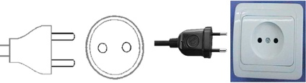

1. [](http://www.xe.com/)Currency

The currency in Germany is the Euro (€). The current exchange rate as of 10 July 2019 is US $1 = € 0.888 EUR and €1 = US $ 1.125 (source: www.xe.com, rates are subject to change).

Currency exchange facilities are readily available in banks and hotels.

1. Disclaimer

The CBD Secretariat disclaims all responsibility for medical, accident and travel insurance, for compensation for death or disability compensation, for loss of or damage to personal property and for any other loss that may be incurred during travel time or the period of participation. In this context, it is strongly recommended to secure international medical, accident and travel insurance for the period of participation prior to departure.

Annex A – Directions to venue

**Directions to venue (Hilton Hotel) via public transport from Bonn central station:**

* Take Metro #66 in direction of Siegburg Bf or Metro #62 in direction Oberkassel Süd/Römlinghoven.
* Exit at Bertha-von-Suttner-Platz.
* Follow the main road towards East in the direction of the Rhine River.
* Take left into Doetschstraße and Hotel Hilton is on the right-hand side.

Timetable information for connections within the Bonn area (including the express bus to Cologne/Bonn airport and the trains to Bonn-Siegburg) can be found at:

<https://en.swb-busundbahn.de/tickets-and-tariffs/tariff-advisory.html>

1 Location of the venue Hilton Hotel (yellow square)

2 Location of the central train station in Bonn: Bonn Hauptbahnhof (green square)

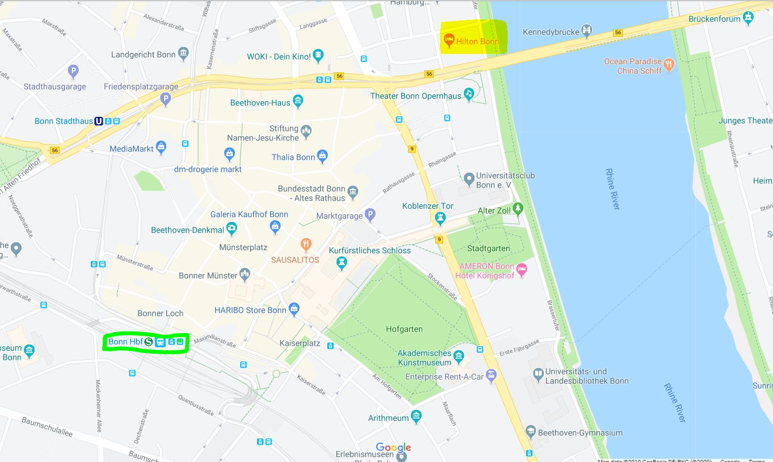

Annex B – Country list for Visa

**COUNTRIES AND TERRITORIES WHOSE CITIZENS REQUIRE VISAS IN ORDER TO ENTER GERMANY AS VISITORS (AS LISTED ON THE WEBSITE OF**

**THE GERMAN FEDERAL FOREIGN OFFICE)**

[https://www.auswaertiges-amt.de/de/einreise-aufenthalt-deutschland/visabestimmungen-node/ staatenlistevisumpflicht-node](https://www.auswaertiges-amt.de/de/einreise-aufenthalt-deutschland/visabestimmungen-node/staatenlistevisumpflicht-node)

Citizens of the following countries and territories require a visa to **visit** or **transit** Germany:

A

Afghanistan

Algeria

Angola

Armenia

Azerbaijan

B

Bahrain

Bangladesh

Belarus

Belize

Benin

Bhutan

Bolivia

Botswana

Burkina Faso

Burundi

C

Cabo Verde

Cambodia

Cameroon

Central African Republic

Chad

China

Comoros

Congo, Democratic Republic of the

Congo, Republic of the

Côte d’Ivoire

Cuba

D

Djibouti

Dominican Republic

E

Ecuador

Egypt

Equatorial Guinea

E (cont’d)

Eritrea

Ethiopia

F

Fiji

G

Gabon

Gambia

Georgia

Ghana

Guinea

Guinea-Bissau

Guyana

H

Haiti

I

India

Indonesia

Iran, Islamic Republic of

Iraq

J

Jamaica

Jordan

K

Kazakhstan

Kenya

Korea, Democratic People’s Republic of

Kuwait

Kyrgyzstan

L

Lao, People’s Democratic Republic

Lebanon

Lesotho

Liberia

Libya

M

Madagascar

Malawi

Maldives

Mali

Marshall Islands

Mauritania

Micronesia, Federated States of

Mongolia

Morocco

Mozambique

Myanmar

N

Namibia

Nauru

Nepal

Niger

Nigeria

O

Oman

P

Pakistan

Palau

Palestinian Authority Papua New Guinea

Philippines

Q

Qatar

R

Russian Federation

Rwanda

S

Samoa

São Tomé and Principe

Saudi Arabia

Senegal

Sierra Leone

S (cont’d)

Solomon Islands

Somalia

South Africa

South Sudan

Sri Lanka

Sudan

Suriname

Swaziland

Syrian Arab Republic

T

Tajikistan

Tanzania, United Republic of

Thailand

Timor-Leste

Togo

Tonga

Tunisia

Turkey

Turkmenistan

U

Uganda

Ukraine

Uzbekistan

V

Vanuatu

Viet Nam

Y

Yemen

Z

Zambia

Zimbabwe

Annex C – Hotel Listing

**LIST OF HOTELS NEAR THE MEETING VENUE OR BONN CENTRAL STATION**

**Rates are indicative and subject to change**

|  |
| --- |
| **Hotels near the venue** |
| 1. **Hilton Hotel**   Berliner Freiheit 2  53111 Bonn, Germany  Tel: +49-228-7269  Website: <https://www3.hilton.com/en/hotels/n-rhine-westphalia/hilton-bonn-BNJHIHI/index.html>  Reservations  Rooms at the Hilton Hotel will be block booked for participants until 29 August 2019. Participants must contact the hotel to book hotel rooms either via telephone (tel. +49-228-7269 2300) or via the following e-mail address: [reservations.bonn@hilton.com](mailto:reservations.bonn@hilton.com)  The code for the rates below is ‘NAGOYA’  Hotel rates:  Sunday (29.09.2019) - €119,00  Monday (30.09.2019) - €129,00  Tuesday (01.10.2019) - €129,00  Wednesday (02.10.2019) - €129,00 |
| 1. **Hotel Motel One Bonn-Beethoven**   **Berliner Freiheit 36**  **53111 Bonn, Germany**  **Tel.: +49-228-9727860**  **Website:** <https://www.motel-one.com/de/hotels/bonn/hotel-bonn-beethoven/> |
| 1. **AMERON Bonn Hotel Königshof**   Adenauerallee 9  53111 Bonn, Germany  Tel.: +49-228-26010  Website: <https://ameronhotels.com/de/bonn-hotel-koenigshof> |
| 1. **Hotel Bonn City**   Sandkaule 3A  53111 Bonn, Germany  Tel.: +49-228-636366  Website: [www.hotelbonncity.de](http://www.hotelbonncity.de) |
| 1. **Hotel Savoy**   Berliner Freiheit 17  53111 Bonn  Tel.: +49-228-725970  Website: [www.hotelsavoybonn.de](http://www.hotelsavoybonn.de) |

There are a lot of other hotels located in Bonn. Information on hotels in Bonn is available at the following web page of the “Bonn Region – Tourisms & Congress” website:

<https://www.bonn-region.de/en/>

General information on hotels in the Bonn region and booking is also available at the following website of the hotel reservation service:

<https://www.hrs.de/web3/init.do?activity=initVisit&jsLangChange=true&differentLanguage=true&cid=64-3&clientId=ZW5fX05FWFQ->

**-----**