|  |  |  |
| --- | --- | --- |
| Macintosh HD:Users:bilodeau:Desktop:logos:template 2017:un.emf | Macintosh HD:Users:bilodeau:Desktop:logos:template 2017:unep-old.emf | **CBD** |
| Macintosh HD:Users:bilodeau:Desktop:logos:template 2017:cbd.emf | | Distr.  GENERAL  CBD/SBSTTA/23/INF/18  20 November 2019  ENGLISH ONLY |

SUBSIDIARY BODY ON SCIENTIFIC,

TECHNICAL AND TECHNOLOGICAL ADVICE

Twenty-third meeting

Montreal, Canada, 25-29 November 2019

Item 7 of the provisional agenda[1]*

**TECHNICAL AND SCIENTIFIC COOPERATION: CAPACITY-BUILDING IN DNA BARCODING FOR SPECIES IDENTIFICATION THROUGH THE GLOBAL TAXONOMY INITIATIVE**

*Note by the Executive Secretary*

1. **INTRODUCTION**
2. In decision 14/24 the Conference of the Parties, recognizing the importance of taxonomy for actions under the post-2020 global biodiversity framework in support of the 2050 Vision, and taking note of the report of the proceedings of the Global Taxonomy Initiative Forum[2], requested the Executive Secretary to further promote and facilitate technical and scientific cooperation and training in DNA technologies, such as DNA barcoding for rapid species identification in countries and regions concerned within the context of the Global Taxonomy Initiative (paragraph 8 of decision 14/24[3]).
3. In the same decision the Conference of the Parties further requested the Executive Secretary to review and renew technical and scientific cooperation programmes, including the Bio-Bridge Initiative, the Forest Ecosystem Restoration Initiative and the Global Taxonomy Initiative.
4. Accordingly, the Executive Secretary prepared a draft proposal to renew and strengthen technical and scientific cooperation in support of the post-2020 global biodiversity framework, CBD/SBSTTA/23/6[4].
5. The present document summarizes the activities of the Global Taxonomy Initiative – DNA Technologies Training undertaken from 2015 to 2019 which provided the basis of the elements contained in the document CBD/SBSTTA/23/6. Section II explains the programmatic approach of the Global Taxonomy Initiative DNA Technologies Training. Section III presents the achievements of the training programme and Section IV describes the lessons learned and the ways forward to remove taxonomic impediment under the Post-2020 Global Biodiversity Framework, as an information for the Subsidiary Body on Scientific, Technical and Technological Advice.
6. **PROGRAMMATIC APPROACH OF THE GLOBAL TAXONOMY INITIATIVE DNA TECHNOLOGIES TRAINING**
7. The Global Taxonomy Initiative DNA Technologies Training (GTI-DNA-tech) has been undertaken in a programmatic approach to address the taxonomic impediment (paragraph 11 of decision VI/8[5]) for Parties to implement article 7 of the Convention, for Parties to undertake identification and monitoring of biodiversity. In accordance with the Actions 4-6 of the Capacity-building Strategy for the Global Taxonomy Initiative annexed to decision XI/29[6], and taking into account the rapid advance in DNA technologies referred to the Outcome Oriented Deliverables of the Planned Activities of the Programme of Work of the Global Taxonomy Initiative (annex to decision IX/22[7]), the Secretariat has undertaken the GTI-DNA-tech in 2015-2019 with generous financial support from the Government of Japan through Japan Biodiversity Fund.
8. The GTI-DNA-tech is designed to provide training for trainers with online and laboratory-based hands-on training at an international centre of excellence in DNA technologies (Center for Biodiversity Genomics, University of Guelph, Canada[8]), followed by on-site training workshops in developing countries organized by the trained-trainers. The GTI-DNA-tech also encourages the trained-trainers to establish a regional center of excellence to sustain the attained capacity for the purpose of the implementation of the CBD and achieving Aichi Biodiversity Targets. To do so, the Secretariat advised the respective CBD national focal point to be well informed on the on-site training workshops by the trained-trainers, and provided guidance to discuss among the participants and the Government on sustainability of the attained skills and the DNA barcode libraries generated through the GTI-DNA-tech.
9. The GTI-DNA-tech is an entry point for any Parties to apply DNA technologies for the implementation of the CBD to achieve the national targets. Primarily, expected outputs of the training (2015-2019) were set, as below, to enable Parties to remove taxonomic impediment to meet Aichi Biodiversity Targets by 2020:
   1. A minimal laboratory set-up to allow processing of specimens and recording with unique identifiers to share the information on global data platform (Barcode of Life Data Systems – BOLD)[9] are in place;
   2. Processing DNA extracts to amplify only the needed fragment of DNA barcode region(s);
   3. The amplified DNA (called PCR product) would then be sent to a sequencing laboratory of commercial providers within the country, which is the most cost effective way to obtain DNA sequence information. Only in a few rare cases when sequencing service is not available or too costly within the country, the Secretariat advises to send the PCR products overseas for sequencing, in compliance with the national legislation on access and benefit-sharing;
   4. New DNA barcode libraries and associated information of the specimens derived from the GTI-DNA-tech training are shared on BOLD as global biodiversity knowledge/data to achieve Aichi Biodiversity Target 19.
10. The GTI-DNA-tech training is a step-by-step process to produce the outputs mentioned above on the ground. The process has engaged the trained-trainers to a global network of DNA barcoding experts (the International Barcode of Life Consortium, iBOL[10]). The step-by-step process was composed of the following actions:
11. Online training on DNA barcoding (2015-2016);
12. Hands-on training on DNA barcoding (2015-2016);
13. Training on project proposal writing, taking into account the national policy (National Biodiversity Strategies and Action Plans) (2017);
14. On-site training courses in ten developing countries or regions organized by the trained-trainers (2018);
15. One on-site training course at a regional level with advanced DNA technologies (DNA meta-barcoding) (2019-2020).
16. The online training consisted of an eight-week introductory course in DNA barcoding methodologies, developed at the Centre for Biodiversity Genomics, University of Guelph, Canada. The modules of the course were, as follows:
17. Foundations of DNA Barcoding;
18. Community Standards and Best Practices;
19. DNA Barcode Analytics;
20. DNA Barcoding and Taxonomy;
21. Applied DNA Barcoding I (Ecology, Conservation Biology & Evolution);
22. Applied DNA Barcoding II (Food Safety, Pest and Health Management, Invasive Species);
23. Applied DNA Barcoding III (Biosurveillance, Habitat Monitoring);
24. Future Trends in DNA Barcoding.
25. In 2015-16, a total of 51 participants from 47 developing countries attained basic knowledge on DNA barcoding through online training. Among the online training participants, 29 individuals from 27 developing countries received the next step of the training (laboratory based hands-on training). The hands-on training included the training modules, as follows:
26. Pre-laboratory processing: sampling, storage, labelling, databasing, imaging, collection of metadata;
27. Laboratory processing: DNA extraction, amplification of the barcode region through polymerase chain reaction (PCR) and validation through agarose gel analysis, DNA sequencing;
28. Analytics I: sequence editing and validation with specific software, query of molecular databases, interpretation of results;
29. Analytics II: upload of barcode data and metadata to the Barcode of Life Data Systems (BOLD, <http://boldsystems.org/>).
30. Other modules: policy on invasive alien species, other DNA technologies used for species detection (e.g., quantitative PCR), and species conservation through cryopreservation banks of important plant species (i.e., *in vitro* conservation).
31. In addition, a module on Access and Benefit-Sharing was included during the hands-on training. This module and the discussions were compiled and published in the GTI e-book, “*Introduction to Access and Benefit-Sharing and the Nagoya Protocol: What DNA Barcoding Researchers Need to Know*”[11].
32. In 2017 a proposal writing training to support Parties’ identification and monitoring of invasive alien species, endangered species or Parties’ priority species in line with the National Biodiversity Strategies and Action Plans took place through a Webinar and email exchanges. The training was attended by 39 participants from 32 developing countries.
33. In 2018, following the notification 2017-110[12] which called for proposals on the GTI-DNA-tech training courses to be hosted in developing countries, the Secretariat, in collaboration with the external panels of experts in DNA barcoding, reviewed the project proposals submitted by the trained-trainers through the CBD national focal points. A total of eleven projects have been selected (a cancelation from one Party occurred due to the limited time period for the implementation)[13]. Figure 1, below, shows the coverage of Parties which received the GTI-DNA-tech training, and ten projects which took place in 2018.

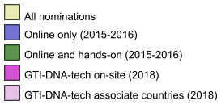 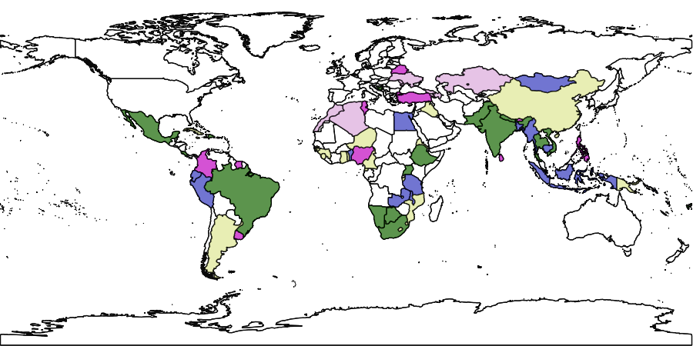

Figure 1. Map of countries participating in GTI-DNA-tech. In blue and green countries which had participants in the online and hands-on training, respectively. In purple, the 10 countries which hosted hands-on training in 2018 and their associates (in light purple). In yellow, countries that have nominated participants not selected for training.

1. The ten projects selected for on-site training in DNA barcoding were implemented in 2018 in ten developing countries across four UN regions:
2. Africa: Nigeria, Tunisia;
3. Asia-Pacific: Nepal, Philippines, Sri Lanka, Turkey;
4. Eastern Europe: Belarus;
5. Latin America and the Caribbean: Colombia, Suriname, Uruguay.
6. Out of the ten projects above, two projects were regional in scope therefore the total number of countries reached by this phase of GTI capacity-building in DNA barcoding for species identification is 18 (Figure 1). The additional countries also received the on-site trainings with the coordination by the trained-trainers, which include: Algeria and Morocco (for the training course in Tunisia), Armenia, Azerbaijan, Georgia, Kazakhstan, Moldova, and Ukraine (for the training course in Belarus).
7. Each of the ten projects conducted a needs assessment with evaluation of the existing capacity to apply DNA technologies in the respective countries, and identified the scientific, technical and technological gaps that should be addressed. As a requisite for conducting the on-site hands-on training, the trained-trainers were tasked to establish a workflow within/between national institutions to designate facilities suitable for storing biological specimens, supplying chemical reagents, molecular laboratories, sequencing, and long-term DNA storage.
8. The ten GTI-DNA-tech trainings covered priority taxa as identified by their respective National Biodiversity Strategies and Action Plans. Most courses focused on invasive alien species, many being agricultural pests, protected species, native species occurring in important ecosystems and indicator species for monitoring the quality of the habitat (Table 1).

Table 1. List of selected ten countries and their target group of taxa.

|  |  |  |  |
| --- | --- | --- | --- |
|  | **Country** | **Priority group of species** | **Ecosystems** |
|  | Belarus | Invasive alien species | Freshwater |
|  | Bhutan | Agricultural pests, protected plants, indicator species | Freshwater, terrestrial |
|  | Colombia | Threatened species | Terrestrial |
|  | Nigeria | Agricultural pests, invasive plants | Terrestrial |
|  | Philippines | Wildlife | Terrestrial, freshwater |
|  | Sri Lanka | Quarantine insects | Terrestrial |
|  | Suriname | Wildlife, pests, invasive alien species | Terrestrial, freshwater |
|  | Tunisia | Invasive alien species | Marine |
|  | Turkey | Native plants | Terrestrial |
|  | Uruguay | Native plants | Terrestrial |

1. During the practical laboratory activities tissue samples belonging to animals (both vertebrates and invertebrates) and plants were processed. A breakdown per taxonomic group is provided in Table 2.

Table 2. Taxonomic groups covered during the GTI-DNA-tech on-site training in 2018 and their respective output in BOLD in terms of number of records and DNA sequences.

|  |  |  |
| --- | --- | --- |
| **Taxonomic group** | **# Records in BOLD** | **# Records with DNA sequences in BOLD** |
| Plants | 217 | 165* |
| Insects | 171 | 131 |
| Non-insect arthropods | 61 | 35 |
| Other invertebrates | 24 | 24 |
| Mammals | 24 | 21 |
| Birds | 19 | 19 |
| Reptiles | 25 | 19 |
| Amphibians | 24 | 20 |
| Fishes | 74 | 22 |
| Total | 639 | 456 |

*The total number of plant DNA sequences is 261 since some plant records include multiple genes sequenced from one plant specimen.

1. Further to the GTI-DNA-tech on-site training in 2018, the final stage of the programme of GTI-DNA-tech aims to include a regional training course for Latin America focusing on recent technological advances in DNA methods (barcoding and metabarcoding) for species identification and large-scale biodiversity monitoring. The course is to take place at the beginning of 2020, envisioning that Aichi Biodiversity Target 19, “*By 2020, knowledge, the science base and technologies relating to biodiversity, its values, functioning, status and trends, and the consequences of its loss, are improved, widely shared and transferred, and applied*” is progressed within the targeted period, in developing countries through the international collaborations.
2. **ACHIEVEMENTS OF THE GTI-DNA-TECH**
3. By the end of 2018, a total of 195 trained-trainers were working in developing countries with 166 new trained-trainers from 91 institutions who received the training workshops organized by the trained-trainers, themselves. The new trained-trainers are from broad sectors, including governmental agencies, universities and research institutes, Non-Governmental Organizations and private sector working on biodiversity conservation at the national or regional level. Many of the trained-trainers and the organizers of the GTI-DNA-tech training workshops in 2018 became part of national networks of experts participating in the International Barcode of Life Consortium (iBOL) and its global biodiversity monitoring programme, BIOSCAN[14] in the respective countries. Figure 2, below, shows the iBOL participating countries, including the GTI-DNA-tech trained-trainers’ networks.
4. A total of 450 new DNA barcode records have been added to the BOLD systems. The records contribute to the global reference library which allows reliable species identification at the global level. This is highly important contribution to science when dealing with species unique to a region. Some of these records represented new species to have barcodes added to BOLD or new species occurrences for those countries.
5. In addition to generating valuable data for the global community, the sustainability plans of the ten GTI-DNA-tech teams included: (a) establishment of surveillance networks for rapid detection of invasive alien species or plant pests in consignments of goods and materials; (b) grant proposals for continuation of building reference libraries for the respective countries; (c) upgrade of molecular facilities at the national level or establishment of satellite laboratories for a decentralized approach; and (d) inclusion of DNA barcoding as a standard tool for species identification in national plans for management of priority species such as invasive alien species.

 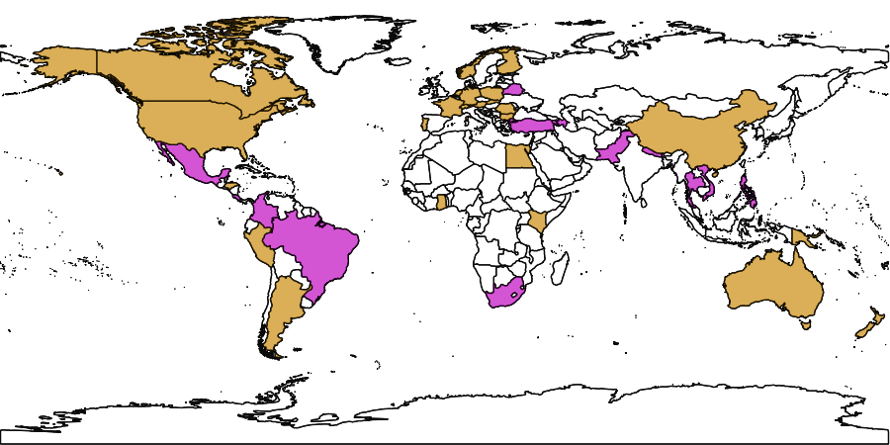

Figure 2. Map of countries members of the International Barcode of Life Consortium (iBOL) (orange colour) and countries which had trained-trainers through GTI-DNA-tech and became also members of iBOL following the training (purple).

1. The experts trained through the GTI-DNA-tech are an asset for the application of DNA barcoding and related technologies in developing countries and can be co-opted into other CBD initiatives for technical and scientific cooperation. The Bio-Bridge Initiative in 2018 also provided some opportunities for Central and Eastern Europe (hosted by Belarus) and Southern African region (hosted by Zimbabwe) to extend the attained training skills to the region by the trained-trainers who received the GTI-DNA-tech training in 2015-2016.
2. The achievements of the GTI-DNA-tech have been presented by three project leaders at the GTI Forum organized on the margins of COP14 in Egypt in 2018[15]. Another presentation has been made for the scientific community attending the 8th International Barcode of Life Conference in Norway in 2019.
3. **LESSONS LEARNED AND WAYS FORWARD**
4. The requests from Parties to receive the GTI-DNA-tech training courses resulted in 93 nominations of trainees from 74 countries in the 2015-16. This illustrates the high interest of Parties in DNA barcoding to remove the taxonomic impediment across the South. A majority of requests received through the CBD national focal points were from the environment sector and academic institutions. A few regulatory organizations in agriculture sector have also requested the GTI-DNA-tech training.
5. Although the Conference of the Parties requested for its promotion of cooperation of the area of the Global Taxonomy Initiative (paragraph 8 of decision 14/24)2, a broad range of sectors that may require species identification beyond the environment agencies, are not yet sufficiently engaged to spread the useful training method of the GTI-DNA-tech training. It is critical to invite the practitioners on the ground to identify and monitor their priority species, and extend the opportunities of training to broader sectors, including regulatory bodies of the Governments, research institutes involved in the implementation of the CBD, as well as indigenous peoples and local communities.
6. The opportunity for taxonomic experts working on the ground to have continuing education on basic science surrounding molecular technologies is urged. The GTI-DNA-tech training itself is a simple procedure, though troubleshooting in a laboratory under the condition of tropical climate and a minimal set of equipment appeared to be challenging in some projects. It may require further assistance from more experienced experts to establish a self-sustaining laboratory. Taxonomic knowledge is also a central part of accurate interpretation of species identification. To this end, other GTI activities undertaken by natural history museums[16],[17] are indispensable.
7. GTI-DNA-tech has shown that relatively small funding can return a large benefit in terms of taxonomic capacity-building in developing countries. The network of trained-trainers is steadily growing and through the ongoing collaboration with the International Barcode of Life Consortium (iBOL).
8. With regard to the future implementation of the post-2020 Global Biodiversity Framework, subject to the availability of funding, the GTI-DNA-tech can open the door for developing countries to initiate biodiversity monitoring in the field with a cost-effective setting. Rapid species identification by using DNA barcoding is an opportunity for Parties to take evidence-based biodiversity management decision and placing appropriate regulatory checkpoints for trans-boundary movement of species that are the country’s concern (e.g. invasive alien species, endangered species, pests or pathogenic organisms).

__________

1. * [CBD/SBSTTA/23/1](https://www.cbd.int/doc/c/9f18/4476/47c0714594b6fbf85bfc31e9/sbstta-23-01-en.pdf)
2. [CBD/COP/14/INF/12/Add.1](https://www.cbd.int/doc/c/66fd/6114/e8fd9956cdfd40377f3dd3cb/cop-14-inf-12-add1-en.pdf)
3. <https://www.cbd.int/doc/decisions/cop-14/cop-14-dec-24-en.pdf>
4. [CBD/SBSTTA/23/6](https://www.cbd.int/doc/c/e36d/fdb8/fa8e366fbbceabb670a14c2e/sbstta-23-06-en.pdf)
5. <https://www.cbd.int/decision/cop/?id=7182>
6. <https://www.cbd.int/decision/cop/?id=13190>
7. <https://www.cbd.int/decision/cop/?id=11665>
8. Centre for Biodiversity Genomics: <https://biodiversitygenomics.net/>
9. <http://www.boldsystems.org/>
10. <http://ibol.org/>
11. Davis, K. and Borisenko A. 2017. Introduction to Access and Benefit-Sharing and the Nagoya Protocol: What DNA Barcoding Researchers Need to Know. Advanced Books. https://doi.org/10.3897/ab.e22579.
12. Notification 2017-110, Call for Proposals on the Global Taxonomy Initiative Training Courses to be hosted in Developing Countries in 2018 https://www.cbd.int/doc/notifications/2017/ntf-2017-110-gti-en.pdf
13. The Global Taxonomy Initiative Training Courses in Developing Countries to be held in 2018, http://cbd.int/gti/
14. BIOSCAN, <https://ibol.org/programs/bioscan/> (see also CBD/SBSTTA/23/INF/7 on meta-barcoding)
15. <https://www.cbd.int/conferences/2018/parallel-meetings/The-Global-Taxonomy-Initiative-Forum>
16. Consortium of European Taxonomic Facilities, <https://cetaf.org/taxonomy/training>
17. The Darwin Initiative: Achievements in support of the Global Taxonomy Initiative, <https://www.darwininitiative.org.uk/assets/uploads/2014/05/The-Darwin-Initiative-Achievements-in-support-of-the-Global-Taxonomy-Initiative.pdf>