|  |  |  |  |  |
| --- | --- | --- | --- | --- |
| Macintosh HD:Users:bilodeau:Desktop:logos:template 2017:un.emf | Macintosh HD:Users:bilodeau:Desktop:logos:template 2017:unep-old.emf | **CBD** | | |
| CBD_logo_CMYK_black [Converted] | | | |  | Distr.  GENERAL  CBD/SBSTTA/22/INF/30  6 June 2018  ENGLISH ONLY | |

|  |  |
| --- | --- |
| SUBSIDIARY BODY ON SCIENTIFIC, TECHNICAL AND TECHNOLOGICAL ADVICE  Twenty-second meeting  Montreal, Canada, 2-7 July 2018  Item 6 of the provisional agenda[[1]](#footnote-1)\* |  |

# UPDATED STATUS OF AICHI BIODIVERSITY TARGET 11

*Note by the Executive Secretary*

# Introduction

1. The Strategic Plan for Biodiversity 2011-2020 was adopted in 2010 at the tenth meeting of the Conference of the Parties to the Convention on Biological Diversity, in Nagoya, Japan, and subsequently endorsed by all other global biodiversity-related conventions and by the United Nations General Assembly ([Resolution 65/161](https://www.cbd.int/undb/goals/undb-unresolution.pdf)). With 20 Aichi Biodiversity Targets organized under five Strategic Goals, it aims to address the underlying causes of biodiversity loss, reduce direct pressures and promote sustainable use, improve the status of biodiversity, enhance the benefits to all, as well as increase implementation, knowledge management and capacity-building. Strategic Goal C which focuses on improving the status of biodiversity by safeguarding ecosystems, species and genetic diversity includes, among others, Target 11[[2]](#footnote-2) on in-situ conservation.
2. The mid-term assessment of progress towards the implementation of the Strategic Plan for Biodiversity, presented in the fourth *Global Biodiversity Outlook* (GBO-4)*,* showed that for all elements of Target 11 progress was occurring. However, for all elements other than terrestrial protected area coverage, progress was occurring at an insufficient rate, and unless efforts were increased, the Target would not be met by 2020.[[3]](#footnote-3)
3. To facilitate achievement of Target 11, the Secretariat developed a two-phase strategy, the details of which were presented to the twentieth meeting of the Subsidiary Body on Scientific, Technical and Technological Advice (SBSTTA) and to the first meeting of the Subsidiary Body on Implementation (SBI) as information documents [UNEP/CBD/SBSTTA/20/INF/43](https://www.cbd.int/doc/meetings/sbstta/sbstta-20/information/sbstta-20-inf-43-en.pdf) and [UNEP/CBD/SBI/INF/41](https://www.cbd.int/doc/meetings/sbi/sbi-01/information/sbi-01-inf-41-en.pdf). In collaboration with partner organizations, the first phase (2015-2016) involved, *inter alia*, the organization of a series of six regional workshops to collect information on the status, gaps and opportunities for the elements of Target 11, as well as national priority actions (roadmaps) for implementation before 2020, as a country-driven process. The Governments of Japan, Germany and the Republic of Korea provided financial support, and the Governments of host countries (Belarus, Brazil, China, Fiji, India and Uganda) provided logistical and other support for the organization of these workshops.
4. The results of an analysis of the roadmaps submitted during the six regional workshops was presented as an information document at the thirteenth meeting of the Conference of the Parties in Cancun, Mexico, in December 2016 ([UNEP/CBD/COP/13/INF/17](https://www.cbd.int/doc/meetings/cop/cop-13/information/cop-13-inf-17-en.pdf)). It provided an update of the status of the elements of Target 11, based largely on information from the April 2016 release of the World Database on Protected Areas (WDPA) as presented in the *Protected Planet Report 2016*, and also included estimates of progress that could be made for each element if identified national priority actions were implemented as proposed. It concluded that progress for some elements of the target would lead to an improvement compared to the status presented in GBO-4 and some elements would be met or exceeded by 2020.
5. This document provides an update on the status of the elements of Target 11 following two years of implementation by Parties of the actions in their roadmaps and other national commitments. These past two years have seen tremendous growth in the protected area coverage of marine environments, as well as progress in the other aspects of Target 11 (Table 1). The following sections will present the status of both quantitative (**Section II**) and qualitative elements (**Section III**) of Target 11, will introduce other effective area-based conservation measures (**Section IV**) and end with potential directions for increasing progress over the next two and a half years (**Section V**) and general conclusions (**Section VI)**.

**Table 1.** Summary of progress since the update provided to COP13.

|  |  |
| --- | --- |
| **Element of Target 11** | **Progress occurring between 2016 and 2018[[4]](#footnote-4)** |
| Terrestrial coverage | Global coverage increased from 14.7% to 14.8%; the number of CBD Parties with at least 17% coverage increased from 87 to 91. |
| Marine coverage | Global coverage increased from 4.12% to 7.26%; the number of CBD Parties with at least 10% coverage increased from 23 to 34. |
| Ecological representation | Terrestrial ecoregions with at least 17% PA cover increased from 351 to 357; marine ecoregions and pelagic provinces with at least 10% MPA cover increased from 84 to 99 and 3 to 4, respectively. |
| Areas important for biodiversity | Mean percent area of terrestrial KBAs covered by PAs increased from 45.5% to 46.6%; for marine KBAs it increased from 41.3% to 44.3%. |
| Connectivity and integration | Indicators for tracking progress towards this element have now been developed, and global assessments are available. Based on the ProtConn indicator, 27.9% of terrestrial ecoregions and 30.5% of countries and territories have protected and connected lands covering at least 17%. |
| Effective management | The number of CBD Parties, excluding overseas territories, with management effectiveness evaluations in at least 60% of PAs was 42 as of Jan 2015, increasing to 47 in May 2018 (for terrestrial PAs). |
| Governance and equity | Proportion of sites in the WDPA reporting shared governance increased from 1.8% to 3.3%, and those reporting private governance increased from 4.5% to 5.7%. |

1. To present changes in progress for the elements of Target 11, the five-point scale and symbols developed for GBO-4 will be used:

|  |  |  |  |  |
| --- | --- | --- | --- | --- |
|  |  |  |  |  |
| On track to exceed target (we expect to achieve the target before its deadline) | On track to achieve target (if we continue on our current trajectory we expect to achieve the target by 2020) | Progress towards target but at an insufficient rate (unless we increase our efforts the target will not be met by its deadline) | No significant overall progress (overall, we are neither moving towards the target nor away from it) | Moving away from target (things are getting worse rather than better) |

# QUANTITATIVE ELEMENTS OF AICHI BIODIVERSITY TARGET 11

|  |  |  |  |
| --- | --- | --- | --- |
| **Element of Target 11**  (and status from GBO-4 in 2014) | **Status in 2016**  (as per the *Protected Planet Report 2016*) | **Current Status**  (analysis by UNEP-WCMC of May 2018 WDPA) | **Opportunities for 2020**  (if all national commitments are implement as proposed) |
| At least **17% of terrestrial and inland water areas** conserved | Global cover: 14.7% | 14.8% | 17.7% |
| 87 Parties reaching at least 17% | 91 Parties reaching at least 17% |
| At least **10% of coastal and marine areas** conserved | Global ocean: 4.1% | 7.26% | 10.5% |
| National waters: 10.2% | 16.77% | 24.0% |
| ABNJ: 0.25% | 1.8% | 2% |
| 23 Parties reaching at least 10% | 34 Parties reaching at least 10% |  |

1. As of May 2018, global protected area coverage of terrestrial and inland waters has reached 14.82%, representing a slight increase from April 2016.[[5]](#footnote-5) For marine protected areas, the growth in coverage over the last two years has been more pronounced (see figure 1) and as of May 2018 has reached 16.77% for marine areas under national jurisdiction (including territorial seas and exclusive economic zones (EEZ)), 1.18% for areas beyond national jurisdiction (ABNJ), and 7.26% for the ocean as a whole.[[6]](#footnote-6) Therefore, to meet the minimum coverage targets by 2020, at least 2.18% (~ 3 million km2) for terrestrial areas and 2.74% (~10 million km2) for the global ocean must be added as protected areas or other effective area-based conservation measures.
2. Although expansion of terrestrial protected area coverage has been slower at the global level, this does not reflect changes that been occurring at the national level, as several countries have made significant progress over the last two years. The largest increase over this time period came from Australia, where over 500 sites were added, increasing coverage by over 175,000 km2. The largest terrestrial site added to the WDPA in 2017 was Bassin de la Lufira, in Democratic Republic of Congo, with an area of 43,684km2,[[7]](#footnote-7) bringing coverage in that country closer to the 17% target expressed in their National Biodiversity Strategy and Action Plan (NBSAP). Mexico also made significant expansions to its terrestrial protected area network (>40,000 km2) in partial fulfilment of the national priority actions identified during the Curitiba workshop in September 2015. United Republic of Tanzania increased coverage by almost 60,000 km2 over the last two years, largely through updating records for forest reserves and game reserves, addressing some of the opportunities it had outlined in its roadmap. At least 31 countries have made progress on their national priority actions or the terrestrial protected area commitments from their NBSAPs. In all, 91 CBD Parties have now surpassed the 17% target for protected area coverage of terrestrial and inland water areas, up from 87 in the April 2016 WDPA release.

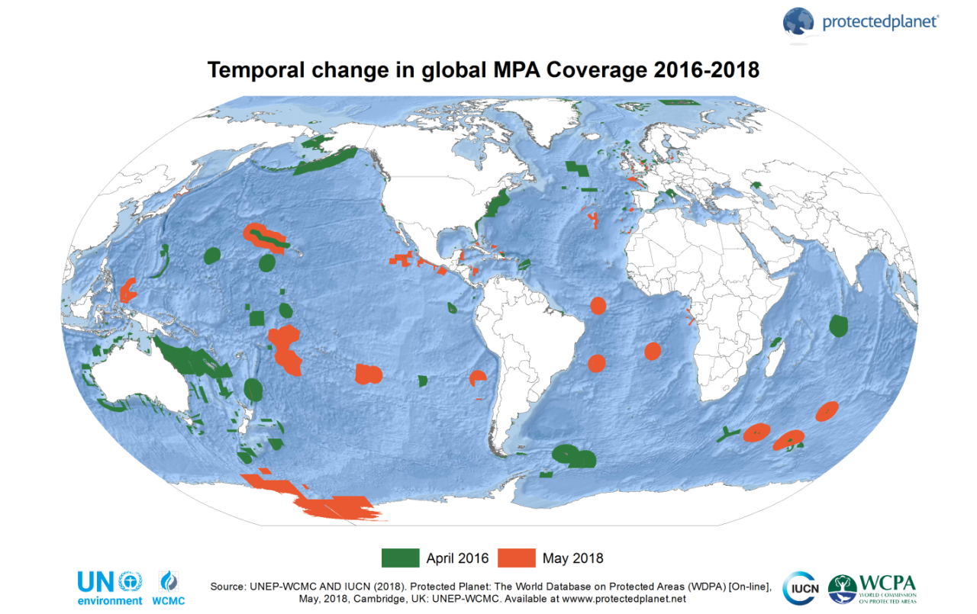

**Figure 1.** Marine protected areas added between April 2016 and May 2018.[[8]](#footnote-8)

1. Some of the increases in protected area coverage over this time period have come not through the designation of new sites, but through improved reporting on existing areas. For instance, Guinea increased coverage by 14% (14,360km2) through improved reporting on the spatial boundaries of four protected areas.[[9]](#footnote-9) A related issue pertains to the lag time for new sites being added to the WDPA, but also for the removal of sites that are no longer protected; this lag time for reporting will become increasingly important as the 2020 deadline for the Aichi targets approaches.[[10]](#footnote-10) Generally the designation of new protected areas and their reporting to the WDPA do not occur in the same year. In 2017 there was some improvement, as 3% of sites added to the WDPA in 2017 were designated that year (compared to less than 1% of sites in the preceding years).[[11]](#footnote-11)
2. For the marine realm, the improved coverage since April 2016 continues the increasing trend of the last decade (see figure 2), with the designation of several very large marine protected areas (MPAs). The four largest MPAs in the world (and five of the ten largest) were either created, or had their area expanded, in the last two years. Box 1 presents a list of large MPAs or MPA networks which have been designated or expanded over the past two years, most of which were listed as proposals in 2016.[[12]](#footnote-12) In total, 34 CBD Parties have now surpassed the 10% target for coastal and marine protected area coverage—a near 50% increase from the 23 Parties which had reached this target in April 2016.

**Figure 2.** Increases in marine protected area coverage since 2000.[[13]](#footnote-13)

**Box 1: More than 10 million km2 in large MPAs were added between April 2016 and May 2018.**

The **Commission for the Conservation of Antarctic Marine Living Resources (CCAMLR)** establishedthe Ross Sea Region marine protected area (MPA) in December 2017 (**>2 million km2**).

In 2017, **Cook Island** designated its entire **1.9 million km2** EEZ as a protected area, with the Marae Moana Marine Park.

In 2017, **France** expanded the Réserve Naturelle Nationale des Terres australes françaisesin its **Southern and Antarctic Territories**, increasing coverage by more than **1.6 million km2**.

In 2016, the **United Kingdom** designated as protected areas the entire EEZs of **Pitcairn** **(840,000 km2)** in the South Pacific, and of **St Helena (>440,000 km2)** in the South Atlantic.

In 2016, the **United States of America** expanded the Papahānaumokuākea Marine National Monument in Hawaii, adding more than **1.1 million km2.**

In March 2018, **Brazil** announced the designation of two large mosaics of MPAs, covering more than **900,000 km²** around the Archipelagos of São Pedro and São Paulo, and Trindade and Martim Vaz.

At COP13 (December 2016), **Mexico** announced thedesignation of three large MPAs (Pacífico Mexicano Profund, Reserva de la Biosfera Caribe Mexicano and Reserva de la Biosfera Islas del Pacífico) adding over **600,000 km2**.

**Palau** closed over 80% of its EEZ in 2016, keeping more than **500,000 km²** as a no-take marine reserve.

**Chile** designatedtheNazca-Desventuradas marine park in 2016 and the Juan Fernández Archipelago MPA in 2017, together adding over **300,000 km²**.

**Source:** Communications by the Secretariat with National Focal Points. Details regarding all commitments, and sources of information available at: <https://www.cbd.int/pa/UN-Ocean-Conference/MPA-commitments.xlsx>.

1. At least 16 Parties have made progress on the national priority actions identified during the regional workshops. For instance, Brazil set out the target of expanding its system of marine and coastal protected areas to at least 5% of its marine territory. With the designation of a mosaic of MPAs around the Archipelagos of São Pedro and São Paulo, and Trindade and Martim Vaz, in March 2018, Brazil has far surpassed this goal, now having over 25% of its EEZ protected. Several countries have also met, or made progress towards, the marine protected area targets set in their NBSAPs.
2. Progress has been made on some voluntary commitments made during the UN Ocean Conference in June 2017. For instance, Cook Islands and Portugal have both completed their proposed MPA expansions, while Greece is making progress towards its commitment of protecting 20% of their territorial waters, by adding 15,000 km2 (over 3% of its entire EEZ). The Bahamas and Dominican Republic have both made progress towards their Caribbean Challenge Initiative goal of effectively conserving and managing at least 20% of their marine and coastal environment by 2020; while Palau, by creating a no-take marine protected area covering more than 80% of its EEZ, has surpassed its Micronesia Challenge commitment to effectively conserve at least 30% of its near-shore marine resources by 2020.
3. Through their national priority actions, NBSAPs, or other national commitments, Parties have proposed the addition of over 3.9 million km2 in terrestrial and over 13 million km2 in marine protected areas (figure 3).[[14]](#footnote-14) These include several large marine protected areas, presented in Box 2.

**Figure 3.** Current status and contribution of national commitments (marine and terrestrial)

1. For terrestrial protected areas, 97 countries have national commitments to be implemented by 2020: 34 Parties with national priority actions communicated through the regional workshops; 62 with approved projects involving the creation of new, or expansion of existing protected areas, funded through the fifth and sixth replenishment of the Global Environment Facility (GEF-5 and GEF-6); and 30 Parties with protected area targets in their post-COP10 NBSAPs.[[15]](#footnote-15) For coastal and marine areas, 78 countries have commitments for increased protected area coverage, including: 19 with national priority actions communicated through the regional workshops; 22 with approved GEF-5 or GEF-6 projects involving the creation of new, or expansion of existing marine protected areas; 19 with voluntary commitments made during the UN Ocean Conference; 12 countries with commitments under the Micronesia Challenge or the Caribbean Challenge Initiative; 23 Parties with protected area targets in their post-COP10 NBSAPs,[[16]](#footnote-16) and 3 countries with large MPA proposals not covered under other commitments (see box 2). If implemented as planned, the minimum coverage targets for both terrestrial and inland waters, and for the global ocean, would be surpassed by 2020 (see figure 3). Coverage of terrestrial and inland waters would exceed 17.7%, while coverage of coastal and marine areas would exceed 24% and coverage of the global ocean would surpass 10.5%. Coverage of marine areas beyond national jurisdiction would reach almost 2%.

**Box 2: More than 9 million km2 in proposed large-scale MPAs still to be added.**

**French Polynesia** plans to create a marine managed area, Taini Atea, covering their entire EEZ (**>4.79 million km2**), which will be designated in 2018.

A proposal for a **1.8 million km2** MPA network in the Weddell Sea (Western Antarctica) was developed by Germany and submitted by the European Union to the **CCAMLR**, which will be discussed again at their October meeting.

**The United Kingdom** has proposals for MPAs around Ascension Island (2019) and Tristan de Cunha Island (2020) which will add more than **970,000 km2**.

In **Chile,** the addition of the Rapa Nui Marine Park and the Cape Horn Marine Protected Area (around the southern tip of Patagonia) would add over **720,000 km2**.

As part of a comprehensive marine spatial plan for its entire EEZ, **Seychelles** plans to designate MPAs covering 30% of its EEZ (>**400,000 km2**) by 2020, via a debt-for-nature swap.

**Fiji** has set the goal of protecting 30% of its marine area (**~375,000 km2**) by 2020.

**Source:** Communications by the Secretariat with National Focal Points. Details regarding all commitments, and sources of information available at: <https://www.cbd.int/pa/UN-Ocean-Conference/MPA-commitments.xlsx>.

1. It has been noted that there are some categories of protected areas which may be under-reported to the WDPA, for example privately protected areas[[17]](#footnote-17) and territories and areas conserved by indigenous peoples and local communities (ICCAs).[[18]](#footnote-18) The Programme of Work on Protected Areas and successive decisions of the COP (e.g. Decisions [IX/18](https://www.cbd.int/doc/decisions/cop-09/cop-09-dec-18-en.pdf) and [X/31](https://www.cbd.int/doc/decisions/cop-10/cop-10-dec-31-en.pdf)) have accorded recognition to privately protected areas and ICCAs. Due in part to the national reporting process by which most sites are added to the WDPA,[[19]](#footnote-19) it is possible that many of these existing sites are not currently recorded.
2. One study, carried out in 64 countries, finds that 1.9 billion hectares of land is designated for or owned by Indigenous Peoples and Local Communities (IPLC).[[20]](#footnote-20) By another estimate, as much as 8.5 billion hectares of the world’s terrestrial surface could be considered as potential commons, and “may be presumed to be the property of rural communities under customary norms.”[[21]](#footnote-21) Some of this area falls under existing protected areas, both state-owned and those under other governance arrangements.[[22]](#footnote-22) While not all of the remaining area would qualify as ICCAs, some portion of it certainly does, and would make a substantial contribution to both quantitative and qualitative elements of Target 11. However, the aim needs to be not just to identify and report on these areas, but to recognise, respect and support them in a way that strengthens or establishes the governance and management rights of the relevant communities, and in ways that do not undermine the diversity of governance mechanisms that exist (see section III.G). Custodian IPLCs need appropriate recognition of their collective rights and responsibilities to land, water and natural resources—for which secure collective land tenure is the backbone; and in all cases they need the capacity to exercise their free, prior and informed consent. The CBD has provided guidance in this regard over the years.
3. Other effective area-based conservation measures (OECMs) also provide opportunity to improve the coverage of both terrestrial and marine areas, with implications for all qualitative elements, and will be discussed further in **section** **IV**.

# Qualitative Elements

1. With the rapid growth in protected areas in recent years, there is some concern being raised that the most important areas for biodiversity in terms of their values and threats are not being conserved.[[23]](#footnote-23) To address these concerns, there will need to be increased efforts to ensure progress in all of Target 11’s qualitative elements, namely: ecological representation, the coverage of areas important for biodiversity and ecosystem services, connectivity, integration into the wider landscapes and seascapes, and effective and equitable management. Given the indivisible nature of the target, for successful achievement, progress is needed on all of its elements, not only the quantitative aspects.

## Ecological representation

|  |  |  |  |  |
| --- | --- | --- | --- | --- |
| **Element of Target 11**  (and status from GBO-4 in 2014) | | **Status in 2016**  (as per the *Protected Planet 2016*) | **Current Status**  (from analysis of the April 2018 WDPA) | **Opportunities for 2020** |
| **Ecologically**  **representative** | **Terrestrial ecoregions** (at least 17% covered) | 42.6% (351) | 43.4% (357) | Implementation of all national commitments, recognition and support of ICCAs, and systematic collection of information on OECMs and PPAs. |
| **Marine ecoregions** (at least 10% covered) | 36.2% (84) | 42.7% (99) |
| **Pelagic provinces** (at least 10% covered) | 8.1% (3) | 10.8% (4) |
|  |  |  |

1. At the global level, ecological representation may be assessed based on the coverage of different ecoregions within protected area networks.[[24]](#footnote-24) Other methods for assessing the ecological representation of protected area networks which may provide a finer-scale of analysis more suited to national assessments have been proposed.[[25]](#footnote-25) Globally, ecoregions have been mapped for both terrestrial and marine areas. They include 823 terrestrial ecoregions[[26]](#footnote-26) (excluding Antarctica), 232 marine ecoregions covering shallow coastal waters (<200m in depth) and 37 pelagic provinces covering all open ocean areas (accounting for over 90% of the ocean). [[27]](#footnote-27)
2. As of April 2018, 357 (43.4%) terrestrial ecoregions had at least 17% coverage; 99 (42.7%) marine ecoregions and 4 (10.8%) pelagic provinces had at least 10% coverage by protected areas, as reported by the Digital Observatory for Protected Areas (DOPA) of the European Commission – Joint Research Centre (EC-JRC)[[28]](#footnote-28) using the WDPA. Due to MPAs added by Brazil (designated in March and added to the WDPA in May 2018), two more marine ecoregions (Sao Pedro and Sao Paulo Islands and Trindade and Martin Vaz Islands) now have coverage of more than 10%. Figure 4 shows the protected area coverage for terrestrial ecoregions, marine ecoregions and pelagic provinces, as of April 2018.

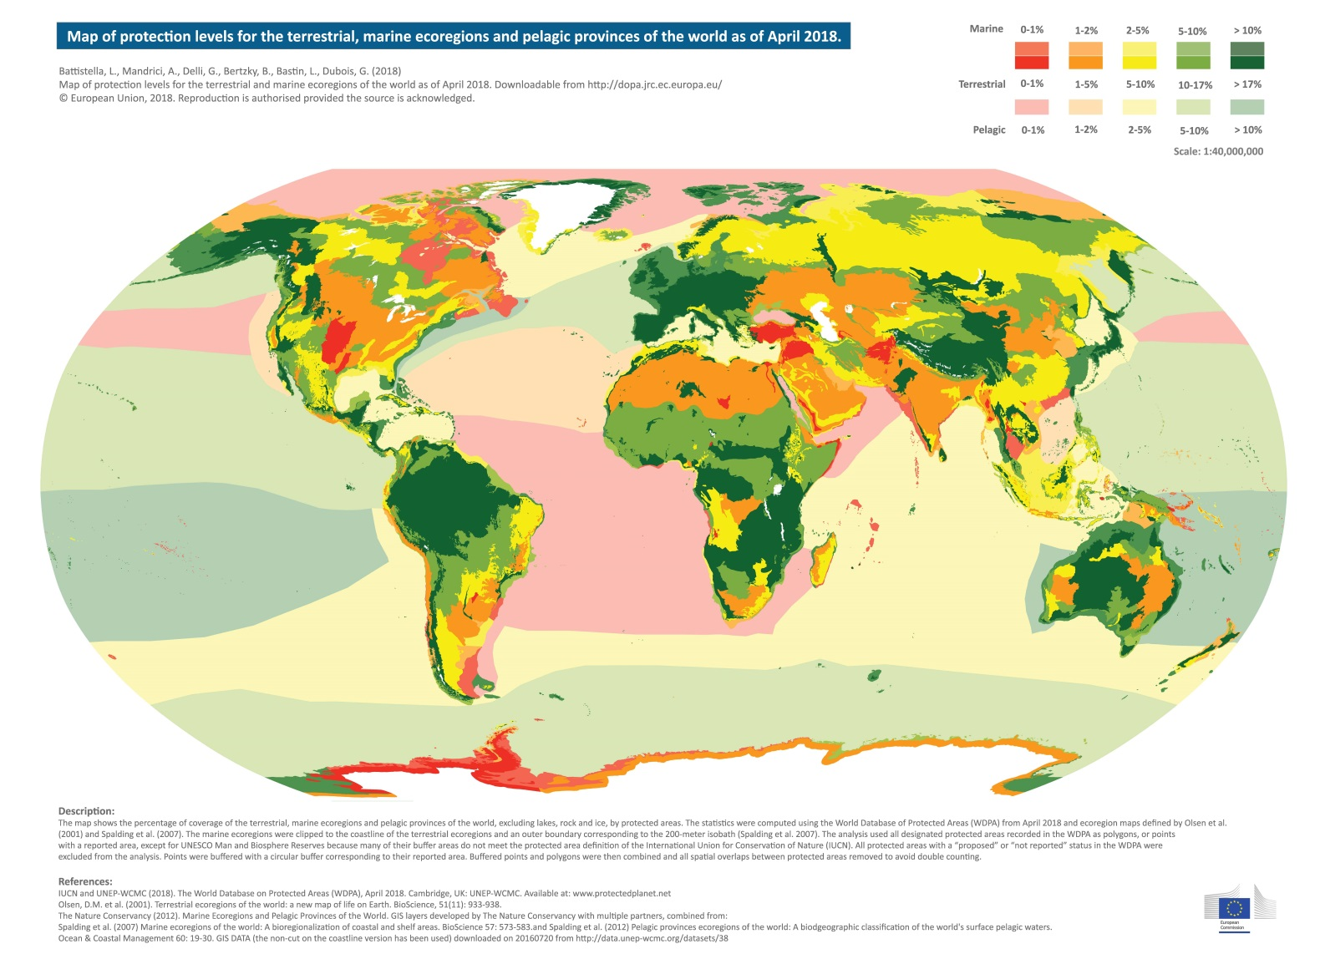**Figure 4.** Protected area coverage of terrestrial and marine ecoregions and pelagic provinces, as of April 2018.[[29]](#footnote-29)

1. There has been general improvement in the coverage of both marine ecoregions and pelagic provinces over the last two years (figure 5). On the other hand, there has been only limited improvement in the coverage of the terrestrial ecoregions. While many terrestrial ecoregions increased in protected area coverage, a significant number also showed decreased coverage. Figure 5 shows the changes in protected area coverage of terrestrial ecoregions, marine ecoregions and pelagic provinces over the period from April 2016 to April 2018.

**Figure 5.** Changes in protected area coverage of terrestrial ecoregions, marine ecoregions and pelagic provinces between April 2016 and April 2018.[[30]](#footnote-30)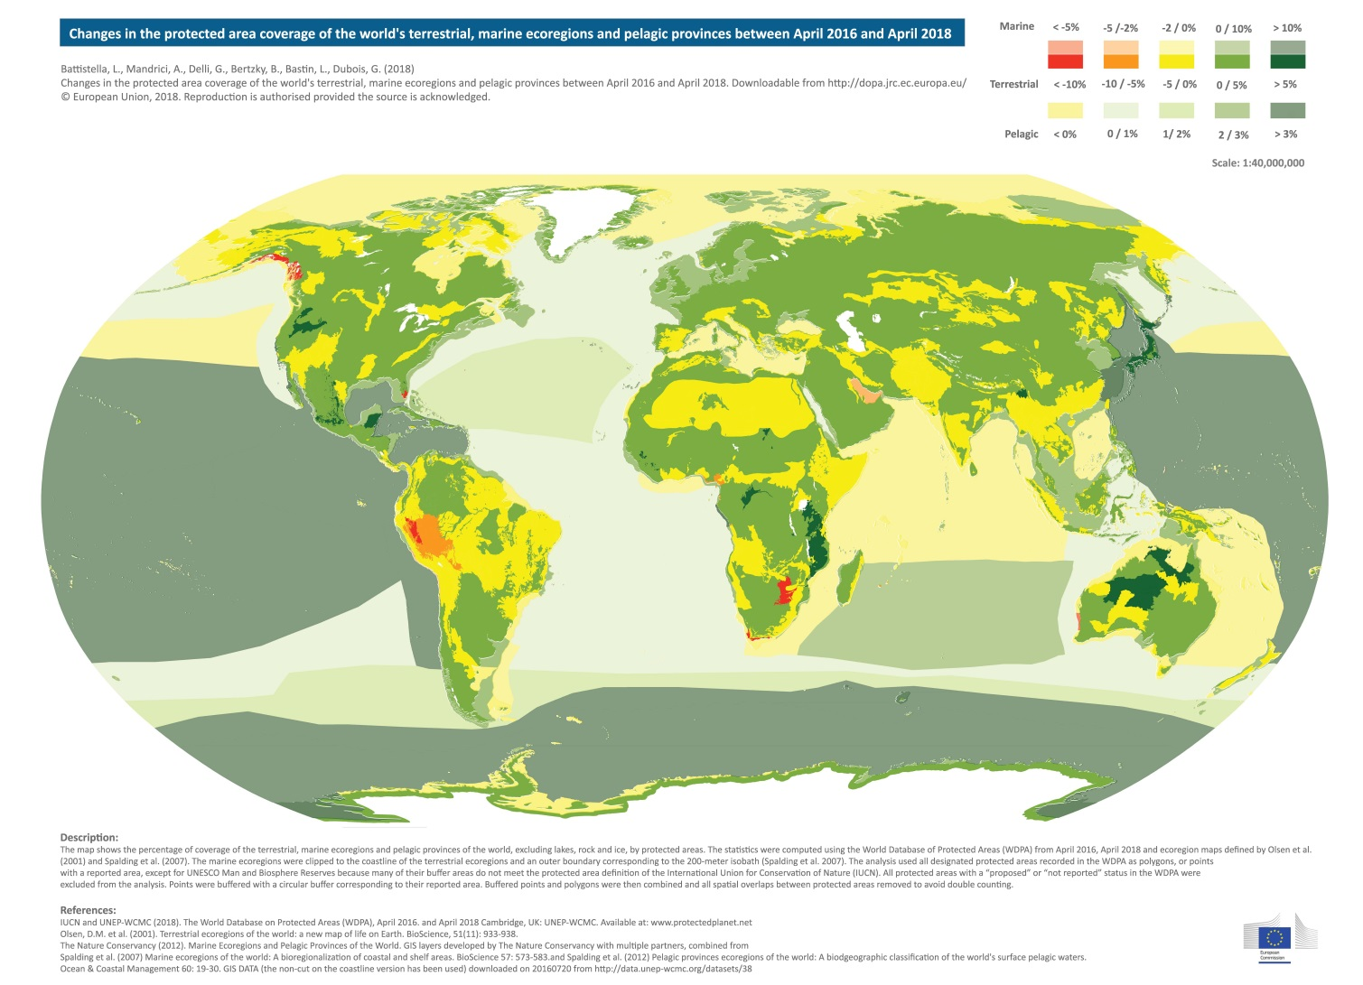

1. Figure 6 shows the protected area coverage for all ecoregions and pelagic provinces as of April 2018 and compares this with biogeographic analyses carried out by the DOPA for the 2014 and 2016 *Protected Planet Reports*. An increase in the number of ecoregions at higher levels of protected area coverage, as well as a decrease in the number of ecoregions at lower levels of protected area coverage (<5%), shows a general improvement in the ecological representation of the world’s protected areas. The improvement is most noticeable for marine areas, with an additional 15 marine ecoregions and one pelagic province surpassing the 10% coverage target compared to the analysis from April 2016.
2. Examples of improved coverage of marine ecoregions can be found in the Chile (Juan Fernández and Desventuradas), following the establishment of the Juan Fernández Archipelago MPA, and in Gabon (Gulf of Guinea South) following the creation an MPA network which now covers 28.8% of its EEZ. Following the establishment of large MPAs in the Cook Islands and Pitcairn, two marine ecoregions (Southern Cook/Austral Islands and Rapa-Pitcairn) and one pelagic province (South Central Pacific Gyre) now have protected area coverage surpassing 10%. The creation of the Ross Sea MPA in Antarctica and the expansion of MPAs in the French Southern and Antarctic Territories has improved coverage for five marine ecoregions (three of which previously had coverage below the 10% target) as well as several pelagic provinces (figure 5).
3. In addition, Romania added over 4,000 km2 (~15% of its EEZ), improving coverage of the Black Sea marine ecoregion to 9.5%. Malta, in fulfillment of its voluntary commitment made during the UN Ocean Conference, added several sites (covering over 3,000 km2 and almost 6% of its EEZ), improving coverage of the Ionian Sea marine ecoregion, which is now 9.6% covered by protected areas. Both marine ecoregions now fall just short of the 10% target.
4. Cuba increased terrestrial protected area coverage from 12.4% in the April 2016 WDPA release to over 16.5% in May 2018, which has led to improved protected area coverage of five terrestrial ecoregions. Two of these ecoregions, Cuban cactus scrub and Cuban moist forests, now have protected area coverage surpassing the 17% target. This follows the commitments presented in Cuba’s NBSAP and their national priority actions: to increase the protection of different landscapes and ecosystem types, including, *inter alia,* a 3% increase in the coverage of natural wetlands and natural plant formations. The Cuban cactus scrub was identified as one of three ecoregions with the highest priority for further protection in the data dossier prepared in advance of the regional capacity-building workshop. Republic of Korea increased terrestrial protected area coverage by over 3,600 km2 (3.65% of the country) over the last two years, improving protection of the Southern Korea evergreen forests. This was the sole terrestrial ecoregion in the country given the highest priority as a candidate site for further protection, as it occurs entirely within the country and its protected area coverage was below the target.

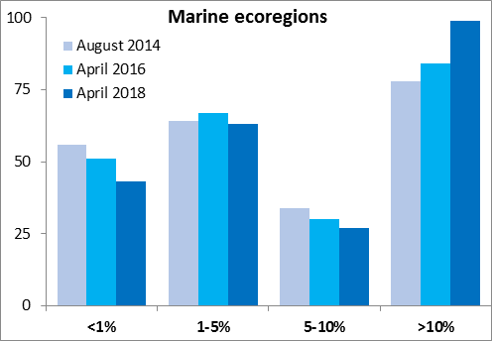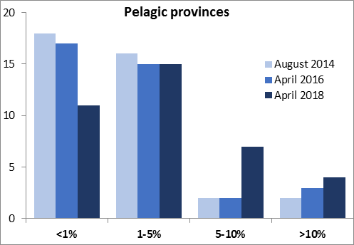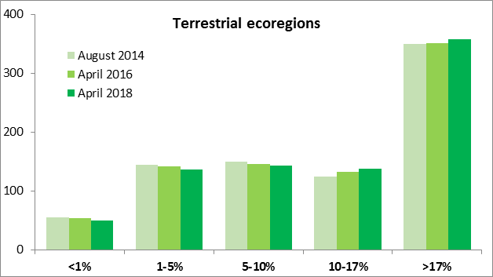

**Figure 6.** Number of marine ecoregions, pelagic provinces, and terrestrial ecoregions at different levels of protected area coverage in August 2014, April 2016, and April 2018.[[31]](#footnote-31)

1. Another positive development is the reduction in the number of ecoregions with lower levels of protected area coverage (see figure 6), including those which previously had no protected areas. For example, in Chad, terrestrial protected area coverage increased by more than 20,000 km2 over the last two years. This has increased coverage for the East Saharan montane xeric woodlands to almost 50%, for an ecoregion which had 0% coverage in April 2016. Additionally, the increase in marine protected area coverage in Japan (from 0.5% in the April 2016 WDPA to over 8.2% in 2018) has led to improved coverage for a number of marine ecoregions and pelagic provinces, including two pelagic provinces (Sea of Japan/East Sea and the Kuroshio-Oyashio Current) which previously had no recorded protected area coverage.[[32]](#footnote-32)
2. There remain 466 non-Antarctic terrestrial ecoregions with less than 17% coverage by protected areas, as well as 131 marine ecoregions and 33 pelagic provinces with less than 10% protection. However, reaching 17% in all terrestrial ecoregions may be unrealistic due to the small size and fragmentation of remaining habitat in some ecoregions; more than 180 ecoregions may not have enough remaining natural or semi-natural habitat to reach this target.[[33]](#footnote-33)
3. There were 174 priority actions addressing ecological representation of protected area networks identified by 93 Parties following the six regional capacity-building workshops, in addition to a range of commitments made by Parties in their NBSAP. For example, Brazil has set specific targets for each of its six biomes: 30% protected area coverage for the Amazon, and 17% for the remaining five biomes. Some of these biomes (Cerrado, Caatinga, Pantanal, and Pampas) are roughly aligned with a single terrestrial ecoregion, while the Amazon and Atlantic Forest biomes have a diverse array of ecoregions. Achievement of this target would provide positive impacts for ecological representation of the terrestrial protected area estate.
4. These actions, together with the commitments for expanding protected area networks (**Section II**), will improve the status of this element of the target. As would the recognition and support of ICCAs, and the systematic collection of information on privately protected areas (PPAs) and OECMs. The next step will need to involve the mapping of these areas with respect to their coverage of ecological regions.

## Areas important for biodiversity

|  |  |  |  |  |
| --- | --- | --- | --- | --- |
| **Element of Target 11**  (and status from GBO-4 in 2014) | | **Status in 2016**  (as per the *Protected Planet Report 2016*) | **Current Status**  (from the 2018 SDG Report) | **Opportunities for 2020** |
| **Areas of particular importance for**  **Biodiversity** | Mean % area of **Terrestrial KBAs** covered by PAs | 45.5% | 46.6% | Implementation of all national commitments, recognition and support of ICCAs, and systematic collection of information on OECMs and PPAs. |
| Mean % area of **Marine KBAs** covered by PAs | 41.3% | 44.3% |
|  |  |  |

1. For assessing progress towards the conservation of areas important for biodiversity, protected area coverage of Key Biodiversity Areas (KBAs) provides the most commonly used indicator.[[34]](#footnote-34) KBAs are identified using global criteria with quantitative thresholds, and aim to identify sites that contribute significantly to the global persistence of biodiversity. Sites may qualify as a global KBA by meeting at least one of the designated criteria, grouped under five categories: threatened biodiversity, geographically restricted biodiversity, ecological integrity, biological processes, and irreplaceability.[[35]](#footnote-35)
2. KBAs currently include Alliance for Zero Extinction sites (which contain more than 95% per cent of the global population of highly threatened species), Important Bird and Biodiversity Areas (sites of global significance for the conservation of birds and other biodiversity, identified by the BirdLife International Partnership), IUCN Freshwater KBAs, as well as KBAs identified through the Critical Ecosystem Partnership Fund hotspot profiling process. The global network of KBAs is still growing, following the development of a new global standard for their identification,[[36]](#footnote-36) as it continues to incorporate further taxonomic groups and different levels of biodiversity.
3. There has been a change in the way that this indicator is presented since the update provided for COP13 ([UNEP/CBD/COP/13/INF/17](https://www.cbd.int/doc/meetings/cop/cop-13/information/cop-13-inf-17-en.pdf)) and from earlier assessments. Previously it was presented as the number of KBA sites that are completely covered by protected areas; however, it is now presented as the mean percent of each KBA that is covered by reported protected areas. This change was made in order to better reflect trends in protected area coverage for countries or regions with few or no KBAs that are completely covered by protected areas.[[37]](#footnote-37)
4. As of 2018, the mean percentage area of marine KBAs covered by reported protected areas is 44.31%; for terrestrial and freshwater KBAs together, the mean percent coverage in 2018 is 46.6%.[[38]](#footnote-38) Figure 7 shows the change in mean percent coverage of KBAs since 2000. We see a significant increase, with marine KBAs showing the greatest improvement in coverage over the 18-year period, as well as the largest improvement over the last three years (2015 to 2018). This is in line with the significant expansion of marine protected areas in recent years (see **Section II**).

**Figure 7**. Change in mean percent coverage of KBAs in different ecosystems from 2000 to 2018.[[39]](#footnote-39)

1. Priority Actions directly addressing the protected area coverage of KBAs (with the number of sites indicated) were identified by 15 Parties, and will increase coverage in at least 96 KBAs. Another 11 Parties identified plans to improve protection of KBAs but did not indicate the specific number of sites that will be protected. For example, the Marshall Islands plans to bring some unprotected or partially protected Important Bird and Biodiversity Areas (IBAs) under protected areas as well as improving the management effectiveness of IBA protected areas. Marshall Islands currently has 15 identified KBAs, five of which are partially covered by protected areas and 10 of which have no protection.
2. Many other Parties provided plans for identifying and protecting areas important for biodiversity more broadly (not necessarily limited to KBAs). In total, 207 actions were identified for addressing this element of the target, which together with commitments made by Parties in their NBSAP will support progress towards the conservation of areas important for biodiversity. Additionally, many of the actions aimed at expanding protected area networks (**section II**) may also have positive impacts for the coverage of KBAs.
3. Opportunities also exist for the recognition and reporting of OECMs to improve the protection of KBAs. For example, an ongoing study of the current role of OECMs in conserving KBAs in 10 countries[[40]](#footnote-40) has found that “around 80% of the 754 unprotected KBAs examined by BirdLife International were at least partly covered by one or more potential OECMs.”[[41]](#footnote-41) ICCAs could also provide a significant contribution to the protection of KBAs. In the Philippines, out of 101 terrestrial KBAs, it was noted that “approximately 96 of these sites are part of the ancestral land and/or domains of IPs [Indigenous Peoples].”[[42]](#footnote-42)

## Areas important for ecosystem services

|  |  |  |  |
| --- | --- | --- | --- |
| **Element of Target 11** (and status from GBO-4 in 2014) | **Status in 2016** | **Current Status** | **Opportunities for 2020** |
| **Areas of particular importance for Ecosystem services** | The role of PAs for securing ecosystem services is recognized, but systematic information is not available. | Approaches to mapping ecosystem services have continued to improve, though there is currently no global indicator to assess their coverage by PAs. | Identification and mapping of areas important for ecosystem services |

1. While there is currently no indicator identified for assessing coverage of areas important for ecosystem services at the global level,[[43]](#footnote-43) many countries have conducted assessments to identify areas important for sustaining essential ecosystem services at a national or local level, and many offer some form of legal protection or other effective means for their conservation.
2. For example, Hungary is in the midst of a large-scale project,[[44]](#footnote-44) which among other aims will involve the identification and assessment of ecosystems and their services on a national scale. In China, the Sanjiangyuan National Nature Reserve was established to conserve the headwaters of the Yellow River, the Yangtze River and the Mekong River, while the Saihan Dam National Nature Reserve has an important role in the windbreak and sand control of the Hunshandak Sandland.
3. Over the past decade, a large number of studies have attempted to map ecosystem services at the global level, and have often focused on those services which can be assessed based on remote sensing data.[[45]](#footnote-45) Ecosystem services being assessed often include carbon sequestration, water and food provisioning services and primary production. The mapping of important ecosystem services has “developed over the past years into a mature scientific field.”[[46]](#footnote-46) Despite these advances “substantial data gaps remain to be filled before a fully integrated and complete ecosystem assessment can be carried out,” though a range of indicators are available for different ecosystems, which could support national-level evaluations.[[47]](#footnote-47)
4. Conservation of areas important for ecosystem services can also provide opportunity for positive synergies among the three Rio Conventions, and with other biodiversity-related multi-lateral environmental agreements. Many GEF projects in protected areas report on their impacts for carbon emission reductions or the maintenance of terrestrial carbon stocks. Additionally, sustainable land management forms an important component of many GEF-funded biodiversity projects.
5. Areas important for ecosystem services may also be poorly correlated with those areas of importance for biodiversity,[[48]](#footnote-48) or their correlation may depend on the scale of the assessment.[[49]](#footnote-49) Even in situations where they are spatially correlated, protected areas may not conserve both biodiversity and ecosystem services to the same extent.[[50]](#footnote-50) There is, therefore, a need to consider separately those areas important for biodiversity and for ecosystem services.[[51]](#footnote-51) Attention should be paid to potential trade-offs between biodiversity and certain ecosystem services, as well as between different ecosystem services.[[52]](#footnote-52)
6. The lack of clarity regarding this element persists; as such, assessing progress over the last two years remains difficult. Nevertheless, actions being taken by Parties, including the identification and mapping of areas important for ecosystem services at a national or local level, should support continued efforts towards the achievement of this element of the target. The support and recognition of ICCAs and the systematic collection of information on OECMs would also enhance the conservation of areas important for ecosystem services.

## Well-connected systems of protected areas

|  |  |  |  |
| --- | --- | --- | --- |
| **Element of Target 11** (and status from GBO-4 in 2014) | **Status in 2016** | **Current Status** | **Opportunities for 2020** |
| **Well-connected**  **systems** of PAs and OECMs | ACC guidelines being developed; progress being made towards indicators.  9.3% of the world is covered by protected connected lands (compared to 14.7% total protected). | PARC-connectedness index -- global value ~0.5.  27.9% of terrestrial ecoregions and 30.5% of countries and territories have protected and connected lands covering at least 17% (ProtConn). | Implementation of all national commitments.  At a minimum, each country develops at least one connectivity conservation initiative. |

1. Well-connected systems of protected areas are important for maintaining of ecological and evolutionary processes, especially given the impacts of climate change and increasingly fragmented natural landscapes. Conserving ecological connectivity is necessary to maintain and enhance the effectiveness of protected areas. Guidelines are being developed to define and describe areas of connectivity conservation (ACCs), as well as presenting identification criteria and possible governance arrangements for them.[[53]](#footnote-53) ACCs could be recognised for species movement or for large-scale migration in terrestrial, freshwater and marine areas, as well as for bird and non-bird flight migration.The development of ACC initiatives could provide one means for assessing progress on the connectivity element of Target 11.
2. Earlier assessments noted a lack of available indicators for tracking progress on the connectivity of protected area networks;[[54]](#footnote-54) in recent years advances have been made in developing them. One is the PARC-connectedness index.[[55]](#footnote-55) It makes use of a cost-benefit analysis (CBA) technique,[[56]](#footnote-56) with the ‘benefit’ assigned as the proportion of a cell included in protected areas or covered by primary vegetation (outside of protected areas), while the ‘cost’ indicates permeability to dispersal, and ranges from 0.1 (areas with no protection or primary vegetation) to 1.0 (fully protected or covered by primary vegetation). The index shows little change in the connectivity of the world’s protected area network between 2000 and 2012. In 2012, the global value was just over 0.5, indicating that, on average, “the connectedness of protected grid-cells is midway between that of a cell surrounded by a continuous expanse of unprotected transformed habitat (within a 500km radius), and a cell instead surrounded by a continuous expanse of protected areas and/or primary vegetation.”[[57]](#footnote-57) Further updates are expected this year.
3. Another is the proposed Protected Connected (ProtConn) indicator, developed by the EC-JRC. ProtConn applies a graph theoretic approach to quantify the percentage of a study region (e.g. continent, country, ecoregion) that is covered by protected connected lands, and can differentiate between several categories of land (unprotected, protected or transboundary) through which movement between protected areas may occur.[[58]](#footnote-58) The ProtConn indicator has since been adapted to be able to distinguish different causes of protected area isolation, including limitations in the design of a country’s protected area system, and natural isolation by the sea or due to intervening lands of other countries.[[59]](#footnote-59) Currently, 27.9% of the world’s terrestrial ecoregions[[60]](#footnote-60) and 30.5% of countries and territories[[61]](#footnote-61) have protected and connected lands covering at least 17% of the ecoregion/country, based on the ProtConn indicator for a median dispersal distance of 10km.[[62]](#footnote-62) This increases to 36.6% of terrestrial ecoregions and 38.6% of countries for a median dispersal distance of 100km. This indicates that many countries, and many terrestrial ecoregions, fall short of the goal of maintaining well-connected systems of protected areas, when considering a range of dispersal distances covering the abilities of most terrestrial birds and mammals.
4. To improve connectivity, many countries would require an overall increase in protected area coverage. For countries which are already approaching 17% terrestrial protected area coverage, the designation of new sites in strategic locations for connectivity, either as corridors or stepping-stones, will be necessary.[[63]](#footnote-63) For some countries (mainly in Micronesia and the European Union, and some countries in Latin America and Southern Africa), protected area networks are already well-designed for connectivity, therefore management to ensure the permeability of unprotected lands and/or the coordinated management of neighbouring protected areas and transboundary sites will be needed to sustain or improve connectivity (see figure 8). In all cases, it is necessary to ensure the effective management of existing protected areas, if connectivity is to be maintained.

**Figure 8**. Priorities for improving protected area connectivity, based on the ProtConn indicator (Source: Saura et al., 2018).

1. One example of a national protected area network successfully designed for connectivity is in Bhutan (figure 9), where all protected areas are connected to each other, either directly or through other intermediate sites, ensuring that movement between all protected areas is possible without the need to move through unprotected lands. The system of biological corridors was designated in 1999, and has been shown to be used by different wildlife species, including large mammals.[[64]](#footnote-64) Together with the country’s existing protected area network, it forms the ‘Bhutan Biological Conservation Complex (B2C2)’

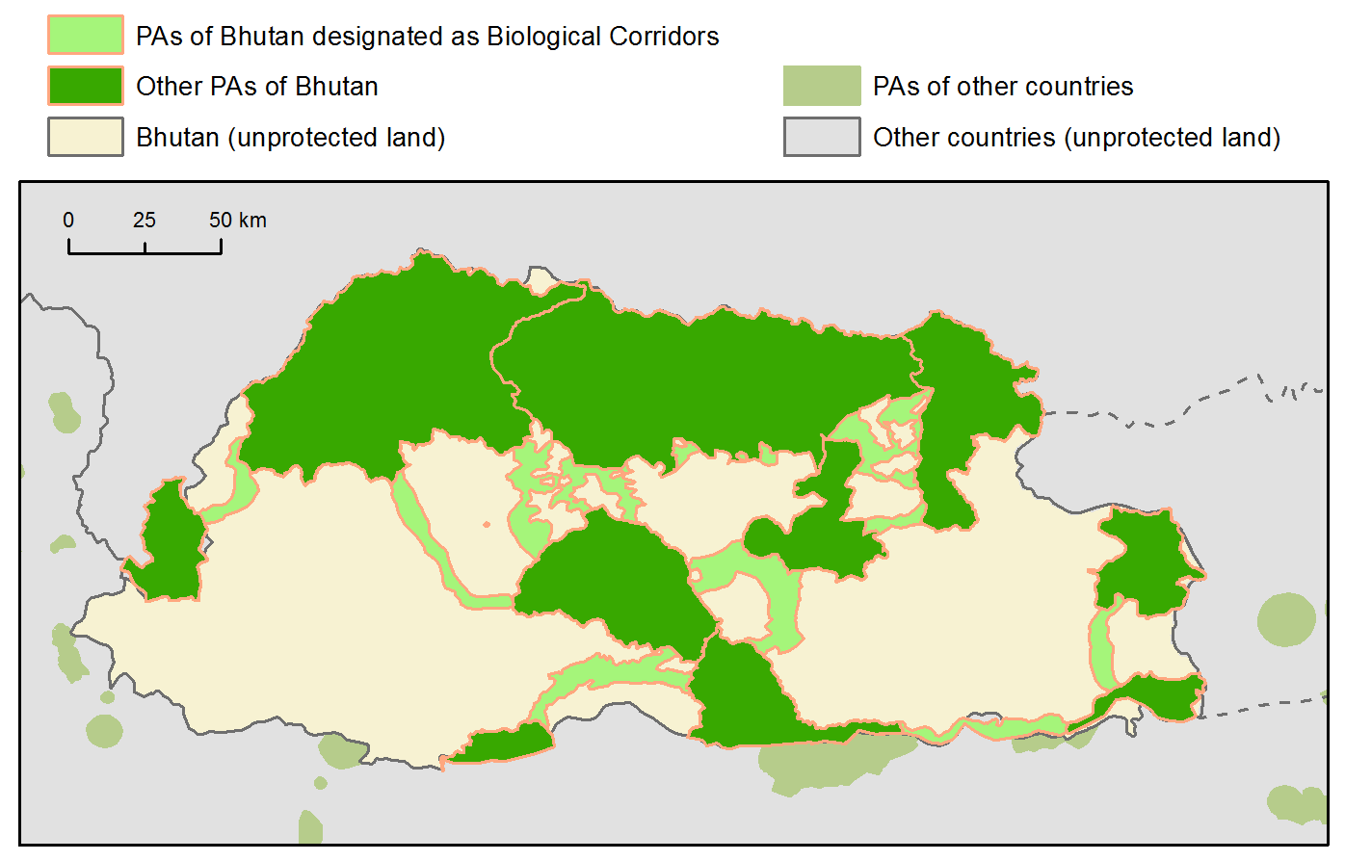

**Figure 9.** Connectivity of protected areas in Bhutan and neighbouring countries (Source: Suara et al., 2018).

1. To date, an assessment of the connectivity of marine protected areas has not been conducted, though with some modification the ProtConn indicator could be applied.[[65]](#footnote-65)
2. Over the last two years, two new transboundary World Heritage Sites have been inscribed: Western Tien-Shan (Kazakhstan, Kyrgyzstan, and Uzbekistan) in 2016 and Landscapes of Dauria (Mongolia, Russian Federation) in 2017. Kyrgyzstan was one of the countries where coordinated management of transboundary protected areas was highlighted as a priority for improving or sustaining protected area connectivity, based on results using the ProtConn indicator (figure 8).[[66]](#footnote-66) The Landscapes of Dauria will protect key natural habitats necessary for the annual migration of a range of different animal species, and will also protect essential breeding and resting habitat for birds along the East Asian-Australasian Flyway. Both of these new sites will help to enhance connectivity in the region.
3. Priority actions to address protected area connectivity were provided by 91 Parties. These 173 actions cover a range of activities, including the creation of new, or improved management of existing, biological corridors and connectivity areas (e.g. Timor-Leste and Samoa), or the development of transboundary conservation initiatives in some cases (e.g. several projects between Togo and its neighbours). These actions, together with the commitments by Parties in their NBSAP and proposed actions under the other spatial elements of Target 11 (protected area coverage, representation, and areas important for biodiversity and ecosystem services) should improve protected area connectivity. Further opportunities for the improvement of connectivity could arise through the recognition and support of ICCAs, and the systematic collection of information on OECMs and PPAs.

## Integration into the wider landscape and seascape

|  |  |  |  |
| --- | --- | --- | --- |
| **Element of Target 11** (and status from GBO-4 in 2014) | **Status in 2016** | **Current Status** | **Opportunities for 2020** |
| **Integration into the wider landscapes and seascapes** | Lack of detailed information.    More guidance is needed. | Development of voluntary guidance on integration of PAs and OECMs into wider landscapes and seascapes and mainstreaming across sectors. | Implementation of all national commitments.  At a minimum, each country integrates their PAs into local, regional, and national spatial planning and into important sectors |

1. In order to yield their full benefits, protected areas should be integrated into the wider landscapes and seascapes, as well as into broader sectoral plans and policies. This includes connecting individual protected areas into wider networks and with managed lands and waters in the wider landscape and seascapes in order to limit the impact of habitat fragmentation; as well as incorporating the design and management of protected areas into national and regional land-use plans, other relevant laws and policies, and into other related sectoral plans, strategies and programmes.[[67]](#footnote-67)
2. There is no indicator identified for tracking progress on the integration of protected areas into wider landscapes, seascapes and sectors, and to date limited information on the status of this element is available.[[68]](#footnote-68) However, some recently completed GEF-5 projects indicate that actions are being taken to improve the integration of protected area networks. For example, in Costa Rica alternative sustainable livelihood opportunities are being provided to more than 1000 families living in corridors and protected area buffer zones, to ensure the conservation of biodiversity. In Ecuador, a mosaic of conservation and sustainable livelihood initiatives were developed, leading to improved connectivity for a range of ecosystems, including páramo ecosystems in the Northern and Central-Southern Highlands, mangroves, dry forests, and tropical rainforest. Additionally, a project in Laos, through the Deutsche Gesellschaft für Internationale Zusammenarbeit (GIZ) GmbH, concluding this year, focused on integrated nature conservation and sustainable resource management in the Hin Nam No region and has helped to harmonise protected area planning with district and provincial plans, among other aims.[[69]](#footnote-69) It also led to Hin Nam No being included as the first natural site on Laos' Tentative List of candidate World Heritage Sites, in 2016.
3. From the roadmaps submitted during the series of regional capacity-building workshops in 2015 and 2016, there were fewer actions submitted for this element (92) than for any other (the average for all elements was 181 actions). This is echoed in the limited number of specific strategies for integration and mainstreaming of protected areas that are presented in countries’ NBSAPs.[[70]](#footnote-70)
4. Examples of efforts being made to improve the integration of protected areas into landscapes, seascapes and sectors include Slovenia’s Spatial Development Strategy (currently in preparation), which includes significant national infrastructure, including green infrastructure, as strategically planned multifunctional system of different spatial/landscape elements on national level with the guidelines for developing it in spatial plans at regional and local levels. Slovenia has also established a network of Natura 2000 sites (now covering 38% of the country) which is contributing to greater inclusion of nature protection considerations in spatial planning and natural resource planning, and forms the core of the EU's (and Slovenia’s) Green Infrastructure. In Australia, zoning arrangements and spatial planning aim to ensure ecologically sustainable uses alongside no-take reserves, to ensure benefits to overall ecosystem health and resilience.
5. Pursuant to paragraph 9(a(i-iv)) of decision [XIII/2](https://www.cbd.int/doc/decisions/cop-13/cop-13-dec-02-en.pdf) of the Conference of the Parties to the Convention, the Secretariat issued notification [2017-065](https://www.cbd.int/doc/notifications/2017/ntf-2017-065-pa-en.pdf), inviting, *inter alia*, Parties and other Governments, relevant partners and regional agencies to submit information and experiences on the various sub-items. These include: (ii) additional measures to enhance integration of protected areas and other effective area-based conversation measures into the wider land- and seascapes; and (iii) mainstreaming of protected areas and OECMs across sectors to contribute, *inter alia*, to the Sustainable Development Goals and as natural solutions to combat climate change. A total of 23 Parties and organizations had responded and 39 documents were submitted. Then, pursuant to paragraph 10(a) of the same decision the corresponding voluntary guidance[[71]](#footnote-71) is prepared and presented as annex I[[72]](#footnote-72) in the pre-session document submitted to SBSTTA 22**. Two information documents[[73]](#footnote-73) were also presented to SBSTTA 22 in support of the relevant sections of the voluntary guidance.**
6. At a minimum, to ensure progress on this element of Target 11, each country should begin integrating their protected areas into local, regional, and national spatial planning and mainstreaming them into important sectors. The voluntary guidance provides possible steps for supporting these aims.

## Effectively managed

|  |  |  |  |  |
| --- | --- | --- | --- | --- |
| **Element of Target 11**  (and status from GBO-4 in 2014) | | **Status in 2015**  (GD-PAME, Jan 2015) | **Current Status**  (GD-PAME, May 2018) | **Opportunities for 2020** |
| **Effectively managed** | Countries and territories with ME evaluations in at least 60% of PAs | 17.5% | 21% terrestrial  16% marine | Implementation of all national commitments.  Continued efforts to carry out national assessments of management effectiveness in PAs and improve management effectiveness scores of assessed PAs. |
| CBD Parties missing 60% target | 154 | 148 terrestrial  123 marine |
|  | Information lacking for other aspects of effective management. | Studies indicate capacity and funding as best predictors of conservation outcomes |

1. Establishing protected areas will not be enough to ensure the conservation of biodiversity if they are not effectively managed.[[74]](#footnote-74)
2. In 2010, Parties were invited to implement management effectiveness evaluations in at least 60% of their total protected areas by 2015 (COP Decision [X/31](https://www.cbd.int/doc/decisions/cop-10/cop-10-dec-31-en.pdf)). In January 2015, as per the Global Database on Protected Areas Management Effectiveness (GD-PAME) managed and maintained by the UNEP-WCMC, only 17.5% of countries and territories had met his target.[[75]](#footnote-75) The following year, in decision [XIII/2](https://www.cbd.int/doc/decisions/cop-13/cop-13-dec-02-en.pdf), the COP encouraged Parties to expand, institutionalize, and undertake more systematic assessments of management effectiveness within their protected areas system, as well as to update and share the relevant information on management effectiveness in the GD-PAME. In response, through a notification ([2017-066](https://www.cbd.int/doc/notifications/2017/ntf-2017-066-pa-en.pdf)), Parties and other governments were invited to review the existing information in the GD-PAME, and submit an official and up-to-date version of their records.
3. Some progress has been made on this element of Target 11. As of May 2018, 21% of countries and territories had reached the target for terrestrial protected areas and 16% had reached the target for marine protected areas (figure 10). This represents an improvement over the 17.5% of countries which had met the target as of January 2015. For CBD Parties, excluding overseas territories, 148 have not met the target for terrestrial protected areas, and 123 have not met the target for marine protected areas. This includes a large number of countries where no protected areas have been assessed for management effectiveness, as recorded in the GD-PAME (figure 10).

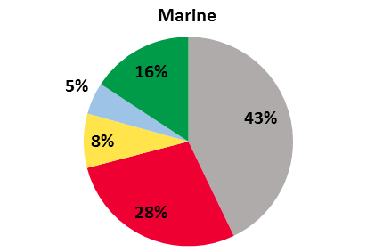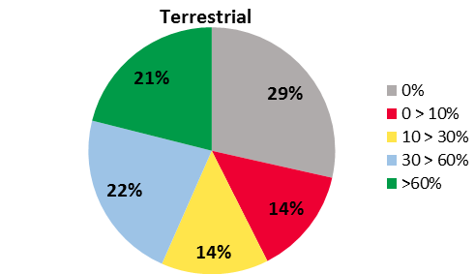

% of PA network assessed

**Figure 10.** Percentage of countries with varying levels of progress towards the 60% management effectiveness assessment target, as per information contained in the GD-PAME in May 2018.[[76]](#footnote-76)

1. Commitments for improving the effective management of protected areas have been submitted in the roadmaps of 95 Parties. These include 240 individual national priority actions, and contain a range of commitments to improve management effectiveness in protected area networks, including: over 70 actions relating to protected area management plans, more than 45 actions involving management effectiveness evaluations, and over 100 other actions aimed at general improvements to protected area management effectiveness.
2. A large number of GEF-5 and GEF-6 projects also provide for the improved management effectiveness of existing protected areas, as well as the assessment of protected area management effectiveness for newly designated sites. Table 2 provides a few examples of the expected outputs of approved GEF-5 and GEF-6 projects.

**Table 2** Examples of GEF-5 and GEF-6 projects that included protected area management effectiveness.

|  |  |  |
| --- | --- | --- |
| **Country** | **GEF project ID** | **Expected project output with impacts for protected area management effectiveness** |
| China | 4868 | Strengthened management of Daxing’anling wetland PA Complex provides effective landscape level biodiversity conservation indicated by: (i) improvement in the average METT scores of the PAs; (ii) improvement in the biodiversity health index2 especially designed for the PAs in the landscape |
| Colombia | 5560 | 1.2 million hectares of existing PAs meet or exceed their management effectiveness targets, and 2.7 million hectares of Amazon Protected Areas (including some of the new and existing PAs) meet their targets for reducing the PA management funding gap of their financial plans |
| Democratic Republic of Congo | 4640 | Improved management effectiveness of three protected areas (Garamba NP, Kahuzi-BiegaNP & Salonga NP), as indicated by METT. |
| Guatemala | 9059 | Improvement of the management effectiveness for 6 national-level and 5 regional-level PAs, as measured by METT; and at least a 15% increase in the management and technical capacity of 80 PA officials, municipal officials, and local communities, as measured by UNDP capacity development indicators. |
| Kenya | 4362 | Enhanced management effectiveness of at least 6 Community Conservancies (a 20% increase in adapted METT scores). |
| Philippines | 4338 | A 40% increase in PA management effectiveness, as recorded by METT. |

1. There are also some other bilateral-funded projects which will also have implications for improving management effectiveness in protected areas. Examples include the recently completed GIZ project, “Protected area management enhancement in the Philippines” aimed at surveying management effectiveness existing nature protection areas, to serve as a basis for establishing new protected areas in identified key biodiversity areas,[[77]](#footnote-77) among many others.
2. The completion of management effectiveness evaluations is only one component of ensuring that protected areas are effectively managed. It is important that management effectiveness assessments are repeated at the same site (or system) to track changes over time and implement remedial measures as needed.[[78]](#footnote-78) An analysis of management effectiveness assessments from 722 protected areas in 74 countries (with multiple assessments carried out in different years), found the majority (69.5%) showed improvements in management over time, while 5.4% saw no change and 25.1% saw a decrease in management scores.[[79]](#footnote-79) There is also need to link these assessments to actual conservation outcomes, and to better understand the types of management interventions that yield effective biodiversity outcomes.
3. One recent study found that the only aspect of protected area management associated with positive changes in the populations of native birds, mammals and reptiles was ‘Capacity and Resources’, which includes factors like adequate staff and budgets and the availability of equipment.[[80]](#footnote-80) Another recent study, addressing marine protected areas, found that the strongest predictors of conservation impact were staff and budget capacity.[[81]](#footnote-81) In fact, those protected areas with adequate staff capacity showed positive conservation effects almost three times greater than those with inadequate capacity.[[82]](#footnote-82) Funding and capacity were also among the most commonly identified gaps hindering progress on achieving the elements of Target 11 identified during the six regional workshops carried out in 2015 and 2016.
4. Improving the utility of data on management effectiveness to address the performance of protected areas will require streamlining assessment processes, improving systems for collating data, and ensuring the application of counterfactual thinking[[83]](#footnote-83) which often lacks in assessments of protected areas.[[84]](#footnote-84)
5. Pursuant to paragraph 9(b)) of decision [XIII/2](https://www.cbd.int/doc/decisions/cop-13/cop-13-dec-02-en.pdf), the COP invited Parties and other Governments, relevant partners, regional agencies, bilateral and multilateral funding agencies, to promote the development of global or regional projects which could support national assessments of management effectiveness and equity in protected areas and encourage the sharing of best practices and lessons learned with interested Parties.
6. There is a need for need for aligning all of these ongoing initiatives, to ensure that protected areas are effectively addressing threats to biodiversity. As the number and extent of protected areas continues to increase, there is a need to address protected area quality, as well as quantity. At a minimum, each country should strive, as requested by the COP, to increase the assessment of management effectiveness in their protected areas, and for an increase in the number of their protected areas falling under sound management. There is a need to address not only the assessment of management effectiveness, but also enhancing protected area management, overall, and its contribution to improved biodiversity outcomes.

## Equity and Governance

|  |  |  |  |  |
| --- | --- | --- | --- | --- |
| **Element of Target 11**  (and status from GBO-4 in 2014) | | **Status in 2016**  (as per the *Protected Planet Report 2016*) | **Current Status**  (as per the May 2018 release of the WDPA) | **Opportunities for 2020** |
| **Equitably managed** | % of sites governed by government | 84% | 81.5% | Continued reporting on governance type for all PAs.  Increase in the number of sites governed by non-state actors.  Systematic application of governance and social assessments at PA (and OECM) site and system level, to establish baselines and identify relevant actions. |
| % private | 4.5% | 5.7% |
| % shared | 1.8% | 3.3% |
| % IPLC governance | 0.6% | 0.6% |
| % not reported | 9% | 9% |
|  | Information lacking for other aspects of this element. | Development of voluntary guidance. |

1. Governance relates to who holds power, authority and responsibility and who is, or should be, held accountable. Governance arrangements should be “tailored to the specifics of [their] context and effective in delivering lasting conservation results, livelihood benefits and the respect of rights.”[[85]](#footnote-85) There is no single indicator available for this element of Target 11: for progress on this element, there is a need to enhance protected area governance in terms of diversity, quality, effectiveness and equity.
2. Governance diversity relates to the range of different governance types, concerning both legal provisions and practices, and their complementarity in achieving effective *in situ* conservation of biodiversity. Recognized protected area governance types include: governance by government (at various levels and possibly combining various institutions); shared governance (by two or more actors working in collaboration); governance by private individuals and/or organizations; and governance by Indigenous peoples and/or local communities.[[86]](#footnote-86)
3. Currently, the global protected area system, as presented in the WDPA, is dominated by state-managed protected areas (84% of sites), though there has been some increase in the number and extent of protected areas under private governance, or governance by indigenous peoples or local communities over the last two decades (figure 11). However, there remain a large number of sites (~9%), covering more than a quarter of all area protected, that still do not have their governance type reported to the WDPA.[[87]](#footnote-87) Some of these fall under international designations (e.g. most Ramsar sites). Others, such as some communal forests in Malaysia, communal reserves in Peru, or some ra-ui marine areas in Cook Islands, could potentially be considered as governed by indigenous peoples or local communities. There are also a range of private conservation lands, private nature reserves, private protected areas, conservation easements and local non-profit preserves, among others, which do not have their governance type reported. As such, the proportion of sites governed privately, or by indigenous peoples and local communities is likely under-estimated in the current WDPA, where the true extent of these sites may also be under-estimated due to insufficient reporting.

**Figure 11.** Percentage changes in the proportion of sites in the WDPA under non-state governance. Note: During this time, sites governed by governments increased from 82 to 84%, and those with their governance type unreported fell from 11 to 8%.[[88]](#footnote-88)

1. Effective and equitable governance in protected areas requires the application of ‘good governance’ principles. Good governance requires that any potential negative impacts are evaluated and monitored and then avoided or mitigated, as well as enhancing positive impacts of protected areas.[[89]](#footnote-89) The IUCN principles of good governance for protected areas highlight the need for legitimacy and voice; direction; performance; accountability; and fairness and rights.
2. One of the elements of good governance is equity. In simple terms, equity means fairness, and is closely related to the concept of justice.It can be divided into three dimensions, including: ‘recognition’, meaning acknowledgement and respect for rights, knowledge systems, values and institutions of involved actors; ‘procedure’, referring to participation in decision-making, transparency, and accountability; and ‘distribution’ of costs and benefits across the set of actors.[[90]](#footnote-90)
3. To assess equity in protected areasa mix of social and governance assessments could be used. Governance assessment looks at the quality of the governance arrangements in relation to good governance principles; while social assessments go further to understand the impacts on human wellbeing, which is an important aspect of equity. An equity framework, proposed to assess progress on equitable protected area management, includes 16 principles nested under the three key dimensions of equity, all embedded within a set of enabling conditions.[[91]](#footnote-91) A preliminary set of 10 indicators, covering the three dimensions of equity has been proposed, and could provide one method to address reporting on this element.[[92]](#footnote-92)This sort of ‘universal scorecard approach’ despite the limitations with its use at a site level, would be useful for the aggregation of results at national and global levels, and could be a good starting point.[[93]](#footnote-93)
4. Despite advances in guidance with respect to governance assessment, and with at least 29 different governance assessment methodologies for protected areas and related contexts, applications of site-based assessments remain limited, with the notable exception of Nepal.[[94]](#footnote-94) Further work needs to be done to ensure that criteria for assessing and reporting on this element of Target 11 are more systematically and broadly applied.
5. Eighty countries, following the six regional workshops, have submitted 163 priority actions addressing equity and governance issues in their protected areas. These cover a range of priorities, including but not limited to: recognizing a diversity of governance types in protected and conserved areas; ensuring active stakeholder participation; carrying out governance assessments in protected areas; and ensuring equity in the distribution of benefits arising from protected areas.
6. Pursuant to paragraph 9(a(i-iv)) of decision [XIII/2](https://www.cbd.int/doc/decisions/cop-13/cop-13-dec-02-en.pdf), the Secretariat had issued notification [2017-065](https://www.cbd.int/doc/notifications/2017/ntf-2017-065-pa-en.pdf), inviting, *inter alia*, Parties and other Governments, relevant partners and regional agencies to submit information and experiences on the various sub-items, including (iv) on effective governance models for management of protected areas, including equity, taking into account work being undertaken under Article 8(j). A total of 23 Parties and organizations had responded and 39 documents were submitted. Then, pursuant to paragraph 10(a) of the same decision the corresponding voluntary guidance[[95]](#footnote-95) is prepared and presented as annex II[[96]](#footnote-96) in the pre-session document submitted to SBSTTA 22**. An information document**[[97]](#footnote-97) **is also presented to SBSTTA 22 in support of this voluntary guidance.**
7. The IUCN Green List of Protected and Conserved Areas Standard includes four components, addressing all aspects of the management elements of Target 11, namely, good governance, sound design and planning, and effective management, which all support successful conservation outcomes.[[98]](#footnote-98) The goal of the Green List is to “increase the number of Protected and Conserved Areas (PAs) that are effectively and equitably managed and deliver conservation outcomes.”[[99]](#footnote-99) Criteria for assessing good governance include: guaranteeing legitimacy and voice; achieving transparency and accountability; and enabling capacity to respond adaptively. In Decision [XIII/2](https://www.cbd.int/doc/decisions/cop-13/cop-13-dec-02-en.pdf), the COP invited Parties to promote the IUCN Green List of Protected and Conserved Areas as a voluntary standard to promote and encourage protected area management effectiveness; and to undertake or participate in, where relevant, national protected area governance assessments with a view to promoting, recognising and improving governance diversity, efficiency and equity in protected area systems.
8. With increased reporting on governance type for all protected areas, and a continued increase in the number of sites governed by non-state actors, progress with respect to the governance diversity aspect of this element will continue. Systematic application of governance and social assessments at the site and system level would help to establish baselines and identify relevant actions necessary for enhancing the quality, effectiveness and equity of protected area governance.

# OTHER EFFECTIVE AREA-BASED CONSERVATION MEASURES

1. In recognition of the important role that areas outside of formally recognised protected area networks may offer for the effective *in-situ* conservation of biodiversity, Target 11 allows for both protected areas and other effective area-based conservation measures (OECMs) to be designated to meet the requirements of the target. Partly due to the lack of an agreed definition for OECMs, and guidance on their identification, to date protected areas have been the primary focus of efforts to achieve Target 11.
2. In response to paragraphs 9(a(i)), 10(a) and 10(b) of decision [XIII/2](https://www.cbd.int/doc/decisions/cop-13/cop-13-dec-02-en.pdf) of the Conference of the Parties to the Convention, the Executive Secretary convened the Technical Expert Workshop on Other Effective Area-based Conservation Measures for Achieving Aichi Biodiversity Target 11([2017-099](https://www.cbd.int/doc/notifications/2017/ntf-2017-099-pa-en.pdf))[[100]](#footnote-100) in Montreal, from 6 to 9 February 2018. The resulting “Scientific and technical advice on definition, management approaches and identification of other effective area-based conservation measures and their role in achieving Aichi Biodiversity Target 11” is presented in annex III of the pre-session document submitted to SBSTTA 22.[[101]](#footnote-101) The report of the workshop was also presented as information document[[102]](#footnote-102) to support the advice.
3. The potential exists for OECMs to support all elements of Target 11. They will increase coverage of both terrestrial and marine areas, and may help fill some of the gaps in ecological representation and the coverage of areas important for biodiversity and ecosystem services. OECMs may enhance connectivity by acting as stepping stones or corridors and may help to integrate sustainable productive activities within networks of protected. It is expected that the tools developed for assessing protected area management effectiveness evaluations, with additional quantitative information on biodiversity outcomes, will also support the management effectiveness of OECMs. The same set of governance types defined for protected areas will be applied to OECMs, and with their focus on the delivery of effective *in-situ* conservation, regardless of the primary management objective, OECMs may help to increase governance diversity and address equity aspects of Target 11.
4. OECMs may also offer an important opportunity to increase recognition and support for ICCAs, subject to important caveats. These include the need for the recognition and reporting of OECMs to “fully respect the rights of the Indigenous peoples and local communities (including their authorities and organisations responsible for such areas) and be based on their free, prior and informed consent.”[[103]](#footnote-103) Accordingly, “governance of an OECM must reflect internationally-, regionally- and nationally-recognised human rights.”[[104]](#footnote-104)

# POTENTIAL DIRECTIONS FOR INCREASING ACHIEVEMENT AND NEXT STEPS

1. The first phase of the Secretariat’s protected areas strategy (2015-2016) saw the completion of six regional workshops covering all developing countries, and involved the collection of information on the status, gaps and opportunities for the elements of Target 11 from 108 Parties, and of roadmaps from 101 Parties. These roadmaps contained more than 1400 national priority actions addressing all elements of Target 11.[[105]](#footnote-105) The figure summarizes the process following in the first phase.

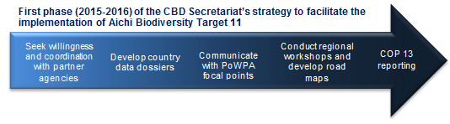

1. Analysis of the roadmaps revealed that the implementation of the proposed national priority actions, taking consideration of their relative strength (e.g. availability of plans and funding for implementation), would lead to significant progress for some elements of Target 11.[[106]](#footnote-106) It would also provide significant contributions, both directly and indirectly, to other Aichi Biodiversity Targets,[[107]](#footnote-107) and many of the goals and targets of the 2030 Agenda for Sustainable Development.[[108]](#footnote-108) It could also deliver various benefits with respect to climate change mitigation and, the Sendai Framework for Disaster Risk Reduction 2015-2030, and the Land Degradation Neutrality goal of the United Nations Convention to Combat Desertification. In addition, there would also be contribution towards the fulfilment of requirements in other multi-lateral environmental agreements, such as UNESCO’s World Heritage Convention and its Man and the Biosphere Programme, the Ramsar Convention, the Convention on Migratory Species, and other biodiversity-related conventions, in a synergistic manner. After two years of implementation of these roadmaps, indeed, progress is noticeable.
2. The second phase of the Secretariat’s protected areas strategy (2017-2020)[[109]](#footnote-109) aims to, *inter alia,* facilitate decentralized implementation of the roadmaps developed/collected in the first phase, in a concerted manner with comprehensive coordination among all relevant partners. The Conference of the Parties to the Convention, in decision [XIII/2](https://www.cbd.int/doc/decisions/cop-13/cop-13-dec-02-en.pdf) paragraph 9(d), called for this approach when it invited Parties, other Governments, relevant partners, regional agencies, bilateral and multilateral funding agencies, in conjunction with the Secretariat, to *inter alia,* facilitate support networks at the regional and subregional level, such as REDPARQUES and other important regional initiatives, as appropriate, to build capacity and support the implementation of national actions identified in national biodiversity strategies and action plans and, as appropriate, through the regional workshops for the achievement of Aichi Biodiversity Targets 11 and 12, to promote the preparation, use and sharing of technical guidance, best practices, tools, lessons learned, and monitoring efforts. The process in the second phase is illustrated briefly below.

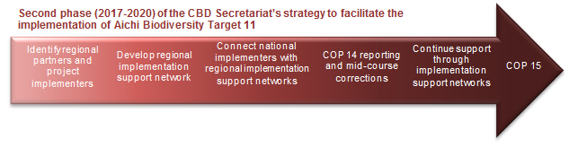

1. For each region,[[110]](#footnote-110) the concerted efforts can be achieved by enabling a Regional Implementation Support Network of partners, coordinated by an agency (Coordination Agency) that will operate in collaboration with the Secretariat, but in a decentralized manner, in different regions. The Coordination Agencies would have on-going capacity building support programme(s); be familiar with the different projects and programmes in their region; and be willing to take up the coordination responsibility. Each Coordination Agency will design an Action Plan for its region based on the national priority actions, NBSAPs and other national commitments of the countries of the region, mapping them vis-a- vis ongoing and planned activities by various partners, and in consultation with the Parties concerned and the Secretariat, to facilitate effective implementation in each country.
2. Tracking progress on the implementation of roadmaps, and reporting the results through the CBD reporting channels would assist in planning for the last two years of implementation (2019-2020) to ensure achievement of as many elements of Target 11 as possible, and facilitate reporting to COP 15. The final status results would also serve as a new baseline for the post-2020 biodiversity framework.

# CONCLUSIONS

1. Progress is clearly noticeable after two years of Parties implementing the actions in their roadmaps, NBSAPs and other national commitments. As such, with two and a half years remaining before the deadline for the Aichi Biodiversity Targets, there are good chances that some of the elements of Target 11 will be met or exceeded by 2020.
2. Progress is evident with respect to the coverage of terrestrial and inland waters and coastal and marine areas, with an increase in the global protected area coverage of both as well as in the number of CBD Parties meeting the coverage targets. This progress is most noticeable in the extraordinary growth in the coverage of marine protected areas, with well over 10 million km2 added over the last two years. The overall increase in protected area coverage has translated into an improvement in the ecological representation of both terrestrial and marine protected area networks, as evidenced by the increase in the number of terrestrial and marine ecoregions reaching the coverage targets, as well as improved coverage of areas important for biodiversity, as measured by the mean percent area of terrestrial and marine KBAs covered by reported protected areas. With this expansion of protected area coverage comes the need to ensure that threats facing biodiversity are properly addressed. Progress has been made in the development of indicators for tracking protected area connectivity, and global assessments are now available. These assessments show that work is still needed to improve the connectivity of the world’s protected areas. The number of Parties meeting the target for completion of protected area management effectiveness evaluations has increased, as has the number of sites in the WDPA reporting shared or private governance. This shows an increase in governance diversity. Other aspects of effective and equitable management currently lack global assessments, though there is a recognized need to focus on the quality of protected area management and governance, to complement the continued progress in the quantity of protected areas. There is a need for more focused application of management effectiveness evaluations, with a view to increasing protected areas under sound management, and the systematic application of governance and social assessments, at the site and system level. Finally, voluntary guidance on integration, mainstreaming, and effective governance models (including equity), and guidance on OECMs, will help to address some of the outstanding gaps with the qualitative elements of Target 11.
3. For those elements which may not be achieved by 2020, the second phase of the Secretariat’s protected areas strategy is putting in place sustained capacity building mechanisms which should ensure continued progress, and the achievement of these in the ensuing years. This will provide a good basis for further discussions of a post-2020 biodiversity framework and the setting of more ambitious goals for the future, as needed to achieve the agreed 2050 vision for biodiversity.
4. With continued implementation of national priority actions and other commitments, the progress of the last two years could be maintained and hopefully accelerated. This could be complemented through the comprehensive assessment of the contribution of PPAs, ICCAs and OECMs, which would support progress on all of the elements of Target 11. There is a need for concerted efforts to systematically collect information and report on these areas; employing all necessary safeguards, including ensuring that IPLCs have the capacity to exercise their free, prior and informed consent. This would include mapping these under-reported protected area categories vis-à-vis the various elements of Target 11.
5. Significant progress towards the achievement of the elements of Aichi Biodiversity Target 11 would generate multiple benefits for the well-being of society by contributing solutions to the many of the most important of global challenges, as addressed in the Strategic Plan for Biodiversity 2011–2020 and emphasised through the United Nations Sustainable Development Goals. It would also make a major contribution towards facilitating sustainable development, including through poverty alleviation, economic growth, and a healthy environment, leading towards a life in harmony with nature at the local, national and global levels, not only for the current but also future generations.

*Annex*

**List of Parties for the 12 subregional groups**

|  |  |  |
| --- | --- | --- |
| ***Pacific Region*** | ***Caribbean*** | ***Central and Western Europe*** |
| Cook Islands | Antigua and Barbuda | Albania |
| Fiji | Bahamas | Andorra |
| Kiribati | Barbados | Austria |
| Marshall Islands | Belize | Belgium |
| Micronesia (Federated States of) | Cuba | Bosnia and Herzegovina |
| Nauru | Dominica | Bulgaria |
| Niue | Dominican Republic | Croatia |
| Palau | Grenada | Cyprus |
| Papua New Guinea | Guyana | Czechia |
| Samoa | Haiti | Denmark |
| Solomon Islands | Jamaica | Estonia |
| Tonga | Saint Kitts and Nevis | Finland |
| Tuvalu | Saint Lucia | France |
| Vanuatu | Saint Vincent and the Grenadines | Georgia |
|  | Suriname | Germany |
| **East and South-East Asia** | Trinidad and Tobago | Greece |
| Brunei Darussalam |  | Hungary |
| Cambodia | ***Central and Southern America*** | Iceland |
| China | Argentina | Ireland |
| Democratic People's Republic of Korea | Bolivia (Plurinational State of) | Israel |
| Indonesia | Brazil | Italy |
| Japan | Chile | Latvia |
| Lao People's Democratic Republic | Colombia | Liechtenstein |
| Malaysia | Costa Rica | Lithuania |
| Mongolia | Ecuador | Luxembourg |
| Myanmar | El Salvador | Malta |
| Philippines | Guatemala | Monaco |
| Republic of Korea | Honduras | Montenegro |
| Singapore | Mexico | Netherlands |
| Thailand | Nicaragua | Norway |
| Timor-Leste | Panama | Poland |
| Viet Nam | Paraguay | Portugal |
|  | Peru | Republic of Moldova |
| ***South Asia*** | Uruguay | Romania |
| Afghanistan | Venezuela (Bolivarian Republic of) | San Marino |
| Bangladesh |  | Serbia |
| Bhutan | ***North America*** | Slovakia |
| India | Canada | Slovenia |
| Iran (Islamic Republic of) |  | Spain |
| Maldives | ***Australia and New Zealand*** | Sweden |
| Nepal | Australia | Switzerland |
| Pakistan | New Zealand | The former Yugoslav Republic of Macedonia |
| Sri Lanka |  | Turkey |
|  |  | United Kingdom of Great Britain and Northern Ireland |
|  |  |
| ***Eastern and Southern Africa*** | ***Western and Central Africa*** | ***Russian-speaking Eastern Europe and Central Asia***  ***Europe and Central Asia*** |
| Angola | Benin | Armenia |
| Botswana | Burkina Faso | Azerbaijan |
| Burundi | Cabo Verde | Belarus |
| Comoros | Cameroon | Kazakhstan |
| Djibouti | Central African Republic | Kyrgyzstan |
| Eritrea | Chad | Russian Federation |
| Ethiopia | Congo | Tajikistan |
| Kenya | Côte d'Ivoire | Turkmenistan |
| Lesotho | Democratic Republic of the Congo | Ukraine |
| Madagascar | Equatorial Guinea | Uzbekistan |
| Malawi | Gabon |  |
| Mauritius | Gambia |  |
| Mozambique | Ghana |  |
| Namibia | Guinea |  |
| Rwanda | Guinea-Bissau |  |
| Seychelles | Liberia |  |
| Somalia | Mali |  |
| South Africa | Mauritania |  |
| South Sudan | Niger |  |
| Swaziland | Nigeria |  |
| Uganda | Sao Tome and Principe |  |
| United Republic of Tanzania | Senegal |  |
| Zambia | Sierra Leone |  |
| Zimbabwe | Togo |  |
|  |  |  |
| ***Middle East and North Africa*** |  |  |
| Algeria |  |  |
| Bahrain |  |  |
| Egypt |  |  |
| Iraq |  |  |
| Jordan |  |  |
| Kuwait |  |  |
| Lebanon |  |  |
| Libya |  |  |
| Morocco |  |  |
| Oman |  |  |
| Qatar |  |  |
| Saudi Arabia |  |  |
| State of Palestine |  |  |
| Sudan |  |  |
| Syrian Arab Republic |  |  |
| Tunisia |  |  |
| United Arab Emirates |  |  |
| Yemen |

\_\_\_\_\_\_\_\_\_\_

1. \* [CBD/SBSTTA/22/1](https://www.cbd.int/doc/meetings/sbstta/sbstta-22/official/sbstta-22-01-en.pdf). The document is also relevant to the work under item 3 of the provisional agenda for the second meeting of the Subsidiary Body on Implementation (CBD/SBI/2/1). [↑](#footnote-ref-1)
2. By 2020 at least 17 per cent of terrestrial and inland water, and 10 per cent of coastal and marine areas, especially areas of particular importance for biodiversity and ecosystem services, are conserved through effectively and equitably managed, ecologically representative and well-connected systems of protected areas and other effective area-based conservation measures, and integrated into the wider landscape and seascapes. [↑](#footnote-ref-2)
3. Secretariat of the Convention on Biological Diversity (2014). *Global Biodiversity Outlook 4*. Montreal, Canada: Secretariat of the Convention on Biological Diversity. [↑](#footnote-ref-3)
4. 2016 data: for all elements except connectivity and management effectiveness, from analyses of the April 2016 WDPA release, as presented in the *Protected Planet Report 2016.* For 2018: terrestrial and marine coverage comes from analyses by UNEP-WCMC of the May 2018 WDPA; ecological representation, from an analysis of the April 2018 WDPA by the EC-JRC; KBA coverage as per analysis for the 2018 SDG report; data on governance type from the May 2018 WDPA. Information on connectivity from Saura et al (2017 & 2018). Management effectiveness information from the GD-PAME, January 2015 and May 2018. Full references given in text, below. [↑](#footnote-ref-4)
5. UNEP-WCMC (2018a). Global statistics from the World Database on Protected Areas (WDPA), May 2018. Cambridge, UK: UNEP- WCMC. [↑](#footnote-ref-5)
6. UNEP-WCMC (2018a). [↑](#footnote-ref-6)
7. UNEP-WCMC and IUCN (2017), Increased growth of Protected Areas in 2017, <https://protectedplanet.net>. [↑](#footnote-ref-7)
8. UNEP-WCMC and IUCN (2018b), Protected Planet: The World Database on Protected Areas (WDPA) [On-line], [May 2018], Cambridge, UK: UNEP-WCMC and IUCN, Available at: [www.protectedplanet.net](http://www.protectedplanet.net). [↑](#footnote-ref-8)
9. UNEP-WCMC and IUCN (2017). [↑](#footnote-ref-9)
10. Lewis, E. et al. (2017), Dynamics in the global protected-area estate since 2004, *Conservation Biology.* [↑](#footnote-ref-10)
11. UNEP-WCMC and IUCN (2018c), The lag effect in the World Database on Protected Areas, Available at: <https://protectedplanet.net/c/the-lag-effect-in-the-world-database-on-protected-areas>. [↑](#footnote-ref-11)
12. See UNEP/CBD/SBSTTA/20/INF/43 and UNEP/CBD/COP/13/INF/17. [↑](#footnote-ref-12)
13. UNEP-WCMC and IUCN (2018), Marine Protected Planet [On-line], [May, 2018], Cambridge, UK: UNEP-WCMC and IUCN, Available at: [www.protectedplanet.net](http://www.protectedplanet.net). [↑](#footnote-ref-13)
14. Details regarding all commitments, and sources of the information are available at: <https://www.cbd.int/pa/UN-Ocean-Conference/MPA-commitments.xlsx>. [↑](#footnote-ref-14)
15. The protected area targets from NBSAPs (submitted by June 2017) excludes Parties with target end dates later than 2020 (n=19), Parties which have already met the target (n=13), or Parties that will surpass the target following the addition of protected areas from approved GEF projects (n=3) or their national priority actions (n=7). [↑](#footnote-ref-15)
16. This excludes Parties with target end dates later than 2020 (n=18), Parties which have already met the target (n=9), or Parties that will surpass the target following the implementation of other commitments (n=5). [↑](#footnote-ref-16)
17. Stolton, S. et al. (2014), *The Futures of Privately Protected Areas*, Gland, Switzerland: IUCN; Bingham, H. et al. (2017), Privately protected areas: advances and challenges in guidance, policy and documentation, *Parks*, *23*(1), 13-28. [↑](#footnote-ref-17)
18. Kothari, A. et al. (eds) (2012), *Recognising and Supporting Territories and Areas Conserved By Indigenous Peoples And Local Communities: Global Overview and National Case Studies*. Secretariat of the Convention on Biological Diversity, ICCA Consortium, Kalpavriksh, and Natural Justice, Montreal, Canada. Technical Series no. 64. [↑](#footnote-ref-18)
19. In May 2018, 98% of sites in the WDPA are state-verified. [↑](#footnote-ref-19)
20. Rights and Resources Initiative (2015), *Who Owns the World’s Land? A global baseline of formally recognized indigenous and community land rights*, Washington DC: Rights and Resources Initiative. [↑](#footnote-ref-20)
21. Alden Wily, L. (2011), *The tragedy of public lands: The fate of the commons under global commercial pressure*, Rome, Italy: International Land Coalition. [↑](#footnote-ref-21)
22. Stevens, S. et al (2016), *Recognising and Respecting ICCAs Overlapped by Protected Areas*, Report for the ICCA Consortium, available online at: [www.iccaconsortium.org](http://www.iccaconsortium.org). [↑](#footnote-ref-22)
23. Barnes, M.D. et al (2018), Prevent perverse outcomes from global protected area policy, *Nature ecology & evolution*, *2*(5), 759; Jones, K.R. et al (2018), One-third of global protected land is under intense human pressure, *Science*, 360(6390), 788-791; Magris, R.A. & Pressey, R.L. (2018), Marine protected areas: Just for show?, *Science*, 360(6390), 723-724. [↑](#footnote-ref-23)
24. Butchart, S.H. et al. (2015), Shortfalls and solutions for meeting national and global conservation area targets, *Conservation Letters*, 8(5), 329-337; UNEP-WCMC and IUCN (2016), *Protected Planet 2016,* Cambridge UK and Gland, Switzerland: UNEP-WCMC and IUCN. [↑](#footnote-ref-24)
25. For example, the Protected Area Representativeness Index (PARC-Representativeness), selected as one of the specific indicators for tracking trends in the ecological representativeness of conserved areas (Decision [XIII/28](https://www.cbd.int/doc/decisions/cop-11/cop-11-dec-28-en.pdf)). [↑](#footnote-ref-25)
26. Olson, D.M, et al. (2001), Terrestrial Ecoregions of the World: A New Map of Life on Earth: a new global map of terrestrial ecoregions provides an innovative tool for conserving biodiversity, *BioScience*, 51: 933–938. [↑](#footnote-ref-26)
27. Spalding, M.D. et al. (2007), Marine ecoregions of the world: a bioregionalization of coastal and shelf areas, *BioScience*, 57(7), 573-583; Spalding, M.D. et al. (2012), Pelagic provinces of the world: a biogeographic classification of the world’s surface pelagic waters, *Ocean & Coastal Management*, 60, 19-30. [↑](#footnote-ref-27)
28. EC-JRC (2018). The Digital Observatory for Protected Areas (DOPA), <http://dopa.jrc.ec.europa.eu/> (see section on maps and datasets) [↑](#footnote-ref-28)
29. EC-JRC (2018). [↑](#footnote-ref-29)
30. EC-JRC (2018). [↑](#footnote-ref-30)
31. Juffe-Bignoli, D. et al. (2014), *Protected Planet Report 2014*, Cambridge, UK: UNEP-WCMC and IUCN (2016); EC-JRC (2018), The Digital Observatory for Protected Areas (DOPA): <http://dopa.jrc.ec.europa.eu/> (see section on maps and datasets) [↑](#footnote-ref-31)
32. Coverage is now 4.6% for the Sea of Japan/East Sea, and 3.83% for the Kuroshio (EC-JRC, 2018). [↑](#footnote-ref-32)
33. Dinerstein, E. et al. (2017), An ecoregion-based approach to protecting half the terrestrial realm, *BioScience*, 67(6). [↑](#footnote-ref-33)
34. For example: Decision [XIII/28](https://www.cbd.int/doc/decisions/cop-11/cop-11-dec-28-en.pdf) [↑](#footnote-ref-34)
35. IUCN (2016). *A Global Standard for the Identification of Key Biodiversity Areas*, Version 1.0. First edition. Gland, Switzerland: IUCN. [↑](#footnote-ref-35)
36. IUCN (2016). [↑](#footnote-ref-36)
37. BirdLife International, UNEP-WCMC and IUCN (2018), Contribution to the 2018 Sustainable Development Goals Report, for indicators 14.5.1, 15.1.2, and 15.4.1. [↑](#footnote-ref-37)
38. BirdLife International, UNEP-WCMC and IUCN (2018). [↑](#footnote-ref-38)
39. BirdLife International, UNEP-WCMC and IUCN (2018). [↑](#footnote-ref-39)
40. Australia, Bolivia, Canada, Ecuador, India, Indonesia, Kazakhstan, Kenya, Philippines and South Africa. [↑](#footnote-ref-40)
41. Donald et al., in prep. [↑](#footnote-ref-41)
42. *Philippine Biodiversity Strategy and Action Plan 2015-2028*, <https://www.cbd.int/doc/world/ph/ph-nbsap-v3-en.pdf>. [↑](#footnote-ref-42)
43. Decision [XIII/28](https://www.cbd.int/doc/decisions/cop-11/cop-11-dec-28-en.pdf). [↑](#footnote-ref-43)
44. “Strategic assessments forming the basis of long-term preservation and development of natural assets of community interest and the implementation of objectives of the EU Biodiversity Strategy to 2020 in Hungary” running from 2016 to 2020. [↑](#footnote-ref-44)
45. de Araujo Barbosa, C. C. et al. (2015), Remote sensing of ecosystem services: a systematic review, *Ecological Indicators*, 52, 430-443; Naidoo, R. et al. (2008), Global mapping of ecosystem services and conservation priorities, *Proceedings of the National Academy of Sciences*, 105(28), 9495-9500. [↑](#footnote-ref-45)
46. Burkhard, B. & Maes, J. (eds.) (2017), *Mapping Ecosystem Services*. Sofia: Pensoft Publishers. [↑](#footnote-ref-46)
47. Maes, J. et al. (2016), An indicator framework for assessing ecosystem services in support of the EU Biodiversity Strategy to 2020, *Ecosystem services*, 17, 14-23. [↑](#footnote-ref-47)
48. Cimon-Morin, J. et al. (2013), Fostering synergies between ecosystem services and biodiversity in conservation planning: a review, *Biological Conservation*, 166, 144-154. [↑](#footnote-ref-48)
49. Di Marco, M. et al. (2018), The extent and predictability of the biodiversity–carbon correlation, *Ecology letters*, 21(3). [↑](#footnote-ref-49)
50. Manhães, A.P. et al. (2016), Spatial associations of ecosystem services and biodiversity as a baseline for systematic conservation planning, *Diversity and Distributions*, 22(9), 932-943. [↑](#footnote-ref-50)
51. Manhães et al (2016). [↑](#footnote-ref-51)
52. Burkhard, B. & Maes, J. (eds.) (2017). [↑](#footnote-ref-52)
53. Worboys, G.L. et al. (2016), *Advanced Draft, Area of Connectivity Conservation Guidelines,* Gland, Switzerland: IUCN. [↑](#footnote-ref-53)
54. UNEP-WCMC and IUCN (2016); Juffe-Bignoli, D. et al. (2014). [↑](#footnote-ref-54)
55. Decision [XIII/28](https://www.cbd.int/doc/decisions/cop-11/cop-11-dec-28-en.pdf). [↑](#footnote-ref-55)
56. Drielsma, M. et al. (2007), A raster-based technique for analysing habitat configuration: the cost-benefit approach, *Ecological Modelling,* 202: 324-332. [↑](#footnote-ref-56)
57. PARC-Connectedness, <https://www.bipindicators.net/indicators/protected-area-connectedness-index-parc-connectedness>. [↑](#footnote-ref-57)
58. Saura, S. et al. (2017), Protected areas in the world’s ecoregions: How well connected are they?. *Ecological indicators*, 76, 144-158. [↑](#footnote-ref-58)
59. Saura, S. et al. (2018), Protected area connectivity: Shortfalls in global targets and country-level priorities, *Biological Conservation*, 219, 53-67. [↑](#footnote-ref-59)
60. Saura, S. et al. (2017). [↑](#footnote-ref-60)
61. Saura, S. et al. (2018). [↑](#footnote-ref-61)
62. EC-JRC (2018). The Digital Observatory for Protected Areas (DOPA), <http://dopa.jrc.ec.europa.eu/> (see section on maps and datasets and DOPA Explorer at <http://dopa.jrc.ec.europa.eu/explorer>) [↑](#footnote-ref-62)
63. Saura, S. et al. (2018). [↑](#footnote-ref-63)
64. Wangchuk, S. (2007), Maintaining ecological resilience by linking protected areas through biological corridors in Bhutan, *Tropical Ecology*, 48, 176-187. [↑](#footnote-ref-64)
65. Saura, S. et al. (2017). [↑](#footnote-ref-65)
66. Saura, S. et al. (2018). [↑](#footnote-ref-66)
67. Ervin, J. et al. (2010), *Making Protected Areas Relevant: A guide to integrating protected areas into wider landscapes, seascapes and sectoral plans and strategies,* CBD Technical Series No. 44, Montreal, Canada: Secretariat of the Convention on Biological Diversity. [↑](#footnote-ref-67)
68. Leadley, P.W. et al. (2014), *Progress towards the Aichi Biodiversity Targets: An Assessment of Biodiversity Trends, Policy Scenarios and Key Actions*, CBD Technical Series 78, Montreal, Canada: Secretariat of the Convention on Biological Diversity. [↑](#footnote-ref-68)
69. Integrated nature conservation and sustainable resource management in the Hin Nam No region (GIZ Project), Available at: <https://www.giz.de/en/worldwide/17453.html>. [↑](#footnote-ref-69)
70. UNDP (2016), *National Biodiversity Strategies and Action Plans: Natural Catalysts for Accelerating Action on Sustainable Development Goals*. Interim Report. United Nations Development Programme. December 2016. New York, United States of America: UNDP, Available at: <https://www.cbd.int/doc/nbsap/NBSAPs-catalysts-SDGs.pdf>. [↑](#footnote-ref-70)
71. Taking into account submissions received in response to notification ([2017-065](https://www.cbd.int/doc/notifications/2017/ntf-2017-065-pa-en.pdf)), decision [X/31](https://www.cbd.int/doc/decisions/cop-10/cop-10-dec-31-en.pdf), other available information, and noting lessons learned from the relevant biodiversity-related conventions and agreements. [↑](#footnote-ref-71)
72. ([CBD/SBSTTA/22/6](https://www.cbd.int/doc/c/36f1/d6e8/90a68e516b0c5e8aa3f5a0eb/sbstta-22-06-en.pdf)**)** [↑](#footnote-ref-72)
73. CBD/SBSTTA/22/INF/6; CBD/SBSTTA/22/INF/7 [↑](#footnote-ref-73)
74. Watson, J.E. et al. (2014), The performance and potential of protected areas, *Nature,* 515:67-73. [↑](#footnote-ref-74)
75. Coad, L. et al. (2015). [↑](#footnote-ref-75)
76. UNEP-WCMC (2018d), Global statistics from the Global Database on Protected Areas Management Effectiveness (GD-PAME), May 2018, Cambridge, UK: UNEP- WCMC. [↑](#footnote-ref-76)
77. Protected area management enhancement in the Philippines (GIZ Project), Available at: <https://www.giz.de/en/worldwide/18221.html>. [↑](#footnote-ref-77)
78. Woodley, S. et al. (2012), Meeting Aichi Target 11: what does success look like for protected area systems, *Parks*, 18(1). [↑](#footnote-ref-78)
79. Geldmann, J. et al. (2015), Changes in protected area management effectiveness over time: A global analysis, *Biological Conservation* 191:692–699. [↑](#footnote-ref-79)
80. Geldmann, J. et al. (2018), A global analysis of management capacity and ecological outcomes in terrestrial protected areas, *Conservation Letters*, e12434. [↑](#footnote-ref-80)
81. Gill, D.A. et al. (2017), Capacity shortfalls hinder the performance of marine protected areas globally, *Nature*, 543(7647). [↑](#footnote-ref-81)
82. Gill et al. (2017) [↑](#footnote-ref-82)
83. Geldmann, J. et al. (2018). [↑](#footnote-ref-83)
84. Pressey, R.L. et al. (2015), Making parks make a difference: poor alignment of policy, planning and management with protected-area impact, and ways forward, *Philosophical Transactions of the Royal Society B*, 370(1681), 20140280. [↑](#footnote-ref-84)
85. Borrini-Feyerabend, G. et al. (2013), *Governance of Protected Areas: From understanding to action*, Best Practice Protected Area Guidelines Series No. 20, Gland, Switzerland: IUCN. [↑](#footnote-ref-85)
86. Borrini-Feyerabend, G. et al. (2013). [↑](#footnote-ref-86)
87. Based on the May 2018 WDPA release (UNEP-WMWC and IUCN, 2018); removing all UNESCO-MAB reserves and all sites with a status of ‘proposed’ or ‘not reported’. [↑](#footnote-ref-87)
88. Based on the May 2018 WDPA release (UNEP-ECMC and IUCN, 2018); this also excludes sites where the year of designation was not reported (>27,000 sites). [↑](#footnote-ref-88)
89. Borrini-Feyerabend, G. et al. (2013). [↑](#footnote-ref-89)
90. Franks, P et al. (2018), *Understanding and assessing equity in protected area conservation: a matter of governance, rights, social impacts and human wellbeing*, IIED Issue Paper. London: IIED. [↑](#footnote-ref-90)
91. Schreckenberg, K. et al. (2016), Unpacking equity for protected area conservation, *Parks*, 22, 11–26. [↑](#footnote-ref-91)
92. Zafra-Calvo, N. et al. (2017), Towards an indicator system to assess equitable management in protected areas, *Biological Conservation*, 211, 134–141. [↑](#footnote-ref-92)
93. Franks, P et al. (2018). [↑](#footnote-ref-93)
94. Nepal has applied a ‘participatory governance assessment’ methodology in more than 750 community forests (Franks, et al., 2018). [↑](#footnote-ref-94)
95. Taking into account submissions received in response to notification ([2017-065](https://www.cbd.int/doc/notifications/2017/ntf-2017-065-pa-en.pdf)), decision [X/31](https://www.cbd.int/doc/decisions/cop-10/cop-10-dec-31-en.pdf), other available information, and noting lessons learned from the relevant biodiversity-related conventions and agreements. [↑](#footnote-ref-95)
96. [CBD/SBSTTA/22/6](https://www.cbd.int/doc/c/36f1/d6e8/90a68e516b0c5e8aa3f5a0eb/sbstta-22-06-en.pdf) [↑](#footnote-ref-96)
97. CBD/SBSTTA/22/INF/8 [↑](#footnote-ref-97)
98. IUCN & WCPA (2016), *IUCN Green List of Protected and Conserved Areas: User Manual*, Version 1.0. Gland, Switzerland: IUCN. [↑](#footnote-ref-98)
99. IUCN & WCPA (2016), [↑](#footnote-ref-99)
100. <https://www.cbd.int/meetings/PAEM-2018-01>. This workshop was held in parallel with the Expert Workshop on Marine Protected Areas and Other Effective Area-based Conservation Measures for Achieving Aichi Biodiversity Target 11 in Marine and Coastal Areas ([2017-098](https://www.cbd.int/doc/notifications/2017/ntf-2017-098-marine-en.pdf)) that was organized pursuant to decision [XIII/9](https://www.cbd.int/doc/decisions/cop-13/cop-13-dec-09-en.pdf), with joint breakout and plenary sessions on relevant topics [↑](#footnote-ref-100)
101. [CBD/SBSTTA/22/6](https://www.cbd.int/doc/c/36f1/d6e8/90a68e516b0c5e8aa3f5a0eb/sbstta-22-06-en.pdf) [↑](#footnote-ref-101)
102. CBD/PA/EM/2018/1/2 [↑](#footnote-ref-102)
103. Jonas, H.D. et al. (2017), Will ‘Other Effective Area-Based Conservation Measures’ increase recognition and support for ICCAs, *Parks*, 23.2, 63-78. [↑](#footnote-ref-103)
104. Jonas, H.D. et al. (2017). [↑](#footnote-ref-104)
105. [UNEP/CBD/COP/13/INF/17](https://www.cbd.int/doc/meetings/cop/cop-13/information/cop-13-inf-17-en.pdf) [↑](#footnote-ref-105)
106. [UNEP/CBD/COP/13/INF/17](https://www.cbd.int/doc/meetings/cop/cop-13/information/cop-13-inf-17-en.pdf) [↑](#footnote-ref-106)
107. [UNEP/CBD/COP/13/INF/20](https://www.cbd.int/doc/meetings/cop/cop-13/information/cop-13-inf-20-en.pdf) [↑](#footnote-ref-107)
108. [UNEP/CBD/COP/13/INF/19](https://www.cbd.int/doc/meetings/cop/cop-13/information/cop-13-inf-19-en.pdf) [↑](#footnote-ref-108)
109. Described in detail in [UNEP/CBD/SBI/INF/41](https://www.cbd.int/doc/meetings/sbi/sbi-01/information/sbi-01-inf-41-en.pdf) [↑](#footnote-ref-109)
110. The 12 expected sub-regions are detailed in Annex I. [↑](#footnote-ref-110)