 |  | CBD/COP/17/4/Add.5-CBD/CP/MOP/12/5/Add.2-CBD/NP/MOP/6/5/Add.2

 | Distr.: General  Date: 2 October 2026  Original: English

 | Conference of the Parties to the Convention on Biological Diversity serving as the meeting of the Parties to the Cartagena Protocol on Biosafety  Twelfth meeting  Yerevan, 19–30 October 2026  Item 6 of the provisional agenda**  Administration of the Cartagena Protocol and budget for the trust funds
  Conference of the Parties to the
  Convention on Biological Diversity
  Seventeenth meeting
  Yerevan, 19–30 October 2026
  Item 7 of the provisional agenda*
  Administration of the Convention on Biological Diversity, budget for the trust funds and functional review of the Secretariat
  Conference of the Parties to the Convention on Biological Diversity serving as the meeting of
  the Parties to the Nagoya Protocol on Access to Genetic Resources and the Fair and Equitable Sharing of Benefits Arising from Their Utilization
  Sixth meeting
  Yerevan, 19–30 October 2026
  Item 6 of the provisional agenda***
  Administration of the Nagoya Protocol
  and budget for the trust funds
Additional information on administrative and budgetary matters∗∗∗∗
Note by the Secretariat

I. Introduction
- The proposed budget for the programmes of work of the Convention and its Protocols for the biennium 2027–2028 was presented for information to the seventh meeting of the Subsidiary Body on Implementation under agenda item 14. Following its first reading, the Chair convened an informal consultation session. The present document provides additional explanations and clarifications on administrative and budgetary matters in response to questions raised during the Subsidiary Body discussions. It complements documents CBD/COP/17/3-CBD/CP/MOP/12/4-CBD/NP/MOP/6/4 and CBD/COP/17/4-CBD/CP/MOP/12/5-CBD/NP/MOP/6/5.
- The present document includes three main components:
  - An overview of administrative and budgetary matters;
  - Additional administrative and budgetary matters related to the work of the Secretariat;
  - Additional administrative and budgetary matters related to organizing and supporting participation in intergovernmental meetings.

II. Overview
- The proposed budget for the programmes of work of the Convention and its Protocols for the biennium 2027–2028 is contained in document CBD/COP/17/4-CBD/CP/MOP/12/5-CBD/NP/MOP/6/5. Two budget categories are presented in that document: the core budget and voluntary contributions (described under the heading “Extrabudgetary resources” in document CBD/COP/17/4-CBD/CP/MOP/12/5-CBD/NP/MOP/6/5). All of the trust funds of the Secretariat fall into either the core budget or the extrabudgetary resources, with the exception of the overhead trust fund. The overhead trust fund comprises programme support costs, which are a percentage charge on all core and extrabudgetary resources (the standard programme support costs are 13%, unless a specific funding arrangement is place, in which case it is typically 7%).
- The types of activities that can be funded from the various budgets and the management of reserves differ by category of budget. In particular, the activities covered by each category include:
  - Core budget: The core budget includes staff costs, meeting costs, excluding participation in formal meetings, and operational costs, excluding the contribution from the host country towards operational costs. There are three core budget trust funds (one for the Convention and one for each Protocol): the BB - General Trust Fund for the Core Programme Budget for the Nagoya Protocol on Access and Benefit Sharing of Genetic Resources; the BG - General Trust Fund for the Core Programme Budget for the Biosafety Protocol; and the BY - General Trust Fund for the Convention on Biological Diversity. As per United Nations rules, programme support costs are charged at the time of expenditure on these trust funds. Furthermore, as per United Nations rules, a working capital reserve of 15% on the core budget is required to be included when the core budget is developed. If there are unspent funds, then these may accumulate and are reflected in the budget document as a cumulative surplus (which may be used as a contingency reserve as required);
  - Voluntary contributions: This includes funding for additional approved activities, funding to support participation in meetings and the contribution from the host country (i.e. for rent and associated costs). The extrabudgetary resource trust funds include: the BE - General Trust Fund for Additional Voluntary Contributions in Support of Approved Activities under the Convention on Biological Diversity and its Protocols; the BZ - General Trust Fund for Voluntary Contributions to Facilitate the Participation of Parties in the Process of the Convention on Biological Diversity; and the VB - General Trust Fund for Voluntary Contributions to Facilitate the Participation of Indigenous Peoples and Local Communities in the work of the Convention of Biological Diversity. As per United Nations rules, programme support costs are charged at the time of expenditure on these trust funds. Furthermore, as per United Nations rules, as the funding is voluntary, no reserve on extrabudgetary resources is included in the budgets for extrabudgetary resources. The funds collected are spent on the activities related to the relevant fund, and no contingency reserve is maintained. Unspent funds for approved activities are either returned to the donor or repurposed towards other activities, as agreed by the donor. Unspent funds for participation are used to fund participation in an upcoming formal meeting;
  - Overhead trust fund: This includes the programme support costs and is used to support the indirect administrative and operational costs related to administering trust funds. The overhead trust fund is maintained by the United Nations Environment Programme (UNEP) in Nairobi; however, 33% of funds maintained by UNEP are used to fund staff within the Secretariat to support the work related to the indirect administrative and operational costs related to administering trust funds. No programme support costs are charged on the overhead trust fund. The United Nations guideline on the management of programme support costs recommends a contingency reserve of 12 months of the estimated total annual expenditures. As these funds are used for staff costs, this ensures stability and helps to mitigate risks from unforeseen circumstances.
- The budget document (CBD/COP/17/4-CBD/CP/MOP/12/5-CBD/NP/MOP/6/5) provides different scenarios for the 2027–2028 budget. It also includes an estimate of the funding required for participation in meetings of the Subsidiary Bodies and the Conference of the Parties in 2027 and 2028. All financial statements for the trust funds maintained by the Secretariat are available online. As noted in the financial statements, the cumulative surplus under the core budget trust funds has been increasing over time. This cumulative surplus is invested at the discretion of the United Nations. Any income earned on these investments is credited to the respective trust fund in accordance with applicable United Nations financial regulations, rules, policies and procedures. The interest is included in the financial statements that are online. The cumulative surplus therefore includes both an accumulation of unspent funds and an accumulation of interest earned on the respective funds over time.
- As described in document CBD/COP/17/3-CBD/CP/MOP/12/4-CBD/NP/MOP/6/4, the current cumulative surplus is $11 million for the Convention, $4.9 million for the Cartagena Protocol and $2.3 million for the Nagoya Protocol, for a total of $18.2 million. The current level of cumulative surplus is equivalent to roughly 10 months of the total 2025–2026 budget.

III. Additional administrative and budgetary matters related to the work of the Secretariat
- The Secretariat receives its mandate from decisions of the Conference of the Parties. The Secretariat is able to deliver this mandate through the work of staff and the resources in the core budget and by raising additional funds to support the approved activities. The Secretariat has taken action towards ensuring streamlined reporting arrangements, optimal functionality and effectiveness, as informed by the functional review (described in document CBD/COP/17/4/Add.1). The present document provides information on the ways in which the Secretariat uses extrabudgetary resources to support delivery and the steps that the Secretariat has taken to improve efficiency.
Core budget and extrabudgetary resources to support the work of the Secretariat
- The needs related to staffing are described in the budget document referred to in paragraph 5 above, with further explanations included in addendum 1 to the present document. The Secretariat works to support all activities requested by the Conference of the Parties through the resources that it has available. The logical framework for this work is included in the results-based budget for the Secretariat. The Secretariat’s structure has been designed to ensure that the Secretariat can continuously support the work of the Convention with a focus on having staff and systems in place to support the delivery of the major outcomes described in the results-based budget, which include work related to supporting major meetings and documents; national implementation; enhanced awareness; monitoring, review and assessment; and management and programme support. However, there are specific requests to the Executive Secretary that arise from the decisions of the Conference of the Parties that require highly specialized skills, additional human resources or financial resources (e.g. for travel) that are not part of the core budget.
- The costs of the additional activities were included in the pre-session document on each agenda item of the twenty-eighth meeting of the Subsidiary Body on Scientific, Technical and Technological Advice and the seventh meeting of the Subsidiary Body on Implementation. Before the seventeenth meeting of the Conference of the Parties, the costings were revised based on the adopted recommendations. The estimate of the required budget for the approved activities for 2027–2028 is presented in document CBD/COP/17/4/Add.2-CBD/CP/MOP/12/5/Add.1-CBD/NP/MOP/6/5/Add.1. The document presents the relevant request to the Executive Secretary from which the need for an activity will arise (note that many of these include bracketed text as they are based on the draft decisions) along with a budget estimate.
- Mobilizing and managing voluntary funding requires significant staff time and effort. Once secured, voluntarily funded activities are, in most cases, managed, supervised and partially implemented by core Secretariat staff. Voluntarily funded activities are assigned to specific Secretariat units that are responsible for their planning, coordination, oversight, implementation, monitoring, and, where applicable, donor reporting. Consequently, these activities are integrated into the respective unit work plans. Secretariat staff provide support for all activities and thus any request to the Executive Secretary is supported by staff that are funded under the core budget.
- The current estimates in document CBD/COP/17/4/Add.2-CBD/CP/MOP/12/5/Add.1-CBD/NP/MOP/6/5/Add.1 were developed under the assumption that there would be staff funded by the core budget to guide the overall work.
Efficiency gains through the functional review of the Secretariat and overall operation
- The Secretariat was requested to provide information related to efficiency gains, including cost savings through the functional review or in the Secretariat’s overall operations. While the external in-depth functional review of the Secretariat was conducted with the main purpose of assessing whether the Secretariat was properly structured and sufficiently resourced to perform its functions effectively, rather than as a cost-reduction exercise, it also supported the Secretariat in taking action to enhance efficiencies and the effectiveness of the Secretariat’s operation in various ways.
- In the context of the Secretariat of the Convention on Biological Diversity, efficiency can be assessed in the relationship between the total resources and time used, and the volume, quality and timeliness of services delivered in response to decisions of the Conference of the Parties. As summarized in the table below, implementation of the functional review has strengthened the conditions for efficient delivery through clearer functional alignment, including the merging of some functions and the budget-neutral redeployment of selected posts.

Table 1
Conditions established through the functional review for efficient delivery
Action areas | Efficiency gains, including cost-saving measures
Functional consolidation | The establishment of the Science, Monitoring and Capacity Division and the Economic and Societal Transformation Division, newly formed through the functional review, have grouped related functions. This restructuring will reduce fragmented coordination and clarify functional ownership. Specifically, this change increases the conditions for efficient delivery of, among others:  (a) Capacity-building activities, by closely connecting thematic programme-based capacity-building activities with the regional and subregional technical and scientific cooperation support centres;  (b) Linking various knowledge products produced by thematic programmes of work with overall Secretariat-wide knowledge management;  (c) Linking biome-based scientific work with monitoring, reporting and review;  (d) Connecting closely resource mobilization and financial mechanism;  (e) Enhancing the strategic linkages in the engagement of indigenous peoples and local communities and various stakeholder groups;  (f) Linking stakeholder engagement and mainstreaming with the functions of communication, education and public awareness;  (g) Consolidation of communication, education and public awareness functions for both the Convention and its two Protocols, so that available staff time can be allocated in an efficient manner without any unit barrier.  During this process, the Drivers and Cross-sectoral Work Unit was created, as described in table 1 of document CBD/SBI/7/15/Add.1–CBD/COP/17/4/Add.4, in a budget-neutral manner, in order to enhance the work on addressing drivers of biodiversity loss in a coherent manner.  The P-3 post previously under the Information Technology Unit has been redeployed to the Drivers and Cross-sectoral Work Unit and the gap in Information Technology replaced with a request for a P-2 post (to replace the P-3) that will result in overall cost savings. While two additional P-3 level staff were requested to fill the gap of expertise for the full operation of this Unit, no upgrade of post level was requested for the Head of the additional Unit, as a cost-saving measure.
Integrated and enhanced conference services | The revised structure provides for an independent Conference Services Section that brings meeting planning and operations together, which used to be distributed among different units, without strong senior leadership and accountability. The vacant P-5 post, after the retirement of the incumbent, previously located within the Stakeholder Engagement and Cooperation Unit, has been redeployed to lead the newly established Conference Services Section, thereby avoiding the need for an additional P-5 post. The previous senior leadership function of P-5 for cooperation was merged with the previous P-5 post for indigenous peoples and local communities and traditional knowledge, which de facto led to cost-saving for senior staffing.
Integrated IT services and digital transformation support | The revised structure provides for an integrated Information Technology and Digital Transformation Unit and a management services and compliance function, which were previously housed in two units. This integrated system can enhance efficiency in supporting common information technology governance systems, risk control and digital transformation for the effectiveness of the intergovernmental processes under the Convention and its Protocols, including meetings, clearing houses and the responsible use of artificial intelligence technology. As a cost-saving measure, the information technology team released one P-3 post after the retirement of the incumbent, which has been redeployed to the Drivers and Cross-sectoral Work Unit. In order to fill the gap of expertise in supporting digital transformation, a request for a new P-2 post was made and redistribution of functions among existing staff was undertaken, which will result in overall cost savings.
Budget-neutral redeployment to support change management and administrative efficiency | 50% of a P-4 post, which was funded by support costs (OTA), originally housed in the New York Liaison Office (shared with the Secretariat of the United Nations Convention to Combat Desertification) was redeployed, following the retirement of the incumbent and the closure of the office, to strengthen the work of the Administrative and Operational Support Section, through the creation of the Management Services and Compliance Unit, in particular related to change management and enhancing administrative and operational efficiency. In this way, the Secretariat will have a dedicated unit to develop and implement a standard approach for efficiency and cost-saving measures.
No upgrades to existing staff posts and minimal level posts were proposed in requesting additional posts | No upgrades to existing staff posts were proposed in implementing the recommendations of the functional review, including preparing the revised organizational structure. While noting that some functions were added to the existing posts, this approach ensures that any increase in the staffing-related budget is attributable solely to the creation of the new proposed posts and does not result from the upward reclassifications of existing posts.
Cost avoidance efforts | Regardless of the functional review, the Secretariat has been making cost avoidance efforts in the following areas, among others:  - Avoiding cost relating to travel to attend in-person meetings, if an alternative option is available to attend, intervene and deliver presentation online  - Avoiding cost relating to organizing in-person meetings, if an alternative option to organize on-line meeting is available without affecting equitable participation by different regions and stakeholder groups  - Reducing the number of support staff accompanying senior managers  - Voluntary downgrade of flight tickets, if downgrading would not affect the health and well-being of the staff travelling to provide meeting services or participate in meeting discussion  - Explicit guidance provided to the staff to reduce the length of meeting documents, as much as possible, so that the cost for editing and translation can be minimized  - Greater oversight by the senior management team is being provided on efficiency, timeliness of delivery and cost avoidance measures  - The administrative team has absorbed the additional workload while maintaining existing staffing levels and controlling administrative costs despite the additional meetings held in 2026, which resulted in increased travel and logistical arrangements and contracts to support these meetings
Training and fostering staff | The functional review was aimed at creating teams that would work more effectively. The Secretariat has also been working to improve efficiency through:  - Providing training and guidance to staff on the use of artificial intelligence tools  - Reviewing and streamlining the “terms of reference” for each staff member in order to ensure clarity and clear deliverables  - Reinforcing the use of the United Nations tools for performance management  - Fostering collaboration across the Secretariat (e.g. almost all staff across substantive units provided specific inputs into the global report on collective progress in the implementation of the Framework)
- Some examples of efficiencies gained through the structural realignment of the Secretariat as part of the implementation of the functional review of the Secretariat include benefits related to streamlining and more efficient coordination within the Secretariat. This includes greater delegation of authority to the Heads of Divisions and Units, which is under way with an aim of enhancing managerial empowerment, improving leadership and responsibility, further supporting timely decision-making, encouraging initiative at the mid-management level and contributing to a more agile and responsive Secretariat. The operational efficiencies were realized in the ability to redeploy the posts described above in a way that has had minimal impact on the work of the Secretariat.
- In addition to the actions taken by the Secretariat, there are a number of UNEP initiatives aimed at improving efficiency. The UNEP Corporate Services Division provides a platform for engagement among UNEP-administered multilateral environmental agreements. The Division facilitates regular meetings of the multilateral environmental agreement administrative community, in which administrative colleagues of the Convention on Biological Diversity actively participate, to exchange knowledge, share best practices and strengthen collaboration across multilateral environmental agreement Secretariats. Secretariats of UNEP-administered multilateral environmental agreements are encouraged to work together, co-develop initiatives and establish communities of practice to enhance efficiency, promote innovation and realize operational synergies.
- Any benchmarking exercise involving UNEP-administered multilateral environmental agreements, aimed at building on existing shared-service models and accelerating the adoption of shared digital tools to enhance administrative synergies, would need to be facilitated by UNEP in response to requests from Member States. This would provide an opportunity to consolidate current practices and promote greater collaboration and efficiency gains across the multilateral environmental agreement community.
- To strengthen operational performance, UNEP is implementing a process simplification project to review and streamline core administrative and operational workflows in the context of the UN80 Initiative. The first two phases of the project concluded during the reporting period with a list of specific actions across various functional areas. These contribute to: (a) reducing duplicative and less value-adding process steps; (b) enhancing clarity in roles and responsibilities; and (c) streamlining the delegation of authority framework and bringing administrative decision-making closer to programme delivery. The UNEP Corporate Services Division is facilitating the roll-out of all relevant simplification efforts to the Secretariat of the Convention on Biological Diversity.
- The third phase of the project will identify additional internal processes that can be standardized and applied more consistently and will define a fit-for-purpose administrative and operational support model across UNEP and multilateral environmental agreement Secretariats. This work is also aligned with the objectives of the UN80 initiative, which promotes greater efficiency, simplification, harmonization and the optimal use of resources across the United Nations system. The Secretariat of the Convention will continue to receive support from the UNEP Corporate Services Division on the roll-out of simplified processes emerging from the third phase. Updates on work package 27 of the UN80 Initiative Action Plan will be made available as they emerge.

IV. Additional administrative and budgetary matters related to organizing and supporting participation in intergovernmental meetings
- The budgets of intergovernmental meetings include the cost of the venue and the Secretariat’s support for the meetings. The costs related to the venue and Secretariat support are part of the core budget. Two trust funds support participation in meetings: BZ and VB.
- Document CBD/COP/17/3-CBD/CP/MOP/12/4-CBD/NP/MOP/6/4 provides estimates of the meeting costs, as well as the participation related costs, for the 2025–2026 period. Detailed tables on funding of participation for the 2025–2026 period, including the funding for least developed countries and small island developing States, as well as the size and composition of Party delegations, will be made available in an information document.
Budget for meetings costs for the venue and Secretariat support for the meeting
- During the period 2025–2026, the actual expenditure under the core budget was higher than that which was included in the original approved budget. The over expenditure was due to the addition of two meetings, i.e. the resumed in-person sessions of the sixteenth meeting of the Conference of the Parties, the eleventh meeting of the Conference of the Parties serving as the meeting of the Parties to the Cartagena Protocol and the fifth meeting of the Conference of the Parties serving as the meeting of the Parties to the Nagoya Protocol and the additional meeting of the Subsidiary Body on Implementation, during the intersessional period. These meetings were not included in the approved budget. The costs of these meetings was $1.1million. The Secretariat was able to reduce the costs for other meetings, but there is a projected overall additional cost of $880,000 on the meeting costs budget line for 2025–2026.
- By decisions 16/29, CP-11/12 and NP-5/13, the Executive Secretary was authorized to draw an amount not exceeding $400,000 from the unspent balance of the General Trust Funds of the Convention and the Protocols, to cover the additional expenditures resulting from the in-person resumed sessions.
- Overexpenditure on meeting costs that cannot be covered through savings under the staff budget line arising from vacancies during the 2025–2026 biennium are absorbed under the provisions provided in decision 16/29.
- In accordance with the approved budget provisions, the Executive Secretary is authorized to transfer resources among the main appropriation lines, up to an aggregate of 15% of the total programme budget, subject to a maximum transfer of 25% of any individual appropriation line. The overexpenditure on the meetings budget line was 18% of the budget line for meetings and much less than 15% of the total budget. Accordingly, the transfer fell within the authority of the Executive Secretary. In addition, the underexpenditure on the staffing budget line was $886,000, and therefore the overexpenditure on the meeting costs will be offset by the underexpenditure on the staffing budget line.
Facilitating the participation of Parties
- In decision 14/37, the Conference of the Parties requested the Executive Secretary to present proposals to revise the structure and rules related to the Special Voluntary Trust Fund for Facilitating the Participation of Parties in the Convention Process (the BZ Trust Fund), with a view to addressing the persistent lack of predictable and sustainable funding and ensuring that the Fund is focused on providing support to Parties most in need.
- Through decisions 16/25 and 16/28, the Conference of the Parties underlined the importance of the participation of developing country Parties, in particular least developed countries and small island developing States, and Parties with economies in transition.
- The Secretariat conducted a survey among the Secretariats of global multilateral environmental agreements to collect information on participation support mechanisms under other multilateral environmental agreements.
- The Executive Secretary periodically sent letters to all Parties inviting voluntary contributions. In the same communications, Parties eligible for funding were encouraged to explore alternative sources of funding. The Executive Secretary also continued to emphasize the importance of participation support during bilateral meetings with Parties and with non-governmental actors, with a view to mobilizing alternative sources of funding.
- The contribution trends for both trust funds, as presented in figures I and II below, depict a downward trend in the overall funding levels for supporting the participation of eligible Parties and indigenous peoples and local communities.
Figure I
BZ Special Voluntary Trust Fund to facilitate the participation of eligible Parties, contribution trend for the years 2017-2026
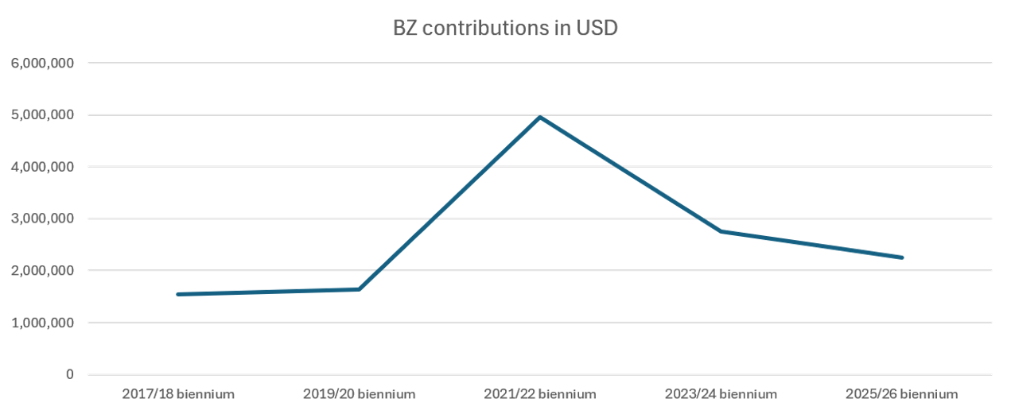
Figure II
VB Special Voluntary Trust Fund for Facilitating Participation of Indigenous Peoples and the Local Communities, contributions trend for the years 2017-2026
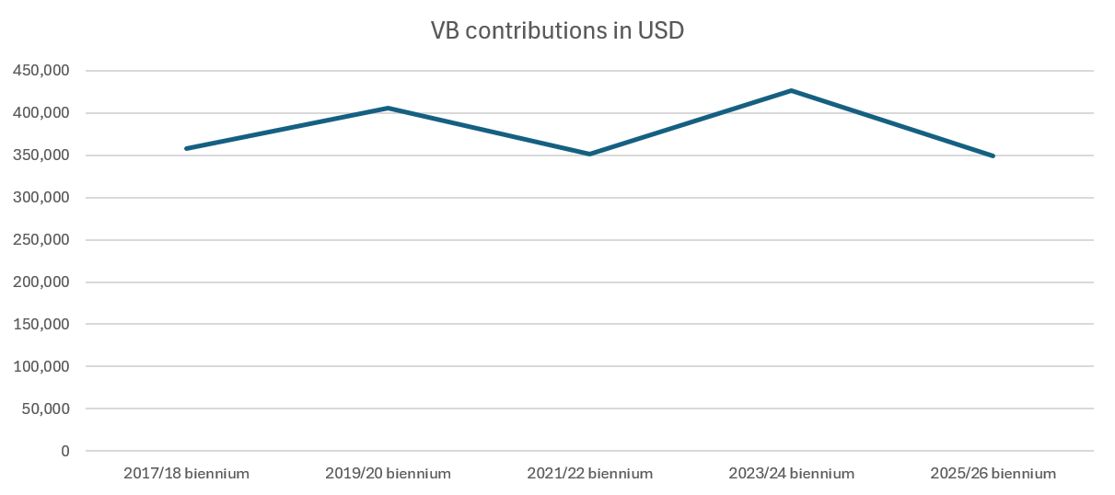
- One session of each subsidiary body is included in the proposed budget for the biennium 2027–2028 presented in document CBD/COP/17/4-CBD/CP/MOP/12/5-CBD/NP/MOP/6/5. Additional estimates of the meeting costs based on different options and scenarios are presented in table 2 below. While the current criteria remain adequate to allocate funding for participation, prioritizing the least developed countries and small island developing States, increasing the number of Parties and other actors contributing to the trust funds is important.

Table 2
Meeting costs based on different options and scenarios
(United States dollars)
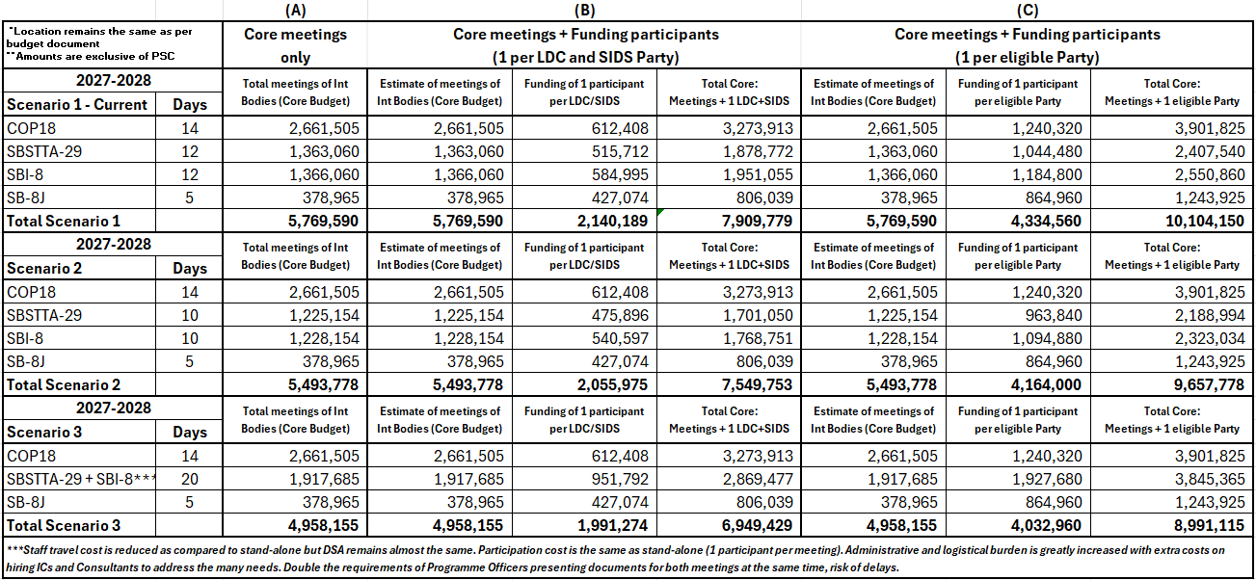
Abbreviations: COP, Conference of the Parties; DSA, daily subsistence allowance; IC, individual consultants; LDC, least developed country; PSC, programme support costs; SB8J, Subsidiary Body on Article 8(j) and Other Provisions of the Convention on Biological Diversity Related to Indigenous Peoples and Local Communities; SBI, Subsidiary Body on Implementation; SBSTTA, Subsidiary Body on Scientific, Technical and Technological Advice, SIDS, small island developing State.
Scenario 1:
  - Eighteenth meeting of the Conference of the Parties, thirteenth meeting of the Conference of the Parties serving as the meeting of the Parties to the Cartagena Protocol and seventh meeting of the Conference of the Parties serving as the meeting of the Parties to the Nagoya Protocol: 14 days
  - Twenty-ninth meeting of the Subsidiary Body on Scientific, Technical and Technological Advice: 12 days
  - Eighth meeting of the Subsidiary Body on Implementation: 12 days
  - Second meeting of the Subsidiary Body on Article 8(j) and Other Provisions of the Convention on Biological Diversity Related to Indigenous Peoples and Local Communities: 5 days
Scenario 2 (shorter meetings of the Subsidiary Bodies):
  - Eighteenth meeting of the Conference of the Parties, thirteenth meeting of the Conference of the Parties serving as the meeting of the Parties to the Cartagena Protocol and seventh meeting of the Conference of the Parties serving as the meeting of the Parties to the Nagoya Protocol: 14 days
  - Twenty-ninth meeting of the Subsidiary Body on Scientific, Technical and Technological Advice: 10 days
  - Eighth meeting of the Subsidiary Body on Implementation: 10 days
  - Second meeting of the Subsidiary Body on Article 8(j) and Other Provisions of the Convention on Biological Diversity Related to Indigenous Peoples and Local Communities: 5 days
Scenario 3 (combining meetings):
  - Eighteenth meeting of the Conference of the Parties, thirteenth meeting of the Conference of the Parties serving as the meeting of the Parties to the Cartagena Protocol and seventh meeting of the Conference of the Parties serving as the meeting of the Parties to the Nagoya Protocol: 14 days
  - Twenty-ninth meeting of the Subsidiary Body on Scientific, Technical and Technological Advice and eighth meeting of the Subsidiary Body on Implementation: 20 days
  - Second meeting of the Subsidiary Body on Article 8(j) and Other Provisions of the Convention on Biological Diversity Related to Indigenous Peoples and Local Communities: 5 days

__________

* CBD/COP/17/1/Rev.1.
** CBD/CP/MOP/12/1.
*** CBD/NP/MOP/6/1.
∗∗∗∗ The present document is being issued without formal editing.
Note that the contribution from the host country is paid as a budget offset and thus is not described below.
The requirements for the trust fund for additional voluntary contributions in support of approved activities for 2027–2028 is presented in CBD/COP/17/4/Add.2-CBD/CP/MOP/12/5/Add.1-CBD/NP/MOP/6/5/Add.1. Note that additional activities include activities requested of the Executive Secretary for which the phrase “subject to the availability of resources” is in the request.
www.cbd.int/information/adm-fin.
CBD/COP/17/4/Add.1.
See CBD/SBI/6/INF/9. The document contains a review of participation support mechanisms in other multilateral environmental agreements including UNFCCC, CITES, CMS, Basel, Rotterdam, Stockholm, Minamata, the Vienna Convention and Montreal Protocol, and Ramsar. It recognizes that all such agreements rely on voluntary trust funds. UNFCCC and CITES have distinct criteria for the allocation of funds to support participation. However, all these agreements pay due consideration to least developed countries and small island developing States. The additional consideration factors identified in the survey include payments of arrears and the small size of delegations at the previous meeting of the Conference of the Parties. For the Convention process, the allocation of BZ fund is guided by decision 9/34 (Annex: Procedure for the allocation of funding from the special voluntary trust fund (BZ) for facilitating participation of Parties in the Convention Process), including the following: (i) Priority is given to the least developed countries and small island developing States; (ii) Adequate geographical representation of all eligible country Parties; (iii) Timely submission of funding request; (iv) Gender considerations.

