 |  |  | CBD
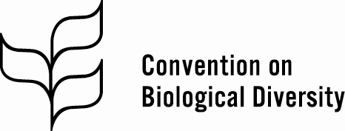 |  |  |  |  | Distr.  GENERAL  CBD/SBSTTA/22/INF/37  1 May 2018  ENGLISH ONLY
Subsidiary Body on Scientific, Technical and Technological Advice
Twenty-first meeting
Montreal, Canada, 2-7 July 2018
Item 7 of the provisional agenda*

Key biodiversity areas and biodiversity conservation targets

Note by the Executive Secretary
- The Executive Secretary is circulating herewith, for the information of participants in the twenty-second meeting of the Subsidiary Body on Scientific, Technical and Technological Advice, a document prepared by the Key Biodiversity Areas Partnership on key biodiversity areas and biodiversity conservation targets.
- The present document is relevant to the deliberations of the Subsidiary Body on the Aichi Biodiversity Targets, in particular Targets 11 and 12.
- The document is being circulated in the form and language in which it was received by the Secretariat. The views expressed in the document are those of the authors and do not necessarily reflect the views of the Secretariat of the Convention on Biological Diversity.

Note by the Key Biodiversity Areas Partnership: Amphibian Survival Alliance, BirdLife International, Conservation International, Critical Ecosystem Partnership Fund, IUCN, GEF, Global Wildlife Conservation, NatureServe, Rainforest Trust, Royal Society for the Protection of Birds, Wildlife Conservation Society, WWF

KEY BIODIVERSITIY AREAS AND Biodiversity Conservation Targets

i. Background on Key Bidiversity Areas

- Biodiversity loss is occurring at an alarming rate across the world’s terrestrial, freshwater and marine environments. A crisis in its own right, the evidence also indicates that the loss of biodiversity jeopardizes the delivery of vital services biodiversity provides to people, such as crop pollination, fisheries, and cultural heritage. Reversing this trend requires addressing the destruction and degradation of natural habitats. Given limited resources, identifying and safeguarding sites of particular importance for biodiversity is urgent. Private industry, governments and many others need a reliable, scientifically valid, and globally representative source of information on sites that are critical for biodiversity conservation, to help them make management, development, and investment decisions. These sites are called Key Biodiversity Areas (KBAs for short).

- The purpose of this information note is fourfold:
- To explain the basic concepts behind the Key Biodiversity Areas
- To provide information on the Key Biodiversity Areas Partnership
- To provide guidance on how information on KBAs can be accessed
- To highlight ways in which KBAs are currently deployed in support of intergovernmental processes
- To underline the opportunities for using Key Biodiversity Areas in achieving the Aichi Targets, in particular Targets 11 and 12
- To underline the opportunities for using Key Biodiversity Areas in achieving the SDGs and the next generation of biodiversity conservation targets.

- KBAs are sites contributing significantly to the global persistence of biodiversity. The Global Standard for the Identification of Key Biodiversity Areas establishes a consultative, science-based process for KBA identification, founded on a standard methodology. It builds on four decades of experience in identifying important sites for different subsets of biodiversity, including Important Bird and Biodiversity Areas, Alliance for Zero Extinction sites, Important Plant Areas, Prime Butterfly Areas, and key biodiversity areas for freshwater and marine species. The KBA Standard harmonises these existing approaches and provides a common currency for the identification and safeguard of sites important for threatened biodiversity, geographically restricted biodiversity, ecological integrity and ecosystem intactness, biological processes, and irreplaceability in terrestrial, inland water, and marine environments. It includes 11 criteria under five categories which can be applied from species to ecosystems.

- The KBA Partnership is comprised of twelve of the world’s leading nature conservation organisations have launched an ambitious new partnership to identify, map, monitor and conserve the most important places for life on Earth. The KBA Partnership mobilises the expertise, experience and resources of the partner organisations to:
• Identify, map and document Key Biodiversity Areas worldwide that, when conserved, will help ensure the long-term survival of the majority of the biodiversity that we know of on Earth;
• Promote targeted conservation action in KBAs; and
• Inform and influence public policy and private sector decision-making that impacts KBAs.

- The World Database of Key Biodiversity Areas managed by BirdLife International on behalf of the KBA Partnership can be accessed at www.keybiodiversityareas.org and provides information on over 15,700 KBAs in terrestrial, freshwater and marine realms in all countries worldwide. National level summaries of KBAs, including maps and analysis of trends in the extent to which they are covered by protected areas, can be accessed in the Country Profiles in the Integrated Biodiversity Assessment Tool at https://www.ibat-alliance.org/ibat-conservation/.

- For the first time, the conservation community has rallied around a standard approach to identifying sites that contribute significantly to the global persistence of biodiversity. National coordination groups identify KBAs using the best available scientific data and globally standardised criteria. To date, the partnership has mapped 15,700 KBAs worldwide, although there are many gaps. KBA maps and associated biodiversity data (1) help guide the implementation of multilateral environmental agreements and governments, including the strategic expansion of protected area networks, (2) support national and regional spatial planning, (3) inform private sector safeguard policies and investments, and (4) inform conservation efforts of local and indigenous communities (see UNEP/CBD/SBSTTA/17/INF/10)

- To date KBAs have been most comprehensively identified for birds. Over the next 10 years, the KBA Partnership will map KBAs for ecosystems as well as many other animal and plant species, and thereby expand and consolidate the list of the most important marine, freshwater, and terrestrial sites to conserve on the planet.

- There are already 15,000+ KBAs identified world-wide, some as early as the 1980s. It is important to regularly monitor their conservation status, pressures and conservation actions on existing KBAs and up-date the information in the World Database of KBAs. This should be a concerted effort between local communities, volunteers, government agencies and conservation organization supplemented by data from remote sensing applications.

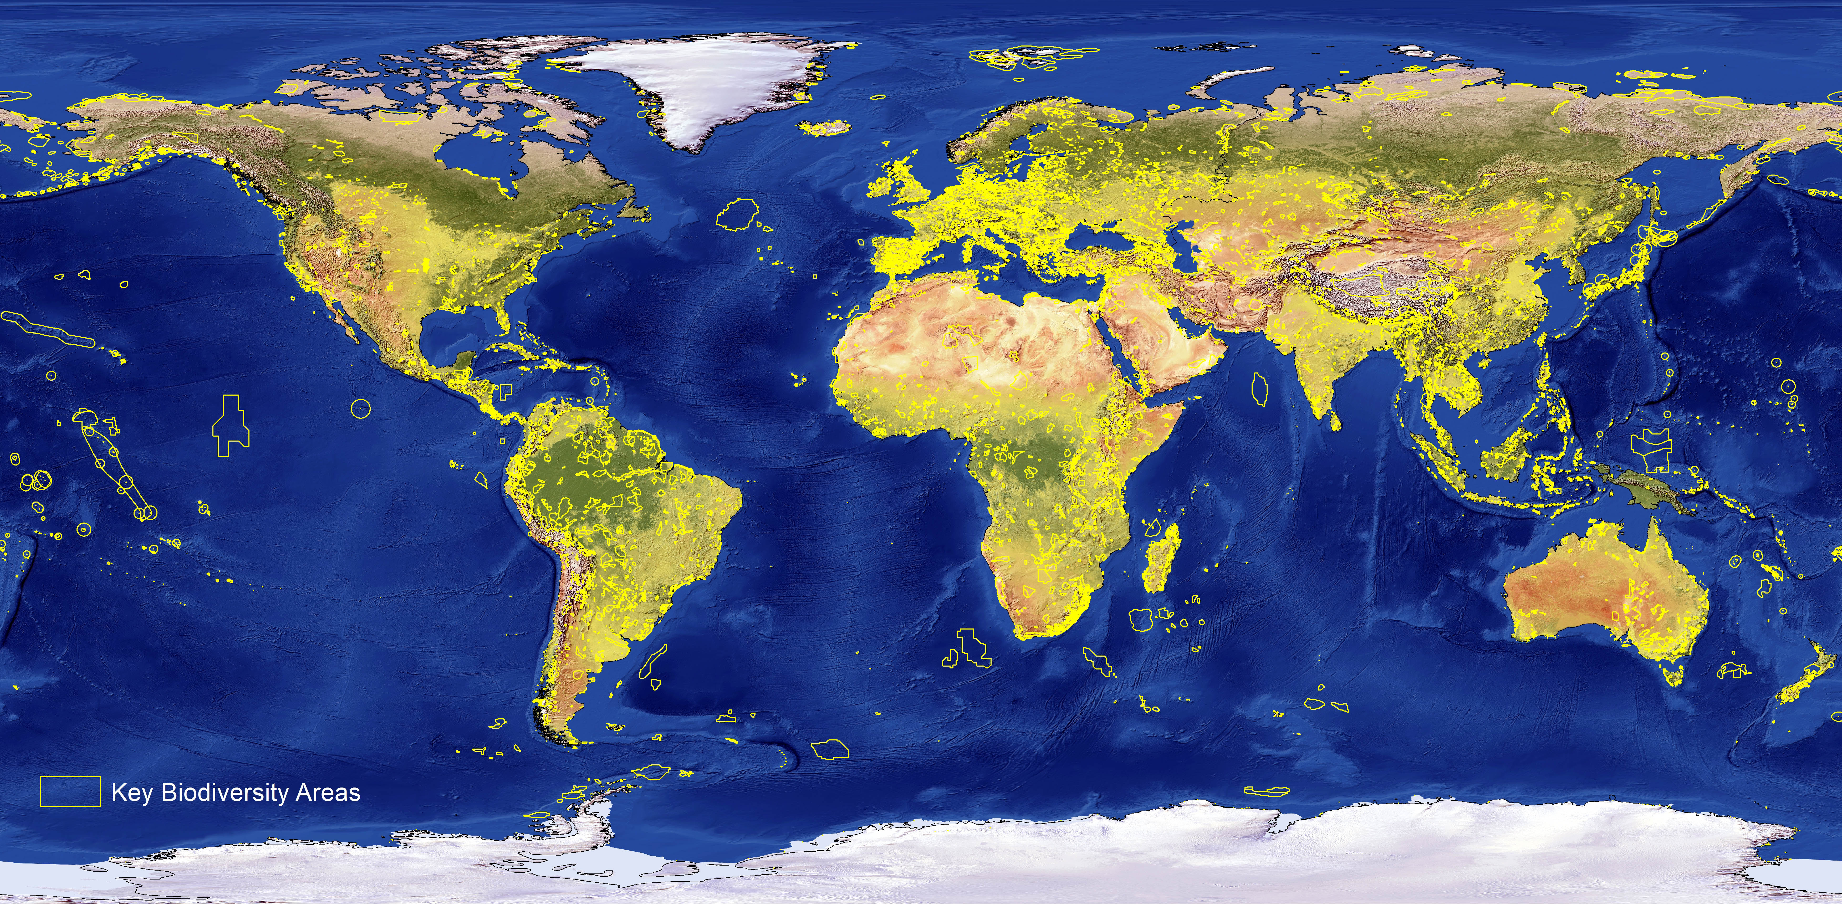

II. Identifying Key Biodiversity Areas

- Identifying and documenting sites - Applying the global KBA Standard, the KBA Partnership is working to ensure that KBAs are appropriately identified through local, national and international consultation and correctly documented, and that the global KBA network is taxonomically, ecologically and geographically comprehensive.

- Targeting conservation action - The KBA Partnership is helping to target conservation efforts worldwide by systematically identifying and mapping internationally important sites and ensuring that scarce resources are directed to the most important places for nature. Through their conservation programmes, the KBA Partners contribute directly to the conservation of KBAs in more than 150 countries worldwide, both on land and in the water.

- Informing policy and decision-making - The KBA Partners engage actively and constructively with public and private sector decision-makers to promote conservation and the sustainable and equitable management of KBAs, whether on land, in freshwater systems, or in the sea. Apart from the targeted expansion of protected area and conservation area networks, key policy priorities should also include guidance for businesses and governments on commercial operations in KBAs and managing risks to biodiversity; and safeguards for corporations and financial institutions for critical habitats.

III. KBAs, Intergovernmental processes and Conservation Targets

- KBAs are used in a wide range of inter-governmental processes related to the conservation of biological diversity; as highlighted below:

- In the language of Aichi Target 11, KBAs represent the only comprehensive global dataset on “areas of importance for biodiversity”. Protected area coverage of KBAs was adopted as an indicator for tracking progress towards Aichi Target 11 under the Strategic Plan for Biodiversity 2011–2020, in CBD/COP/DEC/XIII/28 – page 16, and was profiled in the Global Biodiversity Outlook 3 and 4.

- Protected area coverage of KBAs was adopted as the indicator for tracking progress towards three targets under Sustainable Development Goals 14 and 15:

- SDG Indicator 14.5.1 “Coverage of protected areas in relation to marine areas” – see data (https://unstats.un.org/sdgs/indicators/database/?indicator=14.5.1) and metadata (https://unstats.un.org/sdgs/metadata/files/Metadata-14-05-01.pdf)
- SDG Indicator 15.1.2 “Proportion of important sites for terrestrial and freshwater biodiversity that are covered by protected areas, by ecosystem type” – see data (https://unstats.un.org/sdgs/indicators/database/?indicator=15.1.2) and metadata (https://unstats.un.org/sdgs/metadata/files/Metadata-15-01-02.pdf)
- SDG Indicator 15.4.1 “Coverage by protected areas of important sites for mountain biodiversity”– see data (https://unstats.un.org/sdgs/indicators/database/?indicator=15.4.1) and metadata (https://unstats.un.org/sdgs/metadata/files/Metadata-15-04-01.pdf)

- The documentation of PA coverage of KBAs in the UN Sustainable Development Report:
- 2016 pages 39 and 41 (https://unstats.un.org/sdgs/report/2016/The%20Sustainable%20Development%20Goals%20Report%202016.pdf)
- 2017 pages 46 and 48 (https://unstats.un.org/sdgs/files/report/2017/TheSustainableDevelopmentGoalsReport2017.pdf)

- The documentation of PA coverage of KBAs in the Intergovernmental Science-Policy Platform on Biodiversity and Ecosystem Services IPBES draft Global Assessment and the regional assessments, specifically for:
- Africa, pages 6, 10, 18 (Figure SPM.7) and 28 (https://www.ipbes.net/sites/default/files/downloads/spm_africa_unedited_advance_28march2018_0.pdf)
- Americas, pages 5 and 6 (https://www.ipbes.net/sites/default/files/downloads/spm_americas_unedited_advance_28march2018_0.pdf)
- Asia-Pacific, pages 14, 17 (Figure SPM.6b), 21, and 25 (https://www.ipbes.net/sites/default/files/downloads/spm_asia_pacific_unedited_advance_28march2018_1.pdf)
- Europe and Central Asia, pages 17 and 18 (Figure SPM.7) (https://www.ipbes.net/sites/default/files/downloads/spm_eca_unedited_advance_28march2018.pdf)

IV MORE INFORMATION
- For more information about Key Biodiversity Areas and the KBA Partnership, Standard and site nomination process, and to access data on KBAs worldwide, visit www.keybiodiversityareas.org or contact the Head, KBA Secretariat, Dr. Andy Plumptre - aplumptre@keybiodiversityareas.org

- For those interested in accessing KBA data for commercial use, please see the Integrated Biodiversity Assessment Tool at https://www.ibat-alliance.org.

__________

* CBD/SBSTTA/21/1.
Key Biodiversity Areas Partnership: Amphibian Survival Alliance, BirdLife International, Conservation International, Critical Ecosystem Partnership Fund, IUCN, GEF, Global Wildlife Conservation, NatureServe, Rainforest Trust, Royal Society for the Protection of Birds, Wildlife Conservation Society, WWF.
Amphibian Survival Alliance, BirdLife International, Conservation International, Critical Ecosystems Partnership Fund, Global Environment Facility, Global Wildlife Conservation, IUCN, NatureServe, Rainforest Trust, Royal Society for the Protection of Birds, Wildlife Conservation Society, WWF.
Waliczky et al. (in press) Important Bird and Biodiversity Areas (IBAs): their impact on conservation policy, advocacy and action.

