 |  | CBD/SBI/4/INF/10
 |  | Distr.: General  22 April 2024  English only
Subsidiary Body on Implementation
Fourth meeting
Nairobi, 21–29 May 2024
Item 4 (a) of the provisional agenda*
Resource mobilization
  - Exploration of the biodiversity finance landscape

Note by the Secretariat
Introduction
- In its decision 15/7, the Conference of the Parties decided, among other tasks, to explore the current finance landscape with a view to assessing gaps and overlaps and to identifying opportunities to strengthen, simplify and reform existing instruments to strengthen the current finance landscape for biodiversity (para. 41). In paragraph 43 of the same decision, it established the Advisory Committee on Resource Mobilization to operationalize this provision, tasking the Committee with reporting thereon to the Subsidiary Body on Implementation and, subsequently, to the Conference of the Parties at its sixteenth meeting.
- The terms of reference of the Advisory Committee, provided in annex II to the same decision, give further guidance on the scope and objectives of the exploration. The tasks requested of the Committee include the following:
(a) Provide an overview of the global biodiversity funding landscape and identify which institutions, including global, regional and national, are funding activities related to addressing biodiversity loss, and ways in which coherence, coordination and synergies among them can be enhanced;
(b) Assess how existing instruments, funds and frameworks and their interaction could be further improved, and successful ones promoted, replicated or scaled up, so that they fully align with, and provide immediate support to, the implementation of the Kunming-Montreal Global Biodiversity Framework;
(c) Take into consideration the progress of the reform to the Global Environment Facility to support the quick start mobilization of resources for the implementation of the Framework, and in particular the process for the establishment of the Global Biodiversity Framework Fund and its implementation;
(d) Identify the gaps within the current financing landscape, including the types of gaps, such as those relating to speed, eligibility, adequacy and access to finance, the priority gaps for which solutions should be explored, as well as the most effective ways to address those gaps.
- The exploration of the biodiversity finance landscape contained in the present document has been prepared under the responsibility of the Secretariat of the Convention on Biological Diversity in order to support the Advisory Committee in its work. Its preparation was guided by the experience of and input from the members of the Committee with regard to existing institutions, at the global, regional and national levels, as well as existing instruments, funds and frameworks that could be relevant to the mobilization of resources for the Framework. The discussions held by the Committee at its first meeting, in Kinshasa, and the feedback received at its subsequent meetings were also taken into account, as were the submissions on experiences, good practices and lessons learned with the strategy for resource mobilization, received by the Secretariat in response to notification No. 2023-087.
- An earlier draft of the exploration was considered by the Advisory Committee at its second meeting, in Villa de Leyva, Colombia, from 18 to 22 March 2024. Committee members identified a number of factual inaccuracies and highlighted areas for improvement, and the present document has been revised accordingly.
- At its second meeting, the Advisory Committee reflected the conclusions of the exploration in its recommendations to the Subsidiary Body on Implementation for consideration at its fourth meeting, in the form of annex II to the draft decision, which contains a non-exhaustive list of voluntary actions to strengthen, simplify and reform existing instruments for biodiversity finance. The draft decision, including its annex II and its other two annexes, sought to reflect the various views expressed by members of the Committee in a balanced manner, but it does not reflect the individual comments made by Committee members in their entirety, nor does it reflect a consensus of the members of the Committee.
- The document is issued in the form and language in which it was received.

  - Exploration of the biodiversity finance landscape

Executive summary
The global landscape of biodiversity finance is characterized by a fragmented and diverse array of funding mechanisms that vary significantly in their purpose, scale, and size. This diversity, although creating challenges in terms of accessibility and navigability of funds, may also be beneficial as it allows for tailored approaches to address the unique ecological, social, and economic contexts of each region or country. Moreover, specialization in funding mechanisms may allow specific environmental challenges and conservation needs of recipient countries to be met, thereby enhancing the effectiveness and relevance of biodiversity conservation efforts.
Biodiversity finance is increasingly being integrated into national and international policy levels, yet notable gaps exist, in particular when addressing macroeconomic issues such as illicit financial flows, tax regimes, and sovereign debt. The development and implementation of comprehensive biodiversity metrics and taxonomies and the incorporation of these into ecosystem accounting are essential to build a stronger economic and case for biodiversity. Additionally, biodiversity-related economic taxonomies are important for mobilizing resources by providing a standardized framework that facilitates targeted investments and conservation efforts.
International biodiversity finance has shown encouraging trends, with increased total development finance over the last decade. However, in order to meet the ambitious targets of $20 billion by 2025 and $30 billion by 2030, as set in the Kunming-Montreal Global Biodiversity Framework (GBF hereafter), a considerable further increase in funds is necessary.
Integrating climate and biodiversity finance with a view to leverage synergies and address overlapping drivers of climate change and biodiversity loss is an important ongoing task. By aligning finance across sectors, including a shift towards green infrastructure, ecosystem-based approaches and/or nature-based solutions, there is potential for more impactful biodiversity policy efforts and a reduction in biodiversity loss.
International Financial Institutions including Multilateral Development Banks (MDBs) play an important role in biodiversity finance. Their involvement extends beyond direct funding as they are instrumental in creating a favourable environment for investment in biodiversity projects. They also play an active role in facilitating and maintaining biodiversity safeguards, while de-risking investment.
The establishment of the Global Biodiversity Framework Fund by the Global Environment Facility and the ongoing GEF reforms to enhance its efficiency are important developments in the biodiversity finance landscape.
Domestic public expenditure remains the largest source of global biodiversity financing, yet the proportion of public finance allocated to biodiversity is relatively small, indicating a potential for increased funding. The reallocation of budgetary resources, while challenging due to competing priorities and socio-economic constraints, presents opportunities for optimizing existing expenditures. The further integration of biodiversity considerations into national fiscal strategies and scaled use of innovative financing instruments whenever feasible and appropriate are important building blocks for sustainable biodiversity finance.
There is an urgent need to identify, eliminate, phase out or reform incentives, including subsidies, harmful for biodiversity, and scale up positive incentives for the conservation and sustainable use of biodiversity, in line with Target 18 of the Global Biodiversity Framework. Creating an enabling environment for mobilizing private and non-market mechanisms, developing taxonomies, and implementing environmental and social safeguards will be key to diversifying and expanding biodiversity financing beyond traditional public finance sources. Financial instruments such as biodiversity-earmarked fiscal tools and mechanisms to mobilize private finance, are important for ensuring long-term financial sustainability.
The private sector can potentially play a key role in achieving the GBF targets, but barriers such as the absence of clearly defined transition pathways and a lack of standardized data and metrics hinder the scalability of private biodiversity investments. Important efforts are under way to develop taxonomies and enhance transparency and accountability in biodiversity investments, with initiatives like the Taskforce on Nature-related Financial Disclosures (TNFD). Incentivizing private sector investment through tax breaks, subsidies, and blended finance mechanisms can significantly support biodiversity objectives.
Indigenous peoples and local communities, women, and youth receive a minor share of biodiversity-related Official Development Finance (ODF) and often lack direct access to biodiversity finance. Financial contributions from indigenous peoples and local communities to conservation, both monetary and in-kind, are significant yet challenging to quantify. Growing evidence suggests that increasing direct funding to indigenous peoples and local communities, women and youth could enhance biodiversity policy outcomes by harnessing and strengthening their role as biodiversity stewards, including by creating dedicated funding streams and simplifying access.

1. Context
- The study is informed and guided by specific provisions of, and elements from, the Convention on Biological Diversity (CBD) and the Kunming-Montreal Global Biodiversity Framework (GBF), in particular:
- CBD Articles 20 on Financial Resources, Article 21 on Financial Mechanism, Article 39 on Financial Interim Arrangements, and Article 11 on Incentive Measures;
- Goal C and D of the GBF, as well as the associated targets, such as Target 18 and Target 19.
- The study is also informed by the overall finance gap for biodiversity identified in the Global Biodiversity Framework. Its Goal D identifies a finance gap of $700 billion per year, to be progressively closed by 2030. To this end, Target 18 calls to ‘identify by 2025, and eliminate, phase out or reform incentives, including subsidies, harmful for biodiversity, in a proportionate, just, fair, effective and equitable way, while substantially and progressively reducing them by at least $500 billion per year by 2030, starting with the most harmful incentives, and scale up positive incentives for the conservation and sustainable use of biodiversity.’ Target 19 calls to ‘substantially and progressively increase the level of financial resources from all sources, in an effective, timely and easily accessible manner, including domestic, international, public and private resources, in accordance with Article 20 of the Convention, to implement national biodiversity strategies and action plans, mobilizing at least $200 billion per year by 2030.’
- Target 19 also calls for increasing total biodiversity related international financial resources from developed countries, including official development assistance, and from countries that voluntarily assume obligations of developed country Parties, to developing countries, in particular the least developed countries and small island developing States, as well as countries with economies in transition, to at least $20 billion per year by 2025, and to at least $30 billion per year by 2030.

Methodology
- This report is a desk study, based on a review of existing literature. No primary data collection is involved. It will highlight common insights and conclusions and reflect the current ‘state of play,’ while also reflecting critical nuances or differences. As such, the study will cover funding from a broad range of sources, including: international public finance, both bilateral and multilateral, including the role of international financial institutions; domestic public finance; private finance by companies, international organizations, philanthropies, etc., innovative sources of funding (including blended finance; and the role of non-market-based approaches and collective action of indigenous peoples and local communities.
- The second section will provide cross-cutting considerations that are globally important. It provides an overview of the macroeconomic factors influencing biodiversity finance and highlights the need to integrate biodiversity considerations into relevant policies and to more broadly create or improve an enabling environment for enhanced biodiversity finance. Section 3 explores the evolving state of play in international biodiversity finance, both bilateral and multilateral. Section 4 discusses domestic biodiversity finance, highlighting the importance of integrating biodiversity within the domestic policy context and addressing in more detail how to address subsidies and other incentives that are harmful to biodiversity. Section 5 looks more specifically at the role of the private sector in biodiversity finance (both domestic and international) and some of the important ongoing initiatives, while also highlighting key challenges. Section 6 explores the role of indigenous peoples and local communities in biodiversity conservation and the challenges encountered by them. Section 7 identifies, in accordance with the scope and objectives of the exploration, a number of gaps for which solutions could be explored, as well as possible opportunities to close these gaps, including ways in which coherence, coordination, and synergies among them can be enhanced.

2. Cross-cutting issues of global importance
- Recent studies estimate current global biodiversity finance in the higher two-digit to lower three digit billions USD per year. A report of the OECD published in 2020 estimated global biodiversity finance in the range of USD 78 - 91 billion per year (2015-2017 average, based on available, reported data and without attempts to extrapolate for missing data). A report commissioned by the Paulson Institute (Deutz et al, 2020), using a broader approach, estimated global biodiversity-related funding between USD 124-143 billion per year. However, a more recent UNEP (2023) report estimates global nature-negative finance flows originating from both the public and private sectors reaching nearly $7 trillion per year - almost two orders of magnitude higher. This discrepancy points to the overall importance of integrating biodiversity and its multiple values into decision-making at all levels and to progressively aligning all relevant public and private activities, and fiscal and financial flows with the goals and targets of the GBF (as per its Goal D and Target 14). However, this difference also makes clear that this is a daunting task. The present section highlights a number of global policy processes that can support achieving this, as an important part of creating a better enabling environment for biodiversity finance.

Addressing illicit flows and strengthen tax regimes
- The illicit flow of funds, including issues related to tax justice and tax evasion, may play a detrimental role in securing funds for biodiversity. The availability of funds, including for conservation efforts, is reduced when individuals and corporations engage in tax avoidance or illegal tax evasion. According to some estimates, Fortune 500 companies are estimated to hold USD 2.3 trillion in offshore accounts and capital positions. Tax havens cost governments between USD 500–600 billion a year in lost taxation, including an estimated loss to non-OECD economies of USD 200 billion. Furthermore, individual wealth sheltered in tax havens is an estimated USD 8–36 trillion.
- Moreover, illicit flows may also result from the illegal, unreported, and unregulated (IUU) exploitation of natural resources such as forests or fish stocks. Addressing such illicit flows would provide an important indirect lever to address such IUU exploitation. For instance, crime related to forestry (including illegal logging and illegal land clearing) is estimated to generate $51 to $152 billion each year. The World Bank estimates that governments lose between USD 6 and 9 billion annually in tax revenue from illegal logging. In some instances, as in the case of Papua New Guinea, illicit proceeds generated from forestry crimes exceed the funds earned in the legal timber market.
- Thus, addressing issues related to illicit financial flows, promoting tax justice, and enhancing transparency in financial systems could contribute to ensuring the adequate funding and protection of biodiversity. In this regard, OECD and UNDP jointly launched a relevant initiative. ‘Tax Inspectors Without Borders Initiative (TIWB)’ offers support to national tax administration authorities, with a focus on auditing. With over 110 programs in fifty-six jurisdictions, TIWB has helped countries raise more than $2 billion in additional tax revenues since its inception in 2015. A new focus area under TIWB is the intersection of tax and environmental issues. Currently, there are active TIWB programs aimed at the forestry and fishing sectors in countries like Papua New Guinea and Costa Rica.

International Trade
- International trade can lead to both positive and negative impacts for biodiversity. Positive impacts can come from increased efficiency of production, which reduces demand for land and other natural resources, and from increased demand for an availability of environmentally friendly goods, services, and technologies. Negative impacts can arise from production shifts that exacerbate pressures such as land use change and pollution, the introduction of alien species and trade in environmentally sensitive goods (e.g., timber or wildlife).
- Therefore, trade can be seen as part of the set of solutions to address biodiversity loss and promote benefit-sharing schemes. Trade can support sustainable economic growth and development and is recognised as such within the Addis Ababa Action Agenda, the 2030 Agenda and the SDGs. Trade policies can support and promote biodiversity conservation and sustainable use and benefit sharing, contribute to address over-exploitation and unsustainable consumption and production patterns, as well as to reform subsidies harmful to biodiversity. In this regard, the work undertaken by UNCTAD on defining a common methodology related to the collection and presentation of biodiversity-related trade data may provide helpful insights and allow data driven policy design/formulation.
- In the multilateral trade regime of the WTO, environmental issues garnered increased attention and found reflection in the Doha Declaration and the associated work programme. Although progress on the Doha Agenda has been overall slow, important progress was recently made with the WTO Agreement on Fisheries Subsidies, adopted at the 12th Ministerial Conference in June 2022. This agreement represents a significant step forward in aligning international trade policies with environmental sustainability goals, particularly marine biodiversity conservation. It addresses the issue of harmful subsidies that contribute to overfishing and the depletion of fish stocks, which are crucial components of marine biodiversity. By curbing these subsidies, the agreement aims to mitigate one of the key drivers of overfishing, thereby supporting the conservation and sustainable use of marine resources.
- Similarly, a growing number of Regional Trade agreements include specific provisions related to environmental protection and biodiversity conservation. Examples include the United States-Mexico-Canada Agreement (USMCA) and the European Union's trade agreements, which incorporate chapters on sustainable development, including biodiversity considerations.

Towards Sustainable Economic Growth
- A World Bank (2021) report found that the partial collapse of some ecosystem services globally could bring a decline in global gross domestic product of US$2.7 trillion by 2030. Unsustainable economic growth will have negative impacts on biodiversity, through increased resource consumption, infrastructure development, and land use change. At the same time, SDG 8 seeks to promote, sustained, inclusive and sustainable economic growth. Commonly used economic indicators do not take into account the economic negative externalities associated with biodiversity loss. Important conceptual work has been undertaken to remedy this.
- A key global process under the United Nations Statistical Commission is to promote and further develop the System of Environmental Economic Accounting (SEEA). The SEEA Central Framework was officially adopted as an international statistical standard in 2012. This framework integrates environmental data with economic accounts, aiming to provide a comprehensive view of the interrelations between the economy and the environment. It helps policymakers, researchers, and analysts to better understand environmental impacts, resource use, and how these elements are interlinked with economic activities.
- The SEEA Ecosystem Accounting complements the Central Framework and was adopted by the UN Statistical Commission in 2021. It takes the perspective of ecosystems and considers how individual environmental assets interact as part of natural processes within a given spatial area. Ecosystem accounts enable the presentation of indicators of the level and value of “ecosystem services” in a given spatial area. The SEEA Ecosystem Accounting manual is subject to ongoing review and updates to reflect the latest scientific understanding and methodological advancements.
- As of 2022, at least ninety-one countries have implemented accounts consistent with SEEA Central Framework and forty-one countries have compiled SEEA Ecosystem Accounts. The recent Dasgupta review of the economics of biodiversity notes that increased investment in physical accounts and valuation, with a view to further standardize data and modelling approaches, would improve the quality of the ecosystem accounts and technical support would make it easier to embed ecosystem accounting in national economic accounts.
- Accordingly, COP decision 15/5 (Para 4) also recognized the value of aligning national monitoring with the System of Environmental Economic Accounting statistical standard, in order to mainstream biodiversity in national statistical systems and to strengthen national monitoring systems and reporting as appropriate and according to their national priorities and circumstances.

Taxonomy
- Biodiversity-related economic taxonomy plays an important role in mobilizing resources for biodiversity conservation by providing a standardized framework that helps identify and prioritize areas and species in need of protection, thereby facilitating targeted investment and conservation efforts. Moreover, the application of financial tools requires standardized and tangible measurement methodologies for (components of) biodiversity. Advancing on such ‘biodiversity metrics’ is thus imperative for better biodiversity funding, in particular for private or blended finance. Below are some examples on supranational work on taxonomies related to biodiversity:
- The European Union’s work on taxonomy, which is part of the EU's broader environmental and sustainability goals, aims to categorize and evaluate the impact of economic activities on biodiversity. The taxonomy is a key component of the EU's Green Deal, which seeks to make Europe the first climate-neutral continent by 2050. The framework identifies activities that are beneficial for biodiversity and sets criteria for sustainable investments, thus aiming to guide capital towards more environmentally friendly practices. The taxonomy is expected to play a key role in the EU Biodiversity Strategy for 2030.
- As a part of SEEA, the Classification of Environmental Protection Activities and Expenditure (CEPA) is an international statistical classification, established in 2000, for categorizing activities, products, expenditures, and other transactions related to environmental protection. It encompasses a wide range of activities aimed at preventing, reducing, and eliminating pollution or any other degradation of the environment, including measures for biodiversity. It is used in environmental-economic accounts based on the SEEA standard. The Classification of Resource Management Activities (CReMA) details activities aimed at preserving and enhancing the stock of natural resources, complementing the CEPA framework. The CEPA covers both public and private expenditure. Reporting by EU countries is mandatory, via the Environmental Protection Expenditure Account (EPEA) . The CEPA and CREMA are being merged to create the Classification of Environmental Purposes (CEP), to be adopted at the UNSD in March 2024. Eurostat seeks to implement the new CEP in the European environmental accounts (and thus to replace the classifications CEPA and CReMA). The CEP code 05 covers: soil, surface and groundwater, biodiversity, and forest. It will also be possible to undertake mapping for environmental policy areas (e.g. biodiversity) by adding across relevant environmental purpose codes.
- This work complements the work on biodiversity-related economic taxonomy by providing a structured framework to categorize and account for activities related to the protection, management, and sustainable use of biodiversity. They provide valuable data to enhance understanding of investments and efforts in biodiversity conservation and resource management.
- The BIOFIN GLOBE Taxonomy (GLOBE), still under development, is a comprehensive listing of biodiversity expenditures, aligned with existing global and national frameworks, and seeks to set attribution standards. Its key elements include nine primary biodiversity expenditure categories, secondary and tertiary sub-categories, examples of expenditures, biodiversity attribution rates, and alignments with the GBF and SDGs. GLOBE is exclusively focused on public sector expenditures and considers only “biodiversity-positive” expenditures. It supplements the BIOFIN Biodiversity Expenditure Review (discussed in section 4) by identifying actions that could guide budget alignments at various category levels. The attribution rates, informed by BER practitioners’ expertise, shall serve as reference points during the estimation process. The Biodiversity Attribution Rates in GLOBE, like the Rio Markers, prioritize the intention or objective of an expenditure, requiring clear intentions in the expenditure or deducible from related documents.

Sovereign debt
- According to the World Bank’s International Debt Report (2023), developing countries spent a record $443.5 billion to service their external public and publicly guaranteed debt in 2022. In the same year, the global public debt stood at USD 92 trillion. More than half of all low-income countries, 37 out of 69, are assessed to be at high risk or in debt distress according to the latest IMF and World Bank Debt Sustainability Framework, and some of these countries are providing the world with significant ecosystem services or benefits to humankind. This may provide an opportunity for innovative financing solutions that can alleviate the debt burden while promoting environmental issues like loss of biodiversity.
- The development and implementation of instruments like sustainability-linked sovereign bonds and debt for nature swaps therefore represents an opportunity for countries to mobilize resources for biodiversity conservation. This topic is further discussed in the next section.

3. International biodiversity finance
- This section covers various elements of international biodiversity finance, providing an overview of international public finance (bilateral and multilateral), describing the efforts of important players like traditional and non-traditional donors, international financial institutions, international organizations, and philanthropic organizations, in mobilizing resources for biodiversity. It also discusses how international finance currently supports the provision of non-monetary contributions made by indigenous peoples and local communities.

Public international finance
- The OECD DAC tracks biodiversity-related official development finance, which encompasses the comprehensive value of all reported flows to the OECD, notably via the Rio Markers. Since 1998, the DAC has monitored development finance targeting the objectives of the Rio Conventions, including the CBD, through four “Rio markers” (biodiversity, desertification, climate change mitigation and adaptation). Countries and institutions reporting their official development finance to the OECD signal flows to biodiversity-related activities using the biodiversity Rio Marker, as well as through two SDG tags – SDG 14 (marine biodiversity) and SDG 15 (terrestrial biodiversity). The two sets of information are generally reported to the CRS in a coherent manner.
- For DAC members and countries and institutions reporting on the biodiversity marker, biodiversity-related activities should be screened and marked as (i) targeting the objectives of the CBD as either a principal or significant objective; or (ii) not targeting the objective (the activity has no relation to the marker). Activities marked as “principal” must have biodiversity as fundamental in the design of, or the motivation for, the action. Activities marked “significant” have other primary objectives, but have been formulated or adjusted to help meet biodiversity concerns.
- The Rio Markers were designed to track the degree to which members are integrating and mainstreaming environmental considerations into their development co-operation activities, and thus apply to the entirety of an activity reported – not just the finance associated with the biodiversity-specific component of that activity. However, when reporting against quantified international finance goals (such as the CBD), many DAC members only report their official development finance that targets biodiversity as a “significant” objective as a share of the full finance provided, and estimate this by applying coefficients to reflect the share. There is no agreed definition or common approach for this practice, but 40% is the most common coefficient applied to countries’ “significant” flows, aligning more closely with the reporting approach adopted in the past decade in the CBD . Here, both biodiversity-related development finance (when no coefficients are applied to the data) and biodiversity-specific development finance (when the 40% coefficient is applied to the ‘significant’ portion of the data) are portrayed.
- According to the data reported to the OECD, biodiversity-related official development finance (ODF) (using data without co-efficient) increased from USD 10.9 billion in 2015 to USD 18.5 billion in 2021 (considering development finance commitments reported to OECD). Biodiversity-related ODF reflects the full values of flows. Contributions from public sources (DAC and non-DAC members, South-South providers and multilateral providers) increased by 54%. This increase was largely driven by DAC members, which make up 71% of the total public flows on average over 2015-21 and is mostly DAC members’ ODA. In turn, multilateral institutions make up 29% of the total over this period. Flows from non-DAC members and South-South providers make up an additional 0.1% of the total and gained importance after 2017, when many of these providers started reporting to the OECD.

- Biodiversity-specific development finance (i.e. using data with coefficient) provides a different scale but similar trends. Overall biodiversity-specific development finance from all sources increased by 53% over 2015-21, rising from USD 7.3 billion to USD 11.1 billion (USD 9 billion annual average over the period). Public development finance for biodiversity increased by 31% - largely driven bilaterally by individual DAC members, which made up 76% of the total public flows on average over 2015-21, with the remaining 24% coming from multilateral institutions. Flows from non-DAC members and South-South providers make up an additional 0.2% of the total.

- Under both methodologies, private finance, including mobilized flows by public development finance for biodiversity increased over time. Indeed, private philanthropic flows grew from USD 501 million in 2017 to USD 932 million in 2021 – however, this growth trajectory also reflects the increased coverage of these actors’ activities in the OECD database since 2016. In turn, private finance flows mobilised by public interventions also increased from USD 94 million in 2016 to reach USD 749 million in 2021 – and represents 29% of all private biodiversity-related development finance in 2021.
- In Target 19 (a) of the GBF, Parties agreed to increasing total biodiversity-related international financial resources from developed countries, including official development assistance, and from countries that voluntarily assume obligations of developed country Parties, to developing countries, in particular the least developed countries and small island developing States, as well as countries with economies in transition, to at least USD 20 billion per year by 2025, and to at least USD 30 billion per year by 2030.
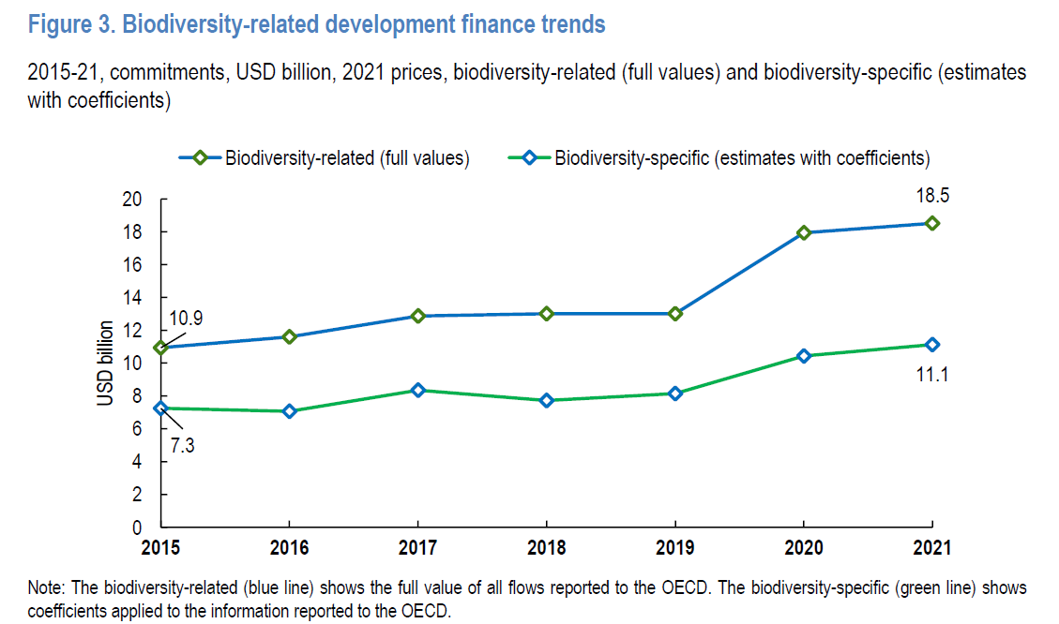
- Overall, we see a positive trend in biodiversity-related official development finance (ODF), with an increase from annual average over the 2015-21 period ranging between USD 8.6-14 billion, depending on the approach considered (total biodiversity-related vs. biodiversity-specific with coefficients applied). While the positive trajectory in spending is evident, there remains a substantial financial gap between the current levels of biodiversity-related funding and the ambitious target set for the coming years. Addressing this gap is crucial to meeting the commitments of the GBF.
Figure 1: Biodiversity related and biodiversity-specific development finance 2015-2021 (Source OECD, 2023)

Allocations by financial instruments, income level and region
- The OECD (2023) report that focuses on development finance finds that DAC members’ support to biodiversity was mainly delivered in the form of grants. The bulk of multilateral financing is attributed to multilateral development banks (MDBs), which are recognised as loan disbursing organisations, accounting for 64% of the total.
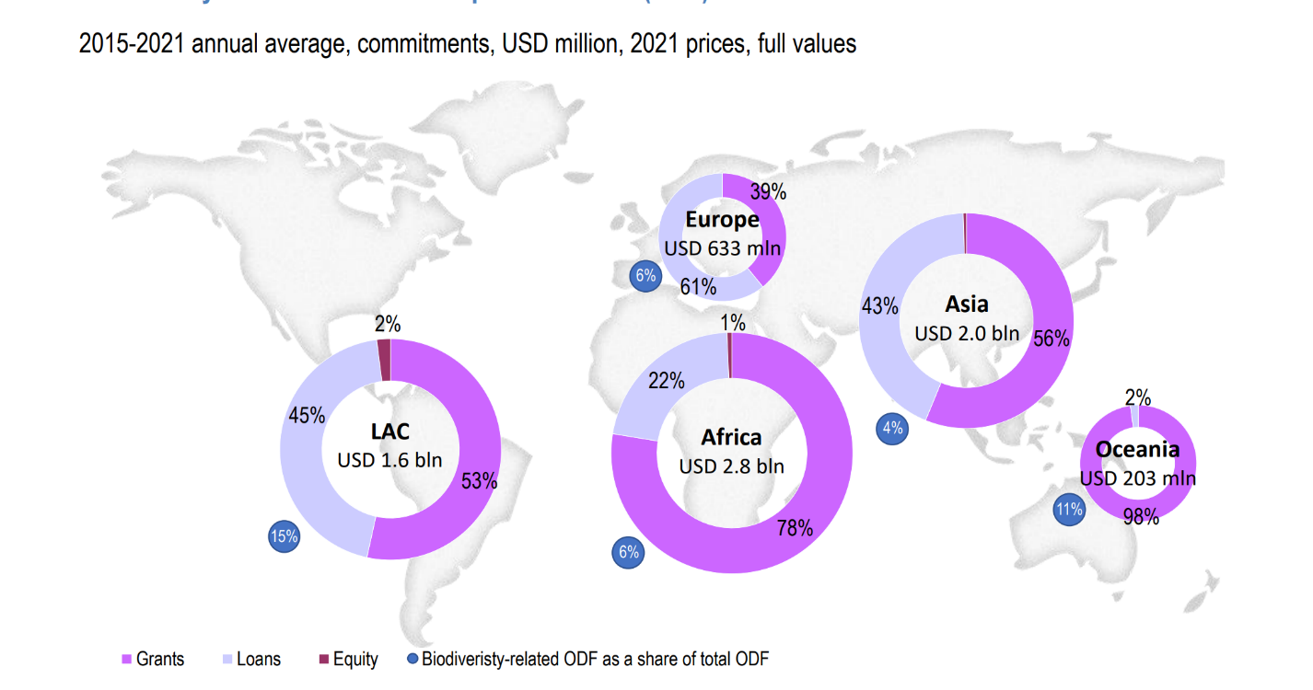
- Overall, Africa and Asia were the regions that benefitted the most from DAC members, receiving USD 2.84 billion (39% out of total biodiversity-related ODF) and USD 1.96 billion (27%) respectively on average annually over 2015-21.
Figure 2: Allocation of financial instruments (Source: OECD, 2023)

The Global Environment Facility (GEF)
- Among the multilateral international finance sources, the GEF, as the institutional structure operating the financial mechanism of the Convention on an interim and ongoing basis, is central to the Convention. The GEF provides financial resources for developing countries and countries with economies in transition to implement the Convention on Biological Diversity. The GEF has invested more than $5.2 billion to conserve biodiversity and use it sustainably. This investment has leveraged over $13.4 billion in additional funds, supporting 1,500 projects in more than 158 countries.
GEF Phase | Replenishment Total (US$ billion) | Biodiversity Focal Area Total (US$ billion) | Biodiversity Focal Area Share
GEF-6 | 4.433 | 1.296 | 29%
GEF-7 | 4.068 | 1.292 | 32%
GEF-8 | 5.330 | 1.919 | 36%

- GEF estimates that at least 60% of all GEF’s investments in the GEF-8 phase will be biodiversity-relevant and GEF will be reporting on this throughout GEF-8 by applying the Rio Markers. 83% of GEF-8 investments were assessed to be contributing toward biodiversity as defined by the Rio Markers and as depicted in the figure below.
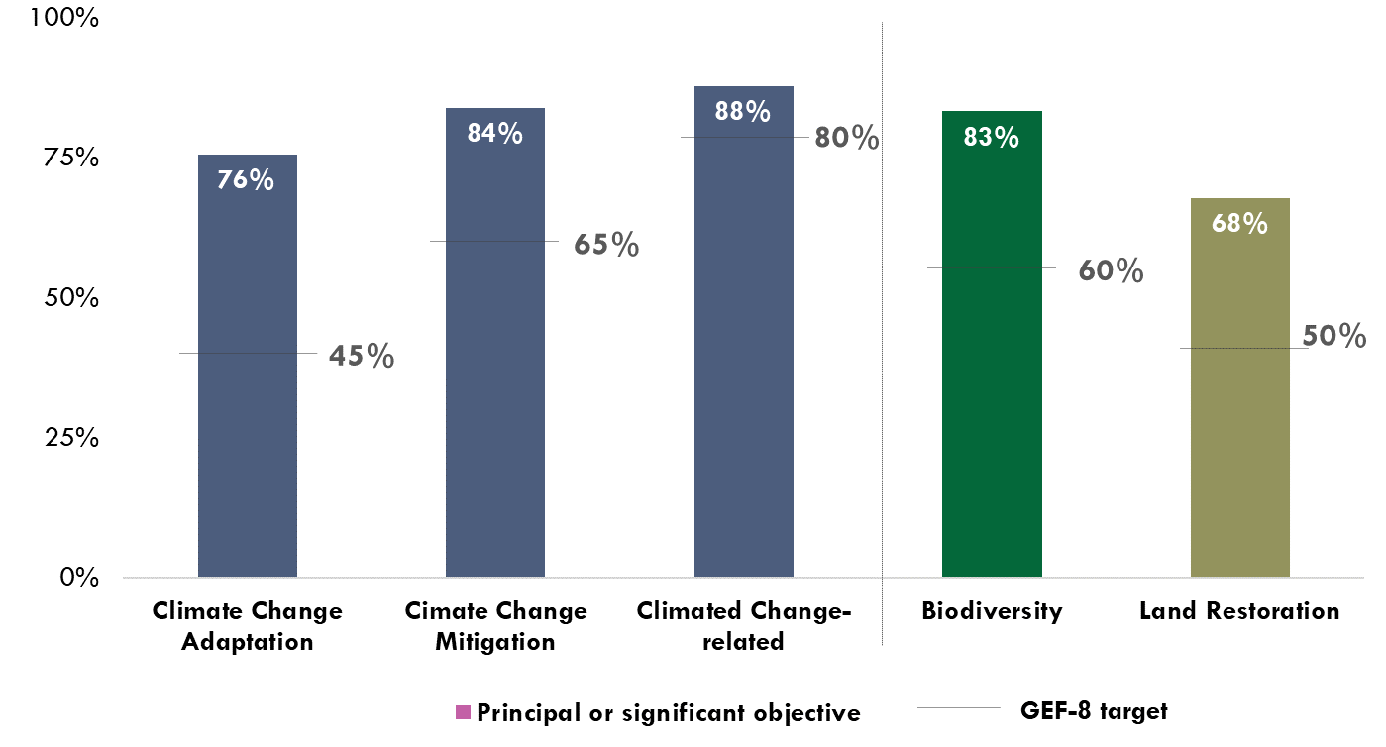
Figure 3: Biodiversity, Climate and Land Degradation Financing

- GEF-8 financing contributing toward Biodiversity, Climate Change Adaptation, Climate Change Mitigation, and Land Degradation as a principal or significant objective is tracked against indicative targets covering GEF-8 investments to date, consistent with the OECD DAC Rio Marker methodology.

Updates on reforms
- In recognition of the GEF’s existing and growing mandate, and the increasing ambition of countries to act on inter-related environmental challenges, the GEF aims to increase its efficiency, agility, and responsiveness to urgent needs through a series of reforms that cover a range of activities.
- First, the GEF is restructuring to streamline and enhance its internal workflows and processes to better serve countries. Relatedly, the GEF Secretariat is expanding its staffing in key programming and policy areas so to support improved and enhanced delivery to countries.
- The GEF had already been reviewing its policies and procedures to improve access, in accordance with commitments made during the GEF-8 replenishment process when COP- 15 provided guidance to the GEF in paragraph 23 of the Decision CBD/COP/15/15 that requested the GEF “…to design and implement a project cycle with a simple and effective application and approval process, providing easy and efficient access to resources of the Global Biodiversity Framework Fund” Hence, the existing reform process that is GEF-wide will assist GEF in responding to the specific request vis a vis the operations of the GBFF.
- To respond to these connected commitments, the GEF has been conducting an internal review of the current project cycle of the GEF and LDCF/SCCF Trust Funds. These analyses are leading to a series of proposed modifications that aim to increase efficiency while preserving the GEF principles of accountability, transparency, and compliance - principles that are essential for the GEF Partnership and its Family of Funds.
- The GEF may consider reforms to the GEF instrument to enable non-sovereign contributions and foster the expanded relationships with these entities. The GEF is examining its programming, policy, and governance frameworks to increase engagements with non-state actors such as Indigenous Peoples and Local Communities (IPLCs), civil society, women, and youth groups. Finally, ahead of the GEF-9 replenishment discussions which will take place in 2025, the GEF is reviewing its governance in the context of potentially increasing its engagement with sub-national and municipal authorities.

Global Biodiversity Framework Fund (GBFF)
- CBD Decision 15/7 requested the Global Environment Facility to establish, in 2023, and until 2030 unless the Conference of the Parties decides otherwise, a special trust fund to support the implementation of the Kunming-Montreal Global Biodiversity Framework, to complement existing support and scale up financing to ensure its timely implementation, taking into account the need for adequacy, predictability, and timely flow of funds. Further to this request, the establishment of the Global Biodiversity Framework Fund (GBFF) as well as its Programming Directions were approved by the GEF Council in its 64th meeting held in Brazil in June 2023, and ratified by the GEF Assembly in its 7th meeting held in Canada in August 2023.
- The GBF Fund is uniquely dedicated to support the implementation of the Kunming-Montreal Global Biodiversity Framework, its goals, and its targets. In response to COP guidance, the Fund was established to receive funding from all sources, quickly disburse resources through streamlined procedures, allocate between 36-39% of resources to LDCs and SIDS. In addition, 25% of programming will be through International Financial Institutions that are GEF implementing Agencies. Finally, given the indispensable role of indigenous peoples and local communities as stewards of biodiversity, projects to support actions by indigenous peoples and local communities for the conservation, restoration, sustainable use and management of biodiversity by indigenous peoples and local communities will be encouraged, on a country-driven basis, with a view to collectively achieving an aspirational programming share of 20% at the portfolio level by 2030 from the total amount of resources allocated under the GBFF, thus enhancing the contributions of indigenous peoples and local communities to the implementation of the GBF. The GEF council also requested to include arrangements to establish an advisory group or advisory groups of members representing non-sovereign contributors to the GBFF.
- The first meeting of the Council of the new Global Biodiversity Framework Fund (GBFF) took place from 8-9 February 2024. The Council approved the GBFF Project Cycle Policy providing for a streamlined project cycle for all GBFF projects, the policy on Allocation of Resources for the GBFF, and the FY24 and FY25 administrative budget and business plan. The decision on the GBFF Project Cycle Policy approved a streamlined project cycle tailored to the guidance from the Conference of Parties of the Convention on Biological Diversity (CBD) and the programming directions provided by the GEF Council in June 2023. GEF Implementing Agencies will have nine months from GEF CEO endorsement of a project preparation grant to fully prepare projects. Projects by the GEF Secretariat can be included in work programs to be approved by the GBFF Council. Projects with comments from the CBD Secretariat, GBFF Council members, or the GEF Scientific and Technical Advisory Panel (STAP) will have three months to address them. The Terms of Reference for Advisory Group(s) and Auxiliary Body for the GBFF will be further discussed at the second GBFF Council in June 2024.
- As of February 8, 2024, the following countries made pledges to the GBFF: Canada with 200 million Canadian Dollars, Germany with 40 million Euros, the UK with 10 million pounds, Spain with 10 million Euros, Japan with 650 million Japanese Yen, and Luxembourg with 7 million Euros. The combined total of these contributions is equivalent to approximately 234 million USD.

Multilateral Institutions
- Multilateral institutions play a crucial role in biodiversity-related development finance through concessional loans and providing grants to foster capacity development. They are also key in mobilising additional finance through the development of credit enhancement schemes in de-risking private finance.
- For example, the World Bank Group has traditionally had a large portfolio of biodiversity projects focused on protected areas, improving natural resource management, and mainstreaming biodiversity into forestry, coastal zone management, and agriculture. Other examples include the European Bank for Reconstruction and Development (EBRD), which supports capacity development programmes for biodiversity; the Asian Development Bank (AsDB), which is a key player in initiatives to improve conservation in the Greater Mekong region; or the International Fund for Agricultural Development (IFAD), which has been central in promoting sustainable smallholder agriculture and agrobiodiversity. The International Finance Corporation has recently published an updated Biodiversity Finance Reference Guide, which provides a structured approach for investors and financiers to identify eligible use of proceeds that constitute biodiversity finance.
- In addition to biodiversity investments (“financing green”), multilateral banks have undertaken important work in developing and implementing safeguards for biodiversity across their project portfolio (“greening finance”). Since 2012, the International Finance Corporation’s (IFC) Performance Standard 6 (PS6) is one of eight environmental and social performance standards which form the foundation of IFC’s sustainability framework. PS6 on “Biodiversity Conservation and Sustainable Management of Living Natural Resources” was designed to help ensure that IFC-financed projects are environmentally and socially sustainable and do not contribute to the significant loss of biodiversity. Similarly, the African Development Bank’s Integrated Safeguard System (ISS), particularly the Operational Safeguard 3 (OS3) on Biodiversity and Ecosystem Services, is designed to ensure that AfDB-financed projects avoid, minimize, and mitigate adverse impacts on biodiversity and ecosystem services. Also, the Asian Development Bank’s Safeguard Policy Statement incorporates key elements of biodiversity conservation and sustainable resource management. These multilateral institutions not only apply their own standards to projects they finance but also work to strengthen the capacity of stakeholders to manage biodiversity and natural resources sustainably.
- Financial institutions, including multilateral development banks, can make important contributions to create an enabling environment for mobilizing finance related to biodiversity. For example, the Inter-American Development Bank (IDB) is aligning its activities with the Global Biodiversity Framework. By instituting nature-positive financing requirements, the IDB is prompting its clients to explore innovative approaches to incorporate nature-positive practices in their business operations.
- At the recent UNFCCC COP 28, eight international organizations and development finance institutions, including the Asian Development Bank (ADB), the African Development Bank (ADB), the European Investment Bank (EIB), the Green Climate Fund (GCF), the Global Environment Facility (GEF), the Inter-American Development Bank (IDB), and bilateral development institutions such as the Agence Française de Développement (AFD) and the United States International Development Finance Corporation (DFC), revealed plans to initiate a global effort aimed at enhancing financial instruments for sustainable climate and nature-linked sovereign financing. The institutions emphasized their commitment to exploring diverse financial solutions, including debt swaps, green bonds, and sustainability-linked bonds, to mobilize private sector capital. The IDB and DFC are set to lead a task force overseeing the group’s mission, focused on increasing the efficiency, affordability, and accessibility of credit enhancement features within these financial instruments. The joint initiative aims to mitigate credit risks for investors in sovereign debt instruments, employing credit enhancement instruments like guarantees and insurance, fostering sustainability-linked financing incentives to mobilize private sector resources. The joint declaration seeks to alleviate the debt burden hindering developing countries’ ability to meet global climate and nature commitments, emphasizing the role of sustainability-linked financing in achieving these goals.
- The International Development Finance Club (IDFC) is a global group of twenty-six national and regional development banks and combined is the largest provider of public development and climate finance globally, with USD 4 trillion in combined assets and annual commitments above USD 600 billion. IDFC is working towards alignment of public development banks with the Kunming-Montreal Biodiversity Global Framework, through research programs and reporting methodologies, knowledge sharing and capacity building, advocacy in the international ©, and partnerships with other financial stakeholders. In 2022, the members of IDFC committed to developing their biodiversity strategy or action plans, combining risk management, impact mitigation, as well as direct conservation and mainstreaming finances; supporting the development of biodiversity/nature strategies at client level; mobilizing finance for nature-positive projects and nature based solutions; managing nature-related risks, impacts and dependencies and integrating nature-related risks in the financial decisions; leveraging private finance through the development of adequate financial mechanisms; allocating a substantive part of climate finance to biodiversity projects; and tracking, reporting and disclosing the nature-related risks, impacts, dependencies and opportunities, through common methodologies or frameworks such as the Taskforce on Nature-related Financial Disclosures (TNFD).

Greening finance: impact assessments and beyond
- Goal D of the GBF calls for “aligning financial flows with the Kunming-Montreal Global Biodiversity Framework and the 2050 Vision for biodiversity.”
- COP decision VIII/3 requested Parties to take measures to improve the effectiveness of environmental impact assessments and strategic environmental assessments, including by strengthening the application of strategic environmental assessment methodologies, by using tools to evaluate potential impacts on biodiversity and ecosystem functions and services, including on resilience. Following the decision, CBD Secretariat commissioned an independent study on the application of biodiversity-inclusive impact assessments which concluded that the most far-reaching effect on impact assessments is created by the binding requirements of the safeguards of the multilateral development banks (discussed above). The study pointed to the IFC Performance Standards (PSs) from 2012, mentioned above, representing the earliest comprehensive and coherent treatment of biodiversity in a regulatory context, closely following the CBD Voluntary Guidelines.
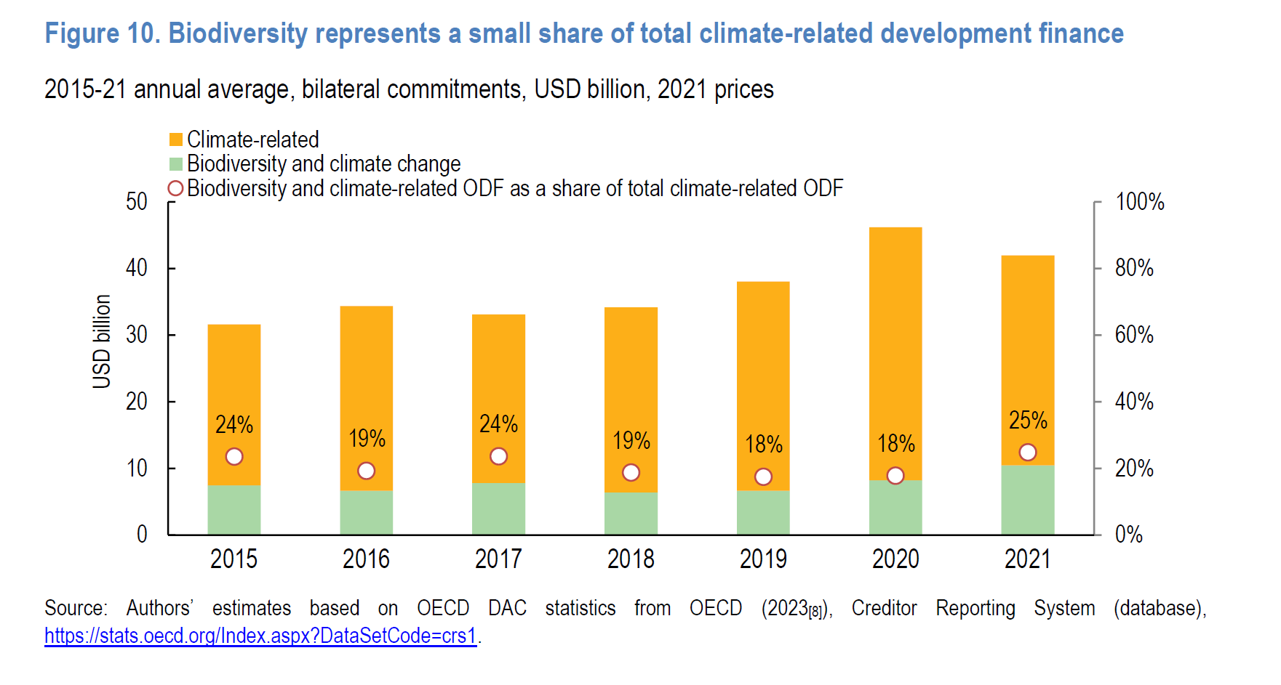
- The share of biodiversity-related ODF that also addresses climate change objectives has steadily increased, rising from 78% in 2015 to 89% in 2021. However, the opposite does not hold true, as biodiversity objectives are only reflected in approximately 21% of total climate-related ODF over the same period, ranging fromg 24% in 2015 to 25% in 2021. Given that total volumes towards climate-related objectives are four times higher than towards biodiversity, and as momentum to reach the Paris Agreement continues increasing, it is crucial that providers recognise the importance of incorporating nature-related considerations when allocating climate finance, to maximise co-benefits, reap synergies and address possible trade-offs. Additionally, given that many of the direct and most of the indirect drivers of biodiversity loss and climate change are common to both these challenges, it makes sense to have tackle these issues together.
Figure 4: Biodiversity represents a small share of total climate-related development finance
- CBD decision 14/5 on biodiversity and climate change further strengthens these linkages. The decision adopted the voluntary guidelines for the design and effective implementation of ecosystem-based approaches to climate change adaptation and disaster risk reduction. Furthermore, the international community has started to pay attention to the potential for synergies. For example, the Agence Française de Développement has set a goal of devoting 30% of its climate funding to efforts to foster biodiversity in 2025 by doubling its investment in biodiversity to reach a target of €1 billion. This could be replicated and scaled.
- In addition to this, there may be other areas for potential synergies. For instance, the need for infrastructure investment is forecast to reach $94 trillion by 2040 globally. More than one-quarter of large infrastructure projects in developing countries are funded by MDBs. Therefore, a strategic inclusion of biodiversity considerations into infrastructure planning can potentially unlock significant co-benefits, while avoiding harmful impact at minimum.
- Research shows that nature-based infrastructure (NBI) can provide effective and more resilient infrastructure services, for up to 50 percent cheaper than traditional ‘grey’ infrastructure. In addition, NBI’s added value is 28 percent greater than grey infrastructure, which in dollar terms translates to $489 billion per annum. These additional values come from the variety of ecosystem services NBI provides and enhances. According to this research, investments into nature-based infrastructure would be financially prudent and indispensable in fostering sustainable and resilient development.
- Promoting investments in nature-based infrastructure requires more holistic decision-making and the more systematic consideration of alternative solutions in early stages of the planning process. Strategic Impact Assessment (SIA), also known as Strategic Environmental Assessment (SEA), is aiming at that, i.e. the assessment of the wider environmental, social, and economic impacts of alternative proposals at the beginning of a project. This concept has been around for a couple of decades but gained relatively little traction. However, recent developments have refined the concept, presenting opportunities to consider and encourage a wider application of this approach.
- Designing projects that seek to harness synergies across different policy areas require engaging multiple stakeholders with divergent views and interests and this can become challenging, involving extensive planning, putting up engagement mechanisms, baseline studies, and the development of monitoring and evaluation frameworks. This complexity is necessary to ensure that projects are feasible, effective, and aligned with broader objectives. However, it also means that considerable time and resources are invested even before any work begins. This process can be particularly daunting for governments or organizations with limited capacity or resources. There are case examples on how to facilitate the preparation of such innovative projects. For example, WWF Finland utilized funding from the Ministry for Foreign Affairs of Finland to facilitate the preparation of GEF proposals, with the financial support covering the salaries of WWF experts in partner countries and enabling engagement meetings with local stakeholders. In tandem, WWF US and the broader WWF network provided essential technical expertise and support throughout the GEF proposal process. This collaboration was strategically designed to focus on landscapes where WWF is already active, ensuring alignment with both GEF’s objectives and WWF’s ongoing conservation efforts. This approach resulted in the successful securing of over 7 million USD for the Tanzanian Ministry of Natural Resources and Tourism for the project “Food Systems, Land Use and Restoration in Tanzania’s Forest Landscapes”.
- It is also important to consider the absorptive capacity of recipient countries, encompassing various dimensions, including institutional strength, governance, financial management, and technical expertise. Strengthening these areas is essential for ensuring that international finance and investments are not only absorbed efficiently but also translated into sustainable outcomes.

The role of non-traditional public donors
- According to the data collected by OECD, funding for biodiversity-related activities from providers beyond the DAC membership amounted to USD 27 million annually on average from 2018-21. These volumes are driven mainly by development co-operation providers that are not members of the DAC (namely, Saudi Arabia, the United Arab Emirates and Kazakhstan). South-South and triangular co-operation (South-South) providers, such as Brazil, Chile, Costa Rica, and Indonesia, are also reporting on their total official support for sustainable development with biodiversity-related objectives. Data available for 2019-21 indicate that South-South contributions increased significantly over this period (and by more than fourfold in 2020-21 alone); however, this can be greatly attributed to a significant increase in reporting by a specific provider in 2021.

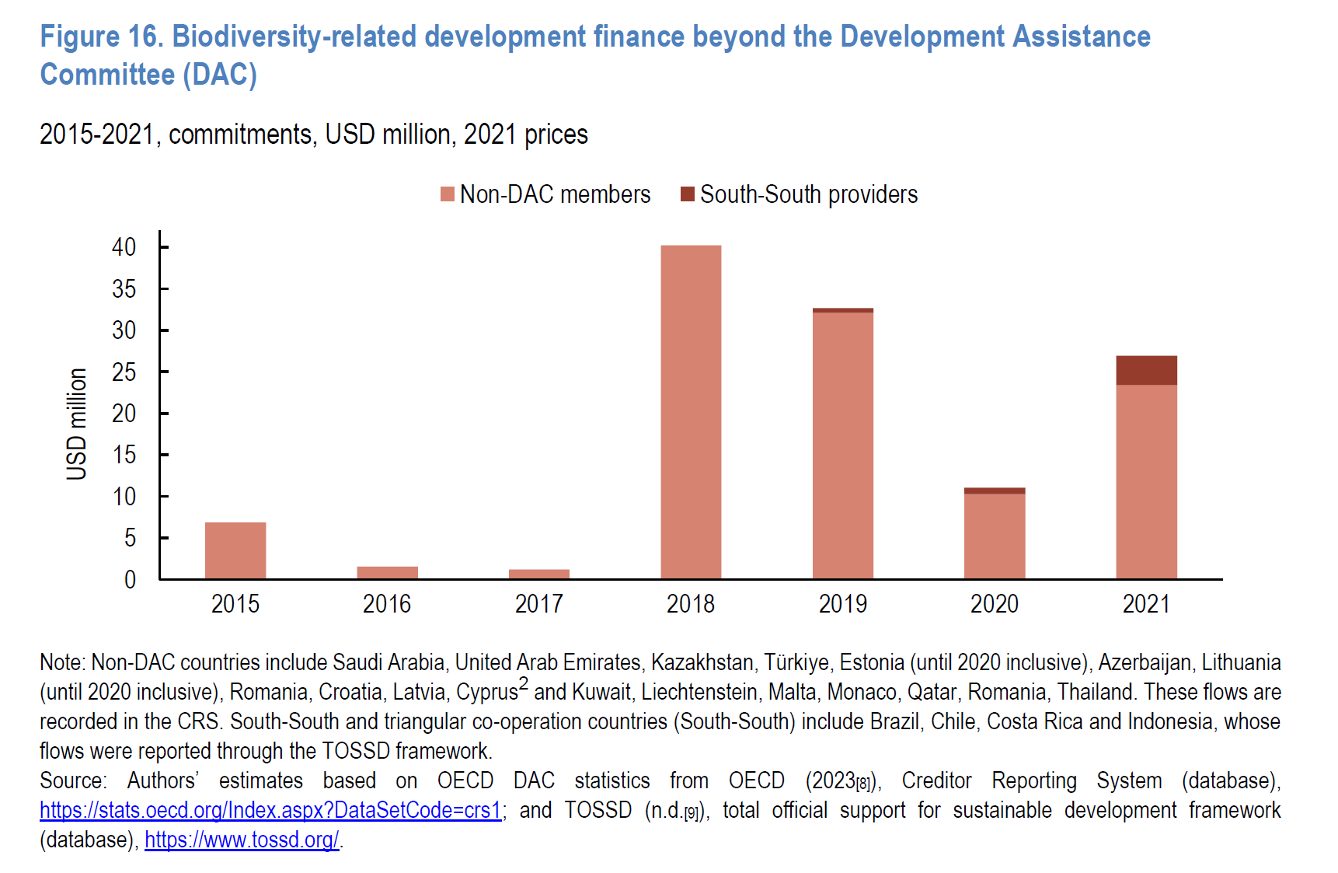
A concrete illustration of this shift is the establishment of the Kunming Biodiversity Fund by China, which has committed 1.5 billion yuan (equivalent to $211 million). This fund was initiated during the initial stages of COP15 and provides substantial financial support for conservation initiatives in developing countries.

Overview of international private finance
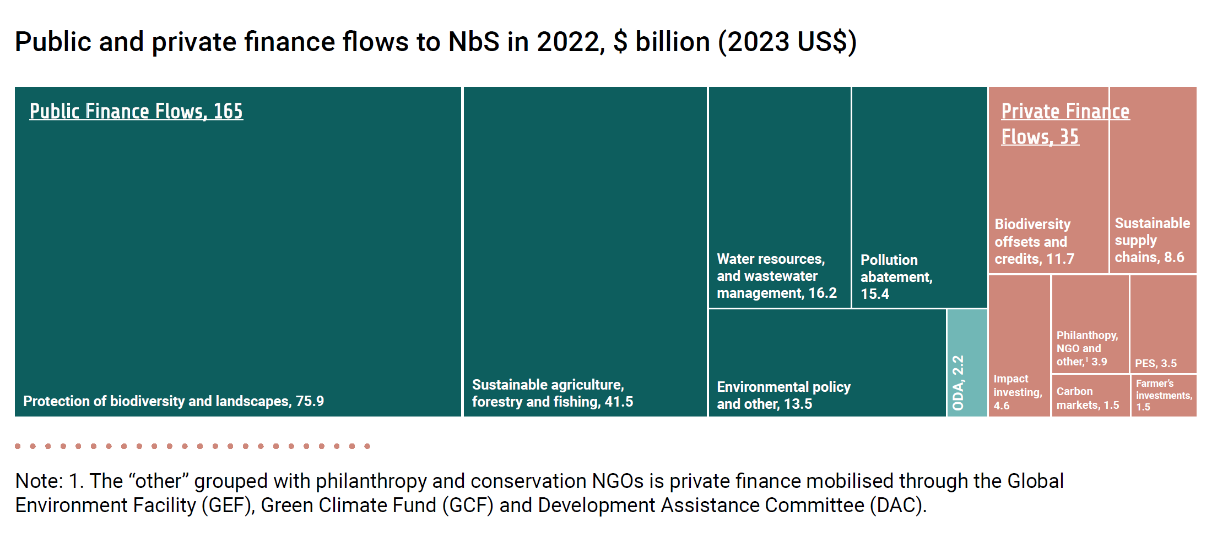
- The OECD (2020) report estimated private finance for biodiversity (covering both domestic and international private finance) at USD 6.6-13.6 billion per year. This estimate is derived from different sources of data for the period 2015-2017 on: biodiversity offsets (which constituted the largest proportion of private finance, at an estimated range of USD 2.6-7.3 billion per year), sustainable commodities, forest carbon finance, payments for ecosystem services, water quality trading and offsets, philanthropic spending, private contributions to conservation non-governmental organisations (NGOs), and private finance leveraged by bilateral and multilateral public development finance. Using similar categories, a more recent UNEP (2023) report estimated private finance flows (both domestic and international finance) to nature-based solutions (Nbs) at USD 35 billion per year. Similar to the OECD (2020) report, biodiversity offsets constituted the largest portion of private finance for biodiversity.
Figure 5: Biodiversity- related development finance beyond the Development Assistance Committee (DAC)
Figure 6: Public and private finance flows to NbS in 2022, $ billion (2023 US $) (Source: UNEP, 2023)
- Overall, comprehensive data on private sector finance on biodiversity is not readily available. This is due, among other things, to a lack of common definitions, an absence of reporting frameworks and obligations and the challenges associated with identifying the biodiversity component of private transactions (OECD, 2020). In addition measuring and tracking private biodiversity finance also has several challenges. Both of these issues are further discussed in Section 5.

Philanthropic organizations
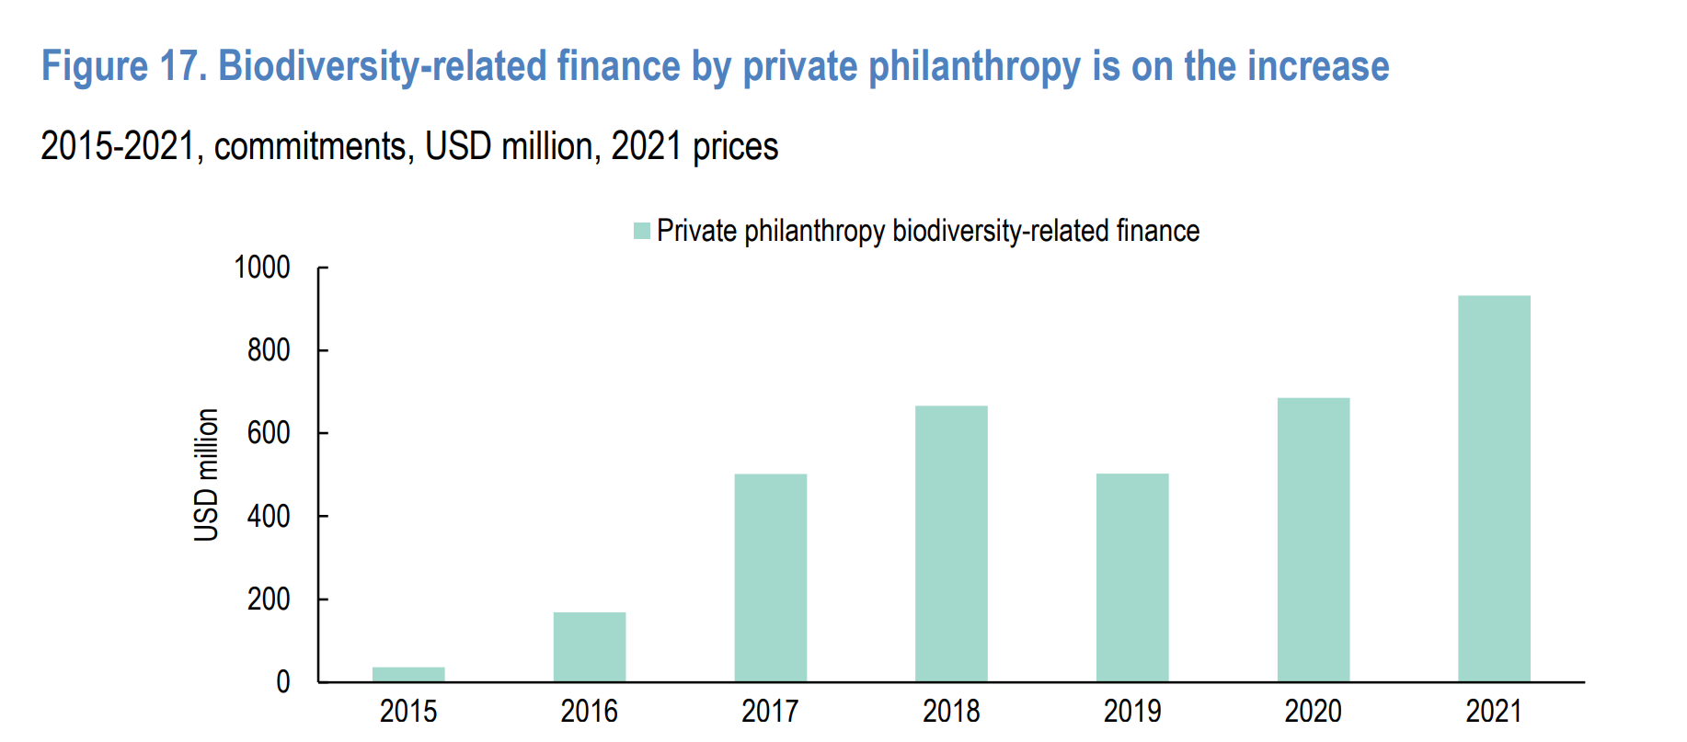
- According to the OECD, philanthropic organizations are increasingly channelling investments into biodiversity-related initiatives, with a notable uptick from USD 501 million in 2017 to USD 932 million in 2021, reflecting an 86% surge (see figure). While these philanthropic contributions remain relatively modest compared to the overall funding for biodiversity-related Official Development Finance (ODF), they play an important role in particular in sectors like environmental protection, agriculture, and fishing, where they account for 62%, 11%, and 8% of the total contributions to biodiversity, respectively.
Figure 7: Biodiversity- related finance by private philanthropy (Source: OECD)

- It is noteworthy that out of the forty-six foundations reporting to the OECD, 40 actively supported biodiversity-related activities. The majority of philanthropic funding for biodiversity-related causes, totalling 78%, was directed towards middle-income economies. Key recipients included countries such as Indonesia, Brazil, India, Peru, and China, collectively constituting 40% of the total funding (excluding unspecified allocations). The remaining 22% of country-allocable funding targeted Least Developed Countries (LDCs), including the Democratic Republic of the Congo, Rwanda, and Ethiopia. Furthermore, the implementation of philanthropic contributions was predominantly carried out through non-governmental organizations (NGOs) and civil society, with international NGOs like WWF, Climate Works Foundation, The Nature Conservancy, Oceana, and Fauna and Flora International playing a significant role (comprising 77% of contributions). Academic and research institutes followed closely, accounting for 14% of the philanthropic funding distribution.
Box 1 : Unlocking Blue Pacific Prosperity
At the recent Climate COP 28, the Pacific Islands State Leaders introduced the Unlocking Blue Pacific Prosperity initiative, in order to conserve and rejuvenate the Blue Pacific Continent. The Bezos Earth Fund pledged up to $100 million in grants for the initiative's design and implementation. The plan covers 100 percent of the Blue Pacific Continent, surpassing the size of Africa by almost 50 percent and the United States by five times. The initiative aims to protect 30 percent of this area, totaling over 1 billion hectares, to enhance the ocean's resilience to climate impacts. The strategy also focuses on establishing sustainable coastal food systems and restoring coral reefs, mangroves, and other coastal ecosystems crucial for food security, livelihoods, and cultural identity in the Pacific Islands, through the restoration and protection of these ecosystems and support to community-based fisheries management.

Role of indigenous peoples and local communities
- The Kunming-Montreal Global Biodiversity Framework, in section C, ‘acknowledges the important roles and contributions of indigenous peoples and local communities as custodians of biodiversity and as partners in its conservation, restoration and sustainable use. The Framework’s implementation must ensure that the rights, knowledge, including traditional knowledge associated with biodiversity, innovations, worldviews, values and practices of indigenous peoples and local communities are respected, and documented and preserved with their free, prior and informed consent,7 including through their full and effective participation in decision-making, in accordance with relevant national legislation, international instruments, including the United Nations Declaration on the Rights of Indigenous Peoples,8 and human rights law. In this regard, nothing in this framework may be construed as diminishing or extinguishing the rights that indigenous peoples currently have or may acquire in the future.”
- It is estimated that indigenous peoples and local communities contribute US $3.16 – 4.57 billion to conservation. It is therefore important to assess how these (typically non-monetary) contributions to the goals and targets of the Global Biodiversity Framework are currently supported through international finance and can potentially be enhanced (further discussed in Section 6). Two recent COP decisions are pertinent and important to recall.
- Decision 14/16 highlighted the important contributions of indigenous peoples and local communities towards the conservation and sustainable use of biodiversity, through their holistic collective actions. The decision acknowledged the need for methodological guidance to identify, monitor, and assess these contributions within a rights-based framework, emphasizing the differentiated roles of women and men among indigenous peoples and local communities. It encouraged the use of an indicative list of methodological elements which includes recognizing traditional knowledge, applying diverse and context-specific methodologies, ensuring the full and effective participation of indigenous peoples and local communities, and promoting intergenerational knowledge transfer. The decision invited Parties, governments, and stakeholders to utilize these elements in their methodologies and encouraged the integration of indigenous peoples and local communities contributions into biodiversity financing mechanisms, aiming for a more inclusive and effective approach to biodiversity conservation.
- In the footsteps of this invitation, and as a flipside, decision 14/15 highlighted the importance of putting safeguards in place in order to ensure that biodiversity financing mechanisms have positive effects and avoid or mitigate unintended negative effects on biodiversity and the livelihoods of indigenous peoples and local communities. To this effect, decision XII/3 on resource mobilization had already adopted voluntary guidelines on such safeguards, and decision 14/15 provided a detailed checklist for the implementation of the guidelines. It urged Parties, other stakeholder organizations and other institutions to continue using the guidelines in designing and operating their financing mechanisms and in setting up their safeguard systems, making use, as appropriate, of this checklist.
- There are already examples and models of activities that are implemented nationally and locally in support of collective action by indigenous peoples and local communities. They include: (a) the recognition of traditional knowledge and practices as key components of community-based conservation; (b) the recognition that value systems linked to the communities’ cultures for conservation and sustainable use need to be understood and supported; (c) the need for exchange platforms and knowledge sharing; and (d) the importance of creating opportunities for policy linkages and direct involvement of indigenous peoples and local communities in policy processes. A fundamental consideration is that the needs and interests of indigenous peoples and local communities related to their livelihoods and cultures should be integral to the assessment of their contributions because indigenous peoples and local communities often have their own ways of conserving and sustainably using biodiversity, in close connection with their holistic approaches.

The need for gender-responsive biodiversity finance
- Recognising the interconnectedness of gender equality and environmental goals can lead to mutually reinforcing outcomes. Financial allocations that are presumed to be "gender-neutral" can impact women and men differently due to their distinct gender roles and unequal access to resources and services. Thus, by addressing the gender-environment nexus explicitly, policymakers can promote policy coherence, improve well-being, and foster green and inclusive growth. Financial institutions, particularly those related to climate and environment initiatives, are increasingly committed to integrating gender perspectives, and offer opportunities for Parties and stakeholders to advance gender-responsive biodiversity finance through strategies such as funding gender-responsive national programmes and by providing grants that are specifically targeted at women's sustainable livelihoods.
- Various global and regional financing mechanisms represent opportunities for stakeholders to focus on or integrate biodiversity actions as well as gender dimensions. Many mechanisms and their funders have commitments, standards and/ or priorities related to gender equality and women empowerment and a number of these have stepped up gender commitments in recent years. The contribution of these mechanisms to gender responsive biodiversity action on the ground is especially effective when investments include tracking, assessing, and sharing compliance and impacts. Parties, indigenous peoples and local communities, and stakeholders accessing these, and other financing mechanisms can also benefit from their guidance on integrating gender in proposals.
- In this context, CBD COP Decision 15/11 emphasizes the importance of gender-responsive biodiversity finance. It calls for increased support from entities such as the Global Environment Facility and relevant funding organizations to provide technical and financial assistance, capacity-building, and development for the implementation of the Gender Plan of Action. Additionally, it urges Parties and relevant public and private entities to enhance the gender responsiveness of provisions of financial resources, and other means of implementation. This aligns with the principles outlined in Decision 15/4 of the Kunming-Montreal Global Biodiversity Framework, where section C (h), highlights that the ‘Successful implementation of the Framework will depend on ensuring gender equality and empowerment of women and girls, and on reducing inequalities”.
- There are further opportunities to improve the gender responsiveness of biodiversity finance, for instance through gender-responsive budgeting, taking into account the specific needs and interests of both women and men when designing and implementing budgets. This approach not only promotes gender equality, but also makes biodiversity finance more efficient. Similarly, OECD proposes several strategies to support women empowerment through green policies and finance. This includes adapting environmental taxes, subsidies and budget instruments to take account of gender segregation; providing access to finance and technology for women-led green initiatives; integrating gender considerations into trade agreements; and supporting cooperation efforts to integrate gender equality into climate finance.

The role of youth in mobilizing resources
- Environmental Youth Constituencies under different MEAs and mechanisms - such as GYBN (with the CBD), YOUNGO (with the UNFCCC), CYMG (with the UNEP cross-cutting all environmental issues) - are actively engaging in the environmental finance conversation. They are mobilizing resources through their roles on strengthening youth networks, enhancing intergenerational connection, organizing capacity building trainings, and bringing perspectives from the local to global, and global to local spaces among the youth communities.

Overview of funds for biodiversity
- This part provides an overview of select existing international funds and frameworks which are funding activities related to biodiversity. These funds are an important part of the biodiversity finance landscape, unlike the GEF and the new GBFF (see section above), they are not under the authority and guidance of the CBD. This list is not exhaustive; it provides a succinct summary of mechanisms that are either large in scale, have the potential to be replicated or scaled, or otherwise provide insights or lessons of interest.

Critical Ecosystem Partnership Fund
- The Critical Ecosystem Partnership Fund (CEPF), established in 2000 with funding from GEF, the World Bank, and the MacArthur Foundation, focuses on empowering civil societies in developing countries and transitional economies to safeguard biodiversity hotspots. By directing over US$277 million in grants and technical assistance to more than 2,600 civil society entities, CEPF has made significant strides in conservation. This includes the protection of over 1,000 species on the IUCN Red List of Threatened Species, management, and preservation of 51.6 million hectares of Key Biodiversity Areas, and support for over 4,900 communities. CEPF combines local-driven conservation strategies with support for non-governmental, private sector, and academic organizations. This model not only protects biodiversity but also fosters sustainable development and local conservation leadership.

Coral Reef Fund
- The Global Fund for Coral Reefs (GFCR) functions as a 10-year, $625 million blended finance vehicle. The fund is broadly structured into two streams: a grant fund and an investment fund. The grant fund serves to nurture a pipeline of investible projects that yield positive environmental, social, and economic impacts. This includes funding for technical assistance, capacity development, emergency grants, and monitoring and evaluation to build local capacity and de-risk the private sector's involvement in the expanding blue economy sector. Simultaneously, the investment fund, managed by Pegasus Capital Advisors with support from consortium partners, provides capital to scale initiatives and amplify the impact of projects incubated by the grant window. To further de-risk investments, the fund mobilizes guarantees and concessional loans from various sources, attracting private investor capital. The GFCR's blended approach aims to create efficiencies of scale, reduce dependence on limited grant funding, accelerate project readiness, diversify risks, and establish local entities for enhanced representation and participation of local stakeholders.

The ASN Biodiversity Fund
- The ASN Biodiversity Fund is the first listed fund for nature that uses investment from the retail sector. It targets large funds and listed companies that have a measurable positive impact on biodiversity and nature restoration through sectors such as agroforestry and sustainable fisheries. For every €1 million invested, the Fund aims to help restore around 230 hectares of land or sea to a healthy ecological balance. Since its launch in November 2021, the Fund has amassed over €26 million from over 1 million retail investors.

The Lion’s Share Fund
- The Lion’s Share Fund is administered by the Multi-Partner Trust Fund Office of the United Nations Development Programme (UNDP). Under The Lion’s Share Fund, among other things, brands that use pictures of animals, including computer-generated and animated images, to promote goods and services can gain partnership status if they commit to contributing to the Fund a fixed 0.5 per cent of media expenditure from advertisements that feature an animal. The Fund has supported more than a dozen conservation projects in 15 countries, predominantly in Africa, Asia, and South America. The funds are not earmarked for specific species; instead, they are allocated to projects chosen by conservation experts from a pool of grant applicants.
- The model of The Lion’s Share Fund has, however, posed a significant challenge, as there is insufficient verifiable data on the estimate of 0.5 per cent of marketing budgets for advertising featuring animals. Companies have struggled to verify estimates of such expenditure, as there are typically no internal procedures to track such advertisements. In addition, it is ultimately the private sector partner that decides which budgets are used for donations, and it is impossible to ensure that marketing budgets are used. Take-up by businesses of the opportunity of partnership with the Fund has been slow. There seems a limit to corporate generosity, and the sustainability of the fund is largely dependent on the continued support of its largest donor, the Mars company, which has contributed about 80 per cent of the total contributions of about $6.5 million. While there is increasing interest from the private sector in engaging in environmental initiatives, companies tend to focus their corporate social responsibility strategies on their own supply chains rather than on global initiatives. A legally binding requirement to pay to use animals in advertising has been proposed, but its potential operationalization raises several questions, including how funds from a vast range of users can be successfully captured and accrued. Given the persistent challenges to capitalize the Fund with the original model, the Fund is undergoing a structural transition that will be announced by early 2024.

Leaf Coalition
- The LEAF Coalition (Lowering Emissions by Accelerating Forest Finance) is an initiative aimed at providing funding to support the protection of tropical rainforests, which in turn contributes to biodiversity conservation. While the primary goal of the LEAF Coalition is to reduce emissions from deforestation and forest degradation, the projects it funds inherently contribute to the conservation of biodiversity, as tropical forests are some of the most biodiverse ecosystems on the planet.
- The LEAF Coalition operates by funding high-quality, verified emission reductions from tropical and subtropical forest countries, ensuring that their efforts to reduce deforestation are matched with financial support. By doing so, it not only contributes to climate change goals but also supports biodiversity conservation in some of the world's most vulnerable regions.

Legacy Landscapes Fund
- The Legacy Landscapes Fund (LLF) was founded in late 2020 as an independent charitable foundation under German law, initiated by the German Ministry for Economic Cooperation and Development. It is financially backed by both public and private entities. This includes contributions from the German Government via the KfW Development Bank, NORAD (Norway), and the French Development Agency (Agence Française de Développement). Additionally, each conservation site under LLF's purview is required to secure a private match-funding partner, committing at least 5 million USD. These partners can be philanthropic organizations or corporate entities. So far 14 sites have been funded, with a total financial commitment of 225 million USD, covering an area of 473,424 square kilometers.
- LLF's primary mission is to bolster conservation efforts primarily in the Global South. It accomplishes this by providing long-term program funding, which is executed by NGOs with proven expertise in the field of conservation. The Legacy Landscapes Fund (LLF) prioritizes conservation actions that effectively mitigate major threats to biodiversity and ecosystem services. In the latter half of 2022, LLF introduced an impact indicator system at both the program and individual site levels, aimed at monitoring these conservation efforts. Grantees are obliged to submit site-level indicator reports to LLF biannually, as part of their program reporting duties. These reporting structures were collaboratively created with input from donors and implementing partners. Other initiatives may learn from the impact indicator system at both the program and site levels which is a significant step towards ensuring accountability and effectiveness. By requiring biannual site-level indicator reports, LLF can monitor the progress and impact of the conservation efforts, allowing for adjustments and improvements over time. Further research into this may be required to draw out lessons learnt.

Biodiverse Landscapes Fund
- The £100 million Biodiverse Landscapes Fund of the United Kingdom is set to run from 2022 - 2029 to develop economic opportunities through investment in nature; slow, halt or reverse biodiversity loss in globally significant regions for biodiversity; and reduce GHG emissions and safeguard national carbon sinks. The fund will support 6 biodiversity hotspots across 18 countries through grant awards.
Funding mechanisms related to the other Rio and biodiversity-related Conventions

Green Climate Fund (GCF) and others
- COP Decisions on Biodiversity and Climate Change recognize that climate change is a major and growing driver of biodiversity loss, and that biodiversity and ecosystem functions and services, significantly contribute to climate change adaptation, mitigation, and disaster risk reduction.
- The Green Climate Fund, the world’s largest dedicated climate fund serving developing countries, has committed over USD 12 billion to 216 projects in 128 developing countries since its inception, mobilizing an additional $33 billion in public and private co-financing. The Green Climate Fund's Strategic Plan for 2024-2027 outlines specific targets which are contributing directly to the goals of the KMGBF. This includes aiding developing nations in conserving, restoring, or sustainably managing 120 to 190 million hectares of land and marine environments. Additionally, the plan envisions supporting 45 to 60 developing countries in creating or enhancing climate-resilient, low-emission infrastructure through comprehensive resilience strategies, financial assistance, and reducing investment risks, with an emphasis on employing nature-based and ecosystem-based approaches.
- At UNFCCC COP-28, four multilateral climate funds – the Adaptation Fund (AF), the Climate Investment Funds (CIF), the Global Environment Facility (GEF) and the Green Climate Fund (GCF) elaborated on how their programming contributes towards making financial flows available to developing countries. They noted that their collective experience, innovative approaches, and concessionary funding can help other international financial institutions, including the Multilateral Development Banks (MDBs), to mitigate financial risks, lower investment costs, and scale up access to finance. The funds committed to strengthen complementarity and coherence and move towards harmonizing procedures to improve and streamline access modalities to finance. They would develop a common concept of complementarity and coherence aimed at avoiding duplication of efforts, enhancing collaboration, streamlining processes, and ensuring they work together effectively towards common goals.

Land Degradation Neutrality Fund
- The Land Degradation Neutrality (LDN) Fund is an impact investment fund blending resources from the public, private and philanthropic sectors to support achieving LDN through sustainable land management and land restoration projects implemented by the private sector. The LDNF aims to restore land in developing countries and promote sustainable farming and agriculture in conjunction with local and indigenous communities by encouraging private donors to invest in long-term environmental and social change. Effective implementation of LDN initiatives requires integrating biodiversity considerations into land management practices, thus providing an opportunity to enhance biodiversity conservation while addressing land degradation challenges.

International Treaty on Plant Genetic Resources for Food and Agriculture (International Treaty)
- The objectives of the International Treaty are the conservation and sustainable use of plant genetic resources for food and agriculture (PGRFA) and the fair and equitable sharing of the benefits arising out of their use, in harmony with the Convention on Biological Diversity, for sustainable agriculture and food security. A new funding strategy for the International Treaty was adopted by its Governing Body in November 2019 with a target of approximately USD 1 billion per year, and is being implemented for the period 2020–2027. The Funding Strategy aims to ensure that sufficient financial resources are mobilized through a range of channels including: national funding; bilateral funding and assistance; international mechanisms, funds and bodies such as the Food and Agriculture Organization, Consultative Group on International Agricultural Research, the World Bank, the Global Environment Facility, Green Climate Fund, International Fund for Agricultural Development ; philanthropic organizations; the private-sector, including the food processing industry ; the Global Crop Diversity Trust; and, the Treaty’s Benefit-sharing Fund.
Lessons learned from other international funding mechanisms
- Initially prepared for the consideration of Ad Hoc Open ended Working Group on Benefit sharing from the Use of Digital Sequence Information on Genetic Resources, a recent report on lessons from other international funding mechanisms provides useful insights relevant to this study and the work of the Advisory Committee. Some of the key findings of the report can be summarized as below:
  - Most large-scale funds rely heavily on government contributions, even those initially meant to diversify revenue sources beyond governmental funding.
  - Regular replenishment cycles, such as those of the GEF trust fund and the Green Climate Fund, help increase and predict finance levels, contrasting with the sporadic funding of funds like the Least Developed Countries Fund and the Benefit-sharing Fund that depend on voluntary contributions without regular cycles.
  - Endowment funds, like the Global Crop Diversity Trust, offer predictable support for long-term activities through interest income but require significant initial contributions.
  - User-based or market-based mechanisms, such as those attempted by the Benefit-sharing Fund and the Adaptation Fund, have not provided sufficient predictable funding.
  - Efforts to raise voluntary contributions from the private sector have seen limited success, with few companies willing to contribute without a requirement for others to do the same, affecting competitiveness.
  - Innovative mechanisms like the International Finance Facility for Immunisation's use of bonds to secure public goods (e.g., vaccines) show potential but come with costs for investors and intermediaries.
  - Governance structures vary across funds, with some governed by boards with majority donor countries and others offering more equitable representation or focusing on expert nominations.

Additional examples of funds for implementation of multilateral environmental agreements
- In addition to the funds mentioned in the study above, below are examples of other funds for multilateral environment agreements

Multilateral fund for the implementation of the Montreal Protocol:
- The Fund was the first financial mechanism to be established for an international treaty. It provides funds to help developing countries comply with their obligations under the Protocol to phase out the use of ozone-depleting substances at an agreed schedule. The Fund is managed by an Executive Committee with an equal representation of developed (industrialized) and developing countries (defined as ‘Article 5’ countries by the Parties) that is elected annually by the Meeting of the Parties. The Committee reports every year to the Meeting of the Parties on its operations. The Fund Secretariat (co-located with UNEP) assists the Executive Committee and carries out day-to-day operation. The fund operates under the authority of the Parties.
- Financial and technical assistance is provided in the form of grants or concessional loans and is delivered primarily through four implementing agencies: United Nation Environment Programme (UNEP); United Nations Development Programme (UNDP); United Nations Industrial Development Organization (UNIDO); and the World Bank. The Fund Treasurer (UNEP) is responsible for receiving and administering pledged contributions (cash, promissory notes or bilateral assistance), and disbursing funds to the Fund Secretariat and the implementing agencies, based on the decisions of the Executive Committee.

Specific International Programme for the Minamata Convention on Mercury
- The GEF serves as the financial mechanism for the Minamata Convention on Mercury. In addition to the GEF, the Convention has a dedicated ‘Specific International Programme (SIP)’ to support capacity-building and technical assistance for implementing the Convention's provisions. The SIP is hosted by the United Nations Environment Programme (UNEP) and is administered through the Secretariat of the Minamata Convention. The SIP has a Governing Board that oversees and implements the guidance of the Conference of the Parties, including making decisions on the priorities, policies, and procedures of the programme. The Board also reviews and approves project proposals and allocates funding. The composition of the Governing Board is designed to ensure broad geographical representation and includes representatives from both donor countries and beneficiary countries. The SIP can receive contributions from various sources, including Parties to the Convention, international organizations, the private sector, and philanthropic entities and can provide support from USD 50,000 to USD 250,000 per project.

Other resources: the FIRE database
- Responding to the potential need for a platform or clearinghouse dedicated to biodiversity finance, which aims to reduce the initial costs of locating sources of financial support, a collective partnership involving UNDP-BIOFIN, UNEP-FI, Cornell University, the Campaign for Nature, the Conservation Finance Alliance, and the governments of the UK, France, and Belgium, has recently launched the Finance Resource Database for Biodiversity (FIRE). FIRE compiles over 200 funding opportunities globally, encompassing both conservation-focused options and other financial mechanisms that can also support biodiversity financing, assisting project developers in identifying global funding resources. The database, continually growing, encompasses diverse funding opportunities from both public and private sources, catering to individuals, organizations, and communities. Anticipated to expand further, with a focus on including more opportunities from the Global South, FIRE has already provided initial insights. The database highlights that the majority of funded projects concentrate on protected areas and other conservation measures, as well as biodiversity knowledge and awareness.

Beyond project financing: mainstreaming into international financial flows
- As discussed in this chapter, international biodiversity finance is predominantly ODF, and the “standard’ delivery in development cooperation is overwhelmingly if not exclusively project-based, involving allocating funds to specific, time-bound projects with defined objectives and outcomes. While this allows for targeted interventions and measurable results, it may compartmentalize efforts, potentially leading to fragmented and discontinuous efforts towards conservation and sustainable use of biodiversity. The typical project cycle in development finance, from conception through to completion, often spans only a few years. This limited timeframe is perhaps adequate for building institutional capacity or for on-off capital investments. However, it would fall short of the long-term financial sustainability needed to reflect the continuous (intangible) benefit stream for human well-being emanating from ecosystems and biodiversity. Faced with increasing opportunity costs of biodiversity policies, without a mechanism for sustained funding, the long-term protection of ecosystem services and its underlying biodiversity remains uncertain. The examples below highlight a number of possible avenues that could potentially go beyond short-term project-based financing.

International Monetary Fund's (IMF) Special Drawing Rights (SDRs)
- The utilization of the International Monetary Fund's (IMF) Special Drawing Rights (SDRs) has been identified as a potential mechanism for financing biodiversity. The SDR itself is not a currency but an asset that holders can exchange for currency when needed. These SDRs can be utilized by countries to bolster their foreign exchange reserves or exchange them for freely usable currencies with other member nations, thus providing a significant injection of liquidity into national economies. Allocating SDRs does not require contributions from donor countries’ budgets. SDRs are a reserve asset, not foreign aid. Most importantly, an SDR allocation does not add to any country’s public debt burden.
- One option for further Governments may want to further explore options like the IMF’s Resilience and Sustainability Trust (RST), which uses SDR channelling and delivers affordable long-term financing to help vulnerable countries tackle long-term challenges. For now, the RST supports climate change and pandemic preparedness only.

Sustainability linked sovereign financing
- In light of the significant share of low-income countries, 37 out of 69, that are assessed to be at high risk or in debt distress, according to the latest IMF and World Bank Debt Sustainability Framework, sustainability-linked sovereign debt can potentially contribute to solving sovereign debt issues. First, it directly rewards countries with lower costs of debt services when they achieve positive nature and climate outcomes. Second, it encourages investments and policy actions that reduce risks and boost resilience and economic productivity, ultimately lowering debt repayment costs for the entire country. Third, it supports broader sustainable development by promoting economic growth and productivity and providing financial flexibility for increased public spending.
- Sustainability-linked bonds may hold significant promise, but they also face numerous challenges. Developing ambitious targets and project pipelines as well as robust KPIs can be costly and time-consuming for issuers, especially under-resourced sovereign Governments. They may also require credit enhancement from multilateral development banks or development finance institutions, such as credit guarantees and political risk insurance, in order to de-risk and attract sufficient capital into relatively novel instruments. However, there are initiatives like Sustainability-Linked Sovereign Debt Hub (SSDH), hosted by the Nature Finance, which will continue to provide support this area.
- At UNFCCC COP28 in December 2023, the world's largest MDBs and international organisations announced a joint declaration and launched a task force to boost sustainability-linked sovereign financing for nature and climate, an effort also supported by leading insurance companies. The participating institutions will collaborate to scale climate and nature-linked financing by sovereigns and other public sector entities by improving the access to and affordability of risk mitigation and credit enhancement instruments.

Debt-For-Nature Swaps
- Debt-For-Nature Swaps involve countries or entities agreeing to purchase and eliminate a portion of another country's debt at a reduced rate. In return, the recipient country commits to investing a specified sum in conservation efforts or making similar conservation pledges. The proceeds from these Debt-for-Nature (DFN) exchanges can serve as initial funding for environmental funds. Stakeholders typically include governments, conservation organizations, multilateral banks, or DFIs.
- Nature-Performance Bonds function similarly to debt-for-nature swaps, restructuring debt in exchange for pledges toward conservation initiatives. The key difference is that these bonds can be issued and restructured based on achieving specific performance targets linked to nature and climate objectives. Investors may include governments, high-net-worth individuals, impact investors, and institutional investors.

Preliminary conclusions
Box 2: Seychelles embarked on the world's first ocean-related debt-for-nature swap, a process initiated through discussions with The Nature Conservancy (TNC) in 2011. With TNC's support, the Seychellois government committed in 2012 to protecting 30% of its Exclusive Economic Zone (EEZ), leading to the Seychelles Marine Spatial Process for zoning and resource identification. Negotiations for the debt-for-nature swap began in 2014 and concluded in 2015, allowing Seychelles to redirect a portion of its debt payments to marine conservation and climate adaptation. The Nature Conservancy provided $15.2 million as an impact capital loan and $5 million in grants, totalling $20.2 million (of $21.6 million, with a $1.4 million discount) to purchase Seychelles' sovereign debt. This financial restructuring enabled Seychelles to channel the freed-up funds to the Seychelles Conservation and Climate Adaptation Trust (SeyCCAT), a nationally based, public-private trust fund.

- International biodiversity finance is primarily channelled through official development assistance (ODA) and other development finance (ODF), with a significant part of the discussion focused on enhancing ODA allocations for biodiversity ("financing green"). In order to reach the GBF target of USD 20 billion by 2025 (and USD 30 billion by 2030), international financial resources from developed countries, including official development assistance, and from countries that voluntarily assume obligations of developed country Parties need to increase.
- The integration of climate and biodiversity finance is important for exploiting synergies and addressing potential conflicts between these two areas. This approach aims to create more coherent and impactful funding strategies, acknowledging that many of the direct and indirect drivers of biodiversity loss and climate change are the same.
- While realizing climate-biodiversity synergies is essential, the underlying logic could be extended to other sectors, such as infrastructure, where consideration of biodiversity is currently undertaken mostly through safeguards, which are essentially defensive. A broader realignment of finance, for instance by more systematic upstream consideration of green infrastructure alternatives, or by aiming to allocate a certain percentage of grey infrastructure finance to nature-based solutions, could be further explored.
- The landscape of donor institutions, both bilateral and multilateral, is fragmented, presenting both challenges and opportunities. While the diversity of administrative requirements can be burdensome for recipients by increasing the complexity of accessing funds, having a bigger choice of institutions may also offer greater flexibility. Furthermore, fragmentation may also reflect specialization, where tailored donor-recipient relationships can develop around specific ecosystems or conservation needs, fostering communities of practice that can share knowledge and best practices. This can lead to more effective and targeted biodiversity conservation efforts.
- The diversity of approaches and the breadth of institutions involved in biodiversity finance offer opportunities for benchmarking and identifying best practices, and this may generate a more innovation-friendly climate. Learning from successful models can inform future strategies to enhance the effectiveness and efficiency of biodiversity finance.
- Arrangements for capitalization and disbursement have different impacts on financial sustainability and the long-term predictability of funding. As far as funds are concerned, endowment funds offer a comparatively high degree of financial sustainability, followed by funds with institutionalized replenishment processes. Purely voluntary arrangements, including by the private sector, had more limited success. Blended finance arrangements can potentially address the limitations of private finding, provided they are in themselves financially sustainable.
- On the disbursement side, funding is to significant extent if not predominantly project-based, which potentially limits the long-term financial sustainability needed to reflect the continuous (intangible) benefit stream for human well-being emanating from ecosystems and biodiversity. Some financial instruments applied at the domestic level, such as Payment for Ecosystem Services (PES) schemes, seek to overcome such limitations while some instruments applied at international level, such linking sovereign financing to sustainability, also offer promise.
- Finally, international and domestic finance cannot be disassociated. International funds should not only complement but also amplify domestic financial efforts. The next section explores issues related to domestic biodiversity finance.

4. Domestic biodiversity finance
- Domestic public expenditure globally accounts for the largest part of biodiversity spending. Between 2015 and 2017, 81 countries collectively spent an average of at least USD 67.8 billion per year domestically on the conservation and sustainable use of biodiversity. In addition to looking at factors influencing domestic public finance, this section will explore some of the instruments used to mobilize domestic biodiversity finance (public and private). The section will also go into detail on the important issue of addressing harmful incentives for biodiversity, including harmful subsidies.
- While still being far from perfect, information on biodiversity-related domestic finance has improved significantly over the past decade. This was due to two processes: (i) the reporting of Parties against the targets for resource mobilization adopted by COP-12 (decision XII/3), through the Financial Reporting Framework, and (ii), the establishment and increasing traction of the UNDP Biodiversity Finance Initiative (BIOFIN) to support achieving these targets in developing countries and countries with economies in transition.

BIOFINs Biodiversity Expenditure Review and OECD Green Budgeting
- UNDP-BIOFIN was launched in 2012 and is currently operating in 47 countries and will be supporting an additional 91 countries to develop Biodiversity Finance plans through support from GEF.
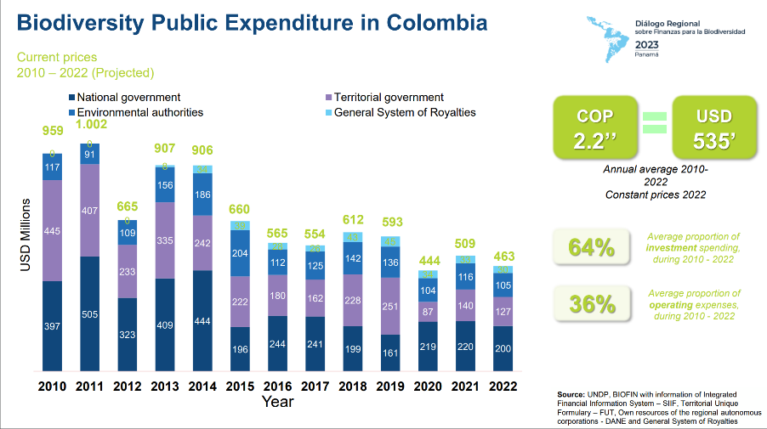
- BIOFIN supports the development of biodiversity finance plans in countries to help close the finance gap and support the implementation of NBSAPs. A national biodiversity-related expenditure reviews (BER) is a critical step of the BIOFIN methodology. The BER goes beyond the purview of environment ministries by taking into consideration other ministry and agency budgets where biodiversity might be a cross-cutting issue. The Biodiversity Expenditure Review seeks to capture detailed data on public, private, and civil society budgets, allocations and expenditures, although data availability is currently weighted heavily towards public sector budgets. The BERs show expenditure over time and offer a baseline for future changes.
Figure 8: Example: snapshot of biodiversity public expenditure in Colombia (Source: BIOFIN)
- The assessment accounts for “primary” expenditures, where biodiversity considerations are the principal concern; and examines and estimates the value of “secondary” expenditures, where biodiversity considerations are not the only concern. This allows for a comprehensive understanding of biodiversity-positive expenditure, including the identification of mainstreaming of biodiversity into other ministries and programmes.
- The BER works with available data. To date, countries may have access to public sector data, while the existence of private and sometime civil society budgets is limited. With the growing awareness of the importance of biodiversity, it is hoped that data on private sector expenditure will be more readily available for BERs in the future.
- An important related concept, designed in a developed country context including by the OECD, is Green Budgeting. In a similar vein, it seeks to identify and assess the environmental contributions – including to biodiversity – of budgetary items and policies with respect to specific performance indicators, with the objective of better aligning budgetary policies with environmental goals.
- The EU Green Budgeting Reference Framework is a toolkit for EU Member States willing to implementing or upgrade green budgeting practices, including in relation to biodiversity. It includes two lists of budgetary items whose net environmental impact could be considered broadly as ‘green’ or ‘brown’.

Information from the Financial Reporting Framework
- A total of 73 Parties reported on their annual financial support provided for domestic biodiversity-related activities in the country. In the Financial Reporting Framework adopted by COP-12, Parties were requested to provide aggregated annual figures and indicate, in a qualitative manner, which sources and categories were included in the figure. The Table below provides an overview of the sources and categories included. Fewer countries cover lower levels of government, non-government sources or expenditures that are indirectly related to biodiversity. This does not necessarily imply that these sources and categories are less important – in federal States, for instance, a significant part if not the bulk of biodiversity-related expenditures is typically spent at sub-national (i.e., provincial and/or municipal) levels (see example from Colombia’s BER). Rather, it is indicative of data limitations as referred to above.
Table 1. Domestic expenditure sources and categories
 | Number of countries
Numbers provided cover | Expenditures directly related to biodiversity | Expenditures indirectly related to biodiversity
Government budgets – central | 70 | 41
Government budgets – state/provincial | 25 | 17
Government budgets – local/municipal | 22 | 14
Extrabudgetary | 24 | 15
Private/market | 16 | 10
Other (NGO, foundations, academia) | 30 | 17
Collective action of indigenous and local communities | 6 | 3
- However, complementary analyses confirm that the bulk of domestic expenditures is of a public nature. As regards extrabudgetary expenditures identified, in developing countries, this typically corresponds to development cooperation activities and the associated finance would thus be captured by the international finance covered in the previous chapter.

Public domestic expenditures
- A recent analysis of data generated by the BIOFIN expenditure reviews used statistical tools to estimate global biodiversity-related domestic expenditures. While the trend is overall positive in absolute terms in the decade after 2008, the share of biodiversity expenditures to GDP is rather decreasing and is hovering around 0.2 percent of GDP (see Figure 9).
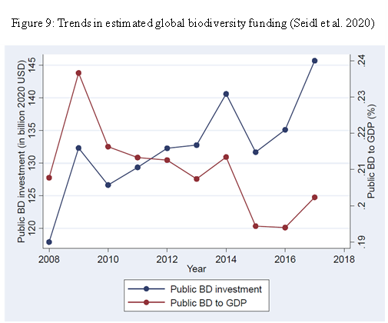
- Global averages can mask important differences at national level. For instance, countries report to the CBD financial reporting framework (2018) indicate that:
  - In Colombia, total biodiversity expenditure represented close to US$ 272 million, an average of 0.12 per cent of gross domestic product (GDP), 0.5 per cent of public spending, and 24 per cent of the country’s environmental spending;
  - In Mexico, biodiversity expenditure has increased 248 per cent from 2006 to 2015 (from US$ 425.6 million to US$ 1,169.8 million); in 2015, public expenditure for biodiversity represented 0.1 per cent of GDP;
  - In the Philippines, 4.9 billion pesos were spent on biodiversity per year between 2008 and 2013, representing 0.08 per cent of GDP for 2008 to 2013, 0.31 per cent of the national budgets;
Financial Instruments
- Methodological information provided by Parties in the Financial Reporting Framework indicates that domestic public expenditures on biodiversity is to significant extent financed through general budgetary appropriations – complemented in developing countries with extrabudgetary development cooperation funding (ODA/ODF). However, the past decades also saw significant experimentation with biodiversity-earmarked instruments like fees, charges, or levies, whose receipts were in turn used to finance various disbursement arrangements ranging from payment for ecosystem services (PES) schemes to offset schemes to national or sub-national biodiversity funds.
Box 3: Colombia’s Fund for Life and Biodiversity aims to articulate, focus and ﬁnance the execution of plans, programs and projects, of a national or territorial nature, aimed at climate action and resilience, environmental management, environmental education and participation and recovery; conservation, protection, organization, management, use and exploitation of renewable natural resources and biodiversity.
The German Federal Nature Conservation Fund implements various measures aimed at enhancing biodiversity in Germany. These measures encompass several initiatives, such as project funding for improving ecosystem services within the federal biological diversity program, enhancing floodplain ecosystems on federal waterways through the floodplain funding program, supporting biotope restoration in testing and development projects, facilitating the acquisition of areas or usage rights within the wilderness fund framework, and promoting large-scale nature conservation projects as part of the chance.natur program. These efforts collectively contribute to the conservation and enhancement of biodiversity in the country.

- There is a plethora of such arrangements for many of which the umbrella term of “innovative finance” is frequently used – BIOFIN maintains a dedicated catalogue of relevant “biodiversity finance solutions.” However, global analyses suggest that the total funding mobilized by such “innovative” schemes remains relatively modest.
- Some of these instruments seek to establish “surrogate” markets or to otherwise build on a (market-based) exchange logic, with a view to mobilize additional, in particular private sources of finance. Such approaches generated intense discussions whether and to what extent they can – or should be – scaled. These discussions, and the guidance proposed, go into considerable technical detail, and it would go beyond the scope of this document to attempt to provide a detailed summary. In the following paragraphs, focus is briefly given to the recent discussions on, and associated experiences with, green bonds and biodiversity credits.
- Green bonds are specialized bonds designed to raise capital for environmentally friendly projects. These bonds adhere to specific criteria, often verified by third parties, with detailed impact frameworks outlining fund distribution, ongoing monitoring, and reporting obligations. Investors receive fixed income through regular coupon payments and the return of principal upon bond maturity. By leveraging green bonds, governments and organizations can fund initiatives aimed at habitat restoration, conservation of endangered species, and sustainable land use practices, all contributing to the preservation of biodiversity.
- For instance, the German government has been issuing Green German Federal Securities since 2020 to boost sustainability in financial markets. The Green Bond Framework lists five main green expenditure categories that can be assigned to Green German Federal Securities. Agriculture, forestry natural landscapes and biodiversity is one of the categories. Currently, an annual volume of 15 to 17 billion euros is issued in Federal Green Bonds. The issuance is accompanied by an extensive reporting to increase transparency on German Governmental Spending. This includes an annual allocation report as well as an impact report.
- Another example is the Rhino Bond - a first-of-its-kind outcome-based bond that offers a payout to bondholders linked to the population growth of black rhinos, a critically endangered species whose health is essential to the ecosystems in which they live. The five-year rhino bond, which raised $150 million is a combination of existing financial products – a bond with an excellent credit rating (AAA for World Bank issued bonds), paired with a performance-based grant funded by the GEF – that mobilizes capital markets’ financing to directly support black rhino conservation activities at two protected areas in South Africa.
- Green bonds may hold promise for biodiversity but there is a risk of over optimism. A decisive question is how the return of investment – i.e., the coupon payment to the investors – is being generated. Cases where such generation is purely driven by private incentives are relatively rare; in most cases (like in the example above), it will require some form of government fiat in order to generate surrogate markets. In some cases, green bonds risk to generate adverse effects (e.g., planting invasive species as a carbon capture approach), and biodiversity and social safeguards need to be in place in order to avoid unintended negative effects on biodiversity and livelihoods. CBD guidance on this topic exists and could be applied.
- Biodiversity credits are identified in the GBF as one possible instrument to help deliver biodiversity-positive outcomes. The current working definition of a biodiversity credit is a certificate that represents a measured and evidence-based unit of positive biodiversity outcome that is durable and additional to what otherwise would have occurred. According to one estimate the market for such credits could reach $2 billion by 2030 and upwards of $69 billion in 2050.
- Unlike carbon or biodiversity offsets, which are payments made by a business to compensate for its damaging impacts on location-specific ecosystems, biodiversity credits allow companies to support nature-positive action, funding long-term conservation and restoration of nature, a higher order contribution than simply offsetting negative impact. This is an emerging concept in environmental conservation and has garnered increased attention within the context of environmental finance. However, given the current size of the market for biodiversity credits, it remains a relatively niche domain, with potential to generate positive ecological and economic outcomes in the future.
- A recent paper by the Biodiversity Credits Alliance suggests that the evolving biodiversity credits market could usefully consider insights from the carbon market and avoid issues like low integrity, poor credit quality, weak demand, limited supply, slow adoption, high costs, lack of results, and potential market failure. However, it is crucial to recognize the fundamental differences between biodiversity and greenhouse gas emissions, necessitating innovative approaches for a biodiversity or nature credits market. The involvement of indigenous peoples and local communities could play a crucial role. Establishing a benchmark standard to define the integrity of biodiversity credit projects and their outcomes, along with systems enabling credible claims from purchasers, is particularly important.
- It is also suggested to explore the incorporation of biodiversity credits within a more comprehensive framework of “nature credits,” encompassing climate and water impacts. Growing concerns about freshwater-related risks and soil health underscore the importance of addressing additional nature impacts. It is essential to design a biodiversity credit market that remains appealing and straightforward for corporate buyers, while also enhancing the efficient allocation of resources for nature conservation and regeneration.
- A number of collaborative initiatives seek to advance the work on biodiversity credits at local, national, and international levels, including the Biodiversity Credit Alliance, the Taskforce on Nature Markets, the World Economic Forum (WEF), and the World Business Council for Sustainable Development (WBCSD). The Governments of France and the UK recently launched a Global Roadmap to Harness Biodiversity Credits for the Benefit of People and Planet, to be delivered under the guidance of a multi-stakeholder International Advisory Panel on Biodiversity Credits (IAPB) which seeks to assemble the latest science, data, technology, knowledge and experience from indigenous people and local communities .
- Australia has recently passed legislation to develop a biodiversity credit market, known as a ‘nature repair market’. Farmers, miners, First Nations peoples and other landholders will be eligible to create ‘certificates’ through protecting or restoring nature and biodiversity on their land. This could be through improving or restoring native vegetation through activities such as fencing or weeding; planting a mix of local native species; or protecting rare grasslands which provide a habitat for endangered species. Biodiversity certificates can be created alongside carbon credits if a carbon project also creates biodiversity benefits. The certificates will be made available to public to improve transparency and allow certificate owners to show they are supporting nature repair. These certificates cannot be used for offsetting purposes.
- The conversation on innovative financial instruments for biodiversity goes back several decades and, perhaps unsurprisingly, some of the points made earlier resurfaced in the recent discussions on biodiversity credits. Overall, a stylized synthesis of proponent views would likely point to the potential efficiency gains; the potential to mobilize new, in particular private sources of funding; and the general importance to understand and manage ecosystems in an economic context. At the same time, critical voices typically point to the risk of adverse social effects, in particular for indigenous peoples and local communities, underpinned by a number of practical experiences; the risk of favoring one type of value and belief system over others; and the inherent limitations due to the uniqueness of many biodiversity components. With regard to instruments that seek to mobilize private finance, these voices also point to evidence that claims about the increase in private sector finance for biodiversity are likely overstated. They would also point to the practical challenges in transforming an intangible stream of biodiversity benefits into a competitive monetary return on investment, while avoiding the risks above.

Biodiversity mainstreaming: integrating biodiversity values, aligning financial flows
- Target 14 of the GBF calls for gradually aligning all pertinent public and private activities, as well as fiscal and financial flows, with the goals and targets of the GBF. Additionally, an essential aspect of this effort is to address harmful incentives, including harmful subsidies, as called for in Target 18.
- Recent analyses, undertaken in the context of the development of the GBF, suggest that Parties made some progress in such biodiversity mainstreaming, at least at the policy level. For instance, in response to the relevant question in the Financial Reporting Framework, the majority of responses indicated to have made progress in including biodiversity in national priorities or development plans, while one third had achieved a comprehensive inclusion. Similarly, in the revised NBSAPs, a total of 32 Parties stated that biodiversity has been integrated into their national development plan or equivalent instrument, while 21 Parties mention integration with their sustainable development plans or equivalent instruments, and 44 Parties refer to links to poverty eradication and/or to integrate this objective into their principles, targets and/or actions.
Box 4: Ecological Fiscal Transfers are financial transfers between different levels of government (e.g., from national to state or local governments) that are linked to ecological indicators. Since 2019, the federal government of Malaysia has transferred USD 87 million to its states with the Ministry of Finance transferring the funds to the ministry of environment - 70% of the allocation is based on Protected Area hectarage by each State, and 30% is "performance based”.
- With regard to public finance, such mainstreaming “across governments” is seemingly corroborated by results of the BIOFIN biodiversity expenditure reviews, which frequently find a considerable amount of biodiversity-related expenditures in the budgets of other line ministries or agencies, covering portfolios such as agriculture, forestry, water, natural resources, and similar.
- The OECD also maintains a unique database on Policy Instruments for the Environment (PINE), to which more than 130 contribute data on biodiversity-relevant taxes, fees and charges, tradable permits (e.g. ITQs for fisheries), PES and biodiversity offsets. According to OECD (2021), biodiversity-relevant taxes, fees and charges, PES and biodiversity offsets generate revenue or mobilise finance estimated at USD 26 billion a year. This is likely to be an underestimate, as not all countries have provided data on the finance categories of the OECD PINE database.

Promoting synergies within Rio Conventions at national level
- Seeking tangible co-benefits of biodiversity in other policy areas is an important potential avenue to enhance biodiversity financing. In countries where there is a strong political support for climate change, communicating the importance of biodiversity to climate change adaptation and mitigation can be an effective strategy. The key is to ensure that these efforts are contextually relevant to each country's unique circumstances.
- Identifying synergies of national action plans within the UNCCD, CBD, and UNFCCC frameworks presents an opportunity to synchronize goals and commitments for land restoration, unlocking various benefits and optimizing returns on investment. A recent case study of Rwanda found that Nationally Determined Contribution (NDC), Land Degradation Neutrality (LDN), and National Biodiversity Strategies and Action Plan (NBSAP) processes in Rwanda are overlapping and mutually complementary. The study estimated that collaborative action on land-based activities under the Rio Conventions can significantly reduce transaction costs by nearly 56 percent or US$45.6 million per year. Efficiency gains from coordinated action primarily result from joint monitoring and evaluation, resource allocation, capacity building, and awareness-raising. Enhanced implementation efficiency leads to a higher return on investment in land restoration, serving as an incentive for funding activities under LDN, NBSAP, and NDC (ELD 2023).
- Similarly, instruments like biodiversity credits could simultaneously contribute to the implementation and achievement of National Biodiversity Strategies and Action Plans (NBSAPs), climate Nationally Determined Contributions (NDCs), and land restoration Land Degradation Neutrality (LDN) targets. Biodiversity credit projects could be structured to address priorities and targets identified in these national-level strategies, which are structured to reflect global targets (based on a country’s particular context).

The importance of donor coordination at domestic level
- Given the important role of international finance in many developing countries, more effective coordination on donor activities is an important means to reduce duplication of domestic efforts and harness synergies among policy areas. Effective donor coordination may sometime be a complex process, as donors operate under unique individual frameworks, and their priorities are often influenced by different national circumstances/issues. Hence there may be potential divergence in priorities of the recipient and donor countries.
- Donor round tables, while valuable platforms for collaboration, sometimes encounter limitations. Notably, environment may not always emerge as a top priority in bilateral discussions, potentially impeding coordinated action. One potential option to explore is the role of the UN resident coordinator office and how it can be leveraged to facilitate donor coordination. Similarly, the GEF-8 Country Engagement Strategy offers another avenue, planning to set up a pilot programme of National Steering Committees in selected countries, with GEF operational focal points playing a central role. This approach aims to improve the focus on and coordination of environmental initiatives by involving key stakeholders.
Box 4: Through the BIOFIN initiative, Belize established the National Biodiversity Office within the Ministry of Sustainable Development, Climate Change and Disaster Risk Management. A coordination office like this may be an effective strategy for fostering donor coordination, potentially serving as templates for other nations seeking to do the same.
- Another challenge faced by countries is that environment discussions occasionally are dominated by climate change issues, potentially overshadowing biodiversity policies. Leveraging synergies between these two critical dimensions of environmental policies can yield more impactful outcomes. Concerted and directed efforts could be made to ensure biodiversity is embedded in the bilateral and multilateral donor coordination meetings.

Addressing harmful incentives and subsidies
- An important element of aligning financial and fiscal flows is to eliminate, phase out or reform incentives, including subsidies, that are harmful for biodiversity, as called for in Target 18. Earlier analyses of progress against the successor target (Aichi Biodiversity Target 3) suggest that Aichi Biodiversity Target 3 was among those with the lowest level of alignment with national targets contained in the NBSAPs, with three quarters having a lower level of ambition than the Aichi Target or not addressing all of its elements. By the end of the last decade, less than a third were on track to reach (30%) or exceed (1%) their national targets, while the majority had made progress towards their targets but not at a rate that will allow them to meet the target.
- This finding is confirmed for sectors where reliable data and methodologies are available to an extent that allows a trend analysis, in particular the data collected and analyzed by the OECD on support measures in agriculture, based on the producer support estimate (see Figure 10). This analysis indicates that only limited progress has been made in the past decade in moving away from support measures that potentially most likely generate environmental harm.
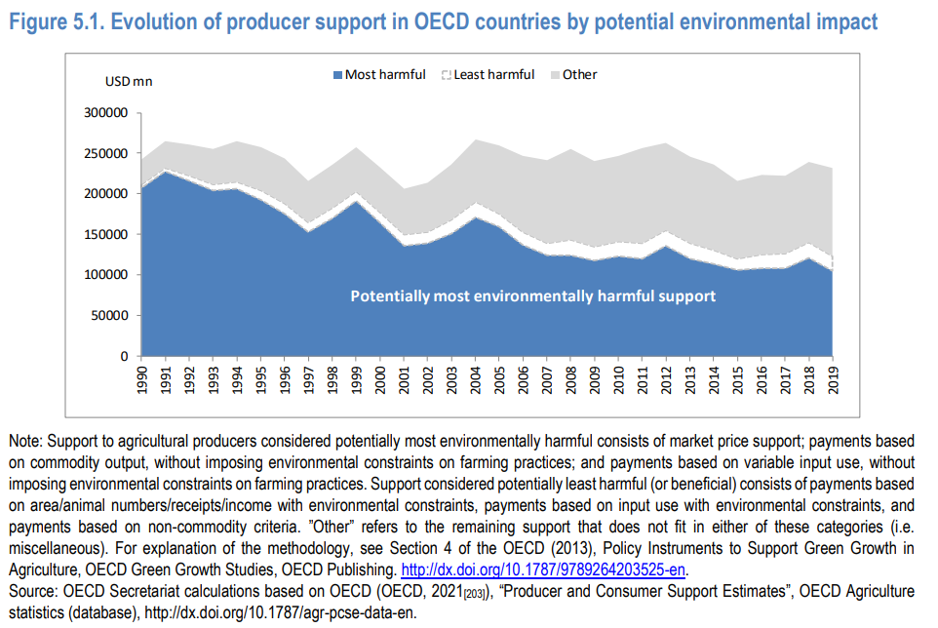
Figure: 10: Evolution of producer support in OECD countries by potential environment impact
- At the same time, the potential of Target 18 is significant. UNEP’s latest report on the State of Nature Finance (2023) estimates public spending on environmentally harmful subsidies in four sectors - agriculture, fossil fuels, fishery, and forestry- to be around US$1.7 trillion in 2022. This latest estimate is much larger than the OECD (2021) estimate of government support, including subsidies, environmentally harmful and market distorting being more than USD 800 billion a year. The significant change in the estimates is, amongst others, due to the doubling of the amount of fossil fuel subsidies from 563 billion to US$ 1.16 trillion in 2022.
- In line with earlier guidance adopted by the CBD, a recent report by OECD recommends, as a starting point, undertaking detailed national studies in order to identify harmful subsidies and the most promising candidates for subsequent policy action. Such studies could encompass four fundamental steps.
1) Scoping: Define the types of subsidies and other incentives harmful to biodiversity to be covered; consider indirect as well as direct subsidies
2) Screening: identify potentially harmful biodiversity subsidies and other support; which sectors will have a particular focus; which subsidies and support are potentially harmful to biodiversity
3) Data gathering: Quantify the size of subsidies and other support; describe the purpose of the subsidy and support, the beneficiaries; list conditions for receipt of the subsidy and support that may act as a ‘policy filter’
4) Assessment: What is the extent of the harm to biodiversity; use a ‘traffic light’ system to qualitatively assess extent of harm to biodiversity.
- Together, these steps would allow governments to prioritize subsidies and other incentives harmful to biodiversity for reform, and to proceed sequentially as needed. This will entail understanding the effects of reform on economic, social and environmental indicators, learning from past examples of reform and developing realistic reform plans.
- BIOFIN also recently developed guidance on repurposing subsidies. Released in January 2024, ‘Nature of Subsidies: A step-by-step guide to repurpose subsidies harmful to biodiversity and improve their impacts on people and nature (BIOFIN, 2024)’ maps out a stepwise approach for governments, businesses, and policymakers to assess, repurpose and monitor subsidies with a view to achieve biodiversity-positive outcomes. Using the guidebook, countries can scan the full spectrum of their subsidies to determine to what extent they may be at risk of harming nature and create plans to redesign them to become more nature positive. A people-centred approach is applied to prevent negative impacts on beneficiaries and enhance any positive impacts for both people and environment.
- The above developments seem to indicate renewed and increasing interest towards implementation of Target 18. This is also reflected in the recent legislative action by the European Union and recent subsidy reform initiatives taken by the United Kingdom, for example. At the global level, the recent adoption of the WTO Agreement on Fisheries Subsidies also holds significant potential to generate more policy momentum at the domestic level in this critical sector.

Aligning financial flows and activities more broadly
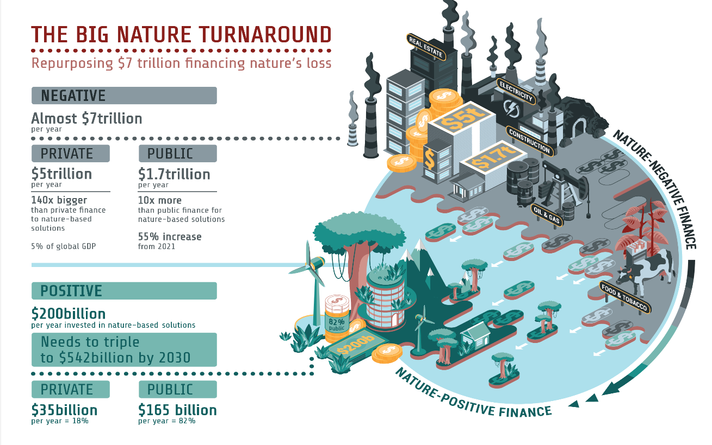
- Looking beyond public expenditures and harmful subsidies, the amount of nature-negative financial flows overall still largely overtakes nature-positive finance flows. According to the aforementioned UNEP report, close to $7 trillion is invested globally each year in activities that have a direct negative impact on nature. This is equivalent to roughly 7 per cent of global Gross Domestic Product (GDP). Thus, broader action to align financial flows, as foreseen in Target 14, is imperative.
- Highlighting and communicating the multiple values of biodiversity, including its socio-cultural and economic dimensions, has been recognized as an important precondition for biodiversity mainstreaming. To this effect, the resource mobilization targets adopted by COP-12 also included assessing and/or evaluating the intrinsic, ecological, genetic, socioeconomic, scientific, educational, cultural, recreational and aesthetic values of biological diversity and its components. Some progress was made in the past decade. In the Financial Reporting Framework, only four Parties indicated that comprehensive assessments had been undertaken but almost 90 per cent of reporting Parties, or over one third of all Parties, reported having undertaken at least some assessments. Thus, constructing a national narrative that establishes a clear linkage between biodiversity and national priorities, such as economic development, job creation, climate change adaptation, food security and disaster risk reduction, is important to convey that biodiversity is not solely the responsibility of ministries of environment, but it is a cross-cutting issue supporting many government functions, including overarching economic development.
- Recent actions are taken to create an enabling environment for a broader alignment of financial flows. For instance, new metrics and tools are needed, and are increasingly becoming available, to support both public and private corporate and financial actors in their efforts to understand, report on, and manage their biodiversity impacts, risks, dependencies and opportunities. ‘The Nature-Finance Alignment Tool’, for example, allows financial institutions to understand how far their investments are compatible with the goals of the KMGBF. They can further use the tool to start building transition planning for nature-positive outcomes into their overall strategies. This can also support the fulfilment of reporting requirements under the TNFD and the integration of transition planning for both nature and climate change. The tool is in its pilot phase.
- As mentioned in the introductory chapter, integrating biodiversity and ecosystems into national accounting systems is an important step. The UN System of Environmental-Economic Accounting (SEEA) has been recognized as an international statistical standard and includes guidance for ecosystem accounting. At least 96 countries have implemented accounts consistent with SEEA and 34 countries have already developed ecosystem accounts. Increased investment in physical accounts and valuation, with a view to further standardize data and modelling approaches, would improve the quality of the ecosystem accounts, and, above all, technical support and capacity-building could subsequently contribute to a better use of the information in order to improve decision-making at scale.
- The Sustainable Finance Disclosure Regulation and Corporate Sustainability Reporting Directive of the European Union, along with related initiatives, are going to compel a significant number of companies and financial institutions to evaluate and disclose their impact on biodiversity and nature at large. These financial regulatory mandates could lead to enterprises aiming for either no net loss or net gain in biodiversity through their direct activities and supply chains.
- In recent years, the United Kingdom has introduced regulations focusing on ‘biodiversity net gain.’ Under these regulations, developers are required to ensure that any new construction project provides a net gain in biodiversity, typically quantified as a 10% improvement over pre-development levels. The policy mandates detailed assessments of the biodiversity value of land before development and necessitates subsequent enhancements post-construction, either on-site or through off-site contributions. This might include creating new habitats, planting more native vegetation, or improving existing natural areas, thus aiming to achieve a sustainable balance between necessary development and the preservation of natural ecosystems.
- In 2023, Brazil started to develop an ‘Action Plan on sustainable taxonomy.’ It consists of a classification system that defines, on a scientific basis, activities, assets and/or categories of projects that contribute to climate, environmental and/or social objectives. The Government believes that taxonomies provide a common terminology for companies, financial institutions, and investors to manage investment decisions, as well as for regulators, governments, and other stakeholders to develop public policies. They are considered an essential tool for increasing transparency of information on sustainable economic and financial activities. Development of sustainable taxonomies need to consider the specific challenges faced by developing countries and be tailored to local circumstances. This action plan will help in reallocate funding and investments to support sustainable economic activities, enhance efficient technological development for a competitive and eco-friendly Brazilian economy, and ensure transparent, long-term sustainable finance practices while avoiding greenwashing.

Public-private partnerships
- A public-private partnership (PPP) for biodiversity is a collaborative arrangement between government entities and private sector organizations, aimed at conserving and managing biodiversity.
Box 5: Recognizing the need for coordinated action and stakeholder involvement, the Danish Ministry of Environment has established the Danish Biodiversity Partnership. This initiative, launched in August 2023, brings together diverse representatives, including industry, financial institutions, NGOs, research institutions, and trade unions. It aims to deliver recommendations in several key areas including guiding Danish companies on best practices for biodiversity-related issues, advising authorities on potential barriers and incentives, directing research and knowledge institutions on information gaps, and suggesting further actions for the partnership, possibly including the formation of sector-specific or thematic working groups.
Similarly, the EU Business & Biodiversity Platform is a European Commission initiative aimed at helping businesses integrate biodiversity into their decision-making. The Platform also educates and engages businesses and financial institutions on the significance of biodiversity, encouraging them to act and transform their operations towards a nature-positive world.
- Colombia recently introduced a new provision in its National Development Plan that legally establishes "green public-private alliances." This initiative, driven by the Ministry of Environment and Sustainable Development in partnership with the Ministry of Finance, is in the process of formulating regulatory guidelines. The aim is to encourage private sector investments in medium to long-term environmental projects, with a focus on biodiversity conservation, climate change mitigation, and particularly on restoration processes.
- The World Bank has used a PPP model with 15 governments in Africa to establish Collaborative Management Partnerships (CMPs) across 40 protected areas. Protected area authorities (government, private or community) partnered with 13 organizations (private and NGO) to co-manage or delegate management of protected areas covering 11.5% of Africa’s protected area estate. CMPs may not be appropriate for all countries and all PAs, but in many parts of the world, CMPs can be part of a broader array of tools for conserving biodiversity and attracting investment in inclusive rural development and green growth.
- A related concept is Project Finance for Permanence (PFP) which is an innovative approach to conservation funding that aims to secure the long-term financial and managerial sustainability of a network of conservation areas. This approach is particularly relevant in the context of biodiversity conservation. The PFP model brings together governments, NGOs, donors, and other stakeholders to develop and fund comprehensive conservation plans that ensure the permanent protection of critical ecosystems.
Box 6: Great Bear Rainforest is an example of PFP in Canada. Led by Indigenous communities, environmental groups, and philanthropic organizations, it covers 6.4 million hectares on British Columbia’s north and central coast. The governments of Canada and British Columbia each contributed $30 million, and individuals and private foundations donated $60 million (totaling $12 million in 2007). Since 2007, the partnership has grown to include additional Indigenous governments and communities, and philanthropic organizations. This has generated a further $296.8 million in new investments, for a total investment of $404 million (to date) for Indigenous-led projects in the region. This successful PFP initiative has also allowed First Nations to use these investments to acquire, expand, and create 123 local businesses. This has led to the creation of 1,253 permanent new jobs. First Nation community members hold more than 960 of these jobs.

Preliminary conclusions
- Domestic public expenditure globally accounts for the largest part of global biodiversity spending, with 81 countries collectively spending an average of at least USD 67.8 billion per year domestically on biodiversity conservation and sustainable use. At the same time, the share of public biodiversity-related finance remains small, and this may indicate opportunities for further increases. To re-prioritize budgetary allocations, while feasible and appropriate in some circumstances, may be more difficult in light of competing priorities and national socio-economic conditions. However, even in this case, optimization opportunities many well exist – that is, to increase the effectiveness and the efficiency of public expenditures, and to continue and intensify exploring innovative financing instruments and approaches.
- Countries will likely benefit by integrating biodiversity considerations more systematically into their national fiscal and budgetary strategies, for instance in their efforts to strengthen their revenue bases, thereby creating a more robust and sustainable financial foundation for biodiversity conservation. On the expenditure side, biodiversity expenditure reviews and green budgeting practices can help increase understanding of biodiversity-positive expenditure and assist in mainstreaming of biodiversity considerations into other ministries and programmes.
- The use of biodiversity-earmarked fiscal instruments like fees, charges, or levies, have been experimented with to finance biodiversity policies. Continuously developing and scaling these arrangements can provide dedicated funding streams for biodiversity initiatives, ensuring better long-term financial sustainability. However, it is important to balance earmarked funding with the overall goal to maintain the flexibility of public finance and governance prerogatives. Similarly, in the case of instruments that seek to mobilize private finance, careful consideration must be given to creating mechanisms that not only attract private investments but also ensure these investments support biodiversity goals effectively and maintain effective social safeguards. This may involve developing incentives for private sector engagement, such as tax breaks or subsidies for projects that have a positive impact on biodiversity (in line with Target 18 of GBF), or blended finance approaches that de-risk private investments.
- It is important to identify and promote the co-benefits of biodiversity conservation in areas such as climate finance, infrastructure, and other sectors. Governments and organizations can harness synergies in public finance, thereby leveraging additional resources for biodiversity conservation through integrated approaches that address multiple environmental or societal objectives simultaneously.
- Effective donor coordination is important in reducing duplication of efforts and maximizing the impact of international biodiversity finance. Improved coordination among donors, governments, and other stakeholders can enhance the efficiency of biodiversity financing in developing countries, ensuring that resources are directed towards priority areas and contributing to the achievement of national and global biodiversity targets.
- Despite limited progress in reducing environmentally detrimental support measures, particularly in agriculture, the potential for impactful change through Target 18 of the GBF is substantial, with recent estimates indicating vast public spending on harmful subsidies across key sectors. The OECD and BIOFIN provide frameworks for identifying and reforming these subsidies, suggesting detailed studies and stepwise approaches for policy action aimed at repurposing subsidies for biodiversity-positive outcomes. Additionally, it is important to integrate biodiversity considerations into broader national and international financial strategies, including continuation of developing new metrics and tools, integrating biodiversity into national accounting systems, and the adoption of regulations that mandate biodiversity net gain in development projects. These efforts should be complemented by legislative actions and subsidy reform initiatives, alongside the development of sustainable taxonomies.
- Creating enabling environments that facilitate the mobilization of private finance and non-financial contributions towards biodiversity conservation is crucial. This includes developing metrics and taxonomies for robust Key Performance Indicators (KPIs), allowing for non-financial or non-market compensation mechanisms, implementing social safeguards, and exploring new financial instruments such as biodiversity credits. By engaging private actors and acknowledging their diverse worldviews and preferences, biodiversity financing can be diversified and expanded beyond traditional public finance sources.

5. The role of business and private finance
- Mobilising private finance is a key component of GBF Target 19. However, recent estimates show that so far only USD 6.6-13.6 billion per year are spent in private biodiversity investments. Furthermore, as noted above, private finance flows that have a direct negative impact on nature are estimated at US$5 trillion, which is 140 times larger than private investments into nature-based solutions. Section 3 of the study already provided a succinct overview of funding volumes pertaining to international philanthropies. This chapter will focus on for-profit organizations.
- As highlighted by a recent report of the World Bank, there are essentially two approaches to mobilizing private finance for biodiversity. First, the financing of activities that contribute to the conservation, restoration, and sustainable use of biodiversity and ecosystem services (“Financing green”). And second, aligning financial flows by directing them away from activities with a negative impact on biodiversity and ecosystems (“greening finance”).
- There are current important challenges to identifying and monitoring private financial flows for biodiversity, which hampers accurate assessments and the generation of policy advice (see sub-heading on ‘key challenges’ for details). The Technical Expert Group on Financial reporting, established through CBD Decision 15/7, is working on developing technical advice and guidance on monitoring resource mobilization, including from the private sector. This work is of relevance in the biodiversity finance landscape as its potential implementation will provide valuable insights and tools for tracking the allocation and effectiveness of private financial resources for the implementation of the GBF.
- In order to increase private finance for biodiversity, Governments need to put in place the appropriate regulatory environment, smart incentives, and well-adapted market structures. By creating supportive policies, offering financial incentives (tax breaks, positive subsidies, strategic grants), and fostering public-private partnerships, governments can incentivize investments in biodiversity. Additionally, utilizing blended finance mechanisms to de-risk investments in biodiversity, combining public, private, and philanthropic funds can be leveraged for more significant private investment. Moreover, taxonomies with well-defined metrics and reporting requirements can compel sustainable investments by the private sector. These efforts can create a conducive environment for private sector engagement in biodiversity conservation.
- As discussed earlier, certain environmental funding mechanisms, such as the Green Climate Fund (GCF) and the Land Degradation Neutrality (LDN) Fund, can have biodiversity as an additional advantage rather than their main objective. Integrating biodiversity more centrally into these mechanisms could further enhance synergies and benefits. The private sector can potentially take a similar approach and focus on tackling the root causes of biodiversity loss, rather than solely focusing on projects explicitly designed for biodiversity conservation. This strategy targets the underlying issues leading to biodiversity loss, such as habitat destruction, pollution, and overexploitation of natural resources.
- This concept is further elaborated in IFC’s recent Biodiversity Finance reference guide which serves as a practical guide to financial institutions, investors, and companies to identify investment opportunities to protect, maintain, or enhance biodiversity and ecosystem services. Co-benefits for biodiversity can be generated by productive land use (climate smart agriculture; regenerative agriculture; certified crops/commodities etc.); freshwater/marine sustainable production; waste and plastic management; forestry and plantations; tourism/ecotourism services; and other investments such as retrofitting existing infrastructure and construction projects, research and development to help monitor, report on and verify biodiversity business impacts and innovations in aviation, trucking and logistics to avoid transporting invasive species.

Potential role of private investors at different stages
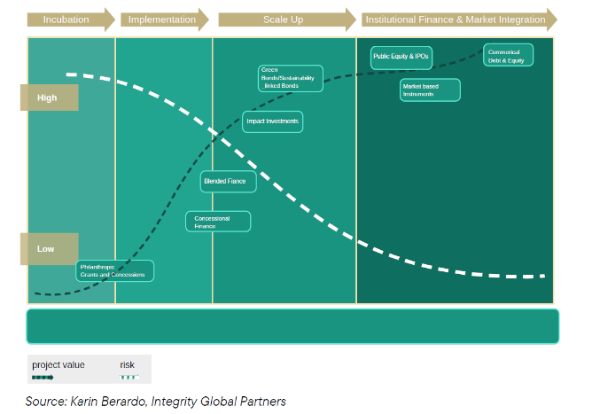
- Investments in biodiversity undergo a capital development continuum with distinct stages, each requiring specific financial approaches and attracting different types of investors. During the incubation stage, philanthropic sources may contribute predominantly as repayable or outright grants, with careful structuring needed for private funds to ensure fair risk-adjusted returns and community benefit sharing. Key investors include governmental bodies, foundations, and philanthropic organizations. As projects move to the implementation phase, capital may shift towards equity or equity-like investments, involving instruments like carbon collateralized loans and concessional capital to manage risks. Impact financiers, private equity firms, and corporate buyers become crucial in this stage. During the scale-up phase, private equity paired with concessional or blended finance dominates, with instruments like junior equity and thematic bonds can play an important role. Development Finance Institutions, multilateral banks, philanthropic entities, high-net-worth individuals, and private equity funds lead investments. In the institutional finance and market integration phase, capital may come from instruments like green or sustainability-linked bonds, involving institutional and retail investors, banks, and asset managers. It is important to note that various financing mechanisms can be applied across multiple stages.

Aligning financial flows by greening value chains

Major value chains impact on biodiversity loss
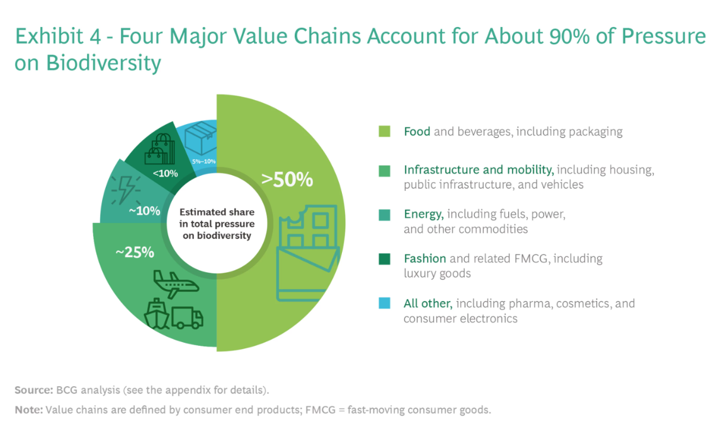
- Four of the major value chains responsible for a significant portion of biodiversity loss are the food, energy, fashion, and infrastructure sectors. Below is an overview of each value chain's impact on biodiversity loss
Figure 11: Major value chains responsible for biodiversity loss (Source: BCG)
1. Food: The food value chain encompasses agriculture, livestock, and fisheries. Biodiversity is critically important to the food value chain, and yet that value chain drives more than 50% of man-made pressure on biodiversity. Key issues include land degradation, water pollution, and the displacement of natural ecosystems. Options that address and engage other actors in food systems (including the public sector, civil society, consumers and grassroots movements) include participatory on-farm research, the promotion of low-impact and healthy diets and the localization of food systems. Such options could help reduce food waste, overconsumption, and the demand for animal products that are produced unsustainably, which could have synergistic benefits for human health. Better allocation and management of land, water, and other inputs could lead to increases in agriculture, grazing, and forestry annual income by approximately US$329 billion—and enough food production increases to feed the world until 2050—without net loss of forests and natural habitats. Global populations are expected to reach 10 billion by 2050, and more food will be needed to meet global demands. Better cultivation strategies that close yield gaps, along with smarter spatial planning, can reduce the land footprint of agriculture while increasing global calories produced by more than 150 percent.
- Infrastructure and Mobility: Housing, public buildings, technical infrastructure, transportation infrastructure, and vehicles are responsible for about 25% of human pressure on biodiversity. Contributing factors include land use for and pollution from the extraction and conversion of raw materials, as well as ecosystem conversion and modification during infrastructure construction.
SWEN BLUE OCEAN is SWEN Capital Partners’ direct impact strategy investing in innovations that help regenerate ocean health. The fund was launched at the World Conservation Congress of the IUCN in 2021, in scientific partnership with Ifremer. It backs startups that deliver both systemic impact and competitive market returns. Its focus is on solutions to overfishing, ocean pollution, and climate change. In April 2024, the fund expanded its strategy to include regeneration of Ocean Biodiversity.
- Energy: The energy value chain accounts for an estimated 10% of man-made pressure on biodiversity, largely due to pollution and greenhouse gas emissions that occur during the extraction and conversion of energy carriers and their use in power generation and mobility.
- Fashion: The fashion industry impacts biodiversity through various means, including the cultivation of cotton (Roughly 25% of textile fibres and more than 50% of apparel are cotton based), leather production, and textile manufacturing. Chemical usage, water pollution, and unsustainable practices contribute to habitat loss and ecosystem disruption. Therefore, fashion depends to a great extent on biodiversity. And like the food value chain, the fashion value chain has a large biodiversity footprint, including effects related to farming and raw materials extraction for natural and synthetic fibre production, fabric production, and consumer usage and disposal.
- These value chains represent sectors where human activities have substantial implications for the environment, biodiversity, and ecosystems. Research into these areas is important for understanding the causes of biodiversity loss and for developing strategies to mitigate and reverse its impact.

Sustainable supply chains
- Supply chain sustainability relates to the management of environmental, social, and governance aspects of the movement of goods and services along supply chains, from producers to consumers. The historical impact of global supply chains on biodiversity has been largely negative, driven by land use change and unsustainable agricultural, forest, fisheries, and other practices associated with commodities. Private investment in sustainable supply chains is estimated at US$8.6 billion in 2022.
- For example, the Investor Initiative for Sustainable Forests, focuses on addressing the material risks of deforestation in cattle and soybean supply chains. It involves over 35 investors engaging with more than 20 companies to tackle not only deforestation but also broader ESG issues like labor conditions and impacts on indigenous peoples. Despite the economic importance of cattle and soybean production in Latin America, these industries are major drivers of the region's tropical deforestation, accounting for approximately 70% of it. Corporate commitments to mitigate deforestation in these supply chains are less common compared to other commodities. The initiative includes investor expectation statements, signed by about 50 investors managing US$6.5 trillion in assets, outlining the standards for managing deforestation risks within these value chains

Ongoing initiatives
- In recent years, there has been an increase in the private sector's engagement in biodiversity conservation, exemplified by several key initiatives aimed at integrating biodiversity considerations into corporate and financial decision-making processes.
- Nature Action 100, a global investor engagement initiative, focuses on increasing corporate ambition and action to counteract nature and biodiversity loss. Created by the Launching Investor Group, a collective of institutional investors, the initiative targets companies in sectors critical for reversing environmental degradation by 2030. The initiative emphasizes the significant risks to investors and businesses from natural capital depletion, such as operational, regulatory, litigation, and reputational risks, and the broader negative economic impacts. The initiative aims to map sector pathways for driving increased corporate ambition and action on nature, coordinates investor and company engagements, details necessary corporate actions for nature protection, and tracks progress against benchmark indicators and provides annual progress report. The investors participating in the initiative engage with 100 key companies. These companies span sectors like biotechnology, pharmaceuticals, chemicals, consumer goods, food production and retail, forestry, packagin,g, and mining, all identified as major contributors to habitat loss, resource overexploitation, and pollution.
- The Finance for Biodiversity Foundation currently has 163 signatories to the Finance for Biodiversity Pledge, representing around $21.7 trillion, that have committed to collaborating, engaging, assessing their biodiversity impact, setting targets and reporting on biodiversity by 2024.
- The Partnership for Biodiversity Accounting Financials includes 38 financial institutions representing close to $9 trillion in lending and investment assets and has developed a standard to assess and disclose impact and dependencies on biodiversity of loans and investments.
- The Taskforce on Nature-related Financial Disclosures (TNFD) is a global initiative aimed at shifting the financial industry towards more sustainable practices by integrating nature-related risks and opportunities into financial decision-making. Modelled after the Taskforce on Climate-related Financial Disclosures (TCFD), the TNFD provides a framework for organizations to report and act on evolving nature-related risks. This initiative recognizes the critical interdependence between economic activities and natural ecosystems and seeks to address the significant financial and systemic risks posed by biodiversity loss and ecosystem degradation. By developing and promoting the adoption of a standardized reporting framework, the TNFD encourages financial institutions and companies to assess, manage, and report on their impacts on nature, thus facilitating the transition to a nature-positive economy. The TNFD's work is particularly important in light of the increasing recognition of biodiversity loss as a key business and financial risk.
- Similarly, the Global Reporting Initiative (GRI) has introduced ‘GRI 101: Biodiversity 2024’, an update to its previous biodiversity standard, to improve transparency in supply chain operations and their impacts on biodiversity. This standard focuses on location-specific reporting, highlighting the direct causes of biodiversity loss, and includes new disclosure requirements related to societal impacts. Aligning with Kunming-Montreal Global Biodiversity Framework, it is applicable to organizations of all sizes and types and is an important initiative which will help increase transparency.

Financing Green
- In 2022, private investments in Nature-based Solutions (NbS) reached approximately $35 billion, which constitutes 18% of the global NbS financing. The most significant channels for these private funds were through biodiversity offsets and credits, as well as sustainable supply chain initiatives, accounting for over half of the total private NbS funding.
- In the same year, around $11.7 billion was invested into biodiversity offsets. While this figure is an underestimate due to incomplete reporting, over 100 countries have policies on biodiversity offsets. Biodiversity offsets, designed as a measure of last resort in the mitigation hierarchy, face criticism for potentially not achieving true net gains in biodiversity and may even inadvertently disincentives to reduce the footprint of economic activities on nature. Nonetheless, mandatory offsetting schemes help to ensure that biodiversity loss is less than it would be if these schemes were not in place.
- As discussed in the section on domestic finance, unlike biodiversity offsets, biodiversity credits allow companies to support nature-positive action, funding long-term conservation and restoration of nature, a higher order contribution than simply offsetting negative impact. This concept is gaining momentum and attracting more focus within environmental finance discussions. Despite its promise, the market for biodiversity credits is currently quite small, positioning it as a niche but emerging area with the potential to deliver significant environmental and economic benefits in the forthcoming years (according to one estimate, biocredits could reach $2 billion by 2030 and upwards of $69 billion in 2050).

Key challenges
- Private sector is important as traditional sources may not be enough to meet the targets of the GBF. However, it should be acknowledge that there are still notable challenges to be addressed.
- The absence of well-defined transition pathways that are comprehensible to the private sector, in contrast to the relatively established energy transition pathways within the context of climate change, presents a challenge for biodiversity conservation.
- Barriers like policies that exacerbate the under-pricing of biodiversity; lack of data, measurement, and reporting standards; and issues with biodiversity investment opportunities, which tend to be small scale and non-commercial—can make private sector financing a challenge.
- Lack of clear and universally accepted definitions is another challenge. The absence of precise definitions can lead to ambiguity in setting goals and objectives for biodiversity conservation efforts. Harmonizing and defining key terms and concepts are essential steps to foster a shared understanding among stakeholders. Here the work on taxonomy (discussed in Section 2) is of relevance and should be developed further in consultation with the private sector.
- The development of comprehensive and standardized biodiversity metrics is also important. Effective metrics are necessary for quantifying and assessing the impact of conservation initiatives. Without clear and universally applicable metrics, it becomes difficult to measure progress and communicate the outcomes of biodiversity projects effectively.
- Ensuring that individuals and organizations possess the knowledge and skills to define, measure, and present biodiversity-related information is important. Capacity building initiatives can empower stakeholders to draft biodiversity projects that are attractive to potential investors.
- Complexities around agreed-upon methods for measuring various nature impacts and lack of relevant data make monitoring and verifying results expensive and inefficient and allow for ‘greenwashing.’ This may skewe focus primarily toward carbon and hinder potential monetization of other positive impacts, like biodiversity and water conservation. Emerging frameworks, such as the Taskforce for Nature-related Financial Disclosures (TNFD) and evolving technological solutions, promise to help build evidence
- There is a need for initiatives aimed at enhancing investor knowledge about Nature-Based Solutions (NBS), which includes guiding them on portfolios that benefit environment (including biodiversity) through everyday investment choices. Particularly for private investors, it may be worthwhile to expand beyond the individual impact investors and engage more long-term capital sources, like pension funds and insurance companies. This involves identifying suitable products and mechanisms that align with their investment strategies and assisting entities that are developing innovative nature-based financial models to scale them up and draw in larger investments. Pension funds and insurance companies, as long-term investors, are in a prime position to leverage their financial reserves to foster the expansion of NBS investments that require longer maturity periods. This effort can be more effective if coupled with an increase in risk-reduction guarantees from public financial institutions.

6. The role of indigenous peoples and local communities
- The IPBES (2019)Global Assessment report acknowledges that nature managed by indigenous peoples and local communities is under increasing pressure. Nature is generally declining less rapidly in indigenous peoples’ land than in other lands, but is nevertheless declining, as is the knowledge of how to manage it. At least a quarter of the global land area is traditionally owned, managed, used or occupied by indigenous peoples. These areas include approximately 35 per cent of the area that is formally protected, and approximately 35 per cent of all remaining terrestrial areas with very low human intervention. In addition, various local communities, including farmers, fishers, herders, hunters, ranchers and forest users manage significant areas under different property and access regulation.
- The report further finds out that among the local indicators developed and used by indigenous peoples and local communities, a concerning 72 percent reveal negative trends in nature, which form the foundation of local livelihoods and well-being. Areas managed by indigenous peoples and local communities are confronting heightened resource extraction, commodity production, mining, transportation, energy infrastructure development, with various consequences for local livelihoods and health. Some climate change mitigation programs have negatively impacted indigenous peoples and local communities. These pressures result in the continued loss of subsistence and traditional livelihoods, stemming from ongoing deforestation, wetland loss, mining, the proliferation of unsustainable agriculture, forestry, and fishing practices, and adverse effects on health and well-being due to pollution and water insecurity. These impacts also pose challenges to traditional management practices, the transmission of indigenous and local knowledge, the potential for benefit-sharing from the use of, and the capacity of indigenous peoples and local communities to preserve and sustainably manage both wild and domesticated biodiversity, which are also pertinent to broader society.
- Finally, the IPBES report highlights that one of the key leverage points for ensuring transformation towards sustainability is to ensure inclusive decision-making and the fair and equitable sharing of benefits arising from the use of and adherence to human rights in conservation decisions.
- Moreover, it is documented that indigenous peoples and local communities contribute financially and through in-kind support to conservation efforts, achieving results comparable to those of state-owned and managed protected areas, and preserving extensive areas of land worldwide. However, quantifying the value of their contribution (monetary and non-monetary) is a challenge .
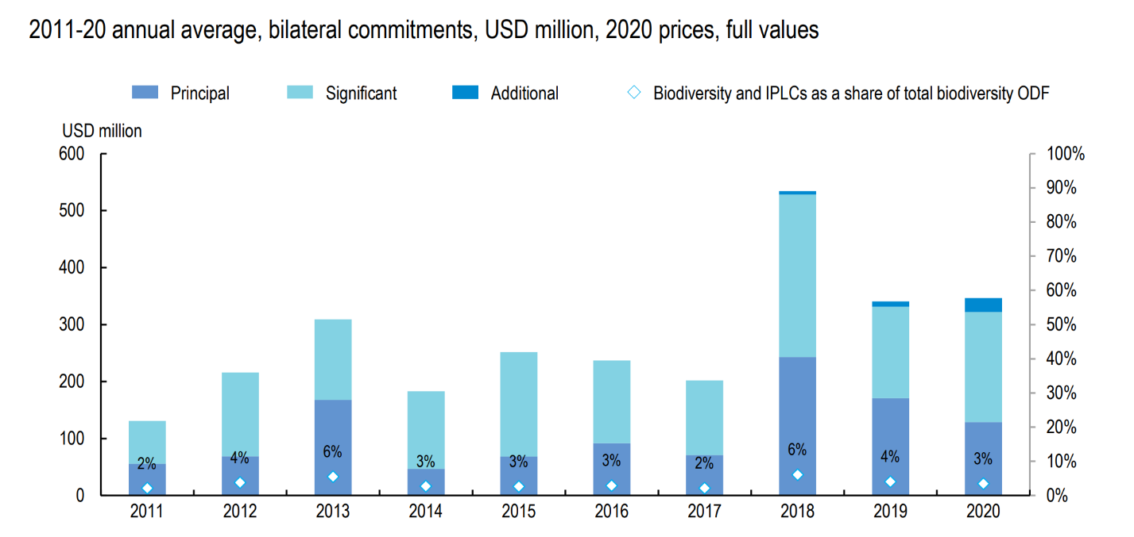
- OECD’s report ‘A decade of development finance for biodiversity (2022)’ analyzes the funding to indigenous people and local communities as part of the total biodiversity ODF. The contribution to indigenous peoples and local communities as a share of bilateral biodiversity-related ODF over 2011-20 averages around 3-4%. Similarly, International Funders for Indigenous Peoples estimates that only 0.6% of the funding reported to the CANDID database (mainly philanthropic funders) was marked as “benefitting Indigenous Peoples”. Of this limited amount, 88.7 % went to Indigenous Peoples in North America.
Figure 12: Indigenous peoples receive a very small share of bilateral biodiversity-related official development finance - Source: A decade of development finance for biodiversity (OECD, 2022)
- It should be further noted that while a share of funds channelled through public sector and multilateral organisations may target indigenous peoples and local communities, there are transaction costs at each step of an activity, and thus only a fraction of the funds is invested locally or are managed by indigenous peoples and local communities.
- The OECD report further suggests that providing more direct funding to indigenous peoples and local communities could help step up action and ambition on biodiversity. However, such funding also needs to develop capacity of indigenous peoples and local communities to access and absorb finance, particularly to meeting essential standards for due diligence, monitoring, and transparency, which are crucial for maintaining the integrity of development finance. There are some promising initiatives which focus on providing direct access to indigenous peoples and local communities, such as:
- The GEF-7 Inclusive Conservation Initiative (ICI), IUCN, IC, GEF-funded, aims to deploy USD 25 million to support indigenous peoples and local communities to secure and enhance their stewardship over an estimated area of at least 7.5 million hectares of territories with high biodiversity and irreplaceable ecosystems. An additional investment of $50 million will be made in GEF-8 in the ICI.
- The Indigenous Peoples Assistance Facility (IPAF) was established by the International Fund for Agricultural Development, offers grants ranging from US$20,000 to US$50,000 for small projects that are designed and implemented by indigenous peoples and their organizations. In its fourth cycle, the facility supported the implementation of 25 projects in 23 countries with a total financing of $1.05 million. These projects collectively reached over 21,850 direct and 458,100 indirect beneficiaries. The projects improved livelihoods for indigenous peoples by increasing food and nutrition security, enhancing income generation, improving access to and management of natural resources, preserving and recovering traditional knowledge and techniques, and empowering communities through raising awareness of indigenous peoples’ rights and needs.
- Forest Investment Programme’s Dedicated Grant Mechanism specifically designed to empower indigenous peoples and local communities in forest areas. It provides direct grants to these communities to support their participation in forest management, conservation efforts, and climate change mitigation activities.
- Lessons learnt on the effectiveness of these approaches may be considered while developing/reforming new and existing funding mechanisms.
- An approach to enhance participation of indigenous peoples and local communities in decision making is to consider approaches similar to the Amazon Fund. The fund features a Guidance Committee which is tasked with setting guidelines and overseeing outcomes. Organizations representing indigenous peoples and local communities are part of the committee. Including indigenous peoples and local communities in the governance framework of such funds ensures their perspectives are integrated into decision-making processes right from the beginning. This approach not only fosters inclusivity but also ensures that the fund's objectives align closely with the needs and insights of indigenous peoples and local communities. Similarly, the Green Climate Fund has been working on a greater integration of stakeholders, including indigenous peoples and local communities, and has established an Indigenous People Advisory Group, which held its first meeting in September 2022. More generally, enhancements to direct access are envisaged under the GCF Strategic Plan for 2024 to 2027.
- As outlined in Section 3, the GEF is examining its programming, policy and governance frameworks to increase engagements with non-state actors such as indigenous peoples and local communities, civil society, women, and youth groups. Indigenous peoples and local communities are a focus of the GBFF. At the 64th GEF Council meeting, the Council approved in the GBFF Programming Directions an aspirational portfolio-level programming target for the GBFF to direct 20% of the total resource envelop of the GBFF by 2030 to support actions by indigenous peoples and local communities for the conservation, restoration, sustainable use and management of biodiversity. The GEF is increasingly engaging with indigenous peoples and local communities through activities funded by both the GEF Trust Fund and the GBFF. The GEF Trust Fund collaborates closely with its Indigenous Peoples Advisory Group (IPAG), ensures compliance with minimum safeguards standards for indigenous peoples and local communities in its programming, and implements the Inclusive Conservation Initiatives during the GEF-7 and GEF-8 funding cycles. The establishment and programming directions of the GBFF were shaped through consultations with various GEF stakeholders, including IPAG, and one of its key action areas is Indigenous-led stewardship. Additionally, indigenous peoples and local communities serve as an observer group at the GBFF Council.
- As mentioned in the Section 3, in the context of the Convention, two decisions of CBD COP14 are pertinent to recall. First, decision 14/16 highlighted the contributions of indigenous peoples and local communities towards the conservation and sustainable use of biodiversity, particularly through their holistic collective actions. The decision acknowledged the need for methodological guidance to identify, monitor, and assess these contributions within a framework of rights, ethical principles and values, governance, and differentiated roles of women and men among indigenous peoples and local communities. It encouraged the use of an indicative list of methodological elements, which includes recognizing traditional knowledge, applying diverse, multi-scale and context-specific methodologies and area-based assessments ensuring the full and effective participation of indigenous peoples and local communities, promoting intergenerational transfer of traditional knowledge and gender-differentiated role analysis. The decision invited Parties, governments, and stakeholders to utilize these elements in their methodologies and encouraged the integration of indigenous peoples and local communities contributions into biodiversity financing mechanisms, aiming for a more inclusive and effective approach to biodiversity conservation.
- In the footsteps of this invitation, and as a flipside, decision 14/15 highlighted the importance of putting safeguards in place in order to ensure that biodiversity financing mechanisms have positive effects and avoid or mitigate unintended impacts on biodiversity, rights and livelihoods of indigenous peoples and local communities. To this effect, decision XII/3 on resource mobilization had already adopted voluntary guidelines on such safeguards, and decision 14/15 provided a detailed checklist for the implementation of the guidelines. It urged Parties, other stakeholder organizations and other institutions to continue using the guidelines in designing and operating their financing mechanisms and in setting up their safeguard systems, making use, as appropriate, of this checklist.
- There are already examples and models of activities implemented nationally and locally in support of collective action by indigenous peoples and local communities. They include: (a) the recognition of traditional knowledge and practices as key components of community-based conservation; (b) the recognition that value systems linked to the communities’ cultures for conservation and sustainable use need to be understood and supported; (c) the need for exchange platforms and knowledge sharing; and (d) the importance of creating opportunities for policy linkages and direct involvement of indigenous peoples and local communities in policy processes. A fundamental consideration is that the needs and interests of indigenous peoples and local communities related to their livelihoods and cultures should be integral to the assessment of their contributions, because indigenous peoples and local communities often have their own ways of conserving and sustainably using biodiversity, in close connection with their holistic approaches.

7. Gaps and opportunities
The following gaps and associated opportunities were observed in the previous sections.

Overview of biodiversity finance landscape
- The landscape of biodiversity finance is fragmented. This fragmentation is evident in the diversity of funding mechanisms and initiatives that vary significantly in their purpose, scale, size etc. This fragmentation has its disadvantages, for instance a diversity of requirements to access funds that may be sometimes difficult to navigate. However, since biodiversity related issues are complex and reflect unique ecological, social, and economic contexts, advantages can also be identified.
- First, the specialization in biodiversity finance reflects the need for tailored approaches to address the specific environmental challenges and conservation needs of recipient countries. It highlights the importance of making finance available for the specific ecological characteristics and conservation priorities of each country to ensure effective and relevant biodiversity conservation efforts.
- Second, the diversity of approaches and the breadth of institutions involved in biodiversity finance offer opportunities for benchmarking and identifying best practices. Learning from successful models, can inform future strategies to enhance the effectiveness and efficiency of biodiversity finance.
- The integration of biodiversity into other policies is overall progressing at all levels, however gaps (and associated opportunities) exist with regard to critical macroeconomic processes such as illicit financial flows and tax regimes, sovereign debt, and international trade.
- Improving biodiversity metrics and incorporating them in accounting methodologies can contribute to make a stronger “economic case” for biodiversity and can provide the basis for financial instruments. Specifically, ecosystem accounting can play a crucial role in incorporating biodiversity related issues into national performance metrics and policy evaluation. COP decision 15/5 recognizes the value of aligning national monitoring with System for Environmental Economic Accounting statistical standards to mainstream biodiversity in national statistical system. With at least 96 countries implementing accounts consistent with SEEA and 34 countries already developed ecosystem accounts, there is a growing international consensus on the importance of integrating biodiversity and ecosystem services into economic planning and decision-making.
- Biodiversity-related economic taxonomies play an important role in mobilizing resources for biodiversity conservation by providing a standardized framework and common terminologies that helps identify and prioritize areas and species in need of protection, thereby facilitating targeted investment and conservation efforts. There are ongoing international and national initiatives on developing this topic further. Additional work is required to better understand the interaction between different taxonomies including relevance of international taxonomies to national ones.

International biodiversity finance
- The total development finance for biodiversity has increased, showing encouraging trends over the last decade. Despite this positive development, there remains an overall need for increasing funds to reach the 20 billion USD by 2025 and 30 billion USD by 2030 target set in the KMGBF.
- In accordance with COP Decision 15/7, the Global Biodiversity Framework Fund has been established by the Global Environment Facility. The fund is established to support the implementation of the KMGBF. It is also encouraging to note that the GEF is also undergoing reforms to increase its efficiency, agility, and responsiveness to urgent needs.
- Financial institutions, including multilateral development banks, can make an important contribution to create an enabling environment for mobilizing finance related to biodiversity. MDBs should be encouraged to continue their work in implementing safeguards for biodiversity, exploring diverse financial solutions (debt swaps, green bonds, and sustainability-linked bonds) and de-risking private biodiversity related investment.
- While progress has been made in the past decade, there is likely more opportunities for greater integration of biodiversity objectives (more specifically of KMGBF) into broader development cooperation frameworks.
- There is an increased recognition in the international community about the benefits of synergies between climate change and biodiversity, however, in practical terms, there is still a gap. For example, share of biodiversity-related ODF focusing on biodiversity that also meet climate change goals have increased from 78% in 2015 to 89% in 2021. Over the same period, only about 21% of climate-related ODF considers biodiversity goals. The donor/international community should be encouraged to increase the potential benefits from synergies as many of the direct and most of the indirect drivers of biodiversity loss and climate change are common.
- While harnessing climate-biodiversity synergies is essential, similar approaches could be extended to other sectors. Current financing is mostly implemented through safeguards, which are primarily preventing harm or negative impacts, rather than proactively creating positive outcomes. Realigning finance, for instance, by allocating a percentage of grey infrastructure finance to nature-based infrastructure, could be an opportunity to explore further. Given the importance of infrastructure investments in the portfolios of MDBs, they could play an important role in progressing such sectorial integration of biodiversity. Methodologies such as strategic impact assessments (SIA) can support more strategic investments, including into in nature- based infrastructure. It supports more holistic decision making while considering wider environmental, social and economic impacts in the early stages of planning processes.
- There are likely opportunities to further enhance financial sustainability and the long-term predictability of funding. It has been observed that endowment funds offer a high degree of financial sustainability, followed by funds with institutionalized replenishment processes. Purely voluntary arrangements, including by the private sector, had more limited success, however, blended finance approaches have potential to mitigate this by de-risking private investments.
- On the disbursement side, most funding is project-based which potentially limits the long-term financial sustainability needed to reflect the continuous (intangible) benefit stream for human well-being emanating from ecosystems and biodiversity. Some financial instruments applied at the domestic level, such as Payment for Ecosystem Services (PES) schemes, seek to overcome such limitations while some instruments applied at international level, such as linking sovereign financing to sustainability, also offer promise.

Domestic biodiversity finance
- Domestic public expenditure globally accounts for the largest part of global biodiversity spending. International and domestic finance are interconnected and should complement and amplify each other​​. Opportunities could be explored to leverage domestic funding through initiatives that are internationally funded.
- The GBF calls for integrating biodiversity into all levels of government and sector policies and gradually aligning all pertinent public and private activities, as well as fiscal and financial flows, with the goals and targets of the framework. Therefore, countries will benefit from identifying, reforming, or removing environmentally harmful incentives (including subsidies) provided to sectors such as agriculture, fisheries, forestry and fossil fuels, and others, prioritising the most environmentally harmful measures. BIOFIN and OECD, for example, offer guidance for taking action on harmful subsidies.
- While most domestic public expenditures on biodiversity are presumably financed through general budgetary appropriations, biodiversity-earmarked fiscal instruments like fees, charges, or levies, have been used in the past decades. Continuously developing and scaling these arrangements can provide dedicated funding streams for biodiversity initiatives and thus ensure better long-term financial sustainability. However, it is important to balance earmarked funding with the overall goal to maintain the flexibility of public finance and budget governance prerogatives.
- In the case of instruments that seek to mobilize private finance, careful consideration must be given to creating mechanisms that not only attract private investments but also ensure these investments support biodiversity goals effectively and maintain effective social safeguards. This may involve developing incentives for private sector engagement, such as tax breaks or subsidies for projects that have a positive impact on biodiversity (in line with Target 18 of the GBF), or blended finance approaches that de-risk private investments, and use environmental and social safeguard policies.
- There is an ongoing discussion on financing instruments such as biodiversity credits or certificates, mirroring to some extent earlier discussions on “innovative” instruments such as payments for ecosystems services schemes or biodiversity offsets. These discussions go into considerable technical detail and an attempt to summarize lest reconcile the different views is beyond the scope of this study. There are, on the one hand, likely opportunities for further experimentation and attempts to scaling, while on the other hand there is a need to avoid over-optimism, in particular with regard to the mobilization of private finance. There are ongoing practical challenges in transforming intangible streams of alleged biodiversity benefits into a competitive monetary return on (private) investment, and at the same time avoiding adverse effects on biodiversity and livelihoods of indigenous peoples and local communities. While important progress has been made, such as by further developing biodiversity metrics as a precondition for “bankable” investments, these challenges are unlikely to be overcome in the short term.
- When developing and planning projects, it would be beneficial to find ways to align the objectives of the project with the goals of the UNCCD, CBD, and UNFCCC frameworks, using LDC, NBSAP, and LDN. To achieve this, countries may need capacity building at the national level.
- It is important to identify and promote the co-benefits of biodiversity conservation in areas such as climate finance, infrastructure, and other sectors. By highlighting these co-benefits, governments and organizations can harness synergies in public finance, thereby leveraging additional resources for biodiversity conservation through integrated approaches that address multiple environmental objectives simultaneously.
- Biodiversity Expenditure Reviews and green budgeting can assist countries in understanding and integrating biodiversity into their national development planning and financial strategies.
- Investing in National Biodiversity Finance Plans or similar instruments can also support long-term sustainable biodiversity efforts. Similarly, there is an opportunity to make National Biodiversity Strategies and Action Plans more ambitious and comprehensive, aligning closely with the Kunming-Montreal Global Biodiversity Framework.
- Effective donor coordination is important in reducing duplication of efforts and maximizing the impact of international biodiversity finance. Equally important is the coordination between donors and recipients to ensure funding is targeted to actual needs and absorptive capacity (the ability to effectively utilize funds). The coordination between donors and recipients can be made more efficient by prior internal coordination on the recipient’s side.

Private biodiversity finance
- Measuring and tracking private biodiversity finance is important given the key role the private sector can play in achieving the goals and targets of the GBF. However, there are challenges to both identifying and tracking private financial flows.
- Some of the barriers to scaling of private investments in nature-based solutions are the scalability and replicability constraints of projects; absence of data, measuring and reporting standards; lack of well-defined transition pathways that are comprehensible to the private sector; lack of a pipeline of investable projects with competitive risk-return profiles; and limited knowledge of the potential benefits of ecosystem-based approaches or nature-based solutions.
- Efforts are underway to address some of these challenges, including the development of taxonomies featuring precise metrics and reporting standards, facilitating transparent and accountable biodiversity investments by the private sector. Additionally, several initiatives led by the private sector, such as Nature Action 100 and the Finance for Biodiversity Pledge, demonstrate a growing engagement and commitment to addressing biodiversity concerns. Moreover, initiatives like the Taskforce on Nature-related Financial Disclosures (TNFD) and other reporting efforts like Global Reporting Initiative are enhancing the private sector's understanding of the financial risks associated with biodiversity loss.
- Tailored investments by relevant actors along certain phases of projects can improve impact. Governments can invest in initial stages of projects to improve the risk-return profile. Similarly, philanthropic institutions and Multilateral financial institutions can invest strategically to make the projects more bankable. Private finance can then be used to scale up and help in institutionalizing projects, ensuring their integration into the broader economic system and aligning them with market dynamics.
- Investing in major value chains such as food, energy, fashion, and infrastructure, which significantly contribute to biodiversity loss, can be a strategic move for the private sector. Investments to these critical areas can have a substantial impact on reducing biodiversity loss and fostering sustainability in sectors with the most significant contribution to biodiversity loss. These strategic investments can enhance the effectiveness of biodiversity conservation efforts while aligning economic activities with biodiversity goals.

Indigenous Peoples, Local Communities, women, and youth
- While the Kunming-Montreal Global Biodiversity Framework acknowledges the important roles and contributions of indigenous peoples and local communities, their contributions are not easily quantified using conventional metrics. Decision 14/16 ‘Methodological guidance concerning the contributions of indigenous peoples and local communities’ provides guiding principles on assessing the contribution of collective action of indigenous peoples and local communities. Related efforts could be encouraged and scaled.
- Indigenous Peoples, Local Communities, women, and youth receive relatively little finance (average of 3-4% of the total biodiversity related ODF over 2011-20) and often lack direct access to biodiversity finance. Creating dedicated funding streams and simplifying application processes can support these groups in their role as biodiversity stewards and empower them to scale their activities. Small grant programmes can play an important role in addressing environmental and climate challenges for disempowered and marginalized groups. Their flexibility and simplified operational requirements empower these communities to initiate projects that mainstream funding may overlook. This approach not only facilitates grassroots action on biodiversity but also fosters resilience and addresses key challenges in poverty and climate change.
- Biodiversity finance instruments, in particular innovative ones, should be assessed for their impact on gender equality and human rights. This involves conducting impact assessments and ensuring that finance mechanisms are designed to avoid or mitigate unintended impacts on the rights and livelihoods of indigenous peoples and local communities, in accordance with national legislation. Recognizing the role of biodiversity for local livelihoods, defining rights and responsibilities of stakeholders equitably, ensuring safeguards are grounded in local circumstances and consistent with national and international frameworks, and establishing effective institutional frameworks for the operationalization, enforcement, and evaluation of safeguards, including transparency, accountability, and compliance. CBD COP already developed guidance thereon and its application could be further encouraged. The design and implementation of biodiversity financing mechanism could take into account the 'checklist' of safeguards provided in COP Decision 14/15 titled 'Safeguards in biodiversity financing mechanism'.
- Direct funding to indigenous peoples and local communities, women and youth, is important for advancing biodiversity efforts; however, their absorption capacity to effectively utilize these resources should also take into consideration and capacity building to this effect could be provided where necessary.
- To improve gender-responsive biodiversity finance, ongoing efforts should continue to increase awareness of the financial and technical support available for gender-responsive approaches. Additionally, establishing funding programmes or budget allocations to support gender-responsive implementation of the Kunming-Montreal Global Biodiversity Framework and the Gender Action Plan will be helpful.
- Like the broader issue of biodiversity finance, while mobilization of resources is essential, the monitoring and tracking of these resources is equally important. Given that contributions from indigenous peoples and local communities, women and youth also encompass non-monetary aspects, this complexity is further exacerbated.

8. Concluding remarks
- The analysis of the biodiversity finance landscape reveals both challenges and opportunities. The fragmented nature of biodiversity finance, characterized by a diverse array of funding mechanisms and initiatives at all levels, constitutes a challenge. However, this diversity may also be perceived as a strength, reflecting the complex, multifaceted nature of biodiversity and allowing for tailored approaches that address the unique ecological, social, and economic contexts of countries. The increasing integration of biodiversity into relevant international/macroeconomic processes, ongoing work on ecosystem accounting, and the development of biodiversity taxonomies are significant steps towards better reflecting biodiversity in economic decision-making. Moreover, the establishment of the Global Biodiversity Framework Fund, along with the increasingly active role of multilateral institutions in de-risking private investment and implementing safeguards, underscores a growing commitment to enhance the effectiveness and efficiency of biodiversity finance. There are also opportunities to increase the financial sustainability of biodiversity finance, both on the generation and the disbursement side. While the increased recognition of synergies between biodiversity and climate change is promising, opportunities to better harness such synergies exist. Similar, potentially greater opportunities for synergies may exist regarding other sectors such as infrastructure. Despite such positive developments, there remains an overall urgent need for increased funding to meet the global biodiversity targets and to continue the integration of biodiversity objectives into broader policy and development cooperation frameworks at all levels.
- Domestic public expenditure represents the largest global biodiversity finance spending, with room for further improvement through enhanced integration of biodiversity into national fiscal policies, more robust action on incentives harmful to biodiversity and promoting positive incentives, the further exploration and scaling as appropriate of financial tools and instruments, including those that seek to leverage private finance, and, last but not least, the better reflection of the important role of indigenous peoples and local communities, as well as of other stakeholders. Initiatives like BIOFIN are helping countries to better understand and integrate biodiversity into national and local development and planning processes. Better donor coordination with national policies in recipient countries can amplify the impact and sustainability of international financial efforts and ensure that international finance can effectively support the mobilization of domestic finance.
- Mobilizing private finance is an important element of achieving Target 19 of the Global Biodiversity Framework (GBF). Current nature positive investments are dwarfed by financial flows causing nature loss. Challenges include poorly defined transition pathways for biodiversity and a lack of data and standards such as harmonized definitions and metrics. Addressing these issues through creating positive incentives (e.g. tax breaks), standardized metrics (taxonomies), using blended finance approaches and developing initiatives to enhance investor knowledge in eco-system and nature-based solutions are some of the considerations for leveraging private finance more effectively.
- Indigenous peoples, local communities, women, and youth play pivotal roles in biodiversity conservation, and enhancing their access to finance is essential for better harnessing their contributions. Importantly, the financial instruments and approaches referenced above need to be designed with careful consideration of their potential impacts on these groups to prevent or minimize adverse effects, ensuring that biodiversity efforts are inclusive and beneficial to all stakeholders involved.
- Overall, while significant challenges remain, the evolving landscape of biodiversity finance is marked by encouraging trends and untapped potential. Strategic investments, mainstreaming biodiversity into national and international policies/frameworks, and the inclusion of all stakeholders are key to advancing global biodiversity goals, overall demonstrating that the ‘whole of society approach’ as called for in the GBF is imperative for effective action on biodiversity loss.
__________

* CBD/SBI/4/1.
See CBD/SBI/4/5.
Kunming-Montreal Global Biodiversity Framework
Blended finance is an approach that involves the use of public and philanthropic funds to change the risk/return profile of investment projects in order to attract the private sector (Source: Blended finance playbook for nature-based solutions, Earth Security, 2022)
Those reports emphasize an overall need to further enhance the tracking and reporting of biodiversity finance. Consequently, it is important to approach the figures utilized in this study with the awareness that there are limitations in the current data.
A Comprehensive Overview of Global Biodiversity Finance (OECD, 2020)
Deutz, A., Heal, G. M., Niu, R., Swanson, E., Townshend, T., Zhu, L., Delmar, A., Meghji, A., Sethi, S. A., and Tobin-de la Puente, J. 2020. Financing Nature: Closing the global biodiversity financing gap. The Paulson Institute, The Nature Conservancy, and the Cornell Atkinson Center for Sustainability.
The scope of the UNEP report is nature-based solutions. According to the resolution of the United Nations Environment Assembly, they are defined as actions to protect, conserve, restore, sustainably use and manage natural or modified terrestrial, freshwater, coastal and marine ecosystems It should be noted that the ecosystem approach is the primary framework for action under the Convention.
State of finance for Nature (UNEP, 2023)
Dempsey, J., Irvine-Broque, A., Bigger, P. et al. Biodiversity targets will not be met without debt and tax justice. Nat Ecol Evol 6, 237–239 (2022). https://doi.org/10.1038/s41559-021-01619-5
INTERPOL’s 2018 World Atlas of Illicit Financial Flows.
Money Laundering from Environmental Crime (FATF, 2021)
Ibid.
https://www.undp.org/press-releases/tax-inspectors-without-borders-and-partners-pass-usd-1-billion-milestone-additional-tax-revenues-developing-countries
https://www.tiwb.org/resources/news/papua-new-guinea-and-oecd-agree-new-tax-inspectors-without-borders-partnership.htm
Biodiversity, Natural capital and the economy (OECD, 2021)
The Trade and Biodiversity product classification Measuring trade in products with a biological origin (UNCTAD. 2023)
https://www.wto.org/english/tratop_e/rulesneg_e/fish_e/fish_e.htm
https://ustr.gov/trade-agreements/free-trade-agreements/united-states-mexico-canada-agreement/agreement-between
The economic case for nature (World Bank, 2021)
See the report of the Stiglitz-Sen-Fitoussi-Commission published in 2009 and, more recently, The Economics of Biodiversity: The Dasgupta Review (2021).
System of Environmental-Economic Accounting 2012 Experimental Ecosystem Accounting
https://seea.un.org/content/homepage
The Economics of Biodiversity: The Dasgupta Review (2021)
Global biodiversity outlook 5 (CBD, 2020)
EU Biodiversity Strategy for 2030
Classification of Environmental Protection Activities and Expenditure (CEPA) and Classification of Resource Management Activities (CReMA) - Explanatory notes (European environmental economic accounts)
https://ec.europa.eu/eurostat/statistics-explained/index.php?title=Environmental_protection_expenditure_accounts\
How Eurostat will implement the different classifications to statistics is still not decided.
World Bank. 2023. International Debt Report 2023. © Washington, DC: World Bank. http://hdl.handle.net/10986/40670 License: CC BY 3.0 IGO.
From Links to linkages: integrating renewable nature capital into sovereign debt instruments (Nature Finance, 2023)
The OECD DAC Secretariat collects individual aid activities on official development assistance (ODA) and other official flows (OOF) in the Creditor Reporting System (CRS). ODA is defined as flows to countries on the DAC List of ODA Recipients and core contributions to multilateral development institutions provided by official or executive agencies in the list of ODA-eligible international organisations (OECD, 2021). ODA must have the economic development and welfare of developing countries as its main objective, and be concessional in character - either flowing as grants or concessional loans (i.e. softer than market terms). In turn, OOF comprises transactions from governments to developing countries that do not qualify as ODA, e.g. non-concessional sovereign loans (OECD, 2021). This definition of other official flows excludes official direct export credits. Together, the sum of bilateral ODA flows, bilateral OOF (except OOF grants and loans for commercial purposes), and all outflows (grants and loans) by multilateral development institutions, define official development finance (ODF). As such, ODF is a broader measure of developing countries’ official receipts for development purposes (OECD, 2021).
This sub-section of the report utilizes the data from the latest OECD report ‘Biodiversity and Development Finance2015-2021:Progress towards Target 19 of the Kunming-Montreal Global Biodiversity Framework’ published in December 2023. The Annex 1 of the OECD report provides a comprehensive overview of the data and sources used in developing the report.
See Article 39 of the Convention and decision 15/15.
The information provided by the GEF Secretariat is gratefully acknowledged.
This section will be updated with further information from the first meeting of the Council of the GBFF.
Further information about the results of the meeting can be found on GEF’s website: https://www.thegef.org/events/1st-gbff-council-meeting#:~:text=About%20the%20GBF%20Fund&text=The%20Fund%20was%20ratified%20by,the%20GBFF's%20streamlined%20funding%20procedures.
https://www.thegef.org/what-we-do/topics/global-biodiversity-framework-fund
OECD (2023), A Decade of Development Finance for Biodiversity, OECD Publishing, Paris, https://doi.org/10.1787/e6c182aa-en.
The blended finance playbook for nature based solutions (2020)
OECD (2023), A Decade of Development Finance for Biodiversity, OECD Publishing, Paris, https://doi.org/10.1787/e6c182aa-en.
https://www.ifc.org/content/dam/ifc/doc/mgrt/biodiversity-finance-reference-guide.pdf
Performance Standard 6: Biodiversity Conservation and Sustainable Management of Living Natural Resources (IFC, 2012)
Demand side source and motivation for biodiversity credits (Biodiversity credit alliance, 2023)
Joint Declaration and Task Force on Credit Enhancement for Sustainability-Linked Sovereign Financing
IDFC common position paper on Biodiversity (Nov, 2022)
CBD/SBSTTA/21/INF/13: Global State Of The Application Of Biodiversity-Inclusive Impact Assessment
Biodiversity and Development Finance2015-2021: Progress towards Target 19 of the Kunming-Montreal Global Biodiversity Framework (OECD, December 2023)
https://www.afd.fr/en/actualites/communique-de-presse/one-planet-summit-afd-undertakes-allocate-least-30-its-climate-funding-biodiversity#:~:text=To%20mark%20the%20One%20Planet,target%20of%20%E2%82%AC1%20billion.
Global infrastructure outlook (2018)
Gurara, D. et al. (2017), Trends and Challenges in Infrastructure Investment in Low-Income Developing Countries, https://www.imf.org/~/media/Files/Publications/WP/2017/wp17233.ashx.
How Can Investment in Nature Close the Infrastructure Gap? (IISD, 2021)
Definition by European Environment agency
Nitz, T., & Brown, A. (2001). SEA MUST LEARN HOW POLICY MAKING WORKS. Journal of Environmental Assessment Policy and Management, 3, 329-342. https://doi.org/10.1142/S146433320100073X.
Maria Partid´ario et.al (2023). Novel perspectives for multi-actor collaboration in strategic environmental assessment using ST4S
Finland’s submission on lessons learned from resource mobilization strategy
OECD (2023), A Decade of Development Finance for Biodiversity, OECD Publishing, Paris, https://doi.org/10.1787/e6c182aa-en.
Available information on private finance for biodiversity does not distinguish between international or domestic finance
A Comprehensive Overview of Global Biodiversity Finance Report (OECD 2020).
State of nature finance (UNEP, 2023)
Nature based solutions are defined as ‘Actions to protect, conserve, restore, sustainably use and manage natural or modified terrestrial, freshwater, coastal and marine ecosystems, which address social, economic and environmental challenges effectively and adaptively, while simultaneously providing human well-being, ecosystem services and resilience and biodiversity benefits’ (UNEA)
CBD/COP/15/L.25 Kunming-Montreal Biodiversity Framework, Section C, Para 8.
Cornered by PAs: Adopting rights-based approaches to enable cost-effective conservation and climate action (2020, Tauli Corpuz et al.)
See CBD/WG8j/10/05.
Gender and the Environment:Building Evidence and Policies to Achieve the SDGs (OECD, 2022)
Secretariat of the Convention on Biological Diversity (2022). Best practices in Gender and Biodiversity: Pathways for multiple benefits
ibid
ibid
Gender and the Environment: Building the Evidence Base and Advancing Policy Actions to Achieve the SDGs (OECD, 2022)
https://www.cepf.net/about
https://globalfundcoralreefs.org/how-we-work/
https://www.greenfinanceinstitute.com/gfihive/case-studies/asn-biodiversity-fund/
Information summarized from CBD/WGD/SI/1/INF/1: ‘Compilation of lessons learned from other international funding mechanisms’
https://www.leafcoalition.org/
Summarize information from https://www.gov.uk/government/publications/biodiverse-landscapes-fund/biodiverse-landscapes-fund-policy-information
VII/15, IX/16, X/33, XI/19, XII/20, XIII/4, and 14/5, 15/30
CBD COP Decision 14/5: Biodiversity and Climate Change
Green Climate Fund's Strategic Plan for 2024-2027
https://www.greenclimate.fund/news/climate-funds-unite-enhance-access-climate-finance-and-increase-impact#:~:text=For%20the%20first%20time%20ever,flows%20available%20to%20developing%20countries)
IPBES (2018)
Resolution 3/2019, Implementation of the Updated Funding Strategy of the International Treaty 2020–2025 (fao.org)
International Treaty’s Food Processing Industry Engagement Strategy: https://www.fao.org/3/cc3626en/cc3626en.pdf
Compilation of lessons learned from other international funding mechanisms (CBD/WGDSI/1/INF/1)
CBD/WGDSI/1/2/Add.2: Executive summary of the compilation of lessons learned from other international funding mechanisms
http://www.multilateralfund.org/aboutMLF/default.aspx
Investing in the wealth of nature through biodiversity and ecosystem service finance solutions (2023, Andrew Seidl, Tracey Cumming, Marco Arlaud, Cole Crossett, Onno van den Heuvel)
It is important to acknowledge that due to limited data availability and a lack of comparability among existing data, aggregating the total spending on biodiversity through the FIRE database remains a challenge.
https://www.imf.org/en/About/Factsheets/Sheets/2023/special-drawing-rights-sdr
https://www.imf.org/en/Topics/special-drawing-right/seven-things-you-need-to-know-about-sdr-allocations
https://www.imf.org/en/Topics/special-drawing-right
Sustainability linked sovereign debt hub
https://climatechampions.unfccc.int/joint-declaration-and-task-force/
A Comprehensive Overview of Global Biodiversity Finance (OECD, 2021)
OECD (2021), Green Budgeting in OECD Countries, OECD Publishing, Paris, https://doi.org/10.1787/acf5d047-en.
OECD (forthcoming 2024), Biodiversity Budget Tagging in Green Budgeting.
Deutz, A., Heal, G. M., Niu, R., Swanson, E., Townshend, T., Zhu, L., Delmar, A., Meghji, A., Sethi, S. A., and Tobin-de la Puente, J. 2020. Financing Nature: Closing the global biodiversity financing gap. The Paulson Institute, The Nature Conservancy, and the Cornell Atkinson Center for Sustainability.
Seidl, A. et al. (2020): Finance for Nature: An Estimate of Public Biodiversity Investments. Ecosystem Services 46.
Further updated Information provided through the Financial Reporting Framework. CBD/COP/14/6.
Payments for Ecosystem Services (PES) Programmes seek to provide financial incentives to landowners or land managers for maintaining or enhancing ecosystem services that benefit society, such as clean water, carbon sequestration, and biodiversity conservation. The Payment for Ecosystem Services (PES) program in Costa Rica has often been quoted as early good practice however similar approaches do exist in a number of countries under different names, such as agri-environmental payments.
For an early collection of case examples see CBD Technical Series No 56 (2011): Incentive Measures for the Conservation and Sustainable Use of Biodiversity. https://www.cbd.int/doc/publications/cbd-ts-56-en.pdf .
Bearing in mind that early experiences with some of these tools go by now back to well over two decades.
https://www.biofin.org/finance-solutions .
A Comprehensive Overview of Global Biodiversity Finance Report (OECD, 2020).
www.deutsche-finanzagentur.de/en/institutional-investors/federal- securities/green-federal-securities/
See decisions 12/3 and 14/15, on safeguards in biodiversity finance mechanisms, and the discussion in chapter 3 above.
Working definition by Alliance for biodiversity credits
Biodiversity Credits: Demand Analysis and Market Outlook (December, 2023, WEF)
Demand side sources and motivation for biocredits (2023, Alliance for Biodiversity Credits).
https://www.naturemarkets.net/final-recommendations
https://iapbiocredits.org/about-us.html
https://www.environmental-finance.com/content/news/australia-passes-legislation-to-create-biodiversity-credit-market.html
Kedward, K., zu Ermgassen, S., Ryan-Collins, J. et al. Heavy reliance on private finance alone will not deliver conservation goals. Nat Ecol Evol 7, 1339–1342 (2023). https://doi.org/10.1038/s41559-023-02098-6
See CBD/COP/14/5/Add.1 and examples contained therein.
Tracking Economic Instruments and Finance for Biodiversity (OECD, 2021)
An important international initiative is the ‘Bern Process’ which promotes cooperation among Parties to the relevant biodiversity-related conventions. It aims to strengthen cooperation and collaboration, contributing to effective and efficient implementation of the Kunming-Montreal Global Biodiversity Framework, and is recognized by the CBD COP decision 15/13. Ultimately the Bern Process strives to see the implementation of the Kunming-Montreal Global Biodiversity Framework, involving contributions from all relevant Multilateral Environmental Agreements(MEAs), within a cooperation process characterised by collaboration among secretariats and parties as well as other stakeholders, aiming for synergistic intergovernmental processes
The Economics of Land Degradation (2022): Case Study Of Rio Synergies In Rwanda
Demand side sources and motivation for biodiversity credits
CBD/COP/15/9/Add.2.
OECD work in support of biodiversity, 2021
Decision XII/3 adopted milestones for the implementation of Aichi Biodiversity Target 3.
Identifying and assessing subsidies and other incentives harmful to biodiversity: A comparative review of existing national-level assessments and insights for good practice. OECD Environment working paper No. 206
State of Finance for Nature (UNEP, 2023)
https://www.naturefinance.net/making-change/data-disclosure-and-frameworks/nature-finance-alignment-tool/
EU’s submission to CBD Secretariat on their experiences, good practices and lessons learned with the strategy for resource mobilization (Dec 2023)
https://www.gov.uk/guidance/understanding-biodiversity-net-gain
Government of Brazil’s submission to CBD Secretariat on their experiences, good practices and lessons learned with the strategy for resource mobilization (Dec 2023)
Government of Colombia’s submission to CBD Secretariat on their experiences, good practices and lessons learned with the strategy for resource mobilization (Dec 2023)
Collaborative management partnership toolkit (2021, World Bank)
Cabrera, h. Et al. (2021). Securing sustainable financing for Conservation areas: a guide to project finance for permanence. Washington D.C. Amazon sustainable landscapes program and WWF.
OECD 2020. A Comprehensive Overview of Global Biodiversity Finance Report.
State of Nature finance (UNEP, 2023)
Mobilizing Private finance for Nature (World Bank, 2020)
Deutz, A., Heal, G. M., Niu, R., Swanson, E., Townshend, T., Zhu, L., Delmar, A., Meghji, A., Sethi, S. A., and Tobin-de la Puente, J. 2020. Financing Nature: Closing the global biodiversity financing gap. The Paulson Institute, The Nature Conservancy, and the Cornell Atkinson Center for Sustainability.
Building a capital continuum for nature positive investments (Oct 2023), Coalition for Private investment in Conservation
The Biodiversity Crisis Is a Business Crisis (BCG, 2021)
IPBES Global Assessment Report on Biodiversity and Ecosystem Services. (2019)
Nature’s Frontier: Achieving sustainability, efficiency, and prosperity with natural capital (World Bank, 2021)
Fashion's Impact on Biodiversity (WWF, (2020)
Deutz, A., Heal, G. M., Niu, R., Swanson, E., Townshend, T., Zhu, L., Delmar, A., Meghji, A., Sethi, S. A., and Tobin-de la Puente, J. 2020. Financing Nature: Closing the global biodiversity financing gap. The Paulson Institute, The Nature Conservancy, and the Cornell Atkinson Center for Sustainability.
Finance for Nature (UNEP, 2023)
https://www.unpri.org/sustainable-land-use/pri-ceres-investor-initiative-for-sustainable-forests/5872.article
https://www.natureaction100.org/
https://www.financeforbiodiversity.org/
Assessing the financial links to Nature Capital (Goldman Sachs, 2022)
https://tnfd.global/about/
GRI 101: Biodiversity 2024
State of Nature Finance (UNEP. 2023)
According to the resolution of the United Nations Environment Assembly, they are defined as actions to protect, conserve, restore, sustainably use and manage natural or modified terrestrial, freshwater, coastal and marine ecosystems It should be noted that the ecosystem approach is the primary framework for action under the Convention (https://www.cbd.int/cop/default.shtml).
The mitigation hierarchy can be defined as: ‘the sequence of actions to anticipate and avoid impacts on biodiversity and ecosystem services; and where avoidance is not possible, minimize; and, when impacts occur, rehabilitate or restore; and where significant residual impacts remain, offset' (Cross Sector Biodiversity Initiative 2013).
Biodiversity Credits: Demand Analysis and Market Outlook (December 2023, WEF)
Mobilizing Private Finance for Nature (The World Bank, 2020)
‘Towards Building a Capital Continuum for Nature-Positive Investments’ Coalition for private investment in conservation (Oct 2023)
The blended finance playbook for Nature based solutions (Earth Security, 2021)
IPBES (2019): Summary for policymakers of the global assessment report on biodiversity and ecosystem services of the Intergovernmental Science-Policy Platform on Biodiversity and Ecosystem Services
Cornered by PAs: Adopting rights-based approaches to enable cost-effective conservation and climate action (2020, Tauli Corpuz et al.)
Campaign for Nature, International Funders for Indigenous Peoples, Indufor, Overseas Development Institute, Rainforest Foundation Norway and Rights and Resources Initiative.
Rainforest Foundation Norway (2021), Falling Short. Donor funding for Indigenous Peoples and local communities to secure tenure rights and manage forests in tropical countries (2011–2020), https://d5i6is0eze552.cloudfront.net/documents/Publikasjoner/Andre-rapporter/RFN_Falling_short_2021.pdf?mtime=20210412123104.
A decade of development finance for biodiversity (OECD, 2022)
https://www.amazonfund.gov.br/en/amazon-fund/Governance/COFA/
Green Climate Fund Board, Report on the Activities of the Secretariat (Green Climate Fund, 26 June 2023) GCF/B.36/Inf.14, Annex 6.
Green Climate Fund, Strategic Plan for the Green Climate Fund 2024-2027 (Green Climate Fund, 2023).
The discussion/results from the 1st GBFF Council in February 2024 to be added.
See COP decisions XII/3 and 14/15, on guidelines for safeguards in biodiversity financing mechanisms.

