 |  | CBD
 |  | Distr.  GENERAL  CBD/SBSTTA/22/INF/29  6 June 2018  ENGLISH ONLY
SUBSIDIARY BODY ON SCIENTIFIC, TECHNICAL AND TECHNOLOGICAL ADVICE
Twenty-second meeting
Montreal, Canada, 2-7 July 2018
Item 10 of the provisional agenda*

Invasive Alien Species: Unintentional Introductions

Note by the Executive Secretary**
- The Executive Secretary is circulating herewith, for the information of participants in the twenty second meeting of the Subsidiary Body on Scientific, Technical and Technological Advice, Invasive alien species: unintentional introductions.
- The present report is relevant to the work of the Convention on Biological Diversity, in particular
with regard to the Development of Supplementary Guidance to Avoid Unintentional Introductions of Invasive Alien Species Associated with the Trade in Live Alien Species, and implementation towards achieving Aichi Biodiversity Targets 9.
- The document is being circulated in the form and language in which it was received by the Secretariat. The views expressed in the document are those of the authors and do not necessarily reflect the views of the Secretariat of the Convention on Biological Diversity.

Unintentional Introductions
The IUCN SSC Invasive Species Specialist group (ISSG)

Invasion pathways are routes along which introduced species move to an area that is biogeographically distinct from their natural range. Although a formal surveillance and reporting system has not been implemented under the CBD, pathways of introduction and spread of alien and potentially invasive species have been recorded for events of introduction in many countries.

Trends in pathways of introduction of alien and invasive species
Several studies have been undertaken that have analysed types of introduction and pathways of introduction. Data and information of over 28400 introduction events, involving 4832 alien species in 101 countries that have occurred since 1800 were used to calculate an indicator of trends in pathways of introductions of alien and invasive species (Invasive Species Specialist Group ISSG, 2018). Each introduction event includes data on either all or some of the following information types- (1) date of first introduction or first record, and (2) introduction being intentional or unintentional, (3) pathway (corridors, escape, release, transport as contaminant or stowaway, unaided or unknown) and (4) vectors
There has been a steady increase in both intentional and unintentional introduction events of alien species since the 1800’s. Analysis of pathway trends indicates that horticulture, agriculture and contamination of transported goods, especially seeds, are responsible for the largest and fastest growing numbers of alien species introductions. There has also been a sharp rise in introductions of marine stowaways since the 1970’s, and species released with the intention of human ‘landscape improvement’.
Faulkner et al (2017) in their case study of undertstanding and managing pathways of introduction of alien taxa in South Africa, found that most alien and invasive taxa were deliberatly introduced into South Africa and escaped captivity or cultivation. Vertebrates and plants were largely escapees, of these more plants were found to have become invasive. Invertebrates were found to have been deliberatly introduced or unintentionally as transport-stowaways or transport-contaminants (Faulkner, Robertson, Rouget, & Wilson, 2016)
Saul et al (2017) who studied pathway information from all major invasive species information databases concluded that the intentional introduction type is more common amongst plants and vertebrates, and unintentional introductions among invertebrates, algae, fungi and microorganisms (Saul, et al., 2017).

Classification of pathways
The IUCN SSC Invasive Species Specialist Group (ISSG) adopted a hierarchical approach to describe and classify pathways of introduction of alien and potentially invasive species based on the framework developed by one of its members (Hulme, et al., 2008). This framework was endorsed by the Convention on Biological Diversity (CBD) (UNEP, 2014) and parties to the CBD were encouraged to use this pathway framework in the identification, assessment and prioritisation of pathways.
Six principle pathway categories have been recognised-
- Intentional release- RELEASE
- Escape from containment- ESCAPE
- Transport as a contaminant- TRNSPORT CONTAMINANT
- Transport as a stowaway- TRANSPORT STOWAWAY
- Spread through corridors both on land and water- CORRIDORS
- Spread through unaided natural dispersal-UNAIDED
Each of these categories include pathway sub-classes. See Figure 1 for the summary table that outlines this pathway framework.
The pathway class and sub-classes can be classified into three types
- Intentional introductions (RELEASE & ESCAPE FROM CONFINEMENT)
- Unintentional introductions (TRANSPORT-CONTAMINANT & TRANSPORT-STOWAWAY)
- Movement of species without intended human mediated transportation (CORRIDOR & Unaided)
This brief report focused on Unintentional Introductions aims to assist Parties to the Convention to get a better understanding of the pathways classified under this category especially those associated with trade in live species. The report includes descriptions of the pathway categories with examples of species dispersed through these pathway sub-classes, as well as examples of regulations or legal enactments by national governments to prevent potential introduction of species through these pathway classes and sub-classes.

Definitions
Transport–Contaminant refers to the unintentional movement of live organisms as contaminants of a commodity that is intentionally transferred through the movement of people and goods, e.g. because of travels and trade, and similar activities (examples are development assistance, or emergency relief programmes). This includes pests and diseases of animals and plants, and their parts and derivatives, such as food, seeds, timber and other products of agriculture, forestry, and fisheries as well as contaminants of other products.

The Transport - stowaway category refers to the unintentional or accidental movement of live organisms as stowaway or hitchhikers, attached to a multitude of means of transport and associated equipment and media. The physical means of transport-stowaway include various transportation methods: ballast water and sediments, biofouling of ships, boats, offshore oil and gas platforms and other water vessels, dredging, angling or fishing equipment, civil aviation, sea, and air containers. Stowaways of any other vehicles and equipment for human activities, in military activities, emergency relief, aid and response, international development assistance, waste dispersal, recreational boating, tourism (e.g., tourists and their luggage) are also included under this pathway.

The Transport - contaminant pathway, can often be confused with the Transport - stowaway pathway. The main source of error can be in the understanding of what is meant by the terms ‘contaminant’ and ‘stowaway’. A stowaway is a species that uses vectors to move between locations by chance or unknowingly; whereas a contaminant can be described as one which an association to a specific organisms or habitat. For instance, an invertebrate species that lays eggs on certain plant species which are transported would be a contaminant of those plant species, however adults of the same invertebrate species happen to enter a cargo container and are transported with then they are a stowaway.

The above definitions have been extracted from (IUCN, 2017)

Figure 1- Pathway Framework
Pathway Class | Pathway Subclass
Release | Biological control
Release | Erosion control/ dune stabilization (windbreaks, hedges…)
Release | Fishery in the wild (including game fishing)
Release | Hunting in the wild
Release | Introduction for conservation purposes
Release | Landscape/flora/fauna “improvement” in the wild
Release | Other intentional release
Release | Release in nature for use (other than above, e.g., fur, transport, medical use)
Escape from confinement | Agriculture (including Biofuel feedstocks)
Escape from confinement | Aquaculture / agriculture
Escape from confinement | Botanical garden/zoo/aquaria (excluding domestic aquaria)
Escape from confinement | Farmed animals, including animals under limited control
Escape from confinement | Forestry (including reforestation)
Escape from confinement | Fur farms
Escape from confinement | Horticulture
Escape from confinement | Live food and live bait
Escape from confinement | Ornamental purpose other than horticulture
Escape from confinement | Other escape from confinement
Escape from confinement | Pet/aquarium/terrarium species (including live food for such species)
Escape from confinement | Research and ex-situ breeding (in facilities)
Transport- Contaminant | Contaminant nursery material
Transport- Contaminant | Contaminant on animals (excluding parasites and species transported by host and vector)
Transport- Contaminant | Contaminant on plants (excluding parasites and species transported by host and vector)
Transport- Contaminant | Contaminated bait
Transport- Contaminant | Food contaminant (including of live food)
Transport- Contaminant | Parasites on animals (including species transported by host and vector)
Transport- Contaminant | Parasites on plants (including species transported by host and vector)
Transport- Contaminant | Seed contaminant
Transport- Contaminant | Timber trade
Transport- Contaminant | Transportation of habitat material (soil, vegetation, wood…)
Transport-Stowaway | Angling/fishing equipment
Transport-Stowaway | Container/bulk, including sea freight, airfreight, train, etc.
Transport-Stowaway | Hitchhikers in or on airplane
Transport-Stowaway | Hitchhikers on ship/boat (excluding ballast water and hull fouling)
Transport-Stowaway | Machinery/equipment
Transport-Stowaway | Organic packing material (wood packing, etc.)
Transport-Stowaway | Other means of transport
Transport-Stowaway | People and their luggage/equipment (in particular tourism)
Transport-Stowaway | Ship/boat ballast water
Transport-Stowaway | Ship/boat hull fouling
Transport-Stowaway | Vehicles (car, train, …)
Corridor | Interconnected waterways/basins/seas
Corridor | Tunnels and land bridges
Unaided | Natural dispersal across borders of invasive alien species that have been introduced through all pathway classes

Evidence of biological invasions because of the introduction of species through the Transport-Contaminant and Transport-Stowaway categories
This section provides detailed information on each of the subclasses of the four categoires of Pathway classes- Transport-Contaminant, Transport-Stowaway, Corridors and Unaided. Information includes a description of the pathway, examples of species that have been introduced through this pathway, including impacts on biodiversity and details on any related national legislation or regulation. Details of examples of invasive species introduced through the ‘Unintentional pathways’ described below have been provided in an annotated table (see Annexure 1)

Transport- Contaminant Pathway
Transport–Contaminant refers to the unintentional movement of live organisms as contaminants of a commodity that is intentionally transferred through the movement of people and goods, e.g. because of travels and trade, and similar activities (examples are development assistance, or emergency relief programmes). This includes pests and diseases of animals and plants, and their parts and derivatives, such as food, seeds, timber and other products of agriculture, forestry, and fisheries as well as contaminants of other products.

Contaminant nursery material
Species released unintentionally as a contaminant on plants or plant material associated with the commercial nursery trade excluding contaminants transported by seeds or contaminants that are parasites.
BOX 1
The predatory New Guinea Flatworm Platydemus manokwari, (one of the 100 of the World’s Worst Invasive Alien Species), has been introduced to several countries in the Oceania region.
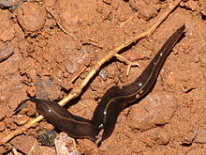
New Guinea Flatworm (Platydemus manokwari) (Photo Wikipedia)
Historically it was introduced as a biological control agent against the Giant African Snail (Achatina fulica). It is an effective predator that poses a serious threat to native snails. Vulnerable native snails threatened by P. manokwari include endemic Partulidae in Gua and Mandarina snails in the Ogasawara Islands (Japan).
Recently, in 2014 it was recorded in a hot house in France (Justine, Winsor, Gey, Gros, & Thevenot, 2014). The flatworm and its cocoons are often associated with soil in rooted and potted plants. A key pathway of introduction and spread is as a contaminant in nursery material. The authors propose an Environmental Pest Risk Assessment to be conducted for this species that could have potentially severe impacts on biodiversity.

In the context of this pathway subclass, Nursery material refers to soils, potting material such as compost, peat, mulch and other material including plants and plant parts such as fragments, roots etc., that may be transported with plants and planting material from a nursery. Examples of species that have been introduced outside their native range through this pathway of introduction include ants, small reptiles, snails and slugs etc. see Box 1 and Box 2
BOX 2
Tranportation of habitat material has been identified as a high risk for the spread of the Red Imported Fire ant (Solenopsis invicta).
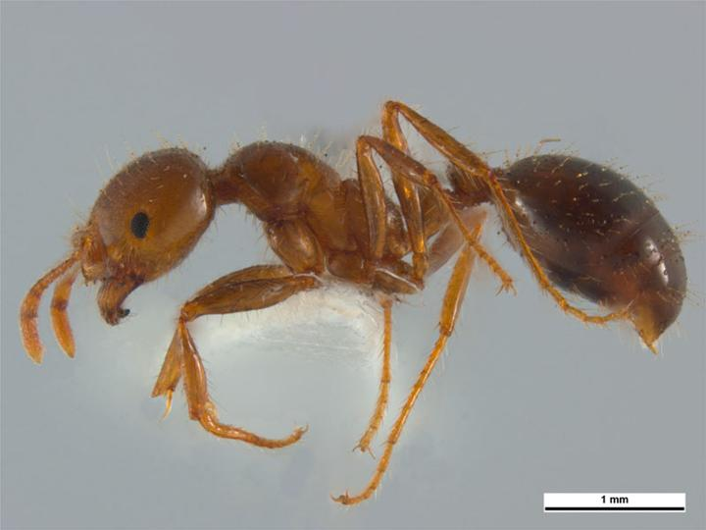
Red Imported Fire Ant (Solenopsis invicata) (Photo Wikipedia)
The first record of RIFA in Australia was in 2001, four other incursions have been reported and large outbreak in Queensland, active but contanied (Invasive Species Council, 2018). Since then . RIFA was reported (and the nest destroyed) in June 2017 at a residential property on Queenslands Sunshine coast. Transportation with soil, turf was mentioned as a likely pathway (Bartholomew, 2017). In New Zealand a Hazard identification and import release assessment for RIFA identifies nursery stock material among a host of other potential pathways of introduction and spread (Biosecurity Authority, Ministry of Agriculture and Forestry, 2002)
RIFA reduces biodiversity among invertebrates and reptiles, and may also kill or injure frogs, lizards or small mammals. In particular the red imported fire ant has the potential to devastate native ant populations. It is competitively dominant to most other invasive ant species; it has displaced the Argentine ant (Linepithema humile), in areas in the USA where the species have been introduced. In the USA, it has been found to negatively impact at least fourteen bird species, thirteen reptile species, one fish species and two small mammal species (through predation, competition and/or stinging). The current economic impact of RIFA on humans, agriculture, and wildlife in the United States is estimated to amount to at least half a billion, if not several billion, dollars per year.
The spread of RIFA in the USA in the 1950s was linked to the nursery trade. Regulations were imposed in 1958 mandating specific treatments to nursery material (Wylie & Janssen-May, 2016). The costs associated with RIFA in the USA, for example, have been estimated at $1 billion per year. The Australian Bureau of Agriculture Resources Economics has estimated the losses procured in rural industries to amount to more than AU $6.7 billion over 30 years. According to a professor at the Texas Agricultural Extension (USA) the agricultural economic losses caused by the ant are an estimated US $90 million annually. In Texas at least US $580 million was spent in 2000 to control this pest. Gutrich et al. (2007) undertook a study to estimate the potential economic costs to Hawaii, in case of the introduction and establishment of the red imported fire ant. The authors of the study conclude that the estimated impact on various economic sectors in Hawaii would be around US $ 211 million/year (Biodiversity and economic impacts information extracted from the Global Invasive Species Database).

.

Contaminated Bait
Species introduced unintentionally as contaminants in/of bait. Bait, both live and frozen including fish, worms, amphibians etc. may carry with them pathogens and parasites. Improper treatment of baits may cause the spread of these pathogens and parasites to areas outside their native range where the bait is used see Box 3.
BOX 3
Larvae of Tiger salamanders (Ambystoma tigrinum) are widely used in the bait trade in USA. Ranavirus was detected in salamanders used in the bait trade, salamandars collected in the wild were widely dispersed as bait and could be a source of pathogen pollution (Picco & Collins, 2008). The authors sugget that this unregulated spread must be regulated including the screening of bait and water.
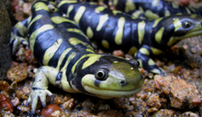
Tiger salamander (Ambystoma tigrinum) (Photo Wikipedia)
The USDA APHIS Plant Protection and Quarantine (PPQ) and USDA APHIS Veterinary Services (VS) issue permits, based on a pest risk analysis, for the importation of regulated organisms used for pet food, animal feed and fish bait into the continental United States. Earthworms that are commonly used as bait are included (United States Department of Agriculture, Animal and Plant Health Inspection Service, 2017).

Food contaminant (including of live food)
Taxa introduced unintentionally as a contaminant of food including live food. Live food including crop plants, vegetables and fruit (see Box 4), and live animals transported for the purpose of processing into meat are a source of food contaminants.
BOX 4
The Mediterranean fruit fly (Ceratitis captata) a contaminant in fresh and processed fruit is widely dispersed and a serious pest. Endemic to most of the sub-Saharan countries, it has dispersed to many African countries, has established in the California region in the United States, it has been recorded in South America and Australia.
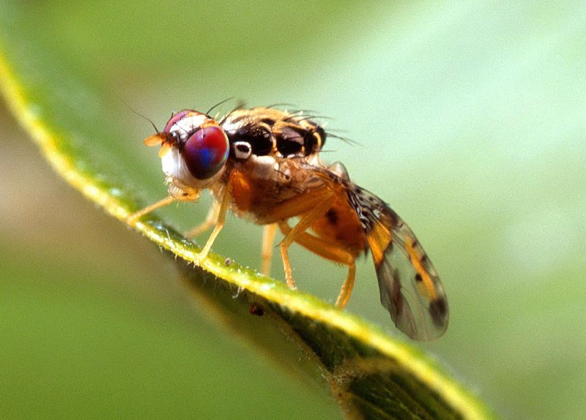
Mediterranean fruit fly (Ceratitis capitata) (Photo Scott Bauer, U.S. Department of Agriculture)
Another fruitfly -the Queensland fruitfly Bactrocera tryoni, a native of Australia was detected in Auckland in 2015- a potential danger to the countries fruit industry, the Ministry for Primary Industries went quickly into action and a community wide surveillance and eradication programme was undertaken and it was declared eradicated. Follow this link for details of the response.
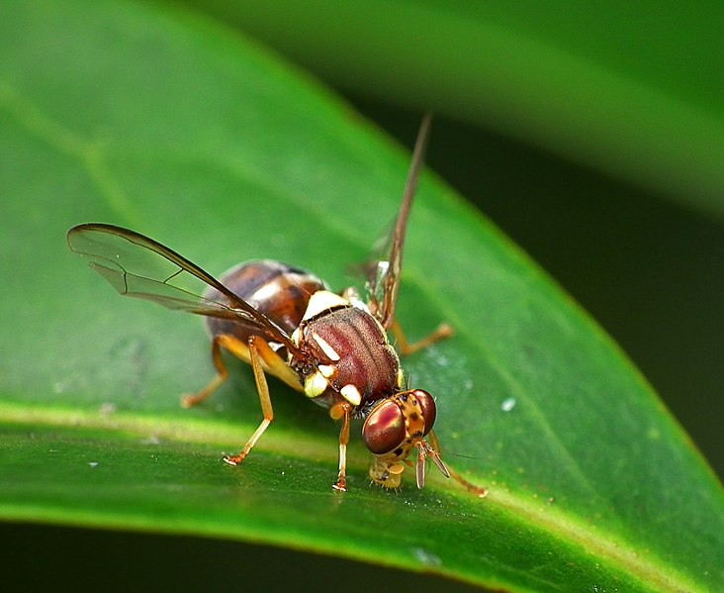
The Queensland Fruitfly (Bactrocera tyroni) (Photo James Niland)
The Ministry of Primary Industries (MPI) New Zealand released the final costs of its eradication programme, which swung into action after the first of 14 flies was found in Auckland. It spent $15.7m eradicating the flies, including setting up hundreds of surveillance traps and collecting fruit and vegetables from houses in the area where the fly was found. Auckland was declared free of the pest in December.
The financial impact of a fruit fly incursion to New Zealand’s kiwifruit industry is estimated to cost between $2 million and $430 million per year (Kiwifruit Vine Health KVH, 2014).

Contaminant on animals (excluding parasites and species transported by host and vector)
Species introduced unintentionally as contaminants on animals transported through human related activities see Box 5. This subclass excludes parasites and species moved by host and vector.
BOX 5
Bathurst Burr (Xanthium spinosum) and Pirri-pirri burr (Acaena novae-zelandiae) are plant species whose hooked spiny seeds can attach themselves to farm and grazing animals Farm biosecurity practices that are aimed at not allowing the alien and invasive plant species to reach seed producing stage is the first step in preventing their spread. Contaminated stock animals also need to be reported.
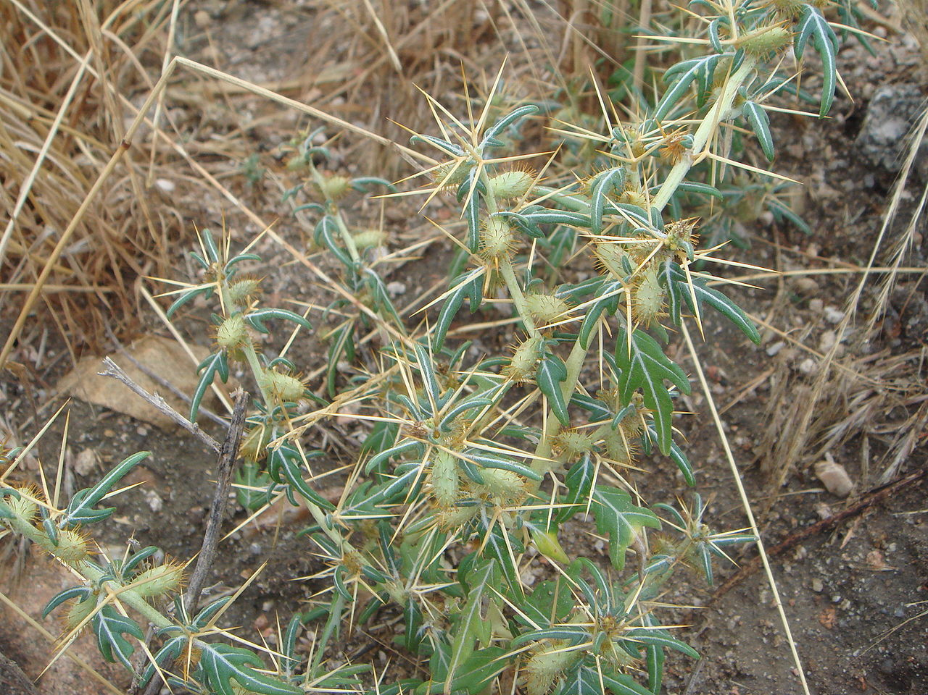
Spiny seeds of Bathurst Burr (Xanthium spinosum) (Photo Xemenendura Wiki Commons)

Parasites on animals (including species transported by host and vector)
Unintentional introduction of parasitic species transported by a host animal or an animal that acts as a vector see Box 6 and 7. These introducted parasites are likely to have impacts on biodiversity in the recepient environment and changes in host specificity are also possible. Ectoparasites and endoparasites are hard to identify by visual inspection, therefore animals require certification by competant authorities before transport.

BOX 6
Chytrid fungi - the amphibian Chytrid fungus ‘Bd’ Batrachochytrium dendrobatidis and the closely related Batrachochytrium salamandrivorans ‘Bsal’ a Chytrid fungus that affects salamandars and newts, are exapmles of parasites on animals that are introduced unintentionally into novel environments. The fungus causes skin lesions and ulcers on affected amphibians leading to disruptions in osmotic regulation and finally death. Some amphibians are a carriers of these pathogens and trade in these amphibian species for the Live food trade, Pet and Aquarium trade are causes of introduction of these pathogens. The US Fish and Wildlife Services has implemented a ban on the importation of Salamandar species (see Injurious Wildlife Species; Listing Salamanders Due to Risk of Salamander Chytrid Fungus). 201 species of Salamandars are banned from importation.
B. salamandrivorans was first detected in the Netherlands in 2013, and has later been found in Belgium in 2013 and 2014. It has also been identified in captive populations of salamanders and newts in Germany and in the United Kingdom. B. salamandrivorans is endemic to Asia, amphibians from this region may act as a disease reservoir. Evidence indicates that B. salamandrivorans is causing disease and mortality in fire salamanders in the Netherlands (OIE World Organisation for Animal Health, 2018).
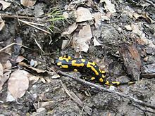
Fire salamander (Salamander salamandra) (Photo Wikipedia)

BOX 7
The spread of the causal agent of Crayfish plague the oomycete Aphanomyces astaci is another example of the introduction of a pathogen unintentionally as a contaminant on an animal. These fungus like watermolds live in the shell of the Crayfish. North American signal Crayfish (Pacifastacus leniusculus), Red Swamp Crayfish (Procambarus clarki) and the Spinycheek Crayfish (Orconectus limosus) carriers of this parasite were introduced into Europe in the late 19th century where they quickly spread (Jernelöv, 2017). European native Crayfish including the Endangered Noble Crayfish (Astacus astacus) and the Whiteclaw Crayfish (Austropotamobius pallipes) were infected by this parasite leading to widespread mortality (see species profiles in the IUCN Red List of Threatened Species). Crayfish species (North American signal Crayfish, Red Swamp Crayfish, Spinycheek Crayfish and Marbled Craysfish) that are carriers of the causal agent of the Crayfish plague, are included in the shortlist of species designated as Invasive Alien Species of Union Concern, this list forms the core of the Invasive Alien Species regulation (EU Regulation 1143/2014 on Invasive Alien Species) that was enacted in the European Union in 2015. Restrictions are imposed on the importing, keeping, breeding, and selling of these species. Member states are obligated to detect and destroy incursions or manage and contain established populations.

Contaminant on plants (excluding parasites and species transported by host and vector)
Species introduced unintentionally as contaminants on plants or plant products transported through human related activities. This subclass excludes parasites and species transported by a host or vector, and applies to species with trophic or abiotic relationships with the plants or plant material being transported.
Examples of introductions through this pathway include introductions through eggs of pest species deposited on foliage of plants, infestations of insects, small amphibians and reptiles etc. see Box 8
A study (Saccaggi & Pieterse, 2013) conducted in South Africa found that budwood cuttings imported into South Africa were found to be infested with arthropods both insects and mites. South Africa under the Agriculture Pests Act requires, that all plant material that is imported into the country are examined upon arrival by the Department of Agriculture, Forestry and Fisheries. 24% of all budwood cutting imported between 2004 and 2011 were found to be contaminated.
BOX 8
The Puerto Rican treefrog Eleutherodactylus coqui has been introduced outside its native range, transported on plants as a contaminant. In Hawai‘i where the population is seen to be expanding, there are concerns of ecological as well as anthropogenic affects. The main pathway for spread has been through the nursery trade as a contaminant on plants. There are concerns that there may be a negative effect on the export nursery trade, should shipments be banned for harbouring frogs. E. coqui have spread from horticultural sites where they were first restricted to public land, residential areas and resorts. There are concerns that property value may be affected due to the high biomass of frogs on infested sites (Invasive Species Specialist Group , 2018).
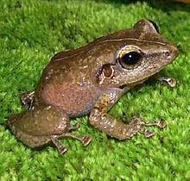
Puerto Rican treefrog (Eleutherodactylus coqui) (Photo Wikipedia)
Experiments were conducted at two spatial scales to investigate the effects of frogs on aerial and litter invertebrates, plant growth and herbivory, and litter decomposition. Results showed that at both scales, frogs reduced aerial invertebrates and leaf herbivory, but had no effect on litter invertebrates. At the smaller scale, frogs increased foliage production rates, measured as the number of new leaves and new leaf area produced, by 80% and decomposition rates by 20%. These results demonstrate that E. coqui may affect ecosystem functions by decreasing prey items and increasing nutrient cycling rates (Invasive Species Specialist Group , 2018)

Parasites on plants (including species transported by host and vector)
Unintentional introduction of parasitic organisms transported by a host plant or a plant that act as vector, including fungal, viral and bacterial diseases of plants. These cases which fall under phytosanitary concerns are difficult to detect at borders unless symptoms can be visually seen on plants. Parasites can be introduced either on their host plant species or by using plants as vectors. Some examples include the spread of Myrtle rust in Australia and New Zealand (see Box 9), and the Phytopthora watermoldin Ireland most likely to have arrived on imported ornamental plants.
Box 9
Myrtle rust (Uredo rangelii), an obligate parasite that requires its host species of the Myrtaceae family is a well known example of a parasite being introduced outside its native range unintentionally on its host species.
Myrtle rust is said to have been established in Florida, USA in the 1970s. It was first identified in Hawaii in 2005 on a nursery grown plant, and has subsequently spread througout the islands. It was most likely introduced to Hawaii as a parasite on imported plants as part of the live plant trade. An interim rule constituting a one year ban on the importation of plant material belonging to family Myrtacea into Hawaii was enacted in 2007. Recently a federal rule was enacted that prohibits the entry into Hawaii of any plants or products belonginhg to family Myrtaceae from other countries.
Myrtle rust is considered a severe threat to New Zealand native biodiversity belonging to the Myrtle family. The rust is widespread on the eastern side of Australia. The highest risk of its entry into New Zealand was on live plants species from Australia. The Ministry for Primary Industries restricted the importation of cut flowers and the raised the quarantine period for plants belonging to the Myrtle family to 6 months (Hood, 2016). Myrtle rust was discovered in New Zealand in May 2017. It is believed that the spores of the fungi were carried to New Zealand by strong winds blowing from Australia; just now the rust is restricted to a few regions and the New Zealand. Measures are in place to report and contain infestations.
Figures presented by the Forest and Wood Products Australia (FWPA) to Primary Industries Ministerial Council (Commonwealth of Australia) in 2006, estimated that the epidemics of Mrytle rust could cause a 60% or 90% reduction in production in high risk forests. The calculations estimated a loss of 2.5 -3.75 million m3 of timber plus hardwood plantation losses of 0.44 -0.66 million m3 resulting in a total gross value reduction of $170-257 million constituting a reduction of total log volume produced in Australia from 9.8-14.8% annually.
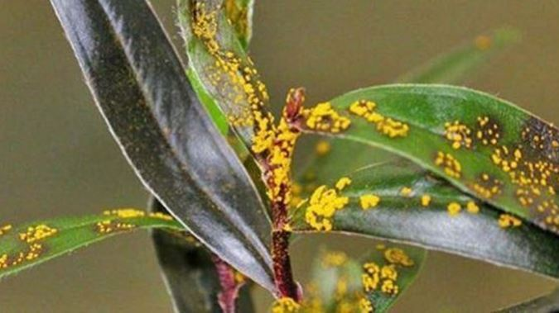
Myrtle rust in New Zealand (Photo \ NZ Herald)

Seed contaminant
Species introduced as contaminants of seed with the exception of seed being used for human consumption. Contamination of seed shipments is a well-known pathway of alien species. One well known example is that of Parthernium (Partenium hysterophorus) introduction into India where it is a widespread invasive species. Seeds of Parthenium are said to have been introduced as contaminants in shipments of food grains (Vartak, 1968). Seeds meant for planting are subject to certification to assure quality and purity. Another example is Aegilops spp. Goatgrass (see Box 10)
BOX 10
A Weed Risk Assessment (WRA) was undertaken for three species of Aegilops (A. geniculata, A. neglecta and A. triuncialis) commonly known as Goatgrass in the United States, by Plant Protection Quarantine Animal and Plant Health Inspection Service (PPQ APHIS). This was initiated by a request for market access in the USA, by the government of Ukraine for the importation of wheat for human and animal consumption.
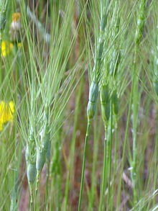
Goatgrass (Aegilops triuncialis) (Photo Wikepedia)
A. triuncialis is naturalised and spreading in California, it is a significant weed of rangeland and forage areas and occupying several million acres in the Central Valley region. It is also present in the states of Nevada, Maryland, New York and Oregon. It is Regulated as a noxious weed seed contaminant in Hawaii and Nevada and a noxiuos weed in California and Orgeon. All Aegilops species are regulated as weed seed contaminants in Oregon, Alaska, New Mexico and Texas. The risk potential of these species was evaluated to assist a decision on whther these three species should be listed as Federal Noxious weeds. The result of the WRA for the three species was that they were a 'HIGH RISK' (United States Department of Agriculture (USDA), 2017).

Timber trade
Species unintentionally introduced as contaminants on timber . Globally timber is traded for the contruction and building industry, as well as for the energy sector. Timber is also used as dunnage. Contaminants on wood including pathogens and parasites can be transported to new locations via the timber trade. Examples include the introduction of insect pests on timber see Box 11.
This pathway can be confused with the Organic packing material pathway as both categories cover contaminants of wood products. While both the sub-categories refer to timber, the distinguishing feature is that Timber trade refers to contaminants in unprocessed timber whereas, Organic packing material refers to stowaways in packing material made of organic material, e.g. including wood.
BOX 11
The Emerald Ash borer EAB Agrilus planipennis is a well known example. A native of Asia and introduced to North America- USA and Canada has caused widespread death of Ash trees. It was first discovered in the state of Michigan in 2002, since then it has spread to over 31 states, including the Canadian provinces of Ontario and Quebec. It is believed to have been introduced as a contaminant on dunnage on ships from Asia. The United States Department of Agriculture Animal and Plant Health Inspection Service has enforced quarantines and fines to prevent the further spread of this species (Emerald Ash Borer Information Network, 2018).
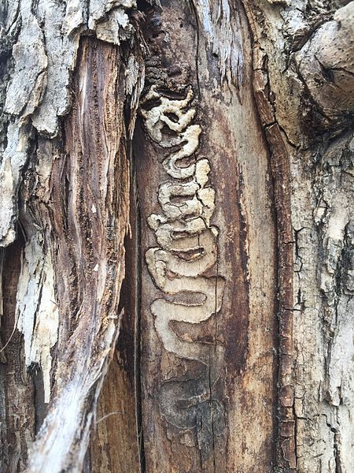
Tunnels bored by Emerald Ash Borer (Agrilus planipennis) (Photo judygva Wiki Commons)
Mckenny et al (2012) estimated the potential cost of impacts of the EAB to the Canadian municipalities based on a simple spread model using spread rates, discount rates and treatment rates.Based on a 30 year spread rate (4% discount rate and 10% treatment rate) costs were estimated at 524 million CAD (2010 value) increasing to 890 million CAD when costs of backyards were included (McKenney, et al., 2012).
Kovacs et al (2010) simulated the spread of EAB in the US, the simulations predicted EAB infestations spreading to 25 states and the costs of responses (including treatment, removal of trees and replacement of more than 17 million Ash trees at 10.7 billion USD (Kovacs, et al., 2010).

Transportation of habitat material (soil, vegetation, wood…)
Species unintentionally introduced as contaminants of habitat material that includes soil, vegetation, landscape material such as chips and mulch, straw, etc. when these products are the focus of trade and not simply transported with plants. Examples of species that have been introduced outside their native range through this pathway of introduction include tramp ants and viable seeds, vegetative parts of plants plant species see Box 12.
BOX 12
The garden ant Lasius neglectus was reported in 1990 in Hungary. It is widely dispersed in Europe now, and one of the likely pathways is believed to be as a contaminant on soils (Ugelvig, et al., 2008).
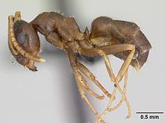
Garden ant (Lasius neglectus) worker from Belgium (Photo Wikipedia)

Transport-Stowaway
The Transport - stowaway category refers to the unintentional or accidental movement of live organisms as stowaway or hitchhikers, attached to a multitude of means of transport and associated equipment and media. The physical means of transport-stowaway include various transportation methods: ballast water and sediments, biofouling of ships, boats, offshore oil and gas platforms and other water vessels, dredging, angling or fishing equipment, civil aviation, sea, and air containers. Stowaways of any other vehicles and equipment for human activities, in military activities, emergency relief, aid and response, international development assistance, waste dispersal, recreational boating, tourism (e.g., tourists and their luggage) are also included under this pathway.

Angling / fishing equipment
Species introduced unintentionally as stowaways on equipment used by recreational anglers or commercial / professional fishermen. Angling / Fishing equipment includes rods, buckets, lines, lures, sinkers, nets, gaffes, traps, waders, boots, tackle boxes etc. Some of these equipment will also be wet and contain water. Zooplankton, aquatic plants, fish, amphibians, invertebrates, fungi and even viruses can be moved from one location to the other as stowaways in these equipment and released unintentionally into new locations see Box 13 and 14.
BOX 13
Spiny waterflea (microscopic zooplankton) eggs that can remain viable for weeks were found fouling fishing lines with the potential of being introduced to new locations (Jacobs & McIsaac, 2007) . Spiny waterflea (Bythotrephes longimanus) native to Europe and Asia, were fisrt discovered in Lake Superior in 1987. Since then they have spread through the Great Lakes. First thought to have been introduced through Ballast water, subsequent spread of this species, both adults and eggs, is thought to have been through Angling and Fishing equipment of recreational fisherman (University of Minnesota, 2018). Outreach and warnings are often in place in Angling/ fishing location, one such example is the “Stop Aquatic Hitchhikers” campaign in the Great Lakes region. The spiny waterflea is a voracious predator and may compete with other planktivores. Through this competition, it has the potential to affect the abundance and condition of zooplanktivorous fish and fish larvae. It also interferes with fisheries by clogging nets and fishing gear (Global Invasive Species Database 2018).
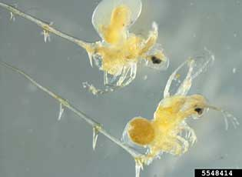
Spiny waterflea adult and eggs (Bythotrephes longimanus) (Photo Gary Montz Invasives.org)

BOX 14
Caulerpa taxifolia is a lightgreen macroalga with upright fronds arising from creeping stolons. An accidental release from the Oceanographic Museum at Monaco in 1984, it now covers several hectares along that coast. By 1992 it was reported in Italian seas on the western Liguurian Riviera. Relini et al (2000) studied the role of fishing gear in the spread of this species. They concluded that trammel nets and bottom otter trawls, used extensively in this area, are most likely to be the vector for the spread of Caulerpa. Caulerpa taxifolia forms dense monocultures that prevent the establishment of native seaweeds and excludes almost all marine life, affecting the livelihoods of local fishermen (Relini, Relini, & Torchia, 2000).
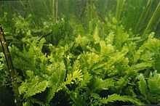
Caulerpa taxifolia (Photo Wikipedia)

Container/bulk
Species introduced as accidental stowaways on containers, bulk freight, airfreight, rail freight etc. (e.g. shipping containers, other cargo in boxes). The phenomenal increase in global trade and the movement of cargo facilitates the movement of alien species as stowaways in freight (air, sea and land) for e.g. in containers, cargo boxes etc. see Box 15
In 2016 six Mongooses (Herpestes javanicus) were discovered to have stowed away in a container that arrived from Fiji. Mongoose are present in Fiji but not in Tonga. This discoverey triggered a massive biosecutity response by the Tongan Quarantine and Environment agencies with support from the Regional Environment agency (Secretariat of the Pacific Regional Environmental Programme (SPREP)) and other non-governmental organisations such as BirdLife International and the Pacific Invasives Initiative (PII). Of the six Mongoose that arrived- two were dead on arrival, two killed as soon as they were discovered and two escaped. Traps were employed. One of the two escapees is believed to be killed (BirdLife International, 2016).

BOX 15
The Asian Gypsy Moth (AGM) (Lymantria dispar) eggs are known to be transported in sea containers. The U.S. Animal and Plant Health Inspection Service (APHIS), an agency in the U.S. Department of Agriculture (USDA) closely monitor seaports for this species including countries from where this pest could enter the USA like Korea, Japan and China. During the active growth season, an AGM free certificate is required from ‘high risk’ ports (World Shipping Council, 2018).
AGM is one of the most destructive pests of shade, fruit and ornamental trees throughout the Northern hemisphere. It is also a major pest of hardwood forests. Asian gypsy moth caterpillars cause extensive defoliation, leading to reduced growth or even mortality of the host tree. Their presence can destroy the aesthetic beauty of an area by defoliating and killing the trees and covering the area with their waste products and silk. Also, urticacious hairs on larvae and egg masses cause allergies in some people ( Information on impacts extracted from the Global Invasive Species Database)
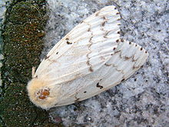
Lymantria dispar Asian Gypsy Moth- Adult female Wikipedia
The AGM was discovered in New Zealand, most likely to have been introduced in bulk cargo of used cars from Japan, in 2003. A spraying and trapping programme was carried out and AGM was declared eradicated in 2005. It was estimated that the economic cost to New Zealand would have been up to $80 million/ annum if it established in this country (New Zealand Farm Forestry , 2005).
Mayo et al (2003) reported on the cost of slowing the spread of AGM in the USA. Slow the Spread (STS) project was initiated in 1992 to target and reduce populations in the transition zones. Total expenditures of STS activities for 1993-1995 were 7,685.2 million USD (Mayo, Straka, & Leonard, 2003)

Hitchhikers in or on airplane
Species that have been introduced unintentionally by being a hitchhiker in or on airplanes and other aircraft (e.g. helicopters, gliders). One of the most well-known examples of the unintentional introduction of an alien species as* a stowaway on airplanes is that of the Brown tree snake (Boiga irregularis) into Guam most likely from Papua New Guinea see Box 16
BOX 16
The Brown tree snake (Boiga irregularis), a native of Papua New Guinea was most likely introduced to Guam as a stowaway on aircraft. This snake established itself in Guam very rapidly and has had devastating impacts on native biodiversity. It has decimated Guam’s birds and herpetofauna, causing the local extinction of over half of Guam’s native bird and lizard species as well as two out of three of Guam’s native bat species. Several indigenous or endemic species of lizards have become extinct or endangered because of snake predation. Guam's 12 forest birds were especially impacted, with 10 species eliminated and the other two severely reduced. By eliminating native pollinators, the brown tree snake has also caused "cascading" effects on Guam ecosystems, reducing pollination by lizards and birds and reducing native plant regeneration and coverage consequently (Global Invasive Species Database 2018).

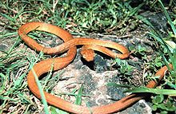
Brown tree snake (Boiga irregularis) (Photo Wikipedia)
Neighbouring Pacific Island nations have targeted Biosecurity measures to prevent the introduction of the Brown tree snake into their territories.
The Regional Biosecurity Plan for Micronesia and Hawaii (United States Department of the Navy, 2015) recognises the dangers associated with the introduction of the Brown tree snake to Hawaii and the territories of Micronesia. The transport and spread of the Brown tree snake is prohibited on aircraft, requiring inspection of all vessels and cargo that leave Guam. The potential cost of a brown tree snake introduction on Hawaii alone has been estimated between $593 million to $2.14 billion annually (US Department of the Interior DOI, 2015)
The USDA APHIS through Acts of Congress require the Department of Agriculture as well as Defence to take all measures, including the use of sniffer dogs and traps and preventative measures at cargo loading points to prevent any Brown tree snake stowaways from entering the State of Hawaii where it could have severe impacts on its native species and economy .

Hitchhikers on ship/boat (excluding ballast water and hull fouling)
Species that have been introduced unintentionally by being a hitchhiker in or on ships, boats or other watercraft (e.g. hovercraft, submarines) but excluding species transported in ballast water or via hull fouling
Rodents and birds are known to hitchhike on ships and boats and can unintentially be introduced to novel locations. Myna species (Acridotheres spp.) and the House crow (Corvus splendens) are a known example of hitchhikers in the Pacific region and in Africa respectively (Invasive Species Specialist Group , 2018). The Ship rat (Rattus rattus) is a well-known species that was introduced globally as a stowaway on ships and boats (Invasive Species Specialist Group , 2018) see Box 17.
Prevention of introduction through stringent biosecurity at points of entry is the recommended management option. Eradication of established populations is expensive and risky.
BOX 17
Ship rat/ Black rat (Rattus rattus) impacts on Biodiversity
The ship rat/Black rat has directly caused or contributed to the extinction of many species of wildlife including birds, small mammals, reptiles, invertebrates, and plants, especially on islands. Ship rats are omnivorous and capable of eating a wide range of plant and animal foods. These include native snails, beetles, spiders, moths, stick insects and cicadas and the fruit of many different plants. They also prey on the eggs and young of forest birds. In the recovery programme for the ‘Vulnerable’ Rarotonga flycatcher or kakerori (Pomarea dimidiata), ship rats are recognised as the most important predator affecting the breeding success of this bird. Several cases are known where predation on seabirds can be reliably attributed to ship rats. These include sooty terns (Sterna fuscata) in the Seychelles Islands, Bonin petrels (Pterodroma hypoleuca) in Hawai', the ‘Critically Endangered’ Galapagos dark-rumped petrels (Pterodroma phaeopygia) in the Galapagos Islands (Harris, 1970), and white-tailed tropicbirds (Phaethon lepturus) in Bermuda.

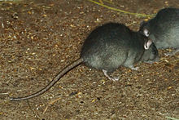
Ship rat/Black rat (Rattus rattus) (Photo Wikipedia)
The ship rat is most frequently identified with catastrophic declines of birds on islands. The best documented examples in the Pacific region are Midway Island in the Leeward Islands of Hawai'i, Lord Howe Island and Big South Cape Island, New Zealand. Atkinson (1977) brought together circumstantial evidence suggesting that ship rats, rather than disease, were responsible for the decline of many species of Hawai'ian native birds during the 19th century (information on impacts extracted from the Global Invasive Species Database 2018)

Machinery/equipment
Species that have been introduced unintentionally by being a hitchhiker in or on machinery or equipment being transported between locations
The transport of machinary and equipment between locations is a likely pathway for the unintentional transport of alien and invasive species. Earth-moving equipment including Tractors, excavators, loaders and water trucks can carry contaminated mud, soil and water with weed seeds and vegetative parts of plants, between locations if they are not cleaned properly.
The Ministry of Agriculture and Forestry (MAF), in New Zealand evaluated the biosecurity risks posed by the importation of vehicles and machinary into New Zealand related to the introduction of alien species (Biosecurity New Zealand, Ministry of Agriculture and Forestry, 2007). High risk groups of organisms identified include ants, beetles, termites, snails, spiders, amphibians, reptiles, mosquitoes, butterflies and moths and other soil-borne organisms.
The Ministry for Primary Indistries (MPI) provides an Importing Guide as well as Import Health Standards for vehicles, machinary, and tyres.
The Canada-Ontario Invasive Species Centre and the Ontario Ministry of Natural Resources by the Peterborough Stewardship Council and the Ontario Invasive Plant Council has published (updated in 2016) a Clean Equipment protocol (Halloran, Anderson, & Danielle, 2013 (2016)), focused on the inspection and cleaning of equipment for the purposes of preventing the spread of invasive alien species. Several weed species have been identified that are known to have been spread through equipment including Common Buckthorn (Rhamnus cathartica), Giant Hogweed (Heracleum mantegazzianum), Japanese Knotweed (Polygonum cuspidatum) and Reed Canary Grass (Phalaris arundinacea).

People and their luggage/equipment (tourism)
Species that have been introduced unintentionally by being a stowaway in or on people and their personal luggage or equipment.
The exponential increase in travelling for leisure, tourism, recreation and work faciliates a pathway for the unintentional introduction of alien and invasive species as stowaway’s in luggage and equipment carried by people.
There is evidence of the introduction of non-native terrestrial and marine species (including seeds and soil) into the Antarctic region and between locations there, on peoples luggage and other belongings (University of Canterbury, 2008). The Committee for Environmental Protection (CEP) of the Secretariat of the Antarctic Treaty has published a Non-native Species Manual Edition 2016 (Committee for Environmental Protection (CEP), 2016) that outlines the risk posed by introduced species in the region and the precautions that need to be taken to prevent the introduction of alien and pottetially invasive species on personal luggage and belongings of individuals. The Australian Antarctic Division (AAD) has introduced a Biosecurity Protocol for scientific projects including the checking and ensuring of luggage and personal belongings being free of propagules when entering the region and for any travel in the region between locations.

Organic packing material (wood packaging material)
Species that have been introduced unintentionally by being a stowaway in or on packing materials such as boxes, pallets, saw dust, hay, straw, etc.
Wood-boring beetles are a well known example of species that can be introduced unintentionally as stowaways on wooden packaging material see Box 18.
BOX 18
The Asian longhorn beetle ALB (Anoplophora glabripennis) is a large wood-boring beetle native to Japan, Korea and China has been introduced widely as a stowaway in organic packing material. The beetle spends most of its life within the inner wood of a variety of hardwood trees as larvae which tunnel and feed on the cambium layer, eventually killing the tree. It was first detected in New York 1996, although it is thought to have arrived in the 1980s in solid wood packing material from China. It has since been detected in Canada and parts of Europe.
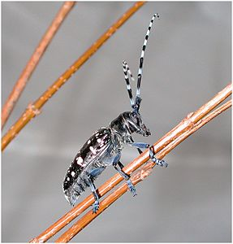
Asian Longhorned Beetle (ALB) (Anoplophora glabripennis) (Photo Wikipedia)
ALB threatens 30-35% of the trees in urban areas of eastern USA. In 2006 the Government Accountability Office GAO in the USA (United States Government Accountability Office (GAO), 2006) estimated that if the beetle spreads out into natural forests, it had the potential to seriously alter the ecological diversity of the natural forests in North America, with additional impacts on wetlands. The potential impact to forests was the loss of 71 billion trees valued at over $2 trillion dollars.
Faccoli & Gatto (2016) quantified the impacts of ALB in terms of tree mortality and their ornamental value in Northern Italy during the first year of eradication of the insect pest. During the first year of eradication 367 ALB infested trees were removed from the infestation area at a total cost of about € 48,000. The ornamental value of the infested trees was estimated at € 850 per tree (Faccoli & Gatto, 2016)

International Standards for Phytosanitary Measures ISPM 15 is an international standard for wood packaging. This standard describes phytosanitary measures that reduce the risk of introduction and spread of quarantine pests associated with the movement in international trade of wood packaging material made from raw wood. It consists of the use of debarked wood as wood packaging material and the application of approved treatments. Treated wood is easily identifiable due to the application of a recogised mark. All National Plant Protection Organisations (NPPOs) of both exporting and importing countries have the responsibility to ensure that approved treatments and application of the mark are carried out under the authorisation of the NPPO. NPPOs of exporting countries have a role to make sure that all standards are met and those of importing countries have a role to make sure that packaging material that subscribes to standards are used. In cases of non-compliance the NPPO is responsible for implementing appropriate mesaures and notification of non-complianace.

Ship/boat ballast water
Species that have been introduced unintentionally via the ballast water of ships and boats
Note that this pathway is excluded from consideration to develop draft supplementary guidance to avioid unintentional introduction of invasive alien species associated with trade in live species, due to the lack of direct interaction with live species and opportunistically attaching themselves to consignments of live species (para. 8 of CBD/SBSTTA/22/9).
The opportunities for the unintentional introduction of aquatic species through ballast water of ships and boats has increased with the increases in global trade and the movement of cargo. Aquatic organisms such as viruses, bacteria, algae, fish, molluscs etc. can be introduced through ballast water. A well known example is the introduction in the mid 1980s of the European Zebra mussel (Dreissna polymorpha) from a European port to the Great Lakes. Another example is the introduction of the stenophore comb jelly Mnemiopsis ledyi a major predator of edible zooplankton pelagic fish eggs and larvae. A native of the temperate, subtropical estuaries along the Atlantic coast of North and South America, it was accidentally introduced in the early 1980s, via the ballast water of ships to the Black Sea, where it had a catastrophic effect on the entire ecosystem. In the last two decades of the twentieth century, it has invaded the Azov, Marmara, Aegean Seas and recently it was introduced into the Caspian Sea via the ballast water of oil tankers (Invasive Species Specialist Group , 2018). Management of Ballast water in order to prevent marine species introductions has been facilitated by the Ballast Water Management Convention BWM see Box 19

BOX 19
Ballast Water Management Convention
Ballast water pumped into holds in ships is used to stabilise ships at sea, compensating for weight changes due to cargo etc. It is taken up or discharged on loading or unloading of cargo. Ballast water when pumped in contain a suite of species from the sea including invertebrates, microorganisms, bacteria in various life stages- as eggs, larvae and adults. When water is discarged at a geographic location well away from the source area, there is the potential of introduction of novel species in these new waters.
With the phenomenal increase in trade in the past few decades, the opportunities to disperse marine species well beyond their native range has increased. There are many examples of introduced marine species that have spread rapidly in their new environment and caused severe impacts to species and ecosystems in this introduced range. Examples include the introduction of the North American comb jelly Mnemiopsis leidyi, that has had devastating impacts on fish stocks in the Sea of Azov and the Black Sea by predating n zooplankton and altering the food web and ecosystem function; and the introduction of the bacterium Vibrio cholorae some strains of which cause the Cholera disease.
After several years of negotiation between its members the International Maritime Organisation (IMO) in 2004 adopted the International Convention for the Control and Management of Ships' Ballast Water and Sediments (BWM Convention). The BWM Convention came into force in Sptember 2017. 71 countries to date have ratified the BWM Convention It provides a list of Guidelines for the proper control and management of ship’s ballast water to prevent the introduction of harmful aquatic species including pathogens to new environments.

Ship/boat hull fouling
Species that have been introduced unintentionally as hull-fouling organisms on ships and boats.
Note that this pathway is excluded from consideration to develop draft supplementary guidance to avioid unintentional introduction of invasive alien species associated with trade in live species, due to the lack of direct interaction with live species and opportunistically attaching themselves to consignments of live species (para. 8 of CBD/SBSTTA/22/9).
The opportunities for the unintentional introduction of aquatic species as hull-fouling organisms on ships and boats has increased with the increases in global trade, and the movement of vessels carrying. Organisms such as barnacles, mussels, sponges, algae, tunicates attach themselves and colonize the hulls of ships and boats, thus hitching rides from port to port. Larvae can be released into new waters and establish themselves on new structures.
The Asian green mussel (Perna viridis), the Black striped mussel (Mytilopsis sallei), the clubbed tunicate (Styela clava) and the seaweed (Hypnea musciformis) are some well known examples of hull-fouling organisms that have been introduced to novel environments and establsihed and caused negative impacts to native biodiversity and ecosystems (Invasive Species Specialist Group , 2018).
The Guidelines for the control and management of ships' biofouling to minimize the transfer of invasive aquatic species (Biofouling Guidelines) was adopted in 2011, by the Marine Environment Protection Committee (MEPC) of the International Maritime Organisation (IMO). These Guidelines provide a consistant approach across the globe in the management of hull-fouling organisms.

Vehicles (car, train, …)
Species that have been introduced unintentionally by being a hitchhiker in or on vehicles such as cars, vans, lorries, trucks, trains, etc. that are not covered by the other stowaway pathways
This subclass includes the introduction of species unintentionally as stowawyas on common modes of ransport such as cars, vans, lorries and trucks. Anecdotal evidence shows that Cane toads (Rhinella marina) that are widespread in parts of Australia, stowaway in transport, cargo, luggage and are introducted to new locations (see Stowaway Cane toad arrives in Rockingham from Queensland via removal van) see Box 20.
The Oxford ragwort (Senecio squalidus) and the South African ragwort (Senecio inaequidens), are described as being dispersed as stowaways on Trains (Ascensão & Capinha, 2017).
BOX 20
Cane toads (Rhinella marina) were intentionally introduced to many countries as biological control agents for insect pests of crops such as sugarcane. Cane toad populations have spread rapidly and they have begun to have severe impacts on native biodiversity in countries where they have been introduced. They will feed on almost any terrestrial animal and compete with native amphibians for food and breeding habitats. Their toxic secretions are known to cause illness and death in domestic animals that come into contact with them, such as dogs and cats, and wildlife, such as snakes and lizards. Human fatalities have been recorded following ingestion of the eggs or adults.
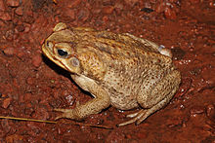
Cane toad (Rhinella marina) (Photo Wikipedia)
Cane toads in Australia are reported to be dispersed as stoaways on vehicles such as cars and trains. There is evidence in Australia that the Cane toad has had direct impact on reducing population of the Yellow-spotted monitor lizard (Varanus panoptes) and Cane toads in Australia (Information extracted from the Global Invasive Species Database 2018)

Other means of transport
Species that have been introduced unintentionally by being a hitchhiker in or on other means of transport other than those already covered by the other stowaway pathways
Oil platforms are a means of transport that have not been covered by the other pathway subclasses. A study (Triay-Portella, et al., 2016) documented the introduction of non-native fish species to the Canary islands through oil rigs. Eleven tropical or subtropical non-native fish species belonging to five families were registered. The origin of these species coincided with the origin of the oil-rigs. The authors of this study recommend more investigations into these type of species introductions.
Compiled by Shyama Pagad- Programme Officer Invasive Species Specialist Group IUCN SSC

Acknowledgements
The compiler would like to acknowledge the contributions of Dr Melodie McGeoch and Chris McGrannachan (Monash University); Dr Piero Genovesi and Lucilla Carnevalli (ISPRA, Italy and IUCN SSC Invasive Species Specialist Group ISSG), Riccardo Scalera (ISSG); Kevin Smith (IUCN); Dr Helen Roy and Colin Harrower (Center for Ecology and Hydrology (UK); Souad Boudjelas (Pacific Invasives Intitiative University of Auckland, New Zealand); Sara Hoffmann (University of Auckland)

References
Ascensão, F., & Capinha, C. (2017). Aliens on the Move: Transportation Networks and Non-native Species. In: Borda-de-Água L., Barrientos R., Beja P., Pereira H. (eds) Railway Ecology. Springer, Cham.
Bartholomew, K. (2017, June 29). Red fire ants found on Queensland's Sunshine Coast for first time. ABC News. Retrieved from http://www.abc.net.au/news/2017-06-29/fire-ants-found-beerwah-sunshine-coast/8663658
Biosecurity Authority, Ministry of Agriculture and Forestry. (2002). Hazard identification and import release The introduction of red imported fire ants into New Zealand via the importation of goods and arrival ofcraft from Australia, the Caribbean, South America, and the USA. Wellington.
Biosecurity New Zealand, Ministry of Agriculture and Forestry. (2007). Import Risk Analysis: Vehicle and Machinery .
BirdLife International, P. (2016). Mongoose on the loose in Tonga.
Committee for Environmental Protection (CEP). (2016). Non-native Species Manual. Edition 2016.
Emerald Ash Borer Information Network. (2018). Emerald Ash Borer. Retrieved from http://www.emeraldashborer.info/
European Food Safety Authority. (2015). Risks to plant health posed by EU import of soil or growing media- EFSA Panel on Plant Health (PLH Panel). EFSA Journal .
Faccoli, M., & Gatto, P. (2016). Analysis of costs and benefits of Asian longhorned beetle eradication in Italy. Forestry: An International Journal of Forest Research.
Faulkner, K. T., Robertson, M. P., Rouget, M., & Wilson, J. R. (2016). Understanding and managing the introduction pathways of alien taxa: South Africa as a case study. Biological Invasions, 18(1), 73–87.
Halloran, J., Anderson, H., & Danielle, T. (2013 (2016)). Clean Equipment Protocol for Industry. Peterborough Stewardship Council and Ontario Invasive Plant Council. Peterborough, ON. Retrieved from https://www.ontarioinvasiveplants.ca/wp-content/uploads/2016/07/Clean-Equipment-Protocol_June2016_D3_WEB-1.pdf
Hood, I. (2016). Myrtle Rust and the New Zealand Forest Industry. New Zealand Forest Research Institute Limited. Retrieved from https://fgr.nz/documents/download/3671
Hulme, P. E., Bacher, S., Kenis, M., Klotz, S., Kuhn, I., Minchin, D., . . . Vila, M. (2008). Grasping at the routes of biological invasions: a framework for integrating pathways into policy. Journal of Applied Ecology, 403–414.
Invasive Species Council. (2018). Australia must stop fire ants in their tracks. Retrieved from https://invasives.org.au/australias-red-fire-ant-emergency-eradication-funding-urgently-needed/
Invasive Species Specialist Group . (2018). Global Invasive Species Database. Retrieved from http://www.iucngisd.org/gisd/
Invasive Species Specialist Group ISSG. (2018). 'Trends in pathways of introductions of alien and invasive species' Indicator Factsheet. Unpublished .
IUCN. (2017). Guidance for interpretation of CBD categories on introduction pathways - Technical note prepared by IUCN for the European Commission. Retrieved from http://nora.nerc.ac.uk/id/eprint/519129/1/N519129CR.pdf
Jacobs, M. J., & McIsaac, J. M. (2007). Fouling of fishing line by the waterflea Cercopagis pengoi: a mechanism of human-mediated dispersal of zooplankton? Hydrobiology.
Jernelöv, A. (2017). Crayfish Plague in Europe. In: The Long-Term Fate of Invasive Species. . In A. Jernelöv, The Long-Term Fate of Invasive Species.
Justine, J.-L., Winsor, L., Gey, D., Gros, P., & Thevenot, J. (2014). The invasive New Guinea flatworm Platydemus manokwari in France, the first record for Europe: time for action is now. PeerJ.
Kiwifruit Vine Health KVH. (2014). Financial impact of a fruit fly incursion to New Zealand’s kiwifruit industry. Retrieved from http://www.kvh.org.nz/vdb/document/98983
Kovacs, K. F., Haight, R. G., McCullough, D. G., Mercader, R. J., Siegert, N. W., & Liebhold, A. M. (2010). Cost of potential emerald ash borer damage in U.S communities, 2009-2019. Ecological Economics.
Mayo, J. H., Straka, T. J., & Leonard, D. S. (2003). The cost of slowing the spread of the gypsy moth (Lepidoptera: Lymantriidae). Journal of Economic Entomology .
McKenney, D. W., Pedlar, J. H., Yemshanov, D., Lyons, B. D., Campbell, K. L., & Lawrence, K. (2012). Estimates of the Potential Cost of Emerald Ash Borer (Agrilus planipennis Fairmaire) in Canadian Municipalities. Arboriculture & Urban Forestry. Retrieved from http://www.bioforest.ca/documents/assets/uploads/files/en/mckenney_etal_2012_-_eab_costs_canada.pdf
New Zealand Farm Forestry . (2005). $80 MILLION PEST ERADICATED.
OIE World Organisation for Animal Health. (2018). Batrachochytrium salamandrivorans. Retrieved from http://www.oie.int/fileadmin/Home/eng/Internationa_Standard_Setting/docs/pdf/A_BSAL_Disease_card.pdf
Picco, M. A., & Collins, J. P. (2008). Amphibian Commerce as a Likely Source of Pathogen. Conservation Biology.
Relini, G., Relini, M., & Torchia, G. (2000). The role of fishing gear in the spreading of allochthonous species: the case of Caulerpa taxifolia in the Ligurian Sea. ICES Journal of Marine Science.
Saccaggi, D. L., & Pieterse, W. (2013). Intercepting Aliens: Insects and Mites on Budwood Imported to South Africa. Journal of Economic Entomology .
Saul, W.-C., Roy, H. E., Booy, O., Carnevali, L., Chen, H.-J., Genovesi, P., . . . Jeschke, J. M. (2017). Assessing patterns in introduction pathways of alien species by linking major invasion databases. Journal of Applied Ecology.
Triay-Portella, R., Pajuelo, J., González, J., Martín, J., Ruiz-Díaz, R., Lorenzo, J., & Luque, A. (2016). Oil platforms as introduction vector of non-native marine fish species to the Canary Islands waters (central-eastern Atlantic). Front. Mar. Sci. Conference Abst.
Ugelvig, L. V., Drijfhout, F. P., Kronauer, D. J., Boomsma, J. A., Pedersen, J. S., & Cremer, S. (2008). The introduction history of invasive garden ants in Europe: Integrating genetic, chemical and behavioural approaches. BMC Biology, 6(11).
UNEP. (2014). Pathways of introduction of invasive species, their prioritization and management. UNEP/CBD/SBSTTA/18/9/Add.1, Subsidiary Body on Scientific, technical and Technological Advice, Eighteenth Meeting, Montreal. .
United States Department of Agriculture (USDA). (2017). Weed Risk Assessment for Aegilops geniculata Roth, Aegilips neglecta Req. ex Bertol., and Aegilops triuncialis L. (Poaceae)- Goatgrass.
United States Department of Agriculture, Animal and Plant Health Inspection Service. (2017). Regulated Organisms Used as Pet Food, Fish Bait, and Animal Feed. Retrieved from https://www.aphis.usda.gov/aphis/ourfocus/planthealth/import-information/permits/regulated-organism-and-soil-permits/SA_Animalfeed/CT_Petfood_fishbait_animalfeed
United States Department of the Navy. (2015). Regional Biosecurity Plan for Micronesia and Hawaii, {Vol 1) Eds. University of Guam and the Secretariat of the Pacific Community. Retrieved from https://www.navfac.navy.mil/content/dam/navfac/NAVFAC%20Pacific/PDFs/Regional%20Biosecurity%20Plan%20for%20Micronesia%20and%20Hawaii/PAC_Regional%20Biosecurity%20Plan%20for%20Micronesia%20and%20Hawaii%20Volume%20I.pdf
United States Government Accountability Office (GAO). (2006). GAO-06-353 Report, April 21, 2006. Invasive Forest Pests: Lessons Learned from Three Recent Infestations May Aid in Managing Future Efforts.
University of Canterbury. (2008). Non-native Species in the Antarctic. Gateway Antarctica Special Publication Series.
University of Minnesota. (2018). Minnesota Aquatic Invasive Species Research Center (MAISRC)- Spiny waterflea.
US Department of the Interior DOI. (2015). Interior Provides $3.7 Million for Brown Tree Snake Control, Interdiction, and Prevention in Western Pacific and Hawaii.
Vartak, V. D. (1968). Weed that threatens crops and grasslands in Maharashtra. Indian Forestry, 23-24.
World Shipping Council. (2018). Industry Issues- Invasive Species. Retrieved from http://www.worldshipping.org/industry-issues/environment/invasive-species
World Shipping Council. (2018). Invasive species.
Wylie, R. F., & Janssen-May, S. (2016). Red Imported Fire Ant in Australia: What if we lose the war? Ecological Management and Restoration, 18(1).

* CBD/SBSTTA/22/1.
** Issued without editing.
The compiler of this report was a co-author of a recent Guidance developed for the interpretation of CBD categories on introduction pathways. The description of the pathway sub-classes is drawn from that report IUCN. 2017. Guidance for interpretation of CBD categories on introduction pathways. Technical note prepared by IUCN for the European Commission.

