 |  | CBD
 |  |  |  | Distr.  GENERAL  CBD/IAS/WS/2017/1/2  7 November 2017  ENGLISH ONLY
Capacity-building workshop for Caribbean small island developing States towards achieving Aichi Biodiversity Target 9
Kingston, 18–22 September 2017

REPORT OF THE WORKSHOP **

INTRODUCTION
- In response to paragraph 9(a) of decisions XII/17 and IX/4 A and B, the Capacity-building Workshop for Caribbean Small Island Developing States towards Achieving Aichi Biodiversity Target 9 was held in Kingston from 18 to 22 September 2017. The workshop was convened by the Secretariat of the Convention on Biological Diversity (CBD) with generous financial support from the Government of Japan, United Nations Environment Program (UN Environment), in kind contributions from the Great Britain Non-native Invasive Species Secretariat of the United Kingdom of Great Britain and Northern Ireland and the Centre for Agriculture and Biosciences International (CABI), and logistical assistance from the Government of Jamaica.
- A total of 39 participants attended the workshop. These included representatives of the biodiversity conservation sector and the national plant protection organization from Small Island developing States in the Caribbean, United Kingdom Overseas Territories in the Caribbean, resource persons of the Great Britain Non-native Species Secretariat, CABI, the Secretariat of the Caribbean Community (CARICOM), UN Environment, and local observers from Jamaica. A full list of participants and their contact information can be found in annex I.

ITEM 1. OPENING OF THE WORKSHOP
- Ms. Junko Shimura, Programme Management Officer for the Global Taxonomy Initiative and Invasive Alien Species at CBD Secretariat convened the workshop at 9:30 a.m. on Monday, 18 September 2017. Ms. Shimura invited the representatives of the Ministry of Economic Growth and Job Creation of Jamaica to open the workshop, and the Caribbean Sub-Regional Office of UN Environment, CARICOM Secretariat, and the Embassy of Japan to join in welcoming the participants.
- Lt. Col. Oral Khan, Chief Technical Director of the Ministry of Economic Growth and Job Creation of Jamaica, welcomed the participants to Jamaica and formally opened the workshop. In his statement, Mr. Khan emphasized the impacts of invasive alien species on ecosystems, economies, livelihoods and public health in the region. He highlighted some of the initiatives that Jamaica is undertaking to reduce these impacts in the country such as the establishment of a National Working Group on Invasive Alien Species and the development of a National Invasive Species Strategy and Action Plan. Mr. Khan also highlighted that Aichi Biodiversity Target 9 will not be achieved solely from individual country actions but through international and regional cooperation and actions. Finally, he encouraged all participants to emerge from this workshop with project proposals and a Regional Action Plan that will sell itself and attract the necessary funding for implementation from multiple sources.
- Mr. Vincent Sweeney, Head of the Caribbean Sub regional Office of UN Environment, also welcomed the participants and stated that the UN Environment, as overarching organization for the Rio Conventions, such as the CBD, is very keen to see more interaction between the CBD Secretariat and the Caribbean. Mr. Sweeney noted the importance of the collaboration among UN organizations to address the risks posed by invasive alien species in the Caribbean region, notably the control and management of lionfish and sargassum. To supplement this collaboration, Mr. Sweeney expressed the keen desire of the UN Environment to secure funding available through the Global Environment Facility (GEF) and elsewhere. Finally, Mr. Sweeney conveyed his best wishes to all participants.
- Ms. Thérèse Yarde, Project Coordinator, Caribbean Hub Capacity Building ACP-MEAs of the CARICOM Secretariat, also welcomed the participants on behalf of the Secretariat General of the Caribbean Community. Ms. Yarde highlighted the collaboration between the CARCOM and CBD Secretariats in building regional capacity to achieve Aichi Biodiversity Targets on mainstreaming, National Biodiversity Strategies and Action Plans (NBSAPs), ecosystem restoration, access and benefit sharing, sustainable financing for biodiversity, and now Aichi Biodiversity Target 9 on invasive alien species. Ms. Yarde also mentioned the ongoing efforts of the Caribbean Community to formulate a regional biodiversity strategy. Conclusively, she emphasized the importance of participants as resource persons that will contribute information and expertise to develop project proposals and action plans during and after the workshop.
- Mr. Shinichi Yamanaka, Deputy Head of Mission, Embassy of Japan to Jamaica, The Bahamas and Belize, welcomed the participants. In his statement, Mr. Yamanaka expressed his gratitude for the opportunity to support the organization of such important workshop for the Caribbean region. He stressed on the close collaboration between the Government of Japan and the Caribbean region in the recent past and congratulated the region on the workshop towards achieving Aichi Biodiversity Target 9.
- On behalf of Ms. Cristiana Paşca Palmer, Executive Secretary of the Convention on Biological Diversity, Ms. Shimura welcomed the participants to the workshop and expressed her deepest sympathies to all participants, their families and friends who have had to endure the severe impacts of hurricane Irma. Subsequently, she noted the importance of cross-sectoral collaboration to put measures in place to prevent the introduction of invasive alien species, as well as to control or eradicate these species. She highlighted the challenges faced by islands as they are considered the most vulnerable places to the introduction, establishment, and negative impacts of invasive alien species. Finally, Ms. Shimura encouraged all participants to engage in the development of a vision that supports safe international trade and sustainable development in the Caribbean region.
- A group photo was taken at the venue of the workshop (see Figure 1).
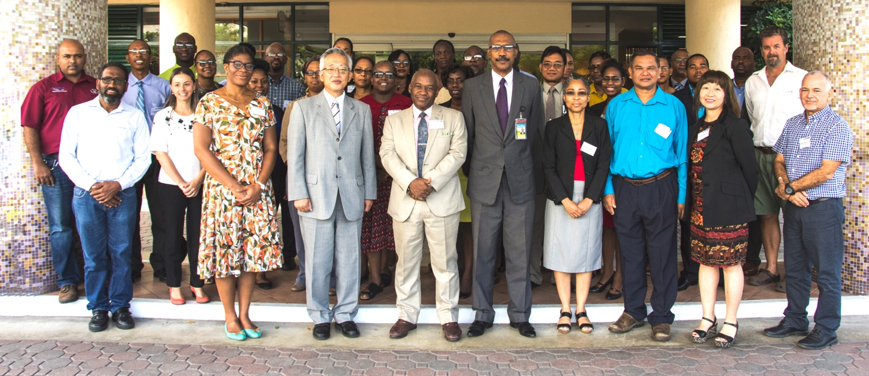
Figure 1. Participants at the opening of the workshop (Photo: Eric Salamanca).

ITEM 2. Organizational matters
- Following the opening of the workshop, a representative of CBD Secretariat introduced the organization of work, including instructions for the poster session aimed at highlighting best practices on the progress towards achieving Aichi Biodiversity Target 9.
- A representative of CARICOM Secretariat shared the action plan that will follow after the workshop.
- Participants were invited to consider and adopt the agenda and organization of work shared by the Secretariat prior to the workshop. Both documents were adopted without amendments.

ITEM 3. Workshop background, goals and expected outputs
“Why are we here?”
- After adopting the agenda and organization of work, CBD Secretariat provided an overview of the background, goals, and expected outputs of the workshop. Expected outputs involved the development of tangible outlines of programmes/projects on invasive alien species management to be implemented at the national or regional level. Such outlines would contribute to the achievement of Aichi Biodiversity Target 9 at the global level.
- Subsequently, participants were invited to introduce themselves to the group and engage in an exercise to discuss cross-sectoral communication and collaboration. They focused their discussion on ways to address the issue of invasive alien species such as the potential spread of red imported fire ants in the region. They also exchanged their views on the roles and common goals of both biodiversity conservation and agricultural sectors with regards to preventing and controlling or eradicating invasive alien species.
- During this exercise, participants representing the ministries responsible for biodiversity conservation and national plant protection organization exchanged information on:
  - The national obligations to implement international agreements such as the CBD, the International Plant Protection Convention (IPPC) and other related international standards;
  - The roles of their ministry/agency on the management of invasive alien species and pests at pre-border (pre-import), border and post-border management in their countries..
- In addition, the Secretariat of the CBD emphasized that transport of alien species with high risk of biological invasion within the national jurisdiction (e.g. transport between islands within a country) should also be considered by the two sectors to achieve Aichi Biodiversity Target 9.
- Participants were then invited to share the ideas exchanged. Among those ideas, participants noted the importance of both biodiversity conservation and agricultural sectors to be on the same page regarding:
  - Listing and prioritizing invasive alien species;
  - Implementing measures of control/eradication;
  - Considering national regulation and legislation on invasive alien species.
- In addition, participants suggested the creation of national committees or task forces at the policy level to deal with this communication challenge between the different sectors.
- Furthermore, participants identified complementary roles in prevention and control of invasive alien species between conservation sector and national plant protection organization.
- Considering the diversity of terms employed by the different organizations, ministries and agencies participating in the workshop to refer to invasive alien species and associated topics, the participants expressed their need for clarification. To fulfill this need, CBD and CARICOM Secretariats took the lead in clarifying the definition of invasive alien species under the Convention on Biological Diversity and IPPC. Accordingly, the definition of invasive alien species and associated terms were reiterated as follows:
  - "Alien species" refers to a species, subspecies or lower taxon, introduced outside its natural past or present distribution. It includes any part, gametes, seeds, eggs, or propagules of such species that might survive and subsequently reproduce (CBD COP Decision VI/23);
  - "Invasive alien species" means an alien species whose introduction and/or spread threaten biological diversity (CBD COP Decision VI/23);
  - “Pest” is any species, strain or biotype of plant, animal or pathogenic agent injurious to plants or plant products (IPPC Glossary of Phytosanitary Terms);
  - “Quarantine pest” means a pest of potential economic importance to the area endangered thereby and not yet present there, or present but not widely distributed and being officially controlled (IPPC Glossary of Phytosanitary Terms);
  - Pests that are not quarantine pests may be subject to phytosanitary measures because their presence in plants for planting results in economically unacceptable impacts. They are defined in IPPC as “regulated non-quarantine pests” (ISPM 16).
- In sum, invasive alien species include those alien species which threaten ecosystems, habitats or native species, as well as species that impact agriculture, forestry, livestock, and aquaculture—in accordance with paragraphs 2-5 of CBD COP decision IX/4A—and the potential negative impacts on biodiversity (and its ecosystem services) posed by the introduction of alien species as pets, aquarium and terrarium species, and as live bait and live food (CBD COP decision XII/16).

ITEM 4. Aichi Biodiversity Targets 9 and projects on invasive alien species management in the Caribbean region
“What has been done?”
- Under this agenda item, a representative of CABI presented the successes, challenges and lessons learned from the project “Mitigating the threats of Invasive Alien Species in the Insular Caribbean (MTIASIC)”during the period 2009-2014. His presentation included an overview of the MTIASIC project, which included 5 components ranging from the development of national and regional invasive alien species strategies to capacity building to prevent introduction, control and manage invasive alien species. Among the successes of the project, CABI highlighted the update and development of 5 national and 1 regional strategies to mitigate the threats of invasive alien species in the Caribbean, and trainings on impact and risk assessment. Challenges included the need for dedicated staff and a formal coordination mechanism, political will to get attention in the region, the myth that information is not available to take action, and the weakness of legislations to enforce prevention. Lessons learned included the need for the multilateral environmental agreements to expand their roles to target the heads of cabinets and finance ministers, and the need to act on the devastating impacts of invasive alien species in the Caribbean and to go beyond awareness and capacity building.
- CABI also gave an overview of the “Strategy and Action Plan for Invasive Alien Species in the Caribbean Region 2011-2016”, developed as part of the MTIASIC project by representatives from national and regional working groups in the region. He shared the participatory process used to develop the strategy and the structure of the final product. The final strategy focused on 5 elements: prevention of new introductions, detection and eradication of new invasive alien species, management of invasive alien species and restoration of ecosystems.
- In addition, Mr. Carlos Rijo, National Coordinator of Invasive Species at the Ministry of Environment and Natural Resources of Dominican Republic, presented the work conducted under the MTIASC project to remove invasive alien species from one of the country’s offshore islands in order to conserve the population of two species of native iguana populations.
- To supplement the review of the progress made toward the achievement of Aichi Biodiversity Target 9 and projects on invasive alien species, Ms. Marianela Araya, GEF Task Manager of UN Environment, was invited to present the project “Preventing COSTS of Invasive Alien Species in Barbados and the Organisation of Eastern Caribbean States (OECS)” via Skype conference call. The GEF Task Manager offered an overview of the project, which aims to prevent, early detect, control and manage frameworks for invasive alien species with a focus on risk management and the highest risk of invasion pathways. Countries participating in the project include Antigua and Barbuda, Barbados, Saint Kitts and Nevis, Saint Vincent and the Grenadines, Grenada, Dominica, and Saint Lucia. Ms. Araya also informed that the project concept was approved by the GEF in 2016 and is planned to be implemented in the period 2018-2021.
- Subsequently, CARICOM Secretariat summarized the progress towards the achievement of Aichi Biodiversity Target 9 in the Caribbean. To do so, the organization presented the overall results of the country dossiers on invasive alien species developed collaboratively by CARICOM and CBD Secretariats prior to the workshop. Among the results, CARICOM Secretariat informed that a total of 17 countries were considered for the production of the dossiers. Out of the 17 countries, CARICOM Secretariat highlighted that 59% have a national target on invasive alien species and this target is included in the National Biodiversity Strategy and Action Plan. In addition, 10 countries have a national policy or legislation on invasive alien species, 88% identified priority invasive alien species, and 78% identified their pathways.
- Additional projects on invasive alien species developed by participating countries, provinces or territories were presented in the format of a poster session. Posters were displayed is a separate room and were visited by participants during lunch times. Poster presenters included Antigua and Barbuda, Bahamas, Barbados, Bermuda, Dominica, Guyana, Jamaica, Saint Kitts and Nevis, and Saint Lucia. Photos of posters are included in Annex VII.
- Following the review of country dossiers, participants were invited to engage in a SWOT analysis exercise in small discussion groups. After concluding their group SWOT analysis, participants were invited share the key points discussed with the plenary. The key points resulting from this exercise are outlined in Annex III.
- To conclude the discussions under this agenda item, CBD Secretariat revisited the main ideas shared among the participants. These included:
  - Invasive alien species listed at the national level;
  - Need for capacity in taxonomy with a focus on species identification and information sharing;
  - Need to improve facilities such as laboratory, disposal and incineration facilities (National Plant Protection Organization);
  - Need to collect information on social and economic impact of invasive alien species;
  - Emergency action plan (rapid response plan) should be established;
  - Need for options of invasive alien species management (biological control, Integrated Pest Management);
  - Need for coordination at the policy level towards legal enforcement of invasive alien species management.

ITEM 5. Evaluation of national policies, legislation, and capacities required within the Caribbean to achieve Aichi Biodiversity Target 9

“What are the gaps we have?”
- Under this agenda item, a representative of the Great Britain Non-native Species Secretariat presented the results of the project “Tackling Invasive Non-native Species in the UK Overseas Territories”. According to this representative, the project aims at improving the biosecurity of the United Kingdom Overseas Territories against invasive non-native species to improve their environment resilience and food security. The Great Britain Non-native Species Secretariat added that the project project carried out a gap analysis of 22 components grouped in three areas: prevention, early warning and rapid response, and management, prioritization and frameworks. To conclude her presentation, Ms. Key shared some of the gaps the project identified. These included limited resources on pathways and species of highest risk, legal policy framework, training, and use of regional coordination bodies and networks.
- Subsequently, the participants from the United Kingdom Overseas Territories Mark Outerbridge, from Bermuda, and Eric Salamanca, from Turks and Caicos, shared their experiences as members of the project presented by the Great Britain Non-native Species Secretariat.
- Afterwards, participants were invited to share their views on national and regional gaps in achieving Aichi Biodiversity Target 9. To guide the discussions during this activity, CBD Secretariat, suggested participants to focus on the following topics:
  - National policies on invasive alien species, agriculture, trade;
  - National legislation;
  - Other relevant policies on pathways management;
  - National capacity to take actions;
  - SPS measures on import and export of animals, plants and their products;
  - Potential impacts on human well-being; and
  - Protecting the value of biodiversity and ecosystem services.
- As a result of the activity, participants identified national and regional gaps to be fulfilled. A compilation of these gaps can be found in Annex IV.
- Considering the gaps identified, CARICOM Secretariat shared the gaps in country dossiers and described the areas requiring definitional clarity. She revisited the definitions and terminology of invasive alien species and pathways under the Convention on Biological Diversity and the International Plant Protection Convention.
- Participants were then invited to share the definitions of these terms used in their respective ministry/agency and in the country dossiers. While some countries and UK Overseas Territories have their own definition of invasive alien species and pathways (e.g. Saint Lucia, Bahamas, and Bermuda), others use the CBD definition (e.g. Guyana) and the IPPC definition (e.g. Barbados).
- To further the debate on pathways, smaller groups were established and assigned a pathway to discuss. Discussions focused on the following questions:
  - What is the prevalence of the pathway in your country (with examples, if possible)?
  - What measures are in place in your country to manage the pathways (with examples)?
  - How adequate are these measures (with explanation)?
      - Not adequate
      - Somewhat adequate
      - Adequate to an acceptable degree
      - Adequate to a high degree
- Participants presented the outcomes of the pathways debate. These outcomes are compiled in Annex V.
- To conclude this agenda item, participants further reviewed and supplemented the information contained in country dossiers, paying special attention to the definitions of terms employed in the text of the dossiers. The review started at the workshop and was agreed to continue after it, as part of the follow up action plan of the workshop.

ITEM 6. Identification of regional priorities FOR invasive alien species management and harmonization of measures to address the risks posed by these species and to achieve Aichi Biodiversity Target 9

“What are the regional issues?”
- Under this agenda item, participants were invited to revisit the workshop goals and expected outputs. CBD Secretariat stressed the importance of the participation of both biodiversity conservation sector and national plant protection organization to address the risks posed by invasive alien species and identify regional priorities.
- Participants were also invited to review the roles of both sectors in dealing with invasive alien species at the national level. To conduct this review, participants formed small groups composed of representatives from both the biodiversity conservation sector and a national plant protection organization from two or three neighbouring countries.
- Representatives from the national plant protection organizations provided an overview of the International Standards on Phytosanitary Measures (ISPMs) to their biodiversity conservation colleagues. They further explored the measures related to quarantine pests, regulated non-quarantine pests and their reporting mechanisms.
- In turn, representatives from the biodiversity conservation sector exposed their role in addressing the risks and consequences posed by invasive alien species, particularly the known impacts of these species on ecosystems, habitats and native species. They also stressed the needs for controlling the populations of these invasive alien species already established and that continue to threaten biodiversity.
- Subsequently, participants were invited to identify existing gaps and measures to be potentially filled and harmonized at the regional level, taking into account the guidance set by the Convention on Biological Diversity and International Standards on Phytosanitary Measures. One recurring gap identified by participants was the lack of communication at the political and regional levels. To reduce this gap, participants suggested coordination of communication through CARICOM Secretariat. CARICOM Secretariat listed possible opportunities to promote the regional environmental agenda to ministers. Additional gaps identified by participants include:
  - National and regional training on risk assessment of alien species becoming invasive in the Caribbean. Training could be based on the ones conducted by United States Department of Agriculture – Food and Agriculture Organization;
  - Engagement of national and regional emergency management organizations on reducing the risk of introduction of IAS during disaster/emergency relief;
  - Border regulation on live animals import/transit taking into account guidance and guidelines established by CBD and OIE – World Organisation for Animal Health;
  - Training on application of Horizon Scanning in the region;
  - Engagement and awareness of customs office and border control agencies on the management of biological invasions risks associated with consignments.
- To conclude the discussions under this agenda item, participants considered a call to action to prevent the invasion of alien species via emergency relief responses after the disastrous passage of hurricanes Irma and Maria in the Caribbean region, referring to paragraph 42 of decision VIII/27 of the Conference of the Parties to the CBD in 2006. Participants supported the release of a joint statement between the UN Environment Caribbean Sub regional Office, CBD and CARICOM Secretariats to be annexed to the workshop report. The joint statement was officially released on 3 November and is available on the Invasive Alien Species website at https://www.cbd.int/invasive/doc/cbd-unec-joint-statement-en.pdf. A copy of the joint statement is also included in Annex VIII.

ITEM 7. Development of programme/project proposals aimed at implementing measures that address the risks posed by invasive alien species and AT achieving Aichi Biodiversity Target 9

“How do we solve the issues?”
- Under this agenda item, CBD Secretariat offered an overview of multilateral environmental agreements, funding opportunities, and additional potential opportunities for eligible Parties to the Convention. Following the overview, CBD Secretariat detailed the logical framework approach used by implementing agencies, such as UN Environment. CBD Secretariat demonstrated an example of logical framework on achieving Aichi Biodiversity Target 9 to help participants get familiar with the task.
- CBD Secretariat also stressed the importance of writing clear and compelling goals, outcomes, and activity outputs and targeting those to third parties such as GEF operational focal points, those implementing and executing agencies, and biodiversity stakeholders. Specifically, CBD Secretariat emphasized that project/logical framework proposals should ensure that:
  - For projects targeting GEF, goals are aligned with GEF priorities and have a clear contribution to conservation of globally significant biodiversity (e.g. unique endemic species, globally recognized sites such as Ramsar sites of World Heritage Sites);
  - Aichi Target 9 is incorporated as a priority in National Biodiversity Strategy and Action Plans given that this a requirement to receive funding from the GEF;
  - For projects targeting the Standards and Trade Development Facility (STDF), a recent PCE was completed. There are opportunities for funding support to build SPS capacity through the STDF grant facility, and linkages can be made between SPS capacity and pest/IAS management.
- CBD Secretariat added that this approach of project formulation better contributes to meeting priorities set by Parties, donors, and implementing and executing agencies.
- To conduct this activity, participants were then invited to form small groups and choose to work at either the national level or the sub regional/regional. Groups were instructed to identify strategies and actions to address invasive alien species by taking into account the following elements of the logical framework approach:
  - Identification of goal, outcome, purpose, outputs and activities;
  - Identification of objective indicators to evaluate the progress on each of the above;
  - Identification of information sources to evaluate using each indicator;
  - Identification of important assumptions and risks (situation analysis).
- Resource persons, staff members of UN Environment and the Secretariats of the CBD and CARICOM Secretariats assisted the groups in identifying the elements to develop the logical framework. One-on-one consultations took place during this activity.

ITEM 8. Presentation of proposals developed
- Under this agenda item, each group presented its draft logical frameworks in plenary.
- While seven groups chose to develop their log frames at the national level, one group chose to create their logical framework at the sub regional level. A summary of the logical frameworks presented is illustrated in Table 1 and the complete results of this activity are included in Annex VI.

Table 1. Logical frameworks presented by participants by title/goal.
LOGFRAME TITLE/GOAL | COUNTRY/GROUP
Regional Coordinating Framework to Effectively manage IAS by 2022 | Antigua and Barbuda, Dominica, and Saint Kitts and Nevis
To protect the endemic iguanas on San Salvador, Andros, The Exumas and Eleuthera in The Bahamas by controlling the population of the invasive alien species Green Iguana (Iguana iguana) | Bahamas
To contribute to Barbados’ prioritization and control of IAS and Achievement of Aichi Biodiversity Target 9 by 2021 | Barbados
To protect threatened native and endemic species in three islands | Dominican Republic
Supporting actions to enable the uptake of Aichi target 9 in Guyana | Guyana
Aichi Biodiversity Target 9 is achieved in Jamaica by 2021 | Jamaica
Strengthening Saint Lucia’s capacity for protection of its unique biodiversity from IAS by 2022 | Saint Lucia
Supporting actions to enable the uptake of Aichi target 9 in Suriname | Suriname

ITEM 9. Development of an action plan for the period 2018-2022 based on regional priorities and programme/project proposals developed

“What actions do we take?”
- Under this agenda item, CARICOM Secretariat introduced the CARICOM Biodiversity Strategy 2018-2022. The strategy aims at establishing a strategic direction for the region on agreed priority targets. Among these priority targets is invasive alien species.
- Subsequently, participants discussed the actions to be taken within the next 12 months to further develop their logical frameworks and prepare project proposals to submit to funding agencies. Participants were invited to submit all outputs produced during the workshop to CBD Secretariat, including their plans to use these outputs at the national and regional levels.
- Among the actions discussed, participants highlighted the following:
  - Connect with their national GEF operational focal point and to present the outputs of the workshop and outline next steps;
  - Create a mailing list to keep in contact;
  - Organize a cross-sectoral meeting on invasive alien species to share outputs of the workshop and initiate national level discussion on programme/project formulation targeting GEF-7. Participants suggested engaging the forestry sector in this process;
  - Review the national legislation relevant to invasive alien species, and if necessary revise the legislation to cover animal imports (mammals, reptiles, amphibians, fishes, insects among others under kingdom Animalia) based on the risk of biological invasions.
  - Communicate the outputs of the workshop to a broader community than that composed of biodiversity stakeholders. This include the industry sector and the general public;
  - Review country dossiers and submit a revised version to CARICOM and Secretariats.
- CBD Secretariat further explained that the logical framework could be a work in progress and suggested participants to adjust it according to feedback received during and after the workshop. CBD Secretariat also highlighted the importance of involving a wider range of sectors that can strengthen the formulation of programme/project proposals at the national level.
- To conclude the discussions under this agenda item, CBD Secretariat informed participants that workshop outputs will be included in the workshop report, and country dossiers will be incorporated into a CBD technical series invasive alien species in small island developing States to be published at the occasion of the fourteenth meeting of the Conference of the Parties to the CBD.

ITEM 10. Review of workshop outputs and next steps

“What did we achieve at the workshop?”
- Participants were invited to complete an online survey to evaluate the workshop. Results of the survey are included in Annex II.
- In addition, participants were encouraged to keep CARICOM and CBD Secretariats informed on the progress of the planned actions over the next twelve months. As a next step, CARICOM Secretariat offered to organize a post-workshop web meeting to follow up the workshop.
- CBD Secretariat also emphasized the importance of the leadership role of participants in advancing workshop outputs when returning to their home institutions. This included sharing scientific information, notably information included in country dossiers, and further strengthening the collaboration between the biodiversity conservation and agricultural sectors to mainstream the invasive alien species agenda.
- Furthermore, CBD Secretariat presented the Global Taxonomy Initiative and its training courses to be held in 2018, as supplementary ideas and means to improve capacity in taxonomic identification of invasive alien species.
- To conclude this agenda item, participants were informed that a post-workshop web meeting to be organized by CARICOM Secretariat would take place in October 2017.
ITEM 11. Other matters
- Under this agenda items, CBD and CARICOM Secretariats announced the best three poster presentations: Barbados, Bermuda and Saint Lucia. Representatives of these countries were awarded CBD shirts, pins and caps.

ITEM 12. Closure of the workshop
- To close the workshop, CBD, CARICOM, and the Great Britain Non-native Species Secretariats congratulated participants for their achievements despite the challenges resulting from the impacts of hurricanes Irma and Maria in the region.
- On behalf of all participants, Mr. Augustine Dominique from Saint Lucia expressed appreciation to the Government of Jamaica for hosting the workshop. He also expressed participants’ gratitude to the CBD Secretariat and UN Environment for organizing the workshop, as well as to the resource persons representing the CARICOM Secretariat, CABI, and the Great Britain Non-native Species Secretariat.
- The workshop closed at 2:30 p.m. on Friday, 22 September 2017.

Annex I

LIST OF PARTICIPANTS

PARTIES
Antigua and Barbuda
- Mr. Ruleo Antonio Camacho  Natural Resources Officer  Department of Environment  Ministry of Health and the Environment  St. John's, Antigua and Barbuda  Email: ruleo.camacho@ab.gov.ag;  ruleo.camacho@gmail.com | - Ms. Janil P. Gore-Francis  Chief of Plant Protection Officer  Plant Protection Unit  Department of Agriculture  Ministry of Agriculture, Lands, Fisheries & Barbuda Affairs  St. John’s, Antigua and Barbuda  Email: janil.gore-francis@ab.gov.ag
The Bahamas
- Ms. Sydnei Cartwright  Environmental Officer  Bahamas Environment, Science and Technology Commission  Office of the Prime Minister  Nassau, The Bahamas  Email: scartwright@best.gov.bs;  sydnei.cartwright@gmail.com | - Mr. Kenneth V. A. Richardson  Assistant Director of Agriculture  Department of Agriculture  Ministry of Agriculture and Marine Resources  Nassau, The Bahamas  Email: kenvarichardson@live.com
Barbados
- Ms. Kim Downes Agard  Environmental Officer  Biodiversity Conservation and Management  Ministry of Environment and Drainage  St. Michael, Barbados  Email: kim.downesagard@barbados.gov.bb;  downeskn@hotmail.com | - Mr. Michael Sylvester James  Senior Agricultural Officer  Plant Pathology  Ministry of Agriculture, Food, Fisheries and Water Resource  Christ Church, Barbados  Email: leahcimsj@gmail.com;  pathology_mar@caribsurf.com
Dominica
- Ms. Shari-Anne A.R.V. Gregoire  Technical Forestry Officer  Environmental Coordinating Unit  Ministry of Health and Environment  Roseau, Dominica  Email: ecu@dominica.gov.dm;  sharianne.gregoire@gmail.com | - Mr. Ryan Anselm  Technical Officer, Projects Service  Division of Agriculture  Ministry of Agriculture and Fisheries  Roseau, Dominica  Email: rlanselm@gmail.com;  anselmr@dominica.gov.dm
Dominican Republic
- Mr. Carlos Modesto Rijo Güílamo  National Coordinator of Invasive Species  Directorate of Wildlife, Department of Genetic Resources, Unit of Invasive Species  Ministry of Environment and Natural Resources  Santo Domingo, Dominican Republic  Email: carlos.rijo@ambiente.gob.do;  rijoguilamo@gmail.com | - Mr. Nelson Domingo Abreu  Plant Protection and Quarantine Inspector  Plant Health Department  Ministry of Agriculture  Santo Domingo, Dominican Republic  Email: nedoca4@gmail.com
Guyana
- Mr. Vidyandand Mohabir  Environmental Officer II  Biological Resource Management  Environmental Protection Agency  Georgetown, Guyana  Email: vvmohabir@gmail.com | - Ms. Seraita Moseley  Plant Quarantine Officer  National Plant Protection Organization  National Agriculture Research Institute  East Bank Demerara, Guyana  Email: seraita.moseley1@gmail.com;  nppogy@gmail.com
Jamaica
- Ms. Yvette Strong  Senior Manager  Conservation and Protection Sub-Division  National Environment and Planning Agency  Kingston, Jamaica  Email: nppogy@gmail.com | - Ms. Monique Inga Tara Solomon  Entomologist/Identifier  Plant Quarantine Produce Inspection Branch  Ministry of Industry, Commerce, Agriculture and Fisheries  Kingston, Jamaica  Email: solomon.mits@gmail.com
Saint Kitts and Nevis
- Mr. Quincy Kevin Bart  Plant Quarantine Officer  Department of Agriculture, Nevis  St. John’s, Nevis, Saint Kitts and Nevis  Email: bartquincy@gmail.com | - Mr. Eavin Parry  Environmental Scientist  Department of the Environment  Ministry of Agriculture, Marine Resources, Cooperatives and the Environment  Basseterre, Saint Kitts, Saint Kitts and Nevis  Email: elvinparry@hotmail.com
Saint Lucia
- Mr. Augustine Dominique  Manager,  Protected Areas and Pitons Management Area Office  Ministry of Education, Innovation, Gender Relations and Sustainable Development  Soufrière, Saint Lucia  Email: augustine.dominique@gmail.com;  augustine.dominique@govt.lc | - Ms. Hannah Dupal-Romain  Crop Protection Officer  Ministry of Agriculture, Fisheries, Physical Planning, Natural Resources and Cooperatives  Castries, Saint Lucia  Email: hanadee24@yahoo.com;  hanadee24@gmail.com
Suriname
- Mr. Asishkumar Romeo Lala
Chief Permit Section (CITES Management Authority)
Suriname Forest Service, Nature Conservation Division
Ministry of Physical Planning, Land and Forest Management
Paramaribo, Suriname
Email: meolala2510@gmail.com

UNITED KINGDOM OVERSEAS TERRITORIES
Bermuda | Turks and Caicos Islands
- Mr. Mark Outerbridge  Wildlife Ecologist  Department of Environment and Natural Resources  Bermuda Government  Bermuda  Email: mouterbridge@gov.bm;  markouterbridge@ymail.com | - Mr. Eric Salamanca  Assistant Director for Research and Development  Department of Environment, and Coastal Resources  Ministry of Tourism, Environment, Heritage and Culture  Turks and Caicos Islands  Email: efsalamanca@gov.tc;  ericfsalamanca@gmail.com

LOCAL OBSERVERS
Jamaica
- Ms. Joni Jackson  Director, Natural Resources  Environment and Risk Management Division  Ministry of Economic Growth and Job Creation  Kingston, Jamaica  Email: joni.jackson@megjc.gov.jm | - Ms. Andrea Donaldson  Manager  Projects Branch  National Environment and Planning Agency  Kingston, Jamaica  Email: adonaldson@nepa.gov.jm
- Ms. Suzanne Davis  Senior Research Officer - Clearing-House Mechanism  Natural History Museum of Jamaica  Institute of Jamaica  10-16 East Street  Kingston, Jamaica  Email: sdavis@nhmj-ioj.org.jm | - Mr. Dayne Buddo  Marine Ecologist  Lecturer and Academic Coordinator  Discovery Bay Marine Laboratory and Field Station  Centre for Marine Sciences  University of the West Indies (Mona)  Queens Highway  Saint Ann, Jamaica  Email: dayne.buddo@uwimona.edu.jm;  daynebuddo@gmail.com
- Mr. Garnet Thompson
Veterinary Officer
Veterinary Services Division
Ministry of Investment, Commerce, Agriculture and Fisheries
Kingston, Jamaica
Email: getpops@yahoo.com

KEY NOTE SPEAKERS AT THE OPENING OF THE WORKSHOP

Government of Jamaica | Government of Japan
- Mr. Oral Khan (Lt. Col.)  Chief Technical Director  Ministry of Economic Growth and Job Creation  Government of Jamaica  Kingston, Jamaica  Email: oral.khan@megjc.gov.jm | - Mr. Shinichi Yamanaka  Counsellor and Deputy Head of Mission  Embassy of Japan to Jamaica, the Bahamas and Belize  Kingston, Jamaica  Email: shinichi.yamanaka@mofa.go.jp

RESOURCE PERSONS

- Ms. Thérèse Yarde  Project Coordinator  Caribbean Hub Capacity Building ACP-MEAs  CARICOM Secretariat  Georgetown, Guyana  Email: therese.yarde@caricom.org | - Ms. Gillian Key  Overseas Territories Project Manager  Great Britain Non-native Species Secretariat  York, United Kingdom  Email: gillian.key@apha.gsi.gov.uk
- Mr. Naitram (Bob) Ramnanan
Invasive Alien Species Coordinator
Centre for Agriculture and Biosciences International (CABI)
Curepe, Trinidad and Tobago
Email: n.ramnanan@cabi.org

UNITED NATIONS ENVIRONMENT PROGRAMME

- Mr. Vincent Sweeney  Head  Caribbean Sub-Regional Office  UN Environment  Kingston, Jamaica  Email: vincent.sweeney@unenvironment.org | - Ms. Alexandra Karekaho  Programme Officer  Caribbean Sub-Regional Office  UN Environment  Kingston, Jamaica  Email: alexandra.karekaho@unep.org
- Ms. Lorna Inniss  Coordinator  The Caribbean Environment Programme  UN Environment  Kingston, Jamaica  Email: lvi@cep.unep.org | - Ms. Jodi Johnson  Programme Assistant, Marine Biodiversity  Specially Protected Areas and Wildlife Sub-Programme  Cartagena Convention Secretariat  Kingston, Jamaica  Email: jj@cep.unep.or
- Mr. Giacomo Udugbor
Intern
The Caribbean Environment Programme
UN Environment
Kingston, Jamaica
Email: intern1@cept.unep.org

SECRETARIAT OF THE CONVENTION ON BIOLOGICAL DIVERSITY

- Ms. Junko Shimura  Programme Management Officer for the Global Taxonomy Initiative/Invasive Alien Species  Scientific and Policy Support Division  Secretariat of the Convention on Biological Diversity  UN Environment  Email: junko.shimura@cbd.int | - Ms. Fabiana Figueiro Spinelli  Consultant, Invasive Alien Species & Global Taxonomy  Scientific and Policy Support Division  Secretariat of the Convention on Biological Diversity  UN Environment  Email: fabiana.spinelli@cbd.int

Annex II

WORKSHOP EVALUATION

Participants were invited to complete an online survey to evaluate the workshop. The evaluation survey was composed of 12 questions and a total of 17 participants out of the 38 included in Annex I responded them. The results of each question are illustrated below.

- Workshop Logistics

The overwhelming majority of survey respondents found that the workshop logistics was excellent or good. Comments to improve workshop logistics included:
- Have a separate lunch room to allow for a more efficient workshop;
- Increase the variety of the lunch menu;
- Adjust the room temperature; the air conditioning made the room too cold;
- Offer a trip to see some of the biodiversity of the host country;

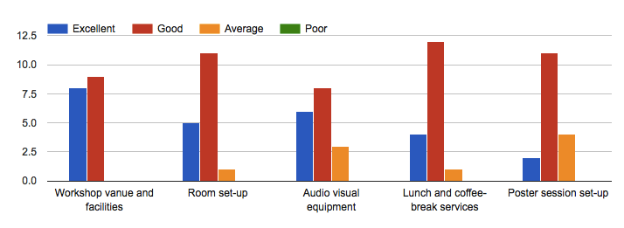

- Quality and Usefulness of Workshop Activities

The vast majority of survey respondents rated the overall quality of the workshop activities as excellent or good and the usefulness of these activities for their work back home as extremely or very useful.
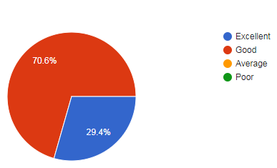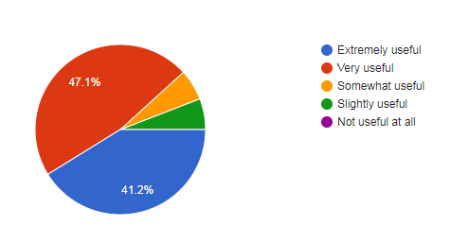

- Confidence in Formulating Logframe/Project Proposals

The greatest proportion of survey respondents feel confident to formulate log frame or project proposals aimed at implementing measures that address the risks posed by invasive alien species and at achieving Aichi Biodiversity Target 9, while a smaller proportion feel somewhat and slightly confident in performing that task.
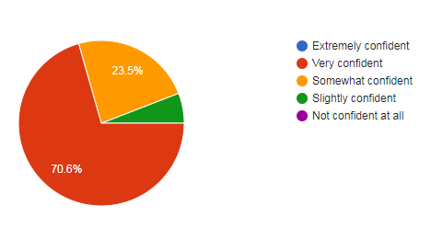
- Usefulness of Workshop Sessions

Overall, the majority of survey respondents rated the sessions related to agenda items 3 (workshop background, goals and outputs), 4 (progress of Aichi Target 9), 5 (evaluation of national policies), 6 (identification of regional priorities), 7 (development of logframe proposals), 8 (presentation of log frame proposals), 9 (development of action plan), and 10 (review of workshop outputs) extremely or very useful. Items 1 (opening) and 12 (closure) were majoritarily rated as very useful or somewhat useful. Comments regarding the usefulness of the workshop sessions included:
- Participation of the attendees and the sharing of their knowledge enhanced the workshop;
- Sessions on the preparation of individual log frames were useful. By seeing other countries submissions, these sessions gave participants a chance to improve on their own log frames;
- The open ceremony was too long;
- It would have been more useful if participants were more specific in what to do when they get back home;
- I appreciate very much a chance to consult face-to-face Dr. Junko Shimura, Dr. Therese Yarde and Dr. Jillian Key on their various pieces of advice on how we (UKOTs) will go about evaluating availability of relevant provisions to achieve Target 9 of Aichi Convention.
- The sessions served to foster additional and very useful discussions between plant health and environment officials to bring all closer to being and operating on the same page;
- Information on funding options was useful;
- More time could have been allotted to some sessions.

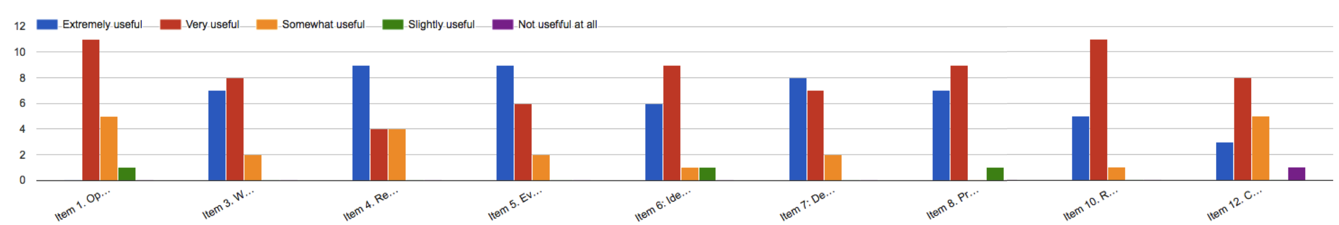

- Learning Challenges During the Workshop Sessions

The majority of survey respondents found that the development of log frames/project proposals was the most difficult thing to learn during the workshop. Their comments included:
- The log frame complexity was more similar to a work plan IMO;
- Information on the development of log frames should have been made available prior to the workshop;
- The preparation of the log frame document for project proposals proved to be the most difficult, particularly at the beginning of the activity. This is because it is not an activity conducted very frequently by this participant;
- The log frames development required input of other colleagues.

- Poster Session
The overwhelming majority of survey respondents evaluated the usefulness of the poster session as extremely or very useful. Comments to improve this session included:
- Provide more information on the guidelines:
  - Include details in terms of objectives and design specifics;
  - Add a suggested format and focus for the poster so that countries are able to showcase the information most pertinent to the process;
  - Announce poster guidelines in advance, including in the notification of the workshop.
- Provide a technical/scientific abstract of the poster for a better understanding of the overall message of the project being described in the poster.
- Allot time for each presenter as part of the agenda. This would facilitate more exchange of information and experiences;
- Have the posters displayed all week in the same room;
- Offer more space to walking around the poster;
- Expand the poster to cover beyond the list of prioritized Invasive Alien Species;
- Show the successes achieved by countries.

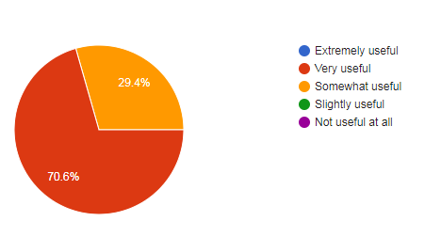

- Usefulness of USB Key Resources
The vast majority of survey respondents evaluated the usefulness of the resources included in the USB key to support your learning during the workshop as extremely and very useful. Comments regarding these resources included:
- The distribution of digital hands out was appreciated as it is good for the environment;
- CBD should continue distributing USB keys in future meetings, workshops, and trainings.

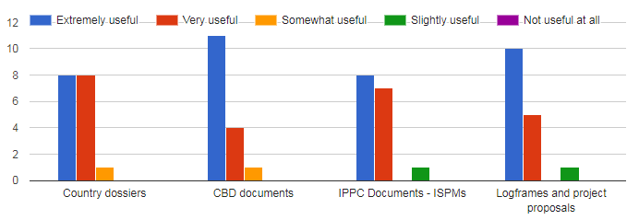
- Additional Comments
Survey respondents offered additional comments on how we can improve future workshops. These included:

- Consider the hurricane season in the Caribbean region for future events ensuring they take place outside this season (November-May);
- Offer a field trip:
  - Being able to visit important biodiversity areas of the host country would have been a welcome addition;
  - For future workshops I would like to suggest having a field trip to sites where IAS management is being undertaken;
  - Field trips in country to see IAS management in action.
- Workshop agenda/sessions:
  - Allocate more time allotted to critical sessions;
  - Invite local GEF focal points and representatives from the customs agency/department to participate;
  - Instructions were sometimes confusing.
- Country dossiers:
  - Country dossiers must be sent to the country before being compiled, so each participant may have sent their comments before compiling them, and update some information that is not currently updated and rectify some other data that must be verified.
- Preparation and follow up:
  - The pre-workshop meeting and the proposed post-workshop meeting will be very useful.

Annex III

RESULTS OF THE SWOT ANALYSIS EXERCISE

Group Analysis
Group 1: Saint Lucia, Jamaica, and Barbados
STRENGTHS | - Good interagency collaboration  - Inclusive of NGOs and academia  - Highly trained, experienced and competent staff  - Identification capacity for IAS {Jamaica)  - Pest risk analysis  - Participation in international processes  - Good structures for addressing IAS  - Ministry of Agriculture and its department  - Working on Biodiversity  - Interception capacity (Jamaica)  - Quarantine  - Public education  - Surveillance and early alerts  - Success in project identification and implementation (St. Lucia)
WEAKNESSES | - Limited capacity as numbers of staff are limited  - Lack of trained staff is some areas  - Financial capacity  - Structures are in place but need strengthening  - Inadequate legislation  - Constant change at the policy level  - Limited appreciation of importance of IAS issues
OPPORTUNITIES | - Involvement of regional and international partners in preparation of briefing policy document  - Access to international agencies and guidelines  - Access to scientific information  - New diagnostic facilities  - Capacity building - training opportunities  - Funding opportunities  - Influencing national policy  - Regional Cooperation  - Use of regional structures such as UWI, CABI  - Integration and harmonization of policy and legislation  - Public engagement as surveillance  - Use of existing guidelines in the IPPC
THREATS | - Increased liberalization  - New methods of trading internet pet trade  - Unintentional introductions through hitch hikers on legitimate trade  - Increase in Tourism, trade and tourism  - Illegal trade and illegal entries  - Signature of agreement that may have negative implications in terms of strict adherence to IAS Strategies, capacity to implement  - Policy shifts diminishing the importance of IAS at the international, regional and national level  - Climate movement of IAS and impact of infrastructure  - Increase infrequency and intensity of hurricanes

Group 2: Saint Kitts and Nevis, Dominica, Antigua and Barbuda
STRENGTHS | - Existence of technical presence at the borders  - Sensitization and public awareness exists at various levels  - National focus on biodiversity conservation exists  - Fairly good communication exists at the technical level  - A multi-sectoral Technical Advisory Committee established in the Department of Environment meets once monthly to discuss ongoing and planned projects & to ensure synergies & sustainability of work programs  - Existence of a good relationship with partner agencies (e.g. NGOs, community groups, regional/international agencies, etc.) with knowledge & technical capacity on IAS issues  - Existence of IAS relevant legislation and regulatory presence at ports of entry  - Access to/participation in high level dialogue at the regional & international levels  - Some level of knowledge & capacity exists (e.g., Gene banks established to combat LY strains & establishment of farmer field schools to combat Diamondback moth) [St. Kitts/Nevis]  - Under law, areas have been designated as protected areas and forest reserves [Antigua and Barbuda, Comm. of Dominica]  - Border control agencies have developed lists of prohibited & permitted commodities, based on Pest Risk Analysis
WEAKNESSES | - High turnover rate of technically capable staff, particularly within government agencies  - Lack of quantification systems to determine impact of IAS  - Lack of trained human resources  - Weak institutional framework (e.g., labs, etc.)  - Lack of national IAS strategy & coordination group  - Lack of IAS-specific legislation  - Lack of coordination at the policy level  - Funding for IAS management does not appear to be a priority
OPPORTUNITIES | - Existence of agencies with an IAS focus with whom greater collaboration is possible  - Collaboration & opportunities with international organizations with knowledge and experience in IAS issues  - Ability to attract funding due to presence of key biodiversity areas  - A national biodiversity strategy can be linked to other sectors (tourism, education, finance, etc.)  - IAS has been identified by the GEF as a priority area for funding  - Existence of various international standards, guidelines that can be adopted at the national level (OIE, IPPC, etc.)
THREATS | - Lack of adequate policy buy-in by stakeholders  - Lack of political will, particularly as it relates to providing resources OR support of proposed policies which are seen as prohibitive to economic growth]  - IAS management is costly and national funding for sustainability of such efforts is limited  - Governments’ priorities re: IAS changes  - Increase in trade, services & infrastructure development increases vulnerability to entry of IAS

Group 3: Bahamas, Dominican Republic, and Jamaica
STRENGTHS | - Support from other govt agencies, NGO, civil societies and other stakeholders  - Legislation  - NIAS Strategy  - Working groups and committee  - Identification capacity (Taxonomy)  - NBSAP
WEAKNESSES | - Public awareness  - Capacity (human resources)  - Budget  - Reactive instead of proactive  - Local buy-in  - Policy support  - Geography of the island(s)
OPPORTUNITIES | - SDGs and Aichi Targets include IAS (Global Agenda)  - International funding for projects  - Regional collaboration  - Funding for regional projects  - Graduate students working on IAS
THREATS

Group 4: Jamaica, Guyana, Suriname, UK, and Bermuda
STRENGTHS | - EPA/Conservation (together)  - Personal networks  - Public/Private partnership (implementation)  - Technical capacity
WEAKNESSES | - No IAS legislation  - NPPO and EPA working in isolation  - Lack of specialized technical experts  - Lack of funding  - Inadequate border control
OPPORTUNITIES | - NGO/Governmental collaboration  - Research opportunity (for funding – lionfish)  - Mechanism for collaboration (communication)  - Border agents collaborate (Customs, NPPO)
THREATS | - Political intervention  - Changes in government policies  - Natural disaster  - Travel tourism/trade

Country Analysis

Bahamas
STRENGTHS | - NISS  - Public awareness via various means  - NBSAP  - Biodiversity Committee which discusses a number of BD committee including IAS  - Technical expertise  - Good collaboration between gov agencies, civil society groups/NGOs & other stakeholders  - Collaboration with other gov agencies (Customs) in frontline defense of borders/ports  - Varied pool of expertise that can contribute to initiatives, issues, etc.  - Have generated a list of experts locally & externally, a broad knowledge base, e.g., experts on local flora & fauna hydrologist wildlife ecologists
WEAKNESSES | - Size of country/geography  - Continuity after project completion  - Capacity in technical personnel  - Budget & funding  - Actions are reactive instead of proactive  - Lack of specific IAS legislation and/or stalled legislation  - Has not been gazette or still in draft form  - Lack of political will  - Little public interest  - No technical presence at the border  - Staff attrition  - Limited of M&E  - Lack of technical expertise within the Dept. of Agriculture for surveillance of ports of entry  - Lack of technical capacity across the scope of The Bahamas
OPPORTUNITIES | - IAS is on the global agenda through SDGs & Aichi Targets  - int’l funding  - Regional collaboration  - UB is developing capacity in its environment & natural resources colleges  - Support through grad research  - Through research permits and collaborations with int’l organizations we have access to seed banks  - Various international standards that can be adopted
THREATS | - Pet trade  - Increased (international) trade  - Unmanned ports of entry  - Natural disasters = decreased resilience  - Economic value of IAS that can be a threat  - Increased tourism/globalization  - Climate change  - Sea level rise  - When funding requests are made, the archipelagic nature of our islands are not taken into account  - Our GDP is skewed, which frequently leads to insufficiently funded projects

Jamaica
STRENGTHS | - Identification capacity  - Knowledge in marine and terrestrial IAS  - Inspection/ Interception at ports of entry  - Pest Risk Analysis Unit  - Institutional support (across the public sector)  - IAS Working Group including NGOs and academia  - Public education programmes  - Early alert leading to control  - Priority potential IAS list
WEAKNESSES | - Lack of human resources  - Inadequate funding  - Lack of legislation  - Lack of understanding from the general public
OPPORTUNITIES | - Access to information from other organizations  - Shared information within the region  - Access to international and regional organization (funding and technical assistance)
THREATS | - Illegal imports  - Increase in tourism, trade and shipping  - Natural disasters as pathways

Annex IV

RESULTS OF THE GAPS IDENTIFICATION EXERCISE

Group 1: Saint Lucia, Jamaica, Barbados, and Bermuda
- Some countries have IAS included in their NBSAPs
- Instead of bringing new species to the country, use what is already there
- Legislation for zoos and aquariums - lionfish
- Many administrative procedures are in place, but may not be covered by current legislation
- Capacity to enforce IAS legislation
- ISPM 41 movement of vehicles

Group 2: Saint Kitts and Nevis, Dominica, Antigua and Barbuda
- Gaps as it relates to: SPS measures on import and export of animals, plants and their products
- There is a need to increase the efficiency of passing legislations relevant to IAS issues, particular as it relates to stressing to policy makers the importance of passing these acts (Antigua e.g.)
- There is a need for internal checks, particularly between Antigua and Barbuda, to regulate the exchange of items between the two islands. Particularly as it relates to difference of issues found in Antigua and Barbuda. Need for internal quarantines, and adherence to internal quarantines (GAS e.g.).
- Yachting sector is a high-risk pathway, which is dependent of reports from custom offices to the various agencies.
  - Trash disposal during customs checks and ship generated waste (Marpol convention is not applied to yachting with the same emphasis as cruise ships, etc.)
  - Pets allowed to roam
  - Importation of “foreign food” which is allowed to transit from port to yacht.
- Lack of training of border control agents (customs staff). There are often informalities at the borders.
- Insufficient human resource, which requires the cross training of agencies to ensure awareness.
- OECS is looking at getting member states to set up a body which deals with SPS regulations
  - Antigua Barbuda is setting up a council which will address cross-cutting issues.
  - We have model Plant and Animal health acts, and model Food Safety act, but these needs to be adopted by the country
  - Dominica: SPS committee is merging into the Agriculture, Health and Food Safety committee and will have joint programs.
- There is an absence of updated pest list, which reduces the ability to conduct an adequate gap analysis.
- There is a need for horizon scanning as it relates to IAS (e.g. Monkeys from St. Kitts to Antigua, need to develop IAS strategy). The Plant health has a regional priority pest list (top 10) and countries are asked to develop their own list of quarantined pest. Although the framework exists, it needs strengthening and improvement of its efficiency.
- Import of food from exotic places (e.g. Sweet Tamarind from Thailand that was initially brought it without import permits). There is often a lack of enforcement due to lack of resources. Non-processed dried (not roasted) feed for animals.
- Passenger baggage is a major gap. Standard for facilities at ports of entry (New Airport issues in Antigua)
- There is a need to develop protocol to handle emergency situations where aid is incoming into a country (e.g. Current Hurricane emergencies)

Group 3: Bahamas, Dominican Republic, and Jamaica
- Effective communication, education and public awareness
  - Promoting IAS establishment and spread
  - Increase coordination between agencies.
  - AS working group publish a newsletter
  - Public awareness campaigns to deal with IAS before they are established
    - IAS affect local livelihoods and cultures
  - Early alert system for potential IAS
    - CIASNET role - to know what is moving and potentially invading other islands
    - PestNet
- Early detection and rapid response

Group 4: Jamaica, Guyana, Suriname, Turks and Caicos, and Bermuda
- Infrastructure
  - Quarantine facilities (ISPM 34)
  - Fumigation facility (ISPM 38)
  - Incinerator close to the ports of entry
  - Diagnostic lab
- Human resources
  - Tech experts
  - Entomologists
  - Soil
  - Marine
  - Health
- Working group coordination

Annex V

RESULTS OF THE PATHWAYS DISCUSSION

Group 1: Jamaica, Barbados and Saint Lucia
Release in nature refers to the intentional introduction of live alien organisms for the purpose of human use in the natural environment. Examples include for biological control, erosion control (and dune stabilization), for fishing or hunting in the wild; landscape “improvement” and introduction of threatened organisms for conservation purposes.

PREVALENCE OF PATHWAYS IN JAMAICA, BARBADOS AND SAINT LUCIA
COUNTRY | IAS | PURPOSE
JAMAICA | Sterile Fly (Cochliomyia hominivorax) | Released for screwworm control
JAMAICA | 2 African parasites released to control (Cephalonomia stephanoderis and Prorops nasuta) | Released to control Coffee Berry Borer
JAMAICA | Wasp | Pink hibiscus mealy-bug (lady bird bug, anygyrus)
BARBADOS | Wasp (Anygyrus) | Pink hibiscus mealy-bug (lady bird bug, anygyrus)
BARBADOS | Mongoose (Herpestes javanicus) | Control of snakes and rats on plantations
BARBADOS | Sages (Artemisia Spp) | released as ornamentals
BARBADOS | Leuceana (Leuceana leucocephala) | for fuel wood to drive bio-fuel production
SAINT LUCIA | Wandering Jew (Trandescantia Zebrine) and Basket Plant (Callisia Fragrans) | Introduced as ornamentals especially along the Gros Piton Nature Trail in the Piton Management Area (PMA) World Heritage Site in Soufriere
 | Heliconia (Heliconia wagneriana) | for horticultural interests
 | Leucaena | for animal feed and alternative wood for charcoal production
 | Asian Mongoose (Herpestes javanicus) | brought in during the sugar cane era for control of snakes
 | Cane Toad (Bufo Marinus) | Introduced intentionally

Group 2: Dominica, Antigua and Barbuda, Saint Kitts and Nevis
- Pathway discussion exercise: ESCAPE from confinement
- Additional pathway could be SEEDS for feeding
- Agriculture (medium prevalence, few examples (e.g. neem which was brought for insecticide purposes, grass brought for agriculture feed)
- Aquaculture (low, non-suitable habitat for escapes)
- Botanical Gardens/Zoo/Aquaria (low, iguana e.g.)
- Pets/Aquarium/Terrarium species (low (monkey brought in as pets and displaced by hurricanes – St. Kitts), Snake releases/escapes (Antigua) e.g. unconfirmed reports)
- Farmed Animals (high: goats and other livestock)
- Forestry (low/non-existent)
- Fur Farms (non-existent)
- Horticulture (low – neem brought for shade purposes)
- Measures: Risk Assessments, issuance of import permits which details reason and location, surveillance and monitoring
- Measures are somewhat adequate, but subject to resource constraints. Additionally, there is a lack of public awareness which illustrates the dangers to biodiversity when organisms escape.

Group 3: Dominican Republic, The Bahamas and Jamaica
Each table is assigned a pathway (Transport as a Stowaway) and asked to identify answers to the following questions:

- What is the prevalence of the pathway in our country (with examples, if possible)?
- Prevalence – High
  - Dominican Republic (DR) – Giant African Snail comes from machinery (especially Brazil), building materials & tourists’ bags; Green Mussels in ballast water
  - The Bahamas – rats/mice on storage containers
  - Jamaica – wood-boring beetles on pallets

- What measures are in place in your country to prevent the pathways (with examples)?
- Jamaica – 1) inspection of pallets regardless of the commodity via ISPM 15; 2) inspection of luggage
- Dominican Republic – 1) ISPM 15 and if a pallet is determined as infested/compromised then the pallet was destroyed by incineration; 2) heavy duty machinery is requested to be sanitized prior to leaving the exporting country and once there the equipment is then cleaned again
- The Bahamas – 1) Customs checks luggage of persons entering the country via airplanes; 2) Customs officers are trained to perform agency functions (by training)

- How adequate are those measures (with explanation)?
- All measures excluding the DR’s ISPM 15 measures were defined as somewhat adequate.
- DR’s ISPM 15 measure was defined as highly adequate.

Annex VI

RESULTS OF THE LOGFRAME DEVELOPED BY PARTICIPANTS

Antigua and Barbuda, Dominica, and Saint Kitts and Nevis
 | PROJECT DESCRIPTION | MEASURABLE INDICATORS  (TARGETS) | SOURCES OF VERIFICATION | ASSUMPTIONS AND  RISKS
GOAL | Regional Coordinating Framework (RCF) to Effectively Manage IAS by 2022 | RCF implemented & operational in the OECS by 2022
OUTCOME | Regional IAS framework strengthened to protect biodiversity in OECS countries for sustainable livelihoods, particularly in light of OECS Free Circulation of Goods (FCG) regime | Reduced risk posed by IAS within OECS MS in realization of Aichi Biodiversity Target 9  Improved IAS capacity in OECS MS  IAS issues handled with a proactive, as opposed to reactive, focus |  | FCG regime up and running by 2022
IMMEDIATE OBJECTIVE (PURPOSE)  A | To develop a regional IAS framework to address FCG within the OECS | IAS Regional Framework developed
OUTPUT A | OECS Free Circulation of Goods IAS framework implemented | IAS regional framework is incorporated into the FCG regime by 2020 | Regional standard on minimal IAS requirements for border control facilities  List of IAS diagnostic experts & laboratories | IAS Regional Framework approved by OECS
ACTIVITY  A-1 | Development of a rapid alert system & response plan for IAS | Rapid alert system & response plan created and implemented | Raid alert system platform  IAS response plans for priority IAS  Regional reports generated through use of the rapid alert system | Financial resources are mobilized to support the rapid alert system & response plan
A-2 | Development of tool to prioritize IAS for management | IAS prioritization tool accessible to MS  MS using IAS tool to develop/update IAS priority lists | IAS prioritization tool  (Updated) priority IAS lists based on the tool & stored in regional database | MS accept and willing to use the IAS prioritization tool
A-3 | Development and implementation of a communication and public awareness strategy | Strategy incorporated into the FCG campaign | Communication & public awareness strategy document | FCG Regime communication strategy is effective  OECS Commission accepts responsibility to incorporate the IAS communication & public awareness strategy into the FCG regime
A-4 | Development of a regional IAS coordination mechanism | OECS chairs the coordination mechanism | Documented responses of OECS on IAS issues | Proposed OECS Invasive Species Steering Committee (ISSC) established by 2020
A-5 | Technical Capacity Development of key staff in IAS relevant areas (incl. PRA, pathway analysis, diagnostics, etc.) | Regional Training programmes held for Training of Trainers (ToT) | Workshop reports  List of trainers & appropriate diagnostic facilities  Training manual(s) | MS have personnel who qualify to be a ToT
A-6 | Development/sourcing of an appropriate regional IAS database | OECS IAS database is sourced or developed | Database updated with relevant IAS information from MS | MS transparent on IAS issues  Existence of an appropriate platform
IMMEDIATE OBJECTIVE (PURPOSE)  B | To develop/update IAS frameworks and coordination mechanisms within OECS Member States | IAS legislation and coordination mechanisms exist within MS | IAS committee established within MS
OUTPUT B | IAS frameworks developed/updated within OECS Member States | IAS legislative/policy documents implemented by MS | MS have relevant IAS legislative/policy document
ACTIVITY  B-1 | Development and use of a diagnostic and survey/surveillance protocol for IAS within Member States | DSS protocol adopted nationally | Diagnostic protocols for priority IAS  Survey/surveillance protocols for priority IAS  Reports of surveys conducted  Surveillance reports  Diagnostic Reports of IAS in MS | National IAS framework exists to support diagnosis and survey/surveillance for IAS within MS
B-2 | Implementation of a communication & public awareness/response strategy | Media campaign launched  Stakeholder training IAS identification/awareness workshops | Improvement in the scores of baseline IAS awareness survey  Increased number of IAS sightings/reports received from the public | Public/stakeholders are receptive and willing to participate in IAS management
B-3 | Adoption/implementation by OECS Member States of existing SPS model legislation | SPS compliant legislation in place | Appropriate facilities at ports of entry  Inspection reports  Interception reports | MS unable to (fully) enforce legislation [risk]
B-4 | Updating and/or drafting of IAS specific legislation/policy in keeping with NBSAPs | Adequate IAS legislation/policy drafted, formally approved & implemented by MS | IAS policy or legislative document  Infrastructure, equipment & human resource available for IAS | Ability of MS to draft/update legislation within project timelines  Financial and Technical Capacity exist within MS to implement IAS documents over timeline

Bahamas
 | PROJECT DESCRIPTION | MEASURABLE INDICATORS  (TARGETS) | SOURCES OF VERIFICATION | ASSUMPTIONS AND  RISKS
GOAL | To protect the endemic iguanas on San Salvador, Andros, The Exumas and Eleuthera in The Bahamas by controlling the population of the invasive alien species Green Iguana (Iguana iguana). | - Eradication of target species  - Increased population of the native iguana species in the targeted areas | - Conducting site-specific assessments for the absence of the green iguana | - Baseline surveys are present  - Risk – Evidence not reported  - Online reported sightings/events
OUTCOME | To enact the Biosecurity Act.  To remove the Green Iguana (Iguana iguana) populations. | - Biosecurity Act is enacted  - Decreased population of targeted species | - Gazetting of Biosecurity Act  - Impact monitoring of native iguana species (inclusive of keystone species quantity) | - Parliamentary approval of legislation within the timeframe of the project  - There are no pressing issues in Parliament  - RISK: Delays in bringing the Bill to Parliament  - Meetings between technical officers and Cabinet  - Prolonged discussion in Parliament
IMMEDIATE OBJECTIVE (PURPOSE)  A | To revise the Biosecurity Act | - Biosecurity Act is revised by the Committee | - Approved by the Office of the Attorney General (OAG) | - The Committee can efficiently review the Draft  - RISK: There is limited scientific evidence
OUTPUT -A | The approval of the revised Biosecurity Act | Committee approved revised final draft | Approval by OAG
ACTIVITY  A-1 | Establish working committee for the drafting of the Biosecurity Act | Working group established with identified stakeholders | Committee minutes
A-2 | Review the draft Bahamas Biosecurity Act Strategy | Edits to the draft | Committee minutes with comments and critiques on the draft
A-3 | Conduct a desktop study of existing legislation | A document listing conflicting & supporting laws/regulations | Table stating laws/policies/legislation which conflict and support the draft
A-4 | Develop a revised draft of the Bahamas Biosecurity Act | A completed revised draft | An e-mail to the Committee with the draft attached requesting feedbacks
A-5 | A final draft of the Bahamas Biosecurity Act | Completed final draft | Draft circulated for feedback
A-6 | Submission of the revised final draft Bahamas Biosecurity Act to OAG | OAG acknowledges receipt of the document | Approval by OAG | - There are no edits necessary  - RISK: OAG has feedback on the document and sends it back for further revision  - OAG officer was consulted by the Committee during the revision process
IMMEDIATE OBJECTIVE (PURPOSE) | To protect endemic iguana populations | Identifying IAS on the islands | Removal and/or control of IAS at each site
OUTPUT-B | To eradicate the Green Iguana (Iguana iguana) populations | Removal of Green Iguana populations | Site-specific population surveys
ACTIVITY  B-1 | Establish task-force to survey selected sites on each island |  | Establishment of Green Iguana Taskforce
B-2 | Locate native iguana populations | Presence of native species | Geographical coordinates of pop’n
B-3 | Locate and survey Green Iguana populations on the selected islands | Presence or absence of Green Iguanas at targeted sites on the islands | Completed surveys on each island
B-4 | Identify other IAS threats to native iguana pop’n | Surveillance of native iguana pop’n for presence of other IAS | Report stating IAS
B-5A | Identify biosecure breeding sites for the native iguana species | Criteria for biosecure sites | GPS coordinates for locations identified
B-5B | Impact assessment of IAS on native iguana pop’n | Desktop study and literature review  Economic valuation of IAS control measures | Development of control measures for identified IAS
B-6 | Execution of IAS control measures | Implementation of spaying & neutering, culling and removal programmes | Number of IAS spayed, neutered, culled or removed
OUTPUT -C | To enact the Biosecurity Act | The Bill is passed in Parliament | Gazetting of the Bill to an Act
ACTIVITY  C-1 | Submission of the Bahamas Biosecurity Bill | The Bill is on Parliament’s agenda for action | The Bill is passed in Parliament  Gazetting of the Biosecurity Act

Barbados
 | PROJECT DESCRIPTION | MEASURABLE INDICATORS  (TARGETS) | SOURCES OF VERIFICATION | ASSUMPTIONS AND  RISKS
GOAL | To contribute to Barbados’ prioritization and control of IAS and achievement of Aichi Biodiversity Target 9 by 2021 towards the protection of Barbados’ endemic species and agricultural biodiversity. | Management Options Identified  IAS Policy prepared  Post Entry Quarantine Facility | Report on Barbados IAS and Risk Analysis  Report on IAS control  Interception reports  Policy submitted and approved by Cabinet  Post Entry Quarantine Facility established | Buy-in and commitment and relevant agencies and departmental heads  Dedicated Project Manager and Assistant  Timely disbursement of funds  Timely approvals by relevant agencies including Town Planning
OUTCOME 1 | Barbados’ Priority List of IAS and Identification of Pathways utilized in decision making and utilized to inform the development of Barbados’ IAS Policy to be implemented by relevant agencies through the Ministries of Agriculture and Environment | IAS List and Policy incorporated into Government planning | Included in National Policy documents including the development strategy | Timely Agency contributions  Availability of key personnel
IMMEDIATE OBJECTIVE (PURPOSE)  A | Preparation of IAS list and prioritization | Consultant’s TOR prepared  List prepared  Pathways identified  Risk Analysis undertaken  Development of prioritization methodology/tool for IAS | Document prepared and shared  Implemented by Ministries of Environment, Agriculture and Trade  Availability and use of tool/methodology | Timely availability of resources
OUTPUT -A | Literature review and background documents prepared. Critical analysis and Risk Analysis undertaken by consultant | Consultant prepare and submit document | Report prepared | Speedy document preparation at all ministries is done  Risk: priority of IAS varies at different ministries  Working Group on Biodiversity will strengthen mainstreaming of Biodiversity and IAS efforts
ACTIVITY  A-1 | Meeting of the Working Group on Biodiversity | Scheduled meetings over the duration of the project | Minutes of Meetings | Timely meeting of Biodiversity Working Group  Availability of members
A-2 | Stakeholder Meeting with Consultant including NGOs and Private Sector | Scheduled meetings over the duration of the project | Workshop report  Guidelines for IAS Risk Analysis | Availability of appropriate persons
A-3 | Compilation and prioritization of list (using prioritization tool) | Priority list and guidance utilized by agencies  Submission of drafts | Draft and final Lists prepared
IMMEDIATE OBJECTIVE (PURPOSE) | To develop an effective policy to address all issue related to IAS in Barbados for the approval of Cabinet to inform the development of new or amendment of existing legislation | Policy prepared | Policy approved by Cabinet | Timely availability of resources
OUTPUT-B | Draft IAS Policy is prepared by Consultants | TOR prepared for consultants
ACTIVITY  B-1 | Preparation of the draft policy by consultant | Consultant prepare and submit policy | Policy prepared | Availability of information
B-2 | Meeting of the Working Group on Biodiversity  Stakeholder meetings including NGOs and Private Sector  Document submitted to Cabinet for approval | Scheduled meetings over the duration of the project | Minutes of Meetings  Workshop report  Cabinet approval  Instruction to Chief Parliamentary Counsel to Prepare Draft Legislation
OUTCOME 2 | To strengthen the ability of agencies to implement the IAS policy and support the implementation of the legislation when developed towards improved management of pathways | All agencies trained  Customs, Port Health, Ministry of Environment, Agriculture  Consultants TOR prepared | Interception reports | Willingness of all agencies to participate  Availability of personnel
IMMEDIATE OBJECTIVE (PURPOSE)  A | Capacity building implemented for agencies involved in the administration of the IAS Policy | Training manual prepared  Trainers trained  100 % of identified staff trained
OUTPUT -A | Consultants Identify gaps and training, equipment and infrastructural needs and prepare training plan | Capacity assessment document prepared  Building Plan Developed  Progress reports prepared by consultants |  | Funds availability  Availability of experts
ACTIVITY  A-1 | Questionnaire administration and meetings by consultants to identify gaps | Questionnaire | Progress reports  Survey reports | Availability of key personnel
A-2 | Capacity needs assessment report prepared | Assessment report prepared with 6 weeks of completion of surveys and interviews | Assessment report | Availability of key personnel
A-3 | Training and capacity programme implemented – equipment purchase, facilities improved or developed | 100 of identified personnel trained  Training manuals provided to agencies  Trainers identified and trained | Training reports  Increased interceptions | Timely approval of relevant documents  Identified area for building
A-4 | Capacity strengthening programme implemented – equipment purchased and installed | Laboratory Facilities improved
A-5 | Capacity strengthening programme implemented – facilities improved and developed | Laboratory facilities improved  Post Quarantine Facility established | Building completed  Equipment installed and staff trained | Timely approval of relevant documents  Identified area for building

Dominican Republic
 | PROJECT DESCRIPTION | MEASURABLE INDICATORS  (TARGETS) | SOURCES OF VERIFICATION | ASSUMPTIONS AND  RISKS
GOAL | Aichi Biodiversity Target 9 is achieved locally at small islands protected area ( Alto Velo, Cabritos and Catalina) by 2022 | - Increased population of protected species (endemic lizards, iguanas).  - Invasive Alien Species (IAS), removed from these protected area | - Management Plan is implemented  - Records of endemic species observed.  - Records of Invasive Alien Species records from the Ministry of Environment and local NGOs | - Successful coordination between the relevant government Departments, the Tourism sector and NGOs.  - Local people and private sector actively involved in monitoring and surveillance of pathways.
OUTCOME | Native and endemic threatened species protected in Alto Velo, Cabritos and Catalina islands and a biosecurity plan in place. | - Biosecurity plan in place  - Endemic and native species population increased  - Recruitment of endemic and native species already occur | - NISS, NBSAP and Biodiversity Law.  - Species records from the Ministry of Environment and local NGOs | Declaration of Protected areas decree mandates to protect these species.
IMMEDIATE OBJECTIVE (PURPOSE)  A | To eradicate Invasive Alien mammals (cats, rats and raccoons) in protected area, Alto Velo, Cabritos and Catalina islands in the Dominican Republic (in order to Achieve Aichi Target 9 on biodiversity conservation by 2022) | - Invasive Alien Species population removed from these islands.  - Consistent Monitoring and surveillance of pathways to prevent reinvasion/ introduction of invasive alien species to these islands | Existing monitoring and management plans. | Assumption: All stakeholders agree with the eradication of invasive alien species  Risk: Non target species affected
OUTPUT -A | Invasive mammals captured and removed from these protected area (Alto Velo, Cabritos and Catalina islands) | - Techniques and methodologies in place for animals capture  - Creation/maintenance of national inventory of captured invasive species. | Reports of field activities and survey | Fund available timely.  Risk: Non expertise available to devise strategy
ACTIVITY
A-0
ACTIVITY  A-1 | Procuring equipment and materials for IAS capture and management | - All environmental Staff trained in equipment use  - Inventory and equipment. | Reports of training. | Assumptions: The trainer and trainee agree to assume responsibility.  Risk: no experts available for training people.
A-2 | Personnel /Local Training: technicians and field support personnel, for capture and surveillance.  Intra-country biosecurity measures explained to the trainees | - Environmental staff trained.  - Field support personnel trained for invasive mammals capture and management. | Reports of training | Intra-country national biosecurity measures are accepted by relevant ministries (Env, Agr, Tourism, Defense)
A-3 | Regular trapping, capturing and removing invasive alien mammals. | Amount of captured animals | Reports of fields activities | Well trained personnel and able to works in the field
A-3 | Biosecurity post established for individuals to enter the protected areas, prior to leaving the main island | Biosecurity post installed at ports to the protected areas on main island | Records of interception at the main island | Intra-country biosecurity measures are accepted by relevant ministries (Env, Agr, Tourism, Defense)
A-4 | Monitoring of invasive alien mammals | Video camera to monitor the eradication sites are set and regular monitoring is conducted | Video tape; video analysis records | Staff can analyze the video regularly
A-5 | Setting intra-national border post on protected areas to prevent entries /reentries of invasive alien mammals | Intra-national border post (video camera and phone system, X ray scanner) is built at ports (sea, air) to access to the protected island | Records of interception in the post of surveillance | Border post can be monitored by main island. Inspection takes place at a ports to access the protected islands so that interception can take place prior to travel to the protected areas
A-6 | Survey and monitoring of population of Invasive Alien mammals and protected species, to ensure all invasive target species individuals has been removed | Number of individuals of each species removed | Inventory of removed and protected species | No climatic events occur during project implementation
IMMEDIATE OBJECTIVE (PURPOSE) | Strengthen capacity to identify and intercept prioritize species | Train personnel for surveillance. | National Invasive Species Strategy | Authorities agree to put in place biosecurity plan  Fund are timely provided
OUTPUT-B | Biosecurity plan elaborated and in place for preventing reinvasion by review and establish revised biosecurity and biodiversity act | Biosecurity plan is reviewed and revised by 2020 | Biosecurity and Biodiversity act review dossier | Revision and approval by legislation office of the cabinet is given in a timely manner
 | Intra-country biosecurity measures developed and established | Biosecurity plan is accepted by relevant ministries (Env. Agr, tourism, Defense ) | Biosecurity plan dossier | Plans are drafted by relevant ministries officials (IAS Steering Committee work in a timely manner)
ACTIVITY  B-1 | Consultants, National Invasive Species and Biosecurity Commission prepare a draft of plan. | Biosecurity plan draft | Minutes of the Committee and the Commission. | Consultants and engage commission and Committee agree on draft prepare.
B-2 | Communication Education and Public Awareness | A public Awareness and education plan in place | National Invasive Species Strategy | Mass media and social web can be used for communicate and advise of risk pose by the invasive alien species.

Guyana
 | PROJECT DESCRIPTION | MEASURABLE INDICATORS  (TARGETS) | SOURCES OF VERIFICATION | ASSUMPTIONS AND  RISKS
GOAL | Supporting actions to enable the uptake of Aichi target 9 in Guyana. | - The national IAS list is reviewed and updated.  - Most traders partners are identified.  - The relevant agencies are trained in recognizing and managing IAS.  - IAS species regulated at ports of entry | - IAS List  - Capacity of BCA enhanced  - IAS Policy is developed  - BCA regulates IAS | - IAS committee is proactive  - Local governments take actions promptly  - Risk: National priority may vary on IAS
OUTCOME | Adequate Protection of Guyana’s BD and contribution to Conservation efforts by management of IAS.  IAS pathways are identified and IAS priority species are regulated at points of entry.  Conservation/Agriculture agencies mandates updated to include IAS management and coordination.  National Capacity is enhanced  Public is sensitized on IAS matters | IAS Policy  IAS regs and guidelines | Monitoring and Compliance is strengthened | Cost of implementation/co-financing should be shared among the relevant ministries/agencies or NGOs
IMMEDIATE OBJECTIVE (PURPOSE)  A | To develop appropriate programs and procedures to minimize the impacts of established invasive species and minimize the number of unintended IAS introduction to Guyana
OUTPUT -A | Risk Assessment Tool  Vector & Pathway Assessment Report of Pathways  Information-Sharing Mechanism between Border-control offices established.
ACTIVITY  A-1 | Recruitment of Consultants to review existing data and conduct studies to develop a risk assessment process to screen species imported to avoid introduction of more IAS. | Consultants hired  Progress reports submitted | Risk assessment tool is developed
A-2 | Assessment for Vectors and Pathways for commercial routes (ballast water, ornamental plants, pet trade, etc.) conducted by Consultant. | Consultants hired  Progress reports submitted | Assessment Report
A-3 | Review of existing communication protocols to identify gaps and present to relevant stakeholders through consultations to improve effectiveness. | Completion of Review | Improved Communication Mechanism
IMMEDIATE OBJECTIVE (PURPOSE) | To minimize the number of IAS that tend to have harmful consequences once they have introduced in Guyana
OUTPUT-B | Priority Species and Pathways identified for immediate monitoring & containment control. | Studies conducted | Priority Report
ACTIVITY  B-1 | Conduct review to identify Priority Pathways and species for immediate monitoring, containment and control. | Review completion | Final Report
B-2 | Preparation of Contingency Plan to avoid potential introduction of IAS | Literature review, surveys conducted | Contingency Plan is developed
B-3 | Conduct training of personnel on CP | No. of personnel trained | Enhanced capacity
IMMEDIATE OBJECTIVE | Eradication priorities in place, eradications are undertaken as necessary and results are disseminated
IMMEDIATE OBJECTIVE | Eradication priorities in place, eradications are undertaken as necessary and results are disseminated
OUTPUT C | Eradication and Control Measure implemented for IAS in Protected Areas, Coastline and other priority areas for conservation of BD and ecosystem services. | Areas identified | Measures in place at selected areas
ACTIVITY  C-1 | Development of Eradication and Controls systems | No. of measures developed | Measures developed
C-2 | Identification of Priority areas for IAS management (eradication & control) | No. Areas identified | Areas identified
C-3 | Training in measures developed | No. of training sessions | Enhanced capacity
IMMEDIATE OBJECTIVE | A coordinated policy and management framework that minimises the risk of IAS to the economy, environment, and society to Guyana
OUTPUT D | Policy on IAS to control IAS identified as high-risk for BD in Guyana  Conditions for use of IAS of economic importance.  Capacity building for Taxonomists
ACTIVITY  D-1 | Development of IAS Policy guided by IAS SAP | National Consultations | Policy developed
D-2 | Training of Taxonomists on non-native species to improve local references | No. of personnel trained | Enhanced capacity in identification of non-native IAS | Personnel is retained
IMMEDIATE OBJECTIVE | To enhance the knowledge and understanding of the Guyana community to increase levels of compliance and support for preventing the introduction of IAS that have not yet reached Guyana, and managing those already present.
OUTPUT-E | Official IAS List  Regulations and guidelines on IAS  Roster of Excperts  Capacity of BCA enhanced
ACTIVITY  E-1 | Establish Official IAS List and categories for restricted use or prohibition. | Stakeholder engagements | List developed | Stakeholders contribute
E-2 | Develop regulations and guidelines as it relates to internal IAS of commercial interests and value. | Stakeholder consultations | Regulations and guidelines prepared | PSC support
E-3 | Develop a training plan to build capacity on EDRR (early detection and rapid response), inspection methods. | No. of training sessions of BCAs | EDRR capacity is enhanced | Capacity is retained
E-4 | Establish and maintain list of technical epxerts | Request for expects | Roster of Experts prepared | Expertise available
IMMEDIATE OBJECTIVE | To have clear understanding of the economic, environmental and social impacts and ready access to IAS information
OUTPUT F | National Database established
ACTIVITY  F-1 | Build a network of data providers and collaborators to feed the national database | No. of IAS data sources/collaborators identified | Database is established | Collaborators support on board
F-2 | Make available national database to public seeking IAS information | Public node is incorporated | Info readily available
F-3 | Maintenance of database with updates from data sources | No. updates | Database is up-to-date | Sustained funds
IMMEDIATE OBJECTIVE | To sensitise public, decision-makers, other stakeholders of IAS in Guyana; the impacts, best practices, and prevention.
OUTPUT G | National IAS Awareness campaigns
ACTIVITY  G-1 | Develop and carry out National Awareness campaigns on IAS (Brochures, Posters, Jingles,blasts, etc) | No. of campaigns developed | National Awareness campaigns are performed
IMMEDIATE OBJECTIVE | To provide a strong scientific basis for decision-making
OUTPUT H | Tailored Control Methods  Risk Assessment of Non-native species
ACTIVITY  H-1 | Define control methods for IAS in the country | No. of measures developed | Tailored control methods developed
H-2 | Perform risk assessment of existing non-native species present in Guyana to verify which have the potential to become invasive in the future | No. of species identified | Assessment Report

Jamaica
Strengthening Systems for Early Detection and Management of Invasive Alien Species in Jamaica
 | PROJECT DESCRIPTION | MEASURABLE INDICATORS  (TARGETS) | SOURCES OF VERIFICATION | ASSUMPTIONS AND  RISKS
GOAL | Aichi Biodiversity Target 9 is achieved in Jamaica by 2021 | Potential and existing invasive alien species intercepted at ports of entry | Records of interception at ports of entry and competent authorities | Regulatory agencies proactively share information and implementation costs.
OUTCOME | Implementation of early detection/rapid response system for identification of non-native organisms at ports of entry and reporting system to competent authorities | Early detection/rapid response system for identification of non-native organisms at ports of entry and reporting system to competent authorities initiated within the life of the project. | Reports and records from competent authorities  Minutes of Invasive Alien Species Working Group | Invasive Alien Species Working Group will monitor implementation of system and report to Biodiversity Committee.  Agencies do not effectively implement system.  Staff attrition
IMMEDIATE OBJECTIVE (PURPOSE)  A | To develop early detection/rapid response system for identification of non-native organisms and reporting system to competent authorities | Early detection/rapid response system for identification of non-native organisms at ports of entry and reporting system to competent authorities documented. | Reports and records from competent authorities  Minutes of Invasive Alien Species Working Group | Invasive Alien Species Working Group will monitor implementation of system and report to Biodiversity Committee.  Agencies do not effectively implement system.  Staff attrition
OUTPUT -A | Updated and expanded Jamaica Invasive Species Database (JISD) | New and updated records totaling 25 entries | Comments from validators on updated records | Records will be validated.  Updated database with invalidated records.
ACTIVITY  A-1 | Review invasive alien species lists | Updated invasive alien species lists | Date of revised list | There are available records.
A-2 | Workshops on data entry and management | 9 persons representing different entities on the IAS Working Group trained | Workshop report and evaluation | Full participation in workshops.
A-3 | Content validation | At least 10% of records no longer showing “some data under review” | Message “some data under review” no longer shown for at least 10% of records
OUTPUT - B | IAS Resource Kit developed for border control agents | IAS Resource Toolkit live and training sessions conducted for 100 persons | Webinars promoting the Resource Toolkit | Resource kit not completed.
ACTIVITY  B-1 | Prepare content for IAS Resource Kit | IASWG reviews content for resource kit | Meeting minutes  Content material | IASWG meets.  Unable to identify technically competent personnel to develop toolkit.
B-2 | Production of interactive IAS Resource Kit to include mobile app, identification cards, taxonomical components, etc. | Demonstration kit with accompanying guidelines completed by “x time” | Demonstration kit with accompanying guidelines | Technically competent personnel engaged early in project life cycle
B-3 | Train the trainer workshops on utilizing the resource kit conducted | 20 trainers trained | Training report  Training manual | Staff attrition and rotation
B-4 | Workshops where trainers train personnel in competent authorities | 100 persons trained | Training report  Evaluations forms | Staff attrition and rotation
OUTPUT - C | Content Managed Database developed for multiple users for interceptions | Database completed by “x time”  Training sessions conducted for 100 persons | URL for content managed database | Agencies have appropriate human and technical expertise.  Agencies do not want an additional database.
ACTIVITY  C-1 | Existing databases for interceptions located in competent authorities reviewed | Analysis of findings | Report on analysis of database | Lack of sharing of information on existing databases.
C-2 | Content Managed Database designed | Demonstration Database completed 6 months prior to project completion | URL for demonstration content managed database
C-3 | Training exercise on use of database | 20 trainers trained | Training report  Training manual | Staff attrition and rotation
OUTPUT - D | Comprehensive protocol for early detection/rapid response developed and implemented | Completed and tested protocol | Reports from simulation exercises | Human and financial capacity available for implementation.
ACTIVITY  D-1 | Review existing procedures and protocols | Analysis of findings | Report | Information not made available.
D-2 | Capacity assessment of competent authorities for carrying out forecasting, surveillance, containment, eradication etc. | All competent authorities assessed | Report | Limited participation of competent authorities.
D-3 | Develop protocol and carry out simulation exercises | Draft protocol completed by x time | Protocol accepted by competent authorities | Protocol signed off on by competent authorities in project timeframe.
OUTCOME | Drafting instructions for legislation for ballast water discharge, treatment and management | Drafting instructions prepared by “x time” | Consultation reports | Buy in by all relevant Ministries and Departments.
IMMEDIATE OBJECTIVE (PURPOSE) | Prepare drafting instructions for legislation for ballast water discharge, treatment and management to enable preparation of draft legislation | Drafting instructions prepared by “x time” | Drafting instructions submitted to relevant Ministry  Consultation reports
OUTPUT-E | Drafting instructions for legislation for ballast water discharge | Drafting instructions prepared by “x time” | Drafting instructions submitted to relevant Ministry  Consultation reports | Buy in by all relevant Ministries and Departments.
ACTIVITY  E-1 | Stakeholder identification exercise | Stakeholder list prepared | Validation of stakeholder list by IASWG
E-2 | Stakeholder meetings | 3 meetings conducted | Meeting reports  Report on comments received | Stakeholders do not attend.
E-3 | National stakeholder consultations | 3 stakeholder consultations held | Consultation reports  Report on comments received | Stakeholders do not attend.
OUTCOME | Priority Invasive Alien Species eradicated or controlled
IMMEDIATE OBJECTIVE (PURPOSE) | Three populations of invasive alien species controlled (Lionfish, white tailed deer, one plant species) | Number of target species removed | Report | Equipment and personnel available
OUTPUT-F | Three population control programmes for lionfish, white tailed deer and one plant species | 3 programmes completed | Programmes and consultation reports
ACTIVITY F-1 | Baseline study on population of white tailed deer and distribution of one plant species | Report on baseline studies | Report and consultation reports
F-2 | Develop methodology for control of white tailed deer | Methodology developed | Methodology available online | Availability of information  Capacity to test methodology available (NGO and farming community etc.)
F-3 | Identify plant species for re-introduction within removal sites for one plant species | Species list | Species list
 | Deep water assessment of lionfish | Methodology developed | Consultation on methodology
OUTPUT-G | Eradication of IAS on Goat Island for re-introduction of Jamaican Iguana and other endangered species for establishment of a wildlife reserve | Goat island free of identified IAS  Wildlife reserve established |  | Private sector funding and support for establishment of the reserve is still available.
ACTIVITY  G-1 | Verification of existing IAS list for IAS on Goat Island | Completed verified list | Report on desk study and field visits
G-2 | Trapping and removal of invasive alien species
G-2 | Establish Goat Island as a wildlife reserve for Jamaican Iguana and other endangered species | x iguanas introduced to Goat Island  Ranger station established | Tours being operated to wildlife reserve | Private sector funding and support for establishment of the reserve is still available.

Saint Lucia
Saint Lucia Completed a National Invasive Species Strategies (NISS) in 2012 and while there has been some progress towards implementation of its recommendations, there is needed to advance implementation of the NISS to accelerate progress towards achievement of Aichi Biodiversity Target 9. The proposed project will facilitate this process by addressing the following gaps:

- Insufficient trained staff for IAS diagnostics, pathway analysis, prioritization and management and control
- Inadequate or incomplete legislative framework
- Limited appreciation of importance of IAS issues at the national level
- Absence of a national policy and coordinated framework for IAS management and control

 | PROJECT DESCRIPTION | MEASURABLE INDICATORS (TARGETS) | MEANS OF VERIFICATION | ASSUMPTIONS AND RISKS
GOAL | Strengthening Saint Lucia’s capacity for protection of its unique biodiversity from IAS by 2022
OUTCOMES | - Improved control and management of IAS nationally  - Improved effectiveness of IAS management and control  - Strengthened IAS management and control protocols  - Priority IAS eradicated or controlled  - Increased public education and awareness on IAS
IMMEDIATE OBJECTIVES | To develop and communicate a national policy on IAS management and control | - Policy approved by Cabinet of Ministers  - IAS legislation enacted  - IAS regulations drafted, enacted and enforced | - IAS management policy gazetted  - Reports from IASWG Meetings  - Cabinet conclusion  - IAS Policy referenced in GOSL Medium Term Strategy/Annual Budget Policy Statement | - Absence of consensus on national IAS policy direction from national agencies  - Relevant agencies willing to champion the process of developing the IAS policy  - Consensus with NBSAP
IMMEDIATE OBJECTIVES | To strengthen national capacity for IAS diagnostics, pathway analysis, prioritization, management and control. | - 2 Staff Trained in Pathway Analysis, Taxonomy and Management Strategies  - Increase in positive identification of IAS | - Updated IAS pest lists  - Certificates of achievement and training workshop reports  - Reports from monitoring and surveillance activities  - Interception records | - GOSL will approve Training requests  - Training opportunities are available  - Financing for training programmes not available  - Challenges with agency collaboration  - Agencies willing to contribute to IAS management and control
IMMEDIATE OBJECTIVES | To develop and implement area specific IAS management interventions | - Increased success in prioritization of high risk pathways  - 75% Reduction in incidence of IAS | - Interception records
 | Exclusion of IAS | - Facilities for post quarantine 100% complete  - Non-compliant materials posing IAS risk are eliminated at ports of entry | - Plans for facility approved and facility constructed and staffed  - Post Quarantine Facility established
OUTPUTS
OUTPUT-A | IAS policy framework strengthened
ACTIVITIES | - Re-activate IASWG (IAS Working Group) established under the NISS  - Consult with Stakeholders (SH) to develop and communicate national policy on IAS management and control  - Write policy  - Implementation of the NISS | - National policy on IAS developed and publicized  - IAS pathways identified, prioritized and managed  - 100% control/management of IAS | - IAS Legislation gazetted
OUTPUT-B | Implementation of IAS Act and Regulations
ACTIVITIES | - Develop ToR for Consultancy to draft IAS Regulations  - Recruit Consultants  - Consultations on IAS regulations | - IAS legislation enacted  - IAS regulations drafted and enforced Increased apprehension of violators | - Consultancy reports  - Draft IAS Regulations  - Official notification in Gazette Records of apprehension from agencies  - Official reports from agencies | - Timely review and endorsement by Attorney General’s Chambers  - Weak inter-agency collaboration  - Limited or no resources for enforcement IAS regulations are enforced
OUTPUT-C | IAS Pathways are analyzed and prioritized and IAS management and control protocols strengthened
ACTIVITIES | - Identify specialist training opportunities in taxonomy etc. | - At least 2 persons receive high level training in taxonomy (Coleoptera and Lepidoptera)  - Increase in positive identification of high risk pathways  - Quick response to possible IAS introduction | - Certificates of completion  - Records of interception | - Quick identification and eradication of IAS  - Staff willing to participate in training programme
OUTPUT-D | Increased public engagement in IAS management and control through citizen science initiatives
ACTIVITIES | - Controlling the spread of IAS plants trandescantia zebrine and Callisia fragrans from the Gros Piton Nature Trail (GPNT) within the PMA  - Convening PMAAC to discuss project concept  - Convening IASWG to discuss and approve interventions  - Engaging Stakeholders within the PMA  - Identification of control mechanisms (biological, physical etc.)  - Citizen engagement and training activities  - Implementation, monitoring and control | - All stakeholders engaged in process  - 75% eradication of IAS from the GPNT  - 75% increase in citizens trained and sensitized on IAS issues | - Meeting reports  - Training reports  - Surveillance and monitoring data | - Members of the public are reluctant to participate in IAS activities  - Willingness to engage in citizen science activities focused on IAS management  - Control measures identified and implemented will be successful
ACTIVITIES | - Exclusion of IAS  - Procurement of Incinerator  - Establishment of Post Entry Quarantine Facility | - Eradication and control of identified species  - Successful procurement of incinerator  - Post Quarantine facility operational | - Invoice and purchase documents  - Capacity to dispose of non-compliant material intercepted at ports of entry | - Facility delayed by planning approval  - Private sector support for facilities and equipment  - Addressing risk of IAS introduction
ACTIVITIES | - Public education and awareness  - Presentation to policy level on IAS issues  - Engage educational institutions and media houses  - Public presentations via electronic and print media  - Development of interactive IAS kit for use by schools and general public | - Buy-in and prioritization of IAS at the policy level  - Increased public education and awareness  - 100% compliance in IAS regulation | - Public pronouncements on IAS matters  - Passenger baggage interceptions | - Other issues given priority  - IAS projects prioritized in national recurrent budget  - Public willingness to participate in IAS activities

Suriname
 | PROJECT DESCRIPTION | MEASURABLE INDICATORS  (TARGETS) | SOURCES OF VERIFICATION | ASSUMPTIONS AND  RISKS
GOAL | Supporting actions to enable the uptake of Aichi target 9 in Suriname. | - The national IAS list is reviewed and updated.  - The relevant agencies are trained in recognizing and managing IAS.  - IAS policy is developed.  - IAS species regulated at ports of entry. | - IAS List  - Certification of the enhanced capacity of Environment/Conservation Agency  - IAS Policy is developed  - Environment/Conservation Agency regulates IAS | - IAS committee is proactive  - Local governments take actions promptly  - Risk: National priority may vary on IAS
OUTCOME | Adequate Protection of Suriname’s Biodiversity and contribution to Conservation efforts by management of IAS.  IAS pathways are identified and IAS priority species are regulated at points of entry.  Conservation/Agriculture agencies mandates updated to include IAS management and coordination.  National Capacity is enhanced  Public is made aware and understands on IAS matters | IAS Policy  IAS regulations and guidelines | Monitoring and Compliance is strengthened | Cost of implementation/co-financing can be done by other donors, as well in kind
IMMEDIATE OBJECTIVE (PURPOSE)  A | To develop appropriate programs and procedures to minimise the impacts of established invasive species and minimise the number of unintended IAS introduction to Suriname
OUTPUT -A | Risk Assessment Tool  Vector & Pathway Assessment Report of Pathways  Information-Sharing Mechanism between Border-control offices established.
ACTIVITY  A-1 | Recruitment of Consultants to review existing data and conduct studies to develop a risk assessment process to screen species imported to avoid introduction of more IAS. | Consultants hired  Progress reports submitted | Risk assessment tool is developed
A-2 | Assessment for Vectors and Pathways for commercial routes (ballast water, ornamental plants, wildlife trade, etc.) conducted by Consultant. | Consultants hired  Progress reports submitted | Assessment Report
A-3 | Review of existing communication protocols to identify gaps and present to relevant stakeholders through consultations to improve effectiveness. | Completion of Review | Improved Communication Mechanism
IMMEDIATE OBJECTIVE (PURPOSE) | To minimise the number of IAS that tend to have harmful consequences once they have been introduced in Suriname
OUTPUT-B | Priority Species and Pathways identified for immediate monitoring & containment control. | Studies conducted | Priority Report
ACTIVITY  B-1 | Conduct review to identify Priority Pathways and species for immediate monitoring, containment and control. | Review completion of country dossier | Final Report
B-2 | Preparation of Contingency Plan to avoid potential introduction of IAS | Literature review, surveys conducted | Contingency Plan is developed
B-3 | Conduct training of personnel on Contingency Plan | Number of personnel trained | Enhanced capacity
IMMEDIATE OBJECTIVE (PURPOSE) | Eradication priorities in place, eradications are undertaken as necessary and results are disseminated
OUTPUT-C | Eradication and Control Measure implemented for IAS in Protected Areas, Coastline and other priority areas for conservation of BD and ecosystem services. | Areas identified | Measures in place at selected areas
ACTIVITY  C-1 | Development of Eradication and Controls systems | No. of measures developed | Measures developed
C-2 | Identification of Priority areas for IAS management (eradication & control) | No. Areas identified | Areas identified
C-3 | Training in measures developed | No. of training sessions | Enhanced capacity
IMMEDIATE OBJECTIVE | A coordinated policy and management framework that minimises the risk of IAS to the economy, environment, and society to Suriname
OUTPUT D | Policy on IAS to control IAS identified as high-risk for Biodiversity in Suriname  Conditions for use of IAS of economic importance.  Capacity building for Taxonomists
ACTIVITY  D-1 | Development of IAS Policy guided by IAS SAP | National Consultations | Policy developed
D-2 | Training of Taxonomists on non-native species to improve local references | No. of personnel trained | Enhanced capacity in identification of non-native IAS | Personnel is retained
IMMEDIATE OBJECTIVE | To enhance the knowledge and understanding of the Guyana community to increase levels of compliance and support for preventing the introduction of IAS that have not yet reached Guyana, and managing those already present.
OUTPUT-E | Official IAS List  Regulations and guidelines on IAS  Roster of Experts  Capacity of BCA enhanced
ACTIVITY  E-1 | Establish Official IAS List and categories for restricted use or prohibition. | Stakeholder engagements | List developed | Stakeholders contribute
E-2 | Develop regulations and guidelines as it relates to internal IAS of commercial interests and value. | Stakeholder consultations | Regulations and guidelines prepared | PSC support
E-3 | Develop a training plan to build capacity on EDRR (early detection and rapid response), inspection methods. | No. of training sessions of BCAs | EDRR capacity is enhanced | Capacity is retained
E-4 | Establish and maintain list of technical experts | Request for expects | Roster of Experts prepared | Expertise available
IMMEDIATE OBJECTIVE | To have clear understanding of the economic, environmental and social impacts and ready access to IAS information
OUTPUT F | National IAS Database established
ACTIVITY  F-1 | Build a network of data providers and collaborators to feed the national database | No. of IAS data sources/collaborators identified | Database is established | Collaborators support on board
F-2 | Make available national database to public seeking IAS information | Public node is incorporated | Info readily available
F-3 | Maintenance of database with updates from data sources | No. updates | Database is up-to-date | Sustained funds
IMMEDIATE OBJECTIVE | To sensitise public, decision-makers, other stakeholders of IAS in Suriname; the impacts, best practices, and prevention.
OUTPUT G | National IAS Awareness campaigns
ACTIVITY  G-1 | Develop and carry out National Awareness campaigns on IAS (Brochures, Posters, Jingles, blasts, etc) | No. of campaigns developed | National Awareness campaigns are performed
IMMEDIATE OBJECTIVE | To provide a strong scientific basis for decision-making
OUTPUT H | Tailored Control Methods  Risk Assessment of Non-native species
ACTIVITY  H-1 | Define control methods for IAS in the country | No. of measures developed | Tailored control methods developed
H-2 | Perform risk assessment of existing non-native species present in Guyana to verify which have the potential to become invasive in the future | No. of species identified | Assessment Report

Annex VII

POSTER SESSION

Antigua and Barbuda
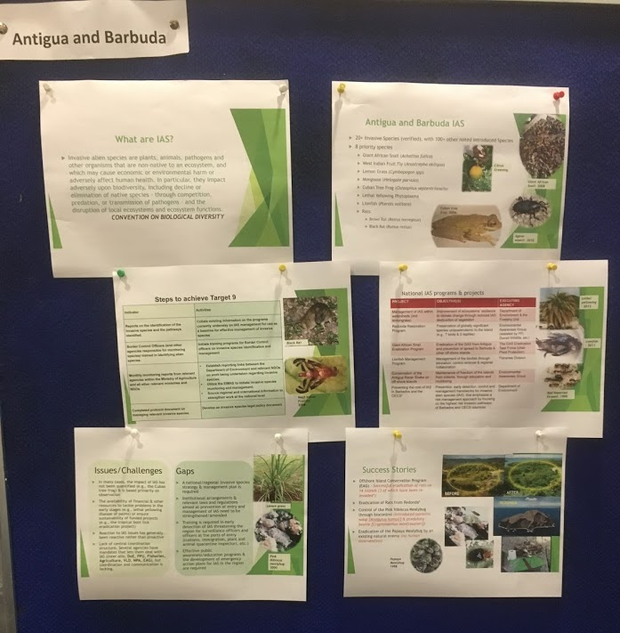

Bahamas
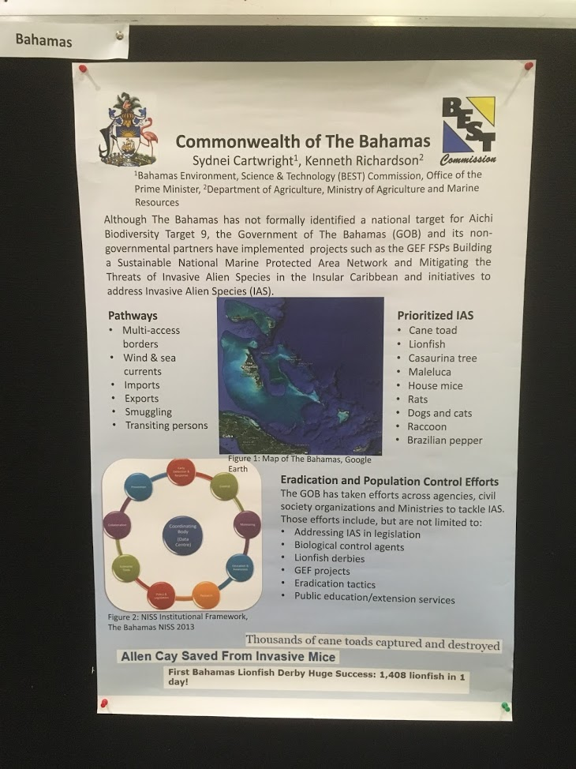

Barbados
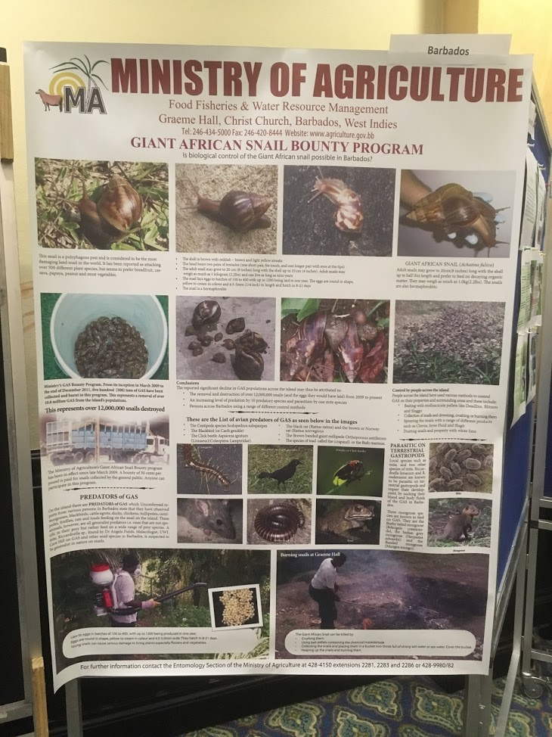

Bermuda
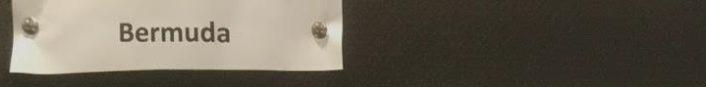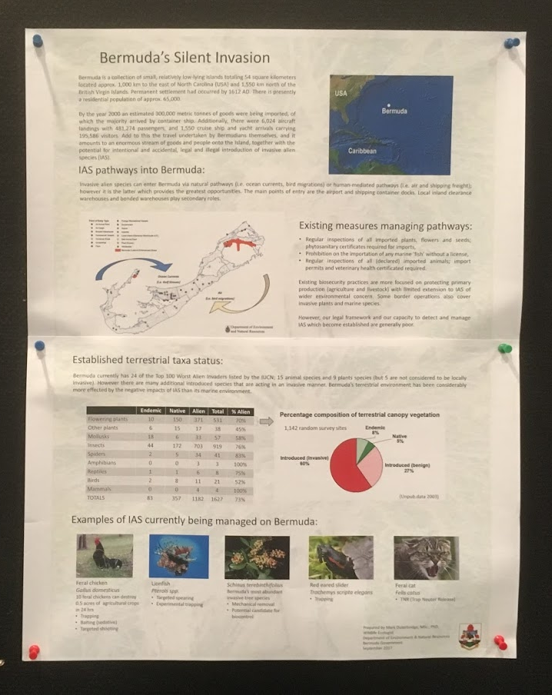

Dominica
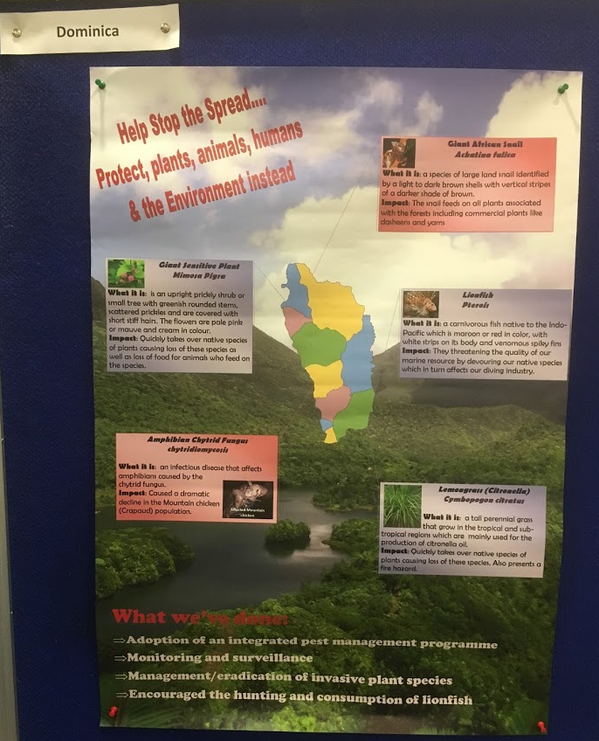

Dominican Republic
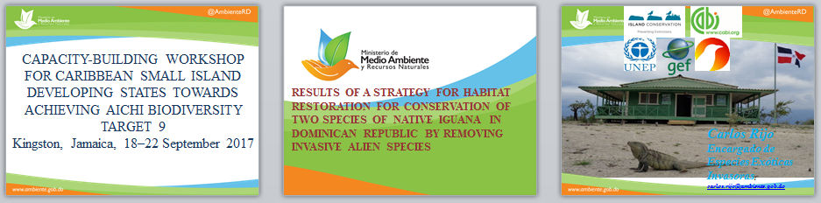
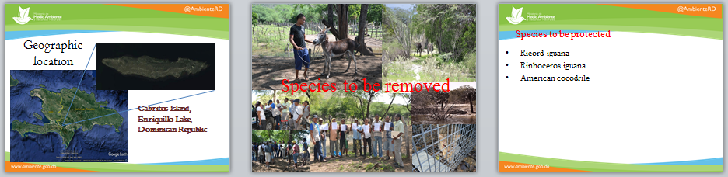
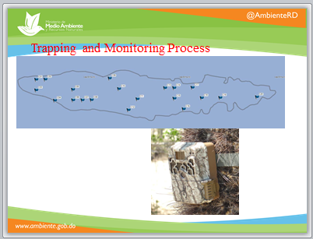

Guyana
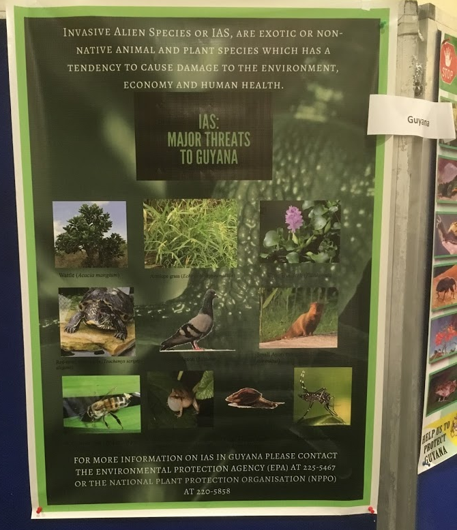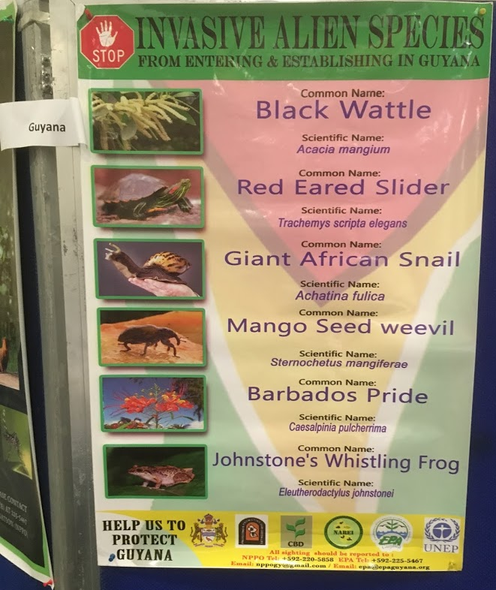

Jamaica
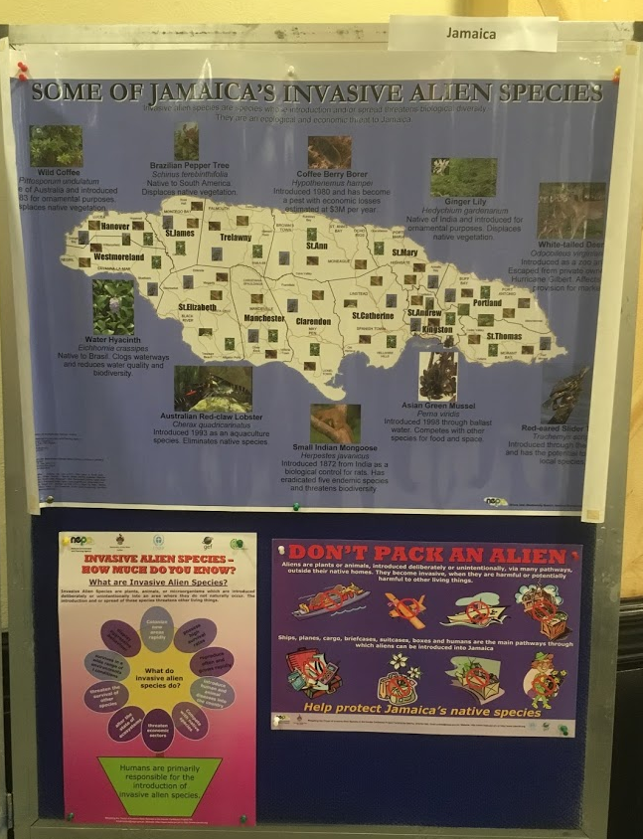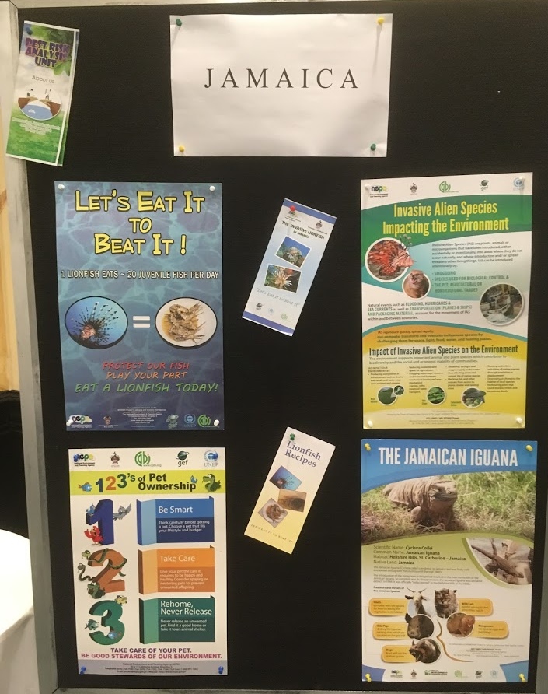

Saint Kitts and Nevis
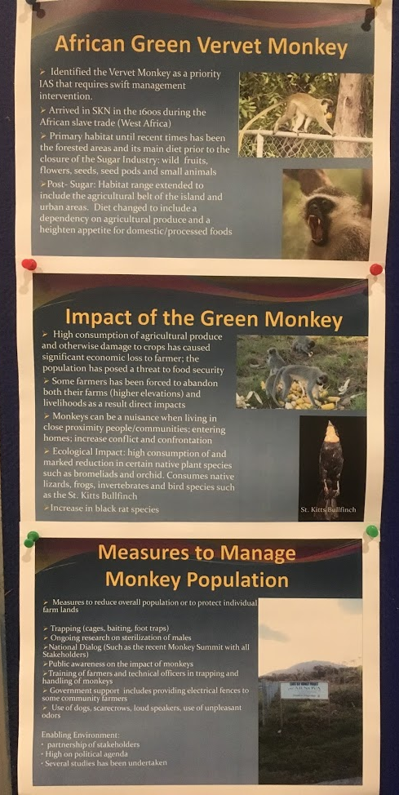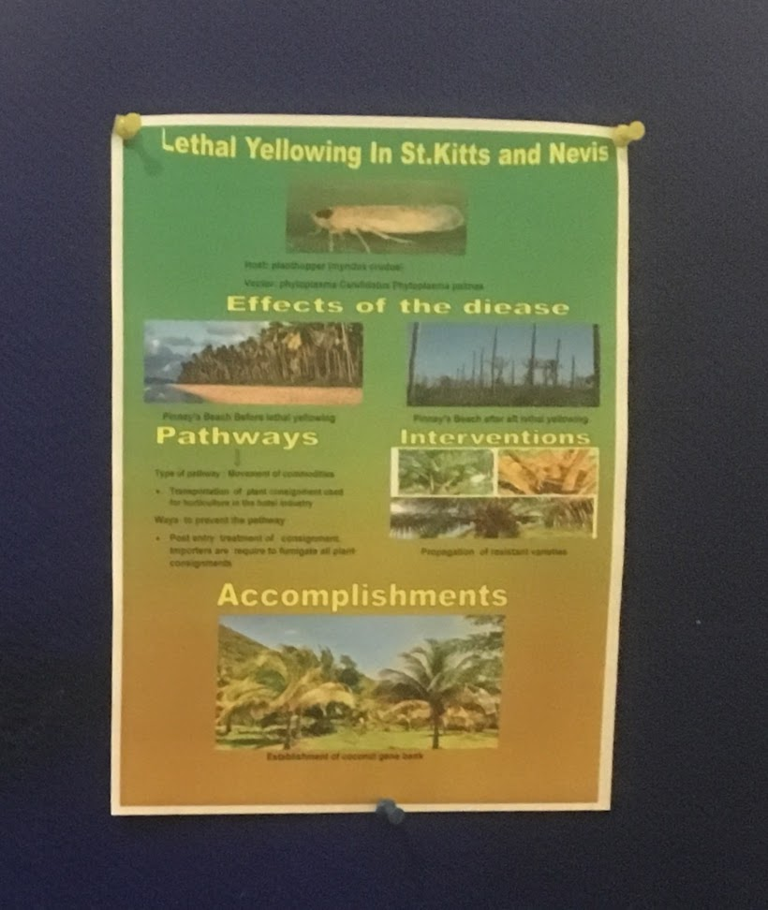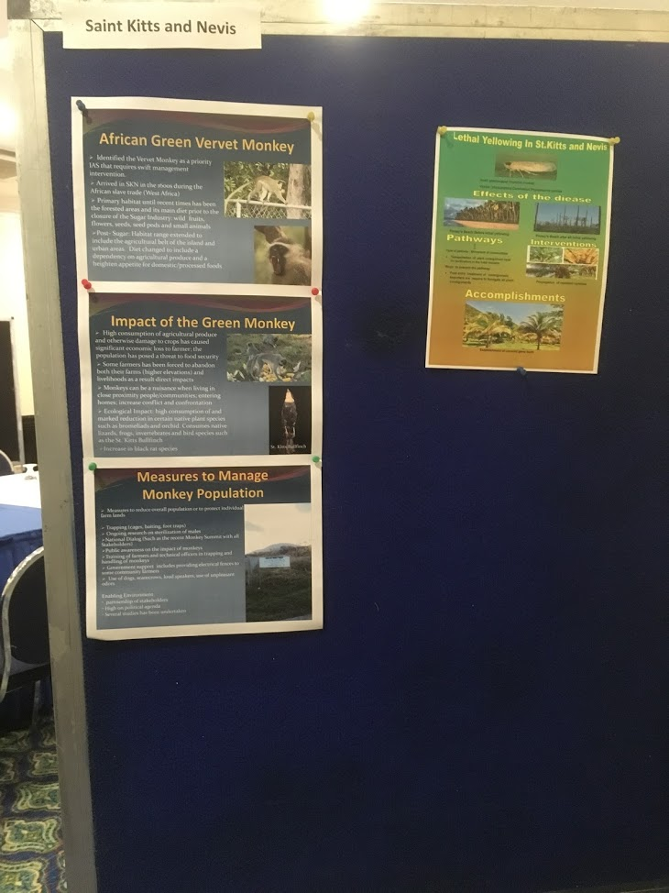

Saint Lucia
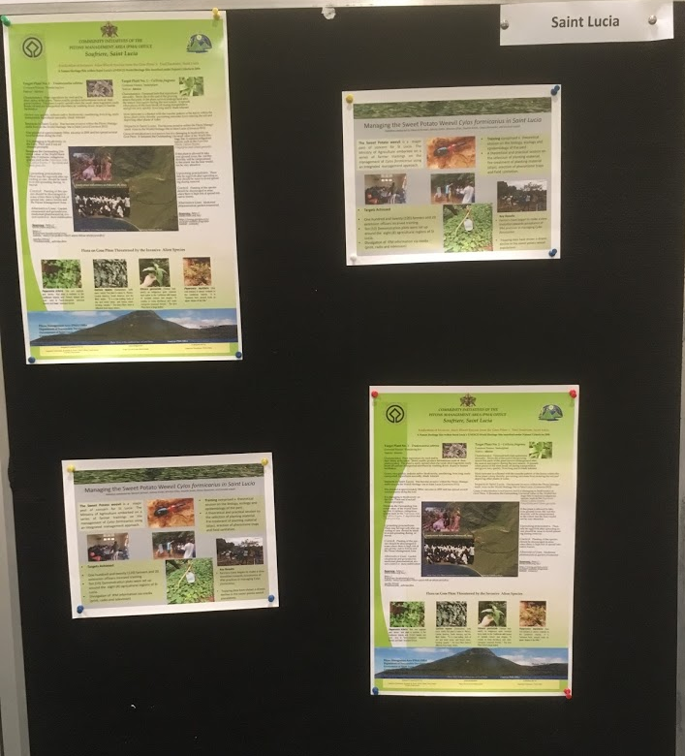

Annex VIII

Joint Statement
of
The secretariat of the Convention on Biological Diversity
and
UN Environment Caribbean sub-regional office
on
The risk of invasive alien species associated with emergency relief, aid and response efforts
in
Small island developing states in the Caribbean

Small island developing States are vulnerable to natural disasters and various pressures from anthropogenic changes. Currently, Caribbean island States are devastated by Hurricane Irma and Hurricane Maria, and suffering from the severe consequences.

We express our great appreciation to all involved in the emergency response with the prime concern of saving lives and livelihoods in the Caribbean.

At the occasion of capacity-building workshop for Caribbean small island developing States towards achieving Aichi Biodiversity Target 9 in Kingston, Jamaica, 18-22 September 2017, organized by the Secretariat of the Convention on Biological Diversity (CBD) with support of UN Environment Caribbean Sub-regional Office in Jamaica, the representatives of Caribbean small island developing States and United Kingdom Overseas Territories, while dealing with the devastating impacts of the hurricanes, also, expressed their concerns on the risk of biological invasions in disaster zones.

Attention was drawn to the Caribbean Comprehensive Disaster Management (CDM) Strategy 2014-2024 aimed to establish Safer, more resilient society through Comprehensive Disaster Management among the member States of the Caribbean Disaster Emergency Management Agency. The Strategy provides regional guidance on coordinated and effective response to natural hazards, such as hurricanes, including appropriate planning, technical advice and the application of customs procedures, without delay of the relief effort.

The workshop participants noted that in 2006 the Conference of the Parties to the Convention on Biological Diversity (CBD) urged Governments and donors to take measures to prevent and minimise the introduction and spread of invasive alien species as part of their emergency relief, aid and any response efforts, and to take into account any relevant codes of practice or guidelines that may be developed at international level, or national legislation as appropriate, in their national aid operations or in the operations of non-governmental organisations within their country (paragraph 42 of decision VIII/27).

To that end, and in accordance with the relevant international guidance, we encourage the actors who plan and operate the disaster management and emergency response in the Caribbean:
  - To minimize the transfer of untreated soils, sands and construction materials from outside islands to the disaster zones;
  - To minimize risk of biological invasions from the inputs for landscape recovery, agriculture and forestry to be released in the disaster zones;
  - To minimize risk of contamination on vehicles, machinery and equipment in prior use for agriculture, forestry, horticulture, earth moving, surface mining, waste management and by the military outside the disaster zones;
  - To support the island states to take early detection of, and rapid response to establishment of invasive alien species in the disaster zones.

Ensuring adequate consideration of environmental issues in humanitarian response actions is important to increase ecosystem resilience and reduce future risks. Moreover, with careful planning and coordination, this does not have to be expensive or time consuming.

Achieving Aichi Biodiversity Target 9 on invasive alien species, in particular with its element on “measures to be in place to manage pathways to prevent introduction and establishment of invasive alien species” is critically important to protect and improve the status of biodiversity in the Caribbean after the devastating impacts of disasters and the response to them.
__________

** Issued without editing.
Earlier this year, CBD and CARICOM Secretariats have signed an agreement to collaborate in the produce country dossiers on invasive alien species. The dossiers aim at evaluating the current occurrences and impacts of invasive alien species, pests, and pathogenic agents on biodiversity and ecosystem services of small islands developing States in the Caribbean. They also describe the impacts of such species and organisms on agriculture, forestry and fisheries, and assess national laws, policies, and regulations that address the risks posed by invasive alien species and unwanted organisms.
https://www.cbd.int/decision/cop/?id=7197, https://www.cbd.int/decision/cop/default.shtml?id=13379, https://www.cbd.int/doc/decisions/cop-13/cop-13-dec-13-en.pdf
Annex to decision XII/16, guidance on devising and implementing measures to address the risks associated with the introduction of alien species as pets, aquarium and terrarium species, and as live bait and live food, available at https://www.cbd.int/decision/cop/default.shtml?id=13379
OIE Guidelines for assessing risks of non-native animals becoming invasive, http://www.oie.int/doc/ged/D13931.PDF
Caribbean Comprehensive Disaster Management Strategy 2014-2024. http://www.cdema.org/CDMStrategy2014-2024.pdf
Decision XIII/27 on invasive alien species https://www.cbd.int/doc/decisions/cop-08/cop-08-dec-27-en.pdf
Article 8(h) of the Convention on Biological Diversity, https://www.cbd.int/convention/articles/default.shtml?a=cbd-08 and the Guiding Principles for the Prevention, Introduction and Mitigation of Impacts of Alien Species that Threaten Ecosystems, Habitats or Species, https://www.cbd.int/decision/cop/?id=7197 The International Standard for Phytosanitary Measures No. 20, https://www.ippc.int/static/media/files/publication/en/2017/08/ISPM_20_2017_En_2017-06-26.pdf The International Standard for Phytosanitary Measures No. 41, https://www.ippc.int/static/media/files/publication/en/2017/05/ISPM_41_2017_En_2017-05-15.pdf

