 |  | CBD/NP/CC/5/4/Add.2-CBD/SBI/7/7/Add.2
 |  | Distr.: General  20 April 2026  Original: English

Compliance Committee under the  Nagoya Protocol on Access and  Benefit-sharing  Fifth meeting  Montreal, Canada, 27–29 May 2026  Item 5 of the provisional agenda*  Input to the second assessment and review of  the effectiveness of the Nagoya Protocol | Subsidiary Body on Implementation  Seventh meeting  Nairobi, 4–12 August 2026  Item 7 of the provisional agenda**  Second assessment and review of the effectiveness of the Nagoya Protocol
Synthesis of views to inform a preliminary review of the compliance procedures and mechanisms of the Nagoya Protocol on Access to Genetic Resources and the Fair and Equitable Sharing of Benefits Arising from Their Utilization
Note by the Secretariat

I. Introduction
- At its fifth meeting, in decision NP-5/5, the Conference of the Parties serving as the meeting of the Parties to the Nagoya Protocol on Access to Genetic Resources and the Fair and Equitable Sharing of Benefits Arising from Their Utilization decided to conduct the second assessment and review of the effectiveness of the Protocol on the basis of the elements contained in the annex to the decision. Element (j) in the annex is a preliminary review of the compliance procedures and mechanisms. The sources of information to inform the preliminary review are the submission of views and the report of the Compliance Committee.
- Section II of the present document contains background information on the development of the compliance procedures and mechanisms, as well as a brief summary of the work of the Compliance Committee to date. Section III contains a synthesis of the views submitted to inform the preliminary review of the procedures and mechanisms on compliance.

II. Background and history of the compliance procedures and mechanisms and the work of the Compliance Committee
- Article 30 of the Nagoya Protocol provides that, at its first meeting, the Conference of the Parties serving as the meeting of the Parties to the Protocol was to consider and approve cooperative procedures and institutional mechanisms to promote compliance by the Parties with the provisions of the Protocol, that is, the obligations that countries contracted when they ratified the Protocol, and to address cases of non-compliance.
- The Open-ended Ad Hoc Intergovernmental Committee for the Nagoya Protocol, which was established by the Conference of the Parties in its decision X/1, considered the matter of the development of the compliance procedures and mechanisms at its first meeting. In its recommendation 1/4, the Committee requested the Executive Secretary to, inter alia: (a) develop draft elements and options for the cooperative procedures and institutional mechanisms to promote compliance; and (b) convene an expert meeting to further refine the elements and options. The outcome of the work of the expert meeting was submitted to the Committee, which discussed draft procedures and mechanisms at its second and third meetings.
- The discussions on the development of compliance procedures and mechanisms were informed by relevant experience gained under other multilateral environmental agreements, in particular the Cartagena Protocol on Biosafety. An overview of compliance procedures and mechanisms established under other multilateral environmental agreements was prepared for the first meeting of the Intergovernmental Committee for the Nagoya Protocol, while presentations on different compliance regimes were delivered in the expert meeting. To assist in the present deliberations, information on experience with the compliance procedures and mechanisms established under the Cartagena Protocol is provided in the annex to the present note, with a focus on the evolution of the work of its Compliance Committee.
- By its decision NP-1/4, the Conference of the Parties serving as the meeting of the Parties to the Protocol adopted cooperative procedures and institutional mechanisms to promote compliance with the provisions of the Nagoya Protocol and to address cases of non-compliance, as set out in the annex to the decision, and established the Compliance Committee under the Protocol.
- The compliance procedures and mechanisms provide that the Compliance Committee is composed of 15 members (3 by region) and two representatives of indigenous peoples and local communities, who serve as observers. Members are nominated by their regions and observers by indigenous peoples and local communities, and all nominees are elected by the Conference of the Parties serving as the meeting of the Parties to the Protocol. Members and observers serve in their individual expert capacity.
- The compliance procedures and mechanisms also provide that the Committee may receive submissions relating to issues of compliance and non-compliance with the provisions of the Protocol from any Party with respect to itself, any Party with respect to another Party, or the Conference of the Parties serving as the meeting of the Parties to the Protocol. The Committee may also examine a situation where a Party fails to submit its national report or where information indicates that the Party concerned is faced with difficulties complying with its obligations under the Protocol. Such information may be received through a national report, through the Access and Benefit-sharing Clearing-House or from the Secretariat on the basis of certain categories of information provided by a directly affected indigenous people or local community.
- During the negotiation of the compliance procedures and mechanisms, consideration was given to additional actors being able to trigger the compliance procedures, including members of the public; however, this possibility was not retained in the final version of the procedures and mechanisms.
- The compliance procedures and mechanisms provide that the Committee is to meet at least once in each intersessional period. Funds to that effect are provided in the core budget.
- At its first meeting, held in April 2016, the Compliance Committee focused on developing draft rules of procedure, which were then submitted at the second meeting of the Conference of the Parties serving as the meeting of the Parties to the Protocol and adopted with a few amendments.
- At its second meeting, held in May 2018, the Committee, among other things, provided inputs to the first assessment and review of the Protocol in the form of information and findings on general issues of compliance. It also considered the rate of submission of the interim national reports, which had been due in November 2017. The Committee requested the Executive Secretary to write to the Parties that had not yet submitted their reports, urging them to do so as soon as possible.
- With the outbreak of the global coronavirus disease (COVID-19) pandemic, the third meeting of the Committee had to be organized online and was held in April 2020. At that meeting, the Committee reviewed general issues of compliance, such as the submission of interim national reports and the obligation to put in place appropriate, legislative, administrative or policy measures for the implementation of the Protocol. The Committee requested that the Executive Secretary follow up with the Parties that had been written to for not submitting their interim national reports. It also requested that the Executive Secretary write to Parties that had not yet established their access and benefit-sharing measures or institutional arrangements, or that had relevant information that needed to be made available through the Access and Benefit-sharing Clearing-House but that had not yet submitted or published such information, to urge them to do so as soon as possible and invite them to provide information on the challenges that they had faced in their efforts to fulfil those obligations. The Committee also provided input to the draft format for the first national reports on the implementation of the Protocol.
- The coronavirus disease (COVID-19) pandemic disrupted the timing of work conducted under the Protocol, including the work of the Compliance Committee, with the following effect:
  - The fourth meeting of the Conference of the Parties serving as the meeting of the Parties to the Nagoya Protocol originally scheduled for 2020 was postponed to 2022;
  - The submission year for the first national reports on the implementation of the Protocol was moved from 2021 to 2026, also owing to the synchronization of the reporting cycles for the Convention on Biological Diversity, the Nagoya Protocol and the Cartagena Protocol;
  - As a result of the postponement of the submission of the first national reports, the second assessment and review originally planned for 2022 is only taking place in 2026;
  - The Compliance Committee should normally have met in 2022; instead, however, there was a four-year gap between its third and its fourth meeting, which was eventually held in March 2024.
- At its fourth meeting, the Committee considered, among other things, general issues of compliance, namely, the submission of national reports, progress in the adoption of measures, the establishment of institutional arrangements and the publication of information in the Access and Benefit-sharing Clearing-House.
- To date, the compliance procedures and mechanisms have never been triggered by a submission.
- The disruptions to the timing of work under the Protocol mean that, for the first time in more than eight years, Parties are submitting comprehensive official information on the status of implementation. It is expected that the information thus received will enable the Committee to engage more actively in reviewing compliance with the Protocol.

III. Synthesis of views
- In notification No. 2025-080 of 17 June 2025, the Executive Secretary invited the submission of views to inform the preliminary review of the procedures and mechanisms on compliance. Fifteen submissions were received in response to the invitation, six of which were from Parties to the Protocol, one from a non-Party and eight from organizations. All submissions have been made available on the notification page.
- A number of submitters addressed the implementation of the Protocol from a broad perspective. They identified various issues with the Protocol and its implementation, provided information on the steps that they were taking to implement the Protocol and the challenges faced. Some submitters highlighted activities that they had undertaken to support the implementation of the Protocol. Two submitters made suggestions on activities to support compliance and recommended the creation of forums where stakeholders could share experiences and challenges with access and benefit-sharing in different countries. All those points will be further addressed in the analysis of information for the second assessment and review of the effectiveness of the Protocol.
- Some submitters included suggestions related to the work of the Committee that could be addressed without changing the compliance procedures and mechanisms. For example, a submitter proposed that the Committee encourage the Secretariat, subject to the availability of funding, to undertake regular audits of the Access and Benefit-sharing Clearing-House so as to ensure that the information that it contains remains up to date. Another submitter suggested that further actions be undertaken to enhance the visibility and awareness of the Committee’s work and that introductory sessions to the work and mandate of the Committee be held to provide Committee members with the information necessary to carry out their functions.
- One submitter expressed support for many parts of the current compliance procedures and mechanisms, while others suggested changes to them.
- A number of submitters suggested that the role of the Committee could be enhanced by enabling it to provide financial, technical and legal assistance. The example of the Compliance Assistance Programme under the Convention on International Trade in Endangered Species of Wild Fauna and Flora was mentioned. Some submitters also suggested that the Committee could be allowed to carry out technical assessments or on-site visits, when necessary, to verify compliance with the provisions of the Protocol, especially in situations where there were reasonable indications of non-compliance or gaps in information. One submitter noted relevant experience under the same Convention as well as the Convention on the Conservation of European Wildlife and Natural Habitats but underlined that on-site visits might have budgetary implications.
- The role of organizations in the compliance procedures and mechanisms was addressed in a number of submissions. One submitter noted that under, section E of the compliance procedures and mechanisms, on information for and consultation by the Committee after the triggering of the procedures, the relevant sources from which the Committee might seek information could include affected organizations and researchers. Others proposed that representatives of civil society, as well as private and public sector users of genetic resources and associated traditional knowledge, be included in the composition of the Committee under section B, on institutional mechanisms, and allowed to submit cases of non-compliance to the Committee under section D, on procedures.
- A submitter proposed that online and hybrid meetings of the Committee be considered. It may be noted that this would require changing the rules of procedure for meetings of the Committee, which were approved by the Conference of the Parties serving as the meeting of the Parties to the Protocol in decision NP-2/3. At present, rule 14 of the rules of procedure provides that electronic means of communication may be used by the Committee for the purpose of conducting informal consultations on issues under consideration, as well as for decision-making except for substantive decisions, such as on submissions relating to issues of compliance and non-compliance with the provisions of the Protocol.
- The same submitter proposed that the provision on what constitutes a quorum in paragraph 10 of section B of the procedures and mechanisms be amended to ensure adequate regional representation in the Committee’s decision-making. The amended paragraph would read (proposed insertion in underline): “Two thirds of the members of the Committee shall constitute a quorum, provided that at least one member from each regional group is present.”
- The same submitter also made a suggestion on section F of the procedures and mechanisms on compliance, on measures to promote compliance and address cases of non-compliance. Paragraph 3 (d) of section F states that the Conference of the Parties serving as the meeting of the Parties to the Protocol, upon the recommendations of the Committee, may also, with a view to promoting compliance and addressing cases of non-compliance, decide on any other measure, as appropriate, in accordance with Article 26, paragraph 4, of the Protocol and the applicable rules of international law, bearing in mind the need for serious measures in cases of grave or repeated non-compliance. The submitter noted that the provision had not been applied and proposed that the phrase “bearing in mind the need for serious measures in cases of grave or repeated non-compliance” be clarified or deleted.

Annex
Experience with the compliance procedures and mechanisms established under the Cartagena Protocol on Biosafety
- The present annex provides a brief overview of key developments under the compliance procedures and mechanisms of the Cartagena Protocol on Biosafety. It does not cover all areas of work, however, and further information is available on the website of the Protocol and in the reports of the Compliance Committee under the Protocol.
- Pursuant to Article 34 of the Protocol, the Conference of the Parties serving as the meeting of the Parties to the Protocol adopted procedures and mechanisms on compliance at its first meeting, in February 2004, by decision BS-I/7.
- The procedures and mechanisms include the establishment of a compliance committee and provide that the Committee is to meet twice a year, unless it decides otherwise. At its fourth meeting, the Conference of the Parties serving as the meeting of the Parties to the Protocol encouraged the Committee to meet less than twice a year if deemed sufficient and within the adopted budget. Subsequently, the budget adopted by the Conference of the Parties serving as the meeting of the Parties provided for one meeting a year, and the Committee has been meeting once a year since 2008.
- By decision BS-II/1, the Conference of the Parties serving as the meeting of the Parties to the Protocol approved the rules of procedure for meetings of the Compliance Committee.
- By 2010, that is, six years after the adoption of the compliance procedures, no submission relating to compliance had been put forward by a Party for consideration by the Compliance Committee.
- Recognizing the difficulties that Parties might have in implementing the Protocol effectively, and in the absence of submissions by Parties, the Committee undertook an evaluation of the perceived limitations of the procedures under the overall evaluation of the effectiveness of the Protocol conducted pursuant to its Article 35. At its fourth meeting, in decision BS-IV/1, the Conference of the Parties serving as the meeting of the Parties to the Protocol invited Parties to submit their views on how the supportive role of the Compliance Committee could be improved.
- Subsequently, in decision BS-V/1, the Conference of the Parties serving as the meeting of the Parties to the Protocol decided that, in the event of a submission relating to compliance by any Party with respect to itself, the Compliance Committee was to consider taking only those measures relating to the provision of advice or assistance and making recommendations regarding the provision of financial and technical assistance, technology transfer, training and other capacity-building measures.
- In the same decision, the Conference of the Parties serving as the meeting of the Parties to the Protocol also decided that the Compliance Committee might also consider taking the same measures in a situation where a Party failed to submit its national report, or where information had been received through a national report or through the Secretariat, on the basis of information from the Biosafety Clearing-House, that showed that the Party concerned faced difficulties with complying with its obligations under the Protocol.
- The Committee discussed its revised mandate at its eighth meeting, in October 2011, and agreed on an approach to guide its functions in the context of decision BS-V/1 and on an organization of work for implementing the decision. The organization of work follows the four-year reporting cycle, as illustrated in the figure below.
Cyclical organization of work of the
Compliance Committee under the Cartagena Protocol
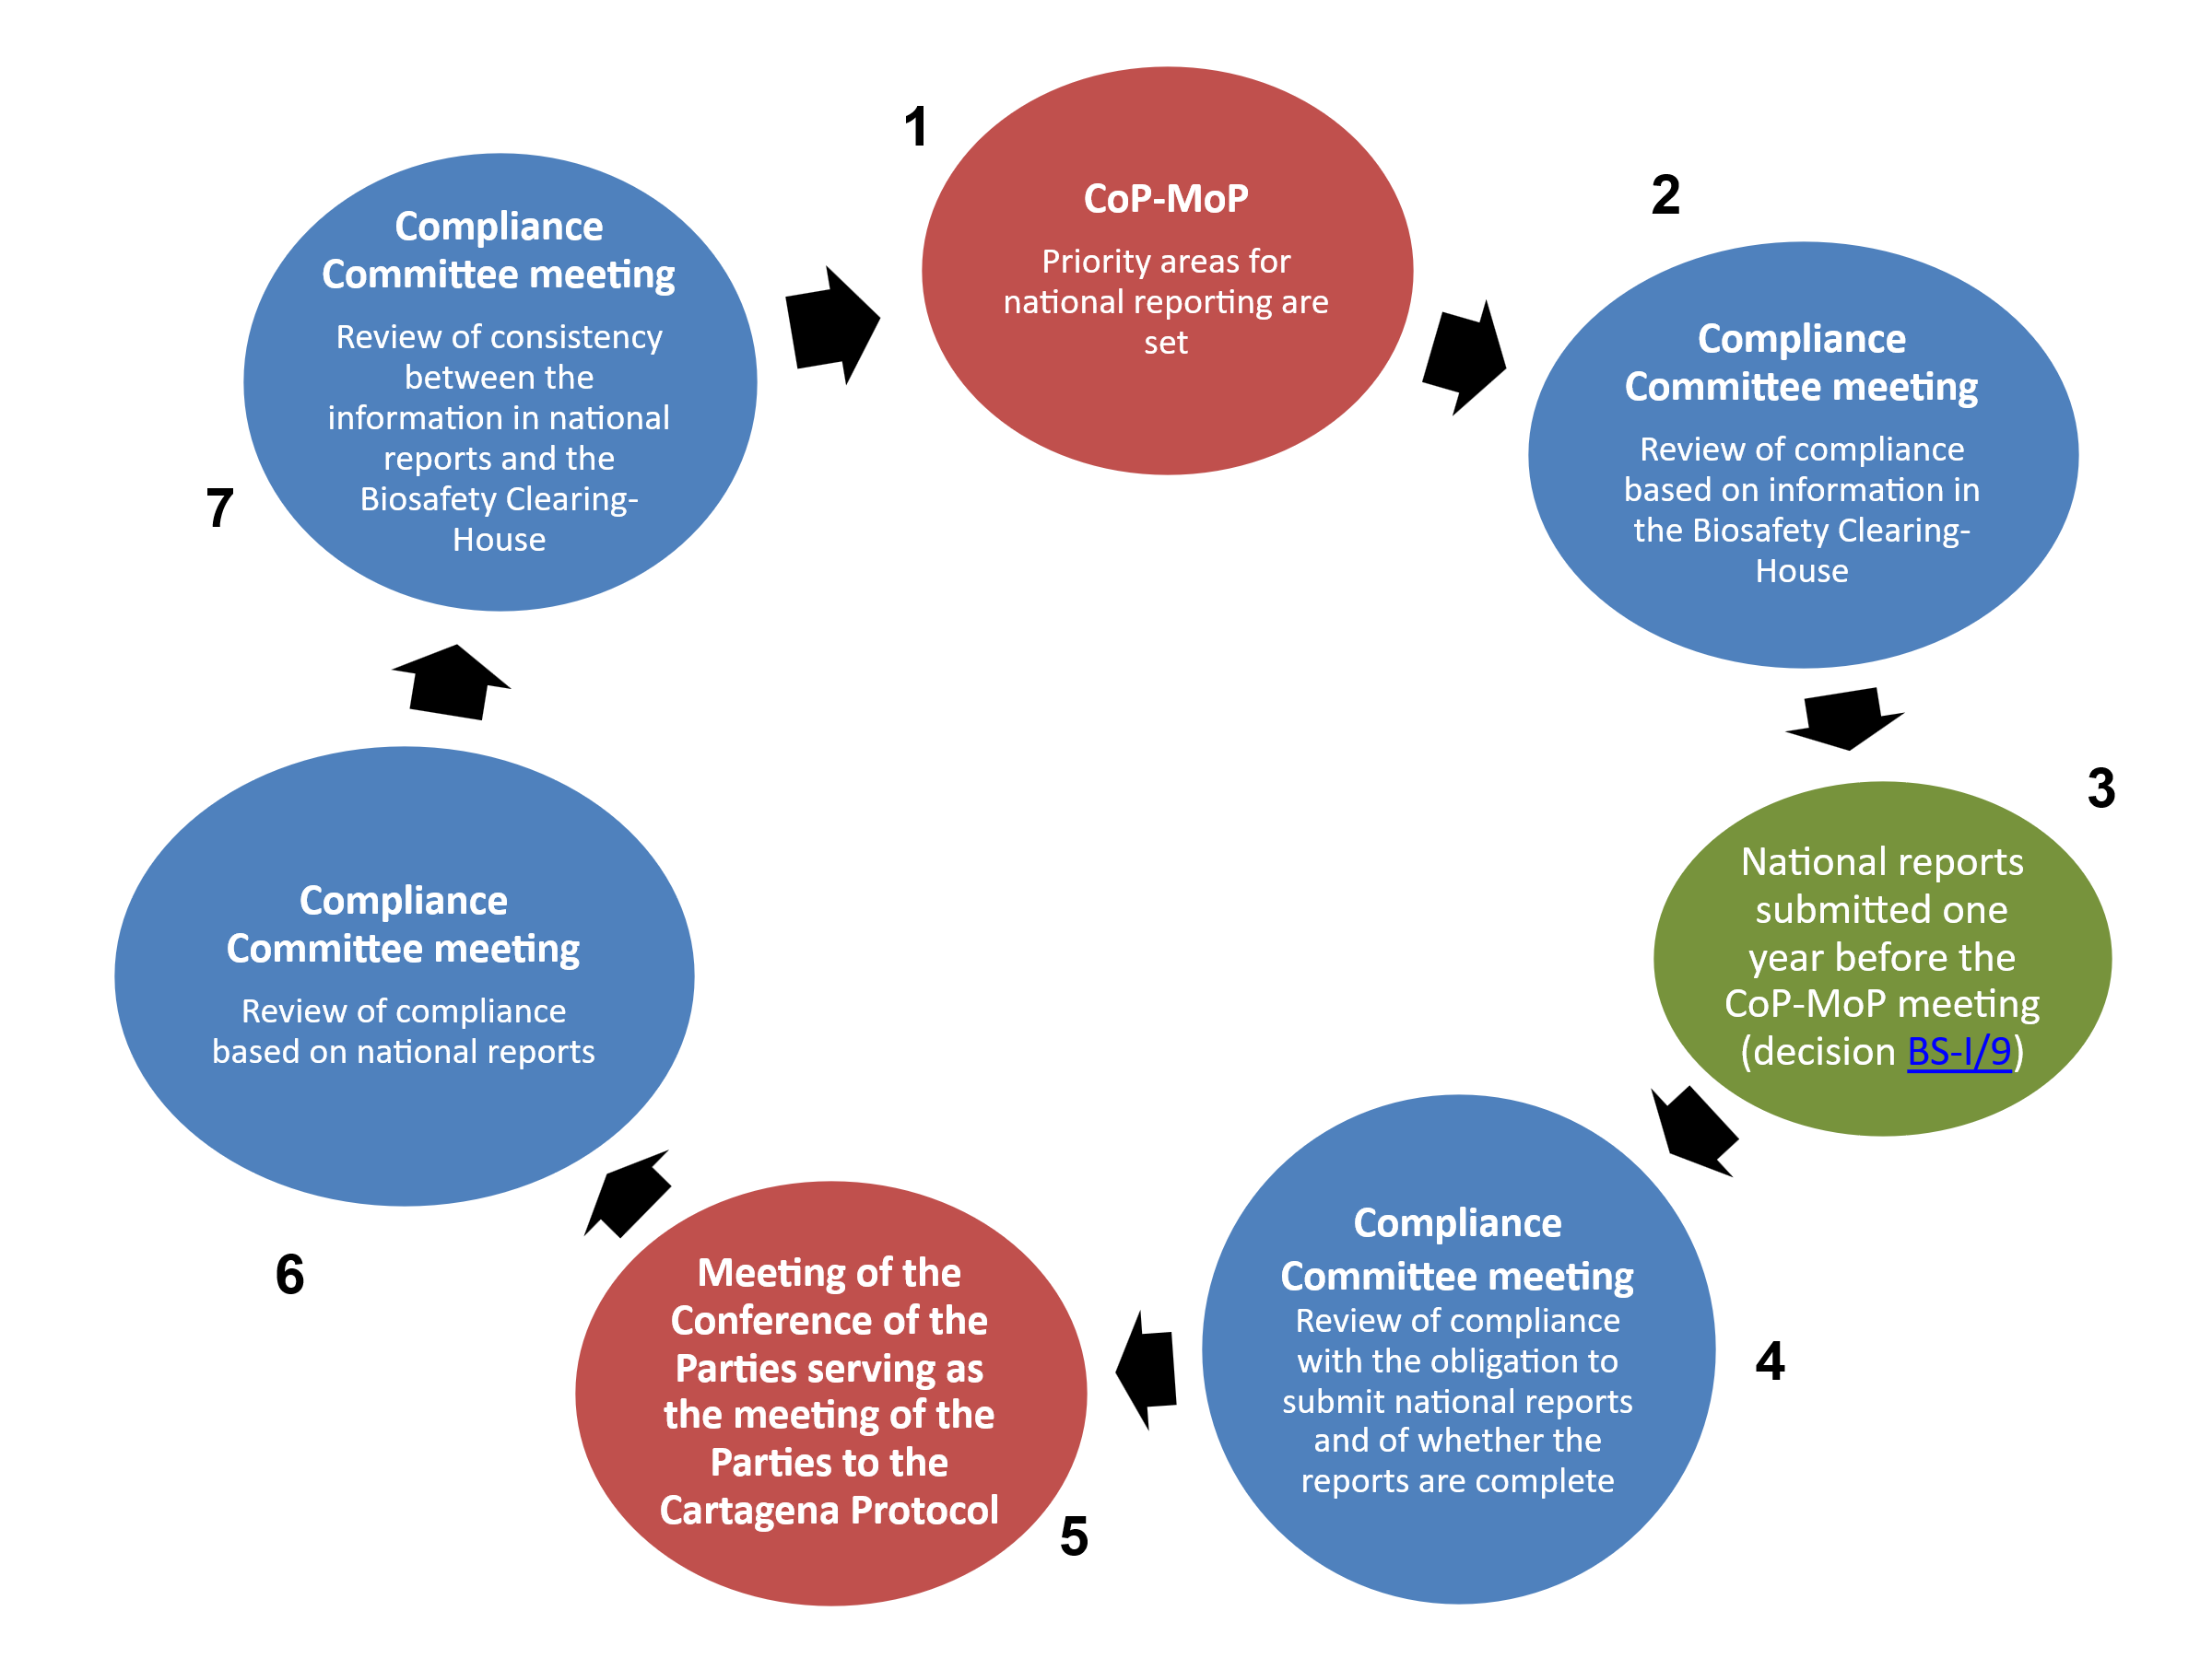

Abbreviation: CP CoP-MoP, Conference of the Parties serving as the meeting of the Parties to the Cartagena Protocol.
- The cyclical organization of work illustrated above has been followed since 2012 and has greatly facilitated the planning of and preparation for the Committee’s meetings.
- Following the adoption of its revised mandate in decision BS-V/1, the Committee has advanced in an incremental manner various compliance issues that have emerged from its deliberations at different stages of its cyclical organization of work. In all cases, the work is based on official information from Parties or the absence of such information when the sharing of specific information is required. The Committee frequently begins by requesting the Secretariat to follow up with Parties on various matters. The follow-up usually takes the form of emails from the Secretariat to Parties to encourage them to take action on a specific issue. As a next step, the Committee may request the Executive Secretary to write to the Parties concerned.
- Should those steps not result in the necessary actions by Parties, the Committee often requests its Chair to write to the Parties concerned to urge them to take action. If this is not successful, in some instances, the Committee has requested its Chair to write to the minister overseeing the national focal point for the Protocol, while in others, it has requested its Chair to write to the Minister for Foreign Affairs of the Party concerned.
- Where Parties have been in non-compliance with the obligation to submit a national report over multiple reporting cycles, the Committee has recommended to the Conference of the Parties serving as the meeting of the Parties to the Protocol that it caution the Parties concerned. When it has made such a recommendation, the Committee has also requested its Chair to inform the Parties concerned of the recommendation and urge them to submit a national report as soon as possible. Its three cautions thus recommended to date have addressed a total of 13 Parties. All but one of those Parties subsequently submitted a national report.
- The Committee has also gradually advanced its consideration of compliance with the obligation to introduce measures to implement the Protocol. Compliance with the obligation to take measures to implement the Protocol emerged as a key issue from the third assessment and review of the Protocol, in 2016, and the Committee discussed the issue at its fourteenth meeting, in May 2017.
- The Committee requested the Secretariat to seek information from Parties that had reported in their third national reports that they had only draft, temporary or partial national biosafety frameworks in place, or that they had not introduced any legal, administrative or other measures for the implementation of the Protocol, and to collect information on the challenges that those Parties were facing in that regard.
- At its fifteenth meeting, in May 2018, in the light of the information thus collected, the Committee considered what additional actions could be taken to assist the Parties concerned and agreed to request them to develop a compliance action plan, in accordance with section VI, paragraph 1 (c), of the procedures and mechanisms on compliance.
- Following the submission of the fourth national reports, due in 2019, additional Parties were identified as having reported either not to have taken any measures to implement the Protocol or as having taken only draft or temporary measures. The Committee requested those Parties to develop a compliance action plan or provide information, as appropriate.
- To date, 34 Parties have thus been requested to prepare a compliance action plan, 19 of which have done so. One of the 19 Parties has successfully completed the activities in its plan. The other 18 plans are under active consideration by the Committee. Of the remaining 15 Parties, 7 are no longer expected to prepare a compliance action plan, as subsequent information has pointed to progress made with the adoption of measures. The remaining eight Parties have not yet submitted a compliance action plan.
- In acknowledging compliance action plans submitted by Parties, the Chair has informed Parties on behalf of the Committee that it may be possible to obtain technical assistance for advancing their compliance action plans from the Law and Environment Assistance Platform under the Montevideo Environmental Law Programme managed by the United Nations Environment Programme. Some Parties have applied for and been granted funding from the Platform to assist them with their plans.
- The Committee has also engaged in informal electronic exchanges with some of the Parties that have prepared compliance action plans as part of the follow-up to the implementation of the activities set out in the plans. The Committee has considered such informal exchanges useful for both the Committee and the Parties concerned. The exchanges have enabled the Committee to gain a better understanding of the progress made by the Parties in developing measures to implement the Protocol and the outstanding actions that they are to take and difficulties that they face in that regard. At the same time, the exchanges have enabled the Parties concerned to discuss their plans and challenges directly with the Committee and to ask the Committee for additional guidance. Furthermore, the exchanges have helped to establish direct contact between the members of the Committee and the responsible national officers, which could facilitate follow-up to compliance issues.
Additional observations
- As mentioned above, the Compliance Committee under the Cartagena Protocol meets once a year. This rhythm enables the Committee to undertake a regular review of and follow-up to the matters under its consideration and helps it to maintain momentum in its work. Steps requested by the Committee at one meeting are considered again at its next meeting, the following year, for it to decide on further action, as necessary. The Committee’s recommendations to the Conference of the Parties serving as the meeting of the Parties to the Protocol are also informed by the deliberations from its two intersessional meetings. Last, the annual meetings of the Committee build a sense of common purpose among the members of the Committee.
- The substantive work of the Committee is supported by 2.5 staff members of the Secretariat – a G-7 Senior Programme Management Assistant and a P-3 Legal Officer who work full time on supporting legal matters under the Cartagena Protocol. The two staff members report to a P-4 Legal Officer, whose work is divided equally between the Cartagena and the Nagoya Protocols.
__________

* CBD/NP/CC/5/1.
** CBD/SBI/7/1.
UNEP/CBD/ICNP/1/INF/1.
Dominican Republic, European Union and its member States, India, Nigeria, Peru and United Kingdom of Great Britain and Northern Ireland.
Armenia.
Asociación Indígena Jieyuu Yala’yalaa A’inruu, Consultative Group on International Agricultural Research, Center for International Forestry Research and World Agroforestry, International Chamber of Commerce, INGRECOS, International Federation of Pharmaceutical Manufacturers and Associations, Leibniz Institute DSMZ and Cell Cultures and Wellcome Sanger Institute.
European Union and its member States, Nigeria, Asociación Indígena Jieyuu Yala’yalaa A’inruu, Center for International Forestry Research and World Agroforestry, INGRECOS, International Chamber of Commerce, International Federation of Pharmaceutical Manufacturers and Associations and Leibniz Institute DSMZ.
Dominican Republic, India and Peru.
India.
Consultative Group on International Agricultural Research and Leibniz Institute DSMZ.
United Kingdom and Wellcome Sanger Institute.
CBD/SBI/7/7/Add.1.
United Kingdom.
European Union and its member States.
Dominican Republic.
European Union and its member States, India and Peru.
Dominican Republic and European Union and its member States.
European Union and its member States.
Dominican Republic.
European Union and its member States, Leibniz Institute DSMZ, International Chamber of Commerce and International Federation of Pharmaceutical Manufacturers and Associations.
European Union and its member States.
See https://bch.cbd.int/protocol/cpb_art34_info.shtml.
With the exception of 2021 and 2022, during the coronavirus disease (COVID-19) pandemic, when no meeting was held.
See UNEP/CBD/BS/CC/8/3, figure 1.

