 |  | CBD/SBSTTA/27/INF/6

 | Distr.: General  22 September 2025  English only

Subsidiary Body on Scientific,
Technical and Technological Advice
Twenty-seventh meeting
Panama City, 20–24 October 2025
Item 6 (a) of the provisional agenda*
Scientific and technical needs to support the implementation of the Kunming-Montreal Global Biodiversity Framework: strategic review and analysis of the programmes of work under the Convention in the context of the Framework
Report on the strategic review of the programmes of work of the Convention
Note by the Secretariat
- In paragraph 9 of its decision 15/4, the Conference of the Parties to the Convention on Biological Diversity requested the Executive Secretary to conduct a strategic review and analysis of the programmes of work of the Convention in the context of the Kunming-Montreal Global Biodiversity Framework to facilitate its implementation, and, on the basis of that analysis, to prepare draft updates of those programmes of work for consideration by the Subsidiary Body on Scientific, Technical and Technological Advice and by the Subsidiary Body on Implementation, as appropriate.
- In subparagraph 1 (a) of its decision 16/12, the Conference of the Parties recognized that the programmes of work and cross-cutting work of the Convention remained important tools to support the implementation of the Framework, although some programmes of work might need to be updated.
- In subparagraph 4 (e) of the same decision, the Conference of the Parties recalled paragraph 9 of decision 15/4 and requested the Secretariat to conduct a strategic review and analysis of the programmes of work of the Convention in the context of the Framework to facilitate its implementation, to prepare draft updates of the programmes of work on the basis of the analysis, taking into account documents prepared for the twenty-sixth meeting of the Subsidiary Body on Scientific, Technical and Technological Advice in relation to that work, and to submit them for consideration by the Subsidiary Body at a meeting held before the seventeenth meeting of the Conference of the Parties.
- Pursuant to the aforementioned request, the Secretariat commissioned a team of consultants to prepare a report on the strategic review and analysis of the programmes of work of the Convention as a whole. A draft version of the report was submitted for review by Parties, other Governments, indigenous peoples and local governments and relevant organizations through notification No. 2025-078 of 5 June 2025, and 14 Parties and 13 entities provided comments by the deadline of 30 June. The final version of the report is provided in the annex to the present document.
- The report was prepared with the generous financial support of the European Commission and the Government of Canada. It is presented in the form and language in which it was received. A summary of the results of the review and analysis and information on opportunities for aligning the programmes of work with the Framework is available in document CBD/SBSTTA/27/5/Add.1.

Annex*
Report on the strategic review and analysis of the programmes of work under the Convention in the context of the Kunming-Montreal Global Biodiversity Framework
1. Introduction
This study was undertaken by a team of consultants, commissioned by the Secretariat of the Convention on Biological Diversity with the generous financial support of the European Commission and the Government of Canada, to support its preparation for twenty seventh meeting of the Subsidiary Body of Scientific, Technical and Technological Advice (SBSTTA-27), scheduled for 20-24 October 2025. This study informs the document and is considered under agenda item 6 (a) of the provisional agenda.

Purpose

This report responds to requests from the Conference of the Parties (COP) to the Executive Secretary contained in subparagraph 4 (e) of decision 16/12 and supported by COP decisions 15/4 and 15/33.
In paragraph 8 of its decision on the Kunming Montreal Global Biodiversity Framework, the Conference of the Parties to the Convention on Biological Diversity decided that the Framework should be used as a strategic plan for the implementation of the Convention and its Protocols, its bodies and its Secretariat over the period 2022-2030 and that, in this regard, the Framework should be used to better align and direct the work of the various bodies of the Convention and its Protocols, its Secretariat and its budget according to the goals and targets of the Framework.

In paragraph 2 of its decision on its multi-year programme of work, the Conference of the Parties decided that the development of further guidance for policy development and implementation should support the achievement of the goals and targets set out in the Framework.

In subparagraph 4 (e) of its decision, the Conference of the Parties requested the Secretariat to conduct a strategic review and analysis of the programmes of work of the Convention in the context of the Kunming Montreal Global Biodiversity Framework to facilitate its implementation.

In essence, this request and the supporting decisions indicate that the COP wants to ensure that all of the work of the Convention contributes to the implementation of the KMGBF and that all elements of the KMGBF are addressed by the work of the Convention. A first step in this process is to determine how the current work of the Convention aligns with the KMGBF and propose options to both increase alignment and simplify communication and planning. This first step is what this work is contributing to.

Further steps may include:
- The consideration of Gaps identified by the SBSTTA (once a decision has been made) and
- The relative allocation of resources.

Scope

The scope of this study was clarified at the planning meeting of the Bureau of the Subsidiary Body, which was held in Montreal, Canada from 1 to 4 April 2025, to focus on an overall review of the programmes of work, including not only the thematic/biome-based programmes of work established by the Conference of the Parties through decisions, but also all the work areas of cross-cutting issues, which have been undertaken under the Convention. The framework of the analysis mainly comes from the targets and some sections of the Kunming-Montreal Global Biodiversity Framework.
The study, therefore, does not review any particular programme of work, which is covered under agenda item 6 (b) of the provisional agenda of the twenty-seventh meeting of the Subsidiary Body. It should also be noted that the approaches for the strategic review and analysis of individual programmes of work may vary. Likewise, the study does not address the areas of potential further work, which is covered under agenda item 6 (c). The analytical framework for this study, however, may also be applied to inform approaches for addressing areas of potential further work, and the outcome of this study may contribute to shaping such future efforts.
The analysis for this study builds on previous work undertaken for the twenty-fifth and twenty-sixth meetings of the Subsidiary Body, as well as further inputs compiled by the Secretariat (see annexes A and B).
It should also be noted that the outcomes of the present study may serve as a useful information basis for the ongoing functional review of the Secretariat, being undertaken pursuant to the request from the COP in its decisions (paragraph 35) and (paragraph 11). In particular, the strategic review and analysis of programmes of work and other work areas under the Convention may inform the strategic visioning process concerning the work programme of the Secretariat.
Terms used for the report
This section presents a list of terms and definitions used in this report.

Programme of Work: The Conference of the Parties has established a total of eight programmes of work, including thematic programmes corresponding to some of the major biomes on the planet, as well as a programme addressing protected areas as a cross-cutting issue. The programmes of work are intended to guide the implementation of the Convention and, as such, generally include various elements and/or actions to be undertaken by relevant stakeholders (including Parties, other Governments, the Secretariat, relevant organizations and other key stakeholders) in order to enhance the conservation and sustainable use of biodiversity. Furthermore, subsequent decisions of the Conference of the Parties in these respective programme areas, including relevant guidance, guidelines and tools in those decisions, are intended to be seen in concert with the adopted programmes of work and support their implementation. These eight programmes of work include the following: agricultural biodiversity, dry and sub-humid lands biodiversity, forest biodiversity, inland waters biodiversity, island biodiversity, marine and coastal biodiversity, mountain biodiversity, and protected areas. Moreover, the Conference of the Parties, in its decision, adopted the programme of work on Article 8(j) and other provisions of the Convention on Biological Diversity related to indigenous peoples and local communities to 2030, prioritizing those tasks that contribute directly to the timely, full and effective implementation of the Kunming-Montreal Global Biodiversity Framework.

Work Area: There are numerous work areas currently being undertaken under the Convention, as identified on the CBD website (https://www.cbd.int/programmes) under the subsection of “cross-cutting issues” and “major groups”. It should be noted that certain listed activities are being implemented under the Protocols and the new programme of work on Article 8(j) and other provisions of the Convention related to indigenous peoples and local communities. For convenience and for the purpose of this exercise, both programmes of work and other relevant areas are referred to as “work areas” in the present document.

Elements of the Kunming-Montreal Global Biodiversity Framework (KMGBF): The analysis was conducted in relation to key sections of the KMGBF, including Section C (Considerations for Implementation), Section H (Global targets), Section I (Monitoring Framework), Section J (Responsibility and Transparency), and Section K (Outreach, Education, and Awareness).

2. Analysis

Methodology
The primary focus of the present report is to provide succinct, high-level advice to Parties on all of the work of the Convention without engaging in detailed analysis of individual work areas, drawing on the information compiled and synthesized in the annexes.
The framework used in Annex A, “work area analysis,” was developed to provide a comprehensive and standardized review of work areas under the Convention on Biological Diversity (CBD). It was designed to assess the strategic relevance, urgency, and implementation needs of each work area in relation to the Convention and the KMGBF.

The matrix contained in Annex B, “assessment of alignment,” illustrates how each work area under the Convention aligns with the Elements of the KMGBF, and conversely, how each Element is addressed by the work of the Convention.

The specific methodology used for the analysis is summarized in the following three steps:
Step I:
The work undertaken and currently being implemented under the Convention was categorized into the following “work areas,” comprising:
- Eight Programmes of Work (PoW) established by COP, which are primarily biome-based.
- Other Work Areas.
These constitute the foundational elements for the analysis presented in this report.
Step II:
For each of the work areas
- A set of basic information compiled by the Secretariat:
- Source of mandate: identifies the legal foundation of the work area, typically referencing specific articles of the Convention or decisions adopted by the Conference of the Parties (COP).
- First (COP) decision authorizing the work: documents the historical trajectory of the work area, including the initial decision that established it and the most recent COP decision or SB recommendation that references or updates it.
- Last COP or SB official reference to the work area: documents the most recent COP decision or SB recommendation that references or updates it. This provides an indication of the attention COP and SBs dedicate to the work area.
- Whether the Secretariat provides ongoing support with available resources (other than maintaining key information on the website).
- Second, for each work area, partnership and leadership dimensions were examined:
- Whether the activity involves external partners and
- If CBD participation is essential to the outcome.
This analysis also assessed whether other international or regional organizations are active in the same area, and whether their mandates complement or overlap with that of the CBD.
- Finally, the relevance of the work area to the KMGBF was assessed:
- Relevance was assessed for selected elements of the KMGBF, including:
  - The targets (Section H)
  - Cross-cutting issues considerations (Section C)
  - Monitoring Framework (Section I)
  - Responsibility and transparency provisions (Section J)
  - communication, education, awareness and uptake (Section K).
- Whether the outcome was needed urgently or could be addressed over a longer timeframe.
The Secretariat provided information for the analytic framework described above, which is contained in Annexes A and B. The analysis was subsequently refined and summarized by the team of consultants.
Step III:
The analysis in the above-mentioned steps enabled the categorization of the work areas into 3 groups. There is no implied hierarchy between the 3 groups.
- Work areas with a discreet mandate or formal Program of Work (PoW), making contributions to the implementation of the KMGBF, and are reviewed regularly by COP or SBs. Minimal adjustments would be recommended for these areas. This category includes cross-cutting areas of work contributing to multiple elements of KMGBF;
- Work areas relevant to and contributing directly to the implementation of one or more elements of the KMGBF, which could, however, benefit from various levels of integration with other work areas;
- Work Areas that could represent an opportunity for efficiency gains or alternative delivery, as they are either
  - Adequately addressed through the implementation by Parties or through other multilateral agreements or processes;
  - Not recently considered by COP or its subsidiary bodies.

Peer Review:
The Draft report of this analysis and related annexes A and B were sent to Parties for Peer review from 5 to 30 June 2025. 240 comments from 7 Parties were received. 14 Stakeholder organizations also provided comments.

Generally, Parties support the methodology and the way the methodology was applied to the Convention work. Parties had a number of detailed comments on individual aspects, refining the analysis and increasing the coherence between the annex and this report. These comments could easily be addressed.

However, there are a few instances where Parties had diverging views:

- Protected area (ID8), Restoration (ID19) and other related land-based conservation (ID 7).
Regarding Protected areas, restoration and other related land-based conservation, some Parties suggested keeping the existing programmes separate as they each represent significant areas of concern. However, other Parties see the value in merging some of the elements. In particular, the suggestion was made to merge land use planning and restoration with the OECM portion of land protection and conservation (but not with the land protection element). Some Parties also supported the notion of grouping these activities under the umbrella designation “land-based conservation”; within this group, some wanted to ensure that each component was clearly visible.
- Communication, Education and Public awareness (ID15)
Regarding communication, education and public awareness, some Parties indicated that this work area was most aligned with Target 14 on mainstreaming, while other Parties suggested Target 21 and section K.
- Access and benefit Sharing (ID10) & Digital Sequence Information (ID16)
Regarding access and benefit sharing and digital sequence information, a submission was made to keep the two separate, while others see value in merging them into one area of work.
- Business Engagement (ID12.1)
Regarding business engagement, a submission was made to keep the area separate as it will be a growing area; however, others see value in placing it under a merged mainstreaming work area.
- Mountain biodiversity (ID7)
Regarding mountain biodiversity, Parties have various levels of support or opposition to merging this area of work with other areas of work, depending on their views on the PoW and the importance of this biome for them. Some Parties would welcome certain aspects (e.g. glaciers) of the PoW being merged with climate change; however, others see the value in maintaining it as a discrete area of work.

3. Conclusions & recommendations

Several conclusions may be drawn from the analysis.

- A large number of the work areas, the vast majority, make a direct and comprehensive contribution to the implementation of the Convention and KMGBF.

  - Fifteen work areas, including 6 Programmes of Work, are recommended to be maintained close to their current form. These include several crosscutting, sectoral and biome-based Programmes of Work.

Table 1 - Work areas requiring minimal adjustments
Note: Work area numbers are presented for ease of reference across documents, as contained in Annex A. They do not represent priorities.
Work Area | Rationale | Recommendations
1. Agricultural Biodiversity | Cross-cutting, sectoral and biome-based Programme of Work addressing direct drivers of biodiversity loss. The KMGBF was designed to be biome neutral on the understanding that implementation would be Biome specific. The PoWs are an essential component of this implementation. | Should continue to be a key work area. Could accommodate action on Pollution (T7), particularly on pesticides (noting that Nutrients and plastics are well addressed under separate processes). Could be renamed Agriculture and Biodiversity.
3. Forest Biodiversity |  | Should continue to be a key work area as PoW has been recently reviewed. A key interest for many Parties, which is not addressed from a biodiversity perspective by other bodies.
4. Inland Waters Biodiversity |  | Should continue to be a key work area. The KMGBF was structured in a way that did not make a distinction between biomes based on the understanding that those would be best addressed at the implementation level, including through PoW.
5. Island Biodiversity |  | Should continue to be a key work area.  While Island biodiversity may be closely linked to Marine and Coastal biodiversity, depending on the size of islands, and to Invasive Alien species, it is a microcosm of various issues under the Convention and merits its own work area. It is therefore not recommended at this stage to merge Island Biodiversity with another work area.
6. Marine and Coastal Biodiversity |  | Should continue to be a key work area. The KMGBF was structured in a way that did not make a distinction between biomes based on the understanding that those would be best addressed at the implementation level, including through PoW.
8. Protected Areas | Significant resources and effort are required for this area. While a number of Parties saw potential benefits in linking all area-based conservation work, others felt that it was important to keep them separate. One submission recommended having an “umbrella” designation with identifiable and discrete work programs. | Option 1: Protected Areas could be a focal area for all work areas related to Targets 1, 2 and 3 in a terrestrial context (Marine context would be addressed by relevant PoW). This will include Land use planning and restoration. This could be named “area-based approaches”.  Option 2: Keep Protected area, Restoration and Land use planning as a separate Work Area.  Option 3: Umbrella designation with 3 discreet work plans.
14 Climate Change and Biodiversity | The work area makes an important contribution towards addressing a direct driver of biodiversity loss. | Keep the work area as it is and look at opportunities to incorporate other relevant work areas.
15. Communication, Education and Public Awareness | Directly addresses Section K of the KMGBF. | A work area focused on Communication, Education and Public Awareness addressing Section K of the GBF will continue to be needed.
20 Gender and Biodiversity | Directly addresses Section C (para h) and target 23 of the KMGBF. | A work area addressing gender will continue to be an essential element of the CBD.
21. Global Strategy for Plant Conservation | Discreet subject. | Should continue to be a discrete work area.
23. Health and Biodiversity | Emerging subject. Directly addresses Section C (para r) of the KMGBF. | A work area addressing Biodiversity and Health will be needed for the future.
25 Planning, Monitoring, Review, and Reporting | A critical work area that directly addresses Sections I and J of the KMGBF and other COP15-associated decisions. | Should continue to be a discreet work area.
26 Invasive Alien Species | Directly addresses target 6 of the KMGBF. Has linkages to other cross-cutting work areas, like Island biodiversity. No other multilateral body supports this work. | Should continue to be a discrete work area.
31 Synthetic Biology | Contributes to target 17 of the KMGBF. | Keep as is.
35 Traditional Knowledge, Innovations and Practices - Article 8(j) | An important area of the Convention: Contributes to Section C (para a) and Target 22. This PoW will form an essential element of the mandate of the new SB on 8J. | Keep as is.

b. Another group consists of work areas that contribute to the implementation of the Convention and KMGBF, although their alignment with the KMGBF could be strengthened. Some of these work areas may benefit from enhanced integration with other related work areas. Such integration would help ensure that existing gaps will be addressed within the revised or newly proposed work areas (inter alia, through work planning).

Table 2 Work areas which scope could be reviewed
Note: Work area numbers are presented for ease of reference across documents, as contained in Annex A. They do not represent priorities.
Work Area | Rationale | Strategic way forward
10 Access to Genetic Resources and Benefit-sharing | ABS and DSI are two important work areas relying on common expertise and addressing one of the Convention’s three objectives. | Option 1: To be integrated with 10 Access to Genetic Resources and Benefit-sharing.  Option 2: keep separate.
12.1 Business Engagement | An issue that can be covered well under mainstreaming, particularly as it relates to Target 15. | To be integrated into 27.1 Mainstreaming.
13 Capacity Building | Capacity building encompasses a range of activities that directly support specific areas of the KMGBF. | Capacity Building will continue to be an essential part of the work under the Convention. Coordination and integration with other related work areas could be advantageous. The work area name could change to better reflect the new scope.
16 Digital sequence information on genetic resources | ABS and DSI are two important work areas that often rely on the same group of experts and share several concepts. Some Parties support merging while others would prefer to keep it separate. | Option 1: To be integrated with 10 Access to Genetic Resources and Benefit-sharing.  Option 2: keep separate.
16.1 Financial Mechanism | Clearly linked to resource mobilization. | To be integrated with 28.1 Resource Mobilization.
17 Economics, Trade and Incentive Measures | This broad area of work encompasses many elements contributing to (ID27.1) mainstreaming. It also contributes to T18 on negative subsidies. | To be integrated with 27.1 Mainstreaming. Could be renamed to Incentive Measures.
19 Ecosystem restoration | See Table 1, ID 8 | See Table 1 ID 8.
27.1 Mainstreaming | A significant area of the Convention’s work. | Keep as is and integrate a number of related work areas.
28.1 Resource Mobilization |  | Keep as is and integrate related work areas.
29 Sustainable Use of Biodiversity | A broad work area that may expand over time and would benefit from alignment with Wildlife management. | Keep as is and integrate related work areas.
30 Sustainable Wildlife Management | Contributes to KMGBF (T6) and could benefit from integration with ID29 Sustainable Use of Biodiversity. | To be integrated with 29 Sustainable Use of Biodiversity.
32 Technical and Scientific Cooperation | Strongly linked to other areas of the capacity building agenda. | To be integrated with 13 Capacity Building.
33 Technology Transfer | Strongly linked to other areas of the capacity building agenda. | To be integrated with 13 Capacity Building.
34 Tourism and Biodiversity | No recent decision. Well covered by other UN entities. Contribute to T15 and to T9. | To be integrated with 27.1 Mainstreaming.

- Finally, 7 work areas can be classified in Category 3: They may present opportunities for increased efficiency by enhancing partners’ engagement, building efforts already undertaken by Parties and ensuring that existing information remains accessible for reference.
Table 3 - Work areas with opportunities for efficiency gains
Note: Work area numbers are presented for ease of reference across documents, as contained in Annex A. They do not represent priorities.
Work Area | Rational | Recommendations
2 Dry and Sub-humid Lands | Largely and effectively covered by UNCCD. There has been no recent consideration by CBD COP or SBSTTA. The work area has linkages to restoration work. | Limit CBD investment and rely on UNCCD.  Ensure linkage to Restoration.
7 Mountain Biodiversity | Effectively covered by partners. No recent consideration by COP or SBs. Minimal investment. Some Parties support merging while others would continue to keep this as a discreet work area. | Limit CBD investment and rely on partners. Some Parties have a national program in place where relevant.
9 Aichi Targets | Superseded by KMGBF. | Ensure material is available for reference on CBD website.
11 Biological and Cultural diversity | No recent COP decision and no resources allocated to it. | Limit CBD investment and rely on UNESCO. Ensure material is available for future reference.
12 Biodiversity for development | No recent COP decision. Secretariat administrative function - liaison with SDGs. | Limit CBD investment. Alternatively, the work area could be merged with 27.1 Mainstreaming.
18 Ecosystem approach | A cross-cutting approach to many, if not, all CBD Work. Yet it does not require material resource investment. No recent COP decision. Should be covered by other/all Work Areas. | Ensure that work outputs undertaken under the Convention on the ecosystem approach are fully applied in implementation.
22 Global taxonomy Initiative | An important cross-cutting subject that has been peripheral to the work under CBD and central to a number of other conventions. No material resources allocated and no recent COP decision. | Limit CBD investment. Basic information and weblinks should remain available on the CBD website, and the Secretariat could maintain minimal capacity in this work area.
24 Impact assessment | No recent COP decision – no urgent need for a new outcome. Linked to T1 and T15 | Limit CBD investment. Ensure it is considered by the relevant area-based conservation work areas.

- If implemented, such change would transform the work under the Convention from a large number of work areas that may not be clearly linked to the KMGBF structure into a streamlined number of elements that are clearly connected to the KMGBF.
This structure could facilitate agenda setting for the SBSTTA and COP agenda.
Figure 1 provides an illustration of the changes from the original set of work areas to the new ones, as well as the linkages of these work areas with the KMGBF elements.
Figure 1 – Sankey diagram: left column: existing Work Areas. right: proposed regrouping. Note that, for clarity, Category 3 Work Areas are not represented. This graph shows how the proposed regrouping would simplify the work architecture under the Convention
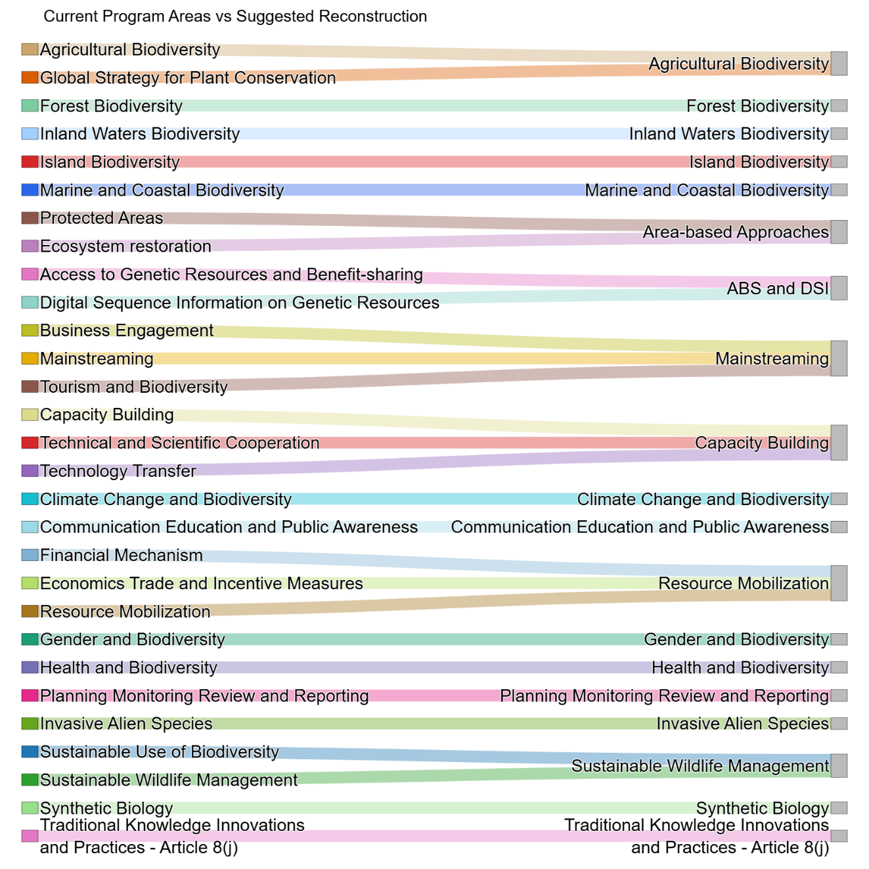

Figure 2 – Sankey diagram: left column shows proposed regrouping, Right Column KMGBF Elements. This graph shows how the proposed work architecture covers all elements of the KMGBF. (Tx: each Target, Cy: Section C paragraph, J: Section J, K Section K of KMGBF)
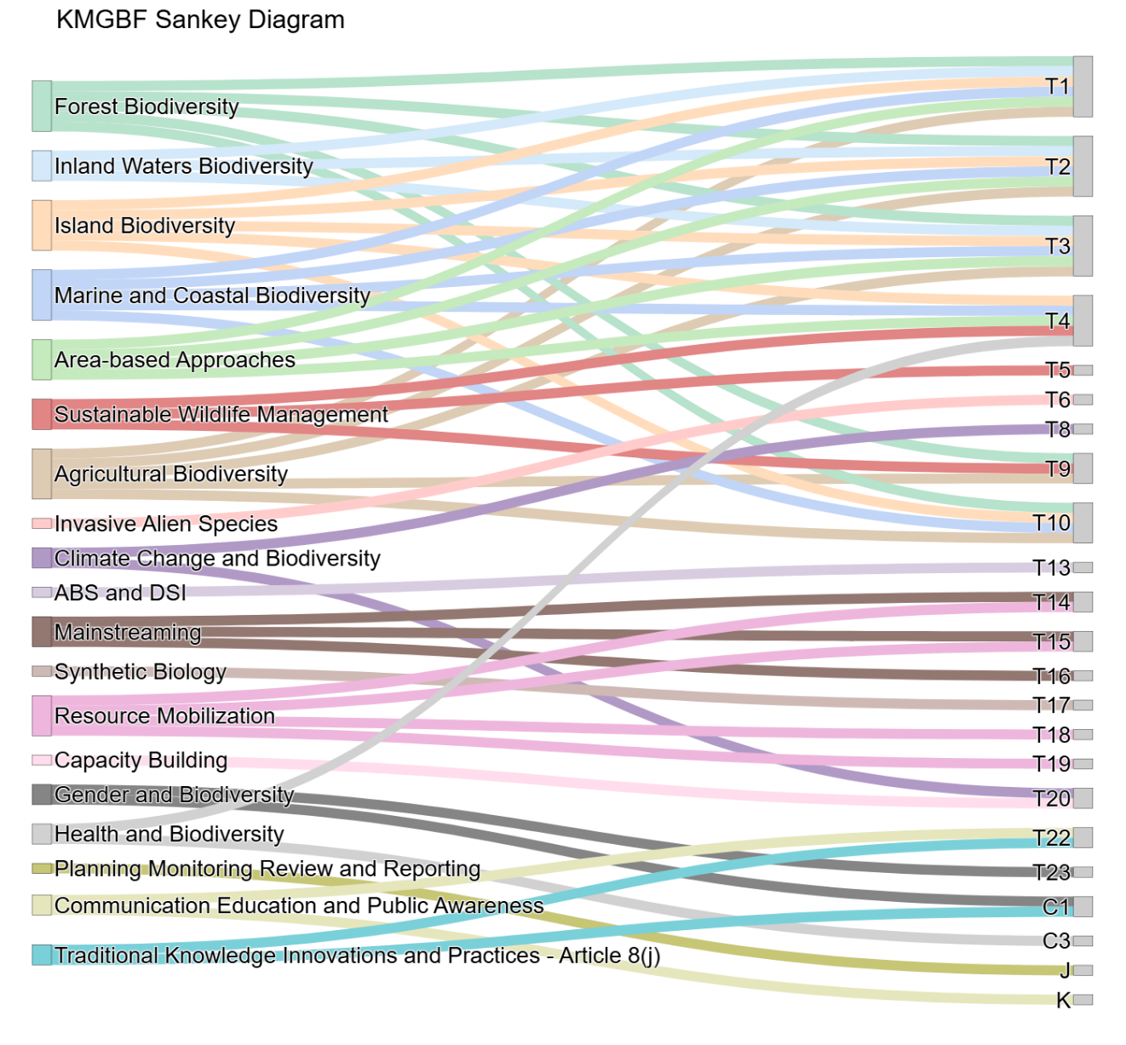

Other observations
While not strictly within the direct scope of this exercise, a number of other observations were noted during the review and might be useful to consider:
- The methodology used for Program of Work reviews varies from one review to the next. While there is a need to adapt to each context, it may be advantageous to have a common structure and process for all.
- Each Work Area should have (or develop) a prioritized workplan taking into consideration capacity, resources available and gaps.
- It would be useful to create a multi-year schedule (or Review Plan) for the review of all Work Areas (e.g. on their relevance and efficiency) over time. It could be that key Work Areas (e.g. PoW) get reviewed in greater detail and more often than others. This could ensure that the work of the Convention remains relevant and adapts over time.

Annex A
This table contains inputs on the strategic relevance, urgency, and implementation needs of each work area in relation to the Convention and the KMGBF. The Annex A table is posted on the SBSTTA-27 conference page.

Annex B
The table below contains an “assessment of alignment,” illustrating how each work area under the Convention aligns with the Elements of the KMGBF, and conversely, how each Element is addressed by the work of the Convention.

 |  | Alignment with KMGBF Element Y: Major contribution, P: partial contribution, N: limited or no contribution
 |  | Section C | Section H (Targets) |  |  |  |  |  |  |  |  |  |  |  |  |  |  |  |  |  |  |  |  |  |  |  |  |  |  |  |  |  |  |  |  |  |  |  |  |  |  |  |  |  |  |  |  |  | Sections I&J |  | Section K
 |  | Section C | Direct drivers |  |  |  |  |  |  |  |  |  |  |  |  |  |  |  | People needs |  |  |  |  |  |  |  |  |  | Tools, solutions, mainstreaming
ID | Description and links | Section C | T1 |  | T2 |  | T3 |  | T4 |  | T5 |  | T6 |  | T7 |  | T8 |  | T9 |  | T10 |  | T11 |  | T12 |  | T13 |  | T14 |  | T15 |  | T16 |  | T17 |  | T18 |  | T19 |  | T20 |  | T21 |  | T22 |  | T23
1 | Agricultural biodiversity | P | Y |  | Y |  | Y |  | P |  | P |  | P |  | P |  | P |  | Y |  | Y |  | P |  | P |  | N |  | P |  | P |  | P |  | P |  | N |  | N |  | P |  | P |  | P |  | P |  | N |  | N
2 | Dry and sub-humid lands biodiversity | P | Y |  | Y |  | Y |  | P |  | P |  | P |  | P |  | P |  | P |  | P |  | P |  | N |  | N |  | P |  | N |  | N |  | N |  | N |  | N |  | P |  | P |  | P |  | P |  | N |  | N
3 | Forest biodiversity | P | Y |  | Y |  | Y |  | P |  | P |  | P |  | P |  | P |  | Y |  | Y |  | P |  | P |  | N |  | P |  | P |  | P |  | N |  | N |  | N |  | P |  | P |  | P |  | P |  | N |  | N
4 | Inland waters biodiversity | P | P |  | P |  | Y |  | P |  | N |  | P |  | P |  | N |  | P |  | N |  | P |  | P |  | N |  | P |  | N |  | N |  | N |  | N |  | N |  | P |  | P |  | P |  | P |  | N |  | N
5 | Island biodiversity | P | Y |  | Y |  | Y |  | Y |  | P |  | P |  | P |  | P |  | P |  | Y |  | P |  | P |  | N |  | P |  | P |  | P |  | N |  | N |  | N |  | P |  | P |  | P |  | P |  | N |  | N
6 | Marine and coastal biodiversity | P | Y |  | Y |  | Y |  | Y |  | P |  | P |  | P |  | P |  | P |  | Y |  | P |  | P |  | N |  | P |  | N |  | N |  | N |  | N |  | N |  | P |  | P |  | P |  | P |  | N |  | N
7 | Mountain biodiversity | P | Y |  | Y |  | Y |  | Y |  | P |  | P |  | P |  | P |  | P |  | P |  | P |  | N |  | N |  | P |  | P |  | P |  | N |  | N |  | N |  | P |  | P |  | P |  | P |  | N |  | N
8 | Protected areas | P | Y |  | P |  | Y |  | Y |  | P |  | P |  | N |  | P |  | P |  | P |  | P |  | P |  | N |  | N |  | N |  | N |  | N |  | N |  | N |  | P |  | P |  | P |  | P |  | N |  | N
9 | Aichi Biodiversity Targets | N | N |  | N |  | N |  | N |  | N |  | N |  | N |  | N |  | N |  | N |  | N |  | N |  | N |  | N |  | N |  | N |  | N |  | N |  | N |  | N |  | N |  | N |  | N |  | N |  | N
10 | Access to genetic resources and benefit-sharing | N | N |  | N |  | N |  | N |  | N |  | N |  | N |  | N |  | N |  | N |  | N |  | N |  | Y |  | N |  | N |  | N |  | N |  | N |  | P |  | N |  | N |  | N |  | N |  | N |  | N
11 | Biological and cultural diversity | Y | N |  | N |  | N |  | N |  | N |  | N |  | N |  | N |  | N |  | N |  | N |  | N |  | N |  | N |  | N |  | N |  | N |  | N |  | N |  | N |  | N |  | N |  | N |  | N |  | N
12 | Biology for development | N | N |  | N |  | N |  | N |  | N |  | N |  | N |  | N |  | N |  | N |  | N |  | N |  | N |  | N |  | N |  | N |  | N |  | N |  | N |  | N |  | N |  | N |  | N |  | N |  | N
12.1 | Business engagement | N | N |  | N |  | N |  | N |  | N |  | N |  | N |  | N |  | N |  | N |  | N |  | N |  | N |  | N |  | Y |  | N |  | N |  | N |  | N |  | N |  | N |  | N |  | N |  | N |  | N
13 | Capacity-building | P | P |  | P |  | P |  | P |  | P |  | P |  | P |  | N |  | P |  | P |  | N |  | N |  | N |  | N |  | N |  | N |  | N |  | N |  | N |  | Y |  | N |  | N |  | N |  | N |  | N
14 | Climate change and biodiversity | N | N |  | N |  | P |  | P |  | N |  | N |  | N |  | Y |  | N |  | N |  | N |  | N |  | N |  | N |  | N |  | N |  | N |  | P |  | N |  | Y |  | N |  | N |  | N |  | N |  | N
15 | Communication, education and public awareness | N | N |  | N |  | N |  | N |  | N |  | N |  | N |  | N |  | N |  | N |  | N |  | N |  | N |  | N |  | N |  | N |  | N |  | N |  | N |  | N |  | N |  | N |  | N |  | N |  | Y
16 | Digital sequence information on genetic resources | P | N |  | N |  | N |  | N |  | N |  | N |  | N |  | N |  | N |  | N |  | N |  | N |  | Y |  | N |  | N |  | N |  | N |  | N |  | N |  | N |  | N |  | N |  | P |  | N |  | N
16.1 | Financial mechanism | N | N |  | N |  | N |  | N |  | N |  | N |  | N |  | N |  | N |  | N |  | N |  | N |  | N |  | N |  | N |  | N |  | N |  | N |  | Y |  | N |  | N |  | N |  | N |  | N |  | N
17 | Economics, trade and incentive measures | N | N |  | N |  | N |  | N |  | N |  | N |  | N |  | N |  | N |  | N |  | N |  | N |  | N |  | Y |  | Y |  | N |  | N |  | N |  | N |  | N |  | N |  | N |  | N |  | N |  | N
18 | Ecosystem approach | N | N |  | N |  | N |  | N |  | N |  | N |  | N |  | N |  | N |  | N |  | N |  | N |  | N |  | N |  | N |  | N |  | N |  | N |  | N |  | N |  | N |  | N |  | N |  | N |  | N
19 | Ecosystem restoration | N | N |  | Y |  | N |  | N |  | N |  | N |  | N |  | N |  | N |  | N |  | N |  | N |  | N |  | N |  | N |  | N |  | N |  | N |  | N |  | N |  | N |  | N |  | N |  | N |  | N
20 | Gender and biodiversity | Y | N |  | N |  | N |  | N |  | N |  | N |  | N |  | N |  | N |  | N |  | N |  | N |  | N |  | N |  | N |  | N |  | N |  | N |  | N |  | N |  | N |  | N |  | Y |  | N |  | N
21 | Global Strategy for Plant Conservation | N | N |  | N |  | N |  | P |  | N |  | N |  | N |  | N |  | N |  | N |  | N |  | N |  | N |  | N |  | N |  | N |  | N |  | N |  | N |  | N |  | N |  | N |  | N |  | N |  | N
22 | Global Taxonomy Initiative | N | N |  | N |  | N |  | N |  | N |  | N |  | N |  | N |  | N |  | N |  | N |  | N |  | N |  | N |  | N |  | N |  | N |  | N |  | N |  | N |  | N |  | N |  | N |  | N |  | N
23 | Health and biodiversity | Y | N |  | N |  | N |  | Y |  | N |  | N |  | N |  | N |  | P |  | P |  | P |  | P |  | N |  | N |  | N |  | N |  | P |  | N |  | N |  | P |  | P |  | P |  | P |  | N |  | N
24 | Impact assessment | N | P |  | N |  | N |  | P |  | N |  | P |  | P |  | N |  | N |  | N |  | N |  | N |  | N |  | Y |  | P |  | N |  | N |  | N |  | N |  | N |  | N |  | N |  | N |  | N |  | N
25 | Planning, monitoring, review, and reporting | N | N |  | N |  | N |  | N |  | N |  | N |  | N |  | N |  | N |  | N |  | N |  | N |  | N |  | N |  | N |  | N |  | N |  | N |  | N |  | N |  | N |  | N |  | N |  | Y |  | P
26 | Invasive alien species | N | N |  | N |  | N |  | N |  | N |  | Y |  | N |  | N |  | N |  | N |  | N |  | N |  | N |  | N |  | N |  | N |  | N |  | N |  | N |  | N |  | N |  | N |  | N |  | N |  | N
27.1 | Mainstreaming | N | N |  | N |  | N |  | N |  | N |  | N |  | N |  | N |  | N |  | N |  | N |  | N |  | N |  | Y |  | Y |  | Y |  | N |  | N |  | N |  | N |  | N |  | N |  | N |  | N |  | N
28.1 | Resource mobilization | N | N |  | N |  | N |  | N |  | N |  | N |  | N |  | N |  | N |  | N |  | N |  | N |  | P |  | N |  | N |  | N |  | N |  | N |  | Y |  | N |  | N |  | N |  | N |  | N |  | N
29 | Sustainable use of biodiversity | P | N |  | N |  | P |  | P |  | P |  | P |  | N |  | N |  | P |  | P |  | N |  | N |  | N |  | N |  | N |  | P |  | N |  | N |  | N |  | N |  | P |  | N |  | N |  | N |  | N
30 | Sustainable wildlife management | P | N |  | N |  | P |  | P |  | P |  | P |  | N |  | N |  | P |  | P |  | N |  | N |  | N |  | N |  | N |  | P |  | N |  | N |  | N |  | N |  | P |  | N |  | N |  | N |  | N
31 | Synthetic biology | N | N |  | N |  | N |  | N |  | N |  | N |  | N |  | N |  | N |  | N |  | N |  | N |  | N |  | N |  | N |  | N |  | Y |  | N |  | N |  | N |  | N |  | N |  | N |  | N |  | N
32 | Technical and scientific cooperation | N | N |  | N |  | N |  | N |  | N |  | N |  | N |  | N |  | N |  | N |  | N |  | N |  | N |  | N |  | N |  | N |  | N |  | N |  | N |  | Y |  | N |  | N |  | N |  | N |  | N
33 | Technology transfer | N | N |  | N |  | N |  | N |  | N |  | N |  | N |  | N |  | N |  | N |  | N |  | N |  | N |  | N |  | N |  | N |  | N |  | N |  | N |  | Y |  | N |  | N |  | N |  | N |  | N
34 | Tourism and biodiversity | N | N |  | N |  | N |  | N |  | N |  | N |  | N |  | N |  | N |  | N |  | N |  | N |  | N |  | N |  | P |  | N |  | N |  | N |  | N |  | N |  | N |  | N |  | N |  | N |  | N
35 | Traditional knowledge | Y | P |  | P |  | P |  | P |  | P |  | N |  | N |  | N |  | N |  | N |  | N |  | N |  | P |  | N |  | N |  | N |  | N |  | N |  | N |  | P |  | P |  | Y |  | N |  | N |  | N
 | Is the global guidance beyond CBD programmes, tools and guidance sufficient? (Yes/No/Partially) | P | P |  | Y |  | P |  | P |  | P |  | Y |  | Y |  | Y |  | Y |  | P |  | P |  | P |  | Y |  | Y |  | Y |  | P |  | Y |  | P |  | Y |  | Y |  | Y |  | P |  | Y
 | Comments |  | Gaps outside of marine and coastal areas |  |  |  |  |  |  |  |  |  |  | Gaps in guidance |  |  |  |  |  |  |  |  |  |  |  |  |  | Gaps in sectors |  | Generic guidance across sectors |  |  |  |  |  | Gaps in guidance to transform harmful subsidies |  | Gaps for paras. c, d and f |  |  |  |  |  | Gaps outside IPLCs
 | Are there existing tools and guidance? (Yes/No/Partially) | Y | Y |  | Y |  | Y |  | Y |  | P |  | Y |  | Y |  | Y |  | Y |  | P |  | Y |  | P |  | Y |  | Y |  | P |  | P |  | Y |  | P |  | Y |  | P |  | Y |  | P |  | P
 | Are there identified gaps? (Yes/No/Partially) | Y | Y |  | Y |  | Y |  | Y |  | Y |  | N |  | Y |  | N |  | Y |  | Y |  | Y |  | Y |  | Y |  | P |  | Y |  | Y |  | Y |  | Y |  | P |  | Y |  | Y |  | Y |  | Y
 | Is it adequately reflected in the COP agenda? (Identify the previous COP Decisions or future COP Decisions/MYPOW.)** |  |  |  |  |  |  |  |  |  |  |  |  |  | N |  |  |  |  |  |  |  |  |  |  |  |  |  | P |  |  |  |  |  |  |  | N

__________

* CBD/SBSTTA/27/1.
Argentina, Belgium, Brazil, Canada, Colombia, European Union, Germany, Japan, Mexico, Netherlands (Kingdom of the), Poland, Spain, Sweden and Switzerland.
BaKoena Royal Council, Botanic Gardens Conservation International, Centre international de droit comparé de l’environnement, Consorcio para el Desarrollo Sostenible de la Ecorregión Andina, Food and Agriculture Organization of the United Nations (two submissions), Global Mountain Biodiversity Assessment, Global Youth Biodiversity Network, International Centre for Integrated Mountain Development, Mountain Partnership Secretariat, National Indigenous Women Forum, Royal Society for the Protection of Birds, The Nature Conservancy and United Nations Environment Programme.
* The present annex is being issued without formal editing.
Mr. Basile van Havre, Ms. Cyrie N. Sendashonga and Mr. David Coates
Available at https://www.cbd.int/meetings/SBSTTA-27
Including those issues being covered by the other Subsidiary Bodies.
COP 16 considered the strategic review and analysis of the programmes of work on marine and coastal biodiversity, and on island biodiversity. In its decision 16/17, COP recognized that the programmes of work on marine and coastal biodiversity and on island biodiversity, together with relevant decisions of the Conference of the Parties, still correspond to global priorities and contain guidance that provides essential support for the implementation of the Framework. COP-16 also noted that there are certain elements of the targets of the Framework for which limited guidance or tools are available under the programmes of work on marine and coastal biodiversity and on island biodiversity and that those elements may require enhanced action and attention to implement the Framework, as listed in the annex to the decision 16/17, and that such work may take the form of new guidance, where needed, in cooperation and collaboration with competent intergovernmental organizations, avoiding duplication and making use of existing tools and guidance developed by other organizations and frameworks, the synthesis of best practices and experiences, and capacity-building and development with regard to the areas concerned
Approaches to identifying scientific and technical needs to support the implementation of the Framework, including its implication for the programmes of work of the Convention (CBD/SBSTTA/25/4); Rapid analysis of programmes of work established under the Convention with respect to the targets of the Kunming-Montreal Global Biodiversity Framework (CBD/SBSTTA/25/INF/1).
Scientific and technical needs to support the implementation of the Kunming-Montreal Global Biodiversity Framework (CBD/SBSTTA/26/3); Review and analysis of existing tools and guidance and their gaps to support the implementation of the targets of the Kunming-Montreal Global Biodiversity Framework (CBD/SBSTTA/26/INF/15).
Cartagena Protocol and Nagoya Protocol under the Convention on Biological Diversity.

