 |  | CBD
 |  |  | Distr.  GENERAL  CBD/EBSA/WS/2017/1/4  9 May 2018  ORIGINAL: ENGLISH/RUSSIAN

Report of the Regional Workshop to Facilitate the Description of Ecologically or Biologically Significant Marine Areas in the Black Sea and Caspian Sea

Baku, 24-29 April 2017

INTRODUCTION
- At its tenth meeting, the Conference of the Parties to the Convention on Biological Diversity requested the Executive Secretary to work with Parties and other Governments as well as competent organizations and regional initiatives, such as the Food and Agriculture Organization of the United Nations, regional seas conventions and action plans, and, where appropriate, regional fisheries management organizations to organize, including the setting of terms of reference, a series of regional workshops, with a primary objective to facilitate the description of ecologically or biologically significant marine areas through the application of scientific criteria in annex I of decision IX/20 as well as other relevant compatible and complementary nationally and intergovernmentally agreed scientific criteria, as well as the scientific guidance on the identification of marine areas beyond national jurisdiction, which meet the scientific criteria in annex I to decision IX/20 (para. 36 of decision X/29).
- In the same decision, the Conference of the Parties requested that the Executive Secretary make available the scientific and technical data, information and results collated through the workshops referred to above to participating Parties, other Governments, intergovernmental agencies and the Subsidiary Body on Scientific, Technical and Technological Advice (SBSTTA) for their use according to their competencies.
- Subsequently, at its eleventh, twelfth and thirteenth meetings, the Conference of the Parties reviewed the outcomes, respectively, of the first, second and third set of regional workshops conducted and requested the Executive Secretary to further collaborate with Parties, other Governments, competent organizations, and global and regional initiatives, such as the United Nations General Assembly Ad Hoc Working Group of the Whole on the Regular Process for Global Reporting and Assessment of the State of the Marine Environment, including Socio-economic Aspects, the International Maritime Organization, the Food and Agriculture Organization of the United Nations, regional seas conventions and action plans, and, where appropriate, regional fisheries management organizations, with regard to fisheries management, and also including the participation of indigenous and local communities, to facilitate the description of areas that meet the criteria for EBSAs through the organization of additional regional or subregional workshops for the remaining regions or subregions where Parties wish workshops to be held, and for the further description of the areas already described where new information becomes available (decisions XI/17, XII/22 and XIII/12).
- Pursuant to the above requests and with financial support from the Government of Japan, through the Japan Biodiversity Fund, the Secretariat of the Convention on Biological Diversity convened the Regional Workshop to Facilitate the Description of Ecologically or Biologically Significant Marine Areas (EBSAs) in the Black Sea and Caspian Sea. The workshop was organized in collaboration with the Commission on the Protection of the Black Sea against Pollution (BSC), the Tehran Convention Interim Secretariat (TCIS), the General Fisheries Commission for the Mediterranean (GFCM) and the Agreement on the Conservation of Cetaceans of the Black Sea, Mediterranean Sea and Contiguous Atlantic Area (ACCOBAMS). This workshop was hosted by the Government Azerbaijan in Baku, Azerbaijan, from 24 to 29 April 2017.
- Scientific and technical support for this workshop was provided by Duke University with financial support from the European Union. The results of technical preparation for the workshop were made available in the meeting document entitled “Data to Inform the CBD Regional Workshop to Facilitate the Description of Ecologically or Biologically Significant Marine Areas in the Seas of the Black Sea and Caspian Sea” (CBD/EBSA/WS/2017/1/3).
- The meeting was attended by experts from Azerbaijan, Bulgaria, Georgia, Iran, Kazakhstan, Romania, Russian Federation, Turkey, Turkmenistan, Ukraine, BSC, TCIS, ACCOBAMS, Food and Agriculture Organization of the United Nations, Ocean Biogeographic Information System (OBIS of the Intergovernmental Oceanographic Commission/United Nations Education, Science and Cultural Organization), Global Ocean Biodiversity Initiative (GOBI), BirdLife International and Centre for Sustainable Development/Indigenous Peoples’ and Community Conserved Territories and Areas (ICCA) Consortium for West and Central Asia. The full list of participants is attached as annex I.

ITEM 1. OPENING OF THE MEETING
- On behalf of the Government of the Republic of Azerbaijan, Mr. Rauf Hajiyev, Deputy Minister of Ecology and Natural Resources, welcomed the representatives of the Secretariat of the Convention on Biological Diversity, as well as all workshop participants. He noted the significance of this workshop in terms of the problems associated with the decline in global biodiversity and the importance of the conservation of the unique marine biodiversity and ecosystems of the Black Sea and the Caspian Sea for the entire region. He stressed the importance of the Sustainable Development Goals set out in the 2030 Agenda for Sustainable Development, especially Goal 14, which calls upon States to take measures aimed at the conservation and sustainable use of oceans, seas and marine resources. He stressed that Azerbaijan pays special attention to the protection of the marine environment and the unique biological diversity of the Caspian Sea. He emphasized that all national programmes being implemented in the country (e.g., “Azerbaijan 2020: Looking to the future”) are formed taking into account the priorities of the national policy in the field of environmental protection and ensuring environmentally sustainable economic growth and the introduction of environmentally friendly innovative technologies. He also noted that the National Biodiversity Strategy and Action Plan for the period 2017-2020 had been adopted in 2016 with the aim of achieving the Aichi Biodiversity Targets. He enumerated progress in the implementation of the First National Strategy and Action Plan for Biodiversity Conservation, including, among others, the increase in protected areas in Azerbaijan from 5 per cent to 10.3 per cent, and the areas covered by forests from 11.4 per cent to 11.8 per cent, respectively. He added that Azerbaijan has nine national parks, 11 national nature reserves and 24 national nature sanctuaries, with a total area of 893,000 hectares, while work is underway to create a new national marine park on the basis of the Gizilagach reserve complex. He also stressed the importance of the Framework Convention for the Protection of the Marine Environment of the Caspian Sea (Tehran Convention) and its Protocol on the Conservation of the Biological Diversity of the Caspian Sea in the context of protecting the marine environment of the Caspian Sea from pollution, including the protection, conservation, sustainable and rational use of its biological resources. In this connection, he noted that Azerbaijan attaches great importance to cooperation with the Caspian countries and international organizations in the environmental field and shares the region's general concern with the current state of the environment and living resources of the Caspian Sea. In conclusion, he noted his appreciation of the common desire of all Parties in the region to cooperate more effectively and wished success to the workshop participants in the achievement of the workshop objectives.
- Ms. Cristiana Paşca Palmer, Executive Secretary of the Convention on Biological Diversity, delivered opening remarks via a video message. She welcomed all the experts from countries and organizations and thanked them for participating in this regional workshop. She thanked the Government of Azerbaijan, in particular the Ministry of Ecology and Natural Resources, for hosting this important workshop in the beautiful and historic city of Baku. She also thanked the Commission on the Protection of the Black Sea against Pollution, the Tehran Convention Interim Secretariat, the General Fisheries Commission for the Mediterranean, and the Agreement on the Conservation of Cetaceans of the Black Sea, Mediterranean Sea and Contiguous Atlantic Area, for providing valuable technical input to the workshop. She also extended her appreciation to the Government of Japan, for its financial contribution, through the Japan Biodiversity Fund, as well as the European Commission. She emphasized that biodiversity is not a hindrance, but a solution for sustainable economic growth and human well-being by supporting the functioning of the Earth’s life support system. She noted that the Convention’s 196 Parties have been collaborating closely for the implementation of the Strategic Plan for Biodiversity 2011-2020 and achieving its 20 Aichi Biodiversity Targets, since its adoption in 2010. She highlighted that Parties’ collective efforts to achieve the Aichi Targets will directly contribute to implementing the 2030 Agenda for Sustainable Development and achieving the Sustainable Development Goals, particularly Goal 14. She pointed out that a central theme of the United Nations Biodiversity Conference in December 2016 was mainstreaming of biodiversity considerations into economic sectors that have an effect on, and rely on, healthy marine ecosystems for sustainable economic growth. She pointed out that the work of the CBD on EBSAs plays a key role in focusing our efforts to achieve global goals related to marine biodiversity conservation and sustainable use. She explained that since 2011, the CBD Secretariat has organized a series of 12 regional EBSA workshops to describe the “special places” of the ocean and seas that are crucial to the healthy functioning of the global marine ecosystem. These workshops have covered more than 74 per cent of the world’s ocean and involved about 153 countries and more than 100 organizations. The summary reports on the outputs of these regional EBSA workshops have been submitted to the United Nations General Assembly and its relevant processes. The process has also facilitated sharing of scientific information, networking of experts, and enhanced collaboration among regional initiatives. In conclusion, she expressed her confidence that the work to be conducted at the workshop would provide a sound basis for achieving the Aichi Biodiversity Targets in this region.
- On behalf of Mr. Halil Ibrahim Sur, Executive Director of the Permanent Secretariat of the Black Sea Commission, Ms. Iryna Makarenko delivered opening remarks. She thanked the Secretariat of the Convention on Biological Diversity and the Government of Azerbaijan for the invitation and for organizing this workshop. She introduced the Black Sea Commission Permanent Secretariat, an executive body to the Convention on the Protection of the Black Sea against Pollution, also known as the “Bucharest Convention”, which was signed and ratified by all six riparian countries of the Black Sea in 1994. She noted that the Black Sea Commission has been working with the Convention on Biological Diversity since the year 2000, on efforts to conserve the biodiversity of the Black Sea. She noted that collaboration with the CBD Secretariat has been reinforced through the organization of the present workshop, which was welcomed by the Commission’s CBD Advisory Group in 2015. She also indicated that the Commission was pleased to have this opportunity to join efforts with their colleagues from the Caspian Sea, given their similar challenges in the conservation and sustainable use of marine biodiversity. She pointed out that the two Secretariats recently exchanged letters of intent to cooperate and that this workshop provided an opportunity for further collaboration.
- On behalf of Mr. Mahir Aliyev, Coordinator of the Tehran Convention Interim Secretariat, Mr. Mateusz Benko delivered opening remarks. He thanked the Government of Azerbaijan for hosting and the CBD Secretariat for organizing this workshop, the first opportunity for the coastal countries of the Black Sea and the Caspian Sea to discuss ecologically or biologically significant marine areas in these two basins. He noted that the achievement of global goals, such as the ambitious Sustainable Development Goals, particularly Goal 14, can only be possible alongside regional cooperation among neighbouring States. He pointed out that the present workshop would facilitate a new level of cooperation among the five Caspian States, building on their existing collective efforts to keep the Caspian Sea healthy and prosperous. He introduced the Caspian Sea as the planet’s largest land-locked water body, whose isolation and climatic and salinity gradients have created a unique ecological system with some 400 species endemic to the Caspian waters. He pointed out that in recent decades, oil and gas activities, industrial pollution, overexploitation of biological resources, and destruction of natural habitats have jeopardized the environmental balance of the Caspian ecosystem. He emphasized that the 2003 Framework Convention for the Protection of the Marine Environment of the Caspian Sea was a historic breakthrough to avoid/mitigate environmental degradation and preserve one of the world’s most precious ecosystems. As the first legally binding agreement between the Caspian States, the Convention serves as a mechanism of regional cooperation to effectively protect livelihoods, health, and well-being for present and future generations around the Caspian Sea. Three years ago, the Caspian States adopted the Biodiversity Protocol, which commits the littoral states to protect and preserve the Caspian ecosystem, safeguarding threatened species, preventing their decline and damage, and conserving those areas that best represent the high range of species, special habitats, ecosystems and natural and cultural heritage. These activities are essential not only for the marine environment itself, but also for the health and well-being of the communities that live by the Caspian shores. He looked forward to continuing partnership between Caspian Sea states, as well as with those of the Black Sea with a view to securing healthy ecosystems for a sustainable future.

ITEM 2. ELECTION OF THE CHAIR, ADOPTION OF THE AGENDA AND ORGANIZATION OF WORK
11. After a brief explanation by the CBD Secretariat on procedures for electing the workshop co-chairs, Ms. Jafarova Elnara Eldar (Azerbaijan), as offered by the host Government, and Ms. Shirin B. Karryyeva (Turkmenistan), proposed by an expert from Azerbaijan and seconded unanimously by the floor, were elected as the workshop co-chairs.
12. Participants were then invited to consider the provisional agenda (CBD/EBSA/WS/2017/1/1) and the proposed organization of work, as contained in annex II to the annotations to the provisional agenda (CBD/EBSA/WS/2017/1/1/Add.1) and adopted them without any amendments.
13. The workshop was organized in plenary sessions and break-out group sessions. The co-chairs nominated the following rapporteurs to assist the CBD Secretariat in preparing the draft workshop report on the discussions to be undertaken at the plenary sessions, taking into consideration the expertise and experience of the workshop participants and in consultation with the CBD Secretariat:
- For the Black Sea: Ms. Iryna Makarenko (BSC) and Mr. Ahmet E. Kideys (GOBI)
- For the Caspian Sea: Mr. Mateusz Benko (TCIS) and Mr. Vassily Spiridonov (resource speaker)

ITEM 3. Workshop background, scope and output
14. Under this agenda item, participants were provided with a series of presentations, as below, during the training day, including presentations on the scientific aspects of the EBSA criteria, the application of the EBSA criteria, and potential use of the EBSA information to support implementation of the ecosystem approach:
- Ms. Jihyun Lee (CBD Secretariat) and Mr. Joseph Appiott (CBD Secretariat) gave presentations on the work of the CBD on EBSAs and other relevant work on marine and coastal biodiversity and the global context for the workshop;
- Mr. David Johnson (GOBI) discussed the work of the Global Ocean Biodiversity Initiative in supporting the description of EBSAs and focused in particular on the values and scientific challenges posed in the description of different types of ecosystem features in open-ocean and deep-sea areas;
- Ms. Iryna Makarenko (BSC) discussed the relevant work of the Black Sea Commission and its applicability to efforts to describe EBSAs in the Caspian Sea and the use of EBSA information to support conservation and management;
- Mr. Mahir Aliyev (TCIS) presented the relevant work under the Tehran Convention;
- Ms. Ayaka Amaha Ozturk (ACCOBAMS) delivered a presentation on the relevant work under the Agreement on the Conservation of Cetaceans of the Black Sea, Mediterranean Sea and Contiguous Atlantic Area;
- Mr. Oleksandr Neprokin (OBIS) presented on the relevant scientific work under the Black Sea Node of the Ocean Biogeographic Information System;
- Mr. Patrick Halpin (technical support team) gave a presentation on the scientific criteria for EBSAs and the approaches to and experience in describing areas meeting the EBSA criteria;
- Mr. Patrick Halpin (technical support team) gave a presentation on the scientific information compiled for the workshop;
- Mr. Vassily Spiridonov (resource speaker) discussed examples of outputs of previous EBSA workshops and how these outputs have been used for the application of conservation and management measures;
- Mr. Patrick Halpin (technical support team) gave a presentation on the use of EBSA information for the application of the ecosystem approach and marine spatial planning.
15. Ms. Jihyun Lee (CBD Secretariat) briefed participants on the workshop objectives, expected outputs and geographic scope, building on her presentation on the Convention's EBSA process, delivered on the training day.
16. The workshop participants agreed that the workshop deliberation would focus on the Black Sea, as defined by the BSC and its relevant protocol, and the Caspian Sea, as defined by the Tehran Convention.
17. The workshop participants noted the following points regarding the guidance of the Conference of the Parties on the regional workshop process as well as the potential contribution of the scientific information produced by the workshops:
- The Conference of the Parties to the Convention, at its tenth meeting, noted that the application of the scientific criteria in annex I of decision IX/20 for the identification of ecologically or biologically significant marine areas presents a tool which Parties and competent intergovernmental organizations may choose to use to progress towards the implementation of ecosystem approaches in relation to areas both within and beyond national jurisdiction, through the identification of areas and features of the marine environment that are important for conservation and sustainable use of marine and coastal biodiversity (para. 25, decision X/29);
- The application of the EBSA criteria is a scientific and technical exercise, and the identification of EBSAs and the selection of conservation and management measures is a matter for States and competent intergovernmental organizations, in accordance with international law, including the United Nations Convention on the Law of the Sea (para. 26, decision X/29);
- The EBSA description process is open-ended, and additional regional or subregional workshops may be organized when there is sufficient advancement in the availability of scientific information (paras. 9 and 12, decision XI/17);
- Each workshop is tasked to describe areas meeting the scientific criteria for EBSAs or other relevant criteria based on best available scientific information. As such, experts at the workshops are not expected to discuss any management issues, including threats to the areas;
- The EBSA description process facilitates scientific collaboration and information-sharing at national, subregional and regional levels, as demonstrated by collective work by workshop participants with different expertise, contributing to each other’s description of areas meeting the EBSA criteria;
- Experts were nominated by CBD National Focal Points and selected to participate based on the selection criteria provided in the CBD notification dated 12 December 2016 (reference number 2016-144). Prior to the workshop, selected experts were asked to provide relevant scientific and technical information, in collaboration with relevant scientists within their respective countries, to support the workshop discussions, including by filling in the EBSA information template (appended to the notification above).
18. Summaries of the above presentations are provided in annex II.

ITEM 4. Review of relevant scientific data/information/maps compiled and submitted for the workshop
19. For the consideration of this item, workshop participants had before them two information notes by the Executive Secretary: “Data to inform the CBD Regional Workshop to Facilitate the Description of Ecologically or Biologically Significant Marine Areas in the Black Sea and Caspian Sea” (UNEP/CBD/EBSA/WS/2017/1/3), which had been issued to support the deliberations of the workshop, and “Compilation of relevant scientific information submitted by Parties, other Governments and relevant organizations in support of the workshop objectives” (UNEP/CBD/EBSA/WS/2017/1/2), compiled based on submissions in response to the Secretariat’s notification (2017-002, dated 17 January 2017). The documents/references submitted prior to the workshop were made available for the information of workshop participants on the meeting website (https://www.cbd.int/doc/?meeting=EBSAWS-2017-01).
20. Mr. Patrick Halpin (technical support team) provided a presentation entitled “Review of relevant scientific data/information/maps compiled to facilitate the description of EBSAs in the Black Sea and the Caspian Sea,” based on document UNEP/CBD/EBSA/WS/2017/1/3. The information provided in this presentation was considered in the description of areas meeting the EBSA criteria by the break-out groups. A summary of this presentation is provided in annex II.
21. Workshop participants, including experts from Parties as well as ACCOBAMS, OBIS, BirdLife International, and CENESTA, who had submitted relevant scientific information using the EBSA templates prior to the workshop, as contained in document UNEP/CBD/EBSA/WS/2017/1/2, were invited to present their draft descriptions of areas potentially meeting the EBSA criteria.
22. Spatial data compiled for this workshop was available to workshop participants both in hard-copy maps as well as in a Geographic Information System (GIS) database with open-source GIS software, for their use, analysis and interpretation in the application of the EBSA criteria.
23. Workshop participants noted with appreciation the considerable amount of data/information gathered, including GIS data, for the workshop deliberation and highlighted the importance of making it available through the development of relevant information platforms (e.g., EBSA regional repository) at national and regional scales.

ITEM 5. description of areas meeting the ebsa criteria through application of the scientific criteria and other relevant compatible and complementary nationally and intergovernmentally agreed scientific criteria
24. Building upon the theme presentations provided in the previous agenda items, the workshop participants exchanged their views on possible ways of organizing their work on assessing the scientific information compiled and submitted for the consideration of the workshop. In this regard, participants noted the following points with regard to the description of areas meeting the EBSA criteria:
- The description of EBSAs is based on the scientific information and expert knowledge available at the time of the workshop, and, as the EBSA process is iterative and ongoing, there may be additional areas to be described as meeting the EBSA criteria in future regional or subregional workshops;
- In describing multiple ecological and/or biological components of a given area, participants should consider how these components may be interconnected as part of a system, and that, if separate components cannot be described as part of a coherent system approach, these components should be described separately;
- The EBSA criteria can be applied on all scales from global to local. Once a scale has been selected, however, the criteria are intended to be used to evaluate areas and ecosystem features in a context relative to other areas and features at the given scale;
- There are no thresholds that must be met, judgements are comparative to adjacent areas, and the current ranking system (e.g., high, medium, low, no information) for assessing the areas meeting each EBSA criterion is devised to facilitate better understanding of available scientific information in describing the areas with regard to the extent to which they meet different criteria. The current ranking system, however, does not intend to compare the importance of each criterion;
- Relative assessments are necessarily scale dependent. Relative significance of areas has generally been viewed from regional or large subregional scales;
- Areas may meet multiple criteria, and that is important, but meeting just one strongly is also important;
- Areas described to meet the EBSA criteria have ranged from relatively small sites to very extensive oceanographic features;
- Areas described to meet the EBSA criteria can be overlapped or nested;
- Difficulties are often encountered in applying two of the EBSA criteria in particular: criterion 4 (vulnerability, fragility, sensitivity, and/or slow recovery) and criterion 5 (biological productivity):
  - Criterion 4 applies to an area that contain a relatively high proportion of sensitive habitats, biotopes or species that are functionally fragile (highly susceptible to degradation or depletion by human activity or by natural events) or with slow recovery, not directly describing the anthrophogenic threats or pressures affecting the areas;
  - Criterion 5 applies to an area containing species, populations or communities with comparatively higher natural biological productivity. The productivity can be measured as the rate of growth of marine organisms and their populations or can be inferred from remote-sensed products. It is usually assessed by considering primary or secondary productivity, though it can be evaluated by data such as fisheries catches. Time-series fisheries data can be used, but caution is required;
- When birds or terrestrial species are referred to in the description of areas meeting the EBSA criteria, their interconnections with marine species and ecosystems need to be clearly described;
- In addition to ecological or biological significance, connectivity is one of the five required network properties and components outlined in the “Scientific guidance for selecting areas to establish a representative network of marine protected areas, including in open ocean waters and deep-sea habitats” (annex II to decision IX/20).
25. This workshop was mandated to evaluate areas at a regional scale within the Black Sea and Caspian Sea. However, the workshop considered that the entire region has unique and vulnerable ecological or biological features, as enclosed marine ecosystems, which need to be viewed on a global scale. This perspective is presented in annex III of this report.
26. For effective review of available scientific information and assessment of potential areas meeting the EBSA criteria, the workshop participants were split into two break-out groups: (a) Black Sea group and (b) Caspian Sea group.
27. Each break-out group was advised to focus on the following in their discussion:
- Review the layers of information available, including GIS maps of ocean features, other types of data sets, primary and other scientific and technical reports and publications, and expert knowledge, relative to each of the CBD EBSA criteria;
- Based on the review of available scientific information, describe areas that may be considered to be relatively ecologically or biologically significant, based on their relative importance on one or more of the criteria;
- Document the description of each area considered to be ecologically or biologically significant, using the EBSA template and augmenting the template with narrative text and maps considered necessary to reflect the rationales of the group. Where appropriate, the narrative text may report on strengths and weaknesses in the information used in description of the area, and key uncertainties;
- Review existing compilation of templates and as necessary refine them, considering comments provided by the Secretariat and the workshop plenary, in terms of scientific data/information; and polygon boundaries of areas to be mapped;
- Where appropriate consider merging areas described in draft descriptions with other areas or refining them into small areas so that the description can accurately cover the ecosystem features under consideration;
- Identify the needs for future scientific research, scientific collaboration, data/information sharing, and capacity building to further enable application of the EBSA criteria in the region, particularly for areas or types of information for which there is a lack of scientific information or expert knowledge at this workshop, as inputs to agenda item 6;
- Work with technical support team to define the polygon boundary of areas of your EBSA description on the GIS map; and
- Invite relevant international/regional experts available at the meeting for their expert opinions.
28. Participants were assisted by the technical support team, including GIS operators, who made hard/electronic copies of the maps available for the deliberation of the break-out group discussion, provided data in a GIS database, and supported data analysis and interpretation as well as mapping of potential areas meeting the EBSA criteria.
29. During the break-out group discussions, participants who were preparing descriptions of areas meeting EBSA criteria, drew approximate polygons of these areas on a map provided by the technical support team as they were completed to keep track of opportunities to extend or merge areas being described and to identify areas that had yet to be considered.
30. The results of the break-out groups were reported at plenary sessions for the consideration of all workshop participants. At these plenary sessions, workshop participants reviewed the draft descriptions of areas meeting the EBSA criteria proposed by the break-out group sessions, using templates provided by the CBD Secretariat, and considered them for inclusion on the final list of areas meeting EBSA criteria.
31. The workshop participants agreed on descriptions of 33 areas meeting the EBSA criteria. The map of described areas is contained in annex IV. They are listed in annex V and described in its appendix.

ITEM 6. Identification of gaps and needs for further elaboration in describing AREAS MEETING ebsa CRITERIA, including the need for scientific information, development of scientific capacity and scientific collaboration
32. Building on the workshop deliberation, the workshop participants were invited to identify, through break-out group sessions and plenary discussion, gaps and needs for further elaboration in describing areas meeting the EBSA criteria, including the need for scientific information, scientific capacity development and scientific collaboration. The results of the plenary and subgroup discussions are compiled in annex VI.
33. The workshop participants also noted some areas that have potential to meet the EBSA criteria, but could not be described at this workshop due to data paucity and lack of analysis. These areas are discussed in annex VI.

ITEM 7. OTHER MATTERS
34. Participants noted the importance of facilitating joint scientific collaboration between the Black Sea and the Caspian Sea.

ITEM 8. ADOPTION OF THE REPORT
35. The participants considered and adopted the workshop report on the basis of a draft report prepared and presented by the co-chairs with some changes.
36. The participants agreed that any additional scientific information and scientific references would be provided to the CBD Secretariat by workshop participants within two weeks of the closing of the workshop in order to further refine the description of areas meeting EBSA criteria contained in annex V and its appendix.

ITEM 9. CLOSURE OF THE MEETING
37. In closing the workshop, participants expressed their appreciation to the Government of Azerbaijan for its hospitality and thanked the workshop co-chairs for their leadership in steering the workshop deliberation. They also thanked the rapporteurs, facilitators, and technical team for their valuable contributions. They acknowledged with thanks the hard work and efficient servicing by the Secretariat staff for successfully organizing and concluding the workshop.
38. The workshop was closed at 1 pm. on Saturday, 29 April 2017.
Annex I

LIST OF participants
PARTIES

Azerbaijan
- Mr. Elchin Mamedov
Lead Advisor
Division of Environmental Policy
Ministry of Ecology and Natural Resources of Azerbaijan
Baku, Azerbaijan
E-mail: evmamedov@mail.ru; evmamedovaz@gmail.com

- Mr. Akhundov Mehman
Director
Azerbaijan Fisheries Research Institute
Ministry of Ecology and Natural Resources of Azerbaijan
Baku, Azerbaijan
E-mail: azfiri@azeurotel.com

- Ms. Jafarova Elnara Eldar
Specialist-Taxonomist
Laboratory Marine Biology- taxonomy
AZECOLAB
Baku, Azerbaijan
E-mail: ejafarova@azecolab.com
Bulgaria
- Mrs. Veradina Nacheva
Senior Expert
Biodiversity Department
National Nature Protection Service
Ministry of Environment and Water
Sofia, Bulgaria
E-mail: vnacheva@moew.government.bg

Georgia
- Ms. Natia Kopaliani
Head
Program for the Ecology and Conservation of Large Mammals
Institute of Ecology
Ilia State University
Tbilisi, Georgia
E-mail: Natia_kopaliani@iliauni.edu.ge

- Mr. Zurab Gurielidze
Professor
Institute of Ecology
Program for the Ecology and Conservation of Large Mammals
Ilia State University
Tbilisi, Georgia
E-mail: Zurab_gurielidze@iliauni.edu.ge; zgurielidze@zoo.ge

Iran (Islamic Republic of)
- Mr. Reza Shahifar
Director General for Rehabilitation and Conservation
Marine Fish Resources
Iran Fisheries Organization
Tehran, Islamic Republic of Iran
E-mail: r.shahifar@gmail.com

Kazakhstan
- Mr. Kuanysh Isbekov
Director
Kazakh Fisheries Scientific Research Institute
Almaty, Kazakhstan
E-mail: isbekov@mail.ru

- Mr. Yevgeniy Kulikov
Lead Scientist
Kazakh Fisheries Scientific Research Institute
Ust-Kamenogorsk, Kazakhstan
E-mail: e.v.kulikov.61@mail.ru

Romania
- Ms. Doina Cioaca
Superior Counsellor
Biodiversity Directorate / Protected Areas Service
Ministry of Environment
Bucharest, Romania
E-mail: doina2004bio@yahoo.com; doina.cioaca@mmediu.ro

- Ms. Valeria Abaza
Scientific Researcher
National Institute for Marine Research and Development Grigore Antipa
Constanta, Romania
E-mail: vabaza@alpha.rmri.ro; vali_abaza@yahoo.com

Russian Federation
- Mr. Kirill V. Litvinov
Deputy Director
Astrakhan State Nature Biosphere Reserve
Astrakhan, Russian Federation
E-mail: kirilllitvinovsu@yandex.ru

- Ms. Ulyana V. Simakova
Research Scientist
Coastal Ecology Lab
P.P. Shirshov Institute of Oceanology
Moscow, Russian Federation
E-mail: yankazeisig@gmail.com

Turkey
- Ms. Aysun Demet Güvendiren
Expert
Division of Research
Department of Biological Diversity
General Directorate of Nature Conservation and National Parks
Ministry of Forestry and Water Affairs
Ankara, Turkey
E-mail: aysundemet@ormansu.gov.tr

- Ms. Hatice Şahin
Expert
Division of Marine Protected Areas
Department of Sensitive Areas
General Directorate of Nature Conservation and National Parks
Ministry of Forestry and Water Affairs
Ankara, Turkey
E-mail: hsahin@ormansu.gov.tr

Turkmenistan
- Ms. Shirin B. Karryyeva
Manager
Royal Society for the Protection of Birds Project on Biodiversity Conservation
Ashgabat, Turkmenistan
E-mail: shirinkarryeva.sk@gmail.com

- Mr. Eldar A. Rustamov
Coordinator
Royal Society for the Protection of Birds Project on Biodiversity Conservation
Ashgabat, Turkmenistan
E-mail: elldaru@mail.ru

Ukraine
- Mr. Borys Aleksandrov
Director
Institute of Marine Biology
National Academy of Sciences of Ukraine
Odessa, Ukraine
E-mail: borys.aleksandrov@gmail.com; imb@nas.gov.ua

- Mr. Evgeniy Sokolov
Senior Lecturer and Researcher
Institute of Marine Biology
National Academy of Science of Ukraine
Odessa, Ukraine
E-mail: Sokolovev87@gmail.com

ORGANIZATIONS

Commission on the Protection of the Black Sea Against Pollution Permanent Secretariat
(Black Sea Commission)
- Ms. Iryna Makarenko
Pollution Monitoring and Assessment Officer
Permanent Secretariat
Commission on the Protection of the Black Sea Against Pollution
Istanbul, Turkey
E-mail: irina.makarenko@blacksea-commission.org;
Tehran Convention Interim Secretariat
- Mr. Mahir Aliyev
Regional Coordinator
UNEP Regional Office for Europe
Tehran Convention interim Secretariat
Geneva, Switzerland
E-mail: mahir.aliyev@unep.org

- Mr. Mateusz Benko
Project Officer
Tehran Convention Interim Secretariat
Geneva, Switzerland
E-mail: mateusz.benko@unep.org
Agreement on the Conservation of Cetaceans of the Black Sea, Mediterranean Sea and Contiguous Atlantic Area (ACCOBAMS)
- Mrs. Ayaka Amaha Ozturk
Vice-Chair
Scientific Committee
ACCOBAMS
Faculty of Fisheries
Istanbul University
Turkish Marine Research Foundation
E-mail: ayakamaha@hotmail.co.jp

BirdLife International

- Ms. Maria Dias
Senior Marine Science Officer
BirdLife International
Cambridge, United Kingdom of Great Britain and Northern Ireland
E-mail: maria.dias@birdlife.org

Ocean Biogeographic Information System (OBIS)/IOC-UNESCO
- Mr. Oleksandr Neprokin
Manager
Black Sea OBIS Node
Scientific Research Department
Ukrainian Scientific Centre of Ecology of the Sea (UkrSCES)
Odessa, Ukraine
E-mail: o.neprokin@gmail.com
Food and Agriculture Organization of the United Nations
- Mr. Piero Mannini
Senior Liaison Officer
Policy, Economics and Institutions Branch
Fisheries and Aquaculture Department
Food and Agriculture Organization of the United Nations
Rome, Italy
E-mail: Piero.Mannini@fao.org

Global Ocean Biodiversity Initiative
- Mr. David Johnson
Coordinator
Global Ocean Biodiversity Initiative Secretariat
Romsey, United Kingdom of Great Britain and Northern Ireland
E-mail: david.johnson@seascapeconsultants.co.uk

- Mr. Ahmet E. Kideys
Professor
Institute of Marine Science,
Middle East Technical University
Erdemli, Turkey
E-mail: kideys@gmail.com

Centre for Sustainable Development (CENESTA) and
ICCA Consortium for West and Central Asia
- Mr. Koosha Dab
Senior expert in marine ecology
Centre for Sustainable Development (CENESTA) and
ICCA Consortium for West and Central Asia
Tehran, Islamic Republic of Iran
E-mail: koosha@cenesta.org

RESOURCE SPEAKER

- Mr. Vassily Spiridonov
Senior Scientist
P.P. Shirshov Institute for Oceanology
Russian Academy of Sciences
Moscow, Russian Federation
E-mail: valbertych@mail.ru

Technical Support Team

- Mr. Patrick N. Halpin
Associate Professor of Marine Geospatial Ecology, Director OBIS - SEAMAP
Nicholas School of the Environment - Duke University Marine Lab
Duke University
North Carolina, United States of America
E-mail: phalpin@duke.edu

- Mr. Jesse Cleary
Research Analyst
Marine Geospatial Ecology Lab, Nicholas School of the Environment
Duke University
North Carolina, United States of America
E-mail: jesse.cleary@duke.edu

- Mr. Ben Donnelly
Research Analyst
Marine Geospatial Ecology Lab, Nicholas School of the Environment
Duke University
North Carolina, United States of America
E-mail: bendy@duke.edu

- Mr. Linas Svolkinas
Researcher
School of Earth and Environment
University of Leeds
Leeds, United Kingdom of Great Britain and Northern Ireland
Email: eelsv@leeds.ac.uk

Secretariat of the Convention on Biological Diversity
- Ms. Jihyun Lee
Environmental Affairs Officer for
Marine and Coastal Biodiversity
Secretariat of the Convention on Biological Diversity
Montreal, Canada
Email: jihyun.lee@cbd.int
- Mr. Joseph Appiott
Associate Programme Officer for
Marine and Coastal Biodiversity
Secretariat of the Convention on Biological Diversity
Montreal, Canada
Email: joseph.appiott@cbd.int

- Jacqueline Grekin
Programme Assistant for
Marine and Coastal Biodiversity
Secretariat of the Convention on Biological Diversity
Montreal, Canada
Email: jacqueline.grekin@cbd.int

Annex II

summary of theme presentations

Work of the CBD on EBSAs and other relevant work on marine and coastal biodiversity (by Jihyun Lee, CBD Secretariat)
Ms. Lee delivered a presentation outlining the context of the workshop highlighting the Strategic Plan for Biodiversity 2011-2020 and its Aichi Biodiversity Targets. She highlighted the close interlinkages between the Aichi Targets and the Sustainable Development Goals, particularly SDG 14. She described the relevant work of the Convention on Biological Diversity on marine and coastal biodiversity, including the work on facilitating the description of ecologically or biologically significant marine areas (EBSAs), addressing the impacts of threats on marine biodiversity, management tools and guidelines, and the capacity development activities of the Sustainable Ocean Initiative. She introduced the process for describing EBSAs, beginning with the adoption of the EBSA criteria at the ninth meeting of the Conference of the Parties to the Convention on Biological Diversity (COP 9) and the call by the tenth meeting of the Conference of the Parties (COP 10) to organize a series of regional EBSA workshops. Since 2011, the CBD Secretariat has convened 12 regional workshops to facilitate the description of areas meeting the EBSA criteria, pursuant to COP decisions X/29, XI/17, XII/22 and XIII/12. These workshops have covered more than 74 per cent of the world’s oceans and involved 153 countries and about 140 organizations, with some attending more than one workshop. So far, a total of 279 areas have been described as meeting the EBSA criteria, and these areas have been considered by COP 11, COP 12 and COP 13, which then requested that the summary reports on the outputs of these regional EBSA workshops be submitted to the United Nations General Assembly and its relevant working groups. Ms. Lee went on to emphasize that the application of the EBSA criteria is a scientific and technical exercise and that areas found to meet the EBSA criteria may require enhanced conservation and management measures, which can be achieved through a variety of means, including marine protected areas and impact assessments. She also emphasized that the identification of EBSAs and the selection of conservation and management measures is a matter for States and competent intergovernmental organizations. She then pointed out that the EBSA process may lead to further strengthening of the region’s existing efforts to meet its goals for marine biodiversity conservation, by facilitating scientific collaboration and increasing awareness. She also explained how the EBSA information can be used for cross-sectoral marine spatial planning.

Global Context: Sustainable Development Goal 14 and the Aichi Biodiversity Targets (by Joseph Appiott, CBD Secretariat)

Mr. Appiott provided a presentation on the global context for the workshop, in particular with regards to the Aichi Biodiversity Targets and the Sustainable Development Goals (SDGs). He discussed the key aspect of the Aichi Targets with regards to marine and coastal biodiversity. He noted the focus of the 13th meeting of the Conference of the Parties (COP 13) to the CBD on mainstreaming biodiversity for well-being and the importance of mainstreaming and cross-sectoral approaches to address the root causes of the multiple pressures on marine ecosystems and support marine ecosystems in providing essential services. He highlighted the importance of biodiversity to sustainable development and stressed the close interlinkages between the SDGs and the Aichi Targets. He also noted the various ongoing global intergovernmental processes relevant to ocean issues. He stressed that global-level commitments reflect the will of governments and that only on-ground implementation will facilitate their achievement. He also stressed that individual targets and global goals cannot be achieved in isolation and that actions to achieve the Aichi Targets will also help to achieve the SDGs, and vice versa

The Global Ocean Biodiversity Initiative: Scientific Partnerships in Support of CBD’s EBSA Process (by David Johnson, Global Ocean Biodiversity Initiative)

David Johnson set out the mission of the Global Ocean Biodiversity Initiative (GOBI). GOBI is a network of more than 30 institutions advancing the scientific basis for conserving marine biodiversity in the deep-seas and open oceans. In addition to supporting the EBSA process, GOBI is working to highlight regional examples of where EBSA data is being used to inform and accelerate progress towards achieving the Aichi Targets and provide support for the capacity-building efforts of the CBD Sustainable Ocean Initiative. He elaborated on a series of scientific challenges facing the understanding of marine ecosystems, including data coverage, biogeography, ecological coherence, indicators that reflect the integrity of ecosystems and ecological processes, and securing resilience and refugia in the context of climate change. The EBSA process is addressing these challenges. He explained that a five-year programme of work funded by the Government of Germany will contribute new data and methodologies to support CBD decision XIII/12. GOBI is also raising awareness of other complementary processes, such as “key ecological features” in the “Commonwealth marine area” of Australia. He noted that EBSAs range in size and can be categorized into four distinct types. He concluded by noting that the EBSA workshops have led to new collaborations, involving the sharing of datasets, tools and methodologies, and integrating the best available scientific and technical information, data collection, synthesis and mapping. EBSAs have the potential to help policy makers to focus management efforts; to help secure the delivery of key ecosystem services for industry; to identify areas important for ocean benefits for people, including food security and sustainable livelihoods; and to help competent international organizations fulfil their mandates.

Black Sea Commission: CBD-related Activities in the Black Sea Region (by Iryna Makarenko, Black Sea Commission Permanent Secretariat)

Ms. Makarenko introduced the Black Sea Commission Permanent Secretariat, as the executive body to the Bucharest Convention, the Convention on the Protection of the Black Sea against Pollution, which was signed and ratified in 1994. She explained that the Black Sea Commission focuses on the conservation of the environment of the Black Sea, and promotes the relevant international bilateral and multilateral agreements with same objectives in the Black Sea basin. She also pointed out that the convention unites the efforts of six countries around the Black Sea, has four protocols and six advisory groups. Within the structure of the Black Sea Commission there is an advisory group that contributes to the implementation of the Convention on Biological Diversity by coordinating efforts and activities within the region, developing guidelines, and sharing the best available scientific results, expertise and knowledge. This group focuses its work on the implementation of the Black Sea Biodiversity and Landscape Conservation Protocol to the Bucharest Convention, one of four protocols to the Bucharest Convention, which entered into force in June 2011. The group periodically updates lists of important species of the Black Sea, species whose exploitation should be regulated, non-indigenous species, and produces Red Data Books, guidelines and manuals. In 2015, the CBD Advisory Group considered the issue of ecologically or biologically significant marine areas in the Black Sea where “the cooperation with CBD Secretariat on description of Ecologically or Biologically Significant Marine Areas (EBSA process) and possible establishment of EBSA sites for the Black Sea was highly welcomed and appreciated”. The Black Sea Commission collaborates extensively with international and public organizations. Among the progress achieved so far: (1) Short format of reporting elaborated and adopted, based on agreed indicators; (2) Black Sea Integrated Monitoring and Assessment Program for 2017-2022 adopted in October, 2016; (3) First Report on the Implementation of the (amended) Black Sea Strategic Action Plan (2009) and State of the Black Sea Environment Report.

Regional Context of Marine Biodiversity Conservation in the Caspian Sea (Mahir Aliyev, Tehran Convention Interim Secretariat)
Mr. Aliyev introduced the 2003 Framework Convention for the Protection of the Marine Environment of the Caspian Sea (Tehran Convention), so far the only legally binding agreement among the five Caspian States. He explained that this Convention is a historic breakthrough to avoid/mitigate environmental degradation and preserve one of the world’s most precious ecosystems. Its auxiliary Protocol for the Conservation of Biological Diversity, adopted in 2014, sets the regional context for marine biodiversity conservation in the Caspian Sea towards achieving the Aichi Biodiversity Targets. He stressed that today’s global partnership to confront emerging environmental challenges can only be built alongside regional cooperation established by neighbouring States within adjoining ecosystems, to protect their valuable shared natural assets. The collaboration of the Caspian Sea and the Black Sea basins to keep these ecosystems healthy and prosperous is one such regional success story that supports the global partnership for environmental sustainability. Mr. Aliyev concluded by noting that this CBD Workshop is the first practical step towards the implementation of the Ashgabat Protocol in the Caspian Sea.

ACCOBAMS and the “Cetacean Critical Habitat” Process (by Ayaka Amaha Ozturk, Agreement on the Conservation of Cetaceans of the Black Sea, Mediterranean Sea and Contiguous Atlantic Area, ACCOBAMS)
Ayaka Amaha Ozturk, Vice Chair of the Scientific Committee of ACCOBAMS, provided an introduction to ACCOBAMS and its approach to habitat protection for cetaceans. She explained that ACCOBAMS has designated Cetacean Critical Habitats (CCHs) in their agreement areas. In the Mediterranean, the EBSAs and CCHs have showed good agreement, which indicates that they are complementary to each other and that cooperation is necessary for future development in habitat protection. Four CCHs have been designated in the Black Sea, including the Balaklava area, which is being proposed by as a potential area meeting the EBSA criteria, for discussion during this workshop. She noted that at the upcoming the Annual Conference of the European Cetacean Society in Denmark, human threats will be dicussed, and its results will be evaluated together with the CCHs to further develop effective conservation measures for the cetaceans in the Mediterranean and Black Seas.
Black Sea OBIS Node: Establishment and Activities (by Oleksandr Neprokin, Ocean Biogeographic Information System (OBIS)/IOC-UNESCO)
Mr. Neprokin provided a short introduction on the Ocean Biogeographic Information System (OBIS), its vision and mission, and then gave general information about his institute – the Ukrainian Scientific Centre of Ecology of the Sea (UkrSCES), where the Black Sea OBIS node was established at the beginning of 2016. He described the activities within the Black Sea OBIS node, which includes five datasets already harvested from the Black Sea OBIS node (UkrSCES) to the OBIS database and two datasets published or ready for publication on the Integrated Publishing Tool (special platform for data sharing using OBIS and required for every OBIS node operation). He also gave an overview of the problems experienced during the operation of the Black Sea OBIS node as well as the solutions found. He then highlighted the following future plans for the Black Sea OBIS node: publication of the datasets from cruise and nearshore monitoring from the UkrSCES database; search for new data providers; sharing of data collected within international activities with the goal to publish the project data via OBIS (e.g., ongoing in UkrSCES ACCOBAMS Project); and including OBIS in the ongoing activities of UkrSCES and obtaining financial support from the Ministry of Environment of Ukraine. He also gave examples of statistics for Ukrainian data stored on the OBIS database using tools on the http://iobis.org website to demonstrate its functionality and user-friendly interface.

Scientific criteria for EBSAs and approaches and experiences in the description of EBSAs (by Pat Halpin, Technical Support Team)
Mr. Halpin gave an overview of the seven scientific criteria adopted by the Conference of the Parties to the Convention on Biological Diversity at its ninth meeting (decision IX/20) for the evaluation of EBSAs. He introduced each criterion and provided some context for their application at the regional workshop, as well as some guidance on their use, as contained in annex I to that decision. He also described four types of areas meeting the EBSA criteria (e.g., fixed and dynamic features of EBSAs). He then summarized some of the lessons that have been learned about the application of the criteria, based on experience with their use in other CBD EBSA workshops, in particular addressing the questions of scale, aggregation/clustering, and overlapping and nested EBSAs, among others. He stressed that the criteria were designed to be applied individually with regard to their relative significance within the region under consideration. He also emphasized that the discussion should focus on the inherent properties of ecosystem features, rather than existing threats or management considerations. The presentation also covered the EBSA description process and the completion of the EBSA template and types of information, maps and references that can supplement templates.

Scientific information compiled for the workshop (by Pat Halpin, Technical Support Team)
Mr. Halpin reviewed the compilation of scientific data and information prepared for the workshop, as presented in document UNEP/CBD/EBSA/WS/2017/1/3. The baseline data layers developed for this workshop closely follow the data types prepared for previous EBSA workshops, to provide consistency between regional efforts, along with many data specific to the Black Sea and Caspian Sea region. More than 75 data layers were prepared for this workshop. The presentation covered three general types of data: (1) biogeographic data (2) biological data and (3) physical data. The biogeographic data focused on major biogeographic classification systems. The biological data covered a variety of data sources, including data and statistical indices compiled by the Ocean Biogeographic Information System (OBIS). The physical data layers included bathymetric and physical substrate data, oceanographic features and remotely sensed data. The report also identified a number of published scientific papers that listed additional data resources. Mr. Halpin noted that there were likely a significant number of scientific data sets and papers for the Black Sea and the Caspian Sea region that were not located in internationally accessible sites and recommended the workshop to rely on local experts to help identify critical regional data sets and analyses that could supplement the workshop efforts. Specific information on the data layers is provided in detail in the data report provided for the workshop (UNEP/CBD/EBSA/WS/2017/1/3).

Examples of outputs of previous EBSA workshop and their application to the Black Sea and the Caspian Sea (by Vassily Spiridonov, Resource Speaker)
Mr. Spiridonov provided examples of outputs from previous EBSA workshops held in other regions and discussed their applicability to the Black Sea and the Caspian Sea. He explained that the EBSA process has almost a decade-long history and provided some lessons learned through the EBSA description process. Among them are scientific practices in EBSA criteria application, scientific research focused at particular EBSAs, management implications (including environmental impact assessment, governmental regulation, and corporate policies), planning of protected areas, and marine spatial planning. The presentation included several examples of the outputs from workshops held in very different regions, such as the Southern Indian Ocean, where the importance of Saya de Malha Bank was highlighted. Mr. Spiridonov pointed out that the Saya de Malha Bank, described as a high seas area meeting the EBSA criteria in the Southern Indian Ocean EBSA workshop, will likely be jointly managed by Seychelles and Mauritius, as a result of the countries’ joint description at the EBSA workshop. Mr. Spiridonov provided another set of examples from the Arctic EBSA process, where the EBSA criteria and data are now used to shape research, are incorporated in the biodiversity protection programmes of oil and gas companies, and in a systematic conservation planning process run by WWF Russia. He pointed out that there are specific issues related to the EBSA process in the Black Sea and the Caspian Sea region, such as the problem of compatibility of proposed EBSA scales, the long history of study but very uneven data coverage in terms of areas and topics, the multi-lingual nature of the information sources, very dynamic ecosystems, and a need for special guidance for application of vulnerability, diversity and naturalness criteria. These conditions lead to a challenging, but nevertheless promising, path for the EBSA description process.

Use of EBSA information for the application of the ecosystem approach and marine spatial planning (by Pat Halpin, Technical Support Team)
Mr. Halpin provided an overview on potential uses of EBSAs to support regional marine spatial planning (MSP). He prefaced the presentation by stating that EBSAs are not marine protected areas, but that EBSAs can help contribute to and may benefit from MSP. He noted that EBSAs can provide information on critical habitats and the needs of species for enhanced conservation and management. The presentation highlighted the following common elements of MSP: the need for scoping and stakeholder engagement, scientific information on the status of the system, scientific inputs to address interactions between pressures and ecosystems, clear management objectives and processes, and the need for a formalized process for monitoring and evaluation. He noted the interactions between pressures and ecological or biological values. Examples of this type of analysis were presented. These examples showed that impact, risk assessment and cumulative impact assessment identify possible set of management interventions, that different values may be managed with different management tools and that more detailed analysis of cumulative impacts may allow for a more precisely targeted management intervention. He concluded that the EBSA process provides opportunity for clear input of scientific information to inform and promote improved management and policy.

Mr. Halpin also presented on the potential role of EBSAs in ecological monitoring. He indicated that classifying EBSAs into types helps add precision to their use for management. In addition, classifying EBSAs into types helps us to better understand what tools and technologies are needed to monitor the ecological condition and human uses at these sites. For example, the remote sensing or survey tools that could be used to monitor a multiple fixed-feature EBSA site (type II) could be different than the type of monitoring to be directed towards a dynamic (type IV) EBSA. He noted that the EBSA process can collaborate with ongoing development of international monitoring protocols such as the emerging GEO-BON Essential Biodiversity Variables (EBV). He also suggested that the EBSA process can collaborate with the IOC/IODE/OBIS programme on the development of open-access information sources and data query tools for these sites. He also showed an example of the application of emerging technologies, such as Global Fishing Watch fishing vessel tracking, as an emerging method to monitor broad-scale human uses in and around the EBSA areas. He then concluded that emerging technologies are allowing more objective monitoring of human uses in the oceans; local and regional assessments allow us to match specific ocean uses to expected pressures and impacts; and different types of EBSAs may have different types of interaction effects.

Annex III
ecological or biological SIGNIFICANCE of the Black Sea and the Caspian Sea at a global scale

Black Sea

The workshop participants recognized the unique and vulnerable ecological and biological characteristics of the Black Sea at a global scale, as follows:
- Marine and coastal areas of the Black Sea demonstrate significant ecological and biological significance on a global scale for the following reasons, inter alia:
- They comprise a vast set of coastal and marine ecosystems that deliver valuable ecosystem services and benefits to all its coastal inhabitants;
- They harbour unique biodiversity components adapted to the unique conditions, related mainly to the deep anoxic waters;
- As a semi-enclosed basin, they are more susceptible to natural and anthropogenic changes; and
- They meet almost all of the EBSA criteria at different scales throughout the Black Sea.

Geological and oceanographic context
- The Black Sea became connected to the Mediterranean Sea after the opening of the Çanakkale Strait in the interglacial period (100 000 -150 000 years ago). It was then again isolated and only about 6 000 years ago reconnected to the Sea of Marmara and Mediterranean Sea (Zaitsev and Mamaev, 1997). The special characteristics of a transitional zone between the Mediterranean Sea and the Black Sea make it a barrier, a corridor or an acclimatisation zone for different organisms. To the north, the Kerch Strait, a shallow channel about 45 kilometres (km) long, connects the Black Sea to the Sea of Azov.
- The Black Sea is a unique ecosystem, having the largest body of permanent anoxic waters (having hydrogen sulfide – H₂S) below 150-200m depths. It has a positive freshwater balance, which results in a comparatively low salinity at the surface (18%o), and this oxygenated water covers only about 13% of the Black Sea by volume. This unique characteristic of the Black Sea gives rise to two distinct ecological layerings in the Black Sea.
- Regarding ecosystems and habitat types, the main biotopes are sandy-bottom shallow-water areas, especially in the north-western part of the Black Sea and the Sea of Azov. The coasts of the southern Crimea, the Caucasus, Anatolia, some capes in the south-western part of the Black Sea (Kaliakra, Emine, Maslen Nos, and Galata) and Zmeiny Island are mostly rocky. The sea beds are mostly muddy in the zone between 10 to 20 m and 150 to 200 m depth. The total area of the Black Sea coastal wetlands is about 10,000 km². There are sites for reproduction, feeding and wintering of many rare and commercially valuable fish species, including the sturgeon family, and are therefore biotopes of special importance. Anoxic conditions occurring below 70 to 200 m delimit the vertical distribution of planktonic, nektonic and benthic organisms.

Marine and coastal biodiversity in the Black Sea
- The diversity of species of Black Sea fauna is approximately one third that of the Mediterranean Sea. A total of 3,774 species from marine fungi and unicellular algae to mammals (including many endemic species or traits) have been described in the Black Sea (Zaitsev, Mamaev 1997).
- However, the productivity of the Black Sea is much higher than in the Mediterranean Sea (Alexandrov & Zaitsev, 1998; Zaitsev & Alexandrov, 2000, Kideys 1994; Kideys 2002, Kovalev et al. 2001, Yunev et al. 2002), including of phytoplankton (as indicated by the satellite chlorophyll data), zooplankton, fish and mammals.
- Most of the Black Sea coastal waters and continental shelf are eutrophic (rich in nutrients), the central part is mesotrophic (medium level of nutrients) in character, and significant parts are hypertrophic (high level of nutrients) (Yunev et al. 2002). The largest hypertrophic areas are located in the Sea of Azov and in the north-western part of the Black Sea in the zone influenced by inflow from the Danube, Dniester and Dnieper rivers, which have high levels of chlorophyll. Primary production ranges from 570 to 1 200 micrograms carbon/m² of sea area per day at the north-west shelf, from 320 to 500 in the regions of continental slope, and from 100 to 370 in the central deep-sea regions (Bologa et al., 1999). Mean biomass of phytoplankton reached 4 105 mg/m³ in the north-west shelf in 1983-90 (Petranu et al., 1999). Maximal biomass (6,2 kg/m³) was registered in the summer of 2010 in Odessa Gulf (Aleksandrov et al., 2012).
- The taxonomic composition and number of bloom-producing species of phytoplankton ranges between the Black Sea coastal area (44 species) and the Mediterranean Aegean Sea (30 species) (Moncheva et al., 1999). Abundance is on annual average around 7 million individuals/litre (l) but in cases of phytoplankton blooms the abundance may reach extreme values of 800 million individuals/l (Sukhanova et al., 1998). An important plankton component is the protozoan Noctiluca scintillans in the surface layer (0-5 cm in diameter), which dominated the planktonic ecosystem since the 1980s, affecting the abundance of all zooplankton components. Noctiluca density has reached extreme values exceeding 6.8 million individuals/l and wet biomass of 500 kg/m³ (Zaitsev and Alexandrov, 1997).
- Among zooplankton organisms, medusae and ctenophores dominated the planktonic communities in the 1980s and 1990s, respectively (Kovalev et al. 2001; Kovalev et al. 1998), affecting the abundance of copepods and small pelagic fish. The Black Sea copepods are represented by about 36 species compared to the 120 copepod species known in the Aegean Sea. Maximal concentrations of zooplankton are found in the coastal waters of the north-western part of the Black Sea in desalinated areas near river mouths in the north from Cape Tarchankut to Danube Delta. Average zooplankton biomass falls from west to east. The average biomass of the zooplankton in the period 1959-88 was 580 mg/m³ for the north-western part, 422 mg/m³ for the eastern part of the Black Sea and 325 mg/m³ for the southern Crimea coastal zone (Simonov et al., 1992).
- Seaweeds are represented by more than 300 species. The most diverse group is red algae. They are widespread in shallow waters up to depths of 60 to 80 m. Large algae are confined to a narrow zone in the periphery of the sea down to depths of 5 to 6 m. During the last two decades, the areas covered by eelgrass (Zostera) and red algae (Phyllophora crispa) have decreased substantially in shallow waters. Zernov's Phyllophora Field (area No. B5), in the centre of the north-west shelf, at 20-50 m depth, is an example of habitat destruction due to human activity. Although the coastal area is free of hydrogen sulphide, concentrations increase rapidly under the thermocline due to the restricted ventilation of deeper shelf water. Consequently, the number of macrobenthic species decreases rapidly with increasing depth—only the polychaete worm Notomastus profundus is found below about 120 m.
- The Black Sea macrozoobenthos is represented by approximately 800 species. The Sea of Azov zoobenthos includes about 190 species. A recent estimate of free-living benthic invertebrates in the Sea of Azov reports the presence of 329 species.
- Four mammal species occur in the Black Sea: the monk seal (Monachus monachus), which is endangered, according to the IUCN Red List, and three species of dolphins, the bottlenose dolphin (Tursiops truncatus ponticus), the common dolphin (Delphinus delphis ponticus) and the harbour porpoise (Phocaena phocaena relicta). In the beginning of the 1950s, the Black Sea was home to about 1 million dolphins. Although hunting for dolphins has been banned since 1966, their population by the end of 1980s was less than 50 000 - 100 000 individuals.
- The wetlands of the Black Sea basin are vital links in the network of wetlands that stretch from the Arctic Ocean to South Africa, providing refuge for 25 million migrating waterfowl (Chernichko, pers. comm.) every year. There are about 160,000 pairs of nesting waterfowl and 480,000 individual wintering birds in the Black Sea wetlands (Chernichko et al., 1993). The most significant habitats are situated in the coastal area of Romania (Danube Delta), Ukraine and the Russian Federation from the Danube Delta to the Tamansky Peninsula in the Kerch Strait. More than 75 per cent of Black Sea bird species concentrate here, and one third of their number inhabit the Danube Delta (320 bird species). Of great importance in the Danube Delta are the pygmy cormorant (Phalacrocorax pygmeus); the red-breasted goose (Branta ruficollis), 275 000, one tenth of the world population, of which winter here; the white pelican (Pelecanus onocrotalus); the Dalmatian pelican (Pelecanus crispus); and the white-tailed eagle (Haliacetus albicilla), eight pairs of which inhabit in the Romanian part (Green, 1992) and three in the Ukrainian part of the delta (Zhmud, pers. comm.). The region's seabirds include gulls (Larus) and terns (Sterna). During migration seasons, the bird fauna comprises numerous species of sandpipers and ducks.

Environmental context
- Specific features, especially having very limited connection to world oceans, make the Black Sea ecosystem very vulnerable to natural and anthropogenic disturbances. Unfortunately, in recent decades, the Black Sea environment has been facing increasing pressure due to demographic and economic growth as well as by diversification and intensification of marine and maritime activities.
- Among the main threats to the environment of the Black Sea are: (1) eutrophication through agriculture, industrial activity and inputs of insufficiently treated sewage; (2) contamination through input of harmful substances, especially oil products; (3) introduction of invasive alien species; (4) unsustainable fishing practices; and (5) climate change.
- Although a tendency of general improvement of the environment has been observed since 2000, eutrophication, pollution and unsustainable fishing practices have continued to cause the decline of biological resources, the diversity of species and landscapes, and the aesthetic and recreational values of the Black Sea. Algal blooms, although localized, affect the biological communities. The fish stocks of commercially valuable species, such as sturgeons and turbots, continue to suffer from illegal fishing, pollution and destruction of their habitats.
- Regarding the biodiversity changes, one of the main threats to benthic diversity in the Black Sea ecosystem is introduction of invasive alien species through ballast waters, fouling, import and invasion. The wide diversity of biotopes and the low local species diversity provide favourable conditions for some exotic invaders, which find unoccupied ecological niches, have no competitors or enemies and develop in abundance. The rate of introductions is constantly increasing. At present, the Black Sea harbours 365 alien species, half of which are naturalized (Aleksandrov et al., 2013).

References
Alexandrov B.G., Zaitsev Yu.P. 1998. Black Sea biodiversity in eutrophication conditions / Conservation of the Biological Diversity as a Prerequisite for Sustainable Development in the Black Sea Region. Dordrecht: Kluver Academic Publ.: 221-234.
Alexandrov B., Zaitsev Yu. 2000. Chronicle of exotic species introduction into the Black Sea / Materials of Intern. Sympos. “The Black Sea ecological problems” (31 October-5 November, Odessa, Ukraine).- OCNTI, 2000:14-19.
Alexandrov B.G., Terenko L.M., Nesterova D.A. 2012. The first case of a bloom of Nodularia spumigena Mertens ex Born. et Flah. in the Black Sea / International Journal on Algae. - Vol. 14 (1): 31-43.
Bologa A., Frangopol, P.T., Vedernikov, V.I. et al., 1999. Distribution of planktonic primary production in the Black Sea, in Environmental degradation of the Black Sea: Challenges and remedies, Kluwer Academic Publishers, the Netherlands: 131-145.
Chernichko, I.I., Siokhin, V.D. et al., 1993. Inventory making and cadastre characteristic of the South Ukrainian wetlands, Branta Publishers, Melitopol', 93 pp. (in Russian).
Green, R., 1992. The ornithological importance of the Danube Delta and Lakes Razim and Sinoe / in Conservation status of the Danube Delta, Environmental Status Reports, Vol. 4, Page Brothers, Norwich: 61-70.
Kideys A.E. 2002. Fall and rise of the Black Sea ecosystem. Science 297(5586): 1482-1484.
Kideys A. E. 1994. Recent dramatic changes in the Black Sea ecosystem: The reason for the sharp decrease in Turkish anchovy fisheries. Journal of Marine Systems 5: 171-181.
Kovalev A.V., M.G. Mazzocchi, I. Siokou-Frangou & A.E. Kideys 2001. Zooplankton of the Black Sea and the Eastern Mediterranean: Similarities and dissimilarities. Mediterranean Marine Science 2: 69-77.
Kovalev A. V., A. D. Gubanova, A. E Kideys, V. V. Melnikov, U. Niermann, N. A. Ostrovskaya, I. Yu. Prusova , V. A. Skryabin, Z. Uysal & Ju. A. Zagorodnyaya 1998. Long-term changes in the biomass and composition of fodder zooplankton in coastal regions of the Black Sea during the period 1957-1996. In: NATO TU-Black Sea Project: Ecosystem Modeling as a Management Tool for the Black Sea, Symposium on Scientific Results, L. Ivanov & T. Oguz (eds.), Kluwer Academic Publishers, pp.209-220.
Moncheva, S., Gotsis-Skretas, O., Pagou, K. et al., 1999. Phytoplankton blooms - A key issue in Black Sea and Mediterranean coastal ecosystems: Similarities and differences, Proceedings of the conference on Oceanography of the Eastern Mediterranean and Black Sea. Similarities and differences of two interconnected basins, Athens 23-27 February 1999: 419.
Petranu, A., Apas, M., Bodeanu, N., Bologa, A.S., Dumitrache, C., Moldoveanu, Maria,Radu, G., Tiganus, V., 1999. Status and evolution of the Romanian Black Sea coastal ecosystem, Environmental Degradation of the Black Sea: Challenges and Remedies (S. Besiktepe et al. eds.), Kluwer Academic Publ., Printed in the Netherlands: 175-195.
Simonov, A.I., Riabinin, A.I., and Gershanovich, D.E. (eds), 1992. Hydrometeorology and hydrochemistry of the USSR's seas, T. IV. The Black Sea, Vol. 2, Hydrochemical conditions and oceanological fundamentals of biological productivity forming, Gydrometeoizdat Publishers, Sankt-Peterburg, 220 pp. (in Russian).
Sukhanova, I.N., Maksimova, O.V. and Nezlin, N.P., 1998. Abundance and biomass of phytoplankton and chlorophyll concentration in eastern Mediterranean in late summer / In: The eastern Mediterranean as a laboratory basin for the assessment of contrasting ecosystems (P. Malanotte-Rizzoli, and V.N. Eremeev), Kluwer Academic Publishers: 169-179.
Yunev O.A. , V. I. Vedernikov, O. Basturk, A. Yilmaz, A. E. Kideys, S. Moncheva & S. K. Konovalov 2002. Long-term variations of surface chlorophyll-a and primary production levels in the open Black Sea. Marine Ecology Progress Series 230: 11-28.
Zaitsev Yu.P., Alexandrov B.G. 1997. Recent man-made changes in the Black Sea ecosystem. Sensitivly to Change: Black Sea, Baltic Sea and North Sea. Dordrecht: Kluwer Academic Publ.: 25-31.
Zaitsev Yu., Mamaev V. 1997. Biological diversity in the Black Sea: a study of change and declined.- Black Sea Environment Series, Vo. 3: 208 pp.
Caspian Sea

The workshop participants recognized the unique and vulnerable ecological and biological characteristics of the Caspian Sea at a global scale, as follows:

Geological and oceanographic context
1. The Caspian Sea is the largest land-locked water body in the world with a 7,000 km coastline and a surface area of 436,000 km. It is shared by five littoral States: Azerbaijan, Kazakhstan, Iran, Russian Federation and Turkmenistan.
2. The Caspian Sea is a remnant of the ancient northern gulf of the Tethys Ocean, which was connected to the precursors of the modern Atlantic and the Indo-Pacific. It is thus the most isolated part of the world ocean, both in terms of area and time. Since its general separation from the world ocean, the Caspian Sea basin underwent a long period of shrinkage, growth, strong salinity changes, losing and re-establishing connection with the Black Sea basin.
3. The isolation of the Caspian Sea basin together with its climatic and salinity gradients has created a unique ecological system with some 400 species endemic to the Caspian waters. The Sea’s diversity of biotopes and biotic and abiotic conditions support a large number of interconnected ecosystems. Freshwater ecosystems exist in deltas and estuaries of inflowing rivers. Oligohaline ecosystems (salinity 0.5 – 5 g/l) characterize the Northern Caspian. The waters of the Middle and Southern Caspian comprise a mesohaline ecosystem, (average salinity 12 g/l) whilst the Gulf of Kara-Bogaz-Gol, on the eastern shoreline, supports a hypersaline ecosystem (salinity > 40 g l). The northern part of the Sea is shallow, with an average depth of 5 m. The middle part has an average depth of 190 m whilst southern areas have depths up to 1,000 m.
Marine and coastal biodiversity in the Caspian Sea
4. The biological diversity of the Caspian Sea and its coastal zone makes the region particularly significant. One of the most important characteristics of the Caspian Sea’s biodiversity is the relatively high level of endemic species among its fauna. The highest number of endemic species across the various taxa is found in the mid Caspian Sea region, while the greatest diversity is found in the northern section of the Caspian Basin. The coastal region is characterized by a wide range of habitats; these include habitats in vast river systems and extensive wetlands such as the deltas of the Volga, Ural and Kura rivers, the wetland systems along the Iranian coast and the exceptionally saline bay of the Kara-Bogaz- Gol Gulf (SOE 2010).
5. One of the Caspian Sea’s unique features is the relative instability of its sea level. Nearly 130 rivers drain into the Caspian Sea with an annual input of approximately 300 km². These rivers are estimated to have once sustained millions of hectares of spawning habitat for the Caspian’s anadromous fish species. The main rivers ranked according to annual input are the Volga River (80%); the Kura River, the Sefidrud River, and others (combined 10%); the Ural River (5%); the Terek, Sulak, and Samur (combined 5%). The wetlands in the region play a significant role as feeding and resting areas for migratory birds.
6. The Caspian biodiversity today is estimated at 1800-2000 species, though the numbers vary considerably in different sources. The first comprehensive checklist of Caspian flora and fauna dates back to the early 1960s (Zenkevich, 1963). It showed that most diverse in the Caspian were crustaceans and fishes, and that 47% of all species were endemics. Twenty-five years later, Zenkevich’s initial list (1963) had almost doubled (reported as 1354 plant, animal and more than 122 fish species in different scientific publications). In Kasymov (1994) the Caspian general species check-list includes 1839 species, among them: 1423 species of invertebrates, or 77% of the fauna, 101 species of fish, 312 species of birds, 1 mammal species, 315 species of zooplankton; 566 species of microbenthos; and 306 species of macrozoobenthos. Flora consists of 733 species, of which 728 are micro- and macroalagae, and 5 species are aquatic plants. Salmonov (1987) reports 557 microalgae, a figure much higher than the number of phytoplankton species published elsewhere.
7. The Caspian seal is the only marine mammal in the Caspian Sea, feeding on kilka (Clupeonella) and other small fish. It is an endemic species in the Caspian and, because of inherent relevant biological properties, is considered vulnerable. During its life span, the Caspian seal migrates from the frozen North Caspian in winter to the South Caspian in summer, and then returns to the north to give birth to pups on the ice. During these migrations, the Caspian seal can be found in all locations in the sea. From a population estimated at more than one million in the early years of the twentieth century, population estimates now vary between 110 000 and 350 000.
8. The Caspian Sea contains 147 species of fish, at least 30 of which are diadromous, including six species of sturgeon, 18 species of Caspian herring and the Caspian salmon. Most of the sturgeon species present in the Caspian comprise genetically distinct sub-populations. Three sub-populations of Beluga sturgeon (H. huso) have been identified. Northern and southern populations of Acipencer stallatus are genetically distinct from each other and have distinct spawning periods in spring and winter. A distinct population of the Persian Sturgeon A. persicus exists in the southern part of the Sea. Different populations of Russian sturgeon (A. gueldenstaedti) have also been identified. The Caspian contains more than 90% of the world’s sturgeon resources. All five species present in the Caspian are classified as Endangered on the IUCN Red List. The genetically distinct populations of Caspian salmon (S. trutta caspius) are also likely to exist. Three species of kilka also support important fisheries: the common kilka (Clupeonella cultriventris caspia); the big-eye kilka (Clupeonella grimmi) and the anchovy kilka (Clupeonella engrauliformes). There are also 18 species and subspecies of herring in the Caspian, of which two are anadromous, spawning mainly in the Volga River: the black-backed shad (Alosa kessleri kessleri) and the Volga shad (Alosa volgensis). The black-backed shad is now the only commercially important species whose spawning grounds are located in the lower stretches of the Volga River below the dams (SOE 2010).
9. Nearly every commercial fishery for anadromous species in the Caspian has essentially collapsed. Landings of sturgeon (all five species) declined by 95% from 16,500 tonnes to 500 tonnes between 1990 and 2010. The Caspian salmon, once caught in commercial quantities, now barely survives in extremely small numbers (TDA, 2007, Khodorevskaya, 2012). Between 1980 and 2000, 55-70 million sturgeon fingerlings were released into the Volga River alone. In the late 1990s Azerbaijan and Iran together released up to 45 million in any one year. However, these efforts did not halt the decline in the fishery. Three species of kilka (Clupeonella spp.) in the Caspian Sea are important commercially, accounting in the past decade for more than 80% of the total catch, as well as being a crucial part of the food chain. Their sustainable management is vital to the fisheries and to the ecosystem health of the Caspian basin. Iranian, Azerbaijan and Russian kilka catches also plummeted strikingly from 1999 to 2005 (Kideys et al. 2005, Mamedov, 2006, Daskalov, Mamedov, 2007). Catches of kilka have further declined 84% between 2003 and 2007. Concern over the collapse of these important fisheries during the past three decades and the loss of biodiversity and ecosystem resilience is a concern both for the region and internationally.
10. The Caspian Sea is highly susceptible to invasions of alien species. As the Caspian Sea has been isolated for a long time, invasions of alien species has a dramatic impact on the ecosystem (36 established invasive alien species; Karpinsky, 2010). The unique dynamic nature of the Caspian Sea allowed for partial adjustment to new conditions but biological invasions along with climate change and sea level variation remain the major global factors that make Caspian Sea biodiversity particularly vulnerable.

References:

Caspian Environment Programme (CEP). 2007a. Transboundary Diagnostic Analysis Revisit, (last accessed 05 November 2010)
Daskalov, G. M., and Mamedov, E. V. 2007. Integrated fisheries assessment and possible causes for the collapse of anchovy kilka in the Caspian Sea. – ICES Journal of Marine Science, 64: 503–511
Daskalov, G. M., and Mamedov, E. V. 2007. Integrated fisheries assessment and possible causes for the collapse of anchovy kilka in the Caspian Sea. – ICES Journal of Marine Science, 64: 503–511.
Karpinsky, M.G.2010, On Peculiarities of Introduction of Marine Species into the Caspian Sea, Moscow Russia.
Kasymov, A.G. 1994. Ecology of the Caspian Sea. Baku. 238 p.
Kideys A.E., A. Roohi, S. Bagheri, G. Finenko, L. Kamburska 2005. Impacts of Invasive Ctenophores on the Fisheries of the Black Sea and Caspian Sea. Oceanography-Black Sea Special Issue, 18(2):76-85
Khodorevskaya, R.P., Kalmykov, V.A., Zhilin, A.A., Current conditions of sturgeon reserves in Caspian basin and preservation measures, Vestn. Astrakh. Gos. Tekhn. Univ., Ser. Ryb. Khoz., 2012, No. 1, pp. 99–106.
Mamedov, E.V. The biology and abundance of kilka (Clupeonella spp.) along the coast of Azerbaijan, Caspian Sea . ICES J Mar Sci 2006; 63 (9): 1665-1673
Salmanov, M.A. 1987. The Role ol Microflora and Phytoplankton in Production Processes in the Caspian Sea. Nauka Publishing. Moscow.
United Nations Environment Programme 1995. Regional Review “Implications of climate change in the Caspian Sea region”
United Nations Environment Programme. 2008. Strategic Convention Action Programme.
United Nations Environment Programme. 2010. State of the Environment of the Caspian Sea.
Zenkevich, LA. 1963. Biology of the Seas of USSR. Moscow: Publisher AN USSR. 739 pp. (In Russian)

Annex IV
MAP OF THE AREAS MEETING EBSA CRITERIA IN THE BLACK SEA AND CASPIAN SEA AS AGREED BY THE WORKSHOP PLENARY

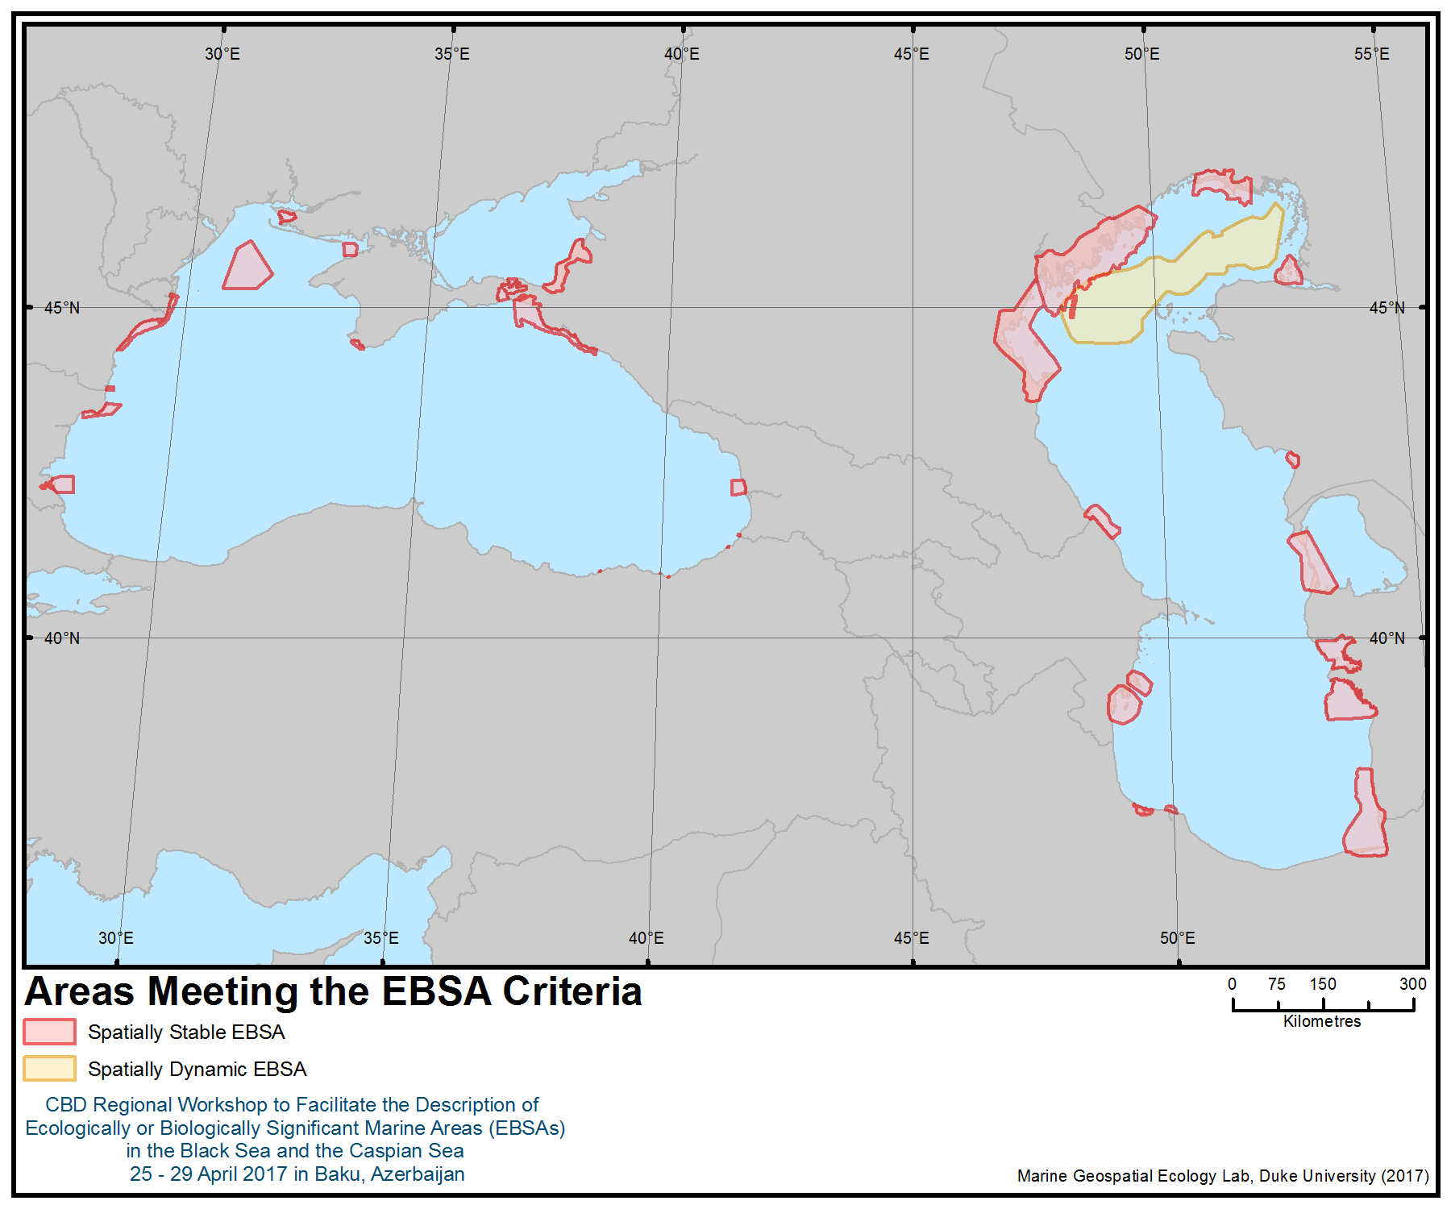

Annex V

DESCRIPTION OF AREAS MEETING THE EBSA CRITERIA IN THE BLACK SEA AND THE CASPIAN SEA AS AGREED BY THE WORKSHOP PLENARY

Area No.
  Area Name
  (See the detailed description of each area in the appendix to this annex)
1 | Ropotamo
2 | Kaliakra
3 | Vama Veche – 2 Mai Marine Reserve
4 | Danube Delta Marine Area
5 | Zernov’s Phyllophora Field
6 | The Small Phyllophora Field
7 | Balaklava
8 | Yagorlytsky Bay
9 | Kuban Delta
10 | Taman Bay and the Kerch Strait
11 | Northern Part of the Caucasian Black Sea Coast
12 | Kolkheti Marine Area
13 | Sarpi
14 | Artvin-Arhavi
15 | Trabzon-Sürmene
16 | Trabzon-Arsin
17 | Giresun – Tirebolu
18 | Pre-estuarine Area of the Ural River
19 | Komsomol Bay
20 | Caspian Seal Breeding Grounds
21 | Kendirli Bay
22 | Karabogazgol Strait
23 | Turkmenbashi Gulf
24 | Turkmen Aylagy
25 | Miankaleh-Esenguly
26 | Sefidroud Delta
27 | Anzali Wetlands Complex
28 | Gizilzgach Bay Complex
29 | Kura Delta
30 | Samur-Yalama
31 | Kizlyar Bay
32 | Malyi Zhemchyzhnyi (“Small Pearl”) Island
33 | Pre-estuarine Area of the Volga River

Appendix to Annex V
DESCRIPTION OF AREAS MEETING THE EBSA CRITERIA IN THE BLACK SEA AND THE CASPIAN SEA AS AGREED BY THE WORKSHOP PLENARY
Area No. 1: Ropotamo

Abstract
The area comprises both a coastal and marine area along the Bulgarian coast of the Black Sea. The terrestrial part includes Ramsar sites, CORINE Biotope sites (under the European Commission) and national protected areas. The marine area stretches over 881.91 km² (89.9 % of the total area). It comprises a variety of habitats of high conservation importance, distinguished by high biodiversity, good ecological status and extensive span – including the unique European flat oyster (Ostrea edulis) biogenic reefs, the rare sciophilic association of the red seaweed Phyllophora crispa on infralittoral rock, productive communities of photophilic brown macroalgae, mussel banks on sediment, with high diversity of invertebrates and fishes, sandbanks and seagrass meadows. The marine area is an important habitat for shad fish, providing feeding grounds and migration routes to the spawning grounds. It is significant for the protection of the three small cetacean populations that occur in the Black Sea. The area represents the largest marine protected area within the Natura 2000 ecological network in the Bulgarian Black Sea, namely the Special Area of Conservation (SAC) Ropotamo BG0001001, designated under the Habitats Directive.

Introduction
Water depths range from 0 m along the shoreline to 75 m at the eastern boundary of the protected site. The seafloor shows a rather complex and variable morphology. In the coastal area down to water depths of 30-35 m, the seafloor morphology is dominated by scattered rocky reefs built up by volcanic rocks. Substrate is dominated by sandy mud in the offshore area, while the coastal area substrates are very heterogeneous, composed of rocky reefs, sands of various grain size and shelly gravel.

The area of conservation comprises a variety of marine habitats of national and European conservation importance, including sandbanks, rocky reefs, seagrass meadows and biogenic reefs. SAC Ropotamo contains the largest shares of the national area of habitat types listed under Annex I of the Habitats Directive, 1170 reefs and 1110 sandbanks, which are slightly covered by sea water all the time, which ranks the site of primary importance for the maintenance and restoration of the favourable conservation status of these habitat types.

Part of the data for this description is provided by the study “Benthic Habitat Mapping in the Bulgarian Black Sea” (project CoCoNet 7FP EC), which aims to produce benthic habitat maps of the site by integrating acoustic, geological and biological data, using digital terrain models, acoustic surveys and modeling. Further information derives from the scientific studies and terrain surveys carried out in the context of Natura 2000 designation of the site, and cited in the Natura 2000 Standard Data form.

Location
Longitude: 27.9343
Latitude: 42.3019
Area [ha]: 98099.76
Marine area [%]: 89.9 (881.91 km²)

Feature description of the area
The site comprises the low lateral branches of the Strandja mountain chain with its outskirts sliding into the Black Sea. The site includes vast areas covered with dunes and with patches of forested dunes between them. The inland area is mostly forested. The Ropotamo River forms a beautiful preserved estuary. The cliffed coast prevails, with an average height of 11-13 m and consists of magmatic rocks and metamorphosed sedimentary rocks, calcareous sandstone and limestone. An accumulative coast is situated in the central parts of the small bays and is of two types: 1) firth type: Ropotamo beach and the beaches of Primorsko, Kiten and Atliman; and 2) lagoon type: Dyuni beach, Arkutino beach and Stomoplo beach. On the seabed are observed rocky banks, made of igneous rocks, at a distance of 600 m to 2200 m from the coastline and with relative height of 5 m to 12.5 m. The rocky bottom, formed of calcareous sandstone and marl-limestone complex, reveals just before the shore for the abrasive coast type and reaches 600 m to 2200 m from the shoreline. The rocky banks rise 3 m to 10-15 m above the seabed and reach a depth down to 40 m. On the beach and the underwater coastal slope, medium sands prevail.

On the rocky reefs in the area there is a biotope of sciophilic macroalgae known as “Lower infralittoral with sciophilic Phyllophora crispa association”, which is unique in terms of biodiversity, status and scope for the Bulgarian Black Sea. It is classified as a subtype of habitat 1170 (for information on Natura 2000 marine habitat types:
http://ec.europa.eu/environment/nature/natura2000/marine/docs/appendix_1_habitat.pdf). This is a rare biotope, occurring only in clean and transparent waters at depths exceeding -10 m, and therefore of high conservation significance at the national and regional level. In the area, there are favourable morphological and physico-geographical conditions for extensive development of Phyllophora crispa: a large area of the rocky substrate in optimal depth horizons, low levels of eutrophication, high transparency of the water column and favourable light climate underpinning the development of the sciophilic macroalgae. All along the rocky reefs in the area at depths of 0m to -12 m were found biotopes of high conservation value - communities of the photophilic brown macroalgae Cystoseira crinita and Cystoseira barbata, classified as subtype of habitat 1170. The greater depth of penetration of C. barbata (-12 to -13 m), species and quantitative composition of the macroalgae communities are typical of oligotrophic conditions.

The marine area includes mussel banks on sediment (subtype of habitat 1170) with significant area, coverage and biomass of the habitat-forming species the blue mussel or the Mediterranean mussel Mytilus galloprovincialis, a relatively large average size and good size structure of the black mussels, high diversity of the accompanying invertebrate fauna and fishes. For reference to presented habitats in the area, see Figure 1.

Modeling and estimations are available in the NATURA 2000 standard form of the designated SPA.

The Ropotamo Complex is a designated Ramsar site. Its water areas include the estuary of the river, the adjacent Vodnite Lilii (Velyov Vir) Reserve and three coastal lagoons: Arkutino, Alepu and Stamopolu. Ropotamo Reserve and Alepu are also CORINE biotope sites. In addition, the coastal area consists of several national protected areas, including the Ropotamo Reserve (with the aim protection of the unique flora and fauna along the coast) and natural monuments “Alepu Marsh” (with the aim of conserving the natural habitats of protected and rare waterfowl birds and the only locality of water caltrop/water chestnut—Trapa natans—on the Black Sea coast), as well as the following sites:”Pyasachni dyuni - Mestnost Alepu”, “Skalnite Obrazuvania and Fiordite I Tyulenovata Peshtera V Mestnost Maslen Nos”.

The area overlaps with a marine Important Bird and Biodiversity Area (IBA; BirdLife International 2017a), primarily designated for its importance for two species of pelican, the great white pelican (Pelecanus onocrotalus) and the Dalmatian pelican (Pelecanus crispus) (the latter classified as vulnerable on the IUCN Red List), and for the pygmy cormorant (Microcarbo pygmaeus).

Feature condition and future outlook of the area
Assessments of the current conservation status of the protected marine habitat types and species are not available. The ecological status of the coastal waters (sensu the Water Framework Directive) according to the biological quality of elements of the benthic macrophytes and benthic invertebrate fauna is good. However, anthropogenic pressures, including dredging of the sandy seabed for clam harvesting and eutrophication of the marine waters due to input of wastewater from tourism, represent threats to the conservation and maintainance of the features of interest in favourable status. Urgent development and implementation of management plans, including measures for prevention and mitigation of the human impacts, is critically important for retaining good conservation prospects for the area.

Assessment of the area against CBD EBSA Criteria

CBD EBSA Criteria  (Annex I to decision IX/20) | Description  (Annex I to decision IX/20) | Ranking of criterion relevance  (please mark one column with an X)
CBD EBSA Criteria  (Annex I to decision IX/20) | Description  (Annex I to decision IX/20) | No information |  | Low |  |  | Medium |  | High
Uniqueness or rarity | Area contains either (i) unique (“the only one of its kind”), rare (occurs only in few locations) or endemic species, populations or communities, and/or (ii) unique, rare or distinct, habitats or ecosystems; and/or (iii) unique or unusual geomorphological or oceanographic features. |  |  |  |  |  |  |  | X
Explanation for ranking
Major coverage in the area has the rare biotope of sciophilic macroalgae “Lower infralittoral with sciophilic Phyllophora crispa association”.
Massive presence of biotopes of high conservation value: communities of the photophilic brown macroalgae Cystoseira crinita and Cystoseira barbata, classified as subtype of habitat 1170.
The rare red alga Phyllophora crispa is encountered in the area. The area harbours a number of other rare species, such as the rare bivalve Tellina lactea (Loripes lacteus), rare fishes such as sand goby (Pomatoschistus minutus), grass goby (Zosterisessor ophiocephalus), Montagu's blenny (Coryphoblennius galerita) and ocellated wrasse (Symphodus ocellatus).
The rose-coloured turfs of the calcareous red alga Corallina officinalis overgrow the shallow bedrock and boulders, making them look like coral reefs. A rare rocky habitat established in the area is limestone punctured by the boring petricola (Petricola lithophaga), a rock-boring bivalve. Another unique, remarkable unknown habitat found in this area is a huge biogenic reef, known as “Ostrak”, built by the native European flat oyster Ostrea edulis (Todorova V. et al., 2008); tube-building serpulid polychaetes also contribute to the reef structure as cementing elements. Unlike the flat oyster beds commonly known from the intertidal zones of Western Europe and North America, the Black Sea’s “Ostrak” are massive, towering biogenic structures, dwarfing the human observer (Todorova V. et al., 2008).

Special importance for life-history stages of species | Areas that are required for a population to survive and thrive. |  |  |  |  |  |  |  | X
Explanation for ranking
Various fauna (bottom invertebrates and fishes) and flora (micro- and macro-epiphytes) are associated with the subhabitat of Cystoseira spp. on exposed infralittoral bedrock and boulders. The latter is used by the community as a substrate for attachment, trophic basis, shelter and place for reproduction and growth (Biserkov, V. et al., 2015).
Although the muds are not a qualifying feature of SAC Ropotamo, their good ecological status is essential in order to ensure the continuity and the food base of the demersal fishes, such as the turbot (Scophthalmus maximus) and sturgeons (Todorova V. et al., 2015). The area is habitat of the shad fishes of the genus Alosa, and in spring it is along the migration routes of the shoals to the spawning grounds in the rivers, and upon completion of the reproductive process, the representatives of the genus inhabit the area, where they actively nurture.
The area overlaps with a passage area of global importance for the vulnerable Dalmatian pelican (Pelecanus crispus), and for other species of pelican, such as the great white pelican (Pelecanus onocrotalus). It is also important for the breeding populations of pygmy cormorant (Microcarbo pygmaeus) (BirdLife International 2017).
Importance for threatened, endangered or declining species and/or habitats | Area containing habitat for the survival and recovery of endangered, threatened, declining species or area with significant assemblages of such species. |  |  |  |  |  |  |  | X
Explanation for ranking
The area of Tsarevo – Lozenets is important as the nucleus of a preserved population of the rare (and vulnerable at Black Sea regional level and at subregional level, according to the IUCN Red List) red algae Phyllophora crispa.
The area is the permanent habitat of significant importance for several small cetacean species. According to the IUCN Red List, the common bottlenose dolphin (Tursiops truncatus ponticus) is endangered (Birkun, 2012), the Black Sea harbour porpoise (Phocoena phocoena relicta) is endangered (Birkun, Frantzis, 2008) and the Black Sea common dolphin (Delphinus delphis ponticus) is vulnerable (Birkun, 2008).
A globally threatened seabird species listed as vulnerable by IUCN is known to occur in the area (BirdLife International 2017b): the Dalmatian pelican (Pelecanus crispus). This species is also listed in CITES Appendix I and CMS Appendixes I and II. The area also overlaps with the distribution range of three other vulnerable species, the yelkouan shearwater (Puffinus yelkouan), the velvet scoter (Melanitta fusca) and the horned grebe (Podiceps auritus) (BirdLife International 2017b). All these species are also included in Annex I of the EU Birds Directive.

Vulnerability, fragility, sensitivity, or slow recovery | Areas that contain a relatively high proportion of sensitive habitats, biotopes or species that are functionally fragile (highly susceptible to degradation or depletion by human activity or by natural events) or with slow recovery. |  |  |  |  |  | X
Explanation for ranking
Sciophilic communities, especially Phyllophora crispa, are highly sensitive to eutrophication processes leading to transparency diminution and biogenic concentration increase as well as Phyllophora extraction (Todorova V. at al, 2012).
Mussel banks on sediments have good prospects, given the low levels of anthropogenic pressure (Natura 2000 – Standard Data Form).
Communities of the photophilic brown macroalgae Cystoseira species associations are resilient enough to withstand periods of elevated anthropogenic eutrophication (Berov et al., 2012).
Considering that the major coverage of the area is represented by habitat 1170, which consists of the above-mentioned three subtypes, the area shows some sensitivity, but isto some extent still resilient to degradation and human activities.
Fishes of the genus Alosa are sensitive to anthropogenic impact, especially regarding human access to reproduction and spawning areas as well as regarding the ecological status of their environment.
Permanently present in the area are the Black Sea common dolphin (Delphinus delphis ponticus), which is assessed as vulnerable (Birkun, 2008).
The area is important to the vulnerable Dalmatian Pelican Pelecanus crispus, a long-lived species with late sexual maturity.

Biological productivity | Area containing species, populations or communities with comparatively higher natural biological productivity. | X
Explanation for ranking
Biological diversity | Area contains comparatively higher diversity of ecosystems, habitats, communities, or species, or has higher genetic diversity. |  |  |  |  |  |  |  | X
Explanation for ranking
On the rocky reefs in the area the rare biotope of sciophilic macroalgae “Lower infralittoral with sciophilic Phyllophora crispa association”, classified as a subtype of habitat 1170, was discovered. All along the rocky reefs in the area there is a massive presence of biotopes of high conservation value: communities of the photophilic brown macroalgae Cystoseira crinita and Cystoseira barbata, classified as subtypes of habitat 1170. The marine area includes mussel banks on sediment (subtype of habitat 1170) with significant area, coverage and biomass of the habitat-forming species Mytilus galloprovincialis, with high diversity of accompanying invertebrate fauna and fishes.
In the area of Cape Maslen Nos, Ropotamo River estuary sedimentary bottom provides a variety of habitats, such as seagrass meadows of Zostera marina, Zannichellia pedicellata and Potamogeton pectinatus. Other important habitats are sediments inhabited by Thalassinid crustaceans: fine sands with Pestarella candida and sandy silts with Mediterranean mud shrimp (Upogebia pusilla), the former being a rare species.
In terms of macroalgae diversity, only in Cystoseira sp.-dominated communities, 61 species in total were identiﬁed in the area, of which: Rhodophyta dominated with 34 species (in 3 classes, 11 orders, 16 families and 20 genera), followed by Chlorophyta – with 15 species (in 2 classes, 4 orders, 4 families and 5 genera), and Ochrophyta – with 12 species (in 1 class, 4 orders, 6 families and 9 genera). In the C. barbata-dominated communities, among the 55 species described in these communities, 24 were found only as epiphytes on C. barbata. In the C. crinita-dominated communities, 48 species were described, of which eight were found only as epiphytes on C. crinita (Berov et al., 2012). These communities provide a habitat for a range of invertebrate epifauna, such as bryozoans, hydroids and ascidians and epiflora, including crustose red algae (Dermatolithon cystoseirae). Other typical inhabitants are the mussels Mytilaster lineatus, the snail (Tricolia pullus), the decapods marbled rock crab (Pachygrapsus marmoratus), bristly crab (Pilumnus hirtellus) and jaguar round crab (Xantho poressa), the sea horse (Hippocampus guttulatus), a variety of wrasses, blennies and gobies. Below the Cystoseira zone the rocky seabed is dominated by the blue mussel (Mytilus galloprovincialis). A rare rocky habitat established in the area is limestone punctured by the boring petricola (Petricola lithophaga), a rock-boring bivalve (Todorova V. et al., 2015).
The ample trophic resources carried by the Ropotamo River determine the particularly high diversity of gastropods (Cyclope neritea, Nassarius nitidus, Rissoa splendida, Bittium reticulatum) and bivalves (Loripes lacteus, Lentidium mediterraneum, Chamelea gallina, Donax trunculus, Tellina tenuis) and lagoon cockle (Cerastoderma glaucum) that inhabit the sands in front of the estuary (Todorova V. Et al.,2008).

The area is a permanent habitat of significant importance for the common bottlenose dolphin (Tursiops truncatus) and Black Sea harbour porpoise (Phocoena phocoena). Recent line transect surveys (Popov, D., 2017), carried out in April and May 2016, recorded the encounter rates per km in the area at 0.32 to 0.54 for harbour porpoise, 0.02 to Tt-0.05 for bottlenose dolphin and 0.02 to 0.23 for common dolphin. Similar encounter rates per km in the adjacent area Strandzha (which is also a NATURA 2000 zone with the code BG0001007) were recorded as 0.14 to 0.25 for harbour porpoise, 0.1 to 0.2 for bottlenose dolphin and 0.02 for common dolphin.
Naturalness | Area with a comparatively higher degree of naturalness as a result of the lack of or low level of human-induced disturbance or degradation. |  |  |  |  |  |  |  |  | X
Explanation for ranking
The Ropotamo River forms a beautiful natural estuary (Natura 2000 Standard form). The small secluded bays between Tsarevo and Lozenets possess unique charm and attractiveness. The area has preserved its naturalness and very good ecological conditions, possesses highly varied representative habitats and occurrence of rare and threatened species, clear value for research and monitoring, and aesthetic attractiveness (Todorova V. et al, 2008). The coasts are characterized by indented fjords and small sheltered bays, delineated by numerous peninsulas ending with unapproachable capes with steep volcanic cliffs. Underwater habitats are equally varied and remarkable. The rocky bottom slopes down vertically to invisible depths at some places (Todorova V. et al., 2008). The marine area includes 14% of the national coverage of the mussel banks, and the prospects for maintaining them are good given the low levels of anthropogenic pressure.

References
Berov D., Deyanova D., Georgieva I., Gyosheva B., Hiebaum G, 2012. Cystoseira sp. – Dominated Macroalgal Communities in the SW Black sea (Burgas Bay, Bulgaria). Current State and Possible Long-term Effects of Eutrophication, in Comptes rendus de l’Académie Bulgare des Sciences, Tome 65, No 6, pp. 821-830.
BirdLife International, 2017a. Important Bird Areas factsheet: Ropotamo Complex. Downloaded from http://datazone.birdlife.org/site/factsheet/407.
BirdLife International. 2017b. IUCN Red List for Birds. Downloaded from http://www.birdlife.org on 26/04/2017.
Birkun Jr., A.A. 2008. Delphinus delphis ssp. ponticus. The IUCN Red List of Threatened Species. e.T133729A3875256. http://dx.doi.org/10.2305/IUCN.UK.2008.RLTS.T133729A3875256.en
Birkun, A. 2012. Tursiops truncatus ssp. ponticus. The IUCN Red List of Threatened Species. http://dx.doi.org/10.2305/IUCN.UK.2012.RLTS.T133714A17771698.en.
Birkun Jr., A.A. & Frantzis, A., 2008. Phocoena phocoena ssp. relicta. The IUCN Red List of Threatened Species. http://dx.doi.org/10.2305/IUCN.UK.2008.RLTS.T17030A6737111.en.
Biserkov, V. et al. (ed.) 2015. Digital edition of Red Data Book of Republic of Bulgaria. Vol. 3 Natural Habitats. BAS & MOEW, Sofia. http://e-ecodb.bas.bg/rdb/en/vol3/08A3.html
NATURA 2000 – Standard Data Form
http://natura2000.moew.government.bg/PublicDownloads/Auto/PS_SCI/BG0001001/BG0001001_PS_16.pdf
Popov, D., 2017. Studies of Black Sea Cetaceans along Bulgarian Coast, Technical report for 2016, Green Balkans NGO, Plovdiv. http://greenbalkans.org/delfini/en/Publications.c135
Todorova V. et al., 2012. Final Report under the Contract N 7976/04.04.2011 between The Enterprise for management of environmental activities in Ministry of Environment and Water and The Institute of Oceanology. Bulgarian Academy of Science on Project Extension of the Natura 2000 Network in Bulgarian Black sea aquatory in order of overcoming the deficiency of marine habitats 1110 Sandbanks which are slightly covered by sea water all the time, 1170 Reefs and species 4125 Alosa immaculatа, 1349 Tursiops truncatus и 1351 Phocoena phocoena and partial filling scientific reserves for marine habitat 1180 Submarine structures made by leaking gases and species 1349 Tursiops truncatus in accordance with conclusions of European Topic Centre on Biological Diversity from Marine seminar, 15 June 2010 (Brindisi, IT).
Todorova V., Dimitrov L., Doncheva V., Trifonova E., Prodanov B., 2015. Benthic Habitat Mapping in the Bulgarian Black Sea in Ozhan E. (Ed.) Proceedings of 12th International Conference on the Mediterranean Coastal Environment MEDCOAST’15, 06-10 October 2015, Varna, Bulgaria, vol.1, pp. 251-262. Project CoCoNet 7FP EC. http://coconetgis.ismar.cnr.it
Todorova V., Micu D., Klisurov L., 2009. Unique Oyster reefs discovered in the Bulgarian Black Sea. Comptes Rendus de l’Academie bulgare des Sciences 62 (7), 871-874.
Todorova V., Micu D., Panayotov M., Konsulova T., 2008. Marine Protected Areas in Bulgaria – Present and Prospects. Publishing House: HelixPress, StenoPublishing House, Varna, ISBN 978-954-449-373-8, pp. 9-13.

Maps and Figures
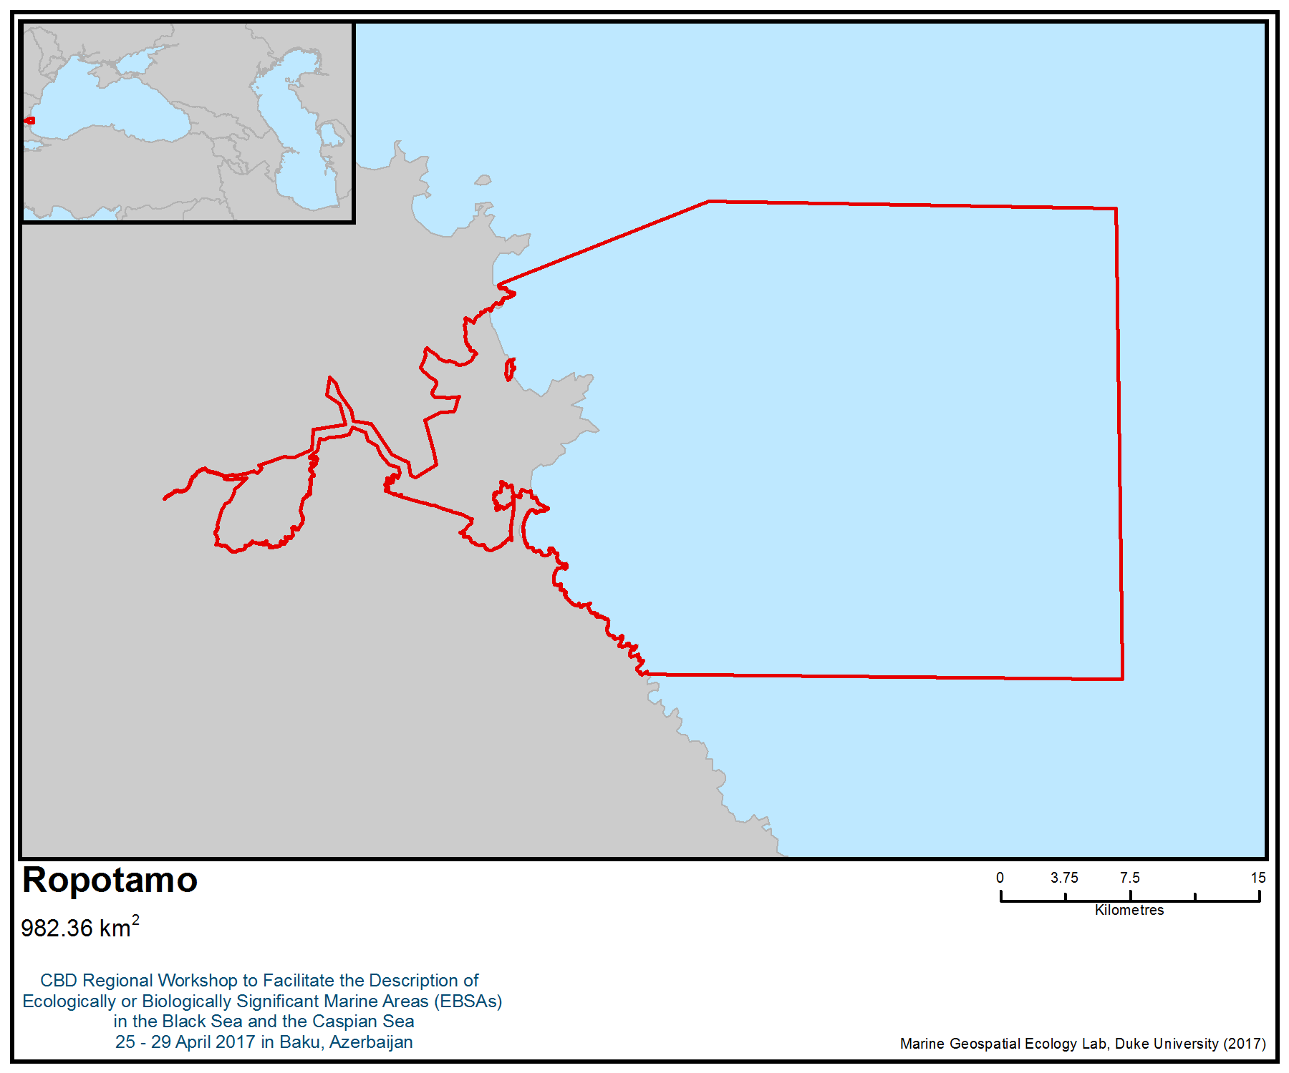
Figure 1. Area meeting the EBSA criteria

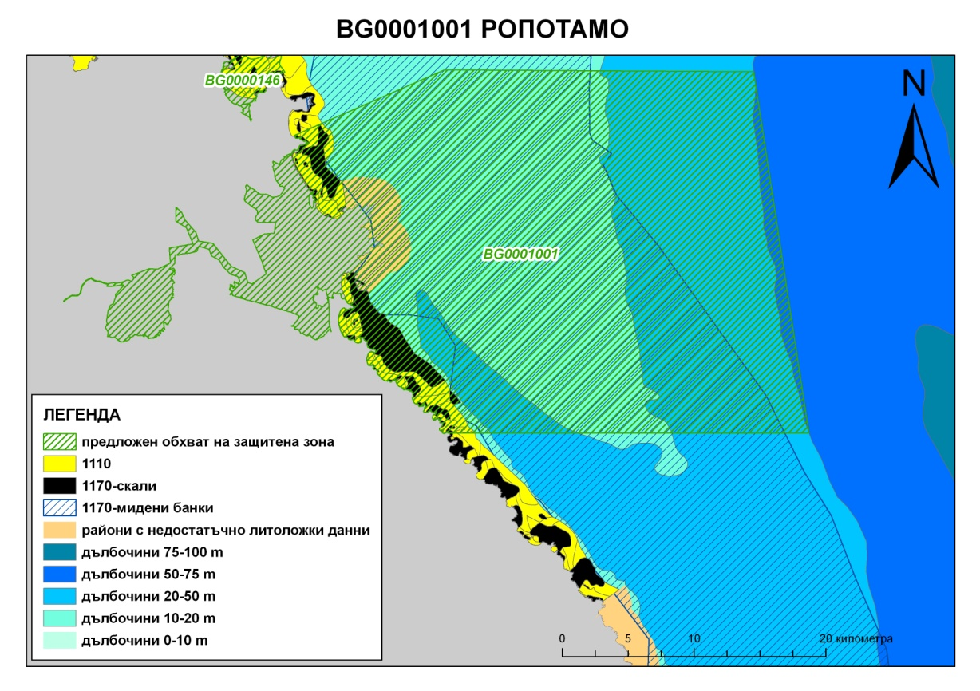
Figure 2. Habitats in the Ropotamo SAC NATURA 2000 site (Todorova V. et al., 2012).
Map Legend:
Green stripes: Proposed extent of Site of Community Importance
Yellow: Habitat type 1110 “Sandbanks which are slightly covered by sea water all the time”
Black: Habitat type 1117 “Reefs” - subtype rocky reefs
Blue stripes: Habitat type 1117 “Reefs” - subtype mussel beds
Beige: Data-deficient
Blue: Depth, with respective range provided in metres

Area No. 2: Kaliakra

Abstract
The area encompasses a marine Important Bird and Biodiversity Area, designated primarily for its importance as a migratory corridor for the vulnerable yelkouan shearwater (Puffinus yelkouan). The yelkouan shearwater is a Mediterranean endemic with a population estimated between 46,000 and 90,000 individuals, of which some 30 to 40 per cent migrate to the Black Sea during the non-breeding season, occurring near the coast of northern Bulgaria during their migrations. The area also encompasses the non-breeding distribution of two additional vulnerable seabirds – the velvet scoter (Melanitta fusca) and the horned grebe (Podiceps auritus). The area is also important for 17 other seabird species and has been designated a Natura 2000 Special Protection Area under the EU Birds Directive and a Special Area of Conservation under the EU Habitats Directive. The area also includes the only national marine and coastal reserve, “Kaliakra”.

Introduction
The area is situated along a 34 km stretch of the northern Bulgarian Black Sea coastline and contains coastal territory and the adjacent marine area at less then 100 m depth. The coast is fringed with vertical limestone cliffs up to 100 m high, carved with characteristic caves and niches. Some of the rarest ecosystem types in the world, natural hyperhaline lakes, occur in the area. The typical marine habitats comprise sandbanks, seagrass meadows, rocky reefs overgrown by communities of perennial brown and red macroalgae, soft bedrock with piddocks and mussel beds on sediments (Natura 2000 - Standard Data Form for SAC BG0000573).

Location
The area is located in the western Black Sea coastal waters between latitudes 43.37°N and 45.19° N.

Feature description of the area
The marine features of the area comprise a diversity of coastal and shelf seabed habitats, small cetaceans and shad species (Alosa spp). The sandy bottom extends 1000-1500 m from the shoreline. Underwater meadows with the dwarf eelgrass Zostera noltii occur in the shallow sands, where they are sheltered from wave action. The sands of exposed shorelines are dominated by clams and shrimps. Towards the deep water, the seafloor is covered by sandy silt and silty sediments inhabited previously by the bed-forming blue mussel Mytilus galloprovincialis. Currently, the extent and status of mussel beds has deminished due to human pressures such as transboundary eutrophication, mobile bottom-gear fishing and predatory pressure from the invasive alien whelk Rapana venosa. Further offshore, the deeper bottom is covered by a thick shell bed of the horse mussel Modiolula phaseolina. The rocky bottom, which extends up to 350 m from the shoreline, is composed of slumped limestone, calcareous sandstones and marls. Dense popullations of the mollusc Pholas dactylus, a species protected by the Bern Convention, occur in the soft marl beds. Communities of high conservation importance, such as the perennial brown algae of the genus Cystoseira and the red macroalgae Phyllophora crispa, overgrow the underwater hard rock and boulders (Natura 2000 - Standard Data Form for SAC BG0000573).

In the limestone rocks from cape Kaliakra to cape Shabla, there are long, partially submerged sea caves, some of which were the habitat of the regionally extinct Mediterranean monk seal (Monachus monachus). The marine area is a suitable habitat for the shad fishes as a migratory corridor to the spawning grounds in the Danube River and as feeding grounds for the juvenile fish and the spawning stock after breeding. The area is also an important feeding ground for populations of the harbour porpoise Phocoena phocoena relicta and the Black Sea bottlenose dolphin Tursiops truncatus ponticus (Natura 2000 - Standard Data Form for SAC BG0000573). Shallow methane seeps represent another characteristic feature of the area (Todorova et al., 2012).

The area includes one marine Important Bird and Biodiversity Area, designated largely for its importance as a migratory corridor for the vulnerable yelkouan shearwater (Puffinus yelkouan) (Doğa Derneği 2014). The yelkouan shearwater is a Mediterranean endemic species with a population estimated between 46,000 and 90,000 individuals (Derhé 2012, BirdLife International 2017a), of which some 30 to 40 per cent migrate to the Black Sea during the non-breeding season (Raine et al. 2012, Péron et al. 2013, Seabird Tracking Database 2017), occurring near the coast of Bulgaria during their migrations. Birds from different colonies located in the Mediterranean congregate in the Black Sea during the winter period (September-December) and migrate through the coasts of Bulgaria (Doğa Derneği 2014). Estimates indicate the regular occurrence of more than 1000 yelkouan shearwaters (BirdLife International 2017b). Recent studies of habitat suitability have also confirmed the importance of this coastal area for the species (Ortega & İsfendiyaroğlu 2017; Figure 2).

The area also includes feeding sites for the Mediterranean endemic subspecies of European shag (Phalacrocorax aristotelis desmarestii) during the breeding season; a colony of the species can be found in the nearby coast (Doğa Derneği 2014; Figure 3). The area is part of the non-breeding range of two additional vulnerable seabirds – the velvet scoter (Melanitta fusca) and the horned grebe (Podiceps auritus) (BirdLife International 2017c). The area is also important for 17 other seabird species BirdLife International 2017b; BirdLife International unpublished data).

Feature condition and future outlook of the area
Assessments of the current conservation status of the protected marine habitat types and species are not available. The ecological status (sensu the Water Framework Directive) of the coastal seabed habitats with macroalgae and invertebrates is estimated as good in the recent period (IO-BAS, 2017). The main anthropogenic pressures on the marine ecosystem aret eutrophication and fishing, especially with mobile bottom gear. Shipping, tourism and oil pollution may also represent threats to the conservation and maintainance of the features of interest in favourable status. Therefore, development and implementation of a management plan, including measures for prevention and mitigation of the human impacts, is critically important for the maintenance or restoration of the favourable conservation prospects of the area.

The fishing activities are the ones most likely to have a negative impact on the vulnerable yelkouan shearwater. Mortality from incidental by-catch is considered the most serious threat to this species (Oppel et al. 2011, BirdLife International 2017b), especially during the non-breeding season (Oppel et al. 2011), when an important percentage of the population is in the Black Sea (Raine et al. 2012).

Assessment of the area against CBD EBSA Criteria

CBD EBSA Criteria  (Annex I to decision IX/20) | Description  (Annex I to decision IX/20) | Ranking of criterion relevance  (please mark one column with an X)
CBD EBSA Criteria  (Annex I to decision IX/20) | Description  (Annex I to decision IX/20) | No information |  | Low |  |  | Medium |  | High
Uniqueness or rarity | Area contains either (i) unique (“the only one of its kind”), rare (occurs only in few locations) or endemic species, populations or communities, and/or (ii) unique, rare or distinct, habitats or ecosystems; and/or (iii) unique or unusual geomorphological or oceanographic features. |  |  |  |  |  | X
Explanation for ranking
Among the typical marine features, the submerged and semi-submerged sea caves represent a rare marine habitat for the Black Sea, previously inhabitated by the regionally extinct Mediterranean monk seal. The regionally endangered red macroalgae Phyllophora crispa is present in the area (Todorova et al., 2008). Previously, Ph. crispa formed extensive meadows in the north-western Black Sea shelf (e.g. the Zernov’s Phyllophora Field, see area No. 5) however, due to overexploitation and eutrophication, the population was nearly exterminated (Zaisev and Alexandrov, 1998).

Methane seeps occuring in the area represent another rare feature that is not well studied in terms of the associated biodiversity, structures and functioning.

The area includes some of the key passage sites for the yelkouan shearwater during their migrations from the Mediterranean into the Black Sea (Doğa Derneği 2014). The area is also used by almost 20 other species of seabirds (Arctic loon Gavia arctica, black tern Chlidonias niger, black-headed gull Larus ridibundus, common tern Sterna hirundo, Dalmatian pelican Pelecanus crispus, European shag Phalacrocorax aristotelis, great cormorant Phalacrocorax carbo, great white pelican Pelecanus onocrotalus, lesser black-backed gull Larus fuscus, little gull Hydrocoloeus minutus, Mediterranean gull Larus melanocephalus, mew gull Larus canus, pygmy cormorant Microcarbo pygmaeus, red-throated loon Gavia stellata, slender-billed gull Larus genei, whiskered tern Chlidonias hybrida, white-winged tern Chlidonias leucopterus) (BirdLife International 2017b; BirdLife International unpublished data).
Special importance for life-history stages of species | Areas that are required for a population to survive and thrive. |  |  |  |  |  |  |  | X
Explanation for ranking
The marine area provides suitable habitat for shad fishes, surving as a migratory corridor to the spawning grounds in the Danube River and as feeding grounds for the juvenile fish and the spawning stock after breeding. As habitat for small Black Sea cetaceans, the area offers abundant food and relatively good environmental conditions for the cetaceans to survive and thrive. During their trophic migrations the small cetaceans are frequently observed in the coastal waters in front of Cape Kaliakra (personal observations and personal communication).

The area is an important stop-over for a number of bird species. About 80 species belonging to 37 families have been identified in the Kaliakra reserve (Natura 2000 - Standard Data Form for SAC BG0000573). The area is an important passage site for the yelkouan shearwater Puffinus yelkouan during the non-breeding season (Doğa Derneği 2014). Birds from different colonies located in the Mediterranean congregate in the Black Sea during the winter period (September-December) and migrate through the coasts of Romania and Bulgaria (Doğa Derneği 2014). The area also includes the feeding sites for the Mediterranean endemic subspecies of European shag (Phalacrocorax aristotelis desmarestii) during the breeding season; a colony of the species can be found in the nearby coast (Doğa Derneği 2014).
Importance for threatened, endangered or declining species and/or habitats | Area containing habitat for the survival and recovery of endangered, threatened, declining species or area with significant assemblages of such species. |  |  |  |  |  |  |  | X
Explanation for ranking
The coastal rocky seabed contains significant assemblage of the piddock Pholas dactylus, which is a species protected by the Convention on the Conservation of European Wildlife and Natural Habitats (Bern Convention) and Barcelona Convention Protocol concerning Specially Protected Areas and Biological Diversity in the Mediterranean (SPA/BD Protocol). The marine area contains habitat for shad fishes that are assessed as either endangered (Alosa maeotica) or vulnerable (A. pontica, A. caspia) in the Bulgarian Black Sea (BAS and MOEW, 2015).

A globally threatened seabird species listed as vulnerable by IUCN, yelkouan shearwater (Puffinus yelkouan), is known to occur in the area (BirdLife International 2017). The known distribution range of other two species also overlaps with the site: velvet scoter (Melanitta fusca) and horned grebe (Podiceps auritus) (Figure 2). All these species are also included in Annex I of the EU Birds Directive, as are the slender-billed gull (Larus genei), Mediterranean gull (Larus melanocephalus), Mediterranean shag (Phalacrocorax aristotelis desmarestii) and common tern (Sterna hirundo).
Vulnerability, fragility, sensitivity, or slow recovery | Areas that contain a relatively high proportion of sensitive habitats, biotopes or species that are functionally fragile (highly susceptible to degradation or depletion by human activity or by natural events) or with slow recovery. |  |  |  |  |  | X
Explanation for ranking
The marine area contains infralittoral rocky bottom overgrown by perennial brown macroalgae Cystoseira spp. and the red alga Phyllophora crispa., which require high water transparency and are therefore sensitive to eutrophication (Natura 2000 - Standard Data Form for SAC BG0000573). The marine area contains a large proportion of a population of Pholas dactylus, which is sensitive to habitat loss and degradation due to sealing/smothering of the natural seabed by coastal construction.

The vulnerable yelkouan shearwater is a long-lived species, with low fecundity rates and delayed sexual maturity. As such, the yelkouan shearwater is particularly vulnerable to factors increasing adult mortality rates, such as by-catch in fisheries and other at-sea threats, which are often the major causes of population decline (Anderson et al. 2011; Oppel et al. 2011).
Biological productivity | Area containing species, populations or communities with comparatively higher natural biological productivity. | X
Biological diversity | Area contains comparatively higher diversity of ecosystems, habitats, communities, or species, or has higher genetic diversity. |  |  |  |  |  |  |  | X
Explanation for ranking
The marine part of the site includes a variety of Natura 2000 marine habitat types: 1110 sandbanks, which are partially covered by sea water all the time; 1170 reefs; and 8330 submerged or partially submerged sea caves. The Special Area of Conservation BG0000573 includes 8.5% of the national coverage of the habitat type 1110, represented by several typical biotopes “Fine and medium sands with Lentidium mediterraneum”, “Sands and silty sands with Chamelea gallina” and “Silty sands with Upogebia pusilla” (information on Natura 2000 marine habitat types is available at: http://ec.europa.eu/environment/nature/natura2000/marine/docs/appendix_1_habitat.pdf). In places protected from the sea waves along the coast west of Cape Kaliakra (Kavarna, White Lagoon) underwater meadows with the dwarf eelgrass Zostera noltii occur, and the constructed jetties and piers create favourable conditions for the development of marine grasses. The rocky reefs are represented by a variety of biotopes, including those with high conservation significance, such as the communities of perennial brown algae of the genus Cystoseira on infralittoral rocky bottom. In the lower infralittoral, the red algae Phyllophora crispa is present (Todorova et al., 2008, 2012).

Soft limestones and marls are inhabited by populations of Pholas dactylus, species protected by the Bern Convention. Another present biotope, a subtype of habitat 1170, are mussel beds of Mytilus galloprovincialis on sediment (Todorova et al., 2008, 2012).

Fishes occurring in the area include: Alosa immaculata, Alosa tanaica, Acipenser gueldenstaedtii (rare), Acipenser stellatus (very rare), Huso huso (rare), Anguilla anguilla (very rare), Arnoglossus kessleri (very rare), Dasyatis pastinaca (rare), Gobius paganellus (rare), Raja clavate (rare), Salmo trutta labrax (very rare), Sciaena umbra (rare), Scomber scombrus (very rare), Squalus acanthias (rare), Umbrina cirrosa (very rare), Zeus faber (very rare) (Natura 2000 – Standard Data Form for SAC BG0000573).

Three small cetacean species encountered in the Black sea are present in the area (Natura 2000 – Standard Data Form for SAC BG0000573). According to the IUCN Red List, Tursiops truncatus ponticus is endangered (Birkun, 2012), Phocoena phocoena relicta is endangered (Birkun, Frantzis, 2008), and Delphinus delphis ponticus is vulnerable (Birkun, 2008).
Naturalness | Area with a comparatively higher degree of naturalness as a result of the lack of or low level of human-induced disturbance or degradation. |  |  |  |  |  |  | X
Explanation for ranking
Limited urban development and absence of large-scale industrial polluters ensure comparatively higher degree of naturalness in the area, therefore good ecological status of the seabed communities of macroalgae and invertevates was recent observed (IO-BAS, 2017). Despite the overall preserved naturalness, a large number of wind turbines and a golf field recently constructed in the coastal area have threatened, due to their cumulative impact, some protected terrestrial habitats and bird species.

In the marine area, artisanal fishing with stationary pound nets and mussel farms occur in the coastal waters, but are not considered to exert significant disturbance on the habitats and species. Commercial fishing by pelagic and beam trawling was estimated to cause relatively less physical disturbance on the seabed in the area as compared to other areas over the Bulgrian Black Sea shelf (Moncheva, Todorova et al., 2013).

Several coastline habitats are subject to intense human impact because of summer tourism, including water sports, sun bathing, parking of vehicles and construction. There is also sand excavation. Jetties and piers have been built in the marine area.

References
Anderson, O.R.J., Small, C., Croxall, J.P., Dunn, E.K., Sullivan, B.J., Yates, O. & Black, A., 2011. Global seabird bycatch in longline fisheries. Endangered Species Research 14: 91–106
BAS and MOEW, 2015. Red Data Book of Republic of Bulgaria, Vol. 2 – Animals.
BirdLife International 2017b. Important Bird Areas factsheet: Black Sea. Downloaded from http://datazone.birdlife.org/site/factsheet/black-sea-iba-romania/details on 05/04/2017.
BirdLife International 2017c. IUCN Red List for birds. Downloaded from http://www.birdlife.org on 05/04/2017.
BirdLife International, 2017a. Species factsheet: Puffinus yelkouan. Downloaded from http://www.birdlife.org on 10/03/2017.
BirdLife International. Unpublished data.
Derhé, M.A., 2012. Population assessment for the Yelkouan Shearwater Puffinus yelkouan, in: BirdLife International (Ed), Methodology for Bird Species Recovery Planning in the European Union. Final Report to the European Commission. BirdLife International for the European Commission, Cambridge, UK.
Doğa Derneği, 2014. Black Sea Seabirds Project Layman’s report, Istanbul
European Union 2016. European Red List of Habitats. Part 1. Marine habitats.
IO-BAS, 2017. Report – analysis of the marine environmental status in 2016. Contract № Д-33-5/28.01.2016 г. between the Ministry of Environment and Waters and the Institute of oceanology – BAS, Varna for execution of the obligations for Black Sea moniotirng under Art. 171 (2,3) of the Water Act.
Moncheva S., Todorova V. et al., 2013. Initial assessment of the marine environmental state under the terms of Article 8 of the Marine Strategy Framework Directive. Contract № 203/09.08.2012 with BSBD. Online: http://www.bsbd.org/UserFiles/File/Initial%20Assessment_new.pdf
Natura 2000 – Standard Data Form for SAC BG0000573: http://natura2000.moew.government.bg/PublicDownloads/Auto/PS_SCI/BG0000573/BG0000573_PS_16.pdf
Natura 2000 - Standard Data Form for SPI BG0002051: http://natura2000.moew.government.bg/Home/ProtectedSite?code=BG0002051&siteType=BirdsDirective
Oppel S., Raine, A.F., Borg, J.J., Raine, H., Bonnaud, E., Bourgeois, K., Breton, AR., 2011. Is the Yelkouan shearwater Puffinus yelkouan threatened by low adult survival probabilities? Biological Conservation 114: 2255- 2263.
Ortega M.P., İsfendiyaroğlu S., 2017. Predicting foraging hotspots for Yelkouan Shearwater in the Black Sea. Deep-Sea Research Part II in press
Péron, C., Grémillet, D., Prudor, A., Pettex, E., Saraux, C., Soriano-Redondo, A., Authier, M., Fort J., 2013. Importance of coastal Marine Protected Areas for the conservation of pelagic seabirds: The case of Vulnerable yelkouan shearwaters in the Mediterranean Sea. Biological Conservation 168: 210-221.
Raine, A.F., Borg, J.J., Raine, H., Phillips, R.A., 2012. Migration strategies of the Yelkouan Shearwater Puffinus yelkouan. Journal of Ornithology 154: 411-422.
Seabird Tracking Database 2017. Tracking Ocean Wanderers – BirdLife Seabird Tracking Database www. http://seabirdtracking.org/, accessed on 10/03/2017
Todorova V. et al., 2012. Report on implementation of grant Contract No. 7976 / 04.04.2011, between EMEPA and the Institute of Oceanology. Project: “Expansion of the Natura 2000 ecological network in the Bulgarian Black Sea marine area to overcome the moderate insufficiencies regarding marine habitats 1110 “Sandbanks which are slightly covered by sea water all the time” and 1170”Reefs”and species 4125 Alosa immaculata, 1349 Tursiops truncatus and 1351 Phocoena phocoena and partial filling of scientific reserve for habitat 1180 “Submarine structures made by leaking gases” and species 1349 Tursiops truncatus in accordance with the conclusions from the Marine Black Sea Seminar, Brindisi, 15 June 2010”. Fund of IO-BAS.
Todorova V., Micu D., Panayotov M., Konsulova T., 2008. Marine Protected Areas in Bulgaria – Present and Prospects. Publishing House: HelixPress, StenoPublishing House, Varna, ISBN 978-954-449-373-8, pp. 9-13.
Tzonev R., 2016. E1.2b Continental dry steppe, In: EU, 2016. European Red List of Habitats. Part 2. Terrestrial and freshwater habitats
Tzonev R., Roussakova V., Dimitrov M. Western-Pontic petrophytic steppes. In: BAS and MOEW, 2015. Red Data Book of the Republic of Bulgaria, Vol. 3 - Natural habitats
Zaisev and Alexandrov, 1998. Black Sea Biological Diversity. Ukraine. Black Sea Environmental Series, 7. United Nations Publications: New York. ISBN 92-1-126098-1. 351 pp.

Maps and Figures
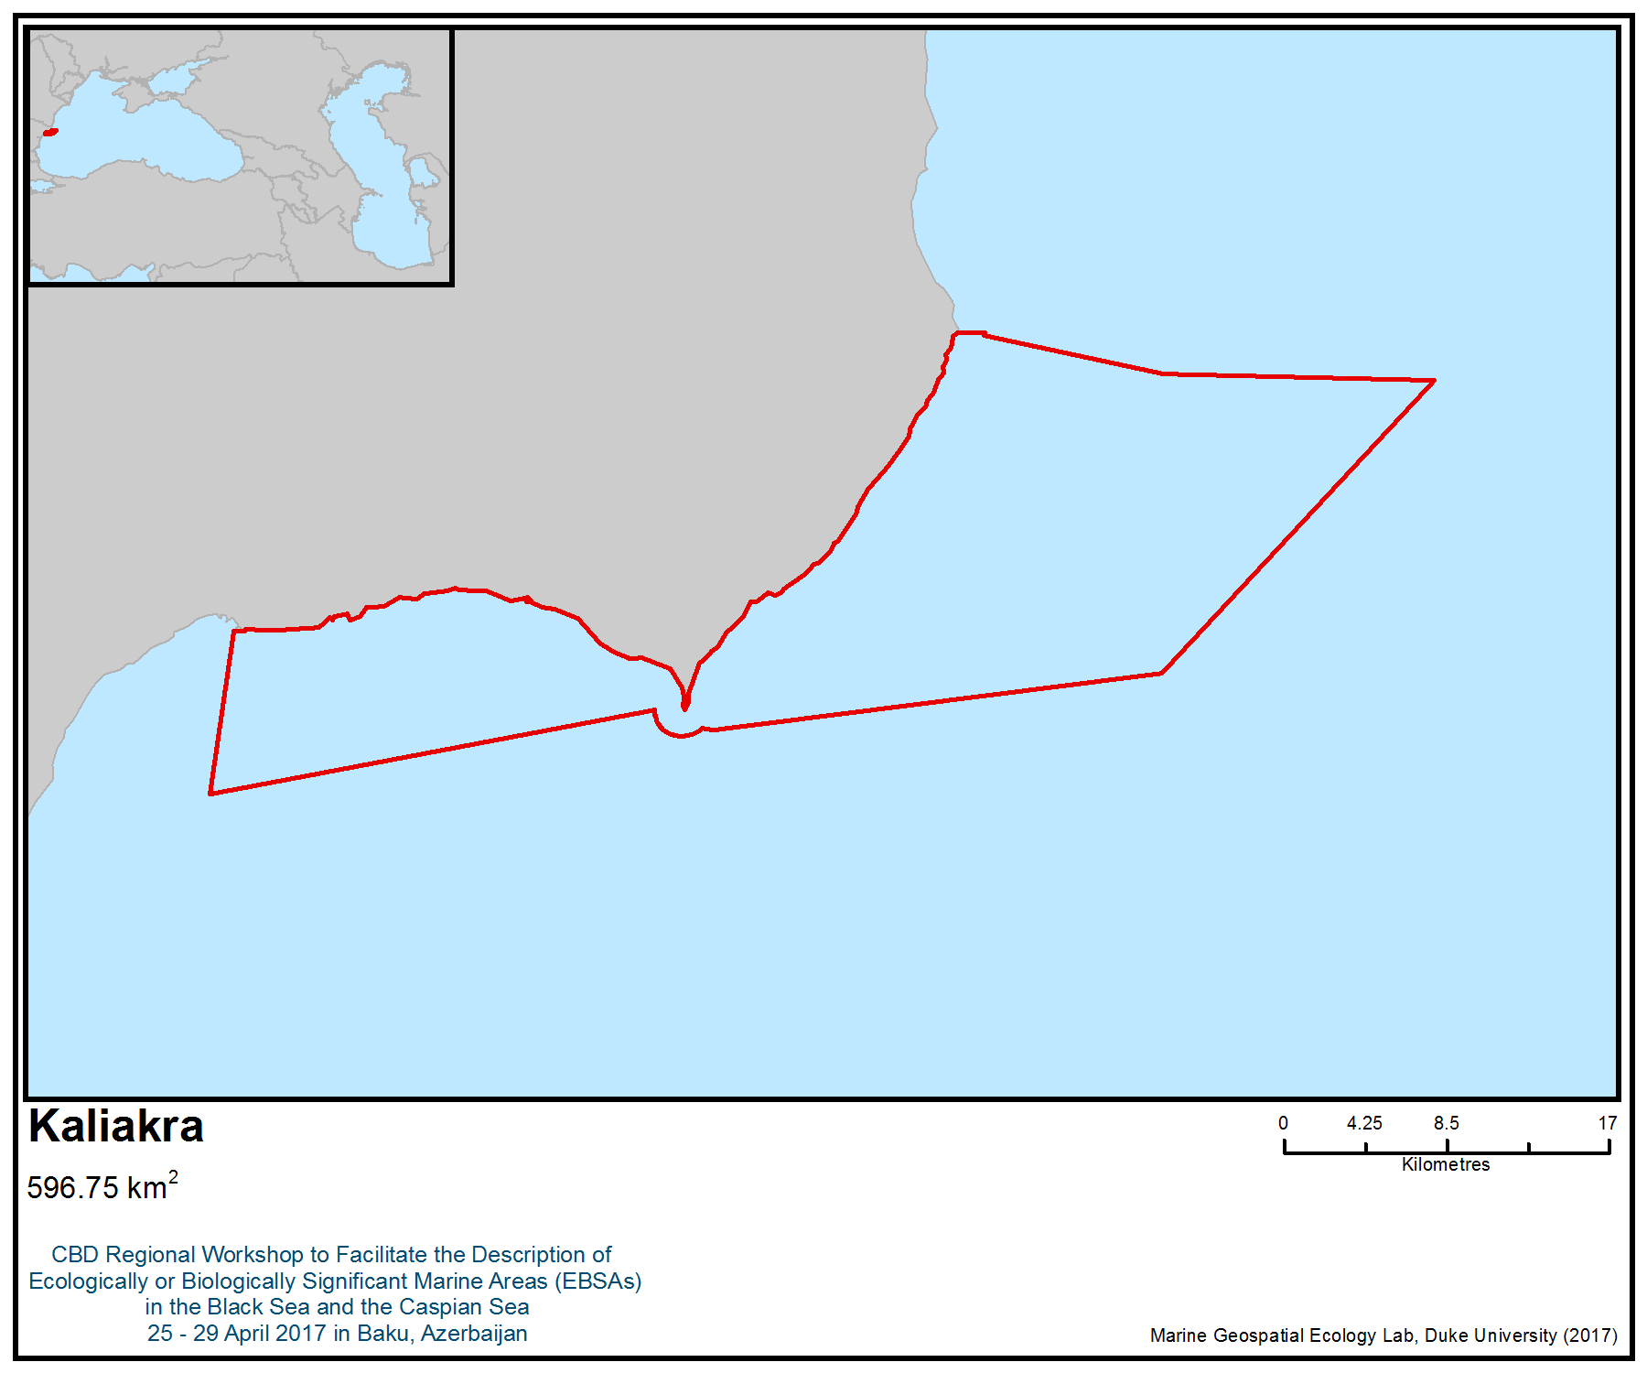
Figure 1. Area meeting the EBSA criteria
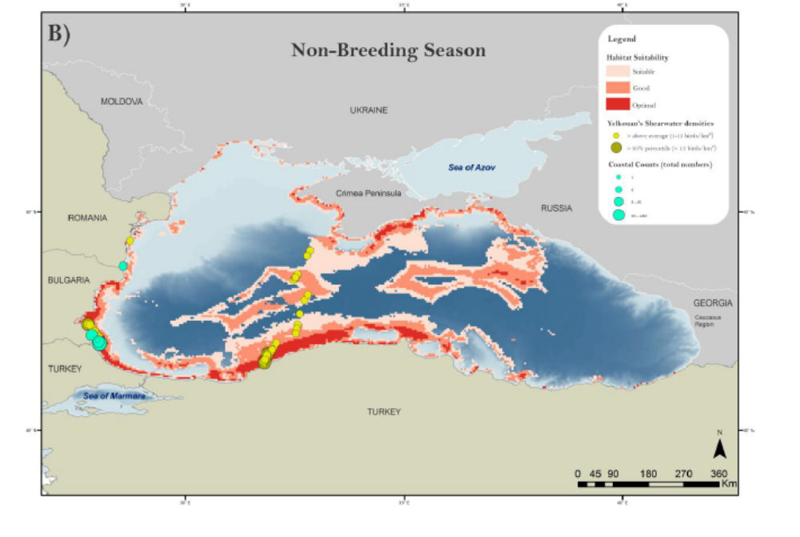
Figure 2: Results of the habitat models revealing the most suitable habitats for yelkouan shearwater in the Black Sea, during the non-breeding season (figure from Ortega and İsfendiyaroğlu 2017)

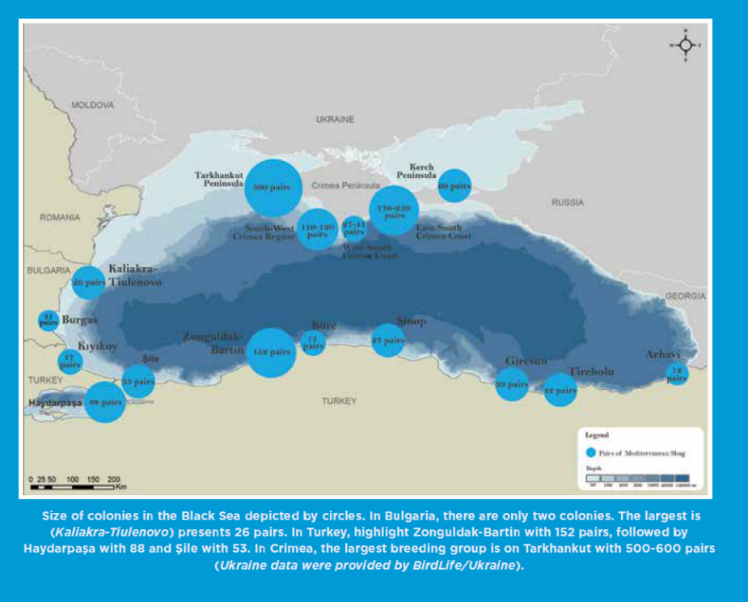

Figure 3. Location of the most important colonies of the Mediterranean endemic subspecies of European shag in the Black Sea (figure from Doğa Derneği 2014).

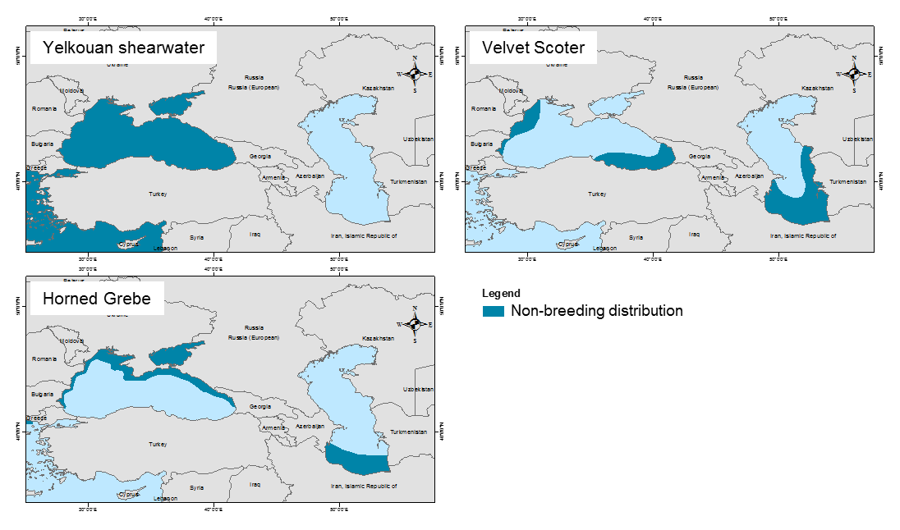
Figure 4. Distribution of the globally threatened seabird species occurring in the Black Sea and in the Caspian Sea: yelkouan shearwater (Puffinus yelkouan), velvet scoter (Melanitta fusca) and horned grebe (Podiceps auritus)
Area No. 3: Vama Veche – 2 Mai Marine Reserve

Abstract
Vama Veche – 2 Mai Marine Reserve represents a unique combination of a wide variety of broad habitat types, considered a real mosaic condensed in a rather small area, serving as shelter and spawning area to many marine species. Benthic and pelagic life is extremely rich here, compared to the biodiversity of the surrounding areas. Although small in size, it was proposed as a sanctuary for cetaceans due to its high biological diversity, and is also classified as a marine Important Bird and Biodiversity Area. Given its location, as well as the scientific interest of a neighbouring country, there is an opportunity for a transboundary expansion in the future.

Introduction
The area is situated in the southern extremity of the Romanian coast and is rather small in size, occupying until recently a surface area of 527 km². In 2016, as the botanical and zoological marine reserve is also a “Site of Community Importance” (SCI) under the EU Habitats Directive (Natura 2000 network), its eastward limit was extended down to 40 m isobaths, at present covering 1231 km² (Natura 2000 Standard Form). The area is monitored on an annual basis, and the data are published in the NIMRD Journal Cercetari Marine – Recherches Marines. The area overlaps with a marine Important Bird and Biodiversity Area (BirdLife International 2017a), designated primarily for its importance as a migratory corridor for the vulnerable yelkouan shearwater (Puffinus yelkouan).

Location
The Vama Veche - 2 Mai Marine Reserve is located in the southernmost part of the Romanian coastline, with a total area of 1231 km² after its extension, all of which is marine. The geographical coordinates of the site are 28.0019777E and 43.0064000 N.

Feature description of the area
The sediments of the area are dominated by biogenic coarse and pebbly sands. With increasing depth, fine quartz becomes dominant. The areas’s rocky floor consists of Sarmatian limestone shelves or rocks of the same origin. They form a continuous board from the shoreline down to 12-18 m depths; certain transects show rocky enclaves surrounded by sandy areas (Nita et al., 2013).

Salinity usually ranges between 16 and 18.5 PSU, representing typical values for brackish waters in the Black Sea. Waters in the area present normal pH values (8.2-8.55) and good oxygen saturation levels. Rare hypoxia phenomena may occur, but none have been recorded in recent years (Nicolaev et al., 2015b).

There are a variety of bottom habitats in the area, defined according to the EU Habitats Directive (Donita et al. 2005ab, Micu et al. 2007 and EUR 27 – Manual of European Union Habitats, 2007). These are:
- 1110-1 Zostera meadows on clean or slightly muddy fine sands: Zostera noltii forms mono-specific submerged meadows, in sheltered bays 4 meters deep, where sedimentary stability leads to a slight siltation of the sand;
- 1110-4: Well sorted sands: Immediately following shallow fine sands, this habitat type stretches from a 3-4 m water depth to the eastern limit of the site;
- 1110-5: Wave-lashed coarse sands and fine gravels: This habitat type is encountered in small bays in the site and does not exceed a few tens of centimeters in depth;
- 1110-6: Infralittoral cobbles: The habitats consist of round and flattened rock (cobbles) submerged beaches, usually white limestone, modeled by the waves. The lower limit corresponds to the area where wave force becomes insufficient to roll the cobbles;
- 1110-9: Sandy muds and muddy sands bioturbated by Upogebia: They form a continuous belt along the Romanian coast, at 10- 30 m depths, on muddy sands;
- 1140-1: Supralittoral sands with or without fast-drying drift lines: This habitat type occupies the beach part that is covered by water only during storms. The deposits are made of the materials brought by the sea — of vegetal origin (tree trunks, wood pieces, algae, leaves), of animal origin (underwater animal corpses, drowned terrestrial animals) and of anthropogenic origin (solid wastes), as well as the dense foam of marine plankton;

- 1140-2: Supralittoral slow-drying drift lines: The habitat occupies the portion of the boulder shoreline or cobble beaches that is covered by waves only during storms. They accumulate in the space between them the debris described above, but also humidity, so that the debris hardly dries;
- 1140-3: Midlittoral sands: This habitat type occupies the sand stretch on the shore, on which the waves break. Depending on the choppiness of the sea, the portion may be wider or narrower. The sand is compact, coarse and mixed with shell debris and gravel;
- 1140-4: Midlittoral detritus on shingle and boulders: This type of habitat occupies the midlittoral portion of the shores and is formed of boulders, cobbles or gravel, continuing the supralittoral slow-drying detritus drift lines;
- 1170-2: Mytilus galloprovincialis biogenic reefs: These habitats are made of mussel banks, the shells of which have accumulated in time, forming a rough support higher than the surrounding sediments (mud, sand, gravel or mixture), on which living mussel colonies fix themselves;
- 1170-4: Boulders and blocks: Large sized rock and boulder piles appear on the midlittoral of rocky shores, at the base of rocky cliffs. These blocks can be rolled or eroded by the water charged with sand during storms, which is why algal populations are ephemeral. The structural complexity and the obscurity attract an extraordinarily diverse fauna for such shallow waters. This habitat is actually a mosaic of microhabitats, representing midlittoral enclaves of species that normally belong to deeper areas;
- 1170-5: Supralittoral rock: The upper-littoral rock is situated above the sea level and becomes wet due to wave foam or during storms. The vertical expansion depends on hydro-dynamism, solar exposure and gradient. This type of habitat is populated by the Verrucaria lichen, isopod crustaceans and the Pachygrapsus marmoratus crab;
- 1170-6: Upper midlittoral rock: The upper midlittoral rock is located in the superior part of the wave breaking area and is not permanently covered by water, being nevertheless intermittently wet by high waves;
- 1170-7: Lower midlittoral rock: The lower midlittoral rock is located in the lower part of the wave breaking area, and it is covered by water most of the time. High and constant humidity and strong light are the dominant factors of this habitat. Articulated Corallina officinalis and ephemeral macrophyte Ulva sp., Cladophora sp. and Ceramium sp. algae occur. The fauna is characterized by Balanus improvisus, Mytilaster lineatus and Mytilus galloprovincialis, bryozoa, amphipod and isopod crustaceans, the Pachygrapsus marmoratus and Eriphia verrucosa crabs;
- 1170-8: Infralittoral rock with photophilic algae: The infralittoral rock with photophilic algae is situated immediately under the lower midlittoral level, where water immersions are only accidental, and stretches down to the inferior limit of the spreading of the photophilic and marine phanerogam algae. This lower limit is conditioned by the penetration of light and is thus variable, according to the topography and water clarity. Generally, on the Romanian littoral, this limit is around 10 meters deep, but in the areas with high turbidity it can be less than 1 meter. The rocky substrate between these two boundaries is covered with rich and varied populations of photophilic algae. It includes various facets (including the ones containing the Cystoseira barbata and Corallina officinalis perennial macrophyte algae) and a great algal and fauna diversity;
- 1170-9: Infralittoral rock with Mytilus galloprovincialis: The infralittoral rock with Mytilus galloprovincialis stretches down to maximum 28 metres deep, at the lower limit of the rocky platforms. In the photophilic algae area, it overlaps the previous habitat, but continues deeper, overcoming its limits. The fauna is extremely diverse, including numerous sponge, hydrozoas, polichaet, mollusk, and crustacean and fish species, characteristic only for this type of habitat, some of them being rare or protected;
- 1170-10: Infralittoral hard clay banks with Pholadidae: This type of habitat comprises red hard clay banks, shaped as plateaus or wavy, that can be partially covered by the surrounding sediments. The galleries dug by Pholas dactylus provide this habitat a high tridimensional complexity and allow the fixation of a special fauna association.

The biodiversity of the area consists of phytoplankton, zooplankton, macroalgae and marine phanerogames, zoobenthos, fish and marine mammals.

The area was designated for the protection of the following species of interest:
- bottlenose dolphin (Tursiops truncatus) occurring in the Romanian marine area during the warm season;
- harbour porpoise (Phocoena phocoena), which in searching for food near the coast, sometimes is accidentally caught in turbot gillnets;
- yelkouan shearwater (Puffinus yelkouan), which passes through the area during the migratory period;
- Danube shad (Alosa immaculata), which is a pelagic cold-water species whose adults come near the coast only during spawning migration, in February-April; juveniles are often encountered in coastal waters
- Caspian shad (Alosa tanaica) is present along the Romanian coast most of the year. It is a warm-water species, which prefers shallow coastal waters; starry sturgeon (Acipenser staellatus);
- beluga sturgeon (Huso huso);
- common piddock (Pholas dactylus);
- red alga Corallina officinalis and
- brown alga (Cystoseira barbata)

The species presented above are included in the Annex II and other annexes of EU Habitats Directive (92/43), Bern Convention, Barcelona Convention and Bucharest Convention (Annex II and IV of the Black Sea Biodiversity and Landscape Conservation Protocol). The area is one of the very few places where brown alga (Cystoseira barbata) occurs in the Romanian Black Sea; it acts as defense, foraging and spawning grounds for fish juveniles and various marine invertebrates. The elastic and yet firm substrate of the Cystoseira thalli and the intricate structure of the branches are ideal locations for the fixation of various macrophytes, both photophilic — bringing them closer to the water surface — and sciaphile, which develops in the shadows of the Cystoseira thickets (Nicolaev et al, 2015a).

Besides the species and habitats mentioned above, the area is important for other species with different conservation status: common dolphin (Delphinus delphis), shads (Alosa caspia caspia, Alosa maeotica), big-scale sand smelt (Atherina boyeri), common dragonet (Callionymus lyra), tub gurnard (Chelidonichthys lucerna), common stingray (Dasyatis pastinaca), European seabass (Dicentrarchus labrax), annular seabream (Diplodus annularis), white seabream (Diplodus sargus sargus), anchovy (Engraulis encrasicolus), long-snouted seahorse (Hippocampus guttulatus), golden grey mullet (Liza aurata), flathead grey mullet (Mugil cephalus), stripped mullet (Mullus barbatus ponticus), tentacled blenny (Parablennius tentacularis), Atlantic bonito (Sarda sarda), round sardinella (Sardinella aurita), Atlantic chub mackerel (Scomber colias), turbot (Scophthalmus maximus), black scorpionfish (Scorpaena porcus), comber (Serranus cabrilla), painted comber (Serranus scriba), guilt-head bream (Sparus aurata), picarel (Spicara smaris), dogfish (Squalus acanthias), corkwing wrasse (Symphodus melops), ocellated wrasse (Symphodus ocellatus), Mediterranean horse mackerel (Trachurus mediterraneus), red-black triplefin (Tripterygion tripteronotus), the shrimps Athanas nitescens, Palaemon adspersus, star ascidian (Botryllus schlosseri), the crabs (Brachynotus sexdentatus, Carcinus aestuarii, Clibanarius erythropus, Eriphia verrucosa, Liocarcinus navigator), the bivalves Gastrana fragilis, Gibbula divaricata, Irus irus, Mytilus galloprovincialis, Paphia aurea, Petricola lithophaga, Pholas dactylus the gastropods Mangelia pontica, Marshallora adversa, Tricolia pullus, sea sponge Dysidea fragilis, red algae Corallina officinalis and Polysiphonia elongata, brown algae Cystoseira barbata and Cystoseira zosteroides, and green algae Enteromorpha intestinalis, Enteromorpha linza (ROSCI0269 Natura 2000 Standard Form).

Feature condition and future outlook of the area
The main purpose for which this MPA was established is preservation of marine biodiversity. Other aims refer to elimination and prevention of any natural resource exploitation or use that does not comply with the conservation objectives, and providing proper conditions for scientific research, educational and leisure activities. In certain sub-areas, the regulation of the marine reserve allows only traditional fishery activities. Any other types of activities are strictly forbidden (e.g., construction, extraction of mineral resources, aquaculture) (Vama Veche-2 Mai Management Plan, 2016).

Assessment of the area against CBD EBSA Criteria

CBD EBSA Criteria  (Annex I to decision IX/20) | Description  (Annex I to decision IX/20) | Ranking of criterion relevance  (please mark one column with an X)
CBD EBSA Criteria  (Annex I to decision IX/20) | Description  (Annex I to decision IX/20) | No information |  | Low |  |  | Medium |  | High
Uniqueness or rarity | Area contains either (i) unique (“the only one of its kind”), rare (occurs only in few locations) or endemic species, populations or communities, and/or (ii) unique, rare or distinct, habitats or ecosystems; and/or (iii) unique or unusual geomorphological or oceanographic features. |  |  |  |  |  | X
Explanation for ranking
Vama Veche – 2 Mai Marine Reserve is one of the few places in Romanian marine waters where rare habitat types occur: 1170-8 with Cystoseira barbata; 1170-10 with Pholas dactylus and natural rocky midlittoral. Cystoseira barbata occurs as a continuous belt sheltering a rich associated fauna, consisting of invertebrates and small fish with high diversity. Among red algae, protected species Corallina officinalis can be found fixed on rocky substrate or mussel shells only within this area. This is the only place in Romanian waters where this species has been identified in present times (Micu et al., 2007).
Special importance for life-history stages of species | Areas that are required for a population to survive and thrive. |  |  |  |  |  | X
Explanation for ranking
The diverse mosaic of rocky and sedimentary habitats, sheltering a diverse fauna of both invertebrates and vertebrates, is an important spawning area for fish, especially gobies (Gobius cephalarges, Mesogobius batrachocephalus,), most of them endemic to the Black Sea (Nita et al., 2013, Nicolaev et al., 2015a). The area is also important for the yelkouan shearwater Puffinus yelkouan during the migratory period (BirdLife International 2017a).
Importance for threatened, endangered or declining species and/or habitats | Area containing habitat for the survival and recovery of endangered, threatened, declining species or area with significant assemblages of such species. |  |  |  |  |  |  |  | X
Explanation for ranking
The brown alga Cystoseira barbata, a regionally vulnerable species, has a particular ecological importance for the marine ecosystem, as it constitutes a protecting environment, feeding and breeding place for juvenile fish, and also for many marine invertebrates. The elastic yet firm enough substrate is represented by Cystoseira thalli, whose complex structure of branches offers an ideal fixing place for various macrophytes, both photophyles (bringing them closer to the water surface) and scyaphyles (growing in the shade of Cystoseira thallus) (Müller et al., 1969). All these facts recommend Cystoseira areas as important ecological niches in the life of this marine ecosystem.

The following species, threatened at the regional level (Black Sea), occur in this area:
Critically endangered: crabs Carcinus aestuarii and Clibanarius erythropus, bivalves Petricola lithophaga and Pholas dactylus, gastropods Gibbula divaricata, Tricolia pullus, red alga Corallina officinalis and brown alga Cystoseira barbata
Endangered: harbour porpoise Phocoena phocoena, bottlenose dolphin Tursiops truncatus, common dolphin Delphinus delphis, bivalves Gastrana fragilis, Irus irus, and decapod Liocarcinus navigator
Vulnerable: Puffinus yelkouan (Vulnerable at a global level; BirdLife International, 2017b)
Near threatened: shad (Alosa immaculata) and golden grey mullet Liza aurata
Most of the fish species occurring in the area are data deficient (DD), so their conservation status is not known (Black Sea Red Data Book, IUCN Red List).
Vulnerability, fragility, sensitivity, or slow recovery | Areas that contain a relatively high proportion of sensitive habitats, biotopes or species that are functionally fragile (highly susceptible to degradation or depletion by human activity or by natural events) or with slow recovery. |  |  |  |  |  |  |  | X
Explanation for ranking
The habitat of the brown alga Cystoseira barbata, seagrass habitats and infralittoral rock with mussels (Mytilus galloprovincialis) are sensitive to environmental changes and recover slowly (Marin et al., 2013, Nicolaev et al., 2015b). Cystoseira fields play an important role in the amortization of shock waves and their reduction favours the re-suspension of sediments and increased water turbidity, with negative effects especially to sensitive organisms. A consequence of the decline of this species is the reduction in macroalgae biodiversity, as Cystoseira represents a habitat-forming species. Therefore, macroalgal species such as Sphacellaria cirrhosa, Feldmannia irregularis, Stilophora rhizoides, Corynophlaea umbellata, Cladostephus verticillatus, Kylinia ssp. disappeared. Disappearance or reduction of Cystoseira fields has also led to the decline of some fish species that used to shelter and feed here. Presently, this habitat-forming species is under slow recovery, which depends very much on anthropogenic pressures (Marin et al., 2013).
Biological productivity | Area containing species, populations or communities with comparatively higher natural biological productivity. |  |  |  |  |  | X
Explanation for ranking
Besides the highly productive habitat of Cystoseira barbata, which displays some discontinuity in the area, another highly productive habitat might be mentioned: infralittoral rock with Mytilus galloprovincialis (Micu et al., 2007), which is well developed in the area and highly productive (Abaza, 2010; Marin & Timofte, 2011; Nita et al. 2013). As result, endemic and threatened species, such as gobies (Mesogobius batrachocephalus), shads (Alosa pontica, A. tanaica), sturgeons and cetaceans can be found in the area, using it both as a shelter and feeding area (Nicolaev et al., 2015b).
Biological diversity | Area contains comparatively higher diversity of ecosystems, habitats, communities, or species, or has higher genetic diversity. |  |  |  |  |  |  |  | X
Explanation for ranking
The biodiversity of the area consists of phytoplankton, zooplankton, macroalgae and marine phanerogames (Zostera sp.), zoobenthos, fish and marine mammals, most of them mentioned above. Due to the diversity of habitats in this small area, the representatives of almost all taxonomic groups identified in the Romanian marine area can be found, which are mainly of scientific interest (Micu et al., 2007, Abaza, 2010).
Naturalness | Area with a comparatively higher degree of naturalness as a result of the lack of or low level of human-induced disturbance or degradation. |  |  |  |  |  |  | X
Explanation for ranking
Vama Veche – 2 Mai Marine Reserve is considered a less impacted area of the Romanian shoreline, despite the proximity of its northern part to Mangalia harbour. The area is moderately inhabited (two villages are located nearshore), but during the summer tourism is well developed, as it is a favoured leisure destination among many young people. The potential effect of this proximity can be observed in the occurrence of barren areas, which occur still in the northern part of the reserve. However, these areas are undergoing a slow natural recovery process (Nicolaev et al., 2015b).

References
Abaza, V., 2010. Zoobenthic communities structure in the eastern part of the marine reserve 2 Mai – Vama Veche under present ecological conditions. Journal of Environmental Protection and Ecology 11(3):1013-1023
Abaza, V., S.P. Godeanu, 2008. Present state of shallow water macrozoobenthos from marine reserve 2 Mai – Vama Veche. Cercetări marine – Recherches marines, INCDM Constanta, 38: 101-117
BirdLife International 2017a. Important Bird Areas factsheet: Black Sea. Downloaded from http://datazone.birdlife.org/site/factsheet/black-sea-iba-romania/details on 05/04/2017.
BirdLife International, 2017b. Species factsheet: Puffinus yelkouan. Downloaded from http://www.birdlife.org on 10/03/2017.
Birkun A Jr, Northridge S P, Willsteed E A, James F A, Kilgour C, Lander M, Fitzgerald G, 2014. Adverse Fisheries Impacts on Cetacean Populations in the Black Sea (DG MARE Final Report).
Donita, N., Popescu, A., Pauca-Comănescu, M., Mihăilescu, S., Biriş, I.-A., 2005. Habitats from omania. Editura Tehnica Silvică, Bucharest, 493 pp. [In Romanian]
Donita, N., Popescu, A., Pauca-Comănescu, M., Mihăilescu, S., Biriş, I.-A., 2005. Habitats from Romania. Modifications. Editura Tehnica Silvică, Bucharest, 94 pp. [In Romanian]
Marin O. A., Timofte F., 2011 - Atlasul macrofitelor de la litoralul romanesc, Ed. Boldas, ISBN 978-606-8066-33-2 [In Romanian]
Marin, O. Abaza V., Sava D., 2013. Phytobenthos – Key Biological Element in Shallow Marine Waters. Cercetari Marine – Recherches marines 43: 197-218
Micu D., 2005. Recent records of Pholas dactylus l., 1758 (Bivalvia: Myoida: Pholadidae) from the Romanian Black Sea, with considerations on its habitat and proposed IUCN regional status. Trav. Mus. Hist. Nat. G. Antipa, vol. 49.
Micu D., 2004. Annotated Checklist of the Marine Mollusca from the Romanian Black Sea. In: Ozturk B., Mokievsky V.O. and Topaloglu B. (Eds) International Workshop on Black Sea Benthos: 89-152. Published by Turkish Marine Research Foundation, Turkey 2004, 244 pp.
Micu S. and Micu D., 2006. Proposed IUCN regional status of all Crustacea: Decapoda species from the Romanian Black Sea. Sci. Annals of Al.I.Cuza Univ. Iasi, 52: 1-32.
Micu D., Micu S., 2006. Recent records, growth and proposed IUCN status of Donacilla cornea (Poli, 1795) (Bivalvia:Veneroida:Mesodesmatidae) in the Romanian Black Sea. Cercetari Marine – Recherches Marines, 36: 1-16.
Micu, D., Zaharia, T., Todorova, V., Niţă, V., 2007. Romanian Marine Habitats of European Interest. Editura Punct Ochit, Constanta, 30 pp. [In Romanian]
Müller G.I., Skolka V.H., Bodeanu N., 1969 - Date preliminare asupra populaţiilor algale şi animale asociate vegetaţiei de Cystoseira barbata de la litoralul românesc al Mării Negre. Hidrobiologia. Bucureşti, 10:279-289 [In Romanian]
Nicolaev S., Zaharia T., Maximov V., 2015a. Marine Protected Areas. Life in the Black Sea – Sites of Community Importance along the Romanian Black Sea Coast. Booklet Aureo Publ., 68 pp.
Nicolaev et al., 2015b. Report on the State of Marine and Coastal Environment in 2014, Cercetari Marine – Recherches Marines, 45:4-159
Nita, V., Zaharia T., Nenciu M., Cristea M., Tiganov G., 2013. Current state overview of the Vama Veche-2 Mai Marine Reserve, Black Sea, Romania, AACL Bioflux 5 (1): 44-54 (http://www.bioflux.com.ro/aacl)
Petran A., 1997 - Black Sea Biological Diversity. Romania. Black Sea Environmental Series, 4, UN Publications: 314 pp
Zaharia T et al., 2003 - Contributions on the knowledge of the present state of the Vama Veche - 2 Mai marine benthic habitats, Recherches marines, v.34/2002: 279-299; ISSN 0250-3069 6.
Black Sea Red Data Book, 1999 UNOPS, Ghent, Belgium: 413 p. 8.
ROSCI0269 Natura 2000 Standard Data Forms, 2015
Vama Veche – 2 Mai Management Plan, 2016

IUCN Red List of Species

www.natura2000.eea.europa.eu
http://circa.europa.eu/Public/irc/env/monnat/library?l=/habitats_reporting/reporting_20072012&vm=detailed&sb=Title
http://bd.eionet.europa.eu/article17/reference_portal
http://cdr.eionet.europa.eu/ro/eu/art17/envurmdya
www.blacksea-commission.org
www.mmediu.ro
www.anpm.ro

Maps and Figures

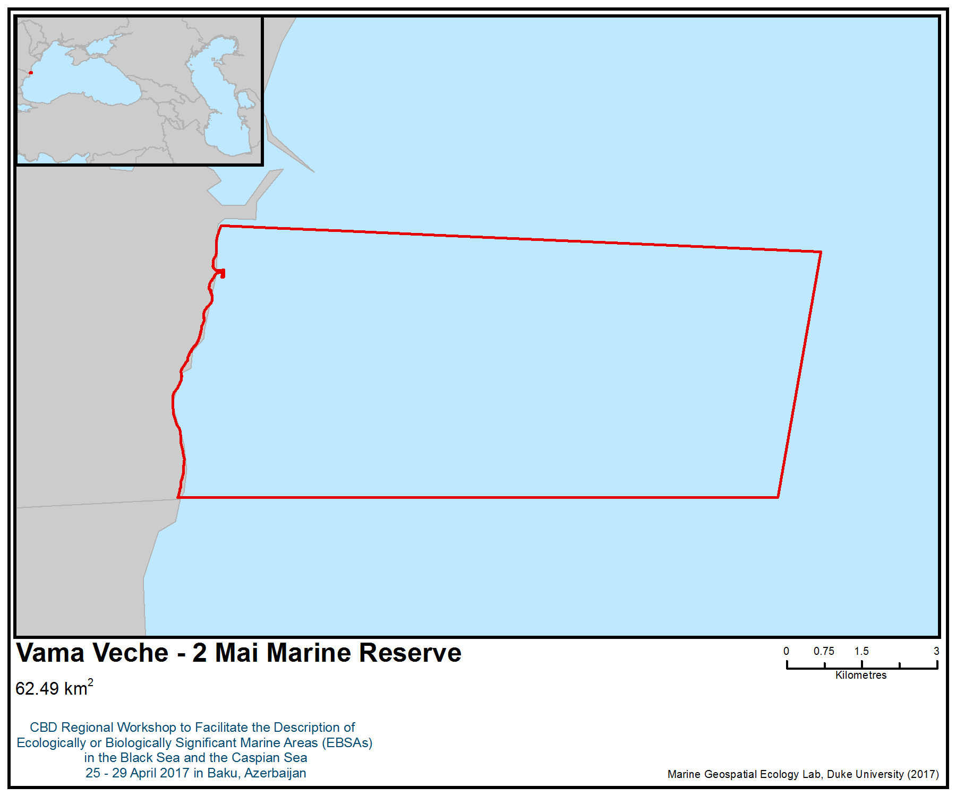
Figure 1. Area meeting the EBSA criteria

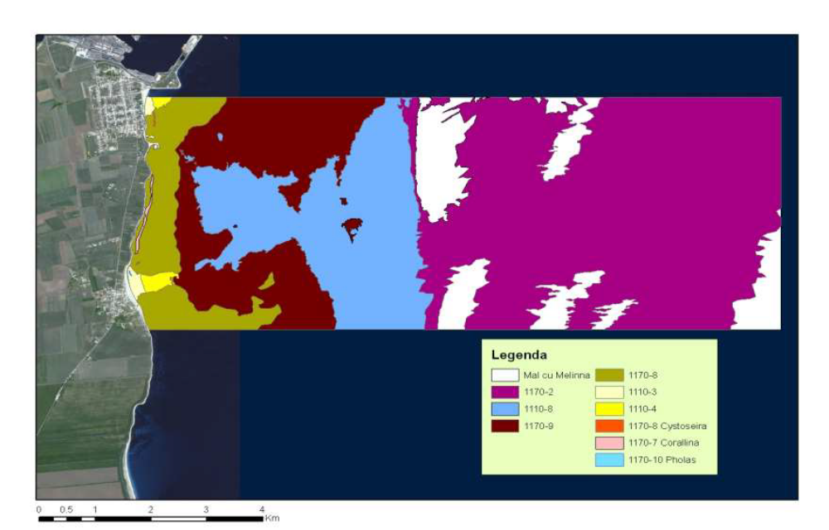
Figure 2. Natura 2000 habitats distribution in the Vama Veche – 2 Mai Marine Reserve (ROSCI0269 Vama Veche-2 Mai site Management Plan www.anpm.ro)

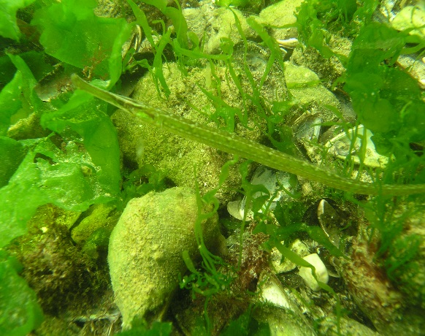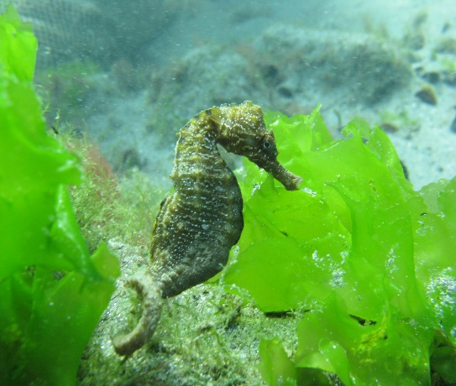
Figure 3. Syngnathidae on rocky habitats with photophilic algae (NIMRD)

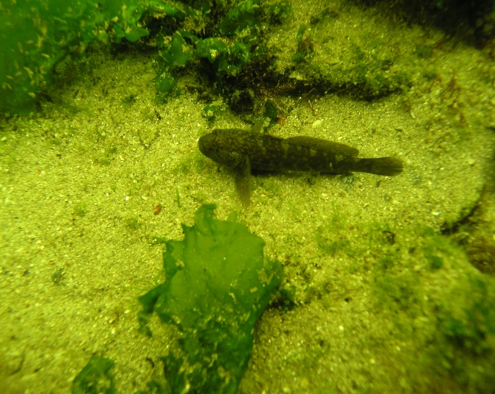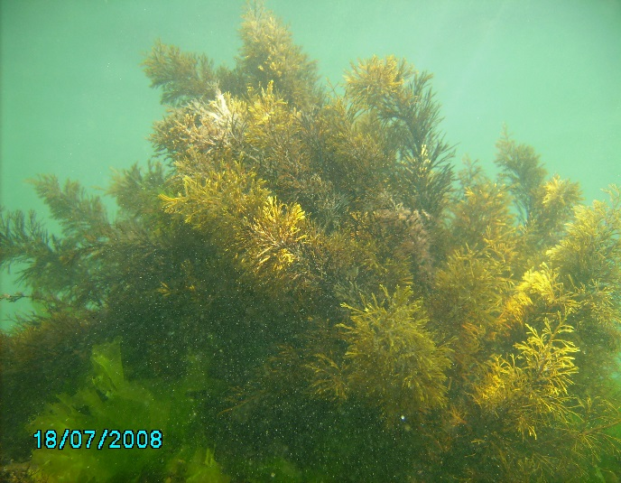
Figure 4. Goby on rocky habitats with photophilic algae Cystoseira barbata at Vama Veche – 2 Mai (NIMRD)

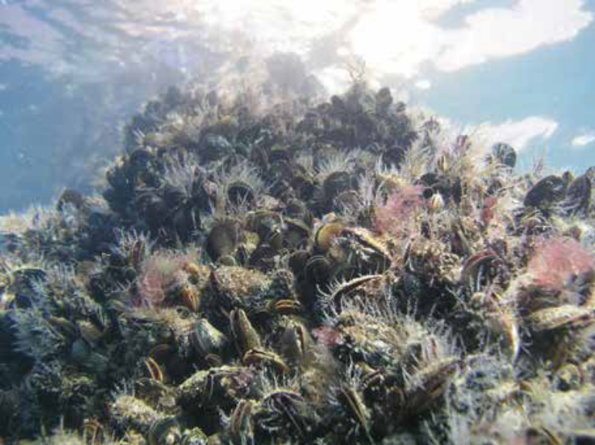
Figure 5. Infralittoral rock with Mytilus galloprovincialis (NIMRD)

Area No. 4. Danube Delta Marine Area

Abstract
This area is strongly influenced by the fresh water inflow and the sediments carried by the Danube River, creating a mixture of sedimentary habitats unique for the Romanian littoral area. These sedimentary habitats and the low salinity pelagic habitats contain a large proportion of freshwater, brackish water and marine species. It is an important nursery and feeding area for Black Sea sturgeons and shads, species that are protected under different conventions. Species in the area include: bottlenose dolphin (Phocoena phocoena), harbour porpoise (Tursiops truncatus), short-beaked common dolphin (Delphinus delphis), yelkouan shearwater (Puffinus yelkouan), beluga sturgeon (Huso huso), Russian sturgeon (Acipenser gueldenstaedtii), starry sturgeon (Acipenser stellatus), Danube shad (Alosa immaculata), Caspian shad (Alosa tanaica) (Danube Delta Biosphere Reserve Management Plan, 2015). The area is part of a larger protected area, Danube Delta Biosphere Reserve, which is listed as a UNESCO World Natural Heritage Site and a Ramsar site under the Ramsar Convention.

Introduction
Occupying about 1217 km², the area is strongly influenced by the Danube, carrying large amounts of both freshwater and fine sediments into the sea, and even creating an island, which increases in size every year. The dominant winds from the north and northeast influence the water mass dynamics and coastal processes characterized in the area by accretion and erosion, in close connection with exposure degree. The accumulation/erosion rates depend on the water masses circulation (currents) and predominant winds (Nicolaev et al., 2015, 2016). The water salinity is also influenced by the Danube flow, gradually increasing from north to south, ranging in surface waters from 0.1 to 15 PSU and creating a gradient for distribution of freshwater, brackish water and marine species, favouring the occurrence of eurihaline species. The depths in the area range between 0 and 20m.

Location
The area is located in front of the Danube Delta between Chilia arm in the north and Midia Cape in the south and projecting into the sea until the 20m isobath. It has a total coverage of 1217 km², all of which is marine. The geographical coordinates of the site are 29.0111277 E and 44.0006472 N.

Feature description of the area
The marine area of the Danube Delta has certain peculiarities due to the major influence of Danube waters and the alluvial deposits they carry. Consequently, unique sedimentary habitats occur here. The beauty and richness of the area are remarkable, with a variety of biotopes and resources, which make it unique not only in Europe, but also among delta ecosystems worldwide.

The Danube outflows, together with the Musura and Sakhalin bays and the Black Sea water in front of them, down to the 20 m isobaths, are estuarine waters. Marine waters off the Danube are strongly influenced by freshwater input. The mixing between fresh and marine water causes the deposition of fine sediments, and currents often dilute and transport these sediments. This habitat covers the midlittoral, infralittoral and circalittoral, being characterized by low salinity of surface waters and upstream penetration of deep marine water (Nicolaev et al., 2015b). These waters shelter plant and animal species typical of estuarine environments. Thus, despite the absence of tides (as in the Mediterranean or the Baltic seas) and of the typical estuary shape, these waters of variable salinity levels represent an estuarine habitat, very close to the one in the Baltic. A series of broad habitat types can be found in the area: littoral sediments, infralittoral sand, infralittoral mud, circalittoral mixed sediments, circalittoral sand and mud. Among marine benthic habitats, the following can be mentioned: mediolittoral fine sands with Pontogammarus maeoticus, infralittoral fine sands with Lentidium mediterraneum, infralittoral and circalittoral sandy and muddy sands with Mya arenaria and Anadara kagoshimensis, circalittoral mud with Abra alba, Cardiidae and Mytilus galloprovincialis, circalittoral biogenic reefs with Mytilus galloprovincialis (Abaza et al., 2006ab, Dumitrache et al., 2013).

The area is important mostly because of its ecological features, rather than its high level of biodiversity, representing an important feeding, wintering and nursery ground for endangered fish species (sturgeons), fish of economic importance and marine mammals (the three dolphin species living in the Black Sea). (Bacesu et al., 1971ș Abaza et al., 2006b; Nicolaev et al, 2015).

Sometimes the bottlenose dolphin (Tursiops truncates) enters the Danube for food; harbour porpoise (Phocoena phocoena), also enters the Danube and lagoons. The populations agglomerate near the coast, where food is more abundant and easy accessible. It is sometimes accidentally caught in turbot gillnets. When winter approaches, it migrates towards wintering grounds in Georgia and Turkey; Danube shad (Alosa immaculata) is a pelagic cold-water species. Adults come near the coast only during spawning migration, in February-April; juveniles are often encountered in coastal waters. Caspian shad (Alosa tanaica) is present along the Romanian coast most of the year. It is a warm-water species, which prefers shallow coastal waters. The species presented above are included in Annex II of EU Habitats Directive (92/43) (DDBR Management Plan, 2015). The area overlaps also with a marine Important Bird and Biodiversity Area (BirdLife International 2017a), mostly designated for its importance as a migratory corridor for the vulnerable yelkouan shearwater (Puffinus yelkouan) (Doğa Derneği 2014). The yelkouan shearwater is a Mediterranean endemic; birds from different colonies located in the Mediterranean congregate in the Black Sea during the winter period (September-December) and migrate through the coasts of Romania (BirdLife International, 2017b; Doğa Derneği 2014). Estimates indicate the regular occurrence of ca. 17,000 yelkouan shearwaters (BirdLife International 2017a). Recent studies of habitat suitability have also confirmed the importance of this area for the species (Ortega & İsfendiyaroğlu 2017). Besides these, the area is important for other species with different conservation states: common dolphin (Delphinus delphis), Russian sturgeon (Acipenser gueldenstaedtii) (critically endangered), starry sturgeon Acipenser stellatus (critically endangered), garfish (Belone belone belone), tub gurnard (Chelidonichthys lucerna), common stingray (Dasyatis pastinaca), beluga (Huso huso) (critically endangered), golden grey mullet (Liza aurata), leaping mullet (Liza saliens), knout goby (Mesogobius batrachocephalus), flathead grey mullet (Mugil cephalus), stripped mullet (Mullus barbatus ponticus), rattan goby (Neogobius ratan), European flounder (Platichthys flesus), blue fish (Pomatomus saltatrix), marbled goby (Pomatoschistus marmoratus), sand goby (Pomatoschistus minutus), thornback ray (Raja clavata), Black Sea salmon (Salmo labrax), black-stripped pipefish (Syngnathus abaster), greater weever (Trachinus draco), green algae Bryopsis plumosa, Enteromorpha intestinalis, Enteromorpha linza Ulva lactuca, Ulva rigida, and red algae Callithamnion corymbosum, Ceramium diaphanum, Phyllophora crispa, Phyllophora pseudoceranoïdes and Porphyra leucosticta, (ROSCI0066 Natura 2000 Standard Form).

Feature condition and future outlook of the area
A series of specific human activities have a distinct impact in deteriorating the quality of the marine environment in the area, even more so as it is under the influence of the Danube. The overexploitation of natural resources materializes as an increased pressure thereon, especially on fish, and by the development of activities improper for the delta system, which can cause the disappearance of foraging and spawning grounds of many species. Among the anthropogenic pressures in the area are: navigation, passive and active fishing using different gears, water pollution and eutrophication, naturally induced by the Danube inflow. Nevertheless, this area, as part of the Danube Delta Biosphere Reserve, is monitored on a regular basis and is subjected to a management plan.

The area was designated for protection of the bottlenose dolphin (Tursiops truncatus) occurring in the Romanian marine area during the warm season.

Assessment of the area against CBD EBSA Criteria

CBD EBSA Criteria  (Annex I to decision IX/20) | Description  (Annex I to decision IX/20) | Ranking of criterion relevance  (please mark one column with an X)
CBD EBSA Criteria  (Annex I to decision IX/20) | Description  (Annex I to decision IX/20) | No information |  | Low |  |  | Medium |  | High
Uniqueness or rarity | Area contains either (i) unique (“the only one of its kind”), rare (occurs only in few locations) or endemic species, populations or communities, and/or (ii) unique, rare or distinct, habitats or ecosystems; and/or (iii) unique or unusual geomorphological or oceanographic features. |  |  |  |  |  |  |  | X
Explanation for ranking
Due to high freshwater input coming from the Danube River, influencing the salinity levels, an interesting mixture of freshwater and brackish water pelagic species can be observed. Thus, in phytoplankton there are taxonomic groups represented only by freshwater species (Chrolophycea and Cyano bacteria), while Bacillariophycea, Dinophycea and other taxonomic groups are represented mainly by brackish water and marine species, with a lower proportion of freshwater species. This is also the case with zooplankton (Lazar et al., 2013; Abaza et al., 2006ab). A fish population survey carried out in 2012 indicates 29% freshwater and 71% brackish water species off Sulina and 14% freshwater and 86% brackish water species off Sf. Gheorghe areas (Nicolaev et al., 2015b). The area includes some of the key passage sites for the yelkouan shearwater during their migrations (Doğa Derneği 2014). The area is also used as a passage site by other 10 species of seabirds, mostly gulls and terns (common gull-billed tern Gelochelidon nilotica, Caspian gull Larus cachinnans, little gull Hydrocoloeus minutus, slender-billed gull Larus genei, black-headed gull Larus ridibundus, Mediterranean gull Larus melanocephalus, mew gull Larus canus, little tern Sternula albifrons, Caspian tern Hydroprogne caspia, whiskered tern Chlidonias hybrida, common tern Sterna hirundo, Sandwich tern Thalasseus sandvicensis and red-necked phalarope Phalaropus lobatus) (BirdLife International, 2017a; BirdLife International unpublished data).
Special importance for life-history stages of species | Areas that are required for a population to survive and thrive. |  |  |  |  |  |  |  | X
Explanation for ranking
This is a nursery area, particularly for shads, an important economic resource. Also, sturgeons and turbot feed in this area (Nicolaev et al., 2015b). It was recognized as highly productive for fish populations in the 1960s (Bacescu et al., 1971). The area is also important for the yelkouan shearwater Puffinus yelkouan during the non-breeding season (Doğa Derneği 2014).
Importance for threatened, endangered or declining species and/or habitats | Area containing habitat for the survival and recovery of endangered, threatened, declining species or area with significant assemblages of such species. |  |  |  |  |  |  |  | X
Explanation for ranking
This is a highly important feeding and wintering area for Black Sea sturgeons (Acipenser gueldenstaedtii, Acipenser stellatus, Acipenser nudiventris, Huso huso), listed as critically endangered at global scale in the IUCN Red List of marine species, as well as for other threatened species: Raja clavata (near threatened), Pomatomus saltatrix (vulnerable) and other species included in the Black Sea Red Data Book and Annex II of the Black Sea Biodiversity and Landscape Conservation Protocol to Bucharest Convention (DDBR Management Plan, 2011, Petran, 1997). Yelkouan shearwater Puffinus yelkouan , a globally threatened seabird species listed as vulnerable by IUCN, occurs in the area (BirdLife International 2017). – The distribution range of two other species also overlaps with the site – the velvet scoter Melanitta fusca and horned grebe Podiceps auritus (BirdLife International 2017c.). All these species are also included in the Annex I of the EU Birds Directive. Other species found here listed under the Annex I of the EU Birds Directive include the slender-billed gull Larus genei, Mediterranean gull Larus melanocephalus, Mediterranean shag Phalacrocorax aristotelis desmarestii, Caspian tern Hydroprogne caspia, common tern Sterna hirundo, little tern Sternula albifrons, common gull-billed tern Gelochelidon nilotica, Sandwich tern Thalasseus sandvicensis and red-necked phalarope Phalaropus lobatus (BirdLife International, 2017a; BirdLife International unpublished data).
Vulnerability, fragility, sensitivity, or slow recovery | Areas that contain a relatively high proportion of sensitive habitats, biotopes or species that are functionally fragile (highly susceptible to degradation or depletion by human activity or by natural events) or with slow recovery. |  |  |  |  |  |  |  | X
Explanation for ranking
There is a high proportion of threatened species, sensitive to environmental changes, especially considering the highly dynamic natural factors combined with anthropogenic environment conditions in the area. Among the environmental conditions, the following could be mentioned: high risk of nutrient pollution and consequently, eutrophication, high rate of siltation, rapid changing of coastline due to erosion/deposition processes (Nicolaev et al., 2015). The area is of high importance to the vulnerable yelkouan shearwater Puffinus yelkouan, a long-lived species with low fecundity and late sexual maturity, which is particularly vulnerable to factors increasing adult mortality rates, such as by-catch in fisheries and other at-sea threats (often considered the major causes of population decline; Anderson et al. 2011; Oppel et al. 2011).
Biological productivity | Area containing species, populations or communities with comparatively higher natural biological productivity. |  |  |  |  |  | X
Explanation for ranking
Biological productivity, although not so high, as studied in the late 1960s, is given by high number of phytoplankton species, both freshwater and brackish water species, which serve as food for zooplankton species, also of freshwater and brackish water origin. Fodder zooplankton is used by pelagic fish species in the area, thus, insuring the pelagic productivity (Petran, 1997; Abaza et al., 2006ab). Also, bottom invertebrate species represent an important food resource for demersal fish species such as sturgeons and turbot (Dumitrache et al., 2013).
Biological diversity | Area contains comparatively higher diversity of ecosystems, habitats, communities, or species, or has higher genetic diversity. |  |  |  |  |  | X
Explanation for ranking
There are diverse species from all functional groups: phytoplankton, zooplankton, zoobenthos (e.g., sandy-bottom bivalve species as Lentidium mediterraneum, Cerastoderema glaucum) or bivalves inhabiting sandy-muddy bottoms as Spisula subtruncata, Mya arenaria, Anadara kagoshimensis, Mytilus galloprovincialis etc.) (Abaza et al., 2006ab, Dumitrache et al., 2013), fish (e.g. sturgeons, shads, anchovy, sprat, salmon, trout, whiting, turbot, spiny dogfish, etc.), marine mammals (common dolphin, bottlenose dolphin and harbour porpoise). Other important species inhabiting the area are birds on the shore surrounding the area, most of them considered threatened, both at global and regional scales (BirdLife International, 2017a).
Naturalness | Area with a comparatively higher degree of naturalness because of the lack of or low level of human-induced disturbance or degradation. |  |  |  |  | X
Explanation for ranking
The coast adjacent to this area is mainly uninhabited, and coastal defense structures are maintained at lowest possible levels. Its naturalness is dictated by the strong influence of the Danube, which creates a very dynamic environment, characterized by large quantities of sediment input, rapid changes of coastline due to erosion/deposition (Diaconeasa et al., 2013) and variable nutrient inputs (Lazar et al., 2013; DDBR Management Plan, 2015).

References
Abaza, V., Boicenco L., Bologa A.S., Dumitrache C., Moldoveanu M., Sburlea A., Staicu I., Timofte F., 2006a. Biodiversity structure from the Romanian marine area. Cercetări marine - Recherches marines, INCDM Constanta, 36: 15-29.
Abaza, V., Boicenco L., Moldoveanu M., Timofte F., Bologa A.S., Sburlea A, Dumitrache C., Staicu I., Radu Gh., 2006b - Evolution of marine biodiversity status at the Romanian Black Sea coast as result of anthropogenic modifications in the last decades. 1st Biannual Scientific Conference “Black Sea Ecosystem 2005 and Beyond - 8-10 May 2006, Istanbul, Turkey (electronic proceedings): 413-429.
Anderson, O.R.J., Small, C., Croxall, J.P., Dunn, E.K., Sullivan, B.J., Yates, O. & Black, A., 2011. Global seabird bycatch in longline fisheries. Endangered Species Research 14: 91–106
BirdLife International 2017a. Important Bird Areas factsheet: Black Sea. Downloaded from http://datazone.birdlife.org/site/factsheet/black-sea-iba-romania/details on 05/04/2017.
BirdLife International, 2017b. Species factsheet: Puffinus yelkouan. Downloaded from http://www.birdlife.org on 10/03/2017.
BirdLife International 2017c. IUCN Red List for birds. Downloaded from http://www.birdlife.org on 05/04/2017.
BirdLife International unpublished data.
Birkun A Jr, Northridge S P, Willsteed E A, James F A, Kilgour C, Lander M, Fitzgerald G, 2014. Adverse Fisheries Impacts on Cetacean Populations in the Black Sea (DG MARE Final Report)
Băcescu, M., Müller, G.I., Gomoiu, M.T., 1971. Cercetări de ecologie bentală în Marea Neagră – Analiza cantitativă, calitativă şi comparată a faunei bentale pontice - în Ecologie Marină 4: 357 pp.
D. Diaconeasa, S. Petrisoaia, Ghe. Munteanu, R. Mateescu, A. Spinu, 2013. Evolution of the Black Sea Shore in the Danube Delta Biosphere Reserve Area, Cercetari Marine-Recherches Marines, 43: 139-148
Doğa Derneği, 2014. Black Sea Seabirds Project Layman’s report, Istanbul.
Dumitrache C., Filimon A., Abaza V., Zaharia T., 2013. Recent data on benthic populations from the sandy bottom community in the marine zone of the Danube Delta Biosphere Reserve (ROSCI0066). Cercetari Marine-Recherches Marines, 43: 219-231
Lazar L., Boicenco L., Coatu V., Oros A. Tiganus D., Mihailov M.E., 2013. Nutrient level and eutrophication of the Romanian Black Sea waters (2006-2011) - Assessment related to the Marine Strategy Framework Directive implementation. Cercetari Marine – Recherches Marines, 43: 162-173
Micu D., Tania Zaharia, Valentina Todorova, V. Nita, 2007 - Habitate marine romanesti de interes european, ed. Punct Ochit Constanta, 30 p., ISBN 978-973-88566-1-5
Nicolaev S., Zaharia T., Maximov V., 2015a. Marine Protected Areas. Life in the Black Sea – Sites of Community Importance along the Romanian Black Sea Coast. Booklet Aureo Publ., 68pp.
Nicolaev et al., 2015b. Report on the State of Marine and Coastal Environment in 2014, Cercetari Marine – Recherches Marines, 45:4-159.
NIMRD, 2012. Report on the State of the Marine and Coastal Environment in 2011. Cercetari Marine – Recherches Marines: 42: 5-92
Oppel S., Raine, A.F., Borg, J.J., Raine, H., Bonnaud, E., Bourgeois, K., Breton, AR., 2011. Is the Yelkouan shearwater Puffinus yelkouan threatened by low adult survival probabilities? Biological Conservation 114: 2255- 2263.
Ortega M.P., İsfendiyaroğlu S., 2017. Predicting foraging hotspots for Yelkouan Shearwater in the Black Sea. Deep-Sea Research Part II in press
Petranu A. (Ed.), 1997 - Black Sea Biological Diversity, Romania, United Nations publication, New York, 314 pp
Zaharia T., Anton E., Radu Gh., Cristea M, Maximov V., Nicolaev S.,Tiganov G., Suciu R., Navodaru I., Alexandrov L., Onciu T.-M.,Samargiu M., Fagaras M., Micu D., Nita V., 2013 - Ghid sintetic de monitorizare pentru speciile marine si habitatele costiere si marine de interes comunitar din Romania, Ed. Boldas, Bucuresti, ISBN 978-606-8066-45-5, p. 17-42;
ROSCI0269 Natura 2000 Standard Data Form, 2015
Danube Delta Biosphere Reserve (DDBR) Management Plan, 2015
http://circa.europa.eu/Public/irc/env/monnat/library?l=/habitats_reporting/reporting_20072012&vm=detailed&sb=Title
http://bd.eionet.europa.eu/article17/reference_portal
http://cdr.eionet.europa.eu/ro/eu/art17/envurmdya
www.blacksea-commission.org
www.mmediu.ro
www.anpm.ro
www.natura2000.eea.europa.eu
Maps and Figures

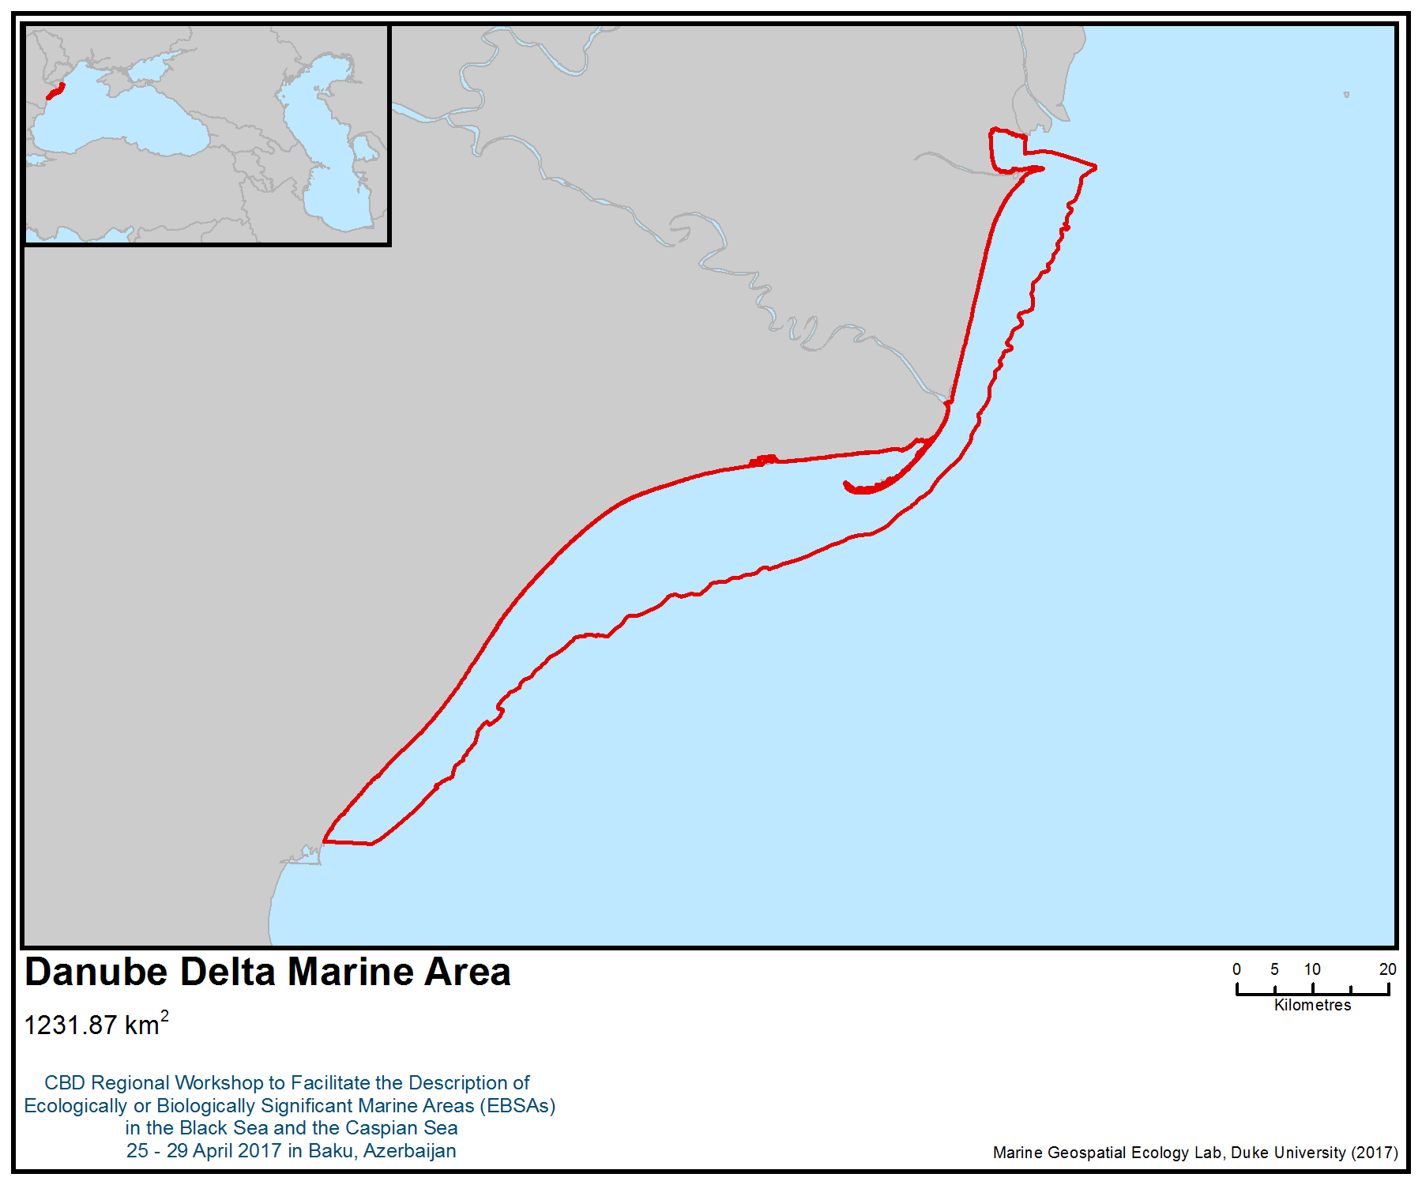

Figure 1. Area meeting the EBSA criteria
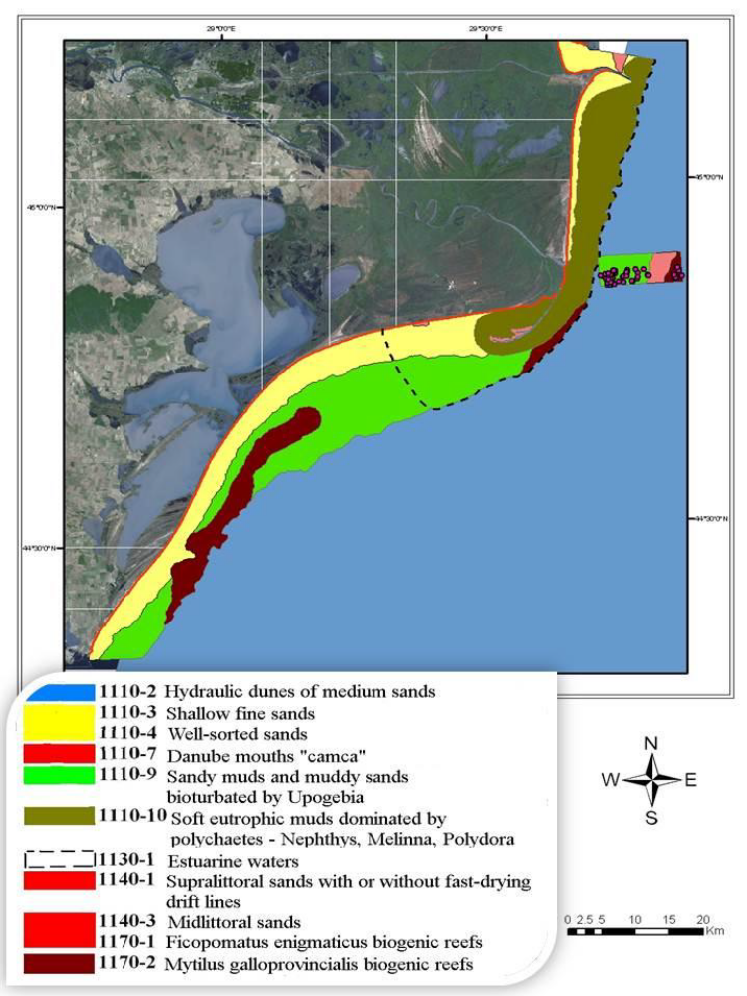

Figure 2. Distribution of Natura 2000 habitats in ROSCI0066 – Danube Delta Marine Area

Area No. 5: Zernov’s Phyllophora Field

Abstract
Zernov’s Phyllophora Field (ZPF) is located in the north-western part of the Black Sea at a depth of 25 to 50 metres. It is a unique natural phenomenon — a concentration of seaweed with a dominant species of red algae (Phyllophoraceae). ZPF is an important habitat for many species of invertebrates and fish. The main cluster of macrophytes is the paleobed of Dnieper River, located between the two branches of the Black Sea circular current. The dominant sediments are shell limestone, silted shell limestone, shelly silt. The state of the ZPF ecosystem is an indicator of the state of the whole north-western part of the Black Sea ecosystem.

Филлофорное поле Зернова представляет собой уникальное природное явление − сосредоточение водорослей-макрофитов, доминирующими видами в котором являются красные водоросли семейства/familia Phyllophoraceae. Важное местообитание для многих видов беспозвоночных и рыб. Поле Зернова расположено в северо-западной части Черного моря, основное скопление макрофитов приходится на палеоложе Днепра, так называемом желобе сноса. Состояние экосистемы Филлофорного поля является индикатором состояния экосистемы всей северо-западной части Черного моря.

Introduction
This area includes pelagic and benthic habitats. The water depth within the ZPF varies from 24 to 54 metres (fig. 2). The main cluster of macrophytes is the paleobed of the Dnieper River, where mussel-attached and unattached forms of algae are growing (fig. 3). Here is situated a globally unique accumulation of phytocoenoses of unattached phyllophores, which are distinguished by structure from all the phytocenoses of the Black Sea (Kalugina-Gutnik 1975). There are three species of Phyllophoraceae within the ZPF: Coccotylus truncates, Phyllophora crispa and endemic Phyllophora pseudoceranoides. In addition, brown Sphacelorbus nanus grows only in this area. The latter two species are listed in the Red Book of Ukraine. The stable circular current of the north-western shelf of the Black Sea contributed to the formation of Phyllophora phytocenosis (Zernov 1909, Bondarev 2008). In 1970s-80s, the habitats of Phyllophora crispa and Coccotylus truncatus dramatically decreased due to anthropogenic impacts, such as eutrophication. In the 1950s, the Phyllophora field covered an area of about 11,000 km², and the total biomass of algae was 10 million tonnes. In the 1970s, it began to decline and, by the mid-1980s, the area had been reduced to 500 km² and the biomass to 200,000 tonnes (Zaitsev, 1998) (figures 6-13). Phyllophora crispa and Coccotylus truncatus are the dominant habitat-forming species and create an ecological niche for more than 100 species of invertebrates and 40 species of fish at the same time (Bondarev 2008). ZPF is an unusual association of organisms, unique combination of the surrounding physical and geographical conditions, a reliable indicator of the state of the marine environment for the whole north-western part of the Black Sea (Berlinsky et al. 2014).

Этот район включает в себя пелагические и донные местообитания. По гидрологическим и гидробиологическим особенностям район Филлофорного поля Зернова не похож ни на какой другой гидроботанический район моря, он характеризуется пологим и ровным рельефом дна, большими глубинами (от 20 до 50 м), песчаным, илисто-песчаным и песчано-илистым ракушечником, сильными придонными течениями и своеобразным физико-химическим составом водных масс. Здесь сосредоточено уникальное для Мирового океана скопление фитоценозов неприкрепленной филлофоры, которые по своей структуре отличаются от всех фитоценозов Черного моря (Калугина-Гутник 1975). В условиях Поля произрастают з вида семейства/familia Phyllophoraceae, 1 вид/species рода/genus Coccotylus − C. truncatus и 2 species рода/genus Phyllophora − Ph. crispa и Ph. pseudoceranoides. Кроме особенностей рельефа формированию фитоценоза филлофоры способствовало устойчивое круговое циклоническое течение северо-западного шельфа Черного моря (Зернов 1909, Бондарев 2008). Phyllophora crispa и Coccotylus truncatus являются доминантами и одновременно средообразующими видами, создававшими экологическую нишу для более чем 100 видов беспозвоночных и 40 видов рыб (Бондарев 2008). Поле Зернова представляет необычную ассоциацию живых организмов, единственное в своем роде сочетание окружающих физико-географических условий, надежный индикатор состояния водной массы и морского дна. (Берлинский et al. 2014).

Location
The area is located on a wide shelf of the north-western part of the Black Sea. It has the following coordinates:

45°18'25'' N 30°42'26'' E;
45°54'42'' N 30°55'05'' E;
46°01'53'' N 31°10'40'' E;
45°З1'05'' N 31°42'56'' E;
45°17'41'' N 31°23'20'' E.

Район расположен на широком шельфе северо-западной части Черного моря в территориальных водах Украины, в ее виключній морской экономической зоне. Указом президента Украины № 1064/2008 от 21.11.2008 создан ботанический заказник общегосударственного значения «Филлофорное поле Зернова» (Указ... 2008) (карта) − природная акватория Черного моря площадью 4025 квадратных километров с координатами:
45°18'25'' северной широты та 30°42'26'' восточной долготы;
45°54'42'' северной широты та 30°55'05'' восточной долготы;
46°01'53'' северной широты та 31°10'40'' восточной долготы;
45°З1'05'' северной широты та 31°42'56'' восточной долготы;
45°17'41'' северной широты та 31°23'20'' восточной долготы.

Feature description of the area
The features of the ZPF are located at a depth of 25 to 50 m. The dominant deposits are shell limestone, silted shell limestone with carbonate content of about 70%, passing to the east in mid carbonate shelly silt (Babanets et al. 1981). Silt deposits are found in the paleodelta of the Dnieper River in the north of the district. Quartz sands are found at the high grounds of the bottom relief. ZPF has the following characteristics: average depth of 20-50 m, 17-18 ‰ salinity, summer temperature of 25 ° C, winter temperature of 4 ° C, dominated by marine species of plankton, but freshwater and brackish are also present. Most of the benthic biocenosis are Phyllophora and mussels, and deeper water is Phaseolina (Zaytsev 1992). In terms of the geochemical migration of elements, the so-called aquatic landscapes of ZPF related to the area are located in the central part of the shelf; they contain oxygen-clayey trans-accumulative landscapes on shell limestone (pelite content up to 20% and organic substances up to 1-1.5%) (Khovansky et al. 1989, Sovga et al.). The bivalves Mytilus galloprovincialis and the deeper Modiolula phaseolina are cenosis-forming species that form not only biocenoses, and also relevant environmental belt areas, landscapes and geologic facies (Bondarev 2012). The benthic zone of the cold intermediate layer (CIL) of the Black Sea is characterized not only by a specific set of shellfish, but also cold-loving representatives of phytobenthos Coccotylus truncatus (Bondarev 2012, Bondarev 2014) (boreal element of the Black Sea ecosystem (Kalugina-Gutnik 1975)). In the northern seas Coccotylus truncatus and Phyllophora pseudoceranoides are found at shallow depths (0.5-8 m), whereas in the Black Sea they are adapted to the greater depths (20-50 m), where their normal existence is facilitated by the constant year-round temperature in the range of 6-10 ° C (Kalugina-Gutnik 1975). The species complex is typical for the benthic zone of the Black Sea’s CIL, in which the leading role belongs to boreal species, which formed about 2,800 years ago (Bondarev 2012, Bondarev 2014). Phyllophora crispa is endemic to the Mediterranean basin (Kalugina-Gutnik 1975).

Ландшафты Филлофорного поля расположены на глубинах от 25 до 50 м. Среди отложений доминируют ракушечники и илистые ракушечники с карбонатностью порядке 70%, переходящие на востоке в средне карбонатные раковинные илы (Бабанец et al. 1981). Отложения ила встречаются в палеодельте Днепра на севере района. Кварцевые пески встречаются на возвышенностях рельефа дна. В соответствие со схемой эколого-географического районирования северо-западной части Черного моря (СЗЧМ) ФПЗ относится к Центральному сектору и имеет следующие характеристики: средние глубины 20-50 м, соленость 17-18‰, температура летом 25°С, зимой 4°С, в планктоне преобладают морские виды, но встречаются пресноводные и солоноватоводные. Большую часть бентали занимает биоценоз филлофоры и мидий, глубинную – биоценоз фазеолины (Зайцев 1992). По геохимической миграции элементов, так называемые аквальные ландшафты ФПЗ относятся к району расположенному в центральной части шельфа, в нем находятся кислород-глеевые ландшафты на ракушняках, в них содержание пелита до 20 %, органических веществ до 1–1,5 % (Хованский et al. 1989, Совга et al.). Двустворчатые моллюски Mytilus galloprovincialis и более глубоководная Modiolula phaseolina являются ценозообразующими видами, которые формируют не только биоценозы, но и соответствующие экологические поясные зоны, ландшафтные и геологические фации (Бондарев 2012). Для бентали холодного промежуточного cлоя (ХПС) Черного моря (ЧМ) характерен не только специфический набор моллюсков, но и холодолюбивый представитель фитобентоса Coccotylus truncatus (Бондарев 2012, Бондарев 2014), который является бореальным элементом экосистемы Черного моря (Калугина-Гутник 1975). Coccotylus truncatus и Phyllophora pseudoceranoides в северных морях обитают на малых глубинах (0,5–8 м), в Черном море они приспособились к большим глубинам (20–50 м), где их нормальное существование обеспечивается постоянной круглогодичной температурой в пределах 6–10 °С (Калугина-Гутник 1975). Характерный для бентали ХПС ЧМ комплекс видов, в котором ведущая роль принадлежит видам с бореальными корнями сформировался примерно 2800 лет назад (Бондарев 2012, Бондарев 2014). Phyllophora crispa является эндемиком Средиземноморского бассейна (Калугина-Гутник 1975).

Feature condition and future outlook of the area
The area is very sensitive to changes in environmental conditions. So, in 2012, the upper limit of Modiolula phaseolina was recorded on 42 m isobaths; clusters of the large-sized clams groups were found at depths of 44-54m. Changes were recorded in the location of the upper boundaries of Modiolula phaseolina communities of the north-western shelf of the Black Sea. It should be noted that Modiolula phaseolina was limited to a depth of 50-60 m up to 200 m until the end of the 20th century (Zaitsev et al, 2006). Coccotylus truncatus distribution in a shallow area of the ZPF in recent years is connected to the decrease in temperature of the bottom waters caused by the widespread decrease in water transparency by a factor of 4 to 10, which in turn caused a rise in the lower boundary of the photosynthesis zone (Kalugina-Gutnik et al, 1989). In recent years, there has been an increase in the area of macrophytobenthos biodiversity, mainly due to the filamentous form with high specific surface area of the thallus. This can be explained by the intake of nutrients with the river flow of the Dniester, Dnieper, and from Karkinitsky Bay, as well as elution of nutrients from the bottom sediments (Minicheva 2007, Minicheva et al., 2009).

Район очень чувствителен к изменениям условий среды. Так, в 2012 г. верхняя граница регистрации Modiolula phaseolina (= Modiolus phaseolinus) проходила по изобате 42 м, скопления моллюсков больших размерных групп находится в диапазоне глубин 44-54м. Это позволило выдвинуть предположение об изменениях верхних границ расположения биоценоза Modiolula phaseolina на шельфе северо-западной части Черного моря (Report... 2013). Необходимо отметить, что до конца 20 столетия граница распространения Modiolula phaseolina была ограничена глубинами 50-60 м и до 200м (Северо-западная... 2006). Распространение в последние годы Coccotylus truncatus в более мелководные участки Поля, связано с уменьшением температуры придонных вод, вызванного повсеместным уменьшением прозрачности воды в 4-10 раз, что в свою очередь вызвало подъем нижней границы зоны фотосинтеза (Калугина-Гутник et al. 1989). За последние годы в районе увеличилось биоразнообразие макрофитобентоса, в основном за счет нитчатых форм с большой удельной поверхностью слоевища. Это можно объяснить поступлением биогенных элементов с речным стоком Днестра, Днепра, из Каркинитского залива (Report... 2013), а также вымыванием биогенов из донных отложений (Миничева 2007, Миничева et al. 2009).

Assessment of the area against CBD EBSA Criteria

CBD EBSA Criteria  (Annex I to decision IX/20) | Description  (Annex I to decision IX/20) | Ranking of criterion relevance  (please mark one column with an X)
CBD EBSA Criteria  (Annex I to decision IX/20) | Description  (Annex I to decision IX/20) | No information |  | Low |  |  | Medium |  | High
Uniqueness or rarity | Area contains either (i) unique (“the only one of its kind”), rare (occurs only in few locations) or endemic species, populations or communities, and/or (ii) unique, rare or distinct, habitats or ecosystems; and/or (iii) unique or unusual geomorphological or oceanographic features. |  |  |  |  |  |  |  | X
Explanation for ranking
There are two endemic species growing in the area: red algae Phyllophora pseudoceranoides and brown Sphacelorbus nanus (Red Data Book of Ukraine. Plants. 2009). The accumulation of algae Coccotylus and Phyllophora makes this a unique habitat of the Black Sea north-western shelf.

В районе произрастают два эндемика красная водоросль Phyllophora pseudoceranoides и бурая Sphacelorbus nanus (Червона... 2009). Скопление водорослей родов Coccotylus и Phyllophora является единственным в своем роде местообитанием на шельфе СЗЧМ.
Special importance for life-history stages of species | Areas that are required for a population to survive and thrive. |  |  |  |  |  |  |  | X
Explanation for ranking
The area is required for populations of Phyllophoraceae, Mytilidae and many species of macrophytes, invertebrates and fish to survive and thrive. Phyllophora crispa and Coccotylus truncatus are the dominant habitat-forming species and create an ecological niche for more than 100 species of invertebrates and 40 species of fish at the same time (Bondarev 2008).

Sergey Zernov, who conducted research on board the trawler “Fedia”, reported that its fishing logbook indicated that the amount of phyllophora raised at two stations was, respectively, two and three tonnes. Phyllophores are so numerous here that naturalists have named this part of the Black Sea the “Phyllophora Sea”, by analogy with the Sargasso Sea of the Atlantic Ocean (Zernov, 1909. – V. 14. – p. 181-191).

In the 1960s and 1970s, the ecological conditions were favourable for the development of algae, and some Phyllophora areas reached several tens and hundreds of square metres in area, and 20-40 cm high (Kalugina-Gutnik et al. 1966, pp 112-131). By the end of 1980s, due to the frequent suffocation phenomena observed in the north-western part of the Black Sea, the die-away of branches and whole thallus, Phyllophora bushes became very thinned and topped with a layer of suspended matter (Kalugina-Gutnik et al. 1993).

In 2012 for the first time it was recorded that Phyllophora truncata in the area of Zernov’s Phyllophora Field propagated in two ways: asexually (attached form) and vegetatively. Today there is the beginning of the transition to true Phyllophora truncata vegetative propagation, probably due to reduction or complete absence of the appropriate substrate. Vegetative propagation is the safest option for this species, given contemporary conditions (Tretiak 2014).

In the first decade of the present century, following the de-eutrophication of the Black Sea basin, the restoration processes in phytobenthos of Zernov’s Phyllophora Field has begun (Minicheva 2009). The tendency of the increase in the total density of macrozoobenthos from 463 (1954-1960) and 2060 (1984-2003) to 2,417 specimens per m² (2010-2013) was noted with a decrease in its biomass from 458.3 and 632.7 up to 283.4 g per m². The latter is mainly due to the dynamics of the dominant species in the benthos of the Zernov’s Phyllophora Field, Mythilis galloprovincialis, whose biomass in the corresponding years of comparison varied from 409 and 591.3 to 205.5 gm² (Revkov 2016).

Район, необходимый для выживания и успешного обитания популяций видов семейства Phyllophoraceae, семейства Mytilidae и многих видов макрофитов, беспозвоночных и рыб.
Phyllophora crispa и Coccotylus truncatus являются доминантами и одновременно средообразующими видами, создававшими экологическую нишу для более чем 100 видов беспозвоночных и 40 видов рыб (Бондарев 2008).
В рыболовном журнале “Феди” на двух станциях количество поднятой филлофоры определено было в 2 и 3 тонны. Филлофоры здесь так много, что мне кажется было бы вполне уместным с точки зрения натуралистов присвоить этой части Черного моря названия “Филлофорное море” по аналогии с Саргассовым морем Атлантического океана [Зернов С.А. 1909. – Т. 14. – С. 181-191.].

В 60-70-е годы 20 столетия, когда экологическая обстановка была благоприятной для развития водорослей, отдельные участки филлофоры достигали нескольких десятков и сотен квадратных метров, высота пласта составляла 20-40 см [Калугина-Гутник А.А. Лачко О.А. 1966. - С.112-131]. К концу 80-х годов из-за частых заморных явлений, наблюдающихся в северо-западной части Черного моря, отмирание ветвей и целых слоевищ, заросли филлофоры стали очень изреженными и сверху покрытыми слоем взвеси [А.А.Калугина-Гутник, И.К Евстигнеева. 1993. - Вып.44. - С. 54-70].

У 2012 р. вперше зареєстровано, що Ph. truncata в районі ФПЗ розмножується двома способами: безстатевим (прикріплена форма) й вегетативним. На сьогодні спостерігається початок процесу переходу C. truncatus до справжнього вегетативного розмноження, мабудь у зв'язку із зменшенням або повною відсутністю відповідного субстрату. Справжнє вегетативне розмноження цього виду найбільш екологічно безпомилкове до існування в умовах ФПЗ в сучасний період [Трет'як І.П. 2014.].
В первом десятилетии нынешнего столетия, после начала де-эвтрофикации бассейна Чѐрного моря, зарегистрированы восстановительные процессы в фитобентосе ФПЗ [Миничева 2009].

Отмечена тенденция возрастания общей плотности макрозообентоса с 463 (1954–1960 гг ) и 2060 (1984–2003 гг) до 2417 экз.∙м-2 (2010–2013 гг.), при снижении в эти же периоды его биомассы с 458.3 и 632.7 до 283.4 г∙м⁻². Последнее, в большей степени обусловлено динамикой доминирующего вида в бентосе ФПЗ – M. galloprovincialis, биомасса которой в соответствующие годы сравнения изменялась с 409 и 591.3 до 205.5 г∙м⁻².[Ревков Н.К. 2016.]
Importance for threatened, endangered or declining species and/or habitats | Area containing habitat for the survival and recovery of endangered, threatened, declining species or area with significant assemblages of such species. |  |  |  |  |  |  |  | X
Explanation for ranking
The area contains habitat for the survival and recovery of endangered, threatened and declining species, such as: Sphacelorbus nanus (Ochrophyta) (Vulnerable), Ectocarpus siliculosus (Ochrophyta) (Vulnerable), Phyllophora pseudoceranoides (Rhodophyta) (Critically Endangered) (Red Data Book of Ukraine. Plants. 2009). Coccotylus truncatus (Rhodophyta) (=Phyllophora brodiaei) («Vulnerable»), Phyllophora pseudoceranoides (Rhodophyta) (Critically Endangered), Phyllophora crispa (Rhodophyta) (Phyllophora nervosa) (Vulnerable), Dіogenes pugіlator (Decapoda) (Endangered) (Dumont, 1999).

Район содержит место обитания для выживания или восстановления находящихся под угрозой исчезновения, угрожаемых или исчезающих видов: Sphacelorbus nanus (Ochrophyta) (=Sphacelaria nana) («вразливий»), Ectocarpus siliculosus (Ochrophyta) («вразливий»), Phyllophora pseudoceranoides (Rhodophyta) («зникаючий») (Червона... 2009). Coccotylus truncatus (Rhodophyta) (=Phyllophora brodiaei) («Vulnerable»), Phyllophora pseudoceranoides (Rhodophyta) («Critically Endangered»), Phyllophora crispa (Rhodophyta) (Phyllophora nervosa) («Vulnerable»), Dіogenes pugіlator (Decapoda) («Endangered») (Dumont, 1999) и другие.

Vulnerability, fragility, sensitivity, or slow recovery | Areas that contain a relatively high proportion of sensitive habitats, biotopes or species that are functionally fragile (highly susceptible to degradation or depletion by human activity or by natural events) or with slow recovery. |  |  |  |  |  |  |  | X
Explanation for ranking
Coccotylus and Phyllophora have minimum values of the specific surface area ratios S/Wp, m2∙kg-1, and are therefore the most vulnerable to eutrophication (Minicheva et al. 2009) and are characterized by a slow recovery rate.

Из всех черноморских макрофитов виды родов Coccotylus и Phyllophora имеют минимальные значения коэффициентов удельной поверхности S/Wp, m²∙kg⁻¹, поэтому наиболее уязвимы при эвтрофировании (Миничева et al. 2009) и отличаются медленными темпами восстановления.
Biological productivity | Area containing species, populations or communities with comparatively higher natural biological productivity. |  |  |  |  |  |  |  | X
Explanation for ranking
Favourable conditions for the mass development of highly productive filamentous macrophytes Ochrophyta: Sphacelaria saxatilis, Ectocarpus siliculosus, Feldmannia irregularis and Rhodophyta: Spermothamnion strictum, Callithamnion corymbosum, Antithamnion cruciatum (Tkachenko et al. 2015).

В современных условиях Поля создались благоприятные условия для массового развития высокопродуктивных видов нитчатых макрофитов представителей отделов/Division Ochrophyta: Sphacelaria saxatilis, Ectocarpus siliculosus, Feldmannia irregularis и Rhodophyta: Spermothamnion st rictum, Callithamnion corymbosum, Antithamnion cruciatum (Ткаченко 2015, неопубликованные данные 2016 года).
Biological diversity | Area contains comparatively higher diversity of ecosystems, habitats, communities, or species, or has higher genetic diversity. |  |  |  |  |  |  |  | X
Explanation for ranking
According to the results of benthic surveys conducted in ZPF in 2010, 2011 and 2013 on board the ship”Professor Vodyanitsky” more than 162 species of benthic macrofauna were found (Revkov N. K., 2016). During expeditions in 2012 and 2016 in the waters of ZPF, 30 species of macrophytes were found (Tkachenko et al. 2015).

По результатам бентосных съемок 2010, 2011 и 2013 гг. в акватории ФПЗ в 68, 70 и 72 рейсах НИС «Профессор Водяницкий» в бентосе ФПЗ обнаружено более 162 видов донной макрофауны (Ревков et al. 2016). По результатам экспедиций 2012, 2016 годов в акватории ФПЗ в фитобентосе обнаружено 30 видов макрофитов (Ткаченко 2015, неопубликованные данные 2016 года).
Naturalness | Area with a comparatively higher degree of naturalness as a result of the lack of or low level of human-induced disturbance or degradation. |  |  |  |  | X
Explanation for ranking
The level of human impact was very high to the end of the last century. For 50 years bottom trawling of Phyllophora (Kitrana trawls) was conducted in the area for agar production.

Уровень антропогенных нарушений до конца прошлого века был очень высоким – на протяжении 50 лет в районе проводилась промышленная добыча филлофоры тралами Китрана (донное траление).

References

Babanets A.A., Emelyanov V.A., Mitropolsky A.Yu., et al. Physical and chemical properties of benthic sediments of the Black Sea. Kiev: Naukova Dumka, 1981. − 204 p. (In Russian)
Berlinsky N.A., Denga Yu.M., Matveev A.V., Podust O.S., Popov Yu.I., Tretyak I.P. Influence of variation of conditions of marine environment on dynamics of Zernov’s Phyllophora Field / Visnyk ONU. Ser. Geogr. and Geol. Sci. 2014. - 19, 2. - P. 40-57. (In Russian)
Bondarev I. P. Problems of instability of underwater seascape (on the example of the northern Black Sea) / Uchene Zapiski TNU. - Ser. Geogr. - 21, 2. - 2008. - P. 128-133 (In Russian)
Bondarev I. P. General features and stages of forming of the Black Sea ecosystem in the Late Pleistocene-Holocene / Geology and fossils of the World Ocean, 2012, 2. - P. 53-71 (In Russian)
Bondarev I. P. Biological basics of facial structuring of the Black Sea shelf / Geology and fossils of the World Ocean. - № 4. - 2014. - P. 72-90 (In Russian).
Dumont, H.J. (Ed.). 1999. Black Sea Red Data Book (Text) /. – New York: United Nations Office for Project Services (UNOPS), 413 pp.
Kalugina-Gutnik A.A., Lachko O.A. Composition, distribution and stock of the Black Sea’s seaweeds in the region of Zernov’s Phyllophora Field. Benthos distribution and biology of benthic animal in south seas. – Kiev: Naukova Dumka, 1966.-P.112-130. (in Russian)
Kalugina-Gutnik AA. Phytobenthos of the Black Sea. Kiev: Naukova Dumka; 1975. 247 pp (in Russian).
Kalugina-Gutnik AA, Evstigneeva IK. Perennial dynamics of species composition and structure of seabed phytocenoses of Zernov’s Phyllophora Field. Ecology of Seas 1993: 43:90-7 (In Russian).
Khovansky AD, Chernousiv SYa. Geochemistry of landscapes of the north-western Black Sea // Geokhimia.– 1989.– 12.– P.1727-1735.
Minicheva GG. Phytocenoses of Zernov’s Phyllophora Field as indicators of the current ecological state for Northwest shelf of the Black Sea. In: Proceedings of international applied science conference on ecological problems of the Black sea; 2007. p. 229-233 (in Russian)
Minicheva GG., Kosenko MN, Shvets AV Phytobenthos of the Big and Small Phyllophora fields as a reflection of modern ecological state of the north-western Black Sea. Morskoy Ekologicheskiy Zhurnal, №4, Т.VIII – 2009. – P. 24-40.
Red Data Book of Ukraine. Plants. – Kiev: Globalkonsalting. – 2009. – 900 p.
Revkov N. K. Species richness and quantitative development of macrozoobenthos on Zernov’s phyllophora Field/ MARINE BIOLOGICAL RESEARCH: ACHIEVEMENTS AND PERSPECTIVES All-Russian Scientific-Practical Conference with International Participation dedicated to the 145th anniversary of Sevastopol Biological Station Sevastopol, 19–24 September, 2016, v.2 p. 501.
Sovga EE, Zhorov VA, Boguslavsky SG, Siden VP. Classification of sea area in the north-western Black Sea in mathematical modelling of shelf ecosystems // Ecological safety of shelf and coastal zones and complex use of shelf resources . – 2005. –. 12. – P. 421-428.
Tkachenko FP, Tretyak IP Macrophytobenthos of a botanical preserve of state-wide importance “Zernov’s Phyllophora Field” (Ukraine) // Algologia. – 2015. –25, 3. – P. 238-246.
Tretiak I.P. Saving rare macrophytes of the north-western Black Sea / Flora in the Red Book of Ukraine: implementation of the Global Strategy for Plant Conservation / Proceedings of the III International Conference (4-7 June 2014, m. Lviv). - Lviv, 2014. - P. 161-164.
Ukraine, 2012. Report on Monitoring and Assessment/. Reg. ID 0113U007210 – 2013. – 68 с.
Zaitsev Yu, Alexandrov B, Minicheva G, editors. 2006. Northwest part of the Black Sea: biology and ecology. Kiev: Naukova Dumka, p. 701 (In Russian).
Yuschenko VA. Presidential order #1064/2008. On declaring an area of natural waters of the Black Sea a botanical preserve of state-wide importance “Zernov’s Phyllophora Field”; 21 November 2008.
Zaitsev YuP. Ecological state of the Black Sea shelf zone along the coast of Ukraine (review). Hydrobiological Journal 1992;28(4): 3-18 (In Russian)
Zaitsev YuP. The Most Blue in the World. Copyright © 1998 by United Nations Development Programme, 1 United Nations Plaza, New York, NY
Zernov S. A. Facies of Phyllophora (Algae-Rhodophyceae), a phyllophore filed in the north-western part of the Black Sea. A zoological cruise on a steam ship Fedya 11-14 April 1909 / Bull Zool Mus Acad Sci – St. Petersburg. - Typogr Imp Acad Sci. - 1909. –14. – pp. 181-191.

Бабанец А.Е. Физико-механические свойства донных осадков Черного моря / А.Е. Бабанец, В.А. Емельянов, А.Ю. Митропольский и др. - Киев : Наукова думка, 1981. − 204 с.
Берлинский Н.А., Деньга Ю.М., Матвеев А.В., Подуст О.С., Попов Ю.И., Третьяк И.П. Влияние изменчивости условий морской среды на динамику Филлофорного поля Зернова / Вісник ОНУ. Сер.: Географічні та геологічні науки. 2014. Т. 19, вип. 2. - С. 40-57.
Бондарев И.П. Проблемы нестабильности подводного ландшафта (на примере северной части Черного моря) / Ученые записки Таврического Национального университета им. В. И. Вернадского. - Серия География. - Том 21, № 2. - 2008. - С. 128-133
Бондарев И.П. Основные черты и этапы формирования экосистемы Черного моря в позднем плейстоцене-голоцене / Геология и полезные ископаемые Мирового океана, 2012, №2. - С. 53-71
Бондарев И.П. Биологические основы фациального структурирования шельфа Черного моря / Геология и полезные ископаемые Мирового океана. - № 4. - 2014. - С. 72-90
Зайцев Ю.П. Экологическое состояние шельфовой зоны Черного моря у побережья Украины // Гидробиологический журнал.– 1992.– 4.– С.3-18.
Report on Monitoring and Assessment: Ukraine, 2012 / Звіт про науково-дослідну роботу «Оцінка стану Чорного моря в форматі Секретаріату Чорноморської Комісіїї». № держреєстрації 0113U007210 – 2013. – 68 с.
Зернов С.А. Фація филлофоры [Algae-Rhodophyceae] - филлофорное поле въ С.-З. части Чернаго моря. Зоологическая экскурсія на пароходѣ”θедя”11-14 апрѣля 1909 г. / Бюл. зоол. музея АН. - С.-Петербургъ. - Типографія Императорской академіи наук. - 1909. – Т. 14. – С. 181-191.
Калугина-Гутник А.В. Фитобентос Черного моря.– Киев: Наукова думка, 1975. - 247 с.
Калугина-Гутник А.А., Евстигнеева И.К. Структура ценопопуляции Phyllophora brodiaei на Филлофорном поле Зернова в июле-августе 1989 г. Экология моря, 1993, вып. 44. с. 57-63.
Калугина-Гутник А.А. Лачко О.А. Состав, распределение и запасы водорослей Черного моря в районе Филлофорного поля // Распределение бентоса и биология донных животных в южных морях. - Киев : Наукова думка. - 1966. - С.112-131
Миничева Г.Г. Фитоценозы Филлофорного поля Зернова, как индикаторы современного экологического состояния северо-западного шельфа Черного моря / Збірник наукових статей до Міжнародної науково-практичної конференції “Екологічні проблеми Чорного моря” (ЗІ травня - 1 червня, 2007, Одеса): З-б наук.ст./відп. ред. В.М. Небрат - Одеса:[нновашйно-інформаційний центр «ІНВАЦ», 2007 р.- C. 229-233;
Миничева Г.Г., Косенко М.Н., Швец А.В.. Фитобентос Большого и Малого филлофорных полей как отражение современного экологического состояния северо-западной части Черного моря. Морський екологічний журнал, №4, Т.VIII – 2009. – С. 24-40.
Ревков Н.К. Видовое богатство и количественное развитие макрозообентоса Филлофорного поля Зернова /, Н. А. Болтачева, И. П. Бондарев, В. А. Тимофеев, Л. В. Бондаренко. Морские биологические исследования: достижения и перспективы :в 3-х т. : сборник материалов Всероссийской научно-практической конференции с международным участием, приуроченной к 145-летию Севастопольской биологической станции (Севастополь, 19–24 сентября 2016 г.) / под общ. ред. А.В. Гаевской. – Севастополь : ЭКОСИ-Гидрофизика, 2016. – Т. 2. – 501 с.
Северо-западная часть Черного моря: биология и экология / Под ред. Ю. П. Зайцева, Б. Г. Александрова, Г.Г. Миничевой. – К, “Наукова думка”, 2006.-701с.
Совга Е. Е. Районирование акватории северо-западной части Черного моря при математическом моделировании шельфовых экосистем / Е. Е. Совга, В. А. Жоров, С. Г. Богуславский, В. П. Сидень // Екол. безпека прибереж. та шельфової зон та комплекс. використ. ресурсів шельфу. – 2005. – Вип. 12. – С. 421-428.
Ткаченко Ф. П. Макрофитобентос ботаническогo заказника общегосударственного значения «Филлофорное поле Зернова» (Украина) / Ф. П. Ткаченко, И. П. Третьяк // Альгология. – 2015. – Т. 25, № 3. – С. 238-246. – Режим доступу: http://nbuv.gov.ua/UJRN/algol_2015_25_3_4
Трет'як І.П. Збереження рідкісних видів макрофітів північно-західної частини Чорного моря / Рослинний світ у Червоній книзі України: впровадження Глобальної стратегії збереження рослин / Матеріали III Міжнародної наукової конференції (4-7 червня 2014 р., м. Львів). – Львів, 2014. – С. 161-164
Указ Президента України № 1064/2008 от 21.11.2008 http://www.president.gov.ua/documents/10642008-8223
Хованский А.Д., Черноусов С.Я. Геохимия ландшафтов северо-западной части Черного моря // Геохимия.– 1989.– 12.– С.1727-1735.
Червона книга України. Рослинний світ – Київ : Глобалконсалтинг. – 2009. – 900 с.

Maps and Figures
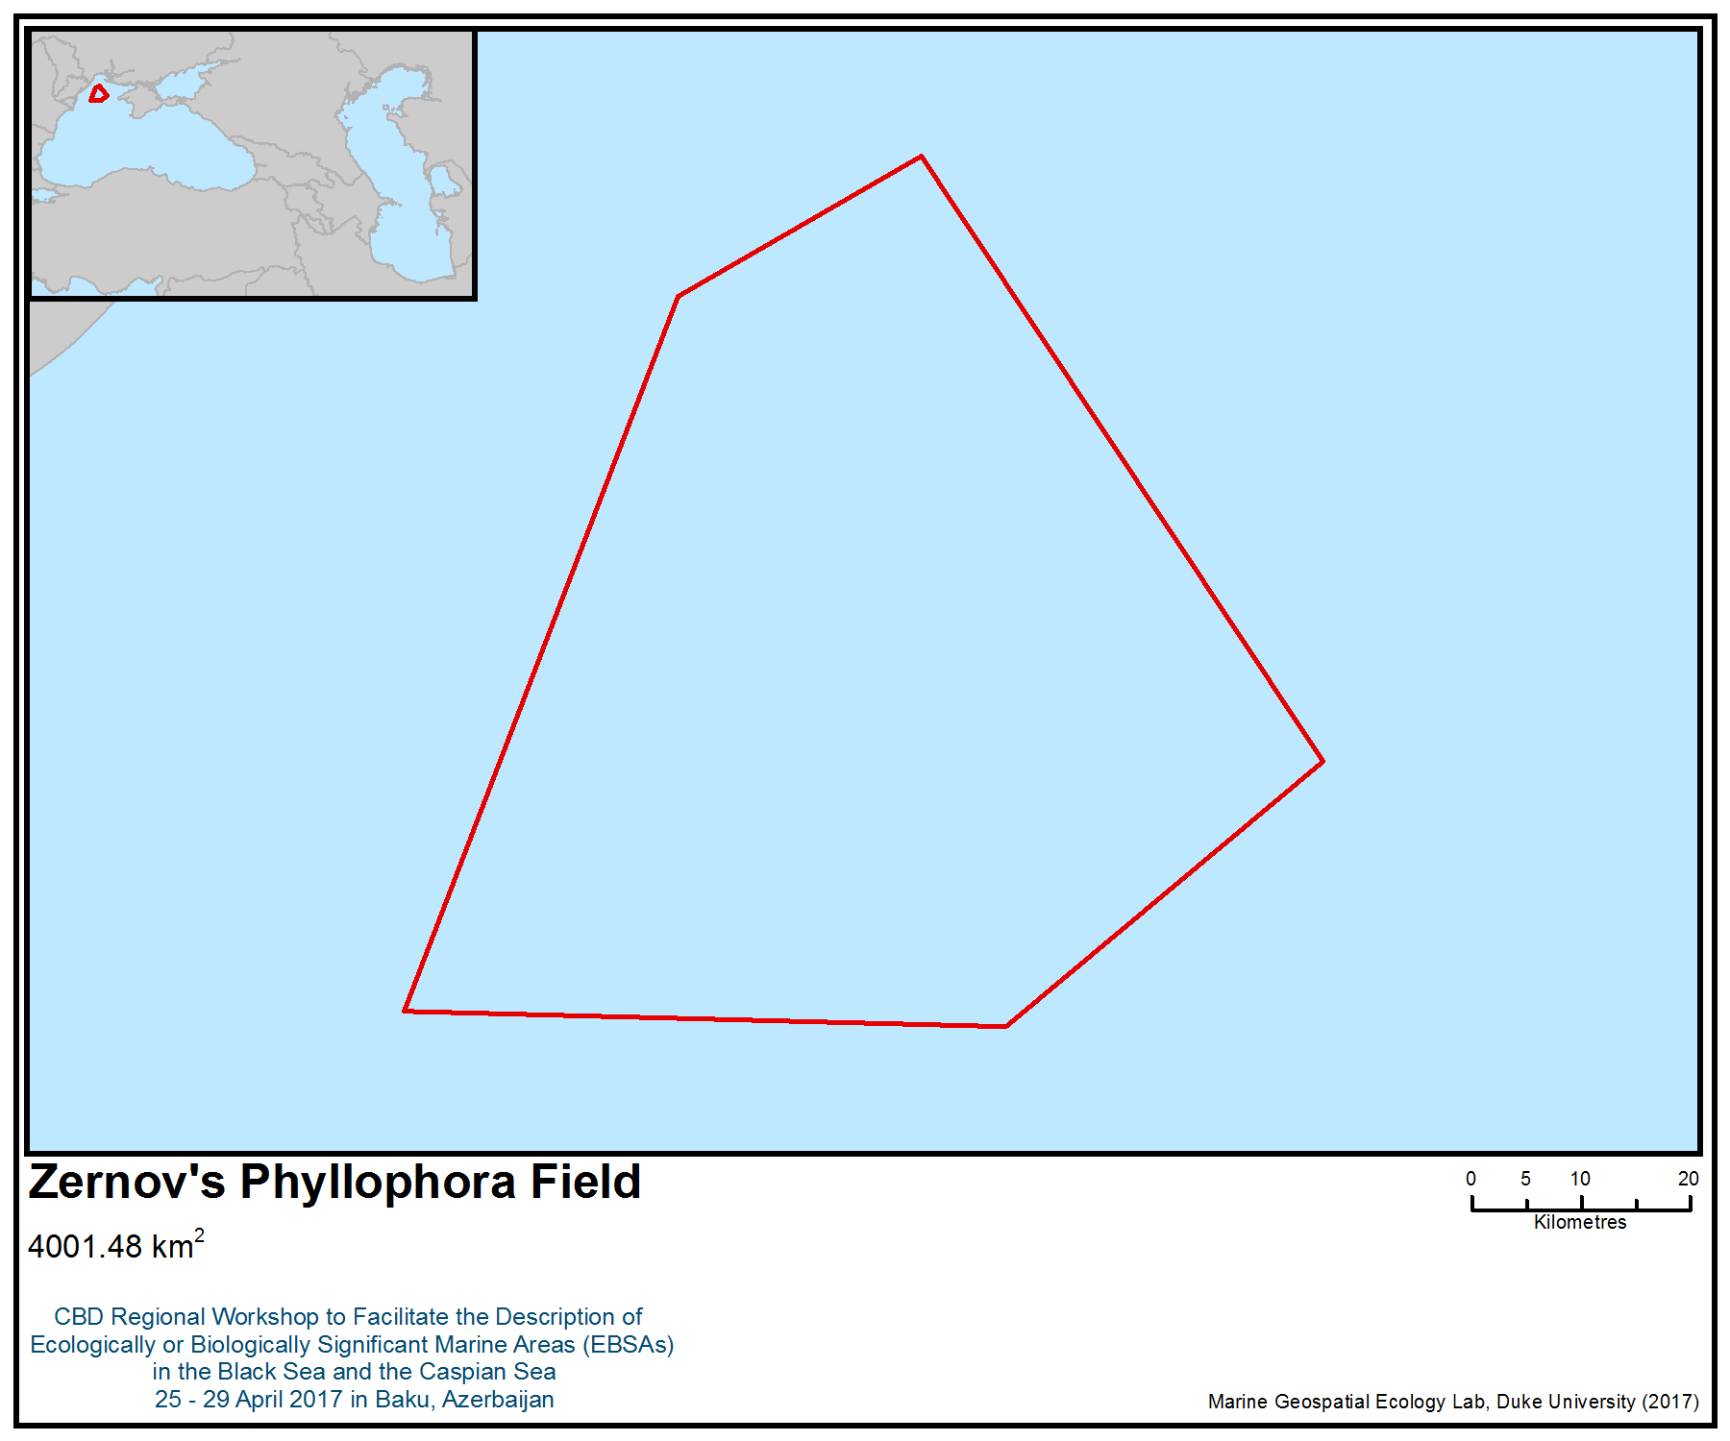
Figure 1. Area meeting the EBSA criteria

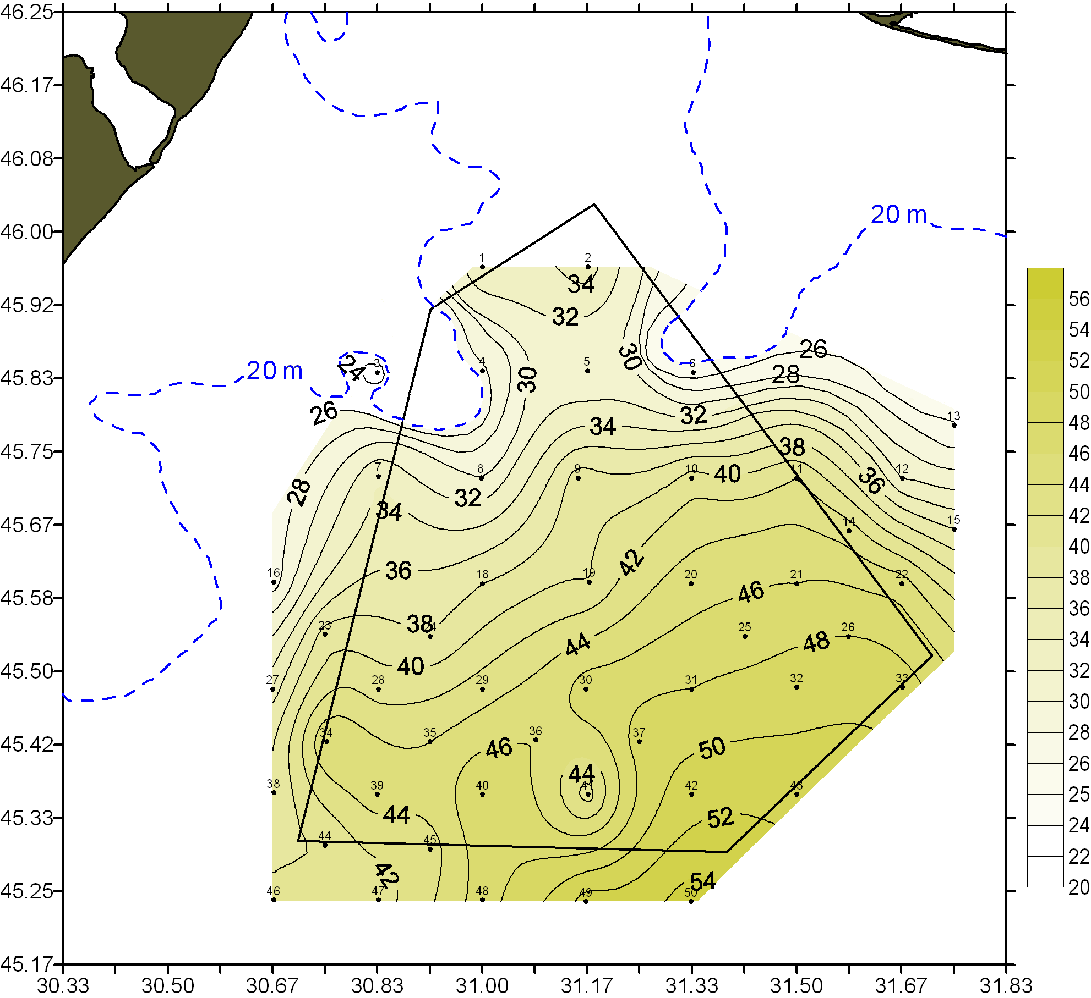

Figure 2. Bathymetric scheme of Zernov’s Phyllophora Field

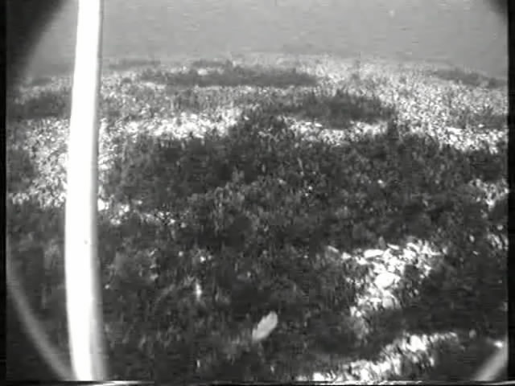

Figure 3. Zernov’s Phyllophora Field (sea floor)

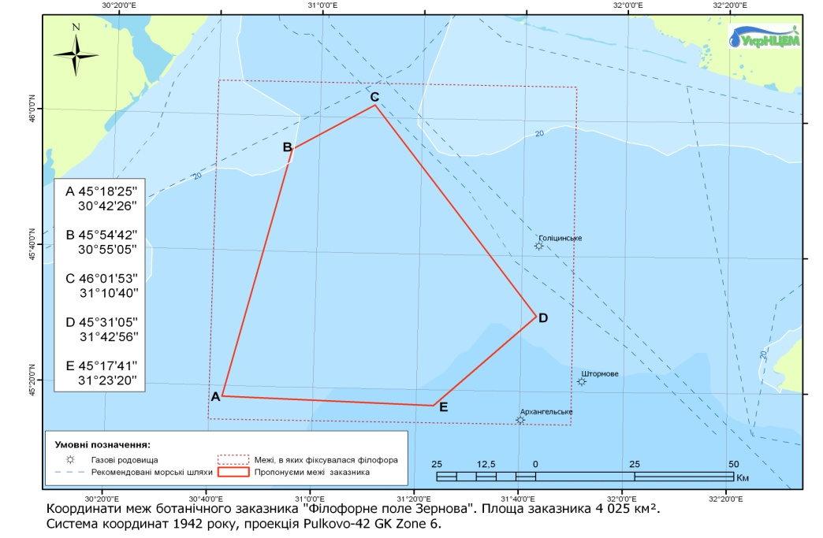
Figure 4. “Zernov’s Phyllophora Field” MPA boundaries
http://ims.sea.gov.ua:8081/MPA/

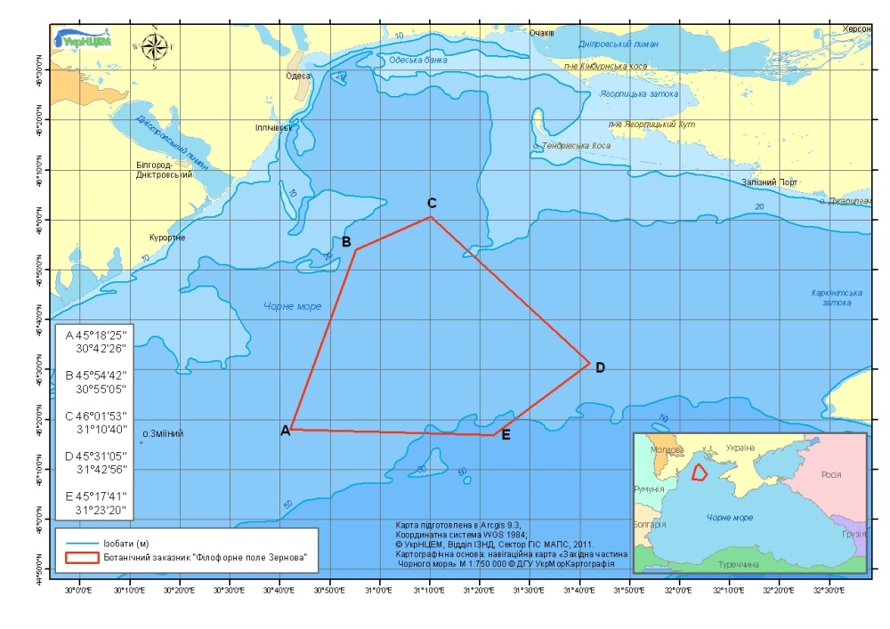
Figure 5. Location of Zernov’s Phyllophora Field (http://ims.sea.gov.ua:8081/MPA/)

Historical trends of the phytobenthos parameters and boundary changes of the Zernov’s Phyllophora Field were provided by digitizing of the data received from OB IBSS - Odessa Branch Institute Biology of Southern Seas of National Academy of Sciences of Ukraine, complied by Coordinator from OBIBSS: Prof. Galina Minicheva. The digitizing work was performed by SR Geo-information Analysis Department UkrSCES O. Bratchenko and O. Neprokin within the framework of CoCoNet Project. This work was carried out using ESRI ArcGIS 10 software. As a result, 5 polygonal layers were created and attribute tables for each layer were prepared.

Maps were created in GIA Department, ©UkrSCES 2013.
Base map: Electronic Nautical Chart of the Black Sea in the scale 1:750 000. ©Ukrmorkartographia.
Complied by Coordinator from OBIBSS: Prof. Galina Minicheva

Table 1. List of distribution maps of the Phyllophora community in the north-western shelf of the Black Sea

Year | Title of map | № fig. | Reference
1951,  1952 | Distribution the Ph. nervosa, Ph. brodiaei and Ph. membranifolia in the north-western part of the Black Sea. | Fig. 6 | Schapova T.F. Phyllophora of the Black Sea / Proceedings of Institute of Oceanology. Publishing house: Academy of Sciences of USSR. - Moscow, 1954. - V. XI. – P. 3-35. (in Russian)
1964 | Distribution species and forms of Phyllophora on the Zernov’s Phyllophora Field.  The phyllophora area covering of bottom.  Distribution of phyllophora stocks (all species and forms) on the Zernov’s Phillophora Field. | Fig. 7  Fig. 8  Fig. 9 | Kalugina A.A., Lachko O.A. Composition, distribution and stock of the Black Sea’s seaweeds in the region of Zernov’s Phyllophora Field. Benthos distribution and biology of benthic animal in south seas. – Kiev: Naukova Dumka, 1966.-P.112-130. (in Russian)
1975 | Distribution stock, of the Phyllophora brodiaei in the area of Zernov’s Phyllophora Field.  Distribution stock, of Phyllophora nervosa in the area of the Zernov’s Phyllophora Field. | Fig. 10  Fig. 11 | Kalugina-Gutnik A.A. Phytobentos of the Black Sea. -Kiev: Naukova Dumka, 1975. – 247 p.(in Russian)
1977  1978 | Boundary of Zernov,s Phyllophora Field and distribution of total biomass (g/m2) of the Phyllophora nervosa and Phyllophora brodiaei in the north-western part of the Black Sea.  Distribution of ecological form of Phyllophora brodiaei in the north-western part of the Black Sea | Fig. 12  Fig. 13 | Kaminer K.M. Phyllophora nervosa (DC) Grev. and Ph. Brodiaei (Turn.) J.Ag. of the north-western part of Black Sea // The trade seaweeds and their use. – Moscow, 1981.-P. 87-97. (in Russian)

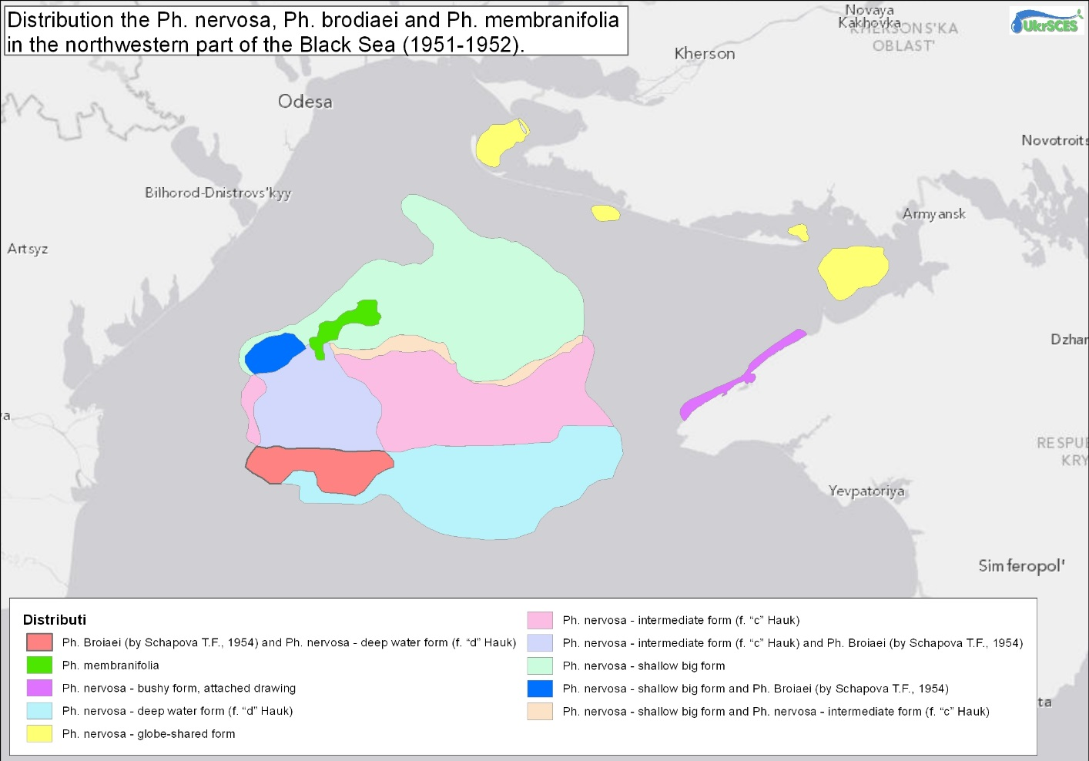Figure 6. Calculated area (ArcGIS 10): 12 285,536 km²

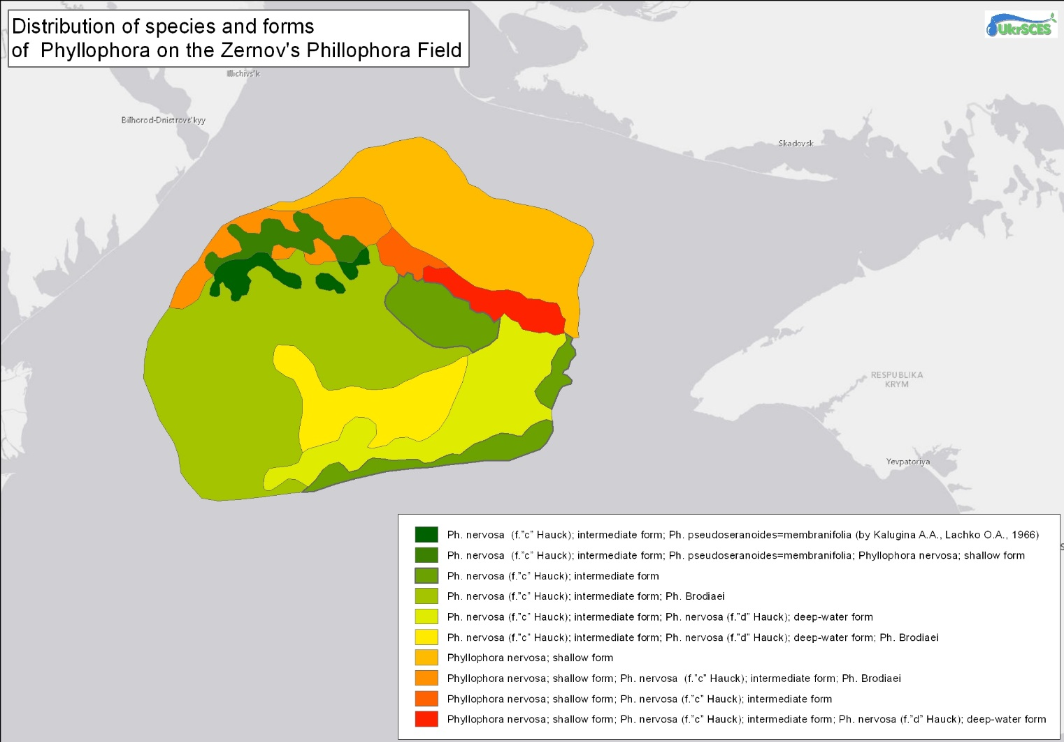Figure 7. Distribution of species and forms of Phyllophora
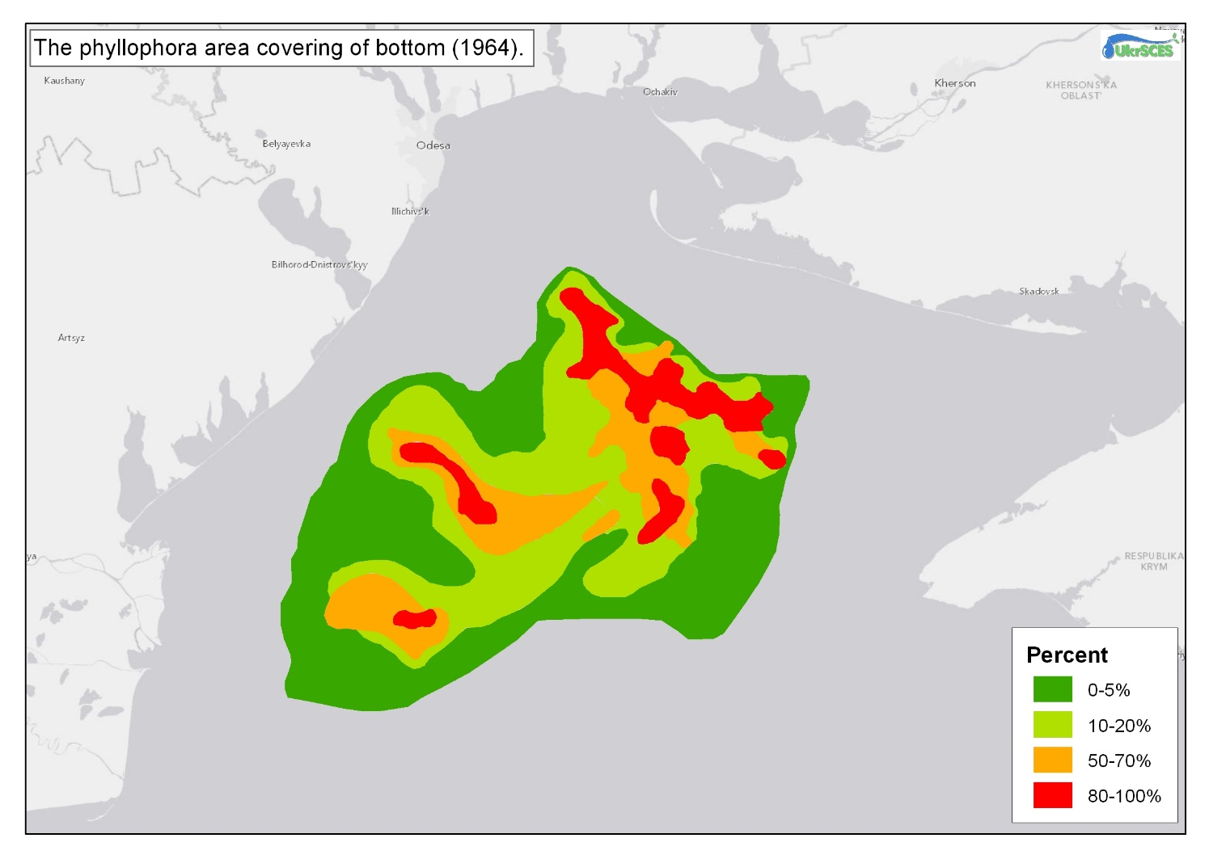 Figure 8. Calculated area (ArcGIS 10): 11,220,596 km²

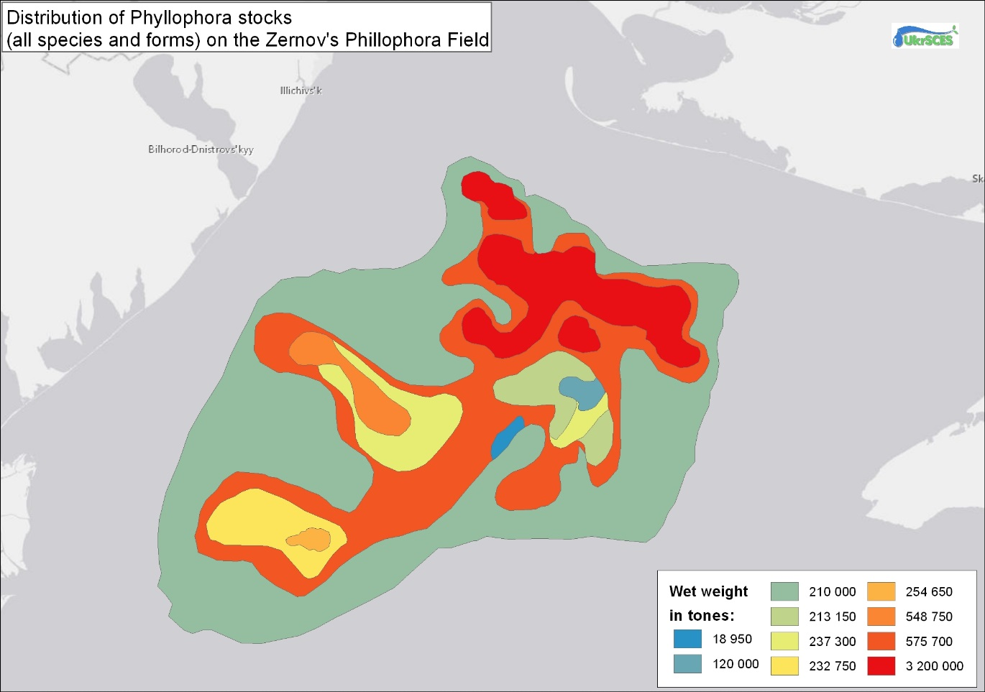 Figure 9. Calculated area (ArcGIS 10): 10,949 km² (1966)
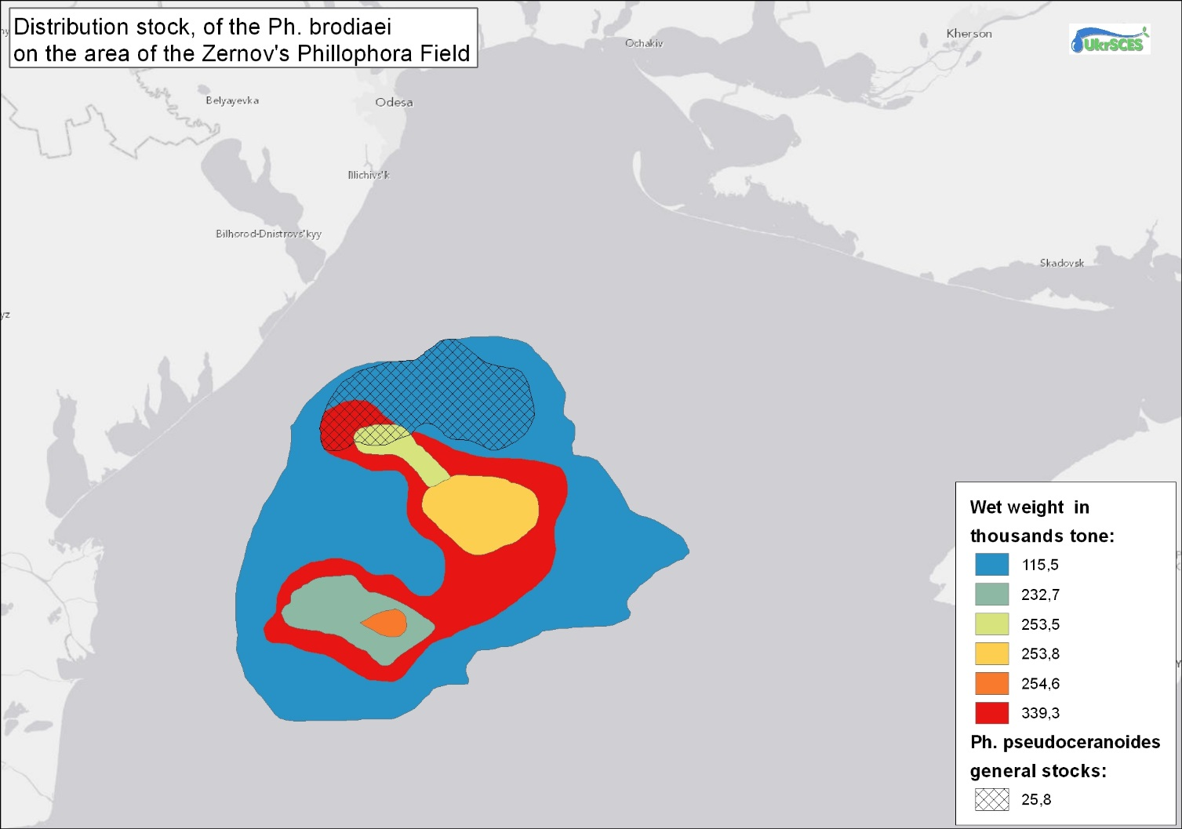Figure 10. Calculated area (ArcGIS 10): 8,366,837 km²

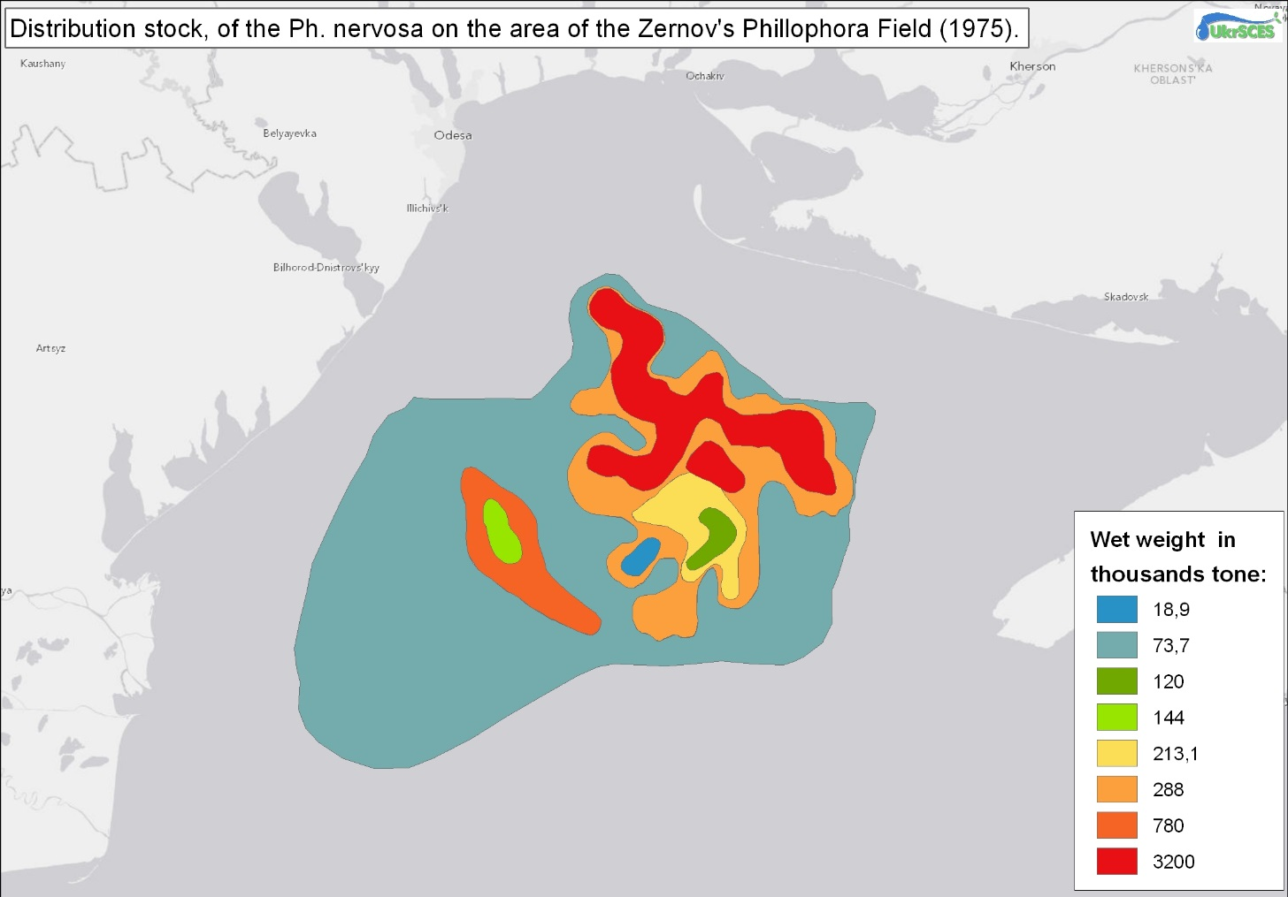Figure 11. Distribution stock of Phyllophora

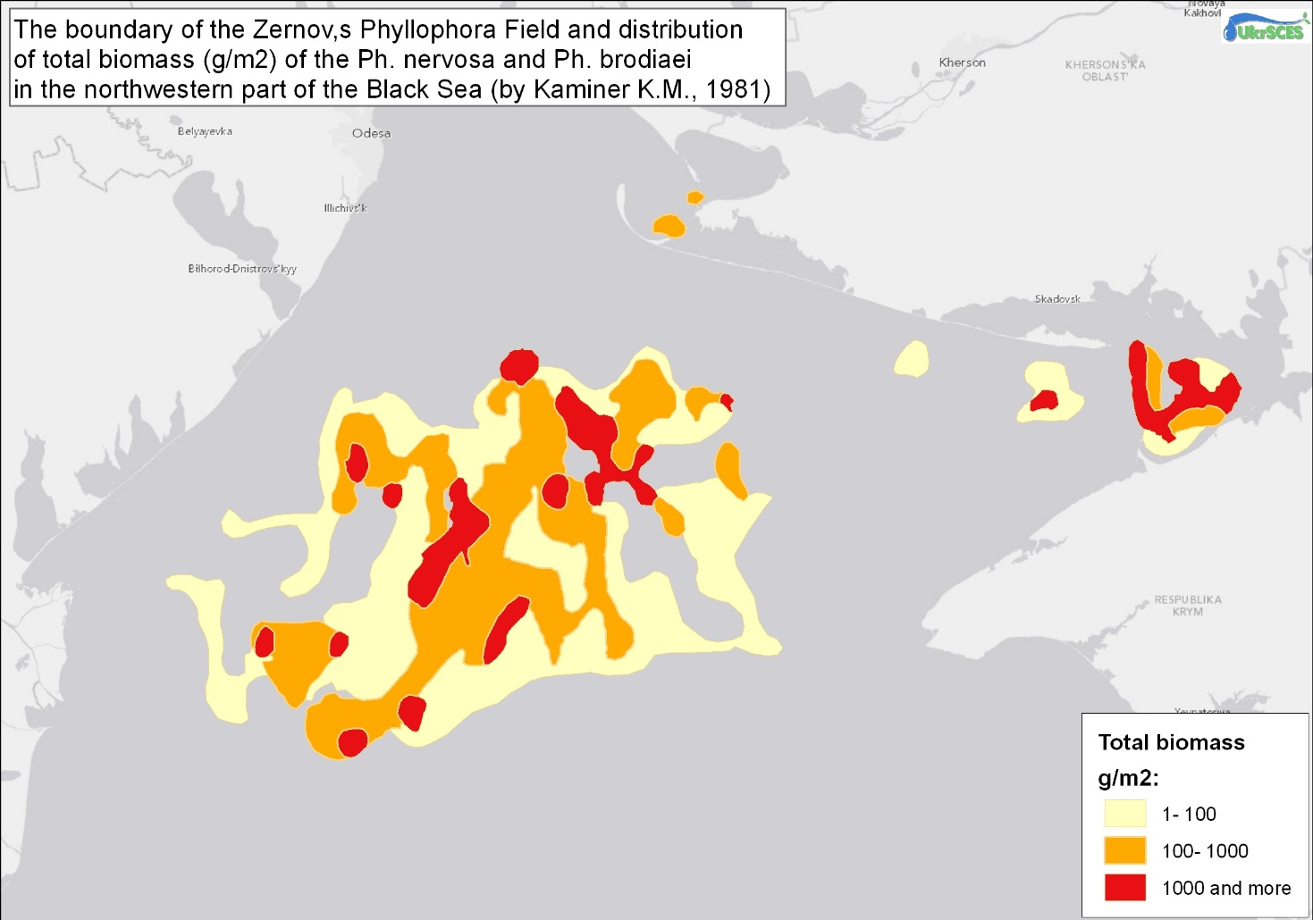Figure 12. Calculated area (ArcGIS 10): 853,785 km²

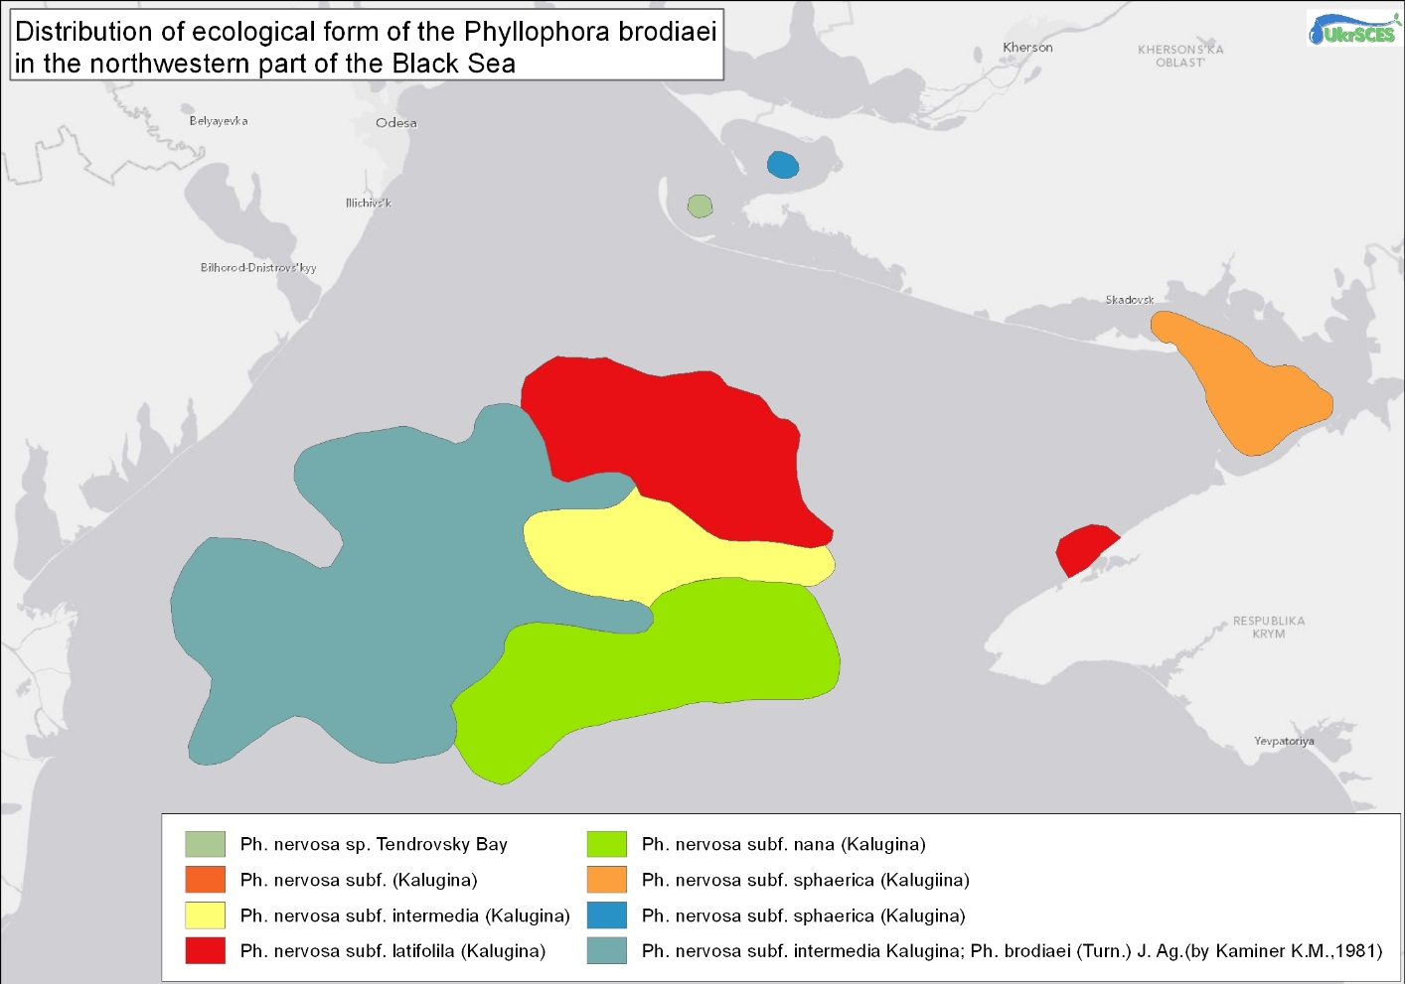Figure 13. Calculated area (ArcGIS 10): 11,166,709 km²

Area No. 6: The Small Phyllophora Field

Abstract
Phyllophora are a group of red algae that have commercial value for harvesting and extraction of agaroids. Phyllophor are also an important source of oxygen, resulting from the photosynthesis performed by the algae. In addition, Phyllophora fields in the north-western Black Sea have associated with them specialized faunal communities, including more than 110 species of invertebrates and 47 species of fish. Many species have evolved a reddish colouration specifically to camouflage themselves inside the algae. The world’s largest area of Phyllophora, Zernov’s Philophora Field (ZPF, area No. 5, above) once covered some 11,000 km² of the north-west shelf of the Black Sea and had a biomass of 7-10 million tonnes. By the early 1990s, the algal field had shrunk to 500 km² and its biomass to under 0.5 million tonnes. As a result, the Small Phyllophora Field (SPF) in Karkinitsky Bay has assumed greater importance for conservation and ecosystem management.

Introduction
The marine waters in Karkinitsky and Dzharylgachsky bays have a relatively high salinity of 18-19 ‰ (the average salinity of the open Black Sea is 17-18 ‰ at the surface and 22-24 ‰ at a depth of 2,000 m). The perimeter of Karkinitsky Bay is more than 118 km. It is divided by Bakal Spit and Bakal Bank into a western offshore part (some 80 km wide and up to 36 m deep) with relatively straight sandy shores, and an eastern inshore part (up to 11.2 m deep) with indented clayey shores. The sea bottom is composed of sand, silt and shell substrates. In summer, the water temperature is 22 – 24 º C; in winter, it lies between 0.06 – 0.7 º C, though in severe winters the water freezes over (Geographical Encyclopaedia, 1990).

Two currents flow in different directions along the shores of Karkinitsky Bay, due to which sand and silt are transported from up to a depth of 5m. Thus, the shell-sand deposits found in the bay result from the joint action of waves and underwater currents. There are a number of islands in the bay, covering about 5,700 ha; by far the largest is Dzharylgach, which is 42 km long and 5,605 ha in extent (Wetlands International, 2006). The main marine current flows north-east along the north-western coast of Crimea. At Bakal spit, it divides, one part going north, the other bending around Peschany Cape and continuing along the coast to Andreevsky Liman, Lebyazhie islands and Perekopsk Bay (Fig. 2).

Location
The Small Phyllophora Field is situated in Karkinitsky Bay, the largest bay in the Black Sea, between the north-western shore of the Crimean peninsula and the coast of Kherson oblast, where it is bounded by Dzharylgach Island and Tendrovsky Spit (Fig. 3).

A Presidential decree of August 31 2012, № 527/2012 (http://zakon0.rada.gov.ua/laws/show/527/2012) declared a botanical reserve of national importance, the “Small Phyllophora field”, measuring 385 square kilometres, with the following coordinates:

A - 45 °48'03 “N and 33 °10'06” E;
B - 45°54'29 “N and 33 °09'12” E;
C - 45°59'00 “N and 33 °06'00” E;
D - 45°59'00 “N and 33°21'00” E;
E - 45 °57'07 “N and 33°24'15” E;
F - 45 °48'33 “N and 33°23'50” E.

Feature description of the area
Physiographic description
The general landscape of Karkinitsky Bay is a low to gently undulating coastal relief, with a very gentle slope from the coast out to the open sea. The southern coast of Karkinitsky Bay is divided by many sandbars, small embayments and limans. The shallower waters hold many areas with charophytic algae, banks, sedimentary islands, spits, and fish breeding ponds. According to international habitat classifications, the wetlands of Karkinitsky Bay include: open sea shallow water; sea bays and straits; сoasts; various shorelines; small islands and spits of sedimentary origin; lakes; near-coastal freshwater biotopes.

This area is among the driest in Ukraine, with average annual total precipitation of 300-325 mm. In the driest periods, precipitation is 209 mm while in the wettest, 466 mm (exceptionally 597 mm), with the highest amount falling between December and January.

The average annual air temperature for the past four decades was 10.2ºC. The coldest months are January and February, the hottest July and August. The lowest temperature recorded at Bekhtersky station was -27ºC on 28 January 1954 and the highest 50ºC on 2 August 1986. The beginning and end of vegetation growth occurs when average daily air temperature rises above 5ºC, during the third week of March and mid-November, respectively. The average length of the plant growth period is 230 days. Karkinitsky Bay experiences intense wind activity. Although patterns change significantly from year to year, the prevailing winds are from the north-east; south-eastern winds are the least frequent (Nazarenko, Amonsky, 1986). On the average, there are 30 days per year with winds of 3m/s or so; winds of 6-12 m/s occur for 223 days per year; winds of 15-18 m/s occur 13 days per year.

Biological communities
Macrophytobenthos
Karkinitsky Bay is included on the Ramsar List of Wetlands of International Importance (see Fig. 1). There are seven biocenoses (habitats) in Karkinitsky Bay where plants are key species (edificator). One of the famous is biocenosis of red algae Phillophora crispa (=nervosa), that formed local concentrations in the eastern part of the bay. The state of this biocenosis is stable, and Karkinitsky Bay has the biggest population of this species in the Black Sea. The maximal concentration of this species is about 6 kg/m² here. The field survey of the inner part of Karkinitsky Bay in September 2008 showed that communities of benthic macrophytes covered more than 80% of the seabed (Fig. 4). The second biocenosis formed by the macrophytes is eelgrass Zostera nana and Z. marina (key species) in shallow coastal waters with soft sediments up to 1 m deep (Aleksandrov et al., 2009). Other macrophyte communities comprise Potamogeton, Ruppia, Zannichellia and charophytic algae Chara and Lamprothamnium (Fig. 5).

The diversity of macrophytes in the SPF in the mid-1960s comprised a total of 35 species: eight green algae; 14 brown algae; 11 red algae; and two eelgrasses. However, by 1986 the floristic diversity had declined significantly and furthermore according to the latest data, only 20 species of benthic macrophytes were found in the SPF (Kalugina-Gutnik, Evstigneeva, 1993). There are two species (eelgrass Zostera marina and red algae Phyllophora crispa) that are included in the Black Sea Red Data Book; four species (Dictyota dichotoma, Cladostephus spongiosus, Laurencia coronopus, Lamprothamnium papullosum) are incuded in the Red Data Book of Ukraine (Aleksandrov et al., 2009).

Macrozoobenthos
In 1957 studies carried out in Karkinitsky Bay on Phyllophora thalli showed large amounts of sessile sponges, ascidians (Ascidiella aspersa, Molgula euprocta, Botryllus schlosseri), and molluscs (Mytilaster lineatus) (Vinogradov 1967). In addition, a high number of mobile invertebrates were encountered on Phyllophora, such as crabs (Pisidia longimana, Pilumnus hirtellus, Rhithropanopeus harrisii), decapods (Leander adspersus, Athanas nitescens), and hermit crabs (Diogenes pugilator). In part of the SPF area, natural reefs from oyster shells up to 1 m height were observed. Unfortunately, no observations have been recorded in recent years of live Ostrea edulis molluscs (Povchun, 1992). During special investigation of benthos in the SPF 72 species of macrozoobenthos were identified (Aleksandrov et al., 2009).

The average abundance and biomass were 1,668 ind/m² and 208.6 g/m² respectively (National Academy of Sciences of Ukraine, 2001). Among the main systematic groups, molluscs were dominant, with 46,0% abundance and 90,1% biomass. The most predominant species were the bivalve mollusc Mytilaster lineatus, with 35.5% abundance and 45.5% biomass (Table 1). The results of the survey showed that the species diversity of macrozoobenthic communities and their biomass were quite high. There are two biocenoses (habitats) in Karkinitsky Bay formed by benthic invertebrates: bivalve mollusk Chamelea gallina and decapoda Upogebia pusilla. The Ch. gallina community prevalent on sandy and clay-sand sediments at depths of 0.2-22 m along the Karkinitsky Bay coast. It then comprised some 28 species. In the 1980s, the Chamelea community was found at 5-12 m depth (Zolotarev et al., 1991). There are five species (crabs: Xantho poressa, Carсinus aestuarii, Pilumnus hirtellus, Mediterranean mud shrimp Upogebia pusilla and European flat oyster Ostrea edulis) included in the Black Sea Red Data Book and Red Data Book of Ukraine.

Fish
According to published data (Vinogradov, 1960), 64 species of fish have been found in Dzharylgachsky Bay and the corner of Karkinitsky Bay. Due to the shallow water and marked warming of the water in summer, North Atlantic species such as sprat and whiting are lacking. Many of the fish recorded in the bays are quite rare and there have been no observations in recent years. Eight species recorded in Karkinitsky Bay are listed in the Red Data Book of Ukraine: Acipenser sturio, Acipenser nudiventris, great sturgeon Huso huso, Black Sea salmon Salmo trutta labrax, Hippocampus guttulatus, Syngnathus variegatus and Syngnathus tenuirostris (Aleksandrov et al., 2009). In 1957, studies carried out in in the SPF of Karkinitsky Bay found several commonly occurring fish, including: Nerophis ophidian teres, Syngnathus nigrolineatus, S. typhle argentatus, Pleuronectes flesus luscus, Belone belone euxini, Blennius tentacularis, Grenilabrus ocellatus and Pomatoschistus pictus (Vinogradov 1967). Further studies carried out in August 2000 discovered eggs of anchovy Engraulis encrasicholus pontica (III-IV stage of development) in Karkinitsky Bay: in most of the samples they comprised a large share of the total zooplankton. In two samples, leaping mullet Lizo saliens larvae and eggs were found, and at one station a single garfish B. belone fry was found. Karinitsky Bay is a breeding ground for some fish with pelagic eggs. The good state of most anchovy and leaping mullet eggs and larvae is attributed to normal conditions for fish breeding in this area.

Birds
Karkinitsky Bay and Dzharylgachsky Island are situated in one of the most important European migration corridors for birds. The coastal zone of Razdelnyansky and Krasnoperekopsky districts in Crimea hold many wetlands that support high numbers of waterbirds that rest, moult, over-winter and breed (Wetlands International, 2006). A total of 67 species of wetland birds have been recorded on the territory adjoining Karkinitsky Bay, of which 52 species breed. The largest colonies of pelicans, herons and seagulls are situated on the Lebyazhie Islands. Smaller colonies of herons occur at Ishunsky Lake and near Kropotkinsky fish farm. The abundance of birds nesting on Lebyazhie Islands has declined in recent decades due to significant changes in adjoining terrestrial habitats and eutrophication of shallow waters (Tarana et al., 2000). Nevertheless, some 12,000-14,000 pairs of birds nest at Lebyazhie Islands, and a large number of birds winter here. In general, the islands support a total of some 20,000 birds at various times of the year (Wetlands International, 2006).

Marine mammals
Dzharylgach Bay (adjacent to the north of the Small Phyllophora Field and intersecting it) has been known as an important habitat for all three species of cetaceans (IUCN Red List status in parenthesis): bottlenose dolphins (Tursiops truncatus ponticus;endangered: Birkun 2012), short-beaked common dolphins (Delphinus delphis ponticus;vulnerble: Birkun 2008), harbour porpoises (Phocoena phocoena relicta; endangered: Birkun and Frantzis 2008). Harbour porpoises and common dolphins have been recorded in Dzharylgach Bay, where their permanent summer presence was confirmed (Birkun et al., 2014). Common dolphins and bottlenose dolphins use this area for feeding as well as breeding, which was indicated by the sighting of calves of these two species (UkrSces 2017). The occurrence of these species is influenced by the rich productivity of the phyllophora field.

Feature condition and outlook of the area
During the last two decades, the amount and number of brown algae species in the SPF has decreased drastically (Fig. 6). This change provides evidence for a rise in eutrophication and industrial household pollution of Karkinitsky Bay, confirmed by data on decreasing water transparency, and an increase in nutrient concentrations (Belyayev, 1993). By 1986, Stilophora rhizodes, Dictyota linearis, Dilophus fasciola, Striaria attenuata and Stictyosiphon adriaticus had disappeared. This reduction had a negative effect not only on the state of native benthic macrophyte communities, but also on fisheries, observed recently in the north-western Black Sea and coastal Crimea (Boltachev and Milchakova, 2004).

More than 40 years ago, the total standing biomass of benthic macrophytes in three small fields, 450 km² in area, was estimated to be 797,900 t or 96% of all bottom vegetation in Karkinitsky Bay (Kalugina-Gutnik 1975, 1979). More than 50% of the Phyllophora stock was concentrated near Kamenniy Cape, while the area of the small field was 3.5 times less than that along Bakalsky Spit. For the period from 1969 to 1981, the phyllophora stock here increased from 451.4 to 705.8 thousand tonnes (YugNIRO 1994, Kalugina-Gutnik et al., 1967, Pogrebnyak, Erevenko, Ostrovchuk, 1977), and in 1988 it dropped to 158.9 thousand tonnes. A stabilization of negative changes in the structure of the phyllophora field was noted from 1988 to 1991. In 1994 Phyllophora stock reached 329 thousand tonnes and became similar to that of 1964 - 326.5 thousand tonnes (Belyayev, 1993, YugNIRO report 1994)

Of the three patches of Phyllophora that occurred in Karkinitsky Bay, most ecological information was collected for Patch A (current SPF), located beyond the Bakalsky Spit, from 1964 to 1994. An analysis of multiyear dynamics of Phyllophora production indices on that site has shown the following: from 1969 to 1981 Phylophora stock rose from 451.4 to 705.8 t.; maximum value was recorded in 1977, reaching 792,700 t in an almost unchanged area of the field (Belyayev, 1993; YugNIRO report 1995). From 1988-1991 negative changes were stabilized in the Phyllophora field structure beyond the Bakalsky Spit and in the state of Phyllophora. Its stock and average biomass rose 2.5-fold to 158,900 t and from 303.3 to 715.5 g·m⁻² in 1985-1988 without change in field area. An increase in spring increment of thalli was also recorded.

Long-term monitoring of Phyllophora distribution in Karkinitsky Bay shows its almost total disappearance from two former patches: near Kamenniy Cape and Yarylgachsky Bay. Degradation first occurred in those areas with significant aggregations (near Kamenniy Cape). Beyond Bakalsky Spit (Patch A, i.e., the present day SPF), the area decreased by 20%, while the Phyllophora stock decreased by 75%.

Although somewhat similar to the fauna of Zernov’s Phyllophora Field (ZPF, area No. 5, above), the SPF fauna differed from that of central areas of the former by the presence of taxa not or rarely encountered in the latter. In the SPF, sponge diversity was lower. The polychaete, Platynereis dumerilli, which was almost lacking in the central part of the field, was encountered in coastal stands of Phyllophora. The amount of Spirorbis pusilla, a calcareous tubeworm that lives on Phyllophora thalli, increased. The dominant Isopod Synisoma capito was replaced by Idothea baltica. Sphaeroma, Synisoma capito, Pilumnus hirtellus, Xantho hygrophilous and sometimes Rhithropanopeus harrisi occurred. In comparison with the central ZPF fish fauna, the SPF hosts more large coastal species, such as Nerophis ophidian teres, striped pipefish Syngnatus variegatus, black-striped pipefish Syngnatus nigrolineatus), some species of blennies (e.g. Blennius zvonimiri), and as shown above several gobies.

Assessment of the area against CBD EBSA Criteria
CBD EBSA Criteria | Description | Ranking of criterion relevance
CBD EBSA Criteria | Description | No information |  | Low | Medium |  | High
Uniquenessor rarity | Area contains either (i) unique (“the only one of its kind”), rare (occurs only in few locations) or endemic species, populations or communities, and/or (ii) unique, rare or distinct, habitats or ecosystems; and/or (iii) unique or unusual geomorphological or oceanographic features. |  |  |  |  |  | X
Explanation for ranking
Karkynytsky Bay was a region of mass habitat for the European flat oyster Ostrea edulis, which disappeared because of eutrophication in the north-western part of the Black Sea. Today, this species is listed in the Red Data Book of Ukraine and the Black Sea as a vanishing species (Aleksandrov, Zaitsev, Minicheva, 2006). At the same time, the most widespread macrophyte in the bay was the red alga Phyllofora crispa (= nervosa), which is an edificator species of biocenosis with the same name (Eremenko, Minicheva, 1992). At present, it is the largest population of Ph. crispa in the Black Sea.
Special importance for life-history stages of species | Areas that are required for a population to survive and thrive. |  |  |  |  |  | X
Explanation for ranking
The aquatic area of Karnitsky Bay is a feeding ground for sturgeons, Black Sea salmon (Salmo trutta labrax) and three species of dolphins that are included in the Black Sea Red Data Book, which lists threatened and rare species in the Black Sea ecosystem.These species are migratory in these waters and occur here annually. Karnitsky Bay is a key nesting site for migrating species from Europe and Africa: terns, waders, ducks (Chernichko et al., 2000).
Importance for threatened, endangered or declining species and/or habitats | Area containing habitat for the survival and recovery of endangered, threatened, declining species or area with significant assemblages of such species. |  |  |  |  |  | X
Explanation for ranking
Karkinitsky Bay is the area with two biggest biocenoses of the Black Sea Red Data Book species of threatened and rare species (see Table 2): red algae (Phillophora crispa) and Mediterranean mud shrimp (Upogebia pusilla) (Aleksandrov et al., 2009b). On the coast of the bay there are 12 species of birds that have European protection status (Chernichko et al., 2000).
Vulnerability, fragility, sensitivity, or slow recovery | Areas that contain a relatively high proportion of sensitive habitats, biotopes or species that are functionally fragile (highly susceptible to degradation or depletion by human activity or by natural events) or with slow recovery. |  |  |  | X
Explanation for ranking
Karkinitsky Bay is a region of mass development of Black Sea Red Book species: Phyllophora crispa, Upogebia pusilla (see Table 2). Phyllophora are vulnerable to eutrophication (Minicheva et al. 2009) and are characterized by a slow recovery rate.
Biological productivity | Area containing species, populations or communities with comparatively higher natural biological productivity. |  | X
Explanation for ranking
The low level of nutrients entering Karkinitsky Bay contributes to a low level of phytoplankton development and high water transparency. This fact explains the high level of development of bottom vegetation and explains the good state of the Small Phyllophora Field (Aleksandrov et al., 2009).
Biological diversity | Area contains comparatively higher diversity of ecosystems, habitats, communities, or species, or has higher genetic diversity. |  |  |  |  |  | X
Explanation for ranking
In Karkinitsky Bay there are nine biocenoses that explain the high number of species (Aleksandrov et al., 2009). The area harbours 15% of the total number of species (macrophytes, invertebrates and fish) that have been recorded in the Black Sea (Table 2).
Naturalness | Area with a comparatively higher degree of naturalness because of the lack of or low level of human-induced disturbance or degradation. |  |  |  |  | X
Explanation for ranking
There are two main kinds of anthropogenic impact: (1) polluted waste water from rice cultivation, (2) shipping activity of the seaport Scadovsk. These factors affect impact the naturalness of the SPF.

References
Aleksandrov B.G., Boltacheva N.A., Bushuyiv S.G., Kolesnikova E.A. , Litvinenko N.M., Milchakova N.A., Minicheva G.G., Synegub I.O., Terentyev A.S. (2009a) The Small Phyllophora Field in KarkinitskyBay, Black Sea, Ukraine Background Information for the Establishment of a Marine Protected Area. Part 1 – desk study. English version, January 2009. (Ed. by Paul Goriup). Environmental collaboration for the Black Sea: Georgia, Moldova, Russian Federation and Ukraine, EuropeAid/120117/C/SV/Multi; Contract № 111779. January 2009. 31 pp.
Belyayev, B. N. (1993) Illumination of the water column in the north-western Black Sea shelf in areas of Karkinitsky Bay and Zernov’s Phyllophora Field. Ekologiya moray: 43, 75-90 (in Russian)
Boltachev, A. R. and Milchakova, N. A. (2004) On reasons for possible consequences of outbreaks of rich green algae Cladophora sericea on the south-western shelf of Crimea in the spring 2004. Rybnoye Khozaistvo Ukrainy, 5: 4 –7 (in Russian).
Chernichko I.I, Siohin V. D, Koshelev A.I, Dyadicheva E. A, Kirikova. 2000. Number and location of nesting waterbirds and wetlands of the Azov-Black Sea coast of Ukraine. Melitopol-Kiev: Branta: 339-372 (in Russian).
Vinogradov, K.A. Ed. 1967. Biology of the north-western part of the Black Sea /.- Kiev: Naukova dumka Publ.- 268pp. (in Russian).
Birkun Jr., A.A. 2008. Delphinus delphis ssp. ponticus. The IUCN Red List of Threatened Species. e.T133729A3875256. http://dx.doi.org/10.2305/IUCN.UK.2008.RLTS.T133729A3875256.en
Birkun, A. 2012. Tursiops truncatus ssp. ponticus. The IUCN Red List of Threatened Species. http://dx.doi.org/10.2305/IUCN.UK.2012.RLTS.T133714A17771698.en.
Birkun Jr., A.A., Frantzis, A., 2008. Phocoena phocoena ssp. relicta. The IUCN Red List of Threatened Species. http://dx.doi.org/10.2305/IUCN.UK.2008.RLTS.T17030A6737111.en.
Birkun, A Jr, Northridge S P, Willsteed E A, James F A, Kilgour C, Lander M, Fitzgerald G D. 2014. Studies for Carrying Out the Common Fisheries Policy: Adverse Fisheries Impacts on Cetacean Populations in the Black Sea. Final report to the European Commission, Brussels, 347p.
Geographical Encyclopaedia of Ukraine, vol. 2. (1990). K. Ukr. Pag. Entsyklopedia im M.P. Bazhana.479pp. (in Ukrainian).
Kalugina-Gutnik, A. A. (1975) Macrophytobenthos of the Black Sea. Kyiv: Naukova Dumka. 248 pp. (in Russian).
Kalugina-Gutnik, A. A., Kulikova, N. M. and Lachko, O. A. (1967) Qualitative composition and quantitative distribution of phytobenthos in Karkinitsky Bay. Bottom biocenoses and biology of Black Sea benthic organisms: 112–130. Kyiv: Naukova Dumka. (in Russian).
Kalugina-Gutnik, A.A, Evstigneeva I.K. 1993 Change in species composition and quantity-The distribution of phytobenthos in the Karkinitsky Bay during the period 1964-1986. Ekol. Seas 43: 98-105. (In Russian).
National Academy of Sciences of Ukraine, Odessa Branch of the Institute Biology of Southern Seas (2001) Report on conducting marine monitoring in Kalanchak underwater deposits and evaluation of the impact of commercial extraction of sand on the marine environment and bioresources of adjacent areas of Karkinitsky Bay. Odessa: OBIBSS. (in Russian)
Nazarenko, L.F. & Amonsky, L.A. 1986. The impact ofcynoptic processes and weather on bird migration in the Black Sea coastal area. Kiev-Odessa, Vischa Shkola, 183 pp.
Pogrebnyak II, Eremenko TI, Ostrovchuk PP. 1976 The development of cystozira in the north-western part of the Black Sea. III Congress of the All-Union. Hydrobiol. Society: Theses. Doc. Riga: 1. 165 pp. (In Russian).
Povchun A.S. Changes in the bottom communities of Karkinitsky Bay. 1992 Long-term changes in the zoobenthos of the Black Sea [Ed. Zaika V.E.]. – Kiev. Naukova Dumka: 105 –137. (In Russian).
Tarina, N. A., Kostin, N. A. and Bagrikova, N. A. (2000) Karkinitsky Bay. pp. 168–189 in: Siokhin-Brandt, V. D. (ed.) Abundance and dispersal of nesting waterfowl of wetlands of the Azov – Black Sea coast of Ukraine. Melitopol: Azov-Black Sea Ornithological Station. Kyiv. (in Russian).
UkrSces 2017. Progress report submitted to ACCOBAMS for the project “Identification and initial assessment of cetacean groupings in coastal waters of the north-western Black Sea, Ukrainian sector”.
Vinogradov, K. A. (1960) Ichtyofauna of the north-western Black Sea. Kyiv: Akademia Nauk Ukrainskoe SSR. 116 pp. (in Russian)
Vinogradov, K. A. (ed.) (1967) Biology of the Northwestern Black Sea. Kiev: Naukova Dumka. 268 pp. (in Russian) Wetlands International (2003) Directory of Azov-Black Sea coastal wetlands.Wetlands International, Kyiv. 235 pp.
Wetlands International (2003) Directory of Azov-Black Sea coastal wetlands. Wetlands International, Kyiv. 235 pp.
YugNIRO (1994) Report on the study of the state of Phyllophora stocks in eastern Karkinitsky Bay and near Evpatoria and recommendations for their harvest in 1995–1996. The study of the influence of Phyllophora extraction on Black Sea bottom biocoenoses. Kerch: Yugniro report. (in Russian).
Zaitsev, Y.P. and B. G Alexandrov (eds.) 2006. North-western part of the Black Sea: (biology and ecology). Naukova Dumka: 351 - 356. (In Russian).
Zaitsev, Yu. and Mamaev, V.O., 1997. Biological diversity in the Black Sea: A study of change and decline, Black Sea Environmental Series, United Nations Publishing, New York. Vol. 3: 208.
Zolotarev, P. N., Litvinenko, N. M. and Terentyev, A. S. (1992) Assessment of the state of bottom communities. Mussel and Phyllophora stocks in the north-western Black Sea. Ruk. Az Cherniro. 73pp. (in Russian)
Zolotarev, P. N., Litvinenko, N. M. and Terentyev, A. S. (1995) Commercial potential and seasonal dynamics of the composition of the benthic Phyllophora biocoenosis in the eastern Karkinitsky Bay. Proceedings of Yugniro, 41: 62 – 68. (in Russian).

Maps and Figures
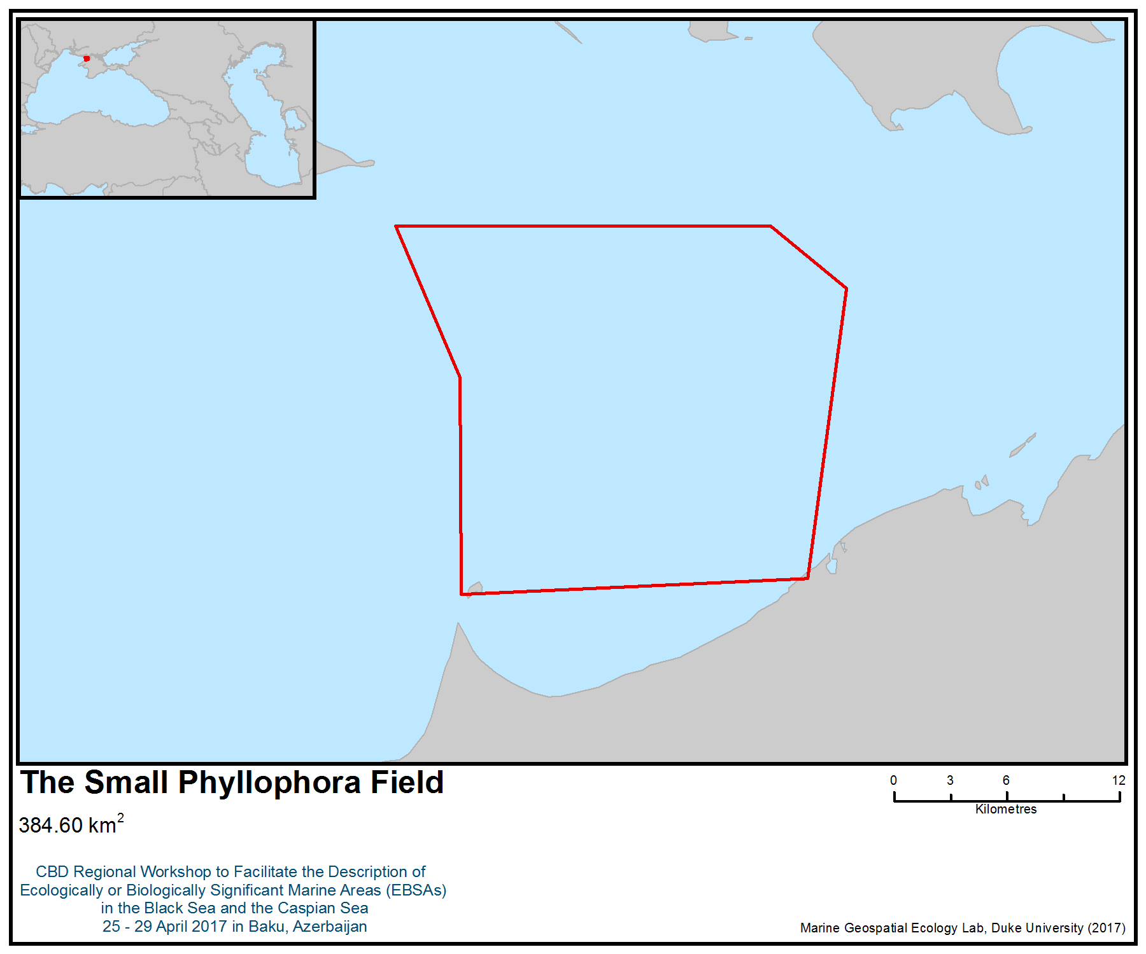
Figure 1. Area meeting the EBSA criteria

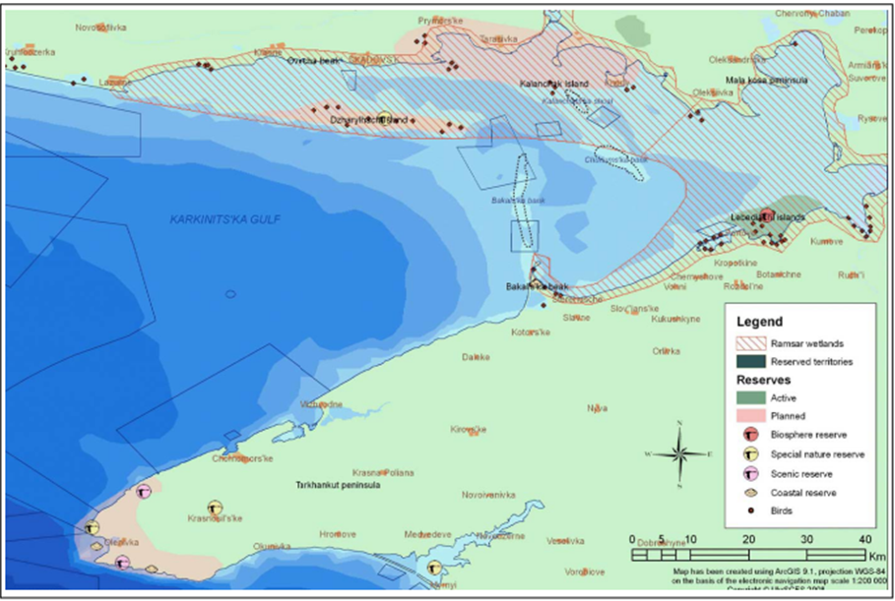
Figure 2. Geographical location of protected areas and important biodiversity sites (UkrSces, 2017)

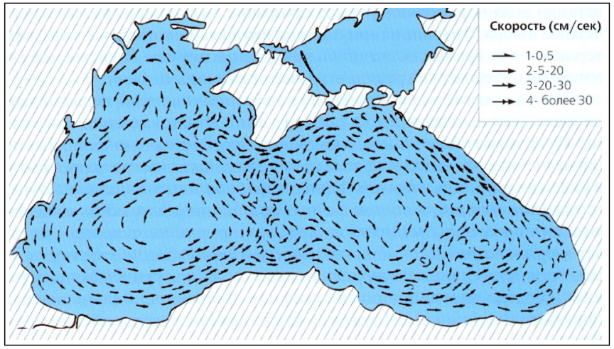
Figure 3. General scheme of surface currents in the Black Sea (Neumann, 1942 cited by Zenkevich, 1963)

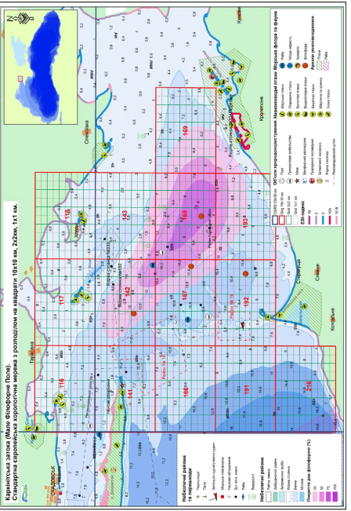
Figure 4. Projective coverage (%) of the bottom by the biocenosis of Phyllophora crispa in Karkinitsky Bay (Aleksandrov et al, 2009 b; UkrSces 2017)

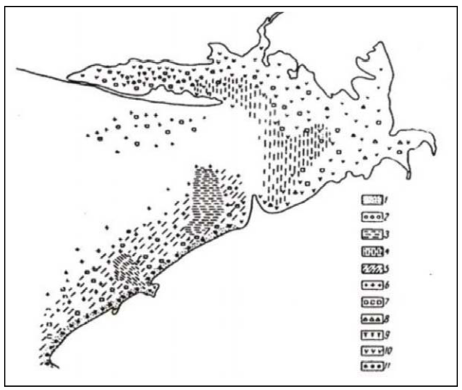
Figure 5. Schematic distribution of dominant benthic macrophytes in Karkinitsky Bay (mid-1950s): 1 – Сystoseira barbata attached form; 2 – С. barbata non-attached form; 3 – Phyllophora crispa large laminated form, 4 – P. crispa ball shaped; 5 – P. crispa bushy form; 6 – Polysiphonia elongata; 7 – Chondria tenuissima; 8 – Dasya pedicellata; 9 – Chara spp.; 10 – Zostera spp.; 11 – P. crispa attached form (Source: Kalugina-Gutnik et al. 1967)

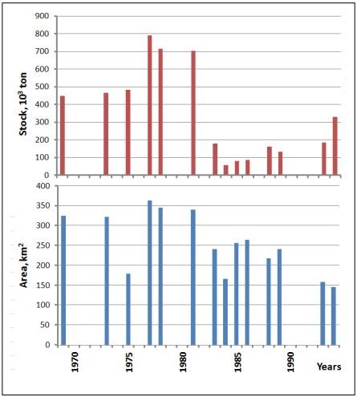
Figure 6. Multiyear dynamics of Phyllophora crispa stock and area in Karkinitsky Bay (Aleksandrov et al, 2009 b).

Table 1. Main systematic groups of macrozoobenthos recorded in the SPF in August 2000 (Aleksandrov et al., 2009b)
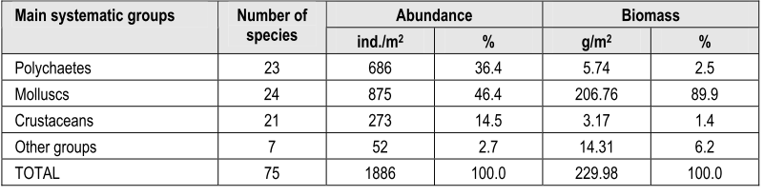

Table 2. Comparative characteristic of marine species in the Black Sea (BS) and Karkinitsky Bay (KB) (Zaitsev, Mamaev, 1997; Kalugina-Gutnik, Evstigneeva, 1993; Vinogradov, 1960; Aleksandrov et al., 2009 a).

Organisms | Total number |  |  | Red Data Book
Organisms | BS | KB | % | BS | KB | %
Macrophytes | 332 | 20 | 6 | 6 | 6 | 100
Invertebrates | 2000 | 72 | 4 | 45 | 5 | 11
Fish | 180 | 64 | 36 | 43 | 8 | 19
TOTAL | 2612 | 156 | 15* | 94 | 19 | 43*
*Average percentage for all investigated organisms
Area No. 7: Balaklava

Abstract
This area has been a hotspot of cetacean distribution in the Black Sea and has been designated a Cetacean Critical Habitat under ACCOBAMS. It is a critically important habitat for two cetacean species, the Black Sea harbour porpoise (Phocoena phocoena relicta) and the Black Sea bottlenose dolphin (Tursiops truncatus ponticus), both of which are listed as endangered on the IUCN Red List. These two cetacean species use this area particularly for reproduction and feeding.

Introduction
The sea area is located in coastal waters between the capes of Fiolent and Sarych, outside of Balaklava Bay, at depths between 0 and 70 m. An oceanographic model for Balaklava Bay was provided by Fomin and Repetin (2005), and the model for the whole coastal area was developed by Kubryakov et al. (2012). It has been identified as one of the important cetacean habitats in the Black Sea by Birkun (2006).

Location

The area is located in coastal waters between the capes of Fiolent and Sarych, outside of Balaklava Bay, at depths between 0 and 70 m, at the following coordinates: 33º 36’ 12.37”E, 44º 26’ 32.76”N.

Feature description of the area
The Balaklava area is a critically important habitat for cetaceans represented by endemic and endangered subspecies or populations: the Black Sea harbour porpoise (Phocoena phocoena relicta) and the Black Sea bottlenose dolphin (Tursiops truncatus ponticus). This is an area where permanent, year-round presence of a resident locally distributed coastal stock of the Black Sea bottlenose dolphin has been recorded for at least 18 years. In addition, dolphins from other coastal stocks were recorded in the area, and hypothetically this could be the area of stock mixture, which is important for their interbreeding and maintaining genetic diversity. The harbour porpoise is also permanently present in the area: this species is vulnerable due to extensive bycatch in fishing gears during its reproduction season, and therefore it needs special protection in its core habitats.

Feature condition and future outlook of the area
At present, the Balaklava area is in need of improved institutional environmental monitoring. There is neither direct evidence of changing economic activities in the area nor a reasonable forecast. Meanwhile, naval activities in the area can pose a threat to the cetacean populations, being potential sources of chemical, radioactive and acoustic contamination of the sea environment and cetacean-ship collisions.

Assessment of the area against CBD EBSA Criteria
CBD EBSA Criteria  (Annex I to decision IX/20) | Description  (Annex I to decision IX/20) | Ranking of criterion relevance  (please mark one column with an X)
CBD EBSA Criteria  (Annex I to decision IX/20) | Description  (Annex I to decision IX/20) | No information |  | Low |  |  | Medium |  | High
Uniqueness or rarity | Area contains either (i) unique (“the only one of its kind”), rare (occurs only in few locations) or endemic species, populations or communities, and/or (ii) unique, rare or distinct, habitats or ecosystems; and/or (iii) unique or unusual geomorphological or oceanographic features. |  |  |  |  |  |  |  | X
Explanation for ranking
The area is characterized by extremely high density and frequent occurrence of cetaceans represented by endemic and endangered subspecies or populations: the Black Sea harbour porpoise (Phocoena phocoena relicta) (Birkun and Frantzis, 2008) and the Black Sea bottlenose dolphin (Tursiops truncatus ponticus) (Birkun, 2002, 2012), which are endangered. This has already been recognized by experts, and the Secretariat of the Bern Convention has listed the area in the Emerald Network of Areas of Special Conservation Interest (category B for T. truncatus and category C for Ph. phocoena; moderately insufficient estimate).
Special importance for life-history stages of species | Areas that are required for a population to survive and thrive. |  |  |  |  |  |  |  | X
Explanation for ranking
The area is the permanent habitat for a locally distributed resident stock of the Black Sea bottlenose dolphin (Tursiops truncatus ponticus), including during its reproduction season (Gladilina et al., 2016). In addition, the area is visited by dolphins from other local coastal stocks (Gladilina et al., 2016) and is hypothetically an important area for other migrating stocks of the Black Sea bottlenose dolphin (Tursiops truncatus ponticus) during the reproductive season (Birkun, 2012). The area is also important for the Mediterranean endemic subspecies of European shag (Phalacrocorax aristotelis desmarestii) during the breeding season, given the proximity to important colonies of this seabird subspecies in the Black Sea (Doğa Derneği 2014).
Importance for threatened, endangered or declining species and/or habitats | Area containing habitat for the survival and recovery of endangered, threatened, declining species or area with significant assemblages of such species. |  |  |  |  |  |  |  | X
Explanation for ranking
The area is the permanent habitat for a locally distributed resident stock of the Black Sea bottlenose dolphin (Tursiops truncatus ponticus). Also, this is a place of permanent presence of the Black Sea harbour porpoise (Phocoena phocoena relicta). Both of them are listed as endangered on the IUCN Red List (Birkun and Frantzis, 2008 for harbour porpoises; Birkun 2012 for bottlenose dolphins).
Vulnerability, fragility, sensitivity, or slow recovery | Areas that contain a relatively high proportion of sensitive habitats, biotopes or species that are functionally fragile (highly susceptible to degradation or depletion by human activity or by natural events) or with slow recovery. |  |  |  |  |  |  |  | X
Explanation for ranking
Bottlenose dolphins and harbour porpoises start reproduction late and produce a limited number of offspring. According to Birkun (2012), Black Sea bottlenose dolphins have a life history similar to bottlenose dolphins elsewhere—the generation time being approximately 20 years, with an interval between births from two to six years; one female is unlikely to produce more than eight calves in her lifetime; gestation lasts 12 months, and lactation can last more than 1.5 years. Gol’din (2004) reported that sexual maturity is reached at 3-4 years for the harbour porpoise, and the maximum life span is at least 20 years. This indicates slow recovery in the event of degradation or depletion by human activities or natural events, such as epidemics and bycatch.
Biological productivity | Area containing species, populations or communities with comparatively higher natural biological productivity. |  |  |  |  |  | X
Explanation for ranking
This area is known as the breeding area of bottlenose dolphins and harbour porpoises. The area has also been recorded as having particularly high productivity in warm periods under the influence of coastal upwelling (Popovichev et al. 2014; Kovrigina et al. 2010). Concentration of meroplankton is extremely high, and unusual diversity and abundance of algal species has been mentioned (Yurakhno, Tamoikin, 1999). This area has a high concentration of migratory fish, like mackerels, horse mackerels and anchovy (Drodzov 2011; Kuzminova 2013).
Biological diversity | Area contains comparatively higher diversity of ecosystems, habitats, communities, or species, or has higher genetic diversity. |  |  |  |  |  |  |  | X
Explanation for ranking
The area is known for its high diversity of habitats (Popov et al., 2014). Infralittoral and circalittoral rocks and other hard substrata, sublittoral sediments, and communities of Cystosira and Phyllophora have been recorded in the area, as well as overall diversity of habitats and communities (Milchakova, 2014; see also Maps). At least three types of habitats are listed in the Emerald Network of Areas of Special Conservation Interest, under the Bern Convention. Fish diversity is also high according to Hetman (2014). Taxonomic diversity by groups was mostly estimated in two minor coastal portions of the area, Balaklava Bay and Laspi Bay. There are at least 278 species of diatoms inhabiting the area, of which at least 40 recorded only in this part of the Black Sea (Nevrova, 2014). Phytoplankton is represented by 140 species (Popov et al., 2014). Periphyton algae are very diverse (72 species in Laspi Bay only), of them at least 43 species of red algae which a distinct feature for algae community. Also, 61 species was recorded in phytobenthos of Laspi bay (Evstigneeva and Tankovskaya, 2010). A preliminary estimate of zoobenthos in Laspi Bay, which is a part of the area, showed there were at least 143 species (and, the most likely, even more), the number comparable with the overall species diversity of the shelf of Crimea (Revkov and Nikolaenko 2002). Also, five rare species of hydrozoans have been reported from the area (Murina and Grintsov, 2009). Meroplankton of Balaklava Bay includes at least 63 species (Lisitskaya, 2010).
Naturalness | Area with a comparatively higher degree of naturalness as a result of the lack of or low level of human-induced disturbance or degradation. |  |  |  |  |  |  | X
Explanation for ranking
The area is relatively “natural” although there is a naval facility and an active tourism industry. But the future of the area is uncertain in terms of naturalness.

References
Birkun Jr, A., 2002, The current status of bottlenose dolphins (Tursiops truncatus) in the Black Sea. In Report of the first meeting of the Parties to the Agreement on the Conservation of Cetaceans of the Black Sea, Mediterranean Sea and contiguous Atlantic area (ACCOBAMS). Document AC18-Inf. 2. 25 pp.
Birkun Jr.A.A. (comp.), 2006. Conservation Plan for Black Sea Cetaceans. ACCOBAMS and Black Sea Commission. 50 pp.
Birkun Jr., A.A. & Frantzis, A., 2008. Phocoena phocoena ssp. relicta. The IUCN Red List of Threatened Species 2008: e.T17030A6737111. http://dx.doi.org/10.2305/IUCN.UK.2008.RLTS.T17030A6737111.en.
Birkun, A. 2012. Tursiops truncatus ssp. ponticus. The IUCN Red List of Threatened Species 2012: e.T133714A17771698. http://dx.doi.org/10.2305/IUCN.UK.2012.RLTS.T133714A17771698.en.
BLASDOL. 1999. Estimation of human impact on small cetaceans of the Black Sea and elaboration of appropriate conservation measures: final report for EC Inco-Copernicus (contract No. ERBIC15CT960104). C. R. Joiris (Coord.), Free University of Brussels, Belgium; BREMA Laboratory, Ukraine; Justus Liebig University of Giessen, Germany; Institute of Fisheries, Bulgaria; and Institute of Marine Ecology and Fisheries, Georgia. Brussels. 113 pp.
Doğa Derneği, 2014. Black Sea Seabirds Project Layman’s report, Istanbul.
Drozdov, V.V., 2011. Long-term variability of fishery resources of the Black Sea, tendencies, the reasons and prospects. Uchenye zapiski RGGMU V 21: 137-154.
Evstigneeva, I. K., and Tankovskaya, I. N. 2010 Macroalgae of the periphyton and benthos of the Laspi Bay seashore (Crimea, Black Sea). Ecology of Sea 81: 40-49.
Fomin, V.V. and Repetin, L.N., 2005. Numerical Simulation of Wind Currents and Propagation of Impurities in the Balaklava Bay. Physical Oceanography, 15(4), pp.232-246.
Gladilina, E., Shpak, O., Serbin, V., Kryukova, A., Glazov, D., Gol’din, P. 2016. Individual movements between local coastal populations of bottlenose dolphins (Tursiops truncatus) in the northern and eastern Black Sea. Journal of the Marine Biological Association of the United Kingdom, doi:10.1017/S0025315416001296
Gol’din, P. 2004. Grow and body size of the harbour porpoise, Phocoena phocoena (Cetacea, Phocoenidae), in the Sea of Azov and the Black Sea.Vestinik zoologii 38(4): 59-73.
Hetman, T. P. 2014. Current state of fish community of hard soil of Laspi Bay (the Black Sea). Trudy GNBS. 110: 36-40.
Kovrigina, N.P., Popov, M. A., Lisit-skaya, E.V., Kuftarkova, E.A., Gubanov, V.I. 2010. Complex monitoring of Balaklava Bay (Black Sea) in 2000 - 2007. Marine Ecology Journal, № 4, Т. IX: 62-75.
Kubryakov, A.I., Korotaev, G.K., Dorofeev, V.L., Ratner, Y.B., Palazov, A., Valchev, N., Malciu, V., Mateescu, R. and Oguz, T., 2012. Black Sea coastal forecasting system. Ocean Science, 8(2), p.183.
Kuzminova, N.S., 2013. Population parameters of horse mackerel in various water areas of the Black Sea in the modern period. Ribogospodarka Science of Ukraine, No. 3: 35-45.
Lisitskaya, Y.V., 2010. Meroplankton of Balaklava Bay. Hydrobiological Journal, 46(5): 29-37
Milchakova, N. A. (ed.). 2014. Nature Reserve Resources of Sevastopol City. 4 Green Inn, Sevastopol. 53 p. Popovichev V. N., Stetsyuk A. P., Plotitsina O. V., Popov M. A., Rodionova N. Yu., Tsarina T. V. 2014. Mercury, primary production and hydrochemical parameters in the system of ecological monitoring of the surface layer of the Balaklava bay. Optimization and Protection of Ecosystems, Simferopol, TNU Iss. 11: 99–105.
Murina V. V., Grintsov V. A. 2009. Species Composition and Ecology of the Hydropolypes (Hydrozoa, Cnidaria) of Laspi Bay (Southern Coast of Crimea). Vestnik Zoologii, 43(5): 465–469.
Nevrova, E. V. 2014. Taxonomic diversity and environmental assessment of benthic diatoms at Balaklava bay (south-western Crimea, the Black Sea, Ukraine). Algologia 24(1): 47-66.
Popov, M.A., Lisitskaya, E. V., Pospelova, N. V. 2014. The habitat and biological diversity of the Megalo Yalo Gulf. Ecological safety of Shelf Zones 28(1): 214-219.
Revkov N. K. and Nikolaenko T. V. 2002 Biodiversity of Zoobenthos in the Coastal Zone of the South Coast of Crimea (Laspi Bay Area) Russian Journal of Marine Biology, 28(3): 151–162.
Vishnyakova, K., Gol’din, P. 2015. Seasonality of strandings and bycatch of harbour porpoises in the Sea of Azov: the effects of fisheries, weather conditions and life history. ICES Journal of Marine Science 72(3): 981–991
Yurakhno V. M., Tamoikin I. Yu. 1999. On the prospect of biodiversity conservation in coastal and marine communities near capes of Fiolent, Aya and Sarych. Pontida 1: 51-59.

Maps and Figures

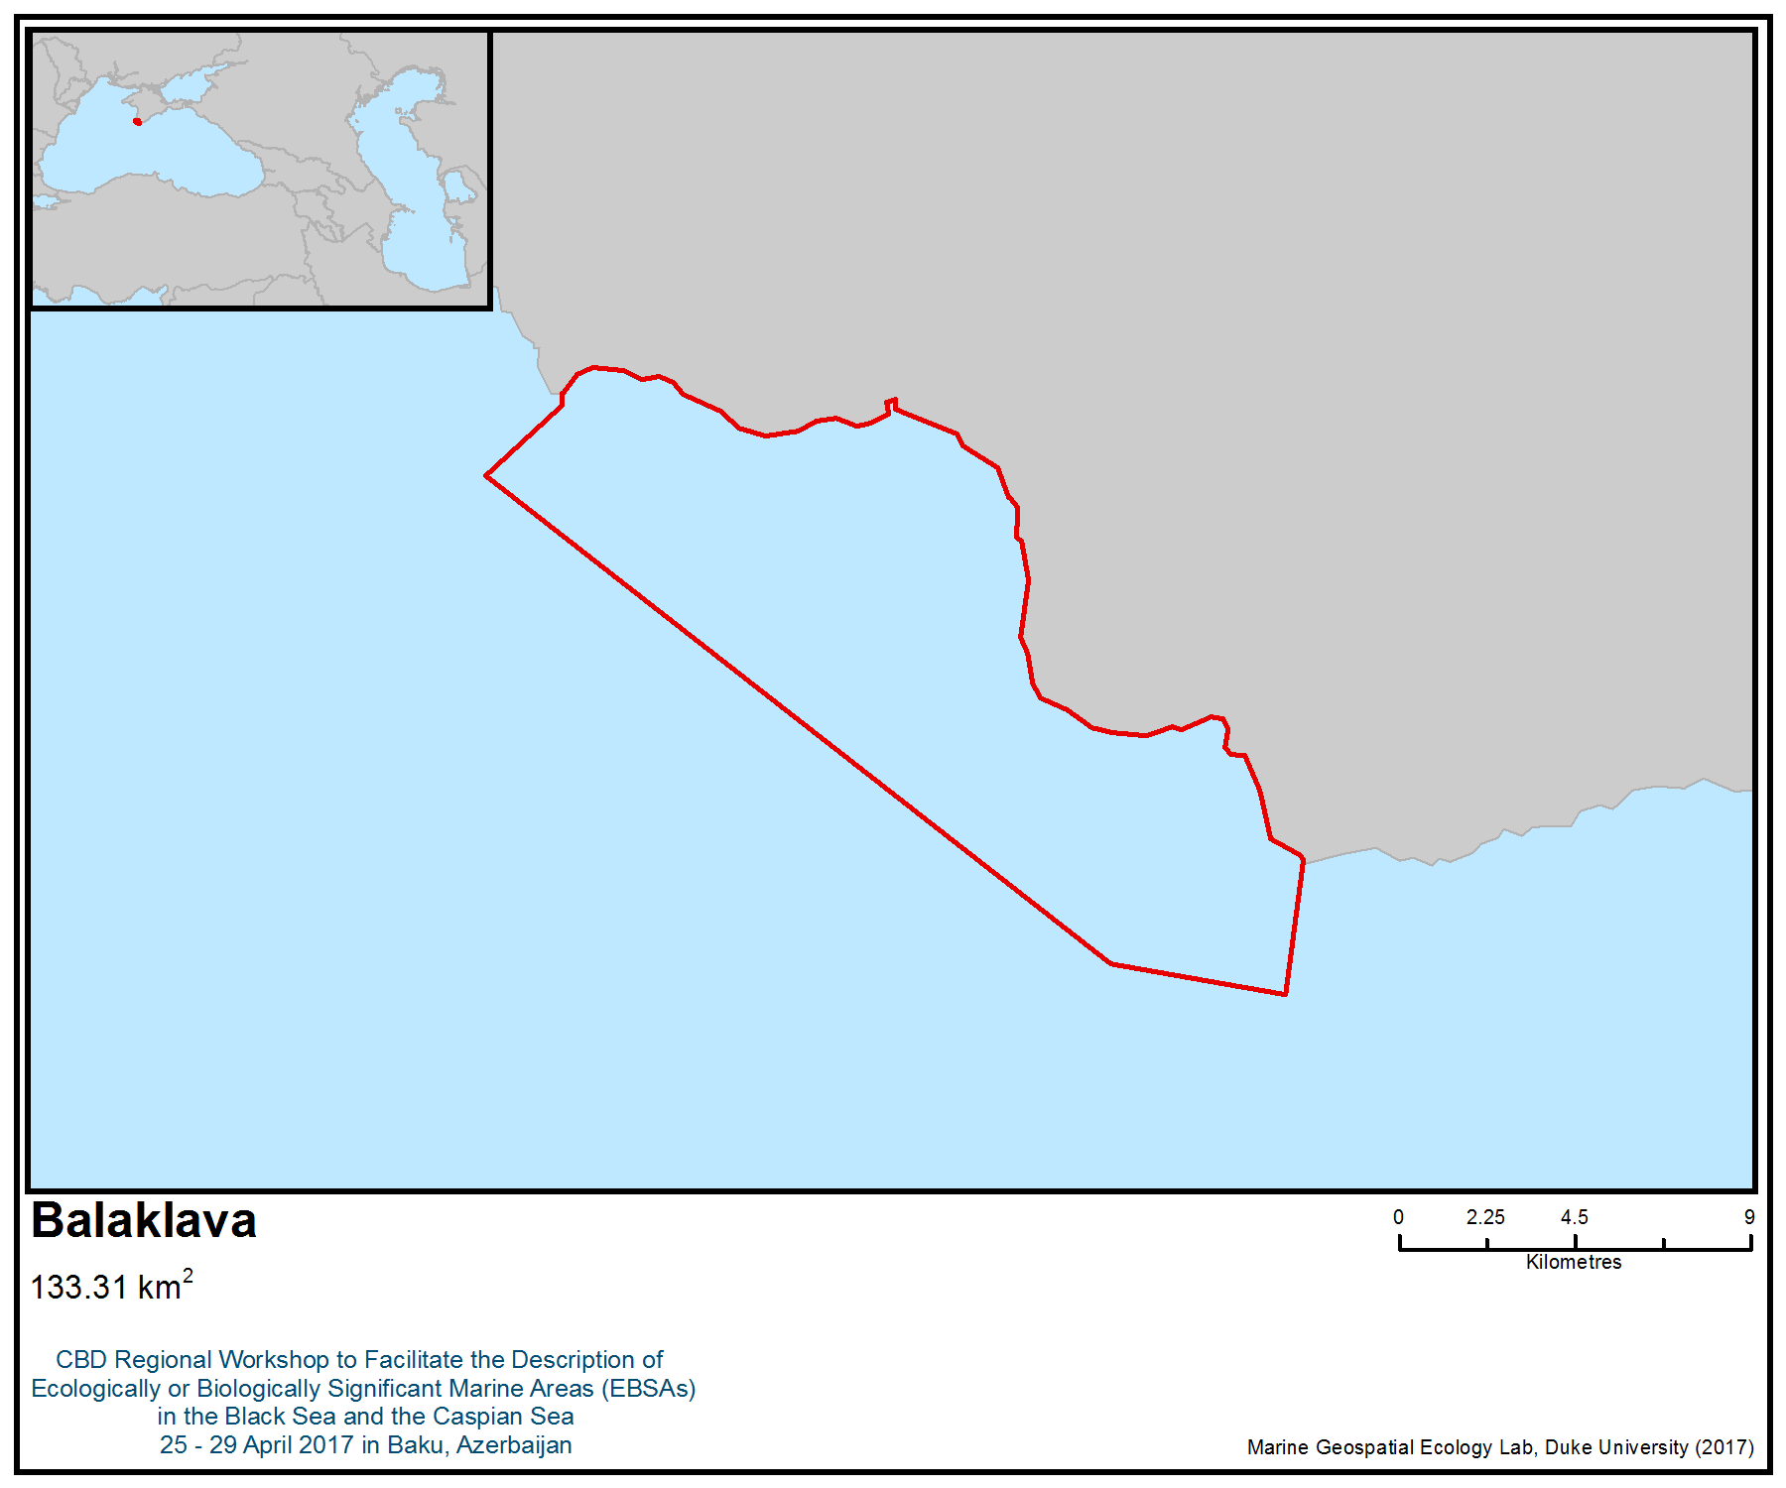
Figure 1. Area meeting the EBSA criteria

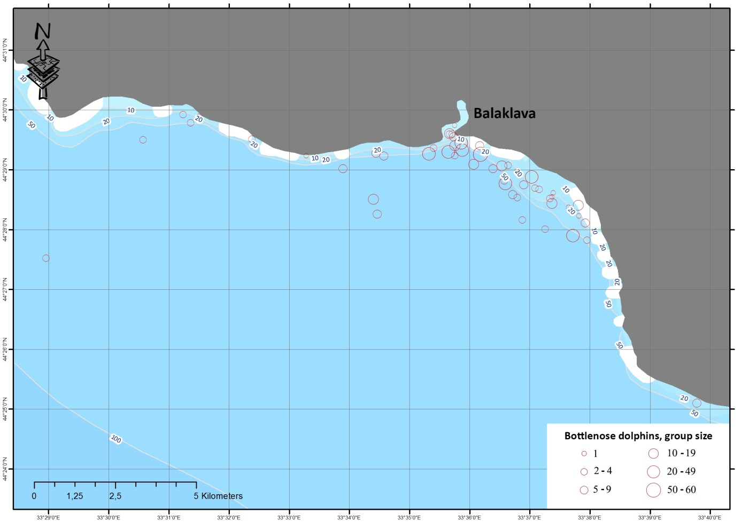
Figure 2. Distribution of Black Sea bottlenose dolphins (Tursiops truncatus ponticus) in coastal waters of Balaklava in 2011-14. Observations by Elena Gladilina (unpublished data)

Area No. 8: Yagorlytsky Bay

Abstract
Yagorlytsky Bay, owing to the peculiarities of the hydrological, hydrochemical and hydrobiological regimes, is a unique area of the north-western part of the Black Sea. The coastal and aquatic complex of Yagorlytsky Bay is characterized by a rich variety of plant and animal life, high endemism, geomorphological and landscape uniqueness and has one of the highest environmental statuses of international importance. The marine area of Yagorlytsky Bay is a part of the National Natural Park “Biloberezhia Sviatoslava” and the Black Sea Biosphere Reserve. The natural and territorial complexes of these reserves are represented not only by the aquatic complex of the bay, but wetlands, steppe, salt marshes, sandy and forest landscapes characterized by high conservation value and mosaic location of biocenoses. The considered biotopes play an exceptional role in maintaining the species diversity of the region and the country; they are used for the reproduction and feeding of the main commercial fish species, and shallow waters are refugia for many nesting and wintering waterbirds.

Introduction
Yagorlytsky Bay was formed as a result of the Black Sea’s ingression into the delta zone of the Dnieper River, in particular to the Yagorlycko-Odzhigolsky and Zaporozhye branches (Krivulchenko, 2016).

The bay is separated from the sea by a chain of acumulant formations sand-shell spits and islands: from the west by the Pokrovskaya oblique and islands Round and Long, in the south by Yagorlytsky peninsula and Tendrovskaya spit. In the south-eastern part of the gulf, there is a group of the Kon Islands (Sabinevsky, 1977). Yagorlytsky Bay has a flat and shallow bottom, with the exception of its deepest section (6 m), which lies beyond the Dolgiy’s Island (Chepizhko et al., 2007). Most of the water area is 2-4 m deep. The eastern and northeastern parts of the inlet area are the shallowest (Fig. 2), where the one-metre isobath is sometimes as far as 2 km from the coastline. The greatest depths—from 4 to 6 m—are noted in the south-west and in a small area of the north-western part of the bay. Based on the bathymetric analysis of the bottom of the bay, it can be divided into four zones: shallow water, underwater slopes, bed and hollow (Chernyakov, 1995).

Circulation of the water flow is observed on the part between the Kinburg and Tendrovskaya spits (Fig. 2). This type of movement of water masses in a given area is due to the features of the coastline and the often recurring northeasterly winds (Chepizhko et al., 2007).

Location
Yagorlitsky Bay is located on the north-western Black Sea coast between the Nikolaev and Kherson regions of Ukraine. In the north it is separated from Dnieper-Bug estuary by Kinburg oblique (Fig. 4, 5). The bay is 26 km long, and its entrance is 15 km wide. Its geographical coordinates are: 46° 29,122' - 46° 19,867' N and 31° 47,066' - 32° 3,695' E.

Feature description of the area
Physiographic description
The terrestrial-aquatic complex of Yagorlytsky Bay belongs to the south-steppe subzone (Miten, 2006).

The climate of the area is moderately continental, with hot, dry summers and mild winters. It is characterized by a relatively low humidity, low cloudiness, low precipitation and a relatively large daily and annual amplitude of air temperature fluctuations. Strong winds blow in the winter and especially in the early spring. The average temperature is 2° C in January and +24° C in July; the average annual temperature is 10.8° C. The average amount of precipitation is 235 mm. In some years, their amount varies sharply from 209 to 430 mm (Sorokina, A. I., 1974)). The average annual temperature varies from 10.5 to 12.5° C. The spring increase in water temperature to 10° C is usually observed in April. Maximum warm-up (up to 26-30° C) is observed in August. The autumn drop in water temperature to10° C is observed in November. The bay freezes only in cold winters (Vekhov, 2010).

The average duration of the growing season (with an average daily temperature of 5° C and above) ranges from 226 to 232 days. The growing period starts between 15 and 20 April and ends between 5 and 10 November, sometimes much later (10-15 December) (Vekhov, 2010).

Maximal salinity of the Yagorlytsky Bay varies on average from 16 to 22‰ for surface waters and 18 to 22‰ for bottom horizons (Vekhov, 2010). In summer, average salinity is 14 to 18‰ (natural complexes of the Black Sea State Biosphere Reserve, 1992), but it can often reach 21 to 43‰. In the rest of the year, especially in the spring, the salinity values decrease significantly, sometimes up to 9 to 11 ‰, which is mainly due to the flow of water from the Black Sea, especially due to the surging processes. Average salinity of the water 14 to 15 ‰ (Alekseev, 1982).

The oxygen content in the bay water in summer reaches saturation of 100% or more. In hot, windless periods, water stratification has led to mass mortality (Grigoriev, 1977). Hydrophysical characteristics of water masses are largely due to the effect of sea water on the water area of Yagorlytsky Bay, in particular on the temperature regime (see Fig. 2) and water turbidity (Fig. 5).

The bottom sediments of the bay are represented by soft and finely dispersed soils, mainly alluvial sands, which in places are replaced by clayey sands and contain loamy interlayers of different thicknesses (Fig. 7). This sequence is explained by the fact that the sand deposits are the ancient alluvial deposits of the Dnieper, formed on the places loess terraces have eroded. Silty sand and sandy sediments predominate in the north-west, north and north-east of the bay (Geology of the shelf of the Ukrainian Soviet Socialist Republic, 1985). The sea coast is characterized by a littoral shaft of sand and shells (Vekhov, 2010). The shores of the bay are mostly leveled. Significant sections of the underwater slopes of the water area are shallow waters up to 1 m deep (Krivulchenko, 2016).

Hydrological and morphological description
Features of the hydrological-morphological structure of Yagorlytsky Bay, the size of the water bed, the configuration of the coastline and the relief of the catchment area are characterized by the following factors (Minicheva, Sokolov, 2016):
- Free water exchange between the bay and the sea across the strait. So, when westerly, south-westerly and north-westerly driving winds are occurring, water exchange is carried out on average in 10 days.
- Large size of the bay compared to local coastal reservoirs (bays, estuaries and lagoons): the volume of water and the surface area of the water (Table 1).
- Insignificant influence of terrigenous processes on the water body. The hydrographic network in the catchment area of the bay is not developed (see Fig. 2), and therefore, the indicator of the specific catchment area of the bay is very low. In addition, the catchment area of the bay has a placer type of terrain—the average height of the surface is only 5 m, and the average slope is 0.7.
- Intensive hydrodynamics. The absence of deep water zones, insignificant development of the shoreline (low values of the tortuosity coefficient) and low values of the depth coefficient due to the high value of the surface area of the water in relation to the average depth (Table 2) form favourable conditions for the vertical mixing of the water mass in the inlet.

Biological community
Phytoplankton
Phytoplankton communities of Yagorlytsky Bay are formed mainly by representatives of dinophyte and diatom algae (Nesterova, 1986). Among the dinophytes, Gonyaulax minima, Prorocentrum micans, Dinophysis acuta, Gymnodinium sanguineum, Glenodinium paululum, Protoperidinium longispinum (Kof.), Heterocapsa triquetra. Among diatoma (Bacillariophyceae), the most common species are: Cerataulina pelagica, Chaetoceros lorenzianus, Chaetoceros affinis, Chaetoceros similis f. solitarius, Chaetoceros insignis, Entomoneis paludosa, Thalassiosira parva. In 2013, the Institute of Marine Biology of the National Academy of Sciences of Ukraine (IMB NASU) confirmed the dominant role of dinophyte algae in quantitative development of phytoplankton. The following species make up the majority of the phytoplankton: Prorocentrum micans, Diplopsalis lenticula, Prorocentrum cordatum and Gymnodinium sp. Representatives of diatoms (Chaetoceros abnormis, Aulacoseira granulata, Coscinodiscus sp.) were subdominant species. During the expedition of IMB NASU in the summer of 2013, 15 phytoplankton species were recorded (Minicheva et al., 2014).

Zooplankton
There are 31 species of zooplankton in Yagorlytsky Bay. One species (hydroid jellyfish, Moerisia maeotica) is listed in the Red Data Book of Ukraine and IUCN as endengered (Table 4).

Phytobenthos
During studies conducted by IMB NASU in 2013 (Fig. 8), 27 macrophyte species were recorded, including multicellular algae and high plants: Chlorophyta - 10, Xanophyta - 1, Rhodophyta - 12, Angiospermatophyta - 3, Charophyceae - 1. There are seven Red Data Book species (see Table 4). There are five main macropyte communities in Yagorlytsky Bay with the following key species: Zostera noltii, Z. marina, Chondria tenuissima, Stukenia pectinata, Lamprothamnium papulosum (Fig. 9). Seven species of phytobenthos found in the bay are listed in the Red Book of Ukraine, and two of them (Ectocarpus siliculosus and Lamprothamnium papulosum) are vulnerable. So Yagorlytsky Bay is a refugium for recovery of L. papulosum. In the early 1980s this species was registered in the southern part of the bay, but it is now common in shallow water along the entire perimeter of the bay. On the other hand, the previously widespread red alga Phyllophora crispa (=nervosa) has practically disappeared as a result of eutrophication. Phyllophora stock in the 1960s, prior to large-scale eutrophication, reached 5909 tonnes (Pogrebnyak, Pashkovskaya, 1966).The average biomass of macrophytes in Yagorlytsky Bay is 650 g·m⁻²; a maximum value of 1800 g·m⁻² was recorded in the Zostera phytocoenosis (Fig. 10).

Macrozoobenthos
There are 73 species of macrozoobenthos in Yagorlytsky Bay. Two species (Mediterranean mud shrimp Upogebia pusilla and European flat oyster Ostrea edulis) are listed in the Red Data Book of Ukraine (see Table 4). In the 1970s the oyster was a dominant species in the bay, and a mariculture farm built on the shore for its mass cultivation. However, this species soon almost completely disappeared due to the silting of water as a result of eutrophication and the impact of invasive alien species, such as Rapana venosa. Seven main bottom hapitats have been registered in Yagorlytsky Bay: sand, black mud, meadow silt, shellfish, European flat oyster (Ostrea edulis), thickets of the seagrass Zostera (Greenbart, 1968). In 1988, the average number of macrozoobenthos in Yagorlytsky Bay was 40 800 ind·m⁻², biomass - 384 g·m⁻². Among the main taxonomic groups in the Yagorlytsky Bay are mollusks (40%) and crustaceans (39%). The most significant contribution to the average biomass of the macrozoobenthos of the Yagorlytsky Bay were Irus irus (381 g∙m⁻²) and Mytilaster lineatus (193 g∙m⁻²) (Sinegub, 2006). According to IMB NASU data received in June 2013, 67 macrozoobenthos taxa were recorded (Table 3). The distribution of quantitative parameters of the bottom macrofauna at the stations was not homogeneous. The maximum abundance and biomass indicators for the zoobenthos of the investigated area were recorded in the south-western part of Yagorlytsky Bay.

Ichthyofauna
For at least the last 20 years, 88 species of fish from 43 families were recorded in the Yagorlytsky Bay (see Table 4). About 67% of these fish are purely marine species, 8% are transitive and widely eurygaline and 17% are brackish and freshwater species (Takchenko, 2012). There are 15 dominant species recorded in Yagorlytsky Bay in recent times: silverside Atherina mochon pontica, roun goby Neogobius melanostomus, sandstone Neogobius fluviatilis, herb Gobius ophiocephalus, black goby Gobius niger, zucicus Proterorhinus marmoratus, leopard bald Pomatoschistus marmoratus, needle-fish Syngnathus nigrolineatus, gloss Platichthys flesus luscus, 4 species of mullets (Liza aurata, Liza saliens, Mugil cephalus and Mugil so-iuy), sprat Sprattus sprattus phalericus (Risso) and anchovy Engraulis encrasiholus maeoticus. Twenty four species of fish are included in the Red Data Book of Ukraine and International Union for Conservation of Nature and Natural Resources (IUCN), eight of which are endangered: sturgeons (Acipenser stellatus, A. gueldenstaedtii, A. nudiventris, Huso huso), Alburnus sarmaticus, Barbus borysthenicus, Sygnathus tenuirostris, S. variegatus (see Table 4). In connection with the increase in the flow from the Crimean peninsula to the north-western part of the Black Sea, 12 fish that are rare in this area have been recorded during the last decade (Takachenko, 2012a).

Ornithofauna
Yagorlytsky Bay is located on the main bird migration route of species that nest not only in the northern regions of Ukraine, but also in other European countries. Southern Prichornormya is the most important wintering place for waterbirds, as well as mass nesting of terns, ducks, waders and storks (Natural complexes of the Black Sea State Biosphere Reserve, 1992). Yagorlytsky Bay serves as a reserve wintering ground for birds, in particular when the northern coast of the Azov Sea freezes. It serves as a refugium and a place of mass nesting of various water-swamp birds: wintering swans, various ducks, terns, waders and storks (Sabinevsky, 1977).

Feature condition and outlook of the area
Features of the structure—the size of the water bed, the configuration of the coastline and the relief of the catchment area of Yagorlytsky Bay, expressed by hydrological and morphometric parameters in conjunction with the climatic conditions of the region—determine the natural intensity of the biogeochemical processes in its ecosystem, i.e., the “morphometry effect” (Romanov, 1991) and determine the natural intensity ecological processes. Based on limnological characteristics for Yagorlytsky Bay, the Nature Resistance Index (NRI) was calculated, which includes seven relevant parameters (Mіnicheva and Sokolov, 2014). In comparison with more than 20 local coastal objects of the north-western Black Sea coast, the values of the NRI are in the altitudes from 0.250 to 0.730, for Yagorlytsky Bay, which can also be regarded as a local ecosystem, the maximum value of this index is fixed at 0.835, which corresponds to the class “High“ (Minichevaet al., 2016).

The estimation of the intensity of the primary production process in the ecosystem of Yagorlytsky Bay using classical and morphofunctional indicators of bottom vegetation (Minichovaet al., 2003) gives an idea of the spatial distribution of the macrophyte biomass, as well as the ecological activity of the phytobenthos communities depending on their floristic composition (Fig. 13).

The spatial distribution of the structural and functional indices of phytocenosis of bottom vegetation in June 2013 is characterized by heterogeneity. The horizon of 2-2.5 m is the most favourable for the formation of plant biomass. The average values of biomass of bottom vegetation exceed 800 g·m⁻², with a maximum of 1,800 g·m⁻², recorded on phytocenoses Zostera marina. The development in this horizon of species with the largest size of thallus and, accordingly, the minimum value of ecological activity (S/Wp), ensures the production of a significant plant biomass and indicates the optimal conditions for the primary production process in this horizon. The average value of the specific surface area of macrophyte populations developing in the Bay is 45,11 ± 3.35 kg⁻¹·m², which is approximately two times lower than in macrophyte phytocenoses developing in the coastal waters of the north-western part of the Black Sea, which indicates the low speed of the intensity of ecological processes. The maximum ecological activity of bottom vegetation communities was recorded on the southern coast at the entrance to the bay (station E1, see Fig.8.) - 95.33 ± 7.30 m²·kg⁻¹.

The use of morpho-functional indicators of the bottom vegetation of Yagorlytsky Bay as Ecological Evaluation Index (EEI) made it possible to assess the ecological state of the water area of Yagorlytsky Bay in the unified European system of “ecological status class” (Fig. 14).

Mostly at all stations the ESC is rated by the category “High” and only at some coastal stations by the category “Good” and “Moderate”. The EEI values at all stations remained rather high and did not drop below 0.74 (Table 5).

Practically all stations with the category “Moderate” were located in coastal areas with the greatest turbidity of water (see Fig. 6), which reflects the spatial location of the zones of increased concentration of suspended organic matter and the features of hydrodynamics. The lowest water turbidity is observed in the places of penetration of sea water into the bay and at the greatest depths. Obviously, biological processes proceed with different intensities, depending on the turbidity and depth; in the shallow coastal zones they are most intense. Similarly, the anthropogenic impact associated with the receipt of the allochthonous biogenic substance, which reduces the ecological status class, is most pronounced in the shoreline zone.

The best environmental quality was noted on the C1-C4 transect (see Fig. 8), located in the northeastern part of Yagorlytsky Bay.

The terrestrial biogeocoenoses adjacent to this coast are characterized by high mosaicism and preservation, being in a natural and quasi-natural state (Fig. 15). Tendrovsky Bay, in comparison with Yagorlytsky Bay, is characterized by a greater turbidity of water and the transformation of natural-territorial complexes into cropland with irrigation systems, which is reflected in lower categories of ESC calculated according to the average specific surface of species of bottom vegetation (S/W_{x}) (see Fig. 14).

The natural terrestrial lands of the area are represented by wormwood-fescue-feather grass steppes, higher-aquatic vegetation, salt marshes, barrows and sands, and natural reservoirs (lakes). Quasi-natural landscapes can be attributed to artificial forest plantations. anthropogenically transformed landscapes include: settlement buildings and their infrastructure, reservoirs, irrigated arable land, rice checks, deposits, horticultural areas, farms, landfills, hayfields, felling of forests. All kinds of anthropogenically transformed territories can lead to the entry of biogenic and polluting substances of allochthon origin into Yagorlytsky and Tendrovsky bays.

Based on the results of the assessment of the landscape and antropogenic structure of the territories adjacent to the bays, the distribution of the coefficient of anthropogenic transformation (Shishchenko, 1988) in the catchment area and adjacent territory of the Yagorlytsky Bay was obtained in such proportions: non-transformed – 37,66%; slightly transformed – 29,61%; converted 5,70%, medium-converted – 3,34%, strongly converted – 20,32%, very strongly converted – 2,49% and transformed – 0,87% of the total area of the territory (Fig. 16). This condition indicates the presence of an ecological and antropogenic balance of the territory and a significant preservation of natural landscapes. A particularly high degree of preservation of natural conditions corresponds to sites that have the status of environmental protection.

Also, the study of the degree of anthropogenic load on the bay was carried out on the basis of an estimate of the spatial distribution of the population (Fig. 17). On the whole, the area under consideration is characterized by a low population density and the absence of large settlements. The least anthropogenic load is observed in nature conservation areas. The largest number of settlements and population density is confined to cultivated agricultural lands.

To quantify the impact of the anthropogenic component on the ecological state of the ecosystem of Yagorlytsky Bay, the artificial force index (AFI) was used (Minicheva et al., 2013). The method of comparing the categories obtained on the basis of morphofunctional indicators of bottom vegetation and the natural stability of the water of the local ecosystem allowed us to estimate the current degree of anthropogenic impact on the ecosystem of Yagorlytsky Bay. The values of all three morphofunctional indicators of the bottom vegetation of the bay correspond to the category “High” (Table 5). The value of the IPU also corresponds to the category: “High”. This means that when the evaluation categories are compared, the EEI value is “0”.

Thus, it can be concluded that at the current time the water area of Yagorlytsky Bay, in accordance with the standards of the Water Frame Directive, is characterized by the highest category of ESC. In addition, the zero value of EEI indicates that the current anthropogenic impact has not reduced the initial natural state of this environmental area of the marine ecological network of Ukraine.

Assessment of the area against CBD EBSA Criteria

CBD EBSA Criteria | Description | Ranking of criterion relevance
CBD EBSA Criteria | Description | No information |  | Low | Medium |  | High
Uniquenessor rarity | Area contains either (i) unique (“the only one of its kind”), rare (occurs only in few locations) or endemic species, populations or communities, and/or (ii) unique, rare or distinct, habitats or ecosystems; and/or (iii) unique or unusual geomorphological or oceanographic features. |  |  |  |  |  | X
Explanation for ranking
Four sturgeon species recorded in the Red Data Book of Ukraine and in IUCN with the highest conservation status are registered in the bay, as well as the seahorse Hippocampus ramulosus, sea cock Trigla lucerna, black-striped pipefish Syngnathus abaster, laurac Morone labrax, light mantel Umbrina cirrosa, marine pikeperch Stizostedion marinum, monkfish Lophius piscatorius (Pinchuk and Tkachenko, 1996; Tkachenko, 1999), listed in the Ukrainian and the Black Sea Red Data Book. Until the end of the 1970s Yagorlytsky Bay was a region of mass habitat for the European flat oyster Ostrea edulis, which disappeared because of eutrophication. Today, this species is listed in the Red Data Book of Ukraine and the Black Sea as a vanishing species (Alexandrovet al., 2006). At the same time, the most widespread macrophyte in the bay was the red alga Phyllofora crispa (= nervosa), which is an edificator species of biocenosis with the same name (Eremenko and Minicheva, 1992). The Red Data Book of Ukraine includes 12 species of birds inhabiting shallow waters and the coast of Yagorlytsky Bay (Chernichko et al., 2000).
Special importance for life-history stages of species | Areas that are required for a population to survive and thrive. |  |  |  |  |  | X
Explanation for ranking
The aquatic area of Yagorlytsky Bay is a feeding ground for sturgeon, in particular the Russian sturgeon Acipenser gueldenstaedtii, star sturgeon Acipenser stellatus, sterled Acipenser ruthenus and giant sturgeon Huso huso, as well as four species of mullets (Mugil cephalus, Liza aurata, Liza saliens, Liza haematocheilus =Mugil so-iuy). Three of these species of sturgeon are included in the new edition of the Red Data Book of Ukraine. For these water areas, these species are pass-through and occur here annually. Most (80-90%) o sturgeons gathering in this region do so in the spring (Tkachenko, 2012). Yagorlytsky Bay is a key nesting site for migrating species from Europe and Africa: terns, waders, ducks (Chernichko, et al., 2000). Today, Yagorlytsky Bay is a refugium of the macrophyte Lamprothamnium papulosum, which is currently one of the dominant species in the bay (IMB NASU, 2013; Minicheva et al., 2014). This species is listed as vulnerable in the Red Data Book of Ukraine.
Importance for threatened, endangered or declining species and/or habitats | Area containing habitat for the survival and recovery of endangered, threatened, declining species or area with significant assemblages of such species. |  |  |  |  |  | X
Explanation for ranking
Yagorlytsky Bay was the last large natural settlement of the European flat oyster population (Zayev et al., 2006). On the coast of the bay there are 12 species of birds that have European protection status (Chernichko et al., 2000). Twenty-four species of fish are included in the Red Data Book of Ukraine and International Union for Conservation of Nature (IUCN), eight of which are endangered: sturgeons (Acipenser stellatus, A. gueldenstaedtii, A. nudiventris, Huso huso), Alburnus sarmaticus, Barbus borysthenicus, Sygnathus tenuirostris and S. variegatus. Seven species of phytobenthos found in the bay are listed in the Red Data Book of Ukraine, and two of them (Ectocarpus siliculosus and Lamprothamnium papulosum) are in the vulnerable category. Yagorlytsky Bay is a refugium for recovery of the macrophyte Lamprothamnium papulosum, which is currently one of the dominant species in the bay (IMB NASU, 2013).
Vulnerability, fragility, sensitivity, or slow recovery | Areas that contain a relatively high proportion of sensitive habitats, biotopes or species that are functionally fragile (highly susceptible to degradation or depletion by human activity or by natural events) or with slow recovery. |  |  |  | X
Explanation for ranking
Changes in the ecosystem of Yagorlytsky Bay due to large-scale eutrophication occurred about ten years later than in other areas of the north-western Black Sea. This feature can be confirmed by the example of red alga Phyllofora crispa (= nervosa) and European flat oyster Ostrea edulis (Eremenko and Minicheva, 1992; Zaitsev, Alexandrov and Minicheva, 2006).
Biological productivity | Area containing species, populations or communities with comparatively higher natural biological productivity. |  | X
Explanation for ranking
The productivity of aquatic ecosystems is determined by the primary production of phytoplankton and macrophytes, which are antagonists. Values of quantitative characteristics of macrophytes in the bay do not indicate a high nutrient content, reduction of water blooms caused by phytoplankton and high transparency of the water that indicates, in general, low level of biological productivity (Minicheva and Sokolov, 2016).
Biological diversity | Area contains comparatively higher diversity of ecosystems, habitats, communities, or species, or has higher genetic diversity. |  |  |  | X
Explanation for ranking
With a low level of eutrophication, which stimulates high biological diversity, the key habitat restriction of many species of the bay is low salinity (mesagolnium zone). In recent years, due to the increased flow from the Crimean Peninsula to the north-western part of the Black Sea, an increase in salinity has been noted, as well as the appearance of 12 species of rare fish for this area (Tkachenko, 2012a). In the bay, there are six species of flowering plants, and 49 kinds of shapes multicellular algae (Pauli, 1927; Eryomenko and Minicheva, 1992). According to recent studies in the bay, 64 macrozoobenthos taxa have been recorded (Minicheva et al., 2014). Eight-four species of fish from 43 families have been recorded, 35 species of which comprise the basis of the fish fauna (annual incidence) (Tkachenko, 2012a; Tkachenko, 2012b).
Naturalness | Area with a comparatively higher degree of naturalness because of the lack of or low level of human-induced disturbance or degradation. |  |  |  |  |  |  | X
Explanation for ranking
Absence of direct impact of river flow from the Dnieper and the Bug. Inadequate farming due to poor soil quality. The lack of industrial production has contributed to the low density of the population living along the perimeter of the bay. These factors determine the high natural value of the water area of ​​Yagorlytsky Bay, which led to the creation here of the first marine protected area in the Black Sea (1927), the Black Sea Biosphere Reserve. Strengthening of the protected status of Yagorlytsky Bay was the creation in 2009 of the national nature park “Beloberezhya Svyatoslava”, which protected the north-western part of the Yagorlytsky Bay water area.

References
Alekseev R.P., 1982. Materials on the results of the expedition of OdDINBIUM employees of the Academy of Sciences of the Ukrainian SSR to Yahorlytskyi Bay of the Black Sea in 1982. Scientific Foundations of the Black Sea Biosphere Reserve: 4. (In Russian).
Mitin, L.I., ed. 2006. Atlas of nature protection of the Black and Azov Seas SPb: State Educational Establishment of the Ministry of Defense of the Russian Federation: 434.
Chepizhko A.V. 2007. Conditions of sedimentation in Dnipro-Bug estuary, the Yagorlytsky Bay and the underwater slope of the western part of the Kinburg spit in the Holocene. Bulletin of the Odessa National University – Odessa 12: 244-251. (In Russian).
Chernichko I.I, Siohin V. D, Koshelev A.I, Dyadicheva E. A, Kirikova. 2000. Number and location of nesting waterbirds and wetlands of the Azov-Black Sea coast of Ukraine. Melitopol-Kiev: Branta: 339-372. (In Russian).
Chernyakov D.O. 1995. Natural aquatic landscape complexes and Tendrovsky Yagorlytsky bays and monitoring ix condition in the Black Sea Biosphere Reserve: Author. di ... candidate. Geography. Sciences: 11.00.03 : 21. (In Russian).
Eremenko T.I, Minicheva G.G. 1992. Structural and Functional Characteristics of the Bottom Vegetation of Yagorlitskyi Bay. Natural Complexes of the Black Sea State Biosphere Reserve. Kiev: Science Dumka: 44-48. (In Russian).
Geology of the shelf of the Ukrainian SSR. Stratigraphy of the shelf and coast of the Black Sea, 1984. Astakhova T.V., Gorak S.V., Krayeva E.Ya., etc. Kiev: “The Science Dumka”: 184. (In Russian).
Grigoryev B.F. and Pupkov V.A. 1977. Bottom invertebrates of Yagorlytsky and Tendrovsky Bays of the Black Sea. Bulletin of Zoology 2: 76-82. (In Russian).
Grinbart S. B. 1968. Zoobenthos of Yagorlytsky and Tendrovsky Bays. Biological Studies of the Black Sea and Its Fishing Resources. Moscow: Nauka: 32-37. (In Russian).
Krivulchenko A.I. 2016. Kinburn: landscapes, current status and meaning. Kropivnitskyi: Central Ukrainian publishing : 416. (In Ukrainian).
Minicheva G.G., Zotov A.B., Kosenko M.N. 2003. Guidelines for determining morphological parameters unicellular and multicellular forms of aquatic vegetation. Odessa: 32. (In Ukrainian).
Minicheva G. G., Sokolov E.V. 2014. Assessment of sustainability natural estuaries of the Northwest Black Sea in accordance with the principles of EU water directives. Scientific reports National Agriculture University of Ukraine 5. Access: http://nbuv.gov.ua/j-pdf/Nd 2014_5_7.pdf. (In Ukrainian).
Minicheva G.G, Zotov A.B, Migas R.V, Sinegub I.A, Sokolov E.V, Shvets A.V. 2014. Status of the biological component and ecological status of the water areas of Yagorlytsky and Tendrovsky bays according to the expedition of the OB InBUM of the NAS of Ukraine in June 2013. – Scientific report. – Odessa Branch, Institute of Marine Biology of the Southen Seas, National academy of Science of Ukraine. Odessa: 55 . (In Russian).
Minicheva G.G., Sokolov E.V. and Shvets A.V. 2016. Evaluation of the natural-anthropogenic status of the coastal-aquatic complex of Yagorlytsky Bay. Scientific notes Ternopil National Pedagogical University named after Volodymyr Hnatyuk. Series: biology 3 - 4 (67): 74 - 84. (In Russian).
Minicheva G.G, Zotov A.B., Sokolov E.V. 2013. New methodological approach in estimation of the north-western black sea water bodies' enviromental status. Materials of the 40th Congress of the Mediterranean Scientific Commission (CIESM). - Marseille, France 28 October to 1 November, 2013. (http://www.ciesm.org/).
Nesterova D.A. Vasilenko L.S. 1986. Phytoplankton and phytoneuston of the shallow bays of the Black Sea. Ecology of the sea. Issue 23: 24 - 30. (In Russian).
Natural complexes of the Black Sea State Biosphere Reserve [Ed. S.V. Trashchuk]. 1992. Кiev: Naukova dumka: 160. (In Russian).
Pauli V.L. 1927. Materials for the knowledge of the biocenoses of the Egorlitsky Bay. Proceedings of the All-Ukrainian State Chernomor-Azov Scientific and Experimental Experimental Station 2: 32-75. (In Russian).
The Red Data Book of Ukraine. Animal world [Ed. I.A Akimova]. 2009. Kiev: Globalconsulting: 600. (In Ukrainian).
Romanov V.P. 1990. Application of morphometric indicators for the purpose of determining the natural potential of reservoirs and predicting their state. Mater. all-Russian. Sow. “Anthropogenic changes in the ecosystems of small lakes (causes, consequences, management possibility)”, March 27 - 29. Petersburg:118-120. (In Russian).
Sabinevskyi B.V. 1977. Azov-Black Sea coast of Ukraine - a complex reserve of water-swamp birds. Bulleten of Zoology 2: 44-54. (In Russian).
Shishchenko P.G. 1988. Applied physical geography. Kiev. Vishcha school: 192. (In Russian).
Sinegub I. A. 2006. Macrozoobenthos: 1984-2002. North-western part of the Black Sea: biology and ecology. Kiev: Naukova Dumka: 276-286. (In Russian).
Sorokina, A.I. (Ed.). 1974. A Guide to the Climate of the Black Sea.
Tkachenko P.V. 2012а. Dynamics of the state of populations of rare fish species of Tendrovsky and Yagorlytsky bays and adjacent waters of the Black Sea from 2006 to 2011. Natural Almanac. Kherson 18: 194-198. (In Russian).
Tkachenko P.V. 2012b. Fish of Tendrovsky, Yagorlytsky Bays and Adjacent Black Sea Water Area Natural Almanac. Ser.: Life sciences 18: 181-193. - Access mode: http://nbuv.gov.ua/UJRN/Pasbn_2012_18_16. (In Russian).
Vekhov N.V., 2010. The Pearl of Nature of the Northern Black Sea Coast - Black Sea State Biosphere Reserve. Geography and Ecology in the School of the 21st Century 4:13-21. (In Russian).
Zaitsev, Y. and Mamaev, V.O., 1997. Biological diversity in the Black Sea: A study of change and decline. Black Sea Environmental Series, United Nations Publishing, New York. Vol. 3: 208.
Zaitsev, Y.P., Alexandrov, B.G. and G.G. Minicheva, (eds.) 2006. North-western part of the Black Sea: (biology and ecology) Naukova Dumka: 351 - 356. (In Russian).

Maps and Figures

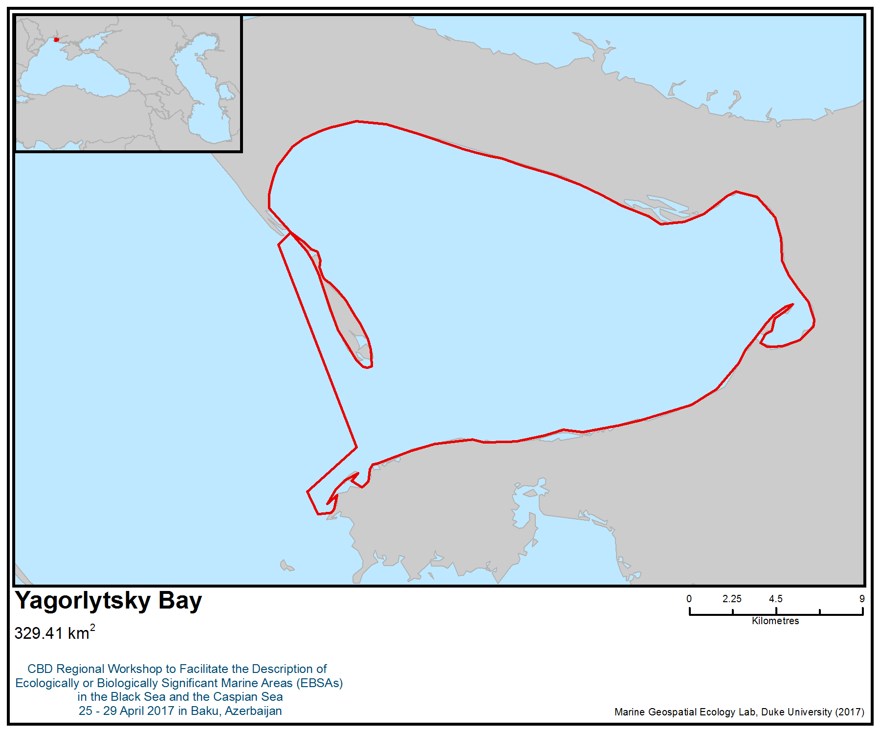
Figure 1. Area meeting the EBSA criteria

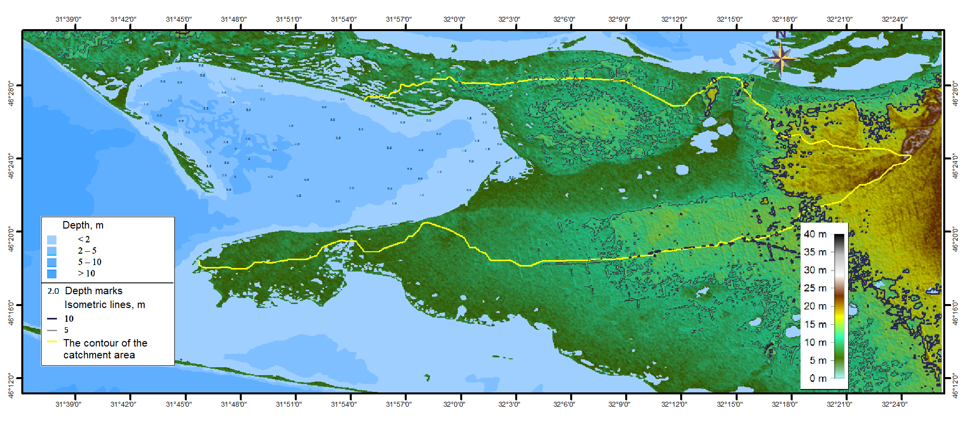
Figure 2. Hydrological and morphometric features of Yagorlytsky Bay (Minicheva, Sokolov and Shvets, 2016)

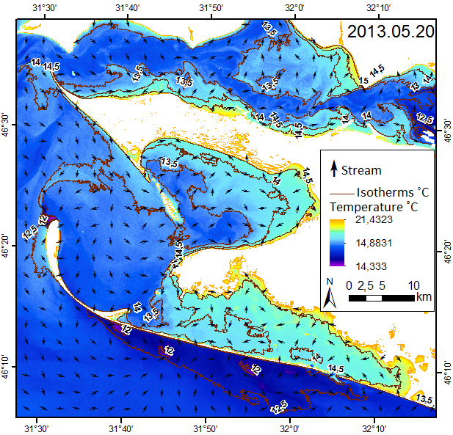
Figure 3. The distribution of surface temperature and surface currents in the water area of Yagorlytsky Bay on 05/20/2013 (8:45:53) calculated based on satellite image Landsat 8 (compiled by E. Sokolov, Institute of Marine Biology NAS Ukraine)

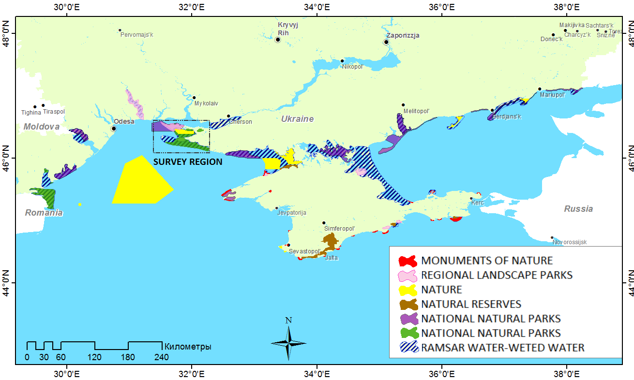
Figure 4. The bays in the Marine Protected Area of Ukraine (Compiled by E. Sokolov, Institute of Marine Biology NAS Ukraine)

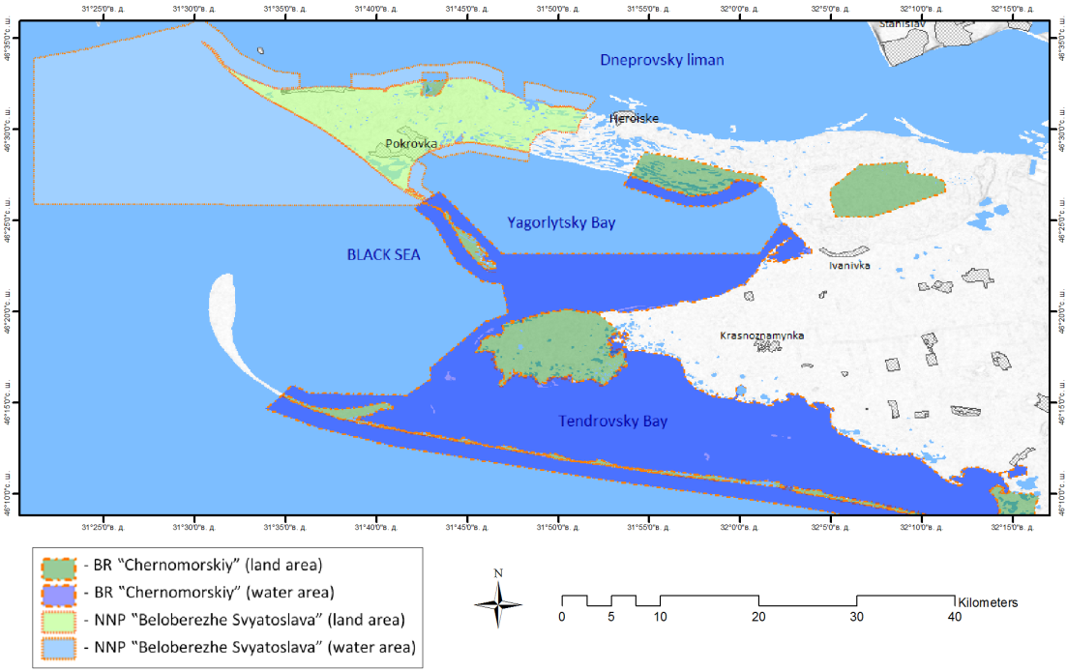
Figure 5. Aqua-coastal complex of Yagorlytsky Bay (Minicheva , Sokolov and Shvets 2016).

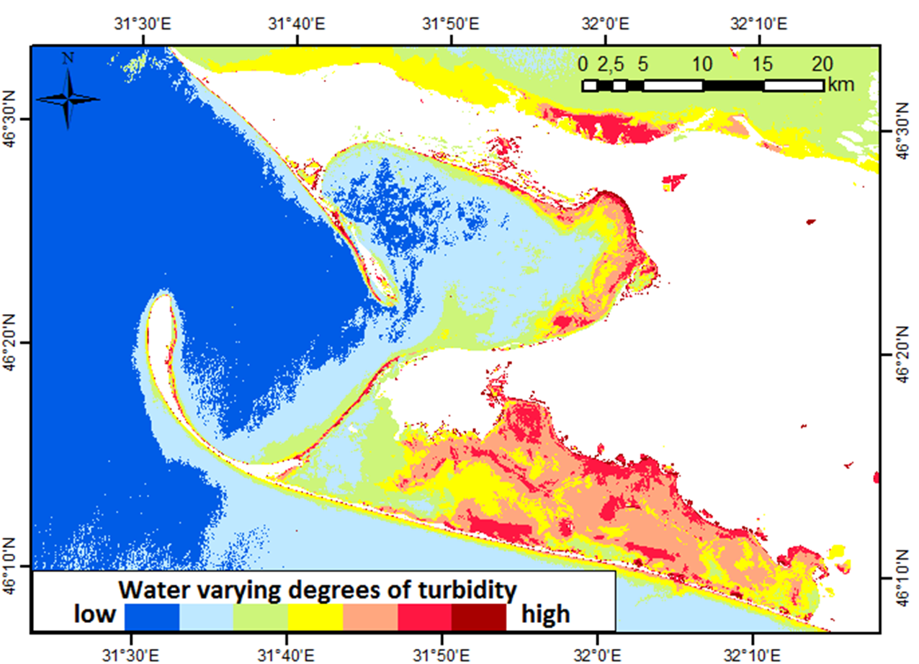
Figure 6. Layers of water turbidity because of decoding of satellite images Landsat 8 at the time of 24.08.2013 (Minicheva , Sokolov and Shvets, 2016)

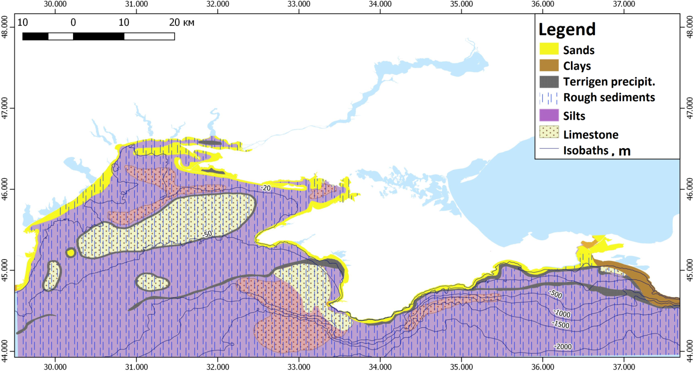
Figure 7. Scheme of propagation of real-genetic types of modern sediments in the north-western part of the Black Sea (Compiled by E. Sokolov, Institute of Marine Biology NAS Ukraine; Geology of the shelf of the Ukrainian SSR, 1985)

Figure 8. Scheme of the stations of the water areas of Yagorlytsky and Tendrovsky Bays according to the expedition of the IMB NASU in June 2013 (Minicheva et al., 2014; Minicheva , Sokolov and Shvets, 2016)

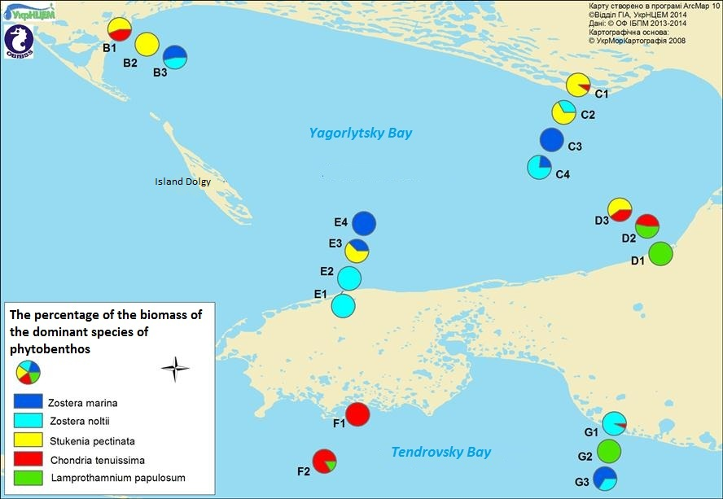
Figure 9. Distribution of macrophytobenthos dominants in Yagorlytsky Bay and north-western parts of Tendrovsky Bay based on the materials of the expedition of the IMB NASU in June 2013 (Minicheva et al., 2014)

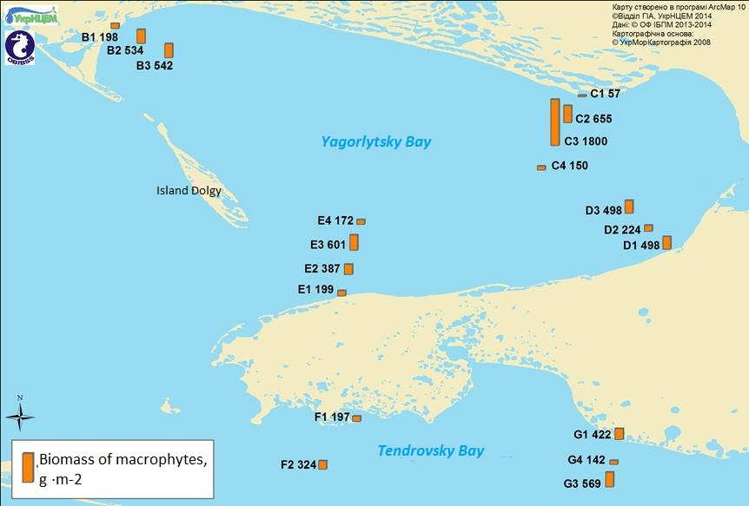
Figure 10. Distribution of macrophytobenthos biomass in Yagorlytsky Bay and north-western part of Tendrovsky Bay based on the materials of the expedition of the IMB NASU in June 2013 (Minicheva et al., 2014)

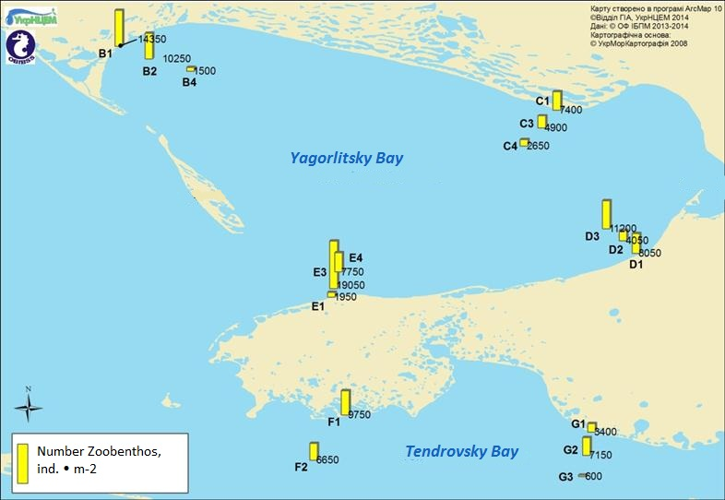
Figure 11. Distribution of macrozoobenthos at the stations of Yagorlytsky and Tendrovsky Bays based on the materials of the expedition of the Institute of Physics and Technology of the IMB NASU in June 2013 (Minicheva et al., 2014)

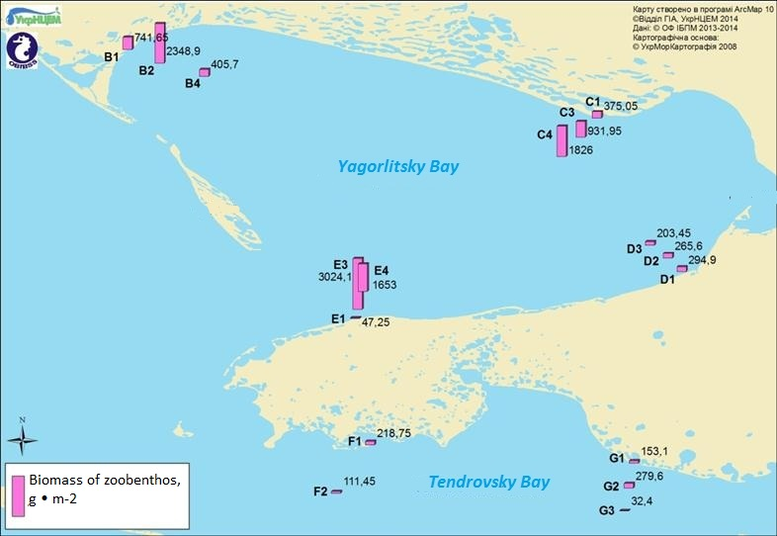
Figure 12. Distribution of the biomass of macrozoobenthos at the stations of Yagorlytsky and Tendrovsky Bays, based on the materials of the expedition of the IMB NASU in June 2013 (Minicheva et al., 2014)

Figure 13. Spatial characterization of structural and functional organization of the ground vegetation of Yagorlytsky Bay in June 2013 (Minicheva et al., 2016)

Figure 14. The spatial distribution of ecological status class (ESC) in the waters of Yagorlytsky Bay and north-western part of Tendrovsky Bay (Minicheva, Sokolov and Shvets, 2016)

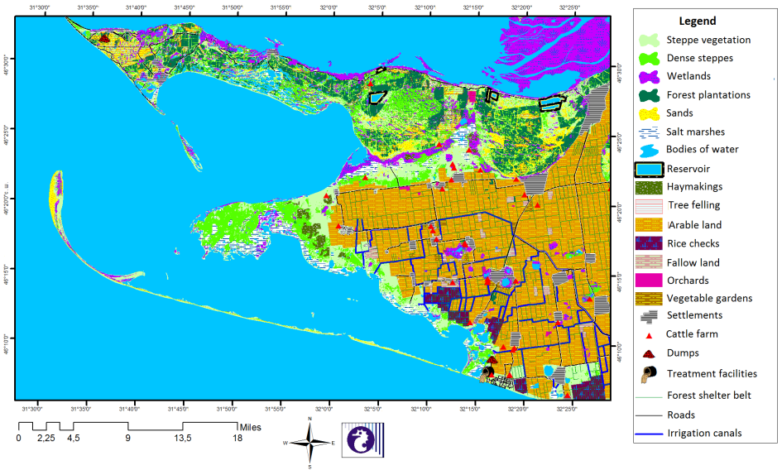
Figure 15. Landscape and anthropogenic structure of the catchment area of Yagorlytsky and Tendrovsky bays (Minicheva et al., 2016)

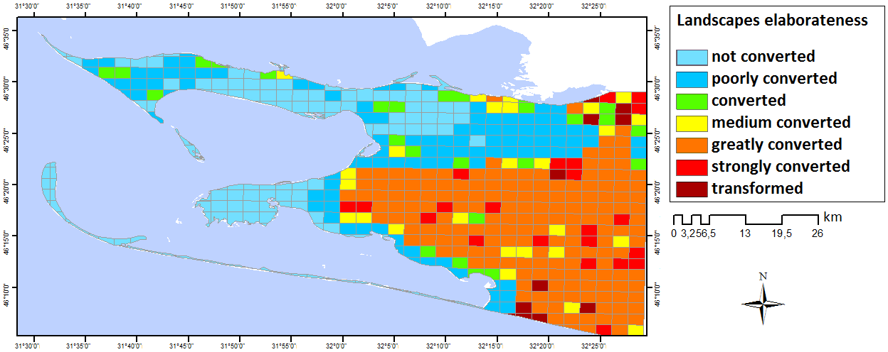
Figure 16. Spatial distribution of the coefficient of anthropogenic transformation of the catchment area and the surrounding area of Yagorlytsky Bay (Minicheva et al., 2016)

Figure 17. Spatial distribution of the population on the catchment area and the surrounding area of Yagorlytsky Bay (Minicheva et al., 2016)
Table 1. Hydrological and morphometric characteristics of Yagorlytsky Bay (Minicheva et al., 2014)
Characteristic | Symbol | Dimension | Value
Water volume | V | 10⁶ m³ | 849,240
Water surface area | F | km² | 303,300
Area of the catchment area | F_{c} | km² | 450,000
Average depth | H_{av} | m | 2,700
Maximum depth | Н_{max} | m | 6,000
Average width of the water area | B_{w} | km | 11,700
Length of the water area | L | km | 26,000
Length of shoreline | L' | km | 69,200
Cross-sectional area of the strait | S | km² | 0,019
Average long-term speed of sea water flows across the strait | U | cm·s⁻¹ | 5,000
Average annual flow of sea water across the strait | Q | m³·с⁻¹ | 950,000
Average annual volume of the seawater flow through the strait | W_{s} | 10⁶ m³ | 14446,080
Table 2. Combined limnovological characteristics of Yagorlytsky Bay (Minicheva et al., 2016)
Characteristic | Symbol | Value*
Specific catchment area | ΔF = F_{c}/F | 1,48
Coefficient of winding coastline | µ = L'/2π√F | 1,12
Coefficient of capacity | С = H_{max}/Н_{av} | 0,5
Depth coefficient | k_{H} = H_{av}/³√S | 0,41
Coefficient of elongation | k_{L} = L/B_{av} | 1,92
Conditional water exchange with the sea | D_{s} = W_{s}/V | 17
*all characreristics are dimensionless quantity

Table 3. Comparative characteristics of qualitative composition and quantitative indices of macrozoobenthos (N - mean number, ind∙m⁻², B - average biomass, g∙m⁻², P - occurrence, %) of Yagorlytsky and Tendrovsky bays in June 2013 (Minicheva et al., 2014)
Taxon | Yagorlytsky Bay |  |  | Tendrovsky Bay
Taxon | N | B | Р, % | N | B | Р, %
Spongia
Spongia g. sp. | + | 5,417 | 33,3 | - | - | -
Coelenterata
Actinia equina (L.) | 208,3 | 14,517 | 66,7 | 10,0 | 1,900 | 20,0
Actinothoe clavata (Ilmoni) | 4,2 | 0,208 | 8,3 | - | - | -
Vermes
Turbellaria g. sp. | 45,8 | 0,338 | 33,3 | 10,0 | 0,260 | 20,0
Nemertini g. sp. | 16,7 | 0,238 | 25,0 | - | - | -
Phyllodoce tuberculata Bobretzky | 91,7 | 0,533 | 50,0 | 40,0 | 0,240 | 40,0
Phyllodoce nana Saint-Joseph | - | - | - | 10,0 | 0,010 | 20,0
Eteone picta Quatrefages | 8,3 | 0,050 | 8,3 | - | - | -
Harmothoe imbricata (L.) | 150,0 | 0,521 | 75,0 | - | - | -
Harmothoe reticulata Claparede | 58,3 | 0,054 | 16,7 | - | - | -
Glycera tridactyla Schmarda | 216,7 | 2,621 | 91,7 | 60,0 | 0,160 | 40,0
Nereis zonata Malmgren | 12,5 | 0,163 | 16,7 | 10,0 | 3,430 | 20,0
Perinereis cultrifera (Grube) | 25,0 | 3,092 | 25,0 | - | - | -
Nephtys hombergii Savigny | 29,2 | 1,329 | 41,7 | 240,0 | 9,250 | 100,0
Staurocephalus kefersteini McIntosh | 16,7 | 0,013 | 16,7 | - | - | -
Nerinides tridentata Southern | 25,0 | 0,467 | 33,3 | 40,0 | 1,090 | 20,0
Spio filicornis (O.F.Muller) | 4,2 | 0,004 | 8,3 | 10,0 | 0,010 | 20,0
Prionospio cirrifera Wiren | 20,8 | 0,025 | 16,7 | - | - | -
Heteromastus filiformis Claparede | 79,2 | 0,117 | 8,3 | 50,0 | 0,150 | 40,0
Capitella capitata (Fabricius) | 8,3 | 0,008 | 16,7 | - | - | -
Leiochone clypeata Saint-Joseph | 108,3 | 3,513 | 41,7 | 510,0 | 28,450 | 80,0
Pectinaria koreni Malmgren | 37,5 | 11,513 | 41,7 | 10,0 | 0,100 | 20,0
Melinna palmata Grube | 266,7 | 7,429 | 25,0 | 20,0 | 0,730 | 20,0
Polycirrus sp. | 4,2 | 0,054 | 8,3 | - | - | -
Amphitrite gracilis (Grube) | 4,2 | 0,050 | 8,3 | - | - | -
Oligochaeta g. sp. | 50,0 | 0,021 | 25,0 | - | - | -
Tentaculata
Phoronis euxinicola Saint-Long. | 112,5 | 0,213 | 33,3 | - | - | -
Mollusca
Lepidochitona cinerea (L.) | 33,3 | 0,179 | 16,7 | - | - | -
Rissoa splendida Eichwald | 4,2 | 0,267 | 8,3 | - | - | -
Hydrobia acuta (Draparnaud) | 75,0 | 0,142 | 16,7 | - | - | -
Bittium reticulatum (Costa) | 112,5 | 4,383 | 58,3 | - | - | -
Retusa truncatella (Locard) | 4,2 | 0,108 | 8,3 | - | - | -
Cylichnina strigella (Loven) | - | - | - | 10,0 | 0,120 | 20,0
Mytilaster lineatus (Gmelin) | 1862,5 | 192,763 | 91,7 | 190,0 | 17,600 | 80,0
Lucinella divaricata (L.) | 8,3 | 0,225 | 8,3 | - | - | -
Loripes lucinalis (Lamarck) | 504,2 | 91,225 | 91,7 | 620,0 | 42,360 | 80,0
Mysella bidentata (Montagu) | 12,5 | 0,042 | 8,3 | - | - | -
Cerastoderma glaucum Poiret | 25,0 | 20,608 | 33,3 | 10,0 | 6,800 | 20,0
Cerastoderma lamarcki lamarcki (Reeve) | 4,2 | 28,333 | 8,3 | - | - | -
Parvicardium exigium (Gmelin) | 120,8 | 14,292 | 66,7 | 60,0 | 6,660 | 80,0
Irus irus (L.) | 183,3 | 380,850 | 41,7 | - | - | -
Polititapes aurea (Gmelin) | 12,5 | 18,100 | 8,3 | - | - | -
Abra ovata (Philippi) | 8,3 | 0,063 | 8,3 | - | - | -
Gastrana fragilis (L.) | 87,5 | 111,183 | 33,3 | - | - | -
Fabulina fabula (Gronovius) | 75,0 | 9,129 | 25,0 | - | - | -
Crustacea
Balanus improvisus Darwin | 66,7 | 1,575 | 41,7 | - | - | -
Brachinotus sexdentatus Risso | 16,7 | 13,917 | 25,0 | - | - | -
Gastrosaccus sanctus (Van Beneden) | - | - | - | 10,0 | 0,040 | 20,0
Iphinoe maeotica (Sowinskyi) | 20,8 | 0,017 | 25,0 | - | - | -
Iphinoe tenella G.O.Sars | 58,3 | 0,046 | 50,0 | 60,0 | 0,070 | 3
Sphaeroma pulchellum (Colosi) | 125,0 | 1,017 | 41,7 | 40,0 | 1,100 | 40,0
Idotea baltica basteri Audouin | 237,5 | 1,400 | 58,3 | 50,0 | 0,240 | 60,0
Synisoma capito (Rathke) | 29,2 | 0,917 | 16,7 | 10,0 | 0,180 | 20,0
Ampelisca diadema A.Costa | 1579,2 | 3,317 | 91,7 | 2970,0 | 4,950 | 80,0
Perioculoides longimanus (Bate et Westwood) | 4,2 | 0,008 | 8,3 | 10,0 | 0,010 | 20,0
Gammarus aequicauda Mart. | 16,7 | 0,308 | 25,0 | 20,0 | 0,380 | 40,0
Melita palmata (Montagu) | 41,7 | 0,083 | 8,3 | - | - | -
Dexamine spinosa (Montagu) | 16,7 | 0,017 | 8,3 | - | - | -
Orchestia montagui Audouin | 8,3 | 0,029 | 16,7 | - | - | -
Microdeutopus gryllotalpa A. Costa | 558,3 | 0,471 | 50,0 | 290,0 | 0,300 | 80,0
Microprotopus minutus Sowinskyi | 4,2 | 0,004 | 8,3 | - | - | -
Amphithoe vaillanti Lucas | 16,7 | 0,042 | 16,7 | 50,0 | 0,180 | 40,0
Erichthonius difformis M. – Edwards | 95,8 | 0,046 | 33,3 | 30,0 | 0,030 | 40,0
Corophium bonelli (M. – Edwards) | 100,0 | 0,079 | 33,3 | 20,0 | 0,040 | 20,0
Tunicata
Botryllus schlosseri (Pallas) | + | 0,333 | 8,3 | - | - | -
Molgula euprocta Drasche | 20,8 | 61,750 | 33,3 | 40,0 | 32,220 | 20,0
Insecta, larvae
Chironomus sp. | 4,2 | 0,025 | 8,3 | - | - | -
Total | 7758,3 | 1009,796 |  | 5510,0 | 159,060

Table 4. Comparative characteristic of marine species in the Black Sea (BS) and Yagorlytsky Bay (YB) (Zaitsev and Mamaev, 1997; Minicheva et al., 2014; Sinegub, 2006; Tkachenko, 2012b)
Organism | Total number |  |  | Red Data Book
Organism | BS | YB | % | BS | YB | %
Macrophytes | 332 | 27 | 8 | 6 | 2 | 33
Invertebrates | 2000 | 104 | 5 | 45 | 3 | 7
Fish | 180 | 88 | 49 | 43 | 24 | 56
TOTAL | 2612 | 219 | 9 | 94 | 29 | 31

Table 5. Assessment of the Nature Resistance Index (NRI) of Yagorlytsky Bay according to field research data in June 2013 (Minicheva , Sokolov and Shvets, 2016)
Morphofunctional state bottom vegetation |  |  |  | Nature Resistance Index |  |  | AFI
EEI | Value EEI | EOR | ESC | NRI | EOR | ESC | AFI
Ecological activity of three dominates (S/W_{3Dp}) m²·kg⁻¹ | 12,5 | 0,89 | High | 0,835 | 0,98 | High | 0
Average ecological activity of species (S/W) m²·kg⁻¹ | 43,3 | 0,96 | High
Phytocenosis surface index (SI_{s}) units | 5,09 | 0,97 | High

Area No. 9: Kuban Delta

Abstract
The Kuban Delta is the second-largest delta ecosystem in the Black Sea – Sea of Azov Basin (1920 km²). It includes more than 600 water bodies with different hydrological regimes. Many waterbirds utilize the coastal wetlands and estuaries of the delta as stopover areas during spring and autumn migrations. The area overlaps with a marine Important Bird and Biodiversity Area and is an important international wetland, designated as a Ramsar site. It is important for the vulnerable Dalmatian pelican (Pelecanus crispus). The Kuban Delta is undergoing continuous change under the influence of both natural and anthropogenic factors.

Introduction
The Kuban Delta is the second-largest delta ecosystem in the Black Sea – Sea of Azov Basin (1920 km²). It includes more than 600 water bodies with different hydrological regimes (Krivenko, 1999). Sands and shell limestone containing the remains of Cerastoderma glauca shells are found in the coastal area. Many waterbirds utilize the coastal wetlands and limans of the delta as stopover areas during spring migrations. The migration starts in February-March, and the total number of migrating birds is estimated at 1.2 to 2 million individuals. It is an important international wetland, designated as a Ramsar site. The area overlaps with a marine Important Bird and Biodiversity Area (IBA; BirdLife International 2017a), designated primarily for its importance for the vulnerable Dalmatian pelican (Pelecanus crispus), and as an area of global or regional importance for six other aquatic species. Flora of the delta estuary includes 103 water plant species (81 species of flowering plants, 20 species of algae, one species of ferns and one horsetail) (Shekhov, 1971). There are 60 species of fish in the Kuban Delta. The bird fauna includes 192 species (Complex ecological survey…, 2014). The area of the Delta has been largely drained and converted into agricultural land during recent decades. As a result, there are two major ecosystems: (1) anthropogenic: reservoirs, rice fields, and (2) natural: a system of foredelta, salt lakes, deltaic freshwater and brackish water bodies, coastal shallows and lagoons (Krivenko, 1999). The Kuban estuaries gradually become silted and shallow. The hydrological regime and the water balance of the Azov-Kuban estuaries currently depend mainly on the delta climate, the water content of the Kuban River, the water regime of the Azov Sea and the regulation of the water regime (Rumyantsev et. al., 2015).

Location
The area is located at 45°30'N 37°48'E. The southern border of the site lies along the shore of Kurchansky Liman (estuary), embraces the Kuban Delta and reaches the Sea of Azov. To the west and north, the borderline extends along the coast of the Sea of Azov and reaches the middle point of Akhtarsky Liman.

Feature description of the area
The Kuban Delta is the second-largest delta ecosystem in the Black Sea – Sea of Azov Basin (173000 ha) after the Danube Delta. It includes more than 600 water bodies with different hydrological regimes (Krivenko, 1999). More than half of them have a water surface measuring 50 to 500 hectares. The morphology of waterbodies is very diverse. They are connected with each other and with the Sea of Azov by narrow straights (girlos and eriks). Most water bodies have flat coasts, overgrown with hydrophilic vegetation — mostly reeds (Phragmites australis) (Beluchenko, 2005). Sands and shell limestone containing the remains of Cerastoderma glauca shells are found in the coastal area. It is an important international wetland that has been designated a Ramsar Site (Ramsar Site: 674 – Kuban Delta: Group of limans between the Kuban and Protoka rivers (Ramsar List, 2017).

The area has a mild climate influenced by two atmospheric circulation patterns: the northeastern (continental) and south-western (marine). The ice period lasts 30-102 days. The thickness of the ice cover reaches 50 cm in cold winters with an average of 25-30 cm (Krivenko, 1999).

Zooplankton and phytoplankton communities in the area are productive. The biomass of zooplankton (rotifers, copepods and cladoceres) varies in time and space (0.1g / m³ – 9.2 g / m³). Phytoplankton biomass ranges from 0.2 to 100.4 g / m³). The transition waterbodies are more productive. The fish fauna is rather diverse, comprising 65 fish species. Of these, eight species are rare or endangered (Krivenko, 1999). Floral inventories of the Kuban Delta list more than 700 plant species. More than 100 plant species are found in the Delta limans (estuaries), including 81 species of flowering plants, 20 species of algae, one species of fern and one species of horsetail. Four groups of types and 10 phytocoenosis types of estuaries have been distinguished (Shekhov 1971).

Many waterbirds use the coastal wetlands and limans of the delta as a stopover area during spring migration. The migration starts in February-March, and the total number of migrating birds is estimated at 1.2 to 2 million individuals. The total number of water birds migrating through the area in autumn is estimated at approximately 1.5 to 2.1 million individuals. In the years when the autumn-winter season begins with a cold spell, the birds pass through the area relatively quickly. This wetland is the breeding area for 46 water bird species, and 0,15 to 0,5 million individuals overwinter there (Krivenko, 1999).

The area overlaps with a marine Important Bird and Biodiversity Area (IBA; BirdLife International 2017a), designated primarily for its importance for the vulnerable Dalmatian pelican (Pelecanus crispus), and as an area of global or regional importance for another six aquatic species, including the Pallas's gull (Larus ichthyaetus), Caspian tern (Hydroprogne caspia), whiskered tern (Chlidonias hybrid) and Sandwich tern (Thalasseus sandvicensis). The site holds regularly more than 30,000 waterbirds during migratory seasons (BirdLife International 2017a).

The area is one of the habitats of rare and endangered bird species listed on the IUCN Red List of Threatened Species (IUCN) and Red Data Book of the Russian Federation (RDBRF), including (Krivenko, 1999):
Nesting species
Dalmatian pelican (Pelecanus crispus) (IUCN RL: VU)
Eurasian spoonbill (Platalea leucorodia) (RDBRF: 2)
Glossy ibis (Plegadis falcinellus) (RDBRF: 3)
Common stilt (Himantopus himantopus) (RDBRF: 3)
Pied avocet (Recurvirostra avosetta) (RDBRF: 3)
White-headed duck (Oxyura leucocephala) (IUCN RL: EN)
White-eyed pochard (Aythya nyroca) (RDBRF: 2)
Pygmy cormorant (Phalacrocorax pygmaeus) (RDBRF: 2)
Migrating species
Great white pelican (Pelecanus onocrotalus) (RDBRF: 1)
Wintering species
Red-breasted goose (Branta ruficollis) (IUCN RL: VU)

Feature condition and future outlook of the area
The Kuban Delta is undergoing continuous change under the influence of both natural and anthropogenic factors. The area of the Delta has been largely drained and converted into agricultural land in recent decades. As a result, there are two major ecosystems: (1) anthropogenic: reservoirs, rice fields, and (2) natural: a system of foredelta, salt lakes, deltaic freshwater and brackish water bodies, coastal shallows and lagoons (Krivenko, 1999). The construction of hydrological systems on the Kuban River since 1948 and thereafter has led to complete regulation of its runoff. The hydrological regime of the site is subject to cyclic changes at intervals of 3, 5, 8 and 12 years (Borisov, 1978).

The Kuban River receives annually up to 0.3 km³ of poorly cleaned housing and communal and industrial wastewater. Pollution by oil products and heavy metals is especially harmful for these ecosystems (Krivenko, 1999).

The coast is a resort area. The sewage load is low, but will increase with time in correlation with tourism development.

The Kuban estuaries gradually become silted and shallow. The hydrological regime and the water balance of the Azov-Kuban estuaries currently depend mainly on the delta climate, the water content of the Kuban River, the water regime of the Azov Sea and the regulation of the water regime (Rumyantsev et. al., 2015).

Assessment of the area against CBD EBSA Criteria
CBD EBSA Criteria  (Annex I to decision IX/20) | Description  (Annex I to decision IX/20) | Ranking of criterion relevance  (please mark one column with an X)
CBD EBSA Criteria  (Annex I to decision IX/20) | Description  (Annex I to decision IX/20) | No information |  | Low |  |  | Medium |  | High
Uniqueness or rarity | Area contains either (i) unique (“the only one of its kind”), rare (occurs only in few locations) or endemic species, populations or communities, and/or (ii) unique, rare or distinct, habitats or ecosystems; and/or (iii) unique or unusual geomorphological or oceanographic features. |  |  |  |  |  | X
Explanation for ranking
The Kuban Delta is the second-largest delta ecosystem in the Black Sea – Sea of Azov basin (173000 ha). It includes more than 600 water bodies with different hydrological regimes. The total number of migrating birds is estimated at 1.2 to 2 million individuals (Krivenko, 1999).
Special importance for life-history stages of species | Areas that are required for a population to survive and thrive. |  |  |  |  |  |  |  | X
Explanation for ranking
The Kuban Delta is important as a spawning and nursery ground for a number of semi-anadromous species, such as common bream (Abramis brama), Azov roach (Rutilus heckelii) and pike perch (Sander lucioperca), as well as anadromous fishes, such as sturgeons, which are now all considered endangered (IUCN).

This is one of the most important bird migration stopovers (annually about 1.5 – 2 million birds both in spring and in autumn) for waterfowl nesting in Eastern Europe and western Siberia and overwintering in the Mediterranean and Black Sea coasts, Asia Minor and Africa (Krivenko, 1999).

The area overlaps with a passage area of global importance for the vulnerable Dalmatian pelican (Pelecanus crispus), and for other species such as the Pallas's gull (Larus ichthyaetus), Caspian tern (Hydroprogne caspia) and the Sandwich tern (Thalasseus sandvicensis). It is also important for the breeding populations of whiskered tern Chlidonias hybrida (BirdLife International 2017). The area is used as a stopover during the migratory periods by more than 30,000 waterbirds (BirdLife International 2017a).
Importance for threatened, endangered or declining species and/or habitats | Area containing habitat for the survival and recovery of endangered, threatened, declining species or area with significant assemblages of such species. |  |  |  |  |  | X
Explanation for ranking
Historically, the area has been extremely important for migration, feeding, nursery and spawning of Azov sturgeons, Russian sturgeon (Acipenser gueldenstaedtii) (IUCN:CR) and starry sturgeon (Acipenser stellatus) (IUCN:CR). Currently, the population is extremely depleted, and the Kuban hatchery is maintaining a breeding stock in their facilities that may be used for restocking population (Chepurnaya, 2017).

A globally threatened seabird species listed as vulnerable by IUCN is known to occur in the area (BirdLife International 2017b) – the vulnerable Dalmatian pelican (Pelecanus crispus). This species is also listed in CITES Appendix I and CMS Appendices I and II. The area also overlaps with the distribution range of other vulnerable species, the horned grebe (Podiceps auritus) (BirdLife International 2017b). All these species are also included on Annex I of the EU Birds Directive.
Vulnerability, fragility, sensitivity, or slow recovery | Areas that contain a relatively high proportion of sensitive habitats, biotopes or species that are functionally fragile (highly susceptible to degradation or depletion by human activity or by natural events) or with slow recovery. |  |  |  |  |  | X
Explanation for ranking
The area is important to the vulnerable Dalmatian pelican (Pelecanus crispus), a long-lived species with late sexual maturity that occurs in the area (BirdLife International 2017c; BirdLife International unpublished data; Eliot et al., 2017).
Biological productivity | Area containing species, populations or communities with comparatively higher natural biological productivity. | X
Biological diversity | Area contains comparatively higher diversity of ecosystems, habitats, communities, or species, or has higher genetic diversity. |  |  |  |  |  |  |  | X
Explanation for ranking
Flora of the delta estuary includes 103 water plant species (81 species of flowering plants, 20 species of algae, one species of fern and one horsetail) (Shekhov,1971) There are 60 species of fish in the Kuban Delta. The bird fauna includes 192 species (Complex ecological survey…, 2014).
Naturalness | Area with a comparatively higher degree of naturalness as a result of the lack of or low level of human-induced disturbance or degradation. |  |  |  |  | X
Explanation for ranking
At the end of the 19th century and, especially, in the 1930s, the development of irrigated agriculture began in the Delta, and a great number of wetlands were transformed into polders and fish ponds. Large adjusting marshy areas were turned into rice fields. A distinguishing feature of fish ponds is that they are surrounded by high coast and do not have shallows. Diversions of water from the natural wetlands to irrigation canals have altered their hydrological regime so that it becomes asynchronous to the natural one (Gineev, 1985, 1989).

The sea coast is used as a resort area. The sewage loads is low, but will increase with time in correlation with tourism development. The main pressure includes water intake in the Kuban River; canal construction, changing the hydrological regime of limans; reed fires; fishing and hunting. The Kuban estuaries gradually become silted and shallow. The hydrological regime and the water balance of the Azov-Kuban estuaries currently depend mainly on the delta climate, the water content of the Kuban River, the water regime of the Azov Sea and the reclamation activities (Rumyantsev et al., 2015).

References
Belyuchenko I.S. 2005. Ecology of the Kuban. Krasnodar: KubGAU.
BirdLife International, 2017a. Important Bird Areas factsheet: Delta of the Kuban' river. Downloaded from http://datazone.birdlife.org/site/factsheet/delta-of-the-kuban-river-iba-russia-(european)/details on 26/04/2017.
BirdLife International. 2017b. IUCN Red List for birds. Downloaded from http://www.birdlife.org on 26/04/2017.
BirdLife International. 2017c. Important Bird Areas factsheet: Bandar Kiashar lagoon and mouth of Sefid Rud. Downloaded from http://datazone.birdlife.org/site/factsheet/bandar-kiashar-lagoon-and-mouth-of-sefid-rud-iba-iran-islamic-republic-of/details on 27/04/2017.
Borisov V.I. 1978. Rivers of the Kuban. Krasnodar: Publishing house.
Chepurnaya T.A. 2017. Data justifying Total Allowable Catch of aquatic biological resources in the internal marine waters and the territorial sea of the Russian Federation in the Black Sea. Sturgeons: Russian sturgeon, Starry sturgeon. Rostov on Don: AzNIRH. http://azniirkh.ru/wp-content/uploads/2017/03/AzNIIRH_Materialyi-ODU_osetrovyie.pdf
Complex ecological survey of the wetland area of the Akhtaro-Griven estuary system and a group of estuaries between the Kuban River and the River of the Eastern Azov Sea Protocol of the Krasnodar Territory, which justifies giving this territory or part of its legal status to a specially protected natural area of regional importance. Justification of the boundaries of wetlands. Stage 2. Krasnodar. DorStroyEngineering. 2014. 240 pp.
Elliott, A., Christie, D.A., Jutglar, F. & Kirwan, G.M. (2017). Dalmatian Pelican (Pelecanus crispus). In: del Hoyo, J., Elliott, A., Sargatal, J., Christie, D.A. & de Juana, E. (eds.). Handbook of the Birds of the World Alive. Lynx Edicions, Barcelona. (retrieved from http://www.hbw.com/node/52613 on 28 April 2017).
Gineev, A.M. 1985. Estimated numbers of furbearing animals in the Northern Caucasus. Pages 12-24 in Resources of Game Animals and Prognosis of Their Utilisation. Moscow.
Gineev, A.M. 1989. To the status and ecological changes in the environment of the Northern Caucasus Region, Kalmyk Republic and Astrakhan Oblast. Pages 312-319 in Environmental Problems in the Stavropol Region and Adjacent Areas. Conf. 4-6 Oct.1989. Stavropol.
Krivenko V. G. (ed.). 1999. Wetlands in Russia: Wetlands of international importance. – Wetlands International.
Rumyantsev VA, Drabkova VG and Izmaylova A.V. 2015. Lakes of the European part of Russia - SPb.: LEMA. - 392 pp.
Ramsar list. https://rsis.ramsar.org/ris/674. 2017
Shekhov, A.G. 1971. Flora and vegetation of the Kuban limans. Biology of inland waters. Inf.Biol. 10:24-29.

Maps and Figures

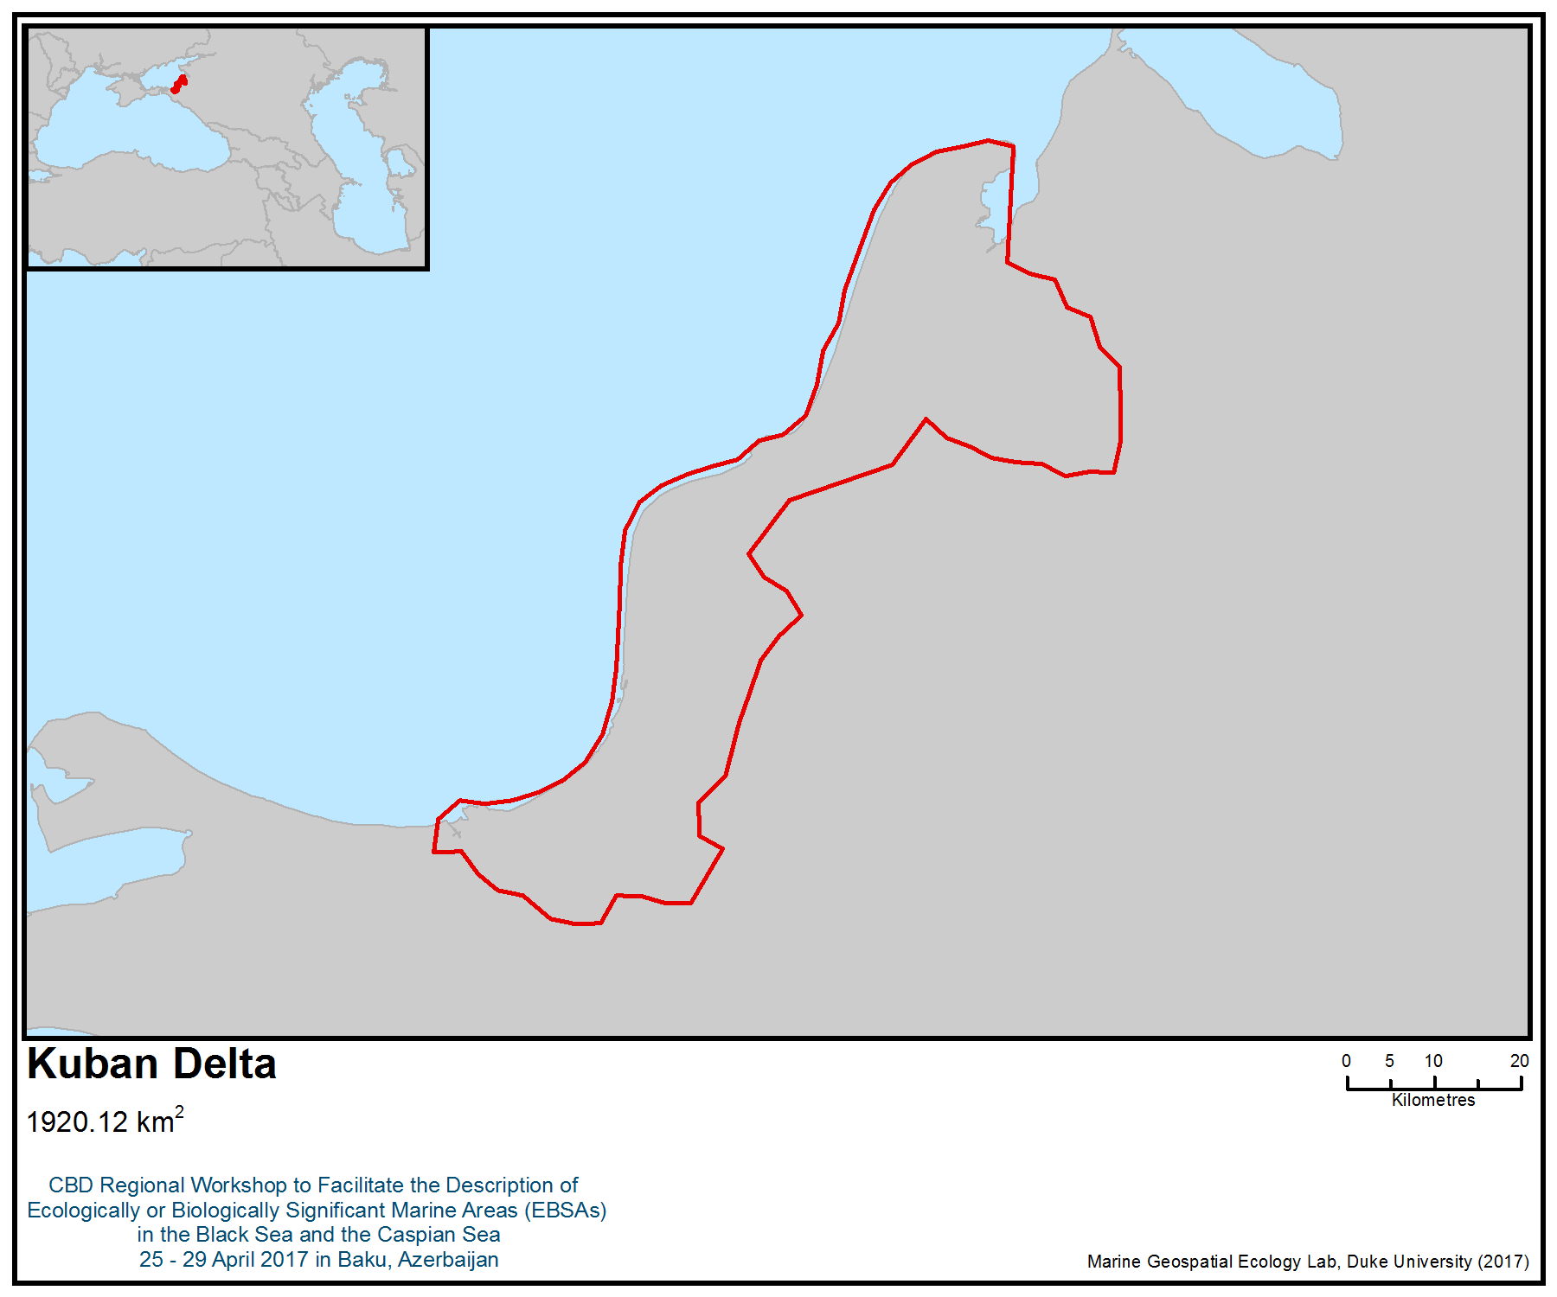
Figure 1. Area meeting the EBSA criteria
Area No. 10: Taman Bay and the Kerch Strait

Abstract
Taman Bay is a shallow semi-closed marine lagoon in the Sea of Azov with no constant source of river inflow. It is a unique sea area in the Russian Black Sea and Sea of Azov coast, with primary production depending on seagrasses. Biomass of bottom vegetation varies strongly and can exceed 5000 g/m² (wet weight), while the macrozoobenthos biomass is 1500 g/m². Up to 1 000 000 birds stop on the bay during seasonal migration. The Taman Bay wetland is a wintering area of many species of waterfowl. The site has a significant value as a place of reproduction of waterbird species listed in the Red Book of the Russian Federation and Krasnodar Province. The ecosystem of the Bay shows some resilience and maintains a quasi-stable regime. The adjacent Kerch Strait is an important migratory pathway for marine life, including various fish species as well as two cetacean species, harbour porpoises (Phocoena phocoena relicta) and bottlenose dolphins (Tursiops truncates ponticus).

Introduction
Taman Bay is a shallow semi-enclosed marine lagoon in the Sea of Azov with no constant source of river inflow. It is a unique sea area in the Russian Black Sea and Sea of Azov coast, with primary production depending on seagrasses. The northern, shallowest part of the bay (Dinskoj Bay) is an important wetland, listed as a candidate for the Ramsar Convention List (Krivenko, 2000) and an Important Bird and Biodiversity Area (Bukreev et al., 2009; BirdLife International, 2017). High anthropogenic pressure (pollution, eutrophication and hydrotechnical building) could lead to negative consequences to the bay ecosystem. On the other hand, the bay’s benthic species are mainly generalists with a wide range of tolerance to environmental factors; therefore, the ecosystem is resilient to the impacts (Nesis, 1956; Spiridonov et al., 2016). The Kerch Strait, with its intensive international shipping, has been designated as an important cetacean habitat by ACCOBAMS (Notarbartolo di Sciara and Birkun, 2010), as they enter through this narrow strait to feed in the Azov Sea but migrate from there to winter in the Black Sea.

Location
Taman Bay is a shallow bay of the lagoon type situated between the Sea of Azov and the Black Sea, lying to the north of the Taman peninsula. It opens to the Kerch Strait and is considered part of the Sea of Azov. The water area of the Kerch Strait is delimited by the line between the Cape Ahilleon on the coast of Taman Peninsula and Cape Hroni on the coast of the Kerch Peninsula in the north and by the line between Cape Panagia (mainland coast) and Cape Taqil (Kerch Peninsula coast) in the south. Taman Bay and the Kerch Strait are partly separated from each other by the spits Chushka and Tuzla (Marine Atlas, 1953). The whole water area measures 803 km². The shores of Taman Bay belong to the Temryuksky District of Krasnodar Krai.

Feature description of the area
Taman Bay and Kerch Strait are located in the area of humid subtropical climate (Cfa) of Köppen climate classification (Kottek et al., 2006; Peel et al., 2007; Ulbrich et al., 2012).

The bottom topography of the Kerch Strait is complex. It decreases from the centre towards the seas, with a narrow channel in the western part and a wide shallow water area with extensive accumulative formations in the eastern part. The main depths are between 2 m and 18 m. The main soft bottom substrates are: fine-grained sands with shell, pelite and aleurite muds, and silts with shell material and clay. In the Kerch Strait salinity varies from 10 ‰ in the north of the strait to 18 ‰ in the south (Golovkina and Nabozhenko, 2012).

The Strait plays an essential role in the hydrological and hydrochemical regime of the Azov-Black Sea basin. It is an important fishing area and shipping route. The currents of the Kerch Strait are mainly wind-driven. In addition to the wind, the circulation of water in the strait also depends on the difference in sea levels at the ends of the strait caused by surges and differences in the freshwater balance of the Black and Azov seas. The Kerch Strait freezes annually, but later than and not as much as the Sea of Azov. This is explained by the proximity of the Black Sea, from which the relatively warm Black Sea waters regularly penetrate the Strait (Eremeev et al, 2003).

A survey of the plankton community was conducted in 2010. The summer phytoplankton was represented by 135 species in the Kerch Strait. Diatoms (54 species) and dinoflagellates (57 species) dominated. Coccolithophorids (11 species), cyanobacteria (7 species), euglenas (4 species), and cryptomonads (2 species) were recorded everywhere. The phytoplankton biomass ranged from 248.1 to 3604.5 mg/m³. Thirty seven zooplankton species were recorded, comprising copepods (9 species), rotifers (5 species) and cladocerans (2 species). Zooplankton biomass averaged 329.8 mg/m3 (Sapozhnikov, et al., 2011). In 2010, 73 animal species were found in the macrozoobenthic communities of the Kerch Strait. Of these: polychaete - 22, crustaceans - 17, bivalve mollusks - 15, gastropod mollusks - 12, ascidians - 3 and one species of sponges, coelenterates, nemertines, etc. Mean biomass of zoobenthos amounted 197.6 g / m², number - 613.7 ind./m² (Fashhuk et al., 2012).

Taman Bay is a shallow marine basin without a permanent source of freshwater inflow. It covers an area of about 350 km². The maximum depth does not exceed 6 m; the prevailing depths are 4.6-4.8 m (Ignatov and Chistov, 2003). Taman Bay is partly isolated from the Kerch Strait by the Chushka spit and Tuzla spit (dam), and due to local currents (Nesis, 1956, Ovsienko et al., 2008) its water exchange with the surrounding sea is somewhat restricted. The Bay is divided into two parts by the shallow ridge (the former bay-bar) with mean depth equal to 1-2 m (Krylenko et al., 2017). This bar is an extension of the Rubanov Cape in the north and Markitantskaja Spit in the south. A partial isolation of the Bay and its shallowness are the factors determining its hydrological regime. The pattern of water circulation changed at least twice during the last hundred years (Ivanov et al., 2004). Five periods of recent ecological history of the Bay can be defined (Matishov et al., 2008):

- The Tuzla Spit was a natural barrier for Black Sea current entry to the Bay until 1925.
- From 1925 (after Tuzla spit destruction by a heavy storm) until the early 1950s.
- A high salinity and low euthrophication period during the early 1950s.
- A lower salinity period from 1956 to1975.
- A high salinity and low euthrophication period during the 1970s.
- A lower salinity period during 1980-2003.
- Present time after the Tuzla dam construction.

The contemporary water circulation pattern (after the dam construction) in the Bay is of predominately anticyclonic type (Ovsiyenko et al., 2008). It facilitates the accumulation of the suspended matter and pollutants in the central parts of the Bay. Salinity in the Bay is determined primarily by the direction of flow in the Strait (waterflow from Black Sea or Azov) and varies from 13 to 19 ‰ (Ovsiyenko et al., 2008; Al’tman, 1991). Taman Bay freezes over during cold winters and remains open during mild winter conditions. It is potentially a stagnant basin, especially in its eastern part, which is separated from the larger western part, characterized by greater hydrodynamic activity by the sill.

Taman Bay is situated at the Kerch-Taman mud volcanoes’ high activity area at the border of the Crimean and Caucasus orogeny zones. It is potentially an oil-and-gas-bearing area (Shnyukov, et al. 1986). The coast between the Tuzla Spit and the Taman village is characterized by abrasion-denudation relief, with cliffs of 15-30 m height. Yhe rest of the Bay is flat. The rare scarps situated near Sennoi and Garkushi villages are the historical remains of the ancient Greek cities Phanagoria and Patrasys, or denudation forms with soil slip. Taman Bay shore structures and seabed deposits consist of Quaternary sediments (Zenkovich, 1958; Ignatov, Chistov, 2003; Skiba et al., 1975). The main part of the Bays’ bottom is flat and consist of sandy mud with the remains of mollusk shells.

Taman Bay is a unique area in the Azov-Black Seas region of the Russian Federation due to dense and highly productive Zostera spp. seagrass meadows. Eelgrass, Z. marina, is the main primary producer of the Bay and the most important ecosystem engineer species. Biomass of bottom vegetation varies strongly and can exceed 5000 g wet w./m². The meadows are a spawning site for the various commercial and game fish species. The other main source of primary production is Phragmites sp, Stuckenia pectinata, Chara sp. The ultrashallow northern (Dinskoi Bay) and eastern shore zones of the Bay are vegetated by Phragmites sp. crops (Figure 2).

Bivalves and polychaetes are dominant macrozoobenthic groups in the Taman Bay and Kerch Strait. The most abundant species of macrozoobenthic assemblages are the bivalves Cerastoderma glaucum, Anadara kagoshimensis, Barnea candida, Mytilus galloprovincialis and Nephthys hombergii (Golovkina, Nabozhenko, 2012; Spiridonov et al., 2016). The macrozoobenthos biomass of Taman Bay ranges from 12 in Charales sp. shallow habitat to 1500 g/m² in Zostera sp. belt (Spiridonov et al., 2016; Kolyuchkina, unpubl.) The abundance varies from 15 at most shallow sites with nearly monospecies Hydrobia acuta assemblages to 60,000 spec/m² in ultrashallow habitat at reed (Phragmites sp.) wetlands along the eastern coast of the Chushka spit (Spiridonov et al., 2016).

Blood ark (Anadara kagoshimensis), an invasive bivalve (clam) species that occurs in Taman Bay and originates from the Western Pacific (Simakova et al., 2013). The other important Black Sea invaders, the bivalve predator whelk Rapana venosa and the comb jelly Mnemiopsis leidyi, appear not to be abundant in the Taman Bay (Golovkina, Nabozhenko, 2012; Spiridonov et al., 2016; Biryukova, 2016) in contrast to adjacent Kerch Strait (Fashuk et al., 2012) and Black Sea (Bondarev et al., 2013). This makes the Bay not only an important wetland, listed as a candidate for the Ramsar Convention List (Krivenko, 2000), but also a prospective area for comparative studies of alien species biology.

Up to 1 000 000 birds stop on the Bay during their seasonal migration (Krivenko, 2000). The Taman Bay wetlands are the wintering area of many species of waterfowl. Its importance increases during cold winters when the waters of the other wetlands and lakes of the Azov region freeze over. The number of waterfowl varied from 8 000 individuals (in 2005) to 49 500 indidivuals during a midwinter inventory (Tilba et al., 2006). During the previous period (1967-1972) the number of wintering waterbirds reached 250 000 individuals.

The area overlaps with a marine Important Bird and Biodiversity Area (IBA; BirdLife International 2017a), designated mainly for its importance as a wintering area for the vulnerable yelkouan ahearwater (Puffinus yelkouan). The yelkouan ahearwater is a Mediterranean endemic (BirdLife International, 2017b); some 30 to 40% migrate of the population migrate to the Black Sea during the non-breeding season. The importance of the area for this species was confirmed by studies based on tracking birds from their colonies (Raine et al. 2012, Péron et al. 2013, Seabird Tracking Database 2017), and also from studies of habitat suitability (Ortega & İsfendiyaroğlu 2017; Figure 4).

Taman Bay has significant value as a place of reproduction of waterbird species listed in the Red Book of the Russian Federation and Krasnodar territory: the common shelduck (Tadorna tadorna), oystercatcher (Haematopus ostralegus longipes), sea plover (Charadrius alexandrinus) and little tern (Sterna albifrons). On the islands along the inner part of the Chushka spit, large colonies of common cormorant (Phalacrocorax carbo) in total number of 750 pairs, of common tern (Sterna hirundo) - 300 pairs, Sandwich tern (Thalasseus sandvicensis) - 300 pairs (Tilba et al., 2006).

Taman Bay and the surrounding area are the habitat and wintering spot for a number of common, rare and protected species of birds, including (Tilba et al., 2006):
- Black-throated diver (Gavia arctica). Regular occurrence during migrations in small numbers in the winter.
- Oystercatcher (Haematopus ostralegus). Common breeding species; rare, irregular wintering species.
- Eurasian curlew (Numenius arquata). Regular occurrence in winter.
- Slender-billed gull (Larus genei). Regular occurrence during migration.
- Black-headed gull (Ichthyaetus ichthyaetus). Occasionally observed in winter.

The Kerch Strait is essentially a migration corridor connecting the Sea of Azov and the Black Sea. Every year massive migration of the Black Sea – Azov form of the Black Sea anchovy and several other fish species migrate to the productive feeding areas of the Sea of Azov from the Black Sea, starting in spring (Drozdov, 2011) while fish stocks return to the Black Sea in autumn. Fish migration is followed by the migration of harbour porpoises (Phocoena phocoena relicta) and bottlenose dolphins (Tursiops truncatus ponticus) (Savenko et al., 2013; Vishnyakova et al., 2013). A resident population or subpopulation of bottlenose dolphin (Tursiops truncatus) inhabits the water area of Taman and Dynskoy bays and Kerch Strait (Gladilina et al., 2016).

Feature condition and future outlook of the area
In the Black – Azov marine basin in general, climate change at a regional scale influences water circulation patterns, horizontal transfer and vertical mixing, pelagic and benthic ecosystem structure, biodiversity, biological production, and pollution level (Vinogradov et al., 2000; Llope et al., 2011). Climatic changes and shipping development facilitate alien species introductions, which in some cases become real invasions with far-reaching consequences (Bologa et al., 1995; Zaitsev and Oztürk, 2001). Geologically young ecosystems with low species diversity such as those in the Black Sea and the Sea of Azov are generally vulnerable to these changes.

However, the benthic ecosystem of the Kerch Strait and Taman Bay has not undergone dramatic changes (Golovkina, Nabozhenko, 2012) compared to the ecosystem of the Black Sea (Chikina and Kucheruk, 2005), Sea of Azov (Matishov et al., 2008) and the Kerch Strait (Panov et al., 2011; Fashuk et al., 2012). On a larger time scale, in spite of significant changes in climate, sea level and hydrological regime, the present dominant species in the benthic communities, such as Cerastoderma glaucum and Abra ovata, persisted over the last 6000 years (Fouache et al., 2005). It may be concluded that the Taman Bay ecosystem is characterized by a quasi-stable regime. As a result of periodical critical events, such as hypoxia, instead of a regime-shift, a change in the abundances of the species is observed, with a successful return to the initial state when the disturbance decreases (Nesis, 1956).

The area is under significant anthropogenic pressure: Tuzla dam construction and changes in hydrological regime during the 20th century due to the discharge control of the Don and Kuban rivers led to changes in currents of the Bay (Ovsienko et al., 2008; Matishov et al., 2008); the 2007 oil spill and constant local anthropogenic pollution (Belyaev et al., 2009) are dangerous for the birds and fishes, but benthic communities show a certain level of resistance (Spiridonov et al., 2016). The ecosystem of Taman Bay is vulnerable to particular impacts. Ship accidents and oil spills in the neighboring Kerch Strait have been shown to have a significant short term effect on the ecosystem even if a moderate portion of spill enters the Bay, as has happened after the Volgoneft 139 wrecking in 2007 (Kolyuchkina et al., 2012; Spiridonov et al., 2016). However, biodegradation of oil pollution was rapid (Sapozhnikov et al., 2013), and in 2009 no traces of oil spill were found.

Climate change (aridization) is also a prominent factor for the functioning of the Taman Bay ecosystem, but not as dramatically as for the Azov Sea (Matishov et al., 2008). Shipping in the adjacent Kerch Strait is the major actual and potential threat that includes permanent chronic pollution and fuel and hydrocarbon cargo spills, such as the MS Volgoneft 139 spill in November 2007 (Oil spill accident in the Kerch Strait, 2011; Kolyuchkina et al., 2012). This area is especially vulnerable to these impacts, as it is home to important biological phenomena, including aquatic bird stopovers and fish spawning sites. Water birds were particularly affected by the black oil spill resulting from the wrecking of the MS Volgoneft-139 in November 2007 (Matishov et al., 2013). Other threats include municipal discharges and growing tourism that may lead to increased nutrient loading.

Decline of the reed area will lead to changes in bird migration paths. Hydrotechnical construction, like the Tuzla dam or the Kerch Strait bridge, could lead to circulation changes in the Bay. The eutrophication, enrichment by organic carbon, increasing pollution load and/or changes in the hydrological regime of Bay waters could result, with potential for suffocation, siltification and degradation of Zostera meadows. This also could lead to changing fish migration paths, as fish will avoid Taman Bay.

Taman Bay had regional reserve status until about 2010. However, the project of upgrading the status to the federal level failed. Currently it has no legal protection status. However, part of the shores has a restricted access due to archeological excavations (on the mainland coast) or vicinity to Port-Kavkaz (in the Chushka Spit).

Assessment of the area against CBD EBSA Criteria

CBD EBSA Criteria  (Annex I to decision IX/20) | Description  (Annex I to decision IX/20) | Ranking of criterion relevance  (please mark one column with an X)
CBD EBSA Criteria  (Annex I to decision IX/20) | Description  (Annex I to decision IX/20) | No information |  | Low |  |  | Medium |  | High
Uniqueness or rarity | Area contains either (i) unique (“the only one of its kind”), rare (occurs only in few locations) or endemic species, populations or communities, and/or (ii) unique, rare or distinct, habitats or ecosystems; and/or (iii) unique or unusual geomorphological or oceanographic features. |  |  |  |  |  |  |  | X
Explanation for ranking
Taman Bay is a tectonically active area with a number of mud volcanoes. This makes the Bay a unique shallow water area for studies of biological processes associated with mud volcano activity and a valuable site for educational tourism.

Taman Bay is the only place on the Russian Azov and Black Sea coast where the eelgrass Zostera marina forms extensive meadows. Two invaders causing the ecosystem shifts in the Black and Azov seas benthic predator Rapana venosa and planctonic predator Mnemiopsis leidyi appear to be rare in Taman Bay (Golovkina and Nabozhenko, 2012; Spiridonov et al., 2016; Biryukova, 2016) in contrast to the adjacent Kerch Strait (Fashuk et al., 2012) and the Black Sea (Bondarev et al., 2013). This makes the Bay not only an important wetland, but also a prospective area for comparative studies of invasive alien species biology. Some rare species are present in the Bay: bivalve Loripes lucinalis and Irus irus (Golovkina and Nabozhenko, 2012). L. lucinalis, Zostera spp. and chaemotrophic bacteria form a unique three-component symbiosis (van der Heide et al., 2012). Some species known as endemic species of the Black Sea – Azov Basin are present in the Bay, i.e., polychaete Eteone picta (Kiseleva, 2004; Syomin, 2011).

The Kerch Strait is the only corridor connecting the Azov Sea and the Black Sea, which makes the migration of fish and cetaceans, such as harbour porpoises (Phocoena phocoena relicta) and bottlenose dolphins (Tursiops truncates ponticus) possible in spring and fall (Savenko et al., 2013; Vishnyakova et al., 2013).
Special importance for life-history stages of species | Areas that are required for a population to survive and thrive. |  |  |  |  |  |  |  | X
Explanation for ranking
Taman Bay is a critical habitat for eelgrass (Zostera marina), supporting abundant populations of this species, which is highly important for maintaining the coastal ecosystem. As a productive shallow area, the Bay plays an important role as a spawning and nursery area for several fish species.

The importance of Taman Bay for waterfowl has long been recognized. Up to one million birds stop over in the Bay during seasonal migrations. The Taman Bay wetlands are the wintering area of many species of waterfowl and some seabird species, such as gulls and cormorants. Its importance increases in cold winters when the other wetlands and lakes of the Azov region freeze over. According to midwinter censuses, the number of waterfowl has varied from 8 000 (in 2005) to 49 500 (Tilba et al., 2006). During the previous period (1967-1972) the number of wintering waterbirds reached 250 000. Wintering of some species is of particular importance: black-throated diver (Gavia arctica), Eurasian curlew (Numenius arquata) and slender-billed gull (Larus genei).

Significant colonies of the following species are found on the islands along the inner part of Chushka Spit: common cormorant (Phalacrocorax carbo) — 750 pairs; common tern (Sterna hirundo) — 300 pairs and Sandwich tern (Thalasseus sandvicensis) — 300 pairs (Tilba et al., 2006).

The role of the Kerch Strait as a migration corridor for several fish and most importantly for cetacean species of the Black Sea cannot be overestimated (see Uniqueness).

This is one of the most important areas in the world for the Yelkouan shearwater Puffinus yelkouan during the non-breeding season (Raine et al. 2012, Péron et al. 2013). Birds from different colonies located in the Mediterranean congregate here during the winter period (September to December), one of the most critical of the life-cycle of the species, when most of the mortality of adult birds (the major cause of the population decline) occurs (Oppel et al. 2011). Recent tracking studies have revealed that between 26% and 42% of the global population of the Yelkouan shearwaters migrate to this region (Raine et al. 2012, Péron et al. 2013, Seabird Tracking Database 2017). At-sea surveys and studies of habitat suitability have also revealed the importance of the area for the species as a non-breeding foraging site (Ortega and İsfendiyaroğlu 2017).

Newborn harbour porpoises have been found stranded in the southern coast of the Azov Sea, close to the Strait, which indicates that breeding occurs in the nearby water, possibly in the Strait as well (Vishnyakova et al. 2013).
Importance for threatened, endangered or declining species and/or habitats | Area containing habitat for the survival and recovery of endangered, threatened, declining species or area with significant assemblages of such species. |  |  |  |  |  | X
Explanation for ranking
This is an important nesting site for waterbird species listed in the Red Data Books of the Russian Federation and the Krasnodar Region: common shelduck (Tadorna tadorna), oystercatcher (Haematopus ostralegus longipes), sea plover (Charadrius alexandrinus) and little tern (Sterna albifrons) ( Tilba et al., 2006).

Some other endangered shore birds, including great black-headed gull (Ichthyaetus ichthyaetus) (Red Data Book of the Russian Federation) occur in the area in winter (Tilba et al., 2006). A globally threatened seabird species, yelkouan shearwater (Puffinus yelkouan), listed as vulnerable by IUCN, is known to occur in the area. The area also overlaps with the distribution range of another vulnerable species, the horned grebe (Podiceps auritus).

The Kerch Strait and Taman Bay are also important for the bottlenose dolphins and harbour porpoises, both of which are listed as endangered in the IUCN Red List (Birkun 2012, Birkun and Frantzis 2008, respectively).
Vulnerability, fragility, sensitivity, or slow recovery | Areas that contain a relatively high proportion of sensitive habitats, biotopes or species that are functionally fragile (highly susceptible to degradation or depletion by human activity or by natural events) or with slow recovery. |  |  |  |  |  | X
Explanation for ranking
The benthic ecosystem of Taman Bay appears to maintain a quasi-stable regime, owing to the dominance of species that are tolerant to a wide range of environmental characteristics (Nesis, 1956; Spiridonov et al., 2016). Their populations may decline in response to environmental stress but have a high potential to recover (Nesis, 1956; Kolyuchkina et al., 2016). Although the Taman Bay ecosystem shows some resilience capacity to eutrophication (see Naturalness) further increases in recreation and tourism may lead to higher nutrient load and a serious threat to water transparency and eelgrass meadows.

The vulnerable yelkouan shearwater is a long lived-species, with low fecundity rates and late sexual maturity. As such, the yelkouan shearwater is particularly vulnerable to factors increasing adult mortality rates, such as by-catch in fisheries and other at-sea threats, which are often the major causes of population decline (Anderson et al. 2011; Oppel et al. 2011).
Biological productivity | Area containing species, populations or communities with comparatively higher natural biological productivity. |  |  |  |  |  |  |  | X
Explanation for ranking
The bottom vegetation of Taman Bay and Dinskoy Bay is formed by highly productive dense meadows of Zostera spp. Stuckenia pectinata, Zannichellia sp., Ruppia sp., Lamprothamium papulosum and Chara spp. Only the Zostera marina L. meadows (inhabiting the depth range 2-3.5 m) are perennial. The biomass of eelgrass may be as high as 300 - 850 g dry w. /m² (ca. 3000-7000 g wet w. /m²) (Simakova, unpubl.). The biomass of shallow water (0.5 – 2 m depth) macrophyte communities of Taman Bay exceeds 300 g dry w. /m² in midsummer. This organic matter is produced annually during vegetation season and degrades in winter (Simakova, unpubl.). These rates correspond to the maximum of bottom vegetation biomass values of the Black Sea (Milchakova, 1999).
Biological diversity | Area contains comparatively higher diversity of ecosystems, habitats, communities, or species, or has higher genetic diversity. |  |  |  | X
Explanation for ranking
The total number of macrobenthic animal species found in Taman Bay in 2003-2013 comprised just 30% (Kolyuchkina et al., 2016) of the macrozoobenthic fauna (329 species) listed for the Sea of Azov (Volovik et al., 2010). The Bay and the Straight ecosystems include at least 16 biotopes types (Fig. 2, 3, Belyaev et al., 2009), and macrozoobenthic assemblages are distinguished by the abundance of particular species, and to a less extent by species composition (Kolyuchkina et al., 2016).
Naturalness | Area with a comparatively higher degree of naturalness as a result of the lack of or low level of human-induced disturbance or degradation. |  |  |  |  | X
Explanation for ranking
The shores of the Taman Bay have been populated since the Paleolitic. Starting in the sixth century BCE, the area was a centre of Greek colonization. The cities of Patrasis, Kepoi, Phanagoria and Hermonasa became important harbours and trading centres. Later they became part of the Kingdom of Bosporus, which was conquered by the Kingdom of Pontus — an important regional power until it was defeated by the then global power of Rome. After, as of 10 CE, the cities became its satellite states and a trade partners. As the main sediments of the Taman Peninsula shores are sand and clay, and natural limestone is limited to few spots (Fouache et al., 2005), the economies of these ancient civilizations created a unique seascape in Taman Bay, with nearly all hard substrates being of cultural origin, i.e., either ancient Greek stone constructions such as ancient piers (Kuznetsov, 2013), or pottery fragments or stone brought as ship ballast brought from the Crimean Peninsula. The civilization of most ancient cities on Taman Bay shores ended by the 9-10th century CE, but the town of Taman (formerly Hermonasa, subsequently known as Tamatarkha, Samkerts Tmutorokan, and Taman) persisted under the rule of Khazars, Russian princes, Genovese, Tatars, and finally the Ottoman Empire. However, until the region became part of the Russian Empire in late 18th century, the population was unstable. In the last two centuries Taman Peninsula has been an area of intensive agriculture, and later industrial development.

Currently the Bay is experiencing significant anthropogenic pressure. The main impact is related to the shoreline transformation, coastal protection and landscaping near the villages of Taman and Sennoi, Chuska spit and Tuzla spit. The hydrological regime of the Bay changed owing to the artificial enlargement of Tuzla spit. There is an agglomeration of towns and villages on the shores that leads to soil erosion and nutrient inflow into the Bay. Several settlements discharge their sewage and waste into the Bay. The Bay is situated near the oil trading port (Port-Kavkaz) and neighbours the Kerch strait, which has intensive shipping traffic. On the other hand the northern part of the Bay and the inner part of the Chushka spit includes reed (Phragmites spp.) crops and remains relatively undisturbed. Eelgrass meadows appear to be healthy. Although significant eutrophication is expected, summer nutrient concentrations in Taman Bay are lower than in the neighbouring Kerch Strait (Sapozhnikov et al., 2013), suggesting an effective mechanism of nutrient removal. Thus the ecosystem of the Bay shows some resilience capacity and a quasi-stable regime.

The Kerch Strait has been an area of intensive shipping for millennia and remains so in the present time. Vessels coming to the area are either passing the strait, are callingfor the Kerch sea port, waiting on anchor for passage or port calls in the southern part of the strait, loading oil cargo in the Port-Kavkaz terminal or trashipping oil cargo. This leads to numerous kinds of impact, including pollution, disturbance and strikes with marine mammals. Heavy winter storms, such as the one on 13 November 2007, may lead to catastrophic events, such as wrecking and oil spills (Oil Spill Accident in the Kerch Strait, 2011).

References
Al’tman E. N. 1991. Hydrodynamics of the Kerch Strait // Gidrometeorologiya i gidrokhimiya morey SSSR. – T. 4. –P. 291-324. [in Russian]
Anderson, O.R.J., Small, C., Croxall, J.P., Dunn, E.K., Sullivan, B.J., Yates, O. & Black, A., 2011. Global seabird bycatch in longline fisheries. Endangered Species Research 14: 91–106.
Belyaev N.A., G.A. Kolyuchkina, E.S. Shapovalova and U.V. Simakova. 2009. Investigations of long-term effects of November 2007 Kerch strait black oil spill // Proceedings of the ninth international conference on the mediterranean coastal environment. Volume 2. (editor - Erdal Ozhan). p. 1107 - 1112.
BirdLife International. http://www.birdlife.org. 2017.
BirdLife International, 2017a. Marine IBA e-atlas. Delivering sites networks for seabird conservation. Accessed from https://maps.birdlife.org/marineIBAs/default.html on 10/03/2017.
BirdLife International, 2017b. Species factsheet: Puffinus yelkouan. Downloaded from http://www.birdlife.org on 10/03/2017.
Birkun, A. 2012. Tursiops truncatus ssp. ponticus. The IUCN Red List of Threatened Species. http://dx.doi.org/10.2305/IUCN.UK.2012.RLTS.T133714A17771698.en.
Birkun Jr., A.A. & Frantzis, A., 2008. Phocoena phocoena ssp. relicta. The IUCN Red List of Threatened Species. http://dx.doi.org/10.2305/IUCN.UK.2008.RLTS.T17030A6737111.en.
Biryukova S. – 2016. – Macrozoobenthos communities of littoral part of the Azov sea Taman bay //Nauchnyy al'manakh stran Prichernomor'ya. №. 4 (8). P, 32-39.
Bologa A. S., Bodeanu N., Petran A., Tiganus V., Zaitsev Yu.P. 1995. Major modifications of the Black Sea benthic and planktonic biota in the last three decades // Bulletin de l'Institut océanographique, Musée océanographique, Monaco. P.85-110.
Bondarev I. P. 2013. Dynamics of the dominant species of modern facies of the Black Sea//Geologiya i poleznyye iskopayemyye Mirovogo okeana. №. 3 (33) [in Russian]
Bukreyev S. A. et al. 2009. Key ornithological territories of international significance in the Caucasus ecoregion//Importart bird areas of Russia. M.: Soyuz okhrany ptits Rossii. T. 3. –302 p. [in Russian]
Chikina M. V., Kucheruk N. V. Long-term changes in the structure of coastal benthic communities in the Northeastern part of the Black sea: influence of alien species // Oceanology. – 2005. – Т. 45.
Commission for the Protection of the Black Sea against Pollution. 2011. Oil spill accident in the Kerch Strait in November 2007. Chief Ed. Korshenko, A. Moscow. Nauka. 284 p.
Drozdov V.V. 2011. Long-term variability of fishery resources of the Black sea: tendencies, the reasons and prospects// Scientific letters of the Russian state hydrometeorological university. No. 21. - P. 137-154. [in Russian]
Eremeev, VN, Ivanov, VA, Ilyin, Yu. P., Oceanographic conditions and ecological problems of the Kerch Strait // Marine Ecological Journal. - 2003. - T. 2. - No. 3. - P. 27-40.
Fashhuk D.Ja., Flint M.V., Kucheruk N.V. et al. 2012.Geography of macrozoobenthos of the Kerch Strait: Dynamic of distribution, structure and indicators of development // Izvestia RAN. Seria geographicheskaya 3. P. 94-108. [in Russian]
Fouache E., Porotov A., Müller C., Gorlov Y. BolokhovskaiaN., Kaitamba M. 2005. Relative sea-level changes throughout the last 6000 years on the Taman Peninsula (Black Sea, Azov Sea, Russia): a geoarchaeological study // Revista Geomorphologica, 7:P. 7 – 20.
Gladilina E., Shpak, O., Serbin, V., Kryukova, A., Glazov, D., Gol’din, P. 2016 . Individual movements between local coastal populations of bottlenose dolphins (Tursiops truncatus) in the northern and eastern Black Sea //Journal of the Marine Biological Association of the United Kingdom. Pp. 1-7. doi:10.1017/S0025315416001296
Golovkina E. M., Nabozhenko M. V. 2012. Contemporary condition of benthic communities of Kerch strait (the Russian sector) and gulfs of Taman peninsula //Vestnik Yuzhnogo nauchnogo tsentra. Т. 8. – №. 2. – P. 53-61.
Ignatov Y. I., Chistov S. V. 2003. Ecological-geomorphological assessment of the coast and the bottom of the Kerch Strait in connection with the solution of transport problems. //Ekologicheskaya bezopasnost' pribrezhnoy i shel'fovoy zon.– T. 8. – P. 163 - 174 [in Russian]
Ivanov V. A., Ignatov Y. I., Chistov S. V. 2004. Origin, history of development and dynamics of the Tuzla spit //Ekologicheskaya bezopasnost' pribrezhnoy i shel'fovoy zon. T. 10. – P. 198-206. [in Russian]
Kiseleva M. I. Polychaete worms (Polychaeta) of the Black and Azov Seas // Apatity: Kol'skiy nauchn. tsentr. – 2004. 409 p.
Kolyuchkina G. A. et al. Long-term effects of Kerch Strait residual oil-spill: hydrocarbon concentration in bottom sediments and biomarkers in Mytilus galloprovincialis (Lamarck, 1819) //Turk. J. Fish. Aquat. Sci. – 2012. – Т. 12. – P. 461-469.
Kolyuchkina G.A., Spiridonov V.A., Kozlovskiy V.V., Simakova U.V., Basin A.B Long-term changes in the macrozoobenthos of the Taman Gulf of the Azov Sea: analysis of repeated surveys in 1955, 2008 and 2013 //Materialy V mezhdunarodnoy nauchno-prakticheskoy konferentsii «Morskiye issledovaniya i obrazovaniye». 19-22 oktyabrya 2016 g., Moskva, MGU. S. 324-328.
Kottek M. et al. 2006. World map of the Köppen-Geiger climate classification updated //Meteorologische Zeitschrift. Т. 15. – №. 3. – P. 259-263.
Krivenko V. G. 2000. Wetlands in Russia //Wetlands on the Ramsar Shadow List. Т. 3.
Krylenko M., Kosyan R., Krylenko V. Lagoons of the Smallest Russian Sea //The Diversity of Russian Estuaries and Lagoons Exposed to Human Influence. – Springer International Publishing, 2017. – P. 111-148.
Kuznetsov V. 2013. “We confirmed the words of Plutarch” Interview with the leader of the Phanagorian Archeological Expedition. http://lenta.ru/articles/2013/11/19/phanagoria/ 19.11.2013. [in Russian]
Llope, et.al. 2011. Overfishing of top predators eroded the resilience of the Black Sea system regardless of the climate and anthropogenic conditions // Global Change Biology, 17(3). pp. 1251-1265.
Marine Atlas / ed. Isakov I.S. Izdaniye glavnogo shtaba voyenno-morskikh sil. T. III. 1953. P. 72. [in Russian]
Matishov G. G. et al. 2008. Long-term changes in the bottom communities of the Sea of Azov in connection with the nature of sedimentation and the hydrological regime // Okeanologiya. T. 48. – №. 3. – P. 425-435. [in Russian]
Matishov G. G., Inzhebeykin YU. I., Savitskiy R. M. 2013. The impact on the environment and the biota of oil spills in the Kerch Strait in November 2007// Vodnyye resursy.T. 40.– №. 3.– P. 259.
Milchakova N. A. 1999. On the status of seagrass communities in the Black Sea //Aquatic Botany. Т. 65. – №. 1. – P. 21-31.
Nesis K.N. 1956. Donnaja fauna Kerchenskogo proliva. Magister work. M: Moskovskij tehnologicheskij institut rybnogo hozjajstva. [in Russian]
Notarbartolo di Sciara G., Birkun A., Jr. 2010. Conserving whales, dolphins and porpoises in the Mediterranean and Black Seas: an ACCOBAMS status report, 2010. ACCOBAMS, Monaco. 212 pp.
Oppel S., Raine A.F., Borg J.J., Raine H., Bonnaud E., Bourgeois K. and Breton A.R. 2011. Is the Yelkouan shearwater Puffinus yelkouan threatened by low adult survival probabilities? Biological Conservation 144(9): 2255-2263
Ortega M.P. and İsfendiyaroğlu S., 2017. Predicting foraging hotspots for Yelkouan Shearwater in the Black Sea. Deep-Sea Research Part II in press
Ovsiyenko S.N., Fashchuk D.YA., Zapera S.N. et.al.. Storm on November 11, 2007 in the Kerch Strait: Chronicle of Events, Mathematical Modeling and Geo-Environmental Analysis//Tr. GOIN. 2008. Vyp. 211. P. 308-340. (in Russian)
Panov B. N. et. al. 2004. Oceanographic assessment of the consequences of modern anthropogenic impact on the ecosystem of the Kerch Strait //Uchenyye zapiski Tavricheskogo natsional'nogo universiteta im. VI Vernadskogo. Seriya «Geografiya. T. 24. №1 – P. 109-120. [in Russian]
Peel M. C., Finlayson B. L., McMahon T. A. 2007. Updated world map of the Köppen-Geiger climate classification //Hydrology and earth system sciences discussions. Т. 4. – №. 2. – P. 439-473.
Péron, C., Grémillet, D., Prudor, A., Pettex, E., Saraux, C., Soriano-Redondo, A., Authier, M., Fort J., 2013. Importance of coastal Marine Protected Areas for the conservation of pelagic seabirds: The case of Vulnerable yelkouan shearwaters in the Mediterranean Sea. Biological Conservation 168: 210-221.
Raine, A.F., Borg, J.J., Raine, H., Phillips, R.A., 2012. Migration strategies of the Yelkouan Shearwater Puffinus yelkouan. Journal of Ornithology 154: 411-422.
Sapozhnikov V.V. Arzhanova N.V., Lapina N.M., Agatova A.I., Torgunova N.I., Zozulya N.M., Bondarenko L.G., Vishevsky S.L., Radchenko S.V., Roi V.I., Stolyarski S.I, Polonsky V.E. 2013. Complex ecological studies in Kech Strait and Taman bight after oil spill (2007 – 2010) // Trudy VNIRO, 150. P. 6 –77 (in Russian).
Sapozhnikov V. V. et al. Complex investigations of the Kerch Strait //Oceanology. – 2011. – Т. 51. – №. 5. – С. 896-898.
Savenko, O., Vishnyakova, K., Gladilina, E., and Goldin, P. 2013. Fish, temperature, visual and acoustic monitoring: discovering seasonal migration patterns of harbour porpoises in the Sea of Azov. In Abstracts of the 20th Biennial Conference on the Biology of Marine Mammals. Dunedin, New Zealand, 9–13 December 2013, p. 188. Society for Marine Mammalogy, Dunedin. 233 pp.
Seabird Tracking Database 2017. Tracking Ocean Wanderers – BirdLife Seabird Tracking Database www. http://seabirdtracking.org/, accessed on 10/03/2017
Shnyukov Y. F., Sobolevskiy Y.V., Gnatenko G.I. et al. 1986. Mud volcanoes of the Kerch-Taman region. Kiyev: Nauk. dumka, 152 s. (in Russian)
Simakova U.V., Lutaenko K.A., Neretina T.A., Kolyuchkina G.A. The alien Bivalve Anadara kagoshimensis in the Black sea region: genetic analysis/ The 4th Bi-annual Black Sea Conference: 28-31 October 2013, Constanta, Romania Black Sea – Challenges towards good environmental status: abstracts book/ Commission on the protection of the Black Sea against pollution, Ministry of Environment and Climate Change, Romania National Institute for Marine Research and Development, Romania. – Constanta: Editura Boldas, 2013. p. 104-105.
Skiba S. I., Shcherbakov F. A., Kuprin P. N. 1975. To the paleogeography of the Kerch-Taman region in the Late Pleistocene and Holocene // Okeanologiya. T. 15. – №. 5. – P. 862-867. [in Russian]
Spiridonov V.A., Kolyuchkina G.A., Belyaev N.A., Basin A.B.., Kozlovsky V.V. 2016. Contemporary state of the macrozoobenthos of the Taman Bay ultrashallow zone //Oceanology. V. 56. № 2. P. 266-277.
Syomin V.L. 2011. Ecological features of the polychaetes of the Sea of Azov and the estuaries of its Russian coast. abstract of PhD thesis of biol. sc. Murmansk: MMRC. 25 p. [in Russian]
Tilba P. A., Mnatsekanov R. A., Krutolapov V. A. 2006. Tamanskiy and Dinskoy bay of the Black sea //Vodno-bolotnyye ugod'ya Rossii. Vodno-bolotnyye ugod'ya Severnogo Kavkaza. T. 6. – P. 71-74.
Ulbrich U. et al. – 2012. Synoptic climatology of the Mediterranean and trends //The Climate of the Mediterranean Region. From the Past to the Future. Elsevier, Amsterdam, The Netherlands. http://dx. doi. org/10.1016/B978-0-12-416042-2.00005-7.
van der Heide T. et al. – 2012. – A three-stage symbiosis forms the foundation of seagrass ecosystems //science. Т. 336. – №. 6087. – P. 1432-1434.
Vinogradov M.Y., et al. 2000. Massovoye razvitiye grebnevika Beroe ovata (Eschscholtz) u severo-vostochnogo poberezh'ya Chernogo morya // Okeanologiya, Vol 1. pp.52-55. [in Russian]
Vishnyakova, K. A., Savenko, O. V., Oleynikov, E. P., Gladilina, E. V., Gorokhova, V. R., and Gol’din, P. E. 2013. Shifting of the spring migration period of the porpoises (Phocoena phocoena relicta) in the Kerch Strait and in the North-Western Black Sea in 2011–2012.
Trudy YugNIRO, 51: 32–35. (In Russian)
Volovik S.P., Korpakova I.G., Barabashin T.O. et al. 2010. Fauna of the water and near water ecosystems of the Azov-Black sea basin. Krasnodar: FGUP AzNIRH. 249 p.
Zaitsev Yu., Ozturk B. 2001. Exotic species in the Aegean, Marmara, Black, Azov and Caspian seas. Zaitsev Yu., Ozturk B. (Eds). Published by Turkish Marine Research foundation, Istanbul, Turkey. 267 pp.
Zenkovich V. P. 1958. Shores of the Black and Azov Seas. – Gos. izd-vo geogr. lit-ry, (in Russian)

Maps and Figures

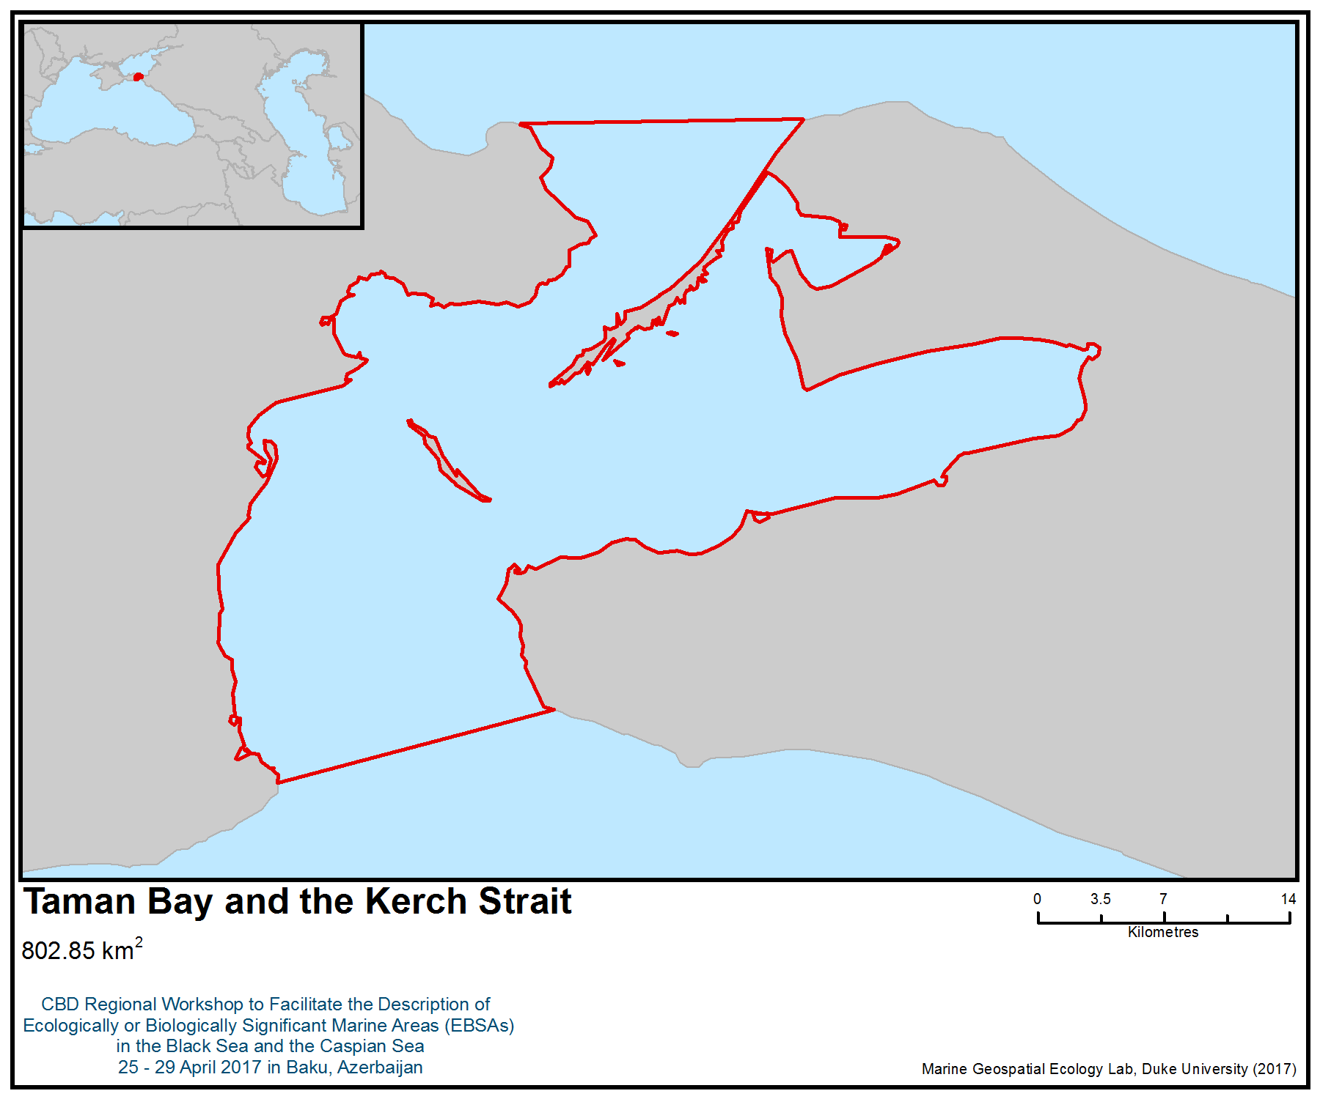
Figure 1. Area meeting the EBSA criteria

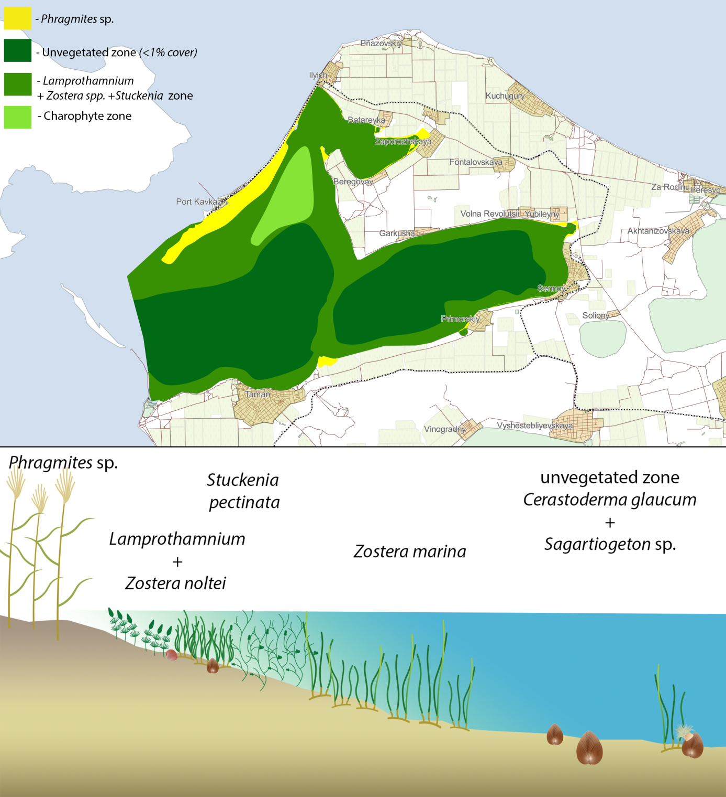
Figure 2. Taman Bay bottom vegetation types map (above) and vertical distribution (below) (Simakova, unpubl.)
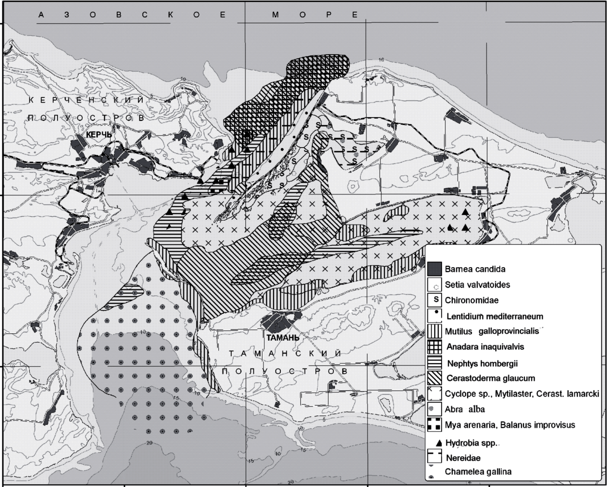
Figure 3. Taman Bay and Kerch Strait bottom macrozoobenthic communities (Golovkina, Nabozhenko, 2012)

Figure 4. Results of the habitat models revealing the most suitable habitats for yelkouan shearwater in the Black Sea, during the non-breeding season (Figure from Ortega and İsfendiyaroğlu 2017)

Area No. 11: Northern Part of the Caucasian Black Sea Coast

Abstract
The area is part of the north-eastern Black Sea shelf and slope, which is narrow in the east and relatively broad in the west, to the south of the Kerch Strait. It also includes large shallow lagoons that are remnants of the Paleo-Kuban Delta. The area provides good conditions for macrophyte development and is highly productive (although not maximally productive) at the regional scale. The area contains some unique and rare features, such as peculiar carbonate banks, but in many other respects it is more representative than distinct. It is important to the life histories of several marine invertebrates and fish species, including the now declining Black Sea turbot, anchovy and horse mackerel. It is also important for endangered species as a migration and foraging area of sturgeons and cetaceans. The biological diversity is high owing to a diversity of biotopes, including sandy spits and shallow sandy flats, shallow shelf carbonate banks, clay reefs, sandy, muddy and gravel biotopes of the shelf, ridged submerged benches and steep rocks with rich algal communities, biotopes of underwater landfall and biotopes of saltwater lagoons. The area has been under anthropogenic influence, including invasive alien species, for many decades but the significant extension of rocky shore restricts economic activities.

Introduction
The area includes an extensive coastal zone in the northeastern Black Sea (2562 km²) and covers a variety of the coastal and shelf habitats encompassing most of the components of the Black Sea biodiversity, such as plankton communities, benthic communities, the macrophyte communities in the phytal zone on various substrata (including endangered algae species and communities), fish assemblages, seabird and waterfowl and dolphin migration routes. Oceanographic conditions are dominated by the main Black Sea current, regularly forming eddies und upwelling. It has been studied by scientists from Russia and the former Soviet Union for a long time, however detailed descriptions of particular biotopes and communities and studies on the biology and distribution of several particularly important species in the area are still lacking.

Location
The area includes the coastal zone on the northeastern Black Sea coast (2562 km²). Its western boundary goes from Volna Village and crosses the shore west of the river mouth at Arkhipo-Osipovka Village (45º 6’N, 36º 43” E to about 44º 30’N, 36º 51’E). The southern boundary is designated by the 200 m isobath. The northern boundary generally follows the shoreline and also includes Bugazskiy, Kiziltashskiy and Vitjazevskiy limans (lagoons), but does not include the Novorossiysk (Tsemes) Bay.

Feature description of the area
The area is part of the north-eastern Black Sea shelf and slope, which is narrow in the east, and relatively broad in the west (to the south of the Kerch Strait connecting the Black Sea and the Sea of Azov). It includes a variety of shore forms: sandy beaches and sandy spits separating coastal lagoons, cliffs, steep rocky shores, different types of estuaries of small or medium-size rivers, and several deep inlets. This complex and diverse coastline stands in sharp contrast to the relatively homogenous shoreline to the south of this area up to the border with the Russian Federation (Petrov, 1961; Kuklev et al., 2013).

Complex oceanographical conditions over a relatively broad shelf and slope of the area, including mesoscale circulation and upwelling, transport of nutrients with numerous rivers of the Caucasian coast and the Sea of Azov waters via the Kerch Strait result in relatively high pelagic productivity of the north-eastern shelf and slope, making this one of the most productive areas of the Black Sea (Vinogradov et al., 1992; Vedernikov, Demidov, 2002; Vostokov et al., 2002).

The area contains a variety of coastal marine biotopes, including sandy spits and shallow sandy flats, shallow shelf carbonate banks (i.e., Maria Magdalene Bank) (Petrov, 1961; Mitiaseva, 2003), clay reefs of Zheleznyi Rog Cape (V.A. Spiridonov, pers. comm.), sandy, muddy and gravel biotopes of the shelf (Kucheruk et al., 2002; Chikina, 2010), ridged submerged benches (Petrov, 1961; Maximova, Luchina, 2002; Simakova and Maximova 2009), biotopes of underwater landfall of Utrish coast (Papunov et al., 2016), biotopes of saltwater lagoons (limans) with a salinity higher than in the adjacent sea. It comprises mostly a diversity of marine algae, invertebrates and fishes species, except those species that are confined to areas of higher salinity in the south-western Black Sea.
The diversity of macroalgae is moderately high and comprises 120 to 140 species of red, green and brown algae (Kalugina-Gutnik, 1975; Teubova, 2012). The diversity of macrophyte communities along the coast is high and reaches almost 20 community types (Kalugina-Gutnik, 1975; Teubova, 2012; Afanasev et al. 2012).

The main communities are the following:
- Ceramium ciliatum + Lophosiphonia obscura + Padina pavonica and Ulva intestinalis (0-5 м)
- assorted Cystoseiretum crinitae Molinier 1958 and assorted Cystoseiretum barbatae Pignatti 1962 (Cystoseira crinita + Cystoseira barbata – Cladostephus spongiosus – Ellisolandia elongata) (0,5 m – 12 m)
- Phyllophora crispa-Codium vermilara (12 m – 25 m)
- assorted Zosteretum marinae (Van Goor 1921) Harmsen (5 m-10 m)
- assorted Zosteretum noltii Harmsen 1936 (5-15 m)

The biomass of the Cystoseiras community in the upper phytal zone (0.25-1 m) reaches 13-15 kg/m² in some places, and its average is about 3.5-5.0 kg/m². However, the lower boundary of the Cystoseireta belt is currently located at 10-12 m depth as a result of the previous extinction by the early 1990s of this community at depths greater than 12-15 m. Only the isolated oppressed thalli of Cystoseira barbata can be recorded as deep as 12-15 m. Its biomass at localities deeper than 5-6 m usually is not higher than 150-300 g/m² (Maximova et al., 2008). The Cladophora sp bloom is a striking example of r-species development in the Black Sea, with its standing crop of 7500 tonnes in an area of 15 km² in the Anapa Bay (Vershinin and Kamnev, 2001).

Maria Magdalene Bank, a carbonate bank surrounded by sandy seabed (fig.1), a rare underwater landscape for the Black Sea, is located 4 km from the sand spit near Blagoveschenskaya Village. The bank extension is about 1200 m perpendicular to the shore and about 800 m along the shore. Water depth ranges from 2.5 to 10 m (figs. 2, 3), and surrounding areas are about 17-30 m deep. Rocky substrates of the bank harbour a variety (41 species) of macroalgae (Petrov, 1961; Mitiaseva, 2003), rich zoobenthic communities and fish assemblages. Besides its ecological importance, the seascape is of high aesthetic value. Other rare biotopes are submerged (5 - 15 m) meadows of seagrass, Zostera noltei and Zostera marina, along exposed coasts of Bugaz spit (U.V. Simakova, pers. comm.). The most common ecotope for macroalgae is the bench – hard bottom substrate. There are different types of benches, but the most common are ridge and graded benches. The northeast coast of the Black Sea bench is formed mainly by marlstone, which forms a series of ridges or steps receding in the depth.

Relatively broad (compared to areas to the south-east and the west) shelf with relatively high level of productivity makes the area important for maintaining populations of dominant macrozoobenthic bivalve species, such as Chamelia gallina, Pitar rudis, Modiolula spp. (Terentiev, 2013; Chikina, 2010), and for spawning, feeding and migration of crabs (V.A. Spiridonov, pers. comm.) and marine fishes including a declining stock of Meothian turbot (Scophthalmus maeoticus) (Kumantsov, 2013). The area is an important feeding and migratory area (fig.4) for the Azov stock of the Black Sea anchovy (Engraulis encrasicolus ponticus), mackerel (Scomber scombrus), and horse mackerel (Trachurus mediterraneus) (Drozdov, 2011).

The area is important for migration and feeding of Russian sturgeon (Acipenser gueldenstaedtii) and starry sturgeon (Acipenser stellatus) (IUCN: CR). Currently the population is extremely depleted, and they are monitored using non-lethal catching and genetic sampling (Chepurnaya, 2017). Lake Abrau harbours a population of endemic species, Abrau sprat (Clupeonella abrau), which is listed in the Red Data Book of the Russian Federation and the IUCN Red List as critically endangered.

Phyllophora crispa (fig. 5), a declining species, inhabits various hard substrates from 0.5 to 25 m depth in the area (Simakova, Maximova, 2009). The biomass of the Phyllophora crispa along the coast showed several times (and even by order of magnitude) decrease in 1990-2008. This was not only single species losses. The Phyllophora thalii are inhabited by abundant epifauna species (more then 130) (Rybnikov, 1993). Decrease of Phyllophora doubtless caused the loss of epifauna. No recovery has been observed yet (Simakova and Maximova, 2009).

Coastal areas, particularly the Bugaz Liman and shallow lakes near the city of Anapa (“Anapskie Plavni”) are important as wintering areas for waterfowl, especially during particularly cold winters (Tilba et al. 2006), when Taman Bay and the lagoons of the Kuban Delta freeze over. The shallow area south of the Kerch Strait is part of a major flyway of migratory birds crossing the Black Sea (BirdLife International 2017a). Owing to a great number of cargo vessels anchoring in front of the entrance to the Kerch Strait, this area recently also became a stopover for migrating birds, which resting on the ships (V.O. Mokievsky, pers. comm.).

The area also overlaps with a marine Important Bird and Biodiversity Area (IBA; BirdLife International 2017a), mostly designated for its importance as a wintering area for the vulnerable yelkouan shearwater (Puffinus yelkouan). The yelkouan shearwater is a Mediterranean endemic (BirdLife International, 2017b), some 30 to 40 per cent of which migrate to the Black Sea during the non-breeding season. The importance of the area for this species was confirmed by studies based on tracking birds from their colonies (Raine et al. 2012; Péron et al. 2013; Seabird Tracking Database 2017), and also from studies of habitat suitability (Ortega and İsfendiyaroğlu 2017).

Feature condition and future outlook of the area
Like most of the Black Sea, the coastal ecosystem of the north-eastern Black Sea has been shown to be affected by eutrophication (Vinogradov et al., 1992), and siltification (Terentiev, 2013), introduction of invasive alien species such as comb jelly (Mnemiopsis leydi), rapana (Rapana venosa), and blood arc (Anadara kagoshimensis) (Vinogradov et al., 1992; Bologa et al., 1995; Zaitsev & Oztürk, 2001; Chikina, Kucheruk, 2005; Chikina, 2010; Leppäkosski et al., 2009) and overfishing (particularly depleted are stocks of sturgeons, Black Sea herring and Black Sea turbot (Drozdov, 2011; Kumantsov, 2013). These processes, especially the consequences of eutrophication and invasion of the comb jelly, destabilized the ecosystem, which now appears to be in transition to a new regime (Kucheruk et al., 2002; Maximova and Luchina, 2002; Chikina and Kucheruk, 2005; Chikina, 2010). The situation in the lower phytal zone is even more dramatic. In the region between Gelendzhik and Novorossijsk, bottom vegetation is absent at depths greater than 20-25 m. Deep-sea formations of Polysiphonieta and Antithamnieta have completely disappeared. As for Phyllophoreta, Phyllophora crispa abundance dropped significantly at all levels of its bathymetric range. In the 1970s, the attached Phyllophora had formed a wide belt with the coverage up to 50-80%, with the mean biomass about 1.5 kg/m² and up to 4 kg/m² in the thick beds along the coastline from Anapa to Novorossijsk (Kalugina-Gutnik, 1975). In the 1980s and early 1990s the coverage was as high as 30 to 40% and mean biomass was 1.5 kg/m² (and up to 6 kg/m² at some locations) at depths from 12 to 28-30 m in the vicinity of Gelendzhik (Maximova et al., 2008).

The area has thus been under anthropogenic influence, including alien species invasions for several decades, and continues to be so. However, a significant extension of rocky shore restricts economic activities, thus maintaining more or less natural conditions in the coastal zone outside of such towns as Novorossiysk, Anapa and Gelendzhik and several smaller settlements. The strictly protected nature reserve (zapovednik) Utrish was established in 2012. It protects some representative and distinct biotopes of the rocky coastal zone.

Assessment of the area against CBD EBSA Criteria

CBD EBSA Criteria  (Annex I to decision IX/20) | Description  (Annex I to decision IX/20) | Ranking of criterion relevance  (please mark one column with an X)
CBD EBSA Criteria  (Annex I to decision IX/20) | Description  (Annex I to decision IX/20) | No information |  | Low |  |  | Medium |  | High
Uniqueness or rarity | Area contains either (i) unique (“the only one of its kind”), rare (occurs only in few locations) or endemic species, populations or communities, and/or (ii) unique, rare or distinct, habitats or ecosystems; and/or (iii) unique or unusual geomorphological or oceanographic features. |  |  |  |  |  | X
Explanation for ranking
Maria Magdalene Bank, a carbonate bank surrounded by sandy seabed, a rare underwater landscape for the Black Sea, is located 4 km from the sand spit near Blagoveschenskaya Village. The bank extends about 1200 m perpendicular to the shore and about 800 m along the shore, water depth ranges from 2.5 to 10 m, and surrounding areas are about 17 m deep. Rocky substrates of the bank harbour a variety (41 species) of macroalgae (Petrov, 1961; Mitiaseva, 2003) and rich zoobenthic communities and fish assemblages. Other rare biotopes are submerged (below 10 m) meadows of seagrass, Zostera noltei and Zostera marina, developing on the exposed coasts of Bugaz spit (U.V. Simakova, pers. comm.)
Special importance for life-history stages of species | Areas that are required for a population to survive and thrive. |  |  |  |  |  |  |  | X
Explanation for ranking
A relatively broad (compared to areas to the south-east and the west) shelf with a relatively high level of production makes the area important for maintaining populations of dominant macrozoobenthic bivalve species, such as Chamelia gallina and Pitar rudis (Terentiev, 2013; Chikina, 2010), and for spawning, feeding and migration of crabs (V.A. Spiridonov, pers. comm.) and marine fishes, including a declining stock of Black Sea turbot (Scophthalmus maeoticus) (Kumantsov, 2013).
The area is an important feeding and migratory area (fig.4) for the Azov stock of the Black Sea anchovy (Engraulis encrasicolus ponticus), mackerel (Scomber scombrus) and horse mackerel (Trachurus mediterraneus) (Drozdov, 2011).

Coastal areas, particular Bugazskiy Liman (lagoon) and shallow lakes near the city of Anapa (“Anapskie Plavni”) are important as wintering areas for waterfowl, especially during particularly cold winters (Tilba and Mnatsekanov, 2006), when the Taman Bay and limans of the Kuban Delta freeze over. The shallow area south of the Kerch Strait falls over the major flyway of migratory birds crossing the Black Sea. Owing to a great number of cargo vessels anchoring in front of the Kerch Strait entrance, this area recently became a stopover where migrating birds rest on the ships (V.O. Mokievsk y, pers. comm.).

The area is one of the most important regions in the world for the yelkouan shearwater (Puffinus yelkouan ) during the non-breeding season (Raine et al. 2012; Péron et al. 2013). Birds from different colonies located in the Mediterranean congregate here during the winter period (September to December), one of the most critical of the life-cycle of the species, when most of the mortality of adult birds (the major cause of the population decline) occurs (Oppel et al. 2011). Recent tracking studies have revealed that between 26% and 42% of the global population of the yelkouan shearwaters migrate to this region (Raine et al. 2012; Péron et al. 2013; Seabird Tracking Database 2017). At-sea surveys and studies of habitat suitability have also revealed the importance of the area for the species as a non-breeding foraging site (Ortega and İsfendiyaroğlu 2017).
Importance for threatened, endangered or declining species and/or habitats | Area containing habitat for the survival and recovery of endangered, threatened, declining species or area with significant assemblages of such species. |  |  |  |  |  | X
Explanation for ranking
The area is important for migration and feeding of Russian sturgeon (Acipenser gueldenstaedtii) and starry sturgeon (Acipenser stellatus) (IUCN: CR). Currently the population is extremely depleted and is monitored using non-lethal catching and genetic sampling (Chepurnaya, 2017). A relic lake, LakeAbrau, harbours a population of endemic species, Abrau sprat (Clupeonella abrau), which is listed in the Red Data Book of the Russian Federation and the IUCN Red List as critically endangered.
A community of the declining algae species Phyllophora crispa forms a belt along the coast of the area (Simakova and Maximova, 2009).

The yelkouan shearwater (Puffinus yelkouan), a globally threatened seabird species listed as vulnerable by IUCN, is known to occur in the area (BirdLife International 2017) –. The area also overlaps with the distribution range of other vulnerable species, including the horned grebe (Podiceps auritus).
Vulnerability, fragility, sensitivity, or slow recovery | Areas that contain a relatively high proportion of sensitive habitats, biotopes or species that are functionally fragile (highly susceptible to degradation or depletion by human activity or by natural events) or with slow recovery. |  |  |  |  |  |  |  | X
Explanation for ranking
The declining species Phyllophora crispa lives in the area at the limit of its distribution. It appears to be vulnerable to several natural and antropogenic factors owing to its biological characteristics (Simakova and Maximova, 2009). The biomass of the Phyllophora crispa along the coast decreased several times (and even by an order of magnitude) between 1990 and 2008. This was not simply a case of a loss of a single species. The Phyllophora thalii are inhabited by abundant epifauna species (more than 130) (Rybnikov, 1993), therefore the decrease of Phyllophora doubtless caused the loss of epifauna. No recovery has been observed yet (Simakova and Maximova, 2009)
The vulnerable yelkouan shearwater is a long-lived species, with low fecundity rates and delayed sexual maturity. As such, the yelkouan shearwater is particularly vulnerable to factors increasing adult mortality rates, such as by-catch in fisheries and other at-sea threats, which are often the major causes of population decline (Anderson et al. 2011; Oppel et al. 2011).
The presence of such species (which may be complemented by such long-living, slow growing fish species as sturgeons and Black Sea turbot) makes the area highly vulnerable.
Biological productivity | Area containing species, populations or communities with comparatively higher natural biological productivity. |  |  |  |  |  | X
Explanation for ranking
Complex oceanographical conditions over the relatively broad shelf and slope of the area, including mesoscale circulation and upwelling, transport of nutrients with numerous rivers of the Caucasian coast and the Sea of Azov waters via the Kerch Strait, result in relatively high pelagic productivity of the north-eastern shelf and slope, making this a productive area of the Black Sea, although not reaching the maximum productivity criteria at the regional scale (Vinogradov et al., 1992; Vedernikov and Demidov, 2002; Vostokov et al., 2002).
Biomass of macrophyto- and macrozoobenthos are relatively high although not maximal for the Black Sea (Maximova and Luchina, 2002; Kucheruk et al., 2002; Kozlovsky, 2008; Chikina, 2009).
Biological diversity | Area contains comparatively higher diversity of ecosystems, habitats, communities, or species, or has higher genetic diversity. |  |  |  |  |  |  |  | X
Explanation for ranking
The area contains a variety of coastal marine biotopes, including sandy spits and shallow sandy flats, shallow shelf carbonate banks (i.e., Maria Magdalene Bank) (Petrov, 1961; Mitiaseva, 2003), clay reefs of Zheleznyi Rog Cape (V.A. Spiridonov, pers. comm.), sandy, muddy and gravel biotopes of the shelf (Kucheruk et al., 2002; Chikina, 2010), ridged submerged benches (Petrov, 1961; Maximova, Luchina, 2002; Simakova and Maximova 2009), biotopes of underwater landfall of Utrish coast (Papunov et al., 2016), biotopes of saltwater lagoons (limans) with higher salinity than in adjacent sea. It harbours most marine algae, invertebrate and fish species of the south-western Black Sea, except those species that are confined to areas of higher salinity.
The flora of macroalgae is relatively rich and includes 120-140 species (Kalugina-Gutnik, 1975; Teubova, 2012).
Naturalness | Area with a comparatively higher degree of naturalness as a result of the lack of or low level of human-induced disturbance or degradation. |  |  |  |  |  |  | X
Explanation for ranking
The area has been under anthropogenic influence, such as fishing, shipping and coastal construction, since ancient times. The coastal ecosystem has been affected by eutrophication and siltification (Terentiev, 2013), overfishing (particularly depleted are stocks of sturgeons, Black Sea herring, Black Sea turbot (Drozdov, 2011; Kumantsov, 2013), and invasion of alien species, such as comb jelly and rapana, which strongly influence the current dynamics of the ecosystem (Bologa et al., 1995; Vinogradov et al., 2000; Kucheruk et al., 2002; Leppäkosski et al., Chikina, 2009; Pereladov, 2013).
The area has been thus under anthropogenic influence for several decades decades and continues to be so. However, in general, as a relatively young marine ecosystem, which is still forming since the connection of the Black Sea and the Mediterranean in the Holocene, the Black Sea ecosystem is highly dynamic by its very nature. Most of its marine species are recent Mediterranean migrants, which have significant adaptability. Significant extension of the rocky shore restricts economic activities, thus maintaining more or less natural conditions in the coastal zone outside of such towns as Novorossiysk, Anapa and Gelendzhik and several smaller settlements (fig.6). The strictly protected nature reserve (zapovednik) Utrish was established in 2012. It protects some representative and distinct biotopes of the rocky coastal zone.

References
Afanasyev DF, Abdullin Sh. R., Sereda MM. 2012. Ecological and Floristic Classification of Bottom Vegetation of the Russian Shelf of the Black Sea // Izvestiya Samara Scientific Center, Russian Academy of Sciences. №. 14. - Vol. 1-4. P. 963-966.
Anderson, O.R.J., Small, C., Croxall, J.P., Dunn, E.K., Sullivan, B.J., Yates, O. & Black, A., 2011. Global seabird bycatch in longline fisheries. Endangered Species Research 14: 91–106.
BirdLife International. http://www.birdlife.org. 2017.
BirdLife International, 2017a. Marine IBA e-atlas. Delivering sites networks for seabird conservation. Accessed from https://maps.birdlife.org/marineIBAs/default.html on 10/03/2017.
BirdLife International, 2017b. Species factsheet: Puffinus yelkouan. Downloaded from http://www.birdlife.org on 10/03/2017.
Bologa A. S., Bodeanu N., Petran A., Tiganus V. and Zaitsev Yu.P. (1995) Major modifications of the Black Sea benthic and planktonic biota in the last three decades Bulletin de l'Institut océanographique. Monaco: Musée océanographique, pp. 85-110.
Chepurnaya T.A. 2017. Data justifying Total Allowable Catch of aquatic biological resources in the internal marine waters and the territorial sea of the Russian Federation in the Black Sea. Sturgeons: Russian sturgeon, Starry sturgeon. Rostov on Don: AzNIRH. http://azniirkh.ru/wp-content/uploads/2017/03/AzNIIRH_Materialyi-ODU_osetrovyie.pdf
Chikina M.V. 2009. Maсrozoobenthos of soft bottom of North Caucasian Coast of the black Sea: the spatial structure and long-term dynamic. PhD thesis. SIO RAS, Moscow. [in Russian]
Chikina M. V., Kucheruk N. V. 2005. Long-term changes in the structure of coastal benthic communities in the Northeastern part of the Black sea: influence of alien species. Russian Academy of Sciences. Oceanology. – Т. 45.
Drozdov V.V. 2011. Long-term variability of fishery resources of the Black Sea: tendencies, the reasons and prospects. Scientific letters of the Russian state hydrometeorological university. No. 21. - P. 137-154. [in Russian]
IUCN. The Red List. http://www.iucnredlist.org. 2017
Kalugina-Gutnik A.A. 1975. Phytobenthos of the Black Sea. Kiev: Naukova Dumka, 247 p. (in Russian).
Kucheruk N.V., Basin A.B., Kotov A.V., Chikina M.V. 2002. Macrobenthos of crumbly sediments of the Black Sea Caucasian Coast: long tern dynamics of the communities In: A.G.Zatsepin, M.V. Flint (Eds) Multidisciplinary Investigations of the Northeast part of the Black Sea. Moscow: Nauka, pp. 289-296.
Kuklev S.B. et al. .-2013. Influence of Atmospheric Synoptic Processes and Wind (Dynamic Factors) on Thermal Conditions and Precipitation in the Area of the North Caucasian Coast of the Black Sea by Long-Term Data (1955-2012) // Sovrem. Probl. Distance. Sensing the Earth from space10. No. 1. - P. 81-92.
Kumantsov MI. 2013. Black Sea flounder-kalkan: the state of reserves and the ways of their preservation and recovery. Proceedings. - T. 150.
Leppäkosski E., Shiganova T. and Alexandrov B. (2009) European enclosed and semienclosed seas. In: Rilov G. and Crooks (eds) Biological invasions in marine ecosystems. Berlin, Heidelberg: Springer, pp. 529–547.
Maximova O.V. Moruchkova N.A., Simakova N.A. 2008. Chapter 7 - State of Macrophytobenthos. 7.6. Northeastern (Russian) shelf area / State of the Environment of the Black Sea (2001 - 2006/7). Pub. of the Commission on the Protection of the Black Sea Against Pollution (BSC): Istanbul,. P. 263-268.
Maximova O.V., Luchina N.P. 2002. Modern state of macrophytobenthos off the northern Caucasian coast: a response to eutrophication of the Black Sea basin. In: A.G.Zatsepin, M.V. Flint (Eds) Multidisciplinary Investigations of the Northeast part of the Black Sea. Moscow: Nauka, pp. 297–308.
Mitiaseva N. 2003. Contemporary macrophytobenthos of the North Caucasian coast. MS Thesis. Moscow: Biological Faculty of the Moscow University. 62 p.
Ortega M.P., İsfendiyaroğlu S., 2017. Predicting foraging hotspots for Yelkouan Shearwater in the Black Sea. Deep-Sea Research Part II in press
Oppel S., Raine A.F., Borg J.J., Raine H., Bonnaud E., Bourgeois K. and Breton A.R. 2011. Is the Yelkouan shearwater Puffinus yelkouan threatened by low adult survival probabilities? Biological Conservation 144(9): 2255-2263
Papunov V.G., Smirnov I.A., Vasiliev N.S., Makalova P.G. 2016, Mapping of seascapes of the state natural strictly protected reserve “Utrish”. Report on the contract 115-2016. Moscow (in Russian).
Petrov K.M. 1961. Underwater vegetation of the Black Sea coast of Taman Peninsula and North Caucasus. In: Using of airborn methods in the studies of natural resources. Moscow-Leningrad: Academy of Sciences of USSR Publishing, pp. 190–256.
Péron, C., Grémillet, D., Prudor, A., Pettex, E., Saraux, C., Soriano-Redondo, A., Authier, M., Fort J., 2013. Importance of coastal Marine Protected Areas for the conservation of pelagic seabirds: The case of Vulnerable yelkouan shearwaters in the Mediterranean Sea. Biological Conservation 168: 210-221.
Raine, A.F., Borg, J.J., Raine, H., Phillips, R.A., 2012. Migration strategies of the Yelkouan Shearwater Puffinus yelkouan. Journal of Ornithology 154: 411-422.
Rybnikov P.V. (1993), “Spatial organization of zooepibiontic community on Phyllophora nervosa at the rocky sublittoral zone of the Black Sea”, Biology of the Black Sea agarophytes: Phyllophora nervosa (D.C.) Grev., Moscow: IO RAS, 113-122 (in Russian).
Seabird Tracking Database. 2017. Tracking Ocean Wanderers – BirdLife Seabird Tracking Database www. http://seabirdtracking.org/, accessed on 10/03/2017
Simakova U.V., Maximova O.V. 2009. Present-day state of the attached Phyllophora community in the vicinity of the Novorossisk. 9th International Conference on the Mediterranean Coastal Environment. Sochy (Russia). P. 317-322.
Terentev A.S. 2013. Change in species composition of bottom biocenoses of the Kerch pre-pouring of the Black Sea as a result of silting up. VNIRO Proceedings. V. 150. P 78-90.
Teyubova V.F. 2012. Variety and ecological features of macrophytobenthos in the Russian sector of the Black Sea. PhD thesis.
Tilba P. A., Mnatsekanov R. A., Krutolapov V. A. 2006. Tamanskiy and Dinskoy bay of the Black Sea //Vodno-bolotnyye ugod'ya Rossii. Vodno-bolotnyye ugod'ya Severnogo Kavkaza. –– T. 6. – P. 71-74.
Vedernikov A.V., Demidov A.B. 2002. Long-term and seasonal variability of chlorophyll and primary production in the eastern regions of the Black Sea, pp. 212–234.
Vershinin A., Kamnev A. 2001. Harmful algae in Russian European coastal waters. Harmful Algal Blooms 2000. – С. 112-115.
Vinogradov M.E., Shushkina E.A., Anokhina L.L., Vostokov S.V., Kucheruck N.V. and Lukashova T.A. 2000. The mass abundance of ctenophore Beroe ovata (Eschscholtz) near the North-Eastern Black Sea coast. Oceanology 1, 52-55.
Vostokov S.V., Lisitsyn B.E., Konovalov D.M., Gagarin V.I. 2002. Mesoscale variability of chlorophyll “a” concentration, particulate organic matter content and spectral index of light absorption in the upper layer of northeastern part of the Black Sea. In: Zatsepin AG, Flint MV (eds) Multidisciplinary investigations of the Northeast part of the Black Sea, pp 235–247, Moscow, Nauka, 476.
Zaitsev Y., Oztürk B. 2001. The Black Sea //Exotic species in the Aegean, Marmara, Black, Azov and Caspian Seas. Turkish Marine Research Foundation, Istanbul. С. 73-138.

Maps and Figures

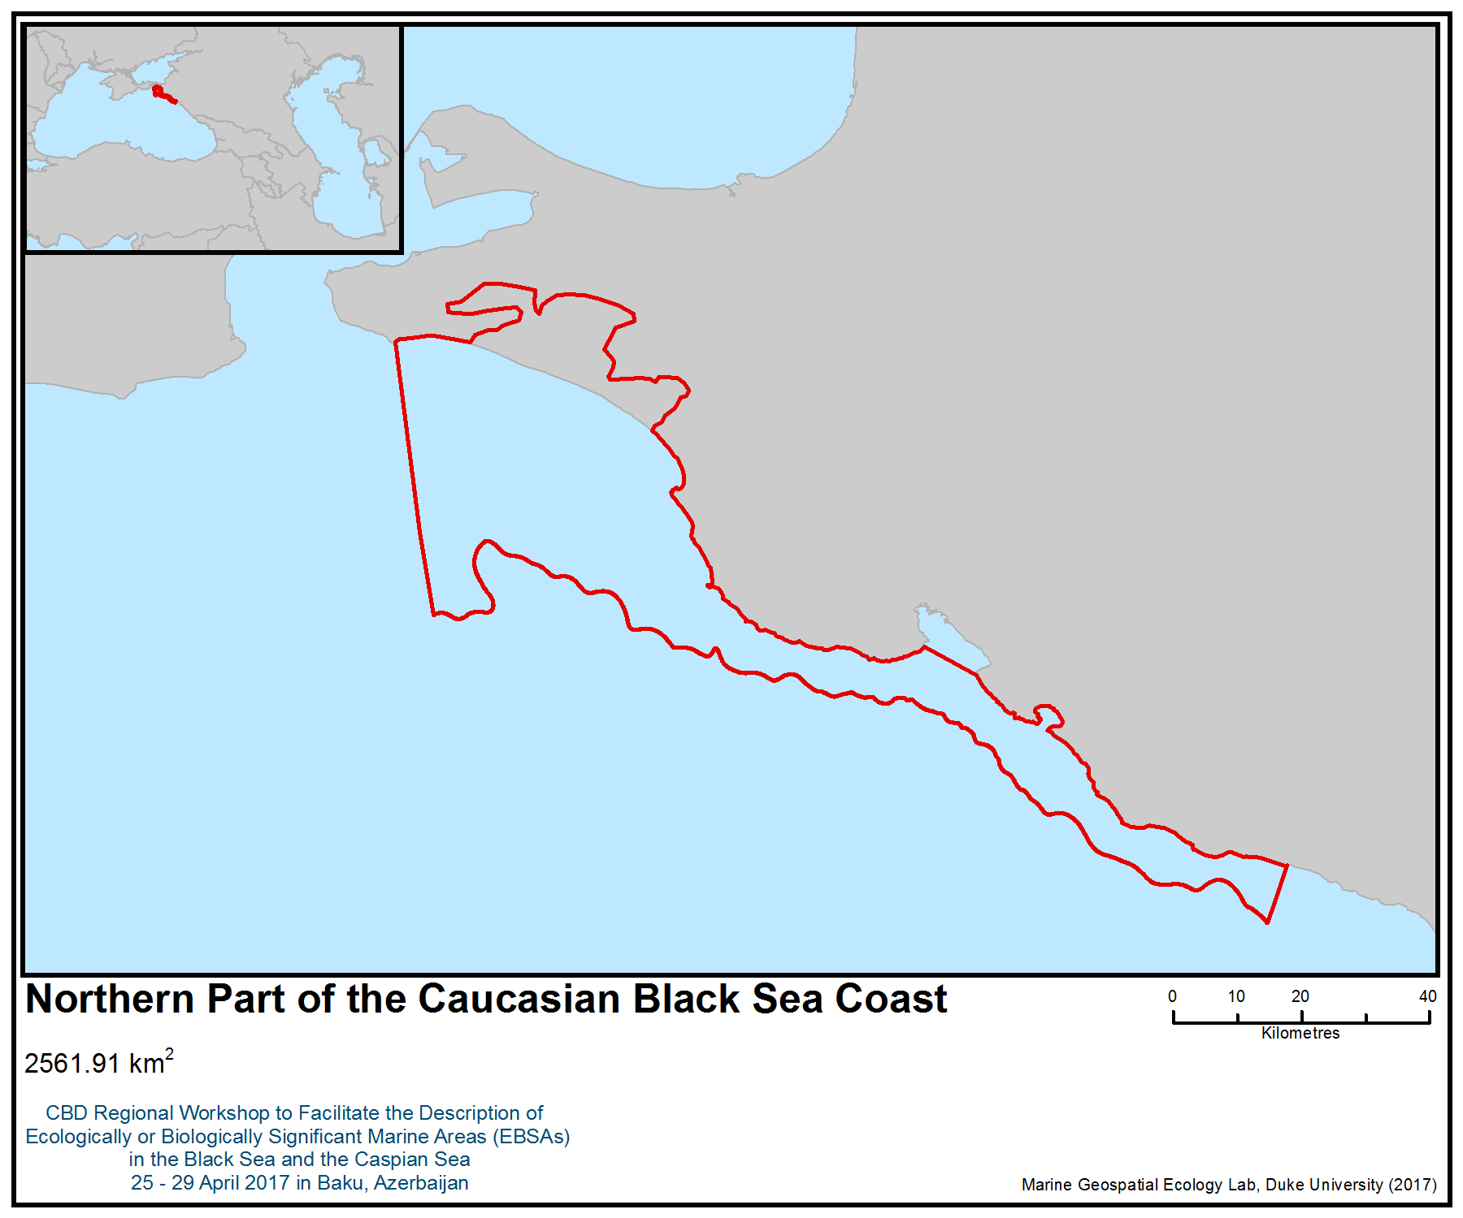
Figure 1. Area meeting the EBSA criteria

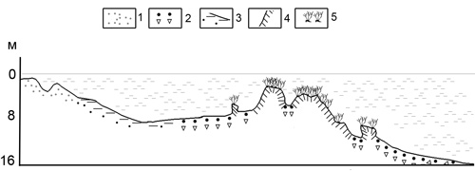
Figure 2 The Scheme of Maria Magdalene Bank, 1 – sand, 2 - shells, 3 – muddy sand, 4 – hard bottom, 5 - vegetation (Petrov, 1961)

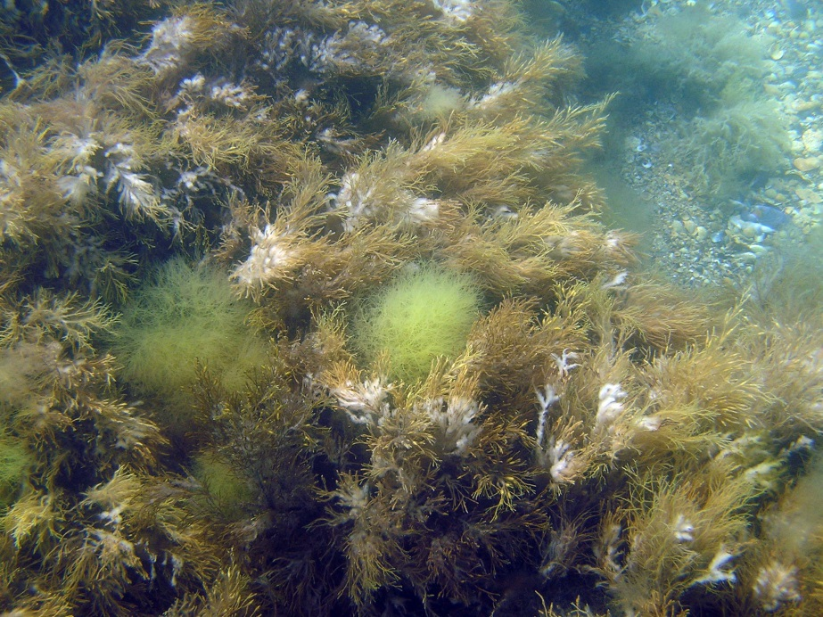
Figure 3. The Maria Magdalene Bank underwater landscape (3 m depth) dominated by Cystoseira spp. (photo: Ulyana V. Simakova).

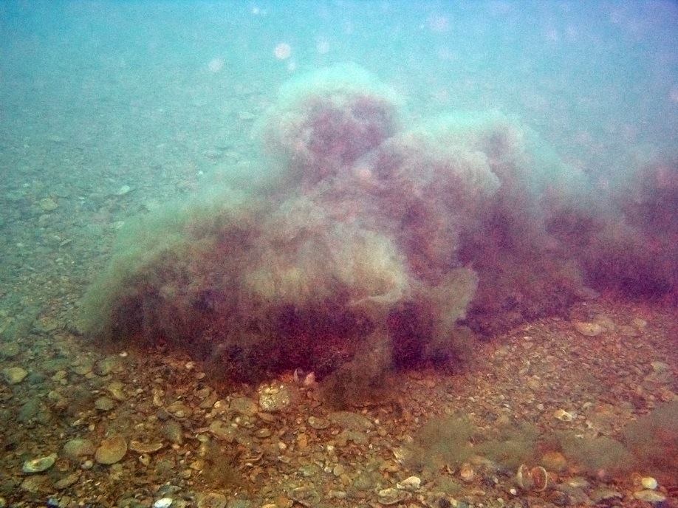
Figure 4. The Maria Magdalene Bank underwater landscape (10 m depth) dominated by Cystoseira spp. (photo: Ulyana V. Simakova)

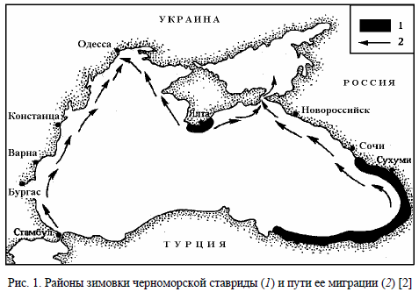
Figure 5. The wintering areas and migration routes of Horse Mackerel (Drozdov, 2011)

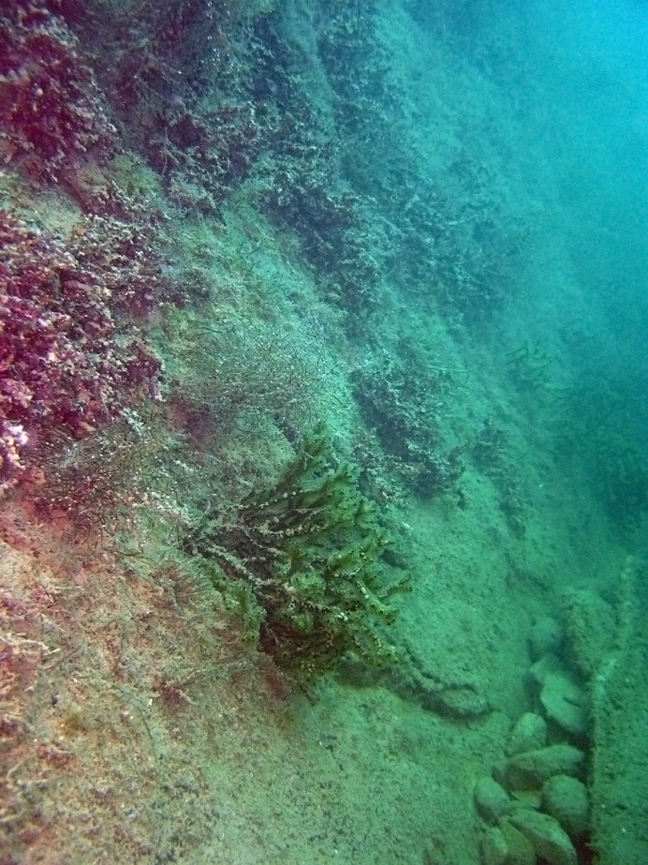
Figure 6. The attached Phyllophora crispa community (photo: Ulyana V. Simakova)

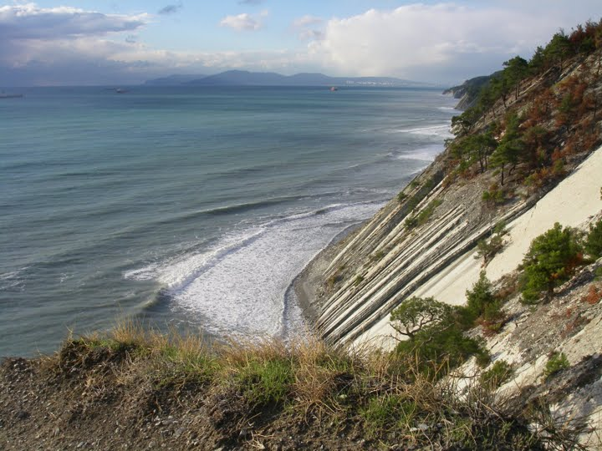
Figure 7. The unpopulated coastline in the vicinity of Novorossiysk (photo: Ulyana V. Simakova)

Area No. 12: Kolkheti Marine Area

Abstract
This area is characterized by a high density and relative richness of zooplankton species and bivalves. It is a preferred habitat for turbot and flounder species. In winter and spring, large aggregations of anchovies (Engraulis encrasicolus) use the area as a wintering and spawning area. It is also a habitat and spawning area of the endangered Acipenseridae species and serves as wintering ground for large numbers of migratory birds and Black Sea cetaceans. The area is an important feeding and nursery ground for cetacean species (Tursiops truncatus ponticus, Delphinus delphis ponticus and Phocoena phocoena relicta) all year-round.

Introduction
The Georgian Black Sea includes a 320 km stretch of the Black Sea coast in the south-eastern and eastern parts of the sea, between the mouths of the rivers Sarpi and Psou. About 150 rivers flow into the Black Sea from the Georgian area (including minor rivers). Among these, the most full-flowing is the Rioni, which yields 406 m³/s of water and an average of 4.7 million tonnes of solid substances annually. The Caucasus chain protects this area from north winds. The average speed of the wind is lowest in Batumi. The volume of the tide-in and tide-out is insignificant. For instance, in the area it is 8-9 centimetres and is of semi-diurnal character. As compared to the oceans, the Black Sea, as the internal continental sea, is characterized by low force of waves. Stormy phenomena occur in cases of cyclone impact. The south and south-east winds are related to the Mediterranean cyclones. The Atlantic cyclones cause westward winds and waves that reach the Georgian coast in the form of strong billows.

The Georgian part of the Black Sea coast includes the following natural habitats: 1) sandy shore with a thin layer of sea water; 2) delta (estuary); 3) coastal lagoon; 4) shallow water and bay; 5) sea rocks and stony coast (according to EU Directive 92/43/EEC) (Akhalkatsi, 2009).

The bottom of the Black Sea is rather steep. The underwater relief of the bottom is widened by former gorges and deltas that are continuations of the superficial gorges of all significant rivers. The relief of the bottom consists of shelf, continental slopes and sea caves. By the Georgian coast the shelf has the form of a narrow dotted line.

The water temperature ranges from 9° C to 11° C in winter (southward). At 60 km from the coast, on the contrary, the water temperature increases northward: from 19.4° C to 20.7° C.

In January, the average temperature on the Georgian coast of the Black Sea is 4-7° C, while the average temperature in July is 22-23°C. Precipitation is ample in all seasons. Rain is especially typical of the southern part of Kolkhis, with over 2500 mm precipitation per year. Precipitation decreases to the north, ranging from 1650 mm (in the central part) to 1400 mm (in the north-western part).

The geomorphology of the Georgian coast is influenced by about 150 rivers of the region (including minor rivers). The entire annual flow comprises 50 km³. The inflow of Georgian rivers comprises 16% of the total continental inflow of the sea. The Georgian rivers flowing into the Black Sea are: Bzipi, Kodori, Enguri, Rioni, Khobi, Supsa, Natanebi, Chorokhi and other minor rivers.

The most full-flowing river on the Georgian area is the Rioni, the largest river that flows entirely on Georgian territory. Its length is 327 km, and its basin measures 13,400 km² in area. Annually, the Rioni fills the Black Sea with a large mass of solid substances: an average of 4.7 million tonness per year (Beruchashvili & Elizbarashvili, 2003). The mouth of the Rioni River is included in the described area.

Location
The area extends 502 km² between Tikori River and the mouth of the Rioni River (inclusive).
Latitude Longitude
42.3688965 41.5923238
42.3678906 41.3485938
42.1492143 41.3730120
42.1781462 41.6434212

Feature description of the area
The area includes the marine part and adjacent waters of Kolkheti National Park and the Rioni River mouth.

The main habitats in the area are:
Open Sea and Circulation Zone
The water level from the sand surface does not exceed 20 metres. It consists of sedimentary sand, but also contains larger stones and pebbles or smaller granules that form mud on the coastline. The sandy-rocky line stretches from Abkhazian coast to Guria and Achara (inclusive). The biotic elements are chiefly represented by algae, invertebrate sea animals and plankton. Various species of fish either inhabit or pass these places; all the three species of dolphin (Tursiops truncatus, Delphinus delphis, Phocoena phocoena) use the area.

Deltas (estuaries)
A delta is the end of the river-bed where it joins the sea and is influenced by the tides. The delta of the river forms part of the coastline, where the bay contains mixed fresh and salty water. This zone is characterized by a large amount of sedimantary rocks brought to the coastline by the river. It constantly changes the type of tide and causes the formation of mud, decomposed rocks and other sediments. The largest delta is formed by the Rioni River.

Coastal Lagoon
The lagoon is a part of the salty water of the sea. It has cut into land and is separated from the sea so that when the tide is high, the sea and the lagoon are connected and their waters are mixed. The lagoon is often separated from the coast by means of rocks or sandy hills. The salinity of water depends on the volume of precipitation. During hard rains, salinity is decreased. A coastal lagoon is found near Grigoleti Village.

Shallow water and bay
A bay and shallow water occupy certain places on the coast. Unlike deltas, here fresh water is not mixed with the sea water. It is affected only by the movement of the sea waves, which brings sedimentary rocks from the bottom of the sea and constantly changes the structure of the bottom. This, in its turn, affects the biotic content of benthos (Akhalkatsi, 2010).

The area includes Kolkheti National Park, which is established with the purpose of protecting and maintaining wetland ecosystems. The Kolkheti lowland became the subject of international interest first in 1996, when Georgia joined the Ramsar Convention on “Wetlands of International Importance Especially as Waterfowl Habitat”. In 2000, Kolkheti National Park began full-scale functioning.

Biological communities
All species of Black Sea apex predators use the area as a feeding ground, in particular bottlenose dolphin (Tursiops truncatus ponticus), common short-beaked dolphin (Delphinus delphis ponticus), harbour porpoise (Phocoena phocoena relicta) and yelkouan shearwater (Puffinus yelkouan). Newborn calves of three cetacean species, the bottlenose dolphin (Tursiops truncatus ponticus), common dolphin (Delphinus delphis ponticus) and harbour porpoise (Phocoena phocoena relicta), have been recorded in the area, and courtship behaviour of common and bottlenose dolphins were also observed. (Kopaliani et al. 2015). It has been concluded that the area serves as feeding, breeding and nursery grounds and is a core area for Black Sea cetaceans.

According to an assessment that began in 2014, the Georgian Black Sea is used by 18 000 harbour porpoises, 16000 common dolphins and 150 bottlenose dolphins in winter; 5000 harbour porpoises, 3000 common dolphins and 150 bottlenose dolphins in spring; 500 harbour porpoises, 6000 common dolphins and 100-150 bottlenose dolphins in summer; and 1000 harbour porpoises in autumn (Kopaliani et al. 2015).

Endangered Acipenseridae species use the area for spawning (Guchmanidze 2009). The endangered species under IUCN Red List are: Acipenser gueldenstaedtii, Acipenser stellatus, Acipenser sturio, Acipenser nudiventris, Huso huso and Acipenser persicus. Acipenser ruthenus is listed as a vulnerable species (IUCN Red List).

An important benthos species, European flounder (Platichthys flesus), inhabits the area, though its population is decreasing (Munroe, 2010). Belone belone euxini and Mullus barbatus, both of which are endangered species protected under the Black Sea Red List, use this area.

A significant representative of the pelagic community, the Black Sea herring (Alosa pontica), which is included on the Georgian Red List, uses the area.

The Kolkheti lowland and adjacent foothills of Meskheti Ridge are important sites for migrating birds and are classified as Important Bird and Biodiversity Areas (BirdLife International 2017). The Caucasus, at the border of Europe and Asia, is important for two life cycle stages of wild seabird waterfowl (migration and wintering), and three flyways converge in the Caucasus region (the Central Asian, East Africa-West Asia and Mediterranean/Black Sea). Tens of thousands of migratory waterfowl use Kolkheti marshes and lakes as well as river deltas and the adjacent sea as stepping stones and wintering areas. Among them is Puffinus yelkouan, which is listed as a vulnerable species (IUCN Red List).

The described area is important for autumn and spring migration of waders and other shorebirds, including thousands of plovers (Calidris spp., Pluvialis spp.), lapwings (Vanellus spp.), red knot (Calidris canutus), sanderling (C. alba), curlew sandpiper (C. ferruginea), turnstone (Arenaria interpres), dunlin (Calidris alpina), broad-billed sandpiper (Limicola falcinellus), Temminck’s stint (Calidris temminckii), little stint (Calidris minuta), sandpipers (Tringa spp.), godwits (Limosa spp.), curlews (Numenius spp.), snipes (Gallinago spp.), woodcock (Scolopax rusticola), ruff (Philomachus pugnax), gulls (Larus spp.), terns (Sterna spp., Chlidonias spp.), crakes (Rallus spp.), moorhen (Gellinula chloropus), coot (Fulica atra), purple swamphen (Porphyrio porphyrio) and herons (Botaurus spp., Egretta spp., Ardea spp.). Some seabird species such as the Arctic loon (Gavia arctica), yelkouan shearwater (Puffinus yelkouan), black-tailed godwit (Limosa limosa), little gull (Hydrocoloeus minutus), Pallas’s gull (Larus ichthyaetus), Mediterranean gull (Larus melanocephalus), and the lesser black-backed gull (Larus fuscus) also occur in the area. Disturbance from grazing animals, motorboat activities, reed burning, seashore development, uncontrolled hunting and poaching are major threats affecting wader and shorebird populations during migration (Lewis et al., 2013; Javakhisvili in Gurileidze et al., 2012).

According to direct observation, part of the described area is suitable habitat for oyster (Ostrea edulis). Being unique and important to marine biodiversity, as well as being a subtype of Natura 2000 habitat 1170 Reefs (for information on Natura 2000 marine habitat types:
http://ec.europa.eu/environment/nature/natura2000/marine/docs/appendix_1_habitat.pdf), oyster reefs present high conservation interest in the region (Todorova and Micu, 2009)

Assessment of the area against CBD EBSA Criteria

CBD EBSA Criteria  (Annex I to decision IX/20) | Description  (Annex I to decision IX/20) | Ranking of criterion relevance  (please mark one column with an X)
CBD EBSA Criteria  (Annex I to decision IX/20) | Description  (Annex I to decision IX/20) | No information |  | Low |  |  | Medium |  | High
Uniqueness or rarity | Area contains either (i) unique (“the only one of its kind”), rare (occurs only in few locations) or endemic species, populations or communities, and/or (ii) unique, rare or distinct, habitats or ecosystems; and/or (iii) unique or unusual geomorphological or oceanographic features. |  |  |  |  |  |  |  | X
Explanation for ranking
Three species of cetaceans (Tursiops truncatus ponticus, Delphinus delphis ponticus and Phocoena phocoena relicta) were found in the area in large numbers year-round. The Black Sea harbour porpoise is listed as endangered on the IUCN Red List, as is the Black Sea bottlenose dolphin, while the short-beaked common dolphin population is classified as vulnerable (IUCN 2008; Birkun, 2006). The areas are important feeding grounds and wintering areas for Black Sea cetaceans. The largest aggregations of harbour porpoises in the Black Sea are found there during the winter and spring (Kopaliani et al., 2015).

According to ACCOBAMS resolution 4.15 (2010), the area from Cape Anaklia to Sarpi is of special importance for Black Sea cetaceans, such as the common dolphin and the harbour porpoise (ACCOBAMS-MOP4/2010/Res.4.15).

The Kolkheti lowland and adjacent foothills of Meskheti Ridge are important sites for migrating birds and are classified as Important Bird and Biodiversity Areas (BirdLife International 2017). Tens of thousands of water birds, 900,000 predators belonging to 34 species and 16,000 small birds belonging to 84 species use the area during migration (Lewis et al. 2013). The area is a significant migration area for the birds of the western part of the Palearctic region (Javakhishvili Z. according to Gurielidze et al. 2012).

Kolkheti National Park is a wintering area of anchovies (Engraulis encrasicolus). The Rioni River delta is an important habitat for Red List sturgeon species (Guchmanidze, 2009).
Special importance for life-history stages of species | Areas that are required for a population to survive and thrive. |  |  |  |  |  |  |  | X
Explanation for ranking
Wintering, breeding and nursery grounds for Black Sea cetaceans (the endangered Phocoena phocoena relicta and Tursiops truncatus ponticus, and the vulnerable Delphinus delphis ponticus) (IUCN 2008; Birkun & Frantzis, 2008; Kopaliani et al., 2015).

The area is a wintering area and stepping stone for many thousands of migratory birds (Lewis et al. 2013), a spawning area for endangered Acipenseridae (Guchmanidze, 2009), a habitat and breeding area for European flounder (Platichthys flesus) , and a spawning area and wintering area for anchovy fish (Engraulis encrasicolus) (Chashchin A.K. 1996).

Importance for threatened, endangered or declining species and/or habitats | Area containing habitat for the survival and recovery of endangered, threatened, declining species or area with significant assemblages of such species. |  |  |  |  |  |  |  | X
Explanation for ranking
The area serves as feeding, breeding and nursery grounds and is one of the core areas for the endangered Black Sea harbour porpoise (Phocoena phocoena relicta) and Black Sea bottlenose dolphin (Tursiops truncatus ponticus), and the vulnerable short-beaked common dolphin (Delphinus delphis ponticus) (IUCN 2008). According to the assessment started in 2014, the Georgian Black Sea is used by 18,000 harbour porpoises, 16,000 common dolphins and 150 bottlenose dolphins in winter; 5,000 harbour porpoises; 3,000 common dolphins and 150 bottlenose dolphins in spring, 500 harbour porpoises, 6,000 common dolphins and 100-150 bottlenose dolphins in summer and 1,000 harbour porpoises in autumn (Kopaliani et al. 2015).

The vulnerable seabirds yelkouan shearwater (Puffinus yelkouan), velvet scotter (Melanitta fusca) and dalmatian (Pelecanus crispus) occur in the area (BirdLife International, 2017).

It is a spawning area for endangered Acipenseridae (Acipenser gueldenstaedtii, Acipenser stellatus, Acipenser sturio, Acipenser nudiventris, Huso huso and Acipenser persicus). Acipenser ruthenus is listed as a vulnerable species (IUCN 2008; Guchmanidze, 2009; Gurielidze et al., 2012)
Vulnerability, fragility, sensitivity, or slow recovery | Areas that contain a relatively high proportion of sensitive habitats, biotopes or species that are functionally fragile (highly susceptible to degradation or depletion by human activity or by natural events) or with slow recovery. |  |  |  |  |  |  |  | X
Explanation for ranking
For threatened species: wintering, breeding and nursery grounds for Black Sea cetaceans; habitat and spawning area for endangered Acipenseridae (Birkun and Frantzis, 2008; Guchmanidze, 2009; Kopaliani et al., 2015).

Vulnerable, long-lived species with low fecundity and late sexual maturity are particularly vulnerable due to factors increasing adult mortality rates (BirdLife International, 2017).
Biological productivity | Area containing species, populations or communities with comparatively higher natural biological productivity. |  |  |  |  |  |  |  | X
Explanation for ranking
The Kolkheti area contains species with comparatively higher natural biological productivity, such as the anchovy (Engraulis encrasicolus), which is a major commercial fish species of the Black Sea (Chashchin 1996).
Biological diversity | Area contains comparatively higher diversity of ecosystems, habitats, communities, or species, or has higher genetic diversity. |  |  |  |  |  |  |  | X
Explanation for ranking
Marine mammals are represented by three species of cetaceans: the bottlenose dolphin (Tursiops truncatus ponticus), common dolphin (Delphinus delphis ponticus) and harbour porpoise (Phocoena phocoena relicta) (Kleinenberg, 1956). The described area is important for autumn and spring migration of waders and other shorebirds, including thousands of plovers (Calidris spp., Pluvialis spp.), lapwings (Vanellus spp.), red knots (Calidris canutus), sanderling (C. alba), curlew sandpipers (C. ferruginea), turnstones (Arenaria interpres), dunlins (Calidris alpina), broad-billed sandpipers (Limicola falcinellus), Temminck’s stints (Calidris temminckii), little stints (Calidris minuta), sandpipers (Tringa spp.), godwits (Limosa spp.), curlews (Numenius spp.), snipes (Gallinago spp.), woodcocks (Scolopax rusticola), ruffs (Philomachus pugnax), gulls (Larus spp.), terns (Sterna spp., Chlidonias spp.), crakes (Rallus spp.), moorhens (Gellinula chloropus), coots (Fulica atra), purple swamphens (Porphyrio porphyrio) and herons (Botaurus spp., Egretta spp., Ardea spp.). Some seabird species such as the Arctic loon (Gavia arctica), yelkouan shearwater (Puffinus yelkouan), black-tailed godwit (Limosa limosa), little gull (Hydrocoloeus minutus), Pallas's gull (Larus ichthyaetus), Mediterranean gull (Larus melanocephalus), and the lesser black-backed gull (Larus fuscus) also occur in the area. Disturbance from grazing animals, motorboat activities, reed burning, seashore development, uncontrolled hunting and poaching are major threats affecting wader and shorebird populations during migration (Lewis et al., 2013; Javakhisvili in Gurileidze et al., 2012).

The ichtyofauna of the national park is represented by 88 species, out of which 23 species are transiting, 21 species live in fresh water and 44 species live in the Black Sea. The cartilaginous fish include the Atlantic sturgeon and beluga, while the bony fish include the Black Sea salmon, herring striped mullet, pike and bonito (Komakhidze, 1998; Guchmanidze, 2009; Gurielidze et al., 2012).

Six species of fish included on the Red List of Georgia are widespread in the water ecosystems of Kolkheti National Park, such as: beluga (Huso huso), sea sturgeon (Acipenser sturio), starry sturgeon (Acipenser stellatus), sea trout (Salmo fario (truta) morpha), sand goby (Gobius (Neogobius) fluvatilis) and roach (Rutilus frisii) (Ninua et al. 2013). Based on direct observation, the area is a suitable habitat for oyster (Ostrea edulis).
Naturalness | Area with a comparatively higher degree of naturalness as a result of the lack of or low level of human-induced disturbance or degradation. |  |  |  |  |  |  | X
Explanation for ranking
The anthropogenic activity in this area is not high relative to other parts of the Black Sea.

References
Akhalkatsi M. 2010. Habitats of Georgia. Natura 2000. Tbilisi.
Beruchashvili N. & Elizbarasvili N. 2003. Geography of Georgia. Tbilisi (in Georgian).
BirdLife International. 2017. Important Bird Areas factsheet: Kolkheti. Downloaded from http://datazone.birdlife.org/site/factsheet/kolkheti-iba-georgia/details on 26/04/2017.Birkun Jr., A.A. & Frantzis, A. 2008. Phocoena phocoena ssp. relicta.
Chashchin A.K. 1996. The Black Sea populations of anchovy. SCI. MAR.., 60 (Supl.2): 219-228.
Guchmanidze A. 2009. Current and historical status of sturgeon in Georgia. In Status and Protection of Globally Threatened Species in the Caucasus. N. Zazanashvili and D. Mallon, Eds. Tbilisi: CEPF, WWF. Contour Ltd., pp. 171-177.
Gurielidze, Z., Kopaliani, N., Devidze, N., Shakarashvili, M. and Javakhishvili, Z. 2012. Black Sea Analysis. Situation Analyses. Supported by German Agency for International Cooperation/ Die Deutsche Gesellschaft für Internationale Zusammenarbeit) (GIZ). NBSAP Implementation.
IUCN Red List of Threatened Species 2008: e.T17030A6737111. http://dx.doi.org/10.2305/IUCN.UK.2008.RLTS.T17030A6737111.en. Downloaded on 26 April 2017.
Kleinenberg, S.E. (1956). Mammals of the Black and Azov. Seas: Research Experience for Biology and Hunting. USSR Acad. Science Publ. House, Moscow. 288p (in Russian)
Komakhidze, A. (ed.), 1998. Black Sea biological diversity - Georgia, Black Sea. United Nations Environmental Series, No. 8, United Nations Publications, 354 pages
Kopaliani N., Gurielidze Z., Devidze N., Ninua L., Dekanoidze D., Javakhishvili Z., Paposhvili N., Qerdikoshvili N. 2015. Monitoring of Black Sea Cetacean in Georgian Waters (Report). Supported by Kolkheti National Fund. Adopted by Ministry of Natural Resources and Environment Protection of Georgia.
Kopaliani, N., Gurielidze, Z., Devidze, N., Shakarashvili, M. 2016. Action Plan for the Conservation of Black Sea Cetacean. Supported by Kolkheti National Fund. Adopted by Ministry of Natural Resources and Environment Protection of Georgia.
Lewis N. S., Javakhishvili Z., Russell C. A., Machablishvili A, Lexmond P, Verhagen J. H., Vuong O., Onashvili T., Donduashvili M., Smith D.J., Fouchier R.A. M. 2013. Avian Influenza Virus Surveillance in Wild Birds in Georgia: 2009–2011. http://journals.plos.org/plosone/article/authors?id=10.1371/journal.pone.0058534. Downloaded on 26 April 2017.
Munroe, T.A. 2010. Platichthys flesus. The IUCN Red List of Threatened Species 2010: e.T135717A4191586. http://dx.doi.org/10.2305/IUCN.UK.2010-4.RLTS.T135717A4191586.en. Downloaded on 26 April 2017.
Ninua N., Japoshvili B., Bochorishvili V. 2013. Fishes of Georgia. Tbilisi, pp. 1-180. ISBN 978-9941-
Доклади на Българската академия на науките
Todorova, V. and Micu, D. 2009. Unicue oyster reefes discovered in the Bulgarian Black Sea. Доклади на Българската академия на науките. Tome 62, No 7.

Maps and Figures
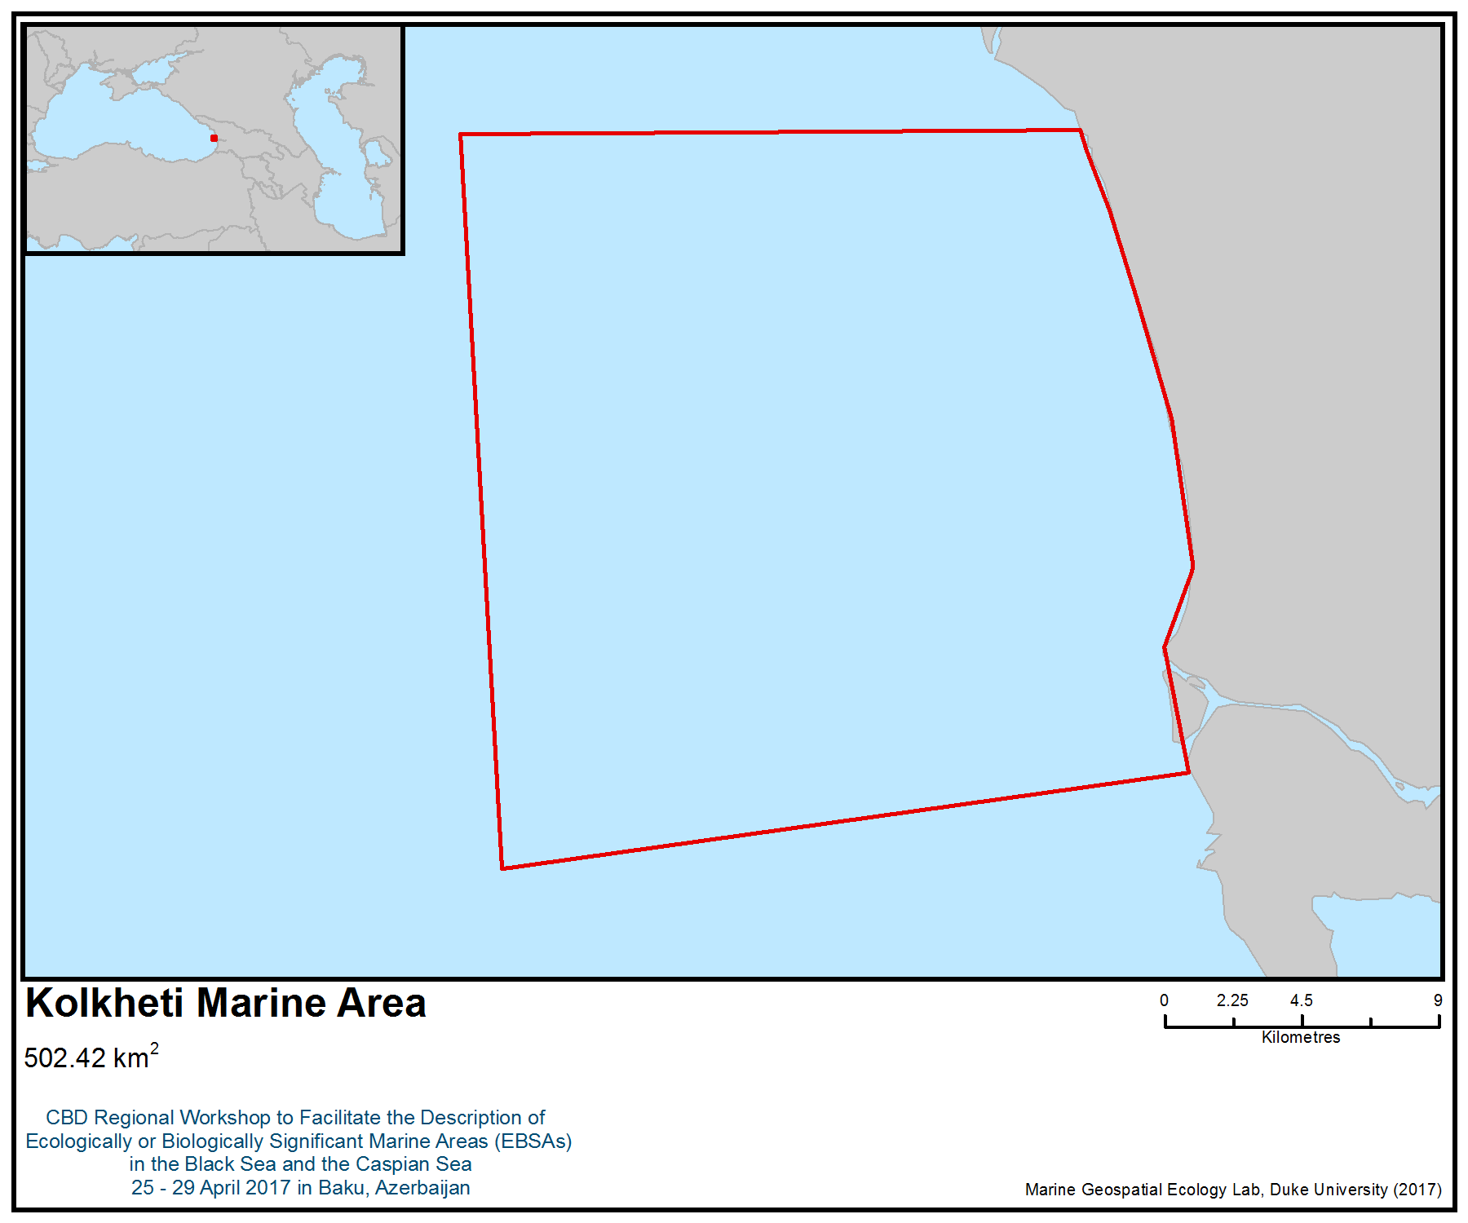
Figure 1. Area meeting the EBSA criteria

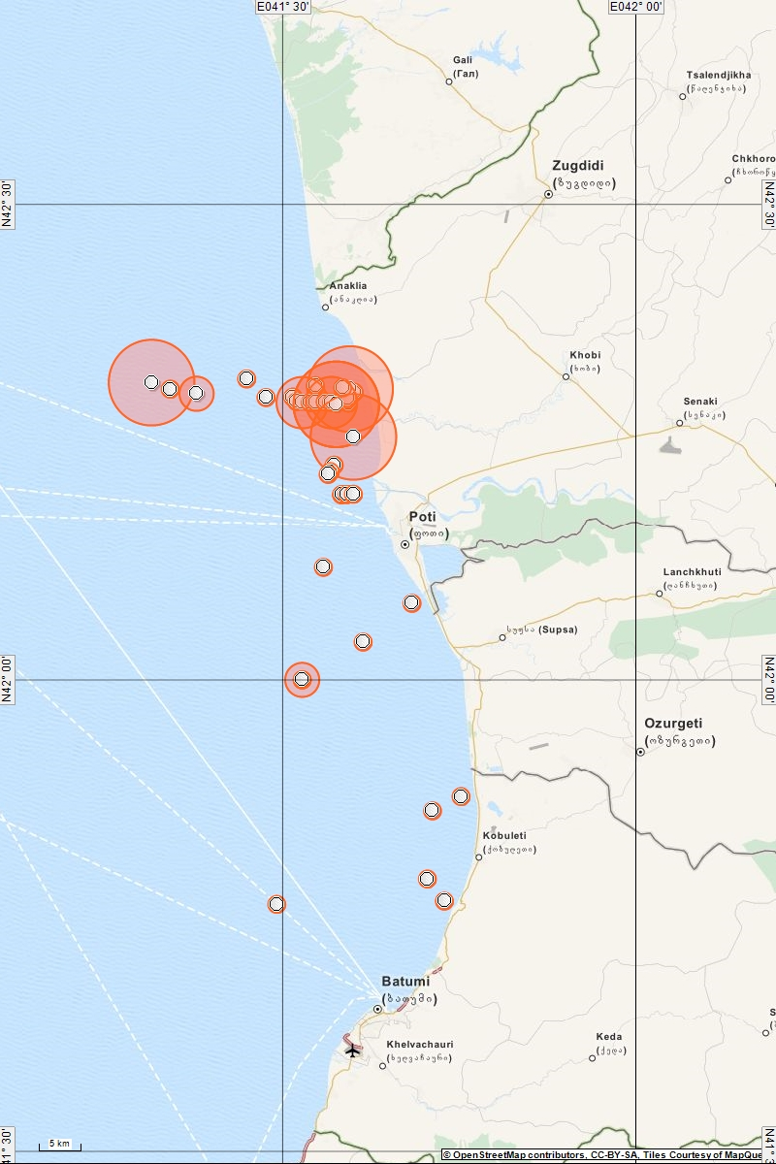
Figure 2. Phocoena phocoena relicta distribution in Georgian Black Sea in winter (Kopaliani et al. 2015)
Legend: The largest agreggations were found in Kolkheti Marine Area
The smallest circle – from 1 to 10 individuals
The largest circle – from 100 to 500 individuals

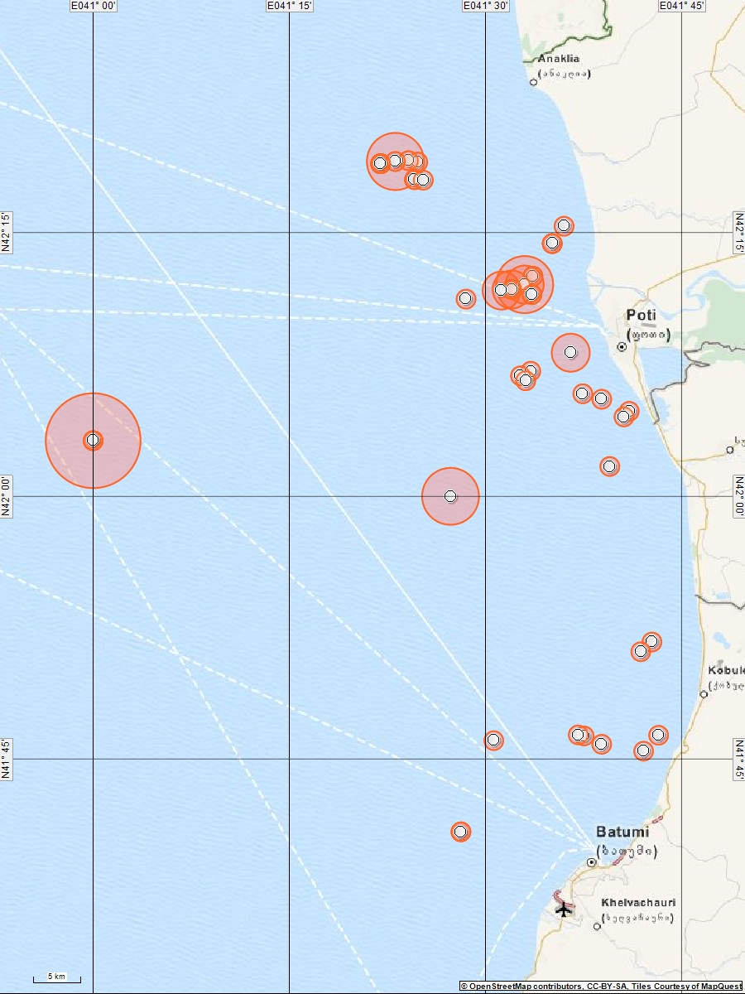
Figure 3. Delphinus delphis ponticus distribution in Georgian Black Sea in winter
Legend: The smallest circle – from 1 to 10 individuals
The largest circle – from 20 to 100 individuals
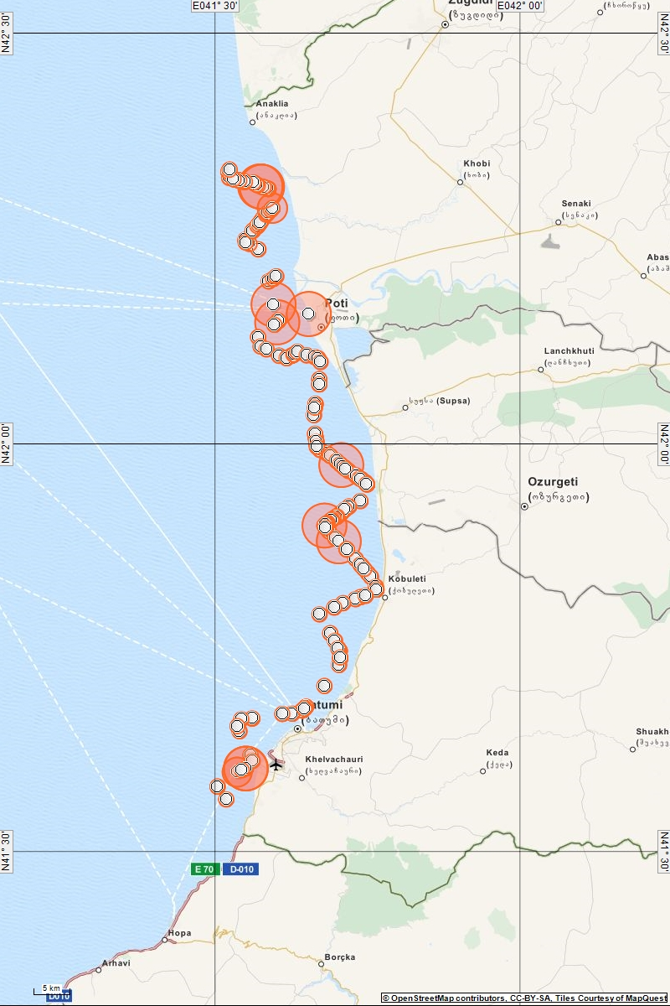
Figure 4. Phocoena phocoena relicta distribution in Georgian Black Sea in spring

Legend: The largest agreggations were found in Kolkheti Marine Area
The smallest circle – from 1 to 10 individuals
The largest circle – from 50 to 100 individuals
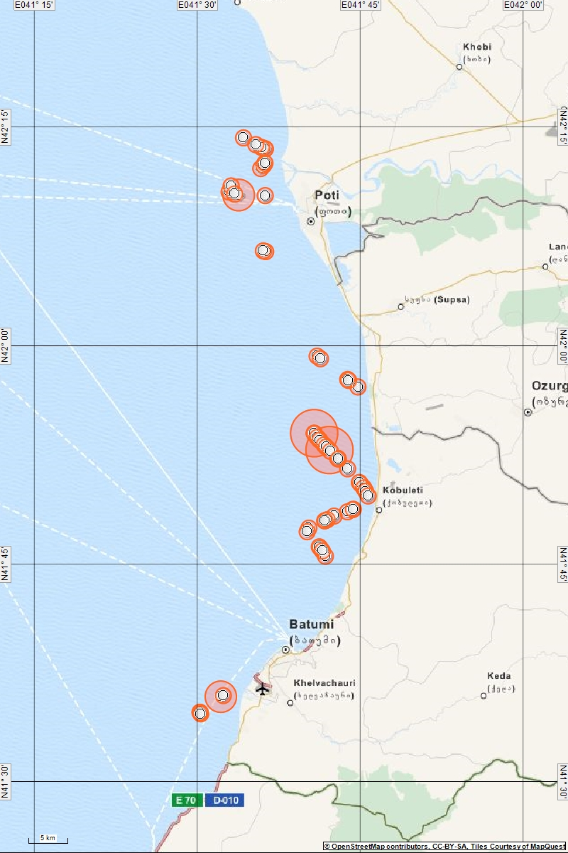
Figure 5. Delphinus delphis ponticus distribution in Georgian Black Sea in spring
(For preceding page)
Legend: The smallest circle – from 1 to 10 individuals
The largest circle – from 20 to 50 individuals
Area No. 13: Sarpi

Abstract
The area covers sea rocks and stony coast. It is the largest rocky habitat on the Georgian coast. The fields of marine algae (Cystoseira barbata and Ceramium rubrum) located here provide shelter for many fish and invertebrate species. Mussels (Mytilus galloprovincialis) and other bivalves attach themselves to the sea rocks. The rocky area provides shelter and feeding grounds for different species of fish. Some of them, such as peacock wrasse (Symphodus tinca), are more common near Sarpi than in any other area in the region. The area overlaps with a non-breeding area of global importance for the yelkouan shearwater (Puffinus yelkouan). It is also located in proximity to colonies of the Mediterranean endemic subspecies of European shag (Phalacrocorax aristotelis desmarestii), thus being potentially important for this subspecies during the breeding season. Black Sea cetaceans use the area for feeding and possibly for breeding.

Introduction
The depth of the Sarpi rocky habitat ranges from 100 cm to 100 metres. The turbidity of the water is low due to the rocky bottom. The area was proposed in Georgia’s National Biodiversity Strategy and Action Plan (NBSAP;objective c6-06.1; 2014) as an area of special protection. Nevertheless, no specific research has been carried out yet.

Location
The area is located at the following coordinates:
Latitude | Longitude
41.5447181 | 41.5606554
41.5266607 | 41.5485533

Feature description of the area
Sea rock areas are important due to macrophytes found only in this habitat. Two macrophyte species have been found here: brown seaweed (Cystoseira barbata) and red seaweed (Ceramium rubrum). They provide shelter and feeding grounds for different species of crustaceans (e.g., Pachygrapsus marmoratus, Clibanarius erythropus, Eriphia verrucosa and Palaemon elegans), mollusks and fish. Special mention should be made of mussels (Mytilus galloprovincialis) and rapa whelk (Rapana venosa), the latter being an invasive alien species in the Black Sea. Regarding the actinia species, mention should be made of Actinia equina. Widespread fish species are: peacock wrasse (Symphodus tinca), ocellated wrasse (Symphodus ocellatus), triplefin (Tripterygion tripteronotus), damselfish (Chromis chromis) and brown meagre (Sciaena umbra) (Gurielidze et al. 2012).

Feature condition and future outlook of the area
This area is important for the mussel Mytilus galloprovincialis, a species with declining population. Mytilus galloprovincialis is the main prey species for the invasive rapa whelk (Snigirov et al., 2013).
The rocky habitat of Sarpi provides shelter for many species of mollusks and other invertebrates as well as for fish. The area overlaps with a marine Important Bird and Biodiversity Area (IBA; BirdLife International 2017a), designated primarily for its importance as a wintering area for the vulnerable yelkouan shearwater (Puffinus yelkouan). The yelkouan shearwater is a Mediterranean endemic (BirdLife International, 2017b), and 30 to 40 per cent of the population migrates to the Black Sea during the non-breeding season (Raine et al. 2012; Péron et al. 2013, Seabird Tracking Database 2017). The importance of the area for this species was confirmed by bird counts, the most recent of which, conducted in 2014, reported values of more than 800 individuals.

Assessment of the area against CBD EBSA Criteria

CBD EBSA Criteria  (Annex I to decision IX/20) | Description  (Annex I to decision IX/20) | Ranking of criterion relevance  (please mark one column with an X)
CBD EBSA Criteria  (Annex I to decision IX/20) | Description  (Annex I to decision IX/20) | No information |  | Low |  |  | Medium |  | High
Uniqueness or rarity | Area contains either (i) unique (“the only one of its kind”), rare (occurs only in few locations) or endemic species, populations or communities, and/or (ii) unique, rare or distinct, habitats or ecosystems; and/or (iii) unique or unusual geomorphological or oceanographic features. |  |  |  |  |  | X
Explanation for ranking
Territory covers sea rocks and stony coast (according to EU Directive 92/43/EEC). Marine algae Cystoseira barbata and Ceramium rubrum fields provide shelter for many fish and invertebrate species (Akhalkatsi, 2013).

Sea rocks are used by the mussel Mytilus galloprovincialis and other bivalves for anchoring purposes (Gurielidze et al., 2012).

The rocky area is a shelter and feeding area for red mullet (Mullus barbatus), black mullet (Mugil cephalus), shi drum (Umbrina cirrosa), annular seabream (Diplodus annularis) and other Black Sea fish species. Some fish species, e.g. peacock wrasse (Symphodus tinca (LC, IUCN Red List) are primarily found near Sarpi (Gurielidze^{(b)} et al., 2012; Ninua et al. 2013).

Breeding and feeding areas for bottlenose dolphins (Tursiops truncatus ponticus) and common dolphins (Delphinus delphis ponticus); harbour porpoise (Phocoena phocoena relicta) also use the area (Kopaliani et al.2015).

The area overlaps with a marine Important Bird and Biodiversity Area (IBA; BirdLife International 2017a), primarily designated for its importance as a wintering area for the vulnerable yelkouan shearwater (Puffinus yelkouan). The yelkouan shearwater is a Mediterranean endemic (BirdLife International, 2017b), 30-40% of which migrate to the Black Sea during the non-breeding season (Raine et al. 2012, Péron et al. 2013, Seabird Tracking Database 2017). The importance of the area for this species was confirmed by bird counts, the most recent of which were conducted in 2014 and reported values of more than 800 individuals.
Special importance for life-history stages of species | Areas that are required for a population to survive and thrive. |  |  |  |  |  |  |  | X
Explanation for ranking
Breeding and feeding area for the bottlenose dolphin (Tursiops truncatus ponticus); feeding area for the common dolphin (Delphinus delphis ponticus) (Kopaliani, 2015).

The area overlaps with a non-breeding area of global importance for the yelkouan shearwater (Puffinus yelkouan). It is also located in the proximity of colonies of the Mediterranean endemic subspecies of European shag Phalacrocorax aristotelis desmarestii (Doğa Derneği 2014), thus being potentially important for this subspecies during the breeding season.

The area provides shelter and feeding ground for fish species (Ninua et al., 2013).
Importance for threatened, endangered or declining species and/or habitats | Area containing habitat for the survival and recovery of endangered, threatened, declining species or area with significant assemblages of such species. |  |  |  |  |  | X
Explanation for ranking
Feeding ground for endangered and vulnerable species of cetaceans (Tursiops truncatus ponticus, Delphinus delphis ponticus, Phocoena phocoena relicta) (Kopaliani et al. 2015).

A globally threatened seabird species, the yelkouan shearwater (Puffinus yelkouan), which is listed as vulnerable by IUCN, is known to occur in the area (BirdLife International 2017b). The area also overlaps with the distribution range of another vulnerable species, the velvet scoter (Melanitta fusca) (BirdLife International 2017c). These two species are also included on Annex I of the EU Birds Directive.

Fish species: gar fish (Belone belone euxini), red mullet (Mullus barbatus), Black Sea herring (Alosa immaculata), sea horse (Hippocampus guttulatus) (NT; IUCN) and others inhabit the area and use it as a feeding ground and shelter.

The area provides habitat for Cystoseira barbata and Ceramium rubrum, which are declining and degrading throughout the range (Ryabushko et al., 2014).
Vulnerability, fragility, sensitivity, or slow recovery | Areas that contain a relatively high proportion of sensitive habitats, biotopes or species that are functionally fragile (highly susceptible to degradation or depletion by human activity or by natural events) or with slow recovery. |  |  |  |  |  |  |  | X
Explanation for ranking
The area is important to the vulnerable yelkouan shearwater (Puffinus yelkouan), a long-lived species with low fecundity and late sexual maturity, which is particularly vulnerable to factors increasing adult mortality rates, such as by-catch in fisheries and other at-sea threats (often considered the major causes of population decline ( Anderson et al. 2011; Oppel et al. 2011).
The area is also used by endangered species of Black Sea cetaceans (Tursiops truncatus ponticus) and harbour porpoises (Phocoena phocoena relicta) and vulnerable common dolphin (Delphinus delphis ponticus).
Biological productivity | Area containing species, populations or communities with comparatively higher natural biological productivity. | X
Biological diversity | Area contains comparatively higher diversity of ecosystems, habitats, communities, or species, or has higher genetic diversity. |  |  |  |  |  |  |  | X
Fish species:
Tub gurnard (Chelidonichthys lucerna)
Gar fish (Belone belone euxini)
Black Sea turbot (Scophthalmus maeoticus)
Black Sea shad (Alosa maeotica)
Black sea salmon (Salmo labrax)
The round goby (Neogobius melanostomus ) (NT, IUCN)
Seahorse (Hippocampus guttulatus) (NT, IUCN)
Scorpion fish (Scorpaena porcus)
Peacock wrasse (Symphodus tinca),
Ocellated wrasse (Symphodus ocellatus)
Triplefin (Tripterygion tripteronotus)
Damselfish (Chromis chromis)
Brown meagre (Sciaena umbra)
(Ninua et al., 2013)
Bird species:
Gulls, cormorants, grebes, yelkouan shearwater (BirdLife International)
Marine mammals:
Bottlenose dolphins, common dolphins and harbour porpoises
Other species:
Bivalves, polyps (Actinia equina); ascidians, crustaceans (Pachygrapsus marmoratus, Clibanarius erythropus, Eriphia verrucosa, Palaemon elegans etc.), (Gurielidze et al. 2012)

Naturalness | Area with a comparatively higher degree of naturalness as a result of the lack of or low level of human-induced disturbance or degradation. |  |  |  |  |  |  | X
Explanation for ranking
Area located near populated places—Kvariati and Sarpi—but bordered by steep rocks and protected from human influence.

References
Akhalkatsi M. 2010. Habitats of Georgia. Natura 2000. Tbilisi.
Anderson, O.R.J., Small, C., Croxall, J.P., Dunn, E.K., Sullivan, B.J., Yates, O. & Black, A., 2011. Global seabird bycatch in longline fisheries. Endangered Species Research 14: 91–106.
BirdLife International, 2017a. Important Bird Areas factsheet: Chorokhi Delta. Downloaded from http://datazone.birdlife.org/site/factsheet/45505 on 26/04/2017.
BirdLife International, 2017b. Species factsheet: Puffinus yelkouan. Downloaded from http://www.birdlife.org on 10/03/2017.
BirdLife International, 2017c. Species factsheet: Melanittafusca. Downloaded from http://www.birdlife.org on 10/03/2017.
Doğa Derneği. 2014. Black Sea Seabirds Project Layman’s Report, Istanbul.
Gurielidze, Z., Kopaliani, N., Devidze, N., Shakarashvili, M. and Javakhishvili, Z. 2012. Black Sea Analysis. Situation Analyses. Supported by German Agency for International Cooperation/ Die Deutsche Gesellschaft für Internationale Zusammenarbeit) (GIZ). NBSAP Implementation.
Gurielidze Z 2012. S7. Extension of Marine Habitats. Report for GIZ (German Agency for International Cooperation/ Die Deutsche Gesellschaft für Internationale Zusammenarbeit)
Kopaliani, N., Guielidze, Z., Devidze, N., Shakarashvili, M. 2016. Action Plan for the Conservation of Black Sea Cetacean. Supported by Kolkheti National Fund. Adopted by Ministry of Natural Resources and Environment Protection of Georgia.
Ninua N., Japoshvili B., Bochorishvili V. 2013. Fishes of Georgia. Tbilisi, pp. 1-180. ISBN 978-9941
Oppel S., Raine, A.F., Borg, J.J., Raine, H., Bonnaud, E., Bourgeois, K., Breton, AR., 2011. Is the Yelkouan shearwater Puffinus yelkouan threatened by low adult survival probabilities? Biological Conservation 114: 2255- 2263.
Péron, C., Grémillet, D., Prudor, A., Pettex, E., Saraux, C., Soriano-Redondo, A., Authier, M., Fort J., 2013. Importance of coastal Marine Protected Areas for the conservation of pelagic seabirds: The case of Vulnerable yelkouan shearwaters in the Mediterranean Sea. Biological Conservation 168: 210-221.
Raine, A.F., Borg, J.J., Raine, H., Phillips, R.A., 2012. Migration strategies of the Yelkouan Shearwater Puffinusyelkouan. Journal of Ornithology 154: 411-422.
Ryabushko A., Prazukin V., Popova E., Nekhoroshev M. 2014. Fucoxanthin of the brown alga Cystoseira barbata (Stackh.) C. Agardh from the Black Sea.J. Black Sea/Mediterranean Environment. Vol. 20, No. 2: 108˗113 (2014).
Seabird Tracking Database 2017. Tracking Ocean Wanderers – BirdLife Seabird Tracking Database www. http://seabirdtracking.org/, accessed on 10/03/2017.
Snigirov S, Medinets V, Chichkin V and Sylantyev S. 2013. Rapa whelk controls demersal community structure off Zmiinyi Island, Black Sea. Aquatic Invasions (2013) Volume 8, Issue 3: 289–297 doi: http://dx.doi.org/10.3391/ai.2013.8.3.05.

Maps and Figures

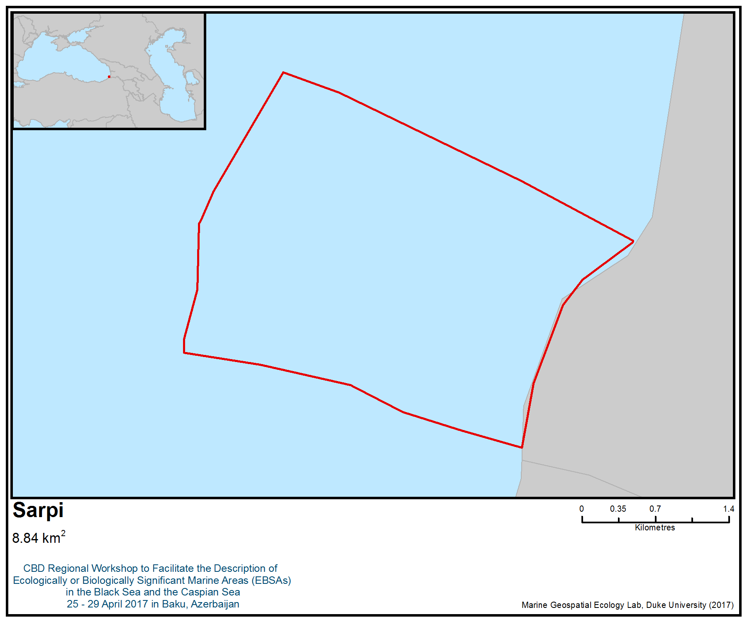
Figure 1. Area meeting the EBSA criteria

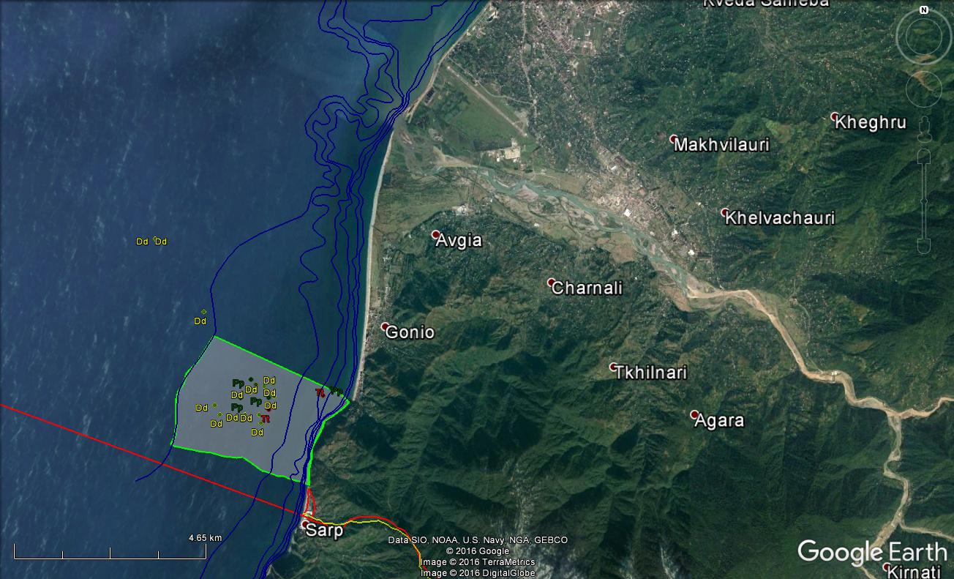

Figure 2. Dolphin distribution in the Sarpi area

Area No. 14: Artvin-Arhavi

Abstract
The area is mainly important for marine pelagic and demersal fish species and cetacean species. In terms of birds, the area overlaps with a marine Important Bird and Biodiversity Area; this IBA is of regional importance for two seabird species: velvet scoter Melanitta fusca and Caspian gull Larus cachinnans. A third species is also known to occur: mew gull Larus canus. Harbour porpoises have been found all along the Turkish Black Sea coast and are especially abundant along the eastern coast, where several rivers enter the Black Sea.

Introduction
Artvin Arhavi is a town within the district of Artvin, Turkey, located in the eastern part of the Black Sea. The coast is about 10 km long. The climate is typical of the Black Sea, with warm summers and cool winters. Mean sea surface temperature is considerably different from the western part of the sea due to the greater exposure of the western Black Sea to the cold air outbreaks from continental Europe, whereas the eastern basin is protected from such cold outbreaks by the mountain chains along the southern and eastern coastlines. The relatively deep interior part of the sea is also slightly cooler than the peripheral zone due to the persistent upwelling motion associated with the cyclonic circulation system (http://giovanni.sci.gsfc.nasa.gov, 2017).

In terms of cetaceans, the primary overwintering area of common dolphin is the south-eastern Black Sea (Birkun 2008). According to Birkun (2008), the population size of common dolphins in the Black Sea is at least several tens of thousands.

According to Çelikkale et al. (1989) all three species of dolphin harbour porpoises have been found all along the Turkish Black Sea coast and are especially abundant in the eastern coast, where several rivers enter the Black Sea. Also, the primary overwintering area of harbour porpoises and bottlenose dolphin is the south-eastern Black Sea (Saydam 2015).

In general, the zooplankton of the southern Black Sea is dominated by Noctiluca scintillans, Oithona similis, Acartia clausi, Pseudocalanus elongatus and Penilia avirostris (Erkan et al., 2000). The cold water species (Calanus euxinus, Pseudocalanus elongatus, Oithona similis and Pleopis polyphemoides) dominate winter spring assemblages, while Penilia avirostris, Acartia clausi, Paracalanus parvus and Centropages spp. are the major summer species (Ünal, 2002).

Studies conducted on the crustaceans of sandy muddy biotopes on the seabeds of central and eastern Black Sea indicate that species diversity is relatively high in shallow waters (<50 m) and that diversity decreases in direct correlation with increasing depth (Kirkim et al., 2006). Lucinella divaricata, Chamelea gallina, Donax venustus and Mytilaster lineatus were commonly found by Mutlu (1994) in sediments with high sand content (93%). Silty sea floors support high mollusc diversity (Mutlu, 1994).

Sezgin et al. (2010) investigated the diversity of macrozoobenthos of the eastern Black Sea region of Turkey at 39 stations (13m -79 m depth range) and reported that the polychaete Melinna palmata, and the mollusks Lentidium mediterraneum, Lucinella divaricata and Chamelea gallina were the most dominant species, while polychaetes M. palmata, Micronephths stammeri, A. fragilis mediterranea, and mollusks C. gallina and Pitar rudis were recorded as frequent in the area. They also observed that the total numbers of soft bottom species for each group decreased with depth and that depth has a major influence on the faunal community composition, in particular above the 50 m depth contour.

In terms of birds, the area overlaps with a marine Important Bird and Biodiversity Area (IBA; BirdLife International 2017) that is of regional importance for two seabird species: velvet scoter (Melanitta fusca) and Caspian gull (Larus cachinnans). A third species, mew gull (Larus canus), is also known to occur (BirdLife International 2017).

Location
Artvin-Arhavi is named for the town of Arhavi, in the district of Artvin Province, Turkey. The area is located close to Yukarı Hacılar village, between Hopa town, to the east of Arhavi county town, and Fındıklı, north of Yusufeli, in the south-eastern part of the Black Sea. The coordinates of the area are: 41 21.48' N- 41 18.824' E, 41 22.116' N- 41 18.824' E, 41 22.659' N- 41 20.216' E, 41 22.14' N- 41 20.216' E.

Feature description of the area
The eastern part of the area is a social area where people go to swim. With the protection of the sea, the coastal area will be under integrated protection and will provide sustainable conservation. It is an important breeding area for fish species (Erüz, 2007) and cetaceans habitat (Saydam, 2015).

The area overlaps with a marine Important Bird and Biodiversity Area (IBA; BirdLife International 2017) that is regionally important as a wintering area for the velvet scoter Melanitta fusca and for the Caspian gull Larus cachinnans (BirdLife International 2017). A third species is also known to occur: mew gull Larus canus.

At least 18 fish species are located in this area:
Gobius cobitis (Giant goby)
Neogobius melanostomus (Round goby)
Neogobius platyrostris (Flatsnout goby)
Lipophrys pavo (Peacock blenny)
Parablennius incognitus (Blennie diabolo)
Parablennius zvonimiri (Red blenny)
Parablennius sanguinolentus (Black Sea blenny)
Psetta maxima (Turbot)
Sciaena umbra (Brown meagre)
Diplodus puntazzo (Sharpsnout seabream)
Dicentrarchus labrax (Common bass)
Liza aurata(Golden grey mullet)
Mugil cephalus (Flathead mullet)
Mullus barbatus (Red mullet)
Merlangius merlangus (Whiting)
Dasyatis pastinaca (Common stingray)
Syngnathus acus (Greater pipefish)
Hippocampus hippocampus (Short-snouted seahorse)

Ten species of benthic organisms are located in this area:
Cystoseira barbata
Entoromorfha spp.
Ulva lactuca
Melinna palmata
Lentidium mediterraneum
Lucinella divaricata
Chamelea gallina
Micronephths stammeri
Aricidea fragilis mediterranea
Pitar rudis

Three marine mammal species live in this area:
Delphnius delphis ssp. Ponticus (Short-beaked common dolphin)
Turiops truncatus ssp. Ponticus (Bottlenose dolphin)
Phocena phocena ssp. Relicta (Harbour porpoise)

Delphinus delphis ssp. ponticus has vulnerable status, while Turiops truncatus ssp. ponticus has endangered status, on the IUCN Red List of Threatened Species based on criterion A2cde (Birkun Jr., A.A, 2008). Finally, Phocena phocena ssp. relicta, has endangered status in the IUCN Red List of Threatened Species based on criteria A1d and A4cde.

Three seabird species in need of protection inhabiting this area are:
Melanitta fusca
Larus cachinnans
Larus canus

Feature condition and future outlook of the area
The area comprises mainly rocky and local sandy habitat with rocks. There is no economically important activity on the alien gastropod Rapana venosa because the area is used forrecreation.

According to a study by Saydam (2015), the highest rate of cetacean distribution was mainly obtained in the eastern part of the Black Sea. More than 15 individuals of Delphinus delphis were recorded and about four individuals of Phocena phocena were recorded during the cruise in 2014. In the July cruise, short-beaked common dolphins were more frequently encountered in the eastern part of the south-eastern Black Sea. Moreover, short-beaked common dolphins were more frequently encountered in the eastern Black Sea, with relatively larger group sizes inhabiting coastal eastern Black Sea waters.

Assessment of the area against CBD EBSA Criteria

CBD EBSA Criteria  (Annex I to decision IX/20) | Description  (Annex I to decision IX/20) | Ranking of criterion relevance  (please mark one column with an X)
CBD EBSA Criteria  (Annex I to decision IX/20) | Description  (Annex I to decision IX/20) | No information |  | Low |  |  | Medium |  | High
Uniqueness or rarity | Area contains either (i) unique (“the only one of its kind”), rare (occurs only in few locations) or endemic species, populations or communities, and/or (ii) unique, rare or distinct, habitats or ecosystems; and/or (iii) unique or unusual geomorphological or oceanographic features. |  |  |  |  |  | X
Explanation for ranking
The area is characterized by frequent occurrence of cetaceans represented by endemic and endangered subspecies or populations: the Black Sea harbour porpoise Phocoena phocoena relicta (Birkun and Frantzis, 2008) and the endangered Black Sea bottlenose dolphin Tursiops truncatus ponticus (Saydam, 2015).
Special importance for life-history stages of species | Areas that are required for a population to survive and thrive. |  |  |  |  |  |  |  | X
Explanation for ranking
The area overlaps with an IBA that is regionally important as a wintering area for the velvet scoter Melanitta fusca and for the Caspian gull Larus cachinnans. Short-beaked common dolphins are more frequently encountered in the eastern part of south-eastern Black Sea than in other parts of the Black Sea. Moreover, short-beaked common dolphins are more frequently encountered in the eastern Black Sea with relatively larger group sizes inhabiting coastal eastern Black Sea waters. Moreover, the primary overwintering area of common dolphin is the south-eastern Black Sea (Saydam, 2015).
Importance for threatened, endangered or declining species and/or habitats | Area containing habitat for the survival and recovery of endangered, threatened, declining species or area with significant assemblages of such species. |  |  |  |  |  |  |  | X
Explanation for ranking
Delphinus delphis ssp. ponticus has vulnerable status, while Turiops truncatus ssp. ponticus has endangered status, on the IUCN Red List of Threatened Species based on criterion A2cde (Birkun Jr., A.A, 2008). Finally, Phocena phocena ssp. relicta, has endangered status in the IUCN Red List of Threatened Species based on criteria A1d and A4cde.
Also in terms of birds, Melanitta fusca, which has vulnerable status on IUCN Red List, inhabits the area, which overlaps with a marine Important Bird and Biodiversity Area.

According to the Black Sea Fish Check List, the species Hippocampus hippocampus is endangered in Turkey (Yankova, n.d.).
Vulnerability, fragility, sensitivity, or slow recovery | Areas that contain a relatively high proportion of sensitive habitats, biotopes or species that are functionally fragile (highly susceptible to degradation or depletion by human activity or by natural events) or with slow recovery. |  |  |  |  |  | X
Explanation for ranking
All cetaceans are known to have low reproductive rates and slow recovery if damaged. It also takes at least 3-4 years for them to start to reproduce.

Bottlenose dolphins and harbour porpoises start reproduction late, and produce a limited number of offspring. Birkun (2012) indicates that Black Sea bottlenose dolphins have a life history similar to bottlenose dolphins elsewhere and therefore that the generation time is approximately 20 years; the interval between births is from two or three to six years; one female is unlikely to produce more than eight calves in her lifetime; gestation lasts 12 months, lactation can last more than 1.5 years. Gold’in (2004) reported that sexual maturity is reached at 3-4 years for the harbour porpoise, and the maximum life span is at least 20 years. This indicates slow recovery in cases of degradation or depletion by human activities or natural events, such as epidemics.

According to the Black Sea Fish Check List, the species Hippocampus hippocampus is endangered in Turkey (Yankova, n.d.).
Biological productivity | Area containing species, populations or communities with comparatively higher natural biological productivity. | X
Biological diversity | Area contains comparatively higher diversity of ecosystems, habitats, communities, or species, or has higher genetic diversity. |  |  |  |  |  | X
Explanation for ranking
Sezgin et al. (2010) investigated the diversity of macrozoobenthos of the eastern Black Sea region of Turkey at 39 stations (13m -79 m depth range) and reported that polychaete Melinna palmata, molluscs Lentidium mediterraneum, Lucinella divaricata and Chamelea gallina were the most dominant species, while polychaetes M. palmata, Micronephths stammeri, A. fragilis mediterranea, mollusks C. gallina and Pitar rudis were recorded frequently in the area.
The area overlaps with a marine Important Bird and Biodiversity Area (IBA; BirdLife International 2017); this IBA is of regional importance for two seabird species: velvet scoter Melanitta fusca and Caspian gull Larus cachinnans. A third species is also known to occur: mew gull Larus canus. (BirdLife International 2017).
Naturalness | Area with a comparatively higher degree of naturalness as a result of the lack of or low level of human-induced disturbance or degradation. |  |  |  |  |  |  |  |  | X
Explanation for ranking
The eastern part of the area is an area that is used only for recreational purposes (i.e., swimming).

References
J. G. Acker and G. Leptoukh, “Online Analysis Enhances Use of NASA Earth Science Data”, Eos, Trans. AGU, Vol. 88, No. 2 (9 January 2007), pages 14 and 17.
BirdLife International 2017. Important Bird Areas factsheet: Eastern Black Sea Mountains. Downloaded from http://datazone.birdlife.org/site/factsheet/eastern-black-sea-mountains-iba-turkey/details on 05/04/2017.
Birkun A., Jr., Krivokhizhin S. (1998). Distribution of Small Cetaceans in the Northern Part of the Black Sea: Cetacean Strandings on Black Sea Coast of the Crimea in 1989-1996 and Cetacean Sightings in the Kerch Strait in 1997 (Report for CIESM, Monaco). BREMA Laboratory, Simferopol, 67 p.
Birkun Jr., A.A. & Frantzis, A. 2008. Phocoena phocoena ssp. relicta. The IUCN Red List of Threatened Species. Version 2015.1. <www.iucnredlist.org>. Downloaded on 18 June 2015.
Birkun, B. A. (2002). The current status of bottlenose dolphins in the Black Sea, ACCOBAMS Report 2: 1–25.
Celikkale, M.S., Unsal, S., Karacam, H., Durukanoglu, H.F. and Duzgunes, E., 1988. Assessment of dolphin stocks and their biological characteristics in the Black Sea. Projects and Applications General Directorate, Ministry of Agriculture, Forestry and Rural Affairs, Turkey, 80 pp. (In Turkish).
Erkan, F., Gücü, A.C. (2000) The diel vertical distribution of zooplankton in the Southeast Black Sea. Turk J Zool. 24: 417-427.
Eruz, Coskun. 2007. Environmentally Sensitive marine and ıntegrated Coastal Areas in Eastern Black Sea.(Report). Black Sea Technical University, Faculty of Marine Science.
Gol’din, P. 2004. Growth and body size of the harbour porpoise, Phocoena phocoena (Cetacea, Phocoenidae), in the Sea of Azov and the Black Sea.Vestinik zoologii 38(4) : 59-73.
http://giovanni.sci.gsfc.nasa.gov, 2017.
Mutlu, E., 1994. Qualitative and quantitative distribution of benthic molluscs along the Turkish Black Sea. Boll. Malacologico, 30: 277-286.
Saydam, G., 2015. Cetacean distribution in The Southern Black Sea: An Acoustıc Approach. 2015. Ms. Thesis.
Sezgin, M., Kirkim, F., Dagli, E., Dogan, A., Unluoglu, A., Katagan, T. & Benli, H.A., 2010. Sublittoral soft-bottom zoobenthic communities and diversity of southern coast of the Black Sea (Turkey). Rapp Comm Int Mer Medit 39: 662.
Ünal, E. (2002) Seasonality of zooplankton in the Southern Black Sea in 1999 and genetics of Calanus euxinus (Copepoda). M.Sc. Thesis, IMS-Middle East Technical University, Ankara, p. 202.
Yankova, M. Black Sea Fish Check List. Commission on the Protection of the Black Sea against Pollution, http://www.blacksea-commission.org/_publ-BSFishList.asp.

Maps and Figures

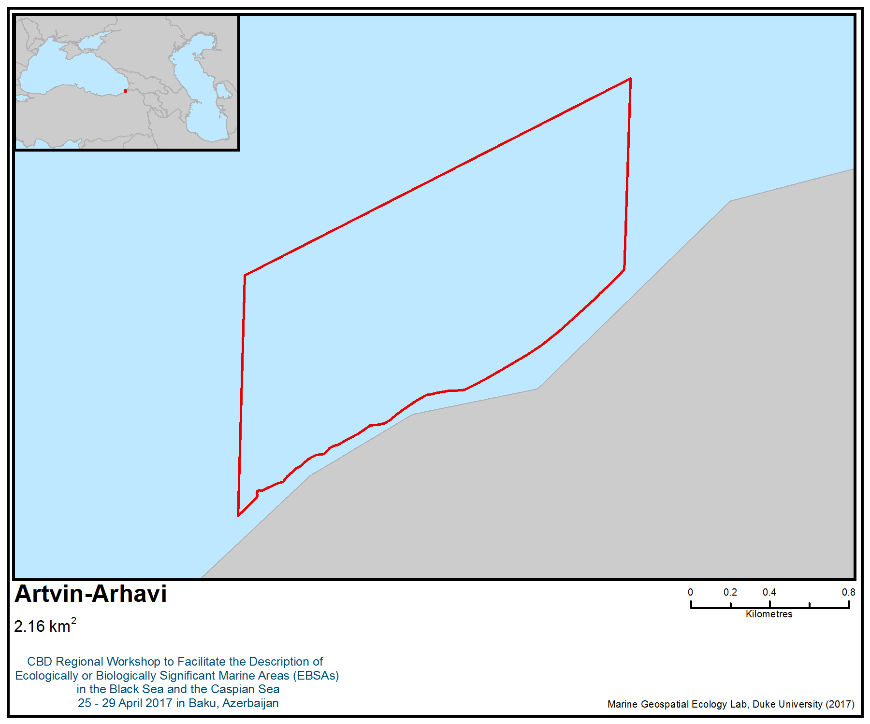
Figure 1. Area meeting the EBSA criteria

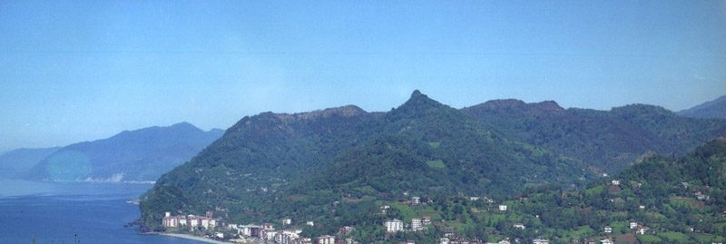
Figure 2. A scene from Artvin Arhavi

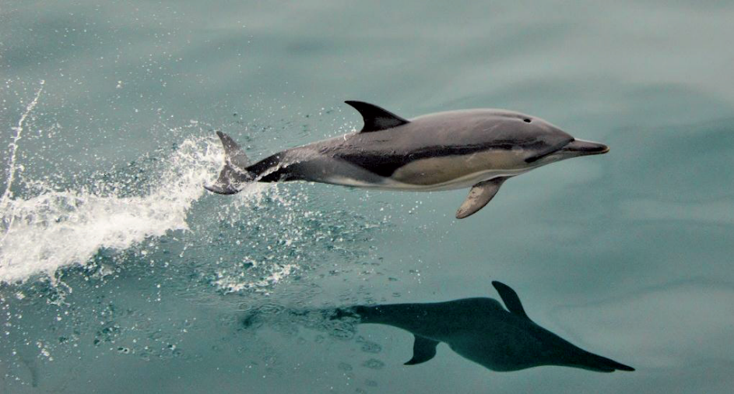
Figure 3. Black Sea short-beaked common dolphin (Delphinus delphis) captured during a cruise in October 2014 (Saydam, 2015)

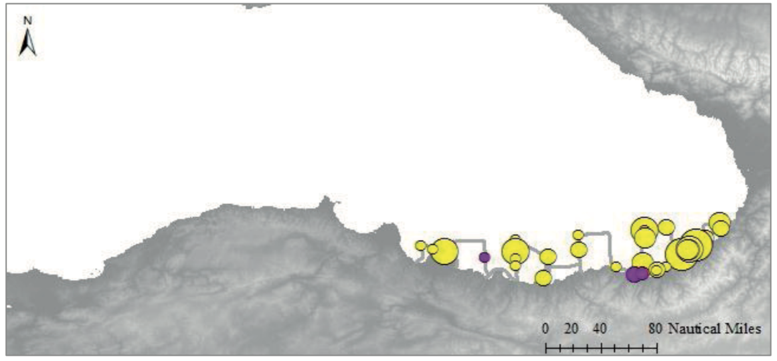

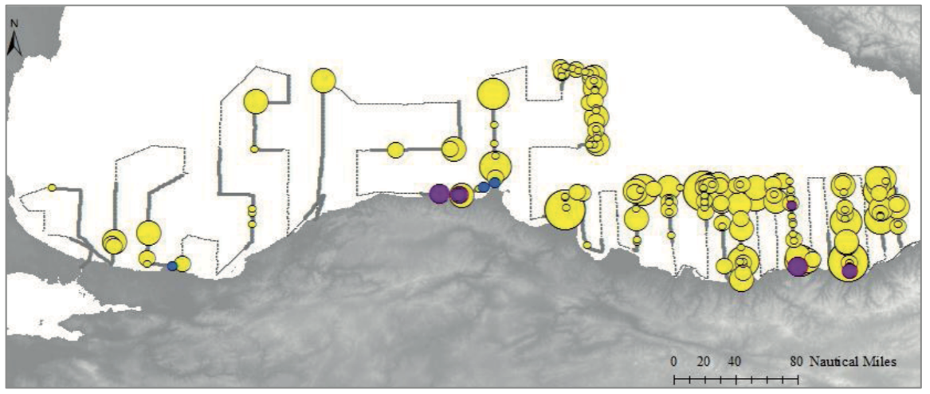
Figure 4. Spatial distribution and average group size (Avg#) of cetacean species Tt: Tursiops truncatus, Pp: Phocoena phocoena, Dd: Delphinus delphis over the day-time cruise track of July 2014 (up) and October 2014 (down) cruises (Saydam 2015)

Area No. 15: Trabzon-Sürmene

Abstract
This area is very important for marine pelagic and demersal fish species. It is an important fish breeding, reproduction and feeding area for demersal and pelagic fish species. It is a bioreserve area that is closed to fisheries. It has a sandy, heel-shaped rocky structure, with an abundance of underwater rocks. The region is also the natural habitat of seabream—the only such spot in the Black Sea. Biological diversity of this part of the Black Sea is considerably high, such that harbour porpoises are found all along the Turkish Black Sea coast and are especially abundant along the eastern coast, where several rivers enter the Black Sea. In terms of birds the area overlaps with a marine Important Bird and Biodiversity Area (IBA) of regional importance for two seabird species: velvet scoter (Melanitta fusca) and Caspian gull (Larus cachinnans). A third species, mew gull (Larus canus), is also known to occur.

Introduction
Trabzon Sürmene is a town within the district of Trabzon. located in the eastern part of the Black Sea of Turkey. There are two transition valleys for the autumn and spring bird migration path. They pass through Karadere - Küçükdere valleys. The length of the coast is about 13 km. Mean sea surface temperature is considerably different from the western part of the sea due to the greater exposure of the western Black Sea to outbreaks of cold air from continental Europe, whereas the eastern basin is protected from such cold outbreaks by the mountain chains along the southern and eastern coastlines. The relatively deep interior part of the sea is also slightly cooler than the peripheral zone due to the persistent upwelling motion associated with the cyclonic circulation system (http://giovanni.sci.gsfc.nasa.gov, 2017).

The biological diversity of this part of the Black Sea is considerably high for zooplankton (Ünal, 2002), mollusk (Mutlu, 1994), benthos in general (Sezgin, 2010) and for fish (Erüz, 2007). All three species of dolphin are observed here in significant numbers (Saydam, 2015).

In general, the zooplankton of the southern Black Sea is dominated by Noctiluca scintillans, Oithona similis, Acartia clausi, Pseudocalanus elongatus and Penilia avirostris (Erkan et al., 2000). The cold water species (Calanus euxinus, Pseudocalanus elongatus, Oithona similis and Pleopis polyphemoides) dominate winter spring assemblages, while Penilia avirostris, Acartia clausi, Paracalanus parvus and Centropages spp. are the major summer species (Ünal, 2002).

Studies conducted on the crustaceans of sandy muddy biotopes on the seabeds of the central and eastern Black Sea indicate that species diversity is relatively high in shallow waters (<50 m) and that diversity decreases in direct correlation with increasing depth (Kirkim et al., 2006). Lucinella divaricata, Chamelea gallina, Donax venustus and Mytilaster lineatus were commonly found in sediments with high sand content (93%) (Mutlu, 1994). Silty sea floors support high mollusc diversity (Mutlu, 1994).

Sezgin et al. (2010) investigated the diversity of macrozoobenthos of the eastern Black Sea region of Turkey at 39 stations (13m -79 m depth range) and reported that polychaete Melinna palmata, molluscs Lentidium mediterraneum, Lucinella divaricata and Chamelea gallina were the most dominant species, while polychaetes M. palmata, Micronephths stammeri, A. fragilis mediterranea, mollusks C. gallina and Pitar rudis were recorded as frequent in the area. They also observed that the total number of soft bottom species for each group decreased with depth and that depth has a major influence on the faunal community composition, in particular above the 50 m depth contour.

In terms of birds, the area overlaps with a marine Important Bird and Biodiversity Area (IBA; BirdLife International 2017) that is regionally important as a wintering area for two seabird species: velvet scoter Melanitta fusca and Caspian gull Larus cachinnans. A third species, mew gull (Larus canus), is also known to occur.

Location
Sürmene is a town in the district of Sürmene in Trabzon Province, located in the south-eastern part of the Black Sea. It is surrounded by Araklı to the west, the town of Of to the east, the Black Sea to the north, and Dernekpazarı to the South.

This area is located between 40 54.749' N - 40 08.364' E, 40 54.794' N - 40 10.404' E, 40 55.183' N- 40 10.404' E and 40 55.183' N-40 08.364' E.

Feature description of the area
It is an important fish breeding and feeding area because it is closed to fishing and has a sandy, heel-shaped rocky structure. There are many underwater rocks in the region.

The area overlaps with a marine Important Bird and Biodiversity Area (IBA; BirdLife International 2017) that is regionally important for two seabird species: velvet scoter (Melanitta fusca) and Caspian gull (Larus cachinnans). A third species, mew gull (Larus canus), is also known to occur. The region is also the only natural habitat of seabream in the Black Sea. Other important fish species are:

Psetta maxima (Turbot)
Sciaena umbra (Brown meagre)
Diplodus puntazzo (Sharpsnout seabream)
Dicentrarchus labrax (Common bass)
Liza aurata (Golden Grey mullet)
Mugil cephalus (Flathead mullet)
Mugil soiuy (So-iuy mullet)
Sparus aurata (Gilthead seabream)
Salpa salpa (Goldline)
Mullus barbatus (Red mullet)
Dasyatis pastinaca (Common stingray)
Diplodus annularis (Annular seabream)
Syngnathus acus (Greater pipefish)
Hippocampus hippocampus (Short-snouted seahorse)

Three species of rocky area algae that will form hard ground are:
Cystoseira barbata
Entoromorfha spp.
Ulva lactuca

Three marine mammals species living in the area are:
Delphnius delphis ssp. Ponticus (Short-beaked Common Dolphin)
Turiops truncatus ssp. Ponticus (Bottlenose dolphin)
Phocena phocena ssp. Relicta (Harbour porpoise)

Delphinus delphis ssp. ponticus has vulnerable status, while Turiops truncatus ssp. ponticus has endangered status, on the IUCN Red List of Threatened Species based on criterion A2cde (Birkun Jr., A.A, 2008). Finally, Phocena phocena ssp. relicta, has endangered status on the IUCN Red List of Threatened Species based on criteria A1d and A4cde.

Three important seabird species inhabiting this area are:
Melanitta fusca (Velvet scoter)
Larus cachinnans (Caspian gull)
Larus canus (Mew Gull)

Feature condition and future outlook of the area
The area is mainly rocky and sandy, providing important habitat for fish breeding and feeding. Due to the presence of underwater rocks and wide, flat sandy areas, the area has high biological diversity.

According to a study by Saydam (2015), the highest rate of cetacean distribution is mainly obtained in the eastern part of the Black Sea. At least 12 individuals of Delphinus delphis and five individuals of Phocena phocena were acoustically estimated to occur during their cruise in July 2014.

Assessment of the area against CBD EBSA Criteria

CBD EBSA Criteria  (Annex I to decision IX/20) | Description  (Annex I to decision IX/20) | Ranking of criterion relevance  (please mark one column with an X)
CBD EBSA Criteria  (Annex I to decision IX/20) | Description  (Annex I to decision IX/20) | No information |  | Low |  |  | Medium |  | High
Uniqueness or rarity | Area contains either (i) unique (“the only one of its kind”), rare (occurs only in few locations) or endemic species, populations or communities, and/or (ii) unique, rare or distinct, habitats or ecosystems; and/or (iii) unique or unusual geomorphological or oceanographic features. |  |  |  |  |  | X
Explanation for ranking
This is an important fish breeding and feeding area due to its closed reserve area for fishery and its sandy, heel-shaped rocky structure. There are many underwater rocks in the region. Also it is the only native and natural habitat for the seabream in the Black Sea. The traditional name of the region is the “Cıpra”, which comes from Sparus aurata Linnaeus (“Çipura” in Turkish), which is the native habitat and natural habitat for the seabream.

The area is characterized by frequent occurrence of cetaceans represented by endemic and endangered subspecies or populations: the Black Sea harbour porpoise (Phocoena phocoena relicta) (Birkun and Frantzis, 2008) and the Black Sea bottlenose dolphin (Tursiops truncatus ponticus) (Saydam 2015).
Special importance for life-history stages of species | Areas that are required for a population to survive and thrive. |  |  |  |  |  |  |  | X
Explanation for ranking
Short-beaked common dolphins were more frequently encountered in the eastern part of the south-eastern Black Sea. Moreover, short-beaked common dolphins are more frequently encountered in the eastern Black Sea with relatively larger group sizes inhabiting coastal eastern Black Sea waters. Moreover, the primary overwintering area of short-beaked common dolphin is the south-eastern Black Sea (Saydam, 2015).
The area overlaps with a marine Important Bird and Biodiversity Area that is regionally important for two seabird species: velvet scoter (Melanitta fusca) and Caspian gull (Larus cachinnans). A third species, mew gull (Larus canus), is also known to occur.

It is a bioreserve area and an area of reproduction and breeding for demersal and pelagic fish species. Also it is the native and natural habitat for the seabream.
Importance for threatened, endangered or declining species and/or habitats | Area containing habitat for the survival and recovery of endangered, threatened, declining species or area with significant assemblages of such species. |  |  |  |  |  |  |  | X
Explanation for ranking
Delphinus delphis ssp. ponticus has vulnerable status, while Turiops truncatus ssp. ponticus has endangered status, on the IUCN Red List of Threatened Species based on criterion A2cde (Birkun Jr., A.A, 2008). Finally, Phocena phocena ssp. relicta, has endangered status on the IUCN Red List of Threatened Species based on criteria A1d and A4cde. Also in terms of birds, Melanitta fusca which is listed as vulnerable (VU) byn IUCN, inhabit in the area, which overlaps with a marine Important Bird and Biodiversity Area.
It is also the native and natural habitat for the seabream.

According to the Black Sea Fish Check List, the species Hippocampus hippocampus is endangered in Turkey (Yankova, n.d.).
Vulnerability, fragility, sensitivity, or slow recovery | Areas that contain a relatively high proportion of sensitive habitats, biotopes or species that are functionally fragile (highly susceptible to degradation or depletion by human activity or by natural events) or with slow recovery. |  |  |  |  |  |  |  | X
Explanation for ranking
All cetaceans are known to have low reproductive rates and slow recovery if injured. It also takes at least 3-4 years for them to start to reproduce.
Bottlenose dolphins and harbour porpoises start reproduction late and produce a limited number of offspring. Birkun (2012) indicates that Black Sea bottlenose dolphins have a life history similar to bottlenose dolphins elsewhere and therefore that the generation time is approximately 20 years; the interval between births is from two or three to six years; one female is unlikely to produce more than eight calves in her lifetime; gestation lasts 12 months and lactation can last more than 1.5 years. Gold’in (2004) reported that sexual maturity is reached at 3-4 years for the harbour porpoise, and the maximum life span is 20 years. This indicates slow recovery in case degradation or depletion by human activities or natural events, such as epidemics.
The area has a sandy, heel-shaped rocky structure. It has the richest benthic species diversity in the region due to the presence of underwater rocks and wide and flat sandy areas.
Moreover, velvet scoter (Melanitta fusca) has vulnerable status on the IUCN Red List.
Biological productivity | Area containing species, populations or communities with comparatively higher natural biological productivity. |  |  |  |  |  | X
Explanation for ranking
Overall, primary productivity in the region displays two phytoplankton peaks throughout the year: the major bloom of mainly diatoms occurs in early spring while a secondary bloom of mainly coccolithophores appears during autumn in both coastal and open waters (Sorokin, 2002; Vedernikov and Demidov, 1997). Recently, additional summer blooms of dinoflagellates and coccolithophorids (mainly Emiliana huxleyi) have frequently been reported (Hay et al., 1990; Sur et al., 1996; Yilmaz et al., 1998; Yayla et al., 2001). The production rates for the southern coasts of the Black Sea were estimated at 247-1925 mg cm-2 d -1 for spring and 405-687 mg cm-2 d -1 for the summer-autumn period during 1995-1996 (Yilmaz et al., 2006).
A total of 89 species of phytoplankton were identified in the stations throughout the March-December 2010 period. During the study period, almost 71% of these were dinoflagellate species, 23% were diatom species and 6% consisted of other species, mainly coccolithophores (Ağırbaş et al., 2004).
Primery productivity was measured by a combination of 14ºC in-situ incubation experiments on natural phytoplankton assemblages. Primary production rates varied notably within the water column with 0.1-40 mg cm -3 d -1 , were always determined in the upper part of the euphotic zone down to the 10% of light intensity depth. The depth-integrated production rates ranged from 285 to 565 mg cm -2 d -1 for the coastal station and from 126 to 530 mg cm -2 d -1 for the offshore station (ANOVA, P>0.05). The average Chl-a concentrations within the euphotic zone ranged from 0.30 to 3.57 µg L -1 for the coastal station and from 0.25 to 3.45 µg L -1 for the offshore station (ANOVA, P0.05). The correlation between integrated PP and Chl-a values for the coastal station (r 2 = 0.98; P0.05) (Ağırbaş et al., 2014).
Biological diversity | Area contains comparatively higher diversity of ecosystems, habitats, communities, or species, or has higher genetic diversity. |  |  |  |  |  | X
Explanation for ranking
The area overlaps with a marine Important Bird and Biodiversity Area (IBA; BirdLife International 2017) that is regionally important for velvet scoter (Melanitta fusca) and Caspian gull (Larus cachinnans). A third seabird species, mew gull (Larus canus), is also known to occur (BirdLife International 2017).
Moreover, it has an underwater bioresrve area and has a complex biodiversity structure. Many of the fish species (at least 14) are resident in this rocky environment, which has three dominant algal species (Erüz, 2007).
Many of the fish species, which do not migrate due to the rocky nature of the coastal part of the region, are located in a rocky and sandy environment and have a rich ecosystem for breeding and feeding. The area’s sandy, heel-shaped, rocky structure makes it important for fish species breeding and feeding. It has the richest benthic species diversity in the region due to the presence of underwater rocks and wide, flat sandy areas.
Sezgin et al. (2010) investigated that diversity of macrozoobenthos of the eastern Black Sea region of Turkey at 39 stations (13m -79 m depth range) and reported that the polychaete Melinna palmata, molluscs Lentidium mediterraneum, Lucinella divaricata and Chamelea gallina were the most dominant species, while M. palmata, Micronephths stammeri, A. fragilis mediterranea, C. gallina and Pitar rudis were recorded as frequent in the area.
Naturalness | Area with a comparatively higher degree of naturalness as a result of the lack of or low level of human-induced disturbance or degradation. |  |  |  |  | X
Explanation for ranking
It is closed reserve area for fisheries. It has an underwater bioreserve area and has a complex biodiversity structure. Many of the fish species, which do not migrate due to the rocky nature of the coastal part of the region, are located in a rocky and sandy environment and have a rich ecosystem of breeding and pasture areas. The area’s sandy, heel-shaped rocky structure makes it important for the breeding and feeding of fish species. It has a rich benthic species diversity in the region due to the presence of underwater rocks and wide, flat sandy areas. However, there are significant developments in the coastal area.

References
Acker, J.G. and G. Leptoukh, “Online Analysis Enhances Use of NASA Earth Science Data”, Eos, Trans. AGU, Vol. 88, No. 2 (9 January 2007), pages 14 and 17.
BirdLife International 2017. Important Bird Areas factsheet: Eastern Black Sea Mountains. Downloaded from http://datazone.birdlife.org/site/factsheet/eastern-black-sea-mountains-iba-turkey/details on 05/04/2017.
Birkun A., Jr., Krivokhizhin S. (1998). Distribution of Small Cetaceans in the Northern Part of the Black Sea: Cetacean Strandings on Black Sea Coast of the Crimea in 1989-1996 and Cetacean Sightings in the Kerch Strait in 1997 (Report for CIESM, Monaco). BREMA Laboratory, Simferopol, 67 p.
Birkun Jr., A.A. & Frantzis, A. 2008. Phocoena phocoena ssp. relicta. The IUCN Red List of Threatened Species. Version 2015.1. <www.iucnredlist.org>. Downloaded on 18 June 2015.
Birkun, B. A. (2002). The current status of bottlenose dolphins in the Black Sea, 2, 1–25.
Celikkale, M.S., Unsal, S., Karacam, H., Durukanoglu, H.F. and Duzgunes, E., 1988. Assessment of dolphin stocks and their biological characteristics in the Black Sea. Projects and Applications General Directorate, Ministry of Agriculture, Forestry and Rural Affairs, Turkey, 80 pp. (In Turkish).
Erkan, F., Gücü, A.C. (2000) The diel vertical distribution of zooplankton in the Southeast Black Sea. Turk J Zool. 24: 417-427.
Eruz, Coskun. 2007. Environmentally Sensitive marine and ıntegrated Coastal Areas in Eastern Black Sea.(Report). Black Sea Technical University, Faculty of Marine Science.
Gol’din, P. 2004. Grow and body size of the harbour porpoise, Phocoena phocoena (Cetacea, Phocoenidae), in the Sea of Azov and the Black Sea.Vestinik zoologii 38(4) : 59-73.
http://giovanni.sci.gsfc.nasa.gov, 2017.
Mutlu, E., 1994. Qualitative and quantitative distribution of benthic molluscs along the Turkish Black Sea. Boll. Malacologico, 30: 277-286.
Saydam, G., 2015. Cetacean distribution in The Southern Black Sea: An Acoustıc Approach. 2015. Ms. Thesis.
Sezgin, M., Kirkim, F., Dagli, E., Dogan, A., Unluoglu, A., Katagan, T. & Benli, H.A., 2010. Sublittoral soft-bottom zoobenthic communities and diversity of southern coast of the Black Sea (Turkey). Rapp Comm Int Mer Medit 39: 662.
Ünal, E. (2002) Seasonality of zooplankton in the Southern Black Sea in 1999 and genetics of Calanus euxinus (Copepoda). M.Sc. Thesis, IMS-Middle East Technical University, Ankara, p. 202.
Yankova, M. Black Sea Fish Check List. Commission on the Protection of the Black Sea against Pollution, http://www.blacksea-commission.org/_publ-BSFishList.asp.

Maps and Figures

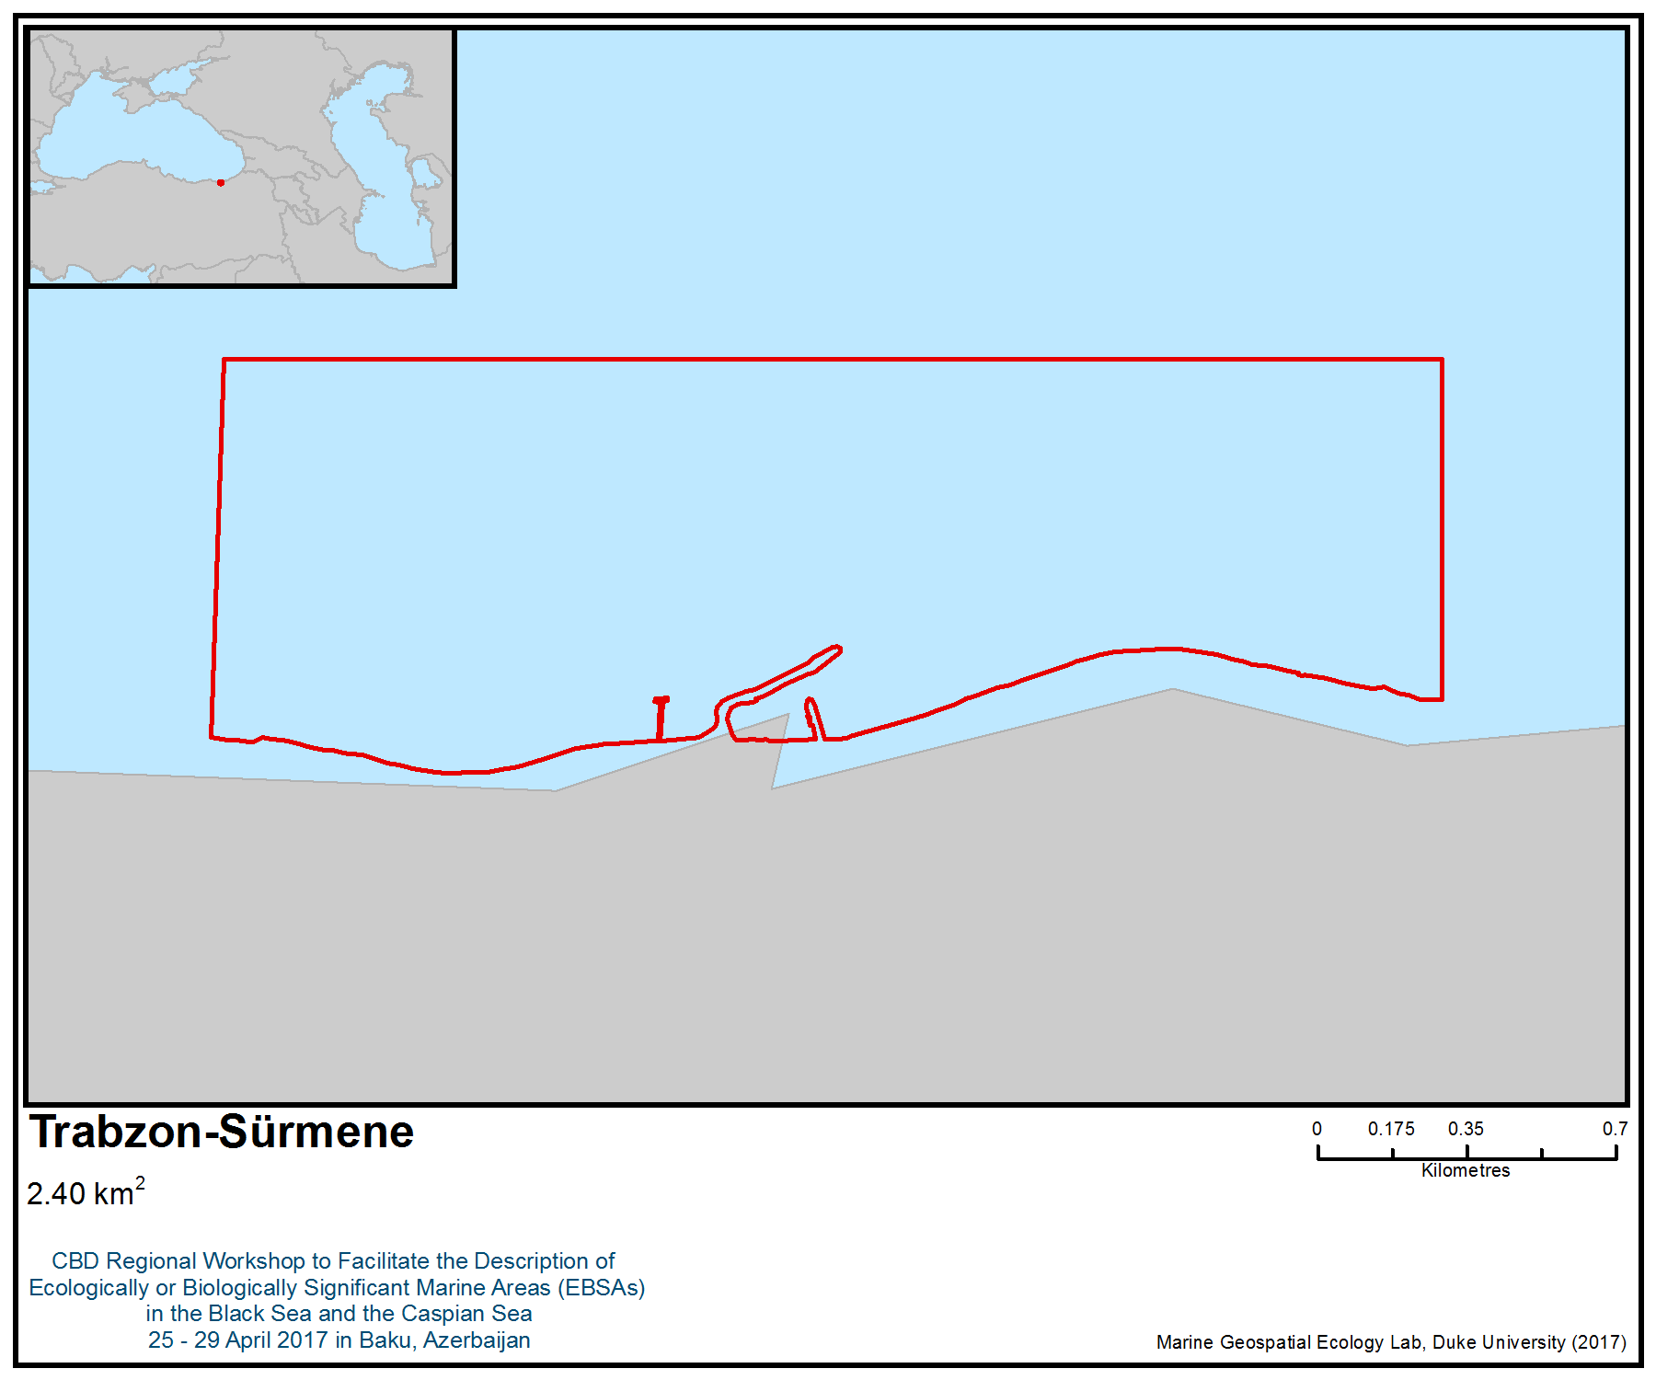
Figure 1. Area meeting the EBSA criteria

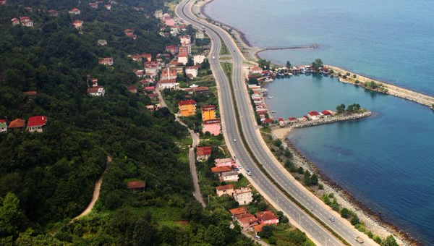
Figure 2. A scene from the Trabzon Sürmene area

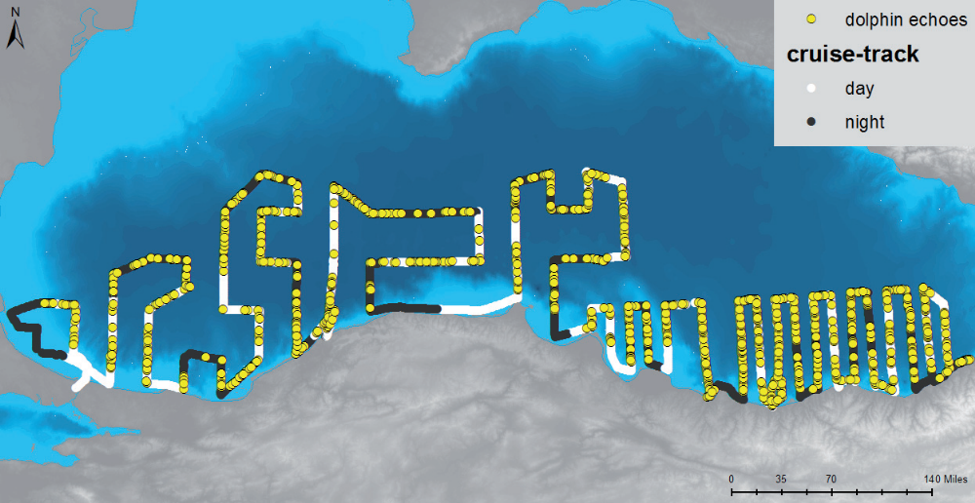
Figure 3. Spatial distribution of all echo-points with mark count over zero, which is estimated as a result of echo-sounder analysis and spatial analysis, Southern Black Sea, October 2014 (Saydam, 2015)

Area No. 16: Trabzon-Arsin

Abstract
This area is very important for habitat, reproduction and breeding of some rare marine pelagic and demersal species, such as three species of dolphins, Psetta maxima (turbot) and Zostera meadows. Several other fish species (e.g., red mullet Mullus barbatus, grey mullet Mugil species) are also abundant. The land side of this area is an official bioreserve site. Many of the fish species, which do not migrate due to the rocky nature of the coastal part of the region, are located in a rocky and sandy environment and have a rich ecosystem for breeding and feeding. This is a reserve area that is closed to fishing. The area has a sandy, heel-shaped rocky structure with the richest benthic species diversity in the region due to the presence of underwater rocks and wide, flat, sandy areas. Moreover, harbour porpoises have been found all along the Turkish Black Sea coast, and are especially abundant on the east coast, where several rivers enter the Black Sea. Also, the primary overwintering area of harbour porpoises is the south-eastern Black Sea. The area overlaps with a marine Important Bird and Biodiversity Area (IBA) that is regionally important for two seabird species: velvet scoter (Melanitta fusca) and Caspian gull (Larus cachinnans). A third species, mew gull (Larus canus), is also known to occur.

Introduction
Trabzon-Arsin is a town within the district of Trabzon, located in the eastern part of the Black Sea along the coast of Turkey. The name “Arsin” means “clean” and “purified”. It is said that this name is taken from the beaches of the districts that are in a natural condition. The length of the coast is about 8 km. The typical Black Sea climate prevails in the district, with warm summers and cool winters. Mean sea surface temperature is considerably different from the western part of the sea due to the greater exposure of the western Black Sea to outbreaks of cold air from continental Europe, whereas the eastern basin is protected from the intrusion of cold air by the mountain chains along the southern and eastern coastlines. The relatively deep interior part of the sea is also slightly cooler than the peripheral zone due to the persistent upwelling motion associated with the cyclonic circulation system (http://giovanni.sci.gsfc.nasa.gov, 2017).

The sea level variations in the Black Sea are affected either by the volume change of the sea due to density changes of sea waters, and/or by mass change due to water exchange with the atmosphere and land through precipitation, evaporation, river runoff and ice melting. The impact of the surface heat flux (internal process) is rather small, with an amplitude of about 1 cm. However, the major driver behind sea level variability in both the Mediterranean and Black seas is wind, associated with the North Atlantic Oscillation. For example, in the south-eastern corner of the sea, there is a long-term trend of sea level raising by 0.4 cm/yr, but this is set against a background of high variability in the data (Avsar et al., 2014).

The surface temperature ranged from 9.52ºC (March) to 27.52ºC (July) during the sampling period in the coastal station. When the surface waters cooled down to 7°C, the upper layer was thoroughly homogenised by convective mixing down to 135 m. The seasonal thermocline formed above 50 m in the late spring and deepened (down to 50-60 m) in autumn. The surface salinity ranged from 15.90‰ (March) to 17.67‰ (December). Although, the permanent halocline was observed between 80 and 120 m depths, the permanent pycnocline formed in surface waters (e.g., 20-40 m), which are controlled by salinity gradient due to continuous intrusion of more saline Mediterranean waters. In the offshore station, the surface temperature ranged from 9.50°C (March) to 27.20ºC (July) during the sampling period. The seasonal thermocline was observed above 40 m during May-October in both stations. The surface salinity ranged from 16.40‰ (May) to 17.80‰ (December). The permanent halocline was observed around 80-130 m depths. (Ağırbaş et al., 2014).

Biological diversity of the current part of the Black Sea is considerably high such that according to Çelikkale et al. (1989) harbour porpoises were found all along the Turkish Black Sea coast, and are especially abundant along the eastern coast, where several rivers enter the Black Sea. Also, the south-eastern Black Sea is the primary overwintering area of harbour porpoises (Saydam, 2005).

In general, the zooplankton of the southern Black Sea is dominated by Noctiluca scintillans, Oithona similis, Acartia clausi, Pseudocalanus elongatus and Penilia avirostris (Erkan et al., 2000). The cold water species (Calanus euxinus, Pseudocalanus elongatus, Oithona similis and Pleopis polyphemoides) dominate winter spring assemblages, while Penilia avirostris, Acartia clausi, Paracalanus parvus and Centropages spp. are the major summer species (Ünal, 2002).

Studies conducted on the crustaceans of sandy muddy biotopes on the seabeds of the central and eastern Black Sea indicate that species diversity is relatively high in shallow waters (<50 m) and that diversity decreases in a direct correlation with increasing depth (Kirkim et al., 2006). Lucinella divaricata, Chamelea gallina, Donax venustus and Mytilaster lineatus were commonly found in sediments with high sand content (93%) (Mutlu, 1994). Silty sea floors support high mollusc diversity (Mutlu, 1994).

Sezgin et al. (2010) investigated the diversity of macrozoobenthos of the eastern Black Sea region of Turkey at 39 stations (13m -79 m depth range) and reported that the polychaete Melinna palmata, and the mollusks Lentidium mediterraneum, Lucinella divaricata and Chamelea gallina were the most dominant species, while the polychaetes M. palmata, Micronephths stammeri, A. fragilis mediterranea, and the mollusks C. gallina and Pitar rudis were recorded as frequent in the area. They also observed that the total numbers of soft bottom species for each group decreased with depth and that depth has a major influence on the faunal community composition, in particular above the 50 m depth contour.

In terms of birds, the area overlaps with a marine Important Bird and Biodiversity Area (IBA; BirdLife International 2017) that is regionally important for two seabird species: velvet scoter (Melanitta fusca) and Caspian gull (Larus cachinnans). A third species, the mew gull (Larus canus) is known to occur.

Location
Arsin is a town and a district of Trabzon Province located in the south-eastern part of the Black Sea. It is located on the coast line of Trabzon-Rize, 20 km east of Trabzon province. It is surrounded by Araklı to the east, Yomra to the west, the Black Sea to the north, and by Yağmurdere town of Gümüşhane Province to the south.

The area is located between 40 57.769' N- 39 58.532' E 40 58.123' N- 39 58.532' E 40 58.123' N- 39 59.528' E and 40 57.849' N- 39 59.528' E coordinates.

Feature description of the area
It has an underwater bioreserve area and a complex biodiversity structure. Many of the fish species, which do not migrate due to the rocky nature of the coastal part of the region, are located in a rocky and sandy environment and have a rich ecosystem for breeding and feeding. The area is a reserve that is closed to fisheries. The area has a sandy, heel-shaped rocky structure with the richest benthic species diversity in the region due to the presence of underwater rocks and wide and flat sandy areas.

The area overlaps with a marine Important Bird and Biodiversity Area (IBA; BirdLife International 2017) that is regionally important for two seabird species: velvet scoter (Melanitta fusca) and Caspian gull (Larus cachinnans). A third species, the mew gull (Larus canus), is known to occur.

At least 15 fish species located in this area are:
Psetta maxima (Turbot)
Sciaena umbra (Brown meagre)
Diplodus puntazzo (Sharpsnout seabream)
Dicentrarchus labrax (Common bass)
Liza aurata (Golden grey mullet)
Mugil cephalus (Flathead mullet)
Mugil soiuy (So-iuy mullet)
Sparus aurata (Gilthead seabream)
Salpa salpa (Goldline)
Mullus barbatus (Red mullet)
Dasyatis pastinaca (Common stingray)
Diplodus annularis (Annular seabream)
Syngnathus acus (Greater pipefish)
Hippocampus hippocampus (Short-snouted seahorse)
Merlangius merlangus (Whiting)

Three species of rocky area algae that will form hard ground are:
Cystoseira barbata
Entoromorfha spp.
Ulva lactuca

Three marine mammal species living in the area are:
Delphnius delphis ssp. ponticus (Short-beaked common dolphin)
Turiops truncatus ssp. ponticus (Bottlenose dolphin)
Phocena phocena ssp. relicta (Harbor porpoise)

Delphinus delphis ssp. ponticus has vulnerable status, while Turiops truncatus ssp. ponticus has endangered status, on the IUCN Red List of Threatened Species based on criterion A2cde (Birkun Jr., A.A., 2008). (Birkun, A. 2008). Finally, Phocena phocena ssp. relicta, has endangered status on the IUCN Red List of Threatened Species based on criteria A1d and A4cde.

Three important seabird species inhabiting this area are:
Melanitta fusca (Velvet scoter)
Larus cachinnans (Caspian gull)
Larus canus (Mew gull)

Feature condition and future outlook of the area
The coastal part of the region is characterized by a rocky and sandy environment. Its sandy, heel-shaped rocky structure makes it an important area for fish breeding and feeding. Due to the presence of underwater rocks and wide and flat sandy areas, the area has the richest benthic species diversity.

According to a study by Saydam(2015), the highest rate of cetacean distribution were mainly obtained in the eastern part of the Black Sea. More than 12 individuals of Delphinus delphis ssp. ponticus were obtained and about five individuals of Phocena phocena ssp. relicta were recorded during the cruise in 2014. In the July cruise, short- beaked common dolphins were more frequently encountered in the eastern part of South-Eastern Black Sea. Moreover, short- beaked common dolphins were more frequently encountered in the eastern Black Sea with relatively larger group sizes inhabiting eastern Black Sea coastal waters.

Assessment of the area against CBD EBSA Criteria

CBD EBSA Criteria  (Annex I to decision IX/20) | Description  (Annex I to decision IX/20) | Ranking of criterion relevance  (please mark one column with an X)
CBD EBSA Criteria  (Annex I to decision IX/20) | Description  (Annex I to decision IX/20) | No information |  | Low |  |  | Medium |  | High
Uniqueness or rarity | Area contains either (i) unique (“the only one of its kind”), rare (occurs only in few locations) or endemic species, populations or communities, and/or (ii) unique, rare or distinct, habitats or ecosystems; and/or (iii) unique or unusual geomorphological or oceanographic features. |  |  |  |  |  | X
Explanation for ranking
This is an underwater bioreserve area with a complex biodiversity structure. Many of the fish species, which do not migrate due to the rocky nature of the coastal part of the region, are located in a rocky and sandy environment and have a rich ecosystem for breeding and feeding. It is the richest benthic species diversity of the region due to the presence of underwater rocks and wide and flat sandy areas (Erüz, 2007).
The area is characterized by frequent occurrence of cetaceans represented by endemic and endangered subspecies or populations: the Black Sea harbour porpoise Phocoena phocoena relicta (Birkun and Frantzis, 2008) and the endangered Black Sea bottlenose dolphin Tursiops truncatus ponticus (Saydam, 2015).
Special importance for life-history stages of species | Areas that are required for a population to survive and thrive. |  |  |  |  |  |  |  | X
Explanation for ranking
Short-beaked common dolphins are more frequently encountered in the eastern part of the south-eastern Black Sea. Moreover, short-beaked common dolphins are more frequently encountered in the eastern Black Sea with relatively larger group sizes inhabiting coastal Eastern Black sea waters. Moreover, the south-eastern Black Sea is the primary overwintering area of short-beaked common dolphin (Saydam, 2015).
The area overlaps with an IBA that is regionally important as a wintering area for the velvet scoter (Melanitta fusca) and the Caspian gull (Larus cachinnans).
It has an underwater bioreserve area and a complex biodiversity structure. Many of the fish species, which do not migrate due to the rocky nature of the coastal part of the region, are located in a rocky and sandy environment that provides a rich ecosystem for breeding and feeding. It has the richest benthic species diversity in the region due to the presence of underwater rocks and wide, flat sandy areas.
Importance for threatened, endangered or declining species and/or habitats | Area containing habitat for the survival and recovery of endangered, threatened, declining species or area with significant assemblages of such species. |  |  |  |  |  |  |  | X
Explanation for ranking
Delphinus delphis ssp. ponticus has vulnerable status, while Turiops truncatus ssp. ponticus has endangered status, on the IUCN Red List of Threatened Species based on criterion A2cde (Birkun Jr., A.A, 2008). Finally, Phocena phocena ssp. relicta, has endangered status on the IUCN Red List based on criteria A1d and A4cde. Also in terms of birds, Melanitta fusca which has vulnerable status on the Red List, inhabits the area, which overlaps with a marine Important Bird and Biodiversity Area.
Vulnerability, fragility, sensitivity, or slow recovery | Areas that contain a relatively high proportion of sensitive habitats, biotopes or species that are functionally fragile (highly susceptible to degradation or depletion by human activity or by natural events) or with slow recovery. |  |  |  |  |  | X
Explanation for ranking
All cetaceans are known to have low reproductive rates and slow recovery if injured. It also takes at least 3-4 years for them to start reproduction. Delphinus delphis ssp. ponticus has vulnerable status, while Turiops truncatus ssp. ponticus has endangered status, on the IUCN Red List of Threatened Species based on criterion A2cde (Birkun Jr., A.A, 2008). Finally, Phocena phocena ssp. relicta, has endangered status on the IUCN Red List based on criteria A1d and A4cde.
Bottlenose dolphins and harbour porpoises start reproduction late and produce a limited number of offspring. According to Birkun (2012), Black Sea bottlenose dolphins have a life history similar to bottlenose dolphins elsewhere and therefore that the generation time is approximately 20 years, and the interval between births is from two or three to six years; one female is unlikely to produce more than eight calves in her lifetime; gestation lasts 12 months; and lactation can last more than 1.5 years. Gold’in (2004) reported that the sexual maturity is reached at 3-4 years for the harbour porpoise and the maximum life span is 20 years. This indicates slow recovery in case degradation or depletion by human activities or natural events, such as epidemics.
Also in terms of birds, Melanitta fusca, which is listed asvulnerable on the Red List, inhabit in the area, which overlaps with a marine Important Bird and Biodiversity Area.
Moreover, velvet scoter (Melanitta fusca) is listed as vulnerable on the IUCN Red List.
According to the Black Sea Fish Check List, the species Hippocampus hippocampus is endangered in Turkey (Yankova, n.d.).
Biological productivity | Area containing species, populations or communities with comparatively higher natural biological productivity. |  |  |  |  |  | X
Explanation for ranking
Sezgin et al. (2010) investigated the diversity of macrozoobenthos of the eastern Black Sea region of Turkey at 39 stations (13m -79 m depth range) and reported that the polychaete Melinna palmata, and the mollusks Lentidium mediterraneum, Lucinella divaricata and Chamelea gallina were the most dominant species, while the polychaetes M. palmata, Micronephths stammeri, A. fragilis mediterranea, C. gallina and Pitar rudis were recorded as frequent in the area.
Overall, primary productivity in the region displays two phytoplankton peaks throughout the year: the major bloom of mainly diatoms occurs in early spring while a secondary bloom of mainly coccolithophores appears during autumn in both coastal and open waters (Sorokin, 2002; Vedernikov and Demidov, 1997). Recently, additional summer blooms of dinoflagellates and coccolithophorids (mainly Emiliana huxleyi) have frequently been reported (Hay et al., 1990; Sur et al., 1996; Yilmaz et al., 1998; Yayla et al., 2001). The production rates for the southern coasts of the Black Sea were estimated as 247-1925 mg cm-2 d -1 for spring and 405-687 mg cm-2 d -1 for summer-autumn period during 1995-1996 (Yilmaz et al., 2006).
A total of 89 species of phytoplankton were identified in the stations throughout the March-December 2010 period. During study period, almost 71% of these were dinoflagellate species, 23% were diatom species and 6% consisted of other species, mainly coccolithophores (Ağırbaş et al., 2004). Primary productivity was measured by a combination of 14ºC in-situ incubation experiments on natural phytoplankton assemblages. Primary production rates varied notably within the water column with 0.1-40 mg cm -3 d -1, were always determined in the upper part of the euphotic zone down to the 10% of light intensity depth. The depth-integrated production rates ranged from 285 to 565 mg cm -2 d -1 for the coastal station and from 126 to 530 mg cm -2 d -1 for the offshore station (ANOVA, P>0.05). The average Chl-a concentrations within the euphotic zone ranged from 0.30 to 3.57 µg L -1 for the coastal station and from 0.25 to 3.45 µg L -1 for the offshore station (ANOVA, P0.05). The correlation between integrated PP and Chl-a values for the coastal station (r 2 = 0.98; P0.05) (Ağırbaş et al., 2014).
Biological diversity | Area contains comparatively higher diversity of ecosystems, habitats, communities, or species, or has higher genetic diversity. |  |  |  |  |  | X
Explanation for ranking
The area overlaps with a marine Important Bird and Biodiversity Area (IBA; BirdLife International 2017) that is regionally important for two seabird species: velvet scoter (Melanitta fusca) and Caspian gull (Larus cachinnans). A third species, mew gull (Larus canus), is also known to occur. (BirdLife International 2017).
The area is an underwater bioreserve with a complex biodiversity structure. Many of the fish species (at least 15) are resident in this rocky environment, which has three dominant algal species (Erüz, 2007).
Sezgin et al. (2010) investigated the diversity of macrozoobenthos of the eastern Black Sea region of Turkey at 39 stations (13m -79 m depth range) and reported that the polychaete Melinna palmata, and the mollusks Lentidium mediterraneum, Lucinella divaricata and Chamelea gallina were the most dominant species, while the polychaetes M. palmata, Micronephths stammeri, A. fragilis mediterranea, C. gallina and Pitar rudis were recorded as frequent in the area.
According to Çelikkale et al. (1989) harbour porpoises were found all along the Turkish Black Sea coast, including in this area.
A total of 15 zooplankton species, seven of which belonged to the copepod group, were identified (Yıldız & Feyzioğlu, 2014)
Naturalness | Area with a comparatively higher degree of naturalness as a result of the lack of or low level of human-induced disturbance or degradation. |  |  |  |  |  |  | X
Explanation for ranking
This is a reserve area that is closed to fisheries.

References
Ağırbaş, A., Feyzioğlu, A. M., Kopuz, U. 2014. Seasonal Changes of Phytoplankton Chlorophyll a, Primary Production and their Relation in the Continental Shelf Area of the South Eastern Black Sea. Turkish Journal of Fisheries and Aquatic Sciences 14: 713-726.
Avsar, N. B., Kutoğlu, S. H., Jin, S. and Erol B. 2014. Investigation of Sea Level Change Along The Black Sea Coast From Tıde Gauge And Satellite Altimetry
BirdLife International 2017. Important Bird Areas factsheet: Eastern Black Sea Mountains. Downloaded from http://datazone.birdlife.org/site/factsheet/eastern-black-sea-mountains-iba-turkey/details on 05/04/2017.
Birkun A., Jr., Krivokhizhin S. (1998). Distribution of Small Cetaceans in the Northern Part of the Black Sea: Cetacean Strandings on Black Sea Coast of the Crimea in 1989-1996 and Cetacean Sightings in the Kerch Strait in 1997 (Report for CIESM, Monaco). BREMA Laboratory, Simferopol, 67 p.
Birkun Jr., A.A. & Frantzis, A. 2008. Phocoena phocoena ssp. relicta. The IUCN Red List of Threatened Species. Version 2015.1. <www.iucnredlist.org>. Downloaded on 18 June 2015.
Birkun, B. A. (2002). The current status of bottlenose dolphins in the Black Sea, 2, 1–25.
Celikkale, M.S., Unsal, S., Karacam, H., Durukanoglu, H.F. and Duzgunes, E., 1988. Assessment of dolphin stocks and their biological characteristics in the Black Sea. Projects and Applications General Directorate, Ministry of Agriculture, Forestry and Rural Affairs, Turkey, 80 pp. (In Turkish).
Erkan, F., Gücü, A.C. (2000) The diel vertical distribution of zooplankton in the Southeast Black Sea. Turk J Zool. 24: 417-427.
Eruz, Coskun. 2007. Environmentally Sensitive marine and ıntegrated Coastal Areas in Eastern Black Sea.(Report). Black Sea Technical University, Faculty of Marine Science.
Gol’din, P. 2004. Grow and body size of the harbour porpoise, Phocoena phocoena (Cetacea, Phocoenidae), in the Sea of Azov and the Black Sea.Vestinik zoologii 38(4) : 59-73.
http://giovanni.sci.gsfc.nasa.gov, 2017
Mutlu, E., 1994. Qualitative and quantitative distribution of benthic molluscs along the Turkish Black Sea. Boll. Malacologico, 30: 277-286.
Saydam, G., 2015. Cetacean distribution in the Southern Black Sea: An Acoustıc Approach. 2015. Ms. Thesis.
Sezgin, M., Kirkim, F., Dagli, E., Dogan, A., Unluoglu, A., Katagan, T. & Benli, H.A., 2010. Sublittoral soft-bottom zoobenthic communities and diversity of southern coast of the Black Sea (Turkey). Rapp Comm Int Mer Medit 39: 662.
Ünal, E. (2002) Seasonality of zooplankton in the Southern Black Sea in 1999 and genetics of Calanus euxinus (Copepoda). M.Sc. Thesis, IMS-Middle East Technical University, Ankara, p. 202.
Sorokin, Y.A. 2002. The Black Sea: ecology and oceanography. Biology of Inland Waters. Backhuys, Leiden, The Netherlands, 875 pp.
Vedernikov, V.I. and Demidov, A.B. 1997. Vertical distribution of primary production and chlorophyll during different seasons in deep regions of the Black Sea. Oceanology 37: 376–384
Yankova, M. Black Sea Fish Check List. Commission on the Protection of the Black Sea against Pollution, http://www.blacksea-commission.org/_publ-BSFishList.asp.
Yilmaz, A., Coban-Yildiz, Y. and Tugrul, S. 2006. Biogeochemical cycling and multilayer production in the Black Sea. Geophysical Research Abstracts, 8: 00541. doi: 1607-7962/gra/EGU06-A-00541
Yıldız, İ. and Feyzioğlu, A. M. 2014. Biological diversity and seasonal variation of mesozooplankton in the south-eastern Black Sea coastal ecosystem. Turkish Journal of Zoology. 38: 179 – 190.

Maps and Figures

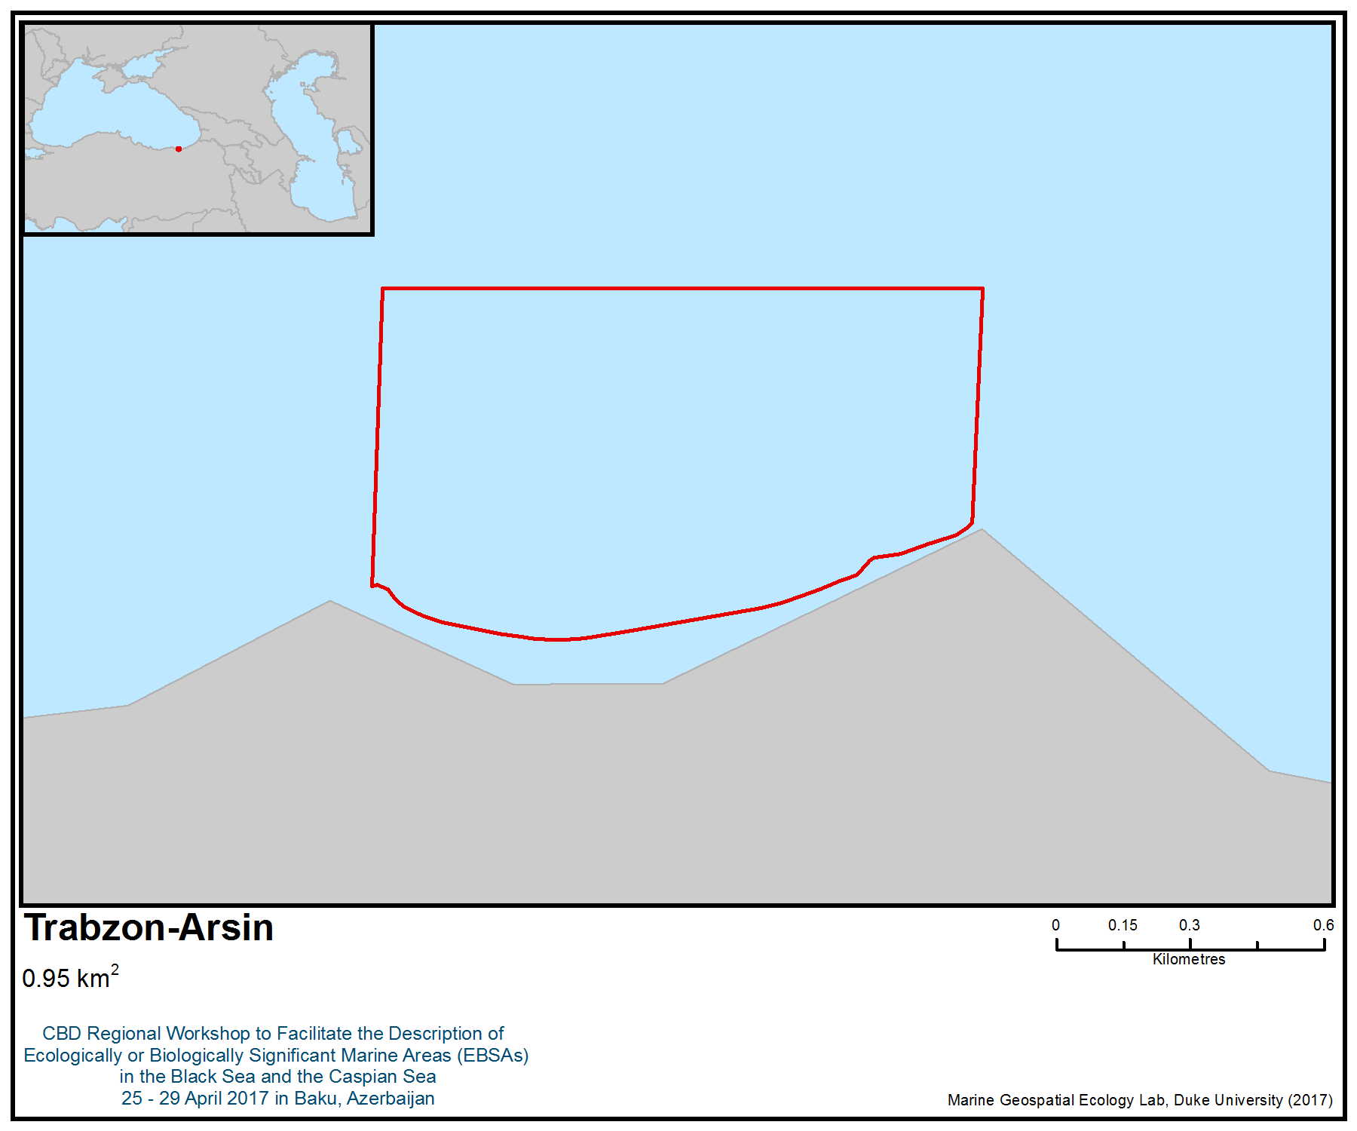
Figure 1. Area meeting the EBSA criteria

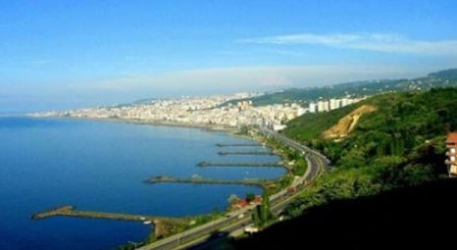
Figure 2. A scene from Trabzon-Arsin

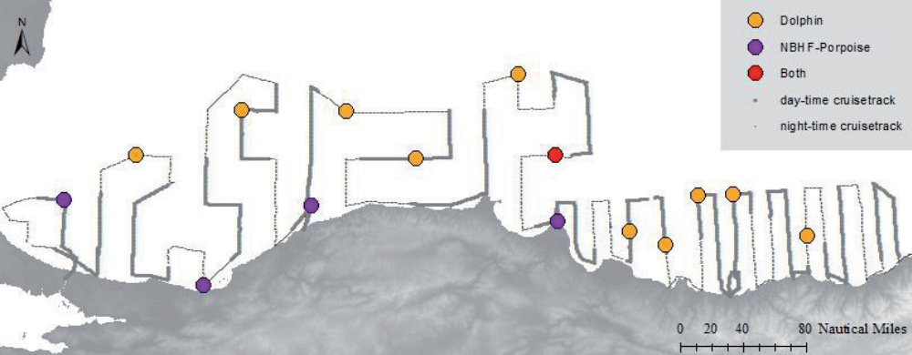

Figure 3. Cetacean detection positive C-POD stations during October 2014 cruise, with respect to classified click trains after the analysis (Saydam, 2015)

Area No. 17: Giresun – Tirebolu

Abstract
This area is very important for marine pelagic and demersal fish species, especially turbot (Psetta maxima), red mullet (Mullus barbatus), grey mullet (Mugil spp.), and for seagrass (Zostera). This area is an underwater canyon area, which provides reproduction and breeding grounds for demersal and pelagic fish species. Biological diversity of this part of the Black Sea is very high, such that the area overlaps with a marine Important Bird and Biodiversity Area, primarily designated for its importance as wintering area for the vulnerable yelkouan shearwater (Puffinus yelkouan). The yelkouan shearwater is a Mediterranean endemic, and some 30 to 40 per cent of the population migrate to the Black Sea during the non-breeding season. The importance of the area for this species was confirmed by studies based on tracking birds from their colonies, and also from studies of habitat suitability. Studies conducted on the crustaceans of sandy muddy biotopes on the seabeds of central and eastern Black Sea indicate that species diversity is relatively high in shallow waters (<50 m) and that diversity decreases in a direct correlation with increasing depth.

Introduction
Tirebolu is a town within the district of Giresun, Turkey, located in the eastern part of the Black Sea. The length of the coast is about 20 km. Mean sea surface temperature is considerably different from the western part of the sea due to the greater exposure of the western Black Sea to the cold air outbreaks from continental Europe, whereas the eastern basinis are protected from such cold outbreaks by the mountain chains along the southern and eastern coastlines. The relatively deep interior part of the sea is also slightly cooler than the peripheral zone due to the persistent upwelling motion associated with the cyclonic circulation system (http://giovanni.sci.gsfc.nasa.gov, 2017).

The biological diversity of this part of the Black Sea is very high; the area overlaps with a marine Important Bird and Biodiversity Area (IBA; BirdLife International 2017a), designated primarily for its importance as a wintering area for the vulnerable yelkouan shearwater (Puffinus yelkouan). The yelkouan shearwater is a Mediterranean endemic (BirdLife International, 2017b), some 30 to 40 per cent of which migrate to the Black Sea during the non-breeding season. The importance of the area for this species was confirmed by studies based on tracking birds from their colonies (Raine et al. 2012; Péron et al. 2013; Seabird Tracking Database 2017), and also from studies of habitat suitability (Ortega & İsfendiyaroğlu 2017).

Studies conducted on the crustaceans of the sandy, muddy biotopes on the seabeds of the central and eastern Black Sea indicate that species diversity is relatively high in shallow waters (<50 m) and that diversity decreases in a direct correlation with increasing depth (Kirkim et al., 2006). Silty sea floors support high mollusk diversity (Mutlu, 1994). Lucinella divaricata, Chamelea gallina, Donax venustus and Mytilaster lineatus were commonly found in sediments with high sand content (93%) (Mutlu, 1994).

Sezgin et al. (2010) investigated the diversity of the macrozoobenthos of the eastern Black Sea region of Turkey at 39 stations (13m -79 m depth range) and reported that the polychaete Melinna palmata, and the mollusks Lentidium mediterraneum, Lucinella divaricata and Chamelea gallina were the most dominant species, while the polychaetes M. palmata, Micronephths stammeri, A. fragilis mediterranea, mollusks C. gallina and Pitar rudis were recorded as frequent in the area.

The area is also important for threatened, endangered or declining species and/or habitats. Special importance for life-history stages of species is high in birds, and the area overlaps with a globally important non-breeding area for the yelkouan shearwater (Puffinus yelkouan) (listed as vulnerable by IUCN) (BirdLife International 2017). It also includes feeding sites for the Mediterranean endemic subspecies of European shag (Phalacrocorax aristotelis desmarestii) during the breeding season (Doğa Derneği 2014).

The area also overlaps with the distribution range of another vulnerable species, the Velvet Scoter (Melanitta fusca) (BirdLife International 2017). These two species are also included on Annex I of the EU Birds Directive.

Location
Tirebolu is a town and a district of Giresun Province located in the south-eastern part of the Black Sea. It is located with the Black Sea to the north, Güce and Espiye to the west, Görele to the east and Doğankent to the south.

The area is located between 40 59.23' N – 38 46.415' E, 41 0.241' N- 38 46.415' E, 41 0.489' N –38 48.48' E and 41 0.24' N - 38 48.48' E.

Feature description of the area
The sea water of Tirebolu is a mixture of brackish, fresh and salt water. It has rocky and sandy soil structure. The sandy, rocky and river-mouth canyon structures protect the benthic and pelagic biodiversity of the area, which is an important fish breeding and feeding area. The region is home to the second-largest river in the eastern Black Sea region (Harşit River) and forms a rich habitat in the region with the alluviums and nutrients it carries. The area is permanently closed to fisheries.

Special importance for life-history stages of species in birds is high and the area overlaps with a globally important non-breeding area for the yelkouan shearwater (Puffinus yelkouan).

The yelkouan shearwater is a Mediterranean endemic (BirdLife International, 2017b), 30 to 40 per cent of which migrate to the Black Sea during the non-breeding season. The importance of the area for this species was confirmed by studies based on tracking birds from their colonies (Raine et al. 2012, Péron et al. 2013, Seabird Tracking Database 2017), and also from studies of habitat suitability (Ortega & İsfendiyaroğlu 2017). The area also includes the feeding sites for the Mediterranean endemic subspecies of the European shag (Phalacrocorax aristotelis desmarestii) during the breeding season (Doğa Derneği 2014) and another vulnerable species, the velvet scoter (Melanitta fusca) (BirdLife International 2017).

14 fish species reported to ocur in the area (Erüz, 2007)
Psetta maxima(Turbot)
Sciaena umbra (Brown meagre)
Diplodus puntazzo (Sharpsnout seabream)
Dicentrarchus labrax (Common bass)
Liza aurata (Golden grey mullet)
Mugil cephalus (Flathead mullet)
Mugil soiuy (So-iuy mullet)
Sparus aurata (Gilthead seabream)
Salpa salpa (Goldline)
Mullus barbatus (Red mullet)
Dasyatis pastinaca (Common stingray)
Diplodus annularis (Annular seabream)
Syngnathus acus Linnaeus (Greater pipefish)
Hippocampus hippocampus (Short-snouted seahorse)

Nine species of rocky algae found in the area:
Cystoseira barbata
Entoromorfha spp.
Ulva lactuca
Zostera marina
Zostera noltii
Potamogeton pectinatus
Ruppia maritima
Ruppia spiralis
Zannichellia major

Feature condition and future outlook of the area
The region is home to the second largest river (Harşit River) in the eastern Black Sea region, which forms a rich habitat as a result of the alluvium and nutrients it carries. The fishing closure will help to sustain many of the features that make this area ecologically or biologically significant.

Assessment of the area against CBD EBSA Criteria

CBD EBSA Criteria  (Annex I to decision IX/20) | Description  (Annex I to decision IX/20) | Ranking of criterion relevance  (please mark one column with an X)
CBD EBSA Criteria  (Annex I to decision IX/20) | Description  (Annex I to decision IX/20) | No information |  | Low |  |  | Medium |  | High
Uniqueness or rarity | Area contains either (i) unique (“the only one of its kind”), rare (occurs only in few locations) or endemic species, populations or communities, and/or (ii) unique, rare or distinct, habitats or ecosystems; and/or (iii) unique or unusual geomorphological or oceanographic features. |  |  |  |  |  | X
Explanation for ranking
The region is home to the second largest river (Harşit river) in the Eastern Black Sea Region and forms a rich habitat in the region with alluviums and nutrients it carries. According to the Black Sea Fish Check List, the species Hippocampus hippocampus, which is present in the area, is endangered in Turkey (http://www.blacksea-commission.org/_publ-BSFishList.asp) (Yankova, n.d.).
Special importance for life-history stages of species | Areas that are required for a population to survive and thrive. |  |  |  |  |  |  |  | X
Explanation for ranking
The area overlaps with a globally important non-breeding area for the yelkouan shearwater (Puffinus yelkouan). It also includes feeding sites for the Mediterranean endemic subspecies of European shag (Phalacrocorax aristotelis desmarestii) during the breeding season (Doğa Derneği 2014).
The area’s sandy, rocky and river-mouth canyon structures protect the benthic and pelagic biodiversity of the area, which is an important fish breeding and feeding area.
Importance for threatened, endangered or declining species and/or habitats | Area containing habitat for the survival and recovery of endangered, threatened, declining species or area with significant assemblages of such species. |  |  |  |  |  | X
Explanation for ranking
A globally threatened seabird species, the Yelkouan shearwater (Puffinus yelkouan), listed as vulnerable by IUCN, is known to occur in the area (BirdLife International 2017) . The area also overlaps with the distribution range of another vulnerable species, the velvet scoter (Melanitta fusca). These two species are also included on Annex I of the EU Birds Directive.
Vulnerability, fragility, sensitivity, or slow recovery | Areas that contain a relatively high proportion of sensitive habitats, biotopes or species that are functionally fragile (highly susceptible to degradation or depletion by human activity or by natural events) or with slow recovery. |  |  |  |  |  | X
Explanation for ranking
The area overlaps with a globally important non-breeding area for the yelkouan shearwater (Puffinus yelkouan). The vulnerable seabird Yelkouan shearwater (Puffinus yelkouan) occurs in the area; this is a long-lived species with low fecundity and late sexual maturity, which is particularly vulnerable to factors increasing adult mortality rates, such as by-catch in fisheries and other at-sea threats, which are often considered the major causes of population decline (Oppel et al. 2011).

It also includes the feeding sites for the Mediterranean endemic subspecies of European shag (Phalacrocorax aristotelis desmarestii) during the breeding season.

According to the Black Sea Fish Check List, the species Hippocampus hippocampus, which is present in the area, is endangered in Turkey (http://www.blacksea-commission.org/_publ-BSFishList.asp) (Yankova, n.d.).
Biological productivity | Area containing species, populations or communities with comparatively higher natural biological productivity. | X
Biological diversity | Area contains comparatively higher diversity of ecosystems, habitats, communities, or species, or has higher genetic diversity. |  |  |  |  |  | X
Explanation for ranking
The sea water of Tirebolu is a mixture of brackish, fresh and salt water. It has rocky and sandy soil structure. Its sandy, rocky and river-mouth canyon structures provide protection of the benthic and pelagic biodiversity of the area, which is an important fish breeding and feeding area. The region is home to the second-largest river in the eastern Black Sea region and carries alluvium and nutrients that form a rich habitat. The area is closed to fisheries. There are six species of marine meadows (Zostera marina, Z. Noltii, Potamogeton pectinatus, Ruppia maritima, R. Spiralis and Zannichellia major), which are spawning grounds for 34 fish species. In the shallow areas of the Tirebolu (1-10 metres), there are Cystoseira barbata sea algae, which can represent the uncontaminated areas of the Black Sea ecosystem (Republic of Turkey, 2008)
Naturalness | Area with a comparatively higher degree of naturalness as a result of the lack of or low level of human-induced disturbance or degradation. |  |  |  |  |  |  | X
Explanation for ranking
The area is closed to fisheries.
Marine meadows (Zostera marina, Z. Noltii, Potamogeton pectinatus, Ruppia maritima, R. Spiralis and Zannichellia major) are the dominant structure of the coasts in this area. Possession of sandy, rocky and river - mouth canyon structures protect the benthic and pelagic biodiversity of the area, which is an important fish breeding and feeding area. The region is home to the second-largest river in the eastern Black Sea region, which carries alluviums and nutrients that create a rich habitat.

References
Acker, J.G. and G. Leptoukh, “Online Analysis Enhances Use of NASA Earth Science Data”, Eos, Trans. AGU, Vol. 88, No. 2 (9 January 2007), pages 14 and 17.
Ağırbaş, A., Feyzioğlu, A. M., Kopuz, U. 2014. Seasonal Changes of Phytoplankton Chlorophyll a, Primary Production and their Relation in the Continental Shelf Area of the South Eastern Black Sea. Turkish Journal of Fisheries and Aquatic Sciences 14: 713-726.
BirdLife International, 2017a. Marine IBA e-atlas. Delivering sites networks for seabird conservation. Accessed from https://maps.birdlife.org/marineIBAs/default.html on 10/03/2017.
BirdLife International, 2017b. Species factsheet: Puffinus yelkouan. Downloaded from http://www.birdlife.org on 10/03/2017.
Doğa Derneği, 2014. Black Sea Seabirds Project Layman’s report, Istanbul.
Erkan, F., Gücü, A.C. (2000) The diel vertical distribution of zooplankton in the Southeast Black Sea. Turk J Zool. 24: 417-427.
Eruz, Coskun. 2007. Environmentally Sensitive marine and ıntegrated Coastal Areas in Eastern Black Sea.(Report). Black Sea Technical University, Faculty of Marine Science.
http://giovanni.sci.gsfc.nasa.gov, 2017
Mutlu, E., 1994. Qualitative and quantitative distribution of benthic molluscs along the Turkish Black Sea. Boll. Malacologico, 30: 277-286.
Oppel S., Raine, A.F., Borg, J.J., Raine, H., bonnaud, E., Bourgeois, K., Breton, A.R. 2011. Is the Yelkouan shearwater Puffinus yelkouan threatened by low adult survival probabilities? Biological Conservation 114: 225-2263.
Ortega M.P., İsfendiyaroğlu S., 2017. Predicting foraging hotspots for Yelkouan Shearwater in the Black Sea. Deep-Sea Research Part II in press
Péron, C., Grémillet, D., Prudor, A., Pettex, E., Saraux, C., Soriano-Redondo, A., Authier, M., Fort J., 2013. Importance of coastal Marine Protected Areas for the conservation of pelagic seabirds: The case of Vulnerable yelkouan shearwaters in the Mediterranean Sea. Biological Conservation 168: 210-221.
Raine, A.F., Borg, J.J., Raine, H., Phillips, R.A., 2012. Migration strategies of the Yelkouan Shearwater Puffinus yelkouan. Journal of Ornithology 154: 411-422.
Republic of Turkey. 2008. National Biodiversity Strategy and Action Plan of Turkey (NBSAP) 2007. Ankara: Ministry of Environment and Forestry, General Directorate of Nature Conservation and National Parks.
Seabird Tracking Database 2017. Tracking Ocean Wanderers – BirdLife Seabird Tracking Database www. http://seabirdtracking.org/, accessed on 10/03/2017
Sezgin, M., Kirkim, F., Dagli, E., Dogan, A., Unluoglu, A., Katagan, T. & Benli, H.A., 2010. Sublittoral soft-bottom zoobenthic communities and diversity of southern coast of the Black Sea (Turkey). Rapp Comm Int Mer Medit 39: 662.
Ünal, E. (2002) Seasonality of zooplankton in the Southern Black Sea in 1999 and genetics of Calanus euxinus (Copepoda). M.Sc. Thesis, IMS-Middle East Technical University, Ankara, p. 202.
Yankova, M. Black Sea Fish Check List. Commission on the Protection of the Black Sea against Pollution, http://www.blacksea-commission.org/_publ-BSFishList.asp.
www.yelkouanshearwater.org, 2017

Maps and Figures

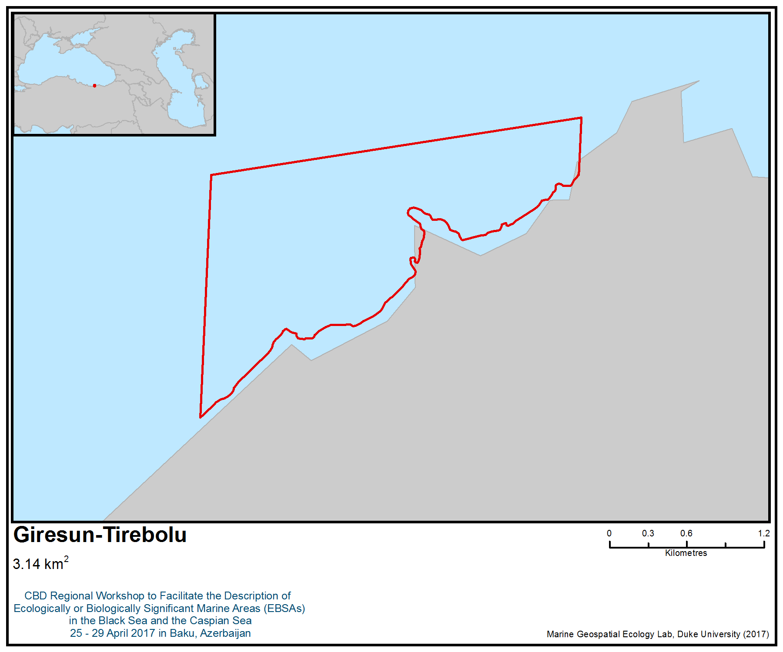
Figure 1. Area meeting the EBSA criteria

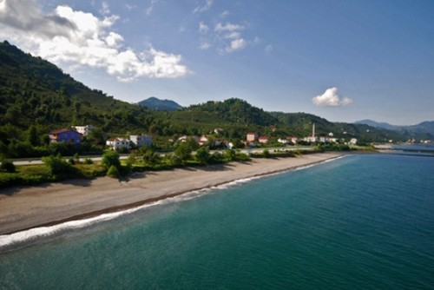
Figure 2. A scene from Giresun Tirebolu

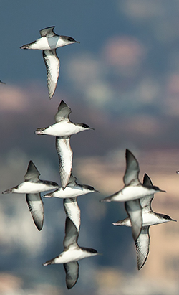
Figure 3. Yelkouan shearwater (www.yelkouanshearwater.org, 2017)

Area No. 18: Pre-estuarine area of the Ural River in the Caspian Sea

Abstract
The pre-estuarine area of the Ural River (Zhayik River) is located in the northern part of the Caspian Sea, adjacent to the mouth of the Ural River. This is an important area for the reproduction of anadromous (sturgeon) and freshwater (carp, perch) fishes. Here in the spring period, pre-spawn concentrations of all numerous fish species are concentrated, which then rush to spawn upstream of the Ural River in spawning grounds located in its lower and middle reaches, and after spawning, the producers and young fish migrate to the lower estuary space (brackish shallow part of the sea) to feed. The fish economy of the Ural-Caspian basin develops under the influence of complex interactions of natural (natural cycles of river water content, transgression and regression of the sea) and anthropogenic (pollution of the natural environment by oil products, legal and poaching fish) factors. The uniqueness of this object is that there are small remaining sturgeon stocks (e.g., Russian sturgeon, beluga, stellate sturgeon, thorn), which, despite the moratorium on industrial catch, are exposed to illegal, unreported and unregulated (IUU) catch, as well as other anthropogenic impacts in the form of loss of habitats and spawning grounds.

Location
The status and exact geographical coordinates of the lower estuary of the Ural River have not been precisely determined. Geographically, the lower estuary area of the Ural River occupies the brackish shallow water area of the Caspian Sea near the confluence of the Ural River (Zhayik) into the sea. In this case, the exact boundaries of the lower estuary have not been established. It is proposed to establish the exact boundaries of the lower estuary space at an isobath of 3 metres.

Introduction
Conventionally, the Ural-Caspian fishing area is divided into several isolated areas: the northeastern part of the Caspian Sea; the lower reaches of the Zhaiyk River with a lower estuary area; and the eastern part of the Volga River delta (Kigash River with a lower estuary space).

The Ural River is part of the Ural-Caspian fishing area. Here, there are commercial stocks of such fish as carp, pike, perch, asp, bream, catfish, gusher, bluefish, sabrefish, bersh. Also, the Ural River plays an important role in the process of formation and restoration of fishing resources in the Ural-Caspian basin. The main spawning grounds of sturgeon (980 hectares) are located here, as well as about 5000 hectares of floodplain providing fish-spawning areas. In floodplain spills, spawning of both local and semi-migratory fish species takes place. Given the remoteness from the sea, commercial fish species migrate to the spawning grounds of the most resilient fish populations. Consequently, the spawning of semi-migratory and anadromous fish is important for improving the qualitative composition of populations.

The delta of the Ural River begins almost in the city of Atyrau. On the Golden Arm passes the river part of the Ural-Caspian canal, which further passes along the mouth of the channel to the sea part of the channel with depths of up to 1.8 m. This channel connects the mouth of the Urals with the Ural furrow, the deepest part of the eastern part of the North Caspian. The Ural furrow is an extension of the Ural submarine channel and was developed by the river with a lower sea level standing. The status and exact geographical coordinates of the lower estuary of the Ural River have not been precisely determined.

Geographically, it occupies a sea area within 30 to 50 km from the mouth of the Ural River (Figure 2). A part of the water area of the pre-estuarine area is occupied by the buffer zone of the Ak-Zhayyk Biosphere Reserve (Figure 3). The Kazakh Research Institute of Fishery conducts research annually on the developed grid of stations (Figure 4).

The sea is between 2 and 5 metres deep in this area. The average oxygen concentration in the water is 8.64 mg / dm³. The total mineralization of water in the investigated sea area averaged 3787 mg / dm³. The highest concentration was recorded at station 41, where the salt content in water was 6540 mg / dm³. This mineralization support sboth freshwater and brackish-water fish. There are no marine species here. Physical and geographical conditions have created here an ideal zone for feeding juveniles of all kinds of fish, including sturgeon (Acipenseridae).

Feature description of the area
The sea is between 2 and 5 metres deep in this area. In summer, the water temperature is, on average, 30.3°C. The average depth reaches 3.1 m. Transparency of water varies from 0.2 m to 1.0 m in stations. The total mineralization of water in the summer period ranged from 0.6 to 6.3 g / dm³. The content of oxygen dissolved in water is at an optimum level in all seasons of the year (references 1, 2).

The distribution of zooplankton is determined mainly by the temperature of water and salinity. In the qualitative composition of zooplankton in 2016, 46 taxa of zooplankton organisms were found, including 23 species of rotifers, 8 species of cladocera and 11 species of copepods. The total average number of zooplankton organisms in the summer was 24.0 thousand specimens / m³. Dominants in the numerical ratio were rotifers — 13.32 thousand specimens / m3. Subdominants were copepods. They numbered 3.44 thousand specimens / m³. The share of branching was insignificant, at 2.02 thousand specimens / m³.

The distribution of bottom invertebrates is determined primarily by salinity. The biomass of forms increases with increasing salinity, and its highest values are observed in areas affected by saline middle Caspian waters at depths of more than 6 m. Seasonal changes in the sea benthos are determined by the features of reproduction and growth of benthic invertebrates, their death from being eaten by fish and the influence of unfavorable environmental factors. The qualitative composition of the macrozoobenthos of the pre-estuarine area in spring 2016 formed four main groups: crustaceans (Semorophilidae, Gammaridae, Cumacea), worms (Kl. Oligochaeta, Polychaeta) and insects (Chironomidae). The taxonomic composition in the spring period comprised 16 taxa. The biomass of the zoobenthos in the study area varied from 11.6 g / m² to 14.0 g / m²; the average biomass of the zoobenthos was 21.6 g / m², excluding non-fodder mollusks - 16.8 g / m².

The Ural River, including the pre-estuarine area of the Caspian Sea, includes a significant area of wetland, which is where fish migrate between the sea and the wetland. Throughout the year, this area is used for fish breeding and feeding.

The prehistoric ichthyofauna includes vobes (Rutilus rutilus caspicus), carp (Cyprinus carpio L.), asp (Aspius aspius L.), bream (Abramis brama orientalis Berg), pike (Esox lucius), crucian carp (Carassius carassius), sechel (Pelicus cultratus), pike-perch (Stizostedion lucioperca L.), bersh (Stizostedion volgensis), catfish (Silurus glanis), Caspian pheasant (Alosa caspia), beluga (Huso huso), Russian sturgeon (Acipenser gueldenstaedtii), sturgeon (Acipenser stellatus), sterlet (Acipenserruthenus), thorn (Acipenser nudiventris) and a number of non-commercial fish species (e.g., stickleback, white-eyed, char, pinewood, loach).

According to the Kazakhstan Agency of Applied Ecology LLP , the most common fish species recorded in autumn 2015 at the boundary of the pre-estuarine area of the Ural River were vobla (34.2%), followed by sabrefish (31.6%), North Caspian pusanok (21.1%), bream (10.5%) and pike perch (2.6%) (Figure 5). Thus, about 80% of the composition of the ichthyofauna, even at the boundary of the pre-estuarine area, comprises freshwater species and ichthyomassa (more than 90%).

Of the 18 fish listed in the Red Book of Kazakhstan (2008), five species inhabit the Ural - Caspian basin: the caspian lamprey (Caspiomyzon wagneri), the Volga herring (Alosa kessleri volgensis), the Caspian salmon (Salmo trutta caspius), the white salmon (Stenodus leucichthys Leucichthys), kutum (Rutilus frizii kutum). These species have become extremely rare in the pre-estuarine area in recent years.

The area is a habitat for commercially valuable species of sturgeon and their young.

Feature condition and future outlook of the area
The physical factors of the environment, depth, salinity, hydrochemical regime, the state of the fodder base of fish,are in a satisfactory state. Fishing for fine-mesh species, often unregulated, has a significant effect on fish stocks. The excessive number of fishing gear and fishing efforts leads to the fact that in spring a significant part of the spawning herd of fish cannot overcome the fishing “barrier” (fishing nets) and enter the river to spawn. Fish stocks are declining. The ban on scientific fishing of sturgeon species since 2009 has made it impossible to conduct qualitative studies on the state of fish spawning, since there is no basis on which to reliably estimate their state in a body of water.

The area is a habitat for commercially valuable protected fish species — sturgeon and their young. Part of the pre-estuary space includes a zone where fishing is forbidden year-round. Outside the restricted area, commercial fishing is conducted in the pre-estuarine area, including a significant proportion of IUU catch. Fishing equipment used is presented in Table 2.

Assessment of the area against CBD EBSA criteria

Criteria | Description  (Annex I to decision IX/20) | Ranking of criterion relevance  (please mark one column with an X)
Criteria | Description  (Annex I to decision IX/20) | No information |  |  |  |  |  |  | Low |  |  |  |  |  |  | Medium |  |  |  |  | High
Uniqueness or rarity | An area in which either i) unique (unique in its kind), rare (found in only a few places) or endemic species, populations or communities are present; and / or ii) unique, rare or special habitats or ecosystems; and / or iii) unique or unusual geomorphological or oceanographic elements. |  |  |  |  |  |  |  |  |  |  |  |  |  |  |  |  |  |  |  | X
Explanation for ranking
The sea is shallow here—within 2 to 5 metres. The average oxygen concentration in the water is 8.64 mg/dm³. The level of mineralization in the seawater averaged 3787 mg/dm³. The highest concentration was recorded at station 41, where the salt content in water was 6540 mg/dm³. This mineralization level supports both freshwater and brackish-water fish. There are no marine species here. Physical and geographical conditions have created here an ideal zone for feeding juveniles of all kinds of fish, including sturgeon (Acipenseridae). The area is a habitat for sturgeon and their young, species that are both valuable and protected. Here there are beluga (Huso huso), Russian sturgeon (Acipenser gueldenstaedtii), stellate sturgeon (Acipenser stellatus), sterlet (Acipenserruthenus) and thorn (Acipenser nudiventris), which are included on the IUCN Red List and Appendix II of CITES. The Ural River is the only unregulated dam in the Caspian Sea and is the only natural spawning ground of sturgeon. This area is a wetland and a place for pre-spawning concentrations of sturgeon and valuable commercial fish species and foraging their young. The loss of this habitat as a result of anthropogenic factors and the total catch of the Ural (Caspian) sturgeon populations will make it impossible to restore their numbers in natural populations in the future, that is, lead to a reduction of biological diversity (2, 3, 5, 7, 8). The area overlaps with an Important Bird and Biodiversity Area (IBA; BirdLife International 2017a) that was primarily designated due to its importance for waterbirds, with an overall number thought to exceed 20,000. More than 250 bird species occur in the area, including the vulnerable Dalmatian pelican (Pelecanus crispus), the great cormorant (Phalacrocorax carbo) and Pallas's gull (Larus ichthyaetus) (9, 10).
Special importance for life-history stages of species | The area necessary for the survival and successful habitat of the population. |  |  |  |  |  |  |  |  |  |  |  |  |  |  |  |  |  |  | X
Explanation for ranking
This is the only area for sturgeon and commercial fish species to migrate to the Ural River to spawn. This region is the only place of pre-spawning concentration of sturgeon and commercial fish species and feeding their young in the whole water basin.

The area contains aquatic zones for juveniles, and habitats for migratory species (feeding areas, migration routes). Forty-six taxa of zooplankton organisms were found here, including 23 species of rotifers, eight species of cladocera and 11 species of copepods. The total average number of zooplankton organisms in the summer was 24 000 specimens/m³. The qualitative composition of the macrozoobenthos of the coastal area in spring 2016 formed three main groups: crustaceans (Semorophilidae, Gammaridae, Cumacea), worms (Kl. Oligochaeta, Polychaeta) and insects (Chironomidae). The taxonomic composition in the spring period comprised 16 taxa. The biomass of zoobenthos in the investigated water area varied from 11.6 g / m² (quarter 12) to 14.0 g / m² (quarter 41); the average biomass of the zoobenthos was 21.6 g / m², so the fodder base is suitable for the feeding of young fish of all kinds (3, 5, 7, 8).

The area overlaps with a passage area of global importance for the vulnerable Dalmatian pelican (Pelecanus crispus), and for other species such as Pallas's gull (Larus ichthyaetus), Caspian tern (Hydroprogne caspia) and the great cormorant (Phalacrocorax carbo). It is also important for the breeding populations of whiskered tern (Chlidonias hybrid) (BirdLife International 2017). The area is used as stopover during the migratory periods by more than 20.000 waterbirds (9, 10).
Importance for threatened, endangered or declining species and/or habitats | Area containing a habitat for the survival or restoration of endangered, endangered or endangered species; Or an area containing significant communities of such species. |  |  |  |  |  |  |  |  |  |  |  |  |  |  |  |  |  | X
Explanation for ranking
Areas critical for threatened, endangered or endangered species. Most sturgeon species are listedI on the IUCN Red List as critically endangered, and all sturgeon species are included in Annex II of CITES (4, 5, 7, 8). A globally threatened seabird species listed as vulnerable by IUCN is known to occur in the area (BirdLife International 2017b) – the Dalmatian pelican (Pelecanus crispus). This species is also listed in CITES Appendix I, CMS Appendixes I and II.
Vulnerability, fragility, sensitivity, or slow recovery | A region containing a relatively large number of sensitive habitats, biotopes or species that are functionally fragile (highly prone to degradation or depletion due to anthropogenic activities or natural events) or are characterized by slow recovery rates. |  |  |  |  |  |  |  |  |  |  |  | X
Explanation for ranking
The area is a habitat for valuable protected species of fish, sturgeon, and their young. Sturgeon species have low fertility, low growth rate, a long period of puberty and a long life cycle. However, this is not the only place they inhabit and reproduce. The area may be subject to degradation as a result of sea-level regression processes and a reduction in the water flow of the Ural River (5, 6, 7, 8). The area is important to the vulnerable Dalmatian pelican (Pelecanus crispus), a long-lived species with late sexual maturity (9, 10).
Biological productivity | Area containing species, populations orcommunities with comparatively higher natural biological productivity. |  |  |  |  |  |  |  |  |  |  | X
Explanation for ranking
This area plays an important role in maintaining the viability of ecosystems in the region and in increasing the rate of growth of organisms and their ability to reproduce (1, 2). The total average number of zooplankton organisms in the summer was 24 000 specimens/m³. Dominants in the numerical ratio were rotifers, of which there were 13 320 specimens/m³. Subdominants were copepods, which numbered 34 400 thousand/m³. The share of branching was insignificant – 2 020 specimens/m³. The biomass of the zoobenthos in the study area varied from 11.6 g / m² to 14.0 g / m², while the average biomass of the zoobenthos was 21.6 g / m², 16.8 g/m² excluding non-fodder mollusks. This is a breeding place for only a few species of fish (carp, crucian carp); other species spawn in the river. Regarding the zoobenthos, the productivity of this area is inferior to that of the nearby regions of the sea.
Biological diversity | Area contains comparatively higher diversity of ecosystems, habitats, communities, or species, or has higher genetic diversity. |  |  |  |  |  |  |  |  |  |  |  |  |  |  |  |  |  | X
Explanation for ranking
This region is located at the junction of fresh water (the mouth of the Ural River) and sea water (the Caspian Sea) and is characterized by an exceptionally high diversity of ecosystems, habitats, communities and species, and higher genetic diversity. The ichthyofauna of this area includes vobla (Rutilus rutilus caspicus), carp (Cyprinus carpio L.), asp (Aspius aspius L.), bream (Abramis brama orientalis Berg), pike (Esox lucius), (Blicca bjoerkna), crucian carp (Carassius carassius),sechel (Pelicus cultratus), pike-perch (Stizostedion lucioperca L.), borsh (Stizostedion volgensis), catfish (Silurus glanis), Caspian pheasant (Alosa caspia), beluga (Huso huso), Russian sturgeon (Acipenser gueldenstaedtii), sturgeon (Acipenser stellatus), sterlet (Acipenserruthenus), thorn (Acipenser nudiventris) and a number of non-commercial fish species (e.g., stickleback, white-eyed, char, pinewood, loach). Due to the low salinity of the water, both freshwater and marine species live here. According to the Kazakhstan Agency of Applied Ecology, in autumn 2015, the proportion of fish species at the limit of this area (quarter 47) was Caspian roach (Rutilus caspicus, 34.2%), sichel (Pelecus cultratus, 31.6%), North Caspian pheasant (21.1%), bream (10.5%), and pike perch (2.6%) (Figure 6). Thus, about 80% of the composition of the ichthyofauna, even at the limit of this area, is made up of freshwater species; in terms of biomass, the composition is more than 90% (1, 2).
Naturalness | Area with a comparatively higher degree of naturalness as a result of the lack of or low level of human-induced disturbance or degradation. |  |  |  |  |  |  |  |  | X
Explanation for ranking
The area is characterized by an average degree of degradation of natural ecosystems, on the one hand because part of it is a protected area, and on the other, because of an increase in anthropogenic load (excessive fishing, increasing pollution due to nearby oilfield development sites).

References
1 Проведение комплексных морских исследований по оценке состояния биологических ресурсов казахстанской части Каспийского моря//Биологическое обоснование. – ТОО «КАПЭ», Алматы, 2015. – 163 с.
2 Определение рыбопродуктивности рыбохозяйственных водоемов и/или их участков, разработка биологических обоснований ОДУ и ООПТ, режиму и регулированию рыболовства на водоемах международного, республиканского и местного значений Жайык-Каспийского бассейна. Раздел: Река Жайык с предустьевым пространством, река Кигаш с предустьевым пространством, буферная зона государственного природного резервата «АкЖайык» (закл.)//Биологическое обоснование. – ТОО «КазНИИРХ», 2016. – 261 с.

3 Ким Ю.А., Куликов Е.В., Кузьменко С.В. Методы подхода сохранения биоресурсов Жайык-Каспийского бассейна// Сб. Управление инновациями в современной науке, 2015. – г. Самара. – С. 21-27.

4 Исбеков К.Б., Асылбекова С.Ж., Куликов Е.В., Ким А.И. Браконьерство – один из основных факторов снижения численности осетровых рыб Каспийского бассейна//Астраханский вестник экологического образования, 2015. – № 1(31). – С. 50-57.
5 Камелов А.К., Сокольский А.Ф., Альпеисов Ш.А. Современное состояние и подходы к восстановлению численности русского осетра Урало-Каспийского бассейна. – Алматы, 2005. – 41 с.
6 Беляева В.Н., Иванов В.П., Зиланов В.К. Научные основы устойчивого рыболовства и регионального распределения промысловых объектов Каспийского моря.- М.: ВНИРО, 1998. – 167 с.

7 Современное состояние популяции русского осетра реки Урал и мероприятия по ее восстановлению: Автореферат дисс. на соиск. уч. степ. канд. биол. наук/Камелов А.К. – Астрахань, 2004 – 128 с.
8 Инвентаризация нерестилищ в прикаспийских государствах. Обзор базовых отчетов стран по нерестилищам в России, Казахстане, Азербайджане, Иране и Туркменистане//Закл. отчет. – Проект КаспЭко, 2012. – 104 с.
9 BirdLife International, 2017a. Important Bird Areas factsheet: Delta of the Ural River. Downloaded from http://datazone.birdlife.org/site/factsheet/delta-of-the-ural-river-iba-kazakhstan/details on 26/04/2017.
10 BirdLife International 2017b. IUCN Red List for birds. Downloaded from http://www.birdlife.org on 27/04/2017.

Maps, Figures and Tables

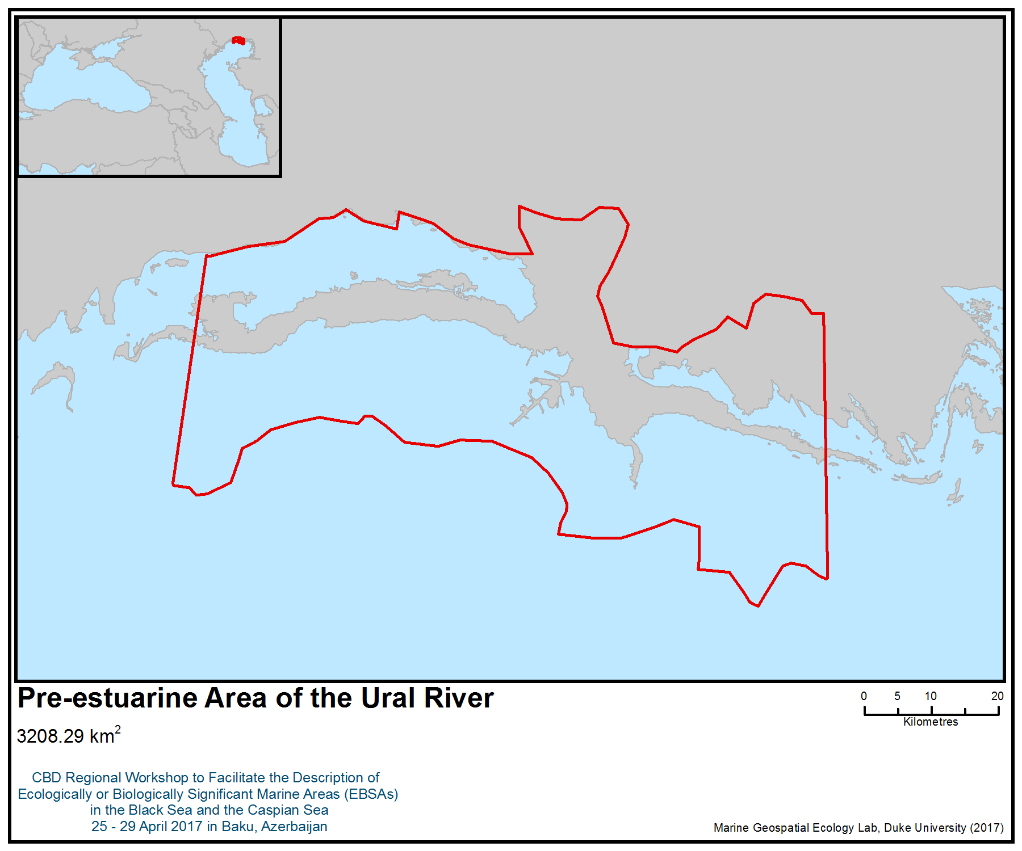
Figure 1. Area meeting the EBSA criteria

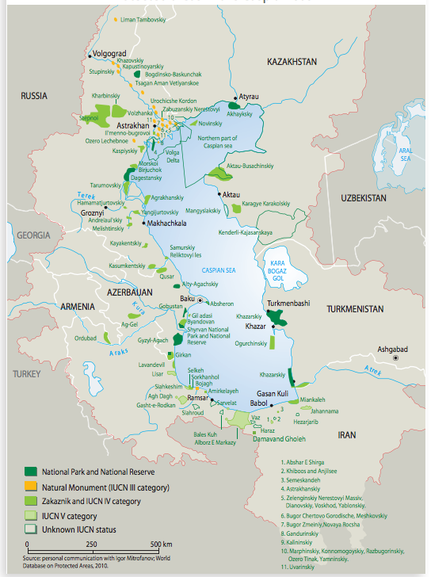
Figure 2. General location of the pre-estuarine area of the Caspian Sea

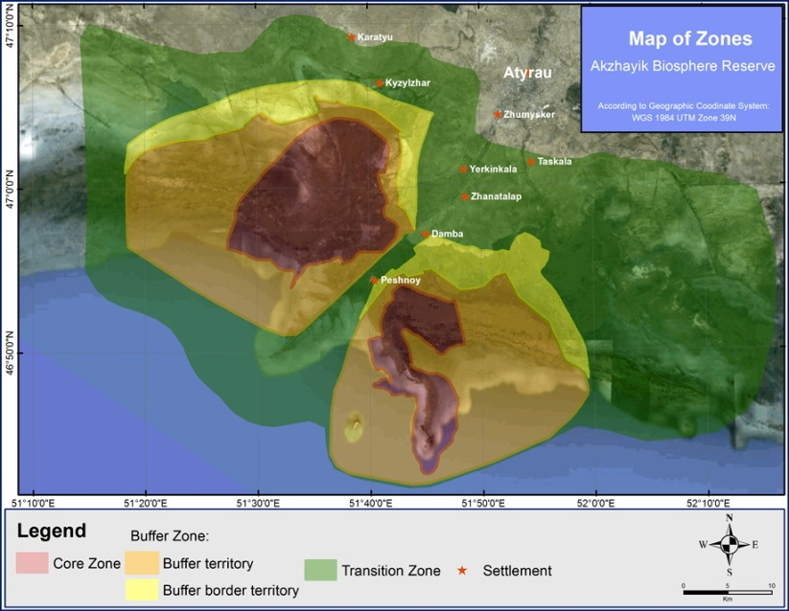
Figure 3. Zones of the Ak-Zhayik Biosphere Reserve

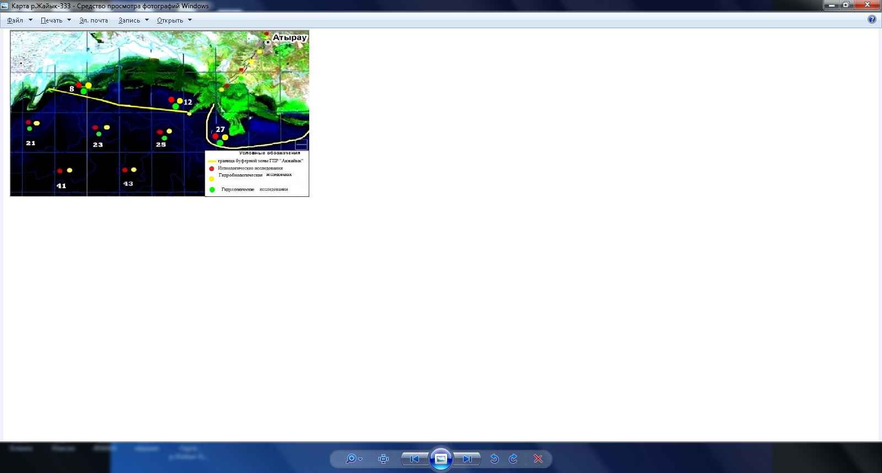
Figure 4. Observation stations in the pre-estuarine area

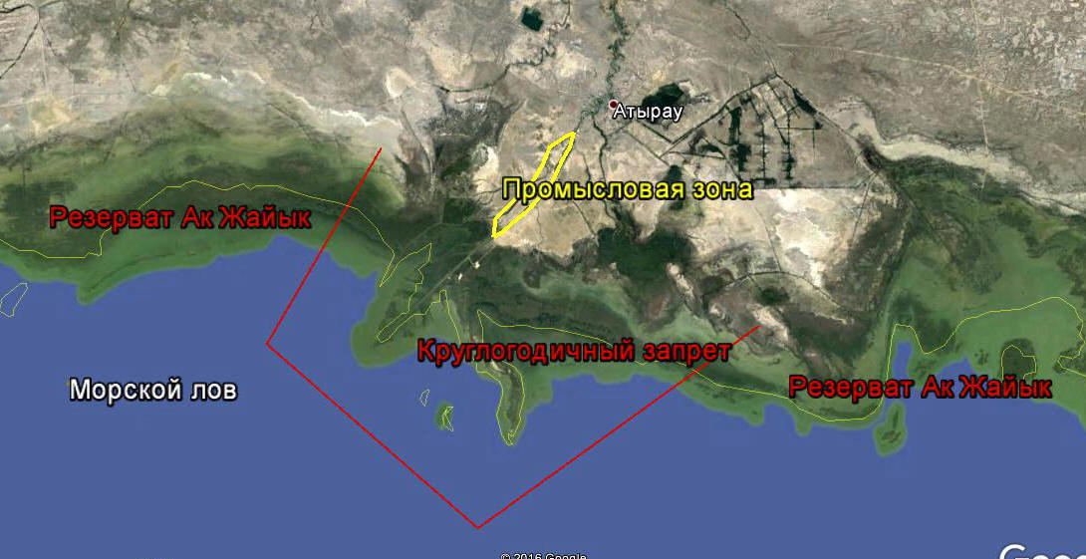
Figure 5. Map-scheme of the area with the designation of a restricted area for fishing and fishing areas in the river and sea

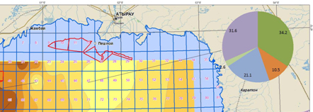
Figure 6. Map of distribution of commercial fish in quarter 47 of the northern part of the Caspian Sea in autumn 2015
Table 1. Average hydrological parameters in the area in the spring of 2016

Quarter | Т, ^{о}С | Depth, m | Water transparency, m
8 | 22,8 | 1,3 | 0,2
12 | 20,4 | 3,7 | 0,12
21 | 22,8 | 3,0 | 0,4
23 | 24 | 4,7 | 0,6
25 | 21,5 | 2,7 | 1,5
27 | 24,5 | 1,5 | 0,3
41 | 22,1 | 3,4 | 0,35
43 | 23 | 3,5 | 0,5
Average | 22,6 | 2,97 | 0,49

Table 2. Fishing gear in the coastal part of the northern Caspian Sea

Years | Fishers | Nets | Venters | Fish catch (tons)
2007 | 406 | 3070 | 700 | 2758,81
2008 | 304 | 2764 | 1270 | 4645,49
2009 | 298 | 2755 | 1268 | 1265,861
2010 | 688 | 3524 | 19874 | 14449,70
2011 | 780 | 4016 | 2479 | 5154,179
2012 | 646 | 2012 | 6473 | 5911,455
2013 | 1102 | 27 926 | 18 784 | 6585,846
2014 | 1996 | 14 773 | 13771 | 2537,095
2015 | 1734 | 7940 | 5601 | 4067,329

Area No. 19: Komsomol Bay

Abstract
The Caspian seal (Phoca caspica, Gmelin, 1788), an endemic, transboundary species, is the only mammal inhabiting the Caspian Sea. In 2008, IUCN changed the status of the Caspian seal from “vulnerable” to “endangered”. The results of research on the distribution, abundance and structure of the population of the Caspian seal show that the rookeries on the Durnev islands are important for the conservation of the population.

Location
Komsomol Bay, including the islands of Durnev, is located to the west of the Dead Kultuk Bay in the northeastern Caspian Sea (45 degrees 38 minutes north latitude, 52 degrees 35 minutes east longitude).

Introduction
The habitat of the Caspian seal (Phoca caspica) is limited exclusively to the Caspian Sea. Based on its morphological structure and physico-geographical conditions, the Caspian Sea is divided into three parts: the northern, middle and southern parts. A conditional border between the northern and middle parts of the Caspian is usually taken by the line connecting Chechnya Island to Tyub-Karagan, and between the middle and southern parts of the Caspian Sea, the Zhulyaya-Kuuli line, within western and eastern areas of the northern part of the Caspian Sea,. Beyond the border of their division the line is taken from Fr. Novinsky on the conventional point with coordinates 45° 41 'N And 50° 07'E, further on to Kulaly and then from the southern extremity of.Kulaly to the peninsula of Dolgiy (1).

Between the western and eastern regions of the northern part of the Caspian, the border is shallow, going towards Novinsky Island—the archipelago of the Seal Islands. The greatest depths within this shoal do not exceed 3.6-3.8 m. With a total area of the northern part of the Caspian Sea, equal to 91 942 km², the area of its water surface is 90,129 km². The share of the northern part of the sea accounts for more than 24.3% of the total area of the sea.

Most of the area (68%) of the northern regions of the Caspian Sea has depths less than 5 m. The most significant areas are the zones with depths from 0 to 1 m (20.2%) and from 3 to 4 m (14.1%). The proportion of the zone with depths exceeding 10 m is 9.8%. In the north-western part of the Caspian Sea, depths of up to 5 m occupy a smaller area than in the eastern part (28,471 and 32,830 km²). The eastern region is shallower than the western — its average depth is 3.3 m, and the maximum is 9.0 m (1).

The results of satellite tagging show that the habitats of the Caspian seal include almost the entire water area of the northern and middle Caspian, as well as the western part of the southern Caspian (Figure 7). The northern Caspian is an important area for the species and provides an ice substrate for breeding in winter, feeding grounds for migrating seals to the south in the spring and back to the north in the autumn, and for seals left in the north Caspian for the entire ice-free period. Shallow areas of the northeastern Caspian, from the Komsomol Bay to the delta of the Urals, are used by seals during migrations, foraging and recreation. The Komsomol Bay is a critical area during moulting, when tens of thousands of seals gather every spring after the ice breaks (Figure 2) (2, 3, 4).

Thus, the islands of Durneva are now of great importance as places for rookeries of Caspian seals in the spring (March-April).

Feature description of the area
Seal rookeries are located on a group of small islands scattered along the Gulf of Durnev. The creation of protected areas for Caspian seals in the Komsomolsk Gulf in the Durnev Islands area would help reduce the risk of anthropogenic mortality and anxiety of animals during moulting and rest, while during the breeding season, a seasonal ban on shipping and other activities in the areas used by ice-breeding seals (5).

Feature condition and future outlook of the area
In the spring of 2008, molting seals in high density groups were found on the islands in Komsomol Bay. Seals lie on small, reed-covered islands, located in shallow water with a depth of ≤1m . The total number of seals in this area exceeded 25 000 individuals. Another such site was found in the south-eastern part of the bay, with an estimated 3 500-4 000 individuals (2, 3, 4).

From 28 April to 7 May, 2016, the Durnev Islands were inspected from the air. Two Caspian seal rookeries of the were found on the islands in the northern part of Komsomol Bay (rookery 1 and rookery 2). Seals were not found on the other surveyed islands, nor in the open water. The rookeries were located on the coast of islands, which were overgrown with reeds, or on sand-mud shoals. At the time of the research, most of the rookeries were abandoned by the seals. On one of the islands (rookery 1), two separated groups of seals totalling about 400 (Table 1) were observed in all stages of moult — though most were in mid-moult.

Observations indicate that the number of seals at the rookery does not remain constant during the day (Table 2). It is impossible to determine the exact cause of seal movements on the basis of observations: it can be assumed that if necessary, the seals leave for food and then return again, or because the observations were made at the end of moulting, part of the casting seals completely leave the rookery, moving to the sea to feed. Maybe both. Unfortunately, it was not possible to conduct longer observations in order to determine the reasons for the described behaviour in the spring of 2016.

The presence of dead seals at the rookeries has been reported; nine were found during the spring research. Judging by their size and colour, the dead animals were adults. The cause of death of one of the individuals was, apparently, a tumor, however, the causes of death of others have not been determined (6).

Assessment of the area against CBD EBSA criteria

Criteria | Description  (Annex I to decision IX/20) | Ranking of criterion relevance  (please mark one column with an X)
Criteria | Description  (Annex I to decision IX/20) | No information |  |  |  |  |  |  | Low |  |  |  |  |  |  | Medium |  |  |  |  | High
Uniqueness or rarity | An area in which either i) unique (unique in its kind), rare (found in only a few places) or endemic species, populations or communities are present; and / or ii) unique, rare or special habitats or ecosystems; and / or iii) unique or unusual geomorphological or oceanographic elements. |  |  |  |  |  |  |  |  |  |  |  |  |  |  |  |  |  |  |  | X
Explanation for ranking
The Caspian seal (Phoca caspica; Gmelin, 1788) is the only mammal inhabiting the Caspian Sea, an endemic, transboundary species. In 2008, the IUCN changed the status of the Caspian seal from “Vulnerable” to “Endangered”. Seal rookeries are located on a group of small islands scattered along the Gulf of Durnev (5).
Special importance for life-history stages of species | The area necessary for the survival and successful habitat of the population. |  |  |  |  |  |  |  |  |  |  |  |  |  |  |  |  |  |  | X
Explanation for ranking
The area is necessary for the success and survival of the population. There are islands in the depths of the bay and there are good conditions for undisturbed moulting and recreation of animals (6).
Importance for threatened, endangered or declining species and/or habitats | Area containing a habitat for the survival or restoration of endangered, endangered or endangered species; Or an area containing significant communities of such species. |  |  |  |  |  |  |  |  |  |  |  |  |  |  |  |  |  | X
Explanation for ranking
The Caspian seal is classified as endangered on the IUCN List. The rookery of Durnev islands at Rjmsomol Bay is one of the last refuges of these seals. At the Durnev rookery, the maximum recorded number of seals in spring 2016 is 227 individuals (Table 1). Previously, there was a population of up to 25,000 individuals (2011). The population of the seal is affected by ocean warming, and the resulting decrease in the area and duration of ice cover, as well as by mortality caused by fishing nets (6,7).
Vulnerability, fragility, sensitivity, or slow recovery | A region containing a relatively large number of sensitive habitats, biotopes or species that are functionally fragile (highly prone to degradation or depletion due to anthropogenic activities or natural events) or are characterized by slow recovery rates. |  |  |  |  |  |  |  |  |  |  |  |  |  |  |  |  | Х
Explanation for ranking
The Caspian seal population is affected by ocean warming and the resulting decrease in the area and duration of ice cover, as well as by mortality caused by fishing nets. Features of seal breeding on ice also make it an extremely vulnerable species (6, 7, 8, 9). In the spring of 2008, moulting seals in high density groups were found on the Durnev Islands in Komsomol Bay. Seals lie on mall, reed-covered islands, located in shallow water with a depth of ≤1m (Figure 5). The total number of seals in this area exceeded 25 000 individuals at this time. From 28 April 28 to 7 May, 2016, the Durnev Islands were surveyed by air, and two rookeries of the Caspian seal were found on the islands in the northern part of the Komsomol Bay. On one of the islands, two distinct groups of seals totaling about 400 individuals were observed (Table 1). During a five-year period, the number of seals in this area decreased several times (6).
Biological productivity | Area containing species, populations orcommunities with comparatively higher natural biological productivity. | Х
Explanation for ranking
The natural biological productivity of seals is very low in all habitats (8, 11). But this site is not a seal-breeding ground. The productivity of other animal species needs to be clarified.
Biological diversity | Area contains comparatively higher diversity of ecosystems, habitats, communities, or species, or has higher genetic diversity. | Х
Explanation for ranking
Due to the remoteness of the area, there is limited information on the presence of other animals here (6).
Naturalness | Area with a comparatively higher degree of naturalness as a result of the lack of or low level of human-induced disturbance or degradation. |  |  |  |  |  |  |  |  | X
Explanation for ranking
The water quality in this area is class V - dirty, ammonium and total phosphorus - to VI class - very dirty, fluorine content - to grade III - slightly contaminated, largely due to petroleum (6). The nature of contamination with nutrients is understandable: a large accumulation of urine from seals and decomposition products of reeds. High content of oil products and fluorine can have both natural and anthropogenic origin (6).

References
1 Олейников Е.П. Исследование краниологических и молекулярно-генетических маркеров разнообразия популяции каспийского тюленя (Pusa caspica GMELIN, 1788 ) в Каспийском море //Диссер. на соиск. кан. биол. наук. Мурманск, 2015. – 116 с.
2 Международное исследование каспийского тюленя – отчет по вертолетным облетам в 2008-2009 годах// Отчет компании Аджип ККО, 2010. 17 с.
3 Международное исследование каспийского тюленя – отчет по вертолетному облету и мечению каспийского тюленя с использованием спутниковой телеметрии в 2009-2010 гг.//Отчет компании Аджип ККО, 2011. 35 с.
4 Международное исследование каспийского тюленя – отчет по вертолетному облету и мечению каспийского тюленя с использованием спутниковой телеметрии в 2011-2012 гг.//Отчет компании NCPOC, 2013. 44 с.
5 Дмитриева Л.Н., Баймуканов М.Т., Касымбеков Е.Б., Вилсон С., Гудман С. Распространение каспийского тюленя//Атлас Атырауской области. Алматы, 2014. С. 94-95.
6 Баймуканов М. Жданко Л.А. и др. Изучение динамики численности и комплексная оценка факторов угроз популяции каспийского тюленя // Отчет о научно-исследовательской работе (промежуточный). Алматы, 2016. – 66 с.
7 Баймуканов М. Жданко Л.А. и др. Изучение динамики численности и комплексная оценка факторов угроз популяции каспийского тюленя // Отчет о научно-исследовательской работе (промежуточный). Алматы, 2015. – 53 с.
8 Tero Harkonen, Mart Ju. ssi, Mirgaly Baimukanov, Anders Bignert, Lilia Dmitrieva, Yesbol Kasimbekov, Mikhail Verevkin, Susan Wilson and Simon J. Goodman Pup Production and Breeding Distribution of the Caspian Seal (Phoca caspica) in Relation to Human Impacts//Ambio Vol. 37, No. 5, July 2008. Р.356-361.
8 Сокольский А.Ф. и др. Современное состояние биопродуктивности Каспийского моря и причины деградации популяции тюленей за последние 300 лет. Астрахань, 2008. 178 с.
9 Л.Дмитриева, А. Кондаков, Е. Олейников, А.Кыдырманов,К. Карамендин, М. Баймуканов, Е.Касымбеков, С. Уилсон, Саймон Дж. Гудман. Прилов каспийского тюленя в нелегальном рыболовстве: оценка методом интервью// http://www.kaspika.org/assessment-of-caspian-seal-bycatch-in-illegal-fishery/.
10 Оценка ледовых условий в Казахстанском секторе Каспийского моря//http://gbpp.org/100-21
11 Крылов В.И. К биологии каспийского тюленя Pusa caspica Gmelin, 1788//Бюллетень М. о-ва исп. природы, отд. биологич., Т. 81 (1), 1976. С. 15-27.
12 Баймуканова А., Жданко Л., Баймуканов Т., Баймуканов М. Сохранение лежбища каспийского тюленя (Pusa caspica) в заливе Кендирли//Материалы международной конференции Голарктика 2016. Астрахань, 2016. В печати.
13 Dmitrieva, L., Härkönen, T., Baimukanov, M., Bignert, A., Jüssi, I., Jüssi, M., … Goodman, S. (2015). Inter-year variation in pup production of Caspian seals Pusa caspica 2005–2012 determined from aerial surveys. Endangered Species Research, 28(3), 209–223. https://doi.org/10.3354/esr00689

Maps, Figures and Tables

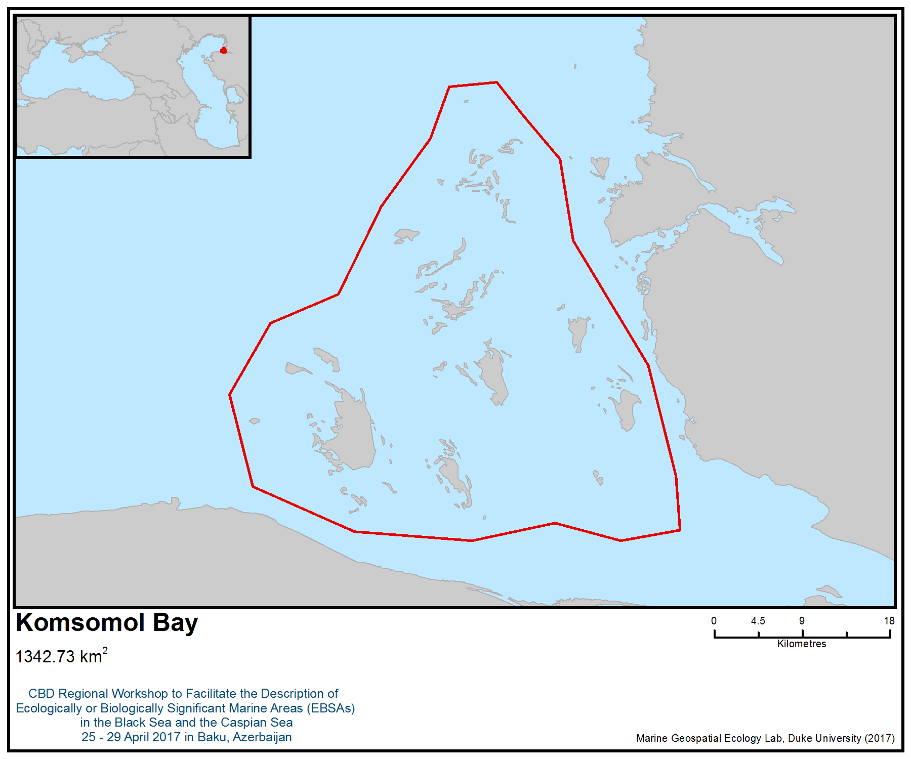
Figure 1. Area meeting the EBSA criteria

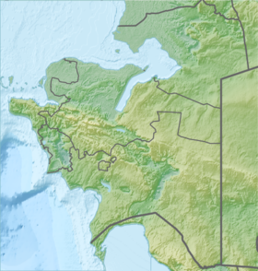

Figure 2. Location of the Durnev islands in Komsomol Bay

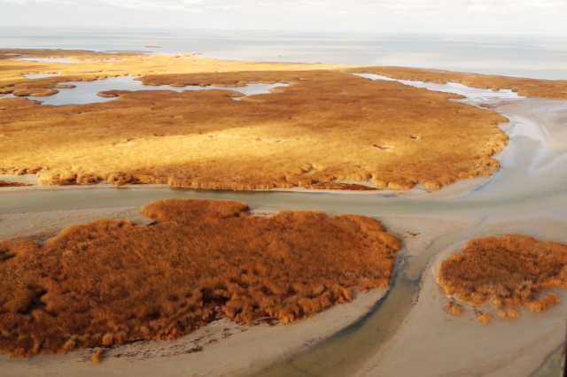

Figure 3. Durnev Islands

Figure 4. Location of the Durnev Islands in Komsomol Bay

Table 1. The number of Caspian seals in rookery 1 (Durnev Islands)
Date | Group | Number of seals
29.04.2016 | 1 | 224
29.04.2016 | 2 | 167
01.05.2016 | 1 | 227
 | 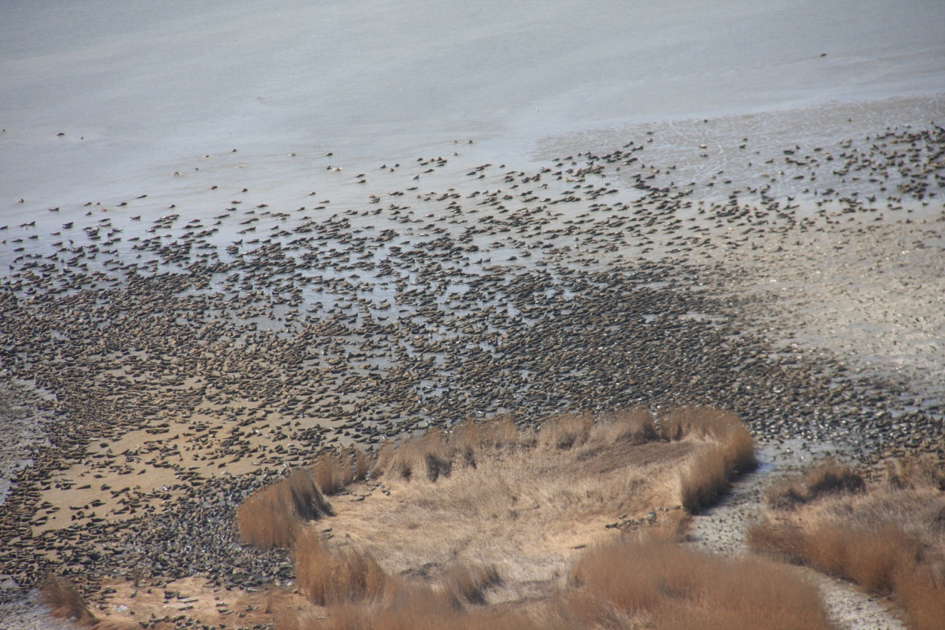

Figure 5 – Spring 2011
Table 2. Daily movement of seals at the rookery on the Durnev Islands (rookery, rookery 1)
Date | Time | At the rookery parish, copies | With rookery care, copies | Total care, copies
29.04.2016 | 18:55-19:40 | 5
30.04.2016 | 9:00 | 1
30.04.2016 | 11:15 | 2 | 1
30.04.2016 | 11:20 |  | 2
30.04.2016 | 11:29 |  | 2
30.04.2016 | 11:34 |  | 1
30.04.2016 | 11:45 | 1
30.04.2016 | 12:35 |  | 1
30.04.2016 | 14:45 |  | 12
30.04.2016 | 16:20 |  | 7
30.04.2016 | 16:40 |  | Массовый, по 5-6 | 60
30.04.2016 | 18:00 |  | Массовый, по 5-6 | 105
30.04.2016 | 18:55 | 5
30.04.2016 | 19:05 | 1
30.04.2016 | 19:45 |  | 5
01.05.2016 | 18:20-19:30 | 25
01.05.2016 | 19:45 |  | 5

Area No. 20: Caspian Seal Breeding Grounds

Abstract
The Caspian seal (Pusa caspica) is an endemic, ice-breeding, trans-boundary species of marine mammal inhabiting the landlocked Caspian Sea. Caspian seals use this winter ice field between January and March each year for birthing and nursing pups. The area is also important for all species of Caspian sturgeons.

Introduction
The Caspian seal (Pusa caspica) is an endemic, ice-breeding, trans-boundary species of marine mammal inhabiting the Caspian Sea. Historically, Caspian seals were numerous, with the historical baseline estimated at between 1 000 000 and 1 500 000 specimens (Harkonen et al. 2012). The abundance of this species has declined to around 104 000 to 168 000 individuals, as demonstrated by recent aerial surveys (Harkonen et al. 2008; Dmitrieva et al. 2015; Goodman and Dmitrieva 2016). As of 2016, the Caspian seal remains classified as endangered in the IUCN Red List of Threatened Species (Goodman & Dmitrieva 2016: http://www.iucnredlist.org/details/41669/0).

The area focuses on the ecological and biological significance of breeding grounds in the northern sector of the Caspian Sea (Figure 3). The importance of the area for Caspian seals has previously been highlighted in the Caspian Seal Conservation Action Plan (CSCAP; Caspian Environment programme 2007) and the scoping plan for development of special protected areas for Caspian seals (CASPECO Project 2012). The area is important for feeding and migrating beluga sturgeon (Huso huso) and other species of Caspian sturgeon (Acipenser gueldenstaedtii, critically endangered according to IUCN; Acipenser nudiventris; critically endangered, according to IUCN; and Acipenser ruthenus, vulnerable according to IUCN).

Location
The location of the area is defined by the extent of ice coverage during winter months, as the breeding season for seals takes place from January until early March. This area takes into account the dynamic nature of ice conditions and distribution with and among years. Therefore, the shape of the area is defined by the overall observed extent of ice coverage during the few months of the winter from historical records and the observed distributions of breeding seals under different ice conditions. The evidence, however, suggests that the spread of ice is hard to predict. Although some evidence has been presented to suggest that ice cover has been declining, more data is needed to allow model predictions of the shifts (Figure 2). Figure 3 was created by merging maps for mild, normal and winters in the Northern Caspian (Figure 2; Dmitrieva et al. 2015; Dmitrieva et al. unpublished data). The timeframe for the area is from 15 December to 15 March.

Feature description of the area
Physical conditions
Formation of ice fields in the Caspian begins in late November and early December, with ice coverage restricted to the shallow, brackish northern sector of the Caspian Sea (Zhindarev et al. 2013; Dobrovolskyi and Zalogin 1982). The duration and extent of the ice coverage in the north varies from year to year, depending on larger-scale annual climate patterns in the northern hemisphere (Harkonen et al. 2008; Dmitrieva et al. 2015). Two unusually warm winters have occurred in the past decade (winters of 2006-7 and 2015-16), with lower than average ice cover and shorter than average duration. Premature melting of the ice sheet before the completion of the lactation period during pupping could increase mortality rates of seal pups (Dmitrieva et al., 2015; Wilson et al. 2017).

Current status of breeding grounds for Caspian seals
Pregnant Caspian seal females use the ice fields for birthing and nursing pups. The ice coverage in the northern sector depends on climatic conditions and severity of the winter temperatures (figures 1, 2). As of 2016, no evidence was presented to suggest that Caspian seals were using other parts of the Caspian for breeding than those that were located in the northern areas. Some sources (see P. Erokhin comment in Harkonen, et al. 2008, have previously demonstrated limited terrestrial breeding behaviour of seals on the ice-free Ogurchinsky Island, in Turkmenistan, for example, in 2005). However, since 2009 no evidence has been presented to suggest that the breeding of seals happened anywhere else than in the northern sector. This conclusion seems to represent a consensus of the national and international scientific community studying the behaviour of Caspian seals (see the conference proceeding materials from a round table discussion “the current status of the Caspian seal”, round table discussion proceedings,04.11.2016, at the IX International Conference on Marine Mammals of the Holarctic. Astrakhan) (Figure 1).

Caspian seal’s breeding behaviour
The Caspian seal (Pusa Caspica) is an endemic, ice-breeding pinniped and the only species of marine mammal in the Caspian Sea. The Caspian seal is well adapted to survive the diverse weather conditions of the Caspian Sea. The increasing amount of available satellite telemetry data from a Caspian seal tagging programme (Dmitrieva et al. 2016), suggests that during the spring and summer, around 60% of tagged seals migrate to the mid and southern sectors, while the remainder spend the ice-free season in the north. From March until November, seals are spread around the Caspian, however, the exact foraging pattern or process is still not completely understood. Seals might use different strategies to adapt to availability of food resources (Dmitrieva et al. 2016). The high concentration of seals for breeding purposes in the northern sector is also well documented in seal hunting records from at least the 18th century (Harkonen et al 2012). In late summer, the breeding individuals, including pregnant females, migrate to the northern sector to give birth to pups. Breeding animals congregate along the ice sheet edge and use natural leads to gain access to the interior. Some females also follow the artificial leads created by icebreaking vessel channels (Wilson et al. 2017). The breeding habitat of Caspian seals is land-fast or drift ice, usually at least 20 cm thick, overlying water 3–5 m deep. Pregnant females often form pairs or small groups. Unlike ringed seals, Caspian seals rarely use snow lairs, but preferentially pup beside ice ridges or ice-slab piles that afford shelter to pups. Females maintain water access holes in the ice at their breeding sites throughout the season. Pups are born from late January with a peak in the first half of February, and lactation lasts for three to five weeks, by the end of which white coat pups have moulted to juvenile coats of silver grey (Wilson et al. 2017). The expert opinion and literature agree that the breeding grounds differ from year to year, depending on the extent of the coverage of the ice fields in the north, but in most years high concentrations of breeding seals are found in an area to the west of the Kulaly archipelago. approximately an area defined by the points: 45.85N 49.8E, 45.85N 51.15E, 45.22N 51.15E, 45.22N 49.8E (Harkonen et al. 2008; Dmitrieva et al. 2015; Wilson et al. 2017). After the ice melts, it is thought that pups disperse to shallow waters and reed beds around the north Caspian, but considerable gaps in knowledge on the pattern of movement of juveniles in the south still exist in the scientific literature (Wilson et. al., 2017).

Feature condition and future outlook of the area
Long-term: Unclear due to uncertain climatic conditions.
Short-term: Shrinking habitat due to a string of warm winters.

Assessment of the area against CBD EBSA Criteria

CBD EBSA Criteria  (Annex I to decision IX/20) | Description  (Annex I to decision IX/20) | Ranking of criterion relevance  (please mark one column with an X)
CBD EBSA Criteria  (Annex I to decision IX/20) | Description  (Annex I to decision IX/20) | No information |  | Low |  | Medium |  | High
Uniqueness or rarity | Area contains either (i) unique (“the only one of its kind”), rare (occurs only in few locations) or endemic species, populations or communities, and/or (ii) unique, rare or distinct, habitats or ecosystems; and/or (iii) unique or unusual geomorphological or oceanographic features. |  |  |  |  |  |  | X
Explanation for ranking
The area provides unique breeding grounds for the endangered Caspian seal (Dmitrieva et al 2016).
Special importance for life-history stages of species | Areas that are required for a population to survive and thrive. |  |  |  |  |  |  | X
Explanation for ranking
The area contains breeding grounds, nursery areas and juvenile habitat that is important for life history stages of species (Wilson et al. 2017); but also feeding grounds for lactating females, wintering or resting areas, moulting sites for pups (Harkonen et al 2008).
Importance for threatened, endangered or declining species and/or habitats | Area containing habitat for the survival and recovery of endangered, threatened, declining species or area with significant assemblages of such species. |  |  |  |  |  |  | X
Explanation for ranking
Important for endangered Caspian seals since seals use the areas for breeding and nursing. Critically endangered beluga sturgeon (Huso huso) (http://www.iucnredlist.org/details/10269/0) and other species of Caspian sturgeons (also cross the region when migrating to the wintering holes in the Ural river:
(1) Breeding grounds, nursery areas, juvenile habitat or other areas important for life history stages of Caspian seals.
(2) Habitats of endangered Caspian seals (feeding, wintering or resting areas, breeding, moulting, migratory routes).
(3) Migratory corridor for critically endangered Huso huso (Lagutov and Lagutov 2007)
Vulnerability, fragility, sensitivity, or slow recovery | Areas that contain a relatively high proportion of sensitive habitats, biotopes or species that are functionally fragile (highly susceptible to degradation or depletion by human activity or by natural events) or with slow recovery. |  |  |  |  |  |  | X
Explanation for ranking
Species of low fecundity, slow growth, long time to sexual maturity, longevity also due to unpredictable weather conditions in the northern sector (Härkonen et al 2008).
The unpredictable extent of ice-covered areas, can cause high rate of juvenile mortality and can impinge upon the recovery of the Caspian seal population (Dmitrieva et al 2015).
Biological productivity | Area containing species, populations or communities with comparatively higher natural biological productivity. | X
Explanation for ranking
In general, experts agree that, due to chlorophyll inputs from the Volga and Ural rivers, the northern Caspian is characterized by high biological productivity (in the summer months) (Fendereski, F. et al. 2014; Khodorevskaya et al. 2012; Pourang et al. 2012; Kideys et al. 2008; Khodorevskaya et al. 1997). However, no conclusive evidence can connect high levels of biological productivity to the increased population of the Caspian seals. The connection suggests three things:
1. The impacts of high biological productivity are too general and other biological factors reduce the impacts of high biological productivity.
2. There is no direct causal connection between biological productivity of the Northern Caspian and the numbers of Caspian seals.
3 Biological productivity throughout winter mounts is less understood. The conclusion is that no information exist to definitely link high levels of biological productivity to the increase in biological productivity of the Caspian seal. More information on the trophic chains in the Caspian needs to be obtained.
Biological diversity | Area contains comparatively higher diversity of ecosystems, habitats, communities, or species, or has higher genetic diversity. | X
Explanation for ranking
The research experts agree that studies on biological diversity in Northern Caspian should be continued due to its high significance to the Caspian seal population and sturgeons.
Naturalness | Area with a comparatively higher degree of naturalness as a result of the lack of or low level of human-induced disturbance or degradation. |  |  |  |  |  | X
Explanation for ranking
Medium level since the Caspian seal breeding polygons are shaped by ice fields as well as by other factors (Wilson et al. 2017; Dmitrieva et al. 2015).

References
In English
CaspEco Project 2012. CaspEco project Component 1, Seal Special Protected Area Scoping and Inception Plan, Final Report, May 2012. http://www.darwininitiative.org.uk/documents/15024/22941/15-024%20SSPA%20Scoping%20and%20Inception%20Plan%20with%20annexes.pdf
Dmitrieva, L., Karkonen_Baimukanov (2015) Inter-year variation in pup production of Caspian seals Pusa caspica 2005-2012 determined from aerial survey. Endangered Species Research 28: 2009-223
Caspian Environment programme (2007). Caspian Seal Conservation Action Plan. http://projects.inweh.unu.edu/inweh/display.php?ID=1057
Dmitrieva L, Kondakov AA, Oleynikov E, Kydyrmanov A, Karamendin K, Kasimbekov Y, Baimukanov M, Wilson S, Goodman JS (2013) Assessment of Caspian Seal by-catch in an illegal fishery using an interview based approach. PLoS One 8(6):e67074
Dmitrieva, L., Karkonen_Baimukanov (2015) Inter-year variation in pup production of Caspian seals Pusa caspica 2005-2012 determined from aerial survey. Endangered Species Research 28: 2009-223
Dmitrieva, L., Jüssi, M., Jüssi, I., Kasymbekov, Y., Verevkin, M., Baimukanov, M. Goodman, S. J. (2016). Individual variation in seasonal movements and foraging strategies of a land-locked, ice-breeding pinniped. Marine Ecology Progress Series, 554, 241–256. https://doi.org/10.3354/meps11804
Fendereski, F. et al. (2014) Biogeographic classification of the Caspian Sea. Biogeosciences 11, 6451–6470.
Goodman, S. & Dmitrieva, L. 2016. Pusa caspica. The IUCN Red List of Threatened Species 2016: e.T41669A45230700. http://dx.doi.org/10.2305/IUCN.UK.2016-1.RLTS.T41669A45230700.en.
Harkonen, T., Jussi, M., Baimukanov, M., Bignert, A., Dmitrieva, L., Kasimbekvo, Y., Verevkin, M., Wilson S., Goodman, S. J. (2008). Pup Production and Breeding Distribution of the Caspian Seal (Phoca caspica) in Relation to Human Impacts. AMBIO: A Journal of the Human Environment 37, 356–361.
Härkonen, T., Karin C. Harding, Susan Wilson, Mirgaliy Baimukanov, Lilia Dmitrieva, Carl Johan Svensson, Simon J. Goodman (2012) Collapse of a Marine Mammal Species Driven by Human Impacts PloS one 7 (9), e43130.
Kovacs, K. M., Aguilar, A., Aurioles, D., Burkanov, V., Campagna, C., Gales, N., Trillmich, F. (2012). Global threats to pinnipeds. Marine Mammal Science, 28(2), 414–436. https://doi.org/10.1111/j.1748-7692.2011.00479.x
Khodorevskaya R, Dovgopol G, Zhuravleva O, Vlasenko A (1997) Present status of commercial stocks of sturgeons in the Caspian Sea basin. Environ Biol Fishes 48(1–4):209–220
Khodorevskaya R, Kalmykov V, Zhilkin A (2012) Sovremennoe sostoyanie zapasov osetrovyh Kaspiyskogo Basseina i mery po ih sohraneniyu (Present state of the Caspian Sturgeons Reserves and Measures on its Conservation). Vestnik AGTU Seriya: Rybnoe hozyaistvo 1:99–106
Kideys, A. E., Roohi, A., Eker-Develi, E., Melin, F. & Beare, D. Increased Chlorophyll Levels in the Southern Caspian Sea Following an Invasion of Jellyfish. (2008). Available at: http://eds.b.ebscohost.com/abstract?site=eds&scope=site&jrnl=16876768&AN=39761509&h=o7%2fKv9bJBeaTYTGUmlV75WidWmq%2fH17CGxAoAGgCcg6bh9iNMfF%2fam1dUuGYOEXul3LdePKx%2ba4dLXnJ9JmQ2w%3d%3d&crl=f&resultLocal=ErrCrlNoResults&resultNs=Ehost&crlhashurl=login.aspx%3fdirect%3dtrue%26profile%3dehost%26scope%3dsite%26authtype%3dcrawler%26jrnl%3d16876768%26AN%3d39761509. (Accessed: 6 March 2017)
Lagutov V. and Lagutov V. (2007) The Ural River Sturgeons: Population Dynamics, Catch, Reasons for Decline, and Restoration Strategies. In Rescue of Sturgeon Species in the Ural River Basin. ed (viktor lagutov) Springer-Verlag New York Inc. New York. 193-276
Pourang, N., Eslami, F., Nasrollahzadeh Saravi, H., & Fazli, H. (2016). Strong biopollution in the southern Caspian Sea: the comb jelly Mnemiopsis leidyi case study. Biological Invasions, 18(8), 2403–2414. https://doi.org/10.1007/s10530-016-1171-9
Wilson, S. C., Dolgova E., Trukhanova, I., Dmitrieva, L., Crawford, I., Baimukanov, M., Goodman, S. J. (2017). Breeding behavior and pup development of the Caspian seal, Pusa caspica. J Mammal 98, 143–153.
Zhindarev L.A., Ignatov E.I., Badyukova E.N., Lukyuanova S.A., Solovyeva G.D., Shipilova L.M. 2013. Scientific basis for balanced planning of economic activity in unique maritime coastal landscapes and perspectives of resources use exemplified by the Azov – Black Sea Coast. Vol. 6. CaspianSea. Gelendzhik: Southern Branch of the Shirshov Institute of Oceanology. P. 940–1066.

In Russian
Баймуканов М. Жданко Л.А. и др. Изучение динамики численности и комплексная оценка факторов угроз популяции каспийского тюленя // Отчет о научно-исследовательской работе (промежуточный). Алматы, 2015. – 53 с.
Баймуканов М. Жданко Л.А. и др. Изучение динамики численности и комплексная оценка факторов угроз популяции каспийского тюленя // Отчет о научно-исследовательской работе (промежуточный). Алматы, 2016. – 66 с.
Добровольский Б.С., Залогин Б.С. 1982. Моря СССР. М.: Изд-во МГУ. 182 с.

Unpublished materials in Russian and English:
“The current status of the Caspian seal”. Proceedings of a round table discussion (04.11.2016) 9th International conference on Marine Mammals of the Holarctic, Astrakhan).

Maps and Figures

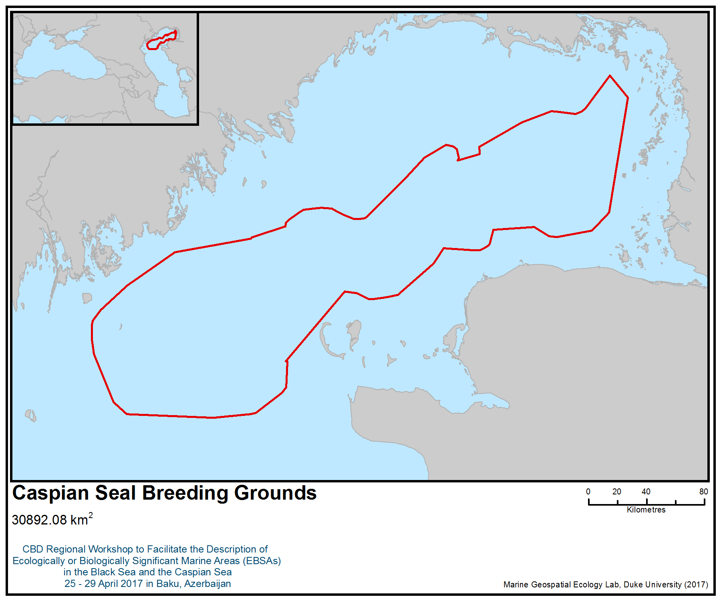
Figure 1. Area meeting the EBSA criteria

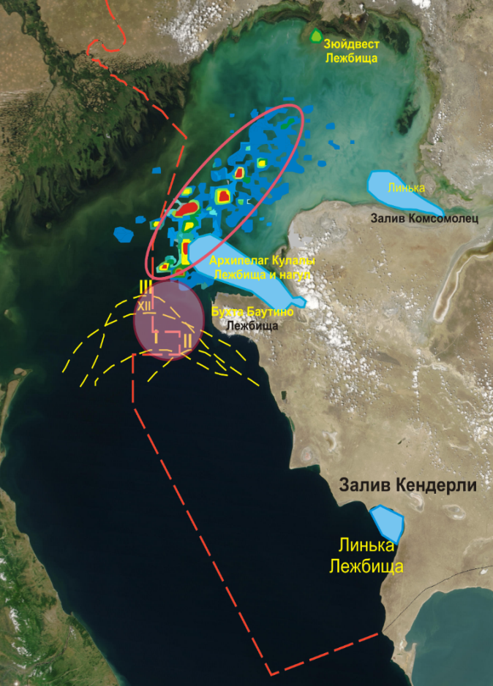
breeding areas
rookery, molting

Figure 2. Caspian seal breeding areas (Баймуканов и др., 2015; 2016)

Warm Normal Cold
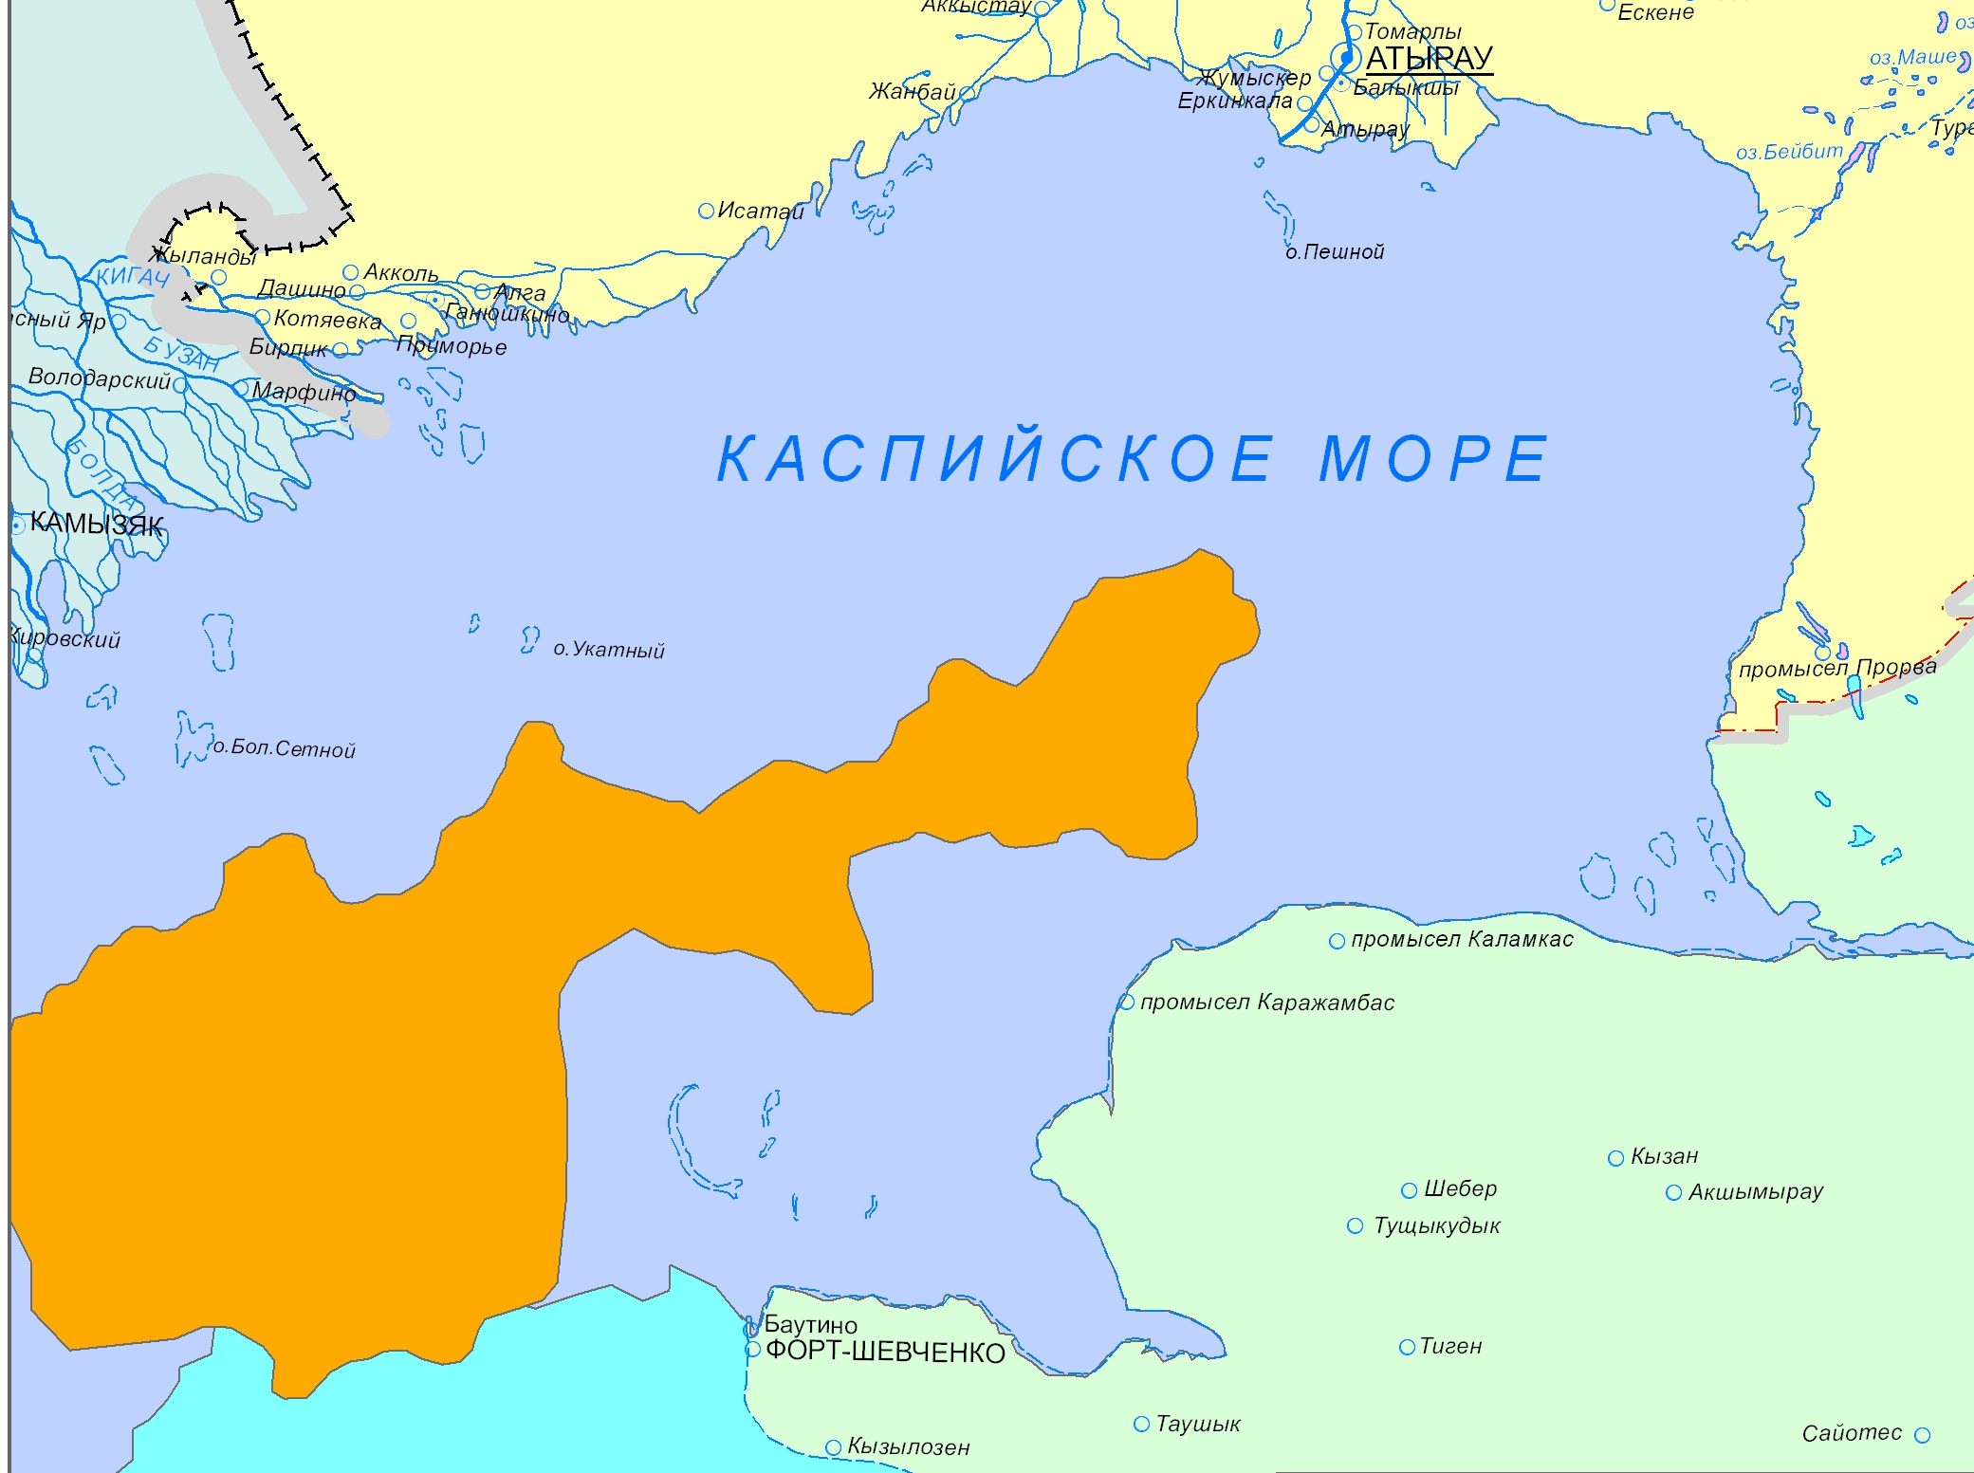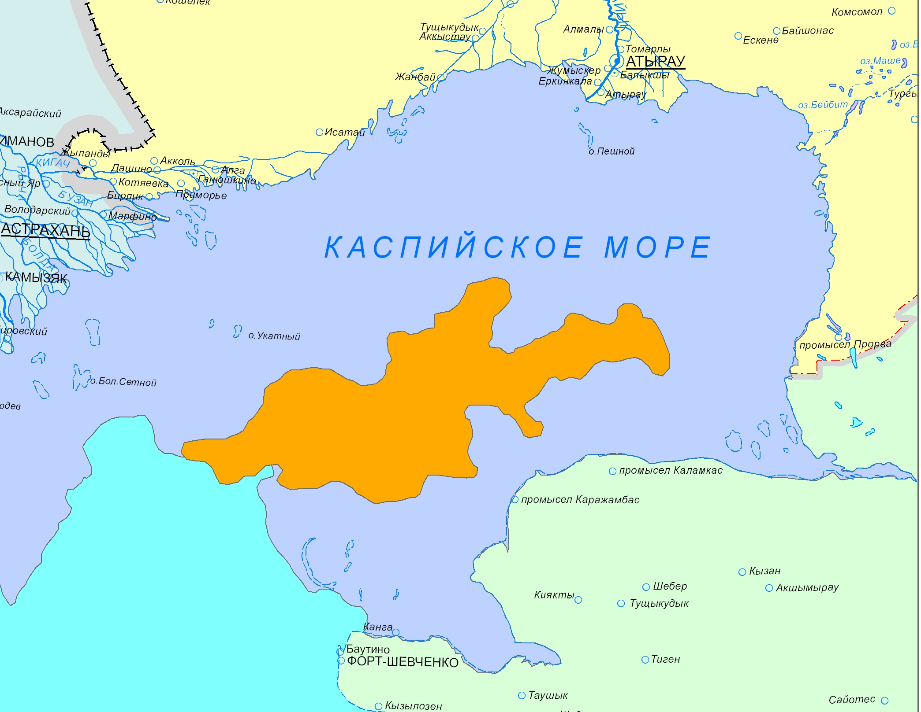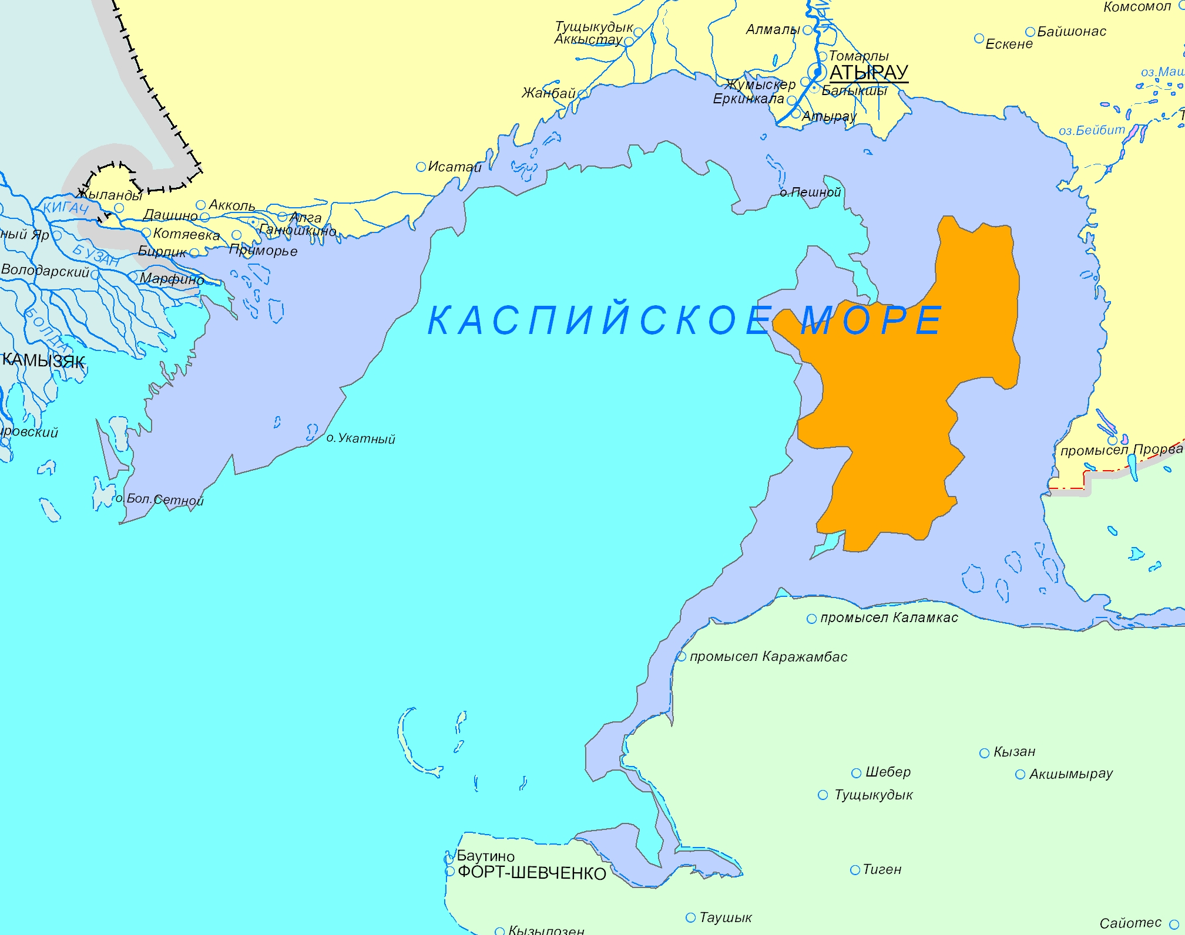

Figure 3. Breeding areas during warm, normal and cold winters (Harkonen et al. 2008; Dmitrieva et al. 2015; Dmitrieva et al. unpublished data)

Area No. 21: Kendirli Bay

Abstract
The Caspian seal (Phoca caspica) is endemic to the Caspian Sea and is also its only mammal. In 2008, IUCN changed the status of the Caspian seal from “vulnerable” to “endangered”. In contrast to habitats in the northern Caspian, on the islands at the tip of the Kendirli spit in the Gulf of Kazakhstan, wind-surge phenomena do not have much effect on the hauling rookery, due to the fact that the islands are located in the deep-sea zone of the middle Caspian. This creates ideal conditions for the formation of rookeries on the islands.

Location
Kendirli Bay is located in the deep water zone of the central Caspian, in the eastern part of the Kazakh Gulf, which is 23 km long, with a maximum width of 1.5 km in the middle. The spit is connected to the mainland in the south-east and extends in a north-westerly direction, forming Kendirli Bay. In the north-western extremity, the spit has a small cove. The north-western part of the bay has an island, the area of which can reach 0.1 km², but which can be split into several smaller islands, depending on the wind-surge phenomena.

Introduction
The habitat of the Caspian seal (Phoca caspica) is limited exclusively to the Caspian Sea. Based on its morphological structure and physico-geographical conditions, the Caspian Sea is divided into three parts: the northern, middle and southern parts. A conditional border between the northern and middle parts of the Caspian is usually taken by the line connecting Chechnya Island to Tyub-Karagan, and between the middle and southern parts of the Caspian Sea, the Zhulyaya-Kuuli line, within the northern part of the Caspian Sea, western and eastern areas (5, 6, 7, 8).

Between the western and eastern regions of the northern part of the Caspian, the border is shallow, going towards Novinsky Island—the archipelago of the Seal Islands. The greatest depths within this shoal do not exceed 3.6-3.8 m. With a total area of the northern part of the Caspian Sea, equal to 91, 942 km², the area of its water surface is 90,129 km². The share of the northern part of the sea accounts for more than 24.3% of the total area of the sea.

Most of the area (68%) of the northern regions of the Caspian Sea is less than 5 m deep. The most significant areas are the zones with depths from 0 to 1 m (20.2%) and from 3 to 4 m (14.1%) . The share of the zone with depths exceeding 10 m is 9.8%. In the north-western part of the Caspian Sea, depths of up to 5 m occupy a smaller area than in the eastern part (28,471 and 32,830 km²). The eastern region is shallower than the western; its average depth is 3.3 m, and the maximum is 9.0 m (5, 6, 7, 8).

The results of satellite tagging show that the habitats of the Caspian seal include almost the entire water area of the northern and middle Caspian, as well as the western part of the southern Caspian(Figure 2). The northern Caspian is an important area for the species and provides an ice substrate for breeding in winter, feeding grounds for migrating seals to the south in the spring and back to the north in the autumn, and for seals left in the north Caspian for the entire ice-free period. Shallow areas of the north-eastern Caspian, from Komsomol Bay to the delta of the Urals, are used by seals during migrations, foraging and recreation. The Kendirli Bay is a critical area during moulting, where thousands of seals gather every spring after the ice breaks (7, 8).

Feature description of the area
In contrast to habitats in the northern Caspian, on the islands at the tip of the Kendirli spit in the Gulf of Kazakhstan, the overtaking phenomena do not have much effect on the hauling rookery, due to the fact that the islands are located in the deep-water zone of the middle Caspian. The bay remains calm even in a strong sea storm. This creates ideal conditions for the formation of rookeries on the islands. In view of this, the seals chose the eastern part of the island as a place for a rookery. (8).

Feature condition and future outlook of the area
The area is located in the state natural reserve of local significance “Adamtas”, but the seal is not included among the protected species. Economic activities are permitted on the reserve territory, including peasant farms, tourism and fishing (7, 8, 10).

Assessment of the area against CBD EBSA criteria

Criteria | Description  (Annex I to decision IX/20) | Ranking of criterion relevance  (please mark one column with an X)
Criteria | Description  (Annex I to decision IX/20) | No information |  |  |  |  |  |  | Low |  |  |  |  |  |  | Medium |  |  |  |  | High
Uniqueness or rarity | An area in which either i) unique (unique in its kind), rare (found in only a few places) or endemic species, populations or communities are present; and / or ii) unique, rare or special habitats or ecosystems; and / or iii) unique or unusual geomorphological or oceanographic elements. |  |  |  |  |  |  |  |  |  |  |  |  |  |  |  |  |  |  |  | X
Explanation for ranking
The Caspian seal (Phoca caspica, Gmelin, 1788), an endemic transboundary species, is the only mammal in the Caspian Sea. In 2008, the IUCN changed the status of the Caspian seal from “vulnerable” to “endangered”.

In contrast to habitats in the northern Caspian, on the islands at the tip of the Kendirli spit in the Gulf of Kazakhstan, the overtaking phenomena do not have much effect on the hauling rookery, due to the fact that the islands are located in the deep-water zone of the central Caspian. This creates ideal conditions for the formation of rookeries on the islands, which are very important for the moulting and feeding season of seals.
Special importance for life-history stages of species | The area necessary for the survival and successful habitat of the population. |  |  |  |  |  |  |  |  |  |  |  |  |  |  |  |  |  |  | X
Explanation for ranking
In contrast to habitats in the northern Caspian, on the islands at the tip of the Kendirli spit in the Gulf of Kazakhstan, the wind-surge phenomena do not have much effect on the hauling rookery, due to the fact that the islands are located in the deep-water zone of the central Caspian. This creates ideal conditions for the formation of rookeries on the islands, which are very important for the moulting and feeding season of seals. (7, 8).
Importance for threatened, endangered or declining species and/or habitats | Area containing a habitat for the survival or restoration of endangered, endangered or endangered species; Or an area containing significant communities of such species. |  |  |  |  |  |  |  |  |  |  |  |  |  |  |  |  |  | X
Explanation for ranking
The Caspian seal is classified as endangered on the IUCN Red List. The seal population is declining as a result of climate change and the resulting decrease in the area and duration of the ice cover, as well as deaths resulting from falling into fishing nets. But the rookery of Kendirli is one of the last seal refuges. At the Kendirli rookery, the maximum recorded number of seals in the autumn of 2016 was 479 individuals, which is more than double that of 2015 (7, 8).
Vulnerability, fragility, sensitivity, or slow recovery | A region containing a relatively large number of sensitive habitats, biotopes or species that are functionally fragile (highly prone to degradation or depletion due to anthropogenic activities or natural events) or are characterized by slow recovery rates. |  |  |  |  |  |  |  |  |  |  |  |  |  |  |  |  | X
Explanation for ranking
Since seals are an extremely vulnerable species, an increase in the anthropogenic pressure on a given habitat can lead to its loss as a seal habitat (7, 8). In conditions when there are only a few rookeries left in the Caspian seal hauling grounds, this should not be allowed.
Biological productivity | Area containing species, populations orcommunities with comparatively higher natural biological productivity. | X
Explanation for ranking
The natural biological productivity of seals is very low in all habitats (3, 6). There is limited information on the presence of other animals here.
Biological diversity | Area contains comparatively higher diversity of ecosystems, habitats, communities, or species, or has higher genetic diversity. |  |  |  |  |  |  |  |  |  | X
Explanation for ranking
In addition to the Caspian seal, marine fish species inhabit the area. The biological diversity of marine fauna is average. The main commercial fish species here include herring, mullet and zander (Sander lucioperca) (1).
Naturalness | Area with a comparatively higher degree of naturalness as a result of the lack of or low level of human-induced disturbance or degradation. |  |  |  |  |  |  |  |  | X
Explanation for ranking
Given that the seals rookery on the island at the northern extremity of the Kenderli spit is unique in its location and, apparently, the only one in the Middle Caspian by Kazakhstan and the seals on it can represent a separate subpopulation with a kind of gene pool (7, 8). The area is located on the territory of the state zoo reserve “Adamtas”, but the seal is not protected. Economic activities are permitted on the reserve territory, including small-scale farming, tourism and fishing (7, 8, 10).

References
1 Захарова Н. А. Уровень накопления и влияние ряда токсикантов на состояние популяции каспийского тюленя// дис. ... канд. биол. наук. Астрахань, 2003.
2 Tero Harkonen, Mart Ju. ssi, Mirgaly Baimukanov, Anders Bignert, Lilia Dmitrieva, Yesbol Kasimbekov, Mikhail Verevkin, Susan Wilson and Simon J. Goodman Pup Production and Breeding Distribution of the Caspian Seal (Phoca caspica) in Relation to Human Impacts//Ambio Vol. 37, No. 5, July 2008. Р.356-361.
3 Сокольский А.Ф. и др. Современное состояние биопродуктивности Каспийского моря и причины деградации популяции тюленей за последние 300 лет. Астрахань, 2008. 178 с.
4 Л.Дмитриева, А. Кондаков, Е. Олейников, А.Кыдырманов,К. Карамендин, М. Баймуканов, Е.Касымбеков, С. Уилсон, Саймон Дж. Гудман. Прилов каспийского тюленя в нелегальном рыболовстве: оценка методом интервью// http://www.kaspika.org/assessment-of-caspian-seal-bycatch-in-illegal-fishery/.
5 Оценка ледовых условий в Казахстанском секторе Каспийского моря//http://gbpp.org/100-21
6 Крылов В.И. К биологии каспийского тюленя Pusa caspica Gmelin, 1788//Бюллетень М. о-ва исп. природы, отд. биологич., Т. 81 (1), 1976. С. 15-27.
7 Баймуканов М. Жданко Л.А. и др. Изучение динамики численности и комплексная оценка факторов угроз популяции каспийского тюленя // Отчет о научно-исследовательской работе (промежуточный). Алматы, 2015. – 53 с.
8 Баймуканов М. Жданко Л.А. и др. Изучение динамики численности и комплексная оценка факторов угроз популяции каспийского тюленя // Отчет о научно-исследовательской работе (промежуточный). Алматы, 2016. – 66 с.
9 Баймуканова А., Жданко Л., Баймуканов Т., Баймуканов М. Сохранение лежбища каспийского тюленя (Pusa caspica) в заливе Кендирли//Материалы международной конференции Голарктика 2016. Астрахань, 2016. В печати.
10 Паспорт Государственного природного (зоологического) заказника «Адамтас» местного значения (наименование особо охраняемой природной территории)// eco.mangystau.gov.kz/media/uploads/885-5.docx
11 Dmitrieva, L., Härkönen, T., Baimukanov, M., Bignert, A., Jüssi, I., Jüssi, M., … Goodman, S. (2015). Inter-year variation in pup production of Caspian seals Pusa caspica 2005–2012 determined from aerial surveys. Endangered Species Research, 28(3), 209–223. https://doi.org/10.3354/esr00689

Maps, Figures and Tables

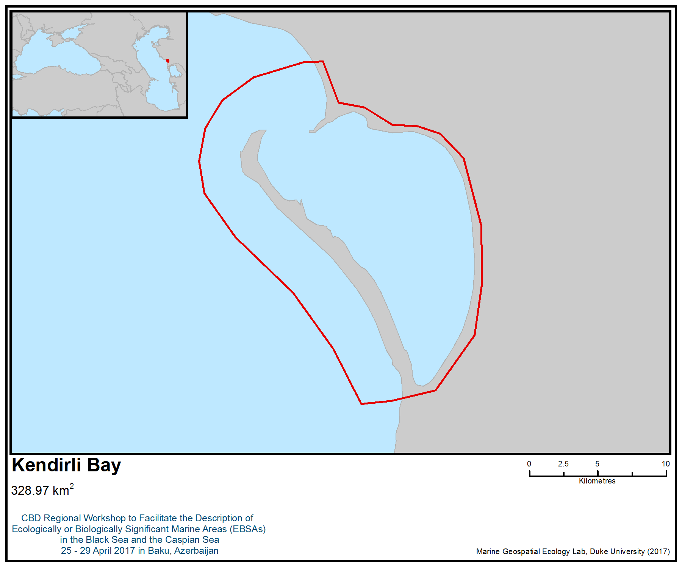
Figure 1. Area meeting the EBSA criteria

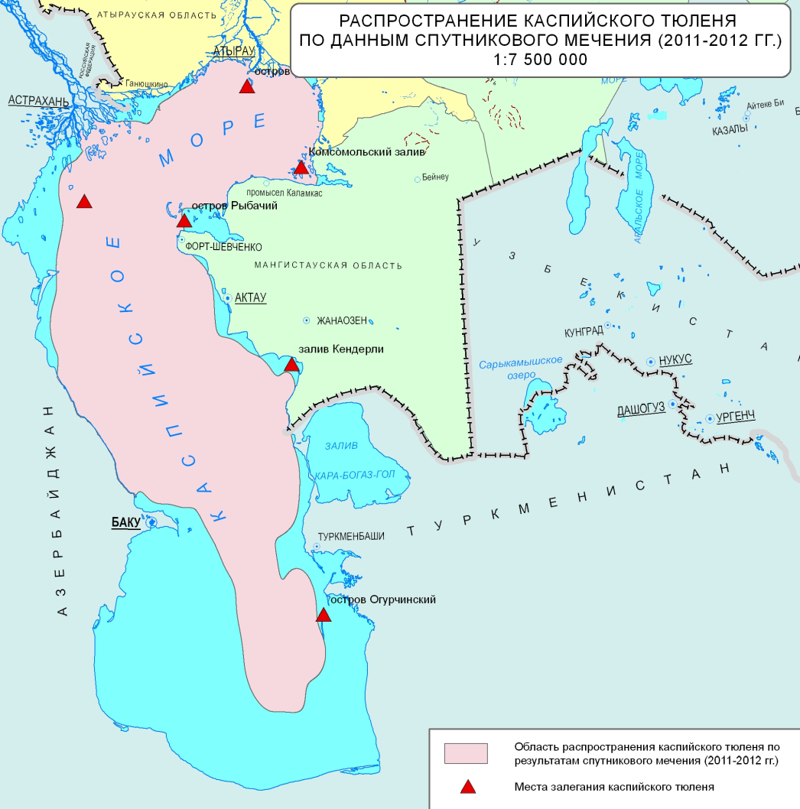

Figure 2. Caspian seal distribution based on satellite telemetry tagging in 2011-2012

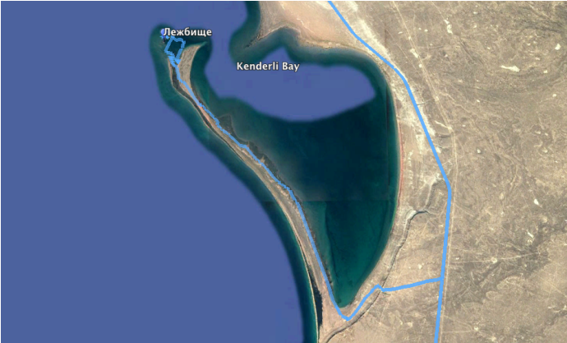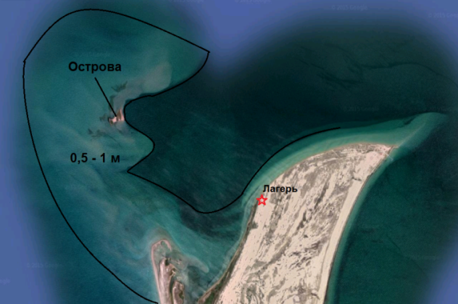

Figure 3. Location of the bay and islands in the north-western extremity of the Kendirli spit

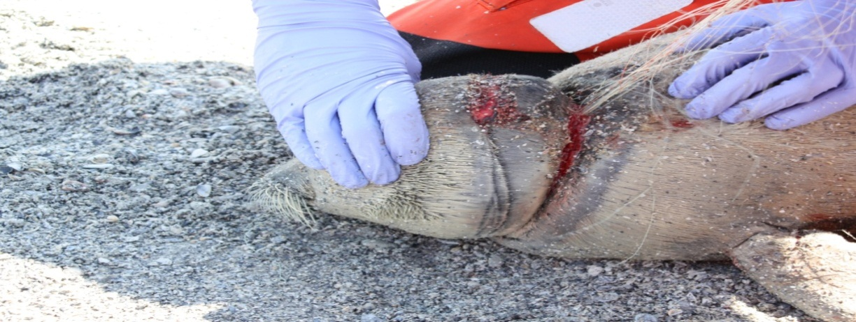

Figure 4. Seal entangled in a fishing net

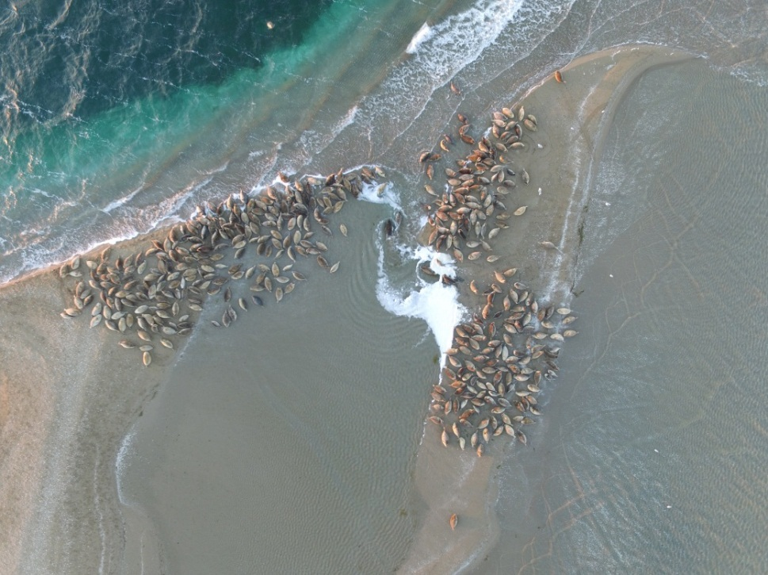

Figure 5. Seals congregating on the islands at the tip of the Kendirli spit (04.10.16)

Table 1. Number of Caspian seals at the Kendirli rookery (spring, summer 2016)
№ | Data | Number of seals (specimens)
1 | 11.05.2016 | 11
2 | 13.05.2016 | 21
3 | 28.08.2016 | 28
4 | 30.08.2016 | 43

Table 2. Average daily dynamics of the Caspian seal population from 03.10.2016 to 12.10.16
Period | The average number of observed seals (specimens) | %
Morning | 339 | 52,4
Noon | 153 | 23,6
Evening | 155 | 24

Area No. 22: Karabogazgol Strait

Abstract
The Karabogazgol Strait connects the Caspian Sea with the Karabogazgol Gulf. The area forms a unique natural hydro-geological complex. There are no rivers that drain into the lagoon. This hydrological system is heavily influenced by the dynamics of the Caspian Sea. All components of the system are very dynamic, and their parameters are defined by sea-level dynamics. All biodiversity in the broader area is concentrated mainly in the strait, including bacteria, lower plants, invertebrates, birds (the majority of which are migrant species). Some species of fish and birds present in the area are included in the Red Book of Turkmenistan.

Introduction
The Karabogazgol Gulf is a natural saltwater lagoon (surface area up to 18,000 km², with a volume of 130 km³ and depth of 10 m), the size of which depends on the levels of the Caspian Sea. It is a unique geological, hydrological and ecological natural site with appropriate biodiversity and extremely high concentration of mineral salts. The largest saltwater Gulf in the world is connected to the Caspian Sea by the Karabogazgol Strait, a passage with a width of 400-800 m, length 7-9 km, depth 3-5 m and total area of 4108 km². A constant current from the sea, with a speed of 0.5 to 1.0 m/sec, is observed in the strait (Гюль, 1956; Дерягин, 1977; Касымов, 1987; Зонн, 2004).

All biodiversity in the area is mainly concentrated in the strait, including bacteria and some species of seaweed. Its biodiversity includes plants, invertebrates and birds, the majority of which are migrants (Рустамов, Щербина, 2009). Some species are listed in the Red Data Book of Turkmenistan (2011): Caspiomyzon wagneri, Acipenser nudiventris, (critically endangered), Alosa kessleri volgensis (endangered), Salmo trutta caspius (vulnerable), Stenodus leucichthys leucichthys (vulnerable).

In line with the declining sea level of the Caspian Sea, all systems in the area are in a transition state towards reduction in the overflow of seawater, as is the area of the gulf, and the width and depth of the strait (Красная книга Туркменистана, 2011).

Location
The Kara-Bogaz-Gol Strait is located in the eastern Caspian Sea, between the Caspian Sea and the Kara-Bogas-Gol Gulf. This area measures 4,108 km², with its centre at 41.093621N, 52.915339E.

Feature description of the area
The area is dependent on sea-level changes and high rates of evaporation, which change considerably, both annually and seasonally. The salinity of the sea water of the gulf can reach 330-380 ‰ and causes the formation of salts (Na₂ SO₄). The gulf exerts a considerable impact on the water and salt balance of the Caspian Sea. Each cubic km of sea water brings to the gulf 13-15 million tonnes of various salts. When the water level is low level 5-7 km³ arrive annually, while up to 25 km³ can be transported when the water level is high. Ill-advised experiments with closing the gulf changed the salt structure and destroyed its unique natural, ecological and aesthetic value (Гюль, 1956; Дерягин, 1977; Касымов, 1987; Зонн, 2004).

In Kara-Bogaz-Gol Strait, there are silt and silt-sandy phyto-benthos: about 30 species of seaweeds: green (Ulvophyceae or Chlorophyta), brown (Phaeophyceae or Ochrophyta), red (Rhodóphyta), which is rarer, and mainly, littoral seaweed-macrophytos. Zoobenthos is represented by hearts (Polychaeta), for example, Nereis diversicolo; and mollusks (Mollusca), for example, Abra ovata.

In some places, such as on submerged bridge piles, gas pipelines and electro pipelines, there are concentrations of shrimps, Palaemon elegans and P. adspersus, Amphipoda, for example, Niphargoides (Pontogammarus) maeoticus and other crustacea, including Rhithropanopeus harrissii (Бирштейн и др., 1968).

Earlier these species were found on a stony ridge of natural origin and in a pool of the former water falls which since 1980, i.e. after a platinum construction, has been submerged, and its population structure is unknown. This picture is particularly unclear because of the catastrophic invasion of comb jellyfish (Mnemiopsis leidyi) across the Caspian Sea over the last 25 years.

In the gulf and strait there are 87 specific and intraspecific seaweed taxa belonging to five phyla: Bacillariophyta (62 taxa), Cyanophyta (12 taxa), Chlorophyta (5 taxa), Dinophyta (7 taxa) and Chrysophyta (1 taxa). Benthos comprises 45,9 % of the total number of taxa, while plankton comprises 39,8 % and periphyton (overcover) comprise 14,3 %. The prevalence of nonplanktonic species in the gulf is related to depth. The phytoplancton structure of Karabogasgol Gulf is derived primarily from Caspian taxa, which comprise 83,2 % of the total number. The majority of taxa is neritic, and only an insignificant proportion of the plankton is pelagic.

Feature condition and future outlook of the area
The particular hydrological, hydrochemical and ecological characteristics that characterize the gulf are reflected in the structure of its algoflora: phytoplankton and phytobentos. The efficiency of its phytoplankton has crucial importance for end production: increased efficiency results in increased biomass of Artemia salina. At a minimal level of efficiency, Artemia salina flow downstream with the current but do not leave the zone where saltwater and brine mix, and have formed in the mouth of the strait a steady biocenoses , especially in a pool under fall (Булатов, 2002).

In well-aerated and organically rich water, an abundance of periphyton of green, brown and red seaweed develops on stones, attracting Crustacea (especially shrimps Palaemon elegans and P. adspersus and Niphargoides (Pontogammarus) maeoticus), the fish that eat them and masses of birds, especially seagulls.

Fish that flow down from the waterfall can only live in the delta; they do not survive in the brine. In the delta there are alluvial sandy islands, and to the north-west of them the water is briny, and the area is home to nesting colonies of rare black-headed Pallas’s gull (Larus ichthyaetus), Caspian gull (Larus cachinnans), Caspian tern (Sterna caspia), common tern (Sterna hirundo) and little tern (Sterna albifrons), little ringed plover (Charadrius dubius) and Kentish plover (Charadrius alexandrinus), Eurasian oystercatcher (Haematopus ostralegus) alternately with common shelduck (Tadorna tadorna) and ruddy shelduck (Tadorna ferruginea), which have scientific and practical value, as a biodiversity component (Андреев, Васильев, Щербина, 1973; Щербина, 1979).

The western part of the Karabogazgol Strait is known as the “Garabogaz – Garshy” Important Bird and Biodiversity Area (IBA), as designated by BirdLife International (Рустамов, Щербина, 2009).

This complex colony existed until 1980 and will be restored in the near future, when the sea level returns to its former level. It becomes an interesting process of restoration of the top chains of “an ecological pyramid”.

A special role is played by the crustacean Artemia salina, which develop optimally on sites with salinity from 80 to 130 ‰. Their eggs and larva are an optimum forage for fish, including aquarium fish. Artemia are also a favourite forage for common shelduck (Tadorna tadorna), and adult individuals are eaten by different snipes. Artemia have disappeared since the gulf dried out in 1980, but their eggs have remained in a salty substratum and as the gulf refills, washing out of deposits of salts and occurrence of sites with suitable salinity, they give life to new generations.

The volume of water arriving from the sea along the strait reached 42-52 km³/year in 1992-1995, i.e. much more than before the strait was closed by the dam in 1980. Optimum salinity conditions for Artemia were set up and sharp increases in its biomass were recorded: reproduction of Artemia was so great that eggs were thrown out by waves and covered a thousand hectares in a half-metre layer along the coast.

A spike in the reproduction of Artemia has led to an increase in bird weight and to mass reproduction of common shelduck (Tadorna tadorna). So, for example, if towards the middle of the 1980s it was estimated that there were no more than 1000 pairs of common shelduck (Tadorna tadorna), in the mid-1990s there were at least 5000 to 6000 pairs, which grew to 80 000 overwintering individuals (Aleksandr Sherbina, unpublished data). In these years around 4500 tonnes of Artemia eggs were prepared by commercial entities (the price in the international market reached around $180/kg).

Assessment of the area against CBD EBSA Criteria
CBD EBSA Criteria  (Annex I to decision IX/20) | Description  (Annex I to decision IX/20) | Ranking of criterion relevance  (please mark one column with an X)
CBD EBSA Criteria  (Annex I to decision IX/20) | Description  (Annex I to decision IX/20) | No information |  | Low |  |  | Medium |  | High
Uniqueness or rarity | Area contains either (i) unique (“the only one of its kind”), rare (occurs only in few locations) or endemic species, populations or communities, and/or (ii) unique, rare or distinct, habitats or ecosystems; and/or (iii) unique or unusual geomorphological or oceanographic features. |  |  |  |  |  |  |  | X
Explanation for ranking
Karabogazgol has an unusual geomorphological structure with unique hydrology in which special ecosystems suitable for dwelling of rare species of flora and fauna are formed. This hydrological system is heavily influenced by the dynamics of the Caspian Sea. All components of the system are very dynamic, and their parameters are defined by sea-level dynamics (Касымов, 1987; Зонн, 2004).
Special importance for life-history stages of species | Areas that are required for a population to survive and thrive. |  |  |  |  |  | X
Explanation for ranking
There are remote islands of the delta and the southern part of the gulf that are suitable for nesting of rare species of ichthyophagous birds. The strait plays an important role and much depends on the structure and quality of the seaweed present in a particular year (Булатов, 2002).
Importance for threatened, endangered or declining species and/or habitats | Area containing habitat for the survival and recovery of endangered, threatened, declining species or area with significant assemblages of such species. |  |  |  | X
Explanation for ranking
The biodiversity is represented by lower plants, invertebrates, fish and waterbirds (Рустамов, Щербина, 2009). But fish do not inhabitat the strait regularly—they enter the strait from the sea and slowly die. The species that could occur are included in the Red Data Book of Turkmenistan (2011), such as Caspiomyzon wagneri (near threatened), Acipenser nudiventris (critically endangered), Alosa kessleri volgensis (endangered), Salmo trutta caspius (vulnerable), Stenodus leucichthys leucichthys (vulnerable) (Красная книга Туркменистана, 2011).
Vulnerability, fragility, sensitivity, or slow recovery | Areas that contain a relatively high proportion of sensitive habitats, biotopes or species that are functionally fragile (highly susceptible to degradation or depletion by human activity or by natural events) or with slow recovery. |  |  |  |  |  |  |  | X
Explanation for ranking
The area is sensitive to changes in sea level, although this is a longer-term process. Changes in sea level have also different amplitudes, and the deterioration that has occurred is slowly restored (Булатов, 2002; Касымов, 1987; Щербина, 1979).
Biological productivity | Area containing species, populations or communities with comparatively higher natural biological productivity. |  |  |  |  |  |  |  | X
Explanation for ranking
At times of low water level in the Caspian Sea, the abundance of seaweed and the Crustacea serving as food for fishes and birds can be observed. The particular hydrological, hydrochemical and ecological characteristics that characterize the gulf are reflected in the structure of its algoflora: phytoplankton and phytobentos. In well-aerated and organically rich water, an abundance of periphyton of green, brown and red seaweed develops on stones, attracting Crustacea (especially shrimps Palaemon elegans and P. adspersus and Niphargoides (Pontogammarus) maeoticus), the fish that eat them and masses of birds, especially seagulls (Бирштейн и др., 1968; Булатов, 2002).
The efficiency of the phytoplankton in the gulf has crucial importance for end production: biomass of Artemia salina increases. The spike in reproduction of Artemia has led to an increase in bird weight and has led to mass reproduction of common shelduck (Tadorna tadorna). So, for example, if toward the middle of 1980s it was estimated that there were no more than 1000 pairs of common shelduck (Tadorna tadorna), in the mid-nineties there were at least 5000 to 6000 pairs, which grew to 80 000 overwintering individuals (Aleksandr Sherbina, unpublished data). In these years around 4 500 tonnes of Artemia eggs were prepared by commercial organisations (Андреев, Васильев, Щербина, 1973; Щербина, 1979 and unpublished).
Biological diversity | Area contains comparatively higher diversity of ecosystems, habitats, communities, or species, or has higher genetic diversity. |  |  |  |  |  |  |  | X
Explanation for ranking
The biodiversity is concentrated mainly in the strait. There are bacteria and some species of seaweed from the organic world in the salty water of the gulf. Biodiversity is represented by lower plants, invertebrates and birds (mostly migrants).

In the gulf and strait there are 87 specific and intraspecific seaweed taxa belonging to five phyla: Bacillariophyta (62 taxa), Cyanophyta (12 taxa), Chlorophyta (5 taxa), Dinophyta (7 taxa) and Chrysophyta (1 taxa). Benthos comprises 45,9% of the total number of taxa, while plankton comprises 39,8% and periphyton (overcover) comprise 14,3%. The prevalence of nonplanktonic species in the gulf is related to depth. The phytoplancton structure of Karabogasgol Gulf is derived primarily from Caspian taxa, which comprises 83,2% of the total number. The majority of taxa is neritic, and only an insignificant proportion of the plankton is pelagic (Бирштейн др., 1968; Булатов, 2002; Рустамов, Щербина, 2009).

Nesting colonies of rare black-headed Pallas’s gull (Larus ichthyaetus), Caspian gull (Larus cachinnans), Caspian tern (Sterna caspia), common tern (Sterna hirundo) and little tern (Sterna albifrons), little ringed plover (Charadrius dubius) and Kentish plover (Charadrius alexandrinus), Eurasian oystercatcher (Haematopus ostralegus) alternately with common shelduck (Tadorna tadorna) and ruddy shelduck (Tadorna ferruginea) have scientific and practical value, as biodiversity components (Андреев, Васильев, Щербина, 1973; Щербина, 1979).
Naturalness | Area with a comparatively higher degree of naturalness as a result of the lack of or low level of human-induced disturbance or degradation. |  |  |  |  |  |  | X
Explanation for ranking
The water level of the Caspian Sea was at one time extremely low, with an overflow only 5 km³/year. The water level decreased to 32m, the area changed to 10,000km², the volume to 20-22 km³, and the salinity increased to 270 to 380 ‰. By the middle of 1984 it practically dried up, threatening the ecological conditions of adjacent areas. In September 1984, having renewed water delivery through pipes, the gulf began to be restored slowly. The gulf has since been restored (Дерягин, 1977; Зонн, 2004; Касымов, 1987).

References
Андреев В.П., Васильев В.И., Щербина А.А. 1973. Условия гнездования и возможное эпизоотологическое значение 4 видов чайковых птиц на некоторых островах Восточного Каспия // Экология вирусов. Вып. I, М. С.111-115.
Бирштейн Я.А., Виноградова Л.Г., Кондакова Н.Н., Кун М.С., Астахова Т.С., Романова Н.Н. 1968. Атлас беспозвоночных Каспийского моря. М.: Пищевая промышленность, М.
Булатов С.А. 2002. Современное состояние водорослевых сообществ залива Кара-Богаз-Гол и их влияние на популяцию артемии // Тез. докл. Межд. научно-исслед. конф. «Биоразнообразие Артемии в странах СНГ: современное состояние ресурсов и их использование» 17-19 июля 2002 г., М. С.6-7.
Гюль К.К. 1956. Каспийское море. Баку. 328 с.
Дерягин В.А. 1977. Каспий, его прошлое, настоящее и будущее (краткий историко-географический очерк). Баку. 115 с.
Зонн И.С. 2004. Каспийская энциклопедия. М.: Международные отношения. 461 с.
Касымов А.Г. 1987. Каспийское море. Л.: Гидрометиоиздат. 157 с.
Красная книга Туркменистана. 2011. Т.2. Беспозвоночные и позвоночные животные. Изд.3-е, перераб. и доп. Ашхабад: Ылым. 384 с.
Рустамов Э.А., Щербина А.А. 2009. Гарабогаз // Ключевые орнитологические территории Туркменистана. Ашхабад: МОП. С.74-76.
Щербина А.А. 1979. Новые данные по гнездовой фауне колониальных и околоводных птиц островов Кара-Богаз-Гола // Природная среда и птицы побережий Каспийского моря и прилежащих низменностей / Труды Кызыл-Агачского гос. зап. Вып. I. Баку: Азернешр. С.89-100.

Maps and Figures

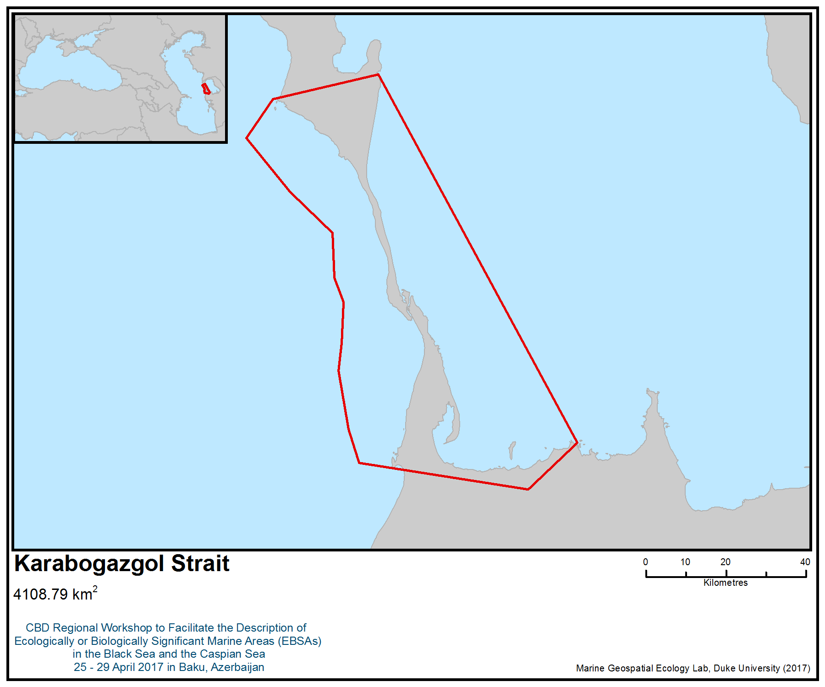
Figure 1. Area meeting the EBSA criteria

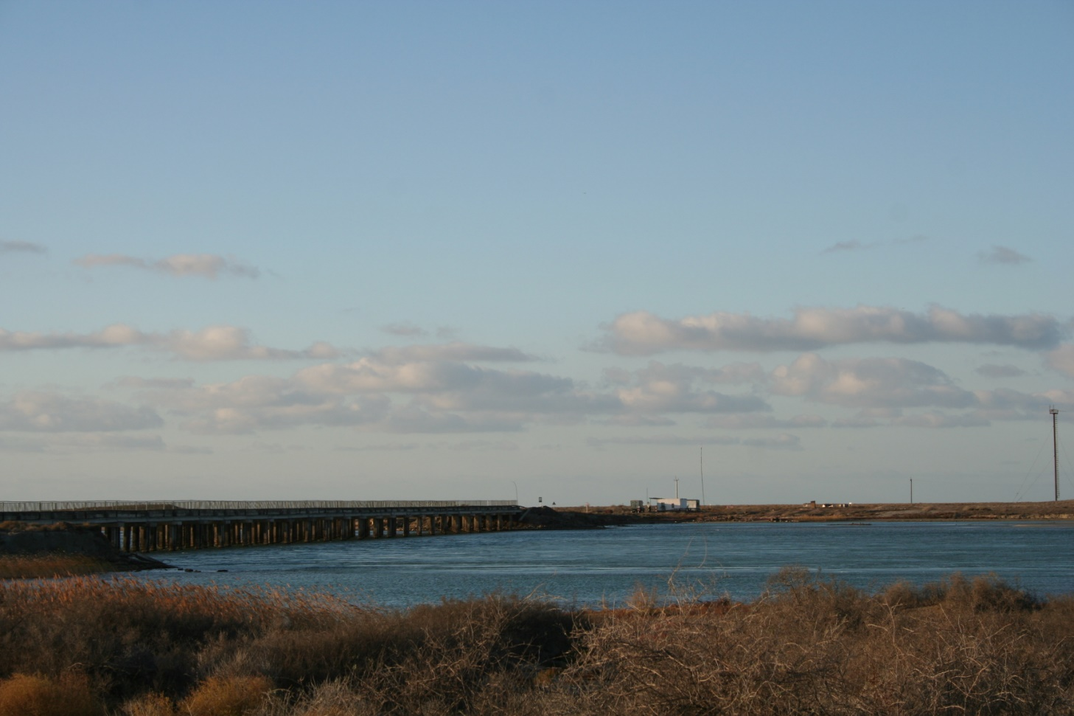

Figure 2. Bridge across the Karabogazgol Strait (Photo: Eldar Rustamov)

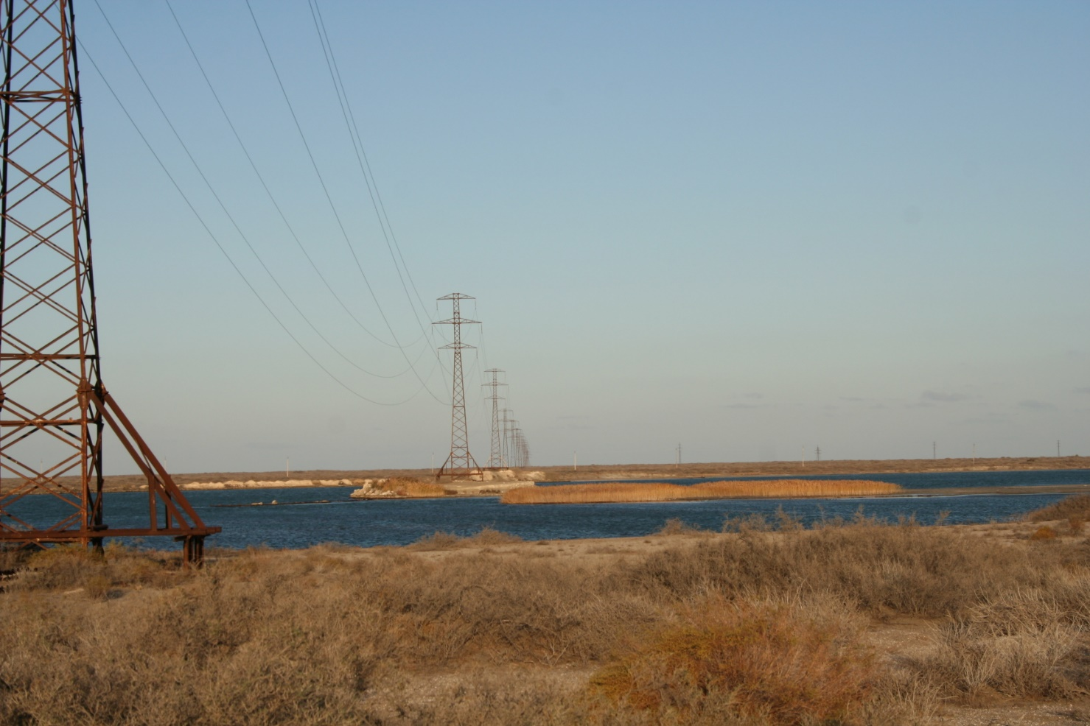

Figure 3. Power lines across the Karabogazgol Strait (Photo: Eldar Rustamov)

Rights and permissions
Among references, private data of authors are used.

Area No. 23: Turkmenbashi Gulf

Abstract
As of 1968, Turkmenbashi Gulf, including Balhan, Northern-Cheleken, Mihajlovsky and other small bays, which is the site of mass winterings and migrations of waterbirds, has been part of Krasnovodsk (now known as Hazar) State Nature Reserve. Hazar State Nature Reserve is the main part of Turkmenbashi Gulf. It is a Ramsar Site and an Important Bird and Biodiversity Area (IBA, BirdLife International). Its biodiversity includes invertebrates and vertebrates (fishes, birds, mammals), including species listed in the Red Data Book of Turkmenistan.

Introduction
The Gulf encompasses several bays on the Caspian Sea: Turkmenbashi, Balkan, North-Cheleken, Mihailovsky and Soymonov bays, which are separated from the open sea by Krasnovodskiy and North-Cheleken spits. The north of the territory is limited by ledges of the Krasnovodskiy plateau, in the south by the Cheleken peninsula, and in the northeast by the Dardzha peninsula. The relief of the Gulf can be divided into three basic components: (a) shallow brackish bays having open access to each other and separated from the sea by sandy spits; (b) sandy-shelly spits, islands and dunes, overgrown with halophytes; (c) stony islands in Balkan Bay, including the largest, Dagada. Alongside favourable natural processes that have increased the area of wetlands over the last 10 years, anthropogenic factors have also strongly increased: pollution due to oil extraction and disturbance (Гюль, 1956; Дерягин, 1977; Зонн, 2004; Зонн, Жильцов, 2004; Касымов, 1987). Illegal hunting of a significant proportion of the wintering and migrating waterfowl and waterbirds has also increased.

Location
Turkmenbashi Gulf is on the east coast of the Caspian Sea. It is connected on the north-west to Sojmonova Bay. Geographical coordinates: centroid 39.792556N, 53.310004E. Total area of this site is 2203 km².

Feature description of the area
Hazar State Nature Reserve has covered most of Turkmenbashi Gulf since 1968. In 2009 all this territory (Turkmenbashi Gulf) became a Ramsar Site, “Turkmenbashy Bay”, with total area of 267124 hectares. Turkmenbashi Gulf is identified by BirdLife International as “Turkmen Bay” Important Bird and Biodiversity Area (IBA) (Рустамов, Гаузер, 2009).

The site’s biodiversity consists almost entirely of seaweeds. It comprisesshallow water areas with maximum depths of 8-10,4 m.The seaweed is present in unicellular, colonial and multicellular forms (more than 200 species). Their biomass ranges from 100 to 1500 mg/m³, and sometimes more, a mid-annual biomass of plankton seaweed 1g/m³. In benthos and periphiton (70 species) seaweed macrophitos (57 species) prevail, extending at depths to 40 m and show strong development to 20 m depth. The general efficiency of biomass microphitos, having development seasonal cycles, is estimated at approximately 750 000 tonnes/year. The higher plants (five species) grow on sandy soils of the coastal zone on depths to 6,0 m. The general biomass of the higher plants is at least 600 000tonnes/year. The list of marine invertebrates totals more than 1200 species belonging to 30 taxa (Прошкина-Лавренко, Макарова, 1968; Киреева, Щапова, 1957; Бобров, 1959; Забержинская, 1974; Блинова, Филлипов, 1975). In recent years, the invasive species Mnemiopsis leidyi has become common.

Vertebrates are represented by fishes, birds and mammals, including species listed in the Red Data Book of Turkmenistan (2011). Among the fish (49 species and subspecies), they include the following species: Acipenser nudiventris, I (critically endangered), Alosa kessleri volgensis, II (endangered), Salmo trutta caspius, III (vulnerable), Stenodus leucichthys leucichthys, III (vulnerable). Fish are represented by 10 valuable species: herring (Caspialosa sp.), mullet (Mugil sp.), Rutilus sp., Cyprinus sp., Artediellus sp., Atherina sp., Clupeonella sp., Aspius sp., Salma sp. Bays provide spawning grounds for commercial fish (Рустамов, Васильев, 1976; Васильев, Гаузер, Тишков, 1990).

Taking into account the value of species in ecosystem services, the most valuable are avifauna, which includes almost 300 species, of which 130 are waterbirds (Щербина, 2013). The majority occur during spring-autumn migration and in winter in some years up to 100 000, with an average of at least 20 000 (Рустамов, Щербина, 2007). These include the following threatened migratory and wintering birds, which are included in the Red Data Book of Turkmenistan (2011): Pelecanus onocrotalus, III (vulnerable); Pelecanus crispus, II (endangered); Platalea leucorodia, IV; Phoenicopterus roseus, IV; Branta ruficollis, II (endangered); Anser erythropus, III (vulnerable); Aythya (Nyroca) nyroca, III (vulnerable); Oxyura leucocephala, III (vulnerable); Haliaeetus leucoryphus, III (vulnerable).

The most interesting species ofmammals is the Caspian seal (Pusa (Phoca) caspica), I (critically endangered), which is listed in the Red Data Book of Turkmenistan (2011) and is endemic to the Caspian (Рустамов, Васильев, 1976).

Feature condition and future outlook of the area
The area is now protected by a reserve. However, over the past decade, Turkmenbashi City has grown rapidly and continues to develop. If it were to be preserved, it would present opportunities to show its unique, globally significant biological diversity and would provide steady income due to its role in providing ecological services.

Assessment of the area against CBD EBSA Criteria

CBD EBSA Criteria  (Annex I to decision IX/20) | Description  (Annex I to decision IX/20) | Ranking of criterion relevance  (please mark one column with an X)
CBD EBSA Criteria  (Annex I to decision IX/20) | Description  (Annex I to decision IX/20) | No information |  | Low |  |  | Medium |  | High
Uniqueness or rarity | Area contains either (i) unique (“the only one of its kind”), rare (occurs only in few locations) or endemic species, populations or communities, and/or (ii) unique, rare or distinct, habitats or ecosystems; and/or (iii) unique or unusual geomorphological or oceanographic features. |  |  |  |  |  | X
Explanation for ranking
Turkmenbashi Gulf has a unique combination of various hydrobiological and ecological factors with presence of conditions that supports the survival of populations for rare components of biodiversity. It supports migration and wintering for a considerable number of water birds (Касымов, 1987; Зонн, 2004; Рустамов, Гаузер, 2009).
Special importance for life-history stages of species | Areas that are required for a population to survive and thrive. |  |  |  |  |  |  |  | X
Explanation for ranking
The area is necessary for the survival of population of fishes and birds. Restoration of biocenoses suitable for feeding and spawning of commercially valuable fish species, resting and wintering of rare, threatened and endangered species of birds. The waters of the gulf are important foraging areas for migratory species (Рустамов, Гаузер, 2009).
Importance for threatened, endangered or declining species and/or habitats | Area containing habitat for the survival and recovery of endangered, threatened, declining species or area with significant assemblages of such species. |  |  |  |  |  |  |  | X
Explanation for ranking
Regarding birds, there are almost 300 species, of which 130 are waterfowl and waterbirds. The majority occur during spring-autumn migration and in winter in some years up to 100 000, with an average of at least 30 000. They include the following threatened migratory and wintering birds, which are included in the Red Data Book of Turkmenistan: Pelecanus onocrotalus, III (vulnerable); Pelecanus crispus, II; Platalea leucorodia, IV; Phoenicopterus roseus, IV; Branta ruficollis, II (endangered); Anser erythropus, III ; Aythya (Nyroca) nyroca, III ; Oxyura leucocephala, III ; Haliaeetus leucoryphus, III (vulnerable). Among the mammals, the most interesting species is the Caspian seal (Pusa (Phoca) caspica), I (critically endangered) which is endemic to the Caspian and is listed in the Red Data Book of Turkmenistan. Among fish there are following Red Data Book of Turkmenistan (2011) species: Acipenser nudiventris, I (critically endangered), Alosa kessleri volgensis, II (endangered), Salmo trutta caspius, III and Stenodus leucichthys leucichthys, III (vulnerable) (Красная книга Туркменистана, 2011).
Vulnerability, fragility, sensitivity, or slow recovery | Areas that contain a relatively high proportion of sensitive habitats, biotopes or species that are functionally fragile (highly susceptible to degradation or depletion by human activity or by natural events) or with slow recovery. |  |  |  |  |  |  |  | X
Explanation for ranking
Now the area is subject to anthropogenic influence, interfering with its normal functioning. The area contains many sensitive habitats, is functionally fragile (extremely subject to degradation or exhaustion owing to anthropogenic activity or natural events) or different slow rates of restoration. The ecosystem of this area is related to the level of the Caspian Sea. Particularly it’s related to the coastal stripe. When the level of the sea is going down, bays are drying, particularly it depends for Michaylovskiy and Balhan bays. This is a factor of degradation of waterbirds habitats. When the sea level increase, activities of strong wave washed away small islands. For example, Osushnoy and Bolshoy and Malyi Islands, on which colonies of sea gulls and Caspian seals rest areas. Therefore, vulnerability is high,particularly during periods when sea level decreases (Бобров, 1959; Рустамов, Васильев, 1976; Васильев, Гаузер, Тишков, 1990; Рустамов, Гаузер, 2009).
Biological productivity | Area containing species, populations or communities with comparatively higher natural biological productivity. |  |  |  |  |  |  |  | X
Explanation for ranking
The area has high natural biological productivity. According to the data available, the biomass of plankton and benthos is considered one of the highest in the Caspian Sea. Small deep bays allow for quick warming, therefore waterweeds grow fast in small bays, thereby promoting high biological productivity (Киреева, Щапова, 1957; Бобров, 1959; Блинова, Филлипов, 1975).
Biological diversity | Area contains comparatively higher diversity of ecosystems, habitats, communities, or species, or has higher genetic diversity. |  |  |  |  |  | X
Explanation for ranking
There are more than 200 species of seaweeds. Five species grow on the sandy soils of coastal zones at depths to 6,0 m. The list of marine invertebrates totals more than 1200 species. Vertebrates are represented by fish (49 species and subspecies), birds (almost 300 species, of which 130 are waterfowl and waterbirds) and mammals (Caspian Seal), including species listed in the Red Data Book of Turkmenistan (Васильев, Гаузер, Тишков, 1990; Рустамов, Гаузер, 2009).
Naturalness | Area with a comparatively higher degree of naturalness as a result of the lack of or low level of human-induced disturbance or degradation. |  |  |  |  |  |  | X
Explanation for ranking
The area’s naturalness has been conserved throughout (except its northern part). Naturalness is, however, related to the water level of the Caspian Sea. During periods of low sea levels, naturalness is rated “medium” (Васильев, Гаузер, Тишков, 1990; Зонн, 2004; Зонн, Жильцов, 2004).

References
Блинова Е.И, Филлипов Г.М. 1975. Фитобентос Красноводского залива // Тр. ВНИРО, Т.108. С.75-80.
Бобров С.Н. 1959. Биологические процессы на дне Красноводского залива // Природа. №10.
Васильев В.И., Гаузер М.Е., Тишков Л.А. 1990. Красноводский заповедник // Заповедники СССР. Заповедники Средней Азии и Казахстана. – М.: Мысль. – С.128-140.
Гюль К.К. 1956. Каспийское море. Баку. 328 с.
Дерягин В.А. 1977. Каспий, его прошлое, настоящее и будущее (краткий историко-географический очерк). Баку. 115 с.
Забержинская Э.Б. 1974. Донная растительность Каспийского моря // Ин-т Ботаники АН Аз.ССР. Деп. в ВНТИТИ. 16.07.1974. №1949-74.
Зонн И.С. 2004. Каспийская энциклопедия. М.: Международные отношения. 461 с.
Зонн И.С., Жильцов С.С. 2004. Каспийский регион: география, экономика, политика, сотрудничество. М.: Эдель-М. 638 с.
Касымов А.Г. 1987. Каспийское море. Л.: Гидрометиоиздат. 157 с.
Красная книга Туркменистана. 2011. Т.2. Беспозвоночные и позвоночные животные. Изд.3-е, перераб. и доп. Ашхабад: Ылым. 384 с.
Киреева М.С., Щапова Т.Ф. 1957. Донная растительность Красноводского залива // Тр. ИОАН СССР. Т.23. С. 125-137.
Прошкина-Лавренко А.И., Макарова И.В. 1968. Водоросли планктона Каспийского моря. Л.: Наука, 291 с.
Рустамов А.К., Васильев В.И. 1976. Природные заповедники СССР: (Всесоюзный орнитологический Красноводский заповедник). – М.: Знание. – 48 с.
Рустамов Э.А., Гаузер М.Е. 2009. Туркменбаши айлагы // Ключевые орнитологические территории Туркменистана. Ашхабад: МОП. С.74-76.
Рустамов Э.А., Щербина А.А. 2007. Учет численности водно-болотных птиц на туркменском побережье Каспия // Проблемы освоения пустынь. №1. С.55-57.
Щербина А.А. 2013. Из материалов по редким и малоизученным видам птиц туркменского Прикаспия // Изучение биоразнообразия Туркменистана (позвоночные животные). Москва – Ашхабад. С.170-181.

Maps and Figures

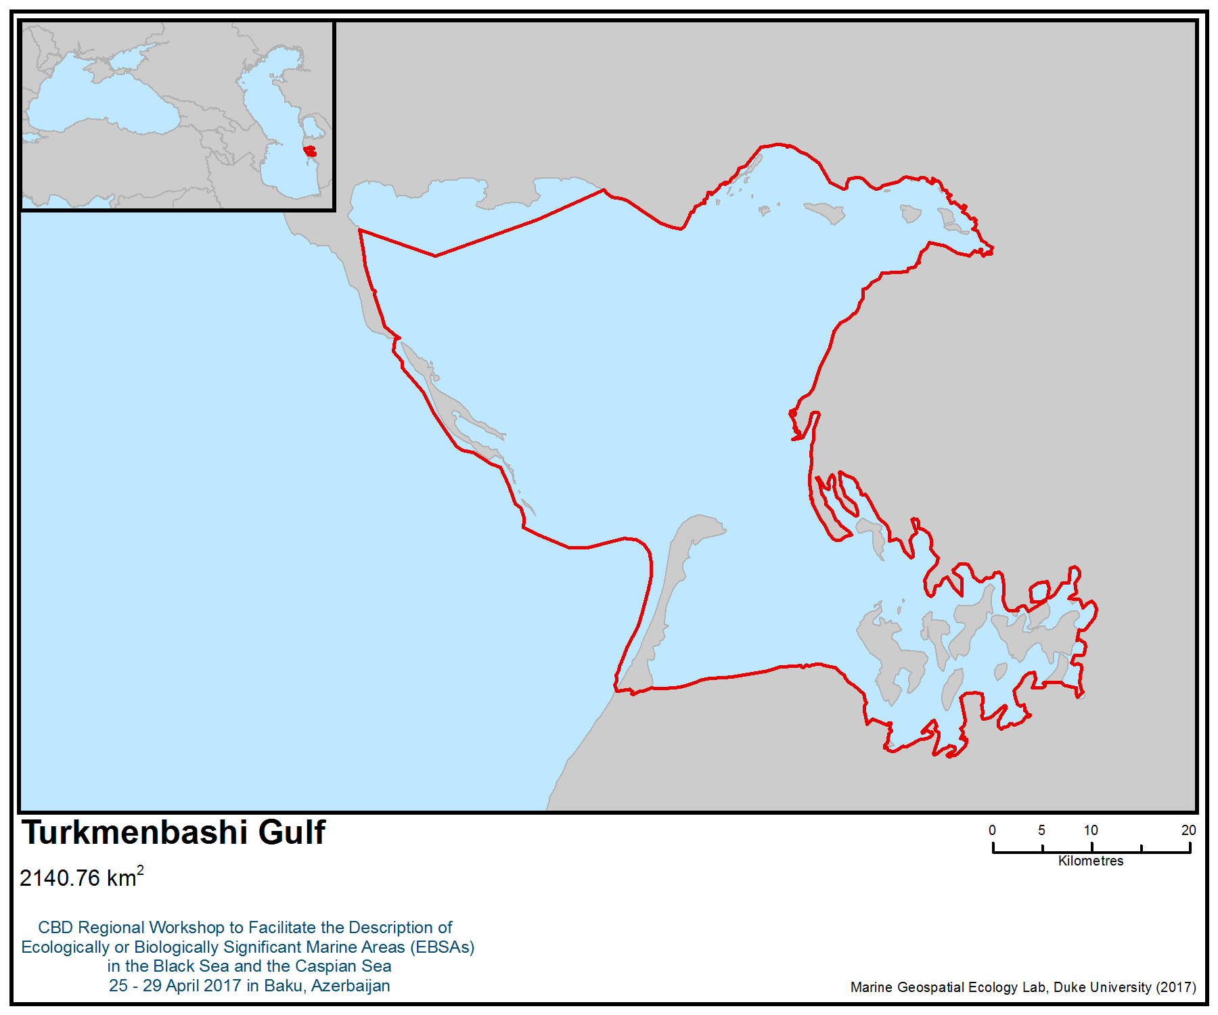
Figure 1. Area meeting the EBSA criteria

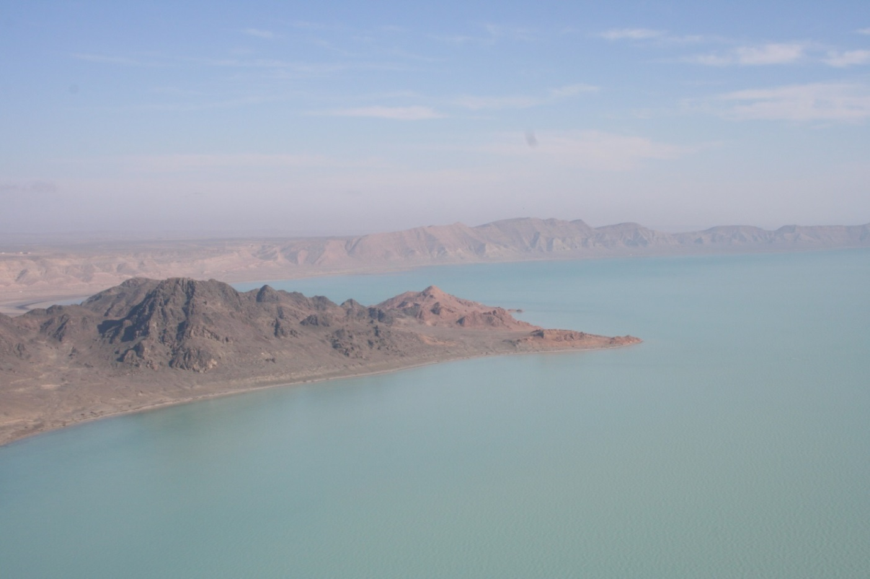
Figure 2. North-eastern part of Turkmenbashi Gulf (Photo: Eldar Rustamov)

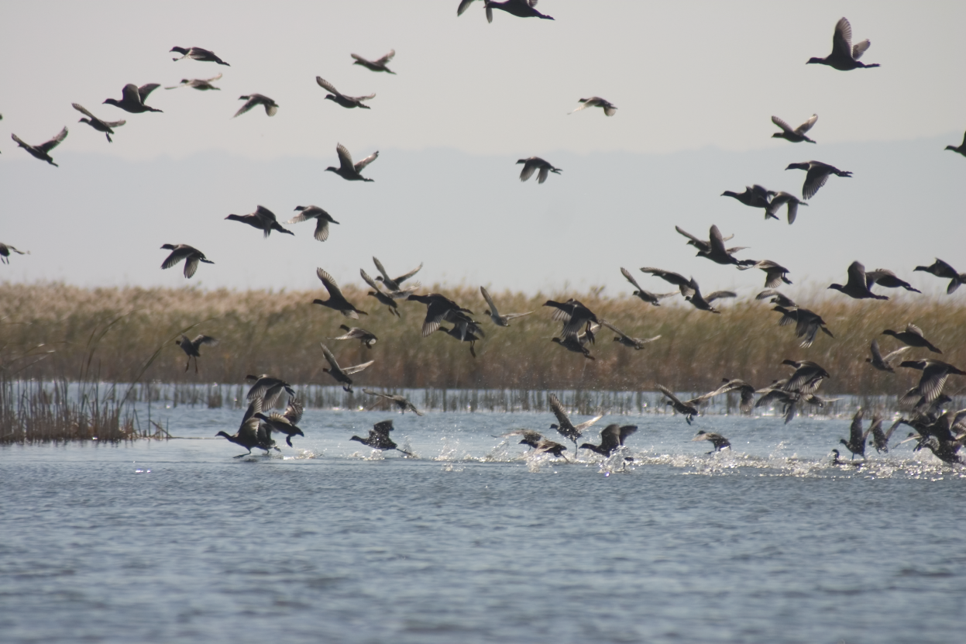
Figure 3. Coots in Mihajlovsky small bay (Photo: Eldar Rustamov)

Rights and permissions
Among references, private data of authors are used.
Area No. 24: Turkmen Aylagy

Abstract
Turkmen Aylagy has a unique complex of biodiversity, especially birds, fishes and two species of mammals. It is affected by seasonal and annual fluctuations in the level of the Caspian Sea and by movements of Dardzhakum sands. During periods of sea level rise, there are favourable conditions for protection, fodder nesting and wintering of birds in bays, but extensive saline soils are formed in their place during periods of sea-level drop. Prevailing depths of the Turkmen Aylagy range from 3-4 m in the east to 9-11 m in the centre. The water in the area has a higher salt content than the Caspian Sea, as the rivers do not run into it.

Introduction
The site covers the water portion of Turkmen Gulf, from Ogurdzhaly island (inclusive) in the west, the South Cheleken Bay, with a total area of 3708 km². Ogurdzhaly Island is a sandy strip, 2 km wide, that extends 40 km in a north-south direction, with an area of 6 000 ha. Coasts are shallow, and atthe northern end of the island there is a small bay. The south Cheleken Bay (which varies from 2 to 10 km in width) has a sandy coast in its western and northern parts, with coverage of the small bays Garakyol and Heles (Гюль, 1956; Дерягин, 1977; Касымов, 1987; Зонн, 2004).

Location
Turkmen Aylagy is bordered in the north by the Cheleken Peninsula and in the west by Ogurdzhaly Island. The site covers the water area of the Turkmen Gulf, from Ogurdzhaly Island (inclusive) in the west, to South Cheleken Bay, with a total area of 3708 km². Ogurdzhaly Island is a sandy strip, 2 km wide, that extends 40 km in a north-south direction, with an area of 6 000 ha. The area is geographically centred at 39.035352N, 53.439243E.

Feature description of the area
Since 1994, Ogurdzhaly Island has been a wildlife sanctuary of the Hazar State Nature Reserve. The area described includes three Important Bird and Biodiversity Areas (IBAs): Ogurdzhaly Island, South Cheleken Bay and Turkmen Bay.

Vegetation includes up to 200 species (Прошкина-Лавренко, Макарова, 1968; Яблонская, 1985). Annually, biomass has exceeded 1000 mg/m³. From the shallowest, to the deepest, at 6 m, there are the following seaweeds: green (28 species), the greatest value among which are Charophyta on oozy bottom. Among red seaweeds, there are 11 species, the most common of whichis Polysiphonia on sandy bottom. There is only one species of brown seaweed: Ectocarpus. Except macroscopical, hundreds of microscopic seaweed species, basically representatives of Diatomeae, green (Clorophyta), blue-green (Cyanophyta) and Pyrrophyta, comprise the plankton and benthos. Floral (sea grasses) plants are represented by Zostera noltii, Ruppia maritima, Potamogeton pectinatus, and Najas marina. The general biomass is at least 500 000 tonnes/year. Along the coasts of Ogurdzhaly Island and gulf coast there are 50 species, most of which are ephemerids (60%);and 10-15% are bushes. In a coastal strip on moderated salted sites there are Salsola dendroides, S. lanata, S. angustata, S. transhyrcanica, Halostachys caspica and in some places Alhagi persarum.

The list of marine invertebrates totals more than 1000 species belonging to 30 taxa (Бирштейн и др., 1968). In recent years, the invasive alien species Mnemiopsis leidyi has become common. The development of zoobenthos (molluscs, Crustacea, hearts) creates favourable fodder conditions for herring (Alosa brashnikovii), mullets (Liza saliens, L. auratus), sprats (Clupeonella engrauliformis, С. delicatula, C. grimmi), etc.

The ichthyofauna includes 34 species, including the following Red Data Book of Turkmenistan (2011) species: Acipenser nudiventris, I (CR), Alosa kessleri volgensis, II (EN), Salmo trutta caspius, III (VU), Stenodus leucichthys leucichthys, III (VU).

The avifauna includes almost 290 species, of which 130 are waterfowl and waterbirds (Щербина, 2013). The majority occur during spring-autumn migration and in winter in some years up to 90 000, with an average of at last 20 000 (Рустамов, Щербина, 2007). On Ogurdzhaly Island, there are colonies of gulls and terns (Гаузер, Бердыев, 2009).

The following threatened migratory and wintering birds, which are listed in the Red Data Book of Turkmenistan (2011), are present: Pelecanus onocrotalus, III (VU); Pelecanus crispus, II (EN); Platalea leucorodia, IV; Phoenicopterus roseus, IV; Anser erythropus, III (VU); Aythya (Nyroca) nyroca, III (VU); Oxyura leucocephala, III (VU).

The key mammal species here, in its most southerly breeding ground, is the Caspian seal (Phoca caspica), which is endemic to the Caspian Sea. The population numbers no more than 100 individuals. Caspian seal is listed as critically endangered (category I) in the Red Book of Turkmenistan (2011).

Feature condition and future outlook of the area
There is no resident population on Ogurdzhaly Island, except for frontier guards. In Garakyol Bay there is a small settlement with the same name with a landing stage for small boats, oil storage and also Aladzha landing stage for bulk-oil carriers. Except the settlement which population, basically, is occupied by fishery and hunting, on northeast coast of a gulf there is a frontier post and a tourist base on Heles Bay. The area is in rather good condition; however, the fishery and the gas drilling on the shelf continue to grow. There are three IBAs located here: Ogurdzhaly Island, South Cheleken Bay and Turkmen Bay (Рустамов, 2009а, 2009в; Гаузер, Бердыев, 2009).

Assessment of the area against CBD EBSA Criteria

CBD EBSA Criteria  (Annex I to decision IX/20) | Description  (Annex I to decision IX/20) | Ranking of criterion relevance  (please mark one column with an X)
CBD EBSA Criteria  (Annex I to decision IX/20) | Description  (Annex I to decision IX/20) | No information |  | Low |  |  | Medium |  | High
Uniqueness or rarity | Area contains either (i) unique (“the only one of its kind”), rare (occurs only in few locations) or endemic species, populations or communities, and/or (ii) unique, rare or distinct, habitats or ecosystems; and/or (iii) unique or unusual geomorphological or oceanographic features. | X
Special importance for life-history stages of species | Areas that are required for a population to survive and thrive. |  |  |  |  |  |  |  | X
Explanation for ranking
The area necessary for the survival and success of populations of fishes, birds and the Caspian seal. The territory contains: i) nesting places of sea gulls and breeding ground of the Caspian seal (Ogurdzhaly Island) and spawning areas for sturgeons (in water column); and ii) habitats of migrating species - places of wintering and migratory routes of waterfowl. The waters surrounding the island are important as foraging areas for seabirds during the breeding period (Гаузер, Бердыев, 2009; Рустамов, 2009а, 2009в).
Importance for threatened, endangered or declining species and/or habitats | Area containing habitat for the survival and recovery of endangered, threatened, declining species or area with significant assemblages of such species. |  |  |  |  |  |  |  | X
Explanation for ranking
The area contains habitat for the survival or restoration of threatened, endangered or decling species, as it contains considerable communities of such species.
Regarding avifauna, the area includes almost 290 species, of which 130 are waterfowl and waterbirds. The majority occur during spring-autumn migration and in winter in some years up to 90 000, with an average of at least 20 000. The species include the following threatened migratory and wintering birds, included in the Red Data Book of Turkmenistan: Pelecanus onocrotalus, III (vulnerable); Pelecanus crispus, II (endangered); Platalea leucorodia, IV; Phoenicopterus roseus, IV; Anser erythropus, III (vulnerable); Aythya (Nyroca) nyroca, III (vulnerable); Oxyura leucocephala, III (vulnerable).
Among mammals, the most interesting species is the Caspian Seal (Pusa (Phoca) caspica), which is endemic to the Caspian and is critically endangered.
The area’s ichthyofauna includes 34 species, including the following Red Data Book of Turkmenistan species: Acipenser nudiventris, I (critically endangered), Alosa kessleri volgensis, II (EN), Salmo trutta caspius, III (vulnerable) and Stenodus leucichthys leucichthys, III (vulnerable) (Красная книга Туркменистана, 2011).
Vulnerability, fragility, sensitivity, or slow recovery | Areas that contain a relatively high proportion of sensitive habitats, biotopes or species that are functionally fragile (highly susceptible to degradation or depletion by human activity or by natural events) or with slow recovery. |  |  |  |  |  |  |  | X
Explanation for ranking
The ecosystem of this area is related to the sea level of the Caspian Sea, particularly the coastline. When the sea level drops, bays are dryout on the eastern part of the coast. This is a factor of in the degradation of waterbirds. Therefore, vulnerability is high, particularly during drops in sea level (Гаузер, Бердыев, 2009; Рустамов, 2009а, 2009в).
Biological productivity | Area containing species, populations or communities with comparatively higher natural biological productivity. | X
Biological diversity | Area contains comparatively higher diversity of ecosystems, habitats, communities, or species, or has higher genetic diversity. |  |  |  |  |  | X
Explanation for ranking
Vegetation includes up to 200 species (Прошкина-Лавренко, Макарова, 1968; Яблонская, 1985). Annually, biomass has exceeded 1000 mg/m³. From the shallowest, to the deepest, at 6 m, there are the following seaweeds: green (28 species), the greatest value among which are Charophyta on oozy bottom. Among red seaweeds, there are 11 species, the most common of whichis Polysiphonia on sandy bottom. There is only one species of brown seaweed: Ectocarpus. Except macroscopical, hundreds of microscopic seaweed species, basically representatives of Diatomeae, green (Clorophyta), blue-green (Cyanophyta) and Pyrrophyta, comprise the plankton and benthos. Floral (sea grasses) plants are represented by Zostera noltii, Ruppia maritima, Potamogeton pectinatus, and Najas marina. The general biomass is at least 500 000 tonnes/year. Along the coasts of Ogurdzhaly Island and the gulf coast there are 50 species, most of which are ephemerids (60 %) and 10-15 % are bushes. In a coastal strip on moderated salted sites there are Salsola dendroides, S. lanata, S. angustata, S. transhyrcanica, Halostachys caspica and in some places Alhagi persarum.

The list of marine invertebrates totals more than 1000 species belonging to 30 taxa (Бирштейн и др., 1968). In recent years, the invasive alien species Mnemiopsis leidyi has become common.
The development of zoobenthos (molluscs, Crustacea, hearts) creates favourable fodder conditions for herring (Alosa brashnikovii), mullets (Liza saliens, L. auratus), sprats (Clupeonella engrauliformis, С. delicatula, C. grimmi), etc.

The ichthyofauna includes 34 species, including the following Red Data Book of Turkmenistan (2011) species: Acipenser nudiventris, I (CR), Alosa kessleri volgensis, II (EN), Salmo trutta caspius, III (VU), Stenodus leucichthys leucichthys, III (VU).

The avifauna includes almost 290 species, of which 130 are waterfowl and waterbirds (Щербина, 2013). The majority occur during spring-autumn migration and in winter in some years up to 90 000, with an average of at last 20 000 (Рустамов, Щербина, 2007). On Ogurdzhaly Island, there are colonies of gulls and terns (Гаузер, Бердыев, 2009).

The following threatened migratory and wintering birds, which are listed in the Red Data Book of Turkmenistan (2011), are present: Pelecanus onocrotalus, III (vulnerable); Pelecanus crispus, II (endangered); Platalea leucorodia, IV; Phoenicopterus roseus, IV; Anser erythropus, III (vulnerable); Aythya (Nyroca) nyroca, III (vulnerable); Oxyura leucocephala, III (vulnerable).

The key mammal species here, in its most southerly breeding ground, is the Caspian seal (Phoca caspica), which is endemic to the Caspian Sea. The population numbers no more than 100 individuals. Caspian seal is listed as critically endangered (category I) in the Red Book of Turkmenistan (2011). (Прошкина-Лавренко, Макарова, 1968; Яблонская, 1985; Гаузер, Бердыев, 2009; Рустамов, 2009а, 2009в; Красная книга Туркменистана, 2011).
Naturalness | Area with a comparatively higher degree of naturalness as a result of the lack of or low level of human-induced disturbance or degradation. |  |  |  |  |  |  |  |  | X
Explanation for ranking
There is a high degree of naturalness thanks to the absence of anthropogenic pressures.

References
Бирштейн Я.А., Виноградова Л.Г., Кондакова Н.Н., Кун М.С., Астахова Т.С., Романова Н.Н. 1968. Атлас беспозвоночных Каспийского моря. М.: Пищевая промышленность, М.
Гаузер М.Е., Бердыев Б.Р. 2009. Огурджалы ада // Ключевые орнитологические территории Туркменистана. Ашхабад: МОП. С.76-78.
Гюль К.К. 1956. Каспийское море. Баку. 328 с.
Дерягин В.А. 1977. Каспий, его прошлое, настоящее и будущее (краткий историко-географический очерк). Баку. 115 с.
Зонн И.С. 2004. Каспийская энциклопедия. М.: Международные отношения. 461 с.
Касымов А.Г. 1987. Каспийское море. Л.: Гидрометиоиздат. 157 с.
Красная книга Туркменистана. 2011. Т.2. Беспозвоночные и позвоночные животные. Изд.3-е, перераб. и доп. Ашхабад: Ылым. 384 с.
Прошкина-Лавренко А.И., Макарова И.В. 1968. Водоросли планктона Каспийского моря. Л.: Наука. 291 с.
Рустамов Э.А. 2009а. Гунорта-Челекен айлагы // Ключевые орнитологические территории Туркменистана. Ашхабад: МОП. С.78-79.
Рустамов Э.А. 2009в. Туркмен айлагы // Ключевые орнитологические территории Туркменистана. Ашхабад: МОП. С.81-83.
Рустамов Э.А., Щербина А.А. 2007. Учет численности водно-болотных птиц на туркменском побережье Каспия // Проблемы освоения пустынь. №1. С.55-57.
Щербина А.А. 2013. Из материалов по редким и малоизученным видам птиц туркменского Прикаспия // Изучение биоразнообразия Туркменистана (позвоночные животные). Москва – Ашхабад. С.170-181.
Яблонская Е.А. 1985. Каспийское море. Фауна и биологическая продуктивность. М.: Наука. 290 с.

Maps and Figures

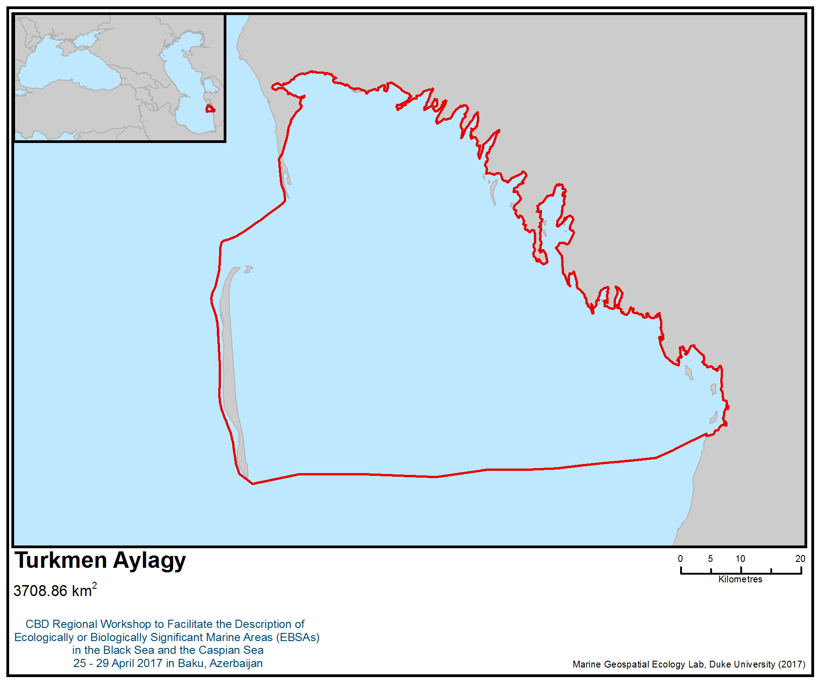
Figure 1. Area meeting the EBSA criteria

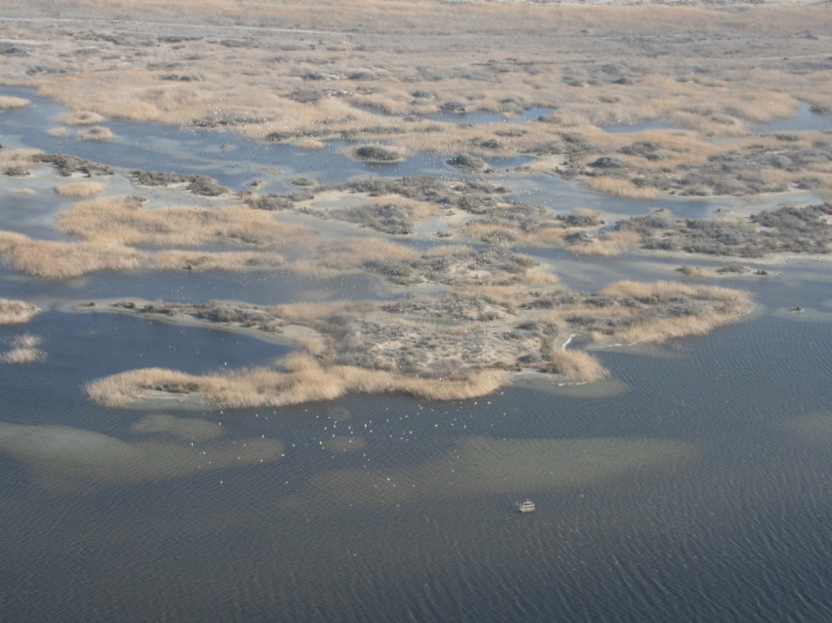
Figure 2. Wetlands on the eastern coast of Turkmen Aylagy (Photo: Eldar Rustamov)

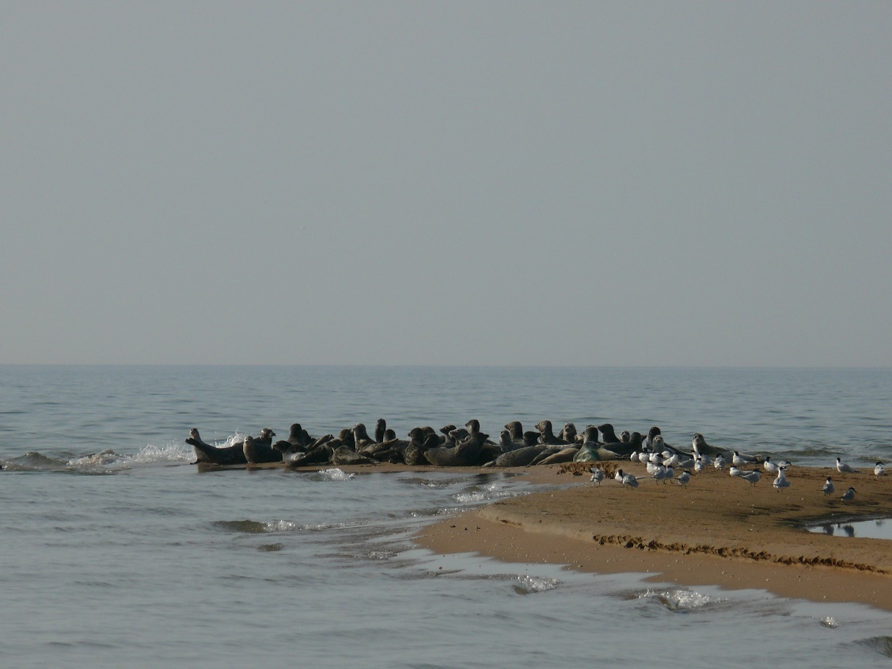
Figure 3. Caspian seals on the southern peninsula of Ogurdzhaly Island (Photo: Pavel Erokhin)

Rights and permissions
Among references, private data of authors are used.

Area No. 25: Miankaleh-Esenguly

Abstract
The area is located in the south-eastern corner of the Caspian Sea in the marine and coastal areas adjacent to Turkmenistan and Iran. The area is a potential candidate Seal Special Protected Area (SSPA), under the Caspian Environment Programme. The area is also one of the most important foraging and spawning grounds for all five critically endangered species of sturgeon, including Acipenser gueldenstaedtii, A. nudiventris, A. persicus, A. stellatus and Huso huso. The Miankaleh-Esenguly area is extremely important for both wintering and passage of waterfowl and holds one of the highest number of wintering birds in the entire south Caspian.

Introduction
The area is located in the south-eastern corner of the Caspian and extends from Esenguly-Okarem in Turkmenistan towards Iranian Gomishan Lagoon and Gorgan Bay, including Miankaleh Peninsula, Ashouradeh and Esmaeilsay islands and the freshwater lagoons of Lapouye Zaghmarz (Lapoo-Zaghmarz Ab-Bandans). The area supports a diverse range of ecosystems and habitats, including shallow marine waters, intertidal muddy and sandy shores, coastal lagoons, extensive coastal reedbeds and coastal freshwater marshes and lagoons.

The area includes a UNESCO biosphere reserve, two wetlands of international importance (Ramsar Sites), five Important Bird and Biodiversity Areas (IBAs), a wildlife refuge, a no-hunting/no-fishing area, a nature reserve and a proposed UNESCO World Heritage site. These IBAs were designated mostly for the importance for waterbirds, with 126 species, representing 24% of the total avifauna of Central Asia.

The wetlands of the area are unique and outstanding examples of a natural sand spit/coastal lagoon system that is characteristic of the south Caspian Sea. They play a substantial hydrological and ecological role in the functioning of the coastal systems of the south-east Caspian Sea (Ramsar Convention Bureau 2001; 1997).

The Esenguly section (with total area of 97 000 hectares, 78 000 of which are marine areas) was established as a reserve in 1932, and in 1968, as the separate southern part of the Khazar State Reserve of Turkmenistan. There are three IBAs: Ekerem, Esenguly and Garadegish (Rustamov et al., 2009, BirdLife International, 2017).

The Miankaleh Peninsula-Gomishan Lagoon area is considered the most important area in the Iranian Caspian Sea based on several specific criteria, including: naturalness, uniqueness, habitat connectivity (lower fragmentation), habitat diversity, number of threatened and endangered marine species, number of threatened and endangered bird species, spawning and nursery grounds, wintering and breeding grounds for birds, number of bird populations, more than 1% of the regional populations of several bird species, bird diversity and importance for the Caspian Seal (BirdLife International, 2017; Danehkar, 2002; Danehkar & Majnoonian, 2004a; Giesen, 2011; 2010; UNEP-GEF, 2013). The Gorgan Bay and Gomishan Lagoon also have the highest score in terms of sensitivity and significance on a combined list of ecological, social and economic criteria suggested by IUCN and the International Maritime Organization (Danehkar & Majnoonian, 2004a; 2004b; Danehkar, 2002; Razmjooy et al., 2010). Miankaleh Peninsula and adjacent Gorgan Bay hold the highest number of wintering waterbirds in Iran (van Diek et al., 2004).

Gorgan Bay, Miankaleh Peninsula, Gomishan Lagoon and Esenguly area are the most important foraging grounds and hauling-out sites for the Caspian Seal (Pusa caspica) in the south Caspian Sea. They are potential candidates for Seal Special Protected Areas (SSPAs) in the south-east Caspian Sea (CEP, 2010). The area is one of the most important feeding and spawning grounds for all five critically endangered species of sturgeon, including Acipenser gueldenstaedtii, A. nudiventris, A. persicus, A. stellatus and Huso huso (Kiabi et al., 1999a; UNEP-WCMC, 2010). In the Iranian waters of the Caspian Sea, the south-east area has the highest concentrations of phytoplankton and zooplankton (Rowshan Tabari, 2013).

Location
This area is located in south-eastern corner of the Caspian Sea and extends from the marine and coastal waters of Ekerem-Esenguly in Turkmenistan to Gomishan Lagoon, Gorgan Bay, Miankaleh Peninsula and the Lapoo-Zaghmarz Ab-Bandans in the Islamic Republic of Iran.

Feature description of the area
Physical description
Gorgan Bay is a shallow, brackish and oligotrophic embayment with a variation of salinity around 13ppt in the warm season and about 15ppt in the cold season (Jamshidi, 2016; Patimar et al., 2008). It is connected to the Caspian Sea through the inlet of Ashouradeh-Bandar Turkman, situated in the north-eastern part of the bay. There are strong currents in the Ashouradeh-Bandar Turkman mouth, which is affected by storm surge and inter-annual water level fluctuations in the Caspian Sea (Ghorbanzadeh Zaferani, 2017). Generally, there is a counter-clockwise flow pattern in the Gorgan Bay in all four seasons. On the northern and southern shores, currents move from west to east along the coast and are affected by dominant winds (Sharbaty, 2011; 2012). The average depth of the bay is 2–2.5 m. The depth increases from west to east of the bay and reaches about 5 m near the connection between Gorgan Bay and the Caspian Sea (Jamshidi, 2016). The bay has a surface area of about 400 km² and is almost separated from the Caspian Sea by the 60 km long sand dune ridge of Miankaleh Peninsula (BirdLife International; Patimar et al., 2008; Scott, 1995; Ramsar Information Sheet; Zonn et al., 2010). Gorgan Bay has a muddy bottom and receives freshwater inflow from nearly 30 small rivers (notably Qarasou River) and a number of streams rising on the humid northern slopes of the Alborz Mountains (Kiabi et al., 1999b; BirdLife International; Carp, 1980; Patimar et al., 2008; Ramsar Convention Bureau 2001; 1997; WCMC, 1990; Zonn et al., 2010). Among them, two rivers affect the bay, including Gorganroud (Gorgan River) in the north of the inlet and Qarasou River in the eastern part of the bay (Ghorbanzadeh Zaferani, 2017). These two rivers drain runoff from residential and agricultural areas into the bay. The narrow inlet of Gorgan Bay (Gorgan Strait) is subjected to shallowing by 8–10 cm every year due to sedimentary buildup from Gorgan Bay (Zonn et al., 2010). There are extensive freshwater marshes and seasonally flooded Tamarix woodlands at the west end of the bay and along its south shore, where the freshwater inflow is greatest. The marshes are flooded in autumn and winter with maximum depth of 0.5 metre.

The Miankaleh Peninsula is a 60 km narrow low-lying spit stretching eastward as far as the Gorgan Strait and separates Gorgan Bay from the Caspian Sea. The peninsula, which covers nearly 24,200 ha, averages about 2 km in width, with the narrowest point being about 1 km wide and the widest about 4 km. A chain of 50 m-wide sand dunes parallels the Caspian Sea coast. The dunes, which rise to about 4-5 m (and occasionally 15-20 m) above the sea level, form the highest points in the area (Scott, 1995). The peninsula is connected to the Ashouradeh Island by the narrow Khozeini channel.

Ashouradeh Island, the largest Iranian island of the Caspian Sea, with its small abandoned fishing village, is located at the eastern tip of the Miankaleh Peninsula almost separated by the narrow Khozeini channel. The Island faces the city of Bandar-e Turkman on the far side of the inlet to the Gorgan Bay. Esmaeilsay Island is the second largest Iranian Island and is located in the western end of Gorgan Bay.

The Lapoo-Zaghmarz Ab-Bandans are two long, narrow constructed freshwater lagoons (reservoirs) with extensive fringing reedbeds located at the landward end of Miankaleh Peninsula, about 10 km west of Gorgan Bay and about 18-20 m below sea level. They are fed by irrigation ditches and local run-off, which drain east into the Gorgan Bay marshes (Carp 1980; Scott, 1995).

The Gomishan area consists of a chain of narrow, brackish coastal lagoons behind the Caspian Sea coast, stretching from the transboundary estuary of Atrek (Atrak) River from the Turkmenistan border to the current estuary of Gorgan River (Gorganroud), with an area of nearly 20,000 ha (Behrouzi-Rad and Ghaeimi, 2015; Gandomi et al., 2011; Ramsar Convention Bureau 2001; 1997). Gomishan Lagoon is bounded by low coastal dunes with typical sand-dune vegetation from the Caspian Sea on the west side and extends onto the short-grass plains of the Turkoman Steppes on the east side. The sea-lagoon connection is through a number of inlets. The Gomishan Lagoon consists of lowlands with fine silty to highly adhesive carbonated clay sand sediments. The depth of the lagoon is variable and depends on fluctuations in Caspian Sea water level. Despite this variation, Gomishan Lagoon is about 1m depth in most locations except the north-west region, which may reach 2.5 m in depth (Gandomi et al., 2011). The salinity ranges from 11 to 15ppt in Gomishan Lagoon (Naddafi et al., 2005). The lagoon receives water from a catchment consisting of two river basins. The Atrek (Atrak) River enters the wetland in the northern part, in Turkmenistan. The Gorganroud (Gorgan River) enters the Caspian Sea at the southern end of the lagoon (Behrouzi-Rad & Ghaeimi, 2015).

The Turkmenistan side of the area includes the extension of Gomishan Lagoon in the country of Turkmenistan and also an extensive pristine coastline of Esenguli (formerly Gasan-Kuli) plain stretching from the transboundary estuary of Atrek (Atrak) River to 80 km north along the Caspian Sea between Esenguly and Okarem (Zonn et al., 2010; Zonn & Kostianoy, 2013). This area is the recent surface of the deltaic plain of the Atrek (Atrak) River. The Esenguly area is a low-lying stretch of coast consisting of a 50 to 100 m-wide sandy strip with hilly ridges of fixed sand and saltmarsh inland. The shoreline of the Caspian Sea between the settlement of Ekerem and the settlement of Esenguly is located in the zone of dry subtropics with hot dry summer and humid mild winter. The average temperature is +17.1°C while the maximum is +48°C and the minimum is -16°C. Average temperature of January is +4.3°C. Precipitation may reach 200 mm per annum on average and occurs mainly from November to April. Cloudy days are quite frequent (up to 74 days). The maximal number of non-freezing days is 296. The shore is a dense layer of sand layer up to 100 m wide. Like the entire shore of the south-eastern Caspian Sea starting from the shore, there are strips differing by substrate and diversity of plant species: wet saline lands covered by incoming sea waves; saline shell sands; semi-saline and wind-cleaned shell sands; fixed plain areas with some sand spits. Changes in micro landscape as a result of sea-level fluctuations are reflected in dynamics of its substrate and vegetation.

The Gorganroud (Gorgan River) is the major river on the south-eastern shore of the Caspian Sea, with a mean discharge of 11 m³/s (Zonn et al., 2010). At present, the Gorganroud delta is 20 km² in area and surges out into the sea to a distance of 2 km. The mean annual runoff of the river equals 0.49 km³, and the suspended load runoff is 3.1 million tonnes. The water turbidity is rather high due to its clay-aleurite banks, and the bed is easily washed out. The river mouth offshore is rather shallow; the 10-m isobath passes at a distance of 15 km from the shore, and the underwater shore slope gradient to the depth of 10 m equals 0.007 (Zonn et al., 2010).

The Atrek (Atrak) River flows along the border between Turkmenistan and Iran into the Caspian Sea. The Atrek waters reach the Caspian Sea only in spring during floods (March–May). The Atrek River flows over the area composed of loose, mostly sandy and clay soils, which determines high water turbidity – 25 kg/m³ on average (six times higher than turbidity of the Amu Darya), while its maximum may be more than 170 kg/m³ (Zonn et al., 2010). This is the most turbid river in Central Asia, and its average annual debit is 10.4 m³/sec (Fet & Atamuradov, 2012).

Biological communities
The Esenguly area covers the “Esenguly section” of Hazar State Nature Reserve and includes two Important Bird and Biodiversity Areas (IBAs): Ekerem-Esenguly and Garadashly-Ekerem. Hazar State Nature Reserve has also been on Turkmenistan’s national tentative list of sites to enter the UNESCO World Heritage List since 2009 (Zonn & Kostianoy, 2013). The Esenguly area has intra-zonal vegetation in the floodplain and Atrek dry delta. The Atrek floodplain and some coastal areas are overgrown with sedge, cane and cattail thickets, which form a 3-4 m high wall surrounding the water bodies (Zonn et al., 2010).

Warm winters, non-freezing sea, and abundant food attract a great number of birds during winter. The lower reaches of the Atrek River and the nearby shores of the Caspian Sea are one of the most important waterfowl wintering and feeding areas in Turkmenistan (Rustamov, 1994). This area is located on a major waterfowl migration route along the east coast of the Caspian Sea and holds winter accumulations of international importance. The avifauna includes at least 280 species, of which 240 (86%) are passing wintering birds, including 120 (43%) of which are waterbirds (BirdLife International; Zonn et al., 2010). These represent 46% and 23% of the total avifauna of Central Asia, respectively. Passeriformes are the most common (96 species), followed by Haematopodidae (45), Anseriformes (28), Falconiformes (27) and Laridae (16). Most typical, only on migration, are coots and ducks (e.g., Netta rufina, Aythya ferina, Anas platyrhynchos, Aythya fuligula, Aythya marila, Anas penelope), plus waders, gulls and terns. In spring, there is a high turnover rate of birds, with migration lasting from the middle of March to the end of April. In autumn, the migration shows several peaks and extends from the end of August to the beginning and middle of November (BirdLife International 2017a). The following species, listed in the Red Data Book of Turkmenistan (1999), have been recorded in this area: Platalea leucorodia, Phoenicopterus ruber, Anthropoides virgo, Buteo buteo, Pandion haliaetus, Haliaeetus leucoryphus, Falco peregrinus, Circaetus gallicus, Burhinus oedicnemus, and also the non-migratory Aquila chrysaetos, Falco cherrug and Bubo bubo. The globally threatened Vanellus gregarius (critically endangered) and Aquila heliaca (vulnerable) have also been recorded in this area. The Esenguly area is one of the potential candidates for Seal Special Protected Areas (SSPAs) in Turkmenistan in the category of area or access corridor –for resting (haul-out) sites throughout the year (CaspEco, 201; CEP, 2010; Goodman & Dmitrieva, 2016; Wilson & Goodman, 2012). Up to 24 Caspian seals were reported in April 2007 and 1–5 seals in June–August 2007 in Esenguly area (CEP, 2010).

The Gorgan Bay and Miankaleh Peninsula together occupy an area of about 97,200 ha. An area of 68,000 ha is a wildlife refuge, Ramsar site and UNESCO Biosphere Reserve. This area is considered the most important area of the Iranian Caspian Sea based on several specific criteria, including: naturalness, uniqueness, habitat connectivity (lower fragmentation), habitat diversity, number of threatened and endangered marine species, number of threatened and endangered bird species, spawning and nursery grounds, wintering and breeding grounds for birds, number of bird populations, more than 1% of the regional populations of bird species, bird diversity and importance for the Caspian Seal (BirdLife International, 2017; Danehkar, 2002; Danehkar & Majnoonian, 2004a; Giesen, 2011; 2010; Razmjooy et al., 2010; UNEP-GEF, 2013).

The vegetation fringing Gorgan Bay is predominantly glasswort (Salicornia sp.), sedges (Carex spp.) and rush (Juncus sp.) with some small reedbeds of Phragmites and Tamarix sp. (Carp, 1980). There is a strip of vegetated sand dune along Miankaleh Peninsula (Ramsar Convention Bureau 1997). The beaked tasselweed (Ruppia maritima) also dominates the eastern and shallow parts of the bay (Ghorbanzadeh Zaferani, 2017).

The Miankaleh Peninsula/Gorgan Bay-Gomishan Lagoon holds the highest number of wintering waterbirds in the Islamic Republic of Iran (Amini & Willems, 2008; van Diek et al., 2004).

At the Esenguly section, the following threatened species of birds pass through and wintering: Aythya nyroca, Marmaronetta angustirostris and Oxyura leucocephala. The concentrations of wintering water birds average more than 40 000, comprising mainly Aythya fuligula (up to 20000) and Fulica atra (more than 20000), but also including Anas platyrhynchos, Netta rufina and Aythya ferina. From 1996 to 2004, the total number of birds (such as gooses, swans, ducks and coots) varied in November from 3 589 to 49 285, and averaging 21 261, while in January, it ranged from 3 434 to 48 750, and averaged 23 022 (Васильев и др., 2007). The number is not stable and varies significantly by years. Some of the bird species in the area exceed 1% of the regional populations. These species are Phalacrocorax carbo, Phoenicopterus roseus, Aythya fuligula, Aythya nyroca, Tachybaptus ruficollis, Podiceps cristatus, Podiceps nigricollis and Fulica atra. This area is located on the migration route; the spring passage of water birds starts from mid-February until the end of April. In fall, the migration takes place from the end of August until the beginning and the middle of November. At the same time, the passage takes place exclusively in northerly or southerly directions because of the north-south orientation of the IBA. For instance, in fall, up to 70,9% of all migrants are passing through in their southern migration. In February and March, the intensity of passage on average is up to 1,5 – 2,8 thousand birds per day. During the migration of spring and fall, there are numerous species of waders – 67,5% and 38% accordingly, gulls – 16,9% and 7,7%, ducks – 6,7% and 21,4%, and terns – 4,9% and 23,3% (Караваев, 1988; 1991a; 1991b).

Gorgan Bay (including Miankaleh Peninsula, Ashouradeh and Esmaeilsay islands and Lapoo-Zaghmarz Ab-Bandans) is undoubtedly one of the most significant bird reserves in the Palearctic (BirdLife International; Mansoori, 2009; Ramsar Convention Bureau, 1997). At least 288 bird species have been recorded in this area, including 15 species currently listed in the I IUCN Red List of Threatened Species. Of the 126 species of waterfowl that occur in this area, at least 63 species have been present in internationally significant numbers. The area is extremely important throughout the year, regularly supporting more than 1 million waterfowl in winter (RamsarConvention Bureau 1997) and large colonies of herons, egrets, pratincoles and terns in summer. The Miankaleh Peninsula, Gorgan Bay and Gomishan Lagoon totally supported more the 1.7 million waterbirds in 2007, including 1,289,526 waterbirds in Miankaleh/Gorgan Bay and 400,000-450,000 waterbirds in Gomishan Lagoon (Amini & Willems, 2008). A total of 1,041,000 wintering waterbirds were counted in 2004 (van Diek et al., 2004). The most abundant species in the census of 2007 were Eurasian coot (1,070,688), greater flamingo (74,641), pochard (48,557), mallard (29,955) and tufted duck (28,637). Notable numbers of internationally or regionally rare or scarce species in the census of 2007 included Dalmatian pelican (93), pygmy cormorant (72), mute swan (833), Bewick’s swan (1), red-crested pochard (515), goosander (134), smew (555), white-headed duck (2 618), white-tailed sea eagle (138), Pacific golden plover (3), white-tailed plover (1) and white-winged black tern (8) (Amini & Willems, 2008). The whole area is especially important for its large wintering populations of grebes, Pelecanus crispus, Phalacrocorax carbo, herons, Phoenicopterus ruber, swans, geese, surface feeding and diving ducks, raptors (Haliaeetus albicilla, harriers, eagles and falcons), shorebirds and gulls, and for its breeding colonies of herons and egrets, Glareola pratincola and Sterna albifrons (van Diek, 2004). The Eurasian coot (Fulica atra) in one of the most numerous species (810,960 individuals) in Gorgan Bay (van Diek, 2004). This area is also a good wintering site for the endangered white-headed duck (Oxyura leucocephala) (van Diek et al., 2004).

The Gomishan wetland comprises shallow, brackish lagoons with saltmarsh vegetation and seasonallyinundated flats with species of Salicornia, Halostachys and Halocnemum (Ramsar Convention Bureau, 1997; BirdLife International 2017c). The eastern side of the lagoon is bordered by a vast strip of low-lying plains with halophytic vegetation. The wetland supports at least 17 species of aquatic macrophytes, including Ceratophyllum demersum, Callitriche palustris, Aeluropus littoralis, Myriophyllum spicatum, Phragmites australis, Potamogeton pectinatus, Juncus effusus, Typha angustifolia and Zannichellia palustris (Basatnia et al., no date; Scott, 1995; Kiabi et al., 1999b, UNECE, 2011).

At least 81 waterbirds species have been recorded in Gomishan Lagoon (Ramsar Information Bureau, 1997; UNECE, 2011). Annually tens of thousands of waterbirds (particularly waders, ducks, coots and gulls) use this coastal wetland as wintering habitat. The Gomishan Lagoon has regularly supported more than 20,000 waterbirds during winter, which exceeds the Ramsar criterion for international importance (more than 20,000 birds), and 20 species occur in numbers exceeding 1% of their regional flyway population. A total of 74 species belonging to 12 families of waterbirds were recorded in mid-winter (January) over a five-year waterbird census (2007-2011) (Behrouzi Rad & Ghaemi, 2015). The Gomishan wetland has been identified as an Important Bird and Biodiversity Area (IBA) by Birdlife International and is recognized as a Wetland of International Importance (Ramsar site) and is nationally protected as a no-hunting area (Behrouzi Rad & Ghaemi, 2015).

The area is primarily important for breeding Himantopus himantopus and terns (c.500 pairs of four species), and wintering geese (including Anser erythropus), Vanellus vanellus and Pterocles alchata (up to 50,000) (BirdLife International 2017c). A small group of the globally threatened Dalmatian pelican (Pelecanus crispus) and white-headed duck (Oxyura leucocephala), five species of Ardeidae and greater flamingo (Phoenicopterus ruber), the critically endangered sociable lapwing (Vanellus gregarius) and the near threatened ferruginous duck (Aythya nyroca) are of particular note (Behrouzi-Rad and Ghaeimi, 2015; BirdLife International; UNECE, 2011).

The Lapoo-Zaghmarz Ab-Bandans are long, narrow freshwater lagoons located at the landward end of Miankaleh Peninsula, about 10 km west of Gorgan Bay. They support extensive reedbeds and fringing vegetation like Salix. The area is extremely important for breeding, passage and wintering waterfowl. It provides wintering habitat to four species of threatened birds: Pelecanus crispus, Microcarbo pygmaeus, Oxyura leucocephala and Aquila heliaca (Ramsar Convention Bureau, 1997). This area supports over 1% of the regional Middle East breeding populations of the waterbirds Glareola pratincola and Sterna albifrons and during the migration seasons and in winter, supports over 1% of the regional populations of at least 32 species of waterfowl (Ramsar Information Sheet). The Lapoo-Zaghmarz Ab-Bandans regularly support over 1% of the regional wintering population of Anas strepera.

The Miankaleh Peninsula, Gorgan Bay and the nearby Lapo- Zaghmarz Ab-Bandans were designated as a Ramsar Site of 100,000 ha in 1975. The entire wildlife refuge was designated as a Biosphere Reserve in 1976.

The Gomishan Lagoon is an important feeding ground for at least 20 fish species belonging to eight families (Naddafi et al., 2005). The most common species are Atherina boyeri, Neogobius spp. and the invasive alien species Liza saliens (Kiabi et al., 1999a; Yazdandad, 2000). The area is also an important migratory path for Caspian roach Rutilus rutilus caspicus, which migrates into the lagoon from the Caspian Sea during winter and spring seasons (UNECE, 2011). During the spawning season, the sand smelt (Atherina boyeri) is found in high abundance in the Gomishan Lagoon and Gorgan Bay, which are considered the most important spawning grounds for this species in the south-east Caspian Sea (Kiabi et al., 1999a; Patimar et al., 2009b).

Gorgan Bay is believed to play a major role as a spawning and nursery ground for fish populations and is a site of the highest priority for fish biodiversity conservation (Ramsar Information Sheet; Kiabi et al., 1999a).

The area supports 42 fish species, more than 90% of the fish fauna of the southern Caspian Sea. At least 21 fish species have also been recorded from Gorgan Bay (Abdoli & Naderi, 2009; Kiabi et al., 1999a). The waters of Gorgan Bay and nearby Miankaleh Peninsula are important foraging grounds for all five critically endangered species of sturgeon, including Acipenser gueldenstaedtii, A. nudiventris, A. persicus, A. stellatus and Huso huso (Kiabi et al., 1999a; UNEP-WCMC, 2010). There are two major inlets of importance from the fisheries point of view for sturgeon in Iran: Anzali Lagoon, south-west Caspian Sea, and Gorgan Bay in south-east Caspian Sea (Abdolhay, 2004).

The fish species recorded by Kiabi et al. (1999a) and Abdoli & Naderi (2009) in the Gorgan Bay include:
Acipenser stellatus, Alburnus chalcoides, Alosa caspia lenipowitschi, Alosa caspia persica, Atherina boyeri, Benthophilus baeri, Benthophilus leobergi, Capoeta capoeta gracilis, Caspiomyzon wagneri, Clupeonella engrauliformis, Cyprinus carpio, Knipowitschia caucasica, Neogobius caspius, Neogobius fluviatilis, Neogobius gorlap, Neogobius kessleri, Neogobius melanostomus, Rutilus frisii kutum, Salmo caspius, Sander lucioperca, Syngnathus abaster, Vimba vimba.

At least 94 species and varieties of phytoplankton (seven genera) have been recorded in the area. The Chlorophyta and Bacillariophyta are predominant and comprise 46% and 33% of all recorded taxa, respectively (Masoudi et al., 2012). The Gorgan Bay and Gomishan Lagoon show some similarities in terms of phytoplankton flora. The phytoplankton taxa mainly reflect the trophic state of this ecosystem. Some identified genera, such as Eunotia, Pinnularia, Achnanthes, and species such as Pediastrum boryanum, Cosmarium laeve, Oscillatoria limosa, Cymbella affinis and Navicula cryptocephala, are characteristic species of oligotrophic lakes (Rawson, 1956). Based on the analysis of the phytoplankton flora composition, Miankaleh wetlands have an oligotrophic character (Masoudi et al., 2012). The green algae and diatoms are dominant algal groups in spring and winter, respectively. The phytoplankton diversity in dry seasons is higher than wet seasons and the density of the phytoplankton population decreases from spring toward winter. The Scenedesmus opoliensis, Pediastrum tetras var. tetraodon, Fragilaria crotonensis, Navicula cuspidata, Calothrix ghosei and Tetraedron minimum are the most important phytoplankton in this area (Masoudi et al., 2012). The south-eastern waters of the Caspian Sea have the highest concentrations of phytoplankton and zooplankton (Rowshan Tabari, 2013). This part of the sea has the highest phytoplankton concentrations during summer, when the water temperature is 27-29°C and the highest concentrations of zooplankton during spring, when the temperature is higher than 18°C and the salinity is 11-13ppt (Rowshan Tabari, 2013).

Gorgan Bay is considered a suitable habitat for benthic communities due to the clayey bed, shallow depth and lack of heavy waves (Saghali et al., 2013). At least 14 species of benthic macrofauna belonging to 12 families have been recorded in Gorgan Bay. The four most abundant taxa are Streblospio gynobranchiata, Tubificidae, Hediste diversicolor and Abra segmentum (Ghorbanzadeh Zaferani, 2017). The oligochaete Tubificoides fraseri and polychaete S. gynobranchiata were unintentionally introduced into the Caspian Sea, while the bivalve Abra segmentum and polychaete Hediste diversicolor were intentionally introduced to the Caspian Sea (including Gorgan Bay) to increase food resources for commercially exploited fish (Ghasemi et al., 2014; Taheri et al., 2012; Vinarski, 2012). Gorgan Bay presents transitional epifaunal and infaunal macrobenthic assemblages that are spatially distributed along substrate gradients, but it is widely acknowledged that the coastal ecosystems of the south Caspian Sea and south-eastern part of Gorgan Bay are very dynamic and characterized by high physical disturbances and lower richness. It seems toward the western part of Gorgan Bay, some species have formed a metapopulation and two endemic species (Stenocuma gracilis & Didacna sp.) and one exotic rare species (Rhithropanopeus harrisii) have begun making colonies (Ghorbanzadeh Zaferani, 2017).

The Gomishan-Miankaleh Peninsula (including Ashouradeh Island) and nearby waters are important foraging and hauling-out grounds for the Caspian Seal (Pusa caspica) and are the only potential candidate for Seal Special Protected Areas (SSPAs) in the Islamic Republic of Iran in the category of area or access corridor –for resting (haul-out) sites throughout the year (Behrouzi-Rad and Ghaeimi, 2015; CaspEco, 2011; CEP, 2010; Goodman & Dmitrieva, 2016; Ramsar Convention Bureau, 1997; 2001; Wilson & Goodman, 2012; UNECE, 2011). The Caspian seals are regularly observed from this area. They were recorded in the waters of Gorgan Bay over the winters of 2004 and 2007-2010 (CEP, 2010; van Diek et al., 2004). Caspian seals flow to the east and south-east Caspian Sea towards Turkmenistan (Ogurdzhaly Island) and Iranian waters during their spring migration. They appear in Iranian waters in June (Eybatov, 2015). Also during spring migration from the islands of the Absheron archipelago and Oil Rocks (Azerbaijan) in early to mid-May, seals migrate to the east and south-east instead of southward, to the central part of the Caspian Sea or closer to the waters of Turkmenistan, and from there most seals migrate towards the Islamic Republic of Iran (Eybatov, 2015).

The Gorganroud (Gorgan River) is the only known spawning ground for all five sturgeon species of the south Caspian Sea (Acipenser persicus, A. gueldenstaedtii, A. stellatus, A. nudiventris and Huso huso) (Billard & Lecointre, 2000; Laluyee, 1996; Tavakoli & Bahmani, 2009; UNEP-WCMC, 2010; Zonn et al., 2010). The Atrek (Atrak) River and Gorganroud support the major natural spawning grounds for Acipenser stellatus and Acipenser nudiventris in the south Caspian Sea (Abdolhay, 2004). The Persian sturgeon (Acipenser persicus) is the most common and important sturgeon in the Iranian coastal waters of the Caspian Sea, comprising more than 60% of total catch of sturgeon (Bakhshalizadeh et al., 2011). In the southern Caspian basin, the Persian sturgeon spawns in April-September, but reproduction is interrupted from June to August when temperature rises above 25°C. Most individuals migrate upriver in April-May, but some may enter rivers at other times of the year. In the southern Caspian basin, there is a second run in September-October. Juveniles migrate to the sea during their first summer and remain there until maturity (Laluyee, 1996). The Persian sturgeon is considered to be endemic to the southern Caspian Sea basin and rarely migrates to the central and northern parts of the sea (UNEP-WCMC, 2010). The stellate sturgeon (A. stellatus) migrates to the Gorganroud during spring and autumn, the intensity of spawning being high particularly after heavy rainfall. The Beluga (H. huso) enters the Gorganroud for spawning during February to April, but sometimes is also seen in these rivers during the autumn months (UNEP-WCMC, 2010). All these sturgeon species have been included in Appendix II of CITES and listed as critically endangered species by IUCN.

Feature condition and future outlook of the area
Gorgan Bay is surrounded by urban areas and agricultural fields; hence the semi-enclosed environment of the bay is susceptible to various anthropogenic threats (Bastami et al., 2012). The semi-enclosed Gorgan Bay is not severely polluted by heavy metals of Pb, Cr, Zn, and Cu and surface sediments of the bay could be generally classified as a ‘low-enriched to non-enriched bay’ (Bastami et al., 2012). Discharge of industrial, agricultural, urban and aquaculture wastes could threaten the bay and adjacent areas in the near future (Jamshidi, 2016). In the Turkmen part, the population (the settlements of Esenguly, Chykishler, Ekerem) mainly fish, hunt and to a lesser extent, breed cattle (Рустамов и др., 2009). The hunting of waterfowl and illegal fishing are among the most important adverse human activities in the area (UNECE, 2011).

The shoreline between Esenguly and Ekerem is located on the migration route of water birds, which lies across the eastern coast of the Caspian Sea: there are cases of not only the migration, but also the concentrations of birds at wintering (up to 20 species; among them, the main species are Aythya fuligula, which can exceed 20 000 individuals); a significant number of Anas platyrhynchos, Netta rufina, Aythya ferina and Fulica atra. Its number is not stable and influenced by significant annual fluctuations. The stable ones are the flocks of flamingo (Phoenicopterus roseus). There are also numerous species of waders, gulls and terns. The spring passage of water birds takes place between mid-March and the end of April. During the fall, the migration takes longer, starting at the end of August and lasting until early to mid-November. In general, this area sees almost 290 species, including 240 passaging and wintering species, 120 of which are water birds.

The geographical range of several exotic species has been increased by human activities, both intentionally and unintentionally. The endemic polychaetes (Hypania invalida, Hypniola kowalewskii and Manayunkia caspica), which had been previously recorded in the Gorgan Bay, are entirely replaced by exotic Streblospio gynobranchiata (Taheri et al., 2012). The Hediste diversicolor has been intentionally introduced to the Caspian Sea to increase food resources for commercially exploited fish (Ghasemi et al., 2014). Although the establishment of nonindigenous polychaetes as an additional food source could facilitate the rehabilitation of commercially exploited fish stocks, benthic communities are at risk of being subjected to unforeseen negative impacts.

Numerous changes in the biodiversity of organisms have been observed in the area following the invasion of the ctenophore Mnemiopsis leidyi. A decrease in total zooplankton abundance and biodiversity and an increase in total phytoplankton abundance are among the most obvious changes recorded after the introduction of M. leidyi. Competing for food with the main zooplanktivorous fish, M. leidyi caused a dramatic recruitment failure of kilka (Clupeonella spp.) in the south Caspian Sea (Roohi et al., 2010). Other factors, such as overfishing, climate change and anthropogenic pollution, might also have played a role in the variations of the ecosystems, in addition to the impact of M. leidyi (Kideys et al. 2008). There are also changes in macrobenthic fauna, including increased bivalve and annelid abundance, but decreased benthic crustacean abundance occurred after the invasion of the M. leidyi in the southern Caspian, which could be related to predation of crustacean larvae by M. leidyi, to a decrease in predators of macrobenthos and/or to an increase in their food source by settling of dead ctenophores (Roohi et al., 2010).If marine species start to penetrate actively, “mediterranization” of the Caspian Sea—replacement of the native species by Mediterranean species and forcing out of the brackish water species into estuaries—as happened in the Sea of Azov and Black Sea after the discovery of the Bosporus, is possible (Kostianoy & Kosarev, 2005).

At least seven invasive alien fish species have been recorded in Gorgan Bay, including Carassius gibelio, Cyprinus carpio, Gambusia holbrooki, Gasterosteus aculeatus, Liza aurata, Lisa saliens and Oncorhynchus mykiss (Kiabi et al., 1999a). The sharpbelly (Hemicultur leucisculus) and threespined stickleback (Gasterosteus aculeatus) have been recorded as invasive alien species in brackish waters of Gomishan Lagoon and nearby waters and Carassisus auratus and Gambusia holbrooki have been recorded as invasive alien species in freshwater estuaries of the area (Patimar et al., 2009a).

The extensive extraction of water for irrigation purposes has led to a drastic decrease of the water level in many rivers and other water bodies in the area, and thus to a considerably reduction in habitat size and structure for fish species (Kiabi et al., 1999a). There has been a progressive fall in the water levels of the Atrek (Atrak) River during the last decades as a result of withdrawal of water in the Iranian part of the river (CEP, 1998a; UNEP, 2006). This is directly responsible for the reduction of spawning grounds in the lower reaches of the Atrek, where semi-anadromous fish, such as Caspian roach (Rutilus rutilus caspicus) and common carp (Cyprinus carpio), reproduce (UNEP, 2006).

In an attempt to prevent the continued decline in sturgeon stocks, artificial spawning grounds were created during the early 1970s at Adjib and Adjiyab in the lower reaches of the Atrek River. The decline in the abundance of sturgeon was temporarily curbed, however, during the last decade there has often been no water in the lower reaches of the Atrek River, thereby preventing the migration to and spawning of sturgeon at these grounds (CEP 1998a; UNEP, 2006). It is now estimated that between 60 and 100 km³ of water would be required during the critical spawning period between November and June to ensure the normal functioning of the Adjib spawning grounds (CEP 1998a; UNEP, 2006).

The high and unregulated commercial fishing, habitat loss and environmental degradation (such as accumulation of pollutants in sediments, the damming of rivers, and restriction of water flows), have negatively influenced the migration and reproduction of fish populations, including sturgeons, in this area (Bakhshalizadeh et al., 2011). The construction of Voshmgir dam has substantially impoverished Gorganroud (Gorgan River) in terms of its capacity to provide suitable grounds for sturgeon spawning and migrations (Abdolhay, 2004; Kiabi et al., 1999a; Pourkazemi, 2006). Due to drainage regulation during the spring season, the river usually becomes very shallow followed by severe fluctuations in water temperature downstream (Abdolhay, 2004).

In response to population declines of the critically endangered Acipenser persicus, the Islamic Republic of Iran has banned netting for sturgeon along their shores of the south Caspian Sea. Furthermore, Iranian production of A. persicus has increased in recent decades (Khoshkholgh et al., 2013). The A. persicus populations seem to be more or less in a fairly stable condition compared to the status of other sturgeon species in the Caspian Sea (Afrai et al., 2006), although their natural spawning grounds need to be restored.

The Caspian Sea deltas are exposed to a rapid sea level fluctuation in a range 100 times greater than that which occurs in the oceans (Kroonenberg et al., 2000). The south-east corner of the Caspian Sea, including Gomishan-Esenguly area, is characterized by a very gentle slope both onshore and offshore, and is therefore vulnerable to sea-level fluctuations (Kakroodi et al., 2012). The maximum seaward and landward shifts in the sea level fluctuations of the south Caspian Sea have been occurred along the gently sloping, N-S oriented Gomishan coastal area (Kakroodi et al., 2012). Low water levels in the Atrek river, a rise in sea level and a subsequent reduction in the amount of intertidal areas has caused a reduction in the waterfowl population in this area (Rustamov, 1994). Waterbird numbers on the lower reaches of the Atrek River and the nearby shores of the Caspian Sea decreased by 45% from 124,400 in the 1930s to 68,400 in 1977-1988 (Rustamov, 1994). The dabbling ducks, mainly teal, were most numerous but, since 1979, coot have become the most widespread species. Pygmy cormorant, red-breasted geese, lesser white-fronted geese, marbled duck, ferruginous duck and shelduck have become very scarce, while cormorants have increased in number.

The greater flamingo (Phoenicopterus ruber) population, which usually consisted of around 50,000 individuals, declined from 50,000 in 1970 to 20,748 in 2007 and 14,364 in 2011 (Behrouzi-Rad & Ghaeimi, 2015). Until the 1970s, Gomishan Lagoon was the most important site for waders, supporting hundreds of thousands of birds throughout the migration season (Scott 1995), but now a decline of over 20% has been noted in the wader populations. The measures show that wintering populations of waterbirds decreased significantly from the winter of 1970 (266,586 individuals) to a peak of 21.97% above the baseline in the winter of 2011 (58,583 individuals) (Behrouzi-Rad & Ghaeimi, 2015). In recent years, the rise in level of the Caspian Sea has flooded large areas of former Salicornia flats in Gomishan, creating large lagoons, which have rapidly become important for wintering waterfowl of many species, notably Pelecanus crispus, Phoenicopterus ruber, Anser anser, dabbling ducks (regularly over 50,000), Fulica atra and Himantopus himantopus (BirdLife International).

The potential threats to the features in this area include possible pollution of shoreline areas, poaching and overfishing.

In the past, the Turkmen side has implemented the following projects in this area: UNDP Project – Improving Management of Protected Areas in Turkmenistan (2003-2006) and UNDP/GEF (2006-2010) – Conservation and sustainable use of biological diversity of global importance in Hazar Reserve on the shore of the Caspian Sea, and the IBA/RSPB (2005-2009) Program (Рустамов и др., 2009; BirdLife International, 2017).

Assessment of the area against CBD EBSA Criteria

CBD EBSA Criteria  (Annex I to decision IX/20) | Description  (Annex I to decision IX/20) | Ranking of criterion relevance  (please mark one column with an X)
CBD EBSA Criteria  (Annex I to decision IX/20) | Description  (Annex I to decision IX/20) | No information |  | Low |  |  | Medium |  | High
Uniqueness or rarity | Area contains either (i) unique (“the only one of its kind”), rare (occurs only in few locations) or endemic species, populations or communities, and/or (ii) unique, rare or distinct, habitats or ecosystems; and/or (iii) unique or unusual geomorphological or oceanographic features. |  |  |  |  |  |  |  | X
Explanation for ranking
- The wetlands of the area are a unique and outstanding example of a natural sand spit/coastal lagoon system characteristic of the south Caspian Sea (Ramsar Convention Bureau 2001; 1997).
- Gorgan Bay, Miankaleh Peninsula, Gomishan Lagoon in Iran and Esenguly area in Turkmenistan are the most important foraging grounds and hauling-out sites for the endangered Caspian seal in the south Caspian Sea. They are potential candidates for Seal Special Protected Areas (SSPAs) in south-east Caspian Sea (CEP, 2010).
- The Gorgan Bay-Gomishan Lagoon area is considered the most important area in the Iranian Caspian Sea based on several specific criteria, including uniqueness (Danehkar, 2002; Danehkar & Majnoonian, 2004a; Razmjooy et al., 2010).

Special importance for life-history stages of species | Areas that are required for a population to survive and thrive. |  |  |  |  |  |  |  | X
Explanation for ranking
- The area is one of the most important foraging and spawning grounds for all five critically endangered species of sturgeon (Acipenser gueldenstaedtii, A. nudiventris, A. persicus, A. stellatus and Huso huso) (Kiabi et al., 1999a; UNEP-WCMC, 2010).
- The Atrek (Atrak) River (in the past) and Gorganroud (Gorgan River) now support the major natural spawning grounds for sturgeons Acipenser stellatus and Acipenser nudiventris in the south Caspian Sea (Abdolhay, 2004).
- Gorgan Bay is believed to play a major role as a spawning and nursery ground for fish populations and is a site of the highest priority for fish biodiversity conservation (Kiabi et al., 1999a; Ramsar Convention Bureau 1997).
- Gorgan Bay is a significant habitat of commercial fish populations (Saghali et al., 2013).
- The area is an important migratory path for Caspian roach (Rutilus rutilus caspicus), which migrates into the lagoon from the Caspian Sea during winter and spring seasons (UNECE, 2011).
- During the spawning season, the sand smelt (Atherina boyeri) is found in high abundance in the Gomishan Lagoon and Gorgan Bay, which are considered the most important spawning grounds for this species in the south-east Caspian Sea (Kiabi et al., 1999a; Patimar et al., 2009b).
- The area is undoubtedly one of the most significant bird reserves in the Palearctic. It is extremely important throughout the year, regularly supporting more than 1 million waterfowl in winter (Amini & Willems, 2008; Ramsar Information Sheet; van Diek et al., 2004) and large colonies of herons, egrets, pratincoles and terns during summer.
- The Miankaleh Peninsula, Gorgan Bay and Gomishan Lagoon totally supported more the 1.7 million waterbirds in 2007 including 1,289,526 waterbirds in Miankaleh/Gorgan Bay and 400,000-450,000 in Gomishan Lagoon (Amini & Willems, 2008). A total of 1,041,000 wintering waterbirds was counted during in 2004 (van Diek et al., 2004).
- This area regularly supports at least 750,000 waterfowl in winter and also large colonies of herons, egrets, terns and pratincoles in summer (Mansoori, 2009; RamsarConvention Bureau 1997). A total of 1,289,526 birds were counted in the Miankaleh-Gorgan Bay area in 2007 (Amini & Willems, 2008).
- The total number of waterbirds regularly exceeds the Ramsar criterion for international importance (more than 20,000 birds) in winter, and 20 species occur in number exceeding 1% of their regional flyway population (Behrouzi Rad & Ghaemi, 2015).
- The Lapoo-Zaghmarz Ab-Bandans supports over 1% of the regional Middle East breeding populations of the waterbirds Glareola pratincola and Sterna albifrons, and during the migration seasons and in winter, supports over 1% of the regional populations of at least 32 species of waterfowl (Ramsar Convention Bureau 1997).
Importance for threatened, endangered or declining species and/or habitats | Area containing habitat for the survival and recovery of endangered, threatened, declining species or area with significant assemblages of such species. |  |  |  |  |  |  |  | X
Explanation for ranking
- The Gorgan Bay-Gomishan Lagoon area is considered the most important area in the Iranian Caspian Sea based on specific criteria, including number of threatened and endangered marine and bird species (BirdLife International, 2017; Danehkar, 2002; Danehkar & Majnoonian, 2004a; Giesen, 2011; Razmjooy et al., 2010; UNEP-GEF, 2013).
- The area is the most important foraging and spawning ground for all five critically endangered species of sturgeon, including Acipenser gueldenstaedtii, A. nudiventris, A. persicus, A. stellatus and Huso huso (Abdolhay, 2004; Kiabi et al., 1999a; UNEP-WCMC, 2010).
- The Gorgan Bay, Miankaleh Peninsula, Gomishan Lagoon in Iran and Esenguly area in Turkmenistan are the most important foraging grounds and hauling-out sites for the endangered Caspian seal (Pusa caspica) in the south Caspian Sea. They are potential candidates for Seal Special Protected Areas (SSPAs) in south Caspian Sea (CEP, 2010).
- At least 15 bird species of the area are currently listed in the IUCN Red List of Threatened Species (BirdLife International 2017g).
- Several globally threatened bird species are known to occur in the area (BirdLife International 2017g), such as Vanellus gregarius, Oxyura leucocephala, Anser erythropus and Marmaronetta angustirostris and Pelecanus crispus.
- The white-headed duck (Oxyura leucocephala), five species of Ardeidae and Greater Flamingo, the critically endangered sociable lapwing (Vanellus gregarius) and the near threatened ferruginous duck (Aythya nyroca) are of particular note in Gomishan Lagoon (Behrouzi-Rad and Ghaeimi, 2015; BirdLife International 2017f; UNECE, 2011).
- The following species listed in the Red Data Book of Turkmenistan (1999) have been recorded in the Esenguli area: Platalea leucorodia, Phoenicopterus ruber, Anthropoides virgo, Buteo buteo, Pandion haliaetus, Haliaeetus leucoryphus, Falco peregrinus, Circaetus gallicus, Burhinus oedicnemus, and also the non-migratory Aquila chrysaetos, Falco cherrug and Bubo bubo. The globally threatened Vanellus gregarius (critically endangered) and Aquila heliaca (vulnerable) have also been recorded in this area (BirdLife International 2017a).
Vulnerability, fragility, sensitivity, or slow recovery | Areas that contain a relatively high proportion of sensitive habitats, biotopes or species that are functionally fragile (highly susceptible to degradation or depletion by human activity or by natural events) or with slow recovery. |  |  |  |  |  |  |  | X
Explanation for ranking
- The only known foraging and spawning ground for all five critically endangered species of sturgeon, including Acipenser gueldenstaedtii, A. nudiventris, A. persicus, A. stellatus and Huso huso, in the south Caspian Sea (Kiabi et al., 1999a; UNEP-WCMC, 2010). Low productivity and dependence on riverine ecosystems for reproduction make them vulnerable to human activity or natural events.
- The area is important to the vulnerable Dalmatian pelican Pelecanus crispus, a long-lived species with late sexual maturity (BirdLife International, 2017)
- The south-east corner of the Caspian Sea, including Gomishan-Esenguly area, is characterized by a very gentle slope both onshore and offshore, and is vulnerable to sea-level fluctuations at the ecosystem scale (Kakroodi et al., 2012). The maximum seaward and landward shifts in the sea- level fluctuations of the south Caspian Sea have been occurred along the gently sloping, N-S oriented Gomishan coastal area (Kakroodi et al., 2012).
- Regarding semi-enclosed environment, the Gorgan Bay is functionally susceptible to various anthropogenic threats in the near future (Bastami et al., 2012).
Biological productivity | Area containing species, populations or communities with comparatively higher natural biological productivity. | X
Biological diversity | Area contains comparatively higher diversity of ecosystems, habitats, communities, or species, or has higher genetic diversity. |  |  |  |  |  |  |  | X
Explanation for ranking
- The area supports 44 fish species in the southern Caspian Sea marine area. At least 21 fish species has also been recorded in Gorgan Bay (Abdoli & Naderi, 2009; Kiabi et al., 1999a).
- The avifauna includes more than 280 species, of which 240 (86%) are passing wintering birds, including 120 (43%) species of waterbirds (BirdLife International 2017a, Zonn et al., 2010).
- The area supports a unique and diverse range of ecosystems and habitats, including shallow marine waters, intertidal muddy and sandy shores, brackish coastal lagoons, extensive coastal reedbeds and coastal freshwater marshes and lagoons (Ramsar Convention Bureau 1997; 2001; BirdLife International 2017c).
Naturalness | Area with a comparatively higher degree of naturalness as a result of the lack of or low level of human-induced disturbance or degradation. |  |  |  |  |  |  |  |  | X
Explanation for ranking
- The area has a pristine to semi-pristine environment with comparatively lower levels of disturbance and limited human activities and the lowest population density in the whole south Caspian Sea (https://populationexplorer.com).
- The Gorgan Bay-Gomishan Lagoon area is considered as the most important area in the Iranian Caspian Sea based on several specific criteria, including naturalness (Danehkar, 2002; Danehkar & Majnoonian, 2004a; Razmjooy et al., 2010).
- The semi-enclosed Gorgan Bay is not severely polluted by heavy metals of Pb, Cr, Zn, and Cu and the surface sediments of the bay could be generally classified as ‘low-enriched to non-enriched bay’ (Bastami et al., 2012).

References
Abdolhay, H. (2004). Sturgeon Stocking Programme in the Caspian Sea with Emphasis on Iran. FAO Fisheries Technical Paper, 429, 133.
Abdoli, A. and Naderi, M. (2009). Biodiversity of Fishes of the Southern Basin of the Caspian Sea. Abzian Scientific Publications, Tehran. 243 pp. [In Farsi language].
Afraei, M. A., Safari, R., & Salmani, A. (2006). Distribution and density of juvenile Acipenser persicus at the lower 10 meter depth of the southern Caspian Sea. Journal of Applied Ichthyology, 22(s1), 108-110.
Amini H. & Willems, F. J. (2008). Waterbirds in Iran. Results of a mid-winter count in the provinces of West Azarbayjan, Gilan, Mazanderan, Golestan, Sistan-Baluchistan, Hormozgan, Fars, Bushehr & Khuzestan of the Islamic Republic of Iran, January 2007. Department of Environment, Islamic Republic of Iran.
Bakhshalizadeh, S., Bani, A., Abdolmalaki, S., Nahrevar, R., & Rastin, R. (2011). Age, growth and mortality of the Persian Sturgeon, Acipenser persicus, in the Iranian waters of the Caspian Sea. Caspian Journal of Environmental Sciences, 9(2), 159-167.
Basatnia, N., Hosseini, S. A., & Khaledian, Y. (No Date). Spatial changes in organic matter content in benthic sediment of Gomishan wetland, northern Iran.
Bastami, K. D., Bagheri, H., Haghparast, S., Soltani, F., Hamzehpoor, A., & Bastami, M. D. (2012). Geochemical and geo-statistical assessment of selected heavy metals in the surface sediments of the Gorgan Bay, Iran. Marine pollution bulletin, 64(12), 2877-2884.
Behrouzi-Rad, B. & Ghaeimi, R. (2015). Changes in the Population of Wintering Waterbirds in Gomishan Wetland at Caspian Sea Coast, Iran, International Journal of Marine Science, Vol.5, No.13 1-7.
BirdLife International (2017a). Important Bird Areas factsheet: Ekerem - Esenguly. Downloaded from http://datazone.birdlife.org/site/factsheet/ekerem-esenguly-iba-turkmenistan/details on 27/04/2017.
BirdLife International (2017b). Important Bird Areas factsheet: Garadashly - Ekerem. Downloaded from http://datazone.birdlife.org/site/factsheet/garadashly-ekerem-iba-turkmenistan/details on 27/04/2017.
BirdLife International (2017c). Important Bird Areas factsheet: Gomishan marshes and Turkoman steppes. Downloaded from http://datazone.birdlife.org/site/factsheet/gomishan-marshes-and-turkoman-steppes-iba-iran-islamic-republic-of/details on 27/04/2017.
BirdLife International (2017d). Important Bird Areas factsheet: Miankaleh Peninsula and Gorgan Bay. Downloaded from http://datazone.birdlife.org/site/factsheet/miankaleh-peninsula-and-gorgan-bay-iba-iran-islamic-republic-of/details on 27/04/2017.
BirdLife International (2017e). http://datazone.birdlife.org/site/factsheet/lapoo--zargmarz-ab-bandans-iba-iran-islamic-republic-of/text
BirdLife International (2017f). Important Bird Areas factsheet: South Caspian shore, from Astara to Gomishan. Downloaded from http://datazone.birdlife.org/site/factsheet/south-caspian-shore-from-astara-to-gomishan-iba-iran-islamic-republic-of/details on 27/04/2017.
BirdLife International (2017g). IUCN Red List for birds. Downloaded from http://www.birdlife.org on 27/04/2017.
Billard, R., & Lecointre, G. (2000). Biology and conservation of sturgeon and paddlefish. Reviews in Fish Biology and Fisheries, 10(4), 355-392.
Carp, E. (Ed.). (1980). Directory of Wetlands of International Importance in the Western Palearctic. IUCN.
CaspEco (2011). CaspEco Project. Seal Special Protected Network (SSPA). Final Report. University of Leeds.
CEP (1998a). Regional Action Plan for Protection of Caspian Habitats. Caspian Environment Programme, Baku, Azerbaijan.
CEP (1998b). National Report, Iran. Caspian Environment Programme, Baku, Azerbaijan.
CEP (2010). Caspeco Project Component I –Creation of Special Protected Areas for the Caspian Seal.
Danehkar A., Majnoonian, H. (2004a). Conservation ranking of coastal areas in Iran Case study: Ranking of critical habitats in the southern part of the Caspian Sea. 6th International Conference on Coasts, Ports and Marine Structures (ICOPMAS 2004). 29-3 Dec 2004 [in Persian language with English abstract].
Danehkar A., Majnoonian, H. (2004b). Protective Ranking of Coastal Regions Case Study: Gradation of Coastal Habitats in Caspian Sea. 6th International Conference on Coasts, Ports and Marine Structures (ICOPMAS 2004). 29-3 Dec 2004 [in Farsi language with English abstract].
Danehkar, A. (2002). Sea sensitive areas of Iran and View of Development. 5th International Conference on Coasts, Ports and Marine Structures (ICOPMAS 2002). 14-17 October 2002 [in Farsi language].
van Diek H., Felix R., Hornman M., Meininger P., Willems F. & Zekhuis M. (2004). Bird counting in Iran in January 2004. Dutch Birding 26: 287–296.
Evans, M.I. (ed). (1994). Important Bird Areas in the Middle East. Cambridge, UK: BirdLife International.
Eybatov, T. M. (2015). Status Report for Seismic Project SWAP. Appendix 5A. Caspian Seals Report. Zardabi Natural History Museum.
Fet, V., & Atamuradov, K. (Eds.) (2012). Biogeography and ecology of Turkmenistan (Vol. 72). Springer.
Gandomi, Y., Shadi, A., & Savari, A. (2011). Classification of Gomishan Lagoon (Caspian Sea, Iran) by using the coastal and marine ecological classification standard (CMECS). Middle-East J. Sci. Res, 8(3), 611-615.
Gharib M. (2006). Studies of Miankaleh Peninsula Water Resources, Geology and Geomorphology. Ministry of Energy [in Farsi language].
Ghorbanzadeh Zaferani, S. Gh., Machinchian Moradi, A., Mousavi Nadushan, R., Sari, A. R., & Fatemi, S. M. R. (2017). Spatial and temporal patterns of benthic macrofauna in Gorgan Bay, south Caspian Sea, Iran. Iranian Journal of Fisheries Sciences, 16(1), 252-274.
Ghasemi, A. F., Clements, J. C., Taheri, M., & Rostami, A. (2014). Changes in the quantitative distribution of Caspian Sea polychaetes: Prolific fauna formed by non-indigenous species. Journal of Great Lakes Research, 40(3), 692-698.
Giesen W. (2011). Management Guidelines for Implementation Biodiversity Management of Wetlands. From the publication series of Conservation of Iranian Wetlands Project (CIWP). IRI Department of Environment, United Nations Development Porgramme, Global Environment Facilities [in Farsi language].
Goodman, S. & Dmitrieva, L. (2016) Pusa caspica. The IUCN Red List of Threatened Species 2016: e.T41669A45230700. http://dx.doi.org/10.2305/IUCN.UK.2016-1.RLTS.T41669A45230700.en. Downloaded on 21 April 2017.
Jamshidi, S. (2016). Study on Physical and Chemical Characteristics of Seawater of Gorgan Bay in The Eastern Part of Southern Coast of the Caspian Sea. Proceedings of Academics World 44th International Conference, Bangkok, Thailand, 13th -14th September 2016.
Kakroodi, A.A., Kroonenberg, S.B., Hoogendoorn, R.M., Mohammadkhani, H., Yamani, M., Ghasssemi, M.R., Lahijani, H.A.K. (2012). Rapid Holocene sea-level changes along the Iranian Caspian coast. Quaternary International. 263, 93–103.
Khoshkholgh, M. R., Nazari, S., & Pourkazemi, M. (2013). Population Structure of Persian Sturgeon (Acipenser persicus Borodin, 1897) in the southern part of Caspian Sea. Iranian Journal of Animal Biosystematics (IJAB), 9(1), 29-39.
Kiabi, B. H., Abdoli, A., Naderi, M. (1999a). Status of the fish fauna in the south Caspian Basin of Iran. J. Zool. Mid. East. 18, 57–65.
Kiabi, B. H., Ghaemi, R., Abdoli, A. (1999b). Wetland and riverain ecosystems of Golestan Province. Department of the Environment Golestan Province Office of D.O.E.
Kideys A. E., Roohi, A., Eker-Develi, E., Me´lin, F., Beare, D. (2008). Increased chlorophyll levels in the Southern Caspian Sea following an invasion of jellyfish, research letters in ecology, 2008, Article ID 185642, 4 pages. (doi: 10.1155/ 2008/185642)
Kostianoy, A. G., & Kosarev, A. N. (2005). The Caspian Sea Environment (Vol. 5). Springer Science & Business Media.
Kroonenberg, S.B., Badyukova, E.N., Storms, J.E.A., Ignatov, E.I., Kasimov, N.S., (2000). A full sea level cycle in sixty-five years: barrier dynamics along Caspian shores. Sedimentary Geology 134, 257–274.
Laluyee (1996). Migration studies of sturgeons in Sefidrud, Tajen and Gorganrud River. Iranian Fisheries Research and Training Organisation Publications.
Mansoori, J. (2009). The Avian Community of Five Iranian Wetlands, Miankaleh, Fereidoonkenar, Bujagh, Anzali and Lavandevil, in the South Caspian Lowlands. Podoces, 4(1), 44-59.
Masoudi, M., Ramezannejad Ghadi, R. & Riahi, H. (2012). Phytoplankton Flora of Miankaleh Wetland. -Iran. J. Bot. 18 (1): 141-148. Tehran.
Naddafi, R., Abdoli, A., Hassanzadeh Kiabi, B., Mojazi Amiri, B., & Karami, M. (2005). Age, growth and reproduction of the Caspian roach (Rutilus rutilus caspicus) in the Anzali and Gomishan wetlands, North Iran. Journal of Applied Ichthyology, 21(6), 492-497.
Nezakati, R., Malmasi, S., Behrouzirad, B., Esmaeeli, F. & Majd, F. F. (2011). Classification of Miankale Wetland Shore Line Based on Environmental Sensitivity Index (ESI), Iran. In Proceedings of International Conference on Environmental Science and Technology (ICEST 2011).
Patimar, R. (2008). Some biological aspects of the Sharpnose mullet Liza saliens (Risso, 1810) in Gorgan Bay-Miankaleh Wildlife Refuge (the south-east Caspian Sea). Turkish Journal of Fisheries and Aquatic Sciences.
Patimar, R., R., Abdoli, A., Hasanzade Kiabi, B., Allahyari, S. and Naderi Jelowdar, M. (2009a). Fish species diversity of the coastal areas in Gomishan wetland. J. Agric. Sci. Natur. Resour., Vol. 16 (Special issue 1-a).
Patimar, R., Yousefi, M., & Hosieni, S. M. (2009b). Age, growth and reproduction of the sand smelt Atherina boyeri Risso, 1810 in the Gomishan wetland–south-east Caspian Sea. Estuarine, Coastal and Shelf Science, 81(4), 457-462.
Pourkazemi, M. (2006). Caspian Sea sturgeon conservation and fisheries: past present and future. Journal of Applied Ichthyology, 22(s1), 12-16.
Ramsar Convention Bureau (1997). Information Sheet on Ramsar Wetlands (RIS). Miankaleh Peninsula, Gorgan Bay and Lapoo-Zaghmarz Ab-bandan (https://rsis.ramsar.org/ris/36).
Ramsar Convention Bureau (2001). Information Sheet on Ramsar Wetlands (RIS). Gomishan Lagoon (https://rsis.ramsar.org/ris/1109).
Razmjooy, S., Danehkar, A., Sharifipour, R. & Nabavi, S. M. B. (2010). Evaluation of sensitiveness of Mazandaran coastline using IMO Method. 9th International Conference on Coasts, Ports and Marine Structures (ICOMPAS 2010).
Roohi, A., Kideys, A., Sajjadi, A., Hashemian, A., Pourgholam, R., Fazli, H., Ganjian Khanari, A. and Eker-Develi, E. (2010). Changes in biodiversity of phytoplankton, zooplankton, fishes and macrobenthos in the southern Caspian Sea after the invasion of the ctenophore Mnemiopsis leidyi. Biol. Invas., 12:2343-2361.
Rowshan Tabari, M. (2013). The zooplankton population structure and their trend of variations in the southern of Caspian Sea (Iranian waters) (Doctoral dissertation, Islamic Azad University, Science and Research Branch, Tehran).
Rustamov, E. A. (1994). The wintering waterfowl of Turkmenistan. Wildfowl, 45(45), 242-247.
Saghali, M., Baqraf, R., Hosseini, S. A., & Patimar, R. (2013). Benthic community structure in the Gorgan Bay (Southeast of the Caspian Sea, Iran): Correlation to water physiochemical factors and heavy metal concentration of sediment. International Journal of Aquatic Biology, 1(5), 245-253.
Scott, D.A. (ed.) (1995). A Directory of Wetlands in the Middle East. IUCN, Gland, Switzerland and IWRB, Slimbridge, United Kingdom.
Sharbaty, S. (2011). Two dimensional simulation of flow pattern in Gorgan Bay by using Mike21 software. Journal of Water and Soil Conservation, Vol. 18(4), 241-246.
Sharbaty, S. (2012). 3-D simulation flow pattern in the Gorgan Bay during summer. International Journal of Engineering Research and Applications (IJERA), 2(3)700-707.
Taheri, M., Foshtomi, M. Y., Noranian, M., & Mira, S. S. (2012). Spatial distribution and biodiversity of macrofauna in the south-east of the Caspian Sea, Gorgan Bay in relation to environmental conditions. Ocean Science Journal, 47(2), 113-122.
Tavakoli, M., Bahmani, M. (2009). Stock Assessment of Acipenser persicus in the Iranian coastline of The southern Caspian Sea. Journal of Wetland Ecobiology (JWEB). I.A.U. Ahvaz/ Winter 2012/ Vol. 10 [in Persian language with English abstract].
UNECE (2011). Second Assessment of Transboundary Rivers, Lakes and Groundwaters, UNECE, Geneva, Switzerland.
World Conservation Monitoring Centre (Eds.) (1990). Directory of Wetlands of International Importance. Sites Designated for the List of Wetlands of International Importance. Ramsar Convention Bureau, Gland, Switzerland. 782 pp.
UNDP-GEF (2013). Conservation of Iranian Wetlands, Brief (June 2003).
UNEP (2006). Stolberg, F., Borysova, O., Mitrofanov, I., Barannik, V. and Eghtesadi, P. Caspian Sea, GIWA Regional assessment 23. University of Kalmar, Kalmar, Sweden.
UNEP-WCMC (2010). Review of four sturgeon species from the Caspian Sea basin. A Report to the European Commission. UNEP-WCMC, Cambridge.
UNESCO (2009). Hazar State Nature Reserve, UNESCO World Heritage Centre, Tentative Lists,
(Accessed at: http://whc.unesco.org/en/tentativelists/5437/ on 14/04/2017).
Vinarski, M. (2012) Turricaspia caspia. The IUCN Red List of Threatened Species 2012: e.T189493A1927211.
Wilson S. & Goodman, S.J. (2012). CaspEco project Component 1 - Seal Special Protected Area Scoping and Inception Plan, Final Report, May 2012. Caspian Environment Programme.
Yazdandad, H. (2000). A study of interspecies changes of Coot, Fulica atra, with different ecological conditions in north Iran wetlands. M.Sc. Thesis, University of Tehran, p. 150.
Zonn, I. S. & Kostianoy, A. G. (Eds.). (2013). The Turkmen Lake Altyn Asyr and Water Resources in Turkmenistan (Vol. 28). Springer.
Zonn, I. S., Kosarev, A. N., Glantz, M. H., & Kostianoy, A. G. (2010). The Caspian Sea Encyclopedia. Springer.
Васильев В. И., Рустамов Э. А., Караваев А. А., Гаузер М. Е., Белоусова А. В., Милютина М. Л. (2008). Динамка численности водоплавающих птиц в Хазарском (Красноводском) заповеднике и на сопредельных участках Восточного Каспия (по учетам 1971-2005 гг.). // Актуальные вопр. в области охр. природной среды. Инф. сборник ФГУ ВНИИ Природы. М. С.80-93.
Васильев В. И., Рустамов Э. А., Гаузер М. Е. (2009). Мониторинг численности водоплавающих птиц на туркменском побережье Каспийского моря в осенне-зимний период (1971-2005 гг.) Мониторинг численности водоплавающих птиц на туркменском побережье Каспийского моря в осенне-зимний период (1971-2005 гг.). М., 69 с.
Караваев А. А. (1988). Многолетние изменения в населении водоплавающих птиц низовьев реки Атрек и мелководий Юго-Восточного Каспия // Бюлл. МОИП., отд. биол. – Т.93. – №1. – С.52-61.
Караваев А. А. (1991а). Условия обитания водно-болотных птиц в Юго-Восточном Прикаспии // Природная среда и животный мир Юго- Восточного Прикаспия / Тр. Красноводского гос. зап. – Вып.2. – М. – С.4- 36.
Караваев А. А. (1991b). Численность и размещение водно-болотных птиц в Юго-Восточном Прикаспии (поганки, веслоногие, голенастые,
пластинчатоклювые) // Природная среда и животный мир Юго- Восточного Прикаспия. / Тр. Красноводского гос. зап. – Вып.2. – М. – С.37-143.
Рустамов Э. А., Уэлш Дж., Бромбахер М. (ред.). (2009). Ключевые орнитологические территории Туркменистана. – Ашхабад: МОП. – 198 с.

https://populationexplorer.com

Maps and Figures

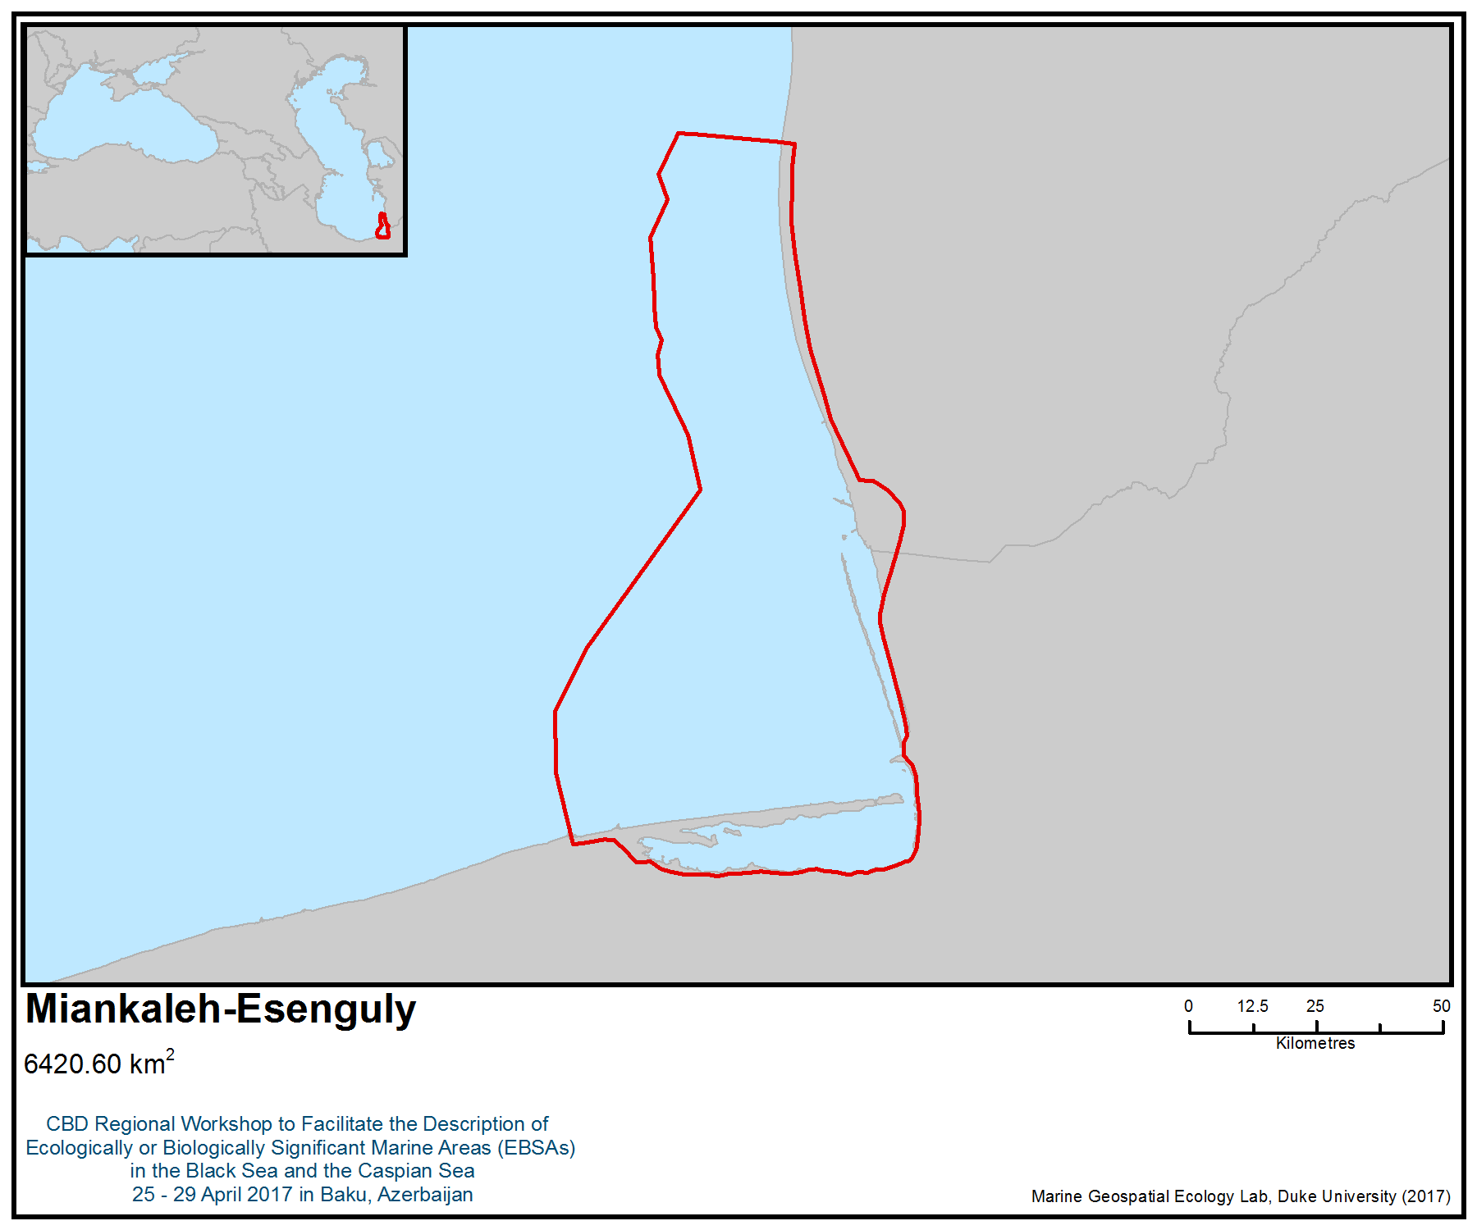
Figure 1. Area meeting the EBSA criteria

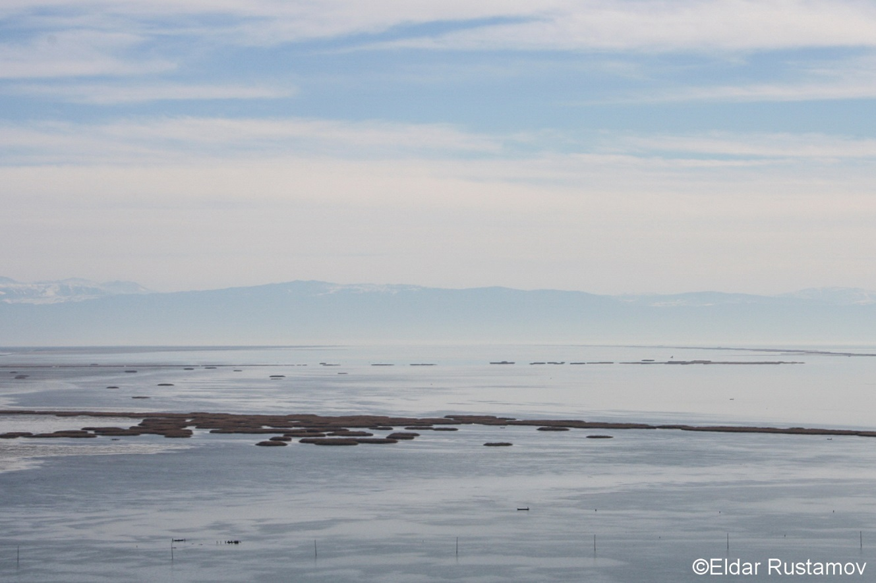
Figure 2. Shallow coastal waters near Esenguly; with Mount Alborz (Elburz) in the background (Photo: Eldar Rustamov)

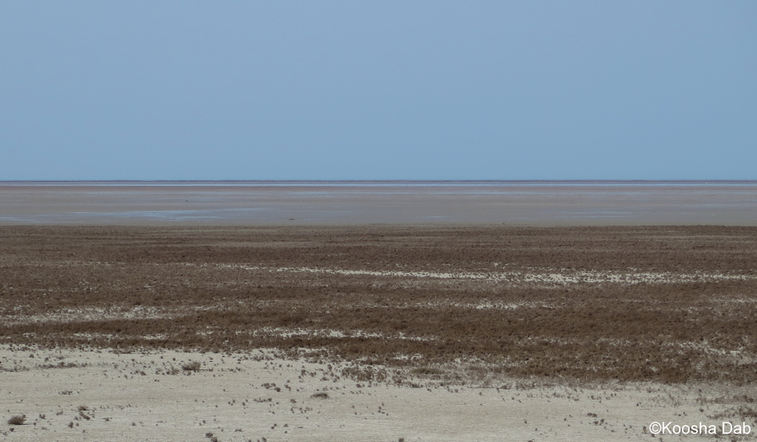
Figure 3. Extensive muddy flats of the northern Gomishan Lagoon (Photo: Koosha Dab)

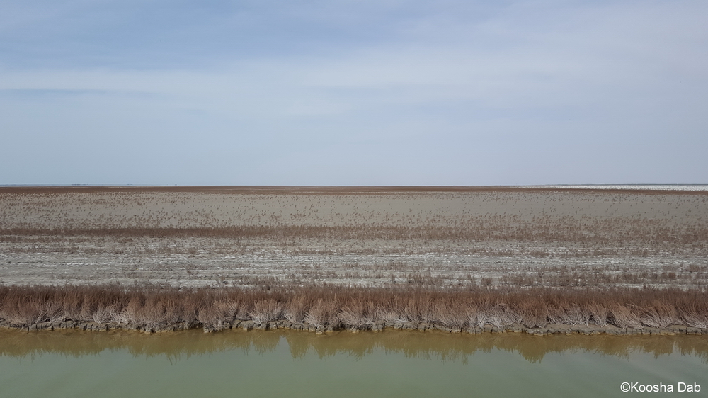
Figure 4. Extensive marshy beds of Gomishan Lagoon (Photo: Koosha Dab)

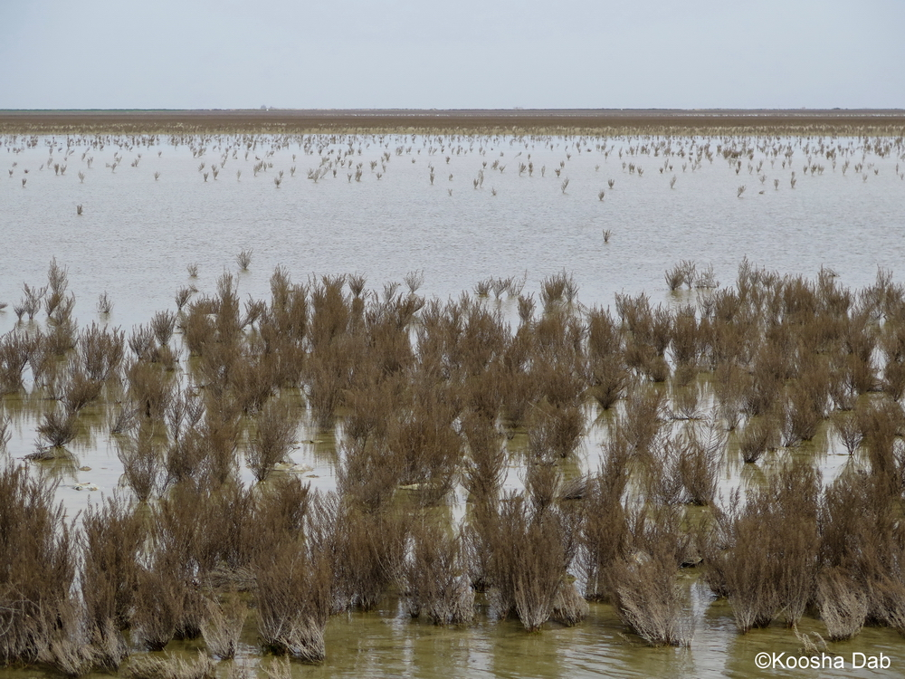
Figure 5. Inundated reedbeds of Gomishan lagoons (Photo: Koosha Dab)

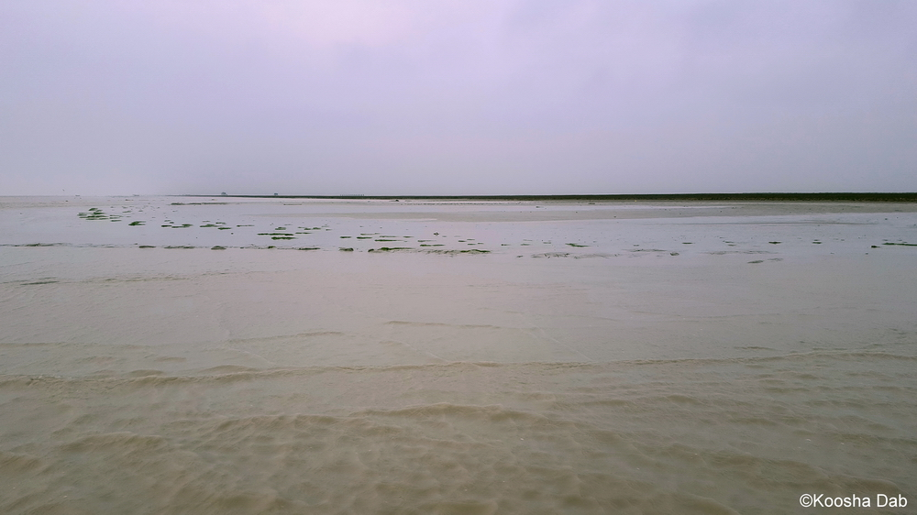
Figure 6. Shallow muddy shores of Gomishan wetland with very gentle slope (Photo: Koosha Dab)

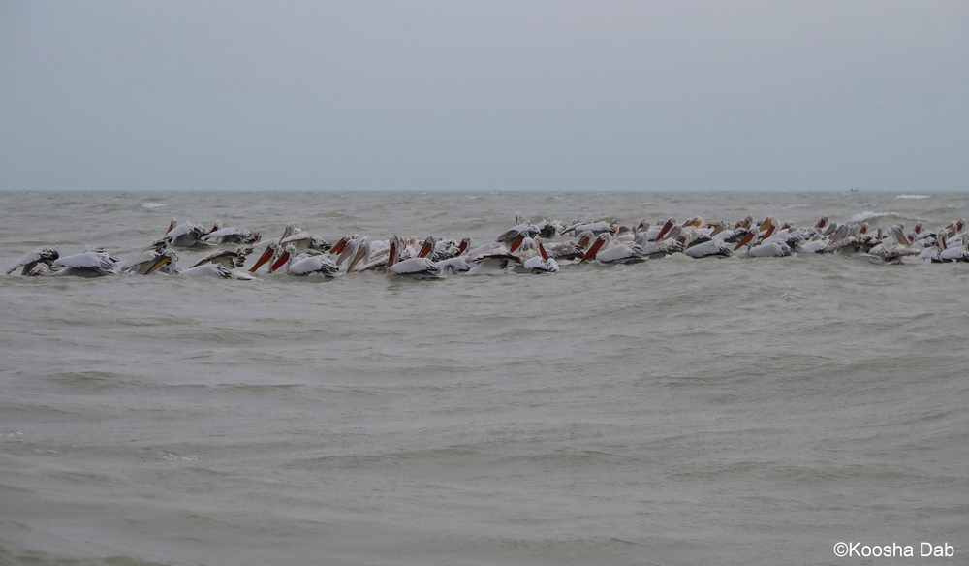
Figure 7. The globally threatened Dalmatian pelicans (Pelecanus crispus) in shallow marine waters of Gomishan area (Photo: Koosha Dab)

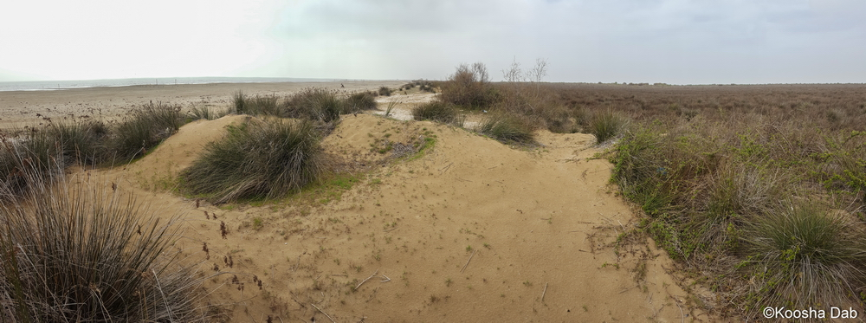
Figure 8. The sand spit/coastal lagoon system in Gorgan Bay (Photo: Koosha Dab)

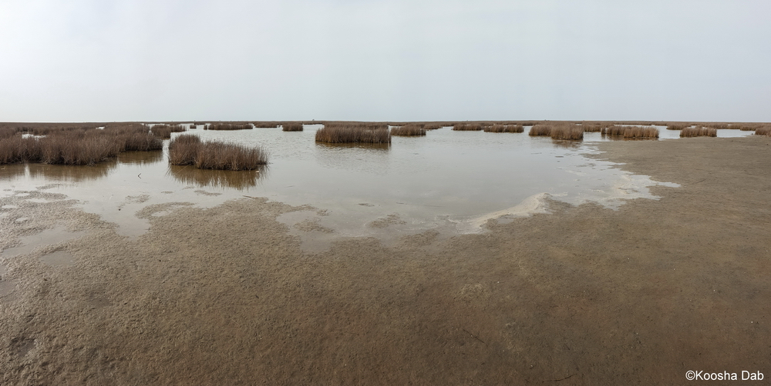
Figure 9. Muddy shores and reedbeds of north Miankaleh Peninsula (Photo: Koosha Dab)

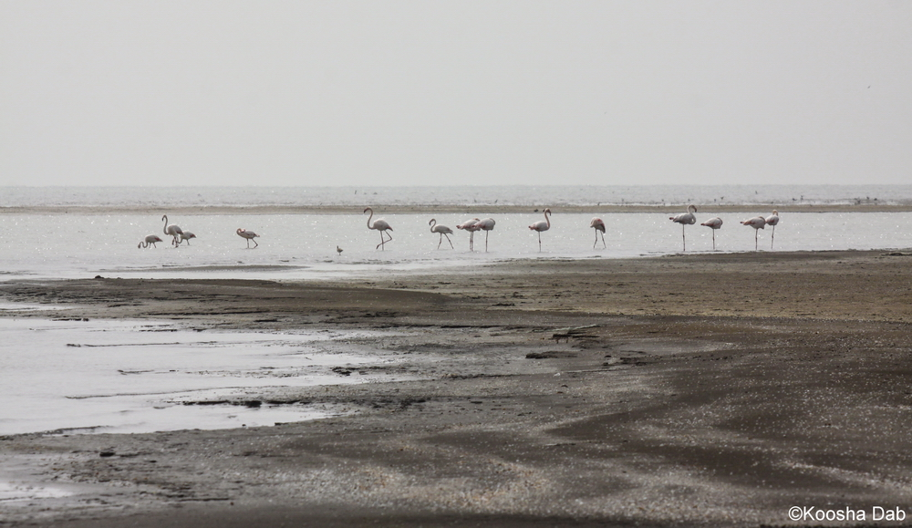
Figure 10. Sandy shores of north Gorgan Bay (Photo: Koosha Dab)

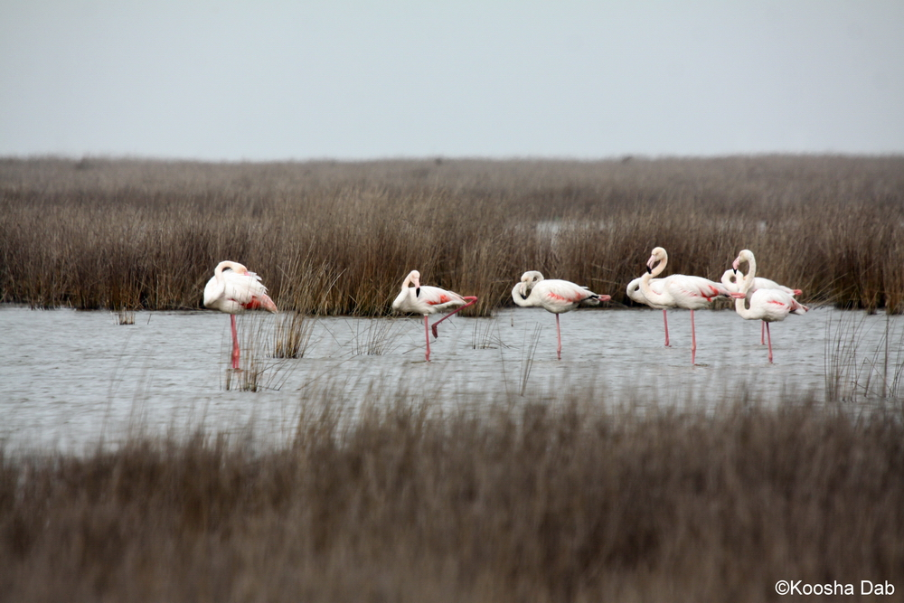
Figure 11. The greater flamingo (Phoenicopterus ruber) in the extensive coastal reedbeds of Ashouradeh Island, Gorgan Bay (Photo: Koosha Dab)

Area No. 26: Sefidroud Delta

Abstract
The Sefidroud Delta is located in the south Caspian lowlands and encompasses the largest river delta in the south Caspian region. This area is a significant foraging and spawning ground for a wide variety of fish species, including five critically endangered sturgeon species: Acipenser gueldenstaedtii, A. stellatus, A. nudiventris, A. persicus and Huso huso. The Sefidroud Delta is an important migratory and wintering ground for a wide variety of migratory waterfowl, regularly supporting more than 100,000 waterbirds and more than 1% of the regional populations of several waterbird species.

Introduction
The Sefidroud Delta is located in the south Caspian lowlands and encompasses the largest river delta in the south Caspian region. The area comprises a diverse range of ecosystems and habitats. The riverine, deltaic and coastal ecosystems of the Sefidroud delta includes shallow marine waters, coastal lagoons, river channels and streams, freshwater and brackish marshes, sand dunes and grasslands.

The area is particularly important for staging and wintering waterbirds, a range of globally threatened species, and as a breeding and nursery ground for a high variety of fish species. The Sefidroud Delta is located at the crossroads of the western, central, and eastern Palearctic, which brings phenomenal numbers of migratory birds from three regions, making it one of the truly great overwintering areas in the region. The Sefidroud Delta is also an important breeding ground for migratory fish species, including the critically endangered stellate sturgeon (Acipenser stellatus), the southern Caspian kutum (Rutilus frisii kutum) and vimba (Vimba vimba). These migratory species enter the freshwaters of Sefidroud by the end of winter and beginning of spring for breeding (Sadeghi-Zadegan, 2016).

The Bandar Kiashahr Lagoon and the mouth of Sefidroud Delta were designated as a Ramsar Site in 1975. The area is also located between two other Ramsar Sites: Anzali and Amirkelayeh wetlands, to the west and east, respectively. The existing Ramsar Site (500 ha) included the whole lagoon area, its associated marshes, and the marshes and sand flats at the mouth of the Sefidroud to the west. It was subsequently extended to share the same boundaries as Bujagh National Park in 2002. The site has been listed as an Important Bird and Biodiversity Area (IBA) by BirdLife International (BirdLife International, 2017; Evans, 1994). Based on its potential as a secure release and wintering site for the Siberian crane, it was also included in the Western/Central Asian Site Network for the Siberian Crane and Other Waterbirds at the launch of this network (Sadeghi-Zadegan and Fazeli 2007; UNEP/CMS 2008, 2011; Ilyashenko 2010). The Sefidroud Delta is also suggested as a possible Seal Special Protected Area (SSPA) in the south Caspian Sea (Caspeco, 2011; CEP, 2010; Wilson and Goodman, 2012).

Location
The area is located in the South Caspian lowlands and encompasses the largest delta in the South Caspian region (about 1,350 ha) and Bandar Kiashahr Lagoon, one of the oldest lagoons in the south Caspian Sea (Sadeghi-Zadegan, 2016).

Feature description of the area
The Sefidroud is the second-largest river in Iran; it has a catchment area of over 54,000 sq.km in the western Alborz Mountains, and a natural flood discharge of 3,400 to 4,200 cubic metres per second (Scott, 1995). This diminishes to a minimum flow of less than 20 cubic metres per second during late summer. The river divides into several tributary channels on the plains, the main channel entering the Caspian Sea at Bandar Kiashahr (Scott, 1995). The Bandar Kiashahr Lagoon is situated in an area of coastal sand dunes and grassland about 1.5 km east of the mouth of the Sefidroud. The area comprises a shallow bay (formerly an enclosed lagoon), the inlet of the main estuary of the Sefidroud River and its riverine marshes, extensive open grasslands, and dunes near the mouth of the river, and the associated fresh to brackish marshes of the Bandar Kiashahr Lagoon, located adjacent to the shallow bay of the Caspian Sea (Sadeghi-Zadegan, 2016). Bandar Kiashahr Lagoon is a shallow, brackish coastal lagoon with fringing Juncus marshes in an area of coastal sand dunes and grassland; it was fed by local runoff, and drained northeast through a narrow channel into the Caspian Sea, having formed in 1960 as a result of the falling level of the Caspian and development of coastal sand spits. The bottom of the lagoon is a mixture of sand and mud, and the waters are predominantly oligotrophic, except toward the marshy western extremity (Carp, 1980; Sadeghi-Zadegan, 2016). The 1.8 m rise in the level of the Caspian since 1978 has converted the wetland into a bay with broad entrance to the sea, similar to the situation in the 1950s. The marshy grassland and sand dune areas at the mouth of the Sefidroud have, however, remained more or less unchanged, while new wetland habitats have been created to the west of the river mouth (BirdLife International, 2017).

The average depth of the main lagoon is 70 cm, and the average volume of water within the lagoon is 381,000 m³ (Sadeghi-Zadegan, 2016). Dependent upon a freshwater supply from the Sefidroud, the depth and area of the wetland change during the wet and dry seasons. During wet season, freshwater enters the wetland from the deltaic system. When the wetland’s water level is high, the wetland is connected to the sea by streams (Sadeghi-Zadegan, 2016). Freshwater marshes at the extreme west end of the lagoon support some beds of Phragmites and Typha, while the southern and eastern shores are dominated by Juncus and grasses. Sandy areas to the west and north-west are covered in scrub and grassland, which give way to sand dune vegetation near the Caspian shore (Sadeghi-Zadegan, 2016).

The Sefidroud Delta comprises a diverse range of ecosystems and habitats. The riverine, deltaic, and coastal ecosystems of the Sefidroud Delta include shallow marine waters, coastal lagoons, river channels and streams, freshwater and brackish marshes, sand dunes and grasslands. Sandy areas to the west and north-west are covered in shrub and grassland, which give way to sand dune vegetation near the Caspian shore. The grasslands along the banks of the Sefidroud floods seasonally.

The area is located at the crossroads of the western, central, and eastern Palearctic, which brings phenomenal numbers of migratory birds from three regions, making it one of the truly great overwintering areas in the region. The area is an important passaging and wintering ground for a wide variety of migratory waterfowl, regularly supporting more than 100,000 waterbirds and more than 1% of the regional populations of several waterbird species, including wintering greater white-fronted goose (Anser albifrons), whooper swan (Cygnus cygnus), gadwall (Anas strepera), mallard (A. platyrhynchos), black-necked grebe (Podiceps nigricollis) and black-headed gull (Larus ridibundus), and breeding greater cormorant (Phalacrocorax carbo) (BirdLife International, 2017; Ramsar Information sheet; Sadeghi-Zadeghan, 2016). Other breeding waterbirds include black-winged stilt, garganey (Anas querquedula), collared pratincole (Glareola pratincola), little ringed plover (Charadrius dubius) and the near threatened northern lapwing (Vanellus vanellus) (Ashoori et al. 2008). At least 60 waterfowl species have been recorded in this area (Ashouri & Zolfinezhad, 2006). This area also supports ferruginous duck (Aythya nyroca), little bustard (Tetrax tetrax) and corncrake (Crex crex), pygmy cormorant (Microcarbo pygmaeus) (up to 300), ducks, shorebirds, gulls and terns, and the raptors marsh harrier (Circus aeruginosus) and merlin (Falco columbarius). A flock of Dalmatian pelican (Pelecanus crispus) (usually 30–40 birds) wintered at the mouth of the Sefidroud Delta in the 1970s. The lesser white-fronted goose (Anser erythropus) was also an occasional winter visitor to the area in the 1970s. The open grassy areas and dunes near the estuary provide breeding habitat for 20–30 pairs of common pratincole (Glareola pratincola), black-winged stilt (Himantopus himantopus), and little ringed plover (Charadrius dubius), while a small patch of woodland to the south of the lagoon supports a large breeding colony of herons and egrets (Carp, 1980; Evans 1994).

The Sefidroud estuary can be considered as a potential wintering site of the critically endangered Siberian crane Leucogeranus leucogeranus. It was also included in the Western/Central Asian Site Network for the Siberian Crane and Other Waterbirds when this network was launched in May 2007 (Sadeghi-Zadegan, 2016; Sadeghi-Zadegan & Fazeli 2007; UNEP/CMS 2008, 2011; Ilyashenko 2010).

Sefidroud Delta is important for its role in supporting fish diversity. At least 36 fish species (85% of south Caspian fish fauna) have been recorded in Sefidroud River (Abdoli & Naderi, 2009; Kiabi et al., 1999a) including: Acanthalburnus microlepis, Acipenser gueldenstaedtii, A. stellatus, A. nudiventris, A. persicus, Alburnoides bipunctatus, Alburnus alburnus, A. chalcoides, A. filippi, Aspius aspius, Barbatula bergiana, B. angorae, Barbus lacerta, B. mursa, Blicca bjoerkna, Capoeta capoeta gracilis, Caspiomyzon wagneri, Cobitis taenia, Cyprinus carpio, Esox lucius, Huso huso, Leuciscus cephalus, Luciobarbus capio, Neogobius fluviatilis, N. gorlap, N. melanostomus, Pelecus cultratus, Rutilus rutilus caspicus natio kurensis, Rhodeus amarus, Rutilus frisii kutum, Sabanejewia aurata, S. caspia, Salmo trutta fario, Silurus glanis, Tinca tinca and Vimba vimba persa.

Five Critically endangered sturgeon, Russian sturgeon (Acipenser gueldenstaedtii), stellate sturgeon (A. stellatus), bastard sturgeon (A. nudiventris), Persian sturgeon (A. persicus), and beluga sturgeon (Huso huso), migrate to the estuary of Sefidroud Delta (Abdolhay, 2004; Abdoli, & Naderi, 2009; Lulayee, 1996; Ramin, 1998). Beluga sturgeon migrate to the Sefidroud River in early spring. They feed on gobies, shads and carp, and, during their first month of life in the sea, on Mysidaca. The Persian sturgeon and stellate sturgeon spawn in late spring, and their fingerlings are stocked in May. Also, southern Caspian kutum (Rutilus frisii kutum) and vimba (Vimba vimba) are important migratory fish species in this area. These species enter the freshwater of the Sefidroud by the end of winter and beginning of spring for breeding and spawning (Abdolhay, 2004; Sadeghi-Zadegan, 2016).

The Sefidroud Delta is also suggested as a possible Seal Special Protected Area (SSPA) in the south Caspian Sea (Caspeco, 2011; CEP, 2010; Wilson & Goodman, 2012).

The Bacillariophytes, Cyanophytes, Chlorophytes, Pyrophytes and Euglenophytes are the dominant phytoplankton groups in this shallow and turbid estuary of Sefidroud Delta (Rahimibashr et al., 2009). The diversity and abundance of phytoplankton has a seasonal pattern, while Diatomas and Chrysophytes are dominant throughout the year; Cyanophytes occurs during the summer. The zooplankton community structure of the area is dominated by copepods, which comprise 68% of the total zooplankton (Rahimibashr et al., 2009).

Feature condition and future outlook of the area
The construction of Manjil and Tarik dams has had adverse impacts on the natural flow regime of Sefidroud River and on migratory species, especially sturgeon. The number of wintering waterfowl has decreased considerably since the 1970s due to increased disturbance from human activities (BirdLife International, 2017, Evans, 1994). The area is close to the city of Kiashahr, and human activities, including hunting, fishing and agricultural and urban runoff, have adverse impacts on the ecosystems of Sefidroud Delta.

Assessment of the area against CBD EBSA Criteria

CBD EBSA Criteria  (Annex I to decision IX/20) | Description  (Annex I to decision IX/20) | Ranking of criterion relevance  (please mark one column with an X)
CBD EBSA Criteria  (Annex I to decision IX/20) | Description  (Annex I to decision IX/20) | No information |  | Low |  |  | Medium |  | High
Uniqueness or rarity | Area contains either (i) unique (“the only one of its kind”), rare (occurs only in few locations) or endemic species, populations or communities, and/or (ii) unique, rare or distinct, habitats or ecosystems; and/or (iii) unique or unusual geomorphological or oceanographic features. |  |  |  |  |  |  |  | X
Explanation for ranking
- Sefidroud Delta is the largest river delta in the south Caspian region (Sadeghi-Zadegan, 2016).
- This area is a significant foraging and spawning ground for a wide variety of fish species, including five critically endangered sturgeon: Acipenser gueldenstaedtii, A. stellatus, A. nudiventris, A. persicus and Huso huso (Abdolhay, 2004; Abdoli, & Naderi, 2009; Lulayee, 1996; Ramin, 1998).
Special importance for life-history stages of species | Areas that are required for a population to survive and thrive. |  |  |  |  |  |  |  | X
Explanation for ranking
- Five critically endangered sturgeon, Russian sturgeon (Acipenser gueldenstaedtii), stellate sturgeon (A. stellatus), bastard sturgeon (A. nudiventris), Persian sturgeon (A. persicus) and beluga (Huso huso), migrate to the estuary of Sefidroud Delta (Abdolhay, 2004; Abdoli, & Naderi, 2009; Lulayee, 1996; Ramin, 1998).
- The area is an important passaging and wintering ground for a wide variety of migratory waterfowl, regularly supporting more than 100,000 waterbirds and more than 1 % of the regional populations of several waterbird species, including wintering greater white-fronted goose (Anser albifrons), whooper swan (Cygnus cygnus), gadwall (Anas strepera), mallard (A. platyrhynchos), black-necked grebe (Podiceps nigricollis) and black-headed gull (Larus ridibundus), and breeding greater cormorant (Phalacrocorax carbo) (BirdLife International, 2017; Ramsar Information sheet; Sadeghi-Zadegan, 2016).
- The open grassy areas and dunes near the estuary provide breeding habitat for 20–30 pairs of common pratincole (Glareola pratincola), black-winged stilt (Himantopus himantopus), and little ringed plover (Charadrius dubius), while a small patch of woodland to the south of the lagoon supports a large breeding colony of herons and egrets (Carp, 1980; Evans 1994).
- The Sefidroud Delta is also suggested as a possible Seal Special Protected Area (SSPA) in the south Caspian Sea (Caspeco, 2011; CEP, 2010; Wilson & Goodman, 2012).
Importance for threatened, endangered or declining species and/or habitats | Area containing habitat for the survival and recovery of endangered, threatened, declining species or area with significant assemblages of such species. |  |  |  |  |  |  |  | X
Explanation for ranking
- Five critically endangered sturgeon, Russian sturgeon (Acipenser gueldenstaedtii), stellate sturgeon (A. stellatus), bastard sturgeon (A. nudiventris), Persian sturgeon (A. persicus) and Beluga sturgeon (Huso huso), migrate to the estuary of Sefidroud Delta (Abdolhay, 2004; Abdoli, & Naderi, 2009; Lulayee, 1996; Ramin, 1998).
- The Sefidroud Delta is also suggested as a possible Seal Special Protected Area (SSPA) in the south Caspian Sea (Caspeco, 2011; CEP, 2010; Wilson & Goodman, 2012).
- The Sefidroud estuary is a potential wintering site of the critically endangered Siberian crane (Leucogeranus leucogeranus). It was also included in the Western/Central Asian Site Network for the Siberian Crane and Other Waterbirds when this network was launched in May 2007 (Sadeghi-Zadegan, 2016; Sadeghi-Zadegan & Fazeli 2007; UNEP/CMS 2008, 2011; Ilyashenko 2010).
Vulnerability, fragility, sensitivity, or slow recovery | Areas that contain a relatively high proportion of sensitive habitats, biotopes or species that are functionally fragile (highly susceptible to degradation or depletion by human activity or by natural events) or with slow recovery. |  |  |  |  |  | X
Explanation for ranking
Acipenser gueldenstaedtii, A. stellatus, A. nudiventris, A. persicus and Huso huso are critically endangered sturgeon species. In general, sturgeon are long-lived and do not reproduce often, making them a vulnerable and slow-recovering biotope. Also, as sturgeon are migratory, they are vulnerable to the damming of rivers, such as the Sefidroud River, which impeds access to their spawning grounds
(http://www.iucnredlist.org/news/sturgeons-highly-threatened).
Biological productivity | Area containing species, populations or communities with comparatively higher natural biological productivity. |  |  |  | X
Explanation for ranking
- The lagoon is predominantly oligotrophic, except toward the marshy western extremity (Carp, 1980; Sadeghi-Zadegan, 2016).
Biological diversity | Area contains comparatively higher diversity of ecosystems, habitats, communities, or species, or has higher genetic diversity. |  |  |  |  |  |  |  | X
Explanation for ranking
- Sefidroud Delta is important for its role in supporting fish diversity. At least 36 fish species (85% of south Caspian fish fauna) have been recorded from Sefidroud River (Abdoli & Naderi, 2009; Kiabi et a., 1999a).
- At least 60 waterfowl species have been recorded in this area (Ashouri & Zolfinezhad, 2006).
Naturalness | Area with a comparatively higher degree of naturalness as a result of the lack of or low level of human-induced disturbance or degradation. |  |  |  |  |  |  | X
Explanation for ranking
- The area has been recognized and protected as Bujagh National Park since 2002.
- The area is close to the city of Kiashahr. Human activities, including hunting, fishing and agricultural and urban runoff, have adverse impacts on the ecosystems of Sefidroud Delta.

References
Abdolhay, H. (2004). Sturgeon Stocking Programme in the Caspian Sea with Emphasis on Iran. FAO Fisheries Technical Paper, 429, 133.
Abdoli, A. and Naderi, M. (2009). Biodiversity of Fishes of the Southern Basin of the Caspian Sea. Abzian Scientific Publications, Tehran. 243 pp. [In Farsi language].
Amini, H., & Sehhatisabet, M. E. (2007). Wintering populations of swans in Iran. J. Podoces, 2(2), 113-121.
Amini H. & van Roomen, M. (eds.) (2009). Waterbirds in Iran, January 2009. Results of a mid-winter count in the provinces of Gilan, Mazanderan, Golestan, Fars, Khuzestan, Bushehr, Hormozgan & Sistan-Baluchistan. Department of Environment, Islamic Republic of Iran & Foundation Working Group International Waterbird and Wetland Research, The Netherlands.
Ashouri, A., & Zolfinezhad, K. (2006). A three-year survey of the status of birds in Boojagh National Park. Journal of Environmental Sciences. Spring, 2006 vol.3 No.11 Pp 11-22.
Ashouri A., Nezami Sh. & Zolfinzhad K. (2008). Identification of Boujagh National Park Kiashahr Birds. Journal of Environmental Studies 34: 101– 112 [In Persian].
BirdLife International (2017) Important Bird Areas factsheet: Bandar Kiashar lagoon and mouth of Sefid Rud. Downloaded from http://www.birdlife.org (http://www.birdlife.org) on 11/04/2017.
Carp, E. (Ed.). (1980). Directory of Wetlands of International Importance in the Western Palearctic. IUCN.
CaspEco (2011). CaspEco Project. Seal Special Protected Network (SSPA). Final Report. University of Leeds.
CEP (2010). Caspeco Project Component I –Creation of Special Protected Areas for the Caspian Seal.
Evans, M.I. (ed). (1994). Important Bird Areas in the Middle East. Cambridge, UK: BirdLife International.
Ilyashenko EI, editor. Atlas of key sites for the Siberian crane and other waterbirds in Western/ Central Asia. Baraboo: International Crane Foundation; 2010. 116 pp.
Kiabi, B. H., Abdoli, A., Naderi, M. (1999a). Status of the fish fauna in the south Caspian Basin of Iran. J. Zool. Mid. East. 18, 57–65.
Laluyee (1996). Migration studies of sturgeons in Sefidrud, Tajen and Gorganrud River. Iranian Fisheries Research and Training Organisation Publications.
Naddafi, R., Abdoli, A., Hassanzadeh Kiabi, B., Mojazi Amiri, B., & Karami, M. (2005). Age, growth and reproduction of the Caspian roach (Rutilus rutilus caspicus) in the Anzali and Gomishan wetlands, North Iran. Journal of Applied Ichthyology, 21(6), 492-497.
Rahimibashar, M. R., Esmaeili-Sary, A., Nezami, S.A., Javanshir, A., Fatemi S. M. R & Jamili, S. (2009). The Planktonic Community Structure and Fluxes Nutrients in the Sefid-Rood River Estuary (South Caspian Sea). Research Journal of Environmental Sciences, 3: 149-162.
Ramin, M. 1998. Migratory studies in sturgeons and their limiting factors in the Sefidrud River. Gilan Fisheries Research Centre Publications.
Ramsar Convention. Information sheet on Ramsar wetlands, Bujagh National Park; Apr 2009. https://rsis.ramsar.org/RISapp/files/RISrep/IR46RIS.pdf
Sadeghi-Zadegan S, Fazeli A. West & Central Asian site network, Bujagh National Park, Iran; 2007. http://sibeflyway.org/wp-content/uploads/2012/03/5-Budjagh-SIS-Part1-eng.pdf
Sadeghi-Zadegan, S., (2016). Bujagh National Park (Islamic Republic of Iran). In The Wetlands Book, Springer Science and Business, eds. Finlayson et al. DOI 10.1007/978-94-007-6173-5_234-2
Scott, D.A. (ed.) (1995). A Directory of Wetlands in the Middle East. IUCN, Gland, Switzerland and IWRB, Slimbridge, United Kingdom.
UNEP-WCMC (2010). Review of four sturgeon species from the Caspian Sea basin. A Report to the European Commission. UNEP-WCMC, Cambridge.
UNEP/CMS. Conservation measures for the Siberian crane, CMS Technical Series Publication No.16. 4th ed. Bonn: UNEP/CMS Secretariat; 2008.
UNEP/CMS. Conservation measures for the Siberian crane. 5th ed. CMS Technical Report Series No.25. Bonn: UNEP/CMS Secretariat; 2011. http://www.cms.int/species/siberian_crane/pdf/ conservation_plans_all_pops_2010_12_e.pdf
Wilson S. & Goodman, S.J. (2012). CaspEco project Component 1 - Seal Special Protected Area Scoping and Inception Plan, Final Report, May 2012. Caspian Environment Programme.

Maps and Figures

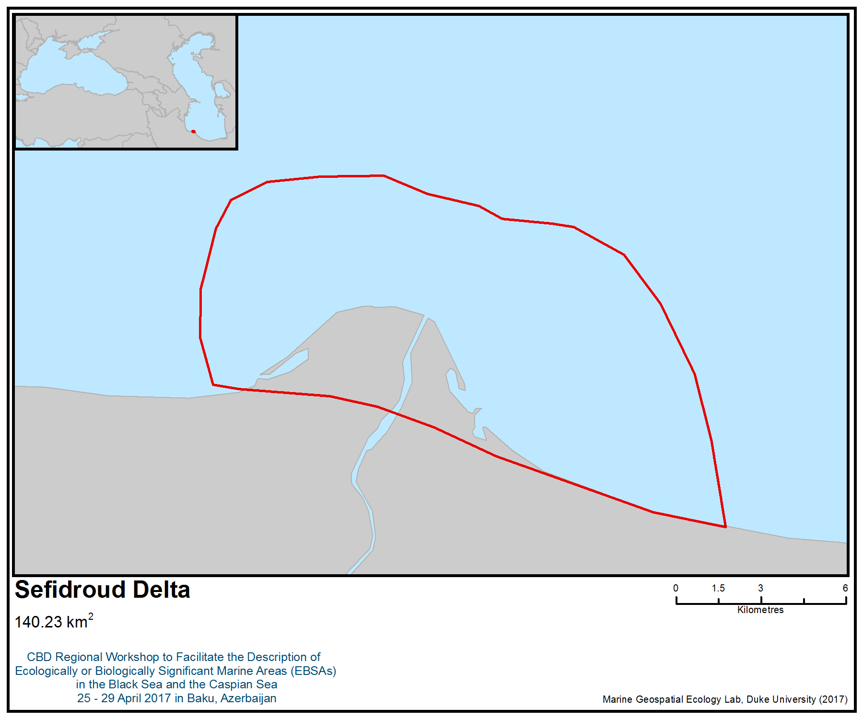
Figure 1. Area meeting the EBSA criteria

Area No. 27: Anzali Wetlands Complex

Abstract
The area is a good example of a natural lagoon and wetland ecosystem characteristic of the south Caspian lowlands. This area supports more than 100,000 wintering waterbirds, and more than 1% of the regional populations of several waterbird species. The area is also a significant site for preserving plant and animal genetic resources and diversity.

Introduction
Anzali wetlands complex is located on the south-western shore of the Caspian Sea, close to the city of Bandar-e-Anzali. The area is a good example of a natural lagoon and wetland ecosystem characteristic of the south Caspian lowlands. The area comprises a complex of large, shallow, eutrophic brackish-freshwater lagoons, marshes and seasonally flooded grasslands, separated from the Caspian Sea by a sandy barrier, about 1 km wide, that has open grasslands, pomegranate scrub and sand dune vegetation. The wetland is extremely important as spawning and nursery grounds for fish and as breeding, staging and wintering areas for a wide variety of waterbirds (Mansoori, 2009, Ramsar Convention Bureau 1997a). Parts of the area receive particular protection, including the Siahkeshim Protected Area, Sorkhankol and the Selkeh Wildlife Refuge, but the entire wetland is designated as a Ramsar Wetland of International Importance (Ramsar Site) of the same name: Anzali Wetlands Complex (Ramsar Convention Bureau (1997a). The Anzali Wetlands Complex is internationally important for migratory waterbirds and has been designated as an Important Bird and Biodiversity Area (IBA) by BirdLife International, known as “Anzali Mordab Complex” (BirdLife International, 2017a). Three reserves have been established in the Anzali wetlands complex, including Sorkan Kol wetland, a wildlife refuge, and the central portion of Siahkeshim Marsh and Selkeh Ab-Bandan, protected areas. This area supports more than 100,000 wintering waterbirds and more than 1% of the regional populations of several waterbird species. The area is also recognized as a significant site for preserving plant and animal genetic resources and diversity (Karimi, 2016).

The 10 perennial flowing rivers draining the 3,610 km² watershed flow into the 15,000 ha Anzali wetland, which supports an extremely diverse flora and fauna.

Location
Anzali wetlands complex is located on the south-western shore of the Caspian Sea, close to the city of Bandar-e-Anzali.

Feature description of the area
Physical description
The Anzali Wetlands Complex comprises large, shallow, eutrophic brackish-freshwater lagoons, shallow impoundments (Ab-Bandans), marshes, and seasonally flooded grasslands (Karimi, 2016; Ramsar Convention Bureau 1997). It is separated to the north from the Caspian Sea by a sand dune barrier about 1 km wide, with open grassland and scrubby vegetation (Karimi, 2016, Ramsar Information Sheet). The main wetland covers about 11,000 ha, and comprises an open lagoon, 26 km long by 2.0–3.5 km wide, surrounded by reedbeds that extend its eastern limits a further 7 km. The entire marsh and lagoon complex drains into the Caspian Sea through the main inlet at the northeastern end of the main lagoon. Water temperatures vary seasonally from 0° C in winter (February) to 27.5°C in midsummer (August) with average of about 16ºC (Asadullayeva & Alekperov, 2007; Jamshidi & Bakar, 2012). The watershed of Anzali wetland has an area of 3,610 km² encompassing 10 river systems with individual subcatchment between 100 and 700 km². The perennial flowing rivers originate in the Alborz Mountains to the south and provide a mean annual discharge to the wetland estimated at about 2,400 M m³ (a mean flow rate of 76 m³/s) and sedimentation rates of 0.1-0.6 (cm yr⁻¹) (Karimi, 2016; Leroy et al., 2011). The latest water level in the area recorded in September 2013 ranged from 26.10 m to 26.30 m (Karimi, 2016). Variations in Caspian Sea level and water abstraction from feeder streams will affect the main wetland’s level and size. In the 1930s the main wetland was 4 to 8 m deep, and the fall in level has severely affected the spawning migrations of fishes and the habitat for developing young. The maximum water depth of both Siahkeshim Marsh and Selkeh wetlands is about 120 cm (Khaleghizadeh, 2007, www.briancoad.com). The rise in the sea level of the Caspian Sea since 1978 has led to a salt water intrusion during the summer months, when the water level is at its highest and freshwater input from rivers is at its lowest. The salinity range of the wetlands is 0.5–8 ppt (Naddafi et al., 2005). The Anzali Lagoon is gradually returning to its former brackish water status. However, although the Caspian Sea level is now even higher than the long-term calculated level for 1879–1930, the environmental conditions of the lagoon are far from those that existedaround 1930. This suggests that until about 1940, the lagoon must have been a brackish water coastal bay; it then gradually transformed to a purely freshwater basin and is now returning to its former brackish-water state (Holchík and Oláh (1992).

Biological Communities
Birds
The Anzali wetland and its satellite wetlands, including Siahkeshim and Selkeh, are extremely important for a wide variety of breeding, passage and wintering waterbirds, and support huge concentrations of wintering ducks, geese, swans and coots (Jafari, N. 2009; Scott, 1995). A total of 70 species of waterbirds have been recorded in the Anzali wetlands complex. Ashouri and Varasteh (2015) recorded the highest number of birds in 2014 and the lowest in 2005, with 125,427 and 68,953 individuals respectively, both occurring in Choukam. The Anatidae family was the dominant group among water birds, with 19 species and an average of 65.99 ±6.52 percent of the total migratory population.

In censuses conducted in 2007 and 2009, the most common species in the Anzali-complex were common teal (43,945), common coot (38,069) and mallard (15,495). Notable numbers of internationally or regionally rare or scarce species include pygmy cormorant (597), Dalmatian pelican (69), white pelican (33), black-crowned nightheron (1.881), whooper swan (42), ferruginous duck (213) and purple swamp-hen (170). Raptors were also numerous and included four white-tailed eagles, five greater spotted eagles, 335 marsh harriers and a red kite (Amini and van Roomen, 2009; Amini and Willems, 2008). Based on the 2007 census, Amini and Willems (2008) concluded that the average number of waterfowl ranges between 0.5 and 1 million birds.

Khaleghizadeh (2000) noted that at least six species in the Anzali wetlands meet the Ramsar criterion of holding at least 1% of the regional population. The area supports more than 1% of the regional Middle Eastern wintering populations of several species, such as mallard (Anas platyrhynchos), northern pintail (A. acuta), common pochard (Aythya ferina), and common coot (Fulica atra). It also provides wintering habitat for a diversity of rare and threatened bird species in addition to some of those mentioned above, including white pelican (Pelecanus onocrotalus), Dalmatian pelican (P. crispus), lesser white-fronted goose (Anser erythropus) andwhite-headed duck (Oxyura leucocephala) (Karimi, 2016).

Anzali Wetlands Complex is an extremely important severe weather refuge for whooper swan and mute swan. This area does not regularly support more than 1% of the flyway population (2,500 birds) of mute swans, but in the extremely severe winter of 2002-2003, this area held over 3% of the total population (7,874 birds), confirming this site as an extremely important hard weather refuge for this species (Amini & Sehhatisabet, 2007).

As noted above, the area overlaps with a marine Important Bird and Biodiversity Area (IBA); known as “Anzali Mordab Complex” (BirdLife International, 2017a).This IBA was designated mainly for its importance for a wide variety of breeding, passage and wintering waterfowl. The Anzali wetlands support a very large breeding colony of whiskered tern (Chlidonias hybridus), small colonies of six species of herons and egrets, western marsh-harrier (Circus aeruginosus) and a large resident population of purple swamphen (Porphyrio porphyrio). The area also supports huge wintering concentrations of ducks, geese, swans and coots (BirdLife International, 2017a). The wetland is the most important wintering area in Iran for pygmy cormorant (Phalacrocorax pygmaeus) (BirdLife International, 2017a), and some globally threatened species occur here, such as white-headed duck (Oxyura leucocephala), lesser white-fronted goose (Anser erythropus), common pochard (Aythya ferina) and sociable lapwing (Vanellus gregarious) (Khaleghizadeh 2000).

The Anzali wetland supports over 1% of the regional breeding population of whiskered tern (Chlidonias hybrid), and in winter supports over 1% of the regional populations of black-necked grebe (Podiceps nigricollis), great cormorant (Phalacrocorax carbo), Eurasian coot (Fulica atra), black-tailed godwit (Limosa limosa), blackheaded gull (Larus ridibundus) and 12 species of Anatidae (Scott 1995). As is characteristic of large wetlands, sometimes large concentrations of waterfowl can be found in relatively small areas. Both Selke and Espand have hosted assemblages of over 20 000 waterbirds in some years (Khaleghizadeh 2007). For example, counts of over 20 000 waterbirds were made at Selke in 1976-78, 1982, 1984-85, 1987-88 and 1992. In 1994 the Anzali wetland complex held more than 67 500 waterbirds (Taylor 1995). At least 157 species of birds have been recorded in the Selke Wildlife Refuge, and at least 144 species in the Siahkesheem Protected Area (Scott 1995). Selke and Siahkesheem held 70-90% of the total waterbirds in the Anzali Wetland from 1970 to 1988.

Flora
Anzali Wetlands Complex supports an extremely diverse wetland flora and fauna. The dominant vegetation throughout the wetlands consists of vast reedbeds of Phragmites australis, which in places grow to 6 m in height. Due to falling levels of the Caspian Sea in the late 1960s, a rapid expansion of the Phragmites reed began, and by the early 1980s, large parts of the main wetland were covered (Scott, 1995). This area supports vast beds of lotus Nelumbo nucifera var. caspica and a very rich growth of other floating and submerged macrophyte vegetation, including Lemna, Patamogeton, Hydrilla, Myriophyllum and Ceratophyllum. The marshes and flood meadows to the south support similar vegetation, in addition to Trapa natans, Juncus and Carex. A vegetation survey conducted in 1999 found 26 species of aquatic plants—10 water’s edge, four emergent, six floating (e.g., water lily Nelumbium (caspium) nuciferum and water chestnut (Trapa natans). and six submergent species (e.g., Hornwort—Ceratophyllum spp) (Khaleghizadeh 2007).

Fish
The Anzali wetlands and Gorgan Bay are two major inlets of importance as foraging, spawning and nursery grounds for fish species (Abdolhay, 2004). At least 34 fish species have been recorded in Anzali wetlands. The most common species in the Anzali wetland are Cyprinus carpio and Carassius auratus (Naddafi et al., 2005; Abdoli & Naderi, 2009). The wetlands are the principal breeding ground for the Caspian kutum (Rutilus frisii kutum) and are also important for several other species (www.briancoad.com). Important fishes of the wetlands include: Sander lucioperca, Cyprinus carpio, Silurus glanis and Esox Lucius.

Investigations by Holchík and Oláh (1992) show that the Anzali wetlands complex and its watershed are inhabited by 13 families, 33 genera and 41 species of fish. Twenty-four species inhabit only freshwater areas, while six species are marine and 11 species occur both in freshwater and the marine areas. The ichthyofauna is dominated by Cyprinidae, which are represented by 23 species,. Seven species (Aristichthys nobilis, Carassius auratus, Ctenopharyngodon idella, Gambusia holbrooki, Hemiculter leucisculus, Hypophthalmichthys molitrix and Liza auratus) are exotic species that were introduced either intentionally (Chinese herbivorous carps, mosquitofish and mullet) or accidentally (German carp and the common sawbelly) (Holchík and Oláh, 1992).

Anzali Lagoon is very rich in species, with 31 species of fish, including both limnophilous and potamophilous species as well as both freshwater and marine fish. Most are found in its western basin, while the eastern and southern basins have far fewer fish species, with only Carassius auratus, Esox lucius, Tinca tinca and Proterorhinus marmoratus. Large areas covered by submerged and floating vegetation are inhabited by dense schools of Gambusia holbrooki, which occur only at the water surface. Outflows from the lagoon with higher salinity are home to marine and brackishwater species, such as Liza auratus and Atherina mochon pontica. Syngnathus nigrolineatus was found in large numbers in the deepest part of the western basin, where the salinity is higher. Migratory species, such as Rutilus frisii kutum, Vimba vimba persa, Barbus capito, Chalcalburnus chalcoides iranicus and Alosa caspia persica have been recorded seasonally and in small numbers in the western basin. These species mostly in outflows and in the inflowing streams during the late winter and in spring months (Holchík, J. and Oláh, J., (1992).

A total of 23 species of fish have been found in the incoming streams, including Clupeonella cultriventrisSome species, such as Alburnoides bipunctatus eichwaldi, Alburnus charusini hohenackeri, Alburnus filippii, Barbus lacerta cyri, Capoeta gracilis gracilis, Noemacheilus angorae and Neogobius kessleri gorlap have been found exclusively in streams. Aside from marine or brackishwater species, such as Alosa caspia, Liza auratus, Atherina mochon and Neogobius platyrostris, Alburnus filippii was also recorded. This was reported to dwell only in freshwater (Berg, 1948–1949; Abdurakhmanov, 1962, cited in Holchík, J. and Oláh, J., 1992)).

The presence of Caspiomyzon wagneri, Sabanejewia aurata and Alburnoides bipunctatus in outflows and in the lagoon's tributaries indicates good water quality, as these species are known to be less tolerant to heavy loads of toxicants and pollutants. (Holchík, J. and Oláh, J., (1992).

Feature condition and future outlook of the area
This area is listed on Ramsar’s Montreux Record, “a register of wetland sites on the List of Wetlands of International Importance where changes in ecological character have occurred, are occurring, or are likely to occur” (http://archive.ramsar.org/cda/en/ramsar-documents-montreux-montreux-record/main/ramsar/1-31-118%5E20972_4000_0_) due to threats that include pollution from urban and agricultural wastewater, spread of the exotic floating water-fern Azolla Filiculoides, sedimentation from upstream deforestation and increased hunting pressure (Karimi, 2016).

Assessment of the area against CBD EBSA Criteria

CBD EBSA Criteria  (Annex I to decision IX/20) | Description  (Annex I to decision IX/20) | Ranking of criterion relevance  (please mark one column with an X)
CBD EBSA Criteria  (Annex I to decision IX/20) | Description  (Annex I to decision IX/20) | No information |  | Low |  |  | Medium |  | High
Uniqueness or rarity | Area contains either (i) unique (“the only one of its kind”), rare (occurs only in few locations) or endemic species, populations or communities, and/or (ii) unique, rare or distinct, habitats or ecosystems; and/or (iii) unique or unusual geomorphological or oceanographic features. |  |  |  |  |  |  |  | X
Explanation for ranking
- A complex of seven interconnected wetlands with different physical characteristics
- A unique dynamic ecosystem and ecotone with a wide range of salinity from brackish waters of the Caspian Sea to freshwater wetlands and estuaries
- The most extensive beds of lotus Nelumbo nucifera var. caspica in the south Caspian Sea (Karimi, 2016)
- Considered the most important area in the Iranian Caspian Sea based on several specific criteria, including: naturalness, uniqueness, habitat connectivity (lower fragmentation), habitat diversity, number of threatened and endangered marine species, number of threatened and endangered bird species, spawning and nursery grounds, wintering and breeding grounds for birds, number of bird populations, number of 1% of the regional populations, bird diversity and importance for the Caspian Seal (BirdLife International, 2017; Danehkar, 2002; Danehkar & Majnoonian, 2004a; Giesen, 2011; 2010; UNEP-GEF, 2013).
Special importance for life-history stages of species | Areas that are required for a population to survive and thrive. |  |  |  |  |  |  |  | X
Explanation for ranking
- The Anzali wetlands complex is one of the two major inlets of importance as foraging, spawning and nursery grounds for fish species in the south Caspian Sea (Abdolhay, 2004; Mansoori, 2009; Ramsar information Sheet).
- Extremely important for a wide variety of breeding, passing and wintering waterfowl. The wetlands support a very large breeding colony of whiskered tern (Chlidonias hybridus), small colonies of six species of herons and egrets, western marsh-harrier (Circus aeruginosus) and a large resident population of purple swamphen (Porphyrio porphyrio). The area also supports huge wintering concentrations of ducks, geese, swans and coots. The wetland is the most important wintering area in Iran for pygmy cormorant (Phalacrocorax pygmaeus) (BirdLife International, 2017a)
- The average number of waterfowl ranges between 0.5 and 1 million birds (BirdLife International, 2017a).
- This area is principal breeding ground for the declining Caspian kutum (Rutilus frisii kutum) (www.briancoad.com).
Importance for threatened, endangered or declining species and/or habitats | Area containing habitat for the survival and recovery of endangered, threatened, declining species or area with significant assemblages of such species. |  |  |  |  |  |  |  | X
Explanation for ranking
- Several globally threatened bird species are known to occur in the area (BirdLife International 2017a), such as white-headed duck (Oxyura leucocephala), lesser white-fronted goose (Anser erythropus), common pochard (Aythya ferina) and sociable lapwing (Vanellus gregarious).
- This area is principal breeding ground for the declining Caspian kutum (Rutilus frisii kutum) (www.briancoad.com).
Vulnerability, fragility, sensitivity, or slow recovery | Areas that contain a relatively high proportion of sensitive habitats, biotopes or species that are functionally fragile (highly susceptible to degradation or depletion by human activity or by natural events) or with slow recovery. |  |  |  |  |  | X
Explanation for ranking
The wetland is the most important wintering area in Iran for pygmy cormorant (Phalacrocorax pygmaeus) (BirdLife International, 2017a), and some globally threatened species occur here, such as white-headed duck (Oxyura leucocephala), lesser white-fronted goose (Anser erythropus), common pochard (Aythya ferina) and sociable lapwing (Vanellus gregarious) (Khaleghizadeh 2000).
Biological productivity | Area containing species, populations or communities with comparatively higher natural biological productivity. |  |  |  | X
Explanation for ranking
- Anzali wetlands complex has a low phytoplankton production and very low biomass of both zooplankton and macrozoobenthos (Holchík, J. and Oláh, J., 1992)

Biological diversity | Area contains comparatively higher diversity of ecosystems, habitats, communities, or species, or has higher genetic diversity. |  |  |  |  |  |  |  | X
Explanation for ranking
- Wide range of habitats from brackish waters of Caspian Sea to freshwater and estuarine ecosystems
- Anzali Wetlands Complex supports a diverse wetland flora; at least 26 aquatic plants have been recorded (Khaleghizadeh 2000; Scott, 1995)
- More than 100,000 waterbirds have been recorded here, and a total of 266 bird species
- At least 34 fish species (80% of south Caspian fauna) has been recorded in Anzali wetlands
Naturalness | Area with a comparatively higher degree of naturalness as a result of the lack of or low level of human-induced disturbance or degradation. |  |  |  |  | X
Explanation for ranking
- The surrounding area is heavily populated with several direct and indirect human disturbances.

References

Abdolhay, H. (2004). Sturgeon Stocking Programme in the Caspian Sea with Emphasis on Iran. FAO Fisheries Technical Paper, 429, 133.
Abdoli, A. and Naderi, M. (2009). Biodiversity of Fishes of the Southern Basin of the Caspian Sea. Abzian Scientific Publications, Tehran. 243 pp. [In Farsi language].
Afraei, M. A., Safari, R., & Salmani, A. (2006). Distribution and density of juvenile Acipenser persicus at the lower 10 meter depth of the southern Caspian Sea. Journal of Applied Ichthyology, 22(s1), 108-110.
Amini, H., & Sehhatisabet, M. E. (2007). Wintering populations of swans in Iran. J. Podoces, 2(2), 113-121.
Amini H. & van Roomen, M. (eds.) (2009). Waterbirds in Iran, January 2009. Results of a mid-winter count in the provinces of Gilan, Mazanderan, Golestan, Fars, Khuzestan, Bushehr, Hormozgan & Sistan-Baluchistan. Department of Environment, Islamic Republic of Iran & Foundation Working Group International Waterbird and Wetland Research, The Netherlands.
Amini H. & Willems, F. J. (2008). Waterbirds in Iran. Results of a mid-winter count in the provinces of West Azarbayjan, Gilan, Mazanderan, Golestan, Sistan-Baluchistan, Hormozgan, Fars, Bushehr & Khuzestan of the Islamic Republic of Iran, January 2007. Department of Environment, Islamic Republic of Iran.
Asadullayeva, E.; Alekperov, I., (2007). Free-living ciliates of the Anzali Wetland of the Caspian Sea, Turkish Journal Zoology., 31, 143–149.
Ashoori, Abbas & Moradi Hossien, Varasteh. (2015). Diversity of Wintering Waterfowls and Waders in Anzali Wetland, Iran. Journal of Wetland Ecobiology. 3. 55-66 (In Farsi). Available from: https://www.researchgate.net/publication/275954086_Diversity_of_Wintering_Waterfowls_and_Waders_in_Anzali_Wetland_Iran [accessed Apr 28, 2017].
Bakhshalizadeh, S., Bani, A., Abdolmalaki, S., Nahrevar, R., & Rastin, R. (2011). Age, growth and mortality of the Persian Sturgeon, Acipenser persicus, in the Iranian waters of the Caspian Sea. Caspian Journal of Environmental Sciences, 9(2), 159-167.
Basatnia, N., Hosseini, S. A., & Khaledian, Y. (No Date). Spatial changes in organic matter content in benthic sediment of Gomishan wetland, northern Iran.
Bastami, K. D., Bagheri, H., Haghparast, S., Soltani, F., Hamzehpoor, A., & Bastami, M. D. (2012). Geochemical and geo-statistical assessment of selected heavy metals in the surface sediments of the Gorgan Bay, Iran. Marine pollution bulletin, 64(12), 2877-2884.
Behrouzi-Rad, B. & Ghaeimi, R. (2015). Changes in the Population of Wintering Waterbirds in Gomishan Wetland at Caspian Sea Coast, Iran, International Journal of Marine Science, Vol.5, No.13 1-7.
BirdLife International, 2017a. Important Bird Areas factsheet: Anzali Mordab complex. Downloaded from http://datazone.birdlife.org/site/factsheet/anzali-mordab-complex-iba-iran-islamic-republic-of/details on 27/04/2017.
BirdLife International 2017b. IUCN Red List for Birds. Downloaded from http://www.birdlife.org on 27/04/2017.
Billard, R., & Lecointre, G. (2000). Biology and conservation of sturgeon and paddlefish. Reviews in Fish Biology and Fisheries, 10(4), 355-392.
Carp, E. (Ed.). (1980). Directory of Wetlands of International Importance in the Western Palearctic. IUCN.
CaspEco (2011). CaspEco Project. Seal Special Protected Network (SSPA). Final Report. University of Leeds.
CEP (1998a). Regional Action Plan for Protection of Caspian Habitats. Caspian Environment Programme, Baku, Azerbaijan.
CEP (1998b). National Report, Iran. Caspian Environment Programme, Baku, Azerbaijan.
CEP (2010). Caspeco Project Component I – Creation of Special Protected Areas for the Caspian Seal.
Danehkar A., Majnoonian, H. (2004a). Conservation ranking of coastal areas in Iran Case study: Ranking of critical habitats in the southern part of the Caspian Sea. 6th International Conference on Coasts, Ports and Marine Structures (ICOPMAS 2004). 29-3 Dec 2004 [in Persian language with English abstract].
Danehkar A., Majnoonian, H. (2004b). Protective Ranking of Coastal Regions Case Study: Gradation of Coastal Habitats in Caspian Sea. 6th International Conference on Coasts, Ports and Marine Structures (ICOPMAS 2004). 29-3 Dec 2004 [in Farsi language with English abstract].
Danehkar, A. (2002). Sea sensitive areas of Iran and View of Development. 5th International Conference on Coasts, Ports and Marine Structures (ICOPMAS 2002). 14-17 October 2002 [in Farsi language].
van Diek H., Felix R., Hornman M., Meininger P., Willems F. & Zekhuis M. (2004). Bird counting in Iran in January 2004. Dutch Birding 26: 287–296.
Evans, M.I. (ed). (1994). Important Bird Areas in the Middle East. Cambridge, UK: BirdLife International.
Eybatov, T. M. (2015). Status Report for Seismic Project SWAP. Appendix 5A. Caspian Seals Report. Zardabi Natural History Museum.
Fet, V., & Atamuradov, K. (Eds.) (2012). Biogeography and ecology of Turkmenistan (Vol. 72). Springer.
Gandomi, Y., Shadi, A., & Savari, A. (2011). Classification of Gomishan Lagoon (Caspian Sea, Iran) by using the coastal and marine ecological classification standard (CMECS). Middle-East J. Sci. Res, 8(3), 611-615.
Gharib M. (2006). Studies of Miankaleh Peninsula Water Resources, Geology and Geomorphology. Ministry of Energy [in Farsi language].
Ghorbanzadeh Zaferani, S. Gh., Machinchian Moradi, A., Mousavi Nadushan, R., Sari, A. R., & Fatemi, S. M. R. (2017). Spatial and temporal patterns of benthic macrofauna in Gorgan Bay, south Caspian Sea, Iran. Iranian Journal of Fisheries Sciences, 16(1), 252-274.
Ghasemi, A. F., Clements, J. C., Taheri, M., & Rostami, A. (2014). Changes in the quantitative distribution of Caspian Sea polychaetes: Prolific fauna formed by non-indigenous species. Journal of Great Lakes Research, 40(3), 692-698.
Giesen W. (2011). Management Guidelines for Implementation Biodiversity Management of Wetlands. From the publication series of Conservation of Iranian Wetlands Project (CIWP). IRI Department of Environment, United Nations Development Programme, Global Environment Facility [in Farsi language].
Goodman, S. & Dmitrieva, L. (2016) Pusa caspica. The IUCN Red List of Threatened Species 2016: e.T41669A45230700. http://dx.doi.org/10.2305/IUCN.UK.2016-1.RLTS.T41669A45230700.en. Downloaded on 21 April 2017.
Holchík, J. and Oláh, J., (1992). Fish, fisheries and water quality in Anzali Lagoon and its watershed. Report prepared for the project -Anzali Lagoon productivity and fish stock investigations. Food and Agriculture Organization (FAO), Rome, FI: UNDP/IRA/88/001 Field Document 2: x + 109p. (http://www.fao.org/docrep/006/AD192E/AD192E02.htm#ch2.3.4)
Jafari, N. (2009). Ecological integrity of wetland, their functions and sustainable use. Journal of Ecology and the Natural Environment, 1(3), 045-054.
Jamshidi, S., & Bakar, N. A. (2012). Seasonal variations in temperature, salinity and density in the southern coastal waters of the Caspian Sea. Oceanology, 52(3), 380-396.
Jamshidi, S. (2016). Study on Physical and Chemical Characteristics of Seawater of Gorgan Bay in The Eastern Part of Southern Coast of the Caspian Sea. Proceedings of Academics World 44th International Conference, Bangkok, Thailand, 13th -14th September 2016.
Kakroodi, A.A., Kroonenberg, S.B., Hoogendoorn, R.M., Mohammadkhani, H., Yamani, M., Ghasssemi, M.R., Lahijani, H.A.K. (2012). Rapid Holocene sea-level changes along the Iranian Caspian coast. Quaternary International. 263, 93–103.
Karimi, M. B. (2016). Anzali Mordab complex (Islamic Republic of Iran). In The Wetlands Book, Springer Science and Business, eds. Finlayson et al. DOI 10.1007/978-94-007-6173-5_231-1
Khalegizadeh, A. (2000): A comparison survey on diversity, density and distribution of wintering waterfowls in Selke and Siahkesheem (Espand Klass) international wetlands [in Farsi]. – M.Sc. Thesis, Tarbiat Modarres University, 123 pp.
Khaleghizadeh A. (2007): Waterbirds in microhabitats of Selke and Espand in the Anzali Wetlands, Iran. - Sandgrouse. 29 (1): 17-34.
Khaleghizadeh, A., & Behrouzi-Rad, B. (2004). On waterbirds in the Anzali Wetlands, Iran, in 1999/2000. Zoology in the Middle East, 31(1), 13-22.
Khoshkholgh, M. R., Nazari, S., & Pourkazemi, M. (2013). Population Structure of Persian Sturgeon (Acipenser persicus Borodin, 1897) in the southern part of Caspian Sea. Iranian Journal of Animal Biosystematics (IJAB), 9(1), 29-39.
Kiabi, B. H., Abdoli, A., Naderi, M. (1999a). Status of the fish fauna in the south Caspian Basin of Iran. J. Zool. Mid. East. 18, 57–65.
Kiabi, B. H., Ghaemi, R., Abdoli, A. (1999b). Wetland and riverain ecosystems of Golestan Province. Department of the Environment Golestan Province Office of D.O.E.
Kideys A. E., Roohi, A., Eker-Develi, E., Me´lin, F., Beare, D. (2008). Increased chlorophyll levels in the Southern Caspian Sea following an invasion of jellyfish, research letters in ecology, 2008, Article ID 185642, 4 pages. (doi: 10.1155/ 2008/185642)
Kostianoy, A. G., & Kosarev, A. N. (2005). The Caspian Sea Environment (Vol. 5). Springer Science & Business Media.
Kroonenberg, S.B., Badyukova, E.N., Storms, J.E.A., Ignatov, E.I., Kasimov, N.S., (2000). A full sea level cycle in sixty-five years: barrier dynamics along Caspian shores. Sedimentary Geology 134, 257–274.
Laluyee (1996). Migration studies of sturgeons in Sefidrud, Tajen and Gorganrud River. Iranian Fisheries Research and Training Organisation Publications.
Leroy, S.A.G., Tavakoli, V., Habibi, P., Naderi Beni, M., Lahijani, H.A.K., Djamali, M., Naqinezhad, A., Moghadam, M.V., Arpe, K., ShaheHosseini, M., Hosseindoust, M., Miller, C.S., 2011. Late Little Ice Age palaeoenvironmental records from the Anzali and Amirkola Lagoons (south Caspian Sea): vegetation and sea level changes. Palaeogeography, Palaeoclimatology, Palaeoecology 302 (3), 415e434.
Mansoori, J. (2009). The Avian Community of Five Iranian Wetlands, Miankaleh, Fereidoonkenar, Bujagh, Anzali and Lavandevil, in the South Caspian Lowlands. Podoces, 4(1), 44-59.
Masoudi, M., Ramezannejad Ghadi, R. & Riahi, H. (2012). Phytoplankton Flora of Miankaleh Wetland. -Iran. J. Bot. 18 (1): 141-148. Tehran.
Naddafi, R., Abdoli, A., Hassanzadeh Kiabi, B., Mojazi Amiri, B., & Karami, M. (2005). Age, growth and reproduction of the Caspian roach (Rutilus rutilus caspicus) in the Anzali and Gomishan wetlands, North Iran. Journal of Applied Ichthyology, 21(6), 492-497.
Naseka, A. M., & Bogutskaya, N. G. (2009). Fishes of the Caspian Sea: zoogeography and updated check-list. Zoosystematica Rossica, 18(2), 295-317.
Nezakati, R., Malmasi, S., Behrouzirad, B., Esmaeeli, F. & Majd, F. F. (2011). Classification of Miankale Wetland Shore Line Based on Environmental Sensitivity Index (ESI), Iran. In Proceedings of International Conference on Environmental Science and Technology (ICEST 2011).
Patimar, R. (2008). Some biological aspects of the Sharpnose mullet Liza saliens (Risso, 1810) in Gorgan Bay-Miankaleh Wildlife Refuge (the south-east Caspian Sea).” Turkish Journal of Fisheries and Aquatic Sciences.
Patimar, R., R., Abdoli, A., Hasanzade Kiabi, B., Allahyari, S. and Naderi Jelowdar, M. (2009a). Fish species diversity of the coastal areas in Gomishan wetland. J. Agric. Sci. Natur. Resour., Vol. 16 (Special issue 1-a).
Patimar, R., Yousefi, M., & Hosieni, S. M. (2009b). Age, growth and reproduction of the sand smelt Atherina boyeri Risso, 1810 in the Gomishan wetland–south-east Caspian Sea. Estuarine, Coastal and Shelf Science, 81(4), 457-462.
Pourkazemi, M. (2006). Caspian Sea sturgeon conservation and fisheries: past present and future. Journal of Applied Ichthyology, 22(s1), 12-16.
Ramsar Convention Bureau (2001). Information Sheet on Ramsar Wetlands (RIS). Gomishan Lagoon (https://rsis.ramsar.org/ris/1109).
Ramsar Convention Bureau (1997a). Information Sheet on Ramsar Wetlands (RIS). Anzali Wetlands Complex (https://rsis.ramsar.org/ris/40)
Ramsar Convention Bureau (1997b). Information Sheet on Ramsar Wetlands (RIS). Miankaleh Peninsula, Gorgan Bay and Lapoo-Zaghmarz Ab-bandan (https://rsis.ramsar.org/ris/36).
Razmjooy, S., Danehkar, A., Sharifipour, R. & Nabavi, S. M. B. (2010). Evaluation of sensitiveness of Mazandaran coastline using IMO Method. 9th International Conference on Coasts, Ports and Marine Structures (ICOMPAS 2010).
Roohi, A., Kideys, A., Sajjadi, A., Hashemian, A., Pourgholam, R., Fazli, H., Ganjian Khanari, A. and Eker-Develi, E. (2010). Changes in biodiversity of phytoplankton, zooplankton, fishes and macrobenthos in the southern Caspian Sea after the invasion of the ctenophore Mnemiopsis leidyi. Biol. Invas., 12:2343-2361.
Rowshan Tabari, M. (2013). The zooplankton population structure and their trend of variations in the southern of Caspian Sea (Iranian waters) (Doctoral dissertation, Islamic Azad University, Science and Research Branch, Tehran).
Rustamov, E. A. (1994). The wintering waterfowl of Turkmenistan. Wildfowl, 45(45), 242-247.
Saghali, M., Baqraf, R., Hosseini, S. A., & Patimar, R. (2013). Benthic community structure in the Gorgan Bay (Southeast of the Caspian Sea, Iran): Correlation to water physiochemical factors and heavy metal concentration of sediment. International Journal of Aquatic Biology, 1(5), 245-253.
Scott, D.A. (ed.) (1995). A Directory of Wetlands in the Middle East. IUCN, Gland, Switzerland and IWRB, Slimbridge, United Kingdom.
Sharbaty, S. (2011). Two dimensional simulation of flow pattern in Gorgan Bay by using Mike21 software. Journal of Water and Soil Conservation, Vol. 18(4), 241-246.
Sharbaty, S. (2012). 3-D simulation flow pattern in the Gorgan Bay during summer. International Journal of Engineering Research and Applications (IJERA), 2(3)700-707.
Taheri, M., Foshtomi, M. Y., Noranian, M., & Mira, S. S. (2012). Spatial distribution and biodiversity of macrofauna in the south-east of the Caspian Sea, Gorgan Bay in relation to environmental conditions. Ocean Science Journal, 47(2), 113-122.
Tavakoli, M., Bahmani, M. (2009). Stock Assessment of Acipenser persicus in the Iranian coastline of The southern Caspian Sea. Journal of Wetland Ecobiology (JWEB). I.A.U. Ahvaz/ Winter 2012/ Vol. 10 [in Persian language with English abstract].
UNECE (2011). Second Assessment of Transboundary Rivers, Lakes and Groundwaters, UNECE, Geneva, Switzerland.
World Conservation Monitoring Centre (Eds.) (1990). Directory of Wetlands of International Importance. Sites Designated for the List of Wetlands of International Importance. Ramsar Convention Bureau, Gland, Switzerland. 782 pp.
UNDP-GEF (2013). Conservation of Iranian Wetlands, Brief (June 2003).
UNEP (2006). Stolberg, F., Borysova, O., Mitrofanov, I., Barannik, V. and Eghtesadi, P. Caspian Sea, GIWA Regional assessment 23. University of Kalmar, Kalmar, Sweden.
UNEP-WCMC (2010). Review of four sturgeon species from the Caspian Sea basin. A Report to the European Commission. UNEP-WCMC, Cambridge.
UNESCO (2009). Hazar State Nature Reserve, UNESCO World Heritage Centre, Tentative Lists,
(Accessed at: http://whc.unesco.org/en/tentativelists/5437/ on 14/04/2017).
Vinarski, M. (2012) Turricaspia caspia. The IUCN Red List of Threatened Species 2012: e.T189493A1927211.
Wilson S. & Goodman, S.J. (2012). CaspEco project Component 1 - Seal Special Protected Area Scoping and Inception Plan, Final Report, May 2012. Caspian Environment Programme.
Yazdandad, H. (2000). A study of interspecies changes of Coot, Fulica atra, with different ecological conditions in north Iran wetlands. M.Sc. Thesis, University of Tehran, p. 150.
Zonn, I. S. & Kostianoy, A. G. (Eds.). (2013). The Turkmen Lake Altyn Asyr and Water Resources in Turkmenistan (Vol. 28). Springer.
Zonn, I. S., Kosarev, A. N., Glantz, M. H., & Kostianoy, A. G. (2010). The Caspian Sea Encyclopedia. Springer.

https://populationexplorer.com

Maps and Figures

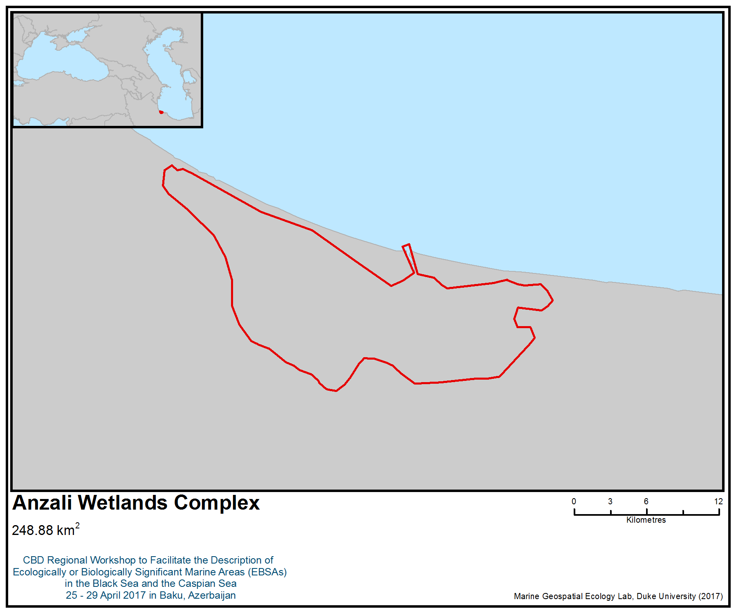
Figure 1. Area meeting the EBSA criteria

Area No. 28: Gizilagach Bay Complex

Наименование/название района: Гызыл-Агачский Залив/Аннотация

- Гызыл-Агачский залив, расположенный в юго-западной части Каспийского моря на побережье Азербайджана, является одним из биологически и экологически значимых морских районов Каспийского моря. Акватория залива входит в состав Гызыл-Агачского заповедника. Заповедник охватывает акваторию всего Большого залива, северную часть Малого Гызыл-Агачского залива, западную часть Куринской косы, степь на севере и северо-западе Большого залива, и основание или северную часть полуострова Сара. Климат умеренно теплый субтропического типа, с мягкой зимой, жарким летом и значительными осадками. Солоноватоводный Гызыл-Агачский залив с максимальной глубиной 3,5 м непосредственно связан с Каспийским морем. Дно залива состоит из ила и песка или ила и раковин. Северная часть залива страдает от постепенного вторжения зарослей тростника.

- Гызыл-Агачский Заповедник был создан в 1929 году с целью защиты мест обитания больших популяций зимующих и перелетных водоплавающих и степных птиц. Вследствие этого Гызыл-Агачский залив получил широкое признание в качестве водно-болотных угодий международного значения. В 1975 г. Гызыл-агачский залив был включен в Рамсарской список. Фауна заповедника включает 47 видов рыб, около 273 видов птиц, 5 видов амфибий, 15 видов пресмыкающихся и 26 видов млекопитающих. Основу местной орнитофауны составляют водно-болотные птицы. Гызыл-Агачский комплес расположен на пути миграции вдоль западного побережья Каспия, и большие стаи перелетных птиц кормятся и отдыхат в этом районе. В предыдущие годы до 10 миллионов птиц останавливались на зимовку в комплексе и прилегающих районах.

Azerbaijan places third in the western Palearctic for numbers of wintering waterbirds (more 1.0 million) as part of the Caspian-West Siberian-East African Flyway. The area contains one of the most important wetlands for wintering and breeding waterbirds in the western Palearctic. The Gizilagach Bay Complex is located in the south-western part of the Caspian Sea along the coast of Azerbaijan. The area covers the entire water area of the Greater Gizilagach Bay, the northern part of the Lesser Gizilagach Bay, the western part of the Kura spit, the steppe in the north and the north-west of the Greater Gizilagach Bay, and the base or the northern part of the Sara Peninsula. The climate is moderately warm, subtropical, with mild winters, hot summers and considerable precipitation. The brackish water of the Gizilagach Bay, with a maximum depth of 3.5 m, is directly connected with the Caspian Sea. The bottom of the bay consists of mud and sand or silt and shells. The northern part of the bay suffers from a gradual invasion of reeds. The “Ghizil-Agaj” Bay was recognized as a Ramsar Wetland of International Importancein 1975. The area’s fauna includes 47 species of fish, about 273 species of birds, 5 amphibia, 15 reptiles and 26 species of mammals. The local avifauna is mainly waterbirds. The area is located along the migration routes on the western coast of the Caspian Sea, and large flocks of migratory birds feed and rest in the area. It was reported that in previous years up to 10 million birds wintered in the complex and its surrounding areas.

Введение
Гызал-Агачский залив расположен в юго-западной части Каспийского моря на побережье Азербайджана. Общая площадь залива составляет 460 км², а глубина 3,5 м. Акватория залива входит в состав Гызылагачского заповедника. Климат умеренно теплый субтропического типа, с мягкой зимой, жарким летом и значительными осадками. Грунт в заливе преимущественно илисто-песчаный. Водный баланс: в залив поступает 11,4 млн м³ воды, сбрасывается в море- 8,7 млн м³, 2,7млн м³- уходит на испарение. Площадь залива в течение года в зависимости от обеспеченности водой сокращается от 5,4 до 7,9тыс.га.

Заповедник охватывает акваторию всего Большого залива, северную часть Малого Гызыл-Агачского залива, западную часть Куринской косы, степь на севере и северо-западе Большого залива, и основание или северную часть полуострова Сара. Два столетия назад Большой Гызыл-Агачский Залив был обширным и глубоководным, проникающимся в Ленкоранскую и Муганскую низменности. В залив впадало множество речек, такие как Виляжчай, Акуша и Кумбашиека, которые опресняли его и служили прекрасным нерестилищем для ценных промысловых рыб. Большой Гызыл-Агачский залив, отделенный от открытого моря Куринской косой, занимает площадь 40,5 тыс.га. Залив мелководный наибольшие глубины не достигают 2,5 м. К западу от него, отделенный полуостровом сара, находится Малый Гызыл-Агачский залив площадью 15 тыс. га. В 1956 г. южный конец полуострова Сара был соединен с материковым берегом дамбой, отделившей Малый залив от Каспийского моря. Питаемый водами рек Кумбашинка и Виляжчай залив превратился в пресноводное водохранилище. Наибольшая длина его 16, 7 км, ширина – 6,7 км, глубина 0,5 – 2,5 м. Большим заливом и Каспийским морем он сообщается тремя каналами – Рыбоходным, Аварийным и Сбросным. Два последних расположены на территории заповедника. Рыбоходный канал предназначен для захода рыбы в Малый залив на нерест.

Гызыл-Агачский Заповедник был создан в 1929 году с целью защиты мест обитания больших популяций зимующих и перелетных водоплавающих и степных птиц. Вследствия этого Гызыл-Агачский залив получил широкое признание в качестве водно-болотных угодий международного значения. В 1975 г. залив был включен в Рамсарской список. Прилегающий Малый Гызылагачский залив расположен в юго-западной части Каспийского моря на территории Азербайджана (Ленкоранский район). Малый залив ограничен с юго-востока полуостровом Сара, с севера - территорией Сальянской степи, с запада - Муганской степью (низовья Талышских гор), а с юга - Каспийским морем, отделенным от него дамбой. Наибольшая длина Малого Гызылагачского Залива 16,7 км, ширина - 6,5 км, береговая линия ок. 40 км, пл. зеркала залива 140 км², глубина - 0,5-1 м. В связи с изменениями уровня Каспия акватория Малого залива существенно уменьшается или увеличивается. М.К.3. имел естественную связь с Большим Кызылагачским заливом и Каспийским морем. Малый Гызыл-Агачский залив также является одним из наиболее важных мест для зимовки и размножения водоплавающих птиц в Западной Палеарктике.

Колебания уровня моря оказали сильное влияние на Гызылагачский комплекс. В период создания Гызылагачского заповедника уровень Каспийского моря был 26,2 м ниже уровня Мирового океана. Общая площадь заповедника составляла 180,000 га. Однако за период 1930-1939 гг. после падения уровня моря Каспийского моря значительные площади на севере и западе заповедного комплекса высохли. В результате часть из этих територий были затем преобразованы в сельскокохозяйственные земли, а площадь заповедника уменьшилась до 88,360 га. В этот период площадь поверхности воды Гызылагачского залива изменялась от 77000 га в 1937 году до 40500 га в конце 1960-х. В 1978 г. начался стремительный подъем уровня моря (в период создания Малого Гызыл-Агачского залива) и в 1994 году уровень моря достиг отметки - 26.5 м. Начиная с 1995 года уровень моря снова упал, достигнув отметки приблизительно - 27 м в 2011 году. В настоящее время площадь поверхности воды Гызылагачского залива составляет около 62,000 га.

Фауна заповедника включает 47 видов рыб, около 273 видов птиц (41 вид в Красной книге), 5 видов амфибий, 15 видов пресмыкающихся (2 вида в Красной книге) и 26 вида млекопитающих (4 из них в Красной книге). В Гызыл-Агачском заливе насчитывается 360 видов растений (3 вида - в Красной книге).

Изменение уровня Каспийского моря привело к образованию обширных мелководных заливов с богатыми местами нагула для рыб, создавая благоприятную среду обитания для значительного числа зимующих водоплавающих птиц. Уток и лебедей привлекают мелководья, которые богаты затопленной растительностью и моллюсками, а стаи гусей и небольшие дрофы находят свои корма в полупустынных районах комплекса. Гызыл-Агачский комплес расположен на пути миграции вдоль западного побережья Каспия , и большие стаи перелетных птиц кормятся и отдыхат в этом районе. В предыдущие годы до 10 миллионов птиц останавливались на зимовку в комплексе и прилегающих районах. Количество водно-болотных птиц (уток и лысух) существенно снизилось с 10 миллионов в 1930-х годах до 5-7 миллионов в конце 1950-х годов, до 1500000 к концу 1960-х годов, до 338,000-715,000 в 1970-е годы, до 200,000-400,000 в начале 1980-х годов, до 180,000-362,000 в 1990-х годах.

Солоноватый режим Гызыл-Агачского залива с максимальной глубиной 3,5 м, напрямую связан с Каспийским морем. Соленость воды колеблется в пределах 0,1 - 13,7%_{О} с максимумом летом и минимумом весной. Влияние речного стока на соленость определяется в прибрежном участке. Содержание растворенного кислорода меняется от 68 до 106%. Концентрация биогенных элементов в толще воды незначительна, что объясняется большим потреблением кислорода водорослями и высшей растительностью, образующими заросли по берегам залива.

В зоопланктоне ведущую роль играли Calanipeda и Eurytemora, общая биомасса их составляла 66% всего зоопланктона. Помимо них на всех участках залива встречались личинки моллюсков, молодь Nereis. Средняя биомасса зоопланктеров достигала 77,03 мг/м³.

Основу зообентоса по численности и биомассе составляли азово-черноморские вселенцы (Nereis , абра, балянус, краб), распространенные по всему заливу. Средняя биомасса донных животных составляла 31,0 г/м².

Дно залива состоит из ила и песка, или ила и ракушек. В северной части залива постепенно наблюдается увеличение зарослей тростников. Грунты преобладали илисто-песчаные с переходом в серый вязкий ил. Водный баланс- допустимость повышения уровня воды в заливе выше отметки 26,5 определяет необходимость сброса воды в море в объеме не менее 10 млн м³ в течение февраля, марта, апреля, когда наблюдается скат молоди из водоема в Каспий. Сброс воды в море привлекает производителей всех видов рыб. При высоком паводке и максимальной отметке горизонта (26,36) объем Малого залива составляет свыше 20 млн м³.

Местонахождение
Гызыл-Агачский комплекс (см. карту ниже) включает в себя Большой Гызыл-Агачский заповедник площадью 88360 га и прилегающий к нему Малый Гызыл-Агачский заказник площадью 10700 га, расположенный на юго-западном побережье Каспийского моря в пределах юрисдикции (административные районы Ленкорани, Масаллы и Нефтчала) Азербайджанской Республики. Топографический рельеф комплекса характеризуется чередованием низких (до 1 м) гребней и открытых впадин, а также старых заиленных русел.

Location
The Gizilagach Bay Complex comprises the Greater Gizil- Agach Reserve, covering an area of 88,360 hectares, and the adjacent Lesser Gizil-Agach Bay Reserve, the area of which is 10,700 hectares, located on the south-western coast of the Caspian Sea of the Republic of Azerbaijan (administrative districts of Lenkorani, Masalli and Neftchala). The topographic terrain of the complex is characterized by an alternation of low (up to 1 m) ridges and open dents (dented/shallow curved valleys), as well as old silted river beds.

Описание особенностей предлагаемого района
Разнообразие физико-географических и климатических условий способствовало развитию в пределах заповедника комплексного растительного и животного мира. Здесь представлена полупустынная, кустарниковая, луговая и водно-болотная растительность, флора которой насчитывает 310 видов высших растений. Облик растительности определяется главным образом прибрежным положением. Здесь можно выделить следующие типы морской зональности: 1) заросли тростника, 2) бескильницевые луга, 3) злаково-эфемеровая полупустыня. Водно-болотная растительность отмечена в местах избыточного увлажнения (берега Малого залива, Акушинские, Лопатинские разливы, Калиновский лиман). Заросли тростника высотой 4-5 м наблюдаются на плавнях и вокруг водоемов. Вместе с камышом озерным и рогозом образует смешанные сообщества.

Широкую известность Гызыл-Агачскому заповеднику принесла расположенные на его территории зимовки водоплавающих птиц. Гызыл-Агачский заповедник является Рамсарской территорией. Зимующие здесь утки, гуси, лебеди, лысуха входят в состав в состав «западносибирской каспийско-нильской» популяции водоплавающих птиц. Гнездящиеся на севере Западной Сибири, Южном Урале и в Северо-Западном Казахстане птицы зимуют преимущественно на побережьях Каспия, в странах Ближнего Востока и в долине Нила. Видовой состав водоплавающих птиц разнообразен. Сюда прилетают лебеди-шипуны, серые гуси и пискульки, кулики, благородные, или речные утки (кряквы, серые, шилохвости, широконосики, чирки-свистунки), красноголовые нырки, лысухи.

Большой Гызылагачский залив характеризуется разнообразием экологических условий (наличием глубоководных участков, прибрежных мелководий, илистых отмелей), служит местообитанием практически всех видов водоплавающих и многих видов околоводных птиц., встречаются в заповеднике.

Большой и Малый Гызылагачский заливы являются местом скопления наиболее ценных и редких видов фауны рыб республики.

Благодаря мелководности, умеренной зарастаемости водоема, хорошему кормовому, водному и температурным режимам, оба залива играют важную роль в воспроизводстве рыбных запасов Каспийского моря.

В 1950-х гг. ХХ столетия уловы рыб в Гызыл-Агачском заливе в среднем составляли 2500 тонн. В настоящее время Малый залив полностью изолирован от Большого залива и превращен в пресноводный водоем. В связи с этим состав ихтиофауны этих заливов несколько отличается. Малый залив - наибольшая его длина составляет 16,7 км, наименьшая ширина-6,5км, длина береговой линии-38,9км, площадь зеркала – 150 км², объем воды – 0,15 км³, глубина - 0,5-2,5м. Климат в районе Малого залива относится к влажному субтропическому.

В Малом заливе обитают преимущественно пресноводные рыбы. В то время как в Большом заливе преобладают морские виды. В Большом Гызыл-Агачском заливе встречается 41 вид, а в Малом - 31 вид рыб. Кроме того, в Малый залив были заселены белый амур и белый толстолобик. Редким экземпляром в обоих заливах является европейский угорь, появившийся в Каспийском море после открытия Волго-балтийского водного пути и заселения водоемов бассейна Волги личинками этой рыбы. В отличие от Малого залива в Большом заливе встречаются 4 вида осетровых (белуга (Huso huso Linnaeus, 1758), куринский осетр (Acipenser persicus Borodin, 1897), севрюга (Acipenser stellatus Brandt, 1869, шип), каспийский лосось (Salmo caspius), два вида усачей (усач-чинари (Luciobarbus capito), каспийский усач (Barbus brachycephalus caspius) чехонь (Pelecus cultratus), кефали (Mugilidae), морской судак (Sander marinus), три вида бычков (Gobiidae). Общими для Большого и Малого Гызыл-Аачского заливов являются 25 видов рыб. Эти рыбы со сравнительно широким ареалом распространения и эвригалинностью способные обитать как в морской, так и в пресноводной среде (щука, куринская вобла, кутум, жерех, ленкоранская шемая, сазан, окунь, речной судак и др.). Большой и Малый заливы представляют важное значение для формирования рыбных запасов Каспийского моря.

Состояние объекта и перспективы относительно предлагаемого района
За последние годы вследствие воздействия как природных (колебания уровня моря, изменение климата), так и антропогенных (загрязнение, вселение чужеродных видов (Mnemiopsis leidyi), чрезмерный вылов рыбных запасов, снижение численности популяции тюлений из-за болезни и истощения запасов килек – основных кормовых объектов тюленей) факторов в экосистеме Каспийского моря, включая Гызылагачский залив, произошли существенные изменения.

Колебания уровня моря оказали сильное влияние на Гызылагачский комплекс. Следует указать, на момент создания Гызылагачского залива уровень Каспийского моря был на 26,2 м ниже уровня Мирового океана, а площадь залива составляла около 180 000 га.

В результате антропогенной деятельности, изменения климата, колебания уровня моря, вселения видов-вселенцев происходят изменения прибрежных экосистем и местообитаний, приводящие к сокращению биоразнообразия Каспийского моря. В ходе инвентаризации прибрежной зоны Каспийского моря были отмечены 112 видов растений и 240 видов животных в прибрежной зоне Каспийского моря и включены в Красный список МСОП (2006 год), а также в Национальные Красные книги. Во второе издание Красной книги Азербайджана (2013) занесены 300 видов растений (20 простейших и 266 высших растений) и 223 видов животных, включая 71 видов беспозвоночных, один вид Mollusca, 9 видов рыб, 6 видов амфибий, 14 видов рептилий, 72 видов птиц и 42 вида млекопитающих.

Оценка района по критериям выявления экологически или биологически значимых морских районов (ЭБЗР), разработанным в рамках Конвенции о биологическом разнообразии (КБР)

Критерии КБР по выявлению ЭБЗР  (Приложение I к решению IX/20) | Описание  (Приложение I к решению IX/20) | Ранжирование актуальности критериев  (просьба поставить в одной из колонок букву X)
 | Описание  (Приложение I к решению IX/20) | Информации нет |  | Низкая |  |  | Средняя |  | Высокая
Уникальность или малая распространённость | Район, в котором присутствуют либо i) уникальные (единственные в своем роде), редкие (встречаются только в нескольких местах) или эндемичные виды, популяции или сообщества; и/или ii) уникальные, редкие или особые места обитания или экосистемы; и/или iii) уникальные или необычные геоморфологические или океанографические элементы. |  |  |  |  |  |  |  | X
Объяснение ранжирования
В Гызыл-Агачском Залив присутствуют редкие и эндемичные виды птиц, рыб и млекопитающих.
В разное время года на обследованной территории наблюдали 13 видов птиц, находящихся под угрозой исчезновения, включая кудрявый пеликан (Pelecanus crispus). 6 из 13 видов этих птиц, встречающих в Гызыл-Агачском заповеднике, занесены в Красную книгу Азербайджана (2013). (Paynter, D., Aarvak, T., and Sultanov, E., 1996).
Широкую известность Гызыл-Агачскому заповеднику принесла расположенные на его территории зимовки водоплавающих птиц. Гызыл-Агачский заповедник является Рамсарской территорией. Зимующие здесь утки, гуси, лебеди, лысуха входят в состав в состав «западносибирской каспийско-нильской» популяции водоплавающих птиц. Гнездящиеся на севере Западной Сибири, Южном Урале и в Северо-Западном Казахстане птицы зимуют преимущественно на побережьях Каспия, в странах Ближнего Востока и в долине Нила. Видовой состав водоплавающих птиц разнообразен. Сюда прилетают лебеди-шипуны, серые гуси и пискульки, кулики, благородные, или речные утки (кряквы, серые, шилохвости, широконосики, чирки-свистунки), красноголовые нырки, лысухи. Нырковые утки обычно составляют около половины от общего числа водоплавающих птиц. Максимальная численность – 290-500 тыс. наблюдалась в зимние периоды 1971-1973 гг. Максимальная численность пеганок и огарей составляет всего 400-500 особей. Изредка единичными экземплярами встречаются большой и средний крохали, турпан, савка. Зимовка этих видов нетипична и относится к случайным залетам. Лысуха вместе с султанской курицей, камышницей относится к отряду пастушковых птиц, а по экологическим особенностям к группе водоплавающих. Максимальная численность лысух составляет 390-242 тысячи в зимние сезоны 1971-1972 и 1976-1977 гг. В Гызыл-Агачском заливе встречается до 2-3 тысяч особей фламинго (Кривоносов, 1977). В Большом Гызыл-Агачском заливе зимой и весной встречается каспийский тюлень. В настоящее время занесен в Красную книгу IUCN (2008) и Азербайджана (2012) как вид, находящийся под угрозой исчезновения.
Около 500 000 зимующих птиц встречаются в заливе. (Sultanov, 2004, 2008).
Особо важное значение для этапов цикла развития видов | Район, необходимый для выживания и успешного обитания популяции. |  |  |  |  |  |  |  | X
Объяснение ранжирования
Большой и Малый Гызылагачский заливы являются местом скопления наиболее ценных и редких видов фауны рыб республики.
Благодаря мелководности, умеренной зарастаемости водоема, хорошему кормовому, водному и температурным режимам, оба залива играют важную роль в воспроизводстве рыбных запасов и успешного обитания Каспийского моря. Кроме того, в данном районе находятся места обитания (отдыха, гнездования, питания) многих популяций водоплавающих птиц.

Важное значение для угрожаемых, находящихся под угрозой исчезновения или исчезающих видов и/или мест обитания | Район, содержащий место обитания для выживания или восстановления находящихся под угрозой исчезновения, угрожаемых или исчезающих видов; или район, содержащий значительные сообщества таких видов. |  |  |  |  |  |  |  | X
Объяснение ранжирования
Гызыл-Агачский залив содержит места обитания для выживания и восстановления многих видов фауны (водоплавающих птиц, осетровых и каспийского тюленя) Каспийского моря, находящихся под угрозой исчезновения.

Азербайджан занимает третье место в Западной Палеарктике по количеству зимующих водоплавающих птиц (более 1,0 млн., Rose & Taylor, 1993) Каспийско-Западно-Сибирско-Восточно-Африканского пролетного пути. По данным Т. Воробьевой (1970), в Каспийском регионе во время миграций ежегодно встречаются до 10-12 млн. водоплавающих птиц, а зимой - 3-3,5 млн. особей (Воробьева, 1979, Кривоносов, 1979). В Азербайджане зимуют около 1,2-1,3 млн. водно-болотных птиц (Султанов, Мустафаев, 1994, Султанов, 1997).

По оценкам (Султанова, 2008), вдоль берегов Азербайджана размножается не менее 250000 птиц. Количество перелетных птиц в 8-10 раз больше, чем зимующих птиц. Особенно много птиц встречается на протяжении длительного периода года (с октября по апрель) встречаются на озерах, расположенных ближе к морю (ближе к путям миграции). В зимний период большинство водоплавающих птиц составляют утки (более 1000000), лысухи (около 200 000), гуси (около 40 000), а также много лебедей (до 30 000 особей в чрезвычайно холодные зимы) и пеликаны (до 3000); Во время гнездования втречаются цапли, ибисы, крачки, чайки, бакланы и др. В сезон миграций встречаются также кулики. В зимний период в заливе преобладают утки и лысухи (63-84%), а в начале сезона размножения встречаются больше представителей Lariidae (34-61%), бакланов (5-9%) и цапель (6- 13% с куликами). В период миграций значительна доля куликов и цаплей до 26-27%. Бакланы и фламинго (до 6%), как правило, встречаются с октября по март; Лебедей (до 0,4%) и гусей (2,7 %) в основном можно обнаружить с января по март.
Уязвимость, хрупкость, чувствительность или медленные темпы восстановления | Район, содержащий относительно большое число чувствительных мест обитания, биотопов или видов, функционально хрупких (чрезвычайно подверженных деградации или истощению вследствие антропогенной деятельности или природных событий) или отличающихся медленными темпами восстановления. |  |  |  |  |  |  |  | X
Объяснение ранжирования

Осетровые – древнейшее семейство пресноводных рыб, появившееся 200–250 миллионов лет назад. Они отличаются от современных костистых рыб хрящевым скелетом. Нотохорда покрыта жесткой оболочкой, которая поддерживает хрящевую структуру (Hochleithner and Gessner, 1999). Спинная хорда (струна) расположена под нотохордой. Хвостовой плавник, как правило, неравнолопастной, с продолжением спинной струны к верхней части тела.

В Большом заливе встречаются 4 вида осетровых (белуга (Huso huso Linnaeus, 1758), куринский осетр (Acipenser persicus Borodin, 1897), севрюга (Acipenser stellatus Brandt, 1869, шип), каспийский лосось (Salmo caspius). По запасам осетровых Каспийское море занимает первое место в мире (90 %).

За последние десятилетия численность и запасы осетровых рыб в Каспийском море катастрофически сократились (Khodorevskaya and Krasikov, 1999; Pourkazemi, 2006; Khodorevskaya et al., 2009).

По данным МСОП, опубликованным в марте 2010 года, все четыре вида каспийских осетровых рассматриваются как виды, находящиеся под угрозой исчезновения (IUCN, 2010). Сообщалось, что «85 % осетровых находятся под угрозой исчезновения, что делает их наиболее уязвимой группой животных, находящихся под угрозой исчезновения в Красном списке МСОП » (МСОП, 2010 г.).

Для осетровых характерна сложная внутривидовая структура: они имеет озимую и яровую формы, а внутри каждой из них выделяются более мелкие группы, различающиеся сроками захода в реки, размерами рыб, продолжительностью пребывания в пресной воде, сроками нереста и т.д. Осетровые поздносозревающие виды рыб. Половая зрелость у большинства самцов наступает в возрасте 10–13 лет, а самки достигают половой зрелости в 12–16 лет. Нерестовая миграция осетровых растянута с конца марта- начала апреля до ноября. Промежуток между повторым нерестом составляет 2-3 года. Нерестилища расположены на участках с гравийным или каменистым дном, на глубине от 4 до 25 м, при скорости течения 1,0–1,5 м/сек. Достигнув длины чуть более 20 мм, предличинки осетра переходят на активное питание сначала планктоном, позднее – мелкими бентосными организмами. Взрослые рыбы после нереста также не задерживаются в реке и быстро скатываются в море. В море взрослые осетровые нагуливаются, в основном, на моллюсковых полях на глубинах от 2 до 100 м. Мальки нагуливаются на глубинах от 2 до 5 м. Помимо моллюсков, осетровые питаются и мелкой рыбой: в Каспийском море – бычками и килькой (Желтенкова, 1964). На нерестилищах икру осетровых поедают хищные рыбы гольцы и пескари. Высокая плодовитость осетровых связана с низкой выживаемостью потомства, обитающего в реке более продолжительное время. Выживаемость молоди осетровых в естественных условиях составляет 3 %. (Державин, 1954).

Каспийский тюлень (Pusa caspica) – эндемик Каспийского моря и единственный представитель ластногих. В настоящее время численность каспийского тюленя сократилась на 90 % с 1 млн. особей ( в 1900 г.) до 100 000 особей и занесен в красный список МСОП в качестве вида, находящегося под угрозой исчезновения. (Härkönen T, Harding KC, Wilson S, Baimukanov M, Dmitrieva L, et al. (2012) Collapse of a marine mammal species driven by human impacts. PLoS One 7(9): e43130. (IUCN (2012) The IUCN Red List of Threatened Species. Version 2012.2. Available: http://www.iucnredlist.org. Accessed 2012 Nov 15).

Основной причиной уязвимости и сокращения численности птиц явились изменения природных угодий Гызыл-Агачского заповедника и всей Ленкоранской низменности.
Биологическая производительность | Район, в котором содержатся виды, популяции или сообщества, обладающие сравнительно высокой естественной биологической производительностью. |  |  |  |  |  |  |  | X
Объяснение ранжирования

Благодаря мелководности, умеренной зарастаемости водоема, хорошему кормовому, водному и температурным режимам, оба залива играют важную роль в воспроизводстве рыбных запасов Каспийского моря.
В зоопланктоне ведущую роль играли Calanipeda и Eurytemora, общая биомасса их составляла 66% всего зоопланктона. Кроме того, них на всех участках залива встречались личинки моллюсков, молодь Nereis. Средняя биомасса зоопланктеров достигала 77,03 мг/м³.
Основу зообентоса по численности и биомассе составляли азово-черноморские вселенцы (Nereis , абра, балянус, краб), распространенные по всему заливу. Средняя биомасса донных животных составляла 31,0 г/м²
Общие уловы рыб в Гызыл-Агачском заливе составляли 2500 тонн. (Кулиев, 1989).
Биологическое разнообразие | Район, отличающийся сравнительно высоким разнообразием экосистем, мест обитания, сообществ или видов или более высоким генетическим разнообразием. |  |  |  |  |  |  |  | X
Объяснение ранжирования

В Малом заливе обитают преимущественно пресноводные рыбы. В то время как в Большом заливе преобладают морские виды. В Большом Гызыл-Агачском заливе встречается 41 вид, а в Малом - 31 вид рыб. Кроме того, в Малый залив были заселены белый амур и белый толстолобик. Редким экземпляром в обоих заливах является европейский угорь, появившийся в Каспийском море после открытия Волго-балтийского водного пути и заселения водоемов бассейна Волги личинками этой рыбы.
В Гызылагачском государственном заповеднике имеются большие смешанные колонии пеликановых и аистообразных (Ciconiiformes) видов птиц, которые могут включать до 11 видов бакланов, цапель и ибисов, численность которых составляет 2-2,5 тыс. особей для озер и дельты Куры, а также до 30-60 тысяч особей в Гызыл-Агачском заливе (Коновалова, 1979).

Естественность | Район, отличающийся сравнительно высокой степенью естественности благодаря отсутствию или низкому уровню антропогенных нарушений или деградации. |  |  |  |  |  |  | X
Объяснение ранжирования

В настоящее время Гызыл-Агачский Залив подвержен среднему уровню антропогенных нарушений как природных (колебания уровня Каспийского моря, снижение экологического стока и изменения климата), а также антропогенных факторов (вселение инвазивного вида Mnemiopsis leidyi, снижения биоресурсов).

Библиография
Akhundov M (2008) Present state of the Caspian ecosystem and bioresources. Volume I. Bakı: Elm, 2008. In: Proceedings of the Azerbaijan Zoological Society, v.1, Baku, Nauka. pp 400–407.
Akhundov M, Zarbalyeva T, Gadjiev R, Kasmov A (2008) State of bioresources and Caspian ecosystem based on recent investigations. Complex approach to preservation and recovery of Caspian bioresources. In: Proceedings of Scientific Conference, Astrakhan, pp 33–36.
Akhundov M. et al. 2013. Preservation and restoration of biological resources of the Caspian Sea (devoted to 100-th anniversary of Azerbaijan Fisheries Research Institute). Collection of articles. - Baku: “Elm”,. - 532 p.
Красная Книга Азербайджана. Второе издание в двух томах. Баку, 2013 г.
З.М. Кулиев. Рыбы залива Кирова Каспийского моря. Баку, 1989, 183
Животный мир Азербайджана. Фауна в 3-х томах.,Баку, 2000 г.
(IUCN (2012) The IUCN Red List of Threatened Species. Version 2012.2. Available: http://www.iucnredlist.org. Accessed 2012 Nov 15.).
Caspian Sea State of the Environment Report, 2011.
Воробьева Т.Д. Материалы по миграциям птиц в Кызыл-Агачском заповеднике. В книге «Природная среда и птицы побережий Каспийского моря и прилежащих низменностей». Труды. Кызыл-Агачского госзаповедника. Баку, 1979 а, вып. I.
Желтенкова М.В. 1964. Питание осетровых рыб южных морей. Осетровые южных морей Советского Союза. М.: Тр. ВНИРО. 54(2): 9-48.
Державин А.Н. 1954 Куринское рыбное хозяйство в условиях осуществления Мингечаурского гидроузла // Труды конф. по вопросам воспроизводства рыбных запасов реки Куры в связи со строительством Мингечаурского гидроузла. Баку. Изд-во АН АзССР. С.13-17.
Кулиев З.М/ 1989. Рыбы залива Кирова Каспийского моря. Баку. Элм. 184 с.
Elchin Sultanov (2004) An ornithological study of the Azerbaijan Caspian coast, islands and regions of oil production. Sandgrouse, Vol.26 (2), Autumn 2004, p.112-126.
Sultanav E. H., Mustafayev G.T. (1994). The basic results of the winter aircount of birds in Azerbaijan. “ A Bird of Caucasus “, Stavropol, p. 38-40] (in Rus).
Khodorevskaya R. et al. (2014) State and Dynamics of the Bioresources in the Caspian Sea. In: The Handbook of Environmental Chemistry. Springer, Berlin, Heidelberg, pp.1-84.
Khodorevskaya, R. P. 1999a. [Breeding of Caspian sturgeons] (In Russian). Rybnoe Khozyaistvo, 5: 54- 55.
Krivonosov G.A. (1979) Wetlands and Waterfowl in region of Caspian Sea. In: Natural Conditions and Birds of Coasts of the Caspian Sea and Bordered Lowlands “, Proc. of Kyzylagach State Reserve, part.1, Baku, Azernashr, p. 5-16.] (in Rus.).
Konovalova N.A. (1979) A state of colonies of Ciconiiformes and Pelecaniformes in the Kyzylagach reserve]. In: [The state of habitats and birds of the coasts of the Caspian Sea and bordering lowlands, Proc. of Kyzylagach State Reserve]. Part.1, Baku, Azernashr. pp. 83–88 [In Russian].
Кривоносов Г.А, Васильев В.И., Русанов Г.М., Морозкин Н.И., Пишванов Ю.В. Зимовки водоплавающих птиц на Каспии в 1974/1975 гг. В кн.: Ресурсы водоплавающих птиц СССР, их воспроизводство и использование. М., Наука, 1977.
Кривоносов Г.А., Васильев В.И., Морозкин Н.И. Фламинго на Каспийском море. В кн.: Тезисы докл. 7 Всесоюз. орнитол. конф. Киев, Наукова думка, 1977, ч. 2.
Härkönen T, Harding KC, Wilson S, Baimukanov M, Dmitrieva L, et al. (2012). Collapse of a marine mammal species driven by human impacts. PLoS One 7(9): e43130
Mammadov E. et al. (2016) Management of Caspian Biodiversity Protection and Conservation. In: The Handbook of Environmental Chemistry. Springer, Berlin, Heidelberg, p.1-34.
Paynter D., Aarvak, T., and Sultanov, E. (1996). Winter counts of Threatened species in Azerbaijan. TWSG news, No. 9, Slimbridge, UK, p. 39-42. 5. Rose, Poul M. and Taylor, Val. (1993) Western Palearctic and South West Asia Waterfowl Census 1993. IWRB, Sultanov E.H., Mustafayev G.T. (1994) The basic results of the winter aircount of birds in Azerbaijan. “ A Bird of Caucasus “, Stavropol, p. 38-40] (in Rus).
Sultanov E.H. (1997). The basic results of the aircount of waterbirds birds in Azerbaijan in 1996. “Scientific inheritance of N.Y. Dinnik and his role in development of modern natural sciences”, Stavropol, p. 123-125] (in Rus).
Sultanov E.H., Kerimov T.A. (1999) Places of concentration and annual dynamics of number of birds at the Absheron archipelago. In book. Ecological monitoring of coastal zone Great Baku and Sumgait, Baku, p. 17-22] (in Azeri).
Sultanov, E. 2004. Results of eight years of monitoring wintering and nesting waterbirds in Azerbaijan. In: Waterbirds around the World, International Conference, 3–8 April 2004, Edinburgh, UK. Abstract book.
Sultanov, E. 2004. The peculiarities of winter census of waterbirds in Azerbaijan. In: Proceedings of V Issyk-Kul Symposium 24– 25 October 2003, Cholpon-Ata, Kyrgyzstan. Biosphere Territory “Yssyk-Kol” 2: 45–48. (In Russian).
Sultanov, E., Kerimov, T., Aliyev, S., Humbatova, S., and Agayeva, N. (2000) Potential Ramsar Sites of Azerbaijan. Baku, Wetlands International-AEME Publication, 152 p. (in Azeri and Rus.).

Карты и рисунки

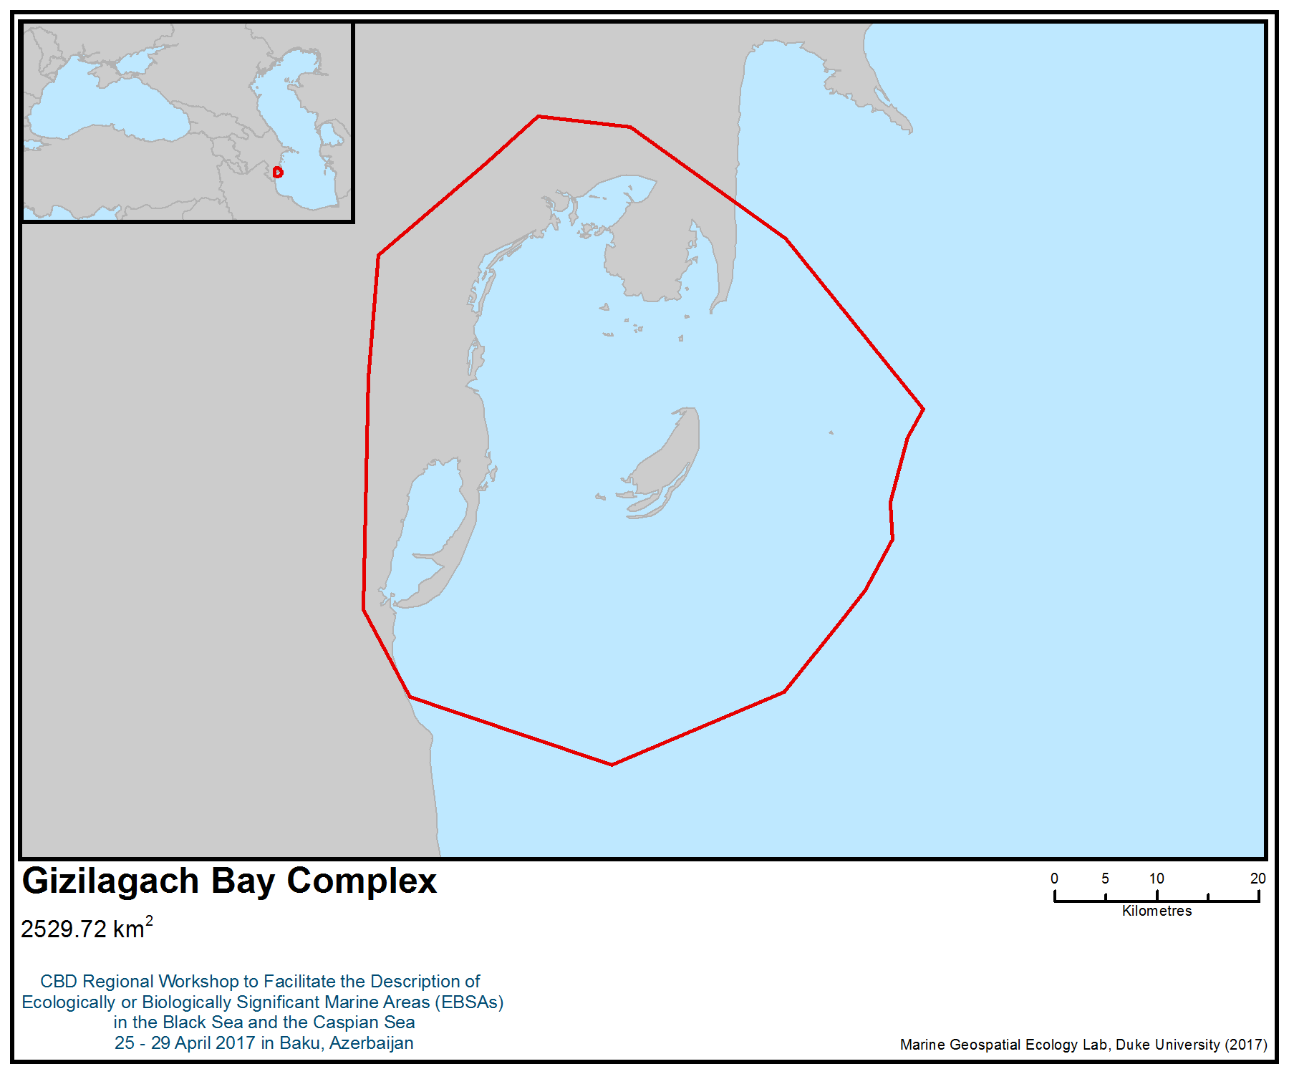

Figure 1. Area meeting the EBSA criteria

Карта Гызыл-Агачского комплекса

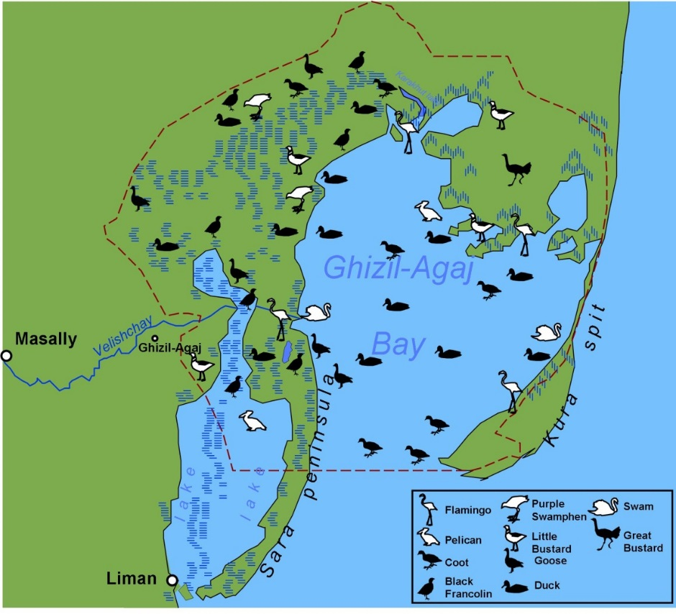
Figure 2. Birds of Gizilagach Bay Complex

Area No. 29: Kura Delta
Наименование/название района: Прикуринское пространство Каспийского моря

Аннотация
Прикуринское пространство Каспия - это район, нагула, зимовки, нерестовых миграций и размножения всех представителей семейства осетровых Каспия, кроме стерляди. Особенно ценным являются персидский осетр и щип, привязанные к реке Кура (Гадживе, Касимов, 2005). В настоящее время их численность ограничена из-за своей товарной ценности. В тоже время они являются экологической ценностью как реликты третичной эпохи. Кроме того, это обширное водно-болотное угодье с густой тростниковой растительностью, сетью дамб и большим островом является важным местом зимовки и гнездования некоторых видов птиц, особенно важно, как место временного отдыха огромного количества птиц в период перелета. По статистическим данным в период перелета численность водно-болотных птиц за один учет достигает 75000 (Sultanov, Haddow, 1997) особей. Здесь встречаются кудрявый и розовый пеликаны, малый баклан, колпица, султанка и другие редкие виды. Данное угодье не имеет охранного статуса. Основным фактором беспокойства здесь являются охота и рыболовство.

The Kura River area of the Caspian Sea is an area of foraging, wintering, spawning migrations and reproduction of all species of the Caspian sturgeon family except for the sterlets. It is an especially valuable area for the Persian sturgeon and pinch, as it is associated with the Kura River. In addition, the area is home to extensive wetlands with dense reed vegetation, a network of dams and a large island that is an important wintering and nesting site for some bird species the area is especially important as a temporary resting place for a large number of birds during their flight. During the migration period, the number of waterbirds in one record reaches 75,000 individuals. Large numbers of curly and pink pelicans, small cormorants, spoonbills, sultan bird and other rare species have been recorded att the site.

Введение
Река Кура - самая крупная река Закавказья. Впадает в Каспийское море, протекает по территории трёх государств: Турции, Грузии, Азербайджана, является основной рекой Грузии и Азербайджана. Протяжённость Куры составляет 1364 км, площадь бассейна 188 тыс. км², длина в пределах Азербайджана 906 км.

Вследствие выноса ила рекой размеры Прикуринского пространства увеличиваются в среднем на 60 м в год. Берега дельты преимущественно низкие, покрытые высокой травой и камышом. Глубины в районе дельты изменяются в зависимости от ветров и количества наносов реки. Колебания уровня воды при сгонно-нагонных явлениях здесь бывают довольно значительны.

В поверхностных слоях температура воды приустьевого пространства повышается в сторону моря, а в глубинных – с севера на юг. В августе температура в месте впадения в Каспий составляет 25-26 Сº. В сентябре, когда здесь температура составляет 19-20 Сº, в море она доходит до 23-24 Сº. Соленость растет от берега в глубь моря от 10-11 до 12,5-13,5 ‰. В самой дельте соленость составляет не более 6-8 ‰, а в самом крупном рукаве – 2-3 ‰. Прозрачность воды в прибрежной полосе не более 1 м, а в море достигает 15-16 м. В маловодное время года прозрачность бывает больше.

Приустьевое пространство образовано двумя рукавами: Северо-Восточным (Норд-Ост Култук) и Юго-Восточным (Зюйд-Ост Култук), которые являются пастбищами всех видов рыб куринского происхождения осетровых, карповых, а также локальных стад и проходных сельдей, бычков, атерин и т. д. (Гадживе, Касимов, 2005). Берег дельты между устьями рукавов сравнительно приглубый. Залив Зюйд-Ост Култук вдается в берег непосредственно от дельты реки Куры. Северо-восточный и северный берега залива низкие, покрытые высокой травой; западный берег песчаный и несколько возвышенный. Залив мелководный; глубины в нем преимущественно менее 5 м, и только на небольшом участке залива вблизи входа в него глубины 5-6 м. В южной части залива грунт – ил с примесью мелкой ракушки, далее к вершине в основном ил. Залив Норд-Ост Култук шириной 1,5 мили окаймляет северо-восточную часть дельты Куры. Глубина на отмели менее 10 метров.

МестонахождениеГеографические координаты приустьевого пространства (см. карту ниже) - 39°16' – 39°25' с.ш.; 49°19' – 49°28' в.д. Географическое положение - Место впадения реки Куры в Каспийское море на территории Нефтечалинского района в 10 км к востоку и юго-востоку от г. Нефтечала. Площадь около 15000 га.Высота над уровнем моря - около –28 м.Тип водно-болотного угодья согласно Рамсарской конвенции F, Tp, Sp. Критерий включения в список - 1a, 2a, 2c, 3a (основные 2c, 3a). Данное угодье не имеет охранного статуса.

The area is located where the Kura River flows into the Caspian Sea in the Neftechalinsky region, 10 km to the east and south-east of the city of Neftechal. The area measures about 15 000 hectares. The altitude above sea level is about 28 m. The geographical coordinates of the near-shore space are 39°16 '- 39 °25' N; 49 °19 '- 49 °28' E.

Описание особенностей предлагаемого района
В Прикуринском пространстве выявлено 34 вида зоопланктона с биомассой 0,03-0,05 г/ м³, 83 вида бентических организмов с биомассой 0,7 г/ м². Данное угодье имеет великолепные кормовые и защитные условия для водно-болотных птиц во все сезоны года, однако фактор беспокойства значителен. Это ценный рыбопромысловый район, где встречаются практически все ценные виды рыб Азербайджана, в общем около 70 видов рыб, причем большинство имеют промысловое значение. Среди них особенно ценные куринский осетр, русский осетр, белуга, севрюга (северо-каспийская и южно-каспийская), каспийский лосось и другие. Прибрежные мелководья западного шельфа Южного Каспия до 10 метровой глубины являются пастбищами молоди рыб, взрослые особи распределяются в основном до 50-70 м, единичные особи крупных рыб до 100 м изобаты. Особенностью каспийской ихтиофауны является большое количество эндемиков, т.е. форм свойственных только этому водоему. Наибольшее количество эндемичных видов и подвидов относятся к семействам сельдевых и бычковых (Гадживе, Касимов, 2005).

Д.Г. Туаев (1975) отмечает здесь 66 видов водно-болотных птиц. Исследования, проведенные в 1995-1996 годах (Sultanov, Haddow, 1997; Султанов, 1997; Султанов Э.Г, Мусаев А.М.), включая вертолетные учеты, показали, что в весенне-летний период выявлено 68 видов водно-болотных птиц, в том числе 2 колонии голенастых и веслоногих птиц. Результаты пеших учетов и учетов с моторной лодки показали, что в этот период общая численность птиц, подсчитанных за один-два дня, составляет 5092-5163 (исключая птиц, скрывающихся в тростнике). Из редких и исчезающих видов мирового значения здесь выявлены кудрявый пеликан P. crispus (в декабре 1995года 108 особей), малый баклан Ph. pygmaeus (884 в гнездовой период), мраморный чирок M. angustirostris, белоглазый нырок A. nyroca, савка O. leucocephala. Из видов, занесенных в Красную книгу Азербайджана – лебедь-шипун C. olor, колпица P. leucorodia, султанка P. porphyrio, розовый пеликан P. onocrotalus (в январе 1996 года 410 вместе с кудрявым пеликаном), белохвостая пигалица Ch. leucura. Среди видов европейского значения – рыжая и желтая цапли, каравайка, серая утка, чирок-трескунок, красноголовый нырок, большой веретенник, шилоклювка, луговая тиркушка, черноголовый хохотун, большой кроншнеп, чеграва, белощека крачка, малая крачка, пестроносая крачка и другие. Результаты вертолетных учетов 1996 года показывают, что численность птиц на зимовке и в период перелета колеблется в пределах 7778 – 74810 особей. Здесь встречаются типичные для Азербайджана водолюбивые виды растений, среди которых основное место занимает тростник.

Состояние объекта и перспективы относительно предлагаемого района
Западное прибрежье Южного Каспия является районом местообитания восстановления численности и запасов, находящихся под угрозой исчезновения видов: осетровых, каспийского лосося, сельдевых. Под отрицательным воздействием антропогенной деятельности, включающей, хроническое нефтяное загрязнение увеличивается количество видов фауны моря и районов моря, имеющих промысловое значение и входящих в разряд исчезающих и сокращающих численностью. Вследствие антропогенной деятельности были потеряны нерестилища осетровых и каспийского лосося, расположенные в среднем течении реки Кура в результате строительства Мингечаурской ГЭС. Площади нерестилищ характеризовались оптимальными скоростями течения речной воды и каменистыми грунтами. В настоящее время нерестилища, расположенные ниже Мингечаурской плотины имеют заиленные площади нерестилищ, а водный режим реки регулируется пропусками воды с ГЭС, срок проведение которых не совпадают с сезоном нереста. Строительство Мингячевирского гидроузла, водохозяйственных сооружений, являющиеся по своему масштабу и народно-хозяйственному значению одними из весьма крупных объектов гидротехнического строительства в бывшем СССР, предусматривало разрешение всех основных задач, связанных с использованием водных ресурсов бассейна реки Куры. Значительной задачей строительства Мингячевирского гидроузла являлось устранение постоянной угрозы затопления около 125 тыс. га земель. В связи с ликвидацией наводнений резко улучшалось санитарное состояние населенных пунктов, прилегающих районов Кура-Аразской низменности. Зарегулированием стока создавались благоприятные условия судоходства по Куре, обусловленные увеличением меженных расходов воды и сокращением минимальных глубин. Одновременно с этим устранялись препятствия для плавания судов, связанные с опасностью подмыва валов волнением. Интенсивность эрозионно-аккумулятивной деятельности реки Куры снизится, русло приобретет большую поперечную устойчивость, заградительные валы станут более устойчивыми от подмыва. В целом строительство Мингячевирского гидроузла, положительно разрешая потребности энергетики, ирригации, здравоохранения и судоходства, в то же время нарушало самые основы Каспийско-Куринского рыбного хозяйства, нанося огромный ущерб естественному размножению рыб. Очевиден тот факт, что Мингячевирская и Варваринская плотины на Куре и Баграмтапинская плотина на Аразе представляют непреодолимую преграду для миграции рыб вверх по рекам, прекращается естественное размножение рыб, нерестующих в горных участках бассейнов обоих рек. Вместе с тем, отрезается большая половина площадей нерестилищ осетровых рыб. Воздействие всех изменений режима рек Кура и Араз в результате зарегулирования стоков на условия воспроизводства рыбных запасов сводилось к катастрофическому уменьшению уловов всех промысловых видов рыб.

Оценка района по критериям выявления экологически или биологически значимых морских районов (ЭБЗР), разработанным в рамках Конвенции о биологическом разнообразии (КБР)

Критерии КБР по выявлению ЭБЗР  (Приложение I к решению IX/20) | Описание  (Приложение I к решению IX/20) | Ранжирование актуальности критериев  (просьба поставить в одной из колонок букву X)
 | Описание  (Приложение I к решению IX/20) | Информации нет |  | Низкая |  |  | Средняя |  | Высокая
Уникальность или малая распространённость | Район, в котором присутствуют либо i) уникальные (единственные в своем роде), редкие (встречаются только в нескольких местах) или эндемичные виды, популяции или сообщества; и/или ii) уникальные, редкие или особые места обитания или экосистемы; и/или iii) уникальные или необычные геоморфологические или океанографические элементы. |  |  |  |  |  |  |  | X
Из редких и исчезающих видов мирового значения здесь выявлены кудрявый пеликан P. crispus, малый баклан Ph. pygmaeus, мраморный чирок M. angustirostris, белоглазый нырок A. nyroca, савка O. leucocephala. Из видов, занесенных в Красную книгу Азербайджана – лебедь-шипун C. olor, колпица P. leucorodia, султанка P. porphyrio, розовый пеликан P. onocrotalus, белохвостая пигалица Ch. Leucura (Sultanov, Haddow, 1997; Султанов, 1997; Султанов Э.Г, Мусаев А.М.).
Особо важное значение для этапов цикла развития видов | Район, необходимый для выживания и успешного обитания популяции. |  |  |  |  |  |  |  | X
Это ценный рыбопромысловый район, где встречаются практически все ценные виды рыб Азербайджана, в общем около 70 видов рыб (Гаджиев, Касимов, 2005).
Важное значение для угрожаемых, находящихся под угрозой исчезновения или исчезающих видов и/или мест обитания | Район, содержащий место обитания для выживания или восстановления находящихся под угрозой исчезновения, угрожаемых или исчезающих видов; или район, содержащий значительные сообщества таких видов. |  |  |  |  |  |  |  | X
В Прикуринском пространстве особенно ценными и на который введен мораторий видами являются: куринский осетр, русский осетр, белуга, севрюга (северо-каспийская и южно-каспийская). Они являются экологической ценностью как реликты третичной эпохи (Гаджиев, Касимов, 2005).
Уязвимость, хрупкость, чувствительность или медленные темпы восстановления | Район, содержащий относительно большое число чувствительных мест обитания, биотопов или видов, функционально хрупких (чрезвычайно подверженных деградации или истощению вследствие антропогенной деятельности или природных событий) или отличающихся медленными темпами восстановления. |  |  |  |  |  |  |  | X
Плотина представляет непреодолимую преграду для миграции рыб вверх по рекам, прекращается естественное размножение рыб, нерестующих в горных участках бассейнов рек. Вместе с тем, отрезается большая половина площадей нерестилищ осетровых рыб. Воздействие всех изменений режима рек Кура и Араз в результате зарегулирования стоков на условия воспроизводства рыбных запасов сводилось к катастрофическому уменьшению уловов всех промысловых видов рыб (Абдурахманов, 1976)
Биологическая производительность | Район, в котором содержатся виды, популяции или сообщества, обладающие сравнительно высокой естественной биологической производительностью. |  |  |  |  |  | X
Это водно-болотное угодье с густой тростниковой растительностью, сетью дамб и большим островом является важным местом зимовки и гнездования некоторых видов птиц, особенно важно, как место временного отдыха огромного количества птиц в период перелета. По статистическим данным в период перелета численность водно-болотных птиц за один учет достигает 75000 особей. Здесь встречаются кудрявый и розовый пеликаны, малый баклан, колпица, султанка и другие редкие виды. (Sultanov, Haddow, 1997; Султанов, 1997; Султанов Э.Г, Мусаев А.М.).
Биологическое разнообразие | Район, отличающийся сравнительно высоким разнообразием экосистем, мест обитания, сообществ или видов или более высоким генетическим разнообразием. |  |  |  |  |  |  |  | X
Объяснение ранжирования
Прикуринское пространство является пастбищами всех видов рыб куринского происхождения осетровых, карповых, а также локальных стад и проходных сельдей, бычков, атерин и т. д.(Гадживе, Касимов, 2005)
Естественность | Район, отличающийся сравнительно высокой степенью естественности благодаря отсутствию или низкому уровню антропогенных нарушений или деградации. |  |  |  |  | X
Объяснение ранжирования
Вследствие строительства Мингечаурской ГЭС были потеряны нерестилища осетровых и каспийского лосося, расположенные в среднем течении реки Кура. Строительство Мингячевирского гидроузла нарушало самые основы Каспийско-Куринского рыбного хозяйства, нанося огромный ущерб естественному размножению рыб. (Абдурахманов, 1976)

Библиография
Абдурахманов Ю.А. Фауна Азербайджана, т. 7, (Рыбы), Баку, Элм, 1976, 222с (на азерб яз.).
Гаджиев Р.В., Касимов Р.Ю. Осетровые и лососевые Купмнско-каспийского региона, их биологические группы и эколого-физиологические особенности. Баку 2005.
Kura River Discharge at Surra (англ.). River Discharge Database. Center for Sustainability and the Global Environment (1930-1984). Проверено 12 марта 2010. Архивировано из первоисточника 26 августа 2011.
Кура, река на Кавказе // Энциклопедический словарь Брокгауза и Ефрона : в 86 т. (82 т. и 4 доп.). — СПб.,1890—1907.
Касымов А.Г. Донная фауна прудов Устеь-Куринского и Алибайрамлинского рыбхозов. Биологические ресурсы внутренних водоемов Азербайджана, Элм, Баку, 1975,с. 72-101
Лиходеева Н.Ф. Зоопланктон Усть-Куринского Нерестово-выростного хозяйства. Известия АН Азерб. ССР, 1968, № 4, с. 55-60.
Отчет Росгидромет Каспийский Морской Научно-Исследовательский Центр, 2006
Султанов Э.Г. Основные итоги авиаучета водных птиц в Азербайджане в 1996 г. “Научное наследие Н.Я. Динника и его роль в развитии современного естествознания”, Ставрополь,1997, с. 123-125.
Туаев Д.Г. Материалы по фауне и экологии водоплавающих и болотных птиц Кура-Араксинской низменности в современных условиях. Материалы по фауне и экологии наземных позвоночных Азербайджана. Баку, Элм, 1975., с. 151-188.
Sultanov Elchin, Haddow Caroline (1997): AIOC ornithological surveys in Azerbaijan. December 1995 to February 1997. – Proceeding of the fourth Baku International congress on energy, ecology, economy. Baku, Sept., 23-26, p. 134-141.

Карты и рисунки
Права и разрешения

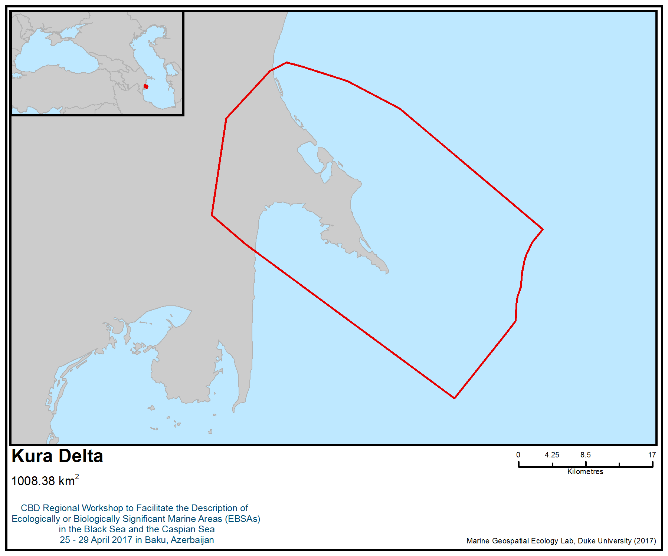
Figure 1. Area meeting the EBSA criteria

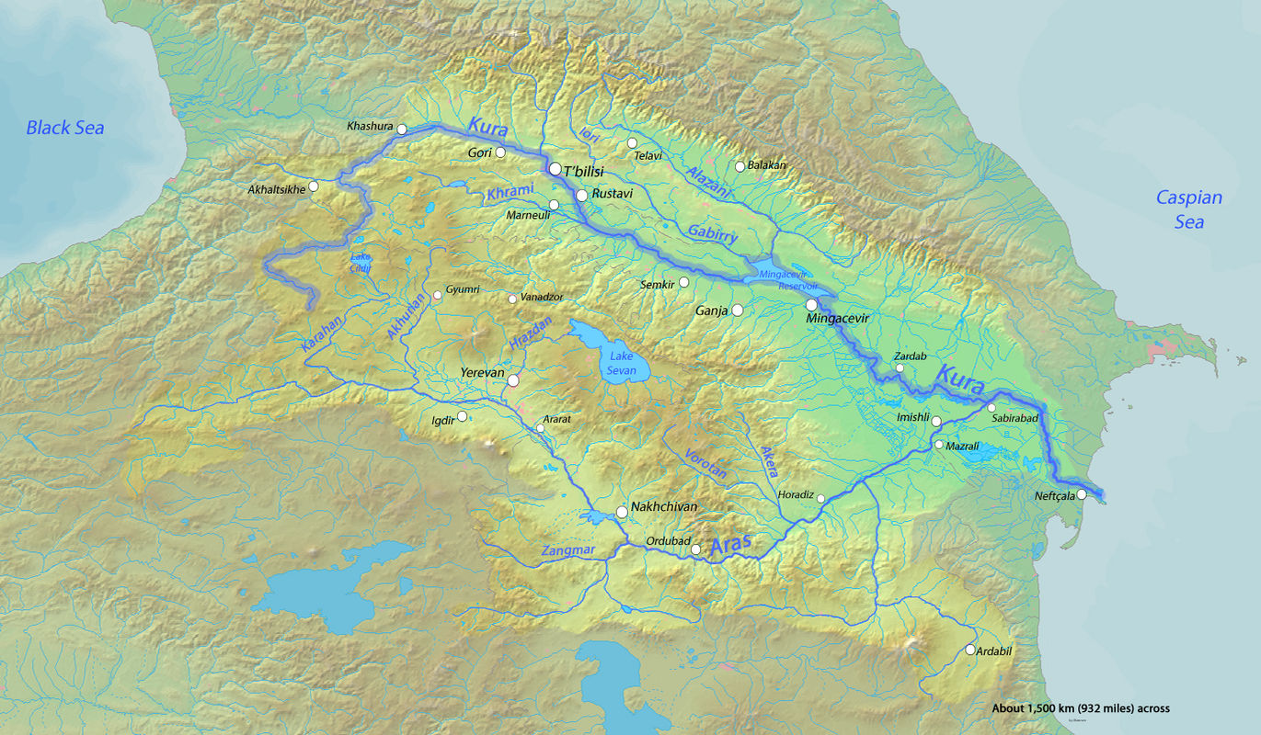
Figure 2. Kura River and its drainage basin

Area No. 30: Samur - Yalama

Abstract
Samur – Yalama includes the deepest nearshore area in the Caspian Sea, with a steep underwater slope. The area is highly important for the life history stages of at least 20 species of fish, and it is a critically important migration corridor and feeding ground for both juveniles and adults. It is also an important bird area, serving as a flyway segment and critical stopover and nesting area for waterfowl. It is also highly significant for all five species of critically endangered sturgeon species (IUCN Red List) and several other protected species of fishes and birds.

Introduction
The deep-water basin is closer to the shore in the Samur – Yalama area than anywhere else in the Caspian, and the shelf and submarine slope of the Caspian Sea are characterized by the greatest steepness. These features and the stability of the sea currents give the region exceptional importance as a migratory corridor and feeding grounds for a number of fish species from the populations of both the northern and southern Caspian. Thisis a transboundary area between Azerbaijan and the Russian Federation. Materials for the description of the area were provided on the basis of studies conducted in the last 20 years. It should be noted that the publications used (Guseynova, 2013) cover a wider water area than the area.

В прибрежной зоне на границе Азербайджана и Российской Федерации (Республика Дагестан) (в районе устья р. Самур) в районе, где глубоководная котловина ближе, чем где-либо на Каспии подходит к берегу, а шельф и подводный склон впадины Каспийского моря характеризуются наибольшей крутизной. Эти особенности и устойчивость морских течений придают району исключительную важность как миграционного коридора и места откорма целого ряда видов рыб из популяций как Северного, так и Южного Каспия, зоной контакта которых район является. Район предложен азербайджанскими и российскими экспертами как трансграничный между Азербайджаном и Россией. Материалы для описания района предоставлены азербайджанскими и российскими экспертами на базе исследований, проводившихся в последнее двадцатилетие. Необходимо учитывать, что использованные публикации (Гусейнова, 2013) охватывают более широкую акваторию, чем предложенный район, и детализация их в будущем весьма желательна.

Location
Samur-Yalama covers an area of 1,250 km², is located in the coastal zone on both sides of the Russian-Azerbaijani border, along which the Samur River flows, and which eventually flows into the Caspian Sea. The site includes the mouth of the Samur River and a number of smaller rivers that start in the mountains of the Caucasus Range; the marine area consists only of the 200 m isobath.

Samur-Yalama covers an area of 1,250 km² along both sides of the Russian-Azerbaijani border, following the flow of the Samur River, which eventually meets the Caspian Sea. The site includes the mouth of the Samur River and a number of smaller rivers that start in the mountains of the Caucasus Range; its marine area consists only of the 200 m isobath.

Морской участок Самур-Ялама площадью 1250 km² находится по обе стороны от российско-азербайджанской границы вдоль которой протекает река Самур, впадающая в Каспий. Участок включает устье р.Самур и ряда более мелких рек, берущих свое начало в горах Кавказского хребта, а в мористой части ограничивается изобатой 200 м.

Feature description of the area
Geographical characteristics
The marine area of Samur-Yalama is located along the western coast of the middle Caspian. The middle part of the Caspian Sea is a separate basin, known as the Derbent Depression, charcaterized by the maximum depth of 788 m, and the average depth of 190 m. The western slope of the Derbent Depression is narrow and steep, and the eastern slope is greatly stretched. The bottom of the depression is a weakly inclined plain with depths mainly reaching from 400 to 600 m.

The characteristic features of the climate are the prevalence of anticyclonic atmospheric circulation, strong temperature changes throughout the year, a fairly cold and windy winter and a hot, dry and relatively calm summer. The dominant winds and wave propagation are in the north-west and south-east directions (Zhindarev et al., 2013).

The shores are mostly alluvial, and in some areas abrasion shores are observed. The shelf sediments are dominated fine-grained terrigenous deposits. In a relatively shallow coastal zone (with depths of up to 100 m) shell debris, and coarse and fine sand predominate. At depths of 100-200 m, sediments are dominated by fine sand and silt fraction mixed with shell (Zhindarev et al., 2013).

The Samur River is one of the four rivers flowing into the Caspian Sea that are the main suppliers of terrigenous sedimentary material. Its water is characterized by an exceptional turbidity (Zhindarev et al., 2013). The slope is characterized by considerable erosion activity associated with turbidity flows, which supply the basin bed with sediments (Lebedev et al., 1973).

Water circulation is determined by dominating winds and is characterized by considerable seasonal variability. In accordance with the prevailing wind direction, the Samur-Yalama region is characterized by relatively stable south-easterly currents (Dobrovolsky and Zalogin, 1982; Fig. 1). The main stream of about 30 – 40 cm sec-1 velocity follows the isobaths 50-70 m, and the maximum velocity can reach 80-100 cm / s (Zhindarev et al., 2013). Wave mixing and surge play a major role in the formation of the coastal zone regime (Zhindarev et al., 2013).

Plankton communities
A high concentration of nutrients creates generally favourable conditions for phytoplankton development in the coastal zone. Phytoplankton biomass in vegetational season is somewhat lower than in the northern Caspian but higher than in the deep waters (Guseynova, 2013).

Phytoplankton of the middle Caspian consists of 225 species, three times greater than in the southern Caspian. Directly in the Samur – Yalama area, 71 species was recorded, with diatoms comprising 42%, while dynophytes and cyanobacteria hold the second and the third ranks, respectively (Guseynova, 2013).

Zooplankton biomass is relatively stable, usually not exceeding 300 mg m-3, which is clearly less than in the northern Caspian. These data refer to early to mid-2000s, when zooplankton was heavily predated by the invasive ctenophore Mnemiopsis leydi. Zooplankton of the Caspian Sea consists of 316 species, while the number of species in the middle Caspian, including the Samur – Yalama area, amounts to 197, including 112 species of ciliates, two species of cnidarinas and ctenophores, nine rotifers, 38 cladoceran species, 10 copepods, six mysids, five cumaceans and six amphipods (Guseynova, 2013).

Benthos
Of the 380 species of macrozoobenthos, 356 have been recorded in the middle Caspian. The bulk of the fauna consists of autochtonous Caspian species representing remnants of the marine Tertiary fauna, which have survived and evolved through numerous changes of the hydrological regime of the Caspian basin. Species diversity and biomass of benthos decline with increasing depth. Abundance and biomass of zoobenthos in the middle Caspian is decreasing from west to east (Karpinsky, 2002). In the macrobenthos of the Dagestan part of Samur – Yalama area, 45 species have been recorded, seven of which are invasive alien species from the Azov – Black Sea basin. Benthic biomass is relatively high (> 100 g/m³), providing appropriate resources for benthic-feeding fish, including sturgeons (Guseynova, 2013).

Ichtyofauna
For a relatively small area of the Samursky Reserve, including the lower part of the river ,60 fish species—including many Caspian endemics—have been recorded (Barkhalov, Rabadanaliev, 2014). Clupeids (Caspian herring), cyprinids, and gobiids comprise 75% of the ichtyofauna. All Caspian marine sturgeon species are recorded (Barkhalov et al., 2012; Barhalov, Rabadanaliev, 2014).

The Samur-Yalama area is importnat as a wintering and feeding ground and, especially as a migration route for fish, including Caspian clupeids (Clupeonella grimmi, Clupeonella delicatula caspia, Alosa brashnikovi brashnikovi, Alosa saposhnikovii, Alosa caspia caspia), kutum and sturgeons (M. Ahundov, pers. comm., Fig. 2). The area is a critically important migration corridor and feeding ground for juvenile and adult Caspian lamprey (Caspiomyzon wagneri, IUCN Red List, near threatened, Red Data Books of Russia), beluga sturgeon (Huso huso, IUCN Red List, critically endangered), Russian sturgeon (Acipenser gueldenstaedtii, IUCN Red List, critically endangered), starry sturgeon (Acipenser stellatus, IUCN Red List, critically endangered), Persian sturgeon (Acipenser gueldenstaedti, persicus; IUCN Red List, critically endangered), ship (Acipenser nudiventris; critically endangered, IUCN, Red Data Books of Azerbajan and Russia) and Caspian trout (Salmo caspium; Red Data Book of Azerbaijan) (Barhalov, Rabadanaliev, 2014).

Marine mammals, aquatic birds and waterfowl
Caspian seals occur in the area round year, but their abundance increases during seasonal migrations in spring and autumn (M. Ahundov, pers. comm.). About 80 species of birds of different migratory status (more than 70 species of migratory species, 15 nesting species, 2 local species and nine– wintering species) occur in the coastal zone of Samur-Yalama. Rare and endangered bird species occur seasonally, including 12 that are listed in the Red Data Book of Azerbaijan and 10 are on the IUCN Red List. A large accumulation of wintering birds is concentrated on Lake Agzybir (Divichinsky Liman) (M. Ahundov, pers. comm.).The main migration routes of many species of waterfowl pass through the western coast of the middle Caspian. The autumn migration of birds along the Caspian coast is longer and can continue, depending on the weather conditions, for five months — from August to December. The most intensive migration takes place in October and November. The spring migration of birds covers the period from February to April, with a maximum number of birds passing by from February to March. The number of migrating birds decreases in April. During the spring and autumn migration, half a million to a million waterfowl can congregate in the mouth of the River Samur (Dzhamirzoev, Bukreev, 2009).

Физико-географическая характеристика участка. Морской участок Самур-Ялама находится вдоль западного побережья Среднего Каспия. Средняя часть Каспийского моря представляет собой обособленную котловину, область максимальных глубин которой, Дербентская впадина, смещена к западному берегу. Средняя глубина этой части моря – 190 м, наибольшая – 788 м. Западный склон Дербентской впадины узкий и крутой, восточный склон сильно растянут. Дно впадины представляет собой слабонаклоненную равнину с глубинами, в основном, от 400 до 600 м.
Характерные черты климата – преобладание антициклональных условий погоды, резкие перепады температуры в течение года, достаточно холодная и ветреная зима и жаркое, сухое и относительно спокойное лето. Преобладающие ветры и волнение имеют северо-западное и юго-восточное направления (Жиндарев и др., 2013).
Берега большей частью аллювиальные, лишь на отдельных участках – абразионные. Шельф сложен из мелкозернистых терригенных отложений. В сравнительно мелководной прибрежной зоне (с глубинами до 100 м) преобладает крупная и мелкая ракуша, крупный и мелкий песок. На участке с глубинами 100-200 м – мелкие песчаные фракции и ил, частично цельная и битая мелкая ракуша (Жиндарев и др., 2013).
Река Самур входит в число четырех рек Каспия, являющихся основными поставщиками терригенного осадочного материала в море. Самурская вода характеризуется исключительной мутностью (Жиндарев и др., 2013). Для склона характерна значительная эрозионная активность, связанная с мутьевыми потоками, которые заполняют осадками ложе котловины (Лебедев и др., 1973).
Циркуляция вод связана с преобладающими ветрами и характеризуется значительной сезонной изменчивостью. В соответствии с преобладающим направлением ветров для данного района Самур - Ялама характерны относительно устойчивые течения юго-восточного направления (Рис. 1). Стрежень течения следует вдоль изобаты 50–70 м со скоростями 30–40 см/с, максимальные скорости по натурным наблюдениям могут достигать 80–100 см/с (Жиндарев и др., 2013). Большую роль в формировании режима береговой зоны играет частое волнение и сгоны/ нагоны воды (Жиндарев и др., 2013).
Планктонные сообщества. Высокая концентрация биогенов создает в целом благоприятные условия для развития фитопланктона в прибрежной зоне, биомасса которого в вегетационный сезон несколько меньше, чем в Северном Каспии, но больше, чем в области глубоководной котловины (Гусейнова, 2013).
В фитопланктоне Среднего Каспия отмечено 225 видов водорослей, почти в 2 раза меньше, чем в Северном Каспии, но в 3 раза больше, чем Южном. При этом непосредственно в районе Самур – Ямала отмечен 71 вид, преобладают диатомовые (42%), а второе и третье места занимают динофитовые и цианобактерии (Гусейнова, 2013).
Концентрация зоопланктона в различные сезоны года характеризуется стабильностью и обычно не превышает 300 мг/ м3, что заметно меньше, чем в северном Каспии. Следует, однако, учитывать, что эти данные относятся к первой половине – середине 2000-х гг., когда зоопланктон подвергался особенно значительному выеданию видом-вселенцем – гребневиком Mnemiopsis leydi (Гусейнова, 2013). В зоопланктоне Каспийского моря обнаружено 316, а в акватории участка EBSA Самур-Ялама, как и во всем Среднем Каспии – 197 видов и подвидов животных организмов, из которых инфузории – 112 видов, кишечнополостные – 1, коловратки – 9, ветвистоусые рачки – 38, веслоногие рачки – 10, мизиды – 6, кумовые – 5, амефиподы – 6, изоподы – 1, клещи – 1, гребневики – 1 и прочие (личинки донных организмов) (Гусейнова, 2013).
Бентос. Из 380 видов макрозообентоса (донных животных), обитающих в Каспийском море, в Среднем Каспии представлено 356 видов. Среди них преобладают виды автохтонного каспийского комплекса (287 видов), представляющие собой остатки морской третичной фауны, претерпевшей многократные изменения гидрологического режима водоема. Видовое разнообразие и биомасса макробентической фауны значительно уменьшается с увеличением глубины. Максимальные плотность и биомасса макробентоса наблюдаются в западном, а минимальные – в восточном направлении (Карпинский, 2002). В составе макрозообентоса дагестанской части EBSA указывается около 45 видов, семь из которых приходится на долю вселенцев из Азово-Черноморского бассейна. Биомасса бентоса достигает достаточно высоких значений (более 100 г/ м3), что создает хорошую кормовую базу для бентосоядных рыб, включая осетровых (Гусейнова, 2013).
Ихтиофауна. Морской участок EBSA Самур-Ялама имеет важное значение для зимующих и нагуливающихся здесь рыб, а также охватывает участки миграционных путей проходных и морских видов рыб. Для сравнительно небольшого участка заказника «Самурский» с учетом нижней части реки указывается 60 видов рыб, включая много каспийских эндемиков (Бархалов, Рабаданалиев, 2014). По количеству форм (видов и подвидов) преобладают рыбы из семейств сельдевых, карповых и бычковых, которые в совокупности составляют около 75 % всех видов рыб участка. Из них все осетровые рассматриваются в Красном списке IUCN как critically endangered; в Красную книгу Азербайджана и России внесены шип Acipenser nudiventris derjavini, в Красную Книгу России – каспийская минога (Caspiomyzon wagneri), а в Красную Книгу Азербайджана кроме того – каспийский лосось Salmo сaspium.
Морские млекопитающие и птицы. На морском участке EBSA Самур-Ялама тюлени обитают круглый год, но их численность относительно возрастает в основном во время сезонных миграций весной и осенью ().
На морском участке Самур-Ялама и прилегающей к ней прибрежной территории представлено примерно 80 видами птиц, имеющими смешанный характер пребывания (более 70 видов пролетные, 15 видов – гнездящиеся, 2 – оседлые и 9 – зимующие). В различные сезоны года здесь обитают редкие и находящиеся под угрозой исчезновения виды птиц, из которых 12 занесены в Красную Книгу Азербайджана и 10 – в Красный спиоск IUCN. Очень большое скопление зимующих птиц сосредоточено на оз.Агзыбир (Дивичинский лиман) (REF).
Через западное побережье Среднего Каспия проходят основные миграционные пути многих видов водоплавающих и болотных птиц. Осенний пролет птиц вдоль Каспийского побережья более длительный и продолжается в зависимости от погодных условий пять месяцев – с августа до декабря. Интенсивный пролет с максимальной численностью птиц происходит в течение октября и ноября. Весенний пролет птиц охватывает период с февраля по апрель, с максимальной численностью птиц с февраля по март. Интенсивность весеннего пролета птиц затухает в апреле. На весеннем и осеннем пролете в устье р. Самур может концентрироваться от полумиллиона до миллиона водоплавающих птиц (Джамирзоев, Букреев, 2009).

Feature condition and future outlook of the area
The shelf area off the mouth of the River Samur retains many features of the natural state of the marine ecosystem. Two branches of the river delta are diverted from the lower part of Samur: to the north (Samur-Dagestan) and to the south (Samur-Apsheronsky), but this does not have much influence on the river discharge, which remains the main supplier of fresh water and terrigenous material in the middle part of the western coast of the Caspian. The area is currently devoted mainly to agriculture on the coast and fisheries (Djamirzoev and Bukreev, 2009; Zhindarev et al., 2013). The main seaports and oil production areas are located far beyond the region. Pollution from terrestrial sources, carried to the sea bythe River Samur, is much less than what is delivered by the rivers of the northern Caspian, and the coastal waters of the south of Dagestan are estimated as “moderately polluted” or even “clean” (Guseynova, 2013). Marine fishing is limited in comparison with other areas due to difficult hydrometeorological conditions, and passing through the state border between Russia and Azerbaijan creates the prerequisites for regular control of sturgeon poaching. At the same time, the marine ecosystem in the area under consideration, as elsewhere in the Middle Caspian, has undergone a significant change due to the introduction of invasive alien species that created new communities of macrobenthos, in particular the dominance of such attached mollusks as Mytilaster lineatus, Abra segmenta, the barancle Balanus improvisus (Karpinsky, 2002, 2010; Guseynova, 2013). In the late 1990ss to the early 2000's, an invasion of the ctenophore Mnemiopsis leydi (Guseynova, 2013), which entered the Caspian Sea from ballast water, had a significant impact on plankton communities and planktonic larvae of fish and benthic invertebrates . It can be assumed that invasions of alien species will continue to be an important factor affecting ecosystems in the region.

Шельфовый участок в районе устья р. Самур сохраняет много черт естественного состояния морской экосистемы. От нижнего участка Самура отведены два канала - на север (Самуро-Дагестанский) и на юг (Самуро-Апшеронский), но это не оказывает большого влияния на сток реки, остающейся основным поставщиком пресной воды и терригенного материала средней части западного побережья Каспия. Хозяйственная деятельность пока ограничивается, в основном, сельским хозяйством на побережье и рыболовством (Джамирзоев, Букреев, 2009; Жиндарев и др., 2013). Основные морские порты и районы добычи нефти расположены далеко за пределами района. Загрязнение от наземных источников, выносимое в море р. Самур существенно меньше того, что доставляется реками Северного Каспия, а прибрежные воды юга Дагестана оцениваются как «умеренно загрязненные» или «чистые»; (Гусейнова, 2013). Морское рыболовство ограничено по сравнению с другими районами из-за сложных гидрометеорологических условий, а прохождение в районе государственной границы между Россией и Азербайджаном создает предпосылки для постоянного эффективного контроля браконьерства осетровых рыб. В то же время морская экосистема на рассматриваемом участке, как и повсеместно в Среднем Каспии, подверглась значительному изменению за счет интродукции чужеродных видов, создавших новые сообщества макробентоса, в частности с доминированием таких прикрепленных и малоподвижных средообразующих Mytilaster lineatus, Abra segmenta, Balanus improvisus (Карпинский, 2002; Гусейнова, 2013). В конце 1990-х – начале 2000-х гг. значительное воздействие на планктонные сообщества и личиночные гемипопуляции рыб и донных беспозвоночных было оказано вселившимся в Каспийское море с балластными водами гребневиком Mnemiopsis leydi (Гусейнова, 2013). Можно предполагать, что инвазии чужеродных видов и в дальнейшем останутся существенным фактором, влияющим на экосистемы района.

Specially protected areas
На территории России в районе впадающего в море рукава дельты Самура Малый Самур существует государственный федеральный заказник Самурский, находящийся под управлением государственного природного заповедника Дагестанский и включающий морскую акваторию до изобаты 20 м (на расстоянии 500 м от береговой линии). Существует проект создания национального парка на базе заказника с сохранением морской акватории.

Assessment of the area against CBD EBSA Criteria

CBD EBSA Criteria  (Annex I to decision IX/20) | Description  (Annex I to decision IX/20) | Ranking of criterion relevance  (please mark one column with an X)
CBD EBSA Criteria  (Annex I to decision IX/20) | Description  (Annex I to decision IX/20) | No information |  | Low |  |  | Medium |  | High
Uniqueness or rarity | Area contains either (i) unique (“the only one of its kind”), rare (occurs only in few locations) or endemic species, populations or communities, and/or (ii) unique, rare or distinct, habitats or ecosystems; and/or (iii) unique or unusual geomorphological or oceanographic features. |  |  |  |  |  | X
Explanation for ranking
The area is remarkable for its bathymetric features, as it has a steep slope and a deep Derbent Depression located in close vicinity to the shore and marine currents that are relatively stable for the Caspian Sea (Zhindarev et al., 2013). These conditions make the area a unique interaction zone for fish populations from the north and the south of the Caspian Sea.
Special importance for life-history stages of species | Areas that are required for a population to survive and thrive. |  |  |  |  |  |  |  | Х
Explanation for ranking
The area is important as a wintering and feeding ground and, especially as a migration route for fish, including such as Caspian clupeids (Clupeonella grimmi, Clupeonella delicatula caspia, Alosa brashnikovi brashnikovi, Alosa saposhnikovii, Alosa caspia caspia), kutum and sturgeons (Ahundov, 2008; Ahundov et al. 2013; Ahundov et al. 2008; Barhalov et al., 2012)
The area is a critically important migration corridor and feeding ground for juveniles and adults of at least 20 species of fishes (Ahundov, 2008; Ahundov et al. 2013; Ahundov et al. 2008). Samur – Yalama and the adjacent coastal zone contain habitats for at least 80 species of waterfowl and associated with waterbirds (more than 70 migrating, species 15 nesting species, 2 resident species, 9 wintering species) (Dzhamirzoev and Bukreev, 2009). During the spring and autumn migrations the Samur mouth wetland harbours from 0.5 million to 1.0 million waterfowl; the area is of particular importance for the great cormorant (Phalacrocorax carbo) and swans (Cygnys cygnys, Cygnus olor) (Dzhamirzoev and Bukreev, 2009).
Importance for threatened, endangered or declining species and/or habitats | Area containing habitat for the survival and recovery of endangered, threatened, declining species or area with significant assemblages of such species. |  |  |  |  |  |  |  | Х
Explanation for ranking
The area is a critically important migration corridor and feeding ground for juvenile and adult Caspian lamprey (Caspiomyzon wagneri, IUCN Red List, near threatened, Red Data Books of Russia), beluga sturgeon (Huso huso, IUCN Red List, critically endangered), Russian sturgeon (Acipenser gueldenstaedtii, IUCN Red List, critically endangered), starry sturgeon (Acipenser stellatus, IUCN Red List, critically endangered), Persian sturgeon (Acipenser gueldenstaedti, persicus; IUCN Red List, critically endangered), ship (Acipenser nudiventris; critically endangered, IUCN, Red Data Books of Azerbajan and Russia), Caspian trout (Salmo caspium; Red Data Book of Azerbaijan) (Barhalov and Rabadanaliev, 2014).

Coastal wetlands are home to rare and endangered bird species, with 12 species listed in the Red Data Book of Azerbajan and 10 species listed in the IUCN Red List (Dzhamirsoev and Bukreev, 2009; (Ahundov, 2008; Ahundov et al. 2013; Ahundov et al. 2008). Nesting colonies of the Dalmatian pelican are of particular importance (Dzhamirsoev and Bukreev, 2009).
Vulnerability, fragility, sensitivity, or slow recovery | Areas that contain a relatively high proportion of sensitive habitats, biotopes or species that are functionally fragile (highly susceptible to degradation or depletion by human activity or by natural events) or with slow recovery. |  |  |  |  |  | Х
Explanation for ranking
The importance of the area is largely related to its use by five species of sturgeon, each being highly vulnerable as long maturing and long-living. On the other hand, these species are migratory and are able to move to other regions. Other components of biological diversity are dynamic and have been able to survive the significant transformation of the Caspian Sea ecosystem in recent decades (Karpinsky, 2002, 2010; Guseynova, 2013).
Biological productivity | Area containing species, populations or communities with comparatively higher natural biological productivity. |  |  |  |  |  | Х
Explanation for ranking
Contemporary data on chlorophyll a distribution, phytoplankton, zooplankton and macrobenthos biomass (Guseynova, 2013) indicate the area to be productive but not highly productive at the scale of the Caspian Sea (Karpinsky, 2002; Guseynova, 2013).
Biological diversity | Area contains comparatively higher diversity of ecosystems, habitats, communities, or species, or has higher genetic diversity. |  |  |  |  |  |  |  | Х
Explanation for ranking
In this area, there is a combination of various biotopes within a relatively small area (Karpinsky, 2002), i.e. from the river delta to deep-water habitats (Dzhamirzoev and Bukreev, 2009; Zhindarev et al., 2013), a significant number of fish species, and an interaction zone of populations from the northern and the southern part of the Caspian (Barhalov and Rabadanaliev, 2014) (indication of genetic diversity). This makes it possible to consider the area a spot of high biological diversity at the regional scale.
Naturalness | Area with a comparatively higher degree of naturalness as a result of the lack of or low level of human-induced disturbance or degradation. |  |  |  |  |  |  | X
Explanation for ranking
Although the plankton and benthic communities of the Middle Caspian have been affected by alien species invasions (Karpinsky, 2010; Guseynova, 2013), and fish stocks are impacted by general fisheries in the Caspian Sea, economic activities around the area are concentrated onshore, where protected areas are established (Dzhamirzoevand Bukreev, 2009; Zhindarev et al., 2013). The area is distant from main seaports, intensive shipping routes and oil production zones in the region, which makes it relatively natural at the regional scale.

References
Akhundov M (2008) Present state of the Caspian ecosystem and bioresources. Volume I. Bakı: Elm, 2008. In: Proceedings of the Azerbaijan Zoological Society, v.1, Baku, Nauka. pp. 400–407.
Akhundov M, Zarbalyeva T, Gadjiev R, Kasmov A (2008) State of bioresources and Caspian ecosystem based on recent investigations. Complex approach to preservation and recovery of Caspian bioresources. In: Proceedings of Scientific Conference, Astrakhan, pp 33–36.
Akhundov M. et al. 2013. Preservation and restoration of biological resources of the Caspian Sea (devoted to 100th anniversary of Azerbaijan Fisheries Research Institute). Collection of articles. - Baku: “Elm”, 532 p.
Бархалов Р.М., Рабаданалиев З.Р. 2014. Инвентаризация рыб и рыбообразных участков заповедника и подведомственных заказников ГПЗ «Дагестанский». Труды государственного природного заповедника «Дагестанский». Вып. 9.Махачкала: АЛЕФ. С. 124–132.
(Barhalov H.M. and Rabadanaliev Z.R. 2014. Inventory of fishes and cyclostomes of the Dagaestanskiy Zapovednik and subordinated reservers. In: Trudy (Proceedings) of the State Nature Zapovednik Dagestanskiy. Vol. 9. Mahachkala: Alef, pp. 124–132).
Бархалов Р.М.,Мирзоев М.З., Куняев К.М. 2012. Рыбы заповедника «Дагестанский». Махачкала: Алеф, 230 с.
(Barhalov R.M., Mirzoev M.Z. and Kuliev K.M. 2012. Fishes of Zapovednik “Dagestanskiy”. Mahachkala: Alef, 230 p.)
Добровольский А.Д., Залогин Б.С. 1982. Моря СССР. М.: Изд-во МГУ. 180 с.
(Dobrovolsky A.D. and Zalogin B.S. 1982. Seas of USSR. Moscow: Moscow University Publishing, 180 pp.)
Джамирзоев Г.С., Букреев С.А. 2009. Устье реки Самур. В кн. Ключевые орнитологические территории России. Т. 3. Ключевые орнитологические территории международного значения в Кавказском регионе. Под ред. Г.С. Джамирзоева и С.А. Букреева.М.: Wetlands International. С. 207 – 208.
Dzhamirzoev G.S. and Bukreev S.A. 2009. Samur Mouth. In: Important Bird Areas of Russia. Vol. 3. Important Bird Areas in the Caucasian Region. Edited by G.S. Dzhamirzoev and S.A. Bukreev. Wetlands International. pp. 207 – 208.
Жиндарев Л.А., Игнатов Е.И., Бадюкова Е.Н., Лукьянова С.А., Соловьева Г.Д., Шипилова Л.М. 2013. Научное обеспечение сбалансированного планирования хозяйственной деятельности на уникальных морских береговых ландшафтах и предложения по его использованию на примере Азово-Черноморского побережья. Том. 6. Каспийское море. Геленджик: Южное отделение ИО РАН. С. 940–1066.
Гусейнова С.А. 2013. Оценка современного экологического состояния Каспийского моря и возможные последствия при эксплуатации нефтегазовых месторождений. М.: Товарищество научных изданий КМК. 165 с.
(Guseynova S.A. 2013. Assessment of the contemporary environmental condition of the Caspian Sea and possible consequence of oil and gas development. Moscow: KMK, 165 pp.)
Карпинский М.Г. 2002. Экология бентоса Среднего и Южного Каспия. М.: Изд. ВНИРО. 283 с
(Karpinsky M.G. 2002. Ecology of benthos of the Middle and the Southern Caspian. Moscow: VNIRO, 283 p.)
Karpinsky, M.G. 2010. On peculiarities of introductions of marine species into the Caspian Sea. Russian Journal of Biological Invasions. 2010 (1): 1–7.
Khodorevskaya R. et al. (2014) State and Dynamics of the Bioresources in the Caspian Sea. In: The Handbook of Environmental Chemistry. Springer, Berlin, Heidelberg, p.1-84
Лебедев Л.И., Маев И.Г., Бордовский О.К., Кулакова Л.С. 1973. Осадки Каспийского моря. М.: Наука. 119 с.
(Lebedev L.I., Maev I.G., Bordovsky O.K. and Kulakova L.S. 1973. Sediments of the Caspian Sea. Moscow: Nauka, 119 pp.)
Mammadov E. et al. (2016) Management of Caspian Biodiversity Protection and Conservation. In: The Handbook of Environmental Chemistry. Springer, Berlin, Heidelberg, pp.1-34.
Zhindarev L.A., Ignatov E.I., Badyukova E.N., Lukyuanova S.A., Solovyeva G.D. and Shipilova L.M. 2013. Scientific basis for balanced planning of economic activity in unique maritime coastal landscapes and perspectives of resources use exemplified by the Azov – Black Sea Coast. Vol. 6. Caspian Sea. Gelendzhik: Southern Branch of the Shirshov Institute of Oceanology. P. 940–1066).

Maps and Figures

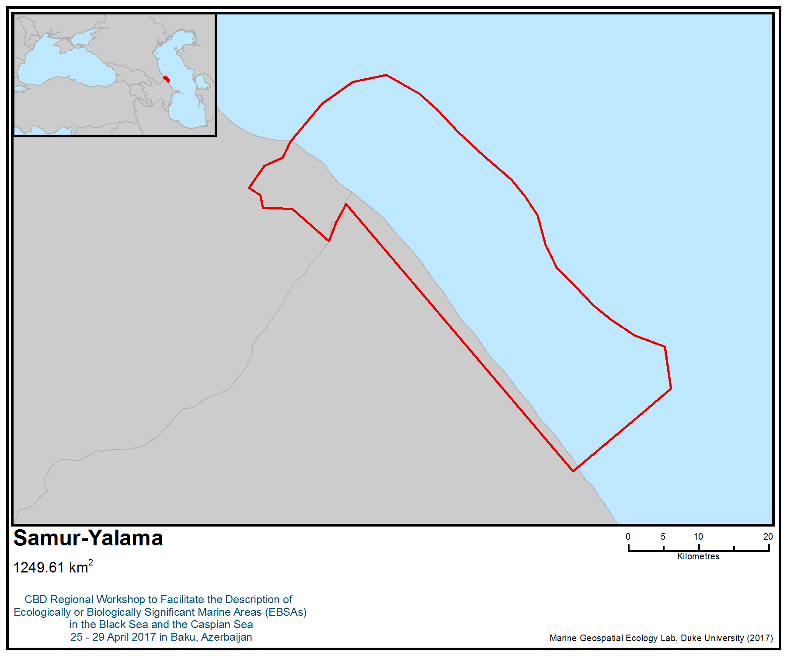
Figure 1. Area meeting the EBSA criteria

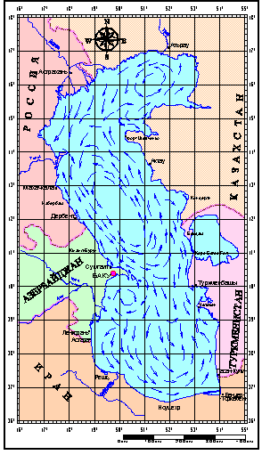

Figure 2. A scheme of surface circulation of the Caspian Sea (Dobrovolsky and Zalogin, 1982)

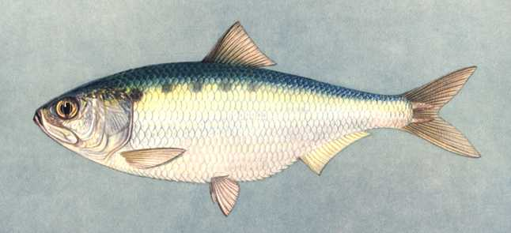 Большеглазая килька Clupeonella grimmi | 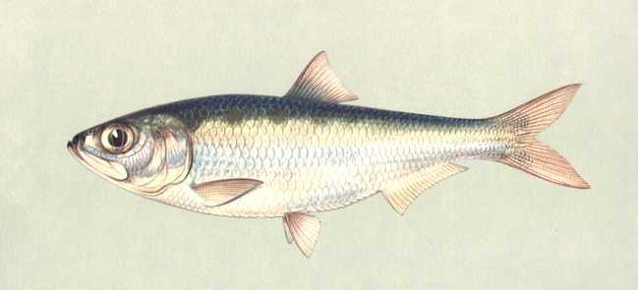 Обыкновенная килька Clupeonella delicatula caspia
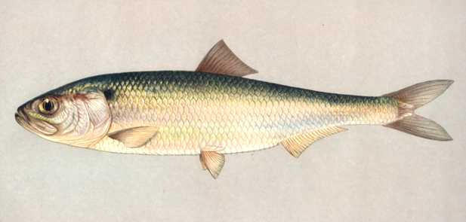 Долгинская сельдь Alosa brashnikovi brashnikovi | 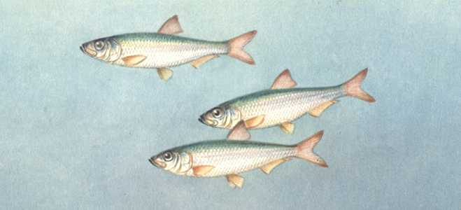 Большеглазый пузанок Alosa saposhnikovii
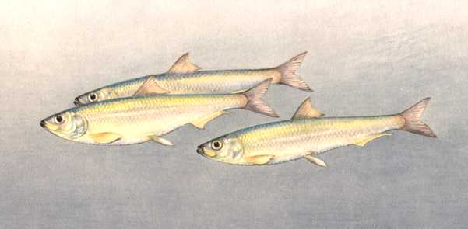 Каспийский пузанок Alosa caspia caspia | 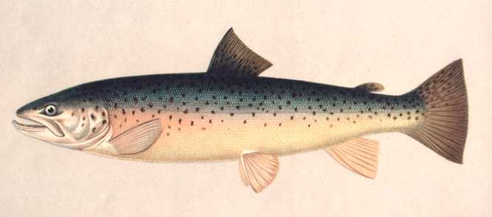 Каспийский лосось (кумжа) Salmo trurra caspius
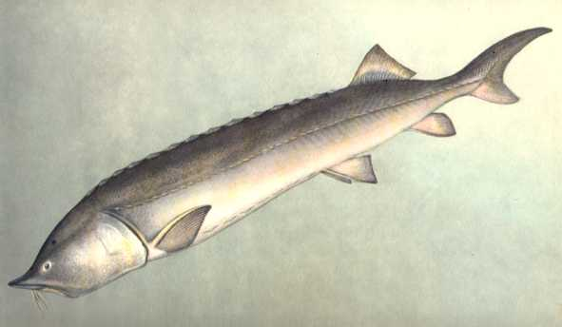 Белуга Huso huso | 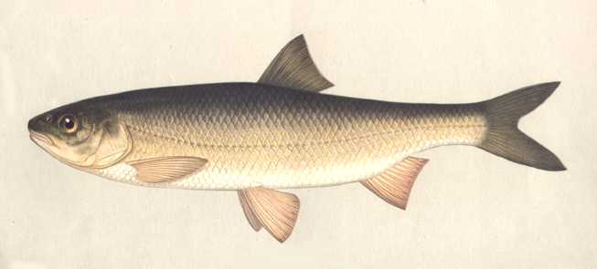 Кутум Rutilus frisii kutum
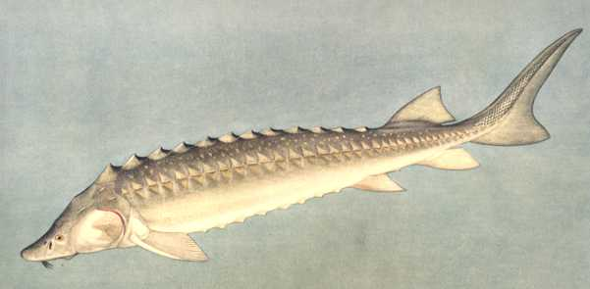 Русский осетр Acipenser guldenstadti | 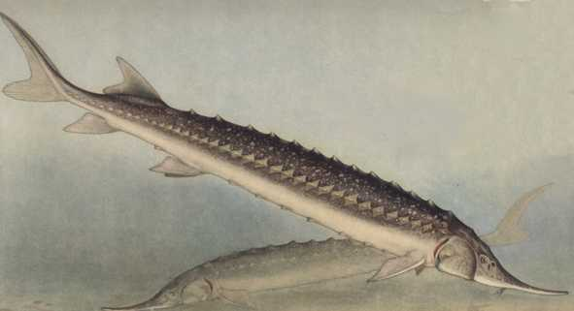 Севрюга Acipenser stellatus
Figure 3. Key fish species for the Samur – Yalama area
Area No. 31: Kizlyar Bay

Abstract
The area is the most northerly sea bay on the western coast of the Caspian Sea. This area is of key importance for seasonal migrations of waterfowl and waterbirds moving from western Siberia and Eastern Europe, flying through, or wintering on this coast. Species composition of birds is represented by 250 species, most of them waterfowl. This is a key area for such rare species of birds such as the Dalmatian pelican (Pelecanus crispus), as well as many common species (e.g., coot, gray goose, different species of ducks). The area serves as a breeding, foraging and migration ground for more than 60 species of fish. Kizlyar Bay is an important habitat for endangered species, such as sturgeons (Huso huso, Acipenser gueldenstaedtii, Acipenser stellatus). The islands that are located within the area are sites of seasonal aggregation of the Caspian seal (Phoca caspica). In 2017, the territory was partially included in the UNESCO Biosphere Reserve “Kizlyar Bay”.

Introduction
The area covers the north-western coast of the Caspian Sea from the Volga Delta to the Agrakhan Peninsula (inclusive) and the islands of Tyuleni and Chechen’. This is essentially a brakish water bay. These are shallow,recently drained sites along the coast of the Caspian Sea. With the almost flat surface of the section, the boundary between land and sea is subtle and constantly changing (Джамирзоев Г.С., 2006).

During the autumn migration of birds, flocks of waterfowl and waterbirds form here. After the formation of ice, birds wintering in the Volga Delta also migrate to this region.

The area overlaps with an Important Bird and Biodiversity Areas (IBA; BirdLife International 2017a), mostly designated for its very high importance for aquatic species. Large numbers of waterbirds can be found during winter and migratory periods (with rough estimates of 50,000-99,999 individuals during migration and 20,000-49,999 during the winter). The globally threatened Dalmatian pelican (Pelecanus crispus) occurs in the area.

Location
The area covers the north-west coast of the Caspian Sea from the Volga Delta to the Agrakhan Peninsula (inclusive) and the islands of Tyuleniy and Chechen.

Feature description of the area
This is a freshwater bay with an average depth of about 1.5 m. Due to the overtaking phenomena, in strong winds, the water level in the bay can fluctuate significantly. The shallow part of the water area is occupied by a wide strip of reed supports, cut by canals, numerous reaches and creeks (Труды…, 2011).

Vegetation is represented by a variety of transitions from the marshy to the marshy and sub-plains meadows. As far as the distance from the water, the meadows go to semi-desert cereal-wormwood and saltwort-sagebrush complexes. In the flora of the Kizlyar Bay, rare and protected species such as common sword grass (Cládium maríscus), white water lily (Nymphaéa álba), smith (Nymphaea lutea), Hyrkan water-nut (trapa gircana), common bladderwort (Utriculária vulgáris) and others (Джамирзоев Г.С., 2006).

The fauna of the bay is notable for a large variety of birds, including many species listed in the Red Books of Russia and Dagestan, such as the Dalmatian pelican, pygmy cormorant (Phalacrocorax pygmeus), glossy ibis (Plegadis falcinellus), white-tailed eagle (Haliaeetus albicilla), lesser white-fronted goose (Anser erythropus), demoiselle crane (Anthropoides virgo), black-winged pratincole (Glareola nordmanni) and the stone-curlew (Burhinus oedicnemus). The bay is also a very important stopover site for migrations of valuable game birds, for which there are good conditions for rest, fattening and refugeduring inclement weather. Place of nesting, migration and wintering of rare and protected bird species (Кривенко, 2000; Джамирзоев Г.С., 2006, Летопись природы…, 2010-2015гг.). A total of 216 bird species have been recorded on the Kizlyar Bay section and adjacent areas, 116 of which nest here (Джамирзоев, 2008).

In the bay, there are about 70 species and subspecies of marine, semi-anadromous, anadromous and freshwater fish, including such rare and vanishing forms as Caspian trout (Salmo trutta caspicus), Inconnu (Stenodus leucichthys) and Ciscaucasian spined loach (Sabanejewia caucasica) (Гаджиев А.А., 2003).

Feature condition and future outlook of the area
The area includes three Important Bird and Biodiversity Areas (IBA) (“Kizlyar Bay”, “Agrakhan Bay” and “Chechnya Island”) and overlaps with one of the clusters of the Dagestan Nature Reserve and Agrakhansky Wildlife Reserve. Currently, a specially protected natural area of federal significance is being formed – the island of Tyuleni.

Anthropogenic impacts on the area include increasing fishing pressure (including illegal fishing) and sport hunting.

Assessment of the area against CBD EBSA Criteria

CBD EBSA Criteria  (Annex I to decision IX/20) | Description  (Annex I to decision IX/20) | Ranking of criterion relevance  (please mark one column with an X)
CBD EBSA Criteria  (Annex I to decision IX/20) | Description  (Annex I to decision IX/20) | No information |  | Low |  |  | Medium |  | High
Uniqueness or rarity | Area contains either (i) unique (“the only one of its kind”), rare (occurs only in few locations) or endemic species, populations or communities, and/or (ii) unique, rare or distinct, habitats or ecosystems; and/or (iii) unique or unusual geomorphological or oceanographic features. |  |  |  |  |  | Х
Explanation for ranking
According to monitoring conducted between 2010 and 2015, this area contains as a concentration of wintering waterfowl and waterbirds (8)
Special importance for life-history stages of species | Areas that are required for a population to survive and thrive. |  |  |  |  |  |  |  | Х
Explanation for ranking
The region has a critically important value for a number of species and groups of species (Кривенко, 2000, Джамирзоев, 2006, Monitoring materials.., 2010-2015):
1. Ornithofauna. The area is important mainly for waterfowl and waterbirds, but it is also used by birds of other ecological groups.
1.1. The nesting area of birds, in particular there are several nesting colonys of the Dalmatian pelican (Pelecanus crispus).
1.2. Area of concentration of waterfowl during moulting (summer period).
1.3. The area is a major migration route for birds, mostly waterfowl and waterbirds. A significant proportion of birds migrate through this region from Western Siberia and Eastern Europe.
1.4. A significant part of migratory bird populations winter in this area during warm winters, or spend part of the winter period in colder winters (depending on the timing of sea ice formation).
2. Ichthyofauna. The region is extremely important for most fish species that live in the North Caspian region and the Volga Delta. It is of particular importance at the following stages of the life cycle (Труды.., вып 2-4):
2.1. Spawning grounds for non-migrating fish species, including species of commercial importance (Шихшабеков М.М., 2006, Труды..., 2-5).
2.2. Place of feeding, a key value for juveniles of semi-anadrompous and non-migrating fish species in the summer-autumn period.
Importance for threatened, endangered or declining species and/or habitats | Area containing habitat for the survival and recovery of endangered, threatened, declining species or area with significant assemblages of such species. |  |  |  |  |  |  |  | Х
Explanation for ranking
There are 40 species of birds listed in the Red Data Books of Dagestan, Russia and the IUCN Red List, includingDalmatian pelican (Pelecanus crispus), pygmy cormorant (Phalacrocorax pygmeus), glossy ibis ( Plegadis falcinellus), white-tailed eagle (Haliaeetus albicilla), lesser white-fronted goose (Anser erythropus), demoiselle crane (Anthropoides virgo), black-winged pratincole (Glareola nordmanni), stone-curlew (Burhinus oedicnemus) and others that occur in the area. Regular inhabitants listed in the IUCN Red List include: white-tailed eagle (Haliaeetus albicilla; winter concentrations), Dalmatian pelican (Pelecanus crispus; several nesting colonies) and otter (Lutra vulgaris). This is a key area for several endangered species of fishes at different stages of their life cycles (beluga sturgeon, Russian sturgeon, stellate sturgeon, all in the IUCN Red List) (Красная книга РФ, 2008; Красная книга республики Дагестан, 2009).
Vulnerability, fragility, sensitivity, or slow recovery | Areas that contain a relatively high proportion of sensitive habitats, biotopes or species that are functionally fragile (highly susceptible to degradation or depletion by human activity or by natural events) or with slow recovery. |  |  |  |  |  | Х
Explanation for ranking
In spite of the existing potential for natural restoration of biodiversity, this area is extremely vulnerable at certain periods of the year, when there are concentrations of birds from large areas.
In addition, among the species inhabiting the area, some are characterized by long life cycles (sturgeons) (Гаджиев А.А., 2003, Красная книга Дагестана, 2009).
Biological productivity | Area containing species, populations or communities with comparatively higher natural biological productivity. |  |  |  |  |  |  |  | Х
Explanation for ranking
Information on the primary biological productivity of the area needs to be clarified, but the high density of living organisms, including those on the upper levels of the food chain, indicates an abundance of food resources. Favourable feeding conditions are created due to the high degree of water heating due to shallow depths and climatic features (Сокольский и др., 2012). The shallow waters of the northern Caspian Sea are the most productive part of the sea. (Шибоянц, 2011).
Biological diversity | Area contains comparatively higher diversity of ecosystems, habitats, communities, or species, or has higher genetic diversity. |  |  |  |  |  | Х
Explanation for ranking
The species abundance of this area does not differ significantly in most groups of organisms. The reasons for this are quite complex living conditions. The avifauna is very diverse, numbering 250 species, mainly waterfawl and near-water species (Кривенко, 2000; Джамирзоев Г.С., 2006, Летопись природы…, 2010-2015гг.). The number of fish species is high for a freshwater ecosystem (Бархалов, 2011).
Naturalness | Area with a comparatively higher degree of naturalness as a result of the lack of or low level of human-induced disturbance or degradation. |  |  |  |  |  |  | Х
Explanation for ranking
This area is a location for sport fishing and hunting (Малкин Е.М., 1999). At the same time, part of the area includes specially protected natural areas at various levels.

References
Бархалов Р.М. Современное состояние популяций промысловых видов рыб Аграханского и Кизлярского заливов. Тр. государственного природного заповедника «Дагестанский», Вып.№4, Махачкала, 2011. с.66-100.
Водно-болотные угодья России. Том 3. Водно-болотные угодья, внесенные в Перспективный список Рамсарской конвенции / Под общ. ред. В.Г. Кривенко. - М.: Wetland International Global Series No. 3, 2000. - 490 с.
Гаджиев А.А., Шихшабеков М.М., Абдурахманов Г.М., Мунгиев А.А. Анализ экологического состояния Среднего Каспия и проблема воспроизводства рыб. М, изд-во Наука, 2003 г. 420 с.
Джамирзоев Г.С., Букреев С.А. Кизлярский залив // Водно-болотные угодья России. Том 6. Водно-болотные угодья Северного Кавказа (под общ. ред. А.Л.Мищенко). - М.: Wetlands International, 2006. - С. 181-191.
Г.С. Джамирзоев, С.А. Букреев, П.А. Тильба, Ю.Е. Комаров, А.А. Караваев, Р.А. Мнацеканов, Р.Х. Пшегусов, С.А. Плакса Рекомендации по сохранению КОТР международного значения в Кавказском экорегионе. – Москва–Махачкала: Союз охраны птиц России, НИИ биогеографии и ландшафтной экологии ДГПУ, 2008. – 176 с.
Красная книга Российской Федерации (растения и грибы)/ министерство природных ресурсов и экологии РФ; Федеральная служба по надзору в сфере ... Р. В. Камелин и др. — М.: Товарищество научных изданий КМК, 2008.
Красная книга Республики Дагестан. 2009. Ответственный редактор и составитель Г.М. Абдурахманов. Махачкала, 2009. - 552 с.
Летопись природы Государственный природный заповедник «Дагестанский». 2010-2015 гг. http://www.dagzapoved.ru/ru/node/75
Малкин Е.М. Репродуктивная и численная изменчивость промысловых популяций рыб. М.; Изд-во ВНИРО, 1999, с.146.
Сокольский А. Ф., Полянинова А. А., Молодцова А. И., Сокольская Е. А., Умербаева Роза Ивановна, Абдурахманов Г. М. Состояние кормовой базы и условий нагула осетровых рыб в Каспийском море // Юг России: экология, развитие. 2012. №1.
Шабоянц Н. Г., Шипулин С. В. Формирование биопродуктивности Северного Каспия // Юг России: экология, развитие. 2011. №3.
Шихшабеков М.М., Исрапов И.М. Экология рыб дагестанского побережья Каспия. Махачкала, Изд-во «Юпитер», 2005, с.63-175.
BirdLife International, 2017a. Important Bird Areas factsheet: Kizlyar Bay. Downloaded from http://datazone.birdlife.org/site/factsheet/kizlyar-bay-iba-russia-(european)/details on 27/04/2017
BirdLife International 2017b. IUCN Red List for birds. Downloaded from http://www.birdlife.org on 27/04/2017.

Maps and Figures

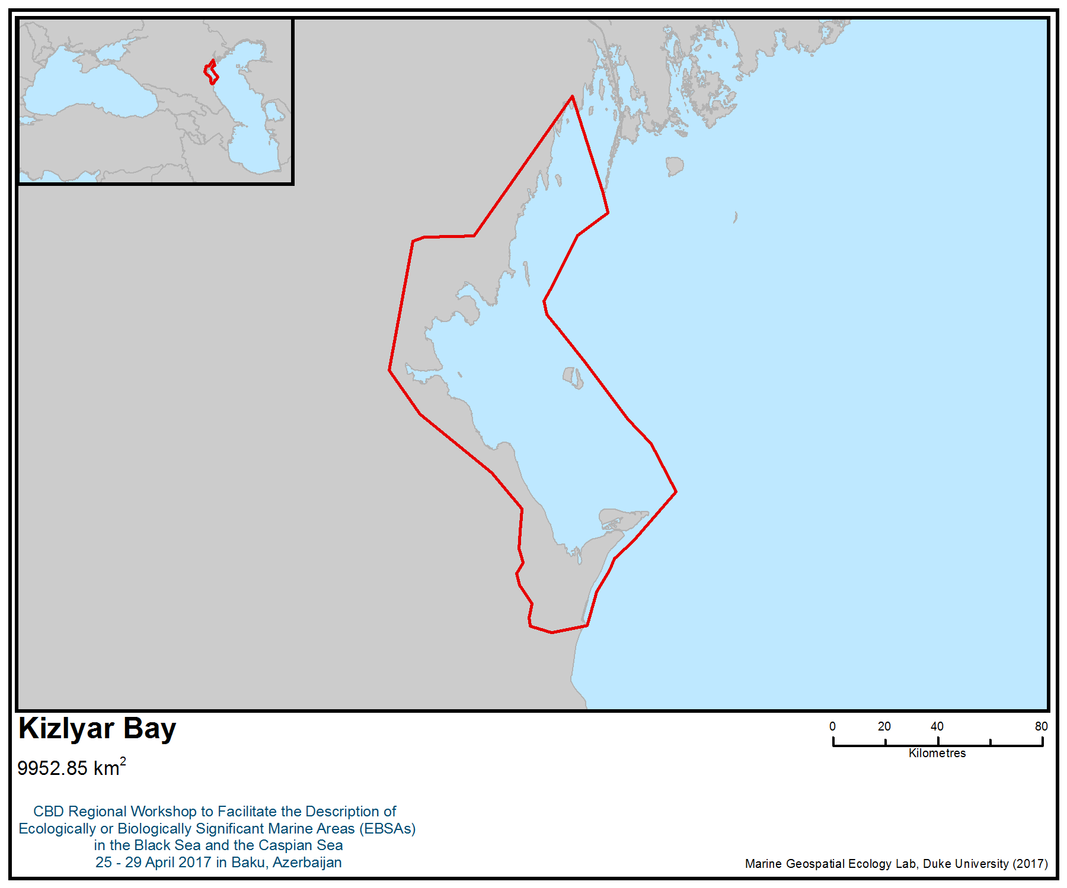
Figure 1. Area meeting the EBSA criteria

Area No. 32: Malyi Zhemchyzhnyi (“Small Pearl”) Island

Abstract
Malyi Zhemchyzhnyi Island is the largest nesting site for Charadriiform birds, including Pallas's gull (Larus ichthyaetus) and the Caspian tern (Sterna caspia), listed in the Red Book of the Russian Federation in the northern Caspian. In the spring, large concentrations (up to several thousand individuals) of the Caspian seal (Phoca caspica) inhabit the island. The adjacent water area is an important place for feeding fish, especially juvenile sturgeons (Huso huso, Acipenser gueldenstaedtii, Acipenser stellatus).

Introduction
The area consists of an island composed of shells of bivalve molluscs and the shallow water area adjacent to the 5 m isobath. The island itself has a length of 3 km and a maximum width of 0.5 km. The loose structure of island-folding soils contributes to changes in the shape of the island due to wind erosion (Русанов и др., 2014). The island and the adjacent water area are actively used by the Caspian seal, and the adjacent water area serves as a feeding ground for juvenile sturgeons (Сокольский, 2014). On the island, there is a large colony of Charadriiformes, two species of which are listed in the Red Book of the Russian Federation.

Location
This region is located in the central part of the northern Caspian, 25 kilometres to the south-east of the island of Chistaya Banka.

Feature description of the area
The area is relatively rare in the northern part of the Caspian Sea. Under the influence of winds, the coastline of the island is regularly subjected to changes. At present, the total area of the island is 24 ha. The island is part of the Malaya Zhemchuzhnaya shelf, which extends to the south for several kilometres (Русанов и др., 2014). In some periods, some braids may appear on the surface of the Malaya Zhemchuzhnaya shelf, serving as a place of attraction for birds of the water complex and the Caspian seal (Русанов и др., 2014).

In the spring-summer period on the island a large colony of Charadriiformes birds is formed, numbering (as reported in 2014) 13,000 pairs of Pallas’s gull (Larus ichthyaetus) and 1,500 Caspian tern (Sterna caspia) - species listed in the Red Book of the Russian Federation (Русанов и др., 2014). In addition, on the island there are about 1,000 pairs of yellow-legged gull nesting (Larus cachinnans), the number of which has been growing in recent years (Гаврилов, 2005).

The vegetation of the island is extremely scarce and includes 8-10 species. Periodically, the island is washed away during autumn storms that kill off part of the vegetation cover (Русанов и др., 2014).
There are resting places of the Caspian seal on the northern and southern parts of the island, the number of which varies considerably during the year from several thousand in the early spring period to low numbers in the autumn (Ноздрина, 2011).

The water area near the island is a place for feeding fish, a special value among which is juvenile sturgeons, for which favourable fodder conditions are created. Species composition of fish and invertebrates of this region was studied for many years by representatives of the Caspian Fisheries Research Institute (Никитин и др., 2002).

On the silty, sandy and coquina soils in the brackish-water zone (4.0-11.0 ‰), associations of Zostereta, Polisiphonieta, and Laurencieta formations have been reported, whereas in the marine zone (8.0-12.0‰) Laurencieta, Polisiphonieta, Enteromorpheta, Ceramieta, Cladophoreta have developed in shell and shell-silty soils. The brackish-water zone is dominated by Laurencia caspica - 75%, while the marine zone is dominated by Laurencia caspica at 70% and Polysiphonia caspica, at 67%. It was found that, with a decrease in the density of growth of associations, the structure was simplified. In freshwater complexes (with a projective coverage of up to 100% and biomass of 10,500 g / m 2), three- and two-tier structures were mainly found, in brackish water and marine (with a projective coverage of up to 60% and biomass of 500-800 g / M 2) - single-stage. In the brackish-water zone, a group of crustaceans dominated (Chaetogammarus, Dikerogammarus, Niphargoides, Schizorhynchus, Gammarus, Corophium, Pterocuma, Stenocuma, Paramysis, Balanus) - 35-45%, in the marine group of mollusks (Bivalvia) - 25-50%. It has been established that in all zones to the thickets of aquatic vegetation the lower crustaceans are more confined than other taxonomic groups. The greatest density and area of ​​growth of macrophytobenthos in the brackish and marine zones had landscape uplifts of the bottom (banks, islands, ridges, etc.); they proved to be the most productive for the zoobenthos.

Summarizing the long-term material on brackish and marine ecological zones, it can be concluded that here, in the places where macrophyto-benthos associations grow, crustaceans predominate, and mollusks are more closely tied to the type of soil than phytocenosis (Chizhenkova, 2009).

Feature condition and future outlook of the area
Malyi Zhemchuzhny Island is a federal natural monument. However, exploration and mining for mineral resources are being conducted in the adjacent water area (web: ООПТ России). Although the current state of the area is stable, there is increasing development of petroleum products and associated infrastructure. The island hase been regularly surveyed by ornithologists from the Astrakhan Biosphere Reserve since the 1980s (Русанов и др., 2014; Гаврилов, 2005; Кривоносов, 1975).

Assessment of the area against CBD EBSA Criteria

CBD EBSA Criteria  (Annex I to decision IX/20) | Description  (Annex I to decision IX/20) | Ranking of criterion relevance  (please mark one column with an X)
CBD EBSA Criteria  (Annex I to decision IX/20) | Description  (Annex I to decision IX/20) | No information |  | Low |  |  | Medium |  | High
Uniqueness or rarity | Area contains either (i) unique (“the only one of its kind”), rare (occurs only in few locations) or endemic species, populations or communities, and/or (ii) unique, rare or distinct, habitats or ecosystems; and/or (iii) unique or unusual geomorphological or oceanographic features. |  |  |  |  |  |  |  | Х
Explanation for ranking
- the island has a unique structure for the northern part of the Caspian Sea
- the island is one of the two nesting places for the northern Caspian population of Pallas’s gull (Larus ichthyaetus) (Кривоносов, 1976).
Special importance for life-history stages of species | Areas that are required for a population to survive and thrive. |  |  |  |  |  |  |  | Х
Explanation for ranking
- The area is particularly significant for two species of birds, (Pallas's gull (Larus ichthyaetus) and Caspian tern (Hydroprogne caspia), whose colonies are no longer recorded in the Russian coastal area of the Caspian Sea (Русанов и др., 2014)
- The marine area of the island serves as a feeding place for fish, including for important concentrations of juvenile sturgeons (Сокольский, 2012)
- The island serves as a habitat for Caspian seals (Phoca caspica), up to several thousand individuals of which are present here at certain times of the year (Кузнецов, 2017)
- The waters surrounding the island are important foraging areas for seabirds during the breeding period (Русанов и др., 2014).
Importance for threatened, endangered or declining species and/or habitats | Area containing habitat for the survival and recovery of endangered, threatened, declining species or area with significant assemblages of such species. |  |  |  |  |  |  |  | Х
Explanation for ranking
- the area is a habitat for two species of nesting birds, (Pallas's gull (Larus ichthyaetus) and Caspian tern (Sterna caspia), which are included in the Red Book of Russia (Русанов и др., 2014);
- the area plays an important role in the life cycle of the Caspian seal (Phoca caspica), during the period preceding the spawning migration of semi-migratory fish in the region of the island, as well as pinnipeds (in March and early April, there are several thousand individuals) (Кузнецов, 2017);
- the area serves as a breeding ground for sturgeon species, particularly in the vulnerable period of their life history (Сокольский, 2012).
Vulnerability, fragility, sensitivity, or slow recovery | Areas that contain a relatively high proportion of sensitive habitats, biotopes or species that are functionally fragile (highly susceptible to degradation or depletion by human activity or by natural events) or with slow recovery. |  |  |  |  |  | Х
Explanation for ranking
Despite the potential for natural restoration of biodiversity, this area is extremely vulnerable in certain periods of the year, when there are accumulations of birds from large areas (Русанов и др., 2000)

In addition, among the animals inhabiting the region, there are species characterized by long life cycles (sturgeons) (Чуйков, 2000).
Biological productivity | Area containing species, populations or communities with comparatively higher natural biological productivity. |  |  |  |  |  |  |  | Х
Explanation for ranking
The shallow waters of northern Caspian Sea are the most productive part of the Caspian Sea (Шабоянц, 2011). High density of living organisms, including those on the upper levels of the food chain, indicates an abundance of food resources (Chizhenkova, 2009).
Shallow depths and climatic features provide warm water and favourable feeding conditions (Русанов и др., 2014; Мошонкин, 2007).
Biological diversity | Area contains comparatively higher diversity of ecosystems, habitats, communities, or species, or has higher genetic diversity. |  |  |  | Х
Explanation for ranking
The area is used by a relatively small number of vertebrates, although the density and species composition of invertebrates requires further research (Русанов и др., 2014).
Naturalness | Area with a comparatively higher degree of naturalness as a result of the lack of or low level of human-induced disturbance or degradation. |  |  |  |  |  |  | Х
Explanation for ranking
Direct anthropogenic impact is currently absent, although the island is lightly littered with debris brought by winds (Сапожников, 2000).

References
Русанов Герман Михайлович, Гаврилов Николай Николаевич, Литвинов Кирилл Васильевич Остров Малый Жемчужный орнитологическая Жемчужина Северного Каспия // Астраханский вестник экологического образования. 2014. №3 (29).
ООПТ России. Веб сайт.
http://oopt.aari.ru/oopt/%D0%BE%D1%81%D1%82%D1%80%D0%BE%D0%B2-%D0%BC%D0%B0%D0%BB%D1%8B%D0%B9-%D0%B6%D0%B5%D0%BC%D1%87%D1%83%D0%B6%D0%BD%D1%8B%D0%B9
Гаврилов И. Н. Состояние гнездовых колоний веслоногих и голенастых птиц в дельте Волги и на Северном Каспии в 1975-2003 гг. (период подъема уровня Каспия)//Долговременный мониторинг и сохранение колониальных водных птиц Северного Каспия в связи с многолетними колебаниями уровня Каспийского моря. -Астрахань, 2005. -С. 214-268.
Кривоносов Г. А. Прибрежные мелководья Северного и Северо-восточного Каспия как местообитания водоплавающих и околоводных птиц//Природная среда и птицы побережий Каспийского моря и прилежащих низменностей. -Баку, 1979.-С. 101-103.
Гаврилов Н.Н. Многолетний мониторинг популяций птиц в дельте Волги и на Северном Каспии как основа мероприятий по их охране и рациональному использованию//Проблемы изучения охраняемых при-родных территорий Астраханской области: Материалы к научно-практической конф., посвященной 70-летию Астраханского заповедника. -Астрахань: Б.и., 1989. -С. 27 -37
Кривоносов Г.А. Очаги массового гнездования чайковых птиц на Северном Каспии и факторы, определяющие длительность их существования//Экология вирусов. -М., 1976. -Вып. 1У. -С. 46-51
Мошонкин Н.Н. Остров Малый Жемчужный//Астраханская энциклопедия. 1 том. Природа. -Астрахань. -2007. -С. 230-231
Русанов Г.М., Гаврилов Н.Н. Состояние колониального гнездовья чаек и крачек на острове Малый Жемчужный на Северном Каспии//Новости в мире птиц. Информационный бюллетень Союза охраны птиц России. -М. 2001. N 2. -С. 11
Русанов Г.М., Гаврилов Н.Н., Литвинов К.В. Остров Малый Жемчужный – орнитологическая жемчужина Северного Каспия // Астраханский вестник экологического образования. - N 3 (29). - 2014. - С. 67-75.
Русанов Г.М., Мошонкин Н.Н. Остров Малый Жемчужный//Ключевые орнитологические территории России. - Том 1. Ключевые орнитологические территории международного значения в Европейской России. Под редакцией Т.В.Свиридовой, В.А. Зубакина. -М., 2000. -С. 502-503
Чуйков Ю.С., Мошонкин Н.Н. Система особо охраняемых природных территорий Астраханской области (современное состояние и перспективы развития). -Астрахань. -2000. -124 с
Сапожников В. В. Современное состояние экосистемы Каспийского моря и сценарий дальнейшего развития событий//Науч. бюл. Каспийского плавучего ун-та (Касп-Ш1РХ). -2000. -N 1. -С. 64-71.
O. A. Chizhenkova, A. M. Kamakin, V. F. Zaitsev Some aspects of qualitative and quantitative composition of benthic biocenoses in the northern part of the Caspian sea // Herald of Astrakhan state technical university/ - 2009
Никитин Э.В., Кушнаренко А.И., Хара Р. Э., Особенности распределения и качественная структура полупроходных и туводных рыб в западной зоне мелководий Северного Каспия. Сбор. НИР КаспНИРХ, 2002 г. С.276.
Ноздрина Л. Ю., Зайцев В. Ф., Мелякина Э. И., Попова Н. В. Состояние популяции каспийского тюленя в условиях разработки морских нефтегазовых месторождений // Защита окружающей среды в нефтегазовом комплексе. 2011. № 10. С. 44-48.
Кузнецов Василий Владимирович Современное состояние популяции каспийского тюленя // Вестник АГТУ. Серия: Рыбное хозяйство. 2017. №1.
Дубинина Наталья Александровна Перспективы развития проектов ОАО «Лукойл» на Северном Каспии // Вестник АГТУ. 2015. №1 (59).
Шабоянц Н. Г., Шипулин С. В. Формирование биопродуктивности Северного Каспия // Юг России: экология, развитие. 2011. №3.
Сокольский А. Ф., Полянинова А. А., Молодцова А. И., Сокольская Е. А., Умербаева Роза Ивановна, Абдурахманов Г. М. Состояние кормовой базы и условий нагула осетровых рыб в Каспийском море // Юг России: экология, развитие. 2012. №1.

Maps and Figures

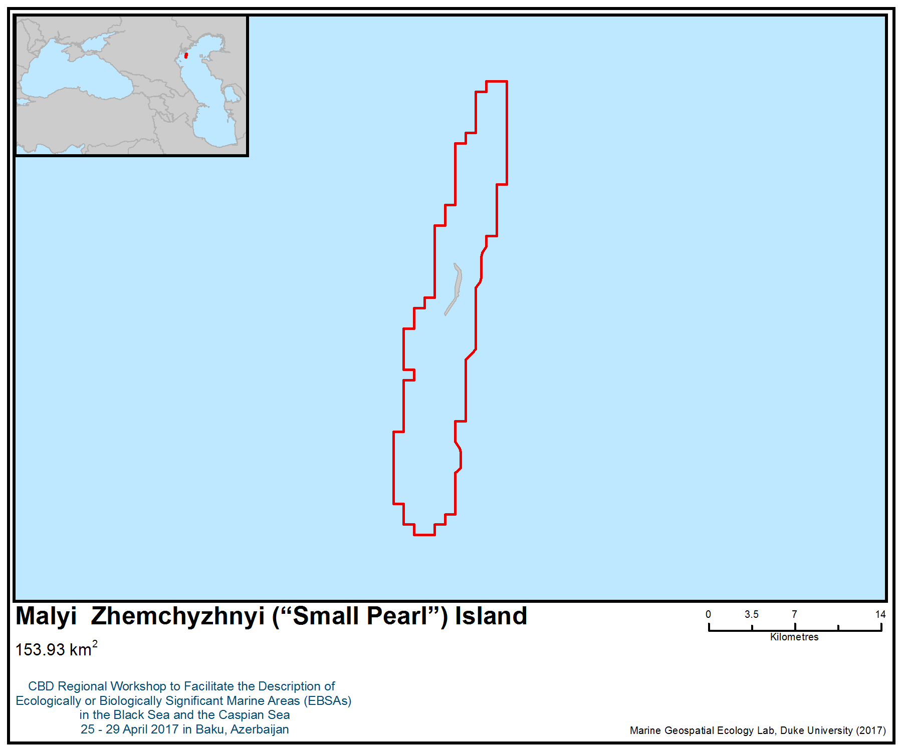
Figure 1. Area meeting the EBSA criteria

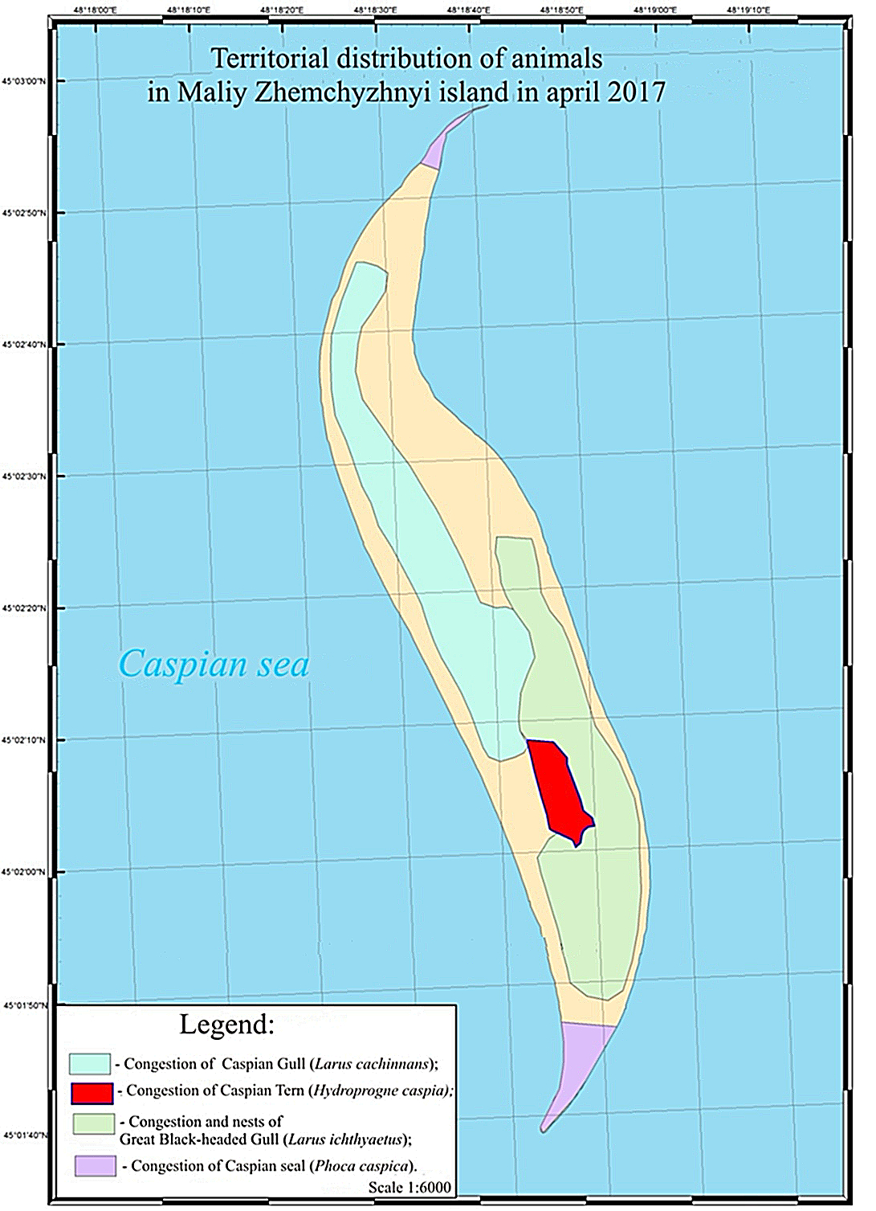

Figure 2. Territorial distribution of animals on Malyi Zhemchuzhniy (“Small Pearl”) Island in April 2017

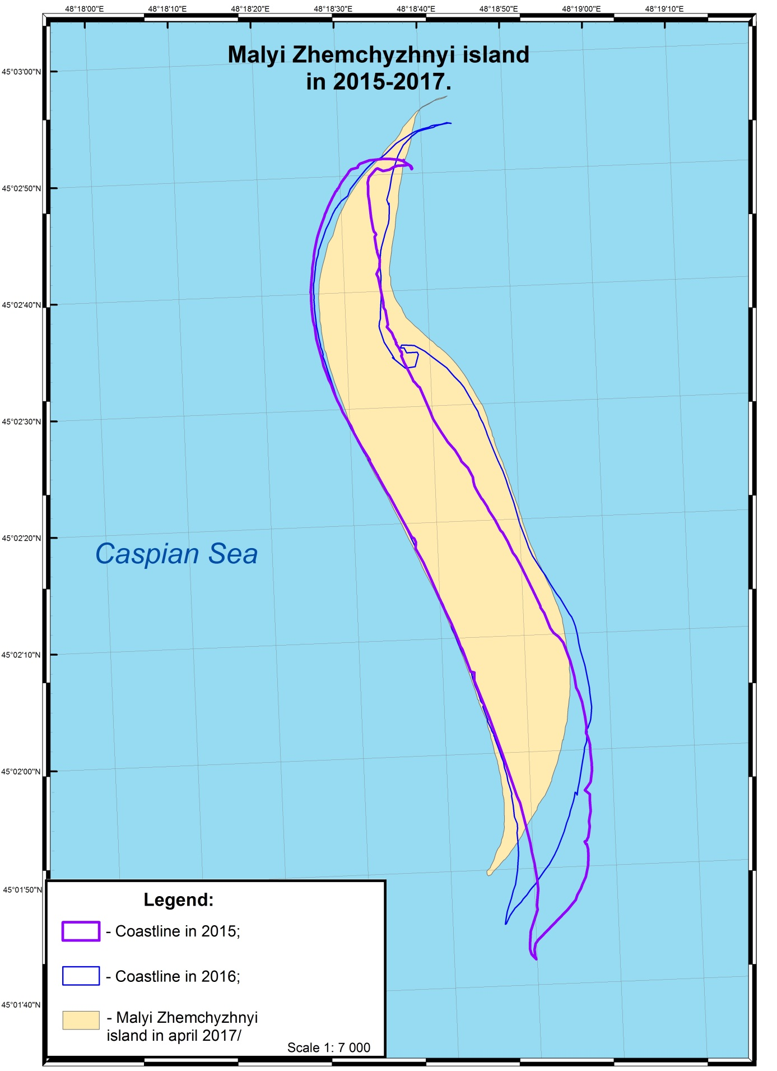
Figure 3. The changing coastline of Malyi Zhemchyzhnyi (“Small Pearl”) Island

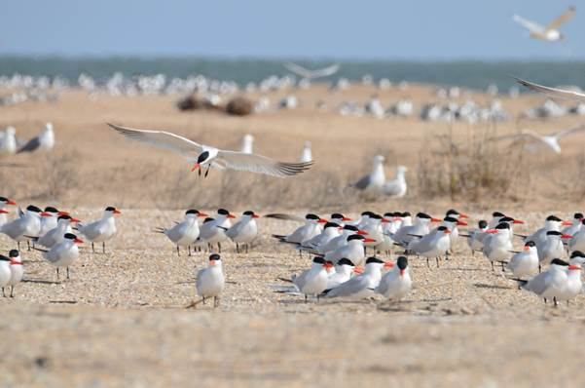
Figure 4. Caspian tern (Hydroprogne caspia) on the Maliy Zhemchyzhnyi island, April 2017
Photo: K.Litvinov

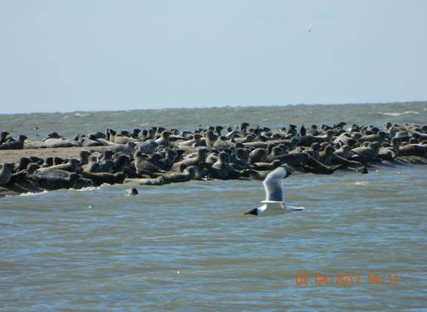
Figure 5. Caspian seals on the Maliy Zhemchyzhnyi island, April 2017
Photo: A. Pankov
Area No. 33: Pre-estuarine Area of the Volga River

Abstract
The area is part of the Volga Delta, a unique natural ecological system and the largest delta in Europe. The Volga Delta is located in the Caspian lowland, and its elevation ranges from -24 to -27 m. The area plays an exceptional role in maintaining populations of some globally significant species, primarily waterfowl and other aquatic and semi-aquatic birds. It serves as an important node of two bird flyways, extending from west Siberia to Eastern Europe. More than 300 species of birds have been recorded in the area. This is a key area for rare bird species such as the Siberian crane (Leucogeranus leucogeranus), white-tailed eagle (Haliaeetus albicilla) and Dalmatian pelican (Pelecanus crispus), as well as many common species (e.g., coots, gray goose, ducks). The area serves as a breeding ground, foraging and migration habitat for more than 60 species of fish. There is an extremely high density of ichthyofauna during mass spawning migrations, when significant populations of semi-anadromous and anadromous fish species of the northern Caspian enter the delta. The area is home to spawning migrations of endangered species such as sturgeons (Huso huso, Acipenser gueldenstaedtii, Acipenser stellatus, Acipenser persicus, Acipenser nudiventris) and Caspian lamprey (Caspiomyzon wagneri).

Introduction
The area is located in the northern part of the Caspian Sea, and includes the pre-estuarine and lower reaches of the Volga delta. This is the system of the Volga branches and extensive shallows, overgrown with aquatic and coastal vegetation. Water depth within the specified area fluctuates within 3-10 m in the riverbed zone and 1-3 m in the pre-estuarine area of the (Раскурин 2016). Shallow depths contribute to the spring warming of the water column and the formation of abundant food resources for animals. The area is used by waterfowl and waterbirds throughout the year, but especially during migration periods. It serves as an important migration route for the movement of fish populations of the northern Caspian to the spawning grounds in the Volga River (Levin 2016), as well as for feeding by juvenile fish in the summer-autumn period. The area overlaps with one of the most Important Bird and Biodiversity Areas (IBA) in the world for waterbirds. A total of 7 million waterbirds is estimated to use the area as a stopover in spring migration, between 5 and 10 million in the autumn (BirdLife International 2017a) and more than 700,000 waterbirds spend the winter here (Solokha 2006). Large numbers of waterbirds of several species breed in the delta, including 56,800 pairs of herons (Ardeidae), cormorants Microcarbo pygmaeus and Phalacrocorax carbo, Plegadis falcinellus and Platalea leucorodia. The number of waterfowl overwintering in the delta depends on the severity of the weather, but can include significant numbers of Cygnus cygnus. Some globally threatened species occur in the area, such as the Dalmatian pelican Pelecanus crispus and the common pochard Aythya ferina.

Location
The area covers the lower zone of the Volga Delta and the Volga pre-estuarine zone within the borders. The northern boundary coincides with the northern boundary of the Volga Delta wetlands and passes along the border of the reed belt to the Ganyushkinsky channel. The area deepens in the sea to a 5 m isobath.

Feature description of the area
The combination of the provincial junction, the Delta's intrasonality and the complex paleogeologic-geomorphological history of its development conditioned the formation of the present aquatic environment. The lower zone of the delta is where the marine and inland factors of delta formation interact. The relief is composed of islands, channels and erikas (small streams). The height of the islands in the meadow ranges from 0.5 to 2.0 m. The height of the relief above sea ranges from -24 to -27 m.

Physico-geographically (Белевич, 1964), the delta of the Volga River is divided into a surface part including the upper, middle and lower zones, an underwater part (the delta), which unites the island and open zones of the pre-estuarine, and a transition zone from the surface to the underwater delta, called the kyltuk zone (Bogutskaya et al., 2013).

The lower zone of the above-water delta, the kyltuk zone and avandelta are united in the so-called lower reaches of the Volga Delta. The above-water part of the area is represented by a large number of alluvial islands separated from each other by numerous channels and streams. The kultuk zone is characterized by the following geomorphological forms: surface and underwater alluvial braids and islands formed in the mouths of the ducts. The density of the river network (average for three sites) is 7.4 km per 100 hectares. There are non-flooded islands in the pre-estuarine island area (Катунин, 2012).

There are four types of vegetation: shrub, forest, meadow and aquatic assemblages. The aquatic vegetation is represented by four groups: 1) attached plants with floating leaves (water-nut (Trápa nátans), white water lily (Nymphaéa álba)); 2) attached immersed plants (Vallisneria spiralis, Potamogéton); 3) unattached plants floating freely on the surface of the water (floating salvinia, Salvínia nátans), duckweed (Lémna mínor)); 4) unattached immersed plants (Ceratophyllaceae) (Громов, 2010).

The fauna of the area has a European zoogeographical affinity with elements of other types. Free-living aquatic invertebrates comprise 828 taxa. These are protozoans (136), rotifers (403), copepods (70), other crustaceans (142), and other groups of animals (77). The diversity of the microclimate promotes coexistence of various ecological groups of insects in the limited territory—from desert to typically mesophilic and aquatic. Species richness of insects reaches 1248 species. The diversity of ecological conditions of water bodies (depth, flow, overgrazing) is a prerequisite for the diversity of the species composition of fish, which are represented by 61 species (12 families). The most numerous are cyprinids (24 taxa) and cottids (12 taxa) (Podolyako et al. (in print).

The core group of freshwater fish, mainly Cyprinidae and Percidae, includes rudd (Scardinius erythrophthalmus), gusher (Blicca bjoerkna), wild carp (Cyprinys carpio), perch (Perca fluviatilis), pike (Esox lucius), catfish ( Silurus glanis), etc.). A significant part of the fish population consists of migrating and semi-anadromous species that perform spawning migrations through the area, and many euryhaline species of marine origin (Litvinov et al., 2013).

The fauna of amphibians and reptiles is poor in species (4 and 6 species, respectively). The avifauna of the reserve is represented by 301 species, of which 104 are nesting, 147 occur during migrations, migrations or wintering and 29 species that are migratory (Русанов, 2013).

According to zoogeographical analysis, 50% of bird species nesting in the Volga Delta are transpalearctic species, 24% are European fauna, about 16% are Mediterranean species, 9% Mongolian, and 1% are Chinese species (Реуцкий, 2014а, 2014б, 2014в, 2014г, 2015а, 2015б).

There are at least 20 species of marine mammals, with a fifth of them not associated with the Delta. Typical representatives of the fauna are migrating species and species associated with aquatic biotopes (Астраханский заповедник, 1991).

In total, the species composition of the area is represented by 1200 species of insects, 76 species of freshwater mollusks, 61 species of fish and cyclostomes, 4 and 6 species of amphibians and reptiles, 301 species of birds and 20 species of mammals, respectively (Климов, 2007).

The number of species of animals classified according to rarity:
Taxonomic group | Including species included in the IUCN Red List | Including species included in the Red Book of the Russian Federation | Including species included in the Red Book of the subject of the Russian Federation
Lichens | 0 | 1 | 5
Vascular plants | 0 | 3 | 5
Insects | - | 1 | 28
Fish and Cyclostomes | 7 | 8 | 9
Aves | 3 | 54 | 67
Mammals | 4 | 2 | 4
Total | 14 | 70 | 118

Feature condition and future outlook of the area
The region has significant resilience to a number of pressures and has a significant potential for self-recovery, but is potentially vulnerable to a number of pressures (Зволинский и др. 2016). In general, there is a worsening degree of anthropogenic impact associated with the direct presence of humans (pollution of solid waste, a factor of concern, overflight), while the situation with chemical pollution of surface waters is static (Исеналиева, 2012; Попова и др., 2015).

The area includes the core zone and protected areas of the Astrakhan Biosphere Reserve, whose employees carry out a number of monitoring and research programmes in this area. The work on multi-year monitoring of a number of areas within the “Volga River Delta” (ornithofauna, water mammals) is underway. The pre-estuary space is an object of attention of the state organizations engaged in calculating the fishing load in the sphere of fisheries (Попова и др., 2015).

Assessment of the area against CBD EBSA Criteria

CBD EBSA Criteria  (Annex I to decision IX/20) | Description  (Annex I to decision IX/20) | Ranking of criterion relevance  (please mark one column with an X)
CBD EBSA Criteria  (Annex I to decision IX/20) | Description  (Annex I to decision IX/20) | No information |  | Low |  |  | Medium |  | High
Uniqueness or rarity | Area contains either (i) unique (“the only one of its kind”), rare (occurs only in few locations) or endemic species, populations or communities, and/or (ii) unique, rare or distinct, habitats or ecosystems; and/or (iii) unique or unusual geomorphological or oceanographic features. |  |  |  |  |  |  |  | Х
Explanation for ranking
Delta ecosystems are a very common type of biocenosis, however, – the Volga Delta is one of the largest deltas in the world (the largest in Europe) and can act as a unique geomorphological object (Белевич, 1965).
Special importance for life-history stages of species | Areas that are required for a population to survive and thrive. |  |  |  |  |  |  |  | Х
Explanation for ranking
The region has a critically important value for a number of species and groups of species:
1. Ornithofauna. The area is important mainly for waterfowl and waterbirds, but it is also used by birds from other ecological groups.
1.1. Nesting area up to 50 000 pairs of birds, 21 large nesting colonies (wood and reed) of waterbirds and water birds. The nesting place for birds of other ecological groups (birds of prey, cane birds, etc.) (Чуйков, 2012, Гаврилов, 2005).
1.2. Area of concentration of waterfowl during moulting (summer period).
1.3. In the area, there is a core of permanently inhabiting (settled) bird species of various ecological groups, especially the number of birds of prey and waterfowl and waterbirds.
1.4. The area is a junction of two major migration routes for birds, mostly waterfowl and waterbirds. A significant proportion of birds migrate through this region from Western Siberia and Eastern Europe. At the same time, more than 1 million waterfowl birds are counted on the area during the peak period (according to aerial survey data).
1.5. A significant part of migratory bird populations winter in this area during warm winters, or spend part of the winter period in colder winters (depending on the timing of ice cover formation).

2. Ichthyofauna. The region is extremely important for most fish species that live in the North Caspian region and the Volga Delta (Naseka, 2009). It is used at the following stages of the life cycle:
2.1. Spawning grounds for sedentary fish species, including large-scale fish species of commercial importance.
2.2. Migratory route for a large number of fish belonging to different ecological groups. Seasonal movements are characteristic of sedentary species, for semi-passages and passageways - this is a key element of the migration route, approaches and directly entering the freshwater zone and the river ecosystem.
2.3. Place of feeding, a key value for juveniles of semi-anadromous and resident fish species in the summer-autumn period. After hatching on the channel or spawning grounds located in the delta of the Volga and the Volga-Akhtuba floodplain, juvenile fish, after a recession of the wave, floods migrate to the zone of the pre-estuarine, where it continues feeding. Undoubtedly, this zone is a region with significant fish resources (Hänﬂing et al. 2009).
3. Flora. The district is the main place for the growth of the Nelumbo nucifera in the Volga Delta (Красная книга Астраханской области, 2014).
Importance for threatened, endangered or declining species and/or habitats | Area containing habitat for the survival and recovery of endangered, threatened, declining species or area with significant assemblages of such species. |  |  |  |  |  |  |  | Х
Explanation for ranking
The total number of rare species included in the lists of different levels is 14 species in the IUCN, 70 species in the Red Data Book of the Russian Federation and 118 species in the Red Book of the Astrakhan Region (Красная книга России…, 2008; Красная книга Астраханской области, 2014).

This is a key area is for a number of endangered species at different stages of the life cycle. Resident species listed in the IUCN list: white-tailed eagle (Haliaeetus albicilla), Dalmatian pelican (Pelecanus crispus), river otter (Lutra vulgaris). During the migration period, this zone is the key for passage to the spawning grounds of sturgeon (Huso huso, Acipenser gueldenstaedtii, Acipenser stellatus, Acipenser persicus, Acipenser nudiventris), Caspian lamprey (Caspiomyzon wagneri), and Stenodus leucichthys (Hänﬂing et al. 2009). This is the resting area of the virtually extinct Siberian Crane (Grus leucogeranus) population. Place of winter concentrations of the eagle-tailed tail. In this zone there are several large nests of curly pelican.
Vulnerability, fragility, sensitivity, or slow recovery | Areas that contain a relatively high proportion of sensitive habitats, biotopes or species that are functionally fragile (highly susceptible to degradation or depletion by human activity or by natural events) or with slow recovery. |  |  |  |  |  | Х
Explanation for ranking
On the one hand, the region in question has extreme resistance to external influences, the ability to self-purify and, while preserving the habitat, is capable of restoring biological diversity (in the last century, after the plundering of the region's natural resources, the introduction of protection measures allowed the restoration of biological diversity within 15-20 years). At the same time, the area is extremely vulnerable to some kinds of impact, (such as oil pollution) due to high concentrations of living organisms.

In addition, among the animals inhabiting the region, there are species characterized by long life cycles (sturgeons).
Biological productivity | Area containing species, populations or communities with comparatively higher natural biological productivity. |  |  |  |  |  |  |  | Х
Explanation for ranking
Shallow waters of northern Caspian Sea are the most productive part of the Caspian Sea (Шабоянц, 2011) High density of living organisms, including those on the upper levels of the food chain, indicates the abundance of food resources.

Favourable feeding conditions are created due to the high degree of water heating due to shallow depths and climatic features. The abundance of food attracts animals. For example, the accumulation of waterfowl and waterbirds in the autumn reaches millions of individuals.
Biological diversity | Area contains comparatively higher diversity of ecosystems, habitats, communities, or species, or has higher genetic diversity. |  |  |  |  |  | Х
Explanation for ranking
The species abundance in this region does not differ significantly among most groups of organisms. The reasons for this are the complex living conditions: cold, snowless winters, a long flood period, and high summer temperature.

The number of fish species (61) is also large enough for a freshwater ecosystem (Никитин, 2003). The ornithofauna, numbering 301 species, is predominantly diverse, mainly a water and a near-water complex (Астраханский заповедник, 1991).
Naturalness | Area with a comparatively higher degree of naturalness as a result of the lack of or low level of human-induced disturbance or degradation. |  |  |  |  |  |  | Х
Explanation for ranking
Despite the high potential for short-term self-restoration, leveling short-term impacts in the area, there are several factors that have a long-term / regular impact: the regulated runoff of the Volga River and the presence of fish-canal channels. These factors lead to some deviations in the watering regime from the natural one (Беляева, 1998; Катунин, 2012).

In addition, sport fishing and hunting take place in the area.

References
Астраханский заповедник. 1991. Под ред. Г. А. Кривоносова, Г. В. Русакова. М.: Агропромиздат. 192 с.
Белевич Е.Ф. Геоморфологическая характеристика авандельты реки Волги // Тр. Астраханского заповедника. 1965. Вып. 10. C. 81-103.
Беляева В.Н., Иванов В.П., Зиланов В.К. Научные основы устойчивого рыболовства и регионального распределения промысловых объектов Каспийского моря.- М.: ВНИРО, 1998. – 167 с.
Гаврилов И. Н. Состояние гнездовых колоний веслоногих и голенастых птиц в дельте Волги и на Северном Каспии в 1975-2003 гг. (период подъема уровня Каспия)//Долговременный мониторинг и сохранение колониальных водных птиц Северного Каспия в связи с многолетними колебаниями уровня Каспийского моря. -Астрахань, 2005. -С. 214-268.
Громов В.В. 2010. Водная и прибрежно-водная растительность северного Каспия: авандельта р. Волги, калмыцкое и казахское побережья Журнал Сибирского федерального университета. Серия: Биология. Т. 3. № 3. С. 250-266.
Зволинский В.П., Мельник И.В., Королев А.В., Меджидов Р.Д. Численность и распределение охотничьих птиц на территории дельты реки Волга Известия Нижневолжского агроуниверситетского комплекса: Наука и высшее профессиональное образование. 2016. № 4 (44). С. 162-170.
Исбеков К.Б., Асылбекова С.Ж., Куликов Е.В., Ким А.И. Браконьерство – один из основных факторов снижения численности осетровых рыб Каспийского бассейна//Астраханский вестник экологического образования, 2015. – № 1(31). – С. 50-57.
Исеналиева Ж.Н., Волкова И.В. 2012. Оценка качества среды аквальных комплексов дельты р. Волги // Международный журнал прикладных и фундаментальных исследований. № 1. С. 89.
Камелов А.К., Сокольский А.Ф., Альпеисов Ш.А. Современное состояние и подходы к восстановлению численности русского осетра Урало-Каспийского бассейна. – Алматы, 2005. – 41 с.
Каналы-рыбоходы дельты реки Волги/Катунин Д.Н., Хрипунов И.А. и др. – Астрахань: ФГУП «КаспНИИРХ», 2012. – 140 с.
Климов В. 2007. Астраханский заповедник в дельте Волги. очередное путешествие журнала. Экология и жизнь. № 6. С. 52-58.
Ким Ю.А., Куликов Е.В., Кузьменко С.В. Методы подхода сохранения биоресурсов Жайык-Каспийского бассейна// Сб. Управление инновациями в современной науке, 2015. – г. Самара. – С. 21-27.
Красная книга Астраханской области/ Астрахань: Астраханский государственный университет, Издательский дом «Астраханский университет», 2014. – 413 с., ил.
Красная книга Российской Федерации (растения и грибы)/ министерство природных ресурсов и экологии РФ; Федеральная служба по надзору в сфере ... Р. В. Камелин и др. — М.: Товарищество научных изданий КМК, 2008.
Никитин Э.В., Кушнаренко Р.Э., Хара-Лемайтре А.И. 2003. Особенности распределения и качественная структура полупроходных и туводных рыб в западной зоне мелководий Северного Каспия. Астрахань: КаспНИРХ. С.276.
Определение рыбопродуктивности рыбохозяйственных водоемов и/или их участков, разработка биологических обоснований ОДУ и ООПТ, режиму и регулированию рыболовства на водоемах международного, республиканского и местного значений Жайык-Каспийского бассейна. Раздел: Река Жайык с предустьевым пространством, река Кигаш с предустьевым пространством, буферная зона государственного природного резервата «АкЖайык» (закл.)//Биологическое обоснование. – ТОО «КазНИИРХ», 2016. – 261 с.
Попова Н.В., Курапов А.А., Умербаева Р.И., Монахов С.К., Зубанов С.А., Непоменко Л.Ф., Лобов А.Л., Елисов В.В., Батов В.И., Островская Е.В., Макарова Е.Н., Васильева Т.В., Кашин Д.В., Литвинов К.В., Русанов Г.М., Курманбаева А.Р., Соколова И.В. 2015. Состояние природной среды мелководной части Северного Каспия. Астрахань. 118 с.
Проведение комплексных морских исследований по оценке состояния биологических ресурсов казахстанской части Каспийского моря//Биологическое обоснование. – ТОО «КАПЭ», Алматы, 2015. – 163 с.
Раскурин В.Н. 2016. Влияние изменений водного стока Волги и колебаний уровня Каспийского моря на состояние экосистем низовий дельты Волги
В сборнике: Биоразнообразие: глобальные и региональные процессы материалы Всероссийской конференции молодых ученых с международным участием. Институт общей и экспериментальной биологии СО РАН. С. 204.
Реуцкий Н.Д. 2014а. Аннотированный список птиц астраханского региона с указанием их распределения по природно-территориальным комплексам Астраханский вестник экологического образования. № 1 (27). С. 159-208.
Реуцкий Н.Д. 2014б. Аннотированный список птиц астраханского региона с указанием их распределения по природно-территориальным комплексам Астраханский вестник экологического образования. № 2 (28). С. 121-159.
Реуцкий Н.Д. 2014в. Аннотированный список птиц астраханского региона с указанием их распределения по природно-территориальным комплексам Астраханский вестник экологического образования. № 3 (29). С. 91-153.
Реуцкий Н.Д. 2014г. Аннотированный список птиц астраханского региона с указанием их распределения по природно-территориальным комплексам Астраханский вестник экологического образования. № 4 (30). С. 109-180.
Реуцкий Н.Д. 2015а. Аннотированный список птиц астраханского региона с указанием их распределения по природно-территориальным комплексам Астраханский вестник экологического образования. № 1 (31). С. 75-108.
Реуцкий Н.Д. 2015б. Аннотированный список птиц астраханского региона с указанием их распределения по природно-территориальным комплексам Астраханский вестник экологического образования. № 3 (33). С. 27-88.
Русанов Г.М. 2013. Птичье население низовьев дельты Волги в условиях изменений гидрологического режима и антропогенных нагрузок (1969-2010)
Астраханский вестник экологического образования. № 4 (26). С. 89-109.
Чуйков Юрий Сергеевич Особенности структуры биогеоценозов колониальных гнездовий веслоногих и голенастых птиц в дельте Волги // Рус. орнитол. журн.. 2012. №776.
Шабоянц Н. Г., Шипулин С. В. Формирование биопродуктивности Северного Каспия // Юг России: экология, развитие. 2011. №3.
BirdLife International, 2017a. Important Bird Areas factsheet: Volga Delta. Downloaded from http://datazone.birdlife.org/site/factsheet/volga-delta-iba-russia-(european)/text on 27/04/2017
BirdLife International 2017b. IUCN Red List for birds. Downloaded from http://www.birdlife.org on 27/04/2017.
Hänﬂing B., Dümpelmann C., Bogutskaya N.G., Brandl R. & Brändle M. 2009. Shallow phylogeographic structuring of Vimba vimba L. across Europe suggests two distinct refugia during the last glaciation. Journal of Fish Biology, 75(9): 2269–2286.
Levin B.A., Simonov E.P., Ermakov O.A., Levina M.A., Interesova E.A., Kovalchuk O.M., Malinina Y.A., Mamilov N.S., Mustafayev N.J., Pilin D.V., Pozdeev I.V., Prostakov N.I., Roubenyan H.R., Titov S.V. & Vekhov D.A. 2016. Phylogeny and phylogeography of the roaches, genus Rutilus (Cyprinidae), at the Eastern part of its range as inferred from mtDNA analysis. [online] Springer International Publishing Switzerland. Available from: https://www.researchgate.net/profile/Oleksandr_Kovalchuk2/publication/308231044_Phylogeny_and_phylogeography_of_the_roaches_genus_Rutilus_Cyprinidae_at_the_Eastern_part_of_its_range_as_inferred_from_mtDNA_analysis/links/57dedcbe08aeea19593b50c0.pdf?origin=publication_list [updated 6 September 2016; visited 1 Dezember 2016].
Litvinov K.V. & Podolyako S.A. 2013. The species composition and status for ichtyofauna of the Volga delta lowlands in 2006–2011 in Astrakhan State Universe Reserve. Identiﬁcation keys for ﬁsh and invertebrates. In: Opredelitel` ryb I bespozvonochnykh Kaspiyskovo morya. Ryby I mollyuski. Identiﬁcation keys for ﬁsh and invertebrates. Fish and mollusks]. 1 St. Peterburg–Moskow: KMK Scientiﬁc Press Ltd.: 516–525. (In Russian)
Naseka A.M. & Bogutskaya N.G. 2009. Fishes of the Caspian Sea: zoogeography and updated check-list. Zoosystematica Rossica, 18: 295–317.
Podolyako S.A., Fedorovich V.V., Litvinov K.V. 2017. The ichthyofauna catalogue of the Astrakhan Nature Reserve. Zoosystematika Rossica. №1 (in print).
Solokha, A. 2006. Results from the International Waterbird Census in Central Asia and the Caucasus 2003–2005. Wetlands International, Moscow, Russian Federation.

Maps and Figures

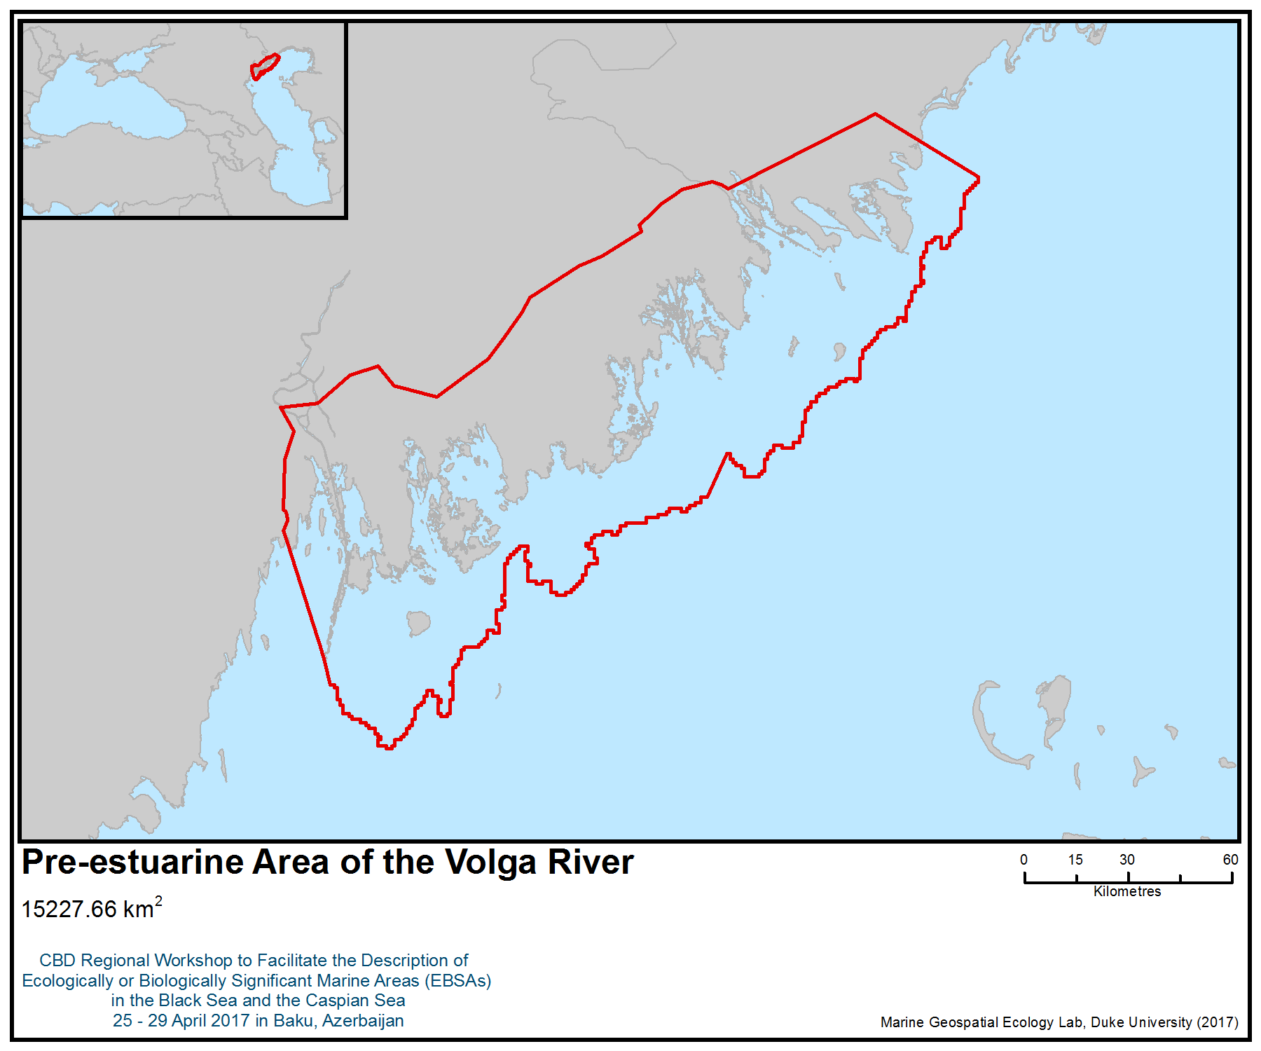
Figure 1. Area meeting the EBSA criteria

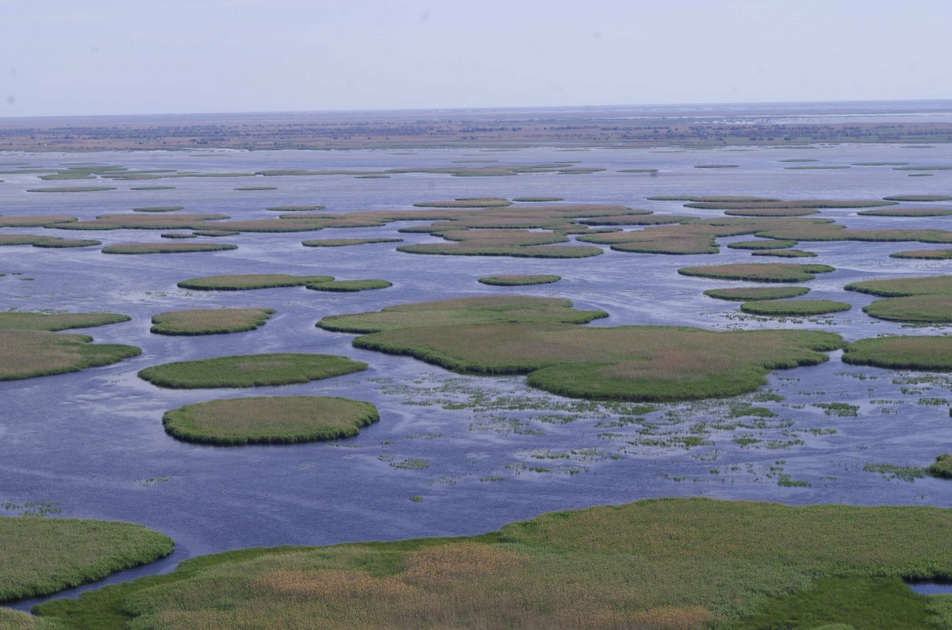
Figure 2. Reed islands in Volga Delta (photo K. Litvinov)
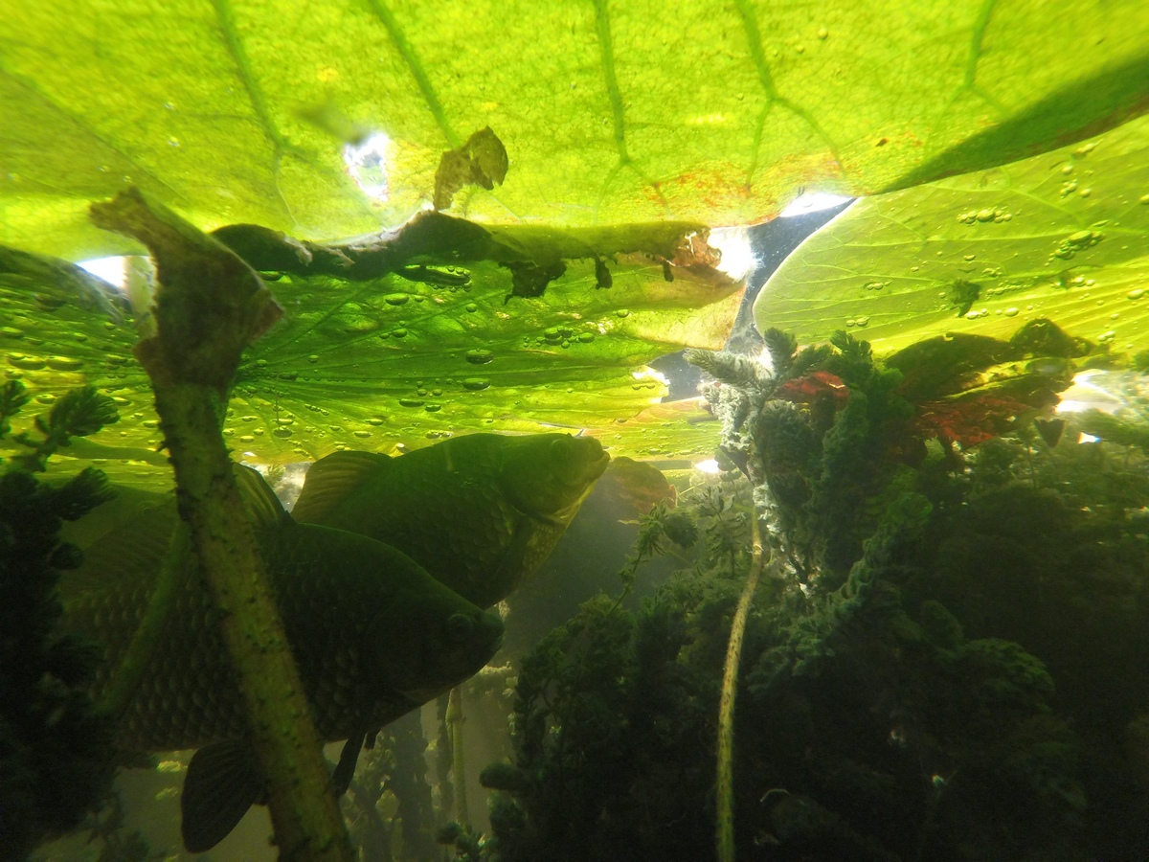
Figure 3. Goldfish (Carassius gibelio L.) - one of the mass species in the Volga Delta
(photo K. Litvinov)

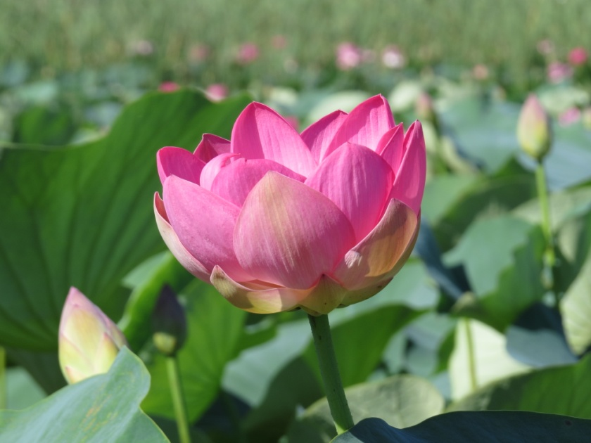
Figure 4. Caspian lotus (Nelumbo nucifera L.) in Astrakhan biosphere reserve (photo K.Litvinov)

Annex VI

SUMMARY OF THE WORKSHOP DISCUSSION ON IDENTIFICATION OF GAPS AND NEEDS FOR FURTHER ELABORATION IN DESCRIBING ECOLOGICALLY OR BIOLOGICALLY SIGNIFICANT MARINE AREAS, INCLUDING THE NEED FOR SCIENTIFIC INFORMATION, DEVELOPMENT OF SCIENTIFIC CAPACITY AS WELL AS SCIENTIFIC COLLABORATION

I. Black Sea

1. The workshop benefitted from the participation of experts from all the countries in this region as well as from relevant international/regional organisations (i.e., Black Sea Commission, OBIS, GOBI, BirdLife International) to describe areas meeting the EBSA criteria in the Black Sea. Participants were aware that describing areas meeting the EBSA criteria is an open and ongoing process, and hence participants discussed a list of potential species, populations, habitats and/or areas requiring further information and additional research that could be useful for future processes.

The Black Sea Rim Current
2. The Rim Current, along the periphery of the entire Black Sea, is one of the most important oceanographic characteristics of the Black Sea, controlling the structure of its ecosystem (Oğuz 2017). The Rim Current jet has a speed of 50–100 cm/s within the upper layer, and about 10–20 cm/s within the 150–300 m depth range (Oğuz et al. 2005). The mesoscale features of the Rim Current dynamic structure apparently provide a mechanism for two-way transport between nearshore and offshore regions. Considering the relatively narrow width of the basin into account, such mesoscale processes can result in meridional transport from one coast to another.
3. This narrow peripheral zone of the Black Sea appears to be always more productive (as seen also from satellite observations) at all trophic levels than the interior basin (Yunev et al. 2002; Mikaelyan et al. 2013). This is the main spawning area of the anchovy (the most abundant fish) and almost all other fish in the Black Sea (Niermann et al., 1994; Kideys et al., 1999; Gucu et al., 2016). It is also a concentration area for the gelatinous species, including invasives (Kideys and Romanova 2001; Mutlu, 2009). The mechanisms promoting relatively high phytoplankton population and thus supporting more effective zooplankton, small pelagic fish, and larvae populations around the periphery with respect to the cyclonic domes of the interior basin was unknown until recently and could not be attributed to the higher nutrient transport from rivers alone.
4. The recent modeling study by Oguz (pers. comm.) relates this feature to the frontogenesis mechanism of the Rim Current circulation arising from its nonlinearity and collapse of the along-front geostrophic balance providing high vertical velocities (∼10–50m d−1) at meander crests on the less dense coastal anticyclonic sides of the front. This results in supplying nutrients effectively into the euphotic zone relative to the cyclonic offshore side and to produce locally high plankton biomass. This phenomenon affects the entire food chain and biodiversity in the Black Sea. Thus, apart from its role in driving the entire ecosystem, due to associated planktonic biomass and biodiversity along with the rim current, this structure has the potential to be described in the future as meeting the EBSA criteria with adequate provision of scientific information and expertise.

References
Gucu, A. C., Inanmaz, O., Ok, M., and Sakınan, S. (2016). Recent changes in the spawning grounds of Black Sea anchovy, Engraulis encrasicolus. Fish. Oceanogr. 25, 67–84. doi: 10.1111/fog.12135
Kideys A. E., A. Gordina, F. Bingel & U. Niermann 1999. The role of environmental conditions on the distribution of eggs and larvae of anchovy (Engraulis encrasicolus L.) in the Black Sea. ICES Journal of Marine Science, 56: 58-64.
Kideys A.E. & Z. Romanova 2001. Distribution of gelatinous macrozooplankton in the southern Black Sea during 1996-1999. Marine Biology 139: 535-547.
Mikaelyan, A. S., Zatsepin, A. G., and Chasovnikov, V. K., (2013). Long-term changes in nutrient supply of phytoplankton growth in the Black Sea. J. Mar. Syst. 117, 53–64. doi: 10.1016/j.jmarsys.2013.02.012
Mutlu, E. (2009). Recent distribution and size structure of gelatinous organisms in the southern Black Sea and their interactions with fish catches. Mar. Biol. 156, 935–957. doi: 10.1007/s00227-009-1139-8
Niermann U., F. Bingel, A. Gorban, A. D. Gordina, A. C. Gücü, A. E. Kideys, A. Konsulov, G. Radu, A. A. Subbotin & V. E. Zaika 1994. Distribution of anchovy eggs and larvae (Engraulis encrasicolus Cuv.) in the Black Sea in 1991 and 1992 in comparison to former surveys. ICES Journal of Marine Science 51:395-406.
Oğuz T. 2017. Controls of Multiple Stressors on the Black Sea Fishery. Frontiers in Marine Science 4:1-12.
Oguz T., S. Tugrul, A. E. Kideys, V. Ediger & N. Kubilay 2005. Physical and biogeochemical characteristics of the Black Sea. In: The Sea, Vol. 14, Chapter 33, 1331-1369. edited by Allan R. Robinson and Kenneth H. Brink, ISBN 0–674– ©2004 by the President and Fellows of Harvard College.
Yunev O.A. , V. I. Vedernikov, O. Basturk, A. Yilmaz, A. E. Kideys, S. Moncheva & S. K. Konovalov 2002. Long-term variations of surface chlorophyll-a and primary production levels in the open Black Sea. Marine Ecology Progress Series 230: 11-28.

Cold (Methane) Seeps, Mud Volcanoes and Associated Biological Communities in the Black Sea
5. In the Black Sea, waters deeper than 150-200 m, down to 2200 m bottom depth, are anoxic (absence of oxygen), and contaminated with hydrogen sulfide (H₂S). The deep seabed has life based on microbial anaerobic processes. However, the benthic ecosystems of the Black Sea are generally poorly studied and represent a research gap.
6. Methane is a source of chemosynthetic production in reducing the hydrogen sulfide zone of the Black Sea. In 1989 methane gas jetting emissions were discovered for the first time in the Black Sea in the area of the Danube Paleodelta. Since then, about 3000 seeps have been found in the northern half of the sea, widely spread but mostly along the continental slope at depths of 60-700 m in the north-west, north and eastern Black Sea (Fig. 1) (Egorov et al. 2011, Klaucke et al. 2006).
7. Bacterial communities form mats or specific carbonate structures up to 30 cm high in the methane seep zones (Fig. 2). Living nematodes have been found at the methane seeps, which can exist due to symbiotic relationships with bacteria (Vorobyova, 1999). It is necessary to explore the formation of unique biocenosis specific to the Black Sea.
8. Recognizing the significance of these communities in the area of the Danube Paleodelta, the first marine reserve in the Black Sea was established in Romania. The “Methanogenic Structures from Sfantu Gheorghe: ROSCI0237” was created according to an order of the Minister of Environment and Sustainable Development (No. 1964/5, December 2007) regarding the designation of Sites of Community Importance (SCI) as part of the European Natura 2000 Network. In 2016, by the Order 46/2016 of the Minister of Environment, Water and Forests of Romania regarding the establishment of natural protected areas and SCIs as integral parts of the European Natura 2000 Network, the outer limit of the Danube Delta Marine Area was extended towards the open sea by 40 m isobaths, incorporating thus the Sfantu Gheorghe submerged marine methanogenic structures into one SCI: ROSCI0066 – Danube Delta Marine Area.

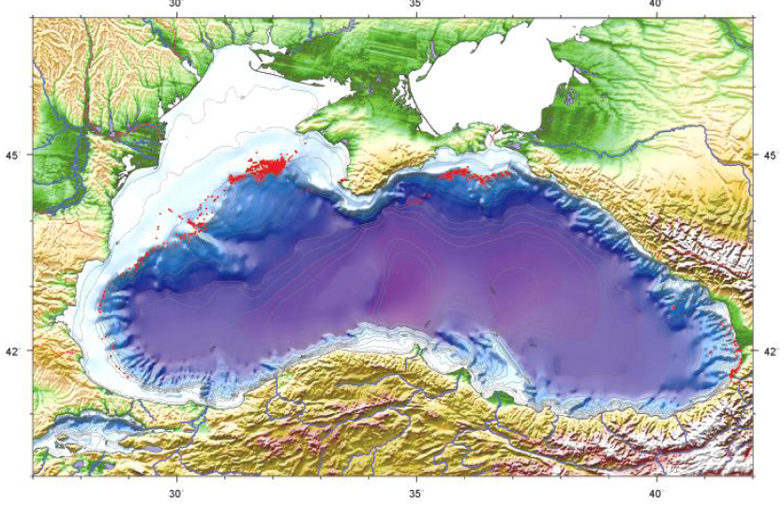
Figure 1. Map of distribution of methane seeps in the Black Sea (from Egorov et al. 2011)

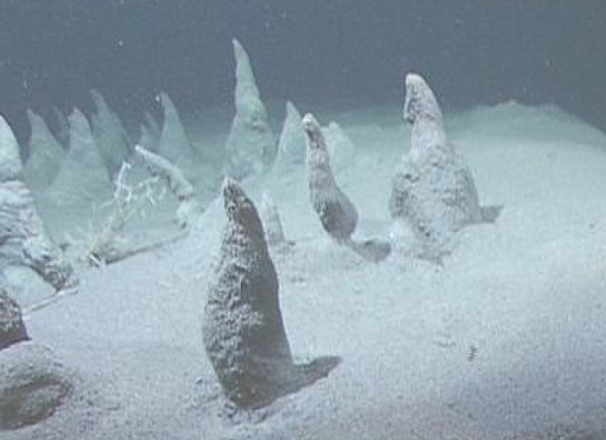

Figure 2. Field of carbonate structures “Forest of trolls” in the area of methane seeps from the bottom sediments of the deep Paleodelta of the Danube
Photo taken during the expedition of the R / V “Meteor”, 2007, depth 730 m (Source: Egorov et al. 2011).

9. Much of the abyssal Black Sea, in particular the entire southern half of the Black Sea, has not been surveyed in detail. Targeted research is needed on methane gas seeps and associated reef structures. In addition there are known concentrations of mud volcanoes in waters deeper than the basin shelf, including the Dvurechenskii mud volcano, which rises 80 m above the seabed with gas flumes rising up to 1,300m (Lichtschlag et al., 2010). Microbial communities (bacteria and archaea) with high genetic diversity, present in extreme deep-sea environments, are likely to be ecologically or biologically significant in terms of their genetic DNA sequence variability.

References
Egorov V.N., Artemov Y.G., Gulin S.B. Methane seeps in the Black Sea: Environment-forming and ecological role / Ed. by G.G. Polikarpov. – Sevastopol: ECOSEA Hydrophysics, 2011. – 405 pp. (in Russian).
Klaucke I, H Sahling, W. Weinrebe, V. Blinova. D. Bürk, N. Lursmanashvili, G. Bohrmann. Acoustic investigation of cold seeps offshore Georgia, eastern Black Sea. Marine Geology 231 (2006) 51-67.
Lichtschlag, A., Felden, J., Wenzhofer, F., Schubotz, F., Ertefai, TF., Boetius, A. and de Beer, D. (2010) Methane and sulfide fluxes in permanent anoxia: In situ studies at the Dvurechenskii mud volcano (Sorokia Trough, Black sea). Geochimica et Cosmochimica Acta. 74: 5002-5018.
Oguz, T., Tugrul, S., Kideys, AE., Ediger, V. and Kubilay, N. (2005) Physical and biogeochemical characteristics of the Black Sea. The Sea 14, Chapter 33: 1331-1369.
Schipers, A., Kock, D., Hoft, C., Koweker, G., and Seigert, M. (2012) Quantification of Microbial Communities in subsurface marine sediments of the Black Sea and off Namibia. Frontiers in Microbiology 3: 16.
Vorobyova L.V. Meiobenthos of Ukrainian shelf of the Black Sea and the Sea of Azov. – К.: Naukova dumka Publ., 1999. – 299 pp. (in Russian).

Birds of the Black Sea
10. In recent years, considerable effort has been made to fill some of the major gaps in the knowledge of seabirds in the Black Sea (e.g., Doğa Derneği 2014). Nevertheless, the area is still relatively poorly known in terms of its importance for seabirds, particularly in the more central, deep areas located away from the coasts.
11. Some threatened seabird species are known to occur in the area, such as the yelkouan shearwater (Puffinus yelkouan), velvet scoter (Melanitta fusca) and horned grebe (Podiceps auritus). While some information is already available about the distribution of the Yelkouan shearwater in the Black Sea (e.g., Ortega and İsfendiyaroğlu 2017), most of the data are from birds tracked from distant colonies located in the Mediterranean and migrating to the Black Sea (Raine et al. 2012, Péron et al. 2013, Seabird Tracking Database 2017), or limited to areas in proximity to the coast (Doğa Derneği 2014). An at-sea seabird survey has also been conducted, but it covered only a relatively narrow transect area between Turkey and Ukraine (Doğa Derneği 2014). Therefore, a more comprehensive survey of the area based on at-sea counts (focusing mostly on offshore areas), along with tracking studies of local birds using more accurate devices (such as platform terminal transmitters, or PTT), would be of great importance to reveal in more detail the specific areas used by the species in the Black Sea.
12. This knowledge would be of key importance to understand the drivers of the decline of the species, which is known to occur mostly during the non-breeding period (Oppel et al. 2011), potentially in the Black Sea. In this regard, a detailed study should also be conducted to quantify the magnitude of the incidental fishing by-catch of the Yelkouan shearwater in the Black Sea, given that this is considered the most serious threat to the species (Oppel et al. 2011, BirdLife International 2017a).
13. At-sea boat surveys would be also important to help understand the diversity, abundance and distribution of other species of seabirds occurring in the Black Sea. Forty-one species of seabirds have been identified so far (Ortega and İsfendiyaroğlu 2017), but clearly more studies are needed to inform the list of species and their phenology.
14. The Black Sea is an important destination for some migrants from other parts of Europe, and some of the local breeders are also migrants that leave the region during the winter. To understand this seasonally dynamic environment, the surveys should ideally be repeated throughout the year. These surveys would also be relevant to identify the areas more intensively used by the other two vulnerable species, the velvet scoter and the horned grebe. While the overall distribution of these species is known (BirdLife International 2017b), virtually no information is available about the most important hotpots in the Black Sea. These species are rarely mentioned in the inventory of the bird species present in the current network of Important Bird and Biodiversity Areas (IBAs) in the region, which highlights the current lack of knowledge.
15. Along with at-sea surveys, counts from the coast can also provide very relevant information, especially about the more coastal species such as gulls, terns and cormorants. The Black Sea is particularly important for the Mediterranean gull Larus melanocephalus (holding over 90% of the global population; Ortega and İsfendiyaroğlu 2017) and for the Mediterranean endemic subspecies of the European shag (Phalacrocorax aristotelis desmarestii). While some areas have been studied in the above-mentioned projects (Doğa Derneği 2014), these covered mostly the west coast (Bulgaria and Romania). A monitoring programme that would include the key known areas (e.g., current IBAs) and some additional potentially suitable new sites would be of high relevance to understand better the distribution of the seabirds along the coastal areas. Such programmes would also be of high value to understand the population trends of the seabirds in the region.

References
BirdLife International, 2017a. Species factsheet: Puffinus yelkouan. Downloaded from http://www.birdlife.org on 10/03/2017.
BirdLife International, 2017b. IUCN Red List for birds. Downloaded from http://www.birdlife.org on 10/03/2017
Doğa Derneği, 2014. Black Sea Seabirds Project Layman’s report, Istanbul.
Oppel S., Raine, A.F., Borg, J.J., Raine, H., Bonnaud, E., Bourgeois, K., Breton, AR., 2011. Is the Yelkouan shearwater Puffinus yelkouan threatened by low adult survival probabilities? Biological Conservation 144(9): 2255- 2263.
Ortega M.P., İsfendiyaroğlu S., 2017. Predicting foraging hotspots for Yelkouan Shearwater in the Black Sea. Deep-Sea Research Part II in press
Péron, C., Grémillet, D., Prudor, A., Pettex, E., Saraux, C., Soriano-Redondo, A., Authier, M., Fort J., 2013. Importance of coastal Marine Protected Areas for the conservation of pelagic seabirds: The case of Vulnerable yelkouan shearwaters in the Mediterranean Sea. Biological Conservation 168: 210-221.
Raine, A.F., Borg, J.J., Raine, H., Phillips, R.A., 2012. Migration strategies of the Yelkouan Shearwater Puffinus yelkouan. Journal of Ornithology 154: 411-422.
Seabird Tracking Database 2017. Tracking Ocean Wanderers – BirdLife Seabird Tracking Database www. http://seabirdtracking.org/, accessed on 10/03/2017

Mapping of the mussel fields of the subtype of habitat 1170 “Mussel banks on sediment” and research of its biodiversity and productivity
16. The subtype of habitat 1170, namely “Mussel banks on sediment”, has a significant coverage in the Special Area of Conservation (SAC) Ropotamo protected area (Area No. B1: Ropotamo) as well as significant biomass and good dimensional structure of the habitat-forming species Mediterranean mussel (Mytilus galloprovincialis). Black mussels also have a relatively large average size and good dimensional structure, maintaining a high level of biodiversity of the accompanying invertebrate fauna and fishes. The species composition of the accompanying fauna is variable and depends on the sediment matrix and depth.
17. This habitat plays a key ecological role for the functioning and resilience of the marine ecosystem as a whole due to the strong biofiltration capacity of the black mussels, hence transforming the primary production into a secondary one.
18. At the same time the mussel beds provide substrate for a diverse epifauna (sponges, hydrozoans, sea anemones, bryozoans, ascidians, polychaetes). They are the food source for the carnivores (veined rapa whelk, decapods, demersal fishes) and deposit-feeders (polychaetes).
19. This habitat also provides suitable places for the reproduction and growth of numerous organisms, some of which are important fishing species such as turbot (Scophthalmus maximus), European flounder (Platichthys flesus), veined rapa whelk (Rapana venosa), and sturgeons. It is an important habitat of the shad fishes of the genus Alosa, providing feeding grounds and migration routes to the spawning grounds.
20. However, its exact area is unknown, hence requiring further investigation to consider its potential to meet the EBSA criteria.
Mapping of the biogenic Ostrea edulis structures (reefs) and research of its biodiversity
21. It is a unique and remarkable habitat, but not well-studied, found in the Ropotamo area representing a huge biogenic reef built by the native and unique European flat oyster Ostrea edulis, called “Ostrak”. Tube-building serpulid polychaetes also contribute to the reef structure as cementing elements. Unlike the flat oyster beds commonly known from the intertidal areas of Western Europe and North America, the Black Sea’s “Ostrak” are massive, towering biogenic structures.
22. In terms of biodiversity, reefs are overgrown by blue mussels, sponges and sciaphilic algae (Delesseria ruscifolia, Zanardinia prototypus) and harbour diverse marine life: abundant crabs (Eri phia verrucosa), blennies, gobies (Aphia minuta, Mesogobius batrachocephalus), scorpionfishes (Scorpaena porcus), wrasses and mullets.
23. No information is available on whether live oyster reefs still exist. Information based on personal conversations with local spear-fishers and observations indicate that fresh oyster shells were visible on the reefs more than 10 years ago; none were found live during the recent observation. However, records of abundant oysters date back decades ago (Todorova et al., 2008). Besides mapping the “Ostrak” boundaries, there is a need to investigate whether live specimens are present or not.
References
Red Data Book of the Republic of Bulgaria, Vol. 3 Natural Habitats.
http://e-ecodb.bas.bg/rdb/en/vol3/11a4.html
NATURA 2000 – Standard Data Form of Special Area of Conservation Ropotamo BG0001001, designated under the Habitats Directive.
http://natura2000.moew.government.bg/PublicDownloads/Auto/PS_SCI/BG0001001/BG0001001_PS_16.pdf
Todorova V., Micu D., Panayotov M., Konsulova T., 2008. Marine Protected Areas in Bulgaria – Present and Prospects, Publishing House: HelixPress, StenoPublishing House, Varna, ISBN 978-954-449-373-8, p. 13.

II. Caspian Sea

Data/Information gaps
1. Noting the existence of various data related to the Caspian Seal, the group on the Caspian Sea highlighted the urgent need for a coordinating mechanism/platform that could facilitate combining the Caspian Sea data both at the national and regional levels as well as increasing public accessibility to the information. However, some specific data gaps were noted regarding:
- Productivity for the different subregions of the Caspian Sea;
- Sea-level fluctuation and its impact on the biodiversity in different subregions of the Caspian;
- Up-to-date population surveys of the Caspian seal;
- Scenario-based modeling of seals’ adaptation to climatic conditions;
- State of the health of the Caspian seals;
- Understanding of behaviour of seal pups;
- Impact of invasive alien species, in particular Mnemiopsis leidyi, on Caspian biodiversity;
- Studies of sturgeons artificially introduced into the Caspian Sea;
- Habitat mapping of the Caspian Sea benthic ecosystems;
- Knowledge on species through taxonomy and molecular genetics.

Capacity-building
2. The following areas were identified as priorities for capacity-building:
- Support to the Caspian Environment Monitoring programme, established by Third Meeting of the Conference of the Parties to the Framework Convention for the Protection of the Marine Environment of the Caspian Sea, in particular its biological dimension. The monitoring programme aims to provide biological data to track changes to the health and diversity of ecosystems;
- Development and agreement on the harmonized Caspian biodiversity indicators within the Caspian Environment Monitoring and Working Group on Monitoring and Assessment to the Tehran Convention;
- For biological data and information: support to Caspian Environmental Information Center (CEIC), as a main regional information and data hub in the region. It would include building the capacity of governments, non-governmental organizations and private businesses to use and feed information to the CEIC;
- Development of the Caspian Red Book, in compliance with the Ashgabat Protocol for the Protection of the Biodiversity of the Caspian Sea;
- Development and production of a scientific information of governments, academia and private businesses on the state of biodiversity of the Caspian Sea and making itavailable in user-friendly format for policy-makers and the public;
- Caspian Seal protection: Under the Caspian Environment Program (Caspeco), countries developed a draft concept plan for the creation of a network of special protected areas for the Caspian seal. Various supportive measures would be required to put the plan into action and to develop marine protected areas for the Caspian seal;
- Use of EBSA information in Caspian Sea to strengthen the existing efforts for conservation and sustainable use of marine and coastal biodiversity;
- Geographic Information Ssystems and remote sensing to generate scientific data and to develop maps.

Scientific networking and collaboration
3. There is a need for network-building and further collaboration among relevant organizations at the international, regional, national and local levels that can contribute to the improved understanding of marine and coastal biodiversity in the region. The participants highlighted the importance of regular meetings between experts from the Caspian region, which allow sharing of best practices.
4. Organization of an international scientific conference on the Caspian Sea environment, in particular on the topic of the impacts of climate change on water level fluctuation in the Caspian Sea. Such a conference could lead to the establishment of regional scientific centres of excellence.
5. Further refinement of the EBSA descriptions using advancements in scientific understanding of marine biodiversity in different marine areas of the Caspian Sea.
6. It is noted by OBIS that there is still no OBIS node operational within the Caspian region, and that there are very few data providers. Accordingly, the urgent need for organizing OBIS capacity-building activities in the Caspian region was highlighted, focusing, for example, on:
- Expanding the OBIS network of collaborators;
- Improving the quality of marine biogeographic data;
- Increasing awareness of international standards and best practices related to marine biogeographic data;
- Increasing the amount of open access data published through OBIS and its OBIS nodes;
- Increasing the use of data from OBIS for science, species conservation and area-based management applications.

__________

The designations employed and the presentation of material in this note do not imply the expression of any opinion whatsoever on the part of the Secretariat concerning the legal status of any country, territory, city or area or of its authorities, or concerning the delimitation of its frontiers or boundaries.
Participants were also provided with a webinar training session prior to the workshop, on 13 April 2017.

