|  |  |  |
| --- | --- | --- |
| Macintosh HD:Users:bilodeau:Desktop:logos:template 2017:un.emf |  | CBD/SBI/4/INF/11 |
|  | | Distr.: General  2 April 2024  Original: English/French |

Subsidiary Body on Implementation

Fourth meeting

Nairobi, 21–29 May 2024

Item 8 of the provisional agenda[1]*

Review of the effectiveness of the processes under the Convention and its Protocols

Compilation of views from Parties and stakeholders on virtual and hybrid meetings, including relevant experience[2]**

Note by the Secretariat

Introduction

1. As requested in paragraph 8 of decisions 15/18, CP-10/8 and NP-4/9, adopted by the Conference of the Parties to the Convention, the Conference of the Parties serving as the meeting of the Parties to the Cartagena Protocol, and the Conference of the Parties serving as the meeting of the Parties to the Nagoya Protocol, respectively, the Executive Secretary is circulating herewith, for the information of participants in the fourth meeting of the Subsidiary Body on Implementation, a compilation of views submitted to the Secretariat in response to notification No. 2023-027 of 13 March 2023 regarding participation in, or conducting virtual and hybrid meetings during 2021 and 2022.
2. Submissions were received from the following Parties: Brazil, Canada, Cote d’Ivoire, European Union, Guinea Bissau, Japan, Kuwait, Mauritius, New Zealand, Nigeria, Switzerland and the United Kingdom of Great Britain and Northern Ireland. Submissions were also received from the following organizations: G-BIKE, Local and Subnational Governments Major Group (LSNG), and Third World Network.
3. Pursuant to the decisions referred to in paragraph 1 above, this document also provides information regarding the experience of some Multilateral Environmental Agreements (MEAs) on the conduct of hybrid and virtual meetings, namely: The Basel, Rotterdam and Stockholm Conventions (BRS), the Convention on International Trade in Endangered Species of Wild Fauna and Flora (CITES), and the Convention on Wetlands (RAMSAR). The Secretariat was also given access by UNEP to its internal study on virtual meetings prepared, with the participation of MEAs, in 2020 and revised in April 2021.
4. The information compiled in this document is structured as follows:[3] section A contains the submissions from Parties; section B comprises the submissions from organizations; and section C sets out the experience of relevant MEAs.

**Table of Contents**

A. SUBMISSIONS FROM PARTIES 3

Brazil 3

Canada 4

Cote d’Ivoire 5

European Union 7

Guinea Bissau 8

Japan 9

Kuwait 9

Mauritius 10

New Zealand 12

Nigeria 15

Switzerland 16

United Kingdom 17

B. SUBMISSIONS FROM ORGANIZATIONS 18

G-BIKE 18

Local and Subnational Governments Major Group (LSNG) 20

Third World Network 22

C. EXPERIENCE OF SOME MULTILATERAL ENVIRONMENTAL AGREEMENTS AND A UNEP STUDY 25

Basel, Rotterdam and Stockholm Conventions (BRS) 25

Convention on International Trade in Endangered Species of Wild Fauna and Flora (CITES) 30

Convention on Wetlands (RAMSAR) 31

UNEP Law Division study (Internal document) ……………………………………………………….36

# SUBMISSIONS FROM PARTIES

|  |  |
| --- | --- |
| Brazil | 30 June 2023 |

|  |  |
| --- | --- |
| Canada | 30 June 2023 |

|  |  |
| --- | --- |
| Cote d’Ivoire | 14 June 2023 |

|  |  |
| --- | --- |
| European Union | 8 May 2023 |

|  |  |
| --- | --- |
| Guinea Bissau | 11 April 2023 |

|  |  |
| --- | --- |
| Japan | 29 June 2023 |

|  |  |
| --- | --- |
| Kuwait | 28 March 2023 |

|  |  |
| --- | --- |
| Mauritius | 25 April 2023 |

|  |  |
| --- | --- |
| New Zealand | 9 May 2023 |

|  |  |
| --- | --- |
| Nigeria | 3 July 2023 |

|  |  |
| --- | --- |
| Switzerland | 15 May 2023 |

|  |  |
| --- | --- |
| United Kingdom | 9 May 2023 |

# SUBMISSIONS FROM ORGANIZATIONS

|  |  |
| --- | --- |
| G-BIKE | 15 June 2023 |

|  |  |
| --- | --- |
| Local and Subnational Governments Major Group (LSNG) | 28 April 2023 |

|  |  |
| --- | --- |
| Third World Network | 9 May 2023 |

# EXPERIENCE OF SOME MULTILATERAL ENVIRONMENTAL AGREEMENTS AND A UNEP STUDY

|  |  |
| --- | --- |
| Basel, Rotterdam and Stockholm Conventions (BRS) | 14 December 2023 |

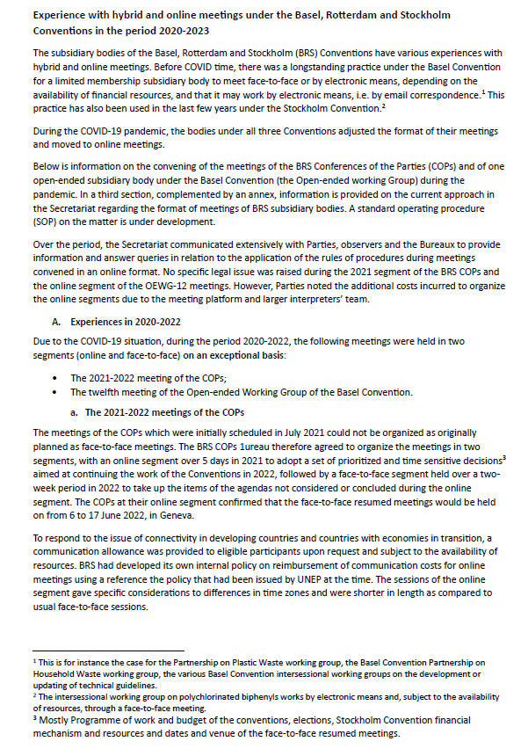

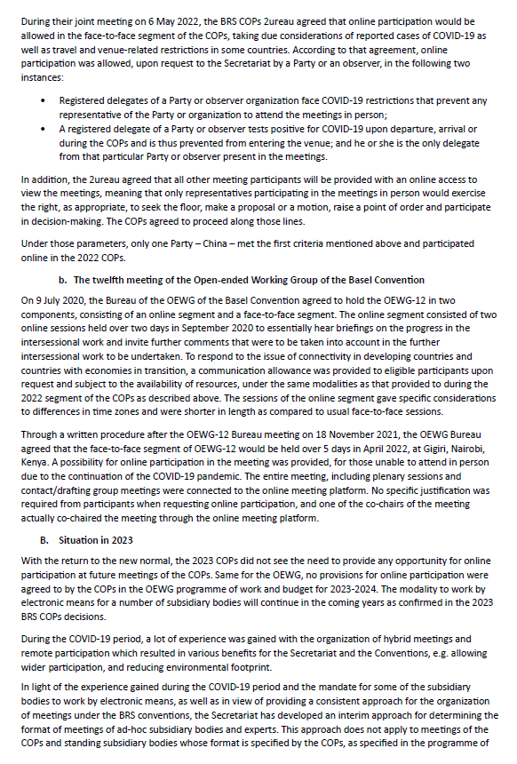

|  |  |
| --- | --- |
| Convention on International Trade in Endangered Species of Wild Fauna and Flora (CITES) | 15 December 2023 |

The relevant experience of CITES is highlighted in document SC77 Doc. 12: [https://cites.org/sites/default/files/documents/SC/77/agenda/E-SC77-12.pdf](https://eur02.safelinks.protection.outlook.com/?url=https%3A%2F%2Fcites.org%2Fsites%2Fdefault%2Ffiles%2Fdocuments%2FSC%2F77%2Fagenda%2FE-SC77-12.pdf&data=05%7C02%7Cmweene%40un.org%7Cd6d6e7a24e744d653aa508dbfd508e42%7C0f9e35db544f4f60bdcc5ea416e6dc70%7C0%7C0%7C638382294646877834%7CUnknown%7CTWFpbGZsb3d8eyJWIjoiMC4wLjAwMDAiLCJQIjoiV2luMzIiLCJBTiI6Ik1haWwiLCJXVCI6Mn0%3D%7C3000%7C%7C%7C&sdata=KCP1KZtzcEKFGLz1hFOgLlphSHz%2Bzbh8ll0C6rYz1As%3D&reserved=0)

|  |  |
| --- | --- |
| Convention on Wetlands (RAMSAR) | 8 December 2023 |

|  |  |
| --- | --- |
| United Nations Environment Programme | 12 December 2023 |

REVISED LAW DIVISION STUDY ON VIRTUAL MEETINGS (and a summary of practice)

Prepared in consultation with the Secretariats of the UNEP Governing Bodies and Multilateral

Environment Agreements and UNEP Regional Offices, APRIL 2021

(Internal document)

__________

1. * CBD/SBI/4/1.
2. ** The present document is being issued without formal editing.
3. The submissions, experiences and studies have been reproduced in the form and languages in which they were provided to, or gathered by the Secretariat. Hyperlinks are provided for lengthy documents.