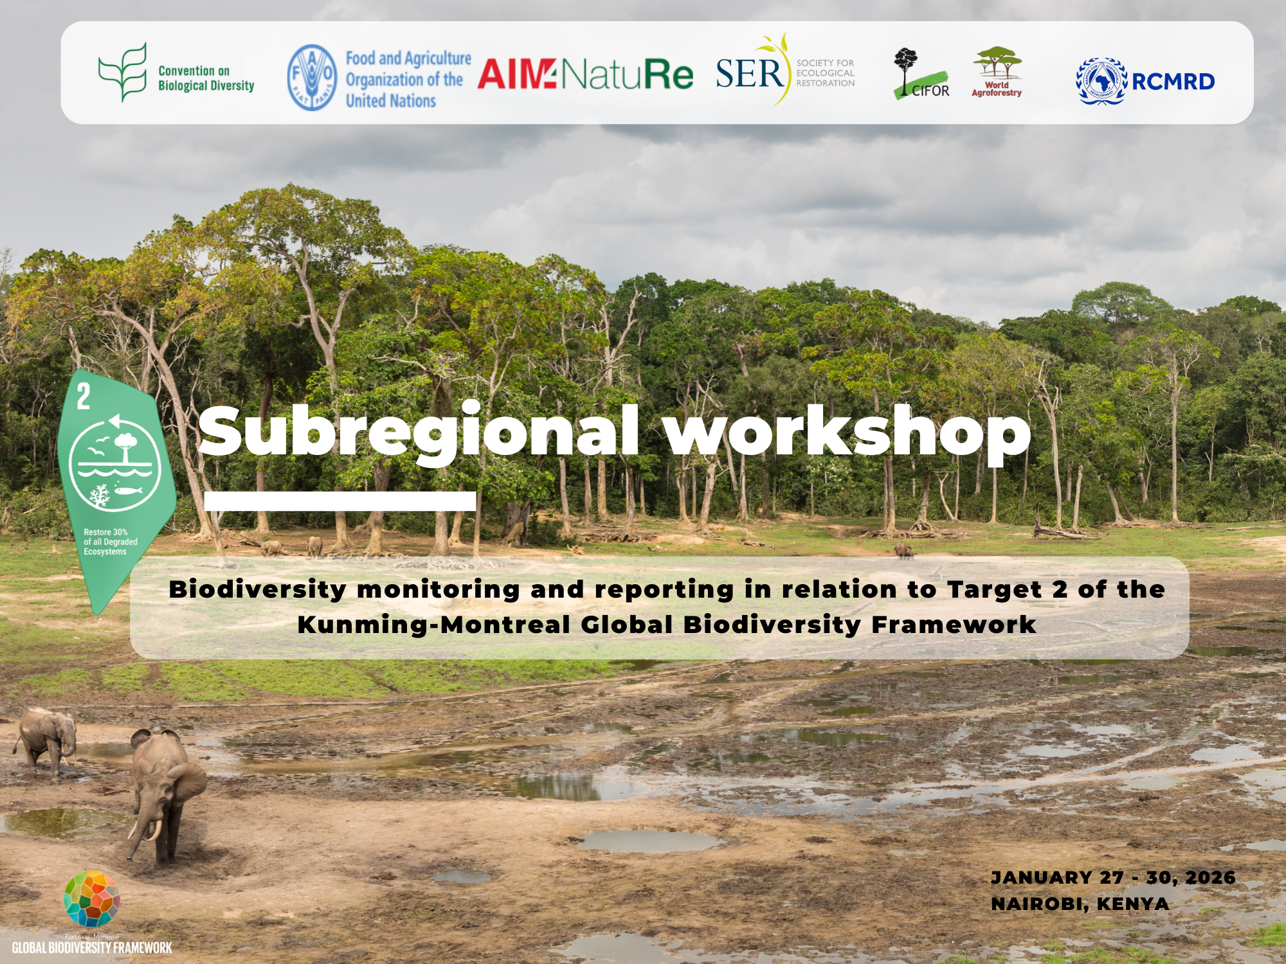

27 to 30 January 2026 - Nairobi, Kenya
To be held at Regional Centre for Mapping of Resources for Development (RCMRD)
Address: Kasarani Road, P.O. Box 632-00618 Nairobi, Kenya

BACKGROUND
The Kunming–Montreal Global Biodiversity Framework (GBF) underscores the urgent need to halt and reverse biodiversity loss, with Target 2 calling for the effective restoration of degraded ecosystems by 2030. Achieving this target requires robust, coordinated, and comparable systems for ecosystem restoration monitoring and reporting, supported by strengthened national capacities and regional cooperation.
In this regard, we are pleased to announce that a Subregional workshop on biodiversity monitoring and reporting in relation to Target 2 of the Kunming-Montreal Global Biodiversity Framework, 27 to 30 January 2026 – RCMRD premises in Nairobi, Kenya.
The workshop is co-organized by the Food and Agriculture Organization of the United Nations, the Regional Centre for Mapping of Resources for Development (RCMRD) and the Secretariat of the Convention on Biological Diversity (CBD). Representatives from countries covered by RCMRD, in its function as subregional technical and scientific cooperation support centre, as well as representatives of other four technical support centres in Africa are invited to participate in the workshop. The countries covered by RCMRD CBD Technical Support Centre are: Comoros, Eswatini, Ethiopia, Kenya, Madagascar, Rwanda, Somalia, South Sudan, Uganda, the United Republic of Tanzania, and Zambia.
The workshop supports the participating countries to accelerate monitoring and reporting on ecosystem restoration in the context of Target 2 of the Framework and offers the opportunity to share subregional, national and local experiences and challenges in this regard. The workshop includes a training of trainers for the representatives of the support centres of the African region. Furthermore, RCMRD will officially launch its role as subregional technical and scientific cooperation support centre and the establishment of its steering committee.
The workshop’s objectives are:
- To enhance technical understanding of ecosystem restoration monitoring under Target 2 of the Kunming–Montreal Global Biodiversity Framework, including relevant indicators, data sources, and reporting pathways.
- To strengthen national capacities to improve monitoring and reporting processes, with particular emphasis on supporting Parties in preparing inputs to the Seventh National Report.
- To facilitate structured exchange of experiences, lessons learned, and challenges in ecosystem restoration monitoring at sub-regional, national, and local levels, to promote harmonized and effective approaches.
- To build the capacity of Sub-Regional Technical and Scientific Cooperation Support Centres in Africa through a Training of Trainers (ToT) approach, enabling sustained technical support to Parties beyond the workshop.
- To Officially launch RCMRD’s mandate as a Sub-Regional Technical and Scientific Cooperation Support Centre, including the establishment of its steering committee, to strengthen coordination, governance, and long-term technical cooperation on biodiversity monitoring.
Through this workshop, participating countries and institutions will be better positioned to accelerate progress toward ecosystem restoration commitments and contribute effectively to the implementation of the Global Biodiversity Framework.
Programme for the Official Launch
27 January 2026 at 9:00hrs | Venue: RCMRD, Nairobi, Kenya.
9:00 – 09:15 Chief Guest arrives at RCMRD Complex
- Signs visitors book at Director General’s Office
09:15– 09:40 Introduction and Overview of the Objectives and Programme of the Workshop
- Welcome and Introduction. Ngugi Kimani, Geospatial Data and Technologies Manager (RCMRD)
- Overview of the Kunming-Montreal Global Biodiversity Framework (KM GBF), Monitoring Implementation, and Preparing National Reports. Jamal Annagylyjova, Forest Biodiversity and Ecosystem Restoration Officer (CBD)
- RCMRD's role as a sub-regional support centre for monitoring and reporting focusing on Target 2 and a regional overview of NBSAPs and national targets. Kelly Waga, Knowledge Management Expert (RCMRD)
09:40– 10:00 Remarks by Partners
- Dr Emmanuel Nkurunziza, Director General (RCMRD)
- Astrid Schomaker, Executive Secretary of the Convention, (CBD), video-message
- Yelena Finegold, Forestry Officer (FAO)
- Robina Abuya, British Embassy
- Patrick Mucheleka, RCMRD Governing Council Chairperson and Permanent Secretary Ministry of Land and Natural Resources, Zambia
10:00– 10:30 CHIEF GUEST SPEECH
- Hon. Dr. Deborah Mlongo Barasa, Cabinet Secretary, Ministry for Environment, Climate Change and Forestry
10:30 – 10:35 Official launch of the Technical and Scientific Cooperation Support Centre
10:35 – 10:40 Group Photo
10:40 – 10:50 Planting of a Tree

Detailed Programme
DAY 1:
TUE, 27-JAN-2026: KM-GBF MONITORING FRAMEWORK AND ECOSYSTEM RESTORATION IMPLEMENTATION
Time | Session | Responsible Person(s)/ Facilitator | ROOM/LOCATION
08.00 - 09.00 | Registration | RCMRD | RCMRD Conference room entrance
ITEM 1: Tuesday 27th January 2026: Opening of the workshop and TSC Launch
09.00 - 10:50 | High Level Opening of the Subregional Workshop (check detailed programme above) | RCMRD | RCMRD Conference room
10:50 - 11.20 | Tea Break | RCMRD | Complex Roof Top (Pergola)
ITEM 2: Unpacking Target 2
11.20 - 11.30 | UN Decade on Ecosystem Restoration: Where the UN Decade is and where it is going in the next 5 years. | UNEP | RCMRD Conference room
11.30 - 11.40 | Presentation of Target 2 self-assessment results | CIFOR-ICRAF | RCMRD Conference room
11.40 - 12.10 | Presentation on the key elements of Target 2, including understanding degradation in the three major ecosystem types and defining the baseline | SER | RCMRD Conference room
12.10 - 12.20 | Country experiences - 1 | Madagascar | RCMRD Conference room
12.20 - 12.30 | Q&A | All | RCMRD Conference room
12.40 - 13.40 | Lunch Break | RCMRD | Complex Roof Top (Pergola)
13.40 - 14.40 | Break-out session: Group Discussion to share examples derived from country and local-level experiences, including how to assess degradation and determine baselines | All | TBC/M1/M2/B8
14.40 - 14.55 | Report back from group discussion | TBC | RCMRD Conference room
14.55 - 15.20 | Tea break | RCMRD | TBC/PAGOLA
15.20 - 15.50 | Presentation on defining restoration outcomes & implementing effective restoration to achieve national targets | SER | RCMRD Conference room
15.50 - 16.00 | Country experiences - 2 | Uganda | RCMRD Conference room
16.00 - 16.10 | Q & A | All | RCMRD Conference room
16.10 - 17.10 | Break-out session: Group discussion on how to implement national targets and contribute to the Target 2 key outcomes | All | TBC/M1/M2/B8
17.10 - 17.25 | Report back from group discussion | TBC | RCMRD Conference room
17.25 - 17.30 | Summarize and close Day 1 | RCMRD | RCMRD Conference room
DAY 2:
WED, 28-JAN-2026: RESTORATION DATA REPORTING AND FERM
ITEM 3: Restoration data, reporting, and FERM
Time | Session | Responsible Person(s)/ Facilitator | ROOM/ LOCATION
08.30 - 9.00 | Registration | RCMRD | RCMRD Conference room entrance
09.00 - 9.10 | Opening and overview of Day 2 | FAO | RCMRD Conference room
09.10 - 09.20 | AFR-100 Monitoring and reporting at the Regional level | AUDA-NEPAD | RCMRD Conference room
09.20 - 09.30 | Country presentation 3 - AFR-100 monitoring and reporting | Tanzania | RCMRD Conference room
09.30 - 09.40 | Q&A
09.40 - 10.00 | Monitoring and reporting Target 2 | FAO | RCMRD Conference room
10.00 - 10.10 | Q & A | RCMRD | RCMRD Conference room
10.10 - 10.30 | Tea Break | RCMRD | Complex Roof Top (Pergola)
10.30 - 10.40 | Component Indicator - SDG 15.3.1 and degradation baselines | UNCCD | RCMRD Conference room
10.40 - 10.50 | Country presentation 4 - SDG 15.3.1 and degradation baselines | Ethiopia | RCMRD Conference room
10.50 - 10.55 | Exploring the linkages between Target 2 and 22 | FAO Kenya (TBC) | RCMRD Conference room
10.55 - 11.05 | Indigenous Led Restoration Monitoring | TBC | RCMRD Conference room
11.05 - 11.15 | Q & A | TBC | RCMRD Conference room
11.15 - 11.45 | FERM - demo, FERM registry, search engine and data review for target 2 reporting | FAO | RCMRD Conference room
11.45 - 12.00 | Q & A | All | RCMRD Conference room
12.00 - 13.00 | Plenary Interactive session for FERM registry tutorial | FAO | RCMRD Conference room
13.00 - 14.00 | Lunch Break | RCMRD | Complex Roof Top (Pergola)
14.00 - 15.00 | Plenary Interactive session for FERM data review functionality | FAO | RCMRD Conference room
15.00 - 15.25 | Tea break | RCMRD | Complex Roof Top (Pergola)
15.25 - 15.35 | Country presentation 5 - Protected areas and restoration | Rwanda | RCMRD Conference room
15.35 - 15.45 | Q & A | All | RCMRD Conference room
15.45 - 16.45 | Break-out session: discussion to identify challenges and opportunities for monitoring and reporting ecosystem restoration related to data collection, compilation, and validation (harmonization, disaggregation, sharing bases) | All | TBC/M1/M2/B8
16.45 - 17.05 | Report back from group discussion | TBC | RCMRD Conference room
17.05 - 17.10 | Summarize and close Day 2 | RCMRD | RCMRD Conference room
DAY 3:
THU, 29-JAN-2026: VISIT TO CIFOR-ICRAF & FIELD TRIP TO RESTORATION SITE (KARURA FOREST)
TIME | Session | Responsible Person(s)/ Facilitator | ROOM/ LOCATION
ITEM 4: Visit to CIFOR-ICRAF
08.30 - 09:00 | - Arrival and Breakfast at CIFOR-ICRAF Campus | CIFOR-ICRAF | Courtyard
ITEM 5: Opening Remarks
09. 00 - 09:30 | - Phillip Osano (COO), CIFOR-ICRAF  - Peter Minang (Africa Director), CIFOR-ICRAF  - Leigh Winowiecki, Global Lead, Soil and Land Health. | CIFOR-ICRAF | Courtyard
ITEM 6: Technical Presentations by CIFOR-ICRAF, the Karura Forest and Countries
09.30 - 10:15 | - CIFOR-ICRAF scientists:Restoration World Cafe  - Karura Forest restoration plan preview | CIFOR-ICRAF and Karura Forest | Conference Hall
10:15 - 10:25 | Country presentation 6 - Restoration examples from the field & monitoring | Comoros | Conference Hall
10:25 - 10:35 | Country presentation 7 - Restoration examples from the field & monitoring | Somalia | Conference Hall
10:35 - 10:45 | Country presentation 8 - Restoration examples from the field & monitoring | South Sudan | Conference Hall
10:45 - 11:00 | Q & A
ITEM 7: Laboratory Visits (3 Rotations with 20 participants per rotation)
11.00 – 12:30 | - Soil Lab,  - Tree & Seed Lab  - Spatial Observation Lab | CIFOR-ICRAF | TBC
12.30 – 13:30 | Lunch Break | CIFOR-ICRAF | Bamboo hut
ITEM 8: Karura Forest Field Visit
13.30 – 16:30 | Nursery and indigenous seedling systems; invasive removal sites; restoration plots; monitoring approaches | Karura Forest | Karura Forest
DAY 4: FRI, 30-JAN-2026: WRAP UP AND TRAINING OF TRAINERS (RESTORATION ACTION PLANS TO ADDRESS NATIONAL NEEDS FOR MONITORING AND REPORTING)
ITEM 9: Restoration action plans to address national needs for monitoring and reporting
TIME | Session | Responsible Person(s)/ Facilitator | ROOM/ LOCATION
09.00 - 09.25 | Preparation and submission of the seventh national report | CBD Secretariat | RCMRD Conference room
09.25 - 09.35 | Country Presentation 9 - National experience on reporting | Zambia | RCMRD Conference room
09.35 - 09.45 | Country Presentation 10 - National experience on reporting | Eswatini | RCMRD Conference room
09.45 - 09.55 | Q&A
09.55 - 10.10 | Synthesize key technical, governance and capacity gaps from SA tool | RCMRD/ CIFOR-ICRAF | RCMRD Conference room
10.10 - 11.10 | Develop a working draft for restoration monitoring plans for countries | RCMRD | TBC
11.10 - 11.30 | Tea Break |  | Complex Roof Top (Pergola)
ITEM 10: Establishment of the steering committee of the technical and scientific cooperation support centre, RCMRD
11.30 - 12.10 | - Overview of the Host Agreement, Roles of the Steering Committee,  - Nomination of Members to the Steering Committee. | RCMRD | TBC
ITEM 11: Conclusions and next steps for Sub-Regional priorities
12.10 - 12:45 | - Next steps for the Parties and Target 2 Roadmap,  - Feedback from the participants | CBD/FAO/RCMRD/ | RCMRD Conference room
ITEM 12: CLOSURE OF WORKSHOP
12.45 - 13:00 | - Workshop Conclusion & Closure | CBD/FAO/RCMRD/ | RCMRD Conference room
13:00 - 14:00 | - Lunch Break | RCMRD | Complex Roof Top (Pergola)
ITEM 13: Training of Trainers session for the technical and scientific cooperation support centres (TSCCs Only)
14:00 - 15.30 | Part 1: Training on -trainers session for the technical and scientific cooperation support centres | SER/CIFOR-ICRAF | RCMRD Conference room
15:30 - 15.45 | Tea Break | RCMRD | Complex Roof Top (Pergola)
15:45 - 17.15 | Part 2: Training on -trainers session for the technical and scientific cooperation support centres | SER/CIFOR-ICRAF | RCMRD Conference room

