Assisting parties in the operationalization of the headline indicator for Target 6: expert-based evaluation and guidance on indicator implementation for invasive alien species

SBSTTA-28 | OTHER Document | Item 3b: Monitoring Framework

About the scope and authors

This document synthesizes the discussions, insights, and recommendations generated during a B-Cubed workshop “From Data to Trends: Workshop on Indicators and Metrics for Tracking Biological Invasions”, held on 17-19 March 2026. The workshop brought together experts and representatives from research institutes, national agencies in Austria, Belgium, France, Germany, Italy, South Africa, and the United Kingdom, as well as participants from the International Union for Conservation of Nature (IUCN) and the Joint Research Centre (JRC) of the European Commission.

Authors and their corresponding affiliation(s) are listed in Annex 1.

1. Practical guidance on the implementation of Target 6 indicators is urgently needed

Context
Tracking progress towards Target 6 of the Kunming-Montreal Global Biodiversity Framework (GBF) requires indicators that are scientifically robust, operationally feasible, and relevant for policy and management. However, many Parties face significant challenges in developing and applying such indicators, including fragmented data sources, uneven taxonomic and geographic coverage, limited technical capacity, and uncertainty regarding minimum data requirements and methodological approaches.

These challenges are particularly relevant for the GBF headline indicator on invasive alien species, where data availability, monitoring systems, and capacity vary considerably among Parties. While methodological advances continue to improve the measurement of biological invasions, there remains a need for practical guidance that enables all Parties to produce meaningful indicators using available data and to progressively strengthen their monitoring systems over time.

Objectives
Prepared as an “OTHER” contribution under Agenda Item 3(b) (Monitoring Framework) of SBSTTA-28, this document responds to that need by providing practice-based guidance informed by the experiences of experts and practitioners working on invasive alien species monitoring and reporting. It complements the Secretariat's Note CBD/SBSTTA/28/1/Add.1, which addresses Parties' capacity needs and technical updates to the monitoring framework, and the metadata factsheet for the headline indicator 6.1.

The purpose of this document is to support Parties in the production, interpretation, and communication of indicators for Target 6 thereby acknowledging the varying conditions of data availability and capacity of Parties. The document facilitates the implementation of the GBF monitoring framework and national reporting under the Convention on Biological Diversity. The document provides information on key challenges, key messages, and recommendations along the continuum of indicator usage from data holding, indicator calculation, indicator application, and reporting.

2. Key messages for the operationalization of the GBF headline indicator for Target 6

1. All Parties can produce indicators of IAS. Although highly variable in coverage and completeness, some data on IAS is available for every country. B-Cubed is producing user-friendly workflows to calculate IAS indicators, which could be used as a baseline for reporting. Workflows and indicators should be modular, flexible, and adaptable to different national contexts, data availability, and evolving data standards.
2. Indicators must be reproducible, transparent, and standardized. Open, well-documented processes build trust and usability. Shared data and workflow standards are essential for comparability and scalability across national and global reporting.
3. Indicator results require clear communication for effective policy uptake. Indicators must be accompanied by accessible explanations, uncertainty estimates, and actionable insights for decision-makers.
4. Adequate capacity and resources, clearly defined responsibilities are essential. Training and accessible tools are critical to broaden participation, ensure consistent implementation, and enable benefits to flow to all stakeholders. Responsibilities should clearly be defined for gathering and holding data, indicator calculation, and reporting.
5. Biological invasions demand whole-of-government and whole-of-society responses. Sustainable, trusted, and independent indicators require integrated governance, spanning data collection, management, and reporting, across sectors and institutions.

3. Key challenges in monitoring progress towards Target 6

Workshop participants consistently identified the following barriers to effective IAS indicator production. These challenges are broadly consistent with those documented in the 7th National reports and align with those identified in the context of data and information sharing, set out in the annex 'Data and information sharing for the management of invasive alien species' of CBD/SBSTTA/27/INF/3.
- Lack of harmonized standards and terminology: Species occurrence data, the primary input for IAS indicators, are collected using inconsistent protocols, classifications, and terminology across agencies and countries, impeding comparability and aggregation.
- Data gaps and uneven data quality: Occurrence data are frequently incomplete, biased toward accessible areas and well-studied taxa, and lack critical attributes such as introduction pathways, dates of first record, and impact assessments.
- Limited interoperability and application of FAIR principles: Data held by different agencies, sectors, and countries are often not findable, accessible, interoperable, or reusable (FAIR). Private or commercially sensitive datasets remain inaccessible to monitoring systems.
- Capacity constraints: Producing IAS indicators requires multi-step data processing pipelines and technical skills in biodiversity informatics that many national agencies currently lack. High staff turnover further erodes institutional capacity.
- Weak linkages between indicators and policy action: Indicators are frequently produced without an explicit theory of change connecting them to management decisions, limiting their policy uptake and perceived relevance.
- Fragmentation across sectors and governance levels: IAS issues span environment, agriculture, trade, health, and transport ministries, yet governance structures remain fragmented and responsibility for end-to-end monitoring is often unclear.
- Communication gaps: Indicator outputs are rarely accompanied by accessible explanations, uncertainty estimates, or actionable insights tailored to decision-maker needs, reducing uptake among non-technical audiences.

4. Practical guidance: Lessons learned and recommendations from practitioners

Workshop participants identified key challenges, solutions and good practices along the monitoring framework (Fig. 1). They specifically focused on four aspects:
- data required to calculate indicators for Target 6
- workflows, defined as steps of data processing from raw data to input data for indicator calculation
- indicators, defined as metrics used to measure trends of biological invasions.
- reporting, defined as the communication of indicator results to inform decision-making

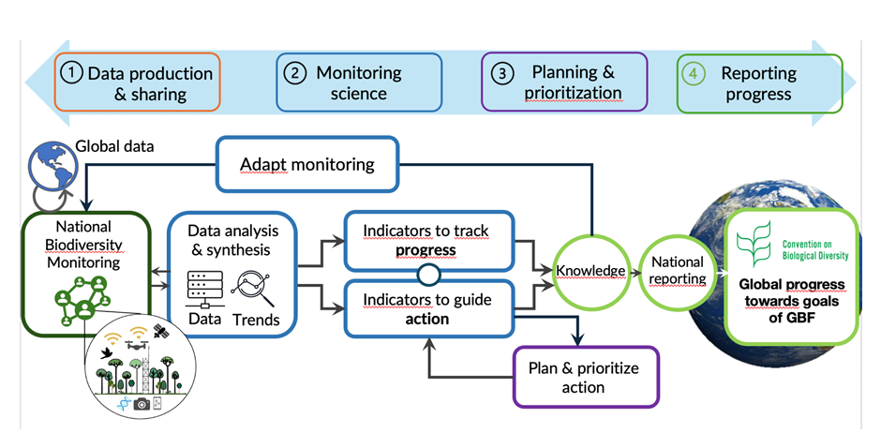

Figure 1: The links between biodiversity monitoring systems, data, and indicators used to track progress and guide action stemming from the priorities in National Biodiversity Strategy and Action Plans (CBD/SBSTTA/26/INF/19).

4.1 Data
Species first occurrence data (i.e., first records) are the primary input for most IAS indicators, though additional data types, including introduction pathways, impact data, and management actions, are frequently required. Key challenges include lack of harmonized standards, data gaps, and inconsistent application of FAIR principles. This hinders robust assessments of IAS trends at the national and international level. Further, responsibility for data is shared across collectors, agencies, and repositories, but governance mandates are often unclear. Adoption of common standards, strengthened data sharing agreements, and dedicated investment in data infrastructure are essential foundations for indicator development.

4.2 Workflows
Workflows transform raw data into policy-relevant indicators through steps including data validation, data processing and aggregation, bias accounting, and dissemination. Most national workflows combine manual and automated steps, and full automation is only feasible where data are highly standardized. Key challenges include insufficient biodiversity informatics capacity, lack of interoperability standards, and reliance on short-term project funding. Modular, well-documented, and reproducible workflows using open-source tools are strongly recommended.

4.3 Indicators - building on the metadata factsheet for Headline Indicator 6.1
A hierarchy of indicators, from simple, readily implementable metrics to more complex data-intensive ones, is essential to enable all Parties to contribute meaningfully to monitoring. Indicators should be explicitly linked to policy objectives and a clear theory of change, and complementary sets of indicators are preferable to reliance on a single metric. Key challenges include variable data quality, lack of common definitions, weak science-policy links, and the cross-sectoral nature of biological invasions.

4.4 Reporting
Effective reporting requires outputs tailored to diverse audiences, including policymakers, resource managers, and the public, with transparency as a central principle. Key challenges include difficulty communicating indicator meaning and uncertainty, disconnect between reporting and decision-making cycles, and fragmented coordination across sectors. Every indicator should be accompanied by a clear explanation of its meaning, limitations, and actionable implications.

4.5. Cross-cutting best practices
Standardization. Adoption of shared data and workflow standards is essential for comparability and scalability.
FAIR data and transparency. Open, well-documented, and reproducible processes build trust and usability.
Modularity and flexibility. Workflows and indicators should be adaptable to different contexts, quality data standards, and evolving data.
Capacity building. Training and user-friendly tools are critical to broaden participation and implementation.
Science-policy integration. Close collaboration between researchers, policymakers, and stakeholders improves relevance and uptake.
Clear communication. Indicators must be accompanied by accessible explanations, uncertainty estimates, and actionable insights.

A key overarching insight is that indicators are not an end in themselves: their value lies in their ability to inform decisions and drive action. Achieving this requires technical solutions, as well as institutional coordination, sustained investment, active participation of involved stakeholders and effective communication

5. Conclusions: A realistic and inclusive path towards monitoring Target 6

A significant gap exists between current data availability and the ambitions of the GBF monitoring framework. Bridging this gap requires national agencies, researchers, and policymakers to collaborate around shared tools, realistic expectations, and a commitment to transparency and reproducibility.

A central finding of this document is that every Party has sufficient data to begin producing indicators. A modular approach enables progression from simple indicators under data-limited conditions to more advanced metrics as data availability and capacity improve. Indicators need not be perfect to be useful: any well-documented indicator can provide a foundation for tracking trends, identifying priorities, and building institutional demand for progressively stronger monitoring systems.

Achieving Target 6 will ultimately require whole-of-government and whole-of-society engagement. Sustainable, trusted, and independent IAS indicators depend on integrated governance spanning data collection, management, and reporting across sectors. Parties are encouraged to draw on the practical guidance, workflow templates, and indicator resources developed through the B-Cubed Project, available at https://b-cubed.eu, and to engage with the technical networks and peer learning opportunities these initiatives provide.

6. About B-Cubed, the workshop and the authors

The B-Cubed Project (Biodiversity Building Blocks for Policy; https://b-cubed.eu) is a collaborative initiative funded under the European Union's Horizon Europe programme that connects biodiversity data infrastructures, indicator science, and policy communities across Europe and beyond. The project aims to make IAS monitoring more harmonized, reproducible, and policy-relevant by developing open, modular workflows aligned with international standards.

The workshop "From Data to Trends: Indicators and Metrics for Tracking Biological Invasions" was held in Brussels from 17 to 19 March 2026. It brought together representatives from national agencies of Austria, Belgium, France, Germany, Italy, South Africa, and the United Kingdom, alongside research institutions, IUCN, and the Joint Research Center of the European Commission. Participants shared national experiences, identified common methodological approaches, and developed shared guidance for IAS indicator production. The workshop report, list of participants, and supporting materials are available at https://b-cubed.eu.

Annex 1: list of authors

Tim Adriaens
Research Institute for Nature and Forest (INBO)
Belgium

Arnaud Albert
French Biodiversity Agency (OFB)
France

Lissa Breugelmans
Meise Botanic Garden
Belgium

Ana Cristina Cardoso
Joint Research Center (JRC)

Shawn Dove
Justus-Liebig University Giessen
Germany

Katelyn Faulkner
South African National Biodiversity Institute (SANBI)
South Africa

Llewellyn Foxcroft
South African National Parks (SANParks)
South Africa

Clara Frasconi-Wendt
Federal Agency for Nature Conservation (BFN)
Germany

Piero Genovesi
International Union for Conservation of Nature (IUCN)

Quentin Groom
Meise Botanic Garden
Belgium

Jasmijn Hillaert
Research Institute for Nature and Forest (INBO)
Belgium

Arnaud Jacobs
Belgian National Scientific Secretariat on Invasive Alien Species
Belgium

Sabrina Kumschick
Stellenbosch University
South Africa

Chiara Magliozzi
Joint Research Center (JRC)
European Commission

McGeoch Melodie
Monash University
Australia

Aileen Mill
Newcastle University
UK

Ana Nunes
International Union for Conservation of Nature (IUCN)

Tanara Renard Truong
Justus-Liebig University Giessen
Germany

Riccardo Scalera
Roma Tre University
Italy

Hanno Seebens
Justus-Liebig University Giessen
Germany

Heliana Teixeira
University of Aveiro
Portugal

Maarten Trekels
Meise Botanic Garden
Belgium

Sonia Vanderhoeven
Belgian Biodiversity Platform
Belgium

John Wilson
South African National Biodiversity Institute (SANBI) and Stellenbosch University
South Africa

Tsungai Zengeya
South African National Biodiversity Institute (SANBI)
South Africa

Wolfgang Rabitsch
Umweltbundesamt (UBA)
Austria

__________

Workshop report, including list of participants and presentations can be accessed here: https://doi.org/10.5281/zenodo.21280617
https://www.gbf-indicators.org/metadata/headline/6-1
The 7th National reports were subsequently analyzed using artificial intelligence (AI) to identify major challenges related to Target 6, as reported by Parties. More information will soon be available on https://b-cubed.eu

