|  |  |  |
| --- | --- | --- |
| Macintosh HD:Users:bilodeau:Desktop:logos:template 2017:un.emf | Macintosh HD:Users:bilodeau:Desktop:logos:template 2017:unep-old.emf | **CBD** |
| Macintosh HD:Users:bilodeau:Desktop:logos:template 2017:cbd.emf | | Distr.  GENERAL  CBD/SBSTTA/23/INF/8  19 November 2019  ENGLISH ONLY |

Subsidiary Body on Scientific, Technical and Technological Advice

Twenty-third meeting

Montreal, Canada, 25-29 November 2019

Item 3 of the provisional agenda[1]*

# Status of the sixth national reports of Parties to the Convention

## *Note by the Executive Secretary*

1. In paragraph 3 of [decision XIII/27](https://www.cbd.int/doc/decisions/cop-13/cop-13-dec-27-en.pdf), Parties were encouraged to submit their sixth national report by 31 December 2018. Parties were also encouraged to prepare and submit their report using the new online reporting tool available on the clearing-house mechanism. The sixth national reports are the key information source for conducting the final assessment of progress towards the Strategic Plan for Biodiversity (2011-2020) and the Aichi Biodiversity Targets, to be undertaken by the Conference of the Parties at its fifteenth meeting, in Kunming, China, in 2020, and for preparing the fifth edition of the *Global Biodiversity Outlook*, which will be launched the same year. The sixth national reports are also informing the current process on the development of the post-2020 global biodiversity framework, led by the Open-ended Working Group on the Post-2020 Global Biodiversity Framework.
2. Forty-seven (47) Parties were able to meet the reporting deadline established by the Conference of the Parties. By 29 November 2019, another 99 Parties had submitted their sixth national report, bringing the total number to 146 (see annex), representing 75 per cent of Parties. Of this total, 70 Parties submitted their report online, 67 submitted their report offline, and 9 Parties have submitted both online and offline versions of their report. All sixth national reports submitted offline can be accessed on the Convention’s website at <https://www.cbd.int/reports/>. The sixth national reports submitted online can be found at <https://chm.cbd.int/search/reporting-map?filter=nr6>.
3. The diagram presented below provides an overview of the submission timelines and rates for all six rounds of national reporting conducted under the Convention to date. At 29 November 2019, which constitutes eleven full months after the sixth national report was due, the submission rate for this national report has surpassed that of the fifth national report by 8 points.

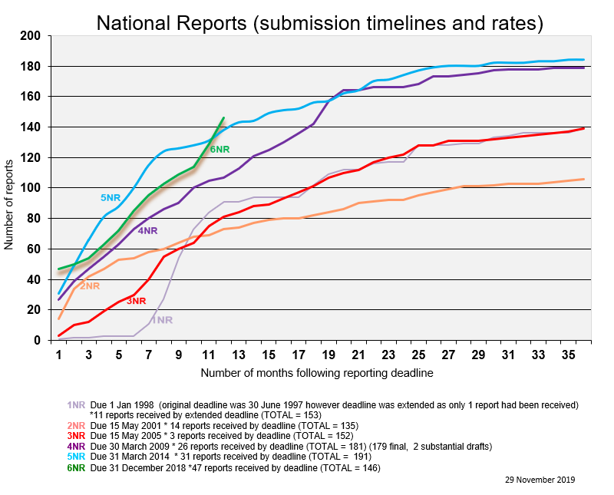

1. Statistics on the proportion of countries within each CBD regional group that have submitted their sixth national report, as of 29 November 2019, are as follows: Latin America and the Caribbean (88%); Africa (83%); Western Europe and Others (72%); Asia and the Pacific (65%); Central and Eastern Europe (61%).

*Annex*

**Countries that have submitted their sixth national report (as of 29 November 2019)**

1. [Afghanistan](https://www.cbd.int/doc/nr/nr-06/af-nr-06-en.pdf)
2. [Albania](https://www.cbd.int/doc/nr/nr-06/al-nr-06-en.pdf)
3. Algeria
4. Andorra
5. [Angola](https://www.cbd.int/doc/nr/nr-06/ao-nr-06-en.pdf)
6. Antigua and Barbuda
7. [Argentina](https://www.cbd.int/doc/nr/nr-06/ar-nr-06-es.pdf)
8. [Armenia](https://www.cbd.int/doc/nr/nr-06/am-nr-06-en.pdf)
9. [Austria](https://www.cbd.int/doc/nr/nr-06/at-nr-06-en.pdf)
10. Bangladesh
11. Belarus
12. Belgium
13. Belize
14. [Benin](https://www.cbd.int/doc/nr/nr-06/bj-nr-06-fr.pdf)
15. Bhutan
16. Bolivia (Plurinational State of)
17. Bosnia and Herzegovina
18. Botswana
19. Brazil
20. Burkina Faso
21. [Burundi](https://www.cbd.int/doc/nr/nr-06/bi-nr-06-fr.pdf)
22. [Cambodia](https://www.cbd.int/doc/nr/nr-06/kh-nr-06-en.pdf)
23. Cameroon
24. Canada
25. [Central African Republic](https://www.cbd.int/doc/nr/nr-06/cf-nr-06-fr.pdf)
26. [Chad](https://www.cbd.int/doc/nr/nr-06/td-nr-06-fr.pdf)
27. Chile
28. China
29. Colombia
30. Comoros
31. Congo
32. Costa Rica
33. Côte d’Ivoire
34. Croatia
35. [Cuba](https://www.cbd.int/doc/nr/nr-06/cu-nr-06-p1-es.pdf)
36. Czechia
37. [Democratic Republic of the Congo](https://www.cbd.int/doc/nr/nr-06/cd-nr-06-fr.pdf)
38. [Denmark](https://www.cbd.int/doc/nr/nr-06/dk-nr-06-p1-en.pdf)
39. [Dominica](https://www.cbd.int/doc/nr/nr-06/dm-nr-06-en.pdf)
40. Dominican Republic
41. Ecuador
42. Egypt
43. [El Salvador](https://www.cbd.int/doc/nr/nr-06/sv-nr-06-es.pdf)
44. [Equatorial Guinea](https://www.cbd.int/doc/nr/nr-06/gq-nr-06-es.pdf)
45. Estonia
46. [Eswatini](https://www.cbd.int/doc/nr/nr-06/sz-nr-06-en.pdf)
47. Ethiopia
48. European Union
49. Finland
50. France
51. Gabon
52. Gambia
53. [Ghana](https://www.cbd.int/doc/nr/nr-06/gh-nr-06-en.pdf)
54. [Greece](https://www.cbd.int/doc/nr/nr-06/gr-nr-06-en.pdf)
55. Guatemala
56. [Guinea](https://www.cbd.int/doc/nr/nr-06/gn-nr-06-fr.pdf)
57. Guinea-Bissau
58. Guyana
59. [Haiti](https://www.cbd.int/doc/nr/nr-06/ht-nr-06-fr.pdf)
60. [Honduras](https://www.cbd.int/doc/nr/nr-06/hn-nr-06-es.pdf)
61. India
62. Indonesia
63. [Iraq](https://www.cbd.int/doc/nr/nr-06/iq-nr-06-en.pdf)
64. [Ireland](https://www.cbd.int/doc/nr/nr-06/ie-nr-06-en.pdf)
65. Italy
66. Jamaica
67. Japan
68. Jordan
69. Kazakhstan
70. [Kuwait](https://www.cbd.int/doc/nr/nr-06/kw-nr-06-ar.pdf)
71. Kyrgyzstan
72. Lao People’s Democratic Republic
73. Latvia
74. Lebanon
75. [Lesotho](https://www.cbd.int/doc/nr/nr-06/ls-nr-06-en.pdf)
76. [Liberia](https://www.cbd.int/doc/nr/nr-06/lr-nr-06-en.pdf)
77. Liechtenstein
78. Luxembourg
79. [Madagascar](https://www.cbd.int/doc/nr/nr-06/mg-nr-06-fr.pdf)
80. [Malawi](https://www.cbd.int/doc/nr/nr-06/mw-nr-06-en.pdf)
81. Maldives
82. Mali
83. [Mauritania](https://www.cbd.int/doc/nr/nr-06/mr-nr-06-fr.pdf)
84. Mexico
85. [Montenegro](https://www.cbd.int/doc/nr/nr-06/me-nr-06-en.pdf)
86. Morocco
87. [Mozambique](https://www.cbd.int/doc/nr/nr-06/mz-nr-06-en.pdf)
88. Myanmar
89. [Namibia](https://www.cbd.int/doc/nr/nr-06/na-nr-06-en.pdf)
90. Nauru
91. Nepal
92. Netherlands
93. [New Zealand](https://www.cbd.int/doc/nr/nr-06/nz-nr-06-en.pdf)
94. Niger
95. Nigeria
96. Norway
97. [Pakistan](https://www.cbd.int/doc/nr/nr-06/pk-nr-06-en.pdf)
98. Panama
99. [Papua New Guinea](https://www.cbd.int/doc/nr/nr-06/pg-nr-06-en.pdf)
100. Paraguay
101. Peru
102. Philippines
103. Poland
104. [Qatar](https://chm.cbd.int/database/record?documentID=248348)
105. Republic of Korea
106. Republic of Moldova
107. Saint Kitts and Nevis
108. Saint Lucia
109. Saint Vincent and the Grenadines
110. [Samoa](https://www.cbd.int/doc/nr/nr-06/ws-nr-06-en.pdf)
111. [Sao Tome and Principe](https://www.cbd.int/doc/nr/nr-06/st-nr-06-en.pdf)
112. Saudi Arabia
113. Senegal
114. [Serbia](https://www.cbd.int/doc/nr/nr-06/rs-nr-06-en.pdf)
115. Slovakia
116. [Slovenia](https://www.cbd.int/doc/nr/nr-06/si-nr-06-en.pdf)
117. Solomon Islands
118. Somalia
119. South Africa
120. South Sudan
121. Spain
122. Sri Lanka
123. Sudan
124. [Suriname](https://www.cbd.int/doc/nr/nr-06/sr-nr-06-en.pdf)
125. Sweden
126. Switzerland
127. Tajikistan
128. [Thailand](https://www.cbd.int/doc/nr/nr-06/th-nr-06-en.pdf)
129. [Timor-Leste](https://www.cbd.int/doc/nr/nr-06/tl-nr-06-en.pdf)
130. Togo
131. Trinidad and Tobago
132. Tunisia
133. Turkey
134. [Turkmenistan](https://www.cbd.int/doc/nr/nr-06/tm-nr-06-ru.pdf)
135. [Uganda](https://www.cbd.int/doc/nr/nr-06/ug-nr-06-en.pdf)
136. [United Arab Emirates](https://www.cbd.int/doc/nr/nr-06/ae-nr-06-ar.pdf)
137. United Kingdom of Great Britain and Northern Ireland
138. United Republic of Tanzania
139. Uruguay
140. Uzbekistan
141. [Vanuatu](https://www.cbd.int/doc/nr/nr-06/vu-nr-06-en.pdf)
142. Venezuela (Bolivarian Republic of)
143. [Viet Nam](https://www.cbd.int/doc/nr/nr-06/vn-nr-06-en.pdf)
144. [Yemen](https://www.cbd.int/doc/nr/nr-06/ye-nr-06-en.pdf)
145. Zambia
146. [Zimbabwe](https://www.cbd.int/doc/nr/nr-06/zw-nr-06-en.pdf)

__________

1. * CBD/SBSTTA/23/1.