 |  |  | CBD
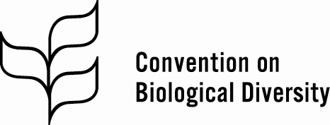 |  |  |  |  | Distr.  GENERAL  CBD/COP/14/INF/28  9 November 2018  ENGLISH ONLY
CONFERENCE OF THE PARTIES TO THE CONVENTION ON BIOLOGICAL DIVERSITY
Fourteenth meeting
Sharm El-Sheikh, Egypt, 17-29 November 2018
Item 8 of the provisional agenda*
BUILDING CAPACITY FOR NATIONAL ECOSYSTEM ASSESSMENT
Note by the Executive Secretary
- In recommendation 22/4 on an updated scientific assessment of progress towards selected Aichi Biodiversity Targets and options to accelerate progress, the Subsidiary Body on Scientific, Technical and Technological Advice recommended, inter alia, that the Conference of the Parties, at its fourteenth meeting, urge Parties and invite other Governments, as appropriate, to consider undertaking national assessments of biodiversity and ecosystem functions and services (para. 5) and invite relevant organizations and development partners to support Parties in undertaking national assessments of biodiversity and ecosystem functions and services, noting ongoing work in this regard undertaken in the context of BesNET with technical support from the United Nations Environment Programme’s World Conservation Monitoring Centre (UNEP-WCMC).
- The Executive Secretary is circulating herewith, for the information of participants in the fourteenth meeting of the Conference of the Parties, an information document detailing progress on the ongoing work in supporting national ecosystem assessment coordinated by UNEP-WCMC. The report is being circulated in the form and language in which it was received by the Secretariat.

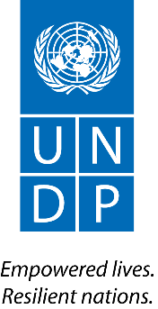
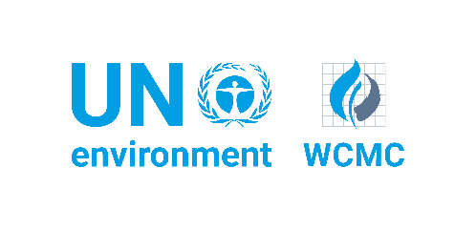

Building capacity for national ecosystem assessment
Addressing IPBES capacity-building priorities

UN Environment World Conservation Monitoring Centre (UNEP-WCMC)
Written in collaboration with national partners
Key messages
- National ecosystem assessments provide countries with an up-to-date and broadly owned evidence base around biodiversity and ecosystem services. This can be used in cross-sectoral national decision-making, as well as in the development of a post-2020 agenda.
- The holistic nature of national ecosystem assessments, as well as the policy-relevant manner in which key findings are presented, mean that they can provide a framework for the national implementation of multiple biodiversity-relevant agreements in a coherent way.
- SBSTTA recommendation 22/4 highlights the value of the assessments conducted by the Intergovernmental Science-Policy Platform on Biodiversity and Ecosystem Services (IPBES), and encourages Parties to undertake ecosystem assessments at the national level with the support of partner organizations.
- Since 2017, a project coordinated by UNEP-WCMC has supported four countries- Cameroon, Colombia, Ethiopia and Viet Nam- to implement national ecosystem assessments. Capacity building activities have facilitated the delivery of guidance around elements of the IPBES ecosystem assessment process relevant at the national level. In October 2018, four more countries- Azerbaijan, Bosnia and Herzegovina, Cambodia and Grenada- joined the global project through a second phase of International Climate Initiative (IKI) funding.
- The project will build a community of practice around the science-policy interface, facilitating greater national engagement in global discussion around biodiversity and ecosystem services, and in the activities of IPBES.
- UNEP-WCMC hopes to initiate an ongoing cycle of capacity-building for national ecosystem assessment. UNEP-WCMC would welcome contact from Parties interested in conducting a national ecosystem assessment in their country (please see contact details on page 11).

Contents
Introduction 3
Relevance of national ecosystem assessments for CBD implementation 5
National ecosystem assessment project: Phase I 6
National ecosystem assessment project: Phase II 10
Conclusions 10
Annex: Synopses of Phase I national ecosystem assessments 12
Cameroon 12
Colombia 13
Ethiopia 15
Viet Nam 17

Introduction
Governments have recognized that human well-being is dependent on healthy functioning ecosystems and the services they provide. This is a key message from Rio+20 in The Future We Want, and is implicit in the Sustainable Development Goals (SDGs). Recognition of this dependency and appropriate response is critical to the achievement of both the Aichi Biodiversity Targets and many of the SDGs and their targets, but despite these ecosystems are being significantly reduced in extent and threatened with loss of function, putting at risk the ecosystem services they deliver.
The challenge appears to be that national policy setting and decision making processes do not take full account of biodiversity and ecosystem services because of a lack of real understanding of their value, and inadequate tools for integrating knowledge about ecosystem services into policy setting and decision making. As a result, different sectors (such as agriculture, water and forestry) may not fully understand and take account of the importance of biodiversity and ecosystem services in achieving their own objectives, and therefore risk undermining sustainability.
Ecosystem assessments can deliver an evidence base that meets the needs of different sectors and encourages integration. Engaging all relevant stakeholders in the assessment process develops an enhanced understanding of alternative priorities with regards to specific policy-relevant questions. This collaborative approach contributes towards better uptake of the outputs. Furthermore national ecosystem assessments provide an opportunity to build capacity at the national scale around the science-policy interface which can support national policies, including those for implementation of the biodiversity-related multilateral environmental agreements.
To conserve and sustainably use biodiversity, a balance must be struck between the interests of different stakeholders and sectors. Amongst other important knowledge and capacity-building functions, the Intergovernmental Science-Policy Platform on Biodiversity and Ecosystem Services (IPBES) aims to strengthen the interface between science and policy by undertaking assessments at global and regional levels, as well as promoting national ecosystem assessments. An IPBES assessment is ‘an expert evaluation of the state of knowledge for policy’, it synthesizes and assesses available policy-relevant knowledge regarding the status and trends in biodiversity and ecosystem services.
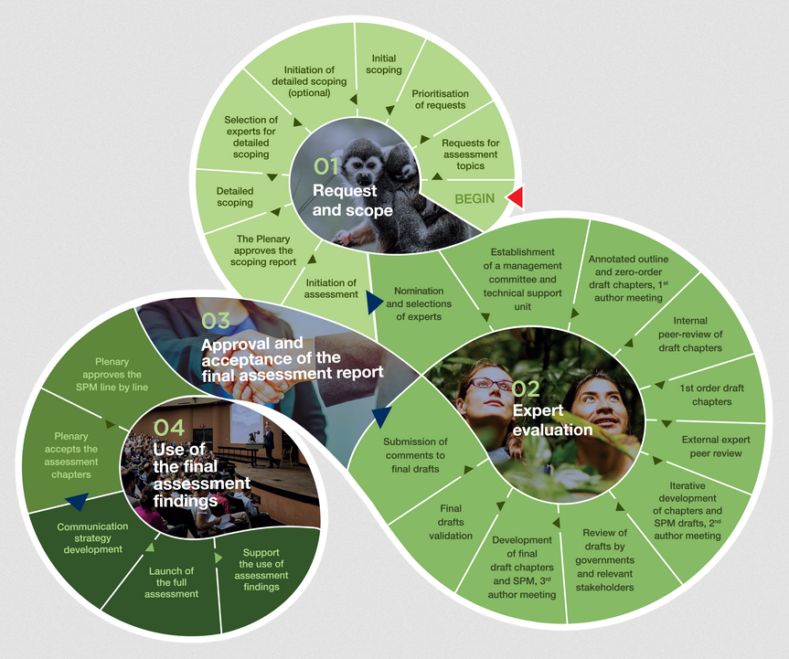
Assessments are based on science and other forms of knowledge, provide policy relevant key findings, and consider options for further action. Throughout the assessment, experts interact with government representatives, observers and other key stakeholders to ensure legitimacy, relevance and credibility. IPBES has developed a consistent framework for the production of assessments which is applicable at the international, regional and national scales. The IPBES Guide on the Production of Assessments is available at https://www.ipbes.net/guide-production-assessments, and is summarised in Figure 1.
Figure 1. The IPBES assessment process
At its third session, the IPBES Plenary adopted a number of capacity-building priorities, and the IPBES capacity-building rolling plan identifies approaches for enhancing the capacity of individuals and institutions based on these approved priority needs. It also contains a list of relevant activities IPBES plans to carry out; both with partners and independently. One of the priority needs to be addressed in the rolling plan is to support countries to implement national ecosystem assessments.
In order to address this need, the UN Environment World Conservation Monitoring Centre (UNEP-WCMC) has initiated a project to support four pilot countries (Cameroon, Colombia, Ethiopia and Viet Nam) carry out national ecosystem assessments. For this project, UNEP-WCMC is working with the United Nations Development Programme (UNDP), under the framework of the Biodiversity and Ecosystem Services Network (BES-Net) and with the financial support of the International Climate Initiative (IKI) of the German Federal Ministry for the Environment, Nature Conservation and Nuclear Safety (BMU). This has been followed by a second project with a further four countries (Azerbaijan, Bosnia and Herzegovina, Cambodia and Grenada), and the inclusion of more partner organizations.
SBSTTA recommendation 22/4 highlights the value of IPBES assessments and encourages Parties to undertake ecosystem assessments at the national level with the support of partner organizations, specifically mentioning the first of the two projects described in sections 3 and 4 below.

Relevance of national ecosystem assessments for CBD implementation
At the heart of the Convention on Biological Diversity (CBD), lies the challenge of integrating biodiversity considerations into national decision-making, as well as mainstreaming these considerations across all sectors of the economy. Article 6 of the Convention on Biological Diversity specifically address these issues:
‘(a) Develop national strategies, plans or programmes for the conservation and sustainable use of biological diversity or adapt for this purpose existing strategies, plans or programmes which shall reflect, inter alia, the measures set out in this Convention relevant to the Contracting Party concerned
(b) Integrate, as far as possible and as appropriate, the conservation and sustainable use of biological diversity into relevant sectoral or cross-sectoral plans, programmes and policies.’
An IPBES assessment is ‘an expert evaluation of the state of knowledge for policy’. National assessments using the IPBES approach can, therefore, be used as a tool to bridge the gap between science and policy at a national level. They can assist in identifying priorities, interlinkages and entry points in the development of national policies such as National Biodiversity Strategy and Action Plans (NBSAPs), and can provide information to support the development of National Reports to the CBD.
A key element at the start of the national ecosystem assessment process is the identification of priority assessment topics through stakeholder consultation. These topics, or priority policy questions, provide a framework for the assessment and reveal the relevance of key findings to multiple sectors. Some examples are as follows:
- What are the current trends in biodiversity and ecosystem services? And how do these trends affect the national economy and human well-being?
- What are the impacts of current policies on biodiversity and ecosystem services? And how can improved knowledge of biodiversity and ecosystem services contribute to better decision-making?
Not only are national ecosystem assessments relevant in the development of biodiversity-specific policies, plans and strategies, but they can also provide an evidence base for mainstreaming biodiversity into other sectors (e.g. agriculture, water and forestry). In addition, the assessment process itself can contribute towards mainstreaming biodiversity into cross-sectoral decision-making via assessment activities such as stakeholder engagement and data collation. The project is working in collaboration with the CBD to develop guidance and capacity-building materials around the national ecosystem assessment process. These resources will support the delivery of CBD-related commitments at the national level.
Beyond the CBD, other multilateral environmental agreements such as the United Nations Framework Convention on Climate Change (UNFCCC), the Convention on International Trade in Endangered Species of Wild Fauna and Flora (CITES), or the Convention on Wetlands of International Importance (the Ramsar Convention), also call for action to address biodiversity issues at a national scale. National ecosystem assessments can support the implementation of these agreements and make links to the achievement of biodiversity-relevant goals and targets embedded within other intergovernmental processes such as Sustainable Development Goals 14 (‘Life below water’) and 15 (‘Life on land’). The holistic nature of national ecosystem assessments, as well as the policy-relevant manner in which key findings are presented, mean that they can provide a framework for the national implementation of multiple biodiversity-relevant agreements in a coherent way. Key findings will also provide an evidence base for the development of a post-2020 agenda.
Importantly, this project, in line with IPBES capacity-building priorities, aims to support partners to implement their own national ecosystem assessments. By building the technical capacity of those involved in the assessment process, positive impacts will be seen not only at the national level, but also internationally, as countries will be better equipped to contribute to international processes such as CBD negotiations and the activities of the IPBES Plenary.

National ecosystem assessment project: Phase I
The aim of Phase I of the national ecosystem assessment project is to build the capacity of four developing countries - Cameroon, Colombia, Ethiopia and Viet Nam - to undertake ecosystem assessments at a national level. This capacity is developed using the guidance provided by IPBES, and the experience and expertise of the Sub-Global Assessment Network (SGAN), a community of practice that connects and supports those involved in ecosystem assessments at the sub-global scale.
Local partner institutions leading on the development of their national ecosystem assessments are: the Network for Environment and Sustainable Development in Africa (NESDA) in Cameroon; the Alexander von Humboldt Biological Resources Research Institute in Colombia; the Ethiopian Biodiversity Institute; and the Center for Biodiversity Conservation (CBC) in Viet Nam. Capacity-building components of the project include webinars, global workshops, and the National Trialogues carried out in coordination with UNDP. Overall coordination of the project is carried out by UNEP-WCMC. The project is funded by the International Climate Initiative (IKI) of the German Federal Ministry for the Environment, Nature Conservation and Nuclear Safety (BMU) under the framework of the BES-Net initiative.
The project commenced in June 2017, with a Global Inception and Capacity-Building workshop held in Cameroon. This workshop introduced national partners to the IPBES assessment process and walked partner countries through the scoping stage. The project is due for completion in 2020. Key findings from the national ecosystem assessment project will come at an important moment in the development of a post-2020 biodiversity agenda and framework, both at a national and global scale.
As expected, the project countries are proceeding at a varied pace, however all countries have developed an assessment scoping report, chapter outline and author lists. It is critical that each national ecosystem assessment is initiated by, and remains relevant to, nationally identified needs. The scoping stages revealed that in all project countries, the livelihoods of their citizens are heavily reliant upon ecosystem services. However, these ecosystem services are increasingly facing threats from biodiversity loss.
The national ecosystem assessment seeks to bring together existing knowledge relating to biodiversity and ecosystem services and present it in a policy-relevant manner. This will strengthen the science-policy interface, as well as the general awareness of biodiversity values amongst key stakeholders (e.g. policy makers, protected area managers, general public). To maintain policy-relevance throughout the assessment process, each country has undertaken a participatory process to co-develop a set of priority policy questions that the national ecosystem assessment will seek to answer. These questions are broadly similar across countries and generally the following themes:
- Status and trends in biodiversity and ecosystem services
- The importance of ecosystem services for the national economy and human wellbeing
- The impact of policies on biodiversity and ecosystem services
- The impact of biodiversity and ecosystem services knowledge on decision-making
- Future scenarios
- Knowledge gaps that need to be addressed for improved decision-making with regards to the management of biodiversity and ecosystem services
In each country, these priority questions have helped shape their chapter outlines of the national ecosystem assessment reports. In addition, some countries have chosen to focus on specific ecosystem types, while others go for a less defined approach. Sections below, written in collaboration with national partners, provide summaries of each country’s national ecosystem assessment. More detail can be found in the Annex to this document.
Cameroon’s national ecosystem assessment
Cameroon’s national ecosystem assessment is underpinned by Goal A, Target 2 of the country’s NBSAP; ‘By 2020 significant increase in the contribution of scientific based information into biodiversity decision making’, and is specifically referred to within an action that contributes to this target; ‘carry out a National Assessment on biodiversity and ecosystem services’.
An important aspect of the national ecosystem assessment is to enhance collaboration between relevant stakeholders at different levels and from different sectors, and in so doing improve national capacity to undertake the assessment, as well as communicate findings. Capacity-building around the uptake of scientific knowledge into policy has also been identified as an important aspect.
The national implementing body, NESDA CA, is a national NGO that works under the supervision of the Ministry of Environment, Nature Protection and Sustainable Development (MINEPDED). Cameroon hosted the Global Inception and Capacity-Building Workshop for the project in June 2017. The Cameroon assessment has a governance structure in place, and a first order draft is currently under review. Linked to the assessment, a National Platform for Science-Policy Interface on Biodiversity and Ecosystems Services (NP-SPBES) has been created. This Platform aims to function as an advisory body for all work related to assessing biodiversity and ecosystem services within Cameroon.
The Cameroonian national ecosystem assessment is aligned with key national processes such as work towards the CBD 6th national report and developing a post-2020 framework, as well as reporting towards NBSAPs and Aichi Biodiversity Targets. This has meant that certain activities can happen collaboratively i.e. joint meetings and data collection. The national ecosystem assessment will also facilitate the uptake of key findings from the 2018 IPBES regional and subregional assessment of biodiversity and ecosystem services for Africa, and equally, enable improved Cameroonian participation in global dialogue around biodiversity and ecosystem services e.g. IPBES Plenary and Programme of work.
Colombia’s national ecosystem assessment
Biodiversity is recognized as being critical for both the economy and society within Colombia. There have been steps towards improving information systems that link biodiversity and ecosystem services with human well-being, however this information has not sufficiently permeated the Colombian National Policy on Biodiversity and Ecosystem Services. The national ecosystem assessment hopes to bridge the gap between the generation of scientific knowledge and decision-making.
Key findings from the assessment will be important at all levels and across all sectors within Colombia. Relevance is maintained due to the interdisciplinary nature of the assessment. Stakeholders from a wide array of backgrounds will be engaged throughout the process. The national ecosystem assessment was officially launched at the beginning of October 2018, and a zero-order draft is due by the end of the year.
Understanding the ultimate causes of biodiversity loss, including the influence of territorial dynamics, will be an important priority for Colombia’s national ecosystem assessment. The assessment is a commitment to implement transformational change towards sustainability, as well a contribution towards the global framework on biodiversity, including the post-2020 strategy.
Ethiopia’s national ecosystem assessment
Biodiversity and ecosystem services are recognized as underpinning Ethiopian livelihoods and will continue to be of increasing importance in the future. The Ethiopian national ecosystem assessment aims to develop policy briefs based on evidence-based scientific data relating to the status, trends and future dynamics of biodiversity and ecosystem services in selected ecosystems. These will improve the science-policy interface.
Five ecosystems have been selected for the focus of the assessment; forest and woodland, rangeland, wetland and aquatic, mountain, and agro-ecological. These were chosen based on importance in terms of human impact and dependencies. The assessment report chapter outline, and priority policy questions have been defined. Authors and editors have been nominated, an orientation and consultative meeting with these authors and editors have been conducted, and contractual agreements have been finalised.
A key output from the national ecosystem assessment project will the development and utilization of policy support tools to enhance the uptake of the assessment findings. Equally important will be the wide dissemination of findings in order to improve awareness of biodiversity values amongst policy-makers, the general public and other key national stakeholders. Key assessment findings will also feed into Ethiopia’s NBSAP 2021-2030.
Viet Nam national ecosystem assessment
Biodiversity is important for a range of ecosystem services that underpin economic and human well-being in Viet Nam. This biodiversity is facing threats such as overexploitation, habitat fragmentation and invasive alien species. The goal of Viet Nam’s National Biodiversity Strategy 2020 is to preserve important ecosystems, species and genetic resources. It is therefore important to assess the current status of ecosystems and ecosystem services. Although biodiversity and ecosystem services considerations are already integrated into many sector plans and policies, there is a need to further this integration across all sectors and at all levels e.g. land use planning, forestry, and climate change response.
Viet Nam’s national ecosystem assessment focuses on three selected ecosystems; forest, wetland, and marine and coastal. Priority policy questions have been identified and the assessment will seek to fill in knowledge gaps around the Drivers-Pressures-State-Impact-Response (DPSIR) framework.
Engagement of stakeholders from many different backgrounds will be an important aspect of Viet Nam’s national ecosystem assessment. This brings with it capacity-building around implementing the assessment, as well as developing an enhanced understanding of biodiversity values. Activities planned for the rest of 2018 include a further consultation workshop and the completion of the zero-order draft national ecosystem assessment report.
Key assessment findings will be disseminated widely and aim to be relevant to a wide range of stakeholders, with some results feeding into the management of a number of ongoing strategies e.g. Payment for Forest Environmental Services (PFES) schemes. The assessment is aligned with national priorities including Aichi Biodiversity Targets, and assessment report chapters exploring future scenarios will have post-2020 relevance.
Coordination, support, and sharing experience
UNEP-WCMC provides global support and coordination for the project. This has included: technical advice on the assessment process and methodologies; assistance in the identification of authors and experts; global capacity-building workshops; quarterly webinars; and regular progress calls with national partners.
Global capacity-building workshops are an important element at the start and end of the project. The first introduced the IPBES assessment process and walked partner countries through the scoping stage. The second occurs at the end of the project lifetime and allows for the dissemination of lessons learned to other interested countries. Opportunities are also sought in the margins of key international meetings to bring country representatives together to share information on progress.
The webinar series gives countries the opportunity to present progress in their respective assessments and discuss topical subjects. Webinars also provide a platform for collaboration and knowledge-sharing between countries. Recordings will contribute towards a freely-available portfolio of capacity-building resources. Webinars undertaken so far have focused on: developing key policy questions; scenario development; and chapter outlines for the assessment report.
UNDP contributes to capacity-building for the project through the coordination of ‘Trialogues’ in each partner country. These events are intended to bring together stakeholders from three target communities- science, policy and practice- for face-to-face discussion, mutual learning and enhanced understanding of alternative priorities with regards to specific policy-relevant questions.
The IPBES technical support unit has also been instrumental in identifying key experts to provide assistance on specific aspects of the assessment process. A member of the IPBES Expert Group on Scenarios and Models recently presented at a project webinar, and an IPBES expert based in the same region as one of the project countries been approached to attend a national workshop.
UNEP-WCMC hosted a side event at the second meeting of the Subsidiary Board for Implementation of the Convention on Biological Diversity (CBD SBI-2), in Montreal, in July. Presentations were given by representatives from Cameroon and Colombia, UNEP-WCMC, UNDP, and the Global Biodiversity Information Facility (GBIF). The side event was particularly relevant for CBD SBI-2 agenda items: 13. National reporting, and assessment and review, under the Convention and its Protocol; and 10. Capacity-building, technical and scientific cooperation and technology transfer.

National ecosystem assessment project: Phase II
A new project, also funded by IKI, enabled four more countries- Azerbaijan, Bosnia and Herzegovina, Cambodia and Grenada- to join the project in October 2018. For each of these countries, their current NBSAP provides the initial political starting point or request for a national ecosystem assessment. As part of the technical scoping process for the assessment, a stakeholder meeting will be held in each country to identify policy-relevant questions, and as part of this process countries will further explore and identify the relevant political and legal frameworks which the national assessment will inform.
The final year of the project will focus on the use of assessment findings and identification of policy support tools and methodologies. The policy support tools and methodologies will vary between countries and cannot be determined until the findings of the assessment are available. For example, a country may choose to use the findings of their assessment to inform the establishment of natural capital accounts, or to develop a new approach to planning within their country, or even to provide an evidence base to inform their next NBSAP.
This second group of countries will benefit from the experiences of Cameroon, Colombia, Ethiopia and Viet Nam. All eight countries will meet in person once a year to discuss different aspects of the assessment process, approaches to mainstreaming results, as well as lessons learned. Collaboration and sharing between countries will be further enhanced through the ongoing webinar series.
As with the first phase of the project, Azerbaijan, Bosnia and Herzegovina, Cambodia and Grenada will not only scope and undertake a national ecosystem assessment addressing specific national policy questions, they will also develop a Summary for Policy Makers (SPM) and spend time communicating key findings; identifying new policies or changes to existing ones. Countries will be supported through the development or enhancement of a national science-policy platform. This platform will support the assessment initially, but also provide a space for science-policy discussions to support other intergovernmental processes. It will also provide guidance and mentoring from an international leadership group, an early career fellowship programme, exchange visits, webinar series and capacity-building workshops.
All resources and guidance materials developed as part of this project will be made freely available. This will build upon resources such as the SGA Network community of practice (http://www.ecosystemassessments.net/) and IPBES assessments catalogue (http://catalog.ipbes.net/) to further enhance knowledge exchange and capacity development on a global level. The project is also working in collaboration with the CBD to identify how these resources can be best presented and disseminated to assist national level implementation of the CBD.

Conclusions
At the national level, the national ecosystem assessment project provides countries with an up-to-date and broadly owned evidence base around biodiversity and ecosystem services. This can be used in cross-sectoral decision-making, and is fundamental in developing a post-2020 agenda. Project countries will have developed policy-support tools, such as a national science-policy platform, and will have built a community of practice around the science-policy interface.
The project will facilitate greater national engagement in global discussions around biodiversity and ecosystem services, and in the activities of IPBES. Equally, the project will promote the increased use of IPBES guidance, and the uptake of key messages from IPBES assessments. Shared experience, materials and resources developed through implementing a national ecosystem assessment will further build upon freely available capacity-building resources.
Cameroon, Colombia, Ethiopia and Viet Nam have already reported positive experiences and successes through participation in the project, whether through building technical expertise in the IPBES assessment process, developing links between national and international experts, or simply sharing experiences between country partners through webinars and workshops.
Progress between countries has varied, however sharing lessons learned is a vital part of this project. Continued engagement in the project is needed to further develop capacity building resources around national ecosystem assessments. Azerbaijan, Bosnia and Herzegovina, Cambodia and Grenada will have their own experiences to contribute over the next four years. UNEP-WCMC hopes to initiate an ongoing cycle of capacity building for national ecosystem assessments and would welcome contact from interested Parties.
For further information please contact:
Abigail Burns
UNEP-WCMC
219 Huntingdon Road,
Cambridge.
CB3 0DL
UK

Or visit https://www.unep-wcmc.org/featured-projects/national-ecosystem-assessments

The national ecosystem assessment project is being represented by Hilary Allison, Jerry Harrison and Daniela Guaras of UNEP-WCMC at CBD COP-14 in Sharm El-Sheikh, Egypt. They can be located in the UN Environment delegation.

Annex: Synopses of Phase I national ecosystem assessments
Written by national partners, edited by UNEP-WCMC

Cameroon
Impetus behind carrying out a national ecosystem assessment within Cameroon
Cameroon’s National Biodiversity Strategy and Action Plan, published in 2014, provides a policy basis for the national ecosystem assessment. Goal A, Target 2, is of particular relevance; ‘By 2020 a significant increase in the contribution of scientific based information into biodiversity decision making’. The national ecosystem assessment provides an opportunity for the Ministry of Environment Nature Protection and Sustainable Development (MINIPDED), and its partners, to focus, and make progress on this Target.
The assessment also provides further opportunity to improve collaboration between relevant stakeholders; government officials, researchers, academia, international and national NGOs. It will also enhance the capacity of these stakeholders to support the assessment process, including the uptake of key messages into decision-making.
Focus on Cameroon’s national ecosystem assessment
Cameroon’s national ecosystem assessment is centred on the following key questions:
- What is the present value of biodiversity and ecosystems and their contribution to economic growth and human well-being?
- What is the current status and the trends of biodiversity and ecosystem services that contribute to the economy and human well-being?
- What are the drivers of change in the status and trends of BES that affect human well-being?
- What are the interactions and future dynamics (scenarios) this presents for BES and well-being?
- How can BES contribute to the transformational change in the emerging Cameroon- policy and governance options?
Mainstreaming priorities for BES into national and regional policies can help address major environmental and development challenges, as well as assist in the achievement of commitments made under biodiversity-related conventions and SDGs. A lack of information and scientific understanding, however, limit policy response measures. Cameroon seeks to address this key concern as a national priority, and the country’s NBSAP clearly defines indicators that monitor progress on this Target;
- An operational National Platform for Science-Policy on Biodiversity and Ecosystem Services (NP-SPBES);
- Number of research projects on the ecosystem and species-specific biodiversity issues carried out;
- Number of information tools produced by NP-SPBES platform;
- Number of institutions/persons using tools for biodiversity decision making and management.
Key deliverables for the national ecosystem assessment project have been identified to ensure assessment findings can and will be integrated into decision-making at national, sector and local levels:
- Organize a National Inception and Scoping Assessment Workshop
- Carry out a National Assessment on biodiversity and ecosystem services
- Carry out communication and outreach geared at sensitizing and disseminating information on the BES Assessment
- Building Capacity for the national assessment and communication of its findings
Summary of progress in Cameroon’s national ecosystem assessment so far
The national ecosystem assessment is coordinated in the country by the Network for the Environment and Sustainable Development in Central Africa (NESDA CA); a national NGO that works under the supervision of MINEPDED. NESDA CA is implementing the assessment in collaboration with key government actors, researchers, academia and NGOs over a four-year period (2017-2021).
Cameroon hosted the Global Inception and Capacity-Building Workshop of Phase I of the IKI-funded project; “Supporting Decision Making and Building Capacity through National Ecosystem Assessments”. This workshop was held on the 13th-15th June 2017 in Kribi, Cameroon.
Progress within Cameroon’s national ecosystem assessment so far includes; setting up a governance structure and steering committee, developing a national network of authors and experts, and finalizing a scoping report and zero-order draft, with the first order draft currently under review. In addition, a Ministerial Decision (No. 0184) in November 2017 enabled the creation of a National Platform for Science-Policy Interface on Biodiversity and Ecosystems Services (NP-SPBES). This tool, formed as a direct result of the NEA project, will serve as a national advisory body for all assessments carried out on biodiversity and ecosystem services in Cameroon.
Anticipated use of key messages and findings from Cameroon’s national ecosystem assessment
The Cameroonian national ecosystem assessment is strongly aligned with key national processes contributing to the development of the post-2020 framework, for example preparations for the 6th National Report to the CBD or reporting on progress towards the NBSAP and Aichi Biodiversity Targets. As such, many processes can be carried out in combination e.g. joint meetings/planning and aligning data collection. The national ecosystem assessment will also facilitate the uptake of key findings from the 2018 IPBES regional and subregional assessment of biodiversity and ecosystem services for Africa, as well as more informed participation in global dialogue around the post-2020 agenda, such as IPBES Plenary.

Colombia
Impetus behind carrying out a national ecosystem assessment within Colombia
Colombia is one of the most biodiverse countries in the world (Andrade, 2011 in MADS, 2014) and it has been recognized that biodiversity and ecosystem services (BES) are critical for the economic and social development of the country. This is evident in Colombia´s legal system. It is also recognized that the status and trends of biodiversity and ecosystem services have significance beyond national borders. A national ecosystem assessment is important in understanding this significance, as well as to identify possible actions required to stop, and potentially reverse, negative impacts.
Awareness of biodiversity values has increased, and efforts have been made to improve information systems that characterize the link between the environment and society. However, much of this information has not permeated decision-making as stated in the Colombian National Policy on Biodiversity and Ecosystem Services (2012).
Many direct and indirect drivers, such as ecosystem and habitat loss, are affecting biodiversity and ecosystem services in Colombia. This makes it critical to undertake an assessment on the status and trends of biodiversity and ecosystem service, as well as ensure key findings of this assessment are translated into positive action by decision-makers.
The best way to understand and manage biodiversity and its link to society are through the creation of open, transparent and participatory spaces that bridge the gap between the generation of scientific knowledge and decision-making. An assessment following the methodology and conceptual framework of IPBES will provide results that are useful in policy-making across different levels and sectors within Colombia.
Focus on Colombia’s national ecosystem assessment
In developing the focus of Colombia’s national ecosystem assessment, a number of questions were prioritised:
- How do current transformations, trends and future scenarios of biodiversity and ecosystem services contribute to the economy, livelihoods and human well-being?
- How does knowledge about the current status and trends of biodiversity and ecosystem services analysed by different systems of knowledge contribute to better decision-making to improve human well-being?
- What are the current and potential drivers of change affecting the status of biodiversity and ecosystem services, and how do these changes affect the economy, livelihoods and well-being of the population?
- What are the current and potential impacts of policies, institutions and governance on nature´s contributions to people?
- What are the knowledge gaps identified and prioritized in the national assessment that need to be addressed to support decision-making for the management of biodiversity and ecosystem services in Colombia and improve human well-being?
These questions were then used to develop the current chapter outline of Colombia’s national ecosystem assessment:
- Introduction to IPBES conceptual framework, objectives, unit of analysis and perspectives
- Status of Colombian biodiversity
- Nature´s contributions to people
- Drivers of biodiversity loss
- Traditional knowledge and biodiversity
- Policies, institutions and governance
- Scenarios and models of biodiversity and ecosystem services
- Conclusions
Summary of progress in Colombia’s national ecosystem assessment so far
An important aspect of the Colombian national ecosystem assessment is to ensure an interdisciplinary balance and encourage dialogue between different knowledge holders. So far this has resulted in the involvement of sixty experts from many different disciplines, as well as engagement from holders of indigenous and local knowledge
Comments on the scoping document, posted on the Humboldt’s webpage, are currently under review. The Official Launch of the National Assessment and First Authors Meeting took place at Villa de Leyva, Colombia, on the 1st-2nd October 2018. The zero-order draft is due to be finished by the end of the year.
Anticipated use of key messages and findings from Colombia’s national ecosystem assessment
The national ecosystem assessment is a key opportunity to strengthen the science-policy interface around the implementation of environmental strategies. This will be achieved through improved communication and discussion, by promoting better ways of working, as well as through the provision of technical and scientific knowledge. Key findings from the national ecosystem assessment will provide policy-makers with a more complete understanding of how people and nature interact, as well as highlighting how decisions made today might affect these interactions in the future. This is also important taking into account the implementation of the peace accord signed between the Colombian government and the Revolutionary Armed Forces of Colombia (FARC). The end of the conflict brings opportunities to restore the environment and rethink the country’s development.
Results of this assessment will also be important for the country to understand the influence of specific territorial dynamics, and thus be able to propose solutions based on an understanding of the ultimate causes of biodiversity loss and the impact of these losses on ecosystem services. This is a commitment to socio-ecological transformations towards sustainability, as well as towards Colombia’s contribution to a global framework on biodiversity, including a post-2020 strategy.

Ethiopia
Impetus behind carrying out a national ecosystem assessment within Ethiopia
Ethiopia is one of the most biodiverse countries in the world. Biodiversity underpins the livelihoods of the majority of the citizens of Ethiopia, and it will be central to the country’s future development. Direct and indirect causes are having a negative impact on the country’s biodiversity and ecosystem services. Ethiopia’s national ecosystem assessment aims to explore the existing knowledge that characterizes the link between nature and human well-being.
The national ecosystem assessment will assess the status of selected ecosystems and produce policy briefs. These policy briefs will strengthen the science-policy interface and lead on to more informed decision-making with regard to biodiversity conservation and related land use issues in Ethiopia. To achieve this, the main objective of the national ecosystem assessment is to produce, and document evidence-based scientific data related to the status, trends and future dynamics of biodiversity and ecosystem services in selected ecosystems. The assessment will also examine the contribution of ecosystem services to human well-being, the drivers of change, as well as the impact of policy, governance and institutional arrangements.
Focus on Ethiopia’s national ecosystem assessment
The chapter outline for Ethiopia’s national ecosystem assessment is presented below:
- Nature’s benefits to people and quality of life
- Status, trends and future dynamics of biodiversity and ecosystems underpinning ecosystem services
- Direct and indirect pressures driving changes in biodiversity and ecosystem services
- The level of awareness and knowledge about nature’s benefit, status and management of biodiversity and ecosystem services
- Impacts of policies and institutional arrangements on biodiversity conservation and ecosystem services
The above five chapters each address the five ecosystems selected for this project; forest and woodland, rangeland, wetland and aquatic, mountain, and agro-ecological. Ecosystems were selected after a series of consultations. They were identified as important with regard to the impact that people have on them. A number of questions provide further focus for the assessment:
- What are the status and trends in selected ecosystems and the services they deliver in Ethiopia?
- What are the pressures driving changes in the status and trends of selected ecosystems and the services they deliver in Ethiopia?
- How do selected ecosystems and the services they deliver contribute to the national economy and to human well-being?
- What is the state of awareness of key stakeholders (policymakers, protected area managers and media) on selected ecosystems, the services they deliver and the contribution of these services to human well-being?
- What is the contribution of indigenous knowledge on conservation and sustainable use of those ecosystems, and the services they deliver?
- What are the actual and potential impacts of various key policies and interventions on the contribution of ecosystem services to the national economy and human well-being in Ethiopia?
- What are the key policy, governance and institutional arrangement needed for improving and maintaining selected ecosystems and ecosystem services?
Summary of progress in Ethiopia’s national ecosystem assessment so far
Beyond developing chapter outlines and selecting ecosystems of importance, a list of authors and editors has been nominated. An orientation and consultative meeting brought together coordinating lead authors, lead authors, contributing authors and editors, and allocated responsibilities according to ecosystems. Contractual agreements for authors and editors have been finalised.
Anticipated use of key messages and findings from Ethiopia’s national ecosystem assessment
As indicated in the above sections, Ethiopia’s national ecosystem assessment aims to produce policy briefs that will strengthen the science-policy interface and lead on to more informed decision-making with regard to biodiversity conservation and related land use issues in Ethiopia. This will involve the identification, development, testing and implementation of policy support tools. It will be important to disseminate the key findings of the national ecosystem assessment and raise awareness of the values of biodiversity and ecosystem services amongst policy-makers and the general public. The outcomes of the findings will be instrumental for setting goals and national targets for Ethiopia’s National Biodiversity Strategy and Action Plan 2021-2030.

Viet Nam
Impetus behind carrying out a national ecosystem assessment within Viet Nam
In Viet Nam, biodiversity brings direct benefits to humans, contributing substantially to the national economy, especially sectors such as agriculture, forestry and fisheries. In Viet Nam, biodiversity is important for ensuring food security, maintaining genetic resources for livestock and crops, and providing resources for construction and pharmaceuticals. In addition, ecosystems play an important role in climate regulation and environmental protection. Biodiversity has also been an inspiration within the art and culture of Vietnamese people for thousands of years.
Currently, biodiversity within Viet Nam faces many threats. Pressure from increasing human populations combined with increasing levels of consumption is resulting in overexploitation of natural resources. Rapid socioeconomic development has also changed the natural landscape. Land conversion and infrastructure development has significantly reduced and degraded areas of natural habitat and increased ecosystem fragmentation. In addition, invasive alien species, environmental pollution and climate change all directly impact the biodiversity of Viet Nam.
To date, the Government of Viet Nam has integrated elements of both environmental protection and biodiversity conservation into national plans, programs and policies including; Law on Planning, Poverty Alleviation Strategy, National Sustainable Development Strategy, and the Territories Development Plan. Recently, economic sectors such as agriculture, forestry, fisheries, and tourism have begun to integrate biodiversity and ecosystem as one of their strategic development goals.
The overall goal of the National Biodiversity Strategy to 2020 is that important ecosystems, species and genetic resources are preserved and used to contribute to a green economy, actively responding to climate change. One of the main tasks in this regard is to investigate and assess the status of ecosystems and ecosystem services. It is also recognized that the integration of biodiversity and ecosystem into policies, strategies, plans and programs of relevant sectors, Ministries and agencies will be vital for long-term biodiversity conservation.
In summary, carrying out a national ecosystem assessment is necessary to help decision-makers formulate policies that take into account relevant scientific knowledge. Enhanced integration of biodiversity and ecosystem services into national policies will be essential in order to achieve targets and commitments under the CBD.
Focus on Viet Nam’s national ecosystem assessment
The focus of Viet Nam’s national ecosystem assessment will be around three selected ecosystems: forest, wetland, and marine and coastal ecosystems. A number of priority questions have been identified:
- What are the status and trends in selected ecosystems and the services they deliver in Viet Nam?
- What are the drivers/pressures driving changes in the status and trends of ecosystems services provided by selected ecosystems? And the impacts on the economy and society? (An important aspect will be the synthesis and update of information related to ecosystems and the services they provide under the Drivers-Pressures-State-Impact-Response (DPSIR) framework.)
- How do ecosystems services provided by selected ecosystems contribute to the national economy and to human well-being?
- What are the actual and potential impacts of ecosystem services policies and interventions on sustainable development (economy, society and environment) in Viet Nam?
- How might ecosystems and their services change in the future under various plausible scenarios?
- What is the key policy need (should this be a new policy or a change to existing policies) for improving and maintaining the ecosystems services provided by selected ecosystems?
The involvement and engagement of a wide range of stakeholders throughout all aspects of the assessment (design, implementation, use etc.) will be important. A key element of this engagement will involve capacity-building and developing an enhanced understanding of biodiversity values.
Summary of progress in Viet Nam’s national ecosystem assessment so far
A detailed step-by-step process of Viet Nam’s national ecosystem assessment is shown in Figure 2.

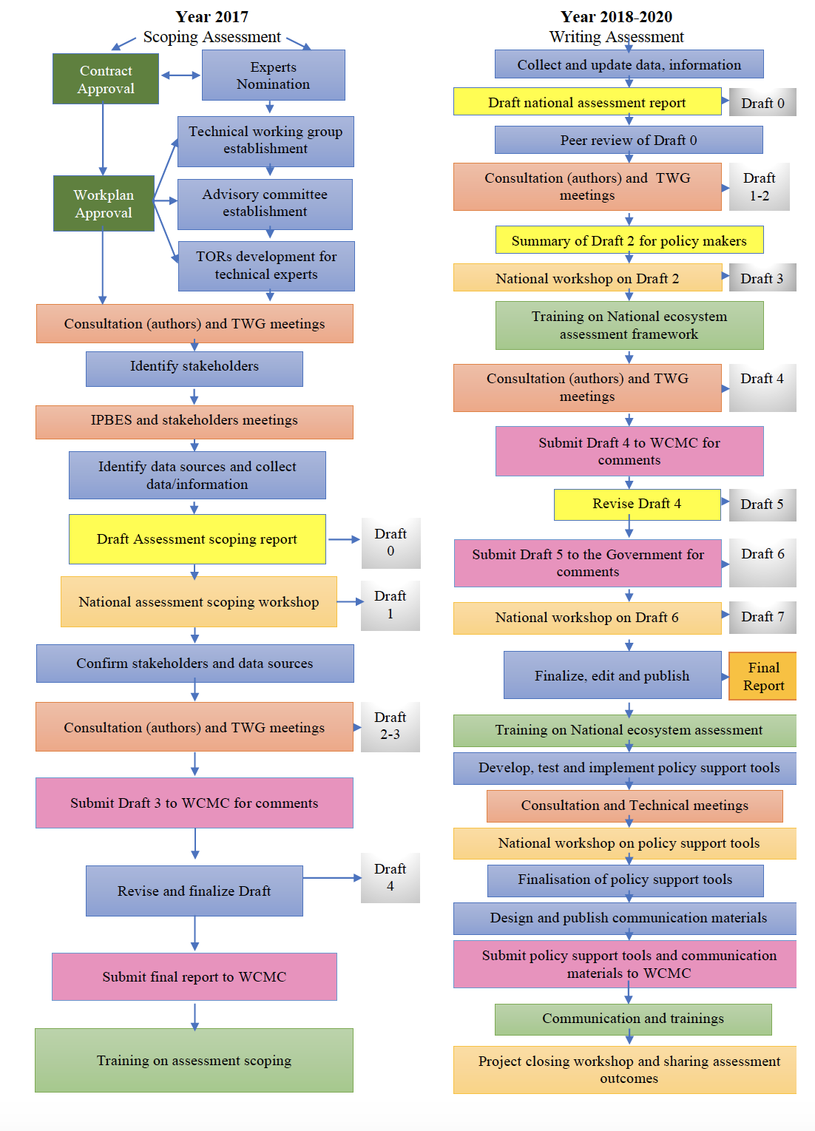
Figure 2. A step-by-step process of Viet Nam’s national ecosystem assessment
The national inception workshop for the national ecosystem assessment was held on the 20th October 2017 in Hanoi, Viet Nam. The scoping document, identifying priority questions to be addressed during the assessment process, was completed in February 2018. The chapter outline was finalized in July 2018. Activities planned for the rest of the year include completion of a zero-order draft of the assessment report, as well as a national consultation workshop aimed at further engaging relevant stakeholders in the assessment process.
Anticipated use of key messages and findings from Viet Nam’s national ecosystem assessment
Data used in the assessment will be from reliable sources, and findings will be reviewed by international experts as well as policy-makers from the Ministry of Natural Resources and Environment (MONRE) and the Ministry of Agriculture and Rural Development (MARD).
Findings from the national ecosystem assessment will be useful for a range of policy-makers working at different levels and in different organizations. The final report and summary for policy-makers will be published and communicated widely, and a high level of stakeholder engagement throughout the assessment process will contribute to the further dissemination of key findings.
Results of the national ecosystem assessment will feed into the management of a number of ongoing strategies and schemes. Examples include the Payment for Forest Environmental Services (PFES) scheme established in Viet Nam in 2010, and the Forest Pricing Framework following the new Law on Forestry (2017).
Key areas of focus within the national ecosystem assessment reflect Viet Nam’s national priorities. The assessment is therefore also aligned with activities in place aimed at achieving progress towards the Aichi Biodiversity Targets. With regard to developing a post-2020 agenda, findings from chapters exploring future scenarios and ecosystem change will be relevant.
__________

* CBD/COP/14/1.
https://www.cbd.int/doc/recommendations/sbstta-22/sbstta-22-rec-04-en.pdf
https://www.ipbes.net/guide-production-assessments
https://www.ipbes.net/sites/default/files/inline/files/ipbes_capacity-building_rolling_plan_and_executive_summary_2.pdf
https://www.cbd.int/doc/recommendations/sbstta-22/sbstta-22-rec-04-en.pdf
https://www.cbd.int/doc/recommendations/sbstta-22/sbstta-22-rec-04-en.pdf Page 2, paragraph 6
https://www.cbd.int/convention/articles/default.shtml?a=cbd-06
http://www.ecosystemassessments.net/
https://www.besnet.world/events?trialogues
United Nations Development Programme. s.f, Consulted September 18, 2018. https://www.biodiversityfinance.net/sites/default/files/content/knowledge_products/PIR.pdf
https://www.cbd.int/doc/world/cm/cm-nbsap-v2-en.pdf
Ministerio de Ambiente y Desarrollo Sostenible, Programa de las Naciones Unidas para el Desarrollo. 2014. Quinto Informe Nacional de Biodiversidad de Colombia ante el Convenio de Diversidad Biológica. Bogotá, D.C., Colombia. 101 p.
United Nations Development Programme. s.f, Consulted September 18, 2018. https://www.biodiversityfinance.net/sites/default/files/content/knowledge_products/PIR.pdf
Ministerio de Ambiente y Desarrollo Sostenible. 2012. Política Nacional para la Gestión Integral de la Biodiversidad y sus Servicios Ecosistémicos. Colombian National Policy on Biodiversity and Ecosystem Services.
http://humboldt.--org.co/es/actualidad/item/1257-convocatoria-evaluacion-ipbes-colombia#documentos
The Law on Planning (2017) regulates that the spatial development distribution during the plan formulation process must ensure a consistency between infrastructures, land allocation, environment protection, and ecosystem services; New Law on Forestry (2017) regulates that the need to prescribe valuation methods and forest price framework; the viewpoint of National Biodiversity Strategy to 2020, vision to 2030 (2013) is to integrate biodiversity conservation into national, sectoral and provincial development strategies, planning, and policies

