 |  | CBD
 |  | Distr.  GENERAL  CBD/SBI/2/INF/7  15 May 2018  ORIGINAL: ENGLISH
SUBSIDIARY BODY ON IMPLEMENTATION
Second meeting
Montreal, Canada, 9-13 July 2018
Item 4 of the provisional agenda*

Review of implementation and operation of the Access and Benefit-sharing Clearing-House

Note by the Executive Secretary

I. INTRODUCTION
- At the second meeting of the Conference of the Parties serving as the meeting of the Parties to the Protocol (COP-MOP), in decision NP-2/2, paragraph 9, Parties decided to review the implementation and operation of the ABS Clearing-House as part of the assessment and review process to evaluate the effectiveness of the Protocol established by Article 31 of the Protocol.
- Decision NP-2/4, annex (g), provided more guidance on the elements to be included and the sources of information that may form the basis for this review. Following this guidance, the sources of information that have been considered in the preparation of this document are as follows:
  - Information from interim national reports (question 3) and ABS Clearing-House;
  - Google analytics from the ABS Clearing-House website;
  - Reports of the meeting of the informal advisory committee (IAC) to the ABS Clearing-House;
  - A survey targeting ABS national focal points and other users of the ABS Clearing-House;
  - Information recorded from the live chat help desk;
  - Capacity-building for the ABS Clearing-House;
- Section II of this document provides an overview of each source of information and section III provides conclusions that summarize the common elements and other noteworthy findings from section II.

II. OVerview of sources of Information

A. Information from the interim national report and ABS Clearing-House

1. Publication of information in the ABS Clearing-House
- As of 22 February 2018, 54 Parties and 8 non-Parties had published ABS measures, competent national authorities, checkpoints or internationally recognized certificates of compliance in the ABS Clearing-House.
- 46 Parties and 15 non-Parties indicated in the interim national report, NBSAP or fifth national report having ABS measures, competent national authorities, checkpoints or permits or their equivalents that have not yet been made available to the ABS Clearing-House. Some countries also indicated their plans for developing a national clearing-house.
Graph 1: Status of progress by Parties in publishing information in the ABS Clearing-House
(22 February 2018)

Table 1: Number of records made available in the ABS Clearing-House (22 February 2018)
Type of information | Number of records published | Number of Parties that published records | Number of non-Parties that published records
National records
National Focal Point | 176 | 103 | 67
Competent national authorities | 68 | 45 | 7
Legislative, Administrative or Policy Measures | 205 | 45 | 5
Checkpoints | 45 | 20 | 1
Permits or their equivalent constituting an internationally recognized certificate of compliance | 146 | 12 | 0
Checkpoint communiqués | 0 | 0 | 0
TOTAL | 640

Table 2: Number of reference records made available in the ABS Clearing-House (22 February 2018)
Reference records
Virtual Library Record (includes Reference material, literature and capacity-building resources) | 134
Capacity-building Initiatives | 74
Model Contractual Clauses, Codes of Conduct, Guidelines, Best Practices and/or Standards | 28
Community protocols and procedures and customary laws | 3

- The following chart shows the progress in populating information on the ABS Clearing-House. From the graph, we can notice a steep increase in the publication of national records from September to November 2017. This increase coincides with the outreach done by the Secretariat to encourage Parties and other Governments to prepare and submit their interim national reports.
Chart 1: Number of national records made available in the ABS Clearing-House 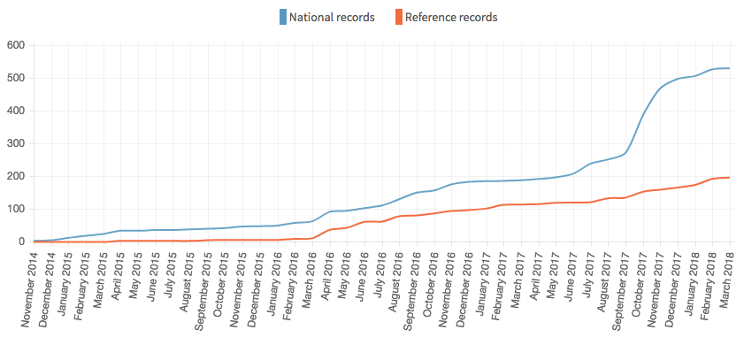
- The below table provides information on the number of national users who have been duly designated and have CBD user accounts. 14 Parties have yet to designate a publishing authority including: 2 from GURLAC, 7 from Africa, 4 from Asia and the Pacific, 1 from WEOG. Without a publishing authority Governments are not able to publish information directly on the ABS Clearing-House.
Table 3: Number of national users registered on the ABS Clearing-House (22 March 2018)
Type of national users | Total users | Users from Parties | Users from Non-Parties
Publishing Authorities | 110 | 90 | 20
National Authorized Users | 243 | 204 | 39
TOTAL | 353 | 294 | 59

Difficulties and challenges mentioned in the interim national report
- Some Parties reported that there were no challenges in making information available in the ABS Clearing-House. However, some Parties did identify certain difficulties and challenges, including: (a) delays in the designation of the publishing authority; (b) frequent changes of responsible authorities; (c) need for translation of the ABS Clearing-House; (d) need for capacity to use the ABS Clearing-House; and (e) technical difficulties.
- With respect to the internationally recognized certificates of compliance, Parties that reported having issued permits or their equivalents, identified the following constraints in publishing this information in the ABS Clearing-House: (a) the need to adopt ABS measures; (b) technical problems accessing the ABS Clearing-House; (c) the need to streamline the process for making permits available to the ABS Clearing-House; (d) lack of human resources; (e) need for capacity-building; and (f) delays in the designation of publishing authorities.
- Some countries that have already made permits available to the ABS Clearing-House noted the need to make the transfer of information to the ABS Clearing-House less time consuming. For example, one country explained that the fact that the format of the agreement was different from the IRCC format made the submission of information time consuming; another country noted that an automated way to transfer permit information to the ABS Clearing-House was desirable; and other countries reported to be working on improving a standardized flow of information on permits from the CNA to the publishing authority to facilitate the publication of this information on the ABS Clearing-House.

Other relevant information from the interim national reports
- In answering question 29 of the interim national report, some countries provided further information on cost-effective communications tools and systems being developed, for example:
  - Ethiopia reported that it has established a web-based ABS information sharing system (http://www.ebi.gov.et/gm-access/) where all required documents such as forms, guidelines, laws and other information are posted and regularly updated for easy access by users of genetic resources and community knowledge;
  - The European Union explained that Article 13 of EU Regulation 511/2014 obliges both the European Commission and EU Member States, as appropriate, to promote the development and use of cost-effective communication tools and systems in support of monitoring and tracking the utilization of genetic resources and traditional knowledge associated to genetic resources by collections and users. An EU-wide web-based application is being developed for the users to submit due diligence declarations electronically to the competent authorities. The portal will be connected to the ABS Clearing-House, thus allowing competent authorities to transfer information in a cost-effective way;
  - Finland indicated having a national ABS Clearing-House and that a web tool for submitting user notifications to the CNA is under consideration;
  - India, Indonesia, Kenya, and Viet Nam reported work on online application/permitting systems;
  - Antigua and Barbuda and China reported on work on web-based information systems.

B. Google analytics for the ABS Clearing-House website
- The ABS Clearing-House website has been enabled with Google’s website analytics service (https://analytics.google.com) in order to provide analysis and insights into the website’s traffic and performance.
- Overall there have been a total of 473,145 pages views from 49,521 unique visitors and on average each visitor spends 5.5 minutes on the ABS Clearing-House viewing 3.5 different ABS Clearing-House webpages. If we look at the trends from the graphs below we find that the total number of page views has been steadily increasing. The bounce rate last year was 35% compared to 62% in the first year after the entry into force of the Protocol.. This statistic may indicate an increase in visitor engagement and that visitors are purposefully coming to the website to look for certain information.
- The below chart shows page views since the launch of the ABS Clearing-House website and the average number of monthly visitors.
Chart 2: Page views per month 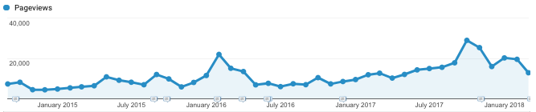
Chart 3: Number of visitor per month
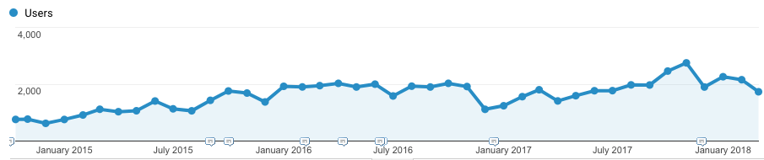
- The number of visitor per year has increased 83% since the entry into force of the Protocol. The past year visitors totaled 18,709 compared with 10,206 visitors in the first year after entry into force of the Protocol.. The below map highlights the countries with the most visitors to the ABS Clearing-House. The top 10 countries, representing 62% of all visitors, are as follows: Germany, Japan, USA, France, UK, Canada, India, South Korea, Switzerland, and Belgium.

Map 1: Overview of visitors based on the country where the session originated (12 Oct 2014 - 22 March 2018)
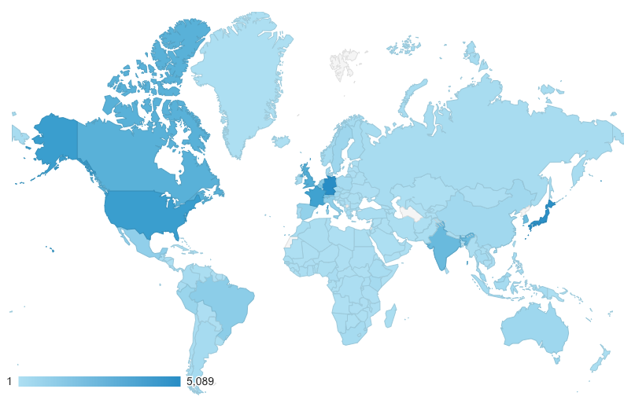
- The below map shows the number of visitors by continent. In term of continent, most visitors originated from Europe (45%) followed by Asia (25%), Americas (23%), Africa (5%), and Oceania (2%).
Map 2: Overview of visitors by continent where the session originated (12 Oct 2014 - 22 March 2018)
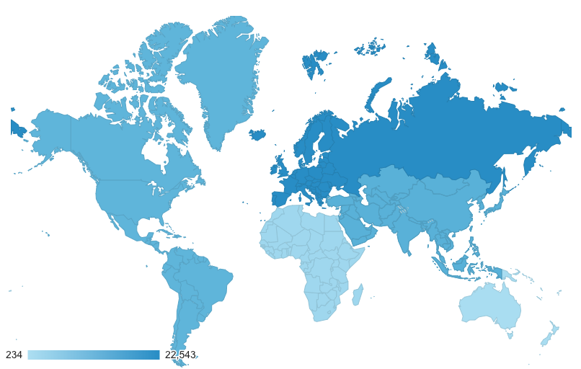
- If we look at the data on each visitor’s language preferences we find that the largest group (43%) are English speaking visitors. The table below shows the breakdown indicating the language preference of visitors to the ABS Clearing-House.
Table 3: Preferred languages of visitors to the ABS Clearing-House (12 Oct 2014 - 22 March 2018)
Language | % of Visitors
English | 43%
French | 10%
Japanese | 10%
German | 10%
Spanish | 8%
Korean | 8%
Other | 11%
- In terms of devices used to access the ABS Clearing-House website we find that 91% use their desktop computer and only a relatively small number access the site from a mobile or tablet. If we examine the bounce rate for mobile and tablet devices we find that it is about 10% higher than desktop devices, this may indicate that users may find the ABS Clearing-House not as user-friendly or as easy to use on a smaller screen sized device.
Chart 4: Device used by visitors to the ABS Clearing-House (22 March 2018)
Device | Number of Users | Percentage of Total
Desktop | 20,181 | 91.15%
Mobile | 1,447 | 6.54%
Tablet | 513 | 2.32%
- If we look at which pages visitors are viewing on the ABS Clearing-House we find that the most visited pages are the home page (“/”), the country profiles and the search (‘/search/nationalRecords’ or ‘/search’), the help page (“/about”), and pages related to the report analyser. Please note that below table looks at the most visited pages since the beginning of 2018, in order to get a picture of the currently active pages, rather than pages with addresses that have changed or are no longer used.
Table 4: Top most pages visited on the ABS Clearing-House (1 Jan 2018 - 22 March 2018)
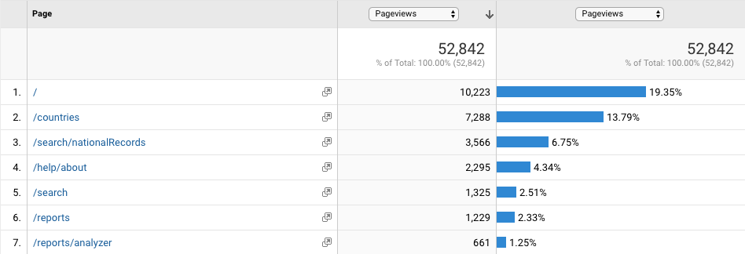
- If we examine analytics related to the website speed, we find that load times have decreased since the ABS Clearing-House was launched. However, there are still a number of countries suffering from below average website loading speeds. The majority of these slow loading speeds are from users visiting the website from either Asia or Africa. For example, over the last year the average loading speed has been reduced to about 15 seconds compared to 42 seconds in the first year after entry into force of the Protocol. The top 10 countries with the slowest loading speeds over the last year were: Laos, Cameroon, Angola, Gabon, Mauritius, Tanzania, China, Malawi, Vietnam, Cambodia. If we look at Google’s pagespeed score rates most ABS Clearing-House webpages do quite well with a score of about 80 out of 100, 100 being a “perfectly” optimized webpage.

C. Reports of the meeting of the Informal advisory committee to the ABS Clearing-House
- The informal advisory committee (IAC) to the ABS Clearing-House has met three times since the entry into force of the Protocol. The reports of each of these meetings are found in the following documents: UNEP/CBD/NP/COP-MOP/2/INF/2, UNEP/CBD/NP/COP-MOP/2/INF/3, and CBD/ABS/CH-IAC/2017/1/4 respectively. From examining these IAC reports we can identify certain key needs that repeatedly surface which may require further consideration going forward. These needs have been captured below:
  - The need to ensure each Party has designated their publishing authority;
  - The need to continue providing technical assistance, and encouragement for the publication of information;
  - The need for additional capacity-building and awareness-raising related to the ABS Clearing-House, particularly for IPLCs;
  - Translation of the ABS Clearing-House website;
  - The need to enhance clarity, certainty and the availability of information related ABS requirements and access to genetic resources and associated traditional knowledge;
  - The need to explore and enhance the ways the ABS Clearing-House can support and improve capacity-building for the implementation of the Protocol;
  - The need to raise-awareness for and provide documentation to support the implementation of interoperability features of the ABS Clearing-House for Government and other stakeholders;
  - The need to continue to explore collaboration with relevant instruments and initiatives;
  - The need to ensure integration, consistency and coherence in developing the ABS Clearing-House in regard to the CBD’s other clearing-houses, shared infrastructure and the web strategy while ensuring the specific functionalities in the ABS Clearing-House important for the implementation of the Protocol are conserved.
  - The need to review the CPC and IRCC as more experience is gained using these tools in monitoring genetic resources and associated traditional knowledge through the ABS Clearing-House.

D. A survey targeting ABS national focal points and other users of the ABS Clearing-House
- A notification was issued (16 October 2017) inviting Parties, non-Parties, indigenous peoples and local communities, and relevant stakeholders to provide feedback on the implementation and operation of the ABS Clearing-House by filling out an online survey. The survey was available in an electronic format on the ABS Clearing-House from 18 Oct 2017 until 3 Dec 2017. The first time a user visited the website during that period the ABS Clearing-House website was setup to launch a pop-up dialogue box inviting the user to complete the survey. There were 128 responses received to the survey with respondents in over 57 different countries.
- The survey questions were organized by five main areas of interest which included information about the respondents, design and functionality, capacity-building, administration and infrastructure, and general suggestions for improvement. The results are summarized below.

Information about the respondents
- The survey found that 39% of respondents were national users (focal points, publishing authorities or national authorized users) and of those national users about 40% were from developing countries and 60% were from developed countries. The majority (90%) of the respondents from the private sector/business, research community, and scientific community came from developed countries. Only 3 respondents were from indigenous peoples and local communities (IPLCs).
Chart 5: Types of user completing the survey
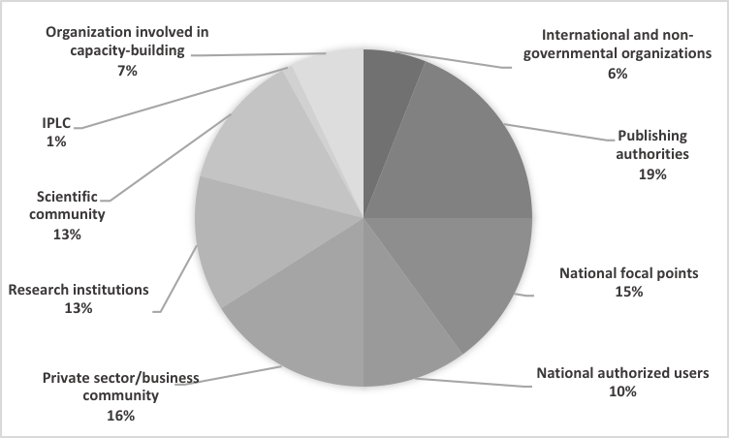

- If we look at the results for how often respondents are using the clearing-house, we find about 30% are regular users who use the ABS Clearing-House at least once a week and 5% of those use the ABS Clearing-House every day. We find that about half these regular users come from the private sector or business community, and the other half were national users.
Chart 6: How often respondents use the ABS Clearing-House

- About half of the users who said they were advanced ABS Clearing-House users were also national users from developed countries. Most (75%) users at the beginner level were not national users, however, of the national users at the beginner level (25%), most (90%) of these national users are from developing countries.
Chart 7: Level of expertise of the respondents using the ABS Clearing-House

Design and functionality
- The design and functionality covered user friendliness, the ability to easily find information and the ability to easily submit information. Only a relatively small number (15%) responded negatively to the questions related to design and functionality and of those only about 2% disagreed strongly. If we look into the specific complaints of these respondents we find that they were related to the lack of national information available, difficulties understanding national ABS access requirements and procedures, and slow loading of the website.
- About 77 users provided suggestions on how to improve the design and functionality. The most common response was related to increasing the amount and clarity of national information and in particular on access procedures, many of these suggestions came from the private sector and business community and the scientific and research community. If we look at suggestions from national users the most common were related to translation of the website and providing more training opportunities, improving the search, and increasing the amount of relevant information. Comments from capacity-building partners and NGOs were more generally related to improving the search, using less ABS specific jargon, and use more visualizations of information (e.g. graphics, charts and maps).

3. Capacity-building for the use of the ABS Clearing-House
- Under the section on capacity-building for the ABS Clearing-House the survey covered a number of issues related to needs, barriers, existing materials, and how to improve.
- Respondents were asked to select from a list of capacity-building needs what were their priority needs. The most common need selected by almost 60% of respondents was related to understanding the system to monitor the utilization of genetic resources through the ABS Clearing-House. 47% said they want to better understand how to implement the interoperability features of the ABS Clearing-House, 36% said they wanted to understand more generally how information sharing and the ABS Clearing-House works to implement the Protocol. In terms of technical support offered by the Secretariat, about 50% of respondent had used the guides, help desk, email, phone or live chat services provided by the Secretariat and found them very helpful. The most useful of the capacity-building options provided by the Secretariat was the live chat service.
- If we look at the top barriers preventing the publication of information for national users we see that 60% of the respondents that answered this question reported that they required additional support and technical assistance to use the ABS Clearing-House, and about 40% answered that lack of translation of the ABS Clearing-House was a barrier. The majority of other stakeholders did not answer this question, but if we look at the ones that did we find many do not seem convinced or are unclear about what information they can share on the ABS Clearing-House.
- On the topic of how to improve capacity-building, only 36 respondents answered this question, most being national users. Almost all national users wanted more training opportunities such as workshops and webinars. Of the three users from IPLCs who responded to the entire survey all requested more training opportunities in answering this question.

4. Administration and infrastructure
- In terms of administration and infrastructure, the respondents were asked about website loading time and browser compatibility. Most, about 60%, reported that loading time was not an issue, while 15% said loading times were too slow. 75% reported that browser compatibility was not an issue, while about 14% had problems when using their browser of choice. Many of the same users who reported slow loading times also reported browser compatibility issues or problems connecting or accessing the website indicating these issues are probably related. Unsurprisingly many of these same users also responded more negatively to questions related to design and functionality.

5. Most useful features and suggested improvements
- 65% of respondents reported that the most useful feature of the ABS Clearing-House was related to its ability to provide up-to-date relevant information in user-friendly and understandable way, in particular, for information related to national contacts (NFP and CNAs) and ABS measures.
- Other frequently mentioned useful features were related to the country profiles (19%), the map (10%), and the availability of on-demand technical support (5%).
- Finally, the survey asked an open-ended question on how the ABS Clearing-House could be improved. Most suggestions were not very detailed and mainly re-enforced responses given earlier in the survey on issues such as: providing more training opportunities, translation of the website, increased population of information and providing more clarity related to national ABS requirements and procedures.

E. Information recorded from the live chat service
- The ABS Clearing-House live chat service was set up in order to provide a mechanism for immediate technical support to users of the ABS Clearing-House as they use the website. The live chat service is accessed through the green question mark icon available on the lower right-hand corner of every page of the ABS Clearing-House website. When the icon is clicked, users can chat with a real person from the Secretariat who can help answer questions and provide technical assistance to use the ABS Clearing-House. Each question is recorded and added to a knowledge base of frequently asked questions which are used to improve awareness-raising and capacity-building guidance material.
- The functionality for the live chat service was added to the CBD website, including the ABS Clearing-House, in May 2016. However, in February 2017 a separate database for the service was setup on the ABS Clearing-House allowing the Secretariat to clearly track the questions that originate from the ABS Clearing-House. For the sake of simplicity, this summary will examine a sample of the online conversations from February 2017 until February 2018.
Chart 8: Number of live chat conversations per month (Feb 2017 – Feb 2018)
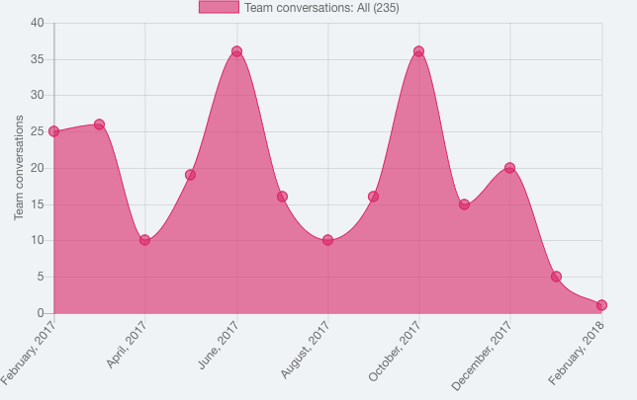
- Over this year long period the live chat service engaged in 235 online conversations, with each conversation including an average of 10 exchanges between an ABS Clearing-House user and the Secretariat. Conversations generally lasted about 15 minutes.
- Users of the live chat service are unknown unless they are signed-in to the ABS Clearing-House or identify themselves during the conversation. Over this period, 102 users of the service, almost half of the users could be identified. Most of the identified users, roughly 85%, were national users (e.g. NFP, PA, NAU). The high level of national users is not surprising and probably due to the fact that national users are likely to have a CBD account and therefore are automatically identified when using the service. Based on this assumption we may also infer that a large portion of the other half of the users are probably not national users. This assumption can also be supported by the types of questions received.
- Looking at all conversations during this period, we find that almost 60% of all questions received were related more to the practical implementation of the Protocol at national level. The conversations were related to clarifying ABS measures, in particular, access to genetic resources and associated traditional knowledge especially for those countries where information on the ABS Clearing-House is limited or ABS national focal points were unresponsive. A smaller percentage of these conversations were related to understanding the system to monitor genetic resources. Examples of these types of questions are included in the following box:
Box 1: Examples of questions received through the live chat service
  - I would like to know how I can obtain recognition through the Certificate of Compliance (IRCC) in order to confirm that my company fulfils Nagoya Protocol requirements for Portugal.
  - I would like to know the procedure to use the traditional knowledge associated to biodiversity in Burkina Faso.
  - We need to sign a PIC and MAT with a University for our collaboration. But I don't know who to sign these files because the contact person didn't reply to me and her phone doesn't work. What should I do?
  - I see that the ABS regulation is an EU regulation...so it concerns only European genetic resources? For example, if I'm from Italy and I need a GR from Africa, does ABS regulate this GR or not?
  - I'm French engineer and I work in a public laboratory. I isolated a bacterial strain in 2004 in New Caledonia waters. Now I want to deposit this strain in two international culture collections for its taxonomic description, so my question is: What document or permit do I need?
  - I'm a scientist at a private research institute in Switzerland, and I tried several times to contact an ABS national focal point. However, neither the email address nor any of the phone or fax numbers stated in the country's entry on your website seem to be working. Please advise what we should do.
  - I am trying to find if there are any access regulations in place in a country. There is nothing on the ABSCH. I have written to the Focal Point a few times since September but received no response. Does that mean plant materials can be exported from this country without any regulations?
  - I work in the cosmetics industry, is it possible to find out the access and benefit sharing agreement for a specific raw material? The distributor of the material does not seem to have the necessary information and I don't know if the genetic resource is from the US or not, but only the supplier would know that, right?
  - Is, prior informed consent obtained from the biodiversity authority in the country of origin, a public information?
  - Is French Polynesia part of France for the purposes of the Nagoya agreement?
  - Just wondering what paperwork would affect to a museum loan which affects material of a single species coming from 3 different neighbour countries (each of them has a different Party Status)?
  - Where can I find out if Kenya has PIC and MAT obligations?
  - What is the role of checkpoints? Do provider countries need to designate checkpoints? What about IRCC?
  - How does the checkpoint send the checkpoint communique to the provider country, I mean is there a system or is it just an official correspondence?
  - Do checkpoints do checking in the country of utilization, for example, if there is a domestic country utilizing domestic genetic resources?
  - How can I find out if a country has established access regulations? Is there any chance to find information somewhere else or in another way? The one I am looking for is not uploaded yet.
  - If I want to obtain genetic resources from a country, do I need a PIC and MAT, or do I need an IRCC?
  - What are the possible consequences of not complying with permits?
  - If country is not a Party, does this mean we do not have to fulfil our due diligence?

- Only about 35% of questions received through the live chat help desk were related directly to technical support to use the ABS Clearing-House, with about 20% related to submitting information on the ABS Clearing-House and about 15% related specifically to the interim national reports, and about 5% related to interoperability.
- Feedback on the live chat service from the users of this service has been very positive. This positive response is also reflected in the targeted survey results where several users cited immediate technical support through the live chat as one of the most useful features of the ABS Clearing-House.

F. Capacity-building for the ABS Clearing-House
- In August 2014, the Secretariat embarked on an outreach and engagement campaign that could provide cost effective, proactive, personalized and consistent follow-up to support Parties in their information-sharing obligations under Article 14 of the Protocol. The outreach, mostly via phone and email, conducted by the Secretariat is tailored to specific needs of countries in the implementation of the Protocol. Personalized outreach, especially phone calls, has also helped to strengthen their rapport with the Secretariat, which in turn has improved responsiveness and participation from ABS national focal points (NFP) and publishing authorities (PAs) in making information available and when contacting the SCBD for technical support.
- In addition, the campaign provides another avenue for the Secretariat to gather feedback and other information on experience with the ABS Clearing-House and progress in implementing the Protocol. This campaign has been well received by the stakeholders, particularly Parties, and has been recognized as a cost-effective way of increasing engagement and awareness and building capacity for the ABS Clearing-House.
- The Secretariat has developed materials to help build capacity for the use of the ABS Clearing-House including guides on how to submit information in the various common formats, as well as, an e-learning course on the ABS Clearing-House. The e-learning course, that will be available on the CBD e-learning platform, is open to the public and free to be used by national governments and partner organizations for their capacity-building needs. All materials developed by the Secretariat will be available in the six official languages of the United Nations thanks to the support of the Japan Biodiversity Fund. This campaign also serves as a way to disseminate capacity-building information directly to the users of the ABS Clearing-House who needs it.
- This campaign has organized 44 trainings for Governments, users of genetic resources, IPLCs and other stakeholders, these include: 34 remote training and 10 face-to-face trainings at regional and global events. The campaign also keeps track of requests received (such as: bugs found, requests for help, comments, suggestions) as well as issues related to obligations on information sharing (for example, a high priority of the campaign aimed encouraging the Parties who have not yet designated their publishing authority or ABS national focal point to do so).
- The Secretariat is grateful to the European Union and the Japan Biodiversity Fund who generously provided temporary financial support, enabling the SCBD to hire short-term staff to assist in the implementation of the outreach and engagement campaign from 2014 to 2017. At COP 13 Parties agreed to establish a regular post (G6), which will enable improved continuity of the outreach and engagement campaign as well as help keep translation of the website up-to-date.

III. CONCLUSIONS
- From the summary and review of each of the sources of information we find a number of common elements and issues worth highlighting for consideration in the future implementation and administration of the ABS Clearing-House. These conclusions, including an update on current progress undertaken to address these issues, have been captured in the list below:
- Ease of use and functionality: As we can see from the survey results, generally most visitors found the ABS Clearing-House user-friendly and easy to use, with less than 15% respondents who disagreed and 2% who strongly disagreed. From the survey, we also find that many commented positively on features like the map, country profiles, search, help pages, and live chat service and found these elements to be critical components of the website. These features may benefit from being prioritized for optimization and refined to best meet needs of all stakeholders.
- A small number of users of the ABS Clearing-House have found the website slow, particularly in the African and Asia-Pacific regions. Since the number of Parties who have reported this issue is relatively small, it should be possible to reach out to these Parties directly to investigate their individual problems. The issues causing slow loading times may also be related to the type or version of the browser being used. Problems and slow loading times caused by older browsers can be fixed by upgrading to a recent version of any popular internet browser. Website improvements to increase cross-browser compatibility and to optimize slow and frequently used webpages also may be prioritized. However, optimization of webpages and the supporting infrastructure is regularly addressed as part of the general up-keep and maintenance of the SCBD’s IT services. The Secretariat has also been exploring other options to better address browser and slow connectivity issues by exploring possible solutions such as a desktop application, a light version of the clearing-house and increased interoperability with existing national systems.
- Visitors: If we look at the types of users responding to the survey, the top visitor countries and the types of questions being asked in live chat service, we can find evidence that users of genetic resources use the website quite often and at least as much as national users. However, this conclusion can be contrasted with the fact that, to date most development and user testing of the website has prioritized national users. A number of useful suggestions have been already provided from users of genetic resources in response to the targeted survey and these have been already taken into account regarding the future development of the ABS Clearing-House. However, other stakeholders in particular the business and scientific communities could benefit from more outreach and awareness-raising, as well as, from a greater understanding of their needs in terms of functionality and design of the ABS Clearing-House.
- Availability of information: Feedback received has highlighted the need to increase and improve the relevant information available on the ABS Clearing-House. Many users of the ABS Clearing-House especially the users of genetic resources and associated traditional knowledge would like more certainty that the information available, in particular the national information, is complete and up-to-date. On the other hand, many countries providing this information have indicated that they are in the process of establishing or updating their national institutional and legal frameworks and therefore have yet to publish the mandatory information on the ABS Clearing-House. In addition, other stakeholders may not be aware of possible information they have that they could contribute. Therefore, more effort is needed to build capacity as well as increase awareness of stakeholders in order to support them to populate the ABS Clearing-House with relevant information. Work is currently being done to improve the search and provide a more in-depth analysis of the breadth of the information published in order to highlight gaps and other issues in a more visual way and add greater value for users to incentivize them to contribute this information.
- In particular, much of the feedback received points to an overwhelming need to provide improved information on national ABS requirements and procedures. In particular, this information should provide users with simple and easy to understand guidance on the necessary steps to apply for access to genetic resources and associated traditional knowledge. Work is currently in progress to develop a new common format before the end of the year that will better capture and make available the information on ABS procedures that users are looking for.
- Languages: The availability of the ABS Clearing-House website, as well as, related capacity-building material in all six United National languages is a high priority and will help facilitate and encourage the population of information in the ABS Clearing-House by all Parties, other Governments, and stakeholders. Translation of the website is being conducted in a stepwise manner, as recommended by the Informal Advisory Committee at its first meeting. The translation of all the submission forms has been completed, and all remaining elements will be sent for translation in the coming months and be available before the end of the year.
Capacity-building and awareness-raising for the use of the ABS Clearing-House:
- More capacity-building opportunities are needed that provide training for the use the ABS Clearing-House, particularly for national users in the African and Asia-Pacific region. Regional level trainings are organized upon request to the Secretariat and a number of trainings are being planned in the coming months.
- There is an important need to continue to provide technical assistance, and encouragement for the publication of information. The live chat service available on the website has been found to be particularly useful in this regard. More could be done to promote the use of this service as well as to better address questions related to the implementation of the Protocol.
- Additional capacity-building, awareness-raising, documentation, examples and training is needed for the use of the ABS Clearing-House’s interoperability features such as the application programming interface (API). This will be especially relevant for many Parties who have indicated they are working on implementing national clearing-houses, databases and permitting systems related to ABS. Improving interoperability with other partner organizations as well as relevant instruments and initiatives can also help increase the availability of up-to-date and relevant information in the ABS Clearing-House.
- The number of expert users of the ABS Clearing-House is growing, as demonstrated by the targeted survey which found that 30% of the users considered themselves expert users of the website. This may suggest a greater availability and potential for new trainers to provide capacity-building to use the ABS Clearing-House through cooperation among Parties, including south-south or triangular cooperation, including through initiatives such as the BioBridge (www.cbd.int/biobridge) initiative.
- There is a lack of understanding related to how the system works to monitor the utilization of genetic resources through the ABS Clearing-House. More capacity-building and awareness-raising to address this issue may be needed. As of 22 March 2018, 146 IRCCs had been made available by 12 Parties. To date, no checkpoint communiques have been published. This demonstrates the limited experience with these tools (such as the IRCC and CPC). The lack of permits available on the ABS Clearing-House may also be connected to the lack of understanding about how this system works. The Secretariat is currently finalizing a short video, in collaboration with the ABS Capacity-Development Initiative, to simply explain the Protocol’s system to monitoring utilization of genetic resources. It may be useful for webinars and other trainings conducted by the Secretariat, other capacity-building organizations and governments to devote more attention to building capacity around this issue.
- The Informal Advisory Committee: The informal advisory committee to the ABS Clearing-House has been instrumental in the development and improvement of the ABS Clearing-House. The three IAC meetings have been productive in providing technical guidance as well as in setting priorities for the development of the ABS Clearing-House. However, as the targeted survey and google analytics indicate at least 50% of users of the ABS Clearing-House are users of genetic resources. This may indicate a need to consider an adjustment to the membership of the IAC to allow for observers. Allowing for a more complete representation of the target audience, such as users of genetic resource and associated traditional knowledge from the business and scientific communities, could bring new perspectives and result in a more useful and effective ABS Clearing-House to support implementation of the Protocol.
__________

* CBD/SBI/2/1.
The publication of national databases, national focal points, the interim national report, reference records or regional measures displayed in the country profile were not considered for the purposes of this overview.
Some of these Parties have published some information in the ABS Clearing-House and also indicated that they have information available that has not yet been published.
E.g. Guinea Bissau, Mongolia.
Question 29: Is your country encouraging the use of cost-effective communications tools and systems as provided in Article 17.1(c)?
The online available documents and information include: The Access to Genetic Resource and Community Knowledge, and Community Rights Proclamation No. (482/2006) (ABS legal framework of Ethiopia); Material Transfer Agreement forms (MTA) (in MS-Word or pdf forms) needed for Export Permit; Instruction to users (Providing information on how to process access requests of genetic materials and indigenous knowledge); Assurance Letter Sample forms (E.g. Letter of Assurance to be produced from University / Research Institutions, or Competent National authorities, etc.);and List of potential genetic resources publicized for bioprospecting and benefit-sharing purposes.
A page view (or page view hit, page tracking hit) is an instance of a page being loaded (or reloaded) in a browser. Page views is a metric defined as the total number of pages viewed.
22 March 2017- 22 March 2018
12 Oct 2014 – 12 Oct 2015
22 March 2017- 22 March 2018
12 Oct 2014 – 12 Oct 2015
Please note Google’s definition of a continent is not exactly the same as CBD regions.
Google Analytics collects a visitor’s language preference from their web browsers. Language is a user-selectable setting in most web browsers which generally defaults to the language of the operating system.
Bounce rate is the percentage of single page visits (or web sessions). It is the number of visits in which a person leaves your website from the landing page without browsing any further.
Please note that ‘/search/nationalRecords’ and ‘/search’ route to the same page.
22 March 2017- 22 March 2018.
12 Oct 2014 – 12 Oct 2015.
The PageSpeed Score indicates the extent to which you can improve the load time of a page. A high score indicates less room for improvement. A low score indicates more room for improvement. The score isn't a measurement of speed, but only the extent to which the speed can be improved.
The survey questions can be found here: https://goo.gl/forms/KdtwyXKYzvVKyxuG2.

