 |  | CBD
 |  | Distr.  GENERAL  CBD/CP/BCH-IAC/12/2  14 April 2023  ENGLISH ONLY
INFORMAL ADVISORY COMMITTEE ON THE BIOSAFETY CLEARING-HOUSE
Twelfth meeting
Montreal, Canada, 15–16 May 2023
Items 3–6 of the provisional agenda*

Report on the Biosafety Clearing-House

Introduction
- Under Article 20, paragraph 1, of the Cartagena Protocol on Biosafety to the Convention on Biological Diversity, a Biosafety Clearing-House (BCH) is established as part of the clearing-house mechanism under Article 18, paragraph 3, of the Convention, in order to: (a) facilitate the exchange of scientific, technical, environmental and legal information on, and experience with, living modified organisms; and (b) assist Parties to implement the Protocol.
- In accordance with the modalities of operation of the BCH adopted by the Conference of the Parties serving as the meeting of the Parties to the Cartagena Protocol in its decision BS-I/3, the Acting Executive Secretary is convening the twelfth meeting of the Informal Advisory Committee on the Biosafety Clearing-House to review the progress made since its eleventh meeting, held in December 2020.
- The present document provides information on the operation of the BCH since its migration to its new platform, with a view to supporting the discussions of the Committee. Section I contains a summary of the latest developments and current and planned activities; section II contains a description of the post-2020 processes and their relation to the BCH; section III contains information on the collaboration on the United Nations Environment Programme-Global Environment Facility Biosafety Clearing-House III Capacity-Building Project (UNEP-GEF BCH III Project); and section IV contains an update on collaboration with biosafety-related organizations.
- Status of the Biosafety Clearing-House: latest developments and current and planned activities

A. Update on the chronogram
- In its decision CP-VIII/2, the Conference of the Parties serving as the meeting of the Parties to the Cartagena Protocol requested the Executive Secretary to undertake a number of tasks related to the BCH, including carrying out its full migration to its new platform and sending to the BCH focal points a chronogram detailing the migration and follow-up processes. At its ninth meeting, in 2019, the Conference reiterated in its decision CP-9/2 its request to the Executive Secretary to complete the migration of the BCH to its new platform.
- At its eleventh meeting, the Informal Advisory Committee provided comments on the status of the activities set out in the chronogram and adopted a number of recommendations, including continuing the migration process to its completion and launching the new BCH platform, even if the function for hosting online forums was not yet available and parts of the platform other than the common formats were available in English only.
- The new platform went officially live on 29 November 2021. Table 1 shows the status, as at the time of reporting, of each activity presented at the eleventh meeting of the Informal Advisory Committee. Further details are provided in the sections below.
Table 1
Status of progress made against the chronogram
Activity | Status as at April 2023
Development of common formats | Completed
Development of the search interface and display of search results | Completed
Development of the BCH training site | Completed
Migration of the fourth national reports | Completed
Testing phase | Completed
Initial set of statistical tools (“Sort”, “Group”, “Table”, “Send”, “Print” and “Export”) | Completedª
Migration of existing plug-ins and other existing BCH applications | Completed^{b}
Development of new record functionalities | Completed
Migration of online forums | Ongoing^{c}
ª All initial statistical tools were completed at the time of the launch, except the “Send” tool, which was developed in 2022 and renamed “Share”.
^{b} Partially completed at the time of the launch; fully completed by August 2022.
^{c} The first forum hosted on the new platform was held from 11 to 20 April 2023.
- Table 2 shows the various recommendations adopted at the eleventh meeting of the Informal Advisory Committee and the actions taken by the Secretariat in response.
Table 2
Recommendations adopted at the eleventh meeting of the Informal Advisory Committee on the Biosafety Clearing-House and actions taken by the Secretariat
Recommendations to the Secretariat | Actions taken/status
Review its staffing needs to ensure the proper functioning of the BCH from both a substantive and information technology perspective | The BCH is supported by two full-time officers: a Programme Management Officer (a permanent position was approved at the fifteenth meeting of the Conference of the Parties to the Convention on Biodiversity) and a Programme Management Assistant.  Other part-time staffing resources comprise: one Associate Information Technology Officer,ª one web development consultant (temporary position), one individual contractor (temporary position) and one Associate Programme Management Officer (scientific officer in charge of validating scientific records, such as living modified organisms, genes and organisms).
Provide an update to Parties, other Governments and relevant stakeholders on progress towards the migration of the BCH | Regular updates were provided on the BCH on BCH Forum. In addition, progress towards migration was communicated through notification 2021-24, additional details and links to training videos were provided through notification 2021-42, and information on the launch date and an introductory webinar were communicated through notification 2021-75. The webinar was held on 7 December 2021 (with 177 participants).
Include in the common format on “Country’s decision or other communication, notification or declaration” an optional field to provide information on the place where an unintentional transboundary movement occurred | The field has been added to the decision common format. To date, no records providing additional information in the new field have been created.
Include a function that enables the export of draft records, so that they can be shared with others to collect input, and a function for exporting the record of discussions from online forums | A feature to share drafts by email, link and PDF has been developed.
Develop further the explanatory videos and similar online tools to demonstrate various features on different sections of the new BCH (e.g. visual tooltip for sorting arrows in the “matrix” views of the “Search” interface) | A suite of videos has been produced in partnership with the UNEP-GEF BCH III Project. Virtual tours are available in the “Search”, “Submit” and “Country Profiles” pages. Contextual help, which is a modern website help tool, has also been implemented.
Consider further development of online help materials and training modules on the new BCH platform, taking into consideration the needs of Parties for capacity-building arising from the new BCH platform | The Secretariat has begun hosting webinars with a particular focus on various clearing-house tasks. The first webinar, on new and improved clearing-house features (29 January 2023), was attended by 45 participants, while 101 participants registered for the second webinar, on publishing information (23 February). A survey was conducted from 13 to 28 February 2023 to seek feedback on particular capacity-building needs for the BCH.
Make national website tools available to allow interoperability with the new BCH platform and take into account national migration requirements and inform countries of the plans and timeline for the phaseout of Hermes | The “Embed” feature has been developed to replace the Ajax plug-in national website tool, with a view to allowing users to display BCH data on their national websites.  The connection to websites using Hermes is still functional; details regarding the phaseout have not yet been completed, but Bioland is currently available for any Government wishing to build a national website.
Migrate the function for hosting online forums to the new BCH | The first forum hosted on the new platform was held in April 2023.
Archive the previous online forums as static HTML | Previous online forums will remain accessible on the legacy pages of the BCH.
Carry out the translation of the common formats and make them available in the six official languages of the United Nations by the time the new BCH is launched | Common formats have been translated into all six languages of the United Nations.
Continue the migration process to its completion and the launch of the new BCH platform even if the function for hosting online forums is not yet available and parts of the platform other than the common formats are available only in English | The migration to the new platform was completed in November 2021.
Develop temporary unique identifiers for living modified animals falling under the scope of the Cartagena Protocol on Biosafety in consultation with developers when information about such living modified organisms is submitted to the BCH and taking into account existing procedures when available | Temporary unique identifiers have not been developed.
Continue discussions with the Organisation for Economic Co-operation and Development (OECD) with the aim of assessing the possibility for OECD to develop permanent unique identifiers for living modified animals in the near future | The Secretariat continues to support OECD in discussions towards the development of permanent unique identifiers for living modified animals.
Continue to collaborate and explore possibilities for facilitating information-sharing between BCH, the Food and Agriculture Organization of the United Nations (FAO) and OECD databases and other relevant databases in the longer term | An information-sharing process has been defined for decision and risk assessment records.
ª The position of Associate Information Technology Officer is shared with other Secretariat departments and is not solely dedicated to the BCH.
- Status of records in the Biosafety Clearing-House
- The BCH continues to remain a key tool for information-sharing, capacity-building and facilitating the implementation of the Cartagena Protocol.
- The Secretariat continues to manage the BCH on a daily basis and to monitor the accuracy and completeness of records by urging Parties to ensure that the necessary information is made available on the BCH (e.g. summaries of risk assessments to accompany records on decisions on introduction into the environment) and that BCH records are kept up to date (e.g. national focal points and competent national authorities). The Secretariat also reviews and validates some categories of records for publication on the BCH (e.g. records on living modified organisms, genes and organisms; biosafety virtual library resources and capacity-development initiatives). With respect to various national focal points and points of contact, in the period from January 2021 to April 2023, records from more than a hundred countries were updated. In its ongoing efforts to ensure the accuracy and completeness of records in the BCH, the Secretariat also routinely compares decisions on living modified organisms published in the BCH with those available in external databases in order to identify existing information that may need to be made available on the BCH. In this regard, the Secretariat contacted and followed up with BCH national focal points of approximately 51 countries during the same period. As a result, 40 per cent of countries have taken action to publish their missing decisions and risk assessment records or have provided the Secretariat with an update on their status. The Secretariat also continues to address a number of requests from Parties and the general public for technical advice and assistance related to the management of records in the BCH.
- The new common format for registering a competent authority for the Nagoya-Kuala Lumpur Supplementary Protocol on Liability and Redress to the Cartagena Protocol on Biosafety has been created pursuant to paragraph 6 of decision CP-9/15 and was made officially available on the BCH at the launch of the new platform. In notification 2021-83, issued shortly thereafter, the Executive Secretary requested Parties to submit the contact information of their competent authorities to the BCH.
- At its tenth meeting, held in 2022, in decision CP-10/7, on the assessment and review of the effectiveness of the Protocol (Article 35) and the final evaluation of the Strategic Plan for the Cartagena Protocol on Biosafety for the period 2011–2020, the Conference of the Parties serving as the meeting of the Parties to the Cartagena Protocol noted the positive trends regarding information-sharing through the BCH, including in relation to the number of national records and reference records published, and the number of visitors. In the same decision, it urged Parties that had not yet completely done so to make all required information available to the BCH and keep their records up to date, and requested the Executive Secretary to ensure that adequate support was provided to the BCH to enable the mechanism to function to its full capacity and potential.
- Since the eleventh meeting of the Informal Advisory Committee, the number of records published in the BCH has increased. Table 3 provides a summary of the number of published records as at 1 December 2020 and 1 April 2023.
Table 3
Number of records published in the Biosafety Clearing-House, excluding national reports
Record type | Total records,  as at  1 December 2020 | Total records,  as at  1 April 2023
National records
National contacts (Cartagena Protocol and BCH focal points, emergency measures contacts under Article 17) | n/aª | 344
Competent national authorities (CNA) | 360 | 405
Supplementary Protocol competent authority (SPCA) | n/a^{b} | 13
Biosafety laws, regulations, guidelines and agreements (LAW) | 1 026 | 1 138
Countries’ decisions and other communications (DEC) | 2 426 | 2732
Risk assessments generated by a regulatory process (RA) | 2 282 | 2 628
National biosafety websites or databases (NDB) | 136 | 151
Biosafety experts (EXP) | 348 | 362
Total, national records | 6 578 | 7 773
Reference records
Biosafety virtual library resource (VLR) | 1 534^{c} | 1 571
Biosafety organizations (ORG) | 258 | 379
Laboratories for the detection and identification of living modified organisms (LAB) | 27 | 75
Living modified organisms (LMO) | 782 | 942
Genetic elements (GENE) | 599 | 852
Organisms (ORGA) | 243 | 269
Risk assessment generated by an independent or non-regulatory process (IRA) | 31 | 32
Capacity-development initiatives (CDI) | 420^{d} | 423
BCH news (BCHN) | 539 | 558
Total, reference records | 4 433 | 5 101
Contacts | 2 351 | 2 462
Grand total, all records | 13 362 | 15 336
ª Due to the changes made to the various national contact databases during the migration process, the Secretariat is unable to generate accurate data for this metric.
^{b} New format as at 29 November 2021.
^{c} Number of “Biosafety Information Resource Centre (BIRC)” records in the previous BCH platform.
^{d} Number of “Capacity-Building Activities, Projects and Opportunities” records in the previous BCH platform.
- As shown in table 3, there has been a substantial increase, of approximately 15 per cent, in published content in the BCH since the previous meeting of the Informal Advisory Committee. Of particular note is the increase in the scientific records, including living modified organisms (+ 20 per cent), genetic elements (+ 42 per cent), and laboratories for detection and identification (+ 178 per cent). In addition, notable increases are seen for key national records, including countries’ decisions (+ 13 per cent), risk assessments generated by a regulatory process (+ 15 per cent), and biosafety laws, regulations, guidelines and agreements (+ 11 per cent).
- Apart from being an important repository of information, the BCH has continued since the eleventh meeting of the Informal Advisory Committee to be the tool used for online forums and discussions on such topics as risk assessment and non-State actors’ engagement in the Action Plan for Nature and People. The BCH on BCH Forum has been widely used and proved crucial to communications with Parties, non-Parties and stakeholders on various items related to the BCH.

C. Activity and traffic on the new platform
- The Secretariat has been tracking activity and traffic on the BCH using Google Analytics since September 2020. In an effort to gauge the use and success of the new platform and user activity, the Secretariat tracked traffic and activity across several metrics in the year preceding the launch (29 November 2020–28 November 2021) and the year following it (29 November 2021–28 November 2022), as shown in the comparison below.
Comparison of traffic and activity on the Biosafety Clearing-House before and after launch
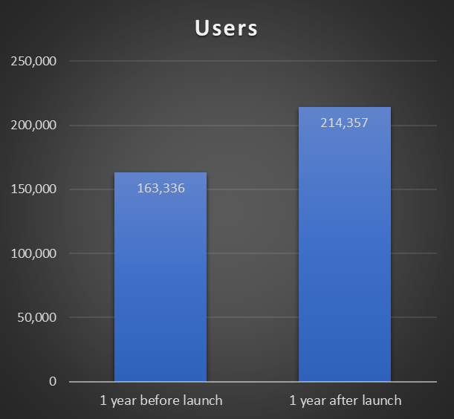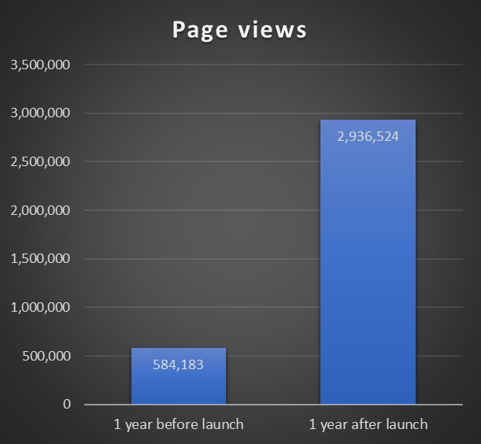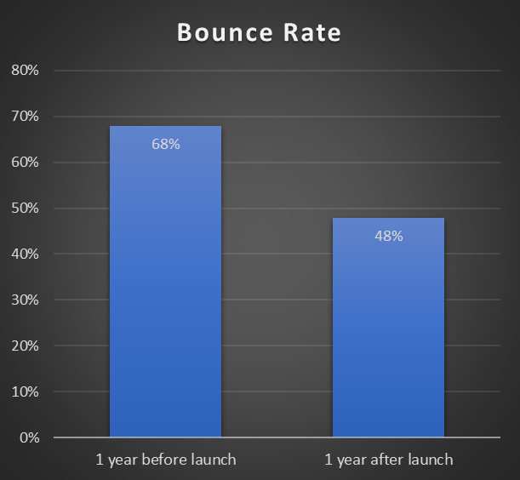
- The traffic metrics above show that activity on the new platform has increased substantially, with more users visiting the BCH and spending more time on the platform. It is worth noting, in particular, that:
  - There was a 31 per cent increase in the number of users of the clearing house in the year following the launch, from approximately 163,000 to 214,000 users;
  - There was a 403 per cent increase in page views, from 584,000 views to 2,936,524. In parallel with this indicator, the number of pages viewed per session went from 2.6 to 10.5 (+ 301 per cent) and average session duration went from 2:42 to 10:17 minutes (+ 280 per cent);
  - In the year preceding the launch, the BCH had a bounce rate of 68 per cent, against 48 per cent in the year that followed.
- The BCH experiences substantially more traffic than the other clearing houses of the Secretariat. In the year following the launch of the new platform, the BCH averaged approximately 587 daily users, compared with an average of 96 daily users for the Access and Benefit-sharing Clearing-House and 58 daily users for the clearing-house mechanism of the Convention.
D. Review of staffing needs
- At its ninth meeting, the Conference of the Parties serving as the meeting of the Parties to the Protocol reiterated in its decision CP-9/2 its request that the Executive Secretary allocate adequate and specific resources, both human and financial, for the management, improvement and maintenance of the BCH. At its eleventh meeting, the Informal Advisory Committee recommended that the Secretariat review its staffing needs to ensure the proper functioning of the BCH from both a substantive and information technology perspective.
- After the ninth meeting of the Conference of the Parties serving as the meeting of the Parties to the Cartagena Protocol, the filling of the post of Programme Management Assistant for the BCH in January 2019 and the allocation of a dedicated Associate Information Technology Officer to work full-time on the migration made it possible for work on the migration of the BCH to the new platform to advance. A temporary Programme Management Officer for the BCH was also hired with voluntary funds and started in June 2021. At its tenth meeting, the Conference approved the creation of a permanent position of Programme Management Officer of the BCH in the regular budget.
- With financial support from the UNEP-GEF BCH III Project, the Secretariat was able to hire a web development consultant to support its information technology team with the migration. In addition, the Project provided funds that enabled the Secretariat to recruit an expert consultant to review the user interface and user experience for the BCH. The Project has since provided additional funds to support the engagement of a web development consultant to carry out additional work.
- The technical maintenance and development of various new functionalities and features of the BCH are an ongoing process, and the Secretariat resources are limited in this regard, as the position of Associate Information Technology Officer is shared with other Secretariat units. The technical work on the BCH is therefore dependent on temporary consultancy contracts. The Secretariat is looking into re-hiring a web development consultant for another term to assist with the development of the BCH.
- Additional resources comprise an individual contractor (temporary position), who supports the testing of the BCH, and an Associate Programme Management Officer, who is the scientific officer in charge of validating the scientific records (living modified organisms, genes, organisms, laboratories for the detection and identification of living modified organisms and Biosafety Virtual Library Resources).

E. Latest developments
- The present section details specific developments in the BCH since the previous meeting of the Informal Advisory Committee.

1. Homepage
- As part of the collaborative activities of the UNEP-GEF BCH III Project, the Secretariat recruited an expert consultant to review the user interface and user experience for the BCH. As part of the work, the expert designed a new homepage. The homepage of the old platform had many links to various parts of the BCH website. This resulted in first-time users struggling to find what they were looking for without direct guidance, thus contributing to the high bounce rate for the BCH in the year preceding the launch, as indicated in paragraph 16 (c). The new homepage was specifically designed to facilitate access to information on how to search and submit information.
- The homepage was slightly revised in the second half of 2022 to improve the visibility of dynamic content and now showcases “Announcements” more prominently on the landing page.

2. Technical maintenance: upgrade to Bootstrap 5
- While the new platform of the BCH launched in 2021, its front-end framework was built using Bootstrap 3, which had been released in 2013 and was the most recent version available at the time of the launch of the Access and Benefit-Sharing Clearing-House platform. With the release of Bootstrap 5 in 2021, it was necessary to dedicate information technology resources to upgrade the front-end framework for all clearing houses of the Secretariat.
- The upgrade did not result in any functionality changes but in aesthetic changes to the icons and buttons. The Secretariat also used the upgrade as an opportunity to standardize the colours and locations of buttons and icons, with a view to providing consistency and coherence among the clearing houses.

3. “Email Alerts” and “My saved searches”
- The BCH allows users to be notified by email when records that match custom-search queries are published in the BCH. For example, a user may wish to set up an email alert to be notified when competent national authority records are added or updated by a specific country or region. This can be done through the “Email Alerts” tab (formerly named “Preferences”) under “Submit” or through “My saved searches” feature under “Search”. When a user creates email alerts using one of those tools, the saved custom-search queries are automatically displayed in both places. Users can also select the frequency for receiving email alerts from the BCH and choose to have an overview section, which provides a summary of all new or updated records published in the BCH within the selected frequency, added to the email alert.
4.“Share” feature
- As recommended by the Informal Advisory Committee at its eleventh meeting, a new function was developed on the “Submit” page that allows for the sharing of draft records. After saving a record as a draft, a user can export the draft to a PDF format, send it by email to specific BCH users or generate a link in order to share the draft.

- Owing to time limitations and the complexity of developing many new functionalities in the “Search” function, the “Share” feature of the search interface was developed after the launch of the new BCH platform. It was originally referred to as “Send”. The feature allows users to share entire search results or a single record with others. There are three ways to share BCH records: by link (URL), by email or by embedding one or more records into another webpage. The “link” option provides users with a link that can be copied and pasted into any form of communication that they choose; the “email” option allows users to type the e-mail addresses of the recipients to whom they wish to send the record or search results; and the “embed” option generates a script that users can copy and paste in any webpages that they wish to embed the content in.

5. Training and capacity-building on the new platform
- The previous platform of the BCH had an extensive help section developed under the UNEP-GEF BCH II Project on the basis of all the work produced under the UNEP-GEF BCH I and II series of activities. It also provided access to tutorial and videos developed by the Secretariat in all six languages of the United Nations. With the migration to the new platform, much of the help and training material previously in use became obsolete.
- As many users have grown familiar with the previous platform of the BCH, there needed to be a concerted effort to ensure familiarity with the new platform and the availability of adequate capacity-building materials.
- The UNEP-GEF BCH III Project continues to support the process of building capacity on the new platform through a series of regional and national workshops, as well as by hosting the “Virtual Learning Environment” that houses a suite of capacity-building materials (see sect. II).
- The BCH Knowledge Base is the dedicated help section on the new platform and houses a collection of background material, contextual information, frequently asked questions and step-by-step guides on how to perform various functions. Content from the Knowledge Base is also directly available in the BCH through the “Contextual help” feature, which is accessible by clicking on the question mark symbol located in the top right corner of the BCH and contains information related to the user’s current page. For example, if a user is navigating the “Search” page, the contextual help pane will display articles from the Knowledge Base that are relevant to the search. Users can thus access pertinent help material from the Knowledge Base without having to navigate away from their current page. As new features become available, the Knowledge Base is updated with new articles that detail the form and function of those features.
- The new platform of the BCH also provides a series of onboarding tours, which walk users through particular pages directly in their browser. The tours are available from the main “Search” page, the “Country Profiles” page, the “Dashboard” of the “Submit” page, the “Summary of records” page for each common format and the “Submission form”, where a user creates or edits a record.
- The Secretariat conducted a survey on training needs on the BCH. A total of 90 responses were collected between 13 and 28 February 2023, indicating user familiarity with different aspects of the new platform. A summary of the results is available in the annex.
- The Secretariat has taken several opportunities to provide trainings on the new platform of the BCH, in person and online:
- A webinar was held on 7 December 2021 to celebrate the launch of the new platform. The webinar was focused on the context of the BCH migration, key differences between the previous and the new platforms and guidance on how to search and submit information and access help on the new platform. A total of 177 participants joined the event, including national focal points and members of the Informal Advisory Committee, other organizations and the general public;
- With support from the Government of the Republic of Korea, through the Korea Biosafety Capacity-Building Initiative, the Secretariat convened three workshops on risk assessment of living modified organisms: (i) in Dakar, from 19 to 22 September 2022, for francophone Africa; (ii) in Antalya, Türkiye, from 17 to 21 October 2022, for Western, Central and Eastern Asia; and (iii) in Manila, from 7 to 11 November 2022, for South and Southeast Asia and the Pacific. The objectives of the workshops were to provide theoretical and practical training on the risk assessment process (concepts, steps, methodology and key issues to consider) and hands-on training in the evaluation of case studies of living modified organisms for environmental release, identifying protection goals and applying the risk assessment methodology to develop risk scenarios to assess. Each workshop featured a session on the new platform of the BCH, providing training to attendees on how to use the platform to find and submit information relevant to risk assessment;
- At the invitation of the UNEP-GEF BCH III Project, the Secretariat participated in the Project’s Regional Advisors Network Training of Trainers meeting, held in Dubai from 13 to 17 June 2022. The aim of the meeting was to enhance the network of BCH III Project regional advisors, to promote the exchange of ideas and experiences among them and to provide them with an opportunity for updating and strengthening their technical skills and procedural knowledge specific to the BCH III Project, as well as their broader knowledge of biodiversity multilateral environmental agreements. The training also enhanced the regional advisors’ knowledge of the newly launched BCH platform, with the active support of the Secretariat of the Convention on Biological Diversity;
- A BCH training workshop, co-organized by the Secretariat of the Convention and UNEP-GEF BCH III Project, was held in Montreal, Canada, on 5 and 6 December 2022, on the margins of the tenth meeting of the Conference of the Parties serving as the meeting of the Parties to the Cartagena Protocol, and was attended by approximately 57 participants. Further details are provided in section III;
- The International Conference on GMO Analysis and New Genomic Techniques was held in Berlin from 14 to 16 March 2023. The event was co-organized by the Federal Office of Consumer Protection and Food Safety, the Federal Institute for Risk Assessment, the Federal Ministry of Food and Agriculture and the Federal Research Centre for Cultivated Plants of Germany, the European Commission Joint Research Centre and the Secretariat of the Convention on Biological Diversity and was attended by more than 200 in-person participants. At the event, global experts exchanged information on new developments in the field of detection and identification of living modified organisms, which included a presentation on the BCH and on how the database supports the field of detection and identification at the global level;
- The Biosafety and Access and Benefit-Sharing units of the Secretariat hosted two webinars. The first was held on 31 January 2023, with approximately 45 participants, and was focused on new and improved search features of the BCH and the Access and Benefit-sharing Clearing-House. The second was held on 23 February, with 101 registered participants, and was dedicated to publishing information. Additional webinars based on the feedback received from the survey mentioned in paragraph 36 are planned.

6. Translations
- In decision CP-10/5, the Conference of the Parties serving as the meeting of the Parties to the Cartagena Protocol requested the Executive Secretary to translate further pages of the BCH, including new features and content as they are developed, to ensure the availability of the BCH in the six official languages of the United Nations.
- At its eleventh meeting, the Informal Advisory Committee suggested that the Secretariat focus on the translation of the common formats before moving on to that of other parts of the platform. The Committee recommended that at least the common formats be made available in the six official languages by the time the new BCH was launched and recognized that other parts of the platform might initially be available in English only and that work on translating the other parts would continue after the launch.
- Translation of all sections of the new BCH platform in the six official languages of the United Nations is one of the key priorities of the Secretariat. While certain sections (online common formats) were translated in time for the launch of the new platform, many other sections of the site were available in English only. Extensive translation work has been carried out since then. One of the key activities has been to test the translation and functionality of each page of the website in the five languages of the United Nations other than English, and to fix bugs and glitches. Table 4 shows the various components requiring translation and the status for each. Translation is an ongoing activity of the Secretariat, as changes are made to the BCH on a continuous basis.
Table 4
Translation status
Sections needing translation | Status
Offline common formats | Completed
Online common formats | 90 per cent completed
Tours | Completed
Help articles (Knowledge Base, frequently asked questions) | Completed
Webpages (main display): home page, “Country Profiles”, “Submit” (“Dashboard”, “Requests”, “Notifications”, “User Management”, “Email Alerts”), “Search” and “Knowledge Base” | Ongoing
Other (i.e. pop-up boxes, tools and various built-in features) | Ongoing

7. Linkages between the Biosafety Clearing-House and national websites
- In decision CP-10/5, The Conference of the Parties serving as the meeting of the Parties to the Cartagena Protocol requested the Executive Secretary to explore how the Bioland tool could be used to facilitate the linkage between national websites and the BCH, and other mechanisms that allowed national clearing houses to retrieve information from the BCH.
- At its eleventh meeting, the Informal Advisory Committee emphasized the importance of maintaining the interoperability of the BCH with national websites, referring to the use of the Ajax plug-in and Hermes national website tools. Those had been developed by the Secretariat to facilitate the building of national biosafety clearing houses by allowing countries to display their own BCH data on national websites and databases autonomously.
- With the launch of the new platform, connections to national websites using the Ajax plug-in and Hermes national website tools were temporarily disrupted. In August 2022, the connection to websites using those tools was restored in such a way that the information being retrieved was consistent with the aesthetics of the new platform.
- Furthermore, the new “Share” feature, as described above, has been developed to allow users to share search results through the “Embed” feature, which enables them to retrieve search results and records from the BCH and incorporate them into national websites. With the new feature, the Ajax plug-in is no longer required, and websites previously using it were migrated to the new “Embed” feature.
- While linkage with the Hermes national website tool was restored, it should be noted that the Hermes tool will be slowly phased out and eventually retired. Hermes was initially built in the early 2000s and is an outdated piece of software requiring information technology time and resources in order to be maintained. While the exact timing of the phaseout is yet to be determined, Parties actively using Hermes will receive support in advance of making the transition to a new landing page for their national BCH. The Bioland tool is currently available to Governments that wish to build a national website. For those that already have one, guidance will be provided to show how to use the “Embed” share feature to integrate records from the BCH into their website.

8. Living modified organisms, organism and genetic element registries

- There are three types of registries in the BCH: living modified organisms, organisms and genetic elements (genes). The purpose of the registries is to provide a summary of all the information on those types of records available in the BCH in a tabular format. Following feedback from users and the UNEP GEF BCH regional advisors, the page for each of the registries was updated to include a clear and easy access link to the main “Search” interface for the respective records. For example, when a user clicks on the link from the living modified organism registry, the “Search” page opens with the living modified organism record type already selected and showing all the respective subfilters, thereby allowing the user to perform a more extensive search of the records.

F. Current and planned activities
- The present section details current and planned activities on the BCH.

1. Submissions
- As part of the migration process, all common formats in the BCH were consolidated and made searchable in one location: the “Search” interface. This has greatly streamlined the process for users to search and find information. However, the current process of submission of information in response to notifications 2023-06 and 2023-07 gave rise to a concern that the direct response from Parties, non-Parties and organizations to the notifications could create confusion for users if they existed alongside other reference records in the BCH. It was therefore agreed that submissions in response to notifications should have their own designated landing page on the BCH, where they could be accessed and viewed in isolation from other BCH content. As a result, the “Submissions to Notifications” landing page was deployed in March 2023 and is accessible from the “Search” drop-down menu. The “Submissions” record type was removed from the main “Search” page.
- At the eleventh meeting of the Informal Advisory Committee, it was agreed that the common format for “Submissions” would only be available to the Secretariat because of problems that had arisen in the past when users published incorrect information using that format. However, this decision has been revised on the new platform in an effort to modernize and streamline the process for submitting information in response to notifications, as the current process is entirely manual: submissions are sent by email to the Secretariat, then validated by the appropriate unit before being manually uploaded by Secretariat staff.
- To streamline the submission process, the Secretariat has decided to make the “Submission” format accessible again to all users for submitting information in response to a notification. The submission process will follow the same workflow as all other reference records, that is, the submission of a record by a user will initiate an automated workflow process whereby the relevant staff will be immediately notified and able to publish the record after its review and verification.
- The complexity of the submission process associated with recent notifications acted as a pilot for the new process of accepting submissions directly through the BCH. Of the 17 submissions received from 14 Governments and organizations, only two submissions (from a single Party) were received by email and published manually by the Secretariat.

2. Development of the online common format of the fifth national report on the implementation of the Cartagena Protocol
- In decision CP-10/9, on monitoring and reporting (Article 33), adopted at its tenth meeting, the Conference of the Parties serving as the meeting of the Parties to the Cartagena Protocol requested the Executive Secretary to make the final format of the fifth national reports on the implementation of the Protocol available online through the BCH.
- Given the limited information technology resources available in the Secretariat, a web development consultant is being engaged to develop the online common format of the fifth national report in the six official languages of the United Nations.

3. Development of new record functionalities
- At its eleventh meeting, the Informal Advisory Committee made a number of recommendations to the Secretariat for the development of new functions for some types of records, for example, to allow the export and sharing of draft records.
- The ability to export search results and record information to a spreadsheet format was made available at the launch of the new platform, and users can now choose to export and download a limited amount of information from records and search results in XLSX (Excel) or CSV (comma-separated values) format. In addition, the Secretariat has started work on enhancing the “Export” function to increase the number of fields available in the exported file. Owing to the complexity of such a functionality, the newly enhanced “Export” feature is currently only available for the the Biosafety Organization format and national focal points. Work on other formats is in progress.
- In decision CP-10/5, the Conference of the Parties serving as the meeting of the Parties to the Cartagena Protocol requested the Executive Secretary to continue to maintain and make necessary improvements to the BCH, including continuing to ensure that information in the BCH is up to date. Currently, the Secretariat communicates with Parties by email regarding any necessary additions or updates. While creating, updating and deleting records can be done through the dashboard on the “Submit” page, a centralized mechanism does not yet exist to allow users to manage and maintain records easily. Furthermore, there is no system to notify users when a linked or referenced record has been updated or deleted.
- The creation of a dedicated landing page for record maintenance on the BCH will allow users to view all records requiring their attention and improve communication between the Secretariat and the Parties on data quality and completeness. In this regard, the Secretariat is planning the development of a “Record Maintenance” tab on the “Submit” page of the BCH as a means to allow users to better manage outdated linkages, the completeness of records and missing information.

- In addition, the “Timeframe confirmation” feature will be developed as part of the “Records Maintenance” tab. Most common formats in the current BCH have a field entitled “Timeframe for confirmation or updating of information” with the following explanation: “Please note that this category of information requires confirmation or updating after one year from the date of submission. After the deadline, you will be asked to confirm or update the record within three months. After that period, if no confirmation has been received, the record will be marked as ‘not confirmed’”. In practice, however, the feature was not operational in the old BCH and is not working in the current platform. The development of this feature for a number of common formats in the new BCH will require substantial time from the information technology team and careful consideration, as most of the existing records in the BCH will automatically become labelled as “not confirmed”. The intent of the “Records Maintenance” interface is to help users to manage the confirmation of those records easily.

4. Online forums
- In decision CP-10/5, the Conference of the Parties serving as the meeting of the Parties to the Cartagena Protocol requested the Executive Secretary to explore options for and implement a coordinated approach to the web infrastructure for online forums across the clearing houses.
- The previous platform also housed the biosafety online forums and thematic portals. At the eleventh meeting of the Informal Advisory Committee, it was agreed that the initial migration to the new platform would not include the thematic portals and online forums and that the migration of those pages would be considered alongside the re-design of the website of the Convention.
- While many of the forums and thematic portals currently remain on the old platform, work is under way to begin the migration of that content.
- As at 1 March 2023, the synthetic biology portal had been migrated to the Convention website at www.cbd.int/synbio. Since synthetic biology is an issue under the Convention, its portal and associated forum should exist on the website of the Convention.
- As at 7 April 2023, the risk assessment and risk management portal had been migrated to a new landing page on the BCH. The portal includes the Open-ended Online Forum on Risk Assessment, which was held from 10 to 21 April and was the first forum to be hosted on the new platform. Furthermore, a suite of changes were made to the interface to improve the use of the forum and facilitate interactions, such as enhancing the visibility of replies to particular posts within a thread, a new functionality allowing users to quote portions of previous messages and the ability for users to subscribe to or unsubscribe from particular threads.
- Future online discussions and forums relevant to the Cartagena Protocol will also be hosted on the new platform, using the improved interface. In addition, a central landing page indicating all relevant portals and forums needs to be built on the new platform, as that page currently exists on the legacy platform of the BCH.

5. Web pages on the substantive areas of work under the Protocol
- The web pages describing the work under the different substantive areas of the Protocol currently remain on the old platform of the BCH. Those web pages were not part of the migration of the BCH, and the Informal Advisory Committee discussed at its eleventh meeting re-integrating them into the web pages of the Convention, in line with the web strategy for the Convention and its Protocols.
- Given that the timeline for the implementation of the web strategy has not yet been defined, it is suggested that the substantive pages of the Cartagena Protocol be migrated to the current website of the Convention, so that they may present a uniform appearance and provide a consistent user experience, as the substantive pages of the Convention and the Nagoya Protocol already do.
6. Other activities, translation and help materials
- Other activities planned by the Secretariat include continuing the translation of the various features of the BCH platform into the six languages of the United Nations and the development of various help materials. The “Search” feature of the Knowledge Base needs to be enhanced to improve the filtering of text from the various articles within that help resource. In addition, as new features are developed for the BCH, the Secretariat will continue to produce explanatory articles in the Knowledge Base to describe the new functionalities of the platform and ensure their translation. The creation of short help videos for various sections of the BCH is also envisaged.

II. Decisions adopted at the fifteenth meeting of the Conference of the Parties to the Convention on Biological Diversity and at the tenth meeting of the Conference of the Parties serving as the meeting of the Parties to the Cartagena Protocol relating to the Biosafety Clearing-House
- At its eleventh meeting, the Informal Advisory Committee reflected on the knowledge management component of the post-2020 global biodiversity framework, expressed general support for it and commented on the importance of ensuring the necessary cross-referencing between the clearing-house mechanism, the BCH and the Access and Benefit-sharing Clearing-House for cross-cutting topics. It was also stressed at the same meeting that there should be an easy way for users to identify information relevant to their needs and find where to access that information. Another consideration concerned the criteria for topics and information to be included in the scope of knowledge management. The Committee also commented on the unique nature of biosafety considerations, the role of transparency in contributing to legal certainty and the need for Parties to maintain the accuracy of information published in the BCH. The Committee members were invited to submit further written inputs to the Secretariat. At its fifteenth meeting, the Conference of the Parties to the Convention considered the draft decision on knowledge management, which was based on recommendation 3/10 of the Subsidiary Body on Implementation, and a progress report on knowledge management and the clearing-house mechanism (CBD/COP/15/INF/9). The knowledge management component was, however, not adopted, and it will be considered further at the next meeting of the Subsidiary Body on Implementation.
1. Implementation Plan and Capacity-building Action Plan for the Cartagena Protocol
- At its tenth meeting, the Conference of the Parties serving as the meeting of the Parties to the Cartagena Protocol adopted the Implementation Plan for the Cartagena Protocol on Biosafety, which constitutes a framework of broad desirable achievements and accomplishments to help to guide Parties to the Protocol in their implementation thereof and measure progress in this regard for the period up to 2030. The Implementation Plan is complemented by the Capacity-building Action Plan with the purpose of facilitating the development and strengthening of the capacities of Parties to implement the Protocol, including by facilitating the engagement of partners, including donors, and by promoting regional and international cooperation and coordination. The Capacity-building Action Plan covers the same period as the Implementation Plan, that is, up to 2030.

- The BCH is featured prominently in both plans, and activities related to it are integral to their implementation. The two plans are structured around a common set of goals, one of which, Goal A.2, relates specifically to the BCH and reads as follows: “Parties have improved the availability and exchange of relevant information through the Biosafety Clearing-House (BCH)”. Two objectives have been identified in the Implementation Plan to achieve that goal. First, Parties should provide accurate and complete mandatory information in the BCH in accordance with their obligations under the Protocol and, second, Parties should publish any non-mandatory biosafety-related information through the BCH. The outcome of Goal A.2 is that the BCH “facilitates the availability and exchange of biosafety-related information and enables Parties to take informed decisions”.

- Under Goal A.2, the Capacity-building Action Plan identifies two key areas for capacity-building, namely, publishing information on the BCH and accessing and using information on the BCH. There are also examples of suggested capacity-building activities, including the development and maintenance of interactive support tools following the migration of the BCH to the new platform and conducting training on the use of the new BCH.
2. Kunming-Montreal Global Biodiversity Framework
- At its fifteenth meeting, the Conference of the Parties adopted the Kunming-Montreal Global Biodiversity Framework, which comprises 23 targets and four goals. Target 17 relates to biosafety measures and the handling of biotechnology and refers to Article 19 of the Convention, which, in its paragraph 4, addresses the provision of information relating to living modified organisms. In decision CP-10/3, the Conference of the Parties serving as the meeting of the Parties to the Cartagena Protocol welcomed the adoption of the Framework and recognized the complementarity of the Implementation Plan for the Cartagena Protocol and of the Framework, as well as the fact that the Implementation Plan could contribute to the achievement of the goals and targets relevant to biosafety in the Framework, especially for Parties to the Convention that were also Parties to the Protocol.
- Although discussions on the monitoring framework for the Kunming-Montreal Global Biodiversity Framework are still ongoing, it is possible that the BCH will play a role in the context of the monitoring process. It would be important for biosafety experts, including those with expertise in the BCH, to provide input into the process.

III. Collaboration on the United Nations Environment Programme-Global Environment Facility Biosafety Clearing-House III Capacity-Building Project
- The Secretariat continues to undertake a number of collaborative activities with the UNEP-GEF BCH III Project, including in response to decision CP-9/2 of the Parties to the Cartagena Protocol, in which the Conference of the Parties serving as the meeting of the Parties to the Cartagena Protocol reiterated its request to the Executive Secretary to facilitate the development, in collaboration with the United Nations Environment Programme through the BCH III Project, of training materials, including online training, based on the new platform and user interface.
- On 5 and 6 December 2022, a BCH training workshop was co-held by the Secretariat and UNEP-GEF BCH III Project on the margins of the tenth meeting of the Conference of the Parties serving as the meeting of the Parties to the Cartagena Protocol. The workshop was attended by 57 participants, including national focal points and national authorized users of the BCH from State Parties to the Protocol. At that event, the Secretariat made presentations on the Protocol and its relevance to the BCH, as well as on the new platform, and provided hands-on training on searching and submitting information, including the examination of case studies and discussion sessions about the BCH.
- On 15 December, also on the margins of tenth meeting, and with financial support from the UNEP-GEF BCH III Project, the Secretariat hosted a side event attended by approximately 70 participants to celebrate the launch of the new platform of the BCH. During the side event, the Secretariat briefly presented the new platform and demonstrated its success in the year following its launch, in November 2021. In addition, presentations were made by representatives from the United Nations Environment Programme, the Institute of Genetics and Cytology of Belarus, the Korea Institute for Promoting Asia Biosafety Cooperation, the Federal Office of Consumer Protection and Food Safety of Germany and the African Union Development Agency-New Partnership for Africa’s Development.
- The UNEP-GEF BCH III Project is also providing funds to the Secretariat for hiring a web development consultant to support the information technology team in the development of key features of the record maintenance functionality.
- A representative of the UNEP-GEF BCH III Project will be invited to make a presentation during the meeting of the Informal Advisory Committee to provide an update on activities under the project.

IV. Collaboration with biosafety-related databases and organizations
- In decision CP-10/5, the Conference of the Parties serving as the meeting of the Parties to the Cartagena Protocol requested the Executive Secretary to continue its collaboration with other biosafety-related databases and organizations.
- The Secretariat has implemented seamless linkages with the CropLife International Detection Methods Database and the European Union Reference Laboratory for Genetically Modified Food and Feed. Detection method information is now dynamically integrated from the two databases. When a user is submitting a living modified organism record, detection methods from the other databases are automatically appended, and this information will be visible when viewing a living modified organism record that has associated detection methods in either database.
- After extensive discussions with OECD and FAO on the information-sharing mechanism, modalities were established for linking BCH decisions and risk assessment records related to living modified organisms for commercial use to the OECD and FAO databases. Users creating that type of records may choose to have the records forwarded to the OECD Secretariat and the FAO Secretariat for possible inclusion in the BioTrack Product Database and the FAO GM Foods Platform, respectively. While published records are automatically sent to the dedicated email of the Secretariat of the FAO GM Foods Platform, the automated forwarding of records to the OECD BioTrack Product Database is currently under development.
- Furthermore, at its eleventh meeting, the Informal Advisory Committee adopted a recommendation to continue discussions with OECD with the aim of assessing the possibility for OECD to develop in the near future permanent unique identifiers for living modified animals. A representative of OECD will be invited to make a presentation on the status of that work and the plan of action for developing the unique identifier system, currently used worldwide for living modified plants, and applying it to living modified animals.
- In addition, the Secretariat held discussions with OECD and FAO on initial steps towards the potential harmonization of the modified trait categories of living modified organisms between the three databases. The three organizations shared their frameworks and structures for their trait lists, with a view to standardizing the naming of the categories in use. After several rounds of discussion on the topic, it was agreed that, rather than harmonizing trait nomenclature, an exercise should be conducted to map the various trait categories used in the three databases.
- Lastly, the Secretariat has been collaborating with the European GMO Initiative for a Unified Database System (EUginius) with a view to simplifying the sharing of information relevant to the standardized abbreviation of genetic elements and facilitating interlinkages between the BCH and the EUginius database. The Secretariat currently inputs the links to the EUginius database manually every time a living modified organism record is uploaded or updated and checks the genetic element names in the database before publishing the record in the BCH. Discussions are under way regarding the possibility of automating that task. A representative of the Federal Office of Consumer Protection and Food Safety of Germany will be invited to make a presentation on the status of the EUginius database and on collaboration with the Secretariat.

Annex

Survey on the training needs on the new platform of the Biosafety Clearing-House
- The Secretariat conducted a survey from 13 to 28 February 2023 to evaluate the Biosafety Clearing-House (BCH) users’ experience, identify challenges with the new BCH platform and gather input on the topics that should be covered in future webinars to enhance the users’ capacity and familiarity with the platform. The survey was completed by 90 respondents from various sectors, and the results were compiled to inform the development of targeted training webinars.

Results
- The survey revealed that most respondents were government users, accounting for 75.6 per cent of the total, while researchers and academia users represented 14.4 per cent. There were no respondents from the private sector or intergovernmental organizations. In terms of usage, 56 per cent of respondents used the platform primarily for searching information, 22 per cent for submitting information and 21 per cent for both searching and submitting information (see figure I).
Figure I
Categories of users
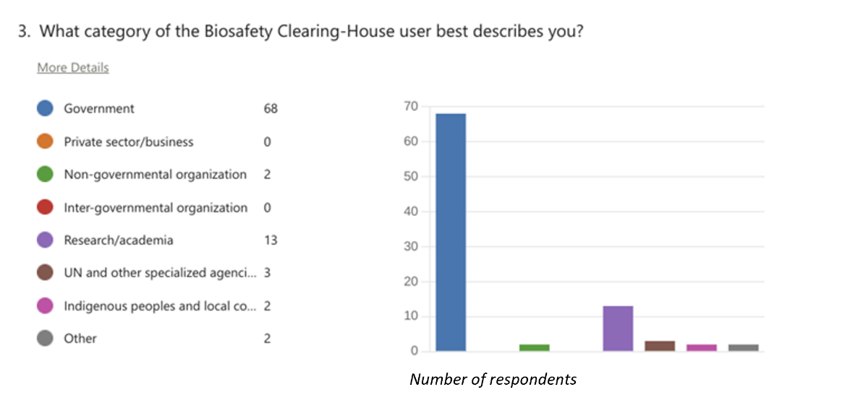

3. The majority of respondents were moderately familiar (37 per cent) or very familiar (26 per cent) with searching information on the BCH. In contrast, 23 per cent categorized themselves as somewhat familiar and 14 per cent as not familiar (see figure II).
Figure II
Familiarity with searching information
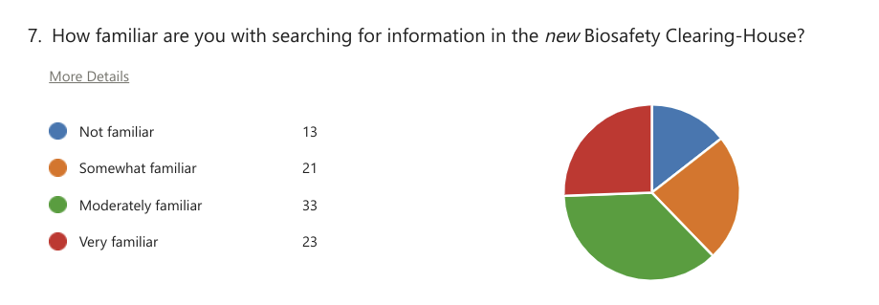

4. The majority of respondents were moderately familiar (44 per cent) or very familiar (16 per cent) with the submission of information, while 12 per cent categorized themselves as somewhat familiar and 28 per cent as not familiar (see figure III).

Figure III
Familiarity with submitting information
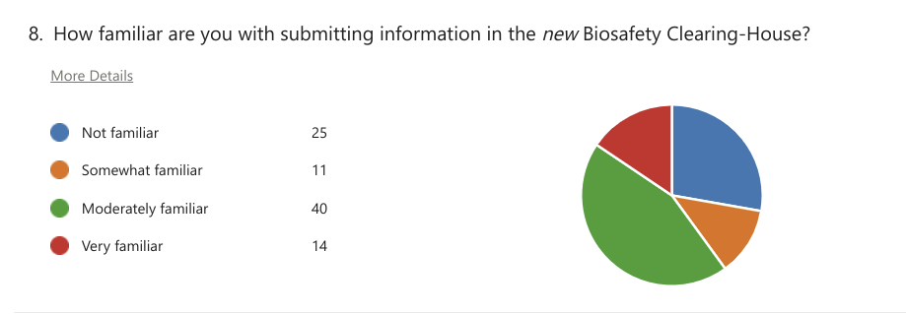

5. Most respondents were moderately familiar (31 per cent) or very familiar (30 per cent) with the country profiles page, while 23 per cent categorized themselves as somewhat familiar and 16 per cent as not familiar (see figure IV).

Figure IV
Familiarity with the country profile pages

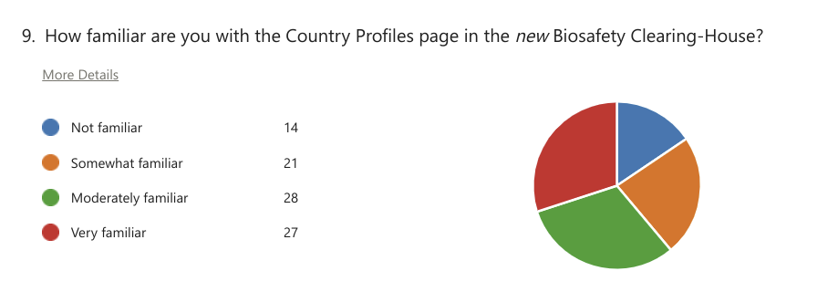

6. Lastly, most respondents were moderately familiar (33 per cent) or very familiar (11 per cent) with the help materials in the new platform, while 31 per cent categorized themselves as somewhat familiar and 24 per cent as not familiar (see figure V).

Figure V
Familiarity with the help materials

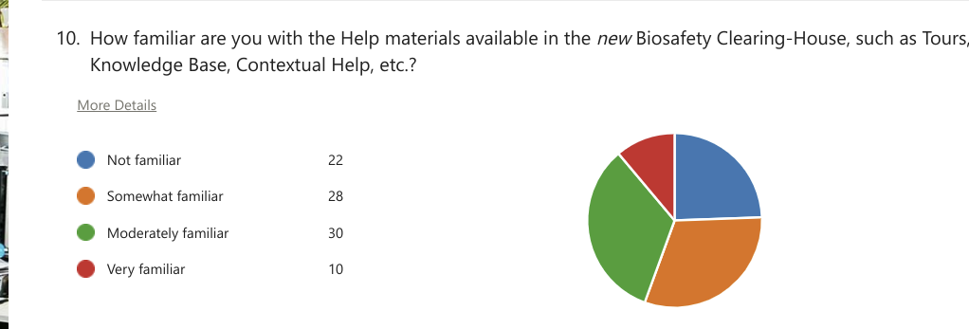

7. Respondents indicated various preferred topics for future training webinars. “Registries” (living modified organism, genetic element, organism) was the most popular choice, with 69 per cent, followed by the submission of information (62 per cent), searching and finding information (59 per cent) and help materials (57 per cent). Fewer respondents communicated interest in training on interoperability (44 per cent) and the country profiles page (39 per cent) (see figure VI).

Figure VI
Topics of interest for future training

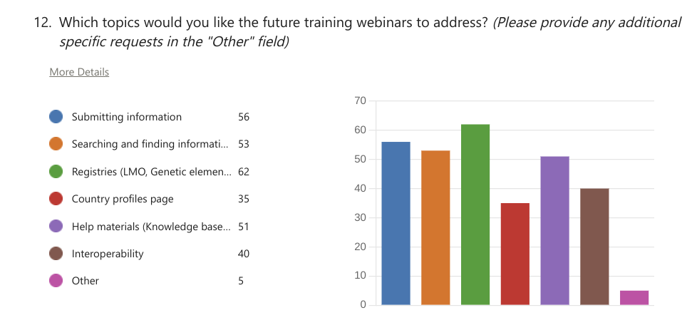

Analysis
8. When asked to describe their major concerns about and difficulties with using the BCH, respondents indicated various issues that mainly fell into the five categories indicated in the table below.

Category of concern | Summary of response
Familiarity and training | Several respondents mentioned that they were still in the process of learning, including through practice, or familiarizing themselves with the BCH. Some expressed the need for more training, while others acknowledged the usefulness of training sessions that they had attended.
Technical difficulties | A number of respondents reported experiencing technical difficulties, for example, when submitting information, registering new users or uploading reference records. Some of those issues had been resolved with the help of the Secretariat or colleagues, while others are still ongoing.
Resources and help materials | Some respondents found the resources and help materials provided by the BCH sufficient, while others expressed the need for additional resources or suggested improvements, such as providing materials in more languages and offering simple and easy-to-understand videos or downloadable materials for remote users.
Searching and accessing information | Several respondents mentioned difficulties with searching information in the BCH. They also suggested improvements, such as providing clearer lists of laboratories and their locations, or improving the text search functionality.
User experience and satisfaction | Several respondents expressed satisfaction with the BCH, describing it as useful, user-friendly and informative. Some had not experienced any difficulties, while others had encountered only minor issues that had been resolved or were expected to be resolved soon.

9. When asked about their needs over the intersessional period in terms of capacity-building, outreach and awareness-raising, respondents emphasized the importance of regional and national training programmes, online training, webinars and capacity-building for stakeholders and focal points.

Conclusion
- 10. The survey has highlighted that most of the BCH users are moderately familiar with the new platform and expressed preference for future webinars to address such functionalities as living modified organism, genetic element and organism registries, submitting information, and searching and finding information. BCH users would also like to learn more about available help materials (Knowledge Base) and interoperability with their national databases, as well as about exploring country profiles. They expressed the need for capacity-building, training and awareness-raising. To address those needs, future webinars should offer comprehensive training on the items mentioned above, as well as tackling common technical issues and fostering opportunities for continuous capacity-building initiatives. By focusing on those aspects, webinars could significantly improve users’ experience and encourage a more effective use of the BCH platform.
__________

* CBD/CP/BCH-IAC/12/1.
A bounce rate is the percentage of users who arrive at a website and immediately navigate away from the page. While the ideal percentage depends on the type of website, generally, rates above 70 per cent are poor, and rates below 50 per cent are optimal.
https://bch.cbd.int/kb.
See http://bch.cbd.int/protocol.
UNEP/COP/13/14/Add.1.
Decision CP-10/3, annex.
Decision CP-10/4, annex.
See decision CP-10/3, annex, appendix, and decision CP-10/4 annex, appendix.
Owing to the coronavirus disease (COVID-19) pandemic, the launch of the new BCH platform on 29 November 2021 had been celebrated online.

