 |  | CBD/SBI/7/INF/22

 | Distr.: General  23 July 2026  English only

Subsidiary Body on Implementation,
Seventh meeting
Nairobi, 4–12 August 2026
Item 3 of the provisional agenda*
Planning, monitoring, reporting and review: global review of collective progress in the implementation of the Kunming-Montreal Global Biodiversity Framework
Analysis of national biodiversity strategies and action plans and national targets established by Parties aligned with the Kunming-Montreal Global Biodiversity Framework**
Note by the Secretariat

I. Introduction
- In its decision 15/6, the Conference of the Parties established mechanisms for planning, monitoring, reporting and review. In its decision 16/32, the Conference of the Parties further refined the mechanisms adopted in decision 15/6, including through finalizing the national reporting template for the seventh and eighth national report and agreeing on the concrete procedures for conducting the global review on collective progress in the implementation of the Framework. The Conference of the Parties also decided that the global review will be primarily based on national reports and a global report on collective progress in the implementation of the Framework. Among other sources, the global report should be based on:
  - The national reports, as the primary source of information. The seventh national reports are to be submitted by 28 February 2026;
  - The global analysis of information in national biodiversity strategies and action plans and national targets. Parties were requested to submit updated or revised national biodiversity strategies and action plans, including submitting national targets, by the sixteenth meeting of the Conference of the Parties or as soon as possible after that.
- The present note provides an analysis of the revised or updated national biodiversity strategies and action plans and the national targets submitted to the Secretariat as at 6 March 2026. Annex I contains a list of all national biodiversity strategies and action plans submitted by Parties as of that as at 6 March 2026. Section A contains information on national biodiversity strategies and action plans and section B contains information on the national targets. The methodology used to undertake the analysis is contained in Annex IV. This analysis is an update to the analysis presented to the twenty-seventh meeting of the Subsidiary Body on Scientific, Technical and Technological Advice as information document CBD/SBSTTA/27/INF/4/Rev.1 and to sixth meeting of the Subsidiary Body on Implementation as information document CBD/SBI/6/INF/5.

Contents Page
I. Introduction 1
Section A. Analysis of national biodiversity strategies and action plans 5
II. Background 5
III. Analysis of contents of the national biodiversity strategies and action plans submitted after the adoption of the Kunming Montreal Global Biodiversity Framework 5
IV. Legal status and revision process of revised/updated national biodiversity strategies and action plans 7
Adoption as “whole-of-government” instrument 7
Adoption as Policy Instrument 8
Assessment of previous national biodiversity strategies and action plans 9
Coordination Mechanism 11
Stakeholder engagement 13
V. Contents of the national biodiversity strategies and action plans 17
Concrete actions, policies and programmes to meet national targets 18
Monitoring Systems 20
Communication Strategies 21
Contributions by actors other than national governments 23
VI. Mainstreaming 24
National development plans and Sustainable development Plans 24
Poverty eradication 26
Subnational plans 27
Multilateral Environmental Agreements and Biodiversity Related Conventions 27
VII. Protocols 29
A. Cartagena Protocol 29
B. Nagoya Protocol and Digital Sequence Information 30
Section B. Analysis of national targets submitted through the online reporting tool 32
VIII. General observations 32
IX. Analysis of national targets 35
Target 1: plan and manage all areas to reduce biodiversity loss 35
Target 2: restore 30 per cent of all degraded ecosystems 38
Target 3: conserve 30 per cent of land, waters and seas 42
Target 4: halt species extinction, protect genetic diversity and manage human-wildlife conflicts 46
Target 5: ensure sustainable, safe and legal harvesting and trade of wild species 49
Target 6: reduce the introduction of invasive alien species by 50 per cent and minimize their impact 53
Target 7: reduce pollution to levels that are not harmful to biodiversity 57
Target 8: minimize the impacts of climate change on biodiversity and build resilience 60
Target 9: manage wild species sustainably to benefit people 63
Target 10: enhance biodiversity and sustainability in agriculture, aquaculture, fisheries and forestry 66
Target 11: restore, maintain and enhance nature’s contributions to people 69
Target 12: enhance green spaces and urban planning for human well-being and biodiversity 72
Target 13: increase the sharing of benefits from genetic resources, digital sequence information and traditional knowledge 75
Target 14: integrate biodiversity in decision-making at every level 79
Target 15: businesses assess, disclose and reduce biodiversity-related risks and negative impacts 82
Target 16: enable sustainable consumption choices to reduce waste and overconsumption 86
Target 17: strengthen biosafety and distribute the benefits of biotechnology 90
Target 18: reduce harmful incentives by at least $500 billion per year and scale up positive incentives for biodiversity 94
Target 19: mobilize $200 billion per year for biodiversity from all sources, including $30 billion through international finance 97
Target 20: strengthen capacity-building, technology transfer and scientific and technical cooperation for biodiversity 101
Target 21: ensure that knowledge to guide action on biodiversity is available and accessible 104
Target 22: ensure participation in decision-making and access to justice and information related to biodiversity for all 108
Target 23: ensure gender equality and a gender-responsive approach for biodiversity action 112
Annex I 117
Status of development of national biodiversity strategies and action plans 117
Annex II 121
List of conventions or multilateral environmental agreements mentioned in the revised and updated national biodiversity strategies and action plans 121
Annex III 127
Parties whose national targets were considered in the analysis of national targets 127
Annex IV 129
Methodology used to undertake the analysis of national biodiversity strategies and action plans and national targets whose national targets were considered in the analysis of national targets 129
A. Methodology for the analysis of national biodiversity strategies and action plans 129
B. Methodology for the analysis of national targets 131
C. Methodology for the analysis of capacity needs 135

Section A. Analysis of national biodiversity strategies and action plans

II. Background
- An analysis of national biodiversity strategies and action plans submitted during the implementation of the Strategic Plan for Biodiversity 2011–2020 was included as part of the fifth edition of the Global Biodiversity Outlook, published in 2020. A further analysis was prepared by the Secretariat for consideration by the Conference of the Parties at its fifteenth meeting in December 2022. These analyses highlighted some of the salient features of the post-2020 national biodiversity strategies and action plans by assessing them against the guidance for their preparation contained in decision IX/8. While the national biodiversity strategies and action plans developed during the decade 2011–2020 included more successes in terms of achieving whole-of-government approaches, as compared with the decade 2001–2010, there remained gaps in several areas, notably: adoption of national biodiversity strategies and action plans as a national policy through legislation; costing the actions of the plan and developing a clear finance plan; stakeholder engagement; building capacity; and mainstreaming in other sectors of government. Moreover, national targets in many national biodiversity strategies and action plans were not aligned with the Aichi Biodiversity Targets of the Strategic Plan for Biodiversity 2011–2020.
- After the adoption of the Kunming-Montreal Global Biodiversity Framework and decision 15/6, Parties initiated the process of revising or updating their NBSAPs and national targets in alignment with the Framework. In 2024, the Secretariat, in collaboration with partners, organized a series of regional NBSAP dialogues to provide an opportunity for country-to-country exchange and learning to support this process. These dialogues were organized in all regions, providing an opportunity for every Party to attend a dialogue. A summary of the experiences and findings from the dialogues was provided in document CBD/SBI/5/2/Add.3 and salient points were highlighted in document CBD/SBI/5/2/Rev.1.
- An analysis of the NBSAPs revised and updated after the adoption of the Kunming-Montreal Global Biodiversity Framework and decision 15/6 was prepared by the Secretariat for consideration of the fifth meeting of the Subsidiary Body on Implementation and COP-16. Updates of that analysis including the more recently submitted NBSAPs were prepared for consideration of the 27th meeting of SBSTTA and the sixth meeting of SBI. This document presents a further update of that analysis.

III. Analysis of contents of the national biodiversity strategies and action plans submitted after the adoption of the Kunming Montreal Global Biodiversity Framework
- As of 6 March 2026, 86 Parties have submitted a revised or updated national biodiversity strategy and action plan pursuant to the request in decision 15/6. Of the 86 NBSAPs, 26 (30%) were from African States, 21 (24%) were from Asia-Pacific States, 6 (7 %) were from Eastern European States, 12 (14 %) were from Latin American and Caribbean States and 21 (24 %) were from Western European and other States (22 developed countries, 55 developing countries, 6 economies in transition, 3 small island developing States). A total of 43 NBSAPs were submitted by the deadline set in decision 15/6.
- The periodicity of the NBSAPs submitted to date varies by Party. 67 of the NBSAPs submitted by 6 March 2026(78%) cover periods up to 2030 and 9 (10%) cover periods beyond 2030. Among the 110 Parties that have yet to submit a revised or updated NBSAP after the adoption of the Framework, 24 (22%) are valid up to 2029, 8 (7% ) are valid up to 2030, 2 NBSAPs cover periods beyond 2030, and 18 NBSAPs do not specify a timeline. The remaining 58 NBSAPs that have yet to be revised and updated in line with the Framework have a coverage end date prior to 2023. Figure 1 reflects these figures as percentages of the total number of Parties/NBSAPs.
- Most (79) of the Parties that have submitted NBSAPs have also submitted national targets. The remaining 7 have not submitted national targets.
- Of the 110 Parties that have yet to submit a revised or updated NBSAP, 65 have already submitted national targets, and 45 have neither a revised NBSAP or national targets. Of these 45, 9 Parties have a pre-COP 15 NBSAP that is still valid up to or later than 2030, or whose validity is unspecified, and 36 have a pre-COP 15 NBSAP that has expired.

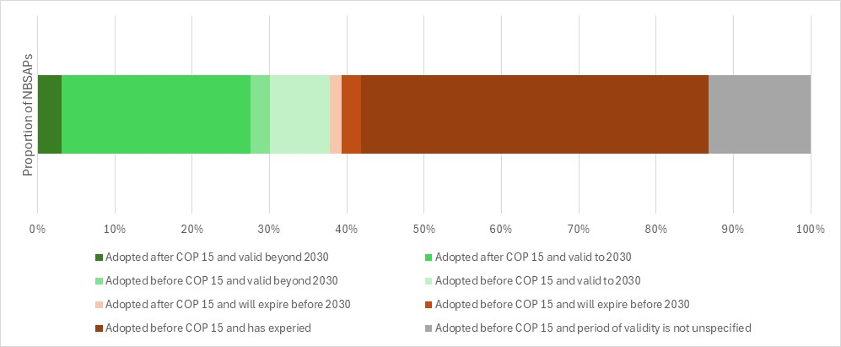Figure 1 - Proportion of national biodiversity strategies and action plans submitted before and after COP-15 and their period of validity. The 196 Parties to the Convention on Biological Diversity are represented in the graph.
- The present analysis considered the extent to which Parties reflected the guidance contained in decisions IX/8 and 15/6 in the development, revision or update of their national biodiversity strategy and action plan. The analysis focuses on four broad areas (a) process and legal status; (b) components of the national biodiversity strategies and action plans; and (c) mainstreaming.

IV. Legal status and revision process of revised/updated national biodiversity strategies and action plans
Adoption as “whole-of-government” instrument
- The Kunming-Montreal Global Biodiversity Framework was adopted by Parties “as a framework for all - the whole-of-government and the whole-of-society”. The intention was that its implementation would entail political will and recognition at the highest levels of government, and engagement by all sectors and levels of government, and by all actors of society.
- The NBSAPs analysed in this document were adopted by a range of different bodies. A total of 34 of the 86 revised/updated NBSAPs have been adopted as “whole-of-government” instruments. For example:
  - The 15 (17%) NBSAPs of Belarus, Canada, Chad, Cuba, Czechia, Equatorial Guinea, Germany, Ireland, Japan, Malaysia, Republic of Korea, Spain, Sweden, Thailand, and the United Arab Emirates are approved by a cabinet or council of ministers;
  - The 9 (10%) NBSAPs of Brunei Darussalam, Brazil, Côte d'Ivoire, Hungary, Liechtenstein, Luxembourg, Peru, Switzerland, and Viet Nam are approved by a head of state or government;
  - The 3 (3%) NBSAPs of the European Union, Malta and Slovenia are approved by a parliament;
  - The 6 (7% ) NBSAPs of Australia, Chile, Egypt, Togo, the United Republic of Tanzania, and Yemen are approved by a national or interministerial committee;
  - The NBSAP of Italy is first approved by the State-Regions Conference representing the Regions and Autonomous Provinces of the country, and then by Ministerial Decree.
- Ten (12 %) other NBSAPs have been adopted by authorities specific to the environmental sector, either by individual ministries or national committees, and the remaining 42 NBSAPs do not provide sufficient information to know the type of approach that was used and whether it was a whole-of-government approach or not.
- Of the 34 (39%) Parties mentioned above as having employed a “whole-of-government” approach, 6 are from Africa, 8 are from the Asia-Pacific region, 4 are from Central or Eastern Europe, 4 are from Latin America or the Caribbean, and 12 are from Western Europe or other Governments. Of the GEF eligible countries, 27% employed a whole-of-government approach versus 59% for non-eligible countries.
- While the current analysis covers only a subset of all the expected revised and updated NBSAPs, compared to the findings in the analysis of post COP-10 NBSAPs (CBD/COP/15/9/Add.1), the proportion of NBSAPs which are adopted by an authority specific to the environmental sector has increased, but the proportion which have been adopted by bodies representing the whole-of-government has remained relatively consistent. While the proportion of non- GEF-eligible Parties which have adopted whole-of-government instruments has stayed relatively constant , the proportion of GEF-eligible Parties that have done so has increased .
- The implications of the adoption of NBSAPs as “whole-of-government’’ instruments vary from country to country and by the levels and sectors of government involved, and it is still too early to assess if, and to what extent, adoption as a “whole-of-government’’ instrument has resulted in the mainstreaming of biodiversity into sectoral and cross-sectoral policy and practice.
Adoption as Policy Instrument
- Decision 15/6 paragraph 9 “encourages Parties to adopt the revised or updated national biodiversity strategies and action plans as policy and/or legal instruments.” Doing so gives the NBSAP a legal and political status, beyond that of a purely technical document, which it is hoped would increase its take-up and implementation by a range of actors. In many countries the development and adoption of NBSAPs have been associated with the establishment of legal frameworks which have facilitated biodiversity action. The actual implications of adoption as a “policy instrument” vary from country to country and by the type of instrument in question. Like with the adoption by whole-of-government, it is not known if, and to what extent, adoption as a policy instrument has indeed represented a stronger legal basis for biodiversity action and by extension into the creation of on-the-ground and tangible change.
- A total of 40 out of 86 (46% ) Parties have adopted their revised/updated NBSAP as a policy instrument. Many of these (38 ) were adopted as national policies. The NBSAP of Brazil and Slovenia have been adopted as a law. The NBSAPs of Egypt, India, Malta, Panama and the Republic of Korea were adopted as reports mandated by law or national policy. The remaining NBSAPs (the majority) do not provide sufficient information to assess if they have been adopted as a policy instrument, or, if they have been, what type of instruments they are (Figure 2)

Figure 2. Proportion of Parties with NBSAPs adopted as a policy instrument, as a law, as a report mandated by law or national policy, or with no information on the type of instrument
Assessment of previous national biodiversity strategies and action plans
- Of the 85 NBSAPs reviewed, 54 (64%) mention that an assessment of the previous NBSAP(s) was done as a part of, or contributing to, the revision and updating process. These assessments have helped Parties to understand the strengths and shortcomings of their previous NBSAPs in order to build and improve on these. Generally, these assessments address the proportion of NBSAP activities that have been implemented, their achievements or lack thereof, and their implementation challenges.
- 27 (32%) NBSAPs mention targets from their previous NBSAP(s) that were achieved or other successes achieved in the implementation of their previous NBSAP(s). Some of the most common areas of achievement include increases in biodiversity awareness, increases in protected areas, and the development of institutions and laws.
- 28 (33%) NBSAPs mention lessons learned, targets that were partially achieved, or targets that were not achieved from their previous NBSAP(s). Some of the most common areas in which targets were not met include the mainstreaming and cross-sectoral integration of biodiversity policies, the reduction in rates of habitat deterioration and destruction, and the establishment of monitoring and evaluation systems.
- 20 (24%) NBSAPs mention implementation challenges from their previous NBSAP(s). Some of the most common areas of difficulty include the mobilization of financial resources, weak institutional coordination and governance and the lack of institutional capacity (Figure 3)
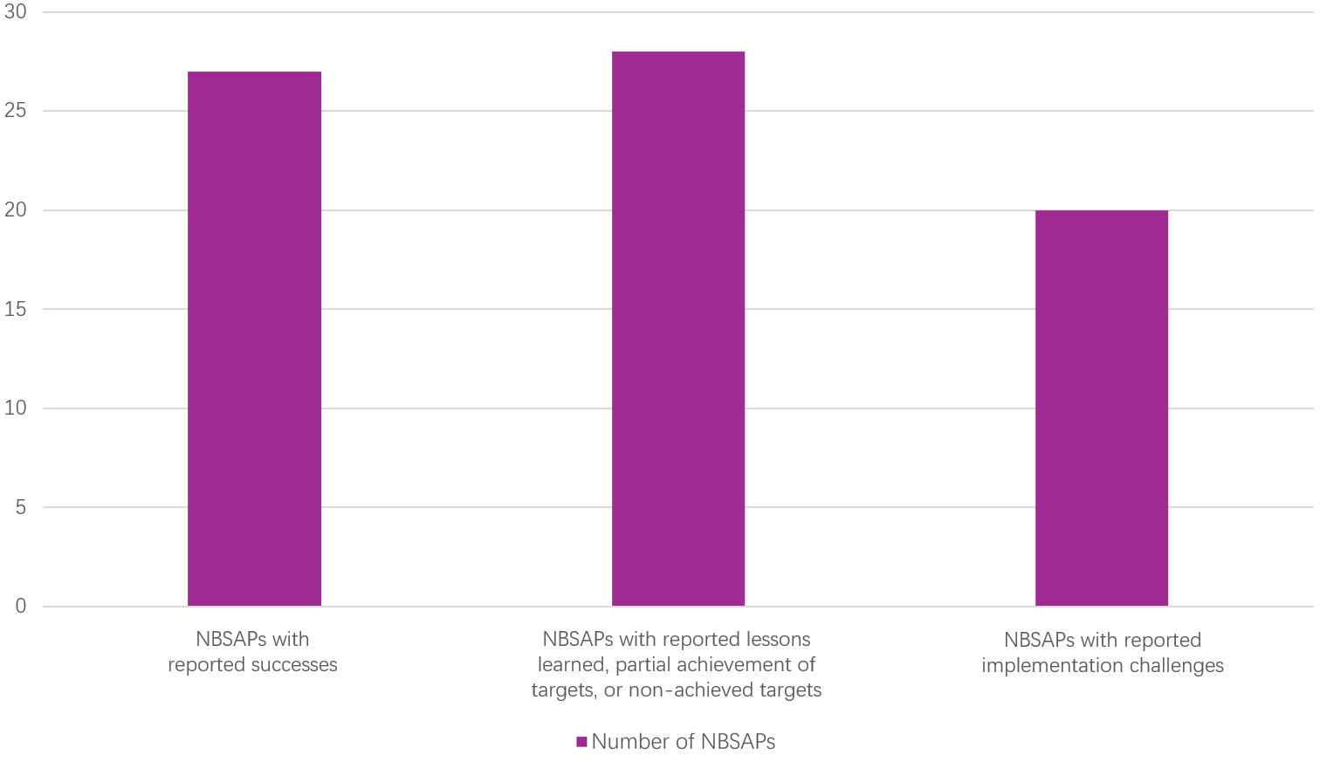

Figure 3. Number of NBSAPs which have reported successes, challenges, lessons learned or targets which were partially or not achieved. Note that some NBSAPs might be represented in several bars as the categories are not exclusive of one another
- Two examples of how assessments were reported in the NBSAPs include:
  - Tonga assessed both the degree of implementation of its targets, and the degree of effectiveness of the measures taken. The implementation of the targets in its previous NBSAP are 2% complete, 72% actively under implementation, 25% planned, and 1% not yet started. The measures taken in implementation were mostly deemed effective (45%) or partially effective (50%). None were deemed ineffective and the effectiveness of only 5% of the measures is not known. Tonga seeks to learn lessons from its successes, including the implementation of local marine protected areas, the increase in appreciation of traditional knowledge in the tourism sector, and increases in participatory processes and community involvement in ago-biodiversity. Implementation challenges included a lack of reliable data and data management capacity, sufficient financing, and the exacerbation of the scale of problems from climate change;
  - Madagascar conducted a systematic assessment of its 2015–2025 NBSAP prior to developing the 2026–2030 strategy. The assessment comprehensively reviewed previous implementation progress, persistent challenges, and required improvements. The assessment confirmed notable progress in biodiversity implementation but highlighted structural, institutional, technical and financial constraints that limited full achievement of expected outcomes. Based on the identified gaps, Madagascar formulated targeted improvement priorities to guide the 2026–2030 NBSAP, including strengthening sustainable financing and national capacities, improving national monitoring and data management systems, enhancing cross-sector governance, boosting public awareness and stakeholder ownership, and refining strategic alignment and operational planning.
  - Lesotho has carried out a performance assessment of its second National Biodiversity Strategy and Action Plan (NBSAP II). They provide a summary table of progress and achievements in the implementation of NBSAP II, where achievements for each of the 21 national targets from 5 priority goals are listed, including the development of policies and strategies and implementation actions. Then they conducted a SWOT analysis for NBSAP II to determine its strategic performance, and listed key implementation challenges and lessons learned, including the delayed validation of NBSAP II, and lack of a monitoring plan and administrative, policies and legislative frameworks. They also provide an overview of the key implementation achievements of NBSAP II, concerning policy frameworks, land governance, protected area network, conservation for endemic and threatened species, environmental impact assessments and law enforcement, and public outreach and community engagement.
- While the current analysis covers only a subset of all the expected revised and updated NBSAPs, compared to the findings in the analysis of post COP 10 NBSAPs (CBD/COP/15/9/Add.1), the proportion of Parties which have indicated that they have conducted an assessment of their previous NBSAP and provided insights on the results of those assessments has slightly decreased (from 67% to 64%) while the proportion of Parties which have reported on specific achievements has slightly increased (from 29% to 32%).
Coordination Mechanism
- The institutional arrangements in place for the development, implementation, monitoring and reporting of the NBSAP are key to the success of biodiversity action. Having implications for governance, accountability, sustainability and cross-sectoral and whole-of-society engagement, they are also a reflection of the long-term commitment of countries to such action. Coordination mechanisms take on different forms in different countries. Building on their assessments of previous NBSAPs, several Parties have recognized the need for stronger institutional arrangements to support more effective implementation.
- Of the 85 NBSAPs reviewed, 46 (54%) record having a formal coordination mechanism, committee, or a working group for NBSAP-related tasks, composed of a variety of stakeholders. An additional 19 (22% ) record plans to create such coordination mechanisms. The mandates of these coordination mechanisms vary. In some countries their mandate is limited to the revision of the NBSAP, while in other countries, coordination mechanisms are also mandated to monitor, evaluate, or report on implementation. In some countries, they are also mandated to oversee the implementation process itself. Some examples of these coordination mechanisms include:
  - Ireland has three different bodies, each with different roles in the NBSAP review and implementation processes. The NPWS NBAP Steering Committee leads the development of the NBSAP, the Biodiversity Working Group assists in the implementation of the NBSAP, and the Biodiversity Forum uses independent experts to increase stakeholder participation throughout the process.
  - India’s National Biodiversity Authority, develops and implements the NBSAP. However, there are also state-level biodiversity boards and Union Territory Biodiversity Councils, which are being strengthened to improve their implementation capacity, as well as biodiversity management committees at the local level which support grassroots mobilization.
(c) Chile's Ministry of the Environment (MMA) is responsible for leading the implementation of the ENB (NBSAP), chairing the National Biodiversity Operational Committee (CONB). At the regional level, the Regional Biodiversity Operational Committees (CORB), chaired by the Regional Ministers of the Environment (SEREMI) are responsible for executing and prioritizing actions at regional level. The CORB will prepare an annual report, which will be analyzed by the CONB which will submit a national implementation progress report, through the MMA to the Council of Ministers for Sustainability and Climate Change (CMSCC). Both the CONB and the CORB may convene civil society organisations, local communities, indigenous peoples, academia and the private sector, to address specific issues of implementation according to the needs and challenges that arise.
(d) Lesotho’s NBSAP identifies an NBSAP National Steering Committee composed of State and non-State actors in the biodiversity sector. Its Monitoring Action Plan further provides for a National Steering Committee on NBSAP Monitoring and Reporting, bringing together line ministries, academic institutions, non-governmental organizations, community-based organizations and the private sector. The committee is assigned oversight, cross-sectoral coordination, decision-making guidance and approval of monitoring and reporting workplans, and is supported by Technical Working Groups aligned with specific targets and indicators.
- While the current analysis covers only a subset of all the expected revised and updated NBSAPs, compared to the findings in the analysis of post COP 10 NBSAPs (CBD/COP/15/9/Add.1), there is a slight decrease in the proportion of Parties who reported having a formal coordination mechanism (from 56% to 54%).
- Of the 39 NBSAPs without a formal coordination mechanism, 18 Parties list responsible domestic organs or authorities responsible for the tasks that a coordination mechanism would otherwise conduct. For example:
  - The United Republic of Tanzania plans to establish focal points and support the National Designated Authority of GEF to facilitate the implementation of their NBSAP.
(b) Brunei Darussalam have plans to establish a Technical Committee and National Steering Committee. The Technical Committee will act as a central hub, receiving regular progress reports from lead agencies. The committee will also conduct thorough analyses and evaluations of these reports - assessing effectiveness of activities and identifying areas for improvement. Based on this, they will provide recommendations for the National Steering Committee. This committee will serve as primary platform for reporting on overall progress of the policy's implementation.
(c) Aruba’s NBSAP provides a detailed plan for establishing a cross-sectoral governance structure for coordination, monitoring and evaluation. The planned structure includes a governmental steering group, working groups with broader societal representation, memoranda of understanding to clarify stakeholder roles, a monitoring and evaluation framework, and public reporting arrangements.
(d) Côte d’Ivoire proposes a structured coordination arrangement composed of a Comité de Pilotage, a Secrétariat Permanent Biodiversité and a Groupe de Travail to support governance, collective decision-making, monitoring and reporting. .

Stakeholder engagement
- Closely linked to the effectiveness of coordination mechanisms is the extent to which diverse stakeholders are meaningfully engaged in NBSAP development and implementation. The Conference of the Parties in its decision 15/6 (para. 23) encourages Parties to enable the full and effective participation and engagement of women, indigenous peoples and local communities, youth, civil society organizations, academia, the private sector, all levels of government and stakeholders from all other relevant sectors, in all levels of development and implementation of the national biodiversity strategies and action plans.
- Of the NBSAPs analysed, 67 (78%) report having been developed with some level of stakeholder engagement.
- 56 (65%) ) Parties report having consulted actors other than national governments
- 52 (61%) Parties report having consulted other ministries.
- 51 (60%) ( Parties report having consulted engaging NGOs/civil society
- 43 (46%) Parties report having consulted subnational governments, cities and other local authorities
- 35 (41%) Parties repot having consulted environmental experts and technical partners from professional environmental institutions
- 41 (48%) Parties report having consulted the private sector
- 42 (49%) (42%) Parties having consulted academia and research institutions
- 36 (42%) Parties having consulted youth
- 37 (43%) Parties having consulted indigenous peoples and local communities.
- 18 (21%) Parties having consulted citizens/the public.32 (37%) Parties report having consulted women’s groups.
- Figure 4 shows these numbers alongside the percentages of NBSAPs reporting the participation of the group on the NBSAP committee, and their expected involvement in the implementation of the NBSAP. Notably, of the 85 NBSAPs reviewed, three-quarters 63 (74%) of Parties included contributions, specific and concrete actions, and activities from a range of actors other than national government towards the achievement of national targets within their NBSAPs. Over half, 62 (74%) of NBSAPs identified ministries other than environment ministry as involved in the implementation of national targets (Figure 5).
- A number of Parties highlighted the important role of their NBSAP, and NBSAP development process, in enabling and supporting coordination between different actors towards common goals. For example:
  - Malta highlights a main objective of their NBSAP is to structure and facilitate collective action for biodiversity conservation and restoration through stakeholder cooperation.
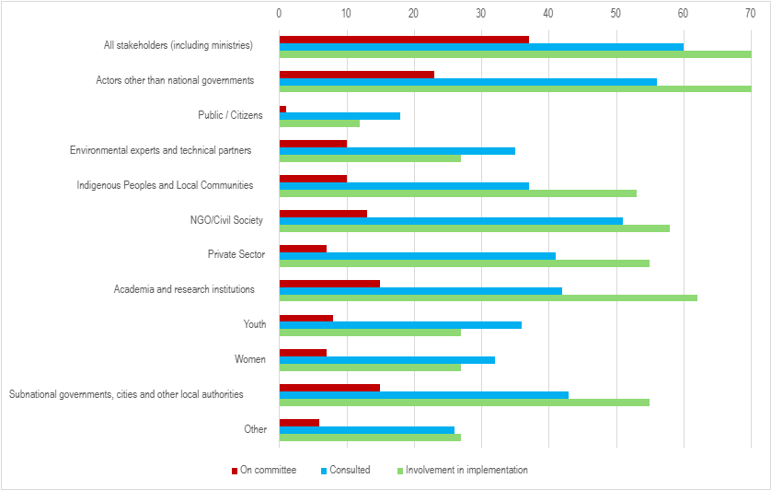

Figure 4. Percentage of Parties reporting the different levels of engagement of different stakeholders and indigenous peoples and local communities in the NBSAP process
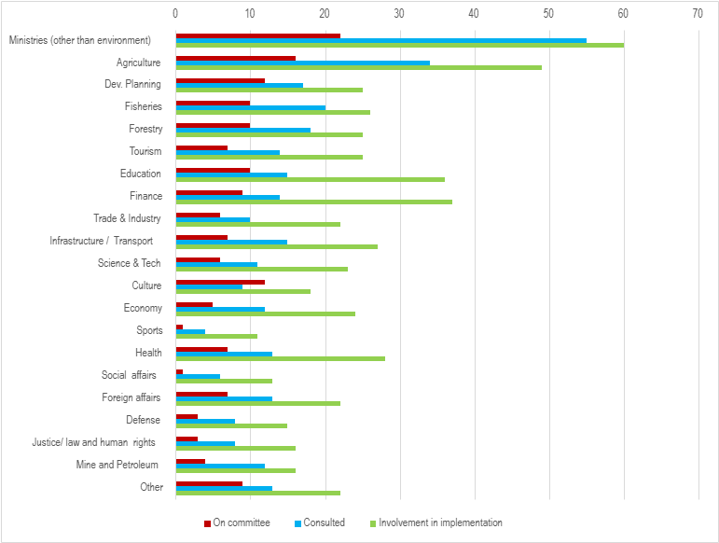

Figure 5. Percentage of Parties reporting the engagement of different ministries in the NBSAP process
43. Many NBSAPs provide detailed information on their stakeholder engagement processes. Some examples include:
  - Ireland’s NBSAP contains a chapter describing its NBSAP process. Stakeholders were engaged in three distinct stages. The first stage focused on the high-level structure and direction of the NBSAP and included stakeholders with a role in biodiversity governance and assessment, the second focused on the actions proposed in the NBSAP and involved stakeholders that would be directly impacted or involved in implementation; the third stage comprised an open public consultation for all interested parties. The first two stages involved several coordinated groups including a NBAP Steering Committee, a Biodiversity Forum (involving an independent group of biodiversity experts), a Biodiversity Working Group (involving an interdepartmental group) and a Business for Biodiversity Platform Steering Group. Ireland also held a National Biodiversity Conference, a Citizens’ Assembly and a Children and Young People’s Assembly on Biodiversity Loss to create recommendations to inform their NBSAP;
  - Austria’s NBSAP explains that its development started with a series of workshops with a range of stakeholders which formed the basis for a public consultation on potential elements of a strategy. The strategy was then discussed and coordinated at National Biodiversity Commission among representatives from all relevant actors, sectors and additional stakeholders;
  - Organizations representing indigenous peoples and local communities and afro-descendants, participated actively in the update and revision of Peru’s NSBAP. As a result, their needs, proposals, knowledges and visions are reflected in the NBSAP, its targets, and in its 2050 vision. Peru’s NBSAP also cites contributions of indigenous peoples and local communities to forest conservation and restoration, climate change mitigation, monitoring and oversight of forest resources and wild fauna, and their contributions as early warning systems in their territories;
  - India National Biodiversity Authority, under Ministry of Environment, Forest and Climate Change, established Working Group comprising independent experts and representatives from various Ministries, State Biodiversity Boards and public institutions. Additionally, a series of National, Regional, Inter and Intra Ministerial Consultations were held, collaborating with 24 Central Ministries, international conservation organizations, subject matter specialists, corporates, industry, state governments, local level institutions, NGOs, youth, and women groups and civil society members from all the 28 states and 8 union territories of India;
  - Thailand undertook detailed stakeholder mapping with “responsible agencies and sectors relevant to each goal”, including several National Consultative Meetings and focus groups with the "target groups of each goal” including “government agencies, private sector representatives, business sector, educational institutions, civil society, independent organizations, ethnic groups, local communities, women and youth groups, and representatives from agencies”.

- While the current analysis covers only a subset of all the expected revised and updated NBSAPs, the number of NBSAPs reporting the involvement of indigenous peoples and local communities, academia and the private sector has increased, while the number of NBSAPs reporting the involvement of NGOs/civil society has decreased slightly compared to the findings in the analysis of Post COP 10 NBSAPs (CBD/COP/15/9/Add.1). (Table 1).
 | Indigenous peoples and local communities | NGOs / Civil Society | Academia and research institutions | Private sector
Current analysis (85 NBSAPs) | 43% | 60% % | 49% | 48% %
Post COP 10 NBSAPs (CBD/COP/15/9/Add.1, 2022) | 26% | 62% | 44% | 33%
Table 1. Percentages of NBSAPs reporting stakeholder engagement NBSAP revision and updating processes

V. Contents of the national biodiversity strategies and action plans
- The Conference of the Parties, in its decision 15/6 paragraph 5, adopted guidance for revising and updating NBSAPs to align with the Framework which is outlined in annex I to the decision. This guidance detailed common elements for inclusion in updated NBSAPs. These elements included (a) national targets addressing or contributing towards each of the goals and targets of the Kunming-Montreal Global Biodiversity Framework and ensuring close alignment where possible, taking into account the availability of resources and means of implementation, (b) concrete actions, policies and programmes designed to meet the national targets and contribute to the global goals and targets, including spatial, temporal and financial aspects, as appropriate and (c) National monitoring, reviewing and assessment.
- National targets were submitted through the online reporting tool. The submission template includes national indicators which would be used to monitor each target, information on the non-State actors engaged in each target, information of the main policy measures to implement, and means of implementation needed for each target as well as information on the consideration of Section C for each Target. These aspects are addressed in section B of this document
- Not all Parties completed the full national target submission template and in some cases the level of detail in the NBSAP was higher than in the national target submission template. This section addresses Parties’ response to the NBSAP guidance in decision 15/6 in their NBSAPs. It addresses the inclusion of concrete actions, policies and programmes to meet their national targets, biodiversity financing, and monitoring systems in the revised and updated NBSAPs. This section also addresses the inclusion of communication strategies or elements thereof and the reflection of non-state actor contributions to the implementation of the GBF in the NBSAPs.
Concrete actions, policies and programmes to meet national targets
- A key component of the revised NBSAPs is the articulation of how national targets will be achieved in practice. This is primarily done through the inclusion of concrete actions, policies, and programmes. Of the 85 NBSAPs analysed, over three quarters (77, 91%) of Parties have totally or partially fulfilled section 6(b) of the NBSAP guidance in Annex I of Decision 15/6. The majority include an action planning matrix within their NBSAP outlining specific concrete actions, and to varying degrees policies and programmes, designed to meet national targets. As part of their action planning matrices, some Parties also included responsible actors, supporting institutions/key partners, measurable outputs and indicators baselines, milestones, and required capacity.
- Parties’ concrete actions, policies and programmes include spatial, temporal and financial aspects to varying degrees. The most common were temporal aspects through the inclusion of timebound actions and targets. This information is further elaborated by Parties in the submission of their national targets. Several Parties included financial aspects into action planning matrices or a chapter on financial means. Financial considerations were also developed as part of national targets mapped to global target 19 (please see section on biodiversity finance). Most actions were not spatially specific; however, spatial aspects were more often included in actions and national targets related to global Targets 1-3 or within introductory sections on areas important to biodiversity.
- Some examples of concrete actions, policies and programmes to meet national targets include:
  - Suriname's NBSAP contains a Strategic Action Framework containing 121 actions (including concrete actions policies and programmes) to meet national targets, each with time frames for implementation, a review of required capacity, identification of lead responsible agencies and key partners, an estimated cost and synergies (including with GBF targets and SDGs). Suriname's NBSAP also presents additional details of estimated costs per target and potential funding sources in a section on ‘financial overview and funding opportunities’, Suriname's 4th Strategic Pathway is focused on increasing ‘mainstreaming’ and ‘enabling conditions’ which includes targets to improve financial resources, capacity-building and national biodiversity integration aiming to harmonise environmental and economic policies;
(b) Japan provides a comprehensive GANTT chart in their NBSAP to outline the sequence and timeline of actions towards their 30X30 targets, providing a clear temporal framework for monitoring and implementation progress;
(c) Brazil’s NBSAP contains a Biodiversity Action Plan structured around its national biodiversity targets. The Action Plan identifies concrete actions, expected outputs, the type of action, responsible parties, supporting institutions and time frames for implementation. It also links the implementation of national targets with broader governance, financing and monitoring arrangements;
(d) Chad’s NBSAP includes an implementation action plan that sets out actions linked to national biodiversity objectives, together with responsible institutions, implementation partners, indicative time frames and cost estimates for the period 2025–2030.
Biodiversity Finance
- To support the implementation of these actions, policies and programmes, securing adequate financial resources is essential. In decision 16/34 paragraph 10, the Conference of the Parties encouraged Parties to “develop, update and implement national biodiversity finance plans or similar instruments, based on an assessment of biodiversity expenditures and finance needs [...]”. In line with this guidance, 71 (84 %) NBSAPs include elements that address biodiversity finance. 66 % of the countries whose NBSAPs included these elements are part of the BIOFIN Initiative and are at either the design or implementation stage. Table 2 shows the sources of finance identified in the 71 NBSAPs.
- Of the 71 NBSAPs mentioned above, 30 NBSAPs include costing estimates for their implementation of which 24 provide cost estimates at the action level and 27 provide overall cost estimates. Of the NBSAPs that include costing at either level, 11 include financial gap analyses, comparing total available resources against estimated finance needs for implementation. One NBSAP includes a gap analysis but does not include costing.

 | Domestic | International | Public | Private
Number of NBSAPs | 68 | 50 | 68 | 41
Table 2. Funding sources identified for financing NBSAP implementation
- Some examples of some of the approaches taken with regards to resource mobilization strategies are:
(a) France’s NBSAP financing plan includes a financing trajectory by stakeholder, covering public, private and EU sources. Projected funding increases are justified through a detailed cost breakdown for targeted priority areas, including protected areas and ecological restoration;
(b) Uganda’s financing plan includes action-level costing by strategy and outlines the total minimum implementation cost, alongside a resource mobilization plan which leverages domestic mechanisms such as payments for ecosystem services.
(c) Vanuatu provides the estimated costs up to 2030 for each action under its each national target at both national and provincial level and conducted a financial gap analysis revealing a large funding gap. Potential funding sources are identified, with responsible departments, short-term timelines and innovative strategies have been designated and developed for some sources.
(d) Ireland’s NBAP includes a chapter dedicated to how the NBSAP will be funded, including the various funding streams secured, to support its achievement.
Monitoring Systems
- Monitoring systems provide a basis for tracking progress in implementation and informing decision-making. Although the specific indicators which will be used to monitoring national targets are included in the national target submission template, the description of how national monitoring systems should work would ideally be described in the NBSAP. Of the 85 NBSAPs analysed, 65 (76%) indicate having a monitoring system in place or explain how the implementation of the NBSAP will be monitored. For example:
  - In France, each entity in charge of implementing the actions in the NBSAP will report on the relevant process and impact indicators for their action. The French Biodiversity Office will compile reports on each action and report to the General Secretary of Ecological Planning;
  - The Malaysia Biodiversity Centre (MBC) and a set of thematic working groups comprised of representatives of different state and non-State actors will monitor the implementation of Malaysia’s NBSAP. An online monitoring system will be used to monitor the targets and indicators of the Policy and the progress of the NPBD 2022-2030. A National Biodiversity Conference will be organized annually to bring together all stakeholder groups to discuss implementation progress.
(c) Gabon's Biodiversity Team in the Ministry of Environment are in charge of monitoring of the implementation of the NBSAP. Each ministry department will designate a SPANB (NBSAP) Focal Point to supervise implementation of NBSAP, mobilize resources, raise awareness, collect relevant data for monitoring the NBSAP and report on progress of sectoral activities. Their monitoring and evaluation system includes process indicators, result indicators requiring period surveys, impact indicators measured at mid-term and end of implementation, the creation of National Dashboard, production of quarterly or semi-annual Progress Reports, organization of Joint Annual Reviews, Mid-Term evaluation and Final Evaluation, deployment of a Biodiversity Information System based on the Ministry of Environment's database which will be linked to the national database. All collected information will feed into the Biodiversity CHM.
(d) Czechia’s Ministry of Environment will monitor the NBSAP and produce regular reports in the progress of biodiversity conservation. An inter-ministerial, inter-departmental coordination group will be set up and continuously monitor the data from the NBSAP. The overall evaluation of the achievement of the individual Action Plan objectives will be presented in the context of the Report on the State of Nature and Landscape in the Czech Republic, prepared in 2028.
- A number of NBSAPs explain how existing monitoring functions or systems will be enhanced. For example:
  - The Republic of Korea aims to amend its Biodiversity Act to strengthen the function of the National Biodiversity Centre to include collecting, verifying and disclosing biodiversity statistics, overseeing the overall implementation of the NBSAP, preparing national reports and building a system for information integration and implementation monitoring. The country aims to disclose information on its progress of implementation of the NBSAP through its CHM (www.kbr.go.kr), and to hold regular forums to review the implementation of each strategic goal;
  - Slovenia positions monitoring as a means to facilitate implementation. It foresees to establish a comprehensive information system in such a way as to create a national hub of data and information crucial for the implementation and monitoring of the situation and planning of the nature protection policy, which will be publicly available and maintained.
  - Panama will have an integrated Monitoring, Reporting, and Verification (MRV) system for all environmental goals within the National Climate Transparency Platform (PNTC), which will gather progress on climate, biodiversity, and land agendas in one place, using common indicators, generating periodic reports, and facilitating independent verification of results. Monitoring will be closely linked to the main national and international planning instruments, the Nationally Determined Contributions (NDCs), the National Adaptation Plan (NAP), the National Biodiversity Strategy, and the Land Degradation Neutrality Strategy, ensuring coherence between commitments and their evaluation mechanisms.
Communication Strategies
- In addition to establishing monitoring systems to track implementation, several COP decisions have emphasized the importance of integrating communication, education, and public awareness (CEPA) into NBSAPs. Specifically, decisions VIII/6 and IX/8 state that communication, education and public awareness (CEPA) strategies and activities should be integral parts of NBSAPs. This is important as CEPA can help increase public understanding of national biodiversity goals, promote behaviour change, and encourage participation from key sectors in implementing NBSAP actions. Public awareness and commitment, can in turn, increase political will to take biodiversity action.
- Nearly all of the 85 NBSAP’s reviewed contained reference to CEPA -related activities. The analysis grouped Parties into three mutually exclusive categories: (a) no substantive CEPA evidence, (b) explicit CEPA or communication strategy, action plan or equivalent, and (c) CEPA initiatives or actions, but no explicit strategy.
- Of the 85 NBSAPs reviewed, 84 NBSAPs contained substantive CEPA evidence. 13 of these (15%) NBSAPscontained an explicit CEPA or communication strategy, action plan or equivalent. For example:
(a) Indonesia has developed a CEPA framework and an IBSAP communication strategy to increase community support, active participation and public understanding of biodiversity, conservation and sustainable use. The strategy is intended to guide national stakeholders and implementing actors in communicating biodiversity-related issues and developing awareness materials. The framework is structured around communication, education, public engagement and awareness, and is linked to strategic biodiversity themes and target-level implementation.
(b) The State of Palestine includes a dedicated Communication and Outreach Strategy within its NBSAP implementation framework. The strategy identifies target groups, sets communication principles, and outlines specific outreach tools, including brochures, videos, webpages, press releases, social media, public lectures and direct communication channels, as well as indicators to track communication outputs and engagement.
(c) Tunisia refers to a National Action Plan on Communication and Awareness for Biodiversity, developed in 2015, which identified interventions, objectives and activities over a ten-year period. The updated action plan builds on this framework through measures on communication, awareness and education, including institutional coordination, targeted awareness campaigns, outreach tools, biodiversity-related media systems, specialized training pathways and the integration of traditional knowledge into biodiversity communication.
- A further 71 (84%) NBSAPs contained substantive CEPA-related initiatives or actions, but did not include an explicit CEPA or communication strategy, action plan or equivalent. In many cases, these initiatives were identified as actions contributing to the achievement of national targets. They were not limited to global Target 21, but were also associated with other global targets, including Targets 6, 7 and 16, for which Parties identified public awareness, education, stakeholder engagement, participation and behavioural change as important enabling conditions for effective implementation. Examples include:
(a) Brazil recognizes communication as an important instrument for NBSAP implementation and includes the development and implementation of an NBSAP communication strategy among its expected outputs. It also sets out CEPA-related measures on sustainable consumption, biodiversity information and public engagement, demonstrating the integration of communication and awareness-raising into target-level implementation.
(b) The Bolivarian Republic of Venezuela includes a transversal axis on education, capacity-building and participation in biodiversity management, covering ecological literacy, biodiversity education, learning platforms, the use of protected areas as educational spaces and improved access to biodiversity information through the Venezuelan System of Information on Biological Diversity. This provides a structured set of CEPA-related measures across the NBSAP, while remaining framed as part of broader implementation actions rather than as a separate CEPA or communication strategy.

(c) Aruba (Kingdom of the Netherlands) links biodiversity communication and education to its broader Rights of Nature approach. Its NBSAP emphasizes that nature-conscious action begins with awareness of the Rights of Nature and includes a subgoal on “Nature Education for a new Aruban Narrative”, supported by a communication campaign across government and society. The campaign is intended to reach government actors, students, businesses, tourists and local communities, using storytelling, social media, digital information materials and environmental training for public officials.
- While comparison with previous analyses should be made with caution, owing to the use of revised and mutually exclusive categories in the present analysis, the findings suggest a broader and more systematic integration of CEPA-related initiatives and actions across revised and updated NBSAPs than was observed in earlier generations of NBSAPs as summarized in (CBD/COP/15/9/Add.).

Contributions by actors other than national governments
- In line with the whole-of-society approach called for in the Kunming-Montreal Global Biodiversity Framework, the Conference of the Parties, in Decision 15/6, (para. 26), invited actors other than national governments to develop, on a voluntary basis, commitments contributing to NBSAPs. These actors included indigenous peoples and local communities, subnational governments, cities and other local authorities, non-governmental organizations, women, youth, research organizations, the business and finance community and representatives of sectors related to or dependent on biodiversity.
- The national target submission template includes an option for parties to integrate contributions by actors other than national governments alongside their national targets. While many Parties availed of that space, many Parties also provide details of contributions and commitments by these actors in their NBSAPs.
- Within the 85 NBSAPs reviewed, most contributions of actors other than national governments were either by those identified as partners working alongside leading government bodies, supporting actions or outlined within the text of actions and targets (as indicated in the stakeholder section above). Few actions, as yet, have been identified as being led by actors other than national governments with the exception of subnational authorities and indigenous peoples and local communities through local government-led, community-led or indigenous-led actions. Some examples include:
  - Canada emphasized the value of indigenous-led conservation actions and initiatives within their NBSAP, including indigenous led area-based conservation efforts with significant results, such as the establishment of over 100,000 km² of indigenous-led protected areas and other effective conservation measures. As well as important projects such as the Indigenous Guardians programmes and the Project Finance for Permanence that is providing $800M to support indigenous-led conservation initiatives;
  - Suriname’s Indigenous and Tribal Peoples Authority representatives are lead responsible agents and key partners for a significant number of actions in their NBSAP, including assessments and management of biodiversity within tribal territories, enforcement of wildlife laws and development of laws and regulations to protect traditional knowledge and support rights;
(c) In the Marshall Islands Local Resource Committees (LRCs) lead the implementation of the Reimaanlok conservation process by preparing and implementing atoll and island management plans, coordinating ecological restoration and invasive species management, and promoting sustainable livelihood initiatives.

VI. Mainstreaming
- Decision 15/6, paragraph 9, encourages Parties to mainstream their NBSAPs (or elements thereof) with broader strategies and plans, such as national sustainable development plans, national development plans, poverty reduction strategies and other relevant national sectoral and cross-sectoral plans, in line with national circumstances and priorities. The decision also recognizes that other biodiversity-related multilateral environmental agreements will contribute to the implementation of relevant or corresponding elements of the Kunming-Montreal Global Biodiversity Framework consistent with their mandates and priorities and therefore also encourages Parties to include relevant actions to implement commitments and recommendations under each of the biodiversity-related multilateral environmental agreements to which they are a party in their NBSAPs
National development plans and Sustainable development Plans
- One of the key motions for integrating biodiversity into the mainstream of countries’ socioeconomic activities is including or linking their biodiversity action in(to) their national development plans and/or their sustainable development plans. While in many cases these two plans are one and the same, in other cases the national development plan details economic development efforts while the sustainable development plan outlines how the country intends to meet the sustainable development goals more broadly.
- Of the 85 NBSAPs reviewed, 17 (20%) Parties’ NBSAPs state that biodiversity has been integrated into their national development plan or equivalent instrument (Figure 6). For example:
  - Jordan’s NBSAP was fully integrated within their Economic Modernization Vision (EMV), which served as the primary national policy document to influence key factors affecting biodiversity gains or losses;
  - The Indonesian Biodiversity Strategy and Action Plan (IBSAP) was harmonized with both their National Long-Term Development Plan (RPJPN) and their Draft National Medium-Term Development Plan.
(c) Rwanda’s NBSAP integrates biodiversity into national development frameworks, including Vision 2050 and the National Strategy for Transformation (NST2). It mandates biodiversity mainstreaming into sectoral strategies and local government plans, supported by budget tagging, ecosystem service valuation, and tourism revenue-sharing mechanisms that allocate 10% of national park revenues to local communities.
(d) Bhutan’s NBSAP aligns biodiversity conservation with Economic Development Policy 2016 and the Bhutan Water Policy, framing environmental protection as a driver of green economic growth under Gross National Happiness. It links biodiversity to sectoral institutions such as energy security and spatial planning and includes incentive reforms under the 13th Five-Year Plan to safeguard biodiversity while supporting inclusive development.
- The NBSAPs of 34 (40%) other Parties contain elements and/or targets and actions which aim at mainstreaming with the national development plan or equivalent instrument. For example:
(a) The 4 goals and 22 targets of Saudi Arabia’s NBSAP are aligned with and complement the framework outlined in their Vision 2030 strategy, which has 3 main pillars: (1) A vibrant society, (2) A thriving economy, and (3) An ambitious nation.
(b) Namibia’s National Development Plan 6 aligns with the implementation approach of target 14, which includes considerations for mainstreaming biodiversity with national development priorities and planning cycles.
- Of the 85 NBSAPs reviewed, 24 (28 %) Parties mention an integration of their NBSAP with their sustainable development plans or equivalent instruments (Figure 6). For example:
(a) The Democratic Republic of Congo’s NBSAP is aligned with the SDGs and is apart of their wider National Strategic Development Plan (2024-2028). Each national target aligns with the SDGs especially SDG 2, 12, 13, 14 and 15.(b) Cameroon's NBSAP serves as a strategic and operational tool for implementing their commitments under SDGs. Their National Sustainable Development Strategy (2016) recognizes biodiversity and ecosystems as pillars of sustainable development and ensures the alignment of national biodiversity conservation goals with their national economic and social priorities.
(b) Vanuatu’s NBSAP serves as the primary implementation instrument for the Environment Pillar of the National Sustainable Development Plan 2016-2030. It directly contributes to achieving several national goals and policy objectives, including those related to social, environmental, and the economy.
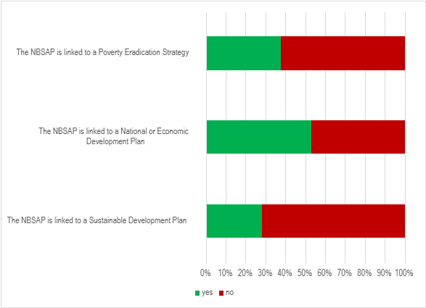

Figure 6. Proportion of NBSAPs which have been linked to poverty eradication strategies, national or economic development plans or sustainable development plans
Poverty eradication
- Building on the integration of biodiversity into national development plans, Parties are also encouraged to identify opportunities to link biodiversity conservation with poverty eradication. 32 (38%) Parties’ post-Nagoya NBSAPs mention links to poverty eradication and/or integrate this objective into their principles, targets and/or actions. For example:
(a) Brazil’s NBSAP integrates biodiversity into poverty and hunger eradication strategies (Target 14), linking biodiversity action to food security, including reducing food waste to support poverty reduction while delivering environmental benefits.
(b) Chad commits to integrating biodiversity values into national and local development and poverty-reduction strategies as a formal objective (ON2). It prioritizes restoring and safeguarding ecosystems that support livelihoods and vulnerable populations (ON14) and mandates biodiversity integration into poverty-reduction planning, accounting, and impact assessments across sectors (Target CM14), supported by dedicated monitoring indicators.
(c) El Salvador presents a more operational approach, linking effective biodiversity conservation with poverty eradication, livelihoods, health and well-being, decent employment and local economic growth. It promotes biodiversity-based economic alternatives, cooperatives, sustainable businesses and local management capacities, with specific attention to women, youth, local communities and Indigenous Peoples;
(d) Lesotho connects biodiversity conservation to poverty-related outcomes through sustainable livelihoods and community-based implementation. Poverty, unemployment and rural dependence on natural resources are identified as pressures contributing to biodiversity degradation, while the action plan includes a concrete measure to develop and implement community-based projects on biodiversity conservation and sustainable livelihoods, with defined outputs, responsible institutions, timeframe and budget;
Subnational plans
- Complementing national-level efforts, many Parties also emphasize the importance of subnational plans to address biodiversity conservation within local contexts and governance structures. Of the 85 NBSAPs reviewed, 63 (74%) NBSAPs address subnational or municipal issues, including but not limited to urban greening initiatives, Subnational Biodiversity Strategy and Action Plans (SBSAPs), and Local Biodiversity Strategy and Action Plans (LBSAPs). Of these, 22 NBSAPs mention that they either already have SBSAPs, LBSAPs, or comparable plans, have started developing them, or they exclusively detail current or previous initiatives undertaken at the subnational level.
- 55 of the 63 revised and updated NBSAPs addressing subnational or municipal issues contain actions, goals, or targets regarding subnational/municipal issues or policies, and 11 NBSAPs mention their intent to prepare SBSAPs, LBSAPs, or another comparable plan. For example, Germany states that 15 of their 16 states have developed an SBSAP and the 16th SBSAP is currently in development. Germany also has targets aimed at urban areas dealing with landscape quality, green spaces, and climate adaptation.
- While the current analysis covers only a subset of all the expected revised and updated NBSAPs, compared to the findings in the analysis of post COP 10 NBSAPs (CBD/COP/15/9/Add.1), both the proportion of Parties which have mentioned that they already have an SBSAP, LBSAP, or another comparable plan and the proportion of Parties with actions, goals, or targets regarding subnational or municipal issues have both increased.
Multilateral Environmental Agreements and Biodiversity Related Conventions
- As the Kunming-Montreal Global Biodiversity Framework contains many relevant and corresponding elements consistent with the mandates and priorities of the other multilateral environmental agreements and biodiversity related conventions, in many instances, Parties articulate their commitments and plans to implement these agreements and conventions through their NBSAPs. In an effort to spell out synergistic implementation they also frequently mention the other Rio Conventions.
- Of the 85 NBSAPs reviewed, 80 (94%) NBSAPs mentioned at least one Multilateral Environmental Agreement (MEA) or environmental convention (excluding the CBD, the Cartagena Protocol, the Nagoya-Kuala Lumpur Supplementary Protocol, and the Nagoya Protocol). Of these:
- 71 (84%) NBSAPs mentioned at least one biodiversity-related convention, 19 (22%) NBSAPs mentioned at least one chemicals-related convention, 57 (67%) NBSAPs mentioned either UNFCCC or UNCCD, 30(35%) NBSAPs mentioned marine-related conventions, and 28 (33%) NBSAPs mentioned at least one human rights-related convention;
- 69 (81%) NBSAPs integrated at least one MEA into at least one domestic goal, target, or action, including the creation of synergies between the NBSAP and the MEA. Among the most commonly integrated MEAs were the Ramsar Convention, CITES, UNFCCC, CMS, and WHC. Some notable examples, characteristic of these measures, include:
(a) Viet Nam, as a part of their objective on the expansion and enhancement of the effectiveness of the management for the system of natural heritage sites and protected areas, includes a quantitative target for the increase in the number of Ramsar and other heritage sites, as well as qualitative goals with regard to the review of criteria and classification of said sites;
(b) Spain seeks to bolster its implementation of the CITES convention through the Spanish Action Plan against Illegal Trafficking and Poaching of International Wildlife Species (TIFIES Plan), which includes the establishment of a CITES Species Rescue Center Network before 2025 and the increase of regulations to enforce a zero-tolerance policy for the illegal trade of wildlife species and timber, among other measures. Spain also details its plans to fulfil its commitments to the Amsterdam Declaration and the Ramsar Convention, as well as a desire to strengthen its role within OSPAR, the Barcelona Convention, ACCOBAMS, the International Whaling Commission, and ACAP, including a plan to ratify the BBNJ Agreement.
(c) Brazil provides a strong example of MEA integration by linking UNFCCC, the Paris Agreement, UNCCD, Ramsar, CITES, CMS, ITPGRFA and pollution-related conventions to target and action-plan implementation.
(d) Sudan operationalizes CITES through actions to develop a national e-CITES permitting and enforcement system and links the Minamata Convention to measures on mercury reduction in artisanal gold mining.
(e) Nigeria maps AEWA, CMS and CITES to specific national targets through stakeholder workshop outputs.
(f) Rwanda links CMS, Ramsar and Nagoya Protocol responsibilities to REMA’s institutional focal-point mandate.
- 71 (84%) NBSAPs acknowledged the legal importance of their ratification of, or their intention of ratification of at least one MEA, including explanations of measures having already been taken towards domestic implementation or international entry into force. In addition to the MEAs mentioned above, some of the most commonly acknowledged MEAs included the BBNJ Agreement, the Bern Convention, UNCCD, the IPPC, and the ITPGRFA (Please see annex II).

VII. Protocols
- National Biodiversity Strategies and Action Plans are the national implementation vehicle for the Protocols and the Supplementary Protocol as they are for the rest of the Convention and the Kunming-Montreal-Global Biodiversity Framework. The KM-GBF integrates biosafety and access and benefit-sharing and thus, NBSAPs aligned with the new framework should also integrate these considerations. The COP 15 guidance on NBSAP calls on Parties to integrate and mainstream biosafety and access and benefit-sharing in NBSAPs pursuant to relevant decisions of the Conference of the Parties to the Convention and of the Conference of the Parties serving as the meetings of the Parties to the Cartagena Protocol on Biosafety and the Nagoya Protocol on Access and Benefit-sharing, as appropriate. Parties have integrated the protocols and supplementary protocols into their national biodiversity planning in different ways. This section looks at how the protocols and the supplementary protocol, as well as digital sequence information are reflected in the revised and updated NBSAPS.
A. Cartagena Protocol
- Following the guidance in decision 15/6 and other calls to mainstream the protocols into NBSAPs, a significant number of Parties address their commitments under the Cartagena Protocol on Biosafety, related supplementary agreements, or biosafety issues more broadly within their NBSAPs. Of the 85 6NBSAPs reviewed, 62 (73%) NBSAPs were submitted by Parties to the Cartagena Protocol on Biosafety, 11 of which are also Parties to the Nagoya – Kuala Lumpur Supplementary Protocol on Liability and Redress.
- 64 (75%) of the NBSAPs reviewed mention the Cartagena Protocol, the Supplementary Protocol, or matters related to their implementation. Of these:
  - 2 Parties report having exclusively conducted assessments of the degree of domestic implementation of international biosafety obligations or of current domestic biosafety benefits and challenges;
  - 10 Parties mention the Protocol but do not provide further information on biosafety.
- Some examples of how the Cartagena Protocol was included in the NBSAPs include:
  - Slovenia’s NBSAP emphasizes the need for an interdisciplinary and interdepartmental approach to biosafety and modern biotechnology products stating that sectors and ministries important for research and development, human health, agriculture and food production and industry should be intensively involved in ensuring biosafety. The country’s biosafety measures include periodic monitoring of developments in biotechnology, continuous updating of the existing biosafety system, and monitoring to ensure safe use of biotechnology and its products;
  - Burkina Faso emphasizes the need to strengthen capacities for risk evaluation and management, and to raise awareness on the advantages and risks related to the use of biotechnology techniques;
  - Malaysia seeks to incorporate biosafety principles into sectoral policies, particularly the agriculture and health sectors, to increase the number and capacity of laboratories that can detect and identify LMOs and their products, to strengthen the network of laboratories that can do this work, and to develop emergency response plans and establish trained emergency response teams to implement response measures.

B. Nagoya Protocol and Digital Sequence Information
- Many Parties also address obligations under the Nagoya Protocol on Access and Benefit-Sharing within their NBSAPs. Of the 85 NBSAPs reviewed, 67 (79%) NBSAPs were submitted by Parties to the Nagoya Protocol on Access to Genetic Resources and the Fair and Equitable Sharing of Benefits Arising from their Utilization.
- 75 (88%) of the NBSAPs reviewed mention the Nagoya Protocol. Of these:
- 14 Parties report having conducted assessments on the degree of domestic implementation of the Nagoya Protocol obligations;
- 63 Parties forwarded national goals, targets, or actions relating to the access and sharing of benefits arising from the use of genetic resources, as expressed in the Nagoya Protocol;
- 6 Parties mention the Protocol and 6 Parties state their intention to ratify it but do not provide further information on domestic measures.
- Some examples of how the Nagoya Protocol was included in the NBSAPs include:
  - Colombia intends to join the Nagoya Protocol and implement its obligations through five distribution mechanisms administered by the Ministry of Environment and Sustainable Development. Each of the domestic regions must adopt specific strategies based on sustainability, knowledge, and technological innovation, according to their territorial contexts and communities which protect and preserve the knowledge to create frameworks that stimulate research and the development of biotechnological products;
  - In Uganda, access and benefit-sharing (ABS) is recognised as a key instrument to ensure that local communities, women and men benefit from the commercialization and use of their natural resources. For that reason, the national ABS legislation is scheduled for revision through an inclusive and participatory process involving all stakeholders. Among other measures, Uganda plans to reinforce institutional structures, increase funding and mechanisms for research and development; and increase awareness so that the potential of ABS can be harnessed;
  - Austria plans to implement an access and benefit-sharing information initiative aimed at enhancing awareness and understanding among of potential users. This initiative will also take into account the issue of Digital Sequence Information.
  - (d) Egypt’s national Goal 12 focuses on the Nagoya Protocol. They have listed challenges related to genetic resources and benefit sharing, including illegal access to genetic resources, lack of legal awareness and knowledge, overexploitation of genetic resources and weak legislation. The Egyptian government is working on developing a legal and regulatory framework to ensure the protection of genetic resources and fair benefit-sharing.
- 46 (54%) of the NBSAPs analysed mention digital sequencing information (DSI), the Cali Fund, or the Multilateral mechanism for the fair and equitable sharing of benefits from the use of DSI. 11 (13%) Parties mention the Cali Fund or the multilateral mechanism. These mentions included national involvement in their establishment at COP15, monetary and non-monetary contributions, and their use as a source of funding for the implementation of NBSAPs. 45 (53%) Parties mention DSI in country-specific NBSAP content, including access and benefit-sharing from DSI, capacity-building, legal and policy measures, data tracking, research, status assessments or implementation challenges. Of these, 42 (49%) Parties link DSI specifically to access and benefit-sharing or benefit-sharing frameworks. These mentions include awareness initiatives, mechanisms to involve businesses, and support for academia and research to increase capacity. For example:
(a) The Islamic Republic of Iran presents an example of an NBSAP where the access and benefit-sharing of DSI is mainstreamed, including a status assessment of existing DSI activities, a national goal on fair and equitable sharing of benefits from the use of DSI, and the integration of DSI into several targets across various sectors from science and capacity-building to data availability.
(b) Saudi Arabia’s NBSAP, refers to mechanisms to record and track DSI for national genetic resources and integrate it into the national ABS framework;
(c) Vanuatu, links DSI to fair and equitable benefit-sharing and includes an action to identify digitized genetic data derived from Vanuatu;
(d) Namibia, links DSI with community rights over associated traditional knowledge;

Section B. Analysis of national targets submitted through
the online reporting tool

VIII. General observations
- As of 7 March 2026, 162 Parties (annex III) have submitted 3693 national targets through the online reporting tool. 83 per cent of Parties, had submitted at least one national target, divided as follows: 50 African States, 46 Asia-Pacific States, 16 Eastern European States, 24 Latin American and Caribbean States and 26 Western European and other States. On average each Party has set 23 national targets but the number ranges from 1 to 104. 118 Parties have set national targets for each of the targets of the Framework. The majority of Parties have submitted detailed targets; however, a few Parties have submitted national targets which are draft or have limited detail. Also, a few Parties have set national targets which are identical to the targets of the Kunming-Montreal Biodiversity Framework (see figure 7).
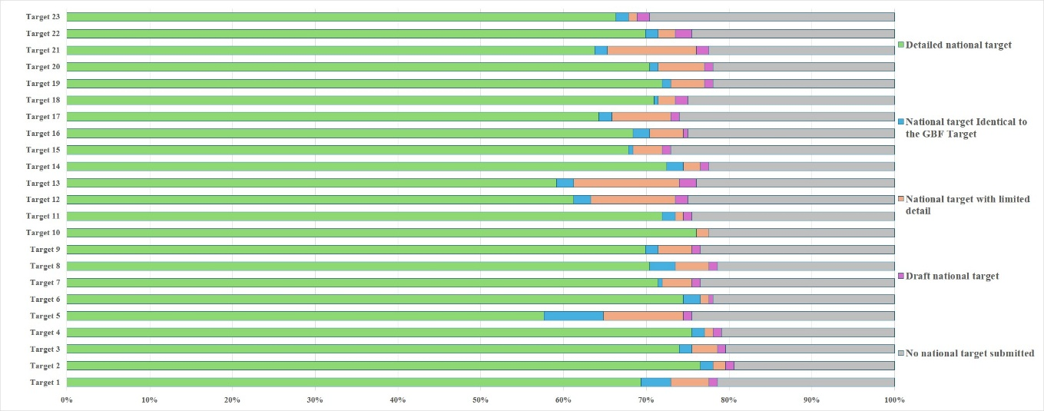
Figure 7 – National target submissions as of 7 March 2026. The coloured bars indicate the proportion of Parties with national targets in each category. The 196 Parties to the Convention on Biological Diversity are represented in the graph.
- Based on the national target submissions the following observations can be drawn:
  - Links between national targets and the goals of the Kunming-Montreal Global Biodiversity Framework – In their national target submissions Parties are requested to identify which goal or goals of the Kunming-Montreal Global Biodiversity Framework their national targets contribute to. Around half of the national targets have been identified as contributing to Goals A and B. In particular national targets related to Targets 1 to 12 of the Kunming-Montreal Global Biodiversity Framework were most commonly associated with Goals A and B. By comparison fewer national targets have been linked to Goals C and D. National targets related to targets 13 and 17 of the Framework were commonly linked to Goal C and national targets related to Targets 15, 18, 19 and 23 were commonly linked to Goal D;
  - Links between national targets and the targets of the Kunming-Montreal Global Biodiversity Framework – In their national target submissions Parties must link their national targets to at least one target of the Framework. However, most Parties have linked individual national targets to multiple targets of the Framework. National targets linked to Targets 1 to 12 of the Framework were often associated with several Framework targets in that range. For example, national targets related to Framework Targets 1, 2 or 3 were often linked to others within that group. National targets related to target 3 of the Framework were also commonly linked to Targets 5, 6, 8, 9, 10, 11, 12 and 21 of the Framework. National targets related to target 5 of the Framework were also commonly linked to targets 9 and 10 of the Framework, and national targets related to target 9 of the Framework were also commonly linked to Targets 4, 5, and 10 of the Framework. By comparison national targets related to Targets 15, 16, 17, 18, 19 and 21 have fewer connections to other targets in the Framework;
  - Degree of alignment - In their national target submissions Parties are invited to provide an assessment of how aligned their national target is with the associated target of the Kunming-Montreal Global Biodiversity Framework. Around half of the national targets submitted were reported as having a high degree of alignment with their associated target of the Kunming-Monreal Global Biodiversity Framework. Around a third were reported as having moderate alignment and around a tenth were reported as having low alignment. For some national targets no degree of alignment was provided;
  - Scope of the national targets in comparison to the targets of the Kunming-Montreal Global Biodiversity Framework – For each target of the Kunming-Montreal Global Biodiversity Framework, of the Parties that have submitted associated national targets, few Parties (on average 11%) have set national targets which fully address all of the target elements. Less than a quarter of Parties (on average 20%) have set national targets which fully address at least half but not all of the target elements. About a quarter (on average 26%) of Parties have set national targets which fully address at least one but less than half of the target elements. On average, for any given target in the Kunming-Montreal Global Biodiversity Framework, about 43% of Parties have set national targets which do not fully address any element. In general, the national targets set by Parties more closely address GBF Targets 3, 4, 6, 8, 10, and 21 of the Framework. By comparison national targets address GBF Targets14, 16, 19 and 19 to a lesser extent (see figure 8).
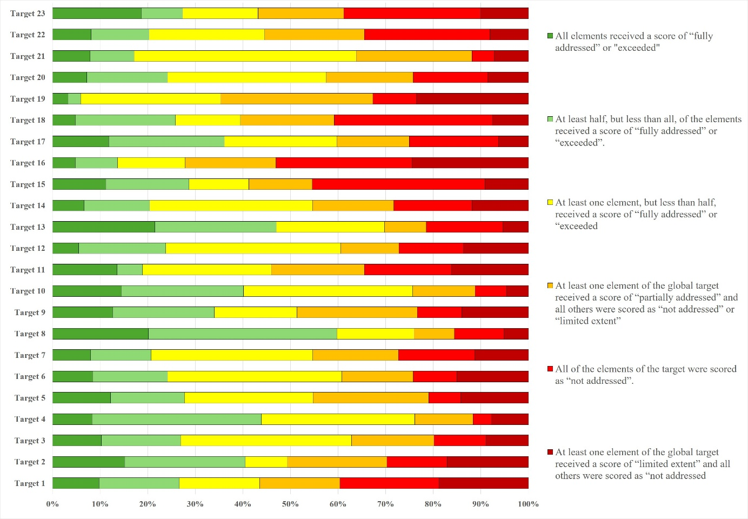
Figure 8 – Assessment of the scope of the national targets set by Parties against the scope of the targets in the Kunming-Montreal Global Biodiversity Framework. The coloured bars indicate the proportion of Parties that have set national targets which correspond to each category. The number of Parties represented in each bar varies with the number of Parties that have submitted national targets related to a given target of the Kunming-Montreal Global Biodiversity Framework.
  - Links to section C of the Kunming-Montreal Global Biodiversity Framework – Section C of the Framework contains a set of considerations for its implementation. In their national target submissions, some Parties have identified which of these considerations have been considered. More than two thirds of national targets contain this information. The most commonly mentioned considerations were collective effort towards the targets, and whole-of-government and whole-of-society approach. By comparison few national targets mentioned different value systems, right to development or principles of the Rio Declaration;
  - Indicators – Headline and binary indicators are automatically linked to national targets based on which target of the Kunming-Montreal Global Biodiversity Framework the national target has been mapped to. The use of component, complementary and national indicators is optional. Less than a fifth of national target submissions identified component or complementary indicators. About half of Parties have identified national indicators for some of their national targets;
  - Means of implementation and capacity needs– More than a third of national target submissions provide information on the associated means of implementation for the target. Of the national targets with this information almost three quarters indicate that additional means of implementation are required to meet the target. For most national targets, Parties expressed the required means of implementation generally. This suggests that means of implementation and capacity-building needs are being expressed in the national targets as a general recognition that additional resources and capacity are needed but that more detailed analysis is required to precisely articulate specific needs. Further some of the needs expressed need to be primarily addressed by national governments, for example the establishment of policies or plans, while others can be addressed but multiple actors, for example the development of guidelines or best practices. Commonly mentioned required means of implementation were financial resources, human resources, capacity-building, awareness raising, technology transfer and capacity-building, and scientific research and collaboration. However, for some national targets more specific needs were identified. Examples include the development of baseline biodiversity data and improving associated databases and their interoperability, mapping, including for the identification of areas with high ecological and biodiversity importance, modelling, monitoring, regulatory frameworks, community engagement, improving the integration of indigenous and local knowledge in decision-making, public-private partnerships, improving access and use of technology and infrastructure, such as geographic information systems, remote sensing, artificial intelligence and machine learning;
  - Commitments from actors other than national governments – On average 15 Parties provided information on the involvement of actors other than national governments for any given target in the Framework. Similarly, on average, less than one fifth of the target submissions provide information on commitments of actors other than national governments. However, many of the target submissions indicate that the involvement of actors other than national governments has not yet begun or that they need to be engaged. Most indicate the ways in which these actors can be involved generally in the implementation of the target but do not indicate specific ongoing actions or commitments. Some also refer to general ongoing activities but which are not necessarily linked to specific commitments or targets of the Kunming-Montreal Global Biodiversity Framework. Actors commonly noted in the target submissions include indigenous peoples and local communities, non-governmental organizations, the private sector, youth groups, and academic institutions.

IX. Analysis of national targets
Target 1: plan and manage all areas to reduce biodiversity loss
- 154 Parties have submitted 467 national targets related to Target 1. On average a Party has submitted 4 national targets related to Target 1 but the number ranges from 1 to 27.
- Of the national targets mapped by Parties to GBF Target 1, 80% were also identified as contributing to Goal A, and 58% were identified as contributing to Goal B. 17% were identified as contributing to Goals C and15% to Goal D. Almost half of the national targets were also linked to GBF Target 3 (48%) while some were linked to GBF Targets 2 (40%) and 4 (35%)
- 47% of national targets were reported as having high alignment to GBF Target 1, d 34%) were reported as having medium alignment to the target and 9% as having low alignment. For 10% of the national targets Parties did not indicate a degree of alignment. 70% of Parties reported that they have at least one national target which has high alignment with this target. For 22% of Parties the highest level of reported alignment for a national target was moderate or low. 10% of Parties did not report on alignment.
- 10% of Parties have set national targets which fully address all elements of Target 1 and 17% have set targets which fully address at least half of the target elements. 17% of Parties have set national targets which fully address one but less than half of the target elements. 56% have set national targets which do not fully address any element of Target 1. 17% have set national targets which partially address all or some of the elements. 19% of Parties have set national targets which address the elements of Target 1 to a limited extent and 21% of Parties have set national targets which do not address any element of Target 1..
- In the national targets submitted, there was a greater focus on the elements of Target 1 related to biodiversity inclusive spatial planning with 33%) of Parties fully addressing this issue through their national targets. More than a quarter of Parties fully addressing the elements related to making planning process participatory (27%) and integrated (27%). Less than a quarter of Parties have set national targets which fully address respecting the rights of indigenous peoples and local communities (23%), having all areas under spatial planning or other management processes (22%) or bringing the loss of areas with high importance for biodiversity close to zero by 2030 (20%) (see figure 9). Some Parties have set targets which refer to putting in place spatial planning or other management processes for specific areas, for example protected areas or areas of high biodiversity importance, areas under agriculture, forestry and fisheries, urban areas, and areas of environmental importance. Some Parties have also set targets indicating the percentage of areas that will be under spatial planning or management by 2030. These range from 20% to 100%. Some Parties have set targets with the number of hectares that will be under spatial planning or other management processes. Further some have targets with different percentages for different ecosystem types. Many of the targets set refer to management approaches, such as sustainable use plans, restoration plans, plans for the control of invasive alien species and development plans, but which do not address the use and planning of terrestrial, inland water and marine areas. Further some target submissions refer to existing land use and management processes and indicate that biodiversity will be reflected in these.
- 55%) of Parties provided information on the means of implementation for at least 1 national target related to Target 1 and 49% of the national target submissions contained this information. Of the Parties providing this information the majority (82% indicated that additional means of implementation are required for at least one target. 75% of the national target submissions indicate that additional means of implementation are needed. 20% indicate that the means of implementation are available. The most mentioned type of means of implementation was funding from external and internal sources, including national biodiversity funds, multilevel financial partnerships and innovative mechanisms, such as payments for ecosystem services. Additional types of means of implementation commonly mentioned were human resources, capacity-building, scientific research and collaboration, technical and technological support and improvements, synergies with planning processes, awareness-raising, technology transfer, access to information, the establishment of necessary web portals, geographic information systems and monitoring systems, clarifying the roles and responsibilities of different national organizations and departments, resolving questions concerning legislation and regulatory frameworks, and means of engaging with stakeholders. See table 3 for more detailed examples of the capacity needs identified by Parties.
Table 3. Reported capacity needs identified in national targets
Category of needs | Subcategory of needs | Examples of specific needs
Technological | Technology related | - GIS, spatial planning tools, remote sensing equipment, metabarcoding, acoustic surveys, innovative technologies  - Artificial intelligence and machine learning algorithms to improve the accuracy of land cover classifications by handling complex data sets and distinguishing between similar land cover types
Technical | Information and data | - Land cover and marine cover databases  - Threatened species inventories  - Systems for continuous or annual reporting
Technical | Scientific research | - Identifying areas of high biodiversity importance and developing land use plans around identified ecosystems  - Filling knowledge gaps for high biodiversity areas and vulnerable ecosystems
Technical | Monitoring and surveillance | - Automate and improve biodiversity monitoring
Technical | Human resources, including training and skills | - Improving the capacity of public officials, local communities and civil society organization on biodiversity management, spatial planning, natural resource management and geographic information systems
Technical | International cooperation and knowledge transfer | - Cooperation among countries to share knowledge, experiences technologies, finance and address transboundary problems
Technical | Environmental governance and policy | - Designing and implementing tourism plans to promote sustainable nature-based and cultural tourism
- 22% of Parties provided information on the involvement of actors other than national governments for at least one of their national targets. At the national target level, 20% of national target submissions included information on the involvement of non-State actions. Of the ones that do, some indicate that the involvement of non-State actors has not yet begun or that they need to be engaged. Most indicate the ways in which non-State actors can be involved generally in the implementation of the target but do not indicate specific ongoing actions or commitments which have been taken by non-State actors. Some also refer to general ongoing activities, such as awareness-raising, but which are not necessarily linked to specific commitments.
- 30% of Parties indicated that they would use at least one national indicator in reporting progress towards their national targets associated with this target of the framework and 30% of Parties indicated that they would make use of component indicators and 25% indicated they would use complimentary indicators. At the target level 22% of national target submissions included associated component indicators (25%) and 22% included associated complimentary indicators (21%). 17% of national targets identified national indicators. Examples of elements measured by these national indicators include the effectiveness and equitability of management plans, the number of spatial plans, the number of areas of high importance for biodiversity identified or integrated into spatial plans. Many national indicators for Target 1 were also disaggregated by biome.
- 67% of national target submissions contain information on which elements of section C of the Kunming-Montreal Global Biodiversity Framework the national target helps to address. The most commonly addressed elements were ecosystem approach (63%), collective effort towards the target (63%), and whole-of-government and whole-of-society approach (61%). Comparatively few targets addressed different value systems (22%), the right to development (25%) or intergenerational equity (27%)
- 68% of national target submissions contained information on associated policy measures. Commonly reported measures include:
  - Strengthening biodiversity inclusive spatial planning, for example by updating and developing supporting legislation, policies and frameworks, updating master planning and statutory planning processes at all scales, zoning maps, management plans, guidelines and assessment frameworks;
  - Developing or strengthening specific strategies, plans, tools and techniques for restoration, connectivity and resilience, including protected area management plans, blue-green infrastructure and local nature recovery strategies;
  - Strengthening of knowledge and data, including the development of central biodiversity spatial databases, registries and indexes;
  - Deepening engagement with and awareness of stakeholders and citizens through the development of guidelines and plans for environmental education;
  - Increasing partnerships and local community engagement in development and implementation of strategies and plans;
  - Institutional strengthening and capacity-building.
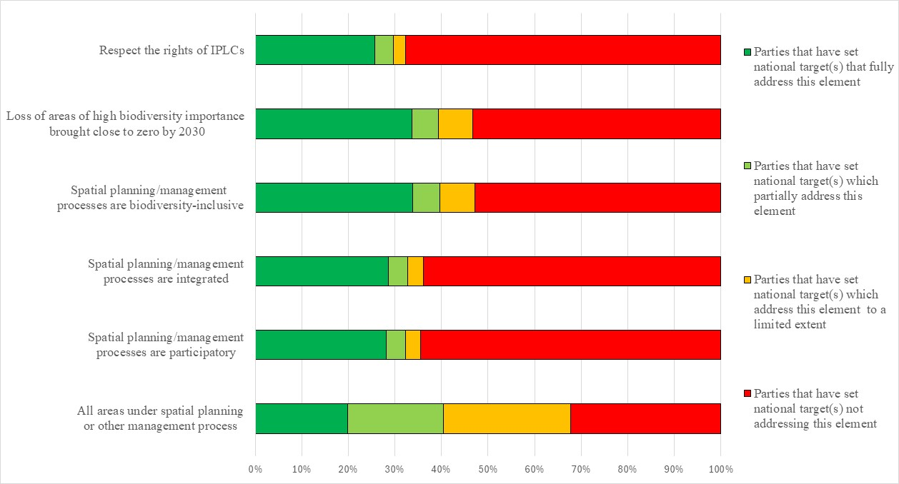Figure 9 – Assessment of the degree to which Parties have addressed the elements of GBF Target 1 in their national target(s). The coloured bars indicate the proportion of Parties that have set national targets which correspond to each assessment category. The number of Parties represented in each bar varies with the number of Parties that have submitted national targets related to a given target of the Kunming-Montreal Global Biodiversity Framework.
Target 2: restore 30 per cent of all degraded ecosystems
- 158 Parties have submitted 449 national targets related to Target 2. On average a Party has submitted 3 national targets related to Target 2 but the number ranges from 1 to 21. Of the national targets mapped by Parties to GBF Target 2, most (82%) were also identified as contributing to Goal A, and 57% were identified as contributing to Goal B. 15% were identified as contributing to Goal C and 12% were identified as contributing to Goal D. 44% of national targets were also linked to GBF Targets 1and 45% were also linked to GBF Target 3..
- 51% of the national targets submitted by Parties were reported as having high alignment to GBF Target 2.31% were reported as having medium alignment to the target and 6% were reported as having low alignment. For 11% of the national targets Parties did not indicate a degree of alignment. 72% of Parties reported that they have at least one national target which has high alignment with this target. For 17% of Parties the highest reported level of alignment for a national target was moderate and for 3% of Parties it was ow low. 8% of Parties did not report on alignment.
- 15%) Parties have set national targets which fully address all elements of Target 2 and 25% have set targets which fully address half of the target elements. 9% of Parties have set national targets which fully address one but less than half of the target elements. (51%) have set national targets which do not fully address any element of Target 2. (21%) have set national targets which partially address all or some of the elements. 17% of Parties have set national targets which address the elements of Target 2 to a limited extent and 13% of Parties have set national targets which do not address any element of the target.
- In the national targets submitted, 85% Parties have addressed elements related to the restoration of terrestrial areas and 72% have set national targets related to the restoration of inland waters. For non-landlocked countries most 74% of Parties refer to the restoration of degraded marine and coastal areas in their national targets:
  - Restoration of terrestrial areas: 66% of Parties have set targets which included quantitative elements for the restoration of terrestrial areas. 34% of these aim to restore 30% of terrestrial areas and the remainder set restoration values of between 3% and 80% or set targets with specific amounts of hectares to be restored. In addition, some place emphasis on specific terrestrial ecosystem types, such as forests, grasslands and meadows, peatlands, areas under agriculture and forestry, areas used for grazing, rangelands, key biodiversity areas, water basins, and priority areas;
  - Restoration of inland waters: 58% of Parties have set targets with quantitative elements for the restoration of inland waters. Of these 58% have targets which call for the restoration of 30% of degraded inland waters. The remainder have restoration targets of between 1% and 30% or have specific quantitative targets expressed in kilometres or hectares. Some targets identified specific types of inland water areas that would be restored, including wetlands, rivers, ecosystems underrepresented in protected areas, water towers and estuaries;
  - Restoration of marine and coastal areas: Of non-landlocked countries 66% have set targets with quantitative elements for the restoration of marine and coastal areas. 54% of these Parties have set targets which aim to restore 30% of degraded marine and coastal areas. The remainder have set restoration targets of between less than 1%% and 80% or have set targets with specific quantitative values in square kilometres or hectares. Some targets identified specific types of marine and coastal areas that would be restored, including mangroves, areas underrepresented in protected areas and priority areas.
- Comparatively few national targets address the other elements of Target 2. 66% Parties have set targets which do not address the enhancement of biodiversity, 62%, of have set national targets which do not address ecosystem services or of the integrity of ecosystems (59%) through ecosystem restoration (see figure 10).
56% of Parties provided information on the means of implementation for at least 1 national target related to Target 2 and 48% of the national target submissions contained this information. Of the Parties providing this information 83% indicated that additional means of implementation are required. Similarly, for targets with this information, 75% of submissions indicate that additional means of implementation are needed. 21% of submissions indicate that the means of implementation are available. Of the Parties indicating that additional means of implementation are required, most mentioned the need for financial resources. Parties also noted the need for the development of baseline data, mapping, ongoing monitoring, development and implementation of plans, and the establishment of research institute, data and information repositories. The need for capacity-building, including increasing training to build expertise within country, human resources to mobilize stakeholders, institutional strengthening to overcome capacity gaps in, for example, rural and marine and coastal areas, developing and updating guidelines, protocols and best practice for effective restoration were noted. Some Parties also noted the need for technical and technological support and improvements, including expertise, tools and technologies for surveying and monitoring, restoration and knowledge management, including for geographic information systems, artificial intelligence, drones and equipment for nurseries. Other means of implementation mentioned included stakeholder and citizen participation collaboration and coordination and strengthening legal frameworks and harmonizing planning instruments across sectors and levels of government. See table 4 for more detailed examples of the capacity needs identified by Parties.
Table 4. Reported capacity needs identified in national targets
Category of needs | Subcategory of needs | Examples of specific needs
Technological | Technology related | - Restoration tools and technologies, including drones, geographic information systems, data collection kits, biodiversity-friendly capture technologies, artificial intelligence applications, remote sensing equipment and improved research facilities  - Lack of technologies to map degraded lands  - Development of platforms and applications to catalyse large scale ecosystem restoration
Technical | Information and data | - Establishment of platforms to consolidate restoration information  - Updated guidelines, models and protocols to support restoration practice  - Improved data on ecosystem condition and drivers of degradation  - Adequate baselines and future climate scenarios to measure progress  - Ecosystem-specific master restoration plans  - Indicators that relate the areas under restoration with priority areas and changes in cover
Technical | Scientific research | - Identifying restoration priority areas  - Assessing ecological condition of habitats including Ramsar sites, coral reefs, mangroves, seagrasses, soils and poorly known species groups  - Research into nature-based solutions, and the use of indigenous knowledge  - Standard methodologies for defining and assessing ecosystem degradation
Technical | Monitoring and surveillance | - Strengthen inspection and enforcement capacities of local authorities
Technical | Human resources: training and skills | - Expand the number of restoration experts, technicians, scientists, planners and data specialists, and to ensure women’s participation in restoration activities
Technical | International cooperation and knowledge transfer | - Alliances with research institutions and partnerships to provide technical support and innovative restoration methods.
Technical | National and local cooperation and knowledge transfer | - Collaborate with different actors to create synergies and multiply the impact of conservation actions  - Strengthen communication and coordination of different agencies and levels of government involved in territorial planning  - Improved organization and empowerment of local communities  - Train local communities and stakeholders in data collection techniques, such as GPS and remote sensing  - Effective incentives for local communities and stakeholders to engage in restoration activities
Institutional | Regulatory and legal frameworks | - Regulatory and legal frameworks to support rehabilitation, harmonize territorial planning instruments, ecological plans and define restoration areas  - Measures to fairly sanction impacts on ecosystems and to support to support the repair of environmental damage
Institutional | Environmental governance and policy | - Integrate restoration into agricultural and environmental policy,  - Address corruption which undermines conservation and restoration efforts  - Harmonize policies and programme priorities with conflicting land uses
- 25% of Parties provided information on the involvement of actors other than national governments for at least one of their national targets. At the national target level, 14% of national target submissions provide information on the involvement of non-State actors. For Parties providing this information, some indicate that the involvement of non-State actors has not yet begun or that they need to be engaged. Most indicate the ways in which non-State actors can be involved generally in the implementation of the target but do not indicate specific ongoing actions or commitments which have been taken by non-State actors. Examples of the types of contributions noted include technology transfer, capacity-building, providing data and information, undertaking studies, and providing funding. Few national targets identify specific actors with ongoing activities or commitments. Those that do often refer to specific projects or actions which are being taken on an ad hoc basis which, while relevant to the target, are not specifically linked to the attainment of the national target. Others refer to cross-cutting actions which are being taken which are relevant to the implementation of the Convention and the Kunming-Montreal Global Biodiversity Framework at the national level generally.
- 32% of Parties indicated that they would make use of component indicators for monitoring implementation of the national targets and and 30% indicated they would use complimentary indicators. 54% of Parties indicated that they would make use of national indicators. At the target level around 26% of submissions identified component indicators and 27%idnetified complimentary indicators (23%). 20% of national targets mapped to GBF Target 2 contained national indicators. Most of the national indicators for Target 2 measure the degraded area or the 67% of national target submissions contain information on which elements of section C of the Kunming-Montreal Global Biodiversity Framework the national target helps to address. The most addressed elements were the ecosystem approach (74%), collective efforts towards the target (71%), and whole-of-government and whole-of-society approach (69%). Comparatively few targets addressed different value systems (27%), the right to development (28%) or intergenerational equity (32%)
- 66% of national targets have associated policy measures. Commonly reported measures were establishing and strengthening plans, programmes, policies and supporting legal frameworks for ecosystem recovery and rehabilitation. Measures to build capacity for development and implementation of these through, for example, technical assistance and institutional strengthening, strengthening data collection and knowledge generation, including systems to identify, categorize, prioritize, inventory, map and regularly update information on degraded areas and components of ecosystem health, such as soil health, were also noted. Strengthening guidance, standards, compliance checks, controls, accountability and transparency, including through environment impact assessment standards, bonds, independent auditors and public access to information, were also identified in some target submissions.
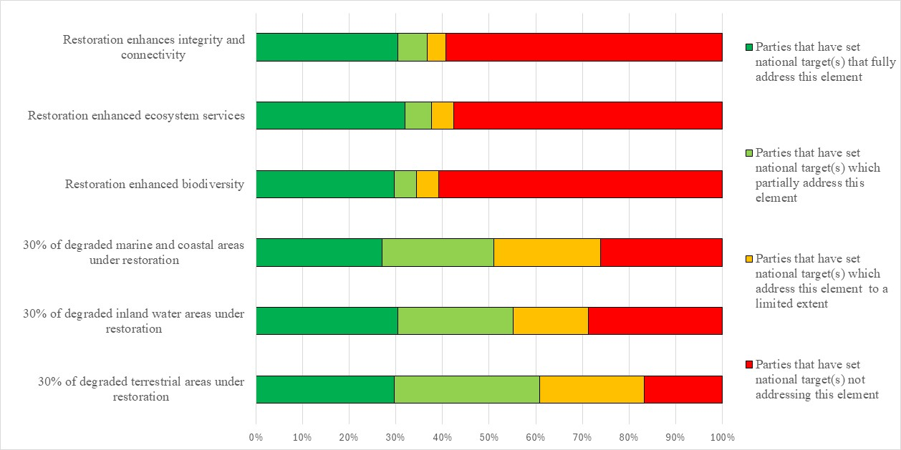Figure 10 – Assessment of the degree to which Parties have addressed the elements of GBF Target 2 in their national target(s). The coloured bars indicate the proportion of Parties that have set national targets which correspond to each assessment category. The number of Parties represented in each bar varies with the number of Parties that have submitted national targets related to a given target of the Kunming-Montreal Global Biodiversity Framework. The bar related to the restoration of marine and coastal areas only reflects the targets submitted by non-landlocked Parties.
Target 3: conserve 30 per cent of land, waters and seas
- 156 Parties have submitted 459 national targets related to Targe 3. On average a Party has submitted 3 national targets related to Target 3 but the number ranges from 1 to 22. 81% of national targets were identified as contributing to Goal A, and 51% were identified as contributing to Goal B. 6% of national targets were identified as contributing to Goal C and 14% as contributing to Goal D. and 12%. 48% of national targets were also linked to GBF Target 1 and 45% were linked to Target 2.
- 51% of national targets were reported by Parties as having high alignment to GBF Target 3. 29% were reported as having medium alignment to the target and 10% as having low alignment. For 10% of the national targets Parties did not indicate a degree of alignment. 73% of Parties reported that they have at least one national target which has high alignment with this target. For 16% of Parties the highest reported level of alignment for a national target was moderate and for 4% of Parties it was low. 7% of Parties did not report on alignment.
- 1% Parties have set national targets which fully address all elements of Target 3 and 16% have set targets which fully address half of the target elements. 36% of Parties have set national targets which fully address one but less than half of the target elements. 37% of Parties have set national targets which do not fully address any element of Target 3. Less than a fifth of 17% of Parties have set national targets which partially address all or some of the elements. 9%of Parties have set national targets which address the elements of Target 3 to a limited extent and 11% of Parties which have set national targets which do not address any element of Target 3..
- 78% of Parties have set targets addressing the protection of terrestrial areas to some extent. Of these 87% have national targets with quantitative elements related to the protection of terrestrial areas, of which 69% have set targets aiming to have 30% or more of terrestrial areas protected by 2030. The remainder have set targets aiming to conserve between 6% and 28% or have set targets aiming to protect a set number of hectares. Some Parties have also set targets about 30% but which focus on specific ecosystem types or areas of high importance for biodiversity only.
64% of Parties have set targets addressing the protection of inland water ecosystems to some extent. Of these most (86%) have set targets with quantitative elements of which 67% have set targets which aim to protect 30% or more of their inland water ecosystems. The remainder aim to protect between 8% and 28% or aim to protect a set number of hectares. Some Parties have also set targets about 30% but which focus on specific ecosystem types or areas of high importance for biodiversity only.
- Of the non-landlocked Parties submitting targets related to Target 3, 75% have set targets addressing the protection of marine and coastal areas to some extent. Of these most 89% have set targets with quantitative elements of which 62% aim to protect 30% or more of their marine and coastal areas. The remainder aim to protect between 5% and 25% of marine and coastal areas. Some Parties have also set targets about 30% but which focus on specific ecosystem types or areas of high importance for biodiversity only.
- The qualitative elements of GBF Target 3 are addressed to a lesser extent in the national targets set by Parties. 74% do not address sustainable use within protected areas. However, this could be because some Parties do not allow any form of use or limit the types of use within their protected areas estates. 63% Parties do not have targets addressing the equitable governance of protected areas , 68% of Parties do not have national targets addressing the integration of protected areas into the land and seascape and 67% of Parties do not have national targets addressing the rights of indigenous peoples and local communities in relation to protected areas. 54% of Parties do not have targets addressing the connectedness of protected areas , 57% of Parties do not have national targets addressing the protection of particularly important areas and 60% of Parties do not have national targets addressing the representativeness of protected areas. 43% Parties do not have national targets addressing the management effectiveness of protected areas (see figure 11).
- 53% of Parties provided information on the means of implementation related to at least one of their national the targets related to Target 3. Of these, 83% indicated that additional means of implementation are required for at least one national target. Looking across all the national targets, 47% of the national target submissions contain information on the associated means of implementation. For targets with this information, 79% of submissions indicate that additional means of implementation are needed and 19%indicate that the means of implementation are available. A bout half of parties identified the need for financial resources and nearly half identified capacity-building needs, including human resources, institutional, regulatory and logistical. Several parties specifically identified a need for the coordination of actions across stakeholders and the need for technical and scientific cooperation, access and transfer of technologies, especially for mapping, planning, data collection, monitoring and reporting needs. The need for awareness-raising was also identified in some submissions as was the need to reduce the impact of armed groups and means to protect the lives of environmental defenders. See table 5 for more detailed examples of the capacity needs identified by Parties.
Table 5. Reported capacity needs identified in national targets
Category of needs | Subcategory of needs | Examples of specific needs
Technological | Technology related | - Technologies for conservation, such as geographic information systems, drones, satellite technologies for surveillance and monitoring, and cloud data processing
Technical | Information and data | - Data and spatial maps of land and marine use and cover  - Baseline data on historic and current biodiversity conditions and trends and future biodiversity scenarios
Technical | Scientific research | - Identifying areas of high biodiversity and ecological value, that coincide with areas suitable for protected areas  - Identifying ecological corridors and habitat linkages between protected areas and advice on the restoration of degraded landscapes within corridors  - Surveys and research on threatened flora and fauna
Technical | Monitoring and surveillance | - Determine effectiveness of protected area management
Technical | Capacity-building | - Capacity support for expanding and creating protected area networks in coastal and marine ecosystems  - Need for basic infrastructure (docks, visitor centres, field stations for genetic and biodiversity research) in protected areas to maximize conservation actions
Technical | Human resources: training and skills | - Need for trusted, long-term workforce in protected areas  - Train staff in spatial and remote sensing technology  - Increase number of park rangers and provide them with better equipment
Technical | Communication and awareness | - Increase citizen participation in marine and coastal conservation
Technical | International cooperation and knowledge transfer | - Cross border collaboration on border rivers, especially in international maritime waters
Technical | National and local cooperation and knowledge transfer | - Promote knowledge management through IT, spatial techniques, AI and joint scientific research
Institutional | Regulatory and legal frameworks | - Legislative action to designate protected areas (especially in poorly represented areas, such as savannas and wetlands)
Institutional | Environmental governance and policy | - Ensure protected area management plans are informed by biodiversity surveys, ecological assessments and reliable data from monitoring programmes  - Consider ecosystem shifts from climate change, human activities and land use conflicts when designing protected areas  - Need to harmonize public policies to avoid incentives that conflict with conservation, sustainable use and restoration of biodiversity
- 20% of Parties provided information on the involvement of actors other than national governments for at least one of their national targets. At the national target level, 16% of national target submissions provide information on the involvement of non-State actors. Of those that do, some indicate that the involvement of non-State actors has not yet begun or that they need to be engaged. Most indicate the ways in which non-State actors can be involved generally in the implementation of the target but do not indicate specific ongoing actions or commitments which have been taken by non-State actors. Examples of the types of contributions noted include technology transfer, capacity-building, providing data and information, undertaking studies, and providing funding. Few national targets identify specific actors with ongoing activities or commitments. Those that do often refer to specific projects or actions which are being taken on an ad hoc basis which, while relevant to the target, are not specifically linked to the attainment of the national target. Others refer to cross-cutting actions which are being taken which are relevant to the implementation of the Convention and the Kunming-Montreal Global Biodiversity Framework at the national level generally.
- 27% of Parties indicated that they would make use of at least one component indicators, 22% indicated they would make use of at least one or complimentary indicator and 29% of Parties indicated they would use at least one national indicator for monitoring implementation of their national targets associated with this target of the Framework. At the target level about 25% of national target submissions identified component indicators %) 23% identified complimentary indicators and (22%) and 18% identified national indicators. Examples of elements measured by these national indicators include the number of ecological corridors, the degree of ecological connectivity of protected areas, the degree of ecological integrity of protected areas, and the area or number of biodiversity heritage sites. While many national indicators for Target 3 were disaggregated by biome, others were also disaggregated by importance for biodiversity, indigenous and traditional territories, and management effectiveness.
- 65% of national target submissions contain information on which elements of section C of the Kunming-Montreal Global Biodiversity Framework the national target helps to address. The most commonly addressed elements were ecosystem approach (81%), whole-of-government and whole-of-society approach (72%), national circumstances and priorities and capabilities (65%) and collective effort towards the targets (71%). Comparatively few target submissions addressed different value systems (30%), the right to development (31%) or intergenerational equity (34%).
- 67% of national targets submissions include associated policy measures. Common policy measures identified in the submissions include spatial planning, the legal designation of new protected areas, OECMs and ecological networks, plans to enhance effectiveness, the development of new management plans, enhancing stakeholder engagement and indigenous rights, enhancing sustainable practices and increasing supportive institutional arrangements. Some Parties also identified more general measures that address threats to the environment including climate change, plastic pollution and invasive species.

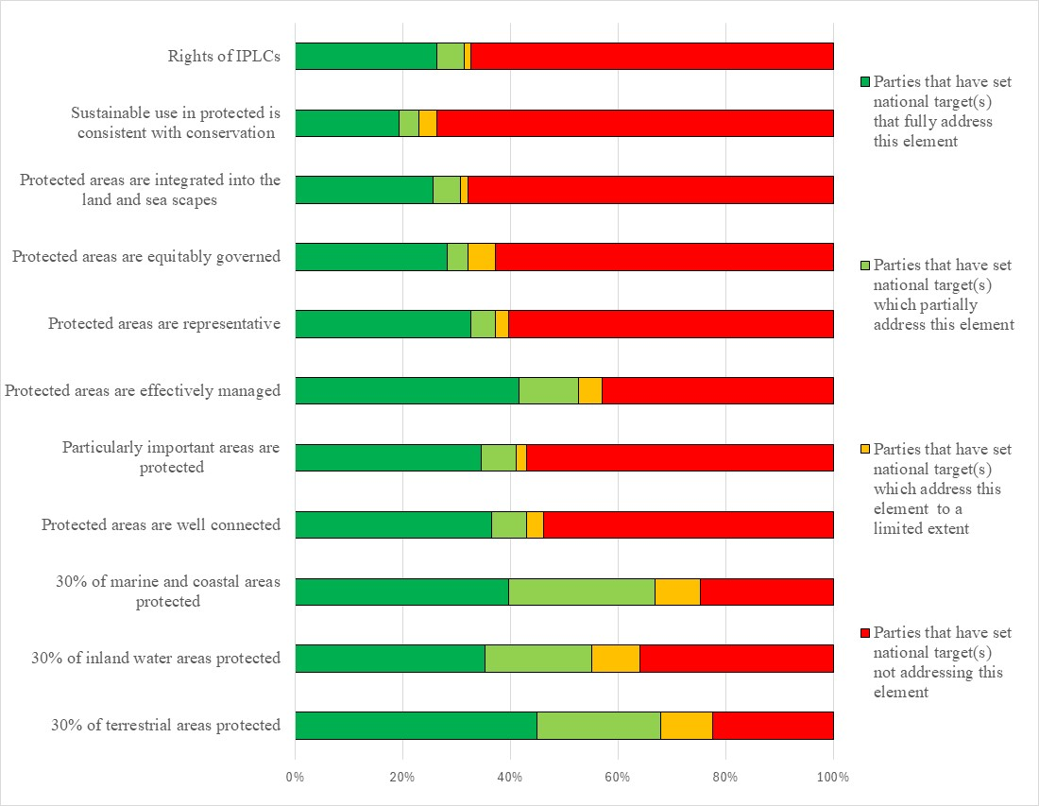Figure 11 – Assessment of the degree to which Parties have addressed the elements of GBF Target 3 in their national target(s). The coloured bars indicate the proportion of Parties that have set national targets which correspond to each assessment category. The number of Parties represented in each bar varies with the number of Parties that have submitted national targets related to a given target of the Kunming-Montreal Global Biodiversity Framework. The bar related to the protection of marine and coastal areas only reflects the targets submitted by non-landlocked Parties.
Target 4: halt species extinction, protect genetic diversity and manage human-wildlife conflicts
- 155 Parties have submitted 524 national targets related to Target 4. On average a Party has submitted 4 national targets related to Target 4 but the number ranges from 1 to 37. Most (85%) national targets mapped to GBF Target 4 were also identified as contributing to Goal A, and about half (51%) were identified as contributing to Goal B. 19% of national targets were linked to Goal C and and 10% were linked to Goal D. National targets were also commonly linked to GBF Targets 1 (32%), 2 (31%), 3 (34%), 5 (31%), 9 (31%), and 10 (32%).
- Less than a half of the national targets (47%) submitted by Parties were reported as having high alignment to GBF Target 4, 35% were reported as having medium alignment to the target and 9% as having low alignment. For 7% of the national targets Parties did not indicate a degree of alignment.
- 8% Parties have set national targets which fully address all elements of Target 4 and approximately and 35% have set targets which fully address at least half but not all of the target elements. 32%) of Parties have set national targets which fully address one but less than half of the target elements. 24% of Parties have set national targets which do not fully address any element of Target 4. 12% of Parties have set national targets which partially address all or some of the elements. Few Parties have set national targets which address the elements of Target 4 to a limited extent (8%) or not at all (4%).
- 62% of Parties have set targets which fully address ensuring urgent management actions are taken. Around half(52%) of Parties have set targets fully addressing the recovery and conservation of threatened species and 40% have set targets fully addressing the element of managing human wildlife conflict. The other elements of the target have been addressed to a lesser extent. 34% of Parties have set targets which do not address halting human-induced extinction of known threatened species or address this element to a limited extent (14%). Similarly, 27% of Parties have set targets which do not address maintaining and restoring the genetic diversity of wild species or address this issue to a limited extent (17%). 45% Parties have set targets which do not address maintaining and restoring genetic diversity of domestic species or address this issue to a limited extent (10%) (see figure 12).
- 46% of Parties provided information on the means of implementation related to at least one of their national the targets related to Target 4. Of these, 73%% indicated that additional means of implementation are required. Example of the types of required means of implementation identified in the target submissions were financial resources, including to establish funds to support landowners in biodiversity protection, to put in place institutional and legal frameworks to promote sustainable land management and genetic resource conservation, and to establish capacity-building programmes to address institutional gaps and enhance biodiversity-related skills. The need for community engagement initiatives, including public-private partnerships and ensuring synergy among stakeholders, including through training, financial incentives, and sustainable development opportunities were also noted. Advancing biodiversity research and monitoring infrastructure, including laboratories for digital sequencing and genetic analysis, and the development of artificial intelligence tools for species identification and ecosystem monitoring were also noted. See table 6 for more detailed examples of the capacity needs identified by Parties.
Table 6. Reported capacity needs identified in national targets
Category of needs | Subcategory of needs | Examples of specific needs
Technological | Technology related | - Adequate infrastructure: camera traps for species monitoring and data collection, equipped laboratories and Internet access for research, digital sequencing information and genetic analysis for species identification  - Improved infrastructure for collecting, organizing and storing species collections and gene banks
Technical | Information and data | - Need for data coordination platforms to integrate and manage data on endangered species
Technical | Scientific research | - Regular assessment and monitoring of threatened, endemic and economically important species, to assess their status and distribution  - Strengthen gene banks  - Assess human-wildlife interaction risks  - Assess threats to genetic diversity and understand genetic conservation approaches, terminology and methods  - Greater research on migratory species
Technical | Monitoring and surveillance | - Monitor human-wildlife conflict
Technical | Capacity-building | - Enhance capacity of ex-situ conservation facilities and protected areas  - Support for mapping and categorizing species
Technical | Human resources: training and skills | - Technical expertise for required technology
Technical | International cooperation and knowledge transfer | - Establish alliances with other countries and international organizations to share experiences, knowledge and resources  - Cooperation with international non-governmental organizations with the technical and scientific capacity to collect species samples
Technical | National and local cooperation and knowledge transfer | - Strengthen capacity for communities to coexist with wildlife
Institutional | Regulatory and legal frameworks | - Legal mechanism to regulate the sustainable use of endemic species of high conservation value
Institutional | Environmental governance and policy | - Policies to restore the habitat of rare, endangered species  - Action plans, with resource allocation, to minimize human-wildlife conflicts and threats, and maintain genetic diversity of threatened species  - Species focused conservation in-situ and ex-situ conservation measures  - Integrate wildlife management into disease and health systems and policy
- 14% of Parties provided information on the involvement of actors other than national governments for at least one of their national targets. At the national target level, 15% of national target submissions provide information on the involvement of non-State actors. Of the ones that do, some indicate that the involvement of non-State actors has not yet begun or that they need to be engaged. Most indicate the ways in which non-State actors can be involved generally in the implementation of the target but do not indicate specific ongoing actions or commitments which have been taken by non-State actors. Examples of the types of contributions noted include actions related to research, species recovery, rehabilitation and conservation, the monitoring of threatened species, awareness-raising and capacity-building. Few national targets identify specific actors with ongoing activities or commitments.
- 26% of Parties indicated that they would make use of component indicators and 22% indicated they would use complimentary indicators for monitoring implementation of their national targets associated with this target of the Framework. 23% of Parties indicated that they would make use of national indicators. At the target level, 36% of submissions identified component indicators , 33% identified complementary indicators and 27% identified national indicators. Examples of elements measured by these national indicators include the number of cases of human-wildlife conflict, the number of conservation or management initiatives, and the number of genetic resources in seed banks and gene banks. While many national indicators were disaggregated by biome, some were also disaggregated by whether initiatives were in-situ or ex-situ and if the targeted species were native or non-native.
- 70% of national target submissions contain information on which elements of section C of the Framework the national target helps to address. The most commonly addressed elements were collective effort towards the targets (68%), ecosystem approach (68%), national circumstances and priorities (60%) and whole of government and whole of society approach (60%). Comparatively few target submissions addressed different value systems (22%), the right to development (22%), and intergenerational equity (29%).
- 66% of national targets have associated policy measures. The measures identified tended to focus on biodiversity conservation, sustainable resource use, and the strengthening of legal and administrative frameworks. Measures to manage threatened and invasive species were also noted as were actions for habitat and species protection, including initiatives to document genetic resources, gene conservation, and protecting migratory corridors. Community engagement and stakeholder partnerships were also noted as were education initiatives.

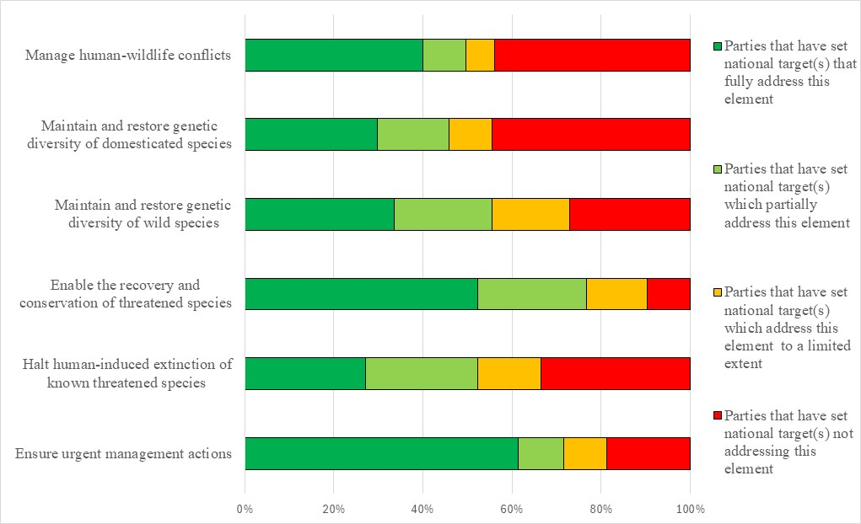
Figure 12 – Assessment of the degree to which Parties have addressed the elements of GBF Target 4 in their national target(s). The coloured bars indicate the proportion of Parties that have set national targets which correspond to each assessment category. The number of Parties represented in each bar varies with the number of Parties that have submitted national targets related to a given target of the Kunming-Montreal Global Biodiversity Framework.
Target 5: ensure sustainable, safe and legal harvesting and trade of wild species
- 148 Parties have submitted 374 national targets related to Target 5. On average, a Party has submitted 3 national targets related to Target 5, but the number ranges from 1 to 14. Of the national targets mapped by Parties to GBF Target 5, 66% were also identified as contributing to Goal A, and 72% as contributing to Goal B. 26% of national targets were identified as contributing to Goal C and 15% as contributing to Goal D. Nearly half of the national targets submitted by Parties linked to GBF Target 5 were also identified as being relevant to Target 9 (49%), 4 (43%) and 10 (42%).
- 52% of the national targets submitted by Parties were reported as having high alignment to GBF Target 5, 30% were reported as having medium alignment and 10% as having low alignment to the target. For 8% of the national targets, Parties did not indicate a degree of alignment.
- 12% of Parties have set national targets which fully address all elements of Target 5 and 16%) have set targets which fully address half of the target elements. 28% of Parties have set national targets which fully address one but less than half of the target elements. 45% of Parties have set national targets which do not fully address any element of Target 5. 24% of Parties have set national targets which partially address some GBF elements but do not address others. 14% of Parties have set targets that address some or all of the GBF elements to a limited extent. Few Parties (7%) have set national targets do not address any elements of GBF Target 5.
- 46% of Parties have national targets which fully address the element of GBF Target 5 on ensuring that the use and harvesting of wild species is sustainable, preventing overexploitation, minimizing impacts on non-target species and ecosystems. 39% of Parties have national targets which fully address ensuring that the use, harvesting and trade of wild species is legal. 35% of Parties have national targets which fully address ensuring that the trade in wild species is sustainable, preventing overexploitation, minimizing impacts on non-target species and ecosystems. 18% of Parties have national targets which fully address ensuring that the use, harvesting and trade of wild species is safe, reducing the risk of pathogen spillover . 22% of Parties have national targets fully addressing applying the ecosystem approach in addressing sustainable, safe and legal use, harvesting and trade of wild species. 25% of Parties have national targets fully addressing the element of the targets related to respecting and protecting customary sustainable use by indigenous peoples and local communities in the sustainable, safe and legal use, harvesting and trade of wild species (see figure 13).
- 52% of Parties provided information on the means of implementation related to at least one of their national the targets related to Target 5. Of these, 71% indicated that additional means of implementation are required. 49% of the national target submissions contain information on the associated means of implementation. Of these, the majority of submissions (78%) indicate that means of implementation will be required, while 17% indicate that means of implementation are available. Implementation needs commonly identified in the target submissions were the mobilization of financial resources and funding and the need for capacity-building, primarily related to training, human resources, and institutional capacity. Other means of implementation mentioned included technical and scientific knowledge and support, awareness-raising, coordination and synergies of action between stakeholders, and transfer of technology and equipment. Specific examples include training and equipment for surveillance, checkpoints for monitoring trade, technical assistance in establishing traceability mechanisms, laboratories to diagnose zoonotic events, tools to document traditional knowledge, and the creation of platforms for citizen participation. See table 7 for more detailed examples of the capacity needs identified by Parties.
Table 7. Reported capacity needs identified in national targets
Category of needs | Subcategory of needs | Examples of specific needs
Technological | Technology related | - Improve laboratory capacity to diagnose prioritized zoonotic events
Technical | Information and data | - Improved access to databases of national and international conservation laws, regulations and species status reports
Technical | Scientific research | - Collection of species-specific data on coastal and oceanic fisheries stocks  - Data collection on population status, trade volumes, sustainable harvest rates, effects of harvesting and distribution of species that are targets of exploitation and trade  - Fish stocks and ecosystems assessments to determine optimal fishing periods and practises  - Research on zoonotic disease threats and disease risk management  - Analyse of data on illegal harvesting/trade and identify trends in specific species, locations, volume and actors
Technical | Monitoring and surveillance | - Greater resources to enforce, monitor and control wildlife poaching and illegal hunting and trade  - Establishment of traceability mechanisms for the exploitation and trade in wildlife within and across country borders
Technical | Human resources: training and skills | - Increased knowledge on protected species and the environmental impact of illegal wildlife trade  - Training on the CITES convention and non-detriment findings for government officials and national scientific authorities  - Training to strengthen capacity to control and monitor illegal wildlife trafficking  - Training for indigenous peoples and local communities on the management and sustainable exploitation and their rights to intellectual property  - Education on inland fisheries to understand how they can positively contribute to biodiversity conservation through supporting sustainable livelihoods, poverty reduction and ecosystem conservation and restoration
Technical | Communication and awareness | - Improved awareness of illegal trade and sustainable practises
Technical | International cooperation and knowledge transfer | - Increased control of illegal international trade, including through custom and control bodies  - Address cross-border coordination challenges in trade
Technical | National and local cooperation and knowledge transfer | - Engagement with farmers, industry and other representatives  - Strengthen powers of indigenous peoples and local communities in the management and sustainable exploitation of local genetic resources  - Engage indigenous peoples and local communities in data collection to provide insights into sustainable use patterns  - Design and implement initiatives to improve the capacity of communities to manage and report illegal trafficking
Institutional | Regulatory and legal frameworks | - Develop legal mechanisms to reduce the pathogen spillover from terrestrial and marine farming activities  - Establish laws to eliminate illegal, unreported and unregulated fisheries
Institutional | Environmental governance and policy | - Use international conventions to support data collection, scientific studies, guideline development and national legislation  - Strengthen check points at strategic locations to monitor the transport of wildlife  - Mainstream wildlife management in the health sector  - Develop management plans for community farms
- 20% of Parties provided information on the involvement of actors other than national governments for at least one of their national targets. At the national target level, 14% of national target submissions provide information on the involvement of actors other than national governments. Of those that submitted information, the most commonly mentioned groups were civil society organizations, mainly non-governmental organizations and indigenous peoples and local communities followed by private sector, academia, youth and citizen participation. Some submissions identified the types of support needed or provided to enable these actors’ contributions, for example, training, capacity-building, development of funding opportunities, partnership programmes, such as co-management of protected areas, and education and awareness raising programmes. Few outlined details of planned contributions in their target submissions. Of those that did, the types of contributions included contributions of indigenous peoples and local communities to monitoring and data collection, design and implementation of management plans, and development of public-private sector partnerships.
- 24% of Parties indicated that they would make use of component indicators and 26% of Parties indicated that they would make use of complimentary indicators for monitoring implementation of their national targets associated with this target of the Framework. 30% of Parties indicated that they would make use of national indicators. At the target level 24% of national target submissions identified component and complementary indicators. 21% of national targets mapped to GBF Target 5 identified national indicators. Examples of elements measured by these national indicators include the proportion of traded wildlife which was illegally poached or trafficked and the number of species harvested and traded sustainably. While national indicators primarily focused on aquatic species, other indicators were also comprehensive of all species, both terrestrial and aquatic.
- 68% of national target submissions contain information on which elements of section C of the Kunming-Montreal Global Biodiversity Framework are addressed by the national target. Of these, collective efforts towards the targets (70%), a whole-of-government and whole-of-society approach (68%) and ecosystem approach (67%) were the mostly commonly identified elements. The least commonly identified elements were different value systems (27%), the right to development (32%), the principles of the Rio Declaration (33%) and intergenerational equity (34%).
- 65% of national target submissions contained information on associated policy measures. Commonly reported measures include measures to increase sustainable forestry, wildlife, fisheries and game management practices, such as promotion of continuous cover forestry and soil-conserving harvesting methods, strengthening hunting and fishing regulations, quotas and monitoring to ensure ecologically sustainable levels are achieved, minimizing impacts to non-target species through technological advancements, such as development of whale safe gear for fisheries, provision of training on sustainable extraction practices, certification of forestry and fishing products and support to obtain these. Other commonly reported measures included support for participation of local communities and inclusion of traditional knowledge in nature resource management and decision-making, including development of and capacity-building for co-management programmes and indigenous-led conservation and monitoring initiatives, such as indigenous guardians programmes. Other reported measures included strengthening national legislation, enforcement and international cooperation related to trade including strengthening law enforcement to combat organized crime related to wildlife trafficking, implementation of CITES and initiatives such as Forest Law Enforcement Governance and Trade (FLEGT) Action Plan as well as enhanced cooperation between indigenous peoples and local communities and enforcement agencies. Mechanisms to monitor, preserve and support genetic diversity, including breeding and (re)colonization of native species in areas where populations have collapsed.
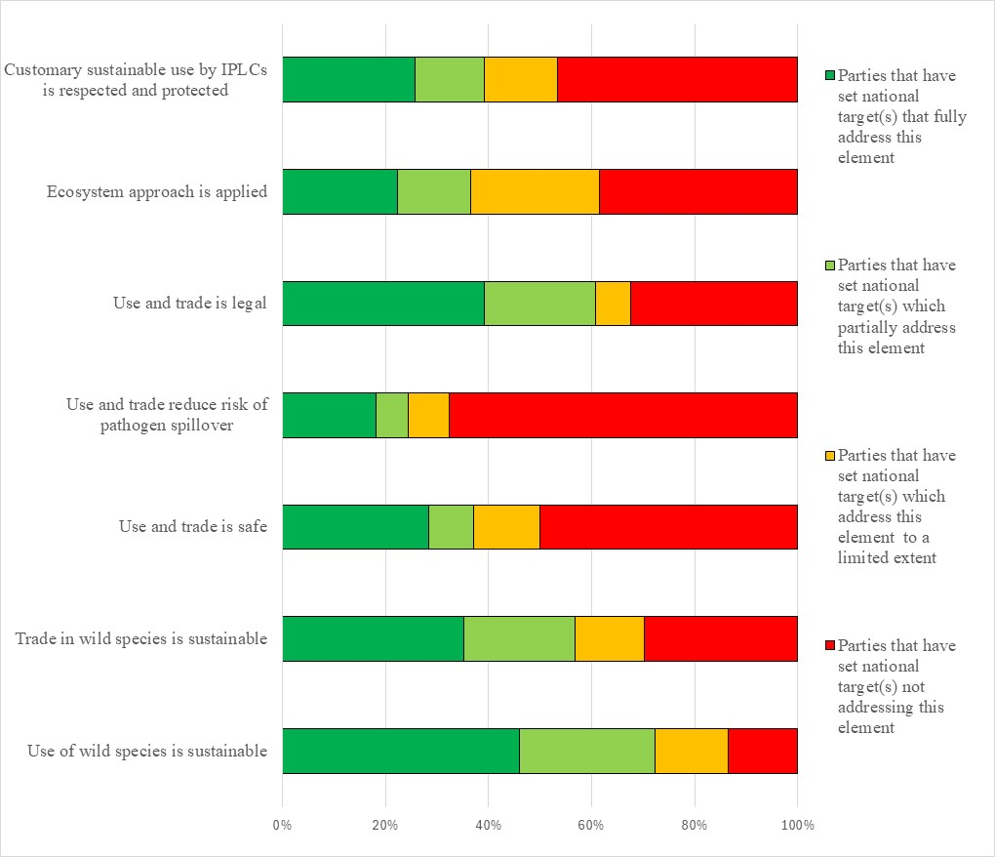
Figure 13 – Assessment of the degree to which Parties have addressed the elements of GBF Target 5 in their national target(s). The coloured bars indicate the proportion of Parties that have set national targets which correspond to each assessment category. The number of Parties represented in each bar varies with the number of Parties that have submitted national targets related to a given target of the Kunming-Montreal Global Biodiversity Framework.
Target 6: reduce the introduction of invasive alien species by 50 per cent and minimize their impact
- 153 Parties have submitted 290 national targets related to Target 6. On average a Party has submitted 2 national targets related to Target 6 but the number ranges from 1 to 16. Most national targets (85%) were also identified as contributing to Goal A. 50% of national targets were identified as contributing to Goal B, 16% as as contributing to Goal C and 14% to Goal D. 44% of national targets were also linked to GBF Target 4 while around one third of the national targets were linked to GBF targets 1 (34%), 2 (31%), 3 (34%), 5 (35%), 10 (32%) and 11 (30%).
- 50% of the national targets submitted by Parties were reported as having high alignment to GBF Target 6, 31% were reported as having medium alignment to the Target and 10% as having low alignment. For 9% of the national targets Parties did not indicate a degree of alignment.
- 8% of Parties have set national targets which fully address all elements of Target 6 and 16% have set targets which fully address half or more of the target elements. 37% of Parties have set national targets which fully address at least one but less than half of the target elements. 39% of Parties have set national targets which do not fully address any element of Target 6. 15% of Parties have set national targets which partially address all or some of the elements and 15% of Parties have set national targets which address the elements of Target 6 to a limited extent. 9% of Parties have set national targets which do not address any element of the target..
- In the national targets submitted, there was a greater focus on the elements of Target 6 related to the eradication and control of already established invasive alien species as opposed to the identification and management of IAS pathways and prevention of IAS introductions. 71% of Parties had national targets which addressed the eradication or control of invasive alien species. 59% of Parties had national targets which addressed eliminating, minimizing, reducing and/or mitigating the impact of invasive alien species on species and 56% of Parties had targets address these impacts on ecosystem services. 18% of Parties fully addressed the prevention of the introduction of priority invasive alien species and 24% fully addressed reducing the rate of introduction and establishment of non-priority species by at least 50% by 2030. 30% of Parties included a quantitative element in their national targets to reduce the rate of introduction of invasive alien species. Of these the majority (78%) aimed for a 50% reduction and approximately. 25% of Parties fully addressed the identification and management of introduction pathways, but 60% and 59% of of Parties, respectively, did not address these issue at all. Overall, the targets had a greater focus on controlling or managing the spread of invasive alien species and the impacts compared to their eradication (see figure 14)
- 49% of Parties provided information on the means of implementation related to at least one of their national the targets related to Target 6. Of these, 82% indicated that additional means of implementation are required. 48% of the national target submissions contain information on the associated means of implementation. For targets with this information, most (83%) indicate that additional means of implementation are needed. 4% indicate that the means of implementation are available. The most commonly mentioned means of implementation included funding from internal and external sources, and capacity-building followed by technical and technological support and improvements, and scientific research and collaboration. See table 8 for more detailed examples of the capacity needs identified by Parties.
Table 8. Reported capacity needs identified in national targets
Category of needs | Subcategory of needs | Examples of specific needs
Technological | Technology related | - Horizon scanning and predictive modelling (incorporating climate change) to predict and prevent invasions  - Artificial intelligence tolls and automation to mobilize data and reduce the lag between detection and information availability  - Technology for early warning systems  - Tools to manage non-target effects from control methods  - Develop alternative control options  - Laboratory equipment to analyse, detect and identify invasive alien species  - Improve quarantine infrastructure to inspect and temporarily house imported species to prevent the spread of invasive species  - Improve phytosanitary and zoo sanitary controls at ports of departure and arrival
Technical | Information and data | - Improved access to standardized and up to date data, including baseline data, on invasive alien species, including on the impacts, entry points, vectors, and occurrences of invasive alien species  - Improved data, including baseline data, on effectiveness and cost of management actions to address invasive species  - Improved data on the role of indirect drivers (governance and sociocultural drivers) affecting biological invasions  - Regional and international data sharing platforms  - Improved data availability on particular taxonomic groups (microorganisms, invertebrates), biomes (marine, tropical, arctic) and regions (Africa, central Asia)  - Improved eradication guidelines and strategies for generalist invasive alien invertebrates and hard-to detect freshwater and marine invasive alien species
Technical | Scientific research | - Research and monitoring on the threat of invasive alien species to human, animal and environmental health  - Research into drivers of invasions, especially in aquatic and marine systems and developing economies  - Scenarios and models of the net effects of multiple interacting drivers of global change in promoting invasions
Technical | Monitoring and surveillance | - Long-term monitoring using emerging technology (eDNA analysis and satellite imagery)  - Monitoring the effectiveness of control measures
Technical | Capacity-building | - Capacity to completely eradicate invasive alien species rather than just stop its spread  - Capacity of staff and communities to control IAS
Technical | Human resources: training and skills | - Training in AI-based detection, GIS, surveillance tools and real time tracking  - Training on cost-benefit tools for prioritizing invasive alien species based on ecological and economic risks  - Training on species identification  - Training for quarantine personnel, border control officers and management supervisors
Technical | Communication and awareness | - Improved awareness and education for stakeholders on the impacts of invasive alien species and how to prevent their spread
Technical | International cooperation and knowledge transfer | - Improved information-sharing and technical exchange on container pathway management  - Improved data-sharing on cross-border regulation and surveillance strategies  - Improved international support to support early detection and rapid response
Technical | National and local cooperation and knowledge transfer | - Improved collaboration with tourism, trade, education, land and sea use planning, infrastructure and public health  - Improved participation of indigenous peoples and local communities in addressing invasive alien species and their effective management
Institutional | Regulatory and legal frameworks | - Enhanced whole-of-government and whole-of-society approaches to managing invasive alien species
Institutional | Environmental governance and policy | - Improved support to customs authorities with species identification  - Improved use the one health framework to consider the role of invasive alien species in zoonotic disease spillover  - Improve policy development and management plans related to invasive alien species  - Improved management strategies for invasive alien species arriving as contaminants through shipping containers, e-commerce, biofouling, ports, land borders and trade supply chains  - Improved alignment between national policies and international frameworks
- 17% of Parties provided information on the involvement of actors other than national governments for at least one of their national targets. At the national target level, 17% of national target submissions provide information on the involvement of non-State actors. Common actions included management initiatives, financing, environmental education, data collection and research, and monitoring from a range of actors including nongovernmental organizations, private entities, indigenous peoples and local community organizations, civil society organizations, and academic institutions.
- Around a quarter of Parties indicated that they would make use of component (24%) or complimentary (24%) indicators for monitoring implementation of their national targets associated with this target of the Framework. 28% of Parties indicated that they would make use of national indicators. At the target level, 27% of national target submissions identified component indicators, 29%identified complimentary indicators and 21% identified national indicators. Examples of elements measured by these national indicators include the number of invasive alien species introduction events, the quantity of area affected by invasive alien species, and the proportion of area or number of invasive alien species covered by prevention, control, and/or management actions have been taken. National indicators were occasionally disaggregated by taxonomic groups.
- 70% of national target submissions contain information on which elements of section C of the Kunming-Montreal Global Biodiversity Framework the national target helps to address. The most commonly addressed elements were the ecosystem approach (75%), and collective effort towards the target (72%). Fewer national target submissions identified different value systems (24%) and the right to development (26%).
- 63% of national target submissions contained information on the associated policy measures. Some commonly mentioned measures include; the development or improvement of legal and enforcement measures, monitoring and knowledge management systems, the creation of early warning systems, public awareness and education campaigns, increased capacity-building, and the development of invasive alien species action or management plans.
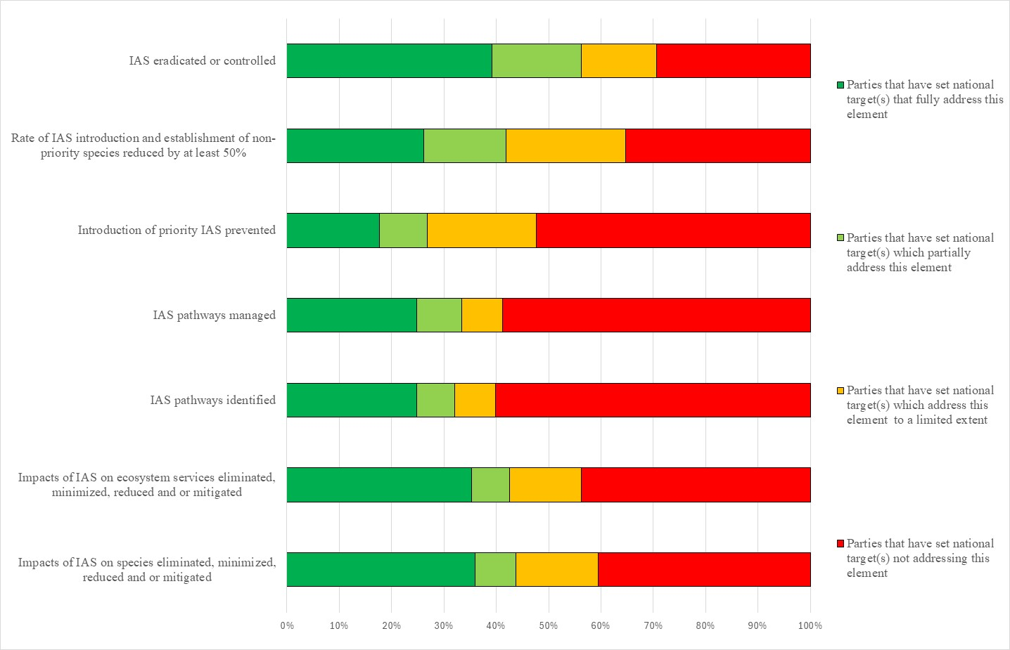Figure 14 – Assessment of the degree to which Parties have addressed the elements of GBF Target 6 in their national target(s). The coloured bars indicate the proportion of Parties that have set national targets which correspond to each assessment category. The number of Parties represented in each bar varies with the number of Parties that have submitted national targets related to a given target of the Kunming-Montreal Global Biodiversity Framework.
Target 7: reduce pollution to levels that are not harmful to biodiversity
- 150 Parties have submitted 347 national targets related to Target 7. On average a Party has submitted about 3 national targets related to Target 7 but the number ranges from 1 to 19. Of the national targets mapped by Parties to GBF Target 7, most (70%) were identified as contributing to Goal A, and 53%)were identified as contributing to Goal B. 14% of targets were identified as contributing to Goal C and 12%) to Goal D=. 34% of the national targets were also linked to GBF Targets 10 while around a quarter were linked to Target 1 (29%), 2 (26%), 3(23%) 4 (28%), 8 (27%) and 11 (27%).
- 47% of the national targets submitted by Parties were reported as having high alignment to GBF Target 7, 30% were reported as having medium alignment to the Target and 12% as having low alignment. For 11% of the national targets Parties did not indicate a degree of alignment.
- 8% of Parties have set national targets which fully address all elements of Target 7 and 9% have set targets which fully address half of the target elements. 28% of Parties have set national targets which fully address one but less than half of the target elements. 45% of Parties have set national targets which do not fully address any element of Target 7. 18% have set targets which address all or some elements to a partial extent. 11% of Parties have set national targets which address the elements of Target 7 to a limited extent and 16% of Parties have set national targets which do not address any element of Target 7.
- In the national targets submitted, there was a greater focus on the elements of Target 7 related to reducing pollution risks to levels that are not harmful to biodiversity and ecosystem services. 38% of Parties have set targets which fully or partially (34%) address the reducing pollutions risks to biodiversity and 32% of Parties have set targets which fully address reducing pollutions risks to ecosystem services. Fewer Parties have submitted targets addressing excess nutrients, pesticides or risks from highly hazardous chemicals. Around three quarters of Parties have set targets which address excess nutrients to a limited extent (45%) or not at all (29%) and which address pesticide risks to a limited extent (23%) or not at all (44%). Most Parties have set targets address risks from highly hazardous chemicals to a limited extent (25%) or not at all (57%). With regard to working towards the elimination of plastics, 29% of Parties have set targets which fully address this element (see figure 15).
- Less than a quarter of Parties have included quantitative measures in their national targets related to the reduction of excess nutrients lost to the environment (20%) and on the reduction of pesticide risk (21%). The majority of these have set targets which aim for a 50% reduction; however, the values range from 10% to 60%. Few Parties (13%) have set quantitative targets for the reduction of the risk from highly hazardous chemicals. The majority of these have set targets which aim for a 50% risk reduction.
- 49% Parties provided information on the means of implementation related to at least one of their national the targets related to Target 7. Of these, 78% indicated that additional means of implementation are required. 43% of the national target submissions contain information on the associated means of implementation. For targets with this information, 72% indicate that additional means of implementation are needed. About a third (23%) indicate that the means of implementation are available. Examples of commonly identified required means of implementation include technical and financial partnerships at the national, subregional, regional, and international levels; effective collaboration with stakeholders across sectors; and strengthened technical and scientific cooperation, training and capacity-building for specialists, upgrading and deploying necessary equipment, enforcement of relevant legislation, and the provision of adequate financial resources to support implementation efforts. See table 9 for more detailed examples of the capacity needs identified by Parties.
Table 9. Reported capacity needs identified in national targets
Category of needs | Subcategory of needs | Examples of specific needs
Technological | Technology related | - Improved access to remote sensors, mobile laboratories, global information systems, artificial intelligence tools and data management to enable accurate identification of pollution sources and evaluation of mitigation measures  - Enhanced collection and recycling infrastructure  - Improved access to safe waste receptors, tanks and incinerators for removing toxic and harmful materials
Technical | Information and data | - Improve national chemical databases and inventories  - Improve data on air pollution’s impacts on biodiversity  - Improved surveys of heavy metal pollutants
Technical | Scientific research | - Research on the impacts of pollution  - Use predictive models to assess the impacts of land-based nutrient inputs on coastal eutrophication and inform policy decisions
Technical | Monitoring and surveillance | - Improved monitoring and modelling to determine environmental concentrations and assess the risk of contaminants to vulnerable ecosystems
Technical | Capacity-building | - Improved capacity-building and technology transfer to farmers for enhanced use of sustainable agricultural practises
Technical | Human resources: training and skills | - Improved training of staff on pollution control and management
Technical | Communication and awareness | - Support for initiatives to promote behavioural change and public support for pollution reduction measures  - Improved awareness on air pollutions’ impacts on biodiversity  - Awareness campaigns on impacts of automobile exhaust emissions on ambient air in densely populated urban environments
Technical | International cooperation and knowledge transfer | - Enhanced cooperation among international agencies on chemical contamination
Technical | National and local cooperation and knowledge transfer | - Public-private partnerships to leverage resources and expertise from all sectors to address pollution challenges
Institutional | Regulatory and legal frameworks | - Improved implementation of regulations related to plastic pollution and ecologically friendly mining  - Updated regulations on empty container management  - Development of specific regulations for pesticides, agricultural fertilisers
- 17% of Parties provided information on the involvement of actors other than national governments for at least one of their national targets. At the national target level, 13% of national target submissions provide information on the involvement of non-State actors. Commonly reported actions include awareness-raising and advocacy, participating in pollution reduction initiatives, organizing community clean up initiatives, research and monitoring.
- 27% of Parties indicated that they would make use of component indicators, 25% indicated they would make use of complimentary indicators and 30% of Parties indicated they would make use of national indicators for monitoring implementation of their national targets associated with this target of the Framework. At the target level 24% of national targets identified component indicators and 22% identified complimentary indicators. 22% of national targets mapped to GBF Target 7 also identified national indicators. Examples of elements measured by these national indicators include the volume or the number of banned hazardous chemicals and pesticides used, the quantity of hazardous waste generated, the quantity of area or the number of instances in which environmentally friendly farming techniques are used, and water or air quality (via various indices).
- 62% of national target submissions contain information on which elements of section C of the Kunming-Montreal Global Biodiversity Framework the national target helps to address. The most addressed elements were collective effort towards the target (71%), whole-of-government and whole-of-society approach (69%) and the ecosystem approach (65%).
- 62% of national target submissions contained information on the associated policy measures. Commonly reported measures included:
  - Developing and strengthening legislation, policies, and institutional frameworks related to environmental monitoring, pollution control, and sustainable resource management, as well as establishing or reinforcing governing bodies to oversee these actions;
  - The creation of environmental management plans, stricter standards for pollutant emissions, and improved monitoring mechanisms for water, air, soil and biodiversity;
  - Strengthening measures to promote sustainable agriculture, including the use of climate-smart practices, improved risk assessments, and the reduction of harmful inputs like pesticides and fertilizers;
  - The mainstreaming of biodiversity into national development planning, protecting natural habitats and species, including through the establishment of red lists and restoration initiatives, addressing invasive species, and enhancing the resilience of ecosystems;
  - Promoting circular economy principles, such as waste reduction, recycling, and the use of durable, ecological materials, advancements in green technologies and renewable energy;
  - Capacity-building efforts, such as training farmers, engaging local communities, fostering public awareness, and creating mechanisms for citizen participation in environmental governance.

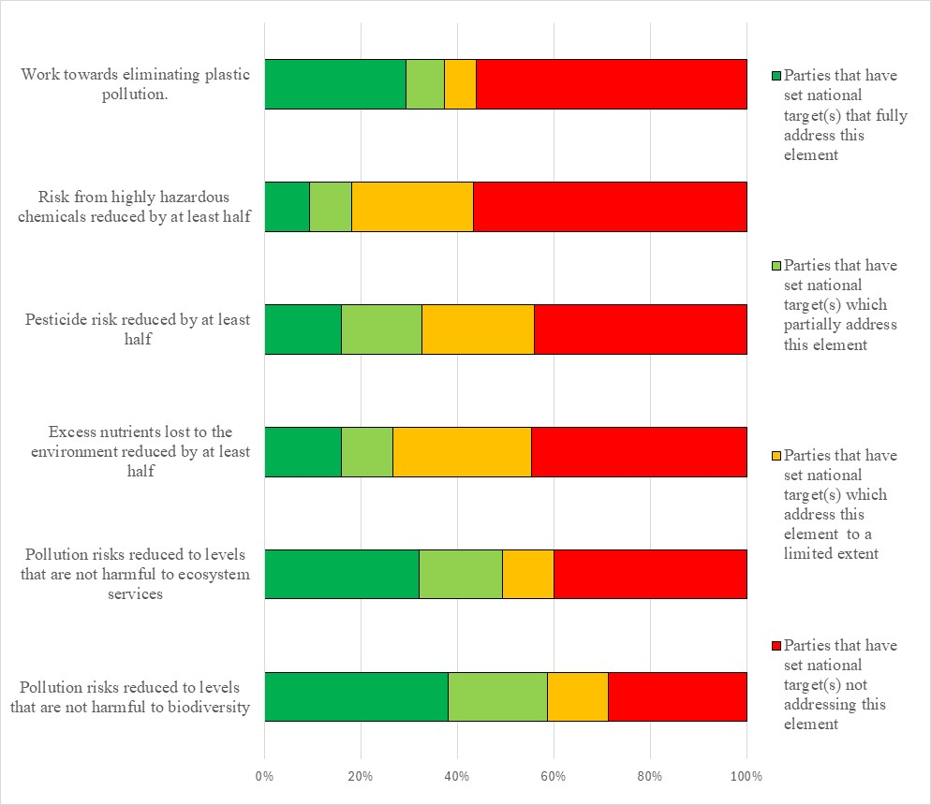Figure 15 – Assessment of the degree to which Parties have addressed the elements of GBF Target 7 in their national target(s). The coloured bars indicate the proportion of Parties that have set national targets which correspond to each assessment category. The number of Parties represented in each bar varies with the number of Parties that have submitted national targets related to a given target of the Kunming-Montreal Global Biodiversity Framework.
Target 8: minimize the impacts of climate change on biodiversity and build resilience
- 154 Parties have submitted 383 national targets related to Target 8. On average a Party has submitted 3 national targets related to Target 8 but the number ranges from 1 to 16. Of the national targets mapped by Parties to GBF Target 8, most (73%) were identified as contributing to Goal A, and 62% were identified as contributing to Goal B. 14% of national targets were identified as contributing to Goal C and 13% were identified as contributing to Goal D. 43% of the national targets were also linked to GBF Target 11 (41%) while 39% were linked to GBF Target 2, 34% were linked to Target 1 and 34% were linked to GBF Target 3..
- 50% of the national targets submitted by Parties were reported as having high alignment to GBF Target 8, 30% were reported as having medium alignment to the target and 10%) as having low alignment. For 10% of the national targets Parties did not indicate a degree of alignment.
- 20% of Parties have set national targets which fully address all elements of Target 8 and 40% of Parties have set targets which fully address half of the target elements. Few (6%) Parties have set national targets which fully address one but less than half of the target elements. 16% of Parties have set national targets which do not fully address any element of Target 8. 8% of Parties have set national targets which partially address all or some of the elements. 5% of Parties reported national targets which address the elements of Target 8 to a limited extent and 10% set national targets which did not address any element of Target 10..
- In the national targets submitted, there was a greater focus on the elements of Target 8 related to the effects of climate change as opposed to those of ocean acidification. 71% of Parties have set national targets which fully addressed the minimization of the impact of climate change on biodiversity. 53% of Parties have national targets which fully addressed the fostering of positive impacts of climate change on biodiversity. 48% of Parties fully addressed the element of the target related to the application of ecosystem-based approaches and 53% of Parties fully addressed the element related to nature-based solutions. 56% of Parties fully addressed minimize negative impacts of climate action on biodiversity in their national targets. 28% of Parties fully addressed the minimization of the impact of ocean acidification on biodiversity, (figure 16).
- 48% of Parties provided information on the means of implementation related to at least one of their national the targets related to Target 8. Of these, 80% indicated that additional means of implementation are required. 48% of the national target submissions contain information on the associated means of implementation. For targets with this information, 68% indicate that additional means of implementation are needed. 29% indicate that the means of implementation are available. Means for implementation commonly mentioned were financial, technical expertise and technological resources, capacity-building, training and awareness-raising, increased coordination and collaboration cross-sectoral and at multiple levels, institutional strengthening and logistics to roll out policy at ground level. See table 10 for more detailed examples of the capacity needs identified by Parties.
Table 10. Reported capacity needs identified in national targets
Category of needs | Subcategory and number of Parties | Examples of specific needs included in submissions
Technological | Technology related | - Improved access to climate change adaptation technology
Technical | Information and data | - Improved access to data on the impacts of climate change and sea level rise
Technical | Scientific research | - Research on the impact of climate change, ocean acidification, vulnerable ecosystems and endemic species  - Vulnerability and resilience assessments to analyse climate risks  - Improved data collection on sea level rise  - Research on ecosystems with high carbon sequestration to support protected areas planning  - Improved understanding of nature’s resilience to climate change  - Research on the impacts of slash and burn agriculture  - Research on genetic resources resistant to biotic and abiotic stresses
Technical | Monitoring and surveillance | - Meteorological data stations to monitor weather  - Early warning systems of climate change risks and hazards
Technical | Communication and awareness | - Improved education of the relationship between climate change and biodiversity across all education levels
Technical | National and local cooperation and knowledge transfer | - Establishment of a climate change institution to promote climate smart technologies across agriculture, food production and energy provision  - Improved access to knowledge on addressing challenges driven by increasing demand and competition for land by development programmes, mining, urbanization and agriculture  - Improved coordination between government agencies and the private sector to implement climate proofing and resilience building measures in protected areas  - Improved engagement of local communities and women in climate change adaptation programmes
Technical | Environmental governance and policy | - Ensure plans are adaptive and resilient to climate change  - Develop management plans for coastal areas  - Develop and implement adaptation plans to mitigate the impact of climate change on vulnerable ecosystems  - Reduce energy derived from fossil fuels and improve energy efficiency
- 19% of Parties provided information on the involvement of actors other than national governments for at least one of their national targets. At the national target level, 15% of national target submissions provide information on the involvement of non-State actors. Commonly included in the submissions were conservation and restoration initiatives, financing, environmental education and research, and the application of ecosystem-based approaches and nature-based solutions from a range of actors including non-governmental organizations, the private entities, indigenous peoples and local communities, youth groups, and academic institutions.
- 29% of Parties indicated that they would make use of component indicators, 28% of Parties indicated that they would use complimentary indicators and 29% of Parties indicated that they would use national indicators for monitoring implementation of their national targets associated with this target of the Framework. At the target level 26% national targets identified component indicators, complimentary indicators and national indicators. Examples of elements measured by these national indicators include the area of degraded and restored land, the number of nature-based solutions and the quantity of greenhouse gas emissions that they absorbed, and the degree of implementation of national disaster risk strategies. The national indicators for GBF Target 8 sometimes addressed specific ecosystems, usually forests or coral reefs.
- 67% of national target submissions contain information on which elements of section C of the Kunming-Montreal Global Biodiversity Framework the national target helps to address. The most addressed elements were the ecosystem approach (75%), consistency with international agreements or instruments (72%), collective effort towards the target (71%) and whole-of-government and whole-of-society approach (71%). Comparatively few targets addressed different value systems (29%) or the right to development (32%)
- 67% of national target submissions contained information on associated policy measures. The most commonly mentioned policy measures fall into four broad categories; increasing knowledge of the current status and future scenarios of biodiversity and climate change, mainstreaming biodiversity and climate change concerns into decision-making, taking actions to restore biodiversity, and promoting wider stakeholder participation and building their capacity.

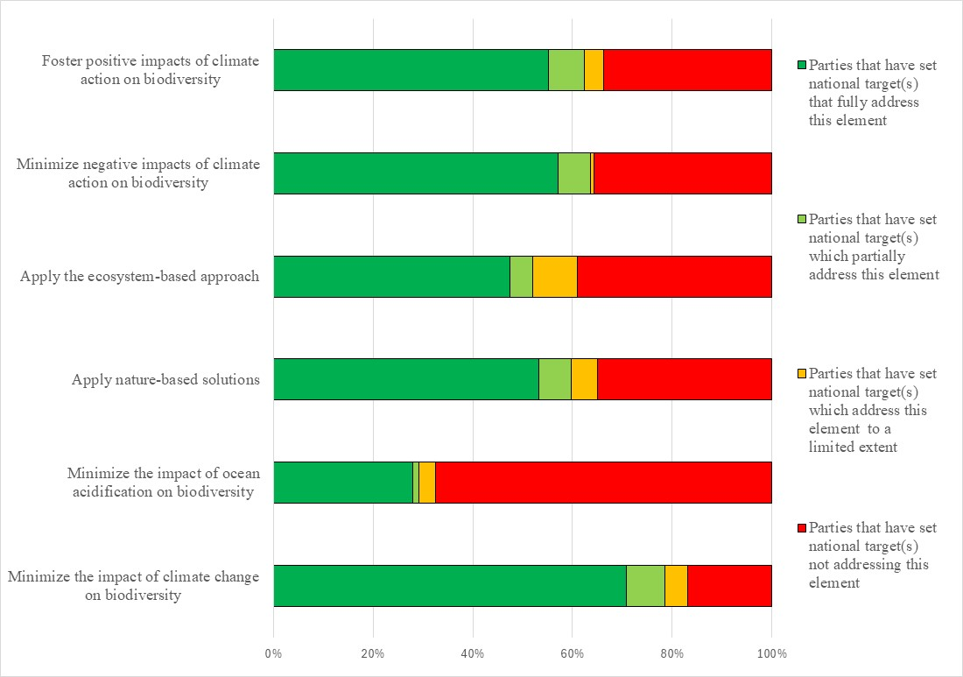Figure 16 – Assessment of the degree to which Parties have addressed the elements of GBF Target 8 in their national target(s). The coloured bars indicate the proportion of Parties that have set national targets which correspond to each assessment category. The number of Parties represented in each bar varies with the number of Parties that have submitted national targets related to a given target of the Kunming-Montreal Global Biodiversity Framework.
Target 9: manage wild species sustainably to benefit people
- 150 Parties have submitted 360 national targets related to Target 9. On average a Party has submitted 3 national targets related to Target 9, but the number ranges from 1 to 13. 62% of the national targets mapped by Parties to GBF Target 9 were also identified as contributing to Goal A and 79% were mapped to Goal B. . 32% of national targets were identified as contributing to Goal, and 15% were identified as contributing to Goal D. National targets related to Target 9 were also most commonly linked to GBF Targets 4 (46%), 5 (54%), and 10 (45%).
- 44% of the national target submitted by Parties were reported as having high alignment to GBF Target 9 and 36% were reported as having medium alignment, while 10% hade low alignment. For 9% of the national targets, Parties did not indicate a degree of alignment.
- 13% of Parties have set national targets which fully address all elements of Target 9 and 21% have set targets which fully address half of the target elements. 17% of Parties have set national targets which fully address one but less than half of the target elements. 49% of Parties have set national targets which do not fully address any element of Target 9. 25% of Parties have set national targets which partially address all or some of the elements. 14% of Parties have set national targets which address the elements of Target 9 to a limited extent and 9% of Parties have set national targets which do not address the elements of Target 9.
- In the national targets submitted, there was a greater focus on the elements of Target 9 related to environmental benefits, with 41% of Parties fully addressing this element. Fewer national targets fully addressed the economic (36%) or social (37%) benefits of the sustainable management and use of wild species. Similarly fewer Parties fully addressed the benefits for people in vulnerable situations (23%), the protection and encouragement of customary sustainable use by indigenous peoples and local communities (19%) and benefits to people derived from biodiversity-based activities, products and services (17%) (figure 17).
- 50% of Parties provided information on the means of implementation related to at least one of their national the targets related to Target 9. Of these, 77% indicated that additional means of implementation are required. 48% of the national target submissions contain information on the associated means of implementation. For targets with this information, most (78%) indicate that additional means of implementation are needed. 18% indicate that the means of implementation are available. The most commonly identified required means of implementation were financial resources, capacity-building and institutional strengthening, followed by technology transfer and technical assistance, and scientific research and cooperation. See table 11 for more detailed examples of the capacity needs identified by Parties.
Table 11. Reported capacity needs identified in national targets
Category of needs | Subcategory of needs | Examples of specific needs
Technological | Technology related | - Geographic information systems and remote sensing to map the extent and spatial distribution of wild species of high conservation, economic and forage value
Technical | Information and data | - Generate and update existing data from studies, surveys and databases on wild species
Technical | Scientific research | - Conduct field studies to identify species of high economic value, endangered or highly exploited species (plants and medicinal organisms), considering population trends, habitat quality and threats  - Identify species suitable for ex-situ propagation and conduct research on propagation techniques and breeding methods for each species  - Strengthen the production of native species to replace exotic species for food  - Identify species which are being used (medicinal plants, non-timber forest products, artisanal fishing)
Technical | Monitoring and surveillance | - Improve traceability mechanism for the exploitation and trade in wildlife within and across countries borders
Technical | Communication and awareness | - Share information on successful propagation techniques to local users  - Increase education and awareness of the importance of sustainable exploitation of resources
Technical | International cooperation and knowledge transfer | - Enhanced involvement of relevant non-governmental organizations  - Establish nurseries, greenhouses, breeding facilities in collaboration with research institutes and universities to cultivate and propagate selected species
Technical | National and local cooperation and knowledge transfer | - Identify the diverse groups of people using wild species and involve them in wild species management committees
Institutional | Regulatory and legal frameworks | - Improve consistency with the United Nations Declaration on the Rights of Indigenous People to ensure harvesting rights are respected and support indigenous leadership, interests and values on wild species management
Institutional | Environmental governance and policy | - Develop standardized protocols and risk assessments for ex-situ propagation and species breeding  - Strengthen co-responsibility in decision-making with communities on sustainable use of resources
- 13% of Parties provided information on the involvement of actors other than national governments for at least one of their national targets. At the national target level, 16% of national target submissions provide information on the involvement of non-State actors. National target submissions highlighted nongovernment organizations, community-based organizations, indigenous peoples and local communities, faith-based groups, private sector companies, academia and research institutions, youth networks, and development partners. These actors contribute through research, education, funding, advocacy and direct conservation activities.
- 27% of Parties indicated that they would make use of component or complimentary indicators and 25% indicated they would would use national indicators for monitoring implementation of their national targets associated with this target of the Framework. At the target level 28% of national target submissions identified component indicators 26% identified complimentary indicators and 16% identified national indicators Examples of elements measured by these national indicators include the number of wild species identified as being of high social or economic value that have been identified or brought under protection, the number of regions engaged in sustainable management practices, and the percentage of the population using and benefiting from wild resources. Several national indicators for GBF Target 9 identify ecosystem services provided by wild species. While the medicinal applications of wild species were the most frequently mentioned, food, energy, and culture were also integrated into indicators.
- 69% of national target submissions contain information on which elements of section C of the Kunming-Montreal Global Biodiversity Framework the national target helps to address. The most commonly addressed elements were collective effort towards the targets (73%), whole-of-government and whole-of-society approach (68%), ecosystem approach (68%), national circumstances, priorities and capabilities (66%), , and contribution and rights of indigenous peoples and local communities (64%). Comparatively few targets addressed the right to development (34%) and different value systems (36%).
- 65% of national target submissions contained information on the associated policy measures. Common measures include strengthening policies for sustainable fisheries, forestry, and wildlife management; ensuring equitable community participation; supporting sustainable local projects; promoting gender and youth inclusion; mainstreaming biodiversity across sectors; and advancing research and disease risk management.

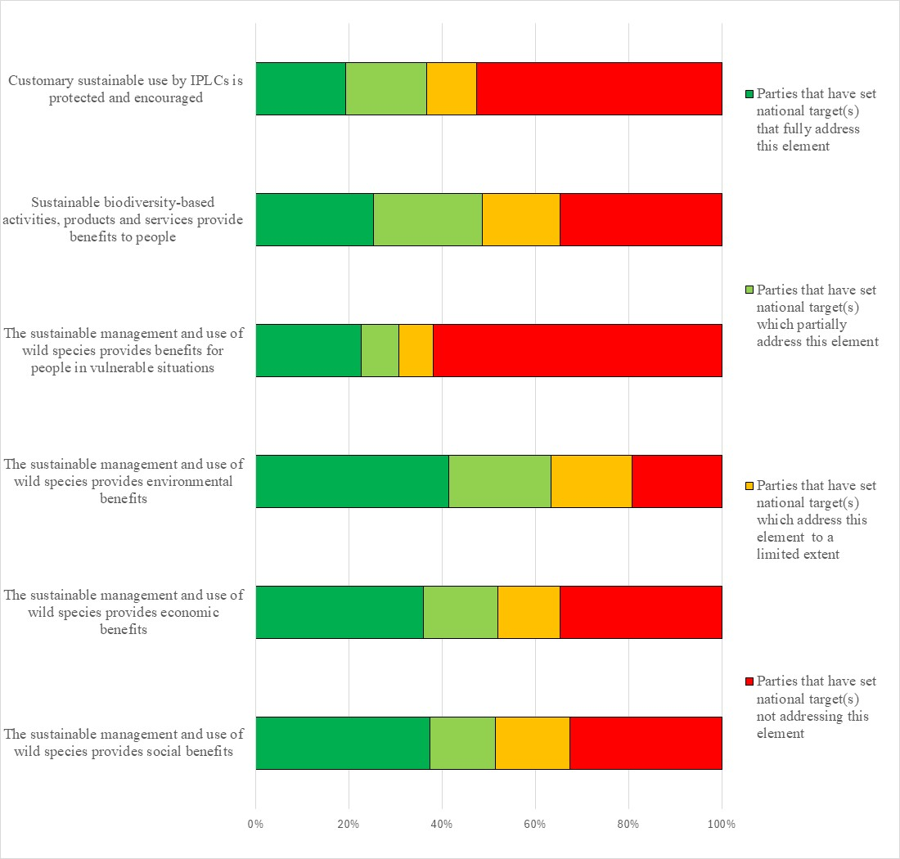Figure 17 – Assessment of the degree to which Parties have addressed the elements of GBF Target 9 in their national target(s). The coloured bars indicate the proportion of Parties that have set national targets which correspond to each assessment category. The number of Parties represented in each bar varies with the number of Parties that have submitted national targets related to a given target of the Kunming-Montreal Global Biodiversity Framework.
Target 10: enhance biodiversity and sustainability in agriculture, aquaculture, fisheries and forestry
- 152 Parties have submitted 492 national targets related to Targe 10. On average a Party has submitted 4 national targets related to Target 10, but the number ranges from 1 to 27. Of the national targets mapped by Parties to GBF Target 10, 79% were identified as contributing to Goal B and 61% as contributing to Goal A. 17% were identified as contributing to Goals C (19%) and 15% as contributing to Goal D (13%). Around a third of the national targets were also linked to GBF Targets 4 (33%), 9 (32%), and 11 (38%).
- 50% of the national targets submitted by Parties were reported as having high alignment to GBF Target 10 and 29% were reported as having medium alignment, while 12% were reported as having low alignment. For 9% of the national targets, Parties did not indicate a degree of alignment.
- 14% Parties have set national targets which fully address all elements of Target 10 and 26% have set targets which fully address half of the target elements. 46% of Parties have set national targets which fully address one but less than half of the target elements. 24% of Parties have set national targets which do not fully address any element of Target 10. 13% of Parties have set national targets which partially address all or some of the elements. 5% of Parties have set national targets which address the elements of Target 10 to a limited extent and 7% of Parties have set national targets which do not address any element of the target.
- In the national targets submitted, there was a greater focus on the elements of Target 10 related to the sustainable management of areas under agriculture, fisheries and forestry, with 61%, 57% and 58%respectively, of Parties fully addressing these elements. Around half of the 41% of Parties fully addressed the element of GBF target 10 related to the sustainable management of areas under aquaculture in their national targets. 41% of Parties fully addressed the element related to the application of biodiversity friendly practices and 34% fully addressed the contribution of sustainable management to conservation and restoration . 36% of Parties fully addressed the elements related to resilience, efficiency and productivity , 34% of Parties fully addressed the element of the target related to food security and 26% of Parties fully addressed the element related to maintaining nature’s contribution to people (34%) (see figure 18).
- A51% of Parties provided information on the means of implementation related to at least one of their national the targets related to Target 10. Of these, 82% indicated that additional means of implementation are required. 47% of the national target submissions contain information on the associated means of implementation. For targets with this information, 77% indicate that additional means of implementation are needed. 19% indicate that the means of implementation are available. The most commonly mentioned required means of implementation included funding from internal and external sources, capacity-building, technical and technological support and improvements, and scientific research and collaboration. See table 12 for more detailed examples of the capacity needs identified by Parties.
Table 12. Reported capacity needs identified in national targets
Category of needs | Subcategory of needs | Examples of specific needs
Technological | Technology related | - Technology for farmers to maintain productivity through sustainable agricultural practises, such as integrated pest management, crop rotation, biological pest control, use of pest resistant crop varieties, and more productive crop varieties  - Develop and implement water saving technology, including modern irrigation and drainage  - Improved access to geographic information systems and remote monitoring tools to map the extent and spatial distribution of areas for sustainable fisheries and forests  - Modernise fishing techniques
Technical | Information and data | - Improved and updated data on productive marine and land areas
Technical | Scientific research | - Identification of pathogens of concern in marine and terrestrial farming activities and research pathogen risk and management strategies  - Identification of the conservation status of productive lands  - Research on carrying capacity and livestock population trends  - Research on the impact of climate change on agriculture
Technical | Capacity-building | - Strengthen capacity of local communities on sustainable forest management techniques and harvesting
Technical | Human resources: training and skills | - Training personnel in spatial planning, natural resource management, geographic information systems and monitoring  - Training fishers in sustainable fishing practises, stock management and markets  - Increasing knowledge on the impacts of unapproved pesticides
Technical | National and local cooperation and knowledge transfer | - Improved delegation of responsibilities to local authorities to promote participatory and efficient management
Institutional | Regulatory and legal frameworks | - Adjust current policies to ensure existing legislation can accommodate the mainstreaming of sustainable fisheries and agriculture  - Strengthen regulatory framework and institutional capacity to incorporate sustainable forestry management
Institutional | Environmental governance and policy | - Promote the use of climate smart agriculture and land use is integrated into policies  - Promote policies on pollinator management and develop guidance for inland aquaculture, agroforestry, unregulated razing practices and controlling factory and vehicle smoke near forests
- 17% of Parties provided information on the involvement of actors other than national governments for at least one of their national targets. At the national target level, 14% of national target submissions provide information on the involvement of non-State actors. Submissions highlight that non-State actors play a vital role in biodiversity conservation through research, restoration, education, and sustainable practices, with many providing specific examples of ongoing commitments; however, some indicate that further engagement and better coordination are needed to maximize their impact on the national target.
- 27% of Parties indicated that they would make use of component indicators, 32% of Parties indicated they would use complimentary indicators and 49% of Parties indicated they would use national indiators for monitoring implementation of their national targets associated with this target of the Framework. At the target level, 22% of national target submissions identified component indicators, 24% of submissions identified complimentary indicators and 42% of submissions identified national indicators. There were more national indicators reported related to agriculture and forestry compared to aquaculture and fisheries. Examples of elements measured by these national indicators include the quantity of forested land, the quantity of area or the number of instances in which environmentally friendly farming techniques are used, and the proportion of plans (across all four sectors) which address sustainability practices.
- 65% of national target submissions contain information on which elements of section C of the Kunming-Montreal Global Biodiversity Framework the national target helps to address. The most commonly addressed elements were ecosystem approach (77%), collective effort towards the targets (75%), and whole-of-government and whole-of-society approach (75%).
- 65% of national target submissions contained information on the associated policy measures. Common measures include strengthening legal and enforcement frameworks; improving monitoring, data management, and early warning systems; raising public awareness and education; building capacity among stakeholders; promoting sustainable land and resource management; supporting financial incentives like Payments for Ecosystem Services; and implementing national action and restoration plans for biodiversity and ecosystem health.

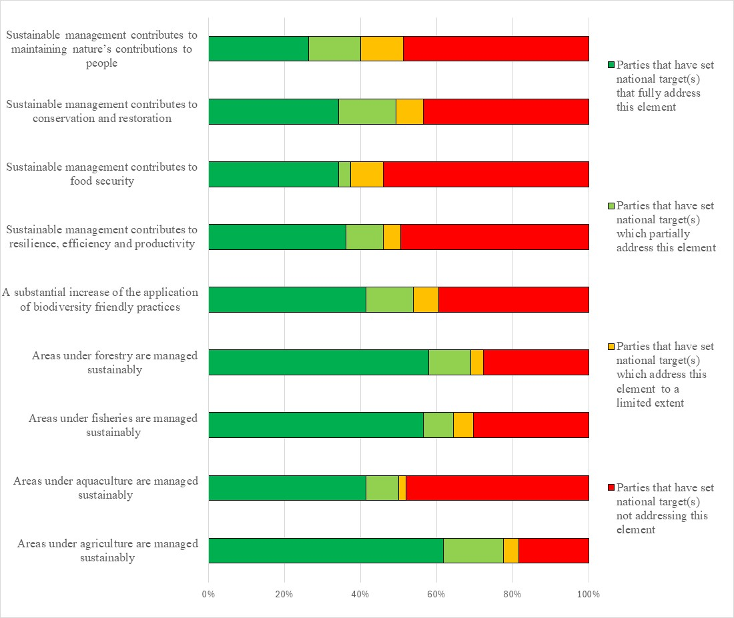Figure 18 – Assessment of the degree to which Parties have addressed the elements of GBF Target 10 in their national target(s). The coloured bars indicate the proportion of Parties that have set national targets which correspond to assessment each category. The number of Parties represented in each bar varies with the number of Parties that have submitted national targets related to a given target of the Kunming-Montreal Global Biodiversity Framework.
Target 11: restore, maintain and enhance nature’s contributions to people
- 148 Parties have submitted 464 national targets related to Target 11. On average a Party has submitted 4 national targets related to Target 11 but the number ranges from 1 to 41. Of the 464 national targets mapped by Parties to GBF Target 11, 68% were identified as contributing to Goal A, 77% were identified as contributing to Goal B,. Comparatively few were identified as contributing to Goals C (18%) and D (15%). 41% of national targets were also linked to GBF Target 10 , 38% were linked to Target 2, 35% were linked to Target 5and 34% were linked to Target 1..
- 47% of the national targets submitted by Parties were reported as having high alignment to GBF Target 11, 37% were reported as having medium alignment to the Target and 9% were reported as having low alignment. For 8% of the national targets Parties did not indicate a degree of alignment.
- 14% of Parties have set national targets which fully address all elements of Target 11 and 5% have set targets which fully address half of the target elements. 27% of Parties have set national targets which fully address one but less than half of the target elements. 54% of Parties have set national targets which do not fully address any element of Target 11. 20% of Parties have set national targets which partially address all or some of the elements. 16% of Parties reported national targets which address the elements of Target 11 to a limited extent. 18% of Parties set national targets which address none of the elements of Target 11.
- With regard to the elements of Target 11, 35% Parties have set national targets which fully address the element of the GBF target related to restoring, maintaining and enhancing nature’s contributions to people through ecosystems-based approaches while 31% have set targets fully addressing the element related to restoring, maintaining and enhancing nature’s contributions to people through nature based solutions. 20% of Partes have set national targets fully addressing the restoration, maintenance and enhancement of air, water and climate regulation. 20% of Parties have set national targets fully addressing the restoration, maintenance and enhancement of soil health, and 18% of Parties have set national targets fully addressing the element related to pollination. 21% of Parties have set national targets fully addressing the restoration, maintenance and reduction of disease and 26% of Parties have set national targets fully addressing the element related to the the restoration, maintenance and enhancement of protection from natural hazards and disasters (figure 19).
- 52% of Parties provided information on the means of implementation related to at least one of their national the targets related to Target 11. Of these, 85% indicated that additional means of implementation are required. 45% of the national target submissions contain information on the associated means of implementation. For targets with this information, 73% indicate that additional means of implementation are needed while about a quarter (23%) indicate that the means of implementation are available. Means for implementation commonly mentioned as being needed were awareness-raising, capacity-building, financial resources, policy instruments and legislative changes, including interministerial and sectoral cooperation, and technology transfer. See table 13 for more detailed examples of the capacity needs identified by Parties.
Table 13. Reported capacity needs identified in national targets
Category of needs | Subcategory of needs | Examples of specific needs
Technological | Technology related | - Improved access to economic evaluation tools to quantify species contributions to human well-being, with frameworks for tracking and measuring benefits
Technical | Information and data | - Improved data on ecosystem services and functions (flood regulation, soil stabilization, pollination, habitat provision, regulation of air, water, climate, disease)  - Development of simple metrics to assess changes in ecosystem functions and services  - Identification of gaps in ecosystem services to improve hazard and disaster resilience
Technical | Scientific research | - Assessments of the full range of ecosystem services (especially understudied services) to understand their diversity, complexity and interconnectedness
Technical | Human resources: training and skills | - Training and support for identifying and improving market access to locally produced products and raw materials from biodiversity resources and enterprises
Technical | Communication and awareness | - Improved awareness of nature-based solutions  - Raised awareness of the importance of sustainable exploitation of resources
Technical | National and local cooperation and knowledge transfer | - Convening of workshops, training sessions and seminars for farmers, restoration practitioners and policymakers to disseminate knowledge and best practices on the benefits and application of agrobiodiversity and ecosystem services  - Improved sharing of traditional knowledge on ecosystem services
Technical | Environmental governance and policy | - Development of comprehensive nature-based solution frameworks and the facilitation of their integration and use across all sectors and governance levels to enhance mainstreaming  - Support for economic incentives to promote sustainable practises, such as payment for ecosystem services and green bonds  - Support for schemes where beneficiaries of ecosystem services (water users, carbon credit buyers) pay landowners and communities for maintaining these services  - Improved consideration of climate change, pressure on natural resources, organized crime and uncontrolled competition for land use in rural areas on ecosystem services
- 20% of Parties provided information on the involvement of actors other than national governments for at least one of their national targets. At the national target level, 16% of national target submissions provide information on the involvement of actors other than national governments. Common actions included community engagement, financing, technology and research, and the application of ecosystem-based approaches and nature-based solutions from a range of actors, including non-governmental organizations, private entities, indigenous peoples and local communities, youth groups, and academic institutions.
- 27% of Parties indicated that they would make use of component (or complimentary indicators for monitoring implementation of their national targets associated with this target of the Framework. 29% of Parties indicated that they would make use of national indicators. At the target level, 25% of national target submissions identified component indicators and complimentary indicators (25%). 16% of national targets mapped to GBF Target 11 identified national indicators. There were more national indicators related to soil, water, and air quality compared to the status of pollinators, the reduction of disease risk, and the protection from natural hazards.
- 69% of national target submissions contain information on which elements of section C of the Kunming-Montreal Global Biodiversity Framework the national target helps to address. The most commonly addressed elements were the ecosystem approach (74%), collective effort towards the targets (68%) and whole-of-government and whole-of-society approach (62%) and national circumstances, priorities and capabilities (61%). Comparatively few targets addressed different value systems (29%), the right to development (26%) or intergenerational equity (32%).
- 66% of national target submissions contained information on associated policy measures. Some commonly mentioned policy measures include climate-smart agricultural practices, including ones that support pollinators, river basin and/or forest management plans, education and outreach programmes, integration of ecosystem services into national accounting and decision-making processes, and the development or strengthening of pollution guidelines and regulations. Many of these policy measures were proposed in conjunction with or in the context of nature-based solutions and ecosystem-based approaches.

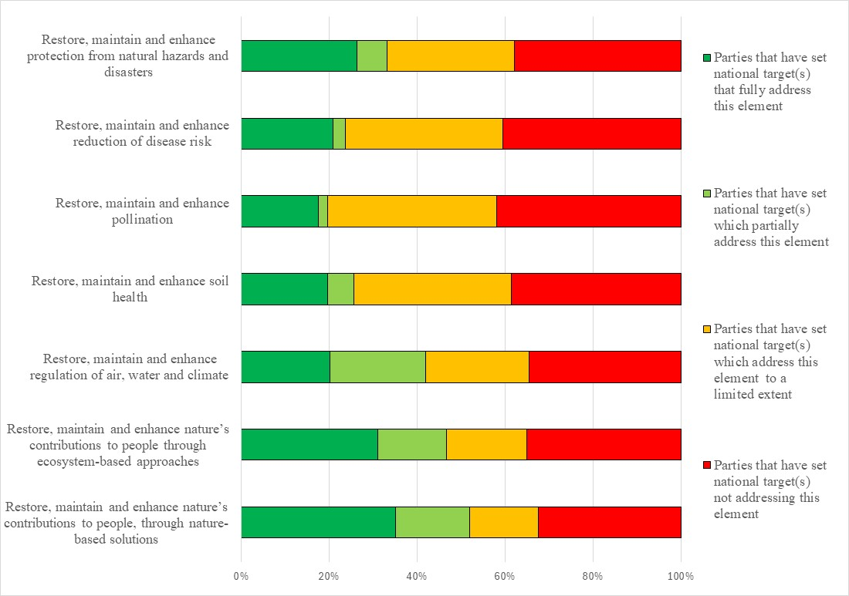Figure 19 – Assessment of the degree to which Parties have addressed the elements of GBF Target 11 in their national target(s). The coloured bars indicate the proportion of Parties that have set national targets which correspond to each assessment category. The number of Parties represented in each bar varies with the number of Parties that have submitted national targets related to a given target of the Kunming-Montreal Global Biodiversity Framework.
Target 12: enhance green spaces and urban planning for human well-being and biodiversity
- 147 Parties have submitted 309 national targets related to Target 12. On average a Party has submitted 3 national targets related to Target 12 but the number ranges from 1 to 10. Of the national targets mapped by Parties to GBF Target 12, 72% were identified as contributing to Goal B and 56% were identified as as contributing to Goal A. Fewer were identified as contributing to Goals C (17%) and D (15%). 42% of the national targets were also linked to GBF Target 11 while 38% were linked to GBF Target 1, 32% were linked to Target 2 (32%), 30% were linked to Target 8, and 31% were linked to Target 10.
- (49% of the national targets submitted by Parties were reported as having high alignment to GBF Target 12, 31% were reported as having medium alignment and 11% as having low alignment. For 9% of the national targets Parties did not indicate a degree of alignment.
- 5% of Parties have set national targets which fully address all elements of Target 12 and 18% have set targets which fully address half of the target elements. 37% of Parties have set national targets which fully address one but less than half of the target elements. 39% of Parties (39%) have set national targets which do not fully address any element of Target 12. 12% Parties (11%) have set national targets which partially address all or some of the elements. 14% of Parties have set national targets which address the elements of Target 12 to a limited extent) or not at all (14%).
- In the national targets submitted there was a greater focus on the elements of Target 12 related to the area of green spaces then blue spaces. 45% of Parties have set national targets fully addressing an increase the area of green spaces while 33% have set national targets fully addressed an increase in blue spaces. Around a third of Parties have set national targets which fully the elements of Target 12 related to an increase of the connectivity of green and blue spaces (31%), ensuring biodiversity inclusive urban planning (37%) and that biodiversity inclusive urban planning improved health, Around a quarter of Parties have fully addressed the elements of Target 12 related to an increase of the quality of green and blue spaces (29%), increasing access and benefits from green and blue spaces (22%) and well-being and connectedness with nature (27%). Comparatively fewer Parties have set national targets fully addressed the elements of Target 12 related to mainstreaming the conservations and sustainable us of biodiversity in urban and densely populated areas (14%) and enhancing native biodiversity in urban and densely populated areas (16%) (Figure 20).
- 49% of Parties (31%) provided information on the means of implementation related to at least one of their national the targets related to Target 12. Of these, 80% indicated that additional means of implementation are required. 43% of the national target submissions contain information on the associated means of implementation. For targets with this information, most (75%) indicate that additional means of implementation are needed and most of the remaining targets (22%) indicate that the means of implementation are available. Means for implementation commonly mentioned included technology transfer, technical assistance, and capacity-building but the most frequently identified was financial resources. See table 14 for more detailed examples of the capacity needs identified by Parties.
Table 14. Reported capacity needs identified in national targets
Category of needs | Subcategory of needs | Examples of specific needs
Technological | Technology related | - Evaluate effectiveness of existing technologies for native species in urban green spaces  - Improved access to geographic information systems and remote sensing to update integrated urban plans for coastal areas  - Improved access to innovative technological approaches to urban planning
Technical | Information and data | - Databases on land use/cover considering urban planning in coastal zones  - Identification and catalogue native species suitable for urban forestry and green spaces
Technical | Scientific research | - Assess current urban plans to identify gaps in green space and shade provisions  - Analyse current urban expansion trends and their impact on green spaces  - Evaluate the status of plant populations in urban areas  - Research the relationship of biodiversity to the well-being of a city’s inhabitants
Technical | Capacity-building | - Greater physical and human capacity to keep green and blue spaces clean
Technical | Human resources: training and skills | - Capacity-building for urban planners, coastal management experts, environmental scientists, and policy advisors to better consider biodiversity in urban areas
Technical | National and local cooperation and knowledge transfer | - Promote indigenous leadership and stewardship of urban green and blue spaces  - Involve local communities in decision-making and green space management to foster ownership and responsibility
Institutional | Regulatory and legal frameworks | - Refine legislative proposals with input from urban planners, environmental experts and community representatives  - Improve enforceability and compliance with planning documents
Institutional | Environmental governance and policy | - Integrate green and blue spaces into urban development plans  - Improved consideration of climate change in urban plans  - Offer financial and tax incentives to developers who include green spaces in their projects and homeowners who green their properties  - Better address challenges related to land-use conflicts and limited urban space which constraints the development of green areas  - Establish urban water use committee  - Restore current urban areas
- 17% of Parties provided information on the involvement of actors other than national governments for at least one of their national targets. At the national target level, 15% of national target submissions provide information on the involvement of non-State actors. Common actions included financing and implementation support from a range of actors, including NGOs, private entities, indigenous peoples and local communities, youth groups, and academic institutions.
- 24% of Parties indicated that they would make use of component (24%) or and 20% indicated that they would make of use complimentary (20%) indicators for monitoring implementation of at least one of their national targets associated with this target of the Framework. 31% of Parties indicated that they would make use of at least one national indicator for their targets associated with Target 12 of the Framework. At the target level, 21% of national target submissions identified associated component indicators and 18% identified complimentary indicators. 21% of national targets identified supplementary national indicators. Examples of elements measured by these national indicators include the share of urban plans that have been updated according to urban greening guidelines, the proportion of the urban population with access to green or blue spaces, and the proportion of native species in urban green and blue spaces. While national indicators did distinguish between urban green spaces and blue spaces, further disaggregation was infrequent.
- 635 of national target submissions contain information on which elements of section C of the Kunming-Montreal Global Biodiversity Framework the national target helps to address. The most addressed elements were collective effort towards the target (73%), the ecosystem approach (70%), and whole-of-government and whole-of-society approach (75%). Comparatively few targets addressed different value systems (34%), and the right to development (35%).
- 68% of national target submissions contained information on the associated policy measures. Some commonly mentioned policy measures include climate adaptation initiatives, such as tree planting, mainstreaming of green infrastructure into urban plans, mapping and/or development of urban green and/or blue spaces, water management directives, and knowledge management initiatives.

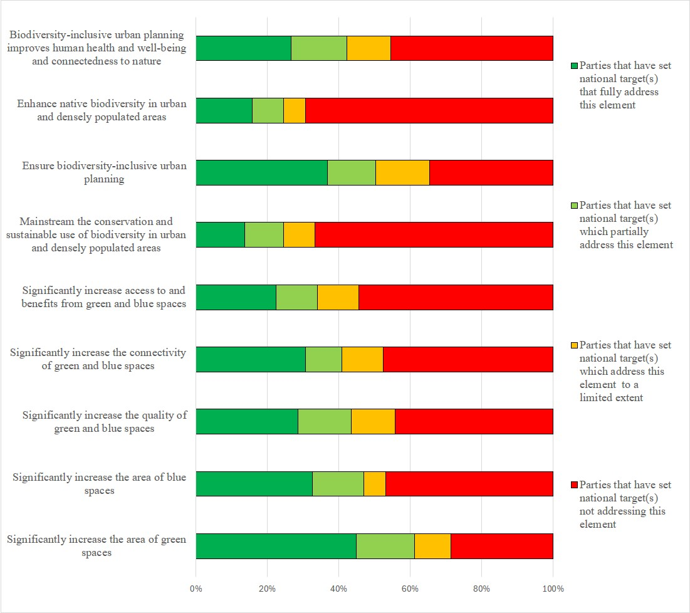Figure 20 – Assessment of the degree to which Parties have addressed the elements of GBF Target 12 in their national target(s). The coloured bars indicate the proportion of Parties that have set national targets which correspond to each assessment category. The number of Parties represented in each bar varies with the number of Parties that have submitted national targets related to a given target of the Kunming-Montreal Global Biodiversity Framework.
Target 13: increase the sharing of benefits from genetic resources, digital sequence information and traditional knowledge
149 Parties have submitted 278 national targets related to Target 13. 79% of the Parties that submitted national targets related to Target 13 were also Parties to the Nagoya Protocol on Access to Genetic Resources and the Fair and Equitable Sharing of Benefits Arising from their Utilization. On average a Party has submitted 2 national targets related to Target 13 but the number ranges from 1 to 10. Of the national targets mapped by Parties to GBF Target 13, most were identified as contributing to Goal C (72%). 35% were linked to Goal A, 37% were linked to Goal B. and 22% were linked to Goal D. National targets related to Target 13, in comparison to other national targets, were not often linked to other national targets. The national targets linked to Targtet 13 were mostly commonly also linked to Targets 4(25%), 5(25%), and 9 (26%).55% of the national targets submitted by Parties were reported as having high alignment to GBF Target 13, 25% were reported as having medium alignment to the Target, and more than a tenth (13%) as having low alignment. For 12% of the national targets Parties did not indicate a degree of alignment.
- 21% of Parties have set national targets which fully address all elements of Target 13 and 26% have set targets which fully address half of the target elements. 24% of Parties have set national targets which fully address at least one element of the Target.30% of Parties have set national targets which do not fully address any element of Target 13. 9% of Parties have set national targets which partially address all or some of the elements. 5% of of Parties reported national targets which address the elements of Target 13 to a limited extent and 16% of Parties set national targets which did not address any element of Target 16..
- In the national targets submitted, more Parties fully addressed the facilitation of appropriate access to genetic resources (51%) compared to the facilitation of a significant increase of the benefits shared (38%). There were also more targets which fully addressed the elements of Target 13 related to genetic resources than digital sequence information and the benefits that arise from traditional knowledge associated with genetic resources. Furthermore, there was generally a greater focus on legal policy and administrative measures as opposed to capacity-building measures (see figure 21):
  - 59% of Parties set targets which fully addressed taking legal, policy and administrative measures to ensure the fair and equitable sharing of benefits that arise from their utilization. Fewer Parties (46%) had targets fully addressing taking capacity-building measures to ensure fair and equitable benefit-sharing;
  - 39% of Parties set targets which fully addressed taking legal, policy and administrative measures to ensure the fair and equitable sharing of benefits that arise from the utilization of digital sequence information on genetic resources. 34% of Parties had targets fully addressing taking capacity-building measures to ensure the fair and equitable sharing of benefits that arise from the utilization of digital sequence information on genetic resources;
  - 49% of Parties set targets which fully addressed taking legal, policy and administrative measures to ensure the fair and equitable sharing of benefits that arise from traditional knowledge associated with genetic resources42% of Parties had targets fully addressing taking capacity-building measures to ensure the fair and equitable sharing of benefits that arise from traditional knowledge associated with genetic resources.
- 51% of Parties provided information on the means of implementation related to at least one of their national the targets related to Target 13. Of these, 82% indicated that additional means of implementation are required. 52% of the national target submissions contain information on the associated means of implementation. For targets with this information, 83% of submissions indicate that additional means of implementation are needed. (13%) of submissions indicate that the means of implementation are available. Means for implementation commonly mentioned were financial and human resources, identifying and filling capacity gaps, awareness-raising, and the creation or enhancement of administrative, legal, and/or institutional frameworks, including explicit linkages with the Nagoya Protocol. See table 15 for more detailed examples of the capacity needs identified by Parties.
Table 15. Reported capacity needs identified in national targets
Category of needs | Subcategory of needs | Examples of specific needs
Technological | Technology related | - Increase technical capacity of laboratories, digital sequencing and genotyping facilities  - Technological systems for detection, traceability, verification and reference of genetic resources
Technical | Information and data | - Gather and collect a greater range of genetic information and traditional knowledge associated with genetic resources and ensure it is freely accessible to research institutions  - Interpret findings of genetic studies for conservation  - Improve databases on the use and benefit-sharing arising from the utilization of genetic resources  - Develop gene banks and collection systems
Technical | Monitoring and surveillance | - Designate national checkpoints for monitoring and traceability of genetic resources and associated traditional knowledge
Technical | Capacity-building | - Capacity-building to start DSI at a national level  - Capacity-building for indigenous peoples and local communities to negotiate benefit-sharing agreements
Technical | Human resources: training and skills | - Train stakeholders in access and benefit sharing mechanisms to ensure their effective implementation, including the design of training models on access and benefit-sharing regulations, digital sequence information and their relationships to relevant conventions and processes
Technical | Communication and awareness | - Increased public and sectoral awareness of access and benefit sharing and the economic and socio-cultural value of genetic resources
Technical | National and local cooperation and knowledge transfer | - Strengthen collaboration between stakeholders involved in the development of traditional knowledge  - Recognise and respect the rights of indigenous peoples and local communities and their traditional knowledge regarding the management of natural resources
Institutional | Regulatory and legal frameworks | - Build frameworks and legal mechanisms to support reasonable access and resource sharing in a fair and equitable manner (including from traditional knowledge)  - Coordinate regulatory entities and actors for genetic resources
Institutional | Environmental governance and policy | - Support value chain recognition of genetic resources  - Strengthen technical and administrative procedures
- 18% of Parties provided information on the involvement of actors other than national governments for at least one of their national targets. At the national target level, 16% of national target submissions provide information on the involvement of non-State actors. Common actions included financing, data collection and research, general implementation support, and awareness-raising from a range of actors, including nongovernmental organizations, private entities, indigenous peoples and local communities, youth groups, and academic institutions.
- 26% f Parties indicated that they would make use of component indicators and 27% of Parties indicated that they would make use of complementary indicators for monitoring progress towards at least one of their national targets. . 26% of Parties indicated that they would make use of at least one national indicator. At the target level, 26% of national targets submissions identified component indicators, 27% identified complementary indictors and 23% identified national indicators. Examples of elements measured by these national indicators include the quantity of data from genetic resources of native species, the proportion of the population aware of the Nagoya Protocol and other sharing agreements, and the number of annual requests for access to national genetic resources. There was a greater number of indicators relating to the non-monetary benefits compared to those relating to the monetary benefits of the sharing of resources. Indicators were frequently disaggregated by type of non-monetary benefit and by type of beneficiary.
- 69% of national target submissions contain information on which elements of section C of the Kunming-Montreal Global Biodiversity Framework the national target helps to address. The most commonly addressed elements were contribution and rights of indigenous peoples and local communities (71%), consistency with international agreements or instruments (71%), whole-of-government and whole-of-society approach (69%). Comparatively few targets addressed Principles of the Rio Declaration (37%) and different value systems (39%).
- 61% of national target submissions contained information on the associated policy measures. Some commonly mentioned policy measures include the increased participation in and mainstreaming of multilateral agreements, such as the Nagoya Protocol and the Biodiversity Beyond National Jurisdiction (BBNJ) Agreement, the creation or strengthening of domestic legislation, increased research and knowledge generation, further capacity-building, and the increase of plant and animal genetic resources in conservation facilities.

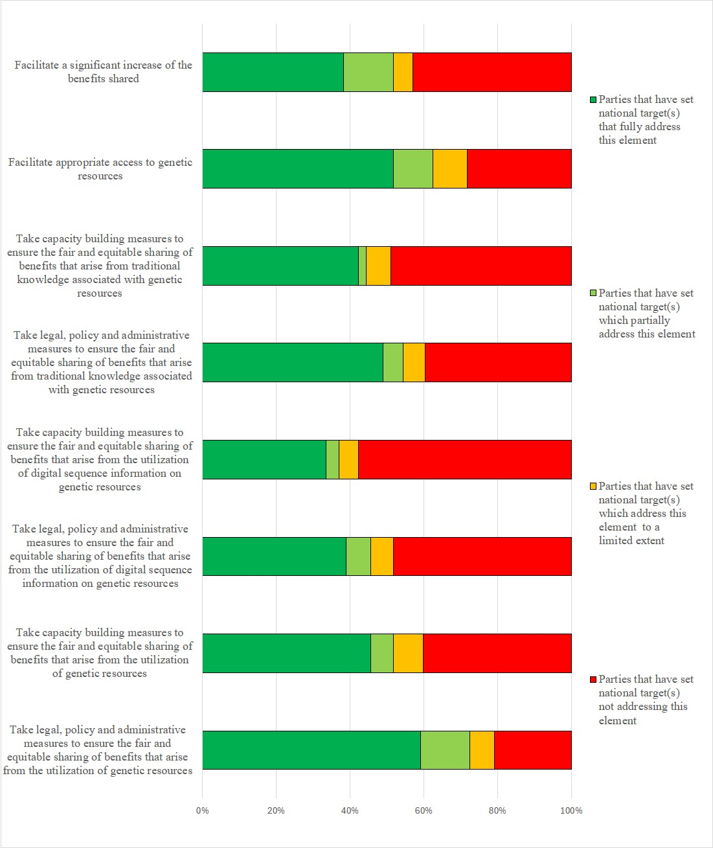Figure 21 – Assessment of the degree to which Parties have addressed the elements of GBF Target 13 in their national target(s). The coloured bars indicate the proportion of Parties that have set national targets which correspond to each assessment category. The number of Parties represented in each bar varies with the number of Parties that have submitted national targets related to a given target of the Kunming-Montreal Global Biodiversity Framework.
Target 14: integrate biodiversity in decision-making at every level
- 152 Parties have submitted 486 national targets related to Target 14. On average a Party has submitted 4 national targets related to Target 15 but the number ranges from 1 to 26. Of the national targets mapped by Parties to GBF Target 14, 48% were also identified as contributing to Goal A, 59% as contributing to Goal B, 22% to Goal C and 36% to Goal D. Around than a quarter of national targets were also linked to GBF Targets 1 (28%), 11 (25%), and 21 (26%)..
- 48% of the national targets submitted by Parties were reported as having high alignment to GBF Target 14, 31% were reported as having medium alignment and 12% as having low alignment to Target 14. For 9% of the national targets, Parties did not indicate a degree of alignment.
- 7% of Parties have set national targets which fully address all elements of Target 14. 14% of Parties have set targets which fully address half of the target elements. 34% of Parties have set national targets which fully address one but less than half of the target elements. 45% of Parties have set national targets which do not fully address any element of Target 14. 17% of Parties have set national targets which partially addresses some elements of Target 14. 12% of Parties have set targets which address the elements of Target 14 to a limited extent and 16% of Parties have set national targets which do not address any element of Target 14.
- The national targets set by Parties had a greater focus on the full integration of biodiversity and its multiple values into policies, regulations, planning and development processes, with 47% of Parties fully addressed this element in their national targets. Fewer Parties fully addressed the integration of biodiversity into poverty reduction strategies (13%), into strategic environmental assessments and environmental impact assessments (13%), national accounting (20%), across levels of government (24%), and across sectors (34%). 16% of Parties Parties fully addressed the progressive alignment of all relevant public and private activities and fiscal and financial flows with goals and targets of the Framework (figure 22).
- 49% of Parties provided information on the means of implementation related to at least one of their national the targets related to Target 14. Of these, 80% indicated that additional means of implementation are required. 49% of the national target submissions contain information on the associated means of implementation. For targets with this information, 66% indicate that additional means of implementation are needed and 32%indicate that the means of implementation are available. Commonly mentioned required means of implementation were financial resources, information and technology sharing, national, regional and international cooperation and partnerships, human resources, and enhancing legal frameworks. See table 16 for more detailed examples of the capacity needs identified by Parties.
Table 16. Reported capacity needs identified in national targets
Category of needs | Subcategory of needs | Examples of specific needs
Technological | Technology related | - Digital platforms to allow the sharing of information and best practises for harmonized decision-making  - Improved technology for the implementation of sophisticated integrated approaches to biodiversity related decision-making
Technical | Information and data | - Analysis of opportunities, gaps, risks, levers and barriers to the integration of biodiversity in priority sectors (mapping of key stakeholders for each sector)
Technical | Human resources: training and skills | - Training on biodiversity integration tailored to priority sectors, including agriculture, fisheries, forestry and tourism
Technical | Communication and awareness | - Awareness and dissemination of knowledge about the importance of integrating biodiversity into various sectors
Technical | International cooperation and knowledge transfer | - Better alignment with international conventions and laws
Technical | National and local cooperation and knowledge transfer | - Development of a road map for coordination between institutions  - Improved involvement of all sectors of society in decision-making and implementing conservation actions  - Improved collaboration between federal and local governments  - Appropriate delegation of responsibilities to local authorities for more participatory and efficient management  - Greater incorporation of indigenous knowledge into biodiversity mainstreaming, while respecting and upholding the rights of indigenous peoples and local communities
Institutional | Regulatory and legal frameworks | - Review of regulations for the development of ecotourism
Institutional | Environmental governance and policy | - Improve technical and administrative capacities of government sectors to promote coordination  - Address complex integration needs, limited resources and institutional silos which hamper cross-sector collaboration  - Development of mechanisms to include biodiversity in the national development plans  - Better integration of biodiversity conservation policies across sectors  - Promotion of transformational change to respect planetary boundaries and preserve biodiversity as a foundation of life,
- 16% of Parties provided information on the involvement of actors other than national governments for at least one of their national targets. At the national target level, 16% of national target submissions provide information on the involvement of non-State actors. Common actions included community engagement, financing, technology and research from a range of actors including non-governmental organizations, private entities, indigenous peoples and local communities, youth groups, and academic institutions.
- 23% of Parties indicated that they would make use of at least one component indicator, 16% of Parties indicated they would make use of at least one complementary indicator and 25% of Parties indicated they would make use of at least one national indicator for monitoring implementation of their national targets associated with this target of the Framework. At the target level, 22% of the national target subbmissions identified component indicators, 18% identified complimentary indicators and 22% identified national indicators indicators. Examples of elements measured by these national indicators include the number of biodiversity inclusive policies, regulations, strategies, and assessments, the proportion of environmental management instruments of investment projects which include biodiversity standards, and the number of subnational and local biodiversity strategies and action plans. There were more national indicators to track biodiversity’s mainstreaming into policies or action plans compared to the use of environmental accounting.
- 66% of national target submissions contain information on which elements of section C of the Kunming-Montreal Global Biodiversity Framework the national target helps to address. The most commonly addressed elements were whole-of-government and whole-of-society approach (74%), national circumstances, priorities and capabilities (73%), and collective effort towards the targets (70%). Comparatively few targets addressed different value systems (30%).
- 66% of national target submissions contained information on the associated policy measures. Many of the measures identified had a focus on policy integration and governance, including actions to embed biodiversity protection within national policies, sectoral strategies, and development frameworks. These measures emphasized the incorporation of biodiversity values into regulations, planning, environmental assessments, and national accounting systems to ensure comprehensive governance. Many target submissions also addressed financial and resource mobilization, underscoring the need for dedicated biodiversity funding within national budgets. Many measures also advocate for integrating biodiversity revenue streams into financial structures and ensuring sufficient human, technical, and financial resources to support biodiversity governance. Capacity-building measures and training, primarily through workshops and training programmes designed for policymakers, institutional technicians, and biodiversity managers were also noted. Public awareness and community participation is a key component in many of the identified measures, with efforts directed toward raising awareness, promoting environmental education, and increasing citizen engagement. Many policies highlight local community involvement, integrating biodiversity considerations into economic and social development to support sustainable livelihoods. Monitoring, reporting, and impact assessment appear in some measures, including the establishment of biodiversity monitoring systems to track policy impacts. Measures addressing sustainable development and economic sectors, focusing on sustainable tourism management, biodiversity-friendly business strategies, and nature tourism initiatives that balance economic growth with conservation objectives were also noted.

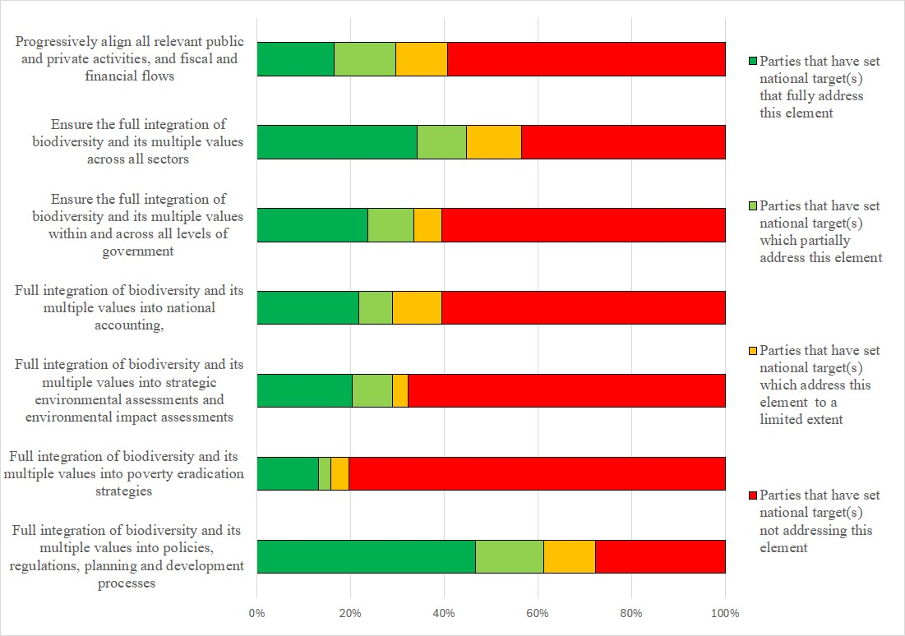Figure 22 – Assessment of the degree to which Parties have addressed the elements of GBF Target 14 in their national target(s). The coloured bars indicate the proportion of Parties that have set national targets which correspond to each assessment category. The number of Parties represented in each bar varies with the number of Parties that have submitted national targets related to a given target of the Kunming-Montreal Global Biodiversity Framework.
Target 15: businesses assess, disclose and reduce biodiversity-related risks and negative impacts
- 143 Parties have submitted 280 national targets related to Target 15. On average a Party has submitted 2 national targets related to Target 15 but the number ranges from 1 to 9. Of the national targets mapped by Parties to GBF Target 15, 39% were also identified as contributing to Goal A, 59% as contributing to Goal B, 34% as contributing to Goal C and 51% as contributing to Goal D. National targets linked to Target 15 were also most commonly linked to Target 14 with 40% of national targets being linked to both Targets 14 and 15.
- 45% of the national targets submitted by Parties were reported as having high alignment to GBF Target 15, 33% were reported as having medium alignment to the Target and 13% as having low alignment. For 9% of the national targets, Parties did not indicate a degree of alignment
- 11% of Parties have set national targets which fully address all elements of Target 15 and 15% have set targets which fully address half of the target elements. 13% of Parties have set national targets which fully address one but less than half of the target elements. 59% of Parties have set national targets which do not fully address any element of Target 15. 13% of Parties have set national targets which partially address all or some of the elements. 9% of Parties have set national targets which address the elements of Target 15 to a limited extent and 36% of Parties have set national targets which do not address any element of Target 15..
- With regard to the elements of GBF Target 15, 36% of Parties fully addressed the element related to taking measures to encourage and enable business to monitor, assess and disclose their risks to biodiversity in their national targets. 37% of Parties fully addressed the element related to taking measures to encourage and enable business to monitor, assess and disclose their impacts on biodiversity in their national targets . About a quarter of Parties set national targets fully addressing taking measures to encourage and enable business to monitor, assess and transparently disclose their dependencies (29%) on biodiversity and taking measures to encourage and enable business to provide information needed to consumers to promote sustainable consumption patterns (26%). 13% of Parties fully addressed measures to encourage and enable business to report on compliance with access and benefit-sharing regulations and measures, in their national targets (figure 23).
- 47% of Parties provided information on the means of implementation related to at least one of their national the targets related to Target 15. Of these, 79% indicated that additional means of implementation are required. 50% of the national target submissions contained information on the associated means of implementation. For targets with this information, 72% indicate that additional means of implementation are needed and 22%indicate that the means of implementation are available. The most frequently mentioned type of means was financial resources. Capacity-building was also commonly referenced. Human and technical resources, knowledge-sharing, stakeholder collaboration and synergy and regulatory frameworks were also frequently mentioned. See table 17 for more detailed examples of the capacity needs identified by Parties.
Table 17. Reported capacity needs identified in national targets
Category of needs | Subcategory of needs | Examples of specific needs
Technological | Technology related | - Improved access to modern monitoring and inspection technologies, including satellite imagery, drones, and pollution monitoring equipment, for real-time tracking of environmental compliance  - Improved access to technology, indicators, metrics and methodologies to accurately assess and report biodiversity-related impacts, risks and dependencies  - Development of tools to analyse disclosures from companies  - Creation of systems to track and calculate fines, track escalating penalties and ensure transparency
Technical | Information and data | - Accessible online platform where businesses can report biodiversity-related performance  - Improve access to accurate and relevant data across value and supply chains
Technical | Scientific research | - Training of environmental inspectors to carry out site visits, audits and compliance checks  - Research on biodiversity resources, businesses and trade at private sector level
Technical | Capacity-building | - Enhanced capacity-building of partners to access and use financial resources effectively
Technical | Human resources: training and skills | - Training and guides for businesses to assess and reduce their impacts on biodiversity and to conduct business impact assessments  - Improved knowledge and training on biodiversity and business disclosures  - Training of compliance officers to oversee enforcement and manage penalties for non-compliance
Technical | Communication and awareness | - Development of engagement materials to promote sustainable strategies and inform businesses about compliance and penalties for violations  - Publicize benefits of being an environmentally compliant business  - Awareness-raising programmes to help businesses to better understand dependencies on biodiversity  - Engage with businesses to minimize the potential compliance burdens  - Engage with businesses to view biodiversity as an opportunity rather than a risk  - Ensure accessible communication for and between the financial and environmental sectors
Technical | International cooperation and knowledge transfer | - Develop platforms to exchange best practises between businesses and stakeholders
Institutional | Regulatory and legal frameworks | - Development of legal, administrative and political framework to govern the consideration of negative impacts on biodiversity by business  - Revise and update decrees and regulations and ensure legal clarity  - Development of verification mechanisms to prevent greenwashing
Institutional | Environmental governance and policy | - Development of labels and certification for businesses that respect biodiversity  - Ensure companies are transparent on the type of corporate responsibility they implement  - Measures to address challenges in disclosing compliance  - Measures to ensure alignment and interoperability between various reporting standards  - Development of economic incentives for the private sector to transition towards more biodiversity friendly business practices
- 18% of Parties and 16% national target submissions provide information on the involvement of non-State actors. Common actions included environmental education, ecosystem restoration, research, monitoring, advocacy, and sustainable business practices, involving NGOs, private companies, academia, and local communities.
- 26% of Parties indicated that they would make use of at least one component, complimentary or national indicators for monitoring implementation of their national targets associated with this target of the Framework. At the target level, 25% of national target submissions related to Target 15, identified component and complementary indicators and 21% identified national indicators. In addition to the national indicators which addressed elements in the GBF Target, such as the number of businesses which publish sustainability reports, national indicators also focused on the role of businesses beyond their reporting obligations. Examples of elements measured by this type of indicators include the positive contributions of businesses to biodiversity conservation, the number of businesses generating biodiversity action plans, and the quantity of waste generated by businesses. National indicators for GBF Target 15 were occasionally sector-specific but were usually applicable to all businesses.
- 66% of national target submissions contain information on which elements of section C of the Kunming-Montreal Global Biodiversity Framework the national target helps to address. The most addressed elements were whole-of-government and whole-of-society approach (77%), national circumstances, priorities and capabilities (72%), and collective effort towards the targets (76%).
- 66% of national target submissions contained information on the associated policy measures. Most national targets emphasize legal and regulatory reforms to embed biodiversity into corporate governance, policy, and environmental, social and governance frameworks, with a strong focus on mandatory risk disclosure, especially for large and transnational companies. Measures commonly aim to institutionalize corporate accountability through regulatory authorities. Additional measures aim to promote sustainable business models via circular economy laws supported via financial incentives and benefit-sharing mechanisms. Beyond corporate focus, governments also prioritize public awareness, stakeholder engagement, and green finance tools like biodiversity-linked investments to drive cross-sectoral support for conservation. Less than half of the measures emphasize strengthening environmental impact assessments and reporting, including the establishment of biodiversity management plans to monitor and control environmental impacts. Measures also advocate for mandatory environmental labelling to enhance transparency and integrate biodiversity considerations into existing certification standards, while encouraging businesses to embed biodiversity into their core strategies.
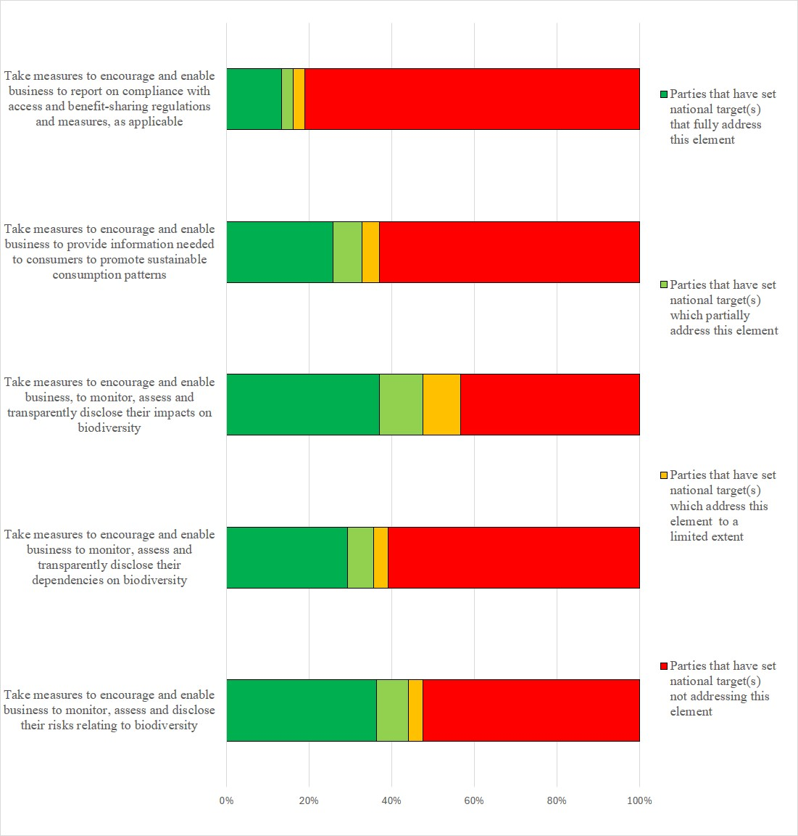
Figure 23 – Assessment of the degree to which Parties have addressed the elements of GBF Target 15 in their national target(s). The coloured bars indicate the proportion of Parties that have set national targets which correspond to each assessment category. The number of Parties represented in each bar varies with the number of Parties that have submitted national targets related to a given target of the Kunming-Montreal Global Biodiversity Framework.
Target 16: enable sustainable consumption choices to reduce waste and overconsumption
- 147 Parties have submitted 271 national targets related to Target 16. On average a Party has submitted 2 national targets related to Target 16 but the number ranges from 1 to 9. Of the national targets mapped by Parties to Target 16 43% were identified as contributing to Goal A, 63% were identified as contributing to Goal B, 23% were identified as contributing to Goal C and 32% were identified as contributing to Goal D. National targets linked to Target 16 were also most commonly linked to Target 15 with 32% of national targets being linked to both Targets 15 and 16. 45% of the national targets submitted by Parties were reported as having high alignment to GBF Target 16, 34% were reported as having medium alignment to the Target and 10% were reported as having low alignment. 11% of the national targets Parties did not indicate a degree of alignment.
- 5% of Parties have set national targets which fully address all elements of Target 16, 9% have set targets which fully address half of the target elements and 14% of Parties have set national targets which fully address one but less than half of the target elements. 72% of Parties have set national targets which do not fully address any element of Target 16. 19% of Parties have set national targets which partially address all or some of the elements. 24% of Parties reported national targets which address the elements of Target 16 to a limited extent and 29% of Parties have set national targets which do not address any element of Target 16.
- 20% of Parties fully addressed the establishment of policy, legislative or regulatory frameworks to encourage and enable people to make sustainable consumption choices. 18% of Parties fully addressed the improvement of education, access to relevant information and alternatives to encourage people to make sustainable consumption choices. Fewer Parties fully addressed the reduction of the global footprint of consumption (12%) and the reduction of waste generation (14%). Few Parties fully addressed the reduction in overconsumption (8%) and the halving of food waste (9%). Few Parties (13%) set targets with a quantitative value for the reduction of food waste. Of those that did, 63% set a target of reducing food waste by half. The remainder set targets for reducing food wasted by between 10% and 30% (figure 24).
- 48% of Parties provided information on the means of implementation related to at least one of their national the targets related to Target 16. Of these, 79% indicated that additional means of implementation are required. 46% of the national target submissions contain information on the associated means of implementation. For targets with this information, 73% indicate that additional means of implementation are needed. 23% indicate that the means of implementation are available. Some commonly mentioned means of implementation include funding, capacity-building, data and information, and technology transfer. See table 18 for more detailed examples of the capacity needs identified by Parties.
Table 18. Reported capacity needs identified in national targets
Category of needs | Subcategory of needs | Examples of specific needs
Technological | Technology related | - Effective and efficient waste management facilities  - Improved access to innovations and technologies for sustainable food processing and recycling, waste management  - Access to technology to monitor shifts in consumer purchasing behaviour
Technical | Information and data | - Greater access and availability of data on countries material footprint, movement of products through the economy, and food waste  - Database on the impact of food types, consumer goods, waste and overconsumption
Technical | Scientific research | - Research on the impacts of marine litter on ecosystems  - Research on innovative solutions to reduce food waste and promote sustainable consumption
Technical | Human resources: training and skills | - Training programmes for government officials, policymakers and stakeholders on sustainable consumption and production practises  - Training for local and traditional farmers in climate smart agriculture and improved biodiversity-friendly practises to food production
Technical | Communication and awareness | - Development of education and awareness campaigns to inform consumers about the environmental and social impacts of their consumption choices  - Improved communication to address resistance to the adoption of sustainable consumption practices  - Greater engagement with businesses to adopt sustainable practises in operations and supply chains, including through corporate social responsibility initiatives, joint ventures and technology transfer
Technical | International cooperation and knowledge transfer | - Improved communication for the creation of a culture of sustainability  - Increased participation in international forums, conferences, and working groups focused on sustainable consumption and production  - Greater support from international organizations, environmental philanthropic organizations and businesses to support innovative approaches to waste management and recycling infrastructure
Technical | National and local cooperation and knowledge transfer | - Support for whole-of-society actions  - Better consideration of indigenous perspectives and knowledge  - Greater empowerment of communities to take ownership of sustainable consumption initiatives by involving them in the design, implementation and monitoring of projects
Institutional | Regulatory and legal frameworks | - Development of laws, regulations and standards which support the reduction of food waste and encourage eco-friendly practices  - Certification and label schemes for resource use and waste generation  - Laws and regulations preventing overconsumption
Institutional | Environmental governance and policy | - Policy reforms to create an enabling environment for sustainable consumption and production  - Implementation of policies which support sustainable consumption, such as incentives for eco-friendly products, regulations on waste management, and taxes on environmentally harmful products  - Development of financial incentives to businesses and industries that invest in sustainable technologies, practises and infrastructure  - Development of financial incentives for the public to engage in waste management and recycling  - Greater incorporation of circular economy principles into policy
- 18% of Parties provided information on the involvement of actors other than national governments for at least one of their national targets. At the national target level, 15% of national target submissions \ provide information on the involvement of non-State actors. Common actions identified included financing, data collection, and implementation support from a range of actors including non-governmental organizations, indigenous peoples and local communities, civil society, academic institutions, and the private sector.
- 27% of Parties indicated that they would make use of at least one component indicator to monitor progress in the implementation of their national targets associated with Target 16. Similarly 23% of Parties reported they would make use of at least one component indicator and 25% reported they would use at least one national indicator. At the target level, 27% of Parties identified component indicators, 22% identified complimentary indicators, and 20% of Parties identified national indicators for at least one of their national targets associated with Target 16.for their national targets The national indicators had a greater focus on monitoring consumer awareness of sustainable consumption options, the quantity of food waste, and the rate of recycling compared to monitoring consumption and overconsumption.
- 62% of national target submissions contain information on which elements of section C of the Kunming-Montreal Global Biodiversity Framework the national target helps to address. The most addressed elements were whole-of-government and whole-of-society approach (79%), collective efforts towards the target (82%), and national circumstances and priorities and capabilities (68%). Comparatively few targets addressed different value systems (35%).
- 63% of national target submissions contained information on the associated policy measures. The policy measures mentioned can be largely categorized based on which elements of the target they address; awareness and education initiatives, targeted policies on food and waste reduction, water quality measures, and programmes to reduce to the overall impacts of consumption, and sustainable ecotourism.

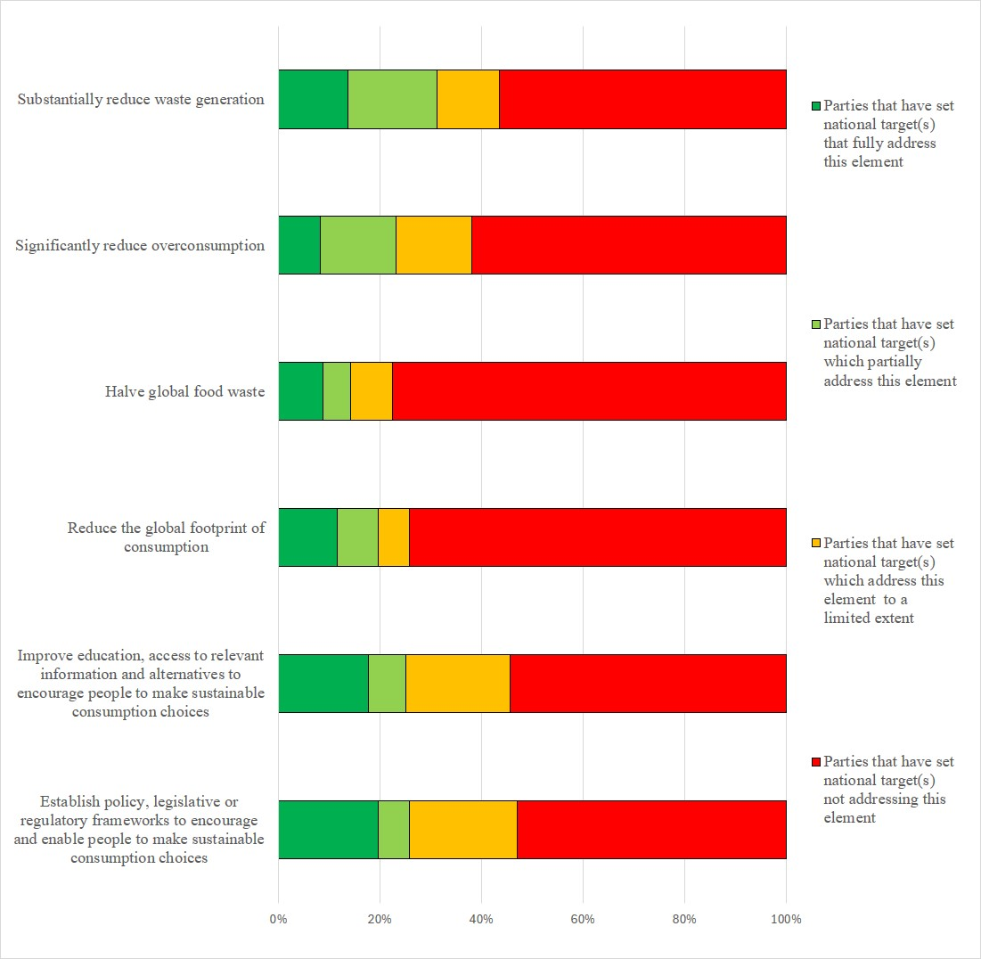Figure 24 – Assessment of the degree to which Parties have addressed the elements of GBF Target 16 in their national target(s). The coloured bars indicate the proportion of Parties that have set national targets which correspond to each assessment category. The number of Parties represented in each bar varies with the number of Parties that have submitted national targets related to a given target of the Kunming-Montreal Global Biodiversity Framework.
Target 17: strengthen biosafety and distribute the benefits of biotechnology
- 145 Parties have submitted 224 national targets related to Target 17. On average a Party has submitted 2 national targets related to Target 17 but the number ranges from 1 to 8. Of the Parties that have submitted national targets related to Target 17, 86% are also Parties to the Cartagena Protocol on Biosafety. Of the national targets mapped by Parties to GBF Target 17, 48% were also identified as contributing to Goal A, 51% were identified as contributing to Goal B, 43% are identified as contributing to Goal C and 36% were identified as contributing to Goal D. 30% of the national targets were also identified as being relevant to Target 13.
- 52% of the national targets submitted by Parties were reported as having high alignment to Target 17, 26% were reported as having medium alignment and 12% were reported as having low alignment. For 10% of the national targets Parties did not indicate a degree of alignment.
- 12% of Parties have set national targets which fully address all elements of Target 17, 24% have set targets which fully address half of the target elements and 23% have set national targets which fully address one but less than half of the target elements. 40% of Parties have set national targets which do not fully address any element of Target 17. 15% of Parties have set national targets which partially address all or some of the elements. 6% of Parties have set national targets which address the elements of Target 17 to a limited extent and 19% of Parties have set national targets which do not address any element of Target 17. In these cases, the national targets have tended to be more cross-cutting than Target 17 and focus on the use of genetic resources and ecosystem services generally. In addition, some national targets position biosafety as a means of helping to reach other targets, for example, Target 6 addressing invasive alien species and Target 13 addressing access and benefit-sharing, as well as those targets addressing issues related to agriculture and food security (Target 10), human well-being (Target 11) and business (Target 15). While relevant to Target 17, the focus in these targets is somewhat limited to the strategic actions or policies required to reach other Targets within the framework and therefore the elements of Target 17 are not always explicitly addressed.
- In the national targets submitted, there was a greater focus on the elements of Target 17 related to Article 8(g) of the text of the Convention. 44% of Parties have set national targets which fully address the establishment of biosafety measures, 36% of Parties fully address the strengthening of capacity and 44% fully address the implementation for Article 8(g). By comparison relatively few Parties have set targets addressing the elements of Target 17 related to Article 19 of the Convention. 25% of Parties have submitted national targets which fully address the establishment of measures for the handling of biotechnology and distribution of its benefits. 20% of Parties have set national targets fully addressing the strengthening of capacity for measures for the handling of biotechnology and distribution of its benefits and 24% have set national targets which fully address the implementation of such measures (figure 25).
- 54% of Parties provided information on the means of implementation related to at least one of their national the targets related to Target 17. Of these, 73% indicated that additional means of implementation are required. 49% of the national target submissions contain information on the associated means of implementation. For targets with this information, 83% indicate that additional means of implementation are needed. Few 13% indicate that the means of implementation are available. Examples of the types of means of implementation identified as being needed include, financial resources, institutional and individual capacity-building, appropriate enabling environments, necessary legal systems, public awareness, technology transfer, monitoring and surveillance systems, methods of effectively engaging with the private sector, including with larger transnational corporations, and standard operating procedures for handling issues related to biosafety. See table 19 for more detailed examples of the capacity needs identified by Parties.
Table 19. Reported capacity needs identified in national targets
Category of needs | Subcategory of needs | Examples of specific needs
Technological | Technology related | - Improved access to horizon scanning and artificial intelligence  - Better equipped laboratories, research centres and Internet access to conduct research, test and analyse living modified organisms  - Greater access to technology to implement biotechnology safety measures and safety systems
 | Scientific research | - Perform risk assessments of living modified organisms  - Promote research on how to increase agricultural production to feed growing populations using living modified organisms
 | Monitoring and surveillance | - Improved surveillance and biomonitoring of living modified organisms at cross border entry points
 | Capacity-building | - Strengthen institutional capacities to regulate biotechnology and its emerging techniques
 | Human resources: training and skills | - Greater availability of specialists in biotechnology research  - Greater training on risk assessment, living modified organisms, risk management, and detection and monitoring of living modified organisms for personnel working in agriculture, environment and health  - Improved training of regulatory authorities (customs, agricultural inspectors, laboratory personnel) to ensure they are equipped to implement biosafety legislations effectively  - Improved training for customs officers to identify and handle living modified organisms
 | Communication and awareness | - Public engagement initiatives among indigenous peoples and local communities, industry and stakeholders and by the agencies that regulate living modified organisms  - Increase public awareness of the importance, regulations and risks of living modified organisms  - Better educational material and guidelines on biosafety and biotechnology
 | International cooperation and knowledge transfer | - Enhanced networks of researchers working on living modified organisms
 | National and local cooperation and knowledge transfer | - Standardize detection protocols for living modified organisms  - Inter-institutional coordination to monitor living modified organisms released into the environment
Institutional | Regulatory and legal frameworks | - Establish a licensing system for the import, transfer, use and release of living modified organisms  - Improved biosafety regulations and standards related to LMOs to ensure laboratory practises align with national and international biosafety requirements  - Improved regulations to address new and emerging biotechnology, accidental release events, financial security for damage from living modified organisms and illegal trafficking of living modified organisms  - Regulatory framework for labelling food containing living modified organisms  - Address legal loopholes and outdated regulations  - Greater availability of enforcement officers and inspectors to monitor and enforce compliance with biosafety regulations
- 17% of Parties provided information on the involvement of actors other than national governments for at least one of their national targets. At national target level, 17% of national target submissions provide information on the involvement of actors other than national governments. Of the Parties that have provided information on this issue, some indicate that the involvement of these actors has not yet begun or that they need to be engaged. Most indicate the ways in which these actors can be involved generally in the implementation of the target but do not indicate specific ongoing actions or commitments which have been taken by them. Examples of the types of contributions noted include technology transfer, capacity-building, providing data and information, undertaking studies, and providing funding. In addition, some national targets note the types of non-State actors which could be involved in implementation. These include biotechnology and pharmaceutical companies, companies developing and selling seeds, research institutes, academia, and development partners and agencies. Others note the need for the involvement of indigenous peoples and local communities, the private sector and non-governmental organizations. Few national targets identify specific actors with ongoing activities or commitments. Those that do often refer to specific projects or actions which are being taken on an ad hoc basis which, while relevant to the target, are not specifically linked to the attainment of the national target.
- 19% of Parties indicated that they would make use of component indicators, 22% indicated they would make use of complimentary indicators and 25% indicated they would make use of national indicators to monitoring progress towards at least one of their national targets associated with this target of the Framework. At the national target level, 21% of national target submissions identified component indicators, 25% identified complimentary indicators and 20% identified national indicators. Examples of elements measured by these national indicators include the number of biosafety issues identified, the proportion of biotechnology products available on the market, the proportion of the population aware of biosafety or biotechnology, and the number of biosafety specialists trained.
- 69% of national target submissions contain information on which elements of section C of the Kunming-Montreal Global Biodiversity Framework the national target helps to address. The most addressed elements were science and innovation (72%), consistency with international agreements or instruments (73%); and collective effort towards the targets (70%). Comparatively few targets addressed different value systems (29%) and human rights-based approach (34%) and intergenerational equity (33%).
- 62% of national targets have associated policy measures. Commonly reported measures include developing and/or strengthening legislation, policies and frameworks related to biosafety and the protection of genetic resources and the establishment or strengthening of related bodies and facilities, strengthen measures related to access and benefit-sharing, including those related to traditional knowledge, and the development of guidelines and/or standards for considering digital sequence information. The strengthening of monitoring and controlling of the use of modern biotechnology, increasing knowledge of biotechnology and promoting its use, improving consultation processes, improving communication and information tools, establishing partnerships with relevant organizations and the private sector, and capacity-building and improving public awareness and access to information were also frequently mentioned.

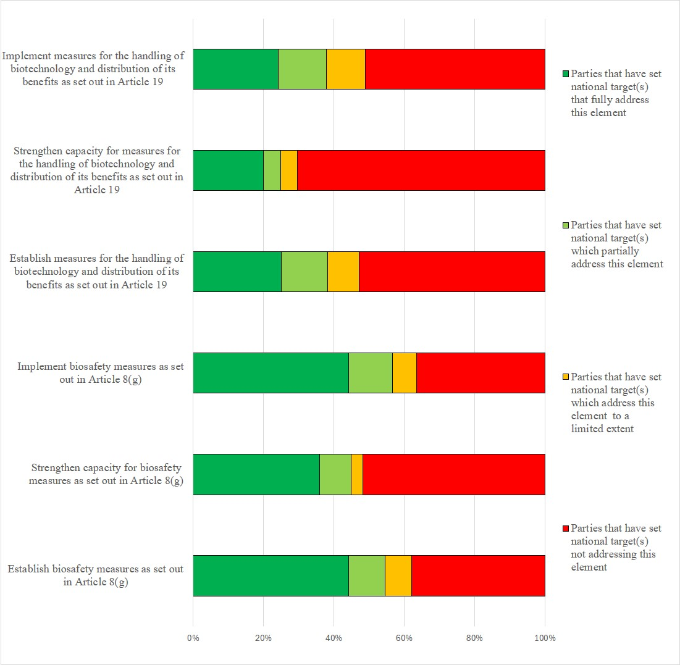Figure 25 – Assessment of the degree to which Parties have addressed the elements of GBF Target 18 in their national target(s). The coloured bars indicate the proportion of Parties that have set national targets which correspond to assessment each category. The number of Parties represented in each bar varies with the number of Parties that have submitted national targets related to a given target of the Kunming-Montreal Global Biodiversity Framework.
Target 18: reduce harmful incentives by at least $500 billion per year and scale up positive incentives for biodiversity
- 147 Parties have submitted 248 national targets related to Target 18. On average a Party has submitted 2 national targets related to Target 18 but the number ranges from 1 to 11. Of the national targets mapped by Parties to GBF Target 18, 41% were identified as contributing to Goal A, 51% as contributing to Goal B, 23% as contributing to Goal C and 61% as contributing to Goal D National targets related to Target 18 were most commonly also linked to Targets 14 (36%) and 15 (32%).
- 49% of the national targets submitted by Parties were reported as having high alignment to Target 18, 29% were reported as having medium alignment to the Target and 10% as having low alignment. 12% of the national targets Parties did not indicate a degree of alignment.
- 5% of Parties have set national targets which fully address all elements of Target 18, 21% of Parties have set targets which fully address half of the target elements and 14% of Parties have set national targets which fully address one but less than half of the target elements. 61% of Parties have set national targets which do not fully address any element of Target 18. 20% of Parties have set national targets which partially address all or some of the elements of GBF Target 18. 7% of Parties reported national targets which address the elements of Target 18 to a limited extent and 33% of Parties have set national targets which do not address any element of Target 18.
- One element of GBF Target 18 has a 2025 deadline: by 2025 incentives, including subsidies, harmful for biodiversity are to be identified. 10% of Parties have fully addressed this element in their national targets. The majority of Parties have either addressed this element to a limited extent (1%) or not at all (61%) in their national targets.
- In the national targets submitted, there was a comparatively higher emphasis on scaling up positive incentives for conservation and sustainable use of biodiversity with 31% of Parties fully addressing this issue. 27% of Parties fully addressed the elimination, phase out, or reform of incentives harmful to biodiversity. 14% of Parties fully addressed the reduction of incentives harmful for biodiversity by at least $500 billion per year by 2030. Most Parties (73%) did not submit targets addressing the reduction in incentives harmful for biodiversity by $500 billion. 10% of Parties included a quantitative element for the reduction of harmful subsidies. Some of those that did refer to reductions of $500 billion while others refer to specific percentage reductions of between 10% and 50%. Some Parties also included quantitative values of between 5% and 25% for the increase of positive incentives (figure 26).
- 50% of Parties provided information on the means of implementation related to at least one of their national the targets related to Target 18. Of these, 79% indicated that additional means of implementation are required. 50% of the national target submissions contain information on the associated means of implementation. For targets with this information, 82% indicate that additional means of implementation are needed. 14% of national target submissions indicate that the means of implementation are available. The most mentioned required means of implementation was financial resources. However, planning, monitoring, technology transfer and capacity-building were also frequently mentioned. See table 20 for more detailed examples of the capacity needs identified by Parties.
Table 20. Reported capacity needs identified in national targets
Category of needs | Subcategory of needs | Examples of specific needs
Technical | Information and data | - Develop standardized methodologies, indicators and metrics to determine positive and harmful impacts on biodiversity  - Develop metrics to measure incentive effectiveness
Technical | Scientific research | - Conduct national assessments of harmful and positive incentives and subsidies impacting biodiversity to identify and promote policies that support conservation and sustainable use of biodiversity
Technical | Communication and awareness | - Greater education and awareness to improve understanding of the negative impact of incentives and subsidies on biodiversity  - Address conflicts that arise from the reform, reduction and elimination of programmes, subsidies and incentives
Technical | National and local cooperation and knowledge transfer | - Develop intersectoral coordination mechanisms for the identification of incentives, programmes, and projects that generate positive or harmful impacts on biodiversity
Institutional | Regulatory and legal frameworks | - Interpret and apply legislation and regulations related to incentives for ecosystem services, environmental impact assessment and strategic environmental assessments  - Develop regulatory frameworks and guideline to recognize and promote productive practices that are positive for biodiversity, alongside enabling elements, such as education, knowledge transfer and markets
Institutional | Environmental governance and policy | - Promote actions to ensure that sustainable economic development does not come at the cost of protecting nature,  - Development of policies to address trade-offs with other environmental and socioeconomic issues  - Develop policies which address incentives from all areas of the economy  - Promote subsidies for non-harmful alternative resources
- 17% of Parties provided information on the involvement of actors other than national governments for at least one of their national targets. 19% of national target submissions provide information on the involvement of non-State actors. Common actions included resource mobilization, data collection and research, and monitoring from a range of actors, including non-governmental organizations, private entities, indigenous peoples and local communities, and academic institutions.
- 22% of Parties indicated that they would make use of component indicators, 19% indicated they would make use of or complimentary indicators and 23% indicated they would make use of national indicators to monitor progress towards at least one of their national targets. At the target level, 22% of national target submissions identified component indicators, 20% identified complimentary indicators and 16% identified national indicators. Most of the national indicators monitor the number or value of beneficial or harmful subsidies for biodiversity in various sectors, especially agriculture and energy.
- 68% of national target submissions contain information on which elements of section C of the Kunming-Montreal Global Biodiversity Framework the national target helps to address. The most commonly addressed elements were national circumstances, priorities and capabilities (75%), whole-of-government and whole-of-society approach (78%), access to financial resources (73%) and collective effort towards the targets (74%). Comparatively few targets addressed different value systems (36%).
- 65% of national target submissions contained information on the associated policy measures. Some commonly mentioned measures include the development or improvement of monitoring and reporting programmes, research and knowledge collection to identify harmful incentives and to optimize the use of positive subsidies, including in the agricultural and energy sectors, increasing awareness, and developing or strengthening political and/or legal frameworks.

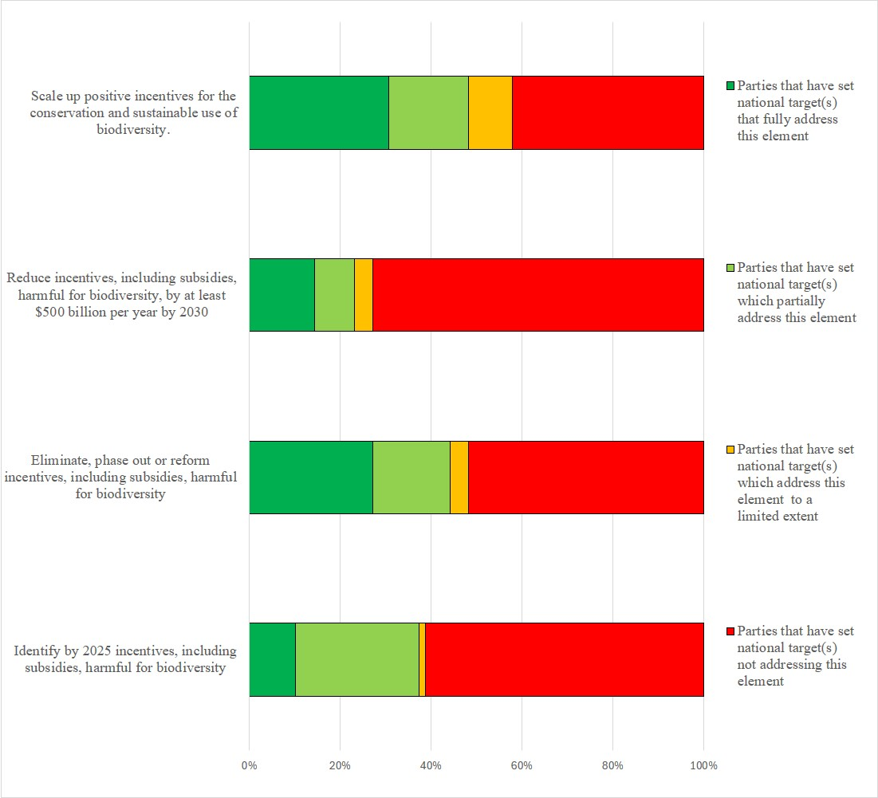Figure 26 – Assessment of the degree to which Parties have addressed the elements of GBF Target 18 in their national target(s). The coloured bars indicate the proportion of Parties that have set national targets which correspond to each assessment category. The number of Parties represented in each bar varies with the number of Parties that have submitted national targets related to a given target of the Kunming-Montreal Global Biodiversity Framework.
Target 19: mobilize $200 billion per year for biodiversity from all sources, including $30 billion through international finance
- 153 Parties have submitted 326 national targets related to Target 19. On average a Party has submitted 3 national targets related to Target 19 but the number ranges from 1 to 14. Of the national targets mapped by Parties to Target 19, 27% were identified as contributing to Goal A, 32% as contributing to Goal B, 20% as contributing to Goal C and 70% as contributing to Goal D. Between 8% and 25% of the national targets submitted by Parties were linked to one of the other 23 Targets in the Framework with Targets 14(26%), 18 (25%) and 20 (25%) being the most associated targets.
- 47% of the national targets submitted by Parties were reported as having high alignment to GBF Target 19, 25% were reported as having medium alignment to the Target and 15% were reported as having low alignment. 12% of the national targets Parties did not indicate a degree of alignment.
- 3% of Parties have set national targets which fully address all elements of Target 19, 3% of Parties have set targets which fully address half of the target elements and 29% of Parties have set national targets which fully address one but less than half of the target elements. 65% of Parties have set national targets which do not fully address any element of Target 19. 32% of Parties have set national targets which partially address all or some of the elements, 24% of Parties set national targets which addressed the elements of Target 19 to a limited extent and 9% of Parties set national targets which do not address any element of Target 19.
- One element of GBF Target 19 has a 2025 deadline: by 2025 total biodiversity related international financial resources from developed countries, including official development assistance, and from countries that voluntarily assume obligations of developed country Parties, to developing countries, in particular the least developed countries and small island developing States, as well as countries with economies in transition should increase at least $20 billion per year. 9% of Parties fully address increasing biodiversity related international financial resources in their national targets. 17% of Parties have included quantitative elements in their national targets related to increasing international financial resources. Some have set targets with specific monetary amounts while others have set targets with percentage increases. For those targets with monetary values, the values range from 1 million dollars to 200 billion dollars. For those targets with percentage increases these range from 0.8% to 400%. In addition, many of the national targets with percentage increases are expressed in relation to gross domestic product or official development assistance. Given the different ways Parties have expressed these quantitative elements it is not possible to aggregate these values.
- 24% of Parties fully address significantly increasing domestic resource mobilization in their national targets. 13% of Parties fully addressed the leveraging of private finance, the promotion of blended finance, the implementation of strategies for raising new and additional resources, and the encouragement of the private sector to invest in biodiversity. 13% of Parties fully addressed the stimulation of innovative finance schemes. 8% of Parties fully addressed the optimization of co-benefits and synergies between finance for biodiversity and climate change, and 7% fully addressed the enhancement of the role of collective action.8% of Parties fully addressed enhancing the effectiveness, efficiency and transparency of resource provision and use in their national targets (see figure 27).
- 49% of Parties provided information on the means of implementation related to at least one of their national the targets related to Target 19. Of these, 78% indicated that additional means of implementation are required. 46% of the national target submissions contain information on the associated means of implementation. For targets with this information, 70% indicate that additional means of implementation are needed. 23% indicate that the means of implementation are available. Some commonly mentioned means of implementation include funding, capacity-building, planning and monitoring programmes, and technology transfer. See table 20 for more detailed examples of the capacity needs identified by Parties.
Table 21. Reported capacity needs identified in national targets
Category of needs | Subcategory of needs | Examples of specific needs
Technological | Technology related | - Access to technical assistance in developing financial models and systems to allocate budgets according to biodiversity priorities  - Access to technical assistance on natural capital accounting and valuation
Technical | Information and data | - Development of database to track and identify resources received at the national and subnational level by private actors  - Access to reliable and relevant local biodiversity data for business decision-making
Technical | Monitoring and surveillance | - Improved monitoring and coordination between different actors who receive or invest in financing for biodiversity
Technical | Human resources: training and skills | - Improved training on attracting private investments  - Training stakeholders on the implementation of new funding solutions to ensure financial resources are used effectively for biodiversity  - Training to manage biodiversity ventures to attract investment, handle blue and green carbon finance and on reducing emissions from deforestation and forest degradation
Technical | Communication and awareness | - Improved communication and awareness-raising on the business case for investing in biodiversity
Technical | International cooperation and knowledge transfer | - Improve collective efforts to scale up investments in biodiversity and advance innovative ways to mobilize resources to support biodiversity outcomes
Technical | National and local cooperation and knowledge transfer | - Increased availability of expertise in financial management to oversee budgeting, allocation and monitoring of funds, ensuring alignment with biodiversity conservation goals
Institutional | Regulatory and legal frameworks | - Establishment and implementation of financial guidelines to ensure that funding complies with legal restrictions  - Development of regulations, policies and framework to enable to private sector to more easily addressing biodiversity funding issues.
Institutional | Environmental governance and policy | - Improved availability of innovative risk-reducing blended finance instruments  - Greater private financing, international financing, impact investing and innovative finance mechanisms  - Expanded programmes on climate-related finance to leverage existing nature-positive activities for biodiversity funding  - Means of addressing funding challenges related to global competition for funding, limited donors, changes in government administration, and funding uncertainty  - Development of incentives for private sector entities that contribute towards biodiversity goals
- 20% of Parties provided information on the involvement of actors other than national governments for at least one of their national targets. At the national target level, 14% of national target submissions provide information on the involvement of non-State actors. Common actions included resource mobilization and financing, data collection, innovation, and public-private partnerships from a range of actors including non-governmental organizations, indigenous peoples and local communities, academic institutions, the private sector and financial institutions.
- 16% of Parties indicated that they would make use of component indicators, 21% of Parties indicated that they would make use of complimentary indicators and 24% of Parties indicated they would make use of national indicators for monitoring implementation of at least one of their national targets associated with this target of the Framework. At the target level, 17% of national target submissions identified component indicators, 22% identified complimentary indicators and 22% identified national indicators. Examples of elements measured by these national indicators include the number of agreements or fora for resource mobilization and the number of innovative finance schemes utilized. Several of the national indicators monitor the quantity of funds by provenance and intended purpose.
- 63% of national target submissions contain information on which elements of section C of the Kunming-Montreal Global Biodiversity Framework the national target helps to address. The most commonly addressed elements were access to financial resources (84%), whole-of-government and whole-of-society approach (72%), and collective effort towards the targets (76%), Comparatively few targets addressed human rights-based approach (30%), different value systems (31%), principles of the Rio Declaration (32%), and intergenerational equity (33%),.
- 60% of national target submissions contained information on the associated policy measures. Some commonly mentioned measures beyond those explicitly mentioned in the wording of Target 19 include utilizing carbon markets, taxes, mainstreaming of ecosystem accounting, awareness-raising initiatives, including conferences or dialogues, training and capacity-building, information schemes, such as labelling and rating, increases in biodiversity aid, planning and monitoring.
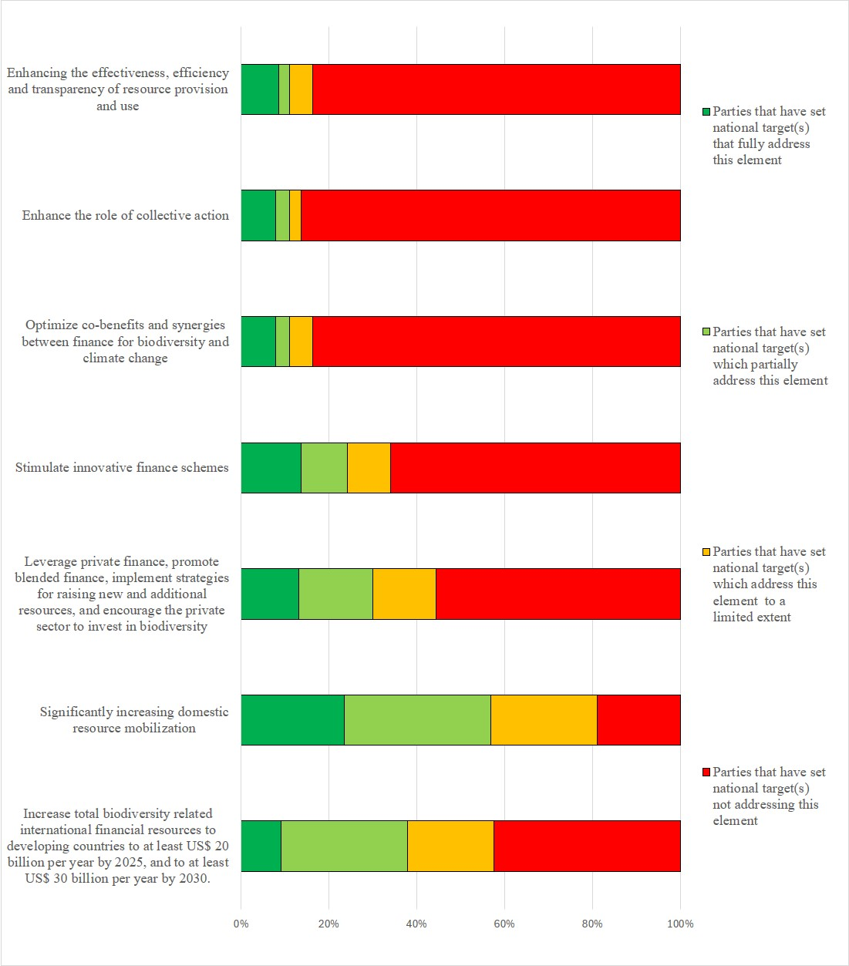Figure 27 – Assessment of the degree to which Parties have addressed the elements of GBF Target 19 in their national target(s). The coloured bars indicate the proportion of Parties that have set national targets which correspond to each assessment category. The number of Parties represented in each bar varies with the number of Parties that have submitted national targets related to a given target of the Kunming-Montreal Global Biodiversity Framework.
Target 20: strengthen capacity-building, technology transfer and scientific and technical cooperation for biodiversity
- 153 Parties have submitted 382 national targets related to Target 20. On average a Party has submitted 3 national targets related to Target 20 but the number ranges from 1 to 14. Of the national targets mapped by Parties to GBF Target 20, 38% were identified as contributing to Goal A. 50% to Goal B, 31% to Goal C and 50% to Goal D. Almost half of the national targets were also linked to GBF Target 21 (47%).
- 47% of the national targets submitted by Parties were reported as having high alignment to GBF Target 20, 29% were reported as having medium alignment to the target and 12% were reported as having low alignment. For 12% of the national targets, Parties did not indicate a degree of alignment. 47% of the national targets related to Target 20 were also linked to Target 21.
- 7% of Parties have set national targets which fully address all elements of Target 20 and 17% have set targets which fully address half of the target elements. 33% of Parties have set national targets which fully address one but less than half of the target elements. 42% of Parties have set national targets which do not fully address any element of Target 20. 18% of Parties have set national targets which partially address all or some of the elements of Target 20, 8% address the elements to a limited extent and 16% of Parties do not address any elements of the Target..
- 42% of Parties fully addressed the strengthening of capacity-building and development and 42% fully address the development of and access to innovation in their national targets. The other elements of Target 20 were addressed to a lesser extent by Parties in their national targets. 22% fully addressed the strengthening of access to and transfer of technology, , 12% of Parties fully addressed the promotion of technical and scientific cooperation, including through South-South, North-South and triangular cooperation, 21% of Parties fully addressed the fostering of joint technology development, 20% of Parties fullt addressed the fostering of joint scientific research programmes, and 20% of Parties fully addressed the strengthening of scientific research and monitoring capacities(see figure 28).
- 25% of Parties provided information on the means of implementation related to at least one of their national the targets related to Target 20. Of these, 82% indicated that additional means of implementation are required. 45% of the national target submissions contain information on the associated means of implementation. For targets with this information, 70% indicate that additional means of implementation are needed and 26% indicate that the means of implementation are available. Means for implementation commonly mentioned were capacity-building, including data and information capacity, financial resources, and technological and scientific cooperation, including technology transfer. See table 22 for more detailed examples of the capacity needs identified by Parties.
Table 22. Reported capacity needs identified in national targets
Category of needs | Subcategory of needs | Examples of specific needs
Technical | Information and data | - Access to database of needs assessments and improved technical and scientific cooperation and technology transfer
Technical | Scientific research | - Development of environmental research systems based on scientific knowledge to support access to information for decision-making on biodiversity and sustainability
Technical | Human resources: training and skills | - Enhanced institutional mechanisms to improve the effectiveness of relevant training
Technical | International cooperation and knowledge transfer | - Establishment of alliances and enhanced collaboration between research and development institutions, international organizations, non-governmental organizations and universities  - Development of mechanisms to allow cooperation and technology transfer among scientific and training institutes  - Cooperation among countries to share knowledge, experiences and technologies
Technical | Environmental governance and policy | - Promote the establishment of biodiversity knowledge-based companies
- 15% of Parties provided information on the involvement of actors other than national governments for at least one of their national targets. At the national target level, 10% of national target submissions provide information on the involvement of actors other than national governments. Common actions included implementation support, financing, and research, from a range of actors including nongovernment organizations, private entities, indigenous peoples and local communities, youth groups, and academic institutions.
- 22% Parties indicated that they would make use of component indicators, 22% indicated they would make use of complimentary indicators and 26% of Parties indicated they would make use national indicators for monitoring implementation of their national targets associated with this target of the Framework. At the target level, 22% of national target submissions identified component indicators (23%) and 24% identified complimentary indicators and 25% identified national indicators. Examples of elements measured by these national indicators include the quantity of funds mobilized for biodiversity related to capacity development, the number of capacity-building initiatives, the number of international scientific research agreements signed, and many indicators relating to the number and scope of domestic biodiversity scientific research initiatives
- Approximately two thirds (65%) of national target submissions contain information on which elements of section C of the Kunming-Montreal Global Biodiversity Framework the national target helps to address. The most commonly addressed elements were science and innovation (70%), collective effort towards the targets (70%), and whole-of-government and whole-of-society approach (63%). Comparatively few targets addressed different value systems (30%), the right to development (33%) the human rights-based approach (33%) or the principles of the Rio Declaration (34%).
- 64% of national target submissions contained information on the associated policy measures. Some commonly mentioned policy measures beyond those explicitly mentioned in GBF Target 20 include education and/or awareness campaigns, information-sharing, including with regard to wild species, financing, capacity-building, the development or strengthening of frameworks for scientific collaboration, and planning and monitoring. In many of the policy measures the need to and importance of collaborating with non-State actors, including nongovernment organizations, indigenous peoples and local communities, research institutions, and the private sector was also noted.
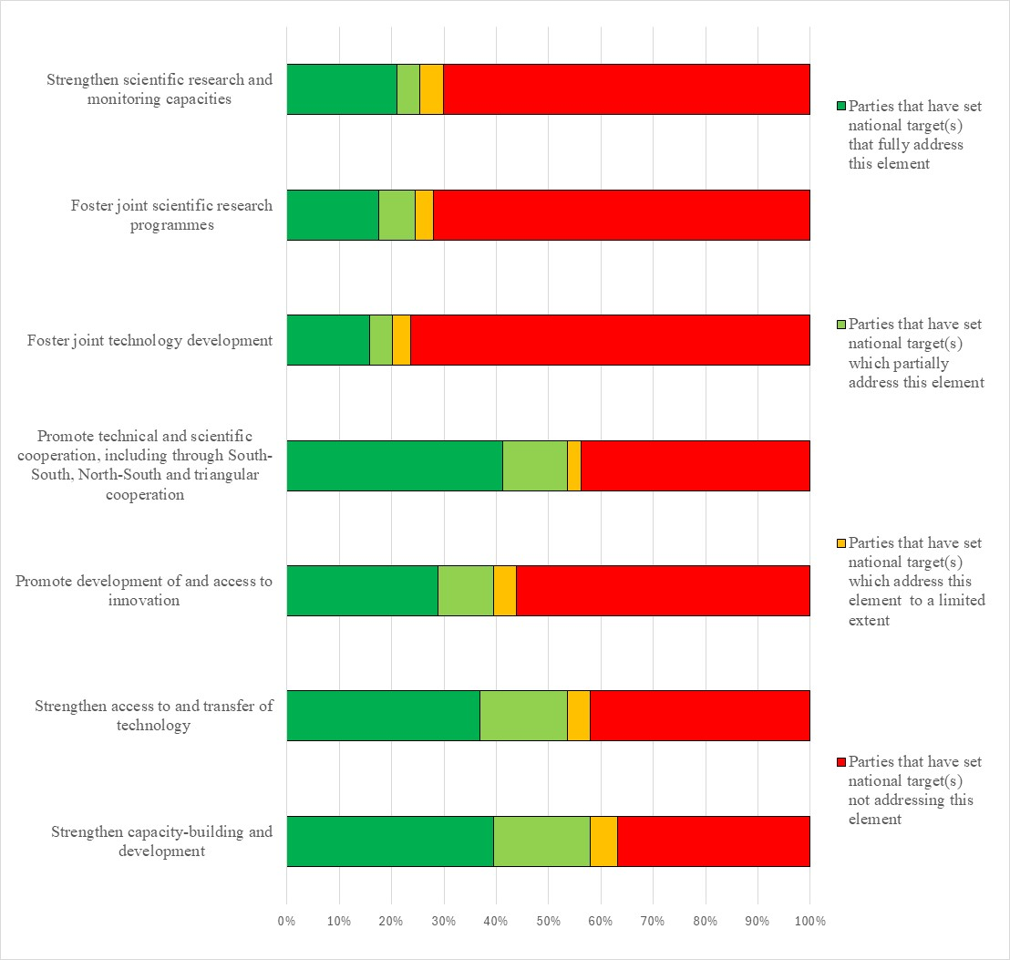Figure 28 – Assessment of the degree to which Parties have addressed the elements of GBF Target 20 in their national target(s). The coloured bars indicate the proportion of Parties that have set national targets which correspond to each assessment category. The number of Parties represented in each bar varies with the number of Parties that have submitted national targets related to a given target of the Kunming-Montreal Global Biodiversity Framework.
Target 21: ensure that knowledge to guide action on biodiversity is available and accessible
- 152 Parties have submitted 489 national targets related to Targe 21. On average a Party has submitted 4 national targets related to Target 21 but the number ranges from 1 to 18. Of the national targets mapped by Parties to GBF Target 21, 45% were identified as also contributing to Goal A, 53% to Goal B, 27% to Goal C and 40% to Goal D. 36% of the national targets submitted by Parties linked to GBF Target 21 were also identified as being relevant to Target 20 and 30% were identified as being also relevant to Target 22. Between 8% and 23% of the national targets submitted by Parties were linked to one of the of the other Targets of the Framework.
- More than a third of the national target (39%) submitted by Parties were reported as having high alignment to GBF Target 21, less than a third (30%) were reported as having medium alignment to the target and less than a fifth (16%) as having low alignment. For 14% of the national targets Parties did not indicate a degree of alignment.
- 8% of Parties have set national targets which fully address all elements of Target 21 and 9% have set targets which fully address half of the target elements. 47% of Parties have set national targets which fully address one but less than half of the target elements. 36% of Parties have set national targets which do not fully address any element of Target 21. 24% of Parties have set national targets which partially address all or some of the elements. 7% of Parties have set national targets which address the elements of Target 21 to limited extent and 5% of Parties have set national targets which do not address any element of the target. Many of the national targets which have been set by Parties have also been aligned to other Targets of the Kunming-Montreal Global Biodiversity Framework. Many of these national targets have data collection, monitoring, knowledge management or research activities or policies associated with them. However, these activities or policies tend to focus on specific topics, such as threatened species, ecosystem types, or types of pollution, rather than representing overarching policies or frameworks for addressing the elements identified in Target 21. The focus in these national targets is therefore somewhat limited to the strategic actions or policies required to reach other targets within the framework.
- 29% of Parties have set national targets which fully address making the best available data accessible and 30% have set targets fully addressing making the best available knowledge . 38% of Parties have set national targets fully addressing the element of target related to strengthening communication, education and public awareness. 20% of Parties have set national targets fully addressing the elements of Target 21 related to strengthening knowledge management and 24% of Parties have set national targets fully addressing the element related to monitoring. 20% of Parties have set national targets fully addressing the elements of Target 21 on strengthening research , and 17% of Parties have set targets fully addressing the element related to accessing traditional knowledge innovations practices and technologies of indigenous peoples and local communities with their free, prior and informed consent (see figure 29).
- 48% Parties provided information on the means of implementation related to at least one of their national the targets related to Target 21. Of these, 76 % indicated that additional means of implementation are required. 45% of the national target submissions contain information on the associated means of implementation. 62% of these submissions indicate that means of implementation will be required and 36% indicate that means of implementation are available. Means of implementation commonly mentioned were financial and human resources, technology transfer, capacity-building, awareness-raising, and improved institutional capacity. See table 23 for more detailed examples of the capacity needs identified by Parties.
Table 23. Reported capacity needs identified in national targets
Category of needs | Subcategory and number of Parties | Examples of specific needs included in submissions
Technological | Technology related | - Develop tools and methodologies for the documentation and transmission of traditional knowledge
Technical | Information and data | - Support for digitalization projects and institutions to ensure accessibility of information  - Increase integration, interoperability, and accessibility of biodiversity data, reducing inconsistencies, unreliability, and security risks  - Apply good practices across the full data life cycle so information can be transformed into knowledge that informs policy, planning, and service delivery  - Ensure inclusive data collection across demographics and regions  - Gather and integrate traditional knowledge using digital and traditional methods and support for integrated knowledge management strategies and the application of innovative technologies  - Establish automated digital data platforms to preserve biodiversity data and knowledge, ensuring long-term accessibility to democratise access and use of data  - Greater support for and utilization of citizen science
Technical | Scientific research | - Support for surveys and studies on traditional knowledge for biodiversity
Technical | Human resources: training and skills | - Training for information providers on data quality, improving efficiency and accuracy in information management and administration  - Training for indigenous peoples and local communities on the management and sustainable use of their local genetic resources, and on their rights to their intellectual property
Technical | Communication and awareness | - Support for addressing misinformation and promoting the use of the best-available information
Technical | International cooperation and knowledge transfer | - Greater inter-institutional mechanisms for data and knowledge management  - Greater collaboration between indigenous peoples and local communities and stakeholders involved in the development of traditional and local knowledge
Institutional | Regulatory and legal frameworks | - Support for ensuring that laws related to free prior and informed consent are applied
Institutional | Environmental governance and policy | - Support to address institutional coordination challenges which affect data flow and accessibility
- 18% of Parties provided information on the involvement of actors other than national governments for at least one of their national targets. At the national target level, 14% target submissions provide information on the involvement of non-State actors. Of the ones that do some indicate that the involvement of non-State actors has not yet begun or that they need to be engaged. Most indicate the ways in which non-State actors can be involved generally in the implementation of the national target but do not indicate specific ongoing actions or commitments which have been taken by non-State actors. Examples of the types of contributions noted include conducting surveys, studies and research, generating information and developing or maintaining information databases to make information more accessible, undertaking environmental education, organizing volunteer activities, supporting capacity-building and providing funding for activities. In addition, some national targets note the types of non-State actors which could be involved in implementation. These include non-governmental organizations, community organizations, indigenous peoples and local community organizations, youth networks, research organizations and universities. Few national targets identify specific actors with ongoing activities or commitments. Those that do often refer to specific projects or actions which are being taken on an ad hoc basis which, while relevant to the target, are not specifically linked to the attainment of the national target.
- 25% of Parties indicated that they would make use of component indicators , 34% indicated they would make use of complimentary indicators and 28% indicated they would make use of national indicators for monitoring implementation of their national targets associated with this target of the Framework. At the target level, 22% submissions identified component indicators, 23% identified complimentary indicators and 23% identified national indicators.. Examples of elements measured by these national indicators include the number of innovations developed, the number of awareness platforms, and the proportion of decisionmakers with access to biodiversity information. Several national indicators monitor the availability of data on traditional knowledge and practices. Infrequently, indicators were disaggregated by type of information.
- 62% of national target submissions contain information on which elements of section C of the Kunming-Montreal Global Biodiversity Framework the national target helps to address. The most commonly addressed elements were science and innovation (70%), collective effort towards the targets (68%), and whole-of-government and whole-of-society approach (68%). Comparatively few targets addressed right to development (32%), and different value systems (32%).
- 61% of national targets have associated policy measures. Three broad and interrelated categories of measures were identified in the target submissions:
  - Data collection and knowledge generation, which includes measures related to encouraging biodiversity research, assessments and surveys, developing biodiversity inventories and updating maps, improving the accessibility of data and strengthening or developing associated platforms, including for example clearing house mechanisms, developing, strengthening or participating in relevant earth observation systems;
  - Procedures and standards, which includes establishing, strengthening or promoting cooperation with relevant councils and processes undertaking data collection and assessments, and developing or applying methods for research and data collection, including for example the UN statistical standard for the System of Environmental Economic Accounting – Ecosystem Accounting;
  - Engagement and awareness-raising, examples which include promoting citizen science, undertaking communication and education activities, capacity-building and training, supporting the protection, generation and use of indigenous knowledge.

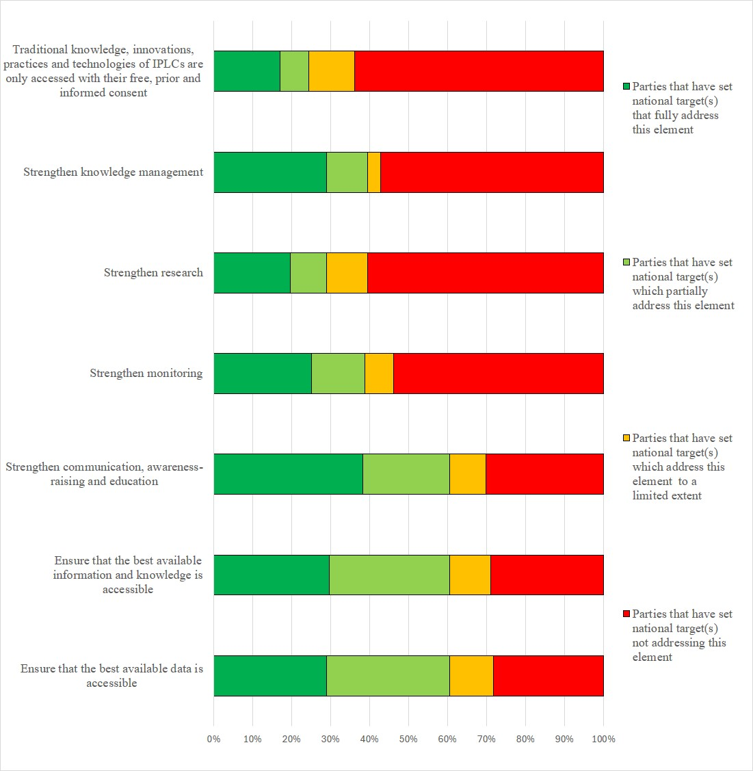Figure 29 – Assessment of the degree to which Parties have addressed the elements of GBF Target 21 in their national target(s). The coloured bars indicate the proportion of Parties that have set national targets which correspond to each assessment category. The number of Parties represented in each bar varies with the number of Parties that have submitted national targets related to a given target of the Kunming-Montreal Global Biodiversity Framework.
Target 22: ensure participation in decision-making and access to justice and information related to biodiversity for all
- 148 Parties have submitted 365 national targets related to Target 22. On average a Party has submitted 23 national targets related to Target 22 but the number ranges from 1 to 18. Of the national targets mapped by Parties to GBF Target 22, 42% were identified as contributing to Goal A 53% were identified as contributing to Goal B 29% were identified as contributing to Goal Cand 27% were identified as contributing to Goal D. National targets related to Target 22 were most often also linked to Targets 21 (42%) and 23 (41%).
- 41% of the national targetssubmitted by Parties were reported as having high alignment to GBF Target 22, 29% were reported as having medium alignment and 17% were reported as having low alignment. For 13% of the national targets, Parties did not indicate a degree of alignment.
- 8% of Parties have set national targets which fully address all elements of Target 22 and 12% have set targets which fully address half of the target elements. 24%of Parties have set national targets which fully address one but less than half of the target elements. 55% of Parties have set national targets which do not fully address any element of Target 22. 21% of Parties have set national targets which partially address all or some of the elements of Target 22. 8% of Parties have set national targets which address elements of GBF Target 22 to a limited extent and 26% of Parties have set national targets which do not address any element of Target 22.
- Around a quarter of Parties had national targets fully addressing the full, equitable, inclusive, effective and gender-responsive representation and participation in decision-making related to biodiversity by indigenous peoples and local communities (28%), by women and girls (26%), children and youth (23%), and persons with disabilities (20%). With regard to the element of GBF Target 22 related to access to justice, around a quarter of Parties fully addressed this issue in relation to indigenous peoples and local communities (22%), women and girls (20%), children and youth (21%) and persons with disabilities (20%).For the element of GBF Target 22 related to access to information, about a quarter of Parties addressed this issue in their national targets for indigenous peoples and local communities (31%), women and girls (27%), children and youth (27%) and persons with disabilities (27%). 11% of Parties fully addressed the full protection of environmental human rights defenders in their national targets. 16% of national targets fully addressed respecting the cultures and rights of indigenous peoples and local communities over lands, territories, resources, and traditional knowledge (see figure 30).
- 53% of Parties (37%) provided information on the means of implementation related to at least one of their national the targets related to Target 22. Of these, 79% indicated that additional means of implementation are required. 49% of the national target submissions contain information on the associated means of implementation. For targets with this information, 69% indicate that additional means of implementation are needed and 27% indicate that the means of implementation are available. Commonly mentioned required means of implementation were capacity-building, interministerial coordination, management schemes, monitoring, data collection, financial resources, and technical assistance. See table 24 for more detailed examples of the capacity needs identified by Parties.
Table 24. Reported capacity needs identified in national targets
Category of needs | Subcategory of needs | Examples of specific needs
Technological | Technology related | - Strengthen infrastructure to collect data and information on indigenous knowledge
Technical | Information and data | - Establish baseline data on how people participate in biodiversity decision-making
Technical | Scientific research | - Identify the specific needs, barriers and enabling factors faced by marginalized groups in accessing decision-making processes, and to analyse participation levels and areas where inclusion is lacking
Technical | Monitoring and surveillance | - Greater monitoring of support programmes by government agencies to ensure participation, access to information and justice are known and guaranteed
Technical | Capacity-building | - Promote youth ambassadors for biodiversity
Technical | Human resources: training and skills | - Provide training and opportunities for indigenous peoples and local communities to share traditional knowledge
Technical | Communication and awareness | - Support for awareness programmes and widened communication to inform marginalized groups about their rights and how they can participate in local governance  - Support for effective means of communication and access to tools for the exchange of information  - Greater integration of biodiversity related topics into school curricular and extracurricular activities  - Support for awareness-raising s on the importance of indigenous peoples and local communities, women and youth in decision-making  - Address the scepticism of indigenous peoples and local communities regarding the appropriate use of their traditional knowledge and local knowledge resulting from its previously inappropriate use and the lack of benefit-sharing.
Technical | National and local cooperation and knowledge transfer | - Greater support for communities in ensuring their rights are respected and that they have access to justice  - Promote intercultural dialogues and the respect of different value systems related to biodiversity, including cultural norms, social hierarchies and power dynamics  - Support for indigenous self-determination, data sovereignty, and equity in knowledge systems, and to recognize and revitalize indigenous cultures and languages
Institutional | Regulatory and legal frameworks | - Establish frameworks for benefit-sharing with communities
Institutional | Environmental governance and policy | - Promote processes for public consultation in decision-making, especially with those in vulnerable situations, while ensuring their free, prior and informed consent  - Increase political will to address corruption, governance failures, land tenure issues and conflicts over natural resources  - Support for rapid actions to prevent cultural and traditional knowledge erosion
- 19% of Parties provided information on the involvement of actors other than national governments for at least one of their national targets. At the national target level, 15% of the national target submissions provide information on the involvement of non-State actors. Common actions included collaboration with the government and/or implementation support, technical assistance, financing, and capacity-building from a range of actors including civil society, non-governmental organizations, private entities, indigenous people and local communities, and academic institutions.
- 25% of Parties indicated that they would make use of component indicators, 25% indicated that they would make use of complimentary indicators and 29% indicated they would make use of national indicators for monitoring implementation of their national targets associated with this target of the Framework. Examples of elements measured by these national indicators include the satisfaction score of marginalized groups in decision-making processes, the percentage of protected areas that incorporate ancestral or traditional uses, and the number of environmental human rights defenders that are arrested, charged, or convicted annually. National indicators were more frequently disaggregated by gender and indigenous peoples and local community status than by age or by disability status.
- 68% of national target submissions contain information on which elements of section C of the Kunming-Montreal Global Biodiversity Framework the national target helps to address. The most commonly addressed elements were whole-of-government and whole-of-society approach (71%), collective effort towards the targets (74%), contribution and rights of indigenous peoples and local communities (68%). Comparatively few targets addressed the right to development (31%) and principles of the Rio Declaration (32%).
- 64% of national target submissions contained information on the associated policy measures. Some of the most common policy measures mentioned include indigenous-led or community-based management, especially of conservation initiatives, awareness-raising programmes, participation programmes, including direct citizen engagement, such as the promotion of various forums, and the strengthening or development of administrative and/or legal measures.

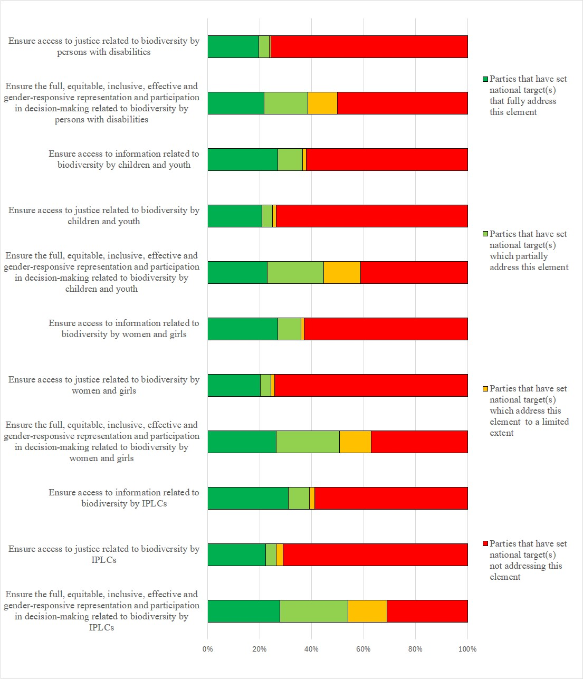Figure 30 – Assessment of the degree to which Parties have addressed the elements of GBF Target 22 in their national target(s). The coloured bars indicate the proportion of Parties that have set national targets which correspond to each assessment category. The number of Parties represented in each bar varies with the number of Parties that have submitted national targets related to a given target of the Kunming-Montreal Global Biodiversity Framework.
Target 23: ensure gender equality and a gender-responsive approach for biodiversity action
- 138 Parties have submitted 276 national targets related to Target 23. On average a Party has submitted 2 national targets related to Target 23 but the number ranges from 1 to 19. Of the national targets mapped by Parties to GBF Target 23, 45% were identified as contributing to Goal A, 59% as contributing to Goal B, 31% as contributing to Goal C and 44% as contributing to Goal D. 55% of the national targets submitted by Parties linked to GBF Target 23 were also identified as being relevant to Target 22.
- 50% of the national targets submitted by Parties were reported as having high alignment to GBF Target 23, 27% were reported as having medium alignment, and 12% as having low alignment to the target. 11% of the national targets Parties did not indicate a degree of alignment.
- 19% of Parties have set national targets which fully address all elements of Target 23 9% have set targets which fully address half of the target elements. 16% of Parties have set national targets which fully address one but less than half of the target elements. 57% of Parties have set national targets which do not fully address any element of Target 23. 18% of Parties have set national targets which partially addresses some elements of Target 23 but do not address others or address them to a limited extent. 10% of Parties have set targets that address some or all of the GBF elements to a limited extent and 29% of Parties have set national targets do not address any elements of Target 23.
- 37% of Parties (34%) have national targets which fully address ensuring gender equality in the implementation of the Framework through a gender-responsive approach. and 31% of Parties have national targets which fully address recognizing the full, equitable, meaningful, and informed participation and leadership of women and girls at all levels of action, engagement, policy and decision-making related to biodiversity. 22% of Parties have national targets which fully address recognizing the equal rights of women and girls to land and natural resources. 22% of Parties have set national targets which fully address recognizing the equal access of women and girls to land and natural resources (see figure 31)
- 51% of Parties provided information on the means of implementation related to at least one of their national the targets related to Target 23. Of these, 79% indicated that additional means of implementation are required. 58% of the national target submissions contain information on the associated means of implementation. Of these, 74% indicate that means of implementation will be required, while 22%indicate that means of implementation are available. The most mentioned required means of implementation fall into three broad categories: funding, capacity-building and political support. Examples include, a dedicated budget allocated to carry out actions and activities that strengthen and promote the incorporation of the gender perspective, a desk for gender and human rights in biodiversity management, training of government officials at all levels on gender and biodiversity issues, development of competencies to effectively incorporate the gender perspective into regulatory documents, a tool to track effective engagement of women, training national stakeholders to take gender into account in the formulation of biodiversity conservation projects, increasing political will of decision makers to remove barriers to access for women in decision-making and conservation funding opportunities. See table 25 for more detailed examples of the capacity needs identified by Parties.
Table 25. Reported capacity needs identified in national targets
Category of needs | Subcategory of needs | Examples of specific needs
Technological | Technology related | - Improved access to tools to assess the conditions and positions of women and associated power relations that could hinder or contribute to women’s participation in decision-making  - Improved access to technology to allow gender mainstreaming
Technical | Information and data | - Analyse current gender strategies to identify gaps in integration  - Develop indicators to measure the impacts of gender inequalities  - Develop baseline data
Technical | Scientific research | - Conduct research on the role of men and women in biodiversity conservation  - Conduct surveys, interviews and focus groups to understand challenges and opportunities to integrate women in the biodiversity sector  - Research the impact of biodiversity loss of women and girl’s health  - Support gender neutral assessment of access to land and resources
Technical | Monitoring and surveillance | - Support for monitoring systems to track representation and participation
Technical | Capacity-building | - Develop, enhance and implement capacity-building programmes specifically tailored to rural communities, indigenous peoples and local communities, and local leaders
Technical | Human resources: training and skills | - Training for marginalised groups on biodiversity conservation to build skills and knowledge  - Improved training for government staff to understand gender perspectives and address resistance to the integration the gender perspectives in biodiversity action
Technical | Communication and awareness | - Disseminate information to promote the involvement and access of women and girls in biodiversity related decision making  - Improved communication on the importance of gender equality in biodiversity conservation, particularly in rural areas
Technical | International cooperation and knowledge transfer | - Increased partnerships with non-governmental organizations, community-based organizations and grassroot movements working on gender equality
Technical | National and local cooperation and knowledge transfer | - Support for community-led initiatives that empower women and marginalized groups to engage in biodiversity conservation  - Improved consultation with gender experts, environmental organizations and ministries
Technical | Environmental governance and policy | - Improved integration of women into governmental institutions and labour markets of all sectors  - Establishment of a gender desk on biodiversity management to effectively address and coordinate biodiversity related issues
- 17% of Parties provided information on the involvement of actors other than national governments for at least one of their national targets. At the national target level, 24% of national target submissions provide information on the involvement of actors other than national governments. Of the ones that do, over half detail the types of non-State actors involved or to be involved. Few mentioned women directly. The majority mentioned civil society organizations and groups, which mostly included non-governmental organizations and community-based organizations. Around a fifth mentioned indigenous peoples and local communities and the private sector. Few mentioned youth and academia. Information in submissions on non-State actors’ commitments varied widely, ranging from those that highlighted the significance of current contributions, identified contributions that are needed by non-State actors, and outlined actions to support and improve engagement of non-State actors in actions. Some also indicated that commitments are in development, and others refer to non-State actors’ contributions as being detailed as part of the implementing agencies in their NBSAPs. Few outlined details of planned contributions by non-State actors in their target submissions. Of those that did, the types of contributions by non-State actors include civil society organizations’ role in advocating and promoting gender-responsive and women’s empowerment approaches, provision of training and awareness-raising to local communities, private sector's role in implementing the regulations that enhance gender rights, as well as non-State actors’ roles in reporting illegal wildlife activities, data collection, and engagement in the preparation and implementation of protected area co-management plans.
- 25% of Parties indicated that they would make use of component indicators, 22% indicated that they would make use of complimentary indicators and 26% indicated they would make use of national indicators for monitoring implementation of their national targets associated with this target of the Framework. Several of the national indicators for Target 23 monitor progress as disaggregated by gender, age, or disability status.
- 79% of national target submissions contain information on which elements of section C of the Kunming-Montreal Global Biodiversity Framework are addressed by the national target. Of these, the majority of submissions (72%) indicated they addressed a whole-of-government and whole-of-society approach, gender (80%), and collective efforts towards the targets (71%) .
- 69% of national targets have associated policy measures. Commonly reported measures related to equitable, inclusive, and gender-responsive representation and participation in biodiversity and natural resource management decision-making at all levels. For example, through the development of national gender strategies and action plans, establishment of quotas and standards for female representation in decision-making bodies, strengthening and development of laws and policies, such as a national equality policy, tools to evaluate and monitor gender inclusion, such as Gender Based Analysis Plus and gender-sensitive indicators, and standards for participation of women and girls in design and objectives of funded projects. Other policy measures focused on supporting and protecting the rights of women, including development of safeguards to protect women involved in biodiversity activities at all levels and provide safety from gender-based harassment, violence and discrimination, as well as integration of gender equality in access and benefit-sharing regulations and policies, and the reforming of laws and policies that discriminate against women. Other policy measures focused on awareness-raising and capacity-building, education, and targeted training of women and girls to enhance leadership, advocacy skills, knowledge of legislation, opportunities in biodiversity management, and creation of partnership projects.

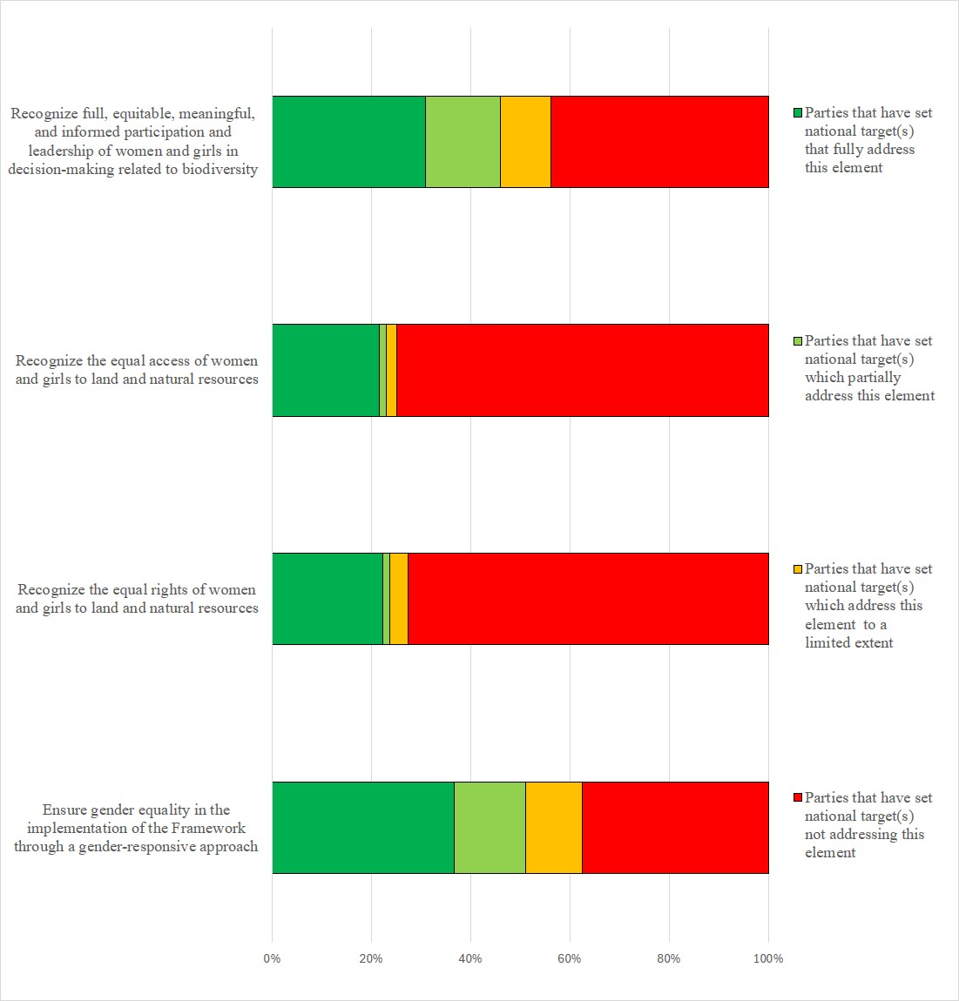Figure 31 – Assessment of the degree to which Parties have addressed the elements of GBF Target 23 in their national target(s). The coloured bars indicate the proportion of Parties that have set national targets which correspond to each assessment category. The number of Parties represented in each bar varies with the number of Parties that have submitted national targets related to a given target of the Kunming-Montreal Global Biodiversity Framework.

Annex I

Status of development of national biodiversity strategies and action plans
All Parties (196) have submitted at least one national biodiversity strategy and action plan as of 6 March 2026. The column titled “Latest NBSAP submission” indicates the year of adoption of the national biodiversity strategies and action plans (where the year of adoption is unknown, the year of completion is provided). The table also shows when the NBSAP is valid until (where known)). .
Party | Latest NBSAP submission | NBSAP valid until
Afghanistan | 2024* | 2030
Albania | 2016 | Unspecified
Algeria | 2016 | 2030
Andorra | 2016 | 2022
Angola | 2019 | 2025
Antigua and Barbuda | 2014 | 2020
Argentina | 2024* | 2030
Armenia | 2015 | Unspecified
Australia | 2024* | 2030
Austria | 2025* | 2030
Azerbaijan | 2016 | 2020
Bahamas | 1999 | Unspecified
Bahrain | 2016 | 2021
Bangladesh | 2016 | 2021
Barbados | 2020 | 2035
Belarus | 2026* | 2030
Belgium | 2025* | 2030
Belize | 2016 | 2020
Benin | 2026* | 2030
Bhutan | 2025* | 2030
Bolivia (Plurinational State of) | 2018 | 2030
Bosnia and Herzegovina | 2016 | 2020
Botswana | 2016 | 2025
Brazil | 2025* | 2030
Brunei Darussalam | 2025* | 2030
Bulgaria | 2005 | 2010
Burkina Faso | 2025* | 2030
Burundi | 2025* | 2030
Cabo Verde | 2014 | 2030
Cambodia | 2016 | 2020
Cameroon | 2025* | 2030
Canada | 2024* | 2030
Central African Republic | 2003 | Unspecified
Chad | 2025* | 2030
Chile | 2026* | 2030
China | 2024* | 2030
Colombia | 2024* | 2030
Comoros | 2016 | 2020
Congo | 2026* | 2030
Cook Islands | 2002 | Unspecified
Costa Rica | 2016 | 2025
Côte d’Ivoire | 2025* | 2030
Croatia | 2017 | 2025
Cuba | 2024* | 2030
Cyprus | 2020* | 2030
Czechia | 2025* | 2050
Democratic People’s Republic of Korea | 2007 | Unspecified
Democratic Republic of the Congo | 2025* | 2030
Denmark | 2024* | 2030
Djibouti | 2017 | Unspecified
Dominica | 2013 | 2020
Dominican Republic | 2011 | 2020
Ecuador | 2016 | 2030
Egypt | 2025* | 2030
El Salvador | 2025* | 2030
Equatorial Guinea | 2026* | 2030
Eritrea | 2025* | 2030
Estonia | 2012 | 2020
Eswatini | 2016 | 2022
Ethiopia | 2015 | 2020
European Union | 2024* | 2030
Fiji | 2020 | 2025
Finland | 2012 | 2020
France | 2024* | 2030
Gabon | 2025* | 2030
Gambia | 2015 | 2020
Georgia | 2014 | 2020
Germany | 2025* | 2030
Ghana | 2016 | 2040
Greece | 2014 | 2029
Grenada | 2016 | 2020
Guatemala | 2014 | 2022
Guinea | 2026* | 2030
Guinea-Bissau | 2015 | 2020
Guyana | 2015 | 2020
Haiti | 2025* | 2030
Honduras | 2017 | 2022
Hungary | 2024* | 2030
Iceland | 2025* | 2030
India | 2025* | 2030
Indonesia | 2024* | 2045
Iran | 2024* | 2030
Iraq | 2015 | 2020
Ireland | 2024* | 2030
Israel | 2010 | Unspecified
Italy | 2025* | 2030
Jamaica | 2016 | 2021
Japan | 2024* | 2031
Jordan | 2024* | 2050
Kazakhstan | 1999 | Unspecified
Kenya | 1999 | Unspecified
Kiribati | 2016 | 2020
Kuwait | 2018 | 2020
Kyrgyzstan | 2026* | 2030
Lao People’s Democratic Republic | 2016 | 2025
Latvia | 2014 | 2020
Lebanon | 2025* | 2030
Lesotho | 2026* | 2030
Liberia | 2017 | 2025
Libya | 2025* | 2030
Liechtenstein | 2025* | 2029
Lithuania | 2015 | 2020
Luxembourg | 2023* | 2030
Madagascar | 2026* | 2030
Malawi | 2015 | 2025
Malaysia | 2024* | 2030
Maldives | 2015 | 2025
Mali | 2014 | 2020
Malta | 2024* | 2030
Marshall Islands | 2026* | 2030
Mauritania | 2024* | 2030
Mauritius | 2017 | 2025
Mexico | 2024* | 2030
Micronesia (Federated States of) | 2018 | 2023
Monaco | 2021 | 2030
Mongolia | 2015 | 2025
Montenegro | 2016 | 2020
Morocco | 2016 | 2020
Mozambique | 2015 | 2035
Myanmar | 2015 | Unspecified
Namibia | 2026* | 2035
Nauru | 2010 | Unspecified
Nepal | 2014 | 2020
Netherlands (Kingdom of the) | 2025* | 2030
New Zealand | 2020 | 2050
Nicaragua | 2016 | 2020
Niger | 2014 | Unspecified
Nigeria | 2025* | 2030
Niue | 2015 | Unspecified
North Macedonia | 2018 | 2023
Norway | 2025* | 2030
Oman | 2001 | Unspecified
Pakistan | 2018 | 2030
Palau | 2018 | 2025
Panama | 2025* | 2035
Papua New Guinea | 2019 | 2024
Paraguay | 2026* | 2030
Peru | 2024* | 2050
Philippines | 2015 | 2028
Poland | 2015 | 2020
Portugal | 2018 | 2030
Qatar | 2014 | 2025
Republic of Korea | 2024* | 2028
Republic of Moldova | 2024* | 2030
Romania | 2014 | 2020
Russian Federation | 2014 | 2020
Rwanda | 2025 | 2030
Saint Kitts and Nevis | 2014 | 2020
Saint Lucia | 2018 | 2025
Saint Vincent and the Grenadines | 2017 | 2020
Samoa | 2015 | 2020
San Marino | 2018 | 2025
Sao Tome and Principe | 2016 | 2020
Saudi Arabia | 2026* | 2030
Senegal | 2026* | 2030
Serbia | 2021 | 2023
Seychelles | 2015 | 2020
Sierra Leone | 2017 | 2026
Singapore | 2019 | Unspecified
Slovakia | 2014 | 2020
Slovenia | 2024* | 2030
Solomon Islands | 2016 | 2020
Somalia | 2015 | 2030
South Africa | 2015 | 2025
South Sudan | 2018 | 2027
Spain | 2023* | 2030
Sri Lanka | 2016 | 2022
State of Palestine | 2024* | 2030
Sudan | 2025* | 2030
Suriname | 2025* | 2035
Sweden | 2026* | 2029
Switzerland | 2024* | 2030
Syrian Arab Republic | 2002 | Unspecified
Tajikistan | 2016 | 2020
Thailand | 2025* | 2027
Timor-Leste | 2015 | 2020
Togo | 2025* | 2030
Tonga | 2024* | 2030
Trinidad and Tobago | 2018 | 2022
Tunisia | 2024* | 2030
Türkiye | 2018 | 2028
Turkmenistan | 2018 | 2023
Tuvalu | 2013 | 2016
Uganda | 2024* | 2030
Ukraine | 2011 | 2020
United Arab Emirates | 2024* | 2031
United Kingdom of Great Britain and Northern Ireland | 2025* | 2030
United Republic of Tanzania | 2025* | 2030
Uruguay | 2016 | 2020
Uzbekistan | 1998 | Unspecified
Vanuatu | 2026* | 2030
Venezuela (Bolivarian Republic of) | 2024* | 2030
Viet Nam | 2024* | 2030
Yemen | 2025* | 2030
Zambia | 2015 | 2025
Zimbabwe | 2014 | 2020

Annex II

List of conventions or multilateral environmental agreements mentioned in the revised and updated national biodiversity strategies and action plans
Due to the differences in analysis procedure and search terms throughout the iterative process of analysing the national biodiversity strategies and action plans, the list of multilateral environmental agreements may be incomplete.
Convention/MEA | NBSAPs which acknowledged, planned to ratify, or had synergies, actions, goals, or targets with the Convention/MEA
Aarhus Convention on Access to Information, Public Participation in Decision-making and Access to Justice in Environmental Matter | Norway, Republic of Moldova, State of Palestine, Sweden
African Convention on the Conservation of Nature and Natural Resources (Algiers Convention) | Chad, Egypt, Libya, Sudan, Uganda
Agreement on the Conservation of Small Cetaceans of the Baltic, Northeast Atlantic, Irish and North Seas (ASCOBANS) | Belgium, Germany
African-Eurasian Migratory Waterbird Agreement (AEWA) | Belarus, Belgium, Italy, Lebanon, Luxembourg, Netherlands (Kingdom of the) (Mainland), Nigeria, Republic of Congo, Rwanda, Saudi Arabia, Slovenia, State of Palestine, Sudan, Togo
Agreement on the Conservation of Albatrosses and Petrels (ACAP) | Spain
Agreement on the Conservation of Cetaceans of the Black Sea, Mediterranean Sea and Contiguous Atlantic Area (ACCOBAMS) | Italy, Lebanon, Spain, State of Palestine
Agreement on the Conservation of Populations of European Bats (Eurobats) | Belgium, Italy, Luxembourg, Republic of Moldova
Alpine Convention | Liechtenstein
Amazon Cooperation Treaty Organization | Brazil, Suriname
Amsterdam Declaration | Italy, Spain
Antarctic Treaty | Luxembourg
ASEAN Heritage Parks | Malaysia
Ballast Water Management Convention | Italy, Japan, Norway, Sweden, Tonga
Baltic Marine Environment Protection Commission (HELCOM) | Germany, Sweden
Barcelona Convention | Egypt, Italy, Lebanon, State of Palestine
Basel Convention on the Control of Transboundary Movements of Hazardous Wastes and Their Disposal | Bhutan, Brazil, Chad, Democratic Republic of Congo (DRC), Eritrea, Lesotho, Marshall Islands, Norway, Paraguay, Republic of Congo, Rwanda, Suriname, Vanuatu
Bern Convention | Andorra, Belgium, Italy, Liechtenstein, Luxembourg, Norway, Republic of Moldova
Commission for Controlling the Desert Locust in North-West Africa | Libya
Convention for the Conservation of Antarctic Marine Living Resources (CCAMLR) | Belgium
Convention for the Protection and Development of the Marine Environment of the Wider Caribbean Region (Cartagena Convention) | Aruba (Kingdom of the Netherlands)
Convention for the Protection of the Marine Environment of the North-East Atlantic (OSPAR) | Belgium, Germany, Ireland, Norway, Spain, Sweden
Convention for the Safeguarding of the Intangible Cultural Heritage | Haiti, Italy
Convention on Fishing and Conservation of Living Resources of the High Seas | State of Palestine
Convention on International Trade in Endangered Species of Wild Fauna and Flora (CITES) | Afghanistan, Argentina, Australia, Austria, Belarus, Belgium, Bhutan, Brazil, Burkina Faso, Burundi, Cameroon, Canada, Chad, Chile, China, Colombia, Côte d’Ivoire, Curaçao (Kingdom of the Netherlands), Czechia, Democratic Republic of Congo (DRC), Egypt, El Salvador, Equatorial Guinea, Eritrea, France, Gabon, Germany, Guinea, Haiti, Hungary, Indonesia, Ireland, Italy, Japan, Kyrgyzstan, Lebanon, Lesotho, Libya, Luxembourg, Madagascar, Marshall Islands, Namibia, Netherlands (Kingdom of the), Nigeria, Norway, Paraguay, Peru, Republic of Congo, Republic of Korea, Republic of Moldova, Rwanda, Saudi Arabia, Slovenia, Spain, State of Palestine, Sudan, Suriname, Switzerland, Thailand, Togo, Tonga, Tunisia, Uganda, Vanuatu, Venezuela (Bolivarian Republic of)
Convention on Long-Range Transboundary Pollution (LRTAP) | Norway
Convention on the Conservation of Migratory Species of Wild Animals (CMS) | Argentina, Australia, Belarus, Belgium, Brazil, Burkina Faso, Cameroon, Chad, Curaçao (Kingdom of the Netherlands), Democratic Republic of Congo (DRC), Egypt, Gabon, Germany, Guinea, Italy, Kyrgyzstan, Lebanon, Madagascar, Marshall Islands, Namibia, Netherlands (Kingdom of the), Nigeria, Norway, Paraguay, Peru, Republic of Congo, Republic of Korea, Rwanda, Saudi Arabia, Slovenia, State of Palestine, Thailand, Togo, Tonga, Tunisia, United Arab Emirates, Vanuatu
Convention on the Elimination of All Forms of Discrimination Against Women (CEDAW) | Brazil, Chile, Lebanon, Lesotho, Luxembourg, Peru, Uganda
Convention on the Protection of the Black Sea Against Pollution (Bucharest Convention) | Italy
Convention on the Rights of Persons with Disabilities (CRPD) | Canada
Convention on the status of the Volta River and the Establishment of Volta Basin Authority | Burkina Faso
Convention Relating to the Preservation of Flora and Fauna in their Natural State | Chad, Uganda
Declaration on the Rights of Indigenous Peoples (UNDRIP) | Norway, Peru
East Asian-Australasian Flyway Partnership (EAAFP) | Japan, Malaysia, Republic of Korea
Espoo Convention on Environmental Impact Assessment in a Transboundary Context | State of Palestine
EU Water Framework Directive (Water Directive) | Czechia, Norway
European Landscape Convention | Andorra, Italy, Norway, Republic of Moldova, Slovenia
High Seas Treaty (BBNJ) | Belgium, Canada, Czechia, Egypt, European Union, France, Gabon, Germany, Indonesia, Madagascar, Marshall Islands, Namibia, Norway, Republic of Korea, Slovenia, Spain, Sweden, Vanuatu
Indigenous and Tribal Peoples Convention (ILO Convention 169) | Brazil, Chile, Paraguay, Peru
International Convention for the Prevention of Pollution from Ships (MARPOL) | Japan, Republic of Congo, Tonga, Vanuatu
International Convention on Civil Liability for Oil Pollution Damage (CLC) | Aruba (Kingdom of the Netherlands), Republic of Congo
International Convention on the Establishment of an International Fund for Compensation for Oil Pollution Damage (FUND) | Aruba (Kingdom of the Netherlands), Republic of Congo
International Plant Protection Convention (IPPC) | Argentina, Bhutan, Brazil, Burkina Faso, Chad, Gabon, Guinea, Libya, Marshall Islands, Norway, Peru, Republic of Congo, Suriname, Togo
International Seabed Authority (ISA) | Canada
International Treaty on Plant Genetic Resources for Food and Agriculture (ITPGRFA) | Argentina, Benin, Bhutan, Brazil, Burkina Faso, Cameroon, Canada, Chad, Czechia, Democratic Republic of Congo (DRC), El Salvador, Gabon, Jordan, Lebanon, Lesotho, Marshall Islands, Netherlands (Kingdom of the), Nigeria, Norway, Peru, Republic of Congo, Rwanda, Saudi Arabia, State of Palestine, Sudan, Togo, Uganda
International Tropical Timber Agreement (ITTA) | Republic of Congo, Suriname, Togo
International Union for the Protection of New Varieties of Plants (UPOV) | Belgium, Burkina Faso, Paraguay
International Whaling Commission (ICRW) | Australia, Belgium, Brazil, Gabon, Marshall Islands, Spain, Switzerland
Kyoto Protocol | El Salvador, Libya, Marshall Islands, Paraguay, State of Palestine
London Dumping Convention/Protocol | Japan, State of Palestine, Suriname
Lusaka Agreement on Cooperative Enforcement Operations Directed at Illegal Trade in Wild Fauna and Flora | Republic of Congo, Uganda
Maputo Convention | Brazil, Burkina Faso, Republic of Congo
Minamata Convention on Mercury | Brazil, Democratic Republic of Congo (DRC), Eritrea, Lesotho, Marshall Islands, Norway, Republic of Congo, Sudan, Suriname
Montreal Protocol on Substances That Deplete the Ozone Layer (Montreal Protocol) | Bhutan, Brazil, Eritrea, Lebanon, Marshall Islands, Paraguay, Republic of Congo, Rwanda, State of Palestine
MoU on Prey Birds | Libya, Saudi Arabia
MoU on Sharks | Italy, Saudi Arabia
New Plastics Treaty' | Brazil, Chad, Democratic Republic of Congo (DRC), Japan, Marshall Islands, Norway
Noumea Convention | Tonga
Oil Spills Protocol of the Convention for the protection and development of the marine environment of the wider Caribbean region | Aruba (Kingdom of the Netherlands)
Paris Agreement | Belarus, Benin, Bhutan, Brazil, Brunei Darussalam, Chad, Cuba, Democratic Republic of Congo (DRC), El Salvador, Equatorial Guinea, Eritrea, European Union, Gabon, Germany, Guinea, Haiti, Italy, Lebanon, Libya, Madagascar, Marshall Islands, Norway, Panama, Paraguay, Republic of Congo, Republic of Moldova, Rwanda, Senegal, Suriname, Sweden, Thailand, Vanuatu
Protocol Concerning Cooperation in Combating Pollution of the Mediterranean Sea by Oil and Other Harmful Substances in Cases of Emergency (Emergency Protocol) | State of Palestine
Protocol Concerning Specially Protected Areas and Wildlife to the Convention for the Protection and Development of the Marine Environment of the Wider Caribbean Region (SPAW Protocol) | Aruba (Kingdom of the Netherlands)
Ramsar Convention on Wetlands of International Importance Especially as Waterfowl Habitat (Ramsar) | Argentina, Aruba (Kingdom of the Netherlands), Australia, Belarus, Belgium, Benin, Bhutan, Brazil, Burkina Faso, Cameroon, Canada, Chad, Chile, China, Colombia, Côte d’Ivoire, Curaçao (Kingdom of the Netherlands), Czechia, Democratic Republic of Congo (DRC), Egypt, El Salvador, Eritrea, Gabon, Germany, Guinea, Hungary, Indonesia, Ireland, Italy, Japan, Jordan, Kyrgyzstan, Lebanon, Lesotho, Libya, Luxembourg, Madagascar, Malaysia, Marshall Islands, Namibia, Netherlands (Kingdom of the), Nigeria, Norway, Paraguay, Peru, Republic of Congo, Republic of Korea, Republic of Moldova, Rwanda, Saudi Arabia, Slovenia, Spain, State of Palestine, Sudan, Suriname, Sweden, Thailand, Togo, Tonga, Tunisia, Uganda, United Arab Emirates, Vanuatu, Viet Nam
Rotterdam Convention on the Prior Informed Consent Procedure for Certain Hazardous Chemicals and Pesticides in International Trade (Rotterdam Convention) | Brazil, Chad, Eritrea, Marshall Islands, Norway, Paraguay, Republic of Congo, Rwanda, Sudan, Suriname, Tonga, Vanuatu
Sendai Framework for Disaster Risk Reduction | Brazil, Democratic Republic of Congo (DRC), Thailand
Stockholm Convention on Persistent Organic Pollutants (Stockholm Convention) | Brazil, Canada, Chad, Democratic Republic of Congo (DRC), Eritrea, Lesotho, Marshall Islands, Norway, Paraguay, Republic of Congo, Suriname, Tonga, Tunisia
UN Covenant on Civil and Political Rights | Norway
UNESCO Man and the Biosphere Programme (MAB) | Equatorial Guinea, Italy, Lebanon, Malaysia, Republic of Congo, Saudi Arabia, Senegal, Spain, Sudan
United Nations Convention on the Law of the Sea (UNCLOS) | Belgium, Canada, Czechia, Egypt, Gabon, Indonesia, Marshall Islands, Namibia, Norway, Republic of Congo, Vanuatu
United Nations Convention to Combat Desertification (UNCCD) | Argentina, Australia, Belgium, Benin, Bhutan, Brazil, Burkina Faso, Cameroon, Chad, Chile, Democratic Republic of Congo (DRC), Egypt, El Salvador, Eritrea, France, Germany, Guinea, Ireland, Italy, Kyrgyzstan, Lebanon, Lesotho, Libya, Madagascar, Malta, Marshall Islands, Namibia, Netherlands (Kingdom of the), Nigeria, Norway, Panama, Paraguay, Peru, Republic of Congo, Saudi Arabia, Senegal, State of Palestine, Sudan, Suriname, Thailand, Togo, Tonga, Tunisia, Uganda, United Kingdom of Great Britain and Northern Ireland, Vanuatu, Yemen
United Nations Educational, Scientific and Cultural Organization (UNESCO) | Belgium, Benin, Brazil, Cameroon, Chad, Democratic Republic of Congo (DRC), Gabon, Germany, Haiti, Italy, Lebanon, Netherlands (Kingdom of the), Nigeria, Norway, Paraguay, Republic of Congo, Rwanda, Saudi Arabia, Senegal, Sudan, Suriname
United Nations Framework Convention on Climate Change (UNFCCC) | Andorra, Australia, Austria, Belarus, Belgium, Benin, Bhutan, Brazil, Burkina Faso, Cameroon, Canada, Chad, Chile, Democratic Republic of Congo (DRC), Egypt, El Salvador, Equatorial Guinea, Eritrea, France, Germany, Guinea, Ireland, Italy, Japan, Lebanon, Lesotho, Libya, Madagascar, Malta, Marshall Islands, Namibia, Netherlands (Kingdom of the), Nigeria, Panama, Paraguay, Peru, Republic of Congo, Republic of Korea, Rwanda, Saudi Arabia, Senegal, Slovenia, State of Palestine, Sudan, Suriname, Thailand, Tonga, Tunisia, Uganda, United Arab Emirates, United Kingdom of Great Britain and Northern Ireland, Vanuatu, Yemen
Vienna Convention for the Protection of the Ozone Layer (Vienna Protocol) | Bhutan, Marshall Islands, Paraguay, Republic of Congo, State of Palestine
Waigani Convention | Tonga
World Heritage Convention (WHC) | Argentina, Australia, Belgium, Bhutan, Brazil, Cameroon, Chad, Democratic Republic of Congo (DRC), Germany, Guinea, Hungary, Italy, Lebanon, Marshall Islands, Nigeria, Norway, Paraguay, Peru, Republic of Congo, Saudi Arabia, Senegal, State of Palestine, Sudan, Uganda, Vanuatu

Annex III

Parties whose national targets were considered in the analysis of national targets

- Albania
- Algeria
- Angola
- Argentina
- Armenia
- Australia
- Austria
- Azerbaijan
- Bahamas (The)
- Bahrain
- Bangladesh
- Belarus
- Belgium
- Belize
- Benin
- Bhutan
- Bolivia (Plurinational State of)
- Bosnia and Herzegovina
- Botswana
- Brazil
- Brunie Darussalam
- Burkina Faso
- Burundi
- Cabo Verde
- Cambodia
- Cameroon
- Canada
- Central African Republic
- Chad
- Chile
- China
- Colombia
- Comoros
- Congo
- Cook Islands
- Costa Rica
- Côte d'Ivoire
- Croatia
- Cuba
- Cyprus
- Czechia
- Democratic Republic of the Congo
- Djibouti
- Dominican Republic
- Ecuador
- Egypt
- El Salvador
- Equatorial Guinea
- Eritrea
- Estonia
- Eswatini
- Ethiopia
- European Union
- Fiji
- Finland
- France
- Gabon
- Gambia (the)
- Germany
- Ghana
- Greece
- Guatemala
- Guinea
- Guyana
- Honduras
- Hungary
- Iceland
- India
- Indonesia
- Iran (Islamic Republic of)
- Iraq
- Ireland
- Israel
- Italy
- Japan
- Jordan
- Kazakhstan
- Kenya
- Kiribati
- Kyrgyzstan
- Lao People’s Democratic Republic
- Lebanon
- Lesotho
- Liberia
- Libya
- Liechtenstein
- Luxembourg
- Madagascar
- Malawi
- Malaysia
- Mali
- Malta
- Marshall Islands
- Mexico
- Micronesia (Federated States of)
- Monaco
- Mongolia
- Montenegro
- Morocco
- Mozambique
- Namibia
- Nauru
- Nepal
- Netherlands (Kingdom of the)
- New Zealand
- Niger
- Nigeria
- Norway
- Oman
- Pakistan
- Palau
- Panama
- Papua New Guinea
- Paraguay
- Peru
- Philippines
- Poland
- Portugal
- Qatar
- Republic of Korea
- Republic of Moldova
- Russian Federation
- Rwanda
- Saint Lucia
- Saint Vincent and the Grenadines
- Samoa
- Sao Tome and Principle
- Saudi Arabia
- Senegal
- Seychelles
- Sierra Leone
- Singapore
- Slovakia
- Slovenia
- Somalia
- South Africa
- South Sudan
- Spain
- Sri Lanka
- Sudan
- Suriname
- Sweden
- Switzerland
- Tajikistan
- Thailand
- Timor-Leste
- Togo
- Tonga
- Trinidad and Tobago
- Tunisia
- Türkiye
- Tuvalu
- Uganda
- Ukraine
- United Arab Emirates
- United Kingdom of Great Britain and Northern Ireland
- United Republic of Tanzania
- Uruguay
- Uzbekistan
- Vanuatu
- Venezuela (Bolivarian Republic of)
- Yemen
- Zambia
- Zimbabwe

Annex IV

Methodology used to undertake the analysis of national biodiversity strategies and action plans and national targets whose national targets were considered in the analysis of national targets
A. Methodology for the analysis of national biodiversity strategies and action plans
- The approach to the NBSAP analysis is drawn from the guidance in Decision 15/6 and from previous guidance adopted by the COP (including, in particular, that contained in Decision IX/8). The methodology also builds on previous experience preparing summary analyses of NBSAPs submitted in the post 2010 period and before.
- The analysis was done by staff of the Secretariat and the NBSAP Accelerator Partnership. First, temporal coverage of revised and existing NBSAPs was analysed. Then, each revised NBSAP was analysed by one analyst who looked across sections of the NBSAP for the inclusion focal topics (described below). Then, for each focal topic, staff analysed the associated text across all NBSAPs (described below) to understand how these topics were included to reflect overall national approaches (e.g. whole of government). This was done to ensure representativity of interpretations in the analysis and consistency of the analysis for each focal topic.
- As per decision 15/6, national targets are submitted using the template adopted in Annex I of 15/6. Therefore, the methodology for assessing the NBSAPs does not include an assessment of the national targets. The methodology for assessing the national targets is described in the next section of this document.
Step 1: Temporal coverage of NBSAPs
- The temporal coverage of existing NBSAPs was reviewed to identify how many Parties had NBSAPs that expired by 2029 or before, by 2030 and later than 2030. This was done for both revised NBSAPs, submitted in line with Decision 15/6, and past NBSAPs submitted between COP15 and COP16. A count of each temporal coverage category (<2029, 2030, >2030, undefined) was obtained for revised and pre-COP15 NBSAPs separately.
Step 2: Topical analysis of revised NBSAPs
- First, the analysis looked for the inclusion of key focal topics. Several topics relating to the planning process, monitoring, means of implementation, synergies, and mainstreaming were identified in each NBSAP. The list of focal topics was extracted from the text of decision IX/8 with some more recent topics from later Decisions added due to their relevance to the KMGBF (Table 1).
Table 1. List of topics included in the analysis and relation to Decision IX/8 or a later decision
Focal topic | Context as based on Decision IX/8
Whole-of-government | Implicitly addressed through cross-sectoral integration and high-level government support
Policy adoption | NBSAPs framed as key implementation tools within policy and legislative frameworks
Assessment | Explicit review and revision requirements
Participation | Strongly emphasized in text
Non-state actor contributions | Participation of other actors was mentioned. The word contribution is from decision 16/32.
Coordination mechanism | Explicit requirement for coordination mechanisms
Planning | Required in text
Monitoring | Required in text
Biodiversity Finance | Resource mobilization emphasized in text
Communication | Public communication encouraged in text
National Development Plan | Required in text for mainstreaming
Sustainable Development Plan | Part of mainstreaming
Poverty Eradication | Explicitly included in text
Subnational | Encouraged in text
Conventions and MEAs | Strongly encouraged in text
Cartagena Protocol | Biosafety was mentioned in the text. Decision 15/4 mentions the Protocols explicitly.
Nagoya Protocol | Access and Benefit Sharing included in text, but Protocol did not yet exist. Decision 15/4 mentions the Protocols explicitly.
Digital sequence information | Issue not yet part of the Convention text; however, Decision 15/4 mentions the digital sequence information.

- The inclusion of the “whole-of-government” and “policy adoption” topics was assessed based on the answers to the standardized online reporting tool questions answered upon NBSAP submission. These questions explicitly ask for a summary of how the NBSAP was prepared, its legal status and approving body (e.g. head of state, minister, parliament, …).
- To identify whether each of the other focal topics were present, staff asked:
  - Assessment: has the Party undertaken an assessment of its previous NBSAP?
  - Participation: did the NBSAP process engage different ministries and/or stakeholders?
  - Non-State actor contributions: Does the NBSAP include contributions (activities, actions) of non-state actors (other than their participation in government-led PMRR processes)?
  - Coordination mechanism: does the country have an NBSAP coordination body/mechanism?
  - Planning: does the NBSAP contain concrete actions, policies and programmes designed to meet the national targets?
  - Monitoring: does the NBSAP include a monitoring and evaluation system/plan?
  - Biodiversity Finance: does the NBSAP include elements of biodiversity finance?
  - Communication: does the NBSAP have a communication strategy (i.e. how the NBSAP, and biodiversity action at the national level will be communicated to the public)?
  - National Development Plan: does the NBSAP link to the country's national/economic development plan?
  - Sustainable Development Plan: does the NBSAP link to the country's national sustainable development plan?
  - Poverty Eradication: does the NBSAP link to the country's poverty eradication strategy?
  - Subnational: does the NBSAP address the subnational level or Subnational Biodiversity Plans?
  - Conventions and MEAs: does the NBSAP make reference to other Conventions and/or MEAs?
  - Cartagena Protocol: does the NBSAP discuss the Cartagena Protocol, the Nagoya-Kuala Lumpur Supplementary Protocol, or other biosafety issues?
  - Nagoya Protocol: does the NBSAP discuss the Nagoya protocol?
  - Digital Sequence Information: does the NBSAP mention DSI, the Cali Fund or the Multilateral Mechanism?
- For each of these topics, a set of key words were defined and used to search for relevant content in every NBSAP. When key words search resulted in a match, staff read the highlighted text to answer each of the questions above with a “yes” or “no”. When no keywords matched, a “no” was reported for the focal topic.
- In cases where the focal topic was identified in an NBSAP (i.e. “yes”), staff read the relevant section to understand the context in which each topic was included. A short summary about how the focal topic was included in the NBSAP was produced in each case. In some cases, a short explanation about “no” answers was also provided to explain the answer when keywords did match to text (e.g. a keyword match was due to global target text rather than NBSAP content). For each focal topic, the proportion of NBSAPs addressing them was calculated.
- Some of the focal topics in this analysis appeared in the text of national targets. These cases reflect aspirations or intentions of Parties and not the current state of affairs. The NBSAP analysis distinguishes between intentions which may become a reality in the future and the current of institutional arrangements or other measures. For example, many countries aspire to enhance public awareness or monitoring and have, in their NBSAPs, national targets and actions/measures to do so. However, the intent of this analysis is to understand whether such efforts are currently in place, not whether Parties intend to develop public awareness or monitoring actions in the future. Therefore, national targets or future aspirations were not included in further analysis and are recorded as “no”.
Step 3: Cross-cutting analysis of focal topics
- Following the topical analysis of each NBSAP, a cross-cutting analysis of each topic across all NBSAPs was done. This analysis investigated how each topic was included across NBSAPs.
- For “whole-of-government” and “policy adoption”, Party answers to the ORT standardized questions were used to analyze how many NBSAP addressed these focal topics and how (e.g. what percentage of Parties adopted their NBSAP into law).
- For each other topic, the analysis used those NBSAPs with “yes” answers to identify how each focal topic was treated in detail. For each focal topic analyzed, the summary descriptions accompanying “yes” answers were used. As each topic is significantly different from others, the type of detail studied in each cross-cutting analysis varied widely. For example, on the topic of Participation: the type of ministry (e.g. Agriculture, Tourism, Forestry, …) as well as the level of engagement (e.g. consultation, committee, implementation) was analyzed across NBSAPs, producing a record of how often each ministry was involved with NBSAPs and in what capacity, across Parties. Similarly, on the question of Biodiversity Finance, estimates of how many Parties identified different types of finance (e.g. domestic, international, public or private) were calculated. For MEAs, the type and frequency of mention of each MEA across NBSAPs was estimated. Every other topic was treated in a similar fashion, as relevant. This detailed analysis was summarized, allowing for a more in depth understanding of how Parties are addressing each of the focal topics in their NBSAPs.
B. Methodology for the analysis of national targets
- In the template for the communication of national targets adopted by the Conference of the Parties through its decision 15/6, Parties are requested to map each national target to at least one target of the Framework. Moreover, Parties can indicate how closely each of their national targets are aligned with the relevant Framework target of the Framework using a three-point scale (low, medium or high alignment). Parties are also requested to: provide a description of the main policy measures that would be taken to reach the national target; specify the aspects of the Framework target that are covered; describe which considerations listed in section C of the Framework were considered in setting the national target; list any component, complementary or national indicators that would be used to measure the national target, in addition to the agreed headline and binary indicators, and; elaborate the contribution of non-State actors towards reaching the national target.
- The methodology used to undertake the analysis in this section of the document builds on past experiences with preparing assessments for the Aichi Biodiversity Targets and the preliminary analysis presented to SBI-5. The methodology has three steps. The first step analysis general information across Parties. The second step analyses the extent to which the elements of the Framework targets are addressed by the national targets. The third analyses the extent to which the national targets cover the overall scope and ambition of the targets of the Framework and assesses the overall target alignment of the national targets to each target of the Framework
- It is important to note that the methodology used in this analysis only considered the scope of national targets as measured against that of the goals and targets of the Framework. It has not considered national circumstances. Moreover, the range of approaches that Parties have taken in setting their national targets and the level of detail provided in the submission through the online reporting tool, as described below, have created challenges in analysing the information systematically.
Step 1: General analysis
- All national target submissions were downloaded from the Online Reporting Tool (ORT) on 31 May 2025. Therefore, any changes made to already submitted national targets after that point are not reflected in the analysis. Similarly, any new national targets submitted after that date are not included in the analyses. Upon download, all national targets not in English were translated using Google translate. However, where possible, national targets were reviewed in their original language.
- National targets were organised by the targets of the Framework based on the mapping included by Parties in their submissions. If a national target was tagged with multiple Framework targets, then it was included in the analysis of each associated Framework target, resulting in some national targets contributing to multiple analyses of the Framework targets.
- The national targets submitted by Parties contained varying levels of detail. The Secretariat reviewed each national target to assess its level of detail and classified each national target as a “detailed national target” or “a national target with limited detail”, based on the richness of information included in the submission fields. Some Parties also submitted draft national targets. Where this was explicitly noted in the submission, the national target was classified as “a draft national target”.
- An analysis of the following elements of the national target submissions was undertaken:
- Degree of alignment – For each national target, Parties were requested to indicate the degree to which it was aligned with the associated target of the Framework. Parties were requested to do this using the categories “high”, “medium” or “low” alignment. This information was used to report on the number of Parties with at least one national target with high alignment to the associated target of the Framework. This information was further aggregated to report on the percentage of national targets with high, medium or low alignment to the Framework target and the number of Parties with at least one national target which has a high degree of alignment to the target of the Framework;
- Elements of section C of the Framework - For each national target, Parties were requested to indicate which of the eighteen considerations from section C of the Framework were taken into account in the development of the national target and/or which elements will be considered in the implementation of the national target. This information was aggregated to determine the percentage of national targets which took each of the considerations into account;
- Optional indicators – The use of component, complementary and national indicators, is optional in the national reporting process. Based on the information in the national target submission, the number of national targets with associated component, complementary and national indicators was calculated. Similarly, the number of Parties with at least one component, complimentary and national indicator for any national target associated with a given target of the Framework was calculated;
- Means of implementation - In the national target submissions Parties were requested to include information on the associated means of implementation. Specifically, Parties were asked to indicate if means of implementation were required or were available. This information was aggregated to calculate the number of national targets where Parties indicated they required additional means of implementation. This information was also aggregated to calculate the number of Parties which indicated they required additional means of implementation for at least one of their national targets for each associated Framework target;
- Commitments of actors other than national governments - In the national target submissions, Parties were requested to indicate the non-state actors which have made commitments in relation to the national target. This information was aggregated to calculate the number of national targets which have identified a role for actors other than national governments.
Note that some of the information described above is directly accessible through the online reporting tool. The online reporting tool provides up to date information on the national target submissions, as it is updated in real time as submissions are entered or updated, it may differ from the results of this analysis.
Step 2: Coverage of the elements of the Framework targets by national targets
- In the national target submissions, Parties are requested to provide for each of their national targets:
  - The title of the target
  - A description of the target
  - The main policy measures to implement the target
  - The aspects of the associated Framework goal or target that it addresses
- Based on this information, the Secretariat assessed how well each national target addressed the different elements of its associated Framework target. The analysis used the elements defined by the AHTEG on indicators in their gap analysis (CBD/COP/16/INF/3/Rev.1).
- For each national target submission, the Secretariat analysed the extent to which each element of the associated Framework target was addressed. This was done using five mutually exclusive categories:
  - Not addressed: The element was not mentioned in any of the national target fields.
  - Addressed to a limited extent: The element is mentioned in the national target submission, but limited detail is provided. For example, target 1 of the Framework calls for all areas to be under spatial planning or other management process. A national target which indicates that indicates a spatial planning exercise will be undertaken in general terms, would be assessed as “addressed to a limited extent”, as it does not provide sufficient detail to address the element.
  - Partially addressed: The element is mentioned in the national target submission; however, either the quantitative value, or the deadline, or the substantive scope of the element is lower than what is in the Framework target, or the national target does not address the full breadth of the element of the Framework target. For example, target 7 of the Framework has an element calling for excess nutrients lost to the environment to be reduced by at least half by 2030. A national target which aims to reduce excess nutrients lost to the environment by 25% or which calls for excess nutrients to be reduced by 50% by 2040 would be assessed as partially addressing this element. If an element of a Framework target includes a quantitative value and the national target does not, then this is the maximum score possible for that that element of the target.
  - Fully addressed: The element is mentioned in the national target and matches the scope of the Framework target. This means that all parts of the element are fully addressed, any quantitative aspects match those in the Framework target and the deadline of the national target matches that of the Framework target. Note that if a country copied exactly the text of the Framework target, then they would be considered as “fully addressed” – even if policy measures described do not include information on how all elements of the target will be addressed in practice.
  - Exceeded: The national target has a higher quantitative value, or its deadline is sooner than that of the associated element of the Framework target. For example, the Framework target element calls for 30% of marine areas to be protected and the national targets sets a value of 40%, or the national target aims to achieve its objective prior to 2030 (or 2025 for elements which have a 2025 deadline). This score is only achievable for elements containing a quantitative objective.
Step 3: Coverage of the overall scope of the Framework targets by national targets
- Based on the information obtained for each element from step 2, an overall assessment of how closely each national target addresses the overall scope (i.e. all elements) of the associated Framework target was undertaken. Each national target was assessed and placed into one of the following categories:
  - Not addressed – None of the elements of Framework target were addressed by the national target.
  - Addressed to a limited extent – At least one of the elements of the Framework target was addressed to a limited extent and no element was addressed to more than a limited extent by the national target.
  - Partially addressed - At least one element of the Framework target was partially addressed, and no element was addressed more than partially by the national target.
  - Substantially addressed – At least half of the elements of the Framework were fully addressed by the national target, but other elements were not.
  - Fully addressed – All elements of the Framework target were fully addressed or exceeded by the national target.
- In many cases Parties have set multiple national targets related to a single Framework target. In such cases, it became necessary to aggregate each national target element assessed into a single assessment to accurately represent a Party’s coverage of the element across its relevant national targets. This aggregation was done using the same categories as above. For each element, the overall element assessment used the highest category for any individual national target. In cases where several elements were assessed as “partially addressed” the overall assessment considered if these “partially addressed” elements collectively add up to an assessment of “fully addressed” (i.e. the different parts of the element are addressed in separate national targets that together cover the element fully, addressing its entire scope).
Table 1. Example aggregation of element coverage for a Party with four national targets mapped onto a single Framework target with three elements. This information is illustrative only and does not represent any real Party or target.
Related National Targets | GBF element 1 | GBF element 2 | GBF element 3
National Target A | Not addressed | Partially addressed | Fully addressed
National Target B | Not addressed | Fully addressed | Exceeded
National Target C | Not addressed | Not addressed | Addressed to a limited extent
National Target D | Addressed to a limited extent | Not addressed | Fully addressed
Overall | Addressed to a limited extent | Fully addressed | Exceeded
- The information collected through this process was aggregated to provide an assessment of extent to which the national targets set by Parties collectively match the overall scope of the targets of the Framework.
C. Methodology for the analysis of capacity needs
- As part of the submission of national targets, Parties were requested to include information on the associated means of implementation. Each national target was reviewed, and any mention of needs, gaps or requirements was noted. A similar review was done for national biodiversity strategies and action plans (NBSAP) where a key word search was used to identify technical, technological and institutional needs by searching for terms like “need”, “gap”, “lack of”, “require”, “technical”, “institution” and “capacity”. Once identified, specific needs were then categorized into three main groups, namely technological, technical or institutional in line with paragraph 6 of decision 16/3. The needs were then further classified into one of the following subcategories:
  - Technology related: tools, equipment and technological systems
  - Information and data: baselines, datasets, platforms and information systems
  - Scientific research: generation of new scientific knowledge to address biodiversity challenges
  - Monitoring and surveillance: systems and methods for tracking, enforcement and evaluation of biodiversity related actions and threats
  - Capacity-building: any mention of the phrase ‘capacity-building’
  - Human resources: skilled personal and retention of workforce to manage biodiversity threats and actions (e.g. To operate technologies or enforce regulations)
  - Communication and awareness: public involvement, engagement and education to improve understanding, support and behavioural change
  - International cooperation and knowledge transfer: any mention of the need for international support, partnerships and knowledge sharing
  - National and local cooperation and knowledge transfer: any mention of the need for national, regional or local support, partnerships and knowledge transfer
  - Regulatory and legal frameworks: implementation, compliance and enforcement of biodiversity actions
  - Environmental governance and policy: institutional arrangements, governance mechanisms and policy integration processes
__________

* CBD/SBI/6/1.
** The present document is being issued without formal editing.
All national biodiversity strategies and action plans aligned with the Kunming-Montreal Global Biodiversity Framework and national targets are available in the Convention’s online reporting tool: https://ort.cbd.int/. However, note that all Parties have developed at least one national biodiversity strategy and action plan since they became a Party. Currently, no Party has submitted a seventh national report.
CBD/COP/15/9/Add.1.
CBD/SBI/5/2/Add.1/Rev.1.
Of these, 5 NBSAPs (Indonesia, Italy, Netherlands (Kingdom of the), Norway, Thailand) were received in non-UN official languages and were analysed using an automated or a courtesy translation. An additional NBSAP (Iceland) was received in a non-UN official language. It has been included in this overall count and in the components of the analysis that rely solely on the data submitted by the Party in the Online Reporting Tool.
Afghanistan, Argentina, Australia, Austria, Belarus, Belgium, Benin, Bhutan, Brazil, Brunei Darussalam, Burundi, Cameroon, Canada, Chad, Chile, China, Colombia, Congo, Côte d'Ivoire, Cuba, Democratic Republic of the Congo, Denmark, Egypt, El Salvador, Equatorial Guinea, Eritrea, European Union, France, Gabon, Germany, Guinea, Haiti, Hungary, Iceland, India, Iran, Ireland, Italy, Kyrgyzstan, Lebanon, Lesotho, Madagascar, Malaysia, Malta, Marshall Islands, Mauritania, Moldova, The Netherlands, Nigeria, Norway, Paraguay, Rwanda, Saudi Arabia, Senegal, Slovenia, Spain, Switzerland, Tanzania, Togo, Tonga, Tunisia, Uganda, United Kingdom, Vanuatu, Venezuela (Bolivarian Republic of), Vietnam, Yemen.
Czechia, Indonesia, Japan, Jordan, Namibia, Panama, Peru, Suriname, United Arab Emirates
Angola, Botswana, Costa Rica, Croatia, Fiji, Greece, Lao People’s Democratic Republic, Liberia, Madagascar, Malawi, Maldives, Mauritius, Mongolia, Palau, Papua New Guinea, Philippines, Qatar, Saint Lucia, San Marino, Sierra Leone, South Africa, South Sudan, Türkiye, Zambia
Algeria, Bolivia, Cabo Verde, Ecuador, Mexico, Monaco, Pakistan, Somalia
Barbados, New Zealand.
Albania, Armenia, Bahamas, Central African Republic, Cook Islands, Djibouti, Israel, Kazakhstan, Kenya, Myanmar, Nauru, Niger, Niue, Oman, Republic of Korea, Singapore, Syrian Arab Republic, Uzbekistan
The NBSAPs that were submitted before May 31, 2025, could resubmit information until July 25, 2025, to add information to their submission on the Online Reporting Tool to clarify whether a Whole-of-Government Approach was used or not.
Australia, Burkina Faso, Haiti, Iceland, India, Marshall Islands, Panama, Suriname, United Kingdom, Venezuela (Bolivarian Republic of).
Australia, Belarus, Brunei Darussalam, Burkina Faso, Burundi, Canada, Chad, Chile, Côte d'Ivoire, Cuba, Czechia, Equatorial Guinea, European Union, France, Germany, Haiti, Hungary, Iceland, Ireland, Italy, Japan, Liechtenstein, Luxembourg, Malaysia, Marshall Islands, Peru, Spain, Suriname, Sweden, Switzerland, Thailand, Togo, United Arab Emirates, United Kingdom, United Republic of Tanzania, Venezuela (Bolivarian Republic of), Viet Nam, Yemen
85 NBSAPs submitted in a UN official language (or analysed using an automated or courtesy translation)
Argentina, Belgium, Benin, Bhutan, Burkina Faso, Burundi, Cameroon, Canada, Chad, Chile, China, Cote d'Ivoire, Democratic Republic of the Congo, Egypt, El Salvador, Equatorial Guinea, Eritrea, European Union, France, Gabon, Germany, Haiti, Ireland, Italy, Lebanon, Lesotho, Madagascar, Malaysia, Malta, Mauritania, Namibia, Netherlands (Mainland), Nigeria, Norway, Panama, Peru, Rwanda, Saudi Arabia, Senegal, Slovenia, Spain, State of Palestine, Suriname, Sweden, Switzerland, Thailand, Togo, Tonga, Tunisia, Uganda, United Arab Emirates, Vanuatu, Venezuela (Bolivarian Republic of), Yemen.
Benin, Burundi, Bhutan, Canada, Chile, Eritrea, Egypt, Germany, Lesotho, Ireland, Madagascar, Mauritania, Namibia, Norway, Panama, Peru, Rwanda, Saudi Arabia, Senegal, Slovenia, State of Palestine, Switzerland, Thailand, Tonga, Tunisia, United Arab Emirates, Yemen. There is overlap between the NBSAPs which detail successes, lessons learned, and implementation challenges: these categories are not mutually exclusive.
Benin, Bhutan, Cameroon, Canada, Cote d'Ivoire, Democratic Republic of Congo, Eritrea, France, Germany, Italy, Lebanon, Lesotho, Madagascar, Namibia, Netherlands (Mainland), Panama, Peru, Rwanda, Saudi Arabia, Senegal, Slovenia, State of Palestine, Switzerland, Thailand, Togo, Uganda, Venezuela (Bolivarian Republic of), Yemen.
Bhutan, Cameroon, Canada, Cote d'Ivoire, Democratic Republic of Congo, Egypt, El Salvador, Eritrea, Lesotho, Madagascar, Mauritania, Namibia, Nigeria, Rwanda, Senegal, Slovenia, Suriname, Tonga, Tunisia, Yemen
Afghanistan, Andorra, Argentina, Austria, Belarus, Belgium, Bhutan, Brazil, Burkina Faso, Burundi, Cameroon, Chad, Chile, China, Colombia, Egypt, Equatorial Guinea, Eritrea, France, Gabon, Germany, Guinea, Haiti, India, Indonesia, Ireland, Japan, Lebanon, Lesotho, Liechtenstein, Luxembourg, Madagascar, Malaysia, Namibia, Nigeria, Republic of Congo, Republic of Korea, Rwanda, Sudan, Suriname, Switzerland, Togo, Tonga, Uganda, United Kingdom of Great Britain and Northern Ireland, Venezuela (Bolivarian Republic of).
Benin, Brunei Darussalam, Côte d’Ivoire, Czechia, Democratic Republic of the Congo, El Salvador, European Union, Italy, Kyrgyzstan, Libya, Malta, Marshall Islands, Mauritania, Netherlands (Aruba and Curaçao), Panama, State of Palestine, Thailand, Tunisia, United Republic of Tanzania.
Brunei Darussalam, Canada, Cuba, Czechia, Democratic Republic of the Congo, European Union, Marshall Islands, Netherlands (Mainland), Republic of Moldova, Saudi Arabia, Senegal, Spain, Sweden, Thailand, United Republic of Tanzania, Vanuatu, Viet Nam, Yemen.
Afghanistan, Andorra, Argentina, Australia, Austria, Belarus, Belgium, Benin, Bhutan, Brazil, Burundi, Cameroon, Canada, Chad, Chile, China, Colombia, Côte d'Ivoire, Cuba, Democratic Republic of the Congo, Egypt, El Salvador, Equatorial Guinea, Eritrea, France, Gabon, Germany, India, Indonesia, Ireland, Italy, Jordan, Kyrgyzstan, Lesotho, Liechtenstein, Luxembourg, Madagascar, Malta, Mauritania, Namibia, Netherlands (Aruba, Curaçao and Mainland), Nigeria, Norway, Paraguay, Peru, Republic of Korea, Republic of the Congo, Rwanda, Saudi Arabia, Senegal, Slovenia, Spain, State of Palestine, Sudan, Suriname, Switzerland, Thailand, Tonga, Tunisia, Uganda, United Arab Emirates, and the United Kingdom, Venezuela (Bolivarian Republic of), Yemen.
Afghanistan, Andorra, Argentina, Austria, Belgium, Benin, Bhutan, Brazil, Burundi, Canada, Chad, Chile, Colombia, Democratic Republic of Congo, Egypt, Equatorial Guinea, Eritrea, France, Gabon, Germany, India, Ireland, Italy, Jordan, Lebanon, Lesotho, Liechtenstein, Luxembourg, Madagascar, Malta, Marshall Islands, Mauritania, Namibia, Netherlands (Aruba, Curacao and Mainland), Nigeria, Norway, Peru, Republic of Korea, Rwanda, Saudi Arabia, Senegal, Slovenia, Spain, State of Palestine, Sudan, Suriname, Switzerland, Thailand, Tonga, Tunisia, Uganda, United Arab Emirates, United Kingdom, Vanuatu, Venezuela (Bolivarian Republic of), Yemen.
Afghanistan, Argentina, Austria, Belgium, Bhutan, Brazil, Canada, Chile, China, Colombia, Cuba, Democratic Republic of Congo, Egypt, El Salvador, Eritrea, France, Gabon, Germany, Guinea, India, Indonesia, Iran, Ireland, Italy, Jordan, Lebanon, Lesotho, Liechtenstein, Luxembourg, Madagascar, Malta, Mauritania, Netherlands (Aruba, Curacao), Norway, Panama, Paraguay, Republic of Congo, Republic of Korea, Senegal, State of Palestine, Sudan, Suriname, Sweden, Switzerland, Thailand, Tonga, Uganda, United Arab Emirates, United Kingdom, Vanuatu, Venezuela (Bolivarian Republic of), Yemen.
Afghanistan, Andorra, Argentina, Austria, Benin, Bhutan, Brazil, Canada, Chad, Chile, Democratic Republic of Congo, El Salvador, Eritrea, Equatorial Guinea, France, Gabon, Germany, India, Ireland, Jordan, Lebanon, Lesotho, Liechtenstein, Madagascar, Marshall Islands, Mauritania, Namibia, Netherlands (Aruba, Curacao and Mainland), Nigeria, Norway, Paraguay, Peru, Republic of Congo, Republic of Korea, Rwanda, Saudi Arabia, Senegal, Slovenia, Spain, State of Palestine, Suriname, Sweden, Switzerland, Thailand, Tonga, Uganda, United Arab Emirates, United Kingdom, Vanuatu, Venezuela (Bolivarian Republic of).
Afghanistan, Andorra, Argentina, Australia, Austria, Belarus, Belgium, Benin, Bhutan, Brazil, Canada, Chad, Chile, Democratic Republic of Congo, El Salvador, Equatorial Guinea, Eritrea, France, Germany, India, Ireland, Lebanon, Lesotho, Liechtenstein, Luxembourg, Madagascar, Marshall Islands, Namibia, Netherlands (Mainland), Norway, Paraguay, Saudi Arabia, Senegal, Spain, Sweden, Switzerland, Tunisia, Uganda, United Arab Emirates, United Kingdom, Vanuatu, Venezuela (Bolivarian Republic of).
Andorra, Benin, Bhutan, Brazil, Canada, El Salvador, Eritrea, France, Germany, India, Ireland, Italy, Lebanon, Lesotho, Madagascar, Netherlands (Mainland), Norway, Paraguay, Republic of Congo, Republic of Korea, Saudi Arabia, Slovenia, Senegal, Spain, State of Palestine, Sudan, Suriname, Sweden, Thailand, Tonga, Tunisia, Uganda, United Kingdom, Venezuela (Bolivarian Republic of), Yemen.
Argentina, Benin, Bhutan, Brazil, Canada, Chad, Colombia, Democratic Republic of Congo, Egypt, El Salvador, Equatorial Guinea, Eritrea, France, Germany, India, Ireland, Italy, Jordan, Lebanon, Lesotho, Liechtenstein, Madagascar, Mauritania, Namibia, Netherlands (Curacao, Mainland), Nigeria, Norway, Paraguay, Republic of Congo, Rwanda, Saudi Arabia, Senegal, Spain, Suriname, Sweden, Thailand, Tonga, Uganda, United Arab Emirates, United Kingdom, Venezuela (Bolivarian Republic of).
Afghanistan, Argentina, Belgium, Benin, Bhutan, Brazil, Canada, Chad, Chile, Colombia, Democratic Republic of Congo, Egypt, El Salvador, Equatorial Guinea, France, Gabon, Germany, India, Jordan, Lebanon, Lesotho, Madagascar, Namibia, Netherlands (Aruba, Mainland), Nigeria, Paraguay, Peru, Republic of Congo, Rwanda, Saudi Arabia, Senegal, Spain, State of Palestine, Sudan, Sweden, Switzerland, Thailand, Uganda, United Arab Emirates, United Kingdom, Vanuatu, Venezuela (Bolivarian Republic of).
Afghanistan, Bhutan, Brazil, Canada, Chad, Chile, Colombia, Democratic Republic of Congo, El Salvador, Equatorial Guinea, Eritrea, Gabon, Germany, India, Ireland, Lebanon, Lesotho, Madagascar, Namibia, Netherlands (Mainland), Nigeria, Norway, Paraguay, Peru, Republic of Congo, Republic of Korea, Rwanda, Saudi Arabia, Senegal, Sudan, Sweden, Thailand, Tonga, Uganda, Vanuatu, Venezuela (Bolivarian Republic of).
Argentina, Benin, Bhutan, Brazil, Canada, Chad, Chile, Colombia, Democratic Republic of Congo, Egypt, El Salvador, Equatorial Guinea, Eritrea, Gabon, Indonesia, Jordan, Lebanon, Lesotho, Madagascar, Marshall Islands, Namibia, Nigeria, Norway, Paraguay, Peru, Republic of Congo, Saudi Arabia, Senegal, State of Palestine, Sudan, Suriname, Sweden, Thailand, Tonga, Uganda, Vanuatu, Venezuela (Bolivarian Republic of)
Austria, Belgium, Brazil, Canada, Chad, Chile, Equatorial Guinea, France, Germany, Ireland, Italy, Lebanon, Luxembourg, Peru, Republic of Korea, Spain, Tonga, United Kingdom.
Afghanistan, Andorra, Argentina, Australia, Belarus, Benin, Bhutan, Brazil, Burkina Faso, Burundi, Canada, China, Colombia, Côte d'Ivoire, Democratic Republic of the Congo, Denmark, Egypt, El Salvador, Eritrea, European Union, Germany, Guinea, Haiti, India, Indonesia, Iran, Ireland, Italy, Kyrgyzstan, Lebanon, Lesotho, Liechtenstein, Libya, Luxembourg, Madagascar, Malaysia, Mauritania, Moldova, Namibia, Netherlands, Nigeria, Norway, Paraguay, Peru, Republic of Korea, Republic of the Congo, Rwanda, Saudi Arabia, Senegal, Slovenia, State of Palestine, Sudan, Suriname, Sweden, Thailand, Togo, Tonga, Tunisia, Uganda, United Arab Emirates, United Kingdom, Vanuatu, Venezuela (Bolivarian Republic of), and Yemen.
Afghanistan, Austria, Belarus, Belgium, Benin, Bhutan, Brazil, Burkina Faso, Burundi, Cameroon, Canada, Chad, Chile, Côte d'Ivoire, Cuba, Democratic Republic of the Congo, Denmark, Egypt, El Salvador, Equatorial Guinea, Eritrea, France, Gabon, Guinea, Haiti, India, Indonesia, Ireland, Italy, Kyrgyzstan, Lebanon, Lesotho, Libya, Liechtenstein, Luxembourg, Madagascar, Malaysia, Marshall Islands, Namibia, Netherlands (Aruba, Curaçao and Mainland), Nigeria, Norway, Paraguay, Republic of Korea, Republic of the Congo, Rwanda, Senegal, Slovenia, State of Palestine, Sudan, Suriname, Sweden, Switzerland, Thailand, Togo, Tonga, Tunisia, Uganda, United Arab Emirates, Vanuatu, Vietnam, and Yemen.
Andorra, Argentina, Austria, Belarus, Belgium, Benin, Bhutan, Brazil, Brunei Darussalam, Burkina Faso, Burundi, Cameroon, Canada, Chad, Chile, China, Colombia, Cote d'Ivoire, Cuba, Czechia, Democratic Republic of the Congo, Denmark, Egypt, El Salvador, Equatorial Guinea, Eritrea, European Union, France, Gabon, Germany, Guinea, Haiti, Hungary, India, Indonesia, Ireland, Italy, Japan, Jordan, Kyrgyzstan, Lebanon, Lesotho, Libya, Luxembourg, Madagascar, Malaysia, Marshall Islands, Namibia, *Netherlands (Aruba), *Netherlands (Curaçao), Netherlands (Mainland), Nigeria, Norway, Panama, Paraguay, Peru, Republic of Congo, Republic of Korea, Republic of Moldova, Rwanda, Saudi Arabia, Senegal, Slovenia, State of Palestine, Sudan, Suriname, Sweden, Switzerland, Thailand, Togo, Tunisia, Uganda, United Arab Emirates, Vanuatu, Venezuela (Bolivarian Republic of), Viet Nam, Yemen.
Belarus, Benin, Bhutan, Brazil, Burundi, Cameroon, Chad, Chile, Colombia, Côte d’Ivoire, Cuba, Czechia, Democratic Republic of the Congo, Denmark, Egypt, El Salvador, Equatorial Guinea, Eritrea, Gabon, Germany, Guinea, Haiti, Ireland, Italy, Kyrgyzstan, Lebanon, Lesotho, Libya, Madagascar, Marshall Islands, Namibia, Nigeria, Panama, Paraguay, Peru, Republic of Congo, Rwanda, Saudi Arabia, Slovenia, Sudan, Sweden, Thailand, Uganda, United Arab Emirates, Vanuatu, Yemen.
Argentina, Belarus, Benin, Bhutan, Brazil, Brunei Darussalam, Burundi, Cameroon, Chad, Chile, Colombia, Côte d’Ivoire, Czechia, Democratic Republic of the Congo, Egypt, El Salvador, Equatorial Guinea, Eritrea, Gabon, Germany, Guinea, Haiti, Hungary, Ireland, Italy, Jordan, Kyrgyzstan, Lebanon, Lesotho, Libya, Madagascar, Marshall Islands, Namibia, Nigeria, Panama, Paraguay, Republic of Congo, Republic of Korea, Republic of Moldova, Rwanda, Saudi Arabia, Slovenia, Sudan, Sweden, Thailand, Uganda, United Arab Emirates, Vanuatu, Venezuela (Bolivarian Republic of), Yemen.
For example, by Austria, Belarus, Benin, Brazil, Brunei Darussalam, Cameroon, Chad, Chile, Czechia, Democratic Republic of the Congo, Denmark, Egypt, Equatorial Guinea, Eritrea, Gabon, Guinea, Haiti, India, Italy, Kyrgyzstan, Lebanon, Lesotho, Madagascar, Marshall Islands, Namibia, Netherlands (Mainland), Nigeria, Panama, Paraguay, Republic of Congo, Republic of Korea, Rwanda, Saudi Arabia, Sudan, Sweden, Vanuatu.
Afghanistan, Austria, Benin, Bhutan, Belgium, Brazil, Burkina Faso, Burundi, Cameroon, Canada, Chad, Chile, China, Colombia, Cote d'Ivoire, Czechia, Democratic Republic of the Congo, Denmark, Egypt, El Salvador, Equatorial Guinea, Eritrea, European Union, France, Gabon, Germany, Guinea, Haiti, Hungary, India, Indonesia, Ireland, Italy, Japan, Kyrgyzstan, Lebanon, Lesotho, Libya, Liechtenstein, Luxembourg, Madagascar, Malaysia, Marshall Islands, Moldova, Namibia, Netherlands (Aruba), Netherlands (Curaçao), Netherlands (mainland), Nigeria, Norway, Panama, Paraguay, Peru, Republic of Congo, Republic of Korea, Rwanda, Saudi Arabia, Senegal, Slovenia, Spain, Sudan, Suriname, Sweden, Switzerland, Thailand, Togo, Tonga, Tunisia, Uganda, United Arab Emirates, United Kingdom of Great Britain and Northern Ireland, Vanuatu, Yemen
Benin, Bhutan, Brazil, Burkina Faso, Burundi, Cameroon, Canada, Chad, Chile, China, Colombia, Cote D'Ivoire, Democratic Republic of the Congo, Egypt, El Salvador, Equatorial Guinea, Gabon, Guinea, Haiti, India, Indonesia, Ireland, Kyrgyzstan, Lesotho, Libya, Madagascar, Malaysia, Marshall Islands, Moldova, Namibia, Netherlands, Nigeria, Panama, Paraguay, Peru, Republic of Congo, Rwanda, Senegal, Sudan, Suriname, Thailand, Togo, Tonga, Tunisia, Uganda, Vanuatu, Yemen
Afghanistan, Benin, Burkina Faso, Burundi, Chad, Colombia, Congo (DRC), Egypt, El Salvador, Equatorial Guinea, Eritrea, France, Guinea, Haiti, India, Lebanon, Lesotho, Libya, Madagascar, Moldova, Nigeria, Republic of Congo, Slovenia, Sudan, Suriname, Togo, Tunisia, Uganda, Vanuatu, Yemen
Benin, Burkina Faso, Burundi, Chad, Congo (DRC), Egypt, El Salvador, Equatorial Guinea, Eritrea, France, Guinea, Haiti, Lebanon, Lesotho, Libya, Madagascar, Moldova, Nigeria, Republic of Congo, Sudan, Suriname, Uganda, Vanuatu, Yemen
Afghanistan, Benin, Burkina Faso, Chad, Colombia, Congo (DRC), Egypt, El Salvador, Equatorial Guinea, Eritrea, France, Haiti, India, Lebanon, Lesotho, Madagascar, Moldova, Nigeria, Republic of Congo, Slovenia, Sudan, Suriname, Togo, Tunisia, Uganda, Vanuatu, Yemen
Burkina Faso, Colombia, Egypt, Eritrea, France, Haití, India, Moldova, Togo, Vanuatu, Yemen
Belgium.
Afghanistan, Andorra, Argentina, Belarus, Belgium, Benin, Bhutan, Brazil, Brunei Darussalam, Burkina Faso, Burundi, Cameroon, Canada, Chad, Chile, China, Colombia, Côte d’Ivoire, Cuba, Czechia, El Salvador, Equatorial Guinea, Eritrea, European Union, France, Gabon, Germany, Guinea, Haiti, Hungary, Indonesia, Ireland, Italy, Japan, Kyrgyzstan, Lebanon, Lesotho, Liechtenstein, Luxembourg, Madagascar, Malaysia, Marshall Islands, Namibia, Nigeria, Panama, Paraguay, Republic of Congo, Republic of Korea, Republic of Moldova, Saudi Arabia, Senegal, Slovenia, Spain, Sudan, Suriname, Sweden, Switzerland, Thailand, Togo, Tonga, Tunisia, Uganda, United Kingdom of Great Britain and Northern Ireland, Vanuatu, Yemen.
Afghanistan, Andorra, Argentina, Australia, Austria, Belarus, Belgium, Benin, Bhutan, Brazil, Brunei Darussalam, Burkina Faso, Burundi, Cameroon, Canada, Chad, Chile, China, Colombia, Côte d'Ivoire, Cuba, Czechia, Democratic Republic of the Congo (DRC), Denmark, Egypt, El Salvador, Equatorial Guinea, Eritrea, European Union, France, Gabon, Germany, Guinea, Haiti, Hungary, India, Indonesia, Iran, Ireland, Italy, Japan, Jordan, Kyrgyzstan, Lebanon, Lesotho, Libya, Liechtenstein, Luxembourg, Madagascar, Malaysia, Malta, Marshall Islands, Mauritania, Namibia, Netherlands, Nigeria, Norway, Paraguay, Peru, Republic of Congo, Republic of Korea, Republic of Moldova, Rwanda, Saudi Arabia, Senegal, Slovenia, Spain, State of Palestine, Sudan, Suriname, Sweden, Switzerland, Thailand, Togo, Tonga, Tunisia, Uganda, United Arab Emirates, United Kingdom of Great Britain and Northern Ireland, United Republic of Tanzania, Vanuatu, Venezuela (Bolivarian Republic of), Viet Nam, Yemen.
Austria, Benin, Cameroon, Côte d'Ivoire, Democratic Republic of the Congo (DRC), Equatorial Guinea, Gabon, Indonesia, Lebanon, Lesotho, Madagascar, State of Palestine, Tunisia.
Afghanistan, Andorra, Argentina, Australia, Belarus, Belgium, Bhutan, Brazil, Brunei Darussalam, Burkina Faso, Burundi, Canada, Chad, Chile, China, Colombia, Cuba, Czechia, Denmark, Egypt, El Salvador, Eritrea, European Union, France, Germany, Guinea, Haiti, Hungary, India, Iran, Ireland, Italy, Japan, Jordan, Kyrgyzstan, Libya, Liechtenstein, Luxembourg, Malaysia, Malta, Marshall Islands, Mauritania, Namibia, Netherlands (Mainland), Nigeria, Norway, Paraguay, Peru, Republic of Congo, Republic of Korea, Republic of Moldova, Rwanda, Saudi Arabia, Senegal, Slovenia, Spain, Sudan, Suriname, Sweden, Switzerland, Thailand, Togo, Tonga, Uganda, United Arab Emirates, United Kingdom of Great Britain and Northern Ireland, United Republic of Tanzania, Vanuatu, Venezuela (Bolivarian Republic of), Viet Nam, Yemen.
Cameroon, Colombia, Gabon, Indonesia, Jordan, Lesotho, Marshall Islands, Mauritania, Republic of Moldova, Namibia, Paraguay, Republic of Congo, Rwanda, Saudi Arabia, Senegal, Vanuatu, Venezuela (Bolivarian Republic of).
Andorra, Bhutan, Brazil, Brunei, Burkina Faso, Cameroun, Canada, Chad, China, Cote D’ivoire, Czechia, Democratic Republic of Congo Egypt, Eritrea, France, Gabon, Japan, Lesotho, Malaysia, Namibia, Netherlands, Nigeria, Paraguay, Peru, , Rwanda, Saudi Arabia, State of Palestine, Sudan, Suriname, Tanzania, Tonga, Tunisia, Uganda, United Arab Emirates.
Cameroon, Canada, Cote d’Ivoire, Democratic Republic of the Congo, Equatorial Guinea, Guinea, Hungary, Italy, Madagascar, Malaysia, Malta, Marshall Islands, Mauritania, Namibia, Netherlands (Curaçao), Paraguay, Republic of Congo, Saudi Arabia, Senegal, Sweden, Thailand, Tunisia, Vanuatu, Vietnam.
Afghanistan, Benin, Brazil, Burkina Faso, Burundi, Cameroon, Chad, Chile, China, Congo, Democratic Republic of the Congo, Egypt, El Salvador, Equatorial Guinea, Gabon, Guinea, Haiti, Indonesia, Lebanon, Lesotho, Malaysia, Marshall Islands, Namibia, Nigeria, Paraguay, Saudi Arabia, State of Palestine, Sudan, Tonga, Uganda, Vanuatu, Yemen.
Andorra, Aruba (Kingdom of the Netherlands), Austria, Belarus, Belgium, Benin, Bhutan, Brazil, Burkina Faso, Cameroon, Canada, Chad, China, Chile, Colombia, Congo, Cote D’Ivoire, Curaçao (Kingdom of the Netherlands), Czech, Democratic Republic of Congo, Denmark, El Salvador, Equatorial Guinea, European Union, France, Gabon, Germany, Guinea, Hungary, India, Indonesia, Ireland, Italy, Japan, Kyrgyzstan, Lebanon, Lesotho, Liechtenstein, Madagascar, Malaysia, Malta, Marshall Islands, Namibia, Nigeria, Norway, Paraguay, Peru, Republic of Korea, Rwanda, Saudi Arabia, Senegal, Slovenia, Spain, State of Palestine, Sudan, Sweden, Thailand, United Arab Emirates , United Kingdom, United Republic of Tanzania, Vanuatu, Venezuela (Bolivarian Republic of).
Benin, Burkina Faso, Canada, Chad, Côte d’Ivoire, Denmark, Equatorial Guinea, Germany, Guinea, Indonesia, Japan, Kyrgyzstan, Lebanon, Lesotho, Malaysia, Marshall Islands, Namibia, Paraguay, Republic of Korea, Saudia Arabia, Senegal, Sudan, United Kingdom
Andorra, Aruba (Kingdom of the Netherlands), Austria, Belarus, Belgium, Benin, Bhutan, Brazil, Cameroon, Chad, Chile, China, Colombia, Curaçao (Kingdom of the Netherlands), Côte d’Ivore, Czech, Democratic Republic of Congo, El Salvador, Equatorial Guinea, European Union, France, Gabon, Germany, Guinea, Hungary, India, Indonesia, Ireland, Italy, Japan, Kyrgyzstan, Lebanon, Lesotho, Liechtenstein, Madagascar, Malaysia, Malta, Marshall Islands, Namibia, Nigeria, Norway, Paraguay, Peru, Republic of Congo, Republic of Korea, Rwanda, Saudi Arabia, Senegal Slovenia, State of Palestine, Sudan, Sweden, Thailand, United Arab Emirates.
Brazil, China, Equatorial Guinea, France, Ireland, Lebanon, Marshall Islands, Namibia, Netherlands (Curaçao), Nigeria, Tanzania.
Afghanistan, Andorra, Argentina, Australia, Austria, Belarus, Belgium, Benin, Bhutan, Brazil, Brunei Darussalam, Burkina Faso, Burundi, Cameroon, Canada, Chad, Chile, China, Colombia, Cuba, Czechia, Côte d’Ivoire, Democratic Republic of the Congo, Egypt, El Salvador, Equatorial Guinea, Eritrea, European Union, France, Gabon, Germany, Guinea, Haiti, Hungary, Indonesia, Ireland, Italy, Japan, Jordan, Kyrgyzstan, Lebanon, Lesotho, Libya, Liechtenstein, Luxembourg, Madagascar, Malaysia, Malta, Marshall Islands, Namibia, Netherlands (Kingdom of the), Nigeria, Norway, Panama, Paraguay, Peru, Republic of Congo, Republic of Korea, Republic of Moldova, Rwanda, Saudi Arabia, Senegal, Slovenia, Spain, State of Palestine, Sudan, Suriname, Sweden, Switzerland, Thailand, Togo, Tonga, Tunisia, Uganda, United Arab Emirates, United Kingdom of Great Britain and Northern Ireland, Vanuatu, Venezuela (Bolivarian Republic of), Viet Nam, Yemen.
Afghanistan, Argentina, Australia, Austria, Belarus, Belgium, Benin, Bhutan, Brazil, Burkina Faso, Burundi, Cameroon, Canada, Chad, Chile, China, Colombia, Czechia, Côte d’Ivoire, Democratic Republic of the Congo, Egypt, El Salvador, Equatorial Guinea, Eritrea, France, Gabon, Germany, Guinea, Haiti, Hungary, Indonesia, Ireland, Italy, Japan, Jordan, Kyrgyzstan, Lebanon, Lesotho, Libya, Luxembourg, Madagascar, Malaysia, Marshall Islands, Namibia, Netherlands (Kingdom of the), Nigeria, Norway, Paraguay, Peru, Republic of Congo, Republic of Korea, Republic of Moldova, Rwanda, Saudi Arabia, Senegal, Slovenia, Spain, State of Palestine, Sudan, Suriname, Sweden, Switzerland, Thailand, Togo, Tonga, Tunisia, Uganda, United Arab Emirates, Vanuatu, Venezuela (Bolivarian Republic of), Viet Nam. Biodiversity-related conventions strictly refers to the MEAs which are a part of the Liaison Group of Biodiversity-related Conventions.
Bhutan, Brazil, Canada, Chad, Democratic Republic of the Congo, Eritrea, Lebanon, Lesotho, Marshall Islands, Norway, Paraguay, Republic of Congo, Rwanda, State of Palestine, Sudan, Suriname, Tonga, Tunisia, Vanuatu.. Chemicals-related conventions refers to MEAs and Conventions as described in the Global Framework on Chemicals Annex II, excluding CEDAW and including the Vienna Protocol.
Andorra, Argentina, Australia, Austria, Belarus, Belgium, Benin, Bhutan, Brazil, Burkina Faso, Cameroon, Canada, Chad, Chile, Democratic Republic of the Congo, Egypt, El Salvador, Equatorial Guinea, Eritrea, France, Germany, Guinea, Ireland, Italy, Japan, Kyrgyzstan, Lebanon, Lesotho, Libya, Madagascar, Malta, Marshall Islands, Namibia, Netherlands (Kingdom of the), Nigeria, Norway, Panama, Paraguay, Peru, Republic of Congo, Republic of Korea, Rwanda, Saudi Arabia, Senegal, Slovenia, State of Palestine, Sudan, Suriname, Thailand, Togo, Tonga, Tunisia, Uganda, United Arab Emirates, United Kingdom of Great Britain and Northern Ireland, Vanuatu, Yemen.. Apart from CBD, the Rio conventions include UNCCD and UNFCCC.
Aruba (Kingdom of the Netherlands), Australia, Belgium, Brazil, Canada, Czechia, Egypt, European Union, France, Gabon, Germany, Indonesia, Ireland, Italy, Japan, Lebanon, Madagascar, Marshall Islands, Namibia, Norway, Republic of Congo, Republic of Korea, Slovenia, Spain, State of Palestine, Suriname, Sweden, Switzerland, Tonga, Vanuatu. Marine-related conventions refers to the following agreements: ACCOBAMS, ASCOBANS, Ballast Water Management Convention, HELCOM, Barcelona Convention, Cartagena Convention, OSPAR, Convention on Fishing and Conservation of Living Resources of the High Seas, Bucharest Convention, BBNJ Agreement, MARPOL, CLC, FUND, International Seabed Authority, International Whaling Commission, London Dumping Convention/Protocol, Noumea Convention, Oil Spills Protocol, Emergency Protocol, SPAW Protocol, and UNCLOS.
Belgium, Benin, Brazil, Burkina Faso, Cameroon, Canada, Chad, Chile, Democratic Republic of the Congo, Gabon, Germany, Haiti, Italy, Lebanon, Lesotho, Luxembourg, Netherlands (Kingdom of the), Nigeria, Norway, Paraguay, Peru, Republic of Congo, Rwanda, Saudi Arabia, Senegal, Sudan, Suriname, Uganda. Human rights-related conventions refers to the following agreements: CEDAW, CRPD, UNDRIP, ILO Convention 169, Maputo Convention, UN Covenant on Civil and Political Rights, and UNESCO.
Afghanistan, Andorra, Argentina, Austria, Belarus, Belgium, Benin, Bhutan, Brazil, Burundi, Cameroon, Canada, Chad, Chile, China, Colombia, Czechia, Côte d’Ivoire, Democratic Republic of the Congo, Egypt, El Salvador, Equatorial Guinea, Eritrea, France, Gabon, Germany, Guinea, Haiti, Hungary, Ireland, Italy, Japan, Kyrgyzstan, Lebanon, Lesotho, Liechtenstein, Luxembourg, Madagascar, Malaysia, Malta, Marshall Islands, Namibia, Netherlands (Kingdom of the), Nigeria, Norway, Panama, Paraguay, Peru, Republic of Congo, Republic of Korea, Republic of Moldova, Rwanda, Saudi Arabia, Senegal, Slovenia, Spain, State of Palestine, Sudan, Suriname, Sweden, Switzerland, Thailand, Togo, Tonga, Tunisia, Uganda, Vanuatu, Venezuela (Bolivarian Republic of), Viet Nam.
Argentina, Australia, Belarus, Belgium, Benin, Bhutan, Brazil, Brunei Darussalam, Burkina Faso, Burundi, Cameroon, Chad, Chile, China, Cuba, Czechia, Côte d’Ivoire, Democratic Republic of the Congo, Egypt, El Salvador, Equatorial Guinea, Eritrea, European Union, France, Gabon, Germany, Guinea, Haiti, Hungary, Indonesia, Ireland, Italy, Japan, Jordan, Kyrgyzstan, Lebanon, Lesotho, Libya, Luxembourg, Madagascar, Malaysia, Malta, Marshall Islands, Namibia, Netherlands (Kingdom of the), Nigeria, Norway, Panama, Paraguay, Peru, Republic of Congo, Republic of Korea, Republic of Moldova, Rwanda, Saudi Arabia, Senegal, Slovenia, Spain, State of Palestine, Sudan, Suriname, Sweden, Thailand, Togo, Tonga, Tunisia, Uganda, United Arab Emirates, United Kingdom of Great Britain and Northern Ireland, Vanuatu, Yemen.
Afghanistan, Austria, Belarus, Belgium, Benin, Burkina Faso, Burundi, China, Colombia, Côte d'Ivoire, Cuba, Denmark, El Salvador, European Union, France, Germany, Guinea, Hungary, India, Indonesia, Iran, Ireland, Italy, Japan, Jordan, Kyrgyzstan, Lebanon, Lesotho, Libya, Luxembourg, Madagascar, Malaysia, Malta, Marshall Islands, Mauritania, Moldova, Namibia, Netherlands (Aruba), Netherlands (Curaçao), Netherlands (Mainland, Aruba), Norway, Paraguay, Peru, Republic of Congo, Republic of Korea, Saudi Arabia, Senegal, Slovenia, Spain, State of Palestine, Suriname, Sweden, Switzerland, Tanzania, Thailand, Togo, Tonga, Tunisia, Uganda, United Arab Emirates, United Kingdom, Vanuatu, Venezuela (Bolivarian Republic of), Vietnam, Yemen.
Austria, Belgium, Burkina Faso, Colombia, Cuba, Denmark, European Union, France, Germany, Hungary, India, Iran, Ireland, Italy, Japan, Luxembourg, Madagascar, Moldova, Netherlands (Aruba), Netherlands (Curaçao), Netherlands (Mainland), Peru, Saudi Arabia, Slovenia, Spain, Switzerland, Togo, Uganda, United Arab Emirates, United Kingdom, Venezuela (Bolivarian Republic of), Vietnam.
Argentina, Austria, Belarus , Belgium, Bhutan, Brazil, Brunei Darussalam, Burkina Faso, Cameroon, Canada, Chad, China, Colombia, Cuba, Democratic Republic of the Congo, Denmark, Egypt, El Salvador , Eritrea, France, Gabon, Germany, Guinea, Haiti , Hungary, Indonesia, Iran, Japan, Jordan, Kyrgyzstan , Lebanon , Lesotho , Libya, Madagascar , Malaysia, Malta, Marshall Islands , Namibia , Netherlands (Curaçao), Netherlands (Mainland), Nigeria, Norway, Paraguay , Peru, Republic of Korea, Republic of Moldova, Rwanda, Saudi Arabia , Slovenia, State of Palestine, Sudan, Suriname, Sweden , Thailand, Togo, Tonga, Tunisia, Uganda, United Arab Emirates , United Kingdom of Great Britain and Northern Ireland, United Republic of Tanzania, Venezuela (Bolivarian Republic of), Viet Nam, Yemen.
Denmark, Jordan.
Austria, Benin, Brunei Darussalam, Curaçao (Kingdom of the Netherlands), Haiti, Republic of Congo, Senegal, Togo, Tonga, Vanuatu.
Afghanistan, Argentina, Austria, Belarus, Belgium, Benin, Bhutan, Brazil, Burkina Faso, Burundi, Cameroon, Chad, China, Côte d’Ivoire, Cuba, Czechia, Democratic Republic of the Congo, Denmark, Egypt, Equatorial Guinea, Eritrea, European Union, France, Gabon, Germany, Guinea, Hungary, India, Indonesia, Ireland, Japan, Jordan, Kyrgyzstan, Lebanon, Lesotho, Luxembourg, Madagascar, Malaysia, Malta, Marshall Islands, Mauritania, Namibia, Netherlands (Kingdom of the), Nigeria, Norway, Panama, Peru, Republic of Congo, Republic of Korea, Republic of Moldova, Rwanda, Saudi Arabia, Senegal, Spain, Sudan, Sweden, Switzerland, Togo, Tonga, Tunisia, Uganda, United Arab Emirates, United Kingdom of Great Britain and Northern Ireland, United Republic of Tanzania, Vanuatu, Venezuela (Bolivarian Republic of), Viet Nam.
Afghanistan, Argentina, Austria, Belarus, Belgium, Benin, Bhutan, Brazil, Brunei Darussalam, Burkina Faso, Burundi, Cameroon, Canada, Chad, Chile, China, Colombia, Côte d’Ivoire, Cuba, Czechia, Democratic Republic of the Congo, Denmark, Egypt, El Salvador, Equatorial Guinea, Eritrea, France, Gabon, Germany, Guinea, Hungary, India, Indonesia, Iran, Ireland, Japan, Jordan, Kyrgyzstan, Lebanon, Lesotho, Libya, Madagascar, Malaysia, Malta, Marshall Islands, Namibia, Netherlands (Kingdom of the), Nigeria, Norway, Paraguay, Peru, Republic of Congo, Republic of Korea, Republic of Moldova, Rwanda, Saudi Arabia, Senegal, Slovenia, Spain, State of Palestine, Sudan, Suriname, Sweden, Switzerland, Thailand, Togo, Tonga, Tunisia, Uganda, United Kingdom of Great Britain and Northern Ireland, United Republic of Tanzania, Vanuatu, Venezuela (Bolivarian Republic of), Viet Nam, Yemen.
Bhutan, Canada, Democratic Republic of the Congo, Denmark, Egypt, Eritrea, Guinea, Jordan, Lebanon, Lesotho, Namibia, Netherlands (Kingdom of the), Suriname, Tunisia.
Afghanistan, Argentina, Austria, Belarus, Belgium, Benin, Bhutan, Brazil, Brunei Darussalam, Burundi, Cameroon, Canada, Chad, Chile, China, Colombia, Côte d’Ivoire, Cuba, Czechia, Democratic Republic of the Congo, Egypt, El Salvador, Equatorial Guinea, Eritrea, France, Gabon, Germany, Guinea, Hungary, Indonesia, Ireland, Japan, Kyrgyzstan, Lebanon, Lesotho, Libya, Madagascar, Malaysia, Malta, Marshall Islands, Namibia, Nigeria, Norway, Paraguay, Peru, Republic of Congo, Republic of Korea, Republic of Moldova, Rwanda, Saudi Arabia, Senegal, State of Palestine, Sudan, Suriname, Thailand, Tunisia, Uganda, United Kingdom of Great Britain and Northern Ireland, United Republic of Tanzania, Vanuatu, Venezuela (Bolivarian Republic of), Viet Nam, Yemen.
Burkina Faso, India, Iran, Spain, Switzerland, Togo.
Chile, Colombia, El Salvador, Libya, Slovenia, State of Palestine.
Afghanistan, Argentina, Austria, Belgium, Benin, Bhutan, Brazil, Burkina Faso, Burundi, Cameroon, Canada, Chile, China, Côte d’Ivoire, Czechia, Democratic Republic of the Congo, Egypt, El Salvador, Equatorial Guinea, Eritrea, Germany, Guinea, India, Iran, Japan, Jordan, Lebanon, Lesotho, Madagascar, Marshall Islands, Namibia, Netherlands (Kingdom of the), Nigeria, Norway, Republic of Congo, Republic of Korea, Saudi Arabia, Senegal, State of Palestine, Sudan, Thailand, Togo, Uganda, United Kingdom of Great Britain and Northern Ireland, Vanuatu, Yemen.
Belgium, Brazil, Canada, Chile, Germany, Netherlands (Kingdom of the), Norway, Republic of Korea, Togo, Uganda, United Kingdom of Great Britain and Northern Ireland..
Afghanistan, Argentina, Austria, Belgium, Benin, Bhutan, Brazil, Burkina Faso, Burundi, Cameroon, Canada, Chile, China, Côte d’Ivoire, Czechia, Democratic Republic of the Congo, Egypt, El Salvador, Equatorial Guinea, Eritrea, Germany, Guinea, India, Iran, Japan, Jordan, Lebanon, Lesotho, Madagascar, Marshall Islands, Namibia, Netherlands (Kingdom of the), Nigeria, Norway, Republic of Congo, Republic of Korea, Saudi Arabia, Senegal, State of Palestine, Sudan, Thailand, Uganda, United Kingdom of Great Britain and Northern Ireland, Vanuatu, Yemen.
Where Parties have set general restoration targets which do not refer to specific ecosystem types this analysis assumes that the target applies to all ecosystems equally. For example, if a Party has set a target which refers to the restoration of 30% of degraded ecosystems generally, it is assumed that the national target applies equally to terrestrial, inland waters and marine and coastal areas and that the Party aims to restore 30% of degraded terrestrial, inland waters and marine and coastal areas.
Where Parties have set protected areas targets which do not refer to specific ecosystem types, this analysis assumes that the target, including any quantitative elements, applies to all ecosystems equally. For example if a Party has set a target which aims to increase protected area coverage to 30% generally, it is assumed that the target applies to terrestrial, inland waters and marine and coastal areas.
Many Parties’ national quantitative targets were in terms of percentage increases in positive subsidies or reductions in negative subsidies. There was insufficient information to compare their targets to the flat rate detailed in the GBF Target 18.
An * indicated that the NBSAP was submitted in alignment with the Kunming-Montreal Global Biodiversity Framework.
See www.cbd.int/doc/c/e24a/347c/a8b84521f326b90a198b1601/sbi-02-02-add2-en.pdf and www.cbd.int/doc/c/4aa3/ba07/3a75f18c4c1222245b118eb9/sbi-05-02-add2-rev1-en.pdf.
Note that the analysis was done by staff of the Secretariat, each target was assessed by a specific staff member to ensure consistency within the analysis of a given target. Once the analysis for each target was completed, the analysis was validated by one staff member.

