 |  | CBD/COP/17/INF/22

 | Distr.: General  24 September 2026  English only

Conference of the Parties to the
Convention on Biological Diversity
Seventeenth meeting
Yerevan, 19–30 October 2026
Item 9 (a) of the provisional agenda*
Planning, monitoring, reporting and review: global
review of collective progress in the implementation of
the Kunming-Montreal Global Biodiversity Framework
Caribbean regional report on collective progress in the implementation of the Kunming-Montreal Global Biodiversity Framework**
Note by the Secretariat
1. In decision 15/6, the Conference of the Parties decided to consider the global review at its seventeenth and nineteenth meetings. In decision 16/32, it decided that the global review would be primarily based on national reports and a global report on collective progress in the implementation of the Framework and would draw upon relevant recommendations of the subsidiary bodies and working groups and, as relevant, the outcomes of an informal technical dialogue, subregional, regional and interregional dialogues and the global analysis of information in national biodiversity strategies and action plans described in subparagraph 1 (c) of decision 15/6.
2. The present report is intended to contribute input from Parties in the Caribbean region into the global review process. It was prepared in collaboration between the United Nations Development Programme and the Secretariat of the Convention on Biological Diversity, with guidance from Parties in the Caribbean region, and with financial support from the Global Environment Facility (GEF), through the GEF-8 Umbrella Programme to Support NBSAP Update and the 7th National Reports.
3. The report is presented in the form and language in which it was received by the Secretariat.




The Caribbean Regional Report on Collective Progress in the Implementation of the Kunming-Montreal Global Biodiversity Framework



Table of contents
Acknowledgements 5
List of abbreviations and acronyms 7
Key messages 9
Part I: Introduction 13
I. An Introduction to the Kunming-Montreal Global Biodiversity Framework and the Regional Report for the Caribbean 13
The Framework 13
Planning, monitoring, reporting and review 14
Purpose of the regional report for the Caribbean 16
Regional report sources and methodology 17
Limitations and methodological assumptions 20
I.B Regional status and trends in biodiversity 21
Part II: Regional progress in implementation of the Kunming-Montreal Global Biodiversity Framework 25
II.A Summary of the status of national biodiversity strategies and action plans, national targets, national report submissions 25
Overview of the submission of national biodiversity strategies and action plans, national targets and national reports 25
II.B Regional progress towards the implementation of the targets 26
Introducing the target progress summaries 26
Reducing threats to biodiversity 29
Target 1: Plan and manage all areas to reduce biodiversity loss 29
Target 2: Restore 30% of all degraded ecosystems 33
Target 3: Effectively conserve and manage at least 30% of terrestrial and inland water areas and 30% of coastal and marine areas 37
Target 4: Halt species extinction, protect genetic diversity, and manage human-wildlife conflict 42
Target 5: Ensure sustainable, safe and legal harvesting and trade of wild species 46
Target 6: Reduce the introduction of invasive alien species by 50% and minimize their impact 50
Target 7: Reduce pollution to levels that are not harmful to biodiversity 54
Target 8: Minimize the impacts of climate change on biodiversity and build resilience 58
Meeting people’s needs through sustainable use and benefit-sharing 62
Target 9: Manage wild species sustainably to benefit people 62
Target 10: Enhance biodiversity and sustainability in agriculture, aquaculture, fisheries, and forestry 67
Target 11: Restore, maintain and enhance nature’s contributions to people 73
Target 12: Enhance green spaces and urban planning for human well-being and biodiversity 76
Target 13: Increase the sharing of benefits from genetic resources, digital sequence information and traditional knowledge 80
Tools and solutions for implementation and mainstreaming 84
Target 14: Integrate biodiversity into decision-making at all levels 84
Target 15: Businesses assess, disclose and reduce biodiversity-related risks and negative impacts 88
Target 16: Enable sustainable consumption choices to reduce waste and overconsumption 92
Target 17: Strengthen biosafety and distribute the benefits of biotechnology 96
Target 18: Reduce harmful subsidies by at least $500 billion per year, and scale up positive incentives for biodiversity 100
Target 19: Mobilize $200 billion per year for biodiversity from all sources, including $30 billion through international finance 103
Target 20: Strengthen capacity-building, technology transfer, and scientific and technical cooperation for biodiversity 108
Target 21: Ensure that knowledge is available and accessible to guide biodiversity action 112
Target 22: Ensure participation in decision-making and access to justice and information related to biodiversity for all 116
Target 23: Ensure gender equality and a gender-responsive approach to biodiversity action 120
II.C Regional progress towards the implementation of the targets 124
Introducing the goal progress summaries 124
Goal A: Protect and restore 126
Goal B: Prosper with nature 129
Goal C: Share benefits from genetic resources fairly 133
Goal D: Invest and collaborate 135
Part III: Conclusion and summary 138
References 144

Acknowledgements
The Caribbean Regional Report on Collective Progress in the Implementation of the Kunming-Montreal Global Biodiversity Framework (henceforth referred to as “the regional report”) is intended to contribute input into the mid-term review processes of the Kunming-Montreal Global Biodiversity Framework (henceforth referred to as “the Framework”) towards achieving the objectives of the Convention on Biological Diversity (CBD). The concept originated at the request of Parties in the Caribbean region, who requested representation in the CBD’s global review of progress while requiring extended reporting deadlines.

The regional report is prepared in collaboration between the United Nations Development Programme (UNDP) and the Secretariat of the Convention on Biological Diversity (SCBD) with guidance from Parties. This work is financed by the Global Environment Facility (GEF), through the GEF-8 Umbrella Programme to Support NBSAP Update and the 7th National Reports.

Parties to the Convention and observer organizations have helped to shape the regional report by sharing their reporting materials, and through their contributions at meetings, and peer review comments. The preparation of the report benefited from collaboration with numerous partner organizations and individuals from government ministries. These organizations and individuals have generously contributed their time, energy and expertise.

Parties in the region chose to produce the regional report by drawing on multiple sources of information, in alignment with the Global Report on Collective Progress in the Implementation of the Kunming-Montreal Global Biodiversity Framework (global report) and its structure, as set out in CBD decision 16/32. As such, the seventh national reports submitted to the CBD through the online reporting tool or provided in draft form by the Parties to the Convention are the primary source of information used in the preparation of the report. UNDP would like to thank the Parties who submitted their seventh national reports, national biodiversity strategies and action plans (NBSAPs) and national targets to be considered in the preparation of the report, as well as Parties and observer organizations that shared additional reports and information, and co-produced case studies, to support its preparation.

The regional report also draws heavily from the format, methods and content of the global report, which involved contributions from many individuals from the SCBD and the Ad Hoc Scientific and Technical Advisory Group for the Preparation of the Global Report. These individuals’ indirect contributions were essential for the preparation of the regional report.

The report has been produced, written and edited by Flavio Affinito, Deanna Albert, Georgina De Moya, Marion Marigo, Lea Phillips, and Christina Supples. Hanna Butsko (UNDP), Jillian Campbell (SCBD), Tim Hirsch (SCBD), Arista Katwaroo, Alexis Legigand (UNDP) and Frederic Vogel (SCBD) provided additional input, feedback and support to the preparation and communication of the regional report. The CARICOM Secretariat also provided support to convene Parties to produce the regional report.

List of abbreviations and acronyms
Abbreviation | Full term
ABS | Access and Benefit-Sharing
BIOFIN | Biodiversity Finance Initiative
BIOREACH | Biodiversity Conservation and Agroecological Land Restoration in Productive Landscapes
CANARI | Caribbean Natural Resources Institute
CBD (“the Convention”) | Convention on Biological Diversity
CHM | Clearing-House Mechanism
CITES | Convention on International Trade in Endangered Species of Wild Fauna and Flora
COP | Conference of the Parties
FAO | Food and Agriculture Organization of the United Nations
FPIC | Free, Prior and Informed Consent
Framework | Kunming-Montreal Global Biodiversity Framework
GBIF | Global Biodiversity Information Facility
GEF | Global Environment Facility
GIS | Geographic Information System
Global report | Global Report on Collective Progress in the Implementation of the Kunming-Montreal Global Biodiversity Framework
IAS | Invasive Alien Species
IPBES | Intergovernmental Science-Policy Platform on Biodiversity and Ecosystem Services
IPLC | Indigenous Peoples and Local Communities
IUCN | International Union for Conservation of Nature
LMO | Living Modified Organism
Nagoya Protocol | Nagoya Protocol on Access to Genetic Resources and the Fair and Equitable Sharing of Benefits Arising from their Utilization
NBSAP | National Biodiversity Strategy and Action Plan
NGO | Non-governmental Organization
ODA | Official Development Assistance
OECD | Organization for Economic Cooperation and Development
OECM | Other Effective Area-based Conservation Measure
PMRR | Planning, Monitoring, Reporting and Review
Regional report | Caribbean Regional Report on Collective Progress in the Implementation of the Kunming-Montreal Global Biodiversity Framework
RLE | Red List of Ecosystems
RLI | Red List Index
SCBD | Secretariat of the Convention on Biological Diversity
SIDS | Small Island Developing States
TNFD | Taskforce on Nature-related Financial Disclosures
UNDP | United Nations Development Programme
UNEP | United Nations Environment Programme

Key messages
Overarching message: Caribbean Parties to the CBD participating in the regional report describe extensive engagement with the Kunming-Montreal Global Biodiversity Framework and action towards all 23 targets. The Framework has galvanised regional conservation efforts, innovation, cooperation, and learning. Yet, progress and efforts are uneven between targets. As found in the global report of collective progress in implementation, some targets appear particularly difficult for participating Parties to address, and information to clearly assess progress in implementation for most targets is limited. Most participating Parties acknowledge some important gaps in progress for all 23 targets. Unless the specific challenges of the region, such as limited human capacity to consistently engage in mainstreaming biodiversity across Government and society, are recognised and addressed, the Caribbean States reflected in this report will continue to face difficulties in implementation of the Framework and regional collective progress is likely to remain insufficient relative to national targets, the ambition reflected in National Biodiversity Strategy and Action Plans, the 2030 mission and the 2050 vision.

Key message 1: Regional planning for implementation
Since the adoption of the Framework in 2022, Parties in the Caribbean participating in the regional report have made important efforts to establish the enabling policy environment required to deliver on its goals and targets. However, progress has been uneven, particularly in advancing through the distinct stages of planning: drafting and technical completion, formal political approval, official submission, and the subsequent mobilization of financing, implementation, and long-term monitoring. While finalizing, approving, and submitting revised National Biodiversity Strategies and Action Plans (NBSAPs) and national targets is now urgent, these planning instruments are necessary starting points rather than sufficient conditions on their own to translate the Framework into tangible outcomes.
This report was produced because Caribbean Parties are largely underrepresented in the global report due to strict reporting cut-offs and the limited volume of submissions finalized in time. At the time of this report’s preparation, one-fifth of Caribbean Parties had yet to publish national targets, and one-third had not published revised NBSAPs. Without completing and formally adopting these instruments, Parties face severe hurdles in aligning domestic policies and tracking progress across the 23 targets. Given the short timeline remaining to 2030, several Parties in the region now find themselves needing to urgently complete, formally approve, and submit their NBSAPs and national targets, while concurrently laying the ground for predictable financing, cross-sectoral execution, and operational monitoring.

Key message 2: Action and implementation challenges
Implementation efforts are underway across all 23 targets, but participating Parties report that progress remains insufficient across most national commitments. Where indicator data exists, trends are mixed, displaying both improvements and declines across Framework targets. As is the case for the global report, progress in the region is concentrated in targets historically associated with direct conservation actions and the sustainable use of biodiversity; most notably Targets 3, 10, 14, and 22. Correspondingly, Parties report substantially more action toward Goals A and B than Goals C and D.
Conversely, far less progress has been achieved on Targets 2, 6, 9, 15, 16, and 17, with no national targets currently on track for achievement under Targets 15 and 16. This uneven implementation stems from historical conservation priorities and the challenge of expanding biodiversity action to indirect drivers (such as incentives and mainstreaming). These difficulties are not unique to the Caribbean region and are reflected in the global report. However, the scale of the challenge and difficulties faced by Parties in the region is particularly acute due to regionally specific capacity constraints. Unless focused attention and accelerated support are directed toward regional implementation challenges, on-the-ground outcomes will continue to lag behind Parties' national targets and the overarching ambition of their NBSAPs.

Key message 3: Regional needs and capacity challenges
Despite advancements in international and domestic resource mobilization, capacity development, and technical cooperation since 2022, participating Caribbean Parties report struggling with chronic implementation bottlenecks. Reported implementation hurdles across the region are systemic, multi-dimensional, and mutually reinforcing. Weak or outdated legislative mandates, fragmented institutional designs, shifting political and administrative leadership, challenging public procurement processes, and lacking data governance frameworks operate alongside financial constraints to hinder effective delivery. When paired with an over-reliance on short-term project grants and insufficient domestic budget lines, these compounding factors constrain institutional capacity and undermine operational sustainability across both Small Island Developing States (SIDS) and continental Caribbean nations.
Addressing these barriers requires shifting from isolated, ad hoc conservation interventions toward structured, systemic capacity solutions. Priority responses could include comprehensive national capacity needs assessments across all relevant sectors, coupled with long-term staffing and retention strategies to counter high personnel turnover within public administrations. Concurrently, the region requires institutionalized technical support mechanisms and peer-learning networks to pool and deploy specialized expertise, accompanied by dedicated lifecycle financing for technology maintenance, digital infrastructure, and analytical tools. Crucially, to be effective, these operational elements must be sustained by transitioning away from unreliable, project-based financing toward recurrent, predictable funding streams that secure core administrative and operational functions over the long term.

Key message 4: Whole-of-Government approach
Achieving the Framework requires operationalizing its full scope across both a Whole-of-Government and Whole-of-Society approach. While participating Parties have initiated actions to strengthen cross-sectoral governance and policy coherence, they report that progress remains largely insufficient. Biodiversity targets intersect directly with national development planning, food systems, health, infrastructure, trade, and fiscal policy. Integrating biodiversity across all levels of government, including sub-national and local authorities, is therefore necessary to prevent trade-offs, eliminate duplication, and optimize domestic resource allocation in an already highly resource-constrained region.
A particular challenge, which is also common to Parties included in the global report, is that implementation is constrained by institutional silos. Targets involving non-state actor engagement and indirect drivers of biodiversity loss have historically fallen outside the remit of traditional environmental agencies tasked with national implementation. Furthermore, small island administrations face structural constraints, including small civil service workforces, stretched ministerial mandates, and limited biodiversity knowledge across non-environmental ministries. Overcoming these barriers requires enhanced institutional mechanisms and technological solutions to coordinate cross-sectoral mandates, particularly for lagging targets such as Target 15 (private sector engagement), Target 16 (waste management), and Target 18 (harmful subsidies).

Key message 5: Monitoring infrastructure and reporting capacity
Participating Parties in the region are largely still developing national monitoring systems and establishing baselines for national datasets that are largely absent. Across all targets, national indicator data is scarce, compelling most submissions to rely on datasets hosted by international organizations. For Targets 6, 8, 13, 14, 15, 16, 20, 22, and 23, no participating Party reported quantitative data across headline, component, complementary, or national indicators. Existing monitoring infrastructure is insufficient to evaluate biodiversity change, while compiling data simultaneously for both national decision-making and global reporting places a major burden on limited personnel in the region. This challenge is particularly acute in the Caribbean relative to other Parties included in the global report.
Biodiversity information remains fragmented across institutions and short-term projects, hampered by an absence of centralized national repositories, common national data standards, standardized metadata, and interoperability between data holders. Furthermore, several targets lack any historical data collection or legal monitoring mandates. Developing functional monitoring systems requires resolving foundational shortages in dedicated personnel, sustainable funding, and data technology. A strategic prioritization model, anchored in immediate national policy priorities, can generate critical operational data in the short term while building the sustained monitoring capacity necessary to guide implementation and secure equitable Caribbean representation in future collective progress assessments.
Table 1: Scorecard of collective regional progress towards each target of the Framework. Each column, and associated percentage values, represent important measures of progress in implementation of the Framework. Column 1: Parties’ self-assessment of progress towards their national targets (percentage of national targets reported as "on-track" or "achieved"). Column 2: assessment of progress towards the Framework target based on all the relevant indicators (percentage based on the average score of all associated indicators). Note that no value is assigned when progress based on the relevant headline indicators cannot be assessed using available data. Column 3: data availability in national reports (percentage of Parties reporting some quantitative data on headline, component, complementary or national indicators). The three colours in columns 1 to 3 reflect where a value for each target sits relative to the highest and lowest scores achieved across all targets (green is assigned to values falling within the top third of the total range, yellow to the middle third, and red to the bottom third). The overall assessment score is based on a formula which gives a 50% weighting to the self-assessment of progress and a 50% weighting to the indicator-based assessment of progress. Results from this calculation are then split into five categories (0-0.25 in red, 0.25-0.5 in orange, 0.5-0.75 in yellow, 0.75-1 in green, insufficient data in grey). This relies on a more detailed scorecard which is included in section II of this report.
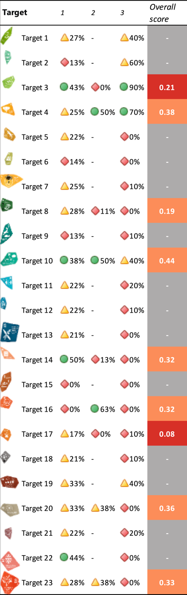

Part I: Introduction

I. An Introduction to the Kunming-Montreal Global Biodiversity Framework and the Regional Report for the Caribbean

The Framework
The Kunming-Montreal Global Biodiversity Framework (henceforth referred to as “the Framework”) is the most significant and comprehensive multilateral plan to date on the conservation and sustainable use of biodiversity. Adopted in 2022 by 196 Parties to the United Nations Convention on Biological Diversity (CBD) (195 countries and the European Union), the Framework succeeds the Strategic Plan for Biodiversity 2011-2020 and its Aichi Biodiversity Targets, as the main vehicle for realizing a global vision of living in harmony with nature by the middle of this century (the “2050 Vision”) (CBD, 2023; United Nations General Assembly, 2023).

The Framework is built around a theory of change which recognizes that “urgent policy action is required globally, regionally and nationally to achieve sustainable development so that the drivers of undesirable change that have exacerbated biodiversity loss will be reduced and/or reversed to allow for the recovery of all ecosystems.” The Framework also sets out a mission of taking urgent action by 2030 to “halt and reverse biodiversity loss, and place nature on a path to recovery for the benefit of people and planet.” This mission is to be achieved through conserving and sustainably using biodiversity, ensuring the fair and equitable sharing of benefits from the use of genetic resources, and providing the necessary means of implementation. This ambition is articulated through four long-term goals to 2050 and 23 action-oriented targets to 2030 (Figure 1). The Framework also sets out 18 cross-cutting considerations to ensure its effective, efficient and equitable implementation.

Figure 1: Kunming-Montreal Global Biodiversity Framework.
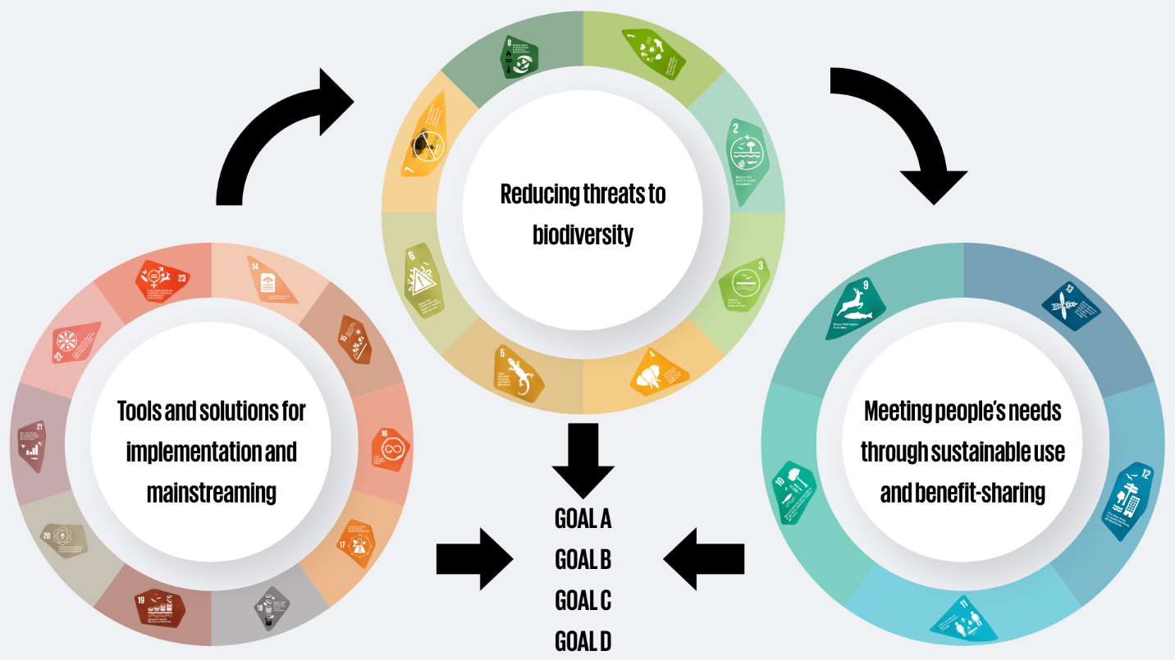The Framework is made up of 23 action-oriented targets to 2030 that together are essential to reach the four 2050 goals.

Planning, monitoring, reporting and review
The Framework is supported by an integrated planning, monitoring, reporting and review (PMRR) mechanism to support implementation, strengthen accountability and transparency, and facilitate assessment of progress towards the Framework’s four goals and 23 targets. Established through decision 15/6 of the Conference of the Parties (COP) to the CBD, the PMRR mechanism links national planning with standardized monitoring, periodic reporting and review of collective progress, while also providing a basis for regional assessment (CBD, 2023). The mechanism comprises four interrelated components: planning, monitoring, reporting and review.

- Planning: This is undertaken through the preparation, revision and implementation of National Biodiversity Strategy and Action Plans (NBSAPs), which constitute the principal national policy instruments for implementing the CBD, pursuant to Article 6. Decision 15/6 (CBD, 2023) adopted guidance for revising and updating NBSAPs and requested Parties to align them with the Framework, including its goals, targets and related means of implementation needs and provision. Parties were requested to submit revised or updated NBSAPs through the CBD clearing-house mechanism (CHM) by COP16. Recognizing that some Parties required additional time to revise their NBSAPs, the decision also provided for the submission of standalone national targets aligned with the Framework in advance of the full NBSAP, supporting continued participation in the implementation, monitoring and review process. Decision 15/6 further encourages Parties to use indicators in national planning and to mainstream revised NBSAPs across relevant policies to strengthen coherence and implementation.
- Monitoring: This is undertaken through the monitoring framework, adopted under CBD decision 15/5, which provides a standardized basis for assessing progress towards the Framework’s goals and targets. The monitoring framework includes required headline and binary indicators, complemented by optional component, complementary and national and subnational indicators (Affinito and others, 2024). Headline indicators provide the primary global measure of progress, while binary indicators assess the implementation of key policy and governance measures. The additional indicator types provide supplementary information to support interpretation and address national priorities. Collectively, these indicators support national reporting and assessment of progress at national, regional and global scales.
- Reporting: This is undertaken through national reports prepared and submitted in accordance with Article 26 of the CBD and the reporting guidelines adopted under CBD decision 15/6. Parties report through the standardized reporting template and CBD online reporting tool, using the required headline and binary indicators, supplemented where appropriate by other indicators. National reports provide the primary evidence base for assessing implementation and informing regional and global reviews of collective progress under the Convention.
- Review: This provides the mechanism through which the COP assesses implementation and collective progress towards the Framework’s goals and targets. Under decision 15/6, the COP will conduct global reviews at its seventeenth and nineteenth meetings (Figure 2), based on the findings of the Global Report on Collective Progress in the Implementation of the Kunming-Montreal Global Biodiversity Framework (henceforth referred to as “the global report”), which draws primarily on national reports and, where appropriate, other relevant sources of information. These reviews assess progress towards the 2030 targets and 2050 goals, identify implementation gaps, and inform on necessary measures to strengthen implementation. Their outcomes can also inform the revision and implementation of NBSAPs, supporting adaptive management of the Framework.

Figure 2: Timeline of the process of planning, monitoring, reporting and review within the period of the Framework, including its alignment with the Intergovernmental Science-Policy Platform on Biodiversity and Ecosystem Services (IPBES) second global assessment and the IPBES monitoring assessment.
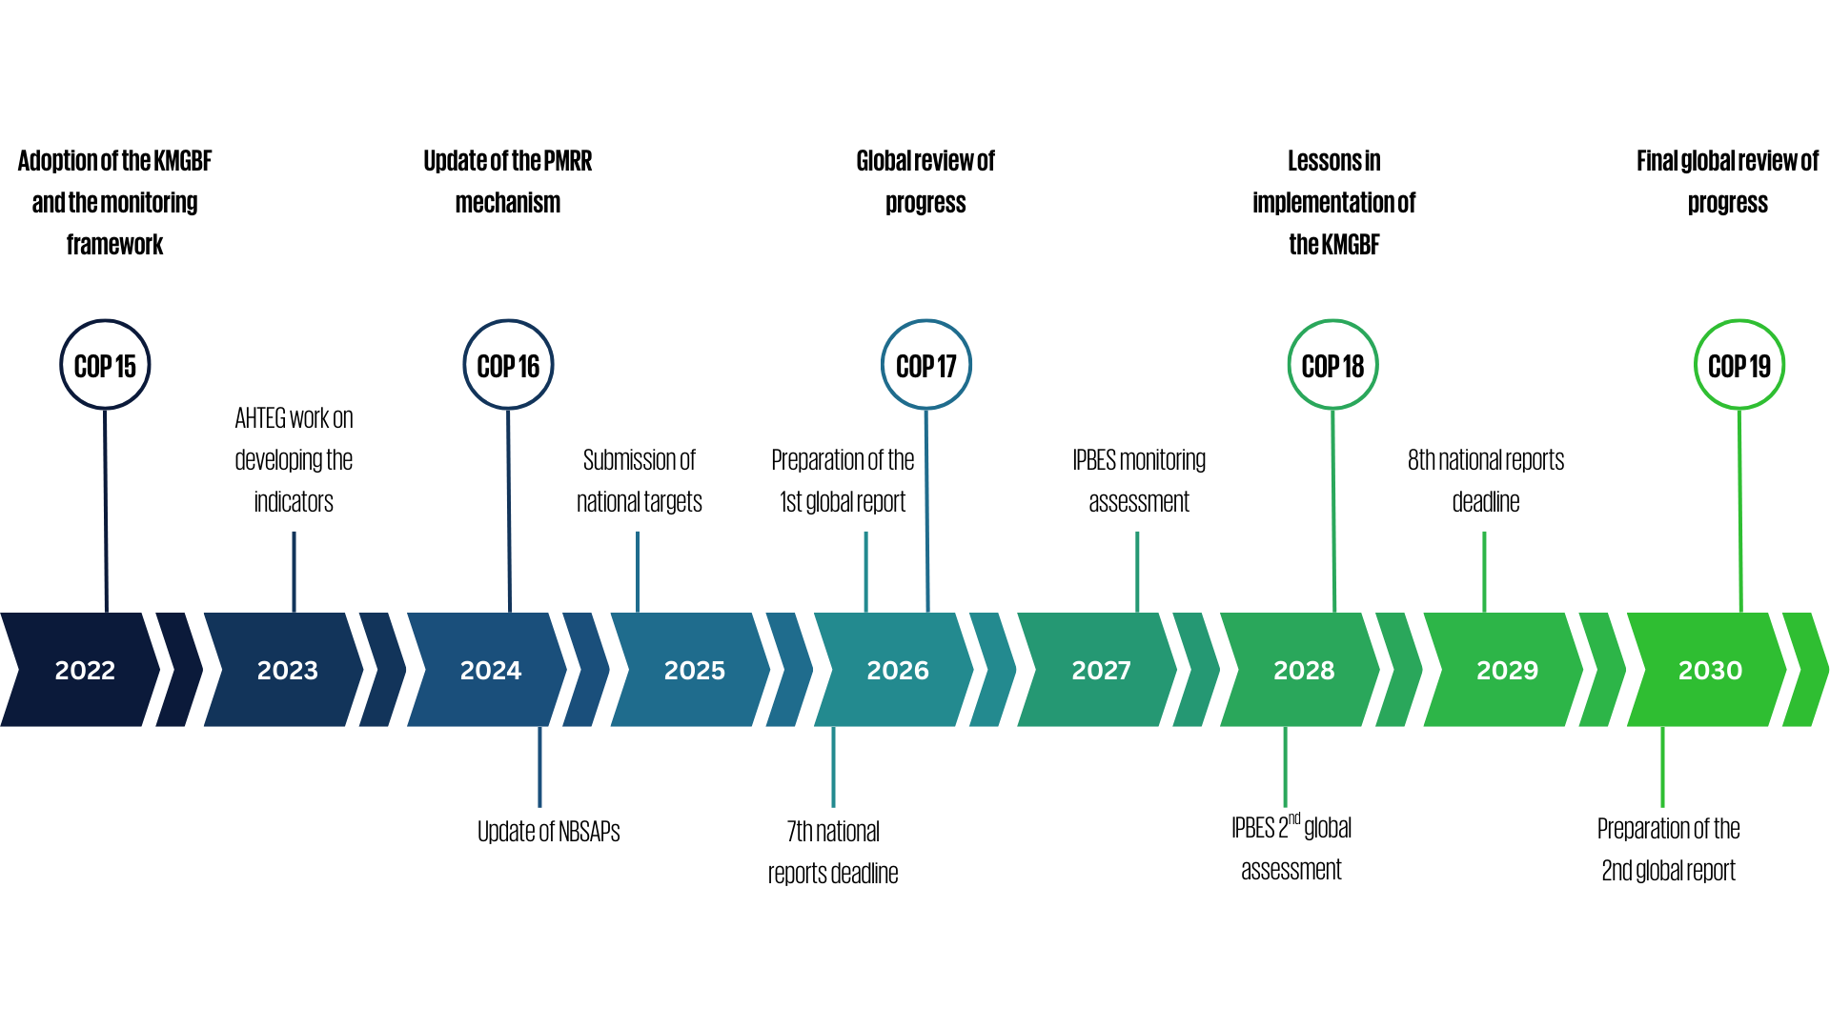

Purpose of the regional report for the Caribbean
The Caribbean Regional Report on Collective Progress in the Implementation of the Kunming-Montreal Global Biodiversity Framework (henceforth referred to as “the regional report”) provides a regional assessment of collective progress towards implementation of the Framework in the Caribbean region to ensure the representation of Parties in the region in the global review. The underlying data comes from draft or published seventh national reports provided voluntarily by ten participating countries.

As part of the PMRR mechanism, Parties were requested to submit their seventh national reports by 28 February 2026, using the agreed reporting template, for inclusion in the first global report and, therefore, consideration in the global review at COP17. However, delays in the preparation and submission of national reports by a number of Caribbean Parties, due to a range of issues – including, but not limited to, access to funds by implementation agencies and procurement issues (CBD/SBI/7/INF/17) - created a risk that information on regional progress, challenges and needs would not be fully reflected in the global review. At the sixth meeting of the Subsidiary Body on Implementation, Parties and CBD focal points highlighted this issue of representativity of the global report and the need to consider the special situation of small island states such as Caribbean Parties, who face particular challenges in monitoring implementation of the Framework (Jarvis and others, 2026). Therefore, it was noted that it would be valuable to compile available national reporting information at the regional level using a methodology consistent with that applied in the global report to better inform and improve the global review.

The regional report was therefore developed as a complementary regional synthesis to the global report to ensure that available information on the region’s progress and needs is captured and made available to inform Parties during the global review. The report does not replace individual Parties’ seventh national reports; rather, it provides a complementary evidence base drawing on available national reporting information and other relevant sources, including for Parties continuing to finalize their seventh national reports under extended timelines. While Party participation in this report was voluntary, it was offered to Parties as an optional exercise, based on national interests. Therefore, while the report focuses on Caribbean countries, it is not representative of all countries in the region.

The regional approach also provides an opportunity to identify common trends, successful solutions, implementation challenges, knowledge and capacity gaps, and opportunities for regional cooperation that may not be readily apparent from individual national assessments. The analysis therefore considers available evidence across participating Caribbean Parties in relation to the Framework goals and targets, while recognizing differences in reporting status, national monitoring systems, data availability and completeness.

Regional report sources and methodology
The regional assessment draws on available national reporting, including relevant indicator data, and supplemented by scientific and technical assessments, regional and subregional sources, peer-reviewed literature, and information from biodiversity-related conventions and international organizations as set out in decision 16/32 (CBD, 2026).

The regional assessment draws on national reporting and biodiversity planning information available from participating Caribbean Parties at the time of analysis. Of the 16 Parties invited to participate in the regional report process, 12 opted to do so. Of these, six had already submitted and published their seventh national reports via the CBD online reporting tool (ORT); four provided draft national reports outside the ORT for inclusion in the regional report; and two provided supporting documentation in lieu of their seventh national reports, primarily to contribute information relevant to the peer review and additional case studies. Therefore, all analysis in the regional report was conducted using data only from those ten Parties providing a seventh national report. These national sources are supplemented by relevant regional and international datasets, scientific and technical assessments and other information sources in concordance with those set out in decision 16/32 (CBD, 2026). The status and availability of national submissions considered in the assessment are presented in Section II.A.

Full details of the methodology used for the different sections of this report are set out in a separate document outlining the methodology used for the global report (SBSTTA/28/INF/9), which was replicated in the regional report.

Figure 3 provides a workflow of the different data sources and methodologies used, as well as how they relate to each section of the regional report. Whenever other sources of information have been used (i.e. not taken from Party submissions to the online reporting tool), relevant citations are provided in the report. Where data from other sources, including national data reported to other global processes, was used in the analysis of headline indicators, this is presented separately from national data. Key elements of the analysis providing the summary of collective progress set out in Part II of this report are as follows:

Part II of the report reflects the majority of the analysis done to synthesise progress in implementation based on Party submissions. Section II.B of the report follows a systematic methodology to analyse every target in the Framework. For every target the report contains:
- An analysis of the use of indicators by Parties. For every headline indicator, the percentage of Parties submitting data out of the 10 Parties included in the analysis for the regional report was calculated. Additionally, the number of Parties for which indicator data was used in each subsequent indicator analysis was also computed;
- An analysis of collective progress based on aggregating comparable headline indicator submissions. For every headline indicator, this methodology was dependent on the indicator’s metadata and affected by differences in Party submissions. The full aggregation methods are found in Annex D of the methodological document;
- An analysis of responses submitted by Parties in their national reports for the binary indicators. Using the methodology established by the ad hoc technical expert group on indicators to provide an overall progress score (see CBD/COP/16/INF/3/Rev.1), this progress score is based on the combination of answers to individual questions and ranges from 0 (no measures in place) to 5 (all measures fully in place);
- An evaluation of the overall level of self-assessed progress towards all highly aligned national targets. In their national target submissions, Parties were asked to state to which target or targets of the Framework each national target was aligned, and in each case, whether the alignment was low, medium or high. This information was used to identify highly aligned targets (more information in Annex E of the methodological document). Then, in their national reports, Parties used a Likert scale (from “no change” to “achieved”) to rank their own estimate of progress towards national targets. The percentage of national targets weighted by Party, to equalize contributions of Parties with many targets to those with few targets, in each category was thus calculated;
- An analysis of text components of the national reports. This was done through a semantic analysis of the relevant sections of national reports. The analysis relied on structured data extraction, semantic processing, ontology-supported evidence retrieval and large language model-assisted analysis followed by verification and validation. The detailed methodology for this approach is found in Annex F of the methodological document. In addition, case studies illustrating examples of success and progress in the implementation were identified (see Annex G of the methodological document) and co-developed with Parties.

Part II.C of the report also follows a systematic methodology for every goal in the Framework and contains:
- An analysis of how Parties associate Framework targets with goals in their national implementation of the Framework. This analysis is done based on national targets submitted by Parties that relate Framework goals to targets. The Party-weighted percentage of national targets associating a Framework target to a goal was used to identify those Framework targets most associated with each goal. The detailed methodology for this approach is found in Annex H of the methodological document;
- The same analysis of indicators (use and status and trends) as for Part IIB;
- An analysis of the types of actions reported by Parties for making progress towards the goals of the framework. This was done through a semantic analysis of the relevant sections of national reports. The analysis relied on structured data extraction, semantic processing, ontology-supported evidence retrieval, and large language model-assisted analysis, followed by verification and validation. The detailed methodology for this approach is found in Annex F of the methodological document.

The final part of the report summarizes and synthesizes the findings of Part II. First, a relative scoring methodology was developed to systematically assess and compare progress in implementation across targets of the Framework. This methodology uses the results of the analyses described above to highlight differences in implementation based on self-assessed progress, data use and indicator results. Specifically, it calculates an overall score for each (see Annex J of the methodological document) to rank Framework targets relative to the highest and lowest scores achieved across targets. These scores are then used to determine an overall score for each target, which is calculated as an equal average of two measures: the self-assessed progress score and a combined indicator results score, subsequently split into four score categories.

Figure 3: Methodological flow diagram for the preparation of the global report. This was applied to the regional report.

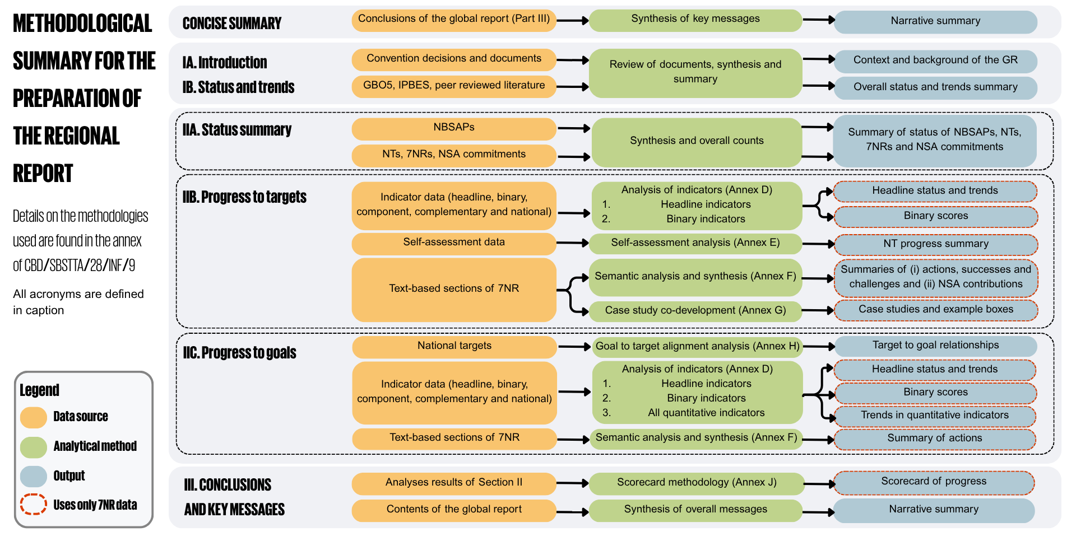The figure highlights, for each section of the global report, what information/data was used, how it was used and how it relates to the content of the report. Acronyms used, in order: GBO5 – Fifth Global Biodiversity Outlook, IPBES – Intergovernmental Science-Policy Platform on Biodiversity and Ecosystem Services, GR – global report, NBSAPs – National Biodiversity Strategies and Action Plans, NTs – national targets, 7NRs – seventh national reports.

Limitations and methodological assumptions
While all 16 Parties in the Caribbean region supported by the United Nations Development Programme (UNDP) were invited to take part in the regional report, some preferred not to be included. In all, 12 Parties (75 per cent) chose to participate in the preparation of the regional report, with 10 Parties (63 per cent) having submitted data for inclusion in the analyses, thereby providing good coverage of the region and representativeness of the challenges faced by small island states in the Caribbean. In addition to challenges directly linked to national contexts and, in some cases, limited national capacity, delays in accessing and receiving financial and technical support for the preparation of NBSAPs, national targets and national reports further delayed these processes for a number of Parties in the region. As such, six of the national reports included in the regional report were already published on the online reporting tool of the CBD, while four others were included in draft format. The remaining two Parties participated in the preparation of the regional report via the peer review process and specific targeted contributions but did not have information available from their seventh national reports.

Additional reasons for these differences in timeliness of the preparation of seventh national reports were shared during the regional and subregional dialogues on biodiversity monitoring and reporting organized by the CBD (CBD/SBI/6/INF/6), including:
- The length of time required to consult all stakeholders involved among other barriers to the inclusion of information from stakeholders;
- The length of time required to complete bureaucratic processes;
- The reporting burden created by having to report to many different multilateral environmental agreements and other processes, especially when compounded by a shortage of human resources;
- The complex nature of the Framework and of the information needed to describe the national targets fully, and to report on their implementation;
- Gaps in the coverage of national monitoring systems or in technical capacity for monitoring, including gaps related to reporting on the headline indicators; and
- Other delays related to specific national contexts.

Therefore, while most Caribbean Parties were able to participate and contribute to the production of the regional report, some of the content of the national reports used and the indicator data submitted may be incomplete. This was also the case for submissions included in the global report and has resulted in a number of challenges and limitations in the preparation of the regional report that should be considered when interpreting its findings:
- Small Island Developing States (SIDS) face particular challenges that affect their ability to produce national reports and compile extensive indicator data;
- Not all participating Parties were able to submit data for inclusion in the analyses;
- The reduced information basis limits inter-target comparison or comparison to the global report (for example, no overall indicator trend analysis was possible for the regional report);
- National targets and national reports are not all yet supported by revised NBSAPs aligned with the Framework.

I.B Regional status and trends in biodiversity
The Caribbean constitutes one of the world's most biologically significant regions, encompassing the Caribbean Islands Biodiversity Hotspot and the Wider Caribbean marine ecosystem. The Caribbean Islands Biodiversity Hotspot is one of the world's 36 recognized biodiversity hotspots, comprising more than 7,000 islands, islets, reefs and cays with a terrestrial area of approximately 230,000 km² dispersed across 4 million km² of sea (CANARI, 2019). The hotspot meets the globally recognized criteria of containing at least 1,500 plant species while having lost more than 70 per cent of its original natural habitat, reflecting both its exceptional biodiversity value and high level of vulnerability.

The region's biodiversity is a product of its complex geological history, island biogeography and climatic heterogeneity. The Caribbean archipelago extends approximately 2,700 km from Trinidad and Tobago to western Cuba (Mohammed and Fanovich, 2024) and comprises volcanic, continental and carbonate islands with distinct evolutionary histories that have promoted high levels of speciation, ecological differentiation and endemism. Geographic isolation, variation in topography, climatic gradients and historical colonization events have resulted in highly heterogeneous ecosystems and unique assemblages of terrestrial, freshwater, coastal and marine biodiversity.

The Caribbean supports a wide diversity of ecosystems across terrestrial, freshwater and marine environments. Within the Caribbean Islands Biodiversity Hotspot, 14 Holdridge life zones and 16 World Wildlife Fund terrestrial ecoregions have been identified, encompassing tropical and subtropical moist broadleaf forests, dry forests, coniferous forests, shrublands and xeric scrub (CANARI, 2019). Coastal and marine environments include coral reefs, mangrove forests, seagrass meadows, coastal lagoons, estuaries, beaches and mud-bottom communities, forming part of the Caribbean Large Marine Ecosystem. The region contains approximately 10 per cent of the world's coral reefs, making it one of the most biologically diverse marine regions in the Atlantic and providing critical habitat for thousands of marine species (Miloslavich and others, 2010; Roberts and others, 2002). More than 12,000 marine species have been documented; however, marine biodiversity remains incompletely characterized, particularly within deeper benthic ecosystems below 500 m depth where sampling remains limited (CANARI, 2019).

Species diversity and endemism within the Caribbean are among the highest globally. The hotspot supports approximately 10,948 seed plant species, of which 71.9 per cent are endemic. Terrestrial vertebrates exhibit particularly high levels of endemism, including 95.5 per cent of amphibians, 82.1 per cent of reptiles, 49.0 per cent of mammals and 26.2 per cent of birds. Compared with terrestrial ecosystems, marine species exhibit lower levels of endemism owing to the high degree of ecological connectivity resulting from ocean currents and species migration.

Despite this diverse and exceptional biodiversity, regional assessments indicate continuing declines in ecosystem integrity driven by interacting anthropogenic and climatic pressures. Habitat conversion and fragmentation associated with urban expansion, tourism development, agriculture, mining, infrastructure development and coastal modification remain the principal drivers of biodiversity loss. Approximately 10 per cent of the hotspot's original natural habitat persists (CANARI, 2019), with much of the remaining habitat becoming increasingly fragmented and exposed to cumulative pressures from land-use change, invasive alien species (IAS), pollution, natural disasters and climate change. The loss of ecological connectivity has reduced ecosystem resilience, increased population isolation and heightened extinction risk, particularly for species with restricted geographic distributions.

Marine and coastal ecosystems continue to experience significant ecological degradation. Coral reef ecosystems remain among the region's most threatened marine habitats, with ecological conditions declining as a result of recurrent marine heatwaves, thermally induced mass coral bleaching, coral disease outbreaks, declining water quality, sedimentation, overfishing and physical habitat disturbance. Between 1980 and 2024, hard coral cover declined by 48 per cent, while mean sea surface temperatures over Caribbean coral reefs increased by 1.07°C (0.27°C per decade, (Acosta-Chaparro and others, 2025)). Recurrent marine heatwaves, coral bleaching and disease have contributed to substantial coral mortality, increasing macroalgal dominance and reducing reef structural complexity through the long-term decline of branching Acropora species. Growing coastal populations, which increased by 27.6 per cent within 20 km of coral reefs between 2000 and 2020, further intensify pressures on these ecosystems (Acosta-Chaparro and others, 2025).

Mangrove forests and seagrass meadows remain critical components of coastal ecosystem connectivity, providing nursery habitat for fisheries, shoreline stabilization, sediment retention and long-term carbon sequestration. However, these ecosystems continue to be affected by coastal reclamation, altered freshwater inflows, dredging, pollution, shoreline hardening and sea-level rise, reducing their capacity to sustain biodiversity and provide essential ecosystem services. According to the State of the World's Mangroves Report, there was an estimated 7 per cent decline in mangrove extent across the Caribbean region between 1996 and 2016 indicating continued regional pressures on mangrove ecosystems (Spalding and Leal, 2021).

Freshwater ecosystems remain among the region's most threatened ecological systems because of their limited spatial extent and increasing anthropogenic pressures (Contreras-MacBeath and others, 2022; Mycoo and Roopnarine, 2024). Watershed degradation, sedimentation, nutrient enrichment, water abstraction, pollution and hydrological modification continue to affect rivers, wetlands and freshwater-dependent ecosystems, contributing to declines in freshwater biodiversity and ecosystem functioning.

Species-level assessments similarly indicate elevated extinction risk across multiple taxonomic groups. The Caribbean Islands Biodiversity Hotspot contains 992 globally threatened species, representing approximately 7 per cent of assessed taxa. Amphibians constitute the most threatened vertebrate group, with 73 per cent of assessed species categorized as globally threatened, followed by reptiles (30.6 per cent), mammals (25.0 per cent), cartilaginous fishes (20.5 per cent) and reef-forming corals (16.5 per cent) (CANARI, 2019). The combination of restricted geographic ranges, high endemism and continuing habitat degradation places many Caribbean species at disproportionate risk of extinction, with island ecosystems particularly vulnerable to IAS, disease emergence and climate change.

Climate change increasingly acts as a cross-cutting driver that amplifies existing environmental pressures across all ecosystem types. Rising sea surface temperatures, ocean acidification, sea-level rise, changing precipitation patterns, prolonged droughts, increasingly intense tropical cyclones and marine heatwaves are altering ecosystem structure, species distributions and ecological processes throughout the region. Historical observations indicate that the average number of named tropical storms increased from approximately 10-14 systems annually during 1950-2015 to more than 20 systems annually during 2019-2023 (Mohammed and Fanovich, 2024), reducing ecosystem recovery time following disturbance and increasing opportunities for habitat degradation and biological invasions.

The degradation of biodiversity has direct implications for ecosystem service provision throughout the Caribbean. Regional ecosystems provide essential provisioning, regulating, cultural and supporting services, including freshwater supply, fisheries production, carbon sequestration and storage, erosion control, coastal protection from extreme hydrometeorological events, soil fertility maintenance, tourism and recreation and cultural and spiritual values. However, ecosystem service assessments remain fragmented and regionally consistent evaluations of ecosystem function and service delivery remain limited.

The regional evidence base supporting biodiversity assessment has improved substantially over recent decades through advances in biodiversity observation, digitization and citizen science. The Global Biodiversity Information Facility (GBIF) currently contains approximately one million digitized natural history specimen records from the Caribbean, complemented by approximately five million georeferenced observations generated through citizen science platforms such as iNaturalist and eBird. These resources have substantially expanded species occurrence data and biodiversity documentation; however, important spatial, temporal and taxonomic biases remain, particularly for freshwater ecosystems, invertebrates, fungi, microorganisms and deep marine habitats. Strengthening standardized biodiversity monitoring, long-term ecological observation, regional data interoperability and biodiversity information systems remains essential for improving assessments of biodiversity status, ecosystem condition and long-term ecological change across the Caribbean.

Overall, the available scientific evidence indicates that Caribbean biodiversity continues to experience declines in ecosystem integrity, habitat quality and species resilience driven by interacting anthropogenic and climatic pressures. Nevertheless, the region continues to retain globally significant concentrations of biodiversity, ecosystem diversity and endemic species that provide irreplaceable ecological, economic and cultural values. Strengthening integrated biodiversity observation systems, ecosystem condition assessments, long-term ecological monitoring and harmonized regional biodiversity information systems will be essential to improve understanding of biodiversity status and trends, support evidence-based decision-making and provide the scientific foundation required for monitoring progress towards the goals and targets of the Framework. Achieving these outcomes will also require sustained investment in biodiversity finance and resource mobilization to strengthen conservation, ecosystem restoration, sustainable management and regional scientific and technical cooperation, thereby supporting the 2050 vision of living in harmony with nature.

Part II: Regional progress in implementation of the Kunming-Montreal Global Biodiversity Framework

II.A Summary of the status of national biodiversity strategies and action plans, national targets, national report submissions

Overview of the submission of national biodiversity strategies and action plans, national targets and national reports
The NBSAPs, national targets and national reports submitted by Parties through the Convention’s online reporting tool are the primary sources of information for analysing the collective regional progress in the implementation of the Framework. Due to the short period available for analysis, UNDP had to enforce a strict cut-off date for submissions to be considered in the regional report, although subsequent submissions may be taken into account by Parties during the global review process of the CBD held at COP17. The submissions available for analysis included NBSAPs from eight Parties, 219 national targets from ten Parties, national reports from six Parties and draft national reports from four Parties (Table 2). This provides a substantial, but necessarily incomplete evidence base for the regional report.

Table 2: Percentage of Parties providing national reports, national targets and NBSAPs that have been considered in this report out of 12 participating Parties.
National Report | National Target | NBSAP
50%  (up to 83% including drafts received) | 83% | 67%

Including draft national targets used in this report, each Party provided an average of 22 national targets, with the number of targets per Party ranging from seven to 30. On average, Parties provided national targets addressing 21 of the 23 targets of the Framework, with coverage ranging from 11 targets to all 23 targets.

In their national target submissions, decision 15/6 asked Parties to state to which target or targets of the Framework each national target was aligned to, if any; and in each case, whether the alignment was low, medium or high. The statement of the level of alignment was not mandatory. On average 43 per cent of Parties whose national targets are considered in the analysis reported that at least one of their national targets is highly aligned with a Framework target, with the percentage ranging from 13 per cent to 63 per cent (see Figure 4). However, it must be noted that Parties who submitted draft national targets did not include the alignment and are therefore not counted in these results even though their targets are included in the analysis of the regional report.

Figure 4: Percentage of Parties submitting at least one national target aligned with each target of the Framework
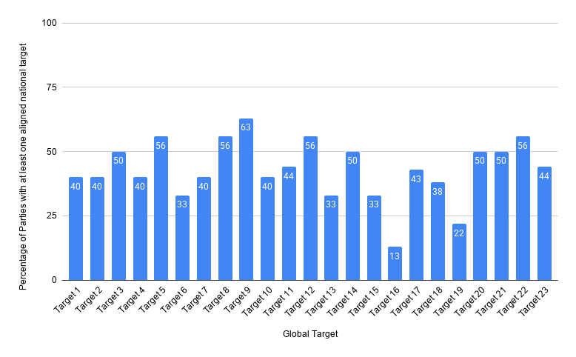

II.B Regional progress towards the implementation of the targets

Introducing the target progress summaries
This section of the report provides a detailed evaluation of collective progress by Parties in the Caribbean region towards the implementation of each of the 23 targets of the Framework. Based on the analysis and methodologies outlined in section I.A, each target summary is set out in a common format with standard sub-sections. An overview of the progress of all targets, using the metrics and indicators set out in the individual target summaries, is provided in Table 3, Section III of the report and in the concise summary of the report.

For each target summary, the following sections are included, with sources of information as indicated:
- Indicators of progress: Evaluation of the data provided by Parties in their national reports for all categories of indicators;
- Self-assessment of progress: An aggregation of the information provided by Parties in their national reports on the level of progress achieved towards implementation of their national targets; and
- Actions, successes and challenges: A synthesis of information provided in national reports about the types of actions undertaken to support implementation of the relevant target, and of the challenges encountered, including those associated with means of implementation.

Table 3: Summary of regional progress in the implementation of the Framework. Progress self-assessment is measured as the percentage of national targets reported as on track or achieved. Data use is measured as the percentage of all quantitative indicators with data submitted. The colour coding reflects where the value for each target sits relative to the highest and lowest scores achieved across targets (green is assigned to values falling within the top third of the total range, yellow to the middle third, and red to the bottom third). Note that this is not equivalent to a threshold-based approach nor is it equivalent to splitting the scores into three equal sized groups. Colours for the headline indicator results are based on progress relative to the target (green is assigned when progress is being made, yellow when progress is mixed, red when progress is insufficient; and grey when progress cannot be assessed). Colours for the binary indicators are based on the percentage of Parties scoring highly (4 or 5) for the indicator overall (green is assigned to values at or above 50 per cent, yellow to values between 50 and 25 per cent; and red to values below less than 25 per cent).The overall progress score is calculated as an equal average of two measures: self-assessment of progress and a combined indicator score, then split into five categories (0-0.25 in red, 0.25-0.5 in orange, 0.5-0.75 in yellow, 0.75-1 in green, insufficient data in grey). The combined indicator score is an unweighted average of the individual score (red/yellow/green) for each type of indicator relevant to the target where data is sufficient to assess progress.
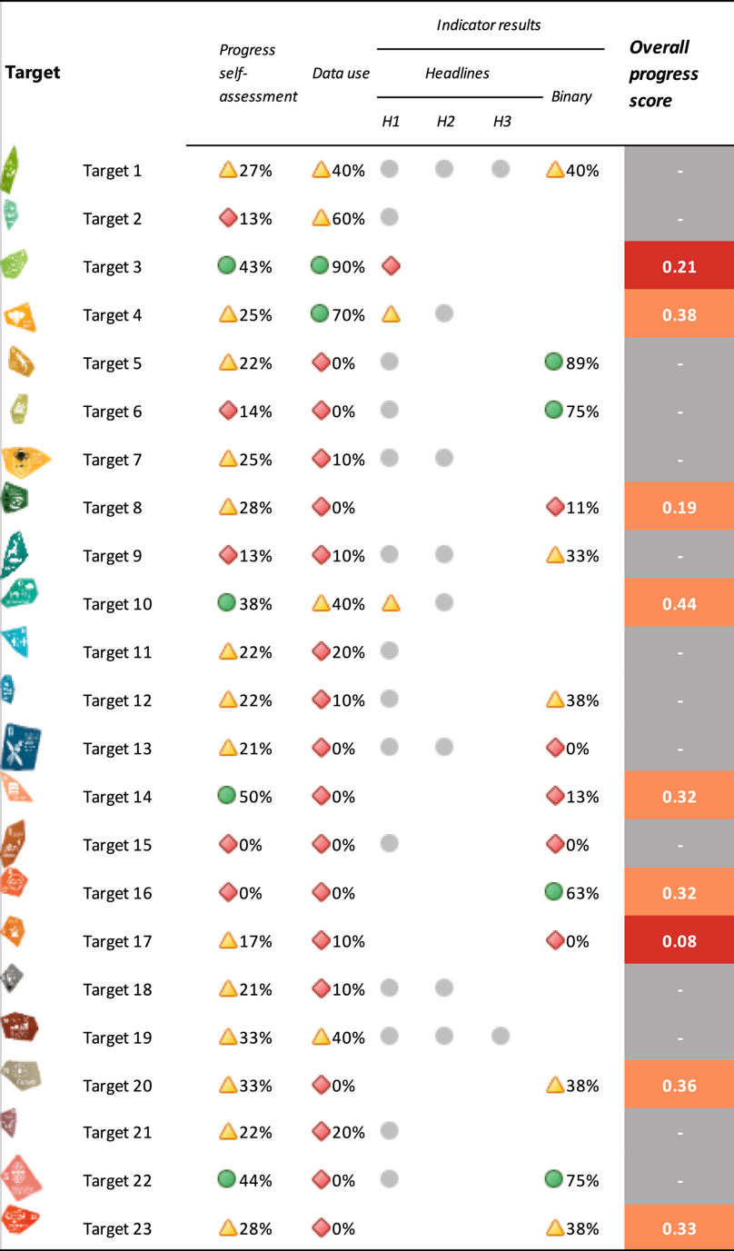

Reducing threats to biodiversity

Target 1: Plan and manage all areas to reduce biodiversity loss
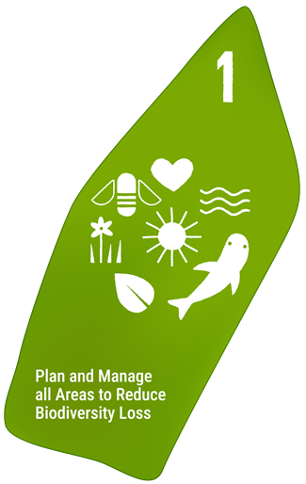
Target text: Ensure that all areas are under participatory, integrated and biodiversity inclusive spatial planning and/or effective management processes addressing land- and sea-use change, to bring the loss of areas of high biodiversity importance, including ecosystems of high ecological integrity, close to zero by 2030, while respecting the rights of indigenous peoples and local communities.

PROGRESS OVERVIEW:
Progress towards biodiversity-inclusive spatial planning in the Caribbean has largely been driven by area-based conservation measures. Insufficient monitoring data limits assessment of progress, but most Parties report that legal instruments to include biodiversity into spatial planning decisions are largely in development and not yet having an impact. However, notable efforts are under way, especially in marine areas.

Indicators of progress
Table 4: Scorecard of indicators for Target 1. Colour coding is related to the overall assessment of progress across targets, of which the methodology is explained in the summary scorecard (Table 1). The colour coding for indicator data use reflects where a value for each target sits relative to the highest and lowest scores achieved across all targets of the Framework (green is assigned to percentage values falling within the top third of the total range, yellow to the middle third, and red to the bottom third). Colours for the binary indicators are based on the percentage of Parties scoring highly (4 or 5) for the indicator overall (green is assigned to values at or above 50 per cent, yellow to values between 50 and 25 per cent; and red to values below less than 25 per cent). Colours for the headline indicator results are based on progress relative to the target (green is assigned when progress is being made, yellow when progress is mixed progress, red when progress is insufficient; and grey when progress cannot be assessed).
 | Indicator use |  | Indicator results
Headline indicator A.1: Red List of Ecosystems | 0% of those Parties |  | No data
Headline indicator A.2: Extent of natural ecosystems | 40% of Parties, 1 of which with time series data |  | 51% of areas
Headline indicator 1.1: Percentage of land and sea area covered by biodiversity-inclusive spatial plans | 0% of Parties |  | No data
Binary indicator 1.b: Number of countries using participatory, integrated and biodiversity-inclusive spatial planning and/or effective management processes addressing land- and sea-use change to bring the loss of areas of high biodiversity importance close to zero by 2030 | 9 Parties | N/A | 40% of Parties that reported scored highly (score 4/5)

No Parties reported on the percentage of land and sea area covered by biodiversity-inclusive spatial plans. Reported challenges for indicator 1.1 focused primarily on foundational data gaps and ongoing technical infrastructure development. Parties report an absence of aggregated national metrics for land and marine areas under biodiversity-inclusive spatial planning, largely because national spatial-data systems and land registries remain under active development. Additionally, indicator compilation is constrained by upstream data collection requirements, including species inventories and baseline ecosystem remapping necessary to construct landscape-level spatial representations.

All areas are fully under biodiversity inclusive spatial plans for half of Parties in terrestrial areas and a quarter in inland waters while this is only partially the case for marine areas (Figure 5). Where plans are in place, these have been created using participatory processes.

As headline indicators A.1 and A.2 are used to measure progress towards Goal A, they are further discussed in Section IIC of the report.

Figure 5: Binary indicator 1.b, the number of countries using participatory, integrated and biodiversity-inclusive spatial planning and/or effective management processes addressing land- and sea-use change to bring the loss of areas of high biodiversity importance close to zero by 2030. 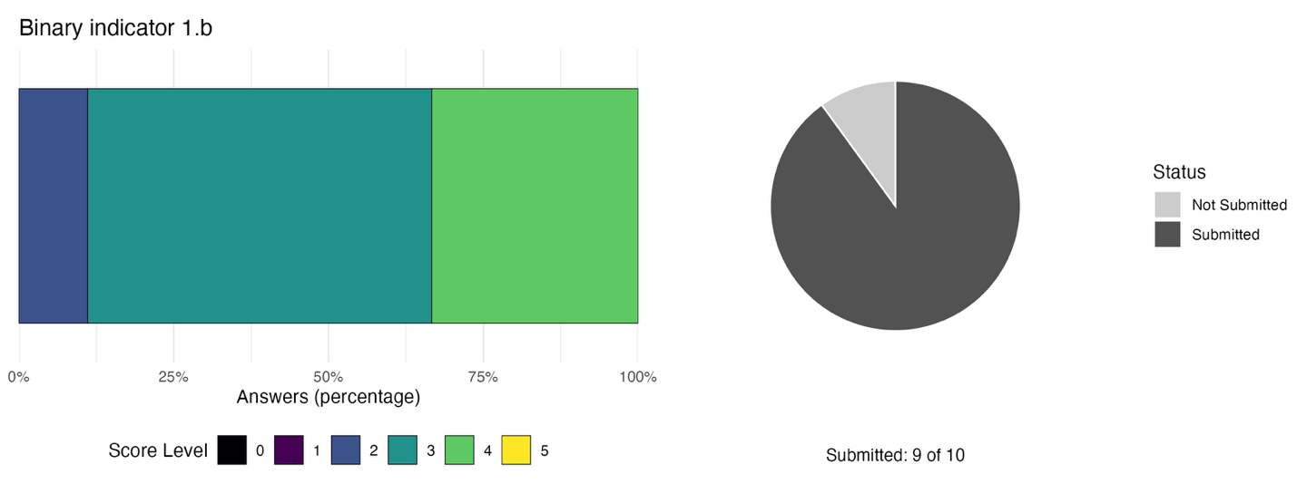The bar widths show the percentage of Parties in each score category, with higher numbers indicating a greater level of progress, based on responses to the questions included in the indicator. The pie chart shows the proportion of Parties included in the regional report who submitted national targets aligned with Target 1 in dark grey.

Self-assessment of progress
Based on the self-assessment provided by Parties in their national reports for each of their national targets, 27 per cent of national targets highly aligned with Target 1 are on track for achievement, while 73 per cent show insufficient progress. However, no national targets were reported as having made no significant progress (see Figure 6).

Figure 6: Self-assessed progress for all national targets submitted as highly aligned to Target 1.
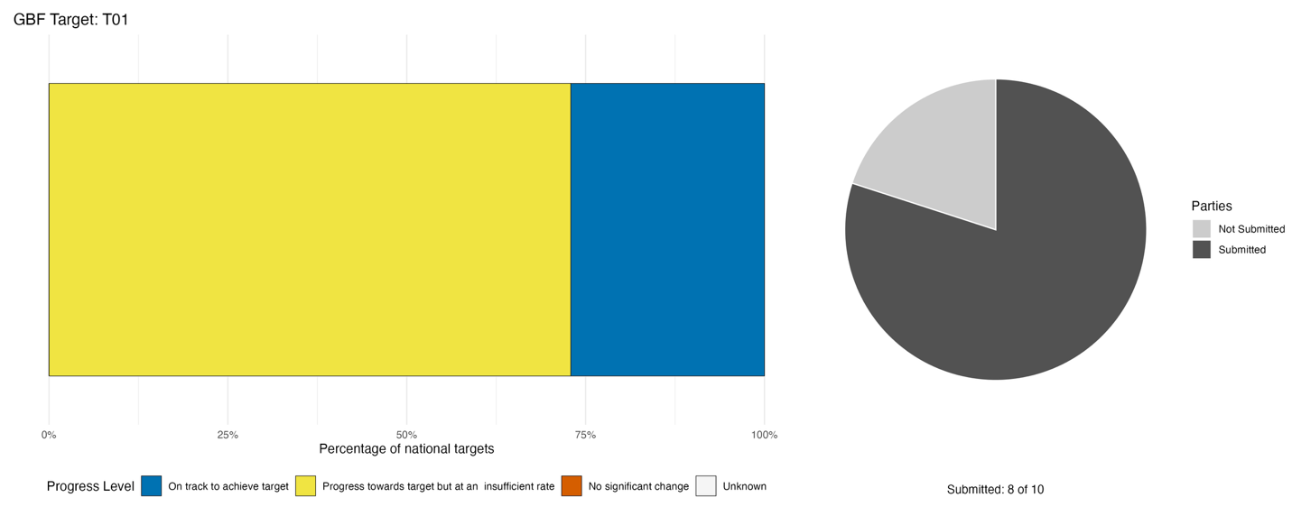Bar widths show the percentage of national targets in each progress category. Percentages are weighted by Party to ensure that Parties contribute equally to overall assessment of progress, regardless of the number of national targets submitted. The pie chart shows the proportion of Parties included in the regional report who submitted national targets aligned with Target 1 in dark grey.

Actions, successes and challenges

Summary of actions in support of Target 1
Parties’ main reported actions for advancing progress towards Target 1 focus on legal and regulatory policy instruments and direct conservation and sustainable use actions. Half of reporting Parties describe already having established legal and regulatory instruments, with most others stating efforts are under way for these to be fully implemented. The dominant instrument types reported are protected area establishment through legislation or decree, environmental impact assessment requirements integrated into development planning, and spatial planning frameworks, including marine integrated spatial planning. In conjunction, most Parties report direct conservation action, including protected area management as well as ecosystem restoration assessments. It is worth noting that most actions reported by Parties as contributing to Target 1 focus on area-based conservation measures, including seascape management and improving participatory governance of areas. Other types of actions were reported by Parties, but a large proportion remain planned or aspirational rather than implemented.

Examples of success and progress in implementation
Box 1

Environmental impact assessment and ecological gap analysis for biodiversity-inclusive planning in The Bahamas

The Ecoregional Plan for the Bahamian Archipelago (2002) provides a national example of a bioregional assessment used to identify conservation priorities across terrestrial and marine ecosystems, establishing a baseline for subsequent planning processes. This was refined through the 2014 and 2017 ecological gap analyses, which identified underrepresented ecosystems and informed conservation and protected area planning.
The Environmental Planning and Protection Act (2019) provides a concrete regulatory example of how biodiversity considerations are integrated into development planning. Through its environmental impact assessment requirements, developers must assess potential impacts on ecosystems and habitats prior to project approval. This mechanism is applied across sectors and supports biodiversity-informed decision-making in national development processes.
Spatial data used in environmental impact assessment processes are supported by the Department of Environmental Planning and Protection’s spatial biodiversity information system and the Bahamian national geographic information systems (GIS) GeoPortal, which provide ecosystem and land-use layers used in regulatory review.

Relevant targets: 1, 14
Source: The Bahamas, seventh national report to the Convention

Challenges
Significant challenges were reported by participating Caribbean Parties in making progress towards Target 1. All Parties report some form of capacity and institutional constraints as well as gaps in monitoring and data. However, reported challenges are often cross-cutting and mutually reinforcing. Specifically, Parties report that weak or unclear institutional mandates between ministries or across jurisdictions limit enforcement of biodiversity-inclusive spatial planning; enforcement gaps allow land-use change to proceed unchecked; absent or fragmented biodiversity data prevent evidence-based planning; and insufficient financing constrains both the development of monitoring systems and the operationalisation of management plans. Several Parties report that policy and legislative frameworks exist in draft or partial form but have not been formally adopted or operationally enforced, creating a structural condition in which biodiversity-inclusive planning is formally articulated but not yet operationalised.

Target 2: Restore 30% of all degraded ecosystems
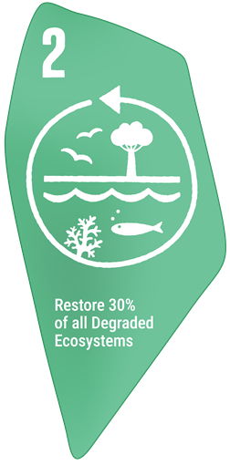
Target text: Ensure that by 2030 at least 30 per cent of areas of degraded terrestrial, inland water, and marine and coastal ecosystems are under effective restoration, in order to enhance biodiversity and ecosystem functions and services, ecological integrity and connectivity.

PROGRESS OVERVIEW
Ecosystem restoration is actively underway across the region; however, its scale and effectiveness cannot be established with current monitoring data. Several projects are underway that imbed restoration with benefits for people, but these remain localised and uncoordinated. Insufficient monitoring data on degraded lands and national level restoration efforts as well as limited financing hinder advancement towards national targets and progress tracking.

Indicators of progress
Table 5: Indicator scorecard for Target 2. Colour coding is related to the overall assessment of progress across targets, of which the methodology is explained in the summary scorecard (Table 1). The colour coding for indicator data use reflects where a value for each target sits relative to the highest and lowest scores achieved across all targets of the Framework (green is assigned to percentage values falling within the top third of the total range, yellow to the middle third, and red to the bottom third). Colours for the headline indicator results are based on progress relative to the target (green is assigned when progress is being made, yellow when progress is mixed progress, red when progress is insufficient; and grey when progress cannot be assessed).
 | Indicator use |  | Indicator results
Headline indicator 2.1: Area under restoration | 60% of Parties |  | 183 thousand hectares total

Half of all Parties participating in the regional report submitted data on restoration of ecosystems. This data included information on restoration of mangroves, beaches, forests and coral reefs. More information was available for forests than for any other ecosystem type. All values submitted were for restoration efforts taking place in 2025 and/or 2026, indicating most recent progress. Some Parties also indicated the type of restoration activity (e.g. community-based) or the location of the reported restoration efforts. In total, Parties reported 183 thousand hectares under restoration.

Parties reported a number of challenges in compiling headline indicator 2.1: area under restoration. A primary hurdle was data fragmentation, as restoration actions are predominantly documented at isolated project or programme levels using varying methodologies, spatial scales, and monitoring approaches across different ecosystem types. This is compounded by a lack of centralized, harmonized national spatial datasets and data management systems capable of consolidating total area coverage across terrestrial, freshwater, coastal and marine realms. Furthermore, reporting was hindered by the operational delays of inter-agency coordination, requiring data synthesis across distinct sectoral ministries, and the fact that national spatial monitoring frameworks, land assessments and data-sharing mechanisms remain under development.

Self-assessment of progress
Based on the self-assessment provided by Parties in their national reports for each of their national targets, only 13 per cent of national targets highly aligned with Target 2 are on track for achievement, with 81 per cent showing insufficient progress and a further seven per cent showing no significant change (see Figure 7).

Figure 7: Self-assessed progress for all national targets submitted as highly aligned to Target 2.
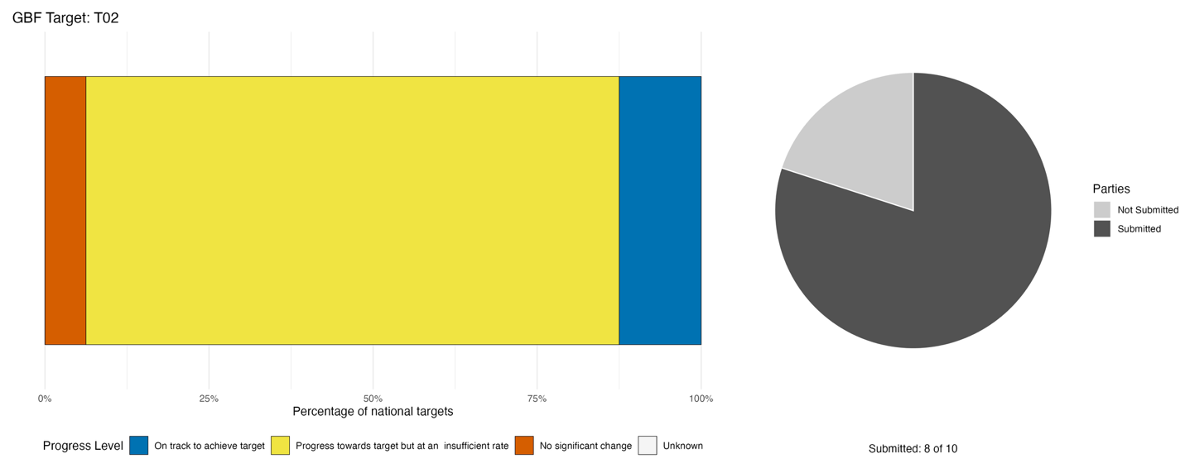Bar widths show the percentage of national targets in each progress category. Percentages are weighted by Party to ensure that Parties contribute equally to overall assessment of progress, regardless of the number of national targets submitted. The pie chart shows the proportion of Parties included in the regional report who submitted national targets aligned with Target 2 in dark grey.

Actions, successes and challenges

Summary of actions in support of Target 2
All Parties report some direct action to restore ecosystems. These actions, focusing on coral reefs, mangroves, forests and wetlands, make up most of the efforts reported by Parties in advancing towards Target 2. Most Parties indicate that monitoring efforts of restoration activities are underway, including via novel technologies such as drone surveys, but these remain infrequent and not nationally standardized. Many Parties also report embedding restoration efforts into community-led conservation projects and participating in international partnerships (e.g. projects via Global Environment Facility (GEF), the International Union for Conservation of Nature (IUCN) and the United Nations Environment Programme (UNEP)) aimed at enhancing conservation outcomes and benefits for people. A few Parties also report legal instruments relevant to the Target, but these are largely focused on preventing further degradation or protecting lands to enable restoration.

Examples of success and progress in implementation
Box 2

Restoration of protected areas in Haiti
Deforestation, ecosystem fragmentation, and weak institutional capacity have historically threatened Haiti’s national network of protected areas. To tackle these interconnected challenges, UNEP, in partnership with the National Agency for Protected Areas, introduced an integrated governance and restoration strategy in southern Haiti. By establishing a scientific, participatory methodology, UNEP and its partners successfully developed climate-resilient management plans for critical sites, including Île-à-Vache, Pointe à Bacou/Port Salut, and La Cahouane. This framework grounded environmental governance in local realities while providing a structured pathway toward sustainable natural resource management.
At the core of this initiative was a strong network of trusted local partners who led operational activities directly within affected communities. Direct ecosystem restoration efforts produced important results: restoring 700 hectares of mangroves, establishing 595 hectares of agroforestry, rehabilitating over 20 kilometers of coastlines and riverbanks, and improving land-use planning practices across nearly 10,000 hectares. Additionally, coastal support initiatives provided local artisanal fishers with specialized equipment towards stabilizing degraded watersheds while fostering community ownership over natural resources.
By combining ecological recovery with socioeconomic support, the programme successfully aligned with Haiti’s NBSAP. Initiatives such as promoting sustainable vetiver production across 7,000 hectares in Port-Salut, supporting local cooperatives and setting up disaster early warning systems have directly improved community livelihoods and climate resilience. Ultimately, UNEP's emphasis on funding and training local organizations strengthened institutional capacity from the ground up, establishing a scalable, community-driven model for long-term biodiversity conservation.
Relevant targets: 2, 3, 8, 9, 20, 22
Source: Haiti, draft seventh national report to the Convention

Box 3
Ma Kôté: restoring Saint Lucia's largest mangrove through community tenure
The Ma Kôté mangrove (Figure 8), a Ramsar site within the Pointe Sable Environmental Protection Area, is Saint Lucia's largest basin mangrove: historically about 63 hectares, its living canopy reduced to roughly 40 hectares by 2021 following rapid dieback. Under the Saint Lucia National Trust's Ecosystem-based Adaptation project, the Institute of Marine Affairs completed a hydrological and ecological diagnosis and an associated rehabilitation plan, giving the site a rare, quantified time series of mangrove change and a repeatable baseline against which recovery can now be tracked. The deeper story is one of governance: rather than restoration through exclusion, the mangrove was brought back from earlier over-exploitation through a shift from open access to secure communal tenure, with a co-management agreement granting the Aupicon Charcoal and Agricultural Producers Group exclusive harvesting rights conditional on sustainable silvicultural practice. Protection became rational for the harvesters themselves, producing a measurable increase in mangrove biomass while preserving the site's blue-carbon function and community livelihoods — a globally cited model of community-based restoration.

Relevant targets: 2, 8, 9, 22
Source: Saint Lucia, draft seventh national report to the Convention

Figure 8: The Ma Kôté mangrove, within the Pointe Sable Environmental Protection Area. Source: Institute of Marine Affairs, Ma Kôté Mangrove Assessment (2022).
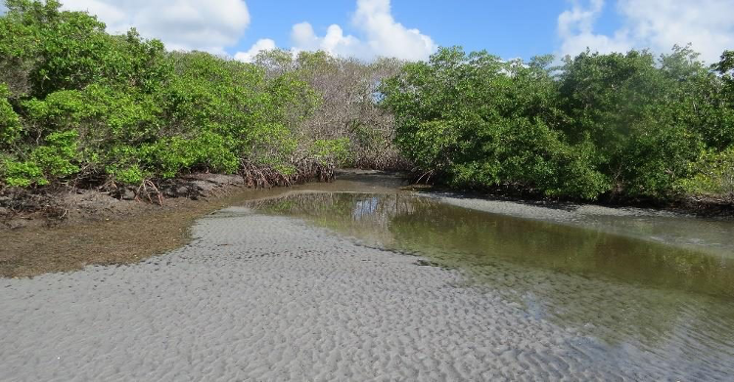

Challenges

Monitoring and reporting challenges
Almost all Parties report significant challenges in monitoring progress towards Target 2 due to a combination of capacity and finance related issues. While Parties acknowledge that restoration is underway, they often report that insufficient baseline information on degraded areas, as well as country level data on ongoing restoration activities and their effectiveness are available to measure national progress towards the Target. In most cases, the absence of national level restoration data is inseparable from institutional coordination gaps and insufficient resources to establish or maintain monitoring systems. Several Parties note that the responsibility for restoring ecosystems is spread across agencies with overlapping mandates and insufficient coordination, limiting their ability to track how much degraded land is being restored.

Implementation challenges
Some Parties note that sector specific incentives currently in place conflict directly with restoration targets, and conversely no incentives to promote restoration are in place. Relatedly, most Parties report difficulties in raising the necessary financing to fund restoration activities at the scale required, often having to rely on project-based financing.

Target 3: Effectively conserve and manage at least 30% of terrestrial and inland water areas and 30% of coastal and marine areas
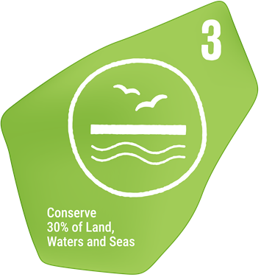
Target text: Ensure and enable that by 2030 at least 30 per cent of terrestrial and inland water areas, and of marine and coastal areas, especially areas of particular importance for biodiversity and ecosystem functions and services, are effectively conserved and managed through ecologically representative, well-connected and equitably governed systems of protected areas and other effective area-based conservation measures, recognizing indigenous and traditional territories, where applicable, and integrated into wider landscapes, seascapes and the ocean, while ensuring that any sustainable use, where appropriate in such areas, is fully consistent with conservation outcomes, recognizing and respecting the rights of indigenous peoples and local communities, including over their traditional territories.

PROGRESS OVERVIEW:
Parties report making progress towards national targets related to the coverage of protected areas, especially for marine areas. Action on area-based conservation measures and enhancing their effectiveness meaningfully contributes to progress towards other targets. However, submitted indicator data shows minor changes in overall coverage with little to no progress towards many of the 30 per cent targets set by Parties. Important challenges remain in improving the effectiveness of area-based conservation measures across the region.

Indicators of progress
Table 6: Indicator scorecard for Target 3. Colour coding is related to the overall assessment of progress across targets, of which the methodology is explained in the summary scorecard (Table 1). The colour coding for indicator data use reflects where a value for each target sits relative to the highest and lowest scores achieved across all targets of the Framework (green is assigned to percentage values falling within the top third of the total range, yellow to the middle third, and red to the bottom third). Colours for the headline indicator results are based on progress relative to the target (green is assigned when progress is being made, yellow when progress is mixed progress, red when progress is insufficient; and grey when progress cannot be assessed).
 | Indicator use |  | Indicator results
Headline indicator 3.1: Coverage of protected areas and other effective area-based conservation measures (OECMs) | 90% of Parties, covering 98% of land and 65% of sea areas under the jurisdiction of Parties included in the analysis |  | Mixed trends in coverage:  - 3% coverage for marine and coastal areas (5% increase since 2020)  - 10% for terrestrial and inland waters (0.1% decrease since 2020)

The coverage of protected areas and OECMs in the region has remained largely stable since 2020 across both marine and terrestrial areas (Figure 9), unlike that of the broader world which has increased steadily (Figure 10). To date, Parties report that only 3 and 10 per cent of marine and coastal areas under national jurisdiction, and terrestrial and inland waters, are covered by protected areas and OECMs, respectively. No information was submitted to differentiate between types of protected area or OECMs. The data provided reflects almost all marine and coastal areas for the region but only about two thirds of terrestrial and inland waters. Therefore, actual coverage of this latter realm may be different from that presented in this report.

Parties did not provide any comments on challenges related to compiling the indicator, but half specified that they relied on data from the World Database on Protected and Conserved Areas for their submission.

Figure 9: Headline indicator 3.1, coverage of protected areas and other effective area-based conservation measures split by marine and coastal areas under national jurisdiction (left) and terrestrial and inland water areas (right).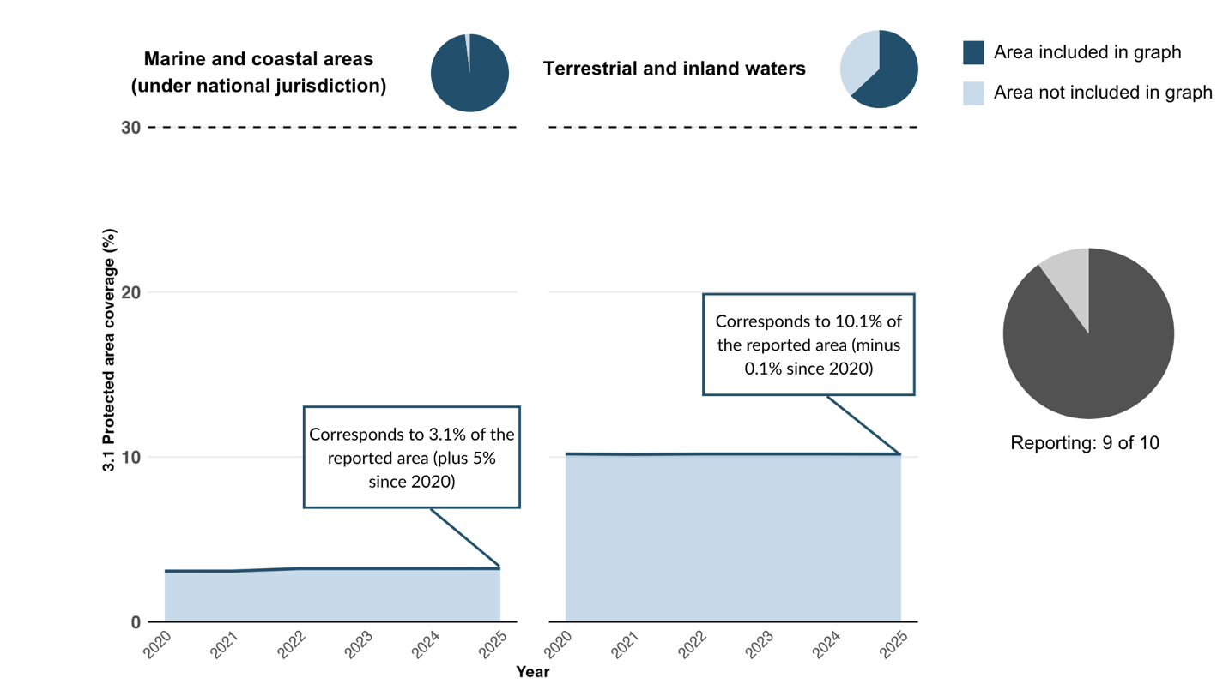This figure includes only indicator data submitted by Parties in the national reports. The right pie chart shows the proportion of Parties providing data for the graph in dark grey. The top pie charts show the representativeness of the data submitted as a proportion of all Parties included in the regional report’s marine and coastal areas under national jurisdiction (left) or terrestrial and inland water areas (right) in dark blue.

Figure 10: Headline indicator 3.1, coverage of protected areas and OECMs, for all marine and coastal areas and terrestrial and inland waters, including areas beyond national jurisdiction, based only on data submitted to the World Database on Protected and Conserved Areas.
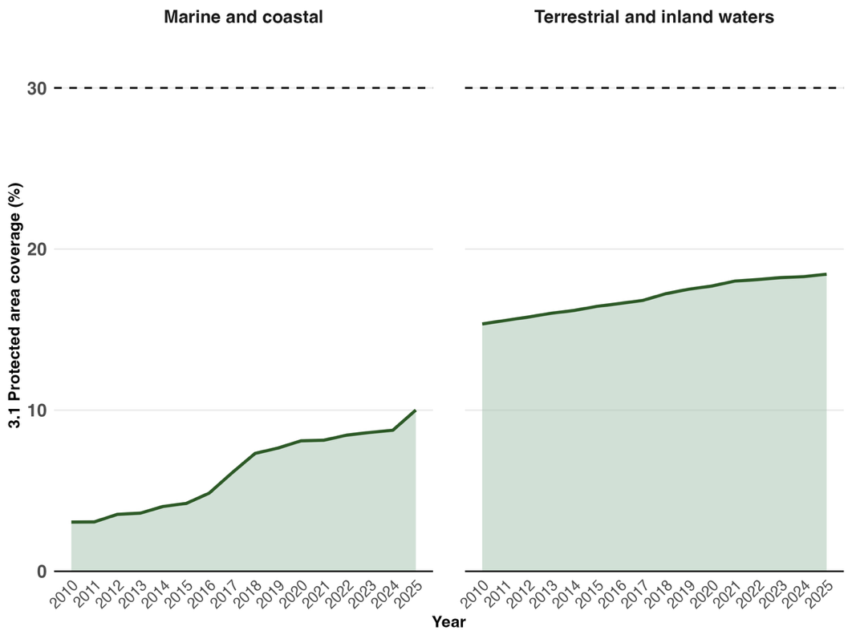
Indicator values show the overall proportion of areas under conservation globally.

Self-assessment of progress
Based on the self-assessment by Parties of progress towards each of their national targets, 43 per cent of national targets highly aligned with Target 3 are on track for achievement, while another 46 per cent show insufficient progress or no significant progress (see Figure 11).

Figure 11: Self-assessed progress for all national targets submitted as highly aligned to Target 3.
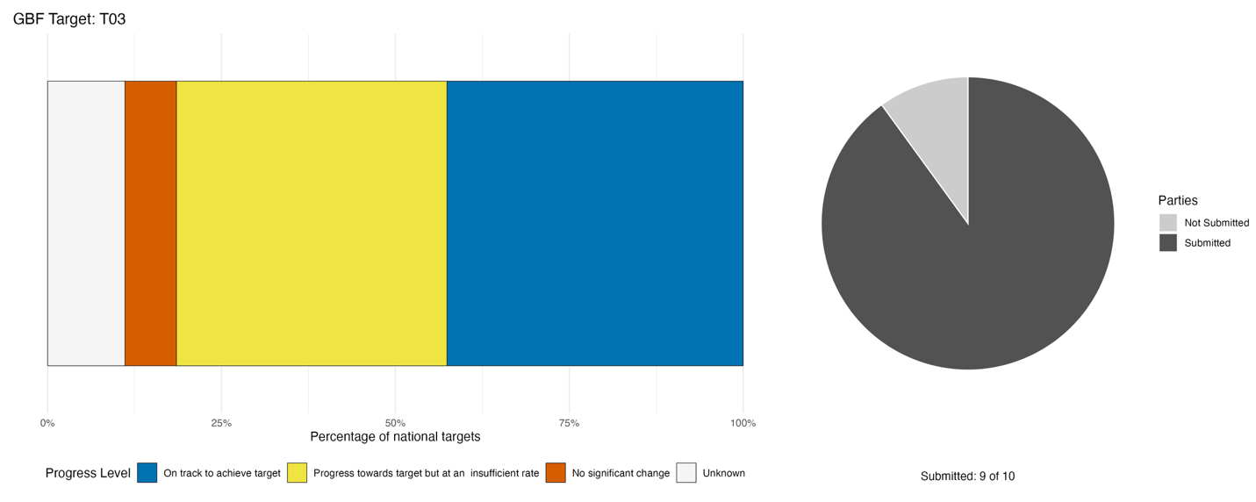Bar widths show the percentage of national targets in each progress category. Percentages are weighted by Party to ensure that Parties contribute equally to overall assessment of progress, regardless of the number of national targets submitted. The pie chart shows the proportion of Parties included in the regional report who submitted national targets aligned with Target 3 in dark grey.

Actions, successes and challenges

Summary of actions in support of Target 3
Across all reporting Parties, the dominant pattern of implementation reported is the direct establishment, expansion and management of protected areas, particularly for marine areas supplemented by legal and regulatory frameworks and increasingly by research and monitoring activities. All Parties report taking some action to formally design or expand protected areas, with several Parties describing specific actions taken within protected areas to increase their effectiveness such as habitat enhancement, no-take zones and community monitoring. Some Parties also report being at the early stages of developing OECMs. In most cases, area-based protection measures are accompanied with legislation on the formal status of areas as well as regulations on the sustainable use of biodiversity within these areas. Many Parties also report active monitoring of protected areas, especially for species of special conservation interest. Co-management of protected areas by involving local communities, fishers, and private sector actors was also reported in several cases.

Examples of success and progress in implementation
Box 4

GEF Amazon Sustainable Landscapes 2: Strengthening Management of Protected and Productive Landscapes in the Surinamese Amazon

The official project design and implementation plan explicitly include functional co-management modalities as a key part of improving protected area governance in Suriname’s Amazon landscapes. The GEF Amazon Sustainable Landscapes 2 Suriname project, aims to increase management effectiveness of protected areas by (1) strengthening co-management arrangements between government agencies and local stakeholders, including communities and civil society; (2) building capacity for participatory management of protected landscapes, involving communities directly in planning, monitoring and action; (3) supporting training and deployment of community rangers and inclusion of local voices in decision-making about protected area use and conservation.
These co-management efforts are designed not only to increase technical capacity within agencies such as Dienst’s Lands Bosbeheer and Stichting Natuurbehoud Suriname, but also to institutionalize collaboration with communities and non-governmental organizations (NGOs) in everyday management of parks and reserves.
The geographic focus of Amazon Sustainable Landscapes 2 in Suriname includes four major protected areas where co-management approaches are expected to be strengthened: Central Suriname Nature Reserve, Sipaliwini Nature Reserve, Brownsberg Nature Park and Brinckheuvel Nature Reserve. These areas are within the Saamaka-Matawai and Coeroeni-Paroe landscapes targeted by the project. Engagement with local communities and stakeholders near these sites will support more effective and equitable management. The project’s “theory of change” highlights that overcoming weak management effectiveness and limited community involvement requires co-management modalities that (1) involve community rangers and local partners in monitoring and reporting systems such as spatial monitoring and reporting tools; (2) promote participatory landscape planning in areas such as Coeroeni-Paroe; and (3) support codes of practice, governance agreements and shared responsibilities between government, communities, NGOs and private sector.
While concrete data on completed co-management arrangements or quantitative results (e.g., hectares under co-management) are not yet published online because the project is ongoing (2022-2027), the design and early implementation plans clearly position co-management as a core mechanism for improved protected area management and shared conservation outcomes.
Relevant targets: 3, 20, 21, 22
Source: Suriname, seventh national report to the Convention

Challenges
All reporting Parties describe challenges related to capacity and institutional constraints, data and monitoring gaps and legal and governance weaknesses in the implementation of national targets related to Target 3. In general, legal/governance gaps, particularly the absence of overarching protected areas legislation and the lack of formal OECM recognition mechanisms, compound institutional weaknesses by leaving conservation mandates fragmented across multiple agencies without clear accountability. These governance deficits in turn undermine data and monitoring systems, since the absence of harmonised legal frameworks and inter-agency coordination mechanisms prevents the standardisation of spatial data, management effectiveness assessments and coverage accounting. Capacity constraints, especially shortages of trained technical personnel, limit enforcement capabilities within protected areas. Finally, Parties report that financial constraints amplify all these gaps, as insufficient domestic budget allocations and dependence on short-term external funding limit both the management of existing protected areas and the expansion of coverage toward 30 by 30 targets. Additionally, specific national conditions, such as active armed conflict, were reported as effectively blocking progress towards effective conservation of areas.

Target 4: Halt species extinction, protect genetic diversity, and manage human-wildlife conflict
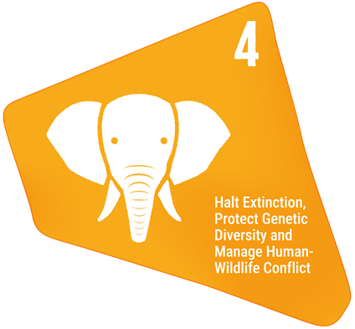
Target text: Ensure urgent management actions to halt human induced extinction of known threatened species and for the recovery and conservation of species, in particular threatened species, to significantly reduce extinction risk, as well as to maintain and restore the genetic diversity within and between populations of native, wild and domesticated species to maintain their adaptive potential, including through in situ and ex situ conservation and sustainable management practices, and effectively manage human-wildlife interactions to minimize human-wildlife conflict for coexistence.

PROGRESS OVERVIEW
Parties report considerable efforts towards species conservation with some noticeable positive results in the region. However, common challenges are widespread, revealing a pattern of externally funded and project-dependent progress, perpetuating a structural vulnerability for species conservation efforts. Little is known about the status of genetic diversity.

Indicators of progress
Table 7: Indicator scorecard for Target 4. Colour coding is related to the overall assessment of progress across targets, of which the methodology is explained in the summary scorecard (Table 1). The colour coding for indicator data use reflects where a value for each target sits relative to the highest and lowest scores achieved across all targets of the Framework (green is assigned to percentage values falling within the top third of the total range, yellow to the middle third, and red to the bottom third). Colours for the headline indicator results are based on progress relative to the target (green is assigned when progress is being made, yellow when progress is mixed progress, red when progress is insufficient; and grey when progress cannot be assessed).
 | Indicator use |  | Indicator results
Headline indicator A.3: Red List Index (RLI) | 70% of Parties |  | Global RLI : 0.81 (range: 0.67-0.99)  National RLI: 0.75 (range: 0.67-0.83)  Mixed trends
Headline indicator A.4: Proportion of populations within species with an effective population size greater than 500 | 0% of Parties |  | No data

Five Parties submitted the national disaggregation of the global RLI, which reflects the national contribution of extinction risk to the global pool of species, while two Parties reported on national RLI values, which reflect the national extinction risk of species. These measures cannot be aggregated together as they reflect different realities. Only one of the two Parties reporting national RLI values submitted a time series, which showed an increase in the index, reflecting an amelioration in the extinction risk faced by species nationally.

All Parties who submitted nationally disaggregated values of the global RLI are reflected in Figure 12, which also includes all other Parties in the region that contributed to the regional report. For these Parties, average RLI values decreased slightly from 0.680 to 0.676 between 2010 and 2025. These findings correspond to the decline also observed across the region when using global RLI values from IUCN.

Reporting on headline indicator A.3 therefore relies primarily on pre-existing global level assessments of extinction risk. Some Parties note that gaps in capacity for species-level monitoring hinder efforts to conduct Red List assessments and compute national RLI values.

Parties report a major difficulty in reporting on genetic diversity through indicator A.4. Some state that there is a misalignment between existing national monitoring, which predominantly tracks macro-level metrics such as species status and habitat condition, and the specific requirements of indicator A.4. While localized genetic studies exist in some instances, they remain narrow in scope and insufficient for nationally representative reporting, forcing reliance on population proxies that fail to provide direct assessments or estimates of effective population sizes in excess of 500. Furthermore, reporting is hampered by limited technical capacity for specialized genetic monitoring and standardized species surveys.

Figure 12: Headline indicator A.3, the RLI based on national disaggregation of the global RLI from IUCN. 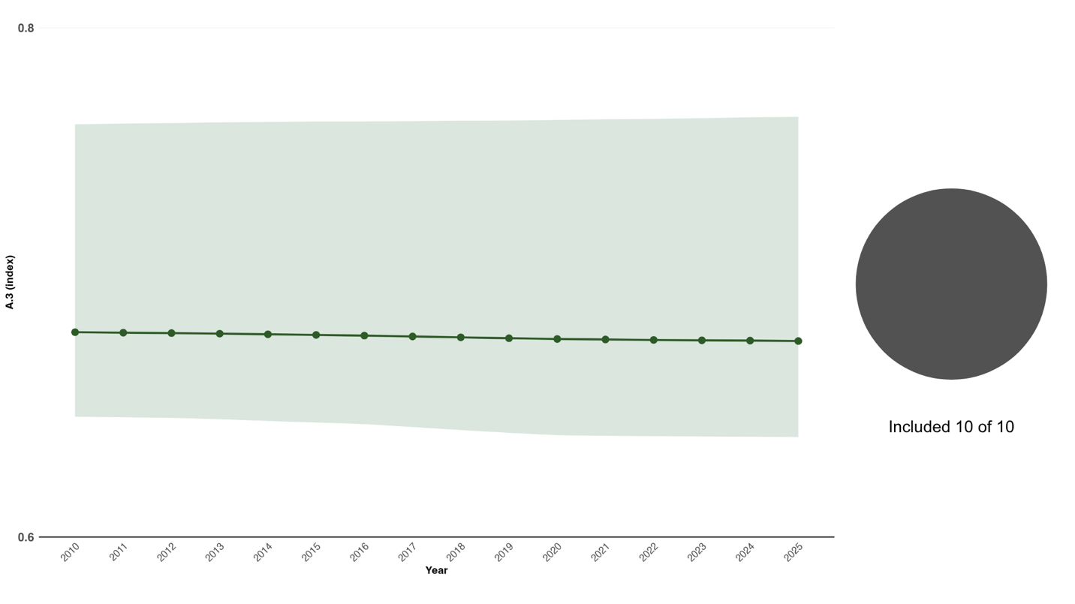Indicator values show the average (mean) and interquartile range across Parties each year. The right pie chart shows the proportion of Parties for whom data is included in the graph.

Self-assessment of progress
Based on the self-assessment by Parties in their national report of each national target, a quarter (25 per cent) of national targets highly aligned with Target 4 are on track for achievement, with 59 per cent showing insufficient progress or no significant progress, while the status of 16 per cent of targets is unknown (see Figure 13).

Figure 13: Self-assessed progress for all national targets submitted as highly aligned to Target 4.
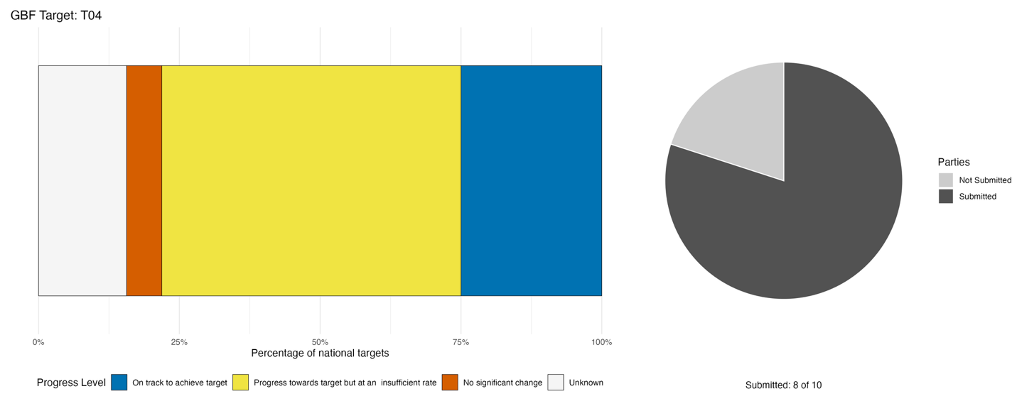
Bar widths show the percentage of national targets in each progress category. Percentages are weighted by Party to ensure that Parties contribute equally to overall assessment of progress, regardless of the number of national targets submitted. The pie chart shows the proportion of Parties included in the regional report who submitted national targets aligned with Target 4 in dark grey.

Actions, successes and challenges

Summary of actions in support of Target 4
All Parties report taking direct action on species conservation via field-level or species-level conservation activities. The dominant type of activity reported is targeted management of individual threatened or commercially important species, often with quantified outcomes for target species. A comparable breadth of research and monitoring actions were also reported, in several cases with notable methodological sophistication, including wildlife acoustic monitoring and artificial intelligence assisted species identification alongside public participation efforts such as bioblitz: a public, participatory event where volunteers focus on finding, identifying and cataloguing as many species as possible in a defined geographical area and within a predetermined time, usually 24 to 48 hours. Most Parties also report enacting legal and regulatory instruments, most commonly through formal threatened species designation. About half of Parties also report institutional partnerships with international organizations or foreign research bodies to improve conservation outcomes for endemic species.

Examples of success and progress in implementation
Box 5

The Saint Lucia Parrot (Jacquot) recovery programme in Saint Lucia

The Saint Lucia Parrot (Jacquot) recovery programme is one of the Caribbean's most successful species conservation initiatives and a seminal example of legislation-backed species recovery. From fewer than 100 birds in the mid 1970s, the programme combined strengthened legal protection, the 1975 Saint Lucia Forestry Department-Durrell Wildlife Conservation Trust captive-breeding partnership, long-term monitoring and habitat protection and the nationally recognized "Jacquot" public awareness campaign to reverse the species' decline. As Saint Lucia's flagship conservation success, the programme demonstrates how sustained institutional commitment, science-based management and public engagement can reverse severe population declines of endemic island species. Its integrated approach provides a highly transferable model for threatened species recovery and endemic biodiversity conservation across Caribbean SIDS.
Relevant targets: 4, 14, 21
Source: Saint Lucia, draft seventh national report to the Convention

Challenges
In the ten submitted or draft national reports reviewed, no Party reports having a fully institutionalised, domestically financed and sustained mechanism for threatened species recovery; highlighting fundamental challenges in the implementation of Target 4 in the region. While broad species management programmes are underway, including in situ and ex situ measures, the most pervasive challenge reported is the dependence on short-term, project-based, or donor-funded cycles for monitoring, enforcement and species recovery; a structural vulnerability that simultaneously drives financial, capacity, data and governance gaps. A second recurring challenge noted by Parties is the absence of species-specific recovery plans, population targets and genetic conservation strategies. A further challenge is the fragmentation of biodiversity data across institutions and legacy systems, compounded by the absence of standardized monitoring frameworks and national Red List assessments, leading Parties to rely on global estimates of species status that may not be reflective of local realities.

Target 5: Ensure sustainable, safe and legal harvesting and trade of wild species
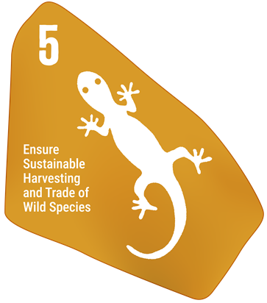
Target text: Ensure that the use, harvesting and trade of wild species is sustainable, safe and legal, preventing overexploitation, minimizing impacts on non-target species and ecosystems, and reducing the risk of pathogen spillover, applying the ecosystem approach, while respecting and protecting customary sustainable use by indigenous peoples and local communities.

PROGRESS OVERVIEW
Progress is being reported in the region, in particular for the harvest and trade of marine species. Legal instruments are largely in place, with most Parties reporting domestic implementation of Convention on International Trade in Endangered Species of Wild Fauna and Flora (CITES). However, challenges in enforcement of these measures, linked to resource and capacity constraints, limit their effectiveness.

Indicators of progress
Table 8: Indicator scorecard for Target 5. Colour coding is related to the overall assessment of progress across targets, of which the methodology is explained in the summary scorecard (Table 1). The colour coding for indicator data use reflects where a value for each target sits relative to the highest and lowest scores achieved across all targets of the Framework (green is assigned to percentage values falling within the top third of the total range, yellow to the middle third, and red to the bottom third). Colours for the binary indicators are based on the percentage of Parties scoring highly (4 or 5) for the indicator overall (green is assigned to values at or above 50 per cent, yellow to values between 50 and 25 per cent; and red to values below less than 25 per cent). Colours for the headline indicator results are based on progress relative to the target (green is assigned when progress is being made, yellow when progress is mixed progress, red when progress is insufficient; and grey when progress cannot be assessed).
 | Indicator use |  | Indicator results
Headline indicator 5.1: Proportion of fish stocks within biologically sustainable levels | 0% of Parties |  | No data
Binary indicator 5.b: Number of countries with legal instruments or other policy frameworks for regulating trade in wild species | 9 Parties | N/A | 89% of Parties that reported scored highly (score 4/5)

Parties did not report directly on headline indicator 5.1. Instead, they described systemic data gaps and technical monitoring limitations prohibiting the calculation of indicator values aligned with the Food and Agriculture Organization of the United Nations (FAO) stock assessment methodologies. Key challenges reported include incomplete national coverage of stock assessments, an absence of long-term monitoring infrastructure and significant underreporting within artisanal and subsistence fisheries sectors. Additionally, high variability in data collection methodologies across fishery subsectors prevents the calculation of standardized, nationally aggregated values. Consequently, while national management frameworks and regional technical initiatives are actively enhancing monitoring capacities, such as through electronic monitoring, bycatch surveys and gear trials, they do not yet yield the comprehensive, long-term stock assessment data required to determine the proportion of fish stocks within biologically sustainable levels. This highlights the need for stronger regional monitoring frameworks to establish standardized baseline assessments.

Data available from FAO on stocks within biologically sustainable levels are available for four Parties (40 per cent of those included in the analysis). For these, latest estimates average 81 per cent of stocks within biologically sustainable levels and range from 55 to 100 per cent. Trends in the period between 2018 and 2023, where data are available, are mixed, with some Parties seeing improvements in the proportion of sustainable stocks while others show declines.

Most Parties who responded to the binary indicator have measures in place to regulate trade in freshwater, marine and terrestrial species, except one who does not yet have any in place and another that does not regulate marine species (Figure 14).

Figure 14: Binary indicator 5.b, the number of countries with legal instruments or other policy frameworks for regulating trade in wild species. The bar widths show the percentage of Parties in each score category, with higher numbers indicating a greater level of progress, based on responses to the questions included in the indicator.
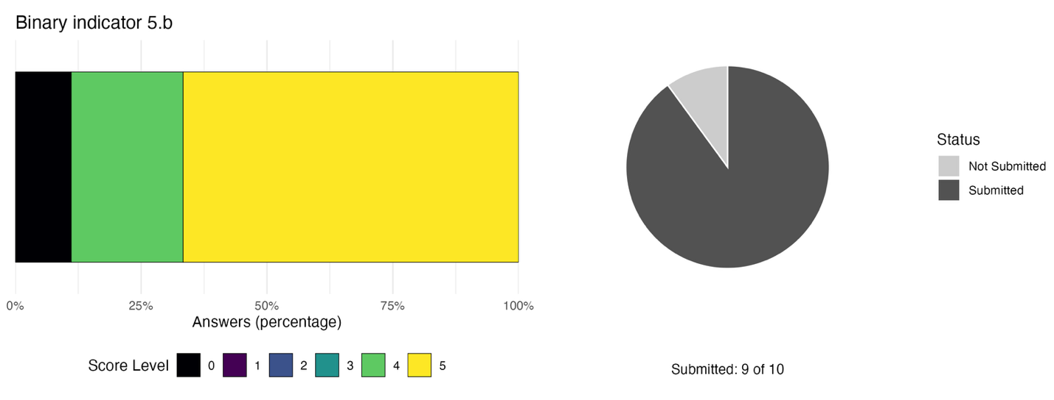The pie chart shows the proportion of Parties included in the regional report who submitted national targets aligned with Target 5 in dark grey.

Self-assessment of progress
Based on self-assessment by Parties in national reports, 22 per cent of national targets highly aligned to Target 5 are reported as achieved or on track for achievement, with two thirds (67 per cent) showing insufficient progress. No national targets were reported as having made no progress, although the status of 11 per cent of targets is unknown (see Figure 15).

Figure 15: Self-assessed progress for all national targets submitted as highly aligned to Target 5.
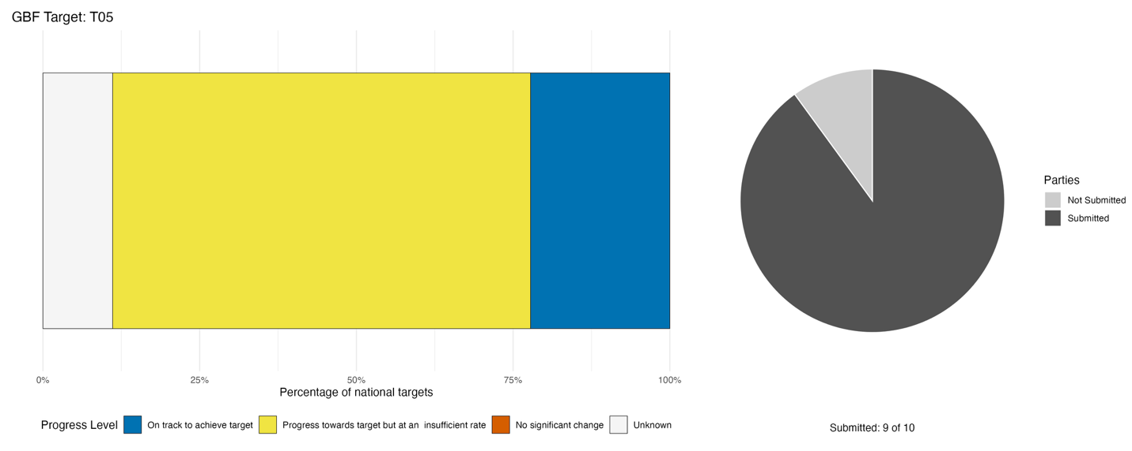
Bar widths show the percentage of national targets in each progress category. Percentages are weighted by Party to ensure that Parties contribute equally to overall assessment of progress, regardless of the number of national targets submitted. The pie chart shows the proportion of Parties included in the regional report who submitted national targets aligned with Target 5 in dark grey.

Actions, successes and challenges

Summary of actions in support of Target 5
All reporting Parties state taking some legal and regulatory action in support of the
objectives of Target 5. The most common instruments reported include CITES-related domestic implementation measures, followed by species-specific seasonal closures, size limits, trade prohibitions and permitting systems. Enforcement of species-specific harvest controls was also commonly reported by Parties, especially for marine species. About half of Parties report monitoring harvest activities using, for example, real-time vessel tracking and fisher sampling protocols. Some Parties reported cross-country cooperation efforts to tackle illegal wildlife trade in the region. Most Parties also report carrying out sensitization campaigns and training programmes to educate participants on sustainable harvest practices and wildlife trade rules.

Examples of success and progress in implementation
Box 6

Strategies, technologies and social solutions to manage bycatch in tropical large marine ecosystem fisheries (REBYC-III CLME+) in Trinidad and Tobago

In 2025, Trinidad and Tobago advanced sustainable fisheries management through the GEF-funded REBYC–III CLME+ project, implemented by the Fisheries Division in collaboration with FAO, The University of the West Indies, and national and local partners. The project aims to reduce bycatch and discards in artisanal gillnet and non-artisanal longline fisheries, with particular focus on impacts on juvenile fish, marine turtles, and marine mammals.
Key interventions include LED net illumination trials in northeast Trinidad, which have shown promising results in reducing sea turtle bycatch, alongside capacity-building activities in species identification, data analysis, and biological sampling. Data-driven management is being strengthened through national surveys on gear use, bycatch, and stakeholder practices, while field activities in communities such as Balandra and Cumana highlight strong stakeholder engagement.
Overall, the project demonstrates an integrated approach combining innovation, capacity development, and participatory governance to support sustainable fisheries and marine conservation outcomes. Other ongoing initiatives include the update of the draft 2017 National Plan of Action for the Conservation and Management of Sharks (NPOA-Sharks) and the Integrated Fisheries Management Plan.

Relevant targets: 5, 10, 20, 21
Source: Trinidad and Tobago, seventh national report to the Convention

Challenges
Parties consistently report compounding challenges in the implementation of national targets related to Target 5. Specifically, they report that insufficient financial resources undermine enforcement capacity; weak enforcement capacity prevents effective implementation of enacted legislation; absent or fragmented monitoring data prevents science-based management through the establishment of catch limits; and governance gaps allow unsustainable harvesting and illegal trade to persist. The main capacity constraints reported span enforcement staffing shortfalls, weak institutional mandates, coordination gaps between agencies, insufficient resources for surveillance and population studies and structural gaps in the legislative authority of enforcement actors. Additional challenges reported by Parties include insufficient deterrent penalties for violators; community and livelihood pressures on wild species from subsistence and commercial harvesting; insufficient public awareness and outreach as a driver of unsustainable or illegal use; and market and commercial pressures on high-value species. Some Parties also note that other pressures on species, such as habitat loss and climate change, increase the challenge of establishing sustainable trade and harvest quotas.

Target 6: Reduce the introduction of invasive alien species by 50% and minimize their impact
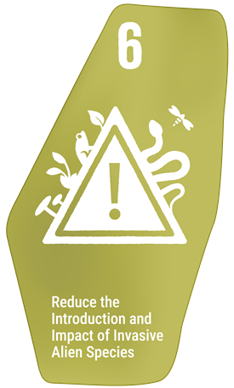
Target text: Eliminate, minimize, reduce and/or mitigate the impacts of invasive alien species on biodiversity and ecosystem services by identifying and managing pathways of the introduction of alien species, preventing the introduction and establishment of priority invasive alien species, reducing the rates of introduction and establishment of other known or potential invasive alien species by at least 50 per cent by 2030, and eradicating or controlling invasive alien species, especially in priority sites, such as islands.

PROGRESS OVERVIEW
Progress has been made on setting up the enabling environment to limit the introduction and impacts of IAS. However, significant funding and capacity limitations constrain effective monitoring and detection of IAS as well as enforcement of legislation and management of impacts. Too little data is available to quantify progress in the region, but Parties largely report that it has been insufficient so far.

Indicators of progress
Table 9: Indicator scorecard for Target 6. Colour coding is related to the overall assessment of progress across targets, of which the methodology is explained in the summary scorecard (Table 1). The colour coding for indicator data use reflects where a value for each target sits relative to the highest and lowest scores achieved across all targets of the Framework (green is assigned to percentage values falling within the top third of the total range, yellow to the middle third, and red to the bottom third). Colours for the binary indicators are based on the percentage of Parties scoring highly (4 or 5) for the indicator overall (green is assigned to values at or above 50 per cent, yellow to values between 50 and 25 per cent; and red to values below less than 25 per cent). Colours for the headline indicator results are based on progress relative to the target (green is assigned when progress is being made, yellow when progress is mixed progress, red when progress is insufficient; and grey when progress cannot be assessed).
 | Indicator use |  | Indicator results
Headline indicator 6.1: Rate of invasive alien species establishment | 0% of Parties |  | No data
Binary indicator 6.b: Number of countries adopting relevant regulations, processes and measures to reduce the impact of invasive alien species | 8 Parties | N/A | 75% of Parties that reported scored highly (score 4/5)

No Party submitted data on the rate of IAS establishment (headline indicator 6.1). Based on comments from Parties, reporting against indicator 6.1 is affected by the absence of standardized, continuous national monitoring efforts capable of generating systematic time-series data on IAS establishment. While several Parties maintain species records through national clearing-house mechanisms and global databases (such as the Global Register of Introduced and Invasive Species), existing national inventories remain largely static, fragmented and sector-specific, and fail to consistently record precise dates of introduction, spread and establishment across terrestrial, freshwater and marine ecosystems. Field data collection is currently dominated by short-term, project-based initiatives, such as targeted management strategies for lionfish, giant African snails or sargassum influxes, which operate independently rather than being integrated into national surveillance systems. Methodologically, Parties report difficulties in distinguishing genuine trends in species establishment from artificial increases resulting from improved detection capabilities and expanded search efforts. Furthermore, underlying structural challenges, including deep gaps in historical baseline data, weak institutional coordination and limited border control capacity in remote or interior regions, prevent Parties from applying a standardized methodology to quantify establishment rates with high confidence.

Based on the binary indicator (Figure 16), most Parties (86 per cent) report having at least partially set up measures for preventing the introduction and establishment of IAS, as well as for eradicating and controlling IAS. However, less progress was reported towards empowering relevant institutions to implement measures necessary to reduce the introduction and impact of IAS.

Figure 16: Binary indicator 6.b, the number of countries adopting relevant regulation, processes and measures and allocating resources to reduce the impact of IAS.
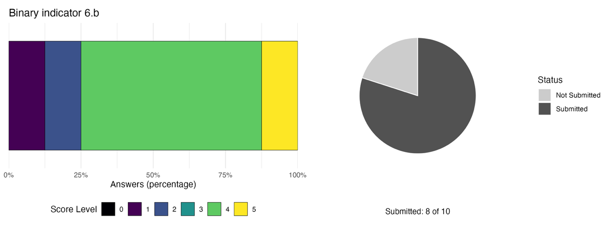The bar widths show the percentage of Parties in each score category, with higher numbers indicating a greater level of progress, based on responses to the questions included in the indicator. The pie chart shows the proportion of Parties included in the regional report who submitted national targets aligned with Target 6 in dark grey.

Self-assessment of progress
Based on self-assessment by Parties in national reports, very few (14 per cent) of targets submitted as highly aligned to Target 6 are on track for achievement, while the rest show insufficient progress; however, no national targets were reported as having made no progress (see Figure 17).

Figure 17: Self-assessed progress for all national targets submitted as highly aligned to Target 6.
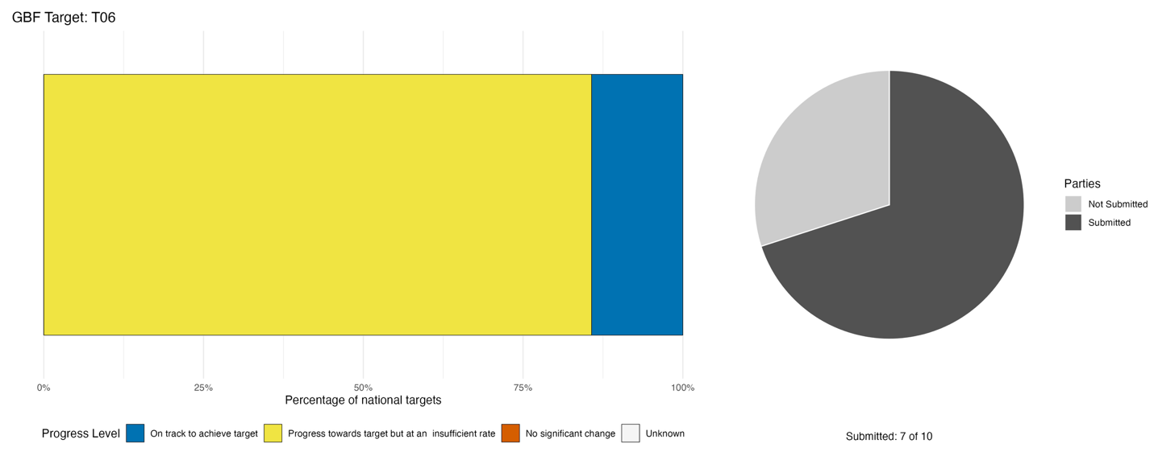
Bar widths show the percentage of national targets in each progress category. Percentages are weighted by Party to ensure that Parties contribute equally to overall assessment of progress, regardless of the number of national targets submitted. The pie chart shows the proportion of Parties included in the regional report who submitted national targets aligned with Target 6 in dark grey.

Actions, successes and challenges

Summary of actions in support of Target 6
Parties reporting on national targets related to Target 6 primarily describe border biosecurity legislation, targeted species control programmes and monitoring systems as key actions. Over half of Parties report having border biosecurity legislation in place, up to and including laws which criminalise the introduction or release of exotic species causing significant ecosystem damage and leading to deprivation of liberty for violators. While no Party reports a fully operational IAS monitoring system, several describe species-specific monitoring systems combined with early warning and rapid response mechanisms leading to targeted removal or eradication of specific IAS. About half of Parties also report community engagement through livelihood-linked programmes and communication strategies embedded within regional projects to increase public awareness of IAS-related issues. Some Parties also report taking part in bilateral technical assistance programmes, multilateral institutional partnerships and the development of regional financing proposals for the management of regionally relevant IAS.

Examples of success and progress in implementation
Box 7

Belize lionfish management programme
Belize has evidenced a proactive and integrated national response to the lionfish (Pterois volitans) IAS. Grounded in a collaborative strategy, the initiative links government agencies, marine protected area managers, local NGOs and coastal communities to safeguard vulnerable Caribbean reef biodiversity. By combining continuous ecological monitoring with rapid-response control protocols, the country has systematically targeted high-risk habitats to prevent native fish stock depletion and preserve fragile coral ecosystems.
Central to the programme’s success is a strong emphasis on community engagement and capacity building. Local fishers, tour guides and dive operators are formally trained and certified in safe lionfish identification and diver-based culling techniques, decentralizing removal efforts across the barrier reef network. This operational capability is guided by scientific assessments that establish data-driven control targets, while public reporting systems track population shifts and assess management impact over time.
Beyond direct removal, Belize has successfully aligned ecological intervention with socio-economic incentives by cultivating a domestic market for lionfish. Promoting lionfish as a sustainable culinary choice and supporting commercial harvesting has turned an environmental threat into a viable economic resource for coastal communities.

Relevant targets: 6
Source: Belize, seventh national report to the Convention

Challenges
Submissions from Parties reveal a consistent narrative around challenges related to Target 6: IAS management frameworks are fragmented, underfunded and insufficiently institutionalised. Where responses exist, they tend to be species-specific or project-funded interventions rather than systemic solutions. The absence of sustained, domestically budgeted prevention and rapid-response financing, combined with the lack of unified governance frameworks and functioning national monitoring systems, represents the most commonly reported cluster of interacting constraints. Many Parties report staffing shortages leading to underperforming monitoring systems for the detection of IAS. In many cases, this is linked to chronic underinvestment in enforcement and monitoring operations, the absence of designated funds for rapid response to new IAS occurrences, and the difficulty of financing long-term surveillance programmes in small island contexts. Some Parties further point out that IAS management is largely focused on productive sectors where impact on commercial production is significant rather than on broader biodiversity-related concerns.

Target 7: Reduce pollution to levels that are not harmful to biodiversity
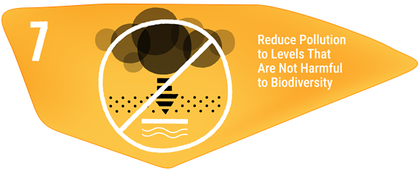
Target text: Reduce pollution risks and the negative impact of pollution from all sources by 2030, to levels that are not harmful to biodiversity and ecosystem functions and services, considering cumulative effects, including: (a) by reducing excess nutrients lost to the environment by at least half, including through more efficient nutrient cycling and use; (b) by reducing the overall risk from pesticides and highly hazardous chemicals by at least half, including through integrated pest management, based on science, taking into account food security and livelihoods; and (c) by preventing, reducing, and working towards eliminating plastic pollution.

PROGRESS OVERVIEW

Data limitations affect any assessment of progress on this target. Limited monitoring capacity, missing data and incomplete information systems reveal a gap in the region’s capacity to monitor progress on pollution reduction. Major barriers to implementation remain linked to institutional challenges and compounded by insufficient resourcing, capacity-building and public awareness.

Indicators of progress
Table 10: Indicator scorecard for Target 7. Colour coding is related to the overall assessment of progress across targets, of which the methodology is explained in the summary scorecard (Table 1). The colour coding for indicator data use reflects where a value for each target sits relative to the highest and lowest scores achieved across all targets of the Framework (green is assigned to percentage values falling within the top third of the total range, yellow to the middle third, and red to the bottom third). Colours for the headline indicator results are based on progress relative to the target (green is assigned when progress is being made, yellow when progress is mixed progress, red when progress is insufficient; and grey when progress cannot be assessed).
 | Indicator use |  | Indicator results
Headline indicator 7.1: Index of coastal eutrophication | 10% of Parties |  | Insufficient data
Headline indicator 7.2: Pesticide environment concentration and/or aggregated total applied toxicity | 0% of Parties |  | No data

A single Party reported concentration values in different cities for headline indicator 7.1 but did not specify what these related to. Other Parties described how structural, technical and resource limitations affect reporting on the indicator. A central barrier is the absence of standardized national eutrophication indices and the supporting monitoring framework needed to synthesize water quality and nutrient measurements into temporal trend analyses. Water quality data management often remains decentralized and fragmented across disparate, site-specific initiatives, preventing centralized national aggregation. Additionally, monitoring efforts, particularly for harmful algal blooms, are hampered by technical capacity gaps, insufficient financial resources and a lack of institutionalized national monitoring programs. As a result, some national frameworks prioritize other indicators supported by pre-existing data collection infrastructure while efforts continue to build capacity and formalize standardized methodologies for indicator 7.1.

No Party reported on pesticide environment concentration nor aggregated total applied toxicity. Parties attributed their reporting challenges for indicator 7.2 primarily to data gaps, resource constraints and ongoing monitoring framework development. A key technical bottleneck is the absence of established national monitoring programmes and systematic mechanisms required to collect baseline data on pesticide concentrations and associated environmental pressures. These challenges are further compounded by capacity limitations within regulatory entities, which lack statistical standards such as national pesticide-concentration indices. Consequently, some national authorities have chosen to prioritize reporting on other indicators supported by pre-existing data streams, similarly to indicator 7.1, while work remains underway to include indicator 7.2 in national monitoring frameworks and strengthen technical capacity for future reporting cycles.

Self-assessment of progress
Based on self-assessment by Parties in national reports, a quarter (25 per cent) of national targets submitted as highly aligned to Target 7 are on track for achievement, while 63 per cent show no significant change or insufficient progress (see Figure 18).

Figure 18: Self-assessed progress for all national targets submitted as highly aligned to Target 7.
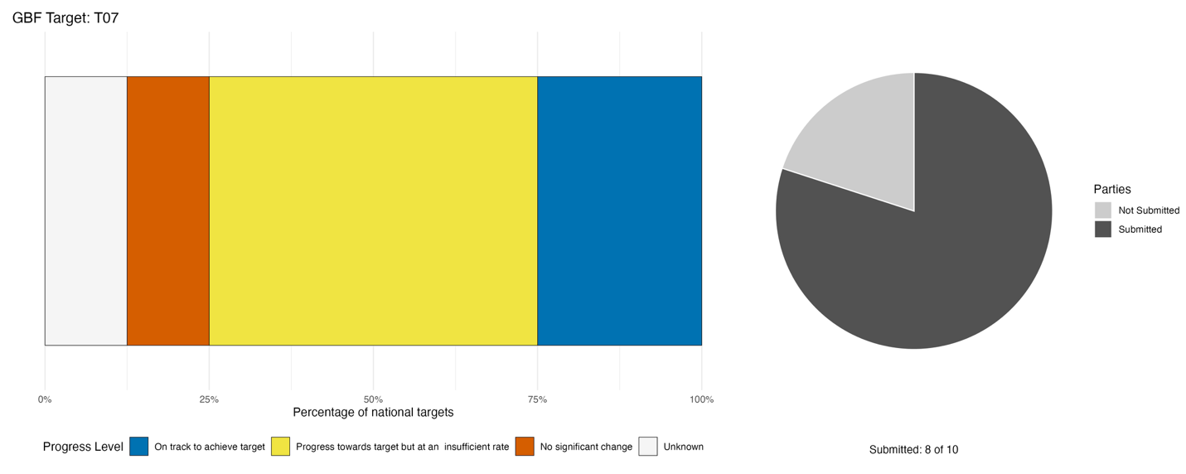
Bar widths show the percentage of national targets in each progress category. Percentages are weighted by Party to ensure that Parties contribute equally to overall assessment of progress, regardless of the number of national targets submitted. The pie chart shows the proportion of Parties included in the regional report who submitted national targets aligned with Target 7 in dark grey.

Actions, successes and challenges

Summary of actions in support of Target 7
The main implementation actions reflected in Parties’ national reports focus on direct action to reduce pollution loads in landscapes and coastal environments, primarily through waste management infrastructure, plastic pollution reduction, hazardous chemical disposal and targeted pollutant elimination. In support of this, Parties report a range of policy instruments, with many including the restriction or prohibition of single-use plastics. Additional legislation focuses on the safe removal of pesticides and the setting of water and air pollution standards. Most Parties report early efforts to monitor pollution through the establishment of baselines rather than the operation of fully institutionalised long-term monitoring systems. Around half of Parties also describe community or public engagement efforts around plastic and waste reduction. Some Parties also report taking part in regional projects to manage pollution as well as multilateral conventions such as the Basel Convention on the Control of Transboundary Movements of Hazardous Wastes and Their Disposal.

Examples of success and progress in implementation
Box 8

Single-use plastics ban and plastic waste minimization in Jamaica

The Government of Jamaica took the initiative to implement two Ministerial Orders to manage plastic pollution, which prohibit the importation, distribution, manufacture and commercial use of certain types of single-use plastics since 1 January 2019. An assessment of the impact and effectiveness of the ban indicates that the ban has been fairly successful in reducing the use of plastic bags, and the public is generally supportive of the ban. The Government’s ban on specific types of single use plastic products is complemented by two private sector-led and Government- endorsed initiatives: Recycling Partners of Jamaica which implements the deposit refund scheme for PET and HDPE bottles, and the Kingston Harbour Cleanup Project led by the GraceKennedy Foundation in collaboration with Ocean Cleanup and Clean Harbours Jamaica Limited.
Concurrently, Jamaica has implemented several public education and awareness initiatives to reduce the incidence and impacts of pollution on biodiversity. Public education campaigns promoting solid waste management best practices have been conducted under the theme “Protect Our Land Support the Plastic Ban”. Other initiatives include the sensitization of commercial business owners and residents on the proper containerization and disposal of waste, under the theme “One Jamaica… Mek Wi Clean Up Di Place,” encouraging citizens to adopt cleaner and more sustainable environmental practices. In addition, the Northern and Eastern St. Andrew Belt and Plastic Waste Separation Initiatives diverted 100,801 kg of plastic waste from the island’s waste streams, representing a 19.7 per cent increase compared to 2022.
Jamaica observes International Coastal Clean-up Day annually, and data from the Jamaica Environment Trust ICC indicates that plastic bags collected in 2019 have increased by 8.2 per cent when compared to 2018, plastic straws collected in 2019 decreased by 33.4 per cent when compared to 2018 and styrofoam collected in 2019 increased by 1.6 per cent when compared to 2018. It is important to understand that the amount of waste collected is dependent on the number of volunteers and the number of sites. The increase in the total number of volunteers and the number of sites could account for these increases. A waste characterization study will need to be carried out to confirm if there have been actual reductions in the waste stream.
Relevant targets: 7, 16, 20
Source: Jamaica, draft seventh national report to the Convention

Challenges
Parties report on institutional weakness, monitoring deficits, lacking or expensive infrastructure and governance gaps, which together prevent them from establishing the baselines, enforcement mechanisms, pollution treatment options and integrated policy frameworks needed to measure and reduce nutrient loss, pesticide risk and other pollution loads. Financial constraints were reported as further compounding these structural weaknesses. Behavioural and market barriers, including the high cost of cleaner technologies, persistent waste-generating practices and limited consumer uptake of alternatives, were reported as secondary but significant challenges by a majority of Parties. Environmental and biophysical pressures, including industrial oil spills, mining contamination, wastewater infrastructure deficits and climate-pollution interactions, were widely reported but more often reported as relevant pressures affecting Parties in the region than as primary implementation barriers in their own right.

Target 8: Minimize the impacts of climate change on biodiversity and build resilience
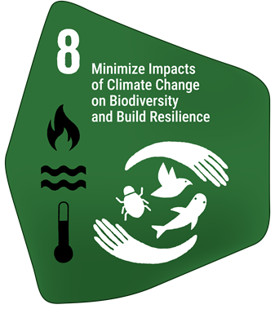
Target text: Minimize the impact of climate change and ocean acidification on biodiversity and increase its resilience through mitigation, adaptation, and disaster risk reduction actions, including through nature-based solutions and/or ecosystem-based approaches, while minimizing negative and fostering positive impacts of climate action on biodiversity.

PROGRESS OVERVIEW
Climate change and ocean acidification continue to pose a significant challenge to implementation of the Framework in the region. Efforts are ongoing and largely focused on the ecosystem approach and nature-based solutions through the restoration and management of key marine and terrestrial ecosystems. Yet, insufficient resourcing and coordination, alongside continuing environmental pressures, limit progress.

Indicators of progress
Table 11: Indicator scorecard for Target 8. Colour coding is related to the overall assessment of progress across targets, of which the methodology is explained in the summary (Table 1). Colours for the binary indicators are based on the percentage of Parties scoring highly (4 or 5) for the indicator overall (green is assigned to values at or above 50 per cent, yellow to values between 50 and 25 per cent; and red to values below less than 25 per cent).
 | Indicator use |  | Indicator results
Binary indicator 8.b: Number of countries with policies to minimize the impact of climate change and ocean acidification on biodiversity and to minimize negative and foster positive impacts of climate action on biodiversity | 9 Parties | N/A | 11% of Parties that reported scored highly (score 4/5)

Parties responding to the binary indicator questions have overall partially put in place measures to address the impact of climate change and ocean acidification on biodiversity and to minimize negative and foster positive impacts of climate action on biodiversity (Figure 19). Overall, more progress has been made on addressing the impacts of climate change than those of ocean acidification, where efforts are falling behind. Indeed, Parties report that their NBSAPs address the impacts of climate change more than twice as often as those of ocean acidification. Additionally, monitoring of the impacts of climate change is largely under development while the impacts of ocean acidification are not monitored for half of reporting Parties. All Parties report including nature-based solutions and disaster risk reduction in their policies and action plans.

Figure 19: Binary indicator 8.b, the number of countries with agreed policies to minimize the impact of climate change and ocean acidification on biodiversity and that minimize negative and foster positive impacts of climate action on biodiversity.
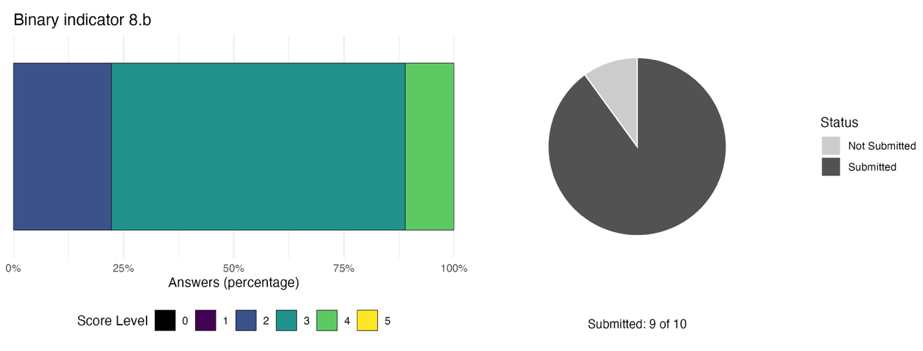The bar widths show the percentage of Parties in each score category, with higher numbers indicating a greater level of progress, based on responses to the questions included in the indicator. . The pie chart shows the proportion of Parties included in the regional report who submitted national targets aligned with Target 8 in dark grey.

Self-assessment of progress
Based on self-assessment by Parties in national reports, 28 per cent of national targets submitted as highly aligned with Target 8 are on track for achievement, with a larger number (61 per cent) showing no significant change or insufficient progress, while the status of some (11 per cent) is unknown (see Figure 20).

Figure 20: Self-assessed progress for all national targets submitted as highly aligned to Target 8.
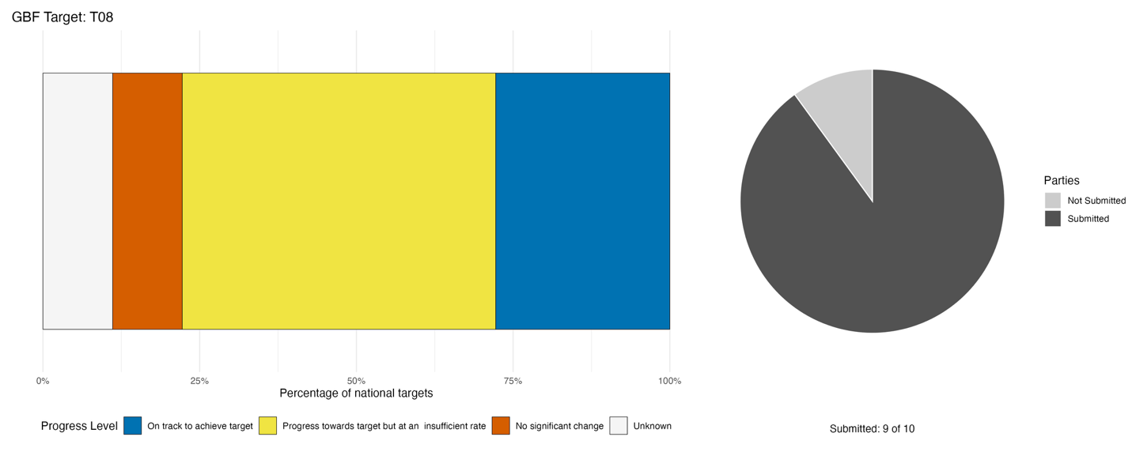
Bar widths show the percentage of national targets in each progress category. Percentages are weighted by Party to ensure that Parties contribute equally to overall assessment of progress, regardless of the number of national targets submitted. The pie chart shows the proportion of Parties included in the regional report who submitted national targets aligned with Target 8 in dark grey.

Actions, successes and challenges

Summary of actions in support of Target 8
The dominant type of action reported by Parties is the implementation of nature-based solutions and the ecosystem approach through marine ecosystem restoration, particularly mangroves, coral reefs and wetlands, reflecting the importance of these ecosystems to both biodiversity and climate resilience objectives in the region. Many Parties also report that nature-based solutions are included in relevant enabling frameworks (e.g. NBSAPs, nationally determined contributions and national adaptation plans), but their operationalisation is uneven. Most Parties report passing legislation on climate change that includes resilience of ecosystems. Some Parties also describe community capacity-building and community-based implementation of nature-based solutions. Additionally, research activities into the impacts of climate change on biodiversity and the resilience of ecosystems are also ongoing in the region, with some Parties taking part in regional or multilateral programmes focused on specific marine ecosystems.

Examples of success and progress in implementation
Box 9

Climate-biodiversity modelling in Cuba
To address the compounding impacts of climate change, Cuba’s national scientific and environmental authority, Citma, spearheaded a forward-looking strategy to protect its terrestrial biodiversity. Leveraging national research institutions, the initiative developed comprehensive species niche models for 402 terrestrial species, projecting their distributions under two distinct climate scenarios leading up to the year 2050. This data-driven effort generated spatially explicit priority conservation areas, giving decision-makers a clear, scientific baseline to draft targeted, climate-adapted action plans.
This approach integrates cutting-edge scientific research directly into legally enforceable national policy. The spatial conservation priorities were formally anchored within the national climate response framework through key regulatory instruments: Decree 86/2023 on Addressing Climate Change and Resolution 106 of 2025 regulating carbon market activities. By giving scientific output legal backing, Cuba ensured that biodiversity preservation and climate adaptation remain binding priorities across national planning sectors.
This strategy offers an instructive, replicable model for SIDS and biodiversity-rich nations operating under financial constraints to tackle both crises together. By combining species distribution modeling with regulatory enforcement, the country demonstrated how science can directly inform policy to achieve national targets. Furthermore, linking conservation priorities to carbon market regulations can help establish an innovative mechanism to mobilize domestic finance, delivering dual biodiversity and climate co-benefits for long-term resilience.

Relevant targets: 4, 8, 21
Source: Cuba, seventh national report to the Convention

Challenges
Across the region, all Parties report that environmental and biophysical pressures are a major challenge in making progress towards Target 8, largely due to climate-driven ecological stress, including coral bleaching, sea-level rise, coastal erosion, hurricane damage, drought and ocean acidification. Indeed, several Parties report that climate change is not only a background pressure but an active constraint on restoration and adaptation efforts. Most Parties report a shortfall in domestic funding relative to needs for implementing management plans or monitoring systems of the impacts of climate change on biodiversity. These shortfalls in turn affect human and technical capacity, which is further constrained by insufficient coordination across agencies and sectors. Consequently, over half of Parties report insufficient research on species and ecosystem responses to climate change, and the specific absence of ocean acidification monitoring infrastructure. Several Parties also report that monitoring systems exist in parallel rather than integrated frameworks, limiting their utility for cross-sectoral planning and accountability.

Meeting people’s needs through sustainable use and benefit-sharing

Target 9: Manage wild species sustainably to benefit people
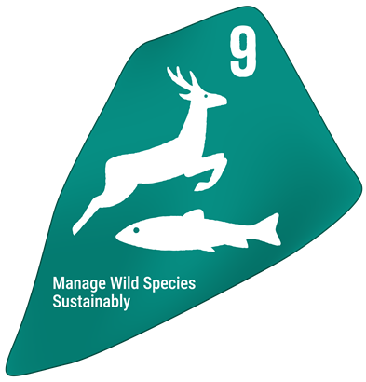
Target text: Ensure that the management and use of wild species are sustainable, thereby providing social, economic and environmental benefits for people, especially those in vulnerable situations and those most dependent on biodiversity, including through sustainable biodiversity-based activities, products and services that enhance biodiversity, and protecting and encouraging customary sustainable use by indigenous peoples and local communities.

PROGRESS OVERVIEW
Insufficient data from monitoring is both a barrier to measuring progress towards Target 9 and implementing actions to manage wild species in the region. Parties report little progress and highlight significant challenges in determining sustainability thresholds for species use, setting up legislation and enforcing management plans.

Indicators of progress
Table 12: Indicator scorecard for Target 9. Colour coding is related to the overall assessment of progress across targets, of which the methodology is explained in the summary scorecard (Table 1). The colour coding for indicator data use reflects where a value for each target sits relative to the highest and lowest scores achieved across all targets of the Framework (green is assigned to percentage values falling within the top third of the total range, yellow to the middle third, and red to the bottom third). Colours for the binary indicators are based on the percentage of Parties scoring highly (4 or 5) for the indicator overall (green is assigned to values at or above 50 per cent, yellow to values between 50 and 25 per cent; and red to values below less than 25 per cent). Colours for the headline indicator results are based on progress relative to the target (green is assigned when progress is being made, yellow when progress is mixed progress, red when progress is insufficient; and grey when progress cannot be assessed).
 | Indicator use |  | Indicator results
Headline indicator 9.1: Benefits from the sustainable use of wild species | 10% of Parties |  | Insufficient data
Headline indicator 9.2: Percentage of the population in traditional occupations | 10% of Parties |  | Insufficient data
Binary indicator 9.b: Number of countries with policies to manage the use of wild species sustainably, providing social, economic and environmental benefits for people, and to protect and encourage customary sustainable use by indigenous peoples and local communities | 9 Parties | N/A | 33% of Parties that reported scored highly (score 4/5)

Reporting on benefits from sustainable use of wild species was sparse. Only one Party reported the value of marine production, in US dollars, as benefits. Another Party commented that there is a disconnect between qualitative, sector-level monitoring and standardized national metrics. While local monitoring qualitatively documents the socio-economic benefits derived from the sustainable use of wild species, such as apiculture, seamoss cultivation and non-timber forest products, aggregating these qualitative datasets into a consolidated national index suitable for formal statistical reporting is not yet possible. The under-developed status of indicator 9.1 is likely responsible for the lack of reporting or commentary on challenges.

One Party reported the number of people, disaggregated by gender, employed as fishers. Others report that existing national datasets, such as general labour force surveys, lack the requisite disaggregation to identify traditional occupations as distinct statistical categories. Consequently, nature-dependent, informal, and subsistence livelihoods (including small-scale fishing, agriculture, and forestry) are not systematically classified or monitored in national statistics. Addressing these reporting gaps would require strengthening socio-economic data collection, upgrading national statistical classification systems and establishing standardized methodologies to consistently capture nature-dependent livelihoods.

Half of Parties reporting on the binary indicator indicate having measures fully in place for the management and sustainable use of wild species. However, most (75 per cent) only partially monitor the management and sustainable use of wild species at the moment, and half do not monitor the benefits derived from the use of wild species for people, in particular for those people in vulnerable situations and most dependent on biodiversity. For those Parties who indicated it as relevant, 29 per cent have measures in place to protect and encourage the customary sustainable use of biodiversity by indigenous peoples and local communities (IPLCs), while the rest are partial or under development.

Figure 21: Binary indicator 9.b, the number of countries with policies to manage the use of wild species sustainably, providing social, economic and environmental benefits for people, and to protect and encourage customary sustainable use by IPLCs.
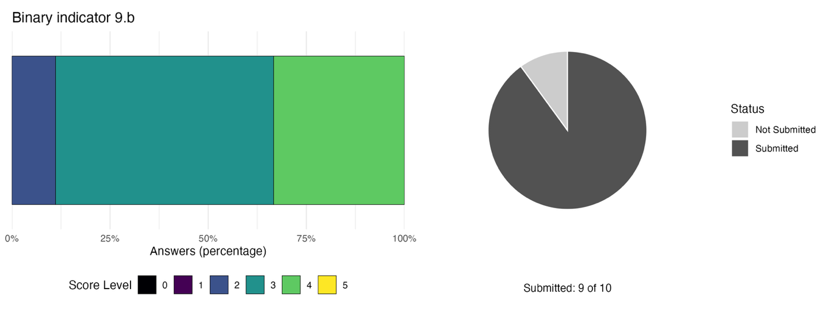The bar widths show the percentage of Parties in each score category, with higher numbers indicating a greater level of progress, based on responses to the questions included in the indicator. The pie chart shows the proportion of Parties included in the regional report who submitted national targets aligned with Target 9 in dark grey.

Self-assessment of progress
Based on self-assessment by Parties in national reports, only 12.5 per cent of national targets submitted as highly aligned to Target 9 are on track for achievement, while most (75 per cent) show no significant progress or insufficient progress, and some (12.5 per cent) are reported as unknown.

Figure 22: Self-assessed progress for all national targets submitted as highly aligned to Target 9.
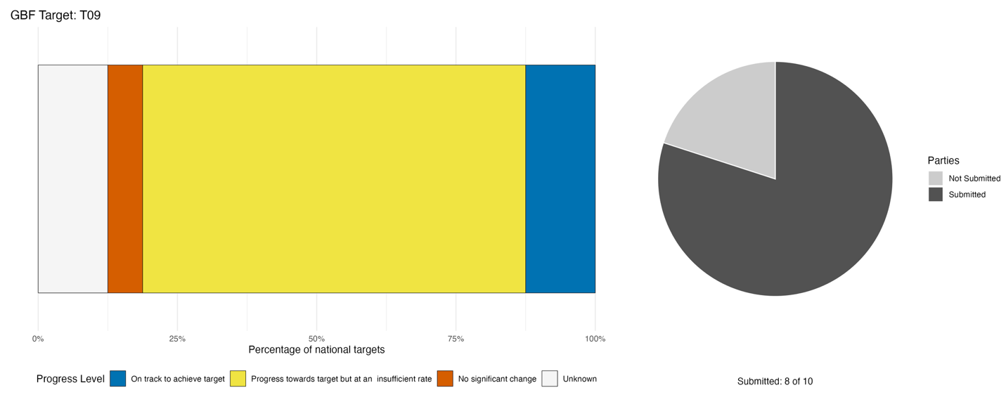
Bar widths show the percentage of national targets in each progress category. Percentages are weighted by Party to ensure that Parties contribute equally to overall assessment of progress, regardless of the number of national targets submitted. The pie chart shows the proportion of Parties included in the regional report who submitted national targets aligned with Target 9 in dark grey.

Actions, successes and challenges

Summary of actions in support of Target 9
The majority of Parties reporting mention the use of legal and regulatory policy options to ensure the sustainable use and management of wild species. The most commonly reported options are fisheries legislation, species-specific management plans and protected area or no-take zone designations. In conjunction, most Parties report social, cultural and awareness actions such as community co-management arrangements, participatory governance structures and livelihood-based engagement with wild species. Some Parties further acknowledge integrating local and community actors into governance structures through co-management bodies, surveillance committees or consultation processes. Most Parties also report conducting research and monitoring actions to ensure sustainable provision of benefits from wild species. Reported actions span population surveys, feasibility and non-detriment findings for commercially harvested species, adaptive management databases, species status assessments and technology trials. A recurring pattern is the use of monitoring data to directly inform harvest quotas and management decisions, reflecting an applied rather than purely academic orientation.

Examples of success and progress in implementation
Box 10

The South East Coast project in Saint Lucia
In Saint Lucia, coastal communities rely heavily on marine and terrestrial wild species, making sustainable resource management essential for both biodiversity conservation and economic resilience. Under the South-East Coast project, national environment and development authorities partnered with local enterprises to implement an integrated livelihood initiative aligned with national targets. By linking the sustainable use of wild species to targeted enterprise development, the project established a practical framework that incentivizes conservation-compatible behavior while building community resilience.
At the core of the initiative was the launch of six community-level livelihood enterprises, focusing on sustainable practices such as seamoss cultivation, apiculture, and non-timber forest product harvesting (Figure 23). The project prioritized women-centered enterprises, providing tailored skills training to approximately 75 direct beneficiaries and ultimately generating economic and social benefits for around 1,000 community members. By using sustainably sourced materials, these green micro-enterprises successfully raised participant incomes, proving that local economic empowerment can go hand in hand with environmental stewardship.

Relevant targets: 9, 23
Source: Saint Lucia, draft seventh national report to the Convention

Figure 23: A community seedling nursery of the kind supported by the South-East Coast project (photo credit: Paul Harrison, 2025).
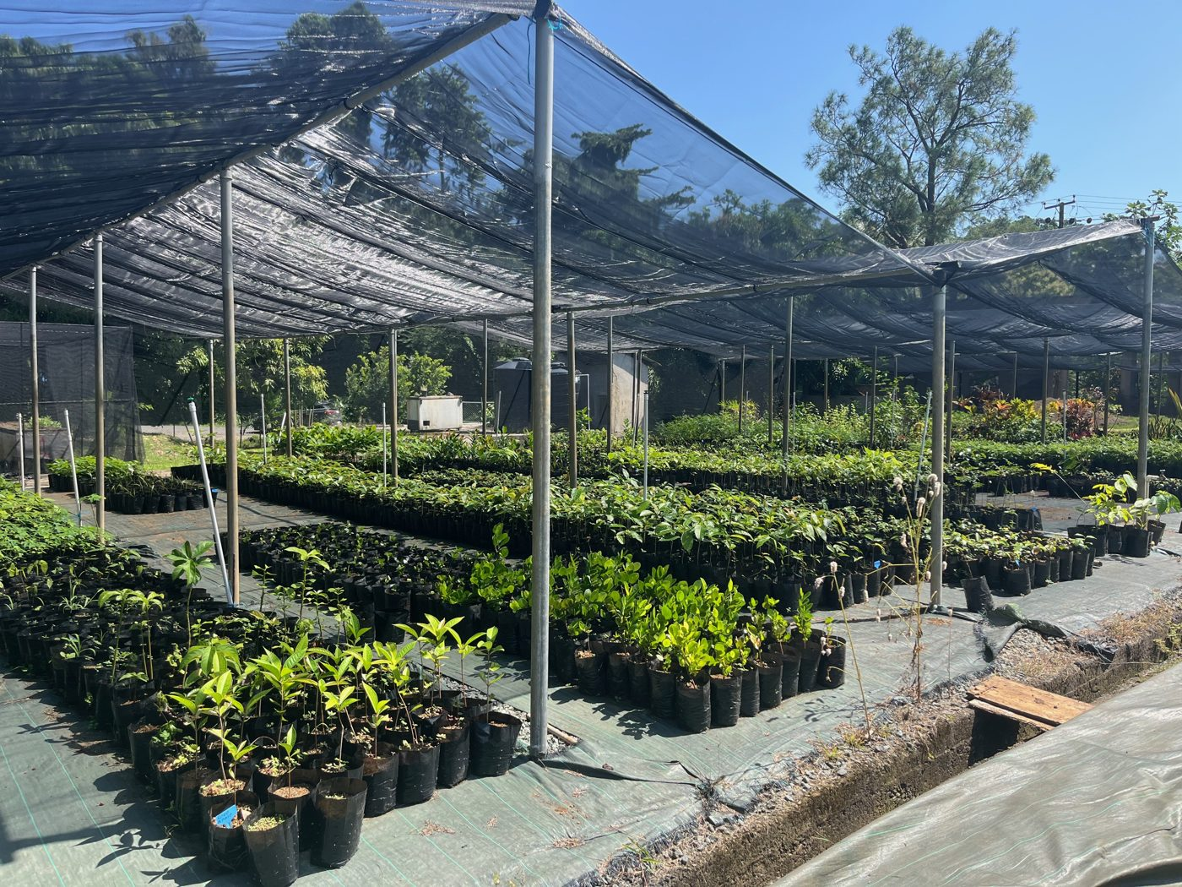

Box 11
Titiree: freshwater biodiversity, local livelihoods and river stewardship in Grenada

Titiree, a small fish larva harvested seasonally in Grenada’s rivers, are an important example of the direct value of freshwater biodiversity to local communities. Local families play a major role in the harvesting of titiree, and its processing and sale is often handled by women (supporting women's livelihoods especially in female-headed single-family homes). The activity contributes to household income and helps meet everyday family needs, including expenses associated with children’s education.

The value of titiree is therefore more than commercial. It is linked to customary use, local ecological knowledge, food and livelihood security, family well-being and contributes to women’s economic participation. However, harvest depends on healthy, connected river systems and on maintaining water quality, river flows and the ecological conditions needed for freshwater species to survive and move through rivers to coastal and marine areas.

The case also illustrates a key development challenge. Climate action and renewable-energy investment are necessary, but they must be planned and implemented in ways that do not transfer environmental costs to freshwater ecosystems and communities that depend upon river biodiversity. Developments that alter river hydrology, reduce water availability, impair water quality, disrupt aquatic connectivity or restrict customary and cultural access could undermine titiree (and other species) and the livelihoods associated with local harvest of titiree. Such outcomes would constitute climate-related maladaptation.

Grenada’s National Ecosystem Assessment identifies freshwater ecosystems as vulnerable to changing rainfall patterns, drought, flooding, erosion and declining water quality. It also notes that climate-related reductions in freshwater availability and quality can adversely affect livelihoods and may intensify existing gender inequalities. Protecting the integrity and resilience of river ecosystems is therefore central to both biodiversity conservation and climate-resilient development.

Relevant targets: 1, 5, 7, 8, 9, 11, 22, 23
Source: Grenada’s National Ecosystem Assessment

Challenges
The most significant challenge reported by Parties in the region relates to data and monitoring gaps. The gaps take several distinct but interrelated forms: absence of stock assessments and sustainability indicators; fragmented or site-level data that cannot support national-level management decisions; insufficient population dynamics studies to underpin regulatory frameworks; weak documentation of traditional knowledge; and siloed agency data systems that prevent cross-sectoral analysis. In several cases, Parties explicitly link data gaps to downstream legal and governance failures: the absence of evidence becomes the reason cited for the absence of regulations or enforcement. For many Parties, resource shortfalls are explicitly linked to data, monitoring and governance gaps, making financing a structural enabler of other reported challenges rather than a standalone barrier. In addition, several Parties report legal and governance challenges including absent legislation, regulatory gaps in hunting and wildlife trade, weak enforcement in remote areas and fragmented cross-sectoral governance.

Target 10: Enhance biodiversity and sustainability in agriculture, aquaculture, fisheries, and forestry
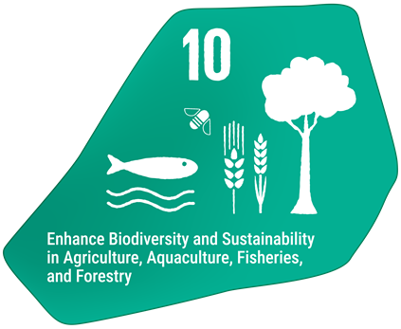
Target text: Ensure that areas under agriculture, aquaculture, fisheries and forestry are managed sustainably, in particular through the sustainable use of biodiversity, including through a substantial increase of the application of biodiversity friendly practices, such as sustainable intensification, agroecological and other innovative approaches, contributing to the resilience and long-term efficiency and productivity of these production systems, and to food security, conserving and restoring biodiversity and maintaining nature’s contributions to people, including ecosystem functions and services

PROGRESS OVERVIEW
Efforts are ongoing to enhance biodiversity across productive sectors. Parties report progress towards expanding agroforestry and improving fisheries practices. Agricultural policy and practices lag, and face particular challenges interlinked with other Framework targets. Community engagement in sustainable practices is a core focus of Party efforts.

Indicators of progress
Table 13: Indicator scorecard for Target 10. Colour coding is related to the overall assessment of progress across targets, of which the methodology is explained in the summary scorecard (Table 1). The colour coding for indicator data use reflects where a value for each target sits relative to the highest and lowest scores achieved across all targets of the Framework (green is assigned to percentage values falling within the top third of the total range, yellow to the middle third, and red to the bottom third). Colours for the headline indicator results are based on progress relative to the target (green is assigned when progress is being made, yellow when progress is mixed progress, red when progress is insufficient; and grey when progress cannot be assessed).
 | Indicator use |  | Indicator results
Headline indicator 10.1: Proportion of agricultural area under productive and sustainable agriculture | 10% of Parties |  | Insufficient data
Headline indicator 10.2: Progress towards sustainable forest management | 40% of Parties |  | Mixed trends across all sub-indicators

One Party, accounting for 66 per cent of all included Parties’ agricultural areas, submitted agricultural data disaggregated by type of agriculture. Across all agricultural methods, this Party reported an increase in productive and sustainable agriculture from 1 to 1.3 million hectares. However, data from the FAO for all Parties included in the analysis suggests that the proportion of agricultural area that is productive and sustainable has slightly decreased between 2015 and 2024 (Figure 24).

Parties note that while field-level interventions, training programs and project-specific sustainable practices are actively implemented, national agricultural data collection systems often lack the standardized criteria and disaggregation necessary to systematically quantify the spatial extent, uptake and impact of these practices. Consequently, localized successes, such as agroforestry and farm-level sustainability projects, remain isolated and unintegrated into national monitoring frameworks. Additionally, Parties highlight that standard aggregate indicators such as 10.1 frequently fail to capture the small-scale nature of local sustainable agricultural endeavours, which require accompanying contextual reporting and tailored frameworks that are currently under active development.

Four Parties submitted data for forests but in different forms, focusing on different dimensions of the FAO indicator. Two Parties, representing four per cent of Parties’ forested areas, submitted data for the average annual forest area rate change, showing an average decrease of 0.38 per cent per year. The same two Parties submitted data for above ground biomass, averaging at a constant 180 tonnes per hectare between 2010 and 2025. Again, these Parties reported that an average of 31 per cent of their forests have been legally protected since 2010. Two other Parties, accounting for 12 per cent of the region’s forested areas, reported an increase in the forest area under an independently verified forest management certification scheme from 1284 to 1486 thousand hectares between 2020 and 2023. A different Party, accounting for 1.5 per cent of the region’s forests, reported that 38 per cent of its forests are under a long-term forest management plan. The low representativeness of the data analysed and the variation in submission rates and submission types makes it challenging to conclude on overall progress towards sustainable forest management in the region.

Data from FAO shows a slowdown in the average annual forest area rate change from 20 to 15 per cent across all Parties included in the analysis. However, this ranged from -56 to 166 per cent in 2025, indicating high variation in the rates of afforestation and deforestation in the region. In fact, about as many Parties showed an increase in forest area as those that showed a decrease in area, with several showing no change in 2025.
Above ground biomass has increased from an average of 207 tonnes per hectare in 2010 to an average of 209 tonnes per hectare in 2025 for all twelve Parties. Additionally, the proportion of forest area within legally established protected areas has increased from an average of 19 to 21 per cent across the region, ranging from 6 to 54 per cent. Data on the proportion of forest with a long-term management plan is only available for half of the Parties included in the analysis. For these Parties, the proportion increased from 38 to 42 per cent between 2010 and 2020 before declining to 40 per cent in 2025. In 2025, the proportion ranged from four to 84 per cent across this subset of Parties. Forest area certified increased between 2010 and 2020 and has been relatively stable up to 2025 (Figure 25).

Difficulties in reporting on headline indicator 10.2 are largely related to an absence of formal national frameworks dedicated to computing sustainable forest management indicators at the domestic level. In the absence of country-owned, systematic monitoring pipelines, national authorities frequently rely on external global assessments, specifically the FAO Global Forest Resources Assessment.

Figure 24: Headline indicator 10.1, proportion of agricultural area under productive and sustainable agriculture based on data from the FAO.
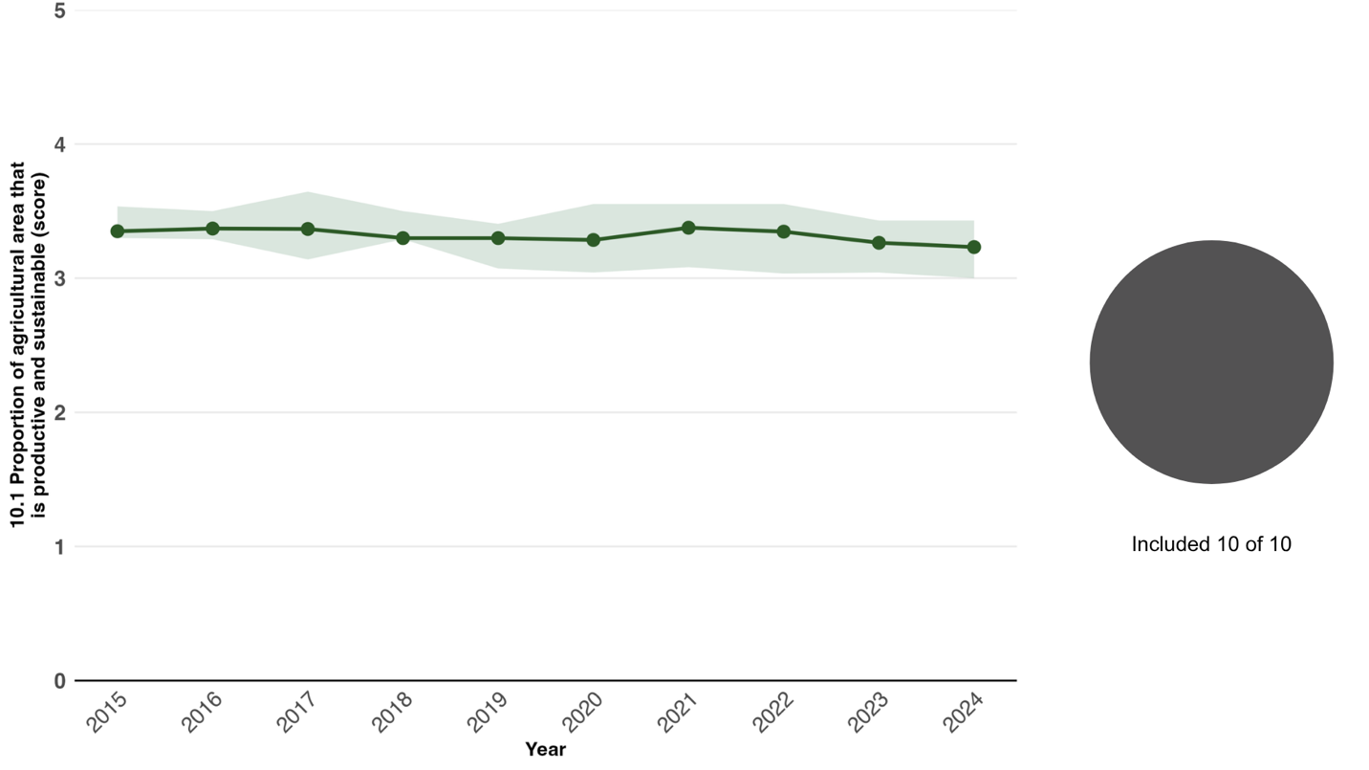
Indicator values show the overall average and interquartile range across Parties each year. The pie chart shows the proportion of Parties for whom data is available in dark grey.

Figure 25: Headline indicator 10.2, progress towards sustainable forest management, sub-indicator e: forest area under an independently verified forest management certification scheme. 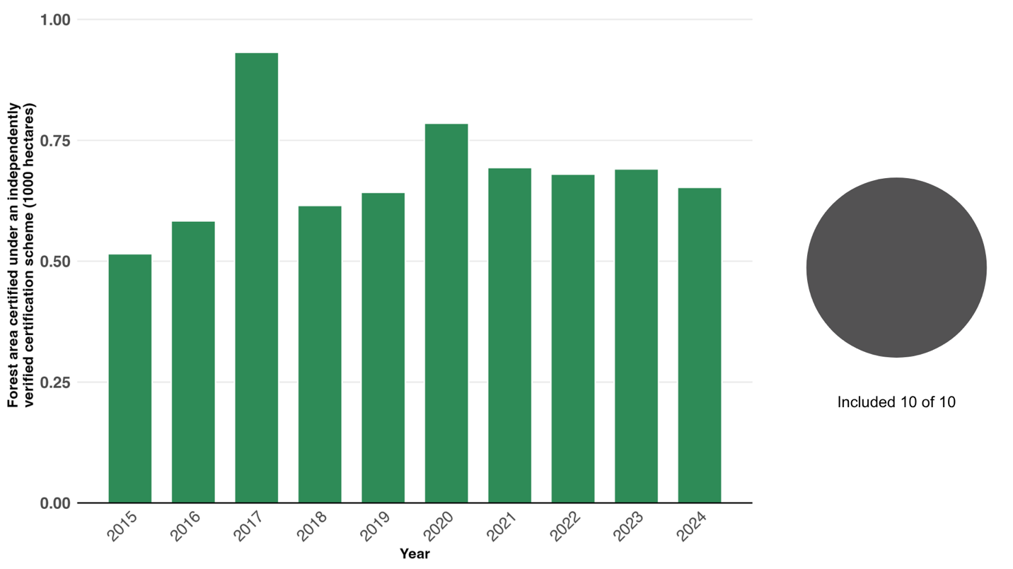Indicator values show the cumulative amount of area across Parties each year based on FAO data. The pie chart shows the proportion of Parties for whom data is available in dark grey.

Self-assessment of progress
Progress towards around two fifths (38 per cent) of national targets related to Target 10 has been self-assessed by Parties as on track or achieved, leaving over half (56 per cent) assessed as progress towards the target at an insufficient rate or no progress made (see Figure 26).

Figure 26: Self-assessed progress for all national targets submitted as highly aligned to Target 10.
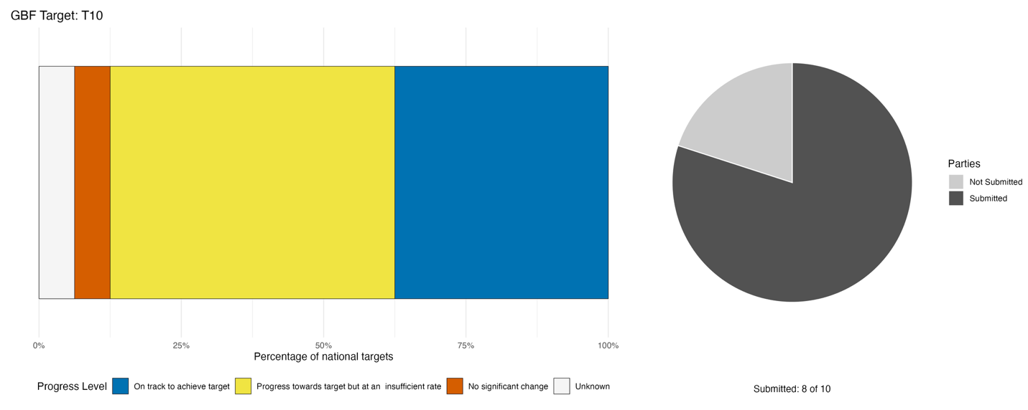
Bar widths show the percentage of national targets in each progress category. Percentages are weighted by Party to ensure that Parties contribute equally to overall assessment of progress, regardless of the number of national targets submitted. The pie chart shows the proportion of Parties included in the regional report who submitted national targets aligned with Target 10 in dark grey.

Actions, successes and challenges

Summary of actions in support of Target 10
Most Parties report taking policy and legislative steps to advance progress on Target 10. In most cases, sector-specific acts and/or framework legislation are in place to promote biodiversity, especially for fisheries, agriculture and forestry. Specific actions in these sectors include agroforestry establishment and promotion; fish sanctuary or no-take zone creation; mangrove and forest restoration; and the deployment of bycatch-reduction technologies. Furthermore, most Parties report substantive efforts to improve biodiversity mainstreaming though farmer training schemes, community-based fisheries co-management and voluntary certification of products. Several Parties also report participating in GEF-funded projects which integrate biodiversity concerns across sectors such as forestry, fisheries and tourism to produce co-benefits for biodiversity and people.

Examples of success and progress in implementation
Box 12

The Biodiversity Conservation and Agroecological Land Restoration in Productive Landscapes of Trinidad and Tobago (BIOREACH)

In Trinidad and Tobago, human encroachment, severe forest fires, and unsustainable land-use practices have accelerated land degradation and habitat fragmentation in productive agricultural landscapes. To break this cycle, the Government of Trinidad and Tobago, led by the Ministry of Planning, Economic Affairs and Development and executed through the Environmental Management Authority and the National Agricultural Marketing and Development Corporation, launched the BIOREACH initiative. Funded by the GEF and implemented in partnership with the Food and Agriculture Organization (FAO), the project focuses on biodiversity-sensitive land-use planning, landscape restoration, and agroecological transitions surrounding critical ecosystems such as the Nariva Swamp.

A central pillar of the initiative is its participatory approach to governance and spatial planning. Collaborating with civil society organizations like the Caribbean Natural Resources Institute, the project utilizes participatory GIS to directly engage local farmers, resource users, and rural residents. By integrating local community knowledge into spatial mapping and socioeconomic assessments around buffer zones, BIOREACH establishes collaborative land-management mechanisms that protect ecological integrity while reducing landscape degradation. It demonstrates an approach to integrating biodiversity considerations into land-use and production systems rather than treating conservation as separate from economic activity.

Relevant targets: 2, 10, 11, 22
Source: Trinidad and Tobago, seventh national report to the Convention

Challenges
Parties report a suite of mutually reinforcing challenges that impact progress on Target 10 across the region. Specifically, financing gaps limit enforcement and monitoring capacity; outdated legislation leaves governance frameworks unable to support biodiversity-friendly production; data fragmentation prevents assessment of implementation progress; and socio-economic pressures, including perverse fiscal incentives and limited producer access to markets, sustain unsustainable practices despite policy commitments. Multiple Parties report that these constraints are systemic rather than sector-specific, cutting across agriculture, fisheries, forestry and aquaculture simultaneously. Several Parties also explicitly acknowledge that legislative reform processes are incomplete or stalled, leaving implementation of sustainable production measures without adequate legal backing. Additionally, some Parties note that climate-related vulnerabilities, invasive species, land degradation and pollution from agricultural inputs interact closely with capacity, governance, and financial constraints reported elsewhere to increase challenges in implementation.

Target 11: Restore, maintain and enhance nature’s contributions to people
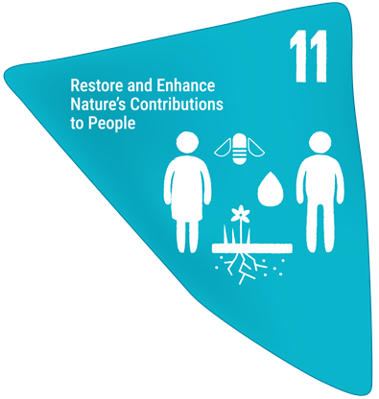
Target text: Restore, maintain and enhance nature’s contributions to people, including ecosystem functions and services, such as the regulation of air, water and climate, soil health, pollination and reduction of disease risk, as well as protection from natural hazards and disasters, through nature-based solutions and/or ecosystem-based approaches for the benefit of all people and nature.

PROGRESS OVERVIEW
Integration of ecosystem services into national policy and action plans is at an early stage. Insufficient data is available across the region to measure progress or include ecosystem service values into decision making. Parties report that more progress is needed to establish baselines of ecosystem service provision so that it can be improved. Currently, progress towards Target 11 is largely linked to efforts on restoration of ecosystems and protection of species.

Indicators of progress
Table 14: Indicator scorecard for Target 11. Colour coding is related to the overall assessment of progress across targets, of which the methodology is explained in the summary scorecard (Table 1). The colour coding for indicator data use reflects where a value for each target sits relative to the highest and lowest scores achieved across all targets of the Framework (green is assigned to percentage values falling within the top third of the total range, yellow to the middle third, and red to the bottom third). Colours for the headline indicator results are based on progress relative to the target (green is assigned when progress is being made, yellow when progress is mixed progress, red when progress is insufficient; and grey when progress cannot be assessed).
 | Indicator use |  | Indicator results
Headline indicator B.1: Services provided by ecosystems | 20% of Parties |  | Insufficient data

Two Parties reported on the dollar value of some provisioning, cultural and regulating services in a specific location as well as the overall value of carbon absorption, shoreline protection services, tourism and fisheries related services. Some of these values date back to 2008, with one more recent local assessment from 2021. These submissions cannot be compared to establish a trend in the underlying provision of services by ecosystems, as market values are driven by dynamics unrelated to the underlying capacity of ecosystems to provide services.
Other Parties report technical and institutional difficulties in reporting on this indicator, primarily due to the absence of standardized national ecosystem service indices and integrated monitoring frameworks. In the absence of centralized data compilation, existing reporting relies heavily on fragmented, project-based valuations and ad-hoc academic studies rather than continuous national tracking. Consequently, reporting efforts often depend on partial value proxies, such as site-specific marine valuations or sectoral economic contributions, which do not reflect comprehensive national status. Overcoming these barriers requires dedicated technical and institutional support to establish formal natural capital accounting systems via ecosystem service accounts to operationalize standardized national indicator frameworks.

Self-assessment of progress
Based on self-assessment by Parties in national reports, only 22 per cent of national targets submitted as highly aligned with Target 11 are on track for achievement, with a much higher number (75 per cent) showing no significant change or insufficient progress, and just a few (3 per cent) reported as unknown (see Figure 27).

Figure 27: Self-assessed progress for all national targets submitted as highly aligned to Target 11.
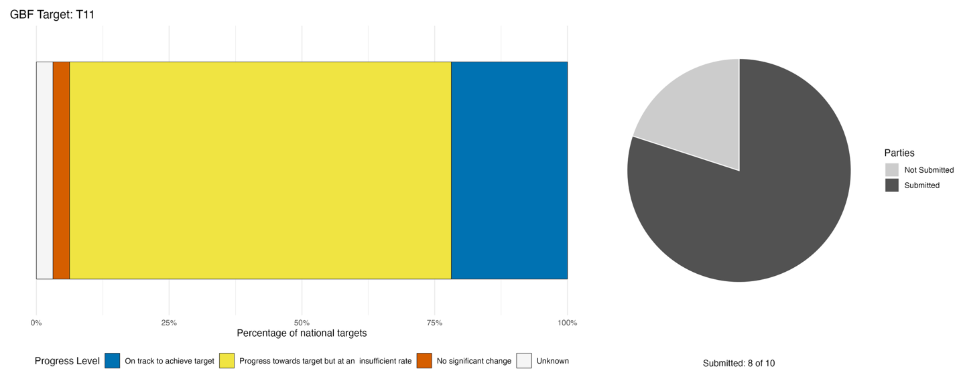
Bar widths show the percentage of national targets in each progress category. Percentages are weighted by Party to ensure that Parties contribute equally to overall assessment of progress, regardless of the number of national targets submitted. The pie chart shows the proportion of Parties included in the regional report who submitted national targets aligned with Target 11 in dark grey.

Actions, successes and challenges

Summary of actions in support of Target 11
All Parties report taking direct on the ground action to progress towards Target 11, of which the most frequently cited are coastal and marine ecosystem restoration, protected area and strengthening of marine area management and fisheries management. Mangrove rehabilitation and coral reef restoration feature across multiple national targets, reflecting the region's focus on coastal ecosystems. Marine zoning was also reported by Parties as a type of legal measure contributing to progress. Some Parties report conducting ecosystem-state assessments and adopting environmental accounting frameworks, but these are in early stages and aimed at developing a baseline understanding of ecosystem service provision. Some Parties also report on multilateral projects focusing on climate adaptation and resilience through biodiversity positive initiatives, such as those funded by the GEF, UNEP, UNDP and the European Union. A few Parties also report using payment for ecosystem services schemes.

Examples of success and progress in implementation
Box 13

Ecosystem services in Central Forest Reserve National Park in Saint Kitts and Nevis

A clear example of the effectiveness of area-based conservation measures is provided by the Central Forest Reserve National Park, which was established to protect the remaining tropical forest ecosystem of Saint Kitts and now constitutes the largest terrestrial protected area in the Federation. The park protects approximately 5,000 hectares of forested landscapes, including critical watershed areas that supply freshwater to the island, while conserving habitats for native and endemic biodiversity. The area encompasses much of the island’s central mountain range and protects the last remaining expanse of tropical forest on Saint Kitts, contributing to the maintenance of ecosystem services, soil conservation, water regulation and climate resilience.

The effectiveness of this conservation approach is reflected in national assessments showing that Key Biodiversity Areas on Saint Kitts and Nevis have achieved substantial levels of protection, with the Central Forest Reserve representing one of the most significant protected biodiversity sites in the country. The park has also become an important platform for biodiversity monitoring, environmental education, research and nature-based tourism, demonstrating how protected areas can simultaneously contribute to biodiversity conservation and sustainable development objectives.

The continued protection and management of the Central Forest Reserve National Park has therefore played a critical role in safeguarding areas of high biodiversity importance, maintaining ecological connectivity across the central mountain range, and supporting national progress towards both the 30x30 target and the maintenance and enhancement of nature’s contributions to people, including ecosystem services.

Relevant targets: 2, 3, 11, 21
Source: Saint Kitts and Nevis, draft seventh national report to the Convention

Challenges
Most Parties report that ecosystem services are not currently well integrated into national policy, plans and frameworks, therefore creating governance-readiness gaps where formal commitments exist but operational mechanisms do not. Moreover, ecosystem service values are generally not yet integrated into national economic planning, and there is limited public awareness or behavioural change in relation to ecosystem services. Monitoring and data infrastructure, including baselines, indicators and nationally consolidated ecosystem service data, is reportedly absent or incomplete in the majority of reporting Parties, constraining progress reporting and decision making. Furthermore, many Parties report that financing for ecosystem service restoration and maintenance is predominantly project-based and externally dependent, with few Parties reporting domestic financing instruments capable of sustaining implementation at scale.

Target 12: Enhance green spaces and urban planning for human well-being and biodiversity
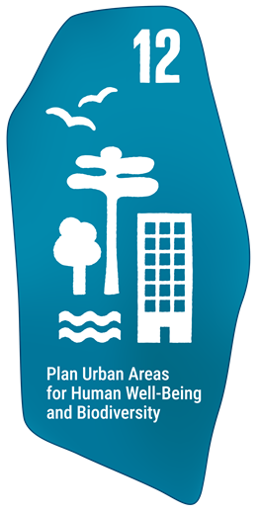
Target text: Significantly increase the area and quality, and connectivity of, access to, and benefits from green and blue spaces in urban and densely populated areas sustainably, by mainstreaming the conservation and sustainable use of biodiversity, and ensure biodiversity-inclusive urban planning, enhancing native biodiversity, ecological connectivity and integrity, and improving human health and well-being and connection to nature, and contributing to inclusive and sustainable urbanization and to the provision of ecosystem functions and services.

PROGRESS OVERVIEW
Progress on Target 12 faces significant challenges. Legislative and policy frameworks to mainstream biodiversity in urban planning remain at early stages and monitoring of green and blue spaces is largely absent. Efforts are under way to set up the enabling environment for enhanced access to green spaces in urban areas, but continuing development pressures still drive current patterns of urban development without a clear focus on biodiversity.

Indicators of progress
Table 15: Indicator scorecard for Target 12. Colour coding is related to the overall assessment of progress across targets, of which the methodology is explained in the summary scorecard (Table 1). The colour coding for indicator data use reflects where a value for each target sits relative to the highest and lowest scores achieved across all targets of the Framework (green is assigned to percentage values falling within the top third of the total range, yellow to the middle third, and red to the bottom third). Colours for the binary indicators are based on the percentage of Parties scoring highly (4 or 5) for the indicator overall (green is assigned to values at or above 50 per cent, yellow to values between 50 and 25 per cent; and red to values below less than 25 per cent). Colours for the headline indicator results are based on progress relative to the target (green is assigned when progress is being made, yellow when progress is mixed progress, red when progress is insufficient; and grey when progress cannot be assessed).
 | Indicator use |  | Indicator results
Headline indicator 12.1: Average share of the built-up area of cities that is green or blue space for public use for all | 10% of Parties |  | 35% coverage (one Party)
Binary indicator 12.b: Number of countries with biodiversity-inclusive urban planning referring to green or blue urban spaces | 8 Parties | N/A | 38% of Parties that reported scored highly (score 4/5)

One Party reported on the indicator for its capital city. Others report encountering technical and administrative barriers to reporting on indicator 12.1, primarily stemming from an absence of nationally standardized methodologies and baselines to systematically capture the spatial extent, classification and public accessibility of urban green and blue spaces. Existing data is predominantly fragmented across institutional silos, municipal planning processes, and isolated project frameworks, preventing central integration of geospatial data. Additionally, while globally derived or regional proxy datasets exist, Parties note that these estimates lack national validation, official adoption into national statistical frameworks and the granularity required for indicator compilation. Overcoming these monitoring gaps requires strengthening national spatial data infrastructures, establishing standardized land-use classification systems and formalizing integrated geospatial planning frameworks.

No Party has fully incorporated the management of green and blue spaces for biodiversity or ecosystem services into urban planning (Figure 28). However, for 75 per cent of responding Parties, such efforts are either in development or already partially in place.

Figure 28: Binary indicator 12.b, the number of countries with biodiversity-inclusive urban planning referring to green or blue urban spaces.
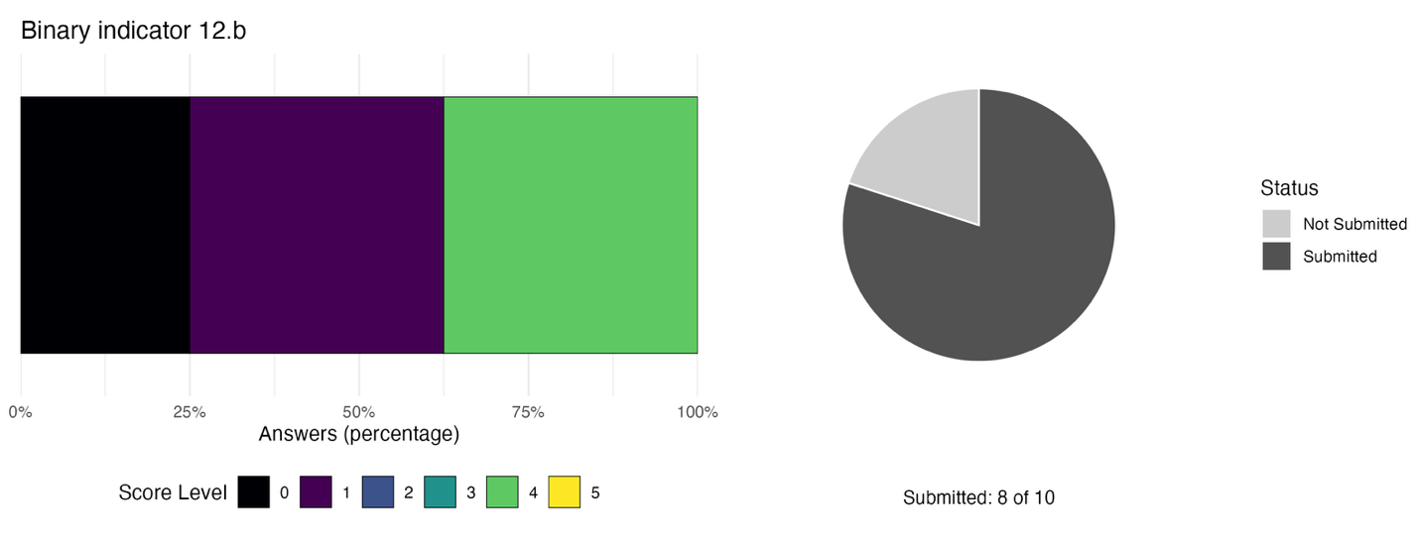The bar widths show the percentage of Parties in each score category, with higher numbers indicating a greater level of progress, based on responses to the questions included in the indicator. The pie chart shows the proportion of Parties included in the regional report who submitted national targets aligned with Target 12 in dark grey.

Self-assessment of progress
Only 22 per cent of national targets submitted as highly aligned to Target 12 are on track for achievement, with many more (67 per cent) showing no significant change or insufficient progress, and one in ten national targets (11 per cent) reported as unknown (Figure 29).
Figure 29: Self-assessed progress for all national targets submitted as highly aligned to Target 12.
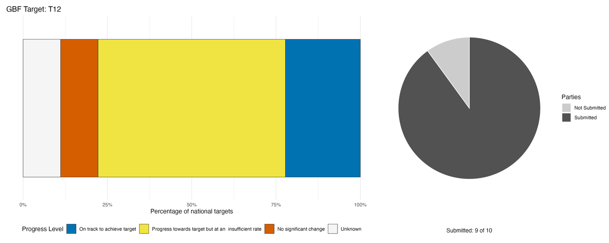
Bar widths show the percentage of national targets in each progress category. Percentages are weighted by Party to ensure that Parties contribute equally to overall assessment of progress, regardless of the number of national targets submitted. The pie chart shows the proportion of Parties included in the regional report who submitted national targets aligned with Target 12 in dark grey.

Actions, successes and challenges

Summary of actions in support of Target 12
Parties principally report direct conservation actions aimed at urban biodiversity. These include designation or formal protection of urban green and blue spaces, including parks, open spaces and protected areas and ecosystem restoration and nature-based solutions, particularly involving native species, green infrastructure and coastal or riparian systems. In support of these efforts, some Parties directly include biodiversity concerns into policy through the integration of biodiversity-sensitive spatial planning into urban development frameworks. Additional efforts towards sensitization and awareness-raising were reported by over half of Parties, including youth and school-based environmental education and tree-planting initiatives and community participation in green space management and clean-up activities.

Examples of success and progress in implementation
Box 14

Mainstreaming nature-based solutions into urban development in Jamaica

In Jamaica, the draft National Ecosystem Restoration Plan 2025-2035 has been structured to serve as both a strategic policy instrument and a practical implementation guide for ecosystem restoration across Jamaica. The Plan is intended for a broad range of users involved in ecosystem management, development planning, and environmental governance in Jamaica. Restoration activities include the planting of over 3,000 trees along main corridors in Kingston, with plans to plant over 10,000 trees along one of the main highways. The Forestry Department further reported that during the fiscal year 2024 to 2025, a total of 19,534 seedlings were planted in urban spaces.
Further, the draft Landscaping Design Guidelines for the Natural Resources Conservation Authority permit system integrates biodiversity and ecological design into development approvals. The guidelines promote the use of native species and the retention of natural vegetation, ensuring that urban development supports habitat connectivity and ecosystem function. This initiative strengthens green infrastructure within the built environment, enhancing urban green spaces, environmental quality, and human well-being, while contributing to biodiversity conservation.
The Urban Development Corporation also continues to advance sustainable urban development and the integration of green and blue spaces through major infrastructure projects. Initiatives such as the Harmony Beach Park, Portmore Resilience Park, and the planned Kingston Harbour Walk demonstrate the incorporation of climate-resilient design, renewable energy, water-efficient systems, recycled materials, and green infrastructure into public spaces. Because so much of the population resides in urban coastal centres, these areas are at the forefront of climate risk management, therefore, a high-priority action in the Blue Economy Roadmap, 2023, involves protecting blue spaces by improving urban infrastructure. To better integrate urban management with marine protection, the roadmap suggests the creation of cross-agency working groups to handle issues like water quality and fisheries that affect town centers.
Additionally, the Guidelines on Urban and Peri-urban Forestry in Jamaica (2024), developed under the CityAdapt Initiative promote the integration of nature-based solutions and ecosystem-based adaptation into urban planning, encouraging the use of endemic plant species and expanded green infrastructure to address urban climate risks such as flooding and rising temperatures. Collectively, these initiatives contribute to enhancing urban biodiversity, ecological connectivity, and ecosystem services for human well-being.

Relevant targets: 8, 11, 12
Source: Jamaica, draft seventh national report to the Convention

Challenges
Parties report many challenges in implementation of national targets associated with Target 12. Several Parties note that while biodiversity concerns may be integrated into development frameworks, these do not necessarily directly relate to urban planning and, even when they do, non-adherence to planning law remains a challenge. These weak institutional mandates are compounded by capacity constraints, leading to absent management units, limited technical expertise and inter-agency coordination failures. Most Parties further report incomplete or insufficient monitoring infrastructure to guide or understand change in green and blue spaces in urban areas. Additional circumstances limiting progress include development pressures in urban areas, land ownership barriers limiting public access to green and blue spaces, insecurity-driven habitat destruction, and the underutilisation of innovative urban greening approaches.

Target 13: Increase the sharing of benefits from genetic resources, digital sequence information and traditional knowledge
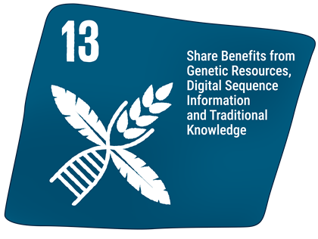
Target text: Take effective legal, policy, administrative and capacity-building measures at all levels, as appropriate, to ensure the fair and equitable sharing of benefits that arise from the utilization of genetic resources and from digital sequence information on genetic resources, as well as traditional knowledge associated with genetic resources, and facilitating appropriate access to genetic resources, and by 2030, facilitating a significant increase of the benefits shared, in accordance with applicable international access and benefit-sharing instruments.

PROGRESS OVERVIEW
Parties in the region are at early stages of implementation. The majority of Parties report not having ratified or fully operationalised the Nagoya Protocol, not having enacted domestic Access and Benefit-Sharing (ABS) legislation, and having no documented, concluded benefit-sharing agreements. As such, monitoring capacity for ABS-related outcomes is also underdeveloped and largely lacking.

Indicators of progress
Table 16: Indicator scorecard for Target 13. Colour coding is related to the overall assessment of progress across targets, of which the methodology is explained in the summary scorecard (Table 1). The colour coding for indicator data use reflects where a value for each target sits relative to the highest and lowest scores achieved across all targets of the Framework (green is assigned to percentage values falling within the top third of the total range, yellow to the middle third, and red to the bottom third). Colours for the binary indicators are based on the percentage of Parties scoring highly (4 or 5) for the indicator overall (green is assigned to values at or above 50 per cent, yellow to values between 50 and 25 per cent; and red to values below less than 25 per cent). Colours for the headline indicator results are based on progress relative to the target (green is assigned when progress is being made, yellow when progress is mixed progress, red when progress is insufficient; and grey when progress cannot be assessed).
 | Indicator use |  | Indicator results
Headline indicator C.1: Monetary benefits received in accordance with applicable internationally agreed access and benefit-sharing instruments | 0% of Parties |  | No data
Headline indicator C.2: Non-monetary benefits arising from applicable international access and benefit-sharing instruments | 0% of Parties |  | No data
Binary indicator 13.b: Number of countries that have taken effective legal, policy, administrative and capacity-building measures at all levels, as appropriate, to ensure the fair and equitable sharing of benefits from the utilization of genetic resources and from digital sequence information on genetic resources, as well as traditional knowledge associated with genetic resources | 8 Parties | N/A | 0% of Parties that reported scored highly (score 4/5)

No Party reported on either headline indicator for Target 13. Reporting challenges for indicators C.1 and C.2 primarily stem from administrative constraints in monitoring ABS outcomes. Parties highlight an absence of centralized national monitoring systems capable of systematically consolidating, tracking, and reporting data on monetary and non-monetary benefits generated from genetic resources. This is further compounded by incomplete or non-operational national ABS frameworks, including pending legal and administrative procedures, a lack of formalized Prior Informed Consent and Mutually Agreed Terms agreements and undeveloped permit and reporting systems. Consequently, even where active research, administrative measures and capacity-building initiatives exist, institutional coordination gaps prevent the systematic capture and quantification of benefit-sharing metrics at the national level.

Progress on establishing measures related to Target 13 is at early stages of development (Figure 30). Only one reporting Party has measures fully in place to ensure the fair and equitable sharing of benefits that arise from the utilization of genetic resources. Capacity-building measures to ensure the fair and equitable sharing of benefits are under development for almost all Parties (86 per cent). Only one Party reported that measures related to the utilization of traditional knowledge associated with genetic resources were relevant, and, in this case, these were not yet in place. Additionally, most Parties (86 per cent) either do not have any measures in place pursuant to the operationalization of the multilateral mechanism in decision 16/2 (CBD, 2026), or are developing them. Similarly, Parties either do not monitor monetary and non-monetary benefits derived from the utilization of genetic resources accessed nationally or are developing monitoring systems. Finally, the majority of Parties (57 per cent) do not have measures in place to ensure the fair and equitable benefit-sharing arising from the utilization of genetic resources and/or traditional knowledge associated with genetic resources that were accessed in another country.

Figure 30: Binary indicator 13.b, the number of countries that have taken effective legal, policy, administrative and capacity-building measures at all levels, as appropriate, to ensure the fair and equitable sharing of benefits from the utilization of genetic resources and from digital sequence information on genetic resources, as well as traditional knowledge associated with genetic resources.
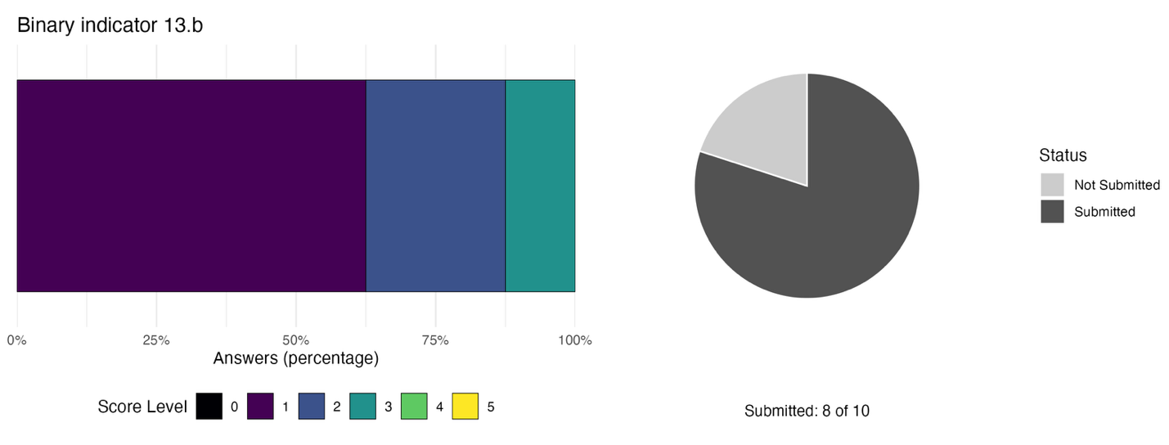The bar widths show the percentage of Parties in each score category, with higher numbers indicating a greater level of progress, based on responses to the questions included in the indicator. The pie chart shows the proportion of Parties included in the regional report who submitted national targets aligned with Target 13 in dark grey.

Self-assessment of progress
Based on self-assessment by Parties in national reports, 21 per cent of national targets submitted as highly aligned to Target 13 are on track for achievement. Ten percent show no significant change, with a further 55 per cent showing insufficient progress, and 11 per cent reported as unknown (see Figure 31).
Figure 31: Self-assessed progress for all national targets submitted as highly aligned to Target 13.
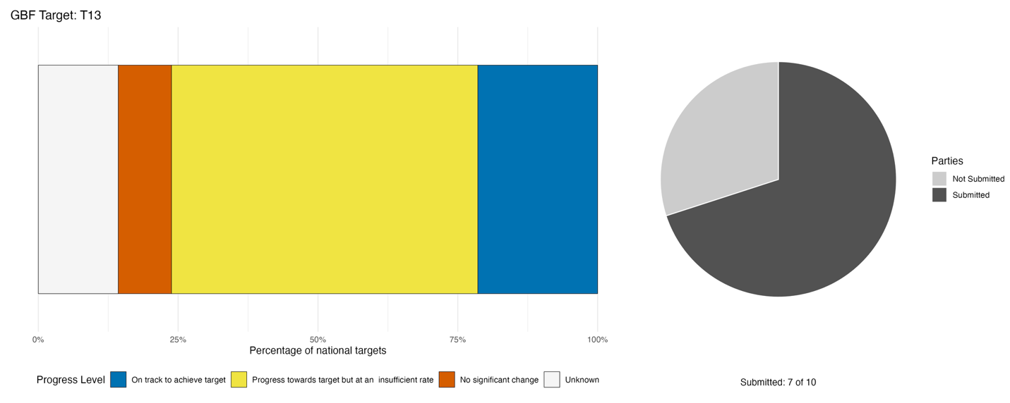
Bar widths show the percentage of national targets in each progress category. Percentages are weighted by Party to ensure that Parties contribute equally to overall assessment of progress, regardless of the number of national targets submitted. The pie chart shows the proportion of Parties included in the regional report who submitted national targets aligned with Target 13 in dark grey.

Actions, successes and challenges

Summary of actions in support of Target 13
Parties largely report being in the early stages of developing the necessary legal and institutional infrastructure to make progress on Target 13. A small number of Parties report enacted and operational legislative instruments, while the majority report frameworks that are under development, partially validated, or awaiting formal adoption. Most Parties also report participating in regionally organized capacity-building activities, such as those convened by CARICOM, and/or receiving external funding (notably from the GEF) to advance national implementation of the Nagoya Protocol. Only one Party reported a concluded bilateral cooperation agreement with documented benefit-sharing terms. Additionally, several Parties describe training and capacity-building activities directed at key stakeholders, awareness-raising on ABS obligations, and the integration of traditional knowledge considerations into community engagement processes. Several Parties also report environmental education initiatives with a broader biodiversity mandate that intersect with ABS awareness.

Examples of success and progress in implementation
Box 15

Operationalizing access and benefit-sharing in Cuba
Establishing effective ABS frameworks under the Nagoya Protocol often presents complex administrative challenges for developing nations. Under Resolution 92/2023, issued by the Ministry of Science, Technology and Environment, Cuba is tackling this challenge. Rather than creating a single new administrative body, the initiative designated five existing institutional entities as official ABS checkpoints, distributing compliance and oversight responsibilities across key federal agencies, including the Cuban Office of Industrial Property and the General Customs of the Republic.
To ensure the system operates effectively across these disparate sectors, Citma rolled out a structured capacity-building program alongside legal implementation. The initiative successfully conducted at least six targeted training activities, upskilling over 100 key actors across customs, intellectual property, and scientific domains. This multi-agency coordination quickly yielded concrete results, culminating in 2025 with the signing of four formal benefit-sharing contracts involving major research centers, including the National Botanical Garden and the Faculty of Biology.
This approach provides a cost-effective template for developing countries seeking to implement ABS compliance mechanisms. By embedding checkpoint duties within existing institutions, such as customs and patent offices, and pairing regulatory designation with targeted training and early scientific contracts, Cuba established a practical pathway to ensure fair and equitable benefit-sharing without heavy administrative overhead.

Relevant targets: 13
Source: Cuba, seventh national report to the Convention

Challenges
Challenges reported by Parties under Target 13 reflect distinct bottlenecks across the ABS implementation chain, requiring differentiated policy and technical support. At the foundational level, non-ratification of the Nagoya Protocol and the lack of enacted domestic ABS legislation delay legal implementation for several Parties. Downstream, institutional hurdles persist: even where legal mandates exist, Parties report an absence of designated competent national authorities, operational checkpoints, and functioning permit and compliance tracking systems. Furthermore, frameworks for negotiating benefit-sharing agreements and securing safeguards for traditional knowledge associated with genetic resources remain largely undeveloped. In addition, the national reports reviewed largely do not contain any description of national frameworks or operational measures to address digital sequence information.

Tools and solutions for implementation and mainstreaming

Target 14: Integrate biodiversity into decision-making at all levels
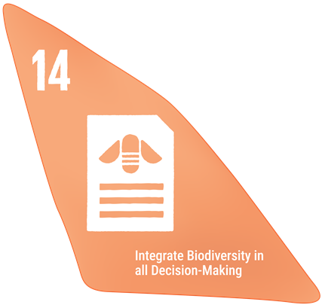
Target text: Ensure the full integration of biodiversity and its multiple values into policies, regulations, planning and development processes, poverty eradication strategies, strategic environmental assessments, environmental impact assessments and, as appropriate, national accounting, within and across all levels of government and across all sectors, in particular those with significant impacts on biodiversity, progressively aligning all relevant public and private activities, and fiscal and financial flows with the goals and targets of this framework.

PROGRESS OVERVIEW
Parties report making substantial efforts towards the mainstreaming of biodiversity. Largely, these efforts have focused on legislation and policy mechanisms to include biodiversity. However, in many cases these efforts are still incomplete, and implementation is at an early stage. Additionally, concerns about sufficient financial resources to support NBSAPs were flagged as a major barrier to progress.

Indicators of progress
Table 17: Indicator scorecard for Target 14. Colour coding is related to the overall assessment of progress across targets, of which the methodology is explained in the summary scorecard (Table 1). Colours for the binary indicators are based on the percentage of Parties scoring highly (4 or 5) for the indicator overall (green is assigned to values at or above 50 per cent, yellow to values between 50 and 25 per cent; and red to values below less than 25 per cent).
 | Indicator use |  | Indicator results
Binary indicator 14.b: Number of countries integrating biodiversity and its multiple values into policies, regulations, planning, development processes, poverty eradication strategies and, as appropriate, national accounts, within and across all levels and across all sectors, and progressively aligning all relevant public and private activities and fiscal and financial flows with the goals and targets of the Framework | 8 Parties | N/A | 13% of Parties that reported scored highly (score 4/5)

Only one Party reported fully integrating biodiversity and its multiple values into policies, regulations, plans and strategies across all sectors to ensure their mainstreaming, while most others reported this is partially the case. Similarly, the mainstreaming of biodiversity into government policies and processes has been partially done for 86 per cent of reporting Parties. However, 29 per cent of reporting Parties do not use environmental economic accounting to quantify the monetary and non-monetary values of biodiversity, with a further 57 per cent currently developing these accounts. Similarly, measures to progressively align fiscal and financial flows with the goals and targets of the Framework are largely under development.

Figure 32: Binary indicator 14.b, the number of countries integrating biodiversity and its multiple values into policies, regulations, planning, development processes, poverty eradication strategies and, as appropriate, national accounts, within and across all levels and across all sectors, and progressively aligning all relevant public and private activities and fiscal and financial flows with the goals and targets of the Framework.
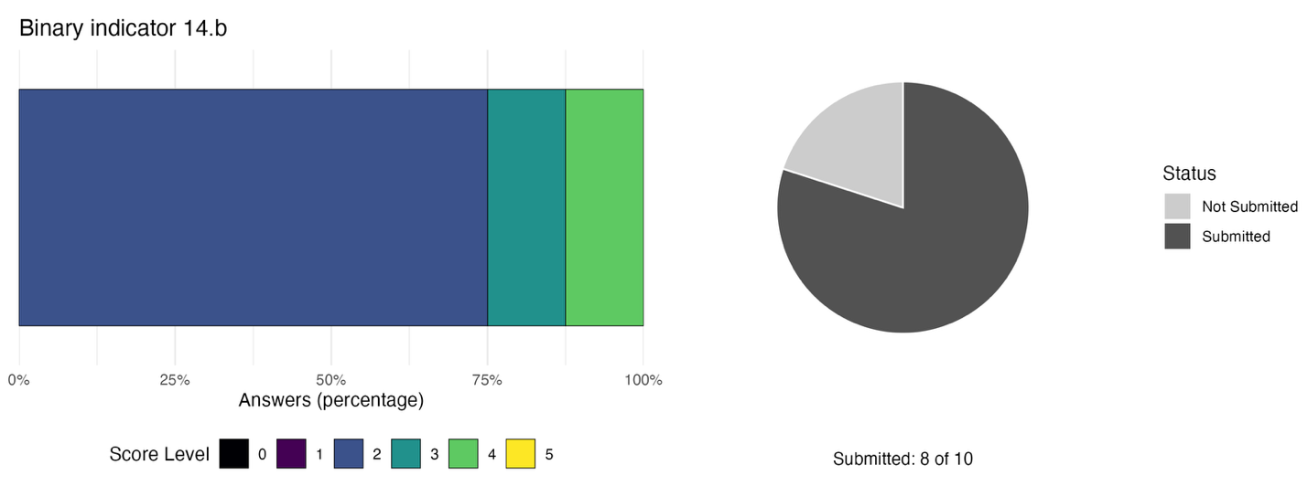The bar widths show the percentage of Parties in each score category, with higher numbers indicating a greater level of progress, based on responses to the questions included in the indicator. The pie chart shows the proportion of Parties included in the regional report who submitted national targets aligned with Target 14 in dark grey.

Self-assessment of progress
Based on self-assessment of Parties in national reports, half (50 per cent) of all national targets submitted with high alignment to Target 14 are on track for achievement, with fewer (39 per cent) showing insufficient progress but none having made no progress even though 11 per cent have an unknown status (see Figure 33).
Figure 33: Self-assessed progress for all national targets submitted as highly aligned to Target 14.
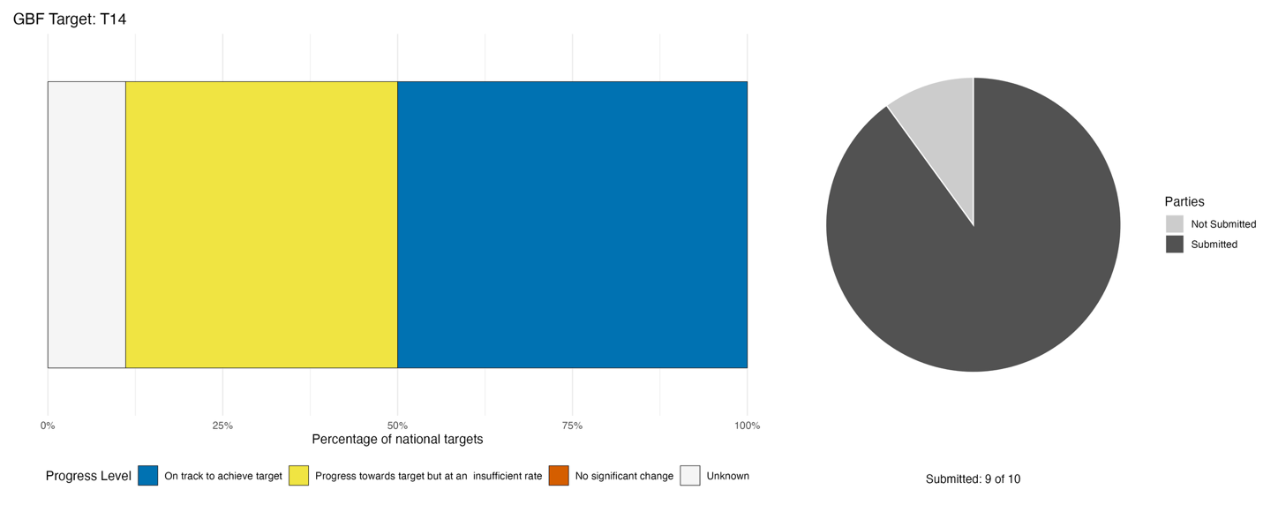
Bar widths show the percentage of national targets in each progress category. Percentages are weighted by Party to ensure that Parties contribute equally to overall assessment of progress, regardless of the number of national targets submitted. The pie chart shows the proportion of Parties included in the regional report who submitted national targets aligned with Target 14 in dark grey.

Actions, successes and challenges

Summary of actions in support of Target 14
Parties report making progress on mainstreaming the values of biodiversity primarily through actions aimed at legal and regulatory policy. The most reported approaches include the integration of biodiversity considerations into environmental impact assessment frameworks, national development planning legislation and sectoral laws. Most Parties also report economic and financial mainstreaming actions, including sovereign finance mechanisms, natural capital accounting frameworks, biodiversity financing strategies and fund establishment linked to conservation mandates. Several Parties further report social and awareness raising efforts through institutionalised environmental education, community-engagement processes and gender-targeted trainings.

Examples of success and progress in implementation
Box 16

Adoption of the National Conservation and Environmental Management Act, 2025 in Saint Kitts and Nevis
To establish a unified, legally binding framework for environmental governance, the Government of Saint Kitts and Nevis enacted the National Conservation and Environmental Management Act in 2025. This overarching legislative mandate serves as the country’s primary vehicle for embedding biodiversity values directly into public planning and decision-making processes.
Rather than relying on isolated conservation initiatives, the 2025 Act operates in tandem with a suite of targeted sectoral plans. Led by national authorities, this structured approach ensures that environmental priorities are systematically incorporated across key government agencies and economic sectors. By establishing explicit statutory obligations, the legislation transitions national biodiversity objectives from aspirational policy goals into cross-governmental practice.
By pairing comprehensive national legislation with actionable, sector-specific operational plans, the Act demonstrates how developing nations can effectively mainstream biodiversity values across all levels of government and achieve long-term conservation outcomes.

Relevant targets: 10, 14
Source: Saint Kitts and Nevis, draft seventh national report to the Convention

Challenges
One of the most recurrent challenges reported by Parties in mainstreaming biodiversity is weak inter-agency coordination combined with fragmented institutional mandates, which silo biodiversity-related matters and hinder broad integration in decision making. Additionally, a key barrier facing several Parties is the incomplete or un-endorsed NBSAPs aligned with the Framework. Some Parties further note that financial resources to implement their NBSAPs are insufficient and that there is an over-reliance on project-based financing. Some Parties also note the limited engagement from the private sector alongside the insufficient economic valuation of ecosystem services. The national reports reviewed contain few examples of biodiversity considerations influencing sectoral plans, budgets, project approvals, fiscal measures and institutional performance systems.

Target 15: Businesses assess, disclose and reduce biodiversity-related risks and negative impacts
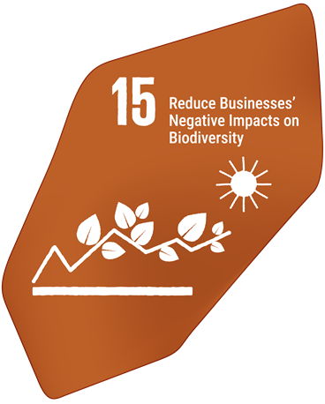
Target text: Take legal, administrative or policy measures to encourage and enable business, and in particular to ensure that large and transnational companies and financial institutions: (a) Regularly monitor, assess, and transparently disclose their risks, dependencies and impacts on biodiversity, including with requirements for all large as well as transnational companies and financial institutions along their operations, supply and value chains, and portfolios; (b) Provide information needed to consumers to promote sustainable consumption patterns; and (c) Report on compliance with access and benefit-sharing regulations and measures, as applicable; in order to progressively reduce negative impacts on biodiversity, increase positive impacts, reduce biodiversity-related risks to business and financial institutions, and promote actions to ensure sustainable patterns of production.

PROGRESS OVERVIEW
Progress towards Target 15 is insufficient in the region. Legal, administrative and policy measures aimed at businesses and financial institutions are largely absent. Some evidence of voluntary private sector engagement is apparent, but this is limited and not representative of the broader landscape. Capacity and resource challenges affect Parties’ ability to make progress.

Indicators of progress
Table 18: Indicator scorecard for Target 15. Colour coding is related to the overall assessment of progress across targets, of which the methodology is explained in the summary scorecard (Table 1). The colour coding for indicator data use reflects where a value for each target sits relative to the highest and lowest scores achieved across all targets of the Framework (green is assigned to percentage values falling within the top third of the total range, yellow to the middle third, and red to the bottom third). Colours for the binary indicators are based on the percentage of Parties scoring highly (4 or 5) for the indicator overall (green is assigned to values at or above 50 per cent, yellow to values between 50 and 25 per cent; and red to values below less than 25 per cent). Colours for the headline indicator results are based on progress relative to the target (green is assigned when progress is being made, yellow when progress is mixed progress, red when progress is insufficient; and grey when progress cannot be assessed).
 | Indicator use |  | Indicator results
Headline indicator 15.1: Number of companies disclosing their biodiversity-related risks, dependencies and impacts | 0% of Parties |  | No data
Binary indicator 15.b: Number of countries with legal, administrative or policy measures aimed at encouraging and enabling business and financial institutions, and in particular for large and transnational companies and financial institutions, to progressively reduce their negative impacts on biodiversity, increase their positive impacts, reduce their biodiversity-related risks and promote actions to ensure sustainable patterns of production | 8 Parties | N/A | 0% of Parties that reported scored highly (score 4/5)

Parties attribute their inability to report quantitatively against Indicator 15.1 primarily to the absence of standardized national disclosure frameworks, unified metrics and regulatory mandates for business biodiversity reporting. Without formal national tracking mechanisms or statutory reporting requirements, private-sector disclosures remain predominantly voluntary, uncoordinated and qualitative, preventing the establishment of consolidated national baselines regarding corporate biodiversity impacts, risks, and dependencies. Additionally, persistent technical, resource, and institutional capacity constraints across both public administration and the private sector limit the systemic adoption of international disclosure standards (such as the Taskforce on Nature-related Financial Disclosures (TNFD) ) and impede the application of standardized methodologies necessary for systematic national monitoring.

Parties reported limited progress in establishing legal, administrative or policy measures aimed at encouraging and enabling business and financial institutions, and in particular for large and transnational companies and financial institutions, to progressively reduce their negative impacts on biodiversity, increase their positive impacts, reduce their biodiversity-related risks and promote actions to ensure sustainable patterns of production (Figure 34). Only one Party reported fully having measures in place to ensure transparent disclosure of risks, dependencies and impacts on biodiversity as well as the progressive reduction of negative impacts on biodiversity and increase of positive impacts, including its monitoring. Very limited progress (none for 57 per cent of Parties) has been reported in ensuring that relevant information to consumers to promote sustainable consumption patterns is shared. Additionally, measures to ensure reporting on compliance with ABS regulations are mostly (for 57 per cent of Parties) under development. Over half of Parties at least partially ensure that large and transnational companies and financial institutions progressively reduce their negative impacts on biodiversity and increase their positive impacts, but most (71 per cent) do not currently monitor it.

Figure 34: Binary indicator 15.b, the number of countries taking legal, administrative or policy measures aimed at encouraging and enabling business and financial institutions, and in particular, ensuring that large and transnational companies and financial institutions, to progressively reduce negative impacts from business and financial institutions on biodiversity, increase their positive impacts, reduce their biodiversity-related risks and promote actions to ensure sustainable patterns of production.
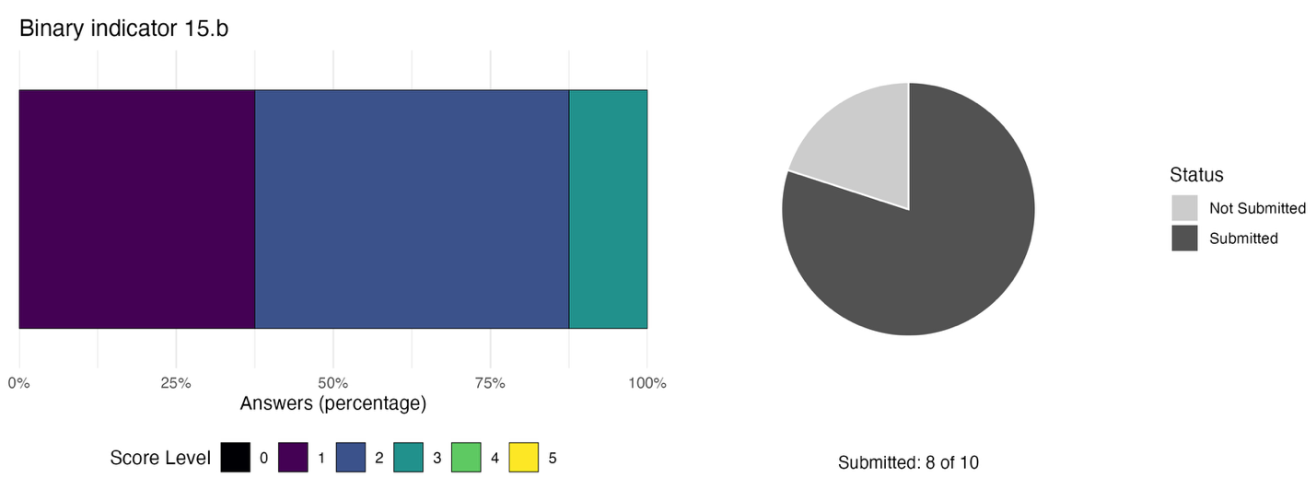The bar widths show the percentage of Parties in each score category, with higher numbers indicating a greater level of progress, based on responses to the questions included in the indicator. The pie chart shows the proportion of Parties included in the regional report who submitted national targets aligned with Target 15 in dark grey.

Self-assessment of progress
Based on self-assessment of Parties in national reports, none of the national targets submitted with high alignment to Target 15 are on track for achievement. The vast majority (86 per cent) show no significant change or insufficient progress, while some (14 per cent) are unknown in status (see Figure 35).

Figure 35: Self-assessed progress for all national targets submitted as highly aligned to Target 15.
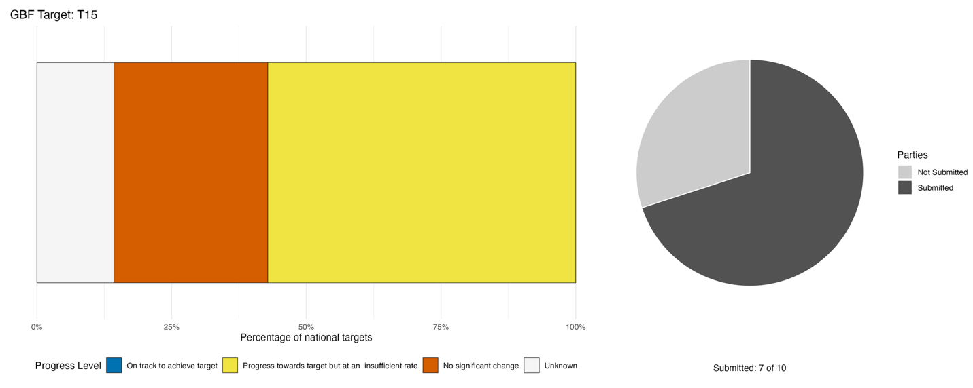
Bar widths show the percentage of national targets in each progress category. Percentages are weighted by Party to ensure that Parties contribute equally to overall assessment of progress, regardless of the number of national targets submitted. The pie chart shows the proportion of Parties included in the regional report who submitted national targets aligned with Target 15 in dark grey.

Actions, successes and challenges

Summary of actions in support of Target 15
Across all reporting Parties, actions described in national reports reflect a broad pattern of pioneering individual instruments aimed at private sector actors rather than established processes for disclosure. The most established legal mechanism reported by Parties is environmental impact assessment requirements. Some Parties also describe private sector participation in voluntary certification schemes and awareness-raising or capacity-building initiatives targeting small businesses.

Examples of success and progress in implementation
Box 17

Private sector action in Trinidad and Tobago
In Trinidad and Tobago, two pioneering voluntary initiatives demonstrate how key commercial actors can integrate sustainability ahead of national legislative mandates. Two prominent private sector efforts have set a precedent for corporate responsibility: the publication of the ANSA Merchant Bank Natural Capital Report 2024 and the Green Key certification of two flagship ecotourism operators, the Asa Wright Nature Centre and Mt. Plaisir Estate Hotel.
The ANSA Merchant Bank report represents the first natural capital disclosure by a financial institution in Trinidad and Tobago and a major achievement for the wider Caribbean. By adopting frameworks such as the Natural Capital Protocol and the TNFD, the bank established a credible baseline for measuring nature-related financial risks and impacts. Concurrently, local ecotourism leaders pursued internationally recognized Green Key certifications, embedding global biodiversity performance standards directly into their daily hospitality operations without reliance on state enforcement mechanisms.
These results prove that financial institutions can independently adopt transparent biodiversity reporting frameworks, creating momentum for peer adoption across regional markets and highlighting international certification schemes as practical, accessible entry points for sustainable business operations in institutionally constrained environments.

Relevant targets: 14, 15
Source: Trinidad and Tobago, seventh national report to the Convention

Challenges
The dominant structural challenge across reporting Parties is the absence of the legal, institutional and financial architecture needed to make corporate biodiversity disclosure and impact reduction operational. Most Parties report lacking mandatory legislative or regulatory requirements for businesses to assess or disclose biodiversity-related impacts, dependencies and risks. Where governance frameworks exist, they are frequently reported as incomplete, unenforced or limited to narrow sectoral applications. These legal gaps are compounded by weak institutional capacity in the regulatory agencies responsible for enabling disclosure, by the absence of centralised platforms through which businesses could report and governments could aggregate information, and by the absence of fiscal incentives or green finance instruments to motivate private-sector participation. A further cross-cutting challenge is the difficulty of engaging small and micro-enterprises specifically. Multiple Parties report that smaller businesses are unfamiliar with biodiversity reporting, find internationally developed disclosure frameworks such as TNFD complex and resource-intensive, and face high compliance costs relative to their capacity. This behavioural and capacity gap at the enterprise level reinforces the structural absence of standardized national reporting systems.

Target 16: Enable sustainable consumption choices to reduce waste and overconsumption
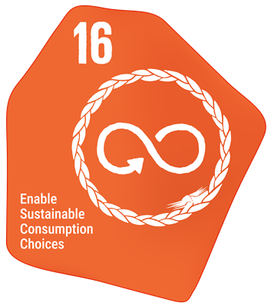
Target text: Ensure that people are encouraged and enabled to make sustainable consumption choices, including by establishing supportive policy, legislative or regulatory frameworks, improving education and access to relevant and accurate information and alternatives, and by 2030, reduce the global footprint of consumption in an equitable manner, including through halving global food waste, significantly reducing overconsumption and substantially reducing waste generation, in order for all people to live well in harmony with Mother Earth.

PROGRESS OVERVIEW
Parties are making progress in developing the enabling environment necessary to reduce waste and enable sustainable consumption choices, but they do not yet report being on track for any national target. Persistent challenges in sustaining behaviour change and infrastructure development hinder the long-term effectiveness of Party actions.

Indicators of progress
Table 19: Indicator scorecard for Target 16. Colour coding is related to the overall assessment of progress across targets, of which the methodology is explained in the summary scorecard (Table 1). Colours for the binary indicators are based on the percentage of Parties scoring highly (4 or 5) for the indicator overall (green is assigned to values at or above 50 per cent, yellow to values between 50 and 25 per cent; and red to values below less than 25 per cent).
 | Indicator use |  | Indicator results
Binary indicator 16.b: Number of countries developing, adopting or implementing policy instruments aimed at encouraging and enabling people to make sustainable consumption choices | 8 Parties | N/A | 63% of Parties that reported scored highly (score 4/5)

All reporting Parties are making at least some progress towards developing, adopting or implementing policy instruments aimed at encouraging and enabling people to make sustainable consumption choices (Figure 36). The most progress was reported towards improving awareness or education regarding the impacts of consumption on biodiversity and access to relevant and accurate information or alternatives supporting sustainable consumption. Additionally, mechanisms, policy, legislative or regulatory frameworks aimed at supporting sustainable consumption are at least partially in place for 71 per cent of reporting Parties. Slightly less progress was reported on encouraging and enabling people to make sustainable consumption choices, including by reducing food waste, over consumption and waste generation.

Figure 36: Binary indicator 16.b, the number of countries developing, adopting or implementing policy instruments aimed at encouraging and enabling people to make sustainable consumption choices.
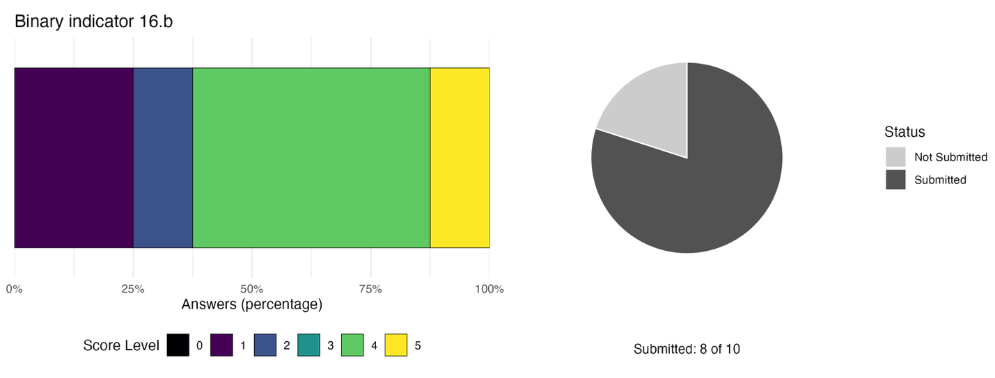The bar widths show the percentage of Parties in each score category, with higher numbers indicating a greater level of progress, based on responses to the questions included in the indicator. The pie chart shows the proportion of Parties included in the regional report who submitted national targets aligned with Target 16 in dark grey.

Self-assessment of progress
Based on self-assessment by Parties in national reports, none of the national targets submitted as highly aligned to Target 16 are on track for achievement, with most (75 per cent) showing insufficient progress, and a quarter of national targets (25 per cent) showing no change (see Figure 37).

Figure 37: Self-assessed progress for all national targets submitted as highly aligned to Target 16.
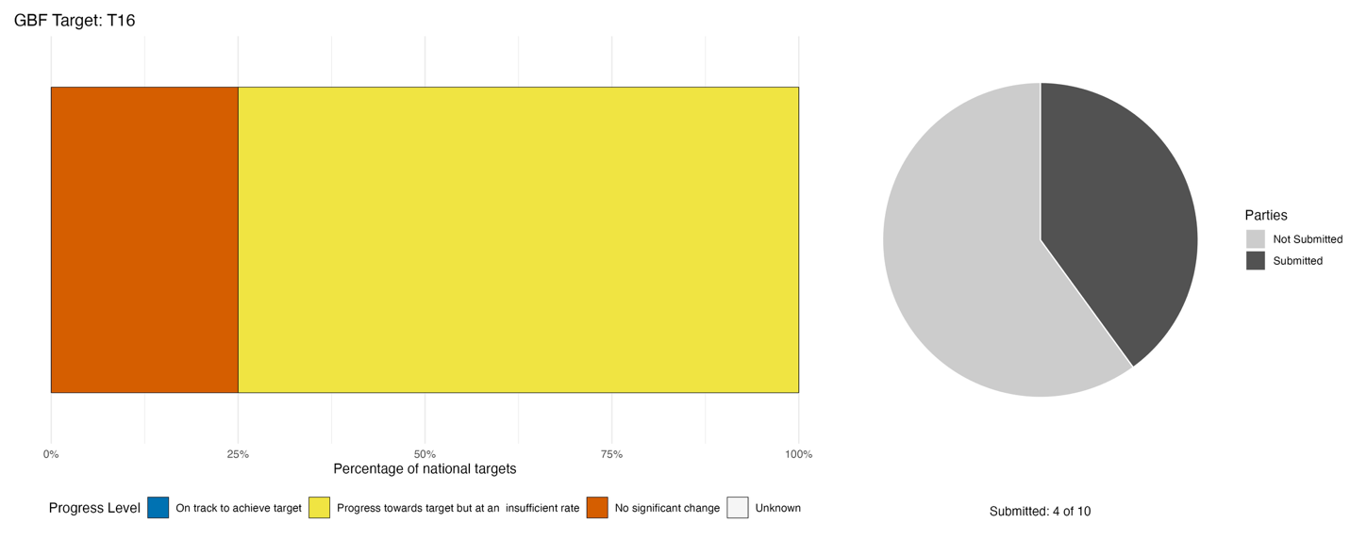
Bar widths show the percentage of national targets in each progress category. Percentages are weighted by Party to ensure that Parties contribute equally to overall assessment of progress, regardless of the number of national targets submitted. The pie chart shows the proportion of Parties included in the regional report who submitted national targets aligned with Target 16 in dark grey.

Actions, successes and challenges

Summary of actions in support of Target 16
Most Parties report enacting regulatory and policy measures aligned with Target 16. The dominant regulatory measures reported focus on single-use plastics through bans, acts, and resolutions. A smaller number of Parties also report broader regulatory frameworks addressing sustainable consumption, procurement or production standards. In addition, most Parties report taking action focused on empowering communities to reduce and/or redirect waste generation flows. These actions include public awareness and behaviour change campaigns (particularly around plastic waste and sustainable consumption); civil society and community-led initiatives; and, to a lesser extent, multi-stakeholder consultation and participation mechanisms.

Examples of success and progress in implementation
Box 18
Saint Kitts and Nevis solid waste management and recycling project
The Saint Kitts and Nevis solid waste management and recycling project provides a practical example of the effectiveness of actions aimed at promoting sustainable consumption and waste reduction. Through the national recycling collection programme, households and communities actively participate in the separation and recovery of recyclable materials, contributing to increased resource recovery and reduced waste disposal. During the first four months of 2026, the programme collected approximately 65,744 pounds of recyclable materials, including plastics, cardboard, and metals, demonstrating strong public engagement in recycling initiatives.
Public awareness and behavioural change are further supported through the “Let’s Recycle Saint Kitts and Nevis” social media platform, which regularly shares information on recycling campaigns, educational activities, community outreach events, collection schedules, and recycling results. By providing regular updates, photographs, and collection statistics, the platform helps increase public awareness of sustainable consumption practices, encourages participation in recycling programmes, and reinforces positive environmental behaviours among citizens. The initiative demonstrates how communication, education, and transparency can support long-term behavioural change and strengthen community participation in environmental sustainability efforts.

Relevant targets: 16, 21
Source: Saint Kitts and Nevis, draft seventh national report to the Convention

Challenges
In general, reporting Parties highlight the difficulty of enabling sustainable consumption choices in the absence of dedicated policy frameworks, adequate financing, functional monitoring systems and the behavioural and infrastructure conditions necessary to make sustainable alternatives accessible and attractive to consumers and businesses. These reported challenges are deeply interconnected: the absence of a dedicated sustainable consumption and production policy limits the institutional mandate and financing basis for action; financing gaps constrain the awareness campaigns, infrastructure, and enforcement capacity needed to shift behaviour; and weak monitoring systems prevent Parties from tracking whether any progress is occurring. Specific challenges in the enabling environment include the absence of dedicated sustainable consumption and production policy frameworks, incomplete or partially operational environmental legislation, weak enforcement of existing measures and missing regulatory instruments such as green labelling standards and beverage container legislation.

Target 17: Strengthen biosafety and distribute the benefits of biotechnology
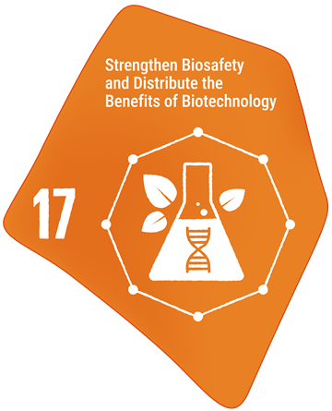
Target text: Establish, strengthen capacity for, and implement in all countries, biosafety measures as set out in Article 8(g) of the Convention on Biological Diversity and measures for the handling of biotechnology and distribution of its benefits as set out in Article 19 of the Convention.

PROGRESS OVERVIEW

Major gaps exist in progress towards Target 17 in the region. Necessary legislation is largely not yet in place, resulting in major capacity barriers and a lack of technical expertise on biosafety and biotechnology. Many Parties do not yet have operational Biosafety CHMs, further hindering progress. Monitoring, scientific and technical capacity in the region also remains too low.

Indicators of progress
Table 20: Indicator scorecard for Target 17. Colour coding is related to the overall assessment of progress across targets, of which the methodology is explained in the summary scorecard (Table 1). Colours for the binary indicators are based on the percentage of Parties scoring highly (4 or 5) for the indicator overall (green is assigned to values at or above 50 per cent, yellow to values between 50 and 25 per cent; and red to values below less than 25 per cent).
 | Indicator use |  | Indicator results
Binary indicator 17.b: Number of countries that have taken action to implement biosafety measures as set out in Article 8(g) of the Convention and measures for the handling of biotechnology and the distribution of its benefits as set out in Article 19 | 8 Parties | N/A | 0% of Parties that reported scored highly (score 4/5)

According to Party submissions for the binary indicator, some progress has been made towards Target 17 (Figure 38), but it is mixed and does not address all aspects of the target. Most Parties (71 per cent) at least partially implement biosafety measures as set out in Article 8(g) of the Convention, some of which (29 per cent) have fully established related measures nationally. However, measures related to the effective participation in biotechnological research activities and to the priority access by Parties to the results and benefits arising from biotechnologies as set out in paragraphs 1 and 2 of Article 19 of the Convention are only in place for one Party. Additionally, 57 per cent of Parties report not carrying out scientifically sound risk assessments on the use and release of living modified organisms. However, these Parties do report currently developing access to biosafety-related information for the safe transfer, handling and use of living modified organisms (LMOs).

Figure 38: Binary indicator 17.b, the number of countries that have taken action to implement biosafety measures as set out in Article 8(g) of the Convention and measures for the handling of biotechnology and the distribution of its benefits as set out in Article 19.
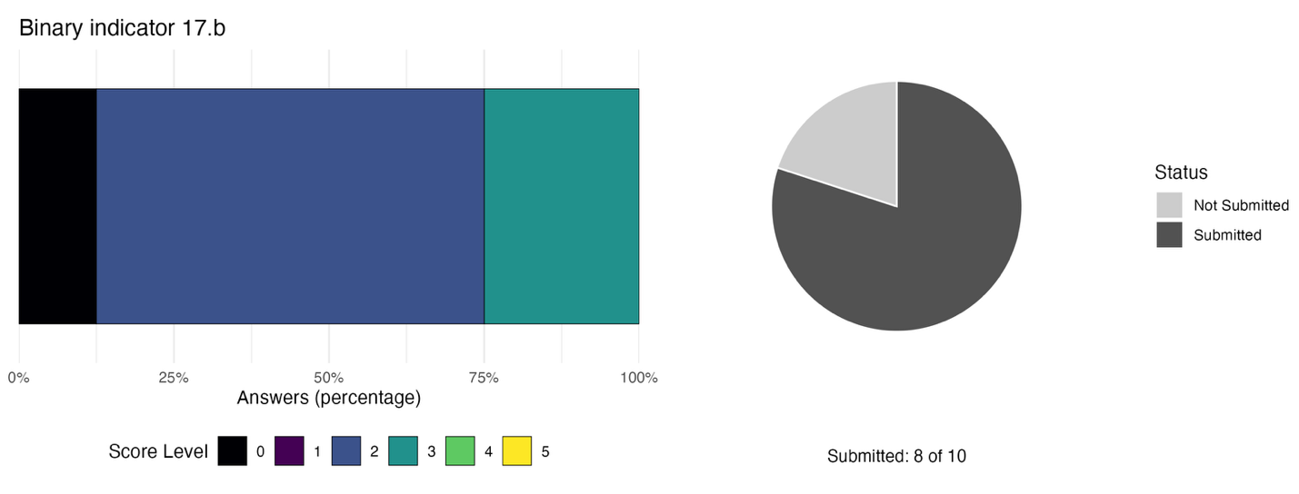Score distribution based on Party answers to the related questions. The bar widths show the percentage of Parties in each score category, with higher numbers indicating a greater level of progress, based on responses to the questions included in the indicator. The pie chart shows the proportion of Parties included in the regional report who submitted national targets aligned with Target 17 in dark grey.

Self-assessment of progress

Based on self-assessment by Parties in national reports, only 17 per cent of national targets submitted as highly aligned with Target 17 are on track for achievement. Half (50 per cent) of all national targets show no significant change, with a further third (33 per cent) showing insufficient progress (Figure 39).

Figure 39: Self-assessed progress for all national targets submitted as highly aligned to Target 17.
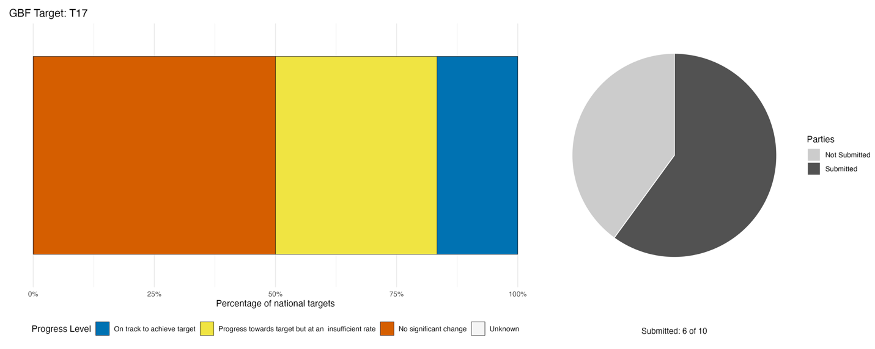
Bar widths show the percentage of national targets in each progress category. Percentages are weighted by Party to ensure that Parties contribute equally to overall assessment of progress, regardless of the number of national targets submitted. The pie chart shows the proportion of Parties included in the regional report who submitted national targets aligned with Target 17 in dark grey.

Actions, successes and challenges

Summary of actions in support of Target 17
Most Parties report establishing or developing national biosafety frameworks, typically comprising a biosafety act or bill, associated regulations and institutional arrangements for oversight of LMOs and genetically modified organisms. Additionally, many Parties report being in the early stages of capacity-building actions with one Party already carrying out laboratory improvements, through physical infrastructure establishment and/or through training of technical personnel. Several Parties also report taking part in regional technical cooperation delivered through bodies such as the Caribbean Public Health Agency, the Pan American Health Organisation, and the Caribbean Society for Biosafety and Biosecurity.

Examples of success and progress in implementation
Box 19
Guyana’s biosafety framework
Guyana has developed a comprehensive national biosafety framework designed to govern the contained use, environmental release, labeling, and market placement of LMOs. Aligned with Target 17 of the Framework and the Cartagena Protocol on Biosafety, this initiative sets out the necessary legal and administrative architecture to ensure biosafety without hindering scientific innovation.
Central to Guyana’s framework is a structured suite of policy and legislative instruments, anchored by the draft Biosafety Policy and the draft Biosafety/Biotechnology Bill. Together, these instruments lay the foundation for a national biosafety authority, dedicated secretariat functions, and a national biosafety clearing-house. Complementing the overarching policy are specific draft regulations covering contained use, environmental release, labeling, and market placement. These measures include important operational mechanisms such as risk oversight, emergency contingency planning, traceability, continuous monitoring, and structured public consultation.
While these instruments remain at the draft or consultation stage, Guyana’s developing framework demonstrates important progress in building institutional capacity for biosafety governance. By integrating scientific risk assessment with public participation and mandatory compliance protocols, the country aims to establish a transparent mechanism for managing LMOs.

Relevant targets: 17
Source: Guyana, seventh national report to the Convention

Challenges
Every reporting Party identified some dimension of incomplete, unenacted, or insufficiently operationalized biosafety legislation, regulation or governance architecture as a barrier to implementation. Additionally, enforcement gaps and weak inter-agency coordination compound these legislative deficits in several Parties, largely due to reported insufficient technical expertise for risk assessment, weak inter-agency coordination, laboratory infrastructure gaps, institutional attrition and the absence of operationally functional biosafety bodies. Consequently, most Parties report data, knowledge, monitoring, and research gaps due to the absence of functional national Biosafety CHMs, insufficient technical knowledge, and underdeveloped monitoring systems for LMOs.

Target 18: Reduce harmful subsidies by at least $500 billion per year, and scale up positive incentives for biodiversity
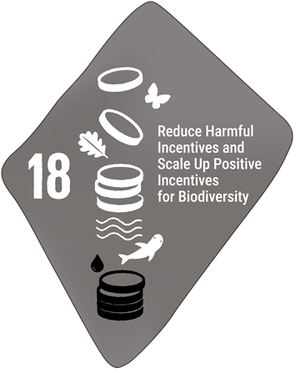
Target text: Identify by 2025, and eliminate, phase out or reform incentives, including subsidies, harmful for biodiversity, in a proportionate, just, fair, effective and equitable way, while substantially and progressively reducing them by at least $500 billion per year by 2030, starting with the most harmful incentives, and scale up positive incentives for the conservation and sustainable use of biodiversity.

PROGRESS OVERVIEW
Significant data limitations hamper assessment of progress towards the reduction of harmful subsidies and the scaling up of positive incentives. While some Parties have put in place positive incentives, few have so far been able to identify harmful subsidies due to technical challenges and siloed information. Self-assessed progress is largely insufficient with a large portion of targets with unknown status.

Indicators of progress
Table 21: Indicator scorecard for Target 18. Colour coding is related to the overall assessment of progress across targets, of which the methodology is explained in the summary scorecard (Table 1). The colour coding for indicator data use reflects where a value for each target sits relative to the highest and lowest scores achieved across all targets of the Framework (green is assigned to percentage values falling within the top third of the total range, yellow to the middle third, and red to the bottom third). Colours for the headline indicator results are based on progress relative to the target (green is assigned when progress is being made, yellow when progress is mixed progress, red when progress is insufficient; and grey when progress cannot be assessed).
 | Indicator use |  | Indicator results
Headline indicator 18.1: Positive incentives in place to promote biodiversity conservation and sustainable use | 10% of Parties |  | Insufficient data
Headline indicator 18.2: Value of subsidies and other incentives harmful to biodiversity | 0% of Parties |  | No data

Only one Party submitted data for the number of positive incentives in place to promote biodiversity conservation and sustainable use. However, this data was submitted in monetary amounts spent between 2019 and 2024 rather than as a count of incentives in place. Parties cite several systemic, methodological and institutional constraints as primary barriers to reporting on indicator 18.1. Chief among these is the absence of standardized national reporting methodologies or quantitative tracking frameworks to measure biodiversity-related incentives. Furthermore, countries report a lack of integrated systems to systematically identify, classify and quantify fiscal measures, positive incentives and subsidies across various economic sectors. The reporting process is further constrained by a limited capacity to evaluate the coverage, effectiveness, and direct contribution of existing policy instruments to biodiversity outcomes. Consequently, while relevant sectoral incentives and financial mechanisms exist locally, Parties are facing challenges in reporting these following the global-level methodology.

No Parties reported on the value of subsidies and other incentives harmful to biodiversity (headline indicator 18.2). Parties explain that reporting is constrained by significant data gaps, the absence of standardized evaluation methodologies, and incomplete national assessment frameworks. Sectoral incentives and subsidies, particularly within agriculture, fisheries, and energy, have not been systematically evaluated, classified, or quantified in terms of their monetary value or environmental impacts. Furthermore, relevant economic and fiscal data remains uncompiled and fragmented across distinct government entities, such as Ministries of Finance, without consolidated inter-agency synthesis mechanisms. Parties emphasize that reporting under a standardized methodology requires the prior completion of comprehensive national baseline assessments, ongoing Biodiversity Finance Initiative (BIOFIN) policy reviews, and the formal adoption of monitoring frameworks within updated NBSAPs.

Self-assessment of progress

Based on self-assessment by Parties in national reports, about a fifth (21 per cent) of national targets submitted with high alignment to Target 18 are on track for achievement, with more than double that number (64 per cent) showing insufficient progress or no significant change, while the rest are unknown in status (Figure 40).

Figure 40: Self-assessed progress for all national targets submitted as highly aligned to Target 18.
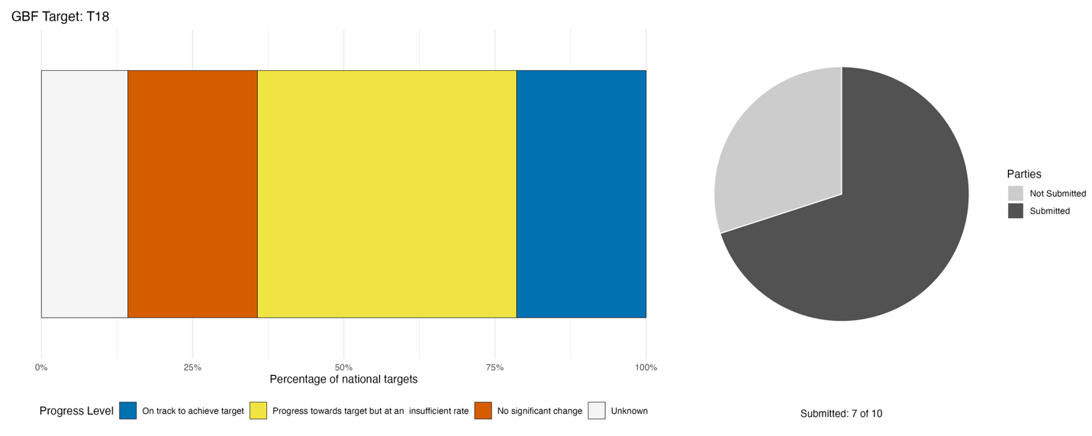
Bar widths show the percentage of national targets in each progress category. Percentages are weighted by Party to ensure that Parties contribute equally to overall assessment of progress, regardless of the number of national targets submitted. The pie chart shows the proportion of Parties included in the regional report who submitted national targets aligned with Target 18 in dark grey.

Actions, successes and challenges

Summary of actions in support of Target 18
Parties largely report early efforts to reduce harmful subsidies and increase positive incentives, in line with Target 18. In general, positive incentive mechanisms are more advanced than harmful subsidy identification and reform and enabling or diagnostic actions substantially outnumber implemented instruments. A small number of Parties report clearly implemented financial instruments, while the majority report preparatory, diagnostic, or enabling measures that have not yet resulted in concrete reforms to harmful subsidies or incentives. The most commonly reported action types are: debt-for-nature and biodiversity finance mechanisms; fiscal incentives for positive environmental behaviour (tax exemptions, duty reductions, green bonds); and diagnostic or review processes aimed at identifying harmful subsidies. Some Parties specifically report commissioning or initiating of diagnostic assessments to identify and quantify harmful subsidies, often conducted through the BIOFIN process or equivalent policy and institutional reviews.

Examples of success and progress in implementation
Box 20
Agricultural incentives in Trinidad and Tobago
The Government of Trinidad and Tobago implemented a targeted direct grant mechanism to redirect public agricultural financial support toward sustainable production methods, the initiative demonstrates how state funding can be leveraged to incentivize eco-friendly farming without compromising the economic stability of local producers.
Under this grant framework, the government successfully disbursed TT$42 million directly to 435 confirmed agricultural recipients across the country. This mechanism provided tangible financial support to farmers adopting sustainable land and resource management practices, validating the operational feasibility of distributing conservation-oriented funding through existing public administrative channels. By maintaining financial support while tying disbursements to sustainable criteria, the program effectively overcame common political economy barriers associated with subsidy reform.
Relevant targets: 10, 18
Source: Trinidad and Tobago, seventh national report to the Convention

Challenges
The most significant challenge hampering progress towards Target 18 is the fact that most reporting Parties have not yet completed, and in several cases have not yet begun, the foundational analytical work required to identify, quantify, and reform harmful incentives and subsidies. Many Parties report the absence of national inventories of harmful subsidies, the lack of specialised technical personnel to conduct economic-environmental assessments, fragmented data across ministries, and the persistence of statutory provisions that actively incentivise biodiversity-harmful behaviour. These challenges mean that even where reform intent is expressed, the preconditions for reform, comprehensive diagnosis, cross-ministerial coordination, and functioning monitoring systems, are often reportedly absent. Additionally, several Parties report that positive incentive mechanisms, such as payment for ecosystem services schemes, biodiversity funds, or green financing instruments, exist in policy but have not been operationalised, or have stalled.

Target 19: Mobilize $200 billion per year for biodiversity from all sources, including $30 billion through international finance

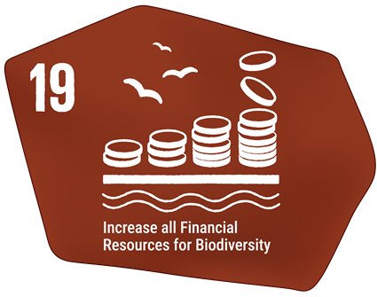
Target text: Substantially and progressively increase the level of financial resources from all sources, in an effective, timely and easily accessible manner, including domestic, international, public and private resources, in accordance with Article 20 of the Convention, to implement national biodiversity strategies and action plans, mobilizing at least $200 billion per year by 2030, including by:
(a) Increasing total biodiversity related international financial resources from developed countries, including official development assistance, and from countries that voluntarily assume obligations of developed country Parties, to developing countries, in particular the least developed countries and small island developing States, as well as countries with economies in transition, to at least $20 billion per year by 2025, and to at least $30 billion per year by 2030;
(b) Significantly increasing domestic resource mobilization, facilitated by the preparation and implementation of national biodiversity finance plans or similar instruments according to national needs, priorities and circumstances;
(c) Leveraging private finance, promoting blended finance, implementing strategies for raising new and additional resources, and encouraging the private sector to invest in biodiversity, including through impact funds and other instruments;
(d) Stimulating innovative schemes such as payment for ecosystem services, green bonds, biodiversity offsets and credits, and benefit-sharing mechanisms, with environmental and social safeguards;
(e) Optimizing co-benefits and synergies of finance targeting the biodiversity and climate crises;
(f) Enhancing the role of collective actions, including by indigenous peoples and local communities, Mother Earth centric actions13 and non-market-based approaches including community based natural resource management and civil society cooperation and solidarity aimed at the conservation of biodiversity; and
(g) Enhancing the effectiveness, efficiency and transparency of resource provision and use.

PROGRESS OVERVIEW
Parties report mobilising international, domestic and private finance for biodiversity across the region. However, the scale, reliability and accessibility of financial resources do not meet the current needs for implementation of the Framework. Regionally, Parties often rely on short-term project-based finance and biodiversity has not been sufficiently mainstreamed into domestic budgets. The private sector also remains insufficiently engaged.

Indicators of progress
Table 22: Indicator scorecard for Target 19. Colour coding is related to the overall assessment of progress across targets, of which the methodology is explained in the summary scorecard (Table 1). The colour coding for indicator data use reflects where a value for each target sits relative to the highest and lowest scores achieved across all targets of the Framework (green is assigned to percentage values falling within the top third of the total range, yellow to the middle third, and red to the bottom third). Colours for the headline indicator results are based on progress relative to the target (green is assigned when progress is being made, yellow when progress is mixed progress, red when progress is insufficient; and grey when progress cannot be assessed).
 | Indicator use |  | Indicator results
Headline indicator D.1: International public funding, including official development assistance (ODA) for conservation and sustainable use of biodiversity and ecosystems | 40% of Parties |  | 33.6 million USD between 2010 and 2025 (no trend)
Headline indicator D.2: Domestic public funding on conservation and sustainable use of biodiversity and ecosystems | 20% of Parties |  | 48.6 million USD between 2020 and 2024 (no trend)
Headline indicator D.3: Private funding (domestic and international) on conservation and sustainable use of biodiversity and ecosystems | 10% of Parties |  | 19.3 million USD in 2024 and 2025 (one Party)

Four Parties provided data for headline indicator D.1 on international public funding. Of those, data included funding for specific projects focused on biodiversity and/or land degradation. Parties reported data for one, two, three and eight years. The total amount presented here is only based on these submissions and is therefore likely an undercount of the total international funding received over the fifteen-year period and no trend can be estimated for the region. Data on headline indicator D.1 is available from the Organization for Economic Cooperation and Development (OECD) for nine Parties. These data show that, between 2009 and 2023, an average of 147 million USD per year in international funding was made available, for a total of 3.2 billion over those 15 years (Figure 41).

Two Parties provided data for headline indicator D.2 on domestic public funding. Of those, data included specific expenditure on species and environmental protection as well as total public sector investment. Only one Party reported domestic public funding continuously between 2020 and 2024 therefore, the total amount presented here is an undercount based on a subset of years for a subset of Parties and no trend can be estimated for the region.

A single Party provided data for headline indicator D.3 on private funding, focusing on a national private trust fund with a focus on marine conservation which provided a total of 19.3 million USD in 2024 and 2025 combined. It is likely that other relevant spending has been unaccounted for in this Party. Therefore, this amount is likely a serious undercount of private spending in the region and does not inform on trends.

Parties state that national reporting on indicators D.1, D.2 and D.3 is primarily constrained by severe data fragmentation, as financial flows supporting biodiversity remain dispersed across multiple government entities, sectoral programs, and external funding sources without centralized tracking mechanisms. This institutional scatter leads to a lack of baseline statistics and formal expenditure accounting frameworks, forcing reliance on ad hoc project-level proxies such as GEF grant allocations or international donor databases. Another major technical constraint is that budget allocations are rarely disaggregated to isolate discrete direct and indirect biodiversity expenditures from broader spending. For private funding, investments in biodiversity are predominantly embedded within broader corporate sustainability and Environmental, Social, and Governance initiatives that lack standardized, biodiversity-specific classifications or tracking taxonomies. These monitoring hurdles are exacerbated by critical national financing gaps and limited technical capacity, which restrict the systematic collection of integrated financial data. Consequently, comprehensive operationalization of the indicators remains largely dependent on ongoing national financial planning assessments, such as the BIOFIN , to establish standardized baseline monitoring systems.

Figure 41: Headline indicator D.1, international public funding, including official development assistance for conservation and sustainable use of biodiversity and ecosystems based on data from the OECD.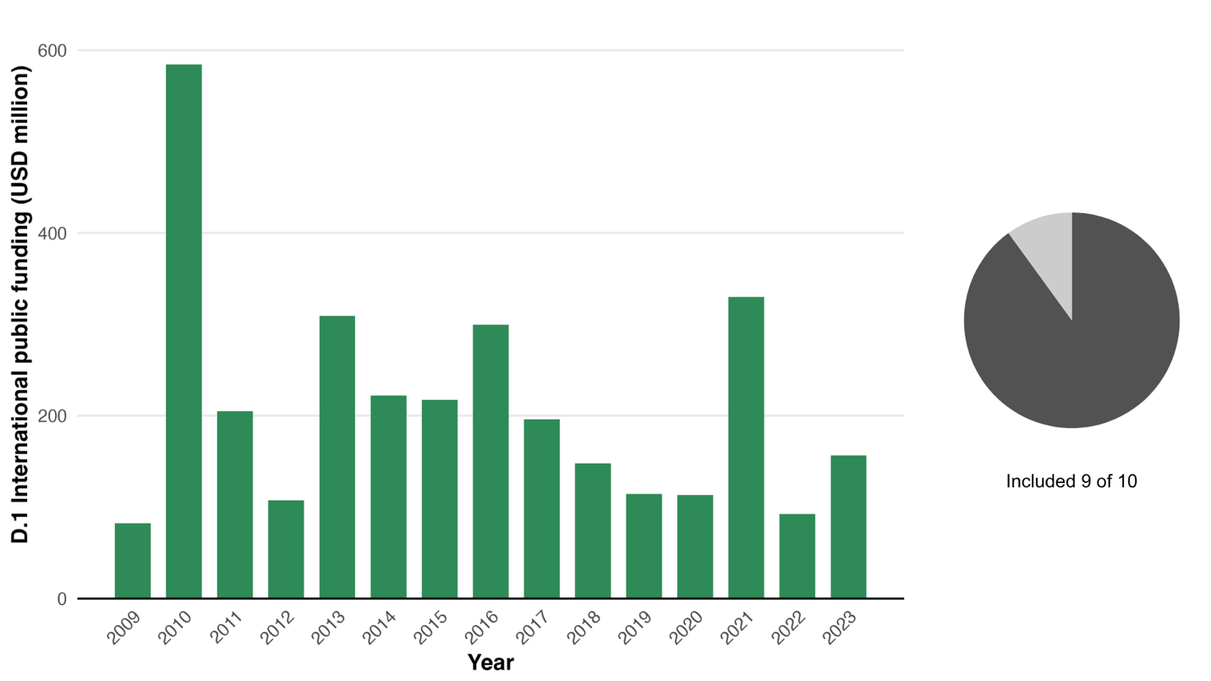 Indicator values show the total amount of money received across Parties each year. The pie chart shows the proportion of Parties for whom data is available in dark grey.

Self-assessment of progress
Based on self-assessment by Parties in national reports, only a third (33 per cent) of national targets submitted with high alignment to Target 19 are on track for achievement, with twice as many (67 per cent) showing insufficient progress (see Figure 42).

Figure 42: Self-assessed progress for all national targets submitted as highly aligned to Target 19.
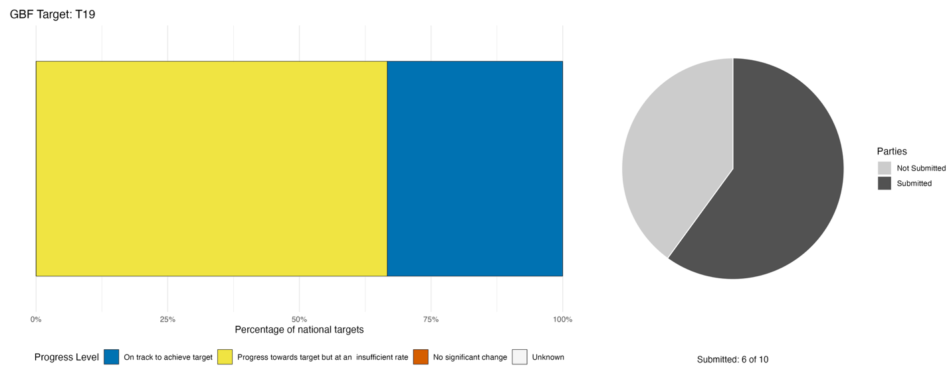
Bar widths show the percentage of national targets in each progress category. Percentages are weighted by Party to ensure that Parties contribute equally to overall assessment of progress, regardless of the number of national targets submitted. The pie chart shows the proportion of Parties included in the regional report who submitted national targets aligned with Target 19 in dark grey.

Actions, successes and challenges

Summary of actions in support of Target 19
Almost all Parties describe at least some form of financial instrument, mechanism, or planning process directed at mobilising biodiversity finance. However, the depth and operational maturity of these actions varies considerably: several Parties report fully operational financing mechanisms with quantified disbursements, while others describe instruments that are in development, in a planning phase, or only partially operational. The most commonly reported instrument types are dedicated national biodiversity or conservation trust funds, participation in the UNDP BIOFIN, debt-for-nature or blue bond arrangements and access to international climate and biodiversity finance facilities. Several Parties also report accessing international biodiversity funding through GEF grant financing, Green Climate Fund accreditation, International Monetary Fund financing facilities and regional fund architectures, particularly the Caribbean Biodiversity Fund. A smaller number of Parties report domestic fiscal instruments such as levies or statutory fund contributions. Some Parties also report implementing enabling legislation or regulatory proposals designed to establish or govern biodiversity finance mechanisms.

Examples of success and progress in implementation
Box 21
Belize’s blue bond debt-for-nature financing mechanism
Belize successfully created a dedicated grant facility that supports both government and non-state conservation projects. This case illustrates the effectiveness of innovative finance in providing sustained funding for stewardship while simultaneously reducing national debt. As of 2021, this pioneering debt-for-nature financing mechanism was launched to restructure national debt while securing long-term funding for marine conservation and sustainable blue economy development. Through this initiative, Belize refinanced approximately US$ 364 million of its external debt via a “blue bond” or blue loan, reducing its debt by roughly 12 per cent of Gross Domestic Product and generating an estimated US$ 180 million in conservation financing over 20 years.

The savings from this restructuring are channelled into the Belize Fund for a Sustainable Future, a dedicated conservation trust that finances marine protection, climate adaptation and “blue business” innovation, supporting sectors such as sustainable fisheries, tourism and coastal management. In exchange, Belize committed to ambitious environmental targets, including protecting 30 per cent of its ocean and implementing marine spatial planning. This model is widely recognized as an innovative blend of sovereign finance and conservation policy, leveraging private capital and debt restructuring to simultaneously address fiscal sustainability, biodiversity protection and climate resilience.

As of 2024, the Belize Fund supported sustainable marine resource management through its Blue Bonds Program, providing grants to NGOs via the Grants Award Program and targeted funding to the Government through the Government Strategic Allocation to meet conservation commitments under the agreement.

Relevant targets: 19
Source: Belize, seventh national report to the Convention

Challenges
Parties consistently report structural challenges linked to the absence of consolidated, predictable, and domestically anchored biodiversity finance mechanisms, compounded by fragmented institutional mandates, limited technical expertise in environmental finance instruments and the absence of national systems to track biodiversity-related financial flows. These challenges are mutually reinforcing: weak institutions limit finance mobilisation; absent tracking systems prevent accountability; and dependence on short-term external funding undermines the sustainability of any mechanism that is established. Some Parties report specific quantified financing shortfalls and report on the difficulty of mobilising domestic funding for biodiversity. This is reportedly linked to insufficient mainstreaming of biodiversity into national budget processes and weak or incomplete legal and regulatory frameworks for operationalizing innovative finance mechanisms such as payment for ecosystem services, carbon credits and national conservation funds. Several Parties also identify competition between climate and biodiversity for available international funding as a systemic external constraint.

Target 20: Strengthen capacity-building, technology transfer, and scientific and technical cooperation for biodiversity

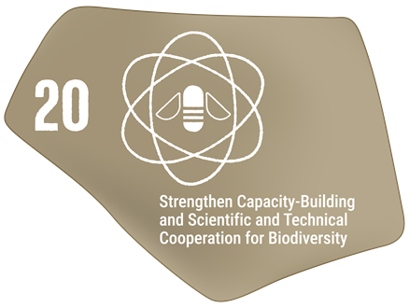
Target text: Strengthen capacity-building and development, access to and transfer of technology, and promote development of and access to innovation and technical and scientific cooperation, including through South-South, North-South and triangular cooperation, to meet the needs for effective implementation, particularly in developing countries, fostering joint technology development and joint scientific research programmes for the conservation and sustainable use of biodiversity and strengthening scientific research and monitoring capacities, commensurate with the ambition of the goals and targets of the Framework.

PROGRESS OVERVIEW

Capacity-building, technology transfer and scientific and technical cooperation remain a challenge for the region. Parties report substantial efforts being made with some progress on national targets. Yet major challenges remain due to the often-short-term project-based approach to biodiversity conservation efforts, including resourcing, monitoring and training. Additionally, Parties report a brain drain effect of qualified personnel away from the region.

Indicators of progress
Table 23: Indicator scorecard for Target 20. Colour coding is related to the overall assessment of progress across targets, of which the methodology is explained in the summary scorecard (Table 1). Colours for the binary indicators are based on the percentage of Parties scoring highly (4 or 5) for the indicator overall (green is assigned to values at or above 50 per cent, yellow to values between 50 and 25 per cent; and red to values below less than 25 per cent).
 | Indicator use |  | Indicator results
Binary indicator 20.b: Number of countries that have taken significant action to strengthen capacity-building and development and access to and transfer of technology, and to promote the development of and access to innovation and technical and scientific cooperation | 8 Parties | N/A | 38% of Parties that reported scored highly (score 4/5)

Parties have reported making progress towards most aspects of the binary indicator (Figure 43). In particular, good progress was reported on establishing partnerships to foster joint technology development and joint scientific research programmes for the conservation and sustainable use of biodiversity, with over half of all reporting Parties (57 per cent) having already fully established these and the rest partially so. Plans, policies or instruments for addressing capacity-building and development needs for biodiversity are partially in place in most Parties (71 per cent). Parties report that these plans always include women and girls as well as children and youth and almost always include persons with disabilities. Conversely, none of the reporting Parties has yet undertaken a national capacity self-assessment, with only two having partially done so.

Figure 43: Binary indicator 20.b, the number of countries that have taken significant action to strengthen capacity-building and development, access to and transfer of technology, and to promote the development of and access to innovation and technical and scientific cooperation.
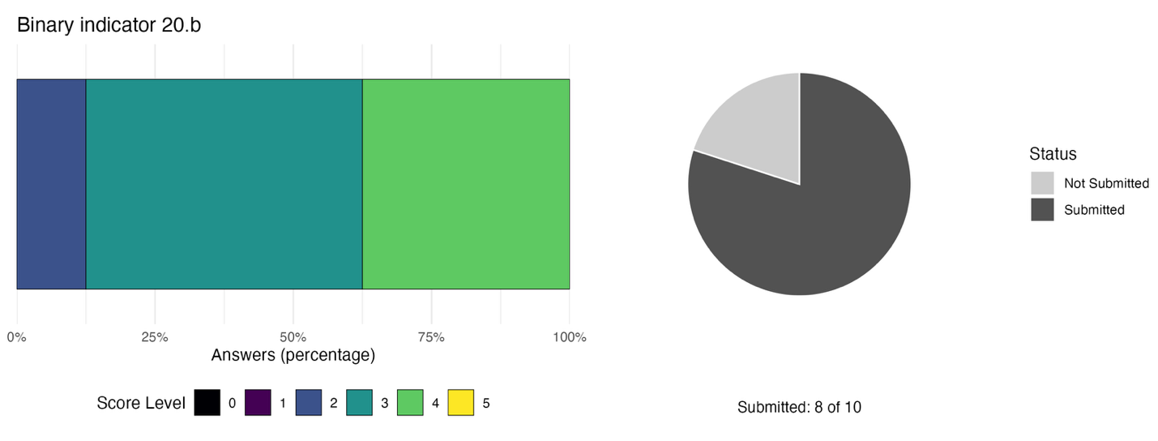The bar widths show the percentage of Parties in each score category, with higher numbers indicating a greater level of progress, based on responses to the questions included in the indicator. The pie chart shows the proportion of Parties included in the regional report who submitted national targets aligned with Target 20 in dark grey.

Self-assessment of progress
Based on self-assessment by Parties in national reports, a third (33 per cent) of national targets submitted with high alignment to Target 20 are on track for achievement, with over half (56 per cent) showing insufficient progress, while the rest (11 per cent) are reported as unknown in status (see Figure 44).

Figure 44: Self-assessed progress for all national targets submitted as highly aligned to Target 20.
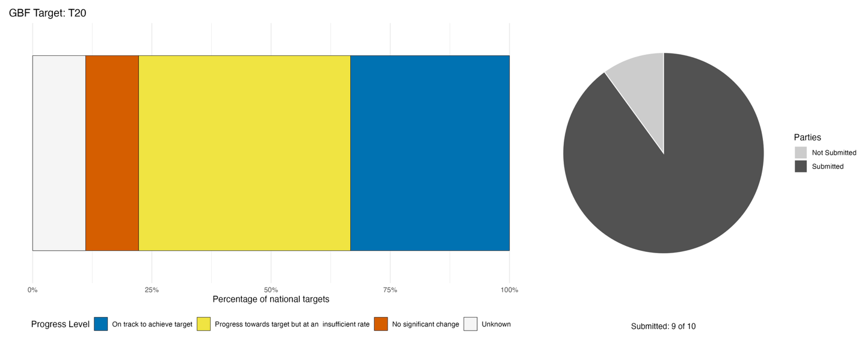
Bar widths show the percentage of national targets in each progress category. Percentages are weighted by Party to ensure that Parties contribute equally to overall assessment of progress, regardless of the number of national targets submitted. The pie chart shows the proportion of Parties included in the regional report who submitted national targets aligned with Target 20 in dark grey.

Actions, successes and challenges

Summary of actions in support of Target 20
Most actions reported by Parties focus on research, monitoring and data collection. Actions span the establishment and strengthening of biodiversity monitoring infrastructure, development of data management platforms, training in monitoring methodologies, taxonomic and ecological field research and the production and dissemination of scientific publications. Most Parties also report taking part in international cooperation efforts through participation in regional biodiversity initiatives and dialogues; technology transfer linked to monitoring and data infrastructure; and capacity-building delivered through international partnerships, scholarships and training programmes, including South-South cooperation. Additionally, most Parties also report conducting training and capacity-building for practitioners and technical staff.

Examples of success and progress in implementation
Box 22
Cuba’s biodiversity capacity-building programme
Cuba instituted a multi-institutional sectoral programme on biological diversity to bridge the gap between academic conservation science and productive land-use sectors. Designed as a nationally coordinated initiative, the framework links state research bodies, agricultural facilitators, farming communities, and local cooperatives, ensuring that scientific outputs directly inform community-level development and sustainable resource management.
Through this integrated mechanism, the program achieved measurable, large-scale capacity-building and scientific outputs. Institutional partners conducted 85 targeted training courses reaching 876 key actors, including researchers, local producers, and cooperative leadership. Simultaneously, the program executed 46 research and development projects addressing 14 specific national conservation objectives, generating 183 actionable research results and publishing 482 scientific documents, comprising 414 peer-reviewed journal articles and 62 books or book chapters. By actively involving farming communities in applied research, the programme successfully embedded sustainable practices within productive economic landscapes. By coordinating domestic research entities and establishing clear metrics for training, scientific publishing, and field application, the initiative provides a structured template for tracking capacity-building outcomes.

Relevant targets: 14, 20
Source: Cuba, seventh national report to the Convention

Challenges
Parties note a series of interrelated challenges in strengthening capacity-building, technology transfer and scientific and technical cooperation for biodiversity, often linked to the short-term nature of actions in the region. Several Parties report that capacity-building investments are not sustained beyond project cycles, that monitoring systems are project-based rather than institutionally embedded, and that technology transfer outcomes are not systematically documented. Challenges related to financial resources include dependence on short-term external or project-based funding, insufficient domestic budget allocations, procurement and equipment delays and the absence of sustained financing mechanisms that can outlast individual projects. In parallel, Parties report staffing shortages, fragmented inter-agency coordination and the absence of institutionalized training and monitoring frameworks. Compounding these challenges, Parties also note currently fragmented biodiversity data systems and absent standardized protocols, weak monitoring frameworks, incomplete baselines and insufficient research infrastructure. One notable issue flagged by Parties is the emigration of specialized technical personnel from the region.

Target 21: Ensure that knowledge is available and accessible to guide biodiversity action
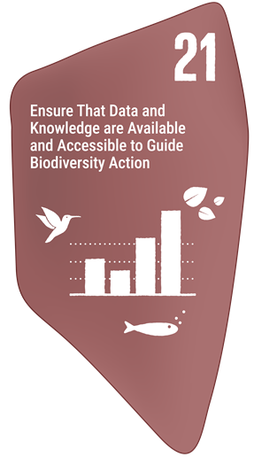
Target text: Ensure that the best available data, information and knowledge, are accessible to decision makers, practitioners and the public to guide effective and equitable governance, integrated and participatory management of biodiversity, and to strengthen communication, awareness-raising, education, monitoring, research and knowledge management and, also in this context, traditional knowledge, innovations, practices and technologies of indigenous peoples and local communities should only be accessed with their free, prior and informed consent, in accordance with national legislation.

PROGRESS OVERVIEW
Efforts to expand biodiversity knowledge and make it broadly accessible in the region are ongoing. Some progress is notable in Parties’ self-assessments. Nevertheless, structural issues still hinder progress on this Target. These are largely linked to the project-based nature of current monitoring programmes. National monitoring systems for biodiversity are nascent and require dedicated capacity and resources. Preserving and including traditional ecological knowledge also appears to be a challenge for the region.

Indicators of progress
Table 24: Indicator scorecard for Target 21. Colour coding is related to the overall assessment of progress across targets, of which the methodology is explained in the summary scorecard (Table 1). The colour coding for indicator data use reflects where a value for each target sits relative to the highest and lowest scores achieved across all targets of the Framework (green is assigned to percentage values falling within the top third of the total range, yellow to the middle third, and red to the bottom third). Colours for the headline indicator results are based on progress relative to the target (green is assigned when progress is being made, yellow when progress is mixed progress, red when progress is insufficient; and grey when progress cannot be assessed).
 | Indicator use |  | Indicator results
Headline indicator 21.1: Indicator on biodiversity information for monitoring the Kunming-Montreal Global Biodiversity Framework | 20% of Parties |  | Average: 35%

Two Parties reported on headline indicator 21.1, which measures the proportion of headline indicators compiled using national datasets. On average, fewer than half of the indicators reported by these Parties used national datasets, focusing instead on available data from international organizations such as the FAO or IUCN. Despite low submission rates for this indicator, this pattern is reflective of the broader region where the majority of Parties reported using available datasets curated by international organizations where these are available.

Parties not reporting on Indicator 21.1 explain that structural and developmental capacity limitations exist at the national level. A core challenge is that national biodiversity-information indicators remain actively under elaboration, requiring further methodology development and integration with international datasets such as GBIF, IUCN, and BirdLife International. Additionally, important data infrastructure bottlenecks persist, notably the need to restore national biodiversity information systems and establish centralized data repositories to support data compilation and computation. While national frameworks and compliance schedules for biodiversity monitoring are being put in place, the operationalization and regular calculation of indicator-level data remain ongoing.

Self-assessment of progress
Based on self-assessment by Parties in national reports, a small proportion (22 per cent) of national targets submitted with high alignment to Target 21 are on track for achievement, with over three times as many (67 per cent) showing no significant change or insufficient progress (Figure 45).

Figure 45: Self-assessed progress for all national targets submitted as highly aligned to Target 21.
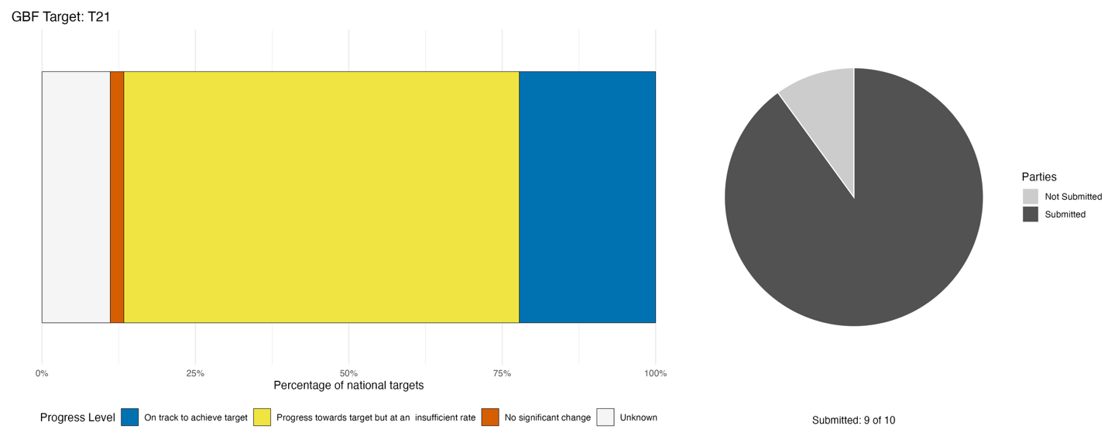
Bar widths show the percentage of national targets in each progress category. Percentages are weighted by Party to ensure that Parties contribute equally to overall assessment of progress, regardless of the number of national targets submitted. The pie chart shows the proportion of Parties included in the regional report who submitted national targets aligned with Target 21 in dark grey.

Actions, successes and challenges

Summary of actions in support of Target 21
Most of the actions Parties report on Target 21 focus on research, monitoring and data collection efforts. All reporting Parties describe at least some implemented action in this space, ranging from the establishment of national biodiversity information systems and spatial data infrastructure to citizen science programmes, species monitoring and international data-sharing arrangements. The most commonly reported action types are: the development or operationalisation of national biodiversity information platforms; the integration of remote sensing and GIS tools into biodiversity data management; and the establishment or strengthening of monitoring systems for specific ecosystems or species groups. Several Parties also report progress on indicator development, baseline assessments, and taxonomic data collection. Several Parties also report public engagement initiatives such as large-scale public awareness campaigns and environmental education programmes, citizen science initiatives, youth-led monitoring and the documentation of indigenous and local knowledge. Many Parties also report contributing to and integrating international biodiversity databases such as the GBIF .

Examples of success and progress in implementation
Box 23
Guyana mangrove information system
In Guyana, where mangroves are classified under the national definition of forests, protecting and restoring these coastal buffers requires accurate, up-to-date spatial data. To strengthen evidence-based decision-making and biodiversity information management, Guyana initiated the redevelopment of the Guyana mangrove information system to serve as a specialized, centralized digital platform.
This functions as a comprehensive repository for mangrove-related spatial data, project documentation, research outputs, and monitoring information. Developed to track changes in mangrove extent and evaluate ongoing restoration interventions, the platform links remote sensing spatial data directly to on-the-ground management activities. By consolidating fragmented environmental data into an accessible tool, the system enhances national capacity for coastal ecosystem oversight, streamlines tracking of ecological restoration, and strengthens data collection for national reporting.

Relevant targets: 2, 8, 11, 21
Source: Guyana, seventh national report to the Convention

Challenges
All Parties report consistent challenges in the region: biodiversity data are dispersed across multiple institutions and platforms, monitoring systems are project-dependent rather than institutionalised, standardized protocols and interoperability frameworks are absent or incomplete, and the information infrastructure needed to support evidence-based decision-making remains either under development or fragmented. The fragmentation of biodiversity data across institutions, systems, and formats, combined with the absence of standardized protocols that would allow data to be consolidated and used for national reporting and decision-making is the most significant challenge. Several Parties also report specific gaps in baseline knowledge, indicator frameworks and the integration of traditional and Indigenous knowledge into national systems. Additionally, many Parties report that these challenges are specifically compounded by the project-dependent nature of current monitoring systems, which creates structural vulnerability to capacity and data loss once external funding cycles end. Traditional knowledge and local communities face particular challenges caused by language and cultural access barriers reducing the effectiveness of education and training for Indigenous and local communities, and the erosion of traditional and intergenerational knowledge systems due to social and demographic pressures.

Target 22: Ensure participation in decision-making and access to justice and information related to biodiversity for all
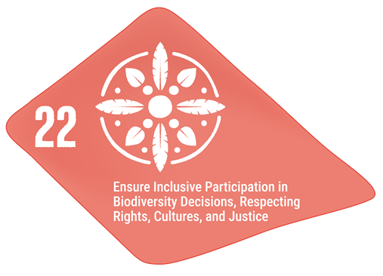
Target text: Ensure the full, equitable, inclusive, effective and gender-responsive representation and participation in decision-making, and access to justice and information related to biodiversity by indigenous peoples and local communities, respecting their cultures and their rights over lands, territories, resources, and traditional knowledge, as well as by women and girls, children and youth, and persons with disabilities and ensure the full protection of environmental human rights defenders.

PROGRESS OVERVIEW
Parties report making progress on their national targets associated to Target 22. However, they also acknowledge severe data gaps and limitations of monitoring systems in tracking effective participation and outcomes for specific groups, reflected in the lack of indicator data submissions. Many efforts are ongoing to include communities through participatory processes, including via legislation and co-governance as reflected in some Party initiatives.

Indicators of progress
Table 25: Indicator scorecard for Target 22. Colour coding is related to the overall assessment of progress across targets, of which the methodology is explained in the summary scorecard (Table 1). The colour coding for indicator data use reflects where a value for each target sits relative to the highest and lowest scores achieved across all targets of the Framework (green is assigned to percentage values falling within the top third of the total range, yellow to the middle third, and red to the bottom third). Colours for the binary indicators are based on the percentage of Parties scoring highly (4 or 5) for the indicator overall (green is assigned to values at or above 50 per cent, yellow to values between 50 and 25 per cent; and red to values below less than 25 per cent). Colours for the headline indicator results are based on progress relative to the target (green is assigned when progress is being made, yellow when progress is mixed progress, red when progress is insufficient; and grey when progress cannot be assessed).
 | Indicator use |  | Indicator results
Headline indicator 22.1: Land-use change and land tenure in the traditional territories of indigenous peoples and local communities | 0% of Parties (20% reporting as not relevant) |  | No data
Binary indicator 22.b: Number of countries taking action towards the full, equitable, inclusive, effective and gender-responsive representation and participation in decision-making and access to justice and information related to biodiversity by indigenous peoples and local communities, respecting their cultures and their rights over lands, territories, resources and traditional knowledge, as well as by women and girls, children and youth, and persons with disabilities, and the full protection of environmental human rights defenders | 8 Parties | N/A | 75% of Parties that reported scored highly (score 4/5)

Reporting on indicator 22.1 across Parties is constrained by structural, methodological and institutional challenges. A primary barrier is the conceptual misalignment between the headline indicator, which presupposes formally recognized Indigenous territories, and the national land governance contexts, where such legal designations do not exist or where land is administered exclusively through state and private tenure systems. Furthermore, even where local and traditional communities actively utilize natural resources, national spatial monitoring and land cover datasets lack the disaggregation required to capture community-managed land dynamics, rendering Parties unable to adhere to the prescribed methodology. These technical limitations are further compounded by early-stage community-led mapping capacities, underscoring a broader need for enhanced spatial data infrastructure, disaggregated land tenure metrics, and complementary engagement indicators tailored to SIDS governance structures.

Parties reporting on the binary indicator have made progress towards many of the actions required under 22.b. For example, 71 per cent of reporting Parties state having policies in place to ensure the full protection of environmental human rights defenders, and that they monitor this protection. Additionally, over half of Parties report having policies in place to ensure that women, youth and IPLCs have (i) equitable, inclusive, effective and gender-responsive representation and participation in biodiversity decision-making related to biodiversity, (ii) access to justice, and (iii) access to information. Moreover, Parties report more often having measures in place to ensure the respect of IPLC cultures and practices as well as rights over traditional knowledge, than rights over lands and territories and resources.

Data from LandMark of the World Resource Institute (LandMark, 2024, 2025; Potapov and others, 2024; Prindex, 2024) on the proportion of natural land in territories held or managed by IPLCs (headline indicator 22.1c) is available for four Parties included in the analysis (i.e. 40 per cent). For these Parties, 92 per cent of land in territories held or managed by IPLCs was natural in 2024, ranging from 81 to 100 per cent.

Figure 46: Binary indicator 22.b, the number of countries taking action towards the full, equitable, inclusive, effective and gender-responsive representation and participation in decision-making and access to justice and information related to biodiversity by indigenous peoples and local communities, respecting their cultures and their rights over lands, territories, resources and traditional knowledge, as well as by women and girls, children and youth, and persons with disabilities, and the full protection of environmental human rights defenders.
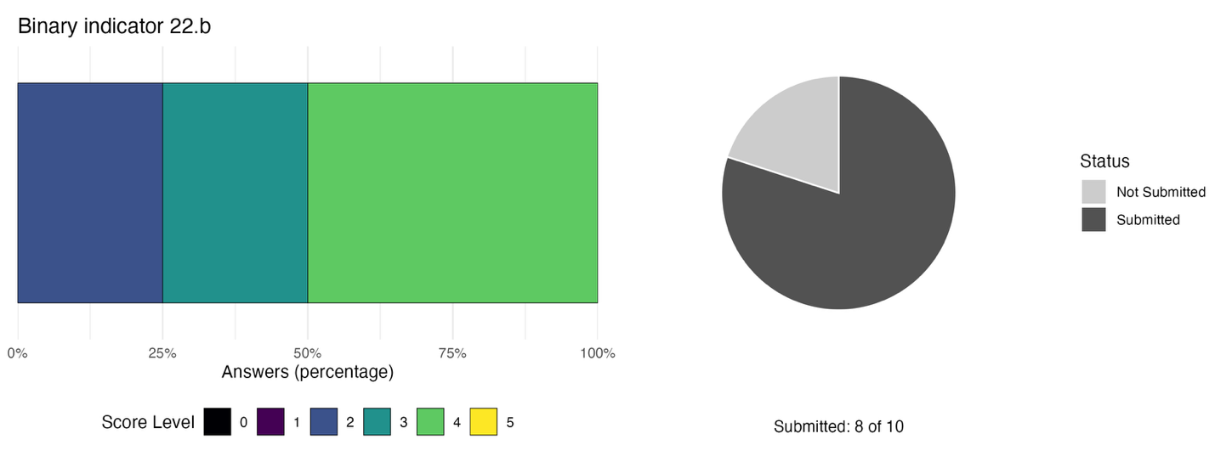Score distribution based on Party answers to the related questions. The bar widths show the percentage of Parties in each score category, with higher numbers indicating a greater level of progress, based on responses to the questions included in the indicator. The pie chart shows the proportion of Parties included in the regional report who submitted national targets aligned with Target 22 in dark grey.

Self-assessment of progress
Based on self-assessment by Parties in national reports, a relatively high proportion (44 per cent) of national targets highly aligned to Target 22 are on track for achievement, though a similar proportion (43 per cent) show no significant change or insufficient progress, and over one in ten national targets (13 per cent) are unknown in status (see Figure 47).

Figure 47: Self-assessed progress for all national targets submitted as highly aligned to Target 22.
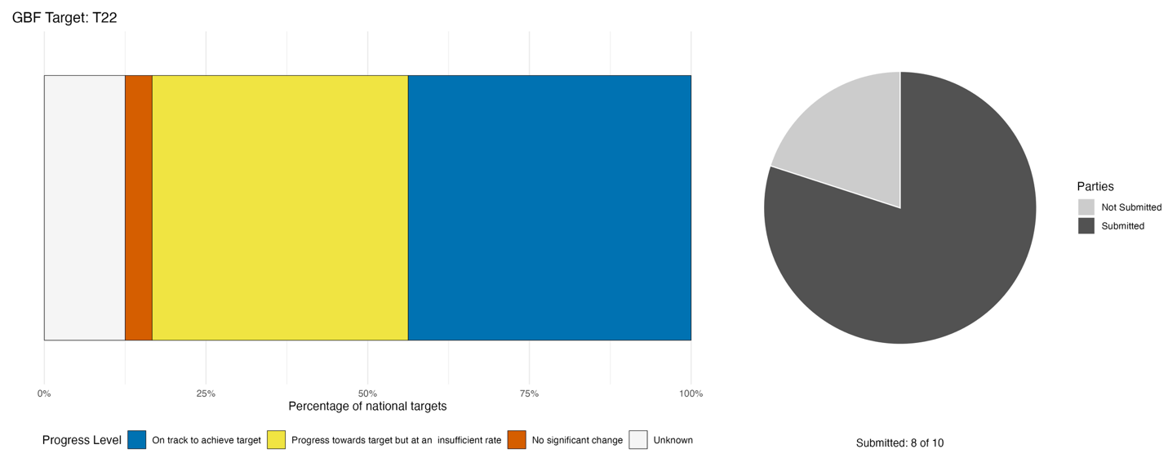
Bar widths show the percentage of national targets in each progress category. Percentages are weighted by Party to ensure that Parties contribute equally to overall assessment of progress, regardless of the number of national targets submitted. The pie chart shows the proportion of Parties included in the regional report who submitted national targets aligned with Target 22 in dark grey.

Actions, successes and challenges

Summary of actions in support of Target 22
Many actions are reported by Parties in support of Target 22. However, the extent to which these are aspirational rather than operational is not always clear. Most Parties point out procedural participation rights embedded in existing legislation or regional treaty frameworks. Some Parties further report legal and regulatory policy actions related to access-to-information and public participation frameworks, most notably through the Escazú Agreement, alongside Free, Prior and Informed Consent (FPIC) standards. Many Parties describe specific actions in implementing the Framework, including multi-stakeholder consultation and participation mechanisms, awareness-raising and environmental education initiatives, civil society engagement and gender-targeted participation programmes. A smaller number of Parties report more substantive co-management arrangements, participatory knowledge documentation, and community-led governance processes. Some Parties also note efforts to integrate traditional knowledge into monitoring systems.

Examples of success and progress in implementation
Box 24
Free, prior and informed content legislation in Suriname
Suriname instituted FPIC as a mandatory, non-negotiable standard for all internationally funded environmental projects operating within its borders. This operational requirement ensures that major conservation and sustainable development programmes formally incorporate social safeguards and community-led consent into their project architectures.
A key milestone in this rights-based approach occurred on October 14, 2025, when the Association of Indigenous Village Chiefs formally handed over an official FPIC protocol to the President and Parliamentary Speaker of Suriname. Driven directly by Indigenous leadership, the protocol establishes a structured methodology for community engagement and decision-making. Alongside mandatory FPIC integration, major environmental initiatives were mandated to implement Gender Action Plans, ensuring equitable participation and resource access for women across targeted landscapes and resource management sectors.
By making FPIC and gender safeguards mandatory conditions for international project execution, Suriname established enforceable rights-based standards without waiting for overarching domestic legislation. Furthermore, the initiative illustrates how Indigenous organizations can directly engage executive and legislative bodies to formalize rights-based frameworks.

Relevant targets: 22, 23
Source: Suriname, seventh national report to the Convention

Challenges
The most substantively significant challenges, reported across multiple Parties, are: the absence of permanent, institutionalised consultation mechanisms linking participation to decision-making; incomplete or delayed legal recognition of indigenous peoples' collective rights and traditional knowledge; gender gaps in decision-making, leadership, and data; the absence or incompleteness of disaggregated data needed to track equitable participation; weak or absent monitoring indicators for inclusive governance and gender equality; limited public access to biodiversity information due to fragmentation, digitisation backlogs and technical literacy barriers; and insufficient institutional capacity, including technical staffing, inter-agency coordination and statutory mandates, to sustain inclusive biodiversity governance. These challenges are frequently compounding as financial constraints delay legal formalisation, which in turn limits the sustainability of participation mechanisms, which in turn constrains the data needed to monitor equity outcomes.

Target 23: Ensure gender equality and a gender-responsive approach to biodiversity action
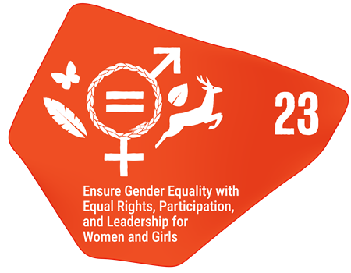
Target text: Ensure gender equality in the implementation of the Framework through a gender-responsive approach, where all women and girls have equal opportunity and capacity to contribute to the three objectives of the Convention, including by recognizing their equal rights and access to land and natural resources and their full, equitable, meaningful and informed participation and leadership at all levels of action, engagement, policy and decision-making related to biodiversity.

PROGRESS OVERVIEW
National report submissions suggest that efforts to ensure gender equality and a gender-responsive approach to biodiversity action are largely under development. While some national targets appear to be on track, sex-disaggregated data remains largely absent, and monitoring of participation outcomes is limited. Yet, Parties report ongoing efforts to ensure gender representation in consultative processes despite continued challenges in the full integration of women and girls in decision making.

Indicators of progress
Table 26: Indicator scorecard for Target 23. Colour coding is related to the overall assessment of progress across targets, of which the methodology is explained in the summary scorecard (Table 1). Colours for the binary indicators are based on the percentage of Parties scoring highly (4 or 5) for the indicator overall (green is assigned to values at or above 50 per cent, yellow to values between 50 and 25 per cent; and red to values below less than 25 per cent).
 | Indicator use |  | Indicator results
Binary indicator 23.b: Number of countries with legal, administrative or policy frameworks, inter alia, to implement the Gender Plan of Action (2023–2030), to ensure that all women and girls have equal opportunity and capacity to contribute to the three objectives of the Convention, including by ensuring women’s equal rights and access to land and natural resources | 8 Parties | N/A | 38% of Parties that reported scored highly (score 4/5)

Parties reporting on binary indicator 23.b are making progress towards the gender-responsive aspects of the Framework. Almost all reporting Parties (86 per cent) have made at least partial progress towards facilitating the full, equitable, meaningful and informed participation and leadership of all women and girls at all levels of action, engagement, policy and decision-making related to biodiversity. Similarly, only one Party reported not having adopted legal, administrative or policy measures that explicitly recognize and protect the rights and access of all women and girls to land and natural resources. However, fewer Parties (57 per cent) report explicitly applying a gender-responsive approach and recognize the contributions and roles of women and girls in their implementation of the Framework. Additionally, no Parties reporting on the binary indicator currently state that they fully conduct sex-disaggregated data collection and analyses to assess the differential impacts of biodiversity policies and programmes.

Figure 48: Binary indicator 23.b, the number of countries with legal, administrative or policy frameworks, including the Gender Plan of Action, as well as the allocation of specific financial resources to ensure that all women and girls have equal opportunity and capacity to contribute to the three objectives of the Convention, including by ensuring women’s equal rights and access to land and natural resources.
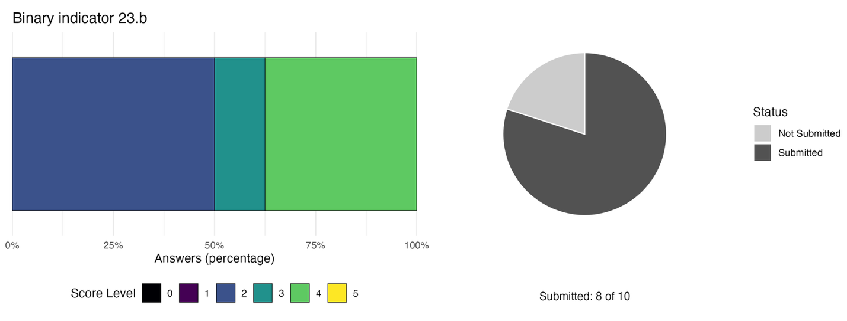The bar widths show the percentage of Parties in each score category, with higher numbers indicating a greater level of progress, based on responses to the questions included in the indicator. The pie chart shows the proportion of Parties included in the regional report who submitted national targets aligned with Target 23 in dark grey.

Self-assessment of progress
Based on self-assessment by Parties in national reports, only 28 per cent of national targets submitted as highly aligned to Target 23 are on track for achievement, with over twice as many (60 per cent) showing insufficient progress, and 13 per cent unknown in status (see Figure 49).

Figure 49: Self-assessed progress for all national targets submitted as highly aligned to Target 23.
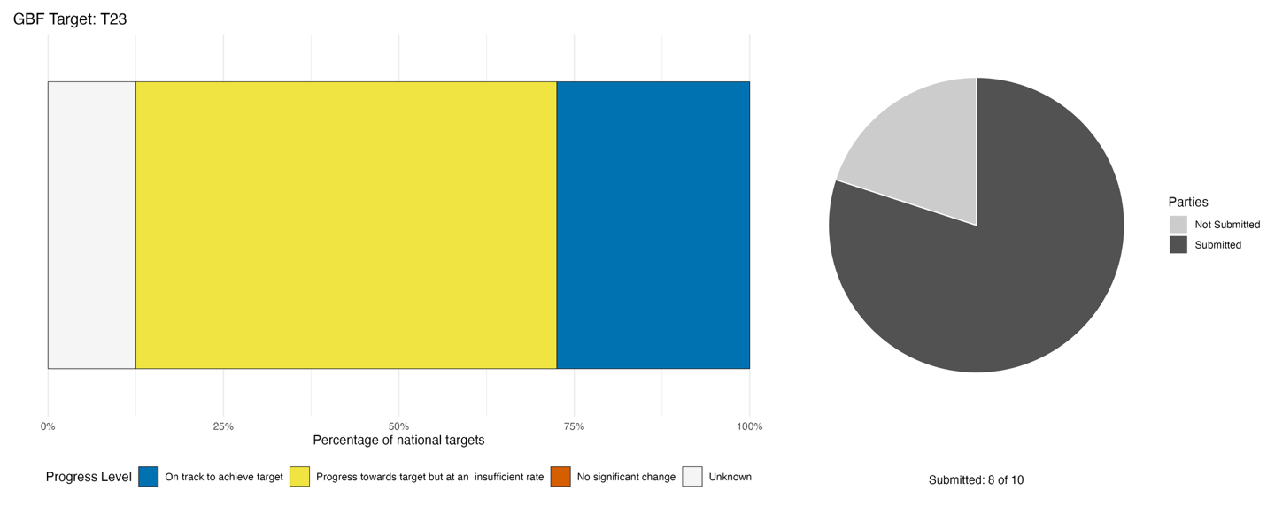
Bar widths show the percentage of national targets in each progress category. Percentages are weighted by Party to ensure that Parties contribute equally to overall assessment of progress, regardless of the number of national targets submitted. The pie chart shows the proportion of Parties included in the regional report who submitted national targets aligned with Target 23 in dark grey.

Actions, successes and challenges

Summary of actions in support of Target 23
Across reporting Parties, the dominant implementation pattern is one of gender mainstreaming within existing biodiversity governance processes, embedding gender considerations into planning frameworks, project cycles, and participatory processes, rather than the establishment of dedicated gender-biodiversity institutions or instruments. The most commonly reported actions by Parties are: gender-inclusive stakeholder engagement and validation processes; awareness-raising and capacity-building activities targeting women and youth; and the integration of gender considerations as cross-cutting themes in biodiversity planning processes. A smaller number of Parties report more operationally specific measures, including named women-centred livelihood programmes, mandatory gender action plans embedded in project cycles, and sex-disaggregated data collection linked to awareness or knowledge surveys.

Examples of success and progress in implementation
Box 25
Women empowerment in Haiti’s Baradères-Cayémites protected area
In Haiti’s Baradères-Cayémites Protected Area for Managed Natural Resources, the Haitian Association for Agricultural, Medical, Educational, and Social Assistance, in partnership with the National Agency for Protected Areas and supported by German Development Cooperation, launched a four-year (2021–2024) community-based conservation project. Central to this initiative was a focus on social inclusion, recognizing that empowering local women is essential for reducing human pressure on coastal ecosystems and achieving long-term environmental governance.
Historically operating in loosely organized networks, local women who sell seafood were central to the project's economic transformation strategy. The Haitian Association for Agricultural, Medical, Educational, and Social Assistance organized these women into five structured associations across Petit-Trou-de-Nippes and Baradères. To improve their position in the fisheries value chain, the initiative equipped these associations with solar-powered ice-making units and distributed 200 insulated containers for processing, storage, and transport. This targeted support significantly reduced post-catch spoilage, improved market product quality, and directly boosted the incomes of participating women, demonstrating how gender-responsive economic tools can foster sustainable livelihoods.
The combined monitoring and socioeconomic interventions eliminated roughly 30 illegal charcoal-burning sites, restored 40 hectares of mangroves, and supported over 700 households. Ultimately, this initiative highlights how prioritizing gender equality and empowering women within local supply chains builds climate resilience, strengthens local governance, and secures sustainable biodiversity conservation in Haïti.

Relevant targets: 9, 22, 23
Source: Haïti, draft seventh national report to the Convention

Challenges
Parties report challenges largely focused on monitoring and data collection challenges. Indeed, Parties consistently report that the absence of sex-disaggregated biodiversity data, weak gender-specific monitoring indicators and insufficient institutional capacity reinforce one another, making it difficult to track, demonstrate, or sustain progress on gender-responsive implementation. A secondary cross-cutting pattern reported by Parties is the gap between policy adoption and effective operationalization: several Parties report that gender-responsive frameworks, strategies, or policies exist in draft or partial form but lack the legal force, institutional linkages, or dedicated resources needed to drive implementation. Some Parties also note the uneven gender mainstreaming capacity across agencies as a barrier to progress. Additionally, some Parties report that women and youth remain underrepresented in governance and decision-making and that structural socio-cultural barriers to meaningful participation exist.

II.C Regional progress towards the implementation of the goals

Introducing the goal progress summaries
Implementation of NBSAPs, and achievement of their associated national targets, are the primary mechanisms that drive progress towards the goals of the Kunming-Montreal Global Biodiversity Framework. Thus, if there are gaps in the meeting of national targets, progress towards the goals will be compromised. While it is too early to draw meaningful conclusions on how much progress has been made towards the 2050 goals in the region, this section discusses the potential consequences for each of the goals from current progress towards the associated targets, as described in section II.B. As such, this part of the analysis for the regional report is largely an indirect assessment of progress based on the associations made by Parties themselves, rather than a direct measurement of progress towards the goals themselves. It also summarizes the information available from reporting on those headline indicators directly associated with each of the goals in the monitoring framework, while recognizing its limitations and biases, as well the binary indicators linked to the goals. The analysis does not consider relationships between the targets of the Framework, nor how progress towards one goal affects progress towards other goals. Many potentially important direct and indirect relationships between goals and targets are likely underestimated, and the associations between targets and goals set out below should not be considered exhaustive.

Parties have aligned each of their national targets with one or more of the 23 global targets of the Framework. When submitting these national targets, Parties are also requested to state to which of the four 2050 goals of the Framework the target will contribute. With reference to these associations, it is therefore possible to gain insights into how progress towards the national targets set by Parties supports progress towards each of the global goals, through the global targets. Figure 50 illustrates how frequently Parties have associated a global target with a global goal in their national target submissions. For example, 25 per cent of all national targets aligned with Target 22 are stated by Parties to contribute to Goal A, 12 per cent contribute to Goal B, zero per cent contribute to Goal C and 62 per cent contribute to Goal D. This suggests that Parties see Target 22 as primarily driving progress towards Goal D. This approach, discussed further in the detailed description of methodology adopted for the global report (CBD/SBSTTA/28/INF/9), is used here to identify the targets for which collective progress is most relevant to each goal.

For each goal, this section also provides a synthesis of approaches identified by Parties for addressing the challenges, gaps, and opportunities identified during the first period of implementation of the Framework. It summarizes the concrete actions explicitly reported by Parties within their national reports, to demonstrate progress toward the goals. These should not be considered prescriptive but rather seen as a source of inspiration and learning between Parties in the region.

Figure 50: Frequency of national targets associating each global goal with a global target from Party submissions.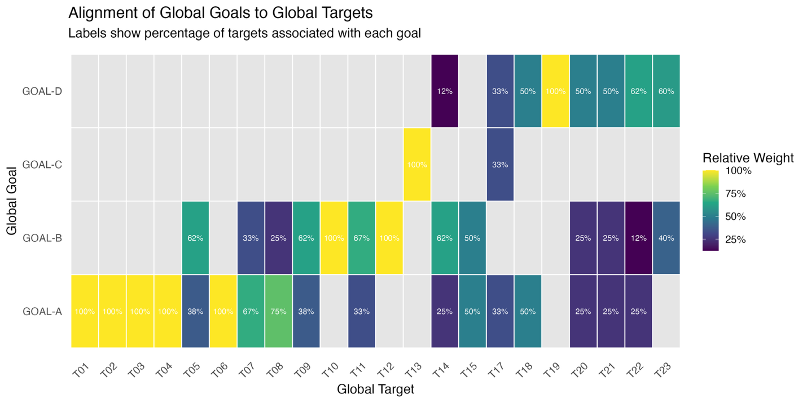
For each target of the Framework, the heatmap highlights the weighted percentage of aligned national targets that were stated as contributing to each of the goals. For example, Parties associated 25 per cent of national targets aligned with Target 20 with Goal A, 25 per cent with Goal B, 0 per cent with Goal C and 50 per cent with Goal D. The percentage values are weighted by Party to avoid inflating associations in cases where individual Parties submit multiple national targets, and to present a balanced picture of the associations, reflecting each Party's contribution equally. Note that five of the twelve Parties included in the regional report submitted national targets that could be included in this graph. Additionally, none of the national targets highly aligned with Target 16 were associated to a Framework goal in Party submissions; this does not mean that Parties did not submit information about implementation of Target 16 nor that the target does not contribute to achievement of the 2050 vision of the Framework.

Goal A: Protect and restore
Goal text: The integrity, connectivity and resilience of all ecosystems are maintained, enhanced, or restored, substantially increasing the area of natural ecosystems by 2050;
Human induced extinction of known threatened species is halted, and, by 2050, the extinction rate and risk of all species are reduced tenfold and the abundance of native wild species is increased to healthy and resilient levels;
The genetic diversity within populations of wild and domesticated species, is maintained, safeguarding their adaptive potential.

GOAL OVERVIEW
Parties associated 13 of the 23 targets of the Framework with Goal A, more than for any other goal. These include all the targets focused on reducing threats to biodiversity, two of the five targets focused on meeting people’s needs through sustainable use and benefit-sharing, and three of the ten targets focused on tools and solutions for implementation and mainstreaming. Based on this, progress towards Goal A depends on implementation across a broad range of targets with both direct and indirect impacts on biodiversity.

Progress on related targets
Using the method described above, 13 of the 23 targets of the Framework were associated with Goal A (Figure 51), more than for any other goal. All the targets under the heading ‘Reducing threats to biodiversity’ (Targets 1-8) were most strongly associated with Goal A, except for Target 5 which was most strongly associated with Goal B (Figure 50). Only two of the five targets under the heading ‘Meeting people’s needs through sustainable use and benefit sharing’ (Targets 9 and 11) were also associated with Goal A. Additionally, three of the targets under the heading ‘Tools and solutions for implementation and mainstreaming’ (Targets 15, 17 and 18) were also associated with Goal A, two of which were strongly associated with Goal A (Targets 15 and 18, Figure 50).

Based on Section II.B, progress towards these associated targets is mixed, with major challenges still affecting implementation. Based on Parties’ self-assessment the most on-track targets related to Goal A are targets 3 followed by 8 and 1, while those showing the least amount of progress are targets 15 followed by 9 and 2. These results suggest potential areas where more action relevant to Goal A is required.

Figure 51: Framework targets associated with Goal A in Parties’ national target submissions.
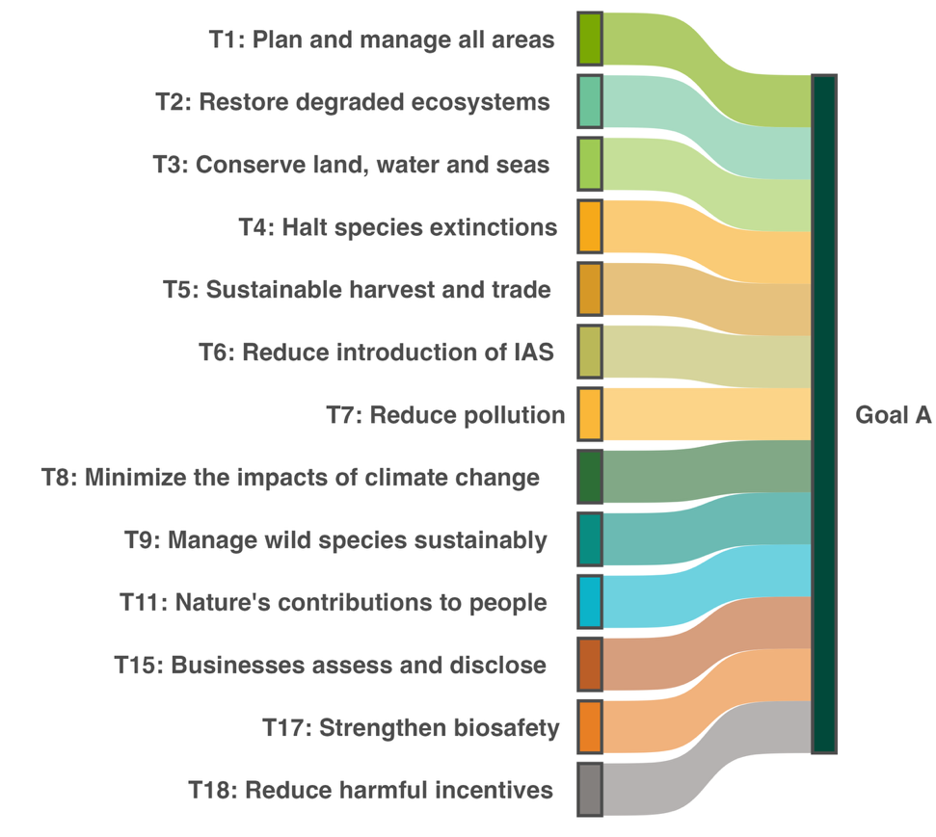
A link is drawn between a target and the goal if at least one in three of all Parties’ national targets associated a target to the goal. Colours are used to highlight each target according to the official brand guidelines of the Framework and do not carry any additional meaning.

Indicators of progress
Table 27: Indicator scorecard for Goal A. Colour coding is related to the overall assessment of progress across targets, of which the methodology is explained in the summary scorecard (Table 1). The colour coding for indicator data use reflects where a value for each target sits relative to the highest and lowest scores achieved across all targets of the Framework (green is assigned to percentage values falling within the top third of the total range, yellow to the middle third, and red to the bottom third). Colours for the headline indicator results are based on progress relative to the target (green is assigned when progress is being made, yellow when progress is mixed progress, red when progress is insufficient; and grey when progress cannot be assessed).
 | Indicator use |  | Indicator results
Headline indicator A.1: Red List of Ecosystems | 0% of those Parties |  | No data
Headline indicator A.2: Extent of natural ecosystems | 40% of Parties, 1 of which with time series data |  | 51% of areas
Headline indicator A.3: Red List Index (RLI) | 70% of Parties |  | Global RLI : 0.81 (range: 0.67-0.99)  National RLI: 0.75 (range: 0.67-0.83)  Mixed trends
Headline indicator A.4: Proportion of populations within species with an effective population size greater than 500 | 0% of Parties |  | No data

No Party submitted data on headline indicator A.1. However, an international ecosystem assessment including all ten Parties in the analysis (Ferrer‐Paris and others, 2019), concluded that the average value for the Red List of Ecosystems (RLE) was 0.58, ranging from 0.49 to 0.84. This suggests that while certain Parties maintain relatively resilient ecosystems, the overall regional value is weighted down by areas facing higher ecological pressure, leading to a compromised regional average.

In their submissions, Parties attribute reporting challenges on A.1 to the limited national-level operationalization of the global RLE methodology, noting that existing national ecosystem mapping and spatial datasets have not yet been systematically assessed against IUCN Red List criteria. A key bottleneck is the absence of nationally coordinated ecosystem assessments and up-to-date baseline datasets, which creates gaps in identifying ecosystems at risk, evaluating ecological condition, and tracking trends.

Four Parties submitted data on the extent of their natural ecosystems, largely focusing on forests, including specific forest types such as mangroves. For these Parties, representing 24 per cent of all Parties included in the analysis’ land area, 51 per cent of areas were reported as natural. This value is likely an undercount of total extent of natural ecosystems as not all types of ecosystems were included by Parties. For example, two Parties reported using the IUCN Global Ecosystem Typology disaggregation, specifying the extent of those specific ecosystem functional groups for which data was available.
For some types of ecosystems, some Parties were able to provide repeat assessments between 2018 and 2025. However, due to these repeat measures not including all the same ecosystem types for all Parties, only an overall most recent extent is provided in this report to serve as a baseline for future assessments of progress towards the goals and targets of the Framework, as was done in the global report.

Two key challenges reported in compiling indicator A.2 are (i) the misalignment between existing national ecosystem classification systems and international standards such as the IUCN Global Ecosystem Typology, and (ii) differences in national data management for ecosystems creating particular challenges in monitoring natural ecosystem extent in marine systems.

Summary of actions taken to advance progress towards Goal A
Across the region, Parties most consistently report actions towards the objectives of Goal A, with actions predominantly focused on protected area expansion, ecosystem restoration, targeted species recovery, and supporting policy frameworks, though the degree of implementation reported varies considerably from quantified ecological outcomes to early-stage planning instruments. Protected area expansion and management serve as the primary mechanism across the majority of Parties, encompassing terrestrial and marine boundary expansions, key biodiversity area coverage, and management effectiveness assessments, though formal demarcation and management capacity remain uneven. Ecosystem restoration efforts center on large-scale tree planting, agroforestry, and coastal habitats such as mangroves and coral reefs, frequently incorporating coastal protection, carbon sequestration, and livelihood co-benefits. In contrast, species recovery actions, IAS control, and genetic diversity conservation are reported by a smaller subset of Parties, spanning ex situ rearing facilities, gene bank accessions and legal protections alongside acknowledged implementation gaps. These direct conservation measures are increasingly supported by spatial prioritization frameworks and developing biodiversity monitoring systems.

Goal B: Prosper with nature
Goal text: Biodiversity is sustainably used and managed and nature’s contributions to people, including ecosystem functions and services, are valued, maintained and enhanced, with those currently in decline being restored, supporting the achievement of sustainable development for the benefit of present and future generations by 2050.

GOAL OVERVIEW
Parties associated nine of the 23 targets of the Framework with Goal B. Based on this, progress towards Goal B is dependent on coordinated action across much of the Framework. As shown in section II.B, regional progress across the Framework is mixed, and requires coordinated action to address both direct and indirect drivers of biodiversity change, thereby maintaining, enhancing and restoring the contributions of nature to present and future generations.

Progress on related targets
Using the method outlined above, nine targets of the Framework were associated with Goal B (Figure 52). Four of the five targets under the heading ‘Meeting people’s needs through sustainable use and benefit sharing’ (Targets 9-12) were more strongly associated with Goal B than any with other goal (Figure 50). Only two of the eight targets under the heading ‘Reducing threats to biodiversity’ were also associated with Goal B (Targets 5 and 7). Additionally, three of the targets under the heading ‘Tools and solutions for implementation and mainstreaming’ were also associated with goal B (Targets 14, 15 and 23), with Target 14 being more strongly associated with Goal B than any other goal (Figure 50).

Based on Section II.B, progress towards these associated targets is mixed, with major challenges still affecting implementation. Based on Parties’ self-assessment the most on-track targets related to Goal B are targets 14 followed by 10 and 23, while those showing the least amount of progress are targets 15 followed by 9 and 11. These results suggest potential areas where more action relevant to Goal B is required.

Figure 52: Framework targets associated with Goal B in Parties’ national target submissions.
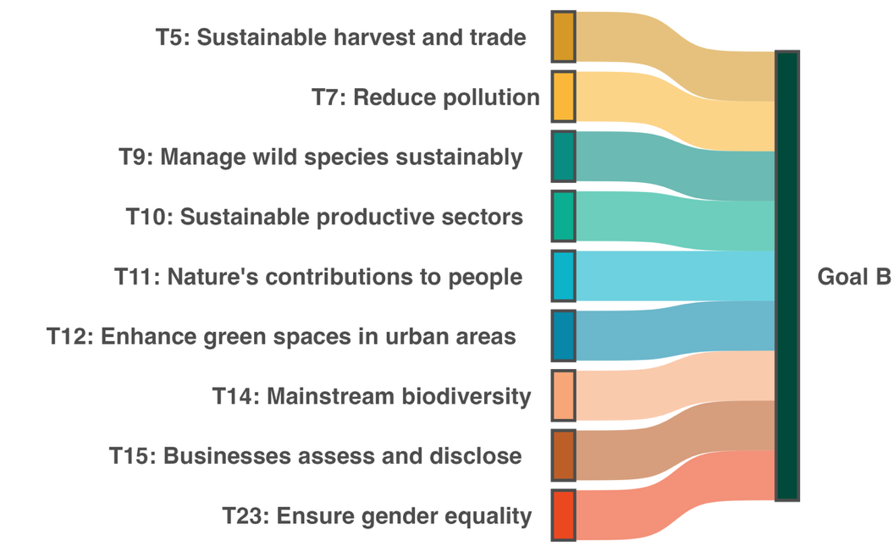
A link is drawn between a target and the goal if at least one in three of all Parties’ national targets associated a target to the goal. Colours are used to highlight each target according to the official brand guidelines of the Framework and do not carry any additional meaning.

Indicators of progress
Table 28: Indicator scorecard for Goal B. Colour coding is related to the overall assessment of progress across targets, of which the methodology is explained in the summary scorecard (Table 1). The colour coding for indicator data use reflects where a value for each target sits relative to the highest and lowest scores achieved across all targets of the Framework (green is assigned to percentage values falling within the top third of the total range, yellow to the middle third, and red to the bottom third). Colours for the binary indicators are based on the percentage of Parties scoring highly (4 or 5) for the indicator overall (green is assigned to values at or above 50 per cent, yellow to values between 50 and 25 per cent; and red to values below less than 25 per cent). Colours for the headline indicator results are based on progress relative to the target (green is assigned when progress is being made, yellow when progress is mixed progress, red when progress is insufficient; and grey when progress cannot be assessed).
 | Indicator use |  | Indicator results
Headline indicator B.1: Services provided by ecosystems | 10% of Parties |  | Insufficient data (one Party)
Binary indicator: B.b Number of countries with policies or actions for implementing and monitoring the sustainable use of biodiversity and the maintenance and enhancement of nature’s contributions to people, including ecosystem functions and services | 5 Parties | N/A | 60% of Parties that reported scored highly (score 4/5)

Issues related to the use of indicator B.1 and the monitoring of ecosystem service provision in the region are discussed under Target 11 in Section IIB.

All reporting Parties are making progress towards implementing and monitoring the sustainable use of biodiversity and the maintenance and enhancement of nature’s contributions to people. All Parties state that they have policies and/or action plans partially in place to ensure the maintenance, enhancement and restoration of ecosystem services as well as the sustainable use of biodiversity. Similarly, three quarters of reporting Parties partially monitor ecosystem services and the sustainable use of biodiversity, while the remaining quarter are developing such monitoring.

Figure 53: Binary indicator B.b, the number of countries with policies or actions for implementing and monitoring the sustainable use of biodiversity and the maintenance and enhancement of nature’s contributions to people, including ecosystem functions and services.
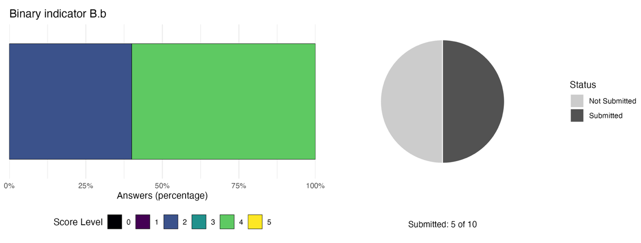The bar widths show the percentage of Parties in each score category, with higher numbers indicating a greater level of progress, based on responses to the questions included in the indicator. The pie chart shows the proportion of Parties included in the regional report who submitted national targets aligned with Target 23 in dark grey.

Summary of actions taken to advance progress towards Goal B
Across the region, actions to advance Goal B focus on sustainable fisheries and forestry governance, ecosystem service valuation, nature-based restoration, and sectoral mainstreaming, although regional reporting varies substantially between concrete examples of implementation and the design of governance frameworks that still lack measured ecological sustainability metrics and quantified ecosystem service outcomes. Marine and coastal initiatives include ecosystem-based fisheries management, closed harvest seasons, monitoring and bycatch reduction devices, innovative species recovery pilots such as larval rearing and mariculture facilities, expanded marine protection, and sustainable financing mechanisms like debt-for-nature swaps and dedicated grant programmes. Actions in terrestrial productive sectors center on maintaining forest cover, large-scale tree planting, agroforestry, and landscape rehabilitation to support food security, watershed functions, carbon sequestration, and rural livelihoods, complemented by waste reduction and circular economy initiatives. Biodiversity is increasingly mainstreamed into land-use planning and private financial risk assessments, alongside structural institutional steps such as adopting the System of Environmental-Economic Accounting and quantifying the economic contribution of nature-dependent sectors like tourism. In addition, emergent adoption of frameworks for FPIC and traditional knowledge support community-level sustainable use.

Goal C: Share benefits from genetic resources fairly
Goal text: The monetary and non-monetary benefits from the utilization of genetic resources and digital sequence information on genetic resources, and of traditional knowledge associated with genetic resources, as applicable, are shared fairly and equitably, including, as appropriate with indigenous peoples and local communities, and substantially increased by 2050, while ensuring traditional knowledge associated with genetic resources is appropriately protected, thereby contributing to the conservation and sustainable use of biodiversity, in accordance with internationally agreed access and benefit-sharing instruments.

GOAL OVERVIEW
Parties associated only two targets of the Framework with Goal C: Target 13 on ABS, and Target 17 on biosafety. There is limited information to track progress on outcomes related to these two global targets; however, Parties’ self-assessments report limited progress on both with largely early efforts to design the enabling environment to drive progress.

Progress on related targets
Using the method described above, only two of the targets of the Framework (Targets 13 and 17) were associated with Goal C, the fewest associated targets for any of the goals (Figure 54). None of the targets under the heading ‘Reducing threats to biodiversity’ were associated with Goal C. Target 13 had the strongest association with Goal C and was not associated with any other goal.

Based on Section II.B, progress towards these associated targets is low, with major challenges still affecting implementation. Based on Parties’ self-assessment progress towards Target 17 is particularly limited and progress towards Target 13 remains relatively low. These results suggest that both relevant targets require additional action to advance progress on Goal C.

Figure 54: Framework targets associated with Goal C in Parties’ national target submissions.
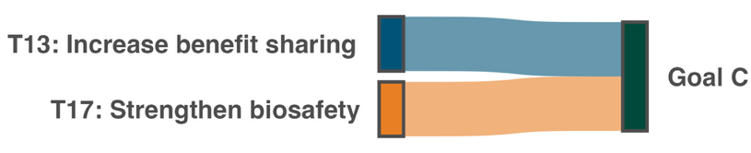
A link is drawn between a target and the goal if at least one in three of all Parties’ national targets associated a target to the goal. Colours are used to highlight each target according to the official brand guidelines of the Framework and do not carry any additional meaning.

Indicators of progress
Table 29: Indicator scorecard for Goal C. Colour coding is related to the overall assessment of progress across targets, of which the methodology is explained in the summary scorecard (Table 1). The colour coding for indicator data use reflects where a value for each target sits relative to the highest and lowest scores achieved across all targets of the Framework (green is assigned to percentage values falling within the top third of the total range, yellow to the middle third, and red to the bottom third). Colours for the headline indicator results are based on progress relative to the target (green is assigned when progress is being made, yellow when progress is mixed progress, red when progress is insufficient; and grey when progress cannot be assessed).
 | Indicator use |  | Indicator results
Headline indicator C.1: Monetary benefits received in accordance with applicable internationally agreed access and benefit-sharing instruments | 0% of Parties |  | No data
Headline indicator C.2: Non-monetary benefits arising from applicable international access and benefit-sharing instruments | 0% of Parties |  | No data

No Party submitted data on either of the headline indicators for Goal C. Issues related to monitoring and indicator use are discussed under Target 13 in Section IIB.

Summary of actions taken to advance progress towards Goal C
Regional progress toward Goal C remains at an early stage, characterized primarily by nascent legislative drafting, policy validation, and foundational capacity building rather than fully operationalized ABS systems. While most actions focus on developing biosafety and ABS frameworks or navigating Nagoya Protocol ratification, concrete operational outcomes remain rare across the region. Concretely described advances are limited to a small number of concluded ABS and research contracts, such as academic partnerships sharing non-monetary benefits, alongside targeted stakeholder training and the preparation of prospective research arrangements around specific genetic resources. In parallel, traditional knowledge and governance efforts involving IPLCs are advancing through the adoption of FPIC protocols, traditional knowledge outlooks, and community engagement hubs.

Goal D: Invest and collaborate
Goal text: Adequate means of implementation, including financial resources, capacity-building, technical and scientific cooperation, and access to and transfer of technology to fully implement the Kunming-Montreal Global Biodiversity Framework are secured and equitably accessible to all Parties, especially developing country Parties, in particular the least developed countries and small island developing States, as well as countries with economies in transition, progressively closing the biodiversity finance gap of $700 billion per year, and aligning financial flows with the Kunming-Montreal Global Biodiversity Framework and the 2050 Vision for biodiversity.

GOAL OVERVIEW
Parties associated seven of the 23 targets of the Framework with Goal D, corresponding largely with the targets under the heading ‘Tools and solutions for implementation and mainstreaming’ (Targets 17-23). These targets are all strongly associated with Goal D. According to self-assessments, regional progress is visible for some targets but important implementation challenges remain for others.

Progress on related targets
Using the method described above, seven of the ten targets placed under the heading ‘Tools and solutions for implementation and mainstreaming’ were associated with Goal D (Targets 17-23, Figure 55), Of these, five targets were more strongly associated with Goal D than with any other goal (Targets 19-23, Figure 50). The association was strongest for Target 19 reflecting its central role in securing adequate financial resources as a means of implementation.

Based on Section II.B, progress towards these associated targets is mixed, with major challenges still affecting implementation. Based on Parties’ self-assessment the most on-track targets related to Goal D are targets 22 followed by 19 and 20, while those showing the least amount of progress are targets 17 followed by 18 and 21. These results suggest potential areas where more action relevant to Goal D is required.

Figure 55: Framework targets associated with Goal D in Parties’ national target submissions.
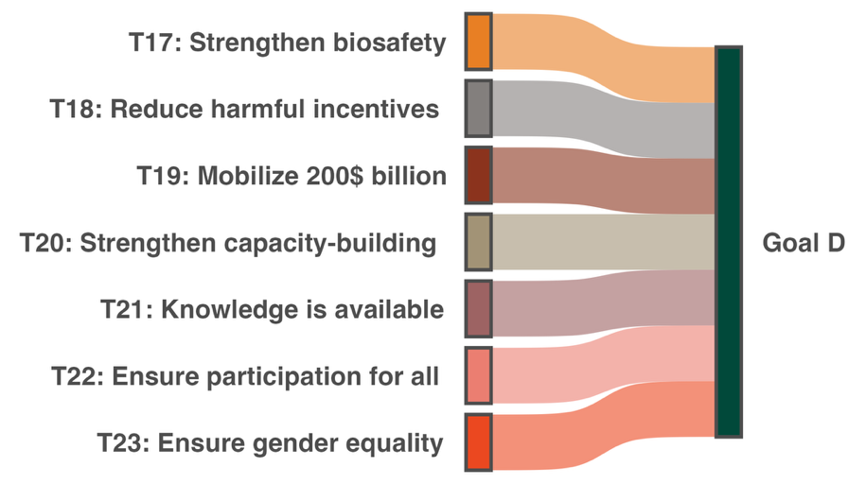
A link is drawn between a target and the goal if at least one in three of all Parties’ national targets associated a target to the goal. Colours are used to highlight each target according to the official brand guidelines of the Framework and do not carry any additional meaning.

Indicators of progress
Table 30: Indicator scorecard for Goal D. Colour coding is related to the overall assessment of progress across targets, of which the methodology is explained in the summary scorecard (Table 1). The colour coding for indicator data use reflects where a value for each target sits relative to the highest and lowest scores achieved across all targets of the Framework (green is assigned to percentage values falling within the top third of the total range, yellow to the middle third, and red to the bottom third)Colours for the headline indicator results are based on progress relative to the target (green is assigned when progress is being made, yellow when progress is mixed progress, red when progress is insufficient; and grey when progress cannot be assessed).
 | Indicator use |  | Indicator results
Headline indicator D.1: International public funding, including official development assistance (ODA) for conservation and sustainable use of biodiversity and ecosystems | 40% of Parties |  | 33.6 million USD between 2010 and 2025 (no trend)
Headline indicator D.2: Domestic public funding on conservation and sustainable use of biodiversity and ecosystems | 20% of Parties |  | 48.6 million USD between 2020 and 2024 (no trend)
Headline indicator D.3: Private funding (domestic and international) on conservation and sustainable use of biodiversity and ecosystems | 10% of Parties |  | 19.3 million USD in 2024 and 2025

Reporting on international (D.1), domestic (D.2), and private (D.3) biodiversity funding is severely limited by incomplete data, low reporting participation, and an inability to establish clear regional trends. Issues related to monitoring of the indicators are discussed under Target 19 in Section IIB.

Nevertheless, Parties report considerably more funding derived from domestic budgets than international sources, with private finance providing the least amount of money (Figure 56). These findings are consistent with the broad pattern seen in the global report.

Figure 56: Total funding reported by Parties in million USD between the years 2020 and 2025.
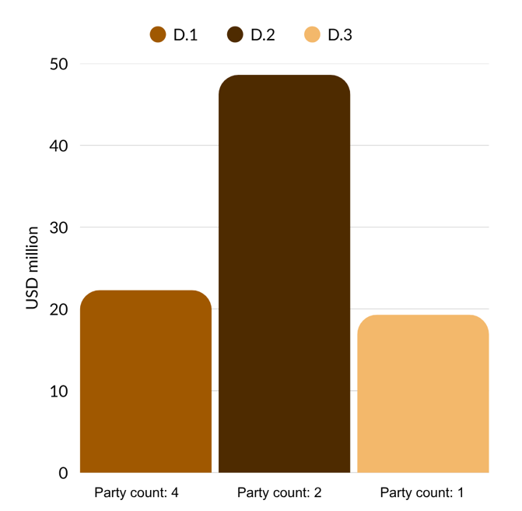
Each bar represents the cumulative total for a different headline indicator: D.1 International public funding, including ODA for conservation and sustainable use of biodiversity and ecosystem; D.2 Domestic public funding on conservation and sustainable use of biodiversity and ecosystems; and D.3 Private funding (domestic and international) on conservation and sustainable use of biodiversity and ecosystems. Note that Party sums differ from those in Table 30 as data shown here include only submissions from 2020 onwards.

Summary of actions taken to advance progress towards Goal D
Progress toward Goal D across the region is primarily characterized by readiness and planning instruments, though select concrete mechanisms have been operationalized to mobilise resources and enhance implementation capacity. Reported financing actions include a multi-year sovereign debt-for-nature conversion securing dedicated marine conservation funding, institutional accreditation to access major international climate funds, and project investments through national conservation funds and multilateral grant programmes. Broader regional efforts center on preparatory frameworks, such as national biodiversity finance planning processes, environmental sustainability assessments for protected areas, and legislative steps to establish domestic environmental funds. Capacity-building and cooperation measures have focused on technical training in biodiversity governance, postgraduate scholarships in environmental management disciplines, private sector natural capital risk assessments, and participation in cross-border conservation efforts. Even though no systematic realignment of harmful financial flows has been reported, some examples of positive incentives financed by domestic budgets exist. Nevertheless, financing efforts across the region remain largely partial, project-dependent, and constrained by substantial funding gaps relative to NBSAPs.

Part III: Conclusion and summary
Overarching message: Caribbean Parties to the CBD participating in the regional report describe extensive engagement with the Kunming Montreal Global Biodiversity Framework and action towards all 23 targets. The Framework has galvanised regional conservation efforts, innovation, cooperation, and learning. Yet, progress and efforts are uneven between targets.

As found in the global report of collective progress in implementation, some targets appear particularly difficult for Parties in the region to address, and information to clearly assess progress in implementation for most targets is limited. Most participating Parties acknowledge some important gaps in progress for all 23 targets (Table 31). Unless the specific challenges of the region, such as limited human capacity to consistently engage in mainstreaming biodiversity across Government and society, are recognised and addressed, the Caribbean States reflected in this report will continue to face difficulties in implementation of the Framework and regional collective progress is likely to remain insufficient relative to national targets, NBSAP ambition, the 2030 mission and the 2050 vision (Figure 57).

Table 31: Scorecard of collective progress towards each target of the Framework. Each column, and associated percentage values, represent important measures of progress in implementation of the Framework. Column 1: Parties’ self-assessment of progress towards their national targets (percentage of national targets reported as "on-track" or "achieved"). Column 2: assessment of progress towards the Framework target based on all the relevant indicators (percentage based on the average score of all associated indicator types, detail available in Table 3). Column 3: data availability in national reports (percentage of Parties reporting some quantitative data on headline, component, complementary or national indicators). The three colours in columns 1 to 3 reflect where a value for each target sits relative to the highest and lowest scores achieved across all targets (green is assigned to values falling within the top third of the total range, yellow to the middle third, and red to the bottom third). The overall assessment score is based on a formula which gives a 50% weighting to the self-assessment of progress and a 50% weighting to the indicator-based assessment of progress. Results from this calculation are then split into four categories (0-0.25 in red, 0.25-0.5 in orange, 0.5-0.75 in yellow, 0.75-1 in green, insufficient data in grey). Summary descriptions of progress rely on the findings of the target-by-target analysis of section IIB.
Target | 1 | 2 | 3 | Overall score | Summary description of progress
Target 1 | ♦  27% | - | ♦  40% | - | Progress towards biodiversity-inclusive spatial planning in the Caribbean has largely been driven by area-based conservation measures. Insufficient monitoring data limits assessment of progress, but most Parties report that legal instruments to include biodiversity into spatial planning decisions are largely in development and not yet having an impact. However, notable efforts are under way, especially in marine areas.
Target 2 | ♦  13% | - | ♦  60% | - | Ecosystem restoration is actively underway across the region; however, its scale and effectiveness cannot be established with current monitoring data. Several projects are underway that imbed restoration with benefits for people, but these remain localised and uncoordinated. Insufficient monitoring data on degraded lands and national level restoration efforts as well as limited financing hinder advancement towards national targets and progress tracking.
Target 3 | ♦  43% | ♦  0% | ♦  90% | 0.21 | Parties report making progress towards national targets related to the coverage of protected areas, especially for marine areas. Action on area-based conservation measures and enhancing their effectiveness meaningfully contributes to progress towards other targets. However, submitted indicator data shows minor changes in overall coverage with little to no progress towards many of the 30 per cent targets set by Parties. Important challenges remain in improving the effectiveness of area-based conservation measures across the region.
Target 4 | ♦  25% | ♦  50% | ♦  70% | 0.38 | Parties report considerable efforts towards species conservation with some noticeable positive results in the region. However, common challenges are widespread, revealing a pattern of externally funded and project-dependent progress, perpetuating a structural vulnerability for species conservation efforts. Little is known about the status of genetic diversity.
Target 5 | ♦  22% | - | ♦  0% | - | Progress is being reported in the region, in particular for the harvest and trade of marine species. Legal instruments are largely in place, with most Parties reporting domestic implementation of Convention on International Trade in Endangered Species of Wild Fauna and Flora (CITES). However, challenges in enforcement of these measures, linked to resource and capacity constraints, limit their effectiveness.
Target 6 | ♦  14% | - | ♦  0% | - | Progress has been made on setting up the enabling environment to limit the introduction and impacts of IAS. However, significant funding and capacity limitations constrain effective monitoring and detection of IAS as well as enforcement of legislation and management of impacts. Too little data is available to quantify progress in the region, but Parties largely report that it has been insufficient so far.
Target 7 | ♦  25% | - | ♦  10% | - | Data limitations affect any assessment of progress on this target. Limited monitoring capacity, missing data and incomplete information systems reveal a gap in the region’s capacity to monitor progress on pollution reduction. Major barriers to implementation remain linked to institutional challenges and compounded by insufficient resourcing, capacity-building and public awareness.
Target 8 | ♦  28% | ♦  11% | ♦  0% | 0.19 | Climate change and ocean acidification continue to pose a significant challenge to implementation of the Framework in the region. Efforts are ongoing and largely focused on the ecosystem approach and nature-based solutions through the restoration and management of key marine and terrestrial ecosystems. Yet, insufficient resourcing and coordination, alongside continuing environmental pressures, limit progress.
Target 9 | ♦  13% | - | ♦  10% | - | Insufficient data from monitoring is both a barrier to measuring progress towards Target 9 and implementing actions to manage wild species in the region. Parties report little progress and highlight significant challenges in determining sustainability thresholds for species use, setting up legislation and enforcing management plans.
Target 10 | ♦  38% | ♦  50% | ♦  40% | 0.44 | Efforts are ongoing to enhance biodiversity across productive sectors. Parties report progress towards expanding agroforestry and improving fisheries practices. Agricultural policy and practices lag, and face particular challenges interlinked with other Framework targets. Community engagement in sustainable practices is a core focus of Party efforts.
Target 11 | ♦  22% | - | ♦  20% | - | Integration of ecosystem services into national policy and action plans is at an early stage. Insufficient data is available across the region to measure progress or include ecosystem service values into decision making. Parties report that more progress is needed to establish baselines of ecosystem service provision so that it can be improved. Currently, progress towards Target 11 is largely linked to efforts on restoration of ecosystems and protection of species.
Target 12 | ♦  22% | - | ♦  20% | - | Progress on Target 12 faces significant challenges. Legislative and policy frameworks to mainstream biodiversity in urban planning remain at early stages and monitoring of green and blue spaces is largely absent. Efforts are under way to set up the enabling environment for enhanced access to green spaces in urban areas, but continuing development pressures still drive current patterns of urban development without a clear focus on biodiversity.
Target 13 | ♦  21% | - | ♦  0% | - | Parties in the region are at early stages of implementation. The majority of Parties report not having ratified or fully operationalised the Nagoya Protocol, not having enacted domestic Access and Benefit-Sharing (ABS) legislation, and having no documented, concluded benefit-sharing agreements. As such, monitoring capacity for ABS-related outcomes is also underdeveloped and largely lacking.
Target 14 | ♦  50% | ♦  13% | ♦  0% | 0.32 | Parties report making substantial efforts towards the mainstreaming of biodiversity. Largely, these efforts have focused on legislation and policy mechanisms to include biodiversity. However, in many cases these efforts are still incomplete, and implementation is at an early stage. Additionally, concerns about sufficient financial resources to support NBSAPs were flagged as a major barrier to progress.
Target 15 | ♦  0% | - | ♦  0% | - | Progress towards Target 15 is insufficient in the region. Legal, administrative and policy measures aimed at businesses and financial institutions are largely absent. Some evidence of voluntary private sector engagement is apparent, but this is limited and not representative of the broader landscape. Capacity and resource challenges affect Parties’ ability to make progress.
Target 16 | ♦  0% | ♦  63% | ♦  0% | 0.28 | Parties are making progress in developing the enabling environment necessary to reduce waste and enable sustainable consumption choices, but they do not yet report being on track for any national target. Persistent challenges in sustaining behaviour change and infrastructure development hinder the long-term effectiveness of Party actions.
Target 17 | ♦  17% | ♦  0% | ♦  10% | 0.08 | Major gaps exist in progress towards Target 17 in the region. Necessary legislation is largely not yet in place, resulting in major capacity barriers and a lack of technical expertise on biosafety and biotechnology. Many Parties do not yet have operational Biosafety CHMs, further hindering progress. Monitoring, scientific and technical capacity in the region also remains too low.
Target 18 | ♦  21% | - | ♦  10% | - | Significant data limitations hamper assessment of progress towards the reduction of harmful subsidies and the scaling up of positive incentives. While some Parties have put in place positive incentives, few have so far been able to identify harmful subsidies due to technical challenges and siloed information. Self-assessed progress is largely insufficient with a large portion of targets with unknown status.
Target 19 | ♦  33% | - | ♦  40% | - | Parties report mobilising international, domestic and private finance for biodiversity across the region. However, the scale, reliability and accessibility of financial resources do not meet the current needs for implementation of the Framework. Regionally, Parties often rely on short-term project-based finance and biodiversity has not been sufficiently mainstreamed into domestic budgets. The private sector also remains insufficiently engaged.
Target 20 | ♦  33% | ♦  38% | ♦  0% | 0.31 | Capacity-building, technology transfer and scientific and technical cooperation remain a challenge for the region. Parties report substantial efforts being made with some progress on national targets. Yet major challenges remain due to the often-short-term project-based approach to biodiversity conservation efforts, including resourcing, monitoring and training. Additionally, Parties report a brain drain effect of qualified personnel away from the region.
Target 21 | ♦  22% | - | ♦  20% | - | Efforts to expand biodiversity knowledge and make it broadly accessible in the region are ongoing. Some progress is notable in Parties’ self-assessments. Nevertheless, structural issues still hinder progress on this Target. These are largely linked to the project-based nature of current monitoring programmes. National monitoring systems for biodiversity are nascent and require dedicated capacity and resources. Preserving and including traditional ecological knowledge also appears to be a challenge for the region.
Target 22 | ♦  44% | - | ♦  0% | - | Parties report making progress on their national targets associated to Target 22. However, they also acknowledge severe data gaps and limitations of monitoring systems in tracking effective participation and outcomes for specific groups, reflected in the lack of indicator data submissions. Many efforts are ongoing to include communities through participatory processes, including via legislation and co-governance as reflected in some Party initiatives.
Target 23 | ♦  28% | ♦  38% | ♦  0% | 0.28 | National report submissions suggest that efforts to ensure gender equality and a gender-responsive approach to biodiversity action are largely under development. While some national targets appear to be on track, sex-disaggregated data remains largely absent, and monitoring of participation outcomes is limited. Yet, Parties report ongoing efforts to ensure gender representation in consultative processes despite continued challenges in the full integration of women and girls in decision making.

Figure 57: Framework targets associated with each of the goals of the Framework.
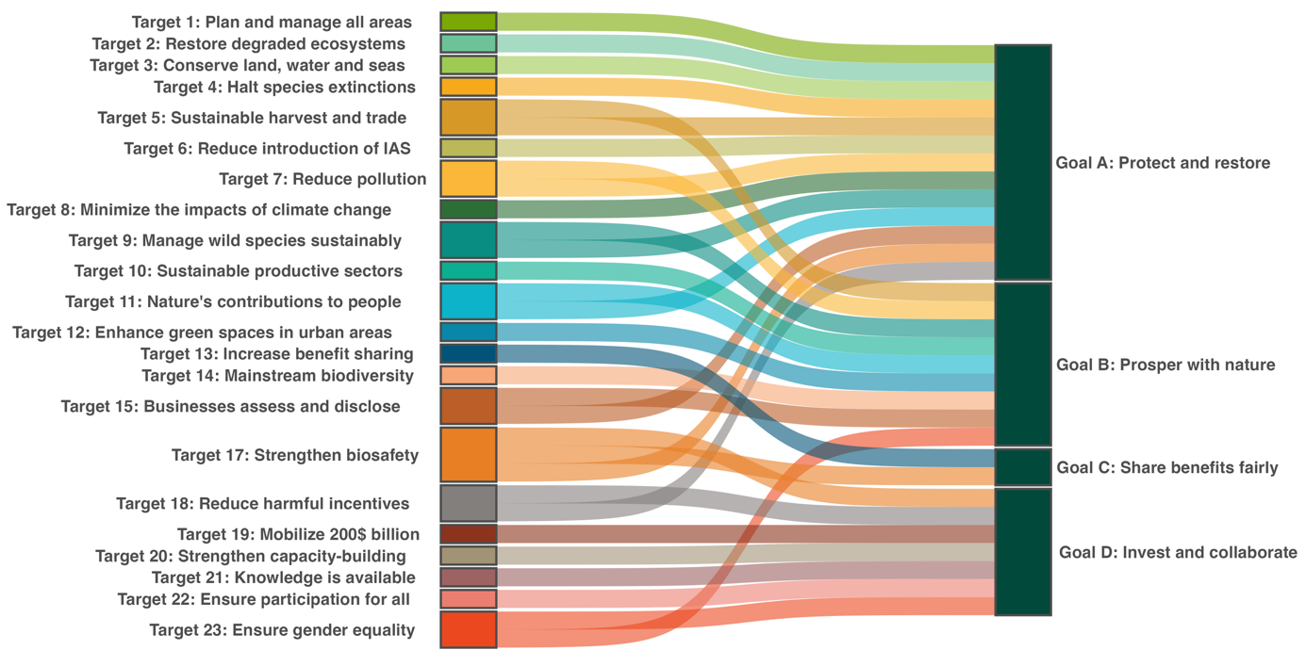
Associations are based on Parties’ national target submissions. A link is drawn between a target and goal if at least one in three of all submitting Parties’ national targets associated a target to the goal. The Framework does not contain a mapping of the relationship between the targets of the Framework and its goals. This figure therefore provides an illustration of how Parties in the region collectively view the relationship between the targets and goals of the Framework. Note: this figure combines a similar figure for each goal which is shown in Section II.C of this report on the progress towards the goals. It is based on how Parties have linked their national targets to the targets and goals of the Framework. Note that none of the national targets highly aligned with Target 16 were associated to a Framework goal in Party submissions, this does not mean that Parties did not submit information about implementation of Target 16 nor that the target does not contribute to achievement of the 2050 vision of the Framework.

Box 26

Goal overviews based on associations in Figure 57

Goal A – Protect and Restore
Parties associated 13 of the 23 targets of the Framework with Goal A, more than for any other goal. These included all the targets focused on reducing threats to biodiversity, two of the five targets focused on meeting people’s needs through sustainable use and benefit-sharing, and three of the ten targets focused on tools and solutions for implementation and mainstreaming. Based on this, progress towards Goal A depends on implementation across a broad range of targets with both direct and indirect impacts on biodiversity.

Goal B – Prosper with Nature
Parties associated nine of the 23 targets of the Framework with Goal B. Based on this, progress towards Goal B is dependent on coordinated action across much of the Framework. As shown in section II.B, regional progress across the Framework is mixed, and requires coordinated action to address both direct and indirect drivers of biodiversity change, thereby maintaining, enhancing and restoring the contributions of nature to present and future generations.

Goal C – Share Benefits of Genetic Resources Fairly
Parties associated only two targets of the Framework with Goal C: Target 13 on access and benefit-sharing, and Target 17 on biosafety. There is limited information to track progress on outcomes related to these two global targets; however, Parties’ self-assessments report limited progress on both with largely early efforts to design the enabling environment to drive progress.

Goal D – Invest and Collaborate
Parties associated seven of the 23 targets of the Framework with Goal D, corresponding largely with the targets under the heading ‘Tools and solutions for implementation and mainstreaming’ (Targets 17-23). These targets are all strongly associated with Goal D. According to self-assessments, regional progress is visible for some targets, but important implementation challenges remain for others.

References
Acosta-Chaparro, A.F. and others, 2025. Status and Trends of Caribbean Coral Reefs: Status and Trends of Caribbean Coral Reefs: 1970 – 2024 (No. GCRMN-Caribbean-1970-2024). Global Coral Reef Monitoring Network (GCRMN) and International Coral Reef Initiative (ICRI). https://doi.org/10.59387/BDHF9180
Affinito, F. and others, 2024. Progress in developing and operationalizing the Monitoring Framework of the Global Biodiversity Framework. Nat. Ecol. Evol. https://doi.org/10.1038/s41559-024-02566-7
CANARI, 2019. Ecosystem Profile: The Caribbean Islands Biodiversity Hotspot, Technical Summary. Caribbean Natural Resources Institute. Available at https://canari.org/wp-content/uploads/2021/08/cepf-caribbean-islands-ecosystem-profile-summary-2020-english.pdf
CBD, 2023. CBD/COP/15/17: REPORT OF THE CONFERENCE OF THE PARTIES TO THE CONVENTION ON BIOLOGICAL DIVERSITY ON THE SECOND PART OF ITS FIFTEENTH MEETING. Secretariat of the Convention on Biological Diversity, Montreal. Available at https://www.cbd.int/doc/c/3119/8611/72d7962a5b058cc30e2299c7/cop-15-17-en.pdf
CBD, 2026. CBD/COP/16/13/Rev.1: Report of the Conference of the Parties to the Convention on Biological Diversity on its sixteenth meeting. Secretariat of the Convention on Biological Diversity, Rome. Available at https://www.cbd.int/doc/c/6752/2897/32597768aa0ea7d0ebd3d988/cop-16-13-rev1-en.pdf
Contreras-MacBeath, T. and others, 2022. Freshwater Fishes of Central America: Freshwater Fishes of Central America: Distribution, Assessment, and Major Threats. Diversity 14, 793. https://doi.org/10.3390/d14100793
Ferrer‐Paris, J.R. and others, 2019. An ecosystem risk assessment of temperate and tropical forests of the Americas with an outlook on future conservation strategies. Conserv. Lett. 12, e12623. https://doi.org/10.1111/conl.12623
Jarvis, A. and others, 2026. Challenges for Small Island Developing States in meeting monitoring requirements of the Kunming‐Montréal global biodiversity framework. Conserv. Sci. Pract. 8, e70348. https://doi.org/10.1111/csp2.70348
LandMark, 2024. Percent of country held by indigenous peoples and communities – acknowledged by government and total (version 202408). LandMark Global Platform of Indigenous and Community Lands. Available at https://landmarkmap.org/
LandMark, 2025. Indigenous peoples’ lands & territories, local communities lands, and indicative areas of indigenous and local community lands (version 202509). LandMark Global Platform of Indigenous and Community Lands. Available at https://www.landmarkmap.org/
Miloslavich, P. and others, 2010. Marine Biodiversity in the Caribbean: Marine Biodiversity in the Caribbean: Regional Estimates and Distribution Patterns. PLoS ONE 5, e11916. https://doi.org/10.1371/journal.pone.0011916
Mohammed, R.S., Fanovich, L., 2024. Biodiversity in the Caribbean from 1950 to the Present, in: Kaltmeier, O. and others (Eds.), Biodiversity - Handbook of the Anthropocene in Latin America II. Bielefeld University Press / transcript Verlag, Bielefeld, Germany, pp. 385–410. https://doi.org/10.14361/9783839470121-021
Mycoo, M.A., Roopnarine, R.R., 2024. Water resource sustainability: Water resource sustainability: Challenges, opportunities and research gaps in the English-speaking Caribbean Small Island Developing States. PLOS Water 3, e0000222. https://doi.org/10.1371/journal.pwat.0000222
Potapov, P. and others, 2024. Land cover and land use 2024.
Prindex, 2024. Prindex global tenure security dataset (Version 2024). Available at https://www.prindex.net/data/
Roberts, C.M. and others, 2002. Marine Biodiversity Hotspots and Conservation Priorities for Tropical Reefs. Science 295, 1280–1284. https://doi.org/10.1126/science.1067728
Spalding, M.D., Leal, M. (Eds.), 2021. The state of the world’s mangroves 2021. Global Mangrove Alliance. Available at https://www.mangrovealliance.org/
United Nations General Assembly, 2023. A/RES/78/155: Biodiversity and sustainable development. Resolution 78/155. United Nations. Available at https://docs.un.org/en/a/res/78/155 (accessed 4 May 2026)
__________

* CBD/COP/17/1/Rev.1.
** The present document is being issued without formal editing.
Available at https://bvearmb.do/handle/123456789/2470.
Available at https://www.iucnredlist.org/.
Available at https://www.gbif.org/.
Available at https://www.inaturalist.org/.
Available at https://ebird.org/.
NBSAPs, national targets and national reports are included in the regional report analysis if they were submitted by 1 August 2026.
As binary indicator data is required automatically by the online reporting tool, submission counts for these indicators do not reflect monitoring capacity differences between targets and do not provide actionable information for making progress in implementation, so no assessment is relevant.
The methodology for calculating the score levels for each binary indicator, as well as the questions included for each indicator, are provided in CBD/COP/16/INF/3/Rev.1.
Available at https://www.protectedplanet.net/en/thematic-areas/wdpa?tab=WDPA.
As binary indicator data is required by the online reporting tool, submission counts for these indicators do not reflect monitoring capacity differences between targets, and do not provide actionable information for making progress in implementation, so no assessment is relevant.
Available from https://dataexplorer.fao.org/.
The methodology for calculating the score levels for each binary indicator, as well as the questions included for each indicator, are provided in CBD/COP/16/INF/3/Rev.1.
As binary indicator data is required automatically by the online reporting tool, submission counts for these indicators do not reflect monitoring capacity differences between targets and do not provide actionable information for making progress in implementation, so no assessment is relevant.
Available at https://griis.org/.
The methodology for calculating the score levels for each binary indicator, as well as the questions included for each indicator, are provided in CBD/COP/16/INF/3/Rev.1.
As binary indicator data is required automatically by the online reporting tool, submission counts for these indicators do not reflect monitoring capacity differences between targets and do not provide actionable information for making progress in implementation, so no assessment is relevant.
The methodology for calculating the score levels for each binary indicator, as well as the questions included for each indicator, are provided in CBD/COP/16/INF/3/Rev.1.
As binary indicator data is required automatically by the online reporting tool, submission counts for these indicators do not reflect monitoring capacity differences between targets and do not provide actionable information for making progress in implementation, so no assessment is relevant.
The methodology for calculating the score levels for each binary indicator, as well as the questions included for each indicator, are provided in CBD/COP/16/INF/3/Rev.1.
Available from https://dataexplorer.fao.org/.
Available from https://dataexplorer.fao.org/.
As binary indicator data is required automatically by the online reporting tool, submission counts for these indicators do not reflect monitoring capacity differences between targets and do not provide actionable information for making progress in implementation, so no assessment is relevant.
The methodology for calculating the score levels for each binary indicator, as well as the questions included for each indicator, are provided in CBD/COP/16/INF/3/Rev.1.
As binary indicator data is required automatically by the online reporting tool, submission counts for these indicators do not reflect monitoring capacity differences between targets and do not provide actionable information for making progress in implementation, so no assessment is relevant.
The methodology for calculating the score levels for each binary indicator, as well as the questions included for each indicator, are provided in CBD/COP/16/INF/3/Rev.1.
As binary indicator data is required automatically by the online reporting tool, submission counts for these indicators do not reflect monitoring capacity differences between targets and do not provide actionable information for making progress in implementation, so no assessment is relevant.
The methodology for calculating the score levels for each binary indicator, as well as the questions included for each indicator, are provided in CBD/COP/16/INF/3/Rev.1.
As binary indicator data is required automatically by the online reporting tool, submission counts for these indicators do not reflect monitoring capacity differences between targets and do not provide actionable information for making progress in implementation, so no assessment is relevant.
Available at https://tnfd.global/.
The methodology for calculating the score levels for each binary indicator, as well as the questions included for each indicator, are provided in CBD/COP/16/INF/3/Rev.1.
As binary indicator data is required automatically by the online reporting tool, submission counts for these indicators do not reflect monitoring capacity differences between targets and do not provide actionable information for making progress in implementation, so no assessment is relevant.
The methodology for calculating the score levels for each binary indicator, as well as the questions included for each indicator, are provided in CBD/COP/16/INF/3/Rev.1.
As binary indicator data is required automatically by the online reporting tool, submission counts for these indicators do not reflect monitoring capacity differences between targets and do not provide actionable information for making progress in implementation, so no assessment is relevant.
The methodology for calculating the score levels for each binary indicator, as well as the questions included for each indicator, are provided in CBD/COP/16/INF/3/Rev.1.
Available at https://www.biofin.org/.
Available at https://www.biofin.org/.
As binary indicator data is required automatically by the online reporting tool, submission counts for these indicators do not reflect monitoring capacity differences between targets and do not provide actionable information for making progress in implementation, so no assessment is relevant.
The methodology for calculating the score levels for each binary indicator, as well as the questions included for each indicator, are provided in CBD/COP/16/INF/3/Rev.1.
Available at https://www.gbif.org/.
As binary indicator data is required automatically by the online reporting tool, submission counts for these indicators do not reflect monitoring capacity differences between targets and do not provide actionable information for making progress in implementation, so no assessment is relevant.
The methodology for calculating the score levels for each binary indicator, as well as the questions included for each indicator, are provided in CBD/COP/16/INF/3/Rev.1.
Available at https://www.cepal.org/en/escazuagreement.
As binary indicator data is required automatically by the online reporting tool, submission counts for these indicators do not reflect monitoring capacity differences between targets and do not provide actionable information for making progress in implementation, so no assessment is relevant.
The methodology for calculating the score levels for each binary indicator, as well as the questions included for each indicator, are provided in CBD/COP/16/INF/3/Rev.1.
As binary indicator data is required automatically by the online reporting tool, submission counts for these indicators do not reflect monitoring capacity differences between targets and do not provide actionable information for making progress in implementation, so no assessment is relevant.
The methodology for calculating the score levels for each binary indicator, as well as the questions included for each indicator, are provided in CBD/COP/16/INF/3/Rev.1.

