 |  | CBD/COP/17/INF/7

 | Distr.: General  10 September 2026  Original: English

Conference of the Parties to the
Convention on Biological Diversity
Seventeenth meeting
Yerevan, 19–30 October 2026
Item 9 (a) of the provisional agenda*
Planning, monitoring, reporting and review: global
review of collective progress in the implementation of the Kunming-Montreal Global Biodiversity Framework
Global report on collective progress in the implementation of the Kunming-Montreal Global Biodiversity Framework
Note by the Secretariat
- 1. In its decision 16/32, the Conference of the Parties adopted an indicative timeline for the global review of collective progress in the implementation of the Kunming-Montreal Global Biodiversity Framework, including the preparation of the global report. According to the timeline, the text of the global report was to be completed and sent for translation and layout by 28 August 2026, and the full report was to be published during the seventeenth meeting of the Conference of the Parties.
- 2. A peer review period of the draft report was conducted from 1 June to 29 June 2026, and the comments received were taken into account to prepare a revised draft that was made available to the Subsidiary Body on Scientific, Technical and Technological Advice at its twenty-eighth meeting, as document CBD/SBTTA/28/2/Add.1/Rev.1. That draft was, however, still subject to revision and technical editing to ensure clarity and consistency.
- 3. The present document contains the final text of the global report, following the further revision and technical editing mentioned above. However, the graphic elements used for the figures and tables therein remain placeholders, as all will be remade for the publication layout of the report. The graphic elements have been included in English only in all language versions of the present document, as their number and complexity made it impossible to produce them in other languages in time for the present meeting, but translations are provided below each graphic element, and they will appear in the relevant language in each language version of the final published report. The final published report will also include photographs, including some that have been kindly provided by Parties and organizations in connection with the case studies used in the global report.

State of Biodiversity Action: Global Report on Collective Progress in the Implementation of the Kunming-Montreal Global Biodiversity Framework

Final edited text

Table of contents
Foreword 4
Acknowledgements 5
List of abbreviations and acronyms 7
Summary of the conclusions and key messages of the global report 10
Part I: Introduction 13
I.A Introduction to the Kunming-Montreal Global Biodiversity Framework and the global report 13
The Framework 13
Planning, monitoring, reporting and review 14
Purpose of the global report 17
Global report sources and methodology 20
Limitations and methodological assumptions 28
I.B Global status and trends 30
Part II: Collective progress in the implementation of the Kunming-Montreal Global Biodiversity Framework 35
II.A Summary of the status of national biodiversity strategies and action plans, national targets, national report submissions, and submissions from actors other than national Governments. 35
Overview of the submission of national biodiversity strategies and action plans, national targets and national reports 35
Support provided to Parties for national biodiversity strategies and action plans, national target development and national reporting 37
Relationship between national biodiversity strategies and action plans, national targets and national reports 38
Overview of national biodiversity strategies and action plans 39
Commitments from actors other than national Governments 42
II.B Collective progress towards the implementation of the targets 43
Introducing the target progress summaries 43
Reducing threats to biodiversity 46
Target 1. Plan and manage all areas to reduce biodiversity loss 46
Target 2. Restore 30 per cent of all degraded ecosystems 55
Target 3. Effectively conserve and manage at least 30 per cent of terrestrial and inland water areas and 30 per cent of coastal and marine areas 67
Target 4. Halt species extinction, protect genetic diversity, and manage human-wildlife conflict 81
Target 5. Ensure sustainable, safe and legal harvesting and trade of wild species 94
Target 6. Reduce the introduction of invasive alien species by 50 per cent and minimize their impact 103
Target 7. Reduce pollution to levels that are not harmful to biodiversity 113
Target 8. Minimize the impacts of climate change on biodiversity and build resilience 124
Meeting people’s needs through sustainable use and benefit-sharing 132
Target 9. Manage wild species sustainably to benefit people 132
Target 10. Enhance biodiversity and sustainability in agriculture, aquaculture, fisheries, and forestry 141
Target 11. Restore, maintain and enhance nature’s contributions to people 157
Target 12. Enhance green spaces and urban planning for human well-being and biodiversity 166
Target 13. Increase the sharing of benefits from genetic resources, digital sequence information and traditional knowledge 174
Tools and solutions for implementation and mainstreaming 184
Target 14. Integrate biodiversity into decision-making at all levels 184
Target 15. Businesses assess, disclose and reduce biodiversity-related risks and negative impacts 192
Target 16. Enable sustainable consumption choices to reduce waste and overconsumption 202
Target 17. Strengthen biosafety and distribute the benefits of biotechnology 211
Target 18. Reduce harmful subsidies by at least US$500 billion per year, and scale up positive incentives for biodiversity 219
Target 19. Mobilize US$200 billion per year for biodiversity from all sources, including US$30 billion through international finance 230
Target 20. Strengthen capacity-building, technology transfer, and scientific and technical cooperation for biodiversity 242
Target 21. Ensure that knowledge is available and accessible to guide biodiversity action 250
Target 22. Ensure participation in decision-making and access to justice and information related to biodiversity for all 260
Target 23. Ensure gender equality and a gender-responsive approach to biodiversity action 271
II.C Collective progress towards the 2050 goals 281
Goal A – Protect and restore 283
Goal B. Prosper with nature 289
Goal C. Share benefits of genetic resources fairly 295
Goal D. Invest and Collaborate 299
II.D Provision of means of implementation 304
Introduction 304
Analysis of needs 305
Financial resources 305
Capacity 307
Technical and scientific cooperation 309
Access to and transfer of technology 311
Overview of needs relating to means of implementation 312
Analysis of provision of the means of implementation 312
Financial resources 312
Capacity 316
Technical and scientific cooperation 317
Access to and transfer of technology 319
Concluding observations 319
Means of implementation for indigenous peoples and local communities, women, youth and other stakeholders 320
Financial resources 321
Capacity 322
Technical and scientific cooperation 323
Access to and transfer of technology 324
Summary and key observations on means of implementation 325
Summary 325
Concluding observations 327
II.E Contributions of relevant multilateral environmental agreements, international organizations and processes 328
Introduction 328
Support for the Framework from multilateral environmental agreements 330
The Rio conventions 330
Biodiversity-related conventions 331
Other relevant multilateral environmental agreements 334
Multilateral environmental agreements, other agreements and conventions in national biodiversity strategies and action plans 335
Note: Only global-level agreements are listed. In cases where a Party has submitted more than one NBSAP (for example, when separate NBSAPs have been submitted for overseas territories), the number of Parties is shown in parentheses. 336
Other relevant international organizations and processes 336
Part III: Conclusions and key messages 340
III.A Synthesis of collective progress towards the implementation of the Kunming-Montreal Global Biodiversity Framework, including the 2030 mission and the 2050 vision 340
III.B Moving forward: challenges and opportunities 352
Bibliography 364

Foreword
“Biodiversity underpins life on Earth. Safeguarding biological diversity is essential to the health of our planet, the resilience of our economies, and the well-being of all people. This global report, State of Biodiversity Action, assesses our progress in implementing the Kunming-Montreal Global Biodiversity Framework, and outlines the urgent actions required to achieve its 2030 targets and realize its 2050 vision. Together, we can accelerate action, halt and reverse biodiversity loss, and secure the natural foundation upon which all human life and prosperity depend.”
António Guterres, Secretary-General of the United Nations
“The Kunming-Montreal Global Biodiversity Framework is our blueprint for protecting and making peace with nature. Yet, as we approach the halfway mark to 2030, this new global report, State of Biodiversity Action, reveals a sobering truth - we remain off track to meet our collective goals. The very biodiversity we depend on needs tangible progress, not more promises. This global review is a clear call to action: we can still get back on track and protect people and planet, but only if we act now, overcome implementation challenges and invest in solutions that work with nature, not against it.”
Inger Andersen, Under-Secretary-General of the United Nations and Executive Director of the United Nations Environment Programme
“The global report, State of Biodiversity Action, presents the first global assessment of collective progress in implementing the Kunming-Montreal Global Biodiversity Framework. It is primarily built on information provided by our Convention’s Parties and illustrates how the Framework has catalysed unprecedented global commitment and engagement since its adoption. At the same time, the report makes clear that the pace and scale of implementation must increase across the world and across all levels of society to realize the Framework’s 2030 ambition. As Parties undertake the first global review of progress in implementing the Framework, this report provides a basis for deliberations and the actions needed to accelerate and broaden our efforts to halt and reverse biodiversity loss.”
Astrid Schomaker, Executive Secretary, Convention on Biological Diversity

Acknowledgements
The State of Biodiversity Action: Global Report on Collective Progress in the Implementation of the Kunming-Montreal Global Biodiversity Framework is an output of the processes of the Convention on Biological Diversity. Parties to the Convention, other Governments, and observer organizations have helped to shape the global report through their contributions at meetings and their peer review comments.
The global report has been prepared by the Secretariat of the Convention on Biological Diversity with guidance from Parties, including through the Subsidiary Body on Implementation, and with the scientific, technical and technological advice of the Subsidiary Body on Scientific, Technical and Technological Advice supported by the Ad Hoc Scientific and Technical Advisory Group for the Preparation of the Global Report on Collective Progress in the Implementation of the Kunming-Montreal Global Biodiversity Framework. The preparation of the report has benefited from collaboration with numerous partner organizations and individuals from Governments, non-governmental organizations and scientific networks. Those organizations and individuals have generously contributed their time, energy and expertise.
The global report draws on multiple sources of information, as decided by Parties. The seventh national reports submitted by the Parties to the Convention have been the primary source of information used in the preparation of the report. The Secretariat would like to thank the Parties who submitted their seventh national reports, national biodiversity strategies and action plans (NBSAPs) and national targets in time for those submissions to be considered in the preparation of the report, as well as Parties and observer organizations that shared additional reports and information, and co-produced case studies, to support the preparation of the report.
The global report draws heavily on the assessments of the Intergovernmental Science- Policy Platform on Biodiversity and Ecosystem Services (IPBES). The Secretariat would like to express its sincere appreciation to all those involved in the IPBES process and, in particular, the experts involved in the preparation of its assessments.
The Ad Hoc Scientific and Technical Advisory Group for the Preparation of the Global Report provided invaluable advice throughout the preparation of the report. Special thanks are extended to its co-chairs, Hesiquio Benítez Díaz and Emily Nicholson, and its members: Ossama Ahmed Abdelkawy, Obaid Ali Humaid Alshamsi, Neil Burgess, Jocelyn Carino, Cristina Eghenter, Megan Eldred, Voskehat Grigoryaní, Shizuka Hashimoto, Walter Jetz, Vainuupo Jungblut, Alice Zione Kammwamba, Marcel Kok, Maria Cecilia Londoño Murcia, William Armand Mala, Mukondi Precious Matshusa, Rita Mesquita, Slaviša Popović, Alexander Shestakov, Ruth Spencer, Andrew Stott, Jade Sullivan, Josefa Tauli and Jing Xu.
The report has been written and edited by Tim Hirsch, Flavio Affinito, Usman Tariq, Kieran Noonan Mooney, Vincent Hulin, Hirotsugu Takahashi, and Jillian Campbell under the guidance of Astrid Schomaker. Its production was managed by Jillian Campbell and supported by Lisa Janishevski and Frederic Vogel.
Many Secretariat staff, interns and consultants provided input, feedback and support to the preparation and communication of the global report. They include Joseph Appiott, Erdoo Awai, Jade Baker, Lis Mullin Bernhardt, Bianca Lisboa Da Camara Brasil, Katherine Brielmaier, Michael Brodsky, Philippa Burgess-Arcos, Lijie Cai, Joshua Cohen, Q"apaj Conde, Annie Cung, Valentina De Noia, Jamie Depolla, Virginie Dupont Shakh, Deniz Dutton, Mohamed elSehemawi, Andrea Floudiotis, Blaise Fonseca, Mingjiang Gao, Sarah Geargeoura, Jihed Ghannem, Ray Goh, Beatriz Gomez Castro, Zakir Jafry, Mariano Castro Jimenez, Sam Johnston, Regina Kipper, Monica Kobayashi, Yuwei Kong, Jihyun Lee, Markus Lehmann Kleineidam, Lucas Magdalena, Wadzanayi Mandivenyi, Matthias Massoulier, Teresa Mazza, Jennifer Mcdonald, Aylin S. McNamara, Ehab Metwali, Natalia Morozova, Asad Naqvi, Ahmed Osman, Claudia Paguaga Trewin, Maria A. Troitiño, Jacopo Pasquero, Shu Pei, Rosario Pérez, Laura Perez Carrara, Anna Polkina, Yonglin Qin, Marianela Araya Quesada, Rachel Richardson, Eliza Richold, Chantal Robichaud, Olivier Rukundo, Nadine Saad, Benjamin Shaw, Nikolay Siganov, Sakhile Silitshena, Jia Tian, Erie Tamale, Tristan Tyrrell, Frederic Vogel, Anaë Werner, Kelan Xiao and Anna Zaitseva.
The production of the global report was enabled through financial contributions from the European Union, the Governments of the Kingdom of the Netherlands and Switzerland, and the United Nations Environment Programme, through the China Trust Fund. The views expressed herein can in no way be taken to reflect the official opinion of the donors.

List of abbreviations and acronyms
Abbreviation | Full term
ABS | access and benefit-sharing
AHSTAG | Ad Hoc Scientific and Technical Advisory Group for the Preparation of the Global Report on Collective Progress in the Implementation of the Kunming-Montreal Global Biodiversity Framework
BIOFIN | Biodiversity Finance Initiative
BWM Convention | International Convention for the Control and Management of Ships’ Ballast Water and Sediments 2004
CARE | collective benefit, authority to control, responsibility, ethics
CBD (“the Convention”) | Convention on Biological Diversity
CDP | Climate Disclosure Project
CGIAR | global agricultural research partnership (formerly the Consultative Group on International Agricultural Research)
CITES | Convention on International Trade in Endangered Species of Wild Fauna and Flora
CMS | Convention on the Conservation of Migratory Species of Wild Animals
COMDEKS | community development and knowledge management for the Satoyama Initiative
CONABIO | Comisión Nacional para el Conocimiento y Uso de la Biodiversidad en México
Convention on Wetlands | Convention on Wetlands of International Importance especially as Waterfowl Habitat
eDNA | environmental DNA
ESG | environmental, social and governance
ELSA | Essential Life Support Area
FAIR | findable, accessible, interoperable and reusable
FAO | Food and Agriculture Organization of the United Nations
FERM | Framework for Ecosystem Restoration Monitoring
Framework | Kunming-Montreal Global Biodiversity Framework
GBFF | Global Biodiversity Framework Fund
GBIF | Global Biodiversity Information Facility
GBO | Global Biodiversity Outlook
GCF | Green Climate Fund
GDP | gross domestic product
GEF | Global Environment Facility
GEO BON | Group on Earth Observations Biodiversity Observation Network
GFC | Global Framework on Chemicals – For a Planet Free of Harm from Chemicals and Waste
GIS | geographic information system
global report | Global Report on Collective Progress in the Implementation of the Kunming-Montreal Global Biodiversity Framework
GRI | Global Reporting Initiative
GYBN | Global Youth Biodiversity Network
IAEA | International Atomic Energy Agency
iCRAFT | Innovative Carbon Resource Application for Energy Transition
IMO | International Maritime Organization
IOC-UNESCO | Intergovernmental Oceanographic Commission of the United Nations Educational, Scientific and Cultural Organization
IPBES | Intergovernmental Science-Policy Platform on Biodiversity and Ecosystem Services
IPPC | International Plant Protection Convention
ITPGRFA | International Treaty on Plant Genetic Resources for Food and Agriculture
IUCN | International Union for Conservation of Nature
IWC | International Whaling Commission
LBSAP | local biodiversity strategy and action plan
MAB | Man and the Biosphere Programme
MEA | multilateral environmental agreement
Nagoya Protocol | Nagoya Protocol on Access to Genetic Resources and the Fair and Equitable Sharing of Benefits Arising from their Utilization
NBSAP | national biodiversity strategy and action plan
NDC | nationally determined contribution
NGO | non-governmental organization
OBIS | Ocean Biodiversity Information System
ODA | official development assistance
OECD | Organisation for Economic Cooperation and Development
OECMs | other effective area-based conservation measures
OECS | Organisation of Eastern Caribbean States
REDD+ | reducing emissions from deforestation and forest degradation in developing countries
RLE | Red List of Ecosystems
SANBI | South African National Biodiversity Institute
SB8J | Subsidiary Body on Article 8(j) and Other Provisions of the Convention on Biological Diversity Related to Indigenous Peoples and Local Communities
SBI | Subsidiary Body on Implementation
SBSTTA | Subsidiary Body on Scientific, Technical and Technological Advice
SDG | Sustainable Development Goal
SEEA EA | System of Environmental-Economic Accounting -Ecosystem Accounting
TNFD | Taskforce on Nature-related Financial Disclosures
UNCCD | United Nations Convention to Combat Desertification in Those Countries Experiencing Serious Drought and/or Desertification, Particularly in Africa
UNDP | United Nations Development Programme
UNDRR | United Nations Office for Disaster Risk Reduction
UNEP | United Nations Environment Programme
UNESCO | United Nations Educational, Scientific and Cultural Organization
UNFCCC | United Nations Framework Convention on Climate Change
VPR | voluntary peer review of national biodiversity strategy and action plan revision and implementation
WDPCA | World Database on Protected and Conserved Areas
WHC | World Heritage Convention
WIPO | World Intellectual Property Organization
WWF | World Wide Fund for Nature

Summary of the conclusions and key messages of the global report

Overarching message. The Kunming-Montreal Global Biodiversity Framework has generated unprecedented global engagement and driven action, innovation, collaboration and learning experiences across all 23 of its targets. However, unless collective implementation accelerates rapidly, the 2030 targets and mission will not be achieved. While it is too early to detect change in biodiversity outcomes, the slow rate of current progress represents a long-term risk, as achieving the 2030 targets and mission are the foundation for putting the world on a pathway towards the 2050 goals and vision.
Since the adoption of the Framework in 2022, many Parties have committed to and adopted national targets and developed strategies and plans and many continue with their work on those instruments. Overall, Parties have taken substantial steps towards implementation. Moreover, many actors other than national Governments – including indigenous peoples and local communities, women, youth, subnational governments, cities and other local authorities, intergovernmental organizations, the secretariats of other multilateral environmental agreements, non-governmental organizations, research organizations, the business and finance community and representatives of sectors related to or dependent on biodiversity – have made commitments and taken actions in support of the implementation of the Framework.
While Parties and other actors have taken action to address all 23 targets, none of the targets present a fully positive picture. The available evidence indicates that there are gaps in collective progress being made and barriers impeding progress (see figure 1). If those gaps and barriers are not urgently addressed, it will not be possible to meet the 2030 targets and mission, thereby putting the achievement of the 2050 goals and vision in jeopardy.
Two distinct gaps in progress are evident. First, the collective scope and planned actions associated with the national targets set by Parties do not yet fully reflect the scope and level of ambition of the global targets of the Framework (key message 1): specifically, not all of the elements of the 23 targets are adequately addressed, while the levels of quantitative commitments are below those of the global targets.
Second, the pace of advances in implementation of actions to achieve the 2030 targets is not sufficient across the Framework. In particular, progress is: uneven among the targets, with those addressing drivers of biodiversity loss lagging behind significantly; uneven across different ecosystems, with marine, coastal and inland water ecosystems consistently showing gaps in coverage; and weak on the cross-cutting issues and considerations for the implementation of the Framework (those considerations are elaborated in sect. C of the Framework).
With respect to barriers to progress, Parties have reported gaps in the scale and timely provision of the means of implementation of the Framework, including financial resources, capacity-building and development, technical and scientific cooperation, access to and transfer of technology, and knowledge-sharing. In addition, Parties have often reported barriers related to policy coherence and coordination across sectors and levels of government; participation and engagement of rights holders and actors other than national Governments, including sectors and actors that have significant biodiversity impacts; and data and knowledge gaps. Those barriers can result in unevenness of capacities and create specific technical and financial constraints for all Parties, particularly developing country Parties. It is likely that those constraints are even more pressing for least developed countries and small island developing States; however, a smaller percentage of small island developing States Parties submitted national reports in time for inclusion of those reports in the global report, and consequently their experiences are underrepresented in the analysis.

Figure 1
Scorecard of collective progress towards each target of the Framework
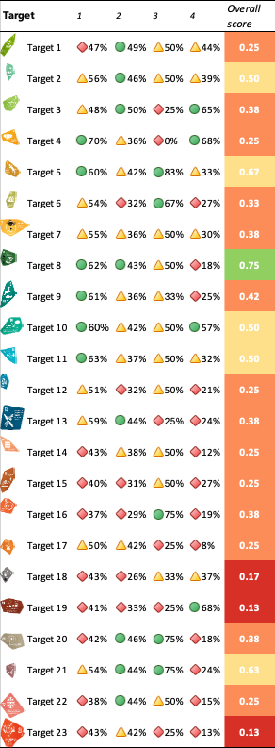
Note: The column entries for each target, with associated percentage values, illustrate the following important measures of progress in implementation of the Framework: column 1: coverage of the elements of the Framework target by Parties’ national targets (percentage of Parties covering at least half of the target elements to some extent); column 2: Parties’ self-assessment of progress towards their national targets (percentage of national targets reported as "on track" or "achieved"); column 3: assessment of progress towards the Framework target based on all of the relevant indicators (percentage based on the average score of all associated indicator types, with details available in table 3); and column 4: data availability in national reports (percentage of Parties reporting some quantitative data on headline, component, complementary or national indicators). The three colours in columns 1 to 4 reflect where a value for each target sits relative to the highest and lowest scores achieved across all targets (the colour green is assigned to values falling within the top third of the total range, yellow to values falling within the middle third and red to values within the bottom third). The overall assessment score is based on a formula that gives a 50 per cent weighting to the self-assessment of progress relative to coverage by national targets and a 50 per cent weighting to the indicator-based assessment of progress. Results derived from this calculation are split into four categories: 0-0.25 (red); 0.25-0.5 (orange); 0.5-0.75 (yellow); and 0.75-1 (green). This relies on a more detailed scorecard which is included as table 3 in section II of the present report. The rationale for the compilation of these scores is briefly explained in box 4 below and the methods are detailed in a note by the Secretariat (CBD/SBSTTA/28/INF/9).
.

Part I: Introduction

I.A Introduction to the Kunming-Montreal Global Biodiversity Framework and the global report

The Framework
In December 2022, the 196 Parties to the Convention on Biological Diversity adopted the Kunming-Montreal Global Biodiversity Framework (dec. 15/4 in CBD, 2023). The Framework constitutes a comprehensive multilateral strategy for achieving the objectives of the Convention, in line with the 2030 Agenda for Sustainable Development and its Sustainable Development Goals (SDGs) (United Nations, 2015). When the Framework was adopted, the Conference of the Parties to the Convention decided that it should be used as a strategic plan for the implementation of the Convention and its Protocols, its bodies and its Secretariat over the period 2022–2030.
The Framework builds on the Strategic Plan for Biodiversity 2011–2020, including the Aichi Biodiversity Targets (dec. X/2 in CBD, 2011), and sets out an ambitious pathway towards realizing a global vision of living in harmony with nature by 2050 (the 2050 Vision). The Framework provides an overarching approach for the urgent and transformative action needed to halt and reverse biodiversity loss. The success of that approach requires the commitment of and actions by all levels of government and all actors of society.
The Framework seeks to address the drivers of biodiversity loss identified in the Global Assessment Report on Biodiversity and Ecosystem Services of the Intergovernmental Science-Policy Platform on Biodiversity and Ecosystem Services (IPBES, 2019), the fifth edition of the Global Biodiversity Outlook (CBD, 2020) and many other scientific documents which provide ample evidence that, despite ongoing efforts, biodiversity is deteriorating worldwide at rates unprecedented in human history.
The Framework includes the 2050 Vision and four outcome-oriented goals for 2050, a mission (the 2030 Mission), and 23 action-oriented targets for action to 2030 to meet those goals (sects. F, G and H of the Framework). The implementation of the Framework is underpinned by 18 cross-cutting considerations (sect. C of the Framework), and a foundation consisting of: implementation and support mechanisms and enabling conditions; responsibility and transparency; and communication, education, awareness and uptake (sects. I, J and K of the Framework) (see figure 2).
The responsibility and transparency component of the Framework (sect. J) is underpinned by effective mechanisms for planning, monitoring, reporting and review. Those mechanisms form an agreed, synchronized and cyclical system which provides the context for the present global report. This system is summarized in the next section (see figure 3).
The Framework promotes complementarity and cooperation between the Convention and its Protocols, the governing bodies of other biodiversity-related conventions and other relevant multilateral environmental agreements and international institutions, while respecting their mandates, and creates opportunities for cooperation and partnerships. Examples of such complementarity are provided in the summaries of collective progress towards each of the targets (sect. II.B below), and in section II.E on the contributions of relevant multilateral environmental agreements and international organizations and processes.
Figure 2
Graphical representation of the Kunming-Montreal Global Biodiversity Framework
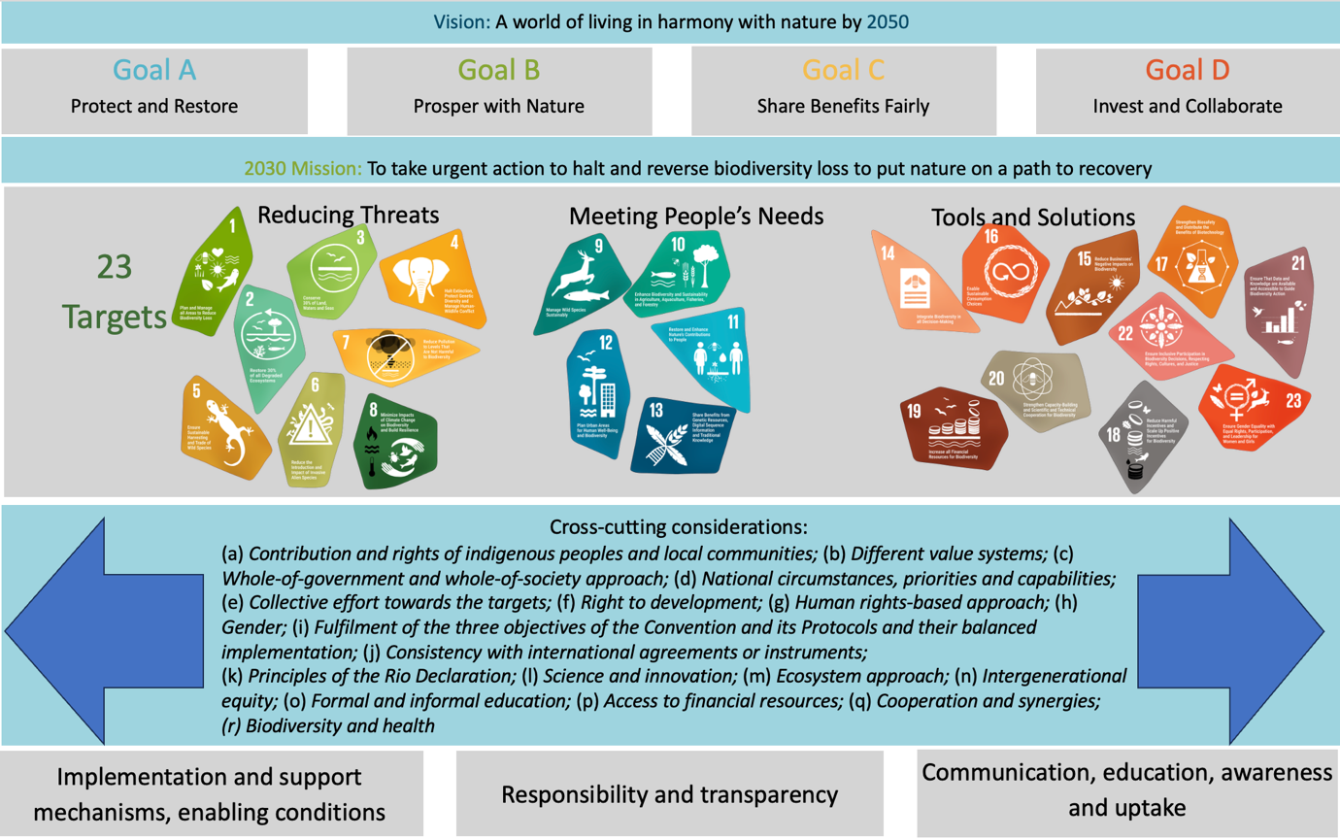

Planning, monitoring, reporting and review
The mechanism established by the Framework to ensure responsibility and transparency has the following key components, which are illustrated in figure 3.
- Planning: at the national level, consisting of revised or updated national biodiversity strategies and action plans (NBSAPs) and national targets aligned with the Framework, defining each Party’s contribution towards the Framework’s targets and the goals (dec. 15/6 in CBD, 2023)
- Monitoring: use of headline and binary indicators, as well as optional component, complementary and additional national or subnational indicators to track progress, as set out in the monitoring framework established alongside the Framework itself (see annex I in dec. 15/5 in CBD, 2023; and annex I in dec. 16/31 in CBD, 2026)
- Reporting: preparation and submission of national reports using a template agreed by the Conference of the Parties, enabling each Party to report on progress in the implementation of its national targets, including submission of data for headline, binary and optional indicators (dec. 15/6 in CBD, 2023; and dec. 16/32 in CBD, 2026)
- Review: global reviews of collective progress in the implementation of the Framework, carried out at the seventeenth and nineteenth meetings of the Conference of the Parties, in 2026 and 2030, respectively, and culminating in recommendations, as necessary, aimed at enhancing actions and efforts to achieve the targets for 2030 and meet the goals for 2050. Each review is informed by a global report on collective progress in the implementation of the Framework, with national reports serving as the primary sources of information (dec. 15/6 in CBD, 2023; and dec. 16/32 in CBD, 2026)

Figure 3
Visualization of the responsibility and transparency component of the Framework, incorporating the mechanism for planning, monitoring, reporting and review (decision 15/6 in CBD, 2023)
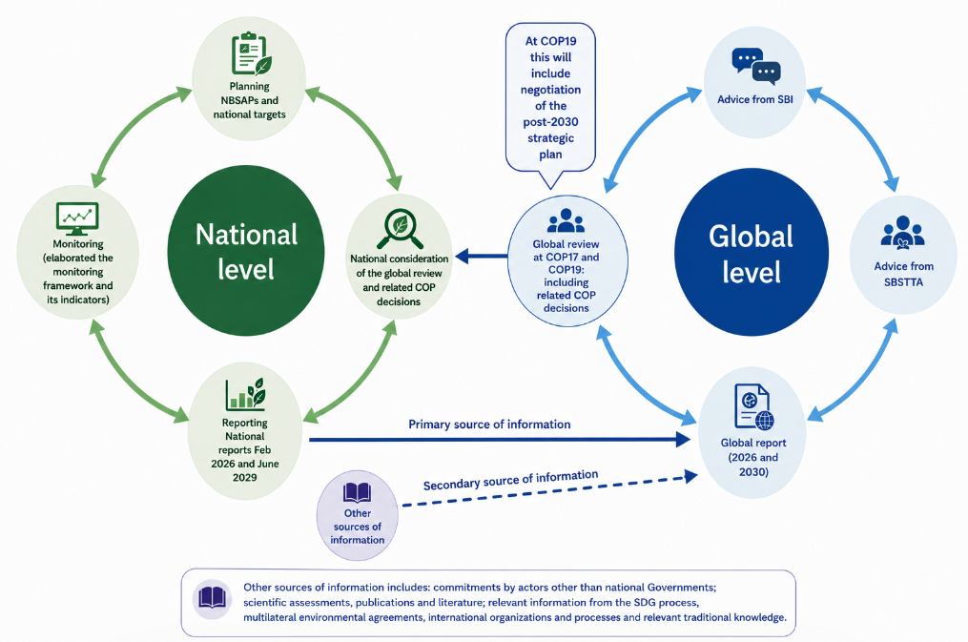

Box 1
Monitoring framework for the Kunming-Montreal Global Biodiversity Framework

An important innovation relating to the Framework, which distinguishes it from the Strategic Plan for Biodiversity 2011–2020, was the concurrent adoption of an agreed monitoring framework to measure collective progress towards the targets and goals (dec. 15/5 in CBD, 2023; and dec. 16/31 in CBD, 2026). Developed by consensus alongside the Framework itself and subject to further adjustment, the monitoring framework includes an agreed set of headline and binary indicators which should be used by all Parties to enable consistent reporting and analysis of collective progress.
The monitoring framework includes five types of indicators:
- Headline indicators. represented by a set of 27 high-level indicators capturing the overall scope of the goals and targets of the Framework. They can be calculated using national data or global data sources validated by Parties (which themselves often include national data reported through other global processes) and are relevant at national, regional and global scales
- Binary indicators, represented by a set of 15 global-level indicators collated from binary and categorical responses to questions included in the national reporting template and thus providing a count of the number of Parties having undertaken certain activities relevant to a particular target
- Optional component indicators (a list of 54) that, together with the headline indicators, cover components of the goals and targets of the Framework, which may apply at global, regional, national and subnational scales
- Optional complementary indicators (a list of 120) for thematic or in-depth analysis of each goal and target, which may be applicable at global, regional, national and subnational scales
- Additional national or subnational indicators which may be used by Parties to supplement the monitoring framework
The monitoring framework provides a standardized architecture for reporting on progress towards national targets, using the reference period 2011–2020 where data are available, enabling assessment of trends, aggregation of national information and the formation of a consistent evidence base for national reporting and contributing to a global analysis of collective progress (Affinito and others, 2024).

Purpose of the global report
The aim of the global report is to provide an overview of collective progress towards the implementation of the Framework since its adoption, through the analysis of:
- Collective ambition: collation of planned actions by Parties and other actors as communicated through the submission of NBSAPs, associated national targets and commitments from actors other than national Governments
- Collective implementation: progress made towards implementing the Framework based on national reports as the primary sources of information, supplemented with additional sources as agreed by Parties (see figure 4)
- Challenges, gaps and opportunities related to implementation of the Framework
- Non-prescriptive approaches: options for addressing challenges, gaps and opportunities, with a view to making collective progress in the implementation of the Framework

Figure 4
Visualization of the way in which the ambition of Parties as set out in national targets, and implementation as described in national reports, contributes to collective progress in the implementation of the Framework
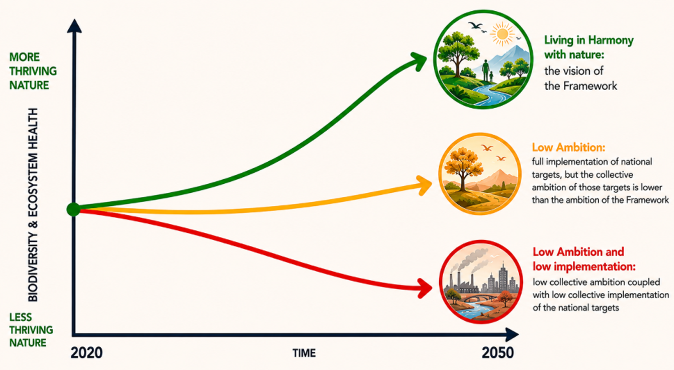

The global report builds upon the experiences gained in producing the five editions of the Global Biodiversity Outlook and serves to complement rather than duplicate the work of other bodies such as IPBES (see box 2). While the report does not provide a comprehensive assessment of the status of, or trends in, biodiversity based on the scientific literature, a concise summary of status and trends is provided in section I.B. In keeping with its mandate (dec. 15/6 in CBD, 2023; dec. 16/32 in CBD, 2026; and rec. 27/1 in CBD, 2025a), the report does not single out individual countries or regions to evaluate their relative progress against the goals and targets of the Framework, nor does it offer any comparisons or rankings involving individual Parties or actors. The report does, however, highlight individual Parties and actors for the purpose of illustrating examples of success or progress in implementation of the Framework, utilizing the format of short case studies. While the global report does not provide recommendations, it does provide an evidence base, including non-prescriptive approaches, to support decision-making under the Convention.

Box 2
History of global reports under the Convention and linkages with the assessments of the Intergovernmental Science-Policy Platform on Biodiversity and Ecosystem Services

The Global Biodiversity Outlook (GBO) was developed prior to the establishment of the Intergovernmental Science-Policy Platform on Biodiversity and Ecosystem Services (IPBES). There have been five editions of the publication (CBD, 2001, 2006a, 2010, 2014a and 2020), which provides an assessment of progress in implementing the Convention. While national reports were used in the drafting process of the publication, the assessment of global progress was reliant largely on the scientific literature and independent analyses. This stemmed from challenges in aggregating information based on national reporting, owing to the lack of a standardized reporting mechanism, lack of clarity in the relationships between national and global targets and the absence of a common monitoring framework. The most recent edition of the Outlook (CBD, 2020), which was released one year after the release of the first IPBES Global Assessment Report on Biodiversity and Ecosystem Services (IPBES, 2019), provided a final evaluation of the level of achievement of the Aichi Biodiversity Targets, as well as set out future options for “bending the curve” of biodiversity loss.

The global report on collective progress in the implementation of the Framework builds on the experiences of producing the five editions of the Outlook and does not duplicate the work of IPBES. While IPBES conducts scientific assessments, the global report includes only a concise overview of the global status of, and trends in, biodiversity (see sect. I.B), which itself draws substantially on the findings of IPBES. The global report focuses its analysis on information submitted by Parties relating to implementation of the Framework, complemented by inputs from other actors and relevant information sources.

For the second global review of the Framework in 2030, the Conference of the Parties at its nineteenth meeting will have available both the second global report on collective progress in the implementation of the Framework and the second global assessment of biodiversity and ecosystem services of IPBES. Thus, during the final review of the Framework, the Conference of the Parties will have before it both an up-to-date analysis of progress in implementation (in the second global report on collective progress in the implementation of the Framework) and a robust scientific assessment of the status of biodiversity and ecosystem services (in the IPBES second global assessment).

The global report is the primary source of information, alongside the seventh national reports under the Convention, for the first global review of progress in the implementation of the Framework, to be conducted at the seventeenth meeting of the Conference of the Parties in Yerevan, Armenia, in October 2026. During the review process, the Conference of the Parties will provide recommendations, as necessary, based on the global report as well as the national reports, related to the achievement of the goals and targets of the Framework. Moreover, Parties may take the outcome of the global review into account in future revisions and implementation of their NBSAPs, including with respect to the provision of the means of implementation, with a view to improving actions and efforts, as appropriate. Particular attention has been paid to the specific challenges faced by developing country Parties, in particular least developed countries and small island developing States. This first global report marks an important milestone in operationalizing the planning, monitoring, reporting and review mechanism of the Framework, while providing valuable lessons to strengthen future global reports and reviews.

Global report sources and methodology
While the national reports are the primary source of information for the global report, there are a number of complementary sources of information which have been used in its development. The information sources for the global report were specified in paragraph 18 of decision 16/32 (CBD, 2026) in which the Conference of the Parties set out the details of the global review process. Box 3 provides a list of those information sources, together with references to where the original information may be found.

Box 3
Sources of information in the global report, as specified by the Conference of the Parties in paragraph 18 of decision 16/32 (CBD, 2026)

At its sixteenth meeting, the Conference of the Parties agreed on a list of sources of relevant information that should be drawn upon in the preparation of the global report. Those sources, along with their locations, are listed below.

Sources Location
(a) As the primary source, national reports submitted in compliance with Article 26 of the Convention and in line with decision 15/6 of the Conference of the Parties (CBD, 2023); | Convention’s online reporting toolª
(b) Analysis of the usage of the headline, binary, component and complementary indicators and of national indicators in national reports; | CBD/SBSTTA/28/INF/11
(c) Global analysis of information in national biodiversity strategies and action plans and national targets provided pursuant to paragraph 15 of decision 15/6 (CBD, 2023); | CBD/SBI/6/INF/5
(d) The five editions to date of the Global Biodiversity Outlook and the two editions of the Local Biodiversity Outlook; | (CBD, 2001, 2006a, 2010, 2014a,2020; and Forest Peoples Programme and others, 2016, 2020)
(e) Assessments, reports and deliverables of IPBES and other relevant intergovernmentally reviewed scientific assessments and reports, including those of the Intergovernmental Panel on Climate Change and other science-policy platforms of the United Nations; | Referenced individually in this report
(f) Relevant national, regional and international scientific and technical assessments, including subregional and regional assessments; | Referenced individually in this report
(g) Reports on means of implementation, including those of the Council of the Global Environment Facility on progress related to the Global Environment Facility Trust Fund and the Global Biodiversity Framework Fund; | CBD/SBI/7/INF/13; referenced individually in this report CBD
(h) Other relevant scientific and technical peer-reviewed studies in the literature; | Referenced individually in this report
(i) Reports of the regional and subregional dialogues; | CBD/SBI/6/INF/6
(j) Information on commitments made by actors other than national Governments towards the Framework, including disaggregated information on contributions from indigenous peoples and local communities, women and youth; | The Convention online reporting toolª
(k) Relevant information from the secretariats of biodiversity-related conventions and other relevant multilateral environmental agreements and international organizations and processes, including reports submitted under related conventions and on the Sustainable Development Goals; | Responses to notification No. 2025-099^{b}
(l) Relevant traditional knowledge, innovations, practices and technology of indigenous peoples and local communities that are given access to with their free, prior and informed consent. | Responses to notification No. 2025-100^{c}

ª Available at: https://ort.cbd.int/.
^{b}Available at: www.cbd.int/notifications/2025-099.
^{c}Available at: www.cbd.int/notifications/2025-100.

There is a strong foundation of evidence for the global report, which takes account of submissions provided in time to be considered for analysis in the global report of: NBSAPs from 43 per cent of Parties to the Convention; almost 3,700 national targets from 83 per cent of Parties; and national reports by 66 per cent of Parties. Details of the status of submissions by Parties are set out in section II.A. In addition, the report considers more than 180 commitments from actors other than national Governments; 28 submissions from secretariats of multilateral environmental agreements, United Nations bodies, other intergovernmental organizations, non-governmental organizations and research networks; and 52 submissions (from 14 Parties and 38 observers) of case studies on relevant traditional knowledge, innovations, practices and technology of indigenous peoples and local communities.
Complete details of the methodologies used in the preparation of the different sections of the global report, and an analysis of the way in which Parties used indicators in their national reports, are set out in separate documents: CBD/SBSTTA/28/INF/9 and CBD/SBSTTA/28/INF/11, respectively. Figure 5 sets out the workflow associated with the different data sources and methodologies used and illustrates how they relate to each section of the report. Whenever other sources of information (i.e. sources not taken from Party submissions to the online reporting tool) have been used, the relevant citations are provided in the report. Where data from other sources, including national data reported to other global processes, were used in the analysis of headline indicators, those data are presented separately from national data.
Part II of the global report encapsulates the major part of the analysis, based on Party submissions, carried out to synthesize collective progress in implementation. Section II.A of the report relies on a qualitative text analysis described in detail in section A of the annex to the methodological document, and section II.B follows a systematic methodology to analyse every target of the Framework. All methodologies were developed in consultation with the Ad Hoc Scientific and Technical Advisory Group for the Preparation of the Global Report (AHSTAG). For every target, the report contains:
- A textual analysis of the national targets submitted by Parties to determine how they covered collectively the overall scope and ambition of the targets of the Framework. In that analysis, the text of each national target was compared with all of the elements contained in the Framework target to ascertain to what extent those elements were reflected in the text of the national target. The percentage of Parties with national targets that addressed each element at least to some extent was then calculated. The exact criteria used to determine coverage are found in section C of the annex to the methodological document
- An analysis of the use of indicators by Parties. For every headline indicator, the percentage of Parties submitting data out of the 129 Parties for which data were available was calculated and the number of Parties for which indicator data were used in each subsequent indicator analysis was computed. Further information on indicator use was analysed and published in a separate document (CBD/SBSTTA/28/INF/11)
- An analysis of collective progress based on aggregation of comparable headline indicator submissions. For every headline indicator, the Ad Hoc Scientific and Technical Advisory Group provided guidance on approaches to aggregation which were used to measure collective progress. This methodology was dependent on each indicator’s metadata and affected by differences in Party submissions. The full aggregation methods are found in sections C and D of the annex to the methodological document and a discussion of methodological challenges encountered are found in the above-referenced review of the use of indicators in seventh national reports (CBD/SBSTTA/28/INF/11)
- An analysis of responses for the binary indicators submitted by Parties in their national reports, using the methodology established by the Ad Hoc Technical Expert Group on Indicators for the Kunming-Montreal Global Biodiversity Framework to derive an overall progress score (CBD/COP/16/INF/3/Rev.1). The progress score is based on the combination of answers to individual questions and ranges from 0 (signifying no measures are in place) to 5 (signifying all measures are fully in place)
- An analysis of the trend of all quantitative indicators within the monitoring framework submitted by Parties (headline, component, complementary and national indicators) to determine whether those indicators were moving in a direction favourable or unfavourable to the achievement of each target. That analysis used a methodology (described in sect. D of the annex to the methodological document) that combined time series from multiple indicators to produce an overall percentage of indicators showing improvement. That percentage was weighted by the number of indicators submitted by each Party for a Framework target to ensure equal contributions to progress from all submitting Parties
- An evaluation of the overall level of self-assessed progress towards all highly aligned national targets. In their national target submissions, Parties were asked to state to which target or targets of the Framework each national target was aligned and, in each case, whether the alignment was low, medium or high. That information was used for the purpose of including only highly aligned targets (further information in that regard is contained in sect. E of the annex to the methodological document). In their national reports, Parties used a Likert scale, with categories ranging from “no change” to “achieved”, to rank their own estimates of progress towards national targets. On that basis, the percentage of national targets in each progress category, weighted by Party to ensure the equalization of the contributions of Parties with many targets with the contributions of Parties with few targets, was calculated
- An analysis of text components of the national reports which was carried out through a semantic analysis of the relevant sections of national reports. The analysis relied on structured data extraction, semantic processing, ontology supported evidence retrieval and large language model-assisted analysis, followed by verification and validation. The detailed methodology for that approach is found in section F of the annex to the methodological document. Moreover, case studies providing examples of success and progress in implementation (see sect. G of the annex to the methodological document) were identified and co-developed with Party focal points and relevant organizations
- A synthesis of the contributions from actors other than national Governments, which includes (a) a prompt-guided artificial intelligence text analysis of commitments made directly through the Convention’s online reporting tool (see sect. B of the annex to the methodological document) and (b) a qualitative summary of the contributions of those actors, as described by Parties in their national reports
- A synthesis of other submissions in response to requests for information on case studies on relevant traditional knowledge, innovations, practices and technology of indigenous peoples and local communities, as well as other information on activities aimed at engaging and supporting indigenous peoples and local communities in implementing the Framework; and on the contributions of the secretariats of other relevant multilateral environmental agreements and of other relevant organizations and processes
Like section II.B of the global report, section II.C follows a systematic methodology developed in consultation with the AHSTAG for all of the goals in the Framework. For each goal, the report contains:
- An analysis of how Parties associate Framework targets with goals in their national implementation of the Framework. The analysis was conducted on the basis of national targets submitted by Parties that related Framework goals to those targets. The Party-weighted percentage of national targets associating a Framework target to a goal was used to identify those Framework targets most associated with each goal. The detailed methodology for that approach is found in section H of the annex to the methodological document
- The same analysis of indicators (use and status and trends) as for section II.B
- An analysis of the types of actions for making progress towards the goals of the Framework, as reported by Parties. This was carried out through a semantic analysis of the relevant sections of national reports, which relied on structured data extraction, semantic processing, ontology-supported evidence retrieval and large language model-assisted analysis, followed by verification and validation. The detailed methodology for that approach is found in section F of the annex to the methodological document
Part II.D of the report uses a structured keyword search based on a pre-existing typology of terms related to means of implementation (CBD/SBI/6/INF/5). That natural language processing approach was applied to the text of all national reports included in the global report and results were summarized then validated using both semantic analysis and manual checks. The detailed methodology for the approach is found in section I of the annex to the methodological document.
Part II.E of the report is based upon a review and synthesis of submissions provided in response to notification No. 2025-099 seeking information from the secretariats of biodiversity-related conventions and other relevant multilateral environmental agreements and from international organizations and processes, as well as other sources consistent with the mandate for the global report established by the Conference of the Parties (dec. 16/32 in CBD, 2026).
Part III of the report summarizes and synthesizes the findings of part II. In that regard, a relative scoring methodology was developed to enable systematic assessment and comparison of progress in implementation across the targets of the Framework. Through application of that methodology, the results of the analyses described above can be used to highlight differences in implementation based on national target coverage, self-assessed progress, data use and indicator results. Specifically, an overall score can be calculated for each component in order to rank Framework targets relative to the highest and lowest scores achieved across the targets (see figure 1, box 4, tables 3 and 56 and sect. J of the annex to the methodological document SBSTTA/28/INF/09). Those scores are then used to determine an overall score for each target which is calculated as an equal average of two measures: a combined coverage and self-assessed progress score; and a combined indicator results score subsequently split into four score categories. The key messages and overall conclusions of the report were co-developed with the AHSTAG and are based on the findings set out in the previous sections.

Figure 5
Methodological flow diagram for the preparation of the global report
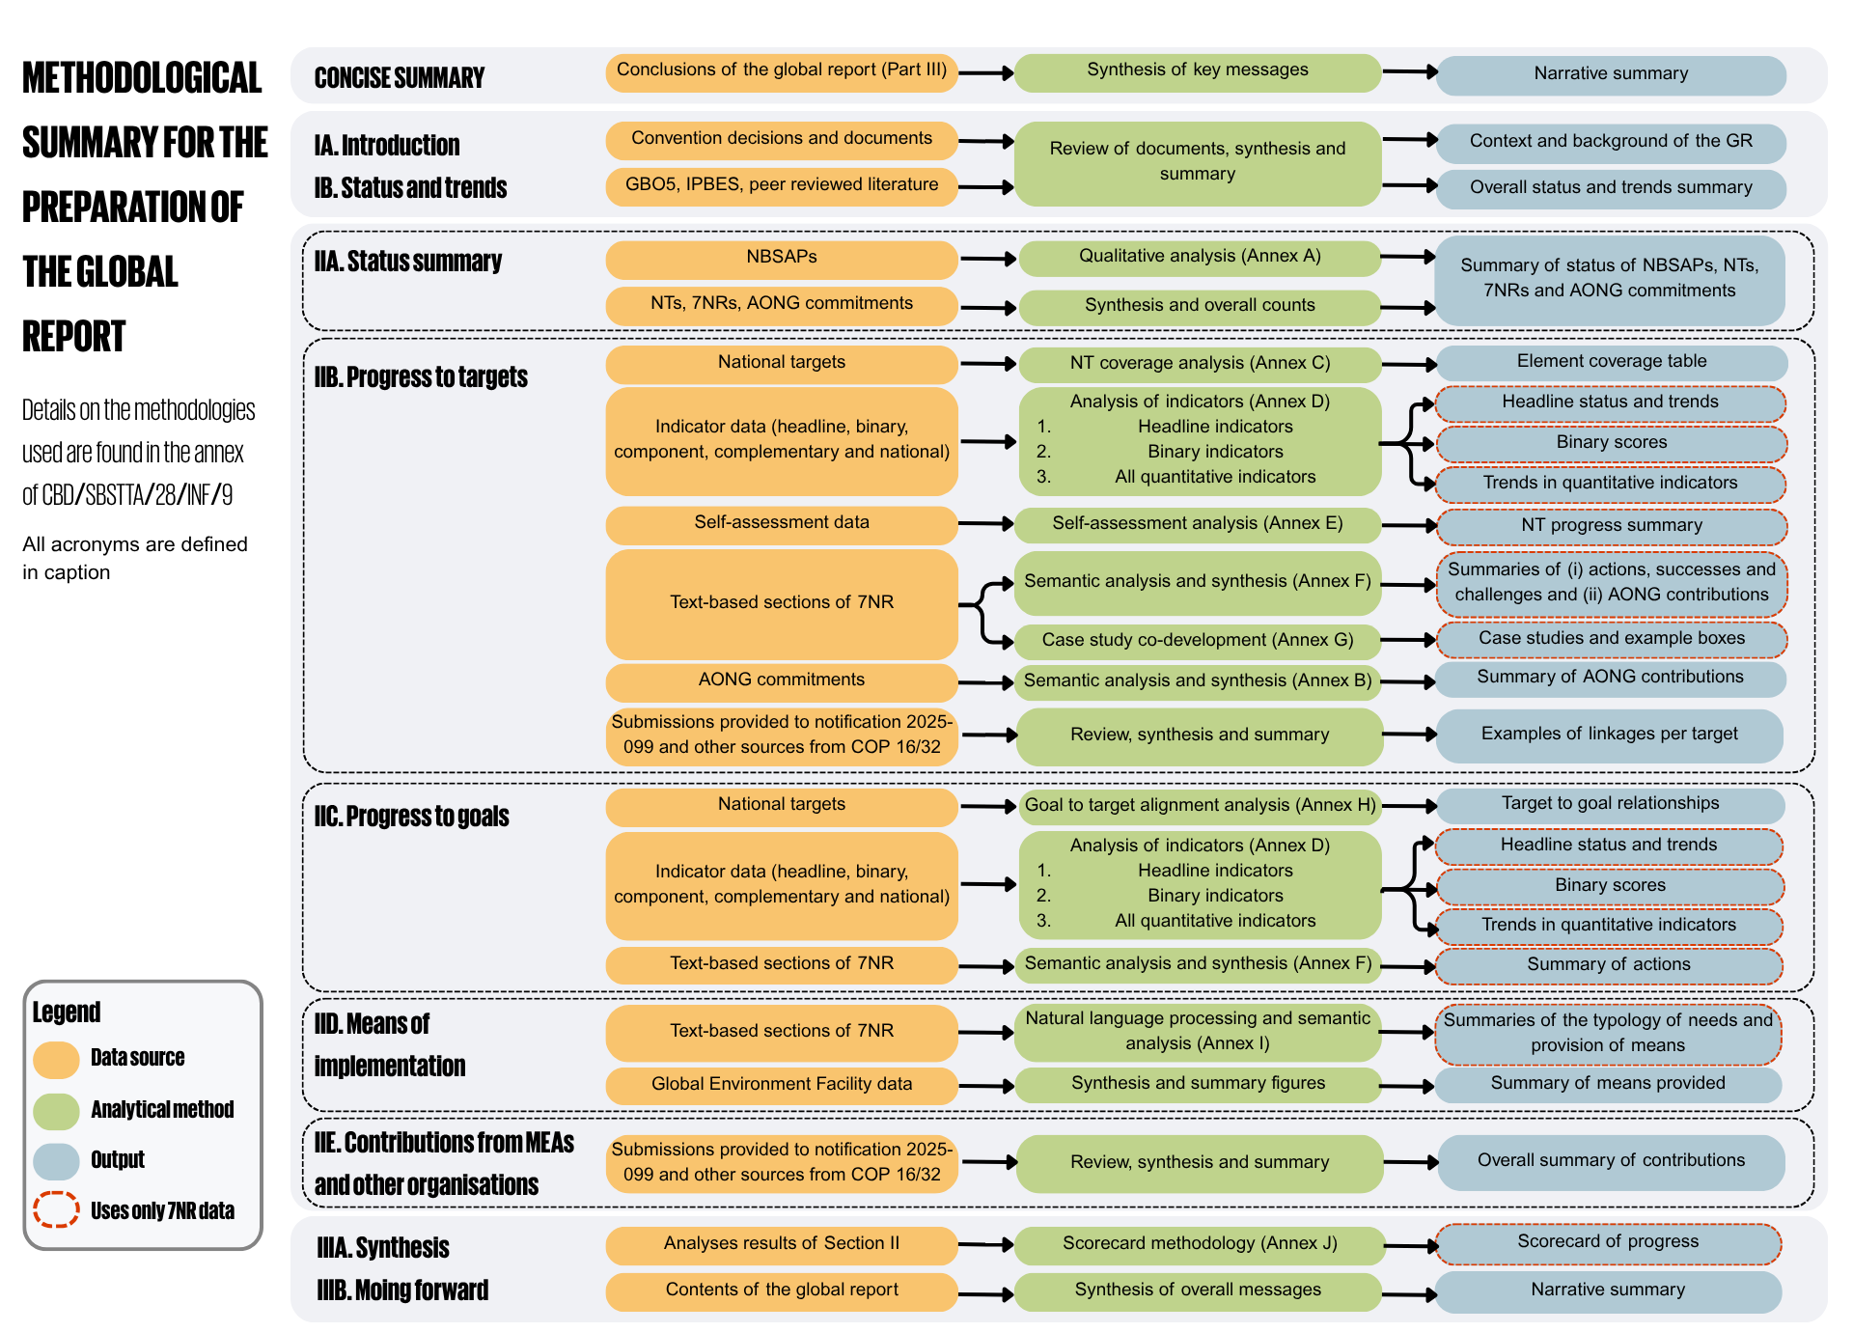
Note: The figure highlights, for each section of the global report, the information and data that were used, how they were used and how they relate to the content of the report. Abbreviations: GBO5, fifth edition of the Global Biodiversity Outlook; GR, global report; IPBES, Intergovernmental Science-Policy Platform on Biodiversity and Ecosystem Services; NBSAPs, national biodiversity strategies and action plans; AONG, actor other than national Government; NTs, national targets; 7NRs, seventh national reports.

Box 4

Understanding the assessment of progress in implementation: how the assessment of Framework targets relates to implementation of the Framework and progress towards the 2050 goals

The global report has the mandate to provide “a summary of collective progress in implementation across all 23 targets, emphasizing areas of relative strengths and weakness in implementing the Framework”. National implementation of the Framework is achieved through implementation of national targets. If national targets are well aligned with the global targets of the Framework, then progress towards national targets should contribute to collective progress towards the global targets. In parallel, indicators in the monitoring framework for the Framework were designed to be able to capture both progress in implementation of national targets and progress towards the global targets when national data were aggregated. The following four metrics used in the report are consequently important for assessing overall progress in implementation of the Framework: (a) coverage of the scope of Framework targets by national targets; (b) Parties’ self-assessed progress towards national targets; (c) indicator values and trends that, in aggregate, show progress towards global targets based on national data; and (d) the quantity of indicator data reported by Parties (i.e. the number of headline, binary, component and national indicators provided by Parties per target). The entries in columns 1 to 4 of the summary scorecard (table 1) illustrate the relative values of these metrics across the targets of the Framework.
These metrics are related to progress in two different ways:

1. Parties’ self-assessed progress towards national targets can translate into progress towards global targets if the national targets cover the global targets effectively. When coverage is high and progress towards national targets is good, progress towards global targets can be expected to occur. However, if coverage by national targets is low, progress towards the global targets will be limited even if self-assessed progress is high. Combining coverage and self-assessed progress consequently provides a first summary measure of expected collective progress.

2. While relevant indicator values and trends measure realized collective progress towards each target, it should be noted that changes in biodiversity outcomes arising from implementation of the Framework will require time to be detectable (see figure 6). moreover, the ability to measure collective progress towards any target depends on the representativeness of the indicator data submitted. Where few data are available, it is unlikely that indicator values and trends will reflect collective progress. As the inverse is also true, any measure of progress as measured by indicators must be interpreted in the context of the quantity of data available for those indicators so as to ensure that representativeness is considered.

Through its joint analysis of coverage of global targets by national targets, self-assessed progress, measured indicator values and trends and data availability, the global report is able to provide a relative assessment of collective progress towards each global target of the Framework. The relative assessment has been used to develop the colour schemes for the scorecards in the report.

The methodology for this approach and the calculations related to the colour schemes are briefly explained in the more detailed scorecard (table 56) and a full methodology for scoring is available in document SBSTTA/28/INF/09. While the overall colour coding does not represent an absolute measure of progress, it does help identify those targets that are facing the greatest implementation challenges, as it displays where relative lack of progress is of the highest concern. This assessment does not, however, imply that there are no implementation-related challenges for targets scoring relatively high.

At this early stage in implementation, it is too soon to assess whether progress towards the global targets is translating into progress towards the global goals. Global trends in biodiversity change are slow and detectable only over long time periods. In their submissions, however, Parties have related their national targets to both global targets and global goals. By mapping how Parties relate targets to goals, it is therefore possible to identify those targets that are seen as most relevant to each goal and summarize the progress made towards those targets specifically. If there are significant barriers to implementation for the targets mapped to a goal, then it is assumed that a lack of progress towards the targets will correspond to a lack of progress towards the goal mapped to those targets. It is not possible with this method, however, to state confidently the specific level of progress towards a goal.

Yet, according to the logic of the Framework, achievement of the 2030 mission through achievement of the targets will be necessary for achievement of the 2050 vision and its goals. Pursuant to that logic, through analysis of current progress towards the targets, some degree of information can be gleaned about progress towards the goals. Specifically, if the targets are not on track, then it is likely that the goals are not on track either.

Once implementation of the Framework has reached a more advanced stage, it should be possible to improve the assessment of collective progress towards the global goals through application of improved methods to better data.

Limitations and methodological assumptions

While the number of national reports received by the February 2026 deadline was higher than for any previous reporting cycle under the Convention, several challenges limited both the quantity and the completeness of national submissions. As described in section II.A below, delays in accessing and receiving financial support for the preparation of NBSAPs, national targets and national reports delayed the process for a number of Parties, although only a minority of Parties did not make their submissions by the relevant deadlines because of the factor of financial support.
Indeed, during the regional and subregional dialogues on biodiversity monitoring and reporting, Parties highlighted a number of other challenges related to the development of their NBSAPs, national targets, and national reports (CBD/SBI/6/INF/6), in particular:
- The length of time required for consulting all stakeholders involved, among other barriers to the inclusion of information from stakeholders
- The length of time required to complete bureaucratic processes
- The reporting burden created by having to report to many different multilateral environmental agreements and other processes, especially when compounded by a shortage of human resources
- Other delays related to specific national contexts
- The complex nature of both the Framework and the information needed to describe the national targets fully and report on their implementation
- Gaps in the coverage of national monitoring systems or in the technical capacity for monitoring, including gaps related to reporting on the headline indicators
As a result of those challenges, while the majority of Parties were able to submit national targets and national reports, some of the textual descriptions and indicator data were incomplete. In addition, the rate of submission of national reports varied across regions (see table 1). This created a number of challenges and limitations with respect to the analysis undertaken for the first global report, which should be taken into account when its findings are considered. Those challenges included:
- Uneven reporting across regions. The submission rates for national reports were not consistent across regions. In particular, the submission rates were low for Eastern Europe, the Caribbean and Pacific island States (see table 1).
- Lack of context for national targets and national reports, in particular for those Parties without revised NBSAPs. Fewer than half of Parties submitted revised NBSAPs aligned with the Framework
- Limited detail in some national targets and national reports. While some of the information submitted by Parties was highly detailed, a number of Parties provided information that was very limited in detail. Between 5 and 10 per cent of the submitted national targets did not include any detailed information (CBD/SBI/6/INF/5)
- Varied use of indicators and monitoring gaps. The data submitted in the national reports varied greatly, as did the number of years of data, with the majority of submissions including data only between 2020 and 2024. In most cases, data for 2011–2020, the reference period established in the monitoring framework, were not available. Moreover, many Parties used different methodologies and approaches for reporting data. Further information in that regard is included in the study conducted by the Secretariat of the Convention on the use of indicators (CBD/SBSTTA/28/INF/11).
- Limited submissions and information received from actors other than national Governments. The portal for those commitments was a new initiative launched only in early 2026, shortly before the drafting of the present report. While there has been a high level of interest, the number of submissions with a sufficient amount of information for analysis remains limited and a learning curve has been associated with the launching of the platform

Furthermore, it is not possible through the global report to detect change in the status of and trends in biodiversity since the adoption of the Framework for at least two key reasons. First, only four years have passed since the adoption of the Framework, and the response of biodiversity and ecosystem functions and services may take years or decades to become evident following a positive management intervention (Moreno-Mateos and others, 2017). Second, monitoring and reporting systems introduce their own delays in detecting and interpreting change. Biodiversity indicators often depend on irregular field monitoring, analysis of remotely sensed data, maintenance of up-to-date data management systems and the aggregation of data into variables or indicators, all of which can introduce time lags between ecological change and the monitoring of that change (Nicholson and others, 2021) (see figure 6).
It should be noted that it was not possible, within the time frame for preparation of the global report, to conduct an extensive literature review for any section.
Figure 6
Visualization of the biodiversity recovery time lag

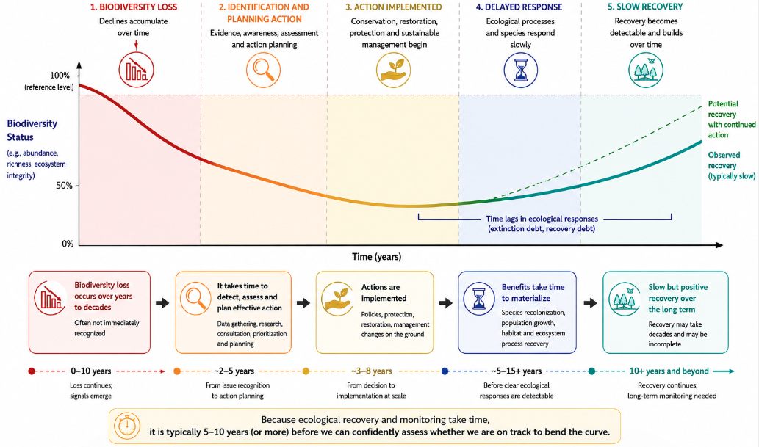
For the reasons mentioned above, it is too early for progress to be evaluated, through the global report, towards the biodiversity outcomes described in the Framework’s goals for 2050 and some of the targets (see box 4). To the extent possible from available indicators, progress is reported towards the action-oriented targets for 2030, whose achievement is necessary for meeting the goals (see sect. II.B). The connections between the targets and the goals and some of the implications of present levels of progress are explored in section II.C. Overall, the report helps to establish a baseline upon which future progress towards the 2050 Vision can build.
Throughout the report, as a means of acknowledging the gaps and biases in reporting, presentation of the analysis is transparent with respect to describing the number of Parties submitting information on each target and indicator and the relative representation of each regional group of United Nations Member States.

I.B Global status and trends
In the 2019 Global Assessment Report on Biodiversity and Ecosystem Services of the Intergovernmental Science-Policy Platform on Biodiversity and Ecosystem Services, it was concluded that, despite decades of conservation and environmental policies, nature and its contributions to people had continued to deteriorate worldwide (IPBES, 2019). As recognized in the Framework, it was stated in the global assessment report that:
- An average of about 25 per cent of species in assessed animal and plant groups are threatened with extinction, suggesting that about 1 million species already face extinction, many within decades, unless action is taken to reduce the intensity of drivers of biodiversity loss. Without such action, there will be a further acceleration in the global rate of species extinction, which is already at least tens to hundreds of times higher than it averaged over the past 10 million years
- The biosphere, upon which humanity depends, is being altered to an unparalleled degree across all spatial scales. Biodiversity – the diversity within species, between species and of ecosystems – is declining faster than at any time in human history
- Nature can be conserved, restored and used sustainably while other global societal goals are simultaneously met, through urgent and concerted efforts fostering transformative change
- The direct drivers of change in nature with the largest global impact are (starting with those with the most impact) changes in land and sea use, direct exploitation of organisms, climate change, pollution and invasion of alien species. Those five direct drivers have resulted from an array of underlying causes, the indirect drivers of change, which are, in turn, underpinned by social values and behaviour. The rate of change in the direct and indirect drivers differs among regions, countries ecosystems and biomes
In 2020, the fifth edition of the Global Biodiversity Outlook (GBO-5) (CBD, 2020) presented a final review of the implementation of the Strategic Plan for Biodiversity 2011–2020 and its Aichi Biodiversity Targets, including its achievements, gaps and lessons learned. The key messages of GBO-5 were that, despite the efforts of Parties to implement the strategic plan at the global level, none of the 20 Aichi Biodiversity Targets agreed to by Parties to the Convention in 2010 had been fully achieved, although six targets had been partially achieved; that biodiversity continued to decline; and that the pressures upon it continued to increase (see figure 7).
Figure 7
Final evaluation of achievement of and progress towards the Aichi Biodiversity Targets
Source: Fifth edition of the Global Biodiversity Outlook (CBD, 2020)
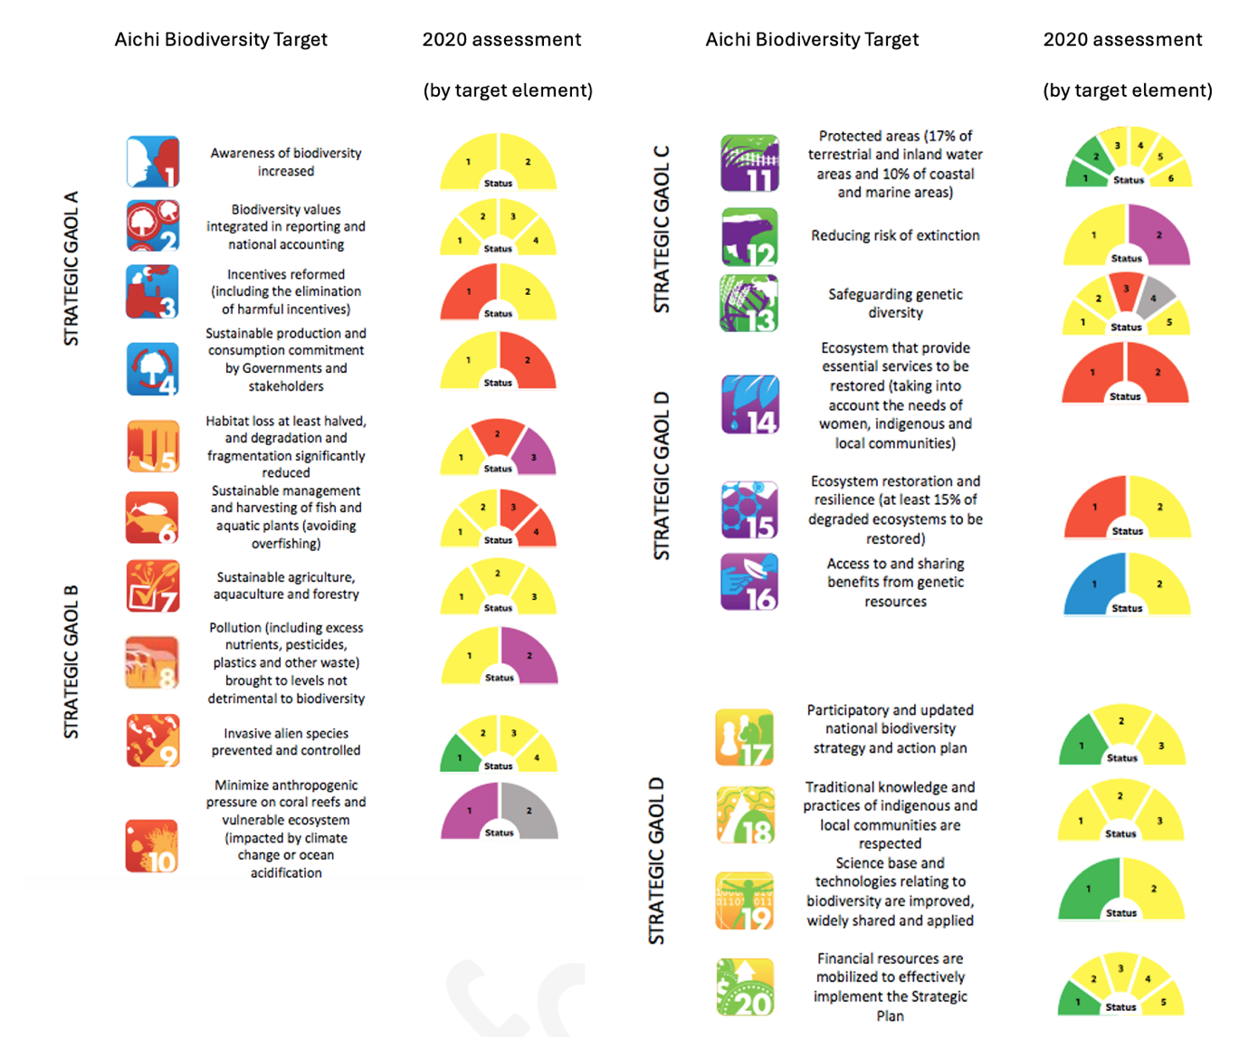
Note: Green colours indicate where an element of the target had been achieved; yellow, where progress had been made but insufficient to achieve the target; red, where no progress had been made; purple, where trends were moving away from the target; blue, where the element had been achieved beyond the target; and grey, where there was insufficient evidence to make an assessment. A target was said to be fully achieved if all elements were achieved (i.e. all segments were green or blue) and partially achieved if at least one element was achieved (i.e. at least one segment was green or blue).
All six of the thematic and methodological assessments that have been adopted by IPBES since the publication of the global assessment report in 2019 include evidence that biodiversity is continuing to decline. Those assessments provide objective evidence on the status of and trends in biodiversity, as well as policy-relevant tools and guidance which can support decision making, including decisions under the Convention. The importance of the IPBES assessment reports for the work under the Convention has been well recognized by the Conference of the Parties (see dec. XI/13 in CBD, 2012; dec. XII/25 in CBD, 2014b; dec. 14/36 in CBD, 2019; dec15/9 in CBD, 2023; and dec. 16/11 in CBD, 2026).
The overall picture, based on all of the IPBES assessments conducted, is clear: despite heterogeneity across regions, countries, ecosystems and biomes, biodiversity decline is continuing; nature’s contributions to people, including ecosystem functions and services, are being weakened; and the direct and indirect drivers of biodiversity loss have not been sufficiently addressed (see box 5). However, biodiversity loss is not presented as inevitable in the assessment reports, which provide potential solutions and further strengthen the case for urgent and transformative action.
While there is scientific evidence that biodiversity loss has continued, there is also evidence that it is not too late to change this trend (Kok and others, 2023; Leadley and others, 2022; and Leclère and others, 2020), and that conservation and restoration actions typically have positive impacts, compared with alternative scenarios in which such actions were not taken (Langhammer and others, 2024). The Framework was developed to identify specific actions that would halt and reverse biodiversity loss.

Box 5

IPBES assessment reports published since the adoption of the Framework

The Methodological Assessment Report on the Diverse Values and Valuation of Nature of the Intergovernmental Science-Policy Platform on Biodiversity and Ecosystem Services (IPBES, 2022) provided evidence on why biodiversity continued to decline despite extensive scientific evidence of the problem. A conclusion of the values assessment was that without changes in the way societies defined value, progress and development, better data and information alone would not result in a shift towards addressing biodiversity loss. The assessment report provided policy options for facilitating a shift in values and jointly addressing biodiversity loss and societal inequalities.

The Thematic Assessment Report on the Sustainable Use of Wild Species (IPBES, 2022b) demonstrated that billions of people depended directly on wild species for food, energy, materials, medicine, income and cultural practices. For example, the sustainable use assessment highlighted that one in five people relied on wild species for income and food, more than 10,000 wild species were harvested for human food and approximately 2.4 billion people depended on fuelwood for cooking. Moreover, the assessment provided a summary of the ways in which people benefited from biodiversity and ecosystem services, considered the risk to human health and well-being if nature’s contributions to people declined and presented options for improved management.

In the Thematic Assessment Report on Invasive Alien Species and their Control (IPBES, 2023a), it was confirmed that the pressure from that driver of biodiversity loss was increasing. Invasive alien species, which are one of the five major direct drivers of biodiversity loss identified in the IPBES Global Assessment Report, have contributed to species extinctions, ecosystem degradation and major economic costs. The risk presented by invasive alien species continues to escalate owing to increasing trade, transport, land-use change and climate change. The invasive alien species assessment provided a tool kit for reducing the risks and impacts caused by invasive alien species.

The Thematic Assessment Report on the Underlying Causes of Biodiversity Loss and the Determinants of Transformative Change and Options for Achieving the 2050 Vision for Biodiversity (IPBES, 2024a) built on the IPBES Global Assessment Report by elaborating the ways in which transformative change was needed for better biodiversity outcomes. In the transformative change assessment, it was concluded that biodiversity continued to decline and that biodiversity loss could not be addressed through marginal adjustments alone. What was required was transformative change in the systems that drove biodiversity decline, including food, energy, infrastructure, finance, trade and governance systems. In the transformative change assessment, it was found that promoting and accelerating transformative change were essential for meeting the 23 targets and the four goals of the Framework and achieving the 2050 Vision for Biodiversity. The assessment provided policy relevant guidance on fostering transformative change.

The IPBES Thematic Assessment Report on the Interlinkages among Biodiversity, Water, Food and Health (nexus assessment) (IPBES, 2024b) further reinforced the awareness that biodiversity loss could not be addressed in isolation from other global challenges and showed the ways in which biodiversity, water, food, health and climate change were deeply interconnected. The nexus assessment presented tools and solutions for addressing all of those challenges through coordinated approaches that minimized trade-offs and generated benefits across each of the nexus elements (biodiversity, water, food and health). Scenarios analysed in that assessment demonstrated that timely implementation of response options was critical, as policies implemented early were associated with positive outcomes. Further, the increasing evidence of the greater effectiveness of investing in actions sooner rather than later was noted.

The Methodological Assessment of the Impact and Dependence of Business on Biodiversity and Nature’s Contributions to People (IPBES, 2026) strengthened the economic case for urgent action from the private sector. The assessment demonstrated gaps and the need to act in order to transform the way in which businesses assessed, disclosed and took action to reduce negative impacts on biodiversity. Ways were outlined in the assessment to increase positive impacts, reduce biodiversity-related risks to business and financial institutions and promote actions to ensure sustainable patterns of production.

Part II: Collective progress in the implementation of the Kunming-Montreal Global Biodiversity Framework

II.A Summary of the status of national biodiversity strategies and action plans, national targets, national report submissions, and submissions from actors other than national Governments.

Overview of the submission of national biodiversity strategies and action plans, national targets and national reports
The national biodiversity strategies and action plans (NBSAPs), national targets and national reports submitted by Parties through the Convention’s online reporting tool are the primary sources of information for analysing the collective progress in the implementation of the Framework. Owing to the short period available for analysis, the Secretariat of the Convention had to enforce a strict cut-off date for submissions to be considered in the global report, although subsequent submissions remain eligible for consideration in the global review process. The submissions available for analysis included NBSAPs from 89 Parties (45 per cent of all Parties), 3,693 national targets from 162 Parties (83 per cent of all Parties) and national reports from 129 Parties (66 per cent of all Parties). Those submissions provided a substantial albeit necessarily incomplete evidence base for the global report.
While information was available for all regions and from countries at all levels of economic development, submission rates varied. African States, Western European and other States, Latin American States and many Asian States had higher submission rates than Eastern European States, Caribbean States and Pacific island States. In addition, countries with economies in transition and small island developing States had lower rates of submission than countries at other levels of development (see table 1).
Each Party submitted an average of 23 national targets, with the number of targets per Party ranging from 1 to 104. On average, Parties established national targets addressing 22 of the 23 targets of the Framework, with coverage ranging from 1 to all 23 targets.
National targets addressing all targets of the Framework were set by 118 Parties, and 160 Parties set national targets addressing at least three-quarters of the targets of the Framework.
In their national target submissions, Parties were asked to state to which target or targets of the Framework each national target was aligned, if any; and in each case, whether the alignment was low, medium or high. The statement of the level of alignment was not mandatory. For any given target of the Framework, on average 63 per cent of Parties whose targets are considered in the analysis reported that at least one of their national targets was highly aligned with it, with the percentage ranging from 51 to 73 per cent (see table 2). More than three quarters of Parties have taken into account at least one of the cross-cutting considerations set out in section C of the Framework in their national targets and, on average, each Party has taken into account 15 of the 18 considerations (dec. 15/4 in CBD, 2023).

Table 1
Percentage of Parties in different regions and at different economic levels providing national reports, national targets and NBSAPs that have been considered in the global report
 |  | National report | National target (at least 1) | NBSAP
 | All Parties | 66% | 83% | 45%
Regional groups of Member States | African States | 72% | 96% | 51%
Regional groups of Member States | Asia-Pacific States | 60% | 78% | 38%
Regional groups of Member States | Eastern European States | 36% | 68% | 23%
Regional groups of Member States | Latin American and Caribbean States | 61% | 73% | 39%
Regional groups of Member States | Western European and other States | 73% | 90% | 70%
Economic level | Developed | 65% | 83% | 63%
Economic level | Developing | 67% | 83% | 42%
Economic level | In transition | 38% | 77% | 15%
Economic level | Least developed countries | 58% | 84% | 44%
Economic level | Small island developing States | 38% | 69% | 23%

Table 2
Percentage of Parties submitting at least one national target reported as having high alignment with each target of the Framework
Target | Parties with at least one highly aligned target | Target | Parties with at least one highly aligned target
Target 1 | 69% | Target 13 | 67%
Target 2 | 72% | Target 14 | 67%
Target 3 | 73% | Target 15 | 57%
Target 4 | 72% | Target 16 | 51%
Target 5 | 68% | Target 17 | 58%
Target 6 | 62% | Target 18 | 62%
Target 7 | 61% | Target 19 | 58%
Target 8 | 71% | Target 20 | 69%
Target 9 | 60% | Target 21 | 69%
Target 10 | 72% | Target 22 | 68%
Target 11 | 65% | Target 23 | 68%
Target 12 | 70%

Support provided to Parties for national biodiversity strategies and action plans, national target development and national reporting

The eighth replenishment cycle of the Global Environment Facility (GEF) included financial support to Parties for the updating of NBSAPs and the preparation of the seventh national reports to the Convention. That support was provided through an umbrella project jointly implemented by the United Nations Environment Programme (UNEP) and the United Nations Development Programme (UNDP) in partnership with the Secretariat of the Convention. The project supported 139 developing countries, small island developing States and countries with economies in transition. Of the Parties receiving support, 33 submitted an NBSAP, 109 submitted national targets aligned with the Framework and 82 submitted national reports by the cut-off date for consideration in the global report.
The support provided by GEF through UNDP and UNEP was the principal source of dedicated financial support available to Parties for the preparation of their seventh national reports and the updating of their NBSAPs. The accessibility of that support and the timing of its disbursement therefore had a direct bearing on the ability of some Parties to prepare their national reports and update their NBSAPs. In some cases, particularly for Caribbean small island developing States, funds were received near the end of the reporting cycle. That may have imposed constraints on the time available for recommended involvement in consultative and participatory processes associated with the preparation of national reports, including engagement with subnational authorities, indigenous peoples and local communities, women and other stakeholders. In other cases, delays related to initiation of project activities or project implementation were encountered, which may have exerted an impact on both the rate of submission of national reports and their content (CBD/SBI/7/INF/13).
In addition to the financial support provided through GEF, capacity-building activities and the development of guidance related to the processes of updating of NBSAPs, implementation of the monitoring framework and preparation of national reports have been supported by numerous organizations. A series of regional and subregional dialogues, for example, were convened by the Secretariat and its partners in 2024 and 2025 to support those processes (CBD/SBI/6/INF/6). Moreover, Parties have been able to draw on other platforms supporting implementation, including the NBSAP Accelerator Partnership which has supported more than 30 countries across all regions with the provision of technical and financial support for implementation. In addition, UNEP and UNDP, through the seventh and eighth replenishment cycles of GEF, have supported other processes related to the NBSAPS and national reports.

Relationship between national biodiversity strategies and action plans, national targets and national reports

While NBSAPs, national targets and national reports represent different mechanisms and sources of information, they are nonetheless interrelated. NBSAPs, revised or updated in alignment with the Framework, its goals and its targets, are the main vehicle for implementation, including the establishment of national targets. NBSAPs are national policy documents tailored to domestic contexts, aligned with national policy cycles and designed for national audiences. Their timelines often differ from the 2030 target deadlines of the Framework and the 2050 time-horizon for the goals and Vision and are often aligned with broader national policy instruments. National targets represent the objectives that Parties have set for themselves with a view to contributing to the implementation of the Framework and provide the link between national policy instruments and national commitment relating to the scope of the Framework and its global targets. The national reports, which are the main instrument for monitoring and reporting on the implementation of the Convention and the Framework at the national level, provide an assessment of progress on the implementation of the Framework, including progress towards the implementation of NBSAPs and national targets, and the successes and challenges that Parties have encountered when taking action to reach their targets.
By virtue of being policy documents, NBSAPs are cross-cutting and address the entirety of the process of implementation. Within this overview of submissions, an analysis of their contents is provided in the next section. Analysis of the national reports is considered primarily in section II.B on collective progress towards implementation of each of the Framework targets and section II.C on collective progress towards each of the goals.

Overview of national biodiversity strategies and action plans

As Parties have different constitutional, legal, administrative and federal arrangements in place, NBSAPs may be implemented through a combination of policy instruments, executive acts, sectoral plans, budgetary programmes, subnational strategies and existing legal frameworks. Given the scope of the mandate for the global report and the limitations of the available sources, the analysis below focuses on the information contained in the NBSAPs themselves. A more complete understanding of an individual Party’s approach to the implementation of the Convention should entail consideration of the broader policy landscape in which its NBSAP is being implemented.
Approximately one third of NBSAPs have been adopted at a high political level, for example, by a cabinet, parliament or Head of State, reflecting efforts to embed biodiversity across government sectors, or through a whole-of-government approach. While about half of the NBSAPs were adopted as formal policy instruments, many others lack sufficient information to allow for a determination of their status. Although whole-of-government approaches are promoted and a substantial proportion of Parties consult with and involve a wide array of ministries other than the ministry responsible for the environment, the actual impact of those efforts on mainstreaming biodiversity into action across sectors remains uncertain.
Many NBSAPs were developed through consultative processes. About half of Parties report having formal coordination mechanisms, such as interministerial committees or multi-stakeholder bodies, while some Parties are establishing new mechanisms to enhance coordination across sectors and levels of government. Those structures vary in scope, ranging from bodies focused solely on NBSAP development to those overseeing implementation, monitoring and reporting on the Framework. Where formal mechanisms are absent, responsibility is often assigned to specific government institutions. Overall, while coordination frameworks are improving, their permanence throughout the policy cycle and their effectiveness remain uneven.
While three quarters of NBSAPs indicate participation from a wide range of actors, the depth and inclusiveness of engagement vary. Although members of non-governmental organizations and ministries are often consulted, serve on committees related to the NBSAP or are involved in implementation, indigenous peoples and local communities, youth, women’s organizations and the broader public participate less often in those ways.
Most NBSAPs include concrete actions, policies and programmes for achieving national targets, which are often presented as constituting structured action plans with timelines and responsible actors. The integration of spatial and financial details varies, however, with temporal aspects addressed more commonly than financial or geographical dimensions. Biodiversity finance is recognized as a critical enabler, yet only about half of the NBSAPs include financing elements and fewer provide detailed costing, funding strategies or financial gap analyses, all of which indicates ongoing challenges in translating biodiversity goals into actionable, fundable or funded programmes.
Monitoring frameworks are included in a majority of NBSAPs. Those frameworks often outline information on reporting processes, institutional responsibilities and data systems. There is limited information, however, on monitoring systems or the indicators that will be used to track implementation of the national targets and how those indicators align to the indicators of the monitoring framework (see box 1).
Nearly all NBSAPs reference activities related to communication, education and public awareness and some have referenced formal communication strategies.
Only a small proportion of NBSAPs refer explicitly to the integration of biodiversity into national development plans – strategies which some Governments use to outline the long- or medium-term socioeconomic and environmental goals for their country. There are relatively few links to poverty eradication strategies, the multidimensional plans developed by some countries to alleviate poverty in its multiple dimensions, despite well-established evidence of the importance of biodiversity and nature’s contributions to people in supporting livelihoods and human well-being (IPBES, 2019). Subnational planning is more prominent, with many NBSAPs incorporating local-level strategies and actions, indicating the growing attention to implementation at multiple governance levels.
Compared with earlier NBSAPs, a larger number of NBSAPs developed or updated following the adoption of the Framework contain elements related to mainstreaming and more than half of Parties address subnational or municipal issues in their strategies and plans. However, very few Parties have integrated sustainable development strategies, climate policies or poverty eradication frameworks into their NBSAPs.
The Cartagena Protocol on Biosafety and the Nagoya Protocol on Access to Genetic Resources and the Fair and Equitable Sharing of Benefits Arising from Their Utilization, both protocols under the Convention, are mentioned in most of the NBSAPs submitted. Most NBSAPs contain references to at least one multilateral environmental agreement, although many do not specify the concrete actions that are being taken to achieve synergistic implementation. Further information on the references in NBSAPs to biodiversity-related conventions and other relevant multilateral environmental agreements is provided in section II.E.
In line with the Framework’s whole-of-society approach, many NBSAPs recognize the role of actors other than national Governments in implementation. Often reflected in NBSAPs are the contributions from indigenous peoples and local communities, non-governmental organizations and the private sector which are cited as playing supporting roles in implementation, for example, by complementing the actions of national Governments or serving as implementation partners for specific projects and programmes.
The option of subjecting the development and implementation of NBSAPs to the process of voluntary peer review (VPR) is mentioned in section J of the Framework as a component of the approach to planning, monitoring, reporting and review (dec. 15/4 in CBD, 2023) and the process is described in more detail in box 6. The first such review since adoption of the Framework is currently under way.

Box 6
Voluntary peer review of the national biodiversity strategy and action plan revision and implementation

The voluntary peer review (VPR) is an in-depth process in which experts from different countries review the development and implementation of the national biodiversity strategy and action plan of a country. Throughout the process, the VPR stimulates mutual experience sharing, learning and capacity-building for both reviewers and Parties whose NBSAPs are under review. The main objective is to strengthen Parties’ capacities and help make their implementation efforts more effective.

The Governments of Japan, through the Japan Biodiversity Fund, Norway and Switzerland have generously committed funds and resources to the development and implementation of the voluntary peer review process.

The VPR process has been developed in response to decisions of the Conference of the Parties since 2008 and included as a component of the enhanced multidimensional approach to planning, monitoring, reporting and review under the Convention and the Kunming-Montreal Global Biodiversity Framework.

A first draft methodology for the VPR was developed in 2016 and tested in Ethiopia and India. A number of lessons emerged from those reviews which provided guidance relating to refinement of the methodology. Further testing and development of the methodology included its application through a pilot phase, which comprised fully fledged reviews in Montenegro, Sri Lanka and Uganda.

The VPR in those countries revealed several examples of best practice. In Sri Lanka, a biodiversity secretariat, established within the Ministry of Mahaweli Development and Environment, coordinates the overall implementation of the NBSAP. A biodiversity expert committee, with representation from different ministries of the Government, plays a key role in the overall supervision of the implementation of the NBSAP. In addition, the Biodiversity Sri Lanka platform provides an innovative mechanism for involving the private sector in the conservation of biodiversity in the country.

Key lessons derived from the VPR in Uganda included the importance of evidence-based budgeting for and financing of biodiversity conservation and the importance of inclusiveness and a multi-stakeholder (sectoral, institutional and disciplinary) approach in the NBSAP process and implementation.

In Montenegro, given the small size of the country, opportunities for cross-border cooperation with neighbouring countries (thereby increasing effectiveness and reducing costs) were highlighted, in particular with regard to protected areas and invasive alien species.

The VPR methodology was updated in 2025 in order to align it with the Framework and recent decisions of the Conference of the Parties. The amended methodology was made available for review on the Convention website.ª The review of the development and implementation of the NBSAP of Luxembourg is under way and the results of the review will be presented to the seventeenth meeting of the Conference of the Parties in October 2026.

Relevant decisions of the Conference of the Parties in this regard are: decisions IX/8 (CBD, 2008), XI/12 (CBD, 2012), XIII/25 (CBD, 2016), 14/29 (CBD, 2019) and 15/6 (CBD, 2023).

ªsee www.cbd.int/nbsap/vpr.

Commitments from actors other than national Governments
In addition to the NBSAPs, national targets and national reports submitted, also considered in this analysis were the commitments made by actors other than national Governments to support the implementation of the Framework, which were submitted through the online reporting tool of the Convention. Those commitments were submitted on a voluntary basis by actors other than national Governments in response to an invitation by the Conference of the Parties to communicate commitments towards the implementation of the Framework. The commitments are separate from and complementary to Party-led planning, monitoring, reporting and review processes.
By the cut-off date for analysis, a total of 4,759 commitments had been submitted through the online reporting tool and reviewed in the preparation of the global report. However, 3,313 of the submissions contained only the name of the submitting organization and the objective of the commitment; 1,214 submissions did not contain a description of the commitment; and 52 were duplicative submissions. Consequently, only 180 commitments contained information sufficient for analysis in a consistent manner (CBD/SBSTTA/28/INF/9).
While commitments were received from organizations based in all regions, about three quarters of those analysed were submitted by actors located in the Western European and other States region. Eleven per cent of commitments were submitted by organizations based in the Latin American and Caribbean States region, 8 per cent were from organizations based in the Asia- Pacific States region, 4 per cent were from organizations based in the Eastern European States region and 3 per cent were from organizations based in the African States region. Fifty-six per cent of the commitments had a focus on specific countries, while 17 per cent were related to multiple countries and 27 per cent were global in scope. Some organizations submitted multiple commitments. The limited number of submissions that could be analysed and their geographical scope should be taken into account in the consideration of that information.
Of the 180 commitments that could be analysed, many addressed multiple targets of the Framework and some were cross-cutting and relevant to all targets. While commitments related to all targets of the Framework were submitted, their coverage was uneven. Targets 2, 3, 4 and 22 and Goal A of the Framework were addressed in the largest number of commitments. Targets 5, 6, 9, 11, 12, 13, 16, 17, 18, 19 and 20 and Goals C and D were addressed to a much lesser extent. Most commitments were related to the promotion of sustainable practices, ecosystem restoration or data and knowledge. Few were related to resource mobilization or financial issues, addressing the drivers of biodiversity loss or participation and inclusion in biodiversity management and planning decisions. The majority of commitments were from non-governmental organizations and few were provided by groups or organizations representing businesses or industry, financial institutions, academia and research, youth, women or indigenous peoples and local communities.
Commitments reflected different time periods and levels of detail. For example, some commitments had end dates of 2030, while others were extended further into the future. Moreover, some commitments contained specific goals or objectives, while others were more general and open-ended.

II.B Collective progress towards the implementation of the targets

Introducing the target progress summaries
The present section of the global report provides a detailed evaluation of collective progress made by Parties towards the implementation of each of the 23 targets of the Framework. Based on the analysis and methodologies outlined in section I.A, each target summary is set out in a common format with standard subsections, headings and graphic elements to communicate an assessment of the collective progress made in each case. An overview of the progress related to all of the targets, using the metrics and indicators set out in the individual target summaries, is provided in table 3 and in the concise summary of the report.
Each target summary includes the following sections, which are based on the sources of information indicated:
- Target text: the full text of the target included in section H of the Framework (dec. 15/4 in CBD, 2023)
- Progress overview: a short description of overall progress in implementation of the target, developed by the Secretariat in consultation with the Ad Hoc Scientific and Technical Advisory Group for the Preparation of the Global Report (AHSTAG), and based on all the evidence available for the global report
- Coverage by Parties of the scope of the Framework target in their national targets: this section presents the separate elements of the Framework target (see annex I to CBD/COP/16/INF/4); and the extent to which each element is addressed by Parties in their national targets, while noting that some elements may be considered less relevant to some Parties, based on national circumstances (see CBD/SBI/7/INF/22)
- Indicators of progress: this section contains an evaluation of the data provided by Parties in their national reports for all categories of indicators (see sect. I.A and the separate technical document (CBD/SBSTTA/28/INF/9) for details of the methodology)
- Self-assessment of progress: this section comprises an aggregation of the information provided by Parties in their national reports on the level of progress achieved towards implementation of their national targets
- Actions, successes and challenges: this section contains a synthesis of information provided in national reports about the types of action undertaken to support implementation of the relevant target and of the challenges encountered, including those associated with means of implementation. These summaries were compiled using methods assisted by artificial intelligence and include short case studies illustrating successes and progress by Parties in implementation of the relevant target, developed in association with the Parties and organizations involved (for detailed methods see CBD/SBSTTA/28/INF/9)
- Contributions of actors other than national Governments: This section is divided into two subsections, as specified in the annotated outline of the global report (rec. 27/1 in CBD, 2025a). The first subsection relates to the 180 substantive commitments submitted through the online reporting tool of the Convention (see sect. II.A) and summarizes the submissions of stakeholders primarily associated with the relevant target. The second subsection provides a synthesis of information from national reports on the contribution of actors other than national Governments towards implementation of the relevant target. This latter subsection was compiled using methods assistance by artificial intelligence (for detailed methods see CBD/SBSTTA/28/INF/9)
- Examples of linkages with other agreements, processes and organizations: this section provides illustrative, non-exhaustive examples of cooperation and synergies with other relevant multilateral environmental agreements, international organizations and processes supporting implementation of each target, including case studies that have been developed in collaboration with the relevant secretariat, organization and/or national focal point. Information for these summaries is derived principally, but not exclusively, from responses to notification No. 2025-099 issued by the Secretariat of the Convention. Where other sources are used, they are individually referenced in the text. A broader summary of such linkages, synergies and cooperation is provided in section II.E of the global report.

An overview of the progress across all targets, synthesizing the information in the individual target summaries that follow, is provided in table 3.

Table 3
Summary of progress in the implementation of the Framework
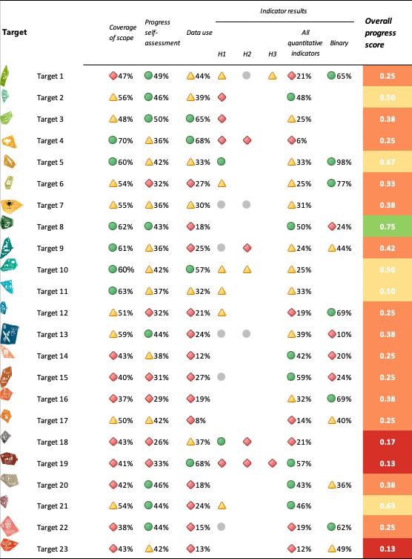
Note: Coverage of scope is measured as the percentage of elements addressed to some extent in national targets, while progress self-assessment is measured as the percentage of national targets reported as being on track or achieved. Data use is measured as the percentage of all quantitative indicators for which data were submitted. Overall quantitative indicator trends are measured as the percentage of indicators with positive trends. The colour coding reflects where the value for each target sits relative to the highest and lowest scores achieved across targets (green is assigned to values falling within the top third of the total range, yellow to the middle third and red to the bottom third). Note that this is not equivalent to a threshold-based approach, nor is it equivalent to splitting the scores into three equal sized groups. Colours for the headline indicator results are based on progress relative to the target (green is assigned when progress is being made, yellow when progress is mixed, red when progress is insufficient and grey when progress cannot be assessed). Colours for the binary indicators are based on the percentage of Parties scoring highly (4 or 5) for the indicator overall (green is assigned to values at or above 50 per cent, yellow to values from 25 to 50 per cent and red to values below 25 per cent).The overall progress score is calculated as an equal average of two measures: a combined coverage to progress score and a combined indicator score, then split into four categories (0–25 per cent, red; 25–50 per cent, orange; 50–75 per cent, yellow; and 75–100 per cent, green). The combined coverage to progress score uses coverage as a maximum possible score, which can be dragged down by lower progress scores (green coverage with yellow progress drops to yellow, green coverage with red progress drops to orange, yellow coverage with yellow progress drops to orange, yellow coverage with red progress drops to red, and all other possible combinations remain as the coverage score). The combined indicator score is an unweighted average of the individual score (red/yellow/green) for each type of indicator relevant to the target.

Reducing threats to biodiversity

Target 1. Plan and manage all areas to reduce biodiversity loss
Target text. Ensure that all areas are under participatory, integrated and biodiversity inclusive spatial planning and/or effective management processes addressing land- and sea-use change, to bring the loss of areas of high biodiversity importance, including ecosystems of high ecological integrity, close to zero by 2030, while respecting the rights of indigenous peoples and local communities.

Progress overview
Progress has been made in developing biodiversity-inclusive spatial planning and management approaches, but major gaps remain in integrating biodiversity into broader planning processes and ensuring participatory implementation. National targets often do not fully address the target’s requirements for integrated planning and participation, and current levels of implementation remain far below those needed to achieve full coverage of biodiversity-inclusive spatial plans, minimizing the loss of areas of high biodiversity importance, and to ensure integrated and participatory processes. Parties are experiencing challenges related to improving participation of stakeholders and rights holders, expanding implementation beyond protected areas and generating integration across sectors.

Coverage by Parties of the scope of Target 1 of the Framework in their national targets

Table 4
Elements of Target 1 of the Framework and how they are addressed in national targets.ª
All areas are under spatial planning and/or effective management processes addressing land/sea use change | 73
Spatial planning and/or effective management processes are participatory | 40
Spatial planning and/effective management processes are integrated | 40
Spatial planning and/or effective management processes are biodiversity-inclusive | 49
Spatial planning/management processes bring the loss of areas of high biodiversity importance, including ecosystems of high ecological integrity, close to zero by 2030 | 50
Spatial planning/management processes respect the rights of indigenous peoples and local communities | 31
On average, Parties have addressed, to at least some extent, 47 per cent of these elements in their national targets.
Note: The right-hand column of the table shows the percentage of Parties with national targets that address the element to at least some extent.
ª The elements for each target were defined by the Ad Hoc Technical Expert Group on Indicators of the Kunming-Montreal Global Biodiversity Framework (see annex I to CBD/COP/16/INF/4; and Affinito and others, 2025). The detailed methodology for the analysis of national targets is provided in document CBD/SBI/7/INF/22.

The extent to which Parties address the full scope of Target 1 varies. While most Parties have targets that address changes in the use of land and sea through spatial planning or other management processes to at least some extent, fewer than half ensure through their national targets that biodiversity is included in such planning, or that loss of areas of high biodiversity importance is brought close to zero by 2030. Even fewer Parties have targets to ensure that spatial planning and management processes are participatory, are integrated, and respect the rights of indigenous peoples and local communities (see table 4).

Indicators of progress

Table 5
Scorecard of indicators for Target 1 of the Framework
 | Indicator use |  | Indicator results
Headline indicator A.1: Red List of Ecosystems | 21 per cent of those Parties whose national reports are considered in the global report |  | Reported values average 0.58 and range from 0.37 to 1
Headline indicator A.2: Extent of natural ecosystems | 50 per cent of Parties, <1 per cent of which with time series data |  | 63 per cent of areas
Headline indicator 1.1: Percentage of land and sea area covered by biodiversity-inclusive spatial plans | 28 per cent of Parties, covering 15 per cent of land and sea |  | Reported values average 39 per cent of land and sea areas covered
Quantitative indicators combined | 57 Parties used indicators (52 headline and 14 other indicators) |  | 21% positive trends  20% negative trends
Binary indicator 1.b: Number of countries using participatory, integrated and biodiversity-inclusive spatial planning and/or effective management processes addressing land- and sea-use change to bring the loss of areas of high biodiversity importance close to zero by 2030 | 127 Parties | n/aª | 65 per cent of Parties scored highly (score 4 or 5)
Biome notes | More progress made on addressing land-use change for terrestrial areas  Less progress for inland waters  Even less progress for coastal and marine areas
Note: The colour coding is related to the overall assessment of progress across targets, the methodology of which is explained in the overall summary scorecard (see table 3). The colour coding for indicator data use and all quantitative indicator trends reflects where a value for each target sits relative to the highest and lowest scores achieved across all targets of the Framework (green is assigned to percentage values falling within the top third of the total range, yellow to the middle third and red to the bottom third). Colours for the binary indicators are based on the percentage of Parties scoring highly (4 or 5) for the indicator overall (green is assigned to values at or above 50 per cent, yellow to values from 25 to 50 per cent and red to values below 25 per cent). Colours for the headline indicator results are based on progress relative to the target (green is assigned when progress is being made, yellow when progress is mixed, red when progress is insufficient and grey when progress cannot be assessed). Note that the percentage of Parties submitting data on headline indicators may be different from that used in the aggregate results for both the headline indicator and all quantitative indicators combined, owing to methodological differences in the way data were used.
ª As binary indicator data are required by the online reporting tool, submission counts for these indicators do not reflect monitoring capacity differences between targets and do not provide actionable information for making progress in implementation, so assessment of indicator use is not relevant.

In their responses to questions related to binary indicator 1.b, many Parties reported that they were in the process of taking action to address Target 1. Nearly all Parties reported some level of biodiversity-inclusive spatial planning and indicated that they used participatory processes, but fewer than half reported participatory processes across all three realms (terrestrial, inland water and marine areas) (see figure 9). The low uptake of headline indicator 1.1 is not surprising, given that an agreed methodology for this indicator has not yet been provided (see CBD/COP/16/INF/3/Rev.1). Parties also pointed to the lack of a clear definition of biodiversity-inclusive spatial planning and limited availability of data (see table 5). Many of the additional indicators used for associated national targets were poorly aligned with Target 1 and few of them addressed whether spatial planning was integrated or whether it was bringing the loss of areas of high biodiversity importance, including ecosystems of high ecological integrity, close to zero by 2030. Based on the quantitative headline, national, component and complementary indicators, Parties are experiencing challenges in monitoring all biomes to assess this target fully (see figure 8).
As headline indicators A.1 and A.2 are also related to monitoring progress towards Goal A of the Framework, they are discussed in section II.C of the present report.
Figure 8
Percentage of all quantitative indicators aligned with Target 1 of the Framework that suggest improving, stable and negative trends, respectively
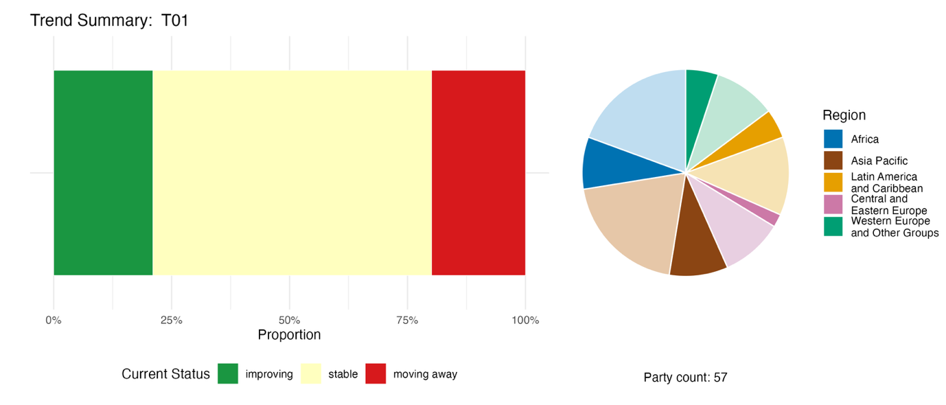
Note: Proportions are weighted by Party. The trends include data from 57 Parties, for three headline indicators from 52 Parties and 54 national indicators from 14 Parties. The pie chart shows the distribution of Parties submitting indicators for Target 1, by region. Colours for each region are defined in the figure legend: darker tones represent the proportion of Parties for any region for which data are included in the graph; lighter tones represent the proportion of Parties for the same region for which no data are included in the graph.
Figure 9
Binary indicator 1.b: number of countries using participatory, integrated and biodiversity-inclusive spatial planning and/or effective management processes addressing land- and sea-use change to bring the loss of areas of high biodiversity importance close to zero by 2030
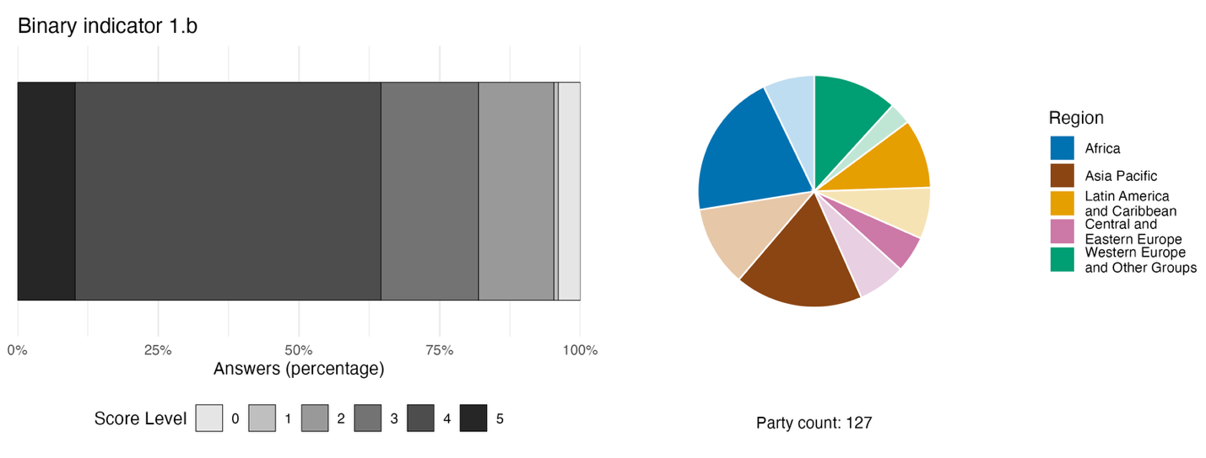
Note: The bar widths show the percentage of Parties in each score category, with higher numbers indicating a greater level of progress, based on responses to the questions included in the indicator.ª The pie chart shows the distribution of Parties providing responses to all questions by region. Colours for each region are defined in the figure legend: darker tones represent the proportion of Parties for any region for which data are included in the graph; lighter tones represent the proportion of Parties for the same region for which no data are included in the graph.
ª The methodology for calculating the score levels for each binary indicator, as well as the questions included for each indicator, are provided in document CBD/COP/16/INF/3/Rev.1.

Self-assessment of progress

Based on the self-assessment provided by Parties in their national reports for each of their national targets, 46 per cent of national targets submitted as highly aligned with Target 1 are on track for achievement, with 50 per cent showing insufficient progress or no significant progress (see figure 10).
Figure 10
Self-assessed progress for all national targets submitted as highly aligned with Target 1 of the Framework
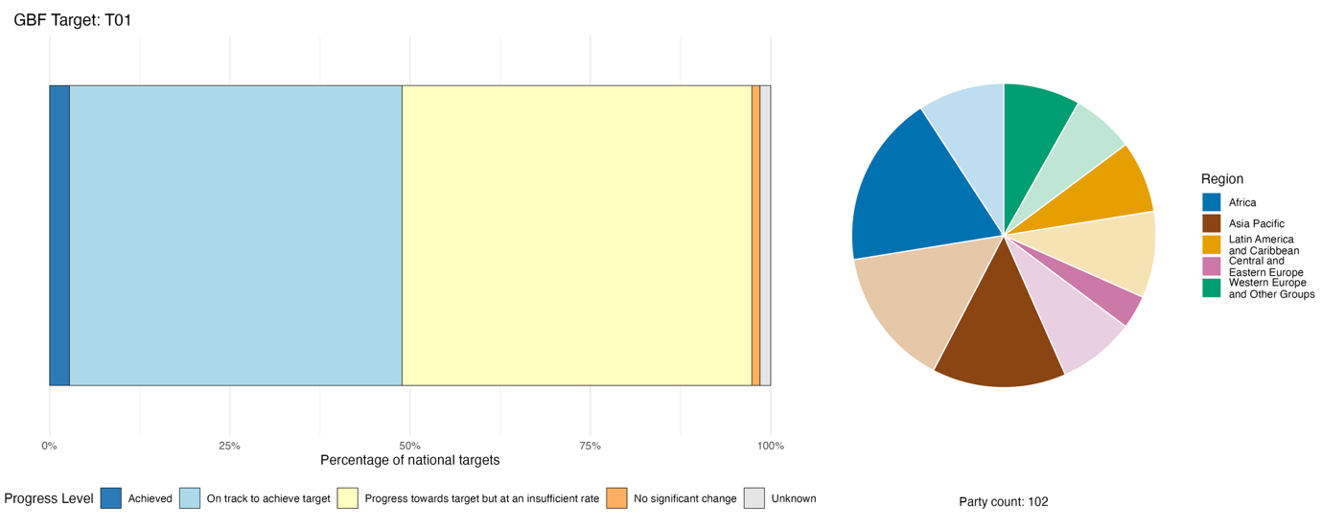
Note: The bar widths show the proportion of national targets submitted in each progress category. Proportions are weighted by Party to ensure that Parties contribute equally to the overall assessment of progress, regardless of the number of national targets submitted. The pie chart shows the proportion of Parties in each region reporting in time for consideration in the global report. Colours for each region are defined in the figure legend: darker tones represent the proportion of Parties for any region for which data are included in the graph; lighter tones represent the proportion of Parties for the same region for which no data are included in the graph.

Actions, successes and challenges in implementation

Summary of actions in support of Target 1

The most reported mechanism for implementation of national targets associated with Target 1 is the development or reform of national, subnational or sectoral spatial planning frameworks that explicitly incorporate biodiversity. Such actions range from legally binding national spatial regulations to integration of biodiversity layers into existing land-use and urban plans. Another set of actions focuses on identifying, mapping and protecting areas of high biodiversity importance such as Key Biodiversity Areas (IUCN, 2016) and broader monitoring activities such as assessments for the Red List of Ecosystems, remote-sensing platforms, national biodiversity portals and decision-support systems based on geographic information systems (GIS). Many Parties, including small island developing States and coastal developing country nations, report dedicated processes for marine spatial planning (see boxes 7 and 8).

Examples of success and progress in implementation

Box 7
Community resource management areas and biodiversity-inclusive spatial planning in Ghana

Ghana's community resource management area initiative is a nationally recognized model for community-based biodiversity conservation and sustainable natural resource management. Established under the collaborative community-based wildlife management policy (2000) and rooted in the forest and wildlife policy (1994), these areas empower local communities to sustainably manage wildlife, forests and other natural resources. Initially focused on forest ecosystems, the approach has expanded across Ghana's high forest and savanna ecological zones, supporting biodiversity conservation, forest landscape restoration, climate change mitigation and sustainable livelihoods.

Supported by the Government of Ghana and development partners, the framework for the community resource management areas formally devolves natural resource management authority to communities through a ministerial gazettement process. Communities establish governance structures, constitutions, by-laws and locally developed management plans to guide sustainable resource use. Key activities include restoration of degraded landscapes, sustainable forest resource management, climate-smart agriculture, threatened species monitoring, REDD+ implementation and equitable benefit-sharing.

The governance framework brings together community resource management and executive committees,, traditional authorities and government institutions, enabling inclusive decision-making and strengthening local stewardship of biodiversity and natural resources.

The World Bank has been a key partner in expanding the community resource management approach through initiatives such as projects on sustainable land and water management, Ghana landscape restoration and small-scale mining and the Ghana forest investment programme.

The community resource management area model has strengthened forest and biodiversity conservation, restored degraded landscapes, improved sustainable agricultural practices, increased community income through livelihood opportunities and enhanced local participation in natural resource governance. Recognizing its success, the framework has been formally integrated into the country’s Wildlife Resources Management Act, 2023, providing a strong legal foundation for community-led conservation. These areas now serve as a scalable model for implementing the Kunming-Montreal Global Biodiversity Framework by promoting effective conservation, sustainable use, equitable benefit-sharing and the meaningful participation of local communities in biodiversity governance.

Relevant targets: 1, 2, 5, 8, 9, 10, 14, 19 and 22.

Sources: Ghana, seventh national report under the Convention; Asare and others, 2013; and Fumey-Nassah, 2025.

Box 8
Multi-stakeholder partnerships advancing mapping of Key Biodiversity Areas and biodiversity-inclusive spatial planning in Mozambique

Mozambique has undertaken extensive efforts to identify and delineate key biodiversity areas, becoming one of the first countries to apply the 2016 Global Standard for the Identification of Key Biodiversity Areas developed by the International Union for Conservation of Nature (IUCN, 2016). The Standard provides a globally recognized framework for identifying sites that are critical for the persistence of biodiversity across terrestrial, freshwater, marine and subterranean ecosystems.

A major outcome of this process was the identification of 29 Key Biodiversity Areas across Mozambique, which now serve as important reference areas for development planning and land-use decision-making. In parallel with the Key Biodiversity Areas programme, Mozambique produced a historical vegetation map, conducted its first national Red List of Ecosystems assessment to identify ecosystems at risk of degradation and areas requiring strict protection, and advanced complementary initiatives such as identifying important plant areas and marine spatial planning.

The programme involved a broad coalition of governmental, non-governmental and international actors. The Government of Mozambique established a national coordination group comprising 20 national institutions, including the Ministry of Land and Environment and the Ministry of the Sea, Inland Waters and Fisheries. International conservation organizations, including IUCN, the Wildlife Conservation Society and the World Wide Fund for Nature, provided technical expertise and fundraising support. Additional support was provided through projects funded by GEF and the United States Agency for International Development.

The programme has been implemented across Mozambique and covers all major ecosystem types. It addresses two principal challenges: limited financial and technical capacity for biodiversity-related spatial planning, and insufficient coordination among diverse stakeholders. The measures taken in the context of the programme have contributed to stronger biodiversity conservation policies and enhanced the implementation of the Mozambique NBSAP.

Relevant targets: 1, 3,19, 20 and 21.
Source: Mozambique, seventh national report under the Convention.

Challenges

Challenges relating to capacity, human resources or institutional constraints are identified by nearly three quarters of Parties reporting on Target 1. These include insufficient technical expertise, understaffed institutions and high staff turnover, all of which are limiting implementation. Data and monitoring gaps are almost as widely reported, with over 70 per cent of Parties highlighting challenges such as lack of baseline data for ecosystems, species or areas of high biodiversity importance. Geospatial data sets are often fragmented across ministries, making it difficult to monitor progress or enforce spatial plans. Legal, policy and governance challenges are described by about 60 per cent of Parties and include issues such as overlapping mandates between ministries and a persistent disconnect between environmental legislation and sectoral planning instruments in agriculture, infrastructure, mining and energy, among other sectors. A number of Parties, especially those affected by conflict, political instability or rapid economic transition, face additional challenges in enforcing existing laws, such as weak penalties and limited enforcement capacity, allowing harmful practices to persist even in areas under formal protection.

Contributions of actors other than national Governments

Commitments submitted directly through the online reporting tool

Of the 180 substantive commitments submitted directly by actors other than national Governments, seven are associated primarily with Target 1. Three of the commitments are from NGOs, two from academic and research institutions and two from business or industry. The majority of the commitments focus on mainstreaming, reflecting efforts by stakeholders to integrate biodiversity into spatial planning, corporate site management and landscape governance frameworks. The commitments include actions in Europe, South-East and South Asia, East Africa and South America.

Contributions integrated in national reports

Subnational governments, including cities and local authorities, often have primary responsibility for spatial planning, especially in federal and devolved systems. This gives them a key role in the implementation of Target 1, and the involvement of subnational governments is reported in about 80 per cent of national reports, with nearly half providing clear descriptions of their involvement. The involvement of intergovernmental organizations and international partners is also widely reported, especially with regard to operational co-financing, technical co-implementation and transboundary governance. The scientific and academic communities contribute spatial data to support biodiversity-inclusive planning, as well as monitoring system design, co-development of tools and capacity-building. The involvement of indigenous peoples and local communities is reported in about two thirds of the national reports that are available for analysis, but only about half of these instances provide a clear description of the roles of indigenous peoples and local communities, which include integration of knowledge, engagement of rights holders and co-governance of spatial planning.

Examples of linkages with other agreements, processes and organizations

The Secretariat of the United Nations Convention to Combat Desertification in Those Countries Experiencing Serious Drought and/or Desertification, Particularly in Africa (UNCCD) defines land degradation neutrality as “a state whereby the amount and quality of land resources necessary to support ecosystem functions and services to enhance food security remain stable, or increase, within specified temporal and spatial scales and ecosystems” (UNCCD, 2015). In practice, this means that any new degradation of land, if it cannot be avoided, needs to be balanced or offset by restoration or sustainable land management elsewhere; in other words, there must be no net loss of productive land. The Science-Policy Interface established by the Conference of the Parties to UNCCD has developed guidelines for applying integrated land-use planning and integrated land management to achieve land degradation neutrality. This approach formed part of the evidence base for Target 1 of the Framework when it was initially agreed, and it enables Parties to address biodiversity loss and land degradation within a combined planning process (UNCCD, 2025; and Verburg, 2022).
The Food and Agriculture Organization of the United Nations (FAO) has also published updated guidelines on integrated land-use planning, aimed at supporting countries in meeting their international commitments, including Target 1 of the Framework, and the Sustainable Development Goals. The guidelines take into consideration the following issues: climate change, land degradation neutrality and restoration, conservation and sustainable use of biodiversity, integrated management of land and water resources, urbanization, peri-urban and urban agriculture, governance, tenure and the land rights of women and indigenous peoples (FAO, 2024a and 2025a). Further guidance on implementing Target 1 is available through the UNDP Essential Life Support Areas (ELSAs) tool via the United Nations Biodiversity Lab platform (UNDP, 2023); and in Issues Paper No. 4 entitled “An overview of participatory, integrated, and biodiversity-inclusive spatial planning and Target 1 of the Convention on Biological Diversity Kunming-Montreal Global Biodiversity Framework”, produced by the World Commission on Protected Areas and published by IUCN (Grantham and others, 2024).
While marine spatial planning is addressed by a growing number of Parties, only 45 countries or territories had approved national, subnational or local plans for marine and coastal areas by the end of 2023, according to the Intergovernmental Oceanographic Commission of the United Nations Educational, Scientific and Cultural Organization (UNESCO-IOC, 2024). To support countries in advancing marine spatial planning and achieving biodiversity and sustainable development objectives, the Intergovernmental Oceanographic Commission of UNESCO and the Directorate General for Maritime Affairs and Fisheries of the European Commission have developed a series of guidance documents through the Marine Spatial Planning Global programme (MSPglobal) on how to implement ecosystem-based marine spatial planning. The guidance provides methodologies and practical recommendations to support countries in developing biodiversity-inclusive marine spatial planning processes and contributes directly to the implementation of Target 1(UNESCO-IOC and European Commission, 2022, 2025). Separately, the High-level Panel for a Sustainable Ocean Economy, an initiative involving 19 States covering about half of all global coastlines, has a target to develop sustainable ocean plans for 100 per cent of marine areas under national jurisdiction of participating countries by 2030 (High Level Panel for a Sustainable Ocean Economy, 2024).
The ongoing methodological assessment of integrated biodiversity-inclusive spatial planning and ecological connectivity by IPBES will have a chapter dedicated to the implementation of Target 1, as well as addressing Targets 2 and 3, and will be a significant additional resource for Parties in implementation of the Framework following its publication in 2027 (IPBES, 2023b).

Target 2. Restore 30 per cent of all degraded ecosystems

Target text. Ensure that by 2030 at least 30 per cent of areas of degraded terrestrial, inland water, and marine and coastal ecosystems are under effective restoration, in order to enhance biodiversity and ecosystem functions and services, ecological integrity and connectivity.

Progress overview
Restoration efforts are expanding, but current commitments to restore areas, together with implementation of those commitments, remain below the level required to restore 30 per cent of degraded ecosystems by 2030, with less progress having been made in marine, coastal and freshwater areas than in terrestrial areas. National targets are generally well aligned with Target 2, although they often lack elements related to addressing the effectiveness of restoration efforts. Monitoring progress is constrained by inconsistent definitions and monitoring approaches to assess ecosystem degradation and restoration. A major barrier remains the need to address challenges in both implementation and monitoring by increasing the reliable provision of resources for restoration efforts.

Coverage by Parties of the scope of Target 2 of the Framework in their national targets

Table 6
Elements of Target 2 of the Framework and how they are addressed in national targets.ª
Ensure the by 2030, at least 30 per cent of areas of degraded terrestrial ecosystems are under restoration | 85
Ensure that by 2030, at least 30 per cent on inland water ecosystems are under restoration | 72
Ensure that by 2030, at least 30 per cent of degraded marine and coastal ecosystems are under restoration | 69
Restoration is effective, enhancing biodiversity | 34
Restoration is effective, enhancing ecosystem functions and services | 38
Restoration is effective, enhancing ecological integrity and connectivity | 37
On average, Parties have addressed, to at least some extent, 56 per cent of these elements in their national targets

Note: The right-hand column of the table shows the percentage of Parties with national targets that address the element to at least some extent.

ª The elements for each target were defined by the Ad Hoc Technical Expert Group on Indicators of the Kunming-Montreal Global Biodiversity Framework (see annex I to CBD/COP/16/INF/4; and Affinito and others, 2025). The detailed methodology for the analysis of national targets is provided in document CBD/SBI/7/INF/22.

The overwhelming majority of Parties (85 per cent) have national targets that address to some extent restoration of degraded terrestrial ecosystems, while a smaller proportion (72 per cent) have national targets relating to restoration of inland waters. Among non-landlocked countries, 69 per cent of Parties have national targets addressing restoration of degraded marine and coastal ecosystems. Other elements of Target 2 are explicitly addressed by comparatively few Parties, with fewer than 40 per cent having national targets that specifically link restoration with enhancement of biodiversity and ecosystem functions or services, ecological integrity and connectivity (see table 6).
The quantitative elements of Target 2 (to ensure that at least 30 per cent of degraded ecosystems are under effective restoration by 2030) are global in scope, and the Framework does not suggest that each Party should set national targets at the same level. Nor does it suggest that Target 2 needs to be disaggregated or distributed equally among ecosystems. About two thirds of Parties, however, have set national targets with quantitative elements relating to restoration of degraded terrestrial ecosystems, and a similar proportion of non-landlocked countries have quantified their ambition with regard to restoration of degraded marine and coastal areas. Slightly fewer Parties (58 per cent) have established quantitative elements in national targets dealing with the restoration of inland water ecosystems. In total, fewer than one fifth of Parties have set national targets to restore at least 30 per cent of degraded ecosystems in any of the three realms (terrestrial, inland waters or marine and coastal areas).

Indicators of progress

Table 7
Indicator scorecard for Target 2 of the Framework
 | Indicator use |  | Indicator results
Headline indicator 2.1: Area under restoration | 53 Parties (41 per cent of those Parties whose national reports are considered in the global report) |  | 193 million hectares (ha) total
Quantitative indicators combined | 51 Parties, with 51 using headline and 25 using other indicators |  | 48 per cent positive trends  26 per cent negative trends
Biome notes | Higher monitoring coverage of terrestrial ecosystems; weaker coverage of inland water and marine and coastal ecosystems  Forests, mangroves, coral reefs and wetlands were among the ecosystems most frequently identified as being under restoration
Note: The colour coding is related to the overall assessment of progress across targets, the methodology of which is explained in the overall summary scorecard (see table 3). The colour coding for indicator data use and all quantitative indicator trends reflects where a value for each target sits relative to the highest and lowest scores achieved across all targets of the Framework (green is assigned to percentage values falling within the top third of the total range, yellow to the middle third and red to the bottom third). Colours for the binary indicators are based on the percentage of Parties scoring highly (4 or 5) for the indicator overall (green is assigned to values at or above 50 per cent, yellow to values from 25 to 50 per cent and red to values below 25 per cent). Colours for the headline indicator results are based on progress relative to the target (green is assigned when progress is being made, yellow when progress is mixed, red when progress is insufficient and grey when progress cannot be assessed). Note that the percentage of Parties submitting data on headline indicators may be different from that used in the aggregate results for both the headline indicator and all quantitative indicators combined, owing to methodological differences in the way data were used.

A total of 53 Parties reported on the headline indicator; Parties also provided trend data for 85 national, component and complementary indicators, representing significant efforts to monitor restoration (see table 7 and figure 12). Many Parties use the registry of the Framework for Ecosystem Restoration Monitoring (FERM), developed by FAO, and the Task Force on Monitoring for the United Nations Decade on Ecosystem Restoration 2021-2030, to track global progress on ecosystem restoration (see the section on linkages with other agreements, processes and organization for Target 2 below). To date, restoration data have been compiled in the FERM registry from more than 121 initiatives in 81 countries (FAO, 2025a; and UNEP, 2025a).
Since the adoption of the Framework, Parties have reported that a cumulative total of approximately 193 million hectares (ha) had been placed under restoration by 2025 (see figure 11). The headline indicator measures only the area under restoration and does not include degradation, but the proportion of land that is degraded over total land area is a component indicator of this target (2.CT.1). Because degradation can take many forms and be measured in different ways, there are varying estimates of the amount of degraded habitat globally and Parties have used different definitions in reporting on the indicator. UNCCD has estimated that over 1.56 billion hectares of land were degraded in 2019, with more than 100 million hectares of healthy and productive land degraded every year (UNCCD, 2022).
A significant constraint mentioned by Parties in reporting on Target 2 is the absence of nationally agreed definitions of “degraded” and “effective restoration”, preventing the establishment of baselines and impeding measurement of progress. This is despite global guidance on implementation of Target 2 defining “effective restoration” as standards-based restoration, underpinned by agreed principles, that results in appropriately balanced sustainable net gain, benefiting and enhancing biodiversity, ecosystem integrity and human well-being (FAO and others, 2024).
It should be noted that the data submitted may not include ecosystems already under restoration before 2020 that continue to be under restoration, and not all countries submitted data. The area of land currently reported as being under restoration, however, is not commensurate with the global target of restoring 30 per cent of all degraded ecosystems. There are specific gaps in the monitoring of restoration efforts in inland water, marine and coastal ecosystems. Thus, while available reported data suggest that restoration action is collectively increasing (see figure 11), it does not seem to be at a level commensurate with Target 2.

Figure 11
Headline indicator 2.1 (area under restoration)
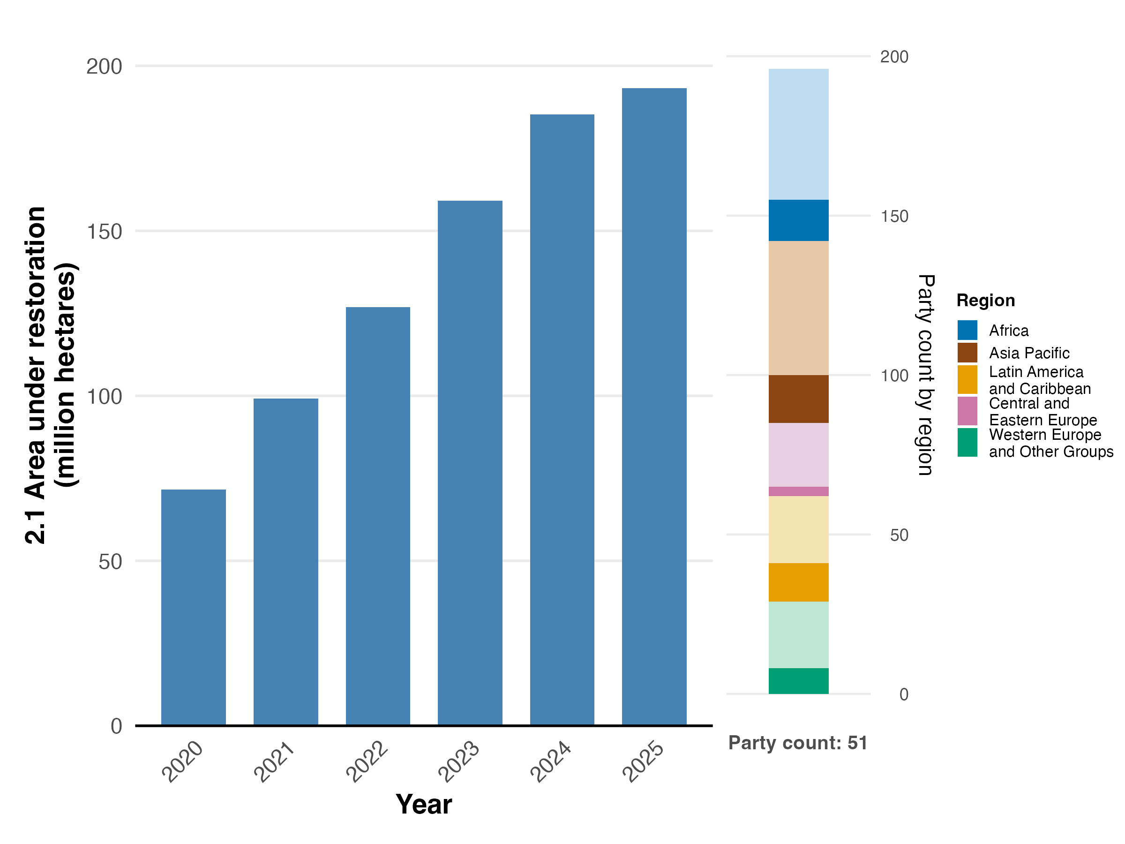
Note: Indicator values show the cumulative area under restoration across all Party submissions. The bar chart at the right shows the distribution of Parties providing data for the graph, by region. Colours for each region are defined in the figure legend: darker tones represent the proportion of Parties for any region for which data are included in the graph; lighter tones represent the proportion of Parties for the same region for which no data are included in the graph. The total area presented here is likely an undercount of all areas under restoration owing to data-collection limitations and should be considered a minimum estimate. The trends include data from 51 Parties.
Figure 12
Percentage of indicators aligned with Target 2 of the Framework that suggest improving, stable and negative trends, respectively
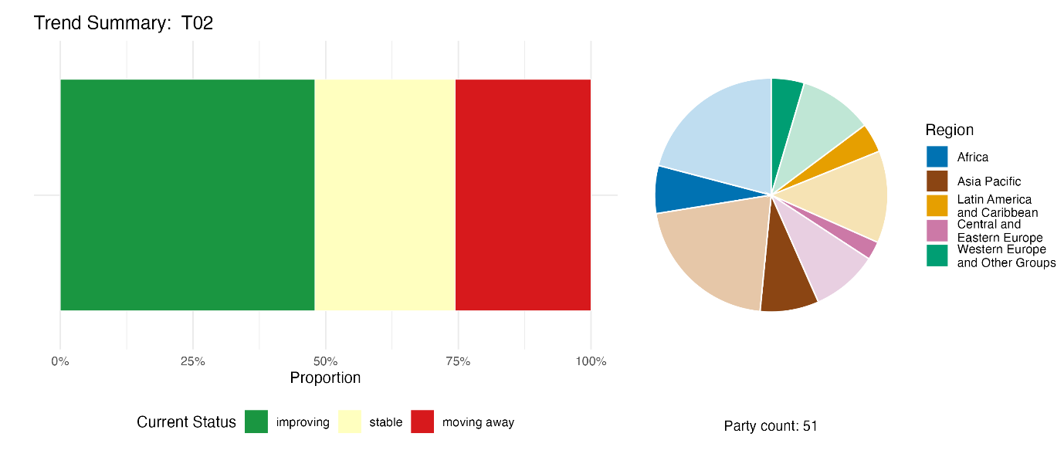
Note: Proportions are weighted by Party. The trends include data for headline indicator 2.1 from 51 Parties, in addition to 1 component, 2 complementary and 82 national indicators from a total of 25 Parties. The pie chart shows the distribution of Parties submitting indicators for Target 2, by region. Colours for each region are defined in the figure legend: darker tones represent the proportion of Parties for any region for which data are included in the graph; lighter tones represent the proportion of Parties for the same region for which no data are included in the graph.

Self-assessment of progress

Based on the self-assessment provided by Parties in their national reports for each of their national targets, 43 per cent of national targets submitted as highly aligned with Target 2 are on track for achievement, with 53 per cent showing insufficient progress or no significant change (see figure 13). This assessment is relatively positive compared with other targets of the Framework.

Figure 13
Self-assessed progress for all national targets submitted as highly aligned to Target 2 of the Framework
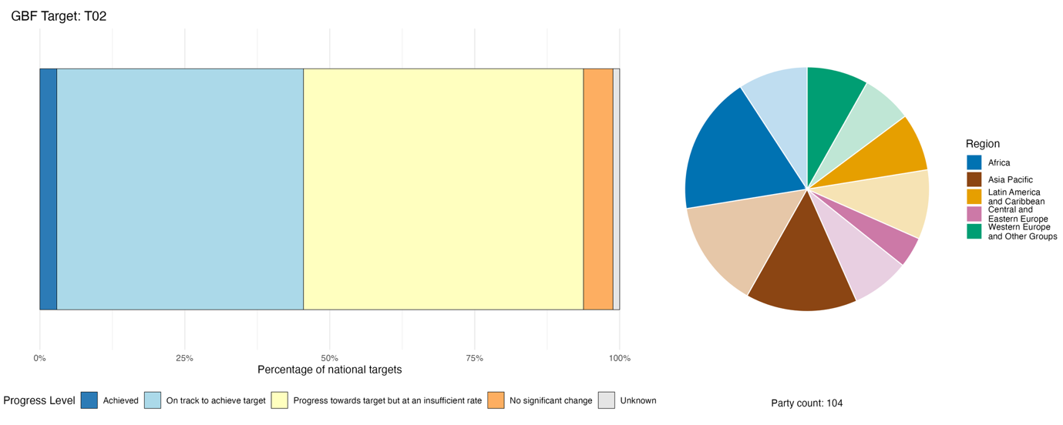
Note: The bar widths show the proportion of national targets submitted in each progress category. Proportions are weighted by Party to ensure that Parties contribute equally to the overall assessment of progress, regardless of the number of national targets submitted. The pie chart shows the proportion of Parties in each region reporting in time for consideration in the global report. Colours for each region are defined in the figure legend: darker tones represent the proportion of Parties for any region for which data are included in the graph; lighter tones represent the proportion of Parties for the same region for which no data are included in the graph.

Actions, successes and challenges in implementation

Summary of actions in support of Target 2 of the Framework

Nearly all Parties report some form of action involving the restoration of ecosystems. Typically, this involves restoration across multiple ecosystem types, for example, forest, wetland, coastal and marine, rangeland and freshwater systems. Many national reports also describe research, monitoring and data collection in relation to Target 2, reflecting widespread investment in the assessment of degradation, mapping of restoration and development of associated monitoring systems. The scale of restoration varies from small-scale implementation in the context of individual projects to large-scale government programmes to meet national-scale targets (see boxes 9 and 10).

Examples of success and progress in implementation

Box 9
Peatland rewetting and paludiculture for ecological restoration and climate action in Germany

Large-scale drainage of peatlands in Germany has led to increasing peat mineralization, resulting in a significant rise in greenhouse gas emissions, biodiversity loss and declining ecosystem functions such as water retention and provision. Conventional agricultural production on drained peat soils has also proven to be environmentally unsustainable, while economically viable alternatives for wet peatland management remain limited. In response, Germany is promoting peatland rewetting and paludiculture (agriculture and forestry on rewetted peatlands) as an integrated approach to ecological restoration, climate mitigation and sustainable rural development.

Under the Federal Action Plan on Nature-based Solutions for Climate and Biodiversity, the restoration of degraded peatland ecosystems is a key measure to reduce emissions in the land-use sector.ª Ongoing pilot and demonstration projects assessing the feasibility of paludiculture practices and related value chains provide a firm basis for upscaling paludiculture. Building on these experiences, the state aid scheme for the rewetting of farmed peatlands supports the establishment of productive land-use systems compatible with wet conditions. Key components of the upscaling process are so-called lighthouse regions with an area of at least 5,000 hectares of peatland. The cultivation of wetland-adapted species such as the common reed (Phragmites australis), cattails (Typha spp.), sedges and peat moss are promising candidates for biomass production on rewetted sites.

Alongside restoration efforts, the programme supports research into and scaling of the material use of paludiculture biomass and the development of marketable products, including insulation materials, packaging, peat substitutes for horticulture, bioplastics, natural medicinal products and textiles.

The programme aims to generate both environmental and socioeconomic benefits. Peatland rewetting reduces greenhouse gas emissions and supports the recovery of biodiversity and
ecosystem functions. At the same time, paludiculture demonstrates that ecological restoration and productive land use can coexist within the same landscape. The case illustrates how ecosystem restoration policies can integrate climate mitigation, biodiversity conservation and sustainable economic development within a single land-use framework.

Relevant targets: 1, 2, 3, 8, 9 and 11.

Source: Germany, seventh national report under the Convention.
ªSee https://moor.fnr.de/moore-schuetzen/moorbodenschutz.

Box 10
Integrating indigenous peoples and local communities into ecosystem restoration under Brazil’s national native vegetation recovery plan

The national plan for the recovery of native vegetation 2025–2028 of Brazil demonstrates how large-scale ecosystem restoration can be integrated with inclusive governance and the participation of indigenous peoples and local communities. The plan aims to restore 12 million hectares of native vegetation by 2030 across the six major biomes in Brazil: the Amazon, the Cerrado forest-savanna, the Atlantic Forest, the semi-arid Caatinga, the Pantanal wetlands and the Pampa grasslands. It combines ambitious national restoration targets with mechanisms that recognize traditional knowledge, territorial rights and community-led restoration practices.

The plan promotes the recovery of permanent preservation areas, legal reserves and restricted-use areas, while also encouraging restoration in degraded agricultural landscapes through agroforestry systems, crop-livestock-forest integration and the cultivation of native tree species. Restoration efforts extend to public lands, including conservation units, indigenous territories and other collectively managed areas. Supporting measures include the development of native seed collector networks, native plant nurseries, restoration supply chains and integrated monitoring systems.

The implementation of the plan involves a broad range of actors operating across multiple governance levels. Federal ministries, including the Ministry of Environment and Climate Change, the Ministry of Agriculture, Livestock and Food Supply, the Ministry of Finance, the Ministry of Planning, Budget and Management and the Ministry of Management and Innovation in Public Services, play key roles in policy coordination and implementation. Biome-level restoration networks, such as the Amazon Restoration Alliance and the Atlantic Forest Restoration Pact, and regional restoration coalitions in the Cerrado, Caatinga, Pantanal and Pampa, contribute technical expertise and stakeholder engagement, with a high level of participation from civil society. Participation extends to indigenous peoples as well as communities including quilombola (Afro-Brazilian descendants), geraizeiros (traditional Cerrado pastoralists) and caatingueiros (traditional dryland communities) and women, youth and elders.

Since its initial launch in 2017 and subsequent update for 2025-2028, the plan has integrated public and private financing, scientific research, technological innovation, spatial monitoring and traditional ecological knowledge within a unified restoration framework. It demonstrates how ecosystem restoration can generate multiple benefits, contributing to climate change mitigation and adaptation, biodiversity conservation, landscape connectivity and sustainable livelihoods, while also creating green employment opportunities and strengthening community income generation.

Relevant targets: 1, 2, 3, 8, 9, 10, 11, 14, 21 and 22.
Sources: Brazil, Ministry of Foreign Affairs, 2025; MMA, 2024.

Challenges

Many Parties report that the funding that is available for ecosystem restoration represents a fraction of the resources required to meet national targets. This shortfall is compounded by a mismatch between short-term, project-based financial cycles, the long-term timescales involved in ecological recovery and limitations in the sectoral capacity to deliver restoration projects. Some reporting systems prioritize outputs, for example, the number of trees planted, rather than verified ecological outcomes or recovery, which risks overclaiming success while ecological integrity continues to decline. Responsibility for restoration is often fragmented across agencies, ministries and sectors. This can lead to contradictory policies and conflicting land-use and sea-use decisions, as well as unharmonized data collection, which can hinder consistent reporting. Restoration gains may be undermined by drivers and underlying causes that continue to degrade ecosystems. Parties include the effects of poverty and conflicts among these underlying causes.

Contributions of actors other than national Governments

Commitments submitted directly through the online reporting tool

Of the 180 substantive commitments submitted directly by actors other than national Governments, 13 are associated primarily with Target 2, of which 12 are from NGOs and one from an academic and research institution. The commitments address restoration at multiple scales from local to global and involve a wide range of ecosystem types from urban wetlands to forests, savannas, grasslands, rivers, mangroves and coastal marshes, among others. They include restoration programmes in Europe, Africa, Asia, Oceania and South America (see box 11).

Box 11
A global non-governmental organization supporting restoration across nine African countries

The World Wide Fund for Nature (WWF) Forest Landscape Restoration initiative is a multi-country commitment to restore 13.5 million hectares of degraded and deforested landscapes by 2030 across nine African countries: Cameroon, Democratic Republic of the Congo, Kenya, Madagascar, Mozambique, Uganda, United Republic of Tanzania, Zambia and Zimbabwe. Launched in October 2021, the initiative operates under three strategic pillars: policy, governance and institutional reform, finance and market mechanisms, and transformational on-the-ground delivery. As of 2025, approximately 3 million hectares were already under effective restoration. The initiative builds investment pipelines, mobilizes public-private finance, including partnerships with the African Development Bank, FAO and UNEP, and fosters restoration-positive value chains in bamboo, honey, sustainable timber and eco-spices. Digital monitoring systems track ecosystem recovery in real time. With a core budget of US$ 38 million and a secretariat hosted by WWF Tanzania, the initiative maintains gender equity, community livelihoods and indigenous land rights as non-negotiable pillars of lasting restoration impact.

Relevant targets: 2, 9, 14, 19, 22 and 23.
Source: WWF stakeholder commitment as reported in the Convention’s online reporting tool (available at https://ort.cbd.int/database/293975).

Contributions integrated in national reports

The role of actors other than national Governments that is most often mentioned in national reports with regard to Target 2 relates to financing and co-financing of ecosystem restoration projects. International partners such as GEF, the Green Climate Fund and the World Bank, and to a lesser extent private sector actors, are most frequently mentioned as sources of external financing for restoration programmes. Several Parties report international co-finance as the enabling condition for restoration delivery at scale. With regard to direct delivery and implementation of restoration programmes, contributions are acknowledged in many reports from NGOs, subnational governments, indigenous peoples and local communities, community groups and sectoral actors such as community fisheries and forest-user groups. Private sector actors are, to a lesser extent, reported as implementers of activities such as planting, habitat restoration and removal of invasive alien species. The scientific community and academia, along with international partners and NGOs, are widely reported as contributing technical assistance, providing knowledge and establishing standards for restoration.

Examples of linkages with other agreements, processes and organizations

The United Nations Decade on Ecosystem Restoration 2021–2030 is a collaboration among multiple United Nations organizations and multilateral environmental agreements, with leadership from UNEP and FAO, and the involvement of all three of the Rio conventions (Convention on Biological Diversity, United Nations Framework Convention on Climate Change (UNFCCC) and UNCCD). The initiative focuses on enhancing and supporting existing commitments and implementation of the Rio conventions and the Sustainable Development Goals by building a global movement, generating political support and developing capacity. The Task Force on Monitoring of the United Nations Decade on Ecosystem Restoration (2021–2030), led by FAO, has developed the Framework for Ecosystem Restoration Monitoring (FERM) (see also the section on Target 2 indicators above) for transparent monitoring and reporting on restoration progress throughout the United Nations Decade (FAO, 2025a, 2025b; and UNEP, 2025a).
The Secretariat of UNCCD is the custodian agency for Sustainable Development Goal indicator 15.3.1 (proportion of land that is degraded over total land area), which is also a component indicator for Target 2. It provides technical expertise for the planning, implementation and monitoring of ecosystem commitments under Target 2 and helps to advance data exchange, interoperability of tools and joint capacity-building efforts to strengthen countries’ monitoring and reporting on degradation and restoration of land and ecosystems. The Secretariat of UNCCD also aims to engage with regional centres to support national monitoring of land degradation, potentially strengthening synergies with the Secretariat of the Convention on Biological Diversity by mirroring its regional and subregional technical and scientific cooperation support centres (Sims and others, 2021; Teich and others, 2025; UNCCD, 2025).
The Secretariat of the Convention on Wetlands of International Importance especially as Waterfowl Habitat has estimated that at least 123 million hectares of wetland needs to be under restoration by 2030 to achieve the 30 per cent restoration commitment in Target 2. This figure is based on the area of wetlands transformed to agriculture and other uses since 1970 (approximately 411 million hectares) and is likely to be an underestimate as it excludes the efforts needed to restore degraded wetlands with a deteriorated ecological character. As of 2025, 45 per cent of the Contracting Parties to the Convention on Wetlands had established national wetland restoration targets, with 21 per cent of Parties reporting partial establishment of national restoration targets and 16 per cent at the planning stage. Restoration efforts are a major focus of the activities under the Convention on Wetlands, also including synergies with other multilateral environmental agreements such as UNFCCC in the restoration of mangroves (see box 12) (Convention on Wetlands, 2025a, 2025b and 2025c).

Box 12
Mangrove Breakthrough: synergies in targets on biodiversity, wetlands and climate change

The Mangrove Breakthrough initiative aims to restore mangroves to cover at least half of all recent losses.ª Using the extent and change maps provided by Global Mangrove Watch,^{b} it is estimated that 818,300 hectares of mangroves are “restorable”. Assuming science-based restoration practices are employed and result in long-lasting restoration, restoring half of recent loss would represent more than 409,000 hectares by 2030, or about 51,000 hectares per year, a significant contribution to the implementation of Target 2. The Mangrove Breakthrough members oversee 66,141 hectares of mangroves under various forms of protection, restoration or policy influence. These direct actions have safeguarded an additional 25 million tons of carbon. More than 30 Governments have officially endorsed Mangrove Breakthrough and will work to include specific, measurable and science-based targets for mangroves in the updates to their nationally determined contributions for UNFCCC.

Relevant targets: 2 and 8.
Sources: Convention on Wetlands, 2025a; and UNFCCC, 2024a.

ªSee www.mangrovebreakthrough.com/.
^{b}See www.globalmangrovewatch.org/.

Target 3. Effectively conserve and manage at least 30 per cent of terrestrial and inland water areas and 30 per cent of coastal and marine areas

Target text. Ensure and enable that by 2030 at least 30 per cent of terrestrial and inland water areas, and of marine and coastal areas, especially areas of particular importance for biodiversity and ecosystem functions and services, are effectively conserved and managed through ecologically representative, well-connected and equitably governed systems of protected areas and other effective area-based conservation measures, recognizing indigenous and traditional territories, where applicable, and integrated into wider landscapes, seascapes and the ocean, while ensuring that any sustainable use, where appropriate in such areas, is fully consistent with conservation outcomes, recognizing and respecting the rights of indigenous peoples and local communities, including over their traditional territories.

Progress overview
Parties continue to make progress in expanding and managing protected areas, especially for marine and coastal areas, but current ambition and implementation remain insufficient to fully achieve all aspects of Target 3. Parties continue to make progress in the designation of terrestrial and inland water areas and of marine and coastal areas for effective conservation outcomes and management and are at an early stage in implementation and monitoring of other effective area-based conservation measures (OECMs), although methodological limitations affect the ability to assess this progress precisely. National targets are less well aligned with qualitative aspects of Target 3, however, and monitoring and reporting of some elements of the target remain low, including relating to equitable governance of protected areas and OECMs, recognition of indigenous and local territories and integration into wider landscapes and seascapes. Parties face significant challenges in implementation, particularly related to a lack of finance and capacity.

Coverage by Parties of the scope of Target 3 of the Framework in their national targets

Table 8
Elements of Target 3 of the Framework and how they are addressed in national targets.ª
At least 30 per cent of terrestrial areas are included in systems of protected areas and OECMs | 78
At least 30 per cent of inland water areas are included in protected areas and OECMs | 64
At least 30 per cent of marine and coastal areas are included in systems of protected areas and OECMs | 72
Areas of particular importance for biodiversity, ecosystem functions and services are included in systems of protected areas and OECMs | 43
Protected areas and OECMs are effectively conserved and managed | 57
Protected areas and OECMs are ecologically representative | 40
Protected areas and OECMs are well connected | 46
Protected areas and OECMs are equitably governed | 37
Protected areas and OECMs are integrated into wider landscapes, seascapes and the ocean | 32
Any sustainable use in protected areas and OECMs is fully consistent with conservation outcomes | 26
Protected areas and OECMs recognize and respect the rights of indigenous peoples and local communities, including over their traditional territories | 33
On average, Parties have addressed, to least some extent, 48 per cent of these elements in their national targets

Note: The right-hand column of the table indicates the percentage of Parties with national targets that address the element to at least some extent.
ª The elements for each target were defined by the Ad Hoc Technical Expert Group on Indicators of the Kunming-Montreal Global Biodiversity Framework (see annex I to CBD/COP/16/INF/4; and Affinito and others, 2025).The detailed methodology for the analysis of national targets is provided in document CBD/SBI/7/INF/22.

The various elements of Target 3 are addressed very unevenly by Parties in their national targets. More than three quarters (78 per cent) of Parties have national targets addressing protected areas and OECMs in terrestrial areas to some extent, while fewer than two thirds (64 per cent) have equivalent national targets relating to inland water areas. Among non-landlocked Parties, 72 per cent have national targets addressing protected areas and OECMs of marine and coastal areas to some extent (see table 8).
Qualitative elements of the target are less well addressed than quantitative measures of area. A smaller proportion of Parties have national targets addressing the elements of Target 3 relating to whether areas of particular importance to biodiversity and ecosystem functions and services are included in protected areas or OECMs and whether such areas are effectively conserved and managed, ecologically representative and well connected. Even fewer Parties have national targets addressing whether protected areas and OECMs are equitably governed, whether they are integrated into wider landscapes, seascapes and the ocean, and whether they recognize and respect the rights of indigenous peoples and local communities, including over their traditional territories (accepting that this last element is not considered relevant by all Parties based on their national context). The element addressed by fewest Parties (26 per cent) relates to whether sustainable use in protected areas is fully consistent with conservation outcomes.
The quantitative elements of Target 3, to ensure that at least 30 per cent of terrestrial, inland water, and marine and coastal areas, are effectively conserved and managed by 2030, are global in scope, and the Framework does not suggest that each Party should set national targets at the same level. The vast majority of Parties, however, have set quantitative national targets for establishing protected areas and OECMs in terrestrial and inland water areas (87 per cent and 86 per cent, respectively), and an even higher proportion of non-landlocked Parties (89 per cent) have set quantitative national targets for conserving marine and coastal areas. Of those Parties with quantitative national targets, just over two thirds have committed to conserve at least 30 per cent of terrestrial and inland water areas by 2030, while slightly fewer than two thirds (62 per cent) of non-landlocked Parties have set targets to conserve at least 30 per cent of marine and coastal areas within their jurisdiction. The remaining Parties have either set quantitative national targets below 30 per cent, have set national targets for selected ecosystem types, or have expressed their national targets in terms of hectares rather than percentages.
A separate analysis of national targets suggests that for terrestrial and inland water areas, present commitments from Parties would bring the total conserved area to approximately 27.5 per cent by 2030. If all of these national targets were achieved, it would represent a fivefold increase in the rate of expansion of conserved area between 2020 and 2030, compared with the previous decade. This analysis does not take account of national targets from Parties that expressed their intentions to increase conserved areas in qualitative rather than quantitative terms, or from Parties that had not yet submitted national targets by the time of the analysis (Immerzeel and others, 2026).

Indicators of progress
Table 9
Indicator scorecard for Target 3 of the Framework
 | Indicator use |  | Indicator results
Headline indicator 3.1: coverage of protected areas and OECMs | 78 per cent of reporting Parties, covering 54 per cent of land and 39 per cent of sea |  | Increasing coverage since 2020 (16.7 per cent of reporting Parties for marine and coastal areas and 19.5 per cent of reporting Parties for terrestrial and inland waters, an increase of 2.9 per cent and 2.2 per cent respectively) but still far from the 30 per cent target
All quantitative indicators combined | 85 Parties, 66 per cent of Parties whose national reports are considered in the global report |  | 25 per cent positive trends  5 per cent negative trends
Biome notes | All information for this target has been shown separately for terrestrial and marine and coastal areas. Available data were insufficient to disaggregate further by inland water areas or OECMs
Note: The colour coding is related to the overall assessment of progress across targets, the methodology of which is explained in the overall summary scorecard (see table 3). The colour coding for indicator data use and all quantitative indicator trends reflects where a value for each target sits relative to the highest and lowest scores achieved across all targets of the Framework (green is assigned to percentage values falling within the top third of the total range, yellow to the middle third and red to the bottom third). Colours for the binary indicators are based on the percentage of Parties scoring highly (4 or 5) for the indicator overall (green is assigned to values at or above 50 per cent, yellow to values from 25 to 50 per cent and red to values below 25 per cent). Colours for the headline indicator results are based on progress relative to the target (green is assigned when progress is being made, yellow when progress is mixed, red when progress is insufficient and grey when progress cannot be assessed). Note that the percentage of Parties submitting data on headline indicators may be different from that used in the aggregate results for both the headline indicator and all quantitative indicators combined, owing to methodological differences in the way data were used.
Of the 196 Parties to the Convention, 100 submitted data on headline indicator 3.1 (coverage of protected areas and OECMs) in national reports received in time to be considered in the global report (see table 9). Coverage within the jurisdictions of these reporting Parties for marine and coastal areas is currently 16.7 per cent, and coverage for their terrestrial areas and inland waters is 19.5 per cent (see figure 14). Supplementing this information, the World Database on Protected and Conserved Areas (WDPCA) indicates that global coverage of terrestrial areas and inland waters is now 18.4 per cent and coverage of marine and coastal areas under national jurisdiction is 23.2 per cent (see figure 15), but it is only 10 per cent for the global ocean including areas beyond national jurisdiction (see figure 16).
Among the reasons given by Parties for not reporting on the headline indicator for Target 3 are challenges relating to the inclusion of OECMs. Additional technical challenges include accounting for overlapping protected areas, changes in calculation methodologies over time and difficulties in recognizing protection on private lands.
Among those Parties submitting data available for analysis in the global report, there have been measurable gains in area coverage, with protected and conserved terrestrial areas increasing by over 2 per cent and marine areas increasing by nearly 3 per cent between 2020 and 2025. If the 2020 edition of WDPCA is used as a baseline, this would increase the protected and conserved area coverage for these reporting Parties from about 17 per cent of terrestrial areas and 18 per cent of marine areas under national jurisdiction, to more than 20 per cent for each.
As noted above, Target 3 includes many elements beyond the extent of protected and conserved areas, and many of these elements have been captured in the additional indicators submitted by Parties (see figure 17). These include indicators on conservation effectiveness (for example, level of protection, or percentage of “highly protected”), management effectiveness and efforts to expand protected areas; however, other elements such as the protection of areas important to biodiversity and ecosystem functions and services, sustainable use within protected areas and the recognition and respect of the rights of indigenous peoples and local communities, including over their traditional territories, were not covered by any indicators included in the national reports.
Figure 14
Headline indicator 3.1: coverage of protected areas and other effective area-based conservation measures (from national reports)
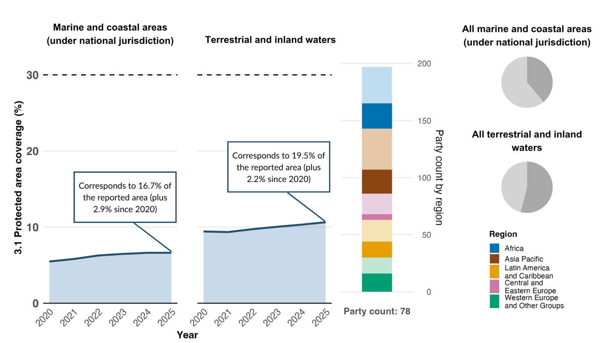
Note: The figure includes only indicator data submitted by Parties in their national reports. The right bar chart shows the distribution of Parties providing data for the graph, by region. Colours for each region are defined in the figure legend: darker tones represent the proportion of Parties for any region for which data are included in the graph; lighter tones represent the proportion of Parties for the same region for which no data are included in the graph. The dark grey areas of the pie charts show the representativeness of the data submitted as a proportion of all Parties’ marine and coastal areas under national jurisdiction (upper) or terrestrial and inland water areas (lower).

Figure 15
Headline indicator 3.1: coverage of protected areas and other effective area-based conservation measures according to the World Database on Protected and Conserved Areas (for marine and coastal areas under national jurisdiction and terrestrial and inland water areas)
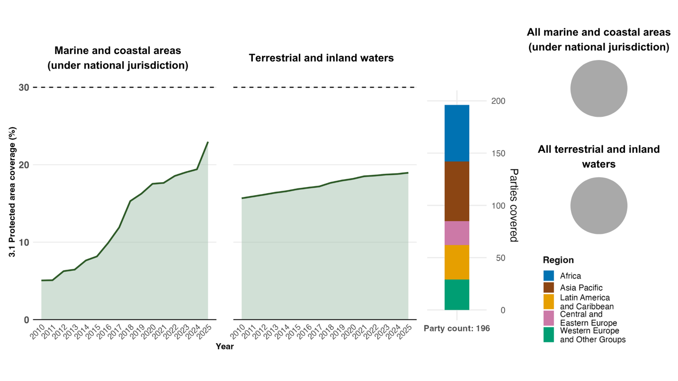
Note: Based only on data submitted to WDPCA. Indicator values show the overall proportion of each area type under conservation. Values represent 100 per cent of all Parties’ land and sea areas (see fully shaded pie and bar charts on the right).

Figure 16
Headline indicator 3.1: coverage of protected areas and other effective area-based conservation measures according to the World Database on Protected and Conserved Areas (for all marine and coastal areas, including areas beyond national jurisdiction)
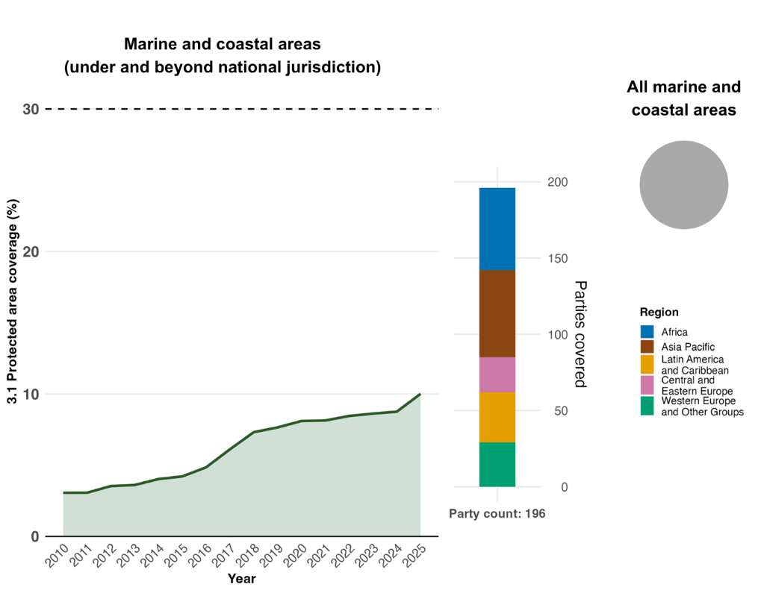
Note: Based only on data submitted to WDPCA. Indicator values show the overall proportion of areas under conservation. Values represent 100 per cent of all Parties’ marine and coastal areas (see fully shaded pie and bar charts on the right).
Figure 17
Percentage of indicators aligned with Target 3 of the Framework that suggest improving, stable and negative trends, respectively
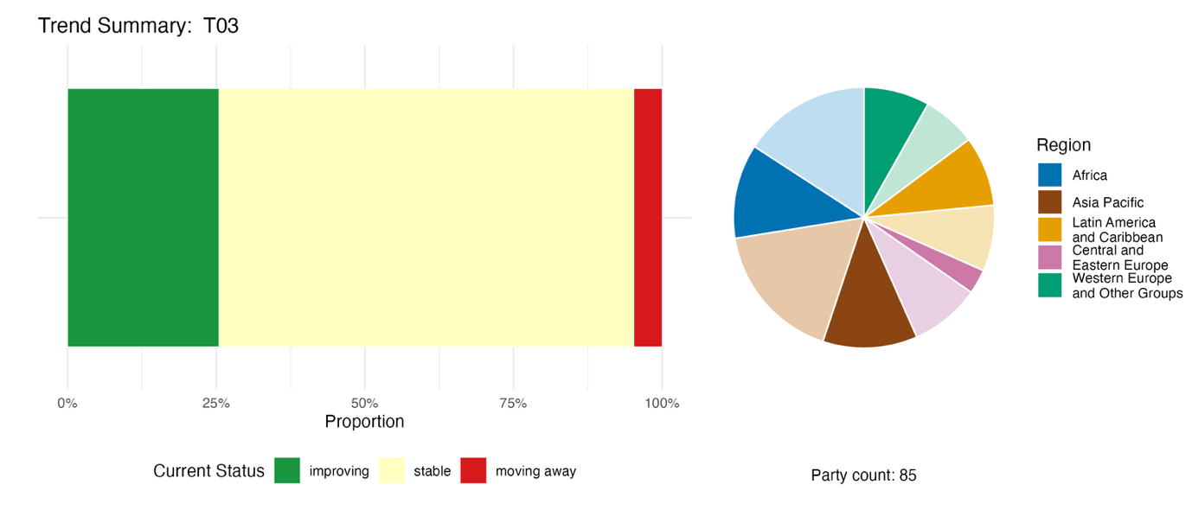
Note: Proportions are weighted by Party. The trends include data for one headline indicator from 79 Parties, and one component, two complementary and 92 national indicators from a total of 27 Parties. The pie chart shows the distribution of Parties submitting indicators for Target 3, by region. Colours for each region are defined in the figure legend: darker tones represent the proportion of Parties for any region for which data are included in the graph; lighter tones represent the proportion of Parties for the same region for which no data are included in the graph.

Self-assessment of progress
Based on the self-assessment by Parties of progress towards each of their national targets, 47 per cent of national targets submitted as highly aligned with Target 3 are on track for achievement, while 3 per cent are already achieved and another 50 per cent show insufficient progress or no significant progress (see figure 18).
Figure 18
Self-assessed progress for all national targets submitted as highly aligned to Target 3 of the Framework
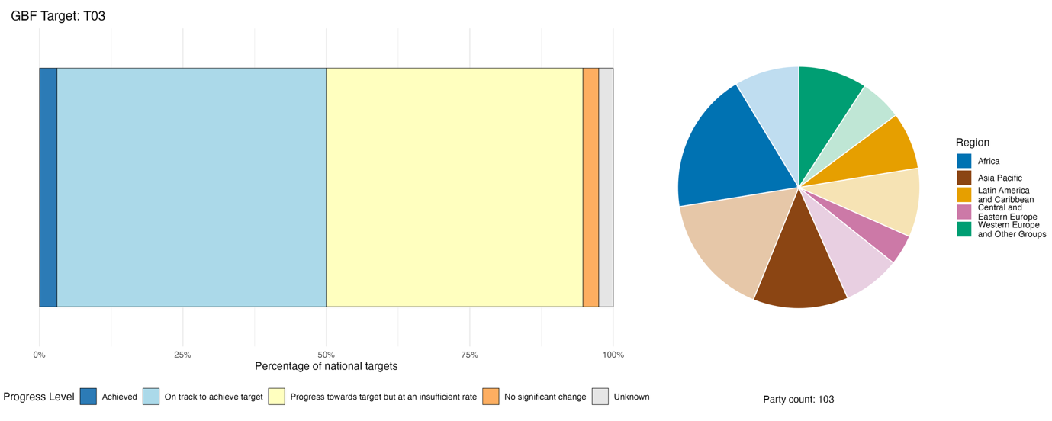
Note: The bar widths show the proportion of national targets submitted in each progress category. Proportions are weighted by Party to ensure that Parties contribute equally to the overall assessment of progress, regardless of the number of national targets submitted. The pie chart shows the proportion of Parties in each region reporting in time for consideration in the global report. Colours for each region are defined in the figure legend: darker tones represent the proportion of Parties for any region for which data are included in the graph; lighter tones represent the proportion of Parties for the same region for which no data are included in the graph.

Actions, successes and challenges in implementation

Summary of actions in support of Target 3 of the Framework

Nearly all Parties report actions to designate new protected areas, to expand existing networks or to identify OECMs. At least 40 Parties report active processes relating to OECMs, ranging from development of a framework to recognize them, to formal designations and reporting to WDPCA. Many Parties report the use of various tools, some developed globally and some at the national level, to assess the effectiveness of protected area management and conservation. Community-based conservation and co-management of protected areas are commonly reported, especially among developing countries and small island developing States. Many Parties report species and ecosystem monitoring activities to support management of existing protected areas and to identify potential new areas for protection. Although economic and financial actions are the least reported category in relation to Target 3, examples include dedicated endowment funds, debt-for-nature swaps, payment for ecosystem services, payment of citizens to act as ecological rangers and sharing of revenues from park fees and tourism (see boxes 13 and 14).

Examples of success and progress in implementation

Box 13
Unified legal framework and ridge-to-reef governance in the Seychelles, exceeding “30x30” targets as a small island developing State model

Seychelles has demonstrated how a small island developing State can strengthen biodiversity conservation through integrated governance, legal reform and ecosystem-based spatial planning. The country has adopted a comprehensive “ridge-to-reef” approach linking terrestrial, coastal and marine management under a unified policy framework, supporting the expansion and effective management of protected and conserved areas. Through the Nature Reserves and Conservancy Act (2022) and the Seychelles marine spatial plan of 2025, Seychelles has modernized its conservation legislation, improved regulatory coherence and embedded ecosystem-based management within national planning processes.

The initiative has been led primarily by national government ministries and agencies, which have coordinated legal reforms, conservation assessments, protected area expansion and evaluation of management effectiveness. The development of the marine spatial plan also incorporated science-based analyses and extensive stakeholder engagement to support evidence-based decision-making across multiple sectors.

Implementation has been undertaken nationally and encompasses forests, coastal habitats, coral reefs, seagrass ecosystems and offshore marine environments. Key actions have included the introduction of legally binding marine spatial planning, the identification and management of ecologically important areas, the establishment of ecological corridors and the designation of seasonal protection zones for threatened species. Seychelles has also undertaken assessments of the effectiveness of protected area management to strengthen governance and management performance.

These measures were designed to address several interconnected challenges. Seychelles is highly dependent on marine fisheries and tourism, has limited financial and technical resources and is increasingly vulnerable to climate change impacts, including coral bleaching, sea level rise and extreme weather events. The integrated framework provides a mechanism for balancing conservation and development objectives while improving ecological resilience across interconnected ecosystems.

These measures have exceeded the global “30×30” conservation targets, achieving protection and conservation coverage of 48.1 per cent of terrestrial areas and 32.6 per cent of marine areas under the jurisdiction of Seychelles. Beyond these quantitative achievements, the initiative has strengthened ecosystem connectivity, enhanced species protection, improved climate resilience and established a governance model for other small island developing States seeking to integrate terrestrial and marine conservation within a single national framework.

Relevant targets: 1, 3, 4, 8, 11 and 21.
Source: Seychelles, seventh national report under the Convention.

Box 14
Governance improvement through the management effectiveness tracking tool and systematic Key Biodiversity Area conservation delivery in the United Arab Emirates

Since 2014, the United Arab Emirates has expanded its protected area network to 54 officially designated sites, including 35 terrestrial and 19 marine protected areas, which currently cover over 20 per cent of national land area and nearly 18 per cent of marine and coastal waters. The expansion supports the country’s 2030 conservation goals and encompasses inland desert ecosystems, wetlands, coastal habitats and offshore marine environments.

As part of its strategy, the United Arab Emirates has adopted the Management Effectiveness Tracking Tool (Stolton and others, 2021) as a national mechanism for addressing and strengthening protected area management, while simultaneously advancing systematic conservation planning and protection of Key Biodiversity Areas (IUCN, 2016).

Building on this systematic approach, the United Arab Emirates was also one of the first countries to undertake a comprehensive assessment of its Key Biodiversity Areas, which was completed and published in the World Database of Key Biodiversity Areas in 2023. Scientists from the United Arab Emirates, together with IUCN, identified nine global Key Biodiversity Areas that qualify as important sites for populations of 22 species of birds, mammals and reptiles. This assessment established a robust scientific foundation for national conservation planning, helping to prioritize protected area expansion, improve site management and strengthen alignment with global biodiversity conservation standards.

A key component of the initiative is the institutionalization of biennial assessments using the Management Effectiveness Tracking Tool, providing a standardized evidence base for identifying management gaps, prioritizing interventions and improving governance arrangements. This systematic approach has contributed to an increase in the national average management effectiveness score from 57 per cent in 2014 to over 74 per cent in 2024, reflecting substantial progress in protected area management.

The initiative has been led by national environmental authorities responsible for biodiversity policy development, spatial planning and the establishment of unified assessment standards. International conservation organizations have supported the integration of protected areas into global conservation frameworks, including the WDPCA, sites included in the Ramsar List of Wetlands of International Importance pursuant to the Convention on Wetlands of International Importance especially as Waterfowl Habitat (Ramsar Sites), the UNESCO World Network of Biosphere Reserves, the IUCN Green List of Protected and Conserved Areas and the ecologically or biologically significant marine areas process.

Implementation has been supported by complementary regulatory and spatial planning measures that integrate biodiversity objectives into land-use planning, ecosystem restoration and urban development strategies. The United Arab Emirates has also introduced technological innovations, including drone-assisted ecological restoration and artificial intelligence-based monitoring systems, to improve conservation management in challenging arid and coastal environments.

Relevant targets: 1,3,4 and 21.

Source: United Arab Emirates, seventh national report under the Convention.

Challenges

Capacity and financial constraints are the most widely reported challenges relating to Target 3. Parties report that biodiversity conservation is not prioritized in central government budgets, leading to a gap between current allocations and actual needs. Parties, in particular least developed countries and small island developing States, report heavy reliance on international partners and donor funding. This creates the risk of a "funding cliff" where conservation efforts stall when project-based grants expire. Parties report capacity gaps ranging from acute staffing shortages to structural challenges in governance. A significant challenge mentioned by Parties is the disconnect between formally declaring a protected or conserved area and managing it. Some Parties report that while they may meet the 30 per cent area target in terms of formal designation, they lack the operational oversight, management plans or personnel to make protection or conservation effective. There is a near universal shortage of qualified personnel, including rangers, eco-guards and specialists in ecology or taxonomy. A high turnover of specialized staff further weakens institutional memory and continuity. A major barrier to reaching the 30 per cent component of Target 3 is the lack of national legal frameworks to recognize OECMs. This prevents many effectively conserved community or private land from being formally counted towards national totals. Parties also mention a lack of technical infrastructure and of the baselines needed to assess ecosystem health or management effectiveness. In addition, Parties mention that the types of biomes under their jurisdiction can compound challenges related to Target 3, for example gaps are particularly acute in arid, marine and deep-water ecosystems, where monitoring is technically demanding and expensive.

Contributions of actors other than national Governments

Commitments submitted directly through the online reporting tool

Of the180 substantive commitments submitted directly by actors other than national Governments, 17 are associated primarily with Target 3, of which 16 are from NGOs and one from a bilateral development agency. The commitments have a strong focus on protected area management, ecosystem restoration and area-based conservation. Several of the commitments involve support for community-based approaches to conservation and the development of OECMs (see box 15). The commitments cover Europe, Africa, South America, Asia and Oceania.

Box 15
A national non-governmental organization advancing voluntary other effective area-based conservation measures and community conserved areas in China
The China OECM partnership is a multi-stakeholder initiative which is committed to the voluntary advancing of OECMs, referred to in Chinese as “nature coexistence areas”, across the country’s terrestrial and marine landscapes by 2030.

With technical guidance from the IUCN OECM China Expert Working Group and jointly advanced by Shan Shui Conservation Center and thirteen partner institutions, the initiative targets the development of around 100 OECMs covering at least 3,000 km², spanning forests, grasslands, wetlands, urban parks, ecological farms and university campuses. As of 2025, two rounds of case identification had yielded 85 potential OECM sites across 2,219 km², with 78 per cent led by actors other than national Governments, including local communities, NGOs, enterprises and campuses. Operating under the guidance of China’s Ministry of Ecology and the Environment, the partnership combines capacity-building, policy advocacy, and a dedicated knowledge platform to mainstream biodiversity conservation beyond the formal protected area system.

Relevant targets: 3, 4, 10, 11, 12, 20 and 22.
Source: China OECM partnership, stakeholder commitment (see https://ort.cbd.int/database/293966).

Contributions integrated in national reports

Actors other than national Governments are most commonly reported as being involved in implementation of Target 3 in the role of co-management and governance of protected and conserved areas. The actors typically involved in this role are indigenous peoples and local communities, subnational governments and NGOs. Parties also report the involvement of NGOs, indigenous peoples and local communities and international partners in roles such as direct execution of conservation programmes, site management and restoration activities. Scientific and academic institutions are reported as providing important monitoring and knowledge needs for implementation of Target 3, with associated roles also reported for indigenous peoples and local communities through traditional knowledge and community-based monitoring and for NGOs, including through citizen science projects.

Examples of linkages with other agreements, processes and organizations

The Convention on the Conservation of Migratory Species of Wild Animals launched the Global Partnership on Ecological Connectivity at the fourteenth meeting of the Conference of the Parties, in February 2024. Responding to a resolution adopted by the Convention on ecological connectivity, the partnership recognizes that achieving the connectivity element of Target 3 (with relevance also to Targets 1, 2 and 12) requires cooperation and collaboration across multiple stakeholders, sectors and national boundaries. The partnership includes three other multilateral environmental agreements (Convention on Biological Diversity, UNCCD and the Convention on Wetlands), as well as the World Bank, the UNEP World Conservation Monitoring Centre, Local Governments for Sustainability (ICLEI), BirdLife International and others. The aim of the Partnership is to maintain, restore and enhance ecological connectivity across the globe by improving connectivity data and knowledge, strengthening legislation and policy and mobilizing action and support. It strengthens collective and coherent action to maintain and enhance existing connected nature and to restore fragmented ecosystems across landscapes, river systems and seascapes. Among the tools promoted by the Partnership are modules of a global Atlas on Animal Migration providing up to date migration maps to support spatial planning and area-based conservation measures (CMS, 2024 and 2025a).
The Ramsar List of Wetlands of International Importance, commonly known as Ramsar Sites, under the Convention on Wetlands, constitutes the largest network of internationally recognized important ecological sites in the world, and it is an important mechanism for implementing and monitoring Target 3. The Ramsar Sites Information Service provides information concerning the areas covered by the sites and other information, including ecological character, governance models and management planning, threats and links with other protected area schemes. National reports to the Convention on Wetlands show that by the fifteenth meeting of its Conference of the Parties, in 2025, 221 new wetlands of international importance had been added to the list since 2015, bringing the total number of sites to 2,535, covering nearly 258 million ha. This represents a 16 per cent increase in number and a 24 per cent increase in area over the previous decade. It is estimated that three quarters of the sites have effective, implemented management plans, a significant increase from earlier assessments; however, fewer than one third of the Contracting Parties have assessed the management effectiveness of all their wetlands of international importance. Global Wetland Outlook 2025 contains an estimate that approximately 428 million hectares of wetland need to be effectively managed within protected areas or OECMs to achieve Target 3 of the Framework (Convention on Wetlands, 2025a, 2025d and 2025b). At the fifteenth meeting of the Conference of the Parties to the Convention on Wetlands, in 2026, the Contracting Parties further strengthened alignment with the Kunming-Montreal Global Biodiversity Framework by adopting a resolution that recognized the role of wetlands within OECMs, supporting their identification, reporting and integration into national “30x30” approaches alongside the Ramsar Site network.

Target 4. Halt species extinction, protect genetic diversity, and manage human-wildlife conflict
Target text. Ensure urgent management actions to halt human induced extinction of known threatened species and for the recovery and conservation of species, in particular threatened species, to significantly reduce extinction risk, as well as to maintain and restore the genetic diversity within and between populations of native, wild and domesticated species to maintain their adaptive potential, including through in situ and ex situ conservation and sustainable management practices, and effectively manage human-wildlife interactions to minimize human-wildlife conflict for coexistence.

Progress overview
Available evidence indicates continuing pressures on threatened species and extinction risks, but the assessment of collective progress remains constrained by uneven national monitoring capacities, incomplete taxonomic coverage and limited data on genetic diversity. National targets generally address species conservation; however, issues related to maintaining and restoring genetic diversity within and between populations of domesticated species, and on effectively managing human-wildlife interactions to minimize human-wildlife conflicts for coexistence, are not addressed to the same extent. Strengthening species recovery programmes, expanding monitoring systems and addressing the drivers of species decline have been identified as priorities.

Coverage by Parties of the scope of Target 4 of the Framework in their national targets

Table 10
Elements of Target 4 of the Framework and how they are addressed in national targets.ª
Ensure urgent management actions including through in situ and ex situ conservation and sustainable management practices | 81
Halt human-induced extinction of known threatened species | 66
Enable the recovery and conservation of species, in particular threatened species, to significantly reduce extinction risk | 90
Maintain and restore the genetic diversity within and between populations of native, wild species to maintain their adaptive potential | 73
Maintain and restore the genetic diversity within and between populations of domesticated species to maintain their adaptive potential | 55
Effectively manage human-wildlife interactions to minimize human-wildlife conflicts for coexistence | 56
On average Parties have addressed, to at least some extent, 70 per cent of these elements in their national targets

Note: The right-hand column of the table indicates the percentage of Parties with national targets that address the element to at least some extent.
ª The elements for each target were defined by the Ad Hoc Technical Expert Group on Indicators of the Kunming-Montreal Global Biodiversity Framework (see annex I to CBD/COP/16/INF/4; and Affinito and others, 2025).The detailed methodology for the analysis of national targets is provided in document CBD/SBI/7/INF/22.

Most of the elements of Target 4 are addressed to some extent by a large majority of Parties in their national targets (see table 10). For example, 90 per cent of Parties address reduction of extinction risk by enabling recovery and conservation of species, in particular threatened species, and 81 per cent address urgent management actions, including through in situ and ex situ conservation and sustainable management practices. More than two thirds of Parties have set national targets intended to halt human-induced extinction of known threatened species, and to maintain and restore the genetic diversity within and between populations of native, wild species. A smaller proportion of Parties address the elements of Target 4 on maintaining and restoring genetic diversity within and between populations of domesticated species, and on effectively managing human-wildlife interactions to minimize human-wildlife conflicts for coexistence (55 per cent and 56 per cent of Parties, respectively).

Indicators of progress

Table 11
Indicator scorecard for Target 4 of the Framework
 | Indicator use |  | Indicator results
Headline indicator A.3: Red List Index | 70 per cent of Parties |  | Global Red List Index : 0.85 (range: 0.65–0.99)  National Red List Index : 0.8 (range: 0.45–0.97)  (both trends in decline)
Headline indicator A.4: Proportion of populations within species with an effective population size greater than 500 | 13 per cent of Parties |  | Overall average: 0.58 (range: 0.17–0.93)
All quantitative indicators combined | 88 Parties, 68 per cent |  | 6 per cent positive trends  4 per cent negative trends
Taxonomic notes | The taxonomic coverage of Red Lists remains highly uneven, with vertebrates and vascular plants much better represented than invertebrates, fungi and algae.  Very few species have population-level data available.
Note: The colour coding is related to the overall assessment of progress across targets, the methodology of which is explained in the overall summary scorecard (see table 3). The colour coding for indicator data use and all quantitative indicator trends reflects where a value for each target sits relative to the highest and lowest scores achieved across all targets of the Framework (green is assigned to percentage values falling within the top third of the total range, yellow to the middle third and red to the bottom third). Colours for the headline indicator results are based on progress relative to the target (green is assigned when progress is being made, yellow when progress is mixed, red when progress is insufficient and grey when progress cannot be assessed). Note that the percentage of Parties submitting data on headline indicators may be different from that used in the aggregate results for both the headline indicator and all quantitative indicators combined, owing to methodological differences in the way data were used.

The data available for headline indicator A.3 (Red List Index) are of two types (see table 11). While some Parties reported on the average risk of global extinction for assessed species occurring in their countries (national disaggregation of the global Red List Index), other Parties reported on the average risk of assessed species becoming extinct within their country (national Red List Index).
Since 2020, average values submitted by Parties for both global and national Red List Index data showed a decline (see figure 19), indicating an increasing extinction risk to species, at both the global and national scales, due to human impacts. This finding is consistent with the overall global Red List Index provided by IUCN (see figure 20). The lower average index score (signifying higher extinction risk), for nationally derived Red Lists compared with national disaggregations of the global Red List Index is to be expected, given that subglobal populations of a given species tend to have a higher extinction risk than the full global population (Brito and others, 2010).
Many Parties that do not have national Red Lists noted the need to rely on IUCN data because of a lack of trend data on the extinction risks of national species or incomplete taxonomic coverage (Butchart and others, 2025). Moreover, Parties commented on the time and resource costs of carrying out national assessments on a regular basis.
Among the Parties whose national reports were available for analysis, only 13 per cent reported on headline indicator A.4 (proportion of populations within species with an effective population size greater than 500). This does not necessarily suggest low ambition towards meeting the genetic diversity commitments in Target 4. More than two thirds of Parties have set national targets for genetic diversity, and the relatively low use of this indicator reflects technical capacity needs, such as assistance in identifying and mobilizing existing data, interpreting data and the overall novelty of the indicator, rather than the absence of genetic diversity conservation actions. A number of Parties reported “no data” for indicator A.4 while also noting that they were working to set up the procedures for gathering data on species populations and reporting in the future. The results presented here thus represent only a small number of Parties and taxonomic groups, and should not be assumed to be representative (see figure 21). The few Parties that were able to report, or for which data are available from the pilot study for the indicator carried out by the Coalition for Conservation Genetics (Mastretta-Yanes and others, 2024), suggest that, on average, assessed species do not currently have large enough populations to maintain their genetic diversity.
Parties also submitted a range of additional indicators that were well aligned with the elements of Target 4, and across these indicators there are few that have a positive trend, suggesting that more effort is needed to make collective progress towards the target (see figure 22).
As headline indicators A.3 and A.4 also monitor progress towards Goal A of the Framework, they are further discussed in section II.C of the present report.

Figure 19
Headline indicator A.3: Red List Index (from national reports)
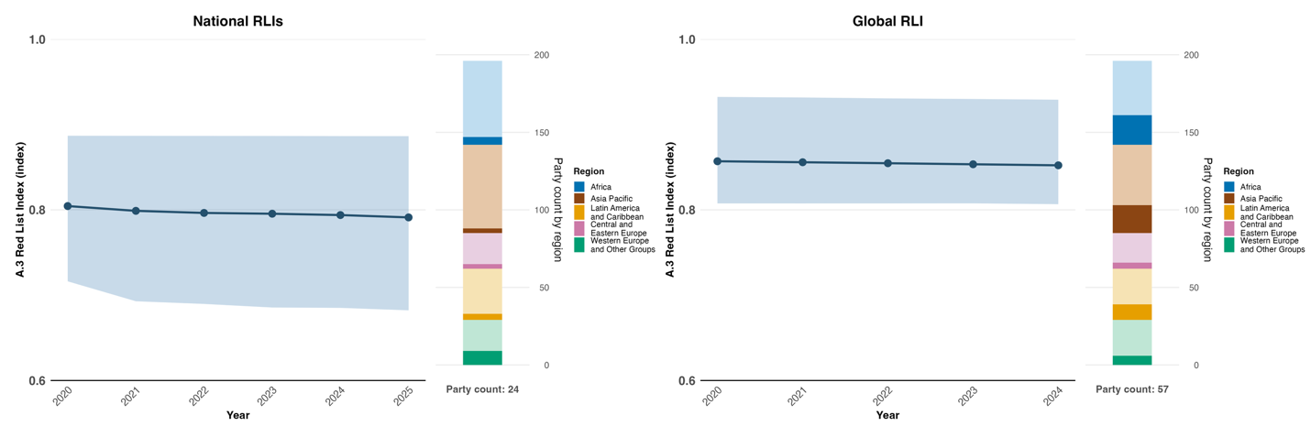

Note: Indicator values show the average (mean) and interquartile range across Party submissions for each year. Left: values for Parties that submitted data for national Red List indices reflecting species’ national extinction risk using their own national Red List assessments. Right: values for Parties that submitted data for national disaggregations of the global Red List Index in their national reports, reflecting each country’s contribution to species’ global extinction risk. The bar charts on the right show the distribution of Parties providing data for the graph by region. Colours for each region are defined in the figure legend: darker tones represent the proportion of Parties for any region for which data are included in the graph; lighter tones represent the proportion of Parties for the same region for which no data are included in the graph.

Figure 20
Headline indicator A.3: Red List Index (based on national disaggregations of the global Red List Index from IUCN)
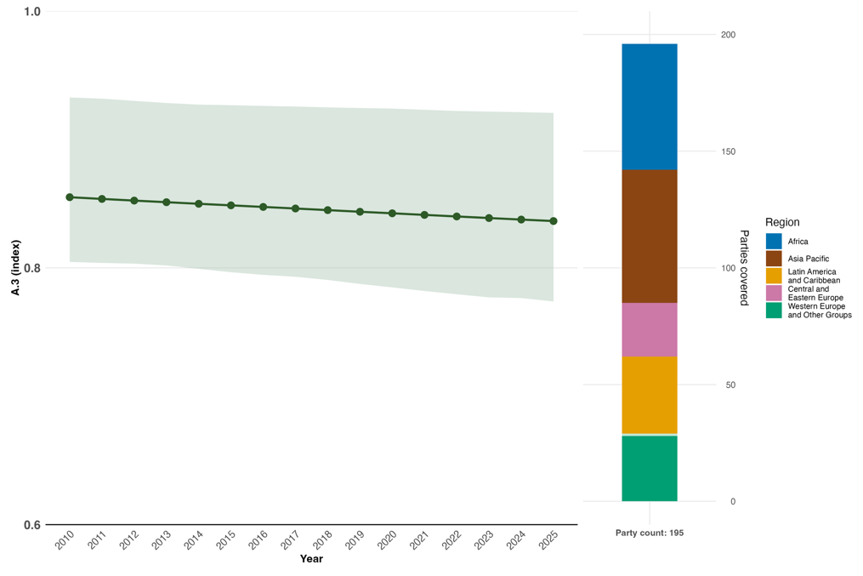
Note: Indicator values show the average (mean) and interquartile range across Parties for each year. The right bar chart shows the distribution of Parties submitting data for the graph by region. Colours for each region are defined in the figure legend: darker tones represent the proportion of Parties for any region for which data are included in the graph; lighter tones represent the proportion of Parties for the same region for which no data are included in the graph.

Figure 21
Headline indicator A.4: the proportion of populations within species with an effective population size greater than 500

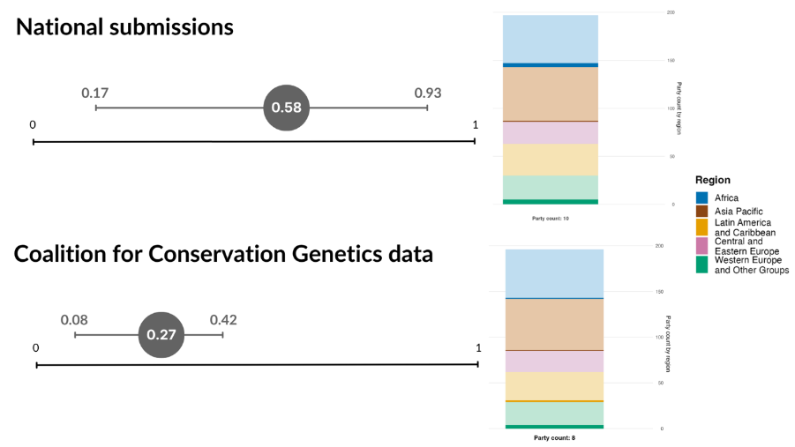
Note: Top: overall average and range of indicator values across Party submissions. Bottom: overall average and range of indicator values across Parties involved in the pilot study for the development of the indicator (Mastretta-Yanes and others, 2024). Only two Parties are included in both averages. In both cases only a single overall value is shown, aggregating all the values submitted/available, as only one Party provided a repeat assessment of the indicator value for a different year. Values should not be compared directly as they do not represent the same set of Parties or species. The bar chart shows the distribution of Parties for which data is available for the graph by region. Colours for each region are defined in the figure legend: darker tones represent the proportion of Parties for any region for which data are included in the graph; lighter tones represent the proportion of Parties for the same region for which no data are included in the graph.
Figure 22
Percentage of indicators aligned with Target 4 of the Framework that suggest improving, stable and negative trends, respectively
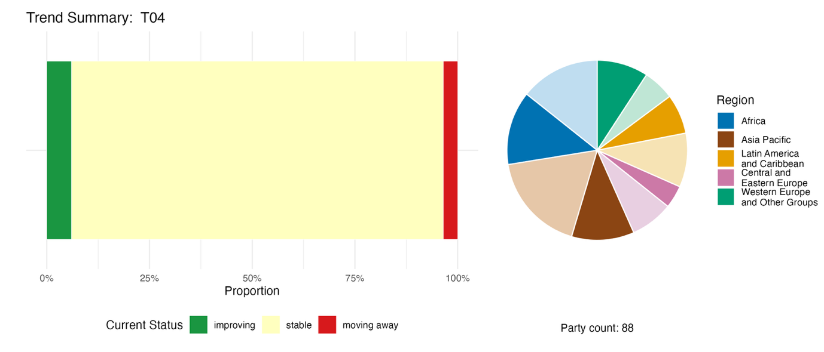
Note: Proportions are weighted by Party. The trends include data for 2 headline indicators from 84 Parties, and 4 component, 1 complementary and 76 national indicators from a total of 25 Parties. The pie chart shows the distribution of Parties submitting indicators for Target 4 by region. Colours for each region are defined in the figure legend: darker tones represent the proportion of Parties for any region for which data are included in the graph; lighter tones represent the proportion of Parties for the same region for which no data are included in the graph.

Self-assessment of progress

Based on the self-assessment by Parties in their national reports of each national target, 35 per cent of national targets highly aligned with Target 4 are on track for achievement, with 1 per cent already achieved, and 59 per cent show insufficient progress or no significant progress (see figure 23).

Figure 23
Self-assessed progress for all national targets submitted as highly aligned to Target 4 of the Framework
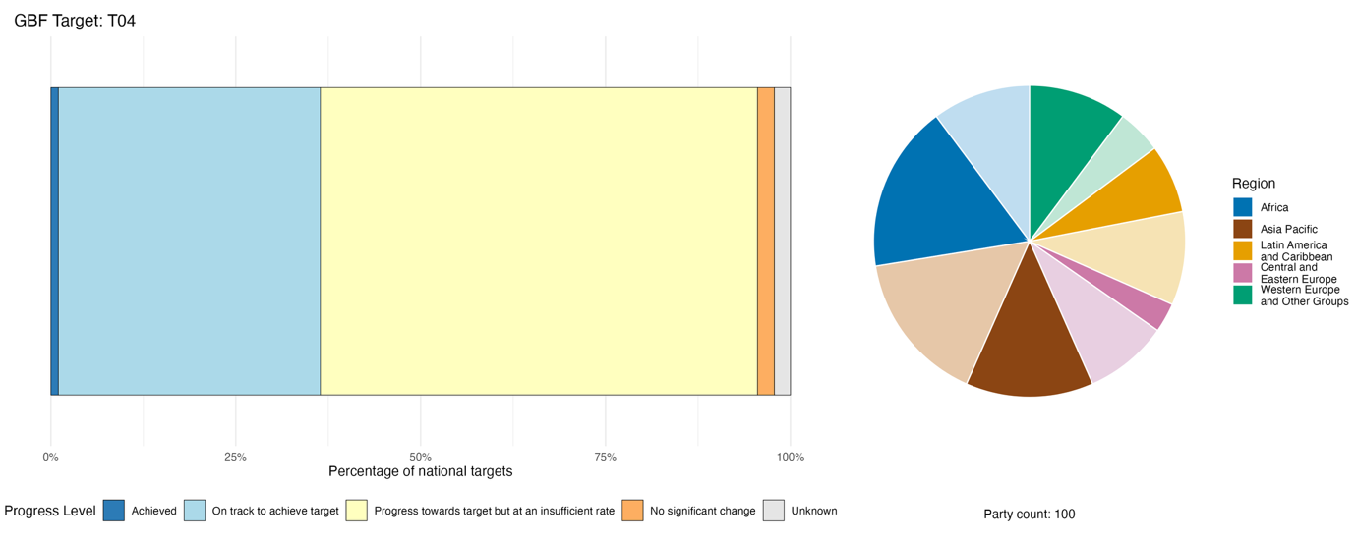
Note: The bar widths show the proportion of national targets submitted in each progress category. Proportions are weighted by Party to ensure that Parties contribute equally to the overall assessment of progress, regardless of the number of national targets submitted. The pie chart shows the proportion of Parties in each region reporting in time for consideration in the global report. Colours for each region are defined in the figure legend: darker tones represent the proportion of Parties for any region for which data are included in the graph; lighter tones represent the proportion of Parties for the same region for which no data are included in the graph.

Actions, successes and challenges in implementation

Summary of actions in support of Target 4 of the Framework

The most widely reported type of action in support of Target 4 is the establishment or implementation of coordinated species recovery programmes and action plans focused on priority species such as flagship, umbrella or keystone species, and threatened species. Direct conservation actions include species reintroduction, habitat restoration, including rewilding, and anti-poaching patrols. Many Parties report research and monitoring activities, including Red List assessments and monitoring of species populations using technologies such as camera trapping, acoustic monitoring and environmental DNA (eDNA). Legal instruments addressing this target include dedicated species protection legislation, the introduction or revision of broader wildlife conservation laws, hunting regulations and national legislation linked to the Convention on International Trade in Endangered Species of Wild Fauna and Flora (CITES). Most Parties also report actions to maintain genetic diversity, for example through gene banks, seed banks, botanical gardens, captive breeding programmes and in vitro conservation. Several Parties report economic instruments to address human-wildlife conflict, including insurance schemes to compensate for damage to crops and livestock, and financial support for infrastructure such as fencing and other deterrents to manage wildlife movement (see boxes 16 and 17).

Examples of success and progress in implementation

Box 16

Saint Vincent and the Grenadines: Endangered species conservation centred on community stewardship

Saint Vincent and the Grenadines has established a systematic conservation model integrating legal regulation, community governance, ecological restoration and international collaboration. The model provides replicable practical experience for small island developing States confronted with biodiversity degradation and climate change pressures.

Initiatives in the Caribbean island nation have yielded measurable ecological recovery outcomes for multiple flagship species threatened with extinction. The population of the critically endangered Union Island gecko (Gonatodes daudini) has increased by 80 per cent through targeted protection and habitat management. Captive-bred Saint Vincent parrots (Amazona guildingii) have been successfully repatriated to stabilize wild populations, while sea turtle nesting numbers have grown steadily as illegal hunting activities have been reduced. Regulated marine harvesting has also facilitated the recovery of herbivorous fish resources and improved coral reef ecological conditions.

Multiple stakeholders participate in long-term conservation implementation across terrestrial and marine ecosystems of Saint Vincent and the Grenadines. Key governmental bodies include the Forestry Department and the Fisheries Division, which undertake planning, law enforcement and ecological monitoring work. Local communities conduct daily patrols and public education, with support from a local NGO: the Union Island Environmental Alliance. Technical guidance and sustainable finance are provided by international partners, including Fauna and Flora International and the Saint Vincent and the Grenadines Environment Fund.

Conservation actions cover the entire territory of Saint Vincent and the Grenadines, focusing on island forests, highland mountain woodlands, coastal nesting beaches and offshore coral reef systems. Projects address multiple inherent conservation challenges faced by Saint Vincent and the Grenadines, including unstable conservation funding and overreliance on external grants, weak law enforcement, severe illegal poaching, wildlife trafficking and unregulated fishing. To resolve these issues, the State has enforced targeted legal bans and formulated standardized by-catch management regulations. It has also implemented species recovery plans, community patrol mechanisms and artificial coral restoration projects. The recognition of Union Island’s ranger team by the IUCN International Ranger Awards has validated the effectiveness of community-centred conservation, further strengthening this as a model to be replicated in other small island developing States.

Relevant targets: 4, 5, 19 and 22.
Source: Saint Vincent and the Grenadines, seventh national report under the Convention.

Box 17
Human-wildlife conflict insurance governance model in China
Human-wildlife conflicts have emerged as a significant governance challenge that accompanies wildlife conservation efforts in many countries. As populations of protected species increase, damage to crops, livestock and property may generate local resistance to conservation measures and undermine long-term conservation outcomes. In Yunnan Province, China, an innovative financial and technical model has been established to mitigate human-wildlife conflicts.
Yunnan Province boasts exceptional biodiversity, but faces severe overlapping pressures between human settlements and wildlife habitats, with frequent damage caused by Asian elephants, black bears, wild boars, macaques and wild birds. Since 1998, Yunnan Province has continually increased financial allocations to protect the interests of local residents, gradually raising compensation standards to provide appropriate economic compensation for those affected by wildlife damage. This policy has helped mitigate human-wildlife conflicts by offsetting losses caused by wildlife and has maintained public enthusiasm for biodiversity conservation.
To further reconcile wildlife conservation with the security of local livelihoods, Yunnan pioneered a government-funded, full-coverage wildlife public liability insurance system that provides timely compensation for wildlife-related losses. An insurance pilot was launched in Xishuangbanna Dai Autonomous Prefecture and Cangyuan Va Autonomous County in 2010. The initiative was elevated as a provincial priority project in 2014 and achieved full coverage across all 16 prefectures and 129 counties within the same year. Over the decade from 2014 to 2024, total premium investment reached RMB 764 million, with compensation payouts reaching RMB 667 million.
Institutional and technical upgrades further refined conflict management, and new measures in 2025 unified compensation standards and laid a legal foundation for insurance coverage. To accelerate services, the Yunnan Forestry and Grassland Bureau partnered with the China Pacific Insurance Company to build “Aixiangsui”, a “smart” public liability insurance platform for wildlife conflict management, to reduce the time taken to process claims from annual settlements to nearly instant compensation through digital reporting and remote verification.
This market-oriented conflict intervention has eased antagonism between local people and protected wildlife, eliminating the retaliatory killing of threatened species such as Asian elephants and black bears. By securing property and personal safety through timely and standardized indemnification, the mechanism reduces human-wildlife tensions, creates social acceptance for species conservation and achieves a triple win for government administration, insurance operators and local communities

Relevant targets: 4, 9, 11 and 19.
Source: China, seventh national report under the Convention.

Challenges

Many Parties flag insufficient financial resources for species protection as a key challenge. Species recovery, the conservation of genetic diversity and human-wildlife conflict management are resource-intensive and cannot be adequately assessed without predictable and accessible means of implementation. Budget allocations in many countries remain largely project-based, creating a barrier to long-term species monitoring, continuity, and the scaling up of conservation efforts. Human-wildlife conflict remains a dominant and persistent challenge even where management tools are deployed. Insufficient monitoring systems, baseline data and indicator frameworks are consistently raised as challenges to implementation. Lack of coordination between national agencies and sectors, and high turnover of technical personnel, are mentioned in national reports as institutional barriers to the implementation of national targets aligned with Target 4.

Contributions of actors other than national Governments

Commitments submitted directly through the online reporting tool

Of 180 substantive commitments submitted directly by actors other than national Governments, 12 are associated primarily with Target 4. They have been submitted by 10 NGOs, one academic and research institution, and an international agricultural research centre. The commitments are mainly associated with collecting data and increasing knowledge; linking species recovery efforts and the conservation of genetic diversity to scientific knowledge; monitoring; and data generation. The commitments include activities ranging from bioacoustics monitoring for biodiversity in agroecological landscapes to conservation of crop genetic diversity through gene banks, data collection through citizen science networks, anti-poaching patrols, actions to prevent species mortality from transport infrastructure, and the reintroduction of captive-bred animals (see box 18).

Box 18
Berlin Zoological Garden supporting global species conservation
Zoo Berlin and Tierpark Berlin are non-profit zoological institutions that coordinate 10 international conservation breeding programmes for threatened species through the European Association of Zoos and Aquaria, and contribute to more than 240 active breeding programmes across a wide range of taxa. As scientifically managed zoos, they provide expertise in population planning, husbandry, veterinary care and conservation biology. They work closely with government authorities and conservation partners to support a range of initiatives for translocation and reintroduction, aimed at restoring and strengthening self-sustaining wild populations. Notable examples include European bison (Bison bonasus), translocated to the Shahdag National Park in Azerbaijan in partnership with its Ministry of Ecology and Natural Resources and WWF; Przewalski's horse (Equus przewalskii), reintroduced to Kazakhstan in cooperation with the Prague Zoo, the Zoological Society Frankfurt and national partners; the Bearded vulture (Gypaetus barbatus), as part of the European reintroduction programme coordinated by the Vulture Conservation Foundation; and the European hamster (Cricetus cricetus) populations reintroduced in Saxony, Germany, in cooperation with Zoo Leipzig. All conservation translocations are implemented in accordance with internationally recognized IUCN guidelines and relevant national species conservation strategies.

Relevant targets: 4, 19, 20 and 22.
Source: Zoo and Tierpark Berlin, stakeholder commitment (see https://ort.cbd.int/database/286541).

Contributions integrated in national reports

Scientific institutions and intergovernmental organizations are commonly reported by Parties as fulfilling such roles as provision of knowledge, technical co-implementation and financing for actions related to Target 4. Specifically, they help to generate threat assessments for species and ecosystems, operate ex situ collections, deliver applied field research and provide methodologies to support conservation and sustainable use. NGOs often act as lead implementers of species recovery programmes and, especially in some developing countries, fill institutional gaps that national agencies cannot cover alone. Indigenous peoples and local communities fulfil a number of roles, including as customary institutions to regulate resource access, as community rangers conducting patrols, and as community seed banks working to conserve agrobiodiversity.

Examples of linkages with other agreements, processes and organizations

CITES has an important role in implementing Target 4, as well as Targets 5 and 9, through its mechanisms to regulate international trade in species at risk of extinction, including non-detriment findings, legal acquisition findings and science-based export quotas. In addition, the inclusion of species in the CITES categories of appendix I (no commercial trade) and appendix II (controlled trade) can form part of broader adaptive strategies to conserve and sustainably use species, based on the particular threats that may be increasing their extinction risk. Equally, the “downlisting” of species from one CITES category to another can be indications of successful conservation measures that may require continued implementation (see box 19). For example, at the twentieth meeting of the Conference of the Parties to the Convention on International Trade in Endangered Species of Wild Fauna and Flora in 2025, the following changes were made (CITES, 2025a and 2026):
- The Guadelupe fur seal (Arctocephalus townsendi) was moved from CITES appendix I to appendix II. This species had been presumed extinct due to the pressure of historical overexploitation, but was subsequently rediscovered and has seen long-term population recovery supported by a combination of national protection in Mexico and international cooperation, illustrating how sustained protection and management can reverse decline.
- Parlatores podocarp (Podocarpus parlatorei), a tree species native to parts of Argentina and the Plurinational State of Bolivia, was moved from appendix I to appendix II, but had a zero export quota for wild specimens for commercial purposes. The conservation outlook for this species has improved, but it has not fully recovered, and the zero export quota reflects a precautionary approach, acting in the best interests of conservation of the species.
- The Bontebok (Damaliscus pygargus subspecies pygargus) was removed from CITES restrictions altogether, having previously been in appendix II. This was due to the long-term recovery of the antelope species following successful conservation management in South Africa. Full exit from the CITES appendices represents a clear example of improved conservation status and reduced extinction risk.
The International Whaling Commission, as the global intergovernmental authority on the conservation and management of whales and other cetaceans, contributes to Target 4. The Commission serves as a repository for global data and conducts detailed assessments on the distribution, abundance and status of cetacean populations across the world. On this basis, it takes measures to address threats and develops multinational conservation management plans for vulnerable species, in some cases in collaboration with the Convention on the Conservation of Migratory Species of Wild Animals (CMS). According to the assessments of the Commission’s Scientific Committee, the pause in commercial whaling on all whale species and populations from the 1985/86 season, which remains in place, has contributed to the recovery of many populations (IWC, 2025).
The promotion of ex situ conservation specifically for plant genetic resources for food and agriculture in gene banks, seed banks and in vitro conservation is undertaken by the Governing Body of the International Treaty on Plant Genetic Resources for Food and Agriculture. The Commission on Genetic Resources for Food and Agriculture of FAO is the only permanent intergovernmental body that specifically addresses all components of biological diversity for food and agriculture. It works to reach international consensus on policies for the sustainable use and conservation of genetic resources for food and agriculture and the fair and equitable sharing of benefits derived from their use. Its objectives are similar to the those of the Convention on Biological Diversity, while specifying biodiversity for food and agriculture. The Commission has negotiated and endorsed numerous global instruments, including global plans of action for genetic resources, as well as codes, standards and guidelines (ITPGRFA, 2026).
At the fifteenth meeting of the Conference of the Contracting Parties to the Convention on Wetlands, the Contracting Parties adopted a resolution establishing the Global Waterbird Estimates Partnership and set out the arrangements for the delivery of the 2027 edition of Waterbird Population Estimates. The Global Waterbird Estimates Partnership provides a framework for the long-term coordination, scientific and technical guidance, and the mobilization of resources for the production of future Waterbird Population Estimates assessments. This process is intended to provide updated waterbird population information to inform improved conservation planning decisions and contribute to halting the loss of or decline in waterbird species or populations (Convention on Wetlands, 2025a).

Box 19
Coordination across multilateral environmental agreements supporting recovery of the Saiga antelope in Kazakhstan

The Saiga antelope (Saiga tatarica) has suffered catastrophic population crashes in recent years owing to a combination of poaching and disease. The Government of Kazakhstan has been working with international partners and through multilateral environmental agreements, notably CMS and CITES, to support one of the most successful wildlife recovery efforts in the region. Conservation actions included strengthened anti-poaching patrols, strict trade controls and expanded protected areas across the antelope’s migratory range. Community engagement programmes have helped reduce incentives for poaching by promoting alternative livelihoods.ª CMS frameworks such as the Central Asian Mammals Initiative and the Medium-Term International Work Programme for the Saiga Antelope (2021–2025) have facilitated cross-border collaboration, policy alignment and habitat connectivity across range States, while CITES provided the legal framework for strictly regulating and monitoring international trade. As a result, the Saiga antelope population in Kazakhstan has rebounded from fewer than 20,000 individuals to more than 2.8 million. Although significant challenges remain, this recovery informed discussions at the twentieth meeting of the Conference of the Parties to Convention in 2025, where Parties agreed to enable strictly limited trade under CITES appendix II, subject to verification requirements, in line with the improved but still vulnerable status of the species, while maintaining a precautionary approach.

Relevant targets: 4 and 5.

Sources : CITES, 2025a, 2026; and CMS, 2021, 2025a).

ªSee https://altyndala.org/.

Target 5. Ensure sustainable, safe and legal harvesting and trade of wild species

Target text: Ensure that the use, harvesting and trade of wild species is sustainable, safe and legal, preventing overexploitation, minimizing impacts on non-target species and ecosystems, and reducing the risk of pathogen spillover, applying the ecosystem approach, while respecting and protecting customary sustainable use by indigenous peoples and local communities.

Progress overview
Progress is being made in strengthening legal and policy frameworks for the sustainable use and trade of wild species, but there is insufficient evidence to assess collective progress across all elements of the target. Reported advances are concentrated in regulated trade and sustainable harvesting practices, while major knowledge, monitoring and capacity gaps limit implementation and assessment of sustainable harvesting. National targets generally align with most aspects of the target, except for reducing the risk of pathogen spillover. Substantial knowledge, data and technical gaps hinder progress, and legal, financial, administrative and capacity constraints on implementation remain.

Coverage by Parties of the scope of Target 5 of the Framework in their national targets

Table 12
Elements of Target 5 of the Framework and how they are addressed in national targets.ª
Ensure that the use and harvesting of wild species is sustainable | 86
Ensure that the trade in wild species is sustainable | 70
Ensure that the use, harvesting and trade of wild species is safe | 50
Ensure that the use, harvesting and trade of wild species prevents pathogen spillover | 32
Ensure that the use, harvesting and trade of wild species is legal | 68
Apply the ecosystem approach in addressing sustainable, safe and legal use, harvesting and trade of wild species | 61
Respect and protect customary sustainable use by indigenous peoples and local communities | 53
On average, Parties have addressed, at least to some extent, 60 per cent of these elements in their national targets
Note: The right-hand column of the table indicates the percentage of Parties with national targets that address the element to at least some extent.
ª The elements for each target were defined by the Ad Hoc Technical Expert Group on Indicators of the Kunming-Montreal Global Biodiversity Framework (see annex I to CBD/COP/16/INF/4; and Affinito and others, 2025).The detailed methodology for the analysis of national targets is provided in document CBD/SBI/7/INF/22.

Most elements of Target 5 are well addressed by Parties in their national targets; however, there are notable gaps (see table 12). The great majority of Parties (86 per cent) have national targets that to some extent address the sustainability of use and harvesting of wild species. More than two thirds of Parties also address the sustainability of trade in wild species (70 per cent) and the legality of use, harvesting and trade in wild species (68 per cent). Fewer than two thirds (61 per cent) have national targets applying the ecosystem approach, and just over half (53 per cent) address the element of Target 5 related to respecting and protecting customary sustainable use by indigenous peoples and local communities. Only half of Parties, however, address the safety of the use, harvesting and trade in wild species, and fewer than one third of Parties (32 per cent) have national targets to prevent pathogen spillover from the use, harvesting and trade of wild species.

Indicators of progress

Table 13
Indicator scorecard for Target 5 of the Framework
 | Indicator use |  | Indicator results
Headline indicator 5.1: proportion of fish stocks within biologically sustainable levels | 27 per cent of Parties |  | Overall average: 60 per cent (range: 14 to 100 per cent)  Trend increasing over time
Binary indicator 5.b: number of countries with legal instruments or other policy frameworks for regulating trade in wild species | 127 Parties | n/aª | 98 per cent of Parties scored highly (score 4/5)
All quantitative indicators combined | 43 Parties, 33 per cent |  | 33 per cent positive trends  17 per cent negative trends
Notes | Indicator values largely focus on fish stocks of national interest
Note: The colour coding is related to the overall assessment of progress across targets, the methodology of which is explained in the overall summary scorecard (see table 3). The colour coding for indicator data use and all quantitative indicator trends reflects where a value for each target sits relative to the highest and lowest scores achieved across all targets of the Framework (green is assigned to percentage values falling within the top third of the total range, yellow to the middle third and red to the bottom third). Colours for the binary indicators are based on the percentage of Parties scoring highly (4 or 5) for the indicator overall (green is assigned to values at or above 50 per cent, yellow to values from 25 to 50 per cent and red to values below 25 per cent). Colours for the headline indicator results are based on progress relative to the target (green is assigned when progress is being made, yellow when progress is mixed, red when progress is insufficient and grey when progress cannot be assessed). Note that the percentage of Parties submitting data on headline indicators may be different from that used in the aggregate results for both the headline indicator and all quantitative indicators combined, owing to methodological differences in the way data were used.
ª As binary indicator data are required by the online reporting tool, submission counts for these indicators do not reflect monitoring capacity differences between targets and do not provide actionable information for making progress in implementation, so assessment of indicator use is not relevant.

Several Parties noted the difficulty of reporting on headline indicator 5.1 (proportion of fish stocks within biologically sustainable levels) owing to a lack of reliable monitoring on fisheries and to a reliance on regional fisheries bodies or international organizations for stock sustainability assessments. Despite this, over a quarter (27 per cent) of Parties whose national reports were available for analysis reported data for the indicator (see table 13). The data, representing about 19 per cent of capture fisheries for all Parties combined, and overrepresented by Parties of the Group of Western European and Other States, show a collectively improving trend in sustainable fish stocks from 2020 and 2025 (see figure 24). Many Parties, however, regularly report national data to FAO under Sustainable Development Goal indicator 14.4.1 on the status of fish stocks (FAO, 2026). The data show that the proportion of assessed fish stocks within biologically sustainable levels declined substantially in previous decades, from 90 per cent in 1974 to 65 per cent in 2021 and to 63 per cent in 2023, but the rate of decline appears to have slowed in recent years.
The majority of Parties report through the binary indicator for Target 5 that legal instruments and policy frameworks to regulate trade in wild species are fully in place (see figure 25). While freshwater and marine species are less well represented in these policies, almost all address terrestrial species and international trade. These results indicate strong progress in setting up an enabling environment to regulate trade in wild species.
When all quantitative indicators submitted for Target 5 are considered together, 33 per cent show positive trends compared with 17 per cent that show negative trends (see figure 26).
While these results suggest some progress in the implementation of Target 5, none of the national indicators submitted by Parties track zoonosis risk, or the protection of customary and sustainable use, indicating a potential gap in the monitoring of progress towards some elements of the target.

Figure 24
Headline indicator 5.1: proportion of fish stocks within biologically sustainable levels
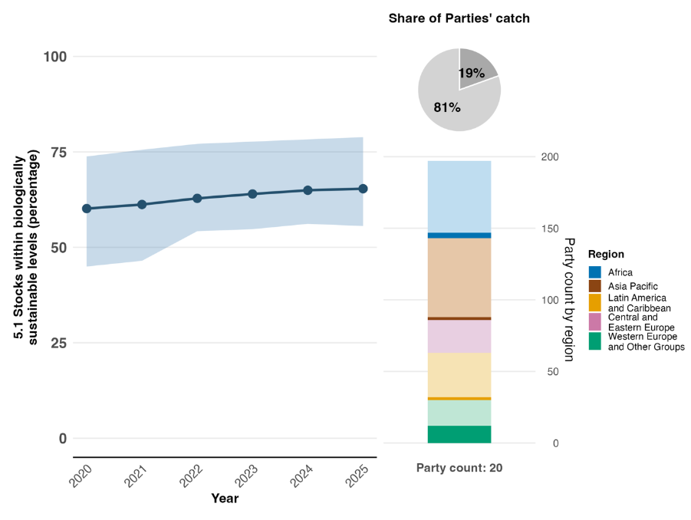
Note: Indicator values show the overall average and interquartile range across Party submissions. The right bar chart shows the distribution of Parties submitting data for the graph by region. Colours for each region are defined in the figure legend: darker tones represent the proportion of Parties for any region for which data are included in the graph; lighter tones represent the proportion of Parties for the same region for which no data are included in the graph. The pie chart shows the proportion of global fish catch accounted for by those Parties that submitted data in dark grey.

Figure 25
Binary indicator 5.b: number of countries with legal instruments or other policy frameworks for regulating trade in wild species
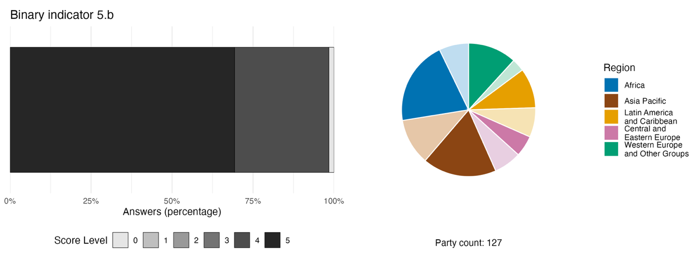
Note: The bar widths show the percentage of Parties in each score category, with higher numbers indicating a greater level of progress, based on responses to the questions included in the indicator.ª The pie chart shows the distribution of Parties providing responses to all questions by region. Colours for each region are defined in the figure legend: darker tones represent the proportion of Parties for any region for which data are included in the graph; lighter tones represent the proportion of Parties for the same region for which no data are included in the graph.
ª The methodology for calculating the score levels for each binary indicator, as well as the questions included for each indicator, are provided in document CBD/COP/16/INF/3/Rev.1.

Figure 26
Percentage of indicators aligned with Target 5 of the Framework that suggest improving, stable and negative trends, respectively
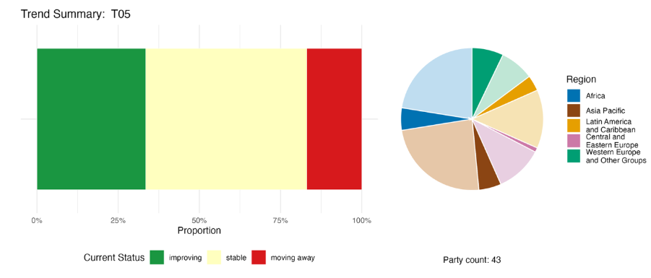
Note: Proportions are weighted by Party. The trends include data for one headline indicator from 30 Parties, one complementary and 63 national indicators from a total of 19 Parties. The pie chart shows the distribution of Parties submitting indicators for Target 5 by region. Colours for each region are defined in the figure legend: darker tones represent the proportion of Parties for any region for which data are included in the graph; lighter tones represent the proportion of Parties for the same region for which no data are included in the graph.

Self-assessment of progress

Based on self-assessment by Parties in national reports, 42 per cent of national targets highly aligned with Target 5 are reported as achieved or on track for achievement, while 54 per cent show no significant progress or insufficient progress (see figure 27).

Figure 27
Self-assessed progress for all national targets submitted as highly aligned with Target 5 of the Framework
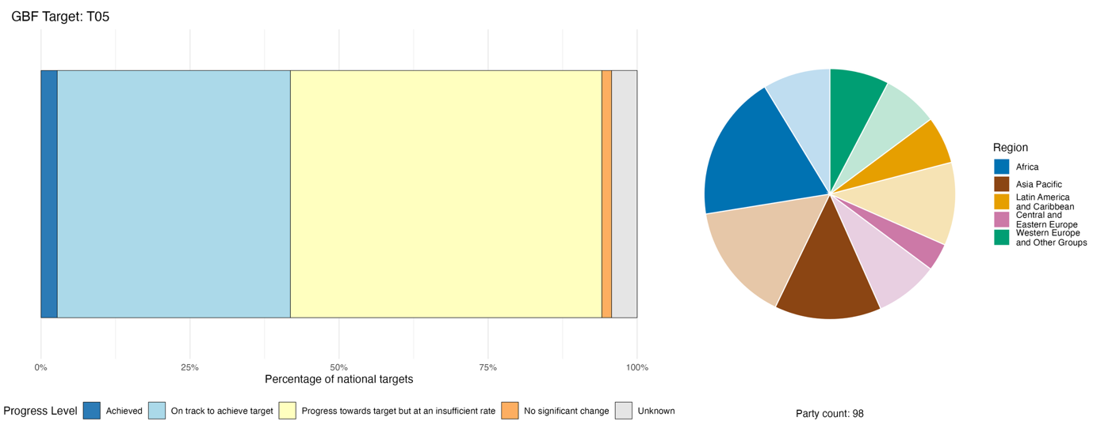
Note: The bar widths show the proportion of national targets submitted in each progress category. Proportions are weighted by Party to ensure that Parties contribute equally to overall assessment of progress, regardless of the number of national targets submitted. The pie chart shows the proportion of Parties in each region reporting in time for consideration in the global report. Colours for each region are defined in the figure legend: darker tones represent the proportion of Parties for any region for which data are included in the graph; lighter tones represent the proportion of Parties for the same region for which no data are included in the graph.

Actions, successes and challenges in implementation

Summary of actions in support of Target 5 of the Framework

The predominant types of action related to Target 5 reported by Parties are the implementation of international trade controls established by CITES, combined with domestic legal frameworks for the hunting, fishing and harvesting of wild species (see boxes 20 and 21). These actions are supplemented by enforcement operations and, in many cases, community engagement. Specific actions relating to sustainable fisheries management include seasonal closures, quotas, gear restrictions and controls on illegal, unreported and unregulated fishing. Research and monitoring activities include species stock assessments, population monitoring programmes, including the use of environmental DNA (eDNA), and non-detriment findings. Many Parties report public-awareness campaigns and measures such as eco-labelling and voluntary certification to support sustainable harvesting of wild species. A minority of Parties report actions to address pathogen spillover, including through One Health approaches.

Examples of success and progress in implementation

Box 20

Biodiversity-based enterprise linking wild species harvesting to regulated value chains in Zimbabwe

Zimbabwe has shown how biodiversity-based value chains can be strengthened through the integration of wildlife governance, community participation and measures to add commercial value. The country has addressed persistent challenges associated with the unsustainable harvesting of wild species and non-timber forest products, including illegal extraction, habitat degradation, weak regulatory frameworks, limited local processing capacity and low returns for rural producers. These challenges were particularly evident in such biodiversity-rich landscapes as the Zambezi Valley and the Lowveld region, where illegal wildlife trade and resource depletion threatened both livelihoods and conservation outcomes.

Since 2021, Zimbabwe has implemented a series of complementary interventions across the country, with flagship initiatives focused on the marula tree (Sclerocarya birrea) in Mwenezi, on the mopane worm (Gonimbrasia belina) in Beitbridge and Matobo, on masawu fruit (Ziziphus spp.) in Muzarabani, on tamarind (Tamarindus indica) in Binga and on fisheries in Lake Kariba. A key milestone was the Parks and Wildlife Amendment Act of 2025, in which science-based harvesting quotas, strengthened anti-trafficking provisions and formalized benefit-sharing mechanisms were introduced. These legal reforms were supported by evidence from national research that assessed biodiversity-based economic opportunities, resource availability and harvesting pressures.

Implementation has involved a broad coalition of actors. Government agencies led activities on legislative reform, quota setting and enforcement, while the National Biotechnology Authority of Zimbabwe supported the establishment of standardized processing facilities for wild biological resources. International partners have contributed financing, technical assistance and training for community wildlife monitors. Academic institutions have collaborated on product development and processing technologies, while private sector partners and foundations supported investment and market integration. Local communities have played a central role in resource co-management, monitoring and sustainable harvesting.

The interventions have combined regulatory reform, monitoring systems, community governance and the large-scale addition of value. Processing facilities for marula, mopane worm, baobab, masawu and tamarind have increased domestic processing capacity and reduced post-harvest losses, while annual fisheries assessments support sustainable management of kapenta (Limnothrissa miodon and Stolothrissa tanganicae) and tilapia (Oreochromis spp.) stocks in Lake Kariba. These measures have contributed to the development of legal and traceable markets benefiting more than 30,000 rural households, supported a formal mopane worm trade valued at approximately US$ 1 million per season, and strengthened compliance with CITES.

Relevant targets: 4, 5, 9 and 20.
Source: Zimbabwe, seventh national report under the Convention

Challenges

Many Parties report that they cannot reliably judge whether use of wild species is sustainable because the science is incomplete. Stock assessments may be missing or outdated, biological reference points and harvest control rules have not been established and catch data are often recorded only in broad species groups that hide trends in individual species. Climate change is making historical baselines less reliable, adding further uncertainty. Alongside these knowledge gaps, Parties report that illegal and unregulated harvesting remains widespread, and enforcement systems struggle to keep pace. Additional challenges reported by Parties include limited monitoring and surveillance capacity, overstretched facilities for confiscated specimens, the entry of illegal goods into legal markets through regulatory loopholes, and uneven cooperation across borders. Moreover, financial, technical and human resources are described as insufficient: funding is short-term and project-based rather than sustained, there are shortages of specialized staff and laboratory and digital infrastructure is weak. In some countries, legal frameworks are incomplete or fragmented, and overlapping mandates among fisheries, forestry, wildlife, customs and environment agencies create delays and inconsistent enforcement.

Contributions of actors other than national Governments

Commitments submitted directly through the online reporting tool

Of 180 substantive commitments submitted directly by actors other than national Governments, only 2 are associated primarily with Target 5. One is from the Danish 92 Group, a civil society network focusing on sustainable resource extraction through transformation of supply chain networks, and the other is from WWF Japan, whose commitment focuses on advancing sustainability in the fisheries sector.

Contributions integrated in national reports

Actors other than national Governments are reported as filling various co-management and governance roles related to the implementation of Target 5, in particular indigenous peoples and local communities, sectoral actors and subnational governments. For example, a number of Parties report that indigenous peoples and local communities hold formal governance authority over the use of wild species, managing harvest quotas, conducting community patrols and operating customary governance systems. Sectoral actors such as fisher associations, hunter organizations, community resource boards and NGOs commonly participate in co-management bodies that have defined responsibilities relating to sustainable use. Subnational governments, especially in federal or devolved systems, often function as primary regulatory implementers of actions relevant to Target 5. With regard to monitoring and data collection, scientific institutions conduct or support stock assessments, non-detriment findings and genetic studies that directly underpin the setting of quotas and authorization of trade. Sectoral actors contribute harvesting and catch statistics that feed into adaptive management, while NGOs and citizen science platforms contribute monitoring data that provide biodiversity baselines.

Examples of linkages with other agreements, processes and organizations

Box 21
Coordinated action across multilateral environmental agreements to address illegal logging and trade in Madagascar

The Rainforests of the Atsinanana in Madagascar were added to the UNESCO World Heritage List in 2007 owing to their exceptional biodiversity and their importance in sustaining ecological processes. This world heritage property, comprising six separate protected areas, faced severe threats from illegal logging and trafficking of Malagasy ebonies (Diospyros spp.) and rosewoods (Dalbergia spp.), with the resulting deforestation also affecting species such as lemurs. This led UNESCO to include the site in its List of World Heritage in Danger in 2010, followed by the inclusion of the relevant tree species in CITES appendix II in 2013, in alignment with the corrective measures recommended under the Convention for the Protection of the World Cultural and Natural Heritage. These joint actions catalysed national reforms, including a ban on commercial logging and the development of a traceability system for seized timber. A pilot project successfully inventoried and marked stockpiles using Quick Response Code tags linked to a public database. In 2025, Madagascar adopted a zero-export quota for all commercial trade in these species. A joint UNESCO-IUCN-CITES monitoring mission conducted under the Convention in 2025 confirmed a significant reduction in illegal logging, the restoration of 63 per cent of previously lost forest cover, and the lowest level of lemur poaching recorded in a decade. As a result, the World Heritage Committee removed the Rainforests of the Atsinanana from the List of World Heritage in Danger in 2025. The case illustrates how collaboration across multilateral environmental agreements can lead to mutually reinforcing actions for combating illegal trade and strengthened governance, supporting long-term habitat and species conservation.

Relevant targets: 3, 4 and 5.
Sources: CITES, 2025a, 2025b; and UNESCO, 2025a, 2025b.

The Collaborative Partnership on Sustainable Wildlife Management is a voluntary partnership of 13 international organizations that have substantive mandates and programmes to promote the sustainable use and conservation of wildlife resources. With a secretariat based within the Forestry Division of FAO, the Collaborative Partnership was established in March 2013 through a decision of the Conference of the Parties to the Convention on Biological Diversity, and tasked with a mission to increase cooperation and coordination on sustainable wildlife management issues among its members in order to promote the sustainable management of terrestrial vertebrate wildlife in all biomes and geographic areas, contributing to the conservation and sustainable use of biodiversity, and to human food security, livelihoods and well-being (dec. XI/25 in CBD, 2012). The Collaborative Partnership has an ambitious workplan and multiple joint programmes and initiatives among member organizations, including the Sustainable Wildlife Management Programme, which has implemented field projects in 16 countries across Africa, Asia, the Caribbean and the Pacific, developed with indigenous peoples and local communities, and national authorities. The Collaborative Partnership’s work directly addresses the regulation of wildlife hunting, the development of sustainable alternative protein sources, the strengthening of management capacities of indigenous peoples and local communities, the reduction of unsustainable urban wild meat demand and the mitigation of zoonotic disease risk through a One Health approach, in line with Targets 4, 5 and 9 of the Framework.

Target 6. Reduce the introduction of invasive alien species by 50 per cent and minimize their impact
Target text. Eliminate, minimize, reduce and/or mitigate the impacts of invasive alien species on biodiversity and ecosystem services by identifying and managing pathways of the introduction of alien species, preventing the introduction and establishment of priority invasive alien species, reducing the rates of introduction and establishment of other known or potential invasive alien species by at least 50 per cent by 2030, and eradicating or controlling invasive alien species, especially in priority sites, such as islands.

Progress overview
Parties are taking action on invasive alien species, but progress remains difficult to assess. Most Parties report that they are not on track to achieve national targets associated with Target 6. Overall, national targets do not explicitly capture the full scope of the target, and only a minority of Parties have quantitative elements that match the global ambition of Target 6. Parties also note the challenges associated with monitoring, such as limited baseline data and a low capacity to detect invasive alien species. Although Parties have reported significant actions taken to deliver on the target, it is not yet possible to discern the long-term effects of these efforts on the establishment or impacts of invasive alien species. Effective actions include strong prevention-focused biosecurity measures, which are not broadly in place across Parties, owing to differences in capacity and national circumstances.

Coverage by Parties of the scope of Target 6 of the Framework in their national targets

Table 14
Elements of Target 6 of the Framework and how they are addressed in national targetsª
Eliminate, minimize, reduce and/or mitigate the impacts of invasive alien species on biodiversity | 59
Eliminate, minimize, reduce and/or mitigate the impacts of invasive alien species on ecosystem services | 56
Identify pathways of the introduction of invasive alien species | 40
Manage pathways of the introduction of invasive alien species | 41
Prevent the introduction and establishment of priority invasive species | 48
Reduce the rates of introduction and establishment of other known or potential invasive alien species by at least 50 per cent by 2030 | 65
Eradicate or control invasive alien species, especially in priority sites, such as islands | 71
On average, Parties have addressed, to at least some extent, 54 per cent of these elements in their national targets

Note: The right-hand column of the table indicates the percentage of Parties with national targets that address the element to at least some extent.
ª The elements for each target were defined by the Ad Hoc Technical Expert Group on Indicators of the Kunming-Montreal Global Biodiversity Framework (see annex I to CBD/COP/16/INF/4; and Affinito and others, 2025).The detailed methodology for the analysis of national targets is provided in document CBD/SBI/7/INF/22.

The majority of Parties have national targets that to some extent address the elements of Target 6 on: the eradication or control of invasive alien species, especially in priority sites such as islands (71 per cent of Parties); reducing the rates of introduction and establishment of known or potential invasive alien species (65 per cent); and the impacts of invasive alien species on biodiversity (59 per cent) and ecosystem services (56 per cent) (see table 14). Fewer than half of Parties have set national targets on the prevention of the introduction of priority invasive alien species (48 per cent) and on identifying and managing pathways of the introduction of invasive alien species (40 and 41 per cent respectively).

Fewer than one third of Parties (30 per cent) have national targets that quantify the targeted reduction in the rate of introduction and establishment of invasive alien species. Of those that have a quantitative component to their national targets, more than three quarters (78 per cent) aim for a 50 per cent reduction in the rate of introduction and establishment of invasive alien species, in keeping with the global reduction rate included in Target 6.

Indicators of progress

Table 15
Indicator scorecard for Target 6 of the Framework
 | Indicator use |  | Indicator results
Headline indicator 6.1: rate of invasive alien species establishment | 21 per cent of Parties |  | Overall, half of reporting Parties have a rate of 2.5 species per year or more  No overall trend
Binary indicator 6.b: number of countries adopting relevant regulations, processes and measures to reduce the impact of invasive alien species | 127 Parties | n/aª | 77 per cent of Parties scored highly (score 4/5)
All quantitative indicators combined | 35 Parties, 27 per cent |  | 25 per cent positive trends  13 per cent negative trends
Notes | Low monitoring capacity for invasive alien species means detection rates are low.  Parties are largely establishing baselines for rates of establishment.
Note: The colour coding is related to the overall assessment of progress across targets, the methodology of which is explained in the overall summary scorecard (see table 3). The colour coding for indicator data use and all quantitative indicator trends reflects where a value for each target sits relative to the highest and lowest scores achieved across all targets of the Framework (green is assigned to percentage values falling within the top third of the total range, yellow to the middle third and red to the bottom third). Colours for the binary indicators are based on the percentage of Parties scoring highly (4 or 5) for the indicator overall (green is assigned to values at or above 50 per cent, yellow to values from 25 to 50 per cent and red to values below 25 per cent). Colours for the headline indicator results are based on progress relative to the target (green is assigned when progress is being made, yellow when progress is mixed, red when progress is insufficient and grey when progress cannot be assessed). Note that the percentage of Parties submitting data on headline indicators may be different from that used in the aggregate results for both the headline indicator and all quantitative indicators combined, owing to methodological differences in the way data were used.
ª As binary indicator data are required by the online reporting tool, submission counts for these indicators do not reflect monitoring capacity differences between targets and do not provide actionable information for making progress in implementation, so assessment of indicator use is not relevant.

Many Parties report capacity and technical challenges related to the monitoring of invasive alien species, stating that many species go unnoticed for years before impacts become apparent. Therefore, detecting a specific quantitative reduction in the rate of introduction and establishment of invasive alien species, as called for in the target, is challenging. Data reported for headline indicator 6.1 (rate of invasive alien species establishment), submitted by 21 per cent of Parties whose national reports are available for analysis (see table 15), show a wide range in rates and no overall trend from 2020 (median 2.37, minimum 0.45 and maximum 40 species per year) to 2025 (median 2.39, minimum 0.45 and maximum 40 species per year (see figure 28).
Through the binary indicator for Target 6 (see figure 29), most Parties have reported progress in implementing measures to manage invasive alien species. These measures have largely focused on reducing the rate of introduction and impact of invasive alien species, while measures to eradicate and control invasive alien species are reported as being partly in place. These differences are reflected in the kinds of national indicators submitted by Parties, which mostly focus on reducing the rates of introduction and establishment. One quarter of these indicators show positive trends, while one fifth show negative trends (see figure 30). Although Parties have reported significant actions to deliver on Target 6, it is not yet possible to discern the long-term effects of these efforts for biodiversity and ecosystem services on the basis of data reported.

Figure 28
Headline indicator 6: rate of invasive alien species establishment
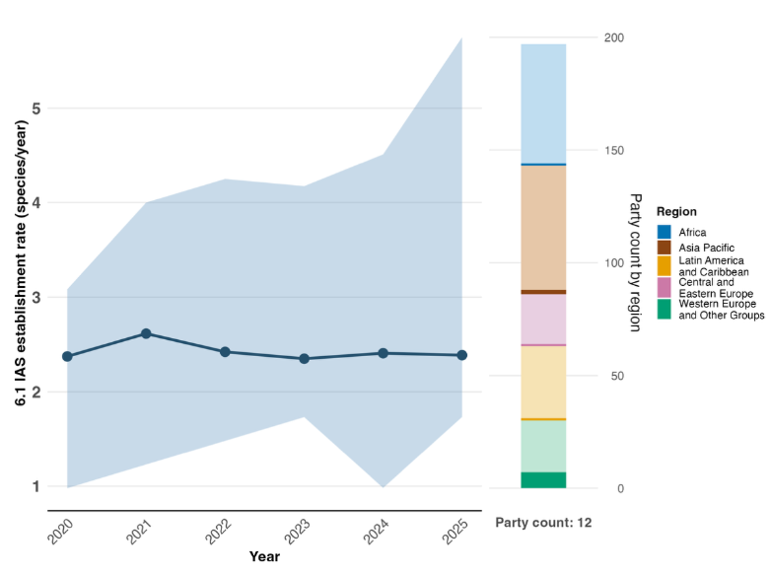
Note: Indicator values show the median and interquartile range across Party submissions each year. The right bar chart shows the distribution of Parties providing data by region. Colours for each region are defined in the figure legend: darker tones represent the proportion of Parties for any region for which data are included in the graph; lighter tones represent the proportion of Parties for the same region for which no data are included in the graph.

Figure 29
Binary indicator 6.b: the number of countries adopting relevant regulation, processes and measures and allocating resources to reduce the impact of invasive alien species
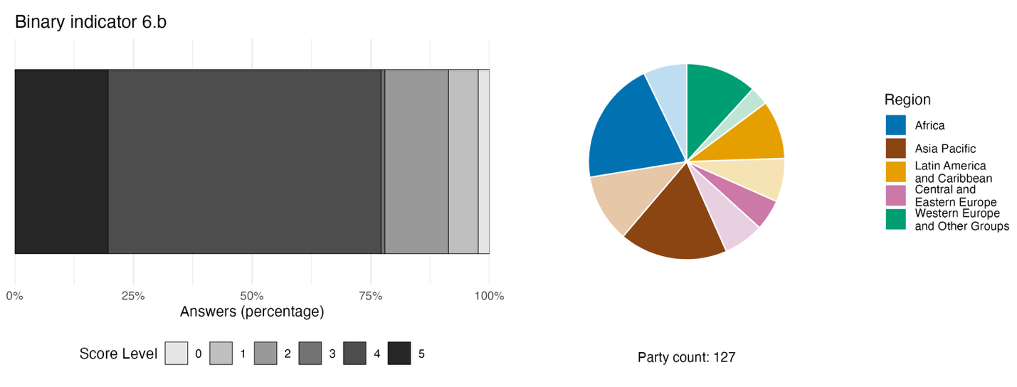
Note: The bar widths show the percentage of Parties in each score category, with higher numbers indicating a greater level of progress, based on responses to the questions included in the indicator.ª The pie chart shows the distribution of Parties providing responses to all questions by region. Colours for each region are defined in the figure legend: darker tones represent the proportion of Parties for any region for which data are included in the graph; lighter tones represent the proportion of Parties for the same region for which no data are included in the graph.
ª The methodology for calculating the score levels for each binary indicator, as well as the questions included for each indicator, are provided in document CBD/COP/16/INF/3/Rev.1.

Figure 30
Percentage of indicators aligned with Target 6 of the Framework that suggest improving, stable and negative trends, respectively
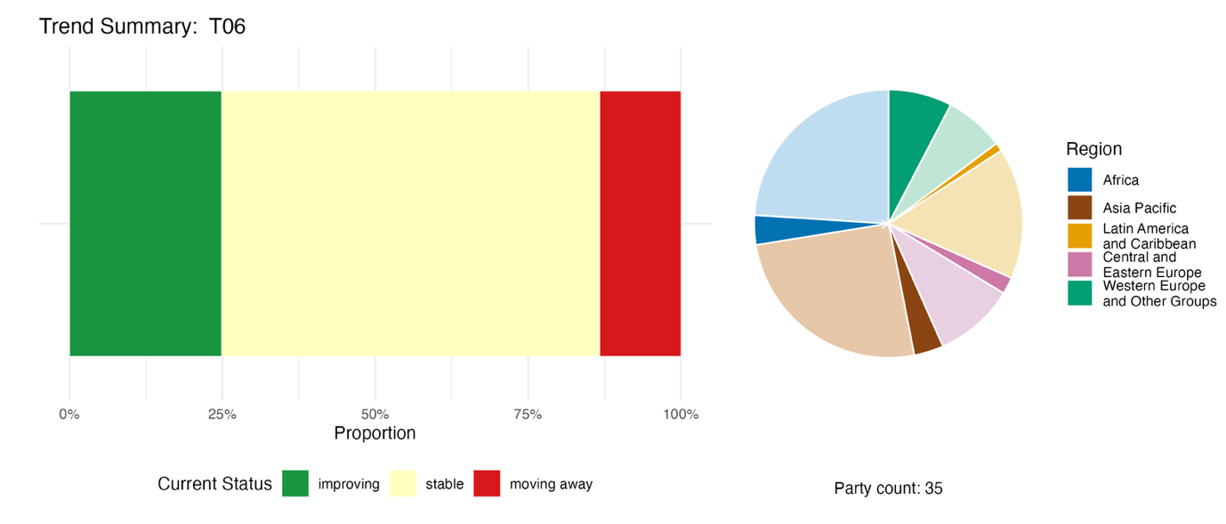
Note: Proportions are weighted by Party. The trends include data for 1 headline indicator from 21 Parties and 63 national indicators from a total of 17 Parties. The pie chart shows the distribution of Parties submitting indicators for Target 6 by region. Colours for each region are defined in the figure legend: darker tones represent the proportion of Parties for any region for which data are included in the graph; lighter tones represent the proportion of Parties for the same region for which no data are included in the graph.

Self-assessment of progress
Based on self-assessment by Parties in national reports, fewer than one third (31 per cent) of targets submitted as highly aligned with Target 6 are on track for achievement, with 66 per cent showing no significant progress or insufficient progress, and a very few (1 per cent, accounting for two national targets) reported as being already achieved (see figure 31).

Figure 31
Self-assessed progress for all national targets submitted as highly aligned with Target 6 of the Framework
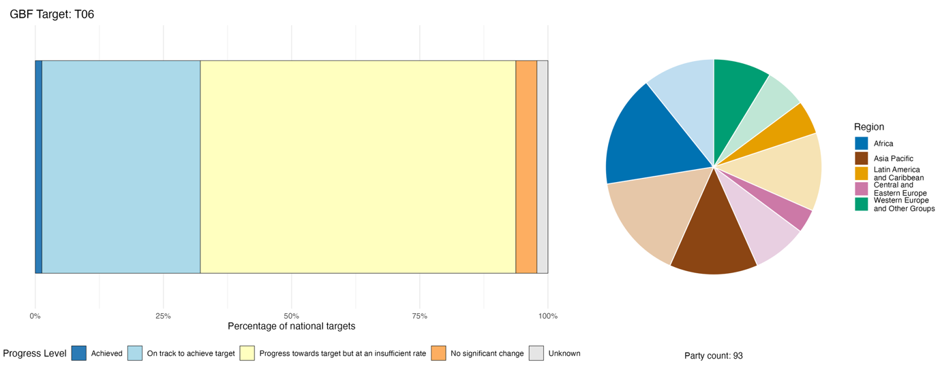
Note: The bar widths show the proportion of national targets submitted in each progress category. Proportions are weighted by Party to ensure that Parties contribute equally to overall assessment of progress, regardless of the number of national targets submitted. The pie chart shows the proportion of Parties in each region reporting in time for consideration in the global report. Colours for each region are defined in the figure legend: darker tones represent the proportion of Parties for any region for which data are included in the graph; lighter tones represent the proportion of Parties for the same region for which no data are included in the graph.

Actions, successes and challenges in implementation

Summary of actions in support of Target 6 of the Framework

Reported actions in support of Target 6 include island biosecurity programmes and species-specific management plans for invasive alien species. Many Parties reported on measures to intercept invasive alien species at borders, as well as campaigns to eradicate invasive alien species by using mechanical removal or biological control. Common legal and regulatory actions include national legislation covering invasive alien species, and restrictions on particular invasive alien species of concern. Actions related to research, monitoring and data collection are widely reported, including national surveys and inventories of invasive alien species, establishment of monitoring systems and databases, citizen science monitoring and analysis of pathways by which invasive alien species are transported. Many Parties reported conducting public-awareness campaigns to draw attention to the risks posed by invasive alien species, and engaging people in helping to eradicate them or prevent their spread (see boxes 22 and 23).

Examples of success and progress in implementation

Box 22
Blended finance for invasive species control in urban water catchments in South Africa

Insufficient and unstable financing has long constrained the effective management of invasive alien species in South Africa. The scale and persistence of biological invasions across water catchments, protected areas, coastal ecosystems and terrestrial biodiversity hotspots have exceeded the capacity of conventional public funding mechanisms. Recognizing these limitations, South Africa has developed a governance framework that combines regulatory reform, ecosystem restoration and innovative financing instruments to support the long-term management of invasive alien species.

Implemented nationwide, with notable interventions in the Cape Town water catchments and the Upper Jukskei River system, the approach has evolved through biodiversity and agricultural legislation enacted between 1983 and 2004, followed by revised invasive species regulations that entered into force in 2021. A new national invasive alien species strategy and management plan will guide action for the period 2026–2036.

A defining feature of the approach of South Africa is the establishment of blended finance mechanisms that combine government budget allocations, private sector investment and contributions from NGOs. These arrangements have expanded the financial resources available for invasive species control, while reducing reliance solely on public expenditure. An example is the Greater Cape Town Water Fund, which mobilized more than R180 million from private sector partners to support the removal of invasive freshwater fishes and alien plant species within water catchments supplying Cape Town.

With regard to implementation, Government departments have led the development of legislation, strategic planning, permitting systems and fiscal support mechanisms. NGOs and corporate partners have provided financial resources and technical expertise through joint funding initiatives and restoration programmes. Additional support has been provided through international initiatives, including the Global Environment Facility’s project related to invasive alien species, which strengthened policy frameworks, institutional capacity, public awareness and biosecurity measures at ports of entry. An eco-disaster risk reduction project, supported by the Green Climate Fund, further linked invasive species management with ecosystem restoration and climate resilience objectives, while the Sustainable Communities and Climate Adaptation in South Africa initiative contributed to the rehabilitation of the Upper Jukskei River catchment.

Relevant targets: 4, 6 and 19.
Source: South Africa, seventh national report under the Convention.

Box 23
Cross-border collaboration and environmental DNA technology for muskrat and coypu invasion control
The Kingdom of the Netherlands has faced persistent challenges from invasive semi-aquatic mammals, in particular muskrat (Ondatra zibethicus) and coypu (Myocastor coypus), whose burrowing activities undermine dikes, riverbanks and other water-management infrastructure. These impacts pose significant risks to flood protection and water security in a country where large areas lie below sea level. Management efforts have been further complicated by the continuous dispersal of muskrats from neighbouring countries, especially Germany, making complete eradication within national borders difficult. Traditional trapping methods also require substantial labour and financial resources, while the concealed nature of burrow systems complicates species detection and removal.
Since the launch of a national population reduction programme in 2019, management actions have been implemented across inland waterways, wetlands, riverbanks and border regions throughout the country. A defining feature of the programme is the use of environmental DNA (eDNA) techniques, using water sampling and quantitative polymerase chain reaction analysis to detect species presence efficiently and accurately. These methods complement conventional trapping by reducing monitoring costs, improving detection precision and minimizing impacts on non-target species. Cross-border cooperation has also facilitated the development of intelligent trapping systems, standardized data collection protocols and coordinated management responses.
A central objective of the programme is to eliminate viable inland coypu populations and to restrict muskrat populations to border areas, with a quantitative target of removing self-sustaining inland muskrat populations from the country by 2034. The programme has produced substantial outcomes, including the successful eradication of coypu from inland areas and a dramatic reduction in muskrat abundance. Annual muskrat captures have declined from approximately 500,000 individuals to 85,000, indicating a significant reduction in population pressure and associated infrastructure damage.
With regard to implementation, water authorities oversee field operations, deploy professional trapping teams and coordinate border-control measures. National agencies engage in dialogue with neighbouring countries to strengthen coordinated management efforts. Research institutions contribute to the development and application of innovative monitoring technologies, while citizens participate through official reporting platforms that support surveillance and early detection.
Relevant targets: 4, 6, 20 and 21.
Source: Kingdom of the Netherlands, seventh national report under the Convention.

Challenges

Parties report that the lack of baseline data and monitoring systems for invasive alien species can hamper the impact assessments needed to provide a defensible rationale for national regulation and management. In addition, without a baseline, it is impossible to calculate introduction or establishment rates or verify progress towards the 50 per cent reduction target. Functional early detection and rapid response systems are frequently absent or underdeveloped. The recurrence and reinvasion of invasive alien species from neighbouring countries or other areas can undermine eradication efforts, which are often short-term and localized. Several Parties point to the absence of legislation specific to invasive alien species as a challenge to the implementation of Target 6. Financial constraints are also cited, as a lack of sustained funding prevents the long-term efforts required to control or eradicate invasive species populations. The lack of sectoral integration in the management of alien invasive species was noted as another barrier to controlling their spread. Some Parties report that, despite control measures, establishment rates of invasive alien species are continuing to increase. Some Parties also note the specific challenges posed by aquatic invasive species, which are often harder to detect and manage.

Contributions of actors other than national Governments

Commitments submitted directly through the online reporting tool

Of 180 substantive commitments submitted by actors other than national Governments, only 5 are primarily associated with Target 6. Four of the commitments are from NGOs, and one is from an academic and research institution. Four of the five commitments relate to data and knowledge, highlighting the importance of monitoring, early warning systems and knowledge-sharing in the management of invasive alien species. Four of the commitments are focused on European countries, while one addresses invasive species management in rangelands in Africa (see box 24).

Box 24
Addressing invasive alien species as part of participatory rangeland management in Africa through the CGIAR System Organization

The CGIAR System Organization has committed to designing and implementing participatory rangeland management processes across Ethiopia, Kenya, Senegal and the United Republic of Tanzania with the aim of bringing 1 million ha of rangelands under sustainable use and management. The initiative involves the formulation of joint participatory rangeland management plans, co-designed rangeland restoration strategies and the development of dedicated tools and methodologies for invasive alien species management and rehabilitation. Progress is tracked against two indicators for Target 6 of the Framework: the rate of invasive alien species establishment (headline indicator 6.1), and the number of countries adopting relevant regulations to reduce the impact of invasive alien species (binary indicator 6.b). Inclusive governance structures are a central design principle, and local communities and governments are actively engaged throughout implementation. The commitment is funded through the CGIAR Trust Fund, a multi-donor, multi-year mechanism aligned with the System’s 2030 research and innovation strategy, and is implemented by a consortium of CGIAR centres. Progress is reported annually through CGIAR publications and communication channels.

Relevant targets: 2, 6 and 22.
Source: CGIAR System Organization, stakeholder commitment (see https://ort.cbd.int/database/293918).

Contributions integrated in national reports

Parties report that the scientific community and academia play key roles in knowledge production to support the implementation of Target 6, for example through the production of inventories, checklists and risk assessments of invasive alien species, as well as through monitoring and surveillance, the development of tools and platforms, direct interventions such as biological control and physical removal, policy advice and capacity-building. Intergovernmental organizations and international partners function both as co-financiers through mechanisms such as GEF, and as providers of technical assistance through FAO, CABI, IUCN and bilateral programmes. Subnational governments and local authorities are often responsible for delivering control programmes for invasive alien species, as well as enforcing relevant legislation or by-laws. Indigenous peoples and local communities are reported by some Parties as contributing to front-line biosecurity surveillance, the mechanical removal of invasive alien species and the integration of traditional knowledge, among other roles.

Examples of linkages with other agreements, organizations and processes

The dominant pathway for the transfer of invasive aquatic species is shipping, with shipping-related vectors (ballast water and biofouling) accounting for the majority of such transfers (Zhang and others, 2026). At the same time, the shipping pathway is by far the most comprehensively managed, for example through the International Convention for the Control and Management of Ships’ Ballast Water and Sediments, 2004 (BWM Convention). This is a legally binding treaty negotiated through the International Maritime Organization (IMO), in force since 2017, and currently includes more than 100 Parties, representing more than 93 per cent of shipping around the world. The BWM Convention was created with the intent of preventing the transfer of invasive aquatic species by ensuring that ships' ballast water and sediments can be discharged only if they have been managed in accordance with its provisions. In 2023, the Marine Environment Protection Committee of IMO adopted revised guidelines for the control and management of ships' biofouling to minimize the transfer of invasive aquatic species. The guidelines provide a globally consistent approach to the management of biofouling–the accumulation of various aquatic organisms on ships’ surfaces (including hulls). As with all guidelines, they are not mandatory, but IMO member States have decided to develop a legally binding framework for the control and management of ships' biofouling, with work having begun in 2026 (IMO, 2023a, 2023b and 2025).
Pathways are also addressed by the International Plant Protection Convention (IPPC). While the focus of IPPC is on plant pest risks, benefits from its measures also address invasive alien species and therefore contribute to Target 6. For example, the Commission on Phytosanitary Measures of IPPC published a recommendation in 2024 on minimizing the pest risk associated with transport in sea containers (IPPC Secretariat, 2024).
Actions to support the implementation of Target 6 are also coordinated through the Inter-Agency Liaison Group on Invasive Alien Species, convened by the Convention on Biological Diversity and involving CABI, CITES, FAO, the Global Biodiversity Information Facility (GBIF), the International Civil Aviation Organization, IMO, IPPC, IUCN), the World Organization for Animal Health, the World Customs Organization and the World Trade Organization.
As noted in box 5, the authors of the IPBES assessment on invasive alien species (IPBES, 2023a) emphasize that mitigating biological invasions requires an integrated governance framework structured around prevention, early detection and strategic control. Prevention through robust border biosecurity and pathway management is identified as the most effective and economical defence. When prevention fails, early detection and rapid response protocols are critical to minimizing establishment rates, in particular in vulnerable marine and connected aquatic networks. For established populations, context-specific interventions, such as eradication, physical or biological containment, and ecosystem restoration, are recommended. Crucially, the authors advocate cross-sectoral collaboration, sustained funding and the integration of open-access data systems. They stress that co-developing policies alongside stakeholders, indigenous peoples and local communities is essential to achieving global environmental targets, including Target 6 of the Framework.

Target 7. Reduce pollution to levels that are not harmful to biodiversity

Target text. Reduce pollution risks and the negative impact of pollution from all sources by 2030, to levels that are not harmful to biodiversity and ecosystem functions and services, considering cumulative effects, including: (a) by reducing excess nutrients lost to the environment by at least half, including through more efficient nutrient cycling and use; (b) by reducing the overall risk from pesticides and highly hazardous chemicals by at least half, including through integrated pest management, based on science, taking into account food security and livelihoods; and (c) by preventing, reducing, and working towards eliminating plastic pollution.

Progress overview

Advances in addressing pollution are uneven, and major gaps in data availability hinder the assessment of progress. Target 7 includes diverse sources of pollution, which Parties have addressed in different ways when setting national targets. Reported trends for national indicators are divergent. Low reporting on headline indicators, incomplete or uneven monitoring systems and limited comparability across indicators constrain the aggregate assessment of pollution risks and progress. Most Parties (60 per cent) acknowledge that they are not currently on track to meet national targets associated with Target 7. A major challenge in advancing Target 7 is ensuring effective and fair consideration and managing impacts on food security and livelihoods.

Coverage by Parties of the scope of Target 7 of the Framework in their national targets

Table 16
Elements of Target 7 of the Framework and how they are addressed in national targetsª
Reduce pollution risks and the negative impact of pollution from all sources by 2030, to levels that are not harmful to biodiversity, considering cumulative effects | 71
Reduce pollution risks and the negative impact of pollution from all sources by 2030, to levels that are not harmful to ecosystem functions and services, considering cumulative effects | 60
Reduce excess nutrients lost to the environment by at least half, including through more efficient nutrient cycling and use | 55
Reduce the overall risk from pesticides by at least half including through integrated pest management, based on science, taking into account food security and livelihoods | 56
Reduce the overall risk from highly hazardous chemicals by at least half | 43
Prevent, reduce and work towards eliminating plastic pollution | 44
On average, Parties have addressed, to at least some extent, 55 per cent of these elements in their national targets

Note: The right-hand column of the table indicates the percentage of Parties with national targets that address the element to at least some extent.
ª The elements for each target were defined by the Ad Hoc Technical Expert Group on Indicators of the Kunming-Montreal Global Biodiversity Framework (see annex I to CBD/COP/16/INF/4; and Affinito and others, 2025).The detailed methodology for the analysis of national targets is provided in document CBD/SBI/7/INF/22.

The elements of Target 7 addressed by most Parties in their national targets are those relating to the reduction of pollution risks to levels that are not harmful to biodiversity (71 per cent of Parties) and ecosystem functions and services (60 per cent) (see table 16). A smaller proportion include national targets on reducing excess nutrients lost to the environment, and on reducing the overall risk from pesticides (55 per cent and 56 per cent, respectively). The elements addressed by the fewest Parties in national targets are those on reducing the overall risk from highly hazardous chemicals. In addition, while many Parties report specific actions related to plastics, fewer national targets capture the full scope of the target with regard to preventing, reducing and working towards the elimination of plastic pollution.
Target 7 includes quantitative components with regard to reducing excess nutrients lost to the environment and reducing the overall risks from pesticides and highly hazardous chemicals (i.e. “by at least half”). About one fifth of Parties include quantitative components in their national targets relating to reductions in nutrient loss and risks from pesticides, and fewer (13 per cent) have set national targets for quantified reductions in risk from highly hazardous chemicals.

Indicators of progress

Table 17
Indicator scorecard for Target 7 of the Framework
 | Indicator use |  | Indicator results
Headline indicator 7.1: index of coastal eutrophication potential | 10 per cent of Parties, <1 per cent have time series data |  | No results: only 2 Parties submitted indicator data as described in the metadata
Headline indicator 7.2: pesticide environment concentration and/or aggregated total applied toxicity | 14 per cent of Parties |  | No results: only 5 Parties submitted indicator data as described in the metadata, but used different units
All quantitative indicators combined | 39 Parties, 30 per cent |  | 31 per cent positive trends  24 per cent negative trends
Notes | Use of the headline indicators is limited, but partial submissions of some national reports include intermediate data required to compile the indicators.  Submitted data mostly includes proxy values for the indicators.
Note: The colour coding is related to the overall assessment of progress across targets, the methodology of which is explained in the overall summary scorecard (see table 3). The colour coding for indicator data use and all quantitative indicator trends reflects where a value for each target sits relative to the highest and lowest scores achieved across all targets of the Framework (green is assigned to percentage values falling within the top third of the total range, yellow to the middle third and red to the bottom third). Colours for the headline indicator results are based on progress relative to the target (green is assigned when progress is being made, yellow when progress is mixed, red when progress is insufficient and grey when progress cannot be assessed). Note that the percentage of Parties submitting data on headline indicators may be different from that used in the aggregate results for both the headline indicator and all quantitative indicators combined, owing to methodological differences in the way data were used.

Parties faced challenges in compiling both of the headline indicators for Target 7 (see table 17). These included methodological issues linked to the modelling required for headline indicator 7.1 (index of coastal eutrophication), and the incomplete methodology of headline indicator 7.2 (pesticide environment concentration and/or aggregated total applied toxicity). Many Parties also noted the limited availability of data owing to incomplete monitoring systems. Differences in the national reporting frameworks of Parties resulted in the use of national and proxy indicators that had different units, making global aggregation difficult. Five Parties, however, did provide estimates for headline indicator 7.2, using the draft methodology for aggregated total applied toxicity. Among these, at least one Party reached a 50 per cent reduction in aggregated total applied toxicity, reaching the objective of halving the overall risk from pesticides. Many additional national indicators associated with water quality, plastic pollution and pesticide use were submitted by Parties, showing trends moving both towards and away from the target (see figure 32). Overall, it is apparent that many Parties have targets addressing several elements of Target 7, and monitoring efforts are under way to assess national progress; however, the data currently used lack the comparability necessary to compile aggregate indicators to assess progress in implementation.

Figure 32
Percentage of indicators aligned with Target 7 of the Framework that suggest improving, stable and negative trends, respectively
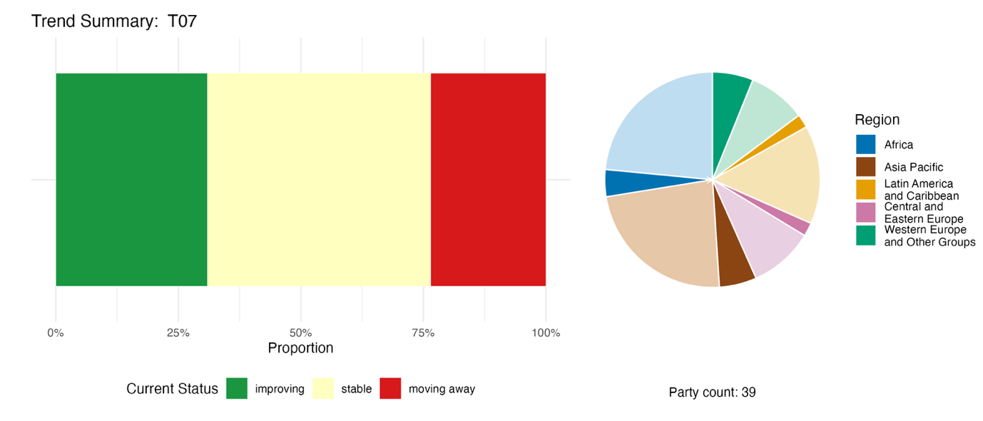
Note: Proportions are weighted by Party. The trends include data for 2 headline indicators from 24 Parties, and 2 component, 3 complementary and 97 national indicators from a total of 22 Parties. The pie chart shows the distribution of Parties submitting indicators for Target 7 by region. Colours for each region are defined in the figure legend: darker tones represent the proportion of Parties for any region for which data are included in the graph; lighter tones represent the proportion of Parties for the same region for which no data are included in the graph.

Self-assessment of progress

Based on self-assessment by Parties in national reports, more than one third (35 per cent) of national targets submitted as highly aligned with Target 7 are on track for achievement, while 60 per cent show no significant change or insufficient progress (see figure 33).

Figure 33
Self-assessed progress for all national targets submitted as highly aligned with Target 7 of the Framework
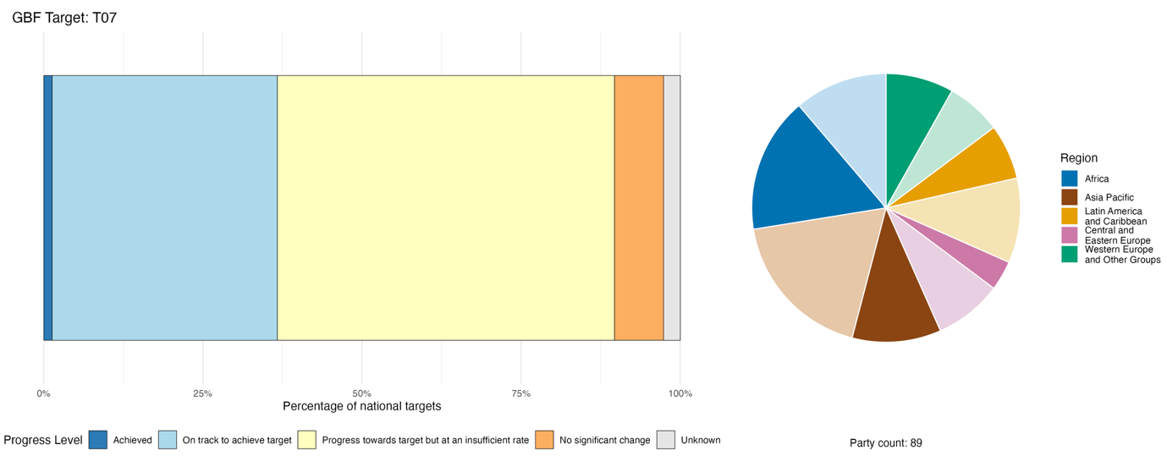
Note: The bar widths show the proportion of national targets submitted in each progress category. Proportions are weighted by Party to ensure that Parties contribute equally to overall assessment of progress, regardless of the number of national targets submitted. The pie chart shows the proportion of Parties in each region reporting in time for consideration in the global report. Colours for each region are defined in the figure legend: darker tones represent the proportion of Parties for any region for which data are included in the graph; lighter tones represent the proportion of Parties for the same region for which no data are included in the graph.

Actions, successes and challenges in implementation

Summary of actions in support of Target 7 of the Framework

Actions addressing plastic pollution are most commonly reported by Parties in relation to Target 7, with the vast majority reporting bans or restrictions on single-use plastic for such items as bags, straws, cutlery and polystyrene. A large number of Parties report using integrated pest management and imposing bans on highly hazardous pesticides as a means of reducing risks posed by pesticide use. A significant additional group of Parties, concentrated in Europe and Asia, report regulatory and technical measures to reduce nutrient losses from fertilizers and slurry. A smaller group of countries report measures to eliminate pollution from mercury and persistent organic pollutants, highlighting actions taken in the context of the Minamata Convention on Mercury and the Stockholm Convention on Persistent Organic Pollutants. A growing number of Parties report investment in recycling infrastructure and circular economy frameworks as a structural response to plastic and waste pollution (see boxes 25 and 26).

Examples of success and progress in implementation

Box 25
National circular economy framework of Australia, including quantified cross-sector pollution reduction

Rising material consumption, increasing waste generation and persistent pollution pressures have posed growing threats to terrestrial, freshwater and marine biodiversity across Australia. In response, Australia has progressively established an integrated national circular economy policy and regulatory ecosystem that links waste reduction, resource recovery, product stewardship, industrial chemicals management, sustainable production and consumption, and circular economy data and reporting. Beginning with the implementation of the Recycling and Waste Reduction Act 2020, Australia has progressively strengthened regulatory settings, investments, national reporting arrangements and cross-jurisdictional collaboration to reduce the impact of pollution on biodiversity while improving resource efficiency.
The national report submitted by Australia to the Convention identifies a national target intended to increase the country’s circularity rate and reduce pollution and its impacts on biodiversity by 2030. The release of the country’s circular economy framework in December 2024 represented a key milestone, establishing a national ambition to double economic circularity in Australia by 2035, supported by targets that aim at safely recovering 80 per cent of resources, improving material productivity by 30 per cent and reducing the per capita material footprint by 10 per cent. The framework builds on earlier reforms, including waste export bans, product stewardship schemes, packaging reforms, national waste policy actions and strengthened environmental management of industrial chemicals.
A notable feature of the country’s approach has been the evolution of national data, measurement and reporting systems. Australia has worked with the Commonwealth Science and Industrial Research Organization, state and territorial governments, industry and researchers to develop nationally consistent circular economy indicators, material flow accounts and resource recovery reporting. These data systems now support the measurement of circularity, material productivity, material footprint and resource recovery outcomes, providing an evidence base for policy development, investment prioritization and progress reporting.
Implementation has involved a broad coalition of governments, research institutions, businesses, investors and communities. Key initiatives include: the expansion of recycling and reprocessing infrastructure through the Recycling Modernization Fund and related investments; nationwide coverage of container deposit schemes; action to phase out problematic and unnecessary plastics; product stewardship arrangements; reforms to packaging design and recyclability; waste export regulation; and the implementation of the Industrial Chemicals Environmental Management Standard, which provides nationally consistent environmental controls on higher-risk industrial chemicals.
The approach of Australia has generated measurable environmental outcomes. Long-term monitoring by the Commonwealth Science and Industrial Research Organization recorded a 39 per cent reduction in coastal plastic debris density across surveyed metropolitan regions between 2013 and 2023. National resource recovery increased from 62.7 per cent in 2019/20 to 66.0 per cent in 2022/23, while domestic recycling and reprocessing capacity has expanded following the implementation of waste export bans and associated infrastructure investment. National circular economy indicators also show gradual improvements in the circularity rate and material productivity, and in the gradual decline of material footprint per capita over the longer term.
Relevant targets: 7, 11, 16 and 21.
Sources: Australia, seventh national report under the Convention; and DCCEEW, 2024.

Box 26
Progress by Jordan in reducing mercury use and strengthening import control
Jordan has made significant progress in implementing measures to reduce the use of mercury and mercury-containing products, while strengthening regulatory control over their import, in line with its commitments under the Minamata Convention on Mercury and Target 7 of the Framework. As a first step, Jordan completed a national inventory of mercury, mercury compounds and mercury-containing products, and their sources and uses, across different sectors. On the basis of those findings, Jordan prepared its initial assessment for the second meeting of the Conference of the Parties to the Minamata Convention on Mercury in 2018, which provided the foundation for strengthening its national legal and institutional framework on mercury management.
Following the assessment, Jordan amended several national regulations governing hazardous chemicals and waste. Instructions for the management and handling of hazardous waste, released in 2019, classified mercury-containing waste as hazardous waste, requiring its collection, storage, transportation and disposal in an environmentally sound manner to protect human health and biodiversity. In addition, under Regulation No. 68 of 2020, the import of elemental mercury and mercury compounds was prohibited.
Jordan also implemented a project entitled "Environmentally sound management of mercury-containing wastes and reduction of mercury-containing products in Jordan", in cooperation with the secretariat of the Minamata Convention on Mercury and the United Nations Environment Programme (UNEP). The project was aimed at strengthening national capacities for the environmentally sound management of mercury-containing products and waste and preventing the release of mercury into the environment.
On the basis of the analytical studies conducted during the project, Jordan prohibited the import of several mercury-added products. To improve collection and prevent the release of mercury into the environment, Jordan established 32 collection points for mercury-containing household waste, including spent fluorescent lamps and electrical and electronic waste, across all governorates. Nine of these collection points were located in public parks to facilitate public access and encourage safe disposal by households.
Jordan has also prepared a draft national action plan to phase out the use of dental amalgam by 2030, consistent with the provisions of the Minamata Convention on Mercury. Furthermore, the Ministry of Agriculture has prohibited the use of mercury in agricultural pesticides for many years, contributing to the prevention of the contamination of soils and water resources and the protection of ecosystems and biodiversity.
Collectively, these actions demonstrate the country’s integrated approach to mercury management through legislative reform, strengthened import controls, improved hazardous waste management infrastructure, public awareness and enhanced collection systems. These measures contribute directly to reducing pollution, preventing the release of mercury into the environment, protecting biodiversity and ecosystem services, and fulfilling the obligations of Jordan under the Minamata Convention on Mercury while supporting the implementation of Target 7 of the Framework.
Relevant target: 7.
Source: Jordan, seventh national report under the Convention.

Challenges

Parties noted the tension between phasing out hazardous products and protecting food security and farmers’ livelihoods. Even in situations where legal frameworks to reduce pollution exist, enforcement action is often weak and implementation capacity may be insufficient. Several Parties identify insufficient domestic financing as a key barrier to implementation. A number of Parties, especially developing countries, point to inadequate wastewater treatment infrastructure as a persistent challenge. Some Parties note the particular challenge of assessing species recovery following coastal and marine pollution from shipping accidents. Many Parties acknowledge insufficient monitoring capacity as a barrier to assessing progress towards Target 7, including a lack of data on pollution from all sources, as well as a lack of data on sales and applications of pesticides and synthetic fertilizers.

Contributions of actors other than national Governments

Commitments submitted directly through the online reporting tool

Of 180 substantive commitments submitted by actors other than national governments, only 5 are primarily associated with Target 7. Three of these have been submitted by a single private corporation (see box 27), one by an NGO and one by a research institution. The three business commitments are global in scope, the commitment by the NGO is focused on Denmark, and the commitment from the research institution (CGIAR) covers Africa, South America and Asia.
(II.B.7-NSA-VEOLIA): Veolia: a transnational corporation addressing pollution and waste across worldwide operations
Box 27

Veolia: a transnational corporation addressing pollution and waste across worldwide operations

Veolia SA, a French multinational company specializing in water, waste and energy management services, has submitted eight complementary commitments that are global in scope, running from 2024 to 2027. They include pollution reduction through the elimination of phytosanitary products (pesticides, herbicides and fungicides) on 95 per cent of its sites; a wastewater treatment efficiency target of 92 per cent chemical oxygen demand purification yield for its large wastewater treatment plants (over 100,000 population equivalents); and the treatment of 10 million metric tons of hazardous waste, including through lithium battery and plastic recycling.
With regard to biodiversity, Veolia has committed to deploying its Green Spaces Charter, developed with IUCN, across 95 per cent of its sites with more than one hectare of green space, and to conducting biodiversity footprint assessments and deploying action plans (targeting an 85 per cent overall deployment rate) on all of its approximately 150 sensitive sites.
Natural resource commitments include preserving 1.5 billion cubic metres of fresh water through water reuse, desalination and leak reduction, alongside a zero deforestation policy with fully traceable and certified wood sourcing for its energy sector. All commitments are underpinned by a Net Zero 2050 trajectory, and tracked annually through Veolia's corporate sustainability reporting.

Relevant targets: 7, 8, 10, 12, 15 and 16.
Source: Veolia, stakeholder commitments (available at https://ort.cbd.int/database/287708, https://ort.cbd.int/database/287712, https://ort.cbd.int/database/287714, https://ort.cbd.int/database/287709, https://ort.cbd.int/database/287710, https://ort.cbd.int/database/287711, https://ort.cbd.int/database/287707 and https://ort.cbd.int/database/287715).

Contributions integrated in national reports

Parties report that subnational governments and local authorities serve in several implementation roles for Target 7, for example by delivering waste management infrastructure, enforcing local ordinances and administering agri-environmental schemes directed at reducing pollution. Business and finance actors are also prominently mentioned in such roles as operating waste collection and recycling enterprises, participating in extended producer responsibility frameworks, and funding pollution-reduction infrastructure through corporate social responsibility and co-financing arrangements. The contributions of sectoral actors, in particular farmers, towards the implementation of Target 7 include implementing integrated pest management, operating reduced-input practices and participating in agri-environmental schemes. With regard to monitoring and knowledge, the scientific community and academia generate data on pesticide residue, water quality and microplastics, and develop tools, indicators and evidence to support efforts to reduce pollution and waste.

Examples of linkages with other agreements, organizations and processes

The Global Framework on Chemicals – For a Planet Free of Harm from Chemicals and Waste (GFC), established in 2023 at the fifth International Conference on Chemicals Management, sets out five strategic objectives and 28 targets addressing the life cycle of chemicals, including products and waste, with the overall vision of a planet free of harm from chemicals and waste. To track progress and impacts, GFC includes a measurability structure with indicators, proposing a high-level indicator on the “global environmental burden attributable to chemicals and waste”. UNEP and the secretariat of GFC are supporting the development of indicators that can complement the monitoring of Target 7 of the Framework, including by helping to capture the impacts of chemical and waste pollution on biodiversity, ecosystem functions and ecosystem services (UNEP, 2024a, 2024b, 2025a and 2025b).
A specific area of connection between the Minamata Convention for Mercury and the Framework is artisanal and small-scale gold mining, predominantly conducted with the use of mercury, which is widespread in developing countries in South America, sub-Saharan Africa and Asia, and has direct and major effects on human health and ecosystems. To date, 37 Parties to the Minamata Convention on Mercury have submitted national action plans on artisanal and small-scale gold mining, focused on the formalization or regulation of the sector and other mandatory elements. Implementation of these plans is expected to lead to substantial mercury reductions, and thus contribute to Target 7 of the Framework. UNEP, with support from GEF, is working with the secretariat of the Minamata Convention on Mercury and other partners on a programme entitled “planetGOLD”, which is aimed at eliminating mercury from the gold supply chain and making small-scale gold mining safer, cleaner and more profitable (Dossou Etui and others, 2024; Minamata Convention on Mercury, 2024, 2025a and 2025b; and UNEP, 2025a).
In addition, the International Whaling Commission works with both the Stockholm Convention on Persistent Organic Pollutants and the Minamata Convention on Mercury to address the contamination of cetaceans. Moreover, based on national reports by Parties to the Convention on Wetlands, pollution is the most reported threat to sites on the Ramsar List of Wetlands of International Importance (IWC, 2025; and Convention on Wetlands, 2025c). The Plastic Waste Partnership, under the Basel Convention on the Control of Transboundary Movements of Hazardous Wastes and Their Disposal, implements pilot projects that enhance capacity-building, waste management and policy frameworks to help countries prevent plastic waste accumulation and minimize pollution at its source (Secretariat of the Basel, Rotterdam and Stockholm Conventions, 2025).
Moreover, synergies exist between efforts to implement the Framework and the Memorandum of Understanding on the Conservation of Migratory Birds of Prey in Africa and Eurasia of CMS (CMS, 2008), in particular to avoid the poisoning of birds from pesticides and harmful chemicals.
Activities of the international cooperative programmes under the Convention on Long-range Transboundary Air Pollution (ECE, 1979) and the UNEP International Nitrogen Management System (INMS, 2026) can contribute to managing nutrient loads in ecosystems. These initiatives support international cooperation on mitigation, and investment for the implementation of solutions relevant to making progress towards Target 7.

Target 8. Minimize the impacts of climate change on biodiversity and build resilience

Target text. Minimize the impact of climate change and ocean acidification on biodiversity and increase its resilience through mitigation, adaptation, and disaster risk reduction actions, including through nature-based solutions and/or ecosystem-based approaches, while minimizing negative and fostering positive impacts of climate action on biodiversity.

Progress overview
Actions to strengthen climate resilience and adaptation are progressing, but implementation remains constrained by data gaps, limited means of implementation and the need for stronger coherence among biodiversity, climate and disaster risk reduction planning. There is generally a good alignment between national targets and Target 8 across all elements, apart from targets related to minimizing the impacts of ocean acidification. Half the indicators submitted by Parties show positive trends, suggesting that the actions implemented are generally effective. Parties acknowledge in their self-assessments, however, that progress is not being made at a sufficient rate to meet half the targets. Important approaches reported to address elements of Target 8 include ecosystem restoration, which is also reported in Target 2, and nature-based solutions, but these are not being deployed at sufficient scale.

Coverage by Parties of the scope of Target 8 of the Framework in their national targets

Table 18
Elements of Target 8 of the Framework and how they are addressed in national targetsª
Minimize the impact of climate change on biodiversity, and increase its resilience, through mitigation, adaptation and disaster risk reduction actions | 83
Minimize the impact of ocean acidification on biodiversity, and increase its resilience, through mitigation, adaptation and disaster risk reduction actions | 32
Apply nature-based solutions | 65
Apply ecosystem-based approaches | 61
Minimize negative impacts of climate action on biodiversity | 64
Foster positive impacts of climate action on biodiversity | 66
On average Parties have addressed, to at least some extent, 62 per cent of these elements in their national targets

Note: The right-hand column of the table indicates the percentage of Parties with national targets that address the element to at least some extent.
ª The elements for each target were defined by the Ad Hoc Technical Expert Group on Indicators of the Kunming-Montreal Global Biodiversity Framework (see annex I to CBD/COP/16/INF/4; and Affinito and others, 2025). The detailed methodology for the analysis of national targets is provided in document CBD/SBI/7/INF/22.

The great majority of Parties (83 per cent) have set national targets that, to at least some extent, address the target element aimed at minimizing the impact of climate change on biodiversity and increasing its resilience through mitigation, adaptation and disaster risk reduction actions (see table 18). A large majority of Parties also address the target elements that involve applying nature-based solutions (65 per cent), applying ecosystem-based approaches (61 per cent), minimizing the negative impacts of climate action on biodiversity (64 per cent) and fostering positive impacts of climate action on biodiversity (66 per cent). Fewer than a third of Parties (32 per cent) have set national targets addressing the impacts of ocean acidification on biodiversity.
Thus, apart from the element on ocean acidification, Parties have generally aligned their national targets with the broad scope of Target 8. There are no quantitative elements within the target.

Indicators of progress

Table 19
Indicator scorecard for Target 8 of the Framework
 | Indicator use |  | Indicator results
Binary indicator 8.b: number of countries with policies to minimize the impact of climate change and ocean acidification on biodiversity and to minimize negative and foster positive impacts of climate action on biodiversity | 127 Parties | n/aª | 24 per cent of Parties scored highly (score 4/5)
All quantitative indicators combined | 32 Parties, 18 per cent |  | 42 per cent positive trends  16 per cent negative trends
Note: The colour coding is related to the overall assessment of progress across targets, the methodology of which is explained in the overall summary scorecard (see table 3). The colour coding for indicator data use and all quantitative indicator trends reflects where a value for each target sits relative to the highest and lowest scores achieved across all targets of the Framework (green is assigned to percentage values falling within the top third of the total range, yellow to the middle third and red to the bottom third). Colours for the binary indicators are based on the percentage of Parties scoring highly (4 or 5) for the indicator overall (green is assigned to values at or above 50 per cent, yellow to values from 25 to 50 per cent and red to values below 25 per cent).
ª As binary indicator data are required by the online reporting tool, submission counts for these indicators do not reflect monitoring capacity differences between targets and do not provide actionable information for making progress in implementation, so assessment of indicator use is not relevant.

For the binary indicator for Target 8, Parties mostly reported being at an intermediate level of implementation of measures related to the impacts of climate change and ocean acidification on biodiversity (see table 19 and figure 34). All Parties reported some progress on such measures, but only 2 per cent reported full implementation. In fact, almost all Parties (97 per cent) report that NBSAPs include actions on minimizing the impacts of climate change, and 90 per cent report that their policies and action plans include nature-based solutions. Fewer Parties reported progress on implementing measures to minimize the impacts of ocean acidification. National indicators submitted that were in alignment with Target 8 largely tracked climate change impacts rather than ocean acidification. Nevertheless, wider climate-related measures adopted by Parties may also contribute to reducing and/or minimizing the impacts of ocean acidification (see figure 35).

Figure 34
Binary indicator 8.b: number of countries with policies to minimize the impact of climate change and ocean acidification on biodiversity and to minimize negative and foster positive impacts of climate action on biodiversity
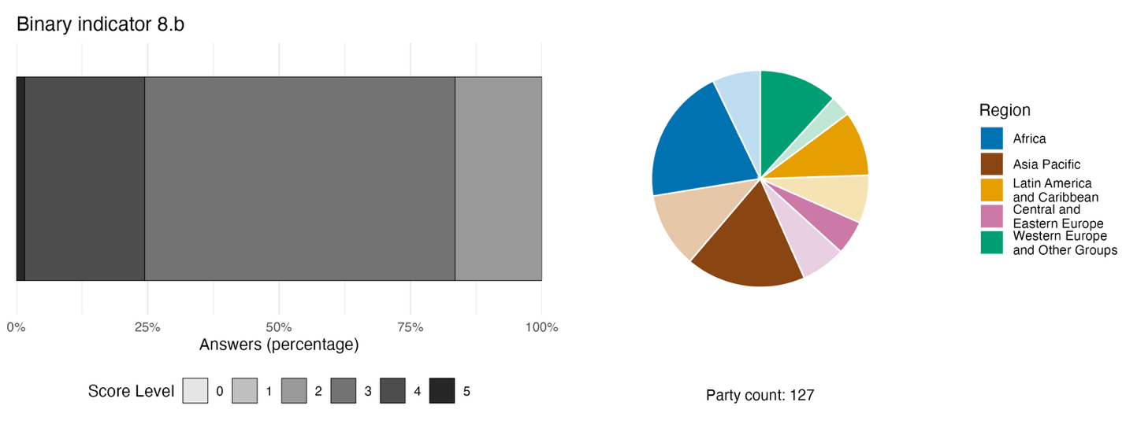
Note: The bar widths show the percentage of Parties in each score category, with higher numbers indicating a greater level of progress, based on responses to the questions included in the indicator.ª The pie chart shows the distribution of Parties providing responses to all questions by region. Colours for each region are defined in the figure legend: darker tones represent the proportion of Parties for any region for which data are included in the graph; lighter tones represent the proportion of Parties for the same region for which no data are included in the graph.
ª The methodology for calculating the score levels for each binary indicator, as well as the questions included for each indicator, are provided in document CBD/COP/16/INF/3/Rev.1.

Figure 35
Percentage of indicators aligned with Target 8 of the Framework that suggest improving, stable and negative trends, respectively
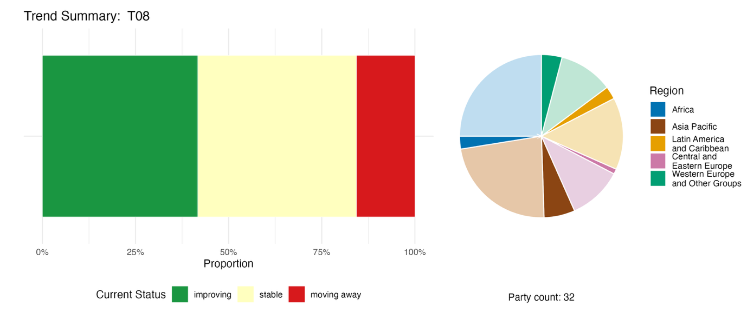
Note: Proportions are weighted by Party. The trends include data for 2 component, 4 complementary and 74 national indicators from a total of 32 Parties. The pie chart shows the distribution of Parties submitting indicators for Target 8 by region. Colours for each region are defined in the figure legend: darker tones represent the proportion of Parties for any region for which data are included in the graph; lighter tones represent the proportion of Parties for the same region for which no data are included in the graph.

Self-assessment of progress
Based on self-assessment by Parties in national reports, 42 per cent of national targets submitted as highly aligned with Target 8 are on track for achievement, with a larger number (53 per cent) showing no significant change or insufficient progress, and just two national targets (1 per cent) reported as already achieved (see figure 36).

Figure 36
Self-assessed progress for all national targets submitted as highly aligned with Target 8 of the Framework
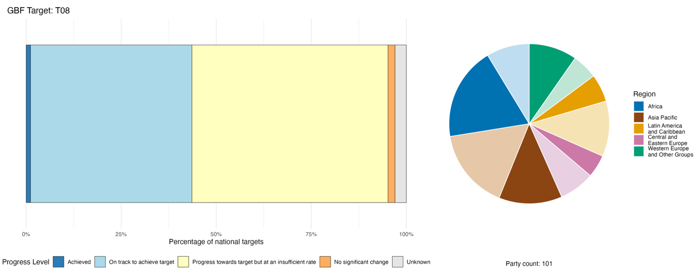
Note: The bar widths show the proportion of national targets submitted in each progress category. Proportions are weighted by Party to ensure that Parties contribute equally to overall assessment of progress, regardless of the number of national targets submitted. The pie chart shows the proportion of Parties in each region reporting in time for consideration in the global report. Colours for each region are defined in the figure legend: darker tones represent the proportion of Parties for any region for which data are included in the graph; lighter tones represent the proportion of Parties for the same region for which no data are included in the graph.

Actions, successes and challenges in implementation

Summary of actions in support of Target 8 of the Framework

The dominant approach to implementing Target 8 is ecosystem restoration as a measure of climate adaptation and mitigation, thus aligning the actions closely with those associated with Target 2. Mangrove restoration is reported by the largest number of Parties in the African, Asia-Pacific and Latin American regions, and among small island developing States. Peatland rewetting is concentrated in Europe and Central Asia, while coral reef restoration is reported by a smaller group of coastal States. Associated research and monitoring actions include climate vulnerability assessments, species and habitat monitoring, greenhouse gas inventories, early warning systems, ocean acidification monitoring and remote sensing platforms. Many Parties, especially among developing countries and small island developing States, report embedding biodiversity into their climate planning instruments, specifically nationally determined contributions and national adaptation plans through UNFCCC, and into disaster risk reduction frameworks (see box 28). Around 40 Parties report the use of economic and financial instruments to support the implementation of Target 8, including payments for ecosystem services, carbon markets, climate funds and finance from the reduction of emissions from REDD+ programmes in developing countries.

Examples of success and progress in implementation

Box 28
Integrated fire management in Brazil: an ecosystem-based approach to building climate resilience

The Cerrado woodland-savanna, Amazon rainforest, Pantanal wetlands and Atlantic Forest biomes in Brazil have suffered from more frequent and severe wildfires, exacerbated by high temperatures and drought induced by climate change. This damages ecosystem integrity and threatens native biodiversity. To minimize the impact of climate change on biodiversity, and to increase ecosystem resilience through ecosystem-based adaptation actions, Brazil has implemented an integrated fire-management model across these biomes since 2014. Between 2014 and 2019, implementation of the model in protected areas in the Cerrado biome increased early dry season prescribed fires by 137 per cent, while achieving a 62 per cent reduction in total burned areas, with an estimated emission abatement potential of over 1 million metric tons of carbon dioxide equivalent (CO₂e). The integrated fire-management model covers the full cycle of fire prevention – preparedness, detection, response and post-fire recovery – combining scientific techniques and biome-specific rules into integrated fire-management plans. The example of Brazil illustrates how ecosystem-based fire management can reduce the extent and severity of wildfires, reduce carbon emissions and enhance ecosystem resilience to climate-induced fire risks, thus contributing to Target 8.

Relevant targets: 8, 10 and 11.
Sources: Brazil, seventh national report under the Convention; and Franke and others, 2024.

Challenges

Many developing country Parties point to the lack of international finance available for the effective support of climate change adaptation and biodiversity resilience. Several Parties note the continuing failure to integrate biodiversity, climate and disaster reduction plans at the national level. Institutional fragmentation means that planning for climate and biodiversity often proceeds without formal coordination, and monitoring systems are poorly integrated across institutions. Nature-based solutions and ecosystem-based approaches often remain fragmented and are not implemented at sufficient scale to provide national-level resilience. Tensions between climate mitigation goals and biodiversity conservation are also mentioned among the challenges confronted by Parties. Even where these approaches are formally recognized, a shortage of trained specialists limits their effective deployment. Several Parties also note the lack of data on ocean acidification and its impacts.

Contributions from actors other than national Governments

Commitments submitted directly through the online reporting tool

Of the 180 substantive commitments submitted by actors other than national Governments, only 5 are associated primarily with Target 8. Four of these are from NGOs, and one is from a transnational corporation. The commitments range from being global in scope to focused on the western Balkans, and include a national initiative from Argentina. Thematic activities include providing support for nature-based solutions, increasing ecosystem resilience, developing climate-resilient protected area management frameworks and providing support for ocean-based climate action.

Contributions integrated in national reports

National reports highlight the role of international partners such as UNDP, UNEP, GEF and the Green Climate Fund (GCF), as well as bilateral development agencies, in implementing measures relevant to Target 8, including ecosystem restoration, nature-based solutions and climate adaptation projects. NGOs function as primary field implementers in many countries for activities such as afforestation, ecosystem restoration and other measures associated with Target 8. Sectoral actors, including farmer groups, fishing communities and forest owners are often responsible for the direct delivery of nature-based solutions and ecosystem-based approaches for climate change mitigation and adaptation. Subnational and local governments often deliver national programmes within their jurisdictions, and in federal systems they may have a primary role in the co-financing and governance of activities required to implement Target 8.

Examples of linkages with other agreements, organizations and processes

As discussed in section II.E below, the effective implementation of the Framework depends on coordinated actions at all levels across the Rio conventions on climate, biodiversity and desertification, for example through the Joint Liaison Group of the Rio Conventions. The implementation of Target 8, in particular, is closely associated with policies and measures taken by Governments in support of UNFCCC and the Paris Agreement. For example, in 2023, Parties to the Paris Agreement adopted the United Arab Emirates Framework for Global Climate Resilience, which includes, among other targets for 2030 and beyond, “reducing climate impacts on ecosystems and biodiversity and accelerating the use of ecosystem-based adaptation and nature-based solutions, including through their management, enhancement, restoration and conservation and the protection of terrestrial, inland water, mountain, marine and coastal ecosystems” (UNFCCC, 2024b). Nature-based approaches are also increasingly reflected in national climate planning, including through forest- and ocean-based mitigation and adaptation measures in nationally determined contributions under the Paris Agreement, and the integration of ecosystem-based adaptation into national adaptation plans under UNFCCC (UNEP, 2021; and UNFCCC, 2025). This provides significant opportunities for Parties to find synergies in implementing Target 8 through their NBSAPs, nationally determined contributions and national adaptation plans.

With regard to other biodiversity-related conventions, there is a consistent increase in the proportion of Contracting Parties to the Convention on Wetlands that have established policies or guidelines for enhancing the role of wetlands in climate change mitigation and adaptation, but more progress is needed to continue including wetland actions in nationally determined contributions under UNFCCC, and other strategies and plans for climate change mitigation and adaptation (Convention on Wetlands 2025c).

The Parties to the Convention for the Protection of the World Cultural and Natural Heritage support Target 8 through the Resilient Reefs Initiative, a global programme that helps communities near coral reefs that are on the list of world heritage sites to confront the escalating impacts of climate change, overfishing, pollution and coastal development. The Initiative brings together reef managers, local communities, scientists, NGOs and financial institutions to develop strategies that strengthen both ecological and social resilience. The Initiative is being implemented in four pilot sites of outstanding universal value: the Great Barrier Reef and Ningaloo Coast (Australia), the Belize Barrier Reef Reserve System (Belize) and the Lagoons of New Caledonia (France). At each site, the Initiative supports the development of integrated resilience strategies, incorporating climate risk assessments into reef management and long-term planning (UNESCO, 2025a).

By limiting the release of persistent organic pollutants, the actions of the Parties to the Stockholm Convention on Persistent Organic Pollutants help to reduce the long-term stress on ecosystems, contributing to greater resilience in the face of climate change. Similarly, by delivering technical assistance, the secretariat of the Rotterdam Convention on the Prior Informed Consent Procedure for Certain Hazardous Chemicals and Pesticides in International Trade, in collaboration with various partners, helps countries to undertake concerted actions towards pesticide risk reduction, including through safer alternatives and techniques for managing pests that may be intensified by climate change-related conditions. These efforts align closely with the objective of Target 8 of increasing ecosystem resilience while addressing chemical pollutants that exacerbate climate-related impacts on biodiversity (BRS Secretariat 2025).
The International Atomic Energy Agency, through its Ocean Acidification International Coordination Centre in Monaco, promotes international collaboration and capacity-building to support countries in minimizing and addressing ocean acidification. With IOC-UNESCO, and in coordination with the Convention on Biological Diversity, the Agency is establishing a task force on ocean acidification and biodiversity, specifically focusing on how best to support member States in evaluating the impact of ocean acidification and other stressors on marine biodiversity, while taking into account traditional knowledge and working with indigenous peoples and local communities to design the science needed for locally relevant solutions (IAEA, 2025).

Meeting people’s needs through sustainable use and benefit-sharing

Target 9. Manage wild species sustainably to benefit people

Target text. Ensure that the management and use of wild species are sustainable, thereby providing social, economic and environmental benefits for people, especially those in vulnerable situations and those most dependent on biodiversity, including through sustainable biodiversity-based activities, products and services that enhance biodiversity, and protecting and encouraging customary sustainable use by indigenous peoples and local communities.

Progress overview
Progress towards ensuring the sustainable use of wild species and associated benefits remains uneven; however, several Parties report important enabling policies and community-based approaches that support livelihoods, customary sustainable use and conservation outcomes. The broad scope of Target 9 is addressed in national targets, although elements specifically relating to indigenous peoples and local communities, as well as people in vulnerable situations, are less well covered. It is difficult to ascertain collective trends in headline indicators for the target, owing to gaps and variability in data and methodological issues. Reported progress in policy implementation through the binary indicator, and self-assessed progress for national targets, was relatively low. Reported challenges in implementation included lack of financing, the persistence of incentives, including subsidies, harmful for biodiversity, weak enforcement and poorly developed monitoring systems.

Coverage by Parties of the scope of Target 9 of the Framework in their national targets

Table 20
Elements of Target 9 of the Framework and how they are addressed in national targetsª
Ensure that the management and use of wild species are sustainable, thereby providing social benefits for people | 67
Ensure that the management and use of wild species are sustainable, thereby providing economic benefits for people | 65
Ensure that the management and use of wild species are sustainable, thereby providing environmental benefits for people | 81
Sustainable management and use of wild species provides benefits for people in vulnerable situations and those most dependent on biodiversity | 38
Ensure benefits to people through sustainable biodiversity-based activities, products and services that enhance biodiversity | 65
Protect and encourage customary sustainable use by indigenous peoples and local communities | 47
On average, Parties have addressed, to at least some extent, 61 per cent of these elements in their national targets

Note: The right-hand column of the table indicates the percentage of Parties with national targets that address the element to at least some extent.
ª The elements for each target were defined by the Ad Hoc Technical Expert Group on Indicators of the Kunming-Montreal Global Biodiversity Framework (see annex I to CBD/COP/16/INF/4; and Affinito and others, 2025). The detailed methodology for the analysis of national targets is provided in document CBD/SBI/7/INF/22.

A large majority of Parties have submitted national targets that address elements of Target 9 related to environmental (81 per cent of Parties), social (67 per cent) and economic (65 per cent) benefits from sustainable management and use of biodiversity (see table 20). A large majority of Parties (65 per cent) have also set national targets ensuring benefits to people through sustainable biodiversity-based activities and products, and services that enhance biodiversity. Fewer than half of Parties (47 per cent) have set national targets to protect and encourage customary sustainable use by indigenous peoples and local communities, although not all Parties regard this element as being relevant to their national circumstances. Fewer still (38 per cent) address the element in Target 9 relating to benefits for people in vulnerable situations and those most dependent on biodiversity. There are no quantitative elements within the target.

Indicators of progress

Table 21
Indicator scorecard for Target 9 of the Framework
 | Indicator use |  | Indicator results
Headline indicator 9.1: benefits from the sustainable use of wild species | 10 per cent of Parties |  | No results: benefits reported include too many different types to meaningfully aggregate
Headline indicator 9.2: percentage of the population in traditional occupations | 19 per cent of Parties  13 per cent reported “not relevant” |  | Overall average: 27 per cent (range: 0 to 80 per cent)  (trend declining over time)
Binary indicator 9.b: number of countries with policies to sustainably manage use of wild species, providing social, economic and environmental benefits for people, and to protect and encourage customary sustainable use by indigenous peoples and local communities | 127 Parties | n/aª | 44 per cent of Parties scored highly (score 4/5)
All quantitative indicators combined | 32 Parties, 25 per cent |  | 28 per cent positive trends  22 per cent negative trends
Note: The colour coding is related to the overall assessment of progress across targets, the methodology of which is explained in the overall summary scorecard (see table 3). The colour coding for indicator data use and all quantitative indicator trends reflects where a value for each target sits relative to the highest and lowest scores achieved across all targets of the Framework (green is assigned to percentage values falling within the top third of the total range, yellow to the middle third and red to the bottom third). Colours for the binary indicators are based on the percentage of Parties scoring highly (4 or 5) for the indicator overall (green is assigned to values at or above 50 per cent, yellow to values from 25 to 50 per cent and red to values below 25 per cent). Colours for the headline indicator results are based on progress relative to the target (green is assigned when progress is being made, yellow when progress is mixed, red when progress is insufficient and grey when progress cannot be assessed). Note that the percentage of Parties submitting data on headline indicators may be different from that used in the aggregate results for both the headline indicator and all quantitative indicators combined, owing to methodological differences in the way data were used.
ª As binary indicator data are required by the online reporting tool, submission counts for these indicators do not reflect monitoring capacity differences between targets and do not provide actionable information for making progress in implementation, so assessment of indicator use is not relevant.

Reporting on headline indicator 9.1 (benefits from the sustainable use of wild species) was limited and lacked standardization, most likely owing to incomplete methodological guidance available to Parties (see table 21). Of those Parties whose national reports were considered in the analysis, 10 per cent submitted information for this indicator, and included many different types of benefits (e.g. income, employment, food, export value and others). While the benefits are not directly comparable and could not be aggregated into a single trend, individual trend analysis showed more declines than increases in benefits. About half of Parties reported that they do not currently monitor benefits derived from sustainable use, pointing to both methodological and data challenges. With regard to headline indicator 9.2 (percentage of the population in traditional occupations), several Parties noted challenges in identifying traditional occupations, pointing out that they are highly location-specific. More than 1 in 10 Parties stated that this indicator was not relevant to national circumstances. The percentage of people in traditional occupations was highly variable among the 19 per cent of Parties that submitted data, with little change over the reporting period of 2020 to 2025 (see figure 37).
With regard to policy implementation reported through the binary indicator for Target 9, many Parties report having taken significant steps towards implementing policies on the sustainable use of wild species, with almost half stating that legal instruments or administrative measures are fully in place (see figure 38). In addition, some three quarters of Parties report having at least partial measures in place to protect and encourage the customary sustainable use of biodiversity by indigenous peoples and local communities. Of those national indicators aligned with elements of the Target, most were associated with customary sustainable use. Therefore, while more effort is required to improve monitoring methods, Parties are reporting progress in improving the enabling environment to support the sustainable use of wild species (see figure 39).

Figure 37
Headline indicator 9.2: percentage of the population in traditional occupations
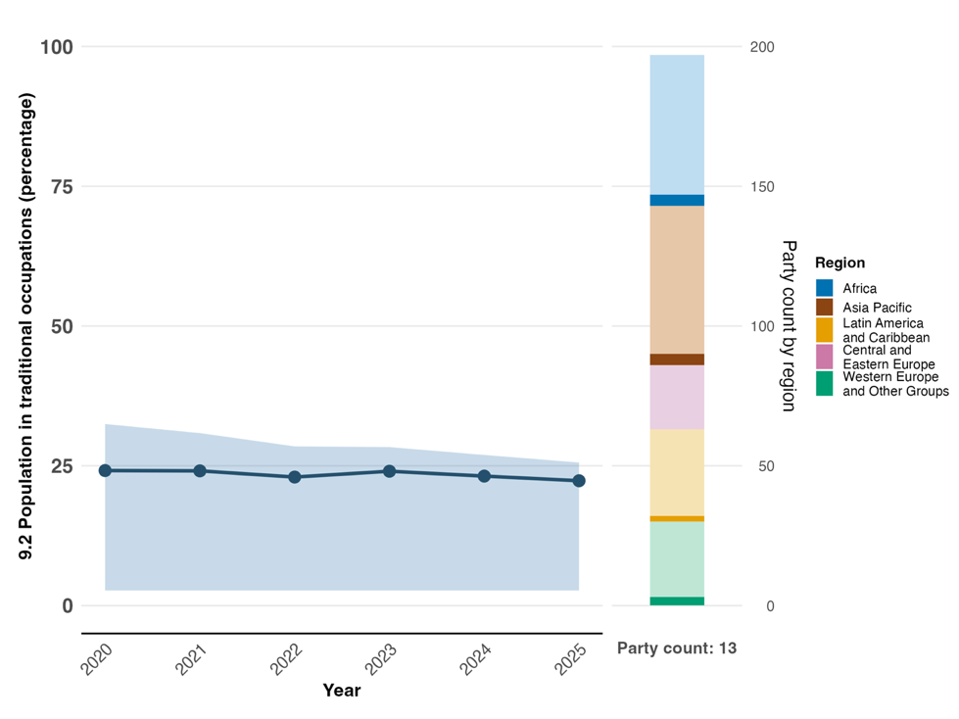
Note: Indicator values show the overall average and interquartile range across Party submissions each year. The right bar chart shows the distribution of Parties submitting indicators by region. Colours for each region are defined in the figure legend: darker tones represent the proportion of Parties for any region for which data are included in the graph; lighter tones represent the proportion of Parties for the same region for which no data are included in the graph.

Figure 38
Binary indicator 9.b: number of countries with policies to sustainably manage use of wild species, providing social, economic and environmental benefits for people, and to protect and encourage customary sustainable use by indigenous peoples and local communities
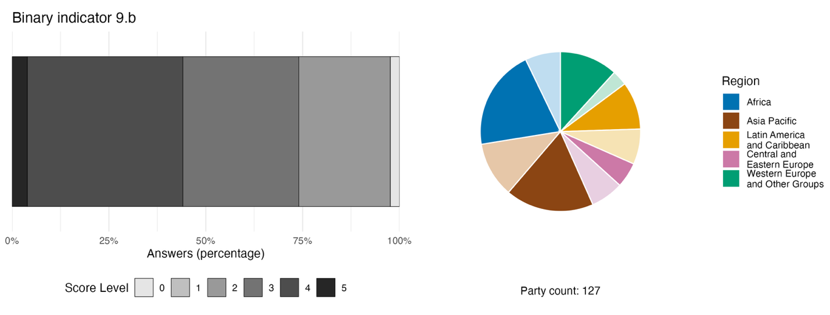
Note: The bar widths show the percentage of Parties in each score category, with higher numbers indicating a greater level of progress, based on responses to the questions included in the indicator.ª The pie chart shows the distribution of Parties providing responses to all questions by region. Colours for each region are defined in the figure legend: darker tones represent the proportion of Parties for any region for which data are included in the graph; lighter tones represent the proportion of Parties for the same region for which no data are included in the graph.
ª The methodology for calculating the score levels for each binary indicator, as well as the questions included for each indicator, are provided in document CBD/COP/16/INF/3/Rev.1.

Figure 39
Percentage of indicators aligned with Target 9 of the Framework that suggest improving, stable and negative trends, respectively
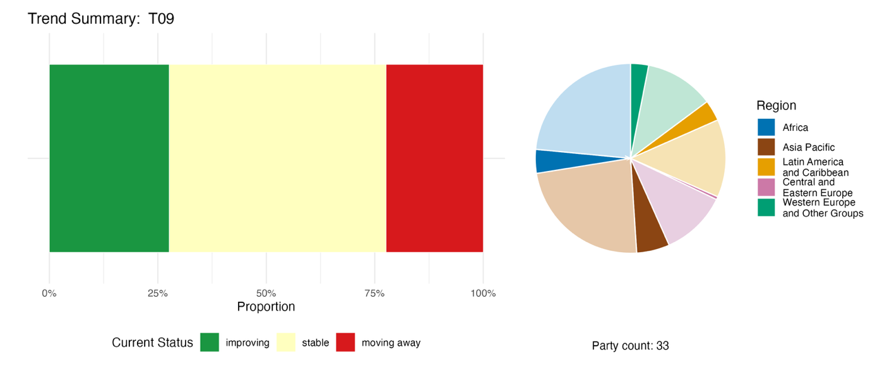
Note: Proportions are weighted by Party. The trends include data for 2 headline indicators from 23 Parties, and 1 component, 1 complementary and 36 national indicators from a total of 16 Parties. The pie chart shows the distribution of Parties submitting indicators for Target 9 by region. Colours for each region are defined in the figure legend: darker tones represent the proportion of Parties for any region for which data are included in the graph; lighter tones represent the proportion of Parties for the same region for which no data are included in the graph.

Self-assessment of progress

Based on self-assessment by Parties in national reports, only 35 per cent of national targets submitted as highly aligned with Target 9 are on track for achievement, with a much higher number (58 per cent) showing no significant progress or insufficient progress, and only a very few (1 per cent, accounted for by just two national targets) reported as already achieved (see figure 40).

Figure 40
Self-assessed progress for all national targets submitted as highly aligned with Target 9 of the Framework
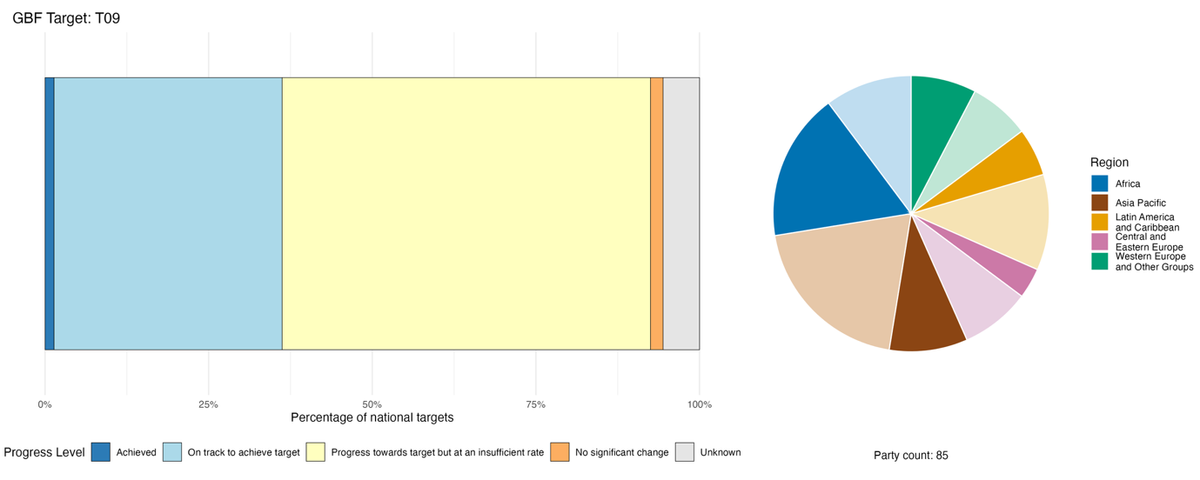
Note: The bar widths show the proportion of national targets submitted in each progress category. Proportions are weighted by Party to ensure that Parties contribute equally to overall assessment of progress, regardless of the number of national targets submitted. The pie chart shows the proportion of Parties in each region reporting in time for consideration in the global report. Colours for each region are defined in the figure legend: darker tones represent the proportion of Parties for any region for which data are included in the graph; lighter tones represent the proportion of Parties for the same region for which no data are included in the graph.

Actions, successes and challenges in implementation

Summary of actions in support of Target 9 of the Framework

The type of action most universally reported in support of Target 9 is legal regulation. This includes the regulation of quota systems, closed seasons and licensing for the extraction or harvesting of wild species, as well as the implementation of trade controls on relevant species through CITES and species protection legislation (see box 29). Many Parties report various models of community-based natural resource management as their primary way to ensure the sustainable use of wild species. These models help to deliver social- and rights-related outcomes along with conservation benefits. Such outcomes include, for example, the formal recognition of the rights of indigenous peoples and local communities to use natural resources based on customary governance and practices, and the protection of traditional knowledge. Action to promote sustainable fisheries management is reported by many Parties as a contribution towards Target 9. A number of Parties also report positive incentives for the sustainable management of wild species, for example through the sharing of revenues from trophy hunting with communities to support local livelihoods, or payments to farmers to maintain wildlife corridors.

Examples of success and progress in implementation

Box 29

Blue BioTrade in Grenada: developing value for the sustainable trade and production of queen conch in the Eastern Caribbean

In Grenada, the Blue BioTrade initiative, jointly implemented by the United Nations Conference on Trade and Development, CITES and the Organisation of Eastern Caribbean States, has advanced the sustainable use of marine biodiversity, directly contributing to Target 9. Queen conch (Strombus gigas), a culturally and economically important species in Grenada, is listed under CITES appendix II. However, Grenada faced trade suspensions owing to non-compliance with CITES reporting and management requirements. In response, the Blue BioTrade initiative piloted the application of the revised BioTrade Principles and Criteria (2020) to the queen conch value chain with the aim of restoring legal, sustainable and traceable trade. The project supported stock assessments, regulatory reviews and capacity-building for fisheries authorities. It also promoted adding value through sustainable processing and the use of conch by-products, such as handicrafts and therapeutic goods. These efforts helped Grenada avoid further trade suspensions and laid the groundwork for improving its compliance with CITES. By integrating biodiversity conservation with livelihood enhancement, the initiative exemplifies how trade-related cooperation can support the sustainable use of wild species. It also highlights the importance of institutional strengthening, stakeholder engagement and regional collaboration in achieving biodiversity targets.

Relevant targets: 5, 9 and10.
Source: CITES, 2025a.

Challenges

Multiple Parties identify weak enforcement as a barrier to the implementation of Target 9. Many report that laws and regulations exist on paper but are poorly enforced, owing to limited institutional capacity, insufficient personnel and fragmented mandates across agencies. Insufficient financing is also identified as a challenge, along with limited data on wild species to support sustainable management programmes. Most Parties lack reliable baseline data on species populations, harvest levels and ecological thresholds. Parties also report the absence of systematic monitoring systems to assess sustainability and measure socioeconomic benefits from the use of wild species. Limited progress in the sharing of benefits with indigenous peoples and local communities is also highlighted by some Parties as a barrier to the sustainable management and use of wild species. In addition, a few Parties report the loss of traditional knowledge due to a lack of intergenerational transfer, poor documentation and inadequate integration into formal governance frameworks. The persistence of subsidies harmful for biodiversity are also highlighted in some national reports as a continuing challenge to the promotion of sustainable management and use.

Contributions from actions other than national Governments

Commitments submitted directly through the online reporting tool

Of the 180 substantive commitments submitted by actors other than national Governments, only 1 is primarily associated with Target 9. That commitment was submitted by the Danish 92 Group, a civil society network composed of a wide range of NGOs based in Denmark that operate in many countries around the world. The commitment encompasses contributions from multiple members of the network and includes the promotion of sustainable fisheries and timber and non-timber forest product harvesting in Denmark, Madagascar, Uganda and Greenland, as well as the documentation of customary sustainable use practices of indigenous peoples across 31 countries.

Contributions integrated in national reports

Sectoral actors such as fishers, hunters, pastoralists, collectors of non-timber forest products and wildlife ranchers are mentioned by many Parties as contributing to implementation of Target 9. National approaches to the sustainable harvesting of wild species often requires the involvement of such groups in co-management, regulated harvest and value-chain participation, among other roles. Indigenous peoples and local communities often contribute to implementation through community resource boards, customary governance systems and formal co-management agreements. The scientific community, sectoral actors, NGOs and citizens all contribute to monitoring and knowledge needs for Target 9, for example, through stock assessments, surveys or inventories of targeted species.

Examples of linkages with other agreements, organizations and processes

The “CITES & Livelihoods” case study series was created to demonstrate how well-regulated wildlife trade can support the sustainable use of wild species, while enhancing the well-being of indigenous peoples and local communities, thus directly contributing to Target 9. Case studies across multiple regions provide examples of sustainable wildlife management that generates income, jobs and social investments, incentivizes conservation, reduces poaching and promotes sustainable use (see box 29) (CITES, 2025a). In addition, the initiative on biodiversity for food and nutrition of the Convention (dec. VIII/23 in CBD, 2006b), in partnership with FAO (FAO, 2021), emphasizes the role of biodiversity, including wild species, in sustaining human well-being and livelihood options, and can support Parties in enabling the reporting of specific targets, where full data sets are not yet available.

Target 10. Enhance biodiversity and sustainability in agriculture, aquaculture, fisheries, and forestry
Target text. Ensure that areas under agriculture, aquaculture, fisheries and forestry are managed sustainably, in particular through the sustainable use of biodiversity, including through a substantial increase of the application of biodiversity friendly practices, such as sustainable intensification, agroecological and other innovative approaches, contributing to the resilience and long-term efficiency and productivity of these production systems, and to food security, conserving and restoring biodiversity and maintaining nature’s contributions to people, including ecosystem functions and services

Progress overview

Collective progress remains uneven across production sectors, but there is evidence of recent positive trends in some areas. Overall, there is good coverage across the scope of Target 10 within the national targets submitted by Parties. Recent improvements are evident in the trends of quantitative indicators for Target 10, suggesting enhanced sustainability in agriculture and forestry. Parties acknowledge in their self-assessments, however, that progress is not on track for over half the national targets. No assessment can be made on sustainable aquaculture. Significant challenges remain with regard to scaling up biodiversity-friendly practices while safeguarding food security, livelihoods and sustainable development. In particular, a lack of incentives and the persistence of harmful subsidies, weak enforcement, the low capacity of local communities and increasing external pressures, including climate change, continue to hinder progress.

Coverage by Parties of the scope of Target 10 of the Framework in their national targets

Table 22
Elements of Target 10 of the Framework and how they are addressed in national targetsª
Ensure that areas under agriculture are managed sustainably | 82
Ensure that areas under aquaculture are managed sustainably | 52
Ensure that areas under fisheries are managed sustainably | 70
Ensure that areas under forestry are managed sustainably | 72
Ensure a substantial increase of the application of biodiversity friendly practices, such as sustainable intensification, agroecological and other innovative approaches | 61
Ensure that sustainable management of productive sectors contributes to the resilience and long-term efficiency and productivity of these production systems | 51
Ensure that sustainable management of productive sectors contributes to food security | 46
Ensure that sustainable management of productive sectors contributes to conserving and restoring biodiversity | 57
Ensure that sustainable management of productive sectors contributes to maintaining nature’s contributions to people, including ecosystem functions and services | 51
On average, Parties have addressed, to at least some extent, 60 per cent of these elements in their national targets

Note: The right-hand column of the table indicates the percentage of Parties with national targets that address the element to at least some extent.
ª The elements for each target were defined by the Ad Hoc Technical Expert Group on Indicators of the Kunming-Montreal Global Biodiversity Framework (see annex I to CBD/COP/16/INF/4; and Affinito and others, 2025).The detailed methodology for the analysis of national targets is provided in document CBD/SBI/7/INF/22.

A large majority of Parties have submitted national targets that address sustainable agriculture (82 per cent), forestry (72 per cent) and fisheries (70 per cent) (see table 22). Fewer Parties (51 per cent) address sustainable aquaculture. A majority of Parties (61 per cent) have also submitted targets that address a substantial increase in the application of biodiversity-friendly practices. About half of Parties have addressed elements of the Target relating to the contribution of productive sectors to conserving biodiversity (57 per cent), nature’s contribution to people (51 per cent), resilience and long-term efficiency in the productive sector (51 per cent) and food security (46 per cent). Overall, there is good coverage across the scope of Target 10 within the national targets submitted. There are no specific quantitative elements included in Target 10, but there is a commitment to a substantial increase in the application of biodiversity-friendly practices.

Indicators of progress

Table 23
Indicator scorecard for Target 10 of the Framework
 | Indicator use |  | Indicator results
Headline indicator 10.1: proportion of agricultural area under productive and sustainable agriculture | 31 per cent of Parties |  | Overall, half of Parties have less than 13 per cent productive and sustainable agriculture, ranging from 0.2 to 100 per cent per cent  (an increasing trend over time)
Headline indicator 10.2: progress towards sustainable forest management | 50 per cent of Parties |  | Overall, trends across all subindicators are stable
All quantitative indicators combined | 74 Parties, 57 per cent |  | 24 per cent positive trends  12 per cent negative trends
Notes | Submissions include indicator data on specific farm types, agricultural methods, forest types, certification programmes and management regimes.  Parties used both methodologies for 10.1 and different subindicators for 10.2.
Note: The colour coding is related to the overall assessment of progress across targets, the methodology of which is explained in the overall summary scorecard (see table 3). The colour coding for indicator data use and all quantitative indicator trends reflects where a value for each target sits relative to the highest and lowest scores achieved across all targets of the Framework (green is assigned to percentage values falling within the top third of the total range, yellow to the middle third and red to the bottom third). Colours for the headline indicator results are based on progress relative to the target (green is assigned when progress is being made, yellow when progress is mixed, red when progress is insufficient and grey when progress cannot be assessed). Note that the percentage of Parties submitting data on headline indicators may be different from that used in the aggregate results for both the headline indicator and all quantitative indicators combined, owing to methodological differences in the way data were used.

More Parties were able to report on the headline indicator related to forests than that related to agriculture (see table 23). Reasons for this included the incomplete methodological guidance for headline indicator 10.1 (proportion of agricultural area under productive and sustainable agriculture), and the reliance on the proxy approach suggested by FAO, which was used by six Parties. Another likely reason is that headline indicator 10.2 (progress towards sustainable forest management) contains five subindicators, and many Parties were able to report on at least one of the subindicators. In both cases, several Parties noted the difficulty of integrating data from different government agencies to report on the indicators, and the need to harmonize national reporting to align submissions relating both to the Framework and to the Sustainable Development Goals.
For those Parties reporting a percentage value for headline indicator 10.1, the overall average share of agricultural lands that was productive and sustainable was about 29 per cent, ranging from 0 to 100 per cent (see figure 41). Six Parties submitted a proxy score as suggested by FAO under SDG indicator 2.4.1, which combines key economic, social and environmental indicators into a value ranging from 0 to 5. The values for this proxy methodology averaged 2.7 for the Parties submitting data this way, with a range between 0.1 and 4. National data submitted to FAO by 186 Parties using the proxy methodology averaged 3.3, suggesting moderate collective progress, and displayed a slowly improving trend since 2015.. Data reported by Parties also showed a slow positive trend, corroborating that of FAO.
For headline indicator 10.2, five Parties submitted a single overall value for the percentage of forests in sustainable management. For these Parties, on average 11 per cent of forests were considered sustainably managed, ranging from 1 to 36 per cent (see figure 42).
Across years and for these Parties, the average change in forest area was 0.1 per cent and ranged from -3 to 5 per cent between 2020 and 2025. Data submitted to FAO by 194 countries and areas indicate that forest loss has slowed compared with the 1990s; however, net losses were slightly higher between 2015 and 2025 compared with the losses between 2000 and 2015. Despite progress in reducing deforestation, gains in forest area from expansion were lower than before. Data submitted both to the Convention (27 Parties) (see figure 43) and to FAO (187 countries and areas) showed an increase in above-ground biomass per hectare since 1990.
The 26 Parties reporting on forest area within legally established protected areas (accounting for 30 per cent of all Parties’ forest area) showed no increase between 2020 and 2025, with an average of 26 per cent (see figure 44). Data submitted by countries to FAO, however, shows that the proportion of forest within legally protected areas rose over the 15-year period between 2010 and 2025 from 18.2 to 19.3 per cent globally. Similarly, both data submitted by 27 Parties in their national reports (see figure 45) and data submitted to FAO show that about half of all forest areas were under long-term management (increasing from 54.4 per cent in 2015 to 56.5 per cent in 2025 globally, according to FAO). Moreover, data submitted to FAO indicate that the overall forest area that falls under an independently verified forest management certification scheme has increased by 15.5 per cent since 2010, and also indicate that the decrease noted in 25 Party submissions for 2022–2023 (Figure 46) was due to conflict-related certificate suspensions in Europe.
Analysis of all quantitative indicators submitted by Parties, relating mostly to agriculture and forestry sectors, shows more positive trends (24 per cent) than negative trends (12 per cent) (see figure 47), suggesting progress towards targets at the national level. No additional indicators were submitted in national reports relating to sustainable aquaculture.

Figure 41
Headline indicator 10.1: proportion of agricultural area under productive and sustainable agriculture
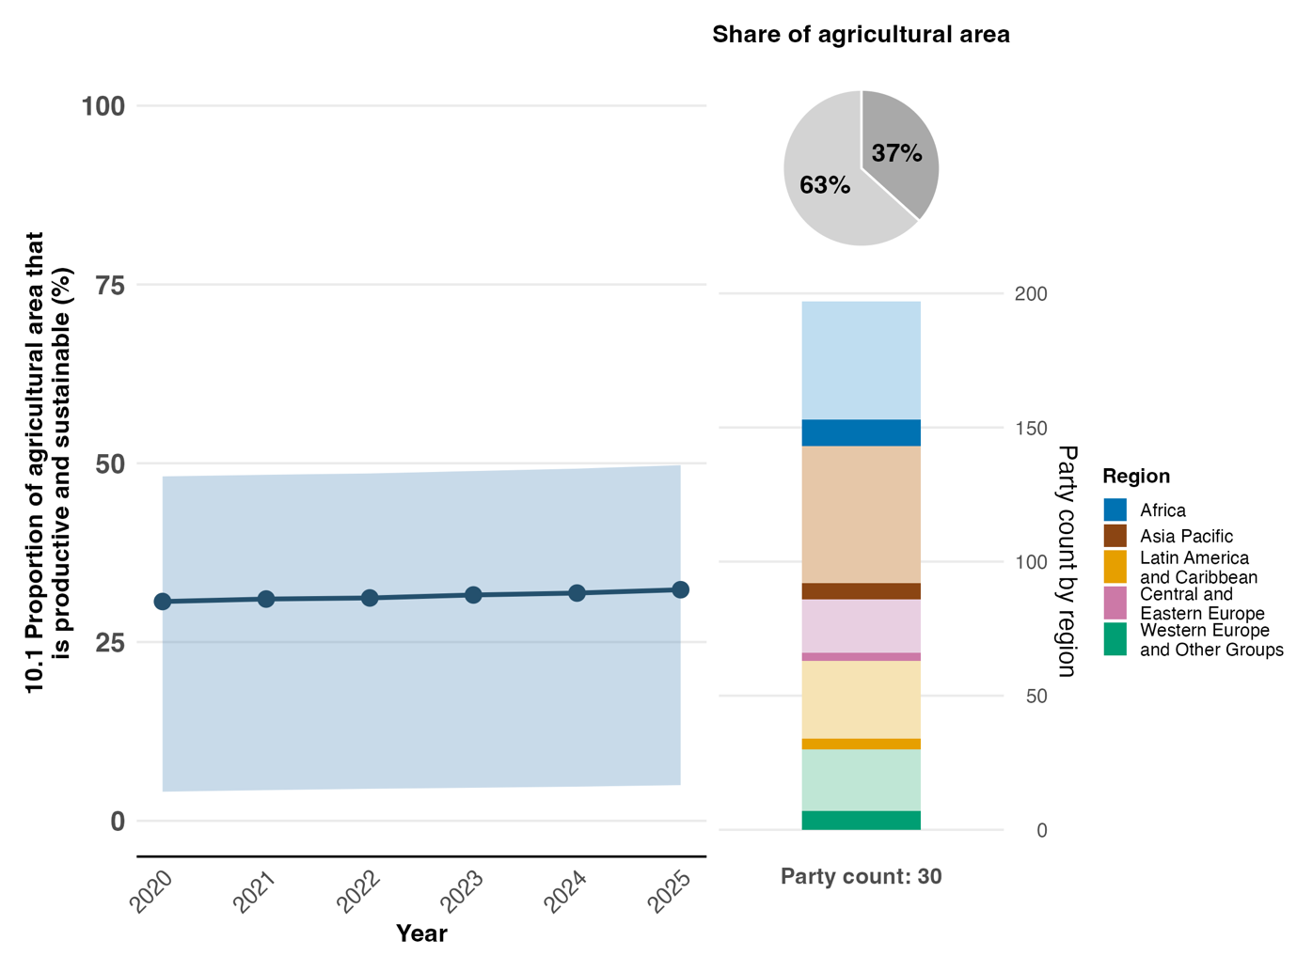
Note: Indicator values show the overall average and interquartile range across Party submissions each year. The right bar chart shows the distribution of Parties providing data by region. Colours for each region are defined in the figure legend: darker tones represent the proportion of Parties for any region for which data are included in the graph; lighter tones represent the proportion of Parties for the same region for which no data are included in the graph. The pie chart shows the proportion of the total agricultural area of all Parties that is accounted for by those Parties submitting data for the indicator.

Figure 42
Headline indicator 10.2: progress towards sustainable forest management, subindicator a – annual forest area rate change
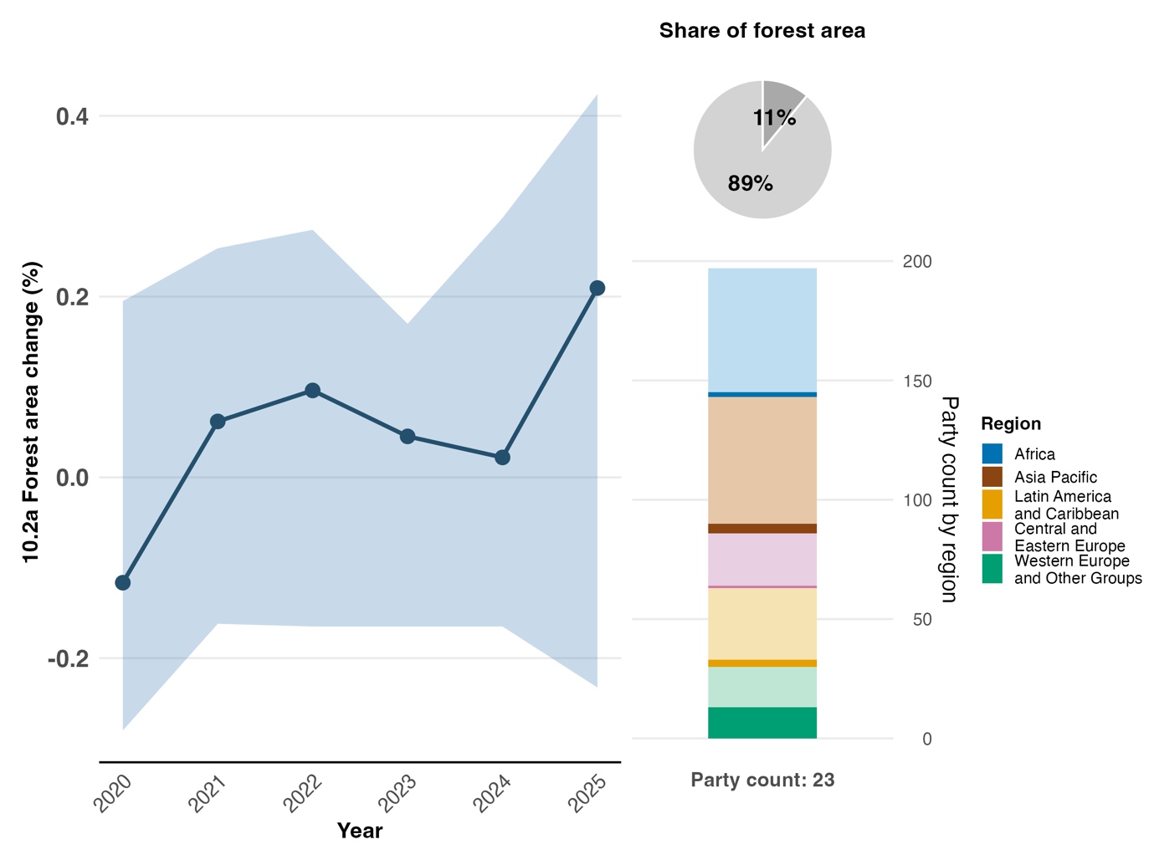
Note: Indicator values show the overall average and interquartile range across Party submissions each year. The right bar chart shows the distribution of Parties providing data by region. Colours for each region are defined in the figure legend: darker tones represent the proportion of Parties for any region for which data are included in the graph; lighter tones represent the proportion of Parties for the same region for which no data are included in the graph. The pie chart shows the proportion of the total forested areas of all Parties that is accounted for by those Parties submitting data for the indicator.

Figure 43
Headline indicator 10.2: progress towards sustainable forest management, subindicator b – above-ground biomass in forest
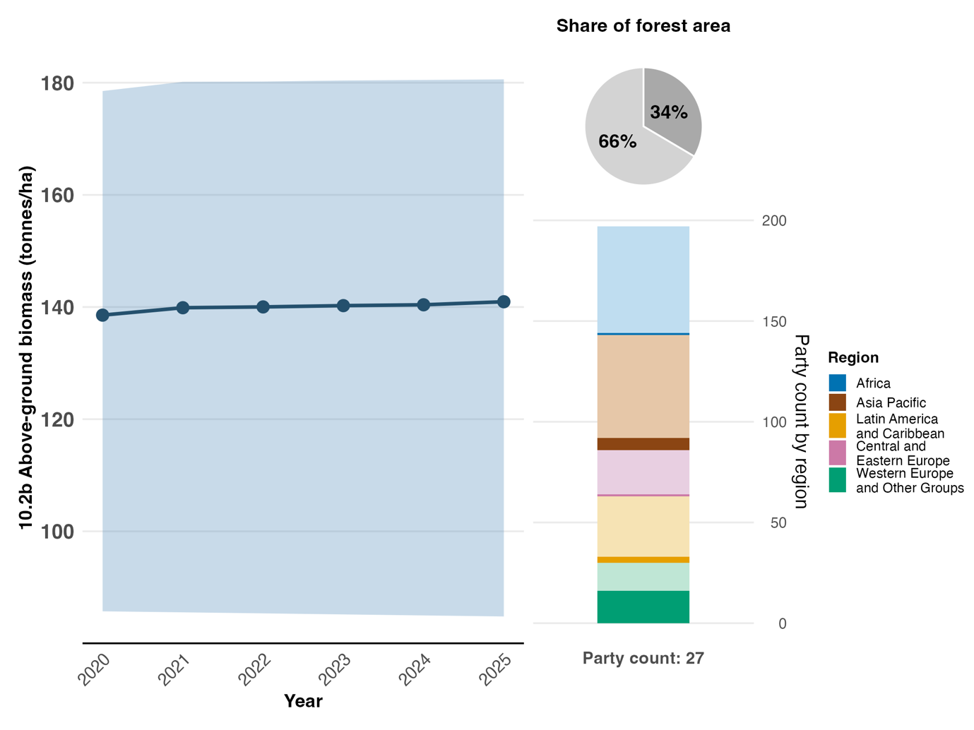Note: Indicator values show the overall average and interquartile range across Party submissions each year. The right bar chart shows the distribution of Parties providing data by region. Colours for each region are defined in the figure legend: darker tones represent the proportion of Parties for any region for which data are included in the graph; lighter tones represent the proportion of Parties for the same region for which no data are included in the graph. The pie chart shows the proportion of the total forested areas of all Parties that is accounted for by those Parties submitting data for the indicator.

Figure 44
Headline indicator 10.2: progress towards sustainable forest management, subindicator c – proportion of forest area within legally established protected areas
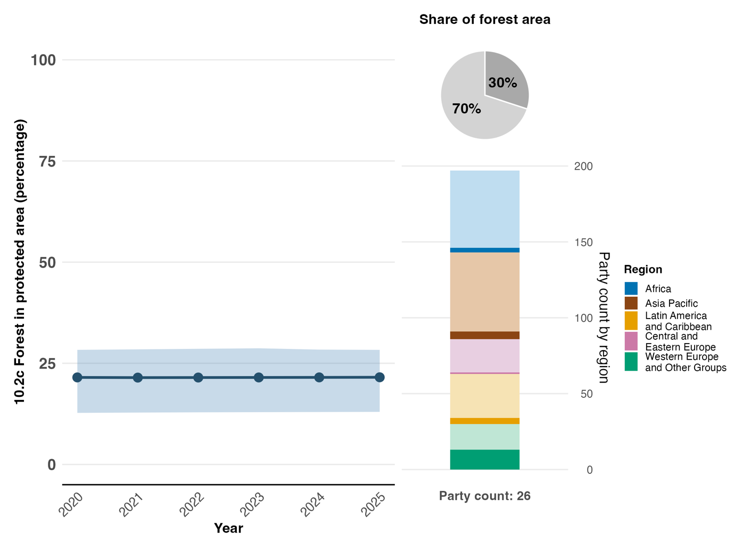
Note: Indicator values show the overall average and interquartile range across Party submissions each year. The right bar chart shows the distribution of Parties providing data by region. Colours for each region are defined in the figure legend: darker tones represent the proportion of Parties for any region for which data are included in the graph; lighter tones represent the proportion of Parties for the same region for which no data are included in the graph. The pie chart shows the proportion of the total forested areas of all Parties that is accounted for by those Parties submitting data for the indicator.

Figure 45
Headline indicator 10.2: progress towards sustainable forest management, subindicator d – proportion of forest area under a long-term forest management plan
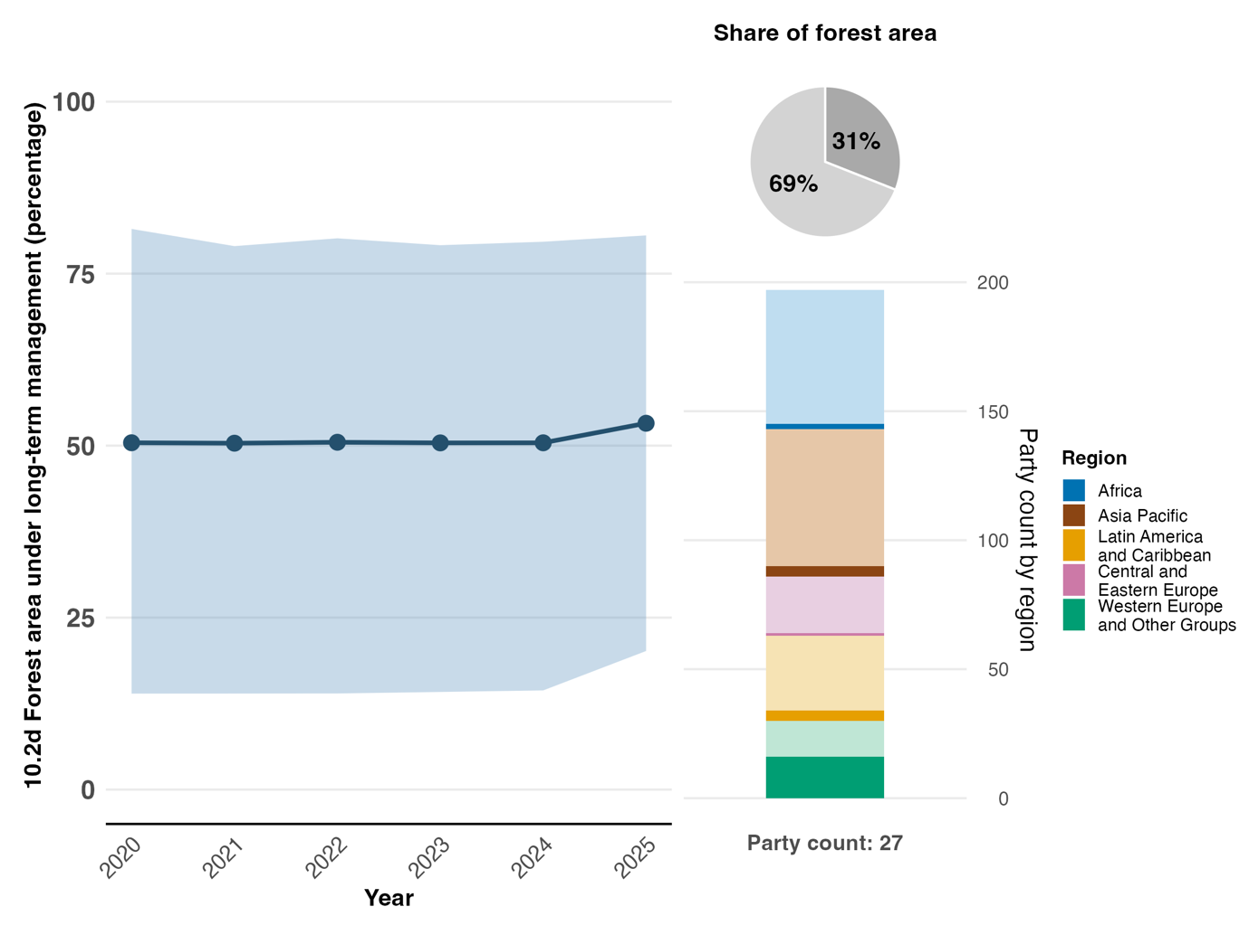
Note: Indicator values show the overall average and interquartile range across Party submissions each year. The right bar chart shows the distribution of Parties providing data by region. Colours for each region are defined in the figure legend: darker tones represent the proportion of Parties for any region for which data are included in the graph; lighter tones represent the proportion of Parties for the same region for which no data are included in the graph. The pie chart shows the proportion of the total forested areas of all Parties that is accounted for by those Parties submitting data for the indicator.

Figure 46
Headline indicator 10.2: progress towards sustainable forest management, subindicator e – forest area under an independently verified forest management certification scheme
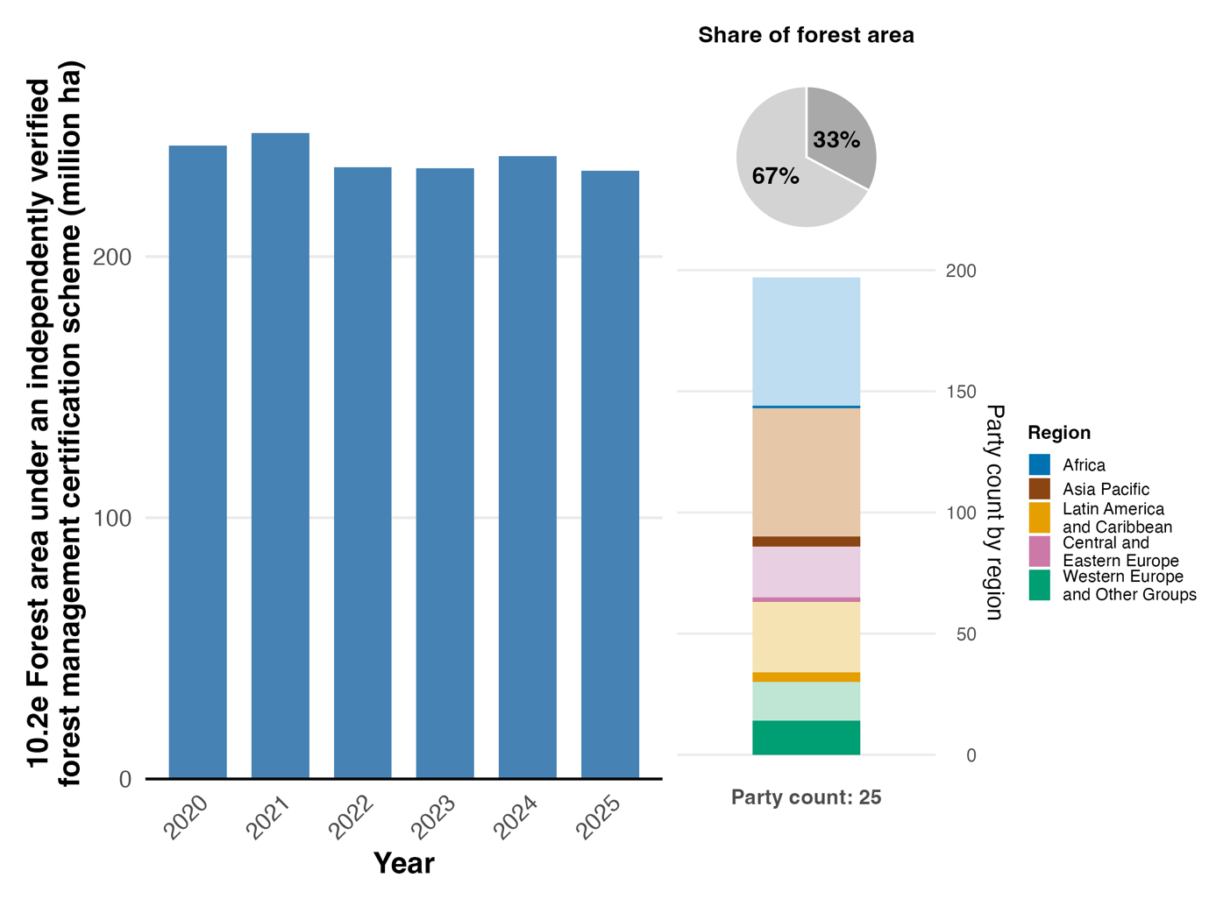
Note: Indicator values show the cumulative amount of area reported by Parties year-on-year. The right bar chart shows the distribution of Parties providing data by region. Colours for each region are defined in the figure legend: darker tones represent the proportion of Parties for any region for which data are included in the graph; lighter tones represent the proportion of Parties for the same region for which no data is included in the graph. The pie chart shows the proportion of the total forested areas of all Parties that is accounted for by those Parties submitting data for the indicator.

Figure 47
Percentage of indicators aligned with Target 10 of the Framework that suggest improving, stable and negative trends, respectively
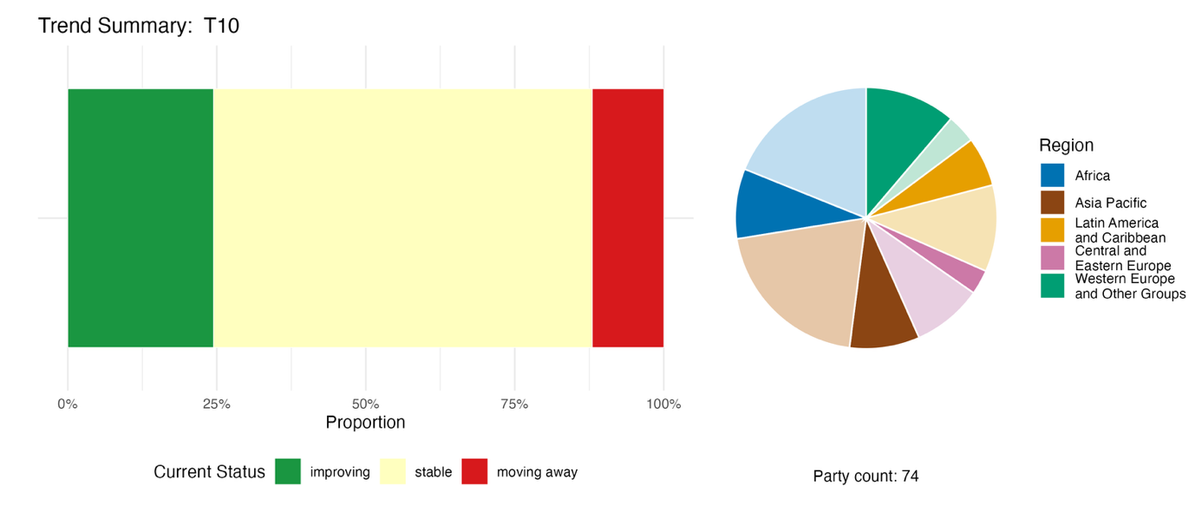
Note: Proportions are weighted by Party. The trends include data for 2 headline indicators from 63 Parties, and 3 component, 5 complementary and 94 national indicators from a total of 30 Parties. The pie chart shows the distribution of Parties submitting indicators for Target 10 by region. Colours for each region are defined in the figure legend: darker tones represent the proportion of Parties for any region for which data are included in the graph; lighter tones represent the proportion of Parties for the same region for which no data are included in the graph.

Self-assessment of progress
Progress towards around two fifths (40 per cent) of national targets related to Target 10 has been self-assessed by Parties as being on track or achieved, leaving over half (57 per cent) of national targets assessed as progressing at an insufficient rate (see figure 48).

Figure 48
Self-assessed progress for all national targets submitted as highly aligned with Target 10 of the Framework
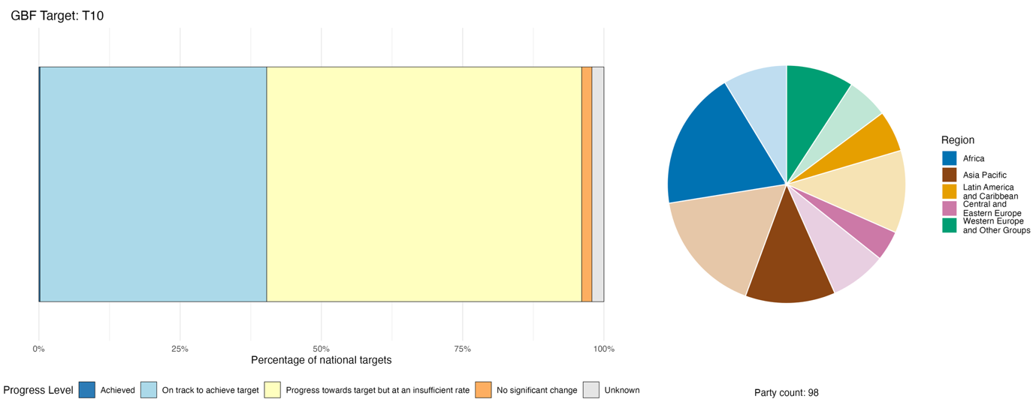
Note: The bar widths show the proportion of national targets submitted in each progress category. Proportions are weighted by Party to ensure that Parties contribute equally to overall assessment of progress, regardless of the number of national targets submitted. The pie chart shows the proportion of Parties in each region reporting in time for consideration in the global report. Colours for each region are defined in the figure legend: darker tones represent the proportion of Parties for any region for which data are included in the graph; lighter tones represent the proportion of Parties for the same region for which no data are included in the graph.

Actions, successes and challenges in implementation

Summary of actions in support of Target 10 of the Framework

The establishment or strengthening of fisheries management frameworks is the type of action most commonly reported across the four production sectors addressed by Target 10. Specific measures include fishery licensing systems, catch quotas, seasonal closures, vessel monitoring systems and by-catch mitigation measures. Actions to support sustainable forest management are also widely reported, and include mandatory management plans for commercial forestry, certification schemes, reforestation programmes and community forestry. In the agricultural sector, many Parties report actions to promote agroecology, agroforestry and silvopastoral systems; the conservation of genetic resources and seed banking; and conservation agriculture, organic farming, integrated pest management and other biodiversity-friendly farming approaches, as well as the provision of farmer training and extension services (see boxes 30 and 31). Actions related to food security and nutrition, and the conservation and sustainable use of pollinators and soil biodiversity, have also been reported. Actions to support sustainability in aquaculture are included less frequently in national reports.

Examples of success and progress in implementation

Box 30
Livestock head tax for rangeland biodiversity in Mongolia

Since the 1990s, uncontrolled herd growth has led to significant overgrazing and pasture degradation across the 112 million hectares of rangeland in Mongolia, which supports approximately 190,000 herder families, representing close to 20 per cent of the national population. The agricultural sector accounts for more than half of national greenhouse gas emissions, with livestock enteric fermentation contributing over 58 per cent of emissions from agriculture. To ensure the sustainable management of rangelands, Mongolia enacted the Livestock Head Tax Law in 2020, empowering local soum administrations (district-level governments) to set species-specific tax rates, with revenues designated for pasture management improvements, and for Government policies aimed at sustainable livestock development.

As a result of the initiative, tax compliance rose significantly, from 45.9 per cent in 2021 to 92.5 per cent in 2024, reflecting stronger enforcement and administrative improvements. Total livestock numbers declined sharply by nearly 14 per cent in 2023 and by a similar level in 2024, in particular among sheep and goats, owing to a combination of regulatory pressures and ecological stressors. Research suggests that the Livestock Head Tax Law has the potential to align livestock numbers with rangeland carrying capacity through economic incentives that reward reductions in herd size and through targeted public spending on pasture management.

Led by the Ministry of Food, Agriculture and Light Industry, in collaboration with the Ministry of Environment and Tourism, the National Federation of Pasture User Groups, local soum administrations and herder communities, this project integrates ancient nomadic grazing wisdom with modern fiscal instruments, forming a distinctive sustainable land management model.

Relevant targets: 2, 8, 10, 11, 19 and 22.
Sources: Mongolia, seventh national report under the Convention; Enkhbayar and others, 2025; FAO and UNDP, 2025; and Government of Mongolia, 2020.

Box 31
REDD+ and agroforestry integration in cocoa supply chains in Côte d’Ivoire
Côte d'Ivoire is implementing an integrated zero-deforestation policy aimed at: (a) reducing greenhouse gas emissions in agriculture; (b) conserving biodiversity and improving sustainability in agricultural and forestry sectors by tackling deforestation linked to cocoa production, one of the main driver of forest loss in the country; (c) increasing private sector participation in the sustainability of these sectors; and (d) improving land-tenure security. The project entitled “Promoting zero-deforestation cocoa production for emissions reduction”, implemented from 2022 to 2027 and financed by the Green Climate Fund, promotes the transformation of degraded conventional cocoa plantations into productive agroforestry systems. Since early 2026, the project has achieved significant results, with more than 3,500 hectares of degraded cocoa plantations converted into agroforestry systems and more than 1,200 hectares of forest plots restored. There have been direct benefits to over 5,700 people, approximately one quarter of whom are women, and support has been provided to three cooperatives, including two organic cocoa cooperatives and one female-led sustainable cocoa cooperative. Over its lifetime, the project is expected to generate an estimated emissions reduction of 5.5 million metric tons of carbon dioxide equivalent (CO₂e). By integrating edible tree species such as kplé (Irvingia gabonensis), akpi (Ricinodendron heudelotii) and petit cola (Garcinia kola), alongside local tree species within cocoa plantations, this approach promotes biodiversity, improves soil fertility, and provides farmers with additional income sources while strengthening food security. The project also supports land-tenure security by facilitating access to land certificates, which serve as guarantees for sustainable investments.
Led by the Ministry of Environment and Ecological Transition, the project demonstrates that it is possible to align agricultural value chain objectives with REDD+ goals, combining economic production, forest conservation and biodiversity enhancement.

Relevant targets: 2, 8, 9, 10, 22 and 23.
Source: Côte d’Ivoire, seventh national report under the Convention.

Challenges

A number of Parties acknowledge in their national reports that harmful subsidies persist alongside sustainability programmes – a significant barrier to the implementation of Target 10. A few Parties report that the current economic incentive structures, including subsidies and market pricing, do not always support the transition to biodiversity-friendly production practices. This suggests some dependency on progress towards Target 18. Parties lack the budget to scale up sustainable practices, monitor compliance or support communities in transitioning away from harmful methods. Weak enforcement capacity and governance gaps continue to undermine the sustainable management of fisheries and forests in several Parties. Many Parties report that monitoring systems for sustainable production initiatives are nascent, project-based or under development. Several Parties note that, even in situations where extensive policy frameworks have been in place, positive outcomes in terms of improved condition of habitats and species populations are not always evident. Smallholder and community capacity constraints are mentioned as barriers to participation in certification schemes and agroecology incentives. The impacts of drivers such as climate change and invasive alien species on productivity are highlighted as challenges to sustainable production efforts in the context of Target 10.

Contributions from actors other than national Governments

Commitments submitted directly through the online reporting tool

Of the 180 substantive commitments from actors other than national Governments, 9 are associated primarily with Target 10. Four of the submissions are from NGOs, three from business or industry, one from a research organization and one from a United Nations organization: the FAO Strategy on Mainstreaming Biodiversity across Agricultural Sectors and its Action Plan. The commitments focus largely on integrating biodiversity into sustainable policies for agriculture, fisheries and forestry, and into corporate value chains (see box 32). The geographical coverage of the commitments spans Europe, Africa, Asia and Latin America and the Caribbean.

Box 32
OroVerde BioFinCas: promoting biodiversity-friendly, climate-resilient agriculture in the Dominican Republic, Guatemala and Mexico

The BioFinCas project, led by the NGO OroVerde, which has its headquarters in Germany, tackles the biodiversity and climate costs embedded in the global production of coffee, banana and cocoa. Running from July 2022 to July 2031 and funded through a grant from the International Climate Initiative, the project is grounded in the recognition that the cheap bulk production of these commodities drives monocultures, agrochemical dependency and deforestation, while placing a disproportionate share of climate risk and financial burden on small and medium-sized producers. Working in the Dominican Republic, Guatemala and Mexico, BioFinCas project partners collaborate with umbrella producer organizations, financial institutions, insurance companies, policymakers and civil society partners to develop scalable risk finance instruments, strengthen producer capacities and feed recommendations into national and international policy dialogues. BioFinCas partners also run awareness and consumer campaigns at the European Union-level to shift demand towards biodiversity-friendly products. Progress is measured against the proportion of agricultural area under productive and sustainable management (headline indicator 10.1), and the average income of small-scale food producers disaggregated by sex and indigenous status (component indicator 10.CT.1), reflecting the project's strong gender and equity focus.

Relevant targets: 10, 19, 20 and 23.
Source: OroVerde, stakeholder commitment (see https://ort.cbd.int/database/293339).

Contributions integrated in national reports

Sectoral actors such as farmers, fishers, foresters, pastoralists and aquaculture operators are the groups most reported by Parties as contributing to the implementation of Target 10. These actors, as well as indigenous peoples and local communities and subnational governments, often hold formal or legally recognized authority over natural resources, and thus have important roles in ensuring that productive areas are managed sustainably. Business actors are consistently mentioned in national reporting on the implementation of Target 10, with references to their involvement in certification schemes and supply-chain governance. Women are also often mentioned as pivotal actors: either they are already involved, or it is important to strengthen their involvement.

Examples of linkages with other agreements, organizations and processes

Through a number of its decisions, the Conference of the Parties to UNCCD has committed to cooperating with other international bodies on promoting sustainable agricultural practices, thus contributing to Target 10 of the Framework. UNCCD is working with FAO to develop guidance that promotes sustainable land use and responsible governance to prevent and reverse the degradation of agricultural lands and soils, and to promote sustainable and diverse cropping systems and crops to improve food security and nutrition, in the context of climate change and environmental degradation. Both organizations are also exploring collaboration on maximizing the synergies between Target 10 and SDG indicator 15.3.1 on degraded land (UNCCD, 2024a, 2024b and 2025).
The Stockholm Convention on Persistent Organic Pollutants contributes directly to Target 10 by eliminating or restricting the use of POPs, many of which have been widely used in agriculture, aquaculture and forestry. POPs such as endosulfan, a pesticide formerly used on crops including cotton and vegetables, are highly toxic to non-target species, including pollinators such as bees and beneficial insects. Endosulfan has been linked to neurological and reproductive effects in insects and vertebrates, contributing to pollinator decline and the disruption of natural pest control and crop productivity. By listing such chemicals for elimination or restriction, the Stockholm Convention reduces environmental contamination and supports the transition to safer, biodiversity-friendly practices (Secretariat of the Basel, Rotterdam and Stockholm Conventions, 2025).

The UNESCO Soil Initiative was launched in 2024, in conjunction with the Man and the Biosphere Programme. It marks a significant contribution to Target 10 with regard to ecosystem functions and services. UNESCO biosphere reserves and Global Geoparks serve as testing grounds for integrated soil conservation practices, in the context of sustainable land management. The Initiative has established a global expert group and initiated pilot actions in collaboration with FAO, the European Union and scientific unions (UNESCO, 2025c).

The International Treaty on Plant Genetic Resources for Food and Agriculture contributes to Target 10 by enabling the exchange of plant genetic resources for food and agriculture through the Multilateral System of Access and Benefit-Sharing. Material is shared for the purposes of breeding, research and training, which supports the development of crops adapted to more extreme climates, in turn supporting food security (ITPGRFA, 2026).
The Commission on Genetic Resources for Food and Agriculture of FAO produces “state of the world” publications on animal, aquatic, plant and forest genetic resources for food and agriculture, as well as a publication entitled The State of the World’s Biodiversity for Food and Agriculture. These publications contribute towards global plans of action for each of the above-mentioned groups. Global plans of action produced by the Commission directly contribute to Target 10 by translating broad conservation and sustainability objectives into practical, sector-specific actions, tools and policies. Fundamentally, the global plans of action recognize that genetic resources are the biological basis for agricultural production and food security, underpinning the resilience, adaptability and productivity of production systems.

Target 11. Restore, maintain and enhance nature’s contributions to people

Target text. Restore, maintain and enhance nature’s contributions to people, including ecosystem functions and services, such as the regulation of air, water and climate, soil health, pollination and reduction of disease risk, as well as protection from natural hazards and disasters, through nature-based solutions and/or ecosystem-based approaches for the benefit of all people and nature.

Progress overview
Available evidence remains insufficient to robustly assess collective progress, and Parties’ self-assessments indicate that implementation is not yet proceeding at the required pace. National targets submitted by Parties provide good coverage across the scope of Target 11. The number of national reports that have consistent data for the associated headline indicator B.1 (services provided by ecosystems), however, is insufficient to assess progress, and the indicator can only be considered experimental at this stage. The trend analysis of all indicators reported by a third of Parties whose national reports were considered for the global report is mixed, and self-assessments indicate that Parties consider their progress towards most national targets (64 per cent) associated with Target 11 to be insufficient. Reported challenges relate to the application of valuation methods for nature’s contributions to people in both policy and monitoring, as well as a lack of financial and legal frameworks for the implementation of nature-based solutions and the management of trade-offs with other policy sectors.

Coverage by Parties of the scope of Target 11 of the Framework in their national targets

Table 24
Elements of Target 11 of the Framework and how they are addressed in national targetsª
Restore, maintain and enhance nature’s contributions to people, including ecosystem functions and services through nature-based solutions | 68
Restore, maintain and enhance nature’s contributions to people, including ecosystem functions and services through ecosystem-based approaches | 65
Restore, maintain and enhance regulation of air, water and climate | 66
Restore, maintain and enhance soil health | 61
Restore, maintain and enhance pollination | 58
Restore, maintain and enhance reduction of disease risk | 59
Restore, maintain and enhance protection from natural hazards and disasters | 62
On average, Parties have addressed, to at least some extent, 63 per cent of these elements in their national targets

Note: The right-hand column of the table indicates the percentage of Parties with national targets that address the element to at least some extent.
ª The elements for each target were defined by the Ad Hoc Technical Expert Group on Indicators of the Kunming-Montreal Global Biodiversity Framework (see annex I to CBD/COP/16/INF/4; and Affinito and others, 2025). The detailed methodology for the analysis of national targets is provided in document CBD/SBI/7/INF/22.

The individual elements of Target 11 are quite evenly addressed by Parties in their national targets (see table 24). Around two thirds of Parties have set targets that, to some extent, address the restoration, maintenance and enhancement of nature’s contributions to people, including ecosystem functions and services, through nature-based solutions and ecosystem-based approaches. A similar proportion (between 58 and 66 per cent) of Parties have national targets to restore, maintain and enhance soil health, pollination, the reduction of disease risk and protection from natural hazards and disasters.
There are no specific quantitative elements included in Target 11; however, it is closely related to Targets 2 and 3, for which there are quantitative elements, as well as to Targets 8 and 10.

Indicators of progress

Table 25
Indicator scorecard for Target 11 of the Framework
 | Indicator use |  | Indicator results
Headline indicator B.1: services provided by ecosystems | 26 per cent of Parties |  | Overall 2.5 per cent decline between 2015 and 2023, during which cultural services increased but regulating and provisioning services declined
All quantitative indicators combined | 42 Parties, 33 per cent |  | 33 per cent positive trends  15 per cent negative trends
Notes | Many submissions incorrectly used United States dollars (or other currencies) instead of an index value for the headline indicator; currencies would be appropriate for use in component indicator B.CT.3 (total value of ecosystems services in monetary units)
Note: The colour coding is related to the overall assessment of progress across targets, the methodology of which is explained in the overall summary scorecard (see table 3). The colour coding for indicator data use and all quantitative indicator trends reflects where a value for each target sits relative to the highest and lowest scores achieved across all targets of the Framework (green is assigned to percentage values falling within the top third of the total range, yellow to the middle third and red to the bottom third). Colours for the headline indicator results are based on progress relative to the target (green is assigned when progress is being made, yellow when progress is mixed, red when progress is insufficient and grey when progress cannot be assessed). Note that the percentage of Parties submitting data on headline indicators may be different from that used in the aggregate results for both the headline indicator and all quantitative indicators combined, owing to methodological differences in the way data were used.

Of those Parties that submitted data for headline indicator B.1 (services provided by ecosystems) (see table 25), only seven submitted the expected index of “services provided by ecosystems” for which guidance was available in the metadata. Many submissions were provided as raw units (for example metric tons or cubic metres) associated with specific ecosystem services. While most Parties report adopting the System of Environmental-Economic Accounting – Ecosystem Accounting (SEEA EA), many state that its implementation is still in the testing and development stages, meaning that the ecosystem and ecosystem service accounts on which the indicator depends are not yet available. Of those Parties that did not include the index, many chose to report on services related to forests and carbon, as well as those related to productive sectors such as fisheries.
For those few Parties that did report on the headline indicator, ecosystem services on average declined between 2015 and 2023, the range of years for which data was available. These Parties provided data both for the overall aggregate and the recommended disaggregations (ecosystem service categories). Overall, the index of ecosystem services declined, as did disaggregated data for provisioning and regulating services. Cultural services showed marked fluctuations from year-to-year (see figures 49 and 50). The data for the headline indicator, however, can only be considered experimental, and not indicative of collective progress, as so few Parties were able to report using the index.
Only about a third of national indicators reported by Parties were directly aligned with elements of the target. The aligned indicators largely focused on air and water quality. Thus, while some data on nature’s contributions to people are available from several Parties, it was not possible to aggregate the data to quantify collective progress towards Target 11. The trend analysis of all indicators reported by Parties (see figure 51) shows significantly more positive trends (33 per cent) than negative trends (15 per cent), mostly relating to regulating services.

Figure 49
Headline indicator B.1: services provided by ecosystems (all reported services)
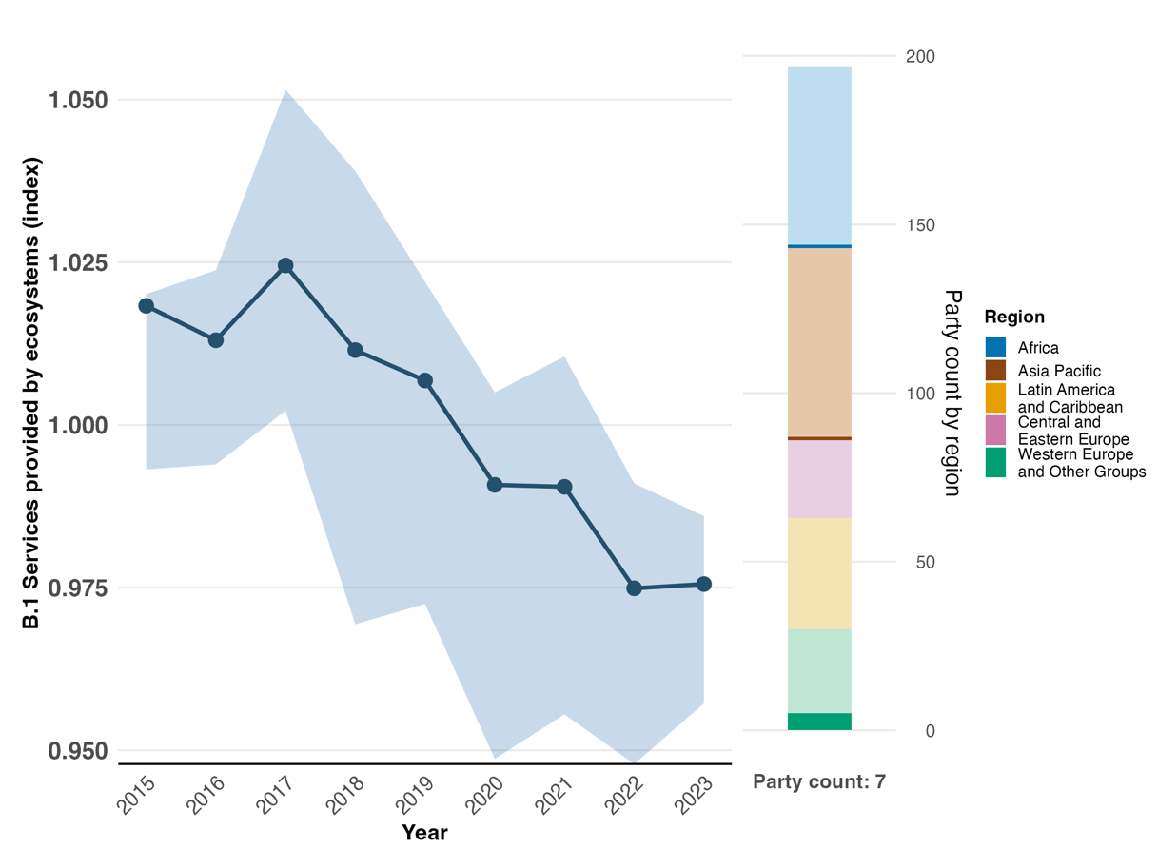
Note: Indicator values show the overall average and interquartile range across Party submissions each year. The right bar chart shows the distribution of Parties providing data by region. Colours for each region are defined in the figure legend: darker tones represent the proportion of Parties for any region for which data are included in the graph; lighter tones represent the proportion of Parties for the same region for which no data are included in the graph. Note that regional representation for this indicator is extremely limited and spatially biased.

Figure 50
Headline indicator B.1: services provided by ecosystems (disaggregated by ecosystem service category)
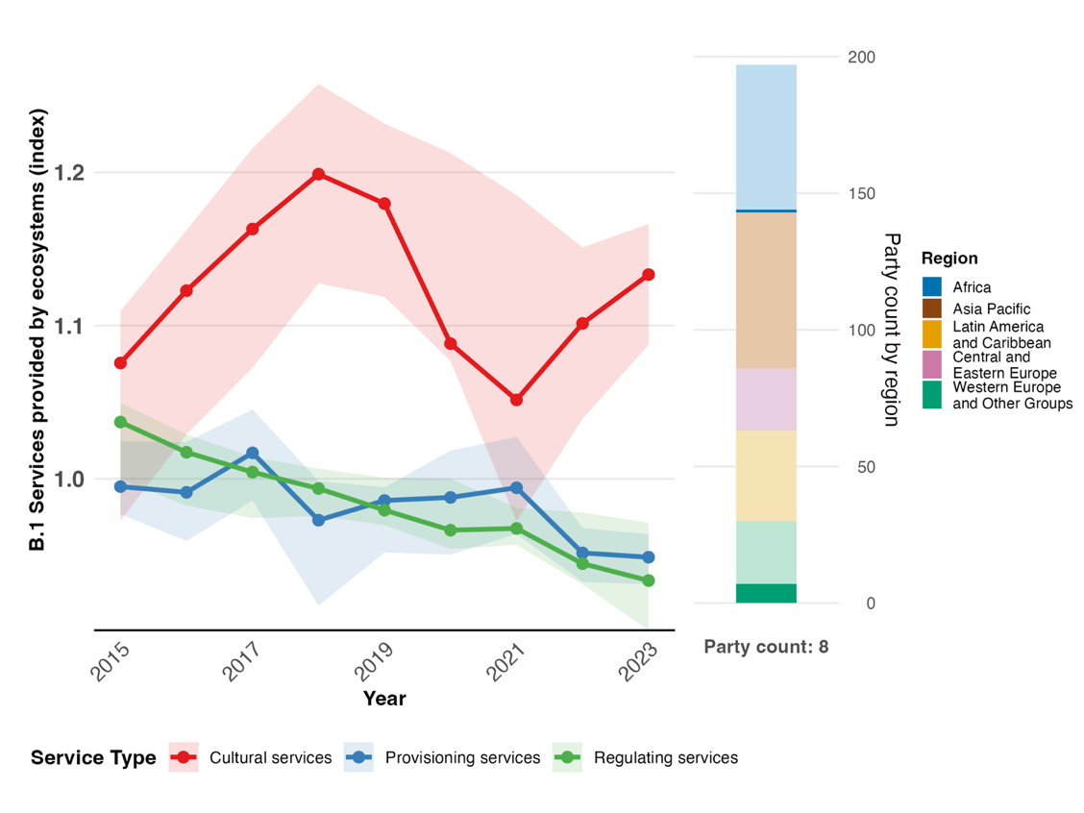
Note: Indicator values show the overall average and interquartile range across Party submissions each year for each of the three ecosystem service categories. The right bar chart shows the distribution of Parties providing data by region. Colours for each region are defined in the figure legend: darker tones represent the proportion of Parties for any region for which data are included in the graph; lighter tones represent the proportion of Parties for the same region for which no data are included in the graph. Note that regional representation for this indicator is extremely limited and spatially biased.

Figure 51
Percentage of indicators aligned with Target 11 of the Framework that suggest improving, stable and negative trends, respectively
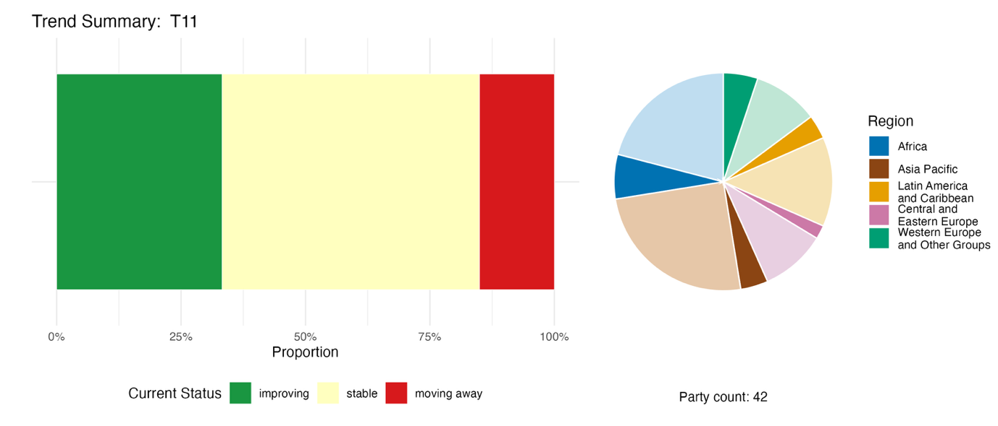
Note: Proportions are weighted by Party. The trends include data for 1 headline indicator from 23 Parties, and 3 component, 4 complementary and 52 national indicators from a total of 25 Parties. The pie chart shows the distribution of Parties submitting indicators for Target 11 by region. Colours for each region are defined in the figure legend: darker tones represent the proportion of Parties for any region for which data are included in the graph; lighter tones represent the proportion of Parties for the same region for which no data are included in the graph.

Self-assessment of progress

Based on self-assessment by Parties in national reports, only 35 per cent of national targets submitted as highly aligned with Target 11 are on track for achievement, with a much higher number (64 per cent) showing no significant change or insufficient progress, and just one national target (0.2 per cent) reported as already achieved (see figure 52).

Figure 52
Self-assessed progress for all national targets submitted as highly aligned with Target 11 of the Framework
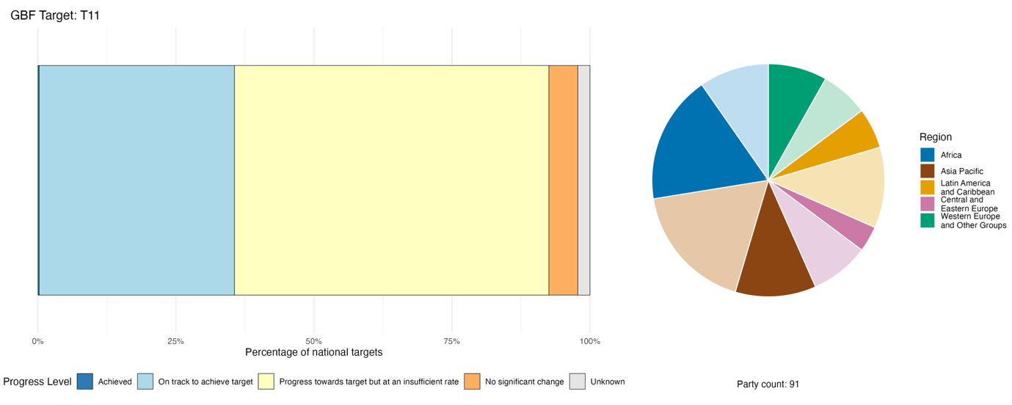
Note: The bar widths show the proportion of national targets submitted in each progress category. Proportions are weighted by Party to ensure that Parties contribute equally to overall assessment of progress, regardless of the number of national targets submitted. The pie chart shows the proportion of Parties in each region reporting in time for consideration in the global report. Colours for each region are defined in the figure legend: darker tones represent the proportion of Parties for any region for which data are included in the graph; lighter tones represent the proportion of Parties for the same region for which no data are included in the graph.

Actions, successes and challenges in implementation

Summary of actions in support of Target 11 of the Framework

The most universally reported approaches to the implementation of Target 11 are actions related to ecosystem restoration and nature-based solutions. They encompass forest landscape restoration, wetland rehabilitation, mangrove replanting, river revitalization, coral reef restoration and urban green infrastructure, among others. The range of actions demonstrates connections with several other Targets that contribute to enhancing nature’s contributions to people, notably Targets 2 and 8. Another dominant pattern in the reported actions for Target 11 is the integration of the concepts of ecosystem services and nature’s contributions to people into planning frameworks, whether through natural capital accounting, the mapping of ecosystem services or the mainstreaming of biodiversity into sectoral strategies. A third widespread pattern is the use of community-based or participatory delivery mechanisms, ranging from community forestry groups to watershed co-management bodies (see box 33).

Examples of success and progress in implementation

Box 33

“A new deal for pollinators”: a comprehensive policy framework to reverse pollinator decline in the European Union

The severe and continuous decline of wild pollinator populations across the European Union is leading to the degradation of critical pollination processes. The European Union policy initiative, entitled “A new deal for pollinators”, was launched in 2023 with the objective of reversing the decline of pollinator species in the European Union. The initiative covers a broad range of aspects, including filling knowledge gaps, improving conservation and restoration policy, implementing measures to tackle key pressures on pollinators and engaging the whole of society.

In 2024, the objective to reverse the decline of pollinator species was included as a binding target in article 10 of the European Union Nature Restoration Regulation. In line with this legal provision, a standardized methodology for a pollinator monitoring scheme is now embedded in regulation. Starting from 2027, bees, hoverflies, butterflies and moths will be monitored at a minimum of 1,820 sites throughout the European Union, ensuring sufficient statistical power to assess trends of pollinator populations at the national and European Union level.

The knowledge base on pollinator species was strengthened through the updated European Red List assessments of hoverflies (2023), butterflies (2025), bees (2026) and moths (2026), all of which continue to show a decline. The major drivers of pollinator decline are tackled through the mainstreaming of pollinator conservation objectives into sectoral policies, including the European Union Common Agricultural Policy, which supports farmers in adopting pollinator-friendly farming practices, and through the integration of pollinator protection in pesticide risk assessment and plant protection management systems.

The mobilization of a broad range of actors in society is key to the success of the “new deal for pollinators”. To support this, the European Union fostered the active role of youth with regard to pollinators through deliberative democracy (the Young Citizens’ Assembly on Pollinatorsª), capacity-building and financial support (the European Fund for Youth Action on Pollinators^{b}) and education (“Buzzing Schools”^{c}).

Relevant targets: 2, 4, 7, 8, 10, 11, 14 and 21.

Sources: European Union, seventh national report under the Convention; European Commission Directorate General for Environment, 2023; European Commission Directorate-General for Environment and others, 2025, 2026a, 2026b; and European Union, 2023, 2024, 2025.

ª See https://citizens.ec.europa.eu/young-citizens-assembly-pollinators_en.
^{b} See https://iucnsos.org/initiative/european-fund-for-youth-action-on-pollinators/.
^{c} See www.scientix.eu/community/partner-projects/buzzing-schools.

Challenges

Many Parties lack operational monitoring systems related to nature’s contributions to people, which presents a clear barrier to the implementation and reporting of Target 11. The systematic valuation of nature's contributions to people, including ecosystem functions and ecosystem services, is often weakly developed or inadequate, and where some valuation has been carried out, it is rarely integrated into decision-making processes. A few Parties further indicate that nature-based solutions are not legally recognized or defined, which limits their integration into planning documents and leaves implementation fragmented and inconsistent. Insufficient financing and mobilization of resources are widely cited as barriers to scaling up nature-based solutions. The weak integration of ecosystem service valuation into policy, planning and budgeting processes remains an obstacle to the implementation of Target 11 for many Parties. In addition, managing overlapping land-use demands, while respecting the rights of indigenous peoples and local communities and ensuring policy coherence across conservation, agriculture, infrastructure and other sectors, remain challenges for some Parties.

Contributions from actors other than national Governments

Commitments submitted directly through the online reporting tool

Of the 180 substantive commitments submitted by actors other than national governments, only 4 are associated primarily with Target 11. Three of the commitments were submitted by NGOs and one by a transnational corporation. The commitments focus on efforts to integrate the maintenance of nature’s contributions to people into corporate and public sector frameworks. The coverage of the commitments includes Denmark, France and Japan and a commitment that has a global scope. Specific activities associated with the commitments include promoting a global standard for nature-based solutions at the national level, and advancing the conservation of wetland ecosystems at the scale of river basins through collaborative actions among stakeholders.

Contributions integrated in national reports

With regard to Target 11, implementation delivery and co-implementation are the most commonly reported roles in national reports for actors other than national Governments, and include NGOs, sectoral actors such as farmers and fishers, and intergovernmental organizations, which act both as financiers and operational partners. Co-management and governance are the most prominent roles for indigenous peoples and local communities and subnational governments, while financing and co-financing is reported mainly for intergovernmental organizations, business and finance actors and some NGOs. The provision of knowledge, monitoring and technical standard-setting are the primary roles of the scientific community. Awareness-raising and capacity-building are the roles most commonly reported for citizens, young people, and women and girls, although these are often described without much operational detail. Finally, livelihood-linked stewardship, which involves conservation in income-generating activities, recurs as a cross-cutting mechanism for indigenous peoples and local communities, sectoral actors, women and young people. This is especially evident across sub-Saharan Africa, Latin America and the Pacific.

Examples of linkages with other agreements, organizations and processes

Target 11 of the fourth strategic plan 2016-2024 of the Convention on Wetlands of International Importance, especially as Waterfowl Habitat, had the objective that within the period of the plan, “wetland functions, services and benefits are widely demonstrated, documented and disseminated.” Progress on this target was assessed as contributing to Targets 11, 12 and 13 of the Kunming-Montreal Global Biodiversity Framework. By 2025, around 70 per cent of Parties to the Convention on Wetlands had made full or partial assessments of ecosystem benefits and services provided by Wetlands of International Importance and other wetlands. The 2025 Global Wetlands Outlook estimated that the 1.4 billion hectares of remaining wetlands provide between US$ 8 trillion and US$ 39 trillion to people every year (Convention on Wetlands, 2025a, 2025b and 2025e).

Target 12. Enhance green spaces and urban planning for human well-being and biodiversity

Target text: Significantly increase the area and quality, and connectivity of, access to, and benefits from green and blue spaces in urban and densely populated areas sustainably, by mainstreaming the conservation and sustainable use of biodiversity, and ensure biodiversity-inclusive urban planning, enhancing native biodiversity, ecological connectivity and integrity, and improving human health and well-being and connection to nature, and contributing to inclusive and sustainable urbanization and to the provision of ecosystem functions and services.

Progress overview
Gaps remain with regard to the alignment of national targets with the full scope of Target 12, and with regard to implementation and monitoring. National targets are largely aligned with increasing the area of green spaces and ensuring biodiversity-inclusive urban planning, rather than other aspects of the target. Reported data is insufficient to assess trends, but an initial baseline of green and blue space in urban and densely populated areas is indicated. A clear majority of Parties report progress on including biodiversity and ecosystem services in urban planning; however, other national indicators, and the self-assessment of Parties, all suggest that progress is not on track to meet most national targets. Parties reported challenges related to data and methods for monitoring, weak planning frameworks and enforcement, poor coordination among authorities, and lack of relevant expertise.

Coverage by Parties of the scope of Target 12 of the Framework in their national targets

Table 26
Elements of Target 12 of the Framework and how they are addressed in national targetsª
Significantly increase the area of green spaces in urban and densely populated areas | 71
Significantly increase the area of blue spaces in urban and densely populated areas | 53
Significantly increase the quality of green and blue spaces in urban and densely populated areas | 56
Significantly increase the connectivity of green and blue spaces in urban and densely populated areas | 52
Significantly increase the access to and benefits from green and blue spaces in urban and densely populated areas | 46
Mainstream the conservation and sustainable use of biodiversity in urban and densely populated areas | 33
Ensure biodiversity-inclusive urban planning contributing to inclusive and sustainable urbanization and to the provision of ecosystem functions and services | 65
Enhance native biodiversity in urban and densely populated areas | 31
Improve human health and well-being and connection to nature | 54
On average, Parties have addressed, to at least some extent, 51 per cent of these elements in their national targets

Note: The right-hand column of the table indicates the percentage of Parties with national targets that address the element to at least some extent.
ª The elements for each target were defined by the Ad Hoc Technical Expert Group on Indicators of the Kunming-Montreal Global Biodiversity Framework (see annex I to CBD/COP/16/INF/4; and Affinito and others, 2025). The detailed methodology for the analysis of national targets is provided in document CBD/SBI/7/INF/22.

A large majority of Parties have submitted national targets that address green spaces in urban and densely populated areas (71 per cent) and biodiversity-inclusive urban planning (65 per cent) (see table 26). Fewer parties (53 per cent) specifically address blue spaces (areas dominated by bodies of water). More than half of Parties have targets addressing the quality (56 per cent), connectivity (52 per cent) and benefits to human health and well-being and connection to nature (54 per cent) of green and blue spaces. Fewer Parties have targets that address access to green and blue spaces (46 per cent) or address enhancing native biodiversity in urban and densely populated areas (31 per cent). Overall, there are significant gaps in the scope of national targets in comparison with the global target. There are no specific quantitative elements included in Target 12, but there is a commitment to significantly increase the area of green and blue spaces.

Indicators of progress

Table 27
Indicator scorecard for Target 12 of the Framework
 | Indicator use |  | Indicator results
Headline indicator 12.1: average share of the built-up area of cities that is green or blue space for public use for all | 26 per cent of Parties |  | Overall average: 23 per cent (range: 1 to 58 per cent)
Binary indicator 12.b: number of countries with biodiversity-inclusive urban planning referring to green or blue urban spaces | 127 Parties | n/aª | 69 per cent of Parties scored highly (score 4/5)
All quantitative indicators combined | 27 Parties, 21 per cent |  | 20 per cent positive trends  3 per cent negative trends
Notes | National values are based on a subset of cities assessed.  Estimating the accessibility of green and blue spaces was largely not feasible.
Note: The colour coding is related to the overall assessment of progress across targets, the methodology of which is explained in the overall summary scorecard (see table 3). The colour coding for indicator data use and all quantitative indicator trends reflects where a value for each target sits relative to the highest and lowest scores achieved across all targets of the Framework (green is assigned to percentage values falling within the top third of the total range, yellow to the middle third and red to the bottom third). Colours for the binary indicators are based on the percentage of Parties scoring highly (4 or 5) for the indicator overall (green is assigned to values at or above 50 per cent, yellow to values from 25 to 50 per cent and red to values below 25 per cent). Colours for the headline indicator results are based on progress relative to the target (green is assigned when progress is being made, yellow when progress is mixed, red when progress is insufficient and grey when progress cannot be assessed). Note that the percentage of Parties submitting data on headline indicators may be different from that used in the aggregate results for both the headline indicator and all quantitative indicators combined, owing to methodological differences in the way data were used.
ª As binary indicator data are required by the online reporting tool, submission counts for these indicators do not reflect monitoring capacity differences between targets and do not provide actionable information for making progress in implementation, so assessment of indicator use is not relevant.

Based on data for headline indicator 12.1 (average share of the built-up area of cities that is green or blue space for public use for all), submitted by 26 per cent of Parties whose national reports were considered for the global report, green or blue space for public use comprises on average 23 per cent of built-up areas (see table 27 and figure 53). This is presented as a single baseline figure for the period 2020–2025, as sufficient trend data were not available. Parties noted that both the collection of data and the methodology were key challenges in reporting on the indicator. The number of cities assessed by reporting Parties ranged from 3 to 31, and thus reported data may not be representative of all urban areas within an individual country. Several Parties noted that capacity constraints at the municipal level created bottlenecks with regard to the availability of city maps and the frequency with which they were updated. In addition, some Parties noted that the methodology of the recommended SDG indicator (11.7.1: average share of the built-up area of cities that is open space for public use for all, by sex, age and persons with disabilities) was unsuitable to report on headline indicator 12.1, as the SDG indicator does not discriminate between green or blue spaces, or artificial spaces that are not related to biodiversity. Many Parties also noted that measuring access to green and blue spaces was particularly challenging, and appropriate methods were lacking. Therefore, many of the submissions used in the overall estimate of the indicator relate to the coverage of green and blue spaces as a fraction of urban area.
Through the binary indicator for Target 12, most Parties (69 per cent) reported progress on including biodiversity and ecosystem services in urban planning (see figure 54). Of those Parties, however, more reported that these efforts were still in the development stage, while fewer reported that they had been fully achieved.
Other national indicators submitted by Parties also largely focus on the area of green spaces in urban and densely populated areas, while most other elements of the target, such as connectivity, are not monitored or reported. Trend analysis shows little change in most of these indicators; however, 20 per cent show positive trends, and very few negative trends have been reported (see figure 55). It is important to note that this analysis relates to only 21 per cent of Parties whose national reports were considered for the global report.

Figure 53
Headline indicator 12.1: average share of the built-up area of cities that is green or blue space for public use for all

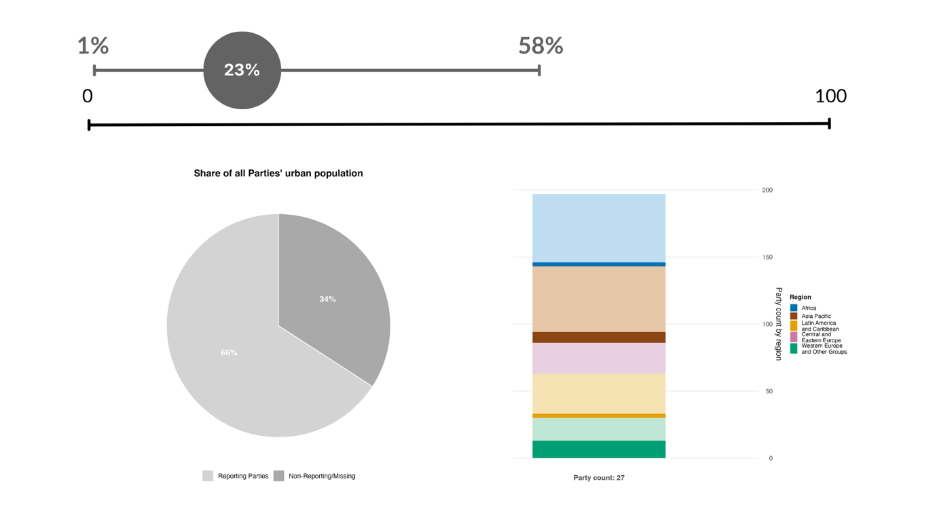

Note: Only a single data point is shown aggregating all the indicator values submitted, as fewer than a fifth of Parties submitted time series data. The average and range of green or blue space in cities across all Parties that submitted data are displayed. The pie chart shows the proportion of Parties’ total urban population accounted for by the Parties that submitted data in dark grey. The bar chart shows the distribution of Parties providing data by region. Colours for each region are defined in the figure legend: darker tones represent the proportion of Parties for any region for which data are included in the graph; lighter tones represent the proportion of Parties for the same region for which no data are included in the graph.

Figure 54
Binary indicator 12.b: number of countries with biodiversity-inclusive urban planning referring to green or blue urban spaces
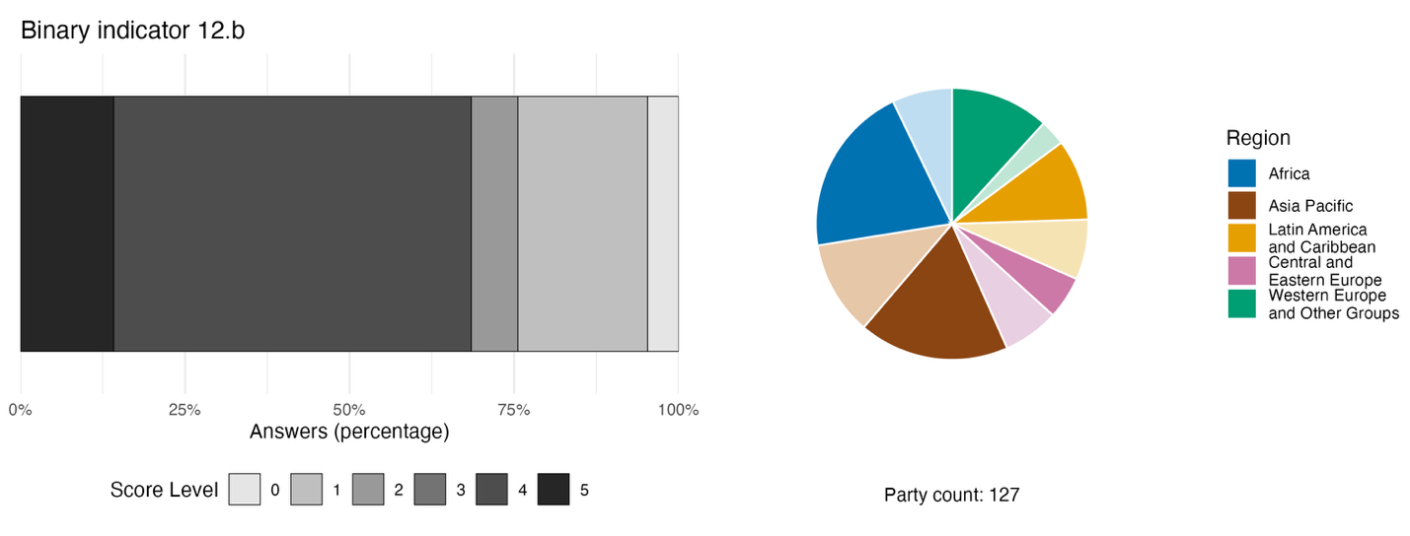
Note: The bar widths show the percentage of Parties in each score category, with higher numbers indicating a greater level of progress, based on responses to the questions included in the indicator.ª The pie chart shows the distribution of Parties providing responses to all questions by region. Colours for each region are defined in the figure legend: darker tones represent the proportion of Parties for any region for which data are included in the graph; lighter tones represent the proportion of Parties for the same region for which no data are included in the graph.
ª The methodology for calculating the score levels for each binary indicator, as well as the questions included for each indicator, are provided in document CBD/COP/16/INF/3/Rev.1.

Figure 55
Percentage of indicators aligned with Target 12 of the Framework that suggest improving, stable and negative trends, respectively
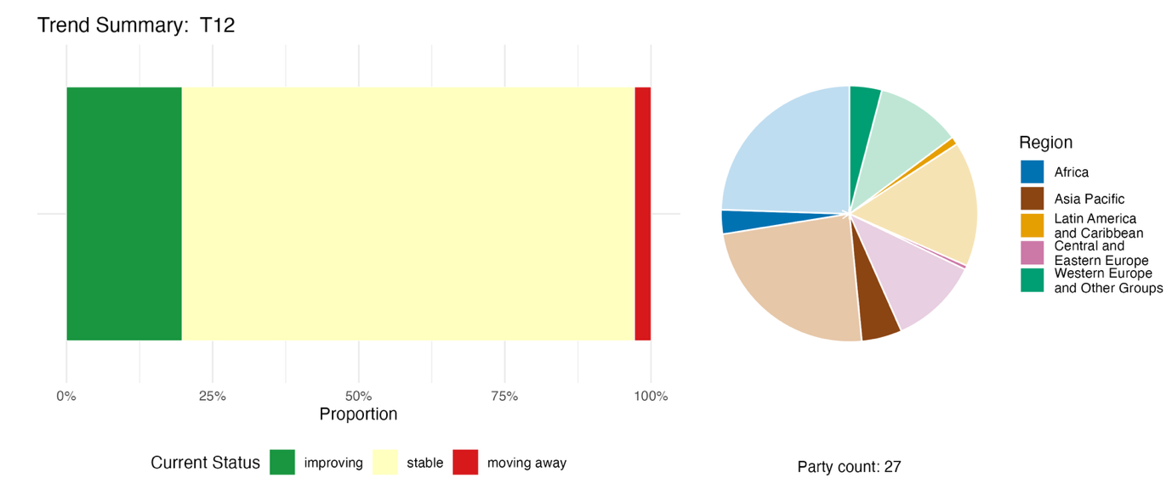
Note: Proportions are weighted by Party. The trends include data for 1 headline indicator from 17 Parties and 39 national indicators from a total of 13 Parties. The pie chart shows the distribution of Parties submitting indicators for Target 12 by region. Colours for each region are defined in the figure legend: darker tones represent the proportion of Parties for any region for which data are included in the graph; lighter tones represent the proportion of Parties for the same region for which no data are included in the graph.

Self-assessment of progress

The self-assessment by Parties in national reports generally supports the indicator trend analysis. Only 32 per cent of national targets submitted as highly aligned with Target 12 are on track for achievement, with many more (64 per cent) showing no significant change or insufficient progress, and just two national targets (0.4 per cent) are reported as already achieved (see figure 56).

Figure 56
Self-assessed progress for all national targets submitted as highly aligned with Target 12 of the Framework
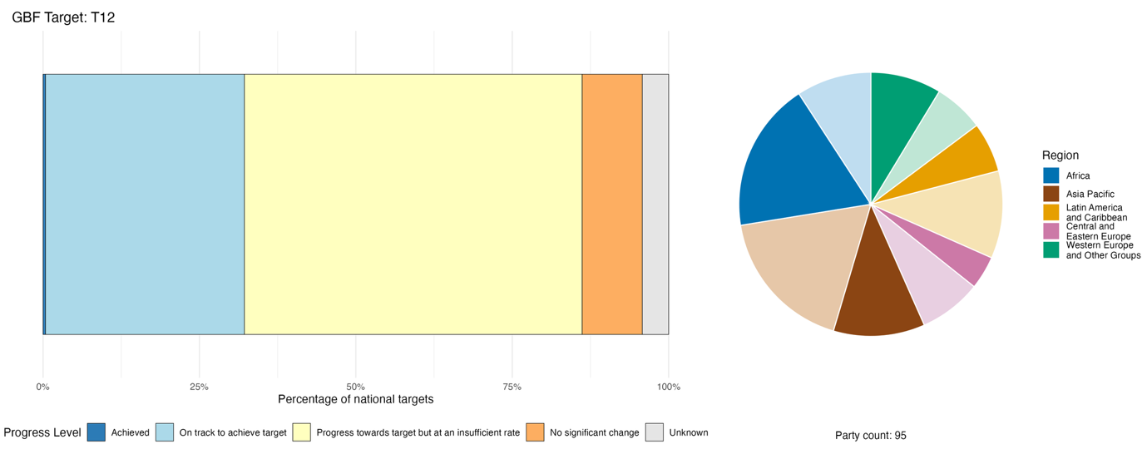
Note: The bar widths show the proportion of national targets submitted in each progress category. Proportions are weighted by Party to ensure that Parties contribute equally to overall assessment of progress, regardless of the number of national targets submitted. The pie chart shows the proportion of Parties in each region reporting in time for consideration in the global report. Colours for each region are defined in the figure legend: darker tones represent the proportion of Parties for any region for which data are included in the graph; lighter tones represent the proportion of Parties for the same region for which no data are included in the graph.

Actions, successes and challenges in implementation

Summary of actions in support of Target 12 of the Framework

The most common type of action reported by Parties is direct intervention to support urban greening and habitat restoration. This ranges from planting trees with quantified targets to the creation of parks, the rehabilitation of wetlands, the stabilization of riverbanks and the construction of ecological corridors in urban areas (see box 34). Many Parties also report actions specific to enhancing blue spaces in urban areas, including policies to reduce the pollution of lakes and rivers and rehabilitate urban waterways. A number of Parties report actions to establish or plan ecological corridors linking urban green spaces. Many Parties have established legally mandated ratios for green and blue spaces accessible to urban populations, and other biodiversity requirements, embedding them within planning instruments. Environmental education, citizen science, community engagement and public awareness campaigns are widely reported as contributing to the implementation of Target 12; however, these actions are not as well represented in the national targets and quantitative indicators submitted.

Examples of success and progress in implementation

Box 34

Multilevel urban greening governance combining legal, financial and community instruments in Belgium

Belgium faces significant challenges in maintaining nature's contributions to people in densely populated urban areas, owing to severe shortages of accessible green and blue spaces, widespread soil sealing, fragmented ecological habitats and excessive pesticide use in public areas. Many residents lack private gardens or nearby public green spaces, and there is uneven distribution of such spaces across neighbourhoods.

To restore, maintain and enhance nature's contributions to people, Belgium has implemented multilevel urban greening governance across the Brussels-Capital, Flanders and Wallonia regions. The relevant national target is reported as being on track for achievement.

As part of the initiative, Belgium has restored 88 kilometres of blue infrastructure and created over 6,300 hectares of wetlands under the Blue Deal (Flanders). Wallonia launched the BiodiverCité grant scheme in 2021, with 88 per cent of municipalities participating. The Late Mowing Programme covers over 16,200 kilometres of roads, and has been adopted by 89 per cent of municipalities. Pesticide use in public spaces has been eliminated across Wallonia, and a network of over 2,400 certified natural gardens has been established. Brussels has added around 100 hectares of managed green spaces over the past 20 years.

Key challenges include fragmented governance across the federal and regional levels, and gaps in data collection. Approaches for further implementation include strengthening coordination mechanisms and scaling up restoration efforts.

Relevant targets: 1, 2, 7, 11, 12 and 14.
Source: Belgium, seventh national report under the Convention.

Challenges

Many Parties acknowledge the absence of dedicated national urban nature policies and the lack of systematic urban biodiversity monitoring, which present challenges to the implementation of Target 12. The lack of coordination across sectors and departments of Government creates further challenges to implementation, as policies relating to green infrastructure can cut across ministries of environment, housing, health, transport, water and land planning. In addition, a lack of information-sharing across different levels of government may create challenges related to the systematic measurement of and reporting on urban biodiversity outcomes. Parties report that subnational governments and municipalities may lack the specialized expertise needed for urban ecology or landscape management. Frameworks for urban biodiversity often remain advisory in nature, and even legal frameworks may have limited enforcement. Insufficient or uncertain financing for subnational governments and local authorities is also a barrier. In some developing countries in particular, rapid urbanization, housing shortages and the expansion of informal settlements into environmentally sensitive areas create complex planning challenges that require integrated housing, sanitation, ecosystem restoration and social inclusion policies.

Contributions from actors other than national Governments

Commitments submitted directly through the online reporting tool

Of the 180 substantive commitments submitted by actors other than national Governments, only 3 are associated with Target 12. Two have been submitted by NGOs and one by a private real estate company. All three commitments reflect efforts to integrate biodiversity and nature-based solutions into urban planning. The commitments are all focused on actions in Europe, with contributions from Bosnia and Herzegovina, Denmark and the Kingdom of the Netherlands.

Contributions integrated in national reports

Subnational governments and local authorities are primarily responsible for actions relating to urban green and blue spaces, and often develop their own greening strategies, ordinances and monitoring frameworks. NGOs and civil society organizations play diverse roles that span ecosystem restoration, certification, co-governance, technical guidance and monitoring, while the scientific community mainly provides baseline data, planning tools and monitoring methodologies. Intergovernmental organizations and international partners act largely as financiers, co-implementers and builders of capacity. Citizens are most often the recipients of awareness-raising efforts, while indigenous peoples and local communities co-manage territories and resources, and sometimes serve as the primary spatial authority where State capacity is weak. While all citizens benefit from urban green spaces for their well-being, women and young people are mentioned largely as recipients or beneficiaries; however, they also contribute to raising awareness of the issue.

Examples of linkages with other agreements, organizations and processes

The Stockholm Convention on Persistent Organic Pollutants addresses sources of chemical pollution that impact the quality and ecological function of urban green and blue spaces, thus supporting biodiversity-inclusive urban planning and contributing to implementation of Target 12 of the Framework. Persistent organic pollutants, such as those found in certain construction and demolition materials, can be released into the environment during urban development and renovation activities. The Stockholm Convention promotes the phase-out and environmentally sound management of these hazardous substances, such as hexabromocyclododecane in insulation materials, helping to reduce contamination in soils and water bodies within and around cities (Secretariat of the Basel, Rotterdam and Stockholm Conventions, 2025).
Implementation of Target 12 is also supported by integration into urban planning strategies of waste management guidelines from the Basel Convention on the Control of Transboundary Movements of Hazardous Wastes and their Disposal. Collaborative efforts between urban planners, environmental authorities, and waste management professionals can help green and blue spaces in cities to be developed and maintained in a way that minimizes pollution and protects ecosystem functions. The Basel Convention’s technical guidelines on the environmentally sound management of municipal solid waste and other relevant streams provide practical measures for waste reduction, segregation, safe disposal, and treatment—critical for preventing contamination in parks, waterways, and urban biodiversity corridors. Embedding these guidelines into urban planning strategies can help reduce environmental pressures on green areas while promoting healthier and more resilient urban ecosystems (Secretariat of the Basel, Rotterdam and Stockholm Conventions, 2025).

Target 13. Increase the sharing of benefits from genetic resources, digital sequence information and traditional knowledge

Target text: Take effective legal, policy, administrative and capacity-building measures at all levels, as appropriate, to ensure the fair and equitable sharing of benefits that arise from the utilization of genetic resources and from digital sequence information on genetic resources, as well as traditional knowledge associated with genetic resources, and facilitating appropriate access to genetic resources, and by 2030, facilitating a significant increase of the benefits shared, in accordance with applicable international access and benefit-sharing instruments.

Progress overview

Progress is being made in establishing access and benefit-sharing (ABS) frameworks, but the implementation of the necessary legislative, policy and administrative requirements is largely in the early stages. Overall, national targets provide good coverage of the elements of Target 13 related to genetic resources. Limited data have been submitted by Parties on monetary or non-monetary benefits arising from ABS instruments. An analysis of indicators suggests an overall positive trend, supported by Party self-assessments, showing that 43 per cent of national targets highly aligned with Target 13 are on track for achievement. Regulatory challenges are among the most frequently cited obstacles to implementation. Increased monitoring is required to determine the impact of national ABS and other regulatory frameworks on increasing the benefits shared.

Coverage by Parties of the scope of Target 13 of the Framework in their national targets

Table 28
Elements of Target 13 of the Framework and how they are addressed in national targetsª
Take effective legal, policy and administrative measures at all levels, to ensure the fair and equitable sharing of benefits that arise from the utilization of genetic resources | 79
Take effective capacity building measures at all levels to ensure the fair and equitable sharing of benefits that arise from the utilization of genetic resources | 60
Take effective legal, policy and administrative measures at all levels to ensure the fair and equitable sharing of benefits that arise from the utilization of digital sequence information | 52
Take effective capacity building measures at all levels to ensure the fair and equitable sharing of benefits that arise from the utilization of digital sequence information | 42
Take effective legal, policy and administrative measures at all levels to ensure the fair and equitable sharing of benefits that arise from traditional knowledge | 60
Take effective capacity building measures at all levels to ensure the fair and equitable sharing of benefits that arise from traditional knowledge | 51
Facilitate appropriate access to genetic resources | 72
By 2030, facilitate a significant increase of the benefits shared, in accordance with applicable international access and benefit-sharing instruments | 57
On average, Parties have addressed, to at least some extent, 59 per cent of these elements in their national targets

Note: The right-hand column of the table indicates the percentage of Parties with national targets that address the element to at least some extent.
ª The elements for each target were defined by the Ad Hoc Technical Expert Group on Indicators of the Kunming-Montreal Global Biodiversity Framework (see annex I to CBD/COP/16/INF/4; and Affinito and others, 2025). The detailed methodology for the analysis of national targets is provided in document CBD/SBI/7/INF/22.

A large majority of Parties have submitted national targets that address legal, policy and administrative measures to ensure the fair and equitable sharing of benefits that arise from the utilization of genetic resources (79 per cent), as well as the facilitation of access to genetic resources (72 per cent). A majority of Parties also have targets that address capacity-building measures for benefit-sharing relating to genetic resources (60 per cent) and traditional knowledge (51 per cent). Fewer Parties have targets addressing legal, policy and administrative measures related to digital sequence information (52 per cent) and associated capacity-building (42 per cent). Overall, national targets provide good coverage of the elements of Target 13 that depend on national implementation (see table 28).

Indicators of progress

Table 29
Indicator scorecard for Target 13 of the Framework
 | Indicator use |  | Indicator results
Headline indicator C.1: monetary benefits received in accordance with applicable internationally agreed access and benefit-sharing instruments | 11 per cent of Parties |  | Total US$ 6.9 million monetary benefits 2022–2025
Headline indicator C.2: non-monetary benefits arising from applicable international access and benefit-sharing instruments | 14 per cent of Parties |  | Total 960 non-monetary benefits 2022–2025
Binary indicator 13.b: number of countries that have taken effective legal, policy, administrative and capacity-building measures at all levels, as appropriate, to ensure the fair and equitable sharing of benefits from the utilization of genetic resources and from digital sequence information on genetic resources, as well as traditional knowledge associated with genetic resources | 127 Parties | n/aª | 10 per cent of Parties scored highly (score 4/5)
All quantitative indicators combined | 31 Parties, 24 per cent |  | 39 per cent positive trends  15 per cent negative trends
Note: The colour coding is related to the overall assessment of progress across targets, the methodology of which is explained in the overall summary scorecard (see table 3). The colour coding for indicator data use and all quantitative indicator trends reflects where a value for each target sits relative to the highest and lowest scores achieved across all targets of the Framework (green is assigned to percentage values falling within the top third of the total range, yellow to the middle third and red to the bottom third). Colours for the binary indicators are based on the percentage of Parties scoring highly (4 or 5) for the indicator overall (green is assigned to values at or above 50 per cent, yellow to values from 25 to 50 per cent and red to values below 25 per cent). Colours for the headline indicator results are based on progress relative to the target (green is assigned when progress is being made, yellow when progress is mixed, red when progress is insufficient and grey when progress cannot be assessed). Note that the percentage of Parties submitting data on headline indicators may be different from that used in the aggregate results for both the headline indicator and all quantitative indicators combined, owing to methodological differences in the way data were used.
ª As binary indicator data are required by the online reporting tool, submission counts for these indicators do not reflect monitoring capacity differences between targets and do not provide actionable information for making progress in implementation, so assessment of indicator use is not relevant.

The following analysis considers all Parties to the Convention as it is based on all submitted national reports (see table 29). It is worth noting, however, that many Parties do not require prior informed consent for access to their genetic resources, and consequently do not receive benefits from their utilization.
Only a small number of Parties submitting national reports considered for the global report provided data for headline indicators C.1 (monetary benefits received in accordance with applicable internationally agreed access and benefit-sharing instruments) and C.2 (non-monetary benefits arising from applicable international access and benefit-sharing instruments). Parties generally reported that both monetary and non-monetary benefits arising from ABS instruments are difficult to track (including tracking across borders and along value chains through to the final product). On the basis of the limited data available, Parties reported that they had received a cumulative US$ 6.9 million in monetary benefits during the period 2022–2025, with several Parties reporting that they had received no monetary benefits to date. With regard to non-monetary benefits, Parties reporting compatible data indicated a cumulative total of 960 benefits during the same period, including scientific outputs, participation in research, technical training, technology transfer, databases and community engagement. These benefits fluctuated over time rather than increasing consistently, and, owing to the very limited reporting, cannot be seen as indicative of global benefit-sharing. More information is provided in the analysis of Goal C in section II.C below.
In terms of progress in developing the legislative, policy and administrative frameworks necessary for achieving Target 13, responses for the binary indicator suggest that implementation is at an intermediate stage overall, with 74 per cent of Parties scoring at a mid-level of progress, and more Parties in early stages of implementation (see figure 57). The strongest progress has been in establishing legal, administrative and policy measures for fair and equitable benefit-sharing arising from the utilization of genetic resources, which often includes traditional knowledge where relevant. Progress on monitoring monetary and non-monetary benefits remains much weaker, however, as most Parties have no monitoring systems in place or are still in the process of developing them. The implementation of measures related to the multilateral mechanism on the sharing of benefits arising from the utilization of digital sequence information (dec.16/2 in CBD, 2026) is particularly limited; however, this was to be expected given the early stages of the development of the mechanism and the associated Cali Fund.
Additional indicators for Target 13, submitted by 31 Parties that were mostly from the African and Asia-Pacific regions, were focused on facilitating access to genetic resources, and did not cover such areas as capacity-building for the use of digital sequence information or sharing benefits from the use of traditional knowledge. Indicator trends are mixed but generally encouraging, with more than twice as many indicators improving as worsening, although nearly half remain stable, suggesting that while implementation is advancing, progress remains insufficient to fully achieve the target (see figure 58).

Figure 57
Binary indicator 13.b: number of countries that have taken effective legal, policy, administrative and capacity-building measures at all levels, as appropriate, to ensure the fair and equitable sharing of benefits from the utilization of genetic resources and from digital sequence information on genetic resources, as well as traditional knowledge associated with genetic resources
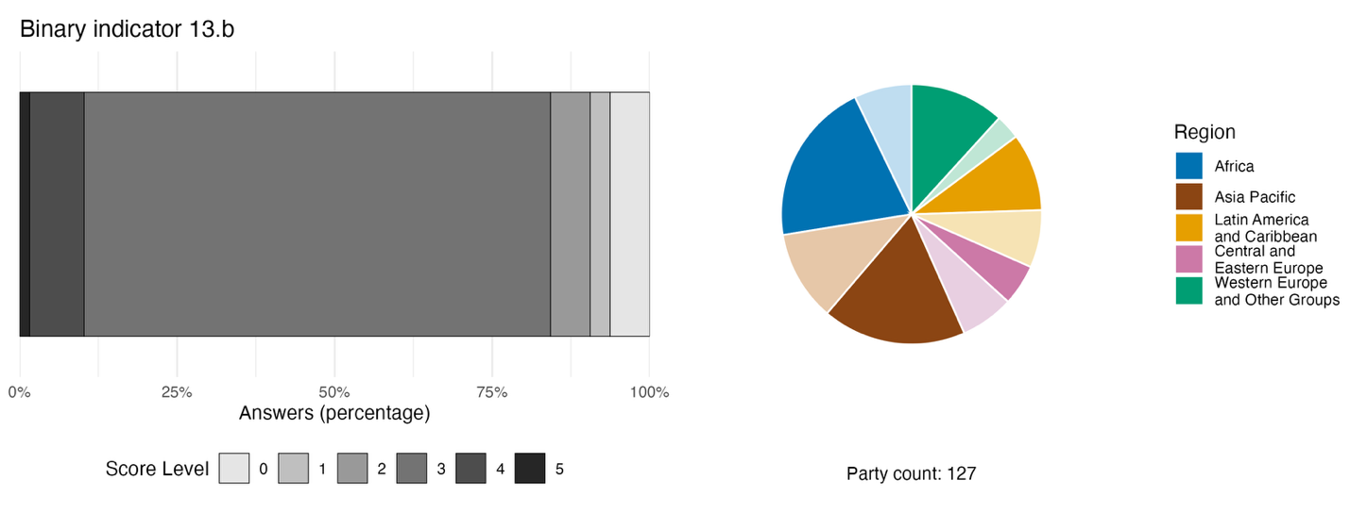
Note: The bar widths show the percentage of Parties in each score category, with higher numbers indicating a greater level of progress, based on responses to the questions included in the indicator.ª The pie chart shows the distribution of Parties providing responses to all questions by region. Colours for each region are defined in the figure legend: darker tones represent the proportion of Parties for any region for which data are included in the graph; lighter tones represent the proportion of Parties for the same region for which no data are included in the graph.
ª The methodology for calculating the score levels for each binary indicator, as well as the questions included for each indicator, are provided in document CBD/COP/16/INF/3/Rev.1.

Figure 58
Percentage of indicators aligned with Target 13 of the Framework that suggest improving, stable and negative trends, respectively
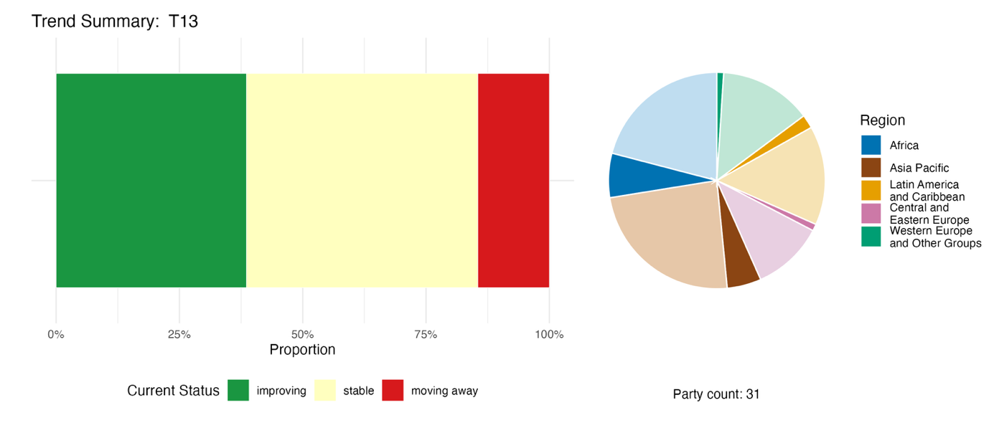
Note: Proportions are weighted by Party. The trends include data for 2 headline indicators from 18 Parties, and 2 complementary and 41 national indicators from a total of 16 Parties. The pie chart shows the distribution of Parties submitting indicators for Target 13 by region. Colours for each region are defined in the figure legend: darker tones represent the proportion of Parties for any region for which data are included in the graph; lighter tones represent the proportion of Parties for the same region for which no data are included in the graph.

Self-assessment of progress

Based on self-assessment by Parties in national reports, 43 per cent of national targets submitted as highly aligned with Target 13 are on track for achievement. Another 8 per cent show no significant change, and a further 44 per cent show insufficient progress. Just two national targets (1 per cent) have been reported as already achieved (see figure 59).

Figure 59
Self-assessed progress for all national targets submitted as highly aligned with Target 13 of the Framework
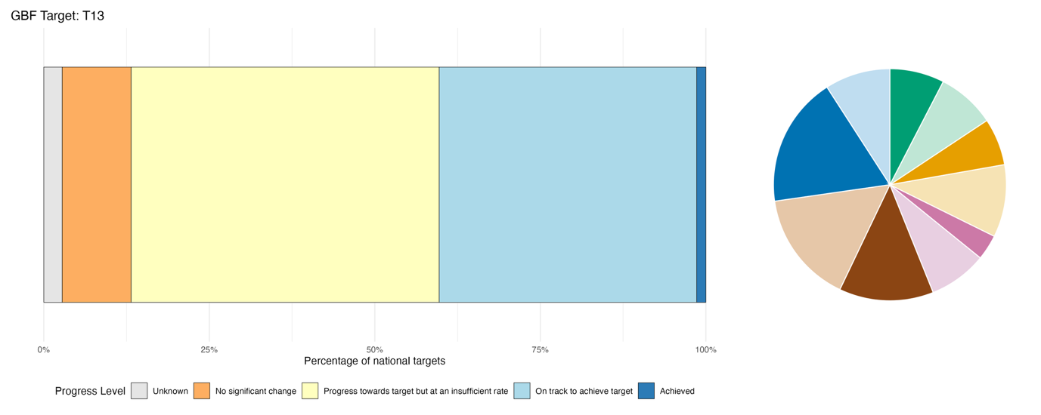
Note: The bar widths show the proportion of national targets submitted in each progress category. Proportions are weighted by Party to ensure that Parties contribute equally to overall assessment of progress, regardless of the number of national targets submitted. The pie chart shows the proportion of Parties in each region reporting in time for consideration in the global report. Colours for each region are defined in the figure legend: darker tones represent the proportion of Parties for any region for which data are included in the graph; lighter tones represent the proportion of Parties for the same region for which no data are included in the graph.

Actions, successes and challenges in implementation

Summary of actions in support of Target 13 of the Framework

The implementation of Target 13 is primarily driven by legal and regulatory actions, with Parties enacting dedicated ABS laws, ratifying or having ratified the Nagoya Protocol on Access to Genetic Resources and the Fair and Equitable Sharing of Benefits Arising from Their Utilization, or establishing administrative systems for permitting and compliance. These legal frameworks are supported by research, monitoring and data-collection efforts, and include the operation of national gene banks, the development of genetic databases, and the creation of digital registries to ensure the traceability of genetic resources and traditional knowledge associated with genetic resources (see box 35). Parties are also focusing on social and awareness actions by conducting capacity-building workshops for government officials and researchers, while engaging local communities through outreach on ABS requirements. Furthermore, many countries are integrating rights-based and customary measures into their policies, which includes formalizing free, prior and informed consent procedures and supporting the development of community biocultural protocols to protect traditional knowledge. While economic and financial instruments such as benefit-sharing funds and royalty mechanisms appear less frequently among the actions reported, Parties are increasingly active in international cooperation, in particular through multilateral engagement in negotiations on the sharing of benefits arising from digital sequence information on genetic resources.

Examples of success and progress in implementation

Box 35
Access and benefit-sharing systems, including traditional knowledge libraries, in Malaysia
Malaysia has implemented an ABS system across the entire country, covering Peninsular Malaysia, Sabah and Sarawak, with core federal ABS legislation enacted in 2017 that supplements previous state-level ordinances. As a result, more than 3,200 access permits have been issued nationwide since 2020, with five formal benefit-sharing agreements signed by January 2026, delivering tangible benefits to local indigenous communities.
A feature of the country’s approach has been the documentation and storage of traditional knowledge in digital libraries, with the aim of preventing biopiracy and providing support for patent review. Malaysia played a key role in promoting the adoption of the 2024 WorId Intellectual Property Organization Treaty on Intellectual Property, Genetic Resources and Associated Traditional Knowledge, lifting global protection standards for genetic resources and traditional knowledge. The MyABS clearing house, regional online application systems and multiple traditional knowledge digital libraries have been launched to realize digital management and the protection of resources and knowledge. This includes targeted training, workshops and outreach activities for regulators, researchers, indigenous peoples and local communities in order to improve overall implementation capacity, and the facilitation of benefit-sharing agreements with mutually agreed terms to promote the commercial development of biological resources.
Relevant targets: 13, 20, 21 and 22
Sources: Malaysia, seventh national report under the Convention; BioJapan, 2025; Government of Malaysia, 2017; and WIPO, 2024

Challenges

Regulatory challenges are among the most frequently cited obstacles to the implementation of Target 13, and have been identified by Parties across income levels and geographic regions. The most fundamental regulatory barrier, raised by a substantial share of reporting Parties, is the lack of a dedicated national ABS framework. Even among Parties that have adopted measures, many still need to make ABS fully operational, or translate existing measures into practice, in order to generate tangible benefits. A few Parties add that even where framework laws exist, those laws cannot function in the absence of subsidiary regulations or implementing orders, and a small number note that elements of their existing legislation pre-date or do not fully align with current international standards under the Nagoya Protocol. Several Parties report that the operationalization of ABS frameworks requires sustained legal, institutional, technical and financial support, including for checkpoints, tracking systems, community protocols and benefit-sharing mechanisms. Parties also report that the absence of functional checkpoints, required by the Nagoya Protocol, present a significant challenge to implementation, and the lack of tracking mechanisms on benefit-sharing also makes accurate reporting difficult. Compounding these gaps is that considerable investment of resources will be required to set up and revise ABS legal and institutional frameworks, together with the inherent complexity of ABS itself, which will generate benefits only over time. The formal protection of traditional knowledge held by indigenous peoples and local communities is similarly underdeveloped, and a significant number of Parties have raised concerns about gaps in recognition, documentation and dedicated registries.

Contributions from actors other than national governments

Commitments submitted directly through the online reporting tool

Of the 180 substantive commitments submitted by actors other than national Governments, 3 are primarily associated with Target 13. Two of the commitments are from centres of the CGIAR agricultural research network: one commitment supports the implementation of the Multilateral System of Access and Benefit-Sharing of the International Treaty on Plant Genetic Resources for Food and Agriculture, while the other relates to gene banks and breeding programmes to manage genetic resources in accordance with national and international ABS laws. The third commitment was submitted by the Danish 92 Group, a network of civil society organizations based in Denmark. That commitment encompasses contributions from multiple member organizations, including global advocacy of traditional knowledge and transparent and equitable sourcing practices among Danish life science and biotechnology companies through the Danish Biodiversity Partnership.

Contributions integrated in national reports

Scientific and academic institutions host ex situ genetic resource collections, act as parties and/or facilitators of ABS contracts, generate research related to genetic resources and digital sequence information and provide related capacity-building activities. Intergovernmental organizations and international partners mainly act as co-financers and co-implementers, especially through GEF-funded, UNDP-implemented ABS capacity projects, and convene multilateral dialogues on digital sequence information. Indigenous peoples and local communities perform the broadest range of roles, acting as co-governance actors, recognized knowledge-holders, parties to benefit-sharing agreements and co-managers of genetic resources. Business and finance actors appear as parties to ABS agreements or co-investors, most often as entities subject to compliance regulations, but increasingly as participants in stakeholder dialogues on digital sequence information. NGOs and civil society mainly provide advocacy and technical support, while subnational governments take operational roles only where legislation delegates competence to them. Sectoral actors feature as in situ conservers and seed bank operators, and women and girls appear as holders of traditional knowledge and cooperative benefit-sharing counterparties – although often only in policy language. Citizens appear exclusively as awareness-raising recipients, and young people appear almost entirely in aspirational roles.

Examples of linkages with other agreements, processes and organizations

The Multilateral System of Access and Benefit-Sharing established by the International Treaty on Plant Genetic Resources for Food and Agriculture contributes significantly to Target 13 and Goal C of the Framework. The Multilateral System creates a shared pool of samples of 64 major food crops, benefiting a wide range of stakeholders, including scientific institutions, farmers, plant breeders and the private sector, who can access and improve materials stored in collections or used in breeding programmes. According to the 2025 report on the implementation and operations of the Multilateral System, Contracting and non-Contracting Parties to the Treaty, along with international centres and regional gene banks, had reported approximately 2.6 million holdings of plant genetic resources for food and agriculture as available in the Multilateral System, representing almost 46 per cent of all holdings reported globally. This is more than twice the quantity compared with 2013, when approximately 1.2 million holdings were reported as available. Since 2007, the Multilateral System has facilitated the transfer of 7 million samples of plant genetic resources for food and agriculture under the Standard Material Transfer Agreement, demonstrating sustained, large‑scale use of the system. Transfers have been concentrated primarily on major food and forage crops, notably wheat, rice, maize, barley, beans and sorghum, which together account for a substantial share of exchanges reported to the Governing Body of the Treaty.
Since its establishment in 2009, the benefit-sharing fund of the Treaty has invested more than US$ 35 million in five funding cycles, and has supported over 100 projects in nearly 80 developing countries, benefiting more than 1 million people. It has created a global network of over 500 institutions, enabling the exchange of knowledge, technologies and good practices related to plant genetic resources for food and agriculture (FAO, 2025c; and ITPGRFA, 2025a, 2026).

Tools and solutions for implementation and mainstreaming

Target 14. Integrate biodiversity into decision-making at all levels

Target text. Ensure the full integration of biodiversity and its multiple values into policies, regulations, planning and development processes, poverty eradication strategies, strategic environmental assessments, environmental impact assessments and, as appropriate, national accounting, within and across all levels of government and across all sectors, in particular those with significant impacts on biodiversity, progressively aligning all relevant public and private activities, and fiscal and financial flows with the goals and targets of this framework.

Progress overview
The integration of the values of biodiversity into policies, planning and decision-making is progressing, but implementation generally remains at an early stage and is difficult to assess. Most Parties have submitted national targets that address the integration of biodiversity and its multiple values into policies, regulations, planning and development processes; however, there are significant gaps in coverage of all other target elements, such as integration with poverty eradication strategies and alignment of fiscal and financial flows. Reporting of progress towards Target 14 is limited, with very few Parties submitting quantitative indicators, and many aspects of the implementation measured by the binary indicator remain poorly addressed. Self-assessment by Parties, however, indicates some confidence that they are on track to meet national targets associated with mainstreaming. Parties report facing a persistent disconnect between formal biodiversity policies and their effective implementation.

Coverage by Parties of the scope of Target 14 of the Framework in their national targets

Table 30
Elements of Target 14 of the Framework and how they are addressed in national targetsª
Ensure the full integration of biodiversity and its multiple values into policies, regulations, planning and development processes | 72
Ensure the full integration of biodiversity and its multiple values into  poverty eradication strategies | 20
Ensure the full integration of biodiversity and its multiple values into  strategic environmental assessments and environmental impact assessments | 32
Ensure the full integration of biodiversity and its multiple values into  national accounting, as appropriate | 39
Ensure the full integration of biodiversity and its multiple values within  and across all levels of government | 39
Ensure the full integration of biodiversity and its multiple values across all  sectors, in particular those with significant impacts on biodiversity | 57
Progressively align all relevant public and private activities, and fiscal and  financial flows with the goals and targets of this framework | 41
On average, Parties have addressed, to at least some extent, 43 per cent of these elements in their national targets

Note: The right-hand column of the table indicates the percentage of Parties with national targets that address the element to at least some extent.
ª The elements for each target were defined by the Ad Hoc Technical Expert Group on Indicators of the Kunming-Montreal Global Biodiversity Framework (see annex I to CBD/COP/16/INF/4; and Affinito and others, 2025).The detailed methodology for the analysis of national targets is provided in document CBD/SBI/7/INF/22.

A majority of Parties have submitted national targets that address, to some extent, the full integration of biodiversity and its multiple values into policies, regulations, planning and development processes (72 per cent), as well as the integration of multiple values of biodiversity across all sectors (57 per cent). A minority of Parties (between 20 and 41 per cent), however, have submitted targets that specifically address other elements of Target 14, including the integration of biodiversity into poverty eradication strategies, and the use of strategic environmental assessments and environmental impact assessments. Thus, national targets submitted by some Parties offer only partial alignment with the scope of Target 14, and have gaps relating to some specific elements (see table 30).

Indicators of progress

Table 31
Indicator scorecard for Target 14 of the Framework
 | Indicator use |  | Indicator results
Binary indicator 14.b: number of countries integrating biodiversity and its multiple values into policies, regulations, planning, development processes, poverty eradication strategies and, as appropriate, national accounts, within and across all levels and across all sectors, and progressively aligning all relevant public and private activities and fiscal and financial flows with the goals and targets of the Framework | 127 Parties | n/aª | 20 per cent of Parties scored highly (score 4/5)
All quantitative indicators combined | 15 Parties, 12 per cent |  | 42 per cent positive trends  11 per cent negative trends
Note: The colour coding is related to the overall assessment of progress across targets, the methodology of which is explained in the overall summary scorecard (see table 3). The colour coding for indicator data use and all quantitative indicator trends reflects where a value for each target sits relative to the highest and lowest scores achieved across all targets of the Framework (green is assigned to percentage values falling within the top third of the total range, yellow to the middle third and red to the bottom third). Colours for the binary indicators are based on the percentage of Parties scoring highly (4 or 5) for the indicator overall (green is assigned to values at or above 50 per cent, yellow to values from 25 to 50 per cent and red to values below 25 per cent).
ª As binary indicator data are required by the online reporting tool, submission counts for these indicators do not reflect monitoring capacity differences between targets and do not provide actionable information for making progress in implementation, so assessment of indicator use is not relevant.

Reporting of progress towards Target 14 is limited. There is no headline indicator, and very few Parties submitted quantitative indicators, meaning that the analysis of trends cannot be considered representative of collective progress (see table 31 and figure 61). Furthermore, these national indicators are aligned with national targets, and largely focus on the integration of biodiversity into policies, regulations, planning and development processes, omitting other elements of Target 14.
In the binary indicator for Target 14 (see figure 60), Parties report making the most progress towards integrating biodiversity and its multiple values into policies, regulations, planning and development processes, but the progress is uneven. Parties report very limited progress on two main areas: environmental economic accounting, and measures to align fiscal and financial flows with the goals and targets of the Framework. In both cases, fewer than half of Parties report that these are in place.

Figure 60
Binary indicator 14.b: number of countries integrating biodiversity and its multiple values into policies, regulations, planning, development processes, poverty eradication strategies and, as appropriate, national accounts, within and across all levels and across all sectors, and progressively aligning all relevant public and private activities and fiscal and financial flows with the goals and targets of the Framework
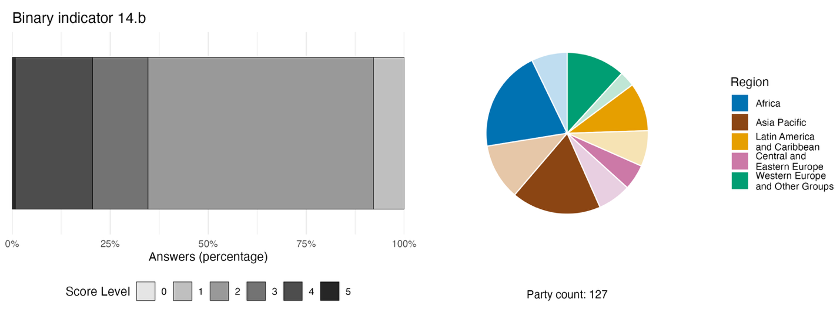
Note: The bar widths show the percentage of Parties in each score category, with higher numbers indicating a greater level of progress, based on responses to the questions included in the indicator.ª The pie chart shows the distribution of Parties providing responses to all questions by region. Colours for each region are defined in the figure legend: darker tones represent the proportion of Parties for any region for which data are included in the graph; lighter tones represent the proportion of Parties for the same region for which no data are included in the graph.
ª The methodology for calculating the score levels for each binary indicator, as well as the questions included for each indicator, are provided in document CBD/COP/16/INF/3/Rev.1.

Figure 61
Percentage of indicators aligned with Target 14 of the Framework that suggest improving, stable and negative trends, respectively
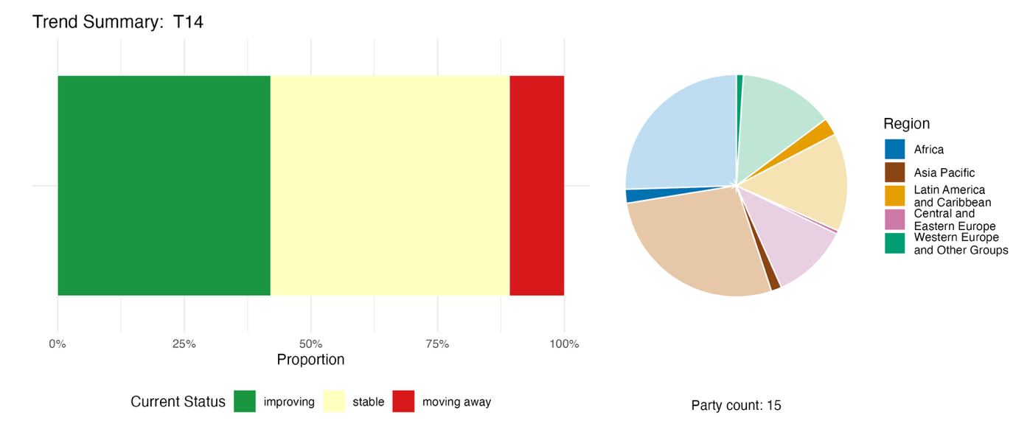
Note: Proportions are weighted by Party. The trends include data for 1 component and 41 national indicators from a total of 15 Parties. The pie chart shows the distribution of Parties submitting indicators for Target 14 by region. Colours for each region are defined in the figure legend: darker tones represent the proportion of Parties for any region for which data are included in the graph; lighter tones represent the proportion of Parties for the same region for which no data are included in the graph.

Self-assessment of progress

Based on self-assessment of Parties in national reports, 38 per cent of national targets submitted as highly aligned with Target 14 are on track for achievement, with a higher number (58 per cent) showing no significant change or insufficient progress, and just two national targets (0.4 per cent) reported as already achieved (figure 62).

Figure 62
Self-assessed progress for all national targets submitted as highly aligned with Target 14 of the Framework
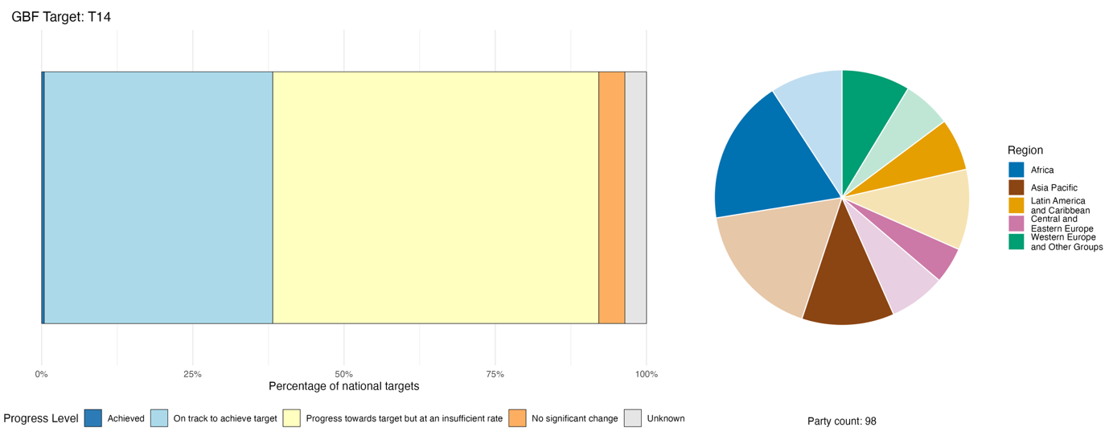
Note: The bar widths show the proportion of national targets submitted in each progress category. Proportions are weighted by Party to ensure that Parties contribute equally to overall assessment of progress, regardless of the number of national targets submitted. The pie chart shows the proportion of Parties in each region reporting in time for consideration in the global report. Colours for each region are defined in the figure legend: darker tones represent the proportion of Parties for any region for which data are included in the graph; lighter tones represent the proportion of Parties for the same region for which no data are included in the graph.

Actions, successes and challenges in implementation

Summary of actions in support of Target 14 of the Framework

The most commonly reported types of actions reported by Parties in support of Target 14 are legal and regulatory. Examples include requirements for mandatory environmental impact assessments and strategic environmental assessments, the reform of planning laws to incorporate biodiversity, the use of regulatory concepts such as “biodiversity net gain” or “no net loss”, biodiversity offset regulations, sustainable finance disclosure mandates and green taxonomy regulations. Research, monitoring and data actions to support Target 14 include natural capital accounting aligned with SEEA EA and the establishment of national data platforms as well as national clearing house mechanisms and monitoring systems to assess compliance with environmental impact regulations (see box 36). Economic and financial actions associated with Target 14 in some national reports include the issuing of green and sovereign bonds, debt-for-nature swaps, biodiversity finance plans under the Biodiversity Finance Initiative (BIOFIN) of UNDP, subsidy reform and reallocation, payment for ecosystem services, sustainable finance taxonomies, biodiversity offset mechanisms, green credit frameworks and sustainable banking principles.

Box 36
Biodiversity mainstreaming across scales and sectors in Colombia

The approach of Colombia to mainstreaming biodiversity is based on integrating biodiversity considerations into national planning, territorial development, sectoral policies and economic decision-making. The Biodiversity Action Plan 2024–2030, aligned with the Framework, provides a road map for national implementation through six national targets and a monitoring system supported by 27 indicators. The National Development Plan 2022–2026 reinforces biodiversity as a cross-cutting priority across government policies, while territorial planning instruments progressively incorporate biodiversity through environmental determinants and participatory spatial planning processes.

Complementing these efforts, SEEA EA strengthens the incorporation of natural capital into national statistics and economic planning, supporting more informed public investment and policy decisions. This integrated approach – linking national planning, spatial planning, sectoral implementation, monitoring and environmental-economic accounting – promotes biodiversity mainstreaming across all levels of governance. Remaining challenges include strengthening subnational institutional capacities, improving intersectoral coordination, ensuring effective implementation at the territorial level and consolidating monitoring through the biodiversity reporting and verification system. The country’s approach is also aimed at advancing public participation, access to environmental information and justice and the protection of environmental human rights defenders, in line with the Regional Agreement on Access to Information, Public Participation and Justice in Environmental Matters in Latin America and the Caribbean (Escazú Agreement).

Relevant targets: 1, 14, 15, 18 and 21.
Sources: Colombia, seventh national report under the Convention; and Economic Commission for Latin America and the Caribbean (ECLAC), 2018.

Challenges

A number of Parties acknowledge the gap between the formal integration of biodiversity into the texts of regulations or policies and the effective mainstreaming of biodiversity that makes a practical difference. Several national reports include observations that mainstreaming remains largely at the policy level, and is not translated into measurable outcomes. Instead, it is treated as an add-on component rather than fully embedded as a core element of decision-making or implementing national policy. There are gaps related to integration with poverty eradication strategies and the alignment of fiscal and financial flows, with only a few Parties describing actions related to the integration of biodiversity into financial, fiscal, investment and regulatory decision-making, including measures that identify, regulate and reduce financial flows to activities that drive biodiversity loss. Institutional capacity and coordination are recognized as an important constraint, and many relevant authorities, including businesses, lack the expertise or mandates to integrate biodiversity into their activities. Government at the national, subnational and local levels all lack trained staff, ecological expertise and the tools to conduct environmental impact assessments, integrate biodiversity into planning, or monitor outcomes. This is particularly evident in ministries focused on subjects other than the environment, such as finance and agriculture, as well as subnational and municipal authorities in some countries. Engagement of the private sector is a challenge at multiple levels, and businesses often regard biodiversity assessment as an additional cost burden. Gaps in data and information-gathering represent an additional barrier: Parties highlight the lack of monitoring frameworks to evaluate the effectiveness of mainstreaming efforts and limited progress in environmental-economic accounting. There are also information gaps related to how the diverse values of biodiversity are reflected in Target 14. Some Parties noted that natural capital accounting, including SEEA EA, are either absent or not yet embedded into national statistics or budget processes.

Contributions from actors other than national Governments

Commitments submitted directly through the online reporting tool

Of the 180 commitments submitted by actors other than national governments, 10 are associated primarily with Target 14. Seven of the commitments have been submitted by NGOs, one by a business group, one by a research institution and one by a non-profit partnership organization. The commitments address various aspects of mainstreaming biodiversity and policy integration into the private and public sectors, and the majority involve the sharing of knowledge and data. Coverage of the commitments includes Europe, Africa, Asia and South America, with some operating at the global scale.

Contributions integrated into national reports

The most substantiated contribution is technical assistance from international organizations, with BIOFIN the most widely reported instrument. Direct implementation and co-management is reported for NGOs, indigenous peoples and local communities, and sectoral actors, while governance and advisory functions include technical working groups, statutory advisory bodies and independent accountability reviews. The production of knowledge and the development of tools are the most consistent contributions from the scientific community, spanning ecosystem service valuation, natural capital accounting and citizen science. Business and finance actors feature mainly in disclosure and compliance, from corporate sustainability reporting to green bonds, while subnational governments deliver biodiversity mainstreaming through spatial planning mandates. Awareness-raising and capacity-building are most common for citizens, young people and women, although usually they are the recipients of such activities.

Examples of linkages with other agreements, processes and organizations

FAO works to mainstream biodiversity by embedding biodiversity considerations into the policies, strategies and practices of key public and private actors that have an impact on or rely on biodiversity, so that biodiversity is conserved and sustainably used both locally and globally. The FAO Strategy on Mainstreaming Biodiversity across Agricultural Sectors was approved in 2019, and had a specific focus on the preparations for the post-2020 global biodiversity framework. The Strategy includes such topics as addressing the mainstreaming of biodiversity across agricultural sectors at the national, regional and international levels in a structured and coherent manner and considering national priorities, needs, regulations and policies and country programming frameworks. The expected result of the application of the Strategy was to reduce the negative impacts of agricultural practices on biodiversity, to promote sustainable agricultural practices and to conserve, enhance, preserve and restore biodiversity as a whole. The Action Plan 2024–2027 for the implementation of the Strategy takes into account the Framework for Action on Biodiversity for Food and Agriculture of FAO, and is aligned with the Kunming-Montreal Global Biodiversity Framework. FAO implements the Action Plan based on the principles of effective governance, partnerships, a knowledge-based approach, inclusiveness, and gender equality and women’s empowerment (FAO, 2020, 2022, 2024b and 2025a).

Target 15. Businesses assess, disclose and reduce biodiversity-related risks and negative impacts

Target text. Take legal, administrative or policy measures to encourage and enable business, and in particular to ensure that large and transnational companies and financial institutions:

- (a) Regularly monitor, assess, and transparently disclose their risks, dependencies and impacts on biodiversity, including with requirements for all large as well as transnational companies and financial institutions along their operations, supply and value chains, and portfolios;
- (b) Provide information needed to consumers to promote sustainable consumption patterns;
(c) Report on compliance with access and benefit-sharing regulations and measures, as applicable;

- in order to progressively reduce negative impacts on biodiversity, increase positive impacts, reduce biodiversity-related risks to business and financial institutions, and promote actions to ensure sustainable patterns of production.

Progress overview

Despite an increase in company disclosures, both the implementation of policy and the coverage of national targets remain limited. Most national targets are not well aligned with the elements of Target 15. Although many Parties noted problems in compiling data for headline indicator 15.1, almost a fifth of Parties whose national reports were available for analysis reported on a total of over 5,000 companies that disclosed biodiversity-related risks, with the number increasing year-on-year. The binary indicator, however, reveals that measures to deliver on Target 15 are largely under development, but not yet in place. Self-assessments acknowledged that two thirds of national targets showed no or insufficient progress. The main challenges identified include an absence of mandatory reporting frameworks, capacity and data gaps, the exclusion of small and medium-sized enterprises and inappropriate incentives.

Coverage by Parties of the scope of Target 15 of the Framework in their national targets

Table 32
Elements of Target 15 of the Framework and how they are addressed in national targetsª
Take legal, administrative or policy measures to encourage and enable business to monitor, assess and transparently disclose their risks relating to biodiversity | 48
Take legal, administrative or policy measures to encourage and enable business to monitor, assess and transparently disclose their dependencies on biodiversity | 39
Take legal, administrative or policy measures to encourage and enable business to monitor, assess and transparently disclose their impacts on biodiversity | 57
Take legal, administrative or policy measures to encourage and enable business to provide information needed to consumers to promote sustainable consumption patterns | 37
Take legal, administrative or policy measures to encourage and enable business to report on compliance with access and benefit-sharing regulations and measures, as applicable | 19
On average, Parties have addressed, to at least some extent, 40 per cent of these elements in their national targets.

Note: The right-hand column of the table indicates the percentage of Parties with national targets that address the element to at least some extent.
ª The elements for each target were defined by the Ad Hoc Technical Expert Group on Indicators of the Kunming-Montreal Global Biodiversity Framework (see annex I to CBD/COP/16/INF/4; and Affinito and others, 2025). The detailed methodology for the analysis of national targets is provided in document CBD/SBI/7/INF/22.

A majority of Parties (57 per cent) have addressed to some extent the element of Target 15 that relates specifically to measures to encourage and enable businesses to monitor, assess and transparently disclose their impacts on biodiversity (see table 32). Fewer than half of Parties have specifically addressed business risks relating to biodiversity (48 per cent), business dependencies on biodiversity (39 per cent) and measures to encourage and enable businesses to provide information needed to consumers to promote sustainable consumption patterns (37 percent). Fewer than one fifth (19 per cent) have submitted national targets encouraging and enabling businesses to report on compliance with access and benefit-sharing regulations and measures.

Indicators of progress

Table 33
Indicator scorecard for Target 15 of the Framework
 | Indicator use |  | Indicator results
Headline indicator 15.1: number of companies disclosing their biodiversity-related risks, dependencies and impacts | 19 per cent of Parties |  | Total of 5,477 companies disclosing  (disclosures increasing over time)
Binary indicator 15.b: number of countries with legal, administrative or policy measures aimed at encouraging and enabling business and financial institutions, and in particular, ensuring that large and transnational companies and financial institutions progressively reduce their negative impacts on biodiversity, increase their positive impacts, reduce their biodiversity-related risks and promote actions to ensure sustainable patterns of production | 127 Parties | n/aª | 24 per cent of Parties scored highly (score 4/5)
All quantitative indicators combined | 35 Parties, 27 per cent |  | 59 per cent positive trends  10 per cent negative trends
Notes | Submissions include disaggregation by reporting standard, company size and types of disclosure.  Not all submissions focus on biodiversity-related disclosure only, but may include environmental, social and governance reports.
Note: The colour coding is related to the overall assessment of progress across targets, the methodology of which is explained in the overall summary scorecard (see table 3). The colour coding for indicator data use and all quantitative indicator trends reflects where a value for each target sits relative to the highest and lowest scores achieved across all targets of the Framework (green is assigned to percentage values falling within the top third of the total range, yellow to the middle third and red to the bottom third). Colours for the binary indicators are based on the percentage of Parties scoring highly (4 or 5) for the indicator overall (green is assigned to values at or above 50 per cent, yellow to values from 25 to 50 per cent and red to values below 25 per cent). Colours for the headline indicator results are based on progress relative to the target (green is assigned when progress is being made, yellow when progress is mixed, red when progress is insufficient and grey when progress cannot be assessed). Note that the percentage of Parties submitting data on headline indicators may be different from that used in the aggregate results for both the headline indicator and all quantitative indicators combined, owing to methodological differences in the way data were used.
ª As binary indicator data are required by the online reporting tool, submission counts for these indicators do not reflect monitoring capacity differences between targets and do not provide actionable information for making progress in implementation, so assessment of indicator use is not relevant.

Many Parties commented on the difficulty of monitoring Target 15. Issues related to the voluntary nature of corporate reporting, as well as the multiple distinct reporting frameworks used by the private sector, were flagged by many Parties as barriers to national-level reporting. In particular, the lack of standards and centralized reporting platforms make data difficult to access for Governments, which in some cases rely on more general environmental, social and governance reporting initiatives. This can inflate counts for the indicator, as such disclosures may not be directly related to biodiversity. Conversely, undercounts are also possible when disclosures are not centralized. Notwithstanding these issues, 27 per cent of Parties reported on headline indicator 15.1 (number of companies disclosing their biodiversity-related risks, dependencies and impacts), encompassing over 5,000 companies, showing an increasing number of companies that disclosed biodiversity-related risks from 2020 to 2025 (see table 33 and figure 63).
The IPBES Biodiversity and Business Assessment concluded that fewer than 1 per cent of companies report on biodiversity (IPBES, 2026). CDP (formerly the Carbon Disclosure Project) provides a centralized database for monitoring private sector disclosures on biodiversity (CDP, 2025). The database captures publicly disclosing organizations that have established processes to identify, assess and manage their nature-related dependencies, impacts and risks. It includes data from 69 countries across all five United Nations regional groups, with 1,934 organizations reporting on such processes in 2024 and 2,355 in 2025. Based on this data set, the sectors with the highest number of disclosing organizations are manufacturing, materials and services, while the fossil fuel, transportation services and hospitality sectors show the lowest levels of disclosure (see table 34). The CDP data include information from considerably more countries (44) than Parties that reported data on the headline indicator for Target 15 of the Framework, but account for a much lower volume of companies. This may account for the difficulty of distinguishing between true biodiversity disclosure and more general corporate reporting, and/or the challenge of centralizing corporate disclosure data.
The progress scores for the binary indicator for Target 15 (see figure 64) suggest that Parties are mostly in the early stages of taking action aimed at encouraging and enabling business and financial institutions to reduce their negative impacts and risks, and improve positive impacts and sustainable patterns of production. Measures to deliver on Target 15 are largely under development, but not yet in place. About two fifths of Parties report that they do not have measures in place to ensure that companies share information with consumers to promote sustainable consumption patterns, to ensure transparent disclosure, or to report on compliance with access and benefit-sharing regulations. A little over half of Parties partly monitor business impacts on biodiversity.
Over half of the indicators submitted by Parties for Target 15 show positive trends (see figure 65), but only about a third of these can be directly related to elements of the target.

Figure 63
Headline indicator 15.1: number of companies disclosing their biodiversity-related risks, dependencies and impacts
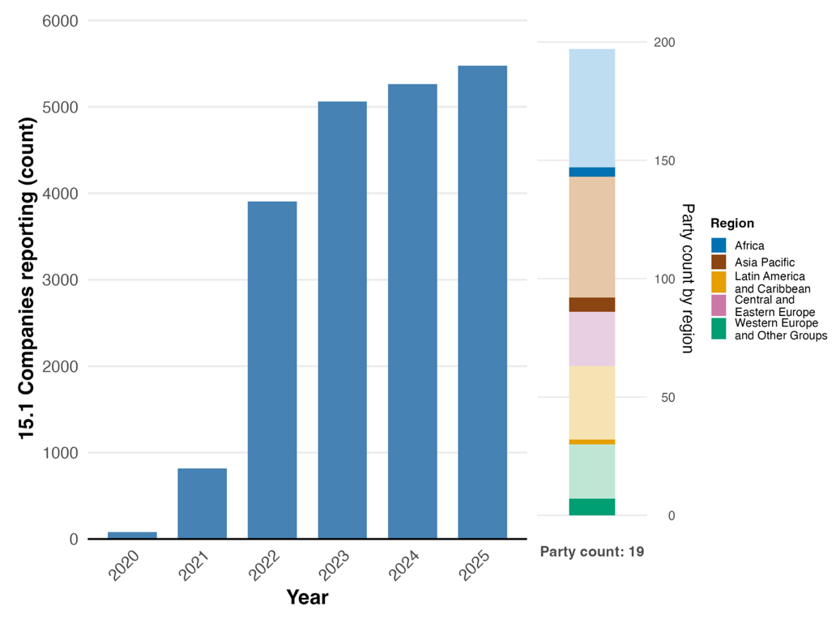
Note: Indicator values show the cumulative number of companies disclosing year-on-year across submitting Parties (note that not all Parties submitted every year). The right bar chart shows the distribution of Parties providing data by region. Colours for each region are defined in the figure legend: darker tones represent the proportion of Parties for any region for which data are included in the graph; lighter tones represent the proportion of Parties for the same region for which no data are included in the graph.
Table 34
Percentage and count of publicly disclosing organizations with existing processes for identifying, assessing and managing environmental dependencies, impacts and risks to CDP, by sector
Sector | Percentage | Count
Manufacturing | 40.0 | 774
Materials | 16.6 | 321
Services | 10.1 | 195
Food, beverage and agriculture | 9.2 | 178
Infrastructure | 7.5 | 145
Financial services | 6.8 | 132
Biotechnology, healthcare and pharmaceutical | 5.6 | 108
Retail | 5.5 | 106
Apparel | 4.2 | 81
Power generation | 3.2 | 62
Fossil fuels | 2.8 | 54
Transportation services | 2.5 | 48
Hospitality | 1.2 | 23
Source: CDPª
Note: These figures do not reflect submissions from Parties on the headline indicator 15.1 as analysed in figure 63.

ªAvailable at www.cdp.net/en/data/monitoring-gbf.

Figure 64
Binary indicator 15.b: number of countries with legal, administrative or policy measures aimed at encouraging and enabling business and financial institutions, and in particular, ensuring that large and transnational companies and financial institutions progressively reduce their negative impacts from business and financial institutions on biodiversity, increase their positive impacts, reduce their biodiversity-related risks and promote actions to ensure sustainable patterns of production
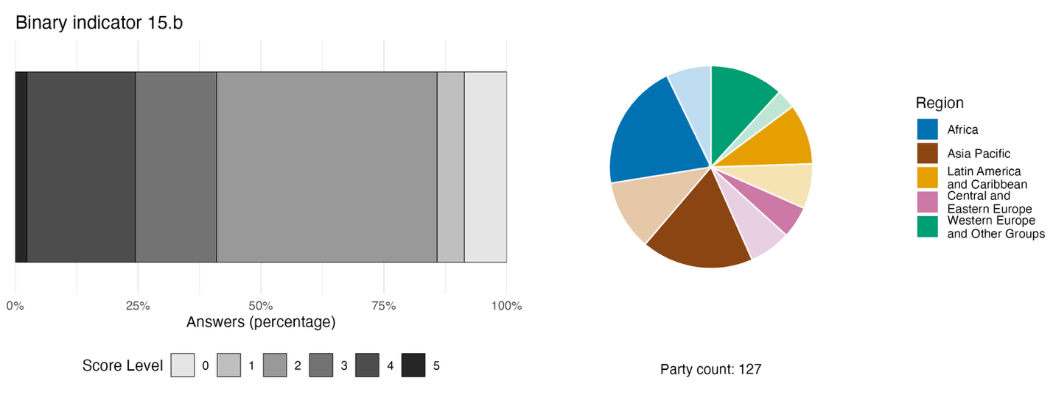
Note: The bar widths show the percentage of Parties in each score category, with higher numbers indicating a greater level of progress, based on responses to the questions included in the indicator.ª The pie chart shows the distribution of Parties providing responses to all questions by region. Colours for each region are defined in the figure legend: darker tones represent the proportion of Parties for any region for which data are included in the graph; lighter tones represent the proportion of Parties for the same region for which no data are included in the graph.
ª The methodology for calculating the score levels for each binary indicator, as well as the questions included for each indicator, are provided in document CBD/COP/16/INF/3/Rev.1.

Figure 65
Percentage of indicators aligned with Target 15 of the Framework that suggest improving, stable and negative trends, respectively
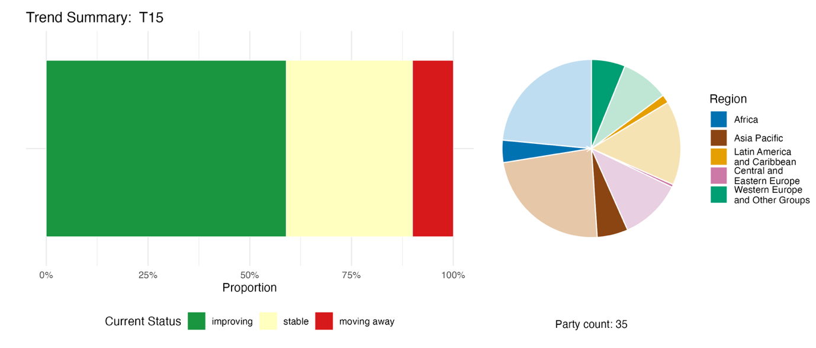
Note: Proportions are weighted by Party. The trends include data for 1 headline indicator from 21 Parties, and 1 component and 33 national indicators from a total of 20 Parties.The pie chart shows the distribution of Parties submitting indicators for Target 15 by region. Colours for each region are defined in the figure legend: darker tones represent the proportion of Parties for any region for which data are included in the graph; lighter tones represent the proportion of Parties for the same region for which no data are included in the graph.

Self-assessment of progress

Based on self-assessment of Parties in national reports, only 30 per cent of national targets submitted as highly aligned with Target 15 are on track for achievement. More than double that percentage (66 per cent) show no significant change or insufficient progress, and just three national targets (1 per cent) are reported as already achieved (see figure 66).

Figure 66
Self-assessed progress for all national targets submitted as highly aligned with Target 15 of the Framework
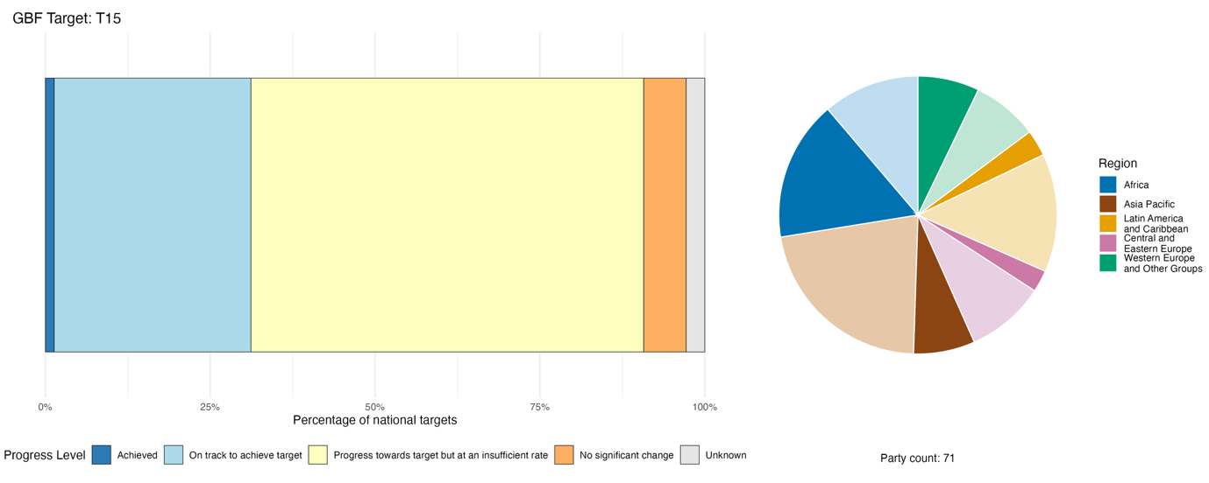
Note: The bar widths show the proportion of national targets submitted in each progress category. Proportions are weighted by Party to ensure that Parties contribute equally to overall assessment of progress, regardless of the number of national targets submitted. The pie chart shows the proportion of Parties in each region reporting in time for consideration in the global report. Colours for each region are defined in the figure legend: darker tones represent the proportion of Parties for any region for which data are included in the graph; lighter tones represent the proportion of Parties for the same region for which no data are included in the graph.

Actions, successes and challenges in implementation

Summary of actions in support of Target 15 of the Framework

The most widely reported action in support of Target 15 is the use of financial sector regulation to embed biodiversity or environmental risk into banking, investment and capital market operations. This ranges from mandatory green finance taxonomies to central bank guidance and environmental, social and governance (ESG) reporting requirements for listed companies (see box 37). The Taskforce on Nature-related Financial Disclosures (TNFD) framework has emerged as the most commonly cited voluntary disclosure mechanism across developing and developed countries alike, with more than 30 national reports making direct reference to implementing or piloting the TNFD framework. For European Union member States and additional countries observing European Union directives and standards, the Corporate Sustainability Reporting Directive and its European Sustainability Reporting Standards represent the dominant legal instrument for implementing Target 15. Requirements for environmental impact assessments, which are often pre-existing but are subject to strengthening or extension, are the most widely reported legal mechanism among developing countries. Regulatory frameworks for ABS are reported as legal instruments under Target 15 by several Parties.

Examples of success and progress in implementation

Box 37
Multi-regulator mandatory environmental risk framework in Ecuador

More than one third of the GDP of Ecuador is estimated to be dependent on ecosystem services, but this has not historically been reflected in financial risk models, credit assessments or investment decisions. The conducting of environmental risk assessments by financial institutions was voluntary, inconsistent and could not be audited.

To require companies and financial institutions to monitor, assess and disclose their biodiversity-related risks, Ecuador has implemented a mandatory environmental risk framework across the country. As part of the initiative, the Superintendency of Banks issued a binding rule requiring all financial institutions to integrate environmental and social risk assessment into their governance, credit analysis and due diligence policies, thus making biodiversity risk auditable. Another resolution by the Superintendency of Companies mandated sustainability reporting under Global Reporting Initiative standards for publicly traded companies. The private banking association Asobanca has developed a sustainable finance protocol that standardizes risk management across private banking, including pilot projects in the Amazon biome applying TNFD guidelines.

Key challenges include data gaps on ecosystems, which hinders the quantification of risk, the persistence of subsidies harmful to biodiversity and limited technical capacity in financial and public institutions.

Relevant targets: 14, 15, 18 and 19.
Source: Ecuador, seventh national report under the Convention.

Challenges

The absence of mandatory biodiversity-specific disclosures for large companies is mentioned as a challenge by around one quarter of reporting Parties. Where disclosure exists, it tends to be focused on climate rather than nature, leaving biodiversity largely unaddressed. Capacity and data gaps are cited as significant barriers, especially in developing countries, with many enterprises lacking the technical and institutional capacity to apply existing methodologies for biodiversity monitoring, assessment and disclosure. Other challenges mentioned by some Parties are the exclusion of small and medium-sized enterprises from disclosure frameworks, and the persistence of incentives harmful to biodiversity as a barrier to reducing business impacts on biodiversity. Existing incentive structures often fail to encourage biodiversity-positive behaviour, with a few Parties pointing to the absence of effective tax breaks, green certification schemes or payments for ecosystem services that would motivate companies to invest in conservation or reduce harmful impacts.

Contributions from actors other than national Governments

Commitments submitted directly through the online reporting tool

Of 180 substantive commitments submitted by actors other than national Governments, 7 are primarily associated with Target 15. Five of the commitments were submitted by NGOs, and two by business or industry. The commitments focus on supporting businesses to take biodiversity into account in their strategies and reporting processes, in particular through data and information tools for mapping and evaluating risks and impacts. The geographic focus of the commitments includes China, Denmark, France, Japan and Nigeria (see example from Japan in box 38).

Box 38
Keidanren Nature Conservation Council encourages and supports Japanese businesses in addressing biodiversity-related risks and impacts

The Keidanren Nature Conservation Council, a Tokyo-based business and industry organization, launched its Action Plan for Nature Positive in 2023, with the commitment continuing to the end of 2030. The Council plays a central role in mobilizing the corporate sector of Japan towards nature-positive outcomes. Through the Keidanren Nature Conservation Fund, the Council calls annually on approximately 1,500 member companies for donations, collecting around ¥200 million per year to support conservation projects led by NGOs, aligned with the targets of the Framework. It also promotes corporate adoption of the TNFD framework: of 210 Japanese companies adopting the TNFD framework as of October 2025, approximately 30 per cent were members of the Keidanren Nature Conservation Council. In addition, the Council works directly with the Ministry of the Environment and the Ministry of Land, Infrastructure, Transport and Tourism of Japan to strengthen the enabling policy environment for corporate biodiversity action, including through proposals on nature-related data infrastructure, incentives for other effective area-based conservation measures (OECMs) and nature-based solutions, as well as the integration of nature into the country’s growth strategies. Together with the Ministry of the Environment of Japan, the Council is also contributing to the COMDEKS (community development and knowledge management for the Satoyama Initiative) project, implemented by UNDP. Progress is reported annually at the Council's general meeting, and is tracked against the country’s NBSAP and the Framework’s headline indicator on private funding for biodiversity conservation (headline indicator D.3).

Relevant targets: 3, 8, 11, 15, 19, 20 and 21.
Source: Keidanren Nature Conservation Council, stakeholder commitment (see https://ort.cbd.int/database/293333).

Contributions integrated in national reports

Business and finance actors contribute to Target 15 through biodiversity disclosure and risk integration, adopting disclosure and reporting frameworks (see the section immediately below), integrating biodiversity risk into lending and investment, issuing green bonds and developing sustainable finance protocols and green taxonomies. Intergovernmental organizations and international partners provide co-financing, technical assistance and standard-setting frameworks, with BIOFIN, the International Finance Corporation, the World Bank, GEF, UNDP and UNEP most frequently cited. NGOs and civil society have acted to co-convene business-biodiversity platforms and deliver capacity-building. Indigenous peoples and local communities serve as co-managers, benefit-sharing partners and knowledge holders within ABS and payment for ecosystem services frameworks. Subnational governments have acted to administer certification schemes and enact legislation. Citizens, young people and women and girls largely remain the recipients of awareness-raising activities.

Examples of linkages with other agreements, organizations and processes

The implementation of Target 15 is supported by a range of internationally recognized disclosure frameworks and reporting standards that provide complementary information on biodiversity and nature. Together, these instruments can provide information on biodiversity impacts, dependencies and risks. Specifically, the Global Reporting Initiative (GRI) (Bosetti, 2023), TNFD (Taskforce on Nature-related Financial Disclosures, 2023) and the International Sustainability Standards Board (International Sustainability Standards Board, 2023) are collaborating to establish a coherent global nature reporting system that will encompass impacts, dependencies, risks and opportunities from both an impact and financial materiality perspective, providing the disclosure architecture necessary for the comprehensive implementation of Target 15. The global reporting system will rely on three already active main complementary frameworks: TNFD helps organizations evaluate and report nature-related dependencies, impacts, risks and opportunities; the Global Reporting Initiative provides globally applicable standards for reporting biodiversity impacts, management and outcomes; and the European Sustainability Reporting Standards mandates nature-related disclosures for in-scope European companies. Because TNFD and the European Sustainability Reporting Standards feature strong interoperability with the Global Reporting Initiative standards, they offer a consistent, data-rich evidence base for implementation.

Target 16. Enable sustainable consumption choices to reduce waste and overconsumption

Target text. Ensure that people are encouraged and enabled to make sustainable consumption choices, including by establishing supportive policy, legislative or regulatory frameworks, improving education and access to relevant and accurate information and alternatives, and by 2030, reduce the global footprint of consumption in an equitable manner, including through halving global food waste, significantly reducing overconsumption and substantially reducing waste generation, in order for all people to live well in harmony with Mother Earth.

Progress overview
Most aspects of Target 16 are not well addressed in national targets, but efforts to implement relevant policy instruments are advancing. Fewer than half the Parties whose national targets have been considered in the global report have addressed any individual element of Target 16. Some good progress is reported on establishing policies and mechanisms to support sustainable consumption, but specific measures to address food waste, overconsumption and waste management are still under development. In their self-assessments, Parties whose national reports were available for analysis acknowledge that most (70 per cent) of national targets related to Target 16 are showing insufficient progress. Parties report on significant challenges, including absence of adequate waste facilities, lack of finance and enforcement, weak implementation of extended producer responsibility, and the persistence of high material footprints in some countries.

Coverage by Parties of the scope of Target 16 of the Framework in their national targets

Table 35
Elements of Target 16 of the Framework and how they are addressed in national targetsª
Ensure that people are encouraged and enabled to make sustainable consumption choices by establishing supportive policy, legislative or regulatory frameworks | 47
Ensure that people are encouraged and enabled to make sustainable consumption choices by improving education and access to relevant and accurate information and alternatives | 46
By 2030, reduce the global footprint of consumption in an equitable manner | 26
By 2030, halve global food waste | 22
By 2030, significantly reduce overconsumption | 38
By 2030, substantially reduce waste generation | 44
On average, Parties have addressed, to at least some extent, 37 per cent of these elements in their national targets

Note: The right-hand column of the table indicates the percentage of Parties with national targets that address the element to at least some extent.
ª The elements for each target were defined by the Ad Hoc Technical Expert Group on Indicators of the Kunming-Montreal Global Biodiversity Framework (see annex I to CBD/COP/16/INF/4; and Affinito and others, 2025). The detailed methodology for the analysis of national targets is provided in document CBD/SBI/7/INF/22.

None of the elements of Target 16 are addressed, to any extent, by as many as half of the Parties in the national targets available for consideration in the global report (see table 35). The elements most commonly addressed by Parties relate to policy, legislative or regulatory frameworks to ensure that people are encouraged and enabled to make sustainable consumption choices (47 per cent) and improving education and access to relevant and accurate information and alternatives (46 per cent). Fewer Parties address the specific objectives in Target 16 to substantially reduce waste generation (44 per cent), to significantly reduce overconsumption (38 per cent), to reduce the global footprint of consumption in an equitable manner (26 per cent) or to halve global food waste (22 per cent).
Very few Parties (12 per cent) have set quantitative national targets on reducing food waste. Of those with such targets, the majority (61 per cent) have the objective of halving food waste, in line with the global ambition of Target 16. The remainder have set values of between 10 per cent and 30 per cent for reducing food waste by 2030.

Indicators of progress

Table 36
Indicator scorecard for Target 16 of the Framework
 | Indicator use |  | Indicator results
Binary indicator 16.b: number of countries developing, adopting or implementing policy instruments aimed at encouraging and enabling people to make sustainable consumption choices | 127 Parties | n/aª | 69 per cent of Parties scored highly (score 4 or 5)
All quantitative indicators combined | 25 Parties, 19 per cent |  | 32 per cent positive trends  16 per cent negative trends
Note: The colour coding is related to the overall assessment of progress across targets, the methodology of which is explained in the overall summary scorecard (see table 3). The colour coding for indicator data use and all quantitative indicator trends reflects where a value for each target sits relative to the highest and lowest scores achieved across all targets of the Framework (green is assigned to percentage values falling within the top third of the total range, yellow to the middle third and red to the bottom third). Colours for the binary indicators are based on the percentage of Parties scoring highly (4 or 5) for the indicator overall (green is assigned to values at or above 50 per cent, yellow to values from 25 to 50 per cent and red to values below 25 per cent).
ª As binary indicator data are required by the online reporting tool, submission counts for these indicators do not reflect monitoring capacity differences between targets and do not provide actionable information for making progress in implementation, so assessment of indicator use is not relevant.

The monitoring framework does not include a specific headline indicator for Target 16. Most Parties scored highly on the target’s binary indicator, demonstrating overall progress in developing policy instruments that encourage and enable sustainable choices (see table 36 and figure 67). The binary indicator does not capture trends related to changes in consumption patterns or consumption-related biodiversity pressures. The greatest progress has been made in establishing mechanisms, policies, legislative frameworks and regulatory measures to support sustainable consumption. However, more Parties report that measures to encourage and enable reductions in food waste, overconsumption and waste generation are still under development or not yet in place than Parties who report such measures are in place. Progress in improving education on and awareness of the impacts of consumption on biodiversity is also largely partial.
Nearly a fifth (19 per cent) of Parties submitted additional indicators, mostly relating to waste management, recycling or reducing the consumption footprint. Few indicators that address reducing overconsumption were reported. Analysis shows that trends for these indicators are varied and it is difficult to draw any overall conclusions relating to quite different target elements at this stage (see figure 68).
Overall, the analysis suggests that Parties are taking action to implement Target 16, but based on the data reported, it is not possible to determine the impact of these actions on consumption patterns.

Figure 67
Binary indicator 16.b: Number of countries developing, adopting or implementing policy instruments aimed at encouraging and enabling people to make sustainable consumption choices
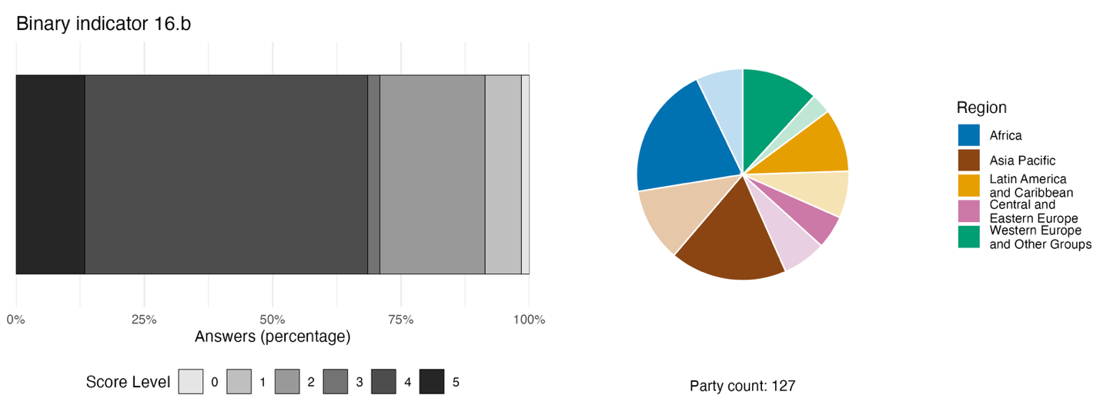
Note: The bar widths show the percentage of Parties in each score category, with higher numbers indicating a greater level of progress, based on responses to the questions included in the indicator.ª The pie chart shows the distribution of Parties providing responses to all questions by region. Colours for each region are defined in the figure legend: darker tones represent the proportion of Parties for any region for which data are included in the graph; lighter tones represent the proportion of Parties for the same region for which no data are included in the graph.
ª The methodology for calculating the score levels for each binary indicator, as well as the questions included for each indicator, are provided in document CBD/COP/16/INF/3/Rev.1.

Figure 68
Percentage of indicators aligned with Target 16 of the Framework that suggest improving, stable and negative trends, respectively
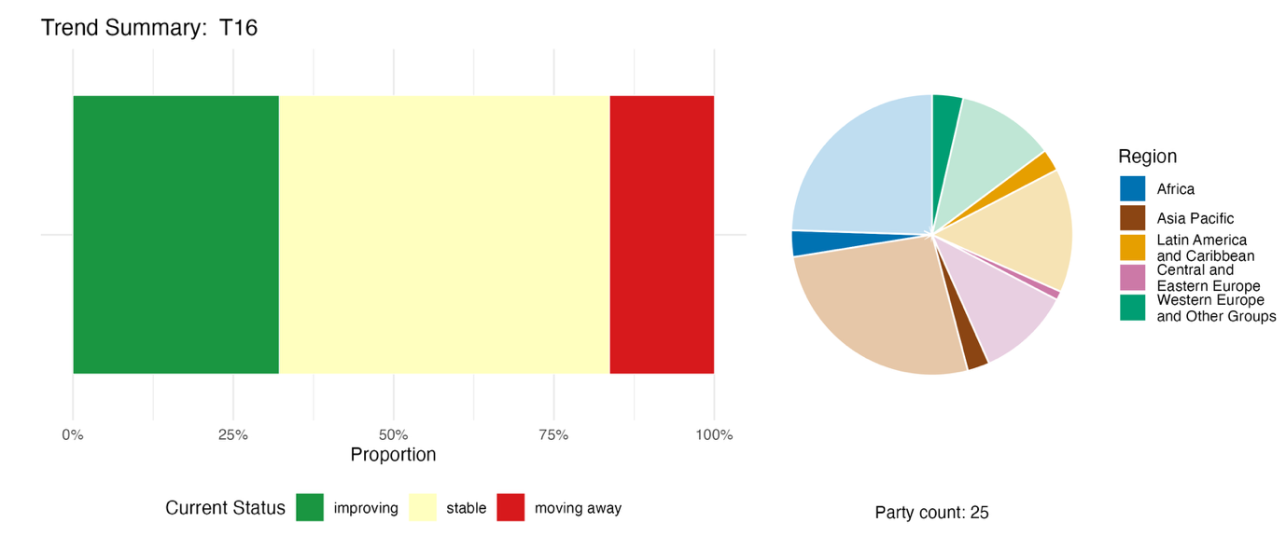
Note: Proportions are weighted by Party. The trends include data for 3 component, 5 complementary and 60 national indicators from a total of 25 Parties. The pie chart shows the distribution of Parties submitting indicators for Target 16 by region. Colours for each region are defined in the figure legend: darker tones represent the proportion of Parties for any region for which data are included in the graph; lighter tones represent the proportion of Parties for the same region for which no data are included in the graph.

Self-assessment of progress
Based on self-assessment by Parties in national reports, fewer than a third (28 per cent) of national targets submitted as highly aligned with Target 16 are on track for achievement, with most (70 per cent) showing no significant change or insufficient progress, and just two national targets (1 per cent) reported as being achieved early (see figure 69).

Figure 69
Self-assessed progress for all national targets submitted as highly aligned with Target 16 of the Framework
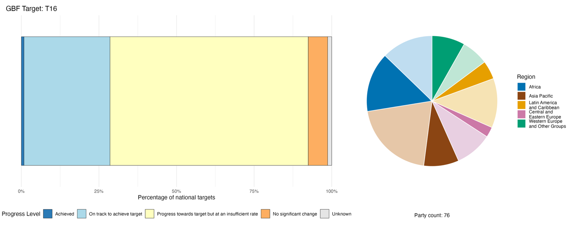
Note: The bar widths show the proportion of national targets submitted in each progress category. Proportions are weighted by Party to ensure that Parties contribute equally to overall assessment of progress, regardless of the number of national targets submitted. The pie chart shows the proportion of Parties in each region reporting in time for consideration in the global report. Colours for each region are defined in the figure legend: darker tones represent the proportion of Parties for any region for which data are included in the graph; lighter tones represent the proportion of Parties for the same region for which no data are included in the graph.

Actions, successes and challenges in implementation

Summary of actions in support of Target 16 of the Framework

The most widespread approach to implementing Target 16 is enactment or enforcement of legal instruments targeting waste, plastics and the circular economy. Bans or restrictions on single-use plastics are the most commonly reported concrete measures, appearing across all regions and among developing and high-income countries alike (see also Target 7). Another very common category of action in national reports is the introduction of extended producer responsibility systems, requiring producers to take financial or direct responsibility for products at the end of their life. Around one quarter of reporting Parties, spread equally across high-income and developing countries, mention extended producer responsibility as a contribution towards implementation of Target 16. Nearly all reporting Parties also include actions to promote awareness, education and behavioural change to promote sustainable consumption, ranging from national campaigns to integration of messages on moderating food consumption and minimizing waste in school curricula (see boxes 39 and 40).

Examples of success and progress in implementation

Box 39
Compost academy: school-based circular economy education at scale in Armenia

Organic waste is a substantial contributor to environmental degradation in Armenia. To increase public awareness programmes and educational measures aimed at preventing food waste and overconsumption, Armenia implemented the compost academy project across the Yerevan and Armavir regions during 2021 and 2022. As part of the initiative, over 500 students received hands-on training in composting and organic waste management. More than 50,000 people were reached through awareness campaigns and over 50 communication materials (videos, social media posts, educational guides) were developed and disseminated. In addition, the project created small composting workshop stations in 11 educational institutions, including the installation of composting bins and the development of composting sites. It also piloted organic waste composting in 12 office-based organizations, with in-house composting bins.
Led by Innovative Solutions for Sustainable Development of Communities, in collaboration with UNDP through the GEF Small Grants Programme, the project promoted sustainable consumption choices to reduce waste and overconsumption by increasing public awareness and installing the necessary infrastructure for community members to participate personally in the effective management of organic waste.ª
This project addresses climate change risk reduction and mitigation by diverting the amount of food waste reaching landfills by approximately 20 tons, thereby reducing methane emissions, while simultaneously transforming the organic waste into high-value fertilizer, thereby enriching soil quality. It also aligns with the national target of Armenia of reducing food waste and overconsumption through targeted educational initiatives and awareness campaigns.

Relevant targets: 7, 8, 16, 20 and 21.
Sources: Armenia, seventh national report under the Convention.

ª See https://issdngo.com/en/projects/ongoing/compost-academy/.

Box 40
Green procurement and deposit-return system in the Dominican Republic

The Dominican Republic has implemented a number of initiatives with the aim of reducing its ecological footprint, decreasing pollution and waste generation and contributing to the conservation and sustainable use of biodiversity.
A non-profit association named New Life for Waste (Nueva Vida para los Residuos – NUVI) launched a campaign in 2020 to promote the return of PET plastic bottles, providing bins at sites across the capital, Santo Domingo, where consumers can deposit their bottles in binsª . The initiative has support from the Ministry of Industry, Commerce, and Micro-, Small and Medium-sized Enterprises and the Association of Industries of the Dominican Republic. Since 2020, New Life for Waste has collected more than 80 million PET plastic bottles, promoting a circular economy and helping to drive the prevention, reduction, recycling and reuse of waste.
In 2022, the Government of the Dominican Republic enacted a decree, in which it declared sustainable and inclusive public procurement to be in the national interest. As a result, between 2023 and 2025, nearly 1,900 processes based on green procurement criteria were launched across the telecommunication, health and commerce sectors. These processes prioritize goods, services and construction projects that reduce negative impacts on the environment and promote the efficient use of resources throughout their entire life cycle.
This combined approach has helped the Dominican Republic to make progress towards achieving its national target for making the transition towards sustainable consumption and production patterns, through integrating biodiversity criteria into public policies, government procurement, production processes, value chains and consumption decisions.

Relevant targets: 7, 12, 14, 16 and 21.
Source: Dominican Republic, seventh national report to the Convention.
ª see www.diesco.com/en/commitment/our-environment/.

Challenges

The absence of appropriate infrastructure is among the among the most common challenges reported by Parties with regard to Target 16. Many lack adequate facilities for sorting, recycling, composting and safely disposing of waste, while some still rely heavily on landfills or open burning. Lack of financial, logistical and human resources are mentioned as barriers, for example by preventing investment in infrastructure and project pipelines to deal with waste management. Multiple Parties report legal instruments without effective enforcement, weakening the impact of bans and regulations. Some Parties mention that extended producer responsibility systems either do not exist or are too narrowly applied, without making producers financially responsible. End-of-life product management and waste management costs often fall entirely on governments with limited budgets. Many Parties lack baseline information on food waste, presenting a major obstacle to the implementation of Target 16. Several Parties report that they have no systematic tracking of household, retail or supply chain food waste or food loss, nor a consistent national methodology to measure progress towards reduction targets. Progress in improving education on and awareness of the impacts of consumption on biodiversity, including resources aimed at different groups such as women, youth, persons with disabilities and other groups, is also largely partial.
Several high-income Parties report the persistence of high material footprints in their societies, footprints that are at unsustainable levels and are not yet declining. Several Parties note that the higher cost of sustainable alternatives limits uptake, particularly among lower-income consumers. There are information gaps in terms of measuring trends related to changes in consumption patterns or consumption-related biodiversity pressures.

Contributions from actors other than national Governments

Commitments submitted directly through the online reporting tool

Of the 180 substantive commitments submitted by actors other than national Governments, only two are primarily associated with Target 16. One of these is from a network of cooperative businesses in the retail and service sectors in Finland, and the other is from the Danish 92 Group network of NGOs. The specific commitments relate mainly to the issues of addressing overconsumption and reduction of food waste, as well as outreach on circular resource use and plastic waste reduction.

Contributions integrated in national reports

Roles relating to the delivery of waste management and circular economy infrastructure are regularly reported, such as where subnational governments, businesses and NGOs co-deliver recycling facilities, buy-back centres, composting programmes and food redistribution networks. Financing and co-financing are led by international partners and the private sector, which serve as the primary financing actors for integrated solid waste management and sustainable production projects. There are examples of business actors driving voluntary and binding industry commitments, such as implementing food waste reduction targets through industry agreements and extended producer responsibility frameworks. Awareness-raising, education and behaviour change are delivered by NGOs, civil society and citizens' platforms through consumer campaigns, school programmes and digital tools.

Examples of linkages with other agreements, processes and organizations

The Global Framework on Chemicals is instrumental in supporting the implementation of Target 16 by promoting transparency and sustainable management practices throughout the chemical value chain. Target B2 of that Framework calls for stakeholders to make reliable information on chemicals in materials and products available throughout the value chain by 2030. This transparency is essential for enabling consumers to make informed choices and for driving the demand for products that have a reduced environmental impact. In addition, Target D6 of the Framework focuses on the development and implementation of sustainable chemical and waste management strategies for major economic and industry sectors. By identifying priority chemicals of concern and applying approaches such as the chemical footprint, these strategies aim to reduce the impact of chemicals along the value chain thus driving global progress towards enabling sustainable consumption choices (Secretariat of the Basel, Rotterdam and Stockholm Conventions, 2025; UNEP, 2024a).
The Basel Convention on the Control of Transboundary Movements of Hazardous Wastes and their Disposal plays a critical role in addressing waste reduction and mitigating the impact that waste from end-consumer products can have on biodiversity. In particular, article 4.2 (a) of the Basel Convention requires each Party to ensure that generation of hazardous and other wastes is reduced to a minimum, taking into account social, technological and economic aspects. An important target for such reduction through the Basel Convention has been electronic waste (e-waste), a rapidly growing global waste stream that contains hazardous substances harmful to ecosystems. Initiatives such as the Mobile Phone Partnership Initiative and the Partnership for Action on Computing Equipment have significantly improved recycling processes and reduced illegal e-waste trafficking. The Household Waste Partnership of the Basel Convention also promotes the environmentally sound management of household waste, including its prevention and minimization, and has developed a guidance document on the environmentally sound management of household waste (Secretariat of the Basel, Rotterdam and Stockholm Conventions, 2025; UNEP, 2025c).

Target 17. Strengthen biosafety and distribute the benefits of biotechnology

Target text. Establish, strengthen capacity for, and implement in all countries, biosafety measures as set out in Article 8(g) of the Convention on Biological Diversity and measures for the handling of biotechnology and distribution of its benefits as set out in Article 19 of the Convention.

Progress overview

Some progress is being made in establishing and implementing biosafety measures, but it remains uneven and some elements of Target 17 remain insufficiently addressed. A majority of Parties have national targets addressing elements related to establishing and implementing biosafety measures, while elements related to Article 19 on handling of biotechnology and the distribution of its benefits remain unaddressed. Parties report that 37 per cent of national targets submitted as highly aligned with Target 17 are on track for achievement and 5 per cent are already achieved. Only a few Parties reported data and indicators related to Target 17. The main challenges reported include adequacy, implementation and enforcement of legal and regulatory frameworks, capacity and access to laboratory facilities, and dependency on external project financing.

Coverage by Parties of the scope of Target 17 of the Framework in their national targets

Table 37
Elements of Target 17 of the Framework and how they are addressed in national targetsª
Establish, in all countries, biosafety measures as set out in Article 8 (g) of  the Convention on Biological Diversity | 62
Strengthen capacity, in all countries, for biosafety measures as set out in  Article 8 (g) of the Convention | 48
Implement, in all countries, biosafety measures as set out in Article 8 (g) of  the Convention | 63
Establish, in all countries, measures for the handling of biotechnology and  distribution of its benefits as set out in Article 19 of the Convention | 47
Strengthen capacity, in all countries, for measures for the handling of biotechnology and distribution of its benefits as set out in Article 19 of the Convention | 30
Implement, in all countries, measures for the handling of biotechnology  and distribution of its benefits as set out in Article 19 of the Convention | 49
On average, Parties have addressed, to at least some extent, 50 per cent of these elements in their national targets

Note: The right-hand column of the table indicates the percentage of Parties with national targets that address the element to at least some extent.
ª The elements for each target were defined by the Ad Hoc Technical Expert Group on Indicators of the Kunming-Montreal Global Biodiversity Framework (see annex I to CBD/COP/16/INF/4; and Affinito and others, 2025). The detailed methodology for the analysis of national targets is provided in document CBD/SBI/7/INF/22.

A majority of Parties address, to at least some extent, elements related to establishing (62 per cent of Parties) and implementing (63 per cent of Parties) biosafety measures as set out in Article 8 (g) of the Convention (see table 37). About half of Parties also have national targets specifically on strengthening capacity for biosafety measures (48 per cent), or for establishing (47 per cent) and implementing (49 per cent) measures for the handling of biotechnology and distribution of its benefits, as set out in Article 19 of the Convention. Fewer than a third of Parties (30 per cent) have set national targets addressing the strengthening of capacity for measures for the handling of biotechnology and distribution of its benefits.

Indicators of progress

Table 38
Indicator scorecard for Target 17 of the Framework
 | Indicator use |  | Indicator results
Binary indicator 17.b: number of countries that have taken action to implement biosafety measures as set out in Article 8 (g) of the Convention and measures for the handling of biotechnology and the distribution of its benefits as set out in Article 19 | 127 Parties | n/aª | 40 per cent of Parties scored highly (score 4 or 5)
All quantitative indicators combined | 11 Parties, 9 per cent |  | 14 per cent positive trends  19 per cent negative trends
Note: The colour coding is related to the overall assessment of progress across targets, the methodology of which is explained in the overall summary scorecard (see table 3). The colour coding for indicator data use and all quantitative indicator trends reflects where a value for each target sits relative to the highest and lowest scores achieved across all targets of the Framework (green is assigned to percentage values falling within the top third of the total range, yellow to the middle third and red to the bottom third). Colours for the binary indicators are based on the percentage of Parties scoring highly (4 or 5) for the indicator overall (green is assigned to values at or above 50 per cent, yellow to values from 25 to 50 per cent and red to values below 25 per cent).
ª As binary indicator data are required by the online reporting tool, submission counts for these indicators do not reflect monitoring capacity differences between targets and do not provide actionable information for making progress in implementation, so assessment of indicator use is not relevant.

The monitoring framework does not include a headline indicator for Target 17. Overall, responses related to the binary indicator for the target suggest that Parties have made mixed progress. Trends related to indicators for which information was submitted reinforce this concern, with few indicators showing a positive trend. Information submitted for additional indicators was also focused primarily on biosafety-related components as opposed to the other elements of Target 17 (see table 38).
In their responses related to binary indicator 17.b, most Parties reported partial progress, indicating that although efforts are under way to implement Target 17, further work is needed. One Party reported having fully achieved all aspects of the actions addressed in the binary indicator (see figure 70).
Parties showed most progress in establishing and implementing biosafety-related measures as set out in Article 8 (g) of the Convention, with these being fully established and implemented for nearly half of Parties. Similarly, nearly half of Parties report carrying out risk assessments on the use and release of living modified organisms and providing access to biosafety-related information. Much less progress has been reported in relation to the handling of biotechnology and the distribution of its benefits, and many Parties have only started to develop measures related to effective participation in biotechnological research, including participation of countries that provide the genetic resources for such research, and priority access on a fair and equitable basis by Parties, especially developing countries, to the results and benefits arising from biotechnologies based on genetic resources provided by Parties.
Relatively few Parties (9 per cent) submitted additional indicators, and these were mostly related to the biosafety elements of Target 17. Among them, more indicators showed negative trends than positive trends (see figure 71). These trends cannot, however, be considered representative of all Parties.

Figure 70
Binary indicator 17.b: number of countries that have taken action to implement biosafety measures as set out in Article 8 (g) of the Convention and measures for the handling of biotechnology and the distribution of its benefits as set out in Article 19
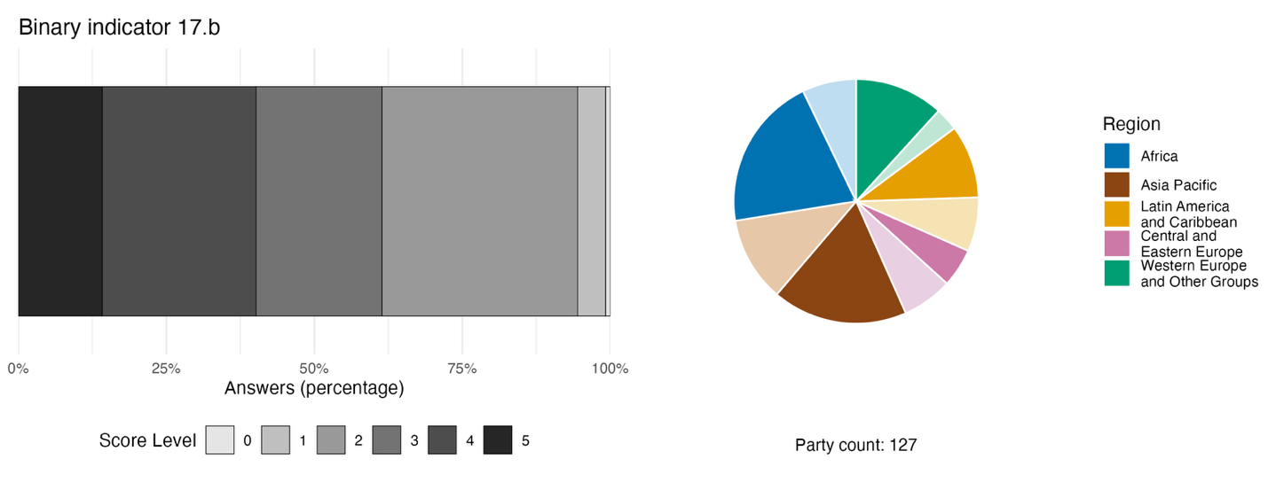
Note: The bar widths show the percentage of Parties in each score category, with higher numbers indicating a greater level of progress, based on responses to the questions included in the indicator.ª The pie chart shows the distribution of Parties providing responses to all questions by region. Colours for each region are defined in the figure legend: darker tones represent the proportion of Parties for any region for which data are included in the graph; lighter tones represent the proportion of Parties for the same region for which no data are included in the graph.
ª The methodology for calculating the score levels for each binary indicator, as well as the questions included for each indicator, are provided in document CBD/COP/16/INF/3/Rev.1.

Figure 71
Percentage of indicators aligned with Target 17 of the Framework that suggest improving, stable and negative trends, respectively
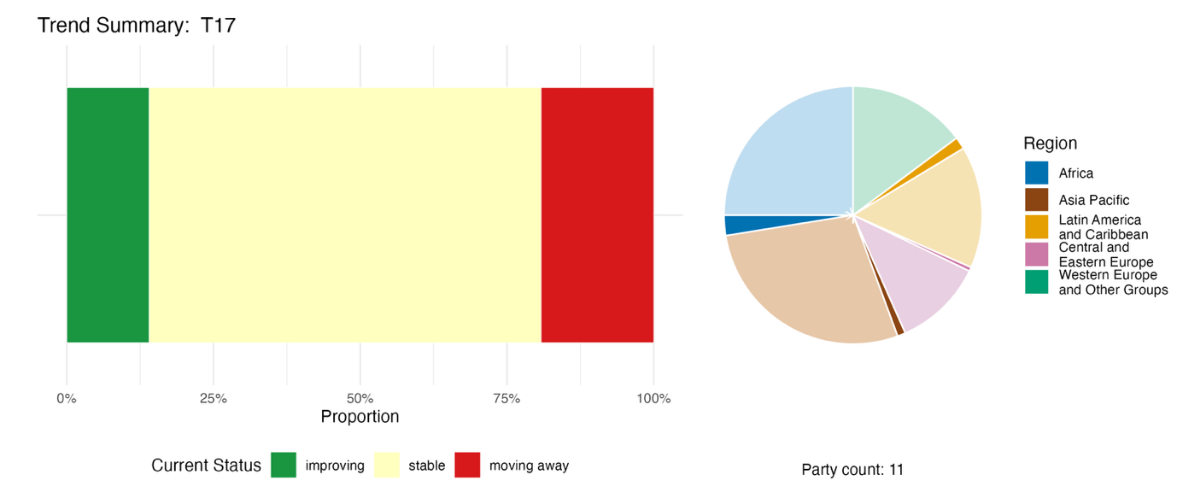
Note: Proportions are weighted by Party. The trends include data for 1 complementary and 26 national indicators from a total of 11 Parties. The pie chart shows the distribution of Parties submitting indicators for Target 17 by region. Colours for each region are defined in the figure legend: darker tones represent the proportion of Parties for any region for which data are included in the graph; lighter tones represent the proportion of Parties for the same region for which no data are included in the graph.

Self-assessment of progress

Based on self-assessment by Parties in their national reports, only 37 per cent of national targets submitted as highly aligned with Target 17 are on track for achievement: 7 per cent show no significant change, 49 per cent show insufficient progress, and 5 (5 per cent) are reported as already achieved (see figure 72).

Figure 72
Self-assessed progress for all national targets submitted as highly aligned with Target 17 of the Framework
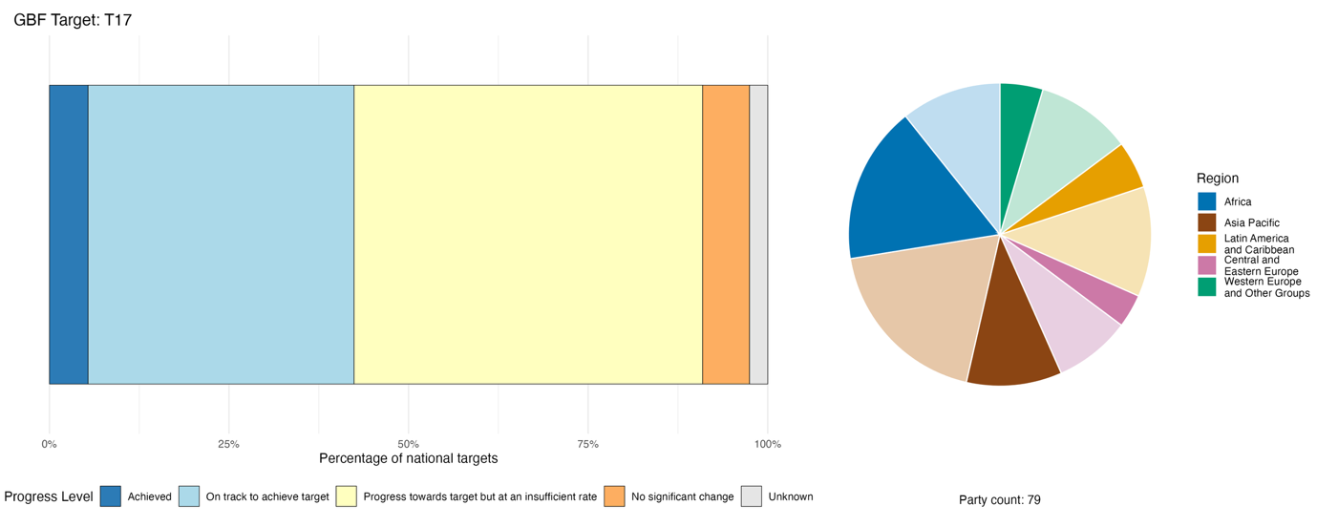
Note: The bar widths show the proportion of national targets submitted in each progress category. Proportions are weighted by Party to ensure that Parties contribute equally to overall assessment of progress, regardless of the number of national targets submitted. The pie chart shows the proportion of Parties in each region reporting in time for consideration in the global report. Colours for each region are defined in the figure legend: darker tones represent the proportion of Parties for any region for which data are included in the graph; lighter tones represent the proportion of Parties for the same region for which no data are included in the graph.

Actions, successes and challenges in implementation

Summary of actions in support of Target 17 of the Framework

Many Parties report progress in developing or strengthening biosafety measures and technical infrastructure, including the establishment of methods to detect living modified organisms and laboratories to apply these methods and systems for monitoring them, border control measures and tools for risk assessment. Some Parties reported granting specific authorizations and permits for living modified organisms, while others documented measures to restrict or limit their cultivation. Some national reports also included information on the development of guidelines or regulations covering new developments in biotechnology, including organisms produced through genome editing. For Parties to both the Cartagena Protocol on Biosafety and the Convention, strengthening support for the Protocol serves as a key mechanism to further advance Target 17, in particular with regard to establishing biosafety standards that support the implementation of the Convention (see boxes 41 and 42).

Examples of success and progress in implementation

Box 41
National legislation strengthening biosafety measures in Cameroon

Cameroon enacted a new law in 2025 to strengthen the legal, institutional and technical framework for biosafety, as well as to manage, control and prevent associated biosecurity risks. The scope of the law covers the introduction, management and control of living modified organisms and invasive alien species, as well as their associated risks and adverse effects on food safety, human, plant and animal health, environmental protection, trade and various industries.
At the institutional level, a decree establishing a national biosafety agency has been drafted and is undergoing consultations. This aims to strengthen the coordination, supervision and oversight of activities related to modern biotechnology. In addition, technical procedures for reviewing applications, based on the precautionary principle, have been implemented and a registry of applications has been established, particularly in the context of reviewing an application for the introduction of genetically modified cotton.
To improve and strengthen national capacity for the detection and analysis of living modified organisms, a number of university laboratories are being provided with specialized equipment, training sessions have been organized for technical and scientific staff and a national training manual is under development.

Since 2023, substantial international funding has been mobilized in partnership with the United Nations Environment Programme (UNEP) and Global Environment Facility (GEF) and will continue until 2028, to assist in strengthening the institutional biosecurity frameworks put in place in the management of living modified organisms and invasive alien species.

At the national level, biosafety has been integrated into sectoral budget planning and public-private partnerships have been established to support research and the procurement of laboratory equipment. Overall, the combination of these measures represents a systematic step towards establishing a more robust national biosafety system that is consistent with the country’s international commitments and tailored to the challenges posed by modern biotechnology.

Relevant targets: 6, 13, 17, 19, 20 and 21.
Sources: Cameroon, seventh national report under the Convention; Government of Cameroon, 2025; and UNEP and GEF, 2023.

Box 42
Legislative biosafety package with European Union accession alignment in the Republic of Moldova
Between 2020 and 2025, the Republic of Moldova drafted and approved several laws and governmental decisions related to biosecurity, including on the regulation, control, movement and use of living modified organisms, food, feed and microorganisms. In 2025, the Environmental Agency of the Republic of Moldova issued 18 authorizations for 17 beneficiaries in the country for products related to genetically modified feed, including authorizations for meal produced from genetically modified soybeans; compound feed containing meal produced from genetically modified soybeans and genetically modified corn; and compound feed containing genetically modified organisms.
These actions are in line with the implementation of the regulatory framework for the use of living modified organisms and the application of the Cartagena Protocol and the Nagoya-Kuala Lumpur Supplementary Protocol on Liability and Redress to the Cartagena Protocol on Biosafety. The measures also help to harmonize the legal framework of the Republic of Moldova with the specific European Union directives in the field of biotechnology and biosafety regulation.
Relevant targets: 10, 14 and 17.
Source: Moldova, seventh national report under the Convention.

Challenges

A significant number of Parties report on draft biosafety laws that remain unadopted, thus limiting enforcement and regulatory authority. Several Parties point to insufficient regulatory frameworks covering new developments in biotechnology. Many Parties, particularly in developing countries and among small island developing States, report insufficient laboratory infrastructure for detection of living modified organisms and risk assessment. In addition, Parties mention a shortage of trained biosafety scientists, risk assessors and inspectors. A few Parties mention having difficulties in monitoring what crosses their borders. Limited inspection infrastructure, reliance on documentation rather than laboratory verification and understaffed border posts mean unauthorized or unregulated living modified organism materials can enter undetected. The element of Target 17 relating to Article 19 of the Convention (the distribution of benefits from biotechnology) is widely acknowledged but rarely operationalized, according to several national reports. Multiple Parties note that biosafety implementation is heavily dependent on external and short-term project financing rather than sustainable domestic budgets. This can lead to implementation measures that are themselves project-based and do not have long-term national stability.
Some Parties reported on challenges regarding public awareness, education and access to information on biosafety measures and obligations. The establishment of national Biosafety Clearing-House platforms and the strengthening of their link with the international Clearing-House platform has also been reported to be a challenge by several Parties.

Contributions of actors other than national Governments

Commitments submitted directly through the online reporting tool

Of the 180 substantive commitments submitted by actors other than national Governments, only one is associated primarily with Target 17. This commitment is from a network of NGOs based in Denmark, which has submitted commitments addressing all of the 23 targets of the Framework. The network focuses on advocacy for the precautionary principle and ensuring that new biological technologies do not inadvertently harm ecosystem integrity.

Contributions integrated into national reports

Research organizations are identified as involved in roles such as laboratory hosts and operators, institutional biosafety committee members, curriculum developers, knowledge generators and scientific advisers to regulatory bodies. Intergovernmental organizations provide project financing, technical assistance, equipment donation, legislative drafting support and training. Citizens and the public appear mainly as recipients of awareness campaigns and consultees in regulatory procedures, with a few reports of citizen science or public deliberation. Indigenous peoples and local communities are mentioned as rights holders in access and benefit-sharing frameworks, and occasionally in free, prior and informed consent integration or co-governance. NGOs appear mostly in the context of workshop participants, and sometimes in the role of co-implementing biosafety standards or delivering projects. Subnational governments, cities and other local authorities appear as co-governance actors where competencies are devolved.

Examples of linkages with other agreements, processes and organizations

The implementation of Target 17 is closely associated with the implementation of the Cartagena Protocol on Biosafety, a legally binding treaty under the Convention with the prime objective of ensuring the safe handling, transport and use of living modified organisms resulting from modern biotechnology that may have adverse effects on biodiversity, taking also into account risks to human health. The Cartagena Protocol was adopted in 2000 and came into force in 2003. Currently, 173 of the 196 Parties to the Convention are also Parties to the Cartagena Protocol. The Nagoya-Kuala Lumpur Supplementary Protocol on Liability and Redress to the Cartagena Protocol on Biosafety, which was adopted in 2010 and came into force in 2018, aims to contribute to the conservation and sustainable use of biodiversity by providing international rules and procedures in the field of liability and redress relating to damage resulting from living modified organisms that have their origin in transboundary movement.

Target 18. Reduce harmful subsidies by at least US$500 billion per year, and scale up positive incentives for biodiversity
Target text. Identify by 2025, and eliminate, phase out or reform incentives, including subsidies, harmful for biodiversity, in a proportionate, just, fair, effective and equitable way, while substantially and progressively reducing them by at least $500 billion per year by 2030, starting with the most harmful incentives, and scale up positive incentives for the conservation and sustainable use of biodiversity.

Progress overview
Limited progress has been made in scaling up positive incentives, or in identifying and reforming harmful incentives. Available evidence suggests that the 2025 milestone for identifying incentives, including subsidies, that are harmful for biodiversity, was not achieved. National targets address the elements of Target 18 unevenly. Reporting on indicators shows growth in the number of positive incentives, but at the same time the value of reported incentives, including subsidies, that are harmful for biodiversity remains substantial. Self-assessments indicate that only a quarter of national targets submitted as highly aligned with Target 18 are on track, while most show insufficient progress. Key challenges include identifying, quantifying and reforming harmful subsidies.

Coverage by Parties of the scope of Target 18 of the Framework in their national targets

Table 39
Elements of Target 18 of the Framework and how they are addressed in national targetsª
Identify by 2025 incentives, including subsidies, harmful for biodiversity | 39
Eliminate, phase out or reform incentives, including subsidies, harmful for biodiversity in a proportionate, fair and equitable way | 48
Substantially and progressively reduce incentives, including subsidies, harmful for biodiversity, by at least $500 billion per year by 2030 | 27
Scale up positive incentives for the conservation and sustainable use of  biodiversity | 58
On average, Parties have addressed, to at least some extent, 43 per cent of these elements in their national targets

Note: The right-hand column of the table indicates the percentage of Parties with national targets that address the element to at least some extent.
ª The elements for each target were defined by the Ad Hoc Technical Expert Group on Indicators of the Kunming-Montreal Global Biodiversity Framework (see annex I to CBD/COP/16/INF/4; and Affinito and others, 2025). The detailed methodology for the analysis of national targets is provided in document CBD/SBI/7/INF/22.

The elements of Target 18 are addressed unevenly by Parties in their national targets (see table 39) The largest proportion (58 per cent) have national targets addressing to some extent the scaling up of positive incentives for the conservation and sustainable use of biodiversity. Fewer than half (48 per cent) have set national targets on the elimination, phasing out or reform of incentives, including subsidies, that are harmful for biodiversity in a proportionate, fair and equitable way. The element of Target 18 with a 2025 deadline, to identify harmful incentives, is addressed to some extent by 39 per cent of Parties in their national targets. The element least addressed by Parties (27 per cent) relates to substantially and progressively reducing harmful subsidies by at least US$ 500 billion globally by 2030.
Very few Parties (5 per cent) have set quantitative national targets for reducing incentives, including subsidies, that are harmful for biodiversity. The values set by those Parties range from 10 per cent to 50 per cent reductions in harmful incentives.

Indicators of progress

Table 40
Indicator scorecard for Target 18 of the Framework
 | Indicator use |  | Indicator results
Headline indicator 18.1: positive incentives in place to promote biodiversity conservation and sustainable use | 30 per cent of Parties |  | Increase year on year to a total of 548 in 2025
Headline indicator 18.2: Value of subsidies and other incentives harmful to biodiversity | 19 per cent of Parties representing 25 per cent of all Parties' GDP |  | Total of US$ 268 billion spent on harmful subsidies from 2022 to 2025
All quantitative indicators combined | 48 Parties, 37 per cent |  | 21 per cent positive trends  19 per cent negative trends
Note: The colour coding is related to the overall assessment of progress across targets, the methodology of which is explained in the overall summary scorecard (see table 3). The colour coding for indicator data use and all quantitative indicator trends reflects where a value for each target sits relative to the highest and lowest scores achieved across all targets of the Framework (green is assigned to percentage values falling within the top third of the total range, yellow to the middle third and red to the bottom third). Colours for the headline indicator results are based on progress relative to the target (green is assigned when progress is being made, yellow when progress is mixed, red when progress is insufficient and grey when progress cannot be assessed). Note that the percentage of Parties submitting data on headline indicators may be different from that used in the aggregate results for both the headline indicator and all quantitative indicators combined, owing to methodological differences in the way data were used.

Nearly a third of Parties provided data on positive incentives (headline indicator 18.1) and a fifth of Parties provided data on harmful subsidies (headline indicator 18.2), with many Parties reporting difficulties in tracking and quantifying biodiversity-related subsidies owing to methodological challenges (see table 40). Differences in methodological approaches could result in inconsistencies in the global estimates, and all reported values are underestimates as they do not represent all Parties, do not capture the full range of subsidies and incentives in place across sectors, and may not include all national subsidies.
Since the Framework was agreed in 2022, Parties reported an increase of more than 60 per cent in the number of incentives in place, with 548 positive incentives reported by 33 Parties in place by 2025 (see figure 73). This may be a serious underrepresentation, as the Policy Instruments for the Environment database of the Organisation for Economic Co-operation and Development (OECD) records more than 869 biodiversity-positive incentives from across 100 countries in 2024, covering biodiversity-positive subsidies, payments for ecosystem services, taxes and fees, tradeable permits and biodiversity offsets (see figure 74)(OECD, 2024).
With regard to incentives, including subsidies, harmful to biodiversity, the 22 Parties that reported represent approximately one quarter of global GDP. Based on the reports of these Parties, there was a cumulative total of US$ 268 billion available for subsidies and other incentives harmful to biodiversity between 2022 and 2025, an average of US$ 67 billion annually. The value of subsidies and other incentives harmful to biodiversity ranged from zero to 2.6 per cent of annual GDP. These figures are likely significant underestimates, as many Parties only reported on sectors where subsidies and other incentives harmful to biodiversity had already been identified, and noted that further national analysis was needed. Among the Parties reporting consistently between 2022 and 2024, there is evidence that subsidies and other incentives harmful to biodiversity dropped by around 20 per cent.
Despite these encouraging signals, the value of subsidies reported remains higher than the resources that Parties reported mobilizing for biodiversity (see also Target 19). One caveat is that these two figures may come from different reporting Parties, so the comparison shows only that there is a gap, not its size. Fewer than 20 per cent of Parties showed a positive trend in the indicators they submitted in relation to Target 18 (see figure 75). In addition, most of the submitted national indicators focus on identifying harmful subsidies and scaling up positive incentives; no indicators were submitted on the elements of the target related to eliminating, phasing out, reforming or reducing harmful subsidies. This suggests that overall progress towards Target 18 remains insufficient.

Figure 73
Headline indicator 18.1: positive incentives in place to promote biodiversity conservation and sustainable use (from national reports)
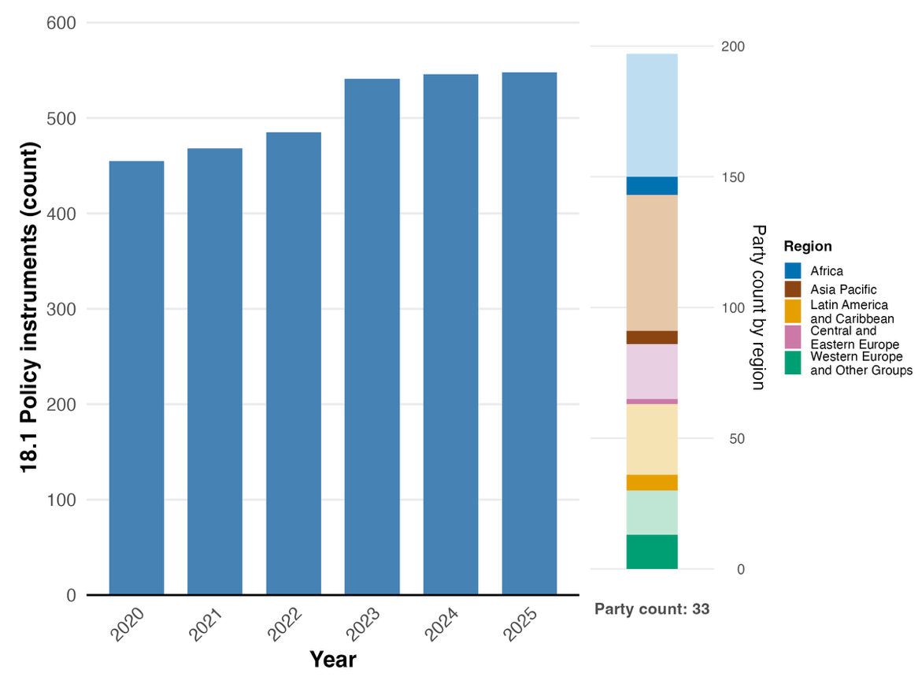
Note: Indicator values show the yearly count of incentives in place across Party submissions. The bar chart at the right shows the distribution of Parties providing data, by region. Colours for each region are defined in the figure legend: darker tones represent the proportion of Parties for any region for which data are included in the graph; lighter tones represent the proportion of Parties for the same region for which no data are included in the graph.

Figure 74
Headline indicator 18.1: positive incentives in place to promote biodiversity conservation and sustainable use (from the OECD Policy Instruments for the Environment database)
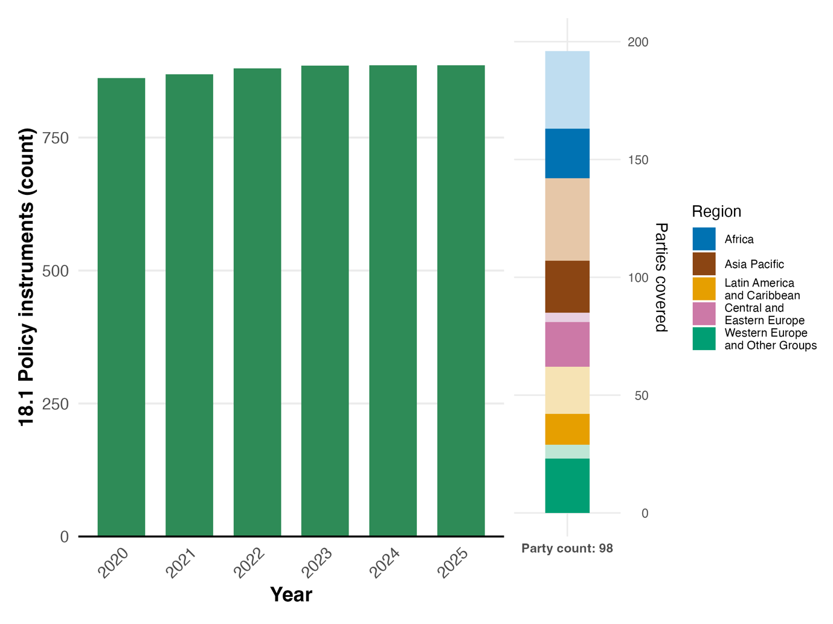
Note: Indicator values show the total count of incentives in place across Parties, by year. The bar chart at the right shows the distribution of Parties for which data are available, by region. Colours for each region are defined in the figure legend: darker tones represent the proportion of Parties for any region for which data are included in the graph; lighter tones represent the proportion of Parties for the same region for which no data are included in the graph.

Figure 75
Percentage of indicators aligned with Target 18 of the Framework that suggest improving, stable and negative trends, respectively
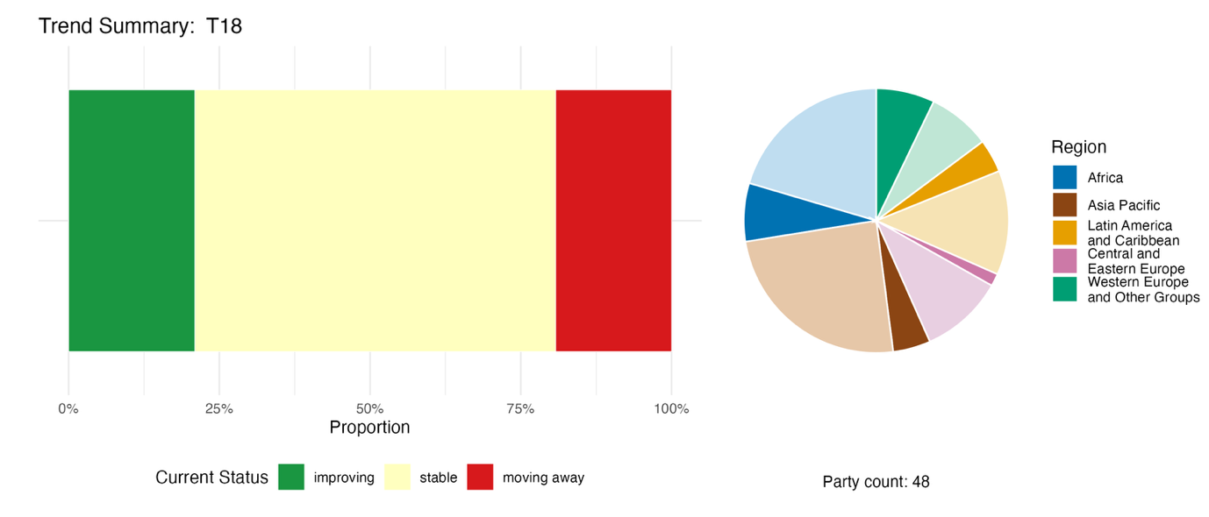
Note: Proportions are weighted by Party. The trends include data for two headline indicators from 44 Parties and 28 national indicators from 12 Parties. The pie chart shows the distribution of Parties submitting indicators for Target 18, by region. The pie chart shows the distribution of Parties submitting indicators for Target 18 by region. Colours for each region are defined in the figure legend: darker tones represent the proportion of Parties for any region for which data are included in the graph; lighter tones represent the proportion of Parties for the same region for which no data are included in the graph.

Self-assessment of progress

Based on self-assessment by Parties in their national reports, only a quarter (25 per cent) of national targets submitted as highly aligned with Target 18 are on track for achievement, with more than double that number (62 per cent) showing insufficient progress and a further 7 per cent with no significant change. Just two national targets (1 per cent) are reported as already achieved (see figure 76).

Figure 76
Self-assessed progress for all national targets submitted as highly aligned with Target 18 of the Framework
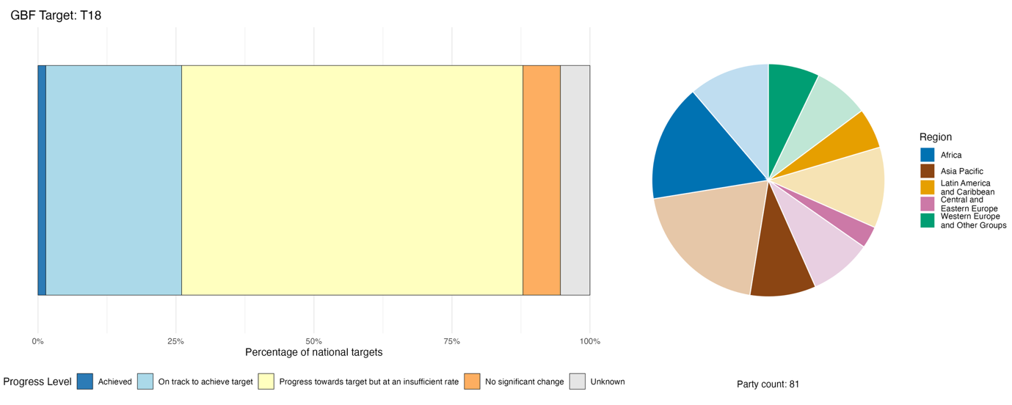
Note: The bar widths show the proportion of national targets submitted in each progress category. Proportions are weighted by Party to ensure that Parties contribute equally to overall assessment of progress, regardless of the number of national targets submitted. The pie chart shows the proportion of Parties in each region reporting in time for consideration in the global report. Colours for each region are defined in the figure legend: darker tones represent the proportion of Parties for any region for which data are included in the graph; lighter tones represent the proportion of Parties for the same region for which no data are included in the graph.

Actions, successes and challenges in implementation

Summary of actions in support of Target 18 of the Framework

The overwhelming majority of Parties report actions for the identification and assessment of incentives, including subsidies, that are harmful to biodiversity, that is, the element of Target 18 with a deadline of 2025. These actions include compiling inventories of subsidies, commissioning studies and developing classification frameworks. A much smaller group of Parties report on concrete steps to reform and eliminate such incentives by 2030, which are key requirements of Target 18 (see box 44). A few Parties address reduction or phasing out of fossil fuel subsidies as a harmful incentive that is relevant to biodiversity (see box 43). Others point to ratification of the World Trade Organization Agreement on Fisheries Subsidies (WTO, 2022), which came into force in September 2025. Steps to scale up positive incentives for conservation and sustainable use of biodiversity are more commonly reported in all regions and among Parties of all income levels than reduction of harmful incentives. Examples of positive incentives include payments for ecosystem services, conservation finance mechanisms and redirection of agricultural support towards biodiversity-friendly practices. BIOFIN is cited by at least 25 Parties as a vehicle for analytical support, methodology or institutional scaffolding in implementation of Target 18.

Examples of success and progress in implementation

Box 43
Legally anchored fossil fuel subsidy phase-out with renewable energy tax incentives in Uzbekistan
Uzbekistan is considered one of the most energy- and emissions-intensive countries in the world. In recent years, the Government has made major efforts to reform and reduce fossil fuel subsidies, while simultaneously providing incentives for the use of renewable energy.
Beginning in 2019, Uzbekistan has been conducting an overhaul of energy-sector legislation, including the enactment of a law on the use of renewable energy sources and a law on energy efficiency, saving and rational use. A presidential decree was enacted on accelerated measures to improve energy efficiency, implement energy saving technologies and develop renewable energy sources. In 2024, ministerial resolutions introduced a revised tariff policy for the fuel and energy sector and formally established the Energy Market Development and Regulatory Agency, an independent energy regulator.
Subsequently, gas and electricity prices in Uzbekistan were increased for businesses and households. A further increase was implemented in 2025, aiming to reach full cost recovery by the end of 2026 and to phase out all tariff subsidies by 2027. As a result, between 2024 and 2025 total spending on key subsidies harmful to biodiversity fell by 13 per cent in real terms, while spending on biodiversity-harmful energy and fuel subsidies declined by 30 per cent.
These efforts are co-funded under the World Bank’s Innovative Carbon Resource Application for Energy Transition (iCRAFT) project, the Bank’s first global initiative to support policy reforms through payments for emission reductions.

Relevant targets: 7, 8, 15 and 19.
Sources: Uzbekistan, seventh national report under the Convention; OECD, 2025; and UNDP and others, 2025.

Box 44
Statutory annual catalogue of environmentally harmful subsidies with quantified reform outcomes in Italy

A law passed in 2015 requires the Ministry of the Environment and Energy Security of Italy to prepare an annual catalogue of environmentally harmful subsidies and environmentally beneficial subsidies.ª The purpose of the law is to promote green-economy measures and curb excessive use of natural resources. The catalogue serves as a key reference for national and international initiatives aimed at identifying, reforming and phasing out environmentally harmful subsidies, while encouraging the expansion of incentives that generate environmental benefits.
Between 2022 and 2023, Italy eliminated several fossil fuel subsidies considered harmful to biodiversity across various sectors covering incentives, concessions, subsidized financing and exemptions. These included:
- Reduction of the excise duty exemption for fuels used in rail transport
- Elimination of the excise duty exemption for energy products used for magnesium production from seawater
- Termination of public funding for research, development and demonstration related to oil, gas and coal
Overall, these measures resulted in a total annual reduction of harmful subsidies of more than 282 million euros.
Relevant targets: 7, 8, 14, 15, 19 and 21.
Source: Italy, seventh national report under the Convention.

ªAvailable at www.mase.gov.it/portale/catalogo-dei-sussidi-ambientalmente-dannosi-e-dei-sussidi-ambientalmente-favorevoli.

Challenges

Many Parties report barriers to the identification of incentives, including subsidies, that are harmful to biodiversity, including incomplete inventories of harmful incentives, missing or incomplete data across Parties of all income levels, and the absence of agreed definitions and harmonized approaches for identifying which incentives are harmful. Since reform cannot be prioritized or measured without knowing what incentives exist, their financial value and their specific impacts on biodiversity, these barriers to identification are also barriers to reform. Even where reforms are attempted, Parties may lack systems to track whether subsidy savings are reinvested in nature, whether positive incentives are delivering results, or whether harmful incentives are returning in another form. Entrenched interests and political barriers to subsidy reform are noted in several national reports. Subsidies for agriculture, energy and fisheries are often embedded in national economies and linked to policies such as food security, poverty reduction or energy affordability. A number of Parties also identify cross-sectoral coordination as a significant challenge, citing difficulties in aligning ministries of finance, the environment, agriculture and energy. Insufficient domestic financial resources for scaling-up positive incentives is a recurring issue raised in national reports, and several reports point to a dependency on donors and external technical support to implement such policies.

Contributions from actors other than national Governments

Commitments submitted directly through the online reporting tool

Of the 180 commitments submitted by actors other than national Governments, only one is primarily associated with Target 18. The commitment is from a network of NGOs based in Denmark, which has submitted commitments addressing all 23 targets of the Framework, and relates to advocacy for more ambitious redirection of subsidies harmful to biodiversity.

Contributions integrated in national reports

National reports include examples of sharing of analysis and knowledge for the implementation of Target 18. Intergovernmental organizations, particularly UNDP through BIOFIN, help with national biodiversity finance plans, research organizations contribute to assessments of harmful subsidies and the business and finance communities participate through disclosure frameworks such as the Taskforce on Nature-related Financial Disclosures. The main implementation role for sectors related to or dependent on biodiversity, NGOs and indigenous peoples and local communities, relates to delivery of positive incentive mechanisms, such as payments for ecosystem services and sustainability certification schemes. With regard to citizens, youth and women, national reports primarily refer to consultation and awareness-raising roles.

Examples of linkages with other agreements, processes and organizations

The entry into force in 2025 of the 2022 World Trade Organization Agreement on Fisheries Subsidies marked a significant step in phasing out subsidies harmful to biodiversity, and was thus closely associated with the implementation of Target 18. The Agreement prohibits subsidies that contribute to illegal, unregulated and unreported fishing, impact overfished stocks, or are associated with fishing in the high seas where the resources are not under the management of regional fishery management organizations (WTO, 2022).
Among the strategic objectives of the Global Framework on Chemicals is encouraging financial investment in safer, more sustainable chemical practices, including clean technologies and resource efficiency. By promoting integrated approaches to financing that include mainstreaming private sector involvement and leveraging external funds, that Framework helps to mobilize resources to phase out harmful subsidies and scale up financial support for green technologies and practices, thus contributing to the implementation of Target 18. Specifically, Target D2 of the Framework aims to implement policies that encourage the use of best available techniques, green procurement and circular economy approaches, driving the shift towards more sustainable production processes (Secretariat of the Basel, Rotterdam and Stockholm Conventions, 2025; UNEP, 2024a).

Target 19. Mobilize US$200 billion per year for biodiversity from all sources, including US$30 billion through international finance

Target text. Substantially and progressively increase the level of financial resources from all sources, in an effective, timely and easily accessible manner, including domestic, international, public and private resources, in accordance with Article 20 of the Convention, to implement national biodiversity strategies and action plans, mobilizing at least $200 billion per year by 2030, including by:
(a) Increasing total biodiversity related international financial resources from developed countries, including official development assistance, and from countries that voluntarily assume obligations of developed country Parties, to developing countries, in particular the least developed countries and small island developing States, as well as countries with economies in transition, to at least $20 billion per year by 2025, and to at least $30 billion per year by 2030;
(b) Significantly increasing domestic resource mobilization, facilitated by the preparation and implementation of national biodiversity finance plans or similar instruments according to national needs, priorities and circumstances;
(c) Leveraging private finance, promoting blended finance, implementing strategies for raising new and additional resources, and encouraging the private sector to invest in biodiversity, including through impact funds and other instruments;
(d) Stimulating innovative schemes such as payment for ecosystem services, green bonds, biodiversity offsets and credits, and benefit-sharing mechanisms, with environmental and social safeguards;
(e) Optimizing co-benefits and synergies of finance targeting the biodiversity and climate crises;
(f) Enhancing the role of collective actions, including by indigenous peoples and local communities, Mother Earth centric actions and non-market-based approaches including community based natural resource management and civil society cooperation and solidarity aimed at the conservation of biodiversity;
(g) Enhancing the effectiveness, efficiency and transparency of resource provision and use.

Progress overview
Biodiversity finance is increasing, but progress remains insufficient and the 2025 finance milestone was likely not achieved, although a definitive assessment will only be possible once complete data for 2024 and 2025 have been reported. Elements related to synergies of finance and the role of collective actions are largely missing from national targets. International and domestic biodiversity finance generally show upward trends, although below levels required to meet the target, and domestic spending as a share of GDP has declined. Private finance peaked in 2021 and fell afterwards, based on reported data, and remains particularly undeveloped. Self-assessments indicate that only a minority of national targets are on track. Key challenges include mobilizing finance at scale, improving access to funding and strengthening enabling conditions for investment.

Coverage by Parties of the scope of Target 19 of the Framework in their national targets

Table 41
Elements of Target 19 of the Framework and how they are addressed in national targetsª
Increase total biodiversity related international financial resources to developing countries to at least US$ 20bn per year by 2025, and to at least US$ 30bn per year by 2030 | 58
Significantly increase domestic resource mobilization, facilitated by the preparation and implementation of national biodiversity finance plans or similar instruments | 81
Leverage private finance, promote blended finance, implement strategies for raising new and additional resources, and encourage the private sector to invest in biodiversity | 44
Stimulate innovative schemes such as payment for ecosystem services, green bonds, biodiversity offsets and credits, benefit-sharing mechanisms | 34
Optimize co-benefits and synergies of finance targeting the biodiversity and climate crises | 16
Enhance the role of collective actions, including by indigenous peoples and local communities, Mother Earth centric actions and non-market-based approaches | 14
Enhance the effectiveness, efficiency and transparency of resource provision and use | 16
On average, Parties have addressed, to at least some extent, 44 per cent of these elements in their national targets

Note: The right-hand column of the table indicates the percentage of Parties with national targets that address the element to at least some extent.
ª The elements for each target were defined by the Ad Hoc Technical Expert Group on Indicators of the Kunming-Montreal Global Biodiversity Framework (see annex I to CBD/COP/16/INF/4; and Affinito and others, 2025). The detailed methodology for the analysis of national targets is provided in document CBD/SBI/7/INF/22.

There is an exceptionally high variation in the proportion of Parties addressing the various elements of Target 19 in their national targets (see table 41). The great majority (81 per cent) have national targets that address a significant increase in domestic resource mobilization, facilitated by the preparation and implementation of national biodiversity finance plans or similar instruments. More than half of Parties (58 per cent) have national targets that to at least some extent address increasing biodiversity-related international financial resources to developing countries. Fewer than half of Parties (44 per cent) address the leveraging of private finance for biodiversity, while just over one third (34 per cent) have national targets on stimulating innovative schemes to increase finance for implementation of the Framework. The elements of Target 19 addressed by the smallest proportion of Parties are those on optimizing co-benefits and synergies of finance targeting the biodiversity and climate crises (16 per cent), on enhancing the role of collective actions, including by indigenous peoples and local communities, Mother Earth centric actions and non-market-based approaches (14 per cent), and on enhancing the effectiveness, efficiency and transparency of resource provision and use (16 per cent).
About a quarter of Parties (26 per cent) have included a quantitative component in national targets regarding an increase in biodiversity-related international financial resources for developing countries. As the values for such increases are expressed in very different terms, including both monetary values and percentages, it is not possible to aggregate the proposed increase in financial resources from national targets alone.

Indicators of progress

Table 42
Indicator scorecard for Target 19 of the Framework
 | Indicator use |  | Indicator results
Headline indicator D.1: international public funding, including official development assistance (ODA) for conservation and sustainable use of biodiversity and ecosystems | 61 per cent of Parties |  | 2020–2023 average equals US$ 4.4 billion per year
Headline indicator D.2: domestic public funding on conservation and sustainable use of biodiversity and ecosystems | 54 per cent of Parties |  | 2020-2023 average equals US$34 billion per year
Headline indicator D.3: private funding (domestic and international) on conservation and sustainable use of biodiversity and ecosystems | 26% of Parties |  | 2020–2023 average equals US$ 8.2 billion per year
All quantitative indicators combined | 88 Parties, 68 per cent |  | 57 per cent positive trends  21 per cent negative trends
Note: The colour coding is related to the overall assessment of progress across targets, the methodology of which is explained in the overall summary scorecard (see table 3). The colour coding for indicator data use and all quantitative indicator trends reflects where a value for each target sits relative to the highest and lowest scores achieved across all targets of the Framework (green is assigned to percentage values falling within the top third of the total range, yellow to the middle third and red to the bottom third). Colours for the headline indicator results are based on progress relative to the target (green is assigned when progress is being made, yellow when progress is mixed, red when progress is insufficient and grey when progress cannot be assessed). Note that the percentage of Parties submitting data on headline indicators may be different from that used in the aggregate results for both the headline indicator and all quantitative indicators combined, owing to methodological differences in the way data were used.

Many Parties describe difficulties in tracking biodiversity-related financial flows, in particular because of the lack of tagging systems to distinguish biodiversity expenditures from broader environmental, social and governance spending, as well as difficulties in identifying private financial flows. Many note that they are currently in the process of developing a finance tracking system, with many using BIOFIN. These difficulties explain the lack of more recent data, and it is likely that the values presented for some countries are undercounts, as they do not always represent funding from all sources.

2025 milestone

Target 19 (a) of the Framework calls for increasing total biodiversity-related international financial resources from developed countries, including ODA, and from countries that voluntarily assume obligations of developed country Parties, to developing countries, in particular the least developed countries and small island developing States, as well as countries with economies in transition, to at least US$ 20 billion per year by 2025, and to at least US$ 30 billion per year by 2030.
Parties reporting under headline indicator D.1, comprising developed country Parties and Parties that have voluntarily assumed the obligations of developed country Parties, have reported a cumulative US$ 17.7 billion in international public finance between 2020 and 2023, with the highest total at US$ 5.2 billion reported in 2023 (see table 42 and figure 77). This amount should be taken as a minimum, as it may not capture the full range of flows covered by Target 19 (a). OECD, whose analysis covers the broader range of flows referred to in Target 19 (a), estimates total international biodiversity finance at approximately US$ 16.8 billion in 2023. Both estimates fall below the US$ 20 billion milestone. The data therefore suggest that the 2025 milestone was likely not met, although a definitive assessment will only be possible once complete data for 2024 and 2025, the milestone year, have been reported.

2030 US$ 200 billion target

Target 19 sets an overall goal for 2030 of mobilizing at least US$ 200 billion per year for biodiversity from all sources.
Total finance from international public sources, domestic public sources and private finance sources amounted to US$ 5.2 billion, US$ 20.6 billion and US$ 6.9 billion respectively, for a total of US$ 32.7 billion in 2023. Parties report mobilizing a cumulative US$ 17.7 billion from international public sources, US$ 135.9 billion from domestic sources and US$ 32.8 billion from private finance sources for a cumulative total of US$ 186.4 billion over four years (2020–2023).
Funding from international public sources and domestic sources has increased year on year; however, domestic public finance for conservation and sustainable use of biodiversity and ecosystems as a percentage of GDP has been declining over the period (see figure 78). Domestic finance as a percentage of GDP varied greatly, from less than 0.1 per cent to as much as 2.7 per cent.
In terms of private sources, the value reached a high of US$ 11.2 billion in 2021 (see figure 79). The decline in funding in 2022 and 2023 could be due to a reporting time lag, or it could reflect a decrease owing to real changes in funding. It is not possible to assess this in the current analysis, since few Parties reported data on private sources of funding and the data are therefore largely incomplete.
A number of Parties shared information on other indicators related to Target 19, with a large majority showing signs of improvement (see figure 80). Most additional indicators relate to enhancing the effectiveness, efficiency and transparency of resource provision and use, so they mostly cover other aspects of Target 19 and may not be directly related to the volume of funding.

Figure 77
Headline indicator D.1: international public funding, including official development assistance, for conservation and sustainable use of biodiversity and ecosystems
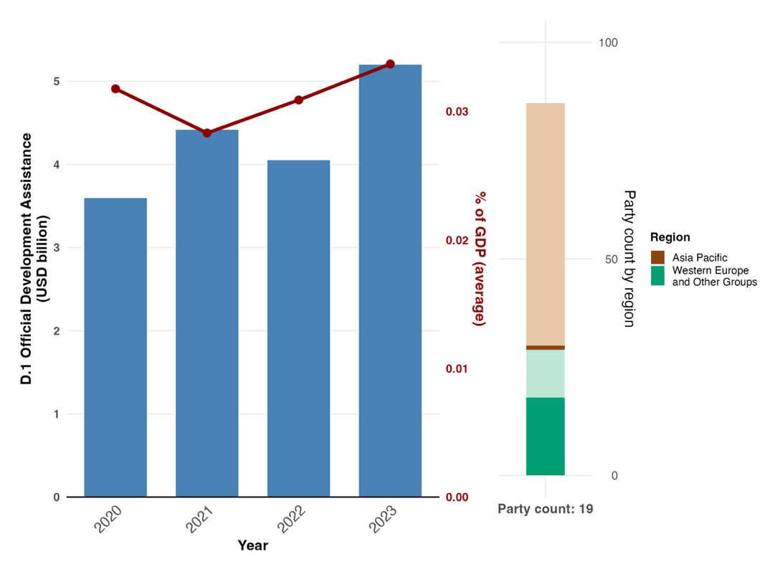
Note: Indicator values are shown as the yearly sum of ODA provided by donor Parties (blue) and the average share of national GDP represented by national value (red). The right bar chart shows the distribution of Parties providing data, by region. Colours for each region are defined in the figure legend: darker tones represent the proportion of Parties for any region for which data are included in the graph; lighter tones represent the proportion of Parties for the same region for which no data are included in the graph. Note that three Parties, accounting for US$ 0.43 billion in total, were not included in the graph as they did not report on each of the years between 2020 and 2023.

Figure 78
Headline indicator D.2: domestic public funding for conservation and sustainable use of biodiversity and ecosystems
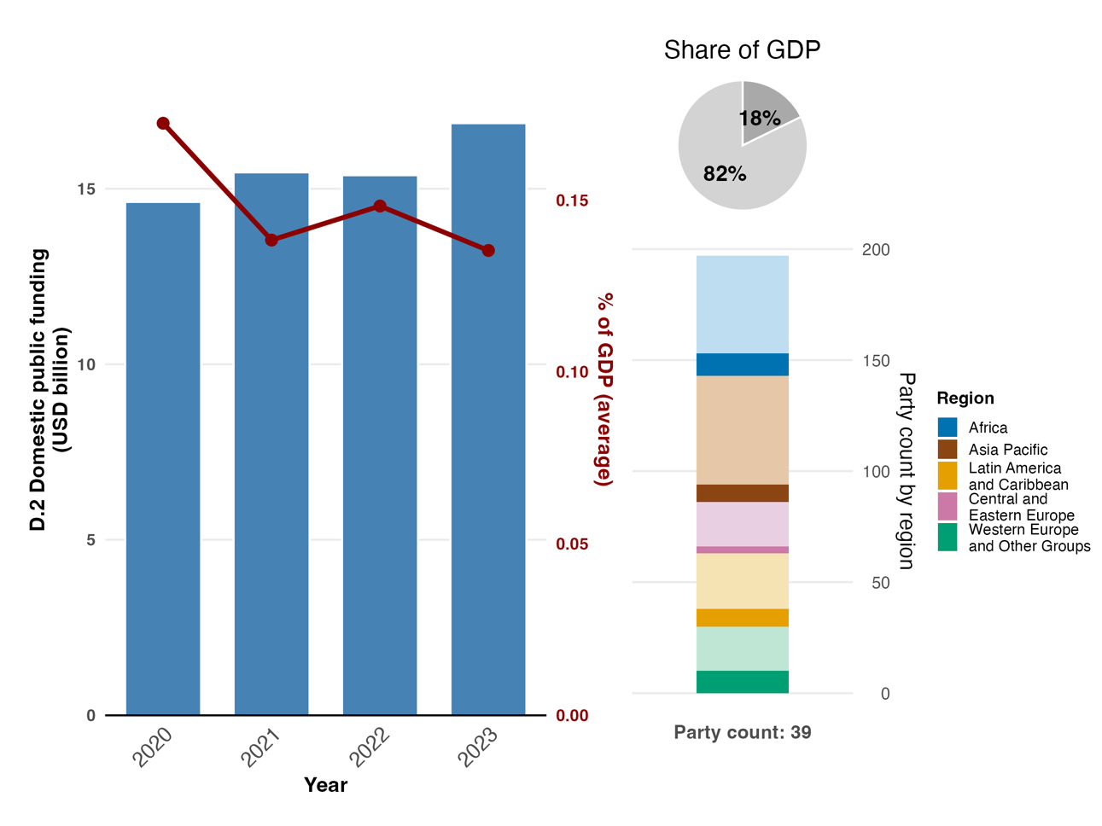
Note: Indicator values are shown as the yearly sum of domestic funding spent on biodiversity by Parties reporting (blue) and the average share of national GDP represented by national value (red). The right bar chart shows the distribution of Parties providing data, by region. Colours for each region are defined in the figure legend: darker tones represent the proportion of Parties for any region for which data are included in the graph; lighter tones represent the proportion of Parties for the same region for which no data are included in the graph. The dark grey area of the pie chart shows the proportion of all Parties’ GDP accounted for by the data. Note that 19 Parties, accounting for US$ 73.5 billion in total, were not included in the graph as they did not report on each of the years between 2020 and 2023.

Figure 79
Headline indicator D.3: private funding (domestic and international) on conservation and sustainable use of biodiversity and ecosystems
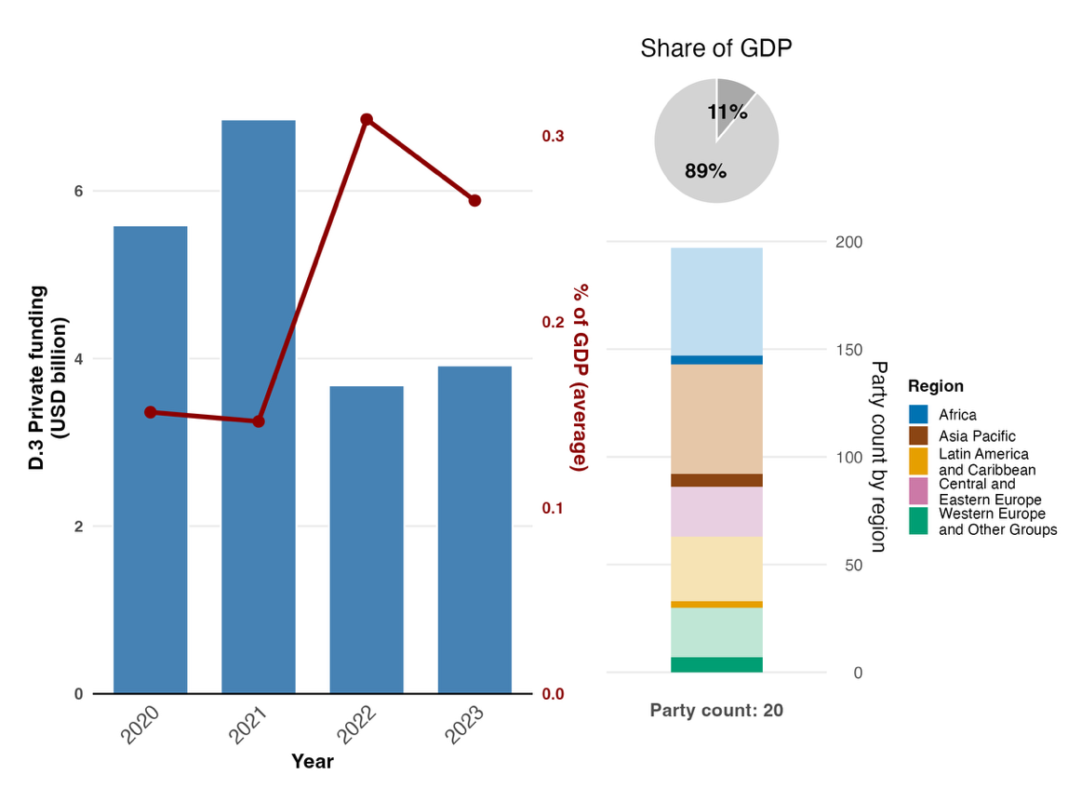
Note: Indicator values are shown as the yearly sum of private funding spent on biodiversity reported by Parties (blue) and the average share of national GDP represented by national value (red). The right bar chart shows the distribution of Parties providing data, by region. Colours for each region are defined in the figure legend: darker tones represent the proportion of Parties for any region for which data are included in the graph; lighter tones represent the proportion of Parties for the same region for which no data are included in the graph. The dark grey area of the pie chart shows the proportion of all Parties’ GDP accounted for by the data. Note that eight Parties, accounting for US$ 12.8 billion in total, were not included in the graph as they did not report on each of the years between 2020 and 2023.

Figure 80
Percentage of indicators aligned with Target 19 of the Framework that suggest improving, stable and negative trends, respectively
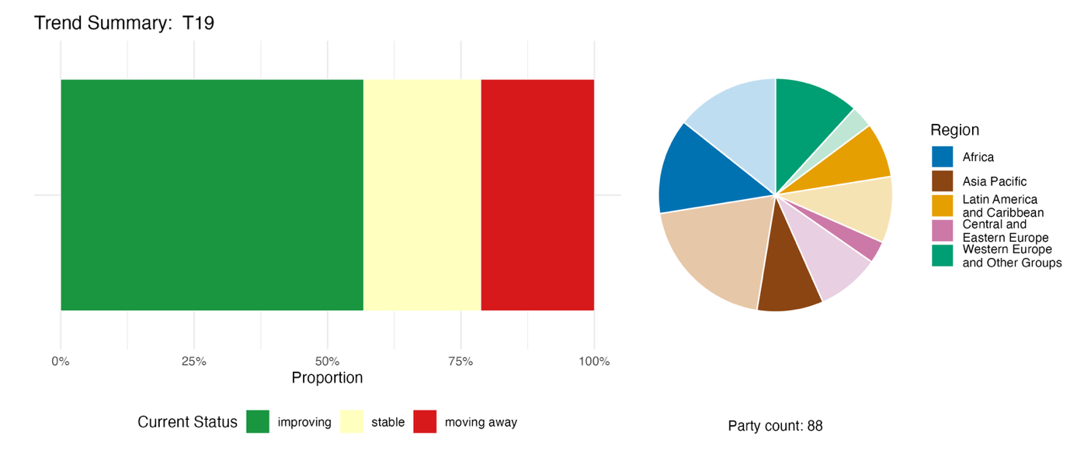
Note: Proportions are weighted by Party. The trends include data for the three headline indicators from 86 Parties and 40 national indicators from a total of 16 Parties. The pie chart shows the distribution of Parties submitting indicators for Target 19, by region. The pie chart shows the distribution of Parties submitting indicators for Target 19 by region. Colours for each region are defined in the figure legend: darker tones represent the proportion of Parties for any region for which data are included in the graph; lighter tones represent the proportion of Parties for the same region for which no data are included in the graph.

Self-assessment of progress
Based on self-assessment by Parties in their national reports, only 32 per cent of national targets submitted with high alignment to Target 19 are on track for achievement, with a much higher number (64 per cent) showing no significant change or insufficient progress, and just two national targets (1 per cent) reported as already achieved (see figure 81).

Figure 81
Self-assessed progress for all national targets submitted as highly aligned with Target 19 of the Framework
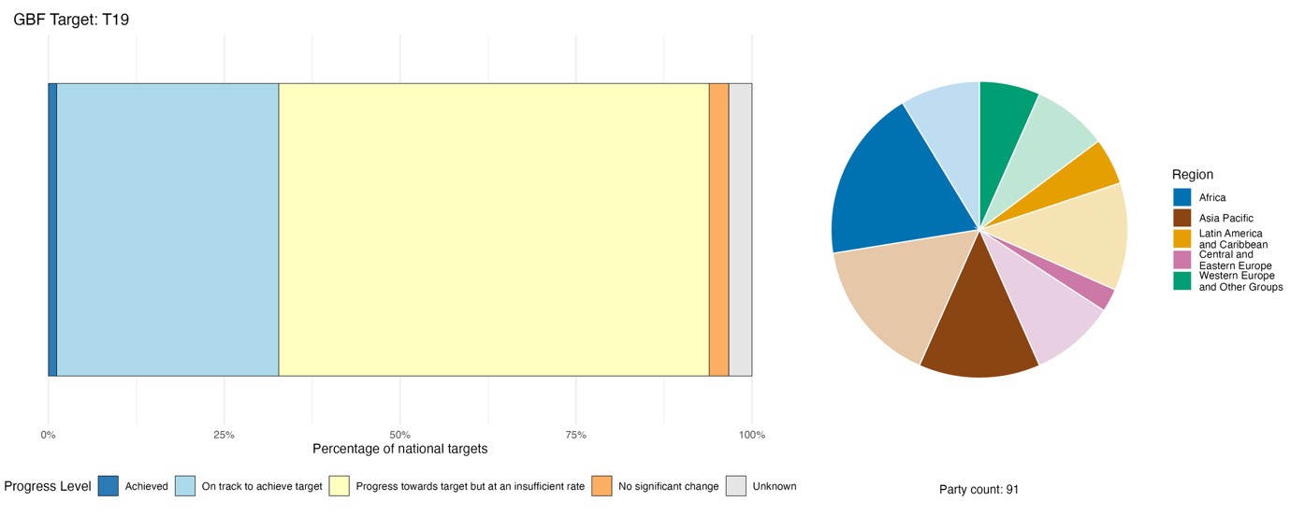
Note: The bar widths show the proportion of national targets submitted in each progress category. Proportions are weighted by Party to ensure that Parties contribute equally to overall assessment of progress, regardless of the number of national targets submitted. The pie chart shows the proportion of Parties in each region reporting in time for consideration in the global report. Colours for each region are defined in the figure legend: darker tones represent the proportion of Parties for any region for which data are included in the graph; lighter tones represent the proportion of Parties for the same region for which no data are included in the graph.

Actions, successes and challenges in implementation

Summary of actions in support of Target 19 of the Framework

The dominant approach reported by Parties for the implementation of Target 19 is biodiversity finance planning and diagnostic work, with the methodology of BIOFIN serving as the most widely adopted framework. The majority of Parties have either launched or are implementing a national biodiversity finance plan, a biodiversity expenditure review or a financial needs assessment. Beyond planning, the most commonly reported concrete actions are mobilization of international public finance, for example through GEF, the Green Climate Fund, ODA or debt-for-nature swaps; development of green taxonomies and sustainable finance frameworks; issuance of green or sustainability-linked bonds; and reform of domestic fiscal mechanisms (see boxes 45 and 46). Private finance mobilization, subsidy reform and finance access for indigenous peoples and local communities are reported less frequently and often remain at enabling or aspirational stages.

Examples of success and progress in implementation

Box 45
World’s first sustainability-linked sovereign bonds, with key performance indicators for biodiversity, in Chile

In 2022, Chile issued the world’s first sustainability-linked sovereign bonds, incorporating two key performance indicators (the reduction of greenhouse gas emissions and the expansion of non-conventional renewable energy generation, including wind, small run-of-the-river hydroelectric power, biomass, biogas, geothermal, solar and ocean energy, and green hydrogen). In 2023, the framework was expanded to include the addition of a key performance indicator related to gender equality (increasing women’s representation on the boards of directors at companies).
In 2025, an updated version of the sustainability-linked bond framework included a new key performance indicator linked to biodiversity, with two main components: increasing the percentage of protected areas and/or OECMs in terrestrial ecosystems (including inland waters); and increasing the percentage of national terrestrial ecosystems (including inland waters) in protected areas that meet all key effectiveness metrics of governance, planning, personnel and monitoring. The new key performance indicator is aimed at increasing the land coverage of protected areas to 30 per cent of the national territory by 2030 (currently 21 per cent), and ensuring the effective management of at least 10 per cent of the national territory.
Implementation of this initiative is supported by Chile’s recently created Biodiversity and Protected Areas Service, the Ministry of the Environment and the Public Debt Office of the Ministry of Finance, as well as international bond market investors.
The framework provides financial incentives for the Government of Chile to meet its goals, as it reduces the interest rates the country qualifies for upon achieving the target reflected in the key performance indicators. As at the end of 2023, the bonds accounted for a total value of more than US$ 8 billion. According to the Government of Chile, this is the first international sovereign bond structured around specific goals for the protection and effective management of biodiversity.
Relevant targets: 1, 3, 8, 11, 14, 15, 18, 19, 22 and 23.

Sources: Chile, seventh national report under the Convention; Ministry of Finance, Government of Chile, 2025.

Box 46
Fragile-state biodiversity finance innovation through climate-biodiversity synergy and traditional systems in Yemen

Yemen is mobilizing financial resources from all funding sources, with the goal of reducing the biodiversity financing gap by 20 per cent by 2030 and by 80 per cent by 2050. Due to various challenges, including the prioritization of humanitarian and security needs, national public spending on biodiversity remains minimal. In addition, there is currently minimal formal private sector investment in biodiversity. As a result, to mobilize resources, a mix of approaches is being undertaken.
For example, the country is leveraging non-monetary assets through traditional systems. In the absence of a national budget, local tribes in the Haraz and Ibb mountains have revitalized the Hima—a traditional communal land management system. Practised for more than 1,400 years in the Arabian Peninsula, Al-hima (meaning “protected place”) consists of a piece of land such as woodlands, grazing lands or flower reserves for beekeeping that is set aside cyclically by the community to allow for regeneration. Using this system, communities designate a specific Hima area or areas for mountain forest restoration. They then collectively ban grazing and tree-cutting for three to five years to allow the ecosystem to recover. In 2025, these community-managed areas showed a 15 per cent increase in native vegetation cover compared with State-managed lands that lacked oversight.
Aligned with the global BIOFIN methodology, Yemen has identified specific finance solutions to mobilize resources. In 2025, Yemen successfully packaged biodiversity restoration projects (such as the restoration of terraces in the Tuban Delta) under climate adaptation funding from the Green Climate Fundª). As a result, US$ 9.9 million was successfully mobilized, an amount that counts towards the 20 per cent target for reducing the biodiversity funding gap.

Relevant targets: 1, 2, 3, 5, 8, 9, 11, 19 and 22.
Sources: Yemen, seventh national report under the Convention; and Permanent Delegation of the Kingdom of Saudi Arabia information to UNESCO, 2023.

ª see www.greenclimate.fund/countries/yemen.

Challenges

Many Parties report that national budget allocations for biodiversity are far too low. Environmental spending is often a fraction of total government expenditure, and biodiversity frequently loses out to competing development priorities that are focused more directly, for example, on defence, food security and infrastructure. There are gaps reported by developing country Parties in access to international finance. When it is available, Parties may lack the institutional capacity to design bankable proposals or meet donor requirements. A recurring cross-cutting challenge is the gap between planning and implementation: many Parties report completed finance plans and expenditure reviews but have not yet operationalized the instruments the plans identify. Private sector engagement is widely cited as a priority, but such engagement is rarely reported with quantified outcomes. Another challenge centres on data and tracking: many Parties lack biodiversity budget tagging systems, consolidated private-sector finance data or monitoring frameworks capable of distinguishing biodiversity from climate finance. Some Parties report that financial data on biodiversity is scattered across ministries, projects and partners with no centralized system. Biodiversity finance spans multiple ministries, yet formal coordination mechanisms are rare. This can lead to overlapping mandates, delayed decisions, fragmented interventions and inefficient resource use.

Contributions from actions other than national Governments

Commitments submitted directly through the online reporting tool

Of the 180 substantive commitments made by actors other than national Governments, only four are associated primarily with Target 19. Two of the commitments are from NGOs, one from a financial institution and one from a research institution. All of the commitments address resource mobilization and finance, with geographic coverage including Europe, Africa, South America and Asia. The specific commitments include a finance and incentive mechanism for forest-friendly production, the allocation of public biodiversity finance in support of biodiversity objectives using a human rights-based approach and mobilizing private finance for nature-based solutions (see box 47).

Box 47
Triodos Bank: mobilizing private finance for nature-based solutions
Triodos Bank, a financial institution based in the Kingdom of the Netherlands and operating across Belgium, Germany, the Netherlands, Spain and the United Kingdom, launched its nature and climate strategy running from January 2020 to December 2030. For the first time, Triodos Bank and Triodos Investment Management have united their climate and biodiversity ambitions in a single strategy. Along with aiming to finance 275 renewable energy projects and cutting absolute greenhouse gas emissions by 42 per cent by 2030, Triodos Bank aims to provide at least 500 million euros in investments, loans and contributions to the nature-based solutions sector by 2030, leveraging the combined capacity of Triodos Bank, Triodos Investment Management and the Triodos Regenerative Money Centre. Then, as part of the group’s biodiversity targets, Triodos Bank also aims to report on the positive biodiversity impact of nature-based solution projects starting from the financial year 2026. The strategy also includes active engagement with listed companies that have dependencies on deforestation and with chemical companies carrying biodiversity risks through pollution, alongside a commitment to setting and acting on key performance indicators for agriculture-related biodiversity impacts. In addition, Triodos Bank engages in advocacy for effective regulation that aligns finance with climate and nature goals.
Relevant targets: 7, 8, 10 14,15 and 19.
Source: Triodos, stakeholder commitment (see https://ort.cbd.int/database/284131).

Contributions integrated in national reports
Mobilizing resources is the main goal of Target 19 and intergovernmental organizations such as GEF and the Green Climate Fund are reported as the primary external financiers, supplying grants and concessional loans, while the business and finance community is reported to issue green bonds and biodiversity credits. NGOs lead on implementation, managing projects, grant programmes and trust funds, and representatives of sectors related to or dependent on biodiversity deliver payment for ecosystem services and certification schemes. Co-governance and co-management bring in several actors: indigenous peoples and local communities help to co-design financing instruments, federal and subnational governments, cities and other local authorities administer ecological fiscal transfers, and NGOs hold board-level positions in national biodiversity funds. Knowledge provision is reported mainly for research organizations and intergovernmental organizations. Awareness-raising and consultation are the dominant roles for citizens, women and youth.

Examples of linkages with other agreements, processes and organizations

BIOFIN, which is managed by UNDP and GEF and implemented in partnership with the European Commission and a number of bilateral donors, is mentioned by many Parties for its role in supporting the implementation of Target 19. Launched in 2012, the BIOFIN methodology comprises a policy and institutional review, a biodiversity expenditure review, a financial needs assessment and a national biodiversity finance plan that prioritizes finance solutions for implementation. Following initial application of the methodology in 41 countries, GEF pledged support for the design and implementation of biodiversity finance plans in more than 90 additional countries, and the methodology is now being applied in over 130 countries. In November 2025, BIOFIN reported having supported partner Governments in unlocking over US$ 2.7 billion in finance for nature globally, an increase from US$ 1.7 billion in 2024. The BIOFIN initiative represents a significant step in strengthening the evidence base for biodiversity finance, providing many Parties with their first quantified baseline of biodiversity-related expenditure, a costed estimate of financial needs, and a prioritized set of finance solutions to inform national budgetary and planning decisions.

Target 20. Strengthen capacity-building, technology transfer, and scientific and technical cooperation for biodiversity

Target text. Strengthen capacity-building and development, access to and transfer of technology, and promote development of and access to innovation and technical and scientific cooperation, including through South-South, North-South and triangular cooperation, to meet the needs for effective implementation, particularly in developing countries, fostering joint technology development and joint scientific research programmes for the conservation and sustainable use of biodiversity and strengthening scientific research and monitoring capacities, commensurate with the ambition of the goals and targets of the Framework.

Progress overview

Progress on capacity-building and technical cooperation is being made, but some aspects of Target 20 remain underdeveloped. Parties have addressed the elements of Target 20 unevenly, with a focus on capacity-building and development and access to innovation over others. Trends in submitted indicators by 24 Parties are largely improving and Parties reported good progress on the binary indicator, particularly in establishing measures to address capacity-building and development needs, but more needs to be done to undertake national capacity self-assessments. Self-assessments of related national targets also indicate that many are making progress (46 per cent), although gaps remain. Key challenges include limited coverage of technical and scientific cooperation and difficulties in monitoring capacity-building outcomes.

Coverage by Parties of the scope of Target 20 of the Framework in their national targets

Table 43
Elements of Target 20 of the Framework and how they are addressed in national targetsª
Strengthen capacity-building and development to meet the needs for effective implementation | 63
Strengthen access to and transfer of technology to meet the needs for effective implementation | 33
Promote development of and access to innovation to meet the needs for effective implementation | 56
Promote technical and scientific cooperation, including through South-South, North-South and triangular cooperation, to meet the needs for effective implementation | 18
Foster joint technology development for the conservation and sustainable use of biodiversity | 36
Foster joint scientific research programmes for the conservation and sustainable use of biodiversity | 38
Strengthen scientific research and monitoring capacities, commensurate with the ambition of the goals and targets of the Framework | 38
On average, Parties have addressed, to at least some extent, 42 per cent of these elements in their national targets

There is a high level of variation in the number of Parties addressing the different elements of Target 20 in their national targets (see table 43). Nearly two thirds of Parties (63 per cent) have national targets that to some extent address the strengthening of capacity-building and development to meet the needs for effective implementation. Over half of Parties (56 per cent) address development of and access to innovation. A much smaller proportion of Parties address strengthening of access to and transfer of technology, fostering joint technology development and joint scientific research programmes, or strengthening scientific research and monitoring capacities. Fewer than one fifth of Parties (18 per cent) have national targets addressing promotion of technical and scientific cooperation, including through South-South, North-South and triangular cooperation, to meet the needs for effective implementation.

Indicators of progress

Table 44
Indicator scorecard for Target 20 of the Framework
 | Indicator use |  | Indicator results
Binary indicator 20.b: number of countries that have taken significant action to strengthen capacity-building and development and access to and transfer of technology, and to promote the development of and access to innovation and technical and scientific cooperation | 127 Parties | n/aª | 36 per cent of Parties scored highly (score 4 or 5)
All quantitative indicators combined | 24 Parties, 19 per cent |  | 45 per cent positive trends  13 per cent negative trends
Note: The colour coding is related to the overall assessment of progress across targets, the methodology of which is explained in the overall summary scorecard (see table 3). The colour coding for indicator data use and all quantitative indicator trends reflects where a value for each target sits relative to the highest and lowest scores achieved across all targets of the Framework (green is assigned to percentage values falling within the top third of the total range, yellow to the middle third and red to the bottom third). Colours for the binary indicators are based on the percentage of Parties scoring highly (4 or 5) for the indicator overall (green is assigned to values at or above 50 per cent, yellow to values from 25 to 50 per cent and red to values below 25 per cent).
ª As binary indicator data are required by the online reporting tool, submission counts for these indicators do not reflect monitoring capacity differences between targets and do not provide actionable information for making progress in implementation, so assessment of indicator use is not relevant.

It is difficult to establish a standardized way to monitor capacity-building and development across countries, as each country has different institutional structures, different priorities and different existing capacities. Some Parties, however, did share quantitative information on capacity-building efforts (see table 44 and figure 83). Trends in submitted indicators are largely stable or improving. As many of these indicators measure implementation effort, this suggests continued progress in putting capacity-building measures in place. About two fifths of the additional indicators submitted by Parties were directly aligned with Target 20, with most focused on strengthening capacity-building and development for effective implementation, scientific research and monitoring capacity, and technical and scientific cooperation. Some indicators also addressed innovation and access to technology, while all other elements of the target were covered to only a limited extent.
Parties report very mixed progress as measured by the binary indicator on action to strengthen capacity-building and development, and access to and transfer of technology, and to promote the development of and access to innovation and technical and scientific cooperation (see figure 82). Most Parties reported an intermediate or high level of progress. This suggests ongoing progress in strengthening capacity-building, with some early successes already evident. Parties reported the greatest progress in establishing measures to address capacity-building and development needs, followed by forming partnerships to foster technology development, research and monitoring, while less progress has been made in undertaking national capacity self-assessments.
Parties generally have measures for including women, youth, indigenous peoples and local communities, and persons with disabilities in capacity building actions.

Figure 82
Binary indicator 20.b: number of countries that have taken significant action to strengthen capacity-building and development, access to and transfer of technology, and to promote the development of and access to innovation and technical and scientific cooperation
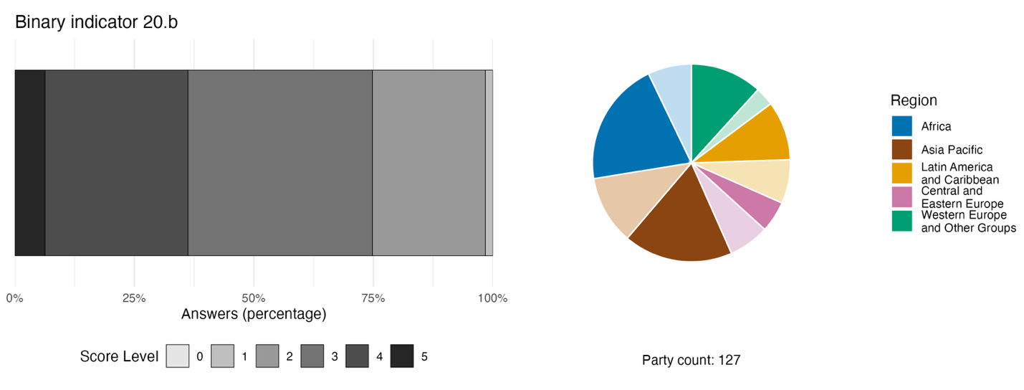
Note: The bar widths show the percentage of Parties in each score category, with higher numbers indicating a greater level of progress, based on responses to the questions included in the indicator.ª The pie chart shows the distribution of Parties providing responses to all questions by region. Colours for each region are defined in the figure legend: darker tones represent the proportion of Parties for any region for which data are included in the graph; lighter tones represent the proportion of Parties for the same region for which no data are included in the graph.
ª The methodology for calculating the score levels for each binary indicator, as well as the questions included for each indicator, are provided in document CBD/COP/16/INF/3/Rev.1.
Figure 83
Percentage of indicators aligned with Target 20 of the Framework that suggest improving, stable and negative trends, respectively
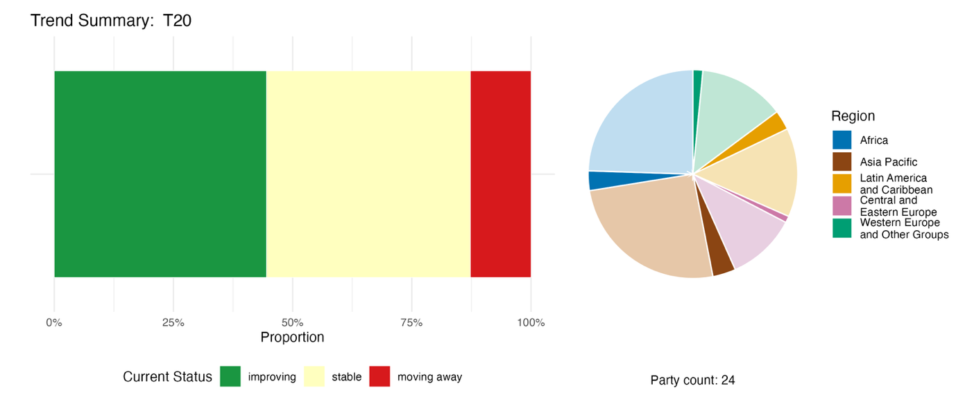
Note: Proportions are weighted by Party. The trends include data for one component, two complementary and 67 national indicators from a total of 24 Parties. The pie chart shows the distribution of Parties submitting indicators for Target 20 by region. Colours for each region are defined in the figure legend: darker tones represent the proportion of Parties for any region for which data are included in the graph; lighter tones represent the proportion of Parties for the same region for which no data are included in the graph.

Self-assessment of progress
Based on self-assessment by Parties in their national reports, nearly half (44 per cent) of national targets submitted with high alignment to Target 20 are on track for achievement, with only slightly over half (51 per cent) showing no significant change or insufficient progress, and three national targets (2 per cent) reported as being achieved early (see figure 84).

Figure 84
Self-assessed progress for all national targets submitted as highly aligned with Target 20 of the Framework
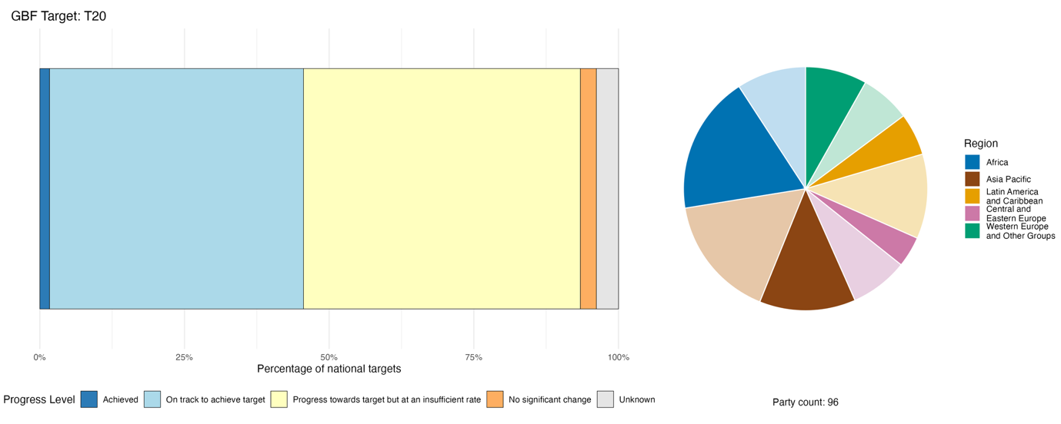
Note: The bar widths show the proportion of national targets submitted in each progress category. Proportions are weighted by Party to ensure that Parties contribute equally to overall assessment of progress, regardless of the number of national targets submitted. The pie chart shows the proportion of Parties in each region reporting in time for consideration in the global report. Colours for each region are defined in the figure legend: darker tones represent the proportion of Parties for any region for which data are included in the graph; lighter tones represent the proportion of Parties for the same region for which no data are included in the graph.

Actions, successes and challenges in implementation

Summary of actions in support of Target 20 of the Framework

Development of research and data infrastructure is the single most prevalent type of action reported in implementation of Target 20, demonstrating a strong overlap with Target 21. Parties report on establishment or strengthening of national biodiversity information systems, contributing species occurrence records to the Global Biodiversity Information Facility (GBIF) and deployment of novel monitoring technologies, including environmental DNA (eDNA), drones, artificial intelligence-enabled camera traps, acoustic sensors and satellite imagery. International cooperation in support of Target 20 is reported across all regions, and ranges from bilateral technology-transfer agreements to multilateral platforms and South-South exchanges (see box 48). Training and capacity-building are reported by nearly all Parties, ranging from large-scale national programmes to targeted specialist training, for example on taxonomy, DNA barcoding techniques and monitoring technologies. Legislative frameworks related to access and benefit-sharing under the Nagoya Protocol and to biosafety under the Cartagena Protocol are also linked to implementation of Target 20.

Examples of success and progress in implementation

Box 48
Subregional cooperation to support implementation of the Framework in southern Africa

In 2025, South Africa officially launched the subregional Technical and Scientific Cooperation Support Centre, hosted by the South African National Biodiversity Institute (SANBI), to meet the implementation needs of nine associated countries in southern Africa.ª Plans for the Centre, part of the technical and scientific cooperation mechanism established by the Conference of the Parties (dec. 15/8 in CBD, 2023; and dec.16/3 in CBD, 2026) include providing a technical help desk for scientific data and tools, conducting capacity needs assessment to inform its work programme up to 2030, convening of regional workshops or learning exchanges, facilitating matchmaking to connect experts for joint research and building strategic partnerships to mobilize resources. The Centre also works to strengthen collaboration between the nine countries involved: Angola, Botswana, Lesotho, Malawi, Mozambique, Namibia, Seychelles, South Africa and Zimbabwe.
Recognizing the resourcing challenges associated with operationalization of the Centre, the Institute issued an expression of interest for partnerships. This process, together with the leveraging of existing partnerships, has opened up opportunities to support the implementation of Target 20. The Centre is also strongly aligned with regional projects and initiatives that contribute to Target 20 implementation.
Among the regional activities led by South Africa is a regional project on spatial biodiversity assessment, prioritization and planning, implemented with Malawi, Mozambique and Namibia.^{b} This five-year project (2022–2027) on building biodiversity knowledge for action in Southern Africa is led by SANBI and is funded by the Agence Française de Développement and the French Global Environment Facility. Under the project, all four countries are working to develop and enhance national spatial biodiversity assessments, prioritization, and planning processes and products. The project involves technical and scientific cooperation to undertake mapping of ecosystem types in order to compile and develop spatial data on terrestrial ecological conditions at both national and regional levels, enhance Red List assessments for both species and ecosystems and identify Key Biodiversity Areas (IUCN, 2016), utilizing these products for prioritization processes through integrated spatial planning and mainstreaming these priorities into key decision-making processes. The project strengthens national knowledge on biodiversity to ensure science-based land-use planning, policy development and decision-making, while providing a baseline for future biodiversity monitoring and supporting each Government’s ability to deliver on commitments under the Framework.

One of the outputs of the regional project is the 2024 update of the Mapping Biodiversity Priorities publication (SANBI and UNEP-WCMC, 2024), a guidance document providing a practical, science-based approach to biodiversity assessment and prioritization, which can be applied at the national level in any country. An introductory e-learning course based on the guide is available on the IUCN Academy platform. Regional and in-country, in-person technical workshops and virtual information sharing sessions are vital capacity-building mechanisms used through the project, and all recordings of the virtual sessions are available for other users via the project and the Centre’s webpages.

Relevant targets: 1, 2, 3, 4, 5, 6, 9, 10, 14, 20 and 21.
Source: South Africa, seventh national report under the Convention.

ª see www.sanbi.org/biodiversity/science-into-policy-action/subregional-technical-support-centre-for-southern-africa/.
^{b} see www.sanbi.org/biodiversity/building-knowledge/biodiversity-monitoring-assessment/the-sbapp-regional-project/.

Challenges

Owing to its cross-cutting scope, Target 20 consolidates and reflects systemic challenges that run throughout the entire Framework. Parties report funding for biodiversity capacity-building is overwhelmingly short-term or project-based, and often externally sourced, meaning that training programmes, monitoring systems and research initiatives are frequently discontinued when individual projects end. Domestic budget allocations for biodiversity research and technology remain insufficient across most reporting Parties, and the lack of sustainable financing mechanisms creates a cycle of dependency on international donors. Compounding this, institutional coordination is weak and mandates are fragmented across multiple government bodies, agencies and academic institutions, leading to duplication of effort, overlapping responsibilities and difficulty consolidating a coherent national agenda for research and implementation. Parties consistently report significant gaps in specialized expertise, particularly in taxonomy, ecological modelling, geographic information systems and data management, alongside limited access to modern monitoring technologies and laboratory infrastructure. Biodiversity data is frequently siloed across institutions without common standards or interoperability, undermining the ability to track progress or inform policy. High staff turnover further erodes institutional memory, meaning skills gained through training are seldom anchored in long-term national systems.

Contributions from actors other than national Governments

Commitments submitted directly through the online reporting tool

Of the 180 commitments submitted by actors other than national Governments, only three are primarily associated with Target 20. These were submitted by two NGOs and one international research institution. One of the submissions is from the international agricultural research network CGIAR, which has made commitments across multiple targets, including design and implementation of training modules for farmers, researchers and practitioners to support agroecosystem planning. The other commitments relating to Target 20 both involve European NGOs and focus on North-South cooperation through partnerships and capacity support for civil society groups in developing countries.

Contributions integrated in national reports

Intergovernmental organizations most commonly serve as financiers and co-implementers of capacity-building programmes, technology-transfer agreements and monitoring infrastructure. Research organizations are the primary actors for knowledge production and biodiversity data infrastructure. These organizations operate data platforms, deliver training and provide science-policy advice. NGOs act as direct implementers, co-managers of protected areas and delivery partners for internationally funded projects. Subnational governments, cities and other local authorities play delivery and co-governance roles. They also have specific capacity-building needs that differ depending on their technical and financial capacity. Citizens contribute through citizen science, and indigenous peoples and local communities as knowledge co-producers and co-managers. Youth and women are most commonly engaged as recipients of capacity-building and training programmes. They are also engaged as knowledge-holders, organizers and designers of these programmes.

Examples of linkages with other agreements, organizations and processes
The NBSAP Accelerator Partnership contributes to capacity-building and technical and scientific cooperation efforts by supporting countries through its MatchMaking Mechanism, Facilitator Programme and knowledge and learning activities. The Partnership is a country-led initiative, presently involving 69 countries, 16 institutions and 45 actors other than national Governments, with a global coordination unit staffed through the Secretariat of the Convention, UNEP and UNDP. The Partnership connects countries with technical expertise, implementation partners and peer-learning opportunities, while promoting North-South, South-South and triangular cooperation to accelerate the implementation of the Framework.

Target 21. Ensure that knowledge is available and accessible to guide biodiversity action

Target text. Ensure that the best available data, information and knowledge, are accessible to decision makers, practitioners and the public to guide effective and equitable governance, integrated and participatory management of biodiversity, and to strengthen communication, awareness-raising, education, monitoring, research and knowledge management and, also in this context, traditional knowledge, innovations, practices and technologies of indigenous peoples and local communities should only be accessed with their free, prior and informed consent, in accordance with national legislation.

Progress overview
Parties are making significant efforts to improve access to and availability of biodiversity data, yet important gaps remain. Most Parties address access to biodiversity data, information and knowledge within national targets, although access to traditional knowledge with free, prior and informed consent is less consistently reflected. With regard to headline indicator 21.1, relatively few Parties currently have the national data needed to implement the monitoring framework. Nevertheless, many improvements in availability of and access to data and knowledge were reported. Self-assessments indicate positive progress towards 43 per cent of associated national targets. Key challenges include addressing data gaps and strengthening communications, including gaps relating to access to traditional knowledge with free, prior and informed consent. Since the availability and accessibility of data, information and knowledge underpin implementation across the Framework, challenges related to Target 21 have cross-cutting implications.

Coverage by Parties of the scope of Target 21 of the Framework in their national targets

Table 45
Elements of Target 21 of the Framework and how they are addressed in national targetsª
Ensure that the best available data is accessible to decision-makers, practitioners and the public | 72
Ensure that the best available information and knowledge is accessible to  decision-makers, practitioners and the public | 71
Strengthen communication, awareness-raising and education | 70
Strengthen monitoring | 46
Strengthen research | 39
Strengthen knowledge management | 43
Ensure that traditional knowledge, innovations, practices and technologies of indigenous peoples and local communities should only be accessed with their free, prior and informed consent | 36
On average, Parties have addressed, to at least some extent, 54 per cent of these elements in their national targets

Note: The right-hand column of the table indicates the percentage of Parties with national targets that address the element to at least some extent.
ª The elements for each target were defined by the Ad Hoc Technical Expert Group on Indicators of the Kunming-Montreal Global Biodiversity Framework (see annex I to CBD/COP/16/INF/4; and Affinito and others, 2025). The detailed methodology for the analysis of national targets is provided in document CBD/SBI/7/INF/22.

A large majority of Parties have national targets addressing, to at least some extent, the elements of Target 21 on ensuring that the best available data (72 per cent), information and knowledge (71 per cent) is accessible to decision-makers, practitioners and the public (see table 45). A large majority of Parties (70 per cent) also have national targets relating to the strengthening of communication, awareness-raising and education. Fewer than half of Parties address the specific elements of Target 21 on strengthening of monitoring (46 per cent), research (39 per cent) and knowledge management (43 per cent) in their national targets. The element of Target 21 addressed by fewest Parties (36 per cent) relates to ensuring that traditional knowledge, innovations, practices and technologies of indigenous peoples and local communities should only be accessed with their free, prior and informed consent.

Indicators of progress
Table 46
Indicator scorecard for Target 21 of the Framework
 | Indicator use |  | Indicator results
Headline indicator 21.1: indicator on biodiversity information for monitoring the Kunming-Montreal Global Biodiversity Framework | 20 per cent of Parties |  | Average: 51 per cent (range: 7–96 per cent)
All quantitative indicators combined | 31 Parties, 24 per cent |  | 46 per cent positive trends  12 per cent negative trends
Note: The colour coding is related to the overall assessment of progress across targets, the methodology of which is explained in the overall summary scorecard (see table 3). The colour coding for indicator data use and all quantitative indicator trends reflects where a value for each target sits relative to the highest and lowest scores achieved across all targets of the Framework (green is assigned to percentage values falling within the top third of the total range, yellow to the middle third and red to the bottom third). Colours for the headline indicator results are based on progress relative to the target (green is assigned when progress is being made, yellow when progress is mixed, red when progress is insufficient and grey when progress cannot be assessed). Note that the percentage of Parties submitting data on headline indicators may be different from that used in the aggregate results for both the headline indicator and all quantitative indicators combined, owing to methodological differences in the way data were used.
Only a few Parties provided comparable data that could be used to compile results for headline indicator 21.1 (indicator on biodiversity information for monitoring the Kunming-Montreal Global Biodiversity Framework) and some Parties noted methodological issues with the indicator or data gaps (see table 46). Many Parties highlighted national efforts to compile and make information accessible and the role of national research institutions and other partners in supporting national biodiversity information systems. Even when they did not report data for the headline indicator itself, many Parties highlighted that biodiversity information is available and that it was used in their national report. Many also noted, however, that national monitoring systems remain in early stages of development and require further institutional strengthening, investment and capacity-building.
As this is a new headline indicator, only one year of data is available from the reporting cycle covered in the present report. Based on the submissions, it appears that relatively few Parties currently have the national data needed to compile results for a large proportion of the headline indicators, and that there are additional gaps in terms of ensuring that traditional knowledge, with free, prior and informed consent, is available for decision-making (see figure 85).
A trend analysis of additional indicators relevant to Target 21, submitted by nearly a quarter of Parties, shows a high proportion of positive trends, suggesting improvements in availability of and access to data and knowledge (see figure 86).
Figure 85
Headline indicator 21.1: indicator on biodiversity information for monitoring the Kunming-Montreal Global Biodiversity Framework
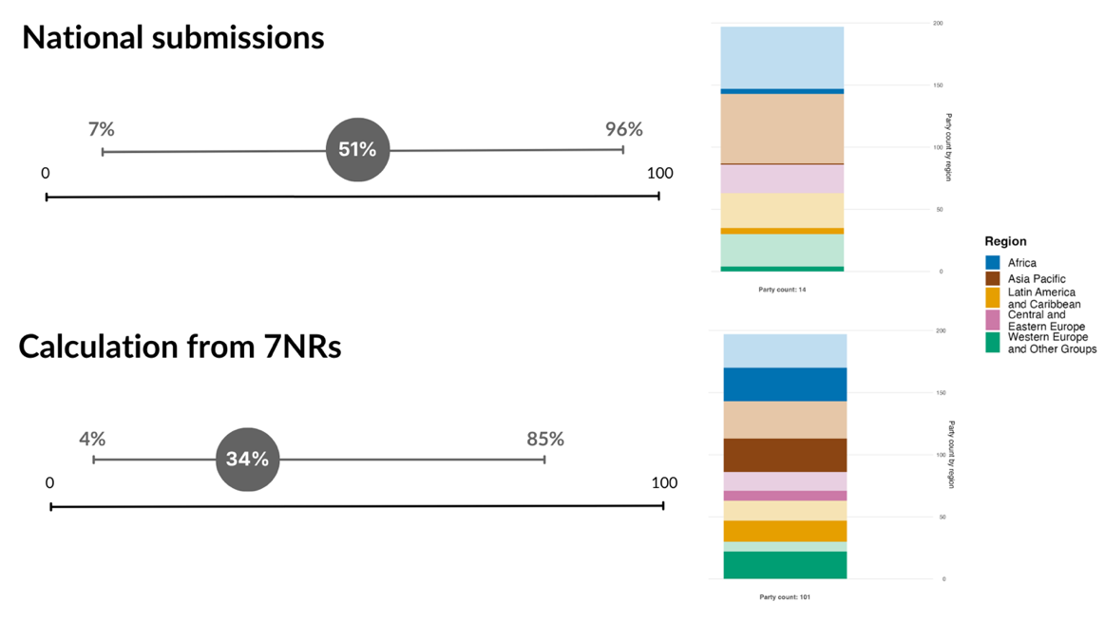
Note: Only data for 2026 are shown owing to the novelty of the indicator. Displayed are the average and range in the percentage of headline indicators compiled by Parties using national data. Top: data only for those Parties that submitted results for the headline indicator; Bottom: data recalculated following the metadata for headline indicator 21.1 for all Parties that submitted results for at least one headline indicator. The bar charts show the distribution of Parties providing data, by region. The colours for each region are defined in the figure legend: darker tones represent the proportion of Parties for any region for which data are included in the graph; lighter tones represent the proportion of Parties for the same region for which no data are included in the graph.

Figure 86
Percentage of indicators aligned with Target 21 of the Framework that suggest improving, stable and negative trends, respectively
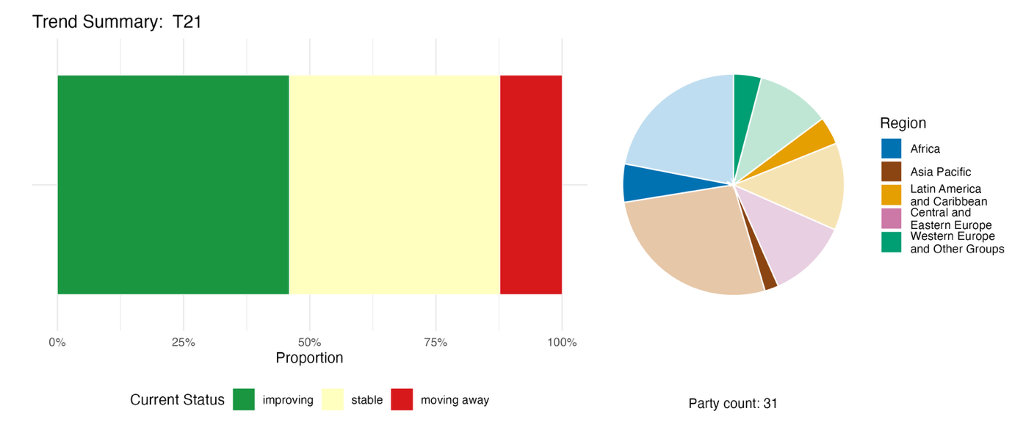
Note: Proportions are weighted by Party. The trends include data for one headline indicator from 15 Parties, and two component, two complementary and 51 national indicators from 19 Parties. The pie chart shows the distribution of Parties submitting indicators for Target 21 by region. Colours for each region are defined in the figure legend: darker tones represent the proportion of Parties for any region for which data are included in the graph; lighter tones represent the proportion of Parties for the same region for which no data are included in the graph.

Self-assessment of progress

Based on self-assessment by Parties in their national reports, 43 per cent of national targets submitted with high alignment to Target 21 are on track for achievement, with a significantly higher number (53 per cent) showing no significant change or insufficient progress (see figure 87 ).

Figure 87
Self-assessed progress for all national targets submitted as highly aligned with Target 21 of the Framework
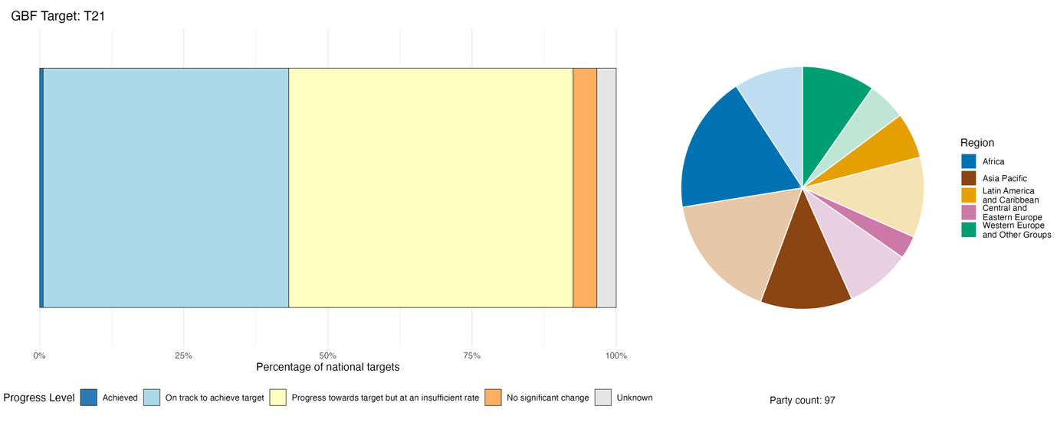
Note: The bar widths show the proportion of national targets submitted in each progress category. Proportions are weighted by Party to ensure that Parties contribute equally to overall assessment of progress, regardless of the number of national targets submitted. The pie chart shows the proportion of Parties in each region reporting in time for consideration in the global report. Colours for each region are defined in the figure legend: darker tones represent the proportion of Parties for any region for which data are included in the graph; lighter tones represent the proportion of Parties for the same region for which no data are included in the graph.

Actions, successes and challenges in implementation

Summary of actions in support of Target 21 of the Framework

The most commonly reported approach to implementation of Target 21 is the establishment, strengthening or operationalization of national biodiversity data infrastructure. This includes actions in relation to national clearing-house mechanisms, national biodiversity information systems and open-access portals often associated with national or regional nodes of the Global Biodiversity Information Facility (GBIF) (see box 49). This pattern is reported across all regions and income groups. Many Parties also report the involvement of citizen science platforms and community-based data collection in national platforms. A significant subset of Parties also report actions to document, register or provide governance models for traditional knowledge (see box 50). Some national reports include descriptions of legal and regulatory frameworks relevant to Target 21, including access and benefit-sharing legislation, data access mandates, open data laws and legal protection of indigenous knowledge. Many Parties report environmental education and public awareness campaigns, biodiversity literacy initiatives and multi-stakeholder dialogues in association with Target 21.

Examples of success and progress in implementation

Box 49
Strengthening environmental knowledge and inclusive governance through national information systems in Mexico
In accordance with the Regional Agreement on Access to Information, Public Participation and Justice in Environmental Matters in Latin America and the Caribbean (Escazú agreement) (Economic Commission for Latin America and the Caribbean (ECLAC), 2018), Mexico has committed to update its National Biodiversity Information Systemª as a public, accessible, up-to-date and reliable repository, taking into account the FAIR (Findable, Accessible, Interoperable and Reusable) and CARE (Collective Benefit, Authority to Control, Responsibility, Ethics) data principles (Carroll and others, 2020; Wilkinson and others, 2016).
Operated by the National Commission for the Knowledge and Use of Biodiversity (CONABIO),^{b} the system collects, generates, organizes, updates and disseminates information on the country’s biological diversity, including flora, fauna, ecosystems, endangered species, invasive species, photographic archives and geospatial data, to support research, conservation and the sustainable use of natural resources.
The system integrates data from more than 1,000 projects and over 1,200 databases and includes several tools, such as the national system for environmental restoration, the agrobiodiversity information system, permanent sites for biodiversity monitoring and the coastal marine information and analysis system. Specific monitoring facilities such as the mangrove monitoring system and the forest fire early warning system facilitate access to information as well as participatory decision-making, and promote a culture of conservation and sustainable use of biodiversity in Mexico. CONABIO also acts as the national node of GBIF, supporting regional and global collaboration on biodiversity data and knowledge exchange.
In parallel, the National Institute of Indigenous Peoples of Mexico designed and launched the National Catalogue of Indigenous and Afro-Mexican Peoples and Communities^{c} in 2024. This constitutes the first public policy instrument to integrate community-level information on territory, culture, identity, collective decision-making bodies and regulatory systems, as well as their economic and social context. The catalogue acts as a central tool for identifying collective legal entities and for planning and decision-making regarding consultation processes, project implementation and the design of culturally relevant public policies, in order to guarantee the exercise of self-determination and autonomy.
Relevant targets: 3, 4, 20, 21 and 22.
Source: Mexico, seventh national report under the Convention.

ªSee www.snib.mx/.
^{b}See www.gob.mx/conabio.
^{c}Available at https://catalogo.inpi.gob.mx/.

Box 50
Documenting indigenous knowledge on reindeer husbandry in Sweden
Sámi reindeer herding communities in Sweden have established a formalized indigenous knowledge repository that mandates open and usable biodiversity knowledge. Developed and managed with technical coordination from the Sámi Parliament, the reindeer husbandry plans organize generations of customary ecological knowledge into standardized, publicly accessible spatial planning materials for boreal mountain ecosystems across northern Sápmi (the traditional territory of the Sámi people). Key stakeholders include Sámi herding villages, local researchers, the Government of Sweden, forestry agencies and mining enterprises. The initiative is continuously updated and applied in ongoing land management procedures.
For centuries, Sámi traditional ecological knowledge about reindeer and local habitats existed only through oral transmission and scattered local records. This fragmented knowledge was rarely accessible to state planners, industrial operators or external conservation practitioners, creating critical information gaps that hindered balanced biodiversity and land-use decision-making. The reindeer husbandry plan framework was created to describe the land use of Sámi communities and to systematize indigenous expertise into retrievable, georeferenced documents, and thus create a greater understanding of the needs of reindeer husbandry among other land-using actors.
Core activities include community-led mapping activities, in which herders decide grazing land division and conduct field inventories. Knowledge such as seasonal grazing zones, flora distributions and culturally vital sites is documented and managed by Sámi communities themselves. A web-based tool has been developed to support these activities. All indigenous observations are compiled into unified archives maintained by the Sámi Parliament. These documents are made available to government bodies, developers and the general public during procedures such as spatial planning, protected area design and impact assessment, forming a recognized official source of local biodiversity data.
The tangible result is that intergenerational indigenous biodiversity knowledge has been transformed into structured, readily accessible information. Planners now integrate Sámi ecological data into national and regional biodiversity monitoring and action plans, addressing data shortages for boreal ecosystem management. The model demonstrates that organized indigenous knowledge repositories can contribute to transparent and inclusive access to biodiversity information that shapes practical conservation and land-use interventions.
Relevant targets: 1, 10, 11, 14, 21 and 22.
Source: Ministry of Climate and Enterprise, Government Offices of Sweden, 2025.

Challenges
Data fragmentation, also referred to as the persistence of “data silos”, is a widely cited challenge in relation to Target 21 implementation. Many Parties in all regions and in all income groups report that biodiversity data is dispersed across institutions, platforms and sectors using incompatible standards. Lack of interoperability between systems is identified as a barrier to timely and consistent use of information in decision-making. Inadequate financing is also reported, with Parties across regions noting the absence of sustained investment to support data systems, capacity building, and long-term monitoring programmes. Limited human and technical capacity for data management, artificial intelligence applications and indicator development is also reported widely as a barrier. The absence or inconsistent application of frameworks for free, prior, and informed consent is a key barrier to implementation in countries with significant populations from indigenous peoples and local communities. Several Parties report that public awareness of biodiversity loss does not match scientific assessments, and a small number report that conflict or crisis has severely disrupted data collection and knowledge management. Parties also highlight the absence of centralized digital platforms and the limited development of artificial intelligence tools as barriers to making biodiversity data accessible and usable for decision-makers.

Contributions from actors other than national Governments

Commitments submitted directly through the online reporting tool

Of 180 substantive commitments submitted by actors other than national governments, ten are primarily associated with Target 21. Seven of these have been submitted by non-governmental organizations, two by youth organizations and one by a research institution. All of the commitments related to data and knowledge, and several involve engagement with youth to promote awareness and knowledge of biodiversity. The geographic coverage spans Europe, Africa, Southeast Asia and the Middle East, and the commitments include support for community-based monitoring and its uptake in national reporting processes.

Contributions integrated in national reports

Knowledge production and data provision are consistently reported as roles for actors other than national Governments, with research organizations generating occurrence records, conducting surveys, and publishing datasets feeding national clearing-house mechanisms and GBIF nodes. Non-governmental organizations and citizen science networks contribute large volumes of species observation data, while indigenous peoples and local communities are knowledge holders, with authority over their knowledge and associated data and, where they so determine, contribute their traditional knowledge to national systems in accordance with free, prior and informed consent. Non-governmental organizations also co-manage protected areas and biodiversity information systems, often as long-term institutional partners, and along with youth and citizens are central to awareness-raising and education. Indigenous peoples and local communities also co-manage protected areas, exercise governance through traditional systems, and participate in access and benefit-sharing frameworks. Subnational governments, cities and other local authorities operate monitoring sites and manage species data within their jurisdictions. Financing is primarily intergovernmental.

Examples of linkages with other agreements, processes and organizations

As noted above, Parties have highlighted the Global Biodiversity Information Facility (GBIF) as a global infrastructure that supports implementation of Target 21 through mobilization of and access to primary data on species occurrences, for use in research and policy and as a data source for a range of indicators within the monitoring framework. GBIF is an intergovernmental collaboration currently bringing together 70 national Governments and 42 international organizations through a voluntary memorandum of understanding, providing free and open access to approximately 3.8 billion species occurrence records shared by over 2,700 institutions worldwide. Providing for the specialist data needs of the marine research and policy communities, the Ocean Biodiversity Information System (OBIS) operates under the International Oceanographic Data and Information Exchange of the Intergovernmental Oceanographic Commission of UNESCO. Among its strategic objectives, OBIS supports evidence-based ocean biodiversity policy, including by aligning data, information products and services with needs related to the Kunming-Montreal Global Biodiversity Framework and the Agreement under the United Nations Convention on the Law of the Sea on the Conservation and Sustainable Use of Marine Biological Diversity of Areas beyond National Jurisdiction. OBIS currently provides access to over 220 million species observations of 207,000 marine species, from 99 countries.
One of the key objectives of the ongoing methodological assessment by IPBES on monitoring biodiversity and nature’s contributions to people (IPBES, 2023c) is to support national and global efforts to monitor progress towards the goals and targets of the Kunming-Montreal Global Biodiversity Framework in support of a balanced and enhanced implementation of the Convention. In that regard, the assessment report, when it is published in 2027, will provide an additional resource for Parties for the implementation of Target 21 and thereby help to address the data and knowledge challenges identified more broadly in the present global report.

Target 22. Ensure participation in decision-making and access to justice and information related to biodiversity for all

Target text. Ensure the full, equitable, inclusive, effective and gender-responsive representation and participation in decision-making, and access to justice and information related to biodiversity by indigenous peoples and local communities, respecting their cultures and their rights over lands, territories, resources, and traditional knowledge, as well as by women and girls, children and youth, and persons with disabilities and ensure the full protection of environmental human rights defenders.

Progress overview

Most Parties have addressed some elements of Target 22, but the scope of the national targets is not well-aligned and data to assess progress remain limited. Progress is being made in strengthening participation, inclusion and rights-based approaches, but monitoring systems remain underdeveloped. Insufficient data were reported to assess trends, and Parties reported methodological, definitional and data challenges. Some Parties reported progress in creating enabling conditions for inclusion and rights-based participation, as well as efforts to ensure representation of indigenous peoples and local communities, women, youth and persons with disabilities and policies related to access to justice. Very few Parties set targets that included the protection of environmental human rights defenders. Self-assessments suggest moderate progress. Key challenges include methodological limitations and insufficient monitoring systems to measure outcomes.

Coverage by Parties of the scope of Target 22 of the Framework in their national targets

Table 47
Elements of Target 22 of the Framework and how they are addressed in national targetsª
Ensure the full, equitable, inclusive, effective and gender-responsive representation and participation in decision-making related to biodiversity by indigenous peoples and local communities | 69
Ensure access to justice related to biodiversity by indigenous peoples and  local communities | 29
Ensure access to information related to biodiversity by indigenous peoples  and local communities | 41
Ensure the full, equitable, inclusive, effective and gender-responsive representation and participation in decision-making related to biodiversity by women and girls | 63
Ensure access to justice related to biodiversity by women and girls | 26
Ensure access to information related to biodiversity by women and girls | 37
Ensure the full, equitable, inclusive, effective and gender-responsive representation and participation in decision-making related to biodiversity by children and youth | 59
Ensure access to justice related to biodiversity by children and youth | 26
Ensure access to information related to biodiversity by children and youth | 38
Ensure the full, equitable, inclusive, effective and gender-responsive representation and participation in decision-making related to biodiversity by persons with disabilities | 50
Ensure access to justice related to biodiversity by persons with disabilities | 24
Ensure access to information related to biodiversity by persons with  disabilities | 36
Ensure the full protection of environmental human rights defenders | 14
Respect the cultures of indigenous peoples and local communities, and their rights over lands, territories, resources and traditional knowledge | 25
On average, Parties have addressed, to at least to some extent, 38 per cent of these elements in their national targets

Note: The right-hand column of the table indicates the percentage of Parties with national targets that address the element to at least some extent.
ª The elements for each target were defined by the Ad Hoc Technical Expert Group on Indicators of the Kunming-Montreal Global Biodiversity Framework (see annex I to CBD/COP/16/INF/4; and Affinito and others, 2025). The detailed methodology for the analysis of national targets is provided in document CBD/SBI/7/INF/22.

There is significant variation in the number of Parties with national targets addressing the four groups specifically referred to in Target 22 and the extent to which each is ensured of representation in decision-making on biodiversity, access to justice and access to information respectively (see table 47). More Parties tend to address representation and participation of indigenous peoples and local communities in their national targets, followed by women and girls, and then children and youth, and finally persons with disabilities receiving the least attention in national targets. Within each of the four groups, the largest proportion of Parties address representation in decision-making on biodiversity, with fewer addressing access to information and the smallest proportion addressing access to justice. Around a quarter of Parties address the need to respect the cultures of indigenous peoples and local communities and their rights over lands, territories, resources and traditional knowledge. The element of the target addressed by fewest Parties (14 per cent) in their national targets is on ensuring the full protection of environmental human rights defenders.

Indicators of progress

Table 48
Indicator scorecard for Target 22 of the Framework
 | Indicator use |  | Indicator results
Headline indicator 22.1: land-use change and land tenure in the traditional territories of indigenous peoples and local communities | 7 per cent of Parties |  | No results: only one Party submitted the indicator fully as described in the metadata
Binary indicator 22.b: number of countries taking action towards the full, equitable, inclusive, effective and gender-responsive representation and participation in decision-making and access to justice and information related to biodiversity by indigenous peoples and local communities, respecting their cultures and their rights over lands, territories, resources and traditional knowledge, as well as by women and girls, children and youth, and persons with disabilities, and the full protection of environmental human rights defenders | 127 Parties | n/aª | 62 per cent of Parties scored highly (score 4 or 5)
All quantitative indicators combined | 19 Parties, 15 per cent |  | 18 per cent positive trends  19 per cent negative trends
Note: The colour coding is related to the overall assessment of progress across targets, the methodology of which is explained in the overall summary scorecard (see table 3). The colour coding for indicator data use and all quantitative indicator trends reflects where a value for each target sits relative to the highest and lowest scores achieved across all targets of the Framework (green is assigned to percentage values falling within the top third of the total range, yellow to the middle third and red to the bottom third). Colours for the binary indicators are based on the percentage of Parties scoring highly (4 or 5) for the indicator overall (green is assigned to values at or above 50 per cent, yellow to values from 25 to 50 per cent and red to values below 25 per cent). Colours for the headline indicator results are based on progress relative to the target (green is assigned when progress is being made, yellow when progress is mixed, red when progress is insufficient and grey when progress cannot be assessed). Note that the percentage of Parties submitting data on headline indicators may be different from that used in the aggregate results for both the headline indicator and all quantitative indicators combined, owing to methodological differences in the way data were used.
ª As binary indicator data are required by the online reporting tool, submission counts for these indicators do not reflect monitoring capacity differences between targets and do not provide actionable information for making progress in implementation, so assessment of indicator use is not relevant.

Only one Party reported on headline indicator 22.1 (land-use change and land tenure in the traditional territories of indigenous peoples and local communities) and only a small proportion (15 per cent) reported on any quantitative indicator for Target 22 (see table 48). The additional indicators submitted by Parties focused mainly on participation, while data on important areas such as access to information, disability inclusion, protection of environmental human rights defenders and land and cultural rights of indigenous peoples and local communities were not reported. The analysis of trends for the quantitative indicators submitted show no overall positive or negative trends and cannot be considered representative of all Parties and all target elements (see figure 90). Parties reported methodological challenges, underdeveloped data collection systems, fragmented land tenure information and legal difficulties in defining traditional territories as some of the constraints.
Data compiled by the World Resources Institute for the LandMark platform, based on data from 2024, show that just over half of territories held or used by indigenous peoples and local communities have legal recognition (for the 102 countries in the database), that around three quarters of indigenous peoples and local communities perceive their tenure as secure (for the 108 countries in the database), and that 95 per cent of land in these territories remains natural (for the 82 countries in the database) (see figure 88) (LandMark, 2024 and 2025).
Regarding the binary indicator for Target 22, many Parties reported progress in creating enabling conditions for inclusion and rights-based participation, efforts to ensure representation of indigenous peoples and local communities, women, youth and persons with disabilities, and policies related to access to justice and protection of environmental human rights defenders. Very few Parties, however, reported progress across all of these areas (see figure 89).

Figure 88
Headline indicator 22.1: land-use change and land tenure in the traditional territories of indigenous peoples and local communities (from the LandMark platform)
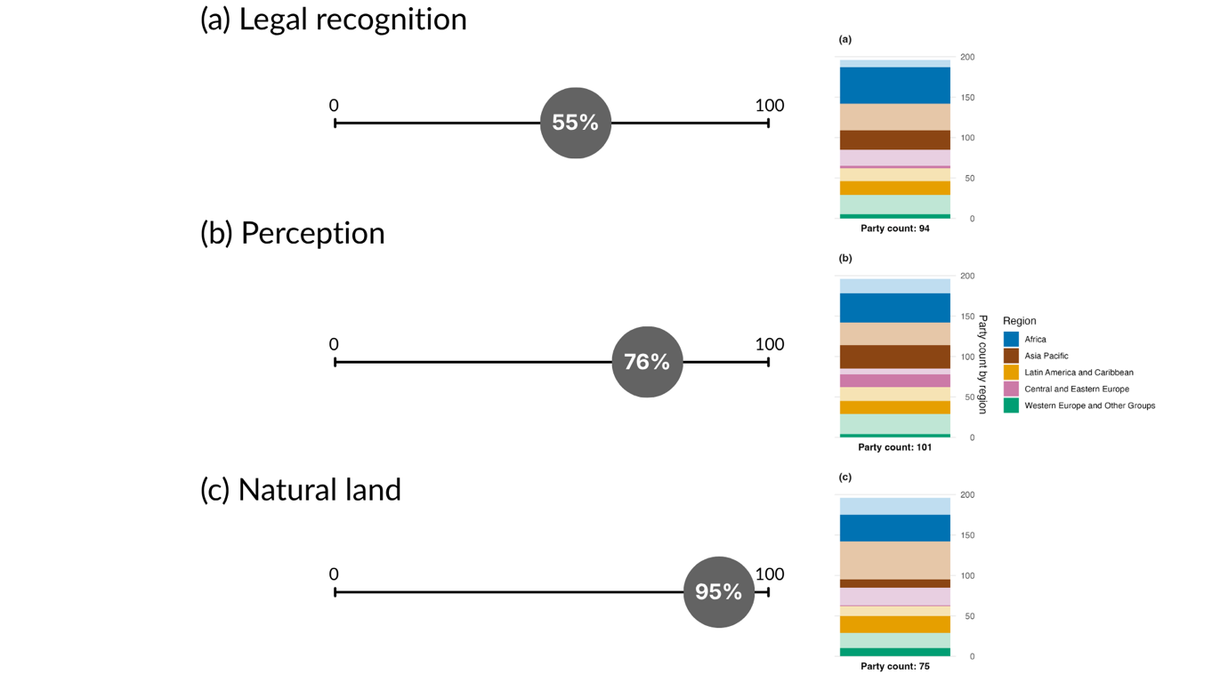
Note: Based on data from the LandMark platform of the World Resource Institute (LandMark, 2024, 2025; Potapov and others, 2024; Prindex, 2024). Each value represents a different dimension of the relation between indigenous peoples and local communities and their traditional territories. Note that not all dimensions represent the same number of Parties, owing to data availability, so they cannot be directly compared. Each dimension is shown as an average of all Parties. The bar charts show the distribution of Parties for whom data is available, by region. Colours for each region are defined in the figure legend: darker tones represent the proportion of Parties for any region for which data are included in the graph; lighter tones represent the proportion of Parties for the same region for which no data are included in the graph.

Figure 89
Binary indicator 22.b: number of countries taking action towards the full, equitable, inclusive, effective and gender-responsive representation and participation in decision-making and access to justice and information related to biodiversity by indigenous peoples and local communities, respecting their cultures and their rights over lands, territories, resources and traditional knowledge, as well as by women and girls, children and youth, and persons with disabilities, and the full protection of environmental human rights defenders
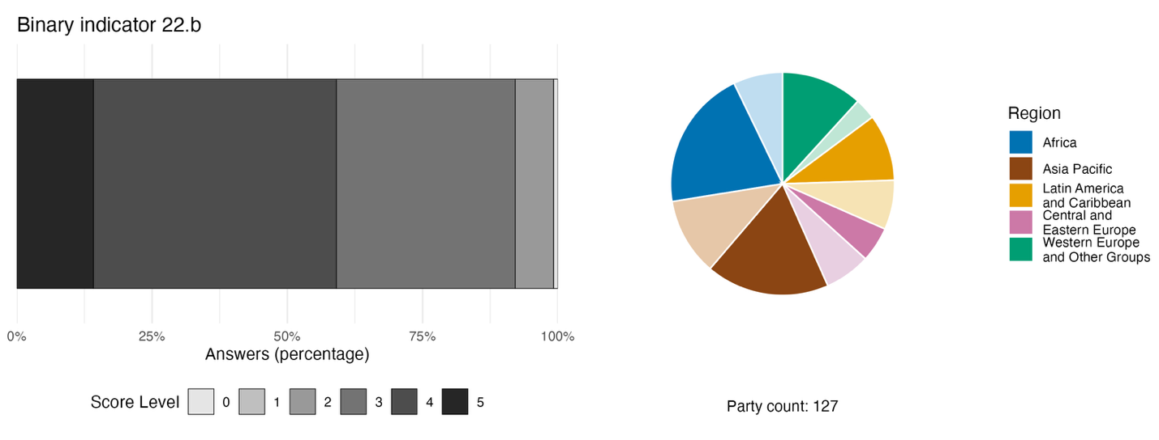
Note: The bar widths show the percentage of Parties in each score category, with higher numbers indicating a greater level of progress, based on responses to the questions included in the indicator.ª The pie chart shows the distribution of Parties providing responses to all questions by region. Colours for each region are defined in the figure legend: darker tones represent the proportion of Parties for any region for which data are included in the graph; lighter tones represent the proportion of Parties for the same region for which no data are included in the graph.
ª The methodology for calculating the score levels for each binary indicator, as well as the questions included for each indicator, are provided in document CBD/COP/16/INF/3/Rev.1.

Figure 90
Percentage of indicators aligned with Target 22 of the Framework that suggest improving, stable and negative trends, respectively
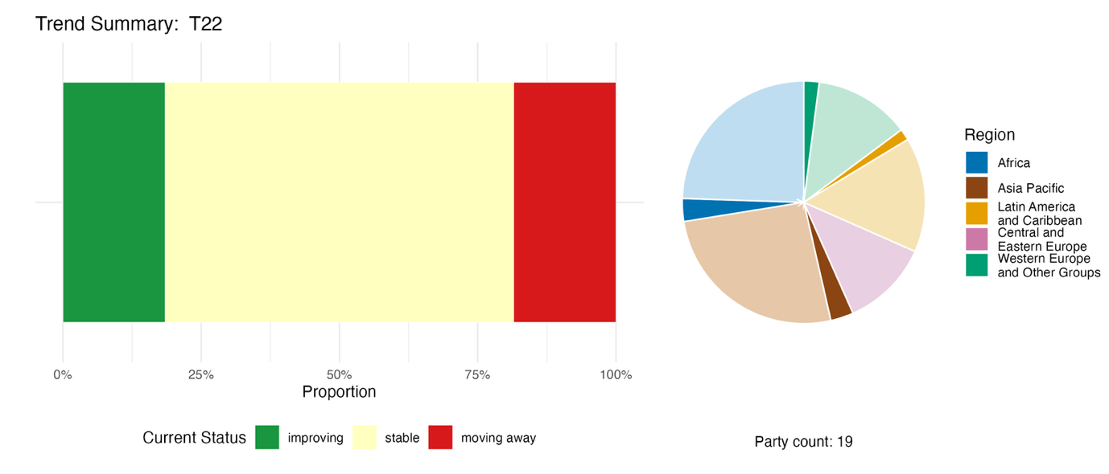
Note: Proportions are weighted by Party. The trends include data for one headline indicator from four Parties, and one component, four complementary and 39 national indicators from 18 Parties. The pie chart shows the distribution of Parties submitting indicators for Target 22 by region. Colours for each region are defined in the figure legend: darker tones represent the proportion of Parties for any region for which data are included in the graph; lighter tones represent the proportion of Parties for the same region for which no data are included in the graph.

Self-assessment of progress
Based on self-assessment by Parties in their national reports, a relatively high proportion (42 per cent) of national targets submitted as highly aligned with Target 22 are on track for achievement, though a higher proportion (55 per cent) show no significant change or insufficient progress, and just one national target (0.2 per cent) was reported as already achieved (see figure 91).

Figure 91
Self-assessed progress for all national targets submitted as highly aligned with Target 22 of the Framework
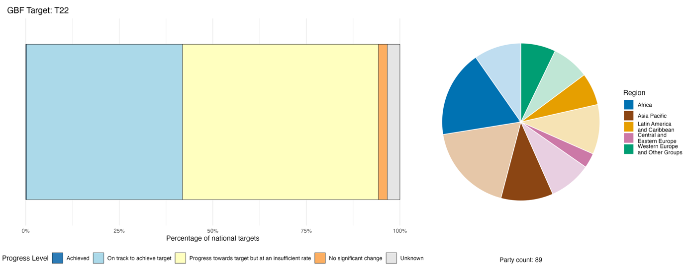
Note: The bar widths show the proportion of national targets submitted in each progress category. Proportions are weighted by Party to ensure that Parties contribute equally to overall assessment of progress, regardless of the number of national targets submitted. The pie chart shows the proportion of Parties in each region reporting in time for consideration in the global report. Colours for each region are defined in the figure legend: darker tones represent the proportion of Parties for any region for which data are included in the graph; lighter tones represent the proportion of Parties for the same region for which no data are included in the graph.

Actions, successes and challenges in implementation

Summary of actions in support of Target 22 of the Framework

The most commonly reported approach to implementing Target 22 is through institutionalized participatory governance: the creation or formalization of multi-stakeholder bodies, consultation processes and co-management arrangements that give indigenous peoples and local communities, women, youth and other groups a formal role in biodiversity decision-making. A second dominant approach is through legal and regulatory reform, in particular ratification or domestic implementation of regional agreements such as the Escazú Agreement in Latin America and the Caribbean (Economic Commission for Latin America and the Caribbean (ECLAC), 2018), and the Convention on Access to Information, Public Participation in Decision-Making and Access to Justice in Environmental Matters (Aarhus Convention) in Europe and Central Asia (ECE, 1998). Many Parties have enacted or are enacting legislation that creates procedural rights to information, participation and access to justice in environmental matters. Gender mainstreaming in biodiversity governance (see also Target 23) is reported in several regions as a contribution towards Target 22. Actions specific to indigenous peoples and local communities include recognition of customary governance, documentation of traditional knowledge and territorial rights. Such governance systems may include sacred territories, community-managed areas and traditional institutions that maintain biocultural practices (see boxes 51 and 52). Only a handful of Parties report on concrete mechanisms for the protection of environmental human rights defenders.

Examples of success and progress in implementation

Box 51
Rākau Rangatira indigenous-government partnership for the protection of Kauri forests in New Zealand
The Department of Conservation of New Zealand has partnered with Te Iwi O Te Roroa (Māori governance entity) to protect the endemic kauri trees (Agathis australis) of Waipoua Forest from the spread of kauri dieback disease (Phytophthora agathidicida) by upgrading visitor infrastructure. The disease has been detected within 60 metres of the sacred Tāne Mahuta tree. The Department and Te Roroa jointly designed a raised boardwalk, bridge and viewing platform to minimize the environmental impact from 200,000 annual visitors. Te Roroa provided cultural leadership throughout, with their Kauri Ora teams involved in construction and monitoring. The project integrates rongoā Māori (traditional treatments) alongside Western science for disease management.
Phase one was completed in December 2024 with a karakia (prayer) and blessing from Te Roroa. Phase two (March to October 2026) involves the building of a new boardwalk and reopening of the Four Sisters, a landmark featuring four tall kauri trees. Future phases aim to explore regenerative tourism using an approach that puts forest health first.
The project addresses Target 22 by ensuring the full participation of Te Iwi O Te Roroa in biodiversity decision-making, respecting their culture and rights over lands, territories, resources and traditional knowledge. Te Roroa exercises kaitiakitanga (guardianship) over their ancestral lands through cultural leadership and traditional knowledge integration.
Relevant targets: 1, 2, 6, 11, 12, 19 and 22.
Source: New Zealand, seventh national report under the Convention.

Box 52
Union of Indigenous Peoples “SOYUZ”: disaggregated data collection for monitoring and reporting in the Russian Federation
Organizations of indigenous peoples in Russia, under the leadership of the Russian Association of Indigenous Peoples of the North, have implemented a system for collecting indicators for monitoring and reporting purposes. The indicator collection system aims to improve capacity to assess the effectiveness of biodiversity conservation, sustainable use and ecosystem restoration measures in traditional lands of indigenous peoples and local communities. Indicators were suggested for incorporation into State-disaggregated data collection, monitoring and statistics, including those that take into account traditional knowledge. The proposal embraces 80 universal and measurable locally and culturally relevant indicators. These include indicators related to the use of biodiversity in traditional lands of indigenous peoples and local communities. In a number of regions, there are registries and monitoring systems that incorporate traditional practices. In the Yamalo-Nenets Autonomous District, a unified system for modelling and monitoring the socioeconomic development of indigenous peoples is in operation. This system collects and disaggregates data on nomadic reindeer herders, as well as information on reindeer migration routes and nomadic families.

Relevant targets: 21 and 22.
Source: SOYUZ, 2025.

Challenges

Multiple Parties report on the inability to track progress towards Target 22 due to the absence of disaggregated data covering the groups of society specified in the target. Many also point to the gap between enacting laws relating to representation and participation in decision-making and effective enforcement or operationalization to ensure access to justice. Several Parties highlight the absence of any mechanisms to protect environmental human rights defenders. Some Parties note that participation of diverse groups does not necessarily translate to decision-making power and that it is often tokenistic or non-binding. Furthermore, a few Parties note that participation mechanisms are often project-based, periodic or consultative rather than embedded in stable governance structures. Very few Parties report any concrete actions targeting people with disabilities. In general, actions to increase participation are also limited by inadequate financial resources. The absence or inconsistent application of frameworks for free, prior and informed consent is a key barrier to implementation in countries with significant populations of indigenous peoples and local communities. The lack of reporting on headline indicator 22.1 or other indicators for this target represents a gap in the ability to monitor progress. Additional challenges in monitoring Target 22 include fragmented data and information systems, issues related to data sovereignty and interoperability, and limited registration of customary and collective land tenure.

Contributions of actors other than national Governments

Commitments submitted directly through the online reporting tool

Of the 180 substantive commitments submitted by actors other than national Governments, 14 are primarily associated with Target 22, making it among the targets with the highest number of such commitments. Of those commitments, 10 were submitted by NGOs, three by youth organizations and one by a research institution. All of the commitments relate to participation and inclusion in biodiversity governance and actions, including by indigenous peoples and local communities, women and youth, with a strong focus on applying a human rights-based approach to implementation of the Framework (see box 53).

Box 53
Applying a human rights-based approach to biodiversity conservation in Kenya
The Economic and Social Rights Centre, known as Hakijamii, is a Nairobi-based NGO operating nationally across Kenya. Its commitment to empowering indigenous peoples and local communities for rights-based biodiversity and climate action focuses on six ecosystem types: savanna and rangeland ecosystems, including Maasai rangelands in the Narok landscape, freshwater ecosystems, including Lake Nakuru and associated wetlands, forest ecosystems, including community and dryland forests, coastal and marine ecosystems, including mangroves in Mombasa County, urban and peri-urban green spaces in Nairobi and Kisumu, and dryland and arid ecosystems. Hakijamii aims to train at least 1,000 individuals from indigenous peoples and local communities, with a minimum of 50 per cent women and 30 per cent youth and with a focus on biodiversity rights, ecosystem-based management and climate finance by 2030. The commitment is also to achieve a minimum 30 per cent average increase in meaningful participation of these communities in county and national biodiversity governance processes. Specific actions include capacity-building on biodiversity rights; strengthening community governance institutions, including community forest associations, councils of elders and land management committees; facilitating structured dialogue between communities and government and conservation actors; and integrating traditional knowledge into biodiversity monitoring and reporting. Progress is tracked quarterly through newsletters and social media and annually through internal performance reviews, with partners including local governments across Nakuru, Narok, Isiolo, Kisumu, Mombasa and Nairobi.

Relevant targets: 14, 22 and 23.
Source: Hakijamii, stakeholder commitment (see https://ort.cbd.int/database/293963).

Contributions integrated in national reports

Co-management and co-governance represent a substantive role reported for actors other than national Governments with regard to the implementation of Target 23. Indigenous peoples and local communities, representatives of sectors related to or dependent on biodiversity, subnational governments, cities and other local authorities and NGOs hold formal authority over, for example, protected areas and marine resources. These actors are reported to exercise operational control over matters such as wildlife quotas and benefit distribution. Implementation delivery is frequently reported for NGOs and intergovernmental organizations as primary or co-primary implementers of biodiversity programmes. Monitoring and enforcement engage women-led groups, community rangers and NGOs through citizen science platforms, community surveillance committees and pollution monitoring. Knowledge provision and traditional knowledge integration is reported for indigenous peoples and local communities, research organizations and representatives of sectors related to or dependent on biodiversity, who co-produce biodiversity data and integrate traditional knowledge with scientific knowledge. Governance participation and advocacy involve youth, women, indigenous peoples and local communities and NGOs in formal governance bodies and legislative processes.

Examples of linkages with other agreements, processes and organizations

In the Minamata Convention on Mercury, the particular vulnerabilities of indigenous peoples and local communities and women and children are recognized because of their exposure to mercury, the biomagnification of mercury and the contamination of traditional foods. The Conference of the Parties to the Convention has taken several decisions and steps to broaden the participation of indigenous peoples and local communities in the implementation of projects and programmes under the Convention. As noted in the summary for Target 7 above, the Conference of the Parties has recognized the impacts of mercury use in artisanal and small-scale gold mining, and has encouraged Parties and others to engage with indigenous peoples and local communities in decision-making processes regarding such mining, in order to protect and strengthen the traditional livelihoods and cultural practices of indigenous peoples and local communities and, where appropriate, to develop and promote alternative, sustainable economic activities, as well as to work with their respective indigenous peoples and local communities with regard to their needs and priorities in relation to the use of mercury in artisanal and small-scale gold mining (Minamata Convention on Mercury, 2025b).
The focus of the International Whaling Commission on sustainable aboriginal subsistence whaling includes recognition that the full participation and cooperation of affected peoples are essential to facilitate appropriate management measures, aligning the Commission’s focus with the principles of Target 22 of the Framework. For example, the Commission’s Aboriginal Subsistence Whaling Subcommittee works directly with hunters and their government representatives in the management of strike limits (the maximum number of whales that hunters may strike with a whaling weapon), ensuring all voices are heard. A new method for the automatic extension of catch and strike limits was designed in conjunction with hunting communities and adopted by the Commission in 2022. In 2024, this led to quotas being renewed by consensus, having met the specific conditions established by this new method (IWC, 2025).

Target 23. Ensure gender equality and a gender-responsive approach to biodiversity action
Target text. Ensure gender equality in the implementation of the Framework through a gender-responsive approach, where all women and girls have equal opportunity and capacity to contribute to the three objectives of the Convention, including by recognizing their equal rights and access to land and natural resources and their full, equitable, meaningful and informed participation and leadership at all levels of action, engagement, policy and decision-making related to biodiversity.

Progress overview
Progress towards gender-responsive biodiversity governance is advancing, but implementation remains at an early stage. Significant gaps remain between national targets and the full scope of Target 23, particularly regarding the rights and access of women and girls to land and natural resources. Binary indicator reporting suggests that implementation is at an early stage for many Parties in monitoring, enabling informed participation and leadership, and applying gender-responsive approaches. Self-assessments indicate some positive progress, although more than half of highly aligned national targets remain off track. Key challenges include policy implementation gaps, limited measurement systems, a lack of sex-disaggregated data and incomplete coverage of target elements. There is a link between the implementation of this target and national implementation of the Gender Plan of Action (2023–2030) (dec. 15/17 in CBD, 2023).

Coverage by Parties of the scope of Target 23 of the Framework in their national targets

Table 49
Elements of Target 23 of the Framework and how they are addressed in national targetsª
Ensure gender equality in the implementation of the Framework through a gender-responsive approach | 63
Recognize the equal rights of women and girls to land and natural resources | 28
Recognize the equal access of women and girls to land and natural  resources | 25
Ensure full, equitable, meaningful, and informed participation and leadership of women and girls at all levels of action, engagement, policy and decision-making related to biodiversity | 57
On average, Parties have addressed, to at least some extent, 43 per cent of these elements in their national targets

Note: The right-hand column of the table indicates the percentage of Parties with national targets that address the element to at least some extent.
ª The elements for each target were defined by the Ad Hoc Technical Expert Group on Indicators of the Kunming-Montreal Global Biodiversity Framework (see annex I to CBD/COP/16/INF/4; and Affinito and others, 2025). The detailed methodology for the analysis of national targets is provided in document CBD/SBI/7/INF/22.

Target 23 is composed of four distinct elements (see table 49). A majority of Parties have national targets addressing the need to ensure gender equality in implementation of the Framework through a gender responsive approach (63 per cent) and to ensure full, equitable, meaningful and informed participation and leadership of women and girls at all levels of action, engagement, policy and decision-making related to biodiversity (57 per cent). Far fewer Parties address the recognition of the equal rights (28 per cent) and access (25 per cent) of women and girls to land and natural resources.
There are significant gaps in the scope of national targets in relation to the four target elements included in Target 23, in particular with regard to the rights and access of women and girls to land and natural resources.

Indicators of progress
Table 50
Indicator scorecard for Target 23 of the Framework
 | Indicator use |  | Indicator results
Binary indicator 23.b: number of countries with legal, administrative or policy frameworks, inter alia, to implement the Gender Plan of Action (2023–2030), to ensure that all women and girls have equal opportunity and capacity to contribute to the three objectives of the Convention, including by ensuring women’s equal rights and access to land and natural resources | 127 Parties | n/aª | 49 per cent of Parties scored highly (score 4 or 5)
Quantitative indicators combined | 17 Parties, 13 per cent |  | 12 per cent positive trends  21 per cent negative trends
Note: The colour coding is related to the overall assessment of progress across targets, the methodology of which is explained in the overall summary scorecard (see table 3). The colour coding for indicator data use and all quantitative indicator trends reflects where a value for each target sits relative to the highest and lowest scores achieved across all targets of the Framework (green is assigned to percentage values falling within the top third of the total range, yellow to the middle third and red to the bottom third). Colours for the binary indicators are based on the percentage of Parties scoring highly (4 or 5) for the indicator overall (green is assigned to values at or above 50 per cent, yellow to values from 25 to 50 per cent and red to values below 25 per cent).
ª As binary indicator data are required by the online reporting tool, submission counts for these indicators do not reflect monitoring capacity differences between targets and do not provide actionable information for making progress in implementation, so assessment of indicator use is not relevant.

The monitoring framework does not include a headline indicator specific to Target 23.
Around half of Parties reported low scores for the binary indicator for Target 23, indicating that those Parties are in the early stages of development and implementation of legal, administrative or policy frameworks that support the target (see table 50).
Where progress is being made, Parties more commonly report measures to recognize and protect the rights of women and girls, including their access to land and natural resources. Weaker progress is evident, however, in areas related to monitoring, enabling informed participation and leadership, and applying gender-responsive approaches to implementation. Overall, the binary indicator results suggest that Target 23 remains at an early stage of delivery, with substantial gaps in both policy implementation and measurement (see figure 92).
A small proportion of Parties (13 per cent) submitted data for relevant national, component or complementary indicators. More of these indicators have negative trends than positive ones, but owing to data gaps these cannot be considered representative of all Parties (see figure 93).

Figure 92
Binary indicator 23.b: number of countries with legal, administrative or policy frameworks, inter alia, to implement the Gender Plan of Action (2023–2030), to ensure that all women and girls have equal opportunity and capacity to contribute to the three objectives of the Convention, including by ensuring women’s equal rights and access to land and natural resources
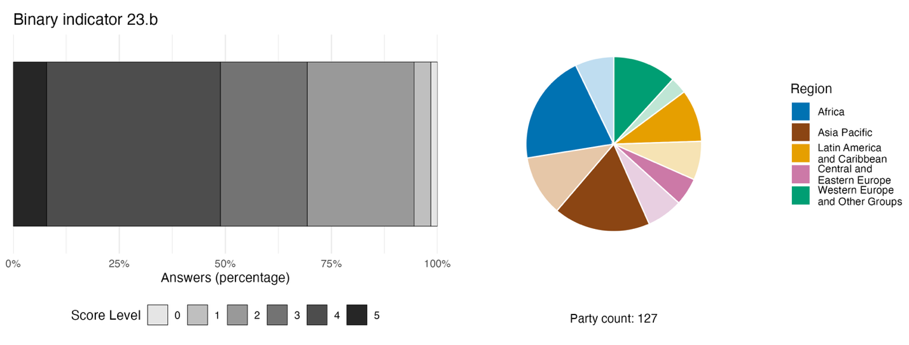
Note: The bar widths show the percentage of Parties in each score category, with higher numbers indicating a greater level of progress, based on responses to the questions included in the indicator.ª The pie chart shows the distribution of Parties providing responses to all questions by region. Colours for each region are defined in the figure legend: darker tones represent the proportion of Parties for any region for which data are included in the graph; lighter tones represent the proportion of Parties for the same region for which no data are included in the graph.
ª The methodology for calculating the score levels for each binary indicator, as well as the questions included for each indicator, are provided in document CBD/COP/16/INF/3/Rev.1.

Figure 93
Percentage of indicators aligned with Target 23 of the Framework that suggest improving, stable and negative trends, respectively
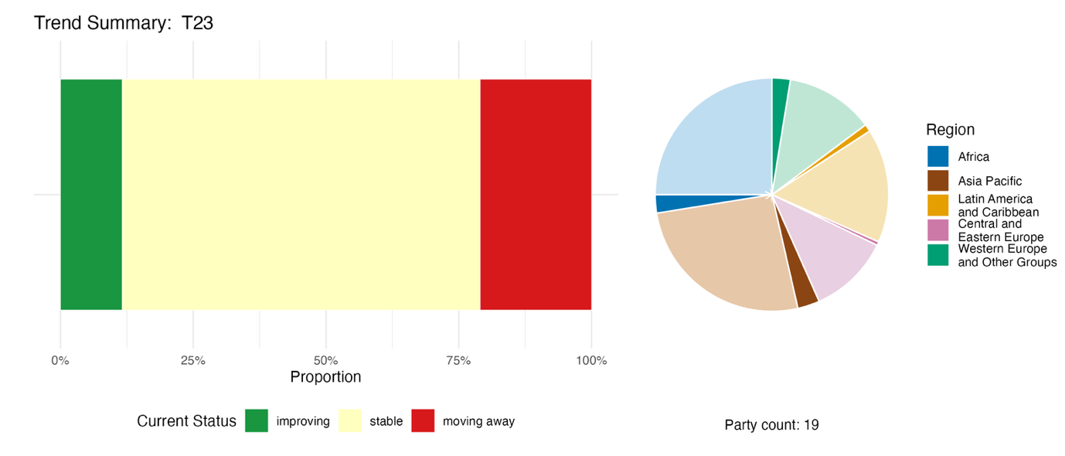
Note: Proportions are weighted by Party. The trends include data for two component, three complementary and 29 national indicators from 19 Parties. The pie chart shows the distribution of Parties submitting indicators for Target 23 by region. Colours for each region are defined in the figure legend: darker tones represent the proportion of Parties for any region for which data are included in the graph; lighter tones represent the proportion of Parties for the same region for which no data are included in the graph.

Self-assessment of progress
Based on self-assessment by Parties in their national reports, 41 per cent of national targets submitted as highly aligned with Target 23 are on track for achievement, with a larger number (54 per cent) showing no significant change or insufficient progress, and just two national targets (1 per cent) reported as already achieved (see figure 94).

Figure 94
Self-assessed progress for all national targets submitted as highly aligned with Target 23 of the Framework
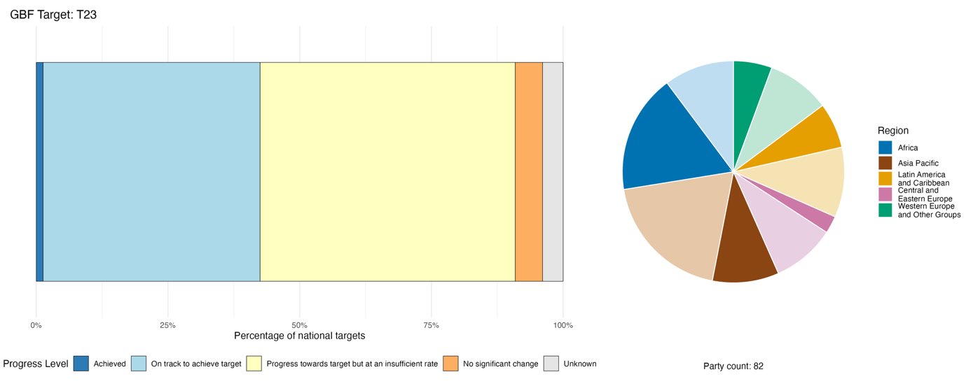
Note: The bar widths show the proportion of national targets submitted in each progress category. Proportions are weighted by Party to ensure that Parties contribute equally to overall assessment of progress, regardless of the number of national targets submitted. The pie chart shows the proportion of Parties in each region reporting in time for consideration in the global report. Colours for each region are defined in the figure legend: darker tones represent the proportion of Parties for any region for which data are included in the graph; lighter tones represent the proportion of Parties for the same region for which no data are included in the graph.

Actions, successes and challenges in implementation

Summary of actions in support of Target 23 of the Framework

The most widespread action reported in support of Target 23 is ensuring or promoting participation of women in biodiversity-related governance, planning and management processes, often combined with capacity-building. This ranges from formal quota mechanisms to training programmes and consultative processes. Many Parties report integrating gender considerations into NBSAPs, sectoral plans or cross-government frameworks. A significant number of Parties have adopted formal representation quotas or targets for women in biodiversity governance bodies. Several Parties report on livelihood programmes, grant schemes and other initiatives specifically targeted at women or with women accounting for the majority of recipients (see boxes 54 and 55).

Examples of success and progress in implementation

Box 54
Supporting women’s entrepreneurship in agroecology and sustainable use of natural resources in Tunisia
Tunisia’s Raïdet programme, launched by the Ministry of Women, Family, Children and Seniors in 2022, has funded more than 3,600 women-led projects, contributing to the creation of nearly 6,000 jobs. The programme specifically supports activities related to agroecology, the sustainable use of natural resources and rural crafts, while simultaneously supporting the local economy by creating jobs and preserving local knowledge and traditions.
The programme aims to support women's entrepreneurship, particularly that of innovative women and girls in promising sectors across all governorates, in priority areas and in densely populated working-class neighborhoods, in addition to supporting special projects targeting specific groups of women in vulnerable situations.
Raïdet helps to achieve the objectives of the national target of Tunisia of ensuring the right of gender-diverse and vulnerable groups to participate in the development of biodiversity policies and ensure their access to resources and decision-making processes regarding climate change and other economic sectors related to biodiversity and to provide training in these areas.
Relevant targets: 5, 9, 10, 11, 19, 22 and 23.
Source: Tunisia, seventh national report under the Convention.

Box 55
Customary governance recognition and women’s social forestry rights in Indonesia

Indonesia has been advancing gender equality in biodiversity governance by granting social forestry management approvals to female-headed households. An example is the Mangroves for Coastal Resilience initiative, which demonstrated that gender-inclusive costal restoration can deliver dual gains for biodiversity and socioeconomic resilience. The initiative was launched by the Ministry of Finance of Indonesia and implemented in the village of Kuala Selat in the Indragiri Hilir Regency of Riau Province, with local women and the Forest Farmers Group (Kelompok Tani Hutan) serving as core participants.
Long-term coastal abrasion has severely degraded mangrove ecosystems and threatened local livelihoods and community resilience in Kuala Selat. Meanwhile, local women are traditionally confined to domestic work and excluded from natural resource management and related decision-making. To reverse ecosystem degradation and advance gender equality, the Mangroves for Coastal Resilience initiative engaged local women in the full workflow of mangrove conservation, including mangrove seedling preparation, planting, maintenance and ecological monitoring. Female leadership in the Forest Farmers Group has also opened up opportunities for economic empowerment through processing local products, especially marine and mangrove products, and providing conservation-related livelihoods such as tourism.
In 2024, a total of 378 women in Riau Province took an active part in mangrove planting and management. The initiative is continuing, with a goal of restoring mangrove ecosystems across broader coastal areas by 2027. This is expected to encourage more women to move beyond traditional domestic roles and contribute to nature conservation. Through this initiative, traditional livelihoods are protected and new livelihoods created, and women are obtaining equal access to coastal natural resources and a meaningful voice in local biodiversity decision-making.
Relevant targets: 1, 2, 4, 5, 9, 10, 11, 22 and 23.
Source: Indonesia, seventh national report under the Convention.

Challenges

Multiple Parties acknowledge that the formal participation of women does not translate into substantive decision-making authority for women or their involvement in biodiversity-related financial governance. There is a need to promote gender-responsive approaches within biodiversity-related financial governance, including public financial management, fiscal policy, financial regulation and other financial decision-making processes that influence biodiversity outcomes. Even where gender strategies or plans have been adopted, implementation is often slow or absent. Many Parties report that gender focal points or units lack dedicated budgets, staff or institutional authority. In some cases, gender mainstreaming, where it exists, is often project-specific and ad hoc rather than embedded in institutions, policies and planning processes as a matter of course. Several national reports include discussion of structural barriers affecting participation by women, including care responsibilities and patriarchal norms, especially for women from indigenous peoples and local communities or from vulnerable groups. In addition, women’s organizations often lack funding for contributing to the Framework. A few Parties report that the limited ownership by women of land and natural resources further undermines their standing in conservation decision-making. Several Parties acknowledge a complete absence of action in relation to Target 23. The absence of sex-disaggregated data and gender-specific biodiversity indicators makes it difficult to track trends, creating a monitoring gap.

Contributions from actors other than national Governments

Commitments submitted directly through the online reporting tool

Of the 180 commitments submitted by actors other than national Governments, eight are primarily associated with Target 23. Four of these have been submitted by NGOs, three from the CBD Women’s Caucus (see box 56) and one from the CGIAR agricultural research network. The geographic scope of the commitments range across Africa, Asia, South America and Europe.

(II.B.23-NSA-WOMENS_CAUCUS): The CBD Women's Caucus strengthening women's leadership in implementation of the Framework

Box 56
The CBD Women's Caucus: strengthening women's leadership in implementation of the Framework

The CBD Women's Caucus represents over 800 organizations and individuals across 137 countries. The Caucus consolidates the Gender and Biodiversity National Focal Points Network as a sustained coordination mechanism among officially designated national gender focal points for the Convention. The Caucus addresses structural gaps in peer exchange and coherence across regions in implementing Target 23 and the Gender Plan of Action (2023–2030). The commitment focuses on systematically strengthening the leadership, negotiating capacity, technical expertise and meaningful participation of women and girls in all their diversity, including those within indigenous peoples and local communities, in the implementation and monitoring of the Framework, and addressing structural inequality in decision-making access and financial barriers to participation. The Caucus is also active in advancing gender-responsive monitoring, reporting and accountability mechanisms through the systematic promotion of sex-disaggregated data, gender-sensitive indicators and community-generated evidence to support measurable and accountable implementation.
Relevant targets: 20, 22 and 23.
Sources: CBD Women’s Caucus, stakeholder commitments (see https://ort.cbd.int/database/287720; https://ort.cbd.int/database/287718; and https://ort.cbd.int/database/287719).

Contributions integrated in national reports

Among actors other than national Governments, NGOs are commonly reported in the role of delivery of implementation of Target 23, while intergovernmental organizations serve as co-implementers. Multilateral funds and bilateral agencies help to finance and co-deliver gender-responsive biodiversity programmes. Co-management and governance roles are reported for indigenous peoples and local communities, subnational governments, cities and other local authorities, representatives of sectors related to or dependent on biodiversity, and women's groups. Such roles include membership of management boards, co-design of conservation plans and exercise of customary governance authority, with women's mandated representation on co-management committees backed by law in several Parties. Financing is a distinctive role for intergovernmental organizations and, to a lesser extent, the business and finance community, drawing on multilateral funds and bilateral agencies as well as more innovative but limited private finance mechanisms. Knowledge provision and monitoring are reported for research organizations, indigenous peoples and local communities, and youth, who generate biodiversity baselines, develop gender-responsive evaluation tools, co-produce citizen science data, and contribute traditional knowledge to governance instruments. Awareness-raising and capacity-building are the most commonly reported roles for citizens and the public, youth, and women and girls. Advocacy and accountability roles are reported for NGOs, youth organizations and international women's networks, including formal participation in the Convention’s negotiations and international policy processes.

Examples of linkages with other agreements, processes and organizations

Gender inequalities in relation to chemicals and waste management significantly affect women's health, decision-making power and economic opportunities. At the same time, women possess valuable knowledge and expertise that can drive more effective and fairer chemical and waste management operations. In recognition of these factors, the Basel, Rotterdam and Stockholm Conventions promote gender equality in chemicals and waste management through their Gender Action Plan for 2025–2035. This includes collecting gender-disaggregated data to guide policies, empowering women with training for leadership roles, and ensuring their active participation in decision-making. Partnerships with initiatives like International Gender Champions and GEF amplify these efforts, fostering inclusive strategies across the sector. The Global Framework on Chemicals – For a Planet Free of Harm from Chemicals and Waste also recognizes women as agents of change in addressing issues related to chemicals and waste, and its Target B5 of focuses on developing by 2030 educational, training and public awareness programmes that highlight chemical safety, sustainability and safer alternatives, and ensuring that these initiatives take into consideration a gender-responsive approach. In addition, Target B7 calls for the generation of comprehensive monitoring and surveillance data on chemical exposures, disaggregated by factors like sex, age and other demographics. These initiatives are aimed at empowering women with the knowledge and tools needed to take on leadership roles in chemicals and waste management, enhancing their capacity to influence policies and drive more inclusive, sustainable practices (Secretariat of the Basel, Rotterdam and Stockholm Conventions, 2025).
In 2018, the Contracting Parties to the Convention on Wetlands adopted resolution XIII.18 on gender and wetlands, in which the Parties recognized the importance of addressing gender equality and women’s empowerment in the implementation of the Convention on Wetlands and of mainstreaming a gender perspective in their work. At the fifteenth meeting of the Conference of the Parties to the Convention, in 2025, 94 per cent of Contracting Parties cited actions promoting gender balance in wetland-related decisions or research, compared with 79 per cent in 2022. Only 11 per cent of Contracting Parties, however, reported collecting gender-disaggregated data in relation to participation in wetland-related decisions, programmes and research (Convention on Wetlands, 2025a).

II.C Collective progress towards the 2050 goals

Implementation of national biodiversity strategies and action plans (NBSAPs) and achievement of their associated national targets are the primary mechanisms that drive progress towards the goals of the Kunming-Montreal Global Biodiversity Framework. Thus, if there are gaps in the meeting of national targets, progress towards the goals will be compromised. The potential consequences for each of the 2050 goals arising from current progress towards the associated targets (as described in sect. II.B above) are discussed in the present section, with the understanding that it is too early to draw meaningful conclusions regarding how much progress has been made towards those goals. This part of the analysis for the global report is therefore largely an indirect assessment of progress based on the associations made by the Parties themselves, rather than a direct measurement of progress towards the goals. The analysis also summarizes the information available from reporting on the headline indicators in the monitoring framework directly associated with each of the goals, while recognizing its limitations and biases, as well as on the binary indicators linked to those goals. The analysis does not consider relationships between the targets of the Framework, nor how progress towards one goal affects progress towards other goals. Many potentially important direct and indirect relationships between goals and targets are likely underestimated and the associations between targets and goals set out below should not be considered exhaustive.
Parties have aligned each of their national targets with one or more of the 23 global targets of the Framework. When submitting those national targets, Parties are requested to state to which of the four 2050 goals of the Framework a target will contribute. It is therefore possible, with reference to those associations, to gain insights into how progress towards the national targets set by Parties supports progress towards each of the global goals through the global targets.
Figure 95 illustrates how frequently Parties have associated a global target with a global goal in their national target submissions. For example, 71 per cent of all national targets aligned with Target 6 are stated by Parties to contribute to Goal A; 19 per cent are stated to contribute to Goal B; 4 per cent are stated to contribute to Goal C; and 5 per cent are stated contribute to Goal D, which suggests that Parties view Target 6 as driving progress primarily towards Goal A. This approach, discussed further in the detailed description of methodology adopted for the global report (CBD/SBSTTA/28/INF/9), is used here to identify the targets for which collective progress is most relevant to each goal.
In this section, a synthesis is provided for each goal of approaches identified by Parties for addressing the challenges, gaps and opportunities identified during the first period of implementation of the Framework, as well as a summarization of the concrete actions reported explicitly by Parties within their national reports to demonstrate progress toward the goals. Those actions should be viewed not as prescriptive but rather as a source of inspiration and learning among Parties. Conducting a systematic quantification or assessment of the contribution of current actions towards the 2050 goals is not within the mandate of this global report nor has it been practicable given the time and resources available. Such an evaluation – building on related efforts by the Intergovernmental Science-Policy Platform on Biodiversity and Ecosystem Services through its Thematic Assessment Report on the Underlying Causes of Biodiversity Loss and the Determinants of Transformative Change and Options for Achieving the 2050 Vision for Biodiversity and the ongoing second global assessment of biodiversity and ecosystem services (IPBES, 2024a and 2024c) – may be considered an option for the next global report.

Figure 95
Frequency of national targets associating each global goal with a global target from Party submissions
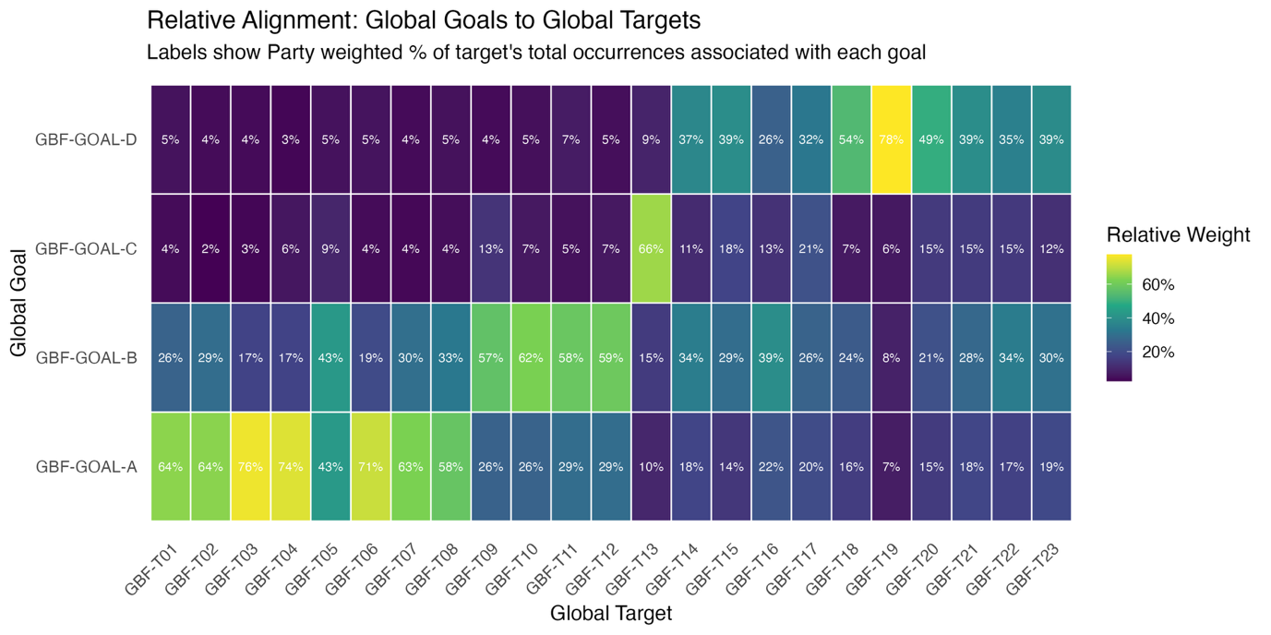
Note: For each target of the Framework, the heatmap highlights the weighted percentage of aligned national targets that were stated as contributing to each of the goals. For example, Parties associated 64 per cent of national targets aligned with Target 1 with Goal A, 26 per cent with Goal B, 4 per cent with Goal C and 5 per cent with Goal D. The percentage values are weighted by Party to avoid inflating associations in cases where individual Parties submit multiple national targets and present a balanced picture of the associations, reflecting each Party's contribution equally.
Abbreviations: GBF, Kunming-Montreal Global Biodiversity Framework; T, target of the Framework.

Goal A – Protect and restore

Goal text. The integrity, connectivity and resilience of all ecosystems are maintained, enhanced, or restored, substantially increasing the area of natural ecosystems by 2050;
Human induced extinction of known threatened species is halted, and, by 2050, the extinction rate and risk of all species are reduced tenfold and the abundance of native wild species is increased to healthy and resilient levels;
The genetic diversity within populations of wild and domesticated species, is maintained, safeguarding their adaptive potential.

Goal overview

Parties associated 15 of the 23 targets of the Framework with Goal A. These included all of the targets focused on reducing threats to biodiversity and four of the five targets focused on meeting people’s needs through sustainable use and benefit-sharing. Based on this association, progress towards Goal A depends on implementation across a broad range of targets with both direct and indirect impacts on biodiversity. While some associated targets show positive trends, overall collective progress towards those targets remains mixed.

Progress on related targets

Through use of the method described above, 15 of the 23 targets of the Framework were associated with Goal A (see figure 96). All of the targets under the heading “Reducing threats to biodiversity” (Targets 1–8) were most strongly associated with Goal A. Four of the five targets under the heading “Meeting people’s needs through sustainable use and benefit sharing” (Targets 9–12) were also associated with Goal A, while only three of the targets under the heading “Tools and solutions for implementation and mainstreaming” (Targets 16, 17 and 23) were associated with Goal A.
For each of the 15 targets associated with Goal A, the average trend is summarized using the indicator trends presented in section II.B (see figure 97). Two of the targets most strongly associated with Goal A (Targets 2 and 8) have many more indicators showing signs of improvement than signs of deterioration. Conversely, two of the associated targets (Targets 17 and 23) have more indicators showing signs of deterioration than signs of improvement. Across all related targets, 26.5 per cent of indicators are improving, 58 per cent are stable and 15.5 per cent are moving away from the target. Those early results suggest an overall mixed and largely static trend of progress towards Goal A, with progress and deterioration noted with respect to targets related to both direct and indirect drivers of biodiversity change. However, as most of these indicators were not intended to track progress towards Goal A and are not equal with regard to the scales, time periods and variables they track, the overall trend should be considered only as an indicative, indirect and imperfect reflection of progress.

Figure 96
Framework targets associated with Goal A in Parties’ national target submissions
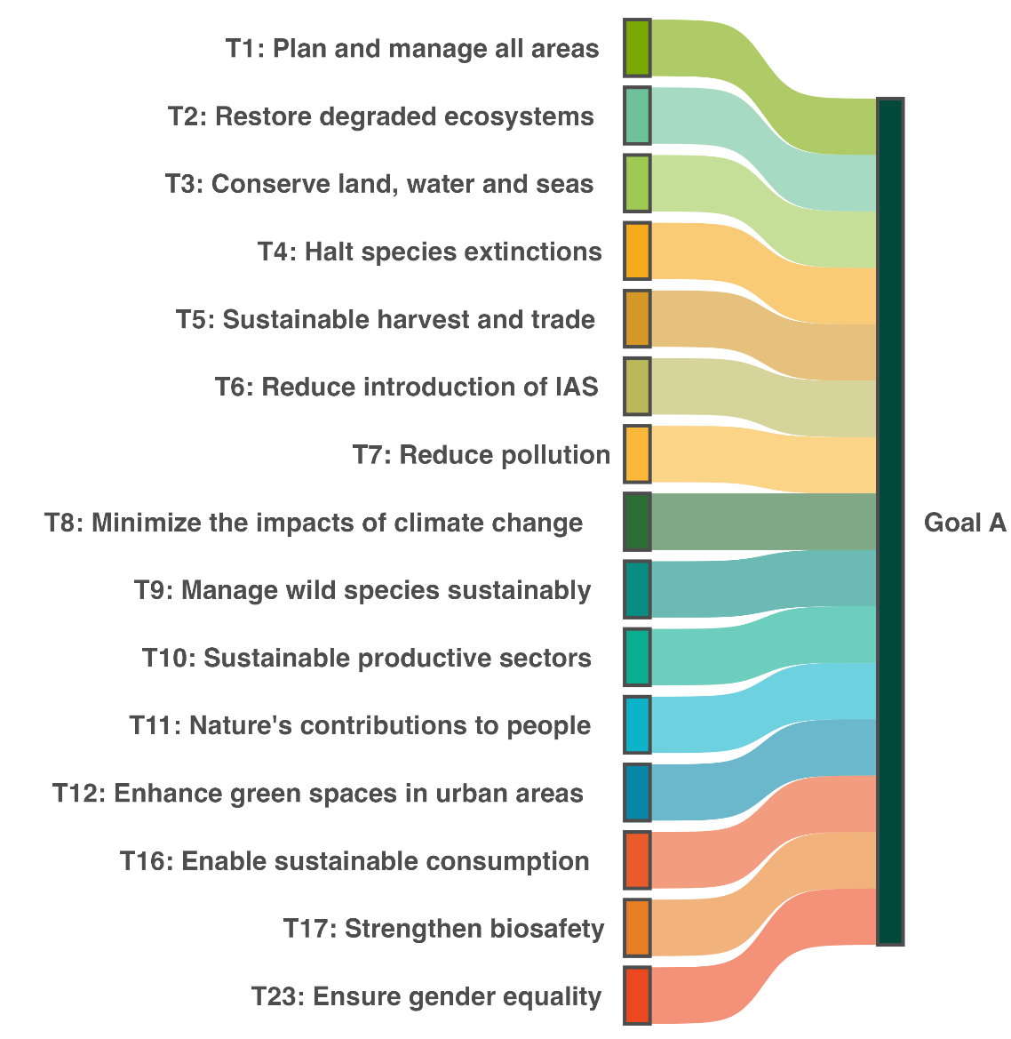
Note: A link is created between a target and the goal if at least one third of all national targets set by Parties from any regional group of United Nations Member States associated a target with the goal. Colours are used to highlight each target according to the official brand guidelines of the Framework and do not carry any additional meaning.

Figure 97
Percentage of all quantitative indicators (headline, component, complementary and national indicators combined) aligned with each target associated with Goal A that suggest improving, stable and negative trends
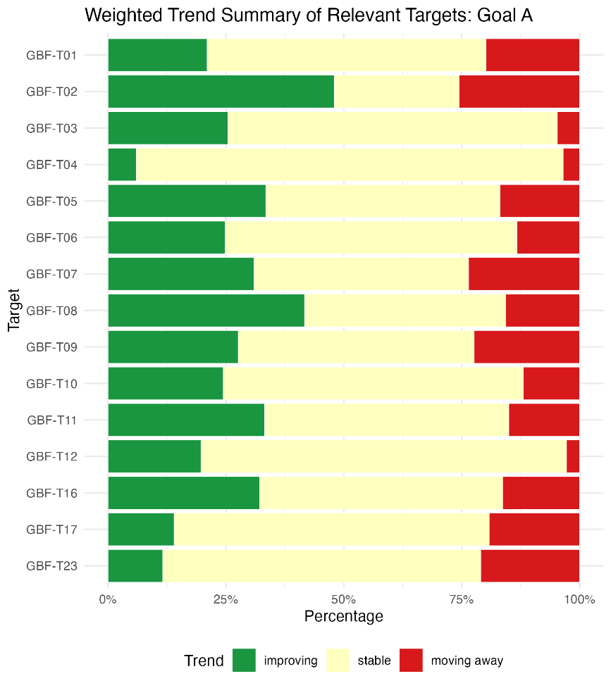
Note: Proportions are weighted by Party. Information on regional representativeness and the types of indicators included is available in each of the relevant target assessments in sect. II.B.
Abbreviations: GBF, Kunming-Montreal Global Biodiversity Framework; T, target of the Framework

Indicators of progress

Table 51
Indicator scorecard for Goal A
 | Indicator use |  | Indicator results
Headline indicator A.1: Red List of Ecosystems | 21 per cent of those Parties whose national reports are considered |  | Reported values average 0.58 and range 0.37–1
Headline indicator A.2: extent of natural ecosystems | 50 per cent of Parties, <1 per cent of which with time series data |  | 63 per cent of areas
Headline indicator A.3: Red List Index | 70 per cent of Parties |  | Global Red List Index: 0.85 (range 0.65–0.99)  National Red List index: 0.8 (range 0.45–0.97)  Both trends in decline
Headline indicator A.4: proportion of populations within species with an effective population size greater than 500 | 13 per cent of Parties |  | Overall average: 0.58 (range 0.17–0.93)
Note: The colour coding is related to the overall assessment of progress across targets, the methodology of which is explained in the overall summary scorecard (see table 3). The colour coding for indicator data use and all quantitative indicator trends reflects where a value for each target sits relative to the highest and lowest scores achieved across all targets of the Framework (green is assigned to percentage values falling within the top third of the total range, yellow to the middle third and red to the bottom third). Colours for the headline indicator results are based on progress relative to the target (green is assigned when progress is being made, yellow when progress is mixed, red when progress is insufficient and grey when progress cannot be assessed). Note that the percentage of Parties submitting data on headline indicators may be different from that used in the aggregate results for both the headline indicator and all quantitative indicators combined, owing to methodological differences in the way data were used.

Headline indicators A.1 and A.2 track progress towards the ecosystem-related elements of Goal A, focusing on risk of ecosystem collapse and area of natural ecosystems, while headline indicators A.3 and A.4 track progress towards the elements of Goal A related to species extinction risk and genetic diversity.
While some Parties have established ecosystem accounting frameworks or national maps, many others are in transitional phases and developing their baselines using proxies or working towards aligning their national data with global standards such as the International Union for Conservation of Nature (IUCN) Global Ecosystem Typology (Keith and others, 2020, 2022). Consequently, many Parties report that they have not yet carried out assessments of ecosystem status. For those Parties that have ecosystem data, it is often partial, covering only specific ecosystems. For headline indicator A.2 in particular, Parties’ submissions focused largely on terrestrial ecosystems.
For headline indicator A.1 (Red List of Ecosystems) data submitted by Parties and data provided by IUCN (IUCN, 2026) show a similar overall risk status for ecosystems (see figure 98). For headline indicator A.2 (extent of natural ecosystems) the extent reported by Parties varied from almost all terrestrial areas to almost none, averaging about three fifths coverage (see table 51 and figure 99).
The results from reporting on headline indicators A.1 and A.2 should be viewed as representing an early attempt at establishing baselines, against which future progress towards the 2050 goal may be measured as Parties build further capacity to map and monitor complete ecosystems (Nicholson and others, 2024). The Global Ecosystem Atlas initiative, convened by the Group on Earth Observations, in collaboration with the Secretariat of the Convention and with the relevant organizations responsible for developing the metadata for headline indicators A.1 (IUCN) and A.2 (United Nations Statistics Division), is aimed at providing a harmonized, comprehensive global map of the distribution of natural and artificial ecosystems, aligned with 110 ecosystem functional groups (Level 3) defined by the Global Ecosystem Typology (Murray and others, 2026). This global map is compiled primarily from existing national or other peer-reviewed data sources, filling gaps using ecosystem classification geospatial models. The emphasis is, therefore, on supporting the continued bottom-up development of ecosystem maps, including specific guidance at the national level (Global Ecosystems Atlas, 2026). With completion forecast before 2029, the Global Ecosystem Atlas is expected to assist with future national reporting on headline indicator A.2 in particular, and also to support reporting on other headline indicators requiring information on ecosystem extent, namely A.1 (Red List of Ecosystems), B.1 (services provided by ecosystems), 2.1 (area under restoration), 3.1 (coverage of protected areas and other effective area-based conservation measures), and 21.1 (indicator on biodiversity information for monitoring the Framework) (Group on Earth Observations, 2025).
Data for headline indicator A.3 (Red List Index) suggest that species extinction risk is still increasing (see figures 19 and 20). However, any reversal in the trend due to recent actions by Parties is unlikely to be detectable in the short term, owing to the time lags between conservation actions and outcomes, as well as delays in the availability of up-to-date species assessments (see also sect. I.A and figure 6). While data from Party submissions for headline indicator A.4 (proportion of populations within species with an effective population size greater than 500) are too sparse to facilitate the drawing of conclusions on progress towards the long-term maintenance of genetic diversity, initiatives such as the European Union’s Biodiversa+ Genetic Indicators for NAture MOnitoring (GINAMO) are supporting Parties in implementing that indicator. Moreover, there is an opportunity for Parties to expand the taxonomic coverage of their extinction risk assessments and use those assessments to assess genetic diversity (Khorngton and others, 2026), thereby helping to inform progress towards the 2050 goal.
As headline indicators A.3 and A.4 also monitor progress towards Target 4 of the Framework, they are discussed further in section II.B of the global report.

Figure 98
Headline indicator A.1: Red List of Ecosystems
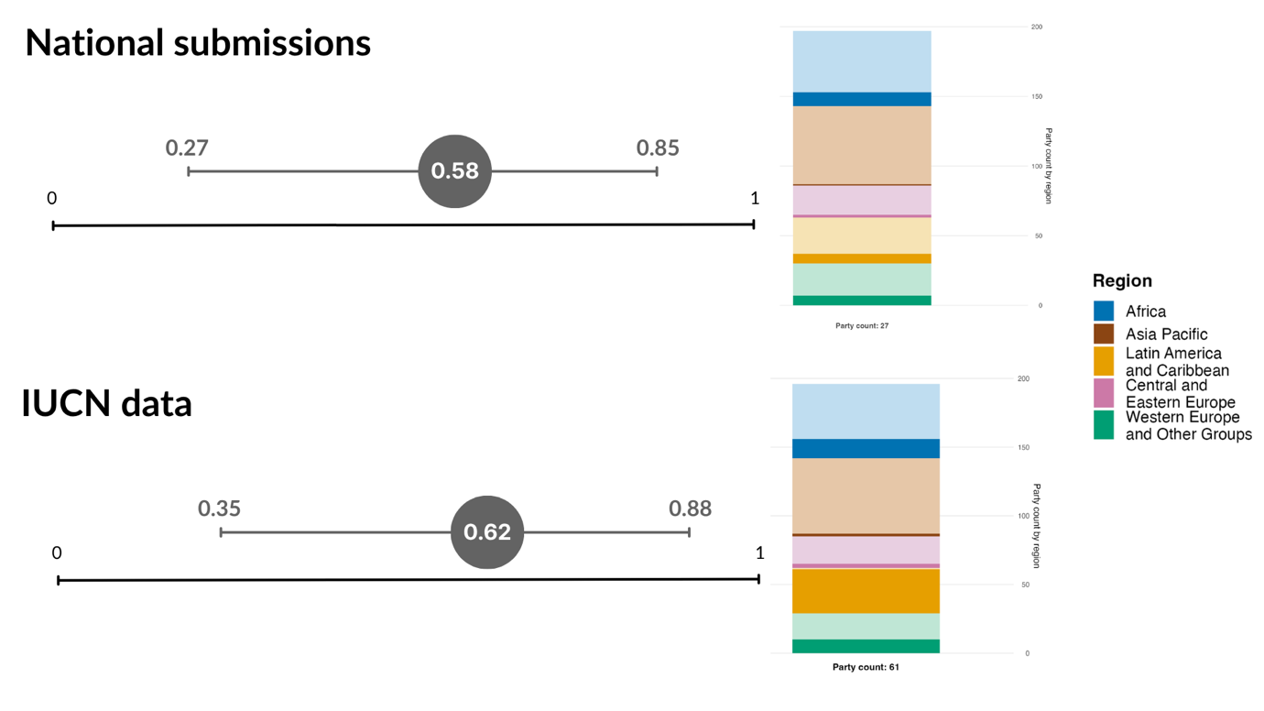
Note: Only a single data point is shown aggregating all of the Red List of Ecosystems (RLE) values submitted, as only three Parties provided a time series. Displayed are the average and range of RLE values across all Parties that submitted. Bars illustrate the regional distribution of Parties’ data included in the indicator value displayed. The relation of colours to regions is shown in the legend for the figure: darker tones represent the proportion of Parties for any region whose data are included in the figure, while lighter tones represent the proportion of Parties for the same region for which no data are included in the figure. Values from national submissions (top) and IUCN (bottom) are shown.

Figure 99
Headline indicator A.2: extent of natural ecosystems
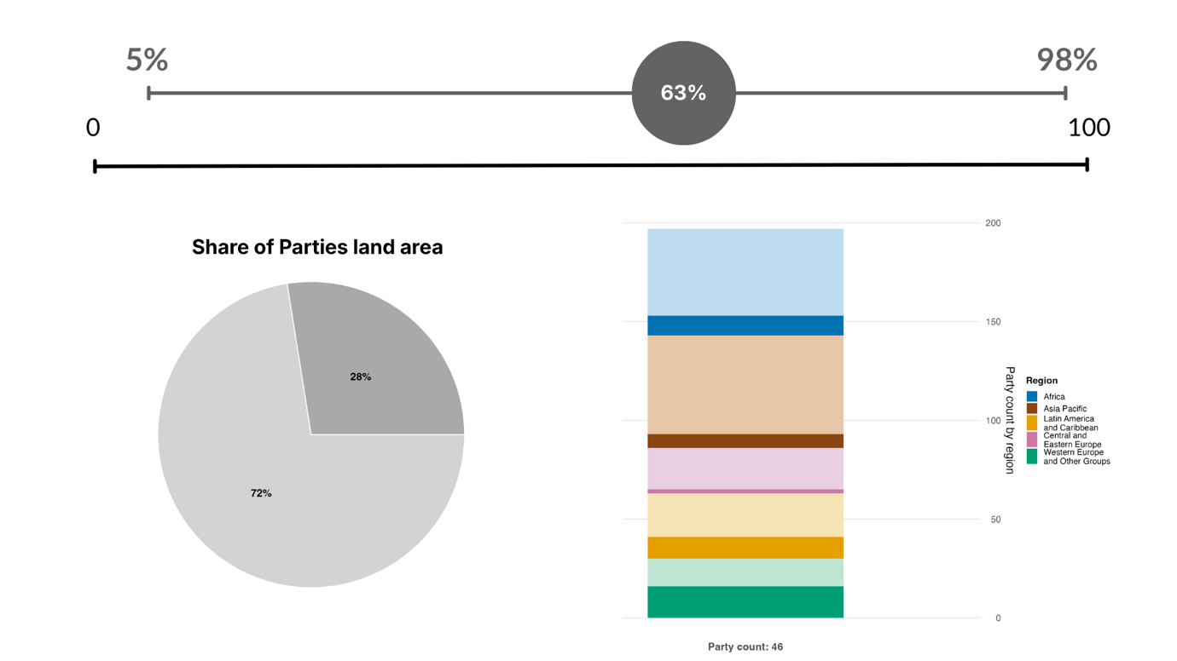
Note: Only a single data point is shown aggregating all of the extent values submitted, as very few Parties submitted a time series. Displayed are the average and range of natural ecosystem extent across all Parties that submitted. The bar illustrates the regional distribution of Party data included in the indicator value displayed. The relation of colours to regions is shown in the legend for the figure: darker tones represent the proportion of Parties for any region whose data are included in the figure, while lighter tones represent the proportion of Parties for the same region for which no data are included in the figure. The pie chart displays, in dark grey, the proportion of total land area accounted for by Parties that submitted.

Summary of actions taken to advance progress towards Goal A
Many of the actions taken to achieve progress towards Goal A highlighted by Parties in their national reports centre on implementing the relevant targets on the ground. Those actions point specifically towards increasing coverage of protected areas and other effective area-based conservation measures (OECMs), especially for important ecosystems and sites of particular importance for biodiversity; scaling up restoration efforts; halting deforestation; and controlling or eradicating invasive alien species. While such actions are already under way in many countries, as noted in the relevant target summaries in section II.B, they are insufficient in both scale and pace of implementation and often fail to incorporate recognition of sustainable use, connectivity, rights-based and community-based conservation, indigenous and traditional territories and the need for adequate means of implementation, in accordance with national circumstances. Parties have highlighted the need to implement legal and regulatory reform and for improved monitoring, the need to address the direct drivers of biodiversity loss and the need for means of implementation. Addressing the gaps in collective progress will require addressing the underlying reasons for the gaps, including those related to political will and ambition, implementation, means of implementation, environmental governance and policy coherence, whole-of-society engagement, and data and knowledge. Based on the targets associated with Goal A, progress towards its achievement will require coherent action across the majority of the targets of the Framework.

Goal B. Prosper with nature

Goal text. Biodiversity is sustainably used and managed and nature’s contributions to people, including ecosystem functions and services, are valued, maintained and enhanced, with those currently in decline being restored, supporting the achievement of sustainable development for the benefit of present and future generations by 2050.

Goal overview
Of the 23 targets of the Framework, Parties associated 19 targets with Goal B, a number greater than that for any other goal. Progress towards Goal B is therefore highly dependent on coordinated action across most of the Framework. As shown in section II.B, collective progress across the Framework is mixed and coordinated action is required to address both direct and indirect drivers of biodiversity change and thereby maintain, enhance and restore the contributions of nature to present and future generations.

Progress on related targets

Using the method outlined above, 19 targets of the Framework were associated with Goal B, a number greater than for any other goal (see figure 100). Four of the five targets under the heading “Meeting people’s needs through sustainable use and benefit-sharing” (Targets 9–12) were more strongly associated with Goal B than any with other goal (see figure 95). Moreover, six of the eight targets under the heading “Reducing threats to biodiversity” and almost all of the targets under the heading “Tools and solutions for implementation and mainstreaming” with the exception of Target 19 were associated with Goal B.
For each of the 19 targets associated with Goal B, the average trend is summarized using the indicator trends presented in section II.B (see figure 101). Two of the targets most associated with Goal B (Targets 11 and 16) have many more indicators showing signs of improvement than signs of deterioration. Conversely, three targets associated with Goal B (Targets 17, 22 and 23) have more indicators showing signs of deterioration than signs of improvement. Across all related targets, 31 per cent of indicators are improving, 53 per cent are stable and 16 per cent are moving away. Those early results suggest an overall mixed and largely static trend in progress towards Goal B, with both progress and deterioration noted regarding targets related to direct and indirect drivers of biodiversity change. However, as most of those indicators were not intended to track progress towards Goal B and are not equal with respect to the scales, time periods and variables that they track, the overall trend should be viewed only as an indicative, indirect and imperfect reflection of progress towards the 2050 goal.

Figure 100
Framework targets associated with Goal B in Parties’ national target submissions
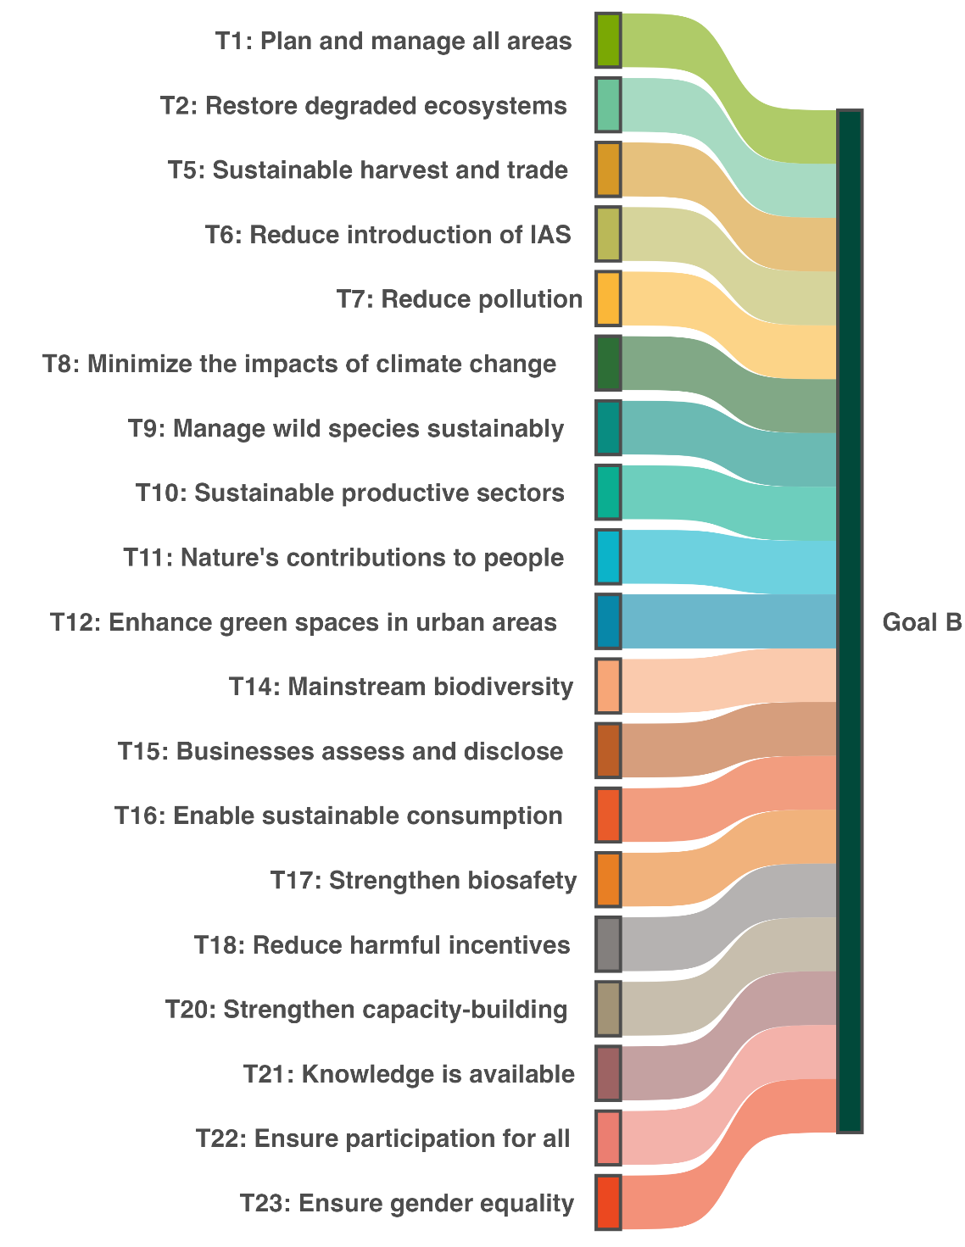
Note: A link is created between a target and the goal if at least one third of all national targets set by Parties from any regional group of United Nations Member States associated a target with the goal. Colours are used to highlight each target according to the official brand guidelines of the Framework and do not carry any additional meaning.

Figure 101
Percentage of all quantitative indicators (headline, component, complementary and national indicators combined) aligned with each target associated with Goal B that suggest improving, stable and negative trends
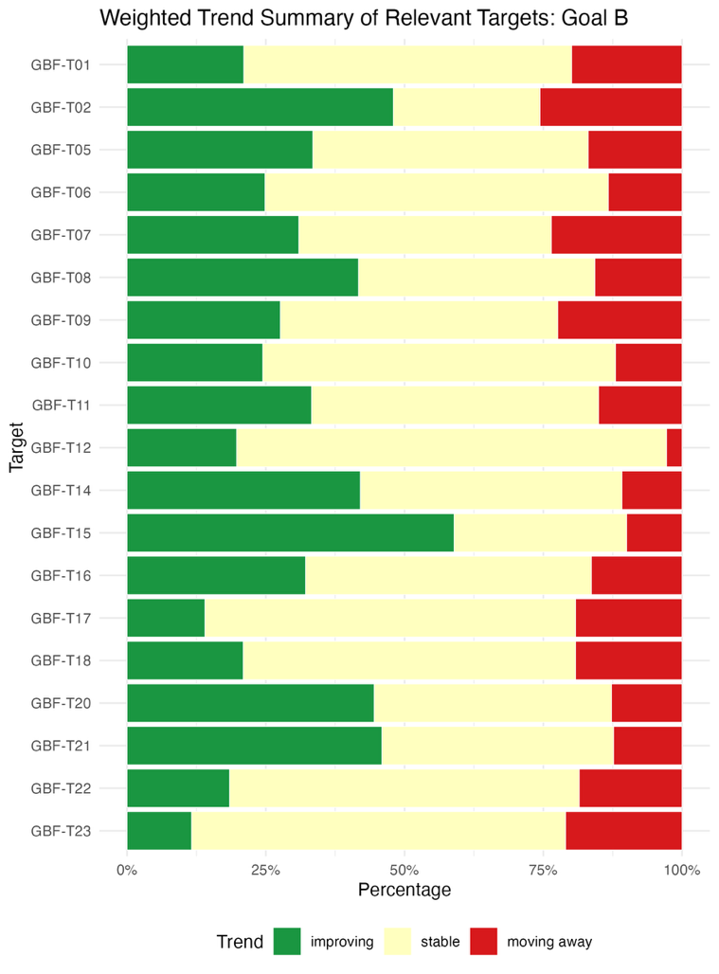
Note: Proportions are weighted by Party. Information on regional representativeness and the types of indicators included is available in each of the relevant target descriptions of sect. II.B.

Indicators of progress

Table 52
Indicator scorecard for Goal B
 | Indicator use |  | Indicator results
Headline indicator B.1: services provided by ecosystems | 26 per cent of Parties |  | Overall 2.5 per cent decline between 2015 and 2023, with cultural services increasing but regulating and provisioning services declining
Binary indicator B.b: number of countries with policies or actions for implementing and monitoring the sustainable use of biodiversity and the maintenance and enhancement of nature’s contributions to people, including ecosystem functions and services | 118 Parties | n/aª | 71 per cent of Parties scored highly (score 4 or 5)
Note: The colour coding is related to the overall assessment of progress across targets, the methodology of which is explained in the overall summary scorecard (see table 3). The colour coding for indicator data use and all quantitative indicator trends reflects where a value for each target sits relative to the highest and lowest scores achieved across all targets of the Framework (green is assigned to percentage values falling within the top third of the total range, yellow to the middle third and red to the bottom third). Colours for the binary indicators are based on the percentage of Parties scoring highly (4 or 5) for the indicator overall (green is assigned to values at or above 50 per cent, yellow to values from 25 to 50 per cent and red to values below 25 per cent). Colours for the headline indicator results are based on progress relative to the target (green is assigned when progress is being made, yellow when progress is mixed, red when progress is insufficient and grey when progress cannot be assessed). Note that the percentage of Parties submitting data on headline indicators may be different from that used in the aggregate results for both the headline indicator and all quantitative indicators combined, owing to methodological differences in the way data were used.
ª As binary indicator data are required by the online reporting tool, submission counts for these indicators do not reflect monitoring capacity differences between targets and do not provide actionable information for making progress in implementation, so assessment of indicator use is not relevant.

Parties reported quantitative data on many different ecosystem services, focusing largely on services relating to water and air quality and productive sectors. Overall, ecosystem services showed a downward trend for those seven Parties that submitted data for headline indicator B.1 (services provided by ecosystems), using the index based on ecosystem services accounts (see table 52 and figure 49). This highlights the need to advance adoption and implementation of ecosystem accounting to support tracking of progress towards Goal B. As headline indicator B.1 also monitors progress towards Target 11 of the Framework, it is discussed further in the relevant part of section II.B above.
Using the binary indicator associated with Goal B, most Parties reported making good progress towards establishing measures to implement and monitor the sustainable use of biodiversity and the maintenance and enhancement of nature’s contributions to people, including ecosystem functions and services (see figure 102). However, only 1 in 10 Parties reported having fully implemented such measures. Parties reported having made much more progress with measures associated with implementation than with measures for monitoring and having made more progress with measures for the sustainable use of biodiversity than with measures for maintaining and enhancing nature’s contributions to people.

Figure 102
Binary indicator B.b: number of countries with policies or actions for implementing and monitoring the sustainable use of biodiversity and the maintenance and enhancement of nature’s contributions to people, including ecosystem functions and services
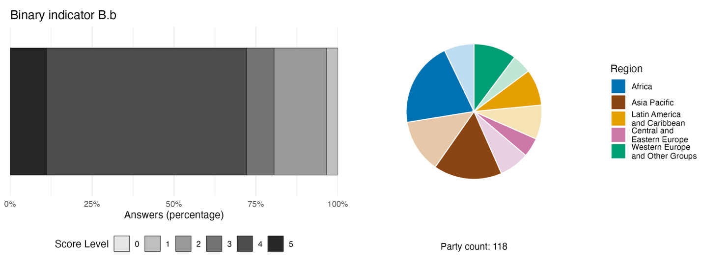
Note: The bar widths show the percentage of Parties in each score category, with higher numbers indicating a greater level of progress, based on responses to the questions included in the indicator.ª The pie chart shows the distribution of Parties providing responses to all questions by region. Colours for each region are defined in the figure legend: darker tones represent the proportion of Parties for any region for which data are included in the graph; lighter tones represent the proportion of Parties for the same region for which no data are included in the graph.
ª The methodology for calculating the score levels for each binary indicator, as well as the questions included for each indicator, are provided in document CBD/COP/16/INF/3/Rev.1.

Summary of actions taken to advance progress towards Goal B

In their national reports, Parties have highlighted many actions related to promoting the sustainability of productive sectors, an aim that is itself associated with Goal B. Options flagged as particularly effective include the expansion of certification schemes and community-based management practices, the designation of no-take marine protected areas, the reduction of pesticide use and the creation of market-based mechanisms linking development activity to maintenance of ecosystem services. Parties have also highlighted a series of actions related to mainstreaming, such as natural capital accounting and the establishment of “green” budgets within all ministries specifically designed to support environment-related activities across government. Many Parties identified the need to establish legally binding instruments to support mainstreaming and conservation as a challenge in relation to making progress towards Goal B. Other relevant actions identified by Parties include use of nature-based solutions related to ecosystem restoration, promotion of and financial support for ecosystem-based livelihoods and inclusion of green infrastructure and pollution reduction in urban planning. Moreover, Parties have suggested addressing gaps in participation through support for and promotion of management of protected and conserved areas by indigenous peoples and local communities and the involvement of women and communities in restoration projects, including through payment of wages.

Goal C. Share benefits of genetic resources fairly

Goal text. The monetary and non-monetary benefits from the utilization of genetic resources and digital sequence information on genetic resources, and of traditional knowledge associated with genetic resources, as applicable, are shared fairly and equitably, including, as appropriate with indigenous peoples and local communities, and substantially increased by 2050, while ensuring traditional knowledge associated with genetic resources is appropriately protected, thereby contributing to the conservation and sustainable use of biodiversity, in accordance with internationally agreed access and benefit-sharing instruments.

Goal overview

Parties associated only two targets of the Framework with Goal C: Target 13 on access and benefit-sharing and Target 17 on biosafety. While there is insufficient information for tracking progress on outcomes related to those global targets, Parties have nonetheless shared information on their progress towards developing some of the administrative, legislative and policy measures required to implement the two targets.

Progress on related targets
Using the method described above, only two Framework targets (Targets 13 and 17) were associated with Goal C, the fewest associated targets for any of the goals (see figure 103). None of the targets under the heading “Reducing threats to biodiversity” were associated with Goal C. Target 13 had the stronger association by far with Goal C and, not being associated with any other goal, it was the only target of the Framework to have a unique association with a single goal.
For both of the targets associated with Goal C, the average trend is summarized using the indicator trends presented in Section II.B (see figure 104). The target more strongly associated with Goal C (Target 13) has more indicators showing signs of improvement than signs of deterioration. Conversely, Target 17 has more indicators showing signs of deterioration than signs of improvement. Across both related targets, 27 per cent of indicators are improving, 56 per cent are stable and 17 per cent are moving away. These early results suggest an overall mixed trend of progress towards Goal C, with a notable deterioration relating to one of the targets identified by Parties. However, as most of those indicators were not intended to track progress towards Goal C and are not equal with respect to the scales, time periods and variables that they track, the overall trend should be viewed only as an indicative, indirect and imperfect reflection of progress towards the goal.

Figure 103
Framework targets associated with Goal C in Parties’ national target submissions
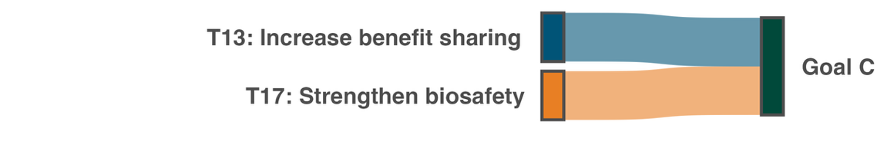
Note: A link is created between a target and the goal if at least one third of all national targets set by Parties from any regional group of United Nations Member States associated a target with the goal. Colours are used to highlight each target according to the official brand guidelines of the Framework and do not carry any additional meaning.

Figure 104
Percentage of all quantitative indicators (headline, component, complementary and national indicators combined) aligned with each target associated with Goal C that suggest improving, stable and negative trends
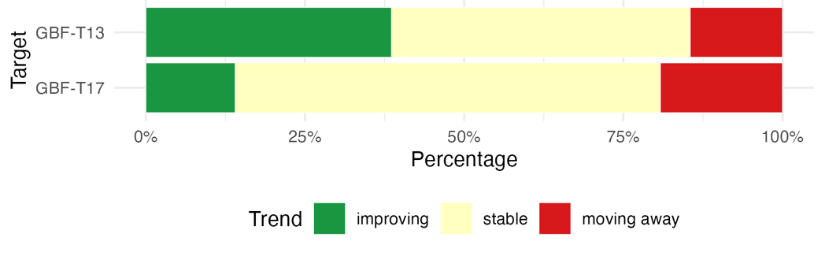
Note: Proportions are weighted by Party. Information on regional representativeness and the types of indicators included is available in each of the relevant target descriptions in sect. II.B.

Indicators of progress

Table 53
Indicator scorecard for Goal C
 | Indicator use |  | Indicator results
Headline indicator C.1: monetary benefits received in accordance with applicable internationally agreed access and benefit-sharing instruments | 11 per cent of Parties |  | Total US$ 6.9 million monetary benefits 2022–2025
Headline indicator C.2: non-monetary benefits arising from applicable international access and benefit-sharing instruments | 14 per cent of Parties |  | Total 960 non-monetary benefits 2022–2025

Very few Parties reported on the monetary or non-monetary benefits received from access and benefit-sharing agreements using the two headline indicators linked to Goal C (see table 53). Many Parties commented on the difficulty of tracking both monetary and non-monetary benefits in the context of decentralized permit systems which are not monitored nationally. As a result, Parties reported many different types of non-monetary benefits, including but not limited to scientific outputs, participation in research, technical training, technology transfer, databases and community engagement. Moreover, several Parties commented on the fact that they were still finalizing their access and benefit-sharing legislation and were in the process of implementing the Nagoya Protocol on Access to Genetic Resources and the Fair and Equitable Sharing of Benefits Arising from Their Utilization to the Convention on Biological Diversity. In addition, some Parties do not require benefit-sharing from the use of their genetic resources.
It has not been possible to date to comment on whether benefits are being shared fairly and equitably nor on the role played by traditional knowledge and indigenous peoples and local communities. Therefore, progress towards goal C cannot yet be assessed.
Data from the Leibniz Institute DSMZ-German Collection of Microorganisms and Cell Cultures GmbH tracking the number of publications citing access and benefit-sharing permits (Leibniz Institute DSMZ, 2025) show that the number of such publications has been increasing over time, reaching 228 in 2025 (see figure 105). Those data highlight that, in the context of access and benefit-sharing permits, Parties from all regions engage in collaboration with each other. As only a few Parties reported on non-monetary benefits using the methodology defined in the indicator metadata (Nunez-Vega and others, 2025), those amounts are not directly comparable. As headline indicators C.1 and C.2 also monitor progress towards Target 13 of the Framework, they are discussed further in section II.B of the report.

Figure 105
Headline indicator C.2: non-monetary benefits arising from applicable international access and benefit-sharing instruments (based on data from the Leibniz Institute DSMZ )
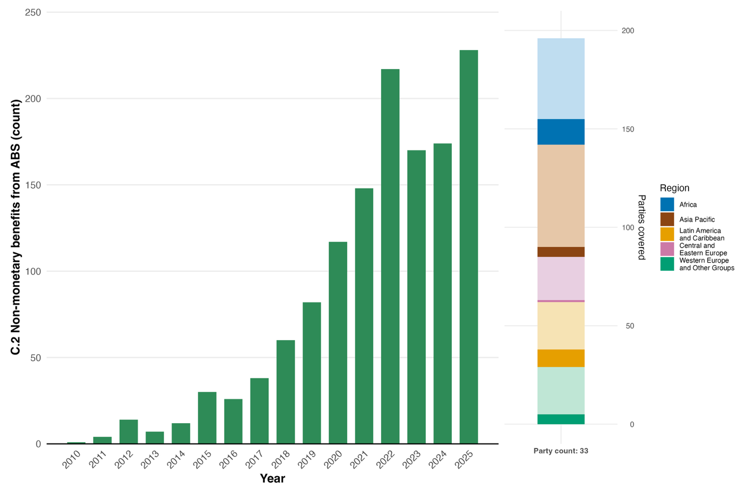
Note: Left: indicator values show the total number of non-monetary benefits received across Parties each year. Right: regional representativeness of the data set (darker shades show submissions for any given region). The relation of colours to regions is shown in the legend for the figure: darker tones represent the proportion of Parties for any region whose data are included in the graph, while lighter tones represent the proportion of Parties for the same region for which no data are included in the figure.

Summary of actions taken to advance progress towards Goal C

Parties reported the least on Goal C in their national reports. While many Parties have acceded to the Nagoya Protocol, they highlighted a lack of the secondary legislation, institutional checkpoints and enforcement mechanisms necessary to monitor and secure benefit-sharing. Nevertheless, some specific actions taken by Parties, and reported in their national reports, highlight opportunities for addressing gaps related to the implementation of Goal C.
The most widespread sign of progress towards Goal C reported was the ratification of the Nagoya Protocol and the subsequent establishment of national legal frameworks for access and benefit-sharing. Parties suggested that formalization of access and benefit-sharing contracts rather than general application of the principles of the Nagoya Protocol was an effective way of ensuring fair and equitable sharing of benefits, as well as supporting the monitoring of benefits. With respect to support for monitoring efforts, the establishment of the Access and Benefit-sharing Clearing-House mechanism was singled out as an effective means of tracking the issuance of permits and associated benefits. At the institutional level, Parties stated that active membership of the International Treaty on Plant Genetic Resources for Food and Agriculture supports ABS-related efforts by taking advantage of synergies between the Treaty, the Convention and the Nagoya Protocol. Moreover, taking direct action to enforce regulation and prosecute illegal trafficking of genetic resources was reported to have further supported fair and equitable sharing of benefits. Beyond government actions, multi-stakeholder partnerships involving traditional practitioners and the development of ABS-compliant value chains, in partnership with indigenous peoples and local communities, were seen as ways to strengthen delivery of the elements of Goal C. Such partnerships would be focused on traditional knowledge, increasing the mainstreaming of access and benefit-sharing, and delivering tangible and visible benefits to indigenous peoples and local communities, while respecting their rights.

Goal D. Invest and Collaborate

Goal text: Adequate means of implementation, including financial resources, capacity-building, technical and scientific cooperation, and access to and transfer of technology to fully implement the Kunming-Montreal Global Biodiversity Framework are secured and equitably accessible to all Parties, especially developing country Parties, in particular the least developed countries and small island developing States, as well as countries with economies in transition, progressively closing the biodiversity finance gap of $700 billion per year, and aligning financial flows with the Kunming-Montreal Global Biodiversity Framework and the 2050 Vision for biodiversity.

Goal overview

Parties associated 10 of the 23 targets of the Framework with Goal D. Those 10 targets corresponded exactly to the targets under the heading “Tools and solutions for implementation and mainstreaming” (Targets 14–23). Targets 18, 19 and 20 showed the strongest association with Goal D. Collective progress towards several of the targets associated with Goal D face major implementation challenges.

Progress on related targets

Using the method described above, all of the 10 targets placed under the heading “Tools and solutions for implementation and mainstreaming” were associated with Goal D (see figure 106). Of those targets, all except Target 16 were more strongly associated with Goal D than with any other goal. The association was strongest for Targets 18, 19 and 20, representing the targets associated most strongly by Parties with means of implementation (see figure 95, and sect. II.D).
For each of the 10 targets associated with Goal D, the average trend is summarized using the indicator trends presented in section II.B (see figure 107). Five targets most strongly associated with Goal D (Targets 14, 15, 19, 20 and 21) have many more indicators showing signs of improvement than signs of deterioration. On the other hand, three targets most strongly associated with Goal D (Targets 17, 22 and 23) have more indicators showing signs of deterioration than signs of improvement. Across all related targets, 35 per cent of indicators are improving, 49 per cent are stable and 16 per cent are moving away. These early results suggest an overall mixed yet encouraging trend towards Goal D, with progress and deterioration noted regarding targets related to indirect drivers of biodiversity change. However, as most of those indicators were not intended to track progress towards Goal D and are not equal with respect to the scales, time periods and variables that they track, the overall trend should be viewed only as an indicative, indirect and imperfect reflection of progress.

Figure 106
Framework targets associated with Goal D in Parties’ national target submissions
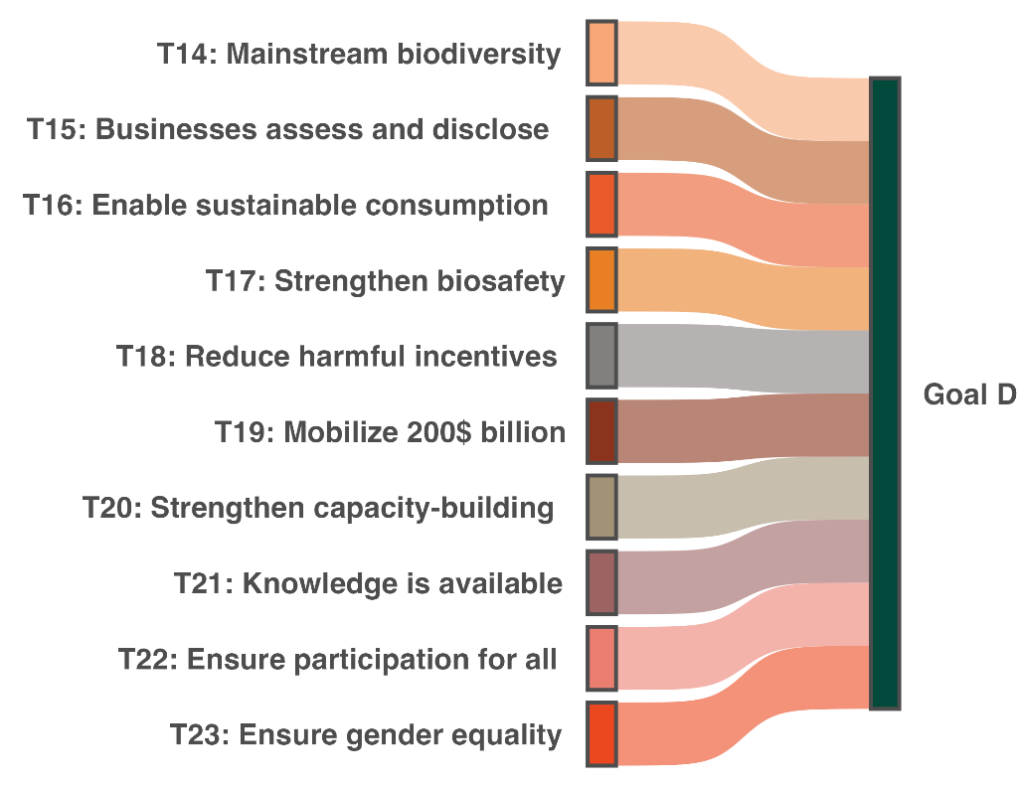
Note: A link is created between a target and the goal if at least one third of all national targets set by Parties from any regional group of United Nations Member States associated a target with the goal. Colours are used to highlight each target according to the official brand guidelines of the Framework and do not carry any additional meaning.

Figure 107
Percentage of all quantitative indicators (headline, component, complementary and national indicators combined) aligned with each target associated with Goal D that suggest improving, stable and negative trends
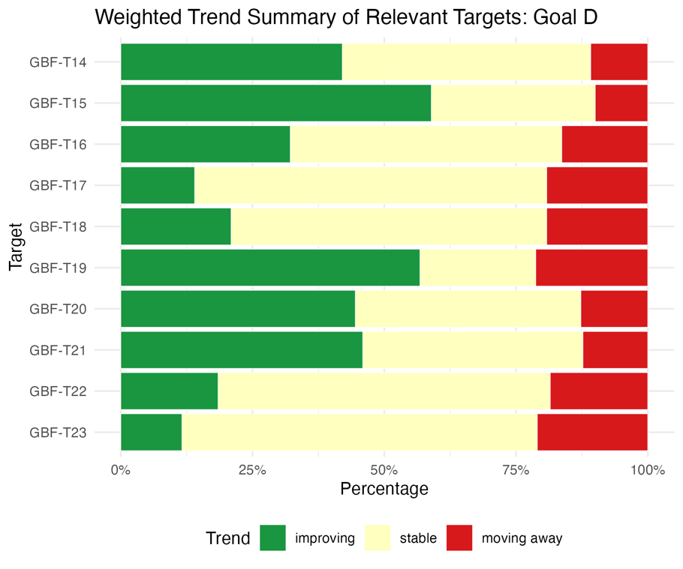
Note: Proportions are weighted by Party. Information on regional representativeness and the types of indicators included is available in each of the relevant target descriptions in sect. II.B.

Indicators of progress

Table 54
Indicator scorecard for Goal D
 | Indicator use |  | Indicator results
Headline indicator D.1: international public funding, including official development assistance (ODA) for conservation and sustainable use of biodiversity and ecosystems | 61 per cent of Parties |  | 2020–2023 average: US$ 4.4 billion per year
Headline indicator D.2: domestic public funding on conservation and sustainable use of biodiversity and ecosystems | 54 per cent of Parties |  | 2020–2023 average: US$ 34 billion per year
Headline indicator D.3: private funding (domestic and international) on conservation and sustainable use of biodiversity and ecosystems | 26 per cent of Parties |  | 2020–2023 average: US$ 8.2 billion per year
Note: The colour coding is related to the overall assessment of progress across targets, the methodology of which is explained in the overall summary scorecard (see table 3). The colour coding for indicator data use and all quantitative indicator trends reflects where a value for each target sits relative to the highest and lowest scores achieved across all targets of the Framework (green is assigned to percentage values falling within the top third of the total range, yellow to the middle third and red to the bottom third). Colours for the headline indicator results are based on progress relative to the target (green is assigned when progress is being made, yellow when progress is mixed, red when progress is insufficient and grey when progress cannot be assessed). Note that the percentage of Parties submitting data on headline indicators may be different from that used in the aggregate results for both the headline indicator and all quantitative indicators combined, owing to methodological differences in the way data were used.

All of the headline indicators associated with Goal D focus on tracking the mobilization of financial resources. Parties reported mobilizing considerably more funding for biodiversity from domestic public funding than from international public funding or private funding (see table 54 and figure 108). Although it is still too early to draw any conclusions on progress towards Goal D, the total amount mobilized so far falls far short of that required to progressively close the biodiversity finance gap of US$ 700 billion per year. As headline indicators D.1, D.2 and D.3 also monitor progress towards Target 19 of the Framework, they are discussed further in section II.B of the report.
As the headline indicators for Goal D do not provide an assessment of whether financial flows are being aligned with the Framework, they do not capture whether financing for activities harmful to biodiversity is being reduced or redirected and consequently provide only a partial picture of progress towards Goal D.
Figure 108
Total funding reported by Parties in billions of US dollars in the period 2020–2023
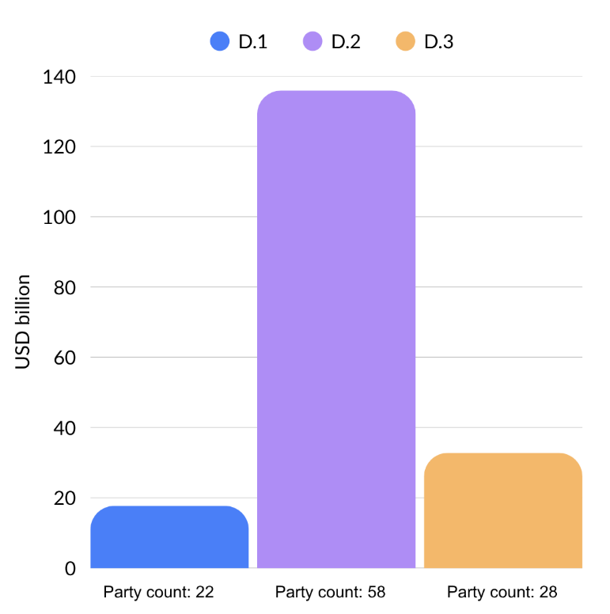
Note: Each of the three bars represents the cumulative total for one of the following three headline indicators: D.1 (international public funding, including official development assistance for conservation and sustainable use of biodiversity and ecosystems); D.2 (domestic public funding on conservation and sustainable use of biodiversity and ecosystems); and D.3 (private funding (domestic and international) on conservation and sustainable use of biodiversity and ecosystems). Note that Party counts differ from those in the headline indicator figures for Target 19, as sums shown here include Parties with incomplete time series between 2020 and 2023.

Summary of actions taken to advance progress towards Goal D

Goal D provides the foundation for implementation of the Framework as a whole, including its goals and targets. In reporting on progress towards Goal D in their national reports, Parties focused mostly, but not exclusively, on mobilizing financial resources. Several options for mobilizing such resources were noted, including funding and utilization of the Kunming Biodiversity Fund; use of extrabudgetary approaches (for example, licensing fees, payment for ecosystem services, debt-for-nature swaps and green bonds) to mobilize additional funds; establishment, funding and use of endowment funds to generate reliable long-term funding for conservation initiatives; and use of sovereign bonds structured around specific targets for protection and effective management of biodiversity. One key option, in addition to mobilizing resources, suggested by several Parties was to develop a national biodiversity finance plan, including an assessment of the financing gap, through the Biodiversity Finance Initiative (BIOFIN) of the United Nations Development Programme (UNDP). All such options support the objective under Goal D of closing the biodiversity funding gap by 2050.
In addition, several Parties noted that aligning financial flows with the Framework, especially by redirecting harmful subsidies, was an essential component of progress towards achievement of Goal D.
Some Parties suggested that fostering of scientific and political cooperation across borders, engagement through the technical and scientific cooperation support centres and development of technical geospatial information infrastructure that integrated international resources, for example, through the Global Biodiversity Information Facility (GBIF) might all be effective options for securing adequate means of implementation (see also sect. II.D below).

II.D Provision of means of implementation

Introduction

While the Kunming-Montreal Global Biodiversity Framework does not provide a formal definition of the term "means of implementation", under Goal D an overarching objective is set out that frames the concept for the purposes of the Framework (sect. G of dec. 15/4 in CBD, 2023):
"Adequate means of implementation, including financial resources, capacity-building, technical and scientific cooperation, and access to and transfer of technology to fully implement the Kunming-Montreal Global Biodiversity Framework are secured and equitably accessible to all Parties, especially developing country Parties, in particular the least developed countries and small island developing States, as well as countries with economies in transition, progressively closing the biodiversity finance gap of $700 billion per year, and aligning financial flows with the Kunming-Montreal Global Biodiversity Framework and the 2050 Vision for biodiversity."
Drawing on this framing, means of implementation are understood in the global report as encompassing four components: financial resources; capacity; technical and scientific cooperation; and access to and transfer of technology. Although, for analytical clarity, those four components are presented separately, in practice they overlap and reinforce one another, making a clear delineation not always possible. Acknowledging the close interlinkages among the components, the Conference of the Parties has stressed the need for Parties to consider them not in isolation but as a package (dec. 15/8 in CBD, 2023).
The specific challenges identified by Parties in relation to particular targets of the Framework are examined in detail within the target-by-target analysis in section II.B above. The present section takes a broader, cross-cutting view of means of implementation, focusing on the systemic and structural challenges that cut across targets. Those challenges include achieving predictability and adequacy of financial flows, persistent gaps in capacity and technology transfer, uneven accessibility of support mechanisms and constraints on the effective uptake and utilization of support by Parties. This approach complements the target-level findings with an overarching assessment of how the architecture of the means of implementation is functioning in support of the Framework.

Analysis of needs

The needs described below, which are drawn from the national reports available for consideration in the global report, are organized according to the four components of the means of implementation set out in Goal D. The analysis builds on the methodology used for the analysis of national targets, with further details available in the description of methodologies used in the preparation of the global report (CBD/SBI/7/INF/22 and CBD/SBSTTA/28/INF/9).

Financial resources

Gaps in financial resources are consistently and explicitly articulated as a constraint on implementation across the national reports. Finance planning supports the quantification and prioritization of financing needs and reported progress in that regard has been uneven. While many Parties have begun such planning, most commonly using the methodology of BIOFIN, many Parties report that their financial needs assessment and biodiversity expenditure review remain incomplete. This is a significant gap since those analyses are a precondition for credible quantification of financing needs. Moreover, national biodiversity finance plans or strategies have been reported by a number of Parties as remaining under development or as absent.

Domestic finance

Many Parties have reported a substantial gap between current domestic public spending on biodiversity and the level of spending required to implement the Framework by 2030. In several cases, the gap has been quantified through BIOFIN or equivalent national processes, with substantial gaps reported for the period to 2030. Some Parties characterize biodiversity finance as fragmented, which further limits its effectiveness in relation to identified needs.
Parties have reported that support of long-term goals is made difficult by the fact that biodiversity funding is often approved only on an annual basis, in line with common national budget cycles. Furthermore, this undermines continuity in monitoring: if resources are not sustained across multiple years, time series data are interrupted and results cease to be comparable, thereby making it difficult to assess trends or demonstrate progress against baselines. A related challenge is the difficulty of consolidating biodiversity expenditure across multilevel governance structures. The fragmentation of biodiversity-related financing across ministries, agencies and levels of government and the absence of biodiversity-specific budget tagging systems for most Parties hinder systematic tracking. In addition, Parties reported the following further barriers: unpredictable and project-based disbursement cycles; the general lack of domestic budget lines for biodiversity; structural barriers preventing stakeholders from accessing available financial instruments (discussed further below); and limited institutional capacity to design proposals or operationalize innovative finance mechanisms such as payment for ecosystem services, biodiversity credits or blended finance.

International finance

Reliance on, and the limitations associated with, international finance and ODA have been reported by developing country Parties, including least developed countries and small island developing States. The dependence on donor and project cycles is reported to have created discontinuity in implementation when projects were concluded.
Beyond detailing the challenges associated with the overall level of funding, Parties have reported challenges in accessing the international finance that is available.

Private finance

Private biodiversity financing is widely reported as underdeveloped, with limited engagement and only a small share of total biodiversity funding available to some Parties. Parties have reported that existing policy and regulatory environments make it challenging for biodiversity aligned investment models to scale.
Reporting on private finance is further constrained by the disclosure environment. Several Parties have noted the absence of mandatory disclosure requirements for biodiversity-related risks and no Party reported a national financial institution registered as a formal adopter of the recommendations of the Taskforce on Nature-related Financial Disclosures. The broader uptake of voluntary disclosure frameworks is assessed in the analysis of Target 15 above.
Of the three headline indicators associated with Goal D of the Framework, headline indicator D.3 (private funding (domestic and international) on conservation and sustainable use of biodiversity and ecosystems) has been consistently identified as the most challenging to report on. In that regard, many private sector contributions are not recorded, corporate reporting is not mandatory in most jurisdictions and other sources of private finance, including philanthropy and individual contributions, are rarely captured.

Incentives, including subsidies, harmful to biodiversity, and positive incentives

Goal D of the Framework concerns both the progressive closing of the biodiversity finance gap of US$ 700 billion per year and the alignment of financial flows with the Framework. The reduction of incentives, including subsidies, harmful to biodiversity by at least $500 billion per year by 2030, together with the scaling up of positive incentives, associated with Target 18, relates in particular to that alignment (see Target 18 summary above).
The identification, quantification and reform of harmful incentives are reported as methodologically and politically complex. A number of Parties report the absence of a national biodiversity subsidy inventory and the fact that absence of monetary value baselines makes it difficult to measure the reduction required by 2030. Several Parties have reported that there is no centralized registry of subsidies and tax concessions and that incentives can be embedded in different budget lines or tax expenditures.
Cross-sectoral coordination for the reform of harmful incentives is reported as politically sensitive and institutionally fragmented. Harmful incentives may originate in the form of taxes or in frameworks covering sectors such as agriculture, transport or energy that fall outside the mandate of environment ministries.

Capacity

Capacity needs are reported across nearly every reporting Party. Needs range from foundational institutional capacity in least developed countries and small island developing States to specialized technical capacity in developed country Parties. Reported support needs range from support for updating NBSAPs and preparing national reports to support for designing and operating biodiversity finance plans, applying spatial planning tools and managing protected areas and OECMs, among many others.
Human resource capacity underpins the other dimensions of capacity and a shortage of trained personnel for biodiversity-related work cuts across all the needs described by Parties. The areas where skill sets are reported as being in short supply include taxonomy, ecology, geographic information systems (GIS) analysis, biodiversity informatics, biosafety and marine and freshwater science, as well as the area of financial-ecological hybrid skills relevant to private finance mobilization noted above. Persistent capacity needs in respect of biosafety, including risk assessment and management, sampling, detection and related technology transfer, have been reported as remaining unmet, owing to ongoing scientific advances that require continuous updating of expertise.
The absence of in-house biodiversity expertise across ministries covering relevant sectors is reported as a constraint on the mainstreaming of biodiversity issues at a national level. In Parties affected by conflict or institutional fragility, the loss of trained staff is reported as compounding the structural constraints on implementation, with decades of conflict in some cases producing a data vacuum and the loss of institutional memory and trained personnel.

Communication and awareness

Communication on biodiversity is reported as often failing to reach rural communities, decision makers outside the environment sector and the general public and public awareness of the linkages between biodiversity and climate change is reported as insufficient. Educational systems generally do not adequately incorporate biodiversity and environmental literacy, although some Parties have reported progress in that area (see below). Norms relating to sustainable consumption are rarely embedded in curricula or consumer information frameworks and product labelling for biodiversity, for example, through certification schemes, has been reported as limited and weakly recognized. Moreover, citizen science has been identified as an underused engagement tool.

Regulatory and legal frameworks

Parties identify continuing needs in the context of implementation, compliance and enforcement of biodiversity relevant legislation. Reported needs include support for updating obsolete legislation (in some cases dating back several decades), strengthening enforcement capacity, addressing legal gaps such as the absence of dedicated legal protection for environmental defenders and aligning national law with international obligations under the Nagoya Protocol, the Cartagena Protocol on Biosafety and related instruments. Several Parties have explicitly noted that, while rights and frameworks exist on paper, their application in practice is uneven.

Environmental governance and policy

Parties have identified needs related to the institutional arrangements and policy integration processes that allow biodiversity to be addressed coherently across government. A significant obstacle to implementation, reported among the challenges relating to many targets, is multilevel governance fragmentation. One aspect of that obstacle is the fragmentation and inconsistency of data across jurisdictions, each of which may use different data-collection methods, standards and metadata, thereby complicating the consolidation of national reporting. Capacity gaps are reported at the subnational level in particular, where responsibility for land-use decisions is greatest.
Reported needs with regard to coherent governance include interministerial coordination mechanisms, the integration of biodiversity into national development planning and sectoral strategies (especially across finance, agriculture, forestry, water, climate adaptation and land use) and, among a smaller number of Parties, the establishment or strengthening of scientific advisory structures linking biodiversity science to policy.

Technical and scientific cooperation

National reports indicate that the technical and scientific cooperation needed to implement the Framework is constrained by gaps in the following areas: scientific research; the data and information systems through which scientific knowledge is made available to decision makers; cooperation among national and local actors; and international cooperation and knowledge transfer.

Scientific research

The number of available biodiversity research personnel is reported as significantly below the levels required for national implementation. Furthermore, biodiversity research is often reported as insufficiently connected to related fields, which makes coordinated responses more difficult. Parties note, in particular, that social sciences, including economics, are not yet fully integrated into biodiversity research or the monitoring of NBSAPs and national targets. Research on climate change and biodiversity is frequently described as siloed, with limited mechanisms for translating cross-disciplinary evidence into policy. Similar gaps are reported in marine biodiversity, where scientific research is not always adequately linked to fisheries management or ocean governance. In addition, Parties have identified the need for stronger cross-sectoral cooperation on zoonotic diseases, human-wildlife conflict and biosafety.

Information and data

One of the most commonly mentioned needs reported by Parties concerns the absence of national or harmonized data sets capable of supporting headline indicators of the Framework. Several Parties have described rigorous reporting of headline indicators as a significant technical and financial burden. A structural dimension of that challenge is associated with the fact that the data required for the headline indicators of the Framework are often not the type of data collected by national statistical systems as part of routine business. Several Parties consequently report that, instead of representing a standing national commitment, biodiversity data collection remains donor funded.

Among the data-related needs reported by Parties are a system for collecting sex- and age-disaggregated biodiversity data, strengthening of the interoperability of databases and a unified national system for biodiversity records across institutions and platforms. The translation of subnational data to the national level has been reported as inconsistent. Baselines against which progress is to be assessed are reported by Parties as being absent, for example, in respect of coral cover, the extent and condition of degraded areas and food waste. Marine and coastal baselines, in particular, are reported by a number of Parties as having only recently been established or as being under construction.

International cooperation and knowledge transfer

In the area of international cooperation and knowledge transfer, some Parties have mentioned weak operational linkages between the Secretariat of the Convention and other international bodies. Synergies among the Rio conventions are reported as underexploited (see sect. II.E below). Transboundary cooperation is identified as both essential and underdeveloped, including in respect of cross-border movement of invasive alien species, shared transboundary waters, migratory species and the implementation of biosafety frameworks under the Cartagena Protocol for the transboundary movement of living modified organisms.

National and local cooperation and knowledge transfer

Parties report failure to aggregate subnational biodiversity data systematically for national reporting purposes. Coordination among federal, regional and local agencies is reported as insufficient for cross-jurisdictional biodiversity governance. Weak inter-institutional coordination, the absence of sustainable funding to maintain data systems, low participation of indigenous peoples and local communities and unequal access to technologies have been identified as principal challenges. Data-sharing between research institutions and responsible ministries is reported as being hampered by institutional silos and, in some cases, financial barriers.

Access to and transfer of technology

Monitoring and surveillance

Many Parties report that, while monitoring systems may exist, they are underresourced, lack functionality and are geographically incomplete. Technology needs identified by Parties include GIS, remote sensing, analysis assisted by artificial intelligence and integrated digital platforms. In Parties affected by conflict or institutional fragility, monitoring is further constrained by the physical inaccessibility of biodiversity areas, the loss of trained technical staff and the fragmentation of administrative records.

Other technologies and infrastructure

National reports indicate insufficient digital infrastructure for the management and sharing of biodiversity data. Among some Parties, a national biodiversity information system has not yet been established and, in some cases, budget adjustments are reported as having limited the modernization of digital platforms and field supervision. Furthermore, technology transfer from developed to developing countries is reported as requiring stronger structural support and predictable financial support.
Gene bank, seed bank and laboratory infrastructure is reported as underdeveloped or in decline in several Parties. Capacity for biosafety oversight of living modified organisms reported by a number of Parties as requiring strengthening, with the activities reported as in need of strengthening including risk assessment procedures, border control and customs capacity for detecting transboundary movement of living modified organisms and the training of regulatory staff.
In several remote and island contexts, basic digital access in rural areas and among indigenous peoples and local communities is reported as a constraint on technology-mediated implementation of the Framework.

Overview of needs relating to means of implementation

Five constraints recur across the needs reported above: inadequate financing; insufficient institutional and human resource capacity; fragmented governance and coordination; weak monitoring and data systems; and incomplete or unenforced legal frameworks. Those constraints are reported in relation to almost every target reviewed and cut across the four components of means of implementation.
Moreover, the constraints are interconnected. Financing gaps can limit the capacity to build institutions, while institutional weaknesses can reduce the ability of Parties to access available finance. Similarly, partial monitoring systems weaken the evidence base needed for policy decisions and isolated responses are therefore unlikely to unlock implementation at scale. Effective support for implementation of the Framework requires interventions that recognize these interdependencies.

Analysis of provision of the means of implementation
The analysis in the global report of the provision of the means of implementation is organized around its four components: financial resources; capacity; technical and scientific cooperation; and access to and transfer of technology. The analysis is constrained by uneven reporting with respect to depth, granularity and methodology.

Financial resources

Provision of financial resources has shown an overall upward trend in recent years. That trend is reflected in the analysis of Target 19 above, which indicates increases in both international and domestic biodiversity finance among those Parties whose national reports are considered in the global report. While the trend is encouraging, the available evidence suggests that further increases, improved predictability and more effective access to resources will be necessary to support full implementation of the Framework.
Target 19 (a) of the Framework calls for “increasing total biodiversity related international financial resources from developed countries, including official development assistance, and from countries that voluntarily assume obligations of developed country Parties, to developing countries, in particular the least developed countries and small island developing States, as well as countries with economies in transition, to at least $20 billion per year by 2025 and to at least $30 billion per year by 2030” (dec. 15/4 in CBD, 2023).
Parties reporting under headline indicator D.1 (international public funding, including ODA for conservation and sustainable use of biodiversity and ecosystems), namely, developed country Parties and Parties that have voluntarily assumed those obligations, reported a cumulative $17.7 billion in international public finance between 2020 and 2023, with the reported annual total highest in 2023, at $5.2 billion. That figure should be understood to be a minimum, as it may not capture the full range of flows covered by Target 19 (a). The Organisation for Economic Co-operation and Development (OECD), whose analysis covers the broader range of flows referred to in Target 19 (a), estimates total international biodiversity finance at approximately $16.8 billion in 2023. Both estimates fall below the $20 billion milestone included in Target 19. A more detailed examination is set out in the analysis of Target 19 above. While the available data suggest that the 2025 milestone was likely not met, a definitive assessment will be possible only once complete data for 2024 and 2025 have been reported.
Consistent with earlier assessments, domestic finance remains the biggest source of finance for Parties. For most developing country Parties whose national reports are considered in the global report, biodiversity expenditure depends on annual budget cycles or project-based donor support and is therefore subject to shifts in fiscal policies, sectoral priorities or external funding decisions. As a reflection of these challenges, Parties report growing interest in instruments that could diversify funding sources and reduce reliance on annual budget allocations or project-based support. Some of the instruments reported by Parties include payment for ecosystem services, green and blue bonds, debt-for-nature swaps and biodiversity credits.
Access to finance remains uneven within as well as between countries. In a number of cases, accessibility of funds is an internal governance challenge: finance does not consistently reach subnational governments, indigenous peoples and local communities or the actors directly responsible for managing protected areas.
The most consistent positive trend is the uptake of national biodiversity finance planning, most often under the BIOFIN methodology, with assessments of biodiversity expenditure, finance needs and gaps as the foundation for resource mobilization. Those processes are improving the predictability of the planning environment, even in cases where they have not yet improved the predictability of disbursements. Progress remains uneven, with least developed countries and small island developing States often reporting that their biodiversity finance systems, including finance reporting, are still at a foundational stage.
Quantitative reporting on private sector biodiversity contributions is lacking and has been flagged as a challenge by a number of Parties. Where Parties report on the effectiveness of finance, they tend to do so through specific instruments and case studies rather than systematic outcome metrics.
Parties that have completed expenditure reviews routinely document gaps between estimated requirements and projected spending. Reporting from least developed countries and small island developing States is particularly consistent in that regard: even where international finance has increased, it remains insufficient relative to the scale of needs identified in NBSAPs with regard to conservation, restoration and sustainable use.

Incentives, including subsidies, harmful to biodiversity, and positive incentives

Under Target 18 of the Framework: a deadline for the identification of incentives, including subsidies, harmful for biodiversity, was set for 2025; there was to be the elimination, phase-out or reform of such incentives; and the incentives were to be reduced by at least $500 billion per year to be achieved by 2030. Further, the target calls for the scaling up of positive incentives for the conservation and sustainable use of biodiversity. Reporting on Target 18 in the seventh national reports does not provide a sufficient basis for determining whether the 2025 milestone has been met. Moreover, reporting against the relevant headline indicators, namely, 18.1 on positive incentives and 18.2 on the value of harmful subsidies, was undertaken by few Parties. A more detailed analysis is set out in the target-by-target analysis of Target 18 above.
On the elements of Target 18 dealing with incentives, including subsidies, harmful to biodiversity, reporting by most Parties is at the stage of subsidy mapping and the identification of priority sectors for reform rather than at the stage of quantified reductions or completed phase-outs. Where Parties have begun to quantify their harmful subsidies, the reported magnitudes are substantial but in most cases, identification of all relevant flows is still under way. Tangible early examples of action in that regard include the ratification of the WTO Agreement on Fisheries Subsidies, under which subsidies for illegal, unreported and unregulated fishing, fishing overfished stocks and fishing on the unregulated high seas are prohibited, with one of the largest internationally recognized categories of harmful incentive being thereby addressed (WTO, 2022).
On the element of Target 18 addressing positive incentives for the conservation and sustainable use of biodiversity, Parties report a range of policy commitments wider than the range of completed actions. Specific instruments reported by Parties providing positive incentives include agri-environmental programmes, schemes involving payment for ecosystem services, exploratory pilots on biodiversity credits and biodiversity aligned markets, green and sustainability linked finance instruments and biodiversity aligned economy programmes. Among most reporting Parties, however, reference to the scaling up of positive incentives tended to be focused on forward-looking commitments rather than accounts of instruments already in operation. Several of those instruments, in particular payments for ecosystem services and biodiversity credits, are also reported under Target 19, reflecting their dual character as positive incentives and mechanisms for resource mobilization.

Funding through the Global Environment Facility

The Global Environment Facility (GEF) constitutes the institutional structure that operates the financial mechanism under the Convention. During the period from 2022 to 2026, GEF programmed $4.2 billion across its family of funds of new, additional funding in support of the Framework, leveraging $26.85 billion in co-financing which included $2.13 billion from the private sector. That funding is supporting 560 projects in 142 countries and will contribute significantly towards the targets of the Framework, including through anticipated impacts over 1.4 billion hectares (ha) of land and seas (Target 1), two million tons of residual plastic waste avoided (Target 7) and benefits to nearly 40 million people. Those impacts will add to the significant contribution of projects already under implementation, which reported substantial achieved results over the past four years, including 25 million ha of land and ecosystems under restoration (Target 2), 287 million ha of protected areas created and 170 million ha of existing protected areas under improved management (Target 3).
Through the rapid establishment and operationalization of the Global Biodiversity Framework Fund (GBFF), $387 million from 12 contributors was mobilized and $362.1 million was programmed across 87 countries, with an emphasis on support to small island developing States, least developed countries and indigenous peoples and local communities, as well as engagement with international financial institutions.
GEF responded to the funding needs assessment adopted by the Conference of the Parties through the ninth replenishment of the GEF Trust Fund. Replenishment participants have pledged an initial $3.85 billion to the GEF Trust Fund for the period from 1 July 2026 to 30 June 2030. They decided to allocate 35 per cent to the biodiversity focal area and further specified that 70 per cent of the total ninth replenishment programming should contribute to the objectives of the Convention on Biological Diversity, using the OECD Development Assistance Committee Rio marker methodology which tracks projects in any focal area in which biodiversity is a principal or significant objective. Further information is available in the preliminary draft of the report of the GEF Council to the seventeenth meeting of the Conference of the Parties to the Convention (CBD/SBI/7/INF/13).

Capacity

Parties report that capacity-building activities are delivered increasingly through peer cooperation, alongside traditional donor-recipient transfers, and describe ongoing training programmes and recurring international cooperation programmes. South-South, North-South and triangular cooperation are documented across Parties at all income levels.
Parties have identified some of the structural challenges to capacity-building and development, including low national investment in research and development as a share of GDP, persistent shortages of taxonomic expertise and limited integration of research outputs into policy and management. The infrastructure required to absorb technology transfer is described by many Parties as under construction rather than operational.
On the positive side, Parties have reported increases in peer-reviewed biodiversity research outputs and the expansion of national herbaria and gene bank collections as supporting capacity.
Across multiple targets, Parties have reported on adoption or strengthening of legal frameworks as a fundamental capacity provision, as exemplified, for example, by legislation for environmental impact assessment providing mandatory biodiversity screening. A majority of Parties have reported legal and institutional frameworks anchored in constitutional provisions, national environmental laws and ratification of relevant regional conventions that support participation, access to environmental information and access to justice. Gender-responsive approaches, the engagement of indigenous peoples and local communities and youth participation are referenced as priority cross-cutting themes by a number of reporting Parties.
A recurring theme, however, is the gap between those frameworks and their application in practice. Several Parties explicitly acknowledged legal gaps, including the absence of dedicated legal protection for environmental defenders and inadequacies in regulatory frameworks more broadly. A number of Parties explicitly acknowledged gaps related to the adoption of policy frameworks and their implementation in practice.
While communication strategies and awareness-raising campaigns are widely reported, systematic measurement of behavioural and decision-making outcomes remains largely absent. Environmental education activities are reported as active provisions across a number of Parties.
Several Parties are strengthening their commitment to gender equality within the context of biodiversity and environmental management. Some of the approaches utilized include developing national strategies that link gender equality to biodiversity governance, establishing mandatory quotas to ensure women's participation in environmental training and leadership roles and incorporating gender criteria into resource management decisions. Moreover, countries are supporting women-led enterprises in environmental sectors, training dedicated gender focal points and investing in gender analyses for utilization in informing future action plans. However, the fact that the availability of gender-disaggregated data remains limited constrains the ability to assess the extent to which such measures are translating into measurable outcomes for women and girls.
Overall, reporting on the outcomes, as opposed to the inputs, of capacity is limited and few Parties measure the effectiveness of training in changing decisions or behaviours.

Technical and scientific cooperation

A formal mechanism for technical and scientific cooperation to support implementation of the Framework has been established through decisions of the Conference of the Parties. The mechanism comprises regional and subregional technical and scientific cooperation support centres and is underpinned by a global coordination entity (dec. 15/8 in CBD, 2023; and dec. 16/3 in CBD, 2026).
Predictability of data provision is improving across Parties, with national biodiversity information systems and data portals being established, upgraded or formalized by a number of them. Where systems exist, they are typically associated with standing institutional mandates.
Some Parties have reported growth in research productivity, with increases in scientific publications, species discoveries, and collaborative research initiatives involving partnerships with international institutions. A few have mentioned strengthening their capacity for advanced research through expanded laboratory networks equipped with technologies such as drone research and remote sensing.
As reported by some Parties, accessibility of biodiversity data has advanced. Citizen-science platforms and open biodiversity data systems are increasingly providing complementary monitoring support, including through nodes of GBIF and the Ocean Biodiversity Information System (OBIS), as well as through the Group on Earth Observations Biodiversity Observation Network (GEO BON) (see, also, the Target 21 summary above).
International technical cooperation has been mentioned by several Parties as helping them to advance biodiversity conservation and research capacity. North-South partnerships are facilitating knowledge transfer through multilateral initiatives focused on environmental challenges associated with, for example, land degradation and freshwater ecosystems, as well as through targeted capacity-building programmes operating across multiple countries. In enabling Parties to share relevant experiences and expertise tailored to similar ecological and development contexts, South-South exchanges are equally important. Those collaborative efforts extend to research partnerships, technology transfer agreements and participation in global scientific networks and databases.
Cooperation arrangements across multilateral environmental agreements (MEAs) constitute an important contribution to the provision of means of implementation, as documented in section II.E below. For example, the sixth joint workplan of the Convention on Biological Diversity and the Convention on Wetlands of International Importance especially as Waterfowl Habitat (2024–2030) includes a dedicated activity area on implementation and monitoring and the provision of technical guidance relating to incorporation of wetlands into NBSAPs across each of the 23 Framework targets. The Hangzhou Strategic Action Plan (2026–2035) for the Man and the Biosphere Programme and World Network of Biosphere Reserves of the United Nations Educational, Scientific and Cultural Organization, with its target for all biosphere reserves to have identified their contributions to the Framework by 2028, illustrates how technical cooperation is being channelled through long-standing United Nations programmes in support of national implementation.

Access to and transfer of technology

Parties have reported making investments in technology systems to support biodiversity monitoring, management and compliance. Technology transfer for biodiversity monitoring has advanced, with integrated monitoring frameworks combining remote sensing through satellite imagery and drone surveillance, field-based data collection and GIS to enable real time monitoring across diverse habitats in terrestrial and inland water, as well as marine and coastal ecosystems. Molecular and genomic technologies, including DNA barcoding and environmental DNA (eDNA) analysis, are enhancing species identification and discovery capabilities. The growing availability of cost-effective tools is further reducing the unit cost of data generation for some of those applications. In parallel, a few Parties are establishing digital infrastructure to implement access and benefit-sharing frameworks, including tracking systems, national checkpoints and community benefit-sharing agreements aligned with international protocols. Some Parties have reported on modernizing biodiversity information systems through investments in geospatial platforms, clearing-house mechanisms and digital indicator systems that facilitate data-sharing and evidence-based decision-making. While there have been advances in provision of means of implementation in this context, Parties identify technology transfer for monitoring as an ongoing priority requiring further strengthening, consistent with reported technology needs.

Concluding observations

The provision of means of implementation is shaped not only by the supply side but also by the capacity of recipient institutions. Institutional readiness – including the existence of dedicated units, qualified personnel and standard operating procedures for receiving and deploying resources – varies considerably, especially in developing and least developed countries. Procedural accessibility of multilateral instruments remains a documented constraint, particularly for Parties whose capacity for project development is itself an area where additional provision is needed. Co-financing requirements may limit access for actors that do not have domestic resources sufficient for providing matching funds. In addition, the short-term duration of some funding instruments may not align well with the long-term nature of conservation investments.
Several Parties, particularly developed country Parties, report that they are improving implementation by organizing their institutions so that those institutions can address related environmental goals together. The arrangements include interministerial coordination committees, shared monitoring systems that support reporting under multiple conventions and policy coherence mechanisms that link biodiversity action with climate, land degradation, wetlands and wider environmental governance. Some developing country Parties have mentioned the Adaptation Fund under the United Nations Framework Convention on Climate Change as a co-financing channel for nature-based solutions. Parties recognize that opportunities going forward include strengthening such synergies through harmonizing indicators and reporting flows so that data collected once can serve multiple conventions. Moreover, where outcomes overlap, finance instruments may be designed to address more than one set of commitments.

Means of implementation for indigenous peoples and local communities, women, youth and other stakeholders

The present section of the global report examines the successes, challenges and gaps relating to the provision of the means of implementation of the Framework so that indigenous peoples and local communities, women, youth, subnational and local governments and other stakeholders are reached.
The contributions of those actors to the Framework are now widely acknowledged by most Parties. In Goal D and Targets 22 and 23, participation, rights and gender-responsive implementation are mentioned explicitly as conditions for delivery, while collective actions by indigenous peoples and local communities are recognized in Target 19 (f) as constituting a distinct stream of resource mobilization. Section C of the Framework, in which the considerations for its implementation are set out, further underpins that recognition through a whole-of-society approach and emphasis on the full and effective participation of indigenous peoples and local communities, women and youth and intergenerational equity. The Subsidiary Body on Article 8(j) and Other Provisions of the Convention on Biological Diversity Related to Indigenous Peoples and Local Communities, established by the Conference of the Parties to the Convention in its decision 16/5, has provided advice and inputs on the traditional knowledge, innovations and practices of indigenous peoples and local communities for consideration in the preparation of the global report. In the recommendation adopted by the Subsidiary Body (rec. 1/5 in CBD, 2025b), the need was highlighted to support the participation of indigenous peoples and local communities, including women and youth among them, in national reporting and the global report, including through capacity-building and financial and technical support.
However, the submissions reviewed for this report indicate that the support mechanisms reaching those actors remain uneven and that, in many cases, evidence on the flows of such mechanisms is itself incomplete.

Financial resources

Of the four components of means of implementation, it is the area of financial resources that is most often the focus of consideration in the context of support to actors other than national Governments. On the other hand, this is also the area in which the gap between recognition and delivery is most visible. Of the actions reported under Target 19 of the Framework, only a minority make explicit reference to flows reaching indigenous peoples and local communities, women, youth or subnational and local governments.
Few Parties report dedicated, substantial and predictable financial mechanisms for indigenous peoples and local communities. More commonly, support reaches those actors indirectly, including, for example, through co-management arrangements within protected area systems, environmental funds with general eligibility or donor-funded projects implemented by national non-governmental organizations. Modalities for direct access to financial support by indigenous peoples and local communities remain rare, with most such flows occurring indirectly through national agencies or international implementing partners. The result is that disbursement timelines, eligibility rules and reporting burdens are rarely tailored to the operational realities of indigenous people and local communities and their associated organizations. Reporting against Target 19 (f) on collective actions is too limited to allow the volume or share of such flows to be assessed and where information is available, it is generally at the project level rather than systemic.

Reporting on financial resources reaching women as biodiversity actors is even more limited than reporting on support for indigenous peoples and local communities. Financial resources reaching women are usually reported as gender-responsive requirements built into international and multilateral finance and targeted support for women’s livelihoods and enterprises through national programmes and donor-funded projects. While national gender-responsive budgeting and gender-equality frameworks have begun to influence biodiversity financing, few Parties have included them in their national reports. Several Parties note that, despite progress on gender-responsive budgeting in general, its translation into biodiversity-specific allocations is still limited. A remaining challenge stems from the fact that few Parties report finance disaggregated by gender, with the share of national biodiversity expenditure flowing through women-led organizations or to gender-responsive activities consequently being largely unknown.

Financial support directed specifically at youth, where reported, tends to take the form of small-scale project grants administered through national agencies, ministries of youth or environmental non-governmental organizations or indirect support including fellowships, internships and stipends. A small number of Parties have reported dedicated youth-focused initiatives, including support for youth-led biodiversity projects, vocational training such as programmes for nature tour guides and engagement with national chapters of the Global Youth Biodiversity Network (GYBN), although the reported financial commitments for those initiatives are generally modest. National GYBN chapters and equivalent youth-led platforms are emerging as channels for engagement and several Parties report formal recognition of youth participation in biodiversity governance. Reported financial flows are typically project based and subject to short funding cycles, with little evidence of multi-year or institutional support provided to youth organizations.
Subnational and local governments are referenced across several national reports, with mention of engagement with provincial, State, regional, municipal and local governments. A small number of developed country Parties and some developing country Parties report direct fiscal support flowing from national to subnational governments for biodiversity action, including dedicated biodiversity funds accessible to municipalities, funding for ecosystem-related measures with co-financing from provincial governments and dedicated nature restoration funds which provide resources directly to local government budgets. A few developing country Parties have mentioned integration of biodiversity into subnational planning and budgeting systems, evidenced by the incorporation of community-based natural resource management measures, including through OECMs, into local development and investment plans and the mainstreaming of biodiversity considerations into municipal disaster risk reduction and territorial planning.
While a few examples of federal and decentralized systems, subnational fiscal transfers and dedicated subnational funds having started to operate are included in national reports and integration of biodiversity into local planning and budgeting instruments is documented in a few Parties, in many submissions, subnational and local governments appear as implementation partners rather than as actors providing predictable funding for biodiversity. Evidence on what proportion of national biodiversity expenditure reaches the subnational level, including local governments, is largely absent from the national reports.
Persons with disabilities and environmental defenders, both explicitly named in Target 22, are mentioned in a much smaller number of actions than the other groups named in that target and reporting on them is largely absent.

Capacity

Several Parties describe arrangements in which indigenous peoples and local communities are themselves capacity providers, through, for example, co-management of protected areas, co-design of management plans and joint governance bodies. A few Parties have reported on institutionalization of traditional knowledge by national outreach programmes and initiatives empowering women and youth as custodians of such knowledge in conservation planning, entailing creation of independent expert bodies with indigenous representation or establishment of co-management arrangements that recognize indigenous knowledge systems and customary sustainable use practices.
Capacity-building for women in biodiversity governance through a mix of approaches has been reported. Those approaches include the development of national strategies that link gender equality to biodiversity governance, the establishment of mandatory quotas to ensure women's participation in environmental training and leadership roles, the incorporation of gender criteria into resource management decisions, support for women-led enterprises in environmental sectors, the training of dedicated gender focal points and investments in gender analyses to inform future action plans.
Capacity-building activities directed at youth are reported across a number of Parties. A small number of Parties describe targeted instruments, including national distance learning platforms covering environmental management and territorial governance and youth-focused environmental living labs. Many Parties report the integration of biodiversity literacy into school curricula and teacher education programmes.
With respect to subnational and local governments, reported capacity-building takes the form of training programmes for local authority staff, the development and implementation of capacity-building plans related to protected area management and the inclusion of local authority representatives in NBSAP formulation processes.

Technical and scientific cooperation

Reporting on technical and scientific cooperation reaching those actors is more limited than reporting on finance or capacity. Inclusion of indigenous peoples and local communities in research, information systems and biodiversity planning is reported by a small number of Parties. Reported examples in that context include the inclusion of traditional knowledge in national biodiversity planning and, in some cases, monitoring frameworks. More specific examples that illustrate emerging practice are less widespread. In that regard, one Party reports the disaggregation of biodiversity-related data by forest ownership, including land managed by indigenous peoples and local communities, while another reports participatory subnational consultations for NBSAP revision involving local authorities, civil society, women’s organizations, research institutions and representatives of indigenous peoples and local communities.
Participation of women and youth in scientific and technical bodies, advisory committees and consultative councils is reported by a limited number of Parties, generally as one element of a broader inclusive participation framework rather than as a self-standing provision.
Subnational data infrastructures are uneven across Parties. In federal and decentralized systems, the aggregation of subnational data for national reporting is reported as a continuing technical and institutional challenge.
International and regional cooperation programmes that explicitly target those groups of actors are reported by a small number of Parties. Examples include long-running climate and forest initiatives that earmark support for indigenous peoples and local communities and international youth conferences on biodiversity.
Across all groups, biodiversity data disaggregated by sex and age is not systematically reported by Parties and operational mechanisms that allow indigenous peoples and local communities to control how data about their territories is collected, stored and used are still under development. While data sovereignty for indigenous peoples and local communities is referenced as an emerging priority by a small number of Parties, operational arrangements are often not yet in place.

Access to and transfer of technology
Technology transfer to indigenous peoples and local communities is expressed generally as aspirational rather than as incorporated in practical policies and measures, especially when it comes to respecting rights and traditional knowledge. For women, youth and many subnational actors, access to advanced biodiversity relevant technologies, including, for example, remote sensing and biodiversity data platforms, is reported within a context of individual projects rather than as systemic processes. Where Parties report on technology transfer to those actors, it is most often described as a component of donor-funded projects with limited continuity beyond the project cycle.
Community-based monitoring is reported by a number of Parties as a provision that extends technology to local actors. With respect to citizen science, several Parties describe biodiversity monitoring initiatives explicitly designed to engage youth and civil society, which are themselves dependent on technological applications such as recording tools, data standards and infrastructure. Some Parties have reported integration of traditional knowledge, community-based monitoring and citizen science into national biodiversity data systems.

Concluding observations

While all actors are recognized within the framing of national targets and actions, the volume of support reported to be reaching them directly remains modest. The strongest examples of direct, predictable and tailored support are concentrated among a relatively small number of Parties and tend to involve indigenous peoples and local communities.
Access to justice, access to information and free, prior and informed consent, addressed under the analysis of Target 22 above, function as enabling conditions for the means of implementation. While environmental liability frameworks, many of which are underpinned by the polluter pays principle, are referenced in some national reports, Parties indicate that their application in practice remains uneven or in the early stages of implementation. Public access to environmental information is reported as limited in practice among a number of Parties, even where legislation on access to information or transparency frameworks exist. Free, prior and informed consent procedures are reported by several Parties as absent, advisory rather than binding, weakly enforced or inconsistently applied.
Another consistent finding across the various means of implementation is the absence of disaggregated data. Without sex- and age-disaggregated reporting, dedicated lines for collective actions under Target 19 (f) and standardized indicators on subnational biodiversity finance and capacity, even Parties making real progress are unable to demonstrate it in fully comparable terms. Improving the evidence base is one of the opportunities identified in national reports.

Summary and key observations on means of implementation

Summary

The pattern of needs related to means of implementation of the Framework is broadly similar across developed and developing country Parties, although the form and extent of those needs vary. Provision across all four components is reported by a large proportion of Parties, with biodiversity finance planning, activities addressing capacity gaps, data and information systems and monitoring technologies each reported by a majority of Parties. Overall, the provision of the means of implementation reported by Parties in their actions does not match up to the needs that they themselves identify.
Increases in international and domestic biodiversity finance are reported under Target 19 and biodiversity finance planning under BIOFIN has spread to a large majority of Parties. Nonetheless, national financing gaps are reported, while project-based and annual financing remains prevalent. Moreover, identification and reform of incentives, including subsidies, harmful to biodiversity under Target 18 is at an early stage, with completed reforms and quantified reductions largely missing. Private finance is underdeveloped, with limited engagement, an absence of mandatory disclosure among most Parties and a small number of early adopters of corporate sustainability reporting aligned with international frameworks.
Capacity gaps are the most widely reported need and although they account for the most widely reported provision of means of implementation, structural gaps persist. Shortages of trained personnel, including in the areas of taxonomy, ecology, geospatial sciences, biodiversity informatics, biosafety and project development, are reported across nearly every Party. Communication and awareness gaps, particularly in relation to rural and remote communities, are a widely reported capacity need. Reported provision includes South-South, North-South and triangular cooperation. Widely acknowledged structural challenges include low national investment in research and development, persistent shortages of specialist expertise, governance fragmentation across ministries and levels of government and nascent infrastructure.
Technical and scientific cooperation is dominated by data and information. Information and data needs are reported by every Party represented in the analysis, including absent baselines, missing harmonized data sets to support headline indicators and fragmentation across ministries and jurisdictions. National biodiversity information systems, centralized data portals and clearing-house mechanisms are being established or formalized by a large majority of Parties and national contributions to global biodiversity data infrastructures have grown. The establishment of the regional and subregional technical and scientific cooperation support centres is noted as a significant advance. The breadth of activity represents an important foundation for addressing a widely reported gap, while pointing to the need for continued and sustained support. Scientific research provision is concentrated in a smaller number of Parties, with the main gaps identified being lack of research personnel, shortages in taxonomic capacity and siloed cross-disciplinary research.
While up- to-date monitoring technologies are widely deployed across many Parties, adequate access to such technology remains a significant unmet need. Moreover, digital infrastructure required to support access and benefit-sharing is at an early stage of operational use.
Reporting of the ways in which means of implementation are reaching actors other than national Governments remains uneven. Most references to those groups in national reports describe them as intended beneficiaries or participants in consultation rather than as resourced actors with predictable dedicated support. Direct access to financial modalities for indigenous peoples and local communities remains rare, reporting against Target 19 (f) on collective actions is sparse, finance disaggregated by gender is reported by few Parties and dedicated, predictable support for subnational and local governments is concentrated in a small number of mostly developed country Parties. Persons with disabilities and environmental defenders, both explicitly named in Target 22, are mentioned in a much smaller number of actions and reporting on direct support reaching them is largely absent.
The absence of disaggregated, harmonized and comparable data on flows means that even Parties making real progress are unable to demonstrate it in fully comparable terms. Improving the evidence base through finance disaggregated by sex, age, subnational level and direct support to indigenous peoples and local communities and through use of standardized indicators of biodiversity expenditure is identified by Parties as an area of opportunity.

Concluding observations

Provision across all four components of the means of implementation is reported as growing, with Parties reporting an increase in biodiversity finance planning, establishment of national biodiversity information systems and deployment of digital and geospatial monitoring technologies. At the same time, needs remain unmet in all components, with data and information gaps reported by almost all Parties, governance and coordination gaps reported by the large majority and capacity, monitoring, and legal framework gaps reported by more than three quarters of Parties. Furthermore, the reported scale of financial provision remains below what is required to meet the quantified ambitions of the Framework, particularly reform of harmful incentives under Target 18 and resource mobilization commitments under Target 19.
Providing the necessary means of implementation, as required under the Framework’s 2030 mission, will require not only further scaling up of support within each category but also structural alignment of finance, capacity, technical and scientific cooperation and technology transfer so that they reach the relevant actors at the right time and reinforce each other in practice. Closing the gaps identified in the global report requires Parties to work across ministries and levels of government and between Governments and the full range of society’s actors so as to provide the necessary means upon which implementation of the Framework depends.

II.E Contributions of relevant multilateral environmental agreements, international organizations and processes

Introduction

Over the years, Governments have entered into a wide range of multilateral agreements that, in different ways, can contribute to achievement of the goals and targets of the Kunming-Montreal Global Biodiversity Framework. This has been acknowledged through decisions and actions aligning the work of those agreements with the Framework, since its adoption in 2022. The fact that many Parties to the Convention are parties to other relevant agreements creates opportunities for synergies and cooperation.
The present section of the global report summarizes recent actions through multilateral environmental agreements (MEAs), as well as other organizations and processes both inside and outside the United Nations system, in support of the Framework. It complements the examples of linkages, synergies and cooperation provided within the summaries of collective progress in implementation of each of the targets of the Framework, as set out in section II.B above.
Designed to drive coordinated action at every level, the Framework is intended to serve as the world’s global biodiversity plan. The need for improved coherence is recognized within section C of the Framework, where it is noted that “[e]nhanced collaboration, cooperation and synergies between the Convention on Biological Diversity and its Protocols, other biodiversity-related conventions, other relevant multilateral agreements and international organizations and processes, in line with their respective mandates, including at the global, regional, subregional and national levels, would contribute to and promote the implementation of the Framework in a more efficient and effective manner” (dec. 15/4 in CBD, 2023).
In its resolution 78/155 of 19 December 2023, the United Nations General Assembly, in welcoming the adoption of the Framework, urged Parties to the Convention “to ensure the coherence and complementarity of the Kunming-Montreal Global Biodiversity Framework with other existing or upcoming international processes, in particular with regard to the 2030 Agenda [for Sustainable Development], the Paris Agreement and other related processes, frameworks and strategies, and reiterate[d] the invitation to the other multilateral environmental agreements, including biodiversity-related conventions and the Rio conventions, relevant international organizations and their programmes, and other relevant processes to actively participate in their implementation” (United Nations General Assembly, 2023a).

Working together across conventions and agreements can be challenging, because of, for example, different mandates, timelines, indicators and funding streams. Overcoming such barriers is essential if the goals and vision of the Framework are to be realized and progress is being made in that regard. Efforts have been made to introduce a greater level of collaboration and communication across MEAs through a number of processes and initiatives, including:
- The United Nations Environment Assembly. As the highest-level decision-making body on the environment, the Environment Assembly brings all MEAs, both global and regional, together under the auspices of the Assembly, to discuss matters related to synergies and cooperation. The seventh session of the Assembly, held from 8 to 12 December 2025, included a Multilateral Environmental Agreements Day, which provided countries with an important platform for sharing their experiences at the national level, including success stories, challenges, ideas and innovative solutions. That platform has provided an important connecting point for global frameworks, including the Kunming-Montreal Global Biodiversity Framework, as it focuses on cross-convention issues, approaches and entry points that can accelerate their implementation (UNEP, 2025d and 2025e).
- The Bern Process, first convened in 2019 through the United Nations Environment Programme (UNEP). The Bern Process has been driving effective cooperation and collaboration among the parties to more than 16 MEAs and their stakeholders, promoting synergies among the thematic areas of biodiversity and desertification, chemicals and waste, and climate change. At the Bern III Conference on Cooperation among the biodiversity-related conventions for the implementation of the Kunming-Montreal Global Biodiversity Framework, held in Bern, Switzerland, from 23 to 25 January 2024, cooperation among the biodiversity-related conventions for the implementation of the Framework was addressed specifically (UNEP, 2023 and 2024c).
- The Liaison Group of Biodiversity-related Conventions, established in 2002 and updated in 2014. The Liaison Group comprises the executive heads of eight conventions including the Convention on Biological Diversity. The group explores and promotes options for advancing cooperation among the conventions (dec. 16/35 in CBD, 2026).

Support for the Framework from multilateral environmental agreements

The Rio conventions

The Joint Liaison Group of the Rio Conventions was established in 2001 to strengthen collaboration among the secretariats of the three conventions that emerged from the United Nations Conference on Environment and Development (the “Earth Summit”), held in Rio de Janeiro, Brazil, in 1992: the Convention of Biological Diversity; the United Nations Convention to Combat Desertification in Those Countries Experiencing Serious Drought and/or Desertification, Particularly in Africa (UNCCD); and the United Nations Framework Convention on Climate Change (UNFCCC). The group promotes coordination, information exchange and joint action on shared priorities across the conventions. It brings together executive secretaries, scientific officers and other secretariat staff to advance integrated solutions to global environmental challenges.
Working across the Rio conventions has provided opportunities for recognizing the inseparable connections between solutions that address biodiversity loss, climate change, desertification and land degradation at national as well as global scales (see box 57). For example, in the outcome of the first global stocktake of the Paris Agreement on climate change, conserving, protecting and restoring nature, halting and reversing deforestation and conserving biodiversity in line with the Kunming–Montreal Global Biodiversity Framework were explicitly emphasized and cooperation across the Rio conventions was encouraged (UNFCCC, 2024b). In the United Arab Emirates Framework for Global Climate Resilience, a target to reduce climate impacts on ecosystems and biodiversity and accelerate ecosystem-based adaptation and nature-based solutions was established, which strongly supported elements of Target 8 of the Framework (UNFCCC, 2024b). Those links were reinforced by the Joint Statement on Climate, Nature and People adopted at the twenty-eighth session of the Conference of the Parties to the United Nations Framework Convention on Climate Change in 2023 and the Belém Joint Statement on the Rio Conventions adopted at the thirtieth session of the Conference of the Parties to the United Nations Framework Convention on Climate Change in 2025, which promoted greater alignment and coordination in implementing national climate, biodiversity and land restoration plans (see, also, the Target 8 summary in sect. II.B above). The contribution of actions through UNCCD to address land degradation neutrality as a component of biodiversity inclusive spatial planning, support monitoring of ecosystem restoration, enhance ecological connectivity and promote sustainable agricultural practices is further explored in the summaries for Targets 1, 2, 3 and 10, respectively, in section II.B above (UNCCD, 2025).

Box 57
Coordinating action for the Rio conventions at national level: the Panama Nature Pledge

The Panama Nature Pledge is a strategic policy framework that brings together commitments under the three Rio conventions addressing biodiversity loss, climate change and desertification. Announced by the President of Panama at the eightieth session of the United Nations General Assembly in 2025, the pledge provides a framework for a coherent set of policies to underpin updates to the NBSAP of Panama under the Convention on Biological Diversity with respect to that country’s nationally determined contribution (NDC) under UNFCCC and its land degradation neutrality targets under UNCCD. By bringing those commitments under a single vision of coordinated action across sectors, Panama is seeking to overcome institutional fragmentation and strengthen the coherence of public policies addressing multiple environmental objectives, with quantifiable targets to be achieved by 2035.

Sources: Ministerio de Ambiente de Panamá (MiAMBIENTE), 2025; and UNCCD, 2025.

Biodiversity-related conventions

Each of the biodiversity-related conventions has recognized the Kunming-Montreal Global Biodiversity Framework within its own processes and procedures, thereby providing significant opportunities for Parties to identify synergistic actions that support commitments under each convention, while at the same time contributing to implementation of the Framework. For example:

- The Conference of the Parties to the Convention on International Trade in Endangered Species of Wild Fauna and Flora (CITES) has stressed that effective implementation of CITES is needed to support implementation of the Framework and underlined the commitment of CITES to demonstrating its contribution to the Framework (CITES, 2025c). The CITES strategic vision: 2021–2030 incorporates a recognition of the contribution of CITES to the Framework and CITES has published a mapping of the objectives of the strategic vision against specific goals and targets of the Framework (CITES, 2025d). Actions related to compliance with CITES are widely mentioned by Parties in their NBSAPs and national reports, especially in connection with actions for the recovery, conservation and sustainable use of threatened species in the context of implementation of Targets 4, 5 and 9 of the Framework (see table 55 and relevant sections in the respective target summaries in sect. II.B above).

- The Convention on Wetlands of International Importance Especially as Waterfowl Habitat has adopted a joint workplan with the Convention on Biological Diversity, covering the period 2024–2030, which seeks to align efforts towards achievement of the objectives of both conventions. The plan provides voluntary guidance, including an activity area on implementation and monitoring, which links the Convention on Wetlands fifth strategic plan (2025-2034) to the Framework. That alignment is reinforced through a resolution adopted at the fifteenth meeting of the Conference of the Contracting Parties to the Convention on Wetlands, associated with the strategic plan, which bridges the two conventions by encouraging integration of wetland data into NBSAPs, as well as strengthening the use of Ramsar site designations and freshwater data to support global conservation and restoration targets (see, also, relevant sections in the summaries for Targets 2 and 3 in sect. II.B above). The Convention on Wetlands has developed detailed technical guidance for Parties to the Convention on Biological Diversity on integrating wetlands across all targets of the Framework within their NBSAPs (dec. 16/35 in CBD, 2026; CBD and Convention on Wetlands, 2024; and Convention on Wetlands, 2024, 2025a, 2025f and 2025g).

- The Convention on the Conservation of Migratory Species of Wild Animals (CMS) adopted a strategic plan for migratory species 2024-2030 which showed explicitly the linkages between its own targets and those of the Framework. The plan highlighted the need for collaboration with regard to aligning indicators for the CMS strategic plan with those of the monitoring framework (CMS, 2023, 2025a and 2025b). Specific contributions to the targets of the Framework included measures to enhance ecological connectivity and conservation programmes targeting threats to species, including from pollution, across their migratory range (see relevant sections in summaries of Targets 3, 4 and 7 in section II.B above).

- At its meeting in 2024, the International Whaling Commission (IWC) expressed its commitment to contributing to the Framework, particularly in implementation, monitoring and relevant capacity-building. The IWC Conservation Committee is developing a new strategic plan which aligns with the targets of the Framework to ensure that its activities contribute effectively. The IWC programme of conservation management plans provides a framework for countries within the ranges of vulnerable cetacean populations to cooperate in protecting those species and restoring their habitats. The programme addresses multiple targets of the Framework (see relevant sections in the summaries for Targets 4 and 7 in sect. II.B above) (IWC, 2024 and 2025).

- The governing body of the World Heritage Convention emphasized at its 2025 meeting the importance of aligning the Convention with the Framework. The governing body took note of recommendations from an expert meeting held in November 2024 which confirmed the Convention’s relevance to nearly all of the 23 targets of the Framework (UNESCO, 2024). Among recommended actions was the integration of World Heritage Convention objectives into NBSAPs. The decision emphasized the links between cultural and biological diversity and the vital role that UNESCO world heritage sites can play in global biodiversity outcomes (see relevant sections in the summaries for Targets 5 and 8 in sect. II.B above) (UNESCO, 2025a; and World Heritage Committee, 2023, 2025).

- The Governing Body of the International Treaty on Plant Genetic Resources for Food and Agriculture (ITPGRFA) has welcomed the Framework and emphasized that implementation of the International Treaty would make a significant contribution to the achievement of the Framework’s vision, goals and targets, particularly in relation to sustainable food systems. The Governing Body, among other matters, invited contracting parties to mainstream the implementation of the International Treaty within NBSAPs to support implementation of the Framework. The Governing Body acknowledged the importance of integrating plant genetic resources in food and agriculture in biodiversity finance plans (ITPGRFA, 2023 and 2025b). The intersessional bodies of the International Treaty’s Governing Body have repeatedly noted Targets 4, 10, 13, 15 and 19 as particularly relevant to plant genetic resources for food and agriculture and the work of the International Treaty (see relevant sections in the summaries of Targets 10 and 13 in sect. II.B above) (ITPGRFA, 2026).
The Agreement under the United Nations Convention on the Law of the Sea on the Conservation and Sustainable Use of Marine Biological Diversity of Areas beyond National Jurisdiction came into force in January 2026. Although it is premature to assess formal alignment with the Framework, the provisions of the Agreement can be expected to support the Framework’s goals and targets in a number of key areas. In particular:

- The Agreement’s focus on fair and equitable sharing of benefits from marine genetic resources, including associated digital sequence information, can support Goal C and Target 13 of the Framework
- The Agreement’s provisions for area-based management tools, including marine protected areas beyond national jurisdiction, can support Target 3 of the Framework
- The Agreement’s provisions for environmental impact assessments for relevant activities in the areas beyond national jurisdiction align with Target 14 of the Framework on mainstreaming biodiversity and its multiple values
- The Agreement’s commitment to capacity-building and transfer of marine technology can support Target 20 of the Framework
- Overall, the Agreement can further advance cross-sectoral collaboration in support of the conservation and sustainable use of marine biodiversity through its focus on cooperation with relevant intergovernmental bodies and processes.

CBD/SBSTTA/26/INF/9/Rev.1 (Blasiak and Jouffray, 2024; CBD, 2025c; Ricard, 2024; UN DOALOS, 2025; UNEP, 2025f)

Other relevant multilateral environmental agreements

Beyond the Rio conventions and biodiversity-related conventions, the MEAs most closely associated with implementation of the Framework are those addressing international action and cooperation in the area of chemicals and waste. In particular, contributions of the following MEAs towards implementation of particular targets of the Framework are described in section II.B above:
- Basel Convention on the Control of Transboundary Movements of Hazardous Wastes and Their Disposal (Targets 7, 10, 12, 16, 18 and 23) (Secretariat of the Basel, Rotterdam and Stockholm Conventions, 2025)
- Rotterdam Convention on the prior informed consent procedure for certain hazardous chemicals and pesticides in international trade (Targets 7, 8 and 18) (Secretariat of the Basel, Rotterdam and Stockholm Conventions, 2025)
- Stockholm Convention on Persistent Organic Pollutants (Targets 7, 8, 10, 12, 16, 18 and 23)(Secretariat of the Basel, Rotterdam and Stockholm Conventions, 2025)
- Minamata Convention on Mercury (Targets 7 and 22)

Multilateral environmental agreements, other agreements and conventions in national biodiversity strategies and action plans

As noted in section II.A above, linkages and synergies between implementation of the Framework and actions under other multilateral environmental agreement, other agreements and conventions are noted in many of the national biodiversity strategies and action plans (NBSAPs) analysed for this report. A list of the agreements addressed in NBSAPs, in order of their frequency of mention, is provided in table 55.

Table 55
Number of NBSAPs mentioning multilateral environmental agreements, other agreements and conventions, ranked by the number of NBSAPs in which the respective agreement is mentioned
Convention/agreement | NBSAPs (Parties)
Convention on Trade in Endangered Species of Wild Flora and Fauna (CITES) | 65 (64)
Convention on Wetlands of International Importance especially as Waterfowl Habitat | 64 (62)
United Nations Framework Convention on Climate Change (UNFCCC) | 53
United Nations Convention to Combat Desertification in Those Countries Experiencing Serious Drought and/or Desertification, Particularly in Africa (UNCCD) | 47
Convention on the Conservation of Migratory Species of Wild Animals (CMS) | 37 (36)
Paris Agreement | 32
International Treaty on Plant Genetic Resources for Food and Agriculture  (ITPGRFA) | 30
World Heritage Convention (WHC) | 25
Agreement under the United Nations Convention on the Law of the Sea on the Conservation and Sustainable Use of Marine Biological Diversity of Areas beyond National Jurisdiction (BBNJ) | 18
International Plant Protection Convention (IPPC) | 14
Stockholm Convention on Persistent Organic Pollutants | 13
Basel Convention on the Control of Transboundary Movements of Hazardous Wastes and Their Disposal | 13
Rotterdam Convention on the prior informed consent procedure for certain hazardous chemicals and pesticides in international trade | 12
United Nations Convention on the Law of the Sea (UNCLOS) | 11
International Whaling Commission/International Convention on the Regulation of Whaling (IWC/ICRW) | 7
Minamata Convention on Mercury | 9
Montreal Protocol on Substances that Deplete the Ozone Layer | 9
Convention on the Elimination of All Forms of Discrimination Against Women (CEDAW) | 7
International Convention for the Control and Management of Ships’ Ballast Water and Sediments (BWM) | 5

Note: Only global-level agreements are listed. In cases where a Party has submitted more than one NBSAP (for example, when separate NBSAPs have been submitted for overseas territories), the number of Parties is shown in parentheses.
Source: Annex II of document CBD/SBI/7/INF/22.

Other relevant international organizations and processes

In addition to government commitments under formal multilateral agreements, activities across a broader range of international organizations and processes can support implementation of the Framework. In response to the information call for this report, a number of United Nations organizations and agencies beyond the MEA secretariats reported on their work aligned to the Framework. Other intergovernmental organizations and processes outside the United Nations system, at both global and regional levels, are contributing to implementation of the Framework and a summary of some of their activities is provided in this section.
Several United Nations organizations have developed road maps or guidance for integrating the Framework into their work. They include:
- The Food and Agriculture Organization of the United Nations (FAO) which contributes directly to implementation of the Framework by providing support to countries on monitoring and reporting, including as the agency responsible for or contributing to several indicators for the Framework and the Sustainable Development Goals, as reflected in the summaries for Targets 2, 5 and 10 in section II.B above, and by helping to strengthen national biodiversity monitoring systems. In addition, FAO provides evidence to guide implementation, notably through its global analysis of how agrifood systems are reflected in revised and updated NBSAPs, thereby helping to identify implementation pathways, gaps and priorities across agriculture, forestry, fisheries and aquaculture. Moreover, FAO provides practical guidance, tools, learning resources and policy support, including through the FAO Biodiversity Knowledge Hub, to help countries translate targets of the Framework into concrete nationally driven action. Those contributions are anchored in the FAO Strategy on Mainstreaming Biodiversity across Agricultural Sectors and the Action Plan for the implementation of the Strategy, a corporate strategy negotiated by FAO members and aligned with the Framework at target level (FAO, 2024b and 2025a).

- The UNESCO Man and the Biosphere (MAB) Programme, which has agreed a 2026–2035 strategic action plan or road map, highlighting the role of its network of nearly 800 biosphere reserves in helping to implement the Framework, as well as the 2030 Agenda for Sustainable Development. Approved by the UNESCO MAB Council in Hangzhou, China, in September 2025, the road map includes a 2028 target for identification by all biosphere reserves in over 140 countries of their individual contributions to the Framework and integration of those contributions into management plans or strategies. Another target aims for all biosphere reserves to be integrated into national biodiversity and sustainable development planning, including national and local biodiversity strategies and action plans (NBSAPs and LBSAPs), national reports and monitoring systems, by 2030 (UNESCO, 2025c, 2025d and 2025e).

- The United Nations Office for Disaster Risk Reduction (UNDRR), which has developed guidance for Governments, published in 2025, on integrating disaster risk reduction into NBSAPs. The guidance builds on the 2023 midterm review of the implementation of the Sendai Framework for Disaster Risk Reduction 2015-2030, which reinforced the key role of healthy and resilient ecosystems in reducing the risk of disasters. Targets 8 and 11 of the Framework refer explicitly to disaster risk reduction and Goal A addresses ecosystem resilience. Moreover, the guidance promotes synergies among biodiversity conservation, disaster risk reduction and climate change adaptation. The 2025 session of the Global Platform for Disaster Risk Reduction reaffirmed the importance of aligning disaster risk reduction with the Framework, recognizing the multiple dividends of nature-based solutions and the ecosystem approach and highlighting the role of green infrastructure and biodiversity protection as cost-effective multibenefit strategies for building resilience (UNDRR, 2015, 2025a, 2025b, 2025c; and United Nations General Assembly, 2023b).

Other examples of contributions of United Nations organizations to particular targets of the Framework are provided in section II.B above.
Some international organizations outside of the United Nations system, even those without a particular focus on biodiversity or sustainable development, nevertheless have important roles in supporting implementation of the Framework. An example in this regard is provided by the International Organization for Standardization (ISO), a global network of national standards bodies, with one member per country. In 2024, ISO commissioned a research study to facilitate a better understanding of how its standards could contribute to the Framework. A total of 549 ISO standards relating to biodiversity were found, with relevance to each one of the 23 targets of the Framework. In 2020, an ISO technical committee focused specifically on biodiversity (ISO TC331 Biodiversity) was created to develop a core set of international standards for integrating biodiversity into economic and organizational practices. Two recently adopted standards relating to the Framework include ISO 17298, on considering biodiversity in the strategy and operations of organizations: requirements and guidelines; and ISO 17620, on the process for designing and implementing biodiversity net gain in development projects (ISO, 2025).
Intergovernmental organizations and processes operate at regional and sub-regional levels to support implementation of the Framework. For example:
- As a regional process, the Arctic Council, through its biodiversity working group, Conservation of Arctic Flora and Fauna (CAFF), is developing a decadal strategy entitled “Actions for Arctic biodiversity 2025-2035”. It sets out four overarching themes and 16 underlying areas to respond to unprecedented changes in the Arctic environment. Broadly aligning with the Framework, the overarching themes are:
  - Address individual and cumulative effects of stressors and drivers of Arctic biodiversity loss
  - Promote sustainable use of Arctic biodiversity
  - Advance enabling conditions to support implementation of actions
  - Establish a monitoring and evaluation framework for implementation
A set of specific actions focused around these themes is under development and expected to be finalized in May 2027 (CAFF, 2025a and 2025b).
- Through a strategic plan for 2022–2030, the Caribbean Biological Corridor Initiative, which involves environmental authorities from the five countries and territories of the Greater Antilles (Cuba, Dominican Republic, Haiti, Jamaica and Puerto Rico), is promoting cooperative actions across the subregion, which forms part of the Caribbean Islands biodiversity hotspot. Among actions directly aligned with targets of the Framework are a spatial, holistic and cooperative approach to development planning in key landscapes and seascapes (Target 1); restoration of mangroves in Haiti and Cuba (Target 2); and expanding and strengthening effective conservation of priority ecosystems and species through protected areas and other effective area-based conservation measures (OECMs), with a focus on coastal and marine biodiversity where the largest gaps persist (Target 3) (Caribbean Biological Corridor Secretariat, 2025).

- The Baltic Marine Environment Protection Commission (HELCOM) has mapped 199 actions under the 2021–2030 Baltic Sea Action Plan to the targets of the Framework. The actions, which relate to 14 of the 23 targets of the Framework, range from improving conservation measures for critically endangered Baltic populations of the harbour porpoise (Phocoena phocoena) (Target 4) to improving the effectiveness of measures to prevent introduction of invasive alien species in the Baltic through biofouling and ballast water from shipping (Target 6). The aim is to support Governments in the region to develop their NBSAPs by highlighting existing commitments made through the Convention on the Protection of the Marine Environment of the Baltic Sea Area (Helsinki Convention) (HELCOM, 2024 and 2025).

Part III: Conclusions and key messages

This report provides a review of collective commitment to and progress in the implementation of the Framework at the midpoint between its adoption in 2022 and the deadline for achieving its 2030 targets. It is important to note that, while, by design, Parties report on progress in implementation with reference to their national targets and not on progress towards the global targets of the Framework, they do define their vision for the alignment between their national targets and the global targets. The analysis across the global report has used this alignment to summarize collective commitment and progress towards each of the global targets of the Framework, based on national targets and NBSAPs and progress reported by Parties towards their national targets, many of which were established just during the period 2023–2026. In addition, the analysis takes account of the reporting of Parties on the common set of indicators as adopted in the monitoring framework, each of which is associated with the goals and targets of the Framework. On this basis, the global report is able to provide a relative assessment of collective commitment and progress of Parties towards each global target of the Framework based on national reports and their own data submitted by the time of the preparation of the report. The methodology for this approach is briefly explained in section I.A and the full methodology is available in the supplementary document on methodologies used in the preparation of the global report (CBD/SBSTTA/28/INF/9).

III.A Synthesis of collective progress towards the implementation of the Kunming-Montreal Global Biodiversity Framework, including the 2030 mission and the 2050 vision
Overarching message. The Kunming-Montreal Global Biodiversity Framework has generated unprecedented global engagement and driven action, innovation, collaboration and learning experiences across all 23 of its targets. However, unless collective implementation accelerates rapidly, the 2030 targets and mission will not be achieved. While it is too early to detect change in biodiversity outcomes, the slow rate of current progress represents a long-term risk, as achieving the 2030 targets and mission are the foundation for putting the world on a pathway towards the 2050 goals and vision.
Parties and other actors have taken action to address all 23 targets; however, none of the targets present a fully positive picture. The available evidence indicates that there are gaps in collective progress being made and barriers impeding progress (see table 56). If those gaps and barrier are not urgently addressing, it will not be possible to meet the 2030 targets and mission, thereby putting the achievement of the 2050 goals and vision in jeopardy (see figure 109 and box 58).

Table 56
Scorecard of collective progress towards each target of the Framework
Target | 1 | 2 | 3 | 4 | Overall score | Summary description of progress
Target 1 | ♦  47% | ♦  49% | ♦  50% | ♦  44% | 0.25 | Progress has been made in developing biodiversity-inclusive spatial planning and management approaches, but major gaps remain in integrating biodiversity into broader planning processes and ensuring participatory implementation. National targets often do not fully address the target’s requirements for integrated planning and participation, and current levels of implementation remain far below those needed to achieve full coverage of biodiversity-inclusive spatial plans, minimizing the loss of areas of high biodiversity importance, and to ensure integrated and participatory processes. Parties are experiencing challenges related to improving participation of stakeholders and rights holders, expanding implementation beyond protected areas and generating integration across sectors.
Target 2 | ♦  56% | ♦  46% | ♦  50% | ♦  39% | 0.50 | Restoration efforts are expanding, but current commitments to restore areas, together with implementation of those commitments, remain below the level required to restore 30 per cent of degraded ecosystems by 2030, with less progress having been made in marine, coastal and freshwater areas than in terrestrial areas. National targets are generally well aligned with Target 2, although they often lack elements related to addressing the effectiveness of restoration efforts. Monitoring progress is constrained by inconsistent definitions and monitoring approaches to assess ecosystem degradation and restoration. A major barrier remains the need to address challenges in both implementation and monitoring by increasing the reliable provision of resources for restoration efforts.
Target 3 | ♦  48% | ♦  50% | ♦  25% | ♦  65% | 0.38 | Parties continue to make progress in expanding and managing protected areas, especially for marine and coastal areas, but current ambition and implementation remain insufficient to fully achieve all aspects of Target 3. Parties continue to make progress in the designation of terrestrial and inland water areas and of marine and coastal areas for effective conservation outcomes and management and are at an early stage in implementation and monitoring of other effective area-based conservation measures (OECMs), although methodological limitations affect the ability to assess this progress precisely. National targets are less well aligned with qualitative aspects of Target 3, however, and monitoring and reporting of some elements of the target remain low, including relating to equitable governance of protected areas and OECMs, recognition of indigenous and local territories and integration into wider landscapes and seascapes. Parties face significant challenges in implementation, particularly related to a lack of finance and capacity.
Target 4 | ♦  70% | ♦  36% | ♦  0% | ♦  68% | 0.25 | Available evidence indicates continuing pressures on threatened species and extinction risks, but the assessment of collective progress remains constrained by uneven national monitoring capacities, incomplete taxonomic coverage and limited data on genetic diversity. National targets generally address species conservation; however, issues related to maintaining and restoring genetic diversity within and between populations of domesticated species, and on effectively managing human-wildlife interactions to minimize human-wildlife conflicts for coexistence, are not addressed to the same extent. Strengthening species recovery programmes, expanding monitoring systems and addressing the drivers of species decline have been identified as priorities.
Target 5 | ♦  60% | ♦  42% | ♦  83% | ♦  33% | 0.67 | Progress is being made in strengthening legal and policy frameworks for the sustainable use and trade of wild species, but there is insufficient evidence to assess collective progress across all elements of the target. Reported advances are concentrated in regulated trade and sustainable harvesting practices, while major knowledge, monitoring and capacity gaps limit implementation and assessment of sustainable harvesting. National targets generally align with most aspects of the target, except for reducing the risk of pathogen spillover. Substantial knowledge, data and technical gaps hinder progress, and legal, financial, administrative and capacity constraints on implementation remain.
Target 6 | ♦  54% | ♦  32% | ♦  67% | ♦  27% | 0.33 | Parties are taking action on invasive alien species, but progress remains difficult to assess. Most Parties report that they are not on track to achieve national targets associated with Target 6. Overall, national targets do not explicitly capture the full scope of the target, and only a minority of Parties have quantitative elements that match the global ambition of Target 6. Parties also note the challenges associated with monitoring, such as limited baseline data and a low capacity to detect invasive alien species. Although Parties have reported significant actions taken to deliver on the target, it is not yet possible to discern the long-term effects of these efforts on the establishment or impacts of invasive alien species. Effective actions include strong prevention-focused biosecurity measures, which are not broadly in place across Parties, owing to differences in capacity and national circumstances.
Target 7 | ♦  55% | ♦  36% | ♦  50% | ♦  30% | 0.38 | Advances in addressing pollution are uneven, and major gaps in data availability hinder the assessment of progress. Target 7 includes diverse sources of pollution, which Parties have addressed in different ways when setting national targets. Reported trends for national indicators are divergent. Low reporting on headline indicators, incomplete or uneven monitoring systems and limited comparability across indicators constrain the aggregate assessment of pollution risks and progress. Most Parties (60 per cent) acknowledge that they are not currently on track to meet national targets associated with Target 7. A major challenge in advancing Target 7 is ensuring effective and fair consideration and managing impacts on food security and livelihoods.
Target 8 | ♦  62% | ♦  43% | ♦  50% | ♦  18% | 0.75 | Actions to strengthen climate resilience and adaptation are progressing, but implementation remains constrained by data gaps, limited means of implementation and the need for stronger coherence among biodiversity, climate and disaster risk reduction planning. There is generally a good alignment between national targets and Target 8 across all elements, apart from targets related to minimizing the impacts of ocean acidification. Half the indicators submitted by Parties show positive trends, suggesting that the actions implemented are generally effective. Parties acknowledge in their self-assessments, however, that progress is not being made at a sufficient rate to meet half the targets. Important approaches reported to address elements of Target 8 include ecosystem restoration, which is also reported in Target 2, and nature-based solutions, but these are not being deployed at sufficient scale.
Target 9 | ♦  61% | ♦  36% | ♦  33% | ♦  25% | 0.42 | Progress towards ensuring the sustainable use of wild species and associated benefits remains uneven; however, several Parties report important enabling policies and community-based approaches that support livelihoods, customary sustainable use and conservation outcomes. The broad scope of Target 9 is addressed in national targets, although elements specifically relating to indigenous peoples and local communities, as well as people in vulnerable situations, are less well covered. It is difficult to ascertain collective trends in headline indicators for the target, owing to gaps and variability in data and methodological issues. Reported progress in policy implementation through the binary indicator, and self-assessed progress for national targets, was relatively low. Reported challenges in implementation included lack of financing, the persistence of incentives, including subsidies, harmful for biodiversity, weak enforcement and poorly developed monitoring systems.
Target 10 | ♦  60% | ♦  42% | ♦  50% | ♦  57% | 0.50 | Collective progress remains uneven across production sectors, but there is evidence of recent positive trends in some areas. Overall, there is good coverage across the scope of Target 10 within the national targets submitted by Parties. Recent improvements are evident in the trends of quantitative indicators for Target 10, suggesting enhanced sustainability in agriculture and forestry. Parties acknowledge in their self-assessments, however, that progress is not on track for over half the national targets. No assessment can be made on sustainable aquaculture. Significant challenges remain with regard to scaling up biodiversity-friendly practices while safeguarding food security, livelihoods and sustainable development. In particular, a lack of incentives and the persistence of harmful subsidies, weak enforcement, the low capacity of local communities and increasing external pressures, including climate change, continue to hinder progress.
Target 11 | ♦  63% | ♦  37% | ♦  50% | ♦  32% | 0.50 | Available evidence remains insufficient to robustly assess collective progress, and Parties’ self-assessments indicate that implementation is not yet proceeding at the required pace. National targets submitted by Parties provide good coverage across the scope of Target 11. The number of national reports that have consistent data for the associated headline indicator B.1 (services provided by ecosystems), however, is insufficient to assess progress, and the indicator can only be considered experimental at this stage. The trend analysis of all indicators reported by a third of Parties whose national reports were considered for the global report is mixed, and self-assessments indicate that Parties consider their progress towards most national targets (64 per cent) associated with Target 11 to be insufficient. Reported challenges relate to the application of valuation methods for nature’s contributions to people in both policy and monitoring, as well as a lack of financial and legal frameworks for the implementation of nature-based solutions and the management of trade-offs with other policy sectors.
Target 12 | ♦  51% | ♦  32% | ♦  50% | ♦  21% | 0.25 | Gaps remain with regard to the alignment of national targets with the full scope of Target 12, and with regard to implementation and monitoring. National targets are largely aligned with increasing the area of green spaces and ensuring biodiversity-inclusive urban planning, rather than other aspects of the target. Reported data is insufficient to assess trends, but an initial baseline of green and blue space in urban and densely populated areas is indicated. A clear majority of Parties report progress on including biodiversity and ecosystem services in urban planning; however, other national indicators, and the self-assessment of Parties, all suggest that progress is not on track to meet most national targets. Parties reported challenges related to data and methods for monitoring, weak planning frameworks and enforcement, poor coordination among authorities, and lack of relevant expertise.
Target 13 | ♦  59% | ♦  44% | ♦  25% | ♦  24% | 0.38 | Progress is being made in establishing access and benefit-sharing (ABS) frameworks, but the implementation of the necessary legislative, policy and administrative requirements is largely in the early stages. Overall, national targets provide good coverage of the elements of Target 13 related to genetic resources. Limited data have been submitted by Parties on monetary or non-monetary benefits arising from ABS instruments. An analysis of indicators suggests an overall positive trend, supported by Party self-assessments, showing that 43 per cent of national targets highly aligned with Target 13 are on track for achievement. Regulatory challenges are among the most frequently cited obstacles to implementation. Increased monitoring is required to determine the impact of national ABS and other regulatory frameworks on increasing the benefits shared.
Target 14 | ♦  43% | ♦  38% | ♦  50% | ♦  12% | 0.25 | The integration of the values of biodiversity into policies, planning and decision-making is progressing, but implementation generally remains at an early stage and is difficult to assess. Most Parties have submitted national targets that address the integration of biodiversity and its multiple values into policies, regulations, planning and development processes; however, there are significant gaps in coverage of all other target elements, such as integration with poverty eradication strategies and alignment of fiscal and financial flows. Reporting of progress towards Target 14 is limited, with very few Parties submitting quantitative indicators, and many aspects of the implementation measured by the binary indicator remain poorly addressed. Self-assessment by Parties, however, indicates some confidence that they are on track to meet national targets associated with mainstreaming. Parties report facing a persistent disconnect between formal biodiversity policies and their effective implementation.
Target 15 | ♦  40% | ♦  31% | ♦  50% | ♦  27% | 0.25 | Despite an increase in company disclosures, both the implementation of policy and the coverage of national targets remain limited. Most national targets are not well aligned with the elements of Target 15. Although many Parties noted problems in compiling data for headline indicator 15.1, almost a fifth of Parties whose national reports were available for analysis reported on a total of over 5,000 companies that disclosed biodiversity-related risks, with the number increasing year-on-year. The binary indicator, however, reveals that measures to deliver on Target 15 are largely under development, but not yet in place. Self-assessments acknowledged that two thirds of national targets showed no or insufficient progress. The main challenges identified include an absence of mandatory reporting frameworks, capacity and data gaps, the exclusion of small and medium-sized enterprises and inappropriate incentives.
Target 16 | ♦  37% | ♦  29% | ♦  75% | ♦  19% | 0.38 | Most aspects of Target 16 are not well addressed in national targets, but efforts to implement relevant policy instruments are advancing. Fewer than half the Parties whose national targets have been considered in the global report have addressed any individual element of Target 16. Some good progress is reported on establishing policies and mechanisms to support sustainable consumption, but specific measures to address food waste, overconsumption and waste management are still under development. In their self-assessments, Parties whose national reports are available for analysis acknowledge that most (70 per cent) of national targets related to Target 16 are showing insufficient progress. Parties report on significant challenges including absence of adequate waste facilities; lack of finance and enforcement; weak implementation of extended producer responsibility; and the persistence of high material footprints in some countries.
Target 17 | ♦  50% | ♦  42% | ♦  25% | ♦  8% | 0.25 | Some progress is being made in establishing and implementing biosafety measures, but it remains uneven and some elements of Target 17 remain insufficiently addressed. A majority of Parties have national targets addressing elements related to establishing and implementing biosafety measures, while elements related to Article 19 on handling of biotechnology and the distribution of its benefits remain unaddressed. Parties report that 37 per cent of national targets highly aligned with Target 17 are on track for achievement, and five per cent are already achieved. Only a few Parties reported data and indicators related to this target. The main reported challenges include adequacy, implementation and enforcement of legal and regulatory frameworks, capacity and access to laboratory facilities, and dependency on external project financing.
Target 18 | ♦  43% | ♦  26% | ♦  33% | ♦  37% | 0.17 | Limited progress has been made in scaling up positive incentives, or in identifying and reforming harmful incentives. Available evidence suggests that the 2025 milestone for identifying incentives, including subsidies, harmful for biodiversity, was not achieved. National targets address the elements of Target 18 unevenly. Reporting on indicators shows growth in the number of positive incentives, but at the same time the value of reported incentives, including subsidies, harmful to biodiversity remains substantial. Self-assessments indicate that only a quarter of national targets highly aligned with Target 18 are on track, while most show insufficient progress. Key challenges include identifying, quantifying and reforming harmful subsidies.
Target 19 | ♦  41% | ♦  33% | ♦  25% | ♦  68% | 0.13 | Biodiversity finance is increasing, but progress remains insufficient and the 2025 finance milestone was likely not achieved, although a definitive assessment will only be possible once complete data for 2024 and 2025 have been reported. Elements related to synergies of finance and the role of collective actions are largely missing from national targets. International and domestic biodiversity finance generally show upward trends, although below levels required to meet the target, and domestic spending as a share of GDP has declined. Private finance peaked in 2021 and fell afterwards, based on reported data, and remains particularly undeveloped. Self-assessments indicate that only a minority of national targets are on track. Key challenges include mobilizing finance at scale, improving access to funding and strengthening enabling conditions for investment.
Target 20 | ♦  42% | ♦  46% | ♦  75% | ♦  18% | 0.38 | Progress on capacity-building and technical cooperation is being made, but some aspects of the target remain under addressed. Parties have addressed the elements of Target 20 unevenly with a focus on capacity-building and development, and access to innovation, over others. Trends in submitted indicators by 24 Parties are largely improving, and Parties reported good progress on the binary indicator, particularly in establishing measures to address capacity-building and development needs, but more needs to be done to undertake national capacity self-assessments. Self-assessment of related national targets also indicate that many are making progress (46 per cent), although gaps remain. Key challenges include limited coverage of technical and scientific cooperation, and difficulties in monitoring capacity-building outcomes.
Target 21 | ♦  54% | ♦  44% | ♦  75% | ♦  24% | 0.63 | Parties are making significant efforts to improve access and availability of biodiversity data, yet important gaps remain. Most Parties address access to biodiversity data, information and knowledge within national targets, although access to traditional knowledge with free, prior and informed consent is less consistently reflected. Headline indicator 21.1 shows that relatively few Parties currently have the national data needed to implement the monitoring framework. Nevertheless, many improvements in availability of and access to data and knowledge were reported. Self-assessments indicate positive progress towards 43 per cent of associated national targets. Key challenges include addressing data gaps and strengthening communications, and gaps relating to access to traditional knowledge with free, prior and informed consent. Because the availability and accessibility of data, information and knowledge underpin implementation across the Framework, challenges related to Target 21 have cross-cutting implications.
Target 22 | ♦  38% | ♦  44% | ♦  50% | ♦  15% | 0.25 | Most Parties have addressed some elements of Target 22, but the scope of the national targets is not well-aligned and data to assess progress remain limited. Progress is being made in strengthening participation, inclusion and rights-based approaches, but monitoring systems remain underdeveloped. Insufficient data were reported to assess trends, and Parties reported methodological, definitional and data challenges. Some Parties reported progress in creating enabling conditions for inclusion and rights-based participation, and efforts to ensure representation of indigenous peoples and local communities, women, youth, and persons with disabilities and policies related to access to justice. Very few Parties set targets that included the protection of environmental human rights defenders. Self-assessments suggest moderate progress. Key challenges include methodological limitations and insufficient monitoring systems to measure outcomes.
Target 23 | ♦  43% | ♦  42% | ♦  25% | ♦  13% | 0.13 | Progress towards gender-responsive biodiversity governance is advancing, but implementation remains at an early stage. Significant gaps remain between national targets and the full scope of Target 23, particularly regarding the rights and access of women and girls to land and natural resources. Binary indicator reporting suggests that implementation is at an early stage for many Parties in monitoring, enabling informed participation and leadership, and applying gender-responsive approaches. Self-assessments indicate some positive progress, although more than half of highly aligned national targets remain off track. Key challenges include policy implementation gaps, limited measurement systems, a lack of sex-disaggregated data and incomplete coverage of target elements. There is a link between the implementation of this target and national implementation of the Gender Plan of Action (2023–2030) (dec. 15/17 in CBD, 2023).
Note: The column entries for each target, with associated percentage values, illustrate the following important measures of progress in implementation of the Framework: column 1: coverage of the elements of the Framework target by Parties’ national targets (percentage of Parties covering at least half of the target elements to some extent); column 2: Parties’ self-assessment of progress towards their national targets (percentage of national targets reported as "on track" or "achieved"); column 3: assessment of progress towards the Framework target based on all of the relevant indicators (percentage based on the average score of all associated indicator types, with details available in table 3); and column 4: data availability in national reports (percentage of Parties reporting some quantitative data on headline, component, complementary or national indicators). The three colours in columns 1 to 4 reflect where a value for each target sits relative to the highest and lowest scores achieved across all targets (the colour green is assigned to values falling within the top third of the total range, yellow to values falling within the middle third and red to values within the bottom third). The overall assessment score is based on a formula that gives a 50 per cent weighting to the self-assessment of progress relative to coverage by national targets and a 50 per cent weighting to the indicator-based assessment of progress. Results derived from this calculation are split into four categories: 0-0.25 (red); 0.25-0.5 (orange); 0.5-0.75 (yellow); and 0.75-1 (green). Descriptions of progress in summary form rely on the findings of the target-by-target analysis in section II.B. The rationale for the compilation of these scores is briefly explained in the ‘global report sources and methodology’ section of section I.A above, and detailed in a note by the Secretariat (CBD/SBSTTA/28/INF/9).

Figure 109
Framework targets associated with each of the goals of the Framework
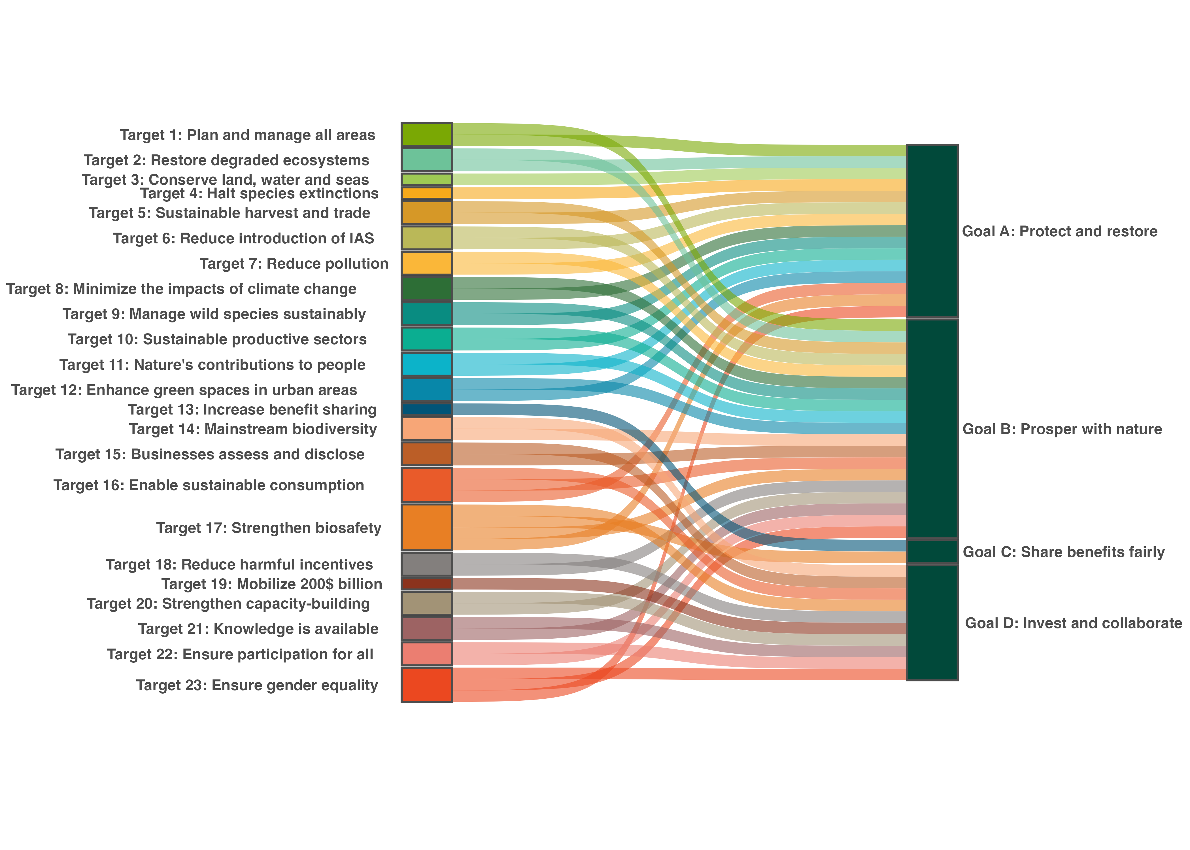
Note: Associations are based on Parties’ national target submissions. A link is created between a target and goal if at least one third of all national targets set by Parties from any regional group of United Nations Member States associated a target with the goal. As the Framework does not contain a mapping of the relationship between its targets and its goals, this figure therefore provides an illustration of how Parties collectively view the relationship between the targets and goals of the Framework. The figure combines the information in the four figures in sect. II.C above (figures 96, 100,103 and 106), showing the targets associated with each of the four goals separately. It is based on how Parties have linked their national targets to the targets and goals of the Framework.

Box 58
Goal overviews based on associations in figure 109

Goal A – Protect and restore

Parties associated 15 of the 23 Framework targets with Goal A, including all targets related to reducing threats to biodiversity except Target 5 and four of the five targets related to sustainable use and benefit-sharing. Progress towards Goal A therefore depends on implementation across a broad range of targets with both direct and indirect impacts on biodiversity. While some associated targets show positive trends, overall collective progress towards those targets remains mixed.

Goal B – Prosper with nature

Parties associated 19 of the 23 Framework targets with Goal B, more targets than were associated with any other Goal. Progress towards Goal B is therefore highly dependent on coordinated action across most of the Framework. As shown in section II.B, collective progress across the Framework is mixed and requires action on both direct and indirect drivers of biodiversity change.

Goal C – Share benefits of genetic resources fairly

Parties associated only two Framework targets with Goal C: Target 13 on access and benefit-sharing and Target 17 on biosafety. While there is insufficient information to enable tracking of progress on outcomes related to those two global targets, Parties have shared progress towards developing some of the administrative, legislative and policy measures defined in those two targets.

Goal D – Invest and collaborate

Parties associated 10 of the 23 Framework targets with Goal D. All 10 were targets related to tools and solutions for implementation and mainstreaming. Targets 18, 19 and 20 show the strongest association with Goal D. Collective progress towards several of the targets associated with Goal D faces major implementation challenges.

III.B Moving forward: challenges and opportunities
Six key messages related to collective progress have emerged from the present global report. Successful implementation of the Framework will require addressing the gaps and overcoming the barriers impeding collective progress identified in those messages. The six messages are set out below, coupled with possible non-prescriptive approaches to addressing gaps and overcoming barriers related to each key message. The key messages are followed by a short concluding reflection related to production of the present report (box 59).
Key message 1: Scope and coverage
The Framework has garnered strong political will and commitment. However, there are gaps between the collective scope of the national targets and the scope of the global targets of the Framework. Strengthening political will and commitment would enable those gaps in scope and ambition to be addressed and overcome.
At the time of preparation of the global report,162 Parties (83 per cent) had set national targets aligned with the Framework, with each Party addressing on average 22 of the 23 global targets. In strong contrast, at the time of the final review of the Aichi Biodiversity Targets in 2020, only about half of Parties had set national targets aligned with the global targets (CBD, 2020). Moreover, more than 100 actors other than national Governments had submitted commitments through the portal established for that purpose in time for those commitments to be considered in the preparation of this report and the number of submissions continues to increase. Despite the high level of engagement, however, many of the key elements making up the global targets are not addressed or are weakly reflected in the national targets submitted by Parties.
National targets aligned with Targets 4, 8 and 11 of the Framework, followed by Targets 5, 9 and 10, were assessed to have the highest coverage of the elements of the global targets (see figure 1). National targets aligned with Targets 15, 16, 19 and 22 of the Framework demonstrated the lowest coverage of the elements of the global targets, followed by national targets aligned with Targets 1, 14, 18, 20 and 23 of the Framework. The specific coverage of different elements in national targets varies greatly among global targets.
In general, the targets and target elements related to biodiversity conservation and sustainable use are addressed more comprehensively in national targets than those targets and target elements related to the indirect drivers of biodiversity loss. Targets and elements related to mainstreaming biodiversity, sustainable consumption, resource mobilization, incentives and subsidies, participation and participatory processes, equitable governance, land and resource rights, gender responsiveness, policy coherence and means of implementation are addressed less consistently. Further, marine, coastal and inland water ecosystems are underrepresented relative to terrestrial ecosystems. Cross-cutting issues, such as the contributions and rights of indigenous peoples and local communities, women and youth; whole-of-government and whole-of-society approaches; human rights-based approaches; gender; and intergenerational equity, as well as other considerations in section C of the Framework are often missing in the descriptions included with national targets, national biodiversity strategies and action plans and national reports.
Possible non-prescriptive approaches:
- Without diverting resources from implementation, Parties could adjust targets and strengthen actions to better address specific targets or elements of the global targets that are not fully reflected. National policy could be reviewed and further developed as necessary with reference to the full scope of the associated global targets to identify potential areas where stronger and more comprehensive national commitments could fill the gaps and overcome challenges in collective implementation and ambition. Different options may be considered depending on national circumstances, for example: Parties that have not yet updated NBSAPs and/or targets could make greater efforts to align with the scope and ambition of global targets, with adequate means of implementation; Parties could review and adjust targets, if this is in accordance with national circumstances, but without taking resources or focus away from implementation; or Parties could keep their already updated targets but strengthen their actions to better address specific targets or target elements where gaps in collective scope and ambition have been identified.
- Multi-stakeholder platforms, coalitions, partnerships, initiatives and other forms of cooperation and collaboration could be scaled up and replicated to support higher ambition and implementation, sustained engagement, communication, awareness, education and advocacy, thus broadening commitment to the Framework, in particular for underrepresented targets and elements.
- To support a broader scope in their national strategies and, in particular, in their action plans, Parties could focus on addressing key barriers related to the means of implementation, policy coherence and environmental governance, participation and engagement of actors other than national Governments and data and knowledge gaps.

Key message 2: Action and implementation
Implementation is under way across all targets, but less than half of Parties reported that their national targets were on track for any global target. This could be addressed through accelerated, strategic and prioritized action, tailored to national circumstances, particularly on issues related to addressing the underlying drivers of biodiversity loss.
Action is being taken across all targets of the Framework and national reports include numerous examples of successful implementation. Many Parties reported progress towards achieving one or more of their national targets; however, consideration of collective progress across the global targets reveals that fewer than half of reporting Parties considered their national targets aligned with any of the global targets of the Framework to be on track. The indicator trends were mixed and, overall, negative trends are more common than positive trends.
National targets associated with Targets 1, 2, 3, 8, 13, 20, 21 and 22 of the Framework are most frequently self-assessed by Parties as being on track, while national targets associated with Targets 6, 12, 15, 16, 18 and 19 are least frequently self-assessed by Parties as being on track. It may be too early to detect trends in indicators related to implementation of the Framework owing to time lags between implementation and monitoring and data gaps across the Framework. However, data submitted in the national reports does not currently consistently demonstrate that the trend is progressing at a rate needed to meet any of the global targets. Nevertheless, some targets, notably those aligned with global targets 5, 6, 16 and 20, demonstrate more collective progress towards the global target than do other targets, in particular those aligned with global targets 3, 4, 13, 17, 19 and 23.
The analysis of the self-reported assessment of progress and the indicators submitted in national reports highlight implementation gaps across the Framework. This includes uneven coverage of specific types of ecosystems in the disaggregated data submitted and in the trends in those data. Implementation gaps reflect broader challenges in addressing the indirect drivers of biodiversity loss, including unsustainable production and consumption patterns, misaligned economic incentives and insufficient integration of biodiversity and its multiple values across sectors.
Possible non-prescriptive approaches:
- Peer-to-peer learning, including at the regional level, and exchanges between policymakers, technical experts, rights holders, specialists involved in implementation and other stakeholders could be further pursued as a modality for helping to identify possible actions and accelerating implementation.
- Further emphasis on developing biodiversity finance plans, capacity-building plans and monitoring plans to support national implementation could foster efficient implementation and provide a basis for targeting action and identifying and addressing gaps in implementation.
- Parties could benefit from identifying and prioritizing actions for which an investment of resources is most likely to deliver the most progress towards targets, taking into consideration the associated requirements for finance, capacity, technology, governance and monitoring. In particular, such a process could target actions aimed at addressing the underlying drivers of biodiversity loss, aligning economic and financial systems with biodiversity objectives, strengthening inclusive and adaptive governance, promoting sustainable and equitable production and consumption and advancing integrated approaches across biodiversity, climate, food, land use, water and health systems, thereby presenting opportunities for delivering multiple benefits and reducing trade-offs.
- Addressing gaps in implementation could be improved through strengthening whole-of-society and whole-of-government approaches and addressing the barriers related to means of implementation, policy coherence and environmental governance, participation and engagement of actors other than national Governments, and data and knowledge gaps.

Key message 3: Means of implementation
There have been some gains in domestic and international public finance, positive incentives for biodiversity, capacity-building and development, technology transfer and technical and scientific cooperation since the adoption of the Framework; however, less progress is reported in mobilizing and tracking private finance and reducing incentives, including subsidies, harmful for biodiversity. Parties report that access to sufficient and timely means of implementation remains a barrier to implementation across the Framework.
Goal D of the Framework defines the need for adequate means of implementation to fully implement the Framework. Parties have identified national targets aligned with Target 19, as well as Targets 18 and 20, of the Framework as being most strongly associated with Goal D, followed by targets 14, 15, 16, 17, 21, 22, and 23. As demonstrated in the target-by-target analysis, in general those global targets have some of the largest gaps in terms of collective scope and ambition.
Targets 15, 16, 18 and 19 scored among the lowest of all targets of the Framework in the context of the self-assessment of progress by Parties. Based on the data reported by Parties in relation to the assessment of collective progress towards target 19, the 2025 milestone of US$ 20 billion per year in total biodiversity-related international financial resources was likely not met; however, a definitive assessment will be possible only once complete data through to 2025 have been reported.
Some of the challenges highlighted by Parties relate to the scale, timeliness and availability of means of implementation, as well as how means of implementation are aligned with the Framework. In addition, challenges are reported in relation to biodiversity-specific finance data, including gaps in disaggregated information on recipients, and target-level finance data. Many Parties report that shortages of financial and human resources limited institutional and technical capacity and were associated with difficulties in accessing or deploying technology. Developing countries, especially least developed countries and small island developing States, are more likely to have reflected gaps in the means of implementation in their national reports. Moreover, national reports highlight that indigenous peoples and local communities, women, youth, subnational Governments and other actors often lack sufficient resources to support or scale up their contributions to the implementation of the Framework. Successful practices and opportunities for improving means of implementation were identified by Parties, including strengthened policy, regulatory and institutional frameworks; improved alignment of public and private financial flows with biodiversity objectives; reform of incentives, including subsidies, harmful to biodiversity; expanded access to finance, capacity-building, technology transfer and technical and scientific cooperation; and greater collaboration across sectors, actors and existing international initiatives to maximize impact and support equitable implementation of the Framework.
Possible non-prescriptive approaches:
- Investing in robust public policy, regulatory frameworks, safeguards and accountability mechanisms, including for taxonomies, disclosure frameworks and other financial instruments where appropriate, could both support resource mobilization and better align economic systems with biodiversity objectives. The consistent integration of biodiversity considerations into economic decision-making and aligning the methodologies used by businesses, financial institutions and other actors with the objectives and indicators of the Framework could support improved coordination and long-term systemic change.
- Blended finance approaches and other innovative financing mechanisms could help mobilize additional resources, while supporting measurable biodiversity outcomes and equitable benefit-sharing.
- Parties could leverage a whole-of-society approach by building on the recognition and integration of the contributions and commitments of actors other than national Government to implementation and improving the way in which different actors, including indigenous peoples and local communities, women, and youth, can access adequate finance.
- Parties could increase efforts to identify and then eliminate, phase out or reform incentives, including subsidies, harmful for biodiversity, in a proportionate, just, fair, effective and equitable way and scale up positive incentives for the conservation and sustainable use of biodiversity.
- Parties may benefit from enhancing capacity around resource mobilization and monitoring. Such efforts would allow for the identification of options for upscaling capacity-building and development, knowledge and information sharing with different actors, technology transfer and technical and scientific cooperation, including through improved regional and subregional mechanisms. The regional and subregional technical and scientific cooperation centres established through the Convention, or other regional mechanisms, could play a particularly important role in this respect.
- Work under the Convention focused on resource mobilization, incentives, capacity-building, technical and scientific cooperation and technology transfer could take the findings of the global report into account, as well as needs identified in national reports, in designing actions aimed at addressing gaps in the means of implementation.
- Knowledge-sharing, matchmaking and South-South, North-South and triangular cooperation could be upscaled, including potentially through the regional and subregional technical and scientific cooperation support centres.
- Building on existing initiatives under the Convention and its Protocols, biodiversity-related conventions, other relevant multilateral environmental agreements, international organizations and processes could improve coherence, reduce duplication and maximize the impact of available resources.
Key message 4: Whole-of-Government approaches
While many Parties report actions to strengthen environmental governance, advance the mainstreaming of biodiversity and its multiple values and improve policy coherence, progress remains uneven and insufficient. The targets of the Framework include aspects related to economic development plans, food systems, health, infrastructure, trade, fiscal policy, finance and other national priorities. Improved integration and mainstreaming of biodiversity across Government is required in order to implement the whole-of-government approach of the Framework, avoid or minimize trade-offs, reduce duplication and streamline domestic resource allocation.

Among the policy actions described in the national reports, Parties report progress in developing legislation and engaging ministries beyond the environmental sector, involving subnational authorities and developing biodiversity inclusive spatial planning and effective management processes. The ministries most commonly reported as associated with such engagement include ministries of agriculture, fisheries and finance. Many Parties have reflected the Rio conventions and other multilateral environmental agreements in their national biodiversity strategies and action plans and numerous international agreements and initiatives are mentioned across the national targets and national reports. Several Parties provided examples of integrated planning across biodiversity and climate, food, water, health, land use and/or other development objectives. However, engagement of ministries beyond the environmental sector is often described in general terms without inclusion of information on coordinated implementation across sectors.
Targets 1 and 14 of the Framework, which most directly relate their success to whole-of-government approaches through integrated planning and mainstreaming, respectively, have shown limited progress. This is especially evident in relation to integrated spatial planning, integrating biodiversity and its multiple values into policies, regulations, planning and development processes, and ensuring integration across all levels of government and sectors.
Possible non-prescriptive approaches:
- Strengthening implementation through better legislative and policy frameworks, stronger coordination mechanisms and improved collaboration across sectors and levels of government is imperative for ensuring effective and integrated planning and implementation.
- Improving integrated planning, monitoring and implementation across processes including the Rio conventions, biodiversity-related or other multilateral environmental agreements or other international, regional and subregional agreements and processes, including those related to finance and/or socioeconomic and development objectives, through improved mainstreaming could improve efficiency, reduce duplication and strengthen policy and action coherence and improve domestic resource allocation.
- Improving institutional understanding of the Framework and its related processes across ministries beyond the ministry of the environment could foster more coordinated and complementary action across government institutions and sectors.
- Investing in participatory, integrated and biodiversity inclusive spatial planning, as addressed in Target 1, and assessing the value of biodiversity and its multiple values, as addressed in Target 14, while building on the traditional knowledge and practices of indigenous people and local communities, women and youth, could improve implementation across the targets of the Framework.
Key message 5: Whole-of-society
The Framework cannot be achieved without engaging actors other than national Governments. The whole of society approach can be a very effective, inclusive and cost-efficient pathway to strengthening implementation. The impacts of different actors on biodiversity, and the reliance of those actors on biodiversity, the participation, rights and resource needs of indigenous people and local communities, women, youth and other actors; and the contributions that different actors are making or could make to the Framework are not yet being fully realized, accounted for and supported or consistently reflected in planning, monitoring and reporting.

Many actors other than national Governments, including indigenous peoples and local communities, subnational governments, cities and other local authorities, intergovernmental organizations, non-governmental organizations, women, youth, research organizations, the business and finance community and representatives of sectors related to or dependent on biodiversity, are currently supporting the implementation of the Framework. Many national biodiversity strategies and action plans describe the participation of different actors in national planning processes to varying degree and more than 100 actors other than national Governments have made commitments in support of the Framework through the portal launched for that purpose. There has been uneven progress on issues related to rights and equity, equitable governance and participation of rights holders and other actors, the actions of businesses and coordination and engagement actors other than national Governments in implementation. While many Parties reported progress towards some elements of Targets 22 and 23, for example, involving, to varying degrees, indigenous peoples and local communities, women and youth and other actors in biodiversity-related decision-making, there was less coverage in the national targets of access to information and justice, rights over lands, territories, resources and traditional knowledge or gender-responsive biodiversity governance. As reflected in the assessment of Target 15, progress has been limited in reducing the negative impacts of businesses on biodiversity, increasing positive impacts, reducing biodiversity-related risks to business and financial institutions, promoting actions to ensure sustainable and equitable patterns of production and consumption and developing corporate disclosure and reporting frameworks.
Many Parties reported challenges in coordinating and tracking the contributions of actors other than national Government towards their national targets. There is limited information on the contributions of different actors or on the financial, capacity and other means of implementation available to those actors. Moreover, in the case of indigenous peoples and local communities, women, youth and subnational governments, there is limited information on the gaps in means of implementation which would be required for supporting or scaling up their contributions to the implementation of the Framework. It should be noted that the reason for that lack of information may be that the portal for collecting information from those actors was launched only a few months before the preparation of this report.
Possible non-prescriptive approaches:
- Improving mechanisms for communication, coordination, tracking and co-implementation of actions with actors other than national Governments, including through multi-stakeholder platforms, could improve coherent and inclusive planning, implementation, monitoring, reporting and review.
- Mechanisms for better tracking, at the national level, the commitments and the progress towards commitments by actors other than national Governments could improve transparency and coordination and integration. That could include tracking the means of implementation that different actors have available or the means of implementation needs of specific actors, such as indigenous peoples and local communities, women, youth and subnational governments.
- Strengthening the enabling environment for action by and accountability of businesses and financial actors could support implementation of the Framework. This could include developing and enforcing relevant policies, laws and regulations, promoting biodiversity-related disclosure and reporting, integrating biodiversity considerations into business and financial decision-making and encouraging action across sectors and value chains that have significant impacts and dependencies on biodiversity.
- Further developing inclusive, rights-based and youth responsive and gender-responsive approaches could support more effective implementation of the Framework. This includes recognizing rights holders as partners in implementation and promoting the full, equitable, inclusive, effective and gender-responsive participation and representation of indigenous peoples and local communities, women, youth, persons with disabilities and other relevant stakeholders in biodiversity-related policy- and decision-making.

Key message 6: Data and knowledge
There has been substantial effort by Parties to improve national monitoring and knowledge management systems, including traditional knowledge. However, there are major gaps in data availability, data-sharing, appropriate and operationalized indicators, existing infrastructure and technical capacity which create gaps in data, information and knowledge available for decision-making.
Many Parties have quantitative data for monitoring Targets 1, 2, 3, 4 and 10, but reporting was uneven across the remainder of the targets, including some significant data gaps. Parties have mobilized information from government agencies, scientific institutions, indigenous peoples and local communities, civil society and international sources and have made progress towards Target 21. Quantitative reporting is more developed for some ecosystems and targets on restoration, protected and conserved areas, species status and production systems than for targets dealing with socioeconomic and cross-cutting issues. Qualitative reporting of elements of targets is also uneven. No Party reported on every headline indicator and methodologies are not operational for two headline indicators. Reported data for most indicators lack comparable time series and are rarely disaggregated by ecosystem type, sex, age, relationship with indigenous peoples or local communities or other relevant characteristics. Consistent reporting on newer headline indicators proved particularly challenging and in consequence so did compiling those indicators.
Challenges related to data and knowledge include a lack of methodological clarity for some indicators, including headline indicators, issues of data availability and access, data fragmentation across institutions and platforms, insufficient technical and technological infrastructure, complexities of national statistical systems, lack of stable and reliable financing, limited human capacity, insufficient institutional coordination and data governance and challenges related to the inclusion of traditional knowledge, with free prior and informed consent, and community-based information in monitoring efforts. Given that headline indicators are intended to guide implementation as well as measure progress, this suggests that Parties may lack the information that they need to implement the Framework, which further hinders progress.
Possible non-prescriptive options:
- Investing in data, monitoring and multiple knowledge systems, including supporting digital infrastructure, national clearing-house mechanisms or other national information management systems, would be fundamental to ensuring effective national implementation, reporting and decision-making at national, subnational and global levels. This would include identifying options for enhancing the means of implementation available to developing country Parties to support the development of national monitoring and statistical systems.
- Parties may benefit from identifying priority areas where investing in monitoring, data analysis and knowledge management systems is most needed, to underpin implementation of and reporting on the Framework. That includes recognizing the value for informed decision-making of having disaggregated information on ecosystem type, taxonomic group, sector, sex, age, indigenous peoples and local communities and other relevant characteristics and of developing national ecosystem maps.
- Peer-to-peer learning, capacity-building and targeted technical support, including at the regional and subregional levels, and involving actors other than national Governments could be carried out, for example, through the technical and scientific cooperation support centres.
- Research coordination and investment could be directed towards knowledge gaps identified through national reports, including gaps affecting developing countries and underrepresented ecosystems, regions, social groups and knowledge systems.
- Processes for engaging indigenous peoples and local communities, women, youth and other knowledge holders, including leveraging or community-based monitoring initiatives, could be developed jointly with them and include appropriate safeguards, mechanisms for free, prior and informed consent and recognition. Such processes could address improving the functionality of the portal for the submission of commitments by actors other than national Governments and encouraging its use.
- Adjusting the monitoring and data systems used by businesses and financial institutions in their disclosure frameworks to align with those of Governments, including alignment with the indicators used in national reports, would improve coherence and transparency.

Box 59
Conclusions related to the production of this report
The updating of NBSAPs, submission of national targets, development of the seventh national reports and preparation of the present first global report on collective progress in the implementation of the Kunming-Montreal Global Biodiversity Framework have provided the first opportunities to deploy the enhanced multidimensional approach to planning, monitoring, reporting and review, including the monitoring framework, adopted at the fifteenth and sixteenth meetings of the Conference of the Parties, to fulfil the requirement for transparency and responsibility in implementation of the Framework. While reviewing the planning, monitoring, reporting and review mechanism is not a specific objective of the global report, its preparation has generated a number of insights into how those mechanisms are functioning.
Based on the information analysed in this report, the planning, monitoring, reporting and review mechanisms for the Framework are providing a strong foundation for transparency, accountability and assessment of collective progress while allowing flexibility in their use according to national circumstances. All Parties that have reported have included data for at least one indicator from the adopted monitoring framework. The figure for submissions of data on headline indicators ranges from 7 to 78 per cent of Parties, depending on the indicator. While good foundations have been laid, the data provided on headline indicators are currently not sufficiently representative or consistent to enable firm conclusions to be drawn on collective progress. While other national indicators submitted provide valuable supplementary information, assessment of collective trends across diverse indicator types and topics remains challenging.
The standardized reporting architecture both for Parties and for actors other than national Governments has improved the ability to assess collective progress globally but there are some gaps in the information collected and the guidance related to reporting, particularly on the use of indicators, information related to section C of the Framework and information included in both the national reports and the commitments from other actors on the progress made by those actors. Moreover, further guidance is needed on the methodology and timing for complementing the information provided in Party submissions with information from scientific assessments, including the work of the Intergovernmental Science-Policy Platform on Biodiversity and Ecosystem Services (IPBES), global data sources and the relevant literature, especially in the context of the preparation of the IPBES second global assessment. Further guidance is also needed on how knowledge gaps identified in national reports and the global report could be used to guide future investments in research and monitoring, and in development of tools and assessments.

Bibliography
Affinito, F. and others, 2024. Progress in developing and operationalizing the Monitoring Framework of the Global Biodiversity Framework. Nat. Ecol. Evol. https://doi.org/10.1038/s41559-024-02566-7
Affinito, F. and others, 2025. Assessing coverage of the monitoring framework of the Kunming-Montreal Global Biodiversity Framework and opportunities to fill gaps. Nat. Ecol. Evol. 1–15. https://doi.org/10.1038/s41559-025-02718-3
Asare, R.A., Kyei, A., Mason, J.J., 2013. The community resource management area mechanism: The community resource management area mechanism: a strategy to manage African forest resources for REDD+. Philos. Trans. R. Soc. B Biol. Sci. 368, 20120311. https://doi.org/10.1098/rstb.2012.0311
BioJapan, 2025. Documentation of Traditional Knowledge on Medicinal Plants in Peninsular Malaysia and the Promotion of Genetic Resource Management through Bioprospecting. National Institute of Genetics ABS Support Office., Yokohama. Available at https://terayoshi-gyosei.com/absreport13/ (accessed 25 July 2026)
Blasiak, R., Jouffray, J.-B., 2024. When will the BBNJ Agreement deliver results? Npj Ocean Sustain. 3, 21. https://doi.org/10.1038/s44183-024-00058-6
Bosetti, L., 2023. Global Reporting Initiative Standards, in: Idowu, S.O. and others (Eds.), Encyclopedia of Sustainable Management. Springer International Publishing, Cham, pp. 1706–1718. https://doi.org/10.1007/978-3-031-25984-5_1033
Brazil, Ministry of Foreign Affairs, 2025. Submission of Brazil in response to CBD notification 2025-100. Secretariat of the Convention on Biological Diversity, Montreal. Available at https://www.cbd.int/notifications/2025-100 (accessed 23 June 2026)
Brito, D. and others, 2010. How similar are national red lists and the IUCN Red List? Biol. Conserv. 143, 1154–1158. https://doi.org/10.1016/j.biocon.2010.02.015
Butchart, S.H.M. and others, 2025. Measuring trends in extinction risk: a review of two decades of development and application of the Red List Index. Philos. Trans. R. Soc. B Biol. Sci. 380, 20230206. https://doi.org/10.1098/rstb.2023.0206
CAFF, 2025a. Submission of the Secretariat of Conservation of Arctic Flora and Fauna (CAFF), in response to CBD notification 2025-099. Secretariat of the Convention on Biological Diversity, Montreal. Available at https://www.cbd.int/notifications/2025-099 (accessed 21 May 2026)
CAFF, 2025b. Actions for Arctic Biodiversity 2025-2035. Conservation of Arctic Flora and Fauna, Akureyri, Iceland. Available at https://oaarchive.arctic-council.org/items/287297c8-cdec-46e1-8022-2c240242d1ad (accessed 21 May 2026)
Caribbean Biological Corridor Secretariat, 2025. Submission of the Caribbean Biological Corridor Secretariat, in response to CBD notification 2025-099. Secretariat of the Convention on Biological Diversity, Montreal. Available at https://www.cbd.int/notifications/2025-099 (accessed 21 May 2026)
Carroll, S.R. and others, 2020. The CARE Principles for Indigenous Data Governance. Data Sci. J. 19. https://doi.org/10.5334/dsj-2020-043
CBD, 2001. First Edition of the Global Biodiversity Outlook. Secretariat of the Convention on Biological Diversity, Montreal. Available at https://www.cbd.int/gbo (accessed 17 April 2026)
CBD, 2006a. GBO2: Second edition of the Global Biodiversity Outlook. Secretariat of the Convention on Biological Diversity, Montreal. Available at https://www.cbd.int/gbo (accessed 16 April 2026)
CBD, 2006b. UNEP/CBD/COP/8/31: REPORT OF THE EIGHTH MEETING OF THE PARTIES TO THE CONVENTION ON BIOLOGICAL DIVERSITY. Secretariat of the Convention on Biological Diversity. Available at https://www.cbd.int/doc/meetings/cop/cop-08/official/cop-08-31-en.pdf
CBD, 2008. UNEP/CBD/COP/9/29/Corr.1/Rev.1: REPORT OF THE CONFERENCE OF THE PARTIES TO THE CONVENTION ON BIOLOGICAL DIVERSITY ON THE WORK OF ITS NINTH MEETING. Secretariat of the Convention on Biological Diversity, Bonn, Germany. Available at https://www.cbd.int/doc/meetings/cop/cop-09/official/cop-09-29-corr1-rev1-en.pdf
CBD, 2010. GBO3: Third edition of the Global Biodiversity Outlook. Secretariat of the Convention on Biological Diversity, Montreal. Available at https://www.cbd.int/gbo (accessed 16 April 2026)
CBD, 2011. UNEP/CBD/COP/10/27/Corr.1: REPORT OF THE TENTH MEETING OF THE CONFERENCE OF THE PARTIES TO THE CONVENTION ON BIOLOGICAL DIVERSITY. Secretariat of the Convention on Biological Diversity, Nagoya, Japan. Available at https://www.cbd.int/doc/meetings/cop/cop-10/official/cop-10-27-corr1-en.pdf
CBD, 2012. UNEP/CBD/COP/11/35: REPORT OF THE ELEVENTH MEETING OF THE CONFERENCE OF THE PARTIES TO THE CONVENTION ON BIOLOGICAL DIVERSITY. Secretariat of the Convention on Biological Diversity, Hyderabad, India. Available at https://www.cbd.int/doc/meetings/cop/cop-11/official/cop-11-35-en.pdf
CBD, 2014a. GBO4: Fourth edition of the Global Biodiversity Outlook. Secretariat of the Convention on Biological Diversity, Montreal. Available at https://www.cbd.int/gbo (accessed 16 April 2026)
CBD, 2014b. UNEP/CBD/COP/12/29: REPORT OF THE TWELFTH MEETING OF THE CONFERENCE OF THE PARTIES TO THE CONVENTION ON BIOLOGICAL DIVERSITY. Secretariat of the Convention on Biological Diversity, Pyeongchang, Republic of Korea. Available at https://www.cbd.int/doc/meetings/cop/cop-12/official/cop-12-29-en.pdf
CBD, 2016. CBD/COP/13/25: REPORT OF THE CONFERENCE OF THE PARTIES TO THE CONVENTION ON BIOLOGICAL DIVERSITYON ITS THIRTEENTH MEETING. Secretariat of the Convention on Biological Diversity, Cancun, Mexico. Available at https://www.cbd.int/doc/c/c533/6dcd/0b0221d38ffc4fc8e992587b/cop-13-25-en.pdf
CBD, 2019. CBD/COP/14/14: REPORT OF THE CONFERENCE OF THE PARTIES TO THE CONVENTION ON BIOLOGICAL DIVERSITY ON ITS FOURTEENTH MEETING. Secretariat of the Convention on Biological Diversity, Sharm El-Sheikh, Egypt. Available at https://www.cbd.int/doc/c/1081/32db/e26e7d13794f5f011cc621ef/cop-14-14-en.pdf
CBD, 2020. GBO5: Fifth edition of the Global Biodiversity Outlook. Secretariat of the Convention on Biological Diversity, Montreal. Available at https://www.cbd.int/gbo (accessed 17 April 2026)
CBD, 2023. CBD/COP/15/17: REPORT OF THE CONFERENCE OF THE PARTIES TO THE CONVENTION ON BIOLOGICAL DIVERSITY ON THE SECOND PART OF ITS FIFTEENTH MEETING. Secretariat of the Convention on Biological Diversity, Montreal. Available at https://www.cbd.int/doc/c/3119/8611/72d7962a5b058cc30e2299c7/cop-15-17-en.pdf
CBD, 2025a. CBD/SBSTTA/27/10: Report of the Subsidiary Body on Scientific, Technical and Technological Advice on its twenty-seventh meeting. Secretariat of the Convention on Biological Diversity, Panama City. Available at https://www.cbd.int/doc/c/e351/bab2/3a33b208be8f37644685ad5a/sbstta-27-10-en.pdf
CBD, 2025b. CBD/SB8J/REC/1/5: Provision of advice on traditional knowledge for the global report on collective progress in the implementation of the Kunming-Montreal Global Biodiversity Framework. Secretariat of the Convention on Biological Diversity, Panama City. Available at https://www.cbd.int/doc/recommendations/sb8j-01/sb8j-01-rec-05-en.pdf (accessed 29 July 2026)
CBD, 2025c. Work under the Convention on Biological Diversity (CBD) relevant to the Agreement under UNCLOS on the Conservation and Sustainable Use of Marine Biological Diversity of Areas beyond National Jurisdiction (BBNJ Agreement). Secretariat of the Convention on Biological Diversity, Montreal. Available at https://www.cbd.int/doc/publications/cbd-bbnj-booklet-en.pdf (accessed 17 April 2026)
CBD, 2026. CBD/COP/16/13/Rev.1: Report of the Conference of the Parties to the Convention on Biological Diversity on its sixteenth meeting. Secretariat of the Convention on Biological Diversity, Rome. Available at https://www.cbd.int/doc/c/6752/2897/32597768aa0ea7d0ebd3d988/cop-16-13-rev1-en.pdf
CBD, Convention on Wetlands, 2024. CBD/COP/16/INF/19: Sixth joint work plan (2024–2030) of the Convention on Biological Diversity and the Convention on Wetlands of International Importance especially as Waterfowl Habitat. Secretariat of the Convention on Biological Diversity, Cali. Available at https://www.cbd.int/doc/c/9064/7ac2/28ce9b98f96e723a731f3361/cop-16-inf-19-en.pdf (accessed 21 May 2026)
CDP, 2025. Target 15 data: CDP monitoring of the global biodiversity framework (GBF) target 15.1. CDP Worldwide. Available at https://www.cdp.net/en/data/monitoring-gbf
CITES, 2025a. Submission of the Secretariat of the Convention on International Trade in Endangered Species of Wild Fauna and Flora (CITES), in response to CBD notification 2025-099. Secretariat of the Convention on Biological Diversity, Montreal. Available at https://www.cbd.int/notifications/2025-099 (accessed 21 May 2026)
CITES, 2025b. SC79 Doc. 6.4: Malagasy Palisanders and Rosewood (Dalbergia Spp.) and Ebonies (Diospyros Spp.). Secretariat of the Convention on International Trade in Endangered Species of Wild Fauna and Flora, Samarkand. Available at https://cites.org/eng/sc/79/agenda-documents (accessed 21 May 2026)
CITES, 2025c. Conf. 16.4 (Rev. CoP20): Cooperation of CITES with other biodiversity-related conventions. Secretariat of the Convention on International Trade in Endangered Species of Wild Fauna and Flora, Samarkand. Available at https://cites.org/eng/res/index.php (accessed 31 July 2026)
CITES, 2025d. Conf. 18.3 (Rev. CoP20): CITES Strategic Vision: 2021-2030. Secretariat of the Convention on International Trade in Endangered Species of Wild Fauna and Flora, Samarkand. Available at https://cites.org/eng/res/index.php (accessed 31 July 2026)
CITES, 2026. 2026/005: Notification to the Parties concerning amendments to Appendices I and II of the Convention adopted by the Conference of the Parties at its 20th meeting (Samarkand, 24 November - 5 December 2025). Secretariat of the Convention on International Trade in Endangered Species of Wild Fauna and Flora, Geneva. Available at https://cites.org/sites/default/files/notifications/E-Notif-2026-005_0.pdf (accessed 21 May 2026)
CMS, 2008. ACTION PLAN FOR THE CONSERVATION OF MIGRATORY BIRDS OF PREY IN AFRICA AND EURASIA. Available at https://raptors.cms.int/sites/default/files/document/Raptors_Action_Plan_E_0.pdf
CMS, 2021. UNEP/CMS/Saiga/MOS4/Outcome 1: Medium-Term International Work Programme for the Saiga Antelope (2021-2025). Secretariat of the Convention on the Conservation of Migratory Species of Wild Animals, Bonn. Available at https://saiga.cms.int/document/medium-term-international-work-programme-saiga-antelope-2021-2025
CMS, 2023. UNEP/CMS/COP15/CRP18.3: CMS Contribution to the Kunming-Montreal Global Biodiversity Framework. Secretariat of the Convention on the Conservation of Migratory Species of Wild Animals, Campo Grande. Available at https://www.cms.int/document/cms-contribution-kunming-montreal-global-biodiversity-framework-1 (accessed 17 April 2026)
CMS, 2024. UNEP/CMS/Resolution 14.16: Ecological connectivity. Secretariat of the Convention on the Conservation of Migratory Species of Wild Animals, Samarkand.
CMS, 2025a. Submission of the Secretariat of the Convention on the Conservation of Migratory Species of Wild Animals (CMS), in response to CBD notification 2025-099. Secretariat of the Convention on Biological Diversity, Montreal. Available at https://www.cbd.int/notifications/2025-099 (accessed 21 May 2026)
CMS, 2025b. UNEP/CMS/COP15/Doc.15: Samarkand Strategic Plan for Migratory Species 2024-2032. Secretariat of the Convention on the Conservation of Migratory Species of Wild Animals, Samarkand. Available at https://www.cms.int/document/strategic-plan-migratory-species-2024-2032 (accessed 15 July 2026)
Convention on Wetlands, 2024. Scaling up wetland conservation and restoration to deliver the Kunming-Montreal Global Biodiversity Framework: Guidance on including wetlands in National Biodiversity Strategy and Action Plans (NBSAPs) to boost biodiversity and halt wetland loss and degradation. Secretariat of the Convention on Wetlands, Gland. https://doi.org/10.69556/strp.tr12.24
Convention on Wetlands, 2025a. Submission of the Secretariat of the Convention on Wetlands, in response to CBD notification 2025-099. Secretariat of the Convention on Biological Diversity, Montreal. Available at https://www.cbd.int/notifications/2025-099 (accessed 21 May 2026)
Convention on Wetlands, 2025b. Global Wetland Outlook 2025: Valuing, conserving, restoring and financing wetlands. Secretariat of the Convention on Wetlands, Gland. https://doi.org/10.69556/GWO-2025-eng
Convention on Wetlands, 2025c. COP15 Inf.3: Report of the Secretariat on assessment of progress on wetland restoration: Full assessment report. Secretariat of the Convention on Wetlands, Victoria Falls. Available at https://www.ramsar.org/sites/default/files/2025-05/COP15_inf_3_full_restoration_assessment_report_e.pdf (accessed 9 July 2026)
Convention on Wetlands, 2025d. COP15 Doc.9 Rev.1: Report of the Secretariat pursuant to Article 8.2 on the List of Wetlands of International Importance. Secretariat of the Convention on Wetlands, Victoria Falls. Available at https://www.ramsar.org/document/cop15-doc9-rev1-report-secretariat-pursuant-article-82-list-wetlands-international (accessed 21 May 2026)
Convention on Wetlands, 2025e. COP15 Doc.8.1: Report of the Secretary General on the implementation of the Convention: Global implementation. Secretariat of the Convention on Wetlands, Victoria Falls. Available at https://www.ramsar.org/sites/default/files/2025-05/cop15_8_1_sg_report_global_implementation_e.pdf (accessed 12 August 2026)
Convention on Wetlands, 2025f. Strategic Plan of the Convention on Wetlands 2025-2034. Secretariat of the Convention on Wetlands, Victoria Falls. Available at https://www.ramsar.org/sites/default/files/2025-09/Convention_on_Wetlands_fifth_strategic_plan_e.pdf (accessed 15 July 2026)
Convention on Wetlands, 2025g. Resolution XV.4: Enhancing the Convention’s visibility and synergies with other multilateral environmental agreements and other international institutions. Secretariat of the Convention on Wetlands, Victoria Falls. Available at https://www.ramsar.org/sites/default/files/2025-09/xv.4_synergies_e.pdf (accessed 15 July 2026)
DCCEEW, 2024. Australia’s Circular Economy Framework. Department of Climate Change, Energy, the Environment and Water, Canberra. Available at https://www.dcceew.gov.au/environment/protection/circular-economy/framework (accessed 25 June 2026)
Dossou Etui, I.M. and others, 2024. Artisanal and small-scale gold mining and biodiversity: a global literature review. Ecotoxicology 33, 484–504. https://doi.org/10.1007/s10646-024-02748-w
ECE, 1979. 1979 Convention on Long-range Transboundary Air Pollution. Available at https://unece.org/sites/default/files/2021-05/1979%20CLRTAP.e.pdf
ECE, 1998. Convention on Access to Information, Public Participation in Decision-Making and Access to Justice in Environmental Matters. United Nations Economic Commission for Europe (UNECE), Aarhus. Available at https://unece.org/environment-policy/public-participation/aarhus-convention/text (accessed 27 July 2026)
Economic Commission for Latin America and the Caribbean (ECLAC), 2018. LC/PUB.2018/8: Regional Agreement on Access to Information, Public Participation and Justice in Environmental Matters in Latin America and the Caribbean. United Nations, Santiago. Available at https://www.cepal.org/en/escazuagreement (accessed 25 July 2026)
Enkhbayar, O. and others, 2025. Reforming livestock taxation for sustainable rangeland use: Macro-level analysis on Mongolia’s livestock tax law implementation. Proc. Mong. Acad. Sci. 1–16. https://doi.org/10.5564/pmas.v65i03.4530
European Commission Directorate General for Environment., 2023. Pollinators on the edge: Pollinators on the edge :our European hoverflies : the European red list of hoverflies. Publications Office, Luxembourg. https://doi.org/10.2779/652219
European Commission Directorate-General for Environment and others, 2025. European red list of butterflies. Publications Office of the European Union, Luxembourg. https://doi.org/10.2779/1280375
European Commission Directorate-General for Environment and others, 2026a. European red list of bees. Publications Office of the European Union, Luxembourg. https://doi.org/10.2779/521877
European Commission Directorate-General for Environment and others, 2026b. European red list of moths. Publications Office of the European Union, Luxembourg. https://doi.org/10.2779/6590787
European Union, 2023. COM(2023) 35 final: Revision of the EU Pollinators Initiative: A new deal for pollinators. European Commission, Brussels. Available at https://eur-lex.europa.eu/legal-content/EN/TXT/?uri=COM%3A2023%3A35%3AFIN (accessed 27 June 2026)
European Union, 2024. Regulation (EU) 2024/1991 of the European Parliament and of the Council of 24 June 2024 on nature restoration and amending Regulation (EU) 2022/869. Brussels. Available at https://eur-lex.europa.eu/legal-content/EN/TXT/?uri=CELEX%3A32024R1991&qid=1722240349976 (accessed 25 July 2026)
European Union, 2025. Commission Delegated Regulation (EU) 2025/2188 of 19 September 2025 supplementing Regulation (EU) 2024/1991 of the European Parliament and of the Council by establishing a science-based method for monitoring pollinator diversity and pollinator populations. Brussels. Available at https://eur-lex.europa.eu/legal-content/EN/TXT/?uri=OJ:L_202502188 (accessed 25 July 2026)
FAO, 2020. FAO Strategy on Mainstreaming Biodiversity across Agricultural Sectors. Food and Agriculture Organization of the United Nations, Rome. https://doi.org/10.4060/ca7722en
FAO, 2021. Climate change, biodiversity and nutrition nexus. FAO. https://doi.org/10.4060/cb6701en
FAO, 2022. Framework for Action on Biodiversity for Food and Agriculture. Food and Agriculture Organization of the United Nations, Rome. https://doi.org/10.4060/cb8338en
FAO, 2024a. COAG/2024/18: Update on the Guidelines for Integrated Land Use Planning. Food and Agriculture Organization of the United Nations, Rome. Available at https://openknowledge.fao.org/server/api/core/bitstreams/8e2fc4bc-086d-4294-95ba-f69ce18f03e9/content (accessed 21 May 2026)
FAO, 2024b. Action Plan for the implementation of the FAO Strategy on Mainstreaming Biodiversity Across Agricultural Sectors 2024–2027. Food and Agriculture Organization of the United Nations, Rome. https://doi.org/10.4060/cd0709en
FAO, 2025a. Submission of the Food and Agriculture Organization of the United Nations (FAO), in response to CBD Notification 2025-099. Secretariat of the Convention on Biological Diversity, Montreal. Available at https://www.cbd.int/notifications/2025-099 (accessed 21 May 2026)
FAO, 2025b. Global Forest Resources Assessment 2025. Food and Agriculture Organization of the United Nations, Rome. https://doi.org/10.4060/cd6709en
FAO, 2025c. The Benefit-sharing Fund: 2024–2025 report. Food and Agriculture Organization of the United Nations, Rome. Available at https://openknowledge.fao.org/server/api/core/bitstreams/c57562d2-b094-429c-bf08-35f525d2c983/content (accessed 30 July 2026)
FAO, 2026. The State of World Fisheries and Aquaculture 2026. FAO, Rome. https://doi.org/10.4060/cd8357en
FAO, CBD, Society for Ecological Restoration, 2024. Delivering restoration outcomes for biodiversity and human well-being: Resource guide to Target 2 of the Kunming-Montreal Global Biodiversity Framework. Food and Agriculture Organization of the United Nations, Rome. https://doi.org/10.4060/cd2925en
FAO, UNDP, 2025. The implementation of the Livestock Tax Law: An opportunity for climate action, Scaling up climate ambition on land use and agriculture through NDC and NAPs (SCALA). Food and Agriculture Organization of the United Nations, United Nations Development Programme. Available at https://www.adaptation-undp.org/sites/default/files/resources/Mongolia%20SLA%20Policy%20Brief%20%281%29.pdf (accessed 27 June 2026)
Forest Peoples Programme and others, 2020. LBO2: Local Biodiversity Outlooks 2: The contributions of indigenous peoples and local communities to the implementation of the Strategic Plan for Biodiversity 2011–2020 and to renewing nature and cultures. A complement to the fifth edition of the Global Biodiversity Outlook. Forest People’s Programme, Moreton-in-Marsh. Available at https://localbiodiversityoutlooks.net/publications/ (accessed 30 May 2026)
Forest Peoples Programme, International Indigenous Forum on Biodiversity, Secretariat of the Convention on Biological Diversity, 2016. LBO-1: Local Biodiversity Outlooks. Indigenous Peoples’ and Local Communities’ Contributions to the Implementation of the Strategic Plan for Biodiversity 2011-2020. A complement to the fourth edition of the Global Biodiversity Outlook. Forest Peoples Programme, Moreton-in-Marsh. Available at https://localbiodiversityoutlooks.net/publications/ (accessed 30 May 2026)
Franke, J. and others, 2024. Prescribed burning and integrated fire management in the Brazilian Cerrado: demonstrated impacts and scale-up potential for emission abatement. Environ. Res. Lett. 19, 034020. https://doi.org/10.1088/1748-9326/ad2820
Fumey-Nassah, C.A., 2025. The CREMA model: a tool for shaping Ghana’s landscape. Presented at the National Landscape Forum. Available at https://thedocs.worldbank.org/en/doc/4b347cebf3722a5af3500909c71ea022-0320052025/original/7-CREMA.pdf (accessed 15 June 2026)
Gerhartz-Muro, J., Viña-Dávila, N., 2022. Strategic Plan for the Caribbean Biological Corridor 2022-2030. United Nations Environment Programme, Santo Domingo. Available at https://cbcbio.org/wp-content/uploads/2024/02/PlanEstrategico-CBC-EN-Full-Final-.pdf
Global Ecosystems Atlas, 2026. Guidelines for developing national ecosystem maps. https://doi.org/10.60566/CD13V-0ME13
Government of Cameroon, 2025. Law No. 2025/006: Governing Biosecurity in Cameroon. Presidency of the Republic of Cameroon. Available at https://www.prc.cm/en/news/the-acts/laws/7719-law-no-2025-006-of-25-april-2025-governing-biosecurity-in-cameroon (accessed 30 June 2026)
Government of Malaysia, 2017. Act 795: Access to Biological Resources and Benefit Sharing Act 2017. Kuala Lumpur. Available at https://www.mybis.gov.my/pb/3567 (accessed 30 June 2026)
Government of Mongolia, 2020. Law on Livestock Tax. Ulaanbaatar. Available at https://www.ecolex.org/details/legislation/law-on-livestock-tax-lex-faoc202443/ (accessed 27 June 2026)
Grantham, H., Adams, V., IUCN WCPA Taskforce on Spatial Planning, 2024. An overview of Participatory, Integrated, and Biodiversity-Inclusive Spatial Planning and Target 1 under the Convention on Biological Diversity Kunming-Montreal Global Biodiversity Framework, IUCN WCPA Issues Paper Series. IUCN, Gland. Available at https://iucn.org/sites/default/files/2024-10/iucn-wcpa-issues-paper-4.pdf (accessed 14 July 2026)
Group on Earth Observations, 2025. Submission of the Group on Earth Observations (GEO) Secretariat, in response to CBD notification 2025-099. Secretariat of the Convention on Biological Diversity, Montreal. Available at https://www.cbd.int/notifications/2025-099 (accessed 21 May 2026)
High Level Panel for a Sustainable Ocean Economy, 2024. Ocean Panel Progress Report 2024: The second progress report from the High Level Panel for a Sustainable Ocean Economy. World Resources Institute, Washington, D.C. Available at https://oceanpanel.org/wp-content/uploads/2024/09/OP_Progress_2024-Final.pdf (accessed 12 May 2026)
IAEA, 2025. Submission of International Atomic Energy Agency, Division of Marine Environment Laboratories, in response to CBD notification 2025-099. Secretariat of the Convention on Biological Diversity, Montreal. Available at https://www.cbd.int/notifications/2025-099 (accessed 21 May 2026)
Immerzeel, R. and others, 2026. From Global Ambition to National Commitments: National Target Setting under the Global Biodiversity Framework: A contribution to the Convention on Biological Diversity’s Global Review. PBL Netherlands Environmental Assessment Agency, The Hague. Available at https://www.pbl.nl/en/publications/from-global-ambition-to-national-commitments-national-target-setting-under-the-global-biodiversity-framework (accessed 22 July 2026)
IMO, 2023a. BWM.2/Circ.13/Rev.5: International Convention for the Control and Management of Ships’ Ballast Water and Sediments, 2004; Methodology for information gathering and conduct of work of the GESAMP-BWWG. International Maritime Organization, London. Available at https://wwwcdn.imo.org/localresources/en/OurWork/Environment/Documents/Biofouling%20pages/BWM.2-Circ.13-Rev.5.pdf (accessed 21 May 2026)
IMO, 2023b. Resolution MEPC.378(80): 2023 Guidelines for the control and management of ships’ biofouling to minimize the transfer of invasive aquatic species. International Maritime Organization, London. Available at https://wwwcdn.imo.org/localresources/en/KnowledgeCentre/IndexofIMOResolutions/MEPCDocuments/MEPC.378%2880%29.pdf (accessed 21 May 2026)
IMO, 2025. Submission of the Secretariat of the International Maritime Organization (IMO), in response to CBD notification 2025-099. Secretariat of the Convention on Biological Diversity, Montreal. Available at https://www.cbd.int/notifications/2025-099 (accessed 21 May 2026)
INMS, 2026. INMS The International Nitrogen Management System [WWW Document]. Available at https://www.inms.international/ (accessed 10 July 2026)
International Sustainability Standards Board, 2023. IFRS sustainability disclosure standards: IFRS S1 and IFRS S2. IFRS Foundation, London, UK. Available at https://www.ifrs.org/issued-standards/ifrs-sustainability-standards-navigator/
IPBES, 2019. Global assessment report on biodiversity and ecosystem services of the Intergovernmental Science-Policy Platform on Biodiversity and Ecosystem Services. IPBES Secretariat, Bonn. https://doi.org/10.5281/ZENODO.6417333
IPBES, 2022. Methodological assessment report on the diverse values and valuation of nature of the intergovernmental science-policy platform on biodiversity and ecosystem services. IPBES Secretariat, Bonn, Germany. https://doi.org/10.5281/zenodo.6522522
IPBES, 2023a. Thematic assessment report on invasive alien species and their control of the intergovernmental science-policy platform on biodiversity and ecosystem services. IPBES Secretariat, Bonn, Germany. https://doi.org/10.5281/zenodo.7430682
IPBES, 2023b. Decision IPBES-10/1 Annex II: Scoping report for a methodological assessment of integrated biodiversity-inclusive spatial planning and ecological connectivity. IPBES Secretariat, Bonn. Available at https://www.ipbes.net/spatial-planning-assessment (accessed 14 July 2026)
IPBES, 2023c. Decision IPBES-10/1, Annex I: Scoping report for a methodological assessment on monitoring biodiversity and nature’s contributions to people. IPBES Secretariat, Bonn. Available at https://www.ipbes.net/monitoring-assessment (accessed 14 June 2026)
IPBES, 2024a. Thematic assessment report on the underlying causes of biodiversity loss and the determinants of transformative change and options for achieving the 2050 vision for biodiversity of the intergovernmental science-policy platform on biodiversity and ecosystem services. IPBES Secretariat, Bonn, Germany. https://doi.org/10.5281/zenodo.11382215
IPBES, 2024b. Thematic assessment report on the interlinkages among biodiversity, water, food and health of the intergovernmental science-policy platform on biodiversity and ecosystem services. IPBES Secretariat, Bonn, Germany. https://doi.org/10.5281/zenodo.13850054
IPBES, 2024c. Decision IPBES-11/1, Annex I: Scoping report for a second global assessment of biodiversity and ecosystem services. IPBES Secretariat. Available at https://www.ipbes.net/second-global-assessment (accessed 2 August 2026)
IPBES, 2026. Methodological assessment of the impact and dependence of business on biodiversity and nature’s contributions to people of the Intergovernmental Science-Policy Platform on Biodiversity and Ecosystem Services. IPBES Secretariat, Bonn, Germany. https://doi.org/10.5281/zenodo.17185116
IPPC Secretariat, 2024. Minimizing the pest risk associated with the sea-container pathway. FAO on behalf of the Secretariat of the International Plant Protection Convention, Rome. Available at https://assets.ippc.int/static/media/files/publication/en/2024/07/R-06_En_2024_Sea_Containers_Post-CPM-18_2024-07-27_Combined.pdf (accessed 17 April 2026)
ISO, 2025. Submission of the Secretariat of the International Organization for Standardization (ISO), in response to CBD notification 2025-099. Secretariat of the Convention on Biological Diversity, Montreal. Available at https://www.cbd.int/notifications/2025-099 (accessed 21 May 2026)
ITPGRFA, 2023. Resolution 13/2023: Cooperation with the Convention on Biological Diversity. Food and Agriculture Organization of the United Nations, Rome. Available at https://openknowledge.fao.org/server/api/core/bitstreams/35a6c199-cf23-449f-bde1-d8cb5de659f5/content (accessed 19 June 2026)
ITPGRFA, 2025a. IT/GB-11/25/9.1 Rev.1: Report on Implementation and Operations of the Multilateral System. Food and Agriculture Organization of the United Nations, Lima. Available at https://openknowledge.fao.org/server/api/core/bitstreams/a1f69eba-51f6-4051-b7e2-a548f16f103d/content (accessed 30 July 2026)
ITPGRFA, 2025b. Resolution 12/2025: Cooperation with the Convention on Biological Diversity. Food and Agriculture Organization of the United Nations, Rome. Available at https://openknowledge.fao.org/server/api/core/bitstreams/f7840eff-4b54-4d47-b771-1ca4803e2125/content (accessed 19 June 2026)
ITPGRFA, 2026. Submission of the Secretariat of the International Treaty on Plant Genetic Resources for Food and Agriculture in response to CBD notification 2025-099. Secretariat of the Convention on Biological Diversity, Montreal. Available at https://www.cbd.int/notifications/2025-099 (accessed 19 June 2026)
IUCN, 2016. A Global Standard for the Identification of Key Biodiversity Areas, Version 1.0. International Union for Conservation of Nature, Gland. Available at https://portals.iucn.org/library/node/46259 (accessed 25 August 2026)
IUCN, 2026. IUCN red list of ecosystems inventory. International Union for Conservation of Nature. Available at https://iucn.org/red-list-ecosystems-inventory
IWC, 2024. Resolution 2024-2: Resolution on the synergies between the IWC, the Convention on Biological Diversity and the Kunming-Montreal Global Biodiversity Framework adopted thereunder, and the agreement under the United Nations Convention on the Law of the Sea on the Conservation and Sustainable Use of Marine Biological Diversity of Areas Beyond National Jurisdiction. Secretariat of the International Whaling Commission, Lima. Available at https://crm.iwc.int/data/node/9832 (accessed 21 May 2026)
IWC, 2025. Submission of the Secretariat of the International Whaling Commission (IWC), in response to CBD notification 2025-099. Secretariat of the Convention on Biological Diversity, Montreal. Available at https://www.cbd.int/notifications/2025-099 (accessed 21 May 2026)
Keith, D.A. and others (Eds.), 2020. IUCN Global Ecosystem Typology 2.0: descriptive profiles for biomes and ecosystem functional groups. IUCN, International Union for Conservation of Nature. https://doi.org/10.2305/IUCN.CH.2020.13.en
Keith, D.A. and others, 2022. A function-based typology for Earth’s ecosystems. Nature 610, 513–518. https://doi.org/10.1038/s41586-022-05318-4
Khorngton, S. and others, 2026. Leveraging Red List data to estimate genetic diversity indicators: Improved workflows to support the Global Biodiversity Framework. Conserv. Sci. Pract. e70321. https://doi.org/10.1111/csp2.70321
Kok, M.T.J. and others, 2023. Assessing ambitious nature conservation strategies in a below 2-degree and food-secure world. Biol. Conserv. 284, 110068. https://doi.org/10.1016/j.biocon.2023.110068
LandMark, 2024. Percent of country held by indigenous peoples and communities – acknowledged by government and total (version 202408). LandMark Global Platform of Indigenous and Community Lands. Available at https://landmarkmap.org/
LandMark, 2025. Indigenous peoples’ lands & territories, local communities lands, and indicative areas of indigenous and local community lands (version 202509). LandMark Global Platform of Indigenous and Community Lands. Available at https://www.landmarkmap.org/
Langhammer, P.F. and others, 2024. The positive impact of conservation action. Science 384, 453–458. https://doi.org/10.1126/science.adj6598
Leadley, P. and others, 2022. Achieving global biodiversity goals by 2050 requires urgent and integrated actions. One Earth 5, 597–603. https://doi.org/10.1016/j.oneear.2022.05.009
Leclère, D. and others, 2020. Bending the curve of terrestrial biodiversity needs an integrated strategy. Nature 585, 551–556. https://doi.org/10.1038/s41586-020-2705-y
Leibniz Institute DSMZ, 2025. NMBS database: Non-monetary benefit-sharing from the use of genetic resources. Available at https://nmbs.dsmz.de/
Mastretta-Yanes, A. and others, 2024. Multinational evaluation of genetic diversity indicators for the Kunming-Montreal Global Biodiversity Framework. Dryad. https://doi.org/10.5061/DRYAD.BK3J9KDKM
Minamata Convention on Mercury, 2024. Mercury and biodiversity – Opportunities for generating co-benefits from the implementation of the Minamata Convention on Mercury and the Kunming-Montreal Global Biodiversity Framework. Secretariat of the Minamata Convention on Mercury, Geneva. Available at https://minamataconvention.org/en/resources/mercury-and-biodiversity
Minamata Convention on Mercury, 2025a. UNEP/MC/COP.6/20: Road map for enhancing co-benefits from implementation of the Minamata Convention and the Kunming-Montreal Global Biodiversity Framework. Secretariat of the Minamata Convention on Mercury, Geneva. Available at https://minamataconvention.org/sites/default/files/documents/working_document/UNEP-MC-COP6-20-Roadmap-Biodiversity_English.pdf (accessed 21 May 2026)
Minamata Convention on Mercury, 2025b. Submission of the Secretariat of the Minamata Convention on Mercury, in response to CBD notification 2025-099. Secretariat of the Convention on Biological Diversity, Montreal. Available at https://www.cbd.int/notifications/2025-099 (accessed 21 May 2026)
Ministerio de Ambiente de Panamá (MiAMBIENTE), 2025. Pacto de Panamá con la Naturaleza (Nature Pledge). Ministerio de Ambiente de Panamá (MiAMBIENTE), Panama City. Available at https://transparencia-climatica.miambiente.gob.pa/wp-content/uploads/2025/11/Pacto-de-Panama-con-la-Naturaleza-Nature-Pledge.pdf (accessed 14 June 2026)
Ministry of Climate and Enterprise, Government Offices of Sweden, 2025. Submission of the Ministry of Climate and Enterprise, Government Offices of Sweden, in response to CBD notification 2025-100. Secretariat of the Convention on Biological Diversity, Montreal. Available at https://www.cbd.int/notifications/2025-100 (accessed 14 August 2026)
Ministry of Finance, Government of Chile, 2025. Chile’s Sustainability-Linked Bond Framework. Ministry of Finance, Government of Chile, Santiago. Available at https://www.hacienda.cl/english/work-areas/international-finance/public-debt-office/esg-bonds/sustainability-linked-bonds (accessed 14 August 2026)
MMA, 2024. Plano Nacional de Recuperação da Vegetação Nativa (PLANAVEG) 2025–2028. Ministério do Meio Ambiente e Mudança do Clima (MMA), Brasilia. Available at https://www.gov.br/mma/pt-br/composicao/sbio/dflo/plano-nacional-de-recuperacao-da-vegetacao-nativa-planaveg/planaveg_2025-2028_2dez2024.pdf (accessed 23 June 2026)
Moreno-Mateos, D. and others, 2017. Anthropogenic ecosystem disturbance and the recovery debt. Nat. Commun. 8, 14163. https://doi.org/10.1038/ncomms14163
Murray, N. and others, 2026. The Global Ecosystems Atlas: comprehensive and systematic mapping of Earth’s ecosystems. EcoEvoRxiv. https://doi.org/10.32942/X22Q3M
Nicholson, E. and others, 2021. Scientific foundations for an ecosystem goal, milestones and indicators for the post-2020 global biodiversity framework. Nat. Ecol. Evol. 5, 1338–1349. https://doi.org/10.1038/s41559-021-01538-5
Nicholson, E. and others, 2024. Roles of the Red List of Ecosystems in the Kunming-Montreal Global Biodiversity Framework. Nat. Ecol. Evol. 8, 614–621. https://doi.org/10.1038/s41559-023-02320-5
Nunez-Vega, G. and others, 2025. A new indicator for the Kunming–Montreal Global Biodiversity Framework: Capturing non-monetary benefit data from access and benefit-sharing agreements. BioScience 75, 298–306. https://doi.org/10.1093/biosci/biae132
OECD, 2024. Policy instruments for the environment (PINE) database. Organisation for Economic Co-operation and Development (OECD). Available at https://oecd-main.shinyapps.io/pinedatabase
OECD, 2025. Roadmap for Sustainable Investment Policy Reforms in Uzbekistan, OECD Investment Policy Reviews. Organisation for Economic Co-operation and Development (OECD), Paris. https://doi.org/10.1787/20865f29-en
OECD, 2026. Biodiversity and Development Finance 2015-2023. Organisation for Economic Co-operation and Development (OECD), Paris. Available at https://storageprdv2inwink.blob.core.windows.net/26dc05c5-0072-f011-8dca-0022488a3cad-public/assets/documents/9118c8a7-66be-f011-8194-6045bd90aa7b/638983976656338368/Biodiversity-and-development-finance-2015-2023-compressed.pdf
Permanent Delegation of the Kingdom of Saudi Arabia information to UNESCO, 2023. The Rural Cultural Landscapes of Sarawat Mountains. UNESCO World Heritage Convention, Paris. Available at https://whc.unesco.org/en/tentativelists/6640/ (accessed 14 August 2026)
Potapov, P. and others, 2022. The Global 2000–2020 Land Cover and Land Use Change Dataset Derived From the Landsat Archive: First Results. Front. Remote Sens. 3, 856903. https://doi.org/10.3389/frsen.2022.856903 Prindex, 2024. Prindex global tenure security dataset (Version 2024). Available at https://www.prindex.net/data/
Ricard, P., 2024. The Advent of the 2023 “BBNJ” Agreement: A Preliminary Legal Analysis. Environ. Policy Law 53, 427–437. https://doi.org/10.3233/EPL-239014
SANBI, UNEP-WCMC, 2024. Mapping biodiversity priorities: A practical approach to spatial biodiversity assessment and prioritisation to inform national policy, planning, decisions and action. Second edition. South African National Biodiversity Institute, Pretoria. Available at https://www.sanbi.org/wp-content/uploads/2024/10/2024-Mapping-Biodiversity-Priorities.pdf (accessed 11 May 2026)
Secretariat of the Basel, Rotterdam and Stockholm Conventions, 2025. Submission of the Secretariat of the Basel, Rotterdam and Stockholm (BRS) Conventions , in response to CBD notification 2025-099. Secretariat of the Convention on Biological Diversity, Montreal. Available at https://www.cbd.int/notifications/2025-099 (accessed 21 May 2026)
Sims, N.C. and others, 2021. Good Practice Guidance. SDG Indicator 15.3.1, Proportion of Land That Is Degraded Over Total Land Area. Version 2.0. UNCCD, Bonn, Germany.
SOYUZ, 2025. Submission of the Union of Indigenous Peoples “SOYUZ” in response to CBD notification 2025-100. Secretariat of the Convention on Biological Diversity, Montreal. Available at https://www.cbd.int/notifications/2025-100 (accessed 16 July 2026)
Stolton, S., Dudley, N., Hocking, M., 2021. METT Handbook: A guide to using the Management Effectiveness Tracking Tool (METT). Second edition guidance for using METT-4. WWF, Gland. Available at https://wdpa.s3.eu-west-1.amazonaws.com/PAME/METT/METT_4_Handbook.pdf (accessed 23 July 2026)
Taskforce on Nature-related Financial Disclosures, 2023. Recommendations of the taskforce on nature-related financial disclosures (Report). Taskforce on Nature-related Financial Disclosures (TNFD). Available at https://tnfd.global/recommendations/
Teich, I. and others, 2025. Good Practice Guidance Addendum. SDG Indicator 15.3.1, Proportion of Land That Is Degraded Over Total Land Area. UNCCD, Bonn, Germany.
UN DOALOS, 2025. Submission of the interim secretariat of the Agreement under the United Nations Convention on the Law of the Sea on the Conservation and Sustainable Use of Marine Biological Diversity of Areas beyond National Jurisdiction (BBNJ Agreement). Secretariat of the Convention on Biological Diversity, Montreal. Available at https://www.cbd.int/notifications/2025-099 (accessed 21 May 2026)
UNCCD, 2015. 3/COP.12: Integration of the Sustainable Development Goals and targets into the implementation of the United Nations Convention to Combat Desertification and the Intergovernmental Working Group report on land degradation neutrality. Secretariat of the United Nations Convention to Combat Desertification, Ankara. Available at https://www.unccd.int/official-documentscop-12-ankara-2015/3cop12 (accessed 21 May 2026)
UNCCD, 2022. UNCCD Data Dashboard: Proportion of degraded land over the total land area – Africa. Secretariat of the United Nations Convention to Combat Desertification, Bonn. Available at https://data.unccd.int/land-degradation?grouping=UNCCD&region=aprL8rz
UNCCD, 2024a. Decision 19/COP.16: Avoiding, reducing and reversing land and soil degradation of agricultural lands. UNCCD. Available at https://www.unccd.int/sites/default/files/2025-03/19-cop16.pdf
UNCCD, 2024b. Decision 29/COP.16: Rangelands and pastoralists. UNCCD. Available at https://www.unccd.int/sites/default/files/2025-03/29-cop16.pdf
UNCCD, 2025. Submission of the Secretariat of the United Nations Convention to Combat Desertification (UNCCD), in response to CBD notification 2025-099. Secretariat of the Convention on Biological Diversity. Available at https://www.cbd.int/notifications/2025-099 (accessed 21 May 2026)
UNDP, 2023. Integrated Spatial Planning Workbook. United Nations Development Programme, New York. Available at https://www.undp.org/publications/integrated-spatial-planning-workbook (accessed 14 July 2026)
UNDP, UNECE and ILO, 2025. A Just Energy Transition Roadmap for Uzbekistan. United Nations Development Programme, United Nations Commission for Europe and International Labour Organization. Available at https://unece.org/sites/default/files/2026-03/UZB_JET_Roadmap_Final%20REV_with_Govnt.logo_.pdf (accessed 13 August 2026)
UNDRR, 2015. Sendai Framework for Disaster Risk Reduction 2015-2030. United Nations Office for Disaster Risk Reduction, Geneva. Available at https://www.undrr.org/publication/sendai-framework-disaster-risk-reduction-2015-2030
UNDRR, 2025a. Submission of the United Nations Office for Disaster Risk Reduction (UNDRR), in response to CBD notification 2025-099. Secretariat of the Convention on Biological Diversity, Montreal. Available at https://www.cbd.int/notifications/2025-099 (accessed 21 May 2026)
UNDRR, 2025b. Integrating Disaster Risk Reduction and Biodiversity into National Strategies and their Implementation: Recommendations and Guidance for Governments. United Nations Office for Disaster Risk Reduction, Geneva. Available at https://www.undrr.org/publication/documents-and-publications/integrating-disaster-risk-reduction-and-biodiversity (accessed 21 May 2026)
UNDRR, 2025c. Global Platform 2025 Co-Chairs’ Summary: Geneva Call for Disaster Risk Reduction. United Nations Office for Disaster Risk Reduction, Geneva. Available at https://www.undrr.org/publication/global-platform-2025-co-chairs-summary-geneva-call-disaster-risk-reduction (accessed 21 May 2026)
UNEP, 2021. Guidelines for Integrating Ecosystem-based Adaptation into National Adaptation Plans: Supplement to the UNFCCC NAP Technical Guidelines. United Nations Environment Programme, Nairobi. Available at https://wedocs.unep.org/handle/20.500.11822/36703 (accessed 11 August 2026)
UNEP, 2023. Key entry points for cooperation and collaboration amongst MEAs. United Nations Environment Programme, Nairobi. Available at https://wedocs.unep.org/items/9e7e3bcd-0eda-40cd-a116-5057e1725e72 (accessed 21 May 2026)
UNEP, 2024a. Global Framework on Chemicals: For a Planet Free from Chemicals and Waste - Brochure. United Nations Environment Programme, Nairobi. Available at https://wedocs.unep.org/items/0acdac69-9e34-47da-8f2c-fbf77b78895a (accessed 21 May 2026)
UNEP, 2024b. Key entry points for mutually supportive action on biodiversity and chemicals and waste. Background document for Capacity-Building Workshop: Implementation of Biodiversity and Chemicals and Waste Multilateral Environmental Agreements (Dakar, Senegal, 26-28 November 2024). United Nations Environment Programme, Nairobi. Available at https://wedocs.unep.org/items/6b928e4c-63e8-49ef-b06d-59216092dbf6 (accessed 15 July 2026)
UNEP, 2024c. Report of the Bern III Conference on Cooperation among the biodiversity-related conventions for the implementation of the Kunming-Montreal Global Biodiversity Framework Bern, Switzerland, 23-25 January 2024. United Nations Environment Programme, Nairobi. Available at https://wedocs.unep.org/items/51420dde-87c9-41af-b192-2c1a701f1ac3 (accessed 21 May 2026)
UNEP, 2025a. Submission by the United Nations Environment Programme (UNEP), in response to CBD notification 2025-99. Secretariat of the Convention on Biological Diversity, Montreal. Available at https://www.cbd.int/notifications/2025-099 (accessed 21 May 2026)
UNEP, 2025b. UNEP/GFC/OEWG.1/INF/12: Open-ended Working Group of the Global Framework on Chemicals – for a Planet Free of Harm from Chemicals and Waste First meeting: Measurability structure and indicators. United Nations Environment Programme, Punta del Este. Available at https://wedocs.unep.org/rest/api/core/bitstreams/da768e39-2249-4b08-92ff-89bddf4c7b60/content (accessed 21 May 2026)
UNEP, 2025c. UNEP/CHW.17/INF/48: Further revised draft of the overall guidance document on the environmentally sound management of household waste. United Nations Environment Programme, Geneva. Available at https://www.basel.int/Implementation/HouseholdWastePartnership/OverallGuidanceDocument/tabid/8227/Default.aspx (accessed 13 August 2026)
UNEP, 2025d. UNEP/EA.7/9: Progress in the implementation of resolution 6/4 on promoting synergies, cooperation or collaboration for national implementation of multilateral environmental agreements and other relevant environmental instruments and resolution 6/6 on fostering national action to address global environmental challenges through increased cooperation between the United Nations Environment Assembly, the United Nations Environment Programme and multilateral environmental agreements. United Nations Environment Programme, Nairobi. Available at https://documents.un.org/doc/undoc/gen/k25/017/92/pdf/k2501792.pdf (accessed 21 May 2026)
UNEP, 2025e. UNEP/EA.7/INF/6: Background document to support discussions on cooperation with multilateral environmental agreements. United Nations Environment Programme, Nairobi. Available at https://docs.un.org/en/UNEP/EA.7/INF/6 (accessed 21 May 2026)
UNEP, 2025f. Horizon scan of possible linkages between the BBNJ Agreement and biodiversity-related MEAs. United Nations Environment Programme World Conservation Monitoring Centre, Cambridge. Available at https://www.unep.org/resources/report/horizon-scan-possible-linkages-between-bbnj-agreement-and-biodiversity-related
UNEP and GEF, 2023. GEF-10981: Implementation and institutionalization of National Monitoring and Management Frameworks for Living Modified Organisms and Invasive Alien Species. United Nations Environment Programme/Global Environment Facility. Available at https://www.unep.org/gef/index.php/projects/implementation-and-institutionalization-national-monitoring-and-management-frameworks (accessed 30 June 2026)
UNESCO, 2024. WORLD HERITAGE AND THE KUNMING-MONTREAL GLOBAL BIODIVERSITY FRAMEWORK Recommendations from expert meeting. Vilm, Germany. Available at https://whc.unesco.org/document/219325
UNESCO, 2025a. Submission of the UNESCO World Heritage Centre, in response to CBD notification 2025-099. Secretariat of the Convention on Biological Diversity, Montreal. Available at https://www.cbd.int/notifications/2025-099 (accessed 24 June 2026)
UNESCO, 2025b. WHC/25/47.COM/17: Decision 47 COM 7A.14. Rainforests of the Atsinanana (Madagascar). World Heritage Committee. Available at https://whc.unesco.org/en/decisions/8681 (accessed 23 June 2026)
UNESCO, 2025c. Submission of the UNESCO Secretariat on behalf of the Man and the Biosphere Programme, UNESCO Local and Indigenous Knowledge Systems programme, and UNESCO Education for Sustainable Development, in response to CBD notification 2025-099. Secretariat of the Convention on Biological Diversity, Montreal. Available at https://www.cbd.int/notifications/2025-099 (accessed 24 June 2026)
UNESCO, 2025d. Hangzhou Strategic Action Plan for the UNESCO Man and the Biosphere (MAB) Programme and its World Network of Biosphere Reserves (2026-2035). UNESCO. Available at https://www.biosphere2025.org.cn/ content/content_9084168.html
UNESCO, 2025e. SC-25/CONF.237/5: International Co-ordinating Council of the Man and the Biosphere (MAB) Programme, 37th Session, Lin’an, Hangzhou, China 26 - 28 September 2025; UNESCO MAB contribution to the Kunming- Montreal Global Biodiversity Framework. UNESCO. Available at https://www.unesco.org/en/mab
UNESCO-IOC, 2024. State of the Ocean Report 2024. IOC Technical Series, 190. Intergovernmental Oceanographic Commission of UNESCO, Paris. https://doi.org/10.25607/4WBG-D349
UNESCO-IOC, European Commission, 2022. Updated Joint Roadmap to accelerate Marine/Maritime Spatial Planning processes worldwide –MSProadmap (2022–2027), IOC Technical Series. United Nations Educational, Scientific and Cultural Organization, Paris. Available at https://unesdoc.unesco.org/ark:/48223/pf0000385718 (accessed 4 August 2026)
UNESCO-IOC, European Commission, 2025. MSPglobal international guide on marine/maritime spatial planning, volume 2 : Biodiversity Inclusive Principle, IOC Manuals and Guides. United Nations Educational, Scientific and Cultural Organization, Paris. Available at https://unesdoc.unesco.org/ark:/48223/pf0000395354 (accessed 4 August 2026)
UNFCCC, 2024a. Yearbook of Global Climate Action 2024: Marrakech Partnership for Global Climate Action. Secretariat of the United Nations Framework Convention on Climate Change, Bonn. Available at https://unfccc.int/documents/642847 (accessed 12 June 2026)
UNFCCC, 2024b. Decision 2/CMA.5: Global Goal on Adaptation. Secretariat of the United Nations Framework Convention on Climate Change, United Arab Emirates. Available at https://unfccc.int/sites/default/files/resource/cma2023_16a01E.pdf (accessed 27 July 2026)
UNFCCC, 2025. FCCC/PA/CMA/2025/8: Nationally determined contributions under the Paris Agreement. Synthesis report by the secretariat. Secretariat of the United Nations Framework Convention on Climate Change, Bonn. Available at https://unfccc.int/documents/650664 (accessed 11 August 2026)
United Nations, 2015. A/RES/70/1: Transforming Our World: The 2030 Agenda for Sustainable Development. United Nations, New York. Available at https://digitallibrary.un.org/record/3923923 (accessed 22 May 2026)
United Nations General Assembly, 2023a. A/RES/78/155: Implementation of the Convention on Biological Diversity and its contribution to sustainable development. Resolution 78/155. United Nations. Available at https://docs.un.org/en/a/res/78/155 (accessed 4 May 2026)
United Nations General Assembly, 2023b. A/RES/77/289: Political declaration of the high-level meeting on the midterm review of the Sendai Framework for Disaster Risk Reduction 2015–2030. UNGA. Available at https://docs.un.org/en/A/RES/77/289 (accessed 15 July 2026)
Verburg, P.H., 2022. The Contribution of Integrated Land Use Planning and Integrated Landscape Management to Implementing Land Degradation Neutrality: Entry Points and Support Tools. UNCCD, Bonn. Available at https://www.unccd.int/resources/reports/contribution-integrated-land-use-planning-and-integrated-landscape-management
Wilkinson, M.D. and others, 2016. The FAIR Guiding Principles for scientific data management and stewardship. Sci. Data 3, 160018. https://doi.org/10.1038/sdata.2016.18
WIPO, 2024. Document GRATK/DC/7.: WIPO Treaty on Intellectual Property, Genetic Resources and Associated Traditional Knowledge. World Intellectual Property Organization, Geneva. Available at https://www.wipo.int/edocs/mdocs/tk/en/gratk_dc/gratk_dc_7.pdf (accessed 25 July 2026)
World Heritage Committee, 2023. Decision 45 COM 7.2: State of conservation of World Heritage properties. UNESCO, Paris. Available at https://whc.unesco.org/en/decisions/8082/
World Heritage Committee, 2025. Decision 47 COM 5D: Progress report on the World Heritage Convention and sustainable development. UNESCO, Paris. Available at https://whc.unesco.org/en/decisions/8658/ (accessed 21 May 2026)
WTO, 2022. WT/MIN(22)/33-WT/L/1144: Agreement on Fisheries Subsidies. World Trade Organization, Geneva. Available at https://docs.wto.org/dol2fe/Pages/SS/directdoc.aspx?filename=q:/WT/MIN22/33.pdf (accessed 28 April 2026)
Zhang, J. and others, 2026. Shipping and water diversion pathways expand the global area at risk from invasive freshwater bivalves. Commun. Earth Environ. 7, 224. https://doi.org/10.1038/s43247-026-03256-x
__________

* CBD/COP/17/1/Rev.1.
In the remainder of this report, the Convention on Biological Diversity is referred to as “the Convention” and the Kunming-Montreal Global Biodiversity Framework is referred to as “the Framework”, except in cases where the full names are used to avoid confusion with other conventions or frameworks.
NBSAPs, national targets and national reports have been included in the global report analysis if they were submitted by 7 March 2026, that is, one week after the deadline of 28 February 2026 for submitting the seventh national reports.
See www.cbd.int/notifications/2025-099.
See https://ort.cbd.int/stakeholders/commitments.
See https://ort.cbd.int/.
NBSAPs, national targets and national reports have been included in the global report analysis if they were submitted by 7 March 2026, one week after the deadline of 28 February 2026 for submitting the seventh national reports (dec. 15/6 in CBD, 2023).
For the purposes of regional comparisons, the present report uses the regional groups of United Nations Member States (see www.un.org/dgacm/en/content/regional-groups).
See https://nbsapaccelerator.org/.
A more detailed analysis of the NBSAPs is available in CBD/SBI/7/INF/22.
Available at www.cbd.int/notifications/2025-099.
See https://unbiodiversitylab.org/en/integrated-spatial-planning/mapping-essential-life-support-areas-elsas/.
Available at www.mspglobal2030.org/msp-global/.
See https://ferm.fao.org/.
See www.decadeonrestoration.org/.
See https://ferm.fao.org/.
Differences between data in national reports and WDPCA are likely explained by methodological differences. For example, the aggregation of national data as reported through the Convention is sensitive to whether or not a few large countries with extensive protected area systems have provided indicator data in their national reports, and not all Parties have recently updated their data on WDPCA.
Such tools include the Management Effectiveness Tracking Tool, the Integrated Management Effectiveness Tool, the Rapid Assessment and Prioritization of Protected Area Management Methodology and national equivalents.
Available at https://www.cms.int/topics/atlas-animal-migration.
Available at https://rsis.ramsar.org/.
See www.fao.org/forestry-fao/wildlife-partnership/en/.
See www.fao.org/in-action/swm-programme/en.
See www.cbd.int/invasive/IALG.
See at https://www.unep.org/global-framework-chemicals.
See www.planetgold.org/about.
See https://rioconventions.org/.
See https://whc.unesco.org/en/reefresilience/.
See https://cites.org/eng/prog/livelihoods.
See www.fao.org/sustainable-development-goals-data-portal/data/indicators/indicator-241-proxy-progress-towards-productive-and-sustainable-agriculture/en.
See www.unesco.org/en/soil-initiative.
Available at https://www.fao.org/cgrfa/resources/en/.
See https://seea.un.org/ecosystem-accounting/.
Available at https://sdgs.unep.org/article/sdg-indicator-1171.
See https://thecalifund.org/.
See https://bch.cbd.int/protocol.
See https://bch.cbd.int/protocol/supplementary/about.
See www.wto.org/english/news_e/news25_e/fish_15sep25_e.htm.
See www.biofin.org/about-biofin/biofin-approach.
See www.biofin.org/news-and-media/global-momentum-nature-finance-undps-biodiversity-finance-initiative-helps-countries.
See https://nbsapaccelerator.org/.
See www.gbif.org/the-gbif-network.
See https://obis.org/about/visionmission/.
See https://global-ecosystems.org/.
See https://globalecosystemsatlas.org/.
see www.biodiversa.eu/2024/04/15/ginamo/ and https://ginamo.org/.
Public international biodiversity-related finance is monitored by OECD through the Development Assistance Committee Creditor Reporting System, including its biodiversity Rio marker, with periodic syntheses published in the OECD Biodiversity and Development Finance series (see, for example, OECD, 2026). Those issuances have a reporting lag of approximately two years between the reference year of the data and the year of publication. Comprehensive data for 2024 and 2025 (the milestone year) are therefore not yet available.
The information in this section of the global report is derived principally from submissions made by the secretariats of MEAs, other international organizations and processes in response to Convention notification No. 2025-099. The full submissions are available at www.cbd.int/notifications/2025-099. Submissions were received by nine secretariats of multilateral environmental agreements; five United Nations organizations; seven intergovernmental organizations; seven non-governmental organizations; two research networks; and one women’s organization.
See www.unep.org/environmentassembly/unea7/mea-day.
See www.cbd.int/blg. The conventions making up this group are: Convention on Biological Diversity; Convention on the Conservation of Migratory Species of Wild Animals (CMS); Convention on International Trade in Endangered Species of Wild Fauna and Flora (CITES); International Treaty on Plant Genetic Resources for Food and Agriculture (ITPGRFA); Convention on Wetlands of International Importance especially as Waterfowl Habitat; Convention for the Protection of the World Cultural and Natural Heritage (World Heritage Convention); International Plant Protection Convention (IPPC); and International Whaling Commission.
See https://rioconventions.org/joint-liaison-group-rio-conventions.
See https://rioconventions.org/case-studies.
See www.cop28.com/en/joint-statement-on-climate-nature.
See www.unccd.int/resources/other/belem-joint-statement-rio-conventions.
See https://cites.org/eng/documents/Strategic_vision.
See www.fao.org/biodiversity/knowledge-hub/.
See www.iso.org/biodiversity.
See https://ort.cbd.int/stakeholders/commitments.

