 | 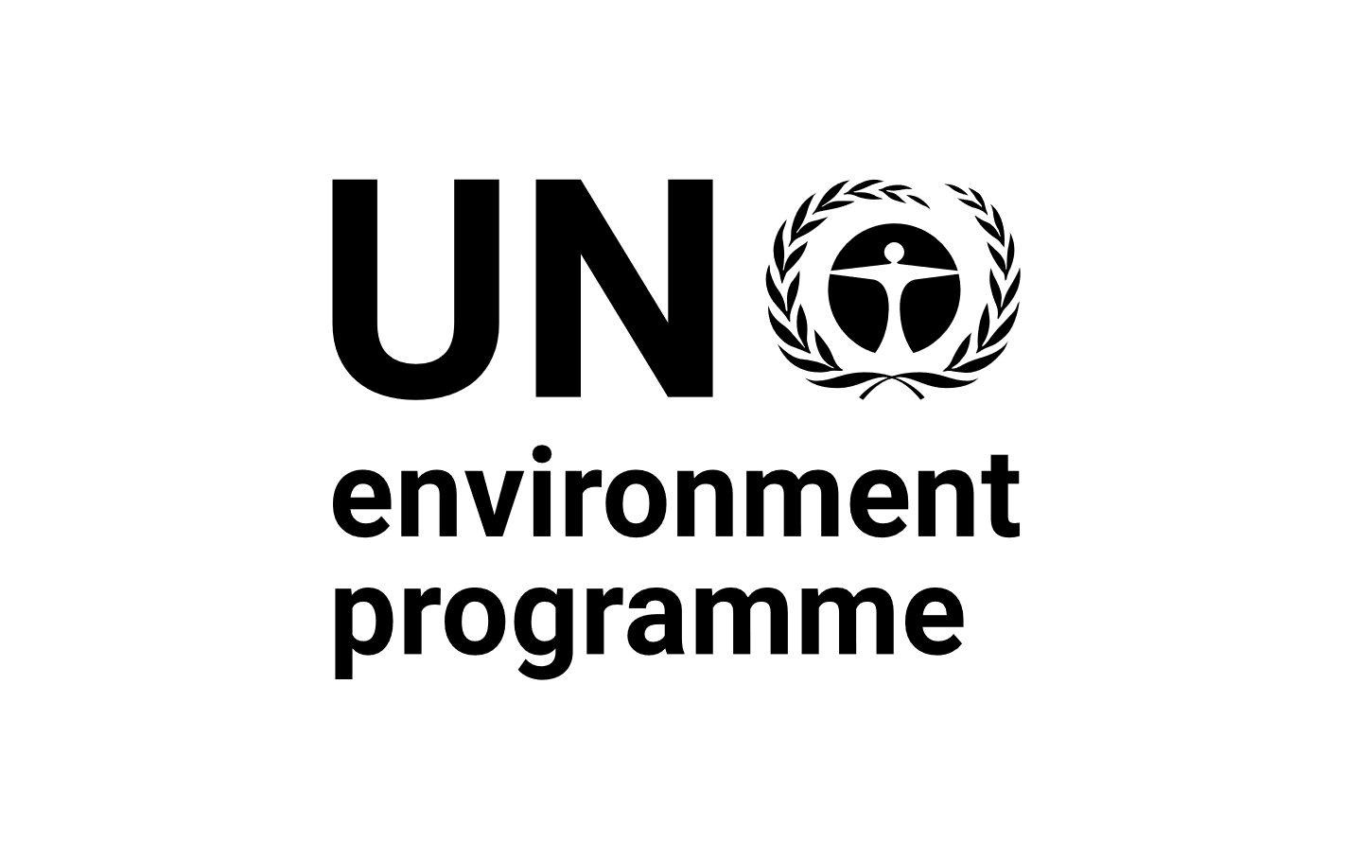 | CBD
Distr.
GENERAL

CBD/POST2020/PREP/2/1
17 August 2020

ORIGINAL: ENGLISH

PREPARATIONS FOR THE POST-2020 BIODIVERSITY FRAMEWORK
Update of the zero draft of the post-2020 global biodiversity framework
Note by the Co-Chairs

BACKGROUND
- In decision 14/34, the Conference of the Parties set out the process for developing a post-2020 global biodiversity framework, established the Open-ended Working Group on the Post-2020 Global Biodiversity Framework to support this process and designated its Co-Chairs. Subsequently, the Working Group at its first meeting requested the Co-Chairs and the Executive Secretary, with the oversight of the Bureau, to continue the preparatory process in accordance with decisions 14/34, CP-9/7 and NP-3/15, and to prepare documentation, including a zero draft text of the post-2020 global biodiversity framework for consideration by the Working Group at its second meeting. Pursuant to these requests, a zero draft of the post-2020 global biodiversity framework was issued for consideration by the Working Group at its second meeting (CBD/WG2020/2/3).
- The Working Group at its second meeting considered the zero draft of the post-2020 global biodiversity framework and requested the Co-Chairs and the Executive Secretary, with the oversight of the Bureau, to prepare a document updating those elements of the draft framework that had been reviewed by the Working Group, taking into account the annex to the outcomes of the meeting and the submissions received in response to notification 2019-108, and to make it available at least six weeks before the twenty-fourth meeting of the Subsidiary Body on Scientific, Technical and Technological Advice.
- Pursuant to the above request, the annex to the present document contains an update of the zero draft of the post-2020 global biodiversity framework which takes into account the outcomes of the second meeting of the Working Group as well as the submissions received in response to the notification noted above. As the monitoring frameworks and the decision text contained in documents CBD/WG2020/2/3 and Add.1 were not reviewed during the second meeting of the Working Group, these have not been included in the present document. This draft will be further updated to take into account the outcomes of the twenty-fourth meeting of the Subsidiary Body on Scientific, Technical and Technological Advice and the third meeting of the Subsidiary Body in Implementation as well as the advice from thematic consultations and issued as Draft One, six weeks prior to the third meeting of the Working Group.

Annex

The post-2020 global biodiversity framework

Introduction

Background
- Biodiversity, and the benefits it provides, is fundamental to human well-being and a healthy planet. Despite ongoing efforts, biodiversity is deteriorating worldwide and this decline is projected to continue or worsen under business-as-usual scenarios. The post-2020 global biodiversity framework builds on the Strategic Plan for Biodiversity 2011-2020 and sets out an ambitious plan to implement broad-based action to bring about a transformation in society’s relationship with biodiversity and to ensure that, by 2050, the shared vision of living in harmony with nature is fulfilled.

The purpose
- The framework aims to galvanize urgent and transformative action by Governments and all of society, including indigenous peoples and local communities, civil society, and businesses, to achieve the outcomes it sets out in its vision, mission, goals and targets, and thereby to contribute to the objectives of the Convention on Biological Diversity and other biodiversity related multilateral agreements, processes and instruments.
- The framework will be implemented primarily through activities at the national level, with supporting action at the subnational, regional and global levels. It aims to promote synergies and coordination with relevant processes. It provides a global, outcome-oriented framework for the development of national, and as appropriate, regional, goals and targets and, as necessary, the updating of national biodiversity strategies and action plans to achieve these, and to facilitate regular monitoring and review of progress at the global level.
- The framework will contribute to the implementation of the 2030 Agenda for Sustainable Development. At the same time, progress towards the Sustainable Development Goals will help to provide the conditions necessary to implement the framework.

Theory of change
- The framework is built around a theory of change (see figure 1) which recognizes that urgent policy action globally, regionally and nationally is required to transform economic, social and financial models so that the trends that have exacerbated biodiversity loss will stabilize in the next 10 years (by 2030) and allow for the recovery of natural ecosystems in the following 20 years, with net improvements by 2050 to achieve the Convention’s vision of “living in harmony with nature by 2050”. It also assumes that a whole-of-government and society approach is necessary to make the changes needed over the next 10 years as a stepping stone towards the achievement of the 2050 Vision. As such, Governments and societies need to determine priorities and allocate financial and other resources, internalize the value of nature and recognize the cost of inaction.
- The framework’s theory of change assumes that transformative actions are taken to (a) put in place tools and solutions for implementation and mainstreaming, (b) reduce the threats to biodiversity and (c) ensure that biodiversity is used sustainably in order to meet people’s needs and that these actions are supported by (i) enabling conditions, and (ii) adequate means of implementation, including financial resources, capacity and technology. It also assumes that progress is monitored in a transparent and accountable manner with adequate stocktaking exercises to ensure that, by 2030, the world is on a path to reach the 2050 Vision for Biodiversity.
- The theory of change for the framework acknowledges the need for appropriate recognition of gender equality, women’s empowerment, youth, gender-responsive approaches and the full and effective participation of indigenous peoples and local communities in the implementation of this framework. Further, it is built upon the recognition that its implementation will be done in partnership with many organizations at the global, national and local levels to leverage ways to build a momentum for success. It will be implemented taking a rights-based approach and recognizing the principle of intergenerational equity.
- The theory of change is complementary to and supportive of the 2030 Agenda for Sustainable Development. It also takes into account the long-term strategies and targets of other multilateral environment agreements, including the biodiversity-related and Rio conventions, to ensure synergistic delivery of benefits from all the agreements for the planet and people.

Figure 1. Theory of change of the framework
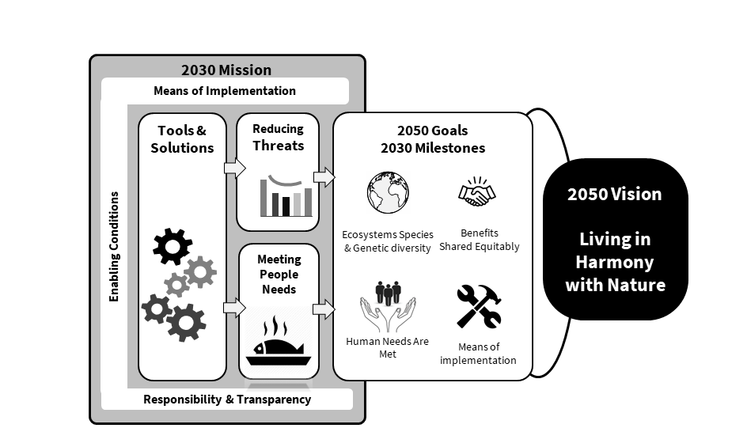

THE FRAMEWORK

2050 Vision
- The vision of the framework is a world of living in harmony with nature where: “By 2050, biodiversity is valued, conserved, restored and wisely used, maintaining ecosystem services, sustaining a healthy planet and delivering benefits essential for all people.”

2050 Goals
- The Framework has four long-term goals for 2050 related to the 2050 Vision for Biodiversity. The four goals are:
  - The area, connectivity and integrity of natural ecosystems increased by at least [X%] supporting healthy and resilient populations of all species while reducing the number of species that are threatened by [X%] and maintaining genetic diversity;
  - Nature’s contributions to people have been valued, maintained or enhanced through conservation and sustainable use supporting global development agenda for the benefit of all people;
  - The benefits, from the utilization of genetic resources are shared fairly and equitably;
  - Means of implementation are available to achieve all goals and targets in the framework.

2030 Mission
- The 2030 Mission for this framework is:
To take urgent action across society to put biodiversity on a path to recovery for the benefit of planet and people.

2030 Milestones
The framework has eight milestones to assess, in 2030, progress towards the 2050 goals:
Goal A
A.1 The area, connectivity and integrity of natural systems increased by at least [5%].
A.2 The number of species that are threatened is reduced by [X%] and the abundance of species has increased on average by [X%].
Goal B
B.1 Nature contributes to the sustainable diets and food security, access to safe drinking water and resilience to natural disasters for at least [X%] million people.
B.2 Nature is valued through green investments, ecosystem service valuation in national accounts, and public and private sector financial disclosures.
Goal C
C.1 Access and benefit-sharing mechanisms are established in all countries.
C.2 Benefits shared increased by [X%].
Goal D
D.1 By 2022, means to implement the framework for the period 2020 to 2030 are identified and committed.
D.2 By 2030, means to implement the framework for the period 2030 to 2040 are identified or committed.

2030 Action Targets
- The framework has 20 action-oriented targets for 2030 which, if achieved, will contribute to 2030 Milestones and the outcome-oriented goals for 2050. Actions to reach these targets should be implemented consistently and in harmony with the Convention on Biological Diversity and its Protocols and other relevant international obligations, taking into account national socioeconomic conditions.
  - Reducing threats to biodiversity
Target 1. By 2030, [50%] of land and sea areas globally are under spatial planning addressing land/sea use change, retaining most of the existing intact and wilderness areas, and allow to restore [X%] of degraded freshwater, marine and terrestrial natural ecosystems and connectivity among them.
Target 2. By 2030, protect and conserve through well connected and effective system of protected areas and other effective area-based conservation measures at least 30 per cent of the planet with the focus on areas particularly important for biodiversity.
Target 3. By 2030, ensure active management actions to enable wild species of fauna and flora recovery and conservation, and reduce human-wildlife conflict by [X%].
Target 4. By 2030, ensure that the harvesting, trade and use of wild species of fauna and flora is legal, at sustainable levels and safe.
Target 5. By 2030, manage, and where possible control, pathways for the introduction of invasive alien species, achieving [50%] reduction in the rate of new introductions, and control or eradicate invasive alien species to eliminate or reduce their impacts, including in at least [50%] of priority sites.
Target 6. By 2030, reduce pollution from all sources, including reducing excess nutrients [by x%], biocides [by x%], plastic waste [by x%] to levels that are not harmful to biodiversity and ecosystem functions and human health.
Target 7. By 2030, increase contributions to climate change mitigation adaption and disaster risk reduction from nature-based solutions and ecosystems based approaches, ensuring resilience and minimizing any negative impacts on biodiversity.
  - Meeting people’s needs through sustainable use and benefit-sharing
Target 8. By 2030, ensure benefits, including nutrition, food security, livelihoods, health and well-being, for people, especially for the most vulnerable through sustainable management of wild species of fauna and flora.
Target 9. By 2030, support the productivity, sustainability and resilience of biodiversity in agricultural and other managed ecosystems through conservation and sustainable use of such ecosystems, reducing productivity gaps by at least [50%].
Target 10. By 2030, ensure that, nature based solutions and ecosystem approach contribute to regulation of air quality, hazards and extreme events and quality and quantity of water for at least [XXX million] people.
Target 11. By 2030, increase benefits from biodiversity and green/blue spaces for human health and well-being, including the proportion of people with access to such spaces by at least [100%], especially for urban dwellers.
Target 12. By 2030, increase by [X] benefits shared for the conservation and sustainable use of biodiversity through ensuring access to and the fair and equitable sharing of benefits arising from utilization of genetic resources and associated traditional knowledge.
  - Tools and solutions for implementation and mainstreaming
Target 13. By 2030, integrate biodiversity values into policies, regulations, planning, development processes, poverty reduction strategies and accounts at all levels, ensuring that biodiversity values are mainstreamed across all sectors and integrated into assessments of environmental impacts.
Target 14. By 2030, achieve reduction of at least [50%] in negative impacts on biodiversity by ensuring production practices and supply chains are sustainable.
Target 15. By 2030, eliminate unsustainable consumption patterns, ensuring people everywhere understand and appreciate the value of biodiversity, and thus make responsible choices commensurate with 2050 biodiversity vision, taking into account individual and national cultural and socioeconomic conditions.
Target16. By 2030, establish and implement measures to prevent, manage or control potential adverse impacts of biotechnology on biodiversity and human health reducing these impacts by [X].
Target 17. By 2030, redirect, repurpose, reform or eliminate incentives harmful for biodiversity, including [X] reduction in the most harmful subsidies, ensuring that incentives, including public and private economic and regulatory incentives, are either positive or neutral for biodiversity.
Target 18. By 2030, increase by [X%] financial resources from all international and domestic sources, through new, additional and effective financial resources commensurate with the ambition of the goals and targets of the framework and implement the strategy for capacity-building and technology transfer and scientific cooperation to meet the needs for implementing the post-2020 global biodiversity framework.
Target 19: By 2030, ensure that quality information, including traditional knowledge, is available to decision makers and public for the effective management of biodiversity through promoting awareness, education and research.
Target 20: By 2030, ensure equitable participation in decision-making related to biodiversity and ensure rights over relevant resources of indigenous peoples and local communities, women and girls as well as youth, in accordance with national circumstances.

Implementation support mechanisms
- Effective implementation of the framework requires implementation support mechanisms commensurate with the ambition set out in the goals and targets of the framework and with the transformative changes required to reach them. These include:
- Mobilizing sufficient resources essential for achieving the objectives of the Convention and for implementing the post-2020 global biodiversity framework and reaching its goals and targets. Effective resource mobilization requires transformative, inclusive and equitable change across economies and society. A strategic approach to resource mobilization consists of five crucial components:
- An enhanced financial mechanism that delivers resources for developing countries;
- Reducing or redirecting resources causing harm to biodiversity;
- Generating additional financial and non-financial resources from all sources, including from international and domestic sources and the public and private sectors;
- Enhancing the effectiveness and efficiency of resource use;
- National finance plans to support implementation.
- Capacity development is crucial for the implementation of the framework includes:
- Enabling evidence-based implementation through nationally determined and/or country-driven actions, in accordance with national priorities;
- Support to government and non-government actors at all levels, particularly in developing countries and countries with economies in transition, to develop, utilize and retain requisite capacities and to learn, adapt and manage change;
- Building capacities at the individual, organizational and enabling enviroment levels to facilitate effective policy formulation, the mainstreaming of biodiversity into all sectors, implementation of the framework and the establishment of national systems and measures for transparency and reporting.
- Knowledge generation, management and sharing for effective biodiversity planning, policy development, decision-making, implementation and transparency and responsibility including:
- Greater protection of traditional knowledge and recognition of its contributions to the conservation and sustainable use of biodiversity;
- Promotion of biodiversity science and education and organizational learning.
- Technical and scientific cooperation, technology transfer and innovation is crucial for the implementation of the framework including:
  - Support mechanisms for technical and scientific cooperation, technology transfer and innovation on mutually agreed terms;
  - Support for cooperation amongst developing countries and with developed countries

Enabling conditions
- Certain enabling conditions will be required for the implementation of the framework. Effective action on these enabling conditions will contribute to the attainment of other societal objectives. These enabling conditions are:
- The participation of indigenous peoples and local communities and a recognition of their rights in the implementation of the framework;
- The participation of all relevant stakeholders, non-governmental organizations, youth, civil society, local and subnational authorities, the private sector, academia and scientific institutions through a whole-of-society approach and through inclusive and representative multi-stakeholder and multisectoral platforms;
- Gender equality, gender-responsive approaches and empowerment of women and girls;
- Recognition of intergenerational equity, including the transmission of knowledge, language and cultural values associated with biodiversity, especially by indigenous peoples and local communities;
- Synergies among relevant multilateral environmental agreements and other relevant international processes, including the 2030 Agenda for Sustainable Development, and instruments at the global, regional and national levels, including through the strengthening or establishment of cooperation mechanisms;
- Partnerships to leverage sustainable activities and programmes at the local, national, regional and global levels;
- Inclusive and integrative governance and whole-of-government approaches to ensure policy coherence and effectiveness for the implementation the framework;
- Mainstreaming biodiversity in all sectors;
- The engagement of private sector, academic institutions and civil societies;
- Safety and security in use of biodiversity to prevent spillover of zoonotic diseases, spread of invasive alien species and illegal trade in wildlife;
- Political will and recognition at the highest levels of government of the urgent need to halt biodiversity loss;
- The active involvement of subnational governments, cities and other local authorities and a recognition of their competence and specific roles for the implementation of the framework;
- Consider and recognize, where appropriate, the rights of nature.

Responsibility and transparency
- The successful implementation of the framework is dependent on the use of a comprehensive system for planning, reporting and review. It allows for transparent communication of progress to all, rapid course correction and timely input in the preparation of the next global biodiversity framework.
- This system minimizes the burden on Parties, the Secretariat and other entities. It is aligned with, and where appropriate integrated with other processes and other relevant multilateral conventions including Agenda 2030 and the Sustainable Development Goals.
- The system will be complemented by the systems of non-State actors, and the development of new systems or the adaptation of existing ones is encouraged.
- The system for planning, reporting and review for national government entities includes the following elements:
  - Planning:
    - National strategies and action plans:
      - Are the main instrument to identify national commitments;
      - Include all targets and actions;
      - Address all performance indicators relevant to the identified targets drawing on the monitoring framework attached to this framework;
      - Should include a financing plan;
      - Should be updated quickly according to an agreed schedule.
    - Indicators will be an important part of planning and reporting process including Headline indicators;
    - Planning documents will be updated on a continuous basis.
  - Reporting:
    - National reports:
      - National reports will report on all actions identified in the national strategies and action plans using agreed indicators including headline indicators;
      - National reports will be issued regularly and in time, in accordance with the agreed schedule.
    - Global reports:
      - Global stocktake:
        - Global collation of statistical information;
        - Takes place frequently according to an agreed schedules.
    - A reporting schedule that will be used consistently by all institutions involved;
    - Global assessment processes, including the Global Biodiversity Outlook and the Intergovernmental Science-Policy Platform on Biodiversity and Ecosystem Services will be reviewed for efficiency and complementarity and timeliness.
  - Review:
    - Global analysis of progress on objective/numerical elements of targets and progress towards milestones and goals;
    - [Open ended Forums] for the review of national implementation and to share lessons learned and best practices;
    - Voluntary in-depth peer review of national implementation by experts including from other parties.

Outreach, awareness and uptake
- Outreach, awareness and uptake of the post-2020 global biodiversity framework by all stakeholders is essential to effective implementation, including by:
  - Increasing understanding, awareness and appreciation of the values of biodiversity including the associated knowledge, values and approaches used by indigenous peoples and local communities;
  - Raising awareness of all actors of the existence of the goals and targets of the post-2020 global biodiversity framework and and progress made towards their achievement;
  - Promoting or developing platforms and partnerships, including with media and civil society to share information on successes, lessons learned and experiences in acting for biodiversity.

Appendices

The term “post-2020 global biodiversity framework” is used in the present document as a placeholder, pending a decision on the final name of the framework at the fifteenth meeting of the Conference of the Parties. Similarly, the word “framework” is used throughout the text as a placeholder.
See CBD/WG2020/REC/2/1.
The submissions received are accessible from https://www.cbd.int/conferences/post2020/submissions/2019-108
The term “post-2020 global biodiversity framework” is used as a placeholder, pending a decision on the final name of the framework by the Conference of the Parties at its fifteenth meeting. Similarly, the word “framework” is used throughout the text as a placeholder.
A monitoring framework provides further information on baselines and milestones for the components of the goals. (see CBD/SBSTTA/24/3 and CBD/SBSTTA/24/3/Add.1).
In the 2030 Mission, “to take urgent action” reflects the need for action to be taken this decade to address the biodiversity crisis. “Across society” reflects the need for actions to be taken by all stakeholders, and for mainstreaming across sectors of society and the economy. “To put nature on a path to recovery” implies the need for positive action-oriented approach and the need for concerted and strategic action across a range of issues. It also implies the need for a stabilization in the rate of loss of biodiversity and enhanced protection and restoration while also recognizing that completely halting the loss of ecosystems, species and genetic diversity is not possible by 2030. “For the benefit of people and planet” highlights elements of nature’s contributions to people, makes a strong link to the delivery of the 2030 Agenda for Sustainable Development and its Sustainable Development Goals while also recognizing the intrinsic and existential importance of biodiversity. The 2030 deadline articulates that this mission is a milestone on the way to the 2050 Vision of “living in harmony with nature” and reinforces the need for urgent action this decade.
Countries will establish national targets/indicators aligned with this framework and progress towards the national and global targets will be periodically reviewed. A monitoring framework (see CBD/SBSTTA/24/3 and CBD/SBSTTA/24/3/Add.1) provides further information on indicators of progress towards the targets.
⁸ Issues related to transparent implementation, monitoring, reporting and review for the post-2020 global biodiversity framework will be discussed during the Subsidiary Body on Implementation at its third meeting. This section of the framework will be updated to take into account the outcomes of those processes.
See CBD/SBSTTA/24/3 and CBD/SBSTTA/24/3/Add.1.

