 |  | 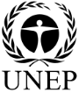 | CBD
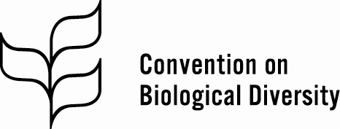 |  |  |  | Distr.  GENERAL  CBD/EBSA/WS/2018/1/4  27 February 2018*  ENGLISH ONLY

Report of the Regional Workshop to Facilitate the Description of Ecologically or Biologically Significant Marine Areas in the Baltic Sea

Helsinki, 19-24 February 2018

INTRODUCTION
1. At its tenth meeting, the Conference of the Parties to the Convention on Biological Diversity (CBD) requested the Executive Secretary to work with Parties and other Governments as well as competent organizations and regional initiatives, such as the Food and Agriculture Organization of the United Nations, regional seas conventions and action plans, and, where appropriate, regional fisheries management organizations to organize, including the setting of terms of reference, a series of regional workshops, with a primary objective to facilitate the description of ecologically or biologically significant marine areas through the application of scientific criteria in annex I of decision IX/20 as well as other relevant compatible and complementary nationally and intergovernmentally agreed scientific criteria, as well as the scientific guidance on the identification of marine areas beyond national jurisdiction, which meet the scientific criteria in annex I to decision IX/20 (decision X/29, para. 36).
2. In the same decision, the Conference of the Parties requested that the Executive Secretary make available the scientific and technical data, information and results collated through the workshops referred to above to participating Parties, other Governments, intergovernmental agencies and the Subsidiary Body on Scientific, Technical and Technological Advice (SBSTTA) for their use, according to their competencies.
3. Subsequently, at its eleventh, twelfth and thirteenth meetings, the Conference of the Parties reviewed the outcomes, respectively, of the first, second and third set of regional workshops conducted, and requested the Executive Secretary to further collaborate with Parties, other Governments, competent organizations and global and regional initiatives, such as the United Nations General Assembly Ad Hoc Working Group of the Whole on the Regular Process for Global Reporting and Assessment of the State of the Marine Environment, including Socio-economic Aspects, the International Maritime Organization, the Food and Agriculture Organization of the United Nations, regional seas conventions and action plans, and, where appropriate, regional fisheries management organizations, with regard to fisheries management, and also including the participation of indigenous and local communities, to facilitate the description of areas that meet the criteria for EBSAs through the organization of additional regional or subregional workshops for the remaining regions or subregions where Parties wish workshops to be held, and for the further description of the areas already described where new information becomes available (decisions XI/17, XII/22 and XIII/12).
4. Pursuant to the above requests, and with financial support from the Government of Finland, through the Ministry of the Environment and the Ministry of Foreign Affairs, and the Government of Sweden, the Secretariat of the Convention on Biological Diversity convened the Regional Workshop to Facilitate the Description of Ecologically or Biologically Significant Marine Areas (EBSAs) in the Baltic Sea. This workshop was organized in collaboration with the Baltic Marine Environment Protection Commission (HELCOM). It was hosted by the Government of Finland and took place in Helsinki, Finland, from 20 to 24 February 2018, preceded by a one-day training session on EBSAs, on 19 February.
5. Scientific and technical support for this workshop was provided by Duke University – Marine Geospatial Ecology Lab, with financial support from the Government of Finland. The results of the technical preparation for the workshop were made available in the meeting document entitled “Data to Inform the CBD Regional Workshop to Facilitate the Description of Ecologically or Biologically Significant Marine Areas in the Baltic Sea” (UNEP/CBD/EBSA/WS/2018/1/3).
6. The meeting was attended by experts from Estonia, Finland, Germany, Latvia, Lithuania, Russian Federation, Sweden, Baltic Marine Environment Protection Commission (HELCOM), BirdLife International, Coalition Clean Baltic, Global Ocean Biodiversity Initiative, Indigenous Peoples’ and Community Conserved Areas and Territories (ICCA) Consortium, UN Environment – World Conservation Monitoring Centre (UNEP-WCMC) and WWF Baltic Ecoregion Programme. The full list of participants is included in annex I.

ITEM 1. OPENING OF THE workshop
7. Ms. Hannele Pokka, Permanent Secretary of the Ministry of the Environment of the Government of Finland, delivered opening remarks on behalf of the Government of Finland. She welcomed the experts to Helsinki and thanked them for participating in this workshop and for their contributions to the protection of the Baltic Sea. She also thanked the Secretariat of the CBD and the HELCOM Secretariat, as well as the technical support team from Duke University, for their strong cooperation and contribution to the scientific and technical preparation for this workshop. Ms. Pokka explained that the Baltic Sea is the youngest sea on the planet, having emerged from the retreating ice masses only 10,000 to 15,000 years ago. As one of the largest bodies of brackish water, it is a highly sensitive and interdependent marine ecosystem that gives rise to unique flora and fauna. However, the marine environment of the Baltic Sea has deteriorated dramatically over the past century. She emphasized that the protection and sustainable use of the biodiversity of the Baltic Sea is a key issue for Finland, which is working closely with HELCOM to carry out the Baltic Sea Action Plan. She noted that the Finnish Inventory Programme for the Underwater Marine Environment (VELMU) has spent 13 years mapping the distribution of Baltic species, producing fundamental data that can be applied in establishing science-based marine protected areas (MPAs) and management plans, protecting threatened species and habitats, determining areas important for ecosystem services and providing the basis for marine spatial planning (MSP). She also pointed out that the data it has produced was made available for the workshop. She outlined several possible uses for the outcomes of this workshop, including work on MSP, work on climate change and its effects on biodiversity, and in updating the biodiversity part of the Baltic Sea Action Plan. Additionally, the workshop outcomes will help in deepening knowledge of Baltic-wide ecosystem services and will be applicable when considering the potential of the blue economy. The workshop can also provide guidance on how to promote Finland’s network of MPAs and management of these areas. In conclusion, she noted that she welcomed the EBSA process and hoped that this workshop would bring scientifically sound information on EBSAs to COP 14 in Egypt in November of this year. She wished the participants luck in their deliberations.
8. Ms. Monika Stankiewicz, Executive Secretary of HELCOM, delivered an opening statement on behalf of HELCOM. She thanked Permanent Secretary Ms. Hannele Pokka for her opening statement and expressed her appreciation to the Government of Finland, Ministry of Foreign Affairs and Ministry of the Environment, for hosting and supporting the workshop. She extended her special thanks to Ms. Penina Blankett, who has a long history of involvement in HELCOM, and Ms. Marina von Weissenberg, CBD Focal Point. She also thanked the “marine team” of the CBD Secretariat, under the leadership of Ms. Jihyun Lee, for their assistance with workshop preparations. She welcomed the workshop participants and the team from Duke University. Ms. Stankiewicz noted the significant data contribution that HELCOM has made to the workshop, including through the “State of the Baltic Sea” report, released in 2017. This report estimates the cumulative burden on the environment based on spatial information at a regional scale, utilizing more than 50 data sets of human activities and pressures and 40 data layers representing the distribution of species and habitats. She pointed out that the data are publicly available and ready for use in MSP. She noted that the economic and social analyses in the report demonstrate the importance of the Baltic Sea to human well-being in the region. Ms. Stankiewicz pointed out that the decision to organize this workshop was made by the HELCOM Heads of Delegation in 2017. She explained that the Contracting Parties to HELCOM believed that the Baltic EBSAs could contribute to the development and application of regionally coherent MSP and application of the ecosystem approach. She explained that MSP is a matter of national responsibility in the Baltic Sea, but noted that regional cooperation is vital. She explained that this was the motivation for the HELCOM-VASAB Maritime Spatial Planning Working Group, established ten years ago by HELCOM and VASAB (Vision and Strategies around the Baltic Sea) – a regional initiative of the ministries responsible for spatial planning. She explained that the main aim of regional cooperation is to advance MSP in the region, particularly in the transboundary context, to ensure national plans are coherent across borders and apply the ecosystem approach. She noted that EBSAs, cumulative impact assessment, and social and economic analysis are all practical tools that can be used for advancing the application of the ecosystem approach in MSP in the Baltic Sea. She noted that these issues will be dealt with in a new regional MSP project called Pan Baltic SCOPE, which is co-funded by the EU and led by Sweden, and in which HELCOM is also a partner. The present EBSA workshop will contribute directly to this work. She expressed her enthusiasm about the workshop and the expertise it has brought together, as well as its impending results. She wished participants an interesting and fruitful workshop.
9. Ms. Jihyun Lee delivered opening remarks on behalf of Ms. Cristiana Paşca Palmer, Executive Secretary of the CBD. She thanked all the experts present for participating in this regional workshop on EBSAs, the 14th of its kind. She thanked the Government of Finland for hosting the workshop and for providing financial support. She also thanked the Government of Sweden for their financial support, as well as HELCOM for their organizational assistance and valuable technical input. She highlighted the uniqueness of the Baltic Sea, in terms of ecology, geography, commerce and social and cultural interactions. She noted that it is one of the world's largest brackish inland seas and has a mixture of marine and freshwater species. She also noted that the Baltic Sea has seen intensive human use throughout history, resulting in negative impacts on biodiversity, in particular due to pollution and eutrophication. She emphasized that biodiversity is not a hindrance, but rather a means to achieve sustainable economic growth and human well-being, and explained that this fact has been recognized by the 196 Parties to the CBD, who have been collaborating closely for the implementation of the Strategic Plan for Biodiversity 2011-2020 and achieving its 20 Aichi Biodiversity Targets. Ultimately, the loss and degradation of biodiversity undermine the functioning of the Earth’s life support system and compromise the ability of marine ecosystems to support sustainable economic growth and human well-being. She noted that countries in the Baltic region have come together under HELCOM, through which they collaborate to better understand, protect and manage the Baltic’s marine resources. This region has shown leadership in advancing cross-sectoral MSP, however, more can be done. In order to do so, we must have a clear understanding of where to take action and which areas are in most need of conservation, management and further research. It is in this respect that the work of the CBD on EBSAs plays a key role. Since 2011, a series of regional EBSA workshops have been organized to describe the “special places” of the ocean and seas crucial to the healthy functioning of the global marine ecosystem. The regional workshops convened by the CBD Secretariat so far have covered more than 74 per cent of the world’s ocean. The summary reports on the outputs of these workshops have been submitted to the United Nations General Assembly and its relevant processes. She noted that the EBSA process has facilitated information-sharing, regional networking and enhanced collaboration among regional initiatives for conservation and sustainable use of marine biodiversity. Through this work, she noted, we have built a rich community of EBSA collaborators around the world. This week provides a key opportunity for countries and organizations in the Baltic to join this community. She wished participants a successful and fruitful workshop.

ITEM 2. ELECTION OF THE workshop CO-CHAIRS, ADOPTION OF THE AGENDA AND ORGANIZATION OF WORK
10. After a brief explanation by the CBD Secretariat on procedures for electing the workshop co-chairs, Ms. Penina Blankett (Finland), as offered by the host Government, and Mr. Dieter Boedeker (Germany), proposed by an expert from Finland and seconded by the floor unanimously, were elected as the workshop co-chairs.
11. Participants were then invited to consider the provisional agenda (UNEP/CBD/EBSA/WS/2018/1/1) and the proposed organization of work, as contained in annex II to the annotations to the provisional agenda (UNEP/CBD/EBSA/WS/2018/1/1/Add.1) and adopted them without any amendments.
12. The workshop was organized in plenary sessions and break-out group sessions. The co-chairs nominated the following rapporteurs to assist the CBD Secretariat in preparing the draft workshop report on the discussions to be undertaken at the plenary sessions, taking into consideration the expertise and experience of the workshop participants and in consultation with the CBD Secretariat:
  - Agenda item 4: Mr. Chris Barrio (Global Ocean Biodiversity Initiative)
  - Agenda item 5: Ms. Corinne Martin (UNEP-WCMC)
  - Agenda item 6: Ms. Jannica Haldin (HELCOM), Mr. Chris Barrio (Global Ocean Biodiversity Initiative) and Ms. Corinne Martin (UNEP-WCMC)

ITEM 3. Workshop background, scope and output
13. Under this agenda item, participants were provided with a series of presentations, as below, during the training day on EBSAs on 19 February:
- Ms. Jihyun Lee (CBD Secretariat) gave a presentation on the work under the CBD on EBSAs and other relevant work on marine and coastal biodiversity;
- Mr. Joseph Appiott (CBD Secretariat) delivered a presentation on the global context for the workshop, in particular with regards to the achievement of the Aichi Biodiversity Targets and the Sustainable Development Goals;
- Ms. Penina Blankett and Ms. Marina von Weissenberg (Government of Finland) described Finnish experiences and lessons learned in achieving Aichi Biodiversity Targets and Sustainable Development Goals related to marine and coastal biodiversity;
- Mr. Markku Viitasalo (Government of Finland) delivered a presentation on Finland’s VELMU Inventory Programme;
- Ms. Monika Stankiewicz (HELCOM) discussed the relevant work of HELCOM and its applicability to efforts to describe EBSAs in the Baltic Sea and the use of EBSA information to support conservation and management;
- Ms. Rieke Scholz (BirdLife International) delivered a presentation on the relevant work of BirdLife International, its contribution to the EBSA process and its relevance to efforts to describe EBSAs in the Baltic Sea;
- Mr. Tero Mustonen (ICCA Consortium and Snowchange Cooperative) gave a presentation on the relevant work of the Snowchange Cooperative, as part of the ICCA Consortium, on their work in the Baltic Sea to support the engagement and use of the traditional and local knowledge of indigenous peoples and local communities in the region;
- Ms. Janica Borg (WWF Baltic Ecoregion Programme) delivered a presentation on the relevant work of WWF Finland to support the conservation and sustainable use of marine resources in the Baltic;
- Mr. Patrick Halpin (technical support team) gave a presentation on the scientific criteria for EBSAs and the approaches and experiences in the description of areas meeting the EBSA criteria;
- Mr. Patrick Halpin (technical support team) gave a presentation on the scientific information compiled for the workshop;
14. Summaries of the above presentations are provided in annex II.
15. Ms. Jihyun Lee (CBD Secretariat) briefed the meeting on the workshop objectives, expected outputs and geographic scope, building on her presentation on the CBD EBSA process, delivered on the training day.
16. The workshop participants agreed that the workshop would focus on the geographic area of competence of HELCOM, as presented in Annex III. The workshop participants noted the absence of participants from two HELCOM countries, Denmark and Poland, although their respective governments were invited to nominate experts to attend this workshop. As such, the workshop could not consider the marine areas of these countries.
17. The workshop participants noted the following points regarding the guidance of the Conference of the Parties on the regional workshop process, as well as the potential contribution of the scientific information produced by the workshops:
- The Conference of the Parties to the Convention, at its tenth meeting, noted that the application of the scientific criteria in annex I of decision IX/20 for the identification of ecologically or biologically significant marine areas presents a tool which Parties and competent intergovernmental organizations may choose to use to progress towards the implementation of ecosystem approaches in relation to areas both within and beyond national jurisdiction, through the identification of areas and features of the marine environment that are important for conservation and sustainable use of marine and coastal biodiversity (paragraph 25, decision X/29);
- The application of the EBSA criteria is a scientific and technical exercise, and the identification of EBSAs and the selection of conservation and management measures is a matter for States and competent intergovernmental organizations, in accordance with international law, including the United Nations Convention on the Law of the Sea (paragraph 26, decision X/29);
- The EBSA description process is open-ended, and additional regional or subregional workshops may be organized when there is sufficient advancement in the availability of scientific information (paragraphs 9 and 12, decision XI/17);
- Each workshop is tasked to describe areas meeting the scientific criteria for EBSAs or other relevant criteria based on best available scientific information. As such, experts at the workshops are not expected to discuss any management issues, including threats to the areas;
- The EBSA description process facilitates scientific collaboration and information-sharing at national, sub-regional and regional levels, as demonstrated by collective work by workshop participants with different expertise, contributing to each other’s description of areas meeting the EBSA criteria; and
18. Participating experts were invited through a selection process, based on nominations by CBD National Focal Points, using the selection criteria provided in the CBD notification dated 17 November 2017 (reference number 2017-122). Prior to the workshop, selected experts were asked to provide relevant scientific and technical information through a CBD notification dated 13 December 2017 (reference number 2017-140), in collaboration with relevant scientists within their respective countries, to support the workshop discussions, including by filling in the EBSA information template (appended to the above-noted notification).

ITEM 4. Review of relevant scientific data/information/maps compiled for the workshop
19. For the consideration of this item, the workshop had before it the following information notes by the Executive Secretary: Data to Inform the CBD Regional Workshop to Facilitate the Description of Ecologically or Biologically Significant Marine Areas in the Baltic Sea (document UNEP/CBD/EBSA/WS/2018/1/3) and Compilation of Relevant Scientific Information Submitted by Parties, Other Governments and Relevant Organizations in Support of the Workshop Objectives (document UNEP/CBD/EBSA/WS/2018/1/2), compiled based on submissions in response to the Secretariat’s notification (2017-140, dated 13 December 2017). The documents/references submitted prior to the workshop were made available for the information of workshop participants on the meeting website (https://www.cbd.int/meetings/EBSAWS-2018-01).
20. Mr. Patrick Halpin (technical support team) provided a presentation entitled “Review of relevant scientific data/information/maps compiled to facilitate the description of EBSAs in the Baltic Sea,” based on document UNEP/CBD/EBSA/WS/2018/1/3. The information provided in this presentation was considered in the description of areas meeting the EBSA criteria by the break-out groups. A summary of this presentation is provided in annex II.
21. Workshop participants, including experts from Parties (Finland, Latvia and Russian Federation) and BirdLife International, who had submitted relevant scientific information using the EBSA templates prior to the workshop, as contained in the document UNEP/CBD/EBSA/WS/2018/1/2, were invited to present their draft descriptions of areas potentially meeting the EBSA criteria.
22. Participants also noted with appreciation the submission of relevant scientific information by Germany, Sweden and Poland, which was incorporated in the above-noted document: Data to Inform the CBD Regional Workshop to Facilitate the Description of Ecologically or Biologically Significant Marine Areas in the Baltic Sea (document UNEP/CBD/EBSA/WS/2018/1/3).
23. Spatial data compiled for this workshop was available to workshop participants both in hard-copy maps as well as in a Geographic Information System (GIS) database with open-source GIS software, for their use, analysis and interpretation in the application of the EBSA criteria.

ITEM 5. Description of ecologically or biologically significant marine areas through the application of the scientific criteria (decision IX/20, annex I) and other relevant compatible and complementary nationally and intergovernmentally agreed scientific criteria, as well as the scientific guidance on the application of EBSA criteria
24. Building on the theme presentations provided in the previous agenda items as well as during the training day, the workshop participants exchanged their views on possible ways of organizing their work on assessing the scientific information compiled and submitted for the consideration of the workshop. In this regard, participants noted the following points with regard to the description of areas meeting the EBSA criteria:
- The description of EBSAs is based on the scientific information and expert knowledge available at the time of the workshop, and, as the EBSA process is iterative and ongoing, there may be additional areas described as meeting the EBSA criteria in future regional or sub-regional workshops;
- In describing multiple ecological and/or biological components of a given area, participants should consider how these components may be interconnected as part of a system, and that, if separate components cannot be described as part of a coherent system, these components should be described separately;
- The EBSA criteria can be applied on all scales from global to local. Once a scale has been selected, however, the criteria are intended to be used to evaluate areas and ecosystem features in a context relative to other areas and features at the given scale;
- There are no thresholds that must be met, judgements are comparative to adjacent areas, and the current ranking system (e.g., high, medium, low, no information) for assessing the areas meeting each EBSA criterion is devised to facilitate better understanding of available scientific information in describing the areas with regard to the extent to which they meet each criterion. The current ranking system, however, does not intend to compare the importance of each criterion;
- Relative assessments are necessarily scale dependent. The relative significance of areas has generally been viewed from regional or large sub-regional scales;
- Areas may meet multiple criteria, and that is important, but ranking at least one as high is also necessary for a proposed area to be described as an EBSA;
- Areas described to meet the EBSA criteria have ranged from relatively small sites to very extensive oceanographic features;
- Areas described to meet the EBSA criteria can be overlapped or nested; and
- Recalling discussions in previous regional EBSA workshops regarding bird migration routes, the workshop noted that consideration of such features in the description of areas meeting the EBSA criteria should focus on seabird species rather, than terrestrial bird species, which demonstrate linkages with marine ecosystems.
25. This workshop was mandated to evaluate areas at a regional scale within the Baltic Sea. However, the workshop stressed that the entire region possesses unique and vulnerable ecological or biological features, which need to be considered at the global scale. This perspective is presented in annex IV.
26. Participants also discussed the significant diversity of indigenous peoples and local communities in the Baltic Sea region, which have endemic, traditional knowledge and customary governance of marine and coastal ecosystems, and the relevance of the indigenous and local knowledge of these indigenous peoples and local communities to the description of areas meeting the EBSA criteria. This perspective is presented in annex V.
27. For the effective review and analysis of available scientific information and assessment of potential areas meeting the EBSA criteria, the workshop participants were split into two break-out groups: (i) Northern Baltic Sea and (ii) Southern Baltic Sea.
28. Participants were assisted by the technical support team, who made geospatial information available in both hard copies and electronic format, as well as data in GIS format, for the break-out group deliberations, and who supported data interpretation and mapping of areas meeting the EBSA criteria.
29. Each break-out group was advised to do the following:
- Review the layers of information available, including maps of ocean features, other types of data sets, primary and other scientific and technical reports and publications and expert knowledge, relative to each EBSA criterion;
- Based on the review of available scientific information, describe areas that may be considered relatively ecologically or biologically significant, addressing their importance with regards to one or more of the EBSA criteria;
- Document the description of each area considered to be ecologically or biologically significant, completing a template provided by the Secretariat using narrative text and maps considered necessary to reflect the ecologically and biologically significant features of the area. Where appropriate, the narrative text may report on strengths and weaknesses in the information used in description of the area, as well as key uncertainties and gaps in scientific knowledge;
- Incorporate comments and input provided by the Secretariat, relevant international/regional experts available and the workshop plenary in the description, including with regards to scientific information and spatial boundaries of each area;
- Where appropriate, consider opportunities to extend proposed areas to include additional features, merge different areas into single descriptions and/or redefine areas into smaller discrete areas, where considered necessary to describe accurately the respective ecological or biological features;
- Identify needs for future scientific research, scientific collaboration, data/information sharing and capacity building to further enable the effective application of the EBSA criteria in the region (as input to agenda item 6), particularly for areas and/or features for which there was a lack of scientific information and/or expert knowledge available at the workshop; and
- Work with the technical support team to define the spatial boundaries of each area.
30. The results of the break-out group discussions were reported to the plenary for its consideration. During plenary sessions, the workshop participants reviewed the description of areas meeting the EBSA criteria proposed by the break-out groups and considered them for inclusion in the final list of areas meeting EBSA criteria.
31. The workshop participants agreed on descriptions of nine areas meeting the EBSA criteria. The map of all described areas is contained in annex VI. The list of these areas is provided in annex VII, and the description of each of these areas is provided in its appendix.

ITEM 6. Identification of gaps and needs for further elaboration in describing AREAS MEETING ebsa CRITERIA, including the need for the development of scientific capacity AND scientific collaboration
32. Building on the workshop deliberation, the workshop participants were invited to identify, through break-out group sessions and plenary discussion, gaps and needs for further elaboration in describing areas meeting the EBSA criteria, including the need for scientific information, scientific capacity development and scientific collaboration. The results of the plenary and subgroup discussions are compiled in annex VIII.
33. The workshop participants noted that the lack of participation by two Baltic Sea (HELCOM) countries, Denmark and Poland, limited the extent to which the features of the entire Baltic Sea could be adequately considered by the workshop, and as a result influenced the list of areas described as meeting the EBSA criteria.
34. The workshop participants also noted some areas that have potential to meet the EBSA criteria, but could not be described at this workshop due to data paucity and lack of sufficient evidence against the criteria. One such area is presented in annex IX as a potential area for future consideration through either national or regional EBSA processes.

ITEM 7. OTHER MATTERS
35. The workshop emphasized that areas (including MPAs) in the Baltic Sea that have not been described during the workshop as meeting the EBSA criteria have not been interpreted as not being ecologically or biologically important, considering that the application of the EBSA criteria and description of EBSAs was prioritized at the regional scale, with the expertise and information available at the time of the workshop.

ITEM 8. ADOPTION OF THE REPORT
36. The participants considered and adopted the workshop report on the basis of a draft prepared and presented by the co-chairs with some changes.
37. The participants agreed that any additional scientific information and references would be provided to the CBD Secretariat by the workshop participants within two weeks of the closing of the workshop, in order to further supplement the description of areas meeting EBSA criteria contained in annex VI and its appendix.

ITEM 9. CLOSURE OF THE workshop
38. In closing the workshop, participants expressed their appreciation to the Government of Finland and the HELCOM Secretariat for their hospitality and thanked the workshop co-chairs for their leadership in steering the workshop deliberation. They also thanked the rapporteurs, facilitators, and technical team for their valuable contributions. They acknowledged with thanks the hard work and efficient servicing by the Secretariat staff for successfully organizing and concluding the workshop.
39. The workshop was closed at noon on 24 February 2018.

Annex I

LIST OF participants
EXPERTS NOMINATED BY PARTIES

Estonia
1. Mr. Georg Martin
Vice-director
Estonian Marine Institute
University of Tartu
Tallinn, Estonia
E-mail: georg.martin@ut.ee

Finland
2. Ms. Penina Blankett
Ministerial Adviser
Ministry of the Environment
Department of the Natural Environment
Government of Finland
Helsinki, Finland
Government of Finland
E-mail: penina.blankett@ym.fi

3. Mr. Michael Haldin
Senior Advisor (Marine)
Parks & Wildlife Finland
Vaasa, Finland
E-mail: michael.haldin@metsa.fi

4. Mr. Markku Viitasalo
Research professor
Finnish Environment Institute
Helsinki, Finland
E-mail: markku.viitasalo@ymparisto.fi

Germany
5. Mr. Dieter Boedeker
Nature Conservation Officer
Unit for marine conservation
German Federal Agency for Nature Conservation
Vilm, Germany
E-mail: dieter.boedeker@bfn.de

6. Mr. Alexander Darr
Researcher
Leibniz-Institute for Baltic Sea Research
Benthic Ecology
Rostock, Germany
E-mail: alexander.darr@io-warnemuende.de
Latvia
7. Ms. Solvita Strāķe
Senior researcher
Head of Hydrobiological Laboratory
Marine Monitoring Department
Latvian Institute of Aquatic Ecology
Riga, Latvia
E-mail: solvita.strake@lhei.lv

Lithuania
8. Ms. Aistė Kubiliūtė
Head of Data Management and Programmes Division
Marine Research Department
Environment Protection Agency
Klaipėda, Lithuania
E-mail: a.kubiliute@aaa.am.lt

9. Mr. Erlandas Paplauskis
Senior specialist/Ecologist
Pajūris Regional Park (Seaside Regional Park)
Klaipeda, Lithuania
E-mail: e.paplauskis@pajuris.info

Russian Federation
10. Mr. Evgeny Genelt-Yanovskiy
Researcher
Laboratory of Molecular Systematics
Zoological Institute
Russian Academy of Sciences
St. Petersburg, Russian Federation
E-mail: genelt.yanovskiy@gmail.com

11. Mr. Roustam Sagitov
Associate Professor
St. Petersburg State University
St. Petersburg, Russian Federation
E-mail: rustam_sagitov@bfn.org.ru

Sweden

12. Ms. Sofia A. Wikström
Associate Professor
Stockholm University
Baltic Sea Centre
Stockholm, Sweden
E-mail: sofia.wikstrom@su.se

13. Ms. Pia Norling
Senior Analyst, Ph.D.
Swedish Agency for Marine and Water Management
Gothenburg, Sweden
E-mail: pia.norling@havochvatten.se

EXPERTS NOMINATED BY ORGANIZATIONS

Baltic Marine Environment Protection Commission (HELCOM)
14. Ms. Monika Stankiewicz
Executive Secretary
Baltic Marine Environment Protection Commission (HELCOM)
Helsinki, Finland
E-mail: monika.stankiewicz@helcom.fi

15. Ms. Jannica Haldin
Professional Secretary
Baltic Marine Environment Protection Commission
Helsinki, Finland
E-mail: jannica.haldin@helcom.fi

16. Mr. Joni Kaitaranta
Data Coordinator
Helsinki, Finland
Baltic Marine Environment Protection Commission (HELCOM)
E-mail: joni.kaitaranta@helcom.fi

17. Mr. Ville Karvinen
Project Coordinator
Horizontal Action “Spatial Planning” Support 2
Baltic Marine Environment Protection Commission (HELCOM)
Helsinki, Finland
E-mail: ville.karvinen@helcom.fi

BirdLife International
18. Ms. Rieke Scholz
Scientific Associate Marine Conservation
NABU – Nature and Biodiversity Conservation Union Germany
Stralsund, Germany
E-mail: Rieke.Scholz@NABU.de

Coalition Clean Baltic
19. Ms. Sandra Marie Neumann Arvidson
Biologist
Nordfyn Municipality
Nature and Environment Department
Fredericia, Denmark
E-mail: sandra@arvidson.dk

Global Ocean Biodiversity Initiative
20. Mr. Christopher Barrio Froján
Project Officer
Seascape Consultants
Romsey, United Kingdom of Great Britain and Northern Ireland
E-mail: christopher.barrio@seascapeconsultants.co.uk

ICCA (Indigenous Peoples’ and Community Conserved Areas and Territories) Consortium
21. Mr. Tero Mustonen
Snowchange Cooperative
Selkie, Finland
E-mail: tero@snowchange.org

UNEP-World Conservation Monitoring Centre
22. Corinne Martin
Head (interim)
Marine Programme
United Nations Environment Programme – World Conservation Monitoring Centre
Cambridge, United Kingdom of Great Britain and Northern Ireland
E-mail: corinne.martin@unep-wcmc.org

WWF Baltic Ecoregion Programme
23. Ms. Janica Borg
Marine Conservation Officer
WWF Finland
Helsinki, Finland
E-mail: Janica.borg@wwf.fi

Technical Support Team

24. Mr. Patrick N. Halpin
Associate Professor of Marine Geospatial Ecology, Director OBIS - SEAMAP
Nicholas School of the Environment - Duke University Marine Lab
Duke University
Durham, United States of America
E-mail: phalpin@duke.edu

25. Mr. Jesse Cleary
Research Analyst
Marine Geospatial Ecology Lab, Nicholas School of the Environment
Duke University
Durham, United States of America
E-mail: jesse.cleary@duke.edu

26. Ms. Sarah DeLand
Research Associate
Marine Geospatial Ecology Lab
Nicholas School of the Environment
Duke University
Beaufort, United States of America
E-mail: sarah.deland@duke.edu

27. Mr. Juho Lappalainen
Researcher
Finnish Environment Institute (SYKE)
Marine Research Centre
Helsinki, Finland
E-mail: juho.lappalainen@ymparisto.fi

Secretariat of the Convention on Biological Diversity
28. Ms. Jihyun Lee
Environmental Affairs Officer
Marine and Coastal Biodiversity
Secretariat of the Convention on Biological Diversity
Montreal, Canada
Email: jihyun.lee@cbd.int

29. Mr. Joseph Appiott
Associate Programme Officer
Marine and Coastal Biodiversity
Secretariat of the Convention on Biological Diversity
Montreal, Canada
Email: joseph.appiott@cbd.int
30. Jacqueline Grekin
Programme Assistant
Marine and Coastal Biodiversity
Secretariat of the Convention on Biological Diversity
Montreal, Canada
Email: jacqueline.grekin@cbd.int

Annex II

summary of theme presentations

Work of the CBD on EBSAs and other relevant work on marine and coastal biodiversity
(by Jihyun Lee, CBD Secretariat)
Ms. Lee delivered a presentation outlining the background of the workshop in the context of the Strategic Plan for Biodiversity 2011-2020 and its Aichi Biodiversity Targets. She highlighted the close interlinkages between the Aichi Targets and the Sustainable Development Goals (SDGs), particularly SDG 14. She described the relevant work of the CBD on marine and coastal biodiversity, including its work on facilitating the description of EBSAs, addressing the impacts of threats on marine biodiversity, management tools and guidelines, and the capacity development activities of the Sustainable Ocean Initiative. She introduced the process for describing EBSAs, beginning with the adoption of the EBSA criteria at the ninth meeting of the Conference of the Parties (COP 9) to the CBD and the call by the tenth meeting of the Conference of the Parties (COP 10) to organize a series of regional EBSA workshops. Since 2011, the CBD Secretariat has convened 14 regional workshops (including this workshop) to facilitate the description of areas meeting the EBSA criteria, pursuant to COP decisions X/29, XI/17, XII/22 and XIII/12. These workshops have covered more than 74 per cent of the world’s oceans (82 per cent, not considering the geographic area of competence of the Antarctic Treaty) and have involved 163 countries and about 150 organizations, with some attending more than one workshop. So far, a total of 279 areas (19 percent of the total area of the ocean) have been described as meeting the EBSA criteria. These areas have been considered by COP 11, COP 12 and COP 13, which have requested that the summary reports on the outputs of these regional EBSA workshops be submitted to the United Nations General Assembly and its relevant working groups. Ms. Lee went on to emphasize that the application of the EBSA criteria is a scientific and technical exercise and that areas found to meet the EBSA criteria may require enhanced conservation and management measures, which can be achieved through a variety of means, including MPAs and impact assessments, for example. She emphasized that EBSAs are not MPAs, nor fishing closures, and that the identification of EBSAs and the selection of conservation and management measures is a matter for States and competent intergovernmental organizations. She then pointed out that the EBSA process may support the strengthening of the region’s efforts to meet its goals for conservation and sustainable use of marine biodiversity, by facilitating scientific collaboration and increasing awareness. She also explained how the EBSA information can be used for cross-sectoral MSP.

Global Context for the Workshop: Aichi Biodiversity Targets and the Sustainable Development Goals
(by Joseph Appiott, CBD Secretariat)
Mr. Appiott provided a presentation on the global context for the workshop, in particular with regards to the Aichi Biodiversity Targets and the SDGs. He discussed the key aspect of the Aichi Targets with regards to marine and coastal biodiversity. He noted the focus of the 13th meeting of the Conference of the Parties (COP 13) to the CBD on mainstreaming biodiversity for well-being and the importance of mainstreaming and cross-sectoral approaches to address the root causes of the multiple pressures on marine ecosystems and support marine ecosystems in providing essential services. He highlighted the importance of biodiversity to sustainable development and stressed the close interlinkages between the SDGs and the Aichi Targets. He also noted the various ongoing global intergovernmental processes relevant to ocean issues. He stressed that global-level commitments reflect the will of governments and that only on-ground implementation will facilitate their achievement. He also stressed that individual targets and global goals cannot be achieved in isolation and that actions to achieve the Aichi Targets will also help to achieve the SDGs, and vice versa.

Finnish experiences and lessons learned in achieving the Aichi Biodiversity Targets and Sustainable Development Goals, in particular relating to marine and coastal biodiversity
(by Ms. Penina Blankett, Government of Finland, and Ms. Marina von Weissenberg, Ministerial Adviser, Ministry of the Environment, Government of Finland—present on training day)
Ms. Blankett introduced the main instruments in Finland to implement the Aichi Biodiversity Targets and SDGs in marine and coastal areas. She introduced relevant EU directives, such as the Habitats and Birds Directive, Water Framework Directive, Marine Strategy Framework Directive and the Maritime Spatial Directive, as well as the EU Common Fishery Policy and the EU biodiversity strategy. She noted that implementing the HELCOM Baltic Sea Action Plan for the region, ministerial declarations and recommendations will facilitate the achievement of the Aichi Targets and SDGs. She noted that Finland has transposed EU Directives into national legislation. Regarding Aichi Target 5 and SDG 14.2 on decreasing the rate of loss of all natural habitats, she noted that one of the key needs is to increase knowledge of Finland’s underwater marine environment. She introduced the VELMU programme (The Finnish Inventory Programme for the Underwater Marine Environment), which has responded to this need.

She described the EU Common Fisheries Policy, a set of rules for managing European fishing fleets and for conserving fish stocks in marine areas, and noted its relevance to Aichi Target 6 and SDG 14.4. Finnish fishing legislation, which entered in force in 2016, aims to achieve sustainable fishing and protect migratory fish species. Finland has a National Fish Passage Strategy in place, as well as national salmon and sea trout strategy. Ms. Blankett noted that the main pressure in Finland’s waters is eutrophication in the Baltic Sea. Finland has several measures to minimize the impact of nutrients in the Baltic Sea, thereby also achieving Aichi Target 8 and SDG 14.1. Regarding Aichi Target 9 and SDG 15.8 on invasive alien species, Finland has taken several measures to prevent their introduction and to reduce their impacts, based on EU regulations as well as national strategy and legislation. Furthermore, Finland ratified the International Maritime Organization’s Ballast Water Management Convention in 2016. Regarding Aichi Target 10 and SDG 14.3, the most relevant pressures in Finland are eutrophication and climate change, which the Ministry of Environment is working to address, in collaboration with HELCOM. For marine litter, Finland is implementing the HELCOM Marine Litter Action Plan and conducting several research programmes. For underwater noise, the Baltic Sea Information on the Acoustic Soundscape (BIAS) has, among other things, assessed the level of underwater noise. Regarding Target 11 and SDG 14.5, Finland has almost reached the target 10 per cent MPA coverage in its Territorial Sea and EEZ (9.9 per cent), while the coverage of Natura 2000 sites is 8.5 per cent and HELCOM MPAs is 7.7 per cent. Preventing the extinction of endangered species and habitats (Aichi Target 12 and SDG 14.2) requires an assessment of the status of species and habitats. In this regard, the latest Finnish Red List assessment of all species was published in 2010, although there are relatively few marine invertebrate, algae and vascular plant species addressed. In 2015, the assessment included only birds and mammals. The next assessment, which will cover all species, will be published in 2019 and, thanks to the VELMU programme, there will be more marine underwater species included. The assessment of threatened habitats was published in 2008 and included 12 marine habitats, 11 of which were assessed as threatened or data deficient. The next assessment will be ready in 2018, including 42 marine habitats. Finland is also part of the periodic EU reporting on progress made with the implementation of the EU Habitats Directive. Aichi Target 14 and SDG 14.c refer to providing ecosystem services as well as conservation and sustainable use of oceans. In this regard, the VELMU 2 project will focus on mapping key habitats and their ecosystem services.

Ms. von Weissenberg explained that marine biodiversity issues are part of Finland’s National Biodiversity Strategy and Action Plan (NBSAP 2012-2020), where the VELMU programme has also been highlighted. The NBSAP for the conservation and sustainable use of biodiversity, entitled “Saving Nature for People”, was drafted in line with CBD article 6. She discussed the inter-ministerial National Biodiversity Committee, which was established in 1995, as an important tool for planning, coordination and stakeholder engagement. In 2016, Finland reported on a mid-term review of the implementation of its NBSAP. Ms. von Weissenberg noted that the effects of climate change on species and habitat types and genetic resources is important to tackle in the Baltic Sea region, as are invasive alien species. She also noted that the tourism sector is both an opportunity and a challenge, and she discussed the need to continue to enhance the ecological quality of Finland’s network of protected areas, as well as the restoration of habitats. Ms. von Weissenberg referred participants to Finland’s biodiversity indicators at www.biodiversity.fi and www.ym.fi.

Detecting EBSAs in Finland: VELMU Inventory Programme
(by Mr. Markku Viitasalo, Government of Finland)
Mr. Viitasalo explained that, in Finland, the mosaic archipelagos, variable benthic habitats and extensive shoreline make it costly and technically challenging to collect data that is useful in planning conservation and sustainable use of the sea. He presented the Finnish Inventory Programme for the Underwater Marine Environment (VELMU), which gathered information on species, communities and habitats between 2004 and 2017 from more than 140,000 observation points. The sampling plan was designed to cover the full range of key environmental gradients, such as salinity, temperature, turbidity and wind exposure. This supported using the data in species distribution modelling, which in turn can be used for MSP. The observations were either video-based or obtained by diving, and thousands of benthos and fish larvae samples were collected. In addition, light detection and ranging (LIDAR), aerial imaging with drones and automatic video platforms were used or tested. The end results include, for example, maps and models of species distribution, maps of benthic geological features and important habitats, maps of fish reproduction areas, data on rare and functionally important species, as well as non-indigenous species. The programme has also compiled data on various environmental factors and human activities on sea. Maps that integrate this information with maps describing biodiversity or general nature values have been produced. The results of the programme have been successfully used in regional planning in Finland, for example, to indicate areas where dumping of dredged material causes the least harm to the environment. Also, data can be used in developing the network of MPAs, and in reporting the status of the marine environment.
HELCOM Activities Relevant to the Aichi Biodiversity Targets
(by Ms. Monika Stankiewicz, HELCOM)
Ms. Stankiewicz introduced the Helsinki Convention and its activities relevant to the Aichi Biodiversity Targets. The Helsinki Convention, a regional treaty for the environmental protection of the Baltic Sea, was signed in 1974, based on international recognition of the sensitivity of the Baltic Sea to pollution. Its 10 Contracting Parties, consisting of the coastal countries and the EU, work together to achieve good environmental status of the marine environment, as reflected in the Baltic Sea Action Plan (2007). She noted that the BSAP was amended in 2013, by the decision to implement the CBD Strategic Plan for Biodiversity on the regional level in the Baltic Sea. Contracting Parties to the Helsinki Convention coordinate the regional implementation of ocean-related Sustainable Development Goals (SDGs) in the Baltic Sea using the HELCOM platform and have identified how SDG targets, Aichi Targets and HELCOM targets are linked with one another. The implementation of the commitments, and their effect, are continuously measured and reported in the “State of the Baltic Sea report”, the most recent version of which shows mixed signals for biodiversity, with some species and communities improving, while others are not. She noted that the biodiversity assessment builds on work over many years by HELCOM to develop core indicators to evaluate the status of important species and species groups. A third of the biodiversity core indicators do not yet show good status in any of the assessed areas, and only one out of 17 shows good status in all assessed areas. HELCOM has also contributed to the implementation of the Aichi Targets in the region by producing comprehensive Red Lists of Baltic Sea species and biotopes (2013), enhancing co-operation in the fisheries-environmental sector, prioritizing pollution control, including input of nutrients to the sea, and bringing forward marine transport issues. Ms. Stankiewicz noted that HELCOM MPAs are the flagship product of HELCOM biodiversity conservation efforts, and in 2010 the Baltic Sea is believed to have become the first sea area in the world to achieve Aichi Biodiversity Target 11, with regard to MPA coverage. Further work will be required in the areas of coherence, management and spatial data coverage. She noted that the BSAP is expected to be updated by 2021, guided by the fundamental principles of the Helsinki Convention, the HELCOM vision of a healthy Baltic Sea environment and relevant SDGs. Finally, she noted that climate change remains a challenge as it impacts the Baltic Sea and its marine flora and fauna, and thus climate change adaptation will also be taken into account in the BSAP update.

BirdLife International: Supporting Efforts to Achieve the Aichi Biodiversity Targets and the Sustainable Development Goals
(by Ms. Rieke Scholz, BirdLife International)
Ms. Scholz introduced the BirdLife Strategy 2013-2020, which is directly linked to, and fully supportive of, the CBD Strategic Plan for Biodiversity 2011-2020. BirdLife International also has a Memorandum of Understanding with the CBD, which provides a platform for coordination of activities in support of achieving the 20 Aichi Biodiversity Targets. The BirdLife International partnership of 121 national organizations is working to conserve birds, their habitats and global biodiversity and working with people towards sustainable the use of natural resources, which also contributes to the achievement of SDG 14. She noted that, with regards to the EBSA process, BirdLife International’s work on identifying Important Bird and Biodiversity Areas (IBAs) has been very useful. More than 12,000 IBAs, both terrestrial and marine, have so far been identified and documented around the world using internationally agreed criteria applied locally by BirdLife International partners and experts. IBAs can be used by governments around the world to support conservation and development planning, in particular to identify where to establish protected areas, and have supported the EBSA process in many regions. Ms. Scholz noted that the Baltic Sea is especially important for birds during the winter season, but also holds some breeding populations. 158 marine IBAs have been identified for 36 bird species, including the long-tailed duck (Clangula hyemalis), the velvet scoter (Melanitta fusca) and the black-legged kittiwake (Rissa tridactyla), as well as others that are classified as vulnerable on the IUCN Red List and endangered on the HELCOM Red List due to major declines in species numbers.

Socio-Ecological Communities of the Baltic Sea Area in Urgent Need of Support
(by Mr. Tero Mustonen, ICCA)
Mr. Mustonen introduced the Baltic Sea region as home to a significant diversity of indigenous peoples and local communities, who have endemic, traditional knowledge and customary governance of their marine and coastal ecosystems. Such groups include the Livonians, the Izora, the Votians, coastal small-scale fishers, as well as the Saami people. Many of these groups monitor habitats using indigenous and local knowledge systems, which have much to contribute to the conservation and sustainable use of the Baltic Sea. For example, Snowchange Cooperative in Finland has been engaged in this work for almost 20 years. In a century of unprecedented change, these communities also have worked to establish Indigenous and Community Conserved Areas (ICCAs), sites of traditional knowledge and significance to local human societies. Mr. Mustonen explained that not all ICCAs have been registered. In fact, only two terrestrial sites have been registered in Finland under the World Conservation Monitoring Centre. For example, the Kvarken Archipelago, located between Finland and Sweden on the Gulf of Bothnia, is a good example of an ICCA. Local seal hunters have precise knowledge of the sea ice and seals, and have historically made extensive use of the marine area. A more contemporary ICCA under threat is the Izora homeland on the coast of the Leningrad region of the Russian Federation, which is suffering from the negative impacts of rapid industrial development, and will be exposed to further impacts associated with the proposed Nord Stream 2 pipeline. While first steps, such as the Nordic IPBES report, have been taken, Mr. Mustonen recommended that ICCAs and local/traditional communities should be engaged, at minimum, to (1) build an atlas of traditional knowledge and maritime uses of ICCAs / local-traditional communities, beginning with selected case studies; (2) create a traditional knowledge monitoring network of the Baltic to increase the coverage and inclusion of local communities in the survey of the state of the marine environment; and (3) initiate collaborative management systems of MPAs and other protected areas, where applicable, with the free, prior and informed consent of the indigenous peoples and local communities.

What is WWF doing for the Baltic Sea?
(by Janica Borg, WWF Baltic Ecoregion Programme)
Ms. Borg explained that WWF Finland is working to implement SDG 14 and several of the Aichi Targets (in particular Targets 2, 4, 6, 11 and 14) at both the policymaking level and in the everyday life of people. She explained that WWF Finland provides expertise to the national marine strategy of Finland, marine spatial planning and the planning of marine protected areas, as well as in the work relating to the sustainable blue economy and fisheries. She explained that WWF Finland has also conducted tangible consumer-level work on Aichi targets 4 (sustainable production) and 6 (sustainable fisheries) through the WWF Fish Guide and WWF Meat Guide, aimed at the consumer and adapted to the Finnish market. These guides are available online to help consumers make better choices in their everyday life. Another success story in recent years was the "Everyone has the right to spawn" campaign, which relates to Aichi Target 6 (sustainable fisheries) and 14 (restore ecosystems). This has helped one of the main supermarket chains in Finland to provide sustainable fish choices in their grocery stores, raising awareness through a television campaign about the dire situation of Finland’s migratory fish and the obstacles in waterways that hinder them from reaching their upstream spawning grounds, and has organized volunteer work on restoring blocked waterways.

Approaches and experiences in the description of EBSAs
(by Mr. Patrick Halpin, Technical Support)
Mr. Halpin reviewed the seven criteria adopted by the Conference of the Parties at its ninth meeting (decision IX/20) for the description of ecologically or biologically significant marine areas. Mr. Halpin introduced the definition of each criterion, provided some context for their application at regional workshops, as well as some guidance on their use, as contained in annex I to that decision. He also described four types of areas meeting the EBSA criteria, comprising both fixed and dynamic features. He then summarized some of the lessons that have been learned about the application of the criteria, based on experience with their use in other CBD workshops, in particular addressing the questions of scale, aggregation/clustering, and overlapping and nested EBSAs, among others. He stressed that the criteria were designed to be applied individually with regard to their relative significance within the region under consideration. Mr. Halpin also noted that only the inherent properties of EBSAs are considered, rather than existing threats or management considerations. The presentation also covered the EBSA description process and the completion of the EBSA template, as well as the types of information, maps and references that can supplement templates.

Review of relevant scientific data/information/maps compiled for the workshop
(by Patrick Halpin, Technical Support)
Mr. Halpin reviewed the compilation of scientific data and information prepared for the workshop and presented in the document entitled Data to inform the Regional Workshop to Facilitate the Description of Ecologically or Biologically Significant Marine Areas in the Baltic Sea (CBD/EBSA/WS/2018/1/3). He explained that the baseline data layers developed for this workshop closely follow the data types prepared for previous EBSA workshops, to provide consistency between regional efforts, along with many data specific to the Baltic Sea. More than 75 data layers were prepared for this workshop. The presentation covered three general types of data: (1) biogeographic data, (2) biological data, and (3) physical data. The biogeographic data focused on major biogeographic classification systems. The biological data portion of the presentation covered a variety of data sources to include data and statistical indices compiled by the Ocean Biogeographic Information System (OBIS). The physical data layers included bathymetric and physical substrate data, oceanographic features and remotely sensed data. The data report also identified a number of published scientific papers that listed additional data resources. Mr. Halpin noted that there were likely a significant number of scientific data sets and papers for the Baltic Sea region that were not located in internationally accessible sites and recommended that the workshop participants rely on local experts to help identify critical regional data sets and analyses that could be identified to supplement their efforts. Specific information on the data layers is provided in detail in the data report referred to above.

Annex III

geographic area of competence of the Baltic Marine Environment Protection Commission (HELCOM)

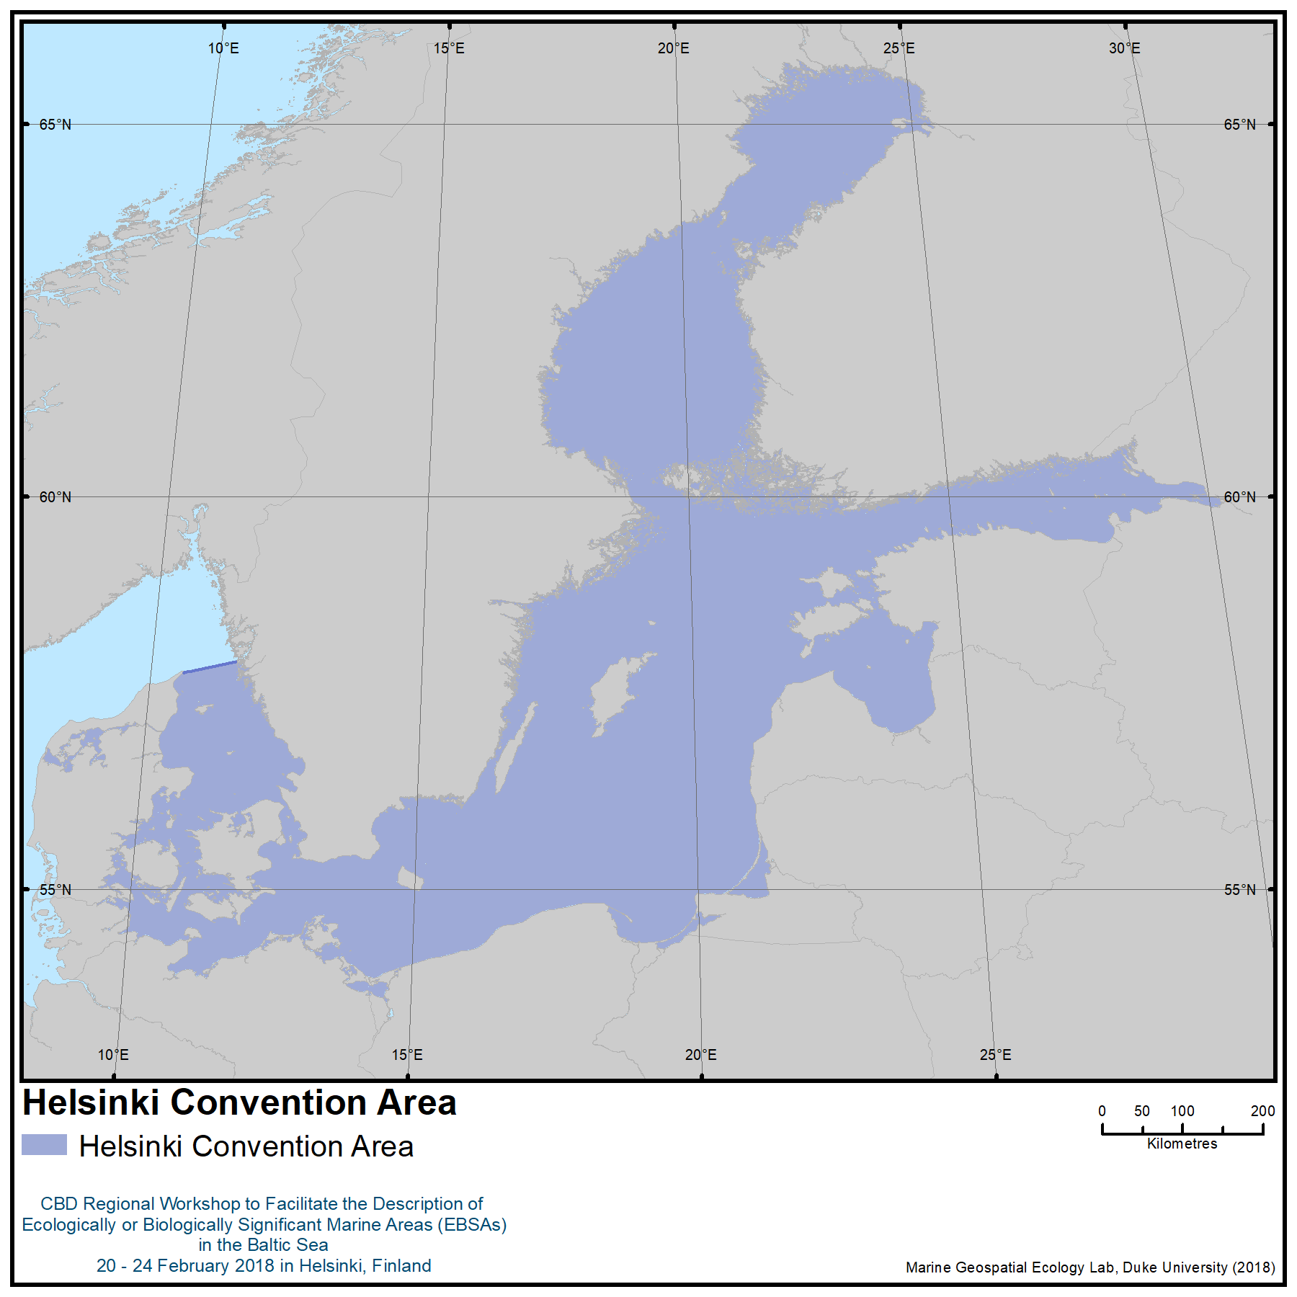

Helsinki Convention Area

Annex IV
ecological or biological SIGNIFICANCE of the BALTIC SEA
at the global scale

Introduction
1. The Baltic Sea is an inland, non-tidal sea situated in the temperate climate zone. It is the largest brackish body of water in the world, with a surface area of 420,000 km². It is also relatively young, shallow and highly dynamic.

2. The coasts of the Baltic Sea vary considerably. The southern coasts are characterized by long, sandy beaches, whereas rocky and moraine shores are a common feature in the northern regions. These coastal features continue underwater. The Baltic Sea is home to a significant diversity of indigenous peoples and local communities who possess endemic and traditional knowledge, as well as customary governance of their marine and coastal ecosystems, and whose unique knowledge systems, both past and present, capture important information on, for example, the natural environment and human culture, including traditional harvests, ecosystems and biodiversity. As of February 2017, almost 17% (almost 70,000 km²) of the surface area of the Baltic Sea was covered by MPAs under a number of designations ranging from international (e.g., World Heritage Sites and Ramsar Sites), regional (EU Habitats Directive, EU Birds Directive and HELCOM) and national. Furthermore, a large portion of the Baltic Sea has been designated as a Particularly Sensitive Sea Area (PSSA) by the International Maritime Organization (IMO).

The Baltic Sea Ecosystem

A young and dynamic sea
3. The Baltic Sea has a long history of changing salinity conditions, with both marine and freshwater phases. The recent configuration of the Baltic Sea, with a connection to the North Sea, was established during the Littorina transgression between 7,500 and 4,000 years ago. The current brackish water form of the Baltic Sea was initiated only around 2,000 years ago (Emeis et al. 2013). This means that the Baltic Sea is in its infancy when compared, for example, to the Atlantic Ocean, which is assumed to be around 180–200 million years old.

4. The seabed of the Baltic Sea is shaped into sub-basins separated by shallow sills. Each sub-basin is characterized by a different depth, volume and water exchange, resulting in sub-basin-specific chemical and physical properties. In addition, the Baltic Sea has highly varied coastlines and seabed types. Large archipelago areas add to this diversity. All of these factors have a profound influence on the proliferation and distribution of species on both a subregional and a local scale (HELCOM 2009b).

Climate as a driving feature
5. Its location in the temperate zone means that the central and northern areas of the Baltic Sea have long winters with strong frosts, while the southwestern and southern areas have relatively moist and mild winters (HELCOM 2017). This results in a climatic gradient with up to six months of ice cover, and a corresponding productive season of four-to-five months in the northern Gulf of Bothnia and an eight-to-nine-month productive season in the southern sounds near the sea’s entrance (HELCOM 2013a).

Climate Change
6. Research shows that the regional climate has already started to show signs of change, and this change is expected to continue. Projections of potential future climates estimate that the region will become considerably warmer and wetter in some parts, but dryer in others. Terrestrial and aquatic ecosystems have already shown adjustments to increased temperatures and are expected to undergo further changes in the near future (BACC II 2015).

7. A temperature increase is expected to result in changes in the species composition, as well as the length of the spring phytoplankton bloom season. Changes in the composition of the spring bloom community will in turn influence the benthos compartment. The projected changes in temperature, and particularly salinity, can influence the composition of the zooplankton community, with negative consequences for the food conditions and growth of the main plankton-eating fish, Baltic herring and sprat. Climate change may also differentially influence the seasonal succession of both phytoplankton and zooplankton, and increase the temporal mismatch between these groups in the spring. A potential climate-induced decrease in salinity would also negatively impact, for example, cod, the main fish-eating fish in the southern Baltic. Climate change influences cod stocks, which influence their preys, sprat and herring, which in turn influence zooplankton population levels. A projected continued decrease in salinity will cause a major distributional shift in the benthic species, with a continued retreat of marine species towards the south. The projected salinity decline will result in geographical shifts in the distribution of species in both deep-water and shallow-water communities (HELCOM 2013c).

Shallow waters
8. More than one third of the Baltic Sea is shallower than 30 metres, giving it a small total water volume in comparison to its surface area. Even though it is shallow, with an average depth of 52 metres (HELCOM 2009a), the water at the bottom remains cold during the summer. Overall, the water is more turbid than oceanic water. This implies that the photic layer available to photosynthesising plants, algae and bacteria is narrower in the Baltic Sea than in the oceans and in many areas light does not reach the bottom. Nevertheless, due to the shallow average depth of the sea bottom, the photic zone covers a significant proportion of the sea, especially in the archipelagos (HELCOM 2013a).

Effects of isolation
9. The Baltic Sea is relatively isolated from other seas. It only has a narrow connection to the North Sea through the Sound and the Belt Seas, and marine water enters the Baltic Sea predominantly during winter storms. The entrance to the North Sea was previously wider, but was narrowed due to land upheaval (Leppäranta and Myrberg 2009). It takes approximately 30 years for the Baltic Sea waters to get fully exchanged (Stigebrandt 2001). Larger inflows of marine water from the North Sea occur intermittently, and lead to temporary increases in salinity in the deeper water of the Baltic Sea, as well as fluctuations in temperature. These inflows of marine water are highly important for oxygenating the deep water areas of the Baltic Sea, and for maintaining the physical environment of marine species.

Oxygen: a challenge
10. The Baltic Sea is characterised by permanent vertical stratification (above vs. below the halocline), meaning that the water between the surface and deeper bottom layers do not mix in all areas. This is a condition that is especially prevalent in the main basin and in the western Gulf of Finland (HELCOM 2013b). These conditions of low oxygen and anoxia are, in part, a natural phenomenon in the deeper areas of the Baltic Sea, although enhanced by eutrophication, which is also the driving factor for seasonal oxygen deficiency in shallow areas and coastal waters. The brackish surface water layer above the halocline stays continuously oxygenated by vertical mixing and thermohaline circulation. The scarcity of high intensity inflows of high salinity water has been an important contributing factor to the extension of areas with poor oxygen conditions in the deep water of the Baltic Sea. The oxygen conditions of the deeper areas are further impoverished by long-term nutrient loading, leading to impacts on species and habitats (HELCOM 2017).

Fresh water inflow
11. The drainage area of the Baltic Sea is about four times larger than its surface area, and is inhabited by a population of around 85 million (HELCOM 2017). Fresh water reaches the Baltic Sea from over 200 rivers, corresponding to about one fortieth of the total water volume per year (Bergström et al. 2001).

Salinity gradient
12. Together, the inflows of saline waters in the south and of freshwater in the north and the estuaries give rise to the characteristic brackish water gradient of the Baltic Sea, with a gradual change from a surface water salinity of 15–18 psu (marine areas) in the entrance at the Sound, to 7–8 psu in the Baltic proper and 0–2 (freshwater conditions) in the north-eastern parts (HELCOM 2016). This gradient creates unique habitats across the different sub-basins of the sea.

Biodiversity
13. It is approximated that the Baltic Sea contains around 5000 species (HELCOM 2017), of both marine and freshwater origin, out of which more than 2700 are macroscopic species. Of these, a majority of the species (1898) belong to the benthic invertebrate group. Macrophytes, vascular plants and bryophytes make up a substantial proportion of the remaining 832 species, followed by the fish and lamprey group. A clear trend in biodiversity is evident for all groups, with the number of species decreasing along a south to north gradient (HELCOM 2012). Species diversity is rather low in the Baltic Sea compared to many other marine environments, as the brackish water environment is physiologically demanding to most organisms. However, the species that have adapted to the Baltic Sea conditions often appear in great abundance. As many of the species live at the edge of their tolerance to environmental variation in their living environment, any changes in this environment can cause the species abundance of the species to alter radically. As a result, small changes in environmental conditions can significantly affect the structure of a community and its biodiversity (HELCOM 2009b). Most of the marine species that are present in the Baltic Sea originate from a time when the level of salinity was higher, and these species have had limited genetic exchange with their counterparts in fully marine waters since those times. On a Baltic-wide scale, marine species live side by side with freshwater species that reproduce in freshwater tributaries or which can tolerate the brackish conditions. This brackish water imposes physiological stress on both marine and freshwater organisms, but there are also several examples of genetic adaptation and diversification (Johannesson and André 2006). Marine species are generally more common in the southern parts, and freshwater species dominate communities in the inner and less saline areas, and the two species groups create a unique food web where marine and freshwater species coexist and interact (HELCOM 2017). Because the sea in its current form is young, the Baltic Sea still offers opportunities for evolutionary development as well as several ecological niches available for immigration (HELCOM 2013b, HELCOM 2017).

References
BACC II Author Team (2015): Second Assessment of Climate Change for the Baltic Sea Basin. DOI 10.1007/978-3-319-16006-1
Bergström, S., H. Alexandersson, B. Carlsson, W. Josefsson, K.-G. Karlsson & G. Westring, G (2001): Climate and hydrology of the Baltic Basin. In: Wulff, F.V., Rahm, L.A. & Larsson, P. A (Eds.) Systems Analysis of the Baltic Sea. Springer Berlin Heidelberg.
Emeis, K.C., U. Struck, T. Blanz, A. Kohly & V. Maren (2003): Salinity changes in the central Baltic Sea (NW Europe) over the last 10 000 years. The Holocene 13 (3) 411-421.
Harff, J., S. Björck & P. Hoth (2011): The Baltic Sea Basin. Heidelberg, Dordrecht, London, New York: Springer, 449 pp.
HELCOM (2007): Baltic Sea Action Plan. Adopted at HELCOM Ministerial Meeting in Krakow, Poland on 15 November 2007.
HELCOM (2009a): Eutrophication in the Baltic Sea – An integrated thematic assessment of the effects of nutrient enrichment and eutrophication in the Baltic Sea region. Baltic Sea Environment Proceedings. No. 115B
HELCOM (2009b) Biodiversity in the Baltic Sea – An integrated thematic assessment on biodiversity and nature conservation in the Baltic Sea. Baltic Sea Environment Proceedings.No. 116B
HELCOM 2012. Checklist of Baltic Sea Macro-species. Baltic Sea Environment Proceedings No. 130
HELCOM (2013a): Red List of Baltic Sea underwater biotopes, habitats and biotope complexes. Baltic Sea Environmental Proceedings No. 138.
HELCOM (2013b): HELCOM Red List of Baltic Sea species in danger of becoming extinct. Baltic Sea Environmental Proceedings No. 140.
HELCOM (2013c): Climate change in the Baltic Sea Area: HELCOM thematic assessment in 2013. Baltic Sea Environmental Proceedings No. 137.
HELCOM (2016): Hydrography and oxygen in the deep sea basins. HELCOM Baltic Sea Environment Fact Sheets. Online. 6.7.2017, http://www.helcom.fi/baltic-sea-trends/environment-fact-sheets/
HELCOM (2017): First version of the ‘State of the Baltic Sea’ report – June 2017 – to be updated in 2018. Available at: http://stateofthebalticsea.helcom.fi
Johannesson, K. & C. André (2006): Life on the margin - genetic isolation and loss of variation in a peripheral marine ecosystem. Molecular Ecology 15: 2013-2030.
Leppäranta, M. & K. Myrberg (2009): Physical oceanography of the Baltic Sea. Springer/Praxis Pub, Berlin.
Stigebrandt, A. (2001): Physical oceanography of the Baltic Sea. In: Wulff, F.V., L.A. Rahm, & P.A. Larsson (Eds.) Systems Analysis of the Baltic Sea. Springer Berlin Heidelberg.
UNEP-WCMC and IUCN (2018), Protected Planet: The World Database on Protected Areas (WDPA) [On-line], February 2018, Cambridge, United Kingdom: UNEP-WCMC and IUCN. Available at: www.protectedplanet.net.

Annex V
INDIGENOUS AND LOCAL KNOWLEDGE RELEVANT TO THE DESCRIPTION OF AREAS MEETING THE EBSA CRITERIA IN THE BALTIC SEA AND POTENTIAL AREAS FOR FUTURE COLLABORATION TO FURTHER DOCUMENT THE RELEVANT KNOWLEDGE

1. Indigenous and local knowledge (ILK) is considered unique knowledge of nature, environment, culture, traditional harvests, ecosystems and biodiversity (Boström in IPBES 2018). In the marine context, ILK often includes information on populations and availability of fish, changes in biodiversity, abnormalities, diseases, variation in sea and weather, as well as oral histories, cosmologies and cultural heritage of the seas and adjacent coasts. The knowledge could contain new discoveries or novel data that have been overlooked in remote sensing and field sampling. Experiences have shown the capacity of ILK to act as an “early warning” system of ecosystem degradation, including, for example, classical historical examples of the impact of PCBs and DDT on grey seals detected by the northern sealers and new diseases and malformations on Baltic herring off the coast of Pori in the 1960s (Saiha and Virkkunen,1986).

2. The indigenous groups of the Baltic Sea include the Livonians, Izora, Saami and Votians (see examples in Paulaharju 2010 and Konkova 2009). Additionally, coastal small-scale fishers in the Baltic possess significant cultural continuums and relations with the sea (Saiha and Virkkunen 1986, Mustonen and Mäkinen 2004, Mustonen 2014 and IPBES 2018). Many of these groups monitor habitats using their ILK systems, which have much to contribute to research, planning and management in the Baltic.

3. The advent of large-scale industrial fishing—in particular trawling—has destroyed the capacity of small-scale fisheries to defend and maintain their ILK systems and endemic existence. A “system” here refers to the knowledge-practice-belief-complex associated with fully functioning ILK (IPBES 2018). This realization is also a warning signal to understand, protect and maintain those socio-ecological systems and ILK traditions that are still present in the Baltic, despite socio-economic change. For example, the small-scale fishers around Fehmarn Island, Germany, have very specific knowledge of their sea and especially the cod stocks. They have mapped areas of conflict arising from the uses of trawling gear to harvest cod, and they report that the cod stocks have collapsed in territories where large trawling has been permitted (personal communication, 20 February 2018 with Tero Mustonen).

4. In the early 1800s, Virolahti local people self-governed the seasonal harvest of sprat and Baltic herring by distributing the harvest locations and boat harbours using endemic decision-making and place-based knowledge.

5. As early as 1924, a Finnish researcher, Sakari Pälsi, worked with the Suursaari fishers and seal hunters to document their ILK on traditional ice uses and knowledge. He was able to document the deep knowledge Suursaari sealers had with regard to sea ice and ringed seals. The sealers had self-imposed limits to their harvest, a special Karelian seal dog and spiritual knowledge of the sea that included sacred places of Suursaari hills. Pälsi considered the Suursaari seal hunters to be on par with Greenlandic and other Inuit sea-ice-based knowledge systems, even though it was little understood in Finland at the time.

6. The legacy of the Suursaari seal hunters has been continued by the present-day seal hunters based in Kotka (Mustonen and Mäkinen 2004). Their harvests and knowledge focus on the grey seal. They wish to protect the ringed seal as a non-harvest species due to its current low population numbers. The Kotka seal hunters maintain the endemic self-organization of a hunting unit, artteli, and observe a range of taboos associated with a successful hunt (Mustonen and Mäkinen 2004). This group is not very visible and is aware of the uniqueness of their traditional knowledge. Similar accounts of endemic fisheries have also existed on the island of Koivisto.
The seal hunters of Kvarken, who have precise knowledge of sea ice and seals and their historic use of these marine areas, are a good case of an indigenous and community conserved area (ICCA) (Mustonen and Mäkinen 2004). In the 1960s the seal hunters were amongst the first to detect the impact of DDT, dioxins and heavy metals on grey seal reproduction (Helle in Mustonen and Mäkinen 2004). This led to a positive partnership between researchers and hunters, demonstrating the hunters’ deep knowledge of their environment.

7. People in the local fishing communities from the coastal Pori area detected the impacts of industrial wastewater on Baltic herring (catching fish with malformed eyes) and many other species of fish. They also detected the early signs of climate change on sea ice and regional weather patterns as early as the 1970s (Mustonen 2014).

8. The Kalix archipelago, in northern Sweden is an area of customary use in the Arctic part of the Baltic (IPBES 2018). The local Kustringen organization has worked to limit by-catch of valued salmonid fish and has advocated for advances in joint management of the fish stocks in the area.

9. Unlike many other sea areas, the Baltic has been under-represented as a space for ILK. Very little is known of the Livonian maritime toponyms, German small-scale fishers, Latvian lamprey harvests, Estonian customary maritime governance of Ruhnu island, and impacts and detection of climate change on small-scale fishing communities, to name a few urgent examples. A consolidated effort to document ILK across the Baltic Sea should be initiated to learn from the ILK communities and to document, while we still can, those cultural heritage regions and places that will disappear or already have. Possible areas of collaboration can include:
- An atlas of traditional knowledge and maritime uses of ICCAs /local-traditional communities beginning with selected case studies; and
- A traditional knowledge monitoring network of the Baltic to increase the coverage and inclusion of local communities in the survey of the state of the marine environment.

References
ICCA Consortium 2018
IPBES 2018. IPBES-like study of the Nordic areas. In print
Konkova, O.J. Izora. Ozerko Istorii i Kultur. St. Petersburg, 2009
Mustonen, Tero and Mäkinen, Aija. Pitkät hylkeenpyyntimatkat ja muita kertomuksia hylkeenpyynnistä. University of Applied Sciences Tampere, 2004
Mustonen, Tero. Endemic Time-Spaces of Finland: Aquatic Regimes. Fennia 192: 2, pp. 120-139. DOI:10.11143/40845
Paulaharju, Marjut (ed). Samuli Paulaharjun Inkeri. Helsinki: SKS, 2010
Pälsi, Sakari. Suomenlahden jäiltä. WSOY, 1924
Raussi, Elias. Vironlahden kansanelämää. Helsinki: SKS, 1966
Saiha, Markku and Virkkunen, Juha. Kalastaja ilman merta — Into Sandbergin elämää ja kynänjälkeä. WSOY, 1986

Annex VI
MAP OF THE AREAS MEETING THE EBSA CRITERIA IN THE BALTIC SEA
AS AGREED BY THE WORKSHOP PLENARY

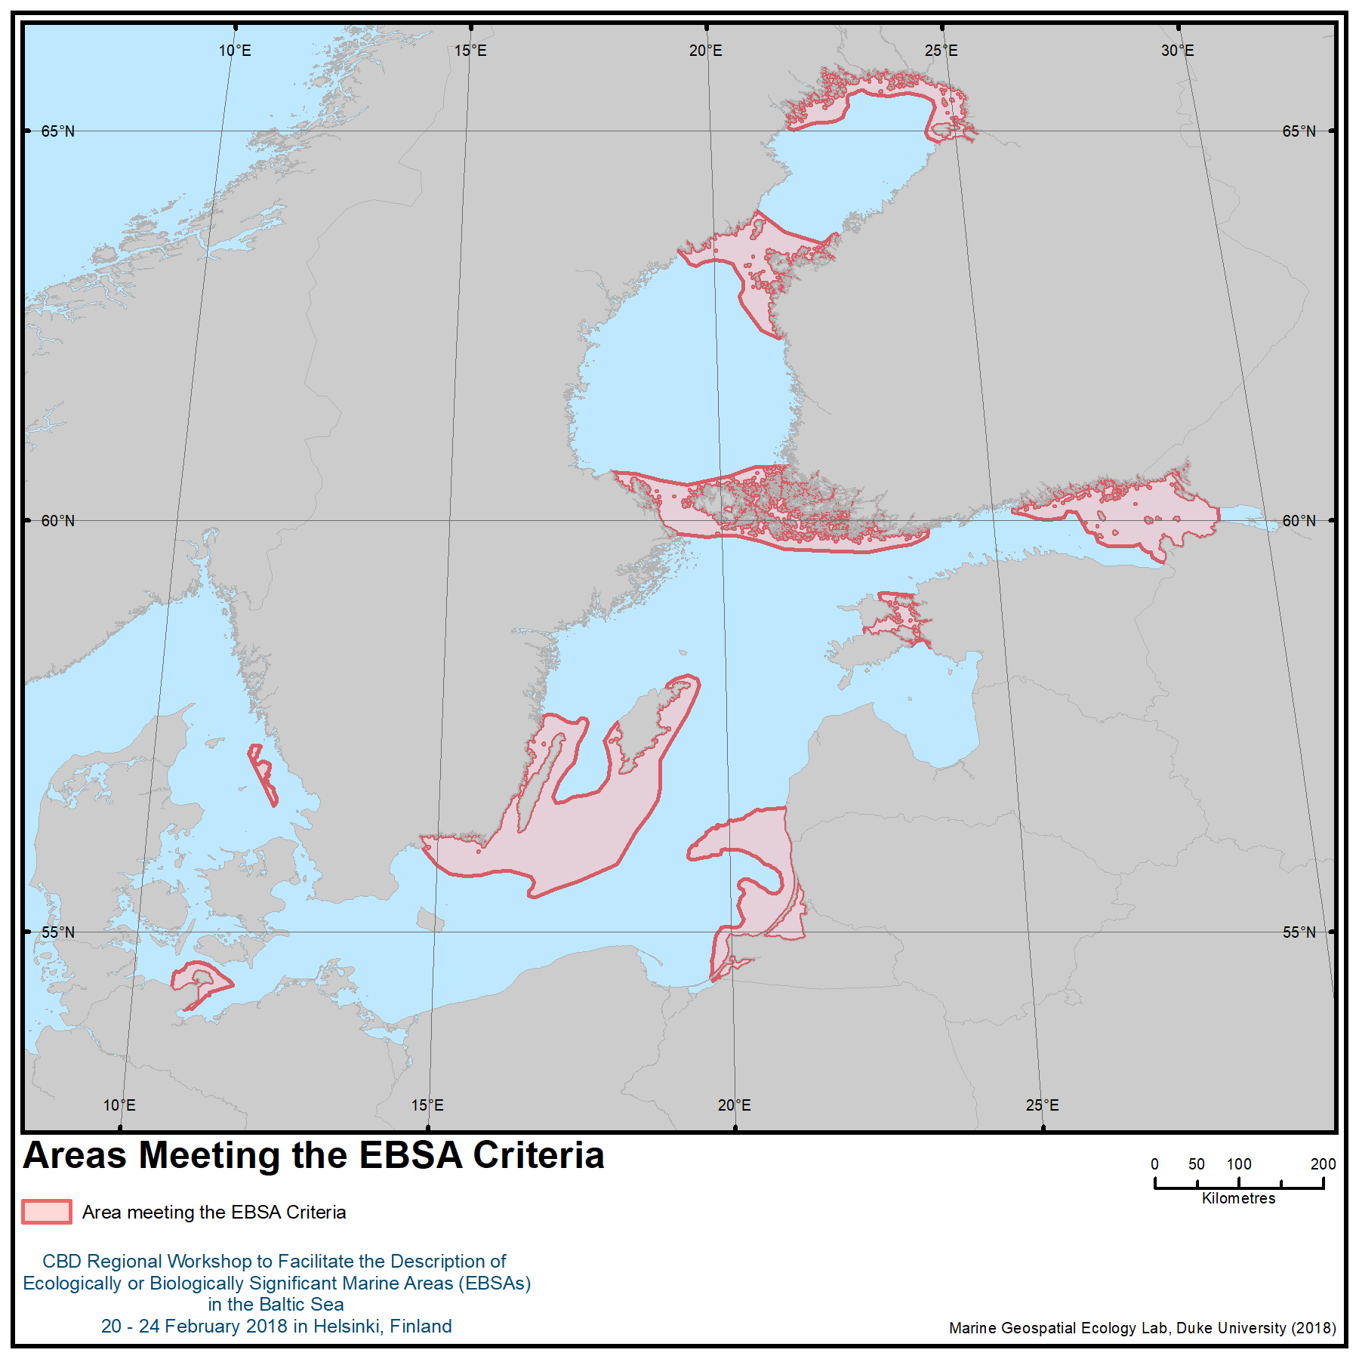

Annex VII
AREAS MEETING THE EBSA CRITERIA IN THE BALTIC SEA
AS AGREED BY THE WORKSHOP PLENARY

Area No. | Area Name
1 | Northern Bothnian Bay
2 | Kvarken Archipelago
3 | Åland Sea, Åland Islands and the Archipelago Sea of Finland
4 | Eastern Gulf of Finland
5 | Inner Sea of West Estonian Archipelago
6 | Southeastern Baltic Sea Shallows
7 | Southern Gotland Harbour Porpoise Area
8 | Fehmarn Belt
9 | Fladen and Stora and Lilla Middelgrund

Appendix to Annex VII

DESCRIPTION OF AREAS MEETING THE EBSA CRITERIA IN THE BALTIC SEA
AS AGREED BY THE WORKSHOP PLENARY

Area No. 1: Northern Bothnian Bay

Abstract
The Bothnian Bay forms the northernmost part of the Baltic Sea. It is the most brackish part of the Baltic, greatly affected by the combined river discharge from four big rivers and a catchment area covering most of the Finnish and Swedish Lapland. The sea area is shallow, and the seabed consists mostly of sand. The area displays Arctic conditions; in winter the whole area is covered with sea ice (for 5-7 months), which functions as the reproductive habitat for the grey seal (Haliochoerus grypus) and is a prerequisite nesting habitat for the ringed seal (Pusa hispida botnica). In summer the area is productive, and due to the turbidity from the river discharge primary production is typically limited to a narrow photic zone (between a depth of 1 and 5 metres). Due to the extreme brackish water the number of marine species is low, yet the number of endemic and threatened species is high, as the area is the final refuge for species retreating northwards after the last glaciation (10,000 BP). It is an important reproductive area for coastal fish and an important gathering area for several anadromous fish species. The Torne, Kalix and Råneå rivers, which all discharge into the northern part of the area, are spawning rivers of regional importance for the Baltic population of the Atlantic salmon (Salmo salar).

Introduction
The northern Bothnian Bay is a large, shallow and tide-less sea area with a seabed consisting mostly of sand and silt, forming the northernmost part of the Baltic Sea. The topography is a result of the last glaciation (10,000 BP), and the isostatic land uplift is ongoing (ca. 8 mm/year). The depth varies from 0 to 58 metres (the deepest part of the Bothnian Bay is 148 m). The photic zone is narrow, with annual variations depending both on river discharge bringing dissolved organic matter into the sea and on-site primary production. River discharge in turn depends on precipitation (and snow melt in spring), while primary production depends on water temperature, nutrients and available sunlight. Sunlight hours vary from less than four hours in winter to more than 20 hours during summer.

The Bothnian Bay has elevated seabed geodiversity (Kaskela et al., 2012; Kaskela & Kotilainen, 2017). Crystalline bedrock dominates the coastal Bothnian Bay especially in the north, and sedimentary rocks characterize the area around Hailuoto Island and the tectonic depressions of the central part. The erosion of the sedimentary rocks partly contributes to the occurrence of large sandy seafloor areas typical of the area (Tulkki, 1977). In addition, depressed seafloor structures corresponding to continuations of the riverbeds and fault lines have been identified (Tulkki, 1977).

The whole Bothnian Bay is covered by ice during most winters. The mean thickness of the seasonal ice in the area is typically 70 cm (Kronholm et al., 2005).

The ecological state of the sea is monitored regularly. The Finnish Inventory Programme for Marine Underwater Environment (VELMU) has conducted extensive biodiversity inventories in the area. The inventories conducted from 2004 to 2017 have included dive lines and drop videos, benthic sampling, fish larvae sampling, and echo soundings. Observation data for hundreds of species is available. Also, species distribution models (SDMs) have been made for many species (below referred to as “VELMU data”; viewable in https://paikkatieto.ymparisto.fi/velmu). Spatial data on birdlife and seals also exist. A large number of inventories of benthic vegetation and fish have been conducted in the area, and detailed local reports are available from the Swedish side.

Location
The area encompasses the northernmost part of the Bothnian Bay. The total coverage of the area is 8963 km^{2,} and its sea area is 8297 km².

Feature description of the area
The area is the largest and most northern brackish sea area in the Baltic. The ecosystem resembles that of an oligotrophic lake, rather than a sea. As in lakes, the phytoplankton production is limited by availability of phosphorus, rather than nitrogen, as is the case in most other parts of the Baltic Sea. The rivers flowing into the Bay of Bothnia carry a large amount of dissolved organic carbon, which makes the water brownish and serves as a substrate for bacterial growth (Figueroa et al. 2015). Therefore the phytoplankton production is low compared to other areas of the Baltic Sea. The secondary producers, including mesozooplankton and fish, gain energy through a food web based on microbes and microzooplankton (Sandberg et al. 2004).

While the number of species, especially that of marine species, is comparatively low, due to the combined constraints of brackish water (salinity that is too low for marine species or too high for freshwater species) and annual variations in temperature and light, the area has a comparatively high number of endemic species, several of which have vulnerable or threatened status on the IUCN Red List. Many of these species are considered to have retreated northwards after the last glaciation and are now using the northernmost Bothnian Bay as a final refuge. The macrophyte community includes rare and threatened species such as Limosella aquatica (near threatened) and Alisma wahlenbergii (vulnerable) (Länsstyrelsen Norrbotten 2017).

The physical, chemical and climatic characteristics make the area suitable for freshwater species that can tolerate low salinities and cold-water conditions. Some fish species have adapted populations that spawn either in the coastal area or migrate to rivers for spawning. Often these also have different feeding areas. Sea-spawning whitefish (Coregonus lavaretus s.l.) and vendace (Coregonus albula) spawn in the shores and reefs of Bothnian Bay (Lehtonen 1981). The sea-spawning grayling (Thymallus thymallus), which occurs in some outer islands, is a unique endemic form whose non-migratory behaviour significantly differs from that of the anadromous grayling (Thymallus thymallus), effectively acting as a reproductive barrier as the original species spawns only in fresh water while the endemic stationary form spawns in the sea (Keränen 2015; Havs- och vattenmyndigheten 2017). The numerous rivers of Bothnian Bay are reproductive areas of migratory whitefish (Coregonus lavaretus) and sea trout (Salmo trutta), which may use the entire Gulf of Bothnia as a feeding area. The spring spawning perch and pike use estuaries and shallow bays as reproductive areas (Kraufvelin et al. 2018).

The northern Bothnian Bay is also an important reproductive area for grey seal (Haliochoerus grypus) and for ringed seal (Pusa hispida botnica), which is dependent on sea ice as nesting habitat (Härkönen et al. 1998; Sundqvist et al. 2012; HELCOM 2017).

Part of the area belongs to the Bay of Bothnia National Park, and there are several areas that are included in the Natura 2000 network and the HELCOM MPA network.

Table 1. Number of species in different sea areas listed by HELCOM (HELCOM 2012). The total number of species in the Baltic Sea is 2730, of which 1898 species are invertebrates. Total number of species in the table excludes bird species.
 | Gulf of Finland | Archipelago Sea | Kvarken Archipelago | Bothnian Sea
Macrophytes | 187 | 68 | 162 | 116
Benthic invertebrates | 482 | 122 | 96 | 132
Fish & lamprey | 87 | 68 | 51 | 48
Marine mammals | 3 | 3 | 2 | 2
Total number of species | 759 | 261 | 311 | 298
Share of species in the Baltic Sea | 27.8 % | 9.6 % | 11.4 % | 10.9 %

Feature condition and future outlook of the area
The overall condition and the future outlook of the area are good. The eutrophication plaguing the Baltic overall is mostly absent, due to the scarcity or absence of agriculture. Forest and mire drainage have increased the amount of humus particles in the water, which occasionally (during snow melt in spring) increases the turbidity. Current climate change scenarios forecast increased precipitation in the drainage area, which might temporarily further increase turbidity.

The shallow and even sea area, with a low level of human use, has high potential for future windfarm development, which might have detrimental effects unless mitigated by informed spatial planning and environmental impact assessment processes.

While land-use change, and especially the construction of dams for energy-production purposes, have suppressed and in part destroyed the natural reproduction of wild anadromous fish in many northern rivers, this area is characterized by four of the most important and still undeveloped rivers (Råneå, Kalix, Tornionjoki and Simojoki). Despite some economic pressure for energy development (more dams) the current decision of both the Finnish and the Swedish governments is to prohibit further damming.

The region benefits from a very innovative cross-border Finnish-Swedish Transboundary River Commission, based in Haparanda, Sweden, which is a “best practice” in Nordic countries for equitable management of water resources.

The Kalix archipelago in northern Sweden is an area of customary use of the Arctic part of the Baltic (Belgrano et al. 2018); several traditional fishing bases and other areas are still in use. The customary regime is still strong. Parts of the Kalix area are also an area of Saami reindeer herding, as the animals migrate on the islands of the archipelago for their winter pastures. The local Kustringen organization has worked to limit by-catch of valued salmonid fish and has advocated for advances in joint management of the fish stocks in the area (Belgrano et al. 2018).

Assessment of the area against CBD EBSA Criteria

CBD EBSA Criteria  (Annex I to decision IX/20) | Description  (Annex I to decision IX/20) | Ranking of criterion relevance  (please mark one column with an X)
CBD EBSA Criteria  (Annex I to decision IX/20) | Description  (Annex I to decision IX/20) | No information |  | Low |  |  | Medium |  | High
Uniqueness or rarity | Area contains either (i) unique (“the only one of its kind”), rare (occurs only in few locations) or endemic species, populations or communities, and/or (ii) unique, rare or distinct, habitats or ecosystems; and/or (iii) unique or unusual geomorphological or oceanographic features. |  |  |  |  |  |  |  | X
Explanation for ranking

Due to its very low and stable salinity, the northern Bothnian Bay is unique compared to other brackish sea areas, including other areas in the Baltic Sea. These conditions facilitate the evolutionary process of adapting marine species to freshwater conditions, or alternatively freshwater species to marine conditions (Leinikki 1995, Yliniva 2010).

The area contains the core area for the plant Alisma wahlenbergii, which is endemic to the Baltic Sea and probably evolved here since the last ice age (Jacobsson 2005, HELCOM Red List Macrophyte Expert Group 2013a). Apart from the Bothnian Bay, the species only occurs in smaller numbers in Lake Mälaren (Sweden) and the inner Gulf of Finland (Russian Federation).

The area contains the largest of only three identified subpopulations of the sea-spawning grayling (Thymallus thymallus), which is endemic to the northern Baltic Sea (Keränen 2015, Havs- och vattenmyndigheten 2017).
The area also contains the current core area for a number of Baltic Sea populations of aquatic macrophytes. This includes the main part of the population of Hippuris tetraphylla (HELCOM Red List Macrophyte Expert Group 2013b), all but one of the known occurrences of Chara braunii (HELCOM Red List Macrophyte Expert Group 2013c), as well as almost the entire remaining population of Potamogeton friesii (HELCOM Red List Macrophyte Expert Group 2013d).
Special importance for life-history stages of species | Areas that are required for a population to survive and thrive. |  |  |  |  |  |  |  | X
Explanation for ranking

The area encompasses the staging area of four of the most important salmon-carrying rivers in the Baltic (Torne, Råneå, Kalix and Simojoki rivers), which are of central importance for the status of the Baltic salmon (Salmo salar). Simojoki and Torne rivers are the only two salmon-carrying rivers in Finland, and Torne River is the single-most important river for Baltic salmon. Both the Baltic salmon (Salmo salar) and the sea trout (Salmo trutta forma trutta) are anadromous, spending most of their time in the Baltic but returning to a specific river to spawn (HELCOM 2011, ICES 2017).

It is also an important staging area for bird migration, both during spring migration when large numbers of birds gather before continuing northwards and in late summer and early autumn, when they utilize the high summer production to increase fitness levels before continuing their migration southwards.

The northern Bothnian Bay is one of two areas in the Baltic where sea ice will reliably form in the future, due to climate change (according to the current IPCC outlook and regional 100-year predictions on effects of climate change, made by the Swedish Meteorological Society). This makes the area extremely important for the ringed seal (Pusa hispida botnica) and the grey seal (Haliochoerus grypus), both of which breed on the annual ice cover (the ringed seal exclusively so) (Sundqvist et al. 2012).

Importance for threatened, endangered or declining species and/or habitats | Area containing habitat for the survival and recovery of endangered, threatened, declining species or area with significant assemblages of such species. |  |  |  |  |  |  |  | X
Explanation for ranking

The area encompasses the staging area of four of the most important salmon-carrying rivers in the Baltic (Torne, Råneå, Kalix and Simojoki rivers), which are of central importance for the international status of the vulnerable Baltic salmon (Salmo salar) as well as the critically endangered local sea trout (Salmo trutta forma trutta). (HELCOM 2011, ICES 2017)

The area contains the largest of only three identified subpopulations of the sea-spawning grayling (Thymallus thymallus), which is classified as critically endangered (Keränen 2015).

The area contains the core area for a number of rare and declining species and populations that are appear on the HELCOM species red list: the endemic and vulnerable Alisma wahlenbergii , the endangered Hippuris tetraphylla , and the Baltic Sea populations of the vulnerable Chara braunii and the near threatened Potamogeton friesii (HELCOM Red List Macrophyte Expert Group 2013a-d). Hippuris tetraphylla has declined significantly along the Finnish coast and is assessed as critically endangered on the national red list of Finland (Rassi et al. 2010). In addition, a large part of the observations of the endangered Persicaria foliosa is from this area (HELCOM Red List Macrophyte Expert Group 2013e). A number of threatened freshwater macrophyte species can also be found in the area (Artportalen database), including (status provided refers, respectively, to Red List of Finland/Sweden) (ArtDatabanken 2015, Rassi et al. 2010); the vulnerable/near threatened Crassula aquatic, the vulnerable/not assessed Nitella hyalina , and the vulnerable Nitellopsis obtuse and Potamogeton compressus.

Macroplea pubipennis (vulnerable/data deficient), a leaf beetle species of the subfamily Donaciinae that feeds on aquatic plants and is endemic to Finland , was found to occur in the area in 2017. This represents the northernmost population in Europe. Globally, the species is only found in Finland, Sweden and China (Saari 2007; Fauna Europaea). Macroplea pubipennis seems to be dependent on brackish water and avoids fresh water since there are no records of the species from freshwater bodies in Finland. (Biström 2006, Vahtera 2017).

A high number of threatened birds breed and/or stage in the area (Sundström and Olsson 2009), including: (Aquila chrysaetos (VU/NT), Circus cyaneus (VU/NT), Gallinago media (CR/NT), Haliaeetus albicilla (VU/NT), Pernis apivorus (EN/NT), Philomachus pugnax (CR/VU), Podiceps auritus (EN/-), Anas acuta (EN/VU), Anas querquedula (EN/VU), Anser fabalis (VU/NT), Arenaria interpres (EN/VU), Aythya fuligula (EN/-), Aythya marila (EN/VU), Calidris maritima (EN/-), Calidris minuta (EN/-), Calidris temminckii (EN/-), Larus fuscus (EN/NT), Larus ridibundus (VU/-), Melanitta fusca (EN/NT), Tringa totanus (VU/-), Anas penelope (VU/-), Delichon urbicum (EN/VU), Mergus merganser (VU/-), Mergus serrator (EN/-).
(VU=vulnerable, NT=near threatened, CR=critically endangered, EN=endangered, -=not assessed
Vulnerability, fragility, sensitivity, or slow recovery | Areas that contain a relatively high proportion of sensitive habitats, biotopes or species that are functionally fragile (highly susceptible to degradation or depletion by human activity or by natural events) or with slow recovery. |  |  |  | X
Explanation for ranking

There are habitats inside the area that are very sensitive to human disturbance, including flads and glo-lakes and bird and seal-breeding areas. The area overall is, however, characterized strong seasonality and additionally by fluctuations caused by river discharge, and is as such fairly resilient.

Biological productivity | Area containing species, populations or communities with comparatively higher natural biological productivity. |  |  |  |  |  | X
Explanation for ranking

The area is very productive during summer (when there are more than 20 hours of sunlight), but less so in winter (with annual sea-ice covering the area). The benthic invertebrate biomass is rather low in the area.

Viitasalo et al. 2017).

Biological diversity | Area contains comparatively higher diversity of ecosystems, habitats, communities, or species, or has higher genetic diversity. |  |  |  |  |  | X
Explanation for ranking

Due to the brackish characteristics of the area, the number of marine species is rather low, however overall this is compensated by a higher number of freshwater species, some of which are endemic to the area (Viitasalo et al.2017).

Naturalness | Area with a comparatively higher degree of naturalness as a result of the lack of or low level of human-induced disturbance or degradation. |  |  |  |  |  |  | X
Explanation for ranking

The level of human-induced pressure is fairly low, especially compared to other parts of the Baltic Sea. The population around the area is quite low (by international standards, around 200,000 inhabitants, including coastal inland areas). Pressures from fisheries can be quite intense locally, especially in and around river estuaries. Wind farm development and sand extraction could become greater threats in the future.

References
ArtDatabanken 2015. Rödlistade arter i Sverige 2015. ArtDatabanken SLU, Uppsala.
Belgrano, A., Ejdung, G., Lindblad, C., Tunón, H. (Eds.) (2018) Biodiversity and ecosystem services in Nordic coastal ecosystems – an IPBES-like assessment. (In prep.)
Biström, O. (2018) Sympatric occurrence of three leaf beetle species of Macroplea Samouelle, 1819 (Coleoptera, Chrysomelidae, Donaciinae) in Finland with a key to species in Northern Europe, Aquatic Insects, DOI: 10.1080/01650424.2017.1420803
Biström, O., and Saari, S. (2006) ‘Meriuposkuoriaisen Macroplea pubipennis, esiintyminen Varsinais-Suomen Paimionlahdella (Coleoptera, Chrysomelidae)’, Sahlbergia, 11, 11–13.
Figueroa, D., Rowe, O., Paczkowska, J., Legrand, C., Andersson, A. 2016: Allochthonous Carbon - a major driver of bacterioplankton production in the subarctic Northern Baltic Sea. Microbial Ecology 71: 789-801.
Haapala, J., Ronkainen, I., Schmelzer, N., Sztobryn, M. (2015). Recent change – Sea ice. In: the BACC II Author Team: Second Assessment of Climate Change for the Baltic Sea Basin. Springer, Cham Heidelberg New York Dordrecht London. Pp. 145-153.
Halkka, A. & Tolvanen, P. (eds.) (2017) The Baltic Ringed Seal – An Arctic Seal in European Waters – WWF Finland report 36.
Havs-och vattenmyndigheten (2017) Harr i Bottniska viken – en kunskapssammanställning. Havs- och vattenmyndighetens rapport 2017:30. 46 p.
HELCOM (2017) Helcom core indicator report: Distribution of Baltic seals.
HELCOM Red List Macrophyte Expert Group 2013a: Species information sheet Alisma wahlenbergii. http://www.helcom.fi/Red%20List%20Species%20Information%20Sheet/HELCOM%20Red%20List%20Alisma%20wahlenbergii.pdf
HELCOM Red List Macrophyte Expert Group 2013b. Species information sheet Hippuris tetraphylla. http://www.helcom.fi/Red%20List%20Species%20Information%20Sheet/HELCOM%20Red%20List%20Hippuris%20tetraphylla.pdf
HELCOM Red List Macrophyte Expert Group 2013c. Species information sheet Chara braunii. http://www.helcom.fi/Red%20List%20Species%20Information%20Sheet/HELCOM%20Red%20List%20Chara%20braunii.pdf
HELCOM Red List Macrophyte Expert Group 2013d. Species information sheet Potamogeton friesii. http://www.helcom.fi/Red%20List%20Species%20Information%20Sheet/HELCOM%20Red%20List%20Potamogeton%20friesii.pdf
HELCOM Red List Macrophyte Expert Group 2013e. Species information sheet Persicaria foliosa. http://www.helcom.fi/Red%20List%20Species%20Information%20Sheet/HELCOM%20Red%20List%20Persicaria%20foliosa.pdf
HELCOM (2012). Checklist of Baltic Sea Macro-species. Baltic Sea Environment Proceedings No. 130.
HELCOM (2011) Salmon and Sea Trout Populations and Rivers in the Baltic Sea - BSEP126A.
Härkönen, T., Stenman, O., ICES (2017) - Report of the Baltic Salmon and Trout Assessment Working Group (WGBAST). ICES fCM 2017ACOM10. 298 p
Jacobsson, A. 2005: Åtgärdsprogram för bevarande av småsvalting (Alisma wahlenbergii). https://www.naturvardsverket.se/Documents/publikationer/620-5499-6.pdf
Jüiss, M., Jüssi, I., Sagitov, R. and Verevkin M. 1998. Population size and distribution of the Baltic ringed seal (Phoca hispida botnica). NAMMCO Scientific Publications 1:167-180.
Kaskela, A.M., Kotilainen, A.T., Al-Hamdani, Z., Leth, J. & Reker, J. 2012. Seabed geomorphic features in a glaciated shelf of the Baltic Sea. Estuarine Coastal and Shelf Science 100, 150–161. ISSN 0272-7714, http://dx.doi.org/10.1016/j.ecss.2012.01.008.
Kaskela, A.M. & Kotilainen, A.T. 2017. Seabed geodiversity in a glaciated shelf area, the Baltic Sea. Geomorphology 295, 419-435. ISSN 0169-555X, http://dx.doi.org/10.1016/j.geomorph.2017.07.014.
Keränen, P.A. 2015. Meriharjuksen hoitosuunnitelma. Osa 1. Meriharjuskannan hoidon ja suojelun tausta. https://www.eraluvat.fi/media/dokumentit/julkaisut/meriharjuksen-hoitosuunnitelma-osa-1-meriharjuskannan-hoidon-ja-suojelun-tausta.pdf
Kraufvelin, P., Pekcan-Hekim, Z., Bergström, U., et al. (2018). Essential coastal habitats for fish in the Baltic Sea. Estuarine, Coastal and Shelf Science 204: 14-30.
Kronholm, M., Albertsson, J., Lainen, A. (2005). Perämeri Life: Perämeren toimintasuunnitelma. (Bay of Bothnia Life: An Action Plan for the Bay of Bothnia; in Finnish). 234 pp. http://www.doria.fi/handle/10024/134770
Lehtonen H (1981) Biology and stock assessments of Coregonids by the Baltic coast of Finland. Finn Fish Res 3: 31−83.
Leinikki, J. & Oulasvirta P. (1995) Perämeren kansallispuiston vedenalainen luonto. Metsähallituksen luonnonsuojelujulkaisuja Sarja A 49.

Luomaranta, A., Ruosteenoja, K., Jylhä, K., Gregow, H., Haapala, J. & Laaksonen, A. 2014: Multimodel estimates of the changes in the Baltic Sea ice cover during the present century. Tellus A 66:22617.
Rassi, P., Hyvärinen, E., Juslén, A. & Mannerkoski, I. (eds.) 2010: The 2010 Red List of Finnish Species. Ympäristöministeriö & Suomen ympäristökeskus, Helsinki. 685 p.
Sandberg J, Andersson A, Johansson S, Wikner J 2004. Pelagic food web structure and carbon budget in the northern Baltic Sea: potential importance of terrigenous carbon. Mar Ecol Prog Ser 268: 13-29.
Sundqvist L., Härkönen T., Svensson C.J., Hårding K.C. 2012. Linking climate trends to population dynamics in the Baltic ringed seal: impacts of historical and future winter temperatures. Ambio 41:865-872.
Sundström, T. and Olsson C. 2009: Norrbottens kustfågelbestånd – inventering 2007 och 2008. Länsstyrelsens rapportserie nr 5/2009
Tiainen, J., Mikkola-Roos, M., Below, A., Jukarainen, A., Lehikoinen, A., Lehtiniemi, T., Pessa, J., Rajasärkkä, A., Rintala, J., Sirkiä, P. & Valkama, J. 2016. Suomen lintujen uhanalaisuus 2015 – The 2015 Red List of Finnish Bird Species. Ympäristöministeriö & Suomen ympäristökeskus. 49 p.
Tulkki, P., 1977. The bottom of the Bothnian Bay, geomorphology and sediments. Merentutkimuslaitoksen Julkaisu 241, 1-89.
Vanhatalo, J., Veneranta, L., & Hudd, R. 2012. Species distribution modeling with Gaussian processes: A case study with the youngest stages of sea spawning whitefish (Coregonus lavaretus L. sl) larvae. Ecological Modelling, 228, 49-58.
Veneranta, L., Hudd, R., & Vanhatalo, J. 2013. Reproduction areas of sea-spawning coregonids reflect the environment in shallow coastal waters. Marine Ecology Progress Series, 477, 231-250.
Viitasalo, M., Kostamo, K., Hallanaro, E., Kiviluoto, S., Ekebom, J. & Blankett, P. (Eds.) (2017) Meren aarteet. Gaudeamus. 518 p.
Yliniva, M. & Keskinen, E. (2010) Perämeren kansallispuiston vesimakrofyytit - peruskartoitus ja näytteenottomenetelmien vertailu. Metsähallituksen luonnonsuojelujulkaisuja. Sarja A 191.
Databases
Artportalen, species sightings database of The Swedish Species information Centre, https://www.artdatabanken.se/en/species-observations/?menu=open

Maps and Figures

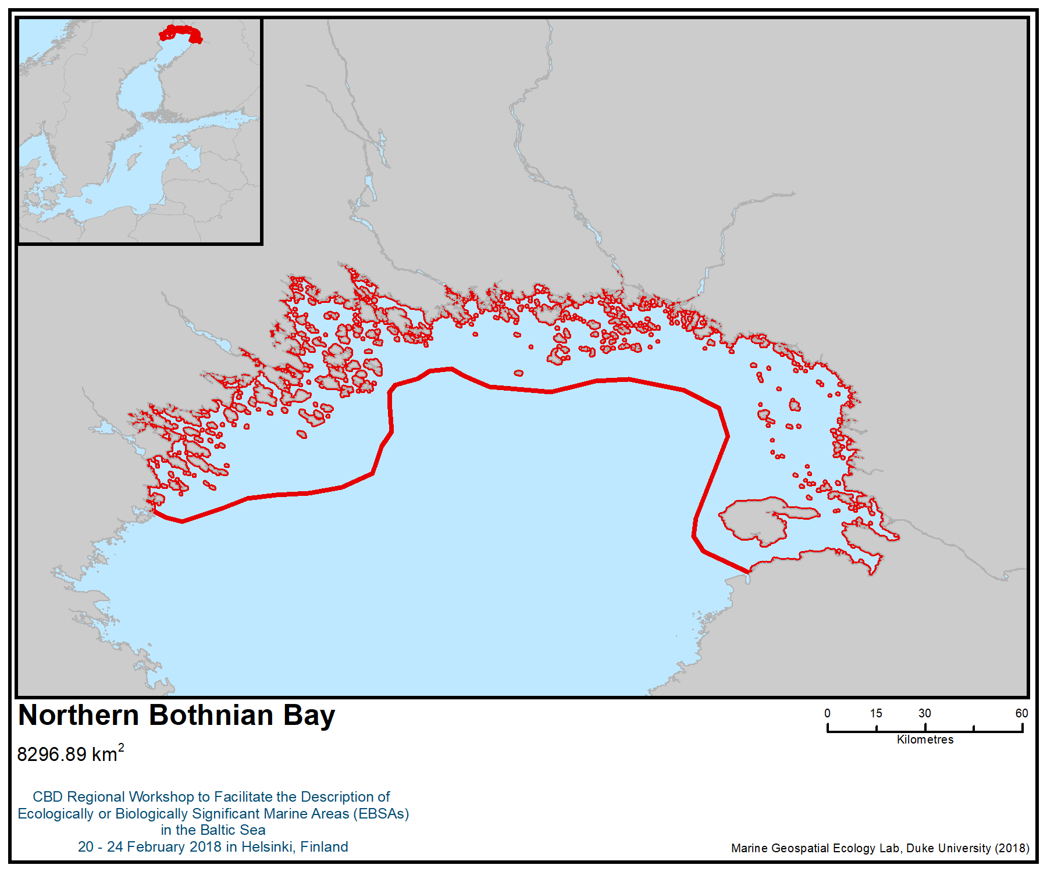

Figure 1. Location of the area
Area No. 2: The Kvarken Archipelago

Abstract
The Kvarken Archipelago consists of a narrow (26 km) strait between Sweden and Finland, with a multitude of islands and skerries on both sides. The Kvarken also divides the Gulf of Bothnia, forming a shallow underwater threshold (max. depth 26 m) between the Bothnian Bay in the north and the Bothnian Sea in the south. The archipelago encompasses approximately 10,000 islands and skerries. The area is typified by its unique landscape, consisting of thousands of different moraine formations dating from the last glaciation (10.000 – 8.000 BP). The area is also characterized by continuous change. Ongoing isostatic land uplift (at a rate of 8 mm per year) continuously affects all biotopes and habitats, constantly bringing new areas up into the photic zone. The Kvarken Archipelago is a transition zone where the dominating and habitat-forming marine fauna and flora rapidly change from freshwater species into marine species from north to south. The relative latitudinal change in salinity is the highest in the Baltic Sea. A continuous mixing of water further adds ecological and evolutionary pressure to the ecosystem. The shallowness and the substrate diversity, combined with up to 20 hours of sunlight in summer, make the area highly productive and important for a large number of fish and bird species.

Introduction
The Kvarken Archipelago exhibits a unique combination of characteristics that can be found nowhere else, which is also the basis for its inscription as a World Heritage Site (http://whc.unesco.org/en/list/898). The Kvarken Archipelago is located on the crystalline bedrock, which forms a unique, brackish shallow-water marine environment with a large number of moraines. The washboard-like De Geer moraines and boulder fields found both on terrestrial and submarine areas characterize the landscape of the Kvarken and contribute to its high geodiversity (e.g., Breilin et al., 2004; Kaskela and Kotilainen, 2017; Kotilainen and Kaskela, 2017), which in turn facilitates a relatively high biological diversity. The isostatic land uplift is still ongoing at a rate of 8 mm per year and creates approximately 1 km² of new dry land each year.

Salinity in the area is low, from 2.5 to 5.5 psu in the more open areas down to 0.0 psu in enclosed coastal lagoons. The relative change in salinity per distance from the northern to the southern part of the area is the greatest in the Baltic. The hydrology is affected by the outflow of less saline water from the Bothnian Bay southwards, created by the combined discharge of all rivers in Northern Fennoscandia. This combined “river”, continuously and invisibly flowing through the shallow Kvarken strait, is larger than any European river, with a yearly mean of over 3000 m³/s. The flow of water through the strait varies both temporally and spatially depending on the amount of precipitation in the large catchment area as well as on seasonal conditions (i.e., snowmelt) and current wind and high/low pressure conditions. The local salinity conditions are further affected by bathymetry and by the counter-clockwise current in the Bothnian Sea, which continuously brings more saline water into the Kvarken area from the south. The continuous changes in the flow of water and the resulting mixing affect not only salinity, but also other hydrological conditions (Ollqvist 2004).

The seabed of the shallow Kvarken Archipelago includes silt, sand and hard bottoms, often in a small-scale mosaic pattern determined by glacial formations. Land uplift and the extensive flow of water continuously affect the composition of the bottom sediment, removing more fine-grained sediments from areas exposed to greater water movement and depositing them in more sheltered areas. The geological formations create additional variation by affecting the exposure, from highly sheltered to highly exposed within a small spatial scale (Breilin 2004).

The area is covered by annual sea ice, but the number of ice days has been steadily declining in the open sea areas due to recent warming of the climate (Haapala 2015).

Regular monitoring of the ecological state of the sea in this area takes place on both shores. The Finnish Inventory Programme for Marine Underwater Environment (VELMU) has conducted extensive biodiversity inventories on the Finnish side, while the Västerbotten county has conducted a multitude of regionally focused inventory projects on the Swedish side. Knowledge about underwater habitats and species has been further improved by long-term cross-boundary cooperation, including 13 cooperative EU-funded projects (interreg III – V) during the last 15 years. This is therefore one of the best inventoried areas in the Baltic, with a combined total of more than 85,000 dive and drop-video transects, benthic sampling spots and fish larvae and spawning ground inventories. In addition, species distribution models (SDMs) have been made for many species, both separately as part of respective national programmes as well as in the form of cross-border cooperation using combined datasets to create combined biotope maps of the whole area (the Finnish national data, referred to as “VELMU data”, is viewable online at https://paikkatieto.ymparisto.fi/velmu, while the combined biotope maps can be accessed through the regional SeaGIS 2.0 platform at https://seagis.org/internt/). Spatial data on birdlife and seals also exist. In addition, there have been a number of regional inventories of habitats, fish and birds conducted in the area.

Location

The Kvarken Archipelago is located in the Gulf of Bothnia, in the northern part of the Baltic Sea. The archipelago’s total area is 10,364 km², and its sea area is 9,638 km². The mean depth of the area is 22 m, with the deepest point in the open sea being 133 m.

Feature description of the area
The area encompasses a World Heritage Site, several Natura 2000 areas, several HELCOM marine protected areas as well as several Important Bird and Biodiversity Areas (IBAs), three Ramsar sites (Umeälvens delta, Kvarken archipelago and Vassorfjärden) and some smaller national protected areas (Toivanen 2014, Sundström 2005).

The shallow area of the Kvarken Archipelago includes silt, sand and hard bottoms, often in a small-scale mosaic pattern due to its glacial formations. The geological formations create additional variation by affecting the exposure (from highly sheltered to highly exposed within a small spatial scale), in turn further generating comparatively high local biodiversity. Due to the low salinity (2.5 to 5.5 psu) and the steep salinity gradient, the area is a transition zone between marine and freshwater fauna and flora. For example, the northern side has a high diversity of aquatic vascular plants and charophytes (including rare species), while the southern side is characterized by algal communities. Several key marine species, like bladderwrack Fucus vesiculosus, Fucus radicans and the blue mussel Mytilus trossulus) reach their northernmost distribution in the Kvarken area (Viitasalo 2017).

As in the rest of the Baltic Sea, there is a continuous evolutionary pressure on species to adapt along the salinity gradient (from fresh water to saline water and vice versa). The unique topography of the Kvarken area, coupled with the land uplift, facilitates this process by creating a multitude of variations (depth, substrate, exposure, salinity), all of which are under constant change. Of special importance is the flad/glo-lake succession (a flad is a coastal lagoon), which transforms topographically enclosed sea areas into freshwater lakes (over a period of 200 years), usually forming a connected system of small water masses in different successional stages (Munsterhjelm 1997). Many flads and glo-lakes are biodiversity hotspots for vascular plants and charophytes (Munsterhjelm 1997). They are also important spawning areas for fish, as they warm up faster and earlier than the surrounding sea while at the same time offering a sheltered environment (Karås & Hudd 1993).

The Kvarken area is productive, due to an overall shallowness and abundance of light, as well as continuously changing water currents that transport nutrients and mix the water. The area is important for several fish species. Due to the many flad bays it forms a very important reproduction area for perch (Perca fluviatilis) and pike (Esox lucius). There are also important spawning areas for Baltic herring (Clupea harengus) and whitefish (Coregonus lavaretus s.l.). The Holmöarna archipelago, on the Swedish side, is one of three areas for coastal spawning grayling (Thymallus thymallus) in the Baltic Sea. This area is also an important corridor for migrating anadromous European whitefish (Coregonus lavaretus s.l.), salmon (Salmo salar) and sea trout (Salmo trutta) (Kallio-Nyberg et al. 2017). The River Ume delta and the Sävarfjärden are very important migration routes on the Swedish side.

Several of the most important breeding areas for archipelago birds in the Baltic is situated in the area, and the area is of international importance for the Baltic population of some species, for instance black guillemot (Cepphus grylle grylle). Both the shallow archipelago on the Finnish side and the Ume River delta on the Swedish side are internationally important staging areas for bird migration (Ramsar and N2000 SPA-areas) (Toivanen 2014, Sundström 2005).

Even though climate change is affecting sea ice cover in exposed areas, the extensive archipelago on the Finnish side facilitates the forming of annual ice cover as well as snow cover on the ice, which is of crucial importance for the reproduction of the ringed seal (Pusa hispida botnica). Climate change modelling shows the Kvarken archipelago as one of only two sea areas where annual sea ice cover will reliably form during the next hundred years, making the area of acute importance for the ringed seal.

The area has a long cultural history connected to the sea and sea resources. As in many other parts of the Baltic, the sea was originally of central importance both for movement and as a general food resource. The Kvarken area is, however, different in that this culture, based on seal-hunting and fishing, was still prevalent in some parts of the area up to the second World War. While the small and culturally distinct fishing villages have largely disappeared, there still exist possibilities to utilize indigenous and local knowledge in natural resource management processes (Belgrano et al. 2018).

Table 2. Number of species in different sea areas listed by HELCOM (HELCOM 2012). The total number of species in the Baltic Sea is 2730, of which 1898 species are invertebrates. Total number of species in the table excludes bird species.

 | Gulf of Finland | Archipelago Sea | Kvarken Archipelago | Bothnian Sea
Macrophytes | 187 | 68 | 162 | 116
Benthic invertebrates | 482 | 122 | 96 | 132
Fish & lamprey | 87 | 68 | 51 | 48
Marine mammals | 3 | 3 | 2 | 2
Total number of species | 759 | 261 | 311 | 298
Share of species in the Baltic Sea | 27.8 % | 9.6 % | 11.4 % | 10.9 %

Feature condition and future outlook of the area
While there are many summer cottages in the area and it is somewhat affected by eutrophication, human impact is concentrated in the summer season. The overall condition of the area is generally better than that of the southern parts of the Baltic Sea, due to the anthropogenic nutrient loading being intermediate and the organic material continuously being flushed towards the deeper parts on both sides. Noticeable effects of eutrophication still occur locally in more sheltered areas, especially closer to the coast. North-south and east-west ship traffic are both concentrated to fairly narrow areas due to the shallowness of the area, leading to disturbance from shipping being quite localized. A maritime disaster (ships carrying oil or chemicals) is a serious threat to this shallow and extensive archipelago area, as the ecosystem would be affected immediately, and mitigating efforts are challenging.

Climate change will affect the impact of the ongoing land uplift as a result of increasing sea-level rise. While the isostatic rebound (land uplift) will continue at approximately the same speed (8 mm per year) and will eventually generate a topographic height increase of 140 metres (compared to today), the increasing sea level will counteract the process (Grinstedt, 2015), and at the same time slow down the continuous change shaping the environment, which is a typical characteristic of the area. This change will affect all biotopes, but especially the natural succession of flads to freshwater and terrestrial environments and will also change the characteristics of the area from a long-term evolutionary viewpoint.

Assessment of the area against CBD EBSA Criteria
CBD EBSA Criteria  (Annex I to decision IX/20) | Description  (Annex I to decision IX/20) | Ranking of criterion relevance  (please mark one column with an X)
CBD EBSA Criteria  (Annex I to decision IX/20) | Description  (Annex I to decision IX/20) | No information |  | Low |  |  | Medium |  | High
Uniqueness or rarity | Area contains either (i) unique (“the only one of its kind”), rare (occurs only in few locations) or endemic species, populations or communities, and/or (ii) unique, rare or distinct, habitats or ecosystems; and/or (iii) unique or unusual geomorphological or oceanographic features. |  |  |  |  |  |  |  | X
Explanation for ranking

The combination of rapid isostatic land uplift (among the highest in the world at 8 mm/y), the abundance of glacial moraine formations forming the actual landscape, brackish waters (with the largest spatial change of salinity in the Baltic) and a continuous flow of water in the form of the combined river discharge from northern Fennoscandia makes the Kvarken Archipelago unique on a global scale. The rapid isostatic uplift forms new land (> 1 km² per year) and also continuously affects underwater areas, continuously lifting new areas up into the photic zone, allowing colonization of vegetation and changing the hydrology in the area, which in turn affects water movement and bottom substrate composition. (UNESCO World Heritage Database, http://whc.unesco.org/en/list/898).

A large part of the area was designated as a World Heritage site, according to World Heritage criteria VIII (“The Baltic Sea has undergone dramatic changes since the last Ice Age, including a series of transitions from marine water to freshwater and then to brackish water, consequently causing subsequent changes in plant and animal life. This serial transboundary property serves as an outstanding example of the continuity of this change with dynamic ongoing geological processes forming the land- and seascape, including interesting interactions with biological processes and ecosystem development.”) (Ollqvist and Rinkineva 2004)

Special importance for life-history stages of species | Areas that are required for a population to survive and thrive. |  |  |  |  |  |  |  | X
Explanation for ranking

The area is of high importance for many species and biotopes, evidenced by both large numbers and high abundances. It is one of the most important breeding areas for birds in the Baltic (Natura 2000 database), and an important spawning area for benthic fish species. It is an important area for bird migration in spring, and large numbers of birds use it as a staging area during autumn migration, using the abundant food production from the large shallow areas to raise energy storage levels before continuing migration southwards (Toivanen 2014). A clear indication of this is that this is the core area of the white-tailed sea eagle Haliaeetus albicilla, an apex predator. The area currently has the most abundant white-tailed sea eagle population in Europe, and this was also the only area where the species was still reproducing during the critical period of the 1970s and 1980s (when the species was expected to become extinct within a decade) (Herrmann et al. 2011, Stjernberg 2007).

The area currently is also an important area for fish migration, almost by definition, as all south- and northwards-bound fish migration has to go through the Kvarken strait (this includes the absolute majority of all anadromous Baltic salmonids, including Baltic salmon Salmo salar). (HELCOM 2011, ICES 2017)

In addition to the general importance for a large number of species, the area is of singular importance for several species. Some specific examples:

There are several distinct local, stationary populations of whitefish (Coregonus lavaretus s.l.) that exist in separate parts of the area with no spatial overlap between populations. The phylogeny and taxonomy of the whitefish group (Coregonus sp.) is challenging and not completely clear, probably due to ongoing evolutionary/genetic transition from an original anadromous behaviour (migrating to freshwater in order to spawn) to a non-migratory, stationary behaviour, spawning in the sea.

The same type of habitat and behavioural switch has happened in the grayling (Thymallus thymallus) and one of only three known populations of stationary, non-migrating and sea-spawning graylings are known in the Baltic, one being specific to the Kvarken area. The sea-spawning form is classified as critically endangered and while it has become locally extinct on the Finnish side there is still a viable local population on the Swedish side (Holmöarna). (Keränen 2015, Havs- och vattenmyndigheten 2017)

Several rivers on the Swedish side (particularly the Ume River) still have original, river-specific and genetically distinct populations of sea trout (Salmo trutta morpha trutta), an anadromous subspecies that, like several other salmonids, migrate to the sea when young (in the “smolt” phase) and back to the original spawning grounds to spawn.

Additionally, the Kvarken Archipelago is an important reproduction area for several economically important fish species, including perch (Perca fluviatilis), pike (Esox lucius), pikeperch or zander (Sander lucioperca), Baltic herring (Clupea harengus) and smelt (Osmerus eperlanus).

The Kvarken Archipelago is the central breeding area for the Baltic population of the endangered greater scaup (Aythya marila), as more than 90% of the population breeds in the area. The Baltic population (currently less than 1000 breeding pairs) is generally considered a relic from the last ice age, adapting to the emerging archipelago while the main palearctic population followed the retreating ice and currently breeds mainly on the Russian tundra.

The area is the autumn feeding ground for Nathusius's pipistrelle (Pipistrellus nathusii), a bat which migrates northwards to Kvarken (from central Europe) after breeding in order to utilize the extremely abundant autumn food production in shallow areas, in this case in the form of nonbiting midges, Chironomidae. Chironomids spend their larval phase in soft sediment on the seafloor, forming an important part of the macrozoobenthos, and emerge as flying adults numbering in the billions (and becoming a food source for the Nathusius's pipistrelle). This type of northward migration is unique for Europe, and additionally shows a rare connection between prevalently terrestrial bat species and marine production. (Fritzen 2015).

The Kvarken Archipelago is one of two areas in the Baltic (and consequently in the whole of the EU) where seasonal sea ice will reliably form in the future, according to the current IPCC prognosis and regional 100-year predictions made by the Swedish Meteorological Society. As a result, the area is of extreme importance for the ringed seal (Pusa hispida botnica), which is dependent on the seasonal ice cover (as well as snow cover on top of the ice) for reproduction. In a relatively short 100-year perspective, the Kvarken area is one of only two areas in the EU where the ringed seal can still continue to exist (the other being the northernmost part of the Bothnian Bay) (Luomaranta et al. 2014, Halkka 2017).

Currently, the core distribution area of the Baltic subspecies of the black guillemot (Cepphus grylle grylle) is the Kvarken archipelago, containing approx. 35-40% of the whole Baltic population. The medium-sized auk is a true marine bird, breeding only on the outermost islands and previously common along all Baltic coasts. It is sensitive to human disturbance and extremely sensitive to predation, especially by two invasive alien species, American mink (Neovison vison) and raccoon dog (Nyctereutes procyonoides).

Importance for threatened, endangered or declining species and/or habitats | Area containing habitat for the survival and recovery of endangered, threatened, declining species or area with significant assemblages of such species. |  |  |  |  |  |  |  | X
Explanation for ranking

The area contains one of only three identified subpopulations of the sea-spawning grayling (Thymallus thymallus). The sea-spawning form is classified as critically endangered and has become locally extinct on the Finnish side in the last 20 years; the local population on the Swedish side (Holmöarna) is still viable.

The Kvarken Archipelago is the central breeding area for the Baltic population of the endangered greater scaup (Aythya marila), as more than 90% of the population breeds in the area. The Baltic population (currently fewer than 1000 breeding pairs) is generally considered a relic from the last ice age, adapting to the emerging archipelago while the main palearctic population followed the retreating ice and currently breeds mainly on the Russian tundra.

The area contains a large part of the distribution of the seaweed species Fucus radicans, which is endemic to the Baltic and estimated to have emerged during the last 500-1000 years. Its main distribution area is the Kvarken archipelago, where it is a key habitat-forming species. In contrast to the (probable) parent species bladderwrack (Fucus vesiculosus), the new species mainly reproduces asexually, forming extensive genetic clones, several of which exist only in the Kvarken area. Initial studies show that the new species can handle both lower salinity, a longer period of complete dark (seasonal ice cover during winter) than its parent species, and is also capable of living longer and reproducing when scraped loose from the growing substrate, which is a common effect of drifting ice floes during spring.

The area is an important breeding and/or staging site for the following threatened bird species (abbreviations in parentheses refer to Red List status respectively in Finland/ Sweden)) (Tiainen et al 2016, ArtDatabanken 2015): Aquila chrysaetos (VU/NT), Bubo bubo (EN/VU), Bubo scandiaca (CR/CR), Calidris alpina schinzii (EN/CR), Circus cyaneus (VU/NT), Dendrocopos leucotos (VU/CR), Emberiza hortulana (EN/VU), Falco peregrinus (VU/NT), Gallinago media (CR/NT), Haliaeetus albicilla (VU/NT), Milvus migrans (CR/EN), Pernis apivorus (EN/NT), Phalaropus lobatus (VU/-), Philomachus pugnax (CR/VU), Podiceps auritus (EN/-), Acrocephalus arundinaceus (VU/NT), Anas acuta (EN/VU), Anas querquedula (EN/VU), Anser fabalis (VU/NT), Anthus cervinus (VU/VU), Arenaria interpres (EN/VU), Aythya ferina (EN/VU), Aythya fuligula (EN/-), Aythya marila (EN/VU, Baltic population CR), Buteo buteo (VU/-), Calidris maritima (EN/-), Calidris minuta (EN/-), Calidris temminckii (EN/-), Cepphus grylle (EN/NT), Eremophila alpestris (CR/VU), Larus fuscus (EN/NT), Larus ridibundus (VU/-), Melanitta fusca (EN/NT), Tadorna tadorna (VU/-), Tringa totanus (VU/-), Turdus torquatus (EN/-), Anas penelope (VU/-), Delichon urbicum (EN/VU), Lagopus lagopus (VU/-), Mergus merganser (VU/-), Mergus serrator (EN/-), Parus cristatus (VU/-), Parus montanus (VU/-), Plectrophenax nivalis (EN/-), Riparia riparia (VU/NT), Somateria mollissima (VU/VU) (Tiainen et al. 2015)

Other threatened species in the area: Pipistrellus nathusii (VU/-), Coregonus lavaretus f. lavaretus (EN/-), Coregonus lavaretus f. pallasi (VU/-), Lota lota (-/NT), Thymallus thymallus (sea spawning grayling) (CR/CR), Salmo salar (VU/-), Anguilla anguilla (EN/CR), Salmo trutta (CR/-), Crassula aquatica (VU/NT), Macroplea pubipennis (VU/-), Hippuris tetraphylla (EN/CR) (Tiainen et al. 2015).

(VU=vulnerable, NT=near threatened, CR=critically endangered, EN=endangered, -=not assessed)
Vulnerability, fragility, sensitivity, or slow recovery | Areas that contain a relatively high proportion of sensitive habitats, biotopes or species that are functionally fragile (highly susceptible to degradation or depletion by human activity or by natural events) or with slow recovery. |  |  |  |  |  | X
Explanation for ranking

There are habitats inside the area that are very sensitive to human disturbance, including flads and glo-lakes, as well as breeding and staging areas for birds. The area overall is, however, characterized by a comparatively large continuous change and additionally by extensive water movements, and is, as such, fairly resilient.
EU Habitat Directive Annex I habitats are abundant in the area, and coastal lagoons (1150), reefs (1170) and large shallow inlets and bays (1160), can be considered typical features of the Kvarken archipelago. The area contains the highest abundance and amount of coastal lagoons in the Baltic. The vulnerability and sensitivity as well as the resilience of the Habitat Directive Annex I habitats are well known, and also the focus of continuous monitoring and reporting (EU-wide every sixth year) (Munsterhjelm, R. 2005).
Biological productivity | Area containing species, populations or communities with comparatively higher natural biological productivity. |  |  |  |  |  | X
Explanation for ranking

The area is very productive during summer (with over 20 hours of sunlight and among the highest quotients of photic vs aphotic areas in the Baltic), but less so in winter (with annual sea ice covering the area). It is an important reproduction area for many bird and fish species, and as a result of the overall productivity, abundant populations of apex predators (white-tailed sea eagle, grey seal, ringed seal) are present in the area (Viitasalo et al. 2017).
Biological diversity | Area contains comparatively higher diversity of ecosystems, habitats, communities, or species, or has higher genetic diversity. |  |  |  |  |  |  |  | X
Explanation for ranking

Due to the extreme characteristics of the area and the species composition mix of freshwater and marine species, the biological diversity is comparatively high. This is further accentuated by the wide shallow areas in combination with complex, small-scale geomorphological features, developing spatially fine-grained diversity also at the biotope level (SEAGIS2 dataportal; VELMU dataportal).

Naturalness | Area with a comparatively higher degree of naturalness as a result of the lack of or low level of human-induced disturbance or degradation. |  |  |  |  |  |  | X
Explanation for ranking

There is human pressure throughout the area in different forms (shipping, fisheries, recreation, dredging, nutrient-loading), but large parts of the area are designated as nature conservation sites and are in almost pristine condition (excepting indirect pressure from nutrient loading). The oldest conservation areas have been in force since the 1930s, and large parts currently belong to the Natura 2000 network or are World Heritage sites, which will limit further development (e.g., building of summer cottages and dredging). On the Swedish side, Holmöarna and parts of the outer coast have very little coastal exploitation and the Vindeln River is unregulated. Some inner archipelago areas are eutrophicated due to nutrient loading from the watershed.

References

ArtDatabanken 2015. Rödlistade arter i Sverige 2015. ArtDatabanken SLU, Uppsala.
Belgrano, A., Ejdung, G., Lindblad, C., Tunón, H. (Eds.) (2018) Biodiversity and ecosystem services in Nordic coastal ecosystems – an IPBES-like assessment. (In prep.)
Bergström, L. (2001) The Northern Kvarken
BirdLife International (2018) Important Bird Areas factsheet: Merenkurkku archipelago.http://datazone.birdlife.org/site/factsheet/1335/details. Accessed on 22.1.2018.
BirdLife International (2018) Important Bird Areas factsheet: River Ume Delta and Plains. http://datazone.birdlife.org/site/factsheet/river-ume-delta-and-plains-iba-sweden/details.
Breilin, O., Kotilainen, A., Nenonen, K., Virransalo, P., Ojalainen, J., Stén, C.-G., 2004. Geology of the Kvarken Archipelago. Appendix 1 to the Application for Nomination of the Kvarken Archipelago to the World Heritage List. Geological Survey of Finland, p. 47.
Fritzen, N. (2015) Kvarken Bats - nya resultat som stöder hypotesen om Kvarkenöverskridande fladdermusmigration. OA Natur 2015.
Grinstedt, A. (2015). Projected change - Sea level. In The BACC Team (Eds.), Second Assessment of Climate Change for the Baltic Sea Basin (pp. 253-263). Cham: Springer.
Haapala, J., Ronkainen, I., Schmelzer, N., Sztobryn, M. (2015). Recent change – Sea ice. In: the BACC II Author Team: Second Assessment of Climate Change for the Baltic Sea Basin. Springer, Cham Heidelberg New York Dordrecht London. Pp. 145-153.
Halkka, A. & Tolvanen, P. (eds.) (2017) The Baltic Ringed Seal – An Arctic Seal in European Waters – WWF Finland report 36.
Havs- och vattenmyndigheten (2017) Harr i Bottniska viken – en kunskapssammanställning. Havs- och vattenmyndighetens rapport 2017:30. 46 p.
HELCOM (2011) Salmon and Sea Trout Populations and Rivers in the Baltic Sea - BSEP126A
HELCOM (2012) Checklist of Baltic Sea Macro-species. Baltic Sea Environment Proceedings No. 130
HELCOM. 2013. HELCOM Red List of Baltic Sea species in danger of becoming extinct. Balt. Sea Environ. Proc. No. 140.
Herrmann, C, Krone, O, Stjernberg, T & Helander, B (2011) Population development of Baltic bird species: White-tailed Sea Eagle (Haliaeetus albicilla). HELCOM Indicator Fact Sheets, 2011. http://www.helcom.fi/baltic-sea-trends/environment-fact-sheets/biodiversity/population-development-of-white-tailed-sea-eagle
ICES (2017) - Report of the Baltic Salmon and Trout Assessment Working Group (WGBAST). ICES CM 2017ACOM10. 298 p
Kallio-Nyberg, I., Veneranta, L., Saloniemi, I., Jutila, E., & Pakarinen, T. 2017. Spatial distribution of migratory Salmo trutta in the northern Baltic Sea. Boreal Environment Research. 22:431-444.
Karås, P., Hudd, R., 1993. Reproduction areas of fish in the northern Quark (Gulf of Bothnia). Aqua Fennica 23, 39e49.
Kaskela, A.M., Kotilainen, A.T., Al-Hamdani, Z., Leth, J. & Reker, J. 2012. Seabed geomorphic features in a glaciated shelf of the Baltic Sea. Estuarine Coastal and Shelf Science 100, 150–161. ISSN 0272-7714, http://dx.doi.org/10.1016/j.ecss.2012.01.008.
Kaskela, A.M. & Kotilainen, A.T. 2017. Seabed geodiversity in a glaciated shelf area, the Baltic Sea. Geomorphology 295, 419-435. ISSN 0169-555X, http://dx.doi.org/10.1016/j.geomorph.2017.07.014.
Keränen, P. A. (2015) Meriharjuksen hoitosuunnitelma. Osa 1. Meriharjuskannan hoidon ja suojelun tausta. https://www.eraluvat.fi/media/dokumentit/julkaisut/meriharjuksen-hoitosuunnitelma-osa-1-meriharjuskannan-hoidon-ja-suojelun-tausta.pdf
Kotilainen, A.T. & Kaskela, A.M. 2017. Comparison of airborne LiDAR and shipboard acoustic data in complex shallow water environments: Filling in the white ribbon zone. Marine Geology 385, 250–259.
Kraufvelin, P. et al. 2018. Essential coastal habitats for fish in the Baltic Sea. Estuarine, Coastal and Shelf Science 204, 14-30.
Luomaranta, A., Ruosteenoja, K., Jylhä, K., Gregow, H., Haapala, J. & Laaksonen, A. 2014: Multimodel estimates of the changes in the Baltic Sea ice cover during the present century. Tellus A 66:22617.
Länsstyrelsen Västernorrland. 2012. Modellering av Västernorrlands marina habitat och naturvärden rapport 2012:3
Länsstyrelsen Västernorrland. 2013. Fiskrekrytering längs Västerbottenskusten, Meddelande 2 2013: ISSN- 0348-0291
Munsterhjelm, R. (2005) Natural succession and human-induced changes in the soft-bottom macrovegetation of shallow brackish bays on the southern coast of Finland. – W. & A. de Nottbeck Foundation Sci. Rep. 26: 1-53.
Munsterhjelm R (1997) The aquatic macrophyte vegetation of flads and gloes, S coast of Finland. Acta Botanica Fennica 157: 1–68.
Ollqvist, S. & Rinkineva, L. (2004) Nomination of the Kvarken Archipelago for the inclusion in the World Heritage List.
SEAGIS2 dataportal (regional distribution maps for species, biotopes, human pressure). https://seagis.org/internt/. Accessed on 26.2.2018.
Stjernberg, T, Koivusaari, J, Högmander, J, Ollila, T & Ekblom, H (2007) Population trends and breeding success of the white-tailed sea eagle Haliaeetus albicilla in Finland, 1970-2005. Status of raptor populations in eastern Fennoscandia: proceedings of the workshop, Kostomuksha, Karelia, Russian Federation, November 8-10, 2005 / eds P. Koskimies, N. V. Lapshin]. pp 151-159, Petrozavodsk.
Sundström , T. & Olsson, C. (2005) Västerbottens kustfågelfauna. Länsstyrelsen Västerbotten, Meddelande 4-2005.
Tiainen, J., Mikkola-Roos, M., Below, A., Jukarainen, A., Lehikoinen, A., Lehtiniemi, T., Pessa, J., Rajasärkkä, A., Rintala, J., Sirkiä, P. & Valkama, J. 2016. Suomen lintujen uhanalaisuus 2015 – The 2015 Red List of Finnish Bird Species. Ympäristöministeriö & Suomen ympäristökeskus. 49 p.
Toivanen, T., Metsänen, T. & Lehtiniemi, T. (2014) Lintujen päämuuttoreitit Suomessa. BirdLife Finland. 21 p + 36 p.
Valkama, Jari, Vepsäläinen, Ville & Lehikoinen, Aleksi 2011: Suomen III Lintuatlas. –Luonnontieteellinen keskusmuseo ja ympäristöministeriö. http://atlas3.lintuatlas.fi. 18.02.2018. ISBN 978-952-10-6918-5.
VELMU dataportal (Finnish national underwater inventory program). https://paikkatieto.ymparisto.fi/velmu. Accessed on 18.2.2018.
Viitasalo, M., Kostamo, K., Hallanaro, E., Kiviluoto, S., Ekebom, J. & Blankett, P. (Eds.) (2017) Meren aarteet. Gaudeamus. 518 p.
UNEP WCMC. United Nation’s Environment Programme. World Conservation Monitoring Centre. World Heritage Sites. High Coast/Kvarken Archipelago. Sweden/Finland: http://ec.europa.eu/ourcoast/download.cfm?fileID=841
UNESCO World Heritage List. “High Coast / Kvarken Archipelago” http://whc.unesco.org/en/list/898
http://ec.europa.eu/environment/nature/natura2000/access_data/index_en.htm

Maps and Figures
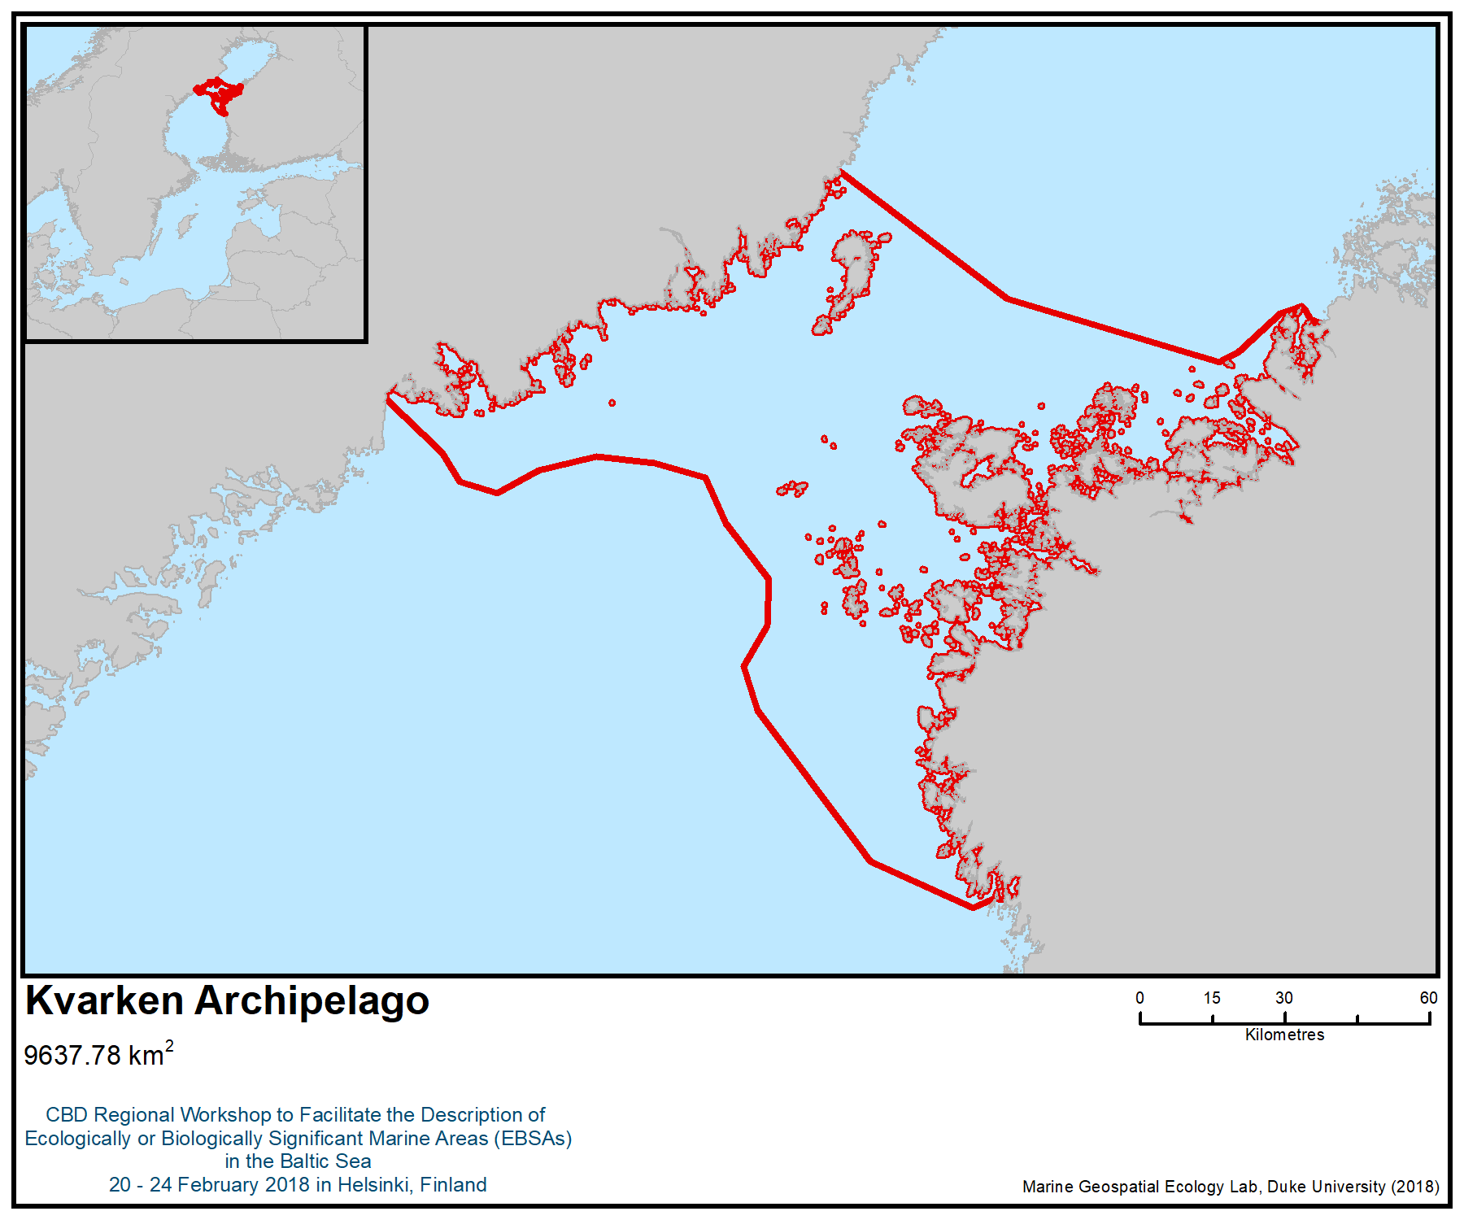
Figure 1. Location of the area

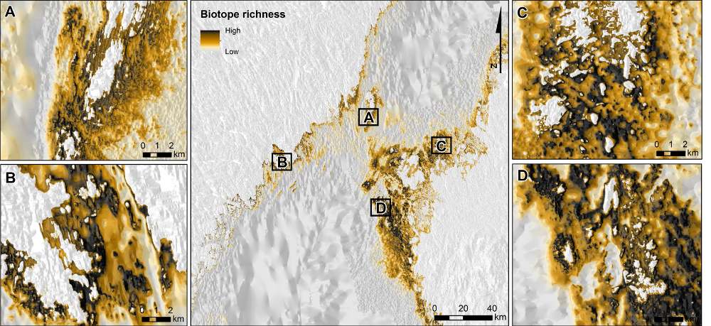

Figure 2 HELCOM HUB-based biodiversity assessment of the Kvarken area, showing areas with more complex/higher biodiversity

Area No. 3: Åland Sea, Åland Islands and the Archipelago Sea of Finland

Abstract
The area contains some of the most geomorphologically, biologically and ecologically variable marine environments in the Baltic Sea, and perhaps in the world. The area stretches from Åland Sea, across the Åland Islands and the Archipelago Sea to Hanko Peninsula in southwestern Finland. It is characterized by an extremely mosaic and extensive archipelago that ranges from shallow and sheltered inner archipelago areas, through middle archipelago, with larger islands, to wave-exposed outer archipelago consisting of thousands of small islands and skerries. The Åland Sea, in contrast, is an open sea area with almost oceanic conditions and has a trench of 300 m—the second-deepest trench in the Baltic Sea.The trench is also the deepest oxygenated area in the Baltic Sea. Due to its low salinity (0 to 7 psu), the species composition in the area is a mixture of fresh water, brackish water and marine organisms, with a high diversity of aquatic vascular plants and charophytes, in particular. The area contains hundreds of lagoons, narrow inlets, shallow bays, estuaries and wetlands, which are important areas for fish and birdlife. The benthic biomass in the shallow areas is the highest in the northern Baltic Sea. The area also supports important populations of the ringed seal (Pusa hispida botnica) and grey seal (Halichoerus grypus). Harbor porpoise (Phocoena phocoena) visit the area regularly.

Introduction to the area
The area contains the most variable marine environments in the Baltic Sea, and perhaps in the world. It is characterized by an extremely mosaic and extensive archipelago, which ranges from sheltered inner archipelago areas with lagoons, shallow bays and boreal inlets, through middle archipelago, with larger islands, to wave-exposed outer archipelago consisting of a myriad of small islands and skerries facing the Northern Baltic proper. The water depth of the archipelagic areas is relatively low in the inner archipelago (mostly 0 to 30 m) and increases in the outer archipelago, where there are several elongated channels that are 80–120 m deep (Figure 2 DEPTH).

The Åland Sea, in contrast, is an open-sea area with almost oceanic conditions and the second-deepest point in the Baltic Sea, 300 m. Notably, this “abyss” is the deepest oxygenated area in the Baltic Sea. All other deep areas south of the Åland Sea are hypoxic or anoxic.

The area is geologically one of the most diverse seafloor environments of the Baltic Sea (Kaskela et al., 2012; Kaskela & Kotilainen, 2017). The Precambrian crystalline bedrock and fault tectonics, together with glacial erosion and deposition as well as post glacial processes, have formed a complex landscape with a mosaic of structures and substrates. Submarine geological features typical to the area include till, various moraines, eskers, Salpausselkä formations, postglacial clays and relict river valley continuations, and the sediments are very varied, containing granite, rocky bottoms, moraine, gravel, sand and mud (Kaskela et al 2012). The Precambrian basement rocks have suffered glacial scouring and over-deepening of pre-existing drainage channels and, at present, the most resistant materials stand out as elevated structures forming, for example, rocky reefs. The elongated deep-sea troughs characteristic of the area partly coincide with fault lines and thrust zones, and serve as important water passages connecting the Baltic proper with the Gulf of Bothnia (Winterhalter et al. 1981; Koistinen et al. 1996).

The surface salinity in the open sea varies from 6 to 7 psu, but may be close to zero in the inner archipelagic estuaries. This enables the existence of both marine and freshwater species.

Location
The area is situated in the northern Baltic Sea and forms the border between the Baltic proper and the Gulf of Bothnia. It extends from the Swedish coast in the west across the Åland Islands to the Finnish Archipelago Sea and Hanko Peninsula in the east. The area is about 375 km in width and 100 km long (in W-E and N-S direction, respectively). The total coverage of the area is 18,524 km².

Feature description of the area
Several important marine habitat types exist in the area. These include, for example, estuaries, coastal lagoons, large shallow inlets and bays, boreal Baltic narrow inlets, underwater sandbanks, reefs, and Baltic esker islands with sublittoral vegetation (EU habitats directive classifications 1130, 1150, 1160, 1650, 110, 1170, 1610, respectively). All of these habitats host specific flora and fauna, which make the area biologically and ecologically very variable. Consequently, there are a large number of marine protected areas (both HELCOM and private) in addition to EU Natura 2000 sites and the large Archipelago Sea National Park (Finland) in the area.

Due to the low salinity (0 to 6 psu, depending on area and proximity of estuaries; cf. VELMU data), the species composition is a mixture of freshwater and marine organisms, and the combined biodiversity of macroalgae and aquatic vascular plants in particular is high (Figures 3 and 4). Charophytes (e.g., Chara horrida, which is endangered in Finland and near threatened in the HELCOM area) form large meadows in sheltered lagoons and bays, and water mosses (Bryophyta), which normally are freshwater species, are found in some inner inlets and bays.

Many marine species, including keystone and habitat-forming species such as bladderwrack (Fucus vesiculosus) and blue mussel (Mytilus trossulus), occur abundantly in the area, especially in the outer and middle archipelago, securing local microhabitats for a myriad of marine species, including algae, invertebrates and fish. The “Boreal Baltic narrow inlets” (habitat 1650, according to the EU Habitats Directive) and “large shallow inlets and bays” (habitat 1160) in the area form some of the most important breeding areas for pikeperch in the northern Baltic Sea (EC 1992).

Also, marine fish species, such as Baltic herring and sprat, are common in the area, and flounder, cod and turbot occur regularly. This the northernmost area in the Baltic Sea where the eelgrass (Zostera marina) forms dense beds (Boström et al. 2014); certain underwater sand banks host the largest eelgrass meadows in Finland. Furthermore, the biomass of soft bottom benthic invertebrates in the Archipelago Sea is, after Kattegatt, the highest in the Baltic Sea (Gogina et al. 2016). This provides an abundant food supply for benthic feeding fish and birdlife.

The area’s coastal lagoons and “Boreal Baltic narrow inlets” are very important feeding and nesting areas for coastal birds. Also the sea area surrounding the fringe of treeless skerries facing the northern Baltic proper includes an almost continuous series of Important Bird and Biodiversity Areas (IBAs). For example, common eider (Somateria mollissima) inhabits the outer archipelago where shallow rocky reefs provide feeding grounds with high densities of blue mussel (Mytilus trossulus). The outer archipelago is also an important breeding and feeding area for colonial alcids, such as razorbill (Alca torda) and black guillemot (Cepphus grylle), which feed on the small fish abundant in the area. In other sea areas they typically breed on cliffs, but in the Archipelago Sea they colonize shallow rocky islets in the extremities of the archipelago. The outer part of the archipelago is also an important wintering area for purple sandpipers (Calidris maritima), at least partially originating from Svalbard (Bioforsk).

The western part of the area supports a population of the ringed seal (Pusa hispida botnica) (Halkka and Tolvanen 2017). Although the ringed seals are only classified as near-threatened in the Baltic Sea (Liukko et al 2015), the population in the Archipelago Sea needs special protection due to its small size (200-300 individuals) (Ministry of Agriculture and Forestry 2007; Ahola & Nordström 2017). The ringed seal is threatened by climate change, because its pups need crested sea ice for hiding places as they grow. Grey seals (Halichoerus grypus) are common in the outer and middle archipelagos and very common on the western side of the area. The high abundance of herring, salmon and cod is an important reason for the very high seal populations in the area, which is the most densely populated seal area in the Baltic Sea (Ministry of Agriculture and Forestry 2007).

The Åland Sea abyss, which is a deep oxygenated area in the Baltic Sea, is a prerequisite for a healthy and species-rich macrofauna community. The abundance of cod and herring is high in the area. There are also indications that cod spawn in the area. However, it is not known if there has been successful spawning in the area or if it is a sink for the Southern Baltic cod (Bergström et al. 2015). The area also provides very important habitats for perch, pikeperch and pike (Bergström et al. 2007; Kraufvelin et al. 2018).

The area also constitutes an important migration route for salmon and trout going up to the rivers in the Bothnian Bay to spawn (Michielsens et al. 2008).

The area is also the northern distribution limit for Harbor porpoise (Phocoena phocoena) in the Baltic Sea (Figure 5) (ASCOBANS 2016, Sambah 2017). The harbour porpoise visits the southern part of the outer archipelago regularly. The harbour porpoise population of the Baltic Sea is critically endangered (HELCOM, 2013).

Table 1. Number of species in different sea areas (HELCOM 2012). The total number of species in the Baltic Sea is 2730, of which 1898 species are invertebrates. Total number of species in the table excludes bird species.
 | Gulf of Finland | Archipelago Sea | Kvarken Archipelago | Bothnian Sea
Macrophytes | 187 | 68 | 162 | 116
Benthic invertebrates | 482 | 122 | 96 | 132
Fish & lamprey | 87 | 68 | 51 | 48
Marine mammals | 3 | 3 | 2 | 2
Total number of species | 759 | 261 | 311 | 298
Share of species in the Baltic Sea | 27.8 % | 9.6 % | 11.4 % | 10.9 %

Feature condition and future outlook of the area
The area, especially its outer archipelago, has a high degree of naturalness, and biodiversity is high for a brackish-water sea area. While there are a lot of smaller buildings and summer cottages in the inner archipelago areas, the outer archipelago is almost completely uninhabited and undeveloped.

Regular monitoring of the ecological state of the sea takes place in the area, implementing the EU directives and Finnish and Swedish national legislations. The Finnish Inventory Programme for Marine Underwater Environment (VELMU) has conducted extensive biodiversity inventories in the area. The inventories conducted from 2004 to 2017 included dive lines and drop videos, benthic sampling, fish larvae sampling, and echosoundings. Observation data for hundreds of species is available, and species distribution models (SDMs) have been made for 100+ species (below referred to as “VELMU data”; viewable in https://paikkatieto.ymparisto.fi/velmu). Habitat modelling activities were also conducted by the Swedish Board of Fisheries in the Archipelago Sea in 2006. The activities were part of the Interreg Baltic Sea Region Programme "Baltic Sea Management – Nature Conservation and Sustainable Development of the Ecosystem through Spatial Planning" (known as BALANCE). Habitat models were developed for four of the most ecologically and economically important fish species in the coastal ecosystem of the Baltic Sea (www.balance-eu.org).

The ecological status of the water in the inner archipelago is presently not good, mainly because of anthropogenic nutrient loading. The water in the inner archipelago is turbid, especially in late summer, and anoxia is common in sheltered sea areas with poor water exchange. The exposed outer archipelago areas facing the northern Baltic Sea are in better condition, albeit blue-green algal blooms may occasionally make the water turbid during late summer. The European Union Marine Strategy Framework Directive (2008/56/EC), and the HELCOM Baltic Sea Action Plan (HELCOM 2007), oblige Sweden and Finland to improve the state of the marine environment by 2020 and 2021, respectively, e.g. by decreasing the amount of nutrient loading from land, so the water quality in area will probably gradually start improving.

Assessment of the area against CBD EBSA Criteria

CBD EBSA Criteria  (Annex I to decision IX/20) | Description  (Annex I to decision IX/20) | Ranking of criterion relevance  (please mark one column with an X)
CBD EBSA Criteria  (Annex I to decision IX/20) | Description  (Annex I to decision IX/20) | No information |  | Low |  |  | Medium |  | High
Uniqueness or rarity | Area contains either (i) unique (“the only one of its kind”), rare (occurs only in few locations) or endemic species, populations or communities, and/or (ii) unique, rare or distinct, habitats or ecosystems; and/or (iii) unique or unusual geomorphological or oceanographic features. |  |  |  |  |  |  |  | X
Explanation for ranking
The area is probably the most complex archipelago area in the world, with tens of thousands of islands and skerries, and a myriad of different types of waters, from enclosed lagoons to large open-sea areas. The area has unique geomorphological and habitat characteristics, with features formed by the last glaciation, such as the largest end moraines (Salpausselkä) in the Baltic Sea (Tolvanen et al. 2004, Kaskela et al. 2012, 2017, Rinne et al. 2014).
Several deep (mostly 70 to 120 m) trenches exist in the area. Due to relatively strong currents they are oxygen-rich (unlike the deep Baltic basins, which are anoxic). The deepest of these is located in the Åland Sea—at 300m, it is the second-deepest in the Baltic Sea. Notably, the trench is the deepest oxygenated area in the Baltic Sea, creating unique conditions for benthic fauna (Snoeijs-Leijonmalm, Schubert & Radziejewska 2017).
The unique combination of various types of habitats, from sheltered lagoons to extremely exposed outer skerries, provides ample opportunities for bird nesting and feeding, and the area displays a unique diversity of coastal and marine birds (Vösa et al. 2017).
A number of rare species can be found in the area, including the charophyte Chara horrida (FIN: EN; HELCOM: NT) (Artportalen database, VELMU data–not visible in VELMU map service), Macroplea pubipennis (FIN: VU; HELCOM: DD), a leaf beetle species of the subfamily Donaciinae that feeds on aquatic plants and is endemic to Finland, has viable populations in the area (VELMU data, not visible in Map Service).
A population of endangered Baltic ringed seal (Pusa hispida botnica) lives in the area (Härkönen et al. 1998); their existence relies on good ice winters (Meier et al. 2004). Harbour porpoises (Phocoena phocoena) visit southern part of the outer archipelago regularly. The harbour porpoise population of the Baltic Sea is critically endangered (HELCOM, 2013).

Special importance for life-history stages of species | Areas that are required for a population to survive and thrive. |  |  |  |  |  |  |  | X
Explanation for ranking
The area is very important for several life history stages of a large number of taxa, including birds (Fig. 6), fish (Snickars et al. 2009, Sundblad et al. 2010, Kraufvelin et al. 2018) and seals (Halkka & Tolvanen 2017).
The rocky islets of the outer archipelago are an important nesting and feeding area for colonial alcids, such as razorbill (Alca torda) and black guillemot (Cepphus grylle), which in other sea areas typically nest on cliffs. The outer part of the archipelago is an important wintering area for purple sandpipers (Calidris maritima), at least partially originating from Svalbard (Bioforsk). The middle and inner archipelagoes, in turn, are important nesting areas for common eider (Somateria mollissima), long-tailed duck (Clangula hyemalis), greylag goose (Anser anser), common tern (Sterna hirundo) and Arctic tern (Sterna paradisea), among others. Major bird migration routes also cross the area (Toivanen et al. 2014), which is therefore important as a resting and feeding area for various migrating birds.
The numerous shallow bays and inlets of the area, which warm up early in spring, are important reproduction areas for many of these species, including pike (Esox lucius), perch (Perca fluviatilis), pikeperch (Sander fluviatilis) and roach (Rutilus rutilus) (Snickars et al. 2009; Kraufvelin et al. 2018).
The sea ice habitat of the area is very important for ringed seal because its pups need ice lairs for shelter during their long lactation period (Meier et al. 2004).

Importance for threatened, endangered or declining species and/or habitats | Area containing habitat for the survival and recovery of endangered, threatened, declining species or area with significant assemblages of such species. |  |  |  |  |  | X
Explanation for ranking

A number of species that are Red Listed for the Baltic Sea region are found in the area (HELCOM 2013): the vulnerable ringed seal, critically endangered Anguilla anguilla, endangered Coregonus lavaretus, and the vulnerable Salmo salar and Salmo trutta.

The area also has a high occurrence of a number of biotopes and habitats that are Red Listed for the Baltic Sea region (HELCOM 2013). This includes estuaries (critically endangered), coastal lagoons (endangered) and sandbanks (vulnerable) and rocky reefs (vulnerable). Zostera marina meadows (near threatened) are at their northerly distribution limit in the area, while charophyte meadows are relatively common throughout the area.

Vulnerability, fragility, sensitivity, or slow recovery | Areas that contain a relatively high proportion of sensitive habitats, biotopes or species that are functionally fragile (highly susceptible to degradation or depletion by human activity or by natural events) or with slow recovery. |  |  |  |  |  | X
Explanation for ranking

The coastal “Boreal Baltic narrow inlets” and semi-enclosed lagoons provide a habitat for a rich bird fauna and nursery areas for fish. Due to limited water exchange, such areas are especially vulnerable to human disturbance, especially nutrient loading, dredging, overfishing and excess boat traffic. This also makes the species in these habitats, such as freshwater fish and certain aquatic vascular plants and charophytes, vulnerable to the environmental change in the area (Eriksson et al. 2004, Pitkänen et al. 2013).

Certain habitat-forming marine species, such as eelgrass (Zostera marina), live on the edge of their geographical range. This makes eelgrass meadows, and the species that live in them, particularly vulnerable to hydrographical and trophic changes caused by eutrophication and climate change (Baden et al. 2003, Boström et al. 2014).

Many of the rare species, for example, ringed seal, waterfowl and charophytes, are slow to recover from disturbance (Meier, Döscher & Halkka 2004, Munsterhjelm 2005, Bäcklin et al. 2011, 2013, Sundqvist et al. 2012, Stjenberg et al. 2016).

Biological productivity | Area containing species, populations or communities with comparatively higher natural biological productivity. |  |  |  |  |  |  |  | X
Explanation for ranking

The entire archipelago has the highest zoobenthos productivity in the entire Baltic Sea inside the Danish and Swedish sounds (Gogina et al. 2016). The lagoons, inlets and bays, in particular, have high macrophyte, invertebrate, waterfowl and fish production.
Biological diversity | Area contains comparatively higher diversity of ecosystems, habitats, communities, or species, or has higher genetic diversity. |  |  |  |  |  | X
Explanation for ranking

The area contains a high diversity of habitats that occur intermixed on a very fine spatial scale. The salinity gradient creates a mix of freshwater and brackish water species, but the species diversity is not particularly high from the Baltic Sea perspective (Table 1; HELCOM 2012). A high number of birds either nest or stop over in the area during migration.

Naturalness | Area with a comparatively higher degree of naturalness as a result of the lack of or low level of human-induced disturbance or degradation. |  |  |  |  |  |  | X
Explanation for ranking

The coast and the inner archipelago are intensively used for housing, agriculture and recreation, while the outer archipelago is, to large extent, unexploited for most part of the year.

References
Ahola, M. & Nordström, M. Arcihipelago Sea. In Antti Halkka and Petteri Tolvanen (eds.) (2017).
The Baltic Ringed Seal – An Arctic Seal in European Waters – WWF Finland report 36.
Artportalen database, species sightings database of The Swedish Species information Centre, https://www.artdatabanken.se/en/species-observations/?menu=open
ASCOBANS 2016. http://www.ascobans.org/es/node/1430. Accessed 7.3.2018.
Bäcklin, B.-M., Moraeus, C., Roos, A., Eklöf, E., Lind, Y. (2011) Health and age and sex distributions of Baltic grey seals (Halichoerus grypus) collected from bycatch and hunt in the Gulf of Bothnia. ICES Journal of Marine Science, 68: 183–188.
Bäcklin, B.-M., Moraeus, C., Kauhala, K., Isomursu. M. (2013) Pregnancy rates of the marine mammals - Particular emphasis on Baltic grey and ringed seals. HELCOM web portal.
Baden, S., Gullström, M., Lundén, B., Pihl, L. & Rosenberg, R. 2003. Vanishing seagrass (Zostera marina, L.) in Swedish coastal waters. Ambio 32: 374–377.
Bergström, U., Sandström, A, Sundblad G. (2007) Fish Habitat Modelling in the Archipelago Sea. BALANCE Interim Report No. 11.
Bioforsk. The Purple Sandpiper in Finnmark. Information sheet for the project «Bird tourism in central and eastern Finnmark», a project part of «The natural heritage as a value creator (M)» http://www.bioforsk.no/ikbViewer/Content/109343/Fjareplytt_Engelsk.pdf. Accessed on 22.1.2018.
Boström, C., Baden, S., Bockelmann, A. C., Dromph, K., Fredriksen, S., Gustafsson, C., ... & Olsen, J. (2014). Distribution, structure and function of Nordic eelgrass (Zostera marina) ecosystems: implications for coastal management and conservation. Aquatic Conservation: Marine and Freshwater Ecosystems, 24(3), 410-434.

EC (1992): Council Directive 92/43/EEC of 21 May 1992 on the conservation of natural habitats and of wild fauna and flora. OJ L 206: 7–50.
Eriksson, Britas Klemens, et al. (2004): "Effects of boating activities on aquatic vegetation in the Stockholm archipelago, Baltic Sea." Estuarine, Coastal and Shelf Science 61.2. 339-349.
Fauna Europaea https://fauna-eu.org/cdm_dataportal/taxon/1cd8581b-67c9-4455-a2f5-6629b84048c8
Finnish Bird Atlas. Suomen III Lintuatlaksen tulokset. Luonnontieteellinen keskusmuseo Luomus, Helsingin yliopisto. Creative Commons 4.0 (Finnish Bird Atlas III results.Natural History Museum Luomus, University of Helsinki. CC4.0.)
Gogina, M., Nygård, H., Blomqvist, M., Daunys, D., Josefson, A. B., Kotta, J., ... & Zettler, M. L. (2016). The Baltic Sea scale inventory of benthic faunal communities. ICES Journal of Marine Science, 73(4), 1196-1213. https://academic.oup.com/icesjms/article/73/4/1196/2458890
Halkka, A., Tolvanen, P. (eds.) (2017). The Baltic Ringed Seal – An Arctic Seal in European Waters – WWF Finland report 36. https://wwf.fi/mediabank/9825.pdf
Härkönen, T., Stenman, O., Jüssi, M., Jüssi, I., Sagitov, R., & Verevkin, M. (1998). Population size and distribution of the Baltic ringed seal (Phoca hispida botnica). NAMMCO Sci Publ, 1, 167-80.
HELCOM (2012). Checklist of Baltic Sea Macro-species. Baltic Sea Environment Proceedings No. 130
HELCOM (2013). HELCOM Red List of Baltic Sea species in danger of becoming extinct. Baltic Sea Environment Proceedings 140: 1-106.
HELCOM Depth. http://metadata.helcom.fi/geonetwork/srv/eng/catalog.search#/metadata/5dcf182a-517a-4599-be0d-626bea8e058d.
Kaskela, A.M., Kotilainen, A.T., Al-Hamdani, Z., Leth, J. & Reker, J. (2012). Seabed geomorphic features in a glaciated shelf of the Baltic Sea. Estuarine Coastal and Shelf Science 100, 150–161. ISSN 0272-7714, http://dx.doi.org/10.1016/j.ecss.2012.01.008
Kaskela, A.M. & Kotilainen, A.T. (2017). Seabed geodiversity in a glaciated shelf area, the Baltic Sea. Geomorphology 295, 419-435. ISSN 0169-555X, http://dx.doi.org/10.1016/j.geomorph.2017.07.014
Koistinen, T., Klein, V., Koppelmaa, H., Korsman, K., Lahtinen, R., Nironen, M., Puura, V., Saltykova, T., Tikhomirov, S. & Yanovskiy, A. (1996). Paleoproterozoic Svecofennian orogenic belt in the surroundings of the Gulf of Finland. In: Koistinen, T. (ed) Explanation to the Map of Precambrian Basement of the Gulf of Finland and Surrounding Area 1: 1 000 000. Geological Survey of Finland Special Paper 21, 21–57.
Kraufvelin, P., Pekcan-Hekim, Z., Bergström, U., et al. (2018). Essential coastal habitats for fish in the Baltic Sea. Estuarine, Coastal and Shelf Science 204: 14-30.
Liukko, U-M., Henttonen, H., Hanski, I. K., Kauhala, K., Kojola, I., Kyheröinen, E-M. & Pitkänen, J. (2016). Suomen nisäkkäiden uhanalaisuus 2015 – The 2015 Red List of Finnish Mammal Species. Ympäristöministeriö & Suomen ympäristökeskus. 34 p
Meier, H. E. M., Döscher, R., & Halkka, A. (2004). Simulated distributions of Baltic Sea-ice in warming climate and consequences for the winter habitat of the Baltic ringed seal. AMBIO: A Journal of the Human Environment, 33(4), 249-256.
Michielsens, C.G., McAllister, M.K., Kuikka, S., et al. (2008). Combining multiple Bayesian data analyses in a sequential framework for quantitative fisheries stock assessment. Canadian Journal of Fisheries and Aquatic Sciences, 65(5): 962-974.
Ministry of Agriculture and Forestry (2007). Itämeren hyljekantojen hoitosuunnitelma. Ministry of Agriculture and Forestry 4b/2007. ISBN 978-952-453-329-4. 93p. http://mmm.fi/documents/1410837/1721042/4b_Hylkeen_enkku_nettiin.pdf/aeb2abf7-d6f0-422e-8a6a-94ba8403df31
Munsterhjelm, Riggert. 2005. "Natural succession and human-induced changes in the soft-bottom macrovegetation of shallow brackish bays on the southern coast of Finland."
Pitkänen, H., Peuraniemi, M., Westerbom, M., Kilpi, M., & Numers, M. V. (2013). Long-term changes in distribution and frequency of aquatic vascular plants and charophytes in an estuary in the Baltic Sea. In Annales Botanici Fennici (Vol. 50, No. SA, pp. 1-54). Finnish Zoological and Botanical Publishing Board.
Rinne, H., Kaskela, A., Downie, A. L., Tolvanen, H., von Numers, M., & Mattila, J. (2014). Predicting the occurrence of rocky reefs in a heterogeneous archipelago area with limited data. Estuarine, Coastal and Shelf Science, 138, 90-100.
Saari, S. (2007). Meriuposkuoriaisen, Macroplea pubipennis (Coleoptera: Chrysomelidae), levinneisyys ja elinympäristövaatimukset Espoonlahdessa. M.Sc thesis (in Finnish). University of Helsinki. https://helda.helsinki.fi/handle/10138/18928
Sambah. 2017. Sambah Final report. Figure 1a. http://www.sambah.org/SAMBAH-Final-Report-FINAL-for-website-April-2017.pdf Accessed 7.3.2018
Snickars, M., Sandström, A., Lappalainen, A., Mattila, J., Rosqvist, K. & Urho, L. (2009). Fish assemblages in coastal lagoons in land-uplift succession: the relative importance of local and regional environmental gradients. Estuarine, Coastal and Shelf Science, 81, 247–256.
Snoeijs-Leijonmalm, P., Schubert, H., & Radziejewska, T. (Eds.). (2017). Biological oceanography of the Baltic Sea. Springer Science & Business Media.
Stjernberg, T., Nuuja, I., Laaksonen, T., Koivusaari, J., Ollilal T., Keränen, S., Ekblom, H. lokki, H. & Saurola, P. 2016: Suomen merikotkat 2013-2015. - Linnut vuosikirja 2015: 20-29.
Sundblad, G., U. Bergström, and A. Sandström (2010). Ecological Coherence of Marine Protected Area Networks: A Spatial Assessment Using Species Distribution Models. Journal of Applied Ecology 48: 112–20.
Sundqvist, L., Harkonen, T. Svensson, C.J., Harding, K.C. (2012) Linking climate trends to population dynamics in the Baltic ringed seal - Impacts of historical and future winter temperatures. Ambio. DOI 10.1007/s13280-012-0334-x
Toivanen, T., Mehtonen, T., Lehtiniemi, T. (2014). Lintujen päämuuttoreitit Suomessa (Main migration routes of birds in Finland; in Finnish). Birdlife 2014. 21 pp. http://www.ymparisto.fi/download/noname/%7BFA98FD1F-987F-4546-84F7-93BDC1F0CE06%7D/100332
Tolvanen, H., Numminen, S., & Kalliola, R. (2004). Spatial distribution and dynamics of special shore-forms (tombolos, flads and glo-lakes) in an uplifting archipelago of the Baltic Sea. Journal of Coastal Research, 234-243.
Vahteri, P., & Vuorinen, I. (2016). Continued decline of the bladderwrack, Fucus vesiculosus, in the Archipelago Sea, northern Baltic proper. Boreal Environment Research, 21(5-6), 373-386.
VELMU data: VELMU Map Service: https://paikkatieto.ymparisto.fi/velmu
VELMU. Data collected from VELMU database managed by Finnish Environment Institute (Markku Viitasalo, Juho Lappalainen. Email: name.surname@environment.fi) Map service available online (https://paikkatieto.ymparisto.fi/velmu).
Vösa, R., Högmander, J. Nordström, M. Kosonen, E. Laine, J. Rönkä, M. & Von Numers, M. 2017: Saaristolinnuston historia, kannankehitys ja nykytila Turun saaristossa. - Metsähallituksen luonnonsuojelujulkaisuja. Sarja A 226, 311 s.
Winterhalter, B., Flodén, T., Ignatius, H., Axberg, S. & Niemistö, L. (1981). Geology of the Baltic Sea. In: Voipio, A. (ed) The Baltic Sea. 30. Elsevier Oceanography Series.

Maps and Figures

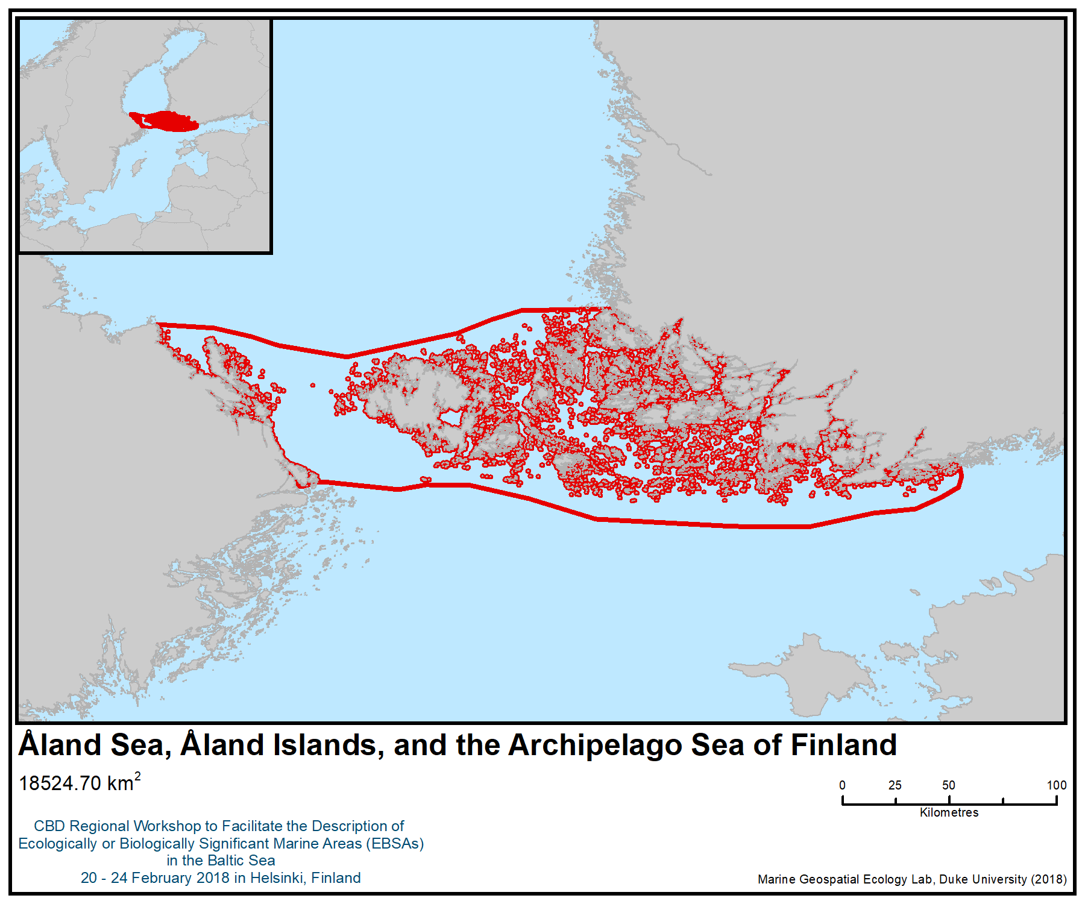
Figure 1. Location of the area

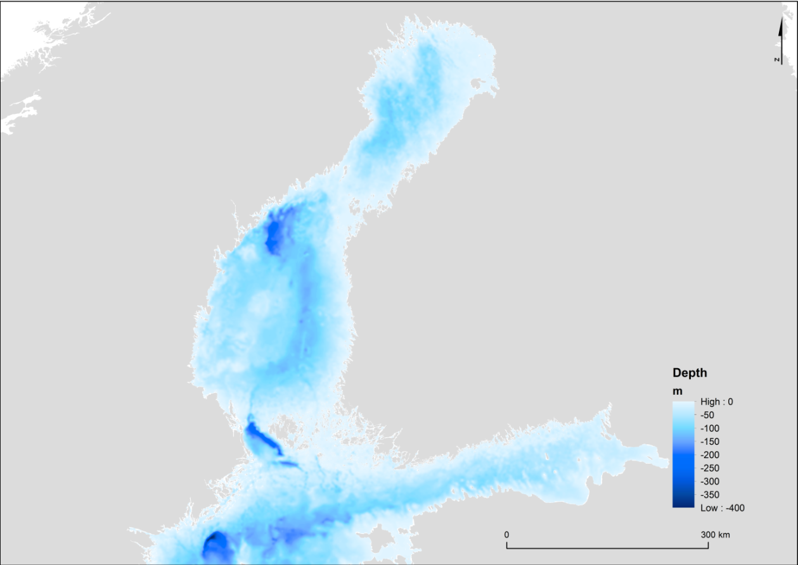
Figure 2. Depth relief map (Source: HELCOM metadata catalogue, http://metadata.helcom.fi/geonetwork/srv/eng/catalog.search#/metadata/5dcf182a-517a-4599-be0d-626bea8e058d)
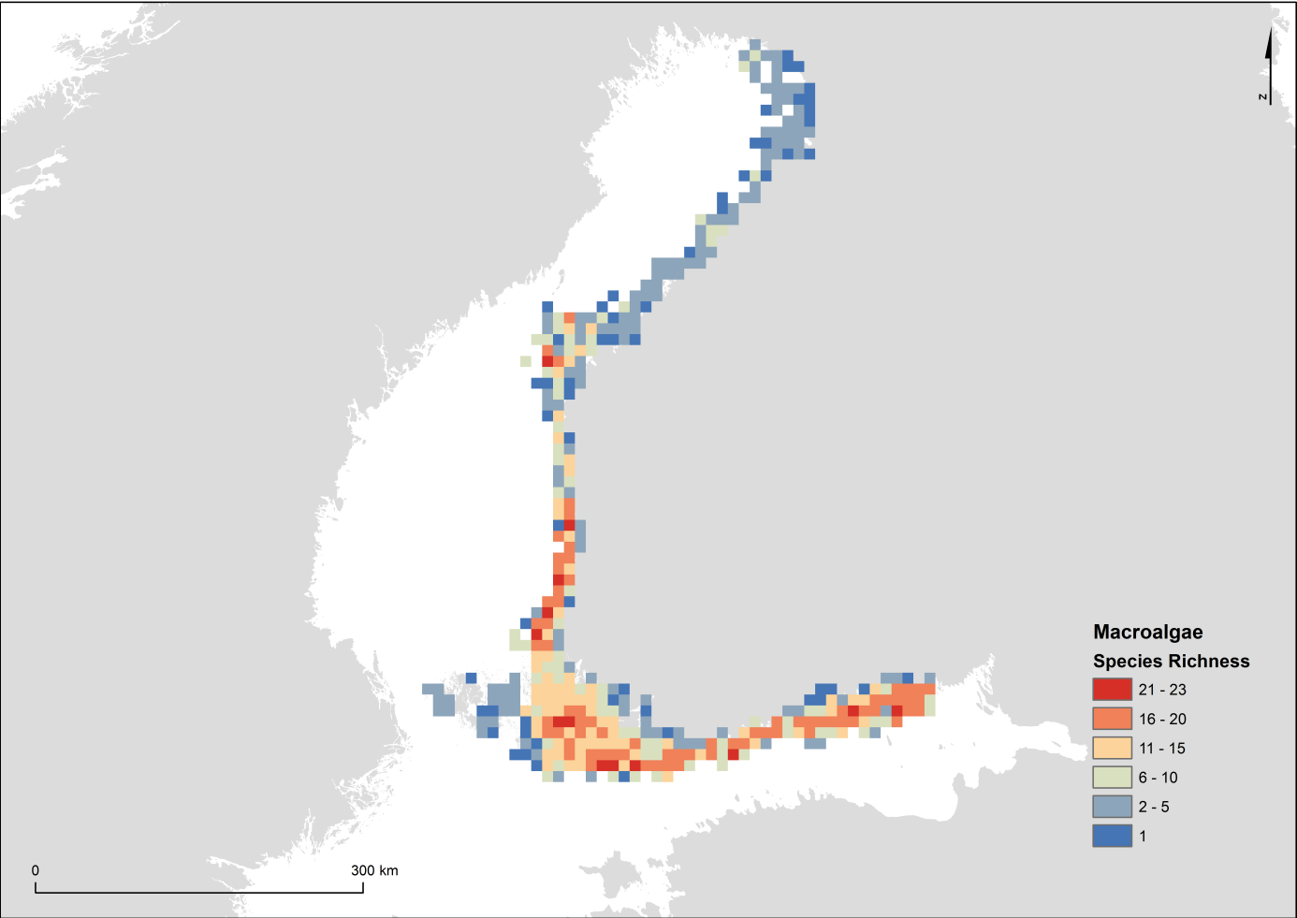
Figure 3. The species richness of macroalgae. Data from Åland area are extremely limited and should not be considered representative. Based on VELMU inventories 2004-2016. VELMU / Finnish Environment Institute.

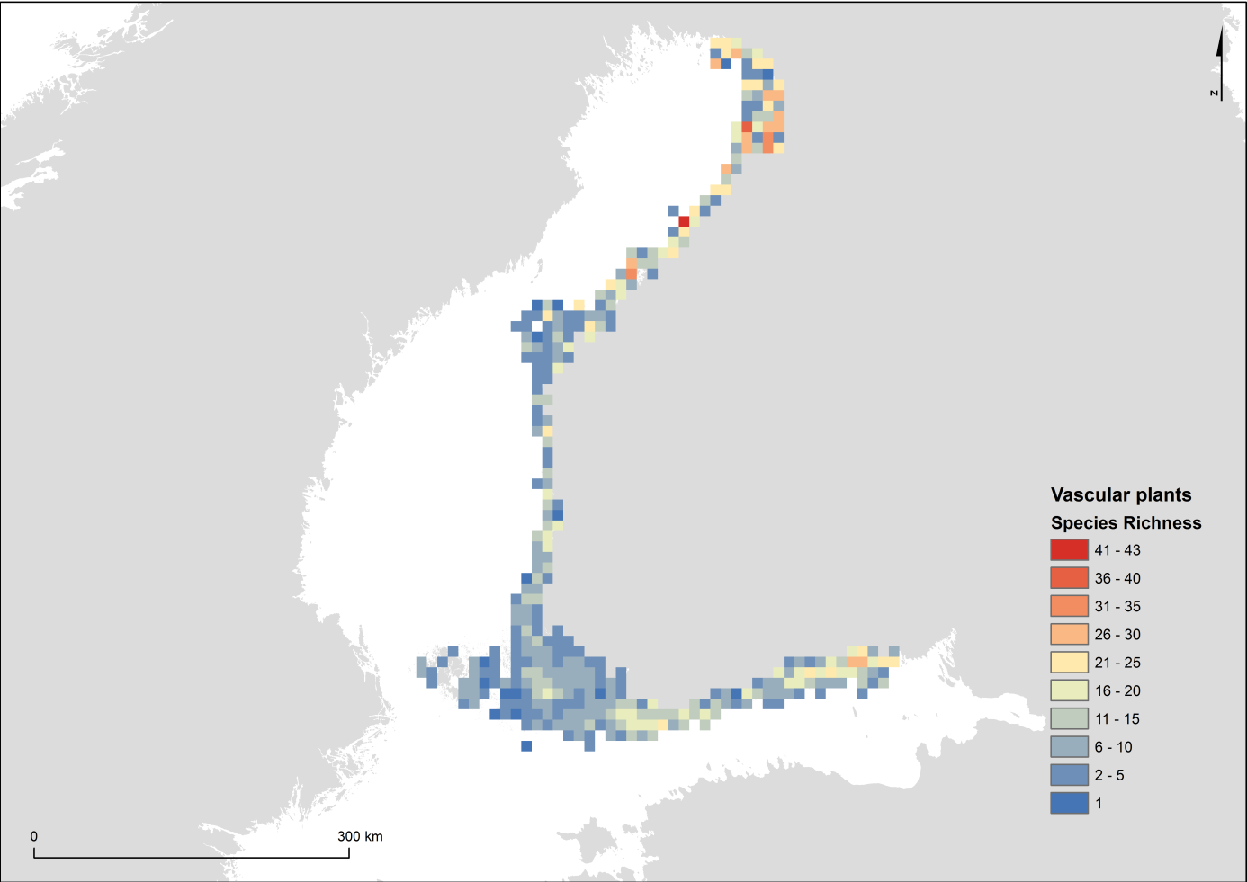
Figure 4. The species richness of aquatic vascular plants. Data from Åland area are extremely limited and should not be considered representative. Based on VELMU inventories 2004-2016. VELMU / Finnish Environment Institute.

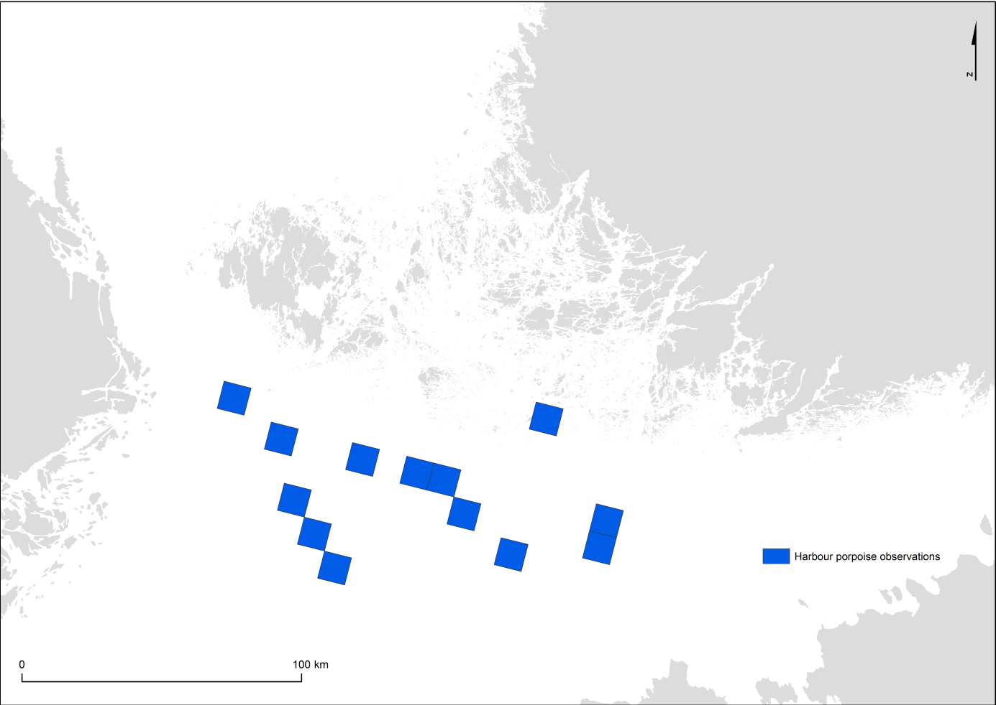
Figure 5. Acoustic observations of harbour porpoise (Phocoena phocoena) 2011-2017
Source: Loisa, O. (ed.) & Working Group for Harbour Porpoise. 2016. Harbour porpoise in Finland - An updated proposal for actions to protect harbour porpoise in Finland. Ministry of the Environment. 56 p.

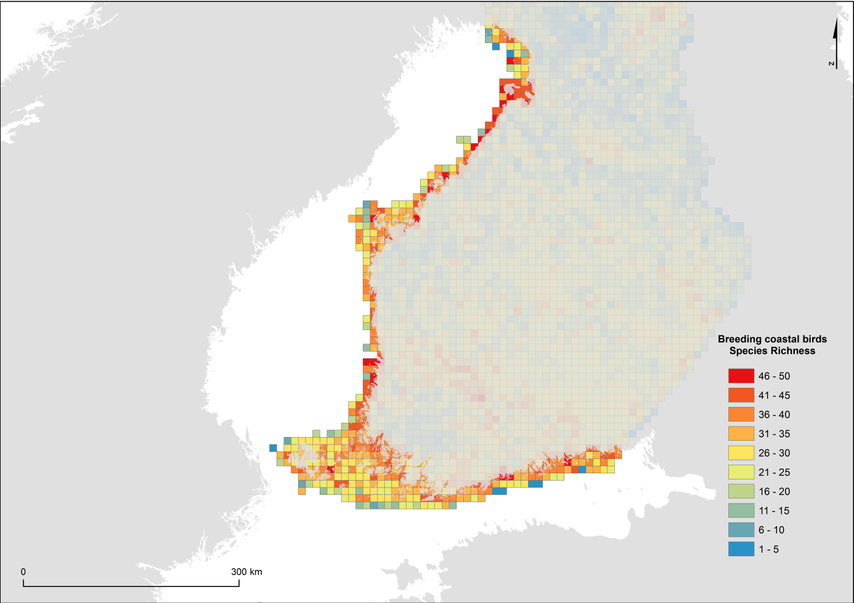
Figure 6. Breeding coastal birds. Finnish Bird Atlas. Data visualized by Metsähallitus Parks and Wildlife Finland & Finnish Environment Institute.
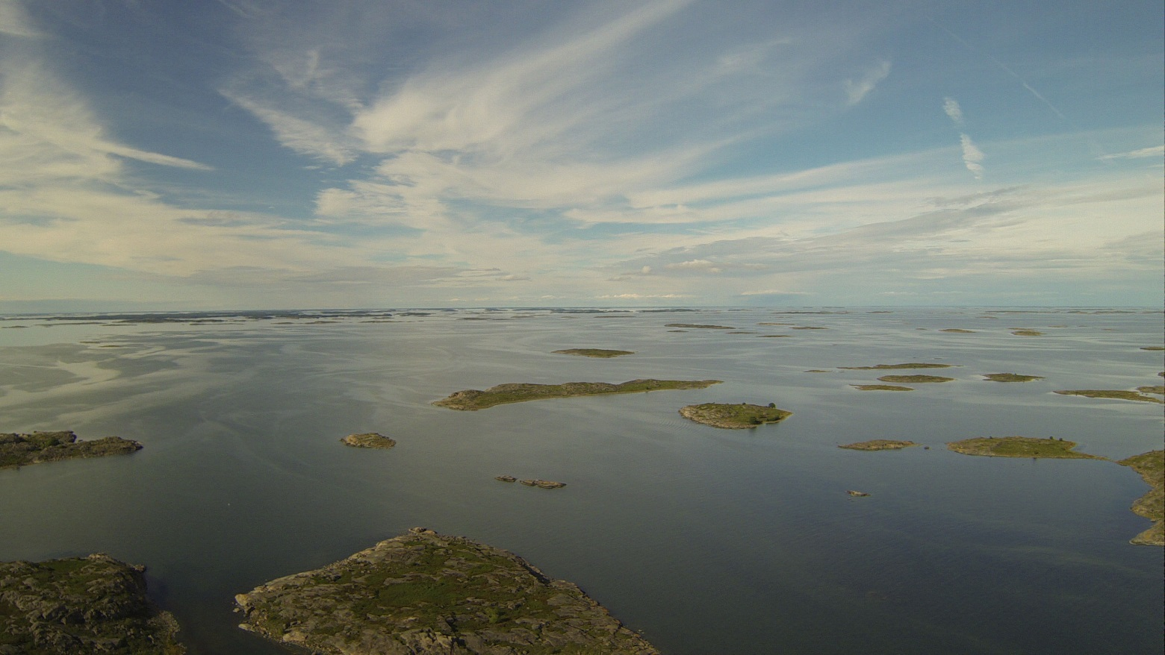
Figure 7. Outer archipelago of the Archipelago Sea. Photo: Kevin O'Brien / Metsähallitus Parks & Wildlife.

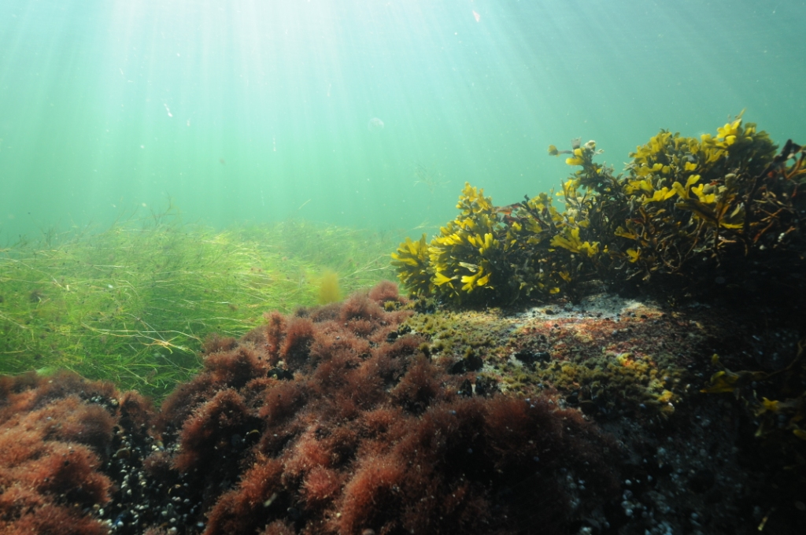
Figure 8. Diverse underwater landscape consisting of macroalgae and vascular plants. Photo: Mats Westerbom / Metsähallitus Parks & Wildlife.
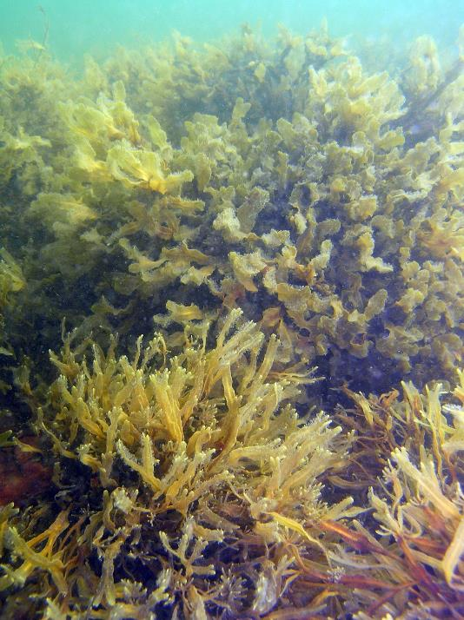
Figure 9. Fucus radicans and F. vesiculosus in Gräsö. Photo: Ulf Bergström.

Area No. 4: Eastern Gulf of Finland

Abstract
The area is a relatively shallow (maximum depth 80 m) archipelago and area of open sea in the eastern Gulf of Finland, northeastern Baltic Sea. It is characterized by hundreds of small islands and skerries, coastal lagoons and boreal narrow inlets, as well as a large area of open sea. The area’s geomorphology shows clear signs from the last glaciation, such as end moraines, sandy beaches, rocky islands and clusters of erratic blocks. Due to the low salinity (0 to 5 permilles in the sea surface layer), the species composition is a mixture of freshwater and marine organisms, and the diversity of aquatic plants in particular is high. Many marine species, including habitat-forming key species, such as bladderwrack (Fucus vesiculosus) and blue mussel (Mytilus trossulus), occur here at the limits of their geographical distribution. As a result, they are particularly vulnerable to human disturbance and the effects of climate change. The area has a rich birdlife and supports one of the most endangered populations of the ringed seal (Pusa hispida botnica) in the Baltic Sea.

Introduction to the area
The area is situated in the north-eastern and eastern part of the Gulf of Finland, in the Baltic Sea, which is the largest brackish-water area in the world. The area includes several types of sea areas: (1) a morphologically very complex archipelago with a specific geology, with clear signs from the last glaciation (ca. 18.000 – 9.000 BP); (2) a relatively open shallow coast with various sediment types, including large sandy shores; and (3) open-sea areas characterized by offshore conditions with few rocky islands and relatively deep bottoms (Kaskela et al. 2012, Kaskela & Kotilainen 2017). Water depth is relatively low in the coastal areas (mostly 0 to 30 m), while the maximum depth of the open sea area is 80 metres (Fig. 2).

The high geodiversity of the eastern Gulf of Finland arises from its Precambrian crystalline basement, and the variable bottom types, including rapakivi granite, large boulders, moraine, gravel, sand and mud (Kaskela et al., 2012; Kaskela and Kotilainen, 2017, Kaskela et al., 2017). Till deposits, moraines, eskers and underwater sandbanks are typical seabed features of the area (Häkkinen and Åker 1991). The offshore seabed sediments in the middle part of the area are mud, hard clay and hard bottom complex.

Many of the islands, especially in the western parts of the area, have shores consisting of rocks, boulders, stones or shingle. The shores eastward from Vyborg Bay are characterized by sandy shores with high dunes followed inshore by marine terraces, and the southern coasts of the area are formed by moraines and Paleozoic clays intermixed with Pleistocene deposits (Amantov et al. 2012).

The area also features certain spectacular islands, such as Pitkäviiri (http://www.nationalparks.fi/gulfoffinlandnp/nature), a 2 km-long esker island, and Gogland, an 11 km-long island in the open sea, which is the highest island of the Baltic Sea, peaking at176 m above sea level (Sokolova & Trifonov 2016).

The water quality and salinity of the eastern part of the area are significantly influenced by the River Neva, the largest river in the Baltic Sea (Golubkov 2009).

All coastal areas freeze over every winter for at least a few weeks, and even the open-sea areas tend to freeze over during most winters.

Regular monitoring of the ecological state of the sea takes place in the Finnish Sea area, implementing EU directives and Finnish legislation. The Finnish Inventory Programme for Marine Underwater Environment (VELMU) has conducted extensive biodiversity inventories in the area. The inventories conducted from 2004 to 2017 have included dive lines and drop videos, benthic sampling, fish larvae sampling and echo soundings. Observation data for hundreds of species is available, and species distribution models (SDMs) have been made for more than 100 species (below referred to as “VELMU data”; viewable at https://paikkatieto.ymparisto.fi/velmu).

To the west, the physical and chemical parameters of the water, as well as benthic and planktonic communities, have been monitored both in offshore and coastal areas by several institutes, including the Zoological Institute of the Russian Academy of Sciences and Russian State Hydrometeorological University. Distribution of Red List species, particularly waterbirds, seals, and aquatic plants and algae, are available for existing nature reserves. The data has been collected and compiled by several institutes, such as Komarov Botanical Institute, St. Petersburg State University, Zoological Institute, St. Petersburg Research Centre of the Russian Academy of Sciences and the Baltic Fund for Nature.

A Finnish-Russian project, Transboundary Tools for Spatial Planning and Conservation of the Gulf of Finland (TOPCONS), which ran from 2012 to 2014, has collected data on species and habitats in the northern part of the area (http://www.merikotka.fi/topcons/index.php/en/overview.html). Also, the recent Gulf of Finland Assessment was prepared through a Finnish-Russian collaboration (Raateoja and Setälä 2016).

The area also has socio-ecological significance. Since pre-historic times it has been home to coastal Finns, Karelians, Votians, Izora and other minority and indigenous peoples and local communities. For example, in the Virolahti archipelago, in the northern part of the area, local fishers have practised self-governance of the seasonal harvest of sprat and Baltic herring by distributing the harvest locations and boat harbours using indigenous local knowledge (ILK) (Raussi 1966). Suursaari Island has been home to traditional seal hunters, whose legacy has been carried out by the present-day seal hunters based in Kotka. Their harvests and knowledge focus on the grey seal, and they wish to protect and keep the ringed seal as a non-harvest species, due to its low numbers, and maintain self-management and regulation of hunting (Mustonen and Mäkinen 2004).

Location
The area is situated in the north-eastern and eastern Gulf of Finland, in the northern Baltic Sea. It extends 247km east-west and 122km north-south. The total coverage of the area is 13,411 km².

Feature description of the area
The area features various types of marine habitats that harbour a rich variety of marine algae and freshwater vascular plants, and are important for fish, invertebrates and birds. These include estuaries, coastal lagoons, large shallow inlets and bays, boreal Baltic narrow inlets, underwater sandbanks, reefs, and Baltic esker islands with sublittoral vegetation (EU Habitats Directive classes 1130, 1150, 1160, 1650, 1110, 1170, 1610). Many of the habitats have been declared marine protected areas due to their high value to the flora and fauna of the area (cf. VELMU data; Pogrepov and Sagitov 2012).

The surface salinity in the open sea varies from 4 to 5 psu, but may be close to zero in the estuaries. In the deep water, the salinity ranges from ca. 4 to 8.5 psu (VELMU data). Due to the low salinity, the species composition is a mixture of freshwater and marine organisms, and the number of species is therefore high (Table 1).

Table 1. Number of species in different sea areas listed by HELCOM (2012). The total number of species in the Baltic Sea is 2730, 1898 of which are invertebrates. Total number of species in the table excludes bird species.
 | Gulf of Finland | Archipelago Sea | Kvarken Archipelago | Bothnian Sea
Macrophytes | 187 | 68 | 162 | 116
Benthic invertebrates | 482 | 122 | 96 | 132
Fish & lamprey | 87 | 68 | 51 | 48
Marine mammals | 3 | 3 | 2 | 2
Total number of species | 759 | 261 | 311 | 298
Share of species in the Baltic Sea | 27.8 % | 9.6 % | 11.4 % | 10.9 %

Many marine species, including keystone and habitat-forming species like bladderwrack (Fucus vesiculosus) and blue mussel (Mytilus trossulus), live on the edge of their geographical distribution range in the area (VELMU data). This makes them vulnerable to human disturbance and the effects of climate change.

The freshwater regions are characterized by, for example, the green algae Cladophora glomerata and Ulva intestinalis, while the more saline areas are characterized by red and brown algae, such as Ceramium sp., Pylaiella littoralis (Nikulina and Gubelit 2011), and Fucus vesiculosus and F. radicans. To the west, charophytes (many classified as VU or NT in HELCOM 2013) form large meadows in sheltered lagoons and bays. Several rare charophytes, such as Nitellopsis obtusa (NT), Nitella hyalina (VU) and Chara braunii (VU), have been found in the Finnish underwater inventories (VELMU data). Water mosses (Bryophyta), which normally are freshwater species, are also found in these sheltered sites (VELMU data; for threat status according to the Helsinki Commission, see HELCOM 2013).

The shallow-water invertebrate communities feature species tolerating strong salinity variation. There are 10 amphipod species in the eastern area, four of which are invasive, originating from Lake Baikal (Gmelinoides facsiatus) and the Ponto-Caspian region (Berezina and Maximov 2016).

Deep-water benthos communities are influenced by recurrent influxes of saline water masses from the west, and of the freshwater outflow from the River Neva. The invertebrate fauna of the Russian part of the area consists of ca.130 taxa (Baluskhina and Golubkov 2015). Macoma balthica and Marenzelleria spp. are the speies usually dominating the biomass of benthos (Maximov 2011).

Macroplea pubipennis (FIN: VU; HELCOM: DD), a leaf beetle species of the subfamily Donaciinae that feeds on aquatic plants and is endemic to Finland, has recently been found to have viable populations in the area. Globally, the species is only found in Finland, Sweden and China (Saari 2007; Fauna Europaea).

Threatened salmonid species, such as salmon (Salmo salar; VU), sea-spawning whitefish (Coregonus lavaretus f. pallasi) (FIN: VU) and anadromous whitefish (Coregonus lavaretus f. lavaretus) (FIN: EN), eel (Anguilla anguilla; (CR), sea trout (Salmo trutta) (FIN: CR; HELCOM: VU), and a near threatened river lamprey (Lampetra fluviatilis) (NT) are occasionally found in the area (e.g., Lappalainen et al. 2000; Urho and Lehtonen 2016).

There are several important bird areas in the area, both in the coastal and open-sea areas. Baltic lesser black-backed gull (Larus fuscus fuscus), a subspecies of lesser black-backed gull that is considered vulnerable in Finland, has a strong population in the area. Common tern (Sterna hirundo) and the Arctic tern (Sterna paradisaea) breed abundantly on the skerries. Threatened bird species, such as velvet scoter (Melanitta fusca, FIN: EN; HELCOM: VU), common eider (Somateria mollissima; VU), common redshank (Tringa tetanus; FIN: VU; HELCOM: NT), ruddy turnstone (Arenaria interpres; FI EN; HELCOM: VU), and also common murre (Uria aalge) breed in the area. The Russian Kurgalskiy Peninsula, on the southernmost part of the area, features 250 bird species, 180 of which nest on site. One of the key species in Kurgalskiy is dunlin (Calidris alpine), an endangered species. Several areas, such as the Gulf of Vyborg, Beryozovie islands and Kurgalskiy peninsula, are important sites for birds of prey, such as white-tailed eagle (Haliaeetus albicilla) and osprey (Pandion haliaetus). The endangered Steller's eider (Polysticta stelleri) rests in the Seskar Island (Valkama et al. 2011; Buzun 2015).

The area is an important stopover and nesting area for migratory birds (Valkama et al. 2011; Hokkanen, 2012; Buzun 2015). During the spring migration the area attracts several million long-tailed ducks (Clangula hyemalis) and common scoters (Melanitta nigra), and thousands of greater scaups (Aythya marila) and velvet scoters (Melanitta fusca) (Buzun 2015). Some 180.000 brent geese (Branta bernicla) and 70,000 barnacle geese (Branta leucopsis) make a migratory stop in the Gulf of Vyborg. The spring numbers of migrating Bewick’s swans (Cygnus bewickii) and whooper swans (Cygnus cygnus) have occurred at several sites across the eastern Gulf of Finland, in numbers approximating 7000 and 3000 individuals, respectively (Buzun 2015).

Grey seals (Halichoerus grypus) are common in the area, both on the Finnish outer archipelagos, and on the Russian sea area, e.g. Hallikarti and Ityakivi near Kopytin, Beryozovie islands, Malyi Tuters and Kurgalskiy Peninsula. The total count of grey seals at Kurgalskiy Peninsula and other Russian sites is estimated to be ca. 400 individuals. On the Finnish side of the area grey seals have numbered between 500 and 700 individuals during the aerial counts in May and June.

The area supports a threatened subpopulation of the ringed seal (Pusa hispida botnica; HELCOM category VU, Finnish category NT) (Halkka and Tolvanen 2017). The total size of the Baltic ringed seal population in the whole Gulf of Finland is a few hundred individuals, most of which inhabit the western end, with main breeding grounds located at the Beryozovie islands (Verevkin and Sagitov 2004; Pogrepov and Sagitov 2012; Jussi et al. 2016; Halkka and Tolvanen 2017). Although the ringed seal is only classified as vulnerable in the Baltic Sea (Liukko et al. 2015), the population in the eastern Gulf of Finland needs special protection due to its small size.

Feature condition and future outlook of the area
The outer archipelago area is in a more natural state than many other Baltic Sea areas. While there are many smaller buildings and summer cottages in the inner archipelago, the outer archipelago is almost completely uninhabited, with few buildings.

The ecological status of the water is, however, presently not good, mainly because of anthropogenic nutrient loading. This makes the water in the inner archipelago turbid, especially in late summer (e.g., Kauppila et al. 2016). During the past five years the state of the area has slightly improved, apparently because the nutrient loading from the River Neva has decreased due to the improved wastewater treatment in the St. Petersburg area.

The EU Marine Strategy Framework Directive (2008/56/EC) http://eur-lex.europa.eu/legal-content/EN/TXT/?uri=CELEX:32008L0056, and the HELCOM Baltic Sea Action Plan (HELCOM 2007), oblige Finland and the Russian Federation to improve the state of the marine environment by 2020 and 2021, respectively, so the water quality in the Gulf of Finland will probably gradually start improving.

There have been changes in the benthic communities in the recent past. The changes have been attributed to long-term changes in environmental conditions, coastal infrastructure development of the Port of St. Petersburg, and introductions of invasive alien species (e.g., Orlova et al. 2006). Until the year 2008, soft bottom benthic communities were dominated by Arctic estuarine arthropods, Monoporeia affinis, Corophium volutator and Saduria entomon (Maximov 2000; Berezina and Maximov 2016). As of 2009, the invasive alien spionid polychaete Marenzelleria arctica became the dominant species in most soft sediments of the area (Golubkov 2009; Maximov 2011). Also, the invasive alien zebra mussel (Dreissena polymorpha) has, in recent decades, dispersed to the area, occurring on the hard bottoms of the area.

Climate change has been predicted to decrease the salinity of the Baltic Sea (Meier et al. 2012). The marine algal species, e.g., bladder wrack and some red algal species, may diminish or disappear if salinity is reduced. In contrast, the freshwater tolerant species, including invasive alien species, might increase in abundance.

Climate change is a major threat to the ringed seal. The reduced ice and snow cover decreases its breeding success because the pups need sea ice lairs for shelter during the long lactation period (Jussi et al. 2016). Organic environmental contaminants pose a major threat to seals, although no clear connection between contaminant levels and pathological changes in the seals has been observed. Bycatch may be a threat to the ringed seal populations, but no reliable data exists yet. In some areas use of the marine environment, such as dredging and coastal construction, can indirectly affect seal populations, e.g. through changes in fish stocks.

Small-scale fishing and seal hunting communities, such as coastal Finns, Karelians, Votians and Izora people, and their descendants, live in the area. Many of the communities are suffering from the deterioration of the environment and expanding industrial development. Their existence increases the socio-ecological uniqueness of the area, and means for maintaining the living conditions of such communities should be sought. Studies on their small-scale fishing and hunting practices and other indigenous and local knowledge would yield new information on historic and present distribution of seals, fish and birds, and would contribute to preserving such traditional socio-ecological communities.

Assessment of the area against CBD EBSA Criteria

CBD EBSA Criteria  (Annex I to decision IX/20) | Description  (Annex I to decision IX/20) | Ranking of criterion relevance  (please mark one column with an X)
CBD EBSA Criteria  (Annex I to decision IX/20) | Description  (Annex I to decision IX/20) | No information |  | Low |  |  | Medium |  | High
Uniqueness or rarity | Area contains either (i) unique (“the only one of its kind”), rare (occurs only in few locations) or endemic species, populations or communities, and/or (ii) unique, rare or distinct, habitats or ecosystems; and/or (iii) unique or unusual geomorphological or oceanographic features. |  |  |  |  |  | X
Explanation for the ranking

This is the easternmost sea area in the Baltic Sea. The area displays unique geomorphological and habitat characteristics with a high number of valuable and vulnerable habitats and species. The area is a seabird biodiversity hotspot (Fig. 3) and serves as a migration and/or nesting site for several threatened or endangered bird species. Other features include:
- one of the few areas in Europe that typically freezes over every winter, which creates unique conditions and influences the seasonal succession and dynamics of most species in the area.
- Due to the low salinity (below 5 permilles at the surface), the area harbours a unique combination of marine, brackish-water and freshwater organisms.
- The area also has socio-ecological significance. Since pre-historic times, coastal Finns, Karelians, Votians, Izora (Paulaharju 2010) and other minority and indigenous or local societies have inhabited the area (see for example Raussi 1966). In particular, Virolahti (Raussi 1966) and Izora (Konkova 2009) fisheries and Suursaari seal hunt (Pälsi 1924, Mustonen & Mäkinen 2004) are unique examples of past and present endemic regimes of marine stewardship and self-governance of marine resources using indigenous and local knowledge.
Special importance for life-history stages of species | Areas that are required for a population to survive and thrive. |  |  |  |  |  |  |  | X
Explanation for the ranking

The area contains several habitats that are important for various life-history stages of fish, invertebrates and birds. In particular, coastal lagoons, large shallow inlets and bays and Boreal Baltic narrow inlets (EU Habitat directive Annex I habitats 1150, 1160 and 1650, respectively), as well as outer skerries and sea ice are important for various species:

- Several migration routes cross the area, and the birds rest and feed in the area (Toivanen et al. 2014).
- Certain vulnerable bird species, such as velvet scoter (Melanitta fusca; FIN: EN; HELCOM: VU), breed on the rapakivi granite islets typical of the outer archipelago of the area (Hokkanen 2012).
- The area harbours numerous habitats, such as coastal lagoons, large shallow inlets and bays, and Boreal Baltic narrow inlets, reefs, underwater sandbanks and Baltic esker islands (EU Habitat directive Annex I habitats 1150, 1160, 1650, 1170, 1110, 1610) that are important breeding and living habitats for many ecologically and biologically important fish species, including pike (Esox lucius), perch (Perca fluviatilis), pikeperch (Sander lucioperca), roach (Rutilus rutilus), smelt (Osmerus eperlanus), gobies (Potamoschistus spp.) and three-spined stickleback (Gasterosteus aculeatus).
- The sea ice has special importance for the Baltic ringed seal (Pusa hispida botnica); its breeding success relies on good ice coverage (Halkka and Tolvanen 2017).
- The outer skerries are important for the springtime moulting of grey seal (Halichoerus grypus) (Verevkin et al. 2008).
Importance for threatened, endangered or declining species and/or habitats | Area containing habitat for the survival and recovery of endangered, threatened, declining species or area with significant assemblages of such species. |  |  |  |  |  |  |  | X
Explanation for the ranking

The area is important to many near threatened or vulnerable species, as follows:
- The easternmost subpopulation of Baltic ringed seal (Pusa hispida botnica) (Halkka and Tolvanen 2017).
- Threatened bird species, such as velvet scoter (Melanitta fusca; FIN: EN; HELCOM: VU), breed in the area (Hokkanen 2012). The endangered southern dunlin (Calidris alpina schinzii) nests at Kurgalskiy Peninsula (Kouzov 2012).
- Critically endangered sea trout (Salmo trutta m. trutta; FIN: CR), and near threatened river lamprey (Lampetra fluviatilis) and lumpsucker (Cyclopterus lumpus) are present in the area (Koljonen et al. 2013, Peuhkuri et al. 2014; Urho and Lehtonen 2016; ICES 2017).
- The sea-spawning whitefish (Coregonus lavaretus f. pallasi; FIN: VU) and anadromous whitefish (Coregonus lavaretus f. lavaretus; FIN: EN) and eel (Anguilla anguilla; EN) are at least occasionally found in the area.
- The Luga River, which flows into the area, harbours the easternmost semi-natural Atlantic salmon (Salmo salar; VU) stock in the Baltic Sea.
- Several rare charophytes (Fig. 4), such as Nitellopsis obtusa (NT), Nitella hyalina (VU) and Chara braunii (VU) occur in the area.
- The water-nymph Najas tenuissima (EN) is only found in a few locations in the inner archipelago of the area, and in some lakes in Eurasia (VELMU data).
- Macroplea pubipennis (VU/DD), a leaf beetle species of the subfamily Donaciinae that is endemic to Finland, and feeds on aquatic plants, has viable populations in the area (VELMU data; not presented in map service). Globally, the species only exists in Finland, Sweden; and China (Saari 2007).
Vulnerability, fragility, sensitivity, or slow recovery | Areas that contain a relatively high proportion of sensitive habitats, biotopes or species that are functionally fragile (highly susceptible to degradation or depletion by human activity or by natural events) or with slow recovery. |  |  |  |  |  | X
Explanation for the ranking

There are several habitats and species groups that are particularly vulnerable:
- The sea ice is vulnerable to anthropogenic climate change, which affects the viability and resilience of the ringed seal population in the area. When such habitats and environments are degraded, their recovery may be slow.
- Certain habitat-forming species, such as Mytilus trossulus, Fucus vesiculosus and Fucus radicans, live on the edge of their geographical distribution limits. This makes the habitats that they form particularly vulnerable to hydrographical and trophic changes caused by climate change or human disturbance.
- The Boreal Baltic narrow inlets, coastal lagoons and large shallow inlets and bays are vulnerable to human disturbance, e.g. high nutrient loads, dredging, overfishing and excess boat traffic. This makes the rare aquatic plants and birds inhabiting such areas vulnerable, too.
Biological productivity | Area containing species, populations or communities with comparatively higher natural biological productivity. |  |  |  |  |  | X
Explanation for the ranking

The area has a comparatively high biological productivity. The lagoons, inlets and bays have a high primary and fish production. Marine birds, especially sea ducks, nest abundantly in the outer archipelago. Benthic invertebrates have medium-to-average biomass in the area. Infaunal bivalves Macoma baltica, Mya arenaria and Cerastoderma glaucum have medium densities in the western part of the area (Gogina et al. 2016). Aquatic plants and macroalgae can colonize large areas due to the shallowness of the area, also creating habitats for invertebrates and small fish (VELMU data; Maximov 2010).
Biological diversity | Area contains comparatively higher diversity of ecosystems, habitats, communities, or species, or has higher genetic diversity. |  |  |  |  |  | X
Explanation for the ranking

The area has a high biodiversity for a brackish-water ecosystem. This is because both marine and freshwater organisms thrive in the area.
- Freshwater species, especially charophytes and vascular plants, are plentiful, and their species richness is high, especially in the sheltered bays and lagoons of the inner archipelago (Fig. 4)
- The area has high species richness of macroalgae compared to its salinity range (Fig. 5)
- Macroalgal species composition is unique: many red algal species are absent, while green algae, such as Cladophora rupestris, are abundant (VELMU data).
- Many species of water mosses, which normally only occur in fresh water, are present in the inner archipelago and in Gulf of Vyborg, increasing the plant diversity in the area.
Naturalness | Area with a comparatively higher degree of naturalness as a result of the lack of or low level of human-induced disturbance or degradation. |  |  |  |  |  |  | X
Explanation for the ranking

The inner archipelago is much used and burdened with human influence, while the outer archipelago is in a relatively natural state.
- The inner archipelago on the Finnish side and the inner part of the Bay of Vyborg are densely built up with summer cottages and other settlements or constructions. Most of the cottages are, however, mainly used in summer, and during the rest of the year human disturbance is low. The outer archipelago is virtually inhabited, and does not have much human disturbance during most of the year.

References

Amantov, AV, Zhamoyda, VA, Ryabchuk, DV, Spiridonov, MA, & Sapelko, TV (2012). Geological structure of the underwater terraces of the eastern part of the Gulf of Finland and modeling of the conditions for their formation at the postglacial stage of the development of the region. Regional geology and metallogeny, 50, 15-27.
Balushkina E., Golubkov S. (2015). Biodiversity of benthic animal communities and quality of waters in the Neva Estuary under antropogenic stress. Proceedings of Zoological Institute RAS. Vol. 319, No.2, P.229-243.
Berezina N., Maximov A. (2016). Abundance and food preferences of Amphipods (Crustacea: Amphipoda) in the Eastern Gulf of Finland, Baltic Sea. Journal of Siberian Federal University. Biology 4 (2016 9), P. 409-426
Buzun V. (2015). Brief overview of migration and nesting of waterfowl in Eastern Gulf of Finland and Ladoga Lake. Russian Ornitological Journal, Vol. 24, No.1112, P. 729-731 (in Russian)
Fauna Europaea https://fauna-eu.org/cdm_dataportal/taxon/1cd8581b-67c9-4455-a2f5-6629b84048c8
Finnish Bird Atlas. Suomen III Lintuatlaksen tulokset. Luonnontieteellinen keskusmuseo Luomus, Helsingin yliopisto. Creative Commons 4.0 (Finnish Bird Atlas III results.Natural History Museum Luomus, University of Helsinki. CC4.0.)
Golubkov, S. M. (2009). Changes of biological communities in the eastern Gulf of Finland during the last century. In Proc. Zool. Inst. RAS (Vol. 313, No. 4, pp. 406-418).
Häkkinen, A., Åker, K. (1991). Kotkan, Pyhtään ja Vehkalahden merenpohjan maalajikerrostumat. Summary: Quaternary seafloor deposits offshore from Kotka. Pyhtää and Vehkalahti. Geological Survey of Finland. Report of Investigation 109.
Halkka, A., Tolvanen, P. (eds.) (2017). The Baltic Ringed Seal – An Arctic Seal in European Waters – WWF Finland report 36. https://wwf.fi/mediabank/9825.pdf
HELCOM (2007). HELCOM Baltic Sea Action Plan. HELCOM. 101 pp. http://www.helcom.fi/baltic-sea-action-plan
HELCOM (2012). Checklist of Baltic Sea Macro-species. Baltic Sea Environment Proceedings No. 130
HELCOM (2013). HELCOM Red List of Baltic Sea species in danger of becoming extinct. Balt. Sea Environ. Proc. No. 140. Helsinki Commission, 106 pp.
HELCOM Depth. http://metadata.helcom.fi/geonetwork/srv/eng/catalog.search#/metadata/5dcf182a-517a-4599-be0d-626bea8e058d.
Hokkanen, T. (2012). Itäisen Suomenlahden saaristolinnuston pitkäaikaismuutokset – erityisesti vuosina 1992–2011. Metsähallituksen Luonnonsuojelujulkaisuja. Sarja A 195. 174 pp.
ICES (2017). Report of the Baltic Salmon and Trout Assessment Working Group (WGBAST), 27 March–4 April 2017, Gdańsk, Poland. ICES CM 2017/ACOM:10. 298 pp.
Jüssi, M., Ahola, M., Verevkin, M., Loisa, O. (2016). Marine mammals. In: Raateoja, M., Setälä, O. (eds.): The Gulf of Finland Assessment. Reports of the Finnish Environment Institute 27/2016: 217-223.
Kaskela, A.M., Kotilainen, A.T. (2017). Seabed geodiversity in a glaciated shelf area, the Baltic Sea. Geomorphology 295, 419-435. ISSN 0169-555X, http://dx.doi.org/10.1016/j.geomorph.2017.07.014.
Kaskela, A.M., Kotilainen, A.T., Al-Hamdani, Z., Leth, J., Reker, J. (2012). Seabed geomorphic features in a glaciated shelf of the Baltic Sea. Estuarine Coastal and Shelf Science 100, 150–161. ISSN 0272-7714, http://dx.doi.org/10.1016/j.ecss.2012.01.008.
Kaskela, A.M., Rousi, H., Ronkainen, M., Orlova, M., Babin, A., Gogoberidze, G., Kostamo, K., Kotilainen, A.T., Neevin, I., Ryabchuk, D., Sergeev, A., Zhamoida, V. (2017). Linkages between benthic assemblages and physical environmental factors: The role of geodiversity in Eastern Gulf of Finland ecosystems, Continental Shelf Research, Volume 142, 1-13. ISSN 0278-4343, https://doi.org/10.1016/j.csr.2017.05.013.
Kauppila, P., Eremona, T., Ershova, A., et al. (2016). Chlorophyll a and phytoplankton blooms. In: Raateoja, M., Setälä, O. (eds.). The Gulf of Finland assessment. Reports of the Finnish Environment Institute 27/2016: 114-223. http://hdl.handle.net/10138/166296
Koljonen, M.-L., Janatuinen A., Saura, A., Koskiniemi J, (2013). Genetic structure of Finnish and Russian sea trout populations in the Gulf of Finland. Working papers of the Finnish Game and Fisheries Institute 25/2013. 100p.
Konkova, O.J. 2009. Izora. Ozerko Istorii i Kultur. St. Petersburg. Kouzov, S. (2012). Baltic dunlin (Calidris alpina schinzii) on Kurgalsky Peninsula: features of biology, the annual cycle, and factors of the environment limiting its distribution in the eastern part of the Gulf of Finland. Proceedings of Zoological Institute RAS, vol. 316, No. 2, pp. 172-188.
Lappalainen, A., Shurukhin, A., Alekseev, G., Rinne, J. (2000). Coastal‐Fish Communities along the Northern Coast of the Gulf of Finland, Baltic Sea: Responses to Salinity and Eutrophication. International Review of Hydrobiology, 85(5‐6), 687-696.
Liukko, U-M., Henttonen, H., Hanski, I. K., Kauhala, K., Kojola, I., Kyheröinen, E-M., Pitkänen, J. (2016). Suomen nisäkkäiden uhanalaisuus 2015 – The 2015 Red List of Finnish Mammal Species. Ympäristöministeriö & Suomen ympäristökeskus. 34 p
Maximov А.А. (2000). The role of Monoporeia affinis (Lindstrom)(Crustacea; Amphipoda) in benthic communities of Eastern Gulf of Finland. PhD Thesis, Zoological Institute RAS.
Maximov, A. A. (2011). Large-scale invasion of Marenzelleria spp. (Polychaeta; Spionidae) in the eastern Gulf of Finland, Baltic Sea. Russian Journal of Biological Invasions, 2(1), 11-19.
Meier, H.E.M., Hordoir, R., Andersson, H.C., et al. (2012). Modeling the combined impact of changing climate and changing nutrient loads on the Baltic Sea environment in an ensemble of transient simulations for 1961–2099. Climate Dynamics 39(9-10): 2421-2441. https://link.springer.com/article/10.1007/s00382-012-1339-7
Mustonen, T, Mäkinen, A. (2004). Pitkät hylkeenpyyntimatkat ja muita kertomuksia hylkeenpyynnistä. University of Applied Sciences Tampere, 2004.
Nikulina, V. N., Gubelit, Y. (2011). Cyanobacteria and macroalgae in ecosystem of the Neva estuary. Knowledge and management of aquatic ecosystems, (402), 06.
Orlova, M.I., Telesh, I.V., Berezina, N.A., et al. (2006). Effects of nonindigenous species on diversity and community functioning in the eastern Gulf of Finland (Baltic Sea). Helgoland Marine Research 60(2): 98.
Paulaharju, Marjut (ed). 2010. Samuli Paulaharjun Inkeri. Helsinki: SKS.
Peuhkuri, N., Saura, A., Koljonen, M.-L., Titov, S., Gross, R., Kannel R., Koskiniemi, J. (2014). Current state and restoration of sea trout and Atlantic salmon populations in three river systems in the eastern Gulf of Finland. Working papers of the Finnish Game and Fisheries Research Institute 26/2014. 56p.
Pogrepov, V.B., Sagitov, R.A. (eds.) (2006). Nature Conservation Atlas of the Russian part of the Gulf of Finland. St. Petersburg: Tuscarora. 60 pp. ISBN 5-89977-126-7.
Pälsi, Sakari. 1924. Suomenlahden jäiltä. WSOY.
Raateoja, M., Setälä, O. (eds) (2016). The Gulf of Finland Assessment. Reports of the Finnish Environment Institute 27/2016, 365 pp. http://hdl.handle.net/10138/166296
Raussi, E. (1966). Virolahden kansanelämää 1840-luvulla. Suomalaisen Kirjallisuuden Seura, Helsinki.
Saari, S. (2007). Meriuposkuoriaisen, Macroplea pubipennis (Coleoptera: Chrysomelidae), levinneisyys ja elinympäristövaatimukset Espoonlahdessa. M.Sc thesis (in Finnish). University of Helsinki. https://helda.helsinki.fi/handle/10138/18928
Sokolova AA, Trifonov AN 2016. Geological Structure and Lithomorphic Landscapes of the Island of Gogland as Excursion-Educational Resource. // G 36 Geology, geoecology, evolutionary geography: Proceedings. -. - P. 407.
Tolvanen, T., Mehtonen, T., Lehtiniemi, T. (2014). Lintujen päämuuttoreitit Suomessa (Main migration routes of birds in Finland; in Finnish). Birdlife 2014. 21 pp. http://www.ymparisto.fi/download/noname/%7BFA98FD1F-987F-4546-84F7-93BDC1F0CE06%7D/100332
Urho, L., Lehtonen, H. (2016). Fishes and Fisheries. Viewpoint. In: Raateoja, M., Setälä, O. (eds). The Gulf of Finland assessment. Reports of the Finnish Environment Institute 27/2016: 224-228. http://hdl.handle.net/10138/166296
Väinölä, R., Strelkov, P. (2011). Mytilus trossulus in northern Europe. Marine biology 158(4): 817-833.
Valkama, J., Vepsäläinen, V., Lehikoinen, A. (2011). The Third Finnish Breeding Bird Atlas. – Finnish Museum of Natural History and Ministry of Environment. http://atlas3.lintuatlas.fi/english ISBN 978-952-10-7145-4
VELMU. Data collected from VELMU database managed by Finnish Environment Institute (Markku Viitasalo, Juho Lappalainen. Email: name.surname@environment.fi) Map service available online (https://paikkatieto.ymparisto.fi/velmu).
VELMU data: VELMU Map Service: https://paikkatieto.ymparisto.fi/velmu
Verevkin, M.V., Sagitov, R.A. (2004). Number and distribution of seals in the Gulf of Finland. Birds and mammals of the North-West of Russia. Proc. of Biological Research Institute of the St. Petersburg State University, 48, 35-39.
Verevkin, MV, Vysotsky, VG, Dmitrieva, LN, & Sagitov, RA (2008). The distribution of gray seal and ringed seal in the Gulf of Finland in the warm winters of 2007-2008. In Marine mammals of the Holarctic: Sat. sci. tr. by mater. V Intern. Conf. Odessa: The Astroprint (pp. 575-578).
Maps and Figures
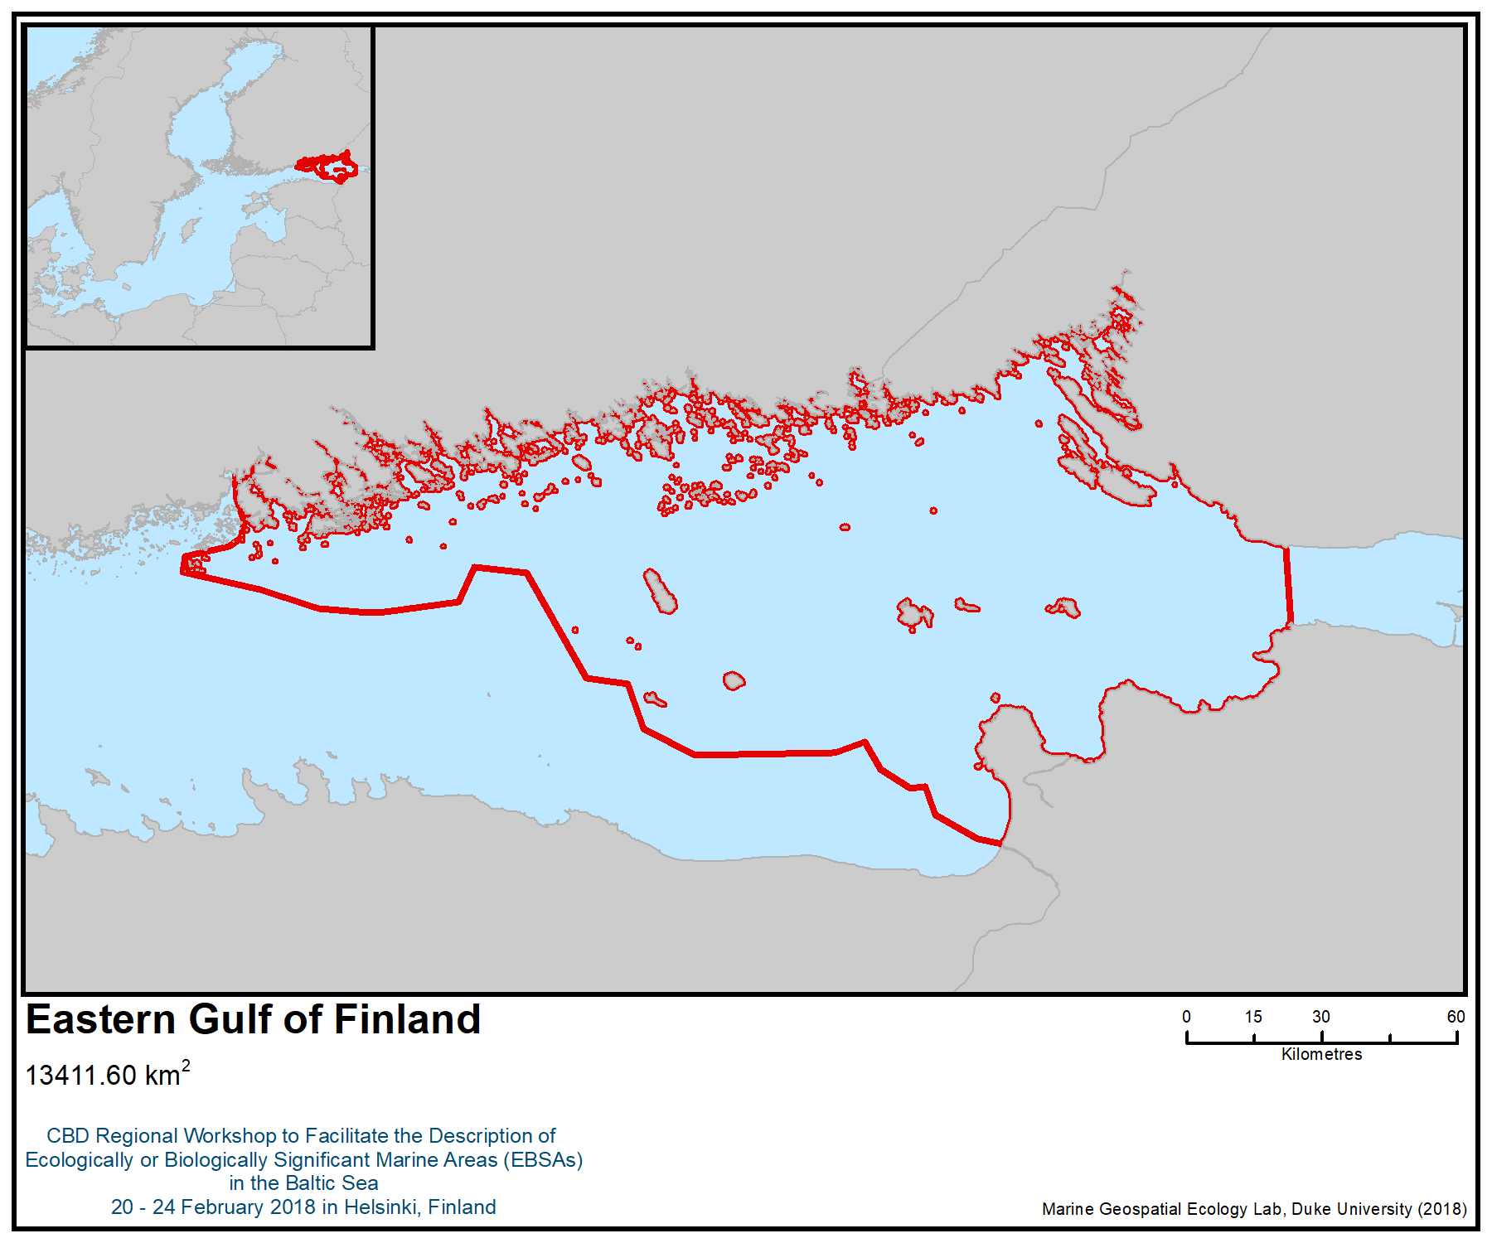
Figure 1. Location of the area

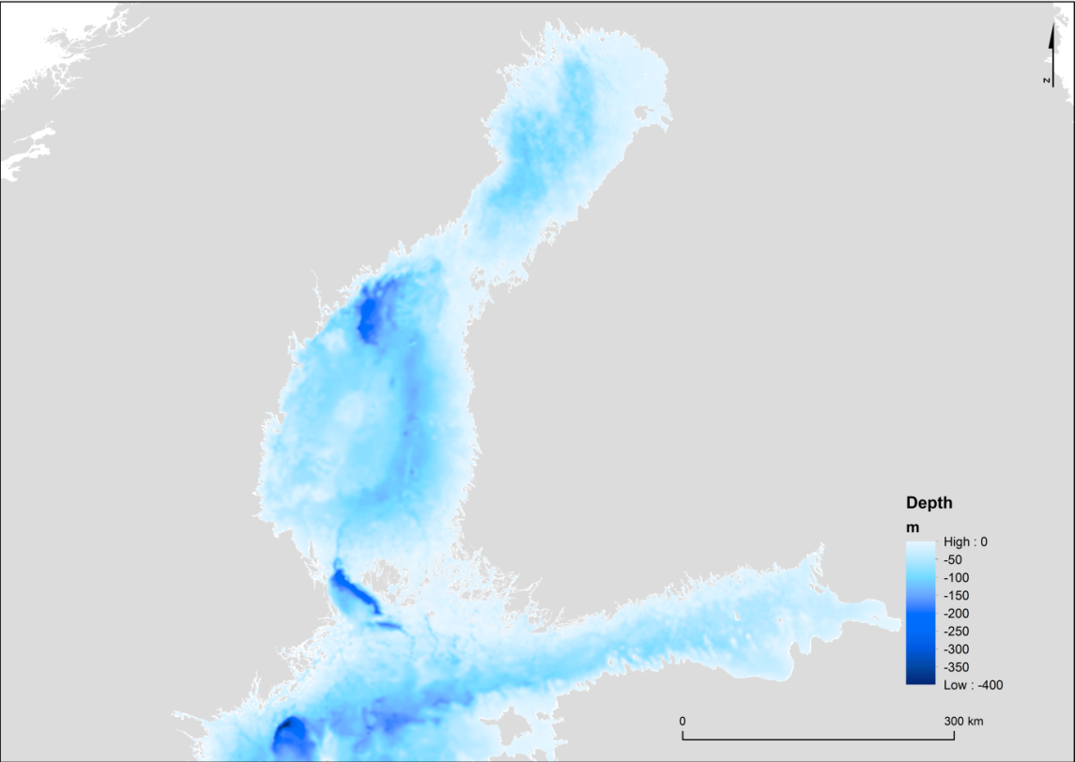
Figure 2. Depth relief map. (Source: HELCOM metadata catalogue, http://metadata.helcom.fi/geonetwork/srv/eng/catalog.search#/metadata/5dcf182a-517a-4599-be0d-626bea8e058d)

Figure 2. The number of breeding coastal birds. Finnish Bird Atlas. Data visualized by Metsähallitus Parks and Wildlife Finland & Finnish Environment Institute.

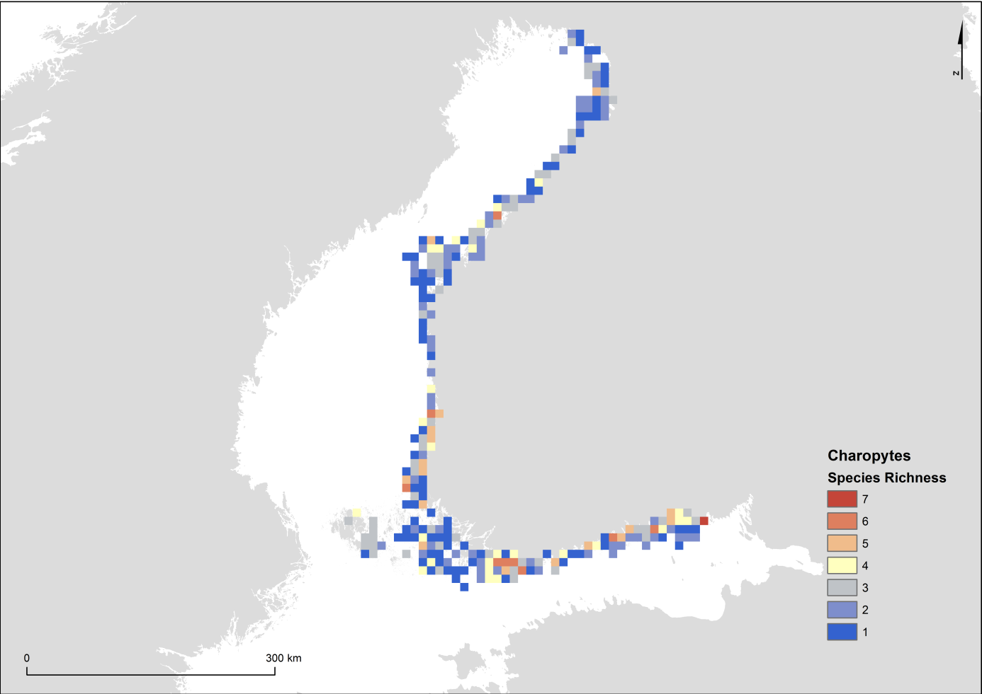
Figure 3. The species richness of charophytes. Data from Åland area is extremely limited and should not be considered representative. Based on VELMU inventories 2004-2016. VELMU / Finnish Environment Institute.

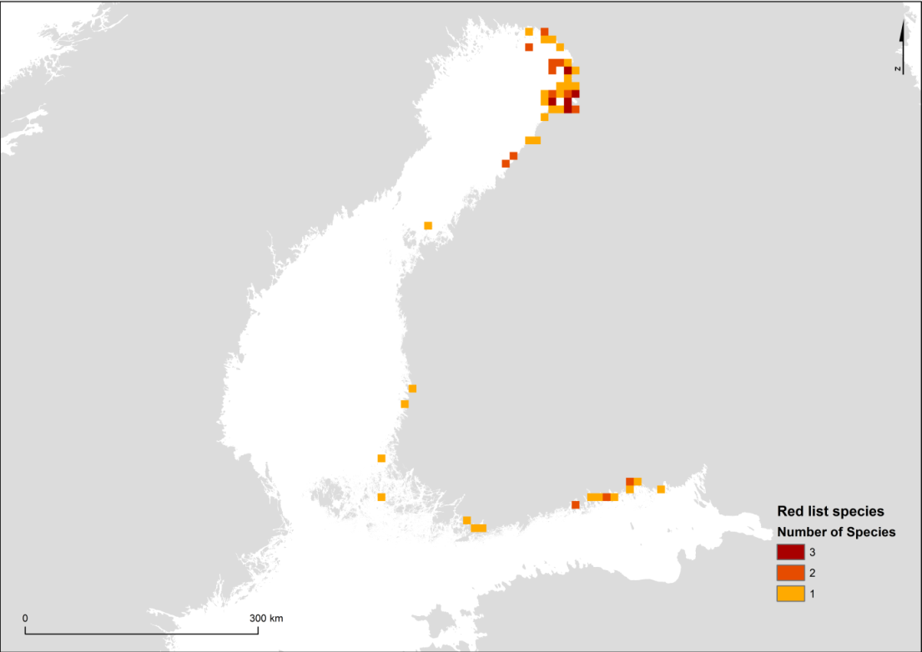
Figure 4. Rare aquatic vascular plants and charophytes observed by VELMU programme in 2004-2016. Data from Åland area are extremely limited and should not be considered representative. Species status assessments according to the HELCOM Red List of Baltic Sea (2013): Alisma wahlenbergii (VU), Chara braunii (VU), Chara horrida (NT), Crassula aquatica (NT), Hippuris tetraphylla (EN), Nitella hyalina (VU), Nitellopsis obtusa (NT), Persicaria foliosa (EN), Potamogeton friesii (NT). (VU=vulnerable, NT=near threatened, EN=endangered) VELMU / Finnish Environment Institute.

Figure 5. The species richness of macroalgae. Data from Åland area are extremely limited and should not be considered representative. Based on VELMU inventories 2004-2016. VELMU / Finnish Environment Institute.

Figure 6. The species richness of aquatic vascular plants. Data from Åland area are extremely limited and should not be considered representative. Based on VELMU inventories 2004-2016. VELMU / Finnish Environment Institute.

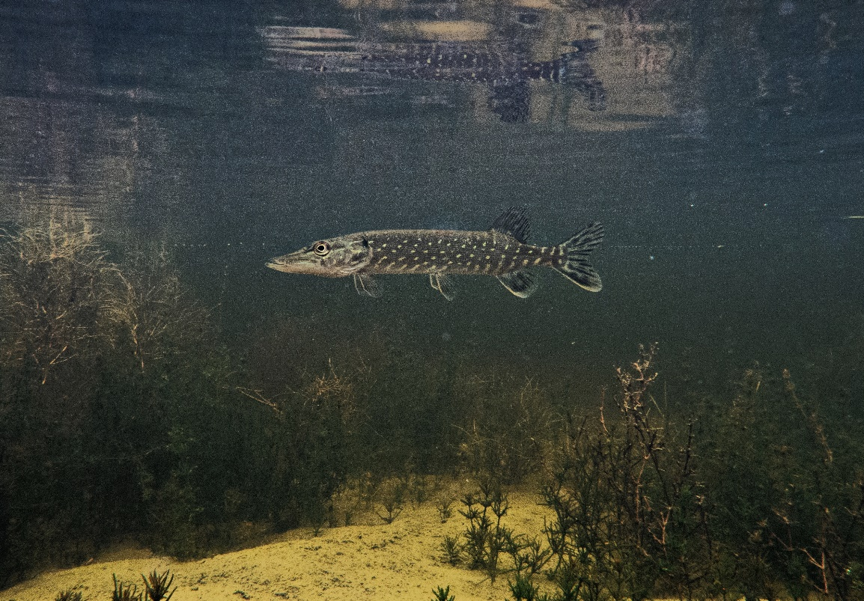
Figure 7. Pike (Esox lucius) in Kuutsalo flad. Photo: Petra Pohjola / Metsähallitus Parks & Wildlife.

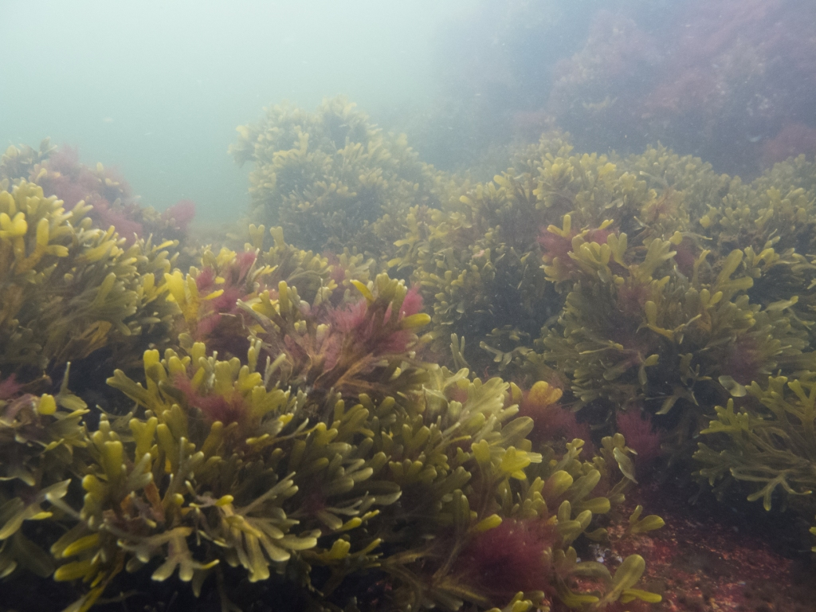
Figure 8. Bladderwrack (Fucus vesiculosus) zone in the outer archipelago of Finnish Eastern Gulf of Finland. Photo: Petra Pohjola / Metsähallitus Parks & Wildlife.

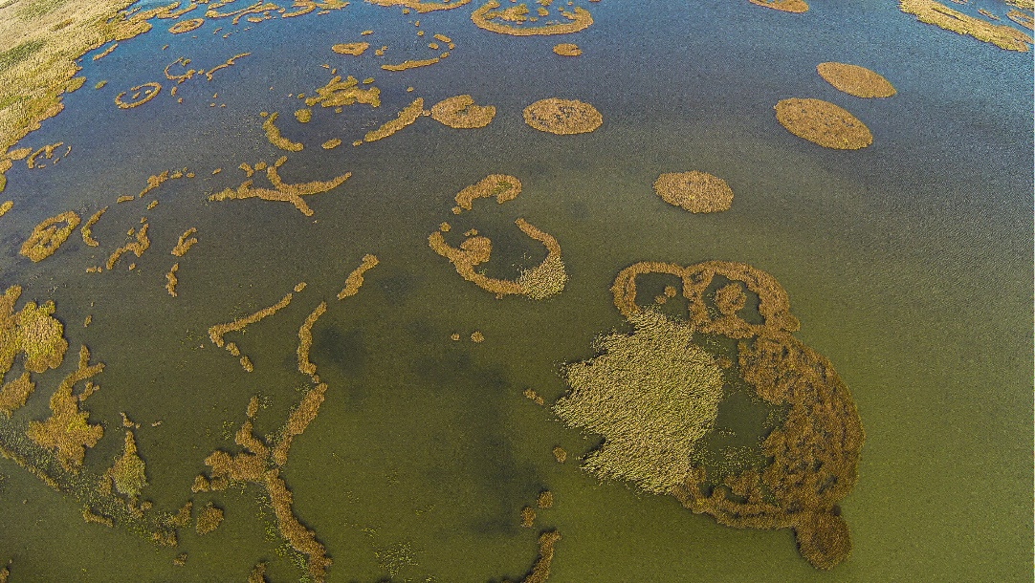
Figure 9. Reeds in Isnäsviken Bay of Finnish Eastern Gulf of Finland. Photo: Jamina Vasama / Metsähallitus Parks & Wildlife.

Rights and permissions

Contact persons:
Finland:
Markku Viitasalo, Finnish Environment Institute, markku.viitasalo@ymparisto.fi
Penina Blankett, Finnish Ministry of the Environment, penina.blankett@ym.fi

Russian Federation:
Evgeny Genelt-Yanovskiy, Laboratory of Molecular Systematics, Zoological Institute RAS, genelt.yanovskiy@gmail.com

Area No. 5: Inner Sea of the West Estonian Archipelago

Abstract
The Inner Sea of the West Estonian Archipelago forms a unique ecosystem in the northeastern Baltic Sea. Geologically, the area is a glacial formation composed of variable substrates of glacial moraine. It is very shallow, with mean depth less than 4m, and most of the seafloor is located in the photic zone. The presence of a salinity gradient from freshwater conditions inside the easternmost parts of Matsalu Bay to up to 6-7 psu in western part in Soela strait and an extensive dynamic hydrological front area creates unique conditions for local and migratory species. High benthic productivity due to frontal conditions and freshwater runoff makes this a very important feeding area for migrating species. Unique local hydromorphological conditions enable the existence of a large loose, free-floating red algae community of Furcellaria lumbricalis in this area. Due to the presence of numerous uninhabited islets and specific ice conditions, this area is important for two seal species. The area is home to a large number of migratory and other species, and is designated as an Important Bird and Biodiversity Area.

Introduction
The West Estonian Archipelago has a unique set of environmental conditions that sustain many different features of marine biodiversity. Its geological origin and hydrological conditions differ from other Baltic archipelagos. Located on the east-west and south-north salinity gradient of the Baltic Sea, the area has its own very distinct salinity gradient within the systems of bays and straits. The archipelago consists of 900 islands, 55 of which are larger than 0.1 km². The archipelago has a human population of 45,000 divided mainly between six larger islands. The area is widely recognized for its natural values, biodiversity and natural landscapes. It is encompassed by three NATURA 2000 sites, and the whole area is a part of West Estonian Archipelago Biosphere Reserve.

Location
The area is located in the inner sea area of the West Estonian Archipelago in the north-east Baltic Sea.

Feature description of the area
The West Estonian Archipelago Sea (Väinameri) is formed by a system of straits connecting the waters of the Gulf of Riga to the Baltic proper and to the entrance of the Gulf of Finland. The total surface area of the system is 2243km², and the total volume is 10.6km³ (Suursaar et al., 1998). This sea area is characterised by its shallow waters. The mean depth of the whole system is less than 4m with the deepest location at 18m in the middle of the Suur Strait. The bottom morphology of the area is flat, with gentle slopes towards its deepest portion. The whole water basin is semi-exposed. Sand and sandy clay sediments prevail in the entire area of the archipelago. Due to the shallowness and clayey sediments, moderate winds cause strong resuspension of bottom sediments and poor underwater light conditions. The general water exchange processes are highly dependent on the shallowness of the sea (minimum sill depth of 5m in the north-south direction). Due to the numerous shallow bays and the grid of small islets, the area could be divided into two relatively independent waterbodies. Kassari Bay, in the western part of the area, is connected to the Baltic proper through the narrow Soela Strait and separated from the eastern part by a grid of islets. Hydrologically, this area behaves differently from the other parts of the Väinameri, as it is influenced, to a greater degree, by the saline waters of the Baltic proper (Suursaar et al., 1998). The system of Hari Strait – Suur Strait in the central part of the archipelago is strongly influenced by the water masses originating from the Gulf of Riga (Suursaar et al., 1998). The impact of the riverine inflow on the system is minimal, because the amount of fresh water entering the system reaches only 1 km³ yr-1 (Astok et al., 1999). Suursaar et al. (1998) point out the existence of a strong hydrological front of Väinameri, which has a number of subfronts moving rapidly over the whole area, depending on the wind-induced water movement between the Gulf of Riga and the entrance to the Gulf of Finland or direction of the Baltic Proper through Soela Strait. Thus, the basic hydrochemical characteristics can fluctuate within a wide range, depending on the origin of the water filling the basin. The seafloor is constituted of mainly soft sediments, including fine mud and sand fractions. Harder substrates such as gravel or boulders can be found only in the most shallow and wave-exposed portions of the area. Due to its shallowness and to its substrate being dominated by fine sediment fractions, the water transparency is often very poor. Following storm events, the Secchi depth may decrease to 0.5m, while, in the case of prolonged calm weather conditions, the photic zone reaches the bottom in about 90% of this area. In the easternmost part Haapsalu and Matsalu bays are the most eutrophied bays within the West-Estonian Archipelago Sea.

Benthic vegetation
Benthic vegetation in the area consists of freshwater and marine species. The most abundant algae species is bladder wrack Fucus vesiculosus (Martin 2000). The area is inhabited by several rare species of Charophytes (e.g. Chara connivens) (Torn et al. 2004). The western and central part of the area includes large meadows of seagrass Zostera marina (Möller & Martin 2007). A free-floating, loose form of Furcellaria lumbricalis (Hudson) J.V. Lamouroux, a red algae that is rare in the Baltic Sea, is present in the area. Kassari Bay, situated in the West Estonian Archipelago Sea area, contains the largest-known community of this kind. Here, the free-floating mixed community of Furcellaria lumbricalis-Coccotylus truncatus (Paela) M. J. Wynne et J. N. Heine inhabits sandy bottoms, covering up to 200 km² of seafloor. The communities of loose Furcellaria lumbricalis-Coccotylus truncatus in the Kassari bay could be considered unique in the sense of phytobenthos biomass distribution (Trei, 1973) where its biomass occasionally reached a maximum of 2.1kg wet weight m-2 (Trei, 1973, 1976; Martin et al., 1996). The mean biomass of this community varies between 500 and 1000g of wet weight m⁻². The community is found on sandy substrates at a depth between 5 and 9m, where it forms a 0.15 to 0.3m thick carpet on the seafloor. The proportion of the two main dominant species differs slightly, depending on the locality, but 60-70% of the biomass is usually composed of Furcellaria lumbricalis, while Coccotylus truncatus accounts for 30-35% on average. The share of other species is usually low, less than 5% of the biomass (Trei, 1973;1976; Martin et al., 1996). Except for the sheltered areas of the southern coasts of Hiiumaa and Vormsi Islands and also the areas close to the northern coast of Muhu and Saaremaa Islands, the phytobenthic biomass in the other parts of the Väinameri is not remarkably high (not exceeding 100 g dry weight m⁻²) (Martin 2000).

Benthic invertebrate diversity
In terms of benthic invertebrate diversity, the area is quite rich in species, compared to other areas of the central Baltic. It includes a total of 122 species (HELCOM 2013) with a mixture of species of marine and freshwater origin. The West Estonian Archipelago is characterized by an invertebrate community dominated by Hydrobiidae, Pygospio elegans and Cerastoderma glaucum, with the highest invertebrate abundance in the Baltic (mean abundance of 4797 individuals per station) (Gogina et al. 2016).

The area contains a large number of different habitats and has a high benthic diversity compared to other regions in the north-eastern Baltic Sea. The entire area is shallow, emphasizing the importance of benthic macroalgae, especially the presence of a loose community of Furcellaria lumbricalis, in the dynamics of macrozoobenthos (Kotta & Orav, 2001).

Benthic habitats
The area is very diverse in benthic habitats (Martin 2013). Due to its geology, the substrate can vary and can have a very high patchiness in shallow waters. Hard substrate is present in the form of boulders, boulderfields, gravel patches and ridges. Most of the area can be characterized by soft substrate, where fine sand and clay prevail. Muddy soft sediment can be found in the sheltered bays.

Fish communities
Fish communities include both marine and freshwater species. In total, up to 72 species of fish and lamprey can be found in the area (HELCOM 2013). The water is brackish; with salinity near freshwater conditions in the easternmost part of the area ( 5 or 6 PSU), where freshwater fish species are most abundant (Saat and Kikas, 2002). Percids and cyprinids (perch Perca fluviatilis, ruffe Gymnocephalus cernuus, roach Rutilus rutilus, ide Leuciscus idus) are dominant species, whereas only two commercially important marine species—herring (Clupea harengus membras), and garpike (Belone belone)—enter the area in large numbers during spring for spawning (Vetemaa et al., 2006). In the eastern part of the area, in Matsalu Bay, fish fauna is strongly dominated by freshwater species. Several species inhabit the bay all year round, such as: roach (Rutilus rutilus), pike (Esox Lucius), white bream (Blicca bjoerkna), perch (Perca fluviatilis) and rudd (Scardinius erythrophthalmus). Some freshwater and anadromous species, on the contrary, are less abundant (vimba bream Vimba vimba) or almost lacking in the bay (smelt Osmerus eperlanus) outside the spawning period. The only abundant marine species is herring (Clupea harengus membras), which spawns mostly in more saline areas (Vetemaa et al. 2006, 2010).

Birds
This is an important breeding and resting area for a number of waterbirds (up to 500,000 individuals) as well as soaring birds (up to 130,000 individuals) including a number of species classified as vulnerable according to the European IUCN Red List. The velvet scoter (Melanitta fusca) (10,000 individuals) is listed as vulnerable because of the decline it has undergone in the Baltic Sea (Skov et al. 2011); it is classified as endangered on the HELCOM Red List. Other vulnerable species present in the area are the common pochard Aythya ferina (40,000 individuals) as well as the lesser white-fronted goose (Anser erythropus) (as up to 50 individuals) (BirdLife 2018).

The area has been identified as an Important Bird and Biodiversity Area by BirdLife International (Skov 2011, Kuus & Kalamees 2003).

Seals
Two seal species are abundant in the area. The southernmost population of the ringed seal is associated with the West Estonian Archipelago. Its ice conditions (on average 90 days of ice per year) make this area suitable for breeding of ringed seals (Härkonen et al. 1998). It is estimated that 20 to 30% of the total Baltic Sea grey seal population uses the area (HELCOM Seal database).

Socioeconomic and cultural aspects
In the area of the West Estonian Archipelago, there are three important socio-ecological systems: (i) the inner archipelago, (ii) Hiiumaa and (iii) Saaremaa islands. The first humans are thought to have arrived on the islands around 4000 BC (Mägi 2004). Most likely these pre-historic populations utilized the marine areas and coasts for seal hunting and small-scale fisheries. The islands are world-famous for their traditions and oral histories. The first modern Estonian president, Lennart Meri (1983), points out in his book, Hopeavalkea (Meri 1983), the ancient linguistic connections the Finno-Ugric peoples have with the sea and the broader region. He elaborated on the documented Finnish rune song “Birth of Fire” (Tulen synty) and the meteorite of Kaali on Saaremaa as examples of how oral systems of traditional knowledge changes in nature and ecosystems for millennia prior to the advent of the written world. Kõmmus and Särg (2017) provide extended documentation of ILK and traditional songs on Hiiumaa. Salve (1996) documented the Livonian and Estonian traditional beliefs and calendar associated with the sea, and she reports that a rich culture of belief-practice-knowledge existed in “traditional times” (prior to large-scale industrialization of the fleet) in the remote fishing communities. This seems to be applicable also to Hiiumaa and Saaremaa as well as the northern archipelago of Estonia.

The traditional knowledge and culture of this area has been affected by the macro-historical changes of the past century, including the Soviet era, with its collectivization and occupation of Estonia. In 1991, Estonian independence allowed for the re-emergence of coastal fisheries as well. The Soviet era also, rather surprisingly, “preserved” many traditions and practices in Estonia that have been lost today in other parts of the Baltic.

Feature condition and future outlook of the area
The area is dynamic in the sense of human pressure and general ecological status. Depending on the direction of wind the basin can be filled either by the water from the Gulf of Riga (generally high concentration of nutrients, low salinity) or by waters from the mouth of the Gulf of Finland (lower nutrient concentrations, higher salinity). Human pressure is generally low, and local inflows of additional nutrients come mainly from the Kasari River estuary (Matsalu area). Regarding eutrophication status, the easternmost bays are affected the most (Haapsalu Bay and Matsalu Bay) (Martin 2000). These areas are classified as areas of concern, and different measures are applied to change the eutrophication status.

Local human pressure is low due to low intensity of agriculture, industry, fishing and hunting. The coastal areas lack dense human population. There is a potential for the future development of marine tourism, with increasing small vessel traffic and recreational fishing.

It is not foreseen that the area will be exposed to the intensification of agriculture or major industrial developments, although the construction of a fixed link bridge connecting Saaremaa and Muhu island inhabitants with the mainland is currently under discussion. The status of the marine environment should improve due to implementation of measures for reducing eutrophication and toxic pollution.

The rich cultural heritage of the region provides baseline information regarding an internationally important ILK system of the marine areas, in terms of stewardship and use of marine resources. Specific aspects of the Hiiumaa, Saarenmaa and adjacent areas are urgently in need ofould mapped and surveying (Mustonen and Mustonen 2016) before the knowledge holders that could report on, for example, past ecological changes, spawning areas, seal stocks and other features of the area are lost forever. This work should include an investigation of the close by Livonian coast in Latvia due to their close proximity in linguistic and ecological parameters, as alluded to by Salve (1996). The local coastal fishers are important partners in establishing community-based monitoring and investigations of biodiversity in this part of the Baltic.

Assessment of the area against CBD EBSA Criteria

CBD EBSA Criteria  (Annex I to decision IX/20) | Description  (Annex I to decision IX/20) | Ranking of criterion relevance  (please mark one column with an X)
CBD EBSA Criteria  (Annex I to decision IX/20) | Description  (Annex I to decision IX/20) | No information |  | Low |  |  | Medium |  | High
Uniqueness or rarity | Area contains either (i) unique (“the only one of its kind”), rare (occurs only in few locations) or endemic species, populations or communities, and/or (ii) unique, rare or distinct, habitats or ecosystems; and/or (iii) unique or unusual geomorphological or oceanographic features. |  |  |  |  |  |  |  | X
Explanation for ranking

- The area includes a community of loose red algae (Fuclellaria lumbricalis) (Martin 2000, Martin et al 2006a,b). The community in this form is unique for this particular area. Community characteristics have been stable during past decades, and the distribution of the recent biomass (as of 2017) is shown in Figure 4.
- The southernmost population of ringed seals is associated with the West Estonian Archipelago (Figure 6). The condition of all sub-populations of ringed seals in the Baltic Sea is poor, mainly due to poor breeding conditions because of the warm winters (HELCOM 2017).
- The geomorphology of the area creates a unique set of environmental conditions and small-scale diversity. The high diversity of benthic habitats, in combination with the salinity and exposure gradients, also contribute to the unique set of ecological conditions in the area (Martin et al. 2013).
- The area includes habitats of several rare species (e.g., species of charophytes). The distribution of Chara connivens in the Baltic Sea is limited to two areas, one of them located within the inner sea of the West Estonian Archipelago (Torn et al; 2004; 2015).
Special importance for life-history stages of species | Areas that are required for a population to survive and thrive. |  |  |  |  |  |  |  | X
Explanation for ranking

- The area is important for different life stages of the gray seal (HELCOM 2017), the number of which is increasing in the area. Areal counts indicate that about 20% of the total Baltic Sea gray seal population is using this area (HELCOM Seal Database).
- The area contains the southernmost population of the ringed seal in the Baltic Sea. It is important for ringed seals, as their breeding distribution in the Baltic can be related to the location and extent of suitable breeding habitat – ridged ice with snow cover. The West Estonian Archipelago is the southernmost large area in the Baltic Sea with prolonged ice cover during average winters (Jüssi, 2012).
Importance for threatened, endangered or declining species and/or habitats | Area containing habitat for the survival and recovery of endangered, threatened, declining species or area with significant assemblages of such species. |  |  |  |  |  | X
Explanation for ranking

- The area is an important breeding and resting area for a number of waterbirds (up to 500,000 individuals) as well as soaring birds (up to 130,000 individuals), including a number of species classified as vulnerable according to the European IUCN Red List as well as the HELCOM Red List. Among those are the velvet scoter (Melanitta fusca) (10,000 individuals), common pochard (Aythya ferina) (40,000 individuals), lesser white-fronted goose (Anser erythropus) (up to 50 individuals), tufted duck (Aythya fuligula) (less than 25.000), greater scaup (Aythya marila) (up to 50,000 individuals) and many other species (Skov 2011, Kuus & Kalamees 2003).
Vulnerability, fragility, sensitivity, or slow recovery | Areas that contain a relatively high proportion of sensitive habitats, biotopes or species that are functionally fragile (highly susceptible to degradation or depletion by human activity or by natural events) or with slow recovery. |  |  |  | X
Explanation for ranking

- The drifting red algae community in the area, as well as its eelgrass meadows, is fragile due to the fact that the reproduction mechanism of these species is vegetative fragmentation. Any unexpected impact on these communities can therefore result in total extinction without the possibility of recovery (Martin 2000, Möller & Martin 2007).
- The area’s ringed seal population is especially vulnerable due to its dependence on the sea ice conditions which are strongly affected by climate change (Jüssi 2012).
Biological productivity | Area containing species, populations or communities with comparatively higher natural biological productivity. |  |  |  |  |  | X
Explanation for ranking

- 90% of the area is shallow, and the bottom is located in photic zone and is mostly vegetated. Benthic primary and secondary production is comparatively higher than neighbouring sea areas (Martin 2000).
- Abundant benthic primary production takes place both on hard and soft substates in the area. On hard substrates, the majority of biomass is composed of brown algae, on abundant soft substrate the biomass is composed either of vascular plants and charophytes (mostly sheltered bays and lagoons up to 4 m depth) or of loose red algae community (exposed areas, depth interval 4-9 m) (Martin et al. 2006a,b; Paalme 2017; Paalme et al. 2007).
- Abundant vegetation in the area enables high secondary production, providing the habitat for invertebrate communities (Kotta &Orav 2001).
- Abundance of benthic invertebrates (Gogina et al 2016).
Biological diversity | Area contains comparatively higher diversity of ecosystems, habitats, communities, or species, or has higher genetic diversity. |  |  |  |  |  |  |  | X
Explanation for ranking

- Area is a local biodiversity hotspot, including a larger number of species than surrounding areas due to its complexity and variability of habitats.
- Mixture of freshwater and marine species (vegetation, invertebrates, fish fauna). Important area for bird feeding (Kuus & Kalamees 2003).
- High species number for some species groups, e.g., Charophytes (Torn et al. 2015).
- Area includes high variety of benthic habitats (figures 2 and 3). Compared to neighbouring marine areas, shallow depth creates specific conditions for different species groups – photic zone reaching the seafloor enablesbenthic primary production on both hard and soft substrates (Martin 2000), and rapid warming of seawater during the spring creates favourable spawning conditions for fish (Vetemaa et al. 2006).
Naturalness | Area with a comparatively higher degree of naturalness as a result of the lack of or low level of human-induced disturbance or degradation. |  |  |  |  |  |  | X
Explanation for ranking

The area experiences limited influence of local pressures, such as shipping, fishing and boating activity. The area has unique environmental conditions in combination with low human pressure.

Sharing experiences and information applying other criteria

Other Criteria | Description | Ranking of criterion relevance  (please mark one column with an X)
Other Criteria | Description | Don’t Know | Low | Medium | High
Other nature protection mechanisms |  |  |  |  | X
Explanation for ranking

- Area is classified as an Important Bird and Biodiversity Area (IBA) – Väinameri IBA (Kuus & Kalamees 2003)
- The West Estonian Archipelago has been designated as a Biosphere Reserve since 1990.
- The area includes three NATURA 2000 sites

References
Astok, V., Otsmann, M., Suursaar, Ü. 1999. Water exchange as the main physical process in semi-enclosed marine systems: the Gulf of Riga case. – Hydrobiologia 393: 11-18.
BirdLife International (2018) Important Bird Areas factsheet: Väinameri. http://datazone.birdlife.org/site/factsheet/v%C3%A4inameri-iba-estonia/details
Estonian Marine Institute, 2016. Modelling of marine habitat types of habitat directive and EUNIS level 3 habitats in Estonian EEZ. NEMA Project report. 27 p.
Gogina, M., Nygard, H., Blomqvist, M., Daunys, D., Josefson, A. B., Kotta, J., Maximov, A., Warzocha, J., Yermakov, V., Gra¨we, U., and Zettler, M. L. 2016. The Baltic Sea scale inventory of benthic faunal communities. – ICES Journal of Marine Science, doi: 10.1093/icesjms/fsv265.
Härkönen, T., Jüssi, M., Jüssi, I., Verevkin, M. Dmitrieva, L., Helle, E., Sagitov, R. and Harding, K.C. 2008. Seasonal activity budget of adult Baltic ringed seals (Phoca hispida botnica). PLoS One 3: e2006. doi:10.1371/journal.pone.0002006.
Härkönen, T., Stenman, O., Jüssi, M., Jüssi, I., Sagitov, R. and Verevkin, M. 1998. Population size and distibution of the Baltic ringed seal (Phoca hispida botnica). Heide-Jörgensen M and Lydersen C (eds). NAMMCO Scientific Publications 1: 167–180.
HELCOM (2017) Distribution of Baltic seals. HELCOM core indicator report. Online. [Date Viewed: Feb. 22, 2018], [Web link]. ISSN 2343-2543
HELCOM 2012. Checklist of Baltic Sea Macro-species. Baltic Sea Environment Proceedings No. 130
Jüssi, M., Härkönen, T., Helle, E., and Jüssi, I. 2008. Decreasing ice coverage will reduce the breeding success of Baltic grey seal (Halichoerus grypus) females. Ambio. 37(2):80–85.
Jüssi, Mart (2012). Living on an edge: land-locked seals in changing climate. Doctoral dissertation. Tartu Ülikool.
Kõmmus, Helen, Särg, Taive. Star Bride Marries a Cook. The Changing Processes in the Oral Singing Tradition and in Folk Song collecting on the Western Estonian Island of Hiiumaa. Estonian Journal of Folklore, 2017
Kotta, J. & Orav, H. 2001: Role of benthic macroalgae in regulating macrozoobenthic assemblages in the Väinameri (north-eastern Baltic Sea). — Ann. Zool. Fennici 38: 163–171.
Kuus, A., Kalamees, A. (eds.) 2003. Important Bird Areas of European Union importance in Estonia. Eesti Ornitoloogiaühing, Tartu.
Mägi, Marika. From Stone Graves to Churchyards. Burial Traditions in the Late Prehistoric and Early Medieval Island of Saaremaa. Estonian Journal of Folklore, 2004.
Martin, G. (2000). Phytobenthic communities of the Gulf of Riga and the Inner Sea of the West-Estonian Archipelago. (Doctoral disertation). Tartu: Tartu University Press.
Martin, G., Paalme, T., Kukk, H. 1996. Long-term dynamics of the commercially useable Furcellaria lumbricalis-Coccotylus truncatus community in Kassari Bay, West-Estonian Archipelago, the Baltic Sea. - In Baltic Coastal Fisheries - Resources and Management. Sea Fisheries Institute. Gdynia: 121 - 129.
Martin, G., Paalme, T. & Torn, K. (2006a). Seasonality pattern of biomass accumulation in a drifting Furcellaria lumbricalis community in the waters of the West Estonian Archipelago, Baltic Sea. Journal of Applied Phycology, 18, 276 - 283.
Martin, G.; Paalme, T.; Torn, K. (2006b). Growth and production rates of loose-lying and attached forms of the red algae Furcellaria lumbricalis and Coccotylus truncatus in Kassari bay, the West Estonian Archipelago Sea. Hydrobiologia, 554, 107 - 115.
Martin, G.; Kotta, J.; Möller, T.; Herkül, K. (2013). Spatial distribution of marine benthic habitats in the Estonian coastal sea, northeastern Baltic Sea. Estonian Journal of Ecology, 62, 165−191.
Meri, Lennart. Hopeavalkea. Gummerrus, 1983
Mustonen, Tero and Mustonen, Kaisu. Life in the Cyclic World: Traditional Knowledge of Eurasia. Selkie: Snowchange Cooperative, 2016
Möller, T.; Martin, G. (2007). The distribution of the eelgrass Zostera marina in the coastal waters of Estonia, NE Baltic Sea. Eesti Teaduste Akadeemia Toimetised. Bioloogia. Ökoloogia, 56 (4), 270−277.
Paalme, T. 2017. Survey of commercially exploited red algae community in Kassari Bay. Project report. In Estonian. 36 p.
Paalme, T; Kotta, J; Kersen, P; Martin, G; Kukk, H; Torn, K (2007). Importance of local and regional environmental factors in the dynamics of the loose-lying red algal community in the Northern Baltic Sea. Fourth European Phycological Congress, Oviedo, Spain, 23-27 July 2007. Taylor & Francis, 2007, 157.
Saat, T., and Kikas, L. 2002. Seasonal dynamics of fish in Käina Bay. In Fishes and Fishery of the Väinameri, pp. 90–103. Ed. by T. Saat. Tartu University Publishers (in Estonian with English summary).
Salve, Kristi. Fisherman’s Work and the Sea in Livonian Folk Calendar. Estonian Journal of Folklore, 1996
Skov, H., S. Heinänen, R. Žydelis, J. Bellebaum, S. Bzoma, M. Dagys, J. Durinck, S. Garthe, G. Grishanov, M. Hario, J.J. Kieckbusch, J. Kube, A. Kuresoo, K. Larsson, L. Luigujõe, W. Meissner, H.W. Nehls, L. Nilsson, I.K. Petersen, M. Mikkola Roos, S. Pihl, N. Sonntag, A. Stock & A. Stipniece (2011). Waterbird populations and pressures in the Baltic Sea. TemaNord 550, 201 pp
Suursaar, Ü., Astok, V., Otsmann, M. 1998. The front of Väinameri. In EMI Report Series, 9: 23-33.
Torn, K.; Martin, G.; Kukk, H.; Trei, T. (2004). Distribution of charophyte species in Estonian coastal water (NE Baltic Sea). Scientia Marina, 68, 129−136.
Torn, K.; Kovtun-Kante, A.; Herkül, K.; Martin, G.; Mäemets, H. (2015). Distribution and predictive occurrence model of charophytes in Estonian waters. Aquatic Botany, 120 (A), 142−149.10.1016/j.aquabot.2014.05.005.
Trei, T. 1973. Phytobenthos of the coastal waters of western Estonia. – Doctoral thesis. Tartu : 1-34. (in Russian)
Trei, T. 1976. Brown and red algae in the coastal waters of western Estonia. - Zvaigzne, Riga: 1-87. (in Russian)
Vetemaa M, Eschbaum R, Verliin A, Albert A, Eero M, Lillemägi R, Pihlak M, Saat T. Annual and seasonal dynamics of fish in the brackishwater Matsalu Bay, Estonia. Ecology of Freshwater Fish 2006: 15: 211–220.
Vetemaa, M., Eschbaum, R., Albert, A., Saks, L., Verliin, A., Jürgens, K., Kesler, M., Hubel, K., Hannesson, R., and Saat, T. 2010. Changes in fish stocks in an Estonian estuary: overfishing by cormorants? – ICES Journal of Marine Science, 67: 1972–1979.

Maps and Figures

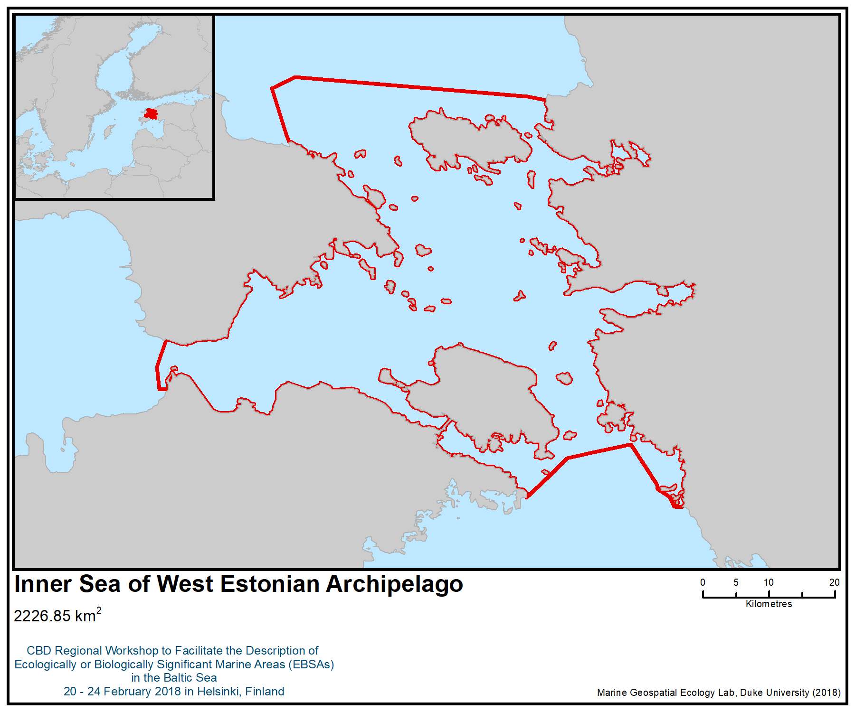
Figure 1. Location of the area

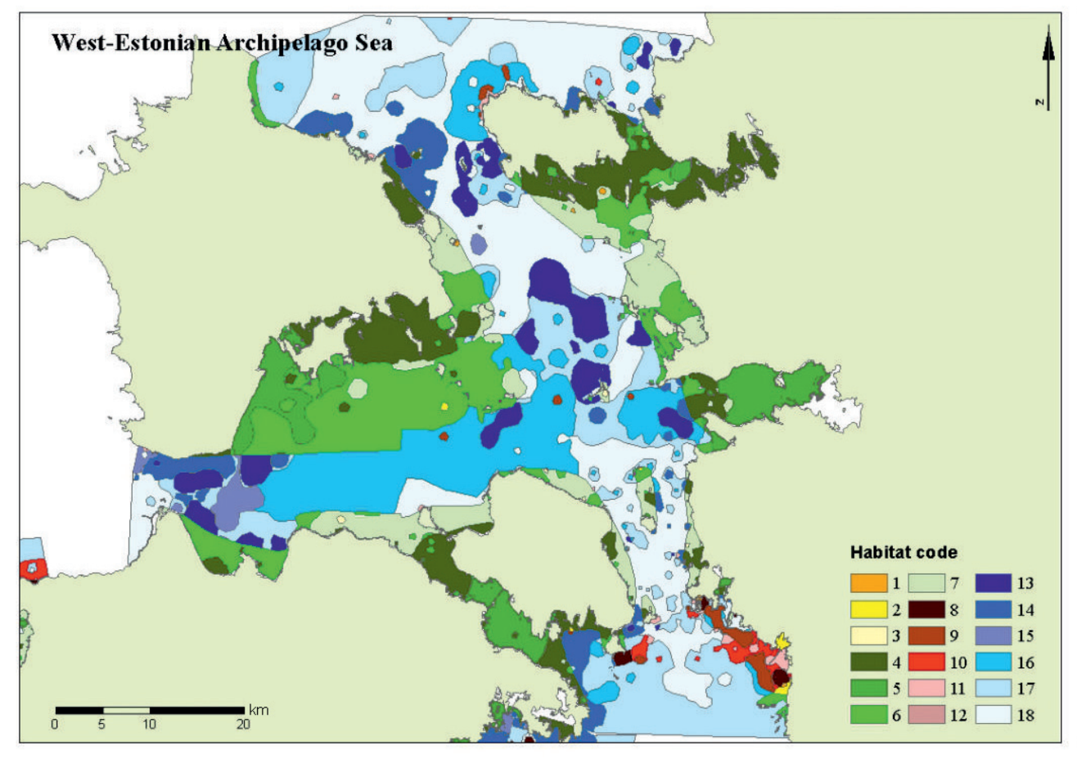
Figure 2. Distribution of benthic habitats (EBHAB system) in inner sea of the West Estonian Archipelago (Martin 2013)
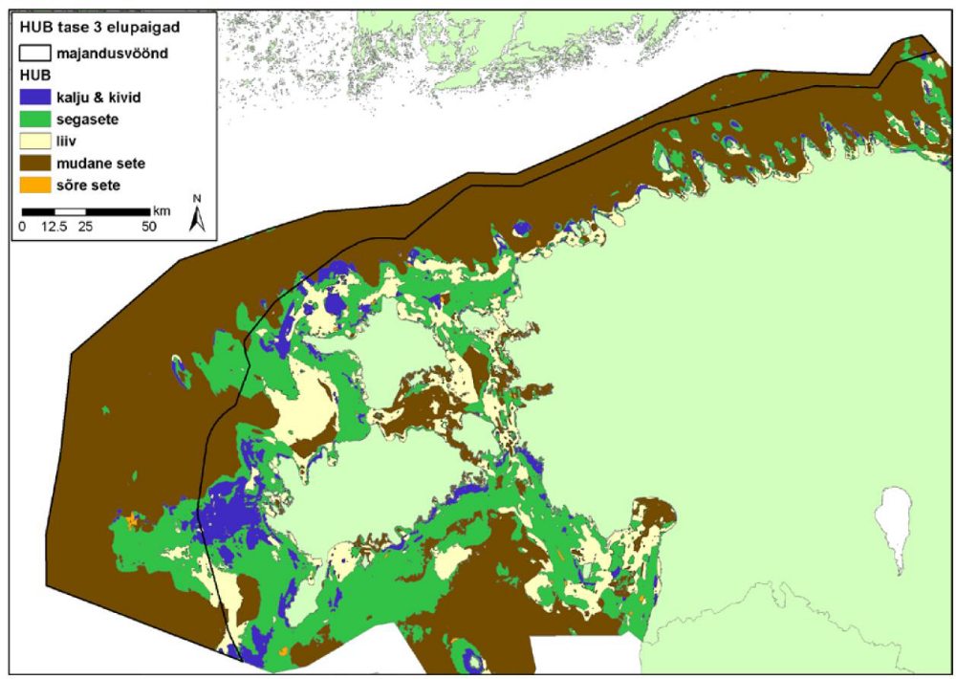
Figure 3. Modelled distribution of HUB level 3 habitats in Estonian territorial sea (Estonian Marine Institute 2016)

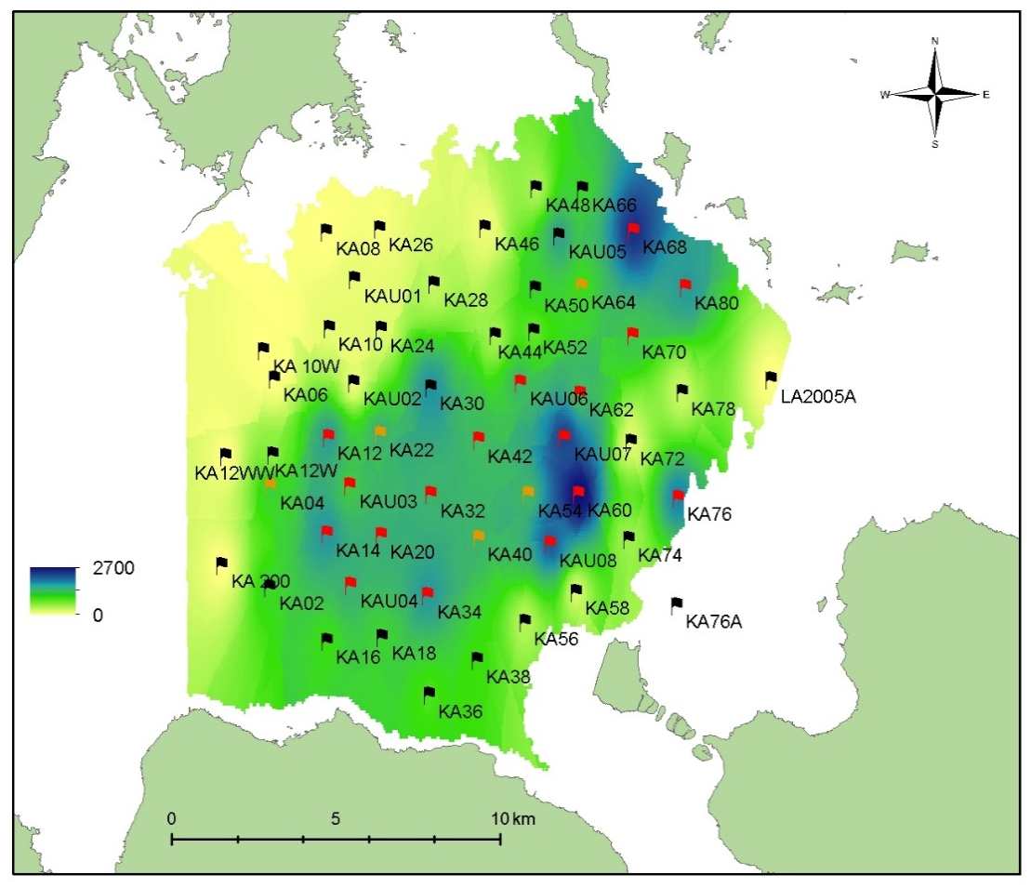
Figure 4. Distribution of drifting red algae community biomass g/m² in Kassari Bay, western part of the West Estonian Archipelago sea in 2017 (Paalme 2017)
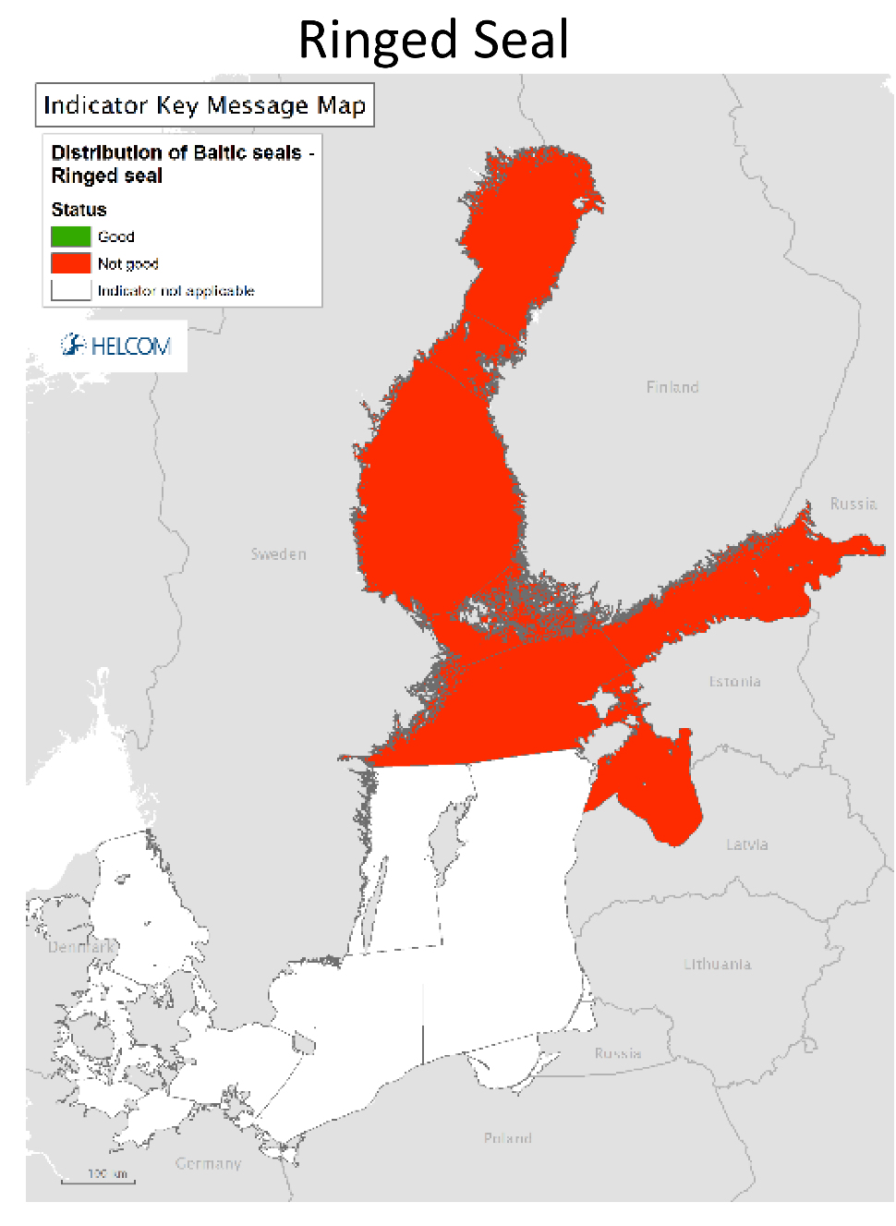
Figure 5. Distribution and status of ringed seals in the Baltic Sea. HELCOM indicator report (HELCOM 2017)

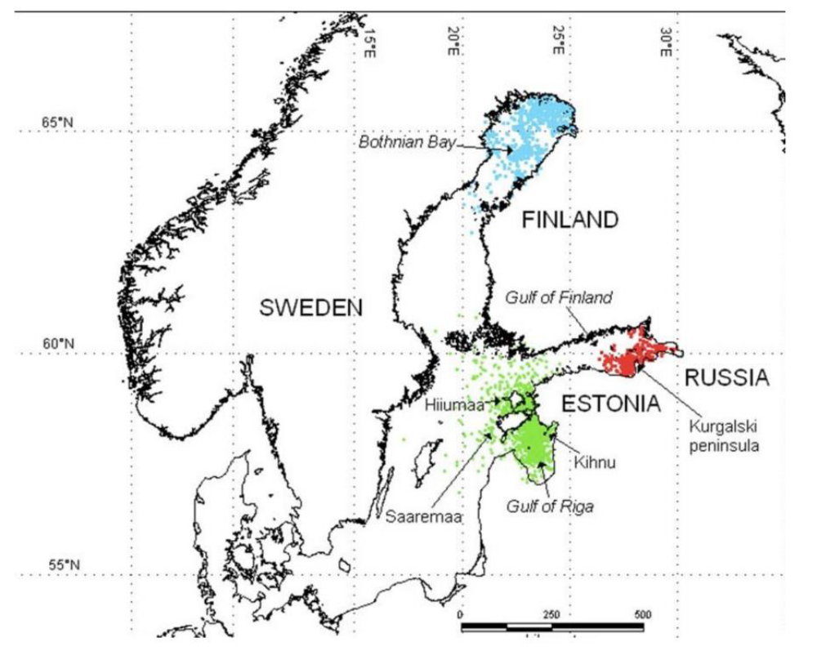
Figure 6. Positions of ringed seals tagged with satellite transmitters in the Bothnian Bay (blue), the Gulf of Finland (red), and Estonian coastal waters (green) during the ice free period of the year. (HELCOM indicator report 2017)
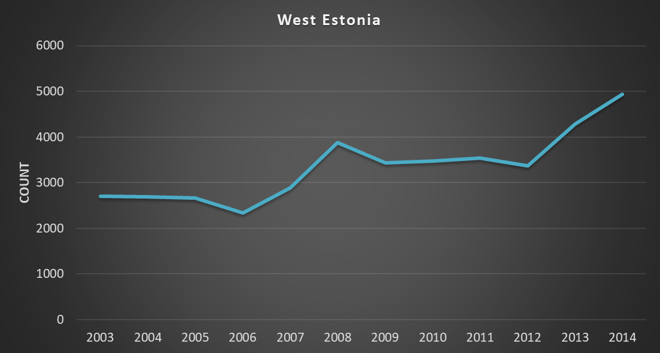
Figure 7. Results of areal counts of grey seals in the West Estonian Archipelago area. (HELCOM Seal Database)

6: Southeastern Baltic Sea Shallows

Abstract
Driven by complex geomorphological structures, the area is a hotspot of biodiversity both in coastal and offshore waters. The shallow water area is one of the most important habitats for benthic communities. Its underwater reefs sustain coastal benthic communities, a high biodiversity of invertebrates, fishes and wintering birds. Reefs are also used as spawning and nursery grounds by commercially important fish species, such as sprat, herring, turbot and flounder. The offshore bank serves as a refuge for mobile species from short-term hypoxia in the deeper parts of the Gotland basin. The coastline is an important stopover site for waterbirds. During particularly severe winters, the abundance of some species of wintering seabirds (e.g. long-tailed duck Clangula hyemalis, velvet scoter Melanitta fusca and red-throated diver Gavia stellata) may increase by several or several tens of times. Lagoons exist as large and multiple freshwater ichthyofauna complexes and permanent or temporary habitats for migratory and marine fish species. The Curonian Lagoon is an important regional spawning and recovery area for twaite shad (Allosa fallax).

Introduction

The Southeastern Baltic Sea shallows are formed by the unique combination of specific topography in underwater plateaus (Curonian-Sambian, Klaipeda-Ventspils) and the Klaipeda bank, the sheltered brackish environments of two large coastal lagoons (Curonian Lagoon and Vistula Lagoon), specific hydrological conditions (riverine plumes, thermoclines, high exposure of the open coast) and a wide variety of benthic substrates. The combination of these features has enabled the formation of unique conditions for local species and species assemblages of the brackish northern Europe ecosystems.

The area comprises the mesohaline (7-8 PSU) waters of the Baltic proper and oligohaline-to-freshwater (0-3 PSU) of the lagoons. Both lagoons are freshwater-dominated transitory basins where episodic inflows of seawater cause irregular rapid increase in salinity. In the coastal waters, major hydrological features are determined by the interaction between the south-eastern Baltic offshore waters and the runoff of the mostly freshwater lagoons (Olenin et al. 2004; Dailidienė et al., 2011). The mixed waters of lower salinity (<5 PSU) dominate closer to the lagoons and may stretch several tens of kilometres from the outflow of the lagoons (Daunys et al. 2007). These hydrographical features generate environmental gradients, which affect the distribution of organisms (Marine Research Consortium, 2012).

The area varies in water depth from 0 to 70 m and represents a diversity of geomorphic features – lagoon plain, shallow water area, slopes of plateaus and a bank (Ezhova et al., 2012). A great variety of benthic habitats exist in the area as a result of the relationship between bottom types, depth and macrofauna communities. The hard substrate type occurs mostly in the shallow water area and in the area of gentle slopes. The deeper water area, lagoon plains, part of the slope and shallow water area are represented by soft bottom habitat. Reefs (habitat type 1170, according to Annex 1 of the EU Habitat Directive) are the most attractive and ecologically significant habitat types on hard bottoms in the area, sustaining high biodiversity, important feeding areas for diving birds, spawning or nursery sites for commercially important fishes or refuge areas for marine species (Marine Research Consortium, 2012). The most biologically valuable reefs in the shallow water area of the Klaipeda-Ventspils Plateau are dominated by perennial red algae Furcellaria lumbricalis (Olenin, 1997).

Benthic faunal assemblages in offshore waters on hard substrate vary in terms of species diversity and abundance but are dominated by sessile suspension feeders (blue mussels, barnacles, hydroids, bryozon), whereas soft bottom assemblages are dominated by selective and nonselective deposit feeders (bivalves, polychaetes). A habitat inventory showed that reefs with the above mentioned blue mussels (Mytilus trosulus) and barnacles (Balanus improvises) are found in offshore waters in both Klaipeda-Ventspils and Curonian-Sambian plateaus (Daunys et al., 2015).

The most distant part of the area to the north-west, Klaipeda Bank, located close to the steep Gotland Deep, is a less geomorphologically distinct basin, but it is particularly important for benthic fish, especially in summer when oxygen concentration is decreasing in the deeper areas and pelagic fishes find suitable conditions on the slopes of the bank. The major part of the bank is situated at a depth of 50-60 m, while about one fifth is exposed to the saline water layer (halocline) which typically supports different marine life (including glacial relicts) compared to more shallow saline waters (Daunys and Čebatariūnaitė, 2015).

Both lagoons are listed as priority habitat types (1150) in the Habitats Directive (EC 1992). Lagoons are important migration corridors for anadromic species, such as salmonids (Salmo salar and Salmo trutta), smelts (Osmerus eperlanus), vimba (Vimba vimba), European eel (Anguilla Anguilla), river lampreys (Lampetra fluviatilis) and spawning ground for twait shad (Alosa fallax) and whitefish (Coregonus lavaretus) (Repecka, 2002). The Curonian Lagoon is designated as a Natura 2000 area for the following EU declining fish species: salmon (Salmo salar), twaite shad (Allosa fallax), asp (Aspius aspius), sabrefish (Pelecus cultratus), spined loach (Cobitis taenia) and lamprey (Lampetra fluviatilis) (Order of Minister of Environment of Republic of Lithuania, No. D1-260, 2009).

Lagoons are also important for migrating birds – part of the Curonian Lagoon is a NATURA 2000 Special Protection Area (SPA) for birds – Bewick's Swan (Cygnus bewickii), pintail (Anas acuta), goosander (Mergus merganser), smew (Mergus albellus), little gull (Larus minutus), white-tailed eagle (Haliaeetus albicilla) (Order of Minister of Environment of Republic of Lithuania, No. D1-260, 2009).

Location
The Southeastern Baltic Sea Shallows encompasses several geomorphologically distinct areas, including the Klaipeda-Ventspils plateau in the north, the Curonian-Sambian plateau in the south, the Klaipeda bank in the northwestern part of the area as well as the largest lagoons in the eastern Baltic Sea, Curonian and Vistula, each separated by a narrow spit. The area extends 11,626 km².

Feature description of the area
Physical description

The sub-marine coastal slope, extending from the shore down to 25-30 m depth, is characterised by diverse bottom types. The uppermost part, 0 to 4 or 6 m deep, is covered by a thin layer of quartz sand, which moves around during storms. The morainic bench (pebble-gravel deposits with large boulders) lies beneath the sand strip, extending down to 25-30 m depth. Patches of pebble and gravel deposits occur on sites down to 60 m. Also, patches of coarse aleurites are found at 20-40 m, extending down to 60-70 m depth (Olenin S., 1997).

The Klaipeda-Ventspils Plateau is a large portion of the seabed with its slopes sinking into Gotland Deep and Gdansk Deep. Part of the seabed is covered with contemporary and relict bottom sediment. Relict bottom sediment is deposits and sediment that formed during the glacial age and earlier stages in the development of the Baltic Sea. They are deposited in hydrodynamically active areas of the sea where accumulation of contemporary bottom sediment does not take place, or where there is even some evidence of abrasion processes. The glacial deposits (moraines) of many similar areas have been extensively washed out, and their surface is covered by boulders, pebbles, gravel and sand of varying grade. Moraine bottoms, including boulder and cobble reefs, extend over larger territories (including slopes) (Marine Research Consortium, 2012).

The seabed of the Sambian-Curonian Plateau, which occupies the southern part of the area, is characterized by bars and furrows. Medium and fine sands prevail in the south of the Plateau and form extended fields joined to the Curonian and Vistula spits. Predominance of various sands is observed at the intermediate depth zone (50-60 m), while mud, silt and clay are typical for the deeper parts. Sand of different grain size, pebble, gravel and tillstones are in the north and northwest of Plateau, while bedrock and tillstones as well are present adjacent to the Sambian Peninsula (Ezhova et al., 2012).

On the Klaipeda bank, the shallow zone (<50 m depth) gradually deepens towards the Gotland depression, up to 75 m water depth, and south-east towards the Gdansk depression, up to 64 m water depth. The most extensive gravel and pebble fields are mainly situated in the shallow zonen with water depth range from 46 to 54 m. Patches of silty clay mostly appear at 52-60 m water depth, and sandy sediments are observed in the area as well (Daunys et al., 2015).

Both lagoons are very shallow and floored with soft sediments. Silty-clayey mud prevails in the central part of the basins, and sand accurs along the lagoon coasts (Ezhova et al., 2012). The average depth of the lagoon is 3.8 m, and the greatest depths (up to 5.8 m) are found in the southern part of the lagoon. Water depths up to 14.5 m are located in the Klaipeda channel, which forms the entrance to the lagoon. The Vistula Lagoon has an average depth of 2.7 m and is characterized by relatively large areas of shallow water, although the maximum depth of 5.2 m is comparable to that of the Curonian Lagoon. The lagoons are a terrestrial runoff-dominated system, and their hydrology is strictly related to the discharge from the catchment area. The biggest river in the Vistula Lagoon catchment is Pregolja River, which accounts for 42 % of total discharge. In the Curonian Lagoon the Neman River contributes 92 % of the total freshwater yield (Chubarenko et al., 2002). The ice-cover in the Curonian Lagoon forms annually during winter and lasts about 90 days, from December until early March (Lange, 2011).

Biological features

More than 50 species of macrofauna are found in the benthic zone of the open eastern Baltic Sea. Coastal waters, up to a depth of 30 m, have a higher diversity of species than waters deeper than 50 m (Marine Research Consortium, 2012).

The diversity of macrophytobenthos consists of 35 taxa belonging to five phyla: red algae Rhodophyta, brown algae Ochrophyta, green algae Chlorophyta, charophyceae Charophyta and angiosperms Magnoliophyta. Green algae are growing in shallow waters up to 6-7 depth, red algae are adapted to grow at greater depths (e.g., perennial red algae Furcellaria lumbricalis up to 15-17 m depth) and brown algae prefers shallow water but can reach 10 m depths (Marine Research Consortium, 2012).

Hard bottom reefs with perennial red algae (Furcellaria lumbricalis) streches along the exposed coastlines of the Klaipeda-Ventspils Plateau. The habitat comprises fields of stones and boulders colonized by blue mussel (Mytilus trosulus) and red algae (Furcellaria lumbricalis). Approximately 30 macroinvertebrate species are recorded in the habitats, with an average of 14±4 species per sample. The habitat is characterised by relatively high benthic primary production and supports high macro-invertebrate species diversity. Typically, the habitat is found in depths between 6 and 12 metres. Locally, however, the habitat may also occur in depths down to 2 m (sheltered conditions) and as deep as 15 m deep (Martin G., 2010).

Another sub-type of reefs, stones and boulders adjacent to coarse sand fields dominated by Mytilus trossulus and Balanus improvises, is found in shallow areas and may occur up to 25 m or up to 40-50 m depth.

The above-mentioned reef habitat is preferred by mobile grazing crustacean species, including isopods, amphipods and mysids. It also provides shelter for small fishes and fish fry, serves as spawning substrate for Baltic herring (Clupea harengus membras), especially reefs with Furcellaria lumbricalis. The habitat provides a food source for important bird species, such as. long-tailed duck (Clangula hyemalis) and Steller's eider (Polysticta stelleri). Since mussels remove large amounts of organic particles from the water column, in terms of functional type this habitat is usually defined as a biological filter (Martin, 2010).

Also exposed moraine ridges overgrown with mussels (Mytilus trossulus) and barnacles (Balanus improvises) are found in the lowest depth range of the photic zone. The habitat comprises steep and narrow 4-5 m-high elongated ridges, which may occur individually or in groups at depths of 19-20 m. Moraine ridges are surrounded either by hard or soft bottoms. The size of an individual ridge may vary considerably: up to 10 m in width and 110 m in length, with the total area from 15 to 3825 m². Deep canyons are formed in cases of two parallel ridges. The habitat supports typical hard bottom functions: it provides a complex environment for benthic species and is colonised by active suspension feeders. The importance of the habitat for fishes and birds is unknown (Martin, 2010).

In the offshore part, mixed or hard bottom habitats of cobble, pebble, gravel and boulders covered by epifaunal Mytilus trossulus and Balanus improvisus dominate in the uppermost parts of plateau and bank, while silty to fine-sand bottoms with different assemblages of macroinvertebrates (including glacial species Saduria entomon, Diastylis rathkey, Monoporeia affinis and Pontoporeia femorata) are typical for the slopes (Daunys et al., 2015).

Reefs in the open sea are highly valuable for the nutrition of demersal fish, primarily European flounder and cod, as well as wintering birds, such as long-tailed ducks (Daunys, Čebatariūnaitė et al., 2015).

Soft-bottom habitats dominated by bivalves (Macoma balthica) or polychaetes (Pygospio elegans and Marenzelleria neglecta), or mobile amphipods are widespread in the central part of the Baltic Sea. Exposed soft bottoms with the polychaetes Pygospio elegans and Marenzelleria neglecta are typical for the shallow part of the area in depths down to 10-11 m. Soft bottoms with Macoma balthica are the most widespread in a wide depth range up to 60-70 m. At depths of 25-30 m, typical shallow taxa are oligochaetes, cockles (Cerastoderma edule, Mya arenaria), whereas ostracods and the crustaceans (Pontoporeia affinis and Diastylis rathkei) are usually restricted to deeper zones. The amphipod crustacean Bathyporeia pilosa is typically found in the shallowest part down to a depth of 3-5 m. Sandy-bottom habitats provide important food source for demersal fishes (turbot, flounder) and some migratory bird species (e.g., velvet scoter).

There are 65 species of lampreys and other fish recorded in the southeastern Baltic Sea; 21 of them are freshwater species, and 11 are diadromous fish species. Around 19 species of lampreys and other fish are protected under the Habitats Directive, the Bern or CITES (the Convention on International Trade in Endangered Species of Wild Fauna and Flora) Conventions, five are included on the IUCN Red List of Threatened Species, and 18 are considered to be very rare (Marine Research Consortium, 2012).

The dominant species are the Atlantic herring (Clupea harengus membras), the European sprat (Sprattus sprattus), European flounder (Platichthys flesus) and Atlantic cod (Gadus morhua). Migratory species, such as salmonids (Salmo trutta), vimba (Vimba vimba), smelts (Osmerus eperlanus), pike-perch (Stizostedion lucioperca) and the relatively rare Bern Convention species twait shad (Alosa fallax) are also rather common in certain seasons. Freshwater fish are more abundant closer to the outflow of rivers or lagoons (Martin, 2010).

There are more than 30 species of seabirds found regularly in the area. The majority of seabirds are found here during the migration period, in particular a wintering period. Long-tailed duck (Clangula hyemalis), velvet scoter (Melanitta fusca) and red-throated diver (Gavia stellate) are the most abundant wintering sea ducks in the waters of the Baltic Sea. Great cormorant (Phalacrocorax carbo) is the main abundant breeding species in the rea – a colony in Curonian Lagoon numbers over 3 000 breeding pairs (Marine Research Consortium, 2012).

Grey seals (Halichoerus grypus) and ringed seals (Pusa hispida) are found in marine waters, as well. The seals do not permanently live here, but swim here with the migratory fish with increasing frequency (Grusas et al, 2008). There have also been observations of harbour porpoises (Phocoena phocoena) along the coast . The southeastern Baltic Sea area is the northern boundary for the Baltic Sea harbour porpoise population listed as critically endangered by the IUCN (Hammond et al., 2008) and by HELCOM (HELCOM, 2013a); during winter porpoises are more dispersed, spreading even to the far north, as well as along the southeastern Baltic coasts (SAMBAH, 2016).

A lagoon plain is characterized by soft sediments (sand, silt, mud) and inhabited by uniform soft-bottom communities. The Chironomidae and Oligochaeta communities occupy 70% of bottoms in the Curonian Lagoon, and the polychaete worm Marenzelleria neglecta occupies 90% of bottoms in the Vistula Lagoon. Communities dominated by invasive alien species occupy sparse hard substrata in both lagoons. The Ponto-Caspian bivalve Dreissena polymorpha occurs in the Curonian Lagoon, and the New Zealand snail Potamopyrgus antipodarum occurs in the Vistula Lagoon. Lagoon plain habitats demonstrate high levels of benthic productivity, and total biomass averages 20–90 g/m² but reaches hundreds of grams per square metre locally (Ezhova et al., 2012).

Among the 57 fish species recorded in the Curonian Lagoon, 11 are of marine origin. The most common are roach (Rutilus rutilus), perch (Perca fluviatilis), redeye (Scardinius erythrophalmus), white bream (Blicca bjoerkna) and common bream (Abramis brama). Lagoons are very important as feeding places for many freshwater or diadromous fishes, but also as spawning and juvenile-schooling habitat. The juvenile fish assemblage is dominated by smelt and pikeperch (Sander lucioperca) in the lagoon habitats, while roach, perch, three-spined stickle-back (Gasterosteus aculeatus) and gudgeon (Gobio gobio) prevail in the littoral.

Feature condition and future outlook of the area
The lagoons are affected by eutrophication, therefore short-term hypoxic events occur during summers under particular environmental conditions. The lagoons are also intensively used for fishing, shipping and recreation. Communities dominated by invasive alien species occupy sparse hard substrata in both lagoons. On the other hand, coastal areas have high biodiversity with respect to macroinvertabrates, birds and fishes. Despite intensive industrial activities and some observed impacts, the area remains ecologically and biologically valuable and has a relatively high level of naturalness (Ezhova et al., 2012; Stankevicius et al., 2002).

The area includes a number of protected sites, some with international designations (e.g., “Wetland of International Importance” (Ramsar Sites), Sites of Community Importance under the EU Habitats Directive, Special Protection Areas under the EU Birds Directive), regional designations (marine Baltic Sea protected areas under HELCOM (HELCOM MPAs), and a range of national designations (e.g., Nature Park, Monument and Reserve, Protected Marine Area, State Park) (https://www.protectedplanet.net/). Some of these sites include both terrestrial and marine parts, while others are truly marine. National sites in this area range from IUCN protected area categories II (“National Park”) to VI (“Protected Area with sustainable use of natural resources”) (Dudley, 2008). The site regulations also protect migratory waterbirds (Melanitta fusca, Bucephala clangula, Clangula hyemalis, Cygnus columbianus, Anas acuta, Mergus merganser, Mergus albellus, Larus minutus, Alca torda, Polysticta stelleri)) (Orders of Minister of Environment of Republic of Lithuania, No. D1-260, 2009 and No. D1-333, 2015).

There are 11 HELCOM MPAs in the area: one in the Russian Federation (Curonian Spit State National Park – southern part), eight in Lithuania (Curonian Spit State National Park – northern part, Nemunas Delta Regional Park, Kursiu Marios Biosphere Polygon, Baltic Sea Biosphere Polygon, Sambijos plynaukštė, Pajuris Regional Park, The state Baltic Sea marine reserve, Klaipėdos–Ventspilio plynaukštė), and one in Latvia - Nida-Perkone (HELCOM Map and Data Service).

The entire Baltic coasts of Latvia, Lithuania and the Russian Federation, including the important Curonian Lagoon, are home to important socio-ecological systems and indigenous peoples and local communities since time immemorial. For example, the coastal Livonians, a Finno-Ugric minority living today close to Kolka, Latvia, have referred to themselves as “People of the Sea Coast” or people of the “white sand” (Vaalgamaa 2001), stressing their close connection to the sea (Mustonen 2015).

Assessment of the area against CBD EBSA Criteria

CBD EBSA Criteria  (Annex I to decision IX/20) | Description  (Annex I to decision IX/20) |  | Ranking of criterion relevance  (please mark one column with an X)
CBD EBSA Criteria  (Annex I to decision IX/20) |  |  | No information |  | Low |  |  | Medium |  | High
Uniqueness or rarity | Area contains either (i) unique (“the only one of its kind”), rare (occurs only in few locations) or endemic species, populations or communities, and/or (ii) unique, rare or distinct, habitats or ecosystems; and/or (iii) unique or unusual geomorphological or oceanographic features. |  |  |  |  |  |  |  |  | X
Explanation for ranking

- The area is formed by the unique combination of underwater plateaus (Curonian-Sambian, Klaipeda-Ventspils), the Klaipeda bank as well as coastal and nearshore landscapes with large coastal lagoons separated from the open sea by the narrow Curonian and Vistula spits.
- Sites with unique underwater moraine ridges, up to 5 m in height, formed by glacial processes (currently at 15-20 m depth) are among few known worldwide. Such steep seabed elevations surrounded by deeper waters is a unique sub-type of reefs overgrown with mussels (Mytilus trosulus) and barnacles (Balanus improvises) (Daunys et al., 2015).
- All lagoons in the Baltic Sea are known to have significantly high biodiversity, but the Curonian Lagoon is exceptional in the whole region as the last spawning ground for twait shad (Alosa fallax), the only herring that migrate to rivers or freshwater lagoons to spawn. It is the only successfully spawning population of twait shad in the Baltic Sea basin. Twait shad disappeared from the catch in the 1950s, but the population has been recovering since the 1990s (Ložys, 2016). Due to its decrease in number and distribution, twait shad has been included in a number of European national Red Lists (Magath and Thiel, 2013). It has been included in the Red Data Book of Lithuania since 1992, in Appendix III of the Bern Convention and Annexes II and V of the EC Habitats Directive.

Special importance for life-history stages of species | Areas that are required for a population to survive and thrive. |  |  |  |  |  |  |  |  | X
Explanation for ranking
- Stony coastal bottom reefs with perennial red algae Furcellaria lumbricalis along the coast of the Klaipeda-Ventspils Plateau are valuable natural spawning grounds for Baltic herring (Clupea harengus membras)and sprat (Spratus spratus) (Olenin and Labanauskas 1994). The area’s coastal zone is also an important spawning ground for flatfishes, especially European flounder (Platichthys flesus) and turbot (Scophthalmus maximus) (Orio et al., 2017).
- The Curonian-Sambian and Klaipeda-Ventspils Plateau are important nursery areas for juveniles of European sprat, European flounder and cod. Offshore reefs are valuable for the nutrition of seabed fish (Daunys et al., 2015).
- Reefs up to 35-40 m depth are important as feeding areas for wintering birds, e.g., long-tailed duck (Clangula hyemalis), while the sandy slopes are important for velvet scoter (Melanitta fusca) (Daunys et al., 2015).
- Klaipeda Bank may serve as an important refuge area for mobile organisms from neighbouring Gotland Deep slopes during hypoxic or anoxic periods (Daunys et al., 2015).
- The Curonian Lagoon is the spawning ground for whitefish (Coregonus lavaretus), sabrefish (Pelecus cultratus), asp (Aspius aspius) and the only spawning ground for twait shad (Alosa fallax) in the Baltic region. Other existing spawning grounds of twaite shad in the Baltic Sea are not significant and cannot significantly support the Baltic sea population (Repečka, 2007).
- In some winters, the area supports more than 10% of the western Palearctic population of velvet scoter (Melanitta fusca), with densities of up to 1000 birds/km². Some parts of the area include important wintering sites for other seaduck and seabirds, including more than 10 000 long-tailed duck (Clangula hyemalis) (Daunys et al., 2015).
- Lagoons are biodiversity hotspots as well as important transitional zones for anadromic fish and migratory birds.
Importance for threatened, endangered or declining species and/or habitats | Area containing habitat for the survival and recovery of endangered, threatened, declining species or area with significant assemblages of such species. |  |  |  |  |  |  | X
Explanation for ranking

- All Baltic lagoons have been assessed as endangered biotopes in the HELCOM Red List (HELCOM, 2013).
- The area is important for wintering of the following threatened species:
  - Red-throated diver (Gavia stellate), which is listed on Annex II of the Convention on Migratory Species, and under the African Eurasian Waterbird Agreement. It is listed on Annex II of the Bern Convention, Annex I of the EU Birds Directive and listed as critically endangered under the HELCOM Convention.
  - Velvet scoter (Melanitta fusca) (IUCN Red list, VU A2abcde).
  - Long-tailed duck (Clangula hyemalis) (IUCN Red list, VU A2abcde+3bcde+4abcde) (HELCOM, 2013).
- The area supports protected wintering and migrating bird species: goosander (Mergus merganser), crested grebe (Podiceps cristatus), golden eye (Bucephala clangula) and tufted duck (Aythia fuligula) (BirdLife International).
- Two large bird migration routes belonging to the East Atlantic Flyway cross in the area – north-south branch and east-west, or White Sea-Baltic Sea route. The Baltic seabird community is highly seasonally variable. Many species, such as velvet scoter, long-tailed duck and goosander, use the area as a wintering ground (HELCOM, 2017).
- Salmon (Salmo salar), vimba (Vimba vimba), sea trout (Salmo truta), asp (Aspius aspius) and sabrefish (Pelecus cultratus) are protected and conserved under the Bern Convention and the Habitat Directive (Repečka R., 2012).
Vulnerability, fragility, sensitivity, or slow recovery | Areas that contain a relatively high proportion of sensitive habitats, biotopes or species that are functionally fragile (highly susceptible to degradation or depletion by human activity or by natural events) or with slow recovery. |  |  |  |  |  |  | X
Explanation for ranking
- The area’s salinity gradient, from pure freshwater in lagoons to saline water in deeper areas, leads to an extraordinary mixture of marine and freshwater species that have adapted to these special conditions. But the same conditions also make the species and habitats extremely vulnerable to changes in ecological conditions. Salinity of 7-8 PSU in the area is critical for many marine species from the southern Baltic regions, while oligohaline waters of lagoons create a salinity border for brackish and freshwater species (Daunys, 2001; Gasiūnaitė, 2000).
- Significant changes have been observed in the past decades in the distribution of many macroalgae species along the depth gradient including southern Baltic Sea area. The maximum depth of distribution of Furcellaria lumbricalis (19 m) was recorded in 1955 (Kireeva, 1960). From 2003 to 2008, this depth ranged from 6 to 10 m in the southern part of the continental coastal waters and from 10 to 16 m in the northern part of the continental coastal waters (Bučas, 2009).
- Velvet is scoter is classified as vulnerable in the IUCN Red List of threatened species.
Biological productivity | Area containing species, populations or communities with comparatively higher natural biological productivity. |  |  |  |  |  |  | X
Explanation for ranking
- The lagoon’s waters are three to five times richer in nutrients than the marine waters of the area, which contributes to the area’s productivity (Jašinskaitė, 2008).
- A general feature of the Curonian Lagoon food web is the very high phytoplankton biomass (Gasiūnaitė et al., 2008).
- The Curonian Lagoon is characterized as a eutrophic water body with high fish productivity. The average fish biomass in the Lithuanian part of the lagoon exceeded 200 kg/ha between 1997 and 2012. The Curonian Lagoon is an important water body for both commercial and recreational fishing (Ložys, 2016).
- The biological production of the Vistula Lagoon is below the potentially possible level as the hydrodynamic activity (high-flow velocity) and brackish water prevent the intensive development of cyanobacteria (Aleksandrov, 2010).
- The highest level of species diversity and productivity occurs in hard-bottom habitats. Density and biomass of macrozoobenthos are highly variable, but can reach respectively 134 175 ind./m² and 9000 g/m² in exposed hard bottom with Mytilus trosulus and Balanus improvisus and up to 933 000 ind./m² and 24875 g/m² in exposed hard bottom with Balanus improvisus. Other parts of the shallow water area contain soft bottom inhabited by bivalves Macoma balthica, polychaetes and mobile amphipods. Density and biomass reach, respectively 11 340 ind./m² and 100 g/m² in exposed soft bottom with polychaetes Pygospio elegans and Marenzellaria neglecta, or 6 000 ind./m² and 200 g/m² in exposed soft bottoms with Macoma balthica (Martin et al., 2010).
Biological diversity | Area contains comparatively higher diversity of ecosystems, habitats, communities, or species, or has higher genetic diversity. |  |  |  |  |  |  |  |  | X
Explanation for ranking
- In the Baltic Sea the reefs are spots of biological diversity, which are important for the survival of many species. Since reefs are distinct from many other seabed areas, they ensure particularly close links between different elements of marine ecosystems.
- Variety in benthic habitats is characteristic of the area as various biotopes are distinguished in the Plateaus. At the Baltic Sea coastal zone the most valuable habitats are stony bottom reefs with perennial red algae (Furcellaria lumbricalis) which dominates along the exposed coast of the Klaipeda-Ventspils Plateau. Densely vegetated areas of the red alga are valuable marine biodiversity spots surrounded by vast sandy bottoms (Olenin and Daunys, 2004; Bucas et al., 2007).
- In the offshore area stony bottom reefs are covered by keystone species in the Baltic Sea ecosystem – blue mussel (Mytilus trossulus) complex. The blue mussel creates complex structures acting as substrate for many organisms, and it is an important food source for many fish and bird species (Koivisto, 2011). Moreover, a recent study shows that blue mussel populations in this area are genetically different from other parts of the Baltic Sea (Larsson et al., 2017).
- Due to the high substrate variability and the high freshwater input from the Nemunas River, the Curonian Lagoon has among the most diverse macrozoobenthos of any estuary in the Baltic Sea. Littoral habitats show considerably higher species diversity than soft bottoms in the open lagoon (Zettler and Daunys, 2007).
- The lagoons are rich in natural recourses. Its large size, peculiar geological structure and geographical location provide the Curonian Lagoon with a diverse freshwater ichthyofauna and make it a permanent or temporary habitat for migratory and marine fish species (Zolubas et al., 2014).
Naturalness | Area with a comparatively higher degree of naturalness as a result of the lack of or low level of human-induced disturbance or degradation. |  |  |  |  |  |  |  | X
Explanation for ranking

The naturalness of the area needs to be further explored, given the high levels of anthropogenic activities occurring within the area, such as fishing, navigation and recreation.

References
Aleksandrov, S. V. 2010. Biological production and eutrophication of Baltic Sea estuarine ecosystems: the Curonian and Vistula Lagoons. Marine Pollution Bulletin, 61(4-6), 205-210.
Bučas, M., Daunys, D. & Olenin, S., 2007. Overgrowth patterns of the red algae Furcellaria lumbricalis at an exposed Baltic Sea coast: The results of a remote underwater video data analysis. Estuarine and Coastal Marine Science 75 (3), 308-316.
Bučas, M., Daunys, D., Olenion, S., 2009. Recent distribution and stock assessment of the red alga Furcellaria lumbricalis on an exposed Baltic Sea coast: combined use of field survey and modelling methods. OCEANOLOGIA, 51 (3), 2009.pp. 341–359.
Chubarenko B., Chresten L., Hansen L., Beloshitskii A. 2002. Comparative analyses of potential wind-wave impact on bottom sediments in the Vistula and Curonian Lagoons. Baltica 15.
Dailidiene I., Baudler H., Chubarenko B., Navrotskaya S., 2011. Long term water level and surface temperature changes in the lagoons of the southern and eastern Baltic. Oceanologia, 53 (1-TI).
Daunys, D., 2001. Dugno makrofaunos kaitos dėsningumai ir vaidmuo seklioje priekrantės lagūnoje. PhD, Klaipėdos universitetas, Ekologijos institutas.
Daunys D., Šaškov A., Šiaulys A., Bagdanavičiūtė I., Dainys J., Ložys L., Dagys M., Nika N., Žydelis R., 2015. Technical report Evaluation of diversity and distribution of habitats, fishes and birds in the Lithuanian exclusive economic zone for development of NATURA 2000 network. Project “Inventory of marine species and habitats for development of NATURA 2000 network in the offshore waters of Lithuania (DENOFLIT)”, http://corpi.ku.lt/denoflit/uploads/5.2.4%20Denoflit%20Technical%20Report.pdf
Daunys D., Čebatariūnaitė D., Dagys M., Ložys. L., Jankevičienė R., 2015. Marine protected areas in the offshore. Layman report. Baltic Environmental Forum. http://ec.europa.eu/environment/life/project/Projects/index.cfm?fuseaction=home.showFile&rep=file&fil=LIFE09_NAT_LT_000234_LAYMAN.pdf
Dudley, N. (ed.), 2008. Guidelines for Appling Protected Areas Management Categories (IUCN: Switzerland).
EC 1992. Council Directive 92/43/EEC of 21 May 1992 on the conservation of natural habitats and of wild fauna and flora. OJ L 206: 7–50.
Ezhova, E., Dorokhov, D., Sivkov, V., Zhamoida, V., Ryabchuk, D., & Kocheshkova, O. (2012). Benthic habitats and benthic communities in Southeastern Baltic Sea, Russian sector. In Seafloor Geomorphology as Benthic Habitat (pp. 613-621).
Jašinskaitė A., 2008. Azotas ir fosforas Kuršių mariose ir Baltijos jūros pakrantėje. Baltijos jūra ir jos
Problemos. Aplinkos ministerijos Jūrinių tyrimų centras, 2008
Gasiūnaitė Z.R., 2000. Planktono vėžiagyvių sezoninė dinamika ir erdvinis heterogeniškumas eutrofinėje priekrantės lagūnoje. PhD, Klaipėdos universitetas, Ekologijos institutas.
Gasiūnaitė Z.R., Daunys D., Olenin, S., Razinkovas A., 2008. The Curonian Lagoon. Ecology of Baltic Coastal waters. Ecological Studies 197. Springer-Verlag Berlin.
Grusas, A., Kulikov, P., 2008. Seals in the Lithuanian territorial waters. Baltijos j8ros ir jos problemos. Aplinkos ministerijos Jūrinių tyrimų centras, 2008.
Gulbinskas, S., Žaromskis., R., 2007. Kuršių marių žemėlapis žvejybai.
HELCOM, 2017. State of the Baltic Sea. Holistic Asessment. First vesion (HELCOM HOLAS II). http://www.helcom.fi/baltic-sea-trends/holistic-assessments/state-of-the-baltic-sea-2017
HELCOM, 2013. Red List of Baltic Sea underwater biotopes, habitats and biotope complexes. Baltic Sea Environment Proceedings No. 138
HELCOM, 2013. HELCOM Red List of Baltic Sea species in danger of becoming extinct. Baltic Sea Environment Proceedings No. 140
Koivisto, M.E., 2011. Blue Mussel Beds as Biodiversity Hotspots on the Rocky Shores of the Northern Baltic Sea Phd thesis, Helsinki University
Lange K. E., 2011. Structure and spatial distribution of winter phytoplankton of the Curonian Lagoon (Baltic Sea). Ekologija. Vol. 57, No. 3, Lietuvos mokslų akademija, 2011.
Larsson J., Lind E.E., Corell H., Grahn M., Smolarz K., Lonn M., 2017. Regional genetic differentation in the blue mussel from the Baltic Sea area. Estuarine, Coastal and Shelf Science, Volume 195, 98-109.
Magath, V, Thiel R., 2013. Stock recovery, spawning period and spawning area expansion of the twaite shad Alosa fallax in the Elbe estuary, southern North Sea. Endagered species research, Vol. 20, 109–119
Marine Research Consortium, 2012. Preparation of documents for strengthening environmental protection management in the Lithuanian Baltic Sea. Interim report, No III. http://vanduo.gamta.lt/files/III%20ataskaita.pdf
Martin G., Möller T., Kotta J., Daunys D., Jermakovs V., Bucas M., Siaulys A., Saskov A., Aigars J., 2010. Benthic Marine Habitats of Eastern Baltic Sea. Estonian Marine Institute.
Zettler M.L., Daunys D., 2007. Long-term macrozoobenthos changes in a shallow boreal lagoon: Comparison of a recent biodiversity inventory with historical data. Limnologica 37 (2007) 170–185.
Mustonen, T., 2015. Traditional Lamprey Fishermen of Carnicava, Latvia. Selkie: Snowchange Cooperative.
Ložys L., 2016. Stintų ir grundalų išteklių būklės tyrimai Baltijos jūroje ir rekomendacijų dėl racionalaus jų naudojimo parengimas. Žemės ūkio, maisto ūkio ir žuvininkystės mokslinio tyrimo ir taikomosios veiklos projektas. Vilnius.
Olenin S., 1997. Benthic zonation of the Eastern Gotland Basin, Baltic Sea. Netherlands Journal of Aquatic Ecology, 30(4) 265-282.
Olenin S., Labanauskas V., 1994, Mapping of the underwater biotopes and spawning grounds in the Lithuanian coastal zone, in: Fishery and aquaculture in Lithuania [Zuvininkystė Lietuvoje], Lithuanian Soc. Hydrobiol., Vilnius, (in Lithuanian with English summary).
Olenin S., Daunys D., 2004, Coastal typology based on benthic biotope and community data: the Lithuanian case study, in: Baltic Sea typology, G. Schernewski & M. Wielgat (eds.), Coastline Rep., 4, 65–83.
Order of Minister of Environment of Republic of Lithuania, 8 May 2009 No. D1-260. Management plan of the Curonian lagoon (in lithuanian).
Order of Minister of Environment of Republic of Lithuania, 23 April 2015 No. D1-333. Management plan of the Curonian lagoon. Regarding establishment of Sambian and Klaipeda-Ventspils Plateaus biosphere polygons, boundaries and regulation (in lithuanian)
Orio A., Bergström U., Casinia M., Erlandsson M., Eschbaum R., Hüssy K., Lehmann A., Ložys L., Ustups D., Florin A.B., 2017. Characterizing and predicting the distribution of Baltic Sea flounder (Platichthys flesus) during the spawning season. Journal of Sea Research, Volume 126, August 2017, Pages 46-55.
Kraufvelin, P., Pekcan-Hekim, Z., Bergström, U., Florin, A-B., Lehikoinen, A., Mattila, J., Arula, T., Briekmane, L., Brown, E.J., Celmer, Z., Dainys, J., Jokinen, H., Kääriä, P., Kallasvuo, M., Lappalainen, A., Lozys, L. Möller, P., Orio, A., Rohtla, M., Saks, L., Snickars, M., Støttrup, J., Sundblad, G., Taal, I., Ustups, D., Verliin, A., Vetemaa, M., Winkler, H., Wozniczka, A. and Olsson, J. 2018. Essential coastal habitats for fish in the Baltic Sea. DOI: 10.1016/j.ecss.2018.02.014, https://www.researchgate.net/publication/323205037
Repečka R., 2002. Praeivių žuvų gausumo kaita. Žuvininkystė Lietuvoje IV. Lithuanian Society of Hydrobiologists.
Repečka R., 2007. Perpelių (Alosa fallax (Lacépède)) migracijų į Kuršių mariasintensyvumas bei biologinių rodiklių pokyčiai pastaraisiais metais. Žuvininkystė Lietuvoje VII. Lithuanian Society of Hydrobiologists.
Repečka R., 2012. The Species Composition of the Ichthyofauna in the Lithuanian Economic Zone of the Baltic Sea and the Curonian Lagoon and Its Changes in Recent Years. Institute of Ecology of Vilnius University, Vilnius, Lithuania
SAMBAH, 2016. Static Acoustic Monitoring of the Baltic Harbour porpoise LIFE08 NAT/S/000261. Nontechnical report, http://www.sambah.org/Non-technical-report-v.-1.8.1.pdf.
Smietana , P., Shibaev., S., Kozlowska, A., Skorupski, J., 2014. Fisheries management in the Curonian Lagoon. Fisheries management in coastal waters of the Baltic Sea. AQUAFIMA resultsof the Szczecin Lagoon, Vistula Lagoon, Curonian Lagoon and Gulf of Riga. Coastline Reports 22.
Stankevicius A., Kubiliute A., 2002. Makrofitų įtaka Kuršių marių dugno faunos įvairovei ir gausumui. Žuvininkystė Lietuvoje. IV. Lietuvos hidrobiologų draugija.
Šaškov, A., Šiaulys, A., Bučas, M., Daunys, D., 2014. Baltic herring (Clupea harengus membras) spawning grounds on the Lithuanian coast: current status and shaping factors. Oceanologia, 56(4): 789–804.
Zolubas, T., Kontautas, A., Shibaev, Sergey S., 2014. Fisheries management in the Curonian Lagoon. Fisheries management in coastal waters of the Baltic Sea. AQUAFIMA resultsof the Szczecin Lagoon, Vistula Lagoon, Curonian Lagoon and Gulf of Riga. Coastline Reports 22.
Thiel R., Riel P., Neumann R., Winkler H.M., Bottcher U., Grohsler T., 2008. Return of twaite shad Alosa fallax (Lace´pe`de, 1803) to the Southern Baltic Sea and the transitional area between the Baltic and North Seas. Hydrobiologia (2008) 602:161–177.
Trimonis E., Gulbinskas S. 2002. Sedimentacijos ypatumai povandeninio pranemunio slėniorajone Baltijos juroje. Geologija, 39: 32-39.
Vaalgamaa, E., 2001. Valkoisen hiekan kansa. Helsinki: Atena.

Maps and Figures

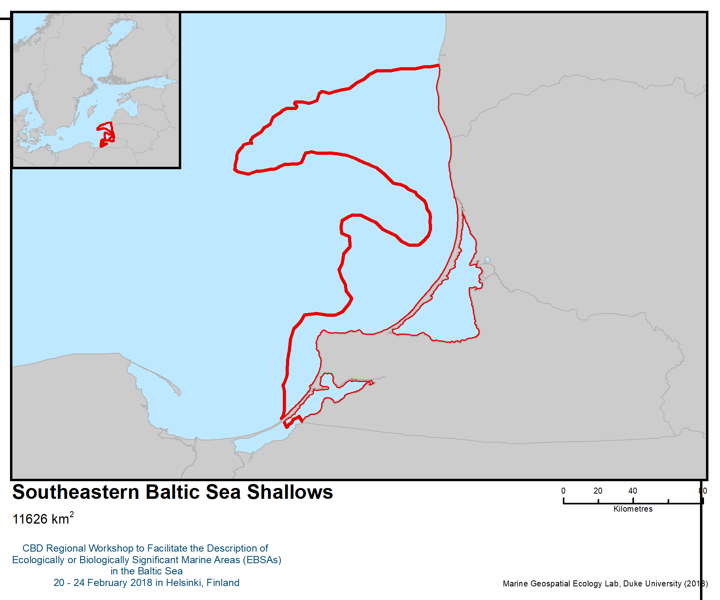

Figure 1. Location of the area

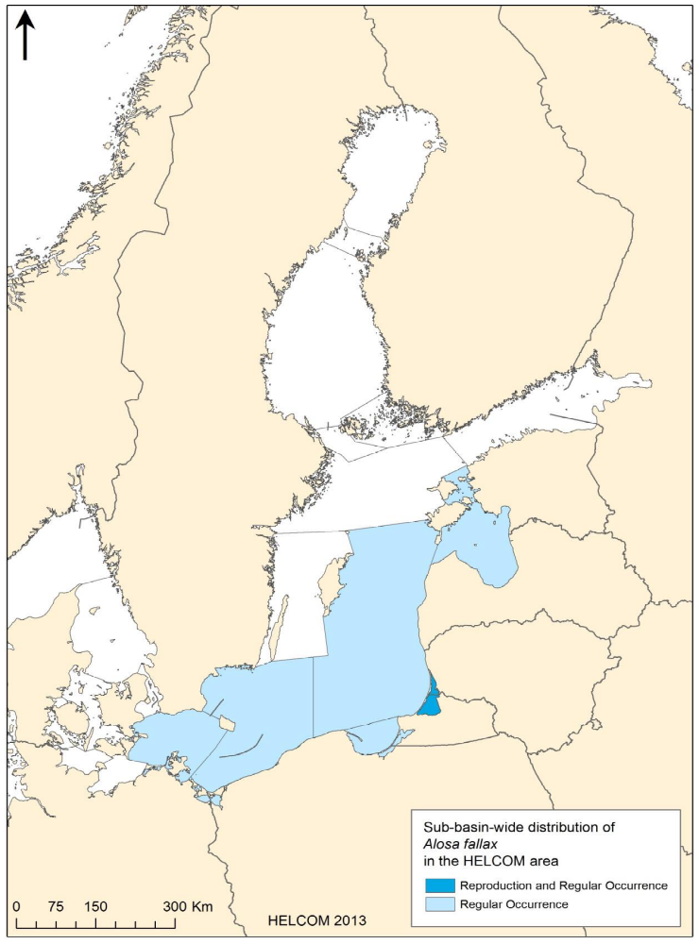
Figure 2. Distribution map of twait shad (Alosa fallax). The map shows the sub-basins in the HELCOM area where the species is known to occur regularly (HELCOM 2012)

Area No. 7: Southern Gotland Harbour Porpoise Area

Abstract

The area covers the core distribution area of the critically endangered harbour porpoise (Phocoena phocoena) subpopulation in the Baltic Sea around the islands of Öland and Gotland, which serves as a key breeding area for the population. Midsjöbankarna and Hoburg’s Bank is the most important area for the Baltic harbour porpoise. The population was estimated at 497 individuals, which represents a drastic decline since the mid-20th century. The area is also home to the vulnerable Kalmarsund subpopulation of the harbour seal (Phoca vitulina vitulina) and is the main wintering area for the endangered long-tailed duck (Clangula hyemalis). The area comprises a variety of geologic and morphologic features, and contains three of the four large offshore banks in the Baltic Sea, which form a unique high-energy environment. These shallow areas create conditions for high productivity of filter-feeding animals that form the food base for flatfish and many wintering birds.

Introduction
Studies of the harbour porpoise (Phocoena phocoena) in the Baltic region by Wiemann et al. (2010), Galatius et al. (2012) and Sveegaard et al. (2015) and data on harbour porpoise population structure in the framework of the SAMBAH project (SAMBAH, 2016a) all indicate one separate population of harbour porpoises in the east of the Baltic Sea. The Baltic harbour porpoise population was estimated at only 497 individuals (95% CI 80 – 1091). Since the mid-20th century, its numbers have declined drastically. The population’s status calls for immediate conservation actions (ASCOBANS, 2016).

The population is currently listed as critically endangered on The IUCN Red List of Threatened Species (Hammond et al. 2016) and the HELCOM Red List. The harbour porpoise is listed in Appendix II of CITES and listed in Annex II and IV of the EU Habitats Directive. The harbour porpoise is part of the “Agreement on the Conservation of Small Cetaceans of the Baltic, North East Atlantic, Irish and North Seas (ASCOBANS)” under the Bonn Convention and with special focus on the Baltic population with the Jastarnia Plan (ASCOBANS, 2016).

The SAMBAH project indicates that an area south of Gotland, including the shallow banks, Hoburg’s Bank, the Northern Midsea Bank and the Southern Midsea Bank supports the main summer distribution from May to October of the Baltic harbour porpoise population and serves as a key breeding area for the population (SAMBAH, 2016a) (Figure 2).

The harbour porpoise is present in the Hanö Bay and the area south of Öland all year round. In the winter this is a high-density area for harbour porpoises in general as well as the Baltic subpopulation (Sveegaard et al. 2015; SAMBAH, 2016a).

The area is also a very important wintering area for the long-tailed duck (Clangula hyemalis) in the Baltic region (Skov et al. 2011, Figure 3). Birds travelling from western Siberia use these waters and foraging grounds between October and May (HELCOM Red List Bird Expert Group 2013). The shallow bank in this area is also used during the winter by the black guillemot (Cepphus grille). The razorbill (Alca torda) and the common murre (Uria aalge) breed on Karlsö Islands (BirdLife International 2018d). The coastal area of Eastern Gotland holds a globally important number of common eiders (Somateria mollissima) during the breeding season. Other species occurring here during the breeding period are the little tern (Sternula albifrons) and the Caspian tern (Hydroprogne caspia) (BirdLife International 2018c).

There is a common occurrence of the grey seal (Halichoerus grypus) in the area, and it is home to the vulnerable Kalmarsund subpopulation of the harbour seal (Phoca vitulina vitulina) (HELCOM, 2013b). The Kalmarsund population is genetically different from the rest of the Baltic harbour seal population, and the number of mature individuals was estimated at 425, with a very restricted area of occupancy (Stanely et al. 1996; HELCOM, 2103).

The area includes eight Important Bird and Biodiversity Areas, a number of Swedish Natura 2000 sites as well as HELCOM MPAs.

Location
The area is located between the coast and the islands of Gotland and Öland, stretching to the south to include three of the four large offshore banks in the Baltic Sea (lattitude between 58.1 N and 55.4 N, longitude between 14.68 E and 19.55 E). Its total area is 29 242 km².

Feature description of the area
The area contains three of the four large offshore banks in the Baltic Sea

Midsjöbankarna and Hoburg’s Bank is the most important area for the Baltic harbour porpoise. The area supports the main summer distribution of the population from May to October and serves as key area for mating and calving (SAMBAH, 2016a; Carlström, 2016). These banks form a unique high-energy environment, dominated by mobile sediment (Naturvårdsverket 2006). In shallow areas, the strong water motion creates conditions for high productivity of filter-feeding animals that form the food base for flatfish and large numbers of wintering seabirds (Naturvårdsverket 2006, 2010). This area is especially important for the endangered long-tailed duck (Clangula hyemalis) (Skov 2011). The banks are also an important spawning area for turbot (Scophthalmus maximus) and juvenile habitat for cod (Gadus morhua) (Bergström et al. 2011, 2016).

The banks are situated off the coast and less impacted by local pollution and sediment loads from land than shallow coastal areas. The photic zone is markedly deeper than in coastal areas, with algal habitats found at exceptional depths (> 30 m depth; Naturvårdsverket 2006).

The coastal areas represent a wide variety of geology and coastal morphology (Snoeijis-Leijonmalm et al. 2017). The large islands of Öland and Gotland are mainly formed by Cambro-Silurian limestone rock, forming either a klint coast (coastal escarpment) or an open, low coast with a limestone platform extending into the sea. The mainland has an archipelago coast, formed by moraine or primary crystalline rock. In the Hanö Bay and the area south of Öland, bottom substrates vary from clay and moraine to rocks, and the depth ranges from 20 to about 60 metres. The harbour porpoise is present in the Hanö Bay all year round (Carlström, 2016).

The archipelago coast forms a varied environment with large shallow areas and high productivity of benthic vegetation and phytoplankton that sustain rich communities of fish and birds, and populations of grey and harbour seal. There are many shallow bays and inlets with limited water exchange with the open Baltic Sea, and their resulting early warm-up in spring makes them important reproduction areas for many species, including pike (Esox lucius), perch (Perca fluviatilis), pikeperch (Sander fluviatilis) and roach (Rutilus rutilus) (Snickars et al. 2009, Sundblad et al. 2010, Kraufvelin et al. 2018). The bays also have diverse communities of vascular plants and charophytes that form an important habitat for many animal species (e.g., Hansen et al. 2008).

There are some relevant observations regarding indigenous and local knowledge from the coastal areas. The small-scale fishers from Ronneby and Karlshamn work in close proximity to the marine ecosystems and operate a fishery that is very important to the local communities (Mustonen 2018). Small-scale marine fishers are often defined in European terms by their gear and vessels, which are less than 12 or 15 metres in length, to distinguish them from the larger-scale trawlers and bigger operators.

The Ronneby and Karlshamn fishers harvest, for example, cod, northern pike, perch, Baltic herring, flounder and turbot. Some of the ILK observations from the fishers of Karlshamn (Mustonen 2018) document the impact of the trawling fleet on the coastal fish stocks. Fishers also feel that the grey seals have expanded in range. Rather than being victims of the times, a local fisher has innovated new, locally led sustainable fishery solutions to support fish markets and provide customers with a very fresh catch as opposed to fish imported from outside the region and overseas. The seal-friendly fishing gear alleviates the pressure from seals and provides new solutions that will allow the coastal small-scale fishers to continue their work.

Feature condition and future outlook of the area
Harbour porpoises mature sexually between the ages of three and four years, and females may produce as few as five viable calves during their lifetime (Lockyer and Kinze 2003). This rate of increase in a population is very low and therefore likewise the recovery rate, since harbour porpoises have a long reproduction cycle; also there is no time of the year where human activity does not represent a major risk of decline in the harbour porpoise population (Carlström et al., 2016). Major threats are bycatch in gillnets, catch in ghost nets, underwater noise from shipping and construction, and contamination from persistent organic pollutants and heavy metals (ASCOBANS, 2016).

Surveys of the wintering population of the long-tailed duck (Clangula hyemalis) in the Baltic Sea indicate that the species has undergone a precipitous decline there, from some 4,272,000 individuals in 1992-1993 to some 486,000 individuals in 2007-2009. This represents 65.3%, or an annual decline of 4.4%. On the Hoburgs Bank – Midsjö Banks alone, the numbers have declined from 1,007,000 to 361,300 (64%) (Skov et al. 2011).

The species is very sensitive to disturbance by ship traffic and is particularly at risk of colliding with offshore wind turbines and other obstacles (HELCOM Red List Bird Expert Group 2013). It is also
threatened with direct mortality from oil pollution and from drowning through entanglement in fishing nets.

The small-scale fishers of Ronneby and Karlshamn represent an important traditional fishery that has survived amidst larger industrialization of the fleet. They continue to harvest the marine resources within their carrying capacity. This in itself is a remarkable achievement and should constitute a model for other coastal fisheries. Further studies and partnerships are needed to fully gather ILK materials from the region but already the seal-friendly gear, focus on traditional small-scale activities and partnerships with new innovative approaches demonstrate the vitality of this marginal socio-ecological system.

Assessment of the area against CBD EBSA Criteria

CBD EBSA Criteria  (Annex I to decision IX/20) | Description  (Annex I to decision IX/20) | Ranking of criterion relevance  (please mark one column with an X)
CBD EBSA Criteria  (Annex I to decision IX/20) | Description  (Annex I to decision IX/20) | No information |  | Low |  |  | Medium |  | High
Uniqueness or rarity | Area contains either (i) unique (“the only one of its kind”), rare (occurs only in few locations) or endemic species, populations or communities, and/or (ii) unique, rare or distinct, habitats or ecosystems; and/or (iii) unique or unusual geomorphological or oceanographic features. |  |  |  |  |  |  |  | x
Explanation for ranking
The area is important for the morphologically and genetically (Galatius et al. 2012, Wiemann et al. 2010) unique population of Baltic Sea harbour porpoise.
Extensive studies of the harbour porpoise (Phocoena phocoena) in the Baltic region by Wiemann et al. (2010), Galatius et al. (2012) and Sveegaard et al. (2015) and data on harbour porpoise population structure in the framework of the SAMBAH project (SAMBAH, 2016a) all indicate a separate population of harbour porpoises in the east of the Baltic Sea. The SAMBAH project indicates that an area south of Gotland, including the shallow banks Hoburg’s Bank, The Northern Midsea Bank and the Southern Midsea Bank, supports the main summer distribution of the Baltic harbour porpoise population and serves as key breeding area for the population.
The area contains three of the four large offshore banks in the Baltic Sea. These form a unique high-energy environment, dominated by mobile sediment (Naturvårdsverket 2006). In shallow areas, the strong water motion creates conditions for high productivity of filter-feeding animals that form the food base for flatfish and many wintering seabirds (Naturvårdsverket 2006, 2010).

Special importance for life-history stages of species | Areas that are required for a population to survive and thrive. |  |  |  |  |  |  |  | x
Explanation for ranking
The Baltic harbour porpoise population has been estimated at only 497 individuals (95% CI 80 – 1091). The area supports the main distribution of the Baltic harbour porpoise population and serves as a key area for mating and calving (SAMBAH, 2016a).
This is a very important wintering area for the long-tailed duck (Clangula hyemalis), which is vulnerable in the Baltic region (>500 000 individuals) (Skov et al. 2011). Birds travelling from western Siberia congregate here between October and May (HELCOM Red List Bird Expert Group 2013), using these waters and foraging grounds.
The area is also used during the winter by the black guillemot (Cepphus grille) (least concern, with 2690 individuals) in the shallow bank. The razorbill (Alca torda) (near threatened, with 4000 breeding pairs) and the common murre (Uria aalge) (8000-9000 breeding pairs) breed on Karlsö Islands (BirdLife International 2018d).
The coastal area of Eastern Gotland holds globally important numbers of the near threatened common eiders (Somateria mollissima) during the breeding season (10,000 breeding pairs). Other species occurring here during the breeding period are the little tern (Sternula albifrons) and the (Caspian tern) Hydroprogne caspia (BirdLife International 2018c).
Importance for threatened, endangered or declining species and/or habitats | Area containing habitat for the survival and recovery of endangered, threatened, declining species or area with significant assemblages of such species. |  |  |  |  |  |  |  | x
Explanation for ranking
The area supports the main summer distribution (May-October) of the Baltic harbour porpoise population and serves as its key breeding area. The Baltic harbour porpoise population has been estimated at only 497 individuals (95% CI 80 – 1091) (SAMBAH, 2016a). In the winter the area is a high-density area for harbour porpoises in general as well as the Baltic subpopulation (Sveegaard et al. 2015; SAMBAH, 2016a).
The harbour porpoise is currently listed as critically endangered in The IUCN Red List of Threatened Species (Hammond et al. 2016) and the HELCOM Red List (HELCOM 2013a). It is also listed in Appendix II of CITES and listed in Annex II and IV of the EU Habitats Directive.
Harbour porpoise is part of the “Agreement on the Conservation of Small Cetaceans of the Baltic, North East Atlantic, Irish and North Seas (ASCOBANS)” under the Bonn Convention and with special focus on the Baltic population with the Jastarnia Plan (ASCOBANS, 2016).
The area holds the one of the largest concentrations of long-tailed duck (Clangula hyemalis) in the Baltic Sea, a species listed as vulnerable in the IUCN Red List and as endangered in the HELCOM Red List. Surveys of the wintering population in the Baltic sea indicate that the species has undergone a precipitous decline there, from some 4,272,000 individuals in 1992-1993 to some 1,486,000 individuals in 2007-2009. This represents a decline of 65.3%, or an annual decline of 4.4%. On the Hoburgs Bank – Midsjö Banks alone, the numbers have declined from 1,007,000 to 361,300 (64%) (Skov et al. 2011).
The site is also important for the near threatened common eider (Somateria mollissima), a species considered vulnerable (breeding population) and endangered (wintering population) in the Baltic (HELCOM Red List).
The Kalmarsund subpopulation of harbour seal (Phoca vitulina) is assessed as vulnerable (HELCOM Red List). The harbour seal is listed in Annex II and V of the EU Habitats Directive (EC 1992).
.
Vulnerability, fragility, sensitivity, or slow recovery | Areas that contain a relatively high proportion of sensitive habitats, biotopes or species that are functionally fragile (highly susceptible to degradation or depletion by human activity or by natural events) or with slow recovery. |  |  |  |  |  |  |  | x
Explanation for ranking
The Baltic harbour porpoise population has been estimated at only 497 individuals (95% CI 80 – 1091) (SAMBAH, 2016a). Harbour porpoises mature sexually between the ages of three and four years, and females may produce as few as five viable calves during their lifetime (Lockyer and Kinze 2003), which means that the rate of increase in a population is very low and therefore likewise the recovery rate. Since harbour porpoises have a long pregnancy and a long nursing period, they are inherently vulnerable to human activity (Carlström et al., 2016).
Biological productivity | Area containing species, populations or communities with comparatively higher natural biological productivity. |  |  |  |  |  | x
Explanation for ranking
The offshore banks form a unique high-energy environment, dominated by mobile sediment (Naturvårdsverket 2006). In shallow areas, the strong water motion creates conditions for high productivity of filter-feeding animals that form the food base for flatfish and many wintering seabirds (Naturvårdsverket 2006, 2010). The banks are also an important spawning area for turbot (Scophthalmus maximus) and juvenile habitat for cod (Gadus morhua) (Bergström et al. 2011, 2016).
The archipelago coast forms a varied environment with large shallow areas with high productivity of benthic vegetation and phytoplankton that sustain rich communities of fish and birds, and populations of grey and harbour seal. There are many shallow bays and inlets with limited water exchange with the open Baltic Sea, and their resulting early spring warm-up makes them important reproduction areas for many species, including pike (Esox lucius), perch (Perca fluviatilis), pikeperch (Sander fluviatilis) and roach (Rutilus rutilus) (Snickars et al. 2009, Sundblad et al. 2010, Kraufvelin et al. 2018). The bays also have diverse communities of vascular plants and charophytes that form important habitats for many animal species (e.g., Hansen et al. 2008).
Biological diversity | Area contains comparatively higher diversity of ecosystems, habitats, communities, or species, or has higher genetic diversity. |  |  |  |  |  | x
Explanation for ranking
The archipelago coast has a high diversity of benthic habitats, co-occurring on a small spatial scale. There are many shallow bays and inlets that have diverse communities of vascular plants and charophytes (Fyhr et al. 2015).
Naturalness | Area with a comparatively higher degree of naturalness as a result of the lack of or low level of human-induced disturbance or degradation. |  |  |  |  |  |  | x
Explanation for ranking
The naturalness varies between high in the coastal areas, with a low amount of human-induced disturbances, and low in the offshore areas, with heavy ship traffic. This is reflected in the Baltic Sea Pressure Index (Helcom 2017). The banks are situated off the coast and are less impacted by local pollution and sediment loads from land than shallow coastal areas.

References
ASCOBANS (2016). Recovery Plan for Baltic Harbour Porpoises - Jastarnia Plan, 2016 Revision.
Bellebaum, J., J. Kube, A. Schulz, H. Skov, & H. Wendeln. (2014). Decline of Long-tailed Duck Clangula hyemalis numbers in the Pomeranian Bay revealed by two different survey methods. Ornis Fennica 91:129–137.
Bergström, U., Bergström, L., Carlén, I. och Isaeus, M. 2011: GIS-baserade metoder för att kartlägga fiskars livsmiljöer i grunda havsområden. Naturvårdsverket report 6427 [in Swedish]
Bergström, U. et al. 2016: Report on distribution maps for different life-stages. Project report of the BONUS INSPIRE project.
BirdLife International (2018c) Important Bird Areas factsheet: Coastal area of Eastern Gotland. Dowloaded from: http://datazone.birdlife.org/site/factsheet/coastal-area-of-eastern-gotland-iba-sweden/details on 05/02/2018.
BirdLife International (2018a) Important Bird Areas factsheet: Southern Midsjö Bank. Downloaded from http://datazone.birdlife.org/site/factsheet/southern-midsj%C3%B6-bank-iba-sweden on 05/02/2018.
BirdLife International (2018b) Species factsheet: Clangula hyemalis. Downloaded from http://datazone.birdlife.org/species/factsheet/long-tailed-duck-clangula-hyemalis on 05/02/2018.
BirdLife International (2018c) Important Bird Areas factsheet: Karlsö Islands. Downloaded from
http://datazone.birdlife.org/site/factsheet/karls%C3%B6-islands-iba-sweden/details on 05/02/2018.
EC (1992): Council Directive 92/43/EEC of 21 May 1992 on the conservation of natural habitats and of wild fauna and flora. OJ L 206: 7–50.
Fyhr et al. 2015: Marine mapping and management scenarios in the Hanö Bight, Sweden. AquaBiota Report 2015:01
Carlström, J & Carlén, I. 2016. Skyddsvärda områden för tumlare i svenska vatten. AquaBiota Report 2016:04. 91 sid.
Galatius, A., Kinze, C.C., Teilmann, J., 2012. Population structure of harbour porpoises in the Baltic region: evidence of separation based on geometric morphometric comparisons. J. Mar. Biol. Assoc. U. K. 92, 1669–1676. https://doi.org/10.1017/S0025315412000513
Hammond, P.S., Bearzi, G., Bjørge, A., Forney, K.A., Karczmarski, L., Kasuya, T., Perrin, W.F., Scott, M.D., Wang, J.Y., Wells, R.S., Wilson, B., 2016. Phocoena phocoena (Baltic Sea subpopulation) (No. e. T17031A98831650), The IUCN Red List of Threatened Species 2016
Hansen, J. P., S. A. Wikström & L. Kautsky, 2008. Effects of water exchange and vegetation on the macroinvertebrate fauna composition of shallow land-uplift bays in the Baltic Sea. Estuarine, Coastal and Shelf Science 77: 535–547.
HELCOM (2017) First version of the State of the Baltic sea report – June 2017
HELCOM Red List Bird Expert Group (2013). Species Information Sheet: Clangula hyemalis (wintering). Downloaded from http://helcom.fi/Red%20List%20Species%20Information%20Sheet/HELCOM%20Red%20List%20Clangula%20hyemalis.pdf on 05/02/2018
HELCOM (2013a) Red List Marine Mammal Expert Group 2013. Species information sheet Phocoena phocoena. Downloaded from http://www.helcom.fi/Red%20List%20Species%20Information%20Sheet/HELCOM%20Red%20List%20Phocoena%20phocoena.pdf on 23/02/2018.
HELCOM (2013b) Red List Marine Mammal Expert Group 2013. Species information sheet Phoca vitulina vitulina. Downloaded from http://www.helcom.fi/Red%20List%20Species%20Information%20Sheet/HELCOM%20Red%20List%20Phoca%20vitulina%20vitulina.pdf on 23/02/2018.
HELCOM (2017a) Helcom core indicator report: Distribution of Baltic seals, p.12
Kraufvelin, P. et al. 2018: Essential coastal habitats for fish in the Baltic Sea. Estuarine, Coastal and Shelf Science: 14-30,
Lockyer, C., Kinze, C., 2003. Status, ecology and life history of harbour porpoise (Phocoena phocoena), in Danish waters, in: Harbour Porpoises in the North Atlantic, NAMMCO SCIENTIFIC PUBLICATIONS. pp. 143–175.
Mustonen, Tero. Thematic interviews with Karlshamn and Ronneby fishermen. February 2018. Notes available at Snowchange Cooperative. Interview conducted in Thorupstrand, Denmark 8.2.2018
Naturvårdsverket 2006: Inventering av marina naturtyper på utsjöbankar. Naturvårdsverket report 5576 [in Swedish]
Naturvårdsverket 2010: Undersökning av utsjöbankar. Inventering, modellering och naturvärdesbedömning. Naturvårdsverket report 6385 [in Swedish]
SAMBAH (2016) LIFE08 NAT/S/000261, Final Report Covering the project activities from 01/01/2010 to 30/09/2015.
Skov, H., S. Heinänen, R. Žydelis, J. Bellebaum, S. Bzoma, M. Dagys, J. Durinck, S. Garthe, G. Grishanov, M. Hario, J.J. Kieckbusch, J. Kube, A. Kuresoo, K. Larsson, L. Luigujõe, W. Meissner, H.W. Nehls, L. Nilsson, I.K. Petersen, M. Mikkola Roos, S. Pihl, N. Sonntag, A. Stock & A. Stipniece (2011). Waterbird populations and pressures in the Baltic Sea. TemaNord 550, 201 pp
Snickars, M., Sandström, A., Lappalainen, A., Mattila, J., Rosqvist, K. & Urho, L. (2009) Fish assemblages in coastal lagoons in land-uplift succession: the relative importance of local and regional environmental gradients. Estuarine, Coastal and Shelf Science, 81, 247–256.
Snoeijis-Leijonmalm, P., Schubert, H. & Radziejewska, T. (eds.) 2017. Biological Oceanography of the Baltic Sea. Springer, Dordrecht, NL.
Sundblad, G., U. Bergström, and A. Sandström 2010. Ecological Coherence of Marine Protected Area Networks: A Spatial Assessment Using Species Distribution Models. Journal of Applied Ecology 48: 112–20.
Sveegaard, S., Galatius, A., Dietz, R., Kyhn, L., Koblitz, J.C., Amundin, M., Nabe-Nielsen, J., Sinding, M.-H.S., Andersen, L.W., Teilmann, J., 2015. Defining management units for cetaceans by combining genetics, morphology, acoustics and satellite tracking. Glob. Ecol. Conserv. 3, 839–850.
Wiemann, A., Andersen, L., Berggren, P., Siebert, U., Benke, H., Teilmann, J., Lockyer, C., Pawliczka, I., Skóra, K., Roos, A., Lyrholm, T., Paulus, K., Ketmaier, V., Tiedemann, R., 2010. Mitochondrial Control Region and microsatellite analyses on harbour porpoise (Phocoena phocoena) unravel population differentiation in the Baltic Sea and adjacent waters. Conserv. Genet. 11, 195–211.

Maps and Figures

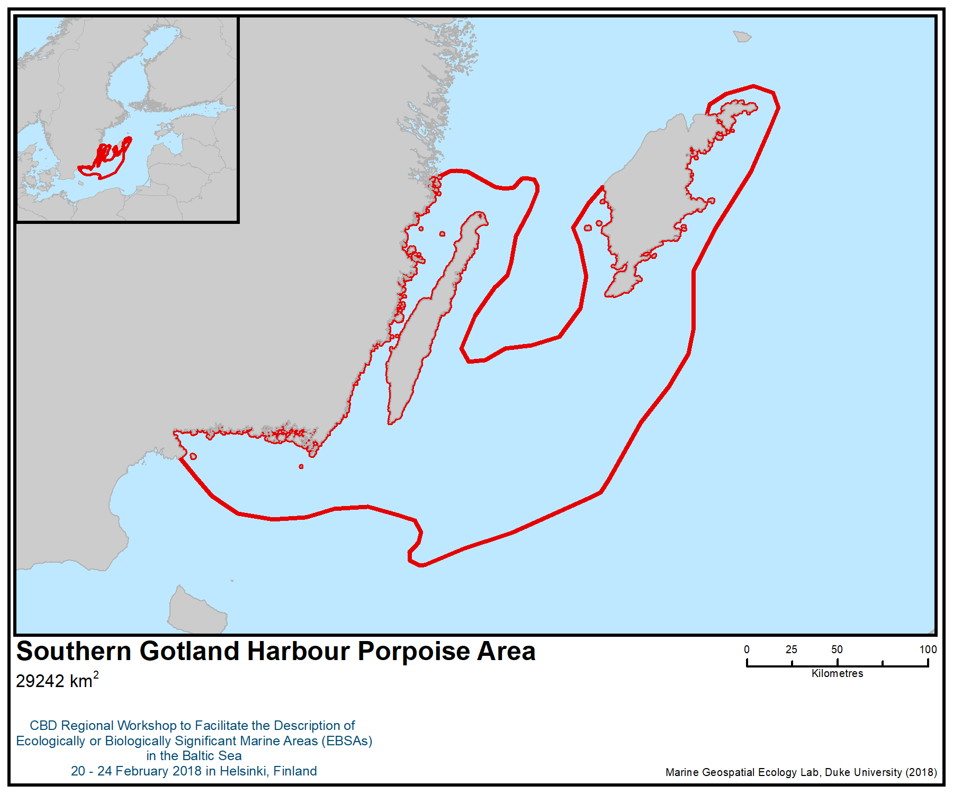
Figure 1. Location of the area

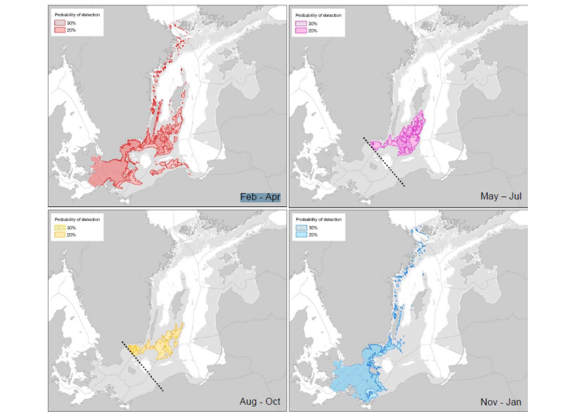Figure 2. High-density areas for harbour porpoises in the SAMBAH area (shaded) based on predictions of probability of detection (SAMBAH 2016)

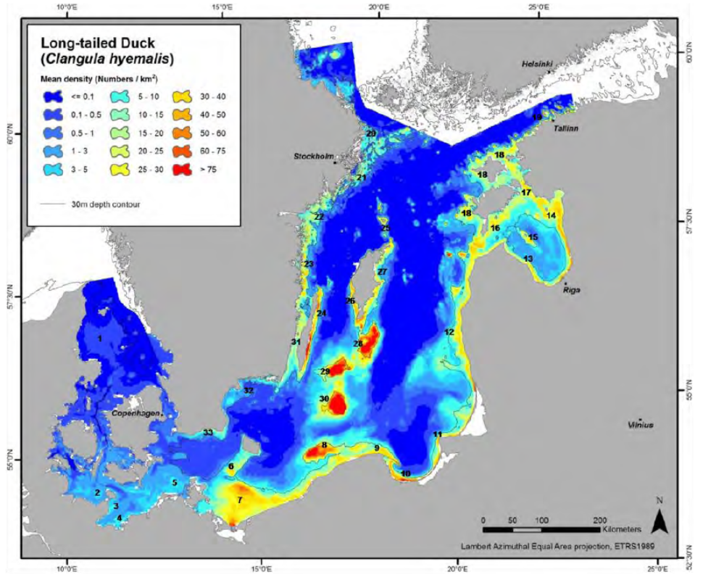
Figure 3. Distribution and density of wintering long-tailed duck (Clangula hyemalis) in the Baltic Sea, 2007–2009 (Skov 2011)

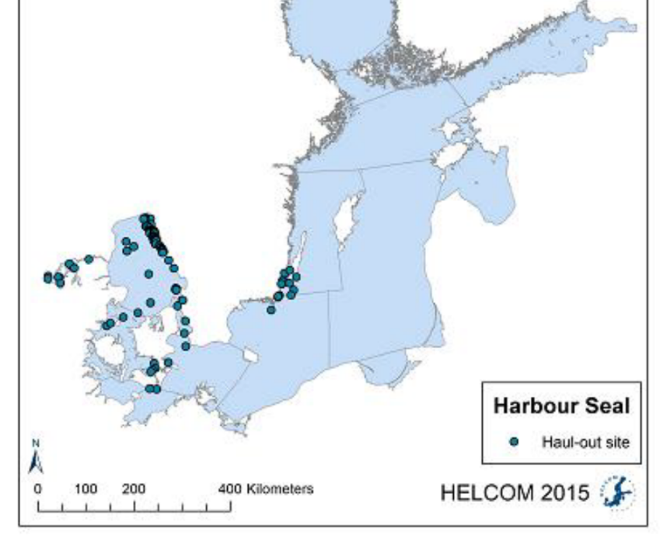

Figure 4. Haul-out sites of Baltic harbour seals (HELCOM 2017a)

Area No. 8: Fehmarn Belt

Abstract
The Fehmarn Belt is situated between Kiel Bay and the Bay of Mecklenburg and is the main pathway of water exchange between the Baltic Sea and the Atlantic Ocean, carrying 70-75 per cent of the water masses. The area is also important for migratory aquatic species, such as the western population of the harbour porpoise. It is also of high regional importance for wintering and migratory waterfowl. The combination of permanent exposure to saline waters and the complexity of bottom structures leads to a complex mosaic of benthic biotopes inhabited by a variety of species-rich communities. Besides the presence of several endangered and protected habitats and benthic species, it is regionally important for one critically endangered biotope dominated by the ocean quahog, one of the longest-lived species in the world.

Introduction
The water exchange between the Baltic Sea and the Atlantic Ocean via Skagerrak and Kattegat is hindered by the narrow belts and sounds as well as by shallow sills such as Darss sill and Drodgen sill. One of the main pathways of water exchange, carrying 70-75 per cent of the water masses (Leppäranta & Myrberg, 2009) leading from the Great and Small Belt into the Arkona basin and into the Baltic proper, passes the 18 km-wide strait called the “Fehmarn Belt”. The area is also important for migratory aquatic species such as the western population of the harbour porpoise (BfN 2008).

In this area, just as in the wider western Baltic Sea area, the seafloor is built up of Pleistocene deposits, mainly glacial till, composed of a grain-size spectrum ranging from clay to boulders (Schwarzer et al. 2014). Abrasion of submarine platforms results in erosion and export of fine fractions and the formation of lag deposits ranging from gravel to boulders. Melting water and rivers subsequently form a complex structure of narrow channels, small ridges and steep slopes down to 40 m water depths (Schwarzer & Diesing 2006). The combination of permanent exposure to saline waters (15 – 25 PSU) and complexity of bottom-structures leads to a complex mosaic of benthic biotopes inhabited by a variety of species-rich communities (Zettler & Gosselck 2006).

As a consequence of the geomorphological structures, which include large shallow areas, the area is also of special importance to wintering birds (BirdLife International 2018). In particular, the shallow areas around the island of Fehmarn (Hohwachter Bucht) and the Sagasbank, which feature large sandy areas and boulder fields densely covered by macrophytes and blue mussels, provide important food sources for the common eider (Somateria mollissima) and other waterfowl. Due to the narrowness of the strait, the Fehmarn Belt provides the shortest distance between Scandinavia and the European mainland. Consequently, many northern bird populations fly over this most important migratory route during their biannual migration in autumn and spring (Koop 2004, Fließbach & Garthe 2018).

The importance of the area has been highlighted by the designation of several HELCOM marine protected areas, including “Küstenlandschaft Bottsand - Marzkamp u. vorgelagerte Flachgründe, Östlichen Kieler Bucht” and “Staberhuk, Großenbrode Meeresbereiche, Wagrien, Sagas-Bank (HELCOM 2018a).

In addition to its importance for the above-mentioned ecosystem components, the area is assumed to be of regional importance for other trophic levels of the Baltic food-web, including cod, the western population of herring and other coastal fish species (Kraufvelin et al. 2018). This assumption is supported by the presence of a traditional community of small-scale coastal fishers in this area. However, the experts at the regional workshop were not able to fully verify this assumption with scientific data. Consequently, the importance of fish species, fish communities and pelagic communities was not considered in the ranking of assessment criteria.

Location
The area covers 1652 km² in the south-western part of the Baltic Sea in the HELCOM sub-basins Kiel Bay and Bay of Mecklenburg.

Feature description of the area

Physical description
Fehmarn Belt and adjacent areas cover a unique combination of geomorphological structures formed during the last glaciation period and subsequent processes driven by isostatic land raising and dynamic erosion and sedimentation processes. As a consequence of the orientation of the shoreline in relation to the predominant wind and wave direction, the coastline is characterized by accretion zones, including spits, subsequently separating shallow bays from the sea and forming lagoons. (FEMERN A/S 2013). Along more exposed parts of the shore, active cliffs provide stones and boulders as hard substrate from the shoreline down to 20 m or below (e.g., Staberhuk). The seafloor is built up of Pleistocene deposits, mainly glacial till, composed of a grain-size spectrum ranging from clay to boulders (Schwarzer et al. 2014). Abrasion of submarine platforms results in erosion and export of fine fractions and the formation of lag deposits ranging from gravel to boulders. Melting water and rivers subsequently form a complex structure of narrow channels, small ridges and steep slopes down to 40 m water depths (Schwarzer & Diesing 2006, FEHMERN A/S 2013, Fig. 3). Lateral sediment transport features the development of submarine sand-dunes. These “mega ripples” fields consist of sand waves with a height of up to 2-3 m, mainly consisting of medium and coarse sand (Feldens et al. 2015). In the valleys of the sand waves, lag sediment characterises the sediment structures, including clay, gravel and small stones.

Fine sand is mainly transported to sheltered areas, forming large shallow sandy grounds and is missing in the deeper part of the Fehmarn Belt. In contrast, silt and organic mud accumulate in the deeper parts of the deep channels as well as in the transition zone to Kiel Bay in the western part and to Bay of Mecklenburg in the eastern part of the area (Tauber 2012).

Biological Description
Benthic biotope and species diversity
The geomorphological structure, with its complex mosaic of different sediments, in combination with the permanent high supply of oxygen-rich saline waters in the deeper part of the area, as well as significantly lower salinities in the shallower parts of the area, are the basis for the presence of a highly diverse mosaic of biotope types and biotope complexes, including protected habitats (EU Habitats Directive) such as sandbanks (habitat type 1110, according to EU Habitats Directive, Annex I), mudflats (habitat type1140), shallow inlets and bays (habitat type 1160) and reefs (habitat type1170) (EC 1992).

The shallow, sheltered area features large macrophyte meadows dominated by eelgrass, charophytes or other vascular plant species (Schubert et al. 2015, FEMERN A/S 2013). Those areas are highly productive biodiversity hotspots and important spawning and nursery grounds for coastal fish species. In more exposed areas of the shallow coastal zone, different grain-sized sands and gravels provide substrate for different endobenthic communities. Smaller stones and boulders are covered by macroalgae, including foliose red algae (e.g., Delesseria sanguinea, Phycodrys) and kelp (Saccharina latissima). Those boulder-reefs (habitat type 1170) form complex habitat structures with high biodiversity and high biomass, including large beds of blue mussels (FEMERN A/S 2013). Along the depth gradient, both endobenthic and epibenthic communities change rapidly in depth from 15 to 20 m due to the decrease in light availability and a significant increase in salinity below the halocline. The macrophyte-dominated communities on the boulders are subsequently replaced by communities dominated by sponges, ascidians, bryozoans or other epibenthic invertebrate taxa, providing habitats for a variety of associated mobile species (Beisiegel et al. 2017).

While the species diversity of epibenthic communities on hard substrates generally decreases with increasing depth due to the absence of macrophytes as habitat-forming species, the species richness of endobenthic communities below the halocline is much higher than above the halocline (FEMERN A/S 2013). Both marine and long-lived species such as Macoma calcarea (classified as vulnerable on the HELCOM Red List, HELCOM 2013a), Astarte spp., Mya truncata and Arctica islandica can frequently be found in locally high densities (Schiele & Darr 2018). The ocean quahog (A. islandica), which can live up to 70 years in this area (Zettler et al. 2001), is the most dominant species of the sandy and muddy substrates of the southwestern Baltic Sea. The highest biomass of this species within the western Baltic Sea was detected along the Fehmarnbelt and in adjacent waters (Darr et al. 2014). Consequently, the eastern part of the area is of special importance for the critically endangered biotope “Baltic aphotic muddy sediment dominated by the Ocean Quahog Arctica islandica”, which is regionally restricted to the western Baltic Sea and has been assessed to be critically endangered within the Baltic Sea due to the increase in frequency of long-lasting oxygen-depletion events (HELCOM 2013b). The areas with high Arctica biomass and the suitable sediment east of Fehmarnbelt represent the most valuable sites for this particular biotope without any significant degradation up to now (Schiele et al. 2015, Schiele & Darr 2018). Also, the adult specimen is among the most robust benthic invertebrates, surviving an oxygen-free period of up to 50 days (Oeschger 1990). The recovery is very slow once it disappears, as larval falls occur infrequently and both larvae as well as young bivalves are much more sensitive to oxygen depletion.

Overall, more than 400 benthic invertebrate species (IOW 2018) and about 80 macrophyte species (FEMERN A/S 2013) have been identified within this narrow area. Zettler et al. (2014) also stated that macroinvertebrate species richness in Kiel Bay and Mecklenburg Bay is higher than in the Belt Sea. In reefs and mixed substrates, up to 100 macroinvertebrate species can be identified per square metre (IOW, unpubl. data), indicating a significantly higher species diversity than in most parts of the Baltic Sea. An additional importance rises from the position of the area at the entrance of the Baltic Sea. It is considered an important stepping stone for the larval and genetic connection of many benthic species to support the populations in Mecklenburg Bay and Arkona basin. Moreover, as the populations in these basins are frequently threatened by seasonal oxygen depletion, the Fehmarn Belt also has to be considered to be of special importance as a refugium for rapid re-settlement after severe oxygen depletion events.

Wintering birds
Among these wintering birds, the common eider is of special importance for the described area. According to the BirdLife International database, around 140,000 individuals of this species winter around Fehmarn Island, making the area one of most important sites for this endangered species (BirdLife International 2018; HELCOM 2013a): “In the western part of the Baltic Sea, common eiders occur preferably in areas of a water depth between 5 and 15 m (Skov et al. 2011) and mostly above coarse sediments like gravel or stone. Such hard substrates offer good conditions for blue mussels, the major food source for common eiders. The total number wintering in the Baltic Sea has declined from 1.048.000 to 515.000 birds, equivalent to 51 % over 16 years (Skov et al. 2011). Since the beginning of the 1990s, a relocation of wintering birds has taken place. The importance of the north-western and south-western Kattegat declined dramatically, while numbers in the region between Fünen Island and Germany increased. This area is now the most important wintering site in the Baltic Sea” (Fig. 6).

Feature condition and future outlook of the area
Although important parts of the area have been designated as HELCOM marine protected areas, the area is under constant pressure from a variety of human activities (HELCOM 2018b). Not only migratory aquatic species, but also large vessels, heading for or coming from the Baltic harbours, frequently pass the Fehmarnbelt. Tourism plays an important role in the local economy of the surrounding area, locally adding pressure to the coastal and marine habitats (e.g., by leisure boats). Deeper areas are partly impacted by bottom-trawling, but also in this area eutrophication represents the major threat to habitat quality (HELCOM 2018b) of many sensitive and important biotopes, such as macrophyte meadows, aphotic reefs dominated by sponges as well as for muddy substrates in the deep basins and channels. However, despite the high pressure, the overall biodiversity of the area is still retained and subject to intense investigations and monitoring programmes on behalf of the EU Water Framework Directive, the Marine Strategy Framework Directive, the Habitats Directive and the Birds Directive.
Assessment of the area against CBD EBSA Criteria

CBD EBSA Criteria  (Annex I to decision IX/20) | Description  (Annex I to decision IX/20) | Ranking of criterion relevance  (please mark one column with an X)
CBD EBSA Criteria  (Annex I to decision IX/20) | Description  (Annex I to decision IX/20) | No information |  | Low |  |  | Medium |  | High
Uniqueness or rarity | Area contains either (i) unique (“the only one of its kind”), rare (occurs only in few locations) or endemic species, populations or communities, and/or (ii) unique, rare or distinct, habitats or ecosystems; and/or (iii) unique or unusual geomorphological or oceanographic features. |  |  |  |  |  |  |  | X
Explanation for ranking
The area is characterized by two unique oceanographic and geomorphological features amplifying its significant importance for the biodiversity of this region:
- As 70-75% of the water exchange between the Atlantic Ocean and the Baltic Sea passes through the Fehmarn Belt, the area plays an exceptional role in the supply of the Baltic Sea with saline and oxygen-rich water as well as in the genetic connectivity of populations of many aquatic species in the Baltic Sea.
- The area is characterized by Pleistocene deposits and covers a combination of rare geomorphological features such as submarine sand-dunes (Feldens et al. 2015) and an ancient post-glacial river bed (River Dana, FEMERN A/S 2013), forming both large shallow areas with mosaics of different substrate types, deep channels (max. 40m) and steep slopes in an area with permanent support of saline and oxygen-rich water masses supporting the presence of an exceptional number of biotopes within a comparatively small area.
Special importance for life-history stages of species | Areas that are required for a population to survive and thrive. |  |  |  |  |  |  |  | X
Explanation for ranking
The Fehmarn Belt is generally very important to migratory aquatic species (e.g., harbour porpoise and migratory fish) as well as to wintering birds (BirdLife International 2018). The ranking is justified by three features:
- The area is of special importance for the wintering populations of the common eider (Somateria mollissima). According to the BirdLife International database (BirdLife International 2018), around 140,000 out of 515,000 individuals (> 25%) of this species winter around Fehmarn Island, making the area one of most important sites for this endangered species (HELCOM 2013a).
- Individuals of the western subpopulation of the vulnerable harbour porpoise (HELCOM 2013a) regularly cross the Fehmarn Belt. The area shows a relatively high density of porpoises, many of which exhibit sensitive behaviour (e.g., resting). Additionally, calves have frequently been observed, indicating a reproductive or nursery area (Fig. 7). The estimated maximum harbour porpoise population in the Fehmarn Belt is 500 individuals (BfN 2008). Over the entire investigation time (2009 to 2010), between 90 and 100% porpoise positive days were registered (FTZ/DMM 2011).
Importance for threatened, endangered or declining species and/or habitats | Area containing habitat for the survival and recovery of endangered, threatened, declining species or area with significant assemblages of such species. |  |  |  |  |  |  |  | X
Explanation for ranking
- A variety of identified biotopes are listed in Annex I of the EU Habitats Directive (1110, 1140, 1160, 1170) and have been classified as regionally threatened, according to the HELCOM Red List (HELCOM 2013b). However, the area is of special importance for the critically endangered biotope “Baltic aphotic muddy sediment dominated by the Ocean Quahog Arctica islandica”, which is regionally restricted to the western Baltic Sea (HELCOM 2013b). The site incorporates the areas with highest biomass of A. islandica within the Baltic Sea (Darr et al. 2014), representing the most valuable sites for this particular biotope without any significant degradation (Schiele et al. 2015, Schiele & Darr 2018).
- The area is of special importance for the wintering population of the common eider (Somateria mollissima), classified as endangered in the Baltic Sea (HELCOM 2013a). According to the BirdLife International database, more than 25% of this species winters around Fehmarn Island, making the area one of most important sites for this endangered species (BirdLife International 2018; HELCOM 2013a).
- Additionally, several species classified as threatened in the Baltic Sea are present in regionally important populations in the area (e.g., Zostera noltii, Macoma calcarea, Cerastobyssum hauniense, FEMERN A/S 2013, Schiele & Darr 2018) or use this area for special stages of their life history (e.g., western population of harbour porpoise).
Vulnerability, fragility, sensitivity, or slow recovery | Areas that contain a relatively high proportion of sensitive habitats, biotopes or species that are functionally fragile (highly susceptible to degradation or depletion by human activity or by natural events) or with slow recovery. |  |  |  |  |  | X
Explanation for ranking
- While the majority of biotopes are well adapted to (natural) physical disturbance, and essential parts of the benthic communities are able to recover in less than 10 years, several important biotopes within these areas are sensitive to degradation, and full recovery is likely to exceed 10-20 years (Schiele & Darr 2018).
- Biotopes dominated by the ocean quahog (Arctica islandica), among the longest-living invertebrate species in the world. The adult specimens are highly tolerant against oxygen depletion, which is the most relevant threat in the area (Oeschger 1990). But once the population has declined, restoration is difficult due to (i) infrequent spawning events, which may fail for several years (Schiele & Darr 2018), (ii) due to long life cycle (Thompson et al. 1980) and (iii) due to higher sensitivity of young individuals to oxygen deficiency (Oeschger 1990).
Biological productivity | Area containing species, populations or communities with comparatively higher natural biological productivity. |  |  |  | X
Explanation for ranking
The site features a variety of highly productive biotopes, such as blue mussel banks, eelgrass meadows and other biotopes dominated by macrophytes. Also, Arctica-dominated biotopes in the western Baltic Sea were identified to be one of the soft-substrate biotopes with high benthic biomass (Gogina et al. 2016). However, the productivity of the area is not considered to be of special importance for the Baltic ecosystem as the area is comparatively small.
Biological diversity | Area contains comparatively higher diversity of ecosystems, habitats, communities, or species, or has higher genetic diversity. |  |  |  |  |  |  |  | X
Explanation for ranking
- Driven by the complex geomorphological structures and the permanent supply of highly saline waters, the benthic biotope diversity and species diversity of this area are exceptionally high. Overall, more than 400 benthic invertebrate species (IOW 2018) and about 80 macrophyte species (FEMERN A/S 2013) were identified within this narrow area. Zettler et al. (2014) also stated that the number of recorded macroinvertebrate species in Kiel Bay and Mecklenburg Bay is higher than in the Belt Sea as well as in eastern basins. Especially in areas with a small-scale mixture of sand, gravel, shells and small boulders, the number of macroinvertebrate species that can be identified per square metre can exceed 100 (IOW & AWI 2017), also indicating a significantly higher species diversity than in most parts of the Baltic Sea.
- Fostered by its position at the entrance of the Baltic Sea along the main pathway of freshwater inflow into the Baltic proper, the area is of high importance for regional biodiversity as the Fehmarn Belt populations of many invertebrate species are key stepping stones for the genetic exchange feeding the genetic diversity of the populations in Mecklenburg Bay and Arkona basin by larval supply. In addition, as the populations in these basins are more threatened by oxygen depletion, the Fehmarn Belt also serves as a refugium for re-settlement of areas impacted by oxygen depletion.
Naturalness | Area with a comparatively higher degree of naturalness as a result of the lack of or low level of human-induced disturbance or degradation. |  |  |  |  |  |  | X
Explanation for ranking
Although the HELCOM State of the Baltic Sea indicates high pressure in parts of the area by human activities such as bottom trawling and ship traffic as well as by eutrophication degrading the quality of the ecosystem components (HELCOM 2018), the overall characteristics of the area of high biotope diversity and species diversity are still maintained.

References
Beisiegel K, Darr A, Gogina M., Zettler ML (2017). Benefits and shortcomings of non-destructive benthic imagery for monitoring hard-bottom habitats. Mar. Poll. Bull. 121: 5-15,
doi: 10.1016/j.marpolbul.2017.04.009
BfN (2008) Erhaltungsziele für das FFH-Gebiet „Fehmarnbelt“ (DE 1332-301) in der deutschen AWZ der Ostsee. Bundesamt für Naturschutz, Stand Januar 2008. https://www.bfn.de/fileadmin/MDB/documents/themen/meeresundkuestenschutz/downloads/Erhaltungsziele/Erhaltungsziele_Fehmarnbelt_2009-03-06.pdf
BirdLife International (2018) Important Bird Areas factsheet: Sagasbank and eastern coast of Oldenburg. Downloaded from http://www.birdlife.org on 23/02/2018.
Darr A, Gogina M, Zettler ML (2014): Detecting hot-spots of bivalve biomass in the south-western Baltic. Journal of Marine Systems 134: 69-80
http://dx.doi.org/10.1016/j.jmarsys.2014.03.003
EC (1992): Council Directive 92/43/EEC of 21 May 1992 on the conservation of natural habitats and of wild fauna and flora. OJ L 206: 7–50.
Feldens P, Diesing M, Schwarzer K, HeinrichC, Schlenz B (2015) Occurrence of flow parallel and flow transverse bedforms in Fehmarn Belt SW Baltic Sea) related to the local palaeomorphology Geomorphology 231: 53-62
https://doi.org/10.1016/j.geomorph.2014.11.021
FEMERN A/S (2013) Feste Fehmarnbeltquerung - Planfeststellung – Anlage 15: Umweltverträglichkeitsstudie (UVS) Band II A. Presented by FEMERN A/S and Landesbetrieb Straßenbau und Verkehr Schleswig-Holstein Niederlassung Lübeck (01.10.2013); download from
https://femern.com/en/Tunnel/Milestones-for-the-project/Approval-process-in-Germany/The-German-plan-approval-procedure
Fließbach & Garthe (2018): Avifauna. In: IOW, IÖR, FTZ, ITAW & Biocnsult Schuchardt & Scholle Gbr: F+E-Vorhaben: „Fachbeitrag Naturschutz zur maritimen Raumordnung (FABENA, FKZ: 3515 82 0600)“ – unpublished final project report on behalf of the Bundesamt für Naturschutz (BfN) 98 p. + annexes.
FTZ/DMM (2011) Monitoringbericht 2009-2010. Marine Säugetiere und Seevögel in der deutschen AWZ von Nord- und Ostsee - Teilbericht marine Säugetiere. Im Auftrag des Bundesamtes für Naturschutz (BfN). Büsum, Oktober 2011.
Gogina M, Nygård H, Blomqvist M, Daunys D, Josefson AB, Kotta J, Maximov A, Warzocha J, Yermakov V, Gräwe U, Zettler ML (2016) The Baltic Sea scale inventory of benthic faunal communities. ICES Journal of Marine Science 73: 1196-1213. doi:10.1093/icesjms/fsv265HELCOM (2013a) HELCOM Red List of Baltic Sea Species in danger of becoming extinct. BSEP 140
HELCOM (2013b) HELCOM Red List of Baltic Sea biotopes and biotope complexes in danger of becoming extinct. BSEP 138
HELCOM (2018a) HELCOM Marine Protected Areas and HELCOM Map and Data Center. 2018-02-23
http://www.helcom.fi/action-areas/marine-protected-areas/
HELCOM (2018b) State of the Baltic Sea. Online Report available at www. http://stateofthebalticsea.helcom.fi/ last access 23.02.2018
IOW (2018): Database of the Benthic Ecology working group at the Leibniz Institute for Baltic Sea Research (IOW), 15.02.2018; contact Michael.zettler@io-warnemuende.de
IOW & AWI (2017) Zustand benthischer Arten und Biotope in der deutschen Ausschließlichen Wirtschaftszone von Nord‐ und Ostsee Untersuchungsjahr 2016. Report on behalf oft he Bundesamt für Naturschutz (BfN)
.
Kraufvelin P, Pekcan-Hekim Z, Bergstrom U, Florin A-B, Lehikoinen A, Mattila J, Arula T, Briekmane L, Brown EJ, Celmer Z, Dainys J, Jokinen H, Kaaria P, Kallasvuo M, Lappalainen A, Lozys L, Möller P, Orio A, Rohtla M, Saks L, Snickars M, Støttrup J, Sundblad G, Taal I, Ustups D, Verliin A, Vetemaa M, Winkler H, Wozniczka A, Olsson J (2018) Essential coastal habitats for fish in the Baltic Sea. Estuarine, Coastal and Shelf Science 204 14e30
Leppäranta M, Myrberg K (2009) Physical Oceanography of the Baltic Sea. Springer-Verlag Berlin Heidelberg 378 p. DOI 10.1007/978-3-540-79703-6
Oeschger R (1990). Long-term anaerobiosis in sublittoral marine invertebrates from the Western Baltic Sea: Halicryptus spinulosus (Priapulida), Astarte borealis and Arctica islandica (Bivalvia), Mar. Ecol. Progr. Ser. 59: 133-143
Schiele K & Darr A (2018) Benthische Wirbellose und Biotope der Ostsee. In: IOW, IÖR, FTZ, ITAW & Biocnsult Schuchardt & Scholle Gbr: F+E-Vorhaben: „Fachbeitrag Naturschutz zur maritimen Raumordnung (FABENA, FKZ: 3515 82 0600)“ – unpublished final project report on behalf of the Bundesamt für Naturschutz (BfN) 98 p. + annexes.
Schiele KS, Darr A, Zettler ML, Friedland R, Tauber F, von Weber M, Voss J (2015): Biotope map of the German Baltic Sea. Marine Pollution Bulletin 96: 127-135
doi.org/10.1016/j.marpolbul.2015.05.038
Schubert PR, Hukriede W, Karez R, Reusch TBH (2015). Mapping and modeling eelgrass Zostera marina distribution in the western Baltic Sea. Mar Ecol Pro Ser 522:79-95
DOI: https://doi.org/10.3354/meps11133
Schwarzer K, Bohling B, Heinrich Ch (2014) Submarine hard-bottom substrates in the western Baltic Sea – human impact versus natural development. J Coast Res 70: 1-6. DOI: 10.2112/SI70-025.1
Schwarzer K, Diesing M (2006) Erforschung der FFH-Lebensraumtypen Sandbank und Riff in der AWZ der deutschen Nord- und Ostsee. Scientific report on behalf of the Federal Agency for Nature Conservation FKZ-Nr. 802 85 270, 66 p.
https://www.bfn.de/fileadmin/MDB/documents/themen/meeresundkuestenschutz/downloads/Forschungsberichte/Sedimentverteilung_Nord-u-Ostsee_2006.pdf
Skov, H., S. Heinänen, R. Žydelis, J. Bellebaum, S. Bzoma, M. Dagys, J. Durinck, S. Garthe, G. Grishanov, M. Hario, J.J. Kieckbusch, J. Kube, A. Kuresoo, K. Larsson, L. Luigujõe, W. Meissner, H.W. Nehls, L. Nilsson, I.K. Petersen, M. Mikkola Roos, S. Pihl, N. Sonntag, A. Stock & A. Stipniece (2011): Waterbird populations and pressures in the Baltic Sea. TemaNord 550, 201 pp.
Tauber, F. (2012). Meeresbodenrelief in der deutschen Ostsee : Fehmarn, Karte Nr. 2942 = Seabed relief in the German Baltic Sea : Fehmarn, map No. 2942 [Map] 1 : 100 000, 54°N. Hamburg: Bundesamt für Seeschifffahrt und Hydrographie, ISBN 978-3-86987-390-9
Thompson I, Jones DS, Deribelbis D (1980) Annual internal growth banding and life history of the ocean quahog Arctica islandica (Mollusca: Bivalvia). Mar Biol 57:25–34
Zettler ML, Bönsch R, Gosselck F (2001): Distribution, abundance and some population characteristics of the ocean quahog, Arctica islandica (Linnaeus, 1767), in the Mecklenburg Bight (Baltic Sea). Journal of Shellfish Research 20: 161-169
https://www.io-warnemuende.de/tl_files/bio/ag-benthische-organismen/pdf/zettler_et_al-2001-arctica.pdf
Zettler ML, Gosselck F (2006) Benthic assessment of marine areas of particular ecological importance within the German Baltic Sea EEZ. In: Progress in Marine Conservation in Europe - NATURA 2000 sites in German offshore waters. H. von Nordheim, D. Boedeker, J.C. Krause (eds.), Springer, Berlin: 141-156
https://www.io-warnemuende.de/tl_files/bio/ag-benthische-organismen/pdf/zettler_und_gosselck-2006-natura.pdf
Zettler ML, Karlsson A, Kontula T, Gruszka P, Laine A, Herkül K, Schiele K, Maximov A, Haldin J (2014) Biodiversity gradient in the Baltic Sea: A comprehensive inventory of macrozoobenthos data. Helgoland Marine Research 68: 49-57
http://link.springer.com/article/10.1007%2Fs10152-013-0368-x
Maps and Figures

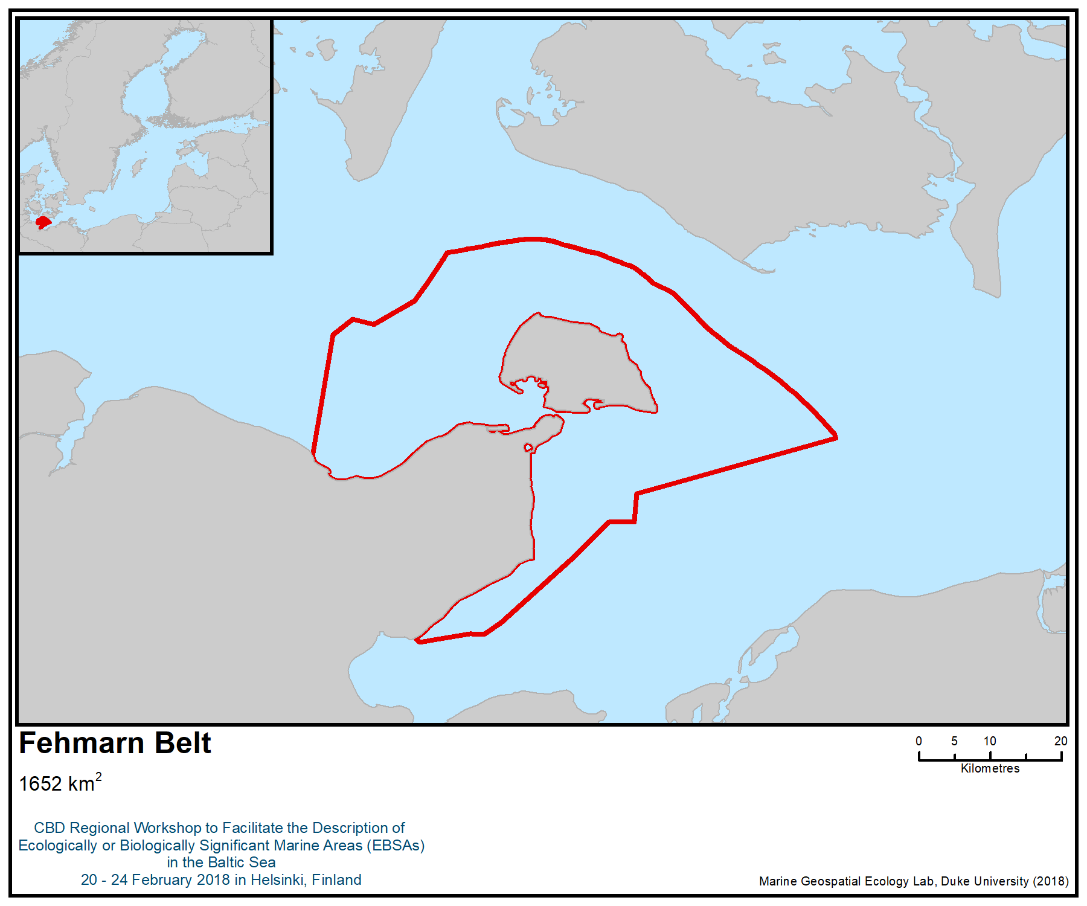
Figure 1. Location of the area

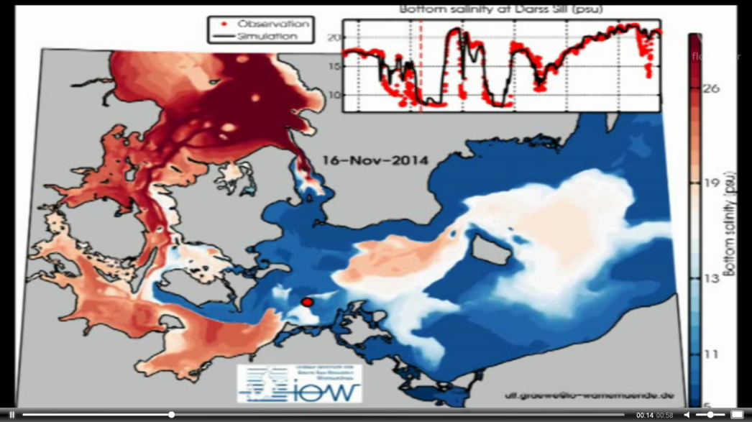
Figure 2. Snapshot of the salt-water inflow into the western Baltic Sea in November 2014 (taken from https://www.io-warnemuende.de/salzwassereinbruch-dezember-2014-computer-simulation.html)

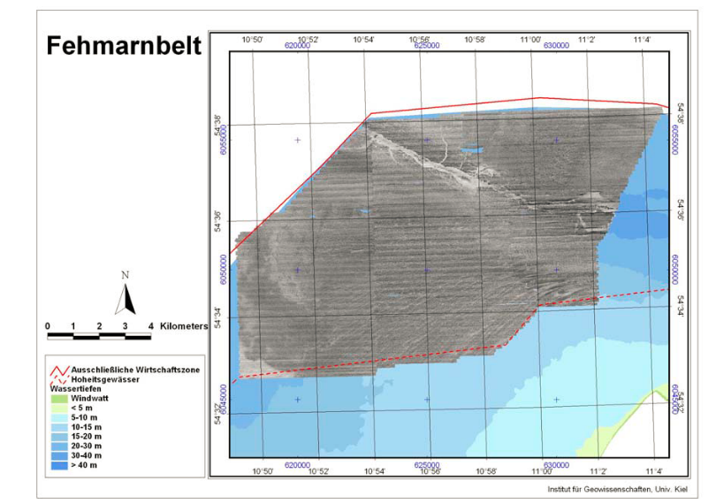
Figure 3. Sidescan sonar mosaic of parts of the Fehmarn Belt area in the German EEZ showing the distribution of meltwater channels and old river beds (taken from Schwarzer & Diesing 2006)

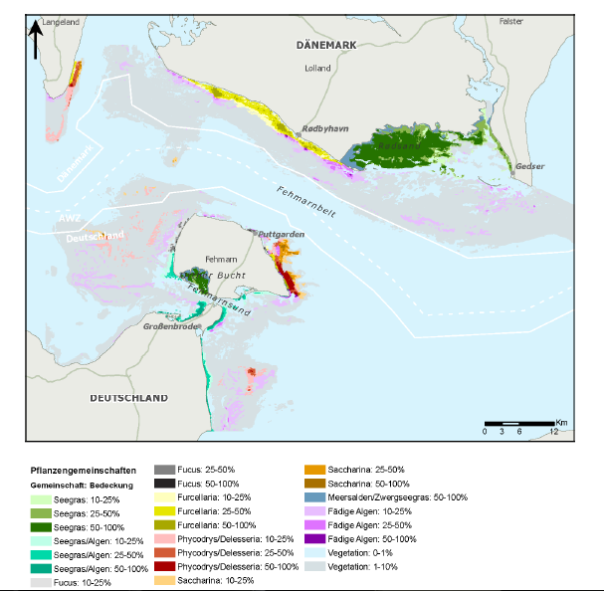
Figure 4. Occurrence of macrophyte-dominated communities in the Fehmarn Belt area (FEMERN A/S 2013) –Seegras: Zostera marina, Meersalden: Ruppia maritima, Zwergseegras: Zoster noltii, fädige Algen: filamentous algae, Vegetation: mixed vegetation in low density

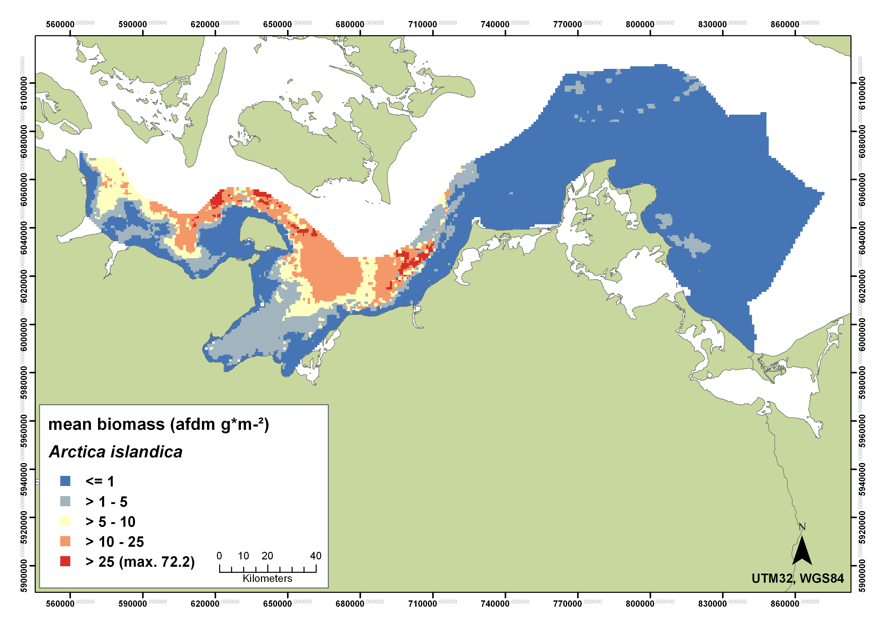
Figure 5. Modeled biomass distribution of Arctica islandica in the German part of the Baltic Sea (Darr et al. 2014)

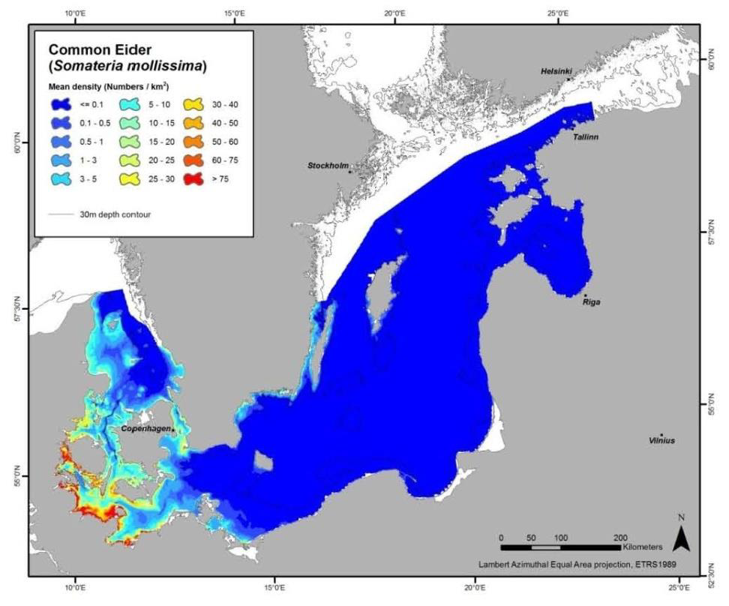
Figure 6. Modelled distribution of wintering population of the common eider (Skov et al. 2011 taken from HELCOM species fact sheet)

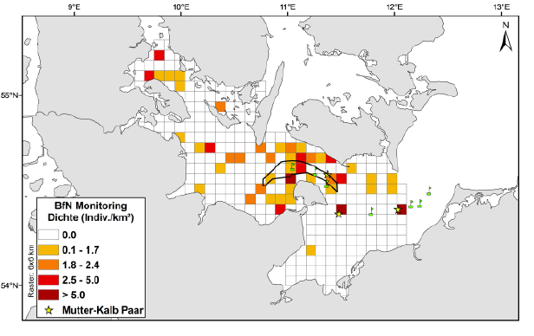
Figure 7. Results from harbour porpoise density monitoring (2009 – 2010, individuals per km², * indicate calve sightings)
Source: FTZ/DMM 2011.

Rights and permissions
Cited unpublished report written on behalf the German Federal Agency for Nature Conservation (BfN): contact Dieter Boedeker.

Area No. 9: Fladen and Stora and Lilla Middelgrund

Abstract
The Fladen and Stora and Lilla Middelgrund are three large offshore banks in the Kattegat. The banks are characterized by large topographic variation formed by boulders and rocks. The area also includes sandbanks and shell gravel, which increase its habitat diversity. The shallowest parts of the area are approximately 6 m deep and are densely covered by kelp forest, which is associated with a high diversity of fish and invertebrate species. Unique habitats like bubbling reefs and maerl beds occur in the area, as well as extensive horse mussel (Modiolus modiolus) beds. The area hosts a high diversity of fish, invertebrates and algae as well as a large quantity of rare and endangered species. The banks are of international importance for seabirds, and moreover, high densities of harbour porpoises have been recorded here. In addition, the area is important as spawning ground for a number of fish species.

Introduction
The offshore banks Fladen and Stora and Lilla Middelgrund are located in the Kattegat, approximately 20 km from the Swedish coast. The area is relatively far from the coast, resulting in a lower natural turbidity, higher water transparency, and less impact from freshwater outflow.

The general water current in Kattegat is the Baltic surface current going northwards, while the deeper water is going southwards. The water column is stratified, with salty deeper water (32-34 PSU) and more fresh surface water (approximately 20 PSU) (Wändahl and Bergstrand 1973). Due to favourable water exchange, the bottom substrate is free of sediment, and the oxygen conditions are good. The banks are characterized by large topographic variation created by boulders and rocks. The area also includes sandbanks and coarse gravel, including shell gravel. The shallowest parts of the area are approximately 6 m deep, and the photic zone extends down to 30 m.

The banks are designated as Natura 2000 areas containing the following habitat types: reefs (1170), sandbanks (1110) and submarine structures made of leaking gases, “bubbling reefs” (H1180) Habitats Directive (EC, 1992) , and has a high diversity of fish, invertebrates, and algae as well as a large quantity of rare and endangered species.

The banks were inventoried in terms of geology, benthic species and fish in the Swedish offshore bank survey (Naturvårdsverket 2006, 2010). In addition, regional inventory and modelling studies of benthic invertebrate species, macroalgae and fish have been conducted on the banks and in the surrounding areas (Karlsson 1997, Fredriksson et al. 2010, Länsstyrelsen 2016a, 2016b).

Location
The area is located approximately between latitudes 56º30’N and 57º14’N and longitudes between 11º40’E and 12º0’E), and encompasses the central part of the Kattegat, a shallow sea area between Sweden and Denmark. The total coverage of the area is 615 km².

Feature description of the area
The area includes a wide variety of substrate types, including rocks, boulders, sandbanks, sand and shell gravel, giving rise to a high diversity of habitats and biotopes (Naturvårdsverket 2006). Part of the area is dominated by dense kelp forests, which form three-dimensional structures with an association of diverse fauna and flora. In deeper areas, diverse red algae communities dominate down to approximately 15 m depth and are replaced in deeper areas with a zone constituted of soft coral (Alcyonium digitatum), anemone (Metridium sp.) and hydroids (Nilsson and Gustafsson 2001). At Lilla och Stora Middelgrund there are large areas of sediment-free shell gravel, which is a unique biotope for the offshore banks in Kattegat (Naturvårdsverket 2006). The bottom substrate on soft sediments is often a mix of sand gravel and shell gravel, which facilitate the burrowing of fauna. The fauna is primarily dominated by filter-feeding mussels, sea stars, brittle stars and polychaetes. The high proportion of filter-feeding organisms is a sign of high water exchange and low sedimentation in the area (Naturvårdsverket 2006).

The high abundance of maerl (Phymatolithon calcareum, coralline encrusting red algae) on Lilla Middelgrund and Fladen is unique for Kattegat (Naturvårdsverket 2006). Maerl beds are structurally and functionally complex perennial habitats that support high species diversity (Barbera et al. 2003). Animals associated with maerl beds in Kattegat include rare crustaceans, such as Corystes cassivelaunus and Thia scutellata, and echinoderms, such as Ophiothrix fragilis and Ophiocomina nigra (OCEANA 2011). The biotope is very rare and is known from fewer than 20 sites within a 20 000 km² area in the Kattegat (HELCOM Red List Expert Group 2013a). The biotope is classified as endangered on the HELCOM biotope red list (HELCOM 2013a).

The unique Kattegat bubbling reefs occur on Fladen (Naturvårdsverket 2006). Bubbling reefs are underwater lime structures created by methane gas and hydrogen sulphide released from the sediment (HELCOM Red List Expert Group 2013b). The reefs have a rich fauna of fish and invertebrate species. The biotope is classified as endangered on the HELCOM biotope red list since it is very rare (HELCOM 2013a).

The rare and threatened reef-building Haploops tubicola has two of its few known Baltic Sea occurences on Fladen and Lilla Middelgrund (Naturvårdsverket 2006, Göransson 2017). Haploops reefs have decreased significantly since the 1960s, when the biotope is believed to have occurred abundantly at depths greater than 15 metres in the south-eastern Kattegat, from Landskrona to Helginborg and the northernmost Öresund (Göransson et al. 2010). Haploops tubicola is now encountered only in a few sites (Göransson et al. 2010, HELCOM Red List Expert Group 2013c) and is classified as endangered on the HELCOM Red List (HELCOM 2013b).

Extensive beds of horse mussel (Modiolus modiolus) are found at Lilla and Stora Middelgrund (Naturvårdsverket 2010). The long-lived horse mussel has declined in coastal waters probably due intolerance to increased anthropogenic pressure (i.e., increased sedimentation and eutrophication) and the species is on the HELCOM Red List (HELCOM 2013b).

The offshore banks host a high diversity and abundance of fish species. For example, a total 55 fish species have been observed at Fladen (Naturvårdsverket 2010). The most common species include cod (Gadus morhua), goldsinny wrasse (Ctenolabrus rupestris), poor cod (Trisopterus minutus) sole (Solea solea) and dab (Limanda limanda). The area is an important habitat for sole (Solea solea) and dab (Limanda limanda) (Fredriksson et al. 2010). At Fladen, in particular, the fish species richness is high, and rare species, such as leopard-spotted goby (Thorogobius ephippiatus) and spotted dragonet (Callionymus maculatus), have been observed. Several species that are red listed according to HELCOM occur in the area, including eel (Anguilla anguilla) (critically endangered), Atlantic catfish (Anarhichas lupus) (endangered), ling (Molva molva) (endangered), cod (Gadus morhua) (vulnerable), haddock (Melanogrammus aeglefinus) (near threatened), whiting (Merlangius merlangus) (vulnerable), spiny dogfish (Squalus acanthias) (critically endangered) and European eelpout (Zoarces viviparus) (near threatened) (HELCOM 2013b).

The species diversity of invertebrates is especially high at Fladen (439 species), but it is also very high at Lilla Middelgrund (374 species), and at Stora Middelgrund, with more than 300 species (Naturvårdsverket 2006). Many species of sea stars occur in the area, for example Asterias rubens, Asteropecten irregularis, Henricia sanguinolenta, Leptasterias mülleri, Luidia sarsi, Marthasterias glacialis and Solaster endeca. Many burrowing crustaceans occur in the area, for example, ghost shrimp (Callianassa subterranae) and burrowing shrimp (Calocaris macandreae), and the crab species Corystes cassivelaunus and Thia scutellata. Examples of rare species include sea cucumber (Echinocyamus pusillus), mud shrimp (Upogebia stellate), isopod (Natatolana borealis), the crab Atelecyclus rotundatus, and the commensal pea crab (Pinnotheres pisum) (living inside Modiolus modiolus). The only record in Kattegat of the peculiar Xenoturbella sp. (Naturvårdsverket 2006) occurred on the soft sediments outside the banks. A number of red-listed invertebrate species occur in the area, including the vulnerable Haploops tubicola, Modiolus modiolus, Solaster endeca, Hippasteria phrygiana and the near-threatened Corystes cassivelaunus (Naturvårdsverket 2006, HELCOM 2013b).

The diversity of macroalgae is high, with 134 species recorded on Fladen, which is considerably higher than the diversity of the coastal area of Kattegat (Karlsson 1997). The algal communities are dominated by red algae, such as Phycodrys rubens, Phyllophora pseudoceranoides, Coccotylus truncata and Delesseria sanguinea, with occurrence of a number of very rare species, such as Tsengia bairdii and Cryptopleura ramosa.

The Lilla Middelgrund is a very important wintering area for seabirds in the Baltic Sea, including the black-legged kittiwake (Rissa tridactyla) (BirdLife International 2018a, 2018b, Durinck et al. 1994). The black-legged kittiwake has been listed as vulnerable because of the depletion of food resources (e.g., through over-fishing; Frederiksen et al. 2004, Nikolaeva et al. 2006), marine oil spills (del Hoyo et al. 1996, Nikolaeva et al. 2006) and chronic oil pollution (Nikolaeva et al. 2006). The breeding population is classified as endangered on the HELCOM Red List, and the winter population is considered vulnerable in the Baltic area (HELCOM Red List Expert Group 2013d). This is a migratory and highly pelagic seabird species; in the Baltic Sea, and in particular the Lilla Middelgrund area, it is particularly important as a foraging area for birds migrating from British colonies that stay in the area from August to February (HELCOM Red List Expert Group 2013d). The area is also an important wintering area for two species of auks, the razorbill (Alca torda) and the common murre (Uria aalge) (both also with estimates of more than 90 000 birds using the site; BirdLife International 2018a).

High concentrations of harbour porpoise from the Belt Sea population occur in the southern part of the area (Carlström and Carlén 2015). The harbour porpoise is listed as vulnerable on the HELCOM Red List (HELCOM 2013b).

Feature condition and future outlook of the area
The area is less affected by eutrophication than the nearby coastal area (Naturvårdsverket 2006), nor is the area significantly affected by trawling, and the occurrence of litter is low (Länsstyrelsen 2016a)

Two of the unique features of the area, maerl beds and bubbling reefs, are vulnerable to physical disturbance (e.g., trawling and sand extraction). The maerl algae are very slow-growing, particularly in the northern part of the distribution, resulting in very slow development of maerl beds (Barbera et al. 2003). The bubbling reefs form lime structures that can be broken off by physical disturbance (HELCOM Red List Expert Group 2013b).

Assessment of the area against CBD EBSA Criteria

CBD EBSA Criteria  (Annex I to decision IX/20) | Description  (Annex I to decision IX/20) | Ranking of criterion relevance  (please mark one column with an X)
CBD EBSA Criteria  (Annex I to decision IX/20) | Description  (Annex I to decision IX/20) | No information |  | Low |  |  | Medium |  | High
Uniqueness or rarity | Area contains either (i) unique (“the only one of its kind”), rare (occurs only in few locations) or endemic species, populations or communities, and/or (ii) unique, rare or distinct, habitats or ecosystems; and/or (iii) unique or unusual geomorphological or oceanographic features. |  |  |  |  |  |  |  | X
Explanation for ranking
The banks have the only known occurrences of maerl beds in Kattegat (HELCOM Red List Expert Group 2013a, Naturvårdsverket 2006). The unique Kattegat bubbling reefs, a very rare biotope, occur at Fladen (Naturvårdsverket 2006). A number of rare species have been found in the area, including Callionomus maculatus, Pollachius pollachius, Haploops tubicola, Solaster endeca, Hippasteria phrygiana, and also the peculiar Xenoturbella sp., which is a separate phylum (Naturvårdsverket 2006, 2010, Länsstyrelsen Halland 2016).
Special importance for life-history stages of species | Areas that are required for a population to survive and thrive. |  |  |  |  |  |  |  | X
Explanation for ranking
The area is the most important foraging ground for the black-legged kittiwake (Rissa tridactyla) in the Baltic Sea, during the winter period (Durinck et al. 1994), with estimates of almost 100 000 individuals using the site. Birds traveling from the colonies located in the British Isles congregate here between August and February (HELCOM Red List Expert Group 2013d). The area is also an important wintering area for two species of auks, the razorbill (Alca torda) and the common murre (Uria aalge) (both also with estimates of more than 90 000 birds using the site; BirdLife International 2018a).
The area is an important reproduction area for sole (Solea solea) and dab (Limanda limanda) (Fredriksson et al. 2010) (Figure 3), and high concentrations of harbour porpoise from the Belt Sea population occur in the southern part of the area (Carlström and Carlén 2015).
Importance for threatened, endangered or declining species and/or habitats | Area containing habitat for the survival and recovery of endangered, threatened, declining species or area with significant assemblages of such species. |  |  |  |  |  |  |  | X
Explanation for ranking
The high abundance of the rare and endangered (HELCOM Red List Expert Group 2013a) maerl beds is unique for the Baltic Sea (Naturvårdsverket 2006). In addition, the area holds the largest concentration of black-legged kittiwake (Rissa tridactyla) in the Baltic Sea, a species listed as vulnerable by IUCN (BirdLife International 2018c) and as vulnerable/endangered in the HELCOM Red List (HELCOM 2013b). It is also one of the most important sites in the Baltic Sea for the near threatened razorbill (Alca torda) (BirdLife International 2018a, 2018b).
The endangered ling (Molva molva), as well as the vulnerable cod (Gadus morhua) and harbour porpoise (Phoaena phocoena), all red-listed by HELCOM (2013b), are abundant in the area. In addition, a number of other species and habitats that are red-listed by HELCOM (2013a,b) occur in the area, including the endangered bubbling reefs, the vulnerable Haploops tubicola, Modiolus modiolus, Solaster endeca and Hippasteria phrygiana, and the near-threatened Corystes cassivelaunus.
Vulnerability, fragility, sensitivity, or slow recovery | Areas that contain a relatively high proportion of sensitive habitats, biotopes or species that are functionally fragile (highly susceptible to degradation or depletion by human activity or by natural events) or with slow recovery. |  |  |  |  |  |  |  | X
Explanation for ranking
Two of the unique features of the area, maerl beds and bubbling reefs, are regarded to be very vulnerable biotopes. The maerl algae are very slow-growing, particularly in the northern part of their distribution, resulting in very slow development of maerl beds (Barbera et al. 2003). The bubbling reefs form lime structures that can be broken off by physical disturbance (HELCOM Red List Expert Group 2013b).
Biological productivity | Area containing species, populations or communities with comparatively higher natural biological productivity. |  |  |  |  |  | X
Explanation for ranking
The shallow parts of the banks are covered by dense kelp forests (Naturvårdsverket 2006), which are highly productive (Mann 1973).
Biological diversity | Area contains comparatively higher diversity of ecosystems, habitats, communities, or species, or has higher genetic diversity. |  |  |  |  |  |  |  | X
Explanation for ranking
The diversity of macroalgae, invertebrates and fish is high on the banks, both compared to other parts of the Baltic Sea and to coastal areas in Kattegat. For instance, 134 macroalgal species have been found at Lilla Middelgrund, which is high compared to coastal areas (Karlsson 1997). A total of 439 invertebrate species occur at Fladen, including many rare species that have declined strongly or disappeared from coastal areas (Naturvårdsverket 2006, 2010). Also the diversity of fish is high, in particular at Fladen (55 species) (Naturvårdsverket 2006, 2010, Fredriksson 2010).
Two of the unique features of the area, maerl beds and bubbling reefs, host a high diversity of associated invertebrate and fish species (Barbera et al. 2003, Naturvårdsverket 2006).
Naturalness | Area with a comparatively higher degree of naturalness as a result of the lack of or low level of human-induced disturbance or degradation. |  |  |  |  |  |  | X
Explanation for ranking
Two of the banks (Stora and Lilla Middelgrund), have large areas of sediment-free shell gravel with high abundance and diversity of benthic invertebrates, which can only be found on the offshore banks in Kattegat that are not affected by sediment from land (Naturvårdsverket 2006). The banks host a large number of filter-feeding invertebrate species, including mussels (Modiolus modiolus), seastars, brittlestars and polychaetes, which have become scarce at coastal sites, probably due to high sedimentation loads from land (Naturvårdsverket 2006).

References
Barbera, C. et al. 2003. Conservation and management of northeast Atlantic and Mediterranean maerl beds. Aquatic Conservation – Marine and Freshwater Ecosystems 13: 65-76.
BirdLife International (2018a) Important Bird Areas factsheet: Lille Middelgrund. Downloaded from http://datazone.birdlife.org/site/factsheet/lille-middelgrund-iba-denmark/details on 12/02/2018.
BirdLife International (2018b) Important Bird Areas factsheet: Little Middelgrund. Downloaded from http://datazone.birdlife.org/site/factsheet/little-middelgrund-iba-sweden/details on 12/02/2018.
BirdLife International (2018c) Species factsheet: Rissa tridactyla. Downloaded from http://datazone.birdlife.org/species/factsheet/22694497 on 12/02/2018.
Bradbury, G., Trinder, M., Furness, B., Banks, A.N., Caldow, R.W.G. and Hume, D. (2014). Mapping Seabird Sensitivity to Offshore Wind Farms. PLoS ONE 9(9): e106366.
Carlström, J & Carlén, I. (2016) Skyddsvärda områden för tumlare i svenska vatten. AquaBiota Report 2016:04. 91 sid.
del Hoyo, J., Elliott, A., and Sargatal, J. (1996). Handbook of the Birds of the World, vol. 3: Hoatzin to Auks. Lynx Edicions, Barcelona, Spain.
Durinck, J., Skov, H., Jensen, F.P. & Pihl, S. 1994. Important Marine Areas for Wintering Birds in the Baltic Sea. Ornis Consult, Copenhagen, Denmark.
EC. 1992. Council Directive 92/43/EEC of 21 May 1992 on the conservation of natural habitats and of wild fauna and flora. OJ L 206: 7–50.
Fredriksson R., Bergström U. & Bergström L. (2010) .Kartläggning av viktiga livsmiljöer för ﬁsk i grunda områden i Kattegatt – rumsliga modeller baserade på provﬁsken vid utsjöbankar och vid kusten. FINFO 2010:4 ISSN 1404-8590
Frederiksen, M., Wanless, S., Harris, M. P., Rothery, P. and Wilson, L. J. (2004). The role of industrial fisheries and oceanographic change in the decline of North Sea black-legged kittiwakes. Journal of Applied Ecology 41: 1129-1139.
Göransson P., Bertilsson Vuksan S., Karlfelt J. & Börjesson L. 2010. Haploops- och Modiolus-samhället utanför Helsingborg 2000-2009. Miljönämnden i Helsingborg.
Göransson P. 2017. Bottenfaunaundersökningar i djupare delar av Natura 2000-området Lilla Middelgrund 2013. Länsstyrelsen i Hallands län, Meddelande 2017:19.
HELCOM (2013a). Red List of Baltic Sea underwater biotopes, habitats and biotope complexes. Baltic Sea Environmental Proceedings No. 138
HELCOM (2013b). HELCOM Red List of Baltic Sea species in danger of becoming extinct. Baltic Sea Environmental Proceedings No. 140.
HELCOM Red List Expert Group (2013a). Biotope information sheet: Baltic photic and aphotic maërl beds. Downloaded on 20/02/2018 from: http://www.helcom.fi/Red%20List%20of%20biotopes%20habitats%20and%20biotope%20complexe/HELCOM%20Red%20List%20AA.D,%20AB.D.pdf.
HELCOM Red List Expert Group (2013b). Biotope information sheet: Submarine structures made by leaking gases. Downloaded on 20/02/2018 from: http://www.helcom.fi/Red%20List%20of%20biotopes%20habitats%20and%20biotope%20complexe/HELCOM%20Red%20List%201180%20Submarine%20structures%20made%20by%20leaking%20gases.pdf
HELCOM Red List Expert Group (2013c). Species information sheet: Haploops tenuis. Downloaded on 20/02/2018 from: http://www.helcom.fi/Red%20List%20Species%20Information%20Sheet/HELCOM%20Red%20List%20Haploops%20tenuis.pdf.
HELCOM Red List Bird Expert Group (2013d). Species Information Sheet: Rissa tridactyla. Downloaded on 12/02/2018 from: http://www.helcom.fi/Red%20List%20Species%20Information%20Sheet/HELCOM%20Red%20List%20Rissa%20tridactyla.pdf
Karlsson. J. (1997). Inventering av marina makroalger i Halland 1997: Lilla Middelgrund. Tjärnö rapport.
Länsstyrelsen (2016a). Videoundersökningar av epifauna i Kattegatt 2016. Del 1 av 3: Stora Middelgrund och Röde bank. Meddelande 2017:7 ISSN 1101– 1084
Länsstyrelsen (2016b). Videoundersökningar av epifauna i Kattegatt 2016. Del 2 av 3: Djupområden vid Fladen. Meddelande 2017:8 ISSN 1101 - 1084
Mann, K.H. 1973. Seaweeds: their productivity and strategy for growth. Science 182: 975-981.
Naturvårdsverket (2006). Inventering av marina naturtyper på utsjöbankar Rapport 5576. ISBN 91-620-5576-3, ISSN 0282-7298
Naturvårdsverket (2010). Undersökning av Utsjöbankar - Inventering, modellering och naturvärdesbedömning. Rapport 6385. ISBN 978-91-620-6385-6, ISSN 0282-7298
Nikolaeva, N.G., Spiridonov, V.A. and Krasnov, Y.V. (2006). Existing and proposed marine protected areas and their relevance for seabird conservation: a case study in the Barents Sea region. In: G. Boere, C. Galbraith and D. Stroud (eds), Waterbirds around the world, pp. 743-749. The Stationery Office, Edinburgh, United Kingdom.
Nilsson H. & Gustafsson B. (2001) Marinbiologisk undersökning av Fladens rev. Marine Monitoring rapport.
OSPAR (2008). OSPAR list of threatened and/or declining species and habitats. OSPAR convention for the protection of the marine environment of the north-east Atlantic. Ref. Nr. 2008-6.
OCEANA (2011). Conservation proposals for ecologically important areas in the Baltic Sea.
http://oceana.org/sites/default/files/reports/OCEANA_Baltic_report_2011_ENG.pd
Teilmann, J., Sveegaard, S., Dietz, R., Petersen, I.K., Berggren, P. och Desportes, G. (2008). High density areas for harbour porpoises in Danish waters. NERI Technical Report No. 657.
Wändahl, T. and Bergstrand E. (1973). Ocenografiska förhållanden i svenska kustvatten. SMHI ser. Hydrologi 27: 8-82
Maps and Figures

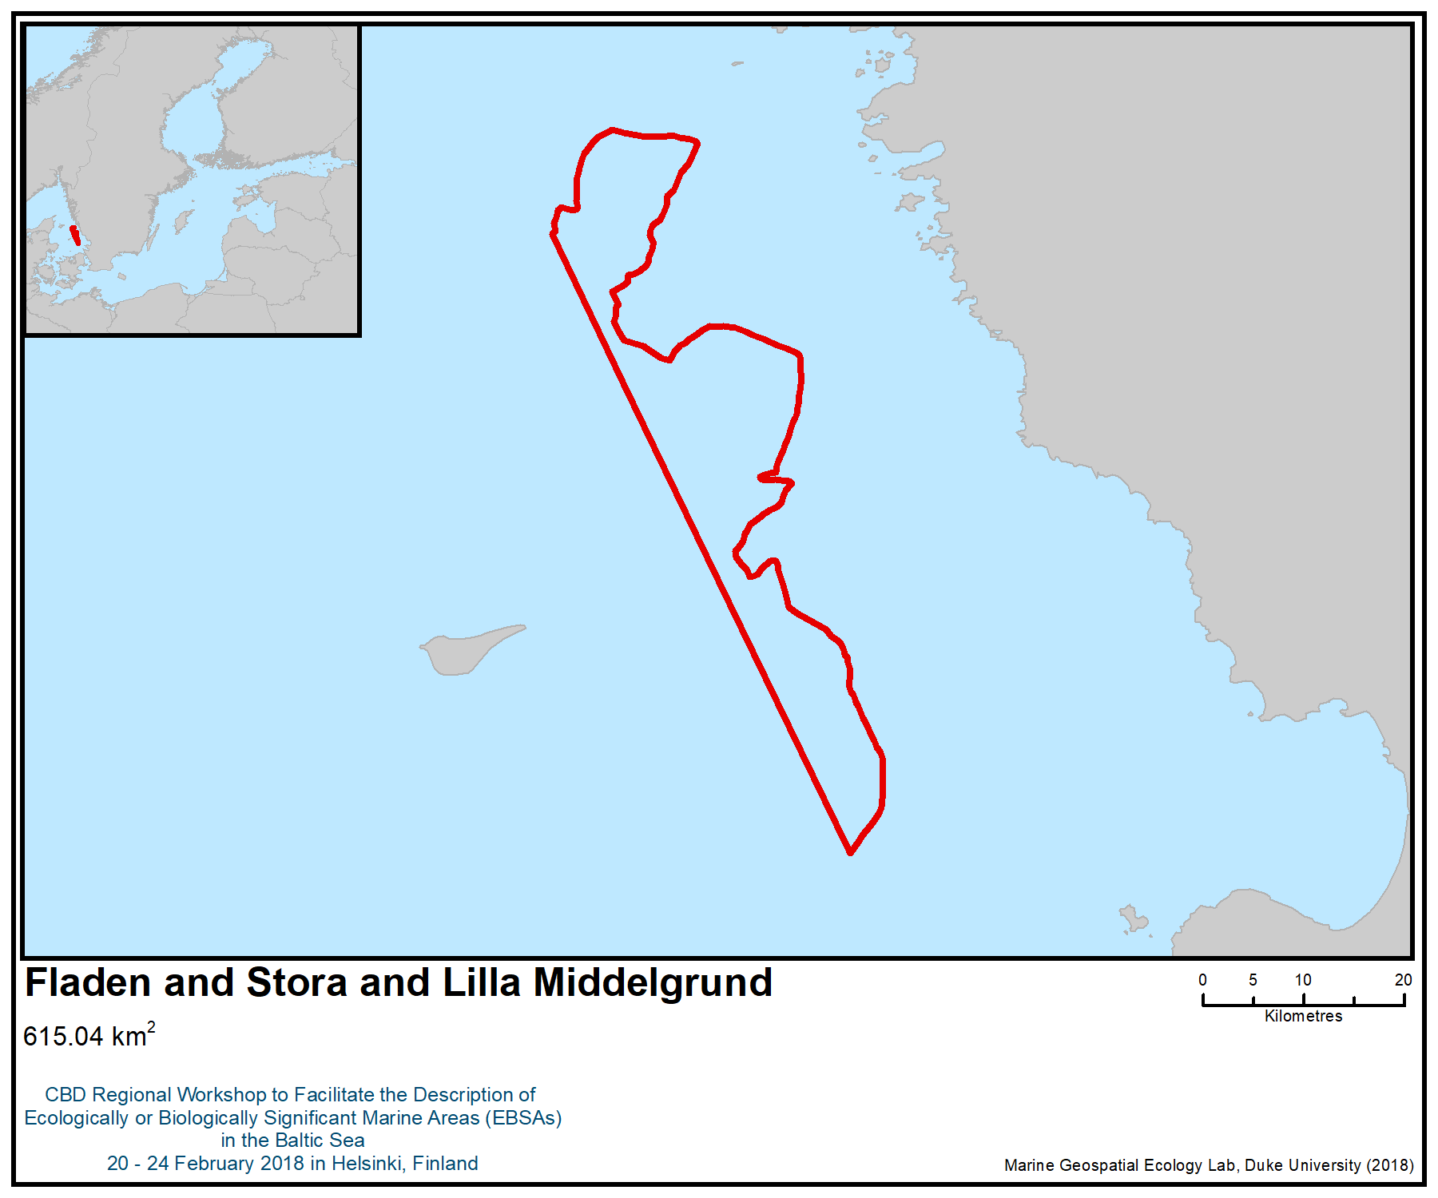
Figure 1. Location of the area

(On preceding page) Figure 2a: Occurrence of habitats and species at the offshore banks (Fladen and Lilla and Stora Middelgrund)

Figure 2b: Occurrence of habitats and species at Fladen

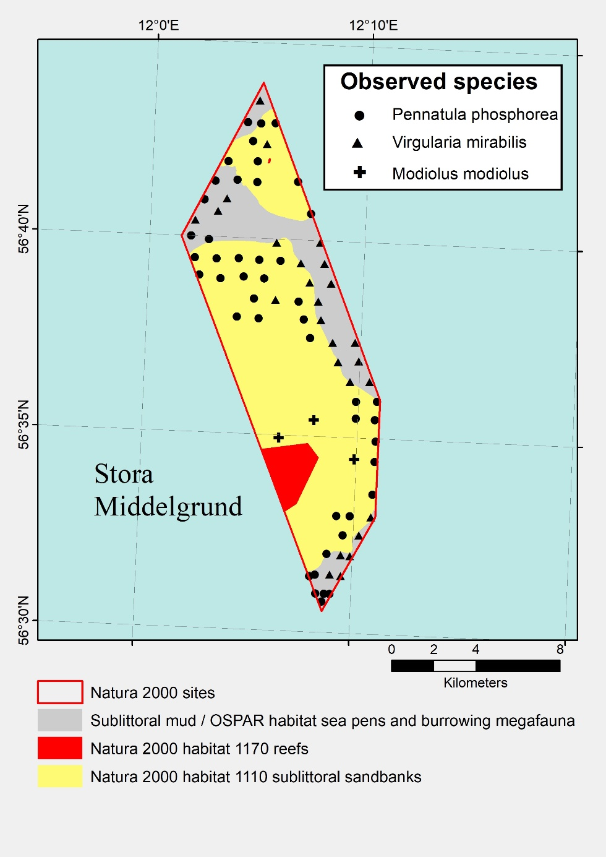
Figure 2c: Occurrence of habitats and species at Stora Middelgrund

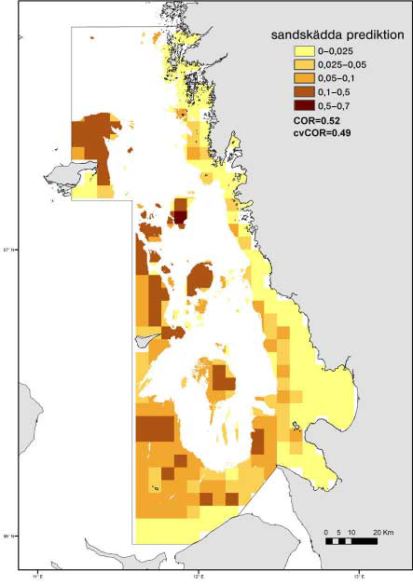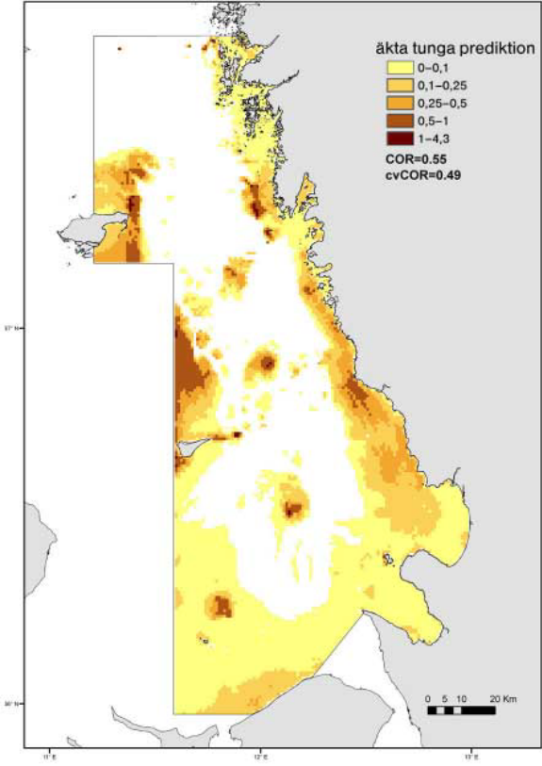
Figure 3: Predicted reproduction areas of dab (Limanda limanda, left) and sole (Solea solea, right) in Kattegat
Source: Fredriksson et al. 2011.

Annex VIII

SUMMARY OF THE WORKSHOP DISCUSSION ON IDENTIFICATION OF GAPS AND NEEDS FOR FURTHER ELABORATION IN DESCRIBING ECOLOGICALLY OR BIOLOGICALLY SIGNIFICANT MARINE AREAS, INCLUDING THE NEED FOR SCIENTIFIC INFORMATION, DEVELOPMENT OF SCIENTIFIC CAPACITY AS WELL AS SCIENTIFIC COLLABORATION

The information presented in this section was based on issues raised during the workshop, both in plenary and break-out group sessions.

Gaps in data/information and needs for further information-sharing

1. With regard to gaps in data/information and needs for further information-sharing, participants noted the following:
- The Baltic is relatively “data rich” compared to other regions. In particular, it was noted that data of relevance to the EBSA criteria were generally well-organized and documented, and generally readily available.
- Unlike many other marine regions, the Baltic has been under-represented with regard to ILK. There are only two entries in the Global ICCA Registry in relation to Baltic countries, and these are both for terrestrial cases (in Finland). Little is known of the Livonian maritime toponyms, German small-scale fishers, Latvian lamprey harvests, Estonian customary maritime governance of Ruhnu island, and the impacts and detection of climate change on small-scale fishing communities, to name a few critical examples. Information related to ILK was limited or unavailable for a number of areas under consideration, in particular for the Latvian and Lithuanian coasts, for example on the Kolka peninsula, Curonian Lagoon and other coastal areas of the Baltic region. Future work would be needed to fill these gaps (e.g., small-scale fisheries data).
- More information is needed on genetic diversity in the Baltic.
- The following are data gaps for specific geographic areas of the Baltic:
  - Limited monitoring data for the eastern parts of the Gulf of Finland / Outer Neva Estuary;
  - In the Bothnian Bay, data on coastal fish recruitment and breeding areas; data on migratory fish (salmon) distribution and abundance; and spatial coverage of bird census monitoring;
- At the local scale, significant data gaps were identified, including for birds (telemetry), benthos, macroplankton, commercial and non-commercially important fish (e.g., tuna, twaite shad), migratory fish (e.g., European eel), and data on food-webs. Knowledge of the changes in food-webs and ecosystem dynamics brought about by non-native/invasive alien species and climate change is particularly scarce.
- Areas in Latvian waters were considered to be potentially significant, but currently lack adequate data to support assessment against the EBSA criteria, due to the insufficient research effort and monitoring.
- Although some species (e.g., Bluefin tuna) are known to occur in the Baltic Sea, this was not consistently reflected in the data available at the workshop.
- Inconsistencies in physical and biological data density and resolution across the region, especially across national boundaries and within and outside of existing MPAs. This led to difficulties in accurately drawing EBSA boundaries in areas with few data and coarse data resolution.
- Some suggested that data on terrestrial species inhabiting archipelagos could be considered as part of the EBSA descriptions, given their strong interdependence with the marine realm.

Needs for future scientific research
2. With regards to the needs for future scientific research, the participants noted the following:
- It was evident from the information available for the workshop that many areas of the Baltic have been very well studied. Yet, the extensive and complex coastlines of certain countries, such as Finland, make it logistically challenging and expensive to monitor species and habitats comprehensively, for instance, considering in situ approaches.
- In the Baltic Sea, “State-sponsored,” and hence quality-controlled, inventories and monitoring programmes (i.e., databases, usually “open-access”) are widely used, although not necessarily published in peer-reviewed publications.
- Further research is necessary on non-indigenous species. For instance, research is needed to identify how non-indigenous species should be considered when these fill previously empty niches in the ecosystem, and so in essence support and increase the biodiversity, and enrich the food web (e.g., the non-indigenous polychaete worm Marenzelleria has contributed to the oxygenation of soft sediments that were previously hypoxic).
- There is a need to better understand the ecological linkages between the migratory bird flyways and the marine environment in the region.

Needs for capacity building to further enable application of the EBSA criteria in the region
3. With regards to needs for capacity-building to further enable application of the EBSA criteria in the region, the participants noted:
- Holders of Indigenous and Local Knowledge would benefit from capacity-building and support for collating and preparing their data and information, so that this information can be easily understood by scientists and other experts, and more readily available as input to the EBSA workshops and other similar assessments, including in spatial formats (i.e., maps). Furthermore, a mutual understanding and appreciation by scientists and ILK holders of the different nature of EBSA-relevant information would be useful.
- Need for more extensive information and capacity-building on how to interpret and apply the EBSA criteria prior to preparing draft descriptions of areas meeting the EBSA criteria.
- Need for further awareness-building regarding the EBSA process, and the use of information on EBSAs, to avoid any misunderstandings in the engagement in the EBSA process.
- Limited monitoring/research data in some countries resulted in areas being set aside for “future consideration.” Beyond the possible financial constraints, it may be that a certain level of capacity-building is required to support countries in establishing/strengthening monitoring/research programmes.
- Further guidance and capacity-building are needed with regard to the application of certain EBSA criteria, in particular:
  - Criterion on importance for threatened, endangered or declining species and/or habitats (i.e., whether the ranking is dependent on the level of threat to the species),
  - Criterion on biological productivity (i.e., maximum productivity or mean productivity)
  - Criterion on vulnerability, fragility, sensitivity, or slow recovery (i.e., inherent functional vulnerability, rather than vulnerability due to the presence of specific pressures)
  - Criterion on biological diversity (i.e., what spatial scale to use in order to ensure coherence across the region).

Gaps in information available for the workshop
4. With regard to gaps in information available for the workshop, participants noted:
- Lack of regional expertise at the workshop on fish and commercial fish stocks, along with detailed knowledge on the distribution and movement of seals and cetaceans in the region. The AquaMaps portal (http://www.aquamaps.org/) can be helpful to mitigate this knowledge gap, noting that its spatial resolution is coarse in relation to the Baltic Sea’s extent.
- Absence of experts from two countries in the region, which did not allow the workshop to fully apply the EBSA criteria to the Baltic Sea as a whole.
- Limited time available for experts to complete EBSA descriptions during the workshop, as well as a limited range of expertise present at the workshop, might have precluded the description of some potential EBSAs.
- Need for more preparatory activities prior to the workshop (e.g., information on how to apply the criteria, how to complete the EBSA template, how to compile relevant ILK, etc.), which could have strengthened the ability of workshop participants to contribute to the description of EBSAs at the workshop.
- With regard to ILK or “traditional knowledge” of the environment, additional knowledge and expertise would have been beneficial (e.g., indigenous fishing communities).
Annex IX

AREAS WITH POTENTIAL TO BE DESCRIBED AS MEETING THE EBSA CRITERIA IN THE FUTURE

The workshop participants noted that the following area has the potential to meet the EBSA criteria in the future, with the availability of additional scientific information or the involvement of experts from respective countries:
- Bornholm Basin

Area for future consideration: Bornholm Basin
Abstract
The Bornholm Basin is one of the deep basins of the Baltic Sea. The deep areas of the Baltic Sea are naturally vulnerable to anoxia and hypoxia, but the oxygen conditions in the Bornholm Basin are better than in the inner deep areas, which are almost completely anoxic below the halocline during some periods. Because of this, the Bornholm Basin is extremely important for marine species, in particular for the unique and threatened Eastern Baltic cod population, which cannot live or reproduce in the low salinity above the halocline.

Introduction
The Bornholm Basin is one of the deep basins of the Baltic Sea. The deep areas of the Baltic Sea are naturally vulnerable to anoxia and hypoxia, due to a strong stratification driven by the extensive freshwater outflow from land together with a restricted water exchange over the very shallow sills between Kattegat and the Baltic proper (Gustafsson & Andersson 2001). Due to its position relatively close to the Danish straits, where the main inflow of oxygen-rich water to the Baltic Sea occurs, this deep basin is less affected by anoxia than the inner basins. Due to the poor oxygen level in the inner deep basins, this is currently the only basin where the Eastern Baltic cod population reproduces (Eero et al. 2007, Hüssy 2011, Hinrichsen et al. 2016, 2017).

The Baltic cod is a genetically distinct population with unique adaptations to the low salinity in the Baltic Sea (Köster et al. 2005). Baltic cod populations have been at very low levels since the early 1990s, due to a combination of high fishing pressure and poor environmental conditions (increased area of hypoxic water); the species is classified as vulnerable on the HELCOM species red list (HELCOM 2013a). During the assessment period, between 1971 and 2012, the eastern Baltic stock has decreased by 45 per cent.

The importance of the Bornholm Basin for the reproduction of the unique and threatened eastern cod population is well supported by oceanographic and fish population modelling (e.g. Hüssy 2011, Hinrichsen et al. 2016, 2017).

Location
The Bornholm Basin is situated in the southern Baltic Sea, east of the island of Bornholm (Figure 1).

Feature description of the area
The deep areas of the Baltic Sea are naturally vulnerable to anoxia and hypoxia, due to a strong stratification driven by the extensive freshwater outflow from land, together with a restricted water exchange over the very shallow sills between Kattegat and the Baltic Sea proper. The strong stratification means that the only replenishment of oxygen in the deep water comes from inflows of dense water with high salinity that flows over a series of sills in the Danish straits, which only occur under certain weather conditions (Gustafsson & Andersson 2001). In particular, the deeper areas are only exchanged during major inflow events, which have become less frequent in the last three decades (Kabel et al. 2012). This, together with the high nutrient load to the Baltic Sea that fuels a high production and deposition of organic material to the seabed, has led to widespread anoxia in deep areas of the Baltic Sea. The hypoxic area, where oxygen conditions are so low that they are damaging to most organisms, is as large as 70,000 km² during the most extreme years (Conely et al. 2009).

The widespread anoxia is threating deep habitats and species that rely on them. One of the species that is strongly affected is the Baltic Sea cod (Gadus morhua), which is genetically distinct from the Atlantic population and has a number of unique adaptations to the low salinity. Most prominently, Baltic cod produce eggs that are buoyant at lower salinities than North Sea cod eggs, which allow them to spawn in the Baltic Sea (Nissling and Westin 1997). In contrast to cod stocks outside the Baltic, eggs from Eastern Baltic cod do not float in surface waters due to the lower density of the brackish water (Köster et al., 2005). Eastern Baltic cod have adapted to lower salinity conditions by increasing the volume of their eggs, thereby allowing them to obtain neutral buoyancy at 14.2 ± 1.1 PSU (Vallin & Nissling 2000).

The Baltic Sea contains two genetically distinct cod stocks, one west of the island of Bornholm (the western stock) and one to the east of Bornholm (the eastern stock). Historically, there have been three main spawning areas for the Eastern Baltic cod stock; Gotland Deep, Gdansk Deep and Bornholm Deep. Spawning is restricted to waters below the halocline in the deep basins, since these are the only areas where the salinity is high enough for reproduction. At the same time, the eggs require an oxygen concentration >2 mg O₂ L⁻¹ to develop (Vallin & Nissling 2000). Consequently, the decreased frequency and intensity of inflows of oxygenated, saline water from the Kattegat during recent decades has meant that the Gotland and Gdansk Deeps have frequently not supported recruitment, leaving the Bornholm Deep as the main recruitment area for eastern cod (Eero et al. 2007, Hinrichsen et al. 2016, 2017).

Baltic cod populations have been at very low levels since the early 1990s, due to a combination of high fishing pressure and poor environmental conditions (increased area of hypoxic water) caused by eutrophication and a long period with few major inflows. In addition, cod size and body condition have also decreased during this period (Casini et al. 2016). Despite a slight recovery in cod stock during the 2000s, the stability and sustainability of the stock is still highly uncertain (Eero et al. 2015).

It is important to maintain, or even increase, cod populations in the Baltic, not just as a commercial species for human consumption, but also as an important component of a well-functioning ecosystem. Cod are an important predator of both benthic invertebrates and pelagic fish and are themselves prey for seals (Casini et al. 2016). Being the most abundant predatory fish species in the Baltic Sea, cod also has an important stuctural function for the whole ecosystem (Rudstam et al. 1994). Indeed, the offshore regime shift from a cod- to sprat-dominated ecosystem has been suggested as a reason for the recent recruitment failure of inshore predatory fish, such as pike and perch (Ljunggren et al. 2010; Eriksson et al. 2011).

Feature condition and future outlook of the area
The area is strongly affected by eutrophication, creating a large inflow of oxygen-consuming organic matter. The nutrient inflow from land has decreased strongly during the last decades due to effective measures to reduce nutrient leakage in the countries bordering the Baltic Sea. Still, the high concentrations of nutrients in the system, which have built up over many years, will slow down the recovery. There is a risk that global warming will increase the problems with hypoxia on the seabed by increasing production and decomposition rates.

Apart from eutrophication, part of the Bornholm Basin, as well as surrounding areas, are affected by bottom trawling, which stirs up sediment that reduces survival of cod eggs and larvae (Westerberg et al. 1996).

Assessment of the area against CBD EBSA Criteria

CBD EBSA Criteria  (Annex I to decision IX/20) | Description  (Annex I to decision IX/20) | Ranking of criterion relevance  (please mark one column with an X)
CBD EBSA Criteria  (Annex I to decision IX/20) | Description  (Annex I to decision IX/20) | No information |  | Low |  |  | Medium |  | High
Uniqueness or rarity | Area contains either (i) unique (“the only one of its kind”), rare (occurs only in few locations) or endemic species, populations or communities, and/or (ii) unique, rare or distinct, habitats or ecosystems; and/or (iii) unique or unusual geomorphological or oceanographic features. |  |  |  |  |  |  |  | x
Explanation for ranking
The Baltic Sea cod population is genetically distinct from the Atlantic population (Andersen et al. 2009) and has a number of unique adaptations to the low salinity. Most prominently, Baltic cod produce eggs that are buoyant at lower salinities than North Sea cod eggs, allowing them to spawn in the Baltic Sea (Nissling and Westin 1997).
Special importance for life-history stages of species | Areas that are required for a population to survive and thrive. |  |  |  |  |  |  |  | x
Explanation for ranking
The Bornholm deep is the main reproduction area for the Eastern Baltic cod (Eero et al. 2015, Hinrichsen et al. 2016, 2017). The cod requires relatively high salinity for a successful reproduction, which means that reproduction is restricted to deep areas, below the halocline. The other former reproduction areas are now temporarily or permanently anoxic or hypoxic, as a consequence of the large-scale eutrophication and a long period with few major inflows (Eero et al. 2015).
Importance for threatened, endangered or declining species and/or habitats | Area containing habitat for the survival and recovery of endangered, threatened, declining species or area with significant assemblages of such species. |  |  |  |  |  |  |  | X?
Explanation for ranking
Baltic cod populations have been at very low levels since the early 1990s, due to a combination of high fishing pressure and poor environmental conditions (increased area of hypoxic water); the species is assessed as vulnerable by HELCOM (HELCOM 2013a). Over the assessment period, between 1971 and 2012, the eastern Baltic stock decreased by 45 per cent.
The pelagic habitat below the halocline is a threatened habitat in the Baltic Sea that is assessed as endangered in the HELCOM Red List due to the widespread anoxia (HELCOM 2013b)..
Vulnerability, fragility, sensitivity, or slow recovery | Areas that contain a relatively high proportion of sensitive habitats, biotopes or species that are functionally fragile (highly susceptible to degradation or depletion by human activity or by natural events) or with slow recovery. |  |  |  |  |  | X
Explanation for ranking
The strong stratification of the Baltic proper, together with the shallow sills separating the basin from Kattegat, makes the deep areas inherently vulnerable to oxygen deficiency (Gustafsson & Andersson 2001).
Biological productivity | Area containing species, populations or communities with comparatively higher natural biological productivity. |  |  |  | X
Explanation for ranking
The phytoplankton productivity is not higher than in other parts of the Baltic proper (Hoepffner 2006), and the benthic productivity is low (Gogina et al. 2016).
Biological diversity | Area contains comparatively higher diversity of ecosystems, habitats, communities, or species, or has higher genetic diversity. |  |  |  | X
Explanation for ranking
The area has a relatively homogenous environment with deep sediment bottoms, lacking species and habitats connected to shallow and coastal areas. The overall diversity in this part of the Baltic Sea is lower than in the western Baltic and Kattegat (HELCOM 2012).
Naturalness | Area with a comparatively higher degree of naturalness as a result of the lack of or low level of human-induced disturbance or degradation. |  |  |  |  | X
Explanation for ranking
The area is less affected by hypoxia than the inner deep basins, but the area is still strongly affected by the large-scale eutrophication of the Baltic Sea and by bottom trawling (HELCOM 2017).

References
Casini M. et al. (2016) Hypoxic areas, density-dependence and food limitation drive the body condition of a heavily exploited marine fish predator. Royal Society Open Science 3: 160416, DOI: 10.1098/rsos.160416
Conley DJ et al. (2009) Hypoxia-related processes in the Baltic Sea. Environ Sci Technol 43:3412–3420
Eero M. et al. (2015). Eastern Baltic cod in distress: biological changes and challenges for stock assessment. ICES J. Mar. Sci. 72: 2180–2186.
Eriksson, B et al. (2011) Effects of Altered Offshore Food Webs on Coastal Ecosystems Emphasize the Need for Cross-Ecosystem Management. AMBIO 40: 786–97.
Gogina, M., Nygård, H., Blomqvist, M., Daunys, D., Josefson, A. B., Kotta, J., & Zettler, M. L. (2016). The Baltic Sea scale inventory of benthic faunal communities. ICES Journal of Marine Science 73: 1196-1213.
Gustafsson BG & Andersson HC (2001) Modeling the exchange of the Baltic Sea from the meridional atmospheric pressure difference across the North Sea. J Geophys Res 106:19731–19744.
HELCOM (2012) Checklist of Baltic Sea Macro-species. Baltic Sea Environment Proceedings No. 130.
HELCOM (2013a) HELCOM Red List of Baltic Sea species in danger of becoming extinct. Baltic Sea Environmental Proceedings No. 140
HELCOM (2013b) Red List of Baltic Sea underwater biotopes, habitats and biotope complexes. Baltic Sea Environmental Proceedings No. 138.
HELCOM (2017): First version of the ‘State of the Baltic Sea’ report – June 2017 – to be updated in 2018. Available at: http://stateofthebalticsea.helcom.fi
Hinrichsen, H.-H. et al. (2016) Spawning areas of eastern Baltic cod revisited: using hydrodynamic modelling to reveal spawning habitat suitability, egg survival probability, and connectivity patterns. Prog. Oceanogr. 143: 13–25.
Hinrichsen, H.-H. (2017) Spatio-temporal dynamics of cod nursery areas in the Baltic Sea, Progress in Oceanography 155: 28-40.
Hoepffner, N. (2006) Concentrations, temporal variations and regional differences from satellite remote sensing. HELCOM Baltic Sea Environment Fact Sheets. Online, viewed 1/3/2018, http://www.helcom.fi/baltic-sea-trends/environment-fact-sheets/eutrophication/chlorophyll-a
Hüssy, K. (2011) Review of western Baltic cod (Gadus morhua) recruitment dynamics. – ICES Journal of Marine Science, 68: 1459–1471.
Kabel K et al. (2012) Impact of climate change on the Baltic Sea ecosystem over the past 1,000 years. Nat Clim Change 2:871–874.
Köster, F.W. (2005) Baltic cod recruitment - the impact of climate variability on key processes. ICES J. Mar. Sci. 62: 1408–1425.
Ljunggren L. et al. (2010) Recruitment Failure of Coastal Predatory Fish in the Baltic Sea Coincident with an Offshore Ecosystem Regime Shift. ICES Journal of Marine Science 67: 1587–95.
Nissling A. and Westin L. (1997) Salinity requirements for successful spawning of Baltic and Belt Sea cod and the potential for cod stock interactions in the Baltic Sea. Mar. Ecol. Prog. Ser., 152: 261-271.
Rudstam L., Aneer G. and Hildén M. (1994) Top-down control in the pelagic Baltic ecosystem. Dana 10: 105-129.
Vallin L. & Nissling A. (2000) Maternal effects on egg size and egg buoyancy of Baltic cod, Gadus morhua: Implications for stock structure effects on recruitment, Fisheries Research 49: 21-37.

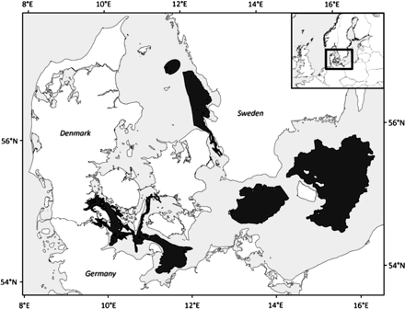

Figure 1. Spawning areas (black) for cod (Gadhus morhua) in the Baltic Sea. The Bornholm Basin is the easternmost area, east of the island of Bornholm
Source: Hüssy 2011.
__________

* Reissued for technical reasons on 10 July 2018.
The designations employed and the presentation of material in this note do not imply the expression of any opinion whatsoever on the part of the Secretariat concerning the legal status of any country, territory, city or area or of its authorities, or concerning the delimitation of its frontiers or boundaries.
The delineation of these sub-groups was arranged for practical purposes and does not reflect any biological, ecological, geomorphological or political considerations.
UNEP-WCMC and IUCN, 2018
“FIN: VU” means that the species is vulnerable in the Finnish national classification. “HELCOM: DD” refers to classification by Helsinki Commission (HELCOM 2013). If no reference is stated, the classification is taken from HELCOM (2013).
“FIN: VU” means that the species is vulnerable in the Finnish national classification. “HELCOM: DD” refers to classification by Helsinki Commission (HELCOM 2013). If no reference is stated, the classification is taken from HELCOM (2013). (VU=vulnerable, NT=near threatened, CR=critically endangered, EN=endangered, -=not assessed)
http://www.iccaregistry.org

