 |  |  | CBD
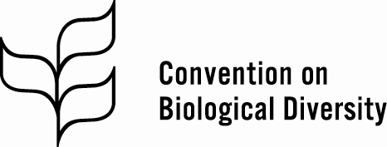 |  |  |  |  | Distr.  GENERAL  CBD/COP/14/INF/47  25 November 2018  ENGLISH ONLY
CONFERENCE OF THE PARTIES TO THE CONVENTION ON BIOLOGICAL DIVERSITY
Fourteenth meeting
Sharm El-Sheikh, Egypt, 17-29 November 2018
Item 14 of the provisional agenda*

Egyptian initiative for a coherent approach for addressing biodiversity loss, climate change, and land and ecosystem degradation

Note by the Executive Secretary
- The Executive Secretary is circulating herewith, for the information of participants in the fourteenth meeting of the Conference of the Parties, a document entitled “Egyptian initiative for a coherent approach for addressing biodiversity loss, climate change, and land and ecosystem degradation” prepared by the Ministry of Environment of the Government of the Arab Republic of Egypt, as a preliminary note for further elaboration with partners.
- The present document is relevant to the deliberations on agenda item 14 on cooperation with other conventions, international organizations and initiatives.
- The document is being circulated in the form and language in which it was received by the Secretariat.

The Egyptian Initiative “A coherent approach for addressing biodiversity loss, climate change, and land and ecosystem degradation”
Concept note

What are the problems?
The World is facing enormous challenges. These challenges include adapting to climate change and enhancing our resilience to natural disasters, protecting biodiversity and ecosystems, providing food to more than 8 billion people, increasing our water and air quality, tackling socio-economic inequality, and dealing with a rapidly expanding urban population.

Climate change is today a reality. Even in the most optimistic greenhouse gas emission (GHG) scenarios, mean planet temperature is likely to increase at least by 2◦C until the year 2100 (IPCC, 2013). The Paris Agreement to combat climate change adopted in December 2015 under the United Nations Framework Convention on Climate Change (UNFCCC) stipulates that parties will pursue efforts to limit temperature increase to 1.5◦C above pre-industrial levels by 2050. People, ecosystems and species are suffering its effects globally, whether it is through super storms and hurricanes in the Caribbean, severe prolonged droughts in Africa, sea-level rise in the Pacific Islands, or record-breaking temperatures worldwide.

Biodiversity provides the basis for all life on earth. However, biodiversity is facing its own crisis, just at the time that we need it most to help mitigate and adapt to climate change. Biodiversity is being lost at up to 1,000 times the natural rate due to multiple drivers and stressors, including climate, water scarcity and pollution. This reduces the resilience of ecosystems to climate change.

Human exploitation and degradation of ecosystems is causing a widespread loss of biodiversity and decline in ecosystem conditions leading to reduced provision of ecosystem services. Ecosystem degradation and biodiversity loss reduce the resilience of communities, and society, and increases their vulnerability to the impacts of climate change.

Currently, we are suffering the effects of a “vicious” cycle, depicted below, which would worsen if climate change exceeds 2 degrees.

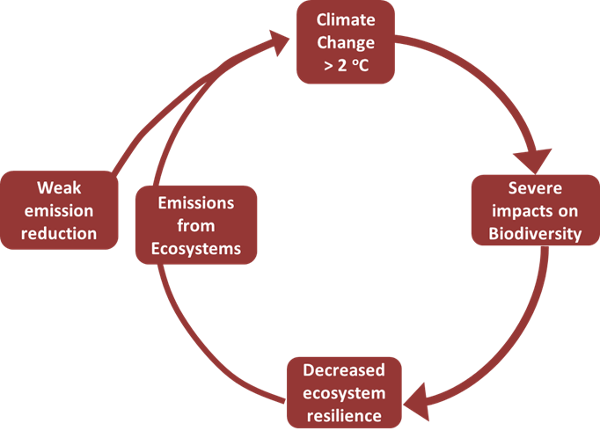

In some cases, proposed responses to climate change could have considerable harmful impact on biodiversity, thus reinforcing the “vicious” cycle of destruction at planetary systems level. Moreover, the benefits of the conservation and sustainable use of biodiversity, and the solutions provided by the restoration of ecosystems for climate change mitigation and adaptation, are neglected or under-utilized.

There is an urgent need to coherently address the biodiversity loss, climate change, and land and ecosystems degradation to protect all of Earth’s living creatures, including the 7.6 billion citizens today and the near-10 billion citizens of 2050.

The assessment report on land degradation and restoration of the Intergovernmental Science-Policy Platform on Biodiversity and Ecosystem Services (IPBES) states that: “Combating land degradation and restoring degraded land is an urgent priority to safeguard biodiversity and ecosystem functions and services that are vital to all life on Earth and to ensure human well-being. Unless urgent and concerted action is taken, land degradation will worsen in the face of population growth, unprecedented consumption, an increasingly globalized economy and climate change. Over time, the implementation of known, proven actions to combat land degradation and thereby transform the lives of millions of people across the planet will become more difficult and costly. An urgent change in effort is needed to prevent irreversible land degradation and accelerate the implementation of restoration measures.”

Further, key messages from the report include:
- Currently, degradation of the Earth’s land surface through human activities is negatively impacting the well-being of at least 3.2 billion people, pushing the planet towards a sixth mass species extinction, and costing more than 10 per cent of the annual global gross product in loss of biodiversity and ecosystem services (A1).
- Investing in avoiding land degradation and the restoration of degraded land makes sound economic sense; the benefits generally by far exceed the cost (A2).
- Timely action to avoid, reduce and reverse land degradation can increase food and water security, can contribute substantially to the adaptation and mitigation of climate change and could contribute to the avoidance of conflict and migration (A3).
- Avoiding, reducing and reversing land degradation is essential for meeting the Sustainable Development Goals contained in Agenda 2030 (A4).

What are the solutions?

Addressing climate change and biodiversity loss and ecosystems degradation are challenges for the 21stCentury and have to be addressed jointly if we are to avoid catastrophic destruction, and also if we are to achieve the Sustainable Development Goals (SDGs). A coherent approach would ensure that climate change impacts on biodiversity and ecosystems are reduced, and that biodiversity and ecosystems can contribute to climate adaptation and mitigation and to restoration of degraded lands.

We aim for a virtuous cycle as shown below, wherein urgent and deep emission reductions allow for climate change to be limited to 1.5 degrees. This would reduce impacts on biodiversity allowing it to improve resilience of ecosystems, which in turn would improve mitigation of climate change.

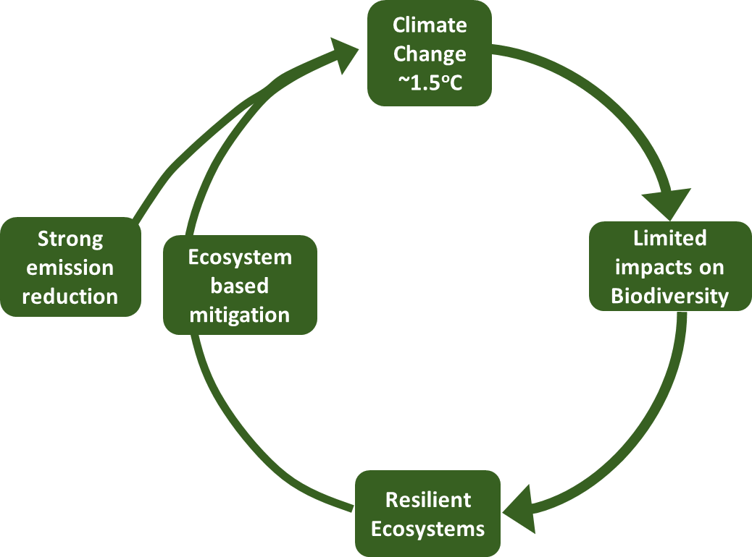

Thus there is a need to address the drivers of biodiversity loss at all levels, and to support actions at scale on the conservation, sustainable use and restoration of biodiversity. For example, nature - based (also known as ecosystem - based) approaches to climate change adaptation and to disaster risk reduction can enhance resilience of systems so that they may better adapt and cope with the effects of climate change. At the same time, these efforts can enhance climate change mitigation and ecosystem restoration. Ecosystem restoration is regarded as a major strategy for increasing the provision of ecosystem services as well as reversing biodiversity loss. At the same time, these efforts can enhance climate change mitigation and ecosystem restoration. With the help of ecosystem-based approaches, synergies are created between different sectors and multiple goals can be pursued simultaneously often at lower cost. It is possible with ecosystem-based approaches to combine measures that can simultaneously protect or restore biodiversity and ecosystem services, remove or reduce emission of atmospheric greenhouse gases and reduce poverty. These approaches provide “no-regret” options, as the measures are useful even if the effects of climate change do not materialize as predicted. Such approaches are often cost-efficient and allow for flexibility in dealing with a constantly changing climate and its associated risks. Although conceptually new, they are rapidly gaining attraction as an integrated policy instrument.

What is already being done?

Countries have made their own national commitments on biodiversity and climate change as contribution to globally agreed goals under the Rio Conventions, the CBD, UNFCCC and the UNCCD, including:
- Commitments on conserving, sustainably using, and restoring biodiversity in National Biodiversity Strategies and Action Plans under the CBD;
- Land degradation neutrality targets under the UNCCD;
- Under the UNFCCC, in the Paris Agreement, countries have pledged, including through their Nationally Determined Contributions, to pursue efforts to limit the global average temperature to well below 2°C above pre-industrial levels and to make efforts to keep the increase below 1.5°C.

Indigenous peoples and local communities, the private sector, civil society, have also made great efforts to address the challenges of biodiversity and climate change. However, the Global Biodiversity Outlook and current indications are showing that our global efforts have not been enough; biodiversity continues to be lost, and indicators are signalling that many of the Aichi Biodiversity Targets will not be met.

The Egyptian Initiative “A coherent approach for addressing biodiversity loss, climate change, and land and ecosystem degradation”

It is now widely recognized that climate change, biodiversity and land are interconnected. International initiatives to address these impacts such as CBD, Sustainable Development Goals (SDGs) and Intergovernmental Science-Policy Platform on Biodiversity and Ecosystem Services (IPBES), explicitly link conservation of biodiversity with the provision of ecosystem services to support sustainable development and poverty reduction. There is ample evidence that climate change affects biodiversity with negative consequences for human well-being. According to the Millennium Ecosystem Assessment, climate change is likely to become one of the most significant drivers of biodiversity loss by the end of the century. Climate change is already forcing biodiversity to adapt through shifting habitat, changing life cycles, or the development of new physical traits. The impacts of climate change will worsen land degradation and further undermine the resilience of vulnerable groups and communities. Climate change impacts will make it more difficult for ecosystems to recover and further impact on the development goals of many countries. Conversely, the conservation, restoration and sustainable management of ecosystems have the potential to contribute to biodiversity restoration, increased food security, climate change mitigation and adaptation. The conservation and sustainable management of ecosystems can lead to significant avoided greenhouse gas emissions, and the restoration of degraded ecosystems can lead to increased sequestration of greenhouse gases.

As host of the fourteenth meeting of the Conference of the Parties (COP) to the Convention on Biological Diversity (CBD), the Government of Egypt will take advantage of this important opportunity to launch an Initiative to coherently address the three most serious global crises: biodiversity loss, climate change and land and ecosystems degradation. The Initiative would also be launched at the 2018 Climate Change Conference to be held in Katowice, Poland from 3-14 December 2018.

The Egyptian Initiative “A coherent approach for addressing biodiversity loss, climate change, and land and ecosystem degradation” (hereafter called “the Initiative”) would aim to contribute to making the Vision of the Strategic Plan for Biodiversity a reality: “By 2050, biodiversity is valued, conserved, restored and wisely used, maintaining ecosystem services, sustaining a healthy planet and delivering benefits essential for all people”.

The Initiative will build upon and will provide linkages between global and regional commitments on climate change, biodiversity, and sustainable development including: the 2030 Agenda for Sustainable Development, the Sendai Framework for Disaster Risk Reduction, the Paris Agreement, the Strategic Plan for Biodiversity 2011 - 2020, and the CBD Short Term Action Plan on Ecosystem Restoration (CBD decision XIII/5).

Other processes leading up to CBD COP 14, and global publications will also inform the Initiative, including:
- The African Biodiversity Ministerial Summit to be held on 13 November 2018 back to back with the CBD COP 14;
- The IPCC special report on the impacts of global warming of 1.5 °C;
- The IPBES global and regional assessments on land degradation.

The Initiative would promote action at all levels to improve and accelerate action for the conservation, the sustainable use, and the restoration of biodiversity contributing to a virtuous cycle that mitigates and adapts to the effects of climate change. Countries could commit to actions that capitalize on meeting multiple international environmental agreement targets in unison:
- To halt or substantially reduce deforestation and other forms of habitat loss and destruction (in line with Sustainable Development Goal 15, Paris Agreement Article 5, and Aichi Biodiversity Target 5);
- To restore and rehabilitate degraded ecosystems (in line with Sustainable Development Goal 15, Paris Agreement Articles 5, 7 and 8, and Aichi Biodiversity Targets 14 and 15);
- To manage croplands and pastures sustainably land to enhance soil carbon (this is in line with (Sustainable Development Goals 2 and 15, and Aichi Biodiversity Target 7);
- To mainstream ecosystem-based approaches to climate change adaptation and disaster risk reduction into land planning processes across sectors

At a domestic level, governments would commit, through this Initiative, to:
- Use nature-based solutions, as a priority, within nationally determined contributions;
- Increase investment and incentives to enable, promote and provide research on nature-based solutions;
- Provide tools for experts in sectors to incorporate nature-based solutions; and
- Measure and report on these activities and review efforts by reporting on the through the CBD process.

By developing and launching this Initiative, the Egyptian Government aims to promote coherent addressing of the climate change, biodiversity loss and land degradation crises both through national action, and by creating awareness in other multilateral environmental agreements and in other global fora.

Conserving natural terrestrial, freshwater and marine ecosystems and restoring degraded ecosystems (including their genetic and species diversity) is essential for the overall goals of the Rio Conventions: the Convention on Biological Diversity, the United Nations Framework Convention on Climate Change and, the United Nations Framework Convention to Combat Desertification because ecosystems play a key role in the global carbon cycle and in adapting to climate change, while also providing a wide range of ecosystem services that are essential for human well-being and the achievement of the Sustainable Development Goals. As ecological restoration can potentially contribute to the improvement of human livelihoods, as well as enhancing biodiversity, it is assuming an increasingly central role in global environmental policy. New methods of ecosystem service valuation are suggesting that the economic benefits of restoration can outweigh costs.

__________

__________

* CBD/COP/14/17.

