CBD
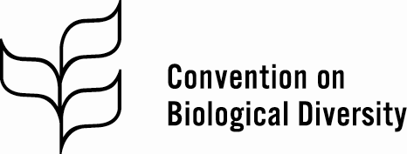 | Distr.  GENERAL  CBD/CHM/WS/2018/2/1  23 February 2018  ENGLISH ONLY
SUBREGIONAL WORKSHOP FOR ARABIC-SPEAKING COUNTRIES ON THE CLEARING-HOUSE MECHANISM
Cairo, 5-9 March 2018

Provisional Agenda
- Opening of the workshop.
- Objectives and programme of the workshop.
- Work programme of the clearing-house mechanism.
- National and regional experiences.
- Guidance for national clearing-house mechanisms.
- Training session.
- Strategic vision and road map for national clearing-house mechanisms.
- Pending matters.
- Synthesis and report of the workshop.
- Closure of the workshop.
__________

