 |  | CBD/SBI/7/INF/5

 | Distr.: General  30 April 2026  English only

Subsidiary Body on Implementation
Seventh meeting
Nairobi, 4–12 August 2026
Item 7 of the provisional agenda*
Second assessment and review of the effectiveness
of the Nagoya Protocol on Access to Genetic Resources and the Fair and Equitable Sharing
of Benefits Arising from Their Utilization
Analysis of responses to the Access and Benefit-sharing Clearing-House Targeted Survey**
Note by the Secretariat

I. Introduction
- The Conference of the Parties serving as the meeting of the Parties to the Nagoya Protocol on Access to Genetic Resources and the Fair and Equitable Sharing of Benefits Arising from their Utilization agreed to the methodology for the second assessment and review of the effectiveness of the Protocol in decision NP-5/5 and on the basis of the elements in the annex to the decision. The review of the implementation and operation of the Access and Benefit-sharing (ABS) Clearing-House was among the elements to be considered (element (g)), and a targeted survey was identified as a source of information for this review.
- On 9 September 2025, the Executive Secretary issued notification No. 2025-113 inviting Parties, non-Parties, indigenous peoples and local communities, and relevant stakeholders to provide feedback on the implementation and operation of the ABS Clearing-House by completing an online survey.
- The survey was open for responses for approximately four months and closed on 31 December 2025. It was disseminated through the notification, posted in the ABS Clearing-House announcements section, and sent by email to more than 1,500 recipients.
- The present document contains the analysis of the responses to the survey questions (sect. II), a summary of the discussion on the analysis of the survey results among experts of the ABS Clearing-House Informal Advisory Committee (sect. III) and conclusions arising from the analysis (sect. IV).

II. Analysis of the survey responses
- This analysis summarizes key findings from the survey responses, providing insight into the effectiveness of the ABS Clearing-House and its crucial role in supporting the implementation of the Protocol. It sheds light on the strengths and challenges related to the ABS Clearing-House, which may inform recommendations for enhancing the ABS Clearing-House. The survey questions are available in annex I to the present document. The analysis has been organized according to the main topics covered by the survey.
A. Respondent information
- The survey received a total of 112 responses from approximately 60 countries, with a significant proportion originating from the European and African regions, as shown in figure I. Slightly more than half (55%) of the respondents identified themselves as government users of the ABS Clearing-House, while the remaining 45% of respondents represented other stakeholder groups, including the scientific community, private sector, capacity-building organizations and indigenous peoples and local communities, as illustrated in figure II below.
Figure I
Regions responding to the survey

Figure II
Types of ABS Clearing-House users responding to the survey

- Responses to question 6 indicated that representation from the personal care and cosmetics sector was most prominent among respondents from the private sector/business community. Within the scientific and research community, responses were more evenly distributed across all sectors, perhaps reflecting the cross-disciplinary nature of research related to access and benefit-sharing (ABS).
- Responses to question 7 indicate that government representatives, members of the scientific community, and private sector users are among the most active users of the ABS Clearing-House. Approximately 34% of respondents from these groups reported visiting the website at least once per week, suggesting a relatively high level of regular engagement.
- Question 8, which examined the primary purpose for using the ABS Clearing-House, indicates that the platform is used for information-seeking purposes across all groups. Among respondents who reported using the ABS Clearing House to find information, the following types of information were most frequently sought:
- Access requirements: (100% of respondents);
- Compliance obligations (59 % of respondents);
- Information on specific internationally recognized certificates of compliance (IRCCs, and other certificates) ( 43% of respondents);
- Capacity-building material (approximately 30% of respondents);
- Information related to the utilization of their genetic resources(approximately 30% of respondents)
- Publishing or updating information in the ABS Clearing-House was reported almost exclusively by government respondents, with approximately 60% of the respondents indicating that they primarily use the platform for this purpose. No other respondent group reported significant engagement in publishing or updating information.
B. Usability, user-friendliness and quality of information
- Overall, respondents expressed positive views regarding the usability and user-friendliness of the ABS Clearing-House. Responses to the statement in question 9, which focused on general usability and ease of navigation, were largely positive, as were responses to Question 10, which addressed aspects related to the publication of information on the platform.
- However, most respondents, apart from government respondents, selected “neutral” in response to many of the statements in Question 10, likely reflecting their limited experience or interest in publishing information in the ABS Clearing-House. One exception was that a slightly higher proportion of respondents indicated some level of disagreement with the statement, “I know the difference between national records and reference records.” Responses to this statement suggest that additional clarification may be needed regarding distinctions between record categories within the clearing-house.
- Question 11, which examined perceptions of the quality of information, elicited a more critical response than the preceding questions. Specifically, more than 15% of respondents indicated that they disagreed or strongly disagreed with the statement: “I find the information accurate and up-to-date”, highlighting concerns about accuracy and reliability.
C. Capacity-building, support and training
- In terms of capacity-building activities and materials currently offered by the Secretariat, the responses to question 12 were largely positive or neutral, with only a small number of negative responses suggesting a generally favourable perception of the Secretariat’s existing efforts in this area.
- Responses to Question 13 indicated, however, that a significant proportion of the respondents, 77%, have not participated in the Secretariat’s e-learning course on the ABS Clearing-House. This finding points to potential challenges related to awareness or accessibility of the e-learning course.
- When it came to the open-ended Question 15, which invited respondents to reflect on their experiences with capacity-building activities and to suggest improvements, respondents generally described the Secretariat’s efforts on capacity-building for use of the ABS Clearing-House as worthwhile and valuable. Several comments praised the Secretariat staff managing the ABS Clearing-House, appreciating and highlighting their responsiveness, subject matter expertise, and the availability in providing on-demand support.
- A recurring concern raised across many of the open-ended responses related to the reliability and completeness of national information available in the ABS Clearing-House. Respondents highlighted challenges from both the provider and the user perspectives. For example, some government respondents noted limited capacity to publish national information and keep it up to date, while respondents from other stakeholder groups pointed to difficulties and challenges in relying on or interpreting incomplete or unclear ABS measures and procedures.
- Overall, suggestions pointed to regular and targeted approaches to capacity-building, with activities and content better tailored to specific stakeholder groups. Many respondents emphasized the need for a practical approach to training that includes relevant real-world cases and concrete examples. Some responses further suggested that capacity-building activities, opportunities, and resources could be more widely and frequently disseminated.
- In addition, many respondents stressed the value of in-person workshops and hands-on training. While webinars organized by the Secretariat were generally viewed as useful, respondents expressed interest in more regular and targeted sessions. Responses also indicated that the capacity-building resources developed have been useful but would benefit from more frequent updates to reflect the current functionality of the ABS Clearing House and be made more visible and accessible on the website. A small number of responses also highlighted the need for further or additional training focused on monitoring utilization and compliance in general, as well as in relation to the role of ABS Clearing-House in supporting implementation of the Protocol.
- Finally, responses to Question 19, which examined steps taken to institutionalize the ABS Clearing-House capacity-building, found that approximately one-third of respondents reported that they have taken steps to fully institutionalize the training within their internal capacity-building activities. About one third reported they are working towards or have partially or informally institutionalized some ABS Clearing-House capacity-building, and another third reported that no steps have been taken in this regard.
D. Existing functionality
- Responses to Question 16, which asked respondents to rate the usefulness of existing ABS Clearing House functionality, indicate that country profiles were perceived as the most useful feature to support the implementation of the Protocol. This was followed, in order of importance, by the search function and the submission of information.
E. Barriers and issues
- Responses to Question 20, which addressed the main barrier or issue encountered while using the ABS Clearing-House, revealed marked differences between government respondents and respondents from the other stakeholder groups. Among government respondents, reported challenges were evenly distributed across several issue areas, including:
- outdated, incomplete, or unreliable information;
- lack of guidance, support, or training;
- translation issues or language barriers;
- technical issues such as bugs or performance problems;
- uncertainty about how to find information.
- In contrast, respondents from the scientific community, private sector and capacity-building organizations overwhelmingly identified “outdated, incomplete or unreliable information” as the primary barrier. This was followed by concerns related to “unclear definitions, scope or legal ambiguity,” indicating that information quality and clarity are the dominant challenges affecting non-government users of the ABS Clearing-House.
F. Suggestions for improvement
- Questions 17, 18 and 21 were open-ended questions inviting respondents to provide suggestions on how to improve the ABS Clearing-House. The issue raised most frequently in this context, appearing in approximately 35% of the responses, related to the lack of reliable, complete and up-to-date national information, particularly with respect to information on measures and procedures and national focal points and competent national authorities contacts. Below are excerpts illustrating the nature of concerns expressed by respondents:
- “Functionality is not the main issue it is the lack of up-to-date useful information or incomplete information on individual countries which means that the website does not allow the user to establish their compliance obligations. Inevitably this means you are required to contact the NFP of the applicable country;
- “The most pressing issue with the ABSCH, by far, is the accuracy and completeness of information provided by countries. This undermines the core purpose of the ABSCH, and as such irrespective of issues of functionality that sit around the uploaded content within the ABSCH, the issue of the content itself is most pressing of all.”;
- “Accurate, up-to-date, easy to understand information about access measures! We struggle to locate accurate and up-to-date information about access measures in over a dozen countries”;
- “By ensuring that Parties submit accurate, comprehensive and up-to-date information. The weak point of the Clearing-House is its dependency on the submissions by Parties”.
- Many of the responses did not provide or propose concrete solutions but simply highlighted their challenges and concerns or suggested that Parties should be required to provide this information or encouraged to submit complete and up-to-date national information. However, some respondents did provide specific and actionable suggestions, which have been summarized objectively in the points below:
- Enhanced support to Parties: Given that reliable national information is essential for ABS Clearing-House to be effective and for ABS to work in practice, provide greater support to Parties through a dedicated team of consultants to work directly with ABS NFPs. Such support could assist with the collection, structuring, input, validation and ensure the publication of their mandatory national information on the ABS Clearing-House;
- Authoritative status of the ABS Clearing-House: Some respondents suggested establishing the ABS Clearing-House as an authoritative source of information for users, such that, where access requirements are not made available by a Party in the ABSCH, users may assume that no restrictions apply;
- Clarity on scope of ABS measures: Respondents called for clear information on whether countries regulate access, and if so, what is within or outside the scope of the ABS measures, including material scope, temporal scope, type of activities covered, and any exemptions;
- Clarity on the completeness of legal frameworks: Requests were made for clearer indications as to whether national ABS legal frameworks are fully developed or whether additional measures are forthcoming;
- Clarity on application of ABS: Respondents highlighted the need for clearer information on how ABS applies within a country, including, for example, whether ratification extends to overseas territories or other sub-national jurisdictions or not; and,
- Practical summaries and guidance related to access: Several respondents suggested providing summaries of applicable ABS rules accompanied by step-by-step guidance and instructions on access application procedures, including relevant forms, workflows, and diagrams.
- The remaining 65% of responses raised a range of additional issues that related to: usability and functionality, accessibility, training and capacity-building and interoperability. These responses have been grouped and summarised under the relevant headings below:
1. Usability and functionality
- Provide greater visibility or create a dedicated section to showcase real-world ABS examples, best practices, case studies, initiatives and positive developments from a variety of countries and sectors;
- Open a dedicated discussion forum for national ABS authorities to ask questions, share experiences, and good practices;
- Add regional profiles or overviews that provide relevant region-specific information to support implementation, such as challenges and opportunities;
- Integrate with the work of the CBD’s subregional technical and scientific cooperation (TSC) centres in matchmaking by supporting, advertising and attracting demands and offers for capacity building and development for the Nagoya Protocol;
- Simplify, streamline and improve how information is visualized, summarized and presented, particularly in cases like on the search and homepage where large and sometimes overwhelming amounts of information are displayed;
- Explore the use of artificial intelligence (AI) tools to help summarise, analyse, and explain national laws in response to user questions, to help address the practical challenges in reviewing lengthy legal texts that may not be translated;
- Improve how contacts are added and displayed in submission forms, managed (many duplicates) and used in records;
- Present ABS procedures visually as a workflow or flow chart, providing a comprehensive overview of the procedures, acting as a summary of the procedures for the country, including all the main steps involved;
- On the IRCC submission form, include textbox to provide information on providers, since in some countries there is a high number of providers, which makes time consuming to fill in each provider as a separate contact;
- Explore how the ABS Clearing-House and IRCCs could be used to better track benefit-sharing related to and support indicators and reporting;
- Improve data quality by developing or strengthening mechanisms to regularly (e.g., annually) review and provide feedback to countries on their published records, report issues and inaccuracies and suggest updates to help ensure that the information remains up-to-date, complete, and reliable; and
- Provide greater clarity on access to digital sequence information and genetic resources associated with ancestral genetic heritage.
2. Accessibility
- Improve and optimize the ABS Clearing-House or provide a website version that works better on slow or low-bandwidth internet, especially for record submissions;
- Expand the translation of the website into additional languages beyond the 6 official UN languages, with a suggestion to explore using AI tools to assist with translation; and
- Provide summaries and courtesy translations of key national records, such as ABS measures and procedures, in other UN languages, and especially in English, to help users understand their obligations and access requirements. This will save time and money for various institutions that need to translate these records.
3. Training and capacity-building
- Provide regular training, workshops, and regularly disseminate guidance material and tools related to capacity-building to implement the protocol and use the ABS Clearing-House platform. Topics mentioned include checkpoint communiques, compliance and enforcement, EU Declare System, and advanced ABS Clearing-House features (such as efficient permit uploading, using the Application Programming Interface (API) and generating statistics and analysing data); and
- Continuously improve and add to the knowledge base and FAQs section, including through developing videos and guidance demonstrating specific functionalities and best practices.
4. Interoperability
- Increase and enhance integration with national databases and systems to help streamline processes, reduce the burden and cost of manual entry and efficiently publish information, increase user engagement and facilitate more sophisticated data analysis.
G. Real life examples
- In many of the 61 responses received on question 22 the ABS Clearing-House was found to be a crucial tool for all stakeholders in supporting the implementation of the Nagoya Protocol. Many respondents also emphasized that the impact of the ABS Clearing-House is greatest when national information is complete, accurate and kept up to date.
- Approximately 30% of respondents indicated that they rely on the ABS Clearing-House as a primary source for national ABS information, including measures, procedures and relevant national contacts. These respondents also underscored the critical importance of reliable contact information for focal points and competent national authorities, particularly in situations where national ABS information is incomplete, unclear, or unavailable. Below are some examples of the response provided:
- “The ABS Clearing House is critical for our day-to-day activities by providing the relevant information and updates we require to do our work, e.g. to understand national regulations with regard to accessing genetic resources in those countries”;
- “I use it regularly to find contact details for focal points. It can be hard to interpret different pieces of legislation and work out how they impact the user, so one-to-one communication gives more clarity”;
- “We have had researchers undertaking activity in France whereby the ABSCH (because France has complete and up-to-date information in the ABSCH) made this a quick and easy act of compliance with the Protocol”;
- “One example where the ABS Clearing-House was particularly helpful involved a provider country whose ABSCH entry clearly distinguished between procedures for commercial and non-commercial research. This allowed us to identify the correct pathway for our intended non-commercial work. The listing also included a direct link to an English-language guidance document and the relevant application form, as well as a timeline outlining the expected stages of the process. Importantly, the contact details for the National Focal Point were accurate, and the NFP was responsive when we sought clarification. The ABSCH provided a well-structured starting point that allowed us to understand the relevant requirements, select the appropriate process and initiate communication efficiently. This early clarity helped prevent delays, supported our compliance obligations and facilitated constructive engagement with the provider country, thereby contributing to the objectives of the Nagoya Protocol by promoting lawful access and transparent collaboration. As a result, our project progressed in a timely manner and contributed to the generation of high-quality biodiversity genomic data enhancing understanding of species diversity and creating resources of value to conservation science and the wider research community”; and
- “The Malawi ABS Collaboration project was made possible through the (ABSCH). At the outset, one of the biggest challenges was identifying the correct Competent National Authority (CNA) and understanding Malawi’s national ABS procedures. The ABSCH provided verified information on national measures, guidelines, and official contact points, which gave us legal certainty and reduced delays. This transparency allowed us to engage Malawi’s authorities with confidence, demonstrating commitment to compliance and building mutual trust. With this foundation, we co-developed a framework for prior informed consent (PIC), mutually agreed terms (MAT), and equitable benefit-sharing, including digital sequence information (DSI). The project has since grown into a model of partnership that strengthens national research capacity, supports sustainable bioprospecting, and advances the Nagoya Protocol’s objectives. The ABSCH thus played a pivotal role in transforming information access into a successful, compliant collaboration”.
- Several other responses, about 25%, pointed to the impact of the ABS Clearing-House on facilitating the development of ABS agreements, supporting greater legal certainty and for monitoring utilization and compliance, illustrated by the responses provided below:
- “I used the ABS Clearing-House (ABSCH) to facilitate a bioprospecting agreement. By accessing model contractual clauses on ABSCH, we drafted mutually agreed terms (MAT) with a local community and a foreign researcher, ensuring fair benefit-sharing under the Nagoya Protocol. The platform’s permit registration feature streamlined issuing an internationally recognized certificate of compliance (IRCC), enhancing transparency and legal certainty for Ethiopia’s genetic resources.”;
- “Publishing the Certificates of Compliance and keeping national information up to date has placed us on the ABS map — we have received many inquiries as a result. In addition, it highlights the technical work carried out, especially during changes in authorities. The communications from the Checkpoint have also been a positive aspect and a clear sign that the system is working properly, which brings reassurance to providers (particularly in a federal country like Argentina)”
- “We identified a genetic resource that had not been accessed in accordance with the provider country's access measures because of the information published on the ABSCH. We informed the user and required them to seek retrospective permission, which they did. This will lead to benefit sharing and the objectives of the Nagoya Protocol”;
- “Through the ABS Clearing-House, the community was able to document their traditional knowledge and the specific uses of the Mamala tree. This documentation was crucial for establishing legal claims to the benefits derived from any commercial use of the tree”.
- A further 16% of respondents highlighted the key role of the ABS Clearing House in supporting information-sharing related to capacity-building and awareness-raising. Respondents also noted the usefulness of the national reports, emphasizing the time savings achieved by using the ABS Clearing-House to understand and compare how access and benefit-sharing is implemented across countries.

III. Summary of the discussions and reflections from ABS Clearing-House Informal Advisory Committee experts on the analysis of the survey
- During the second online preparatory session for the 6th meeting of the Informal Advisory Committee (IAC) of the ABS Clearing-House, held on 3 February 2026, experts were invited to comment on the survey results and discuss the analysis of the survey responses.
- During the discussion, experts shared their experience related to the lack of available or accurate national information on the ABS Clearing-House and emphasised the importance of responsive focal points, especially when information on the ABS Clearing-House is lacking. Points were raised on how the lack of experience, capacity, challenges, such as the lack of full-time staff or frequent turnover in national ABS authorities, as well as the complex, specific or detailed questions and requests from some users, can contribute to delays, inaction or unresponsiveness from NFPs.
- Some experts suggested ways to improve NFPs effectiveness and responsiveness, for example, when possible, NFPs could use a shared email account to help reduce dependence on a single person and prevent delays if the NFP is on leave or overloaded. Some experts expressed the need for improved training of NFPs and national authorities, suggesting that the Secretariat could help develop a training-of-trainer manual and guidance that countries could take and further customize to their unique national context as a basis to carry out and improve training. Others suggested the Secretariat could provide introductory training sessions at regular intervals to prepare and on-board new focal points and national authorities who use the ABS Clearing-House.
- Experts noted that exploring ways to create incentives could help to increase uptake and participation among Parties and other stakeholders. Experts also mentioned the value of communication and regular follow-up from the Secretariat in increasing engagement and participation from Parties, including regular reminders to publish available information and of upcoming training opportunities.
- Some experts noted that aligning and integrating information-sharing obligations and the ABS Clearing-House with national policies and processes, through formalization of workflows and the publication of national information on the ABS Clearing-House within their national measures, has helped certain Parties meet their information-sharing obligations. Experts also highlighted the value of interoperability and integrating national systems with the ABS Clearing-House and noted that it is difficult for some Parties to clearly identify their needs, understand the technical requirements and implement interoperability with the ABS Clearing-House without additional support and capacity-building.
- Some experts stated that the “real-life” examples received in response to the final survey question were inspiring and helped demonstrate the value of the ABS Clearing-House. They suggested that collecting these types of examples and making them visible on the ABS Clearing-House could be useful to encourage broader engagement.
- Finally, some experts suggested the need to strengthen a shared understanding and build capacity around how the monitoring of utilization of genetic resources operates through the ABS Clearing-House, particularly with respect to the checkpoint communiqué. In this context, some experts also noted uncertainty regarding how to act on information received through the checkpoint communique, including expectations related to follow-up actions and cooperation among the parties concerned.

IV. Conclusions
- The results of the targeted survey reaffirm the central role of the ABS Clearing-House in the implementation of the Nagoya Protocol. The ABS Clearing-House was established as an information-sharing mechanism with three primary objectives: to facilitate access to genetic resources and associated traditional knowledge; to support compliance with the Protocol, including by assisting in the monitoring of the utilization of genetic resources; and to share information relevant to capacity-building for the implementation of the Protocol.
- The real-life examples provided by many respondents illustrate that when information is complete, accurate and up to date, the ABS Clearing-House effectively and meaningfully contributes to achieving the fair and equitable sharing of benefits arising from the use of genetic resources.
- At the same time, the survey results indicate that the ABS Clearing House is not yet fully meeting the intended objectives. While its overall usability and functionality are generally perceived as positive, its effectiveness is significantly constrained by the quality, completeness and reliability of the information made available. Outdated, incomplete, inconsistent or unreliable information, especially regarding access measures, procedures and scope, was identified as a major barrier to the effective use of the ABS Clearing-House and, more broadly, to supporting compliance with ABS measures.
- The results of the survey have highlighted the diversity of needs among users of the ABS Clearing-House. For Parties, achieving the ABS Clearing-House’s objectives depends on their capacity to implement and operationalize the Protocol effectively, including by publishing and maintaining complete, accurate and up-to-date national ABS information. Such information is essential to enable users to understand, in practical terms, the applicable rules and procedures for accessing genetic resources and their associated compliance obligations. For users of genetic resources and associated traditional knowledge, the effectiveness and added value of the ABS Clearing-House, are closely linked to the practicality of the information it provides, such as, clear legal requirements and rules, accurate procedural guidance, and current contact details, rather than to the specific technical functionalities of the platform itself.
- However, a core condition for its success is that users of the ABS Clearing-House, and particularly Parties, have the capacity to publish all available national information effectively. Respondents seemed to appreciate the training and support being provided by the Secretariat. However, both the discussions held by the Informal Advisory Committee of the ABS Clearing-House and the survey results highlight the need to continue to strengthen and better target capacity-building efforts. They also indicate that capacity constraints, institutional challenges and staff turnover remain significant factors affecting the ability of government authorities to actively participate in the ABS Clearing-House and to make information available. In addition, the responses highlighted that training on the ABS Clearing-House has not yet been institutionalized in many Parties.
- Secretariat efforts related to the ABS Clearing-House generally fall into three main areas: functional enhancements to the platform, technical support and capacity-building. The insights and suggestions from the survey results, along with the feedback of the Informal Advisory Committee to the Access and Benefit sharing Clearing-House, will be taken into consideration to inform future work by the Secretariat related to the administration and development ABS Clearing-House.
- Building on these insights, future efforts should address the gaps highlighted and focus on the achievement of the primary objectives of the ABS Clearing-House, by:
- Improving how the information is presented to enhance support to potential users of genetic resources and clarify national requirements related to access and compliance.
- Supporting functionality that assists Parties to update and maintain their national information, for example, through automated reminders and streamlined record management processes;
- Improving the organization, accessibility, and visibility of capacity-building material and resources;
- Ensuring Parties have a clear understanding of the ABS Clearing-House, and its role in the broader implementation of the Protocol, as a tool to support access, compliance and monitoring utilization of genetic resources;
- Providing regular, consistent and targeted training aimed at strengthening the ability of governments to use the ABS Clearing-House effectively, including for the publication and maintenance of accurate, reliable, and up-to-date national information;
- Supporting the sustainability and institutionalization of ABS Clearing-House training;
- Promoting interoperability with national ABS systems and the efficient publication of national information, particularly for the internationally recognized certificates of compliance and checkpoint communiques.
- Overall, the survey results show that, while the ABS Clearing-House is essential for implementing the Nagoya Protocol, it is not yet fully achieving its intended objectives. Addressing the gaps identified through the survey will be crucial to strengthening its effectiveness. At the same time, its effectiveness largely depends on the institutional capacity of Parties to implement and operationalize effectively their obligations under the Nagoya Protocol.

Annex I
ABSCH Survey Questions

- Name: _______________
- Email: _______________
- Country: _______________
- Organization name: _______________
- Select the category of user that best describes you:
- ABS national focal point
- Publishing authority
- Nationally authorized user
- Competent national authority
- National compliance authority
- Private sector/business community
- Scientific/research community or institution
- Organization involved in capacity -building for the Nagoya Protocol
- International or non-governmental organization
- Indigenous people and local community (IPLC)
- Other: _______________

- Select the sector(s) most relevant to your work (if applicable)
- Agricultural sector
- Botanical and horticultural sector
- Food and beverage
- Industrial biotechnology
- Personal care and cosmetics
- Pharmaceutical sector
- Other: _______________
- How often do you use the ABS Clearing-House
- Every day
- At least once a week
- At least once a month
- Occasionally
- Never

- What are your primary purposes for using the ABSCH? You may choose multiple options
- Finding information on access requirements
- Finding information on specific international certificates of compliance (IRCCs)
- Publishing or updating national information
- Publishing reference records and information in the virtual library
- Finding information on compliance obligations
- Finding or receiving information on the utilization of my genetic resources
- Finding model contractual clauses
- Finding capacity building material
- Other: _______________
- General usability and user-friendliness (indicate your level of agreement with the following statements with one of the following options: strongly agree, agree, neutral, disagree, strongly disagree)
- I find the ABSCH user friendly and easy to navigate
- I can easily find the information on the ABSCH when it is available
- I find the help and documentation available in the ABSCH helpful
- The ABSCH helps me fulfil obligations under the Nagoya Protocol and facilitate ABS to happen
- The page loading times and responsiveness are satisfactory
- The site works well on my mobile device
- The translation of the user interface (into the 6 UN languages) meets my needs
- Overall, the ABSCH is very useable and user-friendly

- Publication of information (indicate your level of agreement with the following statements with one of the following options: strongly agree, agree, neutral, disagree, strongly disagree)
- I can easily publish information on the ABSCH
- I understand the different roles and responsibilities of the national focal point publishing authority, and national authorized users
- I understand the workflow and process to publish information thus making it publicly available on the ABSCH
- I know the difference between national records and reference records
- I have no problems updating information in the ABSCH

- Quality of information (indicate your level of agreement with the following statements with one of the following options: strongly agree, agree, neutral, disagree, strongly disagree)
- I trust the reliability of the information
- I find in the ABSCH I find the information accurate and up to date
- I understand the different types of records and the information that they provide
- Traditional knowledge associated with genetic resources is appropriately represented where relevant

- Support and training (indicate your level of agreement with the following statements with one of the following options: strongly agree, agree, neutral, disagree, strongly disagree)
- Guidance materials available help me understand how to use and navigate the ABSCH
- Training and webinars have been useful and have improved my ability to use ABSCH
- Secretariat responds to requests for support in a timely and helpful manner
- Overall satisfaction with support/capacity building for the use of the ABSCH

- Have you completed the Secretariat's e-learning course on the ABS Clearing-House?
- Yes
- No

- Which capacity-building activities and materials offered by the Secretariat have been the most helpful for you?
- Knowledge base help and documentation (https://absch.cbd.int/kb)
- On-demand online training
- Support provided via e-mail (absch@cbd.int)
- Webinars hosted by the CBD Secretariat
- In-person training workshops
- E-learning course on the ABSCH
- Step by step guides
- Online functionality tours
- Other: _______________

- Please share more information on your experience with the capacity-building activities and materials offered by the CBD Secretariat for the ABS Clearing-House and any suggestions on how they could be improved?
- Please rate the following ABS Clearing-House functionality in terms of usefulness in supporting the implementation of the Protocol (indicate your level of agreement with the following statements with one of the following options: very useful, useful, neutral, somewhat useful, not useful)
- Search and search filters
- Saved search and email alerts
- Submission of information
- Country profiles
- Report analyser
- Export information to Excel
- Import bulk information through Excel
- The application programming language (API)
- Share links to or embed search results

- How could the current ABS Clearing- House functionality be improved?
- What functionality is missing from the ABSCH, provide your rationale?
- Have you taken steps to institutionalize knowledge and training related to the use of the ABS Clearing-House in your organization? Please explain.
- What have been the main barriers or issues encountered while using the ABS Clearing-House? Select from the following options.
- Unsure how to find information
- Outdated, incomplete or unreliable information
- Translation issues or language barriers
- Technical issues (bugs, performance)
- Lack of guidance/support/ training available
- Unclear definitions, scope or legal ambiguity
- Other: _______________

- If you could change one thing about ABSCH, what would it be and why?
- Bonus question! Please provide a real-life example: Describe a concrete case where the ABS Clearing-House helped you in facilitating ABS and the objectives of the Nagoya Protocol?

Annex II
Charts related to the multi-select questions

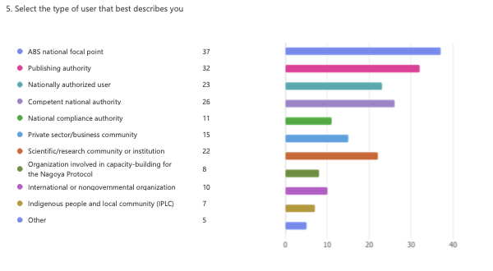

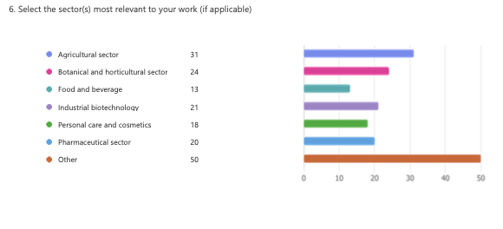
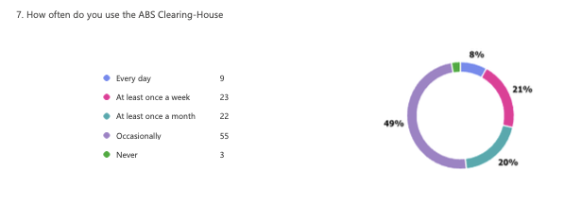
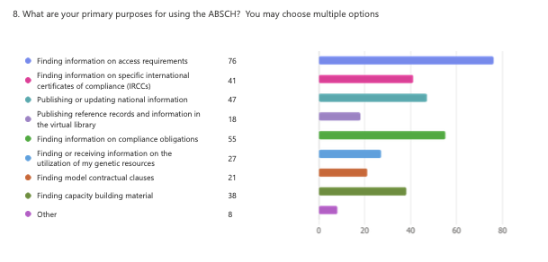

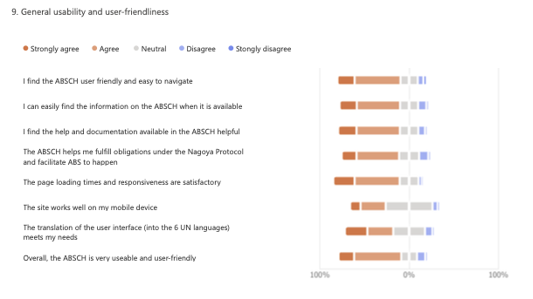
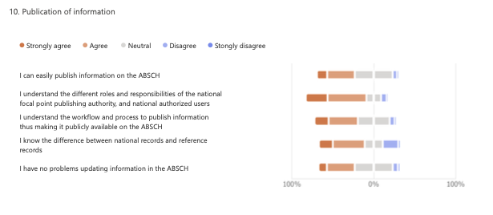
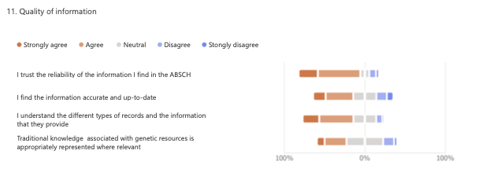

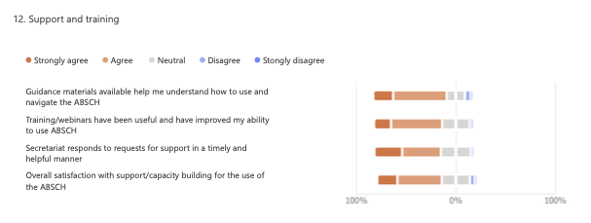

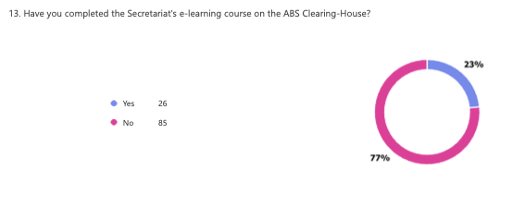
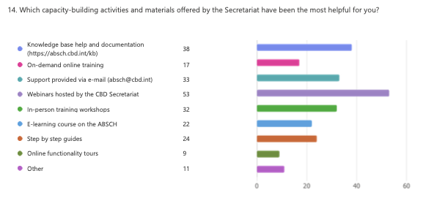
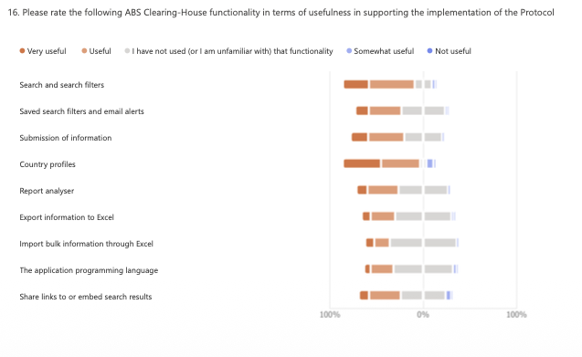

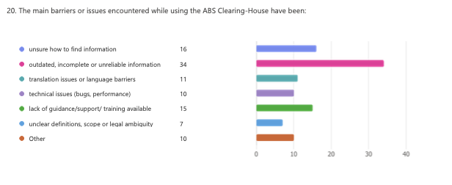
__________

* CBD/SBI/7/1.
** The present document is being issued without formal editing.
Respondents could select multiple types, so percentages add up to more than 100%.
Question 22. Bonus question! Please provide a real-life example: Describe a concrete case where the ABS Clearing-House helped you in facilitating ABS and the objectives of the Nagoya Protocol?

