 |  | CBD
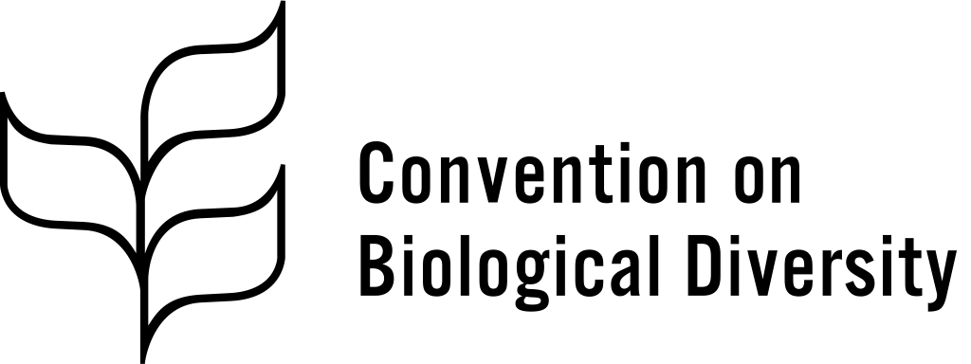 |  | Distr.  GENERAL  CBD/WG2020/2/3/Add.2  22 December 2019  ORIGINAL: ENGLISH
Open-ended Working Group on the Post-2020 Global Biodiversity Framework
Second meeting
Rome, 24-29 February 2020

Zero draft of the post-2020 global biodiversity framework
Addendum
Glossary
Note by the Co-Chairs

BACKGROUND
- In decision 14/34, the Conference of the Parties set out the process for developing a post-2020 global biodiversity framework, established the Open-ended Working Group on the Post-2020 Global Biodiversity Framework to support this process and tasked us to serve as its Co-Chairs. Subsequently the Open-ended Working Group, at its first meeting, requested us and the Executive Secretary, with the oversight of the Bureau, to continue the preparatory process in accordance with decisions 14/34, CP-9/7 and NP-3/15, and to prepare documentation, including a zero draft text of the post-2020 global biodiversity framework for consideration by the Working Group at its second meeting. A proposal for the post-2020 global biodiversity framework is contained in document CBD/WG2020/2/3. The present addendum provides of glossary of key terms used in the framework and information on how they have been used and interpreted therein.

GLOSSARY
- The following is a set of definitions that have been used to develop the different elements in the post-2020 global biodiversity framework:
  - Theory of change: A graphical, narrative or structured description used in planning to articulate what will be considered, implemented, and changed as a result of implementation in order to achieve desired short-term results, long-term impact, and a vision of success;
  - 2050 Vision: A description of what implementation of the framework aims to achieve in the long term. It is intended to serve as an ambitious and motivating statement, helping to place the concrete actions of Parties in a larger context. Note: The 2050 Vision will not be changing;
  - Elements: Refers to the elements of the Framework. Each element has a corresponding “box” in the graphical depiction of the theory of change (2050 Vision, 2030/2050 goals, reducing threats, meeting people’s needs, tools and solutions, enabling conditions, means of implementation and responsibility and transparency);
  - SMART Targets: Reflect the statements of what we want to achieve and by when using the SMART criteria (Specific, Measurable, Achievable, Relevant, Time-bound). Each target will be supported by at least one indicator;
  - Indicator: A measurement relevant to a target that changes over time due to an intervention in comparison with a known baseline;
  - Baseline: The current or past value of an indicator within a certain time frame that will be used to evaluate the achievement of SMART targets;
  - 2030/2050 Goals: These reflect the brief outcome-oriented statements that measure the status of what the framework is aimed at achieving by 2030 and 2050. The goals will use the SMART criteria and will be associated with explicit indicators that can be tracked at the global level and could be scaled down to the regional or national level;
  - 2030 Mission: A formal statement of what the implementation of the framework will achieve, how it will be done, and why or who will benefit therefrom. Mission statements are in the present tense, are more action-oriented, and address the core purpose of the work.
__________

